ASSESSMENT OF RURAL COMMUNITY WATER SUPPLY SCHEMES SUSTAINABILITY AT SHEBEDINO WOREDA, SIDAMA ZONE, SNNPR, ETHIOPIA

MSc Thesis

WONDWOSEN ADMASU

HAWASSA UNIVERSITY, HAWASSA, ETHIOPIA

SEPTEMBER, 2018

ASSESSMENT OF RURAL COMMUNITY WATER SUPPLY SCHEMES SUSTAINABILITY AT SHEBEDINO WOREDA, SIDAMA ZONE, SNNPR, ETHIOPIA

WONDWOSEN ADMASU

ADVISOR: MOLTOT ZEWDIE (PHD)
CO-ADVISOR: BROOK ABATE (PHD)

A THESIS SUBMITTED TO DEPARTMENT OF BIO-SYSTEMS AND ENVIRONMENTAL ENGINEERING,
INSTITUTE OF TECHNOLOGY
HAWASSA UNIVERSITY
HAWASSA, ETHIOPIA

IN PARTIAL FULFILLMENT OF THE REQUIREMENTS FOR THE DEGREE OF MASTER OF
SCIENCE IN WATER RESOURCE ENGINEERING AND MANAGEMENT

SEPTEMBER, 2018

School of Graduate Studies
Hawassa University
Advisors’ Approval Sheet
(Submission Sheet -1)

This is to certify that the thesis entitled ‘Assessment of Rural Community Water Supply Schemes Sustainability at Shebedino Woreda, Sidama Zone ,Southern /N/N/PR, Ethiopia ‘Submitted in partial fulfillment of the requirement for the degree of Master with specification in WREM.
The Graduate Program of the School of BEE, and has been carried out by Wondwosen Admasu ID.No SGSKW/312/03 under my/our supervision. Therefore, I/we recommend that student has fulfilled the requirement and hence hereby can submit the thesis to the department.

Dr. Moltot Zewide _______________________ ___________________
Name of major advisor Signature Date

SCHOOL OF GRADUATE STUDIES
HAWASSA UNIVERSITY
EXAMINERS’ APPROVAL SHEET-1
(Submission Sheet-2)
We, the undersigned, members of the Board of Examiners of the final open defense by___________________________________have read and evaluated his/her thesis entitled “______________________________________________________________________________________________________________________________________________________________________________________________”, and examined the candidate. This is, therefore, to certify that the thesis has been accepted in partial fulfillment of the requirements for the degree _________________________________________________.
_____________________ ___________________ ____________
Name of Chairman Signature Date
_____________________ ___________________ ____________
Name of Major Advisor Signature Date
_____________________ ___________________ ____________
Name of Co-advisor Signature Date
_____________________ _________________ ___________
Name of Internal Examiner Signature Date
_____________________ _________________ ___________
Name of External Examiner Signature Date
_____________________ _________________ ___________
SGS Approval Signature Date
Final approval and acceptance of the thesis is contingent upon the submission of the final
copy of the thesis to the Department of Graduate Council (DGC) of the candidate's major
department.

Stamps of SGS Date ____________

STATEMENT OF THE AUTHOR

I declare that this thesis is my own work and all sources of materials used for this thesis have been duly acknowledged. I seriously declare that this thesis is not submitted to any other institution anywhere for the award of any academic degree, diploma or certificate.

Name: Wondwosen Admasu Signature:……….……………

Place: Hawassa University, Hawassa

Date of Submission: September, 2018

ACKNOWLEDGEMENTS
Above all I thanks a lot my God and Santee Mary for their endless support and make me stronger to finalize successfully this thesis’s. Next, I would also like to thank a lot my advisors Dr. Moltot Zewede and Dr. Brook Abate for their valuable comment, support, encouragement and advice from the very beginning of this research work up to final work. Particularly I would like to thanks a lot Dr. Moltot Zewede for his limitless constructive ideas support for the success of this research paper. I would also like to express my deepest gratitude to my mother W/ro Seblework Kebede, brothers (Tewodrose and Tariku Admasu), and all my family support me in every possible way to bring this work to final and fruitful. My special thanks goes to my friends sharing their knowledge and helpful experiences.
Finally, I would like to thanks a lot Hawassa University Institute of Technology, Bio-System and Environmental Engineering Department staffs, Shebedino Woreda Administration office and Water Office staffs and community representatives in the study area for their attention to detail and wholehearted cooperation during the field work. My thanks also extend to the data collectors and community members those are participated in the House Hold interview, Focus group discussion and Key interview.

ACRONYMS
ADB Africa Development Bank
BH Bore Hole
CSA Central Statistics Agency
DP Deep Well
DRA Demand Responsive Approach
FGD Focus Group Discussions
HDW Hand Dug Well
HH House Hold
HP Hand Pump
JMP Joint Monitoring Program
KI Key informant
GTP Growth and Transformation Plan
GWI Global Water Initiative
MDG Millennium Development Goals
MoFED Ministry of Finance Economy Development
MoWE Ministry of Water and Energy
MoWIE Ministry of Water, Irrigation and Energy
NAPA National Adaptation Programme of Action
NGO Non-Governmental Organization
NWI National Water Inventory
O&M Operation and Maintenance
RWS Rural Water Supply
SSA Sub Sahara Africa
SNNPRS South Nation Nationality People Regional State
SPSS Statistical Package for Social Science
SW Shallow Well
UAP Universal Access Plan
UN United Nation
UNICEF United Nations Children’s Fund
UNESCO United Nations Educational, Scientific and Cultural Organization
WASH Water, Sanitation and Hygiene
WATSAN Water and Sanitation
WHO World Health Organization
WRP Water Resources Policy
WaSHCOW Water, Sanitation and Hygiene Committee
WWMEO Woreda Water Mineral and Energy Office

TABLE OF CONTENTS

STATEMENT OF THE AUTHOR I
ACKNOWLEDGEMENTS II
ACRONYMS III
TABLE OF CONTENTS V
LIST OF TABLE VII
LIST OF FIGURE VIII
1 INTRODUCTION 1
1.1. Background 1
1.2. Statement of the Problem 3
1.3. Research questions 4
1.4. Objective of the Study 4
1.5. Significance of the Study 4
1.6. Scope of the Study Area 4
2. REVIEW OF LITERATURE 6
2.1. The General and Specific Water Supply Policy 7
2.1.1 General water supply policies on drinking water supply 7
2.1.2 Specific water supply policy 7
2.2. Water Supply Service and Coverage in Ethiopia 7
2.3. Functionality of Water Supply Schemes in SSA and Ethiopia 8
2.3.1 Functionality of water supply schemes in SSA 8
2.3.2 Functionality of water supply schemes in Ethiopia 9
2.4. Growth and Transformation Plan on Water Related Target 10
2.5. Major factors affecting water supply scheme sustainability 10
2.5.1 Technical factor 10
2.5.2 Social factor 11
2.5.3 Institutional determinants 11
2.5.4 Financial factors 12
2.5.5 Environmental factors 12
3. MATERIAL AND METHODS 14
3.1. Description of the Study Area 14
3.1.1 Location 14
3.1.2 Topography and Climate 15
3.1.3 Population and Settlement 15
3.1.4 Economic activity 15
3.1.5 Water supply activities 16
3.2. Data Collection 17
3.2.1 Source & type of data 17
3.2.2 Data Collection Methods 18
3.3 Data analysis 20
4. RESULT AND DISCUSSIONS 22
4.1 Type and functionality status of potable water supply schemes 22
4.1.1 Sampled water supply schemes status 23
4.1.2 Proportion of beneficiaries with type of water sources 25
4.1.3 Water supply coverage 26
4.2 Factor for the sustainability of water supply schemes 28
4.2.1 Technical factor 28
4.2.2 Social factor 36
4.2.3 Organizational factor 39
4.2.4 Financial factor 42
4.2.5 Environmental factor 44
4.3 Perception of the Community on Sustainability of Water Supply Schemes 47
4.3.1 Willingness of community in water supply schemes sustainability 47
4.3.2 Trust of community on WASHCOs performance 48
4.3.3 Community attitude toward the costs 49
4.3.4 Communities perception in responsibility 49
5 CONCLUSION AND RECOMMENDATION 51
5.1 Conclusion 51
5.2 Recommendation 52
6 REFERENCE 53
APPENDIX I. WATER SUPPLY SCHEMES ASSESSMENT FORM 56
APPENDIX II. KEY INTERVIEWER QUESTION 59
APPENDIX IV. LIST OF FIGURE 65
BIOGRAPHICAL SKETCH 68

LIST OF TABLE
Table 1: Rural and urban water supply coverage for Ethiopia, JMP and MoWE(2010) 8
Table 2: GWI scheme functionality on the day of the survey from 2011 - 2013 9
Table 3: Type of water supply schemes in the study 4 kebeles 17
Table 4: Sample kebeles population size 18
Table 5: Existing water supply schemes of Shebedino woreda 22
Table 6: General information for sampled water supply schemes 24
Table 7: Water supply coverage proportion in the study area 27
Table 8: Sex and Number of HH Participated in water supply schemes selection and design 28
Table 9: Status of HH participation in water supply scheme selection and design 29
Table 10: Proportion of respondents versus distance travel 31
Table 11: Kebele and number of frequency that the respondents to fetch potable water 32
Table 12: Kebele and frequently failed of water supply schemes 33
Table 13: Provision of regular water supply schemes maintenance 35
Table 14: Kebele and community willingness for water supply scheme maintenance Contribution 36
Table 15: Proportion of family member to fetch water 37
Table 16: Proportion of WASHCOs regular maintenance in sampled kebeles 38
Table 17: Presence of WASHCOs distribution per kebeles 39
Table 18: Status of WASHCOs performance in study area per kebeles 40
Table 19: Situation of water seller regular operation of water supply schemes 41
Table 20: care takers immediate response for schemes maintenance 41
Table 21 : Availability of local, well understood WASCHOs by-law 42
Table 22: Regular financial reporting trained of WASCHOs 43
Table 23: Reasons for lack of WASHCOs regular financial reporting program 44
Table 24: Functionality of water supply schemes throughout the year 45
Table 25: Status of sampled water supply schemes compound 46
Table 26: Environmental protection accomplishment status 47
Table 27: Community willingness for maintenances of water supply schemes 48
Table 28: Trust on WASHCOs performance 49
Table 29: Attitude of beneficiary toward the costs 49
Table 30: Communities perception with respect to responsibility 50

LIST OF FIGURE
Figure 1: Location map of the study area 14
Figure 2 a) Non functional HDW b) Properly functional HDW 25
Figure 3: Focus group discussion with community members 30
Figure 4: Accessibility of water supply schemes for the target beneficiaries 30
Figure 5: Mostly damage part of sampled water supply schemes 34
Figure 6: a) Well cleaned and fenced b) Poor water supply schemes compound 46

ABSTRACT
In developing country there is a problem of water supply schemes sustainability due to damage of functional water supply schemes with different reasons through their service period. This situation is also observed in Ethiopia with in all states and woredas. Shebedino woreda found in sidama zone, SNNPR State has a visible problem in this regard. This study was conducted to assess the sustainability of water supply schemes in Shebedino woreda(study area). The assessment was focused on the functionality of water supply schemes; examining the sustainability of water supply schemes through technical, financial, organizational, social, environmental factors, and community perception within four sampled kebele and 15 water supply schemes of the study area.
For this research purpose primary and secondary data were used. Data was collected focused on House to House interview, Field observation, Focus Group Discussion and Key Informant interview with organized questions. Field observation was conducted .The data was analyzed by descriptive analysis method.
From finding the nonfunctional water supply scheme of study area was 33.58 % which is greater than from SNNPR and national level. Technical, financial, organizational, social, environmental factors and community perception have major contribution in the sustainability of water supply schemes. Among the reasons for frequently failed of water supply schemes, lack of spare part has taken the large percentage which is 47.78% and the second large proportion is poor management which is 31.67%. Inadequate budget were contributed for insecurity of sustainability of water supply schemes .The study result shows that more emphasis is not given for community participation in planning and technological selection. Large percentage of finance was allocated for newly constructed water supply schemes by NGOs 79.2%, but government and community have low contribution.
Community participation, technical factors and organizational management are the major parts need more emphasis to ensure the sustainability of water supply schemes. It was found that even though the community has high willingness in contribution for the sustainability of water supply schemes, but there is low practice of community involvement. This positive attitude has significance in the sustainability of water supply schemes but need more improvement.
Keywords: Sustainability, Assessment, water supply schemes, functional, nonfunctional,
Shebedino woreda.

INTRODUCTION

Background
The proportion of national populations without access to improved drinking water for Sub Sahara Africa in an average is 42%. In this regard the highest county in Africa is Somalia (above 90%) and Ethiopia is nearest to 65%. This is because of malfunctioned and they do not have a new construction of water supply schemes UNICEF and WHO (2012).As per UAP concept the minimum standards for rural areas is define that, to be at least 15 liters per capita per day (lpcd) of safe water, available within 1.5 km of the home.
Water supply coverage measurement standard has its own advantage and disadvantage. Its advantage is easy to count the number of water supply schemes which are functional and way of computation to determine status of coverage of the specific area. However due different reasons some schemes may get some damage through their service period, because of this reason the number of functional schemes are decreased while the water supply service coverage remain as it is or underestimate or over estimated. The above mentioned condition was observed and has contribution for non sustainability of water supply schemes in the study area.
This condition led to having unrealistic coverage data or different coverage data of water supply service in any time in different document by it is or stakeholders. In relation to sustainability of water supply schemes stakeholders have major responsibility. The issue of service sustainability in Ethiopia is not new and also in sub-Saharan Africa (SSA). The available evidence suggests that perhaps 40 per cent of hand pumps are non-functional in SSA and in Ethiopia based on official data 20–30 per cent of schemes have failed, or experience frequent outages, MoFED (2010). In general the water supply coverage data were different in Globally, SSA, and country wise due to inconsistence of data on functional and non-functional verses coverage of water supply schemes.
According to MoWE(2010) sustainability from Ethiopia context stated that, it is strong emphasis on new construction and infrastructure building. In contrary it gives passive emphasis for non-functional water schemes and levels of non-functional schemes are high, while coverage remains relatively low. In addition to this post-construction support for community management is extremely limited. This situation led for the insecurity of sustainability in water supply involves, ensuring continuous availability of sufficient quantity and quality of water, within adequate institutional frameworks; applying sound management practices, appropriate technologies, and full-cost accounting, In relation to water supply schemes sustainability, the schemes has to be given continuous water supply service over a long period of time with consistency yield and safe water for the beneficiaries at particular time.

The study area (Shebediono woreda )has Water supply coverage of 65 % (65% for rural and 87% for urban) , Woreda Water, Mineral and Energy Office, (2014). However based on the actual data and population size of 2014, the study area water supply coverage was 34.3%. In comparison of 34.3% with woreda water office official water supply coverage report of 65.5% show that, there was a gap on realistic figure of water supply coverage. This implies that non functional water supply schemes were assumed in delivery of service for the community. This situation shows that there is still problem to ensure the sustainability of water supply schemes in the study area. Regarding to water supply schemes sustainability factors like technical, social .environmental, organization and finance have major influence.

Hence, in this study water supply schemes sustainability assessment was assessed mainly focus on the determinant factors of sustainability( Technical, Social, Institutional, Financial and Environmental), functionality of water supply schemes and perception of community. Descriptive analysis was carried out through SPSS software. This paper contributes to show direction for the sustainability of water supply schemes.

Statement of the Problem

Functional status of water supply schemes is one of the factors which affect the sustainability of water supply schemes. Among the exciting water supply schemes non-functionality of schemes are above 20% in 2010 and plan to reduce to 10% in 2015, Ethiopia demographic and health survey (2011) and UNICEF (2012). National WaSH Inventory reported that, 92,588 rural water supply schemes were inventoried in 2011, of which an average 23,610 schemes (25.5%) were non-functional. In all regions the non-functionality ranges was between 20% and 35% MoWRE(2010). In the study area the non functionality of water supply schemes was 33.58 which is exceed the SNNPR State of non functionality water supply schemes level which is 25%, MoWRE(2010).

Through the life of water supply schemes service time, some of the schemes were failed due to different causes. Due to this reason the coverage is remained as it is or increased with the other new constructed water supply schemes. This implies that there is a gap on given emphasis for non functional water supply scheme maintenance and to make them sustain their service. This condition was contributed for the increment of the number of non functional water supply schemes. Therefore based on this situation there is insecurity of sustainability of water supply schemes in our country at different woredas. Shebedino woreda found in sidama zone, SNNPR State and which has a visible problem in this regard. The degree of severity of the problem, in relation to water supply schemes functionality and effective utilization to ensure the sustainability is magnified at rural communities like Shebedino woreda due to gaps of technological selection involvement, active community participation, environmental protection, institutional and financial management.

Therefore, this research was conducted to assess the sustainability of water supply schemes and has been developed different possible recommendation to secure the sustainability of water supply schemes by examine the existing situation of technological selection, environmental protection, structure and way of management of the organization, social awareness and willingness , financial management. The study was organized through house to house interview, field observation, Focus Group Discussion and Key Informant interview with organized questions and secondary data.

Research questions
This study has investigated the following research questions,
- Why the water supply schemes are non-functional ?
- What are the determinants factors that contribute to the sustainability of rural water supply schemes?
- What are the community perceptions in proper functioning of water supply schemes?

Objective of the Study
The general objective of this study is to assess the sustainability of water supply schemes in Shebedino woreda,
    - The specific objectives are:
- To assess the functionality of existing water supply schemes in the study areas by the year 2014.
- To examine technological ,environmental, institutional, social , and financial factors impacting on sustainability of water supply schemes,
- To assess perception of users on sustainability of water supply schemes

Significance of the Study
The importance of this study is to identify the causes for the non-functionality of water supply schemes and contributes possible mitigation measures in addressing sustainable management of water supply schemes. In addition to this, it also used as reference for further investigation by different researchers and sectors based on the studied data of water supply schemes sustainability situation. Furthermore, this study has given a direction for WASH strategic planner providing emphasis in the renovation of non functional water supply schemes to ensure the sustainability of the water supply schemes.

Scope of the Study Area
Regarding to the scope of study, it is only focused on assessment the functionality of existing water supply schemes, perception of users and examined the determine factors like technological, environmental, institutional, social , and financial factors on the sustainability of rural water supply schemes. The study area mainly focuses on 4 kebeles( Taremesa, Mider Genet,Dila Aferara and Fura) of Shebedino woreda those have large number of non functional and functional water supply schemes for compare and contrast. Moreover for technological purpose the assessment only focused on the existing HDW with HP, SW with HP, Developed spring on spot and Motorized water supply schemes (Capped spring and BH with pipes distribution line).In this study the primary and secondary data has been used to assess the sustainability of water supply schemes in the study areas of shebedino woreda , Sidama Zone ,SNNPR State. The secondary data which are used for this study was up to 2016. The primary data collection is done through well organized system and it has taken one and half month to achieve the objective of the study. Moreover the analysis work has been done through SPSS Soft ware and tabulation methods.

REVIEW OF LITERATURE
In Ethiopia regarding to safe water supply progress, the lowest national safe drinking water coverage has been improved somehow and scaled up to 68.5% by 2010. According to Universal Access Plan (UAP) ambitious targets set ,substantial investments are being made in increasing access to improved water sources in rural areas of Ethiopia, which aims achieving near-universal access to water and sanitation by 2015 ,Calow, Nicol, Zemede Abebe (2013).
In relation to rural water supply coverage in 1990, coverage was estimated at around 11 per cent of the rural population, while figures published based on the National WASH Inventory (NWI) carried out recently conclude that rural water supply coverage stands at 49 percent in 2010/11, Butterworth et al. (2013).From the Ministry of Water Resources, MoWR( 2007) the latest Water Sector Development Reports, Ethiopia’s national safe water supply coverage reached 42.2% (41% rural and 78% urban). However regarding to nonfunctional of water supply schemes 33% of rural water supply schemes in Ethiopia are nonfunctional at any time, due to lack of funds for O&M, inadequate community mobilization and commitment and a lack of spare parts.
Ethiopia water resource management policy the term water supply is define that it does not considered for hydropower and irrigation however it is related to for human different purpose, animal consumption, and also for factories, commercial, industrial and other uses. Regarding to water supply service accessibility, most of the rural area People were travel long distances for many hours and fetch unsafe and unreliable water from unprotected spring, pond, rivers and other unprotected sources.
In line with this Ethiopia government is given more emphasis to achieve sustainable and equitable solutions to these problems (MoWE).From Ministry of Water Resource and Energy water resource policy point of view the FDRE government set the general goal of Ethiopia Water Resources Policy (WRP) to solve water supply service inaccessibility problem of the country, and to enhance and promote all national efforts towards the efficient, equitable and optimum utilization of the available water resources for significant socio-economic development on a sustainable basis.

The General and Specific Water Supply Policy

General water supply policies on drinking water supply
To be sustained the water supply schemes any one of the county should have its own drinking water supply policies .In our country context the seated water policies ensure that rural drinking water and livestock water supply undertakings shall be integral part of the overall socio-economic development, centered on self-reliance, community participation and management.

Specific water supply policy
According to Ethiopia specific water supply policy the appropriate water supply planning parameters, design criteria and standards (in engineering aspects) along with acceptable, desirable and permissible ranges and limits has to be developed .Moreover it also promote self financing of programmes and projects at the local level, ensure transparency and fairness in the management of water supply services so as to enhance readiness to pay and participation by the users and communities in the financial management of systems, ensure responsibility and financial accountability in the management of water supply services and develop flat rate tariffs for communal services like hand pumps and public stand posts, MoWR (2010 ).

Water Supply Service and Coverage in Ethiopia
Due to the FDRE government initiative and commitment for the improvement of water supply coverage, there is a progress of national water supply coverage from 20% in 1991 to 61.6% by the year 2012/13. In this connection, the progress in rural water supply access has increased to 58.71 percent and 80.72 percent for urban respectively.
According to Ethiopia GTP-1 plan, the rural people water supply consumption liter per capita per day is 15 liters with in 1.5 km and for urban people is 20 L/P/P/day with in 500m radius. Furthermore around 29, 678, 721 people living in the rural are expected to become beneficiaries of safe drinking water by 2015 and 3, 613, 216 urban people will be benefitted of the safe drinking water program by the end of the GTP-1 period. In general the total expected number of potable drinking water beneficiaries is 33, 291,937.
In reference to the target plan of GTP-2 in the two and half year period stated that , 16.5 million of people in rural and 1.7 million people of urban have got access to drinking water supply service . It also was set to make 18.2 million people beneficiaries of clean drinking water. To be realize the sustainability of water supply schemes conditions for conducting monitoring at household and community level has to be encouraged, this is due to the fact that consideration remains purposeful on the required outcomes, and service beneficiaries have got an opportunity of being empowered to manipulate their management and performance ,Carter(2010).
The water supply coverage based on the above data indicates that water supply service is different based on different data’s. Due to lack of similar data on new constructed water supply schemes as whole and particularly on the non- functional schemes of stakeholders including the government there is inconsistence data. The other cause for the inconsistency of data is they don’t have one national plan that is form bottom (community) to top (Federal relevant sectors) in maintaining of these schemes.
In connection to this fact JMP published recent figure for Ethiopia on ‘use of improved water facilities’ are summarized in tabular form. Because of the coverage figure of JMP is differ and show less coverage, the government reject the result of JMP. However the JMP data was based on CSA census data. Particularly the rural water supply coverage reported by the government is greater by fold than JMP report. MoWE(2011) and WHO and UNICEF( 2012)
Table 1: Rural and urban water supply coverage for Ethiopia, JMP and MoWE(2010)
S.No | Area | MoWE water access coverage (%) | JMP use of improved water facilities (%) | Difference of coverage
 | Rural | 65.8 | 34 | 31.8
 | Urban | 91.5 | 97 | 5.5
 | Total | 68.5 | 44 | 24.5
Sources: Ministry of Water and Energy (MoWE), 2011; WHO and UNICEF (2012)

Functionality of Water Supply Schemes in SSA and Ethiopia

Functionality of water supply schemes in SSA
According to GWI (2013) report show that across the sub-Saharan Africa countries there is an increment trained of non- functional schemes. This situation indicated that there are different gaps on effective community- based management, net work of relevant stakeholders, governance, environmental and the importance of investigating and addressing water service sustainability issues.
Table 2: GWI scheme functionality on the day of the survey from 2011 - 2013
No | Functionality on the day of the survey | Ethiopia in % | Uganda in % | Tanzania in % | Overall (%)
1 | 2013 | 61.4 | 78.8 | 100 | 75
2 | 2012 | 97 | No data | No data | 95
3 | 2011 | 94 | 94 | 100 | 92
Source: GWI (Global Water Initiative), (2013)
In reference of data analysis, due to the highest non-functionality rate of roof catchments at schools and health institutions, 42% of non functionality of water supply schemes from the total were recorded. In line with this mechanical failure, lack of or poor quality water , poor management, lack of community water committee and poor linkage between non-functionality and governance are the major reasons for these schemes non -functionality. According to surveyed schemes data Uganda has best performance which is 31% schemes nearly working as compare to Ethiopia and Tanzania, Ethiopia followed with 29% of schemes nearly always working and Tanzania last with only 18% of the schemes falling in this category. As per of GWI report, in Ethiopia context, improper original design is shared 12% for poorly functioning of the schemes ,Katharina Welle, with Jennifer Williams( 2014). In line with this, in Subedino woreda among the total source of water supply schemes 33.58 were not functional and 66.42 % were functional. This implies that around 34% of water supply schemes were not functional and there was insecurity of sustainability of water supply schemes in the study area.

Functionality of water supply schemes in Ethiopia
According to MoWE, 2010 report the national non-functional level of water supply scheme is 22%. On top of this the least and highest non-functional water supply schemes coverage were 18 % for Amhara and Tigray and 35 % for Harari. In the study region that is in SNNPR State the non-functional level was 25%.

Growth and Transformation Plan on Water Related Target
More emphasis is given by GTP-2 to ensure equitable use of resource at base level through integrated and sustainable development and use of water resources for multiple purposes by linking different sectors and users. In addition to this , Due attention is also given by Ethiopia’s National Adaptation Programme of Action (NAPA) in alleviating poverty and building resilience to climate change, including a number of water related priority actions through effective water development and management ,MoWE(2010).

Major factors affecting water supply scheme sustainability
According to Mason et al (2013) water supply scheme sustainability means that to be the schemes sustainable by providing water throughout the design period, moreover the schemes sustainability depends on technical, social, financial, environmental and organizational determinant. Hence for this study purpose the above mentioned water supply schemes sustainability factors were adapted.

Technical factor
Technical issues relating to the design and construction of a rural water system are the most obvious determinants of water system sustainability. According to Meron(2012) due to implementation of poor quality construction and low-grade materials may lead to the failure of the water system before the end of its design life. In addition to this for schemes failed schemes design mistake and overestimates of the water sources have main contribution.For challenge of water supply schemes sustainability some of the causes were the kind of technology that cannot serve the best interest of the beneficiary in terms of the quality of installation and problem for maintenance Carter(2010). Concerning the issue of water supply system technical sustainability, there appears greater interest and commitment of the study communities to maintain the water supply scheme services and benefits over time.
In relation to water supply schemes sustainability Jansz (2011) sated that presently there is a growing tendency to acknowledge the necessity for outsiders support so as to enable communities to undertake effective operation & maintenance of the water system for lasting services has become widely accepted. A presence of a practical and reactive support organization is a decisive pre-condition for efficient operation and maintenance of water supply services that can readily make available the required technical and software support on time, Carter (2009) and Abebe( 2012). Government agencies need to take the led to ensure the provision of spare parts supply as the supply chain lies beyond the control of the user. Furthermore the government should take effective action in order to make sure the functionality of the supply chain, Cater (2010) and Abebe (2012).

Social factor
It was believed that community participation generate favorable conditions for sustainability by allowing beneficiaries to determine the kind of services to be delivered for which they are willing to pay. Besides, it allows the user community to decide on major management issues, cost, investments, and make choices and commit resources as per these choices ,Sara and Katz(1998).By the time being now though out the world Demand Responsive Approach (DRA) has turn out to be the basis of governmental and NGOs water supply guiding principles. The supply-driven water supply interventions have failed to provide poor communities with sustainable water supplies so that the preceding intervention is shifted to Demand Responsive Approach (DRA).
Hence beneficiary communities only take water supply service delivery but failed to play an active role during project implementation and lack a sense of project ownership in the case of supply-driven interventions, Breslin (2003) and Abebe (2012). From socio-economic perspective communities need to be given greater opportunity to manage and decide on issues affecting their livelihoods, Narayan D.(1995). The beneficiaries influence the development and management of development projects rather than merely receiving a share of project benefits when there is proactive community participation (Paul, 1987 and Abebe (2012). Beneficiary participation has to be promoting to be managed water projects efficiently and is to be sustainable in the sense that the main stakeholders should be actively involved in the management of water projects, Dessalegn (1999).

Institutional determinants
Proper institutional arrangement is crucial for well-constructed water supply schemes to keep it functioning over time. Furthermore strengthen partnerships between different sector and stakeholders led for productive programs to be successful. In rural water supply schemes program several different potential stakeholders may be involved, Meron (2012). As per Meron (2012) formation of co-ordination committees at regional or district level was one of the effective way in which different stakeholders can work together for sustainability of water supply schemes.
In line with this a committee is likely to consist of personnel from a variety of local government institutions, which are directly or indirectly involved in rural water supply, as well as representatives of NGOs, private sector organizations and community groups. In addition to this within the community traditional leaders can also have an important role to play, both in representing communities and in ensuring that government is made accountable, and should be included where possible, Meron(2012).

Financial factors
The effective operation and maintenance (O & M) of rural water supply systems is crucial element for the sustainability of the water project. The community management of rural water supply systems on operation and maintenance is not successful, if financing resources are not available and frequent supports are not provided, Binder (2008). Budgeting sufficient funding for rural water supply systems is an important issue for sustainability and proper maintenance but not only one. Binder (2008) states that, “increasing the budget allocation for a rural water supply system is very important, but that is not the only thing to meet the challenges of achieving the Millennium Development Goals (MDGs), Habtamu (2012).

Environmental factors
According to Calow et al(2010); MacDonald et al(2009) and Kebede (2013) local topography, vegetation and soil condition have significant contribution to maintain the sustainability of water resource in the aquifer. So that the recharge rates has to be maintained through effective environmental management and protection to increase the sustainability of rural water supply, Harvey (2004); Calow et al, (2010); MacDonald et al, (2009) and Kebede (2013).To ensure the sustainability of water supply schemes , climate change has to be maintained. The major impacts of climate change on water services are unimproved. Shallow water sources are likely to be more vulnerable to increased climate variability because sustainability is closely to rainfall.
Improved rural water sources that access groundwater over 20 m below ground surface are more sustainable. In the study area context, from environmental perspective it is situated in two topographically distinct areas, that is Eastern Escarpment and the floor of the Ethiopia Rift Valley system. As a result of this, the areas which are situated on the eastern escarpment are characterized by locally undulating topography with the general topography descending toward west. As a result surface water and ground water follow from east to west, towards Hawassa Lake and Giddabo River,SW-WaSH(2005) and Desalegne(2013). The existed water supply schemes those are found in shedino woreda , the water quality was good based on the result of water quality parameters as per World Health Organization water quality standard Desalegne (2013).
In general this research study mainly emphasis on the assessment of water supply schemes sustainability in the adaptation of main influential factors of sustainability these are technical, financial, social ,institutional and environmental factors for discussion ,interpretation and analysis of the research study.

MATERIAL AND METHODS

Description of the Study Area

Location
Shebedino woreda is found in Southern Nations, Nationalities and Peoples Regional State of Sidama Zone. The Woreda capital, Leku is located 30 kms south of Awassa city. The geographical boundary of the woreda extends between 6⁰ 48’ to 6⁰ 58’ Latitude and 38⁰ 19’ to 380 34’Longitude. Shebedino Woreda contains 35 Kebeles, 3 Urban and 32 Rural (. The total area of the Woreda is 235sq km.(Shebedino Woreda Administration).
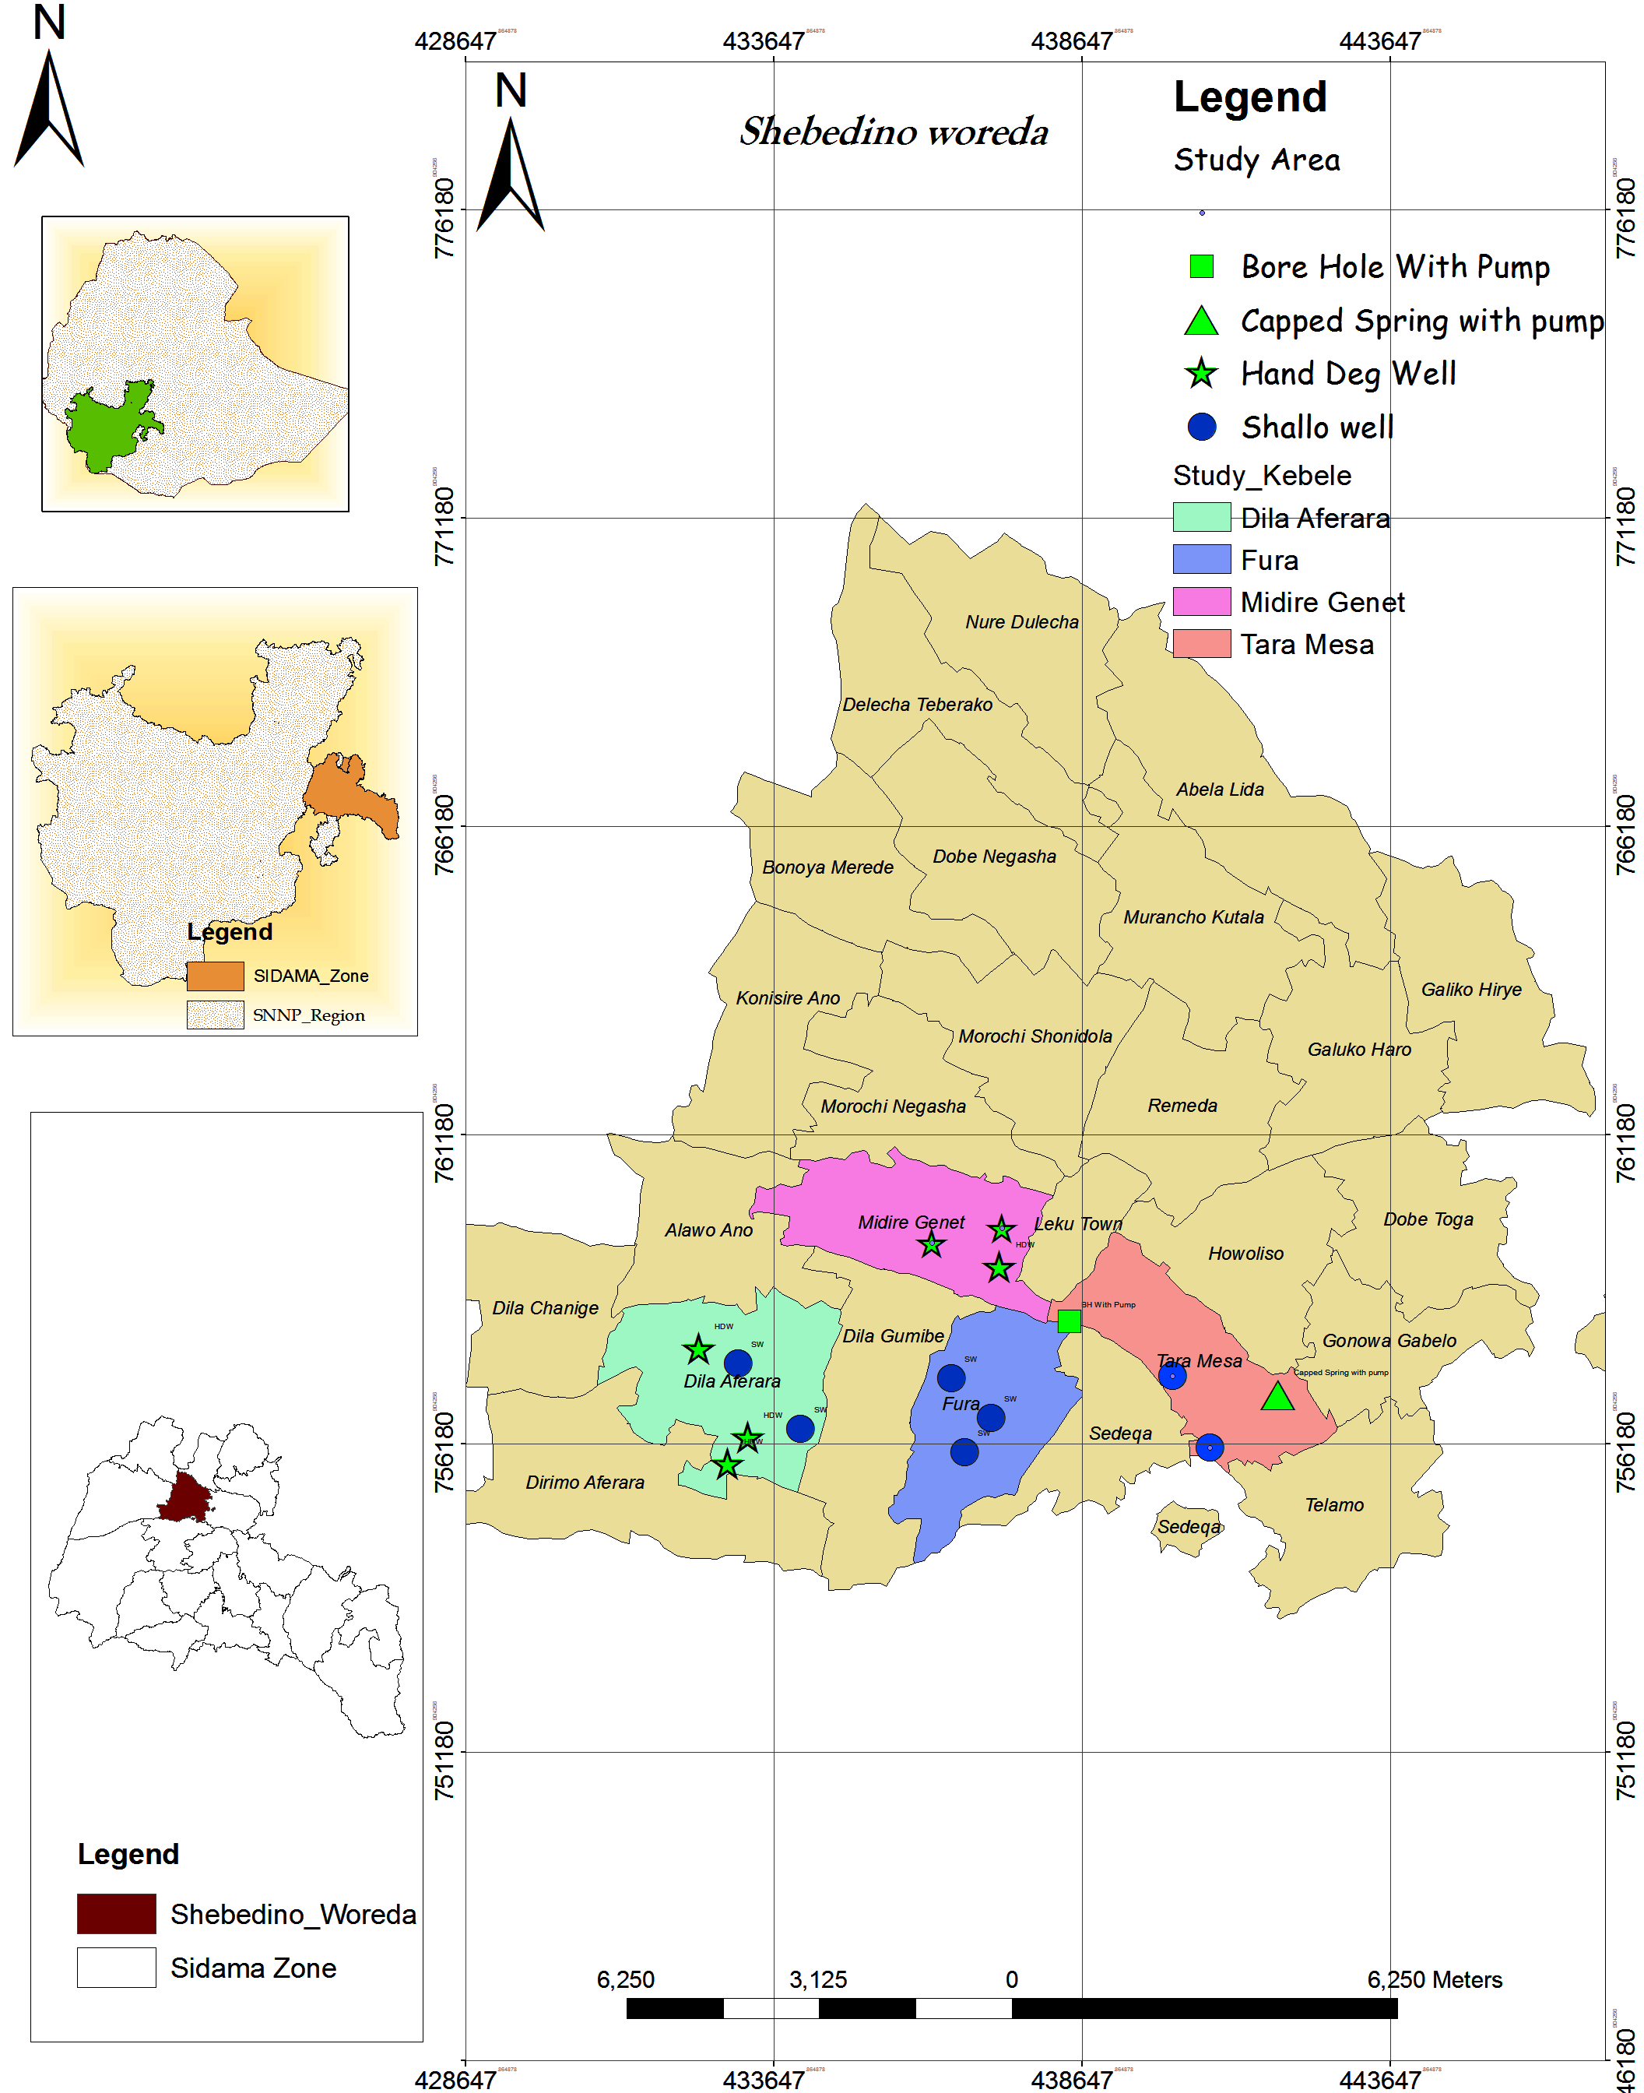
Figure 1: Location map of the study area

Topography and Climate
The mean altitude of the Woreda varies from 1500 – 2300 m above mean sea level. The average annual rainfall of the Woreda is reported to vary from 1000 to 1300mm. The climate of the Woreda is categorized in to three climatically Zones that is Mid Dega the (Cool to cold), Lower Dega(cool) and Woinadeda (moderate). The major part (about 90%) of the Woreda is within Woinadega climate range. The Woreda has generally flat topography (0 – 2% slope) except some undulating, hilly and mountainous areas in the east and west.

Population and Settlement
According to the information obtained from the Woreda Administration, the estimated total population of the woreda is 285,260 Out of this, the male population is 143969 constituting 50.5 percent and that of the female is 141291constituting 49.5 percent, Sidam Zone Water Mineral and Energy Department (2014 ).Taking in to account the above population figure and area of the woreda, the average population density in the Woreda is 1214 people/km^{2,} which indicates high population density. Like other woreda in the country, the majority of the population of this Woreda resides in rural areas constituting 95% of the total population where as the rest 5 percent resides in towns. The settlement is predominantly village type (group of households living closely), which is convenient for developing basic infrastructures.

Economic activity
Like in other Woredas in the country, agriculture workers cover the majority of the study Woreda population , in this context, agriculture is mixed type, i.e farming and livestock rearing. Among the two, farming is the dominant economic activity in the Woreda primarily for the purpose of household consumption. Similar to most other rural areas in Ethiopia, farmers in this Woreda practice traditional farming system, that ploughing using a pair of oxen. In addition to this, human labor and in this respect all family members who are able (including women who have domestic chore) contribute their share on farming activities.
The farmers in the Woreda mainly depend on rain for farming activities, in this respect, the farmers follow the season mainly “meher” that extends from September to December and produce annual crops one time per year. The major crops grown in the area is Inset, Coffee, Chat, and Maize, Barley, Wheat and the like. In addition to these, there are also some farmers who produce fruits and vegetables including Avocado, papaya, Banana, Tomato, Cabbage and the like. Because of shortage of land, most of the farmers in the woreda are not involved in livestock rearing. The main purpose of the activity is to obtain drought animals and generate income for the family by selling the livestock and its product. Apart from agriculture, only a few farmers are involved in petty trade and artisanship activities to generate additional income for the family.

Water supply activities
The Woreda Water Resources Development Office reported that there are 134 water supply schemes located in different kebeles serving the communities. Among functional schemes protected and developed springs has larger proportion of 65.56 percent and followed to this shallow well and hand dug wells fitted with hand pump scheme is 38.89 percent of all type of schemes and deep well with motorized is found in the third line of 4.44%. However Deep well with motorized water supply schemes were 100% functional as compare to the other water supply schemes. Concerning the functional status of the water supply scheme as it is shown in the table 3: 89 schemes (66.42%) are functional where as the rest 45 schemes (33.58%) are non functional. With the existing water supply scheme, the coverage is reported to be 65% percent (WWMEO), and distance traveled to the existing water schemes varies from 1.3 to 2 km. The later indicates that additional work is required to reduce it to 1.5 kms which is the target distance of the universal access program (UAP).

Table 3: Type of water supply schemes in the study 4 kebeles
Nr. | Type of scheme | Dela Aferara |  |  | Midere Genet |  |  | Fura |  |  | Taremes
Nr. | Type of scheme | Total | F | NF | Total | F | NF | Total | F | NF | Total | F | NF
1 | Deep well with motorized( Water points) | 1 | 1 | - | 2 | 2 | - | 1 | 1 | - | - | - | -
2 | Spring with motorized (Water points ) | - | - | - | - | - | - | - | - | - | 1 |  | 1
3 | Shallow well fitted with hand pump | 4 | 1 | 3 | - | - | - | 7 | 4 | 3 | 7 | 3 | 4
4 | Hand Dug Wells fitted with hand pump | 6 | 2 | 4 | 4 | 2 | 2 | 3 | 3 | - | - | - | -
5 | Developed spring (on spot) | - | - | - | - | - | - | - | - | - | 4 | 4 | -
6 | Total | 11 | 4 | 7 | 6 | 4 | 2 | 11 | 8 | 3 | 12 | 7 | 5
Notes: F: Functional NF: Non-Functional

Data Collection

Source & type of data
For this research purpose primary and secondary data were used .The primary data collection process was carried out by Household surveys, Focus Group Discussion, Key Informant Interviews, and observation of the study areas. Secondary data (Population size of each kebeles, socio-economic status of community, number and types of existing water supply schemes, functionality of water supply schemes, and water supply coverage) was collected from Sidama Zone and Shebedino Woreda Water, Mine and Energy offices, other relevant stakeholder (from woreda administration office about socio-economic status, population settlement and others) , journals , different reference books, to find out the relevant information to strengthen the research result.

Data Collection Methods
Primary data focused on functionality of existing water supply schemes, perception of the community and determinants factors (technical, financial, social, organizational and environmental ) interns of sustainability was collected through interviewing of the household with the help of structured questionnaire. Focus Group discussion and Key Informant Interviews with the respective community members and sectors experts were held to discuss on the objective of the study. Field observation was also conducted on the selected 15 water supply schemes. Accordingly the questions were examined about social factor on community contribution (capital, labor and material), water supply schemes management, technical factors (design, implementation and maintenance of construction), financial factors, environmental factors and assess community perception to assess the sustainability of the water supply schemes.
To determine the sample size of the study kebeles among 35 kebeles of the woreda, 10 % of the kebele was taken which are 4 kebeles(Taremesa, MiderGenet,Dila Aferara and Fura) . These kebeles were selected based on their functionality and non-functionality level of schemes among the others to represent the research on the study area. The total number of HHs for the selected 4 kebeles is 6802.
Table 4: Sample kebeles population size
Sample Kebeles | Total population  (A) | Male  (B) | Female  (C) | Total number of HH | Number of sample per kebeles (Proportionally)
Dila Aferara | 8964 | 4538 | 4426 | 1793 | 87
Fura | 6869 | 3449 | 3420 | 1374 | 67
Midere Genet | 9506 | 4779 | 4727 | 1901 | 92
Taremesa | 8669 | 4293 | 4376 | 1734 | 85
Total | 34008 | 17059 | 16949 | 6802 | 331
Source: Sidama Zone Water Mineral and Energy Department 2011
This research was done based on qualitative and quantitative research methods. For quantitative research method to determine the number of sample households for interview , Cochran(1977). Formula was used.
n’ $=\frac{z^{2 }p*q}{d^{2}}$ …………………………………………………... equation (1)
$n=\frac{n^{'}}{1+\frac{n^{'}-1}{N}}$ ………………………………………………...…. equation (2)
Where, n’ = Desire sample size when the population is greater than 10,000
n= Number of sample size when population is less than 10,000
z= 95% confidence limit (z-value at 0.05 is 1.96)
p= 0.05 (Proportion of the population to be included in the sample i.e. 5%)
q =1-p => q =1-0.05= 0.95
d= Margin of error or degree of accuracy (0.05)
N= Total number of household for sampled kebeles
The computation is as follows:
n’ $=\frac{z^{2 }p*q}{d^{2}}$ …………………………………………………... equation (1)
n’=((1.95)²x 0.05 x 0.95)/(0.05)² ₌72.2475
$n=\frac{n^{'}}{1+\frac{n^{'}-1}{N}}$ ………………………………………………...…. equation (2)
$n$= 72.2475/((1+(72.2475-1)/6802))= 71.53 nearest to 72
As per the above computation result from the total sampled kebele house household the sample size was 1%. However to have more representation about the research 4.8% of the total household of sampled kebeles was used for interviewee. After it was computed the sample size becomes 326 and additional 5 households were used. Hence, the total household was 331; this sample size was distributed to the selected 4 kebele’s proportional to the house hold size. The interviewees HHs were selected by using simple random sampling techniques. Hence data for specific objectives study was collected in sample community through;
- Eight structured focus group discussions (FGD) was conducted in four kebeles that means two FGD in each kebele. In each kebele there were two FGD, each FGD has 10 members. One FGD hold elders, men, and women and the other one hold youth and children. Key informant (KI) interviewees were conducted with WASHCOs and DAs.
- House Hold interview was conducted in the sustainability of water supply schemes in the selected sample kebeles with sample size of 331 on community perception, technical, social, financial, institutional and environmental factors and then analyzed based on the collected data.
- A technical assessment on water supply schemes was conducted based on technological selection, site selection for water availability, construction quality, design, swampy area and spare part availability.

Data analysis
Data analysis has been done by suitable statistical software packages like SPSS, figures and tabular form for comparing and contrasting of the research results. The quantitative data were collected from the sampled kebeles respondents through organized open-end questioned were analyzed by SPSS software through descriptive statistics in the form of frequency and percentage, figures, table and charts. The qualitative data which were collected from focus group discussion, water committees and key informants was incorporated and analyzed to complement and realized the quantitative data of the research.
Through descriptive statistics the below major listed studied task were analyzed and discussed to achieved the seated objective of study; The existing water supply schemes functionality; the major determinant factor for water supply schemes sustainability included
a)technical factors focused on participation of community in water supply schemes selection and design, accessibility, frequency to fetch water, frequently damage of water supply schemes and its parts , regular maintenance , spare part availability,
b) Social factors which is based on community interest and type of contribution for water supply schemes construction, family member to fetch water , and regular meeting of WASHCOs
c) Environmental factor in relation to water supply schemes functionality with respect to seasons, water supply schemes compound condition, and environmental protection program around the sampled schemes.
d) Organizational factors mainly focused on presence of WASHCOs , regular WASHCOs meeting, operation status of water supply schemes, and response status for water supply schemes maintenance,
f) Financial factors which included source of fund, request of additional budget source from the community and financial reporting system of WASHCOs,
And perception of target community on water supply schemes sustainability focused on possible reasons for non participation of respondents, their trust on WASHCOs service, their level of responsibility for water supply schemes sustainability and attitude toward the cost that paid for water fee.
According to MoWR, guidelines, water supply coverage is calculated by the number of water systems/schemes to the number of people served. They used fixed multiplication factors representing the average number of beneficiaries per scheme type (for example, 270 people for a hand-dug well fitted with a hand pump, 457 people for a drilled shallow well fitted with a Hand Pump, 3,313 people for a deep well with a piped distribution system and 5000 people for a spring with piped distribution system ). Coverage is then calculated by divided the population that could potentially be served, by the total population estimate for the same area, MoWR( 2009).

RESULT AND DISCUSSIONS

Type and functionality status of potable water supply schemes
As it is shown in table 5, among the total source of water supply schemes 33.58 were not functional and 66.42 % were functional. From the total number of HDW and SW 54.55% of HDW and 38.64 shallow well with hand pump were non functional in the study kebeles. This indicates that from the total non functional water supply schemes HDWs was taken the first larger proportion and SW followed. From field observation it was found that due to their good civil works and schemes management, deep wells with motorized schemes were functional as compare to the other water supply schemes. Whereas, because of loss of some solar panel and poor schemes management, motorized spring schemes with distribution was not functional. Due to this reason the beneficiaries’ community was forced to use water from spring on spot with uncomfortable condition and overcrowded (Appendix IV).
Table 5: Existing water supply schemes of Shebedino woreda
Type of scheme | Functional |  | Non-functional |  | Total
Type of scheme | Number | % | number | % | Number
Deep well with motorized | 4 | 4.5 | 0 | 0 | 4
Spring with motorized | 0 | 0 | 1 | 2.22 | 1
Shallow well fitted with hand pump | 19 | 21.35 | 17 | 37.78 | 36
hand dug wells fitted with hand pump | 7 | 7.86 | 24 | 53.33 | 31
Developed spring (on spot) | 59 | 66.29 | 3 | 6.67 | 62
Total | 89 | 100 | 45 | 100 | 134

As it is found from field investigation some water source fitted with hand pumps were not functioned due to damage of hand pump handling, lack of spare parts and finance to maintain. Furthermore, in Taremesa kebele some of the HDWs water sources were not functional due to bad odor and test. This situation implies that water sources those are operated by hand pump needs more emphasis in operation and maintenance and also selection of quality water to sustain water supply schemes through creation of sense of ownership in the community.

Sampled water supply schemes status
Field study has been done on the selected 15 water supply schemes. Among these 9 were not functional and 6 were functional water supply schemes. From non functional water supply schemes SW and HDW fitted with hand pump were take the larger proportion. Because of lack of community commitment and sense of ownership, financial problem, absence of WASHCOs and caretakers, damage of some parts of schemes, lack of spare parts, poor civil works and lack of community participation, Dila Aferara kebele was the first large proportion of non functional water supply schemes.
Due to the above mentioned similar causes and some wells bad odor and test, Taremesa kebele has the second large proportion of non functioned water supply schemes. In line with this Katharina Welle, with Jennifer Williams (2014) stated that improper original design is shared 12% for poorly functioning of the schemes. Moreover kind of technology that cannot serve the best interest of the beneficiary in terms of the quality of installation and problem for maintenance were the cause of non sustainability of water supply schemes Carter (2010).
However, by the reason of the presence of good management of WASHCOs, commitment of kebele administrators, regular maintenance and proper operation of water supply schemes, Fura kebele has minimum proportion of non functional water supply schemes. Nex to Fura kebele ,Midere Genet kebele has list proportion. This is because of the presence of organized water board, good commitment of kebele administrators, and capability in terms of finance and schemes managements as compares to the others kebelels. Carter (2009) and Abebe( 2012) stated that a presence of a practical and reactive support organization is a decisive pre-condition for efficient operation and maintenance of water supply services.
And also the government should take effective action in order to make sure the functionality of the supply chain to guarantee the sustainability of water supply schemes. It indicate that to sustain functional water supply schemes, the local government, NGOs, other stakeholders and communities by themselves should find mitigation measure for the above mentioned causes. The below listed figures 2(a) and (b) show some image of non functional and functional status of water supply schemes respectively.

Table 6: General information for sampled water supply schemes
Nr | Kebeles | Gott | GPS Coordinate |  |  | Type of water supply schemes | Year of construction | Status of the schemes
Nr | Kebeles | Gott | X | Y | Elevation | Type of water supply schemes | Year of construction | Status of the schemes
1 | Taremesa | Awadana | 440658 | 755887 | 1855 | SW | 2012 | not functional
2 | Taremesa | Gelecha | 439741 | 756765 | 1854 | SW | 2013 | not functional
3 | Taremesa | Dungato | 441825 | 756969 | 1846 | Capped Spring with pump | 2010 | not functional
4 | Taremesa | Yako | 438449 | 758155 | 1833 | BH With Pump | 2009 | functional
5 | Fura | Shale | 437164 | 756590 | 1807 | SW | 2008 | functional
6 | Fura | Sholokanto | 436736 | 756039 | 1809 | SW | 2005 | not functional
7 | Fura | Didamo | 436523 | 757240 | 1810 | SW | 2006 | functional
8 | Midre Genet | Amebosa | 436212 | 759434 | 1837 | HDW | 2011 | not functional
9 | Midre Genet | Badegalo | 437341 | 759674 | 1832 | HDW | 2013 | functional
10 | Midre Genet | Arem | 436940 | 759070 | 1835 | HDW | 2012 | functional
11 | Dila Aferara | Huro Loga | 433064 | 757477 | 1784 | SW | 2007 | not functional
12 | Dila Aferara | Gabiso | 432430 | 757718 | 1816 | HDW | 2008 | not functional
13 | Dila Aferara | Aliso | 434082 | 756420 | 1804 | SW | 2006 | not functional
14 | Dila Aferara | Hailu | 433225 | 756281 | 1805 | HDW | 2011 | functional
15 | Dila Aferara | Tesemo | 432901 | 755854 | 1795 | HDW | 2012 | not functional
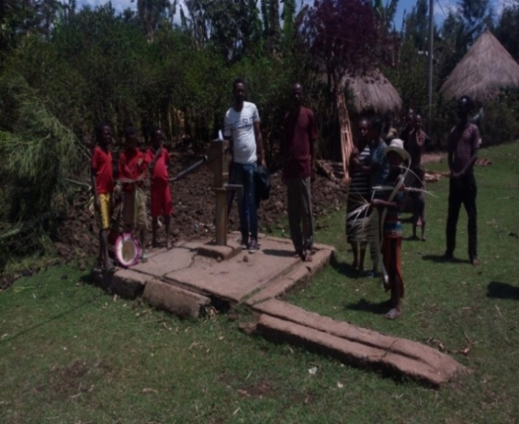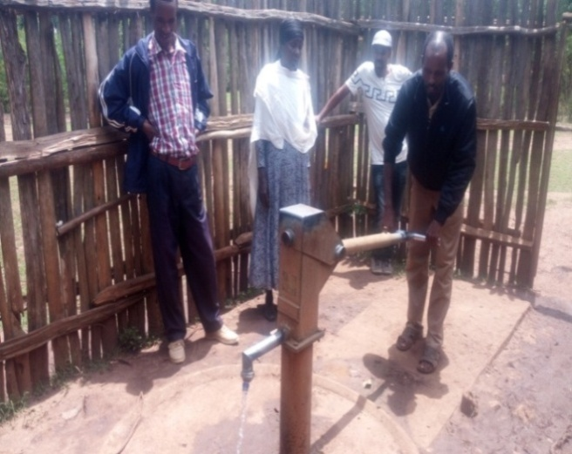
Figure 2 a) Non functional HDW b) Properly functional HDW

Proportion of beneficiaries with type of water sources
The result of collected data indicated that the majority population of the study areas used water from Shallow wells having hand pump for their domestic purpose. Next to shallow well 27.5% of the population use water supply source from capped borehole having distribution system. Hand dug well water supply scheme is found in third line for water supply source which served a population of 18.1% from the total. The rest capped spring on spot and capped spring having distribution used as potable water source for 12.4% and 6% of the sampled population for their basic domestic purpose like for drinking, washing, cooking and others activities respectively. The water supply sources used by the beneficiaries were safe and protected for domestic purpose. From focus group discussion it was found that the communities those are found around non functional water supply schemes were forced to be use water from unprotected water supply source.
Based on secondary data(Table 3) which is found from Shebedino woreda water office and as it is observed from field, it was found that Dila Aferara kebele has the first large proportion of non functional water supply schemes, because of lack of community commitment and sense of ownership, poor schemes construction, absence of WASHCOs and caretakers and financial problem. Taremesa kebele has large number of water supply schemes proportion. However due to the above mentioned similar causes for Dila Aferara kebele and abandoned of some wells due to bad odor and test of the schemes, it has the second large proportion of non functioned water supply schemes. Dela Aferara and Fura kebeles have the second large proportion water supply schemes.
However because of good management of WASHCOs, commitment of kebele administrator, regular maintenance and proper operation of water supply schemes, Fura kebele has minimum proportion of non function water supply schemes in comparison with the rest three kebeles. Finally Midere Genet kebele has last not the list proportion size of water supply schemes however in the presence of established water board, their capability in terms of finance and schemes managements and good commitment of kebele administrators; it is the second minimum level of proportion of nonfunctional of water supply schemes. From field observation it was found that the communities did not have trained to use roof water harvesting as an alternative water source. In general above 50% of the sampled community used HDW and SW fitted with hand pump and secondly BH with motorized covered more beneficiaries as water source. Hence to ensure the sustainability of water supply schemes the respective stakeholder should given priority on regular follow up and maintenance before they are going to expose for malfunctioning.

Water supply coverage
Based on scheme type’s verses number of people to be served water supply coverage of the sampled kebeles were calculated. As it is observed from table 7, from actual water supply coverage point of view, Fura kebele has highest proportion water supply coverage which is 90.99% . Next to Fura kebele , Mideregenet water supply coverage which is 78.9% and it is also higher than the study woreda water supply coverage of 65%.
However DilaAferara and Taremesa kebele have lowest water supply coverage of 50.2% and 31% respectively. Moreover Taremesa kebele water supply coverage is less than by 50% from woreda water supply coverage even though it has large proportion of water supply schemes. In reference to the actual functional water supply schemes data and their accessibility with in 1.5Km distance, the average water supply coverage of sampled kebeles which is 62.81% is less than the woreda water supply coverage which is 65%.

Table 7: Water supply coverage proportion in the study area
Nr. | Kebele | Actual beneficiary | Total beneficiary | Total population | Actual beneficary coverage % | Woreda water supply coverage %
1 | D/Aferara | 4500 | 7000 | 8964 | 50.20 | 65
2 | M/Genet | 7500 | 8000 | 9506 | 78.90 | 65
3 | Fura | 6250 | 7750 | 6869 | 90.99 | 65
4 | Taremesa | 2700 | 9700 | 8669 | 31.15 | 65
 | Total coverage of four kebeles |  |  |  | 62.81 | 65

Note: For this research study purpose the below listed definitions were used
- Actual water supply coverage means, coverage which is computed based on only the functional water supply schemes versus standard beneficiaries.
- Total water supply coverage means, coverage which is computed based on the total number of water supply schemes versus standard beneficiaries.
As it is seen in the table 7, from the total water supply schemes 42.5% of water supply schemes were not functional. However, woreda water office was included the number of non functional water supply schemes in the computation of woreda water supply coverage.
Due to this reason there is mismatch in water supply coverage report at the kebeles, woredas and all other level. This situation creates real information gab at all level of the respective sectors and also policy makers. Due to this reason emphasis is not given for non functional water supply schemes with regards to regular maintenance to secure their sustainable service for the target beneficiaries. Based on MoFED report the national potable water coverage is 68.5 and the rural potable water supply coverage within 0.5km water source is 65.8. In addition to this, the non-functional rural water supply schemes were 20 percent MoFED (2010). However, in the study area non-functional water supply coverage was found to be 33.58 which is greater than the national by 45%. These show that there was problem of giving emphasis on sustaining the functionality of an already constructed water supply schemes in the study area, beside to construction of new water supply schemes.

Factor for the sustainability of water supply schemes

Technical factor
Different researchers stated that for long term usage of water schemes and secure the sustainability of rural water supply; technical determinants like schemes design, water source setting and water point construction have direct influence. In line with this the work of Harvey (2004); Calow et al(2010); MacDonald et al(2009) & Kebede (2013) explain that technical factor is one of the contributor to the failure of water supply schemes. From this perspective the community has to be actively participated in technological selection, design, and implementation and monitoring of water supply schemes. In this regard, from the data found 56.5% of the total respondents were not participated during technological selection and design of water supply schemes those were implemented in their kebeles whereas 43.5% of the total respondents were participated.
From sex distribution point of view (Table 8), indicated that, in water supply scheme selection and design the male taken the larger proportion whereas the female is lowest. However from focus group discussions and field observation it was found that, female were highly involved and have high attachment in operating of water supply schemes and fetching of water for domestic purpose.
Table 8: Sex and Number of HH Participated in water supply schemes selection and design
Description |  | Number of HH Participated in water supply schemes selection and design |  | Total
 |  | Yes | No | Total
Sex | Male | 104 | 100 | 204
Sex | Female | 40 | 87 | 127
Total |  | 144 | 187 | 331
In addition to this particularly female respondents stated that planner and implementer of water supply schemes do not considered the women have leading role in operating and utilization of water from constructed water supply schemes to ensure the sustainability of those schemes. Meanwhile, in contrary they were mostly work closely with men and local administration leaders for the above mention issue. Due to this reasons women involved on technological selection, planning and implementation of water supply schemes was low as compare to men. Hence to have effective management and operation of water supply schemes and then to secure the sustainability of those schemes, planner and implementer should considered and would involved women actively.

Majority of the respondent stated that the project implementers, donors and other related sectors did not have interest to invite them in water supply scheme selection and design (Table 9). The second main reason for non participation was the respondents do not have knowledge about the right to participate in planning and design of water supply scheme. And the third reason is absence of transparence among the project donor, implementer and user community. In addition to these reasons few respondents stated that because of lack of their commitment they did not participated in water supply schemes selection and design. In association with participation Davis and Liyer, (2002), stated that public participation has to be maintaining for the sustainability of water supply schemes associated with small-scale initiatives. From this research it was found that to ensure the sustainability of water supply schemes the community should participated actively in water supply schemes selection and design.
Table 9: Status of HH participation in water supply scheme selection and design
Description |  | Reasons for HH those are not participated in water supply scheme selection and design |  |  |  | Total
 |  | No one invite me | Absence of transparence | Lack of knowledge | Others | Total
Kebele | Taremesa | 50 | 1 | 1 | 0 | 52
Kebele | Fura | 9 | 2 | 16 | 7 | 34
Kebele | Mideregenet | 26 | 4 | 9 | 7 | 46
Kebele | DilaAferara | 33 | 15 | 19 | 3 | 70
Total |  | 118 | 22 | 45 | 17 | 202
Furthermore for a very crucial strategy for efficient and sustainable operation of rural water supply systems (RWSS) community participation is widely considered as; and without the support of the host community no rural water supply system can be truly successful. Whereas in the case of this study area, it was found that community participation was low when the water supply scheme selection and design were carried out. Hence to strengthen community participation for the sustainability of water supply schemes, government and respective stakeholders should work strongly on mechanisms how to aware and motivate the community to participate fully in the planning and implementation of water supply project.
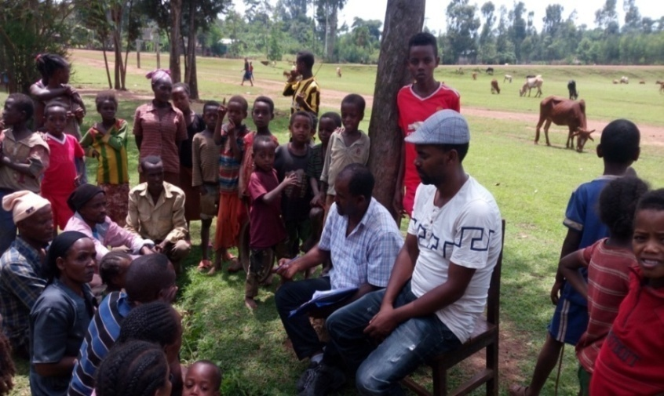

Figure 3: Focus group discussion with community members
Concerning on the accessibility of water supply schemes figure 4, show that larger proportion of the respondents travel a distance of 200 meter and below to fetch water from water supply schemes. The second large proportion respondents were traveled a minimum of 200 and a maximum of 500 meter. Thirdly some respondents travel a distance of a minimum of 500 and maximum of 1500 meter. Few numbers of respondents fetch water by traveled distance above 1500m. In general from accessibility perspective above 90% the study area communities were met the standard of accessibility which is stated by MoWRE (2013).
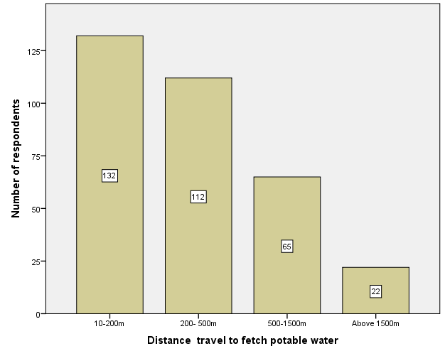
Figure 4: Accessibility of water supply schemes for the target beneficiaries
In this regard the existing water supply schemes were not ideal due to their accessibility to be used by the community. So that, they were provided service with their accessibility and sustained as per their level of service management.
As it is indicated in the table 16, Taremesa ,Fura and Midregenet kebeles beneficiaries have accessibility for water supply schemes not more than 1500 meter whereas 20% of DilaAferara kebele beneficiaries do not have access as per the seated standard distance from our country context. On top of this Fura kebeles has large population proportion relation to accessibility in 200m and below, the second large proportion respondent kebele is Mideregenet and the third and fourth kebeles in the same issue are Taremesa and DilaAferara kebeles respectively. As per UAP concept the minimum standards for rural areas is stated that, to be accessible at least 15 liters per capita per day (lpcd) of safe water, available within 1.5 km of the home.
Table 10: Proportion of respondents versus distance travel
Description |  | Kebele
 |  | Taremesa | Fura | Mideregenet | DilaAferara
 |  | Column N % | Column N % | Column N % | Column N %
Distance travel to fetch potable water | 10-200m | 35.2% | 65.2% | 43.3% | 26.4%
Distance travel to fetch potable water | 201- 500m | 42.0% | 25.8% | 37.3% | 30.0%
Distance travel to fetch potable water | 501-1500m | 22.7% | 9.1% | 19.4% | 23.6%
Distance travel to fetch potable water | Above 1500m | 0.0% | 0.0% | 0.0% | 20.0%
Distance travel to fetch potable water | Subtotal | 100.0% | 100.0% | 100.0% | 100.0%

In study area context, the three kebele Taremesa ,Fura and Mideregnet kebeles are fulfill the minimum accessibility criteria of UAP whereas DilaAferara kebele is meet 80% of the respondents. Due to inaccessibility of water supply schemes in relation to distance; the community did not show willingness to use them. Due to this reason the water supply schemes become ideal and exposed for damage. This situation led the schemes non functional and not sustainable in relation to their service.
As it shown in table 11, 63.1% and 37.9% of the respondents were fetch water two times and three times a day respectively. In connection to this, due to frequent improper operation and utilization of the schemes there is a possibility of destructing of water supply schemes operation materials specially the water supply schemes those are fitted with hand pump. This implies that there should be proper operation and utilization of water supply schemes. In the case of schemes faller due improper operation and utilization, enough spare part should be availability near by the community. However there is no spare part availability in the study areas. In this regard, such kind of problem is led for the increasing of non functionality of water supply schemes and insecure their sustainability. In general in line with the above issue, Maharashtra Jeevan Pradhikaran (MJP), CEPT University (2012) also stated that water supply schemes operation means ensuring effective routine running of system timely and daily to ensure the sustainability of those schemes.
Description |  | Number of frequency that the respondents to fetch potable water for domestic purpose per day |  | Total
 |  | two time | three time | Total
Kebele | Taremesa | 46 | 42 | 88
Kebele | Fura | 24 | 42 | 66
Kebele | Mideregenet | 56 | 11 | 67
Kebele | DilaAferara | 83 | 27 | 110
Total |  | 209 | 122 | 331
In percent from the total |  | 63.14 | 36.86
Table 11: Kebele and number of frequency that the respondents to fetch potable water

As it is indicated in table12, from sampled respondents 56.2% were stated that the water supply schemes were frequently failed due to different reasons which are mentioned in figure 7. In addition to this the same idea was found from focus group discussion attendants and key interviewers in relation to frequent failed of water supply schemes.
Table 12: Kebele and frequently failed of water supply schemes
Description |  | Frequently failed of water supply schemes |  | Total
 |  | Yes | No | Total
Kebele | Taremesa | 51 | 37 | 88
Kebele | Fura | 21 | 45 | 66
Kebele | Mideregenet | 22 | 45 | 67
Kebele | DilaAferara | 57 | 53 | 110
Total number of respondents |  | 151 | 180 | 331
Due to this reasons in general above 50% of water supply schemes were exposed for non sustainability. Particularly Taremesa and Dila Afererara kebeles were highly exposed for non sustainability as compare to the others study kebeles. Hence they need more attention for their regular follow up and maintenance.
As it is shown in table 12, DilaAferara and Taremesa kebeles have taken more proportion in regard to frequently failed of water supply schemes, whereas, Mideregenet and Fura kebeles have less proportion. The result which was found implies that Mideregenet and Fura kebeles have good water supply schemes management, proper operation and utilization as compare to the DilaAferara and Taremesa kebeles. Therefore from this finding, to secure the sustainability of water supply schemes, regular maintenance should be delivered for the existing water supply schemes before the schemes failed frequently with different reasons.
Among the reasons for frequently failed of water supply schemes in the study area, lack of spare part has taken the large percentage which is 47.78% and the second large proportion is poor management which is 31.67% and the third one is lack of water 12.22% and other is 8.33% (like lack of sufficient budget and others )
These causes have similarity with, Abdul Rahman Shekib(2012) ,which was reported that the cause for un-functionality of hand pumps were lack of spare part and droughts or lack of water beside of poor construction of water supply schemes. Accordingly these main causes were observed and found with similar fashion in the study area.
As it is shown in figure 5 indicated that the highest frequently damaged part of water supply schemes were O-ring and seals. Furthermore it also showed that the dominant types of water supply schemes were HDW and SW with fitting hand pump. The second mostly damage part of water supply schemes were water pumps followed by generator of the schemes. The fourth frequently damaged part of the water supply schemes were the civil works and few respondents stated that the handling of the hand pump were damaged. In addition to this as per field observation it was found that some of the HDW and SW water supply schemes did not have pump handling to lift out water from the well. On top of this some of water supply schemes civil works were partially and highly damaged. From FGD and WASHCOs discussion reflection, it was found that mostly damaged part of HDW and SW were O-ring and Seal of hand pump cylinder.
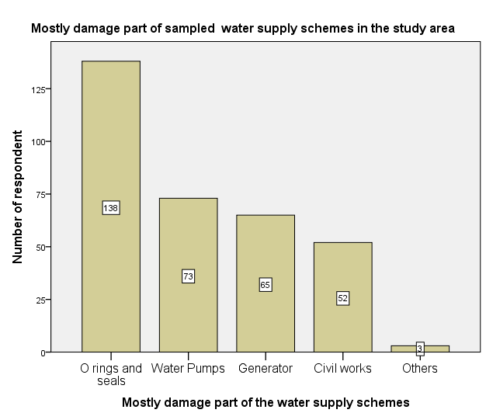
Figure 5: Mostly damage part of sampled water supply schemes
Due to the above major reasons most of the water supply schemes become non functional frequently and were not secure in sustainability. Hence the community was forced to travel long distance from their dwelling to fetch water for their domestic purpose.
As it is indicated in table 13, Fura and Mideregenet kebeles have better response on regular water supply schemes maintenance compare to Taremesa and DilaAfererara kebeles. And from focus group discussion and key interviewer point of view, it was found that regular water supply schemes maintenance service was not delivered, due to this reasons the schemes did not achieved the proposed objective. In general there was no regular maintenance for the existing water supply schemes due to lack of finance and presence of active WASCHOs at local level.
Table 13: Provision of regular water supply schemes maintenance

Description |  | Provision of regular water supply schemes maintenance service |  | Total
 |  | Yes | No | Total
Kebele | Taremesa | 17 | 71 | 88
Kebele | Fura | 47 | 19 | 66
Kebele | Mideregenet | 45 | 22 | 67
Kebele | DilaAferara | 41 | 69 | 110
Total count |  | 137 | 194 | 331
This condition has a contribution for non sustainability of water supply schemes in the study area. In this regard Meron(2102) sated that regular maintenance was not provided for water supply project due to limited funding by government and international organization so that the community should mobilize financial resource to ensure regular maintenance of the schemes.
From the respondents 86.9% of the sampled respondents said that there were no spare part availability in the sampled kebeles and the rest of 13.1% of respondents described that there are some but not nearby their kebeles . Based on field observation it was found that there is no any spare part supplier those can provide spare for hand pump fittings, water pump and generator. During group discussion session the participants were confirmed that there is lack of spare part supplier for immediate response of maintenance and operation of schemes.
It is found that , availability of required spare parts as per the type of existing water supply schemes is crucial for effective operation and maintenance (O & M) of rural water supply systems to ensure the sustainability of the water supply project. In line with this finding, Holly Sanders & Jennifer Fitts (2011) stated that to ensure the water supply schemes sustainability there should effective and sustainable spare parts supply and this supply has to be easily accessible, available, appropriate and affordable. Additionally Binder (2008) said that, the community management of rural water supply systems on operation and maintenance (O & M) is not successful, if financing resources to purchase spare parts is not sufficiently available and frequent supports are not provided. From the study area context, the above mentioned approach was not exercised. Due to these reasons the sampled kebeles water supply schemes sustainability task was not successful.

Social factor
To ensure the sustainability of water supply schemes social status of the community is one of the main determinants factor. For this study the social factors is discussed on community willingness for water supply schemes construction contribution, type of contribution, family member frequently fetch water from schemes, WASHCOs regular maintenance service provision and sampled respondents reflection on their responsibility on water supply schemes sustainability.
Table 14: Kebele and community willingness for water supply scheme maintenance Contribution
Description |  | Willingness for water supply scheme maintenance Contribution |  | Total
 |  | Yes | No | Total
Kebele | Taremesa | 38 | 50 | 88
Kebele | Fura | 59 | 7 | 66
Kebele | Mideregenet | 50 | 17 | 67
Kebele | Dila Aferara | 72 | 38 | 110
Total |  | 219 | 112 | 331

To secure the sustainability of water supply scheme the community willingness in relation to contribution for the maintenance of those schemes is curtail issue. With this perspective, table 14 showed that the respondents in general have larger number of proportion that expressed their willingness to secure the sustainability of sampled water supply schemes.
In relation to the above issue Davis and Liyer(2002 ) stated that for the sustainability of water supply schemes the user community should be participated in the planning, implementation, operation, protection and maintenance of water supply systems meaningfully. Similar to the study area, contributions of community members’ might take in form of money, labor, material, equipment, or participation in project-related decision-making and meetings, Davis and Liyer(2002) and Habtamu (2012). Hence it was found that community contribution in terms of their level of interest and affordability is one the crucial factor to ensure the sustainability of the water supply schemes. Whereas, in the study area it was found that the level of community participation for this purpose is low.
So that this type of community contributions created sense of ownership within the community in the implementation, follow up and management of water supply project to ensure the sustainability of water supply schemes.
In relation to frequently water fetch from scheme shown that women were taken the larger percentage i.e. 72.2% from the total and then children and youth were 14.8% and 13% respectively (Table 15).
Table 15: Proportion of family member to fetch water
Description |  | Kebele
 |  | Taremesa | Fura | Mideregenet | DilaAferara | Subtotal
 |  | Column N % | Column N % | Column N % | Column N % | Column N %
Member of family to fetch water | Children | 13.6% | 10.6% | 9.0% | 21.8% | 14.8%
Member of family to fetch water | Youth | 17.0% | 3.0% | 20.9% | 10.9% | 13.0%
Member of family to fetch water | Women | 69.3% | 86.4% | 70.1% | 67.3% | 72.2%

From field observation it was found that from the family members those were found to fetch water from the water supply schemes, most of them were women and children. As per the discussion reflection from 8 focus group discussion and key interviewer stated that due to local cultural view and responsibility level of home management, the women’s were forced to fetch water mostly. Whereas men not involved in fetch of water for their domestic purpose. In relation to this finding, the surveys data which was conducted at 54 developing countries by MICS and DHS indicated that women (64%) have major burden to fetch drinking water from the source and followed by men, girls and boy which is 24%, 8% and boys4% respectively, Tadese (2012). This shows that at rural level in developing courtiers, women have more burden and responsibility to fetch water for domestic purpose from the water source. Hence it is concluded that to ensure the sustainability of water supply schemes women should be highly involved in planning, implementing, operation and management of water supply schemes.
In reference to table 16, 76% of respondents from four sampled kebeles stated that regular maintenance was not provided by WASHCOs when the schemes were got damage or minor problem. However in comparison of sampled kebeles Fura and Mideregent have got relatively good response for regular maintenance.
Table 16: Proportion of WASHCOs regular maintenance in sampled kebeles
WASHCOs regular maintenance | Kebele
WASHCOs regular maintenance |  | Taremesa | Fura | Mideregenet | DilaAferara
WASHCOs regular maintenance |  | In %
WASHCOs regular maintenance | Yes | 11.40% | 27.30% | 34.30% | 20.90%
WASHCOs regular maintenance | No | 88.60% | 72.70% | 65.70% | 79.10%

According to the respondent it was found that, the main reasons for lack of regular maintenance by WASHCOs were absence of sufficient finance, lack of their motivation and also poor community commitment. Hence to have regular maintenance on water supply schemes the finance has to be secured from the community and other external supportive and also the WASHCOs motivation has to be maintained. Similar to the above finding, Meron (2012) shows that, to deliver regular maintenance service for water supply schemes the communities have full responsibility to secure finance through WASCHOs and used them to coordinate the beneficiaries to protect water supply schemes. This implies that WASHCOs have major role for the sustainability of water supply schemes through close integration work with the local communities mainly and with other stakeholders in relation to regular maintenance of the schemes.

Organizational factor
WASHCO is one of the institutional structure part to manage rural water supply schemes. From the finding 88% of water supply schemes have WASHCOs for proper management, operation and maintenance. The key interviewers and most of FGD respondent mentioned that due to non functionality of water supply schemes for long period of time ,the WASHCOs were stopped their responsibility and go back to their personal business. Due to this reason the schemes did not sustain as per the design service period.
Majority WASHCOs members of Fura and Mideregenet kebeles were functional (Table 17). Whereas,Taremesa and DilaAferara kebeles some of WASHCOs members were not presented. So that to maintain the sustainability of water supply schemes there should be well structured organizations which can manage the schemes proper operation and maintenance.
Table 17: Presence of WASHCOs distribution per kebeles
 |  | Presence of WASHCos |  |  |  | Total number of schemes
 |  | Yes |  | No |  | Total number of schemes
 |  | Count | Column N % | Count | Column N % | Total number of schemes
Kebele | Taremesa | 3 | 67% | 1 | 33% | 4
Kebele | Fura | 3 | 100% | 0 | 0.0% | 3
Kebele | Mideregenet | 3 | 100% | 0 | 0.0% | 3
Kebele | DilaAferara | 4 | 80% | 1 | 20% | 5
Kebele | Subtotal |  |  |  |  | 15

Around 78% respondents stated that there were no regular WASHCOs meetings in the sampled water supply schemes (Table 18). Among the four selected sampled kebeles Taremesa had less percentage regarding to regular meeting. Due to these reason there was not relevant information exchange among WASHCOs, communities and stakeholders about the overall status of the existing water supply schemes to take appropriate action to secure their performance. Similarly Misgina(2006) stated that the project community would have got relevant information about the project to enable them to take collective decisions and action within the community for sustainability of the water supply projects.
Table 18: Status of WASHCOs performance in study area per kebeles

Description |  | WASHCOs regular meeting
 |  | Yes |  | No
 |  | Count | Column N % | Count | Column N %
Kebele | Taremesa | 10 | 13.5% | 78 | 30.4%
Kebele | Fura | 18 | 24.3% | 48 | 18.7%
Kebele | Mideregenet | 23 | 31.1% | 44 | 17.1%
Kebele | DilaAferara | 23 | 31.1% | 87 | 33.9%
Kebele | Subtotal | 74 | 100.0% | 257 | 100.0%

In line with this, to deliver proper service by reducing inefficient operation by relevant sectors and by creating well organized communication channel between governments, stakeholders and community, there should be established potential information communication exchanging technology according to the country context, Clement Dzidonu (2010). It was found that most of the schemes were sustained at Fura and Mideregenet as compare to DilaAferara and Taremesa kebeles due to the presence of WASHCOs regular performance on overall management of water supply schemes. In general as it is indicated in table 26 and, it was found from key interviewer and focus group discussion, the four sampled kebeles WASHCOs members’ regular performance needs more improvement.
Almost 50% of the respondents comprise that the water seller were not operate the water supply schemes as per the seated time (Table 27). In addition to this they also stated that due to this reason they were stayed for long time and this created overcrowded on the schemes while the beneficiaries were used.

Table 19: Situation of water seller regular operation of water supply schemes
Description |  | Count | Column N %
Water seller regular operation of water supply schemes | Yes | 164 | 49.5%
Water seller regular operation of water supply schemes | No | 167 | 50.5%
Water seller regular operation of water supply schemes | Subtotal | 331 | 100.0%
Because of this reasons proper operation and utilization of water supply schemes were not carried out in some water supply schemes. Therefore for proper water supply schemes operation, water seller shall provide their service on the seated time. From practical point of view, proper operation of water supply schemes means that delivery of service as per the seated time and without any beneficiary crowded on the water schemes has significant contribution for water supply schemes sustainability.
Regarding to caretaker service provision (Table 28), indicated that 57.4% of respondent stated the caretakers were not provided immediate response for maintenance of non functional water supply schemes. At Fura and Midergenet kebeles most of the existing caretakers were provided immediate response on schemes maintenance. Due to this reasons it was found that the schemes those are found in Fura and Midergenet kebeles were more sustained as compare to Taremesa and Dila Aferara kebeles(Table 11).
Table 20: care takers immediate response for schemes maintenance
Kebeles | Caretakers providing immediate response for schemes maintenance when failure may occur |  |  |  | Total
Kebeles | Yes |  | No |  | Total
 | Count | Column N % | Count | Column N % | Total
Taremesa | 24 | 27.27% | 64 | 72.73% | 88
Fura | 50 | 75.75% | 16 | 24.25% | 66
Mideregenet | 42 | 62.68% | 25 | 37.32% | 67
DilaAferara | 45 | 40.91% | 65 | 59.09% | 110

In addition to this, respondents from focus group discussion said that the major reasons for caretaker low response were lack of incentive, maintenance tools, spare parts and few in number with in the sampled kebeles. This condition indicated that caretaker has to be trained in proportion to water supply schemes numbers and supply them appropriate maintenance tools to prolong the service life of water supply schemes. Hence to ensure the sustainability of water supply schemes caretakers have major role in maintenance of non functional water supply schemes.
To discharge their responsibility properly and manage water supply schemes in organized manner the WASHCOs should have legal support in terms of police. From this perspective table 21 revealed that above 70% water supply schemes WASHCOs committee do not have local well understood WASHCOs bi-law whereas the rest 29% WASHCOs committee have this bi-law. This implies that most of the water supply schemes were managed without local by-law. The key interviewer were also confirmed that to ensure the sustainability of water supply schemes WASHCOs would have either locally well understood by-law or published police which show WASHCOs responsibility and their management in relation to waters supply schemes.
Table 21 : Availability of local, well understood WASCHOs by-law
Description |  | Count | Column N %
Presence of WaSHCO local well understood bi-Low | Yes | 97 | 29.3%
Presence of WaSHCO local well understood bi-Low | No | 234 | 70.7%
In relation to this, it was found that WASCHOs those have local bi-low have good water supply schemes management by taken appropriate decision which secures the sustainability of water supply schemes.

Financial factor
For sustainability and proper maintenance of water supply project, sufficient budget funding for rural water supply systems is an important issue. According to Binder (2008), even though increasing the budget allocation for rural water supply systems is very important, but that is not the only thing to meet the challenges in relation to sustainability. In line with this, as it is described in table 30, most of the budget source i.e. 79.2% for construction of water supply schemes was covered by NGOs. The second line of budget source was government which is 17.2% and community has less contribution in terms of budget.

As per sampled household respondent and key interviewer idea reflection, 79% the budget sources were allocated from NGOs, whereas government and community were allocated low budget. During phase out of NGOs program from the project area there is no additional fund for the project. This implies that after accomplishment and handover of the proposed project those were funded by NGOs were exposed for the non sustainability of water supply schemes. According to Merone (2012) a water management committee those are capable and trusted were elected by the community and is institutionalized. This led them to set an appropriate tariff system that covers administrative, operation, maintenance and replacement costs (based on the cost-sharing arrangements).Therefore to sustain the water supply schemes for long period of time the above mentioned task should be made.
Table 22: Regular financial reporting trained of WASCHOs
Description | Count | Column N %
Presence of regular financial reporting program of WASHCO | 105 | 31.7%
WASHCOs do not have regular financial reporting program | 226 | 68.3%
Total | 331 | 100.0%
During focus groups discussion most of attendants stated that there is no well organized and regular financial reporting system trained from WASHCOs. According to the woreda water office representative said, majority of functional WASHCOs did not have regular financial reporting program. Furthermore from the above table 22, indicated that around 68.3% of WASHCOs did not have regular financial reporting program to the beneficiaries’ community. This situation made the WASHCOs has weak financial capacity to provide proper service to the community. Due to this reason most of non functional water supply schemes did not obtained proper maintenance. In this regard, Admasu, Kumie, and Fantahun (2002) similarly stated that weak financial capacity at community level is one of among the limiting factors affecting the sustainability of rural water supply projects in North Gonder, Ethiopia.
Based on the table 33, most of the respondent confirmed for the reasons of WASHCOs those did not have regular financial reporting were lack of transparence which has large proportion of percentage i.e. 44.7% , and secondly large proportion is poor management which is 35% , thirdly lack of loyalty i.e. 17.8% and others is 2.4%. So that to secure the sustainability of water supply schemes at rural community level WASHCOs should have regular financial reporting session to the beneficiaries’ community to have common recent information about the financial status and to take common decision and action at appropriate time.
Table 23: Reasons for lack of WASHCOs regular financial reporting program
Description | Possible reasons | Column N %
Reasons for lack of WASHCOs regular financial reporting program | Lack of transparence | 44.7%
 | Poor management | 35.0%
 | Lack of loyalty | 17.8%
 | Others | 2.4%

Environmental factor
Rainfall is one of the dominant factors to control the input side of water balance and recharge of the aquifer. In addition to this the duration and rate of rainfall, wind speed, temperature, relative humidity, vegetation, conditions in the upper soil layers, the soil type ,the depth of the water table, and the geology all play a role in determining how much water reaches an aquifer Famiglietti (2008).Furthermore other factors like soil cover and topography influence how much of the rainfall is ‘lost’ as runoff, and also how much, water can infiltrate and reach the water table, and be transmitted and stored in aquifers. In controlling recharge vegetation, local topography, and soil condition play such an important role. Regarding to recharge, it will change if soil is degraded or land cover changes.
In the other hand, environmental management and protection as an important component of enhancing the sustainability of rural water supply through modify recharge rates. In line with this the ground water source is sufficient in the woreda including the study area as per the woreda water, mineral and energy office information Desalegne (2013). From field observation the environmental management and protection situation is found in good status.
As it can been seen from table 24, Fura and Mideregenet kebele did not have a tendency of frequently failed of water supply schemes throughout the year as compared to Taremesa and DilaAferara kebeles. However, in general the overall view shows that almost 55 % of the water supply schemes were not given service for the beneficiaries throughout the year.
Table 24: Functionality of water supply schemes throughout the year
.Description |  | Functionality of water supply schemes throughout the year
 |  | Yes |  | No
 |  | Count | Column N % | Count | Column N %
Kebele | Taremesa | 24 | 27.27% | 64 | 72.73% | 88
Kebele | Fura | 40 | 60.60% | 26 | 39.40% | 66
Kebele | Mideregenet | 42 | 62.69% | 25 | 37.31% | 67
Kebele | DilaAferara | 39 | 35.45% | 71 | 64.55% | 110

The response found from key interviewer and focus group discussion confirmed that some water supply schemes particularly hand dug wells fitted with hand pumps were non functional due to scarcity of water during dry season. As they stated that the well depth may not be sufficiently drilled or excavated to be got sufficient yield of water. If the water resources are sustained, it is obvious that the benefits of a water supply project can be sustained. To water resource development each watershed has inherent physical limits Merone (2012). In areas where rainfall is very low and groundwater extraction is very high due to population growth, there is a risk of decline of water source quantity has become a serious issue, Abebe (2012). Hence such kind of situation has contribution for the non sustainability of water supply schemes.
As it is indicated in table 25, the large proportion percentage i.e. 40% of the water supply scheme compound were found in good status whereas the second large proportion 27% of them were found in bad status. Moreover at third level 20% of the compound status was found in fair and 13% was found in very good condition. It was observed that the water supply schemes those were found in bad condition are exposed for other damage and led for non functional stage.

Table 25: Status of sampled water supply schemes compound
 |  | Count | Column N %
Water supply scheme compound condition | Bad | 4 | 27%
Water supply scheme compound condition | Good | 6 | 40%
Water supply scheme compound condition | Fair | 3 | 20%
Water supply scheme compound condition | Very good | 2 | 13%
In addition to this from respondents stated that due to lack of motivation ,the WASHCOs did not done strongly to improve the compound status of the schemes through mobilize the sampled community. There is also a gap in regular supervision from woreda water, mine and energy office to solve such kind of problem to ensue the sustainability of water supply schemes.
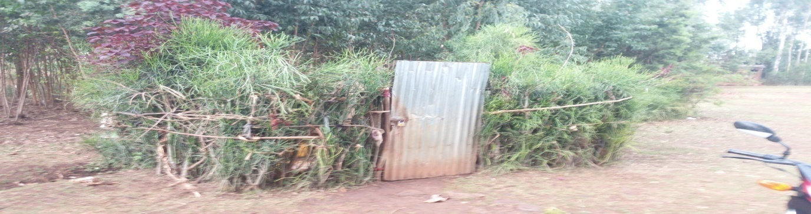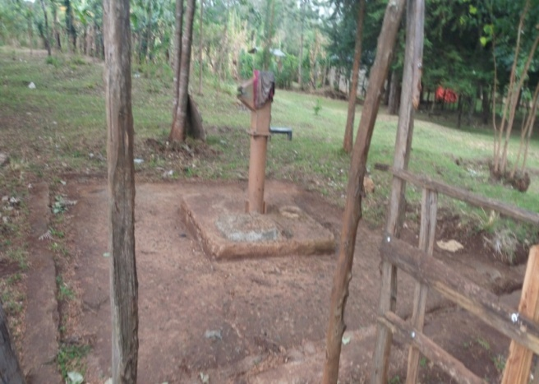
Figure 6: a) Well cleaned and fenced b) Poor water supply schemes compound
water supply scheme compound and damaged hand pump of HDW

According to Famiglietti (2008) factors such as topography and soil cover further influence how much of the rainfall is ‘lost’ as runoff, and how much water can infiltrate and reach the water table, and be transmitted and stored in aquifers. Other it is also stated that because local topography, vegetation and soil condition play such an important role in controlling recharge. In this regard recharge will change if land cover changes or soil is degraded.
Based on the above mentioned fact, table 26 indicates that above 60% of environmental protection is accomplished to secure the sustainability of water supply quantity cultivating and afforestration of the exposed land of sampled kebeles.
Table 26: Environmental protection accomplishment status
Accomplishment of environmental protection program around water supply schemes |  | Count | Column N %
 | No | 132 | 39.9%
 | Yes | 199 | 60.1%

However as it is observed in the field and data which shown in the above table 36 , 39.9% respondents stated that environmental protection work was non accomplished in some area. Therefore based on this reference more emphasis has been given for environmental protection work at sampled kebele level.
Due to different reasons some non functional water supply schemes specially hand dug wells fitted with hand pump do not have maintenance for long period of time. So that, the community were forced leaved the schemes and shifted for other alternative water supply source nearby their locality or neighbor’s kebeles.
The respondents stated that, due to severely damage and lack of maintenance, the non functional HDW were leaved as it is. As it is observed in the field, from environmental protection point view, those hand dug wells were filled with flood during rain seasons. This condition has contribution to increase water table for nearby other hand dug well through percolation.

Perception of the Community on Sustainability of Water Supply Schemes

Willingness of community in water supply schemes sustainability
As it shown in table 38, 68.3% of the community has willingness to pay for water supply schemes maintenance whereas the small proportion of the community did not have willingness for it. This indicate that the large proportion have willingness to pay for maintenance of water supply schemes for their satisfaction fullness to ensure the sustainability of those projects. Similarly, according to Meron (2012), the community willingness is depend on the satisfaction of the community by compared the existing with the previous water source in a community. Community willingness in relation to maintenance of water supply schemes have a significant improvement in water services for the sustainability of water supply schemes.

Table 27: Community willingness for maintenances of water supply schemes
Description | Count | Column N %
Willingness to pay for water supply scheme maintenance | 226 | 68.3%
Unwillingness to pay for water supply scheme maintenance | 105 | 31.7%
Total | 331 | 100.0%
Community willingness have been indicated their commitment for the sustainability of water supply project (Table 27) and it is in line with the statement stated by Breslin (2003) and Abebe (2012) that is, for effective community participation, community willingness is one of the important factor to contribute their share of capital, because they act as an indicator of community commitment to the project. Hence community willingness to pay for operation and maintenance of water supply schemes has significant factor to sustain the schemes.

Trust of community on WASHCOs performance
As it is show in table 28, 63.7% of the respondents explained that they had trust on the WASHCOs and the rest 36.3% did not have trust on them. Trust of community in this study deals on transparence, honesty and commitment of WASHCOs on their responsibility. In this regard, from field observation and focus group discussion, it was found that WASHCOs those were worked in Fura and Mideregent Kebeles have more performance due to close work with the community with their good transparence, honesty and commitment in relation to sustainability of water supply schemes as compare to the others. This indicated that community trusts in WASHCOs in relation to water supply service is one of the determinant factors that contribute for the sustainability of water supply schemes in the Shebedino woreda. Hence to ensure the sustainability of water supply schemes the WASHCOs should have got trust by the community on their performance to work together closely.

Table 28: Trust on WASHCOs performance
Description | Count | Column N %
Trust on WASHCOs performance | 211 | 63.7%
No trust on WASHCOs performance | 120 | 36.3%

Community attitude toward the costs
The large proportion of respondents 73.2% were stated that the sated cost /water tariff/ were not affordable however 26.8% of the respondents were explained that they can afford the costs50cents per 20 liter water container (Table 29). This shows that to ensure the sustainability of water supply schemes, the schemes were needed cost for O & M which is collected from the beneficiaries. In contrary the cost is not affordable by most of the community, so that to solve such kind of problem from the beginning the community should be involved to fix tariff cost of water supply.
Table 29: Attitude of beneficiary toward the costs
Description |  | Count | Column N %
Attitude of beneficiary toward the costs | Affordable | 88 | 26.8%
Attitude of beneficiary toward the costs | not affordable | 240 | 73.2%

Communities perception in responsibility
Perception refers to the community interest by taking responsibility to secure the sustainability of water supply schemes. In line to this different researchers found that for the sustainability of functional water supply schemes, community should share in the responsibility of water supply schemes management. From table 30 that can observe, the majority of communities had interest to share their responsibility on water supply schemes sustainability.

Table 30: Communities perception with respect to responsibility
Description | Count | Column N %
Communities perception having responsibility of water supply schemes proper functionality | 227 | 68.6%
Communities perception do not have responsibility of water supply schemes proper functionality | 104 | 31.4%
.
And this led to develop sense of ownership in relation to water supply schemes to strengthen the sustainability of water supply schemes. According to Haddad (2009) and Triphone (2015), to make the community responsible and develop sense of ownership for effective implementation and sustainability of the project within the community, the community should perceive the approach of how organize, program and implementing of the projects. The result of this research confirmed the finding of Haddad (2009) and Triphone (2015).
It was concluded that, majority of the community perceived that they have willingness to pay for O & M. Hence community willingness to pay for operation and maintenance of water supply schemes has significant factor to sustain the schemes. In addition to this, there should be trust between community and WASHCOs at local level to have effective operation and management of the water supply schemes by having good transparency. To make the water tariff affordable by the majority of community, they should involve in the beginning of water tariff set planning. In the study area the community perceived that they have responsibility to secure the sustainability of water supply schemes.

CONCLUSION AND RECOMMENDATION

Conclusion
The sustainability of water supply schemes in shebedino woreda was assessed in this study. The assessment was based on the functionality of water supply schemes; examine the sustainability of water supply schemes through technical, financial, organizational, social & environmental factors, and community perception within four sampled kebele and 15 water supply schemes of the study area.
It was investigated that among the total existing water supply schemes 33.5% were non functional and 61.42% were functional. The non functional water supply schemes status of the study area was higher than national level. Technical, financial, organizational, social & environmental, and community perception factors have their own contribution in the sustainability of water supply schemes. Among technical factors lack of spare part 47.78% and poor management 31.67% were the dominant causes for water supply schemes non functionality. From finding installed rotary type hand pumps were not easy operated by the community and not functional.
This implies that more emphasis was not given for community participation in planning and technological selection. This is because of low community involvement trained, lack of knowledge and transparency. The organizational net work was not well organized between WASHCOs and local relevant sectors. The community has high willingness in the contribution of labor, material and money to ensure the sustainability of water supply schemes. This good community attitude has contribution in the sustainability of water supply schemes and needs strengthen.
To have consistence and sufficient financial flow for water supply schemes sustainability, community and government should take the leading role. From finding large percentage of finance which was allocated for newly constructed water supply schemes was covered by NGOs that is 79%, but government and community have low contribution. Most of water supply schemes compounds protection was not done properly and 13% was found in very good condition. This situation has contribution for the destruction and misused of the schemes .So that it need more improvement.

Recommendation
- Improve active community participation in planning, technological selection, and contribution in operation and maintenance cost.
- There was weak organizational performance and net work in WASHCOs, community and local respective sectors. So that woreda water, mine and energy office should give emphasis to strengthen the network and performance of community, WASHCOs and relevant sectors to ensure the sustainability of water supply schemes.
- Spare part availability was the major technical factors to secured sustainability of water supply scheme. It was found that there was poor civil works in some water supply schemes.. So that woreda water office should give attention in civil work quality and provides spare parts until the government and other respective stakeholder at zonal and regional level, facilitate and open spare part shop at the locality.
- Beneficiaries’ community, government and other stakeholders should give more emphasis on consistence and adequate budget allocation for non functional water supply schemes maintenance in addition to newly construct. To sustain water supply schemes, strengthen financial management of WASHCOs with respect to water supply schemes.

REFERENCE
- Abebe Tadesse, Girma Gebresenbet and Techane Bosona, , 2013, Rural Water Supply Management and Sustainability: The Case of Adama Area, Ethiopia.
- Ahmed Abdi Muhumed, 2013, Sustainability of rural water services implemented using community-managed project approach in Amhara region of Ethiopia.
- Arto Suominen, COWASH and Ramboll Finland, 2016, Introduction to the National RWS O&M Management Manual and Strategic Framework.
- Centre for Disease Control and Prevention; Ethiopia Demographic and health survey, 2011.
- Christopher D.P., 2008, Community water supply project effectiveness and sustainability.
- Cochran, W 1977, Sampling Techniques, 3rd ed. New York: Wiley.
- David A. Stephen, 2000, Performance indicator for rural water schemes.
- Desalegne E. 2013, Analysis of quality and sustainability of drinking water supply and sanitation condition in Shebedino woreda, Sidama Zone .
- D.M.C.S. Mimrose, E.R.N Gunawardena1and and H.B. Nayakakorala, 2011, Assessment of Sustainability of Community Water Supply Projects in Kandy District. Tropical Agricultural Research Vol. 23 (1): 51 – 60.
- Gwynneth Smith. , 2011, Rural water system sustainability: a case study of community-managed water systems in Saramaka communities’. Report submitted in partial fulfillment of the requirements for the degree of Master of Science, Civil Engineering.
- Habtamu Addis, 2012, Factors affecting the sustainability of rural water supply systems: the case of Mecha Woreda, Amhara Region, Ethiopia. M.Sc Thesis. Faculty of the graduate school of Cornell University.
- Israel Deneke Haylamicheal1and and Awdenegest Moges, 2012, Assessing water quality of rural water supply schemes as a measure of service delivery sustainability: A case study of WondoGenet district, Southern Ethiopia: African Journal of Environmental Science and Technology Vol. 6(5), pp. 229-236, May 2012. Available online at http://www.academicjournals.org/AJEST.
- Katharina Welle, Jennifer Williams and Joseph Pearce, in collaboration with Barbara Befani (QCA analysis) , June 2015, testing the waters a qualitative comparative analysis of the factors affecting success in rendering water services sustainable based on ICT reporting.
- Kennedy, M. , 2004 , Issues regarding sustainability of rural water supply.
- Florian Schaefer, John Butterworth1, Katharina Welle2, Kristof Bostoen and Tamene Hailu , April 2013, Monitoring access to rural water supplies in Ethiopia. A background paper to the National WASH Inventory seminar, Addis Ababa, Ethiopia .
- Jonathan, I. and Satu, K. ,1999, What determines the effectiveness of community-based water projects? Social Capital Initiative Working Paper No. 1.
- José Payero, Professor-Researcher, Department of Natural Resources, Higher Institute of Agriculture (ISA), Dominican Republic.
- Maharashtra Jeevan Pradhikaran (MJP), 2012, Operation and Maintenance of water supply system training module for local Water and Sanitation Management, CEPT University.
- Maggie A. Montgomery, Jamie Bartram, and Menachem Elimelech1,2009. Increasing Functional Sustainability of Water and Sanitation Supplies in Rural Sub-Saharan Africa.
- Mengistu Dessalegn, Likimyelesh Nigussie, Wondwosen Michago,Josephine Tucker, Alan Nicol and Roger Calow ,January 2013, Voices from the source, Struggles with local water security in Ethiopia.
- Meron Mebrahtu ,2012, Assessment of the community managed projects (CMP) approach in developing rural water supply schemes: a case of Pawe and Mandura Woredas, north eastern part of Benishangul Gumuz regional state, Ethiopia. M.Sc Thesis. Addis Ababa Institute of Technology Civil Engineering Department.
- Ministry of Water and Energy, 2013, Community based Operation and Maintenance management manual for rural point water supply schemes.
- Sara and Katz, 1998; Water AID technology briefing ,2013.
- Shebedino Woreda Administration, 2014.
- Sidam Zone Water Mineral and Energy , Department 2014.
- Tenaw , 2014, Assessment of Sustainability of Community Managed Potable Rural Water Supply Schemes/Points in Saharti-Samre Woreda, In Partial Fulfillment for the Requirement of Master of Arts Degree in Development Studies (Specialization in Regional and Local Development) Mekelle.
- Triphone, 2015,(community perception of thei participation in the implementation and sustainability of rural water projects in morogoro rural district council).
- UNICEF ,2012 progress Report: Rapid progress in child survival. Water supply and sanitation in Ethiopia from Wikipedia; the free encyclopedia, 2012.
- United States Agency for International Development ,April 2014, USAID WASH Sector Status and Trends Framework Desk Review: Ethiopia.
- Woreda Water Mineral and Energy Office, 2014.
- World Bank, 2008, Review of effectiveness of rural water supply schemes in India.
- Yewondwossen Tesfaye 2012,A comparative study on woreda managed and community managed rural water supply projects, with respect to their planning, implementation functionality and utilization. the case of Amhara National Regional State, Ethiopia. M.Sc thesis. the Indira Gandhi national open university (IGNOU) school of continuing education post graduate programmes, st.mery’s university college, Addis Ababa, Ethiopia.
- Yan Sun, Felix Asante and Regina Birner, 2010, Opportunities and Challenges of Community-Based Rural Drinking Water Supplies.
- Zemenu Awoke, 2012, Assessment of challenges of sustainable rural water supply: Quarit woreda, Amhara region.

APPENDIX I. WATER SUPPLY SCHEMES ASSESSMENT FORM
WATER SUPPLY SCHEMES ASSESSMENT: THE CASE OF FOUR RURAL KEBELE OF SHEBEDINO WOREDA, ETHIOPIA, SNNPRS
ASSESSMENT QUESTION FOR HOUSEHOLD
- General
- Kebele Village
- Respondent Position 1. Household head 2. Spouse 3. Child 4 other __________________
- Sex: 1. Male 2. Female
- Age 1. 15-24, 2. 25- 44, 3. 45-64, 4. 65⁺
- Marital status 1. Married 2.Divorce 3.Single
- Number of Household member in sex distribution 6.1 Male_________6.2 Female _____________
- Educational background 1. Cannot reader or write 2. Can reader or write 3. Primary 3. Secondary and above
- Occupational of Household respondent 1. Farmer 2. Student 3.Governmental 3. Private
- Annual income of household in Birr
1.5000- 10000 2. 10000- 20000 3. 20000- 30000 4. Above 30000
- Factors of schemes sustainability
- Technical
- Are you participating in water supply scheme selection and design? 1. Yes 2. No
- If not, why?
1. No one invite me 2. Absence of transparence 3. Lack of knowledge 4. Others
- How long you travel to fetch potable water
1.10-200m 2. 200- 500m 3. 500-1500m 4. Above 1500m
- Type of water supply scheme
- HDW 2. SW 3. Capped spring on spot 4. Capped spring with distribution 5. Capped BH with distribution
- When does the water supply scheme is constructed?
1, This year 2. Before one years 3. Before two years 4. Before three years and above
- How many time that you travel to fetch safe water for domestic purpose per day
1.T+wo times 2. Three time 3.Four time 4. Above these
- Is the safe water supply scheme functional? 1. Yes 2. NO
- If not, is it frequently failed its service? 1. Yes 2. No
- Why it is failed? It is because of
1. Poor management 2.lack of water 3. Lack of spare parts 4. Others
- Which part of the scheme mostly damage?
1. O rings and seals 2. Water Pumps 3.Generator 4. Civil works 5.Others
- Is there regular maintenance when the scheme is nonfunctional? 1. Yes 2. No
- If not, why? __________________________________________
- Who maintaining the schemes 1. Care taker 2. WaHCO 3. Community 4. Other
- Is there spare part available? 1. Yes 2. No
- Social/Community
- Do you have any contribution for water supply scheme construction? 1. Yes 2. No
- If yes, what is your contribution? 1. Labour 2. Construction material 3. Money 4. Other
- Do you have willingness to pay for water supply scheme maintenance? 1. Yes 2. No
- If no, why? _____________________________________________________
- Are you participating in planning process for water supply schemes construction? 1. Yes 2. No
- Are you participating in implementation of the water supply scheme projects? 1. Yes 2. No____________________________________________________________
- Do you have trust on WASHCOs in doing their work properly? 1. Yes 2. No
- Do you have meeting program with WASCHOs to discuss on water supply scheme service performance? 1. Yes 2. No
- Do you think that you are responsible for water supply schemes proper functionality? 1.Yes 2.No
- If no, Why? ________________________________________________________________
- Who is responsible for potable water supply schemes management and follow up?
- WaSHCO 2.Community 3. Woreda water office 4.all 5. Others
- Institution/ organization
- Is there WASHCos ? 1.Yes 2.No
- Members of WASHCOs__________________ 1. Male ______ 2. Female_________
- Does WASHCOs have regular meeting ? 1.Yes 2.No
- If yes, when? 1. Weekly 2.Two weeks 3. Three weeks 4. Four weeks.
- Does WASHCOs have regular meeting? 1.Yes 2.No
- If yes, when? 1. Two Weeks 2.Three weeks 3. Four weeks 4. Other
- Does the water supply scheme have water seller? 1. Yes 2. No
- Are the water sellers operating the schemes with regular time? 1.Yes 2.No
- Do you have well trained care taker for your water supply schemes? 1.Yes 2.No
- If no , why ________________________________________________________
- Are care takers providing immediate response for schemes maintenance when failure may occur?
1. Yes 2. No
If no, why ? ______________________________________________________
- Does WaSHCOs have local well understood by-Low 1.Yes 2.Low

- Financial
- Where do you get fund for water supply scheme construction?
- Government 2.NGOs 3. Community 4. Private 5. Others _______________
- Who mainly collect water fee? 1. Water seller 2. Operator 3. Others_______________
- How much do you pay for drinking purpose per 20 liter in Birr 1. <2 2. 2-5 3. 5-10 4. 10-15 5. >35
- What is your attitude toward the costs? 1. Affordable 2. not affordable
- Have you ever been asked to contribute additional money for maintenance? 1. Yes 2.No
- If yes, when was it? 1. Before 2.After breakdown
- Environmental
- Is the potable water supply scheme functional throughout the year? 1. Yes 2.No
- If no, at what time your potable water supply scheme is not functional?
- Summer season 2.Winter season 3. Dry seasons 4. Others
- What is your water supply scheme compound condition?
- Bad 2.Good 2. Fair 4. Very good
- Is there environmental protection program around the water supply scheme area?
- No 2. Yes
- What are doing for non functional HDW?
- Filled the pit with dry disposal
- Filled the pit with runoff water
- Leave as it is
- Others

THANKS FOR YOUR COOPERATION

APPENDIX II. KEY INTERVIEWER QUESTION
WATER SUPPLY SCHEMES ASSESSMENT: THE CASE OF FOUR RURAL KEBELE OF SHEBEDINO WOREDA, ETHIOPIA, SNNPRS
KEY INTERVIEWER
Interview: Woreda Water Office

1: Information on respondent
Woreda name …………………………………….
Respondent name ………………………………………
Position……………………………………………………
Interview date …………………..
2: Project Planning and implementation
a. Are the community participating in water supply schemes planning and appraisal? 1.Yes 2.No , If no why?
........................................................................................................................................................................................................................................................................................................................
b. How the community involve in the implementation of the water supply schemes?
…………………………………………………………………………………………………………………………………………………………………………………………………………………………………………………………………………………………………………………
3. Operation and maintenance
1. Are the community participates in water supply projects selection before implementation? 1. Yes 2.No , If no why?
................................................................................................................................................................................................................................................................................................................................................
2. How to capacitate the WASHCO?
................................................................................................................................................................................................................................................................................................................................................
3. Are the community willing to pay for Operation and maintenance of water supply schemes? 1.Yes 2. No, If no why?
................................................................................................................................................................................................................................................................................................................................................

4: Functionality
5. What type of water supply schemes are in the woreda ?
6. How many water supply schemes are in the Woreda according to their types?
7. Among these facilities how many are functional? And
8. Among these facilities how many are Non-functional? Why from
- Technical point of view …………………………………………………………………………………………………………………………………………………………………………………………
- Social/Community …………………………………………………………………………………………………………………………………………………………………………………
- Institution/organization
…………………………………………………………………………………………………………………………………………………………………………………………
- Financial
…………………………………………………………………………………………………………………………………………………………………………………………
- Environmental
…………………………………………………………………………………………………………………………………………………………………………………………

9. Are caretakers available for water supply schemes maintenance? 1. Yes 2. No, If No Why ………………………………………………………………………………………………………………………………………………………………………………………………………………
10. Are spare parts available in sufficient amount at project level/community level? 1. Yes 2. No , If No Why ……………………………………………………………………................................................................................................................................................................................................................
11. What do you suggest to make the water supply schemes functional and sustainable according to;
- Technical point of view
………………………………………………………………………………………………………………………………………………………………………………………

- Social/Community
…………………………………………………………………………………………………………………………………………………………………………………………
- Institution/ organization
…………………………………………………………………………………………………………………………………………………………………………………………
- Financial
…………………………………………………………………………………………………………………………………………………………………………………………
- Environmental
……………………………………………………………………………………………………………………………………………………………………………………………………

FGD for WASHCO
Introduction
1: Information of Respondents
Woreda ………………………………………………….
Village/Got ………………………………………………….
Type of Water Supply Scheme ………………………………………………….
Number of WASHCOs members, Male………… Female …………….
Date …………………..
2: Planning and Implementation
2.1. Planning
1. How the community involve in planning process of water supply schemes?
2. How to create awareness in the community?
3. How to establish WASHCOs based on Gender composition?
4. How to integrate WASHCOs with community?
5. Community contribution, Estimating costs, and tariff setting?
6. Your way of planning and project appraisal ?
7. What do suggest about water supply scheme planning system?
2.2. Implementation
8. Are you involve in the implementation of water supply schemes construction?
9. Is there integration work with woreda water office?
10. How the community involve in the implementation of water supply project?
11. Is there regular service provision for the community?
12. Does WASHCOs have got training to build their capacity?
13. How to manage the schemes financial system?
14. Is there regular meeting for schemes management?
15. What do suggest about water supply scheme in implementation?
Section 4: Functionality
16. Is the scheme is provide proper service for the community? 1. Yes 2. No , If no why ………………………………………………………………………………………………
17. How many households are using the water supply scheme?
18. Is the water scheme is provide sufficient amount of water for the community regularly? 1.Yes 2.No ,If no why?
………………………………………………………………………………………………
19. Does WASHCOs provide regular Operation and maintenance for schemes? 1.Yes 2.No If No Why ?.............................................................................................................
20. Are spare parts available sufficiently at community levels? 1.Yes 2.No If No Why ? ......................................................................................................................................................
APPENDIX III. OBSERVETION CHECK LIST
WATER SUPPLY SCHEMES ASSESSMENT: THE CASE OF FOUR RURAL KEBELE OF SHEBEDINO WOREDA, ETHIOPIA, SNNPRS OBSERVATION CHECK LIST/ PHYSICAL CONDITION
General:
1. Location
Kebele _____________________________________________
Gott Name ________________________________________
GPS coordinate: X- coordinate _______________Y- coordinate _______________Altitude: __________
2. Year of construction______________________________
3. Type of water
- Hand dug well( HDW)
- Shallow well(SW)
- Capped Spring on spot
- Capped Spring with distribution pipes
- Capped Bore Hole with distribution pipes
- Other______________________________________________
4. Type of distribution system
- Motorized pump
- gravity
- Hand pump
- Rope pump
- Others _________________
5. Status of Scheme
a. Functional
b. Functioning but faulty
c. Not functional
d. Abandoned
6. Type of power supply source for the pump
1. GIRD power 2. Generator 3. Solar 4. Other
7. Functionality of water source
1.Non-functioning at all

2. Functioning with some problems
3. Well functioning without any disrepair
8. Type of distribution system
1.On spot
2.Gravity
3.Motorized and gravity
4. Others
9. Distance travel to tech water supply
1.10-200m 2. 200- 500m 3. 500-1500m 4. Above 1500m
10. Type of storage /reservoir material
1. Reinforcement Concrete 2. Masonry with concrete sandwich 3. Masonry
11. Condition of well or other storage components
1. Cracks 2.leakage 3. Others
12. Pump:
1. Type of pump _____________________________________________________
2. Pump condition ___________________________________________________
3. Condition of the power supply __________________________________
13. Other components at source
1. Head wall condition________________________________________
2. Apron condition, __________________________________________
3. Slab covers condition, __________________________________________
4. Retaining wall condition _______________________________________
14, Is environmental protection done?
1. No 2.Yes
15. Status of water supply schemes compound:
1,Not clean at all
2. Somewhat clean
3. Very clean
4. Others

APPENDIX IV. LIST OF FIGURE
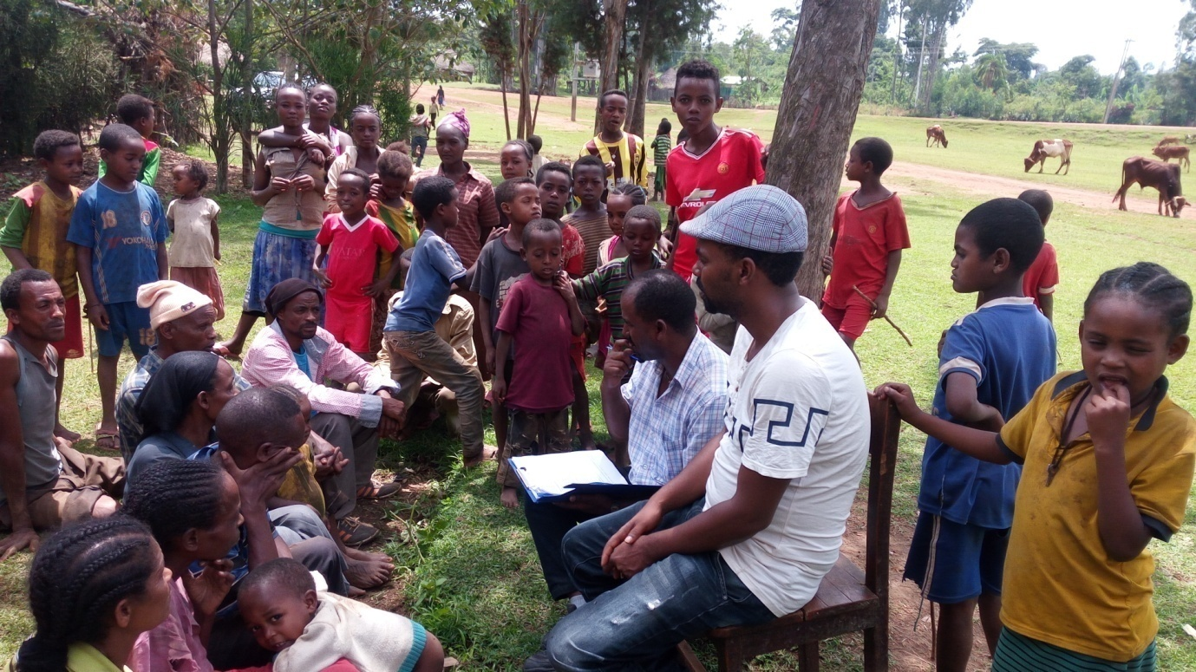

Figure 1: Discussion with community members

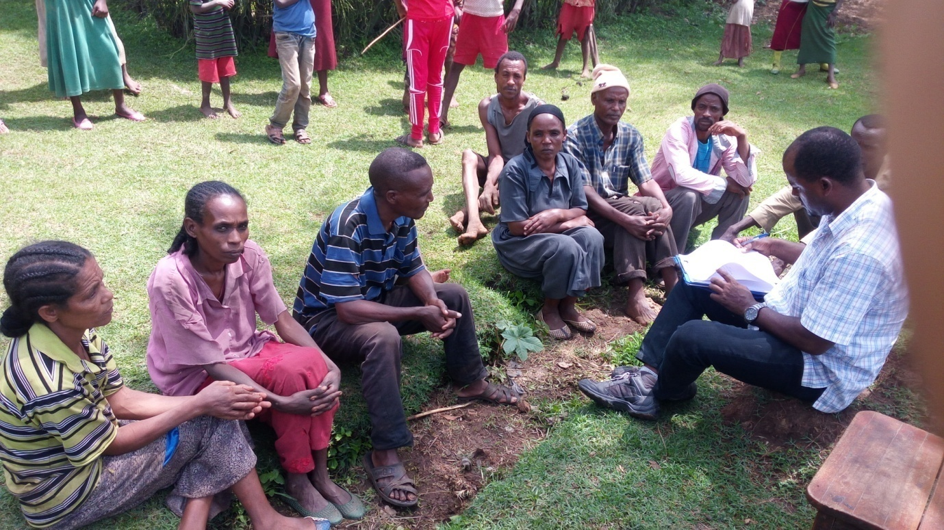
Figure 2: Discussion with men and women community members

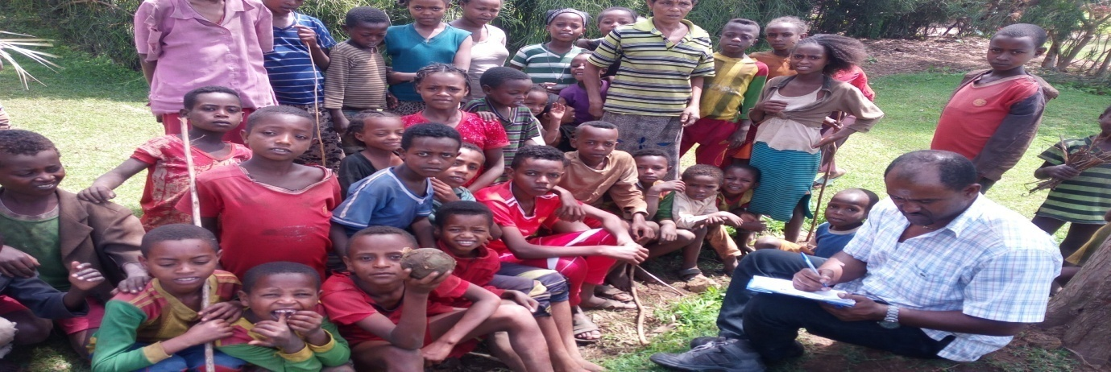

Figure 3: Discussion with children and youth

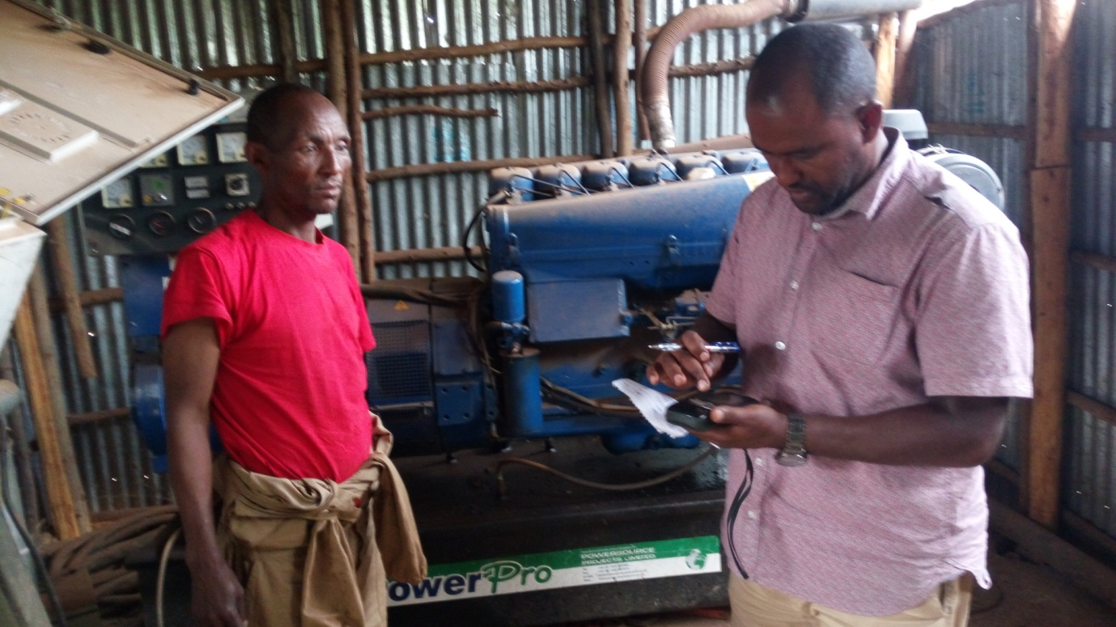

Figure 4: Discussion with caretaker of motorized BH water supply scheme

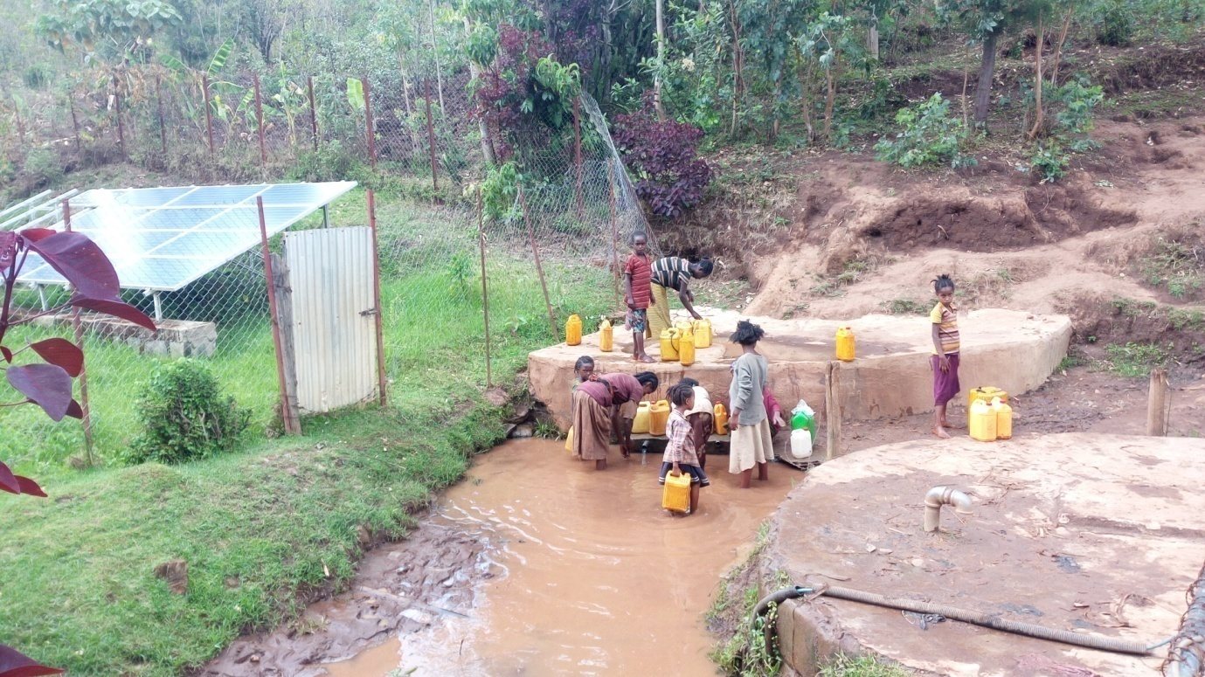

Figure 5: Non functional water supply schemes (spring with renewable energy motorized pump)
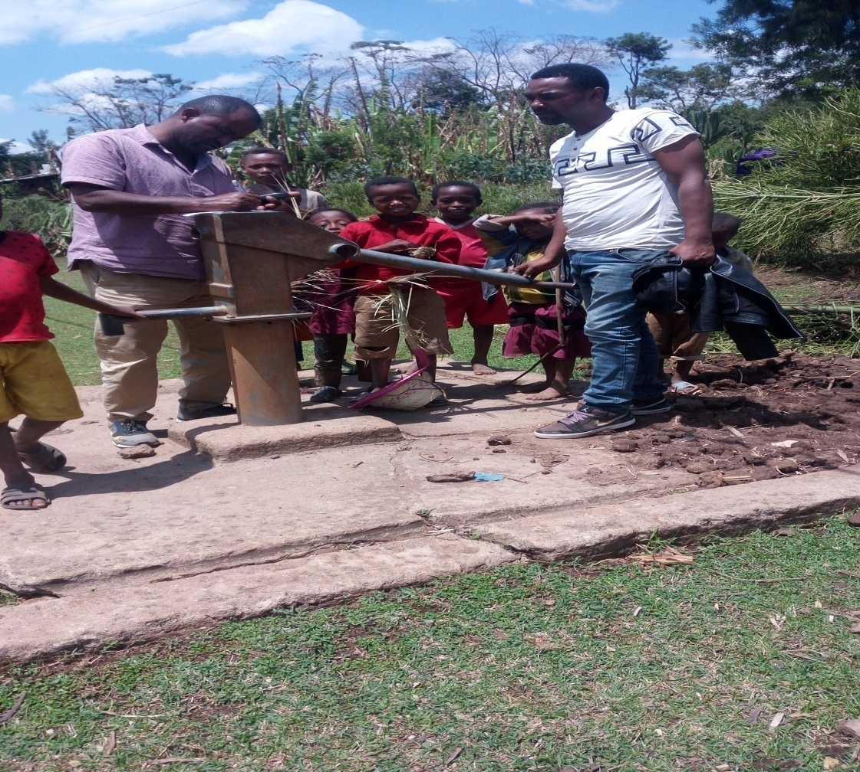
Figure 6: Non functional HDW without fencing

BIOGRAPHICAL SKETCH

Wondwosen Admasu was born on May 28, 1975 in Addis Ababa, Ethiopia. Degree in Bachelor of Sciences in Hydraulic Engineering from Arbaminch University on 23th July, 2005. I have been work in WATER ACTION as Program coordinator on WATSAN program (Local NGO); in Abay Engineering Consulting Firm as WASH Management Specialist; in Plan International Ethiopia( International NGO) as WASH and Infrastructure Program Coordinator and in private sector ( General contractor and water work construction) as General Manger. In 2011, I joined Hawassa University, Institute of Technology, Department of bio-systems and Environmental Engineering, as a candidate for Degree of Masters of Science in Water Resource Engineering and Management.

