

EVALUATION OF THE EFFECTS OF ON-STREET PARKING OF VEHICLES ON TRAVEL SPEED
(A CASE STUDY ON SELECTED ROAD SECTIONS AT SHASHAMANE CITY)

MASTER OF SCIENCE IN ROAD AND TRANSPORT ENGINEERING

BY
JEMALUDIN REDWAN ABDULKADIR

HAWASSA UNIVERSITY INSTITUTE OF TECHNOLOGY
SCHOOL OF POSTGRADUATE STUDIES
HAWASSA, ETHIOPIA

June 2020

EVALUATION OF THE EFFECTS OF ON-STREET PARKING OF VEHICLES ON TRAVEL SPEED
(A CASE STUDY ON SELECTED ROAD SECTIONS AT SHASHAMANE CITY)

BY JEMALUDIN REDWAN ABDULKADIR

THESIS SUBMITTED TO THE DEPARTMENT OF CIVIL ENGINEERING
INSTITUTE OF TECHNOLOGY SCHOOL OF POSTGRADUATE STUDIES, HAWASSA UNIVERSITY
HAWASSA, ETHIOPIA

IN PARTIAL FULFILLMENT OF THE REQUIREMENT FOR THE DEGREE OF A MASTER OF SCIENCE IN ROAD AND TRANSPORT ENGINEERING

(MASTER OF SCIENCE IN ROAD AND TRANSPORT ENGINEERING)

June 2020

SCHOOL OF POSTGRADUATE STUDIES
HAWASSA UNIVERSITY
ADVISORS’ APPROVAL SHEET

This is to certify that the thesis entitled “Evaluation of The Effects of On-Street Parking of Vehicles On Travel Speed (a case study on selected road sections at Shashamane city)” submitted in partial fulfillment of the requirements for the degree of Master of Science in Engineering with specialization in Road and Transport Engineering, the Graduate Program of the Department of Civil Engineering has been carried out by Jemaludin Redwan Abdulkadir Id. No PGRo/013/10, under our supervision. Therefore, we recommend that the student has fulfilled the requirements and hence hereby submits the thesis to the Department.

 12/01/2020
Prof. Emer T. Quezon, P.Eng _______________ _________
Main Advisor Signature Date

Mr Daniel Chufamo _______________ _________
Co- Advisor Signature Date

SCHOOL OF POSTGRADUATE STUDIES
HAWASSA UNIVERSITY
EXAMINERS’ APPROVAL SHEET
We, the undersigned, members of the Board of Examiners of the final open defense by Jemaludin Redwan have read and evaluated his/her thesis entitled “Evaluation onThe Effects Of On-Street Parking Of Vehicles On Travel Speed (a case study on selected road sections at Shashamane city”, and examined the candidate. This is, therefore, to certify that the thesis has been accepted in partial fulfillment of the requirements for the degree Master of Science in civil engineering (Road and Transport Engineering)
Prof.EmerT.Quezon,P.Eng _____________
Name of Major Advisor Signature Date
Mr Daniel Chufamo ______________ ______________
Name of Co Advisor Signature Date
Thomas Bezabih____ ____________ _____________
Name of Internal Examiner Signature Date
Ashenafi Aregawi_(PhD)_ ______________ _______________
Name of External Examiner Signature Date
Tigist Asseffa_______ ______________ _____________
Name of Chairperson Signature Date _____________________ _____________ ______________
(DGC/SGC) Approval Signature Date
Final approval and acceptance of the thesis is contingent upon the submission of the final copy of the thesis to the School of Graduate Studies (SGS) through the Department/School Graduate Committee (DGC/SGC) of the candidate’s department.

DECLARATION
I the undersigned, declare that the thesis entitled “Evaluation on The Effects of On-Street Parking Of Vehicles On Travel Speed (a case study on selected road sections at Shashamane city)", is my original work, has not been presented for degree in any university and all source of material used for the thesis has been duly acknowledged.
Name: Jemaludin Redwan Abdulkadir
Signature_________________
Date_______________________
Email: jmldnaaa@gmail.com
Place: Hawassa University, Hawassa, Ethiopia

ACKNOWLEDGMENT
First of all, I am grateful to Allah for the good health and wellbeing that enabled me to complete this thesis. Secondly, I would like to express my deepest gratitude to my advisor, Prof. Emer Tucay Quezon, and my co-advisor, Mr. Daniel Chufamo, for providing me insight and expert direction that greatly assisted my study. This dissertation would not have been possible without their valuable extended assistance from start to completion.
I also express my gratitude to those who directly or indirectly supported me during the study. In this regard, I would like to take this opportunity to acknowledge the Ethiopian Roads Authority (ERA) Roads and Hawassa University Institute of Technology School of Postgraduate Studies for funding my graduate school studies.
My special thanks go to Mr. Muktar Jemal for providing me with professional advice and similarly to Mr. Sead Awol for sacrificing his valuable time to hold an open discussion on important issues and open data sharing. Also, I would like to express my deepest gratitude to Mr. Abdulmalik Seyfadin, Gudeta Bati, and other colleagues who participate in enumerating data and help me with their profession.
Finally, I would like to give my special thanks to my mother Zahbia Aman, brothers and sister, who treated me with love and enabled me to complete this work.

ACRONYMS/ABBREVIATIONS
AADT: Average Annual Daily Traffic
AASHTO: American Association State of Highway and Transport Organization
ASV: Average Speed of Vehicles
DF: Degree of Freedom
ERA: Ethiopia Roads Authority
ERW: Effective Road Width
FFS: Free Flow Speed
MLR: Multiple Linear Regression
NPC: Number of Pedestrian Crossing
NSPV: Number of Stopped and Parked Vehicles
SPSS: Statistical Package for Social Science
SS: Spot Speed
VIF: Variance Inflation Factor
VV: Volume of Vehicles

TABLE OF CONTENTS
ACKNOWLEDGMENT I
ACRONYMS/ABBREVIATIONS II
LIST OF TABLES VI
LIST OF FIGURES VII
ABSTRUCT VIII
1. INTRODUCTION 1
1.1 Background 1
1.2 Statement of the Problem 2
1.3 Objectives 3
1.3.1 General Objective 3
1.3.2 Specific Objectives 4
1.4 Research Questions 4
1.5 Scope and Limitation of the Research 4
2. LITERATURE REVIEW 6
2.1 Introduction 6
2.2Effects of on-street parking 7
2.2.1 Traffic Speed 7
2.2.2 Traffic congestion 10
2.2.3 Reduction in road width 12
2.2.4 Reduction in Road capacity 13
2.3 Data collection method 14
2.3.1 Data collection method of Spot speed 14
2.3.2 Data collection method of Traffic volume 16
2.4 Regression Model 17
2.4.1 Concept of Multiple Linear Regression 18
2.4.2 Concept of Multiple Non Linear Regression 19
2.5 Summary of Reviewed Literature 20
3. MATERIALS AND METHODS 23
3.1 General 23
3.2 Description of the Study Area 23
3.3 Research Design 26
3.4 Data sources 28
3.5 Data Collection Methods and Preparation 28
3.5.1 Spot speed study 30
3.5.2 Pedestrian crossing study 31
3.5.3 Effective roads width study 32
3.5.4 Traffic volume study 33
3.5.5 Parking volume study 33
3.6 Sampling Technique 33
3.7 Study Variables 34
3.8 Presentation of Field Surveyed Traffic data 36
3.7. Methods of data analysis 40
4. ANALYSIS AND DISCUSSION 42
4.1 Analysis of traffic data 42
4.2 Checking Assumptions of Multiple linear Regression by using data 42
4.3 Developing of Multiple Linear Regression Model 49
4.3.1 Developing Multiple Linear Regression for Bale-exit Road section 49
4.3.2 Developing Multiple Linear Regression for Shewabar Road section 52
4.4 Analyzing the extent of Speed Reduction Suffered by the NSPV 56
4.4.1 Analyzing the extent of Speed Reduction by the NSPV for Bale-exit Road Section 56
4.4.2 Analyzing the extent of Speed Reduction by the NSPV for Shewabar Road Section 57
4.5 Evaluation of the Impacts of Decreasing in ERW on Travel Speed 58
4.5.1 Impacts of Decreasing in ERW on Travel Speed for Bale-exit Road section 58
4.5.2 Impacts of Decreasing in ERW on Travel Speed for Shewabar Road section 59
5. CONCLUSIONS AND RECOMMENDATIONS 60
5.1 Conclusions 60
5.2 Recommendations 61
REFERENCES 63
APPENDIX 1 OUTPUT OF MULTIPLE REGRESSION ANALYSIS OF BALE-EXIT ROAD SECTION 67
APPENDIX 2 OUTPUT OF MULTIPLE REGRESSION ANALYSIS OF SHEWABAR ROAD SECTION 68
APPENDIX 3 F- D I ST R I B UT I O N P E R C E NTAG E P O I NTS (α =.05) 69
APPENDIX 4 DETAIL TRAFFIC DATA FOR SHEWABAR ROAD SECTION 70
Appendix 4.1 Effective Road width study 70
Appendix 4.2 Parking volume and pedestrian study 72
Appendix 4. 3 volume study 74
Appendix 4. 4 Spot Speed study 76
APPENDIX 5 DETAIL TRAFFIC DATA FOR BALE-EXIT ROAD SECTION 78
Appendix 5. 1 Effective road width, Pedestrian crossing and parking volume study 78
Appendix 5. 2volume of vehicles study 80
Appendix 5. 3 Spot speed study 82
APPENDIX 6 84
Appendix 6.1 Ethiopian Road Authority Road Vehicle Count Form 84
Appendix 6.2 Ethiopian Road Authority Road Vehicle Count Summary Sheet 85
APPENDIX 7 86
Appendix 7.1 Posted Speed along the Studied Road Sections 86

LIST OF TABLES
Table 2.1: Reduction in the average speed due to the presence of on-street parking on urban roads…………………………………………………………………..9
Table 2.2: Reduction in the capacity due to the presence of on-street parking on urban road……………….…………………………………………………………….14
Table 3.1: Selected Road sections information………………………………………..... 27
Table 3.2: Recommended Spot Speed Study Lengths source ………………….………..31
Table 3.3: study variables ……………………………………………………………….35
Table3.4: Presentation of traffic data at Bale-exit road section…………...…………..…36
Table 3.5: Presentation of traffic data at Shewabar road section …………...…………...38
Table 4.1: Tests of normality for Bale-exit…….……………………………………..….43
Table 4.2: Coefficient Correlations matrix obtained from SPSS for Bale-exit road section…………………………………………………………………………..46
Table 4.3: Coefficient Correlations matrix obtained from SPSS for Shewabar road
Section …………………………………………………..…………………...48
Table 4.4: Output of Multiple Regression analysis of Bale-exit road section……….…. 50
Table 4.5: Model summary output for Bale-exit multiple regression………………..…..51
Table 4.6: Output of Multiple Regression analysis of Shewabar road section ……….....53
Table 4.7: Model summary output for Shewabar multiple regression …………...……...53 Table4.8:Result of Multiple Regression Average Speed Analysis for both road sections 54

LIST OF FIGURES
Figure 2.1: Variation of Deviation of Speed ……………………………..……….....…....8
Figure 3.1: Map showing the study area …......................................................................24
Figure 3.2: Traffic flow and on-street parking of vehicles at Bale- exit Road Section......25
Figure3.3: Framework of study methodology …………………………….…………….26
Figure 3.4: Manual Traffic data counting on the road section ………………………......29
Figure 3.5: Spot speed study ………………………………………………………...…. 31
Figure 3.6: Section adapted for effective road width data collection ...................…….....32
Figure 4.1: Histogram of the residuals fit with normal by using SPSS for Bale-exit
Road section..………………………………………………….…….....……..43
Figure 4.2: Scatter plot for ASV versus NSPV …………...…………………......…....... 44
Figure 4.3: Scatter plot for ASV versus VV ………………………………....………..44
Figure 4.4: Scatter plot for ASV versus ERW ………………………………….…….....45
Figure 4.5: Scatter plot for ASV versus NPC …………………………………………...45
Figure 4.6: Histogram of the residuals fit with normal by using SPSS for Shewabar
Road section ………..……………………………………………………….47
Figure 4.7: Scatter plot for ASV versus VV ………………………………………….....47
Figure 4.8: Scatter plot for ASV versus NSPV ….………………………….……….......47
Figure 4.9: Scatter plot for ASV versus NPC ………………………………………….. 48
Figure 4.10: Scatter plot for ASV versus ERW ….…………………………………….. 48

ABSTRUCT
On-street parking refers to the parking of vehicles on the street, anywhere on or along the curb or shoulder of a street or road. On-street parking is a common problem everywhere in the world. At present, one of the most challenging phenomena in Shashamane town is traffic congestion, which is a result of the high number of on-street parking vehicles. The purpose of this study is to evaluate the effects of on-street parking on travel speed by developing multiple linear regression model. Two road sections (Bale-exit and Shewabar) that had on-street parking as the main hindrance of travel speed ware selected. Several traffic characteristics and Parameters were then investigated and counted through manual data collection method, for the purpose of obtaining clear relationships between on-street parking and travel speeds. Traffic data collected; were average speed of vehicles, volume of vehicles, number of pedestrian crossings, and number of parked and stopped vehicles, and effective road width. These data are recorded for 12 hours in a day at each road section, covering both peak and non-peak hours with an interval of 15-minute duration. All the surveys at each location are carried out at the same time so as to fulfill the objective of developing relationships between different parameters. Multiple linear regression model was developed to analyze the variation of travel speed for varying traffic volume, number of passenger crossing, the number of parking vehicles, and road width. The result showed that the effective Road width and parking volume have a significant impact on the speed of vehicles along the both road sections. Along Shewabar road section the average speed of vehicles decreased by 3.091km/hr for every 1 meter decreased in the effective road width and decreased by 0.119km/hr for one vehicle increased by the number of stopped and parked vehicles. Along Bale-exit road section only 32.2% from total carriage width of 14m have been used by moving vehicles as an effective road width and the rest 67.8% was occupied by on-street parking vehicles. This decreased travel speed of vehicles by 22.686 km/hr.

Keywords: Average Traffic Speed, Effective Road Width, Multiple linear Regression Model, Number of Stopped and Parked Vehicles, Passenger Crossing,

1. INTRODUCTION

1.1 Background
On-street parking refers to the parking of vehicles on the street, anywhere on or along the curb or shoulder of a street or road in contrast to parking it in a parking garage. The management of on-street Park is one of the main parameters in traffic management. The lack of concentrated parking results in increased on-street parking and disturbance in the traffic system. The behavioral pattern of on-street Park has a direct relation with quantity and quality of traffic variables such as speed, traffic volume, carriage width, and a number of commuters crossing, which are effective in movement analysis (Reihani, 2013). Well-Managed on-street parking is vital to provide safe, secure, fast, environmentally friendly, comfortable, and efficient traffic flow for Ethiopia in general and for Shashamane Town in particular.

On-street parking is a common feature in most of the metropolitan areas around the world. The provision of on-street parking along transport corridors could adversely impact the capacity as well as the achievable driving speeds of the adjacent road. Congestion within modern day urban transport networks has been a significant social, economic and environmental issue. A study by the Australian Bureau of Transport and Regional Economics estimated the total avoidable cost of congestion in 2005 for Australian cities was $9.4 billion. There are a number of factors which result in congestion including: lack of road capacity during peak periods, disruptions and road incidents occurring within the network and interruption of flow at intersections. Furthermore, a key factor which has not been studied quantitatively in great detail, that impacts road capacity and contributes to congestion, is the provision of on-street parking (Sahan, 2015).
On-street parking reduces road capacity, mainly in two ways. Firstly, it narrows down the carriageway width by means of bordering the traffic stream. Vehicles are forced to move into this reduced width, and it leads to a reduction in overall stream speed. Secondly, frequent parking and non-parking maneuvers create complex situations resulting in congestion on busy urban roads. These two consequences of on-street parking eventually contribute towards the capacity loss of urban roads (Glen k. and Praburam, G., 2014).
According to 2017 transportation office report Shashamane city traffic flow trend showed that almost all Auto-rickshaw, Taxis, and many vehicles use the main road as a terminal to serve the passengers. Many trucks are also using the main road during the loading and unloading freights. Most of the buildings in the city have no parking facility, and the vehicles are parked on-street. This will reduces the vehicles speed, eventually contribute towards the bottle neck situation forming traffic congestion, delays, reduction in traffic flow speed and capacity loss of the urban roads.
Traffic speeds are a growing concern, and there is a lot of interest in street treatments that can influence driver speeds. One factor that may affect the driver's choice of speed is the presence of on-street parking, which can narrow the perceived available width of the road ahead.

1.2 Statement of the Problem
Well-Managed on-street parking is vital to provide safe, secure, fast, environmentally friendly, comfortable, and efficient traffic flow for Ethiopia in general and for Shashamane Town in particular. So far, there is no adequate off-street parking in Shashamane city (Shashamane Transportation Office Report, 2017). This metamorphosed to the problem of on-street parking coupled with inadequate traffic managements in the city. As mentioned above, Shashamane has five corridors in which its road network connects to neighboring towns (city). Because of this, much heterogeneous traffic is crossed the city. In the city almost all Auto-rickshaw, Taxis, and many vehicles use the main road as a terminal to serve the passengers. Many trucks are also using the main road during the loading and unloading freights. Most of the buildings in the city have no parking facility, and the vehicles are parked on-street. This was increased traffic congestion (density) and reduced vehicles speed.
Under heterogeneous traffic conditions in Shashamane city, most of the vehicles was located at the kerb side road section, thus caused a reduction in available road width. From the preliminary studies along Bale exit road section from the 14m total width 9.5m road width was used by on-street parked vehicles. This affected the speed of vehicles and increased the operational delay. When the vehicles was stopped and parked on the street, some of the road space was lost depending on the position where the vehicles was stopped, thus reducing the effective road width available for the other traffic. The reduction in the road space was obviously affect the capacity of the road and have an impact on the speed of other vehicles creating a bottleneck situation.
Evaluation of the effects of on-street parking of vehicles on travel speed by considering the influencing parameters such as number of a pedestrian crossing, number of parked vehicles (parking volume) and effective road width is important for transport planners to undertake pertinent studies and formulate some policy decisions in establishing planned off-street parking of vehicles. In view of the above, the study will attempt to fill this gap.

1.3 Objectives

1.3.1 General Objective
The main objective of the study is to evaluate the effects of on-street parking of vehicles on travel speed in Shashamane Town.

1.3.2 Specific Objectives
- To evaluate the impacts of decreasing of the effective road width (ERW) due to the presence of on-street parked vehicles on travel speed.
- To analyze the extent of travel speed reduction suffered by the number of stopped and parked vehicles (NSPV).
- To develop a multiple linear regression model that represents the relationship between traffic speed and major factors affecting traffic speed due to the on-street parking of vehicles.

1.4 Research Questions
Within the view of accomplishing the above-mentioned objectives, the following research questions formulated, and this research intended to answer.
- Is it valid to use multiple regression to model the relationship between traffic speed and on-street parking of vehicles?
- What is the extent of speed reduction suffered by the number of stopped and parked vehicles (parking volumes)?
- What are the impacts of decreasing and increasing the effective road width due to the presence of on-street parked vehicles on traffic speed?

1.5 Scope and Limitation of the Research
The research was conducted at Shashamane within the selected two road sections (Bale exit and Shewabar road section). The primary concern of the study was focused on-street parking vehicles and their consequences on the speed of other vehicles. Even though there are many speed influencing variables, this study was covered variables arising due to on-street parking such as a number of pedestrians crossing the road, Effective road width, parking volume(Number of stopped and parked vehicles), and traffic volume and characteristics. The regression model is developed to examine how much each independent variable influences the traffic speed.
The limitation while doing this research was the absence of previously done research on the effects of on-street parking at Shashamane city. Hence the manual data counting method using the labor force was used for traffic data enumeration instead of an automatic detector method. In this study, traffic data was collected, analyzed, and applied for multiple regression models of average speed for the presented conclusions. This method is developed to gain enhanced knowledge of the effects of on-street parking on traffic speed by improving the data collection method and carried out more efficiently.

2. LITERATURE REVIEW

2.1 Introduction
On-street parking refers to the parking space made available along the curb or shoulder of a street or road that is designed to accommodate vehicles. The use of on-street parking affects the traffic movement in three ways; it reduces the street's capacity; it reduces safety, and increases service conflict. On-street parking causes safety and congestion problems by blocking one or two traffic lanes, reducing visibility, insecurity and forcing pedestrians to walk in the road if no proper footpaths are provided and it also obstructs access for emergency services, thereby resulting into accidents and affecting traffic movement (Olorunfemi et al., 2014).
On-street parking is a common feature in most of the metropolitan areas around the world. However, the provision of on-street parking along transport corridors could adversely impact the capacity as well as the achievable driving speeds of the adjacent road. Road safety is another key factor that needs to be considered when considering the provision of on-street parking along a transport corridor. There was debate regarding the merits and drawbacks of the on-street parking system from a lack of research surrounding the subject over the last two to three decades (Sahan, 2015).
Congestion within modern-day urban transport networks has been a significant social, economic, and environmental issue. A study by the Australian Bureau of Transport and Regional Economics estimated the total avoidable cost of congestion in 2005 for Australian cities was $9.4 billion. There are a number of factors that result in congestion, including lack of road capacity during peak periods, disruptions, and road incidents occurring within the network and interruption of flow at intersections. Furthermore, a key factor that has not been studied quantitatively in great detail that impacts road capacity and contributes to congestion is the provision of on-street parking (Sahan, 2015).

2.2Effects of on-street parking
On-street parking in city centers is an attractive option for drivers because of the accessibility and the closeness to the commercial areas, markets, shopping centers, etc. On-street parking leads to a reduction in the capacity of the roadway due to the occupation of the lane, parking maneuvers, and the effects it makes on the other lanes. The time spent by the vehicles while maneuvering to enter and leave the parking, type of parking, and the duration of the parking were observed in Yildiz Technical University Traffic Management Center (YTUTMC). Using these data, traffic count was conducted, and then the possibility of parking for any vehicle passing through the area was computed. Studies have shown that the design of on-street parking often influence the road capacity if parking locations are not selected and controlled in a careful manner. Most previous studies have taken into account the reduction in road width to accommodate on-street parking and its effect on reduction in road capacity. The influence of the physical use of road space, parking maneuvers, and the opening of car doors on increasing delay. Thus, with the increase in the frequency of parking and with increasing traffic volumes, this becomes a potential cause of congestion (Alguri and Ozen, 2017).

2.2.1 Traffic Speed
Many types of research have been conducted to assess how much traffic flow was reduced due to on-street parking. Earlier research has demonstrated that on-street parking has an effect on speeds and other traffic operations. They were found to hinder the traffic flow directly and indirectly. For example, research done by (Glen and Praburam 2014) observed speeds recorded at various parking demand levels and then analyzed. The results showed that the vehicular speeds fell noticeably with an increase in parking levels. On average, there was approximately a 10km/h reduction in mean speeds between empty and full on-street parking levels. An even bigger effect was noted in 85th percentile speeds. The magnitude of speed reduction varied only slightly based on the road widths.
The selected sites were grouped according to the road widths. Speed surveys were undertaken based on the road volumes and the necessary numbers of samples were collected at various observed parking levels and data shows that traffic speeds generally fell gradually with an increase in parking levels. The results have shown that on-street parking has a noticeable (albeit not always significant) effect on traffic speeds even in local streets. The effects were strongest on medium width streets, more moderate on wide streets. (Glen and Praburam, 2014). Figure 2.1 illustrates the variation of the standard deviation of speeds across different parking levels.
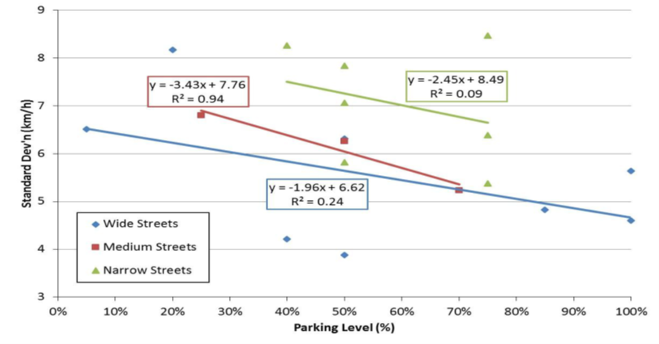
Fig 2.1 Variation of Deviation of Speed (Source Glen and Gautham, 2014)
An ample volume of studies discussed the stream speed reduction on urban roads as an immediate consequence of side friction generated by parked vehicles. (Edquist et al., 2012) measured average speed on the straight mid-block segment in four distinct environments: (a) arterial with no parking, (b) street with no parking, (c) street with empty parking bays marked on the curbsides lane, and (d) street with full parking condition. A gradual reduction in speed was witnessed with demotion in the hierarchy of road conditions from a to d. Investigations by (Chiguma and Bang ,2007) revealed 'parked and stopped vehicles' as the most important side friction element on urban roads causing the maximum reduction in speed compared to other factors like pedestrian movements, non-motorized vehicles, and entry/exit vehicles.
Many studies witnessed this speed diminishing phenomenon of on-street parking; however, it could not prove to be effective in the corresponding quantification of the impact. On the other hand, few attempts got success in quantifying this reduction in speed due to the presence of on-street parking. Major outcomes of these studies are given in Table 2.1.
Table 2.1 Reduction in the average speed due to the presence of on-street parking on urban roads
Author ( locations of the studies from the References list) | Reduction in the speed
Humphreys et al .( 1978) | 15 to 42%
Kladeftiras and Antoniou .( 2013) | 44%
Ivan et al. ( 2009) | 21 kph
Aronsson .( 2006) | 5.5 km/h
Wang et al.( 2006) | 5.1 km/h

As it is observed, the estimated speed reductions caused by the presence of on-street parking fluctuate extremely from 15 to 44% or 5.1 to 21 km/h.
Many studies were done to examine the influence on-street parking on traffic speed with varying intensity of parking, and mathematical model was developed to quantify this influence (Chiguma,2007)defined average speed 'V' (km/h) as a function of 'FLOW' (lvu/h), carriageway width 'CW'(meter), shoulder-width 'SW' (meter) and side friction
‘FRIC’
$V = 46.465 - 0.015 × FLOW- 0.011× FRIC + 1.36 × CW + 5.393 × SW$ ---- (Equation 2.1)
V in Equation (2.1) is the average speed of the vehicles (km/h), FRIC’is further comprised of four frictional elements: Pedestrian crossflow 'PED', Bicycle volume 'BIC,' Parking, and stopping vehicles 'PSV' and Non-motorized vehicle volume 'NMV'. All these factors were retained in a common unit of Number/ 200 m/h to circumvent added complexity and exercised
$FRIC = 1 × PED + 0.45 × BIC+ 0.08 × NMV + 0.37 × PSV$--- (Equation 2.2)
The number of parking maneuvers (n_{man}) is the most significant parking parameter having a substantial impact on the average speed of the through traffic. The study forwarded a combined model (Equation 2.2), which describes the influences of nman along with some other side friction factors on the average speed (Salini et al., 2016).
$V=43.53 - 0.39 × n_{man}- 0.59 ×t_{d}- 0.08× n_{ped}- 0.18 × n_{c}- 0.05 × n_{2w}- 0.27 × n_{3w}$------- ------- (Equation 2.3)
V is the average speed of the through vehicles (km/h).n_{c},n_{2w} and n_{3w} are the hourly traffic volume of cars, two-wheeler and three wheeler respectively. t_{d} and nped are the average dwell time (second) of bus and the number of pedestrians walking along the roads per minute respectively.

2.2.2 Traffic congestion
Parking and traffic congestion are synonymous to each other because failure to meet parking demand of people in a city lead to on-street parking that results in traffic congestion. Traffic congestion is a condition on road networks that occurs as use increases and is characterized by slower speeds, longer trip times, and increased vehicular queuing. On-street parking constitutes one major problem that makes the traffic situation chaotic in Nigerian cities. Most roads in Nigerian cities are narrow and lack pedestrian lanes. There are cases of double parking along these narrow roads, thereby causing traffic congestion (Olorunfemi et al., 2014).
Traffic congestion within urban transport networks has been an issue for transport planners and traffic engineers during the past few decades. Currently, traffic congestion is a daily occurrence in Sydney's motorways and major arterial corridors during peak periods. Traffic congestion can be a result of a number of factors including the lack of capacity during peak periods, disruptions within a network such as traffic accidents, vehicle breakdowns, road works, and traffic control measures (such as traffic signals and traffic calming devices). A city-based analysis shows that the cost of congestion in Sydney is $3 billion and will rise to about $6.1 billion in 2020. Traffic congestion can be managed by some of these policies require minimal effort and cost to implement, such as peak period parking restrictions, turning restrictions and imposing access restrictions for new traffic generating land-use developments (Sahan, 2015).Unstable location of the taxi stop results in tragic congestion. The study was conducted that lack of designed stop locations lack of stop location for shared taxis may induce them to have some maneuvers in order to pick up and drop off passengers in everywhere through the path. Parked cars could have the potential to create congestion on urban roads singlehandedly if parking is irregular or in a haphazard manner. Even a very small number of vehicles, if they are parked in a disruptive way for a long duration, can cause heavy congestion.

2.2.3 Reduction in road width
In the present study, a parameter called Effective Road Width is used to indicate the available carriageway width for traffic in meters, whenever a bus, stops on the road at a kerb side bus stop. It is a common observation that all the buses do not stop at the same point, and the position of the bus when it stops depends on many factors such as the driver's attitude and the amount of passenger traffic waiting by the kerb side. In order to capture this effective road width, it is important to note where the bus stops and how much road width is lost due to the bus stoppage (Reddy, 2017).
On-street parking is recognized as having an effect on vehicle operating speed. It physically constrains both the effective lane width and the effective total pavement width (Sirous et al., 2013). Whenever a bus stops at a kerb side bus stop, the effective road width available for traffic movement reduces, thereby creating a bottleneck situation. The impedance caused by the activity of buses at a kerb side bus stop on the quality of traffic can also be assessed by comparing the capacities of the road not affected by the bus stop and the bottleneck or the capacity resulting due to reduced road width
Research is done by Mofizul et al., (2018) state that the Reduction of effective road width is a common problem everywhere in the world and in Dhaka city; it’s a major problem for its huge traffic volume. Percent of effective roadway width loss in Dhaka city due to different types of parking is reflected.
Percent of loss of effective width can be formulated follows:
$\% Effective width loss = (d/D)*100\%$-------------- (Equation 2.4)
Here, d= Reduction of effective roadway width due to parking vehicle.
D=Effective roadway width at that particular section

2.2.4 Reduction in Road capacity
Roadway capacity is a quantitative assessment of traffic stream properties. It is based on the relationship between flow, speed, and density. At present, one of the most important phenomena in Dhaka city is traffic congestion, which is the result of a high amount of existing vehicles in contrast to inadequate roadway facilities. Though there are a set of factors associated with this, one of the major reasons is the inability to use the city roads to their highest capacities. On-street parking causes more than 10% of loss of capacity (Mohiuddin and Imran, 2016)
Many studies in the past have used data analysis techniques to assess the impact of on-street parking on road capacity. The American Association of State Highway and Transportation Officials (AASHTO, 2011) claims that the road capacity of four to six-lane arterial roads can be increased by 50% to 80% by removing kerb side on-street parking. Additionally (Johnnie and Nordiana, 2011) carried out research in Skudai, Malaysia, aiming at determining the capacity loss and traffic shockwaves associated with bus stop locations along the carriageway lane of a single lane highway, Results and analyses showed significant differences in roadway capacities for the on and off-street bus stops. Roadway capacity loss of 23.4 percent was recorded, and -25km/h propagation of velocity shock waves.
On-street parking is highly associated with the reduction in road capacity. Many researchers quantified the reduction in capacity caused by the presence of on-street parking. Major outcomes of these studies are given in Table 2.2

Table 2.2 Reduction in the capacity due to the presence of on-street parking on urban roads
Authors | Extent of parking | Reduction in road capacity (%)
Rudjanakanoknad ,(2010) | Parking width wider than 4 m on six lanes divided major street | 20–25
Cao et al, (2017) | 1.9 m wide single side parking on two lanes undivided street | 22
Guo et al, (2012) | 35% proportion of the parking vehicles on a major one-way street | 35
Humphreys et al, (1978) | Both side parking on two lanes undivided road | 78–90
Hence, a significant amount of capacity reduction (up to 90%) was reported in the literature as a consequence of on-street parking. An increase in the number of parked cars occupies an additional road space and subsequently causes a more acute reduction in the capacity of the road. All these studies hence, recognize the capacity reduction aspect of on-street parking. Stationary or maneuvering vehicles, in general, on-street parking, cause a substantial impact on the regular traffic flow in a number of cases.

2.3 Data collection method

2.3.1 Data collection method of Spot speed
Speed is an important transportation consideration because it relates to safety, time, comfort, convenience, and economics. Spot speed studies are used to determine the speed distribution of a traffic stream at a specific location. The data gathered in spot speed studies are used to determine vehicle speed percentiles, which are useful in making many speed-related decisions (Robertson, 1994).
The time of day for conducting a speed study depends on the purpose of the study. When a speed study is conducted in response to citizen complaints, it is useful if the time period selected for the study reflects the nature of the complaints. The duration of the study should be such that the minimum number of vehicle speeds required for statistical analysis is recorded. Typically, the duration is at least1 hour, and the sample size is at least 30 vehicles (Nicholas Garber and Lester, 2009).
Spot speed data are gathered using one of three methods: (1) stopwatch method, (2) radar meter method, or (3) pneumatic road tube method.
(1) Stopwatch method: The stopwatch method is the least expensive method that can be used to successfully complete a spot speed study using a small sample size taken over a relatively short period of time. The stopwatch method is a quick and inexpensive method for collecting speed data. A stopwatch spot speed study includes five key steps. Obtain appropriate study length, Select proper location and layout, Record observations on stopwatch spot speed study data form, Calculate vehicle speeds and generate frequency distribution table, and determine speed percentiles (Robertson, 1994).
(2) Radar meter method: A radar meter is a commonly used device for directly measuring speeds in spot speed studies. This device may be hand-held, mounted in a vehicle, or mounted on a tripod (Parma, 2001). A radar meter requires line-of-sight to measure speed accurately and is easily operated by one person. Because of its cost, a radar meter may be the most difficult piece of equipment for an agency to obtain. A radar meter can be purchased, or one may be obtained (rented or borrowed) from a local law enforcement agency.
(3) Pneumatic road tube method: The pneumatic road tube method is normally used for longer data collection time periods than those of either the stopwatch or radar meter method. Using this method, pneumatic tubes are placed in the travel lanes and are connected to recorders located at the side of the road. Pneumatic road tube spot speed studies require specialized equipment and knowledge of how to maintain the equipment.

2.3.2 Data collection method of Traffic volume
Traffic volume studies are conducted to determine the number, movements, and classifications of roadway vehicles at a given location. These data can help identify critical flow time periods, determine the influence of large vehicles or pedestrians on vehicular traffic flow, or document traffic volume trends. The length of the sampling period depends on the type of count being taken and the intended use of the data recorded. For example, an intersection count may be conducted during the peak flow period. If so, manual count with 15-minute intervals could be used to obtain the traffic volume data (Duane et al., 2002)
Two methods are available for conducting traffic volume counts (1) manual and (2) automatic. Manual counts are typically used to gather data for the determination of vehicle classification, turning movements, the direction of travel, pedestrian movements, or vehicle occupancy. Automatic counts are typically used to gather data for determination of vehicle hourly patterns, daily or seasonal variations and growth trends, or annual traffic estimates
(1) Manual Count: Most applications of manual counts require small samples of data at any given location. Manual counts are sometimes used when the effort and expense of automated equipment are not justified. Manual counts are necessary when automatic equipment is not available. Manual counts are typically used for periods of less than a day. Normal intervals for a manual count are 5, 10, or 15 minutes.
(2) Automatic count: The automatic count method provides a means for gathering large amounts of traffic data. Automatic counts are usually taken in 1-hour intervals for each 24-hour period. The counts may extend for a week, month, or year. When the counts are recorded for each 24-hour time period, the peak flow period can be identified.

2.4 Regression Model
Statistical modeling, regression analysis is a set of statistical process for estimating the relationship among the variables. It includes many techniques for modeling and analyzing several variables when the focus is on the relationship between dependent variables and one or more independent variables (or 'predictors'). More specifically, regression analysis helps one understand how the typical value of a dependent variable (or 'criterion variable') changed when any one of the independent variables varied, while the other independent variables are held fixed.
The regression model can be linear or non-linear based upon the linearity of independent variables. Linear regression is an approach for modeling the relationship between a scalar dependent variable y and explanatory variable (or independent variable) denoted by x. The case of one explanatory variable is called a simple linear regression. Multiple linear regression is an extension of simple linear regression. It is used when we want to predict the value of a variable based on the value of two or more other variables. Many applications of regression model involve situations in which there is more than one independent variable. A multiple regression model is a well-known statistical technique that fits a relationship between dependent and independent variables (Halkiyo el.al, 2017).

2.4.1 Concept of Multiple Linear Regression
Multiple Linear Regression is one of the most popular statistical techniques for fitting the mathematical relationship between dependent and independent variables. This technique has been applied fruitfully in a number of transportation planning studies that can be used for predicting the values of a dependent variable from one or more independent variables (Halkiyo el.al, 2017).
The general form of the equation is:
$Y=a_{0}+a_{1}X_{1}+a_{2}X_{2}+a_{3}X_{3}+----- +a_{n}X_{n}$ ………. (Equation 2.5)
Where Y is the dependent variable, such as Saturation traffic speed in the present study. X₁, X₂ ,X₃,…… X_{n} are the independent variables such as proportion of highly maneuverable vehicles, width of the approach under consideration etc. a₁,a₂ ,a₃, …..a_{n} Are the coefficients of the respective independent variables X₁, X₂ ,X₃,…… X_{n} . a₀ is the regression coefficient.
The Multiple linear regression analysis finds the values of ao, a1, a2 … Such that the error of estimation is minimum. In this equation, the regression coefficients represent the independent contributions of each independent variable to the prediction of the dependent variable. The regression line expresses the best prediction of the dependent variable (Y), given the independent variables (X). The deviation of a particular point from the regression line (its predicted value) is called the residual value. The smaller the variability of the residual values around the regression line relative to the overall variability, the better is the prediction. In most cases, the ratio would fall somewhere between these extremes, that is, between 0.0 and 1.0. 1.0 minus this ratio is referred to as R-square or the coefficient of determination. This value is immediately interpretable in the following manner. If the value of R-square is 0.4, it means that the variability of the Y values around the regression line is (1-0.4) times the original variance. In other words, the equation can explain only 40% of the original variability, and the remaining 60% is the residual variability. The R-square value is an indicator of how well the model fits the data. Customarily, the degree to which two or more predictors (independent or X variables) are related to the dependent variable is expressed in the correlation coefficient R, which is the square root of R-square. In multiple regression, R can assume values between 0 and 1 (Halkiyo el.al, 2017).
To interpret the direction of the relationship between variables, one looks at the signs (plus or minus) of the regression coefficients. It is assumed in multiple regression that the residuals (predicted minus observed values) are distributed normally (i.e., follow the normal distribution).

2.4.2 Concept of Multiple Non Linear Regression
In research programs, one often finds it necessary to consider regression models that are nonlinear in the independent variables. Common examples of nonlinear equation forms that are amenable to this technique are
Equation Interpretation Linear Form
Y=Ae^{bx} Y is growing (or shrinking) at a ln(Y) = ln(A) + bX + ln(u)
Constant relative rate of b.
Y=AX^{b}u The elasticity of Y with respect ln(Y) =ln(A) + bln(X)+ln(u)
to X is a constant, b.

Considering the first equation, Y=Ae^{bx}, this is an exponential growth equation; b is the growth rate, u is the random error. If logarithm is taken on both sides, the equation will be transformed into ln(Y) = ln(A) + bX + ln(u). This equation has logarithms in it, but they relate in a linear way. It is in the form y=a+bX+error, except that y, a, and the error are logarithms. That is a way of fitting the curve Y=Ae^{bx} to the data. Similarly, considering the second equation, Y=AX^{b}u, this is a constant-elasticity equation typically used for demand curves (Halkiyo el.al, 2017).If logarithm is taken on both sides, the equation will be transformed into
ln(Y) = ln(A) + bln(X) + ln(u)………….. (Equation 2.6)
For this equation, if it is to create the variable ln(Y) and also a variable for the base-e logarithm of X, written as ln(X), the regular least squares method is used to fit the curve Y = AXb to the required data. Considering the equation, Y=a0a1X +E, taking logarithms ofboth sides, the equation gets the form
ln(Y)= ln(a0) +Xln(a1)+ln(E)…………….. (Equation 2.7)
There are many phenomena in engineering that are inherently nonlinear in nature and, when the true structure is known, an attempt should certainly be made to fit the actual mod

2.5 Summary of Reviewed Literature
On-street parking reduces the road capacity mainly in two ways. Firstly, it narrows down the carriageway width by means of bordering the traffic stream. Vehicles are forced to move into this reduced width and it leads to a reduction in overall stream speed. Secondly, frequent parking and unparking manoeuvres create complex situations resulting in congestion on busy urban roads (Subhadip et al., 2017). These two consequences of on-street parking eventually contribute towards the reduction of traffic speed.
Many researcher (Chiguma (2007), Edquist (2012), Ivan (2009), Reddy (2008) have an ample volume of studies discussed the stream speed reduction on urban roads as an immediate consequence of side friction generated by parked vehicles. Edquist et al, (2007) measured average speed on the straight mid-block segment in four distinct environments: (a) arterial with no parking, (b) street with no parking, (c) street with empty parking bays marked on the kerbside lane and (d) street with full parking condition. A gradual reduction in speed was witnessed with demotion in the hierarchy of road conditions from a to d. Other investigations (Chiguma (2007), Ivan (2009), Reddy (2008) revealed 'parked and stopped vehicles' as the most important side friction element on urban roads, causing the maximum reduction in speed compared to other factors like pedestrian movements, non-motorized vehicles, and entry/ exit vehicles.
On the other hand, few attempts got success in quantifying this reduction in speed due to the presence of on-street parking. Major outcomes of these studies, as given in Table 2.1by, the presence of on-street parking fluctuates extremely from 15 to 44% or 5.1 to 21 km/h. The reason for this fluctuation is simply the existence of a few other factors which also play a noteworthy role in determining the speed.
The common deficiency in all these studies is the consideration of on-street parking as a categorical variable (either 'presence' or 'absence'). Neither this influence was examined with varying intensity of parking, nor was any mathematical model developed to quantify this influence. Marshall et al. (2008), attempted to address this issue by classifying roadside parking occupancy in three levels: (a) less than 30%, (b) 30–50%, and (c) 50–100%. Later it was detected that the level 'b' and 'c' did not show any statistical dissimilarity corresponding to the Free Flow Speed (FFS) and were consequently merged together. The level 'a' parking was also found to be trivial in influencing FFS. Overall, the mean FFS of the streets without having on-street parking (up to 30% parking occupancy) was found 3.7 kph higher with respect to the streets have on-street parking.
Mathematical model was developed to quantify the influence of on-street parking on average speed of vehicles by (Chiguma ,2007)defined average speed ‘V’ (km/h) as a function of ‘FLOW’ (lvu/h), carriageway width ‘CW’(meter), shoulder width ‘SW’ (meter) and side friction
‘FRIC’
$V = 46.465 - 0.015 × FLOW- 0.011× FRIC + 1.36 × CW + 5.393 × SW$ ---- (Equation 2.8)
Salini et al., (2016) develop another model using multiple linear regression to evaluate the effects of on-street parking vehicles on traffic speed. According to him, the number of parking maneuvers (n_{man}) is the most significant parking parameter having a substantial impact on the average speed of the traffic. The study forwarded a combined model (Eq2.9) which describes the influences of n_{man} along with some other side friction factors on the average speed
$V=43.53 - 0.39 × n_{man}- 0.59 ×t_{d}- 0.08× n_{ped}- 0.18 × n_{c}- 0.05 × n_{2w}- 0.27 × n_{3w}$------- (Equation 2.9)
V is the average speed of the through vehicles (km/h).n_{c}, n_{2w} and n_{3w} are the hourly traffic volume of cars, two-wheeler and three wheeler respectively. t_{d} and n_{ped} are the average dwell time (second) of bus and the number of pedestrians walking along the roads per minute respectively.

3. MATERIALS AND METHODS

3.1 General
This chapter presents and describes the approaches and techniques the researcher was used to collect data and investigate the research problem. These include a description of the study area and selected road section, sources of data, and method of data collection for (traffic volume, spot speed, passengers crossing, parked and stopped vehicles, and effective road width).

3.2 Description of the Study Area
The study was conducted at Shashamane, which is located 240 from Addis Ababa. Shashamane Town is a separate Woreda in West Arsi Zone, Oromia Region, Ethiopia which lies on the Trans-African Highway 4 Cairo - Cape Town, about 240 kilometers from the capital city of Ethiopia, Addis Ababa. The city has five corridors in which its road network connects to neighboring towns (city). These are: The northern highway comes from Addis Ababa, the capital city of Ethiopia traversing the towns of Bishoftu, Mojo, Alemtena, Ziway, and Arsi Negele. The southern highway comes from Moyale (border town between Ethiopia and Kenya) and beyond Kenya, traversing the towns of Mega, Yabello, Hageremariam, Yirgachefe, Dilla, and Hawassa. The eastern highway comes Bale town and the surrounding areas traversing the towns of Robe, Adaba, Dodola, and Kofele. Lastly, the southwestern highway comes from Arbaminch and beyond traversing the Wolaita Sodo town (Shashamane transportation office report, 2017).
For this study, two road sections that had on-street parking of vehicles as the main hindrance for traffic flow was chosen. These road sections are Bale-exit Road section and Shewa bar road section. The details explanation of the two selected road sections will discussed as below.
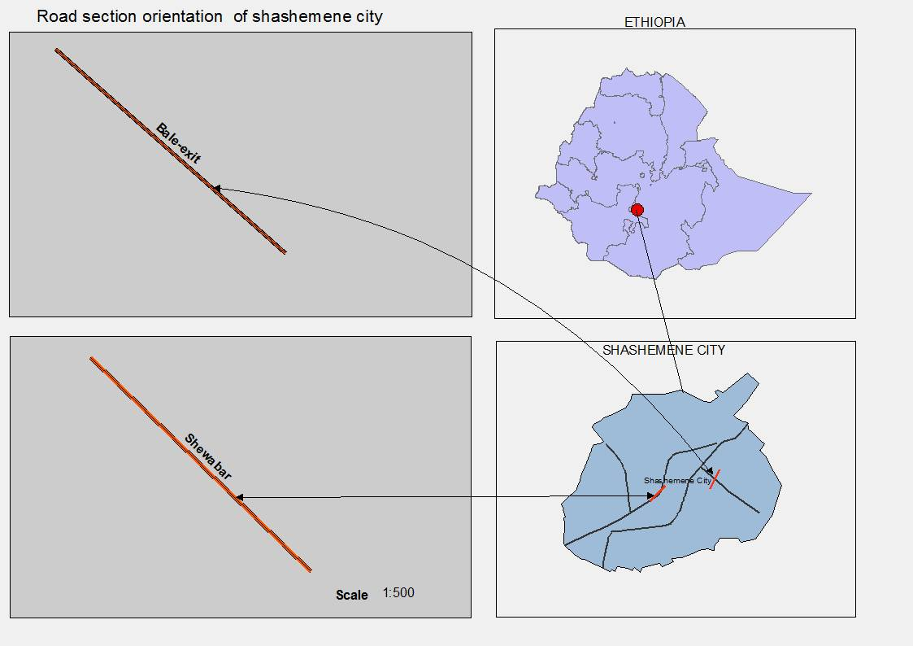Figure3.1: Map showing the study area (Sources: Demography of Shashamane Town Administration, 2019)
Bale-exit Road section: It has a two undivided lane with asphalt concrete surface type. According to ERA (functional classification of road) it's a link road and have 14m road width. Along this road section, Taxis and Bajaj use the edge road as a terminal to give service for the commuters. As a result, the effective width of the road is decreased; this will cause a reduction in traffic speed, an increase in traffic congestion, and a decrease in the capacity of the road.
Bale-exit road section is used by different types of vehicles like heavy truck, light truck, large bus, small bus, auto rickshaw, cart and cars. Freight vehicles load and unload goods parking on-street at the edge of the road. The drivers are drop passengers in the middle of the road by on-street parking vehicle; this kind of problem has been created traffic problems like delay, congestion, pedestrian crossing, and reduction in traffic speed, which are increasing day to day season to season of years.
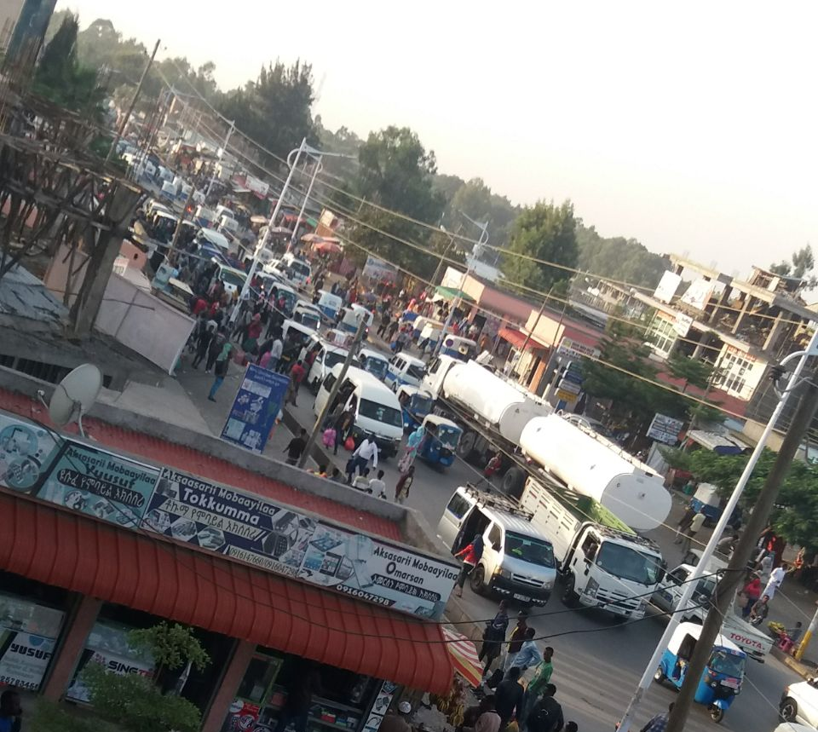
Figure 3.2: Traffic flow and on-street parking of vehicles at Bale- exit Road Section (Source: captured by Jemaludin, 2019)

Shewabar road section: It has a two undivided lane with asphalt concrete surface. According to ERA (functional classification of road) it’s a collector road and have 12m road width. The taxis and rickshaws use the edge of the road to get on and get off the commuters. As a result, roadway occupied by on-street parked vehicles and the travel speed obstructed, and the drivers are forced to reduce the traveling speed.

3.3 Research Design
SELECTION OF ROAD SECTION
DATA COLLECTION

Primary data collection
Secondary data collection
Direct collections of traffic data from the field manually
- Vehicles volume and their classification
- Effective road width
- Number of stopped and parked vehicles
- Number of pedestrian crossing
- Spot speed
Reports from ERA
Shashamane transportation office report
Literature

ANALYZING DATA Statically through Regression model using SPSS

Conclusion and Recommendation

Figure 3.3: Framework of the study

For the purpose of this study, appropriate road sections were chosen from a list of potential locations based on the following conditions:
- Much attention was given to select sites where the on-street parking would be the notable factor affecting the speed of vehicles. Although there are other factors hindering the traffic flows in Shashamane, such as places with high commercial centers, roughness, and deterioration of the pavement.
- Street with a parking lane or off-street parking was not taken into consideration as they would cause less impact. This is because of the additional parking lane would not reduce the operation road width.
- Sites were selected based on their road widths12m and 14m.
Finally, two road sections having different traffic conditions and road widths were selected. These are the road sections along Bale-exit (14m) exit and the road section along Shewabar (12m).
Table 3.1 Selected Road sections information
Road section | Road width | Number of lanes | Direction (starting and ends) | Functional classification | Surface type
Bale-exit Road section | 14m | Two-lane /two way | Along Bale-exit From Natoli along with lead star school 30m | Link | AC Paved
Shewabar Road section | 12m | Two-lane /one way | Along Shewaber From Ummaa hotel to old bus station 30m | Collector | AC Paved

3.4 Data sources
The primary source of traffic data is a field survey through manual traffic count. To meet the objectives of the study, the existing vehicle volume and their classifications, effective road width, number of a pedestrian crossing, number of stopped and parked vehicles, and speed of vehicles were directly enumerated from the selected road sections by manual traffic counting methods. In addition data from ERA and Shashamane transportation office, journals and articles, book, literature, and documents, including educational website will be considered under a secondary data source

3.5 Data Collection Methods and Preparation
Different survey data were conducted along Bale-exit and Shewaber road sections. The manual traffic counting method is the most common method of conducting a traffic survey, in which the traffic data is recorded by the assigned person as it passes the baseline. For this research manual method of data collection was adopted and done in terms of manpower.
The selection of study method should be determined using the count period. The count period should be representative of the time of day, day of month, and month of year for the study area (Sharma 1994). Count periods may range from 5 minutes to 1 year. Typical count periods are 15 minutes or 2 hours for peak periods, 4 hours for morning and afternoon peaks, 6 hours for morning, midday, and afternoon peaks, and 12 hours for daytime periods (Robertson1994).
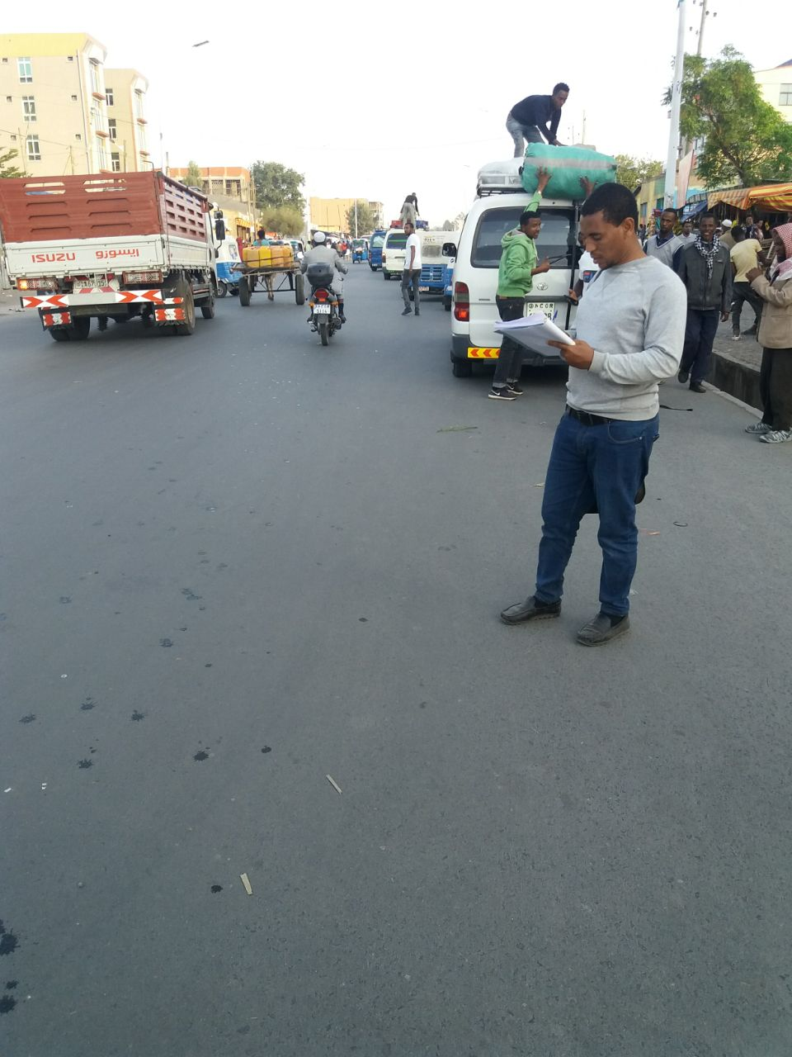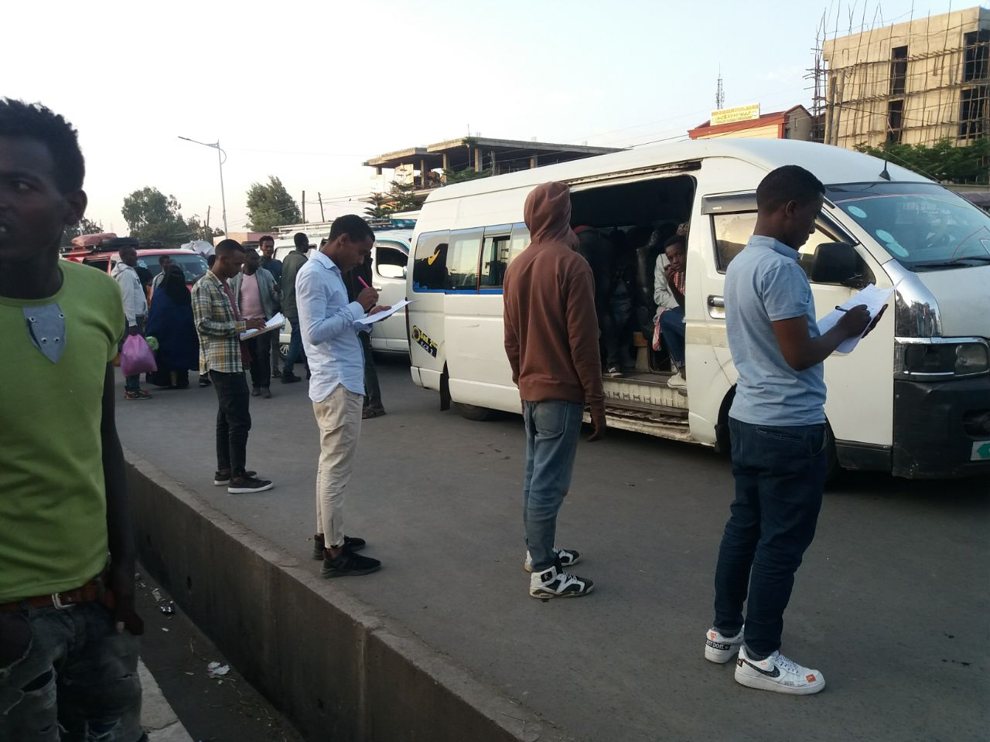
Figure 3.4: Manual Traffic data counting on the road section
In the present study, different traffic surveys were conducted manually using man power for both Bale-exit and Shewaber road sections to collect the traffic data. The data collection comprised of five main activities. These are recording classified traffic volume, speed of vehicles, effective road width, number of the pedestrian crossing, and number of stopped and parked vehicles. The data is collected for 12 hours in a day at both road sections, during peak and non-peak hours with an interval of 15-minute duration. The manual field survey by manpower is comprised of activities such as recording spot speed, passenger crossing, number of parking vehicles, and classified traffic volume. The effective width of the street will be measured manually by measuring tape.
The following methodology is adopted for the data collection at each selected road sections for different surveys. All the surveys at each location are carried out simultaneously so as to fulfill the objective of developing relationships between different parameters.

3.5.1 Spot speed study
Spot speed studies are conducted to estimate the distribution of speeds of vehicles in a stream of traffic at a particular location on a highway. Speed characteristics determined from a spot speed study is used to determine whether complaints about speeding are valid (N.J. Garber, 2009). For this study Spot speed data was gathered by using the stop watched method. A digital clock can prove useful in noting time intervals appropriate study length and proper location and layout was fixed for both selected sites.
The traffic speed is measured at each road section in terms of Time mean speed by using the direct timing procedure method. For this, the times of entry and exit of different vehicles over the length of these sections are recorded, and based on the trap length of 30 m fixed for each section; the time mean speeds are computed. Finally, the speed of the vehicle will be calculated by
$V=\frac{D}{T} where V=speed,D=distance, T=time$…….. (Equation 3.1)
The study length is important because it is used in the calculation of vehicle speeds. Table 3.2 provides recommended study lengths, which are based on the average speed of the traffic stream. Using these recommended study lengths makes speed calculations straightforward and less confusing. If these lengths are not appropriate, another length can be used, assuming it is long enough for reliable observer reaction times (Robertson, 1994). Tally form for speed study was shown in Appendix 4.4

Table 3.2 Recommended Spot Speed Study Lengths source (Robertson, 1994)
Traffic Stream Average Speed (mph) | Recommended Study Length  (feet)
Below25 ( 40.3kmph) | 88 (26.88m)
25-40 (40.3kmph–64.5kmph) | 176 (53.6m)
Above 40 ( 64.5kmph) | 264 (80.5m)

The study length of 30 meters was used for both road sections because the posted speed limit of the selected road section is 30KPH, which is below 40.3KPH. The study layout is illustrated in Figure3.5.
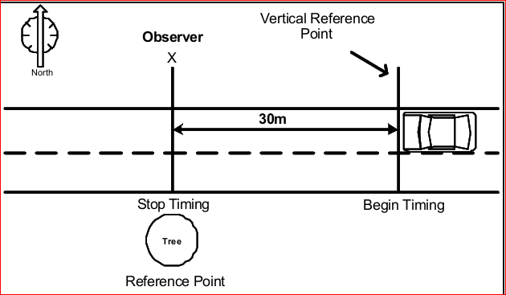
Figure 3.5: Spot speed study

3.5.2 Pedestrian crossing study
Many passengers will cross the road to get in or out of on-street stopped and parked vehicles. The number of pedestrians within the selected road section (baseline) was counted and recorded on the tally sheet to evaluate their effects on other traffic speeds using the road. It was counted an interval of 15 minute for 12 hours.

3.5.3 Effective roads width study
Due to parking on-street parking of vehicles, the width of the road will reduce. This will makes the drivers reduce the speed of the vehicles. To evaluate its effects on traffic speed, the width of the road with the selected baseline will be measured manually by measuring tape.
The width of the approach road is to be measured as the carriageway width at each kerb side vehicle stop and is recorded in terms of meters. The road width refers to the width available from the edge of the divider to the kerb of the road. When a vehicle stop on the road at kerb side, some of the road space is lost along the road, depending on the position where the bus stopped. Thus reducing the space road available for the other traffic. The reduction in road space obviously affect the capacity of the road and have an impact on the speed of other vehicle creating a bottleneck situation.
In order to examine effective road width open to traffic flow, a reference line at an interval of 0.5m was drawn. Fig 3.6 illustrates the section adapted for effective road width data collection.

Figure: 3.6 Section adapted for effective road width data collection
(Source R.R.Reddy, 2017)

3.5.4 Traffic volume study
Traffic volume studies are conducted to determine the number, movements, and classifications of roadway vehicles at a given location. These data can help to identify critical flow time periods, determine the influence of large vehicles or pedestrians on vehicular traffic flow, or document traffic volume trends.
Recording data onto tally sheets is the simplest means of conducting manual counts. The data can be recorded with a tick mark on a pre-prepared field form. A watch or stopwatch is necessary to measure the desired count interval. For this study, traffic volume was counted using the manual counting method. Observers can record count data on tally within 15 minutes of time intervals for 12 hours.

3.5.5 Parking volume study
Parking volume study is the number of Stopped and parked vehicle studies such that it is counting the number of buses, taxi, rickshaw, trucks, and other vehicles parking within the selected location (baseline). They are counted manually and registered on the tally sheet. Finally, the vehicle parking volume effects on the speed of other vehicles are evaluated. Table

3.6 Sampling Technique
Complete enumeration of the total population for study is difficult because of cost, time and speed. Sampling is the technique of selecting representative sample from the population for study to predict regarding the population. By considering the purpose of the study the researcher should decide the type of sampling techniques. Some research studies are designed to investigate variable relationships. A nonprobability sample is often appropriate in situations of these studies (Samy, 2005).
For this study Non-probability sampling, also known by purposive sampling, was used for sample selection. This means, items for the sample are selected deliberately by the researcher; his choice concerning the items remains supreme in other words, the individuals are not selected by the guide line of mathematical probability. This sampling method has been used both for the location of the study and time of the study.
Purposively two road section was filtered and chosen from a list of road section in the Shashamane city based on certain condition discussed below.
- On street parking of vehicles along the selected both road sections are the main hindrance for reduction of travel speed.
- Both the study locations selected are in the mid blocks of major corridors in Shashamane city with heavy traffic movements both in peak and non- peak hours.
For the purpose of obtaining clear relationships between on-street parking and traffic speeds. Traffic data collected; were traffic flow volume, the average speed of vehicles, number of pedestrian crossings, and number of parked and stopped vehicles, and effective road width. These data are recorded for 12 hours in a day at each road section, covering both peak and non-peak hours with an interval of 15-minute duration. All the surveys at each location are carried out simultaneously so as to fulfill the objective of developing relationships between different parameters.

3.7 Study Variables
Variables is any characteristics, number or quantity that can be measured or counted. The two main study variables are the independent and dependent variable. An independent variable is that is changed or controlled by the researcher to test the effects on dependent variable. A dependent variable is the variable being tested and measured in a research.
For this study average speed of vehicles is only dependent variables. The four independent variables are Volume of vehicles, Number of stopped and parked vehicles, number of pedestrian crossing and Effective road width. Table 3.3 illustrates the study variables and methods adopted to collect these variables from the selected road sections.
Table 3.3: study variables
Variables | Types of variable  ( Dependent or Independent variables) | Methodology adopted to collect | Measurement
Average Speed of Vehicles (ASP) | Dependent Variable | Spot Speed study | Kilometer per hour (KPH)
Number of Parking and Stopped vehicles (NPSV) | Independent Variable | Parking Volume study | Vehicle number
Number of Pedestrian crossing (NPC) | Independent Variable | Pedestrian crossing study | Person
Volume of Vehicles (VV) | Independent Variable | Traffic Volume study | Vehicles number
Effective Road Width (ERW) | Independent Variable | Effective Road width study | Meter (m)

3.8 Presentation of Field Surveyed Traffic data
Data collected from the field for both selected road sections (Bale-exit and Shewabar) are presented and summarized in the form of tables. Recorded value for traffic volume, effective road width, number of stopped and parked vehicles, number of pedestrians crossing the road, and average speeds of vehicles are tabulated.
Table3.4 presentation of traffic data at Bale-exit road section
Time Interval | Volume of Vehicles (veh.No.) | Effective Road width (m) | Number of stopped and parked vehicles (veh.No.) | Number of pedestrian crossing (veh.No.) | Average speed(km/hr)
7:00-7:15 | 106 | 8.5 | 16 | 89 | 31.50
7:15-7:30 | 132 | 6 | 17 | 112 | 18.21
7:30-7:45 | 141 | 5.5 | 26 | 121 | 17.61
7:45-8:00 | 166 | 5 | 38 | 146 | 19.44
8:00-8:15 | 176 | 5 | 62 | 136 | 16.88
8:15-8:30 | 197 | 5.3 | 49 | 100 | 15.81
8:30-8:45 | 215 | 4 | 53 | 130 | 20.16
8:45-9:00 | 221 | 4 | 43 | 148 | 15.26
9:00-9:15 | 197 | 4 | 64 | 141 | 15.11
9:15-9:30 | 209 | 3 | 69 | 95 | 13.33
9:30-9:45 | 209 | 4.5 | 45 | 136 | 17.93
9:45-10:00 | 202 | 4 | 76 | 135 | 16.46
10:00-10:15 | 207 | 4 | 48 | 162 | 15.77
10:15-10:30 | 208 | 5.2 | 60 | 93 | 17.64
10:30-10:45 | 195 | 4.3 | 65 | 131 | 15.33
10:45-11:00 | 211 | 4 | 46 | 134 | 14.73
11:00-11:15 | 210 | 3.5 | 42 | 178 | 13.67
11:15-11:30 | 204 | 4 | 35 | 173 | 16.00
11:30-11:45 | 229 | 4 | 51 | 170 | 14.63
11:45-12:00 | 244 | 5 | 51 | 131 | 14.41
12:00-12:15 | 233 | 5 | 48 | 178 | 13.05
12:15-12:30 | 301 | 4 | 39 | 143 | 12.19
12:30-12:45 | 233 | 4.5 | 53 | 105 | 14.95
12:45-1:00 | 304 | 4.5 | 54 | 159 | 17.04
1:00-1:15 | 335 | 4.3 | 41 | 134 | 14.25
1:15-1:30 | 331 | 4.5 | 34 | 152 | 13.86
1:30-1:45 | 250 | 4.7 | 40 | 163 | 18.72
1:45-2:00 | 247 | 4.9 | 41 | 175 | 15.88
2:00-2:15 | 243 | 5 | 42 | 118 | 16.46
2:15-2:30 | 353 | 4 | 47 | 148 | 15.83
2:30-2:45 | 276 | 4.2 | 42 | 181 | 13.78
2:45-3:00 | 309 | 4.3 | 49 | 170 | 13.41
3:00-3:15 | 318 | 4 | 40 | 175 | 13.46
3:15-3:30 | 363 | 3.5 | 34 | 137 | 12.39
3:30-3:45 | 314 | 3 | 36 | 136 | 12.96
3:45-4:00 | 331 | 3 | 33 | 145 | 12.39
4:00-4:15 | 337 | 4 | 39 | 158 | 13.29
4:15-4:30 | 324 | 4.4 | 46 | 132 | 11.92
4:30-4:45 | 288 | 4.5 | 52 | 135 | 14.05
4:45-5:00 | 320 | 4 | 54 | 129 | 13.55
5:00-5:15 | 333 | 4.4 | 53 | 133 | 13.87
5:15-5:30 | 331 | 4.4 | 60 | 150 | 13.67
5:30-5:45 | 341 | 4 | 63 | 147 | 14.61
5:45-6:00 | 319 | 4.5 | 57 | 172 | 12.64
6:00-6:15 | 246 | 5 | 45 | 133 | 14.96
6:15-6:30 | 215 | 5.3 | 26 | 113 | 20.14
6:30-6:45 | 164 | 6.3 | 20 | 91 | 34.92
6:45-7:00 | 146 | 7.2 | 15 | 84 | 34.92

Table 3.5 presentation of traffic data at Shewabar road section
time interval | volume in(veh.No) | Average speed in KPH | Number of stopped and parked vehicles | Number of pedestrian crossing | Average effective road width
7:00-7:15 | 91 | 38.25 | 14 | 96 | 8.7
7:15-7:30 | 124 | 24.75 | 15 | 114 | 6.3
7:30-7:45 | 133 | 19.16 | 22 | 127 | 5.8
7:45-8:00 | 183 | 18.30 | 34 | 139 | 5.9
8:00-8:15 | 199 | 16.49 | 59 | 142 | 5.5
8:15-8:30 | 208 | 18.51 | 47 | 103 | 5.7
8:30-8:45 | 224 | 19.16 | 53 | 127 | 4.4
8:45-9:00 | 233 | 21.86 | 35 | 154 | 4.2
9:00-9:15 | 201 | 14.63 | 65 | 146 | 4.1
9:15-9:30 | 222 | 15.38 | 78 | 102 | 3.5
9:30-9:45 | 199 | 15.56 | 73 | 145 | 4.7
9:45-10:00 | 195 | 16.49 | 78 | 181 | 4.9
10:00-10:15 | 199 | 14.46 | 59 | 153 | 4.6
10:15-10:30 | 232 | 13.98 | 63 | 187 | 4.6
10:30-10:45 | 175 | 17.34 | 57 | 182 | 4.8
10:45-11:00 | 218 | 15.66 | 69 | 185 | 4.8
11:00-11:15 | 221 | 16.46 | 65 | 188 | 4.2
11:15-11:30 | 262 | 15.11 | 59 | 158 | 5.1
11:30-11:45 | 286 | 16.71 | 41 | 169 | 4.1
11:45-12:00 | 229 | 15.63 | 56 | 162 | 5.1
12:00-12:15 | 277 | 14.09 | 42 | 155 | 4
12:15-12:30 | 271 | 15.86 | 47 | 158 | 3.8
12:30-12:45 | 235 | 19.13 | 51 | 172 | 3.9
12:45-1:00 | 284 | 16.23 | 50 | 148 | 4.4
1:00-1:15 | 302 | 16.71 | 36 | 156 | 4.1
1:15-1:30 | 297 | 16.71 | 45 | 173 | 4
1:30-1:45 | 301 | 16.65 | 42 | 182 | 4.2
1:45-2:00 | 288 | 15.86 | 55 | 176 | 4.3
2:00-2:15 | 277 | 15.38 | 46 | 175 | 5.4
2:15-2:30 | 298 | 13.98 | 65 | 167 | 4.2
2:30-2:45 | 308 | 13.17 | 65 | 158 | 3.9
2:45-3:00 | 336 | 12.93 | 53 | 167 | 3.4
3:00-3:15 | 313 | 16.49 | 46 | 161 | 3.7
3:15-3:30 | 325 | 16.71 | 43 | 150 | 4
3:30-3:45 | 293 | 17.61 | 50 | 147 | 4.3
3:45-4:00 | 287 | 17.13 | 50 | 182 | 4.6
4:00-4:15 | 241 | 15.86 | 66 | 183 | 4.7
4:15-4:30 | 262 | 16.11 | 62 | 172 | 4.5
4:30-4:45 | 289 | 17.80 | 52 | 152 | 4.7
4:45-5:00 | 287 | 16.88 | 52 | 146 | 4.4
5:00-5:15 | 326 | 16.76 | 64 | 147 | 4.9
5:15-5:30 | 306 | 16.23 | 62 | 164 | 5
5:30-5:45 | 277 | 16.49 | 70 | 162 | 5
5:45-6:00 | 238 | 17.13 | 73 | 147 | 5.4
6:00-6:15 | 211 | 18.75 | 52 | 124 | 6.1
6:15-6:30 | 220 | 20.70 | 37 | 102 | 6.8
6:30-6:45 | 154 | 33.00 | 16 | 99 | 8.1
6:45-7:00 | 123 | 48.00 | 12 | 72 | 8.9

3.7. Methods of data analysis
The methodology followed to achieve the above objective was started through an intensive review of the literature associated with the title of the research, and by correlating it with the real ground conditions. The surveyed data was analyzed statistically, and a multiple regression model was developed.
For this study dependent variable is average speed of vehicles (ASV) which is measured on a continuous scale (not ordinary scale) and the four independent variables are number of stopped and parked vehicles (NSPV), volume of vehicles (VV), effective road width (ERW) and number of pedestrian crossing the road sections (NPC) are more than two, and they all are continuous variables. This illustrates the SPSS statistics produce to perform a multiple linear regression.
The relationship between a single dependent variable, the average speed of vehicles (ASV), and the four independent variables (NPC, VV, ERW, and NSPV) will be determined from the regression model.
The Regression model developed by SPSS software was used to evaluate how much the extent of speed reduction suffered by the number of stopped and parked vehicles (parking volumes) influence the traffic speed of vehicles. The coefficient of independent variables (NPC, TV, ERW, and NSPV) was determined from this software.
The relationship between traffic speed and the independent Effective road variable that has been developed from the model via SPSS Regression analysis, was help to evaluate the impacts of decreasing of the effective road width due to the presence of on-street parked vehicles on traffic speed. Finally, logical analysis interpretation of charts from different scenario will be analyzed.

4. ANALYSIS AND DISCUSSION

4.1 Analysis of traffic data
Traffic data is analyzed in detail by using Version 20 SPSS software. This covers the modeling of data to evaluate the average speed of vehicles affected due to various influencing parameters that arise by on-street parking vehicles such as a number of stopped and parked vehicles, volume of vehicles, effective road width, and a number of pedestrians crossing the road. In order to estimate the influence of each parameter, multiple linear regression is developed from the data by correlating all the influencing parameters. Before the development of the model, the traffic data was checked for the fulfillment of multiple linear regression assumptions.

4.2 Checking Assumptions of Multiple linear Regression by using data
In order to actually be usable in practice, the classical linear regression model should conform to their assumptions. It was on the basis of these assumptions that we try to estimate the model, and test the significance of the model. These assumptions are:
1. Assumption of Normality of the error term: For each value of the independent variable, the distribution of the dependent variable must be normal. It is very much needed for the validity of the results for testing of hypothesis, confidence intervals, and prediction of intervals. If the error terms are normally distributed, then the statistics used to make inferences about the parameters are distributed as either a t-distribution or F-dist.
For the Bale-exit road section, the assumption of normality distribution of data was checked by using numerical test and histogram of residuals.
Graphically by using the histogram
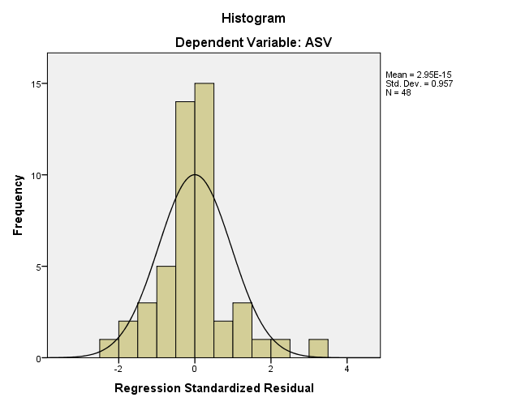
Figure 4.1: Histogram of the residuals fit with normal by using SPSS for Bale-exit road section
In the Histogram, the graph was bell-shaped curve, so it is normal. And also, the mean and standard deviation of the histogram are near to the standard normal distribution
Numerical test for normality of data
Table 4.1 Tests of normality for Bale-exit
Tests of Normality
Kolmogorov-Smirnovª |  |  | Shapiro-Wilk
Statistic | Df | Sig. | Statistic | Df | Sig.
.218 | 48 | .000 | .647 | 48 | .000
a. Lilliefors Significance Correction
From Table4.1, both Kolmogorov-Smirnov and Shapiro-Wilk tests indicate that our data was normal. So that there is no normality problem.
2. The assumption of Linearity of the data: This assumption states that there must be a linear relationship between the outcome variable and the independent variables. That is, the regression model must be linear in their parameters. The relationship between the dependent variable and each independent variable should be linear, and all observations should be independent.
A scatter plot displays the nature of the relationship between variables. If there is no relationship between the variables (i.e., the point on the graph is not clustered in a straight line), then a regression would not be appropriate to use. For the Bale-exit road section, this assumption is checked by using the scatter plots of average speed versus independent parameters.
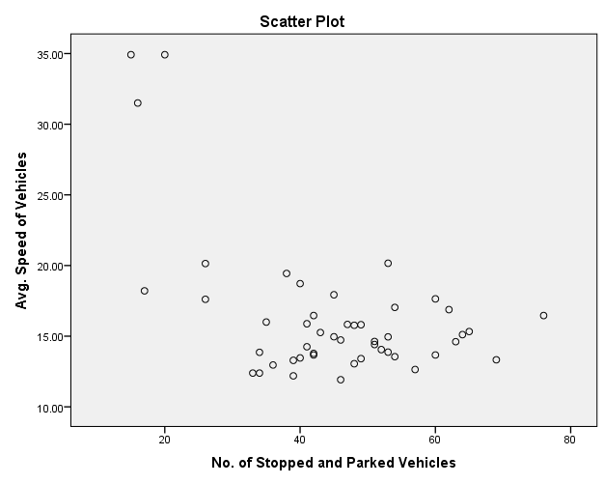
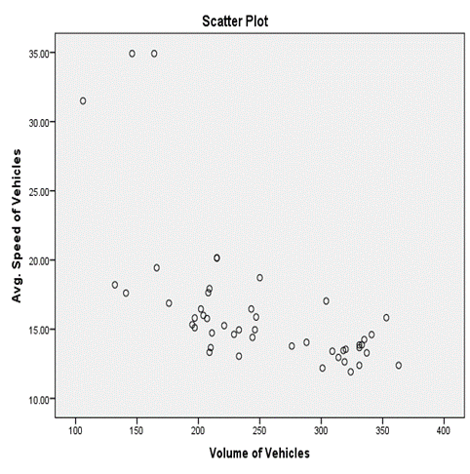
Fig 4.2 Scatter plot for ASV versus NSPV Fig 4.3 Scatter plot for ASV versus VV

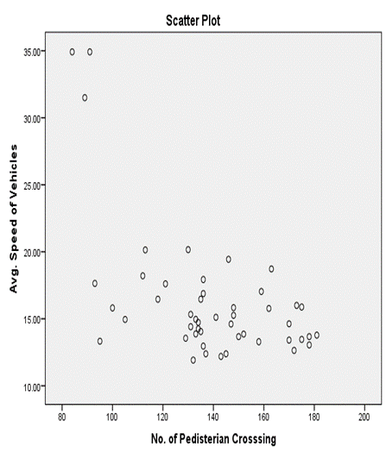
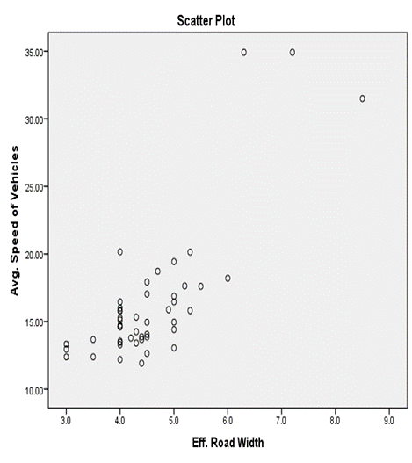
Fig 4.4 Scatter plot for ASV versus ERW Fig 4.5 Scatter plot for ASV versus NPC

From the 4.2, 4.3, 4.4, and 4.5 figures since the points on the graphs are clustered, then multiple linear regression would be appropriate analysis to use for this data set.
3. Assumption of Non-Multicollinearity among the Explanatory Variables: Multicollinearity generally occurs when there are high correlations between two or more predictor variables. In other words, one predictor variable can be used to predict the other. This create redundant information, skewing the results in a regression model. When the condition is present, it can result in unstable and unreliable regression estimates. This assumption states that two or more explanatory variables are not highly correlated to each other. Multicollinearity problems weaken the significance of the model by reducing either the individual t-statistics or F.
For this study Complex matric used as us a diagnostic measure to check whether our independent variables are correlated or not.

Table 4.2 Coefficient Correlations matrix obtained from SPSS for Bale-exit road section
Correlations
Control Variables |  |  | VV | NSPV | NPC | ERW
ASV | VV | Correlation | 1.000 | -.134 | .152 | -.212
ASV | VV | Significance (2-tailed) | . | .369 | .308 | .152
ASV | NSPV | Correlation |  | 1.000 | -.149 | -.199
 |  | Significance (2-tailed) |  |  | .319 | .179
 | NPC | Correlation |  |  | 1.000 | -.137
 | NPC | Significance (2-tailed) |  |  | . | .360
 | ERW | Correlation |  |  |  | 1.000
 | ERW | Significance (2-tailed) |  |  |  | .

From table 4.2, the correlation coefficient and two-tailed significance level indicate that there is no significant relationship between independent variables at 5% level of significance.
Checking multiple linear regression assumptions for Shewabar road section
For the Shewabar road section, the assumption of normality distribution of data was checked by using numerical test and histogram of residuals.
Graphically by using histogram.
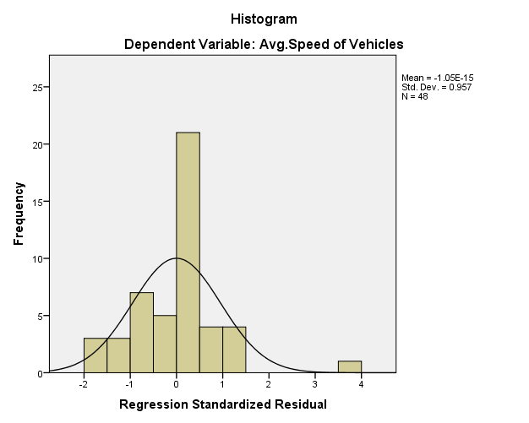
Figure 4.6: Histogram of the residuals fit with normal by using SPSS for Shewabar road section

From fig 4.6, the graph was an almost bell-shaped curve, so it is normal. And also, the mean and standard deviation of the histogram are near to the standard normal distribution.
For the Shewabar road section, the linearity assumption was checked by using the scatter plots of average speed versus independent parameters.
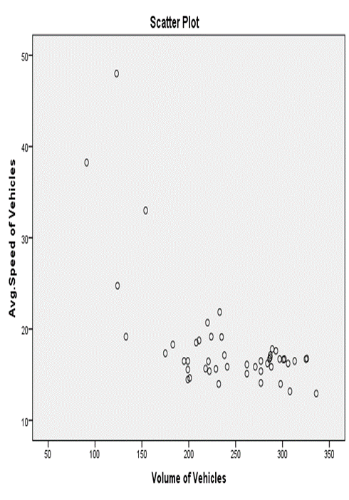
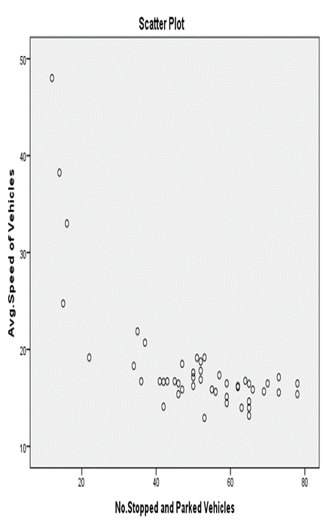
Fig 4.7 Scatter plot for ASV versus VV Fig 4.8 Scatter plot for ASV versus NSPV
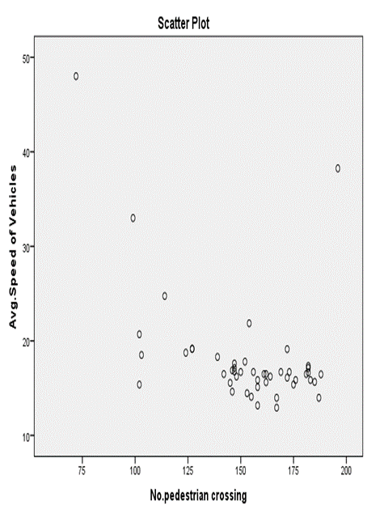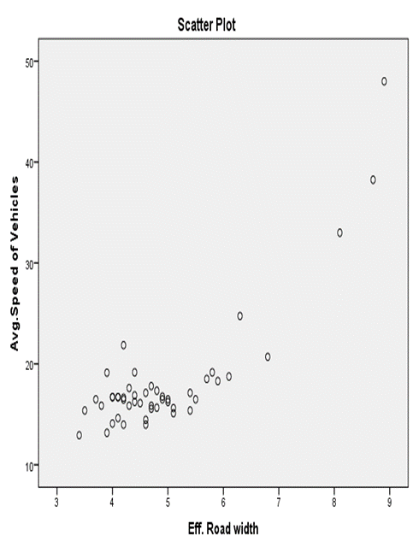 Fig 4.9 Scatter plot for ASV versus NPC Fig 4.10 Scatter plot for ASV versus ERW
From 4.7,4.8,4.9 and 4.10 figures since the points on the graphs are clustered, then multiple linear regression would be appropriate analysis to use for this data set.
For the Shewabar road section, the Complex matric used as us a diagnostic measure to check whether our independent variables are correlated or not.
Table 4.3 Coefficient Correlations matrix obtained from SPSS for Shewabar road section
Correlations
Control Variables |  |  | x1 | x2 | x3 | x4
Y | x1 | Correlation | 1.000 | -.085 | .221 | -.464
Y | x1 | Significance (2-tailed) | . | .570 | .136 | .061
Y | x2 | Correlation |  | 1.000 | .107 | .003
Y | x2 | Significance (2-tailed) |  | . | .474 | .984
Y | x3 | Correlation |  |  | 1.000 | -.269
Y | x3 | Significance (2-tailed) |  |  | . | .067
Y | x4 | Correlation |  |  |  | 1.000

From table 4.3, the correlation coefficient and two-tailed significance level indicate that there is no significant relationship between independent variables at 5% level of significance.

4.3 Developing of Multiple Linear Regression Model
Multiple regression is a model for the relationship between a dependent variable and a collection of independent variables. Linear regression is used to model the value of a dependent scale variable based on its linear relationship or “straight line” relationship to one or more predictors.

4.3.1 Developing Multiple Linear Regression for Bale-exit Road section
The multiple regression equation of the average travel speeds for Bale-exit road section, was as follows:
$ASV=17.764-0.016VV-0.072NSPV-0.037NPC+2.388ERW$ .. (Equation 4.1)
Where:
ASV= Average speed of vehicles (KPH) within the 15-minute time interval between a fixed baseline along the selected road section.
VV= Volume of vehicles (vehicles number) within 15 minute time interval between fixed baseline along the selected road section.
NSPV= Number of stopped and parked vehicles within the 15-minute time interval between a fixed baseline along the selected road section.
NPC=Number of pedestrian crossing a road section within 15 minute time interval between fixed base line along the selected road section.
ERW= Effective road width (m) within 15 minute time interval between fixed baseline along the selected road section.
Detail output of multiple regression analysis that was displayed in Table 4.4 shows at α= 0.05 significance level, the volume of vehicles, number of stopped and parked vehicles, and effective road width appear to be statistically significant predictors of the average speed of vehicles. However, a number of the pedestrian crossing is not significant (with a p-value of 0.058) and are therefore not included.
Table 4.4 Output of Multiple Regression analysis of Bale-exit road section
Coefficientsª
Model |  | Unstandardized Coefficients |  | Standardized Coefficients | T | Sig. | 95.0% Confidence Interval for B
 |  | B | Std. Error | Beta | T | Sig. | Lower Bound | Upper Bound
1 | (Constant) | 17.764 | 5.969 |  | 2.976 | .005 | 5.727 | 29.802
1 | Volume of vehicles | -.016 | .008 | -.210 | -2.016 | .050 | -.031 | .000
1 | No. Stopped and Parked Vehicles | -.072 | .036 | -.196 | -2.031 | .049 | -.144 | .000
1 | No. Pedestrian Crossing | -.037 | .019 | -.191 | -1.949 | .058 | -.075 | .001
1 | Effective Road Width | 2.388 | .631 | .469 | 3.786 | .000 | 1.116 | 3.660
a. Dependent Variable: ASV(average speed of vehicles)

Model Summary
Table 4.5 Model summary output for Bale-exit multiple regression
Model Summary
Model | R | R Square | Adjusted R Square | Std. Error of the Estimate | Change Statistics
 |  |  |  |  | R Square Change | F Change | df1 | df2 | Sig. F Change
1 | .845ª | .713 | .687 | 2.81034 | .713 | 26.767 | 4 | 43 | .000
a. Predictors: (Constant), ERW, NPC, NSPV, VV

From table 4.5 Since Fcal=26.767 > Fα (4, 43) = 2.61 (Appendix 3) indicates the overall model is significant. The value of R2 = 0.713 means that the model (the three variables) explains 71.3% of the observed variation in the average speed of vehicles (this model can predict the average speed of vehicles 71.3% correctly).
The final multiple regression equation for Bale-exit road section is
$ASV=17.764-0.016VV-0.072NSPV+2.388ERW$…….. (Equation 4.2)
- When the number of stopped and parked vehicles and effective road width are held constant, the average speed of vehicles decreases by 0.016km/hr for each 1 unit increase in the volume of vehicles.
- When the volume of vehicles and effective road width are held constant, the average speed of vehicles decreases by 0.072km/hr for each 1 unit increase in the number of stopped and parked vehicles.
- When the volume of vehicles and the number of stopped and parked vehicles are held constant, the average speed of vehicles increases by 2.388km/hr for each 1meter increase in the effective road width.
- When the vehicle's volume, parked vehicles, and effective road width are held constant, the average speed of vehicles will be 17.764km/hr.

4.3.2 Developing Multiple Linear Regression for Shewabar Road section
The multiple regression equation of the average travel speeds for Shewabar road section, was as follows:
$ASV=11.869-0.006VV-0.119NSPV-0.009NPC+3.091ERW$.. (Equation 4.3)
Where
ASV= Average speed of vehicles (km/hr) within the 15-minute time interval between fixed baseline along the selected road section.
VV= Volume of vehicles (vehicles number) within 15 minute time interval between a fixed baseline along the selected road section.
NSPV= Number of stopped and parked vehicles within a 15-minute time interval between a fixed baseline along the selected road section.
NPC=Number of pedestrian crossing a road section within 15 minute time interval between fixed base line along the selected road section.
ERW= Effective road width (m) within 15 minute time interval between fixed baseline along the selected road section.

Table 4.6 Output of Multiple Regression analysis of Shewabar road section
Coefficients
Model |  | Unstandardized Coefficients |  | Standardized Coefficients | T | Sig. | 95.0% Confidence Interval for B
 |  | B | Std. Error | Beta | T | Sig. | Lower Bound | Upper Bound
1 | (Constant) | 11.869 | 6.680 |  | 1.777 | .043 | 1.602 | 25.341
1 | Volume of Vehicles | -.006 | .011 | -.054 | -.522 | .605 | -.028 | .016
1 | No.of Stopped and Parked Vehicles | -.119 | .034 | -.313 | -3.463 | .001 | -.188 | -.050
1 | No.pedestrian crossing | -.009 | .019 | -.041 | -.498 | .621 | -.047 | .028
1 | Eff. Road width | 3.091 | .623 | .600 | 4.958 | .000 | 1.834 | 4.348
a. Dependent Variable: Avg.Speed of Vehicles

At α= 0.05 significance level, the number of stopped and parked vehicles and effective road width appear to be statistically significant predictors of the average speed of vehicles. However, pedestrian crossing and volume of vehicles are not significant predictors of the average speed of vehicles at α=0.05.
Table 4.7Model summary output for Shewabar multiple regression
Model Summary
Model | R | R Square | Adjusted R Square | Std. Error of the Estimate | Change Statistics
 |  |  |  |  | R Square Change | F Change | df1 | df2 | Sig. F Change
1 | .883ª | .779 | .758 | 3.055 | .779 | 37.862 | 4 | 43 | .000
a. Predictors: (Constant), Eff. Road width, No.pedestrian crossing, No.Stopped and Parked Vehicles, Volume of Vehicles

Since F_{cal}=37.862 > F_{0.05}(4,43) = 2.61 indicates the overall model is significant. The value of R² = 0.758 means that the model (the three variables) explains 75.8% of the observed variation in the average speed of vehicles (this model can predict the average speed of vehicles 75.8% correctly).
The final multiple regression equation for Bale-exit road section is
$ASV=11.869-.119NSPV+3.091ER$…… (Equation 4.4)
- When the effective road width is held constant, the average speed of vehicles is decreased by 0.119km/hr for one unit increased by the number of stopped and parked vehicles.
- When the number of stopped and parked vehicles is held constant, the average speed of vehicles is increased by 3.091km/hr for every 1-meter increase in effective road width
- When they stopped, and parked vehicles and effective road width are held constant, the average speed of vehicles will be 11.869km/hr.

4.8 Result of Multiple Regression Average speed Analysis for both road sections
Variable |  | Regression coefficient of the studied road section
 |  | Bale-exit road section | Shewabar road section
 | Constant | 17.764 | 11.869
VOV | Volume of Vehicles (veh.No.) | -0.016 | Not Significant
ERW | Effective Road Width (m) | 2.388 | 3.091
NPC | Number of Pedestrian Crossing | Not significant | Not significant
NSPV | Number Stopped and Parked Vehicles (Veh. No.) | -0.072 | -0.0119
R² | Adjusted R square | 0.758 | 0.713
Results from multiple linear regression analysis showed that for Shewabar road section Effective Road width and parking volume ( number of stopped and parked vehicles) had a significant impact on average travel speed with a high degree of explanation (R²=0.758). Results for the Bale-exit study showed that traffic flow (volume of vehicles), Parking volume (number of stopped and parked vehicles), and Effective road width had a significant impact on the average travel speed of vehicles with (R² = 0.713).
The results have shown that on-street parking has a noticeable effect on travel speeds, even in collector streets. The effects were strongest on the Shewabar road section (12 narrower streets). It was also expected that narrower streets would have lower speeds, all other factors being equal. Another hypothesis suggested was that narrower streets would have been more affected by the presence of parking than wider streets.
Several significant on-street parking variables influencing speed were identified in the analysis using collected field data: parking volume (number of stopped and parked vehicles), Traffic flow (volume of vehicles), number of a pedestrian crossing, and effective road width. These results were used as a basis for simulation model calibration. Multiple regression analysis of simulations for Shewabar road section results showed that effective road width had a significant impact on average travel speed. Parking volume (number of stopped and parked vehicles) was also significant. The resulting equation from the study was
$ASV=11.869-.119NSPV+3.091ER$….. (Equation 4.5)

The results of the regression analysis of traffic data for Bale-exit road section study showed traffic flow (volume of vehicles), parking volume (number stopped and parked vehicles) and Effective road width have a significant impact on the average travel speed of vehicles to have a high degree of explanation (R²=0.713). The resulting equation from the study was
$ASV=17.764-0.016VV-0.072NSPV+2.388E$… (Equation 4.6)
As the tables 4.8 indicate, a reasonably consistent average speed reduction of vehicles as parking volume (number of stopped and parked vehicles) increase. For each group of streets, a linear relationship has been interpolated to determine the average change in speeds. The speeds were found to fall by 0.072km/h for every single vehicle rise in the parking volume for the Bale-exit road section o.016km/h fall for Shewabar Street. The results have shown that on-street parking has a noticeable effect on travel speeds, and the effects were strongest on the Shewabar road section.

4.4 Analyzing the extent of Speed Reduction Suffered by the NSPV

4.4.1 Analyzing the extent of Speed Reduction by the NSPV for Bale-exit Road Section
The number of On-street stopped and parked vehicles have a significant influence on the traffic flow because they interfere with passing vehicles primarily while vehicles maneuver to pull into and out of the vehicles park. On the Bale-exit road section, Auto rickshaw uses the main road as a terminal to serve commuters that are moving to-ward Places such as Abosto, Samniand , Salasa, Alelu and the like. These stopped and parked Taxis and rickshaw are primarily conflict with other passing vehicles when rickshaw maneuver to pull into and out of the stop.
Results from multiple regression analyses showed (Equation 4.2) that the average speed of vehicles is decreased by 0.072 km/hr for each 1 unit increase in the number of stopped and parked vehicles. This means if 10 vehicles are stopped and parked on street the speed of passing vehicles reduced by 0.72 km/hr. During traffic survey data the maximum number of stopped and parked vehicles was 76 vehicles. In this circumstance, the average speed of vehicles are decreased by 5.5 km/hr. From the twelve hours field surveyed data within the 15-minute time interval along the selected Bale-exit road (Appendix 5.1), by an average 45 vehicles was stopped and parked on-street. This was reduced travel speed by 3.42 km/hr.
From the analysis of data, we can judge that On-street parking vehicles will interfere with vehicle movement, resulting in some vehicle congestion. Under the heterogeneous traffic flow conditions, the buses, being relatively larger vehicles, find it difficult to maneuver through the mixed traffic and are subject to frequent acceleration and deceleration, leading to lower speed and discomfort to both the driver and passengers. This also results in enormous delays and uncertainty of travel time to bus passengers.

4.4.2 Analyzing the extent of Speed Reduction by the NSPV for Shewabar Road Section
The developed regression model (Equation 4.4) above from the field surveyed traffic data analysis for Shewabar road section showed that, the number of on-street stopped and parked vehicles have a significant effect on travel speed of passing vehicles. Travel speeds fell gradually with an increase in parking levels (Number of stopped and parked vehicles), although the rate varies across the different time intervals. The average speed of vehicles is decreased by 0.119km/hr for one unit increased by the number of stopped and parked vehicles.
As shown in Appendix 4.2, the number of on-street parked and stopped vehicles are varies across the different time intervals ranging from 14 to 78 in vehicles. This means When the NSPV are 14 vehicles the average speed of vehicles is decreased by 1.6 km/hr and When the NSPV are 78 vehicles the average speed of vehicles is decreased by 9.3 km/hr. from the twelve hours parking volume study, the average NSPV was 52 vehicles. The average speed of vehicles is decreased by 6.2km/hr for 52 vehicles increased by the number of stopped and parked vehicles.

4.5 Evaluation of the Impacts of Decreasing in ERW on Travel Speed

4.5.1 Impacts of Decreasing in ERW on Travel Speed for Bale-exit Road section
Whenever a vehicle is parking on-street, the effective road width available for traffic movement reduces, thereby reducing the traffic speed. The effect caused by the activity of on-street parking vehicles on the quality of traffic speed resulting due to reduced road width. This reduced speed of traffic is a key factor that influences the traffic dynamics at on-street parking. Results from multiple regression analyses for the Bale-exit road section show that effective road width has a significant impact on the average speed of vehicles.
The output from SPSS regression analysis of Bale-exit road section showed that effective road width have a direct positive relationship with the average speed of vehicles. Decreasing the effective road width due to the presence of on-street parked vehicles was reduces average travel speed of vehicles. As indicated by Equation 4.2, the average speed of vehicles decreases by 2.388 km/hr for each 1meter decrease in the effective road width. This means from the total width of 14 meter (Bale-exit road width) when 10 meter of the road width is occupied by the on-steer parking vehicles and only 4 meter effective road width was left for moving vehicles, the average speed of travel vehicles are decreased by 23.88 km/hr.
From 12 hour traffic data survey of Bale-exit road section (Appendix5.1), out of 14 meter of the total carriage width, averagely 67.8% in other word 9.5 meter have been occupied on-street parking vehicles. Only 32.2% from total carriage width are the effective road width in which moving vehicles have used. This means on average, travel speed of vehicles decreased by 22.686 km/hr due to the reduction of effective road by the on-street parking vehicles.
On the Bale-exit road section, on-street parking primarily conflicts with other passing vehicles when vehicles maneuver to pull into and out of the stop, resulting in speed loss. Presence of on-street parked vehicles blocking the running lane and resulting in reducing traffic speed. When vehicles stop located on the carriageway, vehicles blocking the curbside traffic lane during their occupancy period due to the reduced width of the roadway, this vehicle stop also creates problems when attempting to re-enter the traffic, especially during the peak-hour period of high roadway traffic volumes.

4.5.2 Impacts of Decreasing in ERW on Travel Speed for Shewabar Road section
From the above data analysis by multiple regression for the Shewabar road section (Equation 4.4), it can be inferred that the effective lane width of the road segment with on-street parking significantly influences the traffic speed. The average speed of vehicles increases when the carriage lane has small parked vehicles so that there is enough effective road width for passing vehicles and vice versa.
Along the Shewabar road section, one factor that affects a driver's choice of speed is the presence of on-street parking, which can narrow the perceived available width of the road ahead. Enough availability of road width will guide the drivers to accelerate or decelerate. The above-developed model for Shewabar shows that the average speed of vehicles is increased by 3.091km/hr for every 1-meter increase in effective road width.
From 12 hour traffic data survey of Bale-exit road section (Appendix4.1), out of 12 meter of the total carriage width, averagely 59.2% in other word 7.1 meter have been occupied on-street parking vehicles. Only 40.8% from total carriage width are the effective road width in which moving vehicles have used. This means on average, travel speed of vehicles decreased by 21.94 km/hr due to the reduction of effective road by the on-street parking vehicles.

5. CONCLUSIONS AND RECOMMENDATIONS

5.1 Conclusions
In the study, an attempt is made to quantify the reduction in the travel speed of due to the presence of on-street parking. Purposely two road sections (Bale-exit and Shewabar road section) that had on-street parking of vehicles as the main hindrance for travel speed was chosen. The three main assumptions of multiple linear regression model that traffic data should fulfill in order to be actually usable in practice, assumption of Normality of the error term, assumption of linearity of the data and Assumption of Non-Multicollinearity among the Explanatory Variables have checked and conformed. Hence, multiple linear Regression model represents the relationship between travel speed and major factor affecting travel speed due to the on-street parking of vehicles. The model is then developed from surveyed traffic data for both Bale-exit and Shewabar road sections for analysis. The result shows that on-street parking has a noticeable effect on traffic speed.
It is concluded from statistical analysis that for both Bale-exit and Shewabar road sections, the number of stopped and parked vehicles (Parking volume) had a significant impact on average travel speed with a high degree of explanation section R²=0.758 and R²=0.713 respectively. The average speed of vehicles decreases by 0.072km/hr and 0.119km/hr for each 1 vehicle increase in the number of stopped and parked vehicles, respectively for Bale-exit and Shewabar road sections. From the twelve hours field surveyed data within the 15-minute time interval along the selected Bale-exit road (Appendix 5.1), by an average 45 vehicles was stopped and parked on-street. This was reduced travel speed by 3.42 km/hr. In a similar manner, for Shewabar the number of on-street parked and stopped vehicles are varies across the different time intervals ranging from 14 to 78 in vehicles. This means When the NSPV are 14 vehicles the average speed of vehicles is decreased by 1.6 km/hr and When the NSPV are 78 vehicles the average speed of vehicles is decreased by 9.3 km/hr. From the analysis of data, we can judge that On-street stopped and parked vehicles will interfere with vehicle movement, resulting in travel speed reduction.
In a similar manner, results from multiple linear regression analysis for both road sections showed that Effective Road width had a significant impact on average travel speed with a high degree of explanation section. It is concluded that the average speed of vehicles decreased by 2.388km/hr and 3.091km/hr for every 1 meter decreased in effective road width for Bale-exit and Shewabar roads, respectively. From 12 hour traffic data survey of Bale-exit road section (Appendix5.1), out of 14 meter of the total carriage width, averagely 67.8% in other word 9.5 meter have been occupied on-street parking vehicles. Only 32.2% from total carriage width are the effective road width in which moving vehicles have used. This means on average, travel speed of vehicles decreased by 22.686 km/hr due to the reduction of effective road by on-street parking vehicles. Therefore, decreasing in Effective road width by on-street parking vehicle is a key factor that reduce travel speed of vehicles at Shashamane city.

5.2 Recommendations
To improve the existing traffic speed of the Shashamane city, Road authorities and transportation authorities of the Shashamane city use a number of traffic control measures to reduce traffic congestion caused due to on-street parking of vehicles. About 78% composition of observed vehicles around the Shewabar and Bale-exit road sections are Taxis and Auto rickshaw (Badjaj), and they are more affecting travel speed. It is recommended to explore the possibility of removing them or relocating them to adjacent local streets.
Off-street parking facilities/spaces should be provided in designated areas. Insufficient off-street parking facilities result in on-street parking, which reduces the effective width of roads, thus leading to obstruction of traffic flow. This type of parking space is not located at Shashamane city and can be operated by the public or private sector or organization. It promises to provide accessibility for people to visit downtown or any places within the city because the people are the confidence of where to park.
In Shashamane, low traffic enforcement is very poor, most of the small buses, by denying enter of bus station they are illegally parking on-street to collect passengers, and heavy trucks are parked on-street illegally to load and unload the freight. To this end, Police and the traffic Management Authorities are the frontlines in traffic laws. They should be mandated to enforce the rules and regulations binding the vehicular traffic operations without any fear in order to improve the effects caused by on-street parking
In this study, traffic data was collected, analyzed, and applied for multiple regression models of average speed for the presented conclusions. This method could be developed to gain enhanced knowledge of the effects of on-street parking on traffic speed by improving the data collection method and carried out more efficiently. A number of further tasks are recommended by increasing the number of sites in each width category, and choosing sites that have a greater number of different parking demand levels would be helpful in obtaining more accurate and/or more conclusive results.

REFERENCES
American Association of State Highway and Transportation Officials (AASHTO) (2011). A Policy on Geometric Design of Highways and Streets, 6th ed., AASHTO, Washington DC.
Aronsson KFM (2006). Speed characteristics of urban streets based on driver behavior studies and simulation. Royal Institute of Technology in Stockholm
Algburi.S and Ozen.H (2017). Characteristics of on-street parking in Istanbul. Sigma J Eng & Nat Sci 35 (4), 2017, 575-584
Cao Y, Yang ZZ, Zuo ZY (2017). The effect of curb parking on road capacity and traffic safety. Eur Transp Res Rev 9(4):1–10. doi:10.1007/s12544-016-0219-3
Chiguma MLM (2007). Analysis of side friction impact on urban road links; case study Dar-es-salaam. Royal Institute of Technology Stockholm, Sweden
Chiguma MLM, Bang K (2007). Impact of individual side friction factors on free-flow speed: a Case study on urban road links in Dar-es-Salaam, Tanzania. 86th Annu. Meet. Transp. Res. Board (CD-ROM), Natl. Acad. Washington. D.C.
Duane S., Jeff .M, Mark. A., Sarah.M. (2002). Handbook of Simplified Practice for
Traffic Studies. Center for Transportation Research and Education Iowa State University. Iowa DOT Project TR-455. CTRE Project 01-80.
Edquist J, Rudin-Brown CM, Lenné MG (2012). The effects of on-street parking and road environment visual complexity on travel speed and reaction time. Accid Anal Prev 45:759–765.doi:10.1016/j.aap.2011.10.001
Glen k. and Praburam, G. (2014). Effect of On-Street Parking on Traffic Speeds. Master of Engineering in Transportation (MET) research report, Department of Civil and Natural Resources Engineering, University of Canterbury
Guo H, Wang W, Guo W (2012).Micro-simulation study on the effect of on-street parking on vehicular flow. 15th Int IEEE Conf Intell Transp Syst Anchorage, Alaska, USA 1840–1845. doi:10.1109/ITSC.2012.6338713
Halkiyo, J.B., Halkiyu, S.B., &Reddy, R.R., (2017).Road accident of Arbaminch Town in Ethiopia: An Empirical Study. International journal of civil engineering, 4(3), pp 29-33
Humphreys JB, Box PC, Sullivan TD, Wheeler DJ (1978). Safety aspects of curb parking. Report No. FHWA-RD-79-76, Federal Highway Administration, Washington D.C
Institute of Transportation Engineers-ITE (1987), Parking Generation Handbook, 3rd Edition, Washington, DC
Ivan JN, Garrick NW, Hanson G (2009), designing roads that guide drivers to choose safer speeds. Report No. JHR-09-321, Connecticut Transportation Institute, University of Connecticut, Storrs, Connecticut
Johnnie Ben-Edigbe and Mrs.Nordiana Mashros. (2011). Determining the Impact of Bus-Stops on Roadway Capacity"
Kladeftiras M, Antoniou C (2013) Simulation-based assessment of double-parking impacts on traffic and environmental conditions. Transp Res Rec J Transp Res Board 2390:121–130.doi:10.3141/2390-13
Marshall W, Garrick N, Hansen G (2008) Reassessing on-street parking. Transp Res Rec J Transp Res Board 2046:45–52. doi:10.3141/2046-06
Mofizul Islam, Md. Shamim Al Razib, Md. Mahmudul Hasan, Md. Shapon Ali, Md. Ohab Monir, Md. Hasan,(2018) Cause of Reduction of Effective Roadway Width Due to Side Friction in Dhaka City. American Journal of Traffic and Transportation Engineering.Vol. 3, No. 1, 2018, pp. 6-17. doi: 10.11648/j.ajtte.20180301.12
Mohiuddin Imran, Md. Imran Hossain, (2016). A Brief Study on Capacity Loss at Major Dhaka City Roads. International Journal of Transportation Engineering and Technology. Vol. 2, No. 1, 2016, pp. 1-7. doi: 10.11648/j.ijtet.20160201.11
Nicholas J. Garber, Lester A.Hoel, (2009). Traffic and Highway Engineering fourth edition, University of Virginia.
Olorunfemi Samuel Oluwaseyi, Olowosegun Adebola, Koffi Ayadu Edwin, 4Okoko Eno .E1and Mobolaji Stephen,(2014). Examination of On-Street Parking and Traffic Congestion Problems in Lokoja. Civil and Environmental Research www.iiste.org ISSN 2224-5790 (Paper) ISSN 2225-0514 (Online) Vol.6, No.4, 2014
Parma, K. (2001). Survey of Speed Zoning Practices: An Informational Report. Washington, D.C. Institute of Transportation Engineers.

Prof.Dr Samy Tayie (2005). Research Methods and Writing Reseach Proposal. Cairo University (CAPSDU) ISNB 977-403-013-3
Raju Ramesh Reddy,(2017). "Evaluation of Rate of the Reduction in Road Capacity at Kerb side Bus Stop in Urban areas under Mixed Traffic conditions – a case study in Hyderabad city." IOSR Journal of Mechanical and Civil Engineering (IOSR-JMCE) 14.4 (2017): 01-08.
Reddy IR, Rao SN, Rao CR (2008) Modelling and evaluation patterns on the impact of on-street parking in reference to traffic mobility. J Indian Roads Congr 69:101–109
Reihani SH, Naseri A, Sorkhabi RVP, Zehforoush K (2013) Modelling the impact of on-street parking on main parameters on vehicular traffic. Life Sci J 10:1689–1699. doi:10.1017/ CBO9781107415324.004
Robertson, H. D. (1994). Spot Speed Studies. In Manual of Transportation Engineering Studies, ed. H. D. Robertson, J. E. Hummer, D. C. Nelson. Englewood Cliffs, N.J.: Prentice Hall, Inc., pp. 33–51.
Rudjanakanoknad J (2010) Analysis of factors affecting street bottleneck capacity through oblique cumulative plots. J East Asia Soc Transp Stud 8:1621–1631
Sahan Wijayaratna. (2015).Impacts of On-street parking on Road Capacity. Australasian Transport Research Forum 2015 Proceedings30 September - 2 October 2015, Sydney, AustraliaPublication website: http://www.atrf.info/papers/index.aspx
Salini S, George S, Ashalatha R (2016) Effect of side frictions on traffic characteristics of urban arterials. Transp Res Procedia 17:636–643. doi:10.1016/j.trpro.2016.11.118
Samy Taye (2005). Research methods and writing research proposal. Center for advancement of post graduate studies and research in Engineering studies science, faculty of Engineering Cairo University (CAPSCU). ISBN 977-403-013-3.
Sharma, S. C.( 1994). Seasonal Traffic Counts for a Precise Estimation of AADT. ITE Journal, Vol.64, No. 9, pp. 34–41.
Shashamane transportation office report (2017). Annual report of the transportation system of the Shashamane city.
Sirous Heidar Reihani,Alireza Naseri, Ramin Vafaei Pour Sorkhabi , Kasra Zehforoush (2013). Modeling the Impact of On-Street Parking on Main Parameters on VehicularTraffic. Life Science Journal 2013;10 (6s). (ISSN: 1097-8135).
Subhadip Biswas, Satish Chandra, Indrajit Ghosh. (2017). Effects of On-Street Parking in Urban Context: A Critical Review. Published Springer International Publishing Switzerland 2017
Transportation research board (2010). Highway capacity manual. Washington, D.C.
W. L. R Kadiyali. (1987). Traffic Engineering and Transportation Planning. New Delhi: Khanna Publishers
W.M. Daniel Stofan (2017) Development Data Collection Methods. Washington, D.C.
Wang J, Dixon KK, Li H, Hunter M (2006) Operating speed models for low-speed urban environment based on in-vehicle GPS data. Transp. Res. Rec. J. Transp. Res. Board, 1961

APPENDIX 1 OUTPUT OF MULTIPLE REGRESSION ANALYSIS OF BALE-EXIT ROAD SECTION
Coefficients
Model |  |  |  |  | Unstandardized Coefficients |  |  |  | Standardized Coefficients |  | t |  | Sig. |  | 95.0% Confidence Interval for B
 |  |  |  |  | B |  |  | Std. Error | Beta |  |  |  |  |  | Lower Bound |  |  | Upper Bound
1 |  |  | (Constant) |  | 17.764 |  |  | 5.969 |  |  | 2.976 |  | .005 |  | 5.727 |  |  | 29.802
 |  |  | Volume of vehicles |  | -.016 |  |  | .008 | -.210 |  | -2.016 |  | .050 |  | -.031 |  |  | .000
 |  |  | No. Stopped and Parked Vehicles |  | -.072 |  |  | .036 | -.196 |  | -2.031 |  | .049 |  | -.144 |  |  | .000
 |  |  | No. Pedestrian Crossing |  | -.037 |  |  | .019 | -.191 |  | -1.949 |  | .058 |  | -.075 |  |  | .001
 |  |  | Effective Road Width |  | 2.388 |  |  | .631 | .469 |  | 3.786 |  | .000 |  | 1.116 |  |  | 3.660
a. Dependent Variable: ASV(average speed of vehicles)
 | Model Summary
 | Model | R |  | R Square |  | Adjusted R Square | Std. Error of the Estimate |  |  | Change Statistics
 |  |  |  |  |  |  |  |  |  | R Square Change |  | F Change |  | df1 |  | df2 | Sig. F Change
 | 1 | .845ª |  | .713 |  | .687 | 2.81034 |  |  | .713 |  | 26.767 |  | 4 |  | 43 | .000
 | a. Predictors: (Constant), ERW, NPC, NSPV, VV

APPENDIX 2 OUTPUT OF MULTIPLE REGRESSION ANALYSIS OF SHEWABAR ROAD SECTION
 | Coefficientsª
 | Model |  |  |  |  | Unstandardized Coefficients |  |  | Standardized Coefficients |  | T |  | Sig. |  | 95.0% Confidence Interval for B
 |  |  |  |  |  | B | Std. Error |  | Beta |  |  |  |  |  | Lower Bound |  |  | Upper Bound
 | 1 | (Constant) |  |  |  | 11.869 | 6.680 |  |  |  | 1.777 |  | .043 |  | 1.602 |  |  | 25.341
 | 1 | Volume of Vehicles |  |  |  | -.006 | .011 |  | -.054 |  | -.522 |  | .605 |  | -.028 |  |  | .016
 | 1 | No.of Stopped and Parked Vehicles |  |  |  | -.119 | .034 |  | -.313 |  | -3.463 |  | .001 |  | -.188 |  |  | -.050
 | 1 | No.pedestrian crossing |  |  |  | -.009 | .019 |  | -.041 |  | -.498 |  | .621 |  | -.047 |  |  | .028
 | 1 | Eff. Road width |  |  |  | 3.091 | .623 |  | .600 |  | 4.958 |  | .000 |  | 1.834 |  |  | 4.348
 | a. Dependent Variable: Avg.Speed of Vehicles
Model Summary
Model |  |  | R | R Square | Adjusted R Square |  |  | Std. Error of the Estimate |  | Change Statistics
 |  |  |  |  |  |  |  |  |  | R Square Change |  | F Change |  | df1 |  | df2 | Sig. F Change
1 |  |  | .883ª | .779 | .758 |  |  | 3.055 |  | .779 |  | 37.862 |  | 4 |  | 43 | .000
a. Predictors: (Constant), Eff. Road width, No.pedestrian crossing, No.Stopped and Parked Vehicles, Volume of Vehicles

APPENDIX 3 F- D I ST R I B UT I O N P E R C E NTAG E P O I NTS (α =.05)
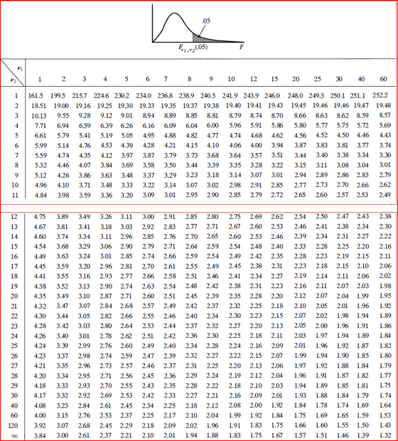

APPENDIX 4 DETAIL TRAFFIC DATA FOR SHEWABAR ROAD SECTION

Appendix 4.1 Effective Road width study
Time Interval | Effective road width in meter
Time Interval | For the 1st  3 min | For the 2nd  3 minute | For the  3rd  3 minute | For the  4th  3 minute | For the  Last  3 minte | Average ERW
7:00-7:15 | 9 | 10 | 8 | 8.5 | 8 | 8.7
7:15-7:30 | 7 | 6.5 | 5 | 8 | 5 | 6.3
7:30-7:45 | 6 | 5 | 6 | 6 | 6 | 5.8
7:45-8:00 | 6 | 5 | 7 | 5.5 | 6 | 5.9
8:00-8:15 | 5.5 | 7 | 5 | 6 | 4 | 5.5
8:15-8:30 | 6 | 7 | 5 | 5 | 5.5 | 5.7
8:30-8:45 | 5 | 3 | 3 | 4 | 7 | 4.4
8:45-9:00 | 5 | 4 | 6 | 3 | 3 | 4.2
9:00-9:15 | 6 | 3.5 | 5 | 3 | 3 | 4.1
9:15-9:30 | 5 | 4 | 3.5 | 3 | 2 | 3.5
9:30-9:45 | 5.5 | 5 | 4 | 4 | 5 | 4.7
9:45-10:00 | 6.5 | 5 | 4 | 5 | 4 | 4.9
10:00-10:15 | 4 | 5 | 4 | 5 | 5 | 4.6
10:15-10:30 | 5 | 5 | 7 | 3 | 3 | 4.6
10:30-10:45 | 6 | 6 | 4 | 4 | 4 | 4.8
10:45-11:00 | 5 | 5 | 4 | 5 | 5 | 4.8
11:00-11:15 | 3 | 4 | 5 | 4 | 5 | 4.2
11:15-11:30 | 5 | 6 | 4 | 5.5 | 5 | 5.1
11:30-11:45 | 6 | 6 | 4 | 3 | 2.5 | 4.1
11:45-12:00 | 5 | 5 | 4.5 | 5 | 6 | 5.1
12:00-12:15 | 2.5 | 2.5 | 5 | 6 | 4 | 4
12:15-12:30 | 4 | 3 | 4 | 3.5 | 4.5 | 3.8
12:30-12:45 | 4 | 3.5 | 3 | 4 | 5 | 3.9
12:45-1:00 | 7 | 4 | 3 | 3 | 4 | 4.4
1:00-1:15 | 5 | 3 | 4.5 | 3 | 5 | 4.1
1:15-1:30 | 5 | 3 | 4 | 3 | 3 | 4
1:30-1:45 | 4 | 4 | 3 | 4.5 | 5.5 | 4.2
1:45-2:00 | 5 | 5 | 4.5 | 3 | 4 | 4.3
2:00-2:15 | 4 | 4 | 6 | 6 | 7 | 5.4
2:15-2:30 | 5 | 6 | 4 | 3 | 3 | 4.2
2:30-2:45 | 4.5 | 4.5 | 5 | 3 | 3 | 3.9
2:45-3:00 | 3 | 4 | 3 | 3 | 4 | 3.4
3:00-3:15 | 4.5 | 3.5 | 3.5 | 4 | 3 | 3.7
3:15-3:30 | 3 | 4 | 3.5 | 4.5 | 5 | 4
3:30-3:45 | 5 | 3 | 4 | 5 | 4.5 | 4.3
3:45-4:00 | 6 | 5 | 3 | 3 | 6 | 4.6
4:00-4:15 | 5.5 | 4.5 | 3.5 | 5 | 5 | 4.7
4:15-4:30 | 4 | 4.5 | 5 | 4 | 5 | 4.5
4:30-4:45 | 6 | 4 | 4.5 | 4 | 5 | 4.7
4:45-5:00 | 4 | 4 | 6 | 4 | 6 | 4.4
5:00-5:15 | 7 | 5 | 3.5 | 4 | 5 | 4.9
5:15-5:30 | 5 | 5 | 5 | 5 | 5 | 5
5:30-5:45 | 6 | 3.5 | 4 | 4.5 | 7 | 5
5:45-6:00 | 6 | 5 | 7 | 5 | 4 | 5.4
6:00-6:15 | 8 | 6 | 6 | 6.5 | 6 | 6.1
6:15-6:30 | 5.5 | 6.5 | 5.5 | 6 | 5.5 | 6.8
6:30-6:45 | 10 | 7 | 8 | 6.5 | 9 | 8.1
6:45-7:00 | 9 | 8 | 10 | 7.5 | 10 | 8.9

Appendix 4.2 Parking volume and pedestrian study
Time interval | number of stopped and parked Vehicles | number of passenger crossing
7:00-7:15 | 14 | 96
7:15-7:30 | 15 | 114
7:30-7:45 | 22 | 127
7:45-8:00 | 34 | 139
8:00-8:15 | 59 | 142
8:15-8:30 | 47 | 103
8:30-8:45 | 53 | 127
8:45-9:00 | 35 | 154
9:00-9:15 | 65 | 146
9:15-9:30 | 78 | 102
9:30-9:45 | 73 | 145
9:45-10:00 | 78 | 181
10:00-10:15 | 59 | 153
10:15-10:30 | 63 | 187
10:30-10:45 | 57 | 182
10:45-11:00 | 69 | 185
11:00-11:15 | 65 | 188
11:15-11:30 | 59 | 158
11:30-11:45 | 41 | 169
11:45-12:00 | 56 | 162
12:00-12:15 | 42 | 155
12:15-12:30 | 47 | 158
12:30-12:45 | 51 | 172
12:45-1:00 | 50 | 148
1:00-1:15 | 36 | 156
1:15-1:30 | 45 | 173
1:30-1:45 | 42 | 182
1:45-2:00 | 55 | 176
2:00-2:15 | 46 | 175
2:15-2:30 | 65 | 167
2:30-2:45 | 65 | 158
2:45-3:00 | 53 | 167
3:00-3:15 | 46 | 161
3:15-3:30 | 43 | 150
3:30-3:45 | 50 | 147
3:45-4:00 | 50 | 182
4:00-4:15 | 66 | 183
4:15-4:30 | 62 | 172
4:30-4:45 | 52 | 152
4:45-5:00 | 52 | 146
5:00-5:15 | 64 | 147
5:15-5:30 | 62 | 164
5:30-5:45 | 70 | 162
5:45-6:00 | 73 | 147
6:00-6:15 | 52 | 124
6:15-6:30 | 37 | 102
6:30-6:45 | 22 | 99
6:45-7:00 | 20 | 72

Appendix 4. 3 volume study
Time interval | heavy truck   | light truck   | large Bus   | Small Bus   | Car   | Auto rickshow  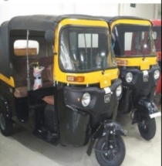 | TOTAL
7:00-7:15 | 0 | 2 | 0 | 5 | 4 | 81 | 91
7:15-7:30 | 0 | 4 | 0 | 7 | 5 | 108 | 124
7:30-7:45 | 0 | 3 | 0 | 5 | 6 | 119 | 133
7:45-8:00 | 0 | 7 | 0 | 9 | 11 | 156 | 183
8:00-8:15 | 0 | 6 | 0 | 8 | 9 | 174 | 199
8:15-8:30 | 0 | 8 | 0 | 8 | 9 | 181 | 208
8:30-8:45 | 0 | 7 | 0 | 10 | 16 | 189 | 224
8:45-9:00 | 0 | 6 | 0 | 7 | 14 | 206 | 233
9:00-9:15 | 0 | 7 | 0 | 10 | 6 | 176 | 201
9:15-9:30 | 0 | 8 | 0 | 10 | 7 | 195 | 222
9:30-9:45 | 1 | 3 | 0 | 8 | 5 | 180 | 199
9:45-10:00 | 0 | 2 | 0 | 9 | 7 | 175 | 195
10:00-10:15 | 0 | 6 | 0 | 8 | 7 | 176 | 199
10:15-10:30 | 0 | 5 | 0 | 8 | 9 | 208 | 232
10:30-10:45 | 3 | 3 | 1 | 7 | 6 | 155 | 175
10:45-11:00 | 1 | 1 | 0 | 7 | 8 | 201 | 218
11:00-11:15 | 0 | 2 | 1 | 7 | 6 | 205 | 221
11:15-11:30 | 0 | 6 | 0 | 3 | 9 | 242 | 262
11:30-11:45 | 0 | 7 | 0 | 4 | 8 | 265 | 286
11:45-12:00 | 0 | 4 | 0 | 6 | 6 | 213 | 229
12:00-12:15 | 0 | 4 | 0 | 6 | 5 | 260 | 277
12:15-12:30 | 0 | 4 | 0 | 7 | 11 | 247 | 271
12:30-12:45 | 0 | 7 | 0 | 4 | 10 | 212 | 235
12:45-1:00 | 0 | 4 | 0 | 10 | 7 | 261 | 284
1:00-1:15 | 0 | 5 | 0 | 5 | 10 | 280 | 302
1:15-1:30 | 0 | 5 | 0 | 9 | 7 | 274 | 297
1:30-1:45 | 0 | 6 | 0 | 6 | 8 | 279 | 301
1:45-2:00 | 0 | 7 | 0 | 8 | 6 | 265 | 288
2:00-2:15 | 0 | 2 | 0 | 6 | 8 | 259 | 277
2:15-2:30 | 0 | 4 | 2 | 5 | 9 | 278 | 298
2:30-2:45 | 0 | 5 | 0 | 5 | 8 | 288 | 308
2:45-3:00 | 0 | 6 | 0 | 6 | 12 | 310 | 336
3:00-3:15 | 1 | 8 | 1 | 10 | 8 | 283 | 313
3:15-3:30 | 0 | 4 | 1 | 8 | 10 | 300 | 325
3:30-3:45 | 0 | 6 | 2 | 9 | 7 | 267 | 293
3:45-4:00 | 0 | 8 | 0 | 12 | 6 | 259 | 287
4:00-4:15 | 0 | 4 | 1 | 6 | 6 | 224 | 241
4:15-4:30 | 1 | 5 | 0 | 10 | 6 | 238 | 262
4:30-4:45 | 2 | 3 | 0 | 8 | 6 | 268 | 289
4:45-5:00 | 0 | 1 | 0 | 11 | 9 | 266 | 287
5:00-5:15 | 0 | 4 | 0 | 8 | 6 | 306 | 326
5:15-5:30 | 0 | 6 | 0 | 8 | 6 | 286 | 306
5:30-5:45 | 0 | 5 | 0 | 5 | 7 | 258 | 277
5:45-6:00 | 0 | 2 | 0 | 5 | 6 | 225 | 238
6:00-6:15 | 0 | 3 | 0 | 5 | 8 | 195 | 211
6:15-6:30 | 0 | 1 | 0 | 2 | 7 | 210 | 220
6:30-6:45 | 0 | 2 | 0 | 0 | 5 | 147 | 154
6:45-7:00 | 0 | 0 | 0 | 1 | 4 | 118 | 123

Appendix 4. 4 Spot Speed study
Time interval | truck tailer | H. Truck | small truck | large bus | small Bus | Car | Authorickshew | Average speed in Km/hr
7:00-7:15 | 0.00 | 0.00 | 27.00 | 0.00 | 36.00 | 54.00 | 36.00 | 38.25
7:15-7:30 | 0.00 | 0.00 | 18.00 | 0.00 | 27.00 | 27.00 | 27.00 | 24.75
7:30-7:45 | 0.00 | 0.00 | 15.43 | 0.00 | 18.00 | 21.60 | 21.60 | 19.16
7:45-8:00 | 0.00 | 0.00 | 18.00 | 0.00 | 12.00 | 21.60 | 21.60 | 18.30
8:00-8:15 | 0.00 | 0.00 | 13.50 | 0.00 | 21.60 | 15.43 | 15.43 | 16.49
8:15-8:30 | 0.00 | 0.00 | 15.43 | 0.00 | 15.43 | 21.60 | 21.60 | 18.51
8:30-8:45 | 0.00 | 0.00 | 18.00 | 0.00 | 15.43 | 21.60 | 21.60 | 19.16
8:45-9:00 | 0.00 | 0.00 | 15.43 | 0.00 | 18.00 | 27.00 | 27.00 | 21.86
9:00-9:15 | 0.00 | 10.80 | 18.00 | 0.00 | 13.50 | 15.43 | 15.43 | 14.63
9:15-9:30 | 0.00 | 0.00 | 12.00 | 0.00 | 13.50 | 18.00 | 18.00 | 15.38
9:30-9:45 | 0.00 | 0.00 | 13.50 | 15.43 | 15.43 | 18.00 | 15.43 | 15.56
9:45-10:00 | 0.00 | 0.00 | 13.50 | 0.00 | 15.43 | 15.43 | 21.60 | 16.49
10:00-10:15 | 0.00 | 0.00 | 9.00 | 0.00 | 15.43 | 15.43 | 18.00 | 14.46
10:15-10:30 | 0.00 | 0.00 | 13.50 | 0.00 | 13.50 | 13.50 | 15.43 | 13.98
10:30-10:45 | 0.00 | 13.50 | 12.00 | 0.00 | 21.60 | 21.60 | 18.00 | 17.34
10:45-11:00 | 0.00 | 18.00 | 10.80 | 0.00 | 18.00 | 13.50 | 18.00 | 15.66
11:00-11:15 | 0.00 | 0.00 | 18.00 | 0.00 | 10.80 | 15.43 | 21.60 | 16.46
11:15-11:30 | 0.00 | 0.00 | 13.50 | 0.00 | 13.50 | 15.43 | 18.00 | 15.11
11:30-11:45 | 0.00 | 0.00 | 15.43 | 0.00 | 15.43 | 18.00 | 18.00 | 16.71
11:45-12:00 | 0.00 | 0.00 | 13.50 | 0.00 | 21.60 | 12.00 | 15.43 | 15.63
12:00-12:15 | 0.00 | 0.00 | 12.00 | 0.00 | 15.43 | 13.50 | 15.43 | 14.09
12:15-12:30 | 0.00 | 0.00 | 12.00 | 0.00 | 18.00 | 15.43 | 18.00 | 15.86
12:30-12:45 | 0.00 | 0.00 | 13.50 | 0.00 | 18.00 | 18.00 | 27.00 | 19.13
12:45-1:00 | 0.00 | 0.00 | 18.00 | 0.00 | 15.43 | 13.50 | 18.00 | 16.23
1:00-1:15 | 0.00 | 0.00 | 18.00 | 0.00 | 18.00 | 15.43 | 15.43 | 16.71
1:15-1:30 | 0.00 | 0.00 | 18.00 | 0.00 | 15.43 | 15.43 | 18.00 | 16.71
1:30-1:45 | 0.00 | 0.00 | 13.50 | 0.00 | 13.50 | 21.60 | 18.00 | 16.65
1:45-2:00 | 0.00 | 0.00 | 12.00 | 0.00 | 18.00 | 18.00 | 15.43 | 15.86
2:00-2:15 | 0.00 | 0.00 | 12.00 | 0.00 | 18.00 | 13.50 | 18.00 | 15.38
2:15-2:30 | 0.00 | 0.00 | 9.00 | 0.00 | 15.43 | 13.50 | 18.00 | 13.98
2:30-2:45 | 0.00 | 0.00 | 8.31 | 0.00 | 13.50 | 15.43 | 15.43 | 13.17
2:45-3:00 | 0.00 | 0.00 | 15.43 | 0.00 | 10.80 | 12.00 | 13.50 | 12.93
3:00-3:15 | 0.00 | 0.00 | 13.50 | 0.00 | 15.43 | 15.43 | 21.60 | 16.49
3:15-3:30 | 0.00 | 0.00 | 15.43 | 0.00 | 18.00 | 18.00 | 15.43 | 16.71
3:30-3:45 | 0.00 | 0.00 | 15.43 | 0.00 | 21.60 | 15.43 | 18.00 | 17.61
3:45-4:00 | 0.00 | 0.00 | 13.50 | 0.00 | 18.00 | 21.60 | 15.43 | 17.13
4:00-4:15 | 0.00 | 0.00 | 15.43 | 0.00 | 12.00 | 18.00 | 18.00 | 15.86
4:15-4:30 | 0.00 | 13.50 | 15.43 | 0.00 | 21.60 | 12.00 | 18.00 | 16.11
4:30-4:45 | 0.00 | 9.82 | 18.00 | 0.00 | 18.00 | 21.60 | 21.60 | 17.80
4:45-5:00 | 0.00 | 0.00 | 13.50 | 0.00 | 18.00 | 18.00 | 18.00 | 16.88
5:00-5:15 | 0.00 | 0.00 | 12.00 | 0.00 | 15.43 | 18.00 | 21.60 | 16.76
5:15-5:30 | 0.00 | 0.00 | 13.50 | 0.00 | 18.00 | 15.43 | 18.00 | 16.23
5:30-5:45 | 0.00 | 0.00 | 13.50 | 0.00 | 15.43 | 15.43 | 21.60 | 16.49
5:45-6:00 | 0.00 | 0.00 | 15.43 | 0.00 | 18.00 | 13.50 | 21.60 | 17.13
6:00-6:15 | 0.00 | 0.00 | 18.00 | 0.00 | 27.00 | 12.00 | 18.00 | 18.75
6:15-6:30 | 0.00 | 0.00 | 21.60 | 0.00 | 21.60 | 18.00 | 21.60 | 20.70
6:30-6:45 | 0.00 | 0.00 | 27.00 | 0.00 | 36.00 | 0.00 | 36.00 | 33.00
6:45-7:00 | 0.00 | 0.00 | 0.00 | 0.00 | 54.00 | 36.00 | 54.00 | 48.00

APPENDIX 5 DETAIL TRAFFIC DATA FOR BALE-EXIT ROAD SECTION

Appendix 5. 1 Effective road width, Pedestrian crossing and parking volume study
TIME INTERVAL | Number of  Parked and stopped vehicles  ( in veh. No.) | Number of pedestrian crossing | Effective road width( m)
7:00-7:15 | 16 | 89 | 8.5
7:15-7:30 | 17 | 112 | 6
7:30-7:45 | 26 | 121 | 5.5
7:45-8:00 | 38 | 146 | 5
8:00-8:15 | 62 | 136 | 5
8:15-8:30 | 49 | 100 | 5.3
8:30-8:45 | 53 | 130 | 4
8:45-9:00 | 43 | 148 | 4
9:00-9:15 | 64 | 141 | 4
9:15-9:30 | 69 | 95 | 3
9:30-9:45 | 45 | 136 | 4.5
9:45-10:00 | 76 | 135 | 4
10:00-10:15 | 48 | 162 | 4
10:15-10:30 | 60 | 93 | 5.2
10:30-10:45 | 65 | 131 | 4.3
10:45-11:00 | 46 | 134 | 4
11:00-11:15 | 42 | 178 | 3.5
11:15-11:30 | 35 | 173 | 4
11:30-11:45 | 51 | 170 | 4
11:45-12:00 | 51 | 131 | 5
12:00-12:15 | 48 | 178 | 5
12:15-12:30 | 39 | 143 | 4
12:30-12:45 | 53 | 105 | 4.5
12:45-1:00 | 54 | 159 | 4.5
1:00-1:15 | 41 | 134 | 4.3
1:15-1:30 | 34 | 152 | 4.5
1:30-1:45 | 40 | 163 | 4.7
1:45-2:00 | 41 | 175 | 4.9
2:00-2:15 | 42 | 118 | 5
2:15-2:30 | 47 | 148 | 4
2:30-2:45 | 42 | 181 | 4.2
2:45-3:00 | 49 | 170 | 4.3
3:00-3:15 | 40 | 175 | 4
3:15-3:30 | 34 | 137 | 3.5
3:30-3:45 | 36 | 136 | 3
3:45-4:00 | 33 | 145 | 3
4:00-4:15 | 39 | 158 | 4
4:15-4:30 | 46 | 132 | 4.4
4:30-4:45 | 52 | 135 | 4.5
4:45-5:00 | 54 | 129 | 4
5:00-5:15 | 53 | 133 | 4.4
5:15-5:30 | 60 | 150 | 4.4
5:30-5:45 | 63 | 147 | 4
5:45-6:00 | 57 | 172 | 4.5
6:00-6:15 | 45 | 133 | 5
6:15-6:30 | 26 | 113 | 5.3
6:30-6:45 | 20 | 91 | 6.3
6:45-7:00 | 15 | 84 | 7.2

Appendix 5. 2volume of vehicles study
Time interval | T.Trailer   | heavy truck | light truck | large bus | small bus | Car | auto rick show | Cart  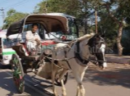 | TOTAL
7:00-7:15 | 0 | 0 | 1 | 0 | 3 | 2 | 100 | 0 | 106
7:15-7:30 | 0 | 1 | 2 | 0 | 5 | 4 | 120 | 0 | 132
7:30-7:45 | 0 | 0 | 4 | 0 | 3 | 7 | 127 | 0 | 141
7:45-8:00 | 0 | 3 | 5 | 1 | 10 | 10 | 136 | 1 | 166
8:00-8:15 | 1 | 1 | 10 | 2 | 10 | 5 | 146 | 0 | 176
8:15-8:30 | 1 | 4 | 9 | 0 | 5 | 14 | 163 | 0 | 197
8:30-8:45 | 0 | 5 | 10 | 0 | 14 | 11 | 175 | 1 | 215
8:45-9:00 | 0 | 2 | 9 | 0 | 19 | 11 | 179 | 0 | 221
9:00-9:15 | 0 | 0 | 8 | 0 | 11 | 10 | 166 | 0 | 197
9:15-9:30 | 2 | 1 | 7 | 0 | 10 | 12 | 176 | 0 | 209
9:30-9:45 | 1 | 1 | 14 | 1 | 9 | 18 | 165 | 1 | 209
9:45-10:00 | 0 | 0 | 6 | 0 | 6 | 23 | 166 | 0 | 202
10:00-10:15 | 0 | 2 | 11 | 0 | 7 | 16 | 171 | 2 | 207
10:15-10:30 | 0 | 3 | 12 | 0 | 8 | 19 | 165 | 0 | 208
10:30-10:45 | 1 | 0 | 3 | 0 | 18 | 14 | 159 | 0 | 195
10:45-11:00 | 0 | 0 | 10 | 0 | 12 | 21 | 168 | 0 | 211
11:00-11:15 | 2 | 4 | 9 | 0 | 10 | 20 | 164 | 1 | 210
11:15-11:30 | 1 | 0 | 9 | 0 | 12 | 21 | 160 | 0 | 204
11:30-11:45 | 0 | 2 | 8 | 1 | 11 | 29 | 177 | 0 | 229
11:45-12:00 | 1 | 4 | 12 | 2 | 9 | 26 | 189 | 0 | 244
12:00-12:15 | 0 | 0 | 8 | 1 | 10 | 17 | 197 | 0 | 233
12:15-12:30 | 0 | 2 | 3 | 1 | 14 | 21 | 260 | 0 | 301
12:30-12:45 | 0 | 4 | 5 | 0 | 8 | 17 | 199 | 1 | 233
12:45-1:00 | 0 | 4 | 16 | 0 | 14 | 14 | 257 | 0 | 304
1:00-1:15 | 0 | 3 | 22 | 0 | 8 | 22 | 280 | 1 | 335
1:15-1:30 | 1 | 3 | 6 | 0 | 11 | 21 | 288 | 0 | 331
1:30-1:45 | 1 | 0 | 15 | 0 | 15 | 14 | 206 | 0 | 250
1:45-2:00 | 1 | 0 | 9 | 0 | 14 | 20 | 203 | 1 | 247
2:00-2:15 | 0 | 0 | 7 | 0 | 8 | 9 | 218 | 0 | 243
2:15-2:30 | 0 | 0 | 18 | 0 | 12 | 21 | 302 | 0 | 353
2:30-2:45 | 0 | 1 | 14 | 0 | 6 | 21 | 234 | 0 | 276
2:45-3:00 | 0 | 2 | 12 | 0 | 14 | 22 | 259 | 1 | 309
3:00-3:15 | 1 | 4 | 9 | 0 | 10 | 24 | 269 | 0 | 318
3:15-3:30 | 1 | 3 | 9 | 0 | 17 | 11 | 321 | 0 | 363
3:30-3:45 | 0 | 0 | 11 | 0 | 17 | 16 | 271 | 1 | 314
3:45-4:00 | 0 | 0 | 15 | 0 | 12 | 17 | 287 | 0 | 331
4:00-4:15 | 0 | 1 | 14 | 0 | 6 | 29 | 287 | 1 | 337
4:15-4:30 | 0 | 2 | 11 | 0 | 11 | 16 | 283 | 0 | 324
4:30-4:45 | 0 | 0 | 15 | 1 | 10 | 12 | 250 | 0 | 288
4:45-5:00 | 1 | 1 | 15 | 0 | 17 | 21 | 266 | 0 | 320
5:00-5:15 | 0 | 1 | 11 | 0 | 16 | 23 | 282 | 0 | 333
5:15-5:30 | 0 | 1 | 10 | 0 | 11 | 18 | 290 | 0 | 331
5:30-5:45 | 2 | 2 | 10 | 0 | 15 | 15 | 298 | 0 | 341
5:45-6:00 | 1 | 0 | 14 | 1 | 9 | 12 | 282 | 0 | 319
6:00-6:15 | 0 | 1 | 8 | 0 | 6 | 14 | 216 | 0 | 246
6:15-6:30 | 1 | 2 | 8 | 0 | 7 | 10 | 186 | 0 | 215
6:30-6:45 | 2 | 0 | 9 | 0 | 12 | 12 | 128 | 0 | 164
6:45-7:00 | 0 | 1 | 7 | 0 | 8 | 11 | 118 | 0 | 146

Appendix 5. 3 Spot speed study
Time interval | truck tailer | H. Truck | small truck | large bus | small Bus | Car | Authorickshew | Average speed in Km/hr
7:00-7:15 | 0.00 | 0.00 | 27.00 | 0.00 | 27.00 | 36.00 | 36.00 | 31.50
7:15-7:30 | 0.00 | 18.00 | 18.00 | 0.00 | 15.43 | 18.00 | 21.60 | 18.21
7:30-7:45 | 0.00 | 0.00 | 15.43 | 0.00 | 21.60 | 15.43 | 18.00 | 17.61
7:45-8:00 | 0.00 | 18.00 | 18.00 | 0.00 | 18.00 | 21.60 | 21.60 | 19.44
8:00-8:15 | 9.00 | 13.50 | 21.60 | 15.43 | 21.60 | 21.60 | 15.43 | 16.88
8:15-8:30 | 9.82 | 12.00 | 15.43 | 0.00 | 18.00 | 21.60 | 18.00 | 15.81
8:30-8:45 | 0.00 | 21.60 | 18.00 | 0.00 | 21.60 | 18.00 | 21.60 | 20.16
8:45-9:00 | 0.00 | 12.00 | 15.43 | 0.00 | 15.43 | 18.00 | 15.43 | 15.26
9:00-9:15 | 0.00 | 0.00 | 13.50 | 0.00 | 13.50 | 15.43 | 18.00 | 15.11
9:15-9:30 | 8.31 | 10.80 | 12.00 | 0.00 | 15.43 | 18.00 | 15.43 | 13.33
9:30-9:45 | 12.00 | 18.00 | 13.50 | 15.43 | 27.00 | 18.00 | 21.60 | 17.93
9:45-10:00 | 0.00 | 0.00 | 10.80 | 0.00 | 18.00 | 15.43 | 21.60 | 16.46
10:00-10:15 | 0.00 | 15.43 | 15.43 | 0.00 | 18.00 | 18.00 | 12.00 | 15.77
10:15-10:30 | 0.00 | 13.50 | 18.00 | 0.00 | 13.50 | 21.60 | 21.60 | 17.64
10:30-10:45 | 10.80 | 0.00 | 10.80 | 0.00 | 18.00 | 21.60 | 15.43 | 15.33
10:45-11:00 | 0.00 | 0.00 | 12.00 | 0.00 | 18.00 | 13.50 | 15.43 | 14.73
11:00-11:15 | 9.00 | 10.80 | 18.00 | 0.00 | 10.80 | 15.43 | 18.00 | 13.67
11:15-11:30 | 9.82 | 0.00 | 9.00 | 0.00 | 18.00 | 21.60 | 21.60 | 16.00
11:30-11:45 | 0.00 | 9.82 | 8.31 | 12.00 | 15.43 | 21.60 | 18.00 | 14.63
11:45-12:00 | 21.60 | 9.00 | 13.50 | 9.82 | 13.50 | 15.43 | 18.00 | 14.41
12:00-12:15 | 0.00 | 0.00 | 10.80 | 13.50 | 12.00 | 13.50 | 15.43 | 13.05
12:15-12:30 | 0.00 | 9.00 | 9.82 | 10.80 | 12.00 | 13.50 | 18.00 | 12.19
12:30-12:45 | 0.00 | 9.82 | 13.50 | 0.00 | 15.43 | 18.00 | 18.00 | 14.95
12:45-1:00 | 0.00 | 12.00 | 18.00 | 0.00 | 21.60 | 12.00 | 21.60 | 17.04
1:00-1:15 | 0.00 | 9.82 | 8.31 | 0.00 | 21.60 | 13.50 | 18.00 | 14.25
1:15-1:30 | 8.31 | 9.00 | 10.80 | 0.00 | 18.00 | 15.43 | 21.60 | 13.86
1:30-1:45 | 10.80 | 0.00 | 21.60 | 0.00 | 21.60 | 21.60 | 18.00 | 18.72
1:45-2:00 | 9.82 | 0.00 | 12.00 | 0.00 | 18.00 | 21.60 | 18.00 | 15.88
2:00-2:15 | 0.00 | 0.00 | 10.80 | 0.00 | 15.43 | 18.00 | 21.60 | 16.46
2:15-2:30 | 0.00 | 0.00 | 10.80 | 0.00 | 12.00 | 13.50 | 27.00 | 15.83
2:30-2:45 | 0.00 | 9.82 | 12.00 | 0.00 | 13.50 | 12.00 | 21.60 | 13.78
2:45-3:00 | 0.00 | 10.80 | 10.80 | 0.00 | 12.00 | 15.43 | 18.00 | 13.41
3:00-3:15 | 9.82 | 12.00 | 12.00 | 0.00 | 13.50 | 15.43 | 18.00 | 13.46
3:15-3:30 | 9.00 | 9.82 | 12.00 | 0.00 | 13.50 | 12.00 | 18.00 | 12.39
3:30-3:45 | 0.00 | 0.00 | 9.00 | 0.00 | 12.00 | 15.43 | 15.43 | 12.96
3:45-4:00 | 0.00 | 0.00 | 9.82 | 0.00 | 10.80 | 13.50 | 15.43 | 12.39
4:00-4:15 | 0.00 | 12.00 | 12.00 | 0.00 | 13.50 | 15.43 | 13.50 | 13.29
4:15-4:30 | 0.00 | 9.82 | 10.80 | 0.00 | 13.50 | 12.00 | 13.50 | 11.92
4:30-4:45 | 0.00 | 0.00 | 9.82 | 13.50 | 15.43 | 13.50 | 18.00 | 14.05
4:45-5:00 | 9.00 | 12.00 | 10.80 | 0.00 | 13.50 | 18.00 | 18.00 | 13.55
5:00-5:15 | 0.00 | 9.82 | 9.00 | 0.00 | 15.43 | 13.50 | 21.60 | 13.87
5:15-5:30 | 0.00 | 12.00 | 12.00 | 0.00 | 15.43 | 13.50 | 15.43 | 13.67
5:30-5:45 | 9.82 | 12.00 | 10.80 | 0.00 | 15.43 | 18.00 | 21.60 | 14.61
5:45-6:00 | 9.00 | 10.80 | 12.00 | 15.43 | 13.50 | 21.60 | 21.60 | 12.64
6:00-6:15 | 0.00 | 0.00 | 10.80 | 0.00 | 12.00 | 15.43 | 21.60 | 14.96
6:15-6:30 | 15.43 | 15.43 | 18.00 | 0.00 | 18.00 | 27.00 | 27.00 | 20.14
6:30-6:45 | 21.60 | 0.00 | 27.00 | 0.00 | 36.00 | 54.00 | 36.00 | 34.92
6:45-7:00 | 0.00 | 21.60 | 27.00 | 0.00 | 36.00 | 36.00 | 54.00 | 34.92

APPENDIX 6

Appendix 6.1 Ethiopian Road Authority Road Vehicle Count Form
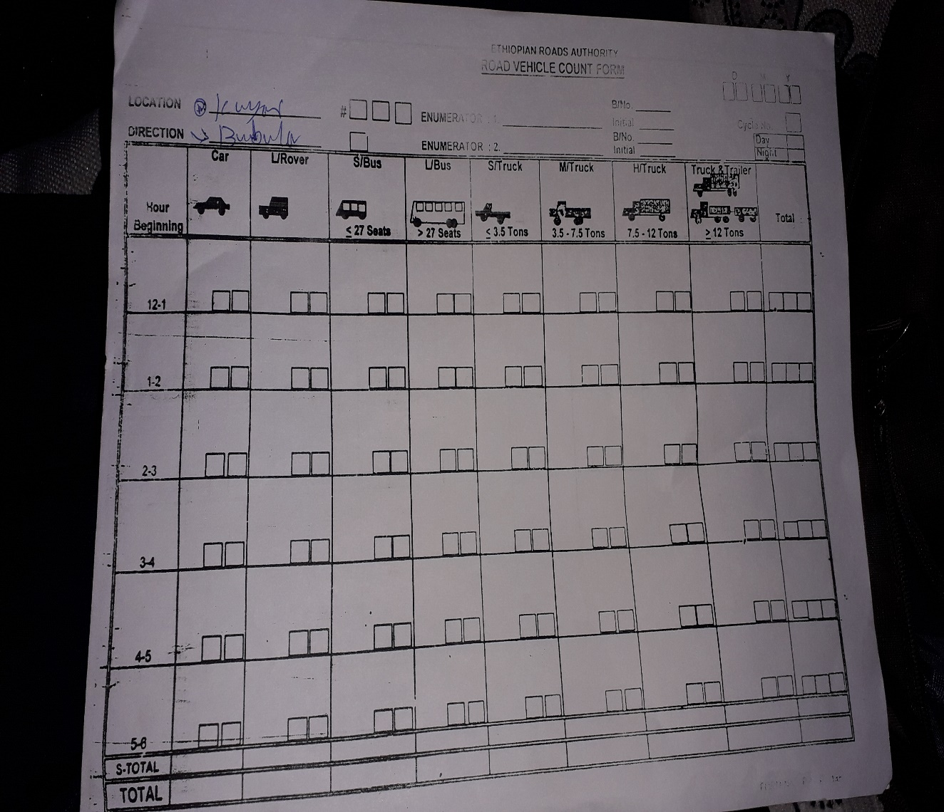

Appendix 6.2 Ethiopian Road Authority Road Vehicle Count Summary Sheet
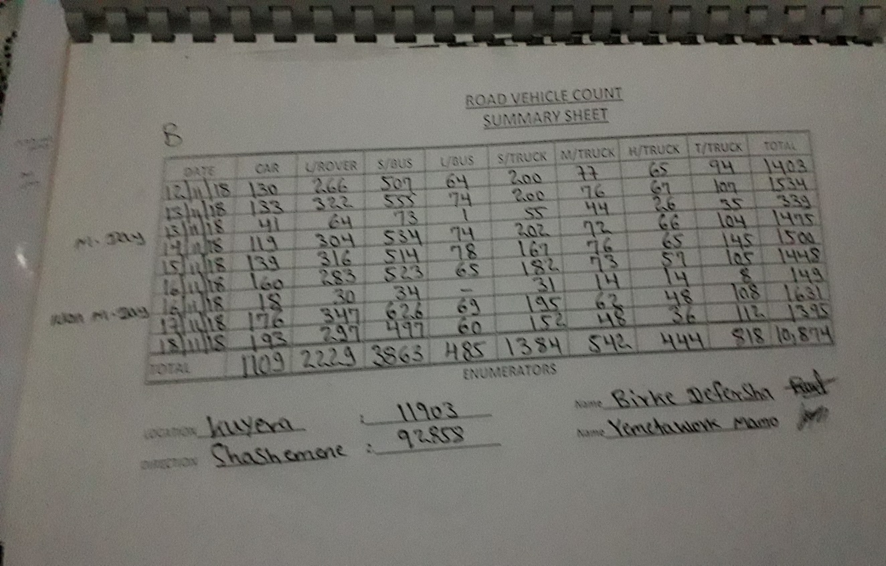
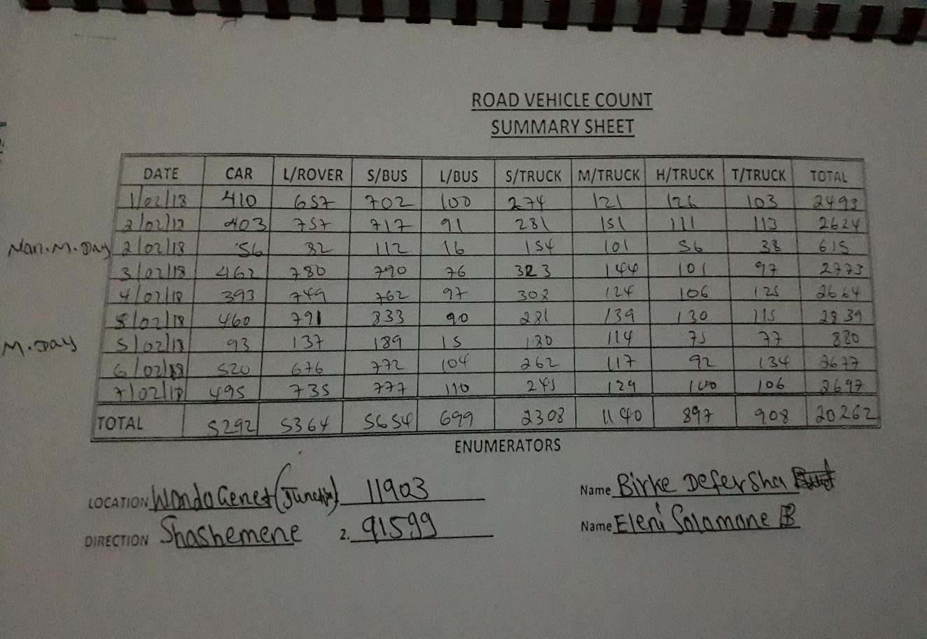

APPENDIX 7

Appendix 7.1 Posted Speed along the Studied Road Sections

