HAWASSA UNIVERSITY
INSTITUTE OF TECHNOLOGY
FACULTY OF BIOSYSTEM AND WATER RESOURCE ENGINEERING


HYDRAULIC PERFORMANCE EVALUATION AND OPERATION OF WATER SUPPLY SCHEMES IN DAMOT GALE WOREDA, WOLAITA ZONE IN ETHIOPIA.

MSc THESIS
BY:
MATEWOS ELTAMO ENARO

HAWASSA UNIVERSITY, HAWASSA, ETHIOPIA
June 7, 2024

HYDRAULIC PERFORMANCE EVALUATION AND OPERATION OF WATER SUPPLY SCHEMES IN DAMOT GALE, WOLAITA ZONE IN ETHIOPIA.
BY
MATEWOS ELTAMO ENARO
MAJOR ADVISOR: TEWODROS TESFAYE (PhD)
CO-ADVISOR: DESSALEGN JAWESO (PhD)

A THESIS SUBMITTED TO DEPARTMENT OF WATER RESOURCE AND IRRIGATION ENGINEERING INSTITUTE OF TECHNOLOGY HAWASSA UNIVERSITY, HAWASSA ETHIOPIA.

IN PARTIAL FULFILLMENT OF THE REQUAREMENT FOR THE DEGREE OF MASTER OF SCIENCE IN WATER RESOURCE ENGINEERING AND MANAGEMENT.

June 7, 2024

SCHOOL OF GRADUATE STEDIES
HAWASSA UNIVERSITY
ADVISORS APPROVAL SHHEET
This is to certify that the thesis entitled “HYDRAULIC PERFORMANCE EVALUATION AND OPERATION OF WATER SUPPLY SCHEMES IN DAMOT GALE, WOLAITA ZONE IN ETHIOPIA.” submitted in partial fulfilment of the requirements for the degree of masters with specialization in Water Resource Engineering and Management. Department of Water Resource and Irrigation Engineering, and has been carried out by MATEWOS ELTAMO ID NO.PGWREMW/0012/13,under our supervision. Therefore, we recommend that the student has fulfilled the requirements and hence hereby can submit the thesis to the department.

Major advisor ___________________ ___________________ Dr Tewodros Tesfaye Signature Date

Co-Advisor: ___________________________ ___________________
Dr Dessalegn Jaweso Signature Date

THESIS APPROVAL SHEET
SCHOOL OF GRADUATE STUDIES
HAWASSA UNIVERSITY EXAMINERS' APPROVAL SHEET

We, the undersigned, members of the Board of Examiners of the final open defense by MATEWOS ELTAMO have read and evaluated his thesis entitled “HYDRAULIC PERFORMANCE EVALUATION AND OPERATION OF WATER SUPPLY SCHEMES IN DAMOT GALE, WOLAITA ZONE IN ETHIOPIA”, and examined the candidate. This is, therefore, to certify that the thesis has been accepted in partial fulfillment of the requirements for the Masters of Science degree.

Dr Tewodros Tesfaye ……………………… ……………………………
Name of Major Advisor Signature Date
………………………… …………………… ..………………..............
Name of Co-Advisor Signature Date
…………………… ………………. …………...............
Name of Internal Examiner-I Signature Date
………………………… …………………… ............…...............
Name of Internal Examiner-II Signature Date
……………………… …………………… ……......................
Name of External Examiner Signature Date
………………………… ……………….. ……..............
SGS Approval Signature Date

DECLARATION
I hereby declare that this MSc thesis is my original work and that it has not been presented and will not be presented to any other university for similar or any other degree awarded, and all sources of material used in this thesis have been duly acknowledged.
Name: Matewos Eltamo Enaro
Signature: _____________________
Date: _________________________

ACKNOWLEDGEMENT
First and for most I would like to thank to almighty God for great support at all situations in my life.
I would also like to express my gratitude to my advisor Dr Tewodros Tesfaye and my co-adviser Dr Dessalegn Jaweso for continuous and eager guidance and encouragement as well as his invaluable advice and charity case throughout this research work particularly.
Finally, I would like to express in profound appreciation to staffs of SNNPR Water, energy and mine Office who helped me to get all the required data. Mr Gelane Galcho the woreda manager of Damot Gale water supply service office and all staff members for their kind cooperation during field visit and data collection.

LISTS OF ACRONYMS AND ABBREVATION
AAWSA Addis Ababa Water and Sanitation Agency
BH Boreholes
CSA Central Statistical Agency
GIS Geographical Information System
HDW Hand dag wells
NRW None revenue water
MoWR Minister of Water resource
MNF Minimum night flow
PCD per Capita Demand
RWMEO Regional water mine energy Office
SNNPR Southern Nations, Nationalities and Peoples Region
SW Shallow wells
TWD Total water Demand
UFW Unaccounted for Water
UNICEF United Nation Children’s and Education Fund
UNDP United Nation Development Program
UWD Unaccounted Demand
WASH Water Supply, Sanitation and Hygiene
WASHCOs Water, Sanitation & Hygiene Committee
WDS Water Distribution System
WDN Water Distribution Network
WHO World Health Organization
WUAs Water use associations
DGWWMEO Damot Gale Woreda Water, Mine & Energy Office

TABLES OF CONTENTS
ACKNOWLEDGEMENT v
LISTS OF ACRONYMS AND ABBREVATION vi
TABLES OF CONTENTS vii
LIST OF FIGURES xi
LIST OF TABLES xiii
ABSTRACT xiv
1. INTRODUCTION 1
1.1 Background 1
1.2 Statement of the problem 2
1.3 Objectives 3
1.3.1 General Objective 3
1.3.2 Specific objectives 3
1.4 Research questions 4
1.5 Significant of the study 4
1.6 Scope of the study area 4
2.1 Overview of access to safe water supply 5
2.2 Water Distribution System 5
2.3. Water Distribution System Component 6
2.3.1. Transmission mains 6
2.3.2. Distribution mains 7
2.3.3. Reservoir and storage tanks 7
2.3.4. Pumps 7
2.4. Hydraulic Analysis and Design of WDN 7
2.4.1 Basic Principles of Hydraulic Modelling 8
2.4.2 Hydraulic Model Selection Criteria 9
2.4.2.1 Bentley WaterGEMSv8i CONNECT Edition Update 2 11
2.4.2.2 Input data for assembling the model. 12
2.4.2.3 Hydraulic Analysis of Water Distribution System 13
2.8.2. Conservation of Energy 18
2.9.1 Some Definitions of Unaccounted for Water (UFW) 19
2.9.2 Methods of Measuring Water Losses 19
3. MATERIALS AND METHODS 29
3.1 Description of the Study Area 29
3.1.1 Climate and Topography 30
3.1.2 Soil and Land Use Type 30
3.2 Materials 30
3.3. Data Collection 31
3.3.1. Analysing Hydraulic performance of existing distribution systems. 31
3.3.2. Estimating the existing water supply and demand. 32
3.3.3. Quantifying water loss on the distribution system 33
3.3.3.1 Water production 33
3.3.3.2 Water Consumption 33
3.3.4 Accessing the operation and maintenance status of rural water supply schemes. 34
3.3.2.1 Water Demand 34
3.5.1. Quantifying Total Water Loss 36
3.5.1.1. Water Loss by Mathematical Calculation 37
3.6.1. Technical Analysis of Distribution Network of the Woreda 37
3.7.1 Data collection methods for Operation and Maintenance 41
3.7.2 Sampling method and size determination 42
3.7.3 Selection of the Respondents 44
3.8.1 Public Awareness and Education. 45
3.8.2 Status of Water Supply Schemes 45
4. RESULTS AND DISCUSSIONS 47
4.1 Hydraulic Analysis of Existing Water Supply Distribution Network 47
4.2 Water Distribution System of the Woreda 47
4.2.1 Population projection 48
4.2.2 Estimation of Water Demand 48
4.2 Layout Schematization 50
4.5. Overall hydraulic performance of the scheme 54
4.6 Estimating of existing water supply and demand schemes 55
4.7 Water Supply Coverage Analysis 56
4.7.1 Existing Water Supply Coverage in the Woreda 56
4.7.2 Water Production and Consumption 56
4.7.3 Average Per capita Water Consumption 57
4.8 Water Loss Analysis 57
4.8.1 Percentage of Water Loss (UFW) 57
4.9 Functional and non-functional rural water supply schemes in the study area 58
4.9.1 Distribution of types of functional and non-functional rural water supply schemes 58
4.9.2 Distribution of hand dug wells fitted with ordinary pumps 58
4.9.3 Distribution of bore hole fitted with ordinary pumps 58
4.9.4 Distribution of shallow wells 59
4.9.5 Distribution of functional and non-functional on spot springs 59
4.9.6 Distribution of functional and non-functional spring with distribution 59
4.9.6.1 Distribution of functional hand dug wells fitted with ordinary pumps 59
4.9.6.2 Distribution of bore hole with distribution 60
4.9.6.3 Distribution of functional shallow wells 60
4.9.6.4 Distribution of functional on spot springs 61
4.9.7 Distribution of non-functional rural water supply schemes 62
4.9.7.1 Scheme Type and Non-Functionality Reason 62
4.9.7.2 Distribution of non-functional hand dug wells fitted with ordinary pumps 62
4.8.7.3 Distribution of non-functional bore hole fitted with ordinary pumps 63
4.9.7.4 Distribution of non-functional shallow wells 64
4.9.7.5 Distribution of non-functional protected springs 65
4.10 Causes for non-functionality of rural water supply schemes 66
4.11 Driving forces for non-functionality 67
4.12. Development of geo-reference map for water supply schemes 68
4.12.1 Geo-reference maps for functioning and non- functional Schemes 68
4.13. Determinant analysis for problem of operation and maintenance of RWSS 69
4.13.1 Distance from water points 69
4.13.2 Water availability of the non- functional water supply schemes 70
4.13.3 Perception of users in Water quality of water supply system 70
4.13.4 Ownership feeling of users for water points 71
4.13.5 Water users’ complain in use of the water supply schemes 72
4.13.5 Level of users’ satisfaction use of water supply schemes before becoming non-functional 72
4.13.6 Personal participation of users in water supply scheme development 73
4.12.7 Activities in which the community participated 74
4.14 Assessment of the operational and maintenance status and problems of the water supply schemes 75
4.14.1 Existence of management system 75
4.14.2 Way of WASHCO Selection 76
4.13.3 Accountability of WASHCO 77
5. CONCLUSIONS AND RECOMMENDATION 96
5.1. CONCLUSIONS 96
5.2. RECOMMENDATION 98
REFERENCES 99
APPENDIX 104

LIST OF FIGURES
Figure 3 1: Map of study area 29
Figure 3.2: Water scheme management structure (Source: People in Need) 40
Figure 3.3: Operation and Maintenance Service Options 41
Figure 3.4: Research flow chart 42
Figure 3.5: Education level, Kebele, family size, and gender 44
Figure 4.1: Pressure and velocity colour code of Mokonisa Woyge Kebele scheme 52
Figure 4 2: Pressure and velocity colour code of Wogera Kebele scheme 53
Figure 4.3: Distribution of functional Bore hole fitted with ordinary pumps 60
Figure 4.4: Distribution of functional shallow well. 61
Figure 4.5: Distribution of functional on spot spring 61
Figure 4.6: Distribution of non-functional bore hole 63
Figure 4.7: Non-Functionality rate due to non-functionality indicator of Bore Hole 64
Figure 4.8: Distribution of non-functional shallow wells 64
Figure 4.9: Non-Functionality rate due to non-functionality indicator of Shallow Well 65
Figure 4.10: Distribution of non-functional On Spot Spring 66
Figure 4.11: Non-Functionality rate due to non-functionality indicator of on spot spring 66
Figure 4.12: Cause of non-functionality of the schemes 67
Figure 4.13: Driving forces for non-functionality of schemes 67
Figure 4.14: Rank of driving forces for non-functionality of schemes 68
Figure 4.15: Geo-reference maps for functioning and non- functional Schemes 69
Figure 4.16: Distance from the water point 70
Figure 4.17: Water availability 70
Figure 4.18: Water Quality 71
Figure 4.19: Ownership feeling of the users 71
Figure 4.20: Water users complain in using water supply schemes 72
Figure 4.21: level of user’s satisfaction on water supply schemes before being non-functional 73
Figure 4.22: Participation of users during development of water supply schemes 74
Figure 4.23: Activities where users participated during development of water supply schemes 75
Figure 4.24: Existence of WASCO 76
Figure 4.25: How WASHCO was formed 77
Figure 4.26: Knowledge of users about WASHCO's accountability 77
Figure 2.27: Pressure for non-functionality 78
Figure 4.28: Technology selection 83
Figure 4.29: Technology option easily operability and manageability 84
Figure 4.30: Technology option difficulties 84
Figure 4.31: Community technicians take training to carryout repairs and maintenance 85
Figure 4.32: Community Technicians to carry out repairs 85
Figure 4.33: Who carries out repairs and maintenance 86
Figure 4.34: Spare part availability and accessibility at community level 87
Figure 4.35: Spare parts affordable at community level 87
Figure 4.36: Overall construction quality of the water supply technology 88
Figure 4.37: Community participation in the implementation of the project 89
Figure 4.38: Staff technicians capable enough for water supply system functionality 89
Figure 4.39: Giving technical support after the construction of the project 90
Figure 4.40: Role of government institutions adequately prepared the community to manage the scheme 90
Figure 4.41: Institutional support to lower government offices 91
Figure 4.42: Spare parts availability and affordability at regional/woreda and community level 91
Figure 4.43: Private sectors that provide spare part 92
Figure 4.44: Problems faced rural water supply scheme functionality 92
Figure 4.45: Woreda water office 93
Figure 4.46: Support to WASHCOs 93
Figure 4.47: Scheme inventory and maintenance plan 94
Figure 4.48: Monitoring of operation and maintenance and WASHCO Performance 95

LIST OF TABLES
Table 2 1: Input parameters and the primary purpose of water GEMS tools 13
Table 3.1 Material used for the research study 31
Table 3.2:- The existing sources of drinking water supply in Damot Gale 32
Table 3.4: Climate Adjustment factor (MoWR, 2006) 35
Table 3.5: Demand adjustment factor for socioeconomic situation 35
Table 3.6: Maximum daily coefficient and peak hour factor 36
Table 4 1: Distribution Network Pipe diameter and Corresponding Lengths with Their Coverage (Mokonisa Woyge and Wogera Kebele, 2023) 48
Table 4.2: Estimation of water demand 2021 up to 2023 49
Table 4.3. Mokonisa Woyge pressure and velocity analysis 51
Table 4 .4: Wogera pressure and velocity analysis 52
Table 4.5: Head loss gradient of Mokonisa Woyge Kebele scheme 53
Table 4.6: Head loss gradient Wogera Kebele scheme 54
Table 4.7: The overall hydraulic performance of the scheme 55
Table 4.9: Annual Consumption of Damot Gale Woreda (2022-2023) 56
Table 4.10: Reason for Non-Functionality 62

ABSTRACT
Water is one of the most essential commodities of every living being in the world. Failure to maintain access to sufficient and clean water is one of the key problems in developing countries, including Ethiopia. The aim of the research is to analyse hydraulic performance evaluation and operation of water supply schemes in Damot gale Woreda, Wolaita Zone Southern Ethiopia Region. For conducting this study, both primary and secondary data were collected and tools such as Water GEMS, GIS and GPS were used. Water GEMS was used for evaluation of hydraulic performance of the schemes. Two sources show 13.33% of nodes were with pressure below allowable limit, 46.7% of nodes were with pressure with acceptable limit and 40.0% of nodes where with pressure greater than allowable limit. The head loss of the scheme shows that 17% of pipes were with head loss below allowable limit, 21.5% of pipes were with head loss with acceptable limit and 61.5% of pipes where with head loss greater than allowable limit. The analysis showed that average per capital domestic water consumption was 20.78 /c/day. Hence, this result indicates there is a big gap between demand and supply. Generally, the result of the analysis showed that, the overall hydraulic performance of water distribution of the study area was poor and, it is therefore significant to improve the water distribution system capacities, changing the diameter of the pipe to get the proper level of pressure and velocity. Among the total schemes 108, 25 schemes were non- functional and the rest 83 schemes were functional. The assessment result showed that 76.85% of schemes are functional. For instance, the rate of non-functionality of hand dug well was 80% and the main cause's non-functionality account 31.25% for yield (quantity). 28.57% of the respondent stated there is great problem of appropriate operation and maintenance, 28.57% of the respondent shows there is lack of post construction support, 19.05% replied is lack of appropriate and timely spare part. Beside 9.52% shows lack of accountability, transparency, financial skill and conflict management technique and finally 4.76% lack of developed rules for service. The driving factors for non-functionality were prioritized from top to bottom as; poor management, weak institutions, a shortage of spare parts, and a lack of funding respectively.

Key word: Water GEMS V8i, hydraulic evaluation, Functionality, Non-functionality,
WASHCo, Damot Gale Woreda
- INTRODUCTION
1.1 Background
Water is one of the most crucial resources of our planet earth. Water distribution system has been facing numerous challenges in recent decades due to the potential effects of climate change and rapid population growth in Ethiopia (Tiwari 2016). The challenges of water distribution system including financing challenges and prospected of water services, sustainability of water infrastructure, customers satisfaction, the impact of urban expansion on water supply system, operation and maintenance of water supply projects. Consequently, reducing the challenges of water supply scheme is vital. The distribution system is hydraulic outlines consisting of aspects are pipes, valves, tanks, reservoirs and pumps. It is significant to the community providing efficient water supply system and performing water distribution network systems.
Hydraulic simulation models are generally used for monitoring, organize and management of water distribution networks (WDN). Hydraulic analysis of water distribution system is an essential step towards understanding the behaviour of water distribution system which includes the flow, pressure, and velocity, head loss in each pressure, efficiency and operation point of each pump. The information gained from a hydraulic model simulation of a water distributions system can also assist in management planning for maintenance and replacement of system equipment and set that are pumps, valves, pipes (AL-Zahrani,2014)
The most crucial of all public services is the ongoing provision of adequate and clean drinking water. In many industrialized and emerging nations, the provision of high-quality rural infrastructure systems has become a key priority. In our nation, rural communities still experience issues with water supply and sanitation. Water is necessary for life, as former UN Secretary General Kofi Annan stated in 2006 during the celebration of World Water Day (summary and statistical report of the (2006). However, there are numerous millions of people that lack access to water worldwide. Every year, water-borne illnesses claim the lives of many millions of children.
In Ethiopia 33% of water schemes where non-functional at any time, due to lack of funds for operation and maintenance, inadequate community mobilization and commitment and a lack of spare parts. Good governance requires the improvement of wide range of institutions and non-state actors in different or overlapping aspects of enabling access to water and including resource management and demand for better service and accountability.
Information helps to solve challenges, demonstrate for higher level of planning and policy making, monitor progress and better governance. Most of the implementation agencies and funders do not allocate a budget for post monitoring. Governments lack of information planning and budgeting of resources for new construction or rehabilitation of facilities. Therefore, in the implementation of water supply all stockholders lack information on better implementation of the facility and on insuring the sustainability of its service. Collecting, aggregating, and analysing data from remote regions and making the data available in a transparent way can help identify where investments are most urgently needed and can improve the long-term project monitoring. The objective of study is hydraulic performance evaluation and operation of water supply schemes in Damot Gale Woreda’, Wolaita zone SER, Ethiopia.

1.2 Statement of the problem
Access to safe and sufficient water supply is prerequisite for health and development of the community and, it is also taken as the basic human right, but several millions of people relying on unsafe drinking water source in Africa including Ethiopia. This is due to intermittent nature of the distribution system caused from in sufficient water supply, irregular pressure and water loss. Population increment and social and economic changes also contribute for water demand increase. For this resin the existing water distribution in Ethiopia did not satisfy the requirement both and quantity and quality for tremendously increasing populations (Solomon, 2022).
The water utility of Woreda, Zone and Regional water resources & energy bureau has made significant contribution in readressing the imbalance of water demand and supply of Woreda.

The provision of adequate clean drinking water in the study area has been through challenging situations in the past years and even still has no enough potable water in Damot Gale Woreda. According to Zone and Woreda Water utility office data, has (23.15%) of the water supply schemes are non-functional and rural water supply coverage is 27%. The Woreda water supply service offices, the official organization in charge of supplying water to the rural kebeles have a lot of issues with maintaining a reliable water supply. When there is no sufficient water in the rural area, people’s even fetch from unprotected streams, which leads to diseases brought on by a lack of clean water supply for the populace. There has been a wide gap, particularly in the water supply service even compared with other infrastructural developments like supply of electricity in the area.
In my study area almost all kebeles are currently getting water with in unsatisfactory way, once within three days and this lead to focus within water use which is inadequate for everyday activities of the household, like, for drinking, cooking, cleaning utensils and washing clothes. Residents are consequently compelled to obtain water from unsafe sources that are far from their dwellings. Additionally, they frequently purchase water from others who have it, even if it may be underground and cost more. Finally, the rural kebeles lack of water supply has put a variety of responsibilities on the people in terms of economic and health issues.
To the best of my knowledge there is no systematic study conducted on distribution, water supply coverage, the operation and performance of water supply schemes.
As result of the above mentioned problem existed in the woreda hydraulic performance and operation of water supply system, it is necessary to evaluate and analyse the current status of water supply and demand in the existing water schemes of Damot Gale Woreda using hydraulic simulation software Water GEMs connected edition to increase the efficiency of the water distribution networks and to avoid inequality among consumer of water supply in service provision from water system.

1.3 Objectives
1.3.1 General Objective
The general objective of the study is hydraulic performance evaluation and operation of water supply schemes in Damot Gale Woreda, Wolaita Zone SER Ethiopia.
1.3.2 Specific objectives
- To analyse Hydraulic performance of water supply distribution systems using water GEMS software for two sources only.
- To estimate the existing water supply and demand of the woreda,
- To quantify the water loss and pinpointing the causes of water loss in the distribution network,
- To assess the operation and maintenance status of rural water supply schemes.
1.4 Research questions
- How is the hydraulic performance of the water supply system at rural level with regard to indicators for better water supply services?
- What are the present and future water supply and demand of existing water supply schemes that needs for populations?
- What is the quantity of water loss in the existing system of water supply?
- What is the status of the existing rural water supply schemes operation and maintenance of Damot Gale district?
1.5 Significant of the study
This study focused on technical analysis of water distribution system and coverage of water supply. This could have a significance on the improvement of evaluating the existing water distribution network, though, indicating the problems in relation to the operation, maintenance activities and hydraulic performance of the water distribution systems with possible mitigation measures. It serves as base line data for any further investigation, as useful materials to government organization, NGOs and academic purposes. Farther more this study was to provide base line information for development of new water supply distribution schemes in other command areas in the future.
1.6 Scope of the study area
The scope of this study was limited to investigate only the technical analysis of Damot Gale Woreda water distribution system as per the above-stated objectives over the study area. The study is to evaluate and develop sustainable water supply distribution systems relating to the various hydraulic characteristics and variables such as the uniformity of pressure, velocity, water distributed to satisfy the human need, the pump energy applied, quantity of water discharging to the users. In addition to identifying the role of operation and maintenance facilities and analysis the current scenarios of WDS of the Woreda rural area using hydraulic model of the water GEMS software.

2. LITERATURE REVIEW
2.1 Overview of access to safe water supply
The access to water is crucial for life, prosperity, and all human activities and Water resources must be used effectively to meet the demand of the ever-growing population, considering the limited and decreasing water availability (Taha et al., 2020). Currently, guaranteeing access to safe drinking water is one of the most problematic in the global world (Alicia et al., 2020). Approximately two and a half billion people on earth do not have access to safe drinking water (Pravinkumar Shinde 1, 2018; Berihun, 2017; Salunke, 2018; Wonduante, 2013), due to this, an acute crisis of water is looming time to time in this world, which is important to optimize the supply and reduce losses. According to, (Desalegn, 2015; Damgir, 2017; Rossman, 2000; Thomas J. Kuehn, 2018; Zewdu A., 2014), the adequate provision of water supply distribution networks efficiently can eradicate poverty and ultimately provide the environment for sustainable development. However, water supply utilities in developing countries are faced with challenges of low service coverage and high unaccounted losses of water. The accessibility of the water supply system in most Ethiopian towns is becoming the most challenging in terms of its quality and quantity to the water utilities. The estimated water supply service level of Ethiopia, interims of its coverage, quantity, quality, and reliability is very low (Desalegn, 2015; Damgir, 2017). Consequently, water demand is increasing drastically due to the population growth rate and per urbanization of the town through this country.
2.2 Water Distribution System
A water distribution system is a complicated combination of hydraulic control parameters connected together to transmit of water from sources to consumers (Abhijeet, 2018) and Network condition is defined as collectively representing the physical condition state of all water pipes in the network (Kambiz et al., 2019). Water distribution system model have become widely accepted within the water utility industry, as a mechanism for similarity the hydraulics behaviour in water distribution system network. The most important consideration in the planning and operation of a water distribution system is to satisfy the consumer’s demands. Thus, it is important to provide all users with good quality water and adequate amount at reasonable pressure at all times to ensure a reliable water distribution network system. Water utilities facing the high level of water loss in their distribution networks, for many utilities reducing loss should be the first option to pursue when addressing low service coverage levels and increased demand for piped water system. But increasing water distribution networks without addressing water losses was only guide to a cycle of waste and inefficiency. Construction operation and maintenance of water infrastructure and providing water services to communities are the responsibilities of water utility. States that the six functional components of water utilities are such as source development, raw water transmission, raw water storage, treatment, finished water storage and finished water distribution. Well-planned water distribution system is vital in the development of urban areas. The network is made to satisfy various consumer demands while meeting minimum pressure requirements at certain nodes. According to this study the benefits of evaluating the existing water supply distribution system to know the problems of the hydraulic system.
2.3. Water Distribution System Component
Water distribution systems consist of a network of smaller pipes with numerous connections that supply water directly to the users (Walski, Chase et al. 2003) .In the water distribution system, piping system is often categorized as transmission/trunk mains and distribution mains (Benyam,2016). According to (Nemanja 2006) trunk main is a pipe for the transport of potable water from treatment plant to the distribution area depending on the maximum capacity. Distribution mains convey water from the secondary mains towards various consumers. (Walski, Chase et al. 2003) also describe reservoir (clear water storage), pump and valves as water distribution system component in addition to the pipe. According to them clear water storage facilities are a part of any sizable water supply system and can be located at source (i.e. the treatment plant), at the end of the transport system or at any other favourable place in the distribution system, usually at higher elevations. They also describe the uses of pumps in the distribution system is to add energy to water and a valve as an element that can be opened and closed to different extents to vary its resistance to flow.

2.3.1. Transmission mains
According to transmission main were consist of device that are convey large amount of water over great distances typically between major facilities within the distribution system. In most water supply system transmission main are mainly used to transport water from the source to the service reservoirs. Where by individual customers are usually not served from these main transitions.
2.3.2. Distribution mains
Distribution mains are an intermediate pipeline used to delivering water from the transmission main to customers. The distribution mains are smaller in diameter than transmission main and typically follow the general topology and alignment of the town streets. Different fittings such as elbows, tees, reducers, closed and numerous other accessories are used in the main to connect pipes. While other maintenance and operation appurtenances, such as fire hydrants and valves are also connected directly to the distribution mains.
2.3.3. Reservoir and storage tanks
In the water distribution system reservoir and storage tanks are mainly provided to meet the variations of water demand and to stabilize pressure within the distribution system. Similarly these components were store water for emergency requirements. Accordingly the common reservoirs established in the water supply system are circular or rectangular type which builds either from concrete or steel materials. The recommended location of such facilities is mainly in elevated area beyond the centre of service area.
2.3.4. Pumps
Pumps are devices which provide pressure and head to the water. The most common input of energy into a system is during pumping. Pumps are crucial to any distribution system that cannot supply acceptable pressures to user through the sole use of gravity flow. The most common pump used in water distribution system is a centrifugal pump because of their low cost, simplicity and reliability. Pump selection is usually dictated by rotational speed, discharge capacity, pumping head, power input, and efficiency. Pump efficiencies influence the pump operating cost, and the higher the efficiency the cheaper the value of operation. Pump efficiency is determined by the ratio of power delivered to the water to power input to the pump.
2.4. Hydraulic Analysis and Design of WDN
The computation of the flows and pressures in networks of pipes has been of great value and interest for those involved with the design, construction and maintenance of public water distribution system and with the advent of computer network components of WDS as well as to investigate more complex issues associated with their design and operation.
In a water distribution system, the steady state analysis is an important component of assessing the adequacy of a network. The hydraulic problem in connection with pipe networks consists of solving for the distribution of flow and head loss in the individual elements for a given total discharge or for a total given total head loss. The supply may be from reservoirs, storage tanks or pumps or specified as in flow or outflows at some points in the network and from the known flow rates the pressure or head losses through the system is computed. Alternatively, the solution may be initially for the heads at each junction of the network and these can be used to compute the flow rates in each pipe of the distribution system. Within the formulation individual energy equations for every pipe are combined with individual nodal equations for every junction node to provide for a simultaneous solution for both nodal heads and individual pipe flow. The method can directly solve both looped and branched network is numerically stable when the system becomes disconnected by checked valves, pressure regulating valves, or modeller’s error and the structure of the extremely fast and reliable sparse matrix solves.
2.4.1 Basic Principles of Hydraulic Modelling
The hydraulic simulation model of distribution network is taken into account to be one within which all elements are connected to every other, every element is influenced by its neighbour’s and every element is consistent with the condition of all other elements. These conditions are mainly controlled by two laws; law of conservation of mass and law of conservation of energy. Thus, the total mass of water living within the system should be equal to the total mass of water leaving in the system and also the sum of the flows at any given node should be equal to zero. The principle of conservation of energy is principally dictated by the Bernoulli’s equation, which states that the difference in the energy between any two points should be the same regardless of the path taken. A typical network in hydraulic model consists of the following components; these are pipes, storage tanks, pumps, valves and reservoirs.
The junctions are representing points having particular base demands. Reservoirs are those points in model, which can have a specific storage capacity that varies with time. Reservoirs in hydraulic model are assumed to be an infinite source of water. Pumps are energy devices which provide pressure and head to the water distribution system. Generally, there are three parameters that define the pump operation; shut off head, the design point and the maximum point. The pump should be able to overcome the elevations differences, which is dependent on the topography of the system. The head added on the pump to overcome these differences is called the static head. Friction and minor losses also affect the discharge from beginning to end of the pump.
2.4.2 Hydraulic Model Selection Criteria
The various modelling software are available in market are of freeware as well as commercial.
The choice of design software is entirely depends upon the availability of the data, time,
financial implications, resources, applicability, compatibility and overall purview of the project. The following are the basic tools for water distribution modelling (Nitin P. Sonaje and Joshi 2015). Water CAD V8i (2014) is a hydraulic modelling software package comprised of wide range of functionality includes graphical and profiling advancements, flexibility in data archiving and representations, advancements in Graphical User Interface and its customization, etc.. Water GEMS V8i (2014) is a versatile hydraulic modelling software package with the advancements in the interoperability, optimization of networks; model building supported with geospatial tools and asset management tools. According to Sonaje and Joshi this software is highly efficient and dynamic modelling software which provides the wide regime of analysis and solutions for fire-flow analysis, water quality modelling, energy and capital cost management, etc. Many of the features and functions are common in Water CAD V8i and Water GEMS V8i which are streamlined model building, integration with the GIS and AutoCAD functionalities optimized model calibration, design and its operations. According to Sonaje and Joshi the best
part in the Water GEMS V8i is the presentation of obtained results which is very attractive and appealing and can be presented with variety of graphical tools include Arc Map visualization, thematic mapping, contouring, profiling with colour coding and semiology. They also prove that Water GEMS V8i is one of the most popular and user friendly hydraulic modelling and optimization software package that has strong design algorithm to meet the criteria of accuracy in design of water distribution networks, control of distribution network variables like flow, pressure, and velocity along with their optimization DisNet (2014) is powerful and efficient water distribution software and offers great simplicity in building water distribution networks. Key strengths of DisNet include its simplicity and appealing user interface with maximum accuracy in output with optimum input details. According to Sonaje and Joshi it is used in the modelling of stream hydrology, generation of unit hydrographs and establishing interrelationships between them.
EPANET (2014) is public domain software which can be efficiently used to design any sort of network. According to Sonaje and Joshi this software provides variety of advantages like water quality analysis, extended period simulation, residual chlorine calculations for disinfection, etc.
HydrauliCAD (2014) is AutoCAD based water distribution software integrated with EPANET hydraulic analysis program. According to Sonaje and Joshi HydrauliCAD possesses a feature of building query for addition and editing of different hydraulic parameters like head-loss, pressure, flow of distribution networks. According to them HydrauliCAD provides inbuilt pipe catalogue comprises of detailed information about pipe material, classes and sizes.
WATSYS (2014) is water distribution simulation and modelling software based on Geographical Information System (GIS). According to Sonaje and Joshi this software is efficiently used for designing new water distribution as well as for up-gradation of existing distribution network. According to them it uses EPANET program as basis for water distribution and water quality analysis scenarios. Pipe2014 is the recent version of KY Pipe hydraulic modelling software package which has a strong computational algorithm for the fluids essentially water. According to Sonaje and Joshi this software can be used for the designing and selection of pumps, valves, tanks as well as pipes and it includes the features like sizing of pipes and optimization of pump operations. According
to them it provides a very interactive and user friendly interface which offers extensive flexibility to users for the designing, optimization of distribution networks and it is compatible to integrate with GIS and variety of formats of images used for designing distribution networks.
Synergi Water (2014) is hydraulic modelling and simulation software package with the strong database management used for increasing the efficiency of existing distribution network as well as in the design and development of the newer one. According to Sonaje and Joshi Synergi Water provides the variety of advantages over other public domain software’s, as it provides versatile environment of tools for detailed and comprehensive modelling, performs speedy and accurate analysis of extremely large systems comprising of more than one lakh system components, water quality modelling and designing of complex systems with proper arrangements of pump, valves and tanks. They also state its integrity with the GIS and SCADA is extremely flexible which makes the remote operations simple and trouble free.
H2Onet and H2Omap (2015) are commercial software’s which are integrated with the GIS and used for design, analysis and optimization of different types of water distribution networks.
According to Sonaje and Joshi it has advantageous for leakage detection and assessment,
analysis of fire-flow and hydrant, cost optimization, etc. The most important feature of this
software according to Sonaje and Joshi includes programmed and automated online SCADA interface, its integration with GIS software provides different vector and raster tools which supports wide range of spatial analysis, sampling, planning, evaluation and assessment of existing as well as newly developed water supply system.
HYDROFLO3 (2015) is advanced version of HYDROFLO series and used to design variety of the distribution systems include pumped flow, gravity flow, flow through pipes as well as open channel flows. According to Sonaje and Joshi this software provides a unique feature as Pump base used for the calculation of pump hydraulic characteristics required in forced flow systems. According them it also used for simulation of treatment plants, chemical dosing systems, industrial applications, fire flow analysis.
Moreover, the choice of software’s for modelling distribution network is based on the overall cost of project, data required by software’s, specificity of the software related to types of distribution networks it can handle as well as its computational requirements.
2.4.2.1 Bentley WaterGEMSv8i CONNECT Edition Update 2
WaterGEMSv8i CONNECT Edition Update 2 is a powerful tool for hydraulic Modelling software package with the advancements in highly competent and active Modelling software, which provides wide management of investigation and resolutions for fire-flow analysis, water quality Modelling. Many of the features and functions are common in Water CAD V8i and WaterGEMSv8i CONNECT Edition Update 2, which modernizes the model building, integrated with the GIS and AutoCAD functionalities, and optimized model calibration, scenario management, design, and its operations (Rudolf, & Liemberger, 2010). The best part of the Water GEMSCONNECT Edition Update 2 is the presentation of obtaining results which is very attractive and appealing and can be presented with a variety of graphical tools include Arc Map conception, thematic charting, contouring, outlining with colour coding and symbology.WaterGEMSv8i CONNECT Edition Update 2 is selected due to the ease of model building and operation and is greater programming competencies as compared to water CAD V8i. The software finds the lowest allowable diameter for each pipe segment that will allow the system to function, or more specifically, to meet the minimum pressure requirements at all junctions (Shinde, et al., 2018).
2.4.2.2 Input data for assembling the model.
Brown (2007) has recognized as a water distribution system model is created using a link node formulation that is governed by two conservation laws, namely mass balance at nodes and energy management round hydraulic nodes. The node is an idea where water drinking is allocated and defined as demand which treated as the nodal hydraulic head can be solved. This design is valid only if the hydraulic pressure at all nodes is acceptable so that the demand is autonomous of pressure. All the nodes are connected by the pipes. In practice, pipe networks consist not only of pipes but composed of various fittings, services, storage tanks and reservoirs, meters, regulating valves, pumps, and electronic and mechanical controls. For modelling purposes, these system elements were organized into the following categories (Hussni, & Zyoud, 2003a).

Table 2 1: Input parameters and the primary purpose of water GEMS tools
Label | Type | Primary Modelling purpose | Input data
Reservoir | Node | Provides water to the system | Hydraulic Grade Line, water surface elevation
Pump | Node/Link | Provides energy to the system and raise the water pressure to overcome elevation deference and friction loss | Elevation, pump definition (characteristics of max, operation and design discharge, head efficiency)
Tank | Node/link | Store execs water within the system and release that water at the time of high usage | Base elevation, maximum elevation, minimum elevation and Diameter
Valve | Node / Link | Controls flow or pressure through a pipe and results in losses of energy in the system | Elevation, diameter, valve type
Pipe | Link | Transport water from one node to another node | Diameter, material, Pipe length and roughness coefficient
Junction | Node | Discharge the demand required or recharge the inflow water from/to  the system | Elevation

2.4.2.3 Hydraulic Analysis of Water Distribution System
Many of the scholars define what the hydraulic modelling mean. Among them (Thomas M. Walski, Donald V. Chase et al. 2003) defines hydraulic modelling as the process of building, verifying and operating network models of distribution systems, which provide valuable insights into operational practice.
According to them water distribution modelling is a critical part of designing and operating water distribution systems that are capable of serving communities reliably, efficiently, and safely, both now and in the future.
The computation of flows and pressures in networks of pipes has been of great value and interest for those involved with the design, construction and maintenance of public water distribution systems and with the advent of computer models of water distribution systems, it has now become possible to analyse more complex network components (e.g. pumps, tanks, etc.) of the water distribution system as well as to investigate more complex issues associated with their design and operation (Ormsbell,2006). The supply may be from reservoirs, storage tanks and / or pumps or specified as in flow or outflows at some points in the network and from the known flow rates the pressures or head losses through the system is computed (Izinyon and Anyata 2011). The continuity equation may be expressed as;
∑ Q_{in} - ∑ Q_{out} = Cj……………………………………………………………………………………………….…………2.1
Where Qin and Qout are the flow rates into and out of the junctions, respectively, and Cj represents external consumption or input flow rates at the junction. The energy principle provides that the head loss between any two points in the system is the
algebraic sum of the head loss of all the elements along any route between the points and the total head loss is the same by all routes. The energy or loop equations are of the form
∑ ℎ_{ij} = 0……………………………………………………………………………………………………………………………2.2
Additionally, for each loop, the head loss may be expressed by the power equation given as;
ℎ_{f} = kQ^{n}……………………………………………………………………………………………………………………………2.3
The values of K and n depend on the friction head loss equation adopted. To solve for the unknowns, the equations must be solved simultaneously but the direct solution
of the large number of simultaneous equations involved in distribution systems is impracticable for all but the simplest systems, hence systematic methods which utilize computers are needed for solving this system of simultaneous equations (Izinyon and Anyata 2011).
According to (Bentley 2008) Water GEMS is a software tool designed, developed and programmed by Haestad Methods Inc. of Cincinnati, Ohio, USA primarily for use in the modelling and analysis of water distribution systems and utilizes the gradient algorithm even during peak demand conditions and decreasing pipes sizes to determine the potential for cost savings without compromising velocity standards.
Applications of Water Distribution Models
(Thomas M. Walski, Donald V. Chase et al. 2003) describe the application of water distribution modelling are used for long-range master planning, fire protection studies, water quality investigations, energy management, system design and daily operational uses including operator training, emergency response, and troubleshooting.
Types of Water Distribution Simulation
According to (Walski, Chase et al. 2003) the term simulation is the process of using a
mathematical representation or real system, called a model. According to them there are two most basic types of simulations that a model may perform, depending on what the modeller is trying to observe or predict. These are Steady state simulation and extended period simulation (EPS). According to (Bentley 2008) a steady-state simulation provides information regarding the equilibrium flows, pressures, and other variables defining the state of the network for a unique set of hydraulic demands and boundary conditions. Bentley also describe the Steady-state models are generally used to analyse specific worst-case conditions such as peak demand times, fire protection usage, and system component failures in which the effects of time are not particularly significant. He also describe that the steady state computes the state of the system (flows, pressures, pump operating attributes, valve position, and so on) assuming that hydraulic demands and boundary conditions do not change with respect to time. (Bentley 2008) also describe as the extended period simulation is appropriate when the variation of the system attributes over time.
(Walski, Chase et al. 2003) states simulation duration and hydraulic time step as follow.
An extended-period simulation can be run for any length of time, depending on the
purpose of the analysis. According to them the most common simulation duration is
typically a multiple of 24 hours, because the most recognizable pattern for demands and
operations is a daily one.
Hydraulic time step is important decision when running an extended period simulation and it is the length of time for one steady-state portion of an EPS, and it should be selected such that changes in system hydraulics from one increment to the next are gradual. They also states a time step, too large may cause abrupt hydraulic changes to occur, making it difficult for the model to give good results.
Pressure Head and Velocity
Water distribution networks must maintain adequate water pressure throughout the network to ensure continuity in service and for fire suppression. Low water pressure can result in flow reductions and high-water pressure can cause leaks and damage to system components.
The main problems related to the water supply distribution network of the cities were the high-water loss (actual water loss) mainly due to increased pressure above the recommended limits and insufficient water due to low pressure at nodes. Practical and short-term measures should be applied to minimize these challenges. High pressure and low pressure at nodes are a reason for reducing the hydraulic performance of the water distribution network. High pressure above recommended values (70 m) is a cause for pipe burst that leads to water loss and pipe failure (Dual, 2020). The low pressure at a demand node decreases the amount of water delivered to the consumer. Installing pressure regulating values (PRV) at critical points is a cost-effective and short-term measure that significantly minimizes and regulates the high-pressure problem at nodes, considerably reducing physical water loss in the system.
Lower pressure (water deficit) at the nodes is resolved by introducing an overhead tank near the affected area to increase the head at nodes responsible for the low water flow at maximum hourly demand. Further, low velocity in the pipes is resolved by redesigning the system and changing some old pipelines in a problematic area with the recommended diameter size. Other water loss problems in WSS can be minimized by active leakage control, pressure management, infrastructure management, and repair speed. Monitoring and controlling the entire Water distribution system using advanced and computerized systems is crucial to operating components properly (Beker, B.A., Kansal, M.L. 2023).
Water velocities shall be maintained at less than 2 m/sec, except in short sections (see also paragraph 5.2 for pumps).
Velocities in small diameter pipes (<DN100) may need even lower limiting velocities. A minimum velocity of 0.6 m/sec can be taken, but for looped systems there will be pipelines with sections of zero velocity.
Head loss is related to velocity and pipe roughness. The maximum head loss with therefore be governed by the maximum velocity criterion (MoWR, 2006).
Head Loss
A continuous resistance is exerted by the pipe walls during water flow. This resistance depends on the flow rate, pipe dimensions and internal roughness of the pipe material as well as from the fluid viscosity, and results in linear head degradation along the pipeline. A head-loss (energy) for a specified length is commonly referred to as friction loss. There are several formulae for calculation of head losses. The most frequently used in the design of water supply system are Darcy-Weisbach and Hazen Williams formulae (OWWSE, 2010).
  - Principles of Network Hydraulics
In networks of interconnected hydraulic elements, every element is influenced by each of
its neighbour’s; the entire system is interrelated in such a way that the condition of one element must be consistent with the condition of all other elements. According to (Thomas M. Walski, Donald V. Chase et al. 2003) the two basic equations that govern in Water GEMS modelling network are:
- Conservation of mass
- Conservation of energy
2.8.1 Law of Conservation of Mass
The principle of conservation of mass dictates that the fluid mass entering any pipe will be equal to the mass leaving the pipe (since fluid is typically neither created nor destroyed in hydraulic systems). In network modelling, all outflows are lumped at the nodes or junctions (Tomas, et al., 2003)
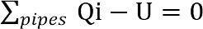 ……………….…………………………..2.4
Where, Qi=water inflow to node in the pipe (L³/T)
U= water used at node (L³/T)
During extended-period simulations; a term to the accumulation of water at certain nodes are considered, because water can be stored and withdrawn from storage tanks (Tomas, et al., 2003).
𝑝𝑖𝑝𝑒𝑠 Qi − U − ds/ (dt) = 0 …………………………….………….2.5
Where ds/dt change in storage (L3/T)
Therefore, the concept to conservation of mass is applied to all junction nodes and tanks in a water distribution networks.
2.8.2. Conservation of Energy
The principle of conservation of energy dictates that the difference in energy between two points must be the same regardless of the path that is taken and for convenience within a hydraulic analysis, the equation is written in terms of head according to (Walski, Chase et al. 2003) which is stated in the equation below.
$Z1+\frac{p}{γ}{+\frac{v2}{2g}+\sum{hp=z2+\frac{p}{γ}}+\frac{v}{2g}}^{2}+\sum{hl}+\sum{hm}$…………………………………2.6
Where
Z= elevation (L)
P= pressure (M/L/T²)
= fluid specific weight (M/L²/T²)
V= velocity (L/T)
g = gravitational acceleration constant (L/T²)
hp = head added at the pumps (L)
hl = head losses in the pipe (L)
hm = head losses due to minor losses (L)
Thus the difference in energy at any two points connected in a network is equal to the energy gains from pumps and energy losses in pipes and fittings that occur in the path between them (Walski, Chase et al. 2003).

Water Loss and Leakage
According to Allan (2003), Leaks can be categorized in different ways like physical and administrative losses. Physical losses can be caused by leaks which may occur in any part of the system like transmission pipes, service reservoirs, pumps, distribution networks, and house connections. Whereas administrative losses can are related to illegal connections, faulty (under registering) or broken meters, inaccurate billing, etc.
2.9.1 Some Definitions of Unaccounted for Water (UFW)
There is no universally applied or accepted definition of unaccounted-for water. In general, Unaccounted-for water (UFW) is the difference between the water supplied to a distribution system and the water that leaves the system through its intended use (Richard G.et al., 2000)
The term Unaccounted-for Water (UFW) refers to an accumulated range of losses that will be experienced by water Utility when comparing the system demand of a hydraulic water network with the quantity of water that is acknowledged as consumed by the water consumers residing within the network (UNEP, 2000).
Although the above definitions seem to have differences, all have in common that they took the water produced and distributed to the system as an input and the water consumed or exported from the distribution system as an output. From the local context, the UFW has been defined as the water loss calculated as the difference between the amount of treated water produced and supplied and the total amount of water billed and collected. The volume of water consumption due to the inaccuracy of the water meters as well as the lump-sum payments made by the customers when their meters cannot be repaired are also taken in to account for the determination of the UFW. On the other hand because of the widely varying interpretation of the term 'Unaccounted-for UFW) worldwide, the IWA task forces do not recommend the use of these terms. If the term UFW is used at all, it should be defined and calculated in the same way as ‘non-revenue water’ (NRW) (Farley and Trow, 2003).
2.9.2 Methods of Measuring Water Losses
The unaccounted-for water (UFW) expressed as a percentage of the total consumption and the minimum night flow (MNF) per connection are the most commonly used methods of measuring losses.
UFW is the measure of losses over a period as the difference between the amount of water put into a system and the metered or estimated quantity of water taken by consumers, while MNF is an indicator of the probable rate of losses at a given time.
Unaccounted for water is a useful indicator of probable losses, but it may overestimate them because supply meters tend to under-record consumption. In the UK, figures for unaccounted for water tend to be unreliable because the un-metered consumptions have to be estimated and can be 10% in error. Different countries use different methodologies to evaluate the losses like the U.K. leakage practitioners and planners consider leakage almost exclusively in terms of night flow rates, rather than as a calculation of annual losses as in West Germany. Each 13 method has its respective merits. 'Annual losses' are used for retrospective assessment of overall performance and long-term demand forecasting. 'Night flows' are used by practitioners responsible for leakage control and prioritization of leakage control activities. Any conceptual model, therefore, needs to be able to link night flows with annual losses in a consistent manner.
Water supply prospects in Ethiopia
Plan for Accelerated and Sustained Development to Eliminate Poverty must be followed in order to guarantee the sustainability of water projects. By the end of the program period, PASEDP sought to reduce the proportion of unreliable water schemes from 25% to 5%. Nevertheless, the PASDEP program time ends in just one year. As a result, its effectiveness in light of the plan will be evaluated following the program. PASEDP sought to reduce the proportion of unreliable water schemes from 25% to 5% by the end of the program period in order to secure the sustainability of water schemes. Nevertheless, the PASDEP program time ends in just one year. Its effectiveness in respect to the strategy will therefore be evaluated following the program (MOFED, 2006).
Even if the government of Ethiopia takes responsibility and makes work in order to achieve accesses water resource availability of the county, the status of water supply and sanitation coverage is still not sufficient in the country.
According to (MoWIE, 2016). About 61% of the total population of the country who have access to safe water supply at the end of 2016 excluding Addis Ababa and South region. Service coverage is considerably higher in urban than rural areas where the coverage is 63.1% and 52.5%, respectively. However, still now the coverage doses not ensure the sustainability of water supply. To improve the poor status of water supply and sanitation, the government of Ethiopia is on the progress to implement universal Access Program during the (GTP-2) Growth and Transformation Plan-II. The program also aimed to achieve 100% sanitation coverage both in urban and rural areas through construction of sanitation facilities, sanitation and hygiene promotion education at the end of the program.
The inventory is conducted across the entire country. However, for reasons that are outside the purview of this essay, a number of woreda’s in the Amhara, Oromia, SNNP, and even Zone regions in the case of Oromia were not included in the NWI2. Nevertheless, the NWI2 has covered 97% of the rural settlement, 91% of the urban settlement, and 96% of the total settlement. A total of 155,482 rural water supply systems were included in the inventory, however all urban water supply systems in all woreda’s and urban utilities were excluded for the same reason. On-the-spot techniques are used in nearly 92% of the aforementioned rural water delivery projects, and rural piped systems are used in 8% of them. Quantitatively, SNNPR and Tigray account for 20.45% (11.85% and 8.6%, respectively, as their orders) of the total inventoried rural water supply schemes, whilst Amhara and Oromia account for 43.97% and 31.76%, respectively (NWI-2, 2021).
Functionality and Non-Functionality of RWSSs
Numerous investigations on RWSSs have led to the development of definitions for functional susceptibility or non-functional in the context of RWSSs. According to Lockwood (2013), functionality is the percentage of water points that are active at any given time. If the system is now operating, it is normally assessed with a single check of a water facility or water point and is typically a binary state (yes/no). The percentage of improved water sources that are operational at the time of spot-checking is known as functionality. Designs that are fully operational, with all of their components functioning as intended (Assefa, 2007).

Functional schemes were identified as the schemes, which met the following primary criteria according to (Mohan, 2005) the water supply system should not have more than 7 day interruptions in supply to any consumer per annum, response to breakdowns approximately two weeks, frequency of breakdowns being once every three months in additions to the above criteria, the scheme should meet the following secondary criteria include: effective communication between the water service provider water services authority and the community , institutional arrangement and community involvement in all aspects of the scheme. Functioning implies the system supply enough water to meet at least the basic needs of all households in the defined project areas, and that water is consistently acceptable. It also means that the system is expanded in time to cope with population growth. In addition, increased water use and that enough fund continues to be available to maintain the agreed standard of operation. Water quality, water quantity, reliability of water supply and convenience are four indicators of the functioning of the water supply facilities.
Water supply schemes functionality status in Ethiopia
Scheme functionality status is one of important indicator of water scheme sustainability. However, considerable numbers of developed water supply schemes are not functional in the country because of multifaceted factors. The scheme non-functionality is contributing for already existing low water supply coverage. In SER there are 18170 (11.85%) of rural water supply of the country NWI, (2011). According to MoWR Annual Report (2007:30), number of non-functional schemes in the country is 25% in average. However, the rate varies from 17% in SER to 30% in many regions (Afar, Somale, B/Gumuz, Hareri, Gambela, Dire dawa). In other study; A total of 29, 204 (19%) of the 155,482 rural water supply schemes that were inventoried at the time of the inventory were not operational for a variety of reasons. There are 27,476 on-spot water supply schemes out of the total non-functional schemes, which mean that 17.9% of the non-functionality is attributable to on-spot water supply schemes, and 1.1% (1,728) is attributable to sources of rural piped water supply systems. When comparing non-functionality on a like-to-like basis, it is 19.4% for on-spot methods and 13.8% for RPS sources (MoWIE, 2016).
Approximately 88% of non-functionality is attributed to five main causes, including 52.1% due to a difficulty with spare parts, 15.6% owing to the drying up of the water source, 7.8% due to a problem with the quality of the water, 6.6% due to a lack of technical staff, and 6.1% due to a problem with the pump.
Other factors, including a shortage of cash or fuel, account for the remaining 12%. The message is unmistakable: a lack of replacement parts availability is the main cause of non-functionality. If the spare parts problem is at least partially resolved, the non-functionality rate could drop from its current level of 19% to 14% (MoWIE, 2016).
Groundwater sources (such as hand-dug wells, shallow wells, and boreholes) account for about 60% (93,250) of all rural water supply schemes. The inventory also showed that, of the 12,277 available rural piped systems, 19% used diesel-powered generators to lift water, 65% relied on gravity, 3% used grid power, and 2% used solar power, respectively. The remaining 11% used a combination of two or more energy sources.
Non-functionality of schemes is one of the challenges affecting the susceptibility provision and coverage increase in rural water supply. In the case of water supply, if the water supply continues to be available for the period which it was designed in the same quantity and at the same quantity as it was designed, the scheme is said to be susceptible and all of the many elements which are required for susceptibility must have been in place. According to this definition, the achievement of functional susceptibility is interdependent to the element of functional susceptibility before construction, during construction and post construction of rural water supply schemes. Non-functional schemes are schemes which are not giving service at all due to various reasons or are repeatedly breaking down and do not give service as required most of the time (Mohan, 2005).
Causes of Non-Functionality of RWSSs
Reasons for Dysfunction Design, construction, operation, and maintenance are all stages of a scheme's development or vulnerability that RWSS can defeat. The goal of the study is to increase knowledge of the primary reasons why various components of rural water supply studies fail to function. One of the top two government priorities in Nepal right now is functionality. Functionality was evaluated in 785 villages, and the government has responded by addressing functionality in the policy and enhancing training for implementers and scheme managers as a result of the concrete data. The difficulties were in developing an atmosphere that would encourage and facilitate better performance from scheme managers and implementers (Wandera J et al., 2011).
(Jackson R, 2011) established that the lack of water system functionality was due to a number of factors, including a low water table (6.6%), technical issues (10%), poor operation and maintenance (40.7%), a lack of trained and active water committees (30%), community initiatives (3.3%), literacy and sensitization (3.3%), and poor sitting (6.6%). The sustainability issues with rural water supply, according to WPF-IF (2012), were a significant factor in Tanzania's decreased access to clean and safe water.
According to the findings of the water point mapping, validation, and inquiry processes, the main causes of the non-operation of many water points were not technical concerns, but rather ineffective management of water resources brought on by problems with accountability among water sector actors.
One of the main factors contributing to the unavailability of rural water sources is the time it takes between the discovery of flaws and their restoration. The use of mono-lift pumps, faulty motor servicing, a lack of qualified operators, and improper technology installation during the design and construction of the scheme all contributed to the scheme's demise. According to (SNV, 2013), broken water stations in rural Zambia make it harder for people to receive a consistent supply of drinkable water. One of the problems is that local governments are unable to efficiently plan, implement, and maintain water infrastructure. Another is that WASH craftspeople are unable to do repairs due to a lack of incentives and replacement parts. Lack of precise information on the condition of water points is one of the other problems.
Inadequate operation and maintenance knowledge and skills at the level of water scheme committees and Woreda, poor access to spare parts, a lack of legal protection for water committees, an inappropriate technology scenario, a lack of a strong sense of ownership, and a lack of frameworks to encourage preventive maintenance of the schemes were the main causes of the non-functionality rate. Total non-operation was caused by unproductive wells, a damaged spring box, a broken hand pump, and a problem with the pump (Seifu A, 2012).
Sixty-two percent of the 65 water points in the special Woreda of Alaba do not provide a service to the community. The primary reasons for the non-functionality of water points are scheme failure (80%), technical problems (18%), closure by the WWRDO owing to WATSANCo management issues (3%), and closure by the WATSANCO due to the pay supplied to tap attendants (8%).
(Seifu A., 2012) of the total, 3% were still being constructed. He claims that the main causes of non-functionality in both states were mechanical, yield quality, and building concerns for the Southern Nations Nationalities Peoples Regional State (SNNPRS) and mechanical, institutional, financial, and yield issues for the Amhara Regional State.

Operation and Maintenance of rural water supply systems
The purpose of a water distribution system is to provide an adequate and reliable supply of safe water to its users. Operation and maintenance are those activities needed to continuously fulfil this purpose. The difference between operation and maintenance is that operation involves activities necessary to deliver the service, while maintenance involves activities that keep the system in good operating condition Carlsson, B., Roux, J. (2010).
According to Heizer.J & Barry Render (2006, maintenance is defined as "all operations involved in maintaining an equipment system in a functional state"). Furthermore, according to maintenance tasks are those that are carried out to maintain, repair, adjust, or replace facilities or equipment as necessary. In order for the operational scenario to be satisfied based on what has been prepared. A good maintenance system will lessen system variability. The maintenance tactics include applying and improving preventive maintenance as well as improving power or speed. Maintaining system functionality while keeping expenses in check is the aim of maintenance. For a maintenance and reliability strategy to be successful, coordinated processes and employee participation are required. A firm must choose the level of dependability and stability it desires. In order to evaluate the performance of maintenance management, two elements must be established. Maintenance procedures and staff participation are these.
In order to end poverty and boost global population health, clean drinking water must be made available. One of the Millennium Development Goals (MDG) 7's objectives was to reduce by half by 2015 the proportion of people who lack appropriate access to clean drinking water and basic sanitation (UN, 2011). Although the drinking water portion of the target has been deemed fulfilled (WHO & UNICEF, 2015), this is not practical globally because some regions are still far behind in achieving the drinking water supply goal. It is important to note that the claim of success misses two important aspects of water supply, namely the provision of safe water and the assurance of a sustainable water supply, in addition to the disparities in water access (Alexander et al., 2015).
It has been discovered that development experts in the water sector are more concerned with building new water supply networks than with assuring their sustained service delivery in order to accomplish the drinking water supply element of the Millennium Development Goals (Katz & Sara, 1997). In order to operate and maintain (O&M) and upgrade the infrastructures of the current water supply systems, little investments were made (Hutton, G., & Bartram, J., 2008). Compared to the planned 60% for sustainable water supply systems, just 5-20% of the overall expenses of the water supply project are estimated to be spent on operation and maintenance (O&M) (Hutton, G., & Bartram, J., 2008). Resources are few for maintenance tasks, endangering sustainability and depriving communities of the advantages of improved water systems. The UN General Assembly created a stand-alone water goal (number 6) in its Sustainable Development Goals (SDGs) (UN, 2011) in September 2015. The goal aims to ensure that everyone has access to water and sanitation, as well as to ensure their sustainable management. This example demonstrates that issues with water supply systems persist even after the MDGs.
Long-term service provision of any water program is almost wholly dependent on effective operation and maintenance (O&M), and this part of the water supply system is still a very often-mistreated facet (Musonda K, 2004). Implementing an effective Operation and Maintenance system depends on related layers of imperative management. The first level is centralized control by an external body of water supply systems; the second layer has zonal / regional responsibilities, and the third tier is local government. The first two solutions are unsuitable for water supply facilities operated by the community because they are a centralized structure that emphasizes a top-down form of support. Unfortunately, these strategies have struggled to effectively maintain and provide service to rural water supply systems. The third tier will be more successful in ensuring that sustainability is promoted. If the societies fail to run and manage their own water supply networks, sustainability cannot be completely realized. This is mainly because operating and maintaining of the water supply system on the day-to-day basis ensures that the facilities continue to function for long durations.
Effective Maintenance
Regardless of the management system used, a water supply facility's successful maintenance is a crucial component of the project's operation and maintenance (O&M) (Truslove, J. et al., 2020).
In order to maintain the accessibility and dependability of facilities, maintenance is essential (Muchiri, P. et al., 2011). (Van Zyl, J., 2014) asserts that maintaining community water supplies is frequently more challenging than building them. In order to achieve their functional requirements, water supply facilities should be developed using the proper technology.
The facilities must be efficiently built, taking into account both construction costs and O&M expenses (Martin.C et al., 2020). (Bazaanah, P., 2019) asserts that appropriate capacities including technology, human resources, sufficient financial resources, and local community support are necessary for the effective administration and management of rural water delivery infrastructure. This is particularly for building new infrastructure, maintaining existing infrastructure, fixing existing facilities, and replacing outdated or dysfunctional infrastructures.
A water supply facility's successful maintenance is an essential part of the project's operation and maintenance (O&M), regardless of the management system employed (Truslove, J. et al., 2020). Maintenance is crucial to preserving the facilities' dependability and accessibility (Muchiri, P. et al., 2011). According to (Van Zyl, J., 2014), managing community water supplies is frequently harder than creating them. Water supply facilities should be designed using the appropriate technology in order to meet their functional requirements. The facilities must be constructed cost-effectively, taking into account both O&M costs and construction costs (Martin C et al., 2020). According to (Bazaanah, P., 2019), effective administration and management of rural water delivery infrastructure require the right resources, including technology, human capital, adequate financial resources, and local community support. This applies primarily to the construction of new infrastructure, the upkeep of already-existing infrastructure, the repair of already-existing facilities, and the replacement of out-of-date or malfunctioning infrastructures.
(Ihuah, P. & Kakulu, I., 2014) note that for the original design of a facility to retain its high quality, the maintenance of that facility must be of the highest standards. The true test of a successful maintenance program is through the perceptions and reactions of the users. Essentially, facility managers must be trained to look beyond daily maintenance operations. They must anticipate and accurately predict component replacements since shipping and delivery of small orders usually delay, consume energy, and disrupt operations (Ihuah, P. & Kakulu, I., 2014).
While technical training should begin; in the early phases of design and construction, facility providers should also provide hands-on training in preventive and cyclic maintenance before handing over the water facility to the community.
According to (Ihuah, P. & Kakulu, I., 2014), maintaining a facility to the highest standards is necessary for it to maintain the high quality of its original design. The perceptions and responses of the users serve as the ultimate litmus test for a maintenance program's effectiveness.
In contrast, (Kumasi, T., 2020) notes that maintenance expenses have frequently received significantly less attention than the investment stage of water facilities. According to (Kumasi, T., 2020), Ghana's rural water delivery systems fall short in addressing crucial concerns that ensure long-term viability, including the requirement for various types of post-construction support. This has an adverse effect on the sustainability and maintenance of water facilities since long-term management plans are not taken into account throughout the design process. Hence, it highlighted in their studies that continuous post-construction technical support and finance schemes for long-term maintenance financing are necessary for sustainable management of the maintenance of rural water facilities.
In contrast, maintenance costs have usually gotten much less attention than the investment stage of water systems, according to (Kumasi, T., 2020). (Kumasi, T., 2020) asserts that Ghana's rural water delivery systems fall short in addressing fundamental issues that assure long-term viability, including the necessity for various forms of post-construction support. Due to the absence of long-term management plans during the design phase, this has a negative impact on the sustainability and maintenance of water facilities. As a result, it was noted in their research that ongoing post-construction technical support and financing schemes for long-term maintenance financing are required for the management of the maintenance of rural water systems in a sustainable manner.

3. MATERIALS AND METHODS
3.1 Description of the Study Area
The study was carried out in Wolaita zone Damot Gale Woreda, which is located in escarpment of rift valley and lies between 6.89⁰ to 7.12⁰ N and 37.75⁰ to 38⁰ E longitude. The altitude ranges from 1900 to 3000 meters above sea level and its peak was mount Damot and 300km of Addis Ababa around Halaba- Worabe- Butajira asphalt road and is 18km from Wolaita Town, the capital city of South Ethiopia Regional State. The Woreda has area coverage of 255.5 km² and accommodate an estimated number of 230,022 human populations from this male 103,510 and female 126,512 at 2022.
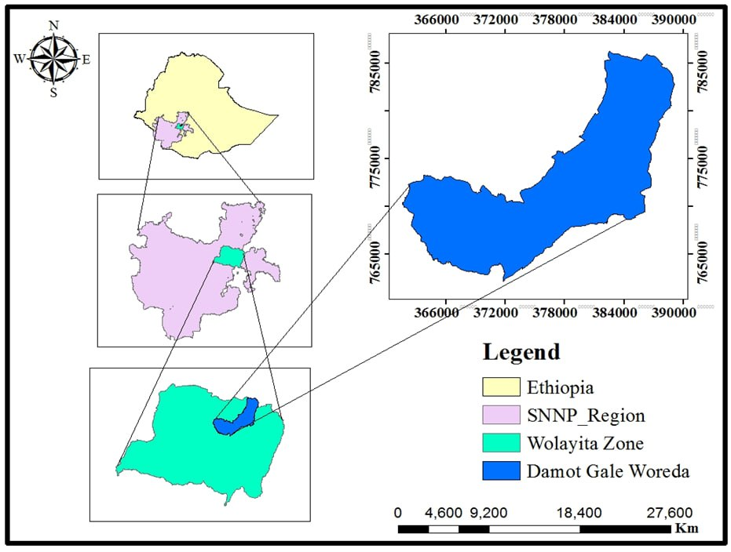
Figure 3 1: Map of study area
3.1.1 Climate and Topography
Two cropping seasons (called Gabbaa and Silla in local or Belg and Meher in National language, respectively) now in the area. The Belg cropping season extends from March to May with medium amount of rainfall, whereas Meher extends from June to September with high amount of rainfall. Mean annual rainfall was 1328.4mm with the highest record in August. Damot Gale district have Dega (highlands) (22%), Woynadega (49%) and Derke Woynadega (lowlands) (29%). The mean annual minimum and maximum of the area were 10.8⁰ C to 28⁰ C respectively. The topography of Damot Gale Woreda is ranged from middle to steep sloop. The mount Damot is ragged with deep gorges incised by river valleys. The sloop gentle at its foot but becomes very steep at about altitude of 2000m and above.
3.1.2 Soil and Land Use Type
Soil types in Damot Gale district are silt, clay and clay loam. In mount Damot area, the soil has reddish brown (Nitosols) colour and derived from multi-storey ignimbrite sub stratum the soil has high porosity and infiltration. These features gave the soil a good quality for cultivation. However, low levels of Nitrogen and Phosphors (nutrient depletion) due to erosion and repeated cultivation significantly affect the production in the area. There are different land use types in Damot Gale Woreda which include perennial crops, annual crops, forest, grazing land and others such fallow land. Intensification of cultivation is higher in the Woreda (Solomon, 2022).
3.2 Materials
To do this thesis the material and equipment listed in the table below was used for data collection, processing and evaluation.

Table 3.1 Material used for the research study
No. | Types of material or equipment | The use of equipment or material
1 | Water GEMS | Used to analysis hydraulic parameter such as pressure, velocity and head loss and another parameter to underline the performance of the study.
2 | Arc GIS 10.3 | To delineate the study area and format the network to export to Water GEMS.
3 | Global Mapper and Google Earth pro. | Used to check the elevation of the network.
4 | Pressure gauge | Used to measure the pressure at the selected location in the water distribution network system.
5 | GPS | Used to collect elevation data during pressure and flow rate measuring activity in the distribution network.
6 | Endnote | Used as personal data base to gather and store citation record.
7 | Microsoft excel | Used for elevation data management, nodal base water demand estimation and for manual validation work.

3.3. Data Collection
3.3.1. Analysing Hydraulic performance of existing distribution systems.
In order to effectively utilize water distribution system, accessing of the system component performance using computer model Water GEMS plays the grate role for the improvement the performance of the system. System component can accessed in term of pressure, velocity and head lose based on the rural water supply system design criteria to use as the guide line provided MoWR, 2016. The source of data used to analyses the hydraulic performance of distribution system was the primary and secondary data. The primary data is collected through field survey and whereas the secondary data collected from other data available in water utility office.
The water distribution system is started from the source of supply, in this case from the boreholes.
The water is pumped using different diameters of ordinary HDPE, DCI and GI transmission pipe from the existing borehole to the different service reservoir systematically scattered on the chained train to Woreda. There is no continuous supply of water in the distribution system. Almost some part of the community of the town could not get ample water supply pressure problem. As a result, currently the water production from ground water sources is not sufficient.
The existing water distribution systems of the Woreda are both pumping and gravity system. The water from the different sources are taken to 200 m³ reservoir by pumping which give service to the two Kebeles and also other different size reservoirs such as 75 m³, 50m³ and 10m³ used to distribute for different districts in the Woreda
3.3.2. Estimating the existing water supply and demand.
Water demand is the volume of water required for domestic purpose, in which different adjustment factor would be applied to estimate the present water demand forecasting the future water demand of the study area. Secondary data such as population data, different literature reviews etc. were obtained from water utility office Damot Gale Woreda, to analysis the present and future water supply and demand.
Currently, the Damot Gale Woreda is supplied from 1 (one) hand dug well, 31 Sallow well, 9 Borehole, 28 On spot springs and 13 Spring with distribution source with a reported water production of 112.27.m3/day. The main characteristics of the existing water sources are presented below according to water service office technician the overall wells are pumped at average rate 7.5m3/h (2.083 l/s) for about 13 to 14 hours per day.
Table 3.2:- The existing sources of drinking water supply in Damot Gale
No | Scheme Type | Number of Scheme | Number of functional scheme | RWS Scheme Coverage
1 | Hand Dug Well | 5 | 1 | 4.63
2 | Shallow Well | 50 | 31 | 46.29
3 | Borehole | 10 | 9 | 9.26
4 | On spot Spring | 29 | 28 | 26.85
5 | Spring with Distribution | 14 | 13 | 12.96
 |  | 108 | 82 | 100

3.3.3. Quantifying water loss on the distribution system
The water loss from the distribution system can be determined using the treated water from the treatment source and the consumed water aggregated from the billed water data, most of the time available on the monthly base in water office. Secondary data such as water production and consumption which is used to analysis water loss from water the water distribution system is obtained from Woreda water, mine and Energy Office.
Interview:-to get additional information, unstructured interview questionaries’ were conducted for the concerned body of Woreda water, mine and Energy Office staff including the manager of Woreda water, mine and Energy Office concerning the factor that cause water loss in the distribution system.
3.3.3.1 Water production
The water production has been evaluated as total annual water supplied to the water distribution system (WDS). The production of water depends on supply system, which administrated by Damot Gale Woreda Water Mine and Energy Office (DGWWMEO).
In the Woreda water supply system, there is big discrepancy between the consumption and production of water. As result of this water is distributed intermittently and even some compartment of the town does not receive water for long period.
The existing source for water supply, to water supply system for water utility office was mentioned below in the above Table 3.1. As per information obtained from water utility office the source is designed to have the production capacity 112.27.m3/day for Woreda. But currently 7.5m3/h (2.083 l/s) is pumped with 13 to 14 average working hours per day for the Woreda rural water distribution system.
3.3.3.2 Water Consumption
From some water points the measured water supply data and most water supply sources locally measured by Jerican (water collecting material) is used to evaluate water loss in the water supply system and, some of the was collected from Woreda water, mine and Energy Office. The monthly collected water measured data were converted to the annual water consumption base for the purpose analysis. The customer data can collect from water billed data available on the monthly base.
Population forecasting
Population projection (forecasting) provides information on the future size, composition of a given area. Knowledge of this information is fundamental for development plans where target is to satisfy the future need of population in the area of water demand. Several methods are used to forecast the population but, their result varies from one method to another. Selection of appropriate method for particular town needs to consider over all current situation of the targeted town. Because of the scheme was under fast growing, where relatively high economic activities were observed at the same time continuous expansion due to various reasons was experienced, so that, for this study Geometric increase method of future population forecasting is used because this method is mostly applicable for emerging towns having that vast scope of expansion. It is expressed as follows:
Pn = Po* ${(1+r)}^{n}$ …………………………………….……………………………………….…………… (3.1)
Where: Po = Initial known population i.e., the population at the end of last known census.
Pn = population after n years
r = Annual population growth rate in %
n = number of years of the concerned period.

Damot Gale Woreda has 29 kilometres of asphalt roads, 1 kilometre of all-weather road and 57 kilometres of dry weather roads, from an average road density of 209 kilometres per 1000 square kilometres.
3.3.4 Accessing the operation and maintenance status of rural water supply schemes.
Under this objective, the current situation of existing water distribution system status can be assessed based on per capita water consumption and level of connection per family. The source of data involved under this objective was the secondary data and it is obtained from Damot Gale Woreda water, mines and energy office as shown table below.
3.3.2.1 Water Demand
According to DGWWMEO (2021), the availability of potable water supply provision in the Woreda is estimated to be 27%. In fact, many water schemes have been established up to the end of 2014; yet, access to adequate potable water remains poor due to non-functionality of water scheme in addition to coverage.
Adjustment to climate
In addition to per-capita water demand and mode of services which influence the quantity of water consumption, the climate also affected the water consumption and the per-capita domestic demand was adjusted by a factor which is given in table 3.4.
Table 3.4: Climate Adjustment factor (MoWR, 2006)
Altitude | Factor
>3300 | 0.8
2300-3300 | 0.9
1500-2300 | 1
500-1500 | 1.3
<500 | 1.5

Adjustment for socio-economic activity
The domestic water demand also depends on the socio-economic situation of the area. Thus per- capita domestic water demand was modified using appropriate factor. The demand adjustment factors in socioeconomic situations were given in Table 3.5.
Table 3.5: Demand adjustment factor for socioeconomic situation
Group | Description | Factor
A | Towns enjoying living standard and with very high potential development | 1.10
B | Towns having a very high potential for development, but lower living standard at present | 1.05
C | Towns under normal Ethiopia condition | 1.00

Variation of Water Use
The maximum daily water demand and peak hour demand coefficients and factor respectively figured out in table as the guidelines.

Table 3.6: Maximum daily coefficient and peak hour factor
Maximum daily coefficient | Town population | Peak hour factor
2.00 | 0-50,000 | 2
1.55 | 50,001-100,000 | 1.8
1.45 | >100,000 | 1.6
(Source: MoWR, 2006)
In demand analysis knowing maximum daily demand and peak hour demand are very crucial. The maximum daily demand is based on the average daily water required and peak hour demand is greatly influenced by population size.
Water Loss Analysis
One of the major challenges of water utilities is high volume of water loss in their distribution networks. If a large quantity of supplied water is lost; it is difficult to meet the required demands, and correspondingly made challenges to keep the water tariffs in the system at a reasonable level. Whereby, water loss for Town was assessed and discussed as follows.
3.5.1. Quantifying Total Water Loss
In order to evaluate the total loss of water in the town, the total volume of water input to the network distribution system was compared with the actual water consumption. In this case, the data on consumption were collected to the entire town level. The total annual water produced and distributed to the system and the water billed that was aggregated from the individual customer meter readings were used to quantify the total water loss for the Woreda.
All the water consumptions in the town were metered, as the authorized non-metered consumption is insignificant while compared with the total water production, the unaccounted-for water (UFW) has been used as a similar of the total water loss in this study.
Certain level of water losses could not be avoided from a technical point of view and considered as acceptable from an economic point of view. According to AWWA leak detection and accountability committee (1996) recommended 10% as a benchmark for UFW (Sharma, 2008).
3.5.1.1. Water Loss by Mathematical Calculation
Water loss expressed as a percentage can be an appropriate means to show the extent of the loss within a given town, but it is not a good indicator for comparing the losses from one area to another. Water loss as % of net water production was used to quantify losses as it could be expressed by Equation 3.2.
UFW (%) = $\frac{Total produced – Total water consumptiony}{Total water produced}$ * 100………………………. (3.2)
UFW levels less than 10% is acceptable and no need for monitoring action whereas UFW levels 10-25% is intermediate and could be reduced. UFW levels above 25% are very acute and it requires immediate action for water loss management.
Data Analysis
To analyse the data which was collected from different sources, both qualitative and quantitative methods were used. From the quantitative methods, the descriptive statistical methods like percentage, graphs and cross tabulation were used in order to come up with the appropriate result. The computer software application water GEMS model and excel were used to analyse the data obtained from office and field survey. The field survey data for distribution system was evaluated by using the software Water GEMS connect edition 10, Global Mapper and GIS. The method of analysis was based on nodal pressure and velocity parameters.
During data analysis, the nodal pressure and pipe link velocity were determined to identify higher or lower pressure zone of the area. The standard value of nodal pressure and velocity were determined. The value which was under normal value taken as acceptable and below and above the standard values taken as unacceptable compared with urban design criteria (MoWR, 2006).
3.6.1. Technical Analysis of Distribution Network of the Woreda
The entire water supply network of the rural area, including their attribute like pipe length, diameter and material type, pipe material, pump stations and reservoir were collected from town water supply and sewerage enterprise. Hydraulic simulation was determined the hydraulic parameters such as velocity, pressure, head loss, flow etc.by using water software water GEMS.
Bentley Water GEMS
It is a multi-platform hydraulic and water quality modelling solution for water distribution systems with advanced interoperability, geospatial model-building, optimization, and asset management tools (Ramesh et al., 2012).
The calculation software algorithm which is based on Hydraulic Gradient method, allows the hydraulic analysis of water networks determining the pressures at various points in the system, as well as the flow rates, velocities, losses the lines that make the water network, and many other operating parameters derived from the elements present in the system as pumps, control valves, tanks, etc. from the physical characteristics of the system and demand conditions previously established. Water GEMS also allows extend its capabilities to issues of long-term management of supply systems including: vulnerability analysis fire protection analysis, cost estimating energy, hydraulic calibration, optimization, etc. This additional program to conventional tools for analysis and modelling of pressurized networks has productivity tools in data management processes, building models from external files, elevation extraction, mapping techniques demands from spatial analysis, preparation and management of scenarios, additional hydraulic calculations, operational management and preparation of reports and plans. In addition, the software provides several options for displaying results as tabular reports, profiles, time-varying graphs, notes and colour coding, etc. (Ramesh et al, 2012).
Developing the Distribution Network
The network was developed by using data entry dialogue boxes to enter data from field surveys, offices, and other sources, such as nodes (elevation, geometry, and base demand), pipes (pipe diameters, pipe lengths, material types, pipe roughness). Tank (base, initial, minimum, and maximum elevation, and diameters of the tank), Pumps (elevation, pump head, and yields). And Hazen–Williams pipe coefficient pipes values and other necessary values by flex table of the software. The data analysis was simulated by developing water distribution network scenarios to evaluate the performance of the hydraulic parameters in terms of pressure, velocity, flow, head loss, and other. There are various types of simulation that a model may perform, depending on what the modeller trying to observe or predict.
Nodal Demand Allocation
To allocate the base nodal demand for water distribution network, the following steps were followed: the town shape file obtained from the town administration was displayed on ArcGIS in a given area was calculated by dividing their respective area. The Theisen polygon was used to design the nodal influence area around each demand node on the town water distribution network using the Water GEMS software, and it could be converted to shape file format. The Theisen polygon was used to form a polygon around the junction influenced area on the Water GEMS software and saved in shape file format Annex Table 5. The Damot Gale Woreda and Kebeles shape file, which was filled with relevant data in ArcGIS, was loaded into Water GEMS using the Load builder toolbar of the software.
The demand for each junction was assigned within the load builder toolbar on Water GEMS within the load estimation by area methods.

Operation and Maintenance
This research methodology is comprised of three main phases as shown in Figure 3.4. At the beginning, the data is collected mainly from Regional; Zone and Woreda Water utility Office. Household questionnaire, interview with key informant, and field observation is taken to understand the existing situation of water supply system of targeted kebeles. Secondly deferent literature and documents that mainly regarding functionality of rural water supply systems are reviewed. Finally, the data was analysed by using SPSS software.
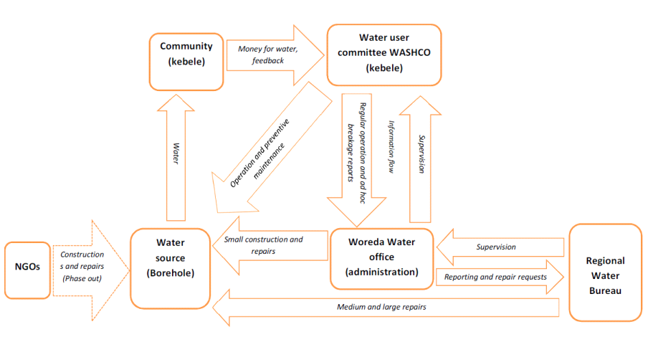
Figure 3.2: Water scheme management structure (Source: People in Need)
WASHCOs are nominated by the community to operate and maintain local water systems and carry out minor repairs. They communicate with official bodies, typically the Kebele Administration and Woreda Water Office; resolve water related disagreements among community establish and collect tariffs. WASHCOs do not have legal status and are currently being transformed into Water User Associations (legal bodies registered with Woreda Water office). Woreda Water, Mines and Energy Office (also referred to as the Woreda Water Office) is responsible for planning, budgeting, implementing and monitoring water construction and programs. Monitors the operation & maintenance of infrastructures, verifies water quality, follows up the operations of the WASHCOs and conducts water scheme repairs. Zonal Water, Mine and Energy Department exists in most, but not all, cases between the Woreda and Regional levels. They supervise and provide technical support to the Woreda Water Office.
Depending on the system's failure for maintenance and rehabilitation costs, the woreda evaluates his capability for operation and maintenance service options. If it is outside the woreda's capacity, the woreda will forward it to the appropriate body. Figure 3.4 depicts the service options for maintenance and rehabilitation.
.
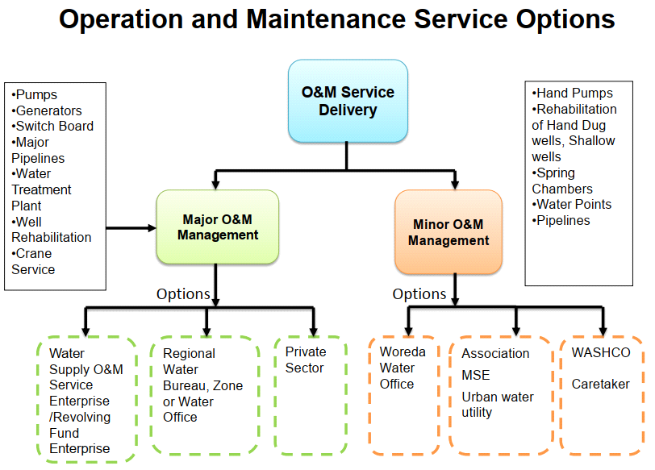
Figure 3.3: Operation and Maintenance Service Options
3.7.1 Data collection methods for Operation and Maintenance
In this study a primary as well as secondary data were used for the evaluation of the problem. This study uses a mixed method comprising of a household survey interview document review and physical site assessment. Structured survey questionnaire was administrated to the community beneficiaries of the water project. Interviews and discussions with water committee members, personal observation and assessment of the physical water project and review of documents was conducted. The researcher was conducted interviews with the selected individuals, who are believed to have good information about the area and that of the subject matter, Kebele administration officials as well as Woreda water resource office experts and Zonal water office professionals.
Household Survey: A cross-sectional descriptive study was undertaken in fifteen selected kebeles utilizing prepared structural questionnaires for operation and maintenance, consumption, and per capita demand to evaluate the present water delivery schemes and their implementation. Field Observation: In addition, the above tool observed the physically existing water scheme, its state of development, and the distances of water sources from dwelling places, as well as the functional sustainability of the schemes, and compared it to the checklists to assess the reliability of the data collected.
Figure 3.4: Research flow chart
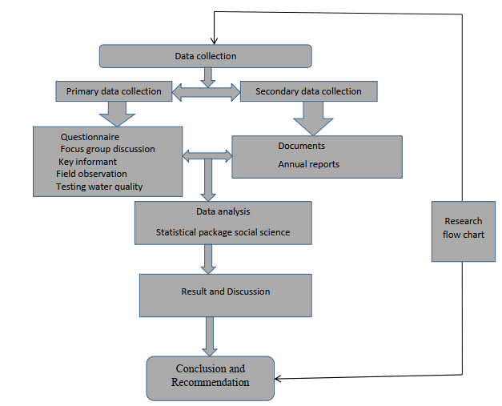
3.7.2 Sampling method and size determination
A non-probability sample is a type of sample in which elements are selected in a non-random manner on the basis of convenience, and each element in the population does not have a non-zero probability of being contained within in the sample (Neuman, 2000). Such type of sampling method is often used in qualitative research and relies on one’s experience and knowledge of theory and previous research findings. Therefore, respondents are select that are considered to be representing the population being studied. A non-probability sampling framework is applied in order to obtain a sample that appropriate for the study. Therefore, the researcher selected purposively fifteen of them with the consultation of Woreda administration and Woreda water office. The survey was conducted in the fifteen kebeles. 16 electro mechanical expert and plumbers are included, 15 kebele officials and one woreda officials and one regional official.
The selection criteria of kebeles that the study was used are based on the study area due to information in to high number of populations settles in the area and repeated community complains, and also by identifying those who have water shortages because of high non functionality rate of the scheme availability in the selected villages and scheme type 26 consideration. Then by determining the sample size from the selected kebeles and survey was undertaken those amounts of size of sample by random method from the selected household of the Keble lives in the area.
Kebele Selection: According to the sample size computation from 27 Kebele 15 Kebele were selected purposely based on accessibility and feasibility factors those which have high non-functional rate and scheme type.
The data obtained from WWMEO, (2020), the beneficiary of total number from protected HDWs and SWs and spring development are 8783 (eight thousand seven hundred eighty-three) the selected kebeles of the households. According to regional water bureau, (RWB) one HDW and SBW served 250 and 350 people respectively. Based on this, used (Taro, 1967) formula to figure out what sample size need to take.
$n=\frac{N}{{1+N(e}^{2})}$…………………………………………………………………………… (3.3)
n = Number of samples
N = Total households and
e = Error tolerance (0.05 - 0.09)
$$n=\frac{8783}{{1+8783(0.07}^{2})}=200$$
A sample of 200 households was drawn from the total number of water consumers. Furthermore, fifteen additional office professionals who work for NGOs at the Woreda level were included in the study as key informants; however there are currently no NGOs active in water supply operation and maintenance.
These specialists assumed that they had more information on numerous areas of the water supply system, such as management, budget allocation, and the availability of spare parts.

3.7.3 Selection of the Respondents
The main objective of contacting respondents is to gain available data about the existing water supply schemes (weather the schemes are functional or not and related service challenges). The profile of the respondents observed and involved in the research for the reliability of the information. The selection of the respondents considered based on their educational background, economic activities, family size and gender. Thus, in figure 3.9 shown that details their education background, economic activities, family size and gender.
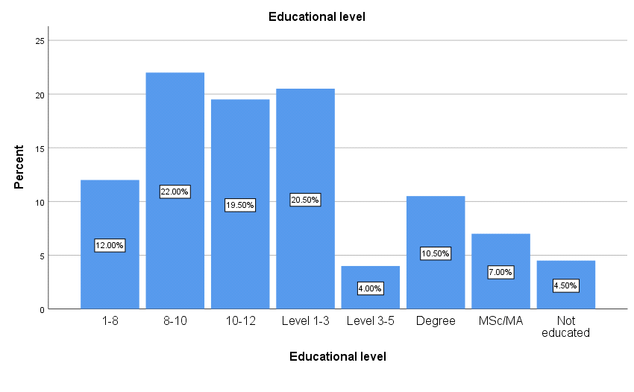
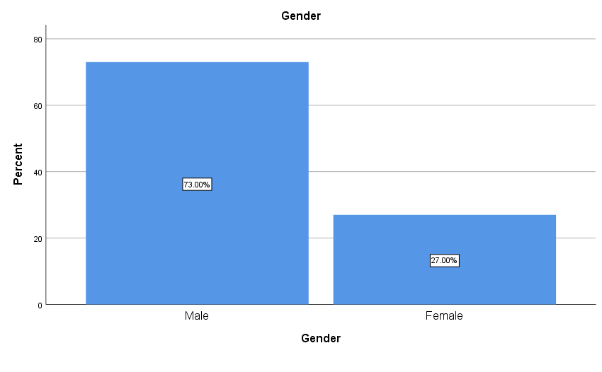
Figure 3.5: Education level, Kebele, family size, and gender
Under this topic the background information of the selected households, those were participated in study through providing answer for questionnaires.
The information includes names of kebeles from where respondents were participated, respondent’s gender, family sizes and educational levels. As it is shown in the Figure 3.8, the investigation regarding to challenges on rural water supply operation and maintenance has conducted in Damot Gale Woreda in 15 kebeles which accounts 55.56% of total 27 woreda’s rural kebeles. Research works shows, using water appropriately requires a minimum level of education.
Existing Water Supply Situation
3.8.1 Public Awareness and Education.
Public awareness and educations are very critical for functionality water supply services to protect water scheme. Beneficiaries, who are informed and involved in the construction of a water supply system, are closer to support the development effort both before and after implementation, and protect their schemes from harm. Although their role of treat water source is not difficult to estimate. Obviously, customers that are informed and involved in the source (who beneficiaries' and participate in the construction of the project as well as who too close) are more likely to support the water supply scheme development. Information and education measures can directly generate water consumption savings by persuading consumers to use less water, as well as support other conservation measures. For example, it is widely believed that education (awareness) plays a great role in how water consumers respond to changes (WSA, 2003).
3.8.2 Status of Water Supply Schemes
As the data obtained from the Woreda, Water, Mine and Energy Office WWMEO, (2023) and regional water, mine and energy bureau, RWMEO (2023) in Damot Gale Woreda 108 water schemes have been developed until 2023.
However, during data collection getting available information and completing data of existing water scheme was difficult. The reasons were the absence of skilled workers at the time of field work and there was not well-organized data about the schemes in the offices. The data obtained indicates that from the total developed water scheme in the fifteen Kebeles, 23.5% of the schemes (19SW and 4 HDW) are completely not-functional during the time of field visit. The other newly growing problem of system failures of the schemes in the area is the theft of hand pedestals.
Even though, the rest functional water schemes were providing service with problems such as lack of spare parts and gap of skill of artesian, there is also limitation on technical capacity of caretakers in rural area to repair and maintain the water supply schemes.

4. RESULTS AND DISCUSSIONS
4.1 Hydraulic Analysis of Existing Water Supply Distribution Network
The minimum and maximum operating pressure in the water supply distribution system network in Ethiopia was 15m and 70m of water column respectively. The maximum pressure in the main is considered not to exceed 80m to limit leakage and stresses on pipes. The Velocity is also one of the vital parameter for assessment of water distribution performance analysis. The velocity of flow in the pipe below 0.6m/s causes water stagnation, sediment accumulation and bacteriological growth in the pipe, on the other hand velocity of flow in the pipe above 2m/s causes head loss as well as water hammer.
The hydraulic analysis for both pressure and velocity in water distribution scheme was conducted using Water GEMS hydraulic software for the steady-state conditions during maximum water demand. Most of the network pressure heads were in acceptable ranges between 15 m and 70 m of water column, regardless, some junctions in the network has below the acceptable values of water pressure of 15 m of water column. The pressure at node in distribution system depends on the adopted minimum and maximum pressure within the network, topographic circumstances, source position, storage elevation and the size of the network.
4.2 Water Distribution System of the Woreda
The water distribution system is started from the source of supply, in this case from the boreholes. The water is pumped using different diameters of ordinary HDPE, DCI and GI transmission pipe from the existing borehole to the different service reservoir systematically scattered on the chained train to Woredas. There is no continuous supply of water in the distribution system. Almost some part of the community of the rural area could not get ample water supply pressure problem. As a result, currently the water production from ground water sources is not sufficient.

Table 4 1: Distribution Network Pipe diameter and Corresponding Lengths with Their Coverage (Mokonisa Woyge and Wogera Kebele, 2023)
Source Name | Kebele | Diameter (Inch/mm) | Pipe Material | Length of Pipe
BoH | Mokonisa Woyge | 4inch | GI | 120m
 |  | 120mm,90mm,75mm,  50mm,25mm | HDPE | 1,105m
SW | Wogera | 3inch | DCI | 80m
 |  | 3inch,90mm,75mm,  63,50,25mm | GI/HDPE | 1174
Total pipe length (m) |  |  |  | 2,504

4.2.1 Population projection
Among the difference approaches of population forecasting methods, the study analysed the method which performed well in terms of similarity and/or least deviation from the census population. The results of all the projections plotted against latest census population, and analysed the approach which performed well in terms of similarity and least deviation from the census population were selected. Accordingly, the geometric increase method was adopted for further water demand calculations, since the geometric increase method performed better population estimation in terms of similarity to or least deviation from the census population.
4.2.2 Estimation of Water Demand
Water demand estimation was made according to MoWR, (2006) demand categories present in the study area. Hence, the populations of Damot Gale Woreda were 160,451 for this population the existing water supply system is the mode and levels of service which used for domestic demand estimation was utilized. According to MoWR, (2006) percentage of domestic water demand of rural water supply is estimated.
The water demand is the summation of all consumptions present in the study area and it would determine the capacity needed from the source.
Currently, the Damot Gale Woreda is supplied from 1 (one) hand dug well, 31 Sallow well, 9 Borehole, 28 On spot springs and 13 Spring with distribution source with a reported water production 112.27.m3/day. The main characteristics of the existing water sources are presented below according to water service office technician the overall wells are pumped at rate 7.5m3/h (2.083 l/s) for about 13 to 14 hours per day.
To determine the demand of the total Woreda define the beneficiary and its consumption, for total population in the woreda, the average daily consumption of the Woreda population was taken from DGWWMEO 25 l/c/d. Form this demand of the Woreda is shown in Table 4.2 below.
Table 4.2: Estimation of water demand 2021 up to 2023
Population in 2020 | Projected Population
Population in 2020 | 2021 | 2022 | 2023
217,336 | 223,679 | 230,022 | 235,724
Water Demand needs (m³/day)
Maximum Daily Demand | 8,611.6 | 8,855.8 | 9,075.4
Average Water demand | 6,151.2 | 6,325.6 | 6,482.4
Peak Hour Demand | 14,147.7 | 14,549 | 14,909.5
Water consumption(m³/day )
Daily consumption p/c/d | 2,827.3 | 2,907.5 | 2,979.6
Hydraulic Model Calibration and Validation
The hydraulic model calibration was made by comparing simulated value with measured values in the field. The results of pressure measured and simulated by GIS integrated with Water GEMS hydraulic model, as it was observed that RMSE is minimal, and has correlation coefficient of 0.9302, which indicates a degree of linear dependence.
In addition, the hydraulic model in Water GEMS was calibrated in the Darwin calibrator feature and optimized until a great agreement with the field data, as can be observed by the fishing volume.
Analysis of Pressure in the network
The analysis of the pressure distribution is a decisive parameter in water distribution network modelling. As a result of simulations carried out in the existing models, it was found that it is possible to reconstruct the actual working conditions water supply network. The pressures are distributed in the range of 11.004 mH₂O to 70 mH₂O, with few nodes with pressures greater than 70 mH₂O (Fig. 8) at the time of peak hour demand.
The result of simulation run was obtained after model constricted from the input data of existing data a total node of 30 was reported from the study inventory dialog box software. As described in Fig. 8 above, 60% and 37.5% of the two source consumption nodes have acceptable pressure limits between (15–70) mH2O.
Analysis of Velocity in the Network
The analysis of the speed distribution made on the existing state models of all tested water supply networks showed that most pipes, its value are lower than the recommended. The result of velocity distribution show that up to 15% and 10% the two sources of the network have low which may causes low water quality due to water stagnation, increase age of water, sediment accumulation and bacteriological growth in a pipe network. This is 116 out of 5 pipes which had a velocity lower than 0.6m/s. A total of 34 pipes out of the 30 links accounting for 70% presented velocity between 0.3m/s to 2m/s, which is recommended range for water distribution network.
Developing Pressure Zone Boundaries
The result of the study indicates that, the Arc Map integrated with the Water GEMS hydraulic model enhanced more detailed elevation contour and pressure contour. The pressure is strongly linked to the topography with a lower ground and the nodes are subjected to higher pressures. The integrated system can generate accurate, smooth contours for any variable including pressure, hydraulic gradient and flow directly on the map with their contour interval.
4.2 Layout Schematization
In constructing a distribution network concerned with assigning labels to pipes and nodes, Tanks and pumps Bentley Water GEMS Connection Edition 10.3 was assign labels automatically. The water distribution network map was obtained from the Woreda Water, Mine and Energy office which was prepared from study and design document report of the woreda water supply distribution network. When creating a schematic drawing, pipe lengths are entered manually. In a scaled drawing, pipe lengths are automatically calculated from the position of the pipes’ bends and start and stop nodes on the drawing pane. In this network, the modelling of a reservoir connected to service line and simulates a connection to the main water distribution system for each kebeles. Simplifying the network in this way can approximate the pressures supplied to the system at the connection under a range of demands.
Table 4.3.Mokonisa Woyege pressure and velocity analysis
Pressure (m of H2O) | Number of nodes | Percentage |  | Velocity (m/s) | Number of pipes | Percentage
<=15 | 22 | 100% |  | <0.6 | 22 | 92%
15 -70 | 0 | 0% |  | 0.6-2 | 2 | 8%
>70 | 0 | 0% |  | >2 | 0 | 0%
Total | 22 | 100% |  | Total | 24 | 100%

Mokonisa Woyege Kebele water supply scheme as indicated on table 4.7 above shows 100% of the distribution nodes were with pressure of less than the allowable limit (15m H20). This indicates that all the system was supplied with insufficient pressure. The flow velocity varies throughout the pipe network during the simulation. From the system consisting of a total of 24 pipes, only 2 pipes have the velocity within acceptable limit and 22 pipes carry the velocity below the limit. This indicates that almost all of the system was supplied with insufficient velocity. The figure 4.6 below shows the pressure variation and the spatial variation of flow velocity in distribution network coded with different colours in Water GEMS for Mekonisa Weyegea kebele. The red collared nodes represent the pressure range between 15 to 70 m of water column, which was acceptable. The pipes which is coded with green colour indicates the velocity below 0.6m/s and those pipes coded with red colour carries the velocity between 0.6 and 2m/s. the red colour coded pipes.

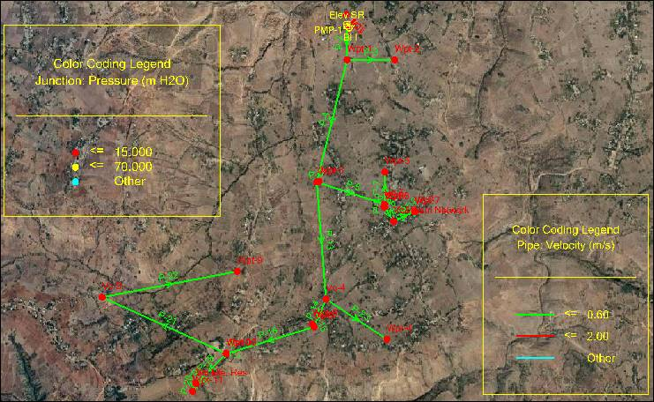
Figure 4.1: Pressure and velocity colour code of Mokonisa Woyge Kebele scheme
Table 4 .4: Wogera pressure and velocity analysis
Pressure (m of H2O) | Number of nodes | Percentage |  | Velocity (m/s) | Number of pipes | Percentage
<=15 | 0 | 0% |  | <0.6 | 6 | 60%
15 -70 | 3 | 37.5% |  | 0.6-2 | 4 | 40%
>70 | 5 | 62.5% |  | >2 | 0 | 0%
Total | 8 | 100% |  | Total | 10 | 100%

Wogera Kebele water supply scheme as indicated on table 4.9 above shown that 62.5% of the distribution nodes were with pressure above the allowable limit(70m of water column), 37.5% of nodes were with acceptable pressure level (15 -70 m H20). This indicates that most of the nodes were supplied with pressure above allowable limit. From the system consisting of 10 pipes, 4 pipes have the velocity within acceptable limit and 6 pipes carry the velocity below the limit. The figure 4.8 below shows that the pressure variation and the spatial variation of flow velocity in distribution network coded with different colours in Water GEMS for Wogera Kebele. The green coloured nodes represent the pressure range between 15 to 70 m of water column, which was acceptable. The nodes coded with red color have the pressure values below acceptable range of pressure. The pipes which is coded with yellow color indicates the velocity below 0.6m/s and those pipes coded with green color carries the velocity between 0.6 and 2m/s.

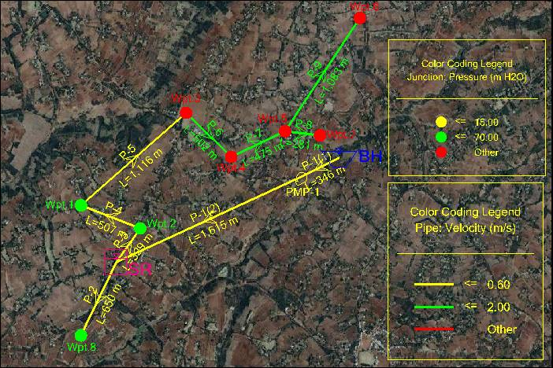
Figure 4 2: Pressure and velocity colour code of Wogera Kebele scheme
Table 4.5: Head loss gradient of Mokonisa Woyge Kebele scheme
Mokonisa Woyge
Head loss gradient (m/Km) | Number of pipes | Percentage
<1 | 8 | 33%
1-5 | 5 | 21%
>5 | 11 | 46%
Total | 24 | 100%
Table 4.6: Head loss gradient Wogera Kebele scheme
Wogera
Head loss gradient (m/Km) | Number of pipes | Percentage
<1 | 2 | 20%
1-5 | 5 | 50%
>5 | 3 | 30%
Total | 10 | 100%

4.5. Overall hydraulic performance of the scheme

As indicated on the Table 4.16 below, the overall hydraulic performance of the Mokonisa Voyage schemes shows 100% and Wogera Schemes 0% of nodes were with pressure below allowable limit, 46.7% of nodes were with pressure with acceptable limit for two sources and 40.0% of nodes where with pressure greater than allowable limit. This indicated that nearly 15% of the system was with pressure less than allowable limit. The velocity of the scheme shows that 5% of pipes were with velocity below allowable limit, 45% of pipes were with velocity with acceptable limit and 50% of pipe where with velocity greater than allowable limit. This indicated that some of the system was with velocity less than allowable limit. The head loss of the scheme shows that 17% of pipes were with head loss below allowable limit, 21.5% of pipes were with head loss with acceptable limit and 61.5% of pipes where with head loss greater than allowable limit. This indicated that most of the system was with head loss greater than allowable limit.
In general, the hydraulic performance evaluation of the scheme shows that acceptable minimum pressure value has not been met. Above half of the distribution system receive water with low pressure. Most parts of the scheme being suffered by lower flow velocities of less than 0.5m/s due to unnecessarily congestion of pipe network. This is to the extent of occurring zero (no) flow conditions in some of the pipes. Thus, as the simulated hydraulic result shows, the current hydraulic performance of the scheme is not satisfactory.
However, it does not mean that the scheme is not functional. Rather the frequency of service interruption is relatively high. This interruption is partly contributing for the current water shortage in the scheme.

Table 4.7: The overall hydraulic performance of the scheme
Pressure |  |  | Velocity |  |  | Head loss
Pressure (m of H2O) | Number of nodes | Percentage | Velocity (m/s) | Number of pipes | Percentage | Head loss gradient (m/Km) | Number of pipes | Percentage
<15 | 66 | 57% | <0.6 | 69 | 51% | <1 | 23 | 17%
15 -70 | 28 | 29% | 0.6-2 | 59 | 48% | 1 to 5 | 27 | 21.5%
>70 | 13 | 14% | >2 | 1 | 1% | >5 | 79 | 61.5%
Total | 107 | 100% | Total | 129 | 100% | Total | 129 | 100%

4.6 Estimating of existing water supply and demand schemes

In order to estimate the existing water supply and demand schemes of the Woredas, water production and water consumption data was collected. There were more than 96,070 beneficiaries in Damot Gale Woreda water supply system. These customers within the entire area have been considered to estimate domestic water supply coverage, water loss and demand gap analysis. Therefore, some of the societies are still fetch additional water from unprotected sources, such as rivers, streams, ponds and springs. From sanitation point of view, it is not well habituated in the study areas open defecation excreted widely but very few use a simple pit latrine. Hence, the overall sanitation of the Woreda is poor therefore, hygiene associated diseases are prevalent. The total annual water production and consumption data of the Woreda for functional water schemes shows in Table 4.9 below.

4.7 Water Supply Coverage Analysis
4.7.1 Existing Water Supply Coverage in the Woreda
The coverage of the water supply of the Woreda has been evaluated based on the average per capita consumption. The average per capita consumption has been derived from the yearly consumption that was collected from the individual domestic water meters. The analysis of average domestic water supply consumption of the Woreda revealed only 20.78 %. According to Ministry of Water Resources, according to GTP-II (Ethiopian Water Sector Strategy, 2015); the per capita consumption standard set for category-3 woreda like Damot Gale is 47 l/d within a distance of 1km, so the water supply coverage of the woreda is below the standard.
4.7.2 Water Production and Consumption
In order to evaluate the water loss of distribution system of the town, water production and water consumption data was collected. There were more than 96,070 beneficiaries in Damot Gale woreda water supply system. These customers within the entire area have been considered to estimate domestic water supply coverage, water loss and demand gap analysis.
Table 4.9: Annual Consumption of Damot Gale Woreda (2022-2023)
Description | Unit | Year
Description | Unit | 2022 | 2023
Population number | No | 230,022 | 235,724
Total Domestic consumption | m3/year | 1,245,978.70 | 1,229,141.15
Average per capita water for Domestic consumption | l/c/day | 21.17 | 20.78
GTP-II minimum service level | l/c/day | 60 | 60

4.7.3 Average Per capita Water Consumption
The water supply coverage of the Woreda was evaluated based on the average per capita consumption. Evaluating the domestic water supply coverage using volume of consumption may not allow realizing the distribution comparison among the Woreda. For this reason, the annual consumption data has been converted to average daily per capital consumption using population the number. The average water consumption per capita was derived from the woreda’s annual consumption, which was aggregated from the individual water meter and the public tap as shown in (Table 4.18)
The result of the analysis as indicated above in Table 4.18, the average domestic water consumption of the Woreda in year 2023 is found as 20.78 l/c/day. According to GTP-II (Ethiopian Water Sector Strategy, 2015); the per capita consumption standard set for category-3 Woreda like Damot Gale is 60 l/c/day within a distance of 250 m. However, the current water supply of the Woreda is 2.78l/c/d, which is far below from the standard.
4.8 Water Loss Analysis
Reducing and controlling water loss was becoming very important issue in this age of rapidly growing demand and relative abundance to one of relative scarcity of the water resource, and climate changes that bring droughts to many locations over the world (Hassam, 2011). The water resources were subjected to the fluctuations of the nature and were therefore largely beyond the human control. In order to preserve valuable water resources, many wat0er utilities have been developing new strategies to minimize losses to an economic and acceptable level.
4.8.1 Percentage of Water Loss (UFW)
The total annual water produced and distributions to the system within the specified year of 2023 G.C is 1,490,393.55 cubic meters and the annual total water loss is 244,414.85 cubic meters that accounts for 16.339 % of the total water production. The water loss seems less this is due to the determination of consumptions at household level.

4.9 Functional and non-functional rural water supply schemes in the study area
4.9.1 Distribution of types of functional and non-functional rural water supply schemes
There were 108 schemes in the study region at the time of the investigation (2023). Shallow Wells are the main sources for rural water supply systems in the Damot gale Woreda, accounting for 46.3% of all water supply schemes, as illustrated in the Figure below 4.11. The principal sources next to the shallow well are the spot spring, which covers 26.85% of the area, and the spring with distribution, which covers 12.96%. Then, HDW accounts for 4.63% and Borehole accounts for 9.26%. As a result, ground water (hand dug wells, shallow, bore holes, and protected springs) is the only source of drinking water for rural communities in Damot Gale District.
Out of 108 total water supply schemes, 83 are functional at the time of the investigation, indicating a 76.85% functionality rate for the studied region. Even today, the study area's rural water delivery schemes are not operating at the level that GTP-2 would like.
The National Rural Water Supply Operation and Maintenance Management Strategic Framework under GTP-2 predicted that "by 2020, 93% of the rural water supply schemes will be functioning."
There were different kebeles in the Woreda which have got a non-functionality rate. Out of the twenty-seven kebeles fifteen were selected for the study based on the non-functionality rate.

4.9.2 Distribution of hand dug wells fitted with ordinary pumps
There were five hand-dug wells with ordinary pumps in the research area, as illustrated in the figure below. The number of these particular types of water supply schemes as well as information on the kebeles where the schemes were located shown in Figure 4.13. As shown in figure 4.13 below, Zamene Sibaye, Wandera Gala, Taba, and Buge Kebele were where the hand-dug well found and where 80% of water supply systems are non-functional.
4.9.3 Distribution of bore hole fitted with ordinary pumps
9.26% of the rural water supply schemes in the research area were borehole schemes. These types of water supply schemes were present in five rural kebeles in the region, as illustrated in the figure below 4.14.
Ade Damot, Ade Aro, and D/Mokonisa have the shallowest well plans among the kebeles having working shallow wells, with 30%, 20%, and 20% respectively. The investigation's findings indicated that a significant non-functionality rate of 25.81% was associated with these kinds of schemes.
4.9.4 Distribution of shallow wells
In shallow wells were distributed throughout the Woreda; Ade Sibaye (14%), Zamene Sibaye (14%), Taba (14%), Buge (22%), and Ade Koysha (12%) were among the kebele where the shallow wells schemes found in the study area.
4.9.5 Distribution of functional and non-functional on spot springs
At the time of the investigation, 16 kebeles included 29 on spot springs. The distribution of these rural water supply schemes in the research area was shown in figure 4.16 below. The majority of the protected springs were located in the kebeles of Washi Gala, Konasa Pulasa, Ade Koysha, and Wandera gala with 13.79%, 10.34%, 10.34%, and 6.9%, respectively. This suggests that on-spot springs were the most significant water supply system in a rural settlement within the research area. For instance, just one of 29 on spot springs' scheme was not working at the time of the investigation, while the other 28 were functional.
4.9.6 Distribution of functional and non-functional spring with distribution
At the time of the investigation, eight kebeles included 12 springs with distribution. The distribution of these rural water supply schemes in the research area. The majority of the springs with distribution were located in these kebeles are 16.67%, 16.67%, 16.67%, and 8.33% in Wandera Gala, Wandera Boloso, Obe Jage, and Ade Ofa. These were the kebeles where the functionality of rural water supply schemes was most prevalent. This suggests that spring with distribution was the most significant water supply scheme in rural community in the research area. For instance, at the time of the research, all 12 of the distribution-based springs' schemes were in function.

4.9.6.1 Distribution of functional hand dug wells fitted with ordinary pumps
One of the 83 functional schemes in the research area consists of hand-dug well with ordinary pumps (Afridev and Indian mark II). This scheme was found in Wandra Gale, a rural kebeles with one (100%) scheme.

4.9.6.2 Distribution of bore hole with distribution
In the rural Demote Gale Woreda kebeles, there were a total of 10 bore holes, including Ade Aro (22.22%), Ade Damot (22.22%), Damot Mokonisa (22.22%), H/Kontola (22.22%), and Gacheno (11.11%) shown in figure below 4.3

Figure 4.3: Distribution of functional Bore hole fitted with ordinary pumps
4.9.6.3 Distribution of functional shallow wells
15.5% of rural water supply schemes in the research area were shallow well schemes. According to the figure below 4.4, eight rural kebeles in the region have these kinds of water supply systems. With 25.81%, 12.9%, and 12.9% of the kebeles having functional shallow wells, respectively, Buge, Ade Sibaye, and Zamine Sibaye have the shallowest well schemes. The investigation's findings indicated that a significant non-functionality rate of 25.81% is associated with these kinds of schemes.

Figure 4.4: Distribution of functional shallow well.

4.9.6.4 Distribution of functional on spot springs
There were 29 operational on-spot springs in the study area as shown in figure below 4.5. It shows that 29 of the 108 functional schemes in total are on spot springs. This type of schemes accounts for the greatest proportion of schemes (12.96% of rural water supply schemes in the area). Woshi gala (14.29%), Konasa Boloso (10.71%), Ade Koysha (10.71%), and Wandra Gale (7.14%) were the kebeles with the highest distribution of this type of scheme.

Figure 4.5: Distribution of functional on spot spring
4.9.7 Distribution of non-functional rural water supply schemes
4.9.7.1 Scheme Type and Non-Functionality Reason
Non-functionality reason of RWSS has been analysed wide within different factors which related to planning, development and sustainability of rural water supply schemes include: Technical problems (construction, yield, quality, and site selection), Financial, Mechanical, Institutional, Management and Others (social and cultural, gender, health and education etc.). Non-functionality rate of the study area of scheme type for HDW was 80%, SHW 38%, SPR 3.45% and for BH 10% averagely 23.5%. The main causes of non-functionality of the study area are explain below for each scheme type
Table 4.10: Reason for Non-Functionality
No | Reason for non-functionality Indicators | Reason for non-functionality
1 | Technical | Construction, quantity (yield), quality (Turbidity, colour, odour, taste), site selection
2 | Finance | Willingness of the community to pay tariff on time for operational and maintenance, cost recovery of the scheme and community contribution during construction
3 | Management of operation and maintenance | Mechanical, ownership fleeing, less work rate of water committee, conflict among water users, poor Woreda expert’s management
4 | Institution | Presence of governmental, NGO’s and civil societies.
5 | Other Reasons of Non-Functionality | Social, cultural, gender, health, education

4.9.7.2 Distribution of non-functional hand dug wells fitted with ordinary pumps
There were total of 5 hand-dug wells in the study area fitted with ordinary pumps (Afridev). Four non-functional schemes distributed in the Kebele.
Zamine Sibaye (100%), Taba (100%), Buge (100%), and Wandra Gale (50%) have hand-dug wells with ordinary pumps that were non-functional. These kinds of schemes non-functionality were directly tied to pump issues that influenced by operation and maintenance problems.
The rate of non-functionality of hand dug well of the study area was 80% and the main causes of HDW non-functionality account 12.5% for construction, 31.25% for yield (quantity), 14.06% for site selection, 26.57% for quality and management, 25% for financial, 13.44% for institutional and 8.13% for other problems include social and cultural, gender, health and education etc. As presented below figure.4.23. Non-functionality causes due to financial reason scores high (23%) as most HDW water points were not functional for more than five months without repair. Those water points were not functioning because; the community were not able to collect money according to structured tariff for maintenance or less willingness to pay tariff on time was the main cause of non-functionality of HDW in the study area.
4.8.7.3 Distribution of non-functional bore hole fitted with ordinary pumps
There were total of 10 bore hole in the demote gale woreda rural kebeles such as Ade Demote has 100% non-functional Kebele as shown in figure 4.6 below.

Figure 4.6: Distribution of non-functional bore hole

The rate of non-functionality of bore hole of the study area was 10% and the main causes of non-functionality of this account 15.79% for construction, 17.11% for site selection, 7.89% for quality, 25% for management and financial, 16.58% for institutional and 12.11% for other problems include social and cultural, gender, health and education etc. as shown in figure 4.7 below.

Figure 4.7: Non-Functionality rate due to non-functionality indicator of Bore Hole

4.9.7.4 Distribution of non-functional shallow wells
There were total of 50 shallow wells in the study area as shown in the Figure 4.8. Among these, 19 were non-functional and they were distributed in eight kebeles. Among the kebeles, Ade Sibaye has shared a greater number of schemes 21.05 percent followed by Zamine Sibaye 21.05%.
Figure 4.8: Distribution of non-functional shallow wells
The rate of non-functionality of shallow well of the study area was 38% and the main causes of SHW non-functionality of this account 5% for construction, 20% for yield, 6.25% for site selection, 20% for quality, 13.75% for management, 10% for financial, 5.75% for institutional and 16.5% for other problems include social and cultural, gender, health and education etc. As presented below figure 4.9. Managements reason of non-functionality scores high (25%) as most SHW Water points were not functional because of three level management problems as shown in figure 4.10 below.

Figure 4.9: Non-Functionality rate due to non-functionality indicator of Shallow Well
4.9.7.5 Distribution of non-functional protected springs
There were 29 on spot springs in the woreda as shown in the figure 4.10. Among this number, only one was not functional which accounts 3.45% of non-functionality rate. Distribution of non-functional protected springs were distributed in the kebeles which shown in the figure 4-11 below. Reason for non-functionality of such types of water supply is due to shortage of water.

Figure 4.10: Distribution of non-functional On Spot Spring
The rate of non-functionality of on spot spring of the study area were 3.45% and the main causes of non-functionality of this account 12.5% for construction, 9.38% for yield (quantity), 13.28% for site selection, 10.94% for quality, 14.84% for management, 9.38% for financial, 12.97% for institutional and 13.44% for other problems include social and cultural, gender, health and education etc. As presented below figure 4.11 below.

Figure 4.11: Non-Functionality rate due to non-functionality indicator of on spot spring
4.10 Causes for non-functionality of rural water supply schemes
According to WASHCO’s responses the reason for non-functionality of water supply schemes predominantly is due to management problems which includes improper usage and over utilization of water, poor management supervision and monitoring, poor quality of water, poor yield (not enough water), pumping system problem, construction material cause failure in water supply scheme management as shown in figure 4.12 below.
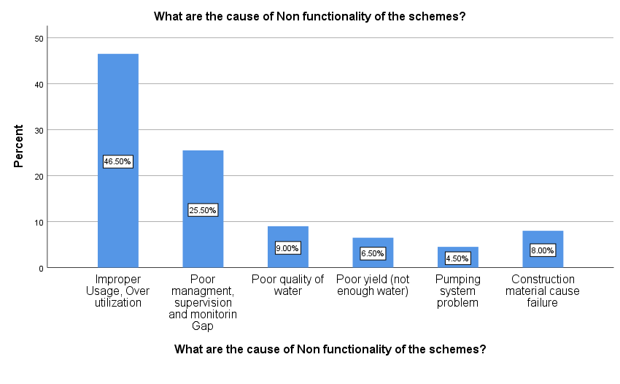
Figure 4.12: Cause of non-functionality of the schemes
4.11 Driving forces for non-functionality
Nearly all of the respondents strongly and very strongly agreed that using water beyond its capacity, a lack of support, a lack of funding. In addition a lack of technical experts, a lack of technical complexity, poor management, a lack of strong institutions, a lack of participation from stakeholders, a lack of ownership rights for the schemes, and a poor design of the schemes were the main causes of the water supply schemes non-functionality as shown in figure 4-13 below.

Figure 4.13: Driving forces for non-functionality of schemes

Figure 4.14: Rank of driving forces for non-functionality of schemes
The figure 4-14 above shown that the first, second, third, fourth, and fifth reasons for the non-functionality of the schemes, respectively, were overuse of water, bad management, weak institutions, a shortage of spare parts, and a lack of funding.

4.12. Development of geo-reference map for water supply schemes
4.12.1 Geo-reference maps for functioning and non- functional Schemes
Development of geo-reference map is crucial in order to manage the schemes easily. To do this, during site investigation the coordinates of all functional and non-functional schemes was collected. The following map showed where the functional and non-functional schemes are located. It was important for field operators simply to operate and maintain the schemes where preventive or breakdown maintenance was needed. As early discussed, there were 83 functional rural water supply schemes and 25 non-functional rural water supply schemes in Damot gale. These schemes were shown in the following figure 4.15 geo-reference map.
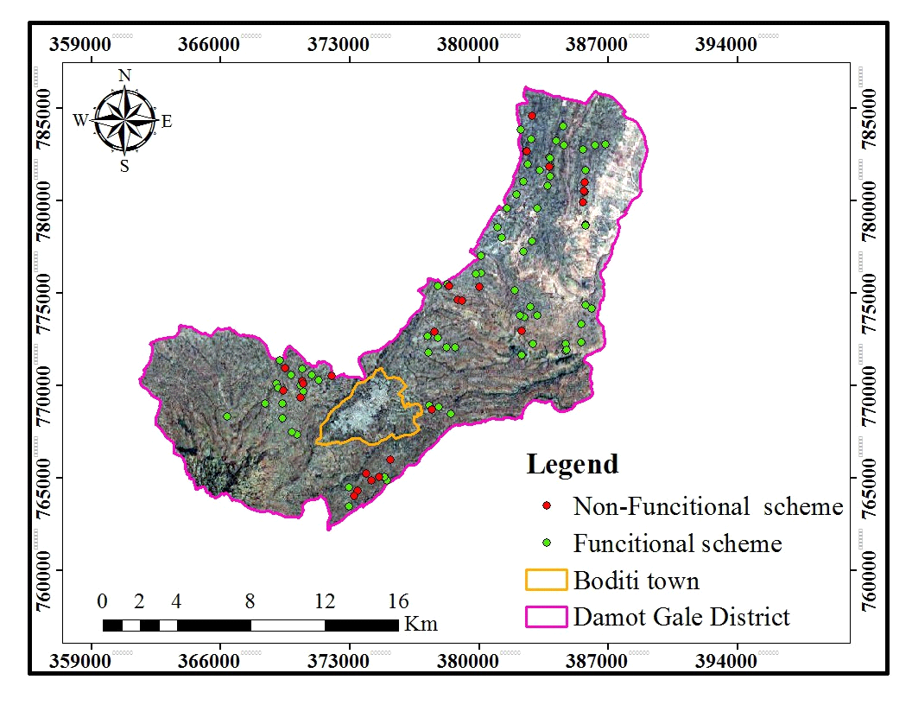
Figure 4.15: Geo-reference maps for functioning and non- functional Schemes

4.13. Determinant analysis for problem of operation and maintenance of RWSS
4.13.1 Distance from water points
Most water supply plans were located close to water users, according to the responses. Due to the fact that 74.5% of respondents obtain water within 1 km. According to this, the rural people will receive a minimum of 25 litres of water per person per day within 1.5 kilometres of the source.
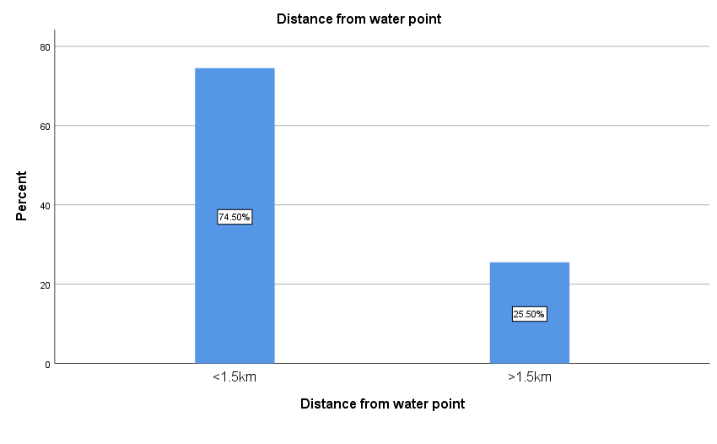
Figure 4.16: Distance from the water point
4.13.2 Water availability of the non- functional water supply schemes
According to the Figure 4.17, 47.5% of respondents agreed that water was available all year long, and 52.0% said that water availability decreased during dry spells before the program stopped working. Therefore, majority of water supply plans had issues with water availability before they stopped working.
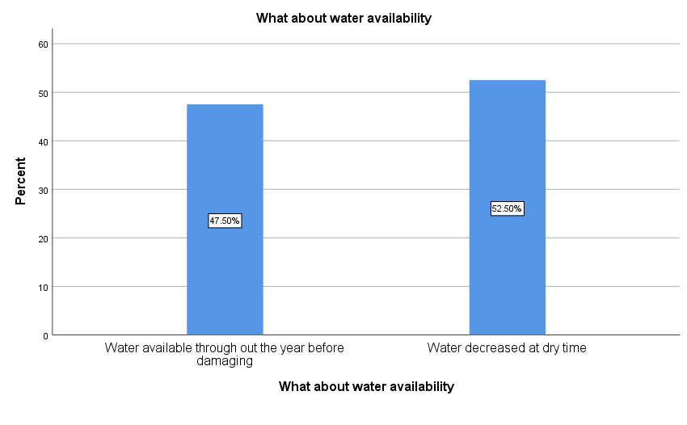
Figure 4.17: Water availability
4.13.3 Perception of users in Water quality of water supply system
Water quality issues are one of the main reasons water delivery schemes do not work, according to several research findings (Draft Report on National WASH Inventory-II & MIS, 2021). This demonstrated that the consumers' lack of concern for the water supply system in this situation has a substantial impact on the operation and maintenance of water supply schemes. In this study, it was interesting to learn how people felt about the quality of the water. Accordingly, 49% of respondents did not mention the issue of poor water quality; yet, as shown in figure 4.18, 30.5% of them connected it to the taste of iron. Six kebeles in the research region have this issue recognized. The three kebeles with the highest percentage of respondents who reported experiencing a problem with the quality of their water are Ade Damot (7.6%), Ade Koysha (4.6%), and Damot Boloso (2.3%); the remaining eight kebeles received 12% of the 26.5% of respondents.
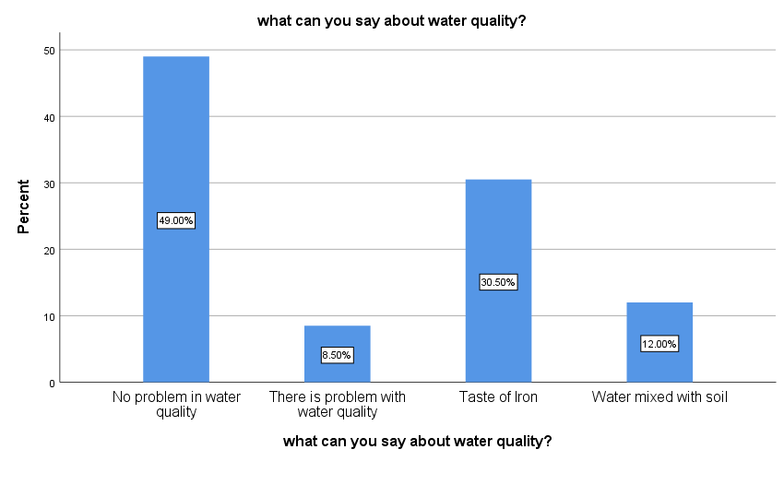
Figure 4.18: Water Quality
4.13.4 Ownership feeling of users for water points
There was ownership feeling, as indicated in figure 4.19 below, as more than 32% of WASHCO rated user ownership feelings for water points as high, 22% very high levels, 17.5% medium, 17.5% low, and 11% very low. It shown that the inability of water supply systems to function properly has little to do with users' feelings of ownership.
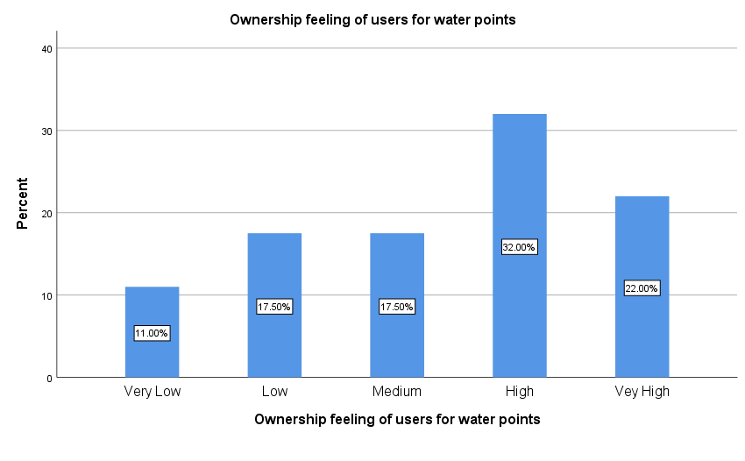
Figure 4.19: Ownership feeling of the users
4.13.5 Water users’ complain in use of the water supply schemes
Was scheme failure, water quality, water quantity, distance from water point, waiting fetching time, speed of maintenance, and lack of confidence your complaint in using the water supply scheme? Was the question posed to determine whether or not users have complaints about using water supply schemes? Since more respondents responded, the majority of rural water supply consumers did not complain about the distance to the water point, the wait time to fetch water, the quality of the water, or the quantity of the water. "No, we didn't have complaints about the use of the water supply from these viewpoints." However, as shown in Figure 4.39, their complaints about the usage of water supply schemes focused on the failure of the schemes, the speed of repair, and a lack of faith in the water committee. In most cases, complaints from customers of water supply schemes were directly tied to their operation and maintenance tasks as shown in figure 4.20 below.

Figure 4.20: Water users complain in using water supply schemes

4.13.5 Level of users’ satisfaction use of water supply schemes before becoming non-functional
The water consumers' degree of satisfaction with the use of water supply schemes before the schemes ceased to function was elicited using questionnaires. The degree of satisfaction that customers of the water supply rated as highly, moderately, satisfied, and satisfied.
According to figure 4.21, more than 58% of water supply scheme customers reported being moderately satisfied, 29% reported being satisfied, and 13% reported highly being satisfied with their use of water supply schemes before they stopped working.
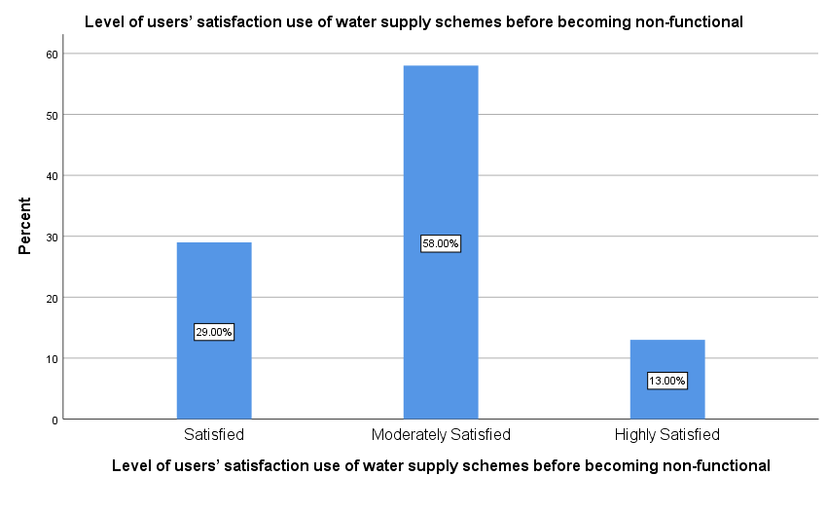
Figure 4.21: level of user’s satisfaction on water supply schemes before being non-functional
4.13.6 Personal participation of users in water supply scheme development
Participation of the community in activities related to the development of the water supply system, including planning, implementation, management, monitoring, and evaluation as well as operation and management (O&M) of the water supply facility. Active community involvement in water supply development gives the community a sense of ownership and responsibility for the water supply schemes. Since the community was a major factor in the operation and maintenance of the rural water supply system. According to the evaluation results, only about 27.5% of the respondents indicated that they had taken part in the development of the water supply system in the research area as shown in figure 4.22 below.
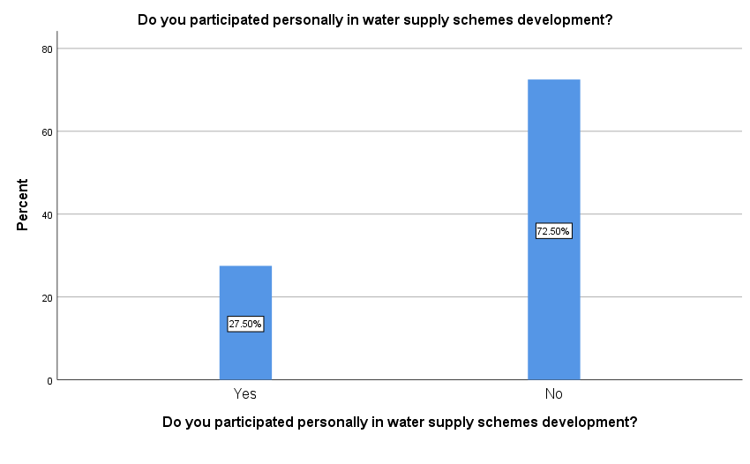
Figure 4.22: Participation of users during development of water supply schemes

4.12.7 Activities in which the community participated
As shown in figure 4.23, nearly 83% of the respondents took part in a variety of activities related to the development of rural water supply schemes, including project inception, labour and financial contributions, problem identification, technology development, and site selection. Among the activities in which users were participated during the development of the water supply schemes; labour works, project initiation, and problem identification accounts first, second and third ranks with 42.5%, 27.5% and 12.5% respectively. Although the users were involved in the scheme development, they played a far smaller role in other crucial project activities including technology selection, location selection, project design, etc. Even though they took part in these development-stage activities, it was obvious that their involvement did not cover the entirety of the schemes' development.
Figure 4.23: Activities where users participated during development of water supply schemes
4.14 Assessment of the operational and maintenance status and problems of the water supply schemes
4.14.1 Existence of management system
It is crucial to confirm the existence of a water supply O&M management system, which primarily depends on the community represented by WASHCO in the study area, before assessing the operational and maintenance state of the water supply schemes in the study region. In order to achieve this, users were first asked whether there was a water managing committee (WASHCO) present or not. WASHCO is in charge of running and maintaining water supply schemes in accordance with the National Rural Water Supply Operational and Maintenance Management Strategic Framework. 89.5% of users, as indicated by their comments, agreed that the water management committees for the schemes were present, as illustrated in figure 4.24. On the other hand, the SPSS analysis using a single sample T-test reveals that the majority of users 'yes' to the question "are there a water managing committee? “The replies to this question were supported by an analysis using SPSS with a level of significance of 0.000 (p<0.05) and a mean value and standard deviation of (1.11, 0.314) respectively.
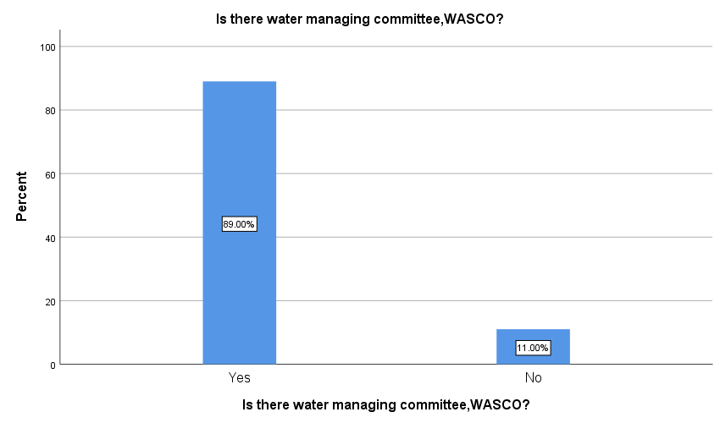
Figure 4.24: Existence of WASCO

4.14.2 Way of WASHCO Selection
This was done to ensure that the water management committee, which was in charge of operating and managing rural water supply systems, is either appointed by a certain authorized entity or elected by the community. According to figure 4.25 below, 38.5% of respondents said the committee was chosen by the Kebele management, 36% said it was chosen with the participation of all users, including women. 11% said that all users, but excluding women, did not participate in the selection of the WASHCO, and 1% said that members of the WASHCO were elected by the community. Nevertheless, without the participation of women and with proportionate women participation. However, respondents reported that women's participation as WASHCO members was not taken into consideration when the water management committee was elected. This fell short of the stated national goal to "empower Women in WASHCO management including in decision making and increase their membership in WASHCO to 50% and more."
Figure 4.25: How WASHCO was formed

4.13.3 Accountability of WASHCO
Nearly all water consumers are aware of who the WASHCO members were responsible for, as indicated in figure 4.26 , 41% of respondents said that the user community was the WASHCOs' primary source of accountability, while 54% were unsure. However, there were certain water supplies programs created by donors through the church and managed by them in which the consumers were not even aware of what WASHCO stood for.
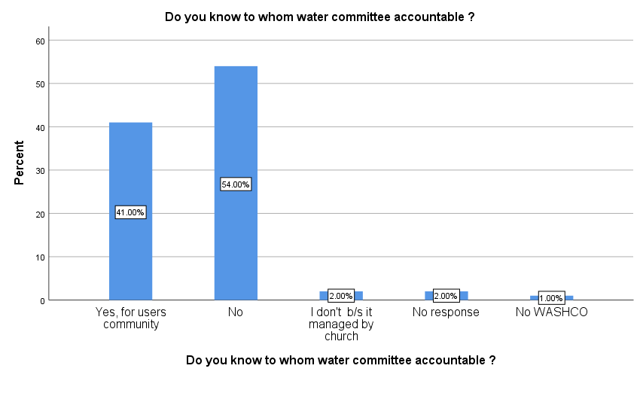
Figure 4.26: Knowledge of users about WASHCO's accountability

Competition, poor coverage of schemes at village and over utilization of water were exerted pressure for non-functionality of the schemes. Management of these factors were important to sustain the schemes.
Each 38.4% replied competition and overutilization highly stress the water supply scheme, 23% replied poor coverage at village level as shown in figure 4.27 below.
Figure 2.27: Pressure for non-functionality
The composition of WASHCOs lacks inclusiveness. Only 34.5% of the respondent replied that there was good composition of male and female in WASHCOs and 65.4% relied there was poor composition of WASHCOs. 57.7% replied that complaints were raised from the users concerning water supply scheme due to rapidly dysfunctional, 42.3% replied that there was the quality problem. 30.8% replied that water users know that for whom WASHCO members should be accountable but 69.2% did not know to whom they accountable. 69.2% of the respondents reporting that issues related with mismanagement of water committee for the community. Next to this, 30.8% report to the Kebele officials.
In scheme management, the contribution of the users is crucial thing. 38.5% of the respondent replied that they participate financially, 61.5% replied they participate physically in water supply scheme management. This assessment was done in order to assess participation of users during the development of water supply schemes in the study area. Community participation on aspects of water supply system development activities such as planning, implementation, management, monitoring, evaluation, Operation and Management (O&M) of the water supply facility.
26.9% responded that WASHCO have problem in providing quality services, 26.9% replied complaint acceptance and correction problem. 23.1% replied they WASHCOs have poor financial management, the 11.5% of the respondents responded that the WSHCOs were not transparent to the users in their water supply schemes management.
The 11.5% of the respondents responded that the WSHCOs were not report to the users in their water supply schemes management.
The values of mean and standard deviation (1.85, 0.585) at the significance level (p<0.000) SPSS one sample T-test analysis shows this reality. Lack of transparency in WASHCO hides accountability and provision of information for the users about their water supply schemes.
Therefore, most of users were disappointed on services of the WASHCO since almost 56% of the respondents confirmed that WASHCO provide very poor-quality services and 43% of them are satisfied with the services as shown in the figure 4.46. The analysis by SPSS with comparing mean and standard deviation of the values (1.79, 0.52) and level of significance (p<0.000) indicated that the WASHCO provided very poor-quality services.
65.4% of the respondent replied that provide training for WASHCO was enhance their performance, 34.6% provide spare parts should be done to tackle the challenge facing water committee in water scheme management. The analysis by SPSS with comparing mean and standard deviation of the values (1.79, 0.52) and level of significance (p<0.000) indicated that the WASHCO need training. 11.5% replied there is a problem in collecting the tariff for operation and maintenance, 26.9% replied in accounting, 7.7% replied in organizing meetings, 34.6% replied physical repairs, 19.2% replied technical knowledge/capacity.
Most WUAs were found to be well constituted with a chairperson, secretary, treasurer, and other members elected by the community. The WUAs are established as community-based organizations and registered with the regional water bureau, but very few were gender-balanced. Training of WUAs was insufficient, with most having received only limited training. 65.4% replied No WASHCo or WUA or without 3 key positions filled or never meets, 15.4 %WASHCo or WUA with all three key positions filled, 15.4% WASHCo or WUA with all three key positions filled and trained, 3.8% responds that WASHCo or WUA with all three key positions filled and trained less than a year ago.
WUAs consisting of members elected by and from the local community are responsible for the operation, maintenance, and day-to-day management of these schemes. 76.9% replied that No WASHCo or WUA with members elected by entire community, 23.1% replied that WASHCO or WUA members elected by entire community.

76.9% of the respondent answered that less than 50 percent of the WASHCo or WUA members are female, 33.1% responded at least 50 percent of the WASHCo or WUA members are female. 15.4% replied that no user payment at regular basis, 61.5% replied that user paid at Ad hoc basis (when the system breaks down), 19.2% replied user paid tariff at Annual fees, 3.8% replies user paid Monthly (or weekly) fees for operation and maintenance.
Most reported that they could get spare parts for minor maintenance 69.2% replied that minor maintenance spare part supply takes more than 1 month. 19.2% replied minor maintenance spare part supply takes more than 3 days, 3.8% replied that minor maintenance spare part supply within 3 days. 7.7% answered minor maintenance spare part supply within 3 days and major spare part supply within a week. Most of the WASHCo did not report conducting routine preventive maintenance. 73.1% replied that routine (preventive) maintenance not done, 19.2% replied that there was routine maintenance but irregularly, 7.7% replied that it was none at least annually.

Performance of Water Supply Schemes
The majority of respondents are using protected sources, such as Shallow well (SW) (46.3%) and on spot spring (26.85%). On these respondents’ further inquiry were made to investigate service failure and their resilience. About 78% of the total respondents were faced the non-functionality problem to their schemes, while (22%) did not faced the non-functionality problem since the time of construction. Approximately, 97% of those who experience non-functionality was faced the same problem within a year during field work. Moreover, the incidence is very repetitive in a year. Over 80% of schemes with the said problem were suffered service breakdown twice or more in a year.
This implies that the majority of the communities did not get proper service from developed schemes because of its frequent problem. 69.23% have faced water facility break down very often, 30.77% did not face often water facility break down. This implies that the majority of the communities did not get proper service from developed schemes because of its frequent problem (about 42.31% have faced once a year, 23.08% have faced the problem at least three times a year and 11.54% have faced a problem twice a year).
Apart from this, 65.4% survey respondents indicated that they did not receive any training on operation and maintenance of water supply systems. 34.6% of family members have received trainings on water and sanitation utilization.
Thus, they lack the technical skill to fix broken or malfunctioning parts even for simple problems. Respondents that have ever faced the non-functional problem were asked about the average time to repair failed schemes. 65.4% agreed that the water point repaired over past 12 months but 34.5% replied that the water point is not repaired over a year. The survey result shows that 15.4% of the respondents estimated the repairs time is less than one month, 53.8 % replied those 1 to 3 months, 30.8% believes greater than three months. The majority (84.5%) of the respondents reported their schemes were remain without service for more than one month per breakdown. Thus, it could be concluded that adequate attention was not given to operation of and maintenance of water supply schemes by concerned bodies. It means the functionality of the schemes is questionable.
30.8% replied repairs to the water facility is done by the water management committee, 42.3% replied the repair is performed by The Tabia/Woreda, 15.4% replied the community performed the repairs, 11.5% believed that NGO involve on operation and maintenance. 96.2% replied water point got minor or major dysfunction, 3.8% replied water point did not perform minor or major dysfunction.
On the other hand, 56.5% survey households reported that the water supply schemes break very frequently even when the water supply sources have sufficient water. Among those who reported that there are heavy breakages on water supply schemes, 26.9% of the respondents indicated that the water supply systems encounter damage once and maintained once a year, or 23.1% maintained twice a year, 50% replied maintained more than twice a year.
In fact, maintenance of water supply scheme mostly performed by woreda water resource development and energy office technicians provided that the community able to avail spare parts. The operators indicated that spare parts are available at zonal water resource development and energy office level, in operation and maintenance section. They also mentioned that zonal office does not have sufficient stack and the available spare parts were also of low quality.

Hence, unavailability of affordable and quality spare parts at a closer location to the beneficiaries could be considered as key contributing factor for functionality of community managed rural water supply systems. Spare parts accessibility affects the time of maintenance.
The 19.2% replied spare parts accessed to maintain the water facility was on the local shops in case of failures and 80.8% replied that the spare parts are available in Woreda water desk. The 65.4% replied in maintenance of the water supply facility there is lack of spare parts and 34.6% replied there is lack of money for spare part and technicians for operation and maintenance. The 67% replied that community did not have rules and regulations in the use of the water supply services but 3 % replied that community did not have rules and regulations in the use of the water supply services. 65% replied there was management systems to manage your water supply facility, 35% replied there was not management systems to manage your water supply facility.
From the total respondent 37.5% were plumbers, 62.5% electro mechanical expert was participated. 56.3% of the experts receive payment always on time, 25% did receives payments but sometimes late, 18.8% receives payment but frequently late.
Electromechanical expert/ plumber has different know how level. 37.5% good knowledge on construct an intake structure, 12.5% good know how on change/install different valves, 12.5% knows about change/Install float valves, 6.3% construct brake pressure box, 12.5% take apart and clean pump, Fix all general plumbing issues.
The 62.5% replied cleaned the tank greater than a month, 12.5% replied that the tank was cleaned monthly, 12.5% replied the tank was cleaned within 2-3 months, 12.5% replied it was cleaned during rainy season. 56.3% replied that majority of the problems were on water intake (spring box/dam), 18.8% replied there was a problem on tube line from intake to storage, 12.5% replied there was a problem on distribution network, and 12.5% replied there was a problem in storage tank. 75% of the respondent replied that there was no maintenance plan but 25% replied there was maintenance plan. 37.8% dedicate to system operation hourly, 43.8% dedicate to system operation daily and 18.8% replied that the experts dedicate once on a weekly basis.

Water supply scheme Maintenance
Use of appropriate technologies which are low cost, easy to maintain, simple to use and readily available is one of the key factors determining sustainability of water supply schemes. Appropriate technologies are integral to the concept of village level operation and maintenance. The community should also play a role in selection of technology options to fit into its context. In this regard, the study has investigated whether the community had their say in the technology selection, whether the technology option is easily operable and manageable by the communities and other related issues. In the response to question delivered to respondents to know who selected their water supply technology option the following result has been obtained. As shown from figure 4.29 out of respondents, 75% replied that their water supply scheme technology was selected by government, 18.75% of respondents said their water supply scheme technology was selected by NGO. Among the remaining respondents, 6.25% had replied that community selected their water supply scheme technology. The result also shows that the users did not have their say in technology selection of water supply scheme.
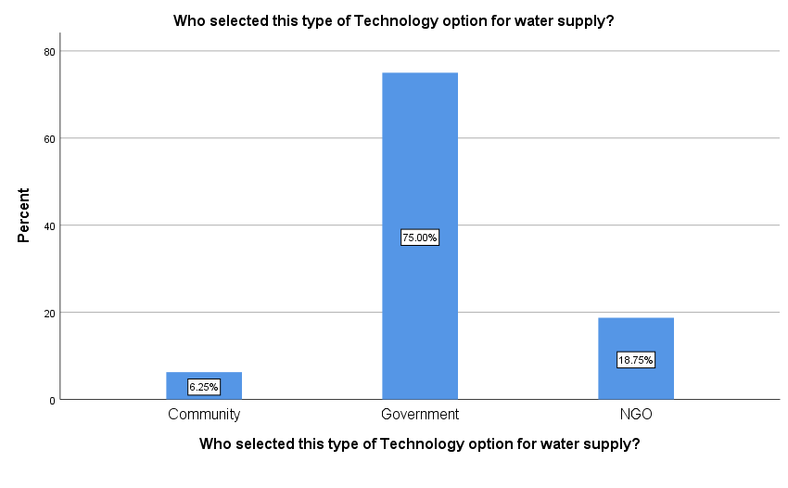
Figure 4.28: Technology selection
With regard to easiness of their technology option for operation and management, the following result has been obtained. As indicated the figure 4.29, among 16 respondents, 75% were replied, as their water supply scheme was not easy for operation and management while the remaining 25% respondents said that their scheme is easy for operation and management.
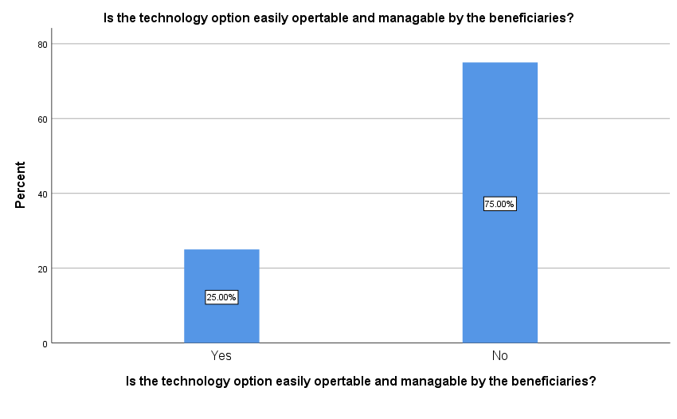
Figure 4.29: Technology option easily operability and manageability
Furthermore, as also illustrated in figure 4.30 , in the response to question delivered to respondents to know difficulties of operating and managing their water supply schemes, the following results has been obtained. Among respondents, those find their water supply scheme difficult for easy operation and maintenance, 56.25% respondents mentioned the reason as lack of skilled community technicians and 12.5% replied that because of easily breaking parts. 12.5% replied because it is hard to move handle and easily breaking parts. The remaining 6.5%, 6.5%, and 6.5% respondents replied that lack of spare parts; lack of adequately skilled technician & repair is costly; hard to move handle respectively.
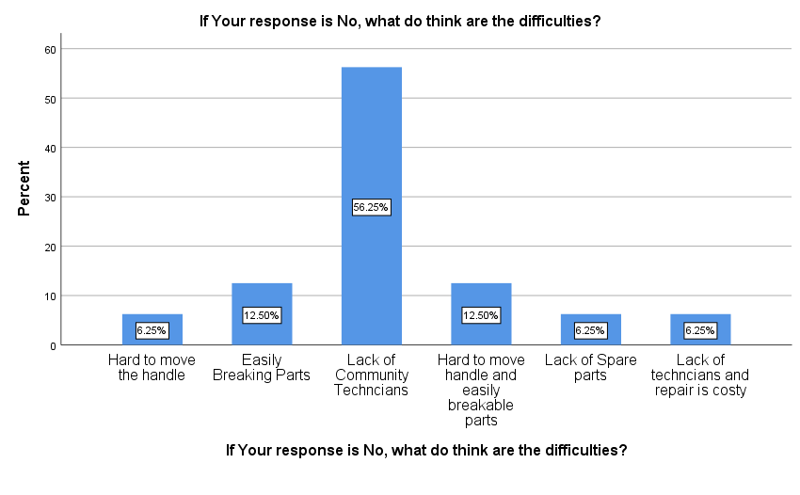Figure 4.30: Technology option difficulties
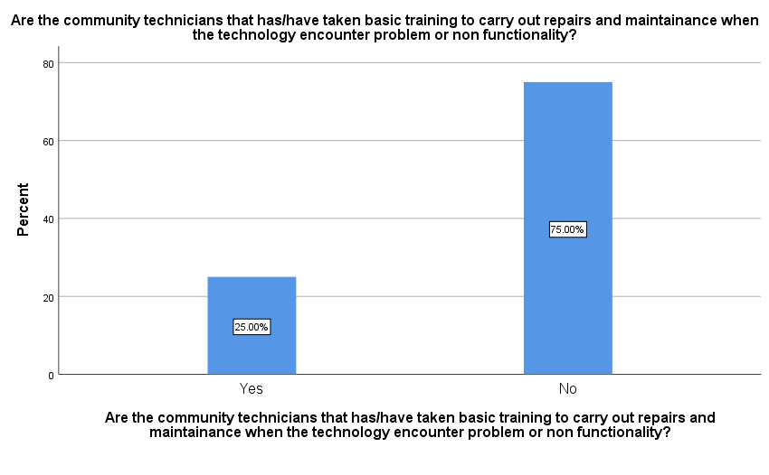
Figure 4.31: Community technicians take training to carryout repairs and maintenance
In this regard, in order to know the situation in the study area, respondents were asked whether there exist skilled/ trained community technicians within their community. Accordingly, out of respondents, 75% replied that there are no trained community technicians while the remaining 25% respondents mentioned that there are trained technicians in their community. According to ·observation by the researcher during the fieldwork, there exist trained technicians only in one community among seven sample water supply schemes. The rest six communities did not have trained technicians and toolkits as well as shown in figure 4.32 below.
With regard to the community that has got water technicians, the technicians were given five-day training by the implementing agency (i.e. an NGO) but it was two years ago. However, the interview made with one of the technicians revealed that they have not undertaken any maintenance activities till now since their scheme has not had any problem. For the question asked whether they can repair 75% disagree to maintain because there is no adequate training but 25% agree they took training and repair and maintain" as shown in figure 4.32 below.
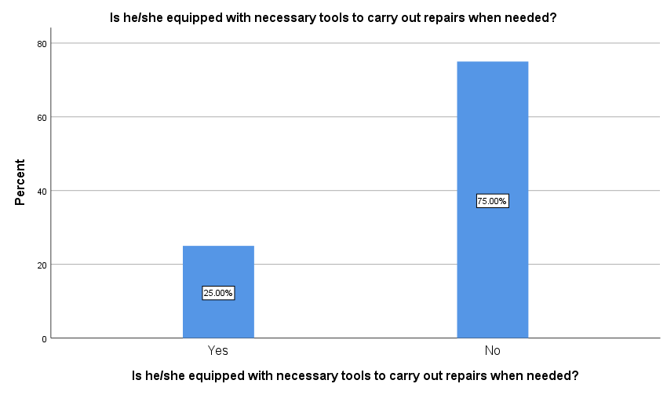
Figure 4.32: Community Technicians to carry out repairs
In the response to the question who carry out repair and maintenance when needed, 75% of respondent said government technicians particularly carries out repair and maintenance of the water supply schemes and 25% of respondent said NGO particularly carries out repair and maintenance. But currently NGOs is not involved water supply scheme operation and maintenance right now they are involved like WASH and new scheme development as shown in figure 4.33.
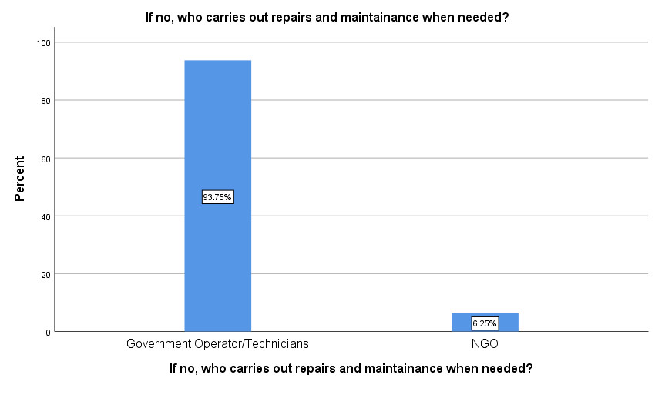
Figure 4.33: Who carries out repairs and maintenance

The spare parts: availability, accessibility
In connection to this issue, the study has investigated the availability and accessibility as well as the affordability of the spare parts by communities when needed for repair of the pumps. As the following figure 4.36 indicated , 87.5% of respondents replied that the spare parts are not available and easily accessible at community level when needed, while the remaining 12.5% respondents replied that spare parts are available and easily accessible at community level when need. For the question asked to know from where they obtain spare parts when needed, almost all of respondents said government provides it as shown in figure 4.34 below.
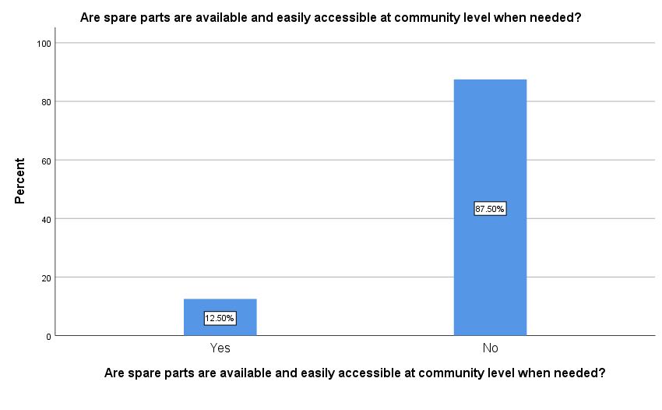
Figure 4.34: Spare part availability and accessibility at community level
Furthermore, as same table shows, in response to question delivered to respondents to know their view about affordability of the spare parts when needed, the following response category has been obtained. Out of total respondents, 93.75% replied that the cost of spare parts could not be afforded at community level while remaining 6.25% respondent replied could be afforded at community level as shown in figure 4.35 below.

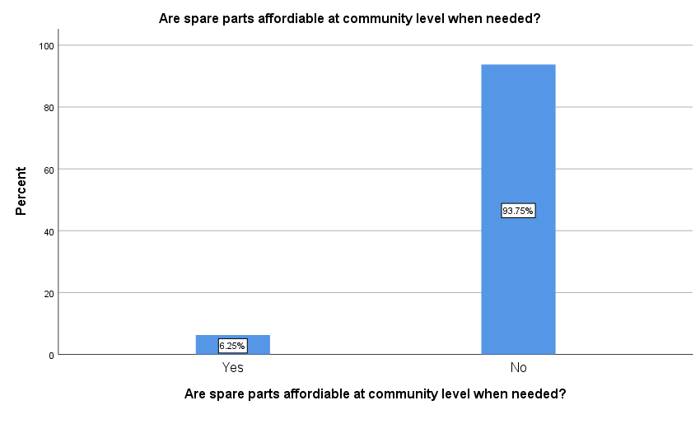
Figure 4.35: Spare parts affordable at community level
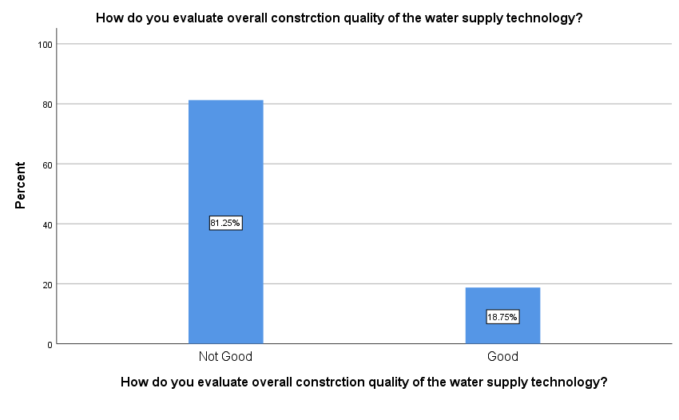
Figure 4.36: Overall construction quality of the water supply technology

Accordingly, only 81.25% replied that the overall construction qualities of their scheme were not good. The remaining 18.75% respondents replied that overall construction quality of their scheme was good as shown in figure 4.37 below.
Community participation is crucial thing in proper functioning of the scheme. 42.86% of the respondent agreed and 57.14% disagree the participation of the community in the implementation of the projects including site selection as shown in figure 4.37 below.

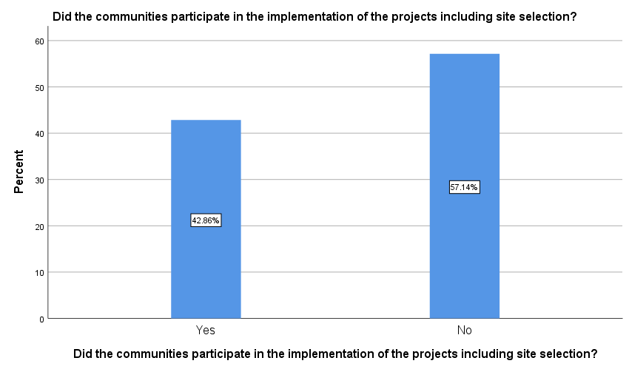
Figure 4.37: Community participation in the implementation of the project
71.43% respondent disagree their staff technicians capable enough for providing support for the woreda water supply system functionality but 28.67% agrees staff technicians capable enough for providing support for the woreda water supply system functionality as shown in figure 4.38 below
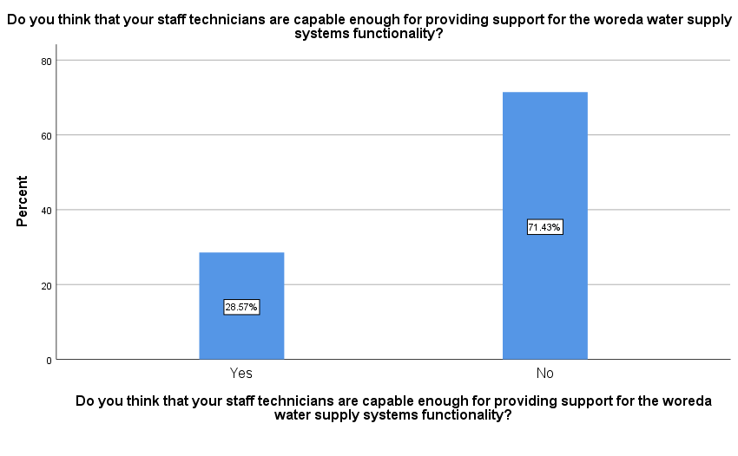
Figure 4.38: Staff technicians capable enough for water supply system functionality
The 76.1% of the respondent agreed that they provide technical support for the community members after the construction of the scheme. Nevertheless, 23.81% disagree the involvement of the woreda officials after the completion of the project as shown in figure 4.39 below.
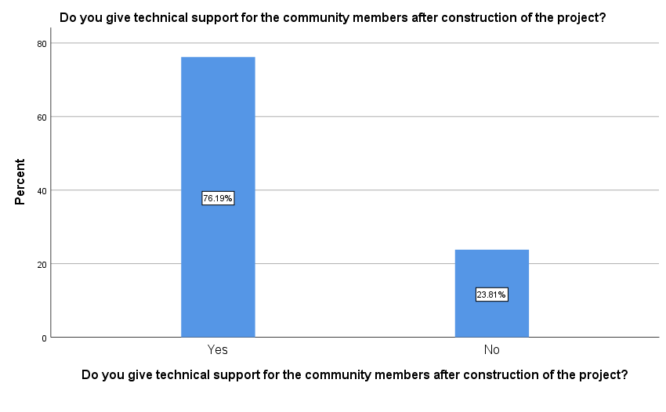
Figure 4.39: Giving technical support after the construction of the project
The 76.1% of the respondent agreed that the government institution adequately prepared the community to manage and sustain their water supply scheme. But 23.81% disagree the government institution adequately prepared the community to manage and sustain their water supply scheme as shown in figure 4.40 below.
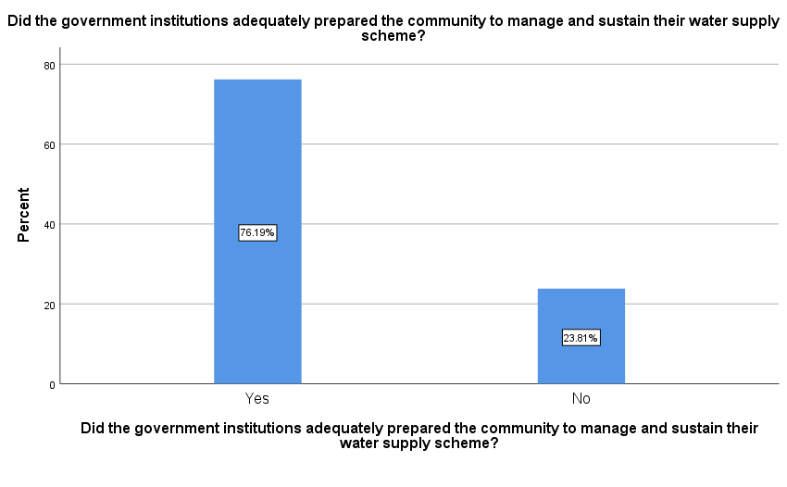
Figure 4.40: Role of government institutions adequately prepared the community to manage the scheme
About one-thirds of WUAs report being visited by government staff (woreda, zone, or region) at least once a month. 47.62% of the respondent mainly the office provides spare parts to the lower government official to sustain the functionality of the scheme, 38.1% of the respondent provide training to the lower government, 14.29% of the respondent assessing the existing performance of the scheme as shown in figure 4.41 below.
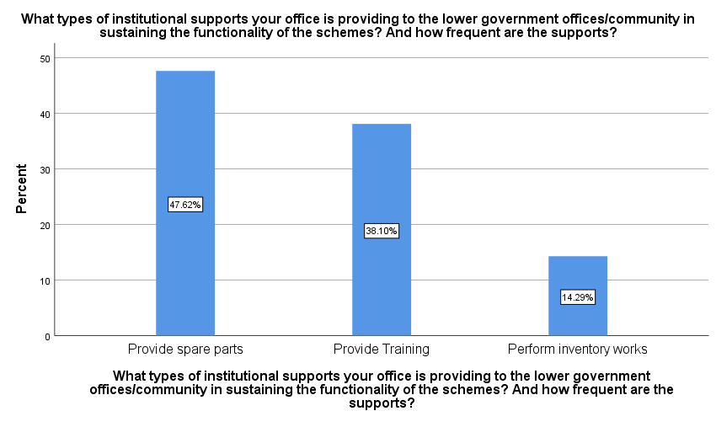
Figure 4.41: Institutional support to lower government offices
76.19% of the respondent accepts the availability of spare parts and toolkits and affordable at regional level and 23.81% responded there was no availability of spare parts and toolkits at regional level as shown in figure 4.42 below.
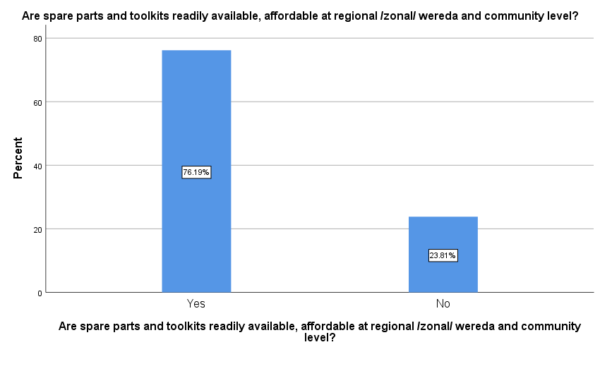
Figure 4.42: Spare parts availability and affordability at regional/woreda and community level
The 52.38% of the respondent disagree the existence of private sectors that provide spare parts during maintenance. 47.62% of the respondent accepts the presence of competent private sectors that spare parts as shown in figure 4.43 below.
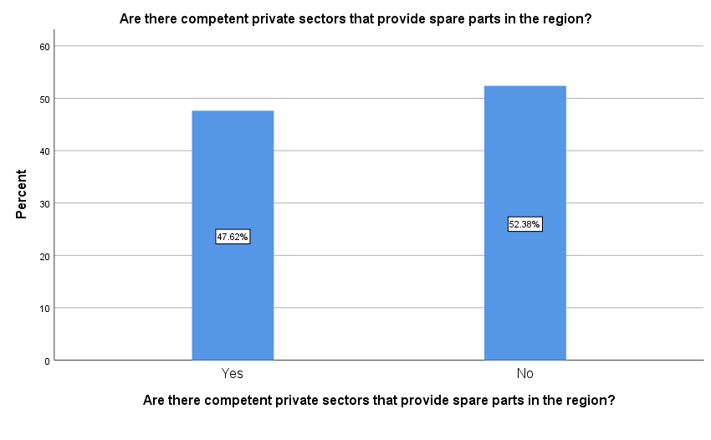
Figure 4.43: Private sectors that provide spare part
The 28.57% of the respondent stated there was great problem of appropriate operation and maintenance, 28.57% of the respondent shows there was lack of post construction support. 19.05% replied was lack of appropriate and timely spare part, 9.52% shows lack of accountability, transparency, financial skill and conflict management technique and finally 4.76% lack of developed rules for service as shown in figure 4.44 below.
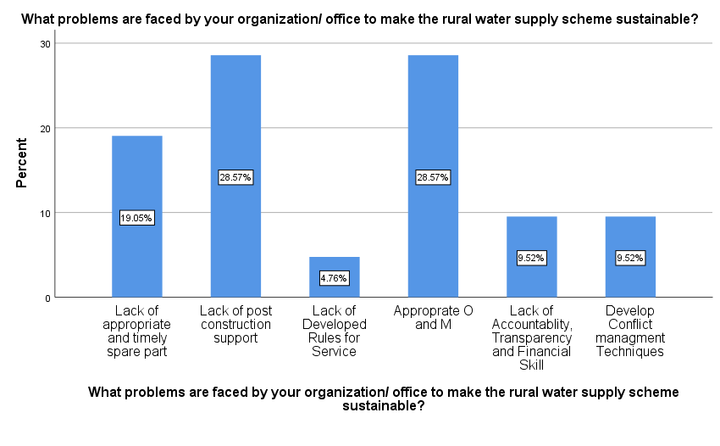
Figure 4.44: Problems faced rural water supply scheme functionality
The 57.14% of the respondent replied that woreda water office (department) has less than 75% of the required staff, 38.1% replied woreda water office has more than 75% of the required staff, 4.76% replied the office has more than 75% of the required staff and are sufficiently trained as shown in figure 4.45 below.
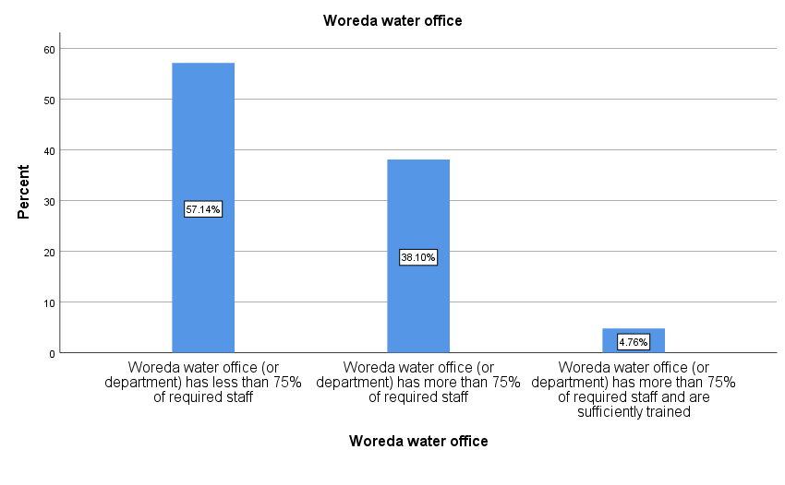
Figure 4.45: Woreda water office
The regional water bureau manages major maintenance, including activities that require a crane and well development, but other maintenance falls to the Damot Gale Woreda water resources Office. The woreda reports responding to maintenance requests within 1 to 3 days, but if the repairs are beyond its capacity, response time depends on the availability of a crane. Nevertheless, breakdowns of WUA schemes are common. Moreover, not all schemes have WUAs. Most WUAs (61.9%) report being less than half of the WASHCOs receive technical support within 3 days, 28.57% replied none of the WASHCOs receives support and back up from the woreda water office, 4.76% replied at least 75% of WASHCOs receive technical support within 3 days as shown in figure 4.46 below.
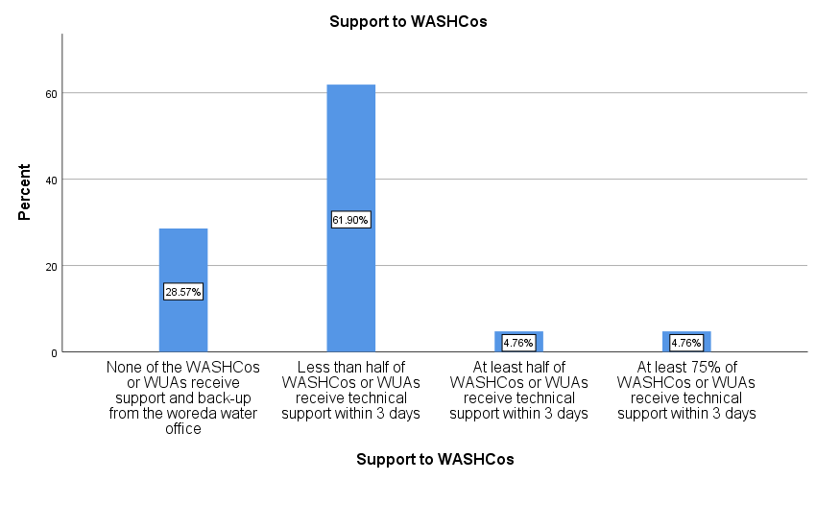
Figure 4.46: Support to WASHCOs

Majority replied scheme inventory was done a year ago. 57.14% replied has done inventory of schemes but more than a year ago, 28.57% replied Woreda has conducted scheme inventory within last year, 9.52% replied Woreda has conducted scheme inventory within last year which includes functionality status and age of the scheme, 4.76% replied Woreda has never done inventory of schemes as shown in figure 4.47 below.
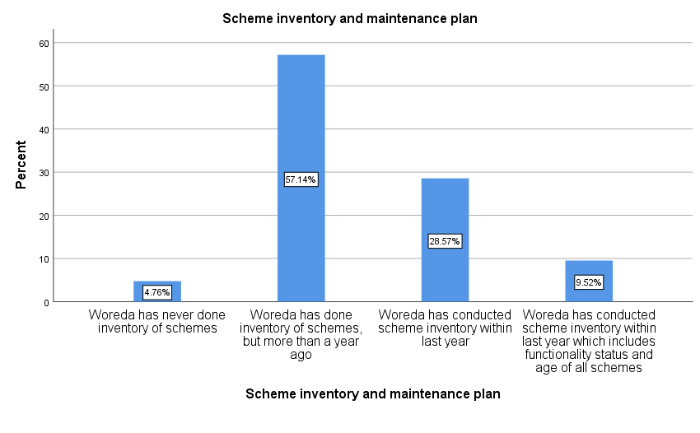Figure 4.47: Scheme inventory and maintenance plan
A permanent national or regional monitoring system has yet to be made operational. SER undertakes occasional region-wide inventories, and a national WASH inventory was undertaken in 2011. The Damot gale Woreda reports to the regional level on a limited number of parameters, including the number and type of schemes and their functionality. They undertake no routine preventive maintenance Only WUAs (23.81%) report that the Woreda monitor services on at least an annual basis and 76.19% of the respondents agree that the Woreda water office staff do not monitor rural water services on going as shown in figure 4.48 below.
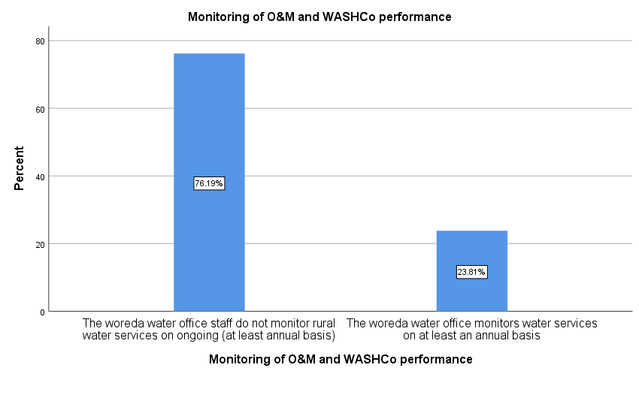Figure 4.48: Monitoring of operation and maintenance and WASHCO Performance

5. CONCLUSIONS AND RECOMMENDATION
5.1. CONCLUSIONS
Based on the findings the following conclusion was provided for Damot gale water supply schemes in general.
- In this study analysed the possibility to evaluate a GIS based water distribution system modelling. The results, obtained with GIS integrated with Water GEMS hydraulic model, in terms of hydraulic simulation show that resulting pressure at most junctions and velocities at most pipes were adequate to deliver water to consumption points. Further studies recommended for reinforcing the water network geospatial databases like mapping household water connection and it is relational class between the parcels and water customers.
- The scheme inventory report showed that by 2023, there are about 108 water supply schemes in the Woreda of which 4.63% hand dug wells, 46.3% shallow wells, 9.26% bore holes, 26.85% on spot springs, and 12.96% spring with distribution. The assessment result showed that 76.86% of schemes are functional. However, it has been noted that about 23.14% of the water supply schemes are non-functional.
- 28.57% of the respondent stated there is great problem of appropriate operation and maintenance, 28.57% of the respondent shows there is lack of post construction support, 19.05% replied is lack of appropriate and timely spare part, 9.52% shows lack of accountability, transparency, financial skill and conflict management technique and finally 4.76% lack of developed rules for service.
- In study area overall water supply coverage of the Woreda in 2007 are 27%. The rate of non-functionality of hand dug well of the study area was 80% and the main causes of HDW non-functionality is primarily for yield (quantity), secondary for quality and management, thirdly for financial, the rate of non-functionality of bore hole of the study area is 10% . Moreover, the main causes of non-functionality is primarily management and financial, secondly site selection, and thirdly institutional. The rate of non-functionality of shallow well of the study area is 38% and the main causes of SHW non-functionality is primarily quantity, secondly quality, thirdly other problems include social and cultural, gender, health and education. The rate of non-functionality of on spot spring of the study area were 3.45% and the main causes of non-functionality primarily management, secondly problems include social and cultural, gender, health and education, and thirdly site selection.
- The determinants analysis result showed that over utilization of water, lack of strong institutions and lack of stakeholders’ participation in water supply scheme management. In addition lack of technical experts have directly contribute for non-functionality of water supply schemes; whereas poor design of schemes, lack of finance for schemes administration, competition, poor management, schemes ownership right feeling and using water beyond its capacity are related indirectly contributed for non-functionality of the water supply schemes. Finally, this study concluded that water beyond its capacity, poor management, lack of strong institutions, lack of spare part, and lack of finance were the 1st ,2nd, 3rd, 4th, and 5th determinates for non-functionality of the schemes respectively.

5.2. RECOMMENDATION
Based on the findings, I have made the following recommendations:
- The smaller diameter pipes that need replacement as indicated in the peak hour demand distribution analysis report at the base year and design year should have to be replaced with new one to solve the water distribution system pressure problem and deliver sufficient quantity of water supply within acceptable pressure for the needy community.
- The system must be maintained as a closed system, which means all taps and gate valves should be replaced. Conservation must be prioritized above all other uses of resources in order to ensure future consumption.
- In order to prevent pressure variations, pressure-sustaining valves or regulating valves must be put on the distribution system between two consecutive connections. These valves begin automatically closing and manually opening to maintain the minimum necessary pressure and prevent pressure fluctuations.
- In addition to the technical advice mentioned above, it is advisable to consider creating an asset management plan, especially to limit water loss.
- The study recommends that the major factors influencing functionality of rural water supply systems, includes but not limited to, availability of enough water from the water supply systems, availability of spare parts and proper community-based management. These elements should be considered in the events of water supply systems development from planning to post implementation stages. Hence, to enhance access to potable water supply in rural areas it is important to ensure functionality of existing water supply systems than focusing on construction of new schemes alone.

REFERENCES

Abhijeet Ghorpade, Deepali Vaidya 2018, Experimental Study of Hydraulic Modelling of Water
Distribution Network with Pressure Driven Approach in Pune, Maharashtra, India
Alexander, K. T. Tesfaye, Y., Dreibelbis, R.Abaire, B., & Freeman, M. C. (2015). Governance and functionality of community water schemes in rural Ethiopia. International Journal of Public Health, 60(8), 977–986.
Al-Zahrani, M. A. (2014). Modelling and Simulation of Water Distribution System: A case Study. Arabian Journal for Science and Engineering, 39(3), 1621-1636.
ASSEFA, S. (2007). Evaluation of technical sustainability of rural water supply projects in the Amhara regional state case study in south wollo.
Atiquzzamn, M. 2004. Water Distribution Network Modelling: Hydro informatics Approach. pp. 20-30.
Aydin, N. y. 2014. Scenario Based Sustainable Assessment to Provide Interactive Decision Support for the Long-Term Transition of Urban Water Supply Systems Dissertation University of Kaiserslautern.
Baumann, E., Ball, P. and Beyene, A. (2005) Rationalization of Drilling Operations in Tanzania: Review of the Borehole Drilling in Tanzania. RWSN, Dar Es Salam.
Bazaanah, P. (2019). Sustainability of Rural Communities Drinking Water Systems and Local Development Projects in the Bole, West and Central Gonja Districts of the Savannah Region, Ghana. Review of Social Sciences.
Bentley (2008). Bentley Water GEMS V8iUser’s Guide.
Berihun, D. (2017). Assessment on the Current Water Quality Status of Walgamo River. Addis Ababa, Ethiopia: International Journal of Innovative Research in Science, Engineering, and Technology.
Carlsson, B., Roux, J. (2010) Water supply services O&M handbook, Department of Housing & Local Government, Northern Cape, and Department of Water Affairs & Forestry: Northern Cape Region
Damgir, R. M. (2017). Hydraulic Modelling of Water Distribution System concerning Technical Sustainability by using Water Gems. International Journal of Innovative Research in Science, Engineering and Technology
D. Hazelton, “The development of community water supply systems using deep and shallow well hand pumps,” Water Research Centre (WRC) Report No. TT132/00, South Africa, 2000.
Dessalegn, W. B. (2015).Water supply coverage and water loss in the distribution system in case of Addis Ababa.
E.Hickey, H. (2008).Water supply system and evaluation methods. USA, U.S.Fire Administration.
Harvey, A. & Reed, and A. (2007) Community-Managed Water Supplies in Africa: Sustainable or Dispensable? Community Development Journal 42: 365–378
Harvey, Peter; Reed, Bob (2004): Rural water supply in Africa: Building blocks for hand pump sustainability. Loughborough University Book.
Heizer.J & Barry Render. (2006). Operation Management, 7th Edition. New Jersey: Person Education.
Hussni & Zyoud, 2003. Hydraulic Performance of Palestinian Water Distribution System Thesis submitted to An-Najah National University Nablus Palestine.
Hutton, G. & Bartram, J. (2008). Regional and global costs of attaining the water supply and sanitation target (Target 10) of the millennium development goals. Bull. World Health Organ. 46045 (September 2007), 13-19.
Ihuah, P. & Kakulu, I. (2014). Rural Water Supply Projects and Sustainable Development in Nigeria. Journal of Sustainable Development in Africa 16(1) 1520-5509.
Izinyon, O. C. and B. U. Anyata (2011). "Water Distribution Network Modelling of Small Community Using Water cad Simulator." Global Journal of Engineering Research
Jackson R,. (2011). Functionality of rural water supply sources: A case study: Nyero Sub- County, Kumi District. Macheri.
Kambiz Rasoulkhani Ali Mostafavi and Jeanne Cole, 2019, Resilience based infrastructure planning and asset management: Study of dual and singular water distribution infrastructure performance using a simulation approach, sustainable city and societies.
Katz & Sara. (1997). Making Rural Water Supply Sustainable: Report on the Impact of Project Rules, by Jennifer Sara & Travis Katz, UNDP World Bank Water and Sanitation Program, 1997.
Kohler. (2020). Technology assessment of block chain-based technologies in the food supply chain. J. Clean. Prod. 2020, 122193.
Kumasi, T. (2020). Rural water asset management practices in Ghana: The gaps and needs. Water and Environment.
Kumpel, E. Peletz, R., Bonham, M., Fay, A., Cock-Esteb, A., & Khush, R. (2015). ‘When are mobile phones useful for water quality data collection? An analysis of data flows and ICT applications among regulated monitoring institutions in sub-Saharan Africa’, International Journal of Environmental Research and Public Health 12(9): 10846–60.
Lockwood, H. (2013). USAID and Rotary International adopt innovative sustainability monitoring tool.
Martin-C, Santillán, D., Iglesias, A., & Garrote, L. (2020). Optimisation of the Design of Water Distribution Systems for Variable Pumping Flow Rates. MDPI Water Journal.
MOFED. (2006). Policy—Plan for Accelerated and Sustained Development to End Poverty (PASDEP).
Mohan. (2005). SWOT Analysis and Sustainability Study for Service Sector—A Case Study of TWAD Board, Indian Institute of Technology, Madras.
MoWIE. (2016). National Rural Water Supply Operation and Maintenance Management Strategic Frame Work for Ethiopia.
MoWR. (2007). Water Sector Development Program (WSDP) Reports. Addis Ababa: MoWR.
Muchiri, P. Pintelon, L. Gelders, L, & Martin, H. (2011). Development of maintenance function performance measurement. Framework and indicators. International Journal of Production Economics.
Musonda K. (2004). Issues Regarding the Sustainability of Rural Water Supply in Zambia, MA Thesis in Social work, the University of South Africa.
NWI-2. (2021). National Rural Water Supply Operation & Maintenance Management Strategic Framework for Ethiopia. 2016.
National rural water supply operation and maintenance management strategic framework for Ethiopia by Ministry of Water, Irrigation and Electricity, Addis Ababa, March, 2016
Nemanja (2006). Introduction to urban water distribution, Taylor & Francis/Balkema
Nitin P. Sonaje and M. G. Joshi (2015). "A Review of Modelling and Application of Water Distribution Networks Software’s." International Journal of Technical Research and Applications.

NRC, N. R. C., 2006. Drinking Water Distribution systems assessing and reducing Risks. The national academics press.
Pravinkumar Shinde 1, P. P. (2018). Design and Analysis of Water Distribution Network Using Water GEMS. International Journal of Advanced Research in Science and Engineering, 7(03), 545.
Prokopy, Linda. (2005). “The Relationship between Participation and Project Outcomes: Evidence from Rural Water Supply Projects in India.” World Development 33:1801–19. doi: 10.1016/j.worlddev.2005.07.002.
Rossman, L. A. (2000). Water Supply and Water Resources Division National Risk Management Research Laboratory. US-EPA.
Salman, A., 2015. Hydraulic Network Model of Water Distribution System in Alhakeem Quarter. p. 570.
Salunke. (2018). An Overview: Water Distribution Network by Using Water GEMS Software. Journal of Advances and Scholarly Researches in Allied Education, 2230-7540
Seifu A. (2012). Assessment of Water Supply and Sanitation in Amhara Region.
Sharma, N. (2012). Community managed project (CMP) in implementing rural water supply: Amhara region, Ethiopia (MSc, thesis, Tamper University of Technology).
SNV. (2013). Rural Water Supply Functionality Factsheet, Zambia.
Stuart, E., Samman, E., Avis, W., & Berliner, T. (2015). The Data Revolution: Finding the Missing Millions, Overseas Development Institute Research Report, and London, UK.
Tiwari, A. (2016). Themes in Urban Infrastructure Research in Ethiopia Cities. Spring Briefs in Geography, 7-35.
Thomas M. W alski, Donald V. Chase, et al. (2003). Advanced Water Distribution Modelling and Management. C. a. E. E. a. E. M. Faculty, University of Dayton Commons.
Truslove, J., Coulson, A., Nhlema, M., Mbalame, E., & Kalin, R. (2020). Reflecting SDG 6.1 in Rural Water Supply Tariffs: Considering’ Affordability’ Versus “Operations and Maintenance Costs” in Malawi. Journal of Sustainability.
UNDP, “Ethiopia: (2010). Millennium Development Goals Report: Trends and Prospects towards Meeting MDG by 2015,” UNDP Ethiopia Office, Addis Ababa, 2010.
Van Zyl, J. (2014). Introduction to Operation and Maintenance of Water Distribution Systems. Edition 1. Water Research Commission. Gezina, 0031, South Africa.
Wandera J, Veerdig H., & Pham Gia B. (2011). Moving towards Functional Rural Water Supply Services. WASH Conference 2011.
WHO and UNICEF, (2008). “A Snapshot of Drinking Water and Sanitation in Africa: A Regional Perspective Based on New Data from the WHO/UNICEF Joint Monitoring Programme for Water Supply and Sanitation,”.
WHO, & UNICEF. (2015). the WHO and UNICEF Joint Monitoring Programme (JMP) Indicators for Water Supply, Sanitation and Hygiene.
Wonduante (2013). Assessing the challenges of sustainable water supply in Gondar town,
Ethiopia Addis Ababa University. Addis Ababa University, 37-49.
Zewdu, A. (2014). Assessing Water Supply Coverage and Water Losses from Distribution
System for planning Water loss Reduction Strategies, Aksum water resources officer.

APPENDIX
Table 1: Water supply sources of Damot Gale
No | Kebele | Type of the scheme | Yield of the schemes in L/Sec | Status of the scheme | System | Year of Construction | Constructed by | Remark
1 | Gacheno | BH | 2.6 | FN | Electric System | 1993EC | Regional Government | Government
1 | Gacheno | SW1 | 0.5 | FN | Manual | 2009EC | WASH | NGO
1 | Gacheno | SW2 | 0.75 | FN | Manual | 2009EC | WASH | NGO
1 | Gacheno | SW3 | 0.4 | FN | Manual | 2010EC | WASH | NGO
1 | Gacheno | SW4 | 0.25 | FN | Solar | 2013EC | World Vision | NGO
 |  | SW5 | 0.28 | FN | Manual | 2013 E | WASH | NGO
2 | Ade Aro | BH | 15.2 | FN | Manual | 2012 | WASH | NGO
2 | Ade Aro | BH | 18.51 | FN | Electric System | 2013 | World Vision | NGO
2 | Ade Aro | On spot spring | 5 | FN | On spot | 2003 | Eth. Road Cross | NGO
3 | Zamine Sibaye
3 | Zamine Sibaye | SW | 0.3 | FN | Manual | 2010 | WASH | NGO
3 | Zamine Sibaye | SW | 0.23 | FN | Manual | 2010 | Wash | NGO
3 | Zamine Sibaye | SW | 0.42 | FN | Solar | 2012 | WASH | NGO
3 | Zamine Sibaye | SW | 0.65 | FN | Manual | 2010 | WASH | NGO
4 | Ade Sibaye | SW | 0.45 | FN | Manual | 2013 | World Vision Ethiopia | NGO
4 | Ade Sibaye | SW | 0.36 | FN | Manual | 2013 | World Vision Ethiopia | NGO
 |  | SW | 0.152 | FN | Manual | 213 | ‘’ | NGO
5 | Wandera Gale
5 | Wandera Gale | SW | 0.25 | FN | Solar | 2013 | World Vision | NGO
5 | Wandera Gale | SW | 0.15 | FN | Manual | 2010 | WASH | NGO
5 | Wandera Gale | SW | 0.256 | FN | Manual | 2013 | WASH | NGO
5 | Wandera Gale | On spot Spring | 0.95 | FN |  | 2004
 |  | On spot spring | 0.236 | FN | On spot
 |  | Hand dug well | 0.16 | FN | Manual | 2010 | World Vision | NGO
6 | Zegera | Spring on spot | 3.5 | FN | On spot | 2000 | Inter Aid | NGO
7 | Wandra Boloso | Spring on spot | 1.5 | FN | On spot | 2001 | Inter Aid | NGO
 | Wandra Boloso | Spring Distn. | 2.5 | FN | Gravity | 2001 | Inter Aid | NGO
8 | Woshi Gale | Spring on spot | 1 | FN | On spot | 2000 | Inter Aid | NGO
 |  | Spring on spot | 5 | FN | On spot | 2010 | Government | GOV.
 |  | Spring on spot | 3 | FN | On spot | 2008 | Inter Aid | NGO
 |  | Spring on spot | 1.78 | FN | On spot | 2006 | Inter Aid | NGO
 |  | Spring on spot | 2.5 | FN | On spot | 2001 | Inter Aid | NGO
9 | Mokonisa Woyge | Spring on spot | 5.8 | FN | On spot | 2014 | World Vision Ethiopia | NGO
9 | Mokonisa Woyge | Spring on spot | 1.75 | FN | On spot | 2004 | Inter Aid | NGO
10 | Shasha Gale | Spring on spot | 4.5 | FN | On spot | 2003 | Inter Aid | NGO
 |  | Spring on spot | 3.02 | FN | On spot | 2011 | World Vision
11 | Obe Jage | BH (Submersible pump) | 15.87 | FN | Electric System | 2014 | World Vision Ethiopia | NGO
11 | Obe Jage | Spring on spot | 1.75 | FN | On spot | 2006 | Inter Aid | NGO
11 | Obe Jage | Spring with distn. | 3.5 | FN | Gravity system | 2003 | Inter Aid | NGO
12 | Bala Koysha | Spring on Spot | 0.85 | FN | On spot | 2002 | Inter Aid | NGO
13 | Ade Ofa | Spring with distribution | 4.5 | FN | Surface pump (Centrifugal pump) | 2003 | Catholic Development fund | NGO
14 | Konasa Pulasa | Spring with distribution | 3.75 | FN | Gravity system | 2004 | Inter Aid | NGO
 |  | Spring on Spot | 3.65 | FN | On spot
 |  | Spring on Spot | 2.69 | FN | On spot
 |  | Spring on Spot | 1.89 | FN | On spot
15 | Wogera Gale | SW | 6.51 | FN | Electric system | 2014 | World vision Ethiopia | NGO
15 | Wogera Gale | SW | 2.1 | FN
15 | Wogera Gale | SW | 1.5 | FN
15 | Wogera Gale | Spring on spot | 0.15 | FN | On spot | 2005 | Inter Aid | NGO
 |  | Spring on spot | 0.156 | FN | On spot
16 | Ade Damot | Spring on spot | 2 | FN | On spot | 2005 | Safety Net Program | NGO
 |  | BH (Submersible pump) | 5.5 | FN | Electric system | 1992 | Regional Govt. | Government
 |  | BH | 4 | FN
 |  | SW | 0.4 | FN | Manual | 2003 | WASH | NGO
 |  | SW | 0.26 | FN
 |  | SW | 0.78 | FN
 |  | SW | 0.3 | FN | Solar | 2013 | World Vision | NGO
17 | Taba
17 | Taba | SW | 0.1 | FN | Manual | 2009 | WASH | NGO
17 | Taba | SW | 0.3 | FN | Manual | 2010 | WASH | NGO
17 | Taba | SW | 0.5 | FN | Solar | 2013 | World Vision | NGO
17 | Taba | SW | 0.25 | FN | Solar | 2013 | World Vision | NGO
18 | Shakisho Shone | BH (Submersible pump) | 14 | FN | Electric System | 1993 | Regional Government | Government
19 | Damot Mokonisa | BH (Submersible) | 1.85 | FN | Electric system | 1992 | Catholic Development Fund | NGO
 |  | SW | 0.75 | FN | Solar system | 2013 | World Vision | NGO
 |  | On spot spring | 1.5 | FN | On spot spring | 2007 | Inter Aid Project | NGO
20 | Buge
20 | Buge | SW | 0.278 | FN | Manual | 1998 | Regional Government | Government
20 | Buge | SW | 0.377 | FN | Manual | 1998 | Regional Government | Government
20 | Buge | SW | 0.351 | FN | Manual | 2009 | WASH | NGO
20 | Buge | SW | 0.42 | FN | Manual | 2009 | WASH | NGO
20 | Buge | SW | 0.588 | FN | Manual | 2009 | WASH | NGO
20 | Buge | SW | 0.45 | FN | Solar | 2013 | World Vision | NGO
20 | Buge | SW | 0.357 | FN | Solar | 2013 | World Vision | NGO
 |  | SW | 0.58 | FN
22 | Ade Koysha
 | Ade Koysha | SW | 0.351 | FN | Solar | 2013 | World Vision | NGO
 | Ade Koysha | SW | 0.281 | FN | Manual | 2009 | WASH | NGO
 | Ade Koysha | SW | 0.275 | FN | Manual | 2009 | WASH | NGO
 |  | On spot spring | 4.5 | FN | On spot |  | Catholic Development | NGO
 |  | On spot spring | 2.65 | FN | On spot | 2011 | World Vision | NGO
 |  | On spot Spring | 2.96 | FN | On spot | 2009 | KAIR Ethiopia | NGO
23 | Harto Kontola | BH | 2.083 | FN | Manual | 2010 | WASH | NGO
 |  | BH | 2.8 | FN | Manual | 2009 | WASH | NGO
24 | Aro Wogera | Spring on spot | 3.5 | FN | On spot | 2010 | WASH | NGO
 |  | Spring with distr. | 5.4 | FN | Gravity | 2009 | Catholic Development | NGO
25 | Damot Boloso | Spring with distr. | 5.4 | FN | Gravity | 2005 | Regional Government | Government
26 | Wogera
27 | Akabilo | Spring on spot | 3 | FN | On spot | 2008 | World Vision | NGO
 |  | Spring on spot | 2.5 | FN | On spot | 2010 | WASH | NGO
 | Average |  | 2.792

Appendix 1: Junction Table 2 of all schemes
Mokonisa Woyge junction table
Label | X  (m) | Y  (m) | Elevation  (m) | Hydraulic Grade  (m) | Pressure  (m H2O)
5m Ele. Res | 384732 | 771921 | 1813 | 1692.92 | -119.83
Vc&Distn Network | 386087 | 773037 | 1737 | 1695.29 | -41.627
Vc-3 | 385560 | 773308 | 1725 | 1695.43 | -29.512
Vc-4 | 385623 | 772503 | 1762 | 1695.03 | -66.831
Vc-5 | 386025 | 773156 | 1773 | 1695.32 | -77.522
Vc-6 | 386025 | 773136 | 1733 | 1695.32 | -37.606
Vc-7 | 386231 | 773104 | 1736 | 1695.18 | -40.741
Vc-8 | 385540 | 772311 | 1763 | 1694.83 | -68.036
Vc-9 | 384086 | 772516 | 1783 | 1691.2 | -91.612
Vc-10 | 384939 | 772128 | 1797 | 1694.12 | -102.67
Vc-11 | 384727 | 771924 | 1715 | 1692.89 | -22.062
Wpt-1 | 385768 | 774148 | 1687 | 1696.16 | 9.138
Wpt-2 | 386095 | 774148 | 1704 | 1694.24 | -9.739
Wpt-3 | 385575 | 773312 | 1726 | 1695.33 | -30.604
Wpt-4 | 386042 | 772227 | 1756 | 1691.85 | -64.016
Wpt-5 | 386028 | 773377 | 1736 | 1693.87 | -42.049
Wpt-6 | 386022 | 773136 | 1733 | 1695.3 | -37.627
Wpt-7 | 386233 | 773106 | 1733 | 1695.16 | -37.767
Wpt-8 | 385531 | 772330 | 1762 | 1694.67 | -67.192
Wpt-9 | 385014 | 772694 | 1776 | 1684.01 | -91.806
Wpt-10 | 384938 | 772130 | 1798 | 1694.11 | -103.68
Wpt-11 | 384707 | 771870 | 1808 | 1692.57 | -115.2

Wogera junction Table. 3
Label | X  (m) | Y  (m) | Elevation  (m) | Hydraulic Grade  (m) | Pressure  (m H2O)
Wpt.1 | 372971 | 764465 | 2058 | 2083.99 | 25.94
Wpt.2 | 373443 | 764281 | 2059 | 2084.86 | 25.81
Wpt.3 | 373808 | 765203 | 2011 | 2081.48 | 70.33
Wpt.4 | 374167 | 764852 | 1978 | 2080.01 | 101.8
Wpt.5 | 374596 | 765056 | 1973 | 2077.3 | 104.09
Wpt.6 | 375192 | 765960 | 1943 | 2039.7 | 96.51
Wpt.7 | 374875 | 765023 | 1959 | 2067.05 | 107.83
Wpt.8 | 372970 | 763427 | 2067 | 2083.88 | 16.85

Appendix: Pipe table of all schemes
Mokonisa Woyge pipe Table. 4
Label | Length (Scaled)  (m) | Diameter  (mm) | Material | Hazen-Williams C | Flow  (L/s) | Velocity  (m/s) | Headless Gradient  (m/km)
P-1(1) | 4 | 250 | HDPE | 140 | 36 | 0.74 | 2.078
P-1(2) | 17 | 250 | HDPE | 140 | 36 | 0.74 | 2.093
P-2 | 236 | 250 | HDPE | 140 | 19 | 0.38 | 0.607
P-3 | 327 | 50 | HDPE | 140 | 1 | 0.47 | 5.857
P-4 | 865 | 225 | HDPE | 140 | 17 | 0.42 | 0.842
P-5 | 16 | 50 | HDPE | 140 | 1 | 0.48 | 6.097
P-6 | 489 | 200 | HDPE | 140 | 6 | 0.19 | 0.219
P-7 | 221 | 50 | HDPE | 140 | 1 | 0.5 | 6.584
P-8 | 20 | 180 | HDPE | 140 | 4 | 0.17 | 0.193
P-9 | 3 | 50 | HDPE | 140 | 1 | 0.51 | 6.846
P-10 | 117 | 140 | HDPE | 140 | 2 | 0.16 | 0.241
P-11 | 159 | 100 | HDPE | 140 | 2 | 0.23 | 0.707
P-12 | 3 | 50 | HDPE | 140 | 1 | 0.52 | 7.104
P-13 | 807 | 200 | HDPE | 140 | 9 | 0.29 | 0.488
P-14 | 209 | 160 | HDPE | 140 | 8 | 0.37 | 0.993
P-15 | 21 | 50 | HDPE | 140 | 1 | 0.53 | 7.348
P-16 | 628 | 140 | HDPE | 140 | 6 | 0.37 | 1.124
P-17 | 2 | 50 | HDPE | 140 | 1 | 0.45 | 5.391
P-18 | 293 | 75 | HDPE | 140 | 2 | 0.5 | 4.084
P-19 | 6 | 63 | HDPE | 140 | 2 | 0.51 | 5.283
P-20 | 58 | 50 | HDPE | 140 | 1 | 0.46 | 5.624
P-21 | 937 | 75 | HDPE | 140 | 2 | 0.43 | 3.113
P-22 | 945 | 50 | HDPE | 140 | 1 | 0.54 | 7.614
P-23 | 502 | 50 | HDPE | 140 | 1 | 0.49 | 6.337

Wogera pipe Table.5
Label | Length (Scaled)  (m) | Diameter  (mm) | Material | Hazen-Williams C | Flow  (L/s) | Velocity  (m/s) | Headless Gradient  (m/km)
P-1(1) | 346 | 250 | HDPE | 140 | 23 | 0.47 | 0.909
P-1(2) | 1615 | 250 | HDPE | 140 | 23 | 0.47 | 0.909
P-2 | 650 | 90 | HDPE | 140 | 3 | 0.4 | 2.185
P-3 | 329 | 200 | HDPE | 140 | 16 | 0.51 | 1.344
P-4 | 507 | 180 | HDPE | 140 | 14 | 0.54 | 1.717
P-5 | 1116 | 160 | HDPE | 140 | 12 | 0.58 | 2.251
P-6 | 502 | 140 | HDPE | 140 | 9 | 0.62 | 2.927
P-7 | 475 | 110 | HDPE | 140 | 7 | 0.76 | 5.705
P-8 | 281 | 50 | HDPE | 140 | 2 | 1.26 | 36.475
P-9 | 1083 | 50 | HDPE | 140 | 2 | 1.22 | 34.718

Annex 2:
Table 6 WASHCOS Response
WASHCOS Response |  | Frequency | Valid Percent | Cumulative Percent
How do you see water committee composition? | Good | 9 | 34.6 | 34.6
How do you see water committee composition? | Poor | 17 | 65.4 | 100.0
How do you see water committee composition? | Total | 26 | 100.0
What complaints are raised from the users concerning water supply scheme? | Rapidly dysfunctional | 15 | 57.7 | 57.7
 | Quality Problem | 11 | 42.3 | 100.0
 | Total | 26 | 100.0
Do you know to whom the water committee accountable? | Yes | 8 | 30.8 | 30.8
Do you know to whom the water committee accountable? | No | 18 | 69.2 | 100
Do you know to whom the water committee accountable? | Total | 26 | 100.0
What will be done if water committee mismanages the scheme? | Reporting | 18 | 69.2 | 69.2
What will be done if water committee mismanages the scheme? | Give Complains | 8 | 30.8 | 100.0
What will be done if water committee mismanages the scheme? | Total | 26 | 100.0
How do you participate personally is water scheme management? | Financially | 10 | 38.5 | 38.5
 | Physically | 16 | 61.5 | 100.0
 | Total | 26 | 100.0
How do you see the performance of the water committee in scheme management? | Financial management Problem | 6 | 23.1 | 23.1
 | Transparency Problem | 3 | 11.5 | 34.6
 | Reporting Problem | 3 | 11.5 | 46.2
 | Quality of service delivery Problem | 7 | 26.9 | 73.1
 | Complaint acceptance and correction Problem | 7 | 26.9 | 100.0
 | Total | 26 | 100.0
What do you think should be done to tackle the challenge facing water committee in water scheme management? | Provide Training | 17 | 65.4 | 65.4
 | Provide Spare parts | 9 | 34.6 | 100.0
 | Total | 26 | 100.0
How do you explain the community demand for water in relation to its population? | Pressure on scheme | 18 | 69.2 | 69.2
 | Community contract, difficulty in providing quality service | 8 | 30.8 | 100.0
 | Total | 26 | 100.0
What complaints are there about the use of the water supply scheme? | Quality | 4 | 15.4 | 15.4
 | Quantity | 12 | 46.2 | 61.5
 | Distance | 4 | 15.4 | 76.9
 | Waiting time, scheme failure | 3 | 11.5 | 88.5
 | Speed of maintenance lack confidence on water committee | 3 | 11.5 | 100.0
 | Total | 26 | 100.0
What have been the greatest difficulties that the Water Committee has had in the Operation & Maintenance of the system? | Collecting the tariff | 3 | 11.5 | 11.5
 | Accounting | 7 | 26.9 | 38.5
 | Organizing meetings | 2 | 7.7 | 46.2
 | Physical repairs | 9 | 34.6 | 80.8
 | Technical knowledge/capacity | 5 | 19.2 | 100.0
 | Total | 26 | 100.0
Main perceived areas for improvement needed from water management systems | Transparency in selection of WASHCo | 3 | 11.5 | 11.5
 | Long idle time | 13 | 50.0 | 61.5
 | React faster to problems | 5 | 19.2 | 80.8
 | Improve water pressure | 2 | 7.7 | 88.5
 | Improve supply time | 2 | 7.7 | 96.2
 | Distance to the water point | 1 | 3.8 | 100.0
 | Total | 26 | 100.0
Well-composed and trained WASHCo or WUA | No WASHCo or WUA or without 3 key positions filled or never meets | 17 | 65.4 | 65.4
Well-composed and trained WASHCo or WUA | WASHCo or WUA with all three key positions filled | 4 | 15.4 | 80.8
Well-composed and trained WASHCo or WUA | WASHCo or WUA with all three key positions filled and trained | 4 | 15.4 | 96.2
Well-composed and trained WASHCo or WUA | WASHCo or WUA with all three key positions filled and trained less than a year ago | 1 | 3.8 | 100.0
Well-composed and trained WASHCo or WUA | Total | 26 | 100.0
Election of WASHCo or WUA by entire community | No WASHCo or WUA with members elected by entire community | 20 | 76.9 | 76.9
Election of WASHCo or WUA by entire community | WASHCO or WUA members elected by entire community | 6 | 23.1 | 100.0
Election of WASHCo or WUA by entire community | Total | 26 | 100.0
Women representation in WASHCo or WUA | Less than 50 percent of the WASHCo or WUA members are female | 20 | 76.9 | 76.9
Women representation in WASHCo or WUA | At least 50 percent of the WASHCo or WUA members are female | 6 | 23.1 | 100.0
Women representation in WASHCo or WUA | Total | 26 | 100.0
User payment and tariffs | No user payment | 4 | 15.4 | 15.4
User payment and tariffs | Ad hoc basis (when the system breaks down) | 16 | 61.5 | 76.9
User payment and tariffs | Annual fees | 5 | 19.2 | 96.2
User payment and tariffs | Monthly (or weekly) fees | 1 | 3.8 | 100.0
User payment and tariffs | Total | 26 | 100.0
Financial management of WASHCo or WUA | No WASHCo or WUA which keeps financial records | 20 | 76.9 | 76.9
Financial management of WASHCo or WUA | Simple financial records | 3 | 11.5 | 88.5
Financial management of WASHCo or WUA | Up-to-date financial records and a dedicated account in a financial institution | 1 | 3.8 | 92.3
Financial management of WASHCo or WUA | Up-to-date financial records and a dedicated account in a financial institution and records are shared with community | 1 | 3.8 | 96.2
Financial management of WASHCo or WUA | Up-to-date financial records and a dedicated account in a financial institution according to their by-laws | 1 | 3.8 | 100.0
Financial management of WASHCo or WUA | Total | 26 | 100.0
Spare part supply | Minor maintenance spare part supply takes more than 1 month | 18 | 69.2 | 69.2
Spare part supply | Minor maintenance spare part supply takes more than 3 days | 5 | 19.2 | 88.5
Spare part supply | Minor maintenance spare part supply within 3 days | 1 | 3.8 | 92.3
Spare part supply | Minor maintenance spare part supply within 3 days and major spare part supply within a week | 2 | 7.7 | 100.0
Spare part supply | Total | 26 | 100.0
Routine (preventive) maintenance | Not done | 19 | 73.1 | 73.1
Routine (preventive) maintenance | Done, but irregularly | 5 | 19.2 | 92.3
Routine (preventive) maintenance | Done at least annually | 2 | 7.7 | 100.0
Routine (preventive) maintenance | Total | 26 | 100.0
WASHCo or WUA water safety plan | There is no water safety plan | 18 | 69.2 | 69.2
WASHCo or WUA water safety plan | There is a water safety plan | 8 | 30.8 | 100.0
WASHCo or WUA water safety plan | Total | 26 | 100.0

Table 0.1: Challenge of water supply schemes in the study area
Challenge of water supply schemes | Response | Frequency | Percent | Cumulative Percent
Does the water facility break very often? | Yes | 18 | 69.2 | 69.2
Does the water facility break very often? | No | 8 | 30.8 | 100.0
Does the water facility break very often? | Total | 26 | 100.0
If it breaks, how many times breaks occur in a year? | Once in a year | 11 | 42.3 | 42.3
If it breaks, how many times breaks occur in a year? | Twice a year | 3 | 11.5 | 53.8
If it breaks, how many times breaks occur in a year? | Three times a year | 6 | 23.1 | 76.9
If it breaks, how many times breaks occur in a year? | More than three times a year | 6 | 23.1 | 100.0
If it breaks, how many times breaks occur in a year? | Total | 26 | 100.0
Have you (family members) ever received trainings on water and sanitation utilization? | Yes | 9 | 34.6 | 34.6
 | No | 17 | 65.4 | 100.0
 | Total | 26 | 100.0
Is the water point repaired over past 12 months? | Yes | 17 | 65.4 | 65.4
Is the water point repaired over past 12 months? | No | 9 | 34.6 | 100.0
Is the water point repaired over past 12 months? | Total | 26 | 100.0
If yes, days between breakdown & repair? | less than one month | 4 | 15.4 | 15.4
If yes, days between breakdown & repair? | less than 3 months | 14 | 53.8 | 69.2
If yes, days between breakdown & repair? | greater than 3 months | 8 | 30.8 | 100.0
If yes, days between breakdown & repair? | Total | 26 | 100.0
Who does the repairs to the water facility? | The water management committee | 8 | 30.8 | 30.8
Who does the repairs to the water facility? | The Tabia/Woreda | 11 | 42.3 | 73.1
Who does the repairs to the water facility? | The Community | 4 | 15.4 | 88.5
Who does the repairs to the water facility? | NGO | 3 | 11.5 | 100.0
Who does the repairs to the water facility? | Total | 26 | 100.0
Did the water point ever got minor or major dysfunction | Yes | 25 | 96.2 | 96.2
Did the water point ever got minor or major dysfunction | No | 1 | 3.8 | 100.0
Did the water point ever got minor or major dysfunction | Total | 26 | 100.0
How many times the system was maintained and made it function? | Once a year | 7 | 26.9 | 26.9
 | Twice a year | 6 | 23.1 | 50.0
 | More than Twice | 13 | 50.0 | 100.0
 | Total | 26 | 100.0
Where do you access spare parts if you need to maintain the water facility? | Woreda water desk | 21 | 80.8 | 80.8
 | Local shops | 5 | 19.2 | 100.0
 | Total | 26 | 100.0
What problems do you face in maintenance of your water supply facility? | Lack of spare part | 17 | 65.4 | 65.4
 | Lack of money | 9 | 34.6 | 100.0
 | Total | 26 | 100.0
Does the community have rules and regulations in the use of the water supply services? | Yes | 10 | 38.5 | 38.5
 | No | 16 | 61.5 | 100.0
 | Total | 26 | 100.0
What management systems have you put in place to manage your water supply facility? | Establishing Water and Sanitation Management Committees | 17 | 65.4 | 65.4
 | Employing guard to protect the water point | 9 | 34.6 | 100.0
 | Total | 26 | 100.0

Table 0.2: Challenges of maintenance of Water supply scheme
Questions to EM Experts | Response | Frequency | Percent | Cumulative Percent
Role | Plumber | 6 | 37.5 | 37.5
Role | Electro mechanical Expert | 10 | 62.5 | 100.0
Role | Total | 16 | 100.0
Payment | always/on time | 9 | 56.3 | 56.3
Payment | Sometimes Late | 4 | 25.0 | 81.3
Payment | Frequent | 3 | 18.8 | 100.0
Payment | Total | 16 | 100.0
Which of the following activities have you done or know how to do? | Construct an intake structure | 6 | 37.5 | 37.5
 | Change/Install different valves | 2 | 12.5 | 50.0
 | Change/Install float valves | 2 | 12.5 | 62.5
 | Construct brake pressure box | 1 | 6.3 | 68.8
 | Take apart and clean pump | 2 | 12.5 | 81.3
 | Fix all general plumbing issues | 3 | 18.8 | 100.0
 | Total | 16 | 100.0
How often do you clean the tank (months between)? | >1-month | 10 | 62.5 | 62.5
How often do you clean the tank (months between)? | Monthly | 2 | 12.5 | 75.0
How often do you clean the tank (months between)? | 2-3 months | 2 | 12.5 | 87.5
How often do you clean the tank (months between)? | Rainy season | 2 | 12.5 | 100.0
How often do you clean the tank (months between)? | Total | 16 | 100.0
Problems with service | Water intake (spring box/dam) | 9 | 56.3 | 56.3
Problems with service | Tube line from intake to storage | 3 | 18.8 | 75.0
Problems with service | Distribution network | 2 | 12.5 | 87.5
Problems with service | Storage Tank | 2 | 12.5 | 100.0
Problems with service | Total | 16 | 100.0
Do you have a maintenance plan? | Yes | 4 | 25.0 | 25.0
Do you have a maintenance plan? | No | 12 | 75.0 | 100.0
Do you have a maintenance plan? | Total | 16 | 100.0
How much time do you dedicate to system operation per week? | Hourly | 6 | 37.5 | 37.5
How much time do you dedicate to system operation per week? | Daily | 7 | 43.8 | 81.3
How much time do you dedicate to system operation per week? | Weekly | 3 | 18.8 | 100.0
How much time do you dedicate to system operation per week? | Total | 16 | 100.0
How much time do you dedicate to system maintenance hours/month | Hourly | 6 | 37.5 | 37.5
 | Daily | 3 | 18.8 | 56.3
 | Weekly | 5 | 31.3 | 87.5
 | Monthly | 2 | 12.5 | 100.0
 | Total | 16 | 100.0
Have you attended a training activity or workshop on plumbing and general operation of aqueducts? | Yes | 7 | 43.8 | 43.8
 | No | 9 | 56.3 | 100.0
 | Total | 16 | 100.0
Relating to the activities of operation and maintenance of the system. Do you feel comfortable doing | All | 4 | 25.0 | 25.0
 | Most | 6 | 37.5 | 62.5
 | Some | 6 | 37.5 | 100.0
 | Total | 16 | 100.0
What is the greatest challenge to the proper functioning of the Scheme? | Improper Usage, Over utilization | 7 | 43.8 | 43.8
 | Poor management, supervision and monitoring Gap | 7 | 43.8 | 87.5
 | Poor quality of water | 2 | 12.5 | 100.0
 | Total | 16 | 100.0

Some study area Figures

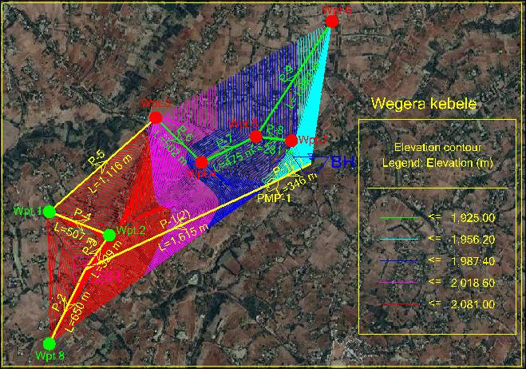

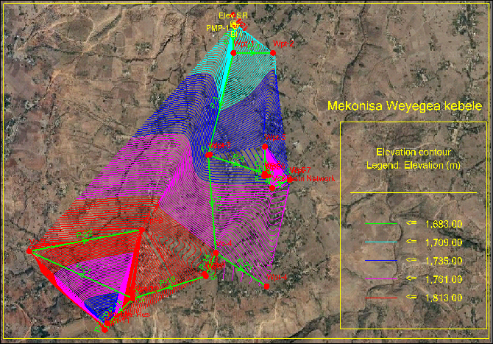

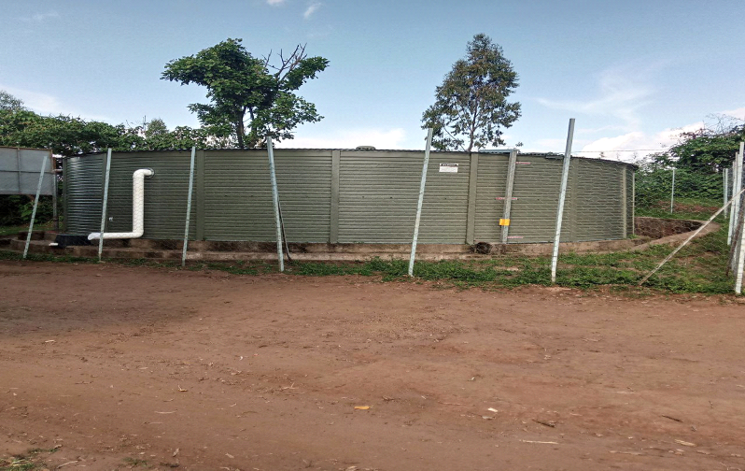
Figure 3 3: The existing 200m³ reservoir in the Woreda

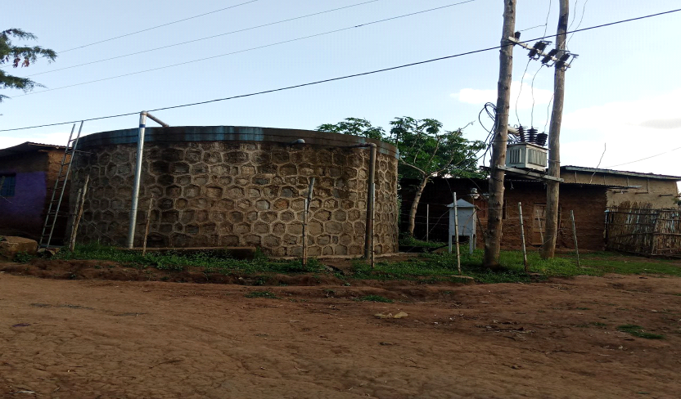
Figure 3.4: The existing 50m³ reservoir in the Woreda

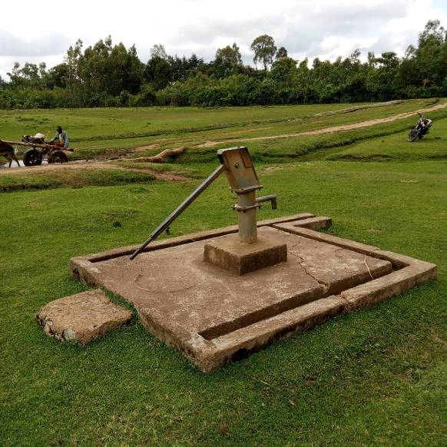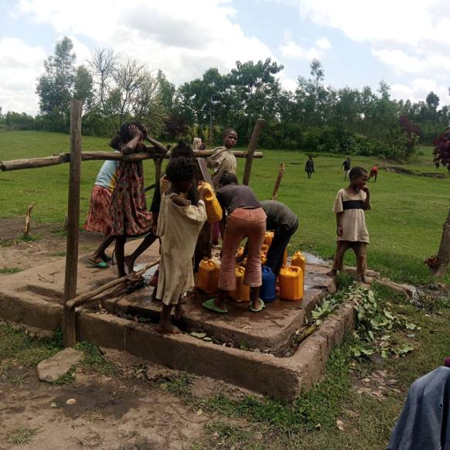
Figure 3 7: Functional water supply schemes in kebeles

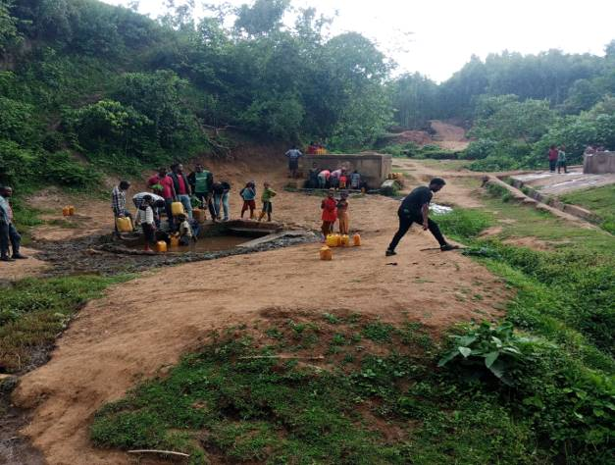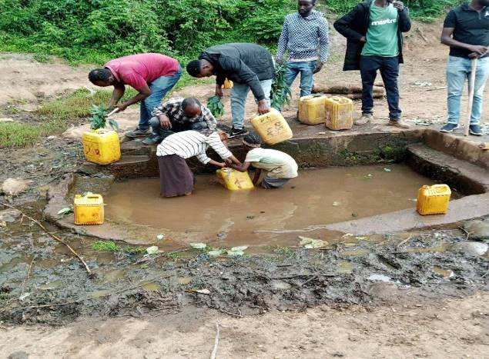
Figure 3 8: Traditional water sources

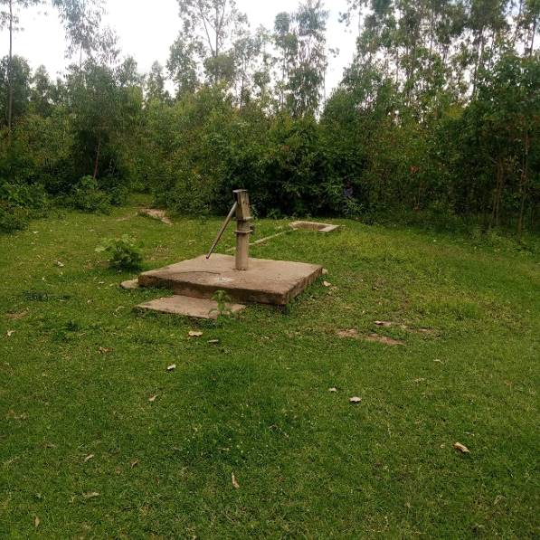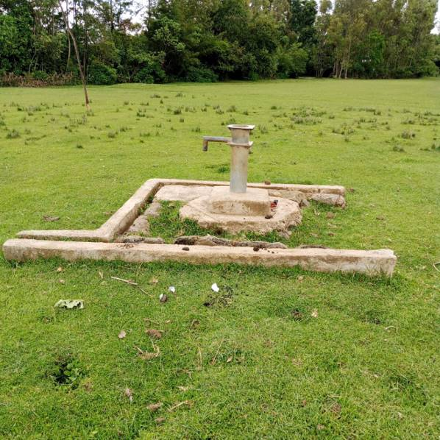
Figure 3 11: Non- functional water supply schemes

