GROUNDWATER POTENTIAL MAPPING USING GIS AND REMOTE SENSING:
A CASE STUDY IN WEYIB SUB-BASIN, GENALE-DAWA RIVER BASIN, SOUTHEAST ETHIOPIA

M.Sc. THESIS

ABDULGEFAR MUHIDIN MOHAMMED

HAWASSA UNIVERSITY, HAWASSA, ETHIOPIA

APRIL, 2021

GROUNDWATER POTENTIAL MAPPING USING GIS AND REMOTE SENSING: A CASE STUDY IN WEYIB SUB-BASIN, GENALE-DAWA RIVER BASIN, SOUTHEAST ETHIOPIA

ABDULGEFAR MUHIDIN MOHAMMED

A THESIS SUBMITTED TO THE
DEPARTMENT OF HYDRAULIC AND WATER RESOURCES ENGINEERING, HAWASSA INSTITUTE OF TECHNOLOGY, SCHOOL OF
GRADUATE STUDIES, HAWASSA UNIVERSITY
HAWASSA, ETHIOPIA

IN PARTIAL FULFILLMENT OF THE
REQUIREMENTS OF THE
DEGREE OF

MASTERS OF SCIENCE IN HYDRAULIC ENGINEERING

APRIL, 2021
SCHOOL OF GRADUATE STUDIES
HAWASSA UNIVERSITY ADVISORS’ APPROVAL SHEET
This is to certify that the thesis entitled ″Groundwater Potential Mapping using GIS and Remote Sensing: A case study in Weyib Sub-basin, Genale-Dawa River Basin, Southeast Ethiopia’’ submitted in partial fulfillment of the requirements for the degree of Master's of Science in Hydraulic Engineering, the Graduate Program of the Department of Hydraulic and Water Resources Engineering, and has been carried out by Abdulgefar Muhidin Mohammed Id No. GPHydr R/001/2011, under our supervision. Therefore, we recommend that the student has fulfilled the requirements and hence hereby can submit the thesis to the department.

Tewodros Assefa (Ph.D.) --------------------------- ---------------------------

Major advisor Signature Date

Teshale Tadesse (M.Sc.) --------------------------- ---------------------------

Co-advisor Signature Date

SCHOOL OF GRADUATE STUDIES
HAWASSA UNIVERSITY EXAMINERS’ APPROVAL SHEET
We, the undersigned, members of the Board of Examiners of the final open defense by Abdulgefar Muhidin Mohammed have read and evaluated his thesis entitled ‘’Groundwater Potential Mapping using GIS and Remote Sensing: A case study in Weyib Sub-basin, Genale-Dawa River basin, Southeast Ethiopia’’, and examined the candidate. This is, therefore, to certify that the thesis has been accepted in partial fulfillment of the requirements for the degree
Tewodros Assefa (Ph.D.) --------------------------- ---------------------------
Major advisor Signature Date
------------------------------ --------------------------- --------------------------
Internal Examiner-I Signature Date
------------------------------ --------------------------- --------------------------
Internal Examiner-II Signature Date
------------------------------ --------------------------- --------------------------
External Examiner Signature Date
------------------------------ --------------------------- --------------------------
SGS Signature Date

ACKNOWLEDGEMENTS
All praise is due to Allah the Exalted, and May peace and blessings be upon Muhammad (SAW), the Seal of the Prophets, who delivered the message of his Lord in the best manner.
ALHAMDULILLAH! I thank Allah for all the opportunities and strength that have been showered on me to bring my hope into reality. Without His support and blessing, it could not have been possible to complete my work.
I would like to express my sincere gratitude to my advisors Tewodros A. (Ph.D.) and Teshale T. (M.Sc.) for their continuous guidance and encouragement during my studies.
This work would not have been possible without the financial support of the Ethiopian Road Authority and MAK PLC. I am especially indebted to extend my thanks to my sponsors.
I would like to appreciate the following institution that supports my work on obtaining data: Ministry of Water, Irrigation, and Energy, Ethiopian Institute of Geologic Survey, Ethiopian National Meteorological Agency and Bale Zone Water Resources Development and Energy.
I wish to thank my parents for their love and encouragement, without whom I would never have enjoyed so many opportunities. My deepest gratitude goes to all of my family members. It would not be possible to finish this thesis without support from them.
Finally, I wish to thank all of my friends who were ever with me, even when my shadow was helping the darkness! Last but not the least, I would like to thank all of my best colleagues and other people whose assistance was a milestone for the completion of this thesis.

TABLE OF CONTENTS
ACKNOWLEDGEMENTS i
TABLE OF CONTENTS ii
LIST OF ACRONYMS vi
LIST OF TABLES vii
LIST OF FIGURES viii
LIST OF TABLES IN THE APPENDIX x
LIST OF FIGURES IN THE APPENDIX xi
ABSTRACT xiii
1. INTRODUCTION 1
1.1. Background 1
1.2. Statement of the Problem 2
1.3. Objectives of the Study 3
1.3.1. General Objective 3
1.3.2. Specific Objectives 4
1.4. Research Questions 4
1.5. Significance of the Study 4
1.6. Scope and limitation of the Study 5
2. LITERATURE REVIEW 6
2.1. Groundwater Potential Mapping 6
2.1.1. Groundwater Potential 6
2.1.2. Groundwater Potential of Ethiopia 6
2.1.3. Groundwater Assessment Methodology 7
2.1.4. Groundwater Potential Mapping using GIS and Remote Sensing 15
2.1.5. Factors Influencing Groundwater Potential 16
2.2. AHP and its Application for Groundwater Potential Zone Mapping 22
2.3. Groundwater Flow Direction 23
2.4. Overview of the Tools Used for the Study 23
2.4.1. Geographic Information System (GIS) and Remote Sensing (RS) 24
2.4.2. ERDAS-Imagine 24
2.4.3. PCI Geomatics 25
2.4.4. Rockworks16 25
2.4.5. System for Automated Geoscientific Analysis (SAGA) GIS 25
2.4.6. Soil Texture Calculator 26
2.4.7. IDRISI Selva 26
2.4.8. Surfer 17.1 27
3. MATERIAL AND METHODS 28
3.1. Description of the Study Area 28
3.1.1. Location 28
3.1.2. Topography 29
3.1.3. Climate 30
3.1.4. Rainfall and Temperature 31
3.1.5. Land Use and Land Cover (LU/LC) 32
3.1.6. Drainage 33
3.1.7. Lithology 34
3.1.8. Stratigraphy 35
3.2. Data Collection and Analyses 36
3.2.1. Characterization of factors influencing groundwater potential zones 36
3.2.2. Delineation of groundwater potential zones 44
3.2.3. Identification of the Groundwater Flow Direction 48
4. RESULTS AND DISCUSSION 50
4.1. Characterization of Factors Influencing Groundwater Potential 50
4.1.1. The Thematic Map of Geomorphology 50
4.1.2. The Thematic Map of Lineament Density 52
4.1.3. The Thematic Map of Geological Formation 55
4.1.4. The Thematic Map of Rainfall Distribution 56
4.1.5. The Thematic Map of Drainage Density 58
4.1.6. The Thematic Map of Slope 60
4.1.7. The Thematic Map of Elevation 62
4.1.8. The Thematic Map of Land Use and Land Cover 64
4.1.9. The Thematic Map of Soil Texture 66
4.2. Assignment of Weight to Factors 68
4.3. Delineation of Groundwater Potential Zones 71
4.4. Verification of the Result Using Water Point Data 74
4.5. Groundwater Flow Direction 76
5. SUMMARY AND CONCLUSION 80
5.1. Summary 80
5.2. Conclusions 81
5.3. Recommendations 83
6. REFERENCES 85
7. APPENDICES 103

Dedicated to:

………………………………………………………………………………………………

Haadholii; Daa’immanii fi Da’oo Isaanii Dhiisanii
Bishaan Barbaacha Dachee Bishaaniin Guuttame irra Maayiloota Deemanii fi
Hidhamtoota Siyaasaa Jiruu fi Jireenya Isaanii Dhiisanii
Haqa Barbaacha Dachee Ummata Isaanii Miliyoonotaan Guuttame Keessatti Ummata
Isaaniitiif Beelayaa fi Gidirfamaa Jiranii fi Turaniif
Haa Ta’u!
………………………………………………………………………………………………

Even you deserve more!

LIST OF ACRONYMS
AHP Analytic Hierarchy Process
BCM Billion Cubic Meter
BCK Billion Cubic Kilometer
ERDAS Earth Resource Data Analysis System
FAO Food and Agriculture Organization
GIS Geographic Information System
GWMATE Groundwater Management Assistance Team
GWPZ Groundwater potential zones
LU/LC Land use land cover
MCDA Multiple criteria decision analysis
MoWIE Ministry of Water, Irrigation and Energy
MoWR Ministry of Water Resources
RS Remote Sensing
SOMSC South Oromia Meteorological Service Center
SRTM DEM Shuttle Radar Topography Mission Digital Elevation Model
SWAT Soil Water Assessment Tool
TPI Topographic Position Index
UNESCO United Nations Educational, Scientific and Cultural Organization
USGS United States Geological Survey
UTM Universal Transverse Mercator

LIST OF TABLES
Table 3.1: Random consistency index (RI) for n ≤ 10 n 46
Table 4.1: The relative weight and consistency ratio of the reclassified landforms 51
Table 4.2: Lineament density and relative weight as per suitability for GWPZ 54
Table 4.3: Geologic formation and their relative weights 56
Table 4.4: Rainfall distribution and relative weight as per suitability for GWPZ 57
Table 4.5: Drainage density and relative weight of classes as per suitability for GWPZ 58
Table 4.6: Slope range and relative weight of slope classes 62
Table 4.7: The elevation range and relative weight of classes 63
Table 4.8: The classified LU/LC, contribution and relative weight of classes 65
Table 4.9: Error matrix and accuracy of the classified LU/LC map 66
Table 4.10: The soil texture, relative weight and consistency ratio. 66
Table 4.11: Pairwise comparison matrix and the relative weights of factors 68
Table 4.12: Normalized pairwise comparison matrix and final weighted values 69
Table 4.13: Consistency ratio (CR) of the generated matrix 69
Table 4.14: Groundwater potential zone 71
Table 4.15: Suitable groundwater potential zone for Woredas in the study area 73
Table 4.16: Validation of the identified groundwater potential zones with actual yield 74

LIST OF FIGURES
Figure 3.1: The location map of the study area 28
Figure 3.2: The shaded DEM and the cross-section along the downstream 30
Figure 3.3: Bar charts of average monthly rainfall (a) and temperature (b) 31
Figure 3.4: Rainfall stations and Thiessen polygon of the study area 32
Figure 3.5: Reach, monitoring point and sub-basin outlet point of the study area 33
Figure 3.6: Double mass curve 37
Figure 3.7: TPI and slope position 39
Figure 3.8: Conceptual framework of the study 49
Figure 4.1: The classified landforms of study area 50
Figure 4.2: The reclassified landforms of study area 51
Figure 4.3: Lineament map of Weyib Sub-basin 52
Figure 4.4: The lineament density map of Weyib Sub-basin 53
Figure 4.5: The reclassified lineament density map of study area 53
Figure 4.6: Major lineament superimposed over the mainstream 54
Figure 4.7: The geologic map of study area 55
Figure 4.8: The reclassified geological map of study area 56
Figure 4.9: The areal rainfall distribution map of study area 57
Figure 4.10: The reclassified areal rainfall distribution map of study area 58
Figure 4.11: The drainage network map of study area 59
Figure 4.12: The drainage density thematic map of study area 59
Figure 4.13: The reclassified drainage density map of study area 60
Figure 4.14: The slope map of study area 61
Figure 4.15: The reclassified slope thematic map of Weyib Sub-basin 61
Figure 4.16: Elevation map of study area 62
Figure 4.17: The reclassified elevation map of study area 63
Figure 4.18: The LU/LC map of Weyib Sub-basin 64
Figure 4.19: The reclassified LU/LC map of Weyib Sub-basin 65
Figure 4.20: The soil texture classes of study area 67
Figure 4.21: The reclassified soil map of study area 67
Figure 4.22: Pie-chart of the physiographic, geology and climatic factors weightage 70
Figure 4.23: The groundwater potential zone map 71
Figure 4.24: Suitable groundwater potential zone for Woredas in the study area 72
Figure 4.25: Bar charts showing very high and high GWPZ’s of Woredas 73
Figure 4.26: Bar chart showing validation of the identified GWPZ 75
Figure 4.27: Evaluation of groundwater potential zones with water point’s yield data 75
Figure 4.28: The groundwater flow direction, Recharge/Discharge zone (I) and groundwater level profile (II) along the downstream 76
Figure 4.29: Groundwater level, reach and flow direction vectors map 77
Figure 4.30 The GWFD vector superimposed over the delineated GWPZ 78
Figure 4.31: The groundwater flow direction, contour map and surface profile generated from topographic tilting 79

LIST OF TABLES IN THE APPENDIX
Appendix table 1: Saaty’s scale of intensity relative importance and descriptions 103
Appendix table 2: Software used for the study 103
Appendix table 3: Sources of data, scale and their respective resolution 104
Appendix table 4: The average annual rainfall of study area 104
Appendix table 5: Soil types, coverage area and their constituents in percentage 105
Appendix table 6: Symbols and the short descriptions of lithological units 106
Appendix table 7: Major soil groups and their short description 107
Appendix table 8: The water points inventory data 109
Appendix table 9: AHP matrix, relative weight, and CR of rainfall thematic map 113
Appendix table 10: AHP matrix, relative weight, and CR of LULC thematic map 113
Appendix table 11: AHP matrix, relative weight, and CR of landforms thematic map 113
Appendix table 12: AHP matrix, relative weight, and CR of slope thematic map 114
Appendix table 13: AHP matrix, relative weight, and CR of lineament density 114
Appendix table 14: AHP matrix, relative weight, and CR of drainage density 114
Appendix table 15: AHP matrix, relative weight, and CR of elevation thematic map 114
Appendix table 16: AHP matrix, relative weight, and CR of soil thematic map 115
Appendix table 17: AHP matrix, relative weight, and CR of geologic thematic map 115

LIST OF FIGURES IN THE APPENDIX
Appendix figure 1: Average maximum and minimum monthly temperature of stations 105
Appendix figure 2: The soil texture triangle 106
Appendix Figure 3: The WEIGHT module of IDRISI Selva’s pair-wise comparison matrix eigenvector and CR value of evaluation criteria 106

DECLARATION
I undersigned and declared that this M.Sc. thesis entitled “Groundwater Potential Mapping using GIS and Remote Sensing: A case study in Weyib Sub-basin, Genale-Dawa River basin, Southeast Ethiopia’’ is my original work and has not been presented for a degree in any other university, and all sources of material used for this thesis have been duly acknowledged.
Name: ____________________________________
Signature: ______________
This M.Sc. thesis has been submitted for examination with my approval as thesis advisor.
Name: ____________________________________
Signature: __________________________________
Place and Date of Submission: ______________

ABSTRACT
To fulfill the demand of a rapidly growing population in drought-prone areas with high rate of urbanization, identification and management of groundwater resources are required. In the Weyib Sub-basin, a search for an alternative source of water has been always a major issue. The current practice of groundwater potential zone (GWPZ) identification is time-consuming and uneconomical. Therefore, it is required to apply effective techniques for proper evaluation of groundwater resources. This study applied integration of GIS-Remote Sensing (RS) and Analytical Hierarchy Process (AHP) for mapping the GWPZ of Weyib Sub-basin, Southeast Ethiopia. For this purpose the physiographic, geology and climatic factors influencing GWPZ of the study area were characterized. The thematic maps of geomorphological landforms, lineament density, geology, rainfall distribution, drainage density, elevation, slope, LU/LC and soil texture were prepared. System for automated geoscientific analysis (SAGA) GIS, PCI Geomatics, Rockworks 16, IDRISI Selva and Surfer 17.1, were employed for landform classification, lineament extraction, rose diagram preparation, pairwise comparison of the factors and identification of groundwater flow direction, respectively. The AHP technique of Multi-criteria decision analysis (MCDA) was employed to determine the relative weight and influences of the thematic layers. Geomorphologic landform, lineament density, geology, and rainfall distribution were found to be the dominant factors sharing the highest weightage of 67%. A weighting overlay approach of GIS was utilized to overlay the thematic maps. The resulting GWPZ of the study area indicates five zones representing very high, high, moderate, poor and very poor GWPZ. The areal extent of very high and high GWPZ is 41 km² and 2032 km², respectively. Moderate, poor and very poor GWPZ covers 2088 km², 252 km² and 0.142 km² areas. The particular direction of groundwater flow is towards the NE and SE, coinciding with the direction of surface water flow. It was controlled by NW-SE striking geologic structures. The delineated GWPZ map is verified by using the existing water point’s inventory data. It indicates a good prediction accuracy of 84%. Thus, the identification of GWPZ by using GIS and RS through AHP is reliable for conducting similar studies.
Keywords: Groundwater potential; GIS and RS; AHP; weighted overlay; Weyib Sub-basin

INTRODUCTION

Background
Groundwater is a precious resource of a limited extent. To ensure its judicious use, proper evaluation is required (Rwanga, 2013). Groundwater has emerged to be one of the major sources of potable water contributing significantly to the total annual water supply for various purposes (Waikar and Nilawar, 2014). From an estimated total world water resource of 1.36 BCK, 2.8% is fresh water, about 2.2% is available as surface water, while 0.6% is groundwater (Raghunath, 2006). Surface waters are seasonal in their availability and respond immediately to climate change (Fiedler, 1992; Louks and Beek, 2005; Whitehead et al., 2009). A tremendous increase in the demand for groundwater due to an increase in population, advanced irrigation practices and industrial usages need a reliable source of water supply (Jha et al., 2010). Hence the largest and reliable source of freshwater lies under the earth’s surface, there is a tendency to think of groundwater as being the primary source of water (Todd, 2005). Assessment of groundwater resources is critically needed to help for mitigation of the effects of drought and reduce the risks of overexploitation (MoWR, 2002).
In Ethiopia, the occurrence and movement of groundwater is mainly influenced by geophysical and climatic conditions of the area. The geology of the country provides good transmission of rainfall to recharge aquifers, which produce springs and feed perennial Rivers (Alemayehu, 2006; Gintamo, 2015). The difficulty in obtaining productive aquifers is the wide heterogeneity of geology, topography and environmental conditions. In many parts of the country, groundwater is an important source of domestic and industrial water use especially in rural areas and towns (Alemayehu, 2006). Hence, the groundwater provides over 90% of the improved rural water supply. About 8.4% of the urban and 56.8% of the rural population of Ethiopia utilize groundwater sources for potable water consumption (Yasin, 2017).
In developing countries like Ethiopia, most of the hydrogeological investigations have been done by using conventional techniques like ground-based surveys and exploratory drilling. The conventional approaches for groundwater investigation are understood to be time-consuming and uneconomical (Mamo, 2007).
Besides, these methods do not cover inaccessible areas and may not be highly reliable due to the assessment of diverse factors affecting groundwater potential (Doyo, 2020).
Recently, with the help of GIS and RS technologies, potential detection of groundwater resources can be done easier, more accurately, and in a short time. The use of Remote Sensing to obtain data for inaccessible areas and the powerful tool, Geographic Information System (GIS), to address a large number of spatial data for quicker and cheaper processing are becoming more useful and mandatory for detection of potential groundwater areas (Nagarajan and Singh, 2009; Zeinolabedini and Esmaeily, 2015).
Groundwater usually flows from points of higher hydraulic heads to the points of lower hydraulic heads in the direction of maximum change in elevation (Doyo, 2020). Even though the flow of groundwater in the aquifer may not always reflect the surface water flows, it flows either towards or away from streams, rivers, lakes, ponds and boreholes (Amah and Agbebia, 2015). Therefore, to enable sustainable use of resources it is necessary to know the direction of groundwater flow and take a measure to ensure the human activity in the recharge area will not pose threat to the quality of groundwater.
Several researchers have been successfully utilized GIS and RS technologies for the identification of GWPZ around the world and in Ethiopia (Andualem and Demeke, 2019; Gebru et al., 2020; Zeinolabedini and Esmaeily, 2015). The approach of GIS and RS techniques for groundwater potential identification indicates an acceptable result. In the present study, GIS and RS technique through the analytic hierarchy process (AHP) is used for mapping the GWPZ of Weyib Sub-basin.

Statement of the Problem
Genale-Dawa River Basin is one of the largest and most drought-prone regions in Ethiopia (Kassahun and Mohamed, 2018). As a result, a search for an alternative source of water has been always a major issue in the region. In the Weyib Sub-basin the growing importance of groundwater based on an increasing need has led to unscientific exploitation of groundwater creating a water stress condition. To fulfill the demand of a rapidly growing population with the high rate of urbanization, identification and management of groundwater resources are required. To address the problems, it is important to apply an effective technique for the proper evaluation of groundwater resources.
The groundwater potential zone of the study area was not delineated by using GIS and RS techniques. Besides this, most of the studies focused on local-scale problems, but also others have been accomplished at a large scale (Kassahun and Mohamed, 2018; Kebede and Mulugeta, 2011; Kifle and Hailemriam, 2010; Kiflu et al., 2009; Mulugeta and Tafa, 2010). Studies conducted at a large scale classified the entire area of the Weyib Sub-basin in a single GWPZ. But the spatial variation of groundwater potential even in an area smaller than the Weyib Sub-basin is obvious. Hence, it is required to conduct a detailed study at the sub-basin level. The report of hydrogeological study conducted by the Geological Survey of Ethiopia identifies the aquifer systems of separate map sheets based on the hydrogeological characteristics (aquifer productivity and permeability) of the lithological units. But the groundwater potential of an area depends on various sensitive factors. So that, those factors are needed to be identified, characterized, and evaluated separately.
A multi-disciplinary study involving hydrogeology and geophysics has been undertaken by Oromia and Bale zone water resources development and energy. The study was aimed to propose the sites for drilling discrete water wells. To identify the feasible site for groundwater development, visualization of general topography and geological setup of the area center for the resistivity survey is selected. Based on the hydrogeological study findings detail geophysical electrical resistivity surveys of the selected site were conducted for tracing, delineating/defining and estimating the depth extent of the sub-surface and aquifer materials. A considerable number of wells identified by this method are drilled and yields low productivity, while others are dry. Hence the method consumes time and costs integration of a variety of disciplines at a single platform is required. Protection of the groundwater recharge site is the other strategy for sustainable groundwater development. Therefore, it is required to identify the groundwater flow direction for planning the Sub-basin and predict the status of groundwater potential for proposing the recommended sanitary site.

Objectives of the Study

General Objective
The general objective of this study was to delineate the groundwater potential zone of Weyib Sub-basin by using GIS and Remote Sensing techniques.

Specific Objectives
The specific objectives of this study were:
- To identify and characterize the climate, physiographic and geologic factors essential for the delineation of groundwater potential zones.
- To delineate suitable groundwater potential zones and identify its spatial variability through integration of different thematic layers.
- To identify the groundwater flow direction of Weyib Sub-basin.

Research Questions
- What are the dominant factors that affect the groundwater potential of the area?
- In which zone the most suitable groundwater potential does exist and to what extent does the spatial variability of groundwater zone?
- What does the predominant groundwater flow direction of study area look like?

Significance of the Study
This study will contribute to the current efforts by government and other concerning bodies to solve the problems of a source of water. The identification of a suitable GWPZ contributes to the rational exploitation and sustainable development of groundwater resources. Thus, the identified maps of GWPZ will be used as a preliminary reference in selecting suitable sites for drilling boreholes. Besides, it will contribute as an alarming factor for considering groundwater quality while planning the sub-basin. The study was considering the local spatial variability of groundwater potential. This will cover the gap in the previous study which categorizes the overall sub-basin in a similar zone. The climatic, physiographic and geologic factors essential for the delineation of GWPZ were identified and characterized at a small scale. The results of this study can be used as the basis for further analysis of Weyib Sub-basin groundwater potential which has a significant contribution toward the watershed management effort of the country. The present study applies GIS and RS techniques for mapping the GWPZ of Weyib Sub-basin. These techniques are very easy to access and identify groundwater potential of large and inaccessible areas. This will contribute to fill the gaps by replacing uneconomical and time-consuming conventional approaches of groundwater investigation by using GIS and RS techniques.

Scope and limitation of the Study
This study specifically focuses on mapping the groundwater potential zone of Weyib Sub-basin. As it was a qualitative study the recharge and groundwater storage was not quantified. Since the time and resources are limited the study does not include the analysis of groundwater water quality and the structural design of groundwater conveyance structures (borehole/dug well depth, cross-section etc.), rather than mapping every zone in the sub-basin with their respective potential and proposing zones of suitable groundwater potential. The effect of LU/LC change on groundwater recharge/potential and the suitability of the identified GWPZ for irrigation, water supply and other water resources development projects were not assessed.

LITERATURE REVIEW

Groundwater Potential Mapping

Groundwater Potential
Groundwater is the most valuable global resource, comprising 96% of the earth’s unfrozen freshwater, as well as being the main water source in many water-scarce areas (Kidanu, 2018). It is the only underground water that is available to supply wells and springs, supports wetlands, and maintains land surface stability. About 70% of the world’s population depends on groundwater for basic domestic water services. The spatial distribution of GWPZ showed regional patterns related to geologic, physiographic and hydrologic characteristics of the area (Mamo, 2007).

Groundwater Potential of Ethiopia
Ethiopia is often referred to as the "rooftop of Africa" because its extensive highlands capture a major portion of the precipitation that falls on the continent (Mamo, 2007). The geology and environmental condition of the country which shaped by complex geological formations, diversity of the topography, climate and soil causes spatial variability of GWPZ. The geology of the country provides usable groundwater resources. In many parts of the country, groundwater is an important source of domestic and industrial water use (Alemayehu, 2006). Groundwater resource in Ethiopia was estimated by different researchers and organizations. However, the estimated values differ from each other.
The MoWR water sector development program main report volume II (2002) estimated the country groundwater resource of 2.6 BCM. A previous study by Makombe et al. (2011) estimated 2.86 BCM of groundwater potential. Later revised by Seleshi et al. (2007), it to be about 28 BCM and other study have estimated it to be above 28 BCM (Seifu, 2012). At present, detailed groundwater assessments in several areas indicate that the estimated groundwater potential of 2.6 BCM by MoWR or 2.86 BCM by Makombe et al. (2011) was underestimated, and it needs to be revised. Best guesses in this respect range between 12 and 30 BCM, or even more if all aquifers in the lowlands are assessed (MoWR and GWMATE, 2011).

The study conducted by Belete et al. (2014) reviews the surface and groundwater resources potential of Ethiopia. The study estimates the country’s groundwater potential of about 30 BCM. With the understanding of the nature of the distribution of rocks and the recharge classification of the country, Alemayehu (2006) estimated the total groundwater reserve of the country as 185 BCM. It was distributed over an area of 924,140 km² made of sedimentary, volcanic and quaternary rocks and sediments, including the highlands and the Rift valley. The groundwater potential of the Genale-Dawa River basin alone is estimated to have a groundwater reserve of 2.78 BCM (Kassahun and Mohamed, 2018), while groundwater of the Hormat-Golina River catchment of Kobo Valley is estimated to have 2033 MCM on the area of 806 km² (Desalegn, 2011).

Groundwater Assessment Methodology
Assessment of the groundwater potential involves the analysis of groundwater flow and its interaction with the stream network, hydrological balance and forecasting the future use of water resources based on various exploitation alternatives (Groundwater assessment and management, 1989). It is essential for protection of water quality and management of groundwater systems (Waikar and Nilawar, 2014).

Groundwater Exploration
The water resources available in the basins remain almost constant, while the water demand continues to increase, due to the human population explosion, a rapid industrial development, urbanization and increase in agricultural production (Kassahun and Mohamed, 2018). Hence, the groundwater exploration is a typical task of a hydro-geologist or an engineer. Several geological, hydrogeological and geophysical methods are employed to target the groundwater potential zones (Balsubramanian, 2007).
The interpretation of satellite images and aerial photographs also help more in this process (Werz, 2006). Groundwater exploration is attempted through either by direct or indirect methods. Test drilling is the direct approach to find out the resource. This is an expensive affair (Sharma, 2021). During the last two centuries, more and more techniques have been developed to explore the groundwater. They are classified into surface and sub-surface methods. The surface methods are easy to operate and implement (Balsubramanian, 2007; Sharma, 2021). These require minimum facilities like topo-sheets, maps, reports, some field measurements and interpretations of data in the laboratories.
The surface methods of groundwater exploration include; esoteric methods, geomorphologic methods, geological and structural methods, soil and micro-biological methods, Remote Sensing techniques and surface geophysical methods (Epuh et al., 2020). The subsurface methods of groundwater exploration include both test drilling and borehole geophysical logging techniques (Coatfs, 1988). When compared to the surface methods, the subsurface methods are very expensive and accurate. It is done at the government level projects where large scale investigations are carried out to ascertain the results of surface surveys (Balsubramanian, 2007).

Estimation of Groundwater Recharge
The methodologies adopted for computing groundwater resources, are generally based on the hydrologic budget techniques. The hydrologic equation for groundwater regime is a specialized form of a water balance equation that requires quantification of the components of groundwater inflow and groundwater outflow, as well as changes in storage therein. Some of these are directly measurable, few may be determined by differences between measured volumes or rates of flow of surface water, and some require indirect methods of estimation (Kumar, 2000).
Several methodologies were adopted for estimation of the groundwater recharge. These can be classified into two classes. Physical methods and tracer methods. The physical method includes; direct measurements, water balance and D’Arcyan techniques. The direct measurement method includes measurement of the soil moisture content using instruments such as Lysimeters, Neutron and Time domain reflectometry probes (Kalbus et al., 2006; Shamuyarira, 2017).
The water balance techniques which developed by Thornthwaite was another physical methods. In this method the water input and output/discharge are compared and the difference in the two is the estimated recharge. The hydrograph separation, river channel water budget, water table fluctuation and saturated volume fluctuation departure methods are included in this techniques (Walker et al., 2019). The tracer method involves the introduction of dissolved substances or solutions into the water cycle and tracing the movement of water using their concentrations. Common tracer methods are chloride mass balance and groundwater dating (Al-Sudani, 2018; Wu et al., 2016) .

Groundwater Flow Modelling
Effective management of groundwater requires the ability to predict subsurface flow and transport of solutes and the response of fluid and solute flux to changes in natural or human-induced stresses. Hence, the use of groundwater models is prevalent in the field of environmental science (Kumar, 2002). One popular type of tool that has been evolving since the mid-1960s is the deterministic, distributed-parameter, computer simulation model for analyzing flow and solute-transport in groundwater systems (Jacques, 1999; Konikow and Mercer, 1988).
The applicability or usefulness of a model depends on how closely the mathematical equations approximate the physical system being modeled (Kumar, 2002). Deterministic models are based on conservation of mass, momentum, and energy and describe cause and effect relations. The following typical topics shows the need for modelling and (lead to) describe the current groundwater flow modelling techniques.
- Groundwater Flow and Transport Processes
The process of groundwater flow is generally assumed to be governed by the relations expressed in Darcy’s law and the conservation of mass. However, Darcy’s law does have limits on its range of applicability, and these limits must be evaluated in any application. The subsurface environment constitutes a complex, 3D, heterogeneous hydro-geologic setting. This variability strongly influences groundwater flow and transport, and such a reality can be described accurately only through careful hydro-geologic practice in the field. Stochastic approaches have resulted in many significant advances in characterizing subsurface heterogeneity and dealing with uncertainty (Gelhar, 1993).
- Deterministic groundwater models
Deterministic groundwater models generally require the solution of partial differential equations (Takounjou1, 2009). Exact solutions can often be obtained analytically, but analytical models require that the parameters and boundaries be highly idealized (Zarrouk and McLean, 2019). Many analytical solutions have been developed for the flow equation; however, most applications are limited to well hydraulics problems involving radial symmetry. The familiar Theis type curve represents the solution of one such analytical model (Jacques, 1999).

- Numerical methods
Numerical methods yield approximate solutions to the governing equation through the discretization of space and time. Deterministic, distributed-parameter, numerical models can relax the rigid idealized conditions of analytical models or lumped-parameter models, by approximating the variables internal properties, boundaries and stresses of the system. Hence, they are more realistic and flexible for simulating field conditions (Atangana and Botha, 2013). But the grid dimensions, boundary conditions and other parameters (such as hydraulic conductivity and storativity) are specified in an application of a generic model to represent a particular geographic area, the resulting computer program is a site-specific model (Selinus, 2013). This does not guarantee a similar level of accuracy when the model is applied to a complex field problem.
If the user of a model is unaware of or ignores the details of the numerical method, including the derivative approximations, the scale of discretization, and the matrix solution techniques, significant errors can be introduced and remain undetected.
- The finite-difference and finite-element methods
Two major classes of numerical methods have come to be well accepted for solving the groundwater flow equation. These are the finite-difference methods and the finite-element methods. Comprehensive treatments of the application of these numerical methods to groundwater problems are presented by Remson et al. (1971) and Wang and Anderson (1982). Both of these numerical approaches require that the area of interest be subdivided by a grid into a number of smaller subareas (cells or elements) that are associated with nodal points (either at the centers or peripheries of the subareas).
To date, finite-difference and finite-element methods have been more widely used than other numerical methods in simulating groundwater flow problems. Each approach has advantages and disadvantages, but there are very few groundwater problems for which either is clearly superior.
- Finite-difference methods
Finite-difference methods approximate the first derivatives in the partial differential equations as difference quotients (the differences between values of the independent variable at adjacent nodes with respect to the distance between the nodes, and at two successive time levels with respect to the duration of the time-step increment).
In general, the finite-difference methods are simpler conceptually and mathematically, and are easier to program. They are typically keyed to a relatively simple, rectangular grid, which also eases data entry.
- Finite-element methods
Finite-element methods use assumed functions of the dependent variable and parameters to evaluate equivalent integral formulations of the partial differential equations. These equations can then be solved using either iterative or direct matrix methods. In direct methods, a sequence of operations is performed only once to solve the matrix equation, providing a solution that is exact, except for machine round-off error. Iterative methods arrive at a solution by a process of successive approximation. They involve making an initial guess at the solution, then improving this guess by some iterative process until an error criterion is satisfied. More recently, a semi-iterative method, or class of methods, known as conjugate-gradient methods, has gained popularity. One advantage of the conjugate-gradient method is that it does not require the use or specification of iteration parameters, thereby eliminating this partly subjective procedure.
Finite-element methods generally require the use of more sophisticated mathematics but, for some problems, may be more accurate numerically than standard finite-difference methods. A major advantage of the finite-element methods is the flexibility of the finite-element grid, which allows a close spatial approximation of irregular boundaries of the aquifer and (or) of parameter zones within the aquifer when they are considered. However, the construction and specification of an input data set are much more difficult for an irregular finite-element grid than for a regular rectangular finite-difference grid.
The method of characteristics was also developed to solve hyperbolic differential equations (advectively dominated transport equations). A major advantage is that the method minimizes numerical dispersion (Reddell and Sunada, 1970; Garder et al., 1964; Zheng and Bennett, 1995). Although finite-difference and finite-element models are commonly applied to transport problems, other types of numerical methods have also been applied to transport problems, including the method of characteristics, random walk, Eulerian-Lagrangian methods, and adaptive grid methods. All of these methods have the ability to track sharp fronts accurately with a minimum of numerical dispersion. A documented models based on variants of these approaches include Konikow and Bredehoeft (1978), Sanford and Konikow (1985), Prickett et al. (1981), and Zheng (1990).
No single one of the standard numerical methods is ideal for a wide range of transport problems and conditions. Thus, there is currently still much research on developing better mixed or adaptive methods that aim to minimize numerical errors and combine the best features of alternative standard numerical approaches.

Models Review
Existing GIS software are extremely diverse in functionality, database structure and hardware requirements. Some of the popular GIS software is Arc/Info, ArcView, MapInfo, MGE (Modular GIS Environment), Genasys, ERDAS, GRASS, IDRISI and Atlas. These software are sophisticated and have a variety of functionalities for GIS applications and analyses. Most of these software come with capabilities to handle data in various formats, thereby facilitating data transfer between GIS software. Some of the above software is hardware specific and others run on a variety of platforms. A large number of generic deterministic groundwater models, based on a variety of numerical methods and a variety of conceptual models, are available.
GIS can facilitate the development, calibration, and verification of models as well as the display of model parameters and results in modeling groundwater movement. Spatial statistics and grid design capabilities of GIS can improve the modeling effort and aid in reliability assessment. A GIS-MODFLOW interface is an example of a groundwater finite-difference model linked with a GIS. The selection of a numerical method or generic model for a particular field problem depends on several factors, including accuracy, efficiency/cost, and usability. A large number and variety of generic groundwater models are documented and available at the present times are the following.
- MODFLOW
One of the most popular and comprehensive deterministic groundwater models available today is the MODFLOW code of McDonald and Harbaugh (1988) and Harbaugh and McDonald (1996). This is actually a family of compatible codes that centers on an implicit finite-difference solution to the three-dimensional flow equation that was coded in FORTRAN in a modular style to allow and encourage the development of additional packages or modules that can be added on or linked to the original code. Newer packages offer several additional solution algorithms, including a preconditioned conjugate gradient solver (Hill, 1990) and a direct solver (Harbaugh, 1995).
The parameter-estimation package, MODFLOWP, can be used to estimate parameters (such as transmissivity, storage coefficient, leakance coefficients, recharge rates, evapotranspiration, and hydraulic head at constant-head boundaries) using nonlinear regression (Hill, 1992). A variety of other MODFLOW accessory codes, packages, and features are available. Most of these were developed by the U.S. Geological Survey (USGS) and are summarized by Appel and Reilly (1994). Other packages have been developed by non-USGS sources to work with MODFLOW; one example is the advective-dispersive solute-transport model MT3D (Zheng, 1990).
MODFLOW is easy to set up and pre/post process files, free and modular (new package added frequently). However, it cannot simulate complex geological features. A considerable amount of research was employed MODFLOW for groundwater flow-modeling, sensitivity analysis etc. (Al-Muqdadi et al., 2020; Dagalo, 2005; Efren, 2020; Hogeboom, 2013; Mitiku, 2011).
- Method Of Characteristics (MOC)
MOC model is developed by Konikow and Bredehoeft (1978). It can simulate solute transport in flowing groundwater in two dimensions. The model has been extensively used since the mid-1970s and has been evolving through updates and improvements. The model computes changes in concentration over time caused by the processes of advective transport, hydrodynamic dispersion, mixing or dilution from fluid sources, and the following types of chemical reactions: first-order irreversible-rate reaction, such as radioactive decay; reversible equilibrium-controlled sorption with linear, Freundlich, or Langmuir isotherms; and reversible equilibrium-controlled ion exchange for monovalent or divalent ions.
The model couples the groundwater flow equation with the solute-transport equation. The model uses a finite-difference approximation to the groundwater flow equation and the method of characteristics to solve the solute-transport equation. The original model of Konikow and Bredehoeft (1978) was later revised by Goode and Konikow (1989) and Konikow et al. (1994). The model has also been used as the foundation for MOCDENSE (Sanford and Konikow, 1985), a model that can simulate two constituents in a density-dependent flow system.
There are public-domain and commercial preprocessors available, including PREMOC (Granato et al., 1993). A 3D version of the model (MOC3D) uses MODFLOW to simulate the flow system (Konikow et al., 1996).
C) Hydrogeosphere (HGS)
The model code Hydrogeosphere, was designed primarily as a research tool and is especially well suited for highly integrated hydrologic modeling involving detailed simulation of rainfall-runoff, infiltration, vadose zone flow, streamflow, and groundwater processes (Harter and Morel-Seytoux, 2013).
D) Integrated Water Flow Model (IWFM)
IWFM is a comprehensive, water resources management and planning tool developed by the California Department of Water Resources (CADWR, 2005). IWFM simulates the groundwater flow, surface flows and interaction between surface and subsurface flow processes using fully coupled conservation equations (Emin et al., 2006; Harter and Morel-Seytoux, 2013).
E) Groundwater and Surface water flow (GSFLOW)
An integrated hydrologic model called GSFLOW was developed to simulate coupled ground-water and surface-water resources. The new model is based on the integration of the U.S.G.S. Precipitation-Runoff Modeling System and the U.S.G.S. Modular Ground-Water Flow Model. Additional model components were developed, and existing components were modified, to facilitate integration of the models. Methods were developed to route flow among the PRMS Hydrologic Response Units and between the HRUs and the MODFLOW finite-difference cells. An important aspect of the integrated model design is its ability to conserve water mass and to provide comprehensive water budgets for a location of interest. GSFLOW provides a robust modeling system for simulating flow through the hydrologic cycle, while allowing for future enhancements to incorporate other simulation techniques (Markstrom, 2008).
F) ParFlow
ParFlow is a parallel simulation platform that operates in steady-state saturated, variably saturated, and integrated-watershed flow modes. It is especially suitable for large scale problems on a range of single and multi-processor computing platforms.
ParFlow can also simulates the three-dimensional saturated and variably saturated subsurface flow in heterogeneous porous media in three spatial dimensions using a multi grid preconditioned conjugate gradient solver and a Newton-Krylov nonlinear solver. ParFlow has recently been extended to couple surface-subsurface flow to enable the simulation of hill slope runoff and channel routing in a truly integrated fashion (Maxwell et al., 2010). The outstanding physically based, deterministic models including Modular hydrologic modelling system (MODHMS) and MIKE System Hydrologique European (SHE) are integrated, distributed, having a records of publication and detailed documentation, have been tested and used by non-development team members (Shamuyarira, 2017).

Groundwater Potential Mapping using GIS and Remote Sensing
Before the incorporation of RS techniques, groundwater potential study was only done by using the data from field observations. In developing countries like Ethiopia, most of the hydrogeological investigations have been done using conventional techniques. The conventional approaches for groundwater investigation like ground-based surveys and exploratory drilling are understood to be time-consuming, uneconomical and able to cover small areas of land (Mamo, 2007; Marghany et al., 2009).
Several researchers have successfully utilized GIS and RS technologies in the identification of GWPZ around the world. RS in the form of aerial photography, satellite imagery and geophysics evolved as solutions with larger coverage, lesser collection period and access to physically inaccessible areas. The study conducted by Gebrie et al. (2019) delineates the GWPZ of the Guna tana landscape, upper Blue Nile basin of Ethiopia by using GIS and RS. MCDA techniques were used to develop the GWPZ by integrating different groundwater contributing thematic layers. Another study conducted by Berihun (2018) assessed the GWPZ of Sekota Woreda, North Ethiopia. Integration of MCDA, RS and GIS techniques were employed to delineate the GWPZ of study area.
The study approach involves integration of thematic layers based on the weights assignment and normalization concerning the relative contribution of the themes to groundwater occurrence using Saaty’s AHP. The GWPZ were classified as low, moderate and high zone. Validation of the result with existing water point yield data highlights the efficiency of the integrated RS and GIS methods for GWPZ mapping.
Generally, a various study conducted by several researchers on the worldwide, continent and in Ethiopia shows the efficiency of the integrated RS and GIS methods for GWPZ. The approach provides a proper groundwater resources evaluation, quick guides of perspective groundwater exploration and exploitation (Arshad et al., 2020; Berhanu and Hatiye, 2020; Çelik, 2019).

Factors Influencing Groundwater Potential
The occurrence of groundwater potential is mainly influenced by the geophysical and climatic conditions of the area. The difficulty in obtaining productive aquifers is a peculiar feature of Ethiopia, which is characterized by the wide heterogeneity of geology, topography and environmental conditions (Alemayehu, 2006). An integrated approach of RS and GIS was adopted to assess the groundwater potential in the Southern lowland of Ethiopia, Moyale-teltele Sub-basin of Genale-Dawa River basin. The lithology, structure, geomorphology, slope, LU/LC and drainage density were considered for mapping groundwater potential zone (Mamo, 2007).
The latest study of groundwater potential assessment using a similar technique were conducted by Andualem and Demeke (2019); Gebrie et al. (2019); Berhanu and Hatiye, (2020) and Gebru et al., (2020). The studies consider several factors including; lithology, geological structures, soil, lineament features, slope, drainage pattern, geomorphology, LU/LC, normalized difference vegetation index (NDVI) and topographic wetness index (TWI) to identify the occurrence and movement of groundwater.
Even though the degree of influence will vary depending on the hydrologic, hydro-geologic and topographic or physiographic factors almost all the considered factor influences the GWPZ. Therefore, in order to obtain more accurate information about the occurrence and distribution of groundwater increasing the number of parameters is mandatory. To bound the factors in Saaty’s random consistency index (RI) which computed for n ≤ 10 and minimize the complexity of finding the plausible random index for n > 10 some factors which is possible to describe by dominant factor (major factors encompassing the minors) are merged together. Thus, in the present study the LU/LC and TPI were considered, while neglecting the normalized difference vegetation index and topographic wetness index.

Geomorphology
The study of landforms is an important branch of earth science that can be used for the prediction of watershed characteristics (Mokarram et al., 2018). The ability to classify the continuous terrain surface into meaningful and discrete features provides a way to describe, analyze and quantify the characteristics of landscape (Blaszczynski, 1997). Since the geomorphologic landform controls the sub-surface movement of groundwater, it is important factor for analysis of groundwater potential prospect.
The volcanic terrain of Ethiopia comes in a variety of landforms that is of significant importance to groundwater occurrence and movement (Kebede, 2013). A study conducted by Gebru et al. (2020) identifies the GWPZ of the Golina River Basin, Northern Ethiopia. The geomorphological landforms of the areas classified by topographic position index (TPI) techniques using SAGA GIS software from the DEM. Accordingly, the geomorphological landforms of the area are classified into the plain, valley, open slope, upper slope, mid-slope drainage, stream, upland drainage, local ridge, mid-slope ridge, and high ridges.
The normalized weight value of plain and valley landforms is higher than the others for groundwater potential. While ridges are lower for groundwater potential (Gebru et al., 2020). Analysis of landform using TPI shows more logical and realistic landform interpretation associated with the landform classes (Alemayehu et al., 2019). The results of the TPI approach derive accurate results for all selected input datasets in comparison to ground-truth data from a geomorphological field survey (Kramm et al., 2017). Several studies assign the highest weight for the geomorphological landforms (Doyo, 2020; Waikar and Nilawar, 2014).

Lineaments Density
Lineaments are the structural results of geomorphological and geological processes. It is a linear feature that occurs on the earth’s surface, distinct from the surrounding features and reflects the unseen sub-surface (Raj and Ahmed, 2014). Lineaments can form Rivers, dry River beds, valleys, ridges, geological faults and fractures in mountain crests (Sotoponto et al., 2013). There is a strong relationship between the groundwater regime and its structural framework.
The importance is related to the ability of lineaments to act as conduit sites for water recharge and flow throughout the area(Ahmed et al., 2019; Andualem and Demeke, 2019; Banti, 2017). It has become prominent throughout the last few years to use lineaments studies in the assessment of GWPZ. The degree of fracturing in these rocks is the determinant of the storage potential of the rocks. High lineament density implies a high permeable zone which results in a high rate of infiltration. Hence, the area characterized by relatively high lineament density and intersection can be taken as an indicator of high specific capacity and shallow groundwater table (Ahmed et al., 2019).
The lineament maps plotted from satellite data are useful for groundwater potential studies, while, the field studies help to detect the nature of structures and correlate lineament interpretation with geological structures. The major rock units of Weyib Sub-basin found in the Asella map sheet area are composed of fractured volcanic rocks, jointed ignimbrite, and basalts. The rocks are permeable formation facilitating rate of infiltration, storage, and movement of groundwater (Kiflu et al., 2009). Berihun (2018) assign a maximum weight of 27 % for lineament density next to lithology and soil thematic map.

Geology
The geological formation of an area influences groundwater movement, storage and subsequently, potential (Shamuyarira, 2017). Types of rocks determine the peculiarities of cross-section structures hydrological property (Kidanu, 2018). The quaternary eluvial sediment which formed by weathering of bedrocks is characterized by poor groundwater yield (Mamo, 2007; Zewdie, 2011). The fracture type permeability aquifer of Ginnir basalt and the tertiary volcanic of Nazret series contribute moderate and high yield (Mulugeta and Tafa, 2010). Alkali trachyte flows are the units with fracture permeability and low productivity (Kiflu et al., 2009).
Aphyric basalt is the dominant rock type of jointed, fractured and porous aquifer of medium to the high productivity (Gobena et al., 1997; Kifle and Hailemriam, 2010). Alaji formation is the moderately productive fractured volcanic aquifer (Kebede and Mulugeta, 2011). The Lower Korahe is an intergranular sedimentary sandstone formation aquifer of low productivity. The moderate permeability and productivity upper Gabredarre formation form a moderately jointed limestone cliffs (Kebede and Mulugeta, 2011).
While considering various factors influencing groundwater potential, researchers assign the maximum weight for geological thematic layer. Andualem and Demeke (2019) assign the normalized weight of 24 % for the geology. This findings were consistent with Dabral et al. (2014); Kidanu (2018); Mamo (2007) and Shamuyarira (2017).

Rainfall Distribution
Rainfall is the an important factor for the formation of groundwater potential (Kidanu, 2018). The spatial distribution of rainfall in Ethiopia is significantly influenced by the topographical variability of the country (Camberlin, 1996). This makes the rainfall system of the country more complex (Berhanu et al., 2014). Major natural recharge to the aquifer system of the Genale-Dawa River basin is believed to occur at elevated regions due to percolation from the major precipitation.
A research was conducted on the average rainfall estimation methods performance comparison in the Brazilian Semi-Arid area. Study compares some methods indirectly by analyzing the data requiring each one to reach better results given in the best spatial data scenario. The results indicate that Thiessen polygon methods are to be applied with satisfaction to obtain the average rainfall value over an area (Barbalho et al., 2014). Even though the weight assigned for each factor varies depending on the respective study areas, various study gives the maximum weight for rainfall. Zeinolabedini and Esmaeily (2015) assign 38%, while Banti (2017) and Tadesse (2019) give the maximum weight of 32 % for rainfall distribution.

Drainage Density
The analysis of drainage characteristics of the basin is important in any hydrological investigation (Gaikwad and Bhagat, 2017). Drainage in an area depends on the topography, slope and sub-surface characteristics (Elango, 2017). Drainage characteristics of a basin provided an indirect clue to the hydrogeological characteristics of the area and are useful for groundwater resources assessment (Singhal and Gupta, 1999). The main drainage characteristics are drainage patterns and drainage density. The drainage pattern is the design formed by the aggregate of drainage ways in an area regardless of whether they are occupied by permanent streams (Nuru, 2018). Drainage density is the total length of streams of all orders per drainage area.
Almost all streams in the Weyib River basin and its tributaries follows dendritic stream patterns (Mulugeta and Tafa, 2010). Dendritic stream pattern resembles spreading branches of a tree (Howard 1967). Irregular branching in all directions with tributaries joining mainstream at all angles (Zernitz 1932). This arrangement indicates the homogeneity of the lithology of the area which is dominated by a variety of basalt formations (Gebru et al., 2020). For large-scale catchment evaluation, the use of GIS, spatial information and DEM affords higher outcomes. A powerful tool used expertise for understanding the status of landform, drainage management for the development of groundwater capability and water resource planning and management (Kudnar and Rajasekhar, 2019).

Slope
The slope gradient directly influences the infiltration of surface water (Senanayake et al., 2016). Low levels of recharging can be observed on steep slopes as water flows rapidly downwards providing insufficient time to infiltrate. Thus, the presence of a steep slope indicates low groundwater potential (Fashae et al., 2013). On the other hand, flatlands and/or valleys facilitate groundwater recharge. The high residence time of rainwater permits extensive retention of rainwater to form pools and infiltrate than to surface runoff (Krishnamurthy et al., 1996).
The vector form closely spaced contours represent steeper slopes and sparse contours exhibit gentle slope. The lower slope values indicate the flatter terrain and higher slope values correspond to the steeper slope of the terrain (Waikar and Nilawar, 2014). Slope gradient was considered in determining the factors affecting groundwater potential of Baro basin. The slope thematic map has been classified into five categories. In assigning rank, the first two group’s i.e. flat and gentle slope was considered favorable classes for groundwater potential. The maximum factor weight of 23.3% was assigned for slope thematic layers (Tegegn, 2015).

Elevation
Water tends to store at lower topography rather than at the higher topography (Ramu and Vinay, 2014; Sewnet et al., 2016). Hence elevation should be considered in the factors affecting groundwater potential of an area. Naturally topographical high lands can generally be considered recharge areas and topographically low areas can be considered discharge areas (Kiflu et al., 2009).
Therefore, the higher the elevation, the lesser the groundwater potential and vice versa (Berhanu and Hatiye, 2020). Thus, the highest weight is assigned for lower elevation areas as compared to higher elevations (Godebo, 2018).

Land Use/ Land Cover (LU/LC)
The role of LU/LC in the development of groundwater potential is highly significant. It controls many hydrogeological processes in the water cycle viz., infiltration, evapotranspiration, surface runoff, etc. Surface cover provides roughness to the surface, reduce discharge thereby increases the infiltration. In the forest areas, infiltration will be more and runoff will be less whereas in urban areas rate of infiltration may decrease (Waikar and Nilawar, 2014).
Hence vegetation increases the chances of groundwater recharge and can be an indication of high groundwater potential (Leduc et al., 2001). In settlements and built-up areas, the high proportion and connectivity of impervious surfaces reduce infiltration, thereby increasing the runoff consequently, low groundwater potentials are expected (Gwenzi and Nyamadzawo, 2014). Several research conducted on Weyib Sub-basin, Shaya and Togona watershed of Weyib Sub-basin classified the LU/LC of the respective study area into agricultural land, bare land, pasture/grassland, shrub land, forest and settlement (Aredo, 2018; Belachew, 2018; Lagesse, 2017; Nasir et al., 2019; Serur and Sarma, 2016a; Tolcha, 2009; Woldeyohannes, 2016). Shamuyarira (2017) consider the consolidation of 13 land-uses and produced four land use types such as; water bodies, vegetation, bare soil and settlements. Water bodies were assigned a normalized weight of zero and vegetation had the highest weighting of 0.48. Finally, the second-highest weight of 24% was assigned for land use themes.

Soil Textures
Soils play a crucial role in the global hydrologic cycle by governing the rates of infiltration, the transmission of rainfall and surface runoff (Abraham et al., 2019; Lakshmi and Reddy, 2019). The rainfall infiltrates to the water table and the deeper geologic framework if the soil provides the permeability necessary for deeper flow (Sanford, 2002). The soil permeability is directly proportional to the effective porosity of soil and governs the best site of groundwater recharge. The rate of recharge is often limited by the type and soil texture.
Grain size, shape, structural arrangement, voids ratio, and other foreign matter adsorbed in clayey soils are the most influential factors of soil permeability (Punmia et al., 2009). The porous or permeable area containing a large amount of sand or gravel permits approximately 50% of precipitation to infiltrate the ground and contribute to groundwater (Nagarajan and Singh, 2009). The permeability of loamy sand and silt clay loam is very high and medium to moderate, respectively. In clay loam permeability is poor, in sandy clay loam permeability is moderate to high. In coarse granule loam, it is high and rapid flow. In coarse sandy loam permeability is medium (Kaliraj et al., 2014).

AHP and its Application for Groundwater Potential Zone Mapping
The AHP is a powerful and flexible decision-making process to help people set priorities and make the best decision when both qualitative and quantitative aspects of a decision need to be considered (Baby, 2013; Fatti, 1989; Saaty, 2000; Saaty and Kearns, 1985). It is the most highly regarded and widely used decision-making theory developed in the 1970s by Dr. Thomas Saaty. It resolves highly complex decision-making problems involving multiple scenarios, criteria and actors. AHP may be applied for general problem-solving in making complex decisions based on variables that do not have exact numerical consequences (Baby, 2013). The simplicity, need of statistically insignificant sample size, and removal of the need for complex survey designs make the AHP approach more advantageous over another method. AHP was selected over other multi-attribute value techniques because it includes systematic checks on the consistency of judgments (Chowdhury et al., 2009; Fashae et al., 2013). The Multi-criteria decision analysis tool has been applied by various researchers to improve their management ability (Rahmati et al., 2015).
Various studies conducted on groundwater potential demonstrates decision-making analysis methods to determine individual class and factor maps weight based on Saaty’s 9-point continuous scale (Dabral et al., 2014; Sewnet et al., 2016; Zeinolabedini and Esmaeily, 2015). The study by Lemecha (2007) determines the weight of factors affecting groundwater and consistency ratio by using IDRISI Selva software. A priority estimation tool (PriEsT) is another decision-making java embedded open-source software that has been developed based on AHP (Siraj et al., 2015). Identification of GWPZ’s of Megech watershed of Northwest Ethiopia using GIS and RS was conducted by Berhanu and Hatiye (2020).
The weights and rates for each thematic layer and class were assigned using the PriEsT AHP tool. The same tool was demonstrated for the assessment of GWPZ’s of Baro basin (Tegegn, 2015). Models applied in the various study showed reasonably good accuracy in spatial predicting of groundwater probability (Andualem and Demeke, 2019; Doyo, 2020; Lemecha, 2007).

Groundwater Flow Direction
Groundwater levels represent the potentiometric state of water recharge, storage and discharge of the aquifer (Conlon et al., 2005; Yu et al., 2016). Ground water flow implies that ground water is recharged over broad upland areas and discharged at relatively focused lowland areas as surface water (Messene, 2017). Depending on the several hydrogeological factors, such as geology, drainage, soil, slope, elevation and other parameters the groundwater level fluctuate and varying from place to place (Chandra et al., 2015; Tiwari et al., 2016).
The topographic setting gives an idea about the general direction of groundwater flow and its influence on groundwater recharge and discharge (Gintamo, 2015). Topographically, much like the flow of water in a River, the groundwater flow is subjected to gravity and is almost always in motion, flowing from areas of higher elevation to areas of lower elevation (Mulugeta and Tafa, 2010). Thus, the direction of groundwater flow can be considered as a gradient of topographic slope without static water level. Generally, mapping groundwater contour is important to identify groundwater flow direction (Doyo, 2020). Groundwater flows from recharge area to discharge area. Flow lines diverge from recharge area and converge towards the discharge area (Fetter, 2001).

Overview of the Tools Used for the Study
Geospatial applications for land resource mapping, monitoring and modeling provide key data underpinning natural resource management planning. The current generation of free and open source geospatial software and free data has removed the need for licensing and data purchase, which has been a significant barrier to broader involvement in land resource mapping, monitoring and modeling for local governments. Free and open source software is commonly considered to be more secure, reliable, and adaptable to their commercial counterparts (Fisher et al., 2017). Hence, all the soft wares used in the study are free open source geospatial application.
This study was conducted on GIS platform using RS data to assess the groundwater potential of Weyib Sub-basin. The thematic maps of groundwater influencing factors were prepared by using various software and computer programs.

Geographic Information System (GIS) and Remote Sensing (RS)
GIS is a tool for working geographic information in order to manage and process spatial data for functioning (Huisman and De, 2009). Satellite sensors have the ability to emphasize the opened new systematic and efficient exploration of groundwater and landform mapping (Mukherje and Fryar, 2008). GIS and RS techniques is the most advanced technology for scientific application of groundwater exploration and water-level fluctuation trend assessment (Amah and Agbebia, 2015; Senanayake et al., 2016). It allow to access large data at the same time which are impossible to reach such as cliff, mountains and gorges (Solomon, 2003). GIS and RS techniques can be used to easily characterize groundwater potential and recharge zone (Senanayake et al., 2016). RS provides information with regard to spatial distribution of vegetation type and land use in less time and low cost in comparison to conventional data (Waikar and Nilawar, 2014).
Comparing GIS and RS applications of groundwater delineation with other methods such as geospatial, numerical modeling and geophysical methods, those methods are very expensive, laborious, time-consuming and destructive (Salwa, 2015). Generally, a number of works done on the role of GIS and RS for GWPZ delineation shows its efficiency, time and cost effectiveness of the technology.

ERDAS-Imagine
ERDAS-imagine is a remote sensing software package with raster graphics editor abilities designed by Earth Resources Data Analysis System (ERDAS) for geospatial applications. It is the frequently used RS software package in order to provide true value, enhancing and classifying RS imagery, re-projecting image data, geometric correction, etc. (Hall et al., 2004; Lemenkova, 2015). The classifier processing features of ERDAS Imagine is used to classify image pixels based on their values in different spectral bands. Classification of LU/LC is carried out using unsupervised or supervised classifier (Alemayehu, 2015; Patra et al., 2018; Rwanga and Ndambuki, 2017).

PCI Geomatics
PCI Geomatics is the remotely sensed image analysis software. The software use to visualizes and process raster and vector datasets. Tools embedded in the software allow to extract lineament through algorithm librarian by using lineament extraction under line tools (PCI Geomatics Enterprises, 2017, 2018). PCI Geomatics was employed in study conducted by Gebru et al., (2020) to identify GWPZ of Golina River Basin, Northern Ethiopia. Land use classification and lineament extraction of Megech watershed, Ethiopia was prepared from Landsat 8 OLI/TIRS multi-spectral image by using PCI Geomatics. Automatic lineament extraction method was preferred due to its time effectiveness and user friendliness compared to the manual lineament extraction. The prepared thematic map was used for identification of GWPZ’s using GIS and RS (Berhanu and Hatiye, 2020).

Rockworks16
RockWorks16 is the newest version of Rock Ware’s integrated software package for geological data management, analysis and visualization. Rockworks specialize in visualization of sub-surface data as logs, cross sections, fence diagrams, solid models, structural and isopach maps. The Rockworks Lineation’s utilities used to import lineation endpoint data from a DXF file and storing the endpoint coordinates in the main Rockworks data sheet. The other Rockworks utilities, Rose diagram/from bearings and from endpoints read either bearing data or line endpoint data and generate a directional diagram that depicts the orientations of the linear features (RockWorks, 2008).
Rockworks software was employed to analyze the distribution of lineaments of Alarasah area of Southeastern central Yemen. The rose diagrams showing orientation trend of lineament was prepared based on the frequency of lineaments (Aldharab et al., 2018). Study conducted by Doyo, (2020) apply similar tool to analyze the lineament of study area for mapping the groundwater potential of Meki watershed, Central Rift valley, Ethiopia.

System for Automated Geoscientific Analysis (SAGA) GIS
SAGA is a free Geographical Information System with support for vector and specially raster data (Olaya, 2004). SAGA GIS software, which was developed by a team of geospatialists at the Department of Physical Geography, University of Gottingen, Germany, facilitates faster geomorphometrical calculations and terrain computations.
This particular software has been designed for easy and effective implementation of spatial algorithms (Zawawi et al., 2014). It simplifies the analysis of raster data, particularly of DEM, which have been used to predict terrain-controlled process dynamics (Conrad et al., 2015). Whilst there are a number of sophisticated free open source raster analysis packages available, SAGA GIS was chosen as it provides the simple process for sophisticated hydrological and terrain modelling, easily comprehensible interface similar to other GIS packages and works seamlessly with all standard GIS data formats. SAGA GIS software was effectively used in process of terrain attributes computation that characterized the landform (Zawawi et al., 2014). Considering the above advantages application of SAGA GIS was employed by various researchers. The TPI based landforms of Golina River Basin, Northern Ethiopia was prepared using SAGA GIS software from the digital elevation model (DEM).

Soil Texture Calculator
The soil texture calculator web is a tool which allows the user to input sand and clay percentages to obtain the soil texture. The web tool is developed by United State Department of Agriculture (USDA) and simplify a tedious USDA soil texture classification process (Michael et al., 2020).

IDRISI Selva
IDRISI is not an acronym. It is the name of Muslim scholar of international reputation in the Mediterranean world of his day; Abu Abdullah Muhammad al-Idrisi (1100-1166 AD). Al-Idrisi was a cartographer and geographer of major significance during the medieval period. Commissioned by the Norman king Roger of Sicily to prepare a geographical survey of the world, al-Idrisi led a fifteen-year collaborative effort by scholars and technicians based at the Norman Court at Palermo. Based on direct field studies as well as archival sources, the maps and texts that resulted from that collaborative effort served as primary reference material for over 500 years. It is to this spirit of collaboration in geographic inquiry that the IDRISI software system is dedicated by Clark lab (Eastman, 2012).
IDRISI system provides a structured approach for understanding GIS, image processing and other geographic analysis techniques. The tools can perform multi-criteria decision making, multi-objective decision making and the use of the decision Wizard.
The procedure of pairwise comparisons associated with the AHP is appropriate to consider the varying interest in the outcome. In IDRISI, the module WEIGHT utilizes pairwise comparison techniques that allow to develop a set of factor weights that will sum to 1.0. WEIGHT requires the decision maker’s judgment about the relative importance of pairwise combinations of the factors involved (Eastman, 2012). In making these judgments, a nine point rating scale is used. Factors are compared twice at a time in terms of their importance relative to the stated objective. After all possible combinations of two factors are comparison, the module calculates a set of weights and, importantly, a consistency ratio. The ratio indicates any inconsistencies that may have been made during the pairwise comparison process (Desta, 2007; Lemecha, 2007).

Surfer 17.1
Surfer is a powerful contouring, gridding and surface mapping package that interpolates irregularly spaced XYZ data into a regularly spaced grid. The grid is used to produce different types of maps including contour, color relief, cross-sectional profiles and 3D surfaces. The program allow users to produce easy and quick publication quality maps, by adding multiple map layers and objects, customizing the map display and annotating with text to create attractive and informative maps map that best represents data.

MATERIAL AND METHODS

Description of the Study Area

Location
Weyib Sub-basin is found in the Southeastern part of Ethiopia in Oromia regional state, Bale zone at about 423 km from Addis Ababa. The Sub-basin is geographically situated at the uppermost portions of the Genale-Dawa river basin, the third-largest basin in the country, after Abay and Wabe-Shebelle.
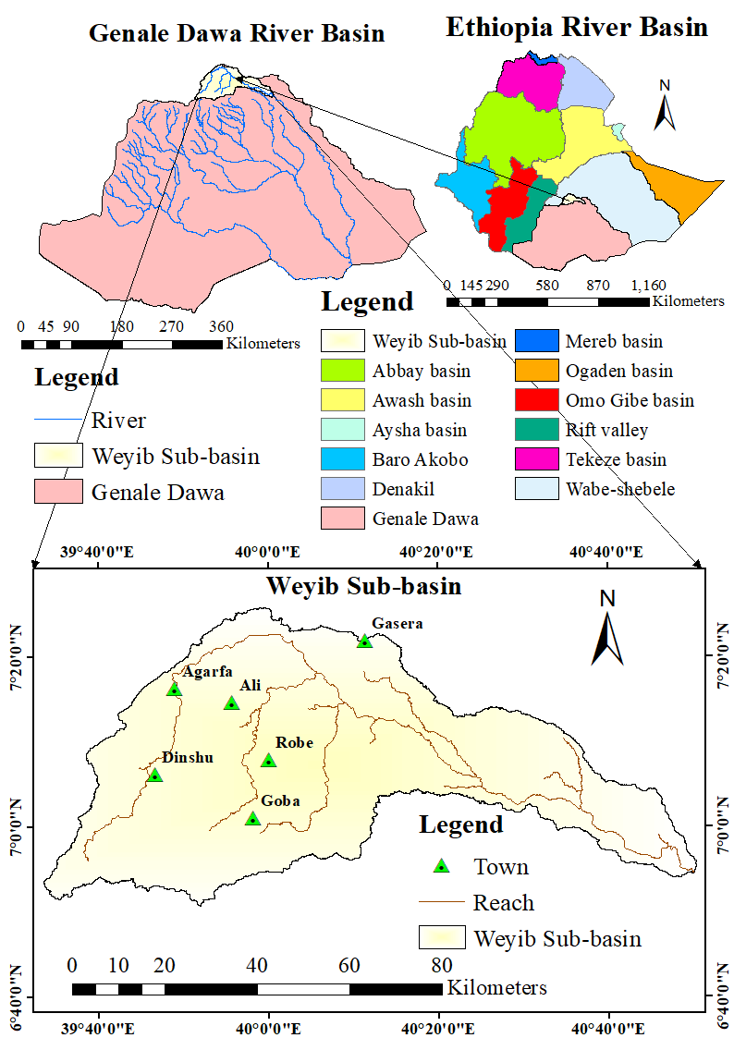
Figure 3.1: The location map of the study area
Weyib Sub-basin extends over a drainage area of 4,413.11 km² between 6⁰50'-7⁰25' Northern latitudes and from 39⁰33'-40⁰50' Eastern longitude (Figure 3.1). The Sub-basin is fortunately found between the second-highest peaks “Tullu Dimtu’’ of the ”Sanetti’’ plateau and the longest cave in Ethiopia ”Sof-Umar’’ caves.
Sof-Umar cave is an extraordinary, unique, and unsurpassed natural phenomenon of breathtaking beauty longest cave in Ethiopia. The subterranean Weyib River sinks at the ‘’Ayo Mako’’ entrance and reappears at the ‘’Holluqa’’ resurgence 1 kilometer away leading to the unique harmony between nature and cultural heritage site that requires an active geo-conservation (Bob, 2020; Courbon et al., 1989; Asrat, 2015). Tullu Dimtu is found in the Bale Mountains National Park, an important area for several threatened Ethiopian endemic species. Tullu Dimtu is the second highest peak in Ethiopia after Ras Dashen, though its topographic prominence is relatively low due to its location in the Sanetti Plateau (Bayih and Tola, 2017; Richman and Admassu, 2013).

Topography
The uppermost part of the Weyib River basin is characterized by the mountainous land of Bale mountains rugged slope up to 76% maximum slope. Batu-Sanate chain forms the thickest volcanic sequence in the Southeastern highlands. Tulu-Dimtu (Batu) ridge, which rises from the Sanate plateau, is the highest peak of the area (reach 4377-meter altitude m.a.s.l.) (Friis et al., 2010; Gobena et al., 1997). Sanate plateau is a flat-topped area of highly dissected edge, characterized by very sharp peaks and broken rocky surfaces underlain by relatively recent lava flows (Kifle and Hailemriam, 2010). This flat-topped highland area marks a nearly East-West oriented watershed characterized by swampy areas and many small shallow lakes (Gobena et al., 1997). The accumulated shallow lakes in volcanic flow depressions recharge the downside springs (Kiflu et al., 2009).
The central part of the sub-basin is characterized by low relief tabular plateau of flat to gentle slope separated by deep River incisions (Kebede, 2013). The relatively extensive flat terrain of Robe-Ginnir are generally called Sheneka plain (Kiflu et al., 2009). The downstream lowland of the study area is characterized by a slightly undulating narrowed gorge and plain. The famous Sof-Umar cave is parts of this unique topography. Weyib River flow within the cave and its entrance and exit into and out of the cave are about 300 meters apart (Yismaw et al., 2015).
The basin falls in elevation between 4346-meter m.a.s.l at the Southwest (around the Bale Mountains) and decreases to 1199-meter m.a.s.l toward Northeastwards at Sof-Umar outlet. Large area (of 2753 km2) fall in the range of altitude between 1000 and 3000-meter m.a.s.l, while 1006 km2 and 654 km2 of the areas are less than 1000-meter m.a.s.l and greater than 3000-meter m.a.s.l respectively.
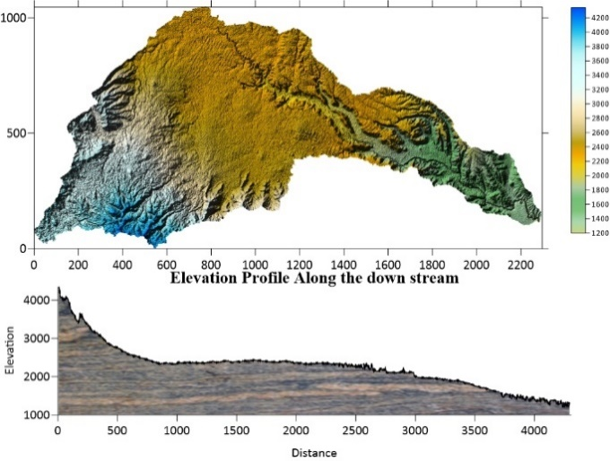
Figure 3.2: The shaded DEM and the cross-section along the downstream

Climate
Climatic conditions in Ethiopia and most equatorial regions are strongly influenced by their altitude. The climate progressively changes Southeastward from tropical to semi-arid and arid in Southern Ethiopia (Gobena et al., 1997). Due to the wide range of altitudinal extent, the seasonal variation of Weyib Sub-basin range from drought in ‘Bega’ to heavy rainfall in ‘Keremt’ (Mulugeta and Tafa, 2010). The climatic condition of an area is identified based on the annual and monthly mean temperature and rainfall, seasonal changes of rainfall and type of native vegetation associated with them, and the altitude of area of interest (Kifle and Hailemriam, 2010).
Due to the great variation in altitude and the great bulk of the mountain massif itself, the climatic condition of Weyib Sub-basin shows a considerable variation (Gobena et al., 1997). Thus, the area comprehends four climatic regions of Alpine (Wurch), Temperate (Dega), Sub-tropical (Weynadega) and Tropical (Kola). Area of elevation above 3300m a.m.s.l. and a temperature less than 10°c are classified under Alpine climate region (Kiflu et al., 2009). This includes parts of Bale Mountain National Park, Dinsho-Gassy plain and Sanate plain highlands. The temperate climatic condition includes the area within the elevation range of 2300-3300m a.m.s.l. and temperature varies from 10 to 15˚c. This includes most of the plateau area up to the mid-slope mountain peaks.
The steep slope of Bale mountain high land along the Goba-Meliyou area and Sheneka Plain are classified under zone of temperate climatic conditions. The area within the elevation range of 1500-200 meter and temperature of 15 to 20 °c is classified under Sub-tropical climate region. The tropical zone occurs between altitudes 500-1500 m and temperature of about 30°c.This includes the Eastern lowlands of study area with hot to very hot temperatures. Tropical and sub-tropical climatic regions are not extensive. Alpine and temperate are the principal climatic regions to represent the study area.

Rainfall and Temperature
The Rainfall of study area is mainly caused by orographic and direction of moisture-bearing seasonal air currents. These are the main factors accounting for the seasonal distribution of rainfall in the area. Though the duration, amount and spatial distribution of the rainfall varies in the plateaus and low lands, a bimodal type of rainfall regime is generally observed (Mulugeta and Tafa, 2010).
(a)
(b)
Figure 3.3: Bar charts of average monthly rainfall (a) and temperature (b)
The bimodal pattern of rainfall divides the year into two main seasons: a main rainy season from July to October and a minor rainy season from March to May (Kassahun and Mohamed, 2018). The dry season spans from November to February. The annual mean rainfall in the lowlands and highlands varies between 546 – 1352 mm. The annual mean areal rainfall of the study area is 978mm/yr. (computed by Thiessen polygon method, Figure: 3.4). The mean annual maximum and minimum temperature of the study area is 23.25°C and 5.92°C, respectively (Figure: 3.3).
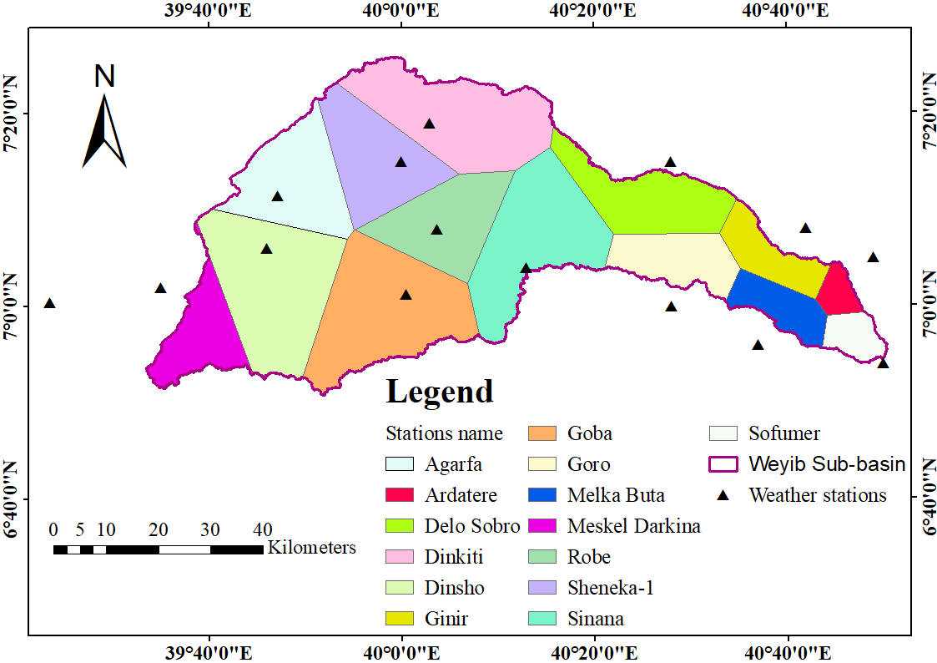
Figure 3.4: Rainfall stations and Thiessen polygon of the study area

Land Use and Land Cover (LU/LC)
The major LU/LC class of the study area is agricultural, bare land, bush land, forest, grazing land and residence/settlement. Agriculture and settlements are mostly found in the middle and downstream portion of the basin. Forest, bush land and grass lands are found towards an upper and lower edge of the sub-basin, while bare land is found distributed throughout the basin (Aredo, 2018; Woldeyohannes, 2016).

Drainage
Weyib River is the biggest western segment tributary of Genale River. The River originates from high elevated Northern sides of Bale Mountain National Park extreme points, named as ‘Sanate’ (app. 4000 m.a.s.l). At the beginning, Weyib River flows N-Eastwards gathering the whole streams of Bale high lands, till Dembel town. Then the River flows South-Easterly to join Genale River from its western bank. Finally, it joins with Genale and Dawa Rivers near Ethiopia-Somalia border to strengthen its journey to Somali lowlands (Nasir et al., 2019).
The Genale-Weyib-Dawa River system with Welmel, Web and other Rivers at the Ethiopian border; meet and form the large River Juba that flows through the Southeastern lowlands into the Southern part of Somalia and meets the Indian Ocean near the town of Kisimaayo on the coast (Friis et al., 2010). The headwaters of major Rivers originate partly or wholly from Bale mountain massif plateau. This flat-topped highland area marks a nearly E-W oriented watershed characterized by swampy areas and many small shallow lakes (Gobena et al., 1997).
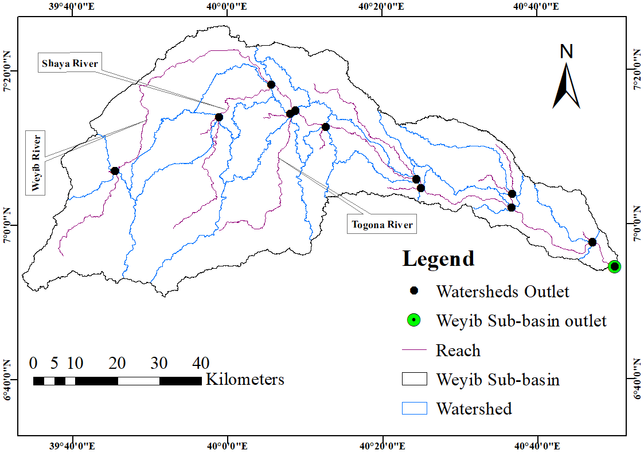
Figure 3.5: Reach, monitoring point and sub-basin outlet point of the study area
Most tributaries of Weyib River are gained from groundwater (Kiflu et al., 2009). Almost all the stream in the Weyib River basin and its tributaries follows dendritic stream patterns (Drummond and Erkeling, 2014; Mulugeta and Tafa, 2010). Shaya, Togona, Asendabo and Web Rivers are perennial tributaries of Weyib River. Other tributaries include; Albabo, Dalcha, Dimbeba, Gareno, Gesse, Kebesha, Kaficho, Keyrensa, Lolla, Micha, Shaya-Gugesa, Teynta, Toroshoma, Wolla, Wasama, and Web (Desta, 2007).

Lithology
The formation of the main Ethiopian rift valley system during Miocene caused development of Southeastern and Northwestern Ethiopian plateau (Kiflu et al., 2009). Genale-Dawa basins are underlain by Precambrian crystalline basement successions covered partly by late-Paleozoic continental clastic sediments, Mesozoic marine sediments and Cenozoic volcanic sequence and in places by veneer superficial sediment deposits (Kiflu et al., 2009). In the Northern and Northwestern parts of the headwater areas of Genale-Dawa and Wabe Shebelle basins, tertiary and quaternary volcanic lava flows rest directly on the peneplain Precambrian basement rocks where the Mesozoic sedimentary succession are missing in some places.
The Precambrian basement successions are croup out in the Southwestern and central part of Genale-Dawa basin. The Geology of Weyib Sub-basin, in Genale-Dawa River basin, is readily falls into two major categories. These are: a) tertiary volcanic successions to quaternary volcanic and sediments. b) Jurassic to Cretaceous sedimentary successions. The tertiary and quaternary volcanic comprise Ginnir basalt, Nazareth groups, Alkali trachyte and basalt flow, Alkali trachyte flow and Arsi-Bale basalts from young to old strati-graphical orientation (Kiflu et al., 2009; Mulugeta and Tafa, 2010).
The volcanic are thought to be Oligocene to Holocene in age and are uncomfortably overlain by the sedimentary units. The sedimentary units in the Eastern part of the study area are Korahe formation (sandstone) and Gabredarre formation (limestone) successively underlain from young to old. The sedimentary formations overlay the basement unit that is not outcropped in the area. The formations are considered to be Jurassic to Cretaceous age.

Stratigraphy
The oldest rock encountered in the study area is the Upper limestone. This limestone is sharply overlain by Upper sandstone (Tefera et al., 1996). The lower part of volcanic succession (the lower lava flow) is uncomfortably underlain by the upper sandstone. It is mostly shown in the Ginnir, Goro and Gasera Woredas following the drainage line of Weyib River. The dense and massive basalts (the middle lava flows) which form plateau scarp is exposed at the upstream of Togona River following the lower lava flow upward. The plateau basalt succession forming the plateau area is unconformable to the middle basalt and themselves. The last event for the fissural lava flow of the plateau basalt is the eruption of the upper pyroclast, mostly covering the plateau.
Many plateau surfaces of South-West Agarfa to North-West of Dinsho Woreda are covered by this type of pyroclasts. The localized areas of most Bale highland mountains are covered by central-type basalts, forming the highland basalts. The highland basalts were ended by the eruption of trachyte which occupies Goba, Homa and Dinsho town. After the formation of the rift, the Main Ethiopian Rift, volcanism continued, on the plateau and within the rift. Separate mountains occupied by the highland basalts in Bale zone mid-slope were overlain by younger Pliocene basalts. These basalts were overlain by central type trachyte eruption, forming the summit of Bale Mountain National Parks. On the Bale Mountains, multiple trachyte dike swarms cut the basalts there. These probably gave rise to the trachyte flows on top of the mountains.
Still later, during Quaternary, on restricted plateau area and within the rift volcanism was continuous. This formed the Quaternary basalts of Gemora area, Quaternary basalts of the rift and basalts occur within the collapsed caldera on Bale Mountains. At later event, scoria cones outpoured through separate vents piercing the plateau volcanism. They cut across the Quaternary basalt flows. Volcanism of the area probably ended with such scoria cones which can be equated to those scoria cones in the rift. Later, event was the formation of Quaternary alluvial deposit. This occurs within the rift and on the plateau East of Bale Robe. Erosion and deposition are still a continuous process today.

Data Collection and Analyses
To meet the objective of studies various data were collected from various sources (Appendix table 3.). Published and unpublished literature of different articles have been reviewed and used as input to obtain more information about findings, methods, gaps and recommendations in/of previous studies. Software and computer programs employed for analysis of raw data and preparation of thematic layers were reviewed in Section 2.4 and tabulated in Appendix table 2.

Characterization of factors influencing groundwater potential zones

Meteorological Data
Historic time series of meteorological data was collected from the NMSA, SOMSC and MoWIE. Before using rainfall records of the weather stations raw data was checked for data set reliability through data quality check and consistency. Since the continuity of record may be broken, missing of data and the homogeneity of meteorological parameters time series has been analyzed (Subramanya, 2008).
- Estimation of Missed Data
For gages that require periodic observation, the failure of the observer to make the necessary visit, vandalism of recording gages and instrument failure can result in missing data. Any such causes of instrument failure reduce the length, reliability and information content of the precipitation record. The missing data can be estimated by using the data of neighboring stations (Subramanya, 2008). A number of methods have been proposed for estimation of rainfall missing data. The normal-ratio method is preferable when the average annual catches differ by more than 10%.
Hence, the normal ratio method was applied to fill the rainfall missing data of study area. The general formula for computing a missing rainfall ‘P’ and weight station i ‘w_{i}’ is given by:
$P=\sum_{i=1}^{n}{w_{i}P_{i}}$………………………………………………………………..Equation (3.1)
$w_{i = \frac{A_{x}}{n_{A_{i}}}}$………………………………………….…………………………….Equation (3.2)
Where $w_{i}$ is the weight for the rainfall depth $P_{i}$ at gage i., $A_{i}$ is the average annual catch at gage i, A, is the average annual catch at station X, and n is the number of stations.
- Gage Consistency
The inconsistency of records may result from changes in observation procedures, exposure of the gage, changes in land use that make it impractical to maintain the gage at the old location and where vandalism frequently occurs. Adjusting for gage consistency involves the estimation of an effect over a period of time. Double mass-curve analysis was used to check for an inconsistency in a gaged record.

Figure 3.6: Double mass curve

Spatial Data
The spatial data of soil type was collected from the MoWIE. The SRTM DEM and Landsat 8 OLI/TIRS multi-spectral images of 2019 were downloaded from USGS earth explorer website. The geological map sheet of Asella, Dodola, Ginnir, and Megallo was collected from the geological survey of Ethiopia.
- Preparation of Satellite Imagery
The satellite image of 2019 was used for LU/LC classification and lineament extraction. To prepare the thematic map of LU/LC and lineament density the Landsat imageries are mosaicked and extracted for the study area. The pre-processing procedure includes importing an image, image correction, layer stacking, image mosaic and geo-referencing to countries coordinate system i.e. WGS 1984 datum, Northern hemisphere, UTM zone 37.
In order to identify surface features in the study area the images are composed in different ways. True color composite usually known by RGB 321 combination were band 3 reflects red color, band 2 reflects green and band 1 reflects blue color. Another composite called "false color composite" which uses an RGB combination of 432. In this band combination band 4 represents the NIR infrared, band 3 belongs to red and band 2 to green.
This combination gives better visualization in identifying vegetation which looks red in 432 combinations.
- Digital Elevation Model (DEM) Processing
DEM is a digital topographic map, which contains the elevation of all points located in the region. It was preprocessed before using for further application. Imperfections related to cell that does not have an associated drainage values are filled with the elevation of lowest neighbor. A 30*30-m resolution DEM were processed for watershed delineation and drainage line extraction. The geomorphological landforms, slope and elevation map of study area were prepared from DEM by using SAGA GIS and ArcGIS 10.5 software, respectively.

Preparation of Thematic Maps
Parameters influencing groundwater potential and their relative importance were reviewed from previous literature and hydrological experts. In process of identification and evaluation of criteria, nine (9) factors affecting groundwater potential was considered. Satellite imagery, DEM, soil, geology, and other existing tabular and map data was used for preparation of thematic layers. In determining the level of desirability of the attributes different measurements and ranges were reviewed from literatures and used.
- Geomorphological Landforms Thematic Map
The geomorphology thematic map of study area was prepared by topographic position index (TPI) methods of landform classification (Gebru et al., 2020). SAGA GIS software was employed as it provides simple process for sophisticated hydrological and terrain modelling (Fisher et al., 2017). The preprocessed SRTM DEM of 30*30m resolution was used for landform classification (Drǎguţ and Eisank, 2012). TPI compares the elevation of each cell in a DEM to the mean elevation of a specified neighborhood around that cell. Positive TPI values represent locations that are higher than the average of their surroundings. Negative TPI values represent locations that are lower than their surroundings.
The TPI values near zero indicates either flat areas or areas of constant slope (Jones et al., 2000; Mokarram and Sathyamoorthy, 2016). The relative weight classes and consistency ratio (CR) were computed depending on the contributions of landform (using AHP).
Considering the relative weight of classes the scale value was identified and the landform thematic map of study area was reclassified into five classes.
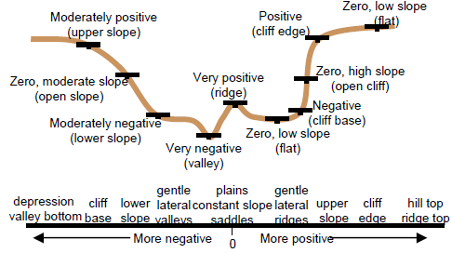
Figure 3.7: TPI and slope position; Source: (Jones et al., 2000)
- Lineament Density Map
The lineament of study area was extracted from satellite image by using Geomatics technique. The PCI Geomatics software simplifies extraction of lineaments through algorithm librarian tools by using lineament extraction under line tools. The preprocessed satellite image of an area has been analyzed to detect the lineaments (Figure 4.3). Rockwork 16 software was employed for plotting the rose diagram showing the orientations of geological structures. The extracted lineament was processed on ArcGIS 10.5 to prepare the lineament density map. The relative weight and CR value of lineament density was computed through AHP (Table 4.2). The relative weight of classes was used for determining the clustered lineament density scale value which used for further reclassification.
- Geology Thematic Map
The geologic thematic map of study area was prepared from the geological map sheets collected from GSE and MoWIE. The geological map sheets are compiled at different time by diving the study area into four regions, at scale of 1:250,000. In order to prepare the geological map of Weyib Sub-basin the geological map sheet of Ginnir, Asella, Megallo and Dodola was geo-referenced, digitized and clipped by using the shapefile of study area.
The relative weight of lithological units, scale value and CR value of the matrix computed by AHP was tabulated in Table 4.3 (Banti, 2017; Kidanu, 2018).
- Rainfall Thematic Map
Meteorological data collected from NMSA, SOMSC and MoWIE for Agarfa, Bale Robe, Ginnir, Dinsho, Sinana, Sheneka, Arda Tere, Meskel Darkina, Goro, Goba, Dinkiti, Melka Buta, Delo Sebro and Sof-umar stations. Except Arda Tere, Ginnir, Meskel Darkina, Goro, Melka Buta, and Delo Sebro weather stations which found in the vicinity of sub-basin boundary, all the other stations are found within the Weyib Sub-basin (Figure 3.3). The raw data of rainfall was checked for missing of data and consistency in process of data analyses under Section 3.2.1.1. For non-uniformly dispersed weather stations the station-average method may not provide an areal average rainfall that reflects the actual spatial distribution of rainfall. Thiessen-polygon method was used to extend the actual point storm events at weather stations to areal estimates over the entire sub-basin. It provide some weightage to various stations on a rational basis.
Thiessen polygon method is a good alternatives in cases where there are large differences in the catches and the rain gages are not uniformly distributed throughout the watershed (Barbalho et al., 2014; Subramanya, 2008). It is frequently used, easier and more reproducible method (Ayenew et al., 2013; Doyo, 2020; Munyaneza et al., 2014). Thiessen polygon method assigns weights to the rain gages according to the proportions of the total watershed area that are geographically closest to the rain gages (Barbalho et al., 2014; Subramanya, 2008).
If P₁ P₂, …., P₆ are the rainfall magnitudes recorded by the stations 1, 2, …, 6 respectively, and A₁, A₂, …, A₆ are the respective areas of the Thiessen polygons, then the average rainfall over the catchment $\overline{P}$ and for M stations is given by Equation (3.3).
$\overline{P}=\frac{P_{1}{*A}_{1}+P_{2}{*A}_{2}+…+P_{6}{*A}_{6}}{{(A}_{1}+A_{2}+…+A_{6})}….$…………………….…………………………… Equation (3.3)
$\overline{P}=\frac{\sum_{i=1}^{M}{P_{i}A_{i}}}{A}=\sum_{i=1}^{M}{P_{i}\frac{A_{i}}{A}}….$………………………………………………… Equation (3.4)
The ratio $\frac{A_{i}}{A}$ is called the weightage factor for each station.
ArcGIS was employed to prepare the Thiessen polygon of study area. In process, the weather stations were geo-referenced with respective location and average annual rainfall. The clustered polygon shapefile was converted to raster format for reclassification and overlay analyses. Depending on the contribution of rainfall classes the classified rainfall distribution classes were ranked. The highest rank was assigned for high rainfall classes while the lowest rank for low rainfall class. The relative weight, scale value and CR value of matrix was determined by using AHP (Table 4.4). The final rainfall distribution thematic layer was prepared by reclassifying the rainfall distribution map using scale value of classes.
- Drainage Density Thematic Map
The drainage network of study area was derived from DEM by using Arc SWAT ArcGIS extension models. The process starts from delineation of the watershed and sub-watershed boundary. Watersheds are delineated by the area upstream from specified outlet point, in GIS environment. A flow direction grid assigns value to each cell to indicate the ultimate destination of the water flowing across the surface of the land. Based on the landscape topography the flow accumulation tool calculates the flow into each cell by identifying the upstream cells that flows into each downslope cell.
Automated watershed delineation embedded in Arc SWAT interface simplify the watershed delineation and drainage line. The default threshold-based stream definition was used to define the minimum size of the sub-basins (Serur and Sarma, 2016a). As the major parts of Weyib Sub-basin is flat plateau, minimum threshold area was used to extract the finer drainage lines (minor streams). This will avail in establishing the spatial variability of respective factors contribution for groundwater potential zone (i.e. for reclassification). Weyib Sub-basin was delineated at Sof-umar outlet. All the stream flowing to Weyib River was derived and shown in Figure 4.11. The extracted drainage network was processed on ArcGIS 10.5 to prepare drainage density map (Figure 4.12). Drainage density is the total length of streams of all orders (km) per drainage area (km²) (Magesh et al., 2012; Sukristiyanti et al., 2018).
The drainage density is be given by:
$DD=\sum_{i=1}^{n}{ ( \frac{Li}{A}}) ….$…………………………………………………...……Equation (3.5)
Where DD is drainage density, ∑Li is the total length of the stream in the watershed and A is the total area of the watershed.
Even though there are no fixed value ranges for drainage density, based on some definitions about drainage classes it can be highlighted that there are two main classes of drainage density; low/coarse and high/fine class. Low drainage densities and stream frequency indicate excessive permeability of the underground formation, dense vegetation and low relief (Kudnar and Rajasekhar, 2019). Surface runoff is not rapidly removed from the watershed, showing a slow hydrologic response. The high drainage density of the watershed reflects high runoff and low infiltration, showing a quick hydrological response to rainfall events. Area of high drainage density has an impermeable sub-soil material and sparse vegetation (Sukristiyanti et al., 2018).
Commonly very high drainage density was recorded at the volcanic mountain’s and near the mountain’s foot, while very low drainage density was recorded at the central rift floor (Drummond and Erkeling, 2014). Depending on the contribution of drainage classes for groundwater potential, the rank and relative weight of classes are computed through AHP process. Finally, the drainage density map was reclassified on basis of the scale value.
- Slope Thematic Map
The thematic map of slope was extracted from SRTM DEM of 30*30-meter spatial resolution by using ArcGIS 10.5. The slope tool in Arc GIS calculates the maximum rate of change in elevation over the distance between the cell and its eight neighbors (Tegegn, 2015). The lower the slope value is the flatter the terrain while the higher the slope value is the steeper the terrain. AHP is used for computing the relative weight of slope classes and percentage of inconsistency of the matrix (Table 4.6). The computed value of relative weight was used for demining the scale value and reclassification of slope thematic map.
- Elevation Thematic Map
The thematic map of elevation was extracted from DEM by using ArcGIS 10.5. The generated map of elevation was ranked as per contribution for groundwater potential and reclassified into five classes to prepare the final thematic layer of elevation.
The highest rank was given for low elevation zone and vice versa (Berhanu and Hatiye, 2020; Doyo, 2020; Godebo, 2018). The relative weight and CR value of elevation map was computed through AHP. Using the relative weight of classes, the elevation map was ranked and the thematic layer was reclassified by using scale value (Table 4.7).

- Land Use and Land Cover (LU/LC) Thematic Map
To prepare the LU/LC map of study area the pre-processed Landsat 8 OLI/TIRS multi-spectral images of 2019 was used. Supervised images classification technique was employed by using the actual points and linking ERDAS Imagine 2015 with Google earth. The accuracy of classified LU/LC map was assessed by calculating the overall accuracy, producer’s accuracy, user’s accuracy and Kappa coefficient (K) (Desta, 2007; Doyo, 2020; Emiru et al., 2018; Rahman et al., 2012). One hundred forty nine control points were used for assessing the accuracy of classified LU/LC. Since the sub basin is large and encompassing a limited accessibility area, it is not possible to record a densely populated huge amount of control points actual location and LU/LC by using GPS (with limited time and resources). Hence only twenty points of mixed LU/LC classes (which need detail identification) was recorded intently by using GPS and the left one hundred twenty nine point was taken randomly by using Arc GIS 10.5 Arc tool box.
The overall classification accuracy is the percentage of correctly classified samples of an error matrix. It is computed by dividing the total number of correctly classified sample by the total number of sample including error sample (Abdelkareem et al., 2018). The producer’s accuracy depicts how well a certain area could be classified. It is obtained by dividing the number of correctly classified pixels in the category by the total number of pixels assigned to the same class (Doyo, 2020). User’s Accuracy is the ratio between the total number of pixels correctly belonging to a class and the total number of pixels assigned to the same class by the classification procedure. This quantity explains the probability that a pixel of the classified image truly corresponds to the class to which it has been assigned.
The kappa statistics is an estimate of measure of overall agreement between image data and the reference data. It compensates for chance of agreement in the classification and provides a measure of how much better the classification performed in comparison to the probability of random assigning of pixels to their correct categories.
$K=\left[\frac{\left(TS*TCS\right)-(\sum{CT*RT)}}{\left({TS}^{2}\right)-(\sum{CT*RT)}}\right]*100\%$.........................................................................Equation 3.6
Where TS, CT, RT and TCS represents total number of sample, column total, raw total, and total corrected sample.
A Kappa coefficient greater than 0.80 (80%) represents strong agreement. The value between 0.40 and 0.80 (40 to 80%) represents moderate agreement, while a value below 0.40 (40%) represents poor agreement (Desta, 2007). Depending on the contribution of LU/LC classes, the relative weight and CR value of LU/LC was computed (Table 4.8). The final LU/LC map was reclassified by using the scale value of LU/LC classes (Figure 4.19).
- Soil Texture Thematic Map
The soil map of Weyib Sub-basin was clipped from the soil map of Genale-Dawa River basin. The soils are classified on the basis of the revised legend of FAO/UNESCO soil map of the world (FAO, 1988). The soil shape file was converted to raster format on ArcGIS 10.5 software’s platform. Since the rate of infiltration, permeability and recharge depends on the soil textures, the identified types of soils are reclassified on basis of soil texture (IUSS Working Group WRB, 2015). Sandy soil particles are visible and within a range of 0.05–2 mm diameter. Silt soil particle are merely visible having a diameter ranges between 0.002–0.05 mm. Clay soil particle diameter is less than 0.002 mm and not visible (Nachtergaele et al., 2009).
Loams are soils with mixed particles of sand, silt and clay. The rate of infiltration of sandy soil is higher than in a silty soil. In a clayey soil, it may be initially high (for heavy black clay with cracking), but becomes low when the soil is moist to wet. The percentage of sand, silt and clay contents of soil classes are determined from Microsoft access database of world FAO 2003 digital soil map of the world (FAO, 2003). Using USDA soil texture classification method, the soil texture class corresponds to a particular range of separate fractions are determined (Appendix table 5 and Appendix figure 2). Considering the soil textures, the relative weight of each classes, scale value and CR value was determined by using AHP (Nachtergaele et al., 2009). Finally, the identified soil texture was reclassified on the basis of groundwater potential contribution.

Delineation of groundwater potential zones
A GIS and RS technique was applied to delineate the GWPZ of Weyib Sub-basin. The application of multiple criteria decision analysis, Analytic hierarchy process, was used to develop the GWPZ’s by integrating nine groundwater influencing factors. The thematic layer of geomorphology, lineament density, geology, slope, soil texture, rainfall distribution, drainage density, LU/LC and elevation was prepared.
The methods include identification/evaluation of criteria, data collection, preprocessing, input dataset and reclassification of input layers. Pair wise comparison of criteria was conducted to determine the weight of each thematic layer. After assigning weight and ranking each thematic layer the thematic maps was integrated by weighted overlay analysis tools of ArcGIS, to develop GWPZ. Finally, the delineated GWPZ’s was verified by comparing the mapped GWPZ with the actual boreholes, hand dug wells and springs yield.

Analytical Hierarchy Process (AHP)
The relative weight of classes and the magnitude factors influencing groundwater potential was computed by using the AHP. The three successive steps in AHP include; pair-wise comparison of thematic importance, matrix normalization and ranking and consistency check. To perform the pairwise comparison and identify the relative importance of factors, previous literatures were reviewed and experienced hydrological experts are decided. The comparison was made on a scale of numbers 1–9 which shows how many times a layer is important than the other (Saaty and Kearns, 1985). Appendix table 1 represents the scaling used in AHP, while the matrix is tabulated in Table 4.11.
The main diagonal matrix contains 1, as each factor is as important as itself. The upper triangular matrix above the main diagonal matrix was filled by comparison of criteria in the row to the column, while the lower triangular matrix was filled using reciprocal values of the upper triangular matrix based on Saaty’s rating scale. The matrix was normalized by dividing each number in the column by the sum of the column.
${\overline{a}}_{jk}=\frac{a_{jk}}{\sum_{i=1}^{m}{a_{jk}}}$……………………….………………………………………...Equation (3.7)
Where $\overline{a}$ is value in the matrix, j is column number, k is row number, i is the theme or class, m is the total number of themes or classes. To produce thematic weights or classes relative weight w_{j} from the normalized values, Equation (3.8) was used. The normalized weights were then ranked in descending order.
$w_{j}=\frac{{\overline{a}}_{jk}}{n}$…………………….………………………………………….……...Equation (3.8)
The final stage is to calculate a consistency ratio (CR) to measure how consistent the judgments have been relative to large samples of purely random judgments. A consistency ratio of 0 indicates perfect consistency of pair-wise comparison.
If the CR is much in excess of 0.1 the pair-wise comparison will be too inconsistent and the exercise must be repeated. The consistency is desirable to be less than 0.10 (Baby, 2013; Saaty and Kearns, 1985; Shamuyarira, 2017). Consistency check was done following the procedure by Saaty (1980).
$Consistency ratio \left(CR\right)=\frac{CI}{RI}$………………………………………………....Equation (3.9)
$Consistency index \left(CI\right)=\frac{λ_{max}-n}{n-1}$ ………………………………………….Equation (3.10)
$/λ_{max}I-H/ =0$…………………………………….………..…………….Equation (3.11)
$H=\sum{Ratio}=\frac{\sum{{\left(WSV\right)}_{i}}}{{CW}_{i}}$……………………………….…………………….Equation (3.12)
$WSV=\sum{{{(\overline{a}}_{jk})}_{i}}$…………………………………….………….…………….Equation (3.13)
Where RI is the random index (Table 3.1), λ_{max} is maximum eigenvalue of the matrix, n-is the number of compared elements, WSV is weight sum value, CW criteria weight.
Table 3.1: Random consistency index (RI) for n ≤ 10 n
Matrix size | 1 | 2 | 3 | 4 | 5 | 6 | 7 | 8 | 9 | 10
RI | 0 | 0 | 0.58 | 0.9 | 1.12 | 1.24 | 1.32 | 1.41 | 1.45 | 1.49
Source: (Saaty, 1977)
IDRISI Selva software performs the process of prioritizing factors according to their importance and weight assignment (Appendix figure 3). Using the reclassified raster layers, the module WEIGHT utilizes a pairwise comparison that allows to develop a set of factor weights that will sum to 1.0. Judgment about the relative importance of pairwise combinations of the factors involves nine point rating scale (Appendix table 1). Factors are compared twice at a time in terms of their importance relative to the stated objective. After all possible combinations of comparisons, the module calculates a set of weights and a consistency ratio (CR). The module allows repeated adjustments of pairwise comparisons and reports new weights and CR for each iteration.

GIS Integration and Groundwater Potential Map
The GWPZ’s of Weyib Sub-basin was delineated by the integration of all reclassified thematic layers using weighted overlay analysis tools of ArcGIS 10.5.
The raster of common measurement scale value and varying weights overlaid by using Equation 3.14 (Andualem and Demeke, 2019). Since the summation of criteria weight of all thematic layers is adjusted to 100%, the maximum possible value of groundwater index is five and the minimum value is one. The maximum value of five indicates very high groundwater potential, while four, three, two and one indicates high, moderate, low and very low GWPZ respectively. The normalized weights of the themes multiplied by the normalized weights of the class are applied to evaluate the groundwater potential index.
The groundwater potential index is given by;
$GWPI=\sum_{w=1}^{m}{\sum_{j=1}^{n}{\left(W_{j}*X_{i}\right)}}$……………….…….…………………..…Equation (3.14)
Where, GWPI is the groundwater potential index, $W_{j}$ is the normalized weight of the $j^{th}$ thematic layer, $X_{i}$ is the normalized weight of the ${i }^{th}$feature of the thematic layer, m is the total number of thematic layers, and n is the total number of features of a given theme. The GWPI values was used to classify whether an area is very good, good, moderate, poor or very poor with respect to groundwater potential (Andualem and Demeke, 2019; Gebru et al., 2020; Lakshmi and Reddy, 2019).

Verification of the Results Using Water Point Information
The groundwater potential map is the prediction with the assumption that the weight for different groundwater indicating factors were assigned through judgment related to field condition. Therefore, to provide accurate prediction, the accuracy of identified GWPZ should be estimated based on the percentage of agreement and disagreement between expected potential and actual yield data (Adiat et al., 2012; Banti, 2017; Berhanu and Hatiye, 2020; Gebru et al., 2020; Tegegn, 2015). Hence, the identified GWPZ’s are verified by comparing the output map with the existing water point’s inventory data. The wells/springs/dug well point shape file was superimposed over the final GWPZ map (Figure 4.27). A multi-value extraction tool of ArcGIS spatial analyst tools was used to extract and record the GWPZ raster cell values on the attribute table of the water points feature classes. The process of weight assignment and layers overlay was repeatedly accomplished until the resulting GWPZ was reasonably agree with the actual yield of the field conditions.

Identification of the Groundwater Flow Direction

Water Points Inventory Data
Data of the existing boreholes, hand-dug wells and springs with their respective location, yield, static water level and drawdown were collected from MoWIE and Bale zone water resources development and energy. Unfortunately the collected data of water points are not well organized. So that the water points which have not yield/discharge was discarded from the verification. Even though, they were discarded from the process of verification, the water points having the data of static water level, elevation, and hydraulic head were used for identification groundwater flow direction.

Identification of Groundwater Flow Direction
The hydraulic heads, static water levels and surface elevation of existing inventory data was used to identify the groundwater flow direction. The groundwater level contour map and flow direction vector was generated from the groundwater level data using GIS and Surfer 17.1 software (Doyo, 2020; Messene, 2017). The hydraulic head of the boreholes was computed as the difference between the surface elevation above mean sea level (m.a.s.l) and the static water level or depth to water level (Amah and Agbebia, 2015). The groundwater table layer was interpolated for entire study area from the point’s hydraulic head. To determine the influence of topographic tilting on the groundwater flow direction and analyze groundwater flow with surface water flow, the contour maps of surface elevation and hydraulic head was produced by joining lines of equal elevation and hydraulic head values (Figure 4.28 and Figure 4. 30).
Validation
Data Processing for thematic map preparation
Pairwise comparison and determination of factors weight (AHP)
Calculate Consistency Ratio (CR)
GROUNDWATER POTENTIAL ZONE
Preprocessing
Layer Stacking
Correction
Image Enhancement
Geomorphology
Slope Map
Drainage Map
Drainage Density Map
LU/LC map
Lineament Map
Lineament Density
Map
Digitization, Extract, Editing, Filling data
Geology
Map
Soil
Map
Rainfall
Map
Thematic maps of the input layers
Reclassified geology map
Reclassified geomorphologic map
Reclassified Soil texture map
Reclassified drainage density map
Reclassified lineament density map
Reclassified
LU/LC map
Reclassified rainfall map
Reclassified soil
Map
Reclassified elevation map
Elevation Map
Well/Spring yield
CR<10%
NO
YES
Weight overlay analysis
MCDA__AHP
If verification is failed
Mapping groundwater flow direction
Landsat8 Image
Auxiliary data
Geology, Rainfall, GPS data, Soil
SRTM DEM
Data collection
Figure 3.8: Conceptual framework of the study

RESULTS AND DISCUSSION

Characterization of Factors Influencing Groundwater Potential

The Thematic Map of Geomorphology
The TPI based landform classification of geomorphology shows ten classes of landforms including; high ridges, mid-slope ridges, upland drainage, upper slopes, open slopes, plains, valleys, local ridges, mid-slope drainage, and streams (Figure 4.1).
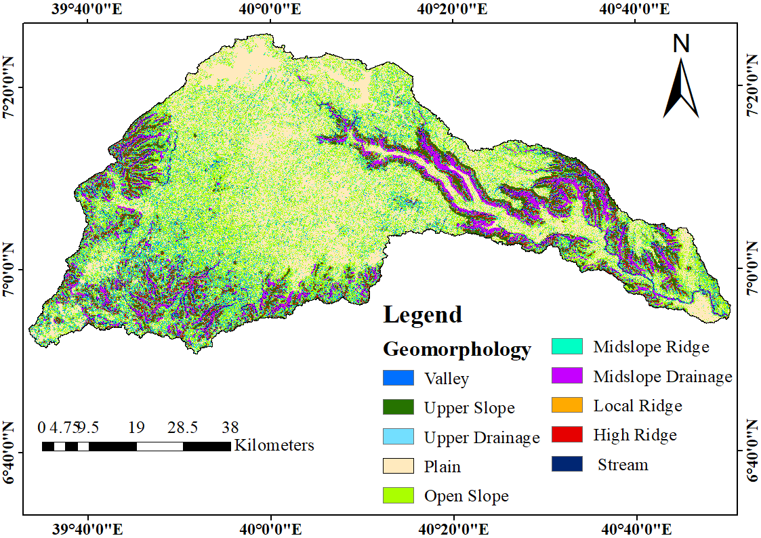
Figure 4.1: The classified landforms of study area
Depending on the contribution of landform classes, the identified geomorphologic landforms were reclassified into five classes. High ridges and mid-slope ridges are the areas with the least groundwater potential, while valleys and plains are types of landforms encouraging very high groundwater potential. The computed relative weight of classes, CR and scale values are presented in the Table: 4.1. The CR value of 0.018 is within the acceptable limit.
Table 4.1: The relative weight and consistency ratio of the reclassified landforms
Factor | Landforms* | Area (km²) | Area (%) | Contribution | Scale value | Relative weight (%) | CR
Land forms | High ridges/Mid-slope ridges | 532 | 12 | Very low | 1 | 4 | 0.018
Land forms | Upper Drainage/  Local ridge | 61 | 1.5 | Low | 2 | 6 | 0.018
Land forms | Stream/Mid-slope drainage | 413 | 9.5 | Moderate | 3 | 16 | 0.018
Land forms | Open slope/Upper slope | 1555 | 35 | High | 4 | 29 | 0.018
Land forms | Valley/Plain | 1852 | 42 | Very high | 5 | 45 | 0.018
* (Gebru et al., 2020; Jenness, 2006; Kiflu et al., 2009)
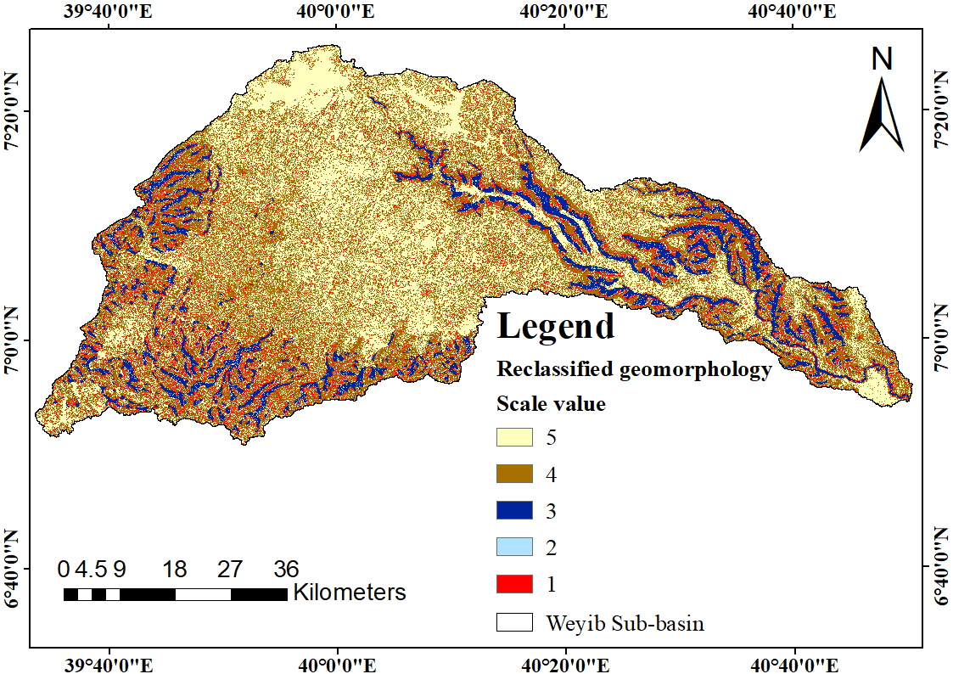
Figure 4.2: The reclassified landforms of study area

The Thematic Map of Lineament Density
In order to cluster the linear features in the study area the lineament density of the extracted lineament map was used (Figure 4.3). The lineament density of Weyib Sub-basin is varying from 0.02 to 3.8 km/km² (Figure 4.4). The relative weight of each class, CR and scale value were computed by AHP (Table: 4.2). Since, the computed consistency ratio 0.024 is less than 0.1 the pairwise comparison matrix of classes is reasonably consistent. Finally, the lineament density map was reclassified into five classes of varying groundwater contribution (Figure 4.5).
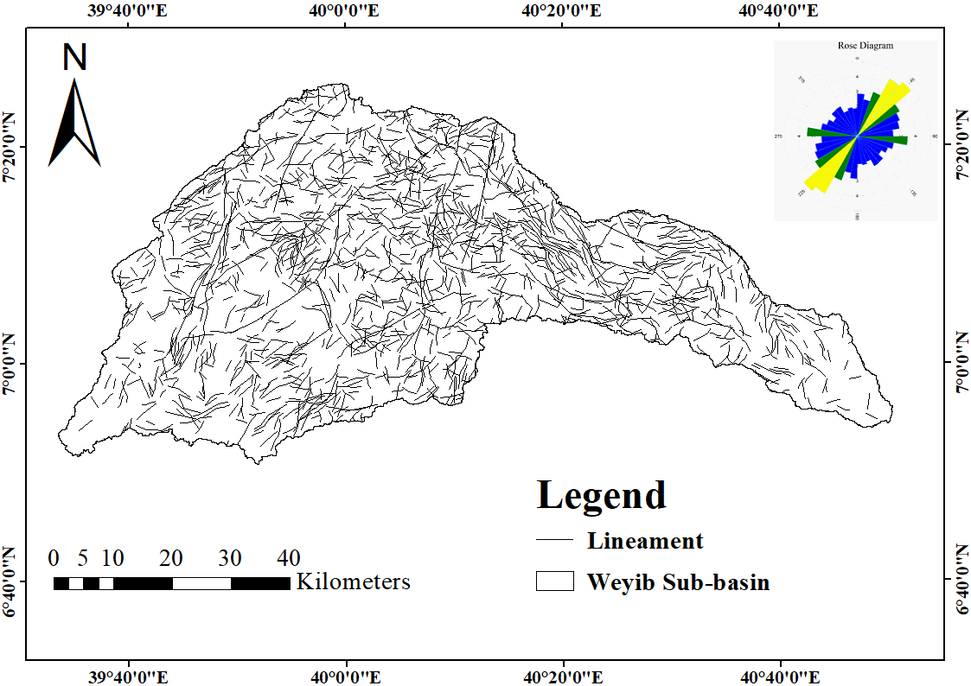
Figure 4.3: Lineament map of Weyib Sub-basin
Several wells drilled on the same aquifer unit (e.g. on Ginnir basalt plateaus and the surrounding area) shows varying yield. These indicate the yield of wells depend on the intensity of local lineaments (Mulugeta and Tafa, 2010). The directional analysis of rose diagram indicates NE–SW and NW–SE orientation trending lineaments. From hydrogeological point of view, the groundwater flow direction follows the orientation of lineament direction (Doyo, 2020; Takorabt et al., 2018). Therefore, NE–SW regions were expected to have high groundwater potential.
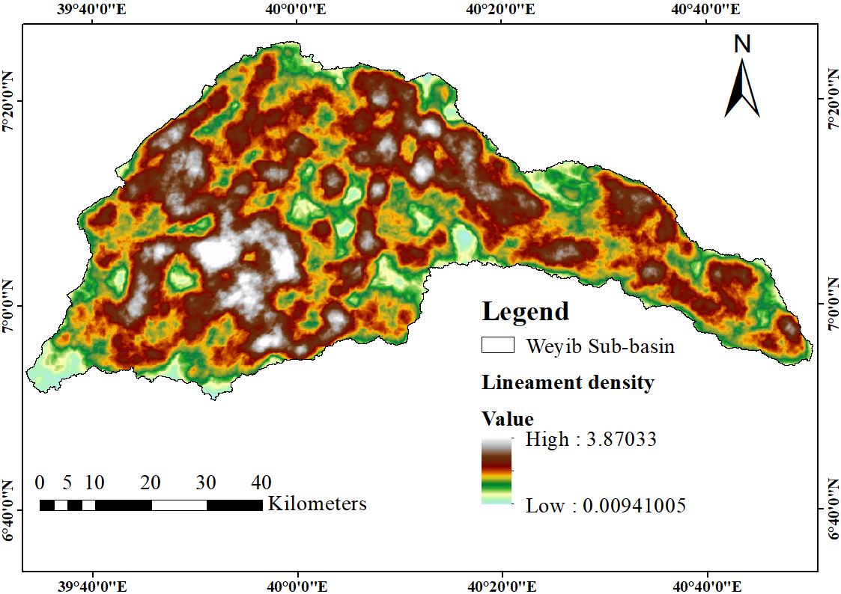
Figure 4.4: The lineament density map of Weyib Sub-basin
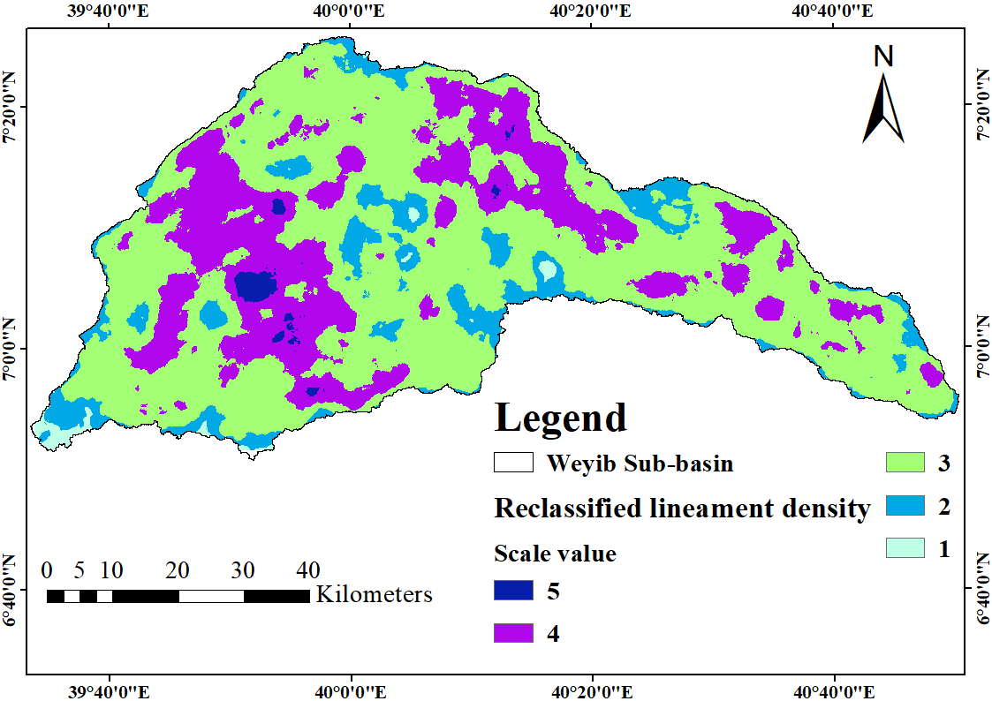
Figure 4.5: The reclassified lineament density map of study area
Table 4.2: Lineament density and relative weight as per suitability for GWPZ
Factor | S. No. | Value (km/km²) | Contribution* | Scale value | Relative weight | CR
Lineament | 1 | 3.8-2.79 | Very high | 5 | 43 | 0.024
Lineament | 2 | 2.79-1.79 | High | 4 | 28 | 0.024
Lineament | 3 | 1.79-0.79 | Moderate | 3 | 17 | 0.024
Lineament | 4 | 0.79-0.28 | Low | 2 | 8 | 0.024
Lineament | 5 | 0.28-0 | Very low | 1 | 4 | 0.024
* (Behzad et al., 2017; Lemecha, 2007; Waikar and Nilawar, 2014)
Similarly, the drainage line and major lineaments are almost following the same pattern. This suggests that the direction of aquifers mostly tends to be aligned with surface water bodies (Figure 4.6) (Banti, 2017). The major tributaries of Weyib River (e.g. Shaya and Togona River) follow the NW-SE trend. In the mapped area all trending elements never cross the NE-SE trending line of Weyib River. Thus, the NW trending lineaments control the flow direction of Rivers in the area.
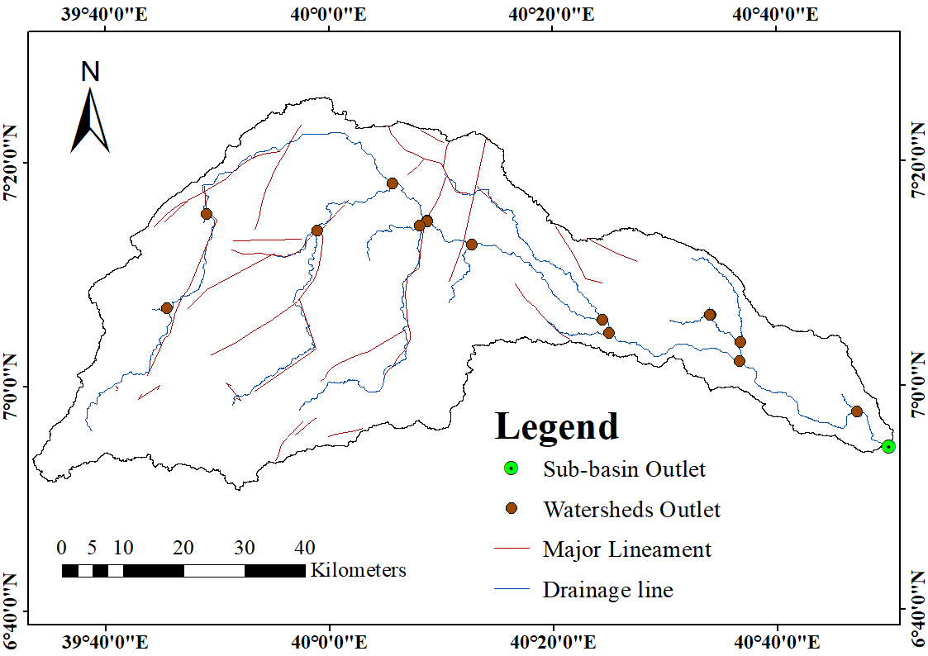
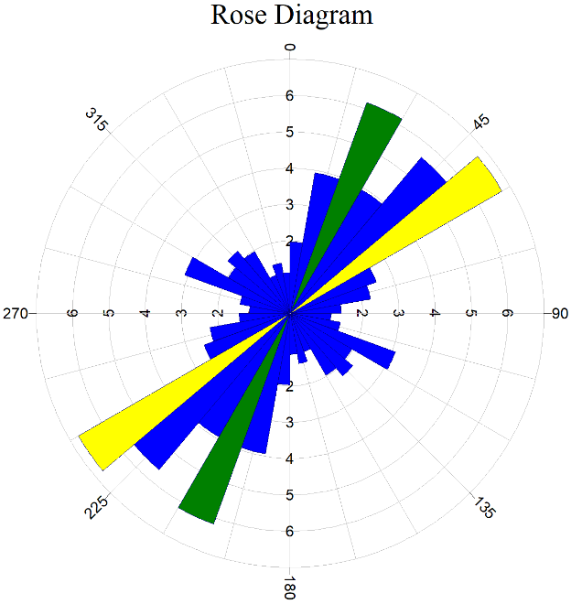
Figure 4.6: Major lineament superimposed over the mainstream

The Thematic Map of Geological Formation
The geology of study area is mainly plateau volcanism belonging to Southeastern Ethiopia and associated lowlands. The volcanism crop-out throughout the area except the Eastern parts of sub-basin which is covered by sedimentary units. The geomorphology that is formed by the volcanic rocks is favorable for the emergence of groundwater as springs along the foothills of the volcanic shields.
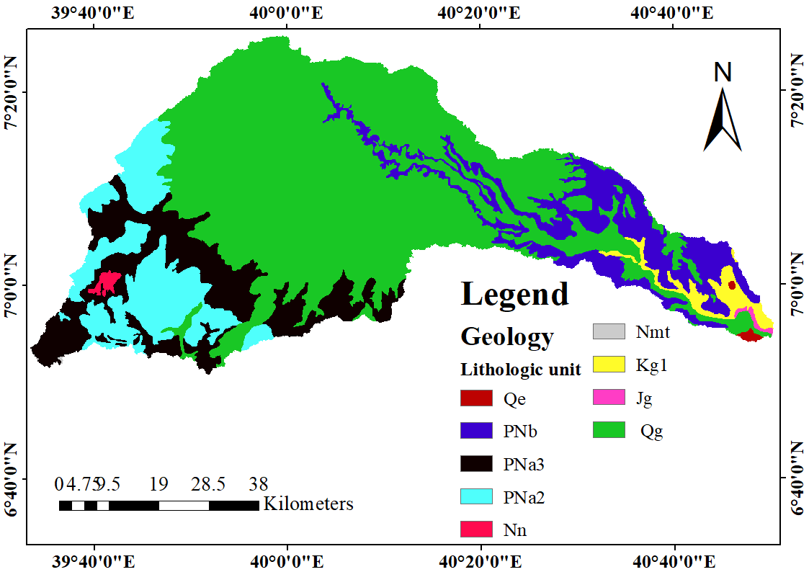
Figure 4.7: The geologic map of study area
The lithological units exposed in the study area includes; Quaternary eluvium (Qe), Ginner Basalt (Qg), Nazret group (Nn), Alkali trachyte flows (PNa2), Alkali trachyte and basalt flows (PNa3), Aphyric basalt (Nmt), Lower flood basalt (PNb), Lower Korahe formation (Kg1) and Upper Gabredarre formations (Jg) (Figure 4.7). The short description of exposed geological formation is described in Appendix table 6. The relative weight, scale value and CR were determined through AHP (Table 4.3). The computed CR value 0.05 confirm the consistency of geological unit’s pairwise comparison.
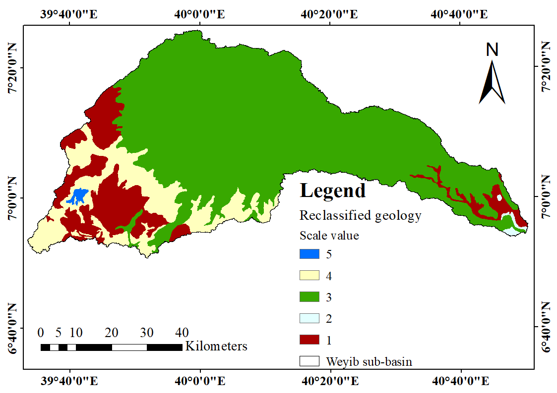
Figure 4.8: The reclassified geological map of study area
Table 4.3: Geologic formation and their relative weights
Geological  unit | Area  (km²) | Area  (%) | Contribution* | Scale  value | Relative  Weight (%) | CR
PNa2/Kg1 | 609.9 | 13.8 | Very low | 1 | 5 | 0.05
Qe/Jg | 16.3 | 0.4 | Low | 2 | 7 | 0.05
PNb/Qg | 1119.1 | 25.4 | Moderate | 3 | 15 | 0.05
Nmt/ PNa3 | 2653.3 | 60.1 | High very | 4 | 24 | 0.05
Nn | 14.6 | 0.3 | High | 5 | 49 | 0.05
* (Gobena et al., 1997; Kebede and Mulugeta, 2011; Kifle and Hailemriam, 2010; Kiflu et al., 2009; Mulugeta and Tafa, 2010; Zewdie, 2011).

The Thematic Map of Rainfall Distribution
The Thiessen polygon techniques of areal rainfall distribution approach provides a good result of for non-uniformly distributed rain gauges over a flat area and hilly terrains.
Depending on the contribution of rainfall the relative weight of the clustered rainfall classes was assigned. The thematic layer of average annual rainfall distribution was classified into five classes. The Reclassification was accomplished through AHP. Suitability, the scale value and CR were determined and tabulated in Table 4.4. The computed consistency ratio 0.047 confirms consistency of pairwise comparison matrix.
Table 4.4: Rainfall distribution and relative weight as per suitability for GWPZ
Factor | Rainfall(mm) | Suitability* | Scale value | Relative Weight (%) | CR
Rainfall (mm/year) | 1352-1055 | Very high | 5 | 46 | 0.047
Rainfall (mm/year) | 1055-921 | High | 4 | 27 | 0.047
 | 921-832 | Moderate | 3 | 16 | 0.047
 | 832-723 | Poor | 2 | 7 | 0.047
 | 723-546 | Very poor | 1 | 4 | 0.047
* (Banti, 2017; Berhanu and Hatiye, 2020; Doyo, 2020; Senanayake et al., 2016; Sridhar et al., 2019).
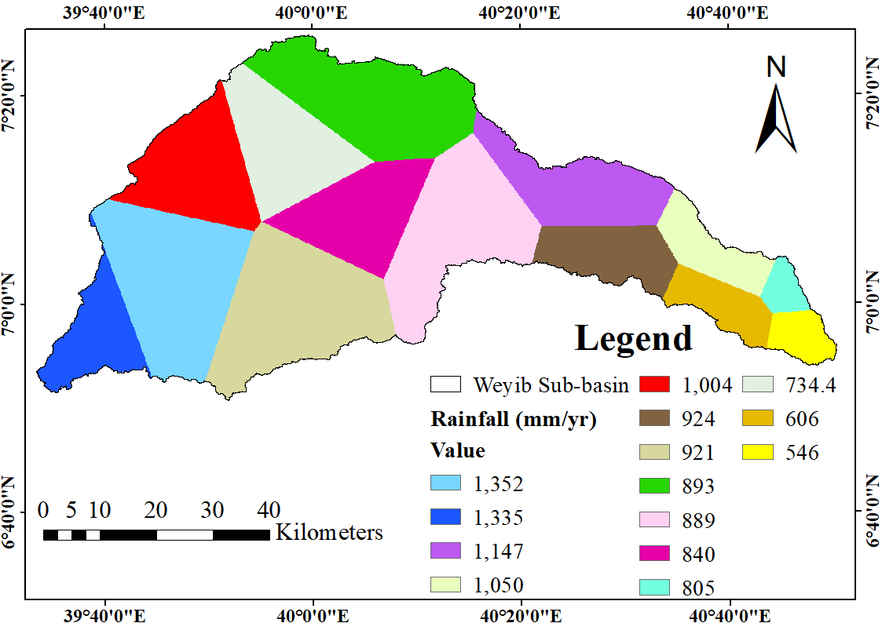
Figure 4.9: The areal rainfall distribution map of study area
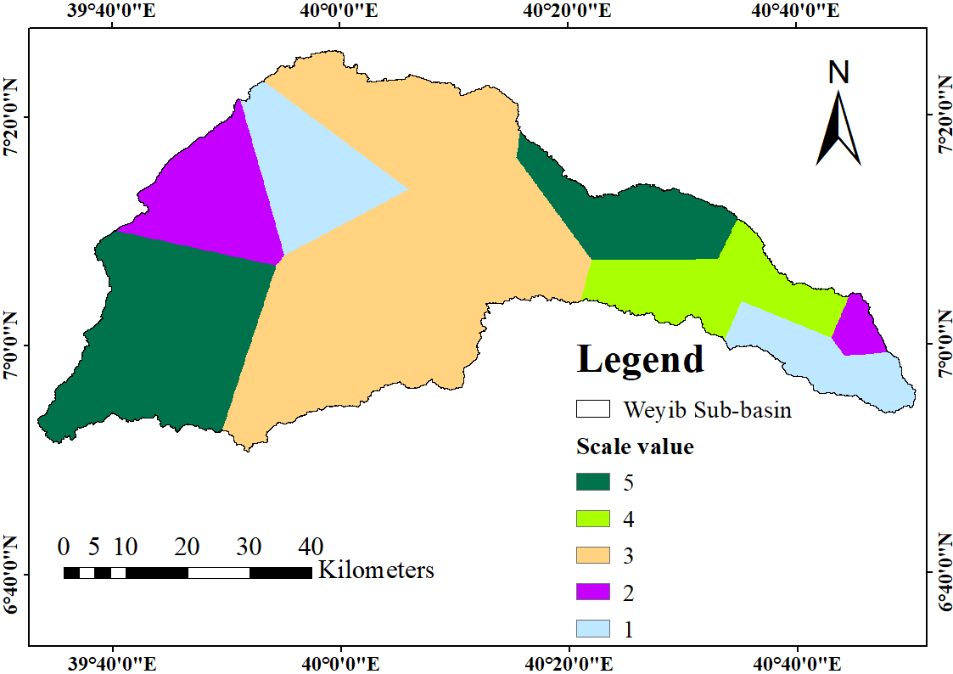
Figure 4.10: The reclassified areal rainfall distribution map of study area

The Thematic Map of Drainage Density
The drainage density of the Weyib Sub-basin varies from 0 to 6.3 km/km² (Figure 4.12). The drainage density was classified into five classes of very high, high, moderate, low and very low contribution. The relative weight and CR value of classified drainage density was computed through AHP (Table 4.5). The final thematic map of drainage density was prepared by reclassifying the drainage density map using scale value (Figure 4.13).
Table 4.5: Drainage density and relative weight of classes as per suitability for GWPZ
S. No. | Drainage density*  (km/km²) | Contribution* | Scale value | Relative weight (%) | CR
1  2  3  4  5 | 0-1.2 | Very high | 5 | 45 | 0.027
1  2  3  4  5 | 1.2-2.4 | High | 4 | 27 | 0.027
1  2  3  4  5 | 2.4-3.6 | Moderate | 3 | 19 | 0.027
1  2  3  4  5 | 3.6-4.8 | Low | 2 | 5 | 0.027
1  2  3  4  5 | 4.8-6.3 | Very low | 1 | 4 | 0.027
* (Waikar and Nilawar, 2014)
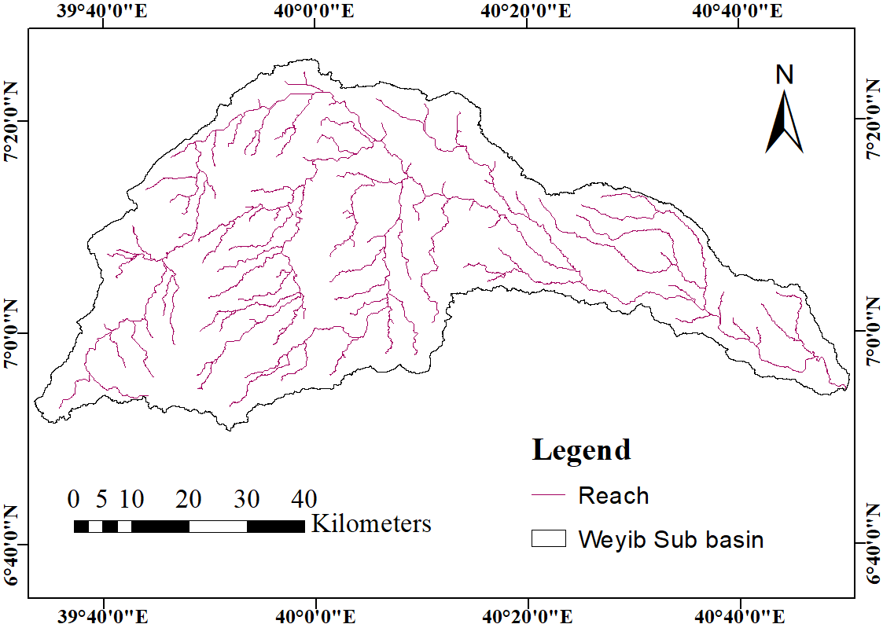
Figure 4.11: The drainage network map of study area
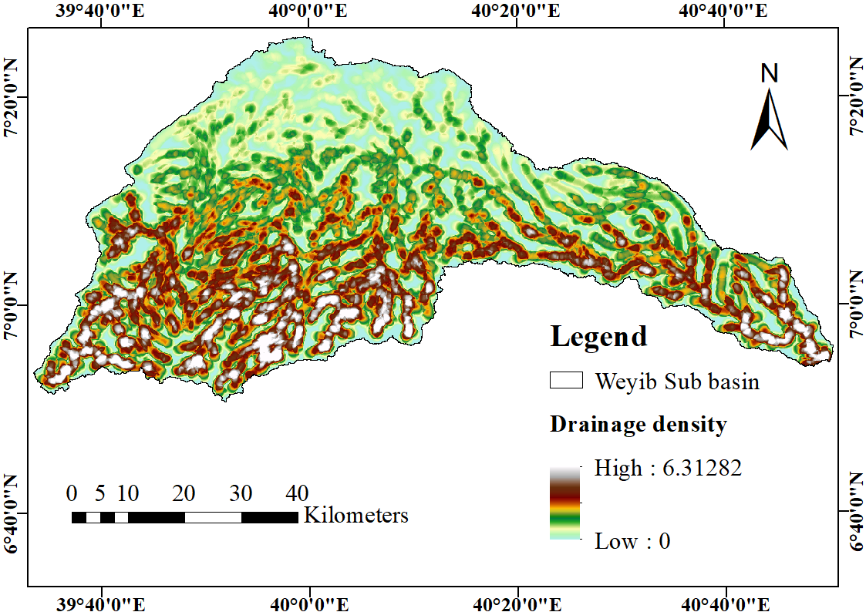
Figure 4.12: The drainage density thematic map of study area
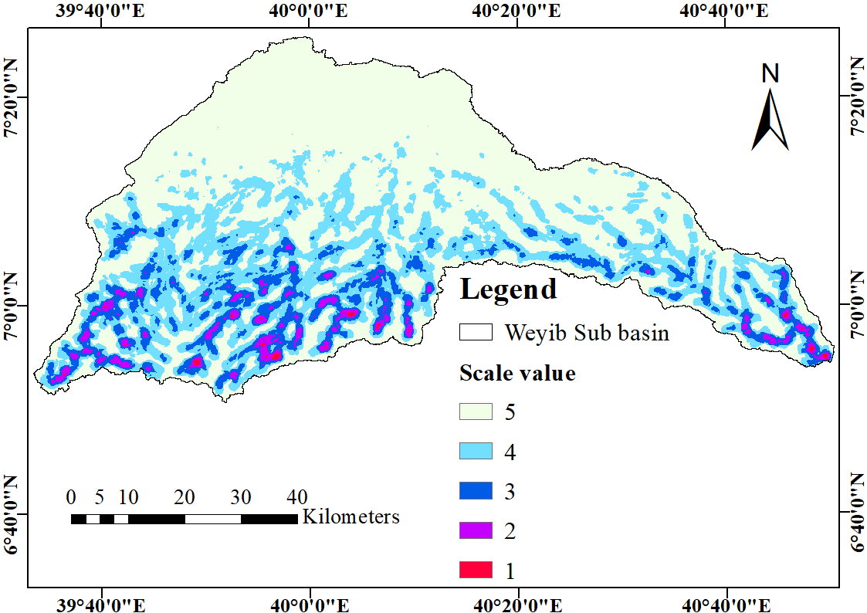
Figure 4.13: The reclassified drainage density map of study area

The Thematic Map of Slope
Weyib Sub-basin is characterized by landforms varying from flat plains to steep slope hilly terrains. The slope value of study area varies from 0 to 76⁰. The slope map was classified into five classes of flat, gentle, moderate, high and steep slopes. About sixty two percent of the study area was categorized under flat/gentle slope, twenty percent are moderate slope while the left eighteen percent are found under steep/very steep slope. The central parts of study area are flat agricultural areas, while the Northwest and Southwestern edges are a rugged landscape of steep slope.
A highly sloping region causes more runoff which leads to less infiltration and poor groundwater prospects, while the low slope region is contrary (Banti, 2017). Thus, ranking of the generated slope classes and their relative weight was computed on basis the contribution. The relative weight of each slope class and CR value computed by AHP was tabulated in Table 4.6. Since the computed consistency ratio 0.019 is less than 0.1 the matrix is reasonably consistent.
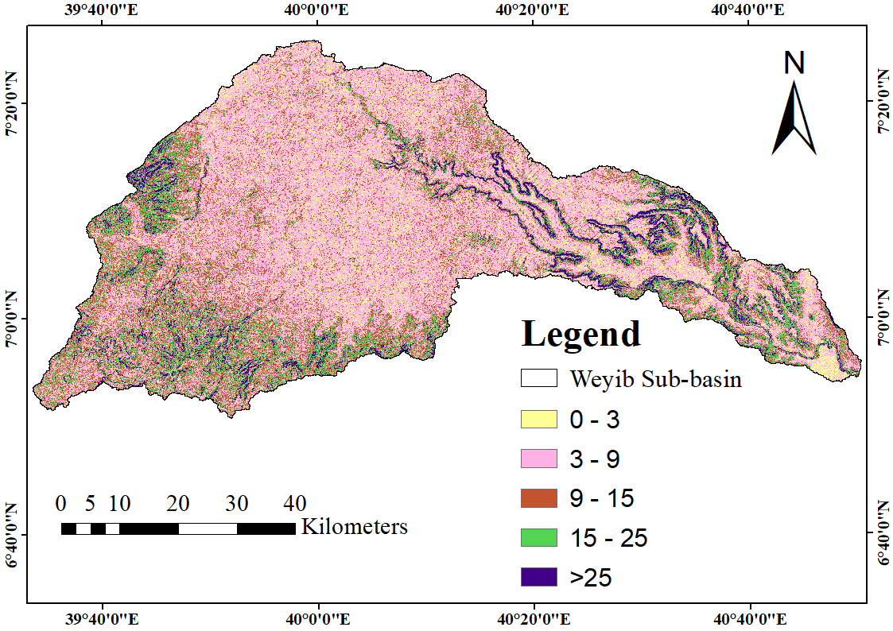
Figure 4.14: The slope map of study area
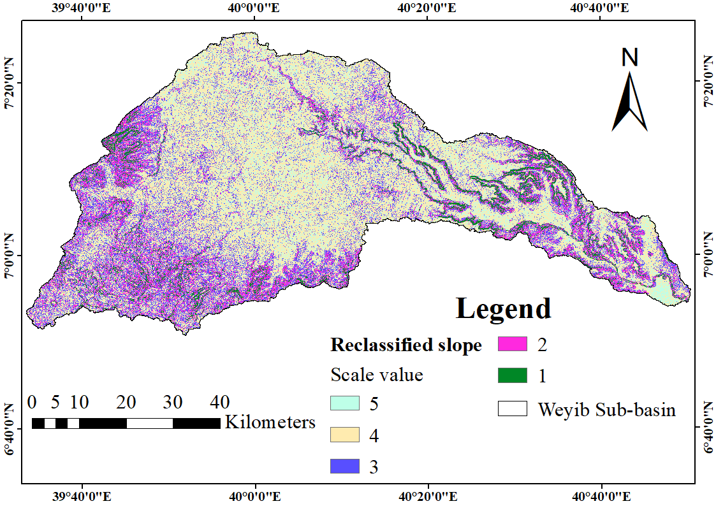
Figure 4.15: The reclassified slope thematic map of Weyib Sub-basin
Table 4.6: Slope range and relative weight of slope classes
Slope (%) | Area (km²) | Area (%) | Classes | Contribution* | Scale value | Relative weight (%) | CR
0-3 | 660.02 | 14.9 | Flat | Very high | 5 | 47 | 0.019
3-9 | 2093.3 | 47.4 | Gentle | High | 4 | 32 | 0.019
9-15 | 873.8 | 19.8 | Moderate | Moderate | 3 | 11 | 0.019
15-25 | 531.8 | 12.0 | Steep | Low | 2 | 6 | 0.019
>25 | 254.2 | 5.7 | Very Steep | Very low | 1 | 4 | 0.019
* (Alemayehu, 2006; Eszobedo, 1998; Mamo, 2007; Nuru, 2018; Tegegn, 2015).

The Thematic Map of Elevation
The elevation range of study area lies between 1,199 to 4,346 m.a.s.l. The Western part of the Weyib Sub-basin is a mountainous highland of elevation ranging from 3,300 m to 4346 m. The lowest elevation range from 2,300 m to 1,199m is found in the Eastern part.
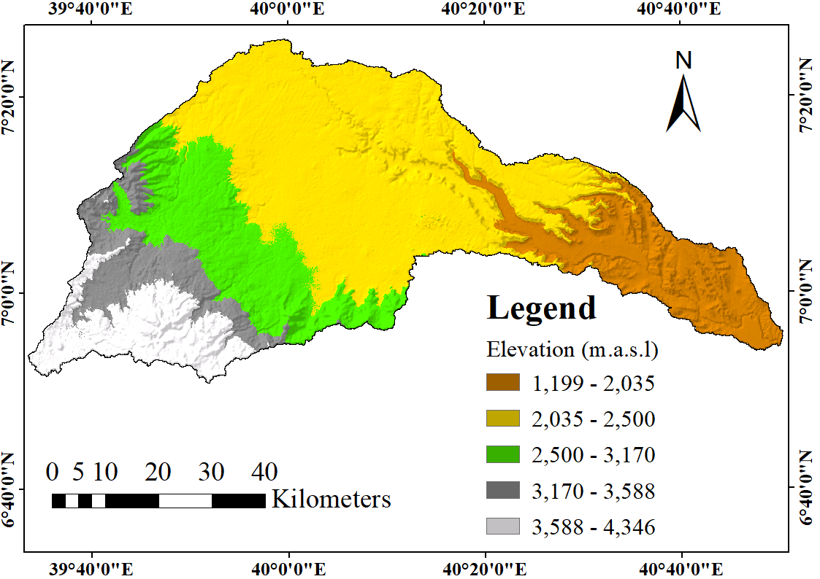
Figure 4.16: Elevation map of study area
The relatively extensive flat terrain of Sheneka plain covers the central part of study area. The area characterized by low relief tabular plateau of flat to gentle slope separated by deep River incisions. Since water tends to be stored at lower elevation the Eastern lowland has the higher relative weight (Ramu and Vinay, 2014; Sewnet et al., 2016).
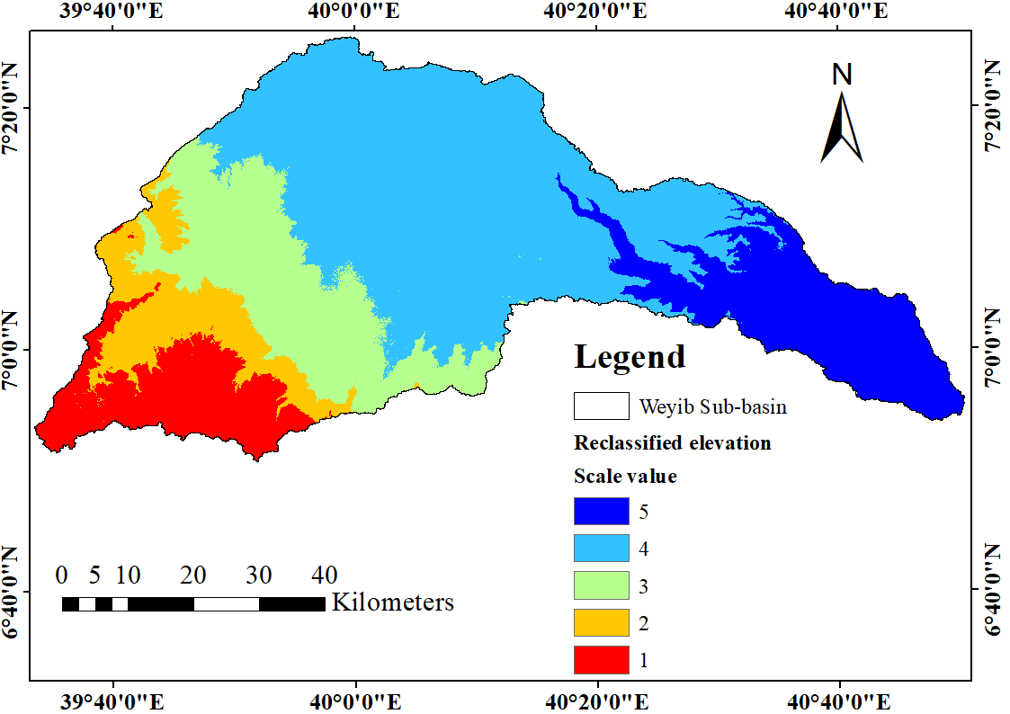
Figure 4.17: The reclassified elevation map of study area
Depending on the contribution of clustered elevation classes, the relative weight (relative importance) and CR value were determined through AHP (Table 4.7).
Table 4.7: The elevation range and relative weight of classes
Elevation (m.a.s.l.) | Contribution* | Scale value | Relative weight (%) | CR
1,199 - 2,035 | Very high | 5 | 36 | 0.032
2,035- 2,500 | High | 4 | 27 | 0.032
2,500- 3,170 | Moderate | 3 | 20 | 0.032
3,170- 3,588 | Low | 2 | 10 | 0.032
3,588- 4,346 | Very low | 1 | 7 | 0.032
* (Berhanu and Hatiye, 2020; Godebo, 2018; Kiflu et al., 2009; Ramu and Vinay, 2014; Sewnet et al., 2016)

The Thematic Map of Land Use and Land Cover
The LU/LC of Weyib Sub-basin was classified into six major classes including; agriculture, bare land, bush land, forest, grass land and settlements (Figure 4.18). Agriculture and settlements are mostly found in the middle plateau and downstream portion of the sub-basin.
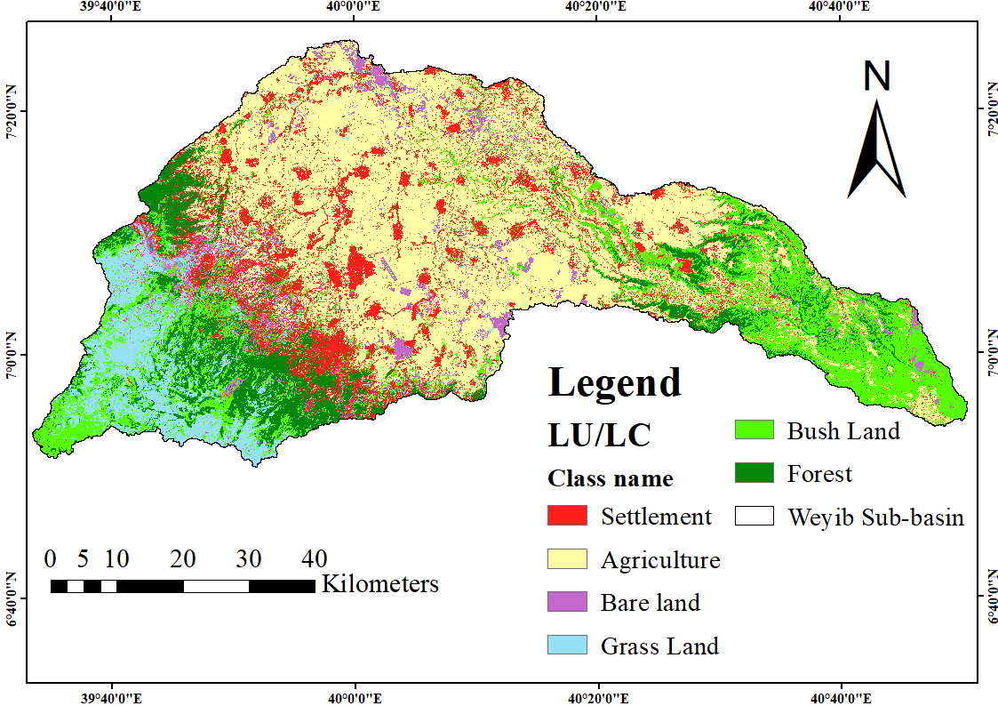
Figure 4.18: The LU/LC map of Weyib Sub-basin
Agricultural land includes an area used for perennial and annual crop cultivation under smallholder farmers and state farms. Forest occupies dense tall trees with widely spreading crowns and a large variety of multi-store species. It is restricted to sub-humid climates and along the River courses (Zewdie, 2011). Shrub land compose patches of shrubs and bushes interspersing grasslands with some scattered trees. Grassland is composed of grassland with very rare shrubs, bushes and trees. The settlement is an area used for infrastructure and buildings in towns and urban centers. Bare land consists of recent lava flows, exposed rock outcrops, sand and soil surfaces devoid of vegetative cover. Forest, bushland and grasslands are found towards an upper and lower edge of the sub-basin, while bare land is found distributed throughout the area. The classified LU/LC of the study area were ranked and reclassified into five classes (Figure 4.19).
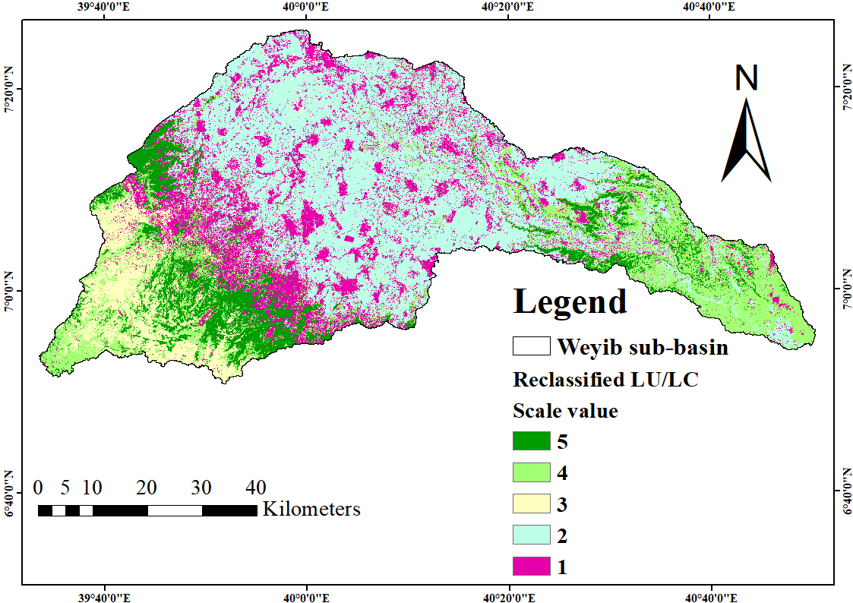
Figure 4.19: The reclassified LU/LC map of Weyib Sub-basin
Depending on the contributions of LU/LC classes for groundwater potential the relative weight of each class and CR was computed (Table 4.8). The CR value of 0.062 is within the acceptable limit.
Table 4.8: The classified LU/LC, contribution and relative weight of classes
 | Class name | Area  (km²) | Area  (%) | Contribution* | Rank | Relative weight (%) | CR
 | Agriculture | 1864.05 | 42.24 | Low | 2 | 7 | 0.062
 | Bare land | 265.32 | 6.01 | Very low | 1 | 3 | 0.062
 | Bush land | 837.94 | 18.99 | High | 4 | 26 | 0.062
 | Forest | 483.45 | 10.95 | Very high | 5 | 49 | 0.062
 | Grass land | 326.44 | 7.40 | Moderate | 3 | 15 | 0.062
 | Settlement | 635.90 | 14.41 | Very low | 1 | 3 | 0.062
* (Lagesse, 2017; Serur and Sarma, 2016b; Tegegn, 2015)
The accuracy assessment of classified LU/LC map was accomplished by using the covariance matrix.
The overall accuracy, producer’s accuracy (PA), user’s accuracy (UA), and Kappa coefficient (K) was tested. Thus, the classified LU/LC shows 91.5% overall accuracy and Kappa accuracy of 91.4%.
Table 4.9: Error matrix and accuracy of the classified LU/LC map
Classes | Settlement | Agriculture | Bare  land | Grass  land | Bush  land | Forest | UA (%)
Settlement | 12 | 2 | 0 | 1 | 0 | 0 | 80
Agriculture | 0 | 61 | 0 | 1 | 0 | 0 | 98
Bare land | 0 | 0 | 7 | 1 | 0 | 0 | 88
Grass land | 0 | 3 | 1 | 24 | 0 | 0 | 86
Bush land | 0 | 1 | 0 | 0 | 17 | 1 | 89
Forest | 0 | 0 | 0 | 0 | 1 | 16 | 94
PA (%) | 100 | 91 | 88 | 89 | 94 | 94

The Thematic Map of Soil Texture
Thirteen types of dominant soils were spatially distributed over an area includes; Haplic Arenosol, Calcaric Cambisol, Dystric Cambisol, Eutric Cambisol, Chromic Cambisol, Leptosol, Haplic Luvisol, Vertic Luvisol, Chromic Luvisol, Regosol, Calcic Solonetz, Eutric Vertisol and Calcic Vertisol. A short description of soil types are described in Appendix table 7. Depending the contribution of soil groups the relative weight and CR value of soil classes were determined and presented in Table 4.10. The CR value of 0.042 is acceptable.
Table 4.10: The soil texture, relative weight and consistency ratio.
Soil texture class | Contribution* | Area (km²) | Scale  value | Relative weight (%) | CR
Sand | Very high | 0.5 | 5 | 51 | 0.042
Sandy loam | High | 764 | 4 | 25 | 0.042
Loam | Moderate | 607.7 | 3 | 14 | 0.042
Sand clay loam/clay loam | Low | 1692.3 | 2 | 6 | 0.042
Sandy clay /clay (light) | Very low | 1348.7 | 1 | 4 | 0.042
* (Assistance to Soil and Water Conservation Program, Phase III, field document No. 19 ETH/85/016., 1998; Berhanu et al., 2013)
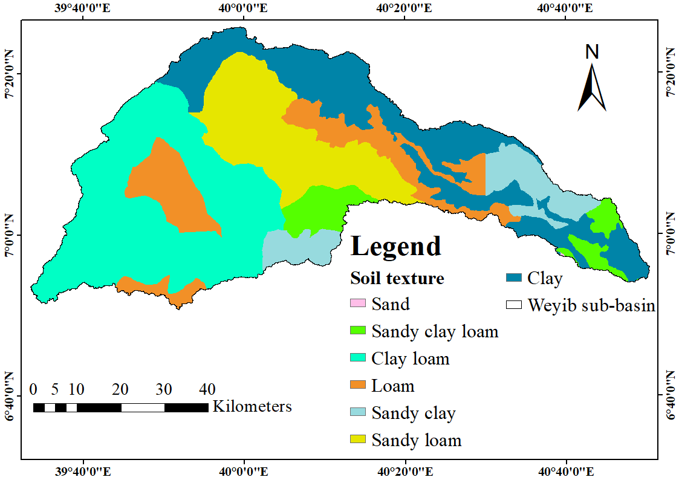
Figure 4.20: The soil texture classes of study area
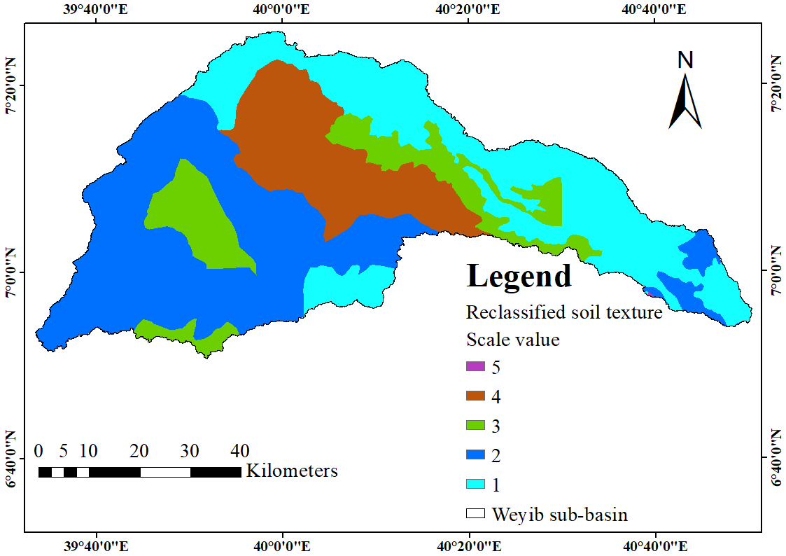
Figure 4.21: The reclassified soil map of study area

Assignment of Weight to Factors
The weight of physiographic, geology and climatic factor were determined on basis of the factors relative importance. The physiographic and geologic factors are the major factors affecting GWPZ of Weyib Sub-basin. Geomorphological landforms determine runoff, groundwater recharge and to some extent rainfall conditions. Hence, it is a dominant factor influencing the GWPZ of study area. Lineament density, geology and rainfall distribution are the second, third and fourth factors influencing the GWPZ of Weyib Sub-basin. The importance of lineament is related to the ability of lineaments to act as conduit sites for groundwater recharge and flow throughout the area. Types of rocks determine peculiarities of cross-section structures hydrological property affecting groundwater movement. Saaty’s (1980) pair-wise comparison of themes mentioned in Appendix table 1 and Table 3.1 produced Table 4.11, which shows the importance of themes in the first row relative to the themes on the columns.
Table 4.11: Pairwise comparison matrix and the relative weights of factors
Factors | Geom | Lin | Geol | PCP | DD | Slp | Elv | LULC | ST
Geom | 1 | 2 | 2 | 3 | 3 | 4 | 4 | 5 | 9
Lin | 1/2 | 1 | 2 | 3 | 4 | 5 | 5 | 7 | 8
Geol | 1/2 | 1/2 | 1 | 2 | 3 | 4 | 4 | 6 | 7
PCP | 1/3 | 1/3 | 1/2 | 1 | 2 | 3 | 4 | 5 | 6
DD | 1/3 | 1/4 | 1/3 | 1/2 | 1 | 3 | 3 | 4 | 5
Slp | 1/4 | 1/5 | 1/4 | 1/3 | 1/3 | 1 | 2 | 3 | 4
Elv | 1/4 | 1/5 | 1/4 | 1/4 | 1/3 | 1/2 | 1 | 3 | 3
LULC | 1/5 | 1/7 | 1/6 | 1/5 | 1/4 | 1/3 | 1/3 | 1 | 2
ST | 1/9 | 1/8 | 1/7 | 1/6 | 1/5 | 1/4 | 1/3 | 1/2 | 1
SUM | 3.48 | 4.75 | 6.64 | 10.45 | 14.12 | 21.08 | 23.67 | 34.50 | 45.00
The abbreviation Geol, Geom, Lin, PCP, Elv, DD, Slp, LULC, and ST represent; geology, geomorphology, lineament density, rainfall distribution, elevation, drainage density, slope, land use land cover, and soil texture, respectively. The pair-wise comparison matrix was normalized by dividing each value by the column total and subsequently averaging the row total (Table 4.12).
Table 4.12: Normalized pairwise comparison matrix and final weighted values
Factors | Geom | Lin | Geol | PCP | DD | Slp | Elev | LULC | ST | CW | CW (%)
Geom | 0.29 | 0.42 | 0.30 | 0.29 | 0.21 | 0.19 | 0.17 | 0.14 | 0.20 | 0.249 | 25
Lin | 0.14 | 0.21 | 0.30 | 0.29 | 0.28 | 0.24 | 0.21 | 0.20 | 0.18 | 0.234 | 23
Geol | 0.14 | 0.11 | 0.15 | 0.19 | 0.21 | 0.19 | 0.17 | 0.17 | 0.16 | 0.167 | 17
PCP | 0.10 | 0.07 | 0.08 | 0.10 | 0.14 | 0.14 | 0.17 | 0.14 | 0.13 | 0.118 | 12
DD | 0.10 | 0.05 | 0.05 | 0.05 | 0.07 | 0.14 | 0.13 | 0.12 | 0.11 | 0.088 | 9
Slp | 0.07 | 0.04 | 0.04 | 0.03 | 0.02 | 0.05 | 0.08 | 0.09 | 0.09 | 0.054 | 5
Elev | 0.07 | 0.04 | 0.04 | 0.02 | 0.02 | 0.02 | 0.04 | 0.09 | 0.07 | 0.041 | 4
LULC | 0.06 | 0.03 | 0.03 | 0.02 | 0.02 | 0.02 | 0.01 | 0.03 | 0.04 | 0.027 | 3
ST | 0.03 | 0.03 | 0.02 | 0.02 | 0.01 | 0.01 | 0.01 | 0.01 | 0.02 | 0.018 | 2
To check the consistency of pairwise comparison matrix and the acceptability of judgments the consistency ratio (CR) was checked Table 4.13.
Table 4.13: Consistency ratio (CR) of the generated matrix
Factors | Geom | Lin | Geol | PCP | DD | Slp | Elev | LULC | ST | WS | CW | Ratio
Geom | 0.25 | 0.46 | 0.33 | 0.36 | 0.27 | 0.23 | 0.19 | 0.14 | 0.17 | 2.39 | 0.25 | 9.05
Lin | 0.12 | 0.23 | 0.33 | 0.36 | 0.36 | 0.29 | 0.23 | 0.20 | 0.15 | 2.27 | 0.23 | 11.43
Geol | 0.12 | 0.11 | 0.17 | 0.24 | 0.27 | 0.23 | 0.19 | 0.17 | 0.13 | 1.63 | 0.17 | 9.07
PCP | 0.08 | 0.08 | 0.08 | 0.12 | 0.18 | 0.17 | 0.19 | 0.14 | 0.12 | 1.15 | 0.12 | 9.27
DD | 0.08 | 0.06 | 0.06 | 0.06 | 0.09 | 0.17 | 0.14 | 0.11 | 0.10 | 0.86 | 0.09 | 12.15
Slp | 0.06 | 0.05 | 0.04 | 0.04 | 0.03 | 0.06 | 0.09 | 0.08 | 0.08 | 0.53 | 0.05 | 8.44
Elev | 0.06 | 0.05 | 0.04 | 0.03 | 0.03 | 0.03 | 0.05 | 0.08 | 0.06 | 0.43 | 0.04 | 8.42
LULC | 0.05 | 0.03 | 0.03 | 0.02 | 0.02 | 0.02 | 0.02 | 0.03 | 0.04 | 0.26 | 0.03 | 8.02
ST | 0.03 | 0.03 | 0.02 | 0.02 | 0.02 | 0.01 | 0.02 | 0.01 | 0.02 | 0.18 | 0.02 | 10.70
WS is weight sum value, CW is criteria weight, RI is the random index, λmax is the maximum eigenvalue of the matrix, and n-is the number of compared elements. λmax =9.523, Consistency index (C.I) =0.065 computed by using equation (3.10) Random index (R.I) =1.450, CR =0.04 computed by using equation (3.9). The value of consistency ratio (CR) 0.04 is less than 0.1(10%), hence it is acceptable. Therefore, the judgment of generated the pairwise comparison matrix was consistent and the factors weights will be used for further analyses.
The spatial distribution of rainfall of the study area which was significantly influenced by topographic variability of the sub-basin result in the spatial variability of GWPZ. Due to the percolation of the higher precipitation, the major natural recharge of the Weyib Sub-basin is believed to occur at elevated regions. The drainage density of an area depends on the topography, slope and sub-surface characteristics. Thus, the higher weight was assigned for drainage density than the factors contributing for high drainage density, except the sub-surface geological formation. The slope gradient directly influences the rainfall infiltration. The high residence time of rainwater permits extensive retention of rainwater to form pools and infiltrate to the water table and the deeper geologic formation. The process will be held if the soil provides the permeability necessary for deeper flow than surface runoff.
For those interdependent factors, the relative weight was assigned depending on the contribution of factors and their ability to determine the spatial variability of groundwater potential. The influence of physiographic, geologic and climatic factors is 46%, 42%, and 12%, respectively. The value reveals that the GWPZ of the Weyib Sub-basin is influenced almost equally by physiographic and geologic factors. The geomorphologic landform, lineament density, geology and rainfall distribution shares the highest weightage of 67%.

Figure 4.22: Pie-chart of the physiographic, geology and climatic factors weightage

Delineation of Groundwater Potential Zones
The resulting groundwater potential index of the study area indicates five zones representing very high, high, moderate, poor and very poor groundwater potential areas. The total areal extent of very high GWPZ is 41 km². A considerable extent of very high GWPZ is found in the Southwestern part of the study area. The high productive fractured, jointed and porous volcanic aquifer of Nazret group stratoid silics and teltele basalt forming flat slope plain and valley landforms suit very high GWPZ. The relatively high and constant discharge rate multiple eye springs emerging from those unit were developed for Dinsho town and Bale Mountain National Park water supply (Kiflu et al., 2009).
Table 4.14: Groundwater potential zone
S.no | Evaluation scale | GWPZ | Area (km2) | Percentage of the total area (%)
1 | 5 | Very high | 41 | 0.92
2 | 4 | High | 2032 | 46.06
3 | 3 | Moderate | 2088 | 47.31
4 | 2 | Poor | 252 | 5.71
5 | 1 | Very Poor | 0.142 | 0.0032
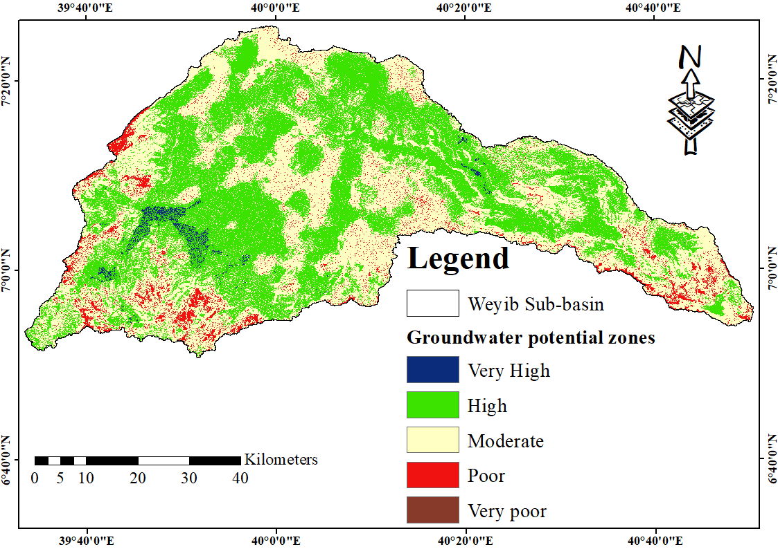
Figure 4.23: The groundwater potential zone map
The foothills of lower plateau volcanic terrains formed by volcanic shields are characterized by high lineament density. These areas are favorable for the emergence of groundwater as springs. Areas following the alluvial plain of the Weyib River course classified under high GWPZ, while the subsequent edge is characterized by moderate GWPZ’s. A small area of very high GWPZ zone followed by high groundwater potential was discretely distributed over the NE side between Gasera and Ginnir Woreda. The barren top of steep slope mountain/ridge and drainages are classified under poor and very poor GWPZ. The low productivity sedimentary aquifer and scarce rainfall distribution of the Southeastern edge enforce the GWPZ of an area for categorizing under low and moderate groundwater potential zone.
The boundary of Weyib Sub-basin encompasses eight Woredas including; Dinsho, Agarfa, Adaba, Gasera, Ginnir, Goba, Goro and Sinana. The suitability of Woredas GWPZ was identified in terms of potentials. I.e. considering very high and high GWPZ. The present administrative boundary of Woredas and the delineated hydrologic boundary of the sub-basin cannot follow the same configuration. Hence, the identified suitable groundwater potential zone includes only the area of parts of the Woredas which found in the Sub-basin.
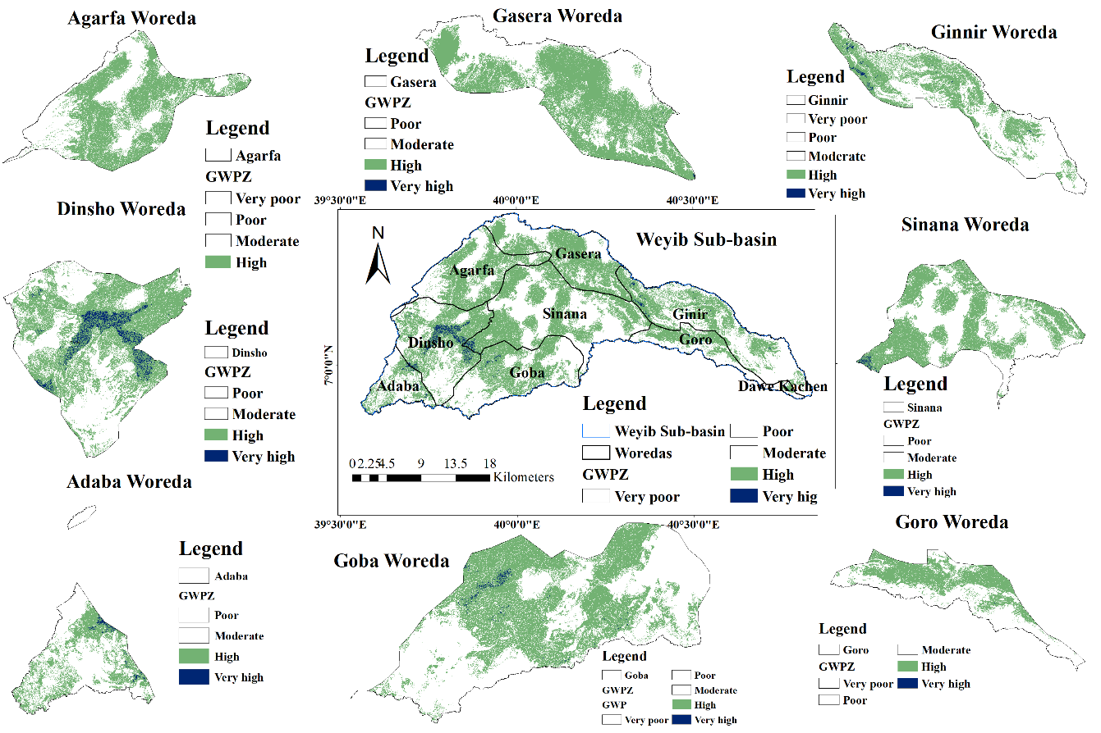
Figure 4.24: Suitable groundwater potential zone for Woredas in the study area
The coverage area of suitable GWPZ for parts of Woredas found in the Sub-basin was illustrated in Figure 4.24 and tabulated in Table 4.15.
Table 4.15: Suitable groundwater potential zone for Woredas in the study area
Woreda | Suitability | Area  (km²) | Area (%)  (In Woreda) | Area (%)  (from the total Sub-basin)
Dinsho | High | 296.5 | 47.5 | 6.7
 | Very high | 28.0 | 4.5 | 0.6
Agarfa | High | 260.8 | 51 | 5.9
Adaba | High | 77.7 | 32.6 | 1.7
 | Very high | 2.5 | 1 | 0.06
Gasera | High | 308.9 | 57.6 | 6.9
 | Very high | 0.15 | 0.02 | 0.003
Ginnir | High | 286 | 41 | 6.5
 | Very high | 3.53 | 0.5 | 0.08
Goba | High | 251 | 42 | 5.6
Goro | Very high | 3 | 0.5 | 0.07
Goro | High | 99 | 42.8 | 2
Sinana | Very high | 0.04 | 0.02 | 0.001
Sinana | High | 452 | 47 | 10
 | Very high | 3.8 | 0.4 | 0.08

Figure 4.25: Bar charts showing very high and high GWPZ’s of Woredas

Verification of the Result Using Water Point Data
To confirm the accuracy of predicted GWPZ, the resulting groundwater potential map was verified by using the existing water point’s inventory data. The highest yield among the collected groundwater point was Mio-spring of 40 l/s discharge. On the contrary, Asenberara spring and Amigna Shirar No. 1 dug well yields the least value of 0.05 l/s yield (Appendix 19). The actual yields of fifty-one water points were checked with the identified GWPZ. The actual yield of boreholes and spring discharge were classified into five classes (Berhanu and Hatiye, 2020; Doyo, 2020; Gebru et al., 2020). The water points that fall in the highest yield of ≥15 l/s were classified under very high groundwater potential. Yields/discharge between 15-3.5 l/s, 3.5-0.5 l/s, 0.5-0.05 l/s and less than 0.05 were classified under high, moderate, low and very low GWPZ’s.
Table 4.16: Validation of the identified groundwater potential zones with actual yield
Actual GWPZ |  | Mapped GWPZ
Actual GWPZ |  | VH | H | M | L | VL | A | DA | Total
Actual GWPZ | VH | 2 | 1 | 0 | 0 | 0 | 2 | 1 | 3
Actual GWPZ | H | 0 | 12 | 1 | 0 | 0 | 12 | 1 | 13
Actual GWPZ | M | 0 | 3 | 21 | 1 | 0 | 21 | 4 | 25
Actual GWPZ | L | 0 | 0 | 2 | 8 | 0 | 8 | 2 | 10
Actual GWPZ | VL | 0 | 0 | 0 | 0 | 0 | 0 | 0 | 0
OPA (%) =(Total number of agreement /Total Number of wells) *100%=84%
The acronyms; VH, H, M, L, VL, DA, A and OPA represent very high, high, moderate, low, very low, disagreement, agreement and overall prediction accuracy. Out of the three springs of very high actual yields only one spring was found in high GWPZ, while the left two were found in very high GWPZ. No wells have been found within the very low potential zone. This indicates a good correlation between the existing boreholes and the mapped GWPZ’s. From the total water points, forty-three boreholes, springs and hand dug well satisfy the identified GWPZ. Hence, the overall prediction accuracy of groundwater potential is 84%. A single springs of very high discharge was found in high GWPZ. Since the location of spring is around the volcanic mountains foothill of high lineament area, the variation may be due to the possible presence of well intersecting interconnected fractures.
The better agreement of the comparison between the water point’s inventory data and GWPZ’s approve the efficiency of GIS and Remote Sensing technique for mapping the groundwater potential zone of study area.

Figure 4.26: Bar chart showing validation of the identified GWPZ
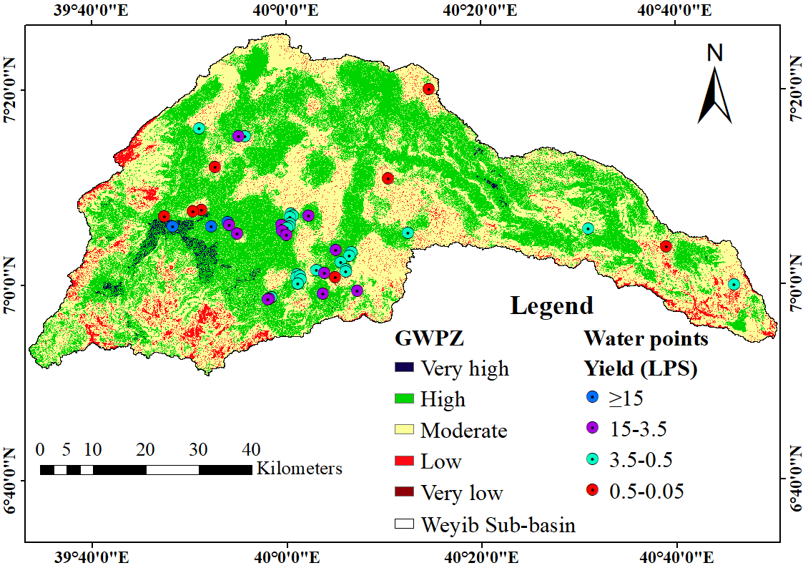
Figure 4.27: Evaluation of groundwater potential zones with water point’s yield data

Groundwater Flow Direction
The recharge and discharge zones of the study area were determined from the direction vectors (Figure 4.28 and Figure 4.31). Divergent zone is a specific area where the water starts to flow to any other area, whereas convergent zone is the area where the water flows toward specific zones that comes from its surrounding (Doyo, 2020). The location, elevation, depth, static water level and hydraulic head of water points used for determination of groundwater flow direction was attached under Appendix table 8. The circles in blue color shown in Figure 4.28 and Figure 4.31 indicate the area of groundwater recharge vectors, whereas the circles in red color shows area of discharge with collecting vectors. The groundwater flow direction of study area is particularly towards the Northeast and Southeast.
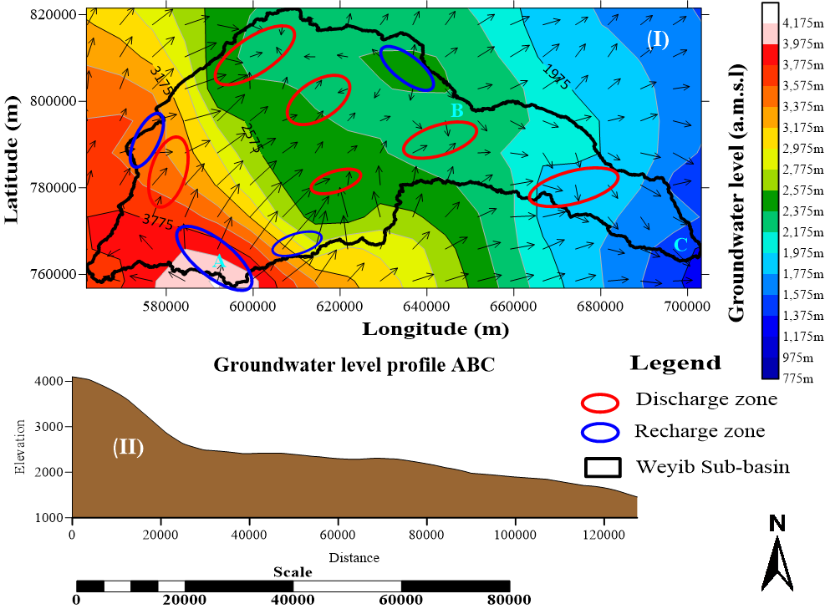
Figure 4.28: The groundwater flow direction, Recharge/Discharge zone (I) and groundwater level profile (II) along the downstream
The dispersing vectors of Southwestern areas are the indicators of the major recharging zone. At the same time, perennial rivers emanate from those areas.
Therefore, the identified recharging sites can also be acting as discharging areas at the same time and vice versa. Moreover, it is seen that discharging sites do coincide with River networks showing points at which groundwater contributes to Rivers (Figure 4.29). But at points where the recharging site is away from Rivers, it is possibly an indication that the aquifer is discharging to underlying strata (Kassahun and Mohamed, 2018).
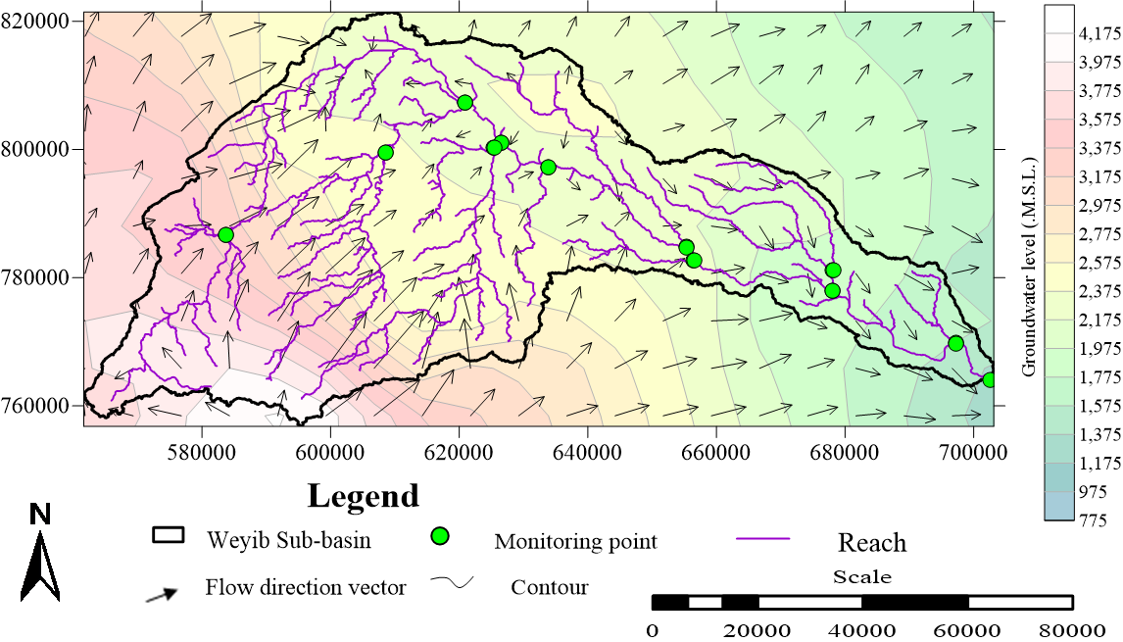
Figure 4.29: Groundwater level, reach and flow direction vectors map
In addition to the groundwater level flow direction vector the topographic contour map was analyzed (Amah and Agbebia, 2015; Gintamo, 2015; Messene, 2017). The resulting topographic tilting and hydraulic head contour maps reveal that the groundwater flow direction was controlled by the geomorphology, topographic slope aspect, gradient of groundwater and structure of the sub-basin (Kifle and Hailemriam, 2010).
The perennial springs were merge at depressions, stream channel and hillside topographic setting (Kiflu et al., 2009). The groundwater flow direction vectors that prepared from sparsely distributed water points shows a local variations from the groundwater flow direction vector of the densely considered topographic map. Even though the groundwater flow direction vectors of both maps cannot match exactly, the general groundwater flow direction, discharge and recharge zone of the study area shows the same pattern.

In addition to the delineated GWPZ, the groundwater flow direction vector identified from densely populated topographic tilting enable to show the local (detail) groundwater recharge/discharge zone of study area. The Groundwater flow direction (GWFD) vector superimposed over the delineated GWPZ, shown in Figure: 4.30, depicts as a low GWPZ is recharge zone while, the high GWPZ is discharging zone.
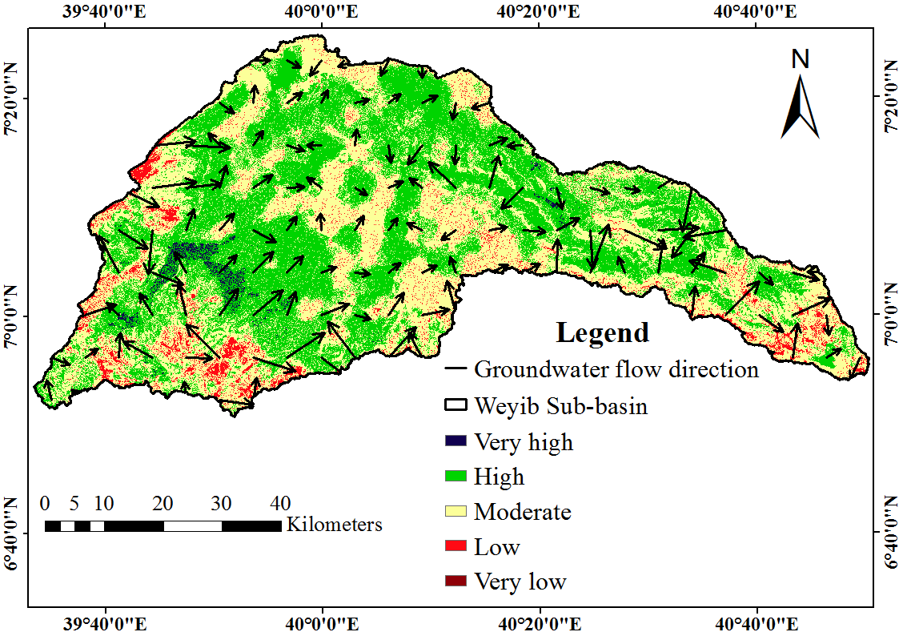
Figure 4.30 The GWFD vector superimposed over the delineated GWPZ
Note: The GWFD arrow in Figure 4.30 was generated from topographic tilting.
The groundwater locally flows in different directions while the entire groundwater flow direction of both contours reveals the Southeast and Northeastern flow direction. The complex geologic structures of the study area govern the occurrence and movement of ground and surface water flow (Kifle and Hailemriam, 2010). Mainly the NE-SE striking structures influence the flow direction of most streams and the groundwater toward the SE direction. The Bale mountains highland which is characterized by high rainfall, dense forest, and bushlands are the major recharge zone of study area. The headwater of Weyib River and its tributaries are originate partly or wholly from this area.
The recharge from this area discharges at the valley floor, mountains foothill and the sedimentary low-land areas, i.e. from Bale highlands down to Robe-Goro Sheneka plain. Especially the foothills of lower plateau volcanic terrains formed by volcanic shields characterized by high lineament density are favorable for the emergence of springs.
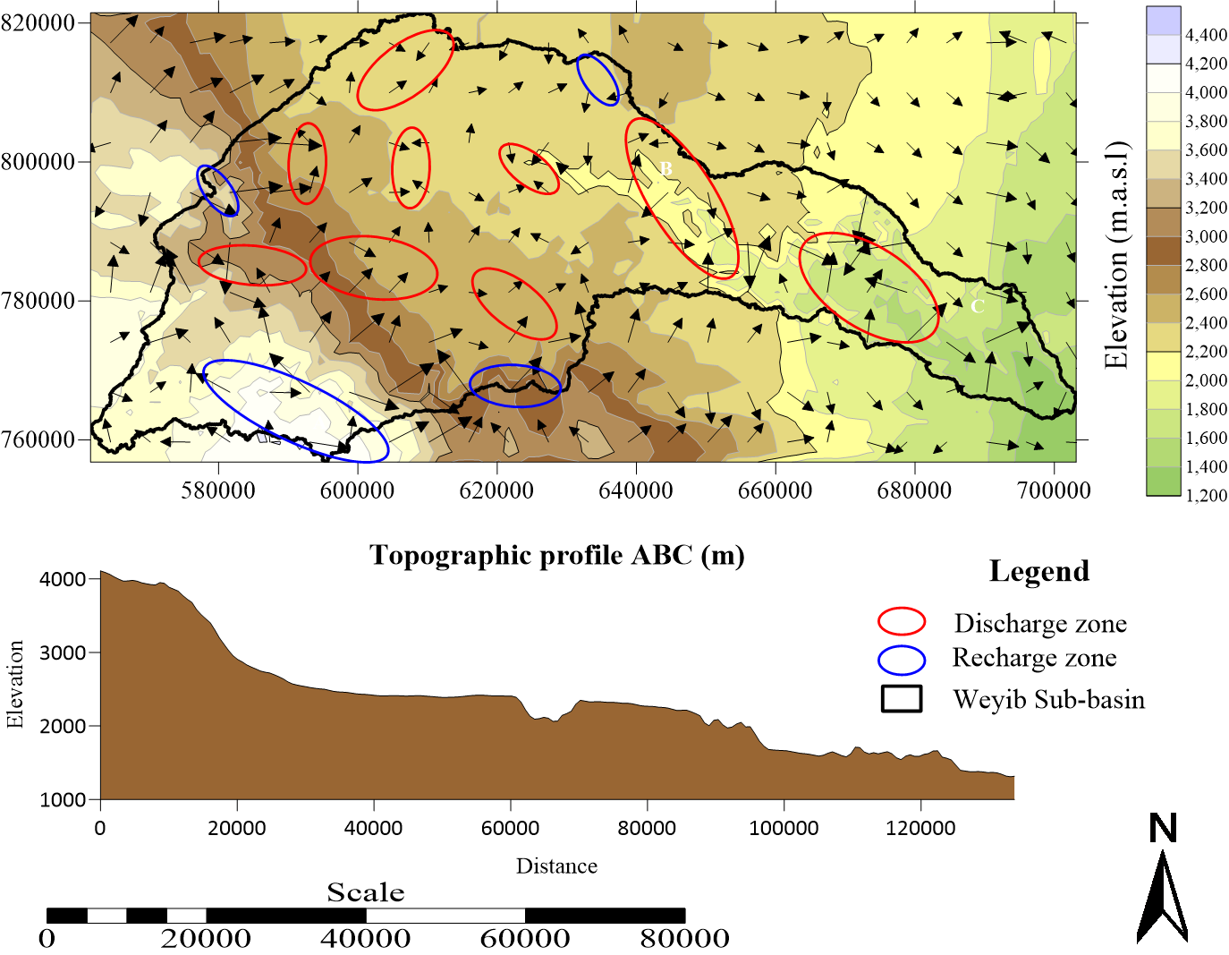
Figure 4.31: The groundwater flow direction, contour map and surface profile generated from topographic tilting
The extensively fractured Eastern valley of Weyib River channels that compose a thick succession of alluvial deposits was shown as the discharge areas. The result is consistent with the previous study conducted by Kassahun and Mohamed (2018); Kebede and Mulugeta (2011); Kifle and Hailemriam (2010); Kiflu et al. (2009); Mulugeta and Tafa (2010).

SUMMARY AND CONCLUSION

Summary
The groundwater potential zone of Weyib Sub-basin was delineated by using GIS and Remote sensing techniques through analytical hierarchy process (AHP). The physiographic, geologic and climatic factors influencing groundwater potentials were identified and evaluated. To determine the scale value of clustered classes and the influence of thematic layers, the relative weight of classes and percentage of influences was computed by AHP method. The identified factors influencing groundwater potential of the study area include; geomorphological landforms, lineament density, geology, rainfall distribution, drainage density, elevation, slope, LU/LC and soil texture.
To prepare the thematic maps of each factor and verify the delineated GWPZ, several data were collected from various sources. The historic time series of meteorological data, spatial data of soil, geology, DEM, satellite images and the existing water point’s inventory data were used. Various software and computer programs employed for processing, identification and preparation of groundwater potential map include; ArcGIS 10.5, ERDAS-imagine, PCI Geomatics, IDRISI Selva, Rockworks 16, SAGA GIS, Arc SWAT and Surfer 17.1. A weighting overlay approach of ArcGIS 10.5 was selected as the basic tool for the development of GWPZ. The groundwater prospect zones were evaluated based on the groundwater potential index computed from the integration of all groundwater influencing thematic layers.
The resulting groundwater potential index of the study area indicates five zones representing very high, high, moderate, poor and very poor GWPZ’s. The total areal extent of the very high groundwater potential is 41 km² (0.92%). The areal extent of high, moderate, poor and very poor GWPZ’s are 2032 km² (46.06%), 2088 km² (47.3%), 252 km² (5.7%) and 0.142 km² (0.0032%). The groundwater potential map was validated using the existing well yield and spring discharge. It indicated a good prediction accuracy of 84%. The suitable groundwater potential zone of Woredas encompassed in the Sub-basin was identified. A very high groundwater potential zone in Dinsho, Sinana, Ginnir and Goba Woreda covers an area of 28, 3.8, 3.5 and 3 km², respectively. Similarly, the high GWPZ coverage area of Sinana, Gasera, Dinsho and Ginnir Woreda is 452, 309, 296.5 and 286 km², respectively.
The recharge and discharge zone of groundwater zones were determined from the groundwater direction vectors. The groundwater flow direction of the study area is particularly towards the Northeast and Southeast. The Bale mountains highland which is characterized by high rainfall, dense forest and bushlands are the major recharge zone of the study area. Recharge from areas discharges at the valley floor, mountains foothill and low lands. Especially the foothills of lower plateau volcanic terrains formed by volcanic shields characterized by high lineament density are favorable for the emergence of groundwater as springs. I.e. Bale highlands down to Robe-Goro Sheneka plain. The extensively fractured Eastern valley of Weyib River channels that compose a thick succession of alluvial deposits was shown as the discharge areas.

Conclusions
The result of this study indicates the efficiency of GIS and Remote Sensing techniques for mapping the groundwater potential zone of Weyib Sub-basin. RS provides information in space and time while GIS helps to store, interpret and retrieve spatial data. The use of ArcGIS weighted overlay analysis shows a good capability to achieve the spatial classification of GWPZ. The powerful and flexible decision-making technique, AHP, helps to set priorities and make the best decision. Identification and evaluation of climatic, physiographic, and geologic factors are essential for mapping the GWPZ’s of study area. The study reveals that the integration of geomorphological landforms, lineament density, geology, rainfall distribution, drainage density, elevation, slope, soil texture and LU/LC thematic layers identify the suitable GWPZ of Weyib Sub-basin. The influence of physiographic, geologic and climatic factors are 46%, 42% and 12%, respectively.
The geomorphologic landform, lineament density, geology and rainfall distribution shares the highest weightage. The geomorphologic landform is a dominant factor influencing the GWPZ of the study area. The Southwestern Bale Mountain’s highland which is characterized by high rainfall, dense forest and bushlands are the major recharge zone of the study area. The spatial distribution of rainfall is significantly influenced by the topographic variability of the sub-basin. Recharge from runoff and precipitation provides a source of groundwater infiltration to the area of interest. The resulting GWPZ of study area was classified into five zones representing very high, high, moderate, low and very low GWPZ’s covering an area of 41 km², 2032 km², 2088 km², 252 km² and 0.142 km², respectively. The GWPZ was validated by using the existing water point’s inventory data.
The overall prediction accuracy of identified groundwater potential zone with actual water point inventory data shows 84% agreement. This, indicates the accuracy and of GWPZ’s identification by using GIS and RS through AHP is reliable. A considerable extent of very high groundwater potential is found in the Southwestern part of the study area. The high productive fractured, jointed and porous volcanic aquifer of Nazret group stratoid, silica, and teltele basalt (aphyritic basalt) forming flat slope plain and valley landforms between the mountains suit very high groundwater potential. The extensively fractured valley of Weyib River channels that compose a thick succession of alluvial deposits was classified under high groundwater potential zone. The subsequent edge next to the high groundwater potential zone is characterized by moderate GWPZ’s. Small area of very high groundwater potential zone followed by high groundwater potential was discretely distributed over the Northeastern side between Gasera and Ginnir Woreda.
The barren top of steep slope weather-resistant rocky mountain and drainages are classified under poor and very poor GWPZ. In this area, most parts of the volcanic terrain are covered by impenetrable forest, whereas the cliffs themselves and peaks remain barren. The low productivity sedimentary aquifer and scarce rainfall distribution of the Southeastern edge enforce the GWPZ’s of an area for categorizing under low and moderate GWPZ. The boundary of Weyib Sub-basin encompasses eight Woredas including; Dinsho, Agarfa, Adaba, Gasera, Ginnir, Goba, Goro and Sinana. The suitability of Woredas GWPZ were identified in terms of potentials. I.e. considering very high and high GWPZ. The groundwater table profile together with the topographic tilting shows the SE and NE groundwater flow direction, coinciding with the direction of surface water flow. It was controlled by NW-SE striking geologic structures.
Recharge from area discharges at the valley floor, mountains foothill, and low land areas. Especially the foothills of lower plateau volcanic terrains formed by volcanic shields characterized by high lineament density are favorable for the emergence of groundwater as springs, i.e. Bale highlands down to Robe-Goro Sheneka plain. The extensively fractured Eastern valley of Weyib River channels that compose thick succession of alluvial deposits was identified as the discharge areas. Generally, the better agreement of the comparison between the water point’s inventory data and GWPZ approve the efficiency of GIS and RS technique for mapping groundwater potential of Weyib Sub-basin.
This will contribute to fill the gaps by replacing uneconomical and time-consuming conventional approaches of groundwater investigation. Moreover, it is recommended to apply the same method in other places with appropriate modifications, especially for large and inaccessible areas. Hence, it is fair to conclude that the result of this study can be used for planning new groundwater-based projects and expansion of the existing water supply and irrigation project. Further, the delineated GWPZ and the identified groundwater recharge zone can be used as a primary source of information in making decisions related to groundwater management and river basin planning which have a significant contribution to the watershed management effort of the country.

Recommendations
Based on the major findings obtained from this study and the conclusion reached, the following recommendations are forwarded.
- The physiographic, geology and climatic variability of Weyib Sub-basin demand a small-scale groundwater potential mapping. Therefore, it is recommended to conduct a further study of groundwater potential zonation by increasing the number of variables using high-quality (high spatial resolution) data.
- Bale Mountain highland is the major recharge zone of the study area. It is the major source of surface and groundwater resources. To assure the groundwater quality and increase the available groundwater reserve, the area shall be protected.
- The suitability of identified GWPZ was not assessed for various purposes. Further study is recommended to evaluate the suitability of groundwater potential zone for irrigation, water supply and other water resources development projects.
- Human activities have been exerted small to large scale changes on the hydrological cycle (Tadesse, 2017). Evidences suggest that, with extreme urbanization, more than one-half of rainwater runs off and only a fraction of it goes for deep infiltration (Arnold and Gibbons, 1996). The current scenario regarding groundwater resources suggests as the amount of water available is decreasing with time. Moreover, the problem is resulting in the global water crisis in terms of quantity (availability) and quality (Sudhir et al., 2010). Therefore, it is recommended to assess the effect/impact of LU/LC change and over pumping on the groundwater recharge and potential zone of study area.
- Since the time and resources are limited the study does not include analysis of groundwater water quality and the structural design of groundwater conveyance structures (borehole/dug well depth, cross-section etc.), rather than mapping every zone in the sub-basin with their respective potential and proposing zones of suitable groundwater potential. Hence, it is recommended to assess the quality of identified suitable groundwater potential zone and conduct a detailed hydrogeological study to identify the specific location of water points in very high and high GWPZ.
- This study specifically focuses on mapping the groundwater potential zone of Weyib Sub-basin. As it was a qualitative study the recharge and groundwater storage was not quantified. Hence, it is recommended to conduct a detail quantitative study using hydrological models.
- To delineate the GWPZ of Weyib sub-basin various secondary data were collected from varying sources. Even though the data quality was checked by using various methods, the collected data was not cross-checked with the field investigation (except for those factors which does not require much effort). Having well organized and updated database system in different governmental organization and conducting a detailed field investigation will reduce the inconsistency and missing of data that has been widely shown (may result in inaccuracy of results). Hence it is recommended to have well organized and updated database system in different governmental organization and conduct a detailed field investigation, so as to provide accurate data about the hydrogeological and hydrological systems of the sub-basin

REFERENCES
Abdelkareem, O. E. A., H. M. A. Elamin, M. E. S. Eltahir, H. E. Adam, M. E. Elhaja, A. M. Rahamtalla, O. Babatunde and C. Elmar. 2018. Accuracy assessment of land use land cover in Umabdalla natural reserved forest, South Kordofan, Sudan. International Journal of Agricultural and Environmental Sciences 3(1):5–9.
Abraham, Shiny, Chau Huynh and Huy Vu. 2019. Classification of soils into Hydrologic groups using Machine learning. Creative Commons Attribution 5(2):1–14.
Adiat, K. A. N., M. N. M. Nawawi and K. Abdullah. 2012. Assessing the accuracy of GIS Based Elementary Multicriteria Decision Analysis as a Spatial Prediction Tool: A case of predicting potential zones of sustainable groundwater resources. Journal of Hydrology 440:75–89.
Ahmed, Alaa, Mahmoud El Ammawy, Abdel Galil Hewaidy, Bothaina Moussa, Nabil Abdel Hafz and El Sayed El Abd. 2019. Mapping of lineaments for groundwater assessment in the Desert Fringes East El-Minia, Eastern Desert, Egypt. Environmental Monitoring and Assessment 191:556.
Aldharab, Hamdi S., Syed Ahmad Ali, Javed Ikbal and Saleh A. Ghareb. 2018. Spatial analysis of lineaments and their tectonic significance using Landsat Imagery in Alarasah Area-Southeastern Central Yemen. Journal of Geography, Environment and Earth Science International 18(2):1–13.
Alemayehu, Bireda. 2015. GIS and Remote Sensing based LU/LC change detection and prediction in Fagita Lekoma Woreda, Awi Zone, North Western Ethiopia. M.Sc Thesis. Addis Ababa University. Addis Ababa, Ethiopia. 85 p.
Alemayehu, Daniel, Meseret Tadesse and Mohammed Abdul Athick. 2018. Application of TPI for analysis of landforms and LU/LC of Adama Wereda, Ethiopia. Journal of Geographical Studies 2(2):100–109.
Alemayehu, T. 2006. Groundwater occurrence in Ethiopia. Addis Ababa University Press. Addis Ababa, Ethiopia 97 p.
Al-Muqdadi S. W. H., R. Abo, M. O. Khattab and F. M. A-Hussein. 2020. Groundwater flow-modeling and sensitivity analysis in a Hyper Arid Region. Water 12:2131.
Al-Sudani, H. I. Z. 2018. “Study of Morphometric Properties and Water Balance Using Thornthwaite Method in Khanaqin Basin, East of Iraq. Journal of University of Babylon, Engineering Sciences (JUBES). 26(3):165 – 175.
Amah, E. A. and M. A. Agbebia. 2015. Determination of groundwater flow direction in Ekintae Limestone Quarry near Mfamosing, Southeast, Nigeria. International Journal of Geology, Agriculture and Environmental Sciences 3:1–5.
Andualem, Tesfa Gebrie and Girum Getachew Demeke. 2019. Groundwater potential assessment using GIS and Remote Sensing: A case study of Guna Tana Landscape, Upper Blue Nile Basin, Ethiopia. Journal of Hydrology: Regional Studies 24:100610.
Aredo, Mesfin Reta. 2018. Impact of LU/LC change on stream flow using MIKE SHE: case study of Shaya catchment, Ethiopia. M.Sc Thesis. Arba Minch University, Arba Minch, Ethiopia 84 p.
Arnold, J. G., R. Srinivasan, R. S. Muttiah and J. R. Williams. 1998. Large area hydrologic modeling and assessment Part I: Model Development. Journal of American Water Resources Association 34(1):73–89.
Arshad, Arfan, Zhijie Zhang, Wanchang Zhang and Adil Dilawar. 2020. Geoscience frontiers mapping favorable groundwater potential recharge zones using a GIS-based analytical hierarchical process and probability frequency ratio model : A case study from an Agro-Urban region of Pakistan. Geoscience Frontiers 11:1805–19.
Asrat, Asfawossen. 2015. Geology, geomorphology, geodiversity and geoconservation of the Sof Omar Cave system, Southeastern Ethiopia. Journal of African Earth Sciences. 108. 10.1016/j.jafrearsci.2015.04.015.
Atangana, A. and Botha, J. F. 2013. Generalized groundwater flow equation using the concept of variable order derivative. Boundary Value Problems. 2013:53. 10.1186/1687-2770-2013-53.
Awulachew, Seleshi Bekele, Aster Denekew Yilma, Makonnen Loulseged, Willibald Loiskandl, Mekonnen Ayana and Tena Alamirew. 2007. Water resources and irrigation development in Ethiopia working paper 123. Colombo, Sri Lanka.
Ayenew, Tenalem, Merhawi GebreEgziabher, Seifu Kebede, and Sileshi Mamo. 2013. Integrated assessment of hydrogeology and water quality for groundwater-based irrigation development in the Raya Valley, Northern Ethiopia. Water International 38:480–92.
Baby, Saji. 2013. AHP modeling for multicriteria decision-making and to optimise strategies for protecting coastal landscape resources. International Journal of Innovation, Management and Technology 4(2):218–27.
Balasubramanian, A. 2007. Methods of groundwater exploration. Centre for advanced Studies in Earth Science, University of Mysore. Mysore-6. 1-13 p.
Banti, Bane Lammesa. 2017. Groundwater potential and recharge zone mapping by using GIS and Remote Sensing techniques in the case of Middle Awash River Basins, Ethiopia. M.Sc Thesis. Addis Ababa University. Addis Ababa, Ethiopia. 66 p.
Barbalho, Fernando D., Gabriela F. N. DaSilva and Klebber T. M. Formiga. 2014. Average rainfall estimation: methods performance comparison in the Brazilian Semi-Arid. Journal of Water Resource and Protection 6(2):97–103.
Bayih, Berhanu & Tola, Mesfin. 2017. Practices and challenges of promoting major tourism destinations of Bale Zone for sustainable tourism development in Ethiopia. African Journal of Hospitality, Tourism and Leisure 6(2):19. ISSN: 2223-814X. http//:www.ajhtl.com
Behzad, Hamid M., Abbas Charchi, Nasrolah Kalantari and Hossein Karimi Vadanjani. 2017. Delineation of groundwater potential zones using Remote Sensing (RS), Geographical Information System (GIS) and Analytic Hierarchy Process (AHP) techniques: A case study in the Leylia–Keynow Watershed, Southwest of Iran. Carbonates and Evaporites 7(2).
Belachew, Tadyalehu Mulatu. 2018. Impact of climate change on flood frequency of Tegona River, Ethiopia. M.Sc Thesis. Arba Minch University, Arba Minch, Ethiopia. 91 p.
Berhanu, Belete, Assefa M. Melesse and Yilma Sileshi. 2013. GIS-based hydrological zones and soil geo-database of Ethiopia. CATENA 104:21–31. ISSN 0341-8162, https://doi.org/10.1016/j.catena.2012.12.007.
Berhanu B., Seleshi Y., and Melesse A. 2014. Surface Water and Groundwater Resources of Ethiopia: Potentials and Challenges of Water Resources Development. In: Melesse A., Abtew W., Setegn S. (eds) Nile River Basin. Springer, Cham. 97–117. https://doi.org/10.1007/978-3-319-02720-3_6
Berhanu, Kibrit Gedam and Samuel Dagalo Hatiye. 2020. Identification of groundwater potential zones using proxy data: case study of Megech Watershed, Ethiopia. Journal of Hydrology: Regional Studies 28(2):1–20.
Blaszczynski, Jacek S. 1997. Landform Characterization with geographic information systems. Photogrammetric Engineering and Remote Sensing 63(2):183–91.
Bob Gulden. 2020. World’s longest caves. NSS Geo2, Bob Gulden NSS#13188LF. http://www.caverbob.com
California Department of Water Resources (CADWR). 2005. Integrated water flow model (IWFM v2.3): Theoretical documentation, Modeling Support Branch, Bay-Delta Office, Sacramento, CA.
Camberlin, Pierre. 1996. Rainfall anomalies in the source region of the Nile and their connection with the Indian Summer Monsoon. Journal of Climate 10:1380–1392.
Çelik, Recep. 2019. Evaluation of groundwater potential by gis-based multicriteria decision making as a spatial prediction tool : case study in the Tigris River. Water 11:1–16.
Chandra, S., PK. Singh, AK. Tiwari, B. Panigrahy and A. Kumar. 2015. Evaluation of hydrogeological factor and their relationship with seasonal water table fluctuation in Dhanbad District, Jharkhand, India. ISH Journal of Hydraulic Engineering 21:1–14.
Chowdhury, A., M. K. Jha, V. M. Chowdary and B. C. Mal. 2009. Integrated Remote Sensing and GIS‐based approach for assessing groundwater potential in West Medinipur District, West Bengal, India. International Journal of Remote Sensing 30(1):231–50.
Coatfs, D.R. 1988. Groundwater exploration. In: General Geology. Encyclopedia of Earth Science. Springer, Boston, MA. https://doi.org/10.1007/0-387-30844-X_53.
Conlon, Terrence D., Karl C. Wozniak, Douglas Woodcock, Nora B. Herrera, Bruce J. Fisher, David S. Morgan, Karl K. Lee and Stephen R. Hinkle. 2005. Groundwater hydrology of the Willamette Basin, Oregon. 83 p.
Courbon P., C. Chabert, P. Bosted, K. Lindsley. 1989. Atlas of the Great Caves of the World. Cave Books; 1st U.S. Edition.
Csoma, Rózsa. 2001. The Analytic element method for groundwater flow modelling. Periodica Politechnica Ser. Civ. Eng. 45(1):43–62.
Dabral, Sumit, Bindu Bhatt, Janak P. Joshi, and N. Sharma. 2014. Groundwater suitability recharge zones modelling-A GIS application. International Archives of the Photogrammetry, Remote Sensing and Spatial Information Sciences - ISPRS Archives 8:347-53.
Dagalo, Samuel. 2005. Condition assessment and modeling of groundwater in Arba Minch area. M.Sc. Thesis. Arba Minch University. Arba Minch, Ethiopia. 188 p.
Desalegn, Afework. 2011. Groundwater potential evaluation and flow dynamics of Hormat-Golina River Catchment, Kobo Valley, North Ethiopia. M.Sc. Thesis. Addis Ababa University. Addis Ababa, Ethiopia. 126 p.
Desta, Wallelign Alem. 2007. Assessment of LU/LC dynamics at Bale Mountains National Park Using GIS and Remote Sensing. M.Sc Thesis. Addis Ababa University. Addis Ababa, Ethiopia. 88 p.
Doyo, Diriba Worku. 2020. Groundwater potential mapping using remote sensing and GIS techniques: The case of Meki Watershed, Central Rift Valley, Ethiopia. M.Sc Thesis. Hawassa University, Hawassa, Ethiopia. 84 p.
Drǎguţ, Lucian and Clemens Eisank. 2012. Automated object-based classification of topography from SRTM Data. Geomorphology 141–142:21–33.
Drummond, Sarah A. and Gino Erkeling. 2014. Drainage Pattern. Encyclopedia of Planetary Landforms 1–15.
Eastman, J. Ronald. 2012. IDRISI Selva Tutorial. Vol. 45. 1st ed. Clark Labs. Clark University, USA. IDRISI Production, Clark Labs-Clark University, Main Street. Worcester, MA. 01610-1477, USA. p 354.
Efren D. G. A. 2020. A groundwater flow model to aid in water resource management for the Carraipia Basin in the coastal semi-arid region of La Guajira state (Colombia). Electronic theses and dissertations. The University of Maine. 97 p.
Emin C. Dogrul, Charles F. Brush, and Tariq N. Kadir. 2006. Integrated Water Flow Model (IWFM): A tool for numerically simulating linked groundwater, surface water and land-surface hydrologic processes. AGU Fall Meeting Abstracts.
Emiru, Tamam, Hasan Raja Naqvi and Mohammed Abdul Athick. 2018. Anthropogenic impact on LU/LC: Influence on weather and vegetation in Bambasi Wereda, Ethiopia. Spatial Information Research 26(4):427–36.
Epuh, E. E., M. J. Orji, H. A. Iyoyojie and O. E. Daramola. 2020. Groundwater potential mapping in Ikorodu, Lagos State, Nigeria, Using Multi-criteria analysis and Hydrogeophysics. Nigerian Journal of Technology (NIJOTECH) 39(1): 278 – 292.
Eszobedo, J. 1998. Assistance to Soil and Water Conservation Program, Phase III, Field Document No. 19 ETH/85/016. Addis Ababa, Ethiopia.
FAO (Food and Agricultural Organization). 1988. Soil Map of the World, FAO/UNESCO-ISRIC, Revised Legend with Corrections. World Soil Resources Report No. 60. 1–109. Rome, Italy. p 109.
FAO (Food and Agricultural Organization). 2003. The digital soil map of the World version 3.6. FAO/UNESCO. Rome, Italy.
FAO (Food and Agricultural Organization). 2015. Status of the World’s Soil Resources (SWSR) – Main Report. Food and Agriculture Organization of the United Nations and Intergovernmental technical panel on soils. Rome, Italy. p 527–598.
Fashae, O. A., M. N. Tijani, A. O. Talabi and O. I. Adedeji. 2013. Delineation of groundwater potential zones in the crystalline basement terrain of SW-Nigeria: An integrated GIS and Remote Sensing approach. Applied Water Science 4(1):19–38.
Fatti, L. P. 1989. Decision Making for Leaders: The Analytic Hierarchy Process for Decisions in a Complex World. Journal of Operational Research 42(1):107–9.
Fetter, C. W. 2001. Applied Hydrogeology. Fourth edition. Prentice-Hall inc., Upper Saddle River, New Jersey. p 598.
Fiedler, Paul C. 1992. Seasonal Climatologies and variability of Eastern Tropical Pacific Surface Waters. NOAA Technical Report NMFS. NOAA/National Marine Fisheries Service. http://aquaticcommons.org/id/eprint/2706.
Fisher, Rohan, Sarah Hobgen, Iradaf Mandaya, Norman Riwu Kaho, Tenggara Timur and Zulkarnain. 2017. Satellite image analysis and terrain modelling-version 2 SAGA GIS 4+. A practical manual for natural resource management, disaster risk and development planning using free geospatial data and software. Charles Darwin University.
Friis, Ib, Sebsebe Demissew and Paulo van Breugel. 2010. Atlas of the potential vegetation of Ethiopia. Vol. 107. Edited by H. C. A. Boulevard and M. A. Nielsen. The Royal Danish Academy of Sciences and Letters. Copenhagen V, Denmark: Det Kongelige Danske Videnskabernes Selskab. p 305.
Gaikwad, RD. and VS. Bhagat. 2017. Multi-criteria watershed prioritization of Kas Basin in Maharashtra (India): AHP and influence approaches. Hydrosp Anal 1(1):41-61.
Gebru, Hindeya, Tesfamichael Gebreyohannes and Ermias Hagos. 2020. Identification of groundwater potential zones using analytical hierarchy process and GIS-Remote Sensing integration, the case of Golina River Basin, Northern Ethiopia. International Journal of Advanced Remote Sensing and GIS 9(1):3289–3311.
Gintamo, Tesfaye Tessema. 2015. Groundwater potential evaluation based on integrated GIS and Remote Sensing techniques, in Bilate River catchment : South Rift Valley of Ethiopia. American Scientific Research Journal for Engineering, Technology, and Sciences 10:85–120.
Gobena, Hambisa, Mandefro Belayneh, Tesfaye Kebede, Samson Tesfaye and Amenti Abraham. 1997. Geology of the Dodola area memoir 10. Geological Survey of Ethiopia, Addis Ababa, Ethiopia. p 96.
Godebo, Tewodros Rango. 2018. Application of Remote Sensing and GIS for geological investigation and groundwater potential zone identification, Southeastern Ethiopian Plateau, Bale Mountains and the surrounding areas. M.Sc Thesis. Addis Ababa University. Addis Ababa, Ethiopia. 126 p.
Groundwater assessment and management. 1989. Developments in Water Science, 38(C):219–242. https://doi.org/10.1016/S0167-5648 (08)70623-3.
Gwenzi, Willis and George Nyamadzawo. 2014. Hydrological impacts of urbanization and urban roof water harvesting in water-limited catchments: A review. Environmental Processes 1(4):573–93.
Hall, M., L. Bateson and C. Jordan. 2004. ERDAS Imagine 8.5 and 8.6 training manual. British Geological Survey (BGS). London information office at the natural history museum (earth galleries), Exhibition road, South Kensington, London. p 1–83.
Harter T. and H. Morel-Seytoux (2013). Peer Review of the IWFM, MODFLOW and HGS Model Codes: Potential for Water Management Applications in California’s Central Valley and Other Irrigated Groundwater Basins. Final Report, California Water and Environmental Modeling Forum, August 2013, Sacramento. http://www.cwemf.org.
Hogeboom H. J. 2013 .The influence of groundwater abstractions on Lake Naivasha’s water level. M.Sc. Thesis. University of Twente, The Netherlands. 90p.
Huisman, O. and Rolf A. De. 2009. Principle of Geographic Information System. 4th ed. edited by O. Huisman and R. A. De. International Institute for Geo-information Science and Earth Observation (ITC). Enschede, Netherlands. p 135.
IUSS Working Group WRB. 2015. World Reference Base for Soil Resources 2014, Update 2015 International soil classification system for naming soils and creating legends for soil maps. World soil resources reports No. 106. Rome, Italy.
Jacques W. Delleur. 1999. The handbook of groundwater Engineering. CRC Press LLC 2000 Corporate Blvd., N.W. Boca Raton, FL 33431, USA and Springer-Verlag GmbH & Co. KG, Tiergartenstrasse 17 D-69121 Heidelberg, Germany. p 677-731.
Jenness, Jeff. 2006. Topography Position Index (TPI). Jenness Enterprises 1–362.
Jha, M., V. Chowdary and A. Chowdhury. 2010. Groundwater Assessment in Salboni Block, West Bengal (India) using Remote Sensing, Geographical Information. Journal of Hydrology: Regional Studies 18(7):1713–1728.
Jones, K. B., D. T. Heggem, T. G. Wade, A. C. Neale, D. W. Ebert, M. S. Nash, M. H. Mehaffey, K. A. Hermann, A. R. Selle, S. Augustine, I. A. Goodman, J. Pedersen, D. Bolgrien, J. M. Viger, D. Chiang, C. J. Lin, Y. Zhong, J. Baker and R. D. Van Remortel. 2000. Assessing landscape conditions relative to water resources in the Western United States: A Strategic Approach. Environmental monitoring and assessment 64:227 – 245.
Kalbus, E., F. Reinstorf and M. Schirmer. 2006. Measuring methods for groundwater? Surface water interactions: a review. Hydrology and Earth System Sciences Discussions, European Geosciences Union 10(6): 873-887.
Kaliraj, S., N. Chandrasekar and N. S. Magesh. 2014. Identification of potential groundwater recharge zones in Vaigai Upper Basin, Tamil Nadu, using GIS-Based analytical hierarchical process technique. Arabian Journal of Geosciences 7(4):1385–1401.
Kassahun, Nebiyou and Mebruk Mohamed. 2018. Groundwater potential assessment and characterization of Genale-Dawa River Basin. Open Journal of Modern Hydrology 8(4):126–44.
Kebede, Mintesnot, and Yonas Mulugeta. 2011. Hydrogeological map of Megallo map Sheet (NB 37-8). Geological Survey of Ethiopia, Addis Ababa, Ethiopia.
Kebede, Seifu. 2013. Groundwater in Ethiopia: Features, numbers and opportunities. Springer-Verlag Berlin Heidelberg. New York Dordrecht London, doi: 10.1007/978-3-642-30391-3.
Kidanu, Kindeya. 2018. Identification of groundwater potential zone mapping using Remote Sensing and GIS techniques, in case of Inderta District, Ethiopia. M.Sc Thesis. Addis Ababa University. Addis Ababa, Ethiopia. 64 p.
Kifle, Astatike and Mulugeta Hailemriam. 2010. Integrated Hydrogeological mapping of Dodola map sheet (NB 37-7) Southeastern Ethiopia highlands with associated lowlands. Geological Survey of Ethiopia. Addis Ababa, Ethiopia.
Kiflu, Astatke, Yosef Tafa and Yonas Mulugeta. 2009. Hydrogeological mapping of part of Asela map sheet (NB 37-3) Southeastern high land of Ethiopia. Geological Survey of Ethiopia. Addis Ababa, Ethiopia.
Konikow L. F. and J. W. Mercer. 1988. Groundwater flow and transport modeling. Journal of Hydrology 100(1-33):379-409 ISSN 0022-1694, https://doi.org/10.1016/0022-1694 (88)90193-X.
Kramm, Tanja, Dirk Hoffmeister, Constanze Curdt, Sedigheh Maleki, Farhad Khormali and Martin Kehl. 2017. Accuracy assessment of landform classification approaches on different spatial scales for the Iranian Loess Plateau. ISPRS International Journal of Geo-Information 6:1–22.
Krishnamurthy, J., N. Venkatesa Kumar, V. Jayaraman and M. Manivel. 1996. An approach to demarcate groundwater potential zones through Remote Sensing and Geographical Information System. International Journal of Remote Sensing 17:1867–84.
Kudnar, N. S. and M. Rajasekhar. 2019. A study of the Morphometric analysis and cycle of erosion in Waingangā Basin, India. Modeling Earth Systems and Environment 6(1):311–27.
Kumar, C. P. 2000. Groundwater assessment methodology. National Institute of Hydrology. Roorkee – 247667 (Uttarakhand):21.
Kumar, C. P. 2002. Groundwater flow models. Scientist ‘E1’National Institute of Hydrology Roorkee–247667 (Uttaranchal).
Lagesse, Abel. 2017. Hydrological trend, variability and time series modeling of Weyib catchment. M.Sc Thesis. Addis Ababa University. Addis Ababa, Ethiopia. p 108.
Lakshmi, Vidhya Savikumar and Vinay Kumar Reddy. 2019. Identification of groundwater potential zones using RS and GIS. International Journal of Pure and Applied Mathematics 119:3195–3209.
Lemecha, Gezahegn. 2007. Delineation of groundwater potential zones of Upper Tumet catchment, Menge area, Western Ethiopia using Remote Sensing and GIS. M.Sc Thesis. Addis Ababa University. Addis Ababa, Ethiopia. p 86.
Lemenkova, Polina. 2015. Processing Remote Sensing data using ERDAS Imagine for mapping Aegean Sea Region, Turkey. Informatics (2):11–15.
Louks, D. P. and E. V. Beek. 2005. Water resource systems planning and management: An introduction to methods, models and application, studies and reports in hydrology. United Nations Educational, Scientific and Cultural Organization (UNESCO) publishing, 7, place de Fontenoy F-75352 Paris 07 SP. ISBN 92-3-103998-9. 690 p.
Magesh, N. S., N. Chandrasekar and J. P. Soundranayagam. 2012. Delineation of groundwater potential zones in Theni District, Tamil Nadu, using Remote Sensing, GIS and MIF techniques. Geoscience Frontiers 3(2):189–96.
Mamo, Abiy Getachow. 2007. Integration of Remote Sensing and GIS for groundwater resources assessment in Moyale-Teltele Sub-basin, South Ethiopia. M.Sc Thesis. Addis Ababa University. Addis Ababa, Ethiopia. p 88.
Marghany, M., M. Hashim and S. Mansor. 2009. Geologic mapping of United Arab Emirates using Multispectral Remotely Sensed data. American Journal of Engineering and Applied Sciences 2(2):476–80.
Markstrom, S. L., R. G. Niswonger, R. S. Regan, D. E. Prudic, and P. M. Barlow. 2008. GSFLOW—Coupled ground-water and surface-water flow model based on the integration of the precipitation-runoff modeling system (PRMS) and the modular ground-water flow model (MODFLOW-2005): U.S. Geological Survey Techniques and Methods 6-D1, Reston, Virginia. 240 p.
Maxwell, R.M., S.J. Kollet, S.G. Smith, C.S. Woodward, R.D. Falgout, I.M. Ferguson, C. Baldwin, W.J. Bosl, R. Hornung, and S. Ashby. 2010. ParFlow User’s Manual. International ground water modeling center report GWMI 2010-01, Free Software Foundation, Inc.132p.
Messene, Genet Mathewos. 2017. Groundwater Flow direction, recharge and discharge zones identification in Lower Gidabo Catchment, Rift Valley Basin, Ethiopia. Journal of Environment and Earth Science 7(2):32–39.
Michael, Pelagio C., Divina A. Navarro, Les J. Janik and Rheo B. Lamorena. 2020. USDA soil texture calculator. Potential application of laser‐induced breakdown spectroscopy data for the determination of Cation exchange capacity of agricultural soils, Chemistry 3798–3804.
Mitiku, Dereje Birhanu. 2011. Numerical Groundwater Flow Modeling of the Meki River Catchment, Central Ethiopia. M.Sc. Thesis. Addis Ababa University. Addis Ababa, Ethiopia. 111 p.
Mokarram, Marzieh and Dinesh Sathyamoorthy. 2016. Relationship between landform classification and vegetation (case study: Southwest of Fars Province, Iran). Open Geosciences 8(1):302–9.
MoWR. 2002. Federal Democratic Republic of Ethiopia, Ministry of Water Resource Water Sector Development Program Main Report Volume II. Report II. Addis Ababa, Ethiopia. 1–170 p.
MoWR and GWMATE. 2011. Ethiopia: Strategic framework for managed groundwater development. Addis Ababa, Ethiopia. 2–7 p.
Mukherje, A. and A. E. Fryar. 2008. Deeper groundwater chemistry and geochemical modeling of the Arsenic affected Western Bengal Basin, West Bengal, India. Applied Geochemistry 23(4):863-894.
Mulugeta, Yonas and Yosef Tafa. 2010. Integrated Hydrogeological mapping of Ginnir map sheet (NB-37-4) Southeastern lowland and adjacent highland of Ethiopia. Geological Survey of Ethiopia. Addis Ababa, Ethiopia.
Munyaneza, O., A. Mukubwa, S. Maskey, S. Uhlenbrook and J. Wenninger. 2014. Assessment of surface water resources availability using catchment modelling and the results of tracer studies in the Mesoscale Migina catchment, Rwanda. Hydrology and Earth System Sciences 18(12):5289–5301.
Nachtergaele, Freddy, Harrij Van Velthuizen, Luc Verelst, Niels Batjes, Koos Dijkshoorn, Vincent Van Engelen, Guenther Fischer, Arwyn Jones, Luca Montanarella, Monica Petri, Sylvia Prieler, Edmar Teixeira, David Wiberg and Xuezheng Shi. 2009. Harmonized World Soil Database (Version 1.1). 1–39.
Nagarajan, Moni, and Sujit Singh. 2009. Assessment of groundwater potential zone using GIS technique. Journal of Indian Society of Remote Sensing 37:69–77.
Nasir, G., A. Tamane, and A. Tolera. 2019. Irrigation potential assessment on Shaya River Sub-basin in Bale Zone, Oromia Region, Ethiopia. Irrigation and Drainage Systems Engineering 8(1):1–7.
Nuru, Adem Berihun. 2018. Assessment of potential groundwater zone using integrated GIS and Remote Sensing techniques in Sekota Wereda, Northern Ethiopia. M.Sc Thesis. Addis Ababa University. Addis Ababa, Ethiopia. p 59.
Olaya, Victor. 2004. A Gentle Introduction to SAGA GIS. First edition. Edited by J. Pineda and V. Olaya. p 214. AESIA Desarrollo y Proyectos Medioambientales, S.L., Madrid, Spain.
Patra, Suman, Satiprasad Sahoo, Pulak Mishra and Subhash Chandra Mahapatra. 2018. Impacts of urbanization on LU/LC and its probable implications on local climate and groundwater level. Journal of Urban Management 7(2):70–84.
PCI Geomatics Enterprises. 2017. Geomatica 2017 installation and licencing guide. PCI Geomatics Enterprises, Inc.90 Allstate Parkway, Suite 501, Markham, Ontario, Canada p 1-24.
PCI Geomatics Enterprises. 2018. Geomatica I guide version 2018. PCI Geomatics Enterprises, Inc. 90 Allstate Parkway, Suite 501, Markham, Ontario, Canada. p130.
Punmia, B. C., Pande Brij Basi Lal, Ashok Kumar Jain and Arun Kumar Jain. 2009. Irrigation and water power engineering. Sixteenth. Laxmi publication (p) LTD.113, Golden house, Daryaganj, New Delhi-11002, India p 1-961.
Raghunath, H. M. 2006. Hydrology: Principles, analysis and design. Second. New Age International. New Delhi, India.
Rahman, Atiqur, Sunil Kumar and Shahab Fazal. 2012. Assessment of LU/LC change in the North-West District of Delhi using Remote Sensing and GIS techniques. Journal of the Indian Society of Remote Sensing (5).
Rahmati, O., A. Nazari Samani, M. Mahdavi, H. R. Pourghasemi and H. Zeinivand. 2015. Groundwater potential mapping at Kurdistan Region of Iran using analytic hierarchy process and GIS. Arabian Journal of Geosciences 8(9):7059–7071.
Raj, Kiran and Ashfaq Syed Ahmed. 2014. Lineament extraction from Southern Chitradurga Schist Belt using Landsat TM, ASTERGDEM and geomatics techniques. International Journal of Computer Applications 93(12):12–20.
Rajaveni, S. P., K. Brindha and L. Elango. 2017. Geological and geomorphological controls on groundwater occurrence in a Hard Rock Region. Applied Water Science 7(3):1377–89.
Ramu, Mahalingam B., and M. Vinay. 2014. Identification of groundwater potential zones using GIS and Remote Sensing techniques: A case study of Mysore Taluk - Karnataka. International Journal of Geomatics and Geosciences 5(3).
Richman, Eliza and Admassu, Biniyam. 2013. Bale Mountains National Park: A traveller’s guide book. The Ethiopian Wildlife Conservation Authority (EWCA). Frankfurt Zoological Society and the Bale Mountains National Park. European Union p 13.
RockWorks. 2008. RockWorks manual: Earth science and GIS software. Vol. 1. First edit. RockWare, Inc. 2221 East St., Suite 101 80401 Golden, CO USA. p 361.
Rwanga, S. S. and J. M. Ndambuki. 2017. Approach to quantify groundwater recharge using GIS based water balance model: A review. International Journal of Research in Chemical, Metallurgical and Civil Engineering 4(1):144–50.
Rwanga, Sophia S. 2013. A review on groundwater recharge estimation using WetSpass model. In International Conference on Civil and Environmental Engineering. Johannesburg, South Africa. 156–160 p.
Saaty, T. L. 1977. A Scaling Method for priorities in hierarchical structures. Journal of Mathematical Psychology 15(3):231–81.
Saaty, T. L. 2000. Fundamentals of decision making and priority theory with the analytic hierarchy process. RWS Publications, Pittsburgh, USA.
Saaty, T. L., and K. Kearns. 1985. The Analytic Hierarchy Process, Decision Analysis. McGraw Hill, New York, USA.
Salwa, F. 2015. An overview of integrated Remote Sensing and GIS for groundwater mapping in Egypt. Ain Shams Engineering Journal 6(1):1–15.
Sanford, Ward. 2002. Recharge and groundwater models: An overview. Hydrogeology Journal 10(1):110–20.
Seifu, K. 2012. Groundwater in Ethiopia current state and development outlook.
Seifu, K. 2006. Groundwater occurrence in Ethiopia. Addis Ababa University Press. Addis Ababa, Ethiopia.
Selinus, O. 2013. Essentials of Medical Geology Revised Edition. Dordrecht: Springer Netherlands. Web. ISBN: 9789400743755/9789400743748.
Semere, Solomon. 2003. Remote Sensing and GIS: Applications for groundwater potential assessment in Eritrea. Ph.D Thesis. Royal Institute of Technology SE-100 44 Stockholm, Sweden. p 136.
Senanayake, I. P., D. Dissanayake, B. B. Mayadunna and W. L. Weerasekera. 2016. An approach to delineate groundwater recharge potential sites in Ambalantota, Sri Lanka using GIS techniques. Geoscience Frontiers 7(1):115–24.
Serur, Abdulkerim Bedewi and Arup Kumar Sarma. 2016a. Evaluation of the ArcSWAT model in simulating catchment hydrology : In Weyib River Basin, Bale Mountainous area of Southeastern Ethiopia. International Journal of Innovative and Emerging Research in Engineering 3(2):7.
Serur, Abdulkerim Bedewi and Arup Kumar Sarma. 2016b. Impact of climate change on water availability in the Weyib River Basin, Southeastern Ethiopia. International Journal of Innovative Research in Science, Engineering and Technology 5(6):9704–12.
Sewnet, Demeke, Hasan Raja Naqvi, A. S. Mohammed and Abdul Athick. 2016. Zonation of potential groundwater and its spatial correlation with indices and boreholes: Western Region of Blue Nile Basin, Ethiopia. Journal of Remote Sensing and GIS 7(3):1–13.
Shamuyarira, K. K. 2017. Determination of recharge and groundwater potential zones in Mhinga Area, South Africa. Master’s dissertation. University of Venda.
Sharma, C. B. 2021. Applied environmental sciences and engineering. BFC Publications private limited. CP-61, Viraj khand, Gomti nagar, Lucknow-226010. p645
Singhal, B. B. S. and R. P. Gupta. 1999. Applied Hydrogeology of fractured rocks. Second edition. Springer Science+Business B.V. Media, London.
Siraj, S., L. Mikhailov and J. Keane. 2015. PriEsT: An interactive decision support tool to estimate priorities from pairwise comparison judgments. International Transactions in Operational Research 22:217–35.
Sotoponto, C., A. ArellanoBaeza and G. Sanchez. 2013. A new code for the automatic detection and analysis of lineament pattern for geophysical and geological purposes. Computers and Geosciences 57:93–103.
Sudhir, K. S., K.S. Chander and M. Saumitra. 2010. Impact of LU/LC change on groundwater quality in the Lower Shiwalik hills: a Remote Sensing and GIS based approach. Central European Journal of Geosciences 2(2):124-131.
Sridhar, Venkataramana, Syed Azhar Ali and Venkataraman Lakshmi. 2019. Assessment and validation of total water storage in the Chesapeake Bay watershed using GRACE. Journal of Hydrology: Regional Studies 24(2018):100607.
Subramanya, K. 2008. Engineering hydology. In Engineering hydrology. Third edition. Edited by S. Mukherjee. McGraw-Hill publishing company limited. 7 West Patel Nagar, New Delhi 110008. 26–37 p.
Sukristiyanti, S., R. Maria and H. Lestiana. 2018. Watershed-based morphometric analysis: a review. IOP Conference Series: Earth and Environmental Science 118(1).
Tadesse, T. 2017. Spatiotemporal LU/LC change, driving forces and consequences in Ameya Woreda, Central, Ethiopia. M.Sc. Thesis, Addis Ababa University. Addis Ababa, Ethiopia.
Takorabt, Mebarka, Ahmed Cherif Toubal, Hamid Haddoum and Siham Zerrouk. 2018. Determining the role of lineaments in underground hydrodynamics using Landsat 7 ETM+ data, case of the Chott El Gharbi Basin (Western Algeria). Arabian Journal of Geosciences 11:76.
Takounjou1, A.F., V. V. S. Gurunadha Rao, J. N. Ngoupayou, L. S. Nkamdjou and G. E. Ekodeck. 2009. Groundwater flow modelling in the upper Anga’a river watershed, Yaounde, Cameroon. African Journal of Environmental Science and Technology 3(10): 341-352.
Tefera, Mengesha, Tadiwose Cherinet and Workineh Haro. 1996. Explanation to the Geological Map of Ethiopia, Addis Ababa.
Tegegn, Kassa. 2015. Assessment of Groundwater potential zones in Baro basin using GIS and Remote Sensing. Arba Minch University. Arba Minch, Ethiopia. p 68.
Tiwari, AK., PK. Singh, S. Chandra and A. Ghosh. 2016. Assessment of groundwater level fluctuation by using Remote Sensing and GIS in West Bokaro Coalfield, Jharkhand, India. ISH Journal of Hydraulic Engineering 22:59–67.
Todd, David Keith. 2005. Groundwater Hydrology. 3rd edition. John Wiley and Sons, Inc. edited by B. J. W. V. A. V. Zobrist. Hoboken, USA. p 636.
Tolcha, Ashenafi Tedla. 2009. Impact Assessment of LU/LC changes on Shaya River flow using SWAT (case study of Shaya watershed, in Bale). M.Sc Thesis. Arba Minch University. Arba Minch, Ethiopia.
Waikar, M. L. and Aditya P. Nilawar. 2014. Identification of groundwater potential zone Using Remote Sensing and GIS technique. International Journal of Innovative Research in Science, Engineering and Technology 3:12163–74.
Walker D., G. Parkin, P. Schmitter, J. Gowing, S. A. Tilahun, A. T. Haile, and A. Y. Yimam. 2019. Insights from a multi-method recharge estimation comparison study. Groundwater (NGWA.org). 57 (2):245–258.
Werz, Heike. 2006. The use of remote sensing imagery for groundwater risk intensity mapping in the Wadi Shueib, Jordan. Ph.D. Thesis. University of Karlsruhe, Germany. 1-144 p.
Whitehead, P. G., R. L. Wilby , R. W. Battarbee , M. Kernan and A. J. Wade. 2009. A review of the potential impacts of climate change on surface water quality. Hydrological Sciences Journal, 54:1, 101-123, doi: 10.1623/hysj.54.1.101
Winchell, M., R. Srinivasan, M. Di Luzio and J. Arnold. 2013. ArcSWAT Interface for SWAT2012 user’s guide. Blackland Research and Extension Center Texas Agrilife Research, 720 East Blackland Road - Temple, Texas. p 459.
Woldeyohannes, Meseret. 2016. Estimating water balance of Tegona watershed in, Southeastern Ethiopia, using SWAT model. M.Sc. Thesis. Madda Walabu University, Bale Robe, Ethiopia.
Wu Q., G. Wang, W. Zhang, H. Cui and W. Zhang. 2016. Estimation of groundwater recharge using tracers and numerical modeling in the North China Plain. Water 8: 353. doi:10.3390/w8080353.
Yasin, Ahmed. 2017. Investigation of drinking water quality, sanitation-hygiene practices and the potential of indigenous plant seed for water purification in Southeast Ethiopia. Ph. Thesis. University of South Africa, South Africa.
Yismaw, Aman, Asaminew Besufikad, Tarekegn Dure, Argaw Ersido, Eriko Kebede, Dimberu Besfiat, Tsegaye Wondfraw and Tewodros Abdulahid. 2015. Geology geochemistryand gravity survey of Megalo map sheet memoir 45. Geological Survey of Ethiopia, Addis Ababa, Ethiopia. p 80.
Yu, X., R. Ghasemizadeh, IY. Padilla, D. Kaeli and A. Alshawabkeh. 2016. Patterns of temporal scaling of groundwater level fluctuation. Journal of Hydrology 536:485–495.
Zarrouk, S. J. and McLean K. 2019. Advanced analytical pressure-transient analysis relevant to geothermal wells. Geothermal well test analysis. Academic Press. 89-111p. ISBN 9780128192665. doi:10.1016/B978-0-12-814946-1.00005-0.
Zawawi, Azita Ahmad, Masami Shiba and Noor Janatun Naim Jemali. 2014. Landform classification for site evaluation and forest planning: integration between scientific approach and traditional concept. Sains Malaysiana 43(3):349–58.
Zeinolabedini, M. and A. Esmaeily. 2015. Groundwater potential assessment using geographic information systems and AHP method (case study: Baft City, Kerman, Iran). International Archives of the Photogrammetry, Remote Sensing and Spatial Information Sciences 40:769–74.
Zewdie, Getachew. 2011. Hydrogeological and hydrochemical maps of Negele NB 37-11. First edition. AQUATEST. Edited by J. Sima. prague 5, Czech Republic. p 113.

APPENDICES
Appendix table 1: Saaty’s scale of intensity relative importance and descriptions
Intensity of importance | Definition | Explanation
1 | Equal importance | Two factors contribute equally to the objective
3 | Moderately important or Somewhat more important | Experience and judgment slightly favour one over the other.
5 | Strongly important or Much more important | Experience and judgment strongly favour one over the other
7 | Very strong or Very much more important | Experience and judgment very strongly favour one over the other. Its importance is demonstrated in practice.
9 | Extremely important or Absolutely more important. | The evidence favouring one over the other is of the Highest possible validity.
2,4,6,8 | Intermediate values | When compromise is needed
1/3,1/5,1/7,1/9 | Value for inverse comparison
Source: (Baby, 2013; Dabral et al., 2014; Saaty and Kearns, 1985).
Appendix table 2: Software used for the study
S.No. | Software | Uses
1 | Arc GIS 10.5 | Preparation of geologic, drainage density, rainfall distribution, elevation, slope thematic map and weight overlay analysis
2 | ERDAS-imagine | Land Use Land Cover classification
3 | PCI Geomatics | Lineament extraction
4 | Rockworks16 | Rose diagram
5 | SAGA GIS | Landforms classification
6 | Arc SWAT | Watershed boundary and drainage network
7 | Soil texture calculator | Identification of soil texture
8 | IDRISI Selva | Weight assignment and consistency ratio
9 | Surfer 17.1 | Groundwater flow direction
Appendix table 3: Sources of data, scale and their respective resolution
S.No. | Data | Source
1 | Weather data | NMSA and SOMSC
2 | Soil data | MoWIE
4 | DEM and Landsat (Landsat 8 OLI/TIRS multi-spectral) images (30*30m) | Earth explorer USGS website  (www.earthexplorer.usgs.gov).
5 | Geology (1:250,000) | Geological survey of Ethiopia and MoWIE
6 | Borehole and spring | MoWIE and Bale zone water resources development and energy
7 | Topographic map (1:50,000) | Ethiopian map authority
Appendix table 4: The average annual rainfall of study area
Stations | Lat. | Long. | Elev. | Pi (mm/yr.) | Area_km²(Ai) | WF | $$\overline{P}$$
Agarfa | 7.06 | 40.21 | 2400 | 1004 | 362.1404 | 0.082 | 82.4
Dinsho | 7.13 | 40.05 | 3072 | 1352 | 568.4828 | 0.128 | 174.2
Ginir | 7.10 | 39.76 | 1750 | 1050 | 160.8711 | 0.036 | 38.3
Robe | 7.13 | 40.70 | 1750 | 840 | 328.101 | 0.074 | 62.5
Sinana | 7.26 | 39.81 | 2550 | 889 | 500.3906 | 0.113 | 100.8
Dinkiti | 7.32 | 40.05 | 2350 | 893 | 521.825 | 0.118 | 105.6
Goba | 7.02 | 40.00 | 2545 | 921 | 573.8071 | 0.130 | 119.7
Sheneka | 7.25 | 40.00 | 2280 | 734.4 | 355.7336 | 0.080 | 59.2
Delo Sobro | 7.25 | 40.47 | 2205 | 1147 | 324.7039 | 0.073 | 84.4
Meskel Darkina | 7.03 | 39.58 | 3250 | 1335 | 219.4237 | 0.049 | 66.4
Goro | 7.00 | 40.47 | 1760 | 924 | 219.3866 | 0.049 | 45.9
Sofumer | 6.90 | 40.83 | 1180 | 546 | 84.54011 | 0.019 | 10.5
Melka Buta | 6.93 | 40.62 | 1580 | 606 | 137.9329 | 0.031 | 18.9
Ardatere | 7.08 | 40.82 | 1560 | 805 | 55.76962 | 0.012 | 10.2
The abbreviation; Pi, WF, Long., Lat., and A represents; annual rainfall, weightage factor, longitude, latitude, and total area.
Appendix table 5: Soil types, coverage area and their constituents in percentage
Soil classes | Area  (km²) | Area (%) | Sand (%) | Silt (%) | Clay (%) | Soil texture
Haplic Arenosol | 0.5 | 0.01 | 91.9 | 3.1 | 5 | Sand
Calcaric Cambisol | 149.7 | 3.4 | 60.4 | 17.1 | 22.5 | Sandy clay loam
Dystric Cambisol | 559.8 | 12.7 | 32.7 | 30.2 | 37.1 | Clay loam
Eutric Cambisol | 228.8 | 5.2 | 36.4 | 37.2 | 26.4 | Loam
Chromic Cambisol | 426.8 | 9.7 | 40.1 | 21.5 | 38.4 | Clay loam
Leptosol | 338.3 | 7.7 | 57.7 | 5.8 | 36.5 | Sandy clay
Haplic Luvisol | 764.0 | 17.3 | 70.4 | 10.3 | 19.3 | Sandy loam
Vertic Luvisol | 463.3 | 10.5 | 26.1 | 27.2 | 46.7 | Clay
Chromic Luvisol | 92.6 | 2.1 | 64.3 | 12.2 | 23.5 | Sandy clay loam
Regosol | 378.8 | 8.6 | 70.6 | 14 | 15.4 | Sandy loam
Calcic Solonetz | 0.02 | 0.0004 | 73 | 6 | 21 | Sandy clay loam
Eutric Vertisol | 893.3 | 20.2 | 21 | 25 | 54 | Clay
Calcic Vertisol | 117.1 | 2.7 | 17 | 26 | 57 | Clay

Appendix figure 1: Average maximum and minimum monthly temperature of stations
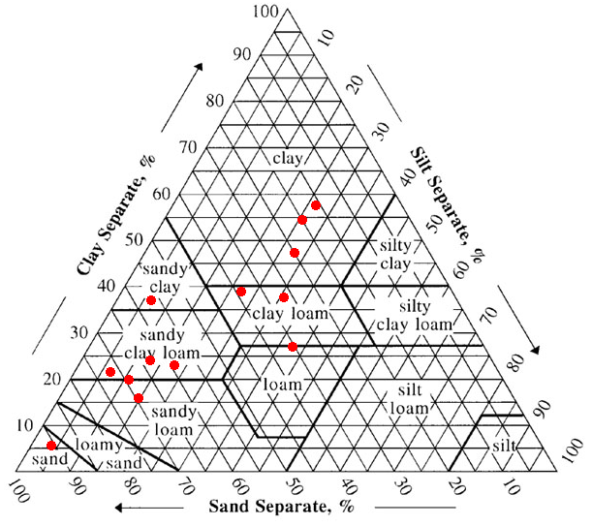
Appendix figure 2: The soil texture triangle
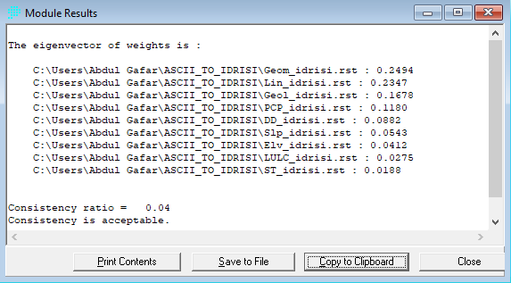
Appendix Figure 3: The WEIGHT module of IDRISI Selva’s pair-wise comparison matrix eigenvector and CR value of evaluation criteria
Appendix table 6: Symbols and the short descriptions of lithological units
Code | Symbol and their Description
Qe | Quaternary Eluvium Sediment: Red to reddish brown sandy soil, black cotton soil, calcrite, minor ferricrite, silt and clay. The elluvial sediments are the weathering product of the underlying parent rock occurring insitu. It is a Local and Low productive intergranular aquifer developed at the flat lying eastern plain part of the study area (Kebede and Mulugeta, 2011).
Qv (Qg) | Ginnir Basalt: Often Scoraceous with minor cinder cones of Scoria and Scoraceous olivine-phyric basalt vitric tuff. Extensive fracture volcanic aquifer (Kebede and Mulugeta, 2011; Kiflu et al., 2009; Mulugeta and Tafa, 2010; Zewdie, 2011).
Nn | Nazret group: Stratoid silics: ignimbrites, unwelded tuff, ash flow, rhoyolites and trachyte. Extensive and high productive fracture and/or porous volcanic aquifer (Kiflu et al., 2009; Zewdie, 2011).
Ntr3(PNa2) | Alkali trachyte flows; Aphantic, aphyritic alkali trachytes and scattered trachytic plugs, minor proclastic rock and basalt flows. Extensive and Low productive Fractured volcanc aquifer (Kiflu et al., 2009; Zewdie, 2011).
Ntr2(PNa3) | Alkali trachyte and basalt flows; alkali trachyte plugs are common. Extensive, and moderately productive fractured volcanic aquifer (Kiflu et al., 2009; Zewdie, 2011).
NMt (Tab) | Teltele Basalt: Aphyritic basalt: Extensively developed Medium to High productive, fractured jointed and/or porous aquifer (Gobena et al., 1997; Kifle and Hailemriam, 2010).
PNb1(PNb) | Alaji formation/ lower flood basalt: Aphyric and prophytic basalt flows with lesser visicular basalt, minor alkali trachyte flows and tuffs. Extensive and Moderately productive fractured volcanic aquifer (Kebede and Mulugeta, 2011; Zewdie, 2011).
Kg1(Kg) | Lower Korahe formation; sandstone with beds of dolomite limestone, marl, shale, gypsum. Extensive and low productive fractured and intergranular or sedimentary aquifer (Kebede and Mulugeta, 2011; Zewdie, 2011).
Jg (Jg2) | Upper Gabredarre formation: Thinly bedded alternating oolitic and marl limestone inter-bedded in the upper part with gypsum and shale. Extensive and moderately productive fractured and karstic sedimentary aquifer (Kebede and Mulugeta, 2011).
Appendix table 7: Major soil groups and their short description
Major soil groups | Short description
Arenosols | Arenosols comprise unconsolidated deep sandy soils. This includes soils in residual sands after in situ weathering of usually quartz-rich sediments or rock, and soils in recently deposited sands such as dunes in deserts and beach lands. In the dry zone, Arenosols are featuring very weak or no soil development.  Parent material: Unconsolidated, in places calcareous, translocated materials of sandy texture; relatively small areas of Arenosols occur in extremely weathered siliceous rock.
Cambisols | Weakly to moderately developed soils. Most Cambisols are medium-grained and have a good structural stability, a high porosity, and good water holding capacity and good internal drainage. Most Cambisols also contain at least some weatherable minerals in the silt and sand fractions. Based on these characteristics, Cambisols have a good infiltration capacity to recharge groundwater.  Parent material: Medium and fine textured materials derived from a wide range of rocks.
Leptosols | Leptosols comprise very thin (shallow) soils over continuous rock and soils that are extremely rich in coarse fragments or in unconsolidated very gravelly material. Leptosols are particularly common in mountainous regions.  Parent material: Various kinds of continuous rock or of unconsolidated materials with less than 20 percent (by volume) fine earth.
Luvisols | Soils with sub-surface accumulation of high activity clays and high base saturation. Porous and well aerated topsoil. Luvisols have a higher clay content in the sub-soil than in the topsoil.  Parent material: A wide variety of unconsolidated materials including glacial till, and aeolian, alluvial and colluvial deposits.
Regosol | Regosols are very weakly developed mineral soils in unconsolidated materials that do not have a mollic or umbric horizon, are not very thin or very rich in coarse fragments (Leptosols), not sandy (Arenosols), and not with fluvic materials (Fluvisols).  Parent material: unconsolidated, generally fine-grained material.
Solonetz | Solonetz have a dense, strongly structured, clayey sub-surface horizon that has a high proportion of adsorbed sodium and in some cases also magnesium ions.  Parent material: Unconsolidated materials, mostly fine-textured sediments.
Vertisols | Vertisols (known as black cotton soil) are heavy clay soils with a high proportion of swelling clays. Vertisols are characterized by their sticky nature and high water holding capacity and low infiltration capacity. These soils become very hard and form deep wide cracks from the surface downward when they dry out, which happens in most years.  Parent material: Sediments that contain a high proportion of swelling clays, or swelling clays produced by neoformation from rock weathering.
Source: (FAO, 2015; IUSS Working Group WRB, 2015; Nachtergaele et al., 2009)
Appendix table 8: The water points inventory data
S.N0. | Site Name | UTM  X | UTM  Y | Y  (LPS) | HH  (m) | Type | DGW  PZ | AGW  PZ
1 | Koso Lega | 621667 | 776447 | 1.5 | 2422 |  | M | M
2 | Ali_a | 601367 | 802109 | 4 | 2421.4 |  | M | H
3 | Robe TTI_2 | 610410 | 786164 | 0 | 2419 | BH | H | H
4 | Oyora_2 | 622382 | 779466 | 2.5 | 2417 |  | M | M
5 | Sheydeba-Ar | 620729 | 778201 | 2 | 2416 |  | H | M
6 | Ali No_14 | 603042 | 799576 | 0 | 2411 | BH | L | L
7 | Fasil Sura | 622767 | 780108 | 2.5 | 2409 |  | M | M
8 | Ali W_No_4 | 593834 | 803243 | 0 | 2399 | BH | H | H
9 | Ashuta | 619782 | 780492 | 4.5 | 2394.3 |  | H | H
10 | Ali W_011 | 603042 | 799576 | 0 | 2381 | BH | H | H
11 | Ali town_2 | 603062 | 800338 | 0 | 2373 | BH | L | L
12 | Amigna Shr1 | 637389 | 810924 | 0.05 | 2369 | DW | M | M
13 | Elanigde Mt | 593966 | 803587 | 2 | 2362.6 | BH | M | M
14 | Mio(WR12k) | 589000 | 785000 | 15 | 3107 | SP | VH | HV
15 | Zalo Abe_2 | 587208 | 786697 | 0.2 | 3086 | SP | M | L
16 | Abakrazal_2 | 592941 | 787853 | 0.18 | 2939 | SP | L | L
17 | Abkarazal_3 | 594319 | 788161 | 0.14 | 2881 | SP | L | L
18 | Mio Gasera | 596266 | 784965 | 40 | 2792 | SP | H | VH
19 | Goba1 | 606911 | 771199 | 4.5 | 2770.5 |  | H | H
20 | Goba3 | 607202 | 771329 | 4 | 2756 |  | H | H
21 | Goba2 | 607647 | 771571 | 3 | 2745.5 |  | H | M
22 | Chelo_RMly | 601204 | 783645 | 9 | 2661 | SP | H | H
23 | Werbo_RMl | 599691 | 785277 | 8 | 2656 | SP | H | H
24 | Robe_ORMl | 599555 | 785878 | 20 | 2642 | SP | VH | VH
25 | Kasowara | 597012 | 796128 | 0.27 | 2582 | SP | L | L
26 | kedu | 613500 | 767963 | 0 | 2542 |  | M | M
27 | Aloshe | 612589 | 774143 | 2.5 | 2522 |  | M | M
28 | oyora1 | 612597 | 774254 | 2 | 2519 |  | M | M
29 | Aloshe1 | 612401 | 775436 | 2 | 2516 |  | M | M
30 | Robe No 1 | 611048 | 784924 | 1 | 2516 | BH | M | M
31 | Aloshe3 | 612495 | 775999 | 2 | 2512.5 |  | M | M
32 | Robe_C_Sch | 610824 | 784977 | 1 | 2512 | BH | H | M
33 | Aloshe2 | 613058 | 775624 | 2 | 2510 |  | M | M
34 | Aloshe4 | 613151 | 775061 | 2 | 2510 |  | M | M
35 | Robe1 | 609686 | 784235 | 7 | 2509.6 |  | H | H
36 | Robe-Cth | 610601 | 784670 | 2.5 | 2508.5 |  | M | M
37 | Robe No 2 | 611162 | 785579 | 2.42 | 2507 | BH | M | M
38 | Robe3 | 610442 | 783383 | 7 | 2507 |  | H | H
39 | Robe2 | 609590 | 785222 | 4 | 2499.7 |  | H | H
40 | Haseno Gnt | 592389 | 801962 | 0 | 2496 | SP | H | H
41 | Robe No 4 | 611139 | 786804 | 2 | 2491 | BH | M | M
42 | D/Misra | 617673 | 776271 | 5 | 2488.1 |  | H | H
43 | Elasa | 617321 | 772261 | 4.5 | 2485 |  | H | H
44 | Robe Kndrg. | 611254 | 787346 | 1 | 2483 | BH | M | M
45 | Robe town_6 | 611730 | 786993 | 1 | 2482 | SP | M | MM
46 | Robe OIDA | 610268 | 785187 | 0 | 2480 | SP | M | M
47 | Ali Akabi_4 | 602659 | 802014 | 2.5 | 2479 | BH | M | M
48 | Abakara | 616134 | 776820 | 2 | 2474 |  | M | M
49 | Elabidu No 4 | 601716 | 797936 | 0 | 2474 | BH | M | M
50 | Elabidu No 5 | 601507 | 798213 | 0 | 2468 | SP | M | M
51 | Misira | 619550 | 775382 | 0.25 | 2465 | SP | L | L
52 | Elabidu No 3 | 601958 | 796984 | 0 | 2462 | BH | H | H
53 | Elabidu No 1 | 601519 | 797776 | 0 | 2460 | BH | H | H
54 | Elabidu No 2 | 601645 | 797714 | 0 | 2456 | BH | H | H
55 | Robe No 3 | 611249 | 786148 | 0 | 2455 | BH | L | L
56 | Robe TTC_1 | 610276 | 786068 | 0 | 2455 | DW | H | H
57 | Ali town_1 | 603061 | 800340 | 0 | 2453 | BH | L | L
58 | Haro Borama | 621532 | 776810 | 0 | 2451 |  | L | L
59 | WachoMish. | 623861 | 772782 | 3.5 | 2444.5 |  | H | H
60 | Ali _No_17 | 592001 | 799554 | 0 | 2444 | BH | H | H
61 | Bale_R_A.P. | 614635 | 786982 | 5 | 2443.7 | BH | H | H
62 | BMH | 611056 | 786642 | 0 | 2440 | DW | H | H
63 | Mechemena | 621700 | 776587 | 0 | 2438 |  | L | L
64 | Ali_W._3 | 593841 | 799558 | 0 | 2437 | BH | H | H
65 | Elebdu VI 23 | 601205 | 797730 | 0 | 2435 | BH | H | H
66 | Robe_NCA1 | 608594 | 784847 | 0 | 2429 | BH | H | H
67 | B.A.I.R | 610431 | 786693 | 0 | 2428.7 | BH | H | H
68 | Selka Oda_a | 633411 | 783903 | 2 | 2427 | BH | M | M
69 | Derara | 621700 | 776870 | 1.5 | 2423 |  | M | M
70 | Asenberara | 629561 | 794041 | 0.05 | 2362 | SP | L | L
71 | Reteba No 2 | 590760 | 806628 | 0 | 2359 | BH | H | H
72 | Elanigdge_1 | 594260 | 803315 | 0 | 2358 | BH | M | M
73 | Sebaja G._2 | 590614 | 807842 | 0 | 2354 | BH | H | H
74 | Reteba No 1 | 590784 | 805805 | 0 | 2353 | BH | M | M
75 | Sebaja G._5 | 590991 | 807454 | 0 | 2345 | SP | H | H
76 | Assano_029 | 591994 | 803239 | 0 | 2344 | BH | H | H
77 | New Selka_2 | 632682 | 783522 | 0 | 2344 | BH | H | H
78 | AmijaHaro 5 | 595664 | 808774 | 0 | 2318 | BH | M | M
79 | Abugure_08 | 636127 | 814396 | 0 | 2270 | DW | L | LL
80 | Coloba Sur. | 603019 | 819384 | 0 | 2242.6 | DW | M | M
81 | Amalama_06 | 644016 | 787401 | 0 | 2210 | BH | H | H
82 | Kubsa No 2 | 650580 | 787352 | 0 | 1952 | SP | L | L
83 | Kubsa No 1 | 650924 | 787142 | 0 | 1926 | BH | H | H
84 | Hisu_No_ 13 | 645385 | 794152 | 0 | 1894 | SP | H | H
85 | Elani Abiyu | 682444 | 781206 | 0.25 | 1845 | SP | L | L
86 | Weltai Nga_1 | 657086 | 782985 | 0 | 1791 | BH | H | H
87 | Weltai Nga_2 | 657319 | 782613 | 0 | 1786 | BH | H | H
88 | Weltai Nga_3 | 658012 | 782490 | 0 | 1778 | SP | H | H
89 | Bale Dureni | 667575 | 784572 | 2.5 | 1754 | SP | M | M
90 | BaleAlmKr1 | 664178 | 780630 | 0 | 1718 | BH | M | M
91 | Melka Oda | 695164 | 774045 | 2 | 1441.7 | BH | L | M
92 | Weltei Drs_3 | 624586 | 741314 | 0 | 1330 | DW
93 | Weltei Drs_2 | 624777 | 741155 | 0 | 1316 | DW
94 | Weltei Drsa_1 | 624951 | 741025 | 0 | 1312 | DW
95 | Melka Oda_2 | 705448 | 773777 | 0 | 1165 | SP
96 | Chelchel_2 | 729099 | 763783 | 0.4 | 1111 | BH
97 | Chelchel_1 | 729188 | 763589 | 0.4 | 1107 | BH
98 | Tedcha_BL_2 | 734767 | 762840 | 0 | 1078 | BH
99 | Tedcha_BL_1 | 733893 | 762962 | 0 | 1037 | BH
100 | Arda Kello | 736292 | 754011 | 1 | 971 | BH
101 | Tedcha_Alm1 | 737637 | 750255 | 0 | 934 | BH
102 | TedchaAlm2 | 739480 | 750264 | 1 | 912 | BH
103 | Gabu Oda | 748669 | 755837 | 0 | 906 | BH
104 | Tedcho Frda | 741268 | 746967 | 0 | 775 | BH
105 | GermbDma_4 | 573289 | 782900 | 0 | 3438 | DW
106 | Dinsa W_N0 | 677972 | 824208 | 1.5 | 1841 | BH
107 | Micha | 718785 | 825057 | 4 | 1291 | BH
108 | DirieGudo No 1 | 674733 | 823591 | 0 | 1879 | BH
109 | Araremo BH | 672466 | 823146 | 2.5 | 1946 | DW
110 | BulalaFurfrsa | 675194 | 816242 | 0 | 1756 | BH
111 | Tagay | 668509 | 813130 | 0 | 1845 | SP
112 | Adele | 709974 | 811366 | 1.5 | 1568 | BH
113 | Harewa No 4 Motrzd | 687349 | 810879 | 2.2 | 1876 | BH
114 | Hada | 741609 | 810553 | 1.67 | 1226 | BH
115 | Suratari No. 1 | 687048 | 810723 | 0 | 1800 | BH
116 | Elbulcki No. 1 | 687209 | 808574 | 2 | 1898.46 | BH
117 | Harewa No 7 | 687037 | 808639 | 3 | 1915 | BH
118 | Hesernege No. 1 | 687209 | 808574 | 1.75 | 1889.25 | BH
119 | Harewa No 3_2 | 687038 | 807960 | 1.9 | 1888 | BH
120 | Wadja No. 1 | 690131 | 806588 | 0 | 1825 | BH
121 | Harewa No 1 & 2 | 685261 | 805957 | 0 | 1849 | BH
122 | Harewa No_2 | 685027 | 805989 | 0 | 1868 | BH
123 | Elbuco & Harwa_8 | 683899 | 805240 | 0 | 1908 | BH
124 | Harawa No. 2 | 680319 | 805323 | 0 | 2068 | BH
125 | Harawa No. 3 | 680319 | 805323 | 0 | 2002 | BH
126 | Harawa No. 4 | 680319 | 805323 | 0.42 | 2092 | BH
127 | Harawa No. 5 | 680319 | 805323 | 0 | 1916 | BH
128 | Weltai Atota | 672952 | 804715 | 0 | 2037 | BH
129 | Wolti Hatota No. 3 | 678486 | 803473 | 2 | 2011 | DW
130 | Wolti Hatota No. 2 | 672198 | 803144 | 0 | 1879 | BH
131 | Akasha | 679194 | 801693 | 3 | 1962 | SP
132 | Harana No. 1 | 684934 | 801807 | 0 | 1760 | BH
133 | Arda Gelma | 703138 | 801078 | 2.5 | 1703 | SP
134 | Kebena | 673327 | 798220 | 0 | 1969 | BH
135 | Tulu Jaja No 3 | 686627 | 797056 | 0.5 | 1883 | DW
136 | Sede Fente No 2 | 684845 | 795839 | 0.6 | 1858 | BH
137 | Tulu Jaja No 1 | 686853 | 795623 | 3 | 1849 | BH
138 | Tulu Jaja No 2 | 686381 | 795589 | 0.3 | 1852 | BH
139 | Sede Fente No 1 | 684485 | 795510 | 2 | 1858 | BH
140 | Ebisa | 683136 | 792317 | 0.6 | 1911 | SP
141 | Ginir | 690000 | 788000 | 1.7 | 1900 | SP
142 | Gamora | 639953 | 780710 | 1.56 | 2245 | DW
143 | Tullicha No 4 | 700047 | 779439 | 2.5 | 1360 | BH
144 | Tullicha No 1 | 700903 | 778997 | 0 | 1296 | BH
145 | Tullicha No 2 | 700497 | 778771 | 0.5 | 1354 | BH
146 | Tullicha No 3 | 700224 | 779151 | 0.5 | 1361 | BH
147 | Sinana_3St. Frm | 643010 | 778424 | 1.52 | 2264 | SP
148 | SelkaW_No.012 | 645432 | 777567 | 0 | 2146 | BH
149 | Melka Oda | 703398 | 775701 | 0 | 1311 | BH
150 | Melka Oda No. 1 | 705143 | 773469 | 1.1 | 1298 | BH
152 | Weltai Chefa | 664708 | 771782 | 0 | 1694 | BH
153 | Gamo Duksi | 749680 | 770946 | 0 | 1263.57 | BH
154 | Duksi No. 1 | 706092 | 766407 | 2 | 1268 | BH
155 | Keku W.No_025 | 685982 | 766639 | 0 | 1376 | SP
156 | Melka Buta | 678614 | 766613 | 2.5 | 1580 | SP
161 | Gamo Duksi No. 1 | 704576 | 761332 | 0 | 1208 | BH
164 | Ardatere No. 1 | 697083 | 753347 | 0 | 1449.91 | SP
The abbreviation DGWPZ, AGWPZ, Y(LPS), HHSP, BH, DW, VH, H, M, L and VL represent Delineated groundwater potential zone, Actual groundwater potential zone, Yield liter per second, Hydraulic head, spring, bore hole, dug well, very high, high, moderate, low and very low.
Appendix table 9: AHP matrix, relative weight, and CR of rainfall thematic map
Contribution | Very high | High | Moderate | Low | Very low | λmax | 5.21
Very high | 1 | 3 | 4 | 5 | 7
High | 1/3 | 1 | 3 | 5 | 6 | C.I | 0.053
Moderate | 1/4 | 1/3 | 1 | 4 | 5
Low | 1/7 | 1/5 | 1/4 | 1 | 2 | R. I | 1.12
Very low | 1/9 | 1/7 | 1/5 | 1/2 | 1
Relative weight (%) | 49 | 26 | 15 | 6 | 4 | CR | 0.04
Appendix table 10: AHP matrix, relative weight, and CR of LULC thematic map
LULC | F | BL | GL | A | SB | λmax | 5.27
F | 1 | 3 | 4 | 7 | 9
BL | 1/3 | 1 | 3 | 5 | 7 | C.I | 0.06
GL | 1/4 | 1/3 | 1 | 4 | 5
A | 1/7 | 1/5 | 1/4 | 1 | 3 | R. I | 1.12
SB | 1/9 | 1/7 | 1/5 | 1/3 | 1
Relative weight (%) | 49 | 26 | 15 | 7 | 3 | C.R | 0.06
The acronyms F, BL, GL, A, and SB represent Forest, Bush land, Grass land, Agriculture, and Settlement/Bare lands.
Appendix table 11: AHP matrix, relative weight, and CR of landforms thematic map
Landforms | P/V | OS/US | MsD/S | UD/LR | MsR/HR | λmax | 5.170
P/V | 1 | 2 | 3 | 7 | 9
OS/US | 1/2 | 1 | 2 | 6 | 8 | C.I | 0.043
MsD/S | 1/3 | 1/2 | 1 | 2 | 6
UD/LR | 1/7 | 1/6 | 1/2 | 1 | 2 | R. I | 1.12
MsR/HR | 1/9 | 1/8 | 1/6 | 1/2 | 1
Relative weight (%) | 45 | 29 | 16 | 6 | 4 | CR | 0.04
Note: P-Plain, V-Valley OS-Open slope, US-Upper slope, MsD-Mid-slope drainage, S-Stream, UD-Upper Drainage, LR-Local Ridge, MsR-Mid-slope ridge, HR-High Ridge
Appendix table 12: AHP matrix, relative weight, and CR of slope thematic map
Slope | Flat | Gentle | Moderate | Steep | Very Steep | λmax | 5.196
Flat | 1 | 2 | 5 | 8 | 9
Gentle | 1/2 | 1 | 3 | 7 | 9 | C.I | 0.0489
Moderate | 1/5 | 1/3 | 1 | 2 | 4
Steep | 1/8 | 1/7 | 1/2 | 1 | 2 | R. I | 1.12
Very Steep | 1/9 | 1/9 | 1/4 | 1/2 | 1
Relative weight (%) | 47 | 32 | 11 | 6 | 4 | CR | 0.04
Appendix table 13: AHP matrix, relative weight, and CR of lineament density
Contribution | Very high | High | Moderate | Low | Very low | λmax | 5.10
Very high | 1 | 2 | 3 | 5 | 8
High | 1/2 | 1 | 2 | 4 | 7 | C.I | 0.02
Moderate | 1/3 | 1/2 | 1 | 3 | 5
Low | 1/5 | 1/4 | 1/3 | 1 | 3 | R. I | 1.120
Very low | 1/8 | 1/7 | 1/5 | 1/3 | 1
Relative weight (%) | 43 | 28 | 17 | 8 | 4 | CR | 0.02
Appendix table 14: AHP matrix, relative weight, and CR of drainage density
Contribution | Very high | High | Moderate | Low | Very low | λmax | 5.2866
Very high | 1 | 2 | 3 | 8 | 9
High | 1/2 | 1 | 2 | 5 | 7 | C.I | 0.0716
Moderate | 1/3 | 1/2 | 1 | 5 | 7
Low | 1/8 | 1/5 | 1/5 | 1 | 2 | R. I | 1.1200
Very low | 1/9 | 1/7 | 1/7 | 1/2 | 1
Relative weight (%) | 45 | 27 | 19 | 5 | 4 | CR | 0.06
Appendix table 15: AHP matrix, relative weight, and CR of elevation thematic map
Contribution | Very high | High | Moderate | Low | Very low | λmax | 5.1439
Very high | 1 | 2 | 2 | 3 | 4
High | 1/2 | 1 | 2 | 3 | 4 | C.I | 0.0360
Moderate | 1/2 | 1/2 | 1 | 3 | 3
Low | 1/3 | 1/3 | 1/3 | 1 | 2 | R. I | 1.1200
Very low | 1/4 | 1/4 | 1/3 | 1/2 | 1
Relative weight (%) | 36 | 27 | 20 | 10 | 7 | CR | 0.03
Appendix table 16: AHP matrix, relative weight, and CR of soil thematic map
Soil | S | SL | L | SCL/CL | C/SC | λmax | 5.1882
S | 1 | 3 | 5 | 7 | 9
SL | 1/3 | 1 | 3 | 4 | 6 | C.I | 0.0471
L | 1/5 | 1/3 | 1 | 3 | 5
SCL/CL | 1/7 | 1/4 | 1/3 | 1 | 2 | R. I | 1.1200
C/SC | 1/9 | 1/6 | 1/5 | 1/2 | 1
Relative weight (%) | 51 | 25 | 14 | 6 | 4 | C.R | 0.04
Note: S-Sand, SL-Sandy loam, L-Loam, SCL-Sandy clay loam, CL-clay loam, C-Clay (light), SC-Sand clay
Appendix table 17: AHP matrix, relative weight, and CR of geologic thematic map
Geological unit | Nn | Nmt/Qg | PNb/PNa3 | Qe/Jg | PNa2/Kg1 | λmax | 5.2621
Nn | 1 | 3 | 5 | 6 | 7
Nmt/Qg | 1/3 | 1 | 3 | 4 | 5 | C.I | 0.0655
PNb/PNa3 | 1/5 | 1/3 | 1 | 3 | 5
Qe/Jg | 1/6 | 1/4 | 1/3 | 1 | 2 | R.I | 1.1200
PNa2/Kg1 | 1/7 | 1/5 | 1/5 | 1/2 | 1
Relative weight (%) | 49 | 24 | 15 | 7 | 5 | CR | 0.05

