QUANTIFYING AND MODELING OF SOIL DUST EMISSION RELEASED FROM GRAVEL ROAD (THE CASE OF DC4 STANDARD ROAD FROM HAWASSA REFERRAL ROUNDABOUT TO HAWASSA AIRPORT)

MSc THESIS SPECIALIZATION in: Road AND Transport Engineering
DANIEL HAILEMARIAM WELDEMICHAEL
HAWASSA UNIVERSITY, HAWASSA, ETHIOPIA
NOVEMBER, 2020

QUANTIFYING AND MODELING OF SOIL DUST EMISSION RELEASED FROM GRAVEL ROAD (THE CASE OF DC4 STANDARD ROAD FROM HAWASSA REFERRAL ROUNDABOUT TO HAWASSA AIRPORT)
DANIEL HAILEMARIAM WELDEMICHAEL
A Thesis Submitted TO Hawassa university
DEPARTMENT OF CIVIL ENGINEERING,
Hawassa Institute of Technology,
SCHOOL OF GRADUATE STUDIES,
Hawassa university,
Hawassa, ethiopia

In Partial Fulfillment Of The
Requirements for The Degree of
Master of Science in Civil Engineering
(SPECIALIZATION: Road AND Transport Engineering)
NOVEMBER, 2020
ADVISORS’ APPROVAL SHEET
This is to certify that the thesis entitled “Quantifying and Modeling of Soil Dust Emission Released from Gravel Road, (The Case of DC4 Standard Road from Hawassa Referral Roundabout to Hawassa Airport)” submitted in partial fulfillment of the requirements for the degree of Master’s with specialization in Road and Transport Engineering, the Graduate Program of the Department of Civil Engineering, and has been carried out by Daniel Hailemariam ID. No. PGRoTrR/007/11, under our supervision. Therefore, we recommend that the student has fulfilled the requirements and hence hereby can submit the thesis to the department.

Ashenafi A. Weldemichael (PhD.) ______ _11/12/2020__
Name of Major Advisor Signature Date
Daniel Chufamo (MSc.) _______________ ______________
Name of Co-advisor Signature Date

EXAMINERS’ APPROVAL SHEET
We, the undersigned, members of the Board of Examiners of the final open defense by Daniel Haile Mariam have read and evaluate his thesis entitled “quantifying and modeling of dust emission from gravel road “The Case of DC4 Standard Road from Hawassa Referral Roundabout to Hawassa Airport”, and examined the candidate. This is, therefore, to certify that the thesis has been accepted in partial fulfillment of the requirements for the degree.

_______________________ ___________ _______________
Name of Major Advisor Signature Date
________________________ ___________ _______________
Name of Internal Examiner Signature Date
________________________ ___________ _______________
Name of External Examiner Signature Date
________________________ ___________ _______________
Name of Chairperson Examiner Signature Date
________________________ ___________ _______________
SGS Approval Signature Date

DECLARATION

I hereby declare that this MSc thesis entitled “The Case of DC4 Standard Road from Hawassa Referral Roundabout to Hawassa Airport” is my original work and has not been presented for a degree in any other university, and all sources of material used for this thesis have been duly acknowledged.

Name: Daniel Hailemariam
Email: Danielhailemariam4@gmail.com / Dani200477@hu.edu.et
Phone: +251-913-609-241
Hawassa University, Ethiopia
Signature: _______________

This MSc thesis entitled “The Case of DC4 Standard Road from Hawassa Referral Roundabout to Hawassa Airport” has been submitted for examination with my approval as thesis advisor.

Name: Dr. Ashenafi Aregawi (PhD)
Signature: _______________
Place and Date of Submission: 11/12/2020 Hawassa-Ethiopia.

ACKNOWLEDGEMENT
First of all, I would like to thanks almighty God for his grace and love. It is also my great pleasure to express my deepest gratitude to my advisors Dr. Ashenafi Aregawi and Mr. Daniel Chufamo for their guidance and skill full advice during course work and research work. I would also like to thank for the sponsorship of Ethiopian road authority (ERA), and Hawassa University graduate research program. I want to thank those who supported me in all those successfully conducted in every aspect of this research.
Finally, it is my pleasure to thank my families for their unlimited support and encouragement throughout the research to accomplish.

LIST OF ABBREVIATIONS
AASHTO American Association of State Highways and Transport Organization
ADT Average Daily Traffic
ASTM American Standard Test Manual
CBR California bearing ratio
GD Gravel Dust
DC Design Class
DCP Dynamic Cone Penetrometer
EPA Environmental Protection Agency
ERA Ethiopian Road Authority
ISO International standard organization
MLR Multiple Linear Regression
MMP Mean monthly precipitation
OMC Optimum Moisture Content
PI Plasticity Index
PM10 Particulate matter less than or equal to 10 in diameter
PM2.5 Particulate matter less than or equal to 2.5 in diameter
P0.075 Percentage of the Surfacing material passing 0.075-mm sieve
SANS South African National Standards
SPSS Statistical Package for the Social Sciences
TSP Total suspended particulate
UK United Kingdom
USA United States of America
USCS Unified Soil Classification System
ANOVA Analysis of Variance

TABLE OF CONTENTS
ACKNOWLEDGEMENT I
LIST OF ABBREVIATIONS II
LIST OF TABLES V
LIST OF FIGURES VI
1 INTRODUCTION 1
1.1 Background of the Study 1
1.2 Statement of the Problem 3
1.3 Objectives 3
1.3.1 General Objective 3
1.3.2 Specific Objectives 3
1.4 Research Questions 4
1.5 Significance of the Study 4
1.6 Scope and Limitations of the Study 4
1.6.1 Scope of the Study 4
1.6.2 Limitation of the Study 4
2 LITERATURE REVIEW 5
2.1 Introduction 5
2.2 How Dust Forms 11
2.3 Sources of Dust 13
2.4 Dust Erosion and Subsequent Transport 13
2.5 Dust Fallout Monitoring Methods 15
2.6 Measurement of Dust Emissions 21
2.7 Characterization of Soil Dust 24
2.8 Models for Adoption Gravel Road 26
3 MATERIALS AND METHODS 31
3.1 Description of the Study Area 31
3.2 Study Subject 32
3.3 Data Collection 33
3.3.1 Sample Size and Sampling Techniques 34
3.3.2 Criteria for Sample Selection 34
3.4 Study Design and Study Methodology 35
3.5 Data Management and Analysis 36
3.5.1 Dust Data Analysis 36
3.5.2 Surfacing Material Data Analysis 41
3.5.3 Meteorological Data 43
3.5.4 Traffic Count Data 45
3.5.5 Model Data Analysis 46
4 RESULTS AND DISCUSSIONS 47
4.1 Results 47
4.1.1 Gravel Dust Observation Result 47
4.1.2 Material Test Results 49
4.1.3 Modeling of Gravel Dust result 53
5 CONCLUSIONS AND RECOMMENDATIONS 61
5.1 Conclusions 61
5.2 Recommendations 62
REFERENCES 63
APPENDICES 66

LIST OF TABLES
Table 2.1: Road classes in Ethiopia 5
Table 2.2: Relationships developed between CBR and DCP by different authors 9
Table 2.3: Description of different standard deposit gauges 18
Table 2.4: Nuisance dust mass deposition measurements 18
Table 2.5: Dust standards, target, action and alert thresholds for dust deposition 18
Table 2.6: The National Dust control regulation 19
Table 2.7: Visual Rating for road dust 22
Table 2.8: Precipitant Dust particle with an aerodynamic diameter 24
Table 2.9: Dust deposit percent pass (Inhalable) 24
Table 2.10: Dust deposit percent pass (Thoracic) 25
Table 3.1: Study location description 32
Table 3.2: Data Source and Size 33
Table 3.3: Meteorological Data 44
Table 3.4: Traffic Volume of the Selected Roads 45
Table 4.1: Summarized Material test result 50
Table 4.2: Summary of R-square, Significance, and MLR results 54
Table 4.3: Analysis of variance 59
Table 4.4: Variance Inflation Factors of Independent Variables 60

LIST OF FIGURES
Figure 2.1: Material quality zones 7
Figure 2.2: Dynamic Cone Penetrometer Test 9
Figure 2.3: Correlation Plot of CBR versus DCP Index 10
Figure 2.4: Example of DCP Data plot for three tests in similar type soils. 10
Figure 2.5: Creation of fugitive dust 11
Figure 2.6: Sources of dust on gravel roads 12
Figure 2.7: Composition of Dust 13
Figure 2.8: Modes of particle transported by wind 14
Figure 2.9: Dust measurements methods 15
Figure 2.10: Non-directional dust fall gauge 16
Figure 2.11: Single bucket dust fallout 17
Figure 2.12: standard vertical gauges 19
Figure 2.13: ISO deposit gauge 20
Figure 2.14: Dust measurement 22
Figure 2.15: Installation Requirements 23
Figure 2.16: Determination of Maximum Allowable Deducts (m). 26
Figure 3.1: Geographical Map of the research Area 31
Figure 3.2: Map of Hawassa City with study area 32
Figure 3.3: Schematics flow chart of the research 33
Figure 3.4: Single bucket dust deposition gauge monitor without windshield 37
Figure 3.5: Hydrometer apparatus 39
Figure 3.6: Dust samples analyzed by a hydrometer 41
Figure 3.7: Sample material for Atterberg limits test 42
Figure 3.8: Data Collecting from Manual DCP 43
Figure 3.9: Dry and wet sieve analysis 43
Figure 4.1: Gravel Dust deposition results 47
Figure 4.2: Particle Size distribution using Hydrometer for section C 48
Figure 4.3: Relationship between observed gravel dust and traffic volume 56
Figure 4.4: Relationship between observed gravel dust and mean monthly precipitation 56
Figure 4.5: Relationship between observed gravel dust and plasticity in 57
Figure 4.6: Relationship between observed gravel dust and <0.075 Passing 58
Figure 4.7: Relationship between observed gravel dust and (CBR) 58

ABSTRACT
A large portion of the Ethiopia road network is made up of gravel roads. Despite easy from locally available soil of better engineering properties, dust emission from these roads due to traffic at different season’s results in health and environmental problems. This study is aimed at quantifying and modeling dust emission from gravel roads of design class 4 design standard for the case Hawassa referral roundabout to Hawassa airport. The road segment has length of 33km divided into 3 segments (Hawassa Referral Roundabout – Loke Hospital village, Loke Hospital village – Dore Bafana Town and Dore Bafana Town – New Hawassa Airport). Based on systematic random sampling, 150 dust samples along the road at 2kms interval were collected over five months using single pocket record. Average daily traffic and mean monthly precipitation data (both for five months of 2017-2020) were collected as secondary data. Dust characterization was performed using hydrometer method of analysis. Result from the analysis indicated that 81.54% of the total sample collected was dust. Of these dust inhalable particulate constitute (%), 42.91, 38.94, 40.7, thoracic particulate (%) 21.6, 28.77, 31.26, and respirable particulate (%), 8.52, 12.95, 12.61.Labratory tests (plasticity index & shrinkage product, graduation, California bearing ratio) and field test (Dynamic cone penetration test) were conducted. The shrinkage product were 214,184,142 which all are between 100 and 250, implying dust is a major concern. Percent passing 75μm analysis indicated that segment A constitute high fine and clay content (9.65%) indicating decrease in strength. Whereas, B and C exhibit low fine content (12.66%, 10.52%) which is disposed for erosion. California bearing ratio of (32.54, 35.64 and 33.26%), indicating higher strength materials having low clay content, consequently corrugation problem exit. Multiple linear regression model was developed for the 3 segments between dependent variable (Gravel dust) and independent variables (Average daily traffic, mean monthly precipitation, plasticity index, percent passing 75μm and California bearing ratio). Negative relationship existed between gravel dust and California bearing ratio, whereas positive for remaining factors. Strong correlation was observed between plasticity index and silt content. The R² values were 0.991, 0.939 and 0.967.To summarize, dust is a major concern on the selected segment harms human health and environment. Considering the result of this study, stake holders should give attention to dust emission before undertaking planning and maintenance activities.
Keywords: Average daily traffic, Dust, Gravel roads, Hydrometer,

INTRODUCTION

Background of the Study
Worldwide gravel road networks are nearly 90% (Edvardsson, 2010). Windblown dust originating in the desert regions of Africa, Mongolia, Central Asia, and China can affect air quality and the population’s health in remote areas (Claiborn et al., 2000). Deposited (fall-out) dust is one of the major causes of complaints about air pollution (Mpanza et al., 2020). Deposited (fall-out) dust is one of the main causes of complaints about air pollution. Deserts, arid and semi-arid environments (covering 40% of the world land surface) are perennial sources of Aeolian dust ( Martins, J., 2014).
In Ethiopia, the current gravel road network has increased from 26550 km in 1997 to 113,066 km in 2016 (an increase of 326 percent). As a result, road density per 1000 sq. km has increased from 24.1 km in 1997 to 102.8 km in 2016. Also, substantial improvement has been registered on the condition of the country’s road network. The gravel road network proportion is in good shape; it increased from 22% in 1997 to 72% in 2016 (ERA, 2016).
Unsealed roads give rise to dust emissions during dry weather conditions when vehicles are traveling along with them. Dust generated mainly by the action of vehicular traffic and wind means loss of road surface material. The vehicle wheels also act to grind down the road aggregate and create additional fine dust material. Subsequently, the loss of surface material fines in the form of dust leads to the formation of ruts, potholes, and corrugation. The amount of dust generated and the loss of the consequent fine is determined primarily by the volume of traffic using the gravel road as well as the speed, weight, and several wheels of the vehicle. The abrasive resistance of the road surface material and the number of fines in the initial road surface material mix are also important contributing factors (Jonathan et al, 2004).
Several adverse effects can occur from dust arising from unsealed roads, including nuisance, health, and ecological impacts. Nuisance dust particles typically comprise the larger size fraction of suspended particles and are referred to as total suspended particulate (TSP – aerodynamic diameter up to 100 microns). The finer size fraction of dust particles with an aerodynamic diameter of fewer than 10 microns (PM10) is of concern regarding their potential health effects ( Johnson, K., 2016).
Application of a proper dust suppressant to a gravel road is necessary to ensure road safety and riding comfort while creating a cleaner and healthier environment for residents alongside the gravel road and reducing the need and cost of road maintenance activities and aggregate supplementation (Edvardsson, 2010). Dust is one of the most important, interesting, complex, and controversial topics in types of deterioration on a gravel road. Dust causes a lot of problems not only in Ethiopia but throughout the world. Among them are health complications, reduction in agricultural yield, pollution to the environment, and loss of road construction materials are few to mention. The dust emitted on air causes a problem not only to the road users only but it has a tremendous effect on the inhabitants of the building nearby a gravel road.
Hence, quantifying traffic generating dust will be important to know the severity of the problems, their rating, and for extent measures to be taken. This thesis has found necessary to devise some mechanism which could help the road agencies manage their road asset decision making properly by quantifying and modeling soil dust emission released from a gravel road an assist in performing road maintenance for the most appropriate Surface defects mainly focused by dustiness.

Statement of the Problem
One of the most severe problems associated with gravel roads is traffic-generated dust emissions in and around Hawassa city. Hawassa is a fast-growing city in the southern part of Ethiopia. The city’s rapid growth pace attracts many traffic mobility, thereby leaving the roads congested and used more often than their intended purposes. That leads the roads scoured, and the dust can easily escape into the environment, because of the high number of traffic traveling throughout the year (John A. and Alan L, 2007). The emitted dust particulates cause discomfort for drivers and other road users, causes visibility problems to the drivers in opposing movements and similar direction movements, thereby leaving the drivers in danger. The dust can also cause problems for the people living in a house near the gravel/earth roads. Due to dust emission, the fuel cost increases, traveling time increases, causes vehicular wear and tear, and riding discomfort (Greening, 2011).
These indicate that Hawassa city is the most disposed area and highest in terms of exposure to dust. Ethiopia Road Authority’s (ERA) unsurfaced road-distress manual condition survey that requires codes or intervention levels don’t include dust and cannot compute the Pavement Condition Index (PCI) Calculation for the entire pavement section. Different suggestions have been raised about the reason for dust emission induced damages regarding the quantification and model principles during road construction in Hawassa. The main reason for this study is, to investigate and model the causes of dust emissions along with their material properties.

Objectives

General Objective
The general objective of the research is to quantify and model the dust emission released from the gravel road.

Specific Objectives
- To analyze the characterization of soil dust using hydrometer analysis.
- To determine the material properties of the collected soil from the study area.
- To develop an MLR model that best represents dust emission of gravel roads in a section of road under this study.

Research Questions
- What is the soil dust characterization of the gravel road selected for this study?
- What are the material properties of the collected soil for gravel road selected?
- What is the best model that represent dust emission, and which factors affect it?

Significance of the study
One of the present-day issues of the Government of Ethiopia is to increase the national economy through transportation. Road users of this community react to the problems by recommending some countermeasures and gives the policy developers attention to set some policy on transportation, especially on low volume gravel road networks. This research finding helps vital for several reasons: to analyze and plan, to upgrade at the appropriate time, and to determine maintenance and rehabilitation requirements in evaluating the different maintenance and construction policies on gravel roads.

Scope and Limitations of the study

Scope of the study
This study proposed quantifying dust emissions from gravel roads and identify model variables at the selected section of gravel road from Hawassa Referral Roundabout to Hawassa Airport gravel roads which is DC-4 standard in Hawassa city. It mainly focuses on the material property of the wearing course in gravel roads, and dust emissions.

Limitation of the study
It is not possible to cover all aspects of the study area like the impact of dust, geometry parameters, vehicle overloading, and its distress type. However, the effect may not be controlled as the existing road segment geometry is variable. The road dust concentrations different from site to site, weather conditions, topography, vehicle speed, and existing gravel wearing course.

LITERATURE REVIEW

Introduction
Different standards regarding soil evaluation, dust emission released from gravel road have been reviewed and summarized in Table 2.1 (ERA, 2011a). Gravel roads are considered as low volume roads in Ethiopia (ERA, 2011a). Low volume roads are defined as those carrying up to about 300 vehicles per day and Less than about 1 million equivalent standard axles. These roads contain mainly collector and feeder roads. Ethiopian Road Authority (ERA) is responsible for major roads included in the higher design classes, predominantly DC5 and above, and has a substantial stock of roads below DC5. Regional and local authorities are responsible for roads in classes DC4 – DC1 (ERA, 2011b).
Table 2.1: Road classes in Ethiopia

Road  Function Classification |  |  |  |  | Design Standard | Design Traffic Flow AADT  (mid-life) | Surface Type | width (m) | Deign Speed (km/hr.)
 |  |  |  |  |  |  |  | Carriageway | Flat | Rolling | Moun  tainous | Escar  pment | Urban/peri urban
 |  |  |  | TRUNK | DC8 | 10,00-15,000 | Paved | Dual2*7.3 | 120 | 100 | 85 | 70 | 50
 |  |  | LINK | TRUNK | DC7 | 3,000-10,000 | Paved | 7.3 | 120 | 100 | 85 | 70 | 50
 |  |  |  |  | DC6 | 1,000-3,000 | Paved | 7 | 100 | 85 | 70 | 60 | 50
 |  | MAIN ACCESS | LINK | TRUNK | DC5 | 300-1,000 | Paved | 7 | 85 | 70 | 60 | 50 | 50
 | COLLECTOR | MAIN ACCESS | LINK | TRUNK | DC4 | 150-300 | Paved | 6.5 - 7 | 70 | 60 | 50 | 30 | 50
 |  |  |  |  |  |  | Unpaved | 7.0 - 7.5 | 70 | 60 | 45 | 30 | 50
FEEDER | COLLECTOR | MAIN ACCESS | LINK |  | DC3 | 75-150 | Paved | 6 | 70 | 60 | 50 | 30 | 50
 |  |  |  |  |  |  | Unpaved | 7 | 70 | 60 | 45 | 30 | 50
FEEDER | COLLECTOR | MAIN ACCESS |  |  | DC2 | 25-150 | Paved | 3.3 | 60 | 50 | 40 | 25 | 50
 |  |  |  |  |  |  | Unpaved | 6 | 60 | 50 | 35 | 25 | 50
FEEDER |  |  |  |  | DC1 | 1--25 | Unpaved | 4.5 | 50 | 40 | 30 | 20 | 40
 |  |  |  |  | Basic Access | <10 | Unpaved | 3.5
Source: (ERA, 2013a).
In general, the gravel roads classified as part of the low-volume road network are either engineered or partly engineered (Jonathan et al., 2004). Although there are many definitions of gravel surface roads: usually engineered and the surface material includes sand and gravel or crushed rocks are the concerns of this study (Jonathan et al., 2004).
The problem on gravel roads it is caused by the action of Traffic, Climate, and Surfacing material. It is the major variables that deterioration on gravel roads. Due to those factors that cause deterioration, corrugation, potholes, ruts, dust loose gravel, loss of gravel, stoniness, and cracking will be the final output on gravel roads. The dust affects other road users, pedestrians, and schoolchildren, houses, shops, and crops near the road (ERA, 2011b). The quantity of dust emitted into the air from gravel roads depends on the following factors, traffic, climate, and surfacing materials, which are briefly described below.
Traffic is the most significant cause of the wear of the road (Okafor et al., 2017). It comprises two active mechanisms: the slipstream and mechanical abrasion due to the driving wheel’s torque. When the vehicle’s wheel rolls along the roads, the particles on the aggregate in the surface are subjected to considerable forces. Underneath the wheel load, the carriageway deformed to some extent. The particle crushed against one another and abraded. Gradually, large particles become smaller. As regards to gravel loss, dusting becomes much more severe (Hossein, 1999).
Traffic on a dry gravel road can generate dust. Good quality gravel used in gravel road construction mixes large aggregate, sand, and fine material or binder. These fines can be picked up under the action of traffic and become air born. Dust on gravel roads creates several problems. Visibility can be severely restricted under heavy dust conditions, creating traffic safety hazards. The loss of fine material from a well-graded gravel surface can eventually lead to a loss of stability. Without the fine binder material, the larger particles become unstable and are dislodged traffic (Kassa, 2015).
Precipitation and climate during a heavy fall of rain, fine particles dislodged, suspended in the water, and carried by the water into the ditch. The condition of gravel roads varies significantly from season to season. In the spring and autumn, the carriageway is generally softened by water (Kassa, 2015). During the summer, gravel roads are often corrugated, potholed, and dusty. A high water ratio reduces bearing capacity. When water ratio is excess, cohesion decreases, and material on the road’s surface is easily dislodged by traffic. One of the consequences of this is the formation of corrugations across the gravel wearing course (Hossein, 1999).
Surfacing material selection is one of the most crucial for design and maintenance considerations. Alternative surfacing options are often considered for poor-performing unsealed roads. The problem can be resolved using quality materials (Kassa, 2015).
Performance-related specifications: for wearing course materials have been developed for southern Africa based on extensive sampling, testing, and monitoring of a large number of test sections. These specifications have been successfully implemented in a many of African countries and are considered to be generally applicable to the Ethiopian environment. The most suitable materials in terms of two basic soil parameters Shrinkage Product and Grading Coefficient which is determined from particle size distribution and linear shrinkage tests as shown in Figure 2.1(ERA, 2011a).
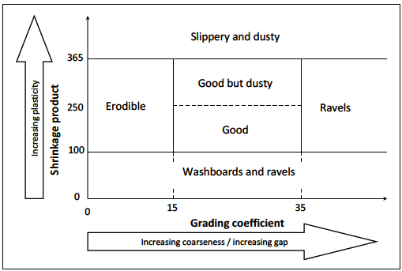
Figure 2.1: Material quality zones
Source: (ERA, 2011a)
Grading Coefficient (Gc) = ((P25 mm – P2.36 mm) x P 0.425 mm) / 100, Where P is percent passing Linear Shrinkage (Sp) = (PI x 0.5) x P 0.425 mm if PI is plasticity index is used. The material quality zones define material quality in concerning to their anticipated in-service performance. The combination of grading coefficient and shrinkage product of each material determines which material quality zone it falls into each of these predicted material performances are erodible materials are typically fine-grained and have some plasticity and perform well when used inroads on flat terrain or in areas of very low rainfall. Materials that washboard (corrugate) and ravel are usually poorly graded or gap‐graded (absence or insufficient quantities of certain sizes leading to poor aggregate interlock) and lack fines and plasticity. Materials that ravel have some plasticity, but are gap‐graded, the presence of clay usually limits wash boarding but does not prevent raveling, and materials that are slippery when wet and very dusty when dry typically have high fines and clay contents (Jones, 1996).
The load CBR values are obtained by dividing loads at 0.1 in. and 0.2 in. by the standard loads of 1,000 and 1,500 psi, respectively. These loads represent the loads required to penetrate a well-graded, minus 3/4 in., crushed limestone.100 to obtain the CBR in percent multiply each ratio. The CBR is usually selected at 0.1 in. If the CBR at 0.2 in. is greater, the test rerun. If check tests give similar results, the CBR at 0.2 inches is used (Shahin, 2005).
$CBR (\%)=\frac{Test Unit Load}{Standard Unit Load }{ *100 }$ ………...………………….…….Equation 2.1
Similar to the CBR, the DCP measures soil resistance to penetration. The field CBR, however, is much more time consuming to run than in the laboratory CBR? The DCP consists of a 5/8-in. diameter steel rod with a steel cone attached to one end. The cone is driven into the pavement layers tested by either dropping an 8-kg (17.6 lb.) or 4.6 kg (10.1 lb.) sliding hammer from a height of 22.6 in. (575 mm) (Patel, 2013). The depth of cone penetration is measure at selected penetration or hammer drop intervals and the soil strength reported in terms of DCP index. The cone must penetrate a minimum of 25 mm between recorded measurements. The penetration measurements were recorded to the nearest 5 mm. The test is complete when the cone has been driven to the desired depth (maximum 39 in.). The DCP index was calculated as a ratio in mm per blow to the 8-kg hammer. If the 4.6-kg hammer is used, multiply the ratio by 2 to obtain the DCP index value (Kessler, 2014). A plot of the correlation of the CBR versus DCP index. The correlation was developed by the U.S. Army Corps of Engineers (Webster, Grace, and Williams 1991) based on a database of field CBR vs. DCP index values collected from many sites and different soil types. A useful presentation of the DCP test data is a plot of CBR versus depth, as shown in figure 2.2.
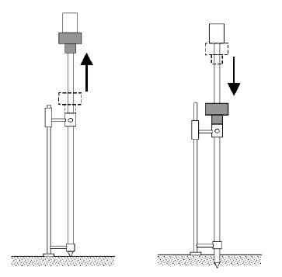
a) Before hammer dropping (b) After hammer dropping
Figure 2.2: Dynamic Cone Penetrometer Test
Source: (Gebremariam and Alemgena, 2016)
Most of the relationships developed between DCP and CBR are based on the best fit log-log equation having the form:
$Log \left(CBR\right)= A + B log \left(DCPI\right)………………….$…....Equation 2.2
Where:
CBR = California Bearing Ratio in percent
DCPI = DCP penetration resistance or penetration index in units of mm per blow
Table 2.2: Relationships developed between CBR and DCP by different authors
 | Soil type | Reference
  Correlation Equation
log(CBR) = 2.81-1.32log(DCPI) | all | Harison (1989)
log(CBR) = 2.20-0.71(log DCPI)1.5 | all | Livneh (1987)
log CBR = 2.465-1.12log(DCPI) or CBR = 292/ DCPI 1.12 | all | U.S. Army Corps of Engineers (1992)
log(CBR) = 2.48-1.057log(DCPI) | all | TRL

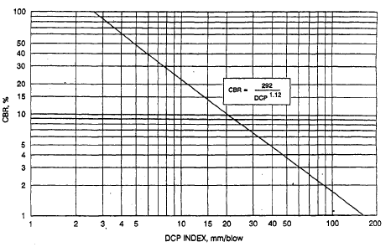
Figure 2.3: Correlation Plot of CBR versus DCP Index
Source: Webster et al. 1991, referred by, (Shahin, 2005)
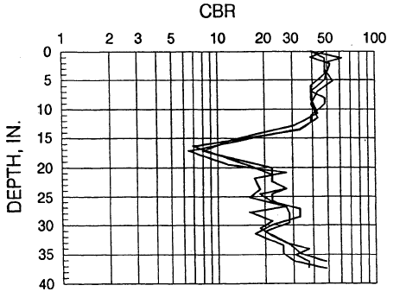
Figure 2.4: Example of DCP Data plot for three tests in similar type soils.
Source: Webster et al. 1991, refereed by,(Shahin, 2005).
The turbulence created by the air displacement around and a moving vehicle creates shearing forces that can dislodge particles from the ground surface. Once dislodged, turbulent eddies and vortices lift particles off the ground surface. As air passes over a moving vehicle, the air is forced upward over the accelerating vehicle as it gets “squeezed” between the top of the vehicle and the air above. There is room for air expansion behind the vehicle; however, the air cannot immediately fill this space. Therefore, the flow separates from the vehicle’s top surface, creating a low-pressure zone in the space directly behind the vehicle and an associated vortex (roll-up flow). The vortex lifts dust from near the road surface created by mechanical shear and turbulence created under the vehicle. Wake eddies were continued to dislodge and lift particles from the surface and keep particles suspended for a distance behind the vehicle. Larger aerodynamic vehicles create the relatively greatest turbulence amount resulting in relatively large fugitive dust Figure 2.5 (David et al., 2014).

Figure 2.5: Creation of fugitive dust
Source: (David et al., 2014).
The height that fugitive dust is lifted is a function of the turbulence created by a vehicle and dependent upon the atmosphere's stability. Under stable conditions, air does not tend to rise from the ground surface. During the settling process, relatively larger particles were settled back to the ground surface shortly after lofted. The smallest of the particles can stay aloft for several hours up to days depending on atmospheric conditions. (David et al., 2014).

How Dust Forms
A technical definition of mechanically generated dust is solid particulate matter capable of temporary (seconds to hours) suspension in air. These particles are smaller than medium-sized sand but larger than the majority of particulates found in smoke. This categorization places these particles between approximately 0.5 to more than 100 μm in particle diameter (WHO, 2014). As a size reference, the typical diameter of a human hair is 50 to 70 μm.
The generation of dust from gravel roads can be from multiple sources. Mechanical breakdown of the surfacing aggregate on gravel roads results in the generation of dust. As vehicles pass over the surfacing aggregate, the shearing force created at the interface between the vehicle tires and the aggregate generates dust. The weight of the vehicle also results in particle-to-particle grinding as the tires roll over the aggregate. This repetitive grinding breaks down the particles generating dust. Fine soil particles in the size range of dust are also present in surface aggregate when the aggregate is placed on the gravel road surface. These small particles are necessary for proper construction and performance of the road surface. Airborne dust from other sources (agricultural fields, gravel lots, etc.) can settle out onto the road resulting in re-suspension as vehicles pass. Finally, the deposition of dust attached to vehicles and vehicle tires by vehicles entering the road is another likely source of dust. The dust present on the road from these different sources becomes airborne, becoming fugitive dust (David et al., 2014).
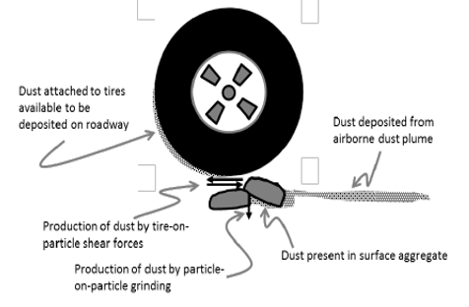
Figure 2.6: Sources of dust on gravel roads
Source: (David et al., 2014).

Sources of Dust
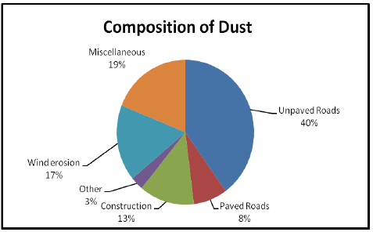
Figure 2.7: Composition of Dust
Source: EPA 1997, refereed by (Greening, 2011)
Various figures have given for dust generated on gravel roads, but the worldwide amount is thought to total over a billion tons annually. The mechanisms by which dust generated, transported, and redeposit have been mainly connected with the problems that can arise in arid conditions (Greening, 2011).

Dust Erosion and Subsequent Transport
Dust mobilization occurs only for winds velocities higher than a threshold value and is not linearly dependent on the wind fraction velocity. The threshold friction velocity, defined as the minimum friction velocity required initiating particle motion, is dependent on the size of the erodible particles and the effect of the wind shear stress on the surface. The threshold friction velocity decreases with a decrease in the particle diameter for particles with a diameter >60 μm. Particles with a diameter of <60 μm result in increasingly high threshold friction velocities due to the increasingly strong cohesion forces linking such particles to each other.
Following the exceedance of the necessary threshold friction velocity, the particle's movement depends on the relationship between the particle's weight acting downward and the opposite aerodynamic drag on the particle. The particles (<60 μm) are small enough to be transported upward by turbulent eddies. Particles in the range 60 to 2000--μm can lift from the surface at the height of some tenths of cm, but the aerodynamic drag is seldom sufficient to exceed the weight, and the particles are carried back to the surface. Such flights define a motion called saltation. The maximum height of the saltation layer is generally in the order of 1 m. Particles that are too large or too heavy to be lifted from the surface (>2000 μm) role and creep along the surface in a motion called creeping (Sibanda, 2009).
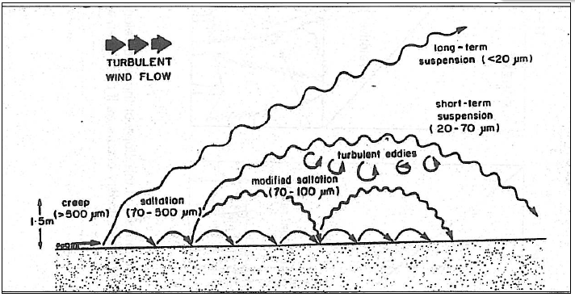
Figure 2.8: Modes of particle transported by wind
Source: Pye 1987, refereed by (Sibanda, 2009).
Sequences of dust fallout effects on the community would likely occur at wind speeds greater than 2 m/s. According to ( Sibanda, 2009), the Single Bucket at wind speeds greater than 2 m.s was collect less dust than in an area with the same atmospheric load but with lower wind speed. The reason being that collected dust is lost easily due to the scouring action of the wind-driven circulation inside the bucket, which tends to remove material already contained. This is mitigated by filling the bucket with water (Sibanda, 2009).

Dust Fallout Monitoring Methods
Dust fallout monitoring is an important practical activity for pollution control activities. Monitoring methods can be divided into two categories, namely: passive and active systems. Active monitoring methods require electricity or a pump to run. Examples include manual methods and reading instruments. On the other hand, passive monitoring methods need no source of power, poor electricity. The dust particles settle passively through gravity, adhesion, and electrostatic attraction (see Figure 2.9).

Figure 2.9: Dust measurements methods
Source: Soltani, 2011, refereed by, (Sebaiwa, 2016)
Passive samplers are designed to naturally collect dust fallout through mass transfers the operational costs associated with these samplers are extremely low, which implies several numbers can be installed. A sampling of dust fallout using these samplers can be over days, weeks, and months. Passive samplers have the advantage of giving a good overall picture of average pollutant concentrations. They usually give long averaging periods typically 1-4 weeks (Breuer, 1999). They have low operational costs, thus facilitating the installation of several samplers in non-secure areas to enhance data collection potential. The samplers must be situated in a generally open space, which allows free circulation of air. Examples of passive samplers include single and double bucket fallout monitors (Sebaiwa, 2016).
Passive samplers are divided into non-directional and directional techniques (e.g., single bucket dust fallout monitors, Frisbee gauge, and Dust watch).
Non-directional methods provide nuisance monitoring using either dust fall or surface soiling. Deposit gauges are designed to collect material deposited over a given monitoring period, typically one week to one month. They are based on the principle that course particulates suspended in the air were precipitated out either under the influence of gravity (dry deposition) or in contact with water droplets (Environmental Agency, 2003).
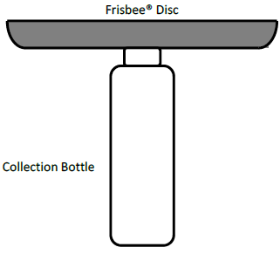
Figure 2.10: Non-directional dust fall gauge
Source: Hall and Upton, 1988, referred (David, et al, 2014)
Directional techniques single bucket dust fallout the monitor deployed according to the American Society for Testing and Materials (ASTM) D1739 standard method, which deals with the measurement of vertical dust fallout (ASTM D1739:98, 2004). This method employs single or double bucket units, half-filled with deionized water, and 10.0 mL of 3.5% bleach (hypo chloride) solution. The unit is comprised of a cradle with a 2.2 m stand above the ground and a bird ring to prevent birds from perching inside the buckets. According to (Kwata, 2014), the most recent version (ASTM, D 1739, 2010) has a windshield which aids in maximizing the laminar flow across the top of the collecting container, thereby stimulating ground-level conditions as compared to previous versions (ASTM D1739:70 and ASTM D1739:82). After the collection of dust, the buckets were sent to the laboratory for filtration and gravimetric analysis. Furthermore, these methods are cost-effective, easy to operate, electricity-independent, and allow multiple sampling stations to be established. However, only nuisance dust can be measured, and the process is laboratory intensive (Sebaiwa, 2016).
 | 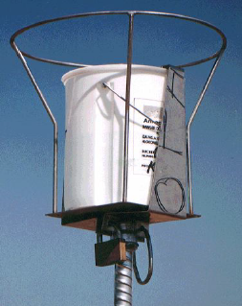 | 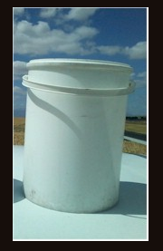 | 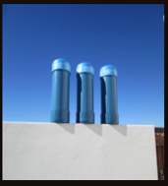
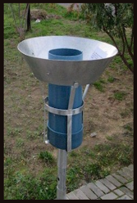 | 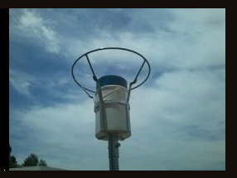 | 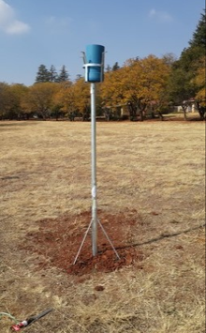 | 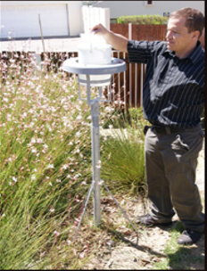
Figure 2.11: Single bucket dust fallout
Source: Dust Watch.com, 2015 and ASTM 1739-98 refereed by, (Sebaiwa, 2016)

Table 2.3: Description of different standard deposit gauges
Standard | Shape | Diameter | Depth | Extra
UK BSI, 1969 | Funnel | 300mm | 200mm
German (VDI, 1990 | Glass jar | 100mm | 200mm
US (ASTM, 1990) | Cylindrical | 150mm | 300mm | Surrounded by a Wind deflector at an angle 45º
Irish | Plastic funnel | 200 and 250mm | 300mm
ISO 1991 | Cylindrical | 200mm | 400mm
Norwegian NILU | Cylindrical | 200mm | 400mm
Source: Environment Agency 2003, refereed by, (Sebaiwa, 2016).
Table 2.4: Nuisance dust mass deposition measurements
Authority | Pollutant | Concentration Measurement | Measured as | Relevance
UK dust deposit rate | All particulates | 200mg/m²/day | Monthly mean | Serious nuisance
West Australia Nuisance standard | All particulates | 133mg/m²/day 133mg/m²/day | Monthly mean | The First loss of amenity Unacceptable reduction in air quality
West Germany Nuisance standard | All particulates | 350mg/m²/day 650mg/m²/day |  | Possible nuisance very likely nuisance
Malaysia Air Quality Standard | All particulates | 133mg/m²/day |  | Nuisance dust deposit
Source: US-EPA 2000, refereed by, (Sebaiwa, 2016)
Table 2.5: Dust standards, target, action and alert thresholds for dust deposition
1 | 2 | 3 | 4
Level | Dust fall rate, D ( mg/m²/day, 30-d average) | Average period | Permitted frequency of exceeding dust fall rate
Target | 300 | Annual | Three with any year, no two sequential months
Action residential | 600 | 30 days | Three with any year, no two sequential months
Action industrial | 1200 | 30 days | Three with any year, no two sequential months
Alert threshold | 2400 | 30 days | Three with any year, no two sequential months
Source: SANS 1929:2011, refereed by, (Sebaiwa, 2016)

Table 2.6: The National Dust control regulation
Restriction areas | Dust fall rate, D (mg/m²/day,  averaged over 30-d) | Permitted frequency of exceeding dust fall rate
Residential area | D<600 | Two within a year , not sequential months,
Non-residential area | 600<D<1200 | Two within a year , not sequential months,
Source: DEA 2013, refereed by, (Sebaiwa, 2016)
ASTM D1739:82 and ASTM D1739:98 describe a single bucket monitor, which is deployed following the ASTM standard test method for collection and analysis dust deposition rates. A straightforward device comprising a container shaped like a cylinder (in the 50% full of deionized water) exposed for 30 days. Distilled water and copper sulfate added to the dust buckets to prevent algae growth. A filtration process is used to separate dust from water. The dust then dried in an oven at 105oc and cooled at room temperature for 24 hours. A metal frame supports the cylindrical container (bucket) so that the top edge of the container is 2m above the ground. The dust deposited into the bucket vertically in two possible ways: dry deposition or wet deposition (Kwata, 2014).
There are several standard vertical gauges to measure dust deposition rates. Some of these are: ASTM D1739:82 and ASTM D1739:98 deposit gauges, BS 1747 part 1 deposit gauge, ISO deposit gauge, Frisbee dust deposit gauge, Nilu dust deposit gauge, Marble dust collector sample, and Met dust (Wind sampler).
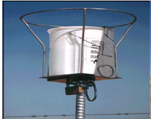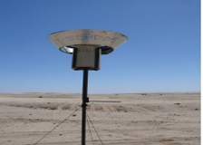
a) Without windshield but with a bird, ring b) with a windshield.
Figure 2.12: standard vertical gauges
Source: ASTM D1739:82, refereed by, (Kwata, 2014)
The advantage of the ASTM D1739 method is that is simple and economical and it can be deployed at multiple sites to obtain a more detailed spatial distribution of dust deposition rates. The gauge is easy to install, does not require electricity to function, and can be operated by personnel with little training.
The disadvantages of the ASTM method are that it measures only nuisance dust deposition and is not directly related to any health effect. Since this method can obtain the only measurement per month per site, it is not sensitive to individual dust episodes. Another major drawback of using this apparatus is easily stolen and vandalized (Kwata, 2014).
ISO deposit gauge (ISO/DIS 4222) the ISO deposit gauge comprises an “upward-facing contained made of polythene and shaped like a cylinder with the top edge chamfered outward at 450 the top of the cylinder is approximately 1.7m above ground level”. The dust collection period is 30 days. The deposition rate was expressed as mg/m²/d. The gauge has limited collection efficiency, and the collection of dust depends on the wind speed. The ISO large collecting bucket accommodates 400mm rain (Kwata, 2014).
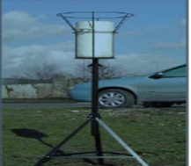
Figure 2.13: ISO deposit gauge
Source: ISO/DIS 4222, refereed by, (Kwata, 2014)
The shortcoming of the ISO deposit gauge is similar to ASTM D1739 Gauges: They have limited to collection Efficiency; they are dependent on wind speed; they are prone to contamination by leaves and insects in the case of the ASTM D1739 gauge. The effect of this contamination is mitigated by removal using a 1mm screen during laboratory processing.

Measurement of Dust Emissions
The earliest measurements of dust were by gravimetric methods, usually derived from the weight of dust deposited in trays near roads in Kenya deposited in collection equipment in vehicle-drawn trailers. The results from the Kenya measurements indicated a loss due to dust of some 25 tons per km per year for a road carrying 100 vehicles per day traveling at an average speed of 75km/hour. Other studies have indicated losses due to dust as high as 300 tones per km per year. This range of values shows the variations that can be expected on different roads in differing environments (Greening, 2011).
The Kenya study also demonstrated the influence of speed on the generation of dust. Still, one of the surprising results from the study was the conclusion that nearly all the dust fell within 7 meters of the road edge. Even given the more sophisticated dust measurement methods available now, this result is in stark contrast with other observations, which indicate a much wider area of influence of dust generated on gravel roads. Which indicated a corridor of influence at a distance of about 50m from the center of the road and a figure of 300m quoted for some orchards in South Africa (Greening, 2011).
Many so-called ‘dust measurements’ have been carried out by visual estimation by the driver of a vehicle or a roadside observer ranking dust according to a given scale (Hossein, 1999). One such scale is presumably suited for driver observations, which is subjective and operator dependent. There are many problems with observational methods of this type, including the large variations in the assessment of dust clouds about the observer's position concerning the position of the sun, the strength and direction of the wind, and other factors (Greening, 2011). There was substantial agreement at the severest levels of dust (a value of 5 in the scale given in Table 2.7) but there tended to be large variations between observers at lower dust levels.

Table 2.7: Visual Rating for road dust
Rating | Rating descriptors
1 | No visible dust behind the vehicle
2 | Dust jest visible through the rear window
3 | Dust easily visibly visible but not enough to cause driver discomfort
4 | Very dusty, causing major discomfort when passing approaching vehicles but not causing a dangerous loss of visibility
5 | Extremely dust, the surrounding being obscured to a dangerous level, and the impact on drive/passenger comfort and safety aspects being unacceptable
Source: D Jones Ph.D. Thesis, refereed by, (Greening, 2011)
Drive a vehicle at 25 mph and watch the dust cloud. Dust is measured as low-, medium, or high-severity for the sample unit.
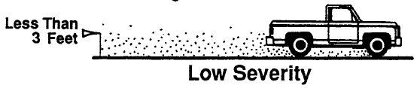
Visibility Moderately Obstructed
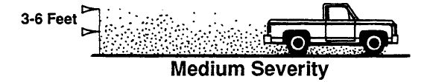
Greater Than Severe Visibility Problem
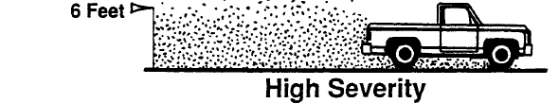
Figure 2.14: Dust measurement
Source: (Shahin, 2005)
Dust is not rated by density. The deduct values for the levels of severity are Low 2 points, Medium 5 points, and High 15 points (Shahin, 2005).
The main drawback would seem to be in the capability to make comparisons with other dust measurements, which are reports in different units. For this reason, there may well also be merit in developing countries for using one of a number of the other reported methods that measure the emissions of traffic-generated dust directly by gravimetric methods (Greening, 2011).
Measurement Range and Sensitivity analysis range and sensitivity depend on the method employed by the laboratory. The lower range of total dust fall measurements reported by a commercial laboratory is typically 0.1mg/dm²/day.
The dust fall station installation requirements should conform to the monitoring location should be an open area, with no structures higher than 1 m within a 20 m radius of the dust fall Container. The container should be placed at 2 m above the ground (2 m from ground to container opening) and Locate the container more than ten stack heights from an operating stack (unless the monitoring objectives are to monitor stack impacts precisely). Higher objects such as trees and buildings should not exceed 30 degrees from the horizontal as viewed from the monitoring location. This is shown in the figure 2.15 (Ontario Ministry of Environment, 2018).
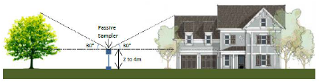
Figure 2.15: Installation Requirements
Source: B.R. Irwin, ENV (Ontario Ministry of Environment, 2018)

Characterization of soil dust
Size Characterization of dust is typically classified as its particle size, deposited matter refers to any dust that falls out of suspension in the atmosphere. Although table 2.8 represents the average frequency and percentage distribution of particulate matter of an urban environment, it is clear that deposition dust accounts for a large portion of particulate matter in any geographical region. The portion of particulate matter was increased for semi-arid to arid regions (Martins, 2014).
Table 2.8: Precipitant Dust particle with an aerodynamic diameter
Description | Diameter (µm) | Impact of dust
Inhalable Particulate | < 100 TSP | Materials that are hazardous when deposited anywhere in the respiratory tract. Particulate that will pass from the air into the nose or mouth and will travel up to the beginning of the throat.
Thoracic Particulate | < PM 10 | Materials that are hazardous when deposited anywhere within the lung airways and the gas-exchange region. Particulate that will pass through the throat and up to the small bronchiole.
Respirable particulate | < PM 2.5 | Materials that are hazardous when deposited in the gas-exchange region.
Source: (Martins, 2014)
Table 2.9: Dust deposit percent pass (Inhalable)
Inhalable
Particle Aerodynamic Diameter (µm) | 0 | 1 | 2 | 5 | 10 | 20 | 30 | 40 | 50 | 100
Mass % Inhalable Particulate | 100 | 97 | 94 | 87 | 77 | 65 | 58 | 54.5 | 52.5 | 50.0
Mass % of Inhalable Dust that can be deposited. The bold numbers in this table indicate how many of the particles with an aerodynamic diameter above 10 microns are inhaled into the body. (WHO, 2014). This provides information regarding the health implications of fallout dust, which is often regarded as benign. If particles are breathed into the body, then the dust contents can be absorbed into the body (Dust Watch, 2018).

Table 2.10: Dust deposit percent pass (Thoracic)
Thoracic
Particle Aerodynamic Diameter (µm) | 0 | 2 | 4 | 6 | 8 | 10 | 12 | 14 | 16 | 18 | 20 | 25
Mass % Thoracic Particulate | 100 | 94 | 89 | 80.5 | 67 | 50 | 35 | 23 | 15 | 9.5 | 6 | 2
Mass % that can be deposited in the Lung Airways and the Gas-exchange Region (Dust Watch, 2018).
The gravel road constructed can be related to dust. Dust is defined as “any solid particle with an aerodynamic diameter less than 100µm (Kwata, 2014). Dust as a generic term (ASTM, D 1739, 2010) defined it as any material that is made up of tiny particles that can pass through a 1mm screen and large enough to settle owing to their weight into the container from the ambient air (Sebaiwa, 2016).
The detailed distress inspection may be conducted less frequently but should be done at least once every 3 years. The inspection should be performed at the time of year when the roads are in their best and most consistent condition (Beaucham, 1992). Seven distresses have been defined for the unsurfaced road: improper cross-section, inadequate roadside drainage, corrugations, dust, potholes, ruts, and loose aggregate.
The pavement condition index (PCI) is calculated for each inspected sample unit. The PCI cannot be computed for the entire pavement section without computing the PCI for the sample units first. The PCI calculation is based on the deduct values weighing factors from 0 to 100 that indicate the impact each distress has on pavement condition. A deduct value of 0 indicates that distress has no effect on pavement structural integrity and/or surface operational condition, whereas a value of 100 indicates an extremely serious distress. Determine the allowable number of deducts, m in Figure 2.16.
M, = 1 + (9/95Xl 00-HDy) (for airfields and unsurfaced roads)………………….…...Equation 2.3
Where:
m. = allowable number of deducts, including fractions, for sample unit.
HDVi = highest individual deduct value for sample unit.
For the example, in Figure 2.16:
m = l + (9/95Xl00-21.0) = 8.48……………………….………………….…...Equation 2.4
The number of individual deduct values is reduced to m, including the fractional part. If less than m deduct values are available, then all of the deduct values are used. For the example in Figure 2.16, all the deducts are used since they are less than m (Shahin, 2005).
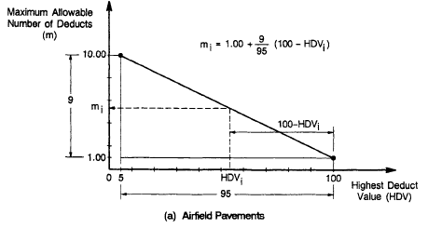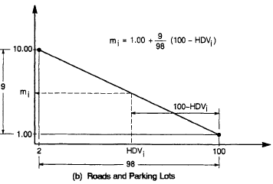
Figure 2.16: Determination of Maximum Allowable Deducts (m).
Source: (Shahin, 2005)

Models for Adoption Gravel Road
A model is a representation of a system that allows for the investigation of the system's properties and predicts future outcomes in some cases. As a result, a good model depends on what it is used for and how accurate the prediction or calculation should be (Mwaipungu and Allopi, 2012). The output from models must recognize precisely for what they are – information based on a simplified representation of reality. Never can all constraints affecting gravel roads performance be included in a statically model of the problem
Prediction models can be classified either as probabilistic or deterministic (Garcia et al., 2016). Depending on the modeling preference, dust can be formulated by using prediction modeling principles. The Probabilistic model is a statistical analysis tool that estimates, based on past data, the probability of an event occurring again. Probabilistic modeling is any form of modeling that utilizes the presumed probability distribution of certain input assumptions to calculate the implied probability distribution for chosen output metrics (Velten, 2009).
A Deterministic model is a mathematical model in which the outcomes are precisely determined through known relationships among states and events, without any random variation (Velten, 2009). These models are developed from empirical or mechanistic-empirical models, which do not explicitly consider uncertainty. Future performance owing to deterioration and maintenance activities is, therefore, assume certainly (R. Mwaipungu and Dhiren Allopi, 2012).

Confidence interval
Usually, tests start by using the 95% level (p = 0.05), if the test at that level is passed. The 95% confidence level indicates that, although the data support the conclusion with a 95% probability, there is a 5% chance that the conclusion is wrong. The probability of making an error to reject a hypothesis whereas it happens to be true is called the level of significance.

Analysis of variation (ANOVA)
This parametric test is based on a statistical method called the F-test, which is the ratio of the variance among conditions (between-groups variance) to the variance within conditions (within groups, or error variance). The larger the between-groups variance relative to the within-groups variance, the larger the calculated value of F. The more likely the condition's differences reflect the independent variable's true effects rather than error variance.

R-Square (R²)
This statistic represents the proportion of variation in the dependent variable that is explained by the model. It is also the square of the correlation coefficient. The correlation coefficient measures how well the best fit line fits the sample data. The value of R=1 or -1 shows there is a perfect correlation but R = -1 shows the inverse relationship. On the other hand, R=0 or approaches to zero shows no valid relationship between the variables.

Coefficient
The Coefficient is the parameter estimate for every increase or decrease in one variable, the change of another variable.

Scatter plot and best-fit curve
For this analysis, the vehicle dust is considered the dependent variable. The Plasticity index, sieve passing 0.075um, and average monthly precipitation, average daily traffic, and California Bearing are independent variables. Statistical analysis was performed by employing an SPSS built-in program referred to as a curve-fitting tool used to analyze the scatter plot and best-fit of the study area. The model that best suits the result of the data points has been developed.
Equations such as the one below have developed to help estimate the volume of dust generated from gravel roads. The quality of materials used for the construction and maintenance of gravel roads is an important factor in road performance and a factor in the loss of pavement material, including dust (David et al., 2014). Such equation (Paige-Green, 2017) based on extensive in other countries by the Council for Scientific and Industrial Research in South Africa model is:
$GL = D [ADT x (0.059 + 0.0027(N) - 0.006(P26)) - 0.367 - 0.0014(PF) + 0.474(P26)]$ ……………………………………………………………………..……………………..…..Equation 2.5
Where:
GL = Annual Gravel Loss in mm
N = we inert N-value (climate region)
ADT = Average Daily Traffic
PF = Plastic Factor
P26 = percentage passing the 26.5 mm sieve (approximately 1 inch)
D = the number of days between blading
$GL =D [1.58 + 0.366*G + 0.083*SV - 0.210*PI + 0.0132*NC + 0.0081*NT +420.45]$ .………………….………………………….…. Equation 2.6
Where
GL = is the gravel loss in mm
D = number of days since last blading in hundreds (days/100)
NC = average daily light vehicles in both directions
NT = average heavy vehicle traffic in both directions
G = absolute grade in percentage
SV = percent of surface material passing the 0.074 mm sieve
PI = plasticity index of surfacing material (%)
R = radius of the horizontal curve (Henning et al., 2008).
Highway Design and Maintenance Model, as mentioned, information from the Kenya and Brazil studies were used to develop gravel loss, prediction models (Paige-Green And T. Visser, 1998). The gravel loss model developed in the HDM-3 had a coefficient of determination of 31%. The HDM-4 gravel loss model is the same as the HDM-3 model, which is
$MLA = 3.65(3.46 + 0.246(MMP) (RF) + (KT) (ADT)]$…....………….Equation 2.7
Where:
MLA = predicted annual material loss (mm/year),
MMP = mean monthly precipitation (m),
RF = road rise plus fall (m/km).
KT = max {0; [0.022 + 0.969/57.300 (KCRV) + 0.00342(MMP) (P75) - 0.0092(MMP) (PI) - 0.l0l (MMP)]}, and KCRV = curvature (degrees/km).
$LDQ = D \{0.4314 - 0.1705(T2) + 0.001159(NC) + 0.000895(NT) - 0.000227(NT) (G) + S [- 0.1442 - 0.0198(G) + 0.0062l (SV) - 0.0l42(Pl) - 0.00U617 (NC)]\}..$....................................................................................................Equation 2.8
Where:
T2 = surfacing type dummy variable (1 for clay. 0 for other),
NC = average daily car and pickup traffic in both directions,
NT = average daily bus and truck traffic in both directions.
G = absolute value of vertical grade (percent),
S = season dummy variable (0 for the dry season. I for wet season),
SY = percentage of surfacing material passing the 0.075- mm sieve, and
PI = plasticity index of surfacing material (percent)
$BF = 3.527– 0.173*Age+ 0.012*ADT +1.156*GH$..................................Equation 2.9
$Life = 9.656 + 0.002*ADT – 0.089*GH$....................................................... Equation 2.10
$BF = 3.748– 0.109*Age + 0.006*ADT + 0.825*GH$………...…………. Equation 2.11
$Life = 11.64 –0.035*ADT + 0.566*GH$….................................................... Equation 2.12
Where:
BF = Blading Frequency
Age = 0.5*Life (average age of pavement)
ADT = Average Daily Traffic
GH = Horizontal Geometry Factor (Henning et al., 2015).
$G=D (-0.299*ADT+0.461*MMP-4.643*PI+2.337*G$) ………… Equation 2.13
Where:
GL= Gravel Loss,
D= Observation days (days/100),
ADT= Average Daily Traffic,
MMP=Mean Monthly Precipitation,
PI=Plasticity Index and G= Absolute Gradient (Kassa, 2015).

MATERIALS AND METHODS

Description of the Study Area
The study area is located in Hawassa city, Ethiopia. The city is located in the Sidama Regnal state, 273 km South of Addis Ababa. With a latitude 7°, 3′43.4” and longitude N 38°28′34.9’’E Coordinates an elevation of 1708 meter respectively. The city bounded Loke village in the West, Oromia Region in the North, Wondo Genet woreda in the East, and Shebedino woreda in the South. Three gravel roads authorized by Dilla District were selected for this study. Namely are (1) the Hawassa Referral Roundabout – Loke Hospital village road, (2) the Loke Hospital village – Dore Bafana Town road, and (3) the Dore Bafana Town – New Hawassa Airport road.
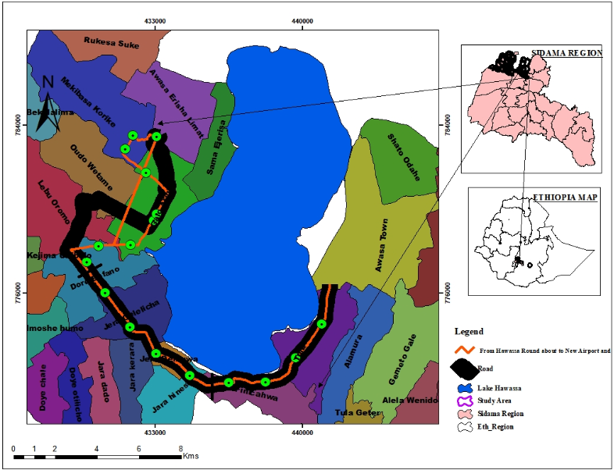
Figure 3.1: Geographical Map of the research Area
Source: (Ethiopia map agency, 2020)
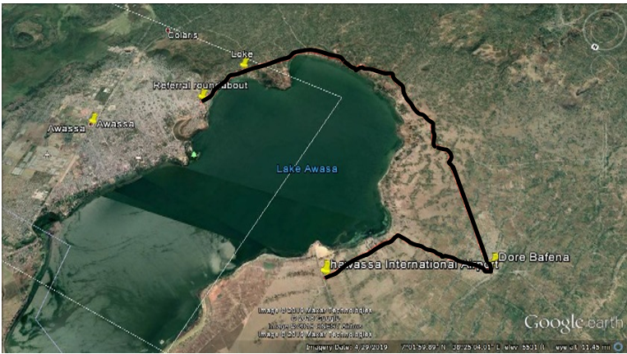
Figure 3.2: Map of Hawassa City with study area
Source: Google map accessed on September 1, 2020.

Study Subject
The study's objective is to evaluate the performance of gravel road surfacing materials as a function of quantifying dust. Three different monitoring section around residential and commercial areas of Hawassa city from February 2020 to June 2020. A single road of 33 km was divided into three road section. The Global Position System (GPS) coordinates, and the characteristics of all section roads are authorized by Southern Nation and Nationalities and Peoples’ Region Rural Roads Authority. The surfacing material on all gravel roads was selected material, and the roads' width was variable. According to the observation, road section widths of the roads range from 5. 5m to 7. 5m.
Table 3.1: Study location description
Research area | Road Section (A) | Road Section (B) | Road Section ( C)
Research area | Hawassa Referral Roundabout – Loke Hospital village | Loke Hospital village – Dore Bafana Town | Dore Bafana Town – New Hawassa Airport
Number of lanes | 2 | 2 | 2
Length (m) | 10000.00 | 13000.00 | 10000.00

Data Collection
Table 3.2: Data Source and Size
Data | Primary | Secondary | Size | Source
Predicted Gravel Dust | √ |  | 150 | Field and laboratory investigations (ASTM, D 1739, 2010)
Average Daily Traffic |  | √ | 4 Years | SNNPR Rural Roads Authority
Plasticity index | √ |  | 15 | Field and laboratory investigations (ASTM D 4318)
Mean Monthly Precipitation |  | √ | 4 Years | SNNPR National Metrological Agency
Particles passing 0.075 mm | √ |  | 15 | Field and laboratory investigations (ASTM, D 422, 1998)
California Bearing Ratio | √ |  | 15 | Field and laboratory investigations (AASHTO, 1993)
Figure 3.3: Schematics flow chart of the research

Sample Size and sampling techniques
Green (1991) has addressed how many samples do require to do a MLR analysis. He recommended a sample size of 𝑛 ≥104+K, where K is the number of five independent variables are Average Daily Traffic, Plasticity index, Mean Monthly Precipitation, Particles passing 0.075 mm, and California Bearing Ratio were employed. Thus, the minimum sample size is calculated according to Green is 𝑛 ≥104+𝐾=104+5=109. Accordingly, 150 samples were collected in five months of the study period (Wilson et al., 2007).
Typical boring and sampling techniques were conducted following a systematic random sampling standard methods. It defines the dust collected as material smaller than 1mm. The document also specifies that the dust fall sampling points should be placed within a maximum distance of 2km of the source (ASTM, D 1739, 2010). This quantitative study utilized existing road soil samples to evaluate the material's physical characteristics along the alignment that can be initiated depending on the field conditions. As a standard guideline, at least one representative soil sample should be collected per 2 kilometers of the proposed roadway alignment, with more frequent samples. The sampling location may be alternatively on the left and right edge of the proposed roadway. Site Investigation Manual gives a recommended sampling frequency and the corresponding tests (ERA, 2013b).

Criteria for Sample Selection
This method of data collection was chosen traffic data reasonably Number, type of vehicles passing the site each day, suitable locations to install equipment near to the roadside requires permission from private Landowners, several nearby houses assessment of dust impacts in a location that has sensitive receptors Providing support with the logistics of monitoring and a location within a region that allowed the application of dust suppressants on Unsealed roads (Johnson, 2016).

Study Design and Study Methodology
This section deals with the methods that have been used in this study to quantify and model the soil dust. Different techniques were used to collect quantitative data, from Institutions, field measures data, and investigations conducted in the laboratory (including the dust, plastic index, California baring ratio, and present pass 75μm selection of target population and sampling, distribution, and data analysis).
Dust sample was taken at 2km intervals through the road’s according to the American Society for Testing and Materials (ASTM) D1739 standard method, which deals with the measurement of vertical dust fallout (ASTM D1739:98, 2004). Ones prepared and sealed in a laboratory and then opened and set up at an appropriately chosen locations. Particulate matter can settle into them for about a week.
The results were reported as milligrams per square meter per day mg/m²/week. The Total Suspended Particles (TSP) fine material passing 0.1mm was determined by sieve analysis, whereas silt passing the 0.075 mm sieve was taken to conduct hydrometer analysis to determine the PM10, and PM2.5 as per (ASTM, D 1739, 2010).
Single bucket, dust fallout gauges longitudinal observational research conducted to collect the data regarding gravel dust with the help of dust falls deposit gauge. The suspended silt and clay size of the gravel road recorded as the vehicle soil dust from the roads. The duration between the first and the second observation for this research was five months (Sibanda, 2009).
Plasticity index: to feel a wide spectrum of the materials, samples A, B & C have been extracted at fifteen (15) sampling locations and they were taken for material testing in the road section’s vicinity. The tests carried out on the samples in Atterberg limit tests, the analysis, and results of which are presented in subsequent sections as per ASTM D 4318 / (AASHTO, 1996a).
Laboratory and field CBR testing road segment by knowing the wearing course of soil bearing capacity, a laboratory California bearing ratio (CBR) test, and field CBR by using Dynamic cone penetration (DCP) were then used in the study. Several correlations exist to link the DCP penetration rate (mm/blow) to the pavement design’s subgrade strength parameters. These correlations are based on either soaked or unoaked CBR values versus DCP penetration rates measured in different soil types as per (AASHTO, 1993) and (ERA, 2013c).
Particle size: distribution Practitioners should undertake a sieve analysis of their local gravel pits to identify any deficiencies in grading and attempt to mix various materials. the aim being to try to achieve the appropriate grading distribution was greatly enhanced the performance of unsealed roads (ASTM, D 422, 1998) / (AASHTO, 1996b).
Traffic data: The approach for collecting the data regarding traffic volume in each road section was different from Hawassa Referral Roundabout to Loke hospital road, Loke hospital to Dore Bafano Town road, and Dore Bafano Town to New Hawassa Airport road. Average daily traffic (ADT) traffic count was obtained from SNNPR Rural Roads Authority secondary data. The Time interval between observations of two-directional road volumes was collected for about one week and 16 hours in each day. The traffic at the night level was recorded in two days and was found to be insignificant. The Town ADT data history of 2017-2020 was used contained a monthly average of (February, March, April, May, and June) in the model.
The meteorological data comprised monthly average temperature, humidity, rainfall, and wind velocity obtained from the SNNPR National Meteorological Agency of Ethiopia. The Town rainfall history of 2017-2020 was used since this was the secondary available historical data obtained from the agency. Mean monthly precipitation (February, March, April, May, and June), were averaged to have single values.

Data Management and Analysis

Dust Data Analysis
The dust sampling procedure was based on the standard test method for collecting and measurements of dust deposition single bucket monitors were deployed; according to the American Society for Testing and Materials Standard Method for collection and analyses of dust fallout (ASTM, D 1739, 2010).
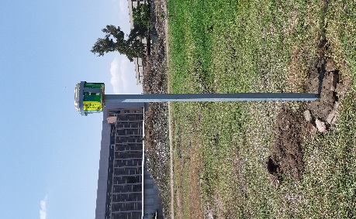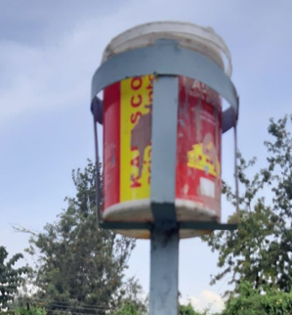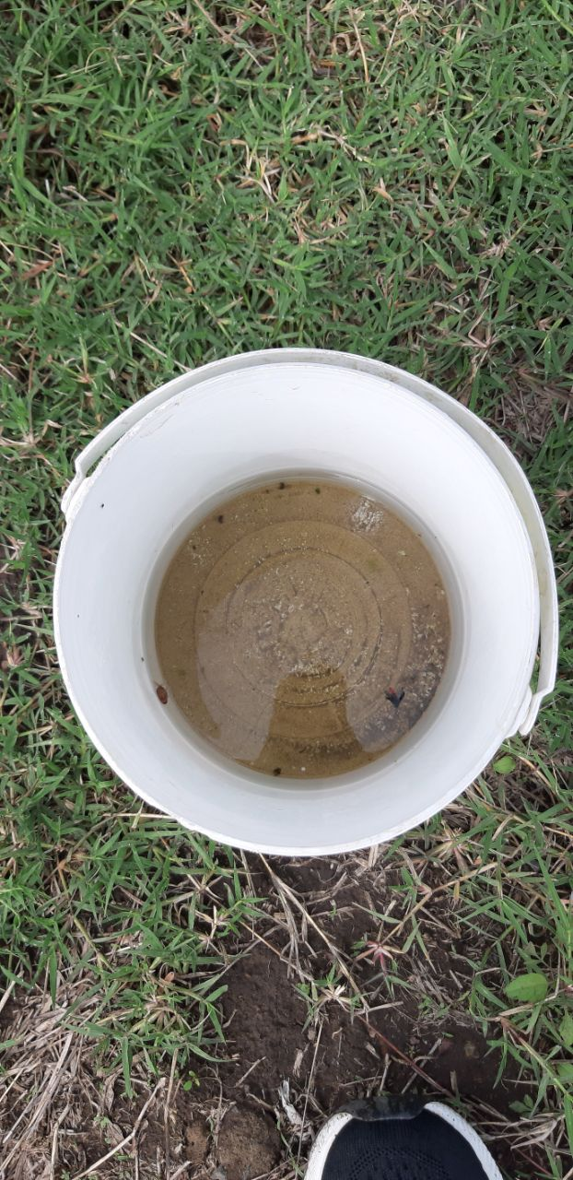
(a) Sample frame (b) sample sites (c) dust buckets (d) samples collected dust material
Figure 3.4: Single bucket dust deposition gauge monitor without windshield
The 5.0 L buckets and bottles, their lids cleaned with a household detergent, rinsed with distilled water to remove all the dust in the buckets, were used to collect the dust samples in the study area. The height of polypropylene buckets was 210.0 mm, and the inside diameter of the lip was 180.0 mm. They were half-filled (2.5 L) with distilled water before adding about 10.0 ml of 3.5% of bleach (hypo chloride) solution to each bucket to prevent algae growth. The buckets were deployed to different sample sites and put into the frame, which was located 2.2 meters high above the ground. The sample bucket and sample bottles were appropriately labeled. They have been exposed for one calendar month duration and collected every month (from Feb 2020 - June 2020) for laboratory analysis (Kwata, 2014).
After the dust samples were collected, a spatula used to remove the dust in the buckets, and the replacement bottle they were filtered using Bucher funnel to determine the mass concentration of dust fallout material after weighing the mass of filter paper before and after filtration. The filter papers were must in the weighing room before use. The suspended material on the bucket walls was removed by using the distilled water contained in a wash bottle. Filter papers containing Filtered dust fallout material were stored on evaporation dishes and placed into oven dry at a temperature of 105ºC for 24 hours. The samples were then cooled after drying in the oven-dried filter papers were weighted to determine the mass of dust collected.
Deposition ratings for vertical dust deposit gauge were calculated using the equation 3.1 the cross-sectional area of the buckets is a standard constant in all of the calculations representing the area over which fall-out collection has been made: A = 0. 02545m² and The actual mass collected is derived by subtraction of the mass of the filter (mass1) from the combined mass of the filter and filtrate (mass2):: Mass2 – mass1 = collected mass of dust sample all units should be expressed in milligrams, and the value of milligram/square meter/day derived from the formula: the settled dust was ready to be analyzed (Dust Watch, 2018).
$Dust Fall-out rate \left(\frac{\frac{mμ}{m2}}{day}\right)=\frac{\left(collected mass x 1\right)}{\left(0.02545 X days\right)}*100$….……….….Equation 3.1

Dust deposition Nuisance effects of dust can be assessed using dust deposition gauges. Dust deposition gauges are set up and left to collect dust for a period of between 20 and 30 days. At the end of that period, the water contained in the jar filtered to collect the dust then dried and weighed to quantify the amount of dust accumulated over the monitoring period. The collection method and analysis of deposited dust are defined in the standard recommend a mitigation activate level for deposited dust of 133.3mg/m²/ days above background (Johnson, 2016).
Limitations of sampling and filter materials generally finer suspended dust (2.5µm > 5µm) was remain airborne almost indefinitely due to the dynamic nature of the air currents and thermal activities on any given day, even if there is no wind at all. A rapid increase in humidity and an absence of wind resulted in less than 5-micron particulate precipitation. Particulate larger than about 5µm settled on a very still day and this material collected within the Dust Watch buckets in varying amounts depending on the wind velocities.
The optimum efficiency occurs at wind Velocities exceeding 2.0m/s. at velocities below 3.0 m /s, no particulate of this size lifted higher than a maximum of about 2.2m. Once the wind changes direction, the particulate starts precipitating, and this gets captured in the buckets. We thus note that no dust gets captured during Very windy conditions, but actually when the wind drops. Once the wind changes, the maximum precipitation rate is reached when the air mass movement is arrested and then moves in the opposite direction (Dust Watch, 2018).
The Hydrometer size distribution of the settled dust samples analyzed by a hydrometer particle analyzer based on Stokes’ low. ASTM D 422-9D, 1988 test method was used to calculate the mass concentration of dust fallout and determine the grain size of soil particles passing through 200mm sieve. The sample's mass concentration is then calculated by the diameter of particles corresponding to the percentage indicated by a given the hydrometer reading. ASTM and AASHTO characterized samples collected from February to June 2020. The hydrometer is used to determine the size distribution and organic matter. All necessary data and information such as sample name, analysis date, a mass of the labeled sample, and oven-drying date documented in the sample book and an Excel spreadsheet.
. 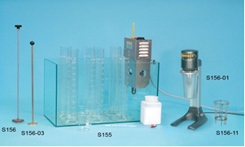
Figure 3.5: Hydrometer apparatus
Source: (ASTM, D 422, 1998)
Samples of dust fallout collected from February to June 2020 were analyzed using hydrometer analysis. The samples Procedure was used 50g of the oven-dried soil passing through a 200mm sieve Transfer the sample carefully into the container of the stirrer using distilled water and add 100 ml deflocculating agent (mixing 33g of Sodium Hex metaphosphate and 7g of Sodium carbonate) Operate the stirrer for about 10 minutes. Meanwhile, clean the hydrometer and keep in 1000ml sedimentation jar filled with distilled water and 10 ml of deflocculating agent solution. After stirring put the sample into another sedimentation jar of 1000ml capacity. Add enough distilled water to bring to the 1000ml mark. After proper and thorough mixing put the jar on a flat surface, start the stopwatch, and gently insert the hydrometer in it. Take the hydrometer readings at half one, two, and four minutes. Remove the hydrometer gently Reinsert the hydrometer in distilled water and deflocculating agent. The hydrometer readings were taken at 0.5, 1, 2, and 3 minutes intervals. Remove the hydrometer gently and reinsert it into distilled water and deflocculating agent. Note the temperature of the soil suspension. Reinsert the hydrometer in the suspension and note the readings at 8, 15, and 30 minutes, 1,2,4,8, and 24 hours after shaking (ASTM, 1998a).
Determination of the diameter of particles corresponding to the percentage indicated by some given hydrometer readings.
…………………………………Equation 3.2
Where:
D = Diameter of particles in mm.
η = Viscosity of water in poises
L = Distance effective depth.
T = Elapsed time for the beginning of sedimentation to the taking hydrometer reading, min.
G’s = Specific gravity of solid particle.
G1= Specific gravity (relative density) of water value may be used as one practical purpose.
For convenience in the calculation.
Where,
K = constant depending on the temperature of the suspension and specific gravity of the soil particles. Values of ‘K’ for a range of temperature and specific gravity given from (ASTM, 1998a). Table1-4 Presented in appendices A.
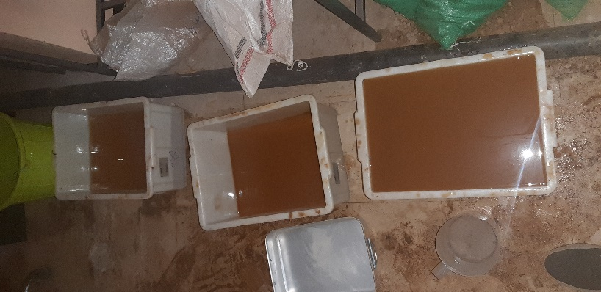
(a) Dust samples Collected from the road segment
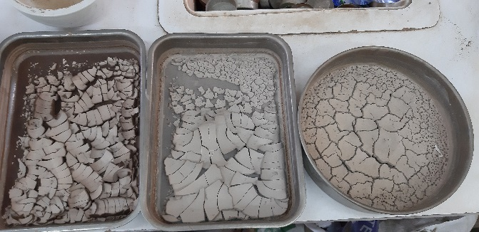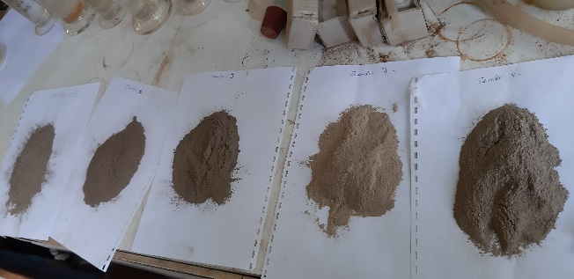
(b) Samples inside the lab after oven-dry
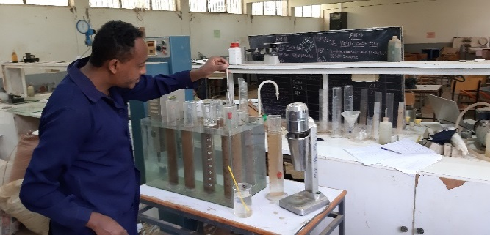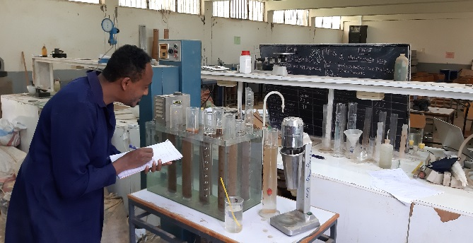
(c) Dust samples were loaded into the hydrometer analysis and during measure
Figure 3.6: Dust samples analysis by a hydrometer
Several technologies are used to monitor dust concentrations. Standard full out methods that are relatively cheap and provide good measures of relative dust concentrations. The most appropriate method used to monitor dust for a specific road section is determined using hydrometer analysis was highly desirable (Johnson, 2016).

Surfacing Material Data Analysis
Analysis of data was conducted with the gravel road's surfacing material obtained by the laboratory test of the sample material. The data analysis included the value of soil physical properties, mechanical properties of soil testing, laboratory CBR, and field CBR by using DCP on-road segment at Hawassa Referral Hospital to Hawassa Airport Sample material obtained from the quarry site of each road.
The needed output of the test was the plasticity index. Standard procedure (ASTM, 1998b) was used to obtain each road's sample material's liquid limit and plastic limit. After the plasticity index was obtained, the type of surfacing material was determined and presented in appendices D.
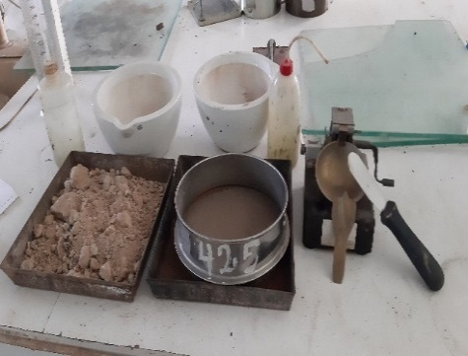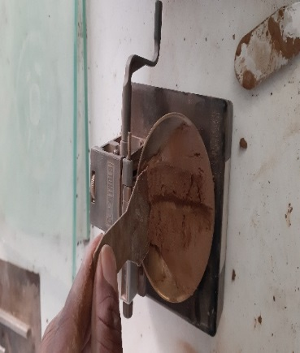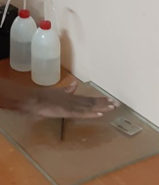
- sample preparation (b) determination of liquid limit (c) determination of plastic limit
Figure 3.7: Sample material for Atterberg limits test
California bearing ratio (CBR): in addition to the above, the experiment aimed to establish a gravel-wearing course thus incorporates with CBR test conducted for strength were Compaction tests to determine the Maximum Dry Density (MDD), Optimum Moisture Content (OMC), and California Bearing Ratio (CBR). As depicted by the same manuals, the compaction tests are used to specify field compaction for gravel materials. As explained earlier, the study area falls under moderate and dry climate zones. The minimum soaked Californian bearing ratio (CBR) was 30% when determined by the requirements of AASHTO T-193. The Californian-bearing ratio (CBR) was determined at a 95% density of the maximum dry density when determined by the AASHTO T-80 method D.
The Dynamic cone penetration (DCP) this method covers the procedure for conducting DCP used to indirectly determine the immediate bearing value of wearing course material used to evaluate the subgrade stability and determine the wearing course depth. Relationships exist between the DCP and the California Bearing Ratio (CBR), a measure of unbound layer strength. The minimum thickness required for wearing course protection can generally exclude from Model. The in situ CBR value can be easily determined using the Dynamic Cone Penetrometer (DCP). A DCP penetration of more than about 32 mm per blow indicates that the CBR is 5 percent or above for most wearing course material (Illinois, 2017).
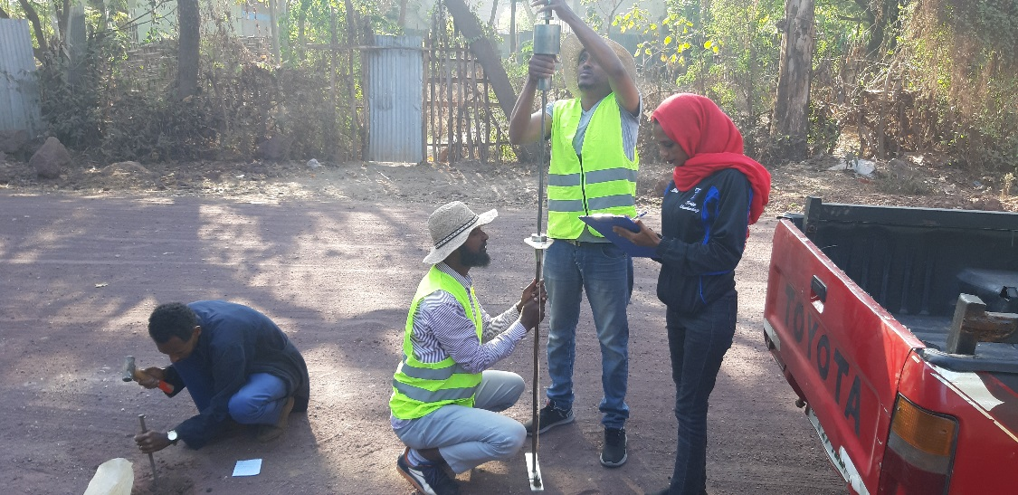
Figure 3.8: Data Collecting from Manual DCP
According to the AASHTO and USCS soil classification system, particle size distribution was classified as coarse-grained soil, and Fine-grained soil is above 35% of its granular passing the no.200 sieve. In contrast, silt and clay were classified less than 35% of the total number of the grain of this type of soil passing the no.200 sieves as per ASTM-C-136 / (AASHTO, 1996c).
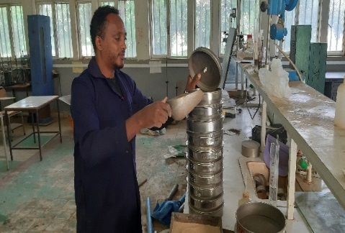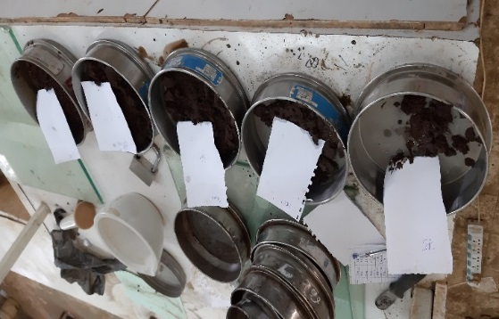
Figure 3.9: Dry and wet sieve analysis

Meteorological Data
The data divided into three categories according to the sampling points. The data for Hawassa Referral Roundabout – Loke Hospital village, Loke Hospital village – Dore Bafana Town, and Dore Bafana Town – New Hawassa Airport was collected from the weather station (38⁰ 28' 27.53" E and 7º 03' 21.99" N Altitude 1694). The data were available from meteorological parameters recorded during the sampling, i.e., temperature (maximum and minimum) rainfall and wind velocity around the Hawassa town.
Table 3.3: Meteorological Data
 | Years | Feb | Mar | Apr | May | June | Average
Temperature (ºC) | 2017 | 27.91 | 31.56 | 31.6 | 29.35 | 27.7 | 29.624
 | 2018 | 28.22 | 29.05 | 27.12 | 28.7 | 25.02 | 27.622
 | 2019 | 29.11 | 32.74 | 29.68 | 30.05 | 26.4 | 29.596
 | 2020 | 28.2 | 31 | 29 | 29.3 | 28.4 | 29.18
 | Average | 28.36 | 31.088 | 29.35 | 29.35 | 26.88
Rainfall (min)
 | 2017 | 88.4 | 91 | 88.5 | 222 | 54.7 | 108.92
 | 2018 | 59 | 121.9 | 198.3 | 106.2 | 162.7 | 129.62
 | 2019 | 13.3 | 17.6 | 128.6 | 125.6 | 78.4 | 72.7
 | 2020 | 59 | 120 | 195 | 104 | 154 | 126.4
 | Average | 54.925 | 87.625 | 152.6 | 139.45 | 112.5
Wind Velocity (m/s)
 | 2017 | 0.604 | 0.673 | 0.628 | 0.5 | 0.7 | 0.621
 | 2018 | 0.62 | 0.5 | 0.43 | 0.562 | 0.67 | 0.5564
 | 2019 | 0.56 | 0.56 | 0.5 | 0.44 | 0.68 | 0.548
 | 2020 | 0.6 | 0.62 | 0.56 | 0.5 | 0.64 | 0.584
 | Average | 0.596 | 0.5883 | 0.5295 | 0.5005 | 0.673
Wind Direction
 | 2017 | SW | SW | WN | SW | SW
 | 2018 | SW | SW | SW | WN | WN
 | 2019 | SW | WN | SW | SW | SW
 | 2020 | SW | SW | SW | SW | SW
Source: SNNPR National Metrological Agency of Ethiopia.
The three gravel road selected originate from observation starts and ends at Hawassa town. The models developed using the road data with an average of 4 years monthly samples with MMP of 54.93, 87.63, 152.6, 139.45, and 112.5 mm/month. This may be reduced the significance of precipitation in the model. The historical precipitation data gathered shows a smaller in their magnitude. This was due to similar climatic conditions. Considering the observed gravel dust and the MMP of the three roads selected, it’s expected that the road, which had lower mean monthly precipitation, could have had lower observed gravel dust.
Average wind velocities of five months February, March, April, May, and June around Hawassa city were 0.6, 0.59, 0.53, 0.50, and 0.673 m/s, respectively. It should recorded wind velocity recorded the same average wind velocities (0.58 m/s).

Traffic count data
Traffic count is done to obtain the average daily traffic of the selected roads. The highest traffic volume encountered in Hawassa Referral Roundabout to Loke Hospital village road, and the lowest traffic was observed on the Dore Bafana Town to New Hawassa Airport Road. The average value of the traffic observed on these roads was 106 veh/day.
Table 3.4: Traffic Volume of the Selected Roads
 | Referral Roundabout –  Loke Hospital village | Loke Hospital village –  Dore Bafana Town | Dore Bafana Town –  New Hawassa Airport
ADT (veh/day)
2017 | 93 | 51 | 45
2018 | 150 | 125 | 108
2019 | 155 | 127 | 111
2020 | 92 | 76 | 65
Average | 123 | 110 | 83
It was indicated that a road that had ‘Hawassa Referral Roundabout – Loke Hospital village’ the Average recorded ADT is 123 veh/day, a higher traffic volume and also higher observed gravel dust the significant traffic was the passenger cars & Taxis, Station Wagon, land rovers, Jeeps, land cruiser, Small Bus, Large Bus, Small Truck, Medium Truck, Heavy Truck.
In the less-trafficked road, Dore Bafana Town to New Hawassa Airport, the average of 4 years recorded ADT of five months February, March, April, May, and June is 83 veh/day with minimum gravel dust of the surfacing material This road had there is no small bus, large bus, and truck trailer for the road.
The road from Loke Hospital village to Dore Bafana Town, significant traffic was the passenger cars. Taxis, Station Wagon, land rovers, Jeeps, land cruiser, Small Bus, Large Bus, Small Truck, Medium Truck, Heavy Truck, and Truck Trailer the average of 4 years recorded ADT of five months February, March, April, May, and June is 110 veh/day was the amount of traffic that passes the roads. It includes all kinds of vehicles, starting from the data obtained in 2020.
The road with the highest traffic volume had the highest dust load on the road from the observation of sample roads. Since this road is near the popular referral hospital, construction sites, quarry sites, new airport buildings, and new road construction around this area, heavy vehicles and higher traveled speeds were observed. The road that had higher traffic volume also had higher dust and raveled easily by traffic. Although in the five-month observation of the three roads, the significant defects found were rutting, potholes, corrugation, dusting, and raveling of the gravel roads.

Model Data Analysis

General
In carrying out the statistical analysis, the software program referred to as SPSS 20.0 package for Windows, Multiple Linear Regression (MLR), and Microsoft Office (MS) Excel software was used to perform descriptive data analysis. In contrast, dust was a crucial dependent variable. The analysis assumes that the data are typically distributed. Pearson correlation coefficients and one-way Analysis of Variance (ANOVA) analysis were also performed on the elemental concentrations and dust fallout concentrations, respectively, more suitable for analysis (Kwata, 2014).

RESULTS AND DISCUSSIONS

Results
This chapter presents the analysis of the dust collected as specified in the methodology section; it analyzed using a different mechanism and methods. The results of the analysis are explained in the consecutive sub-sections. The result was analyzed using multiple linear regression (MLR) with SPSS software.

Gravel dust observation result
Data points during the measurement of dust amounts were measured on all test sections. All data points are averages of replicate samples made during the study period.

Figure 4.1: Gravel Dust deposition results
Dust fall rates for the Single Bucket recorded at three sites from February to June 2020 sampling period. Each site recorded within residential was average dust fall rates of five months February, March, April, May and June 113116.61μg/m²/day, 115500.29μg/m²/day, 117358.63μg/m²/day, 118703.83μg/m²/day, and 117839.5 μg/m²/day respectively. Dust samples from Single Bucket and collected from each Road Section A,

Figure 4.2: Particle Size distribution using Hydrometer for section C
The dust samples from a single Bucket, through from Hawassa Referral Roundabout – Loke Hospital village, Loke Hospital village – Dore Bafana Town, and Dore Bafana Town –New Hawassa Airport have analyzed a laboratory. Throughout the investigation, there were no recorded values that showed significant variation in dust fall rates because it was not affected by the changing wind direction as it could position itself in any wind direction.
Significant variation in dust fall rates was recorded in all site samples from February to June 2020. The Single Bucket at wind speeds greater than 2 m. s⁻¹ collected less dust than in an area with the same atmospheric load, but the single bucket's collection efficiency for wind speeds is between 0.43 and 0.673 m. s⁻¹ with lower wind speed weather conditions collected dust is easily collected. These weather conditions resulted in the Single Bucket collecting high dust in February. The predominant winds during February were coming from the southwest. The increased dust fall rates recorded by the single Bucket in June and less dust in February could have been from a dust source located to the west of the road (Sibanda, 2009).
Roads in sections A, B, and C produced a very similar particle analysis results as indicated in the particle size analysis graphs presented in appendices A, B, and D. But, dust samples passing sieve 75um are considered as irregular square particles certainly derived from the soil. The particles observed from the Bucket are rounded particle size distribution plots for the dust collected by the fifteen (15) samplers during the February to June 2020 dust monitoring period Particles below 75 μm can enter to laboratory and be existent in this size particle by hydrometer analysis. These fine dust contribute to allergies, sensitizations, and asthma. The average percentage of particles by volume, below 75 μm, is just about 42.91 percent for Road Section A, 38.94 percent for Road Section B, and 40.7 percent for the Road Section C particle size distribution.
The average percentage of particles by volume, below 10 μm, is just about 21.60 percent for Road Section A is, 28.768 percent for Road Section B, and 31.26 percent for the Road Section C, respectively inhalable. This provides information regarding the health implications of fallout dust, which is often regarded as benign. If particles are breathed into the body, then the dust contents can be absorbed into the body.
The percentage of particles by volume of 2.5 μm for Road Section A is 8.52 percent, 12.95 percent for the Single Bucket Road Section B, and 12.61 percent for Road Section C, and thus is thoracic. This particulate that will pass through the throat and up to the small bronchiole and particles of < 2.5 μm size are repairable and penetrate the lungs' gas exchange region (Dust Watch, 2018).

Material Test Results
According to Unpaved Road Material Specifications, there are a range of recommendations, guidelines, and specifications available for unpaved road base and wearing course materials. These are discussed here; in this study the sample material on the wearing surface of the particular roads taken from the individual quarry sites. The laboratory test was to determine the particle size distributions, plasticity index, California bearing ratio, and dynamic cone penetration of each sample road wearing surface material.

Table 4.1: Summarized Material test result
 | Soil test results
Standard test methods | ASTM D422/AASHTO T 11 |  |  | ASTM D4318 |  |  | ASTM
Test type | Grain Size Analysis |  |  | Atterberg Limits |  |  | USCS | (C B R)
Observation GPS coordinate sample | Silt & Clay % | Sand % | Gravel % | Liquid Limit (%) | Plastic Limit (%) | Plasticity Index (%) | (%) D2487
Name of the road | Hawassa Referral Roundabout – Loke Hospital village
0 7 01 2657N 38 28 0729E 5584M | 9.45 | 59.75 | 30.8 | 42.16 | 32.69 | 9.47 | ML-OL | 40.45
2 7 00 54.28N 38 28 02.17E 5554M | 9.24 | 54.0 | 36.76 | 25 | 15.26 | 9.74 | CL-OL | 39.55
4 7 00 24.98N 38 27 54.11E 5549M | 12.9 | 44.67 | 42.43 | 41.17 | 31.35 | 9.82 | ML-OL | 36.30
6 7 00 08.93N 38 27 43.86E 5564M | 7.47 | 56.92 | 35.61 | 30.31 | 20.23 | 10.05 | CL-OL | 33.42
8 6 59 43.64N 38 27 24.78E 5558M | 9.24 | 54.0 | 36.76 | 42.07 | 30.86 | 11.2 | ML-OL | 33.0
Name of the road | Loke Hospital village – Dore Bafana Town
12 6 59 33.38N 38 27 55.67E 5641M | 11.70 | 59.95 | 28.35 | 35 | 27 | 7.10 | ML-OL | 41.35
14 6 58 56.17N 38 27 28.98E 5656M | 12.29 | 60.97 | 26.74 | 30.06 | 22.32 | 7.75 | ML-OL | 38.68
16 6 58 49.48N 38 25 04.60E 5590M | 12.57 | 60.37 | 27.06 | 32.79 | 23.75 | 9.05 | ML-OL | 33.78
18 6 59 15.39N 38 24 20.94E 5574M | 14.53 | 43.8 | 41.67 | 33.75 | 24.43 | 9.32 | ML-OL | 33.70
20 7 00 01.66N 38 23 26.71E 5569M | 12.29 | 60.97 | 26.74 | 41.33 | 30.45 | 10.88 | ML-OL | 32.6
22 7 00 37.76N 38 22 45.69E 5600M | 12.57 | 60.37 | 27.06 | 30.11 | 16.66 | 13.46 | CL-OL | 33.7
Name of the road | Dore Bafana Town – New Hawassa Airport
26 7 02 12.48N 38 21 31.45E 5643M | 9.97 | 63.92 | 26.11 | 31.36 | 25.2 | 6.16 | ML-OL | 40.0
28 7 02 19.09N 38 21 25.75E 5649M | 7.47 | 70.74 | 21.79 | 34.16 | 27.32 | 6.84 | ML-OL | 34.2
30 7 02 58.85N 38 21 38.76E 5621M | 7.82 | 63.78 | 28.4 | 35.11 | 27.76 | 7.34 | ML-OL | 32.3
32 7 03 49.25N 38 21 42.55E 5644M | 14.53 | 52.19 | 33.28 | 35.11 | 27.76 | 7.39 | ML-OL | 31.78
34 7 04 54.50N 38 22 10.68E 5676M | 11.49 | 47.8 | 40.71 | 35.76 | 26.81 | 8.95 | ML-OL | 31.33
36 7 05 17.50N 38 23 02.93E 5644M | 11.82 | 33.07 | 55.11 | 31.36 | 25.2 | 6.16 | ML-OL | 30.0
It is found important to carry out Atterberg limits as these are helpful as input index parameters to make the soil classification together with the particle size distribution results. The basic limits needed for this research are the plastic Index (%).The plasticity index of the material used to determine whether the fine material on the surface of the roads significantly gravel, sands, clay, and silt. Using the standard procedure to obtain the liquid limit and the plasticity limit, the plasticity index obtained.
The average plasticity index of from Hawassa Referral Roundabout to Loke Hospital village road was 9.67%. The sample surfacing material is classified as ML-OL Gravelly silt. For the Loke Hospital village – Dore Bafana Town road, the plasticity index was 10.26%. It is classified as ML- OL Gravelly silt. For Dore Bafana Town – New Hawassa Airport road, a plasticity index of 7.94% was obtained, and the sample material was found to be ML-OL Gravelly silt.
From the observation of the three gravel roads selected for the research, all roads become dusty when traffic traveled on them. However, the magnitude of the dust created by the vehicle was different. The road segment C had a higher amount of silt (lower plasticity index). Hawassa Referral Roundabout – Loke Hospital village and Loke Hospital village – Dore Bafana Town roads were most of the time, after the vehicle passes, become dusty for a longer time than the other roads.
Plastic index the percent passing the (0.425 mm) sieve is used together with the linear shrinkage (LS), or plasticity index (determined from the Atterberg Limit tests if the LS test to optimize the clay content using the shrinkage product (Sp): Sp = LS x P 0.425 mm if the linear shrinkage or Sp = (PI x 0.5) x P0.425 mm if plasticity index is used.
These materials often have a plasticity index of absorption result of road section A, B, and C average PI =10.1%, 9.59% and 7.14%, and consequently also a shrinkage product of zero used the above formula. The shrinkage product results show that for road section A, B, and C average =214, 184 and 142. The shrinkage product is between 100 and 365 (or between 100 and 250 if dust is a major concern). Many unpaved road base course specifications limit or exclude any clay in the mistaken belief that this will reduce dust (Jones, 1996).
The mechanical or sieve analysis is performed to determine the distribution of the coarser, larger-sized particles, and the hydrometer method is used to determine the distribution of the finer particle size distribution is to determine the percentage of soils passing different sieve opening sizes used for classification purpose and overall engineering characteristics indication.
Sieve size analysis graphs presented in appendices A, and D. Materials that corrugate and ravel are usually Road Section B and Road Section C poorly graded absence or insufficient quantities of certain sizes leading to poor aggregate interlock and lack of finesse and plasticity. Consequently, the particles do not bind together, leading to washing boarding, raveling and, ultimately, gravel loss, and thus a poor and unsafe ride on a surface requiring regular maintenance. These materials are also disposed of erosion during rainfall. Whereas Road Section A materials that are slippery when wet and very dusty when dry typically have high fines and increasing clay content also results in decreasing (CBR).
Sieve sizes are required for the grading analysis used to check for the correct mix of course, intermediate, and fine particles using the grading coefficient (Gc): Gc = ((P25 mm – P2.36 mm) x P4.75 mm) / 100 Where P is percent passing
The average grading coefficient results show that for road section A, B, and C is 27.3, 25.7, and 26.2. The grading coefficient is between 15 and 35. Average % pass 75um result absorption also 9.65%, 12.66%, and 10.52%. Whereas the percentage material passing the #200 (0.075 mm or 75 μm) sieve is also a useful indicator of how an unpaved road will perform and will influence the decision of what treatment to use. High percentages of material (that is, >20 percent) passing this sieve imply that the road will be dusty when dry and may become slippery when wet. Low percentages (that is, <10 percent), imply that the road will washboard and require regular grader maintenance (Jones, 1996).
The soil classification in Table 4-1 shows whether the soil is categorized as coarse-grained or fine-grained soil by seeing the percent passing, degree of plasticity index property of the soil, and the soil class type. Result performed explains that silty sand with gravel (SM) and silty clayey sand with gravel (SC-SM) is dominant soil type. Such kind of classification helps to provide information in which group symbol the soil lies. Besides this, these group symbols inform the soil's quality and where to use it as a highway material.
The moisture content and the soil texture of the surface material are important factors for the road dust generation. Road Section A and Road Section B roads in this study have high, but Road Section C low content of moisture in the surface material during measurement, as presented in appendices D
The optimum moisture content versus maximum dry density obtained from this compaction test is used as input data to prepare the CBR specimen to be tested for the soaked condition. Both observed CBR and DCP data are important variable determination. In addition to dust, creating quality of the data measured in the laboratory by the soaked (CBR) of the wearing course should be above a minimum of 30%. However, the average of two data points from Road Section A and Road Section B were higher 36.54 and 35.64% (CBR). Whereas observed was on Road Section C it was 33.26% from these materials tend to have higher CBR materials tend to have low clay contents and consequently wash boarding may be a problem. Therefore, a balance between CBR and shrinkage product needs to be determined for optimal performance for specific traffic type and volume.

Modeling of Gravel Dust result
Using the above-collected model data, to model gravel dust from the gravel roads. SPSS 20.0 was used to develop the models. In this study, the variables that used to develop the model are –
$GD=βO+β1ADT+β2PI+β3MMP+β4P0.075+β5CBR$……………..…Equation 4.1
Where:
Dependent variable: -
GD = Predicted Gravel Dust mg/m2/day,
Independent variables: -
ADT = Average Daily Traffic in veh/day,
PI = plasticity index (%),
MMP = Mean Monthly Precipitation in mm/month,
P0.075 = % of particles passing through the 0.075 mm sieve %,
CBR = California Bearing Ratio %,
𝛽 = Model Constant, and
𝛽1, 𝛽2, 𝛽3, 𝛽4, 𝛽5 = model coefficients.

Table 4.2: Summary of R-square, Significance, and MLR results
Road Section A
Variable | Estimates | Std. Error | T value | P | Tolerance | VIF | Durbin Watson
Intercept | 105728.039 | 1303.987 | 81.081 | 0.000
MMP | 10.456 | 0.962 | 10.871 | 0.000 | 0.167 | 6.002 | 0.444
PI | 882.912 | 74.754 | 11.811 | 0.000 | 0.121 | 8.292
Pass75μm | 786.08 | 24.063 | 32.668 | 0.000 | 0.249 | 4.018
CBR | -94.428 | 14.127 | -6.684 | 0.000 | 0.111 | 8.990
ADT | 6.170 | 0.777 | 7.940 | 0.000 | 0.333 | 3.006
R = 99.5%, R² = 99.1%, Adj. R² = 99.0% Std. Error = 164.6119 Sig. F = 0.000
Road Section B
Variable | Estimates | Std. Error | T value | P | Tolerance | VIF | Durbin Watson
Intercept | 1198377.918 | 857.923 | 137.982 | 0.000
MMP | -11.498 | 2.247 | -5.116 | 0.000 | 0.145 | 6.874 | 0.444
PI | 636.385 | 47.57 | 13.378 | 0.000 | 0.556 | 1.800
Pass75μm | 224.527 | 31.023 | 7.237 | 0.000 | 0.339 | 2.947
CBR | -315.899 | 13.40 | -23.575 | 0.000 | 0.361 | 2.773
ADT | 11.623 | 1.777 | 6.539 | 0.000 | 0.278 | 3.603
R = 971%, R² = 943%, Adj. R² = 94.1%, Std. Error = 362.4577 Sig. F = 0.000
Road Section C
Variable | Estimates | Std. Error | T value | P | Tolerance | VIF | Durbin Watson
Intercept | 127455 | 840.608 | 151.622 | 0.000
MMP | 17.4 | 2.902 | 5.996 | 0.000 | 0.189 | 5.293 | 0.290
PI | 382.76 | 97.665 | 3.919 | 0.000 | 0.438 | 2.283
Pass75μm | 188.989 | 47.237 | 4.001 | 0.000 | 0.374 | 2.675
CBR | -634.86 | 21.638 | -29.340 | 0.000 | 0.347 | 2.880
ADT | 8.416 | 3.257 | 2.584 | 0.011 | 0.247 | 4.054
R = 98.4%, R² = 96.9%, Adj. R² = 96.8%, Std. Error = 0.53635 Sig. F = 0.001

The final output of the analysis, which determine the coefficients of each variable, given as follows: -
Road Section A
$GD = 105728.039 + (6.17ADT + 10.45MMP + 882.91PI + 786.08P0.075 mm - 94.42CBR)$………………………………………………………………….….Equation 4.2
Referring to equation 4.1, the coefficients of this model are -
𝛽=105728.0 𝛽1=6.17 𝛽2=10.45 𝛽 3= 882.91 𝛽4= 786.08 𝛽5= -94.42
Road Section B
$$GD = 1198377.91 + (11.62ADT - 11.49MMP + 636.38PI + 224.52P0.075 mm-315.89CBR)$$
…………………..………………………………………………………….….….Equation 4.3
Referring to equation 4.1, the coefficients of this model are -
𝛽=1198377.91 𝛽1=11.62 𝛽2= - 11.49 𝛽 3= 636.385 𝛽4= 224.52 𝛽5= 315.59
Road Section C
$GD = 127455 + (8.41ADT + 17.4MMP + 383.76PI + 188.99P0.075 mm - 634.86CBR)$…………………………………………………………………….….Equation 4.4
Referring to equation 4.1, the coefficients of this model are -
𝛽=127455.0 𝛽1= 8.41 𝛽2= 17.40 𝛽 3= 383.76 𝛽4= 188.99 𝛽5= - 634.86
In this research, a model developed using MLR. Traffic is considered in these models the coefficient in the traffic model was positive. This means there were positive relationships between traffic and gravel dust. Considering equations 4.2, 4.3, and 4.4 the coefficient of traffic is for road section A is 6.17, for road section B is 11.623, and for road section, C is 8.41. In a review of similar works (Paige-Green And T. Visser, 1998), the coefficient of traffic was 0.012, 0.002, and 0.006, in equation 2.9, 2.10, and 2.11 respectively, all are positive.
Regarding the importance of traffic in the model, as a guide, look for t values well below -2 or above +2. Table 4.2 shows that the t statistic was 7.94, 6.54, and 2.584, it was well above 2, which was greater than any variable entered in the model. This indicates that traffic was one of the major independent variables that caused gravel dust and higher traffic volume versus observed gravel dust.

Figure 4.3: Relationship between observed gravel dust and traffic volume
The mean monthly precipitation of the selected roads entered the proposed model. For the model developed by MLR, the coefficient of MMP for road section A is 10.45, for road section B is -11.49, and for road section, C is 17.40. Result of related research work in the past (Kassa, 2015), the coefficient was 0.246, 0.00342, and 0.461, in equations 2.7, 2.8, and 2.13, respectively. This research was related to the dependent variable are positive. The t value in table 4.2 becomes 10.87, -5.11, and 5.996, which was well below -2 and above +2, i.e., it was an important variable that should be considered in the model.

Figure 4.4: Relationship between observed gravel dust and mean monthly precipitation
The relationship between observed gravel dust and plasticity index was positive, i.e., the plasticity index increase gravel dust to be higher and vice versa. The model, which was developed by MLR, However, in this model, the coefficient of plasticity index for road section A is 882.9, for road section B is 636.38, and for road section, C is 382.76. Apply this for comparing these results to other research work (Paige-Green, 2017) in the past, it was -0.210, -0.0092, -4.643 in Equation 2.6, 2.7, and 2.13. Considering the significance of the plasticity in the model, it had t Value of 11.81, 13.40, and 3.92, which was well above 2. It was an important variable that should be considered in the model.

Figure 4.5: Relationship between observed gravel dust and plasticity in
To visualize the silt content as an influencing factor, more data points are required. This shows a relationship consistent with earlier findings that the dust generation increases with silt content (Jia et al., 2013). In the model developed by MLR, the coefficient of <0.075 Passing was for road section A is 786.08 for road section B is 224.52, and for road section C is 188.99, considering the significance of <0.075 Passing in the model, from table 4.2, it has a, t value of 32.668, 7.237, and 4.001. It has a positive value in the model and has the same coefficient. Considering the research done in other countries Apply this for comparisons results (Henning et al., 2008), the silt had a Coefficient of -0.006, 0.083, and 0.00621 in equation 2.5, 2.6, and 2.8. Considering the observed <0.075 Passing increases, the sample gravel dust also increases.

Figure 4.6: Relationship between observed gravel dust and <0.075 Passing
The model developed was for road section A is – 94.42, for road section B is -315.89, and for road section, C is -634.86 considering the significance of CBR in the model, from table 4.2, it has a, t value of -6.68,-23.57, and -29.34. The relationship between observed gravel dust and CBR was negative. The CBR is decreased gravel dust to be higher and vice versa. This was caused due to for each value to enter as observed gravel dust, unlike another independent variable in the model.

Figure 4.7: Relationship between observed gravel dust and (CBR)
SPSS 20.0 statistical analysis software was used as a major data analysis tool. Using the MLR analysis model was used to find the regression coefficient values and the corresponding coefficient of determination (R²) shown on consecutive. The regression analysis results for each road segment are displayed and summarized in tables 4.2.
In this research, summary outputs of the regression analysis comprise the regression statistic and ANOVA results. The value of N was 150. Table 4.2 displays R, R squared, adjusted R squared, and the standard error. Larger values of R indicate stronger relationships. In this study, the values of R become for road section A is 99.5%, for road section B is 97.1%, and for road section, C is 98.4%. The sample R squared optimistically estimates how well the models fit the population and important to conclude the strength of the relationship between two variables. Adjusted R squared attempts to correct R squared to more closely reflect the goodness of fit of the model in the population. In this research, the model by MLR has 0.991, 0.939, and 0.969, of R squares respectively.
The ANOVA table displays the regression coefficient values, which are the major outputs of this study. The p-value checks the normality distribution and significance of data used in the analysis. Here for any p-value less than significance level α = 0.05 implies data under usage is statistically significant and normally distributed.
Table 4.3: Analysis of variance
 | Model | Sum of Squares | Df | Mean Square | F | Sig.
 | Regression | 412620969.469 | 5 | 82524193.894 | 3045.501 | .000^{b}
Road A | Residual | 3901980.531 | 144 | 27097.087
 | Total | 416522950.000 | 149
 | Regression | 310143654.984 | 5 | 62028730.997 | 472.148 | .000^{b}
Road B | Residual | 18786711.162 | 143 | 131375.603
 | Total | 328930366.147 | 148
 | Regression | 1287810913.19 | 5 | 257562182.638 | 895.332 | .000^{b}
Road C | Residual | 41424822.808 | 144 | 287672.381
 | Total | 1329235736.00 | 149
a. Dependent Variable: Dust, b. Predictors: (Constant), ADT, PI, pass75um, MMP, CBR
There is no multicollinearity problem in study data. Analysis of collinearity statistics shows this assumption has been met, as shown in Table 4.4. All the Variance inflation factor scores were well below 10, and tolerance scores above 0.1.
Table 4.4: Variance Inflation Factors of Independent Variables
Variables | MMP | PI | Pass75μm | CBR | ADT
VIF A | 6.002 | 8.292 | 4.018 | 8.990 | 3.006 | Much lesser than 10
VIF B | 6.874 | 1.8 | 2.947 | 2.773 | 3.603 | Much lesser than 10
VIF C | 5.293 | 2.283 | 2.675 | 2.880 | 4.054 | Much lesser than 10
Tolerance A | 0.167 | 0.121 | 0.249 | 0.111 | 0.333 | Much greater than 0.1
Tolerance B | 0.145 | 0.556 | 0.339 | 0.361 | 0.278 | Much greater than 0.1
Tolerance C | 0.189 | 0.438 | 0.374 | 0.347 | 0.247 | Much greater than 0.1
The values of the residuals are independent. The Durbin-Watson statistic showed that this assumption had been met, as the obtained value was close to 2 (Durbin-Watson Road Section A is 0.444, Road Section B is 0.444, and Road Section, C is 0.290, respectively).
The variance of the residuals is constant. The Plot of standardized residuals versus standardized predicted values showed no obvious signs along the line of best fit remain similar as it moves along the line, suggesting the assumption of homoscedasticity has been met in Appendix E.
The values of the residuals are normally distributed. The P-P plot for the model suggested that the residuals' assumption of normality may have been violated. However, as only extreme deviations from normality are likely to significantly impact the findings, the results are probably still valid in Appendix E.
No influential cases are biasing model. Cook’s Distance values were all under 1, suggesting individual cases were not unduly influencing the model (Cook's Distance Road Section A is 0.041, Road Section B is 0.175, and Road Section, C is 0.034, respectively). The model data are given in Appendix E.

CONCLUSIONS AND RECOMMENDATIONS

Conclusions
The characterization of the collected dust of the selected road is thoroughly determined and found by Hydrometer analysis tests that are applied for the characterization of soil dust emission released from fine-grained soil for gravel roads from Hawassa Referral Roundabout to New Airport. Experimental trial data indicated that the average percentage of particles by volume for below 75 μm is 40.85%, for 10 μm is 29.33%, and 2.5 μm is 11.36%, of suspended remains within 1 to 2 meter above the ground level. This percentage indicates that the dust which is releasing from the study area harms human health as many of the literature reviewed agrees.
Material Properties of Plastic index are required for shrinkage product results for road sections, A, B, and C, average =214, 184, and 142. Because of the shrinkage product is between 100 and 250, the dust is a major concern.
Material Properties of sieve sizes are required for grading analysis using grading coefficient results that for road A, B, and C, average 27.3, 25.7, and 26.2. The grading coefficient is between 15 and 35 percent is typically required to meet optimal grading coefficient requirements. Whereas the percentage of material passing the 75 μm road section A, that is, less than 10 percent, propose that the road has to be washboard and require routine maintenance. Road section B and road section C, that is, greater than 10 percent, propose that the road has to be dusty when dry and may become slippery when wet.
The California Bearing Ratio (CBR) performed on the material in the laboratory is the results from road A, B, and C, the average for CBR =36.54%, 35.635%, and 32.27%. The road has a quality base course should be above a minimum of 30. Still, higher CBR materials tend to have low clay contents and consequently paves for wash boarding problems hence a surface is requiring routine maintenance.
The regression analysis result indicated that there is a strong positive relationship between the dependent variable (GD) and independent variables (ADT, PI, MMP, % pass 75μm). However, there is a negative relationship between GD and CBR. The model equation for the road section from Hawassa Referral to Loke village (Section A in this study) is given a high R² value (0.991) which means it is more acceptable than the other road sections. The model equation for section A is found to be GD = 105.73 + (0.006ADT + 0.010MMP + 0.883PI + 0.786P0.075 mm -0.094CBR).
Generally, the R² value obtained for three sections of the selected road is found to be significant for the models. The three models showed that the plastic index and silt content increase the gravel dust emission will also increases, which is in line with other research findings.

Recommendations
A Single Bucket record should be used for appropriate dust fall rates record so that appropriate soil dust emission released from gravel roads wearing course material has to be obtained. International accepted manuals include adopting traditional evaluation techniques that utilize separately by Visual Rating for available measurements such as low-, medium, or high-severity. However, this study proved that dust can be quantified to evaluate the impact of its on-road performance rather than a simple visual rating.
The evaluation of gravel road for scheduling maintenance activities, the ERA pavement distress identification manual doesn’t consider dust as distress while internationally accepted guidelines like ASTM do. This study has evidence since it quantified and modeled the emitted dust that has significant impacts on the serviceability of the road. It should be included in the ERA pavement distress identification manual in future versions.
From the model, the dust has a strong correlation with plastic index and silt content. This means the wearing course material needs to be well investigated before use. Due to this, the stakeholders should use better material so as minimize the emission of dust.

REFERENCES
AASHTO, 1996a. Determining the Plastic Limit and Plastic Index of Soils 2.
AASHTO, 1996b. Sieve Analysis of Fine and Coarse Aggregates 4.
AASHTO, 1996c. Materials Finer Than 75-um (No.200) Sieve in Mineral Aggregates by Washing 3.
AASHTO, 1993. Determining of California Bearing Ratio 6.
ASTM, 1998a. Particle-Size Analysis of Soils. D 422 – 63 Standard Test Method 8.
ASTM, 1998b. Standard Practice for Classification of soil for Engineering Purposes (Unified Soil Classification System 11.
ASTM, D 422, 1998. Grain Size Analysis (ASTM D 422) (Sieve Analysis).
ASTM, D 1739, 2010. Dust monitoring Legislation.
Beaucham, R.E., 1992. Unsurfaced Road Maintenance Management 62.
Breuer, D. (Ed.), 1999. Monitoring ambient air quality for health impact assessment, WHO regional publications. World Health Organization, Regional Office for Europe, Copenhagen.
Claiborn, C.S., Finn, D., Larson, T.V., Koenig, J.Q., 2000. Windblown Dust Contributes to High PM ₂₅ Concentrations. J. Air Waste Manag. Assoc. 50, 1440–1445. https://doi.org/10.1080/10473289.2000.10464179
David, B., P.E, Billy, C., 2014. Managing Dust on Unpaved Roads and Airports.
Dust Watch, 2018. Fallout Dust Training - Both Practical Training and Theoretical Training for Fallout Dust Monitoring. [WWW Document]. URL https://www.dustwatch.com/training-dust-monitoring-fallout.htm (accessed 9.5.20).
Edvardsson, Karin, 2010. Evaluation of Dust Suppressants for Gravel Roads: Methods Development and Efficiency Studies 70.
ERA, 2016. Road Sector Development Program 17 Years Performance Assessment 65.
ERA, 2013a. Geometric Design Manual 273.
ERA, 2013b. Era Site Investigation Manual.
ERA, 2013c. Site Investigation manual 212.
ERA, 2011a. Design-Manual-for-Low-Volume-Roads-Part-D 280.
ERA, 2011b. Design Manual for Low Volume Roads Part A, Part B and Part C 45.
Garcia, J.A., Casado, J.L., Marco, I.M., Manzao, A., Manzao, A.M., Fernández-Peruchena, C.M., Gastón, M., 2016. Deterministic and probabilistic weather forecasting. https://doi.org/10.13140/RG.2.2.17670.83527
Gebremariam, G.F., Alemgena, A.A., 2016. Prediction of CBR Using DCP for Local Subgrade Materials 30.
Greening, T., 2011. Quantifying the Impacts of Vehicle-Generated Dust: A Comprehensive Approach 84.
Henning, Flockhart, Waters, Rainsford, 2015. Unsealed Roads Tactical Asset Management Guide.
Henning, T.F.P., Giummarra, G., Roux, D.C., Land Transport NZ, 2008. The development of gravel deterioration models for adoption in a New Zealand gravel road management system.
Hossein, A., 1999. Operation and maintenance of gravel roads.
Jia, Q., Al-Ansari, N., Knutsson, S., 2013. Estimation of road dust using BSNEs. Nat. Sci. 05, 567–572. https://doi.org/10.4236/ns.2013.55072
John A., A., Ph.D., Alan L, G., P.E., 2007. Environmentally Sensitive Maintenance for Dirt and Gravel Roads 360.
Johnson, 2016. Impacts of exposure to dust from unsealed roads — August 2016 104.
Jonathan, Q., Addo, P., Thomas, G., Sanders, Melanie, Chenard, 2004. Road Dust Suppression: Effect on Maintenance Stability, Safety and the Environment Phases 1-3.
Jones, D., 1996. Understanding Unpaved Road Material Performance ‐ Interpretation.
Kassa, G.M., 2015. Modeling of Gravel Loss for Unsealed Roads 131.
Kessler, 2014. Manual for in Situ Strength of Soils Using the Kessler dynamic comptometer 36.
Kwata, M.G., 2014. Comparison of Methods for Measurement of Dust Deposition in South African Mining Sectors 97.
Lllinois, 2017. Manual of Test Procedures for Materials.
Martins, 2014. A critical evaluation of the challenges facing dust management within gold mining regions of South Africa 136.
Mpanza, M., Adam, E., Moolla, R., 2020. Dust Deposition Impacts at a Liquidated Gold Mine Village: Gauteng Province in South Africa. Int. J. Environ. Res. Public. Health 17, 4929. https://doi.org/10.3390/ijerph17144929
Mwaipungu, R.R., Allopi, D., 2012. The Use of Gravel Loss Predicting Models for Effective Management of Gravel Roads 11.
Okafor, K., Azuike, E., Okojie, P., 2017. The causes and prevalence of road traffic accidents amongst commercial long distance drivers in Benin City, Edo State, Nigeria. Niger. J. Med. 26, 220. https://doi.org/10.4103/1115-2613.278844
Ontario Ministry of Environment, 2018. Standard Operating Procedure for the Sample Collection of Dustfall (Settleable Particulate Matter) and Metals -DRAFT 6.
Paige-Green, P., 2017. THE INFLUENCE OF GEOTECHNICAL PROPERTIES ON THE PERFORMANCE OF GRAVEL WEARING COURSE MATERIALS 296.
PAIGE-GREEN, P., T. VISSER, T., 1998. Comparison of the Impact of Various Unpaved Road Performance Models on Management Decisions 6.
Patel, M.A., 2013. GANPAT UNIVERSITY GANPAT VIDYANAGAR 287.
R. MWAIPUNGU, R., DHIREN ALLOPI, P., 2012. The Use of Gravel Loss Predicting Models for Effective Management of Gravel Roads 11.
Sebaiwa, M.M., 2016. Characterization of Dust Fallout Around the City of Tshwane (Cot), Gauteng, South Africa 166.
Shahin, M., 2005. Pavement management for airports, roads and parking lots, 2nd ed. Springer, New York.
Sibanda, I., 2009. Characterization and comparison of aeolian dust collected by horizontal flux gauges and vertical deposit gauges 97.
Velten, K., 2009. Mathematical modeling and simulation: introduction for scientists and engineers. Choice Rev. Online 47, 47-0926-47–0926. https://doi.org/10.5860/CHOICE.47-0926
WHO, 2014. Hazard Prevention and Control in the Work Environment: Airborne Dust 96.
Wilson et al., 2007. Understanding Power and Rules of Thumb for Determining Sample Sizes. Tutor. Quant. Methods Psychol. 3, 43–50. https://doi.org/10.20982/tqmp.03.2.p043

APPENDICES
Appendix A
Table 1, Sample Gravel Dust Observation Result. Determination of Fallout Dust test (ASTM D1739, 2010). DATE of collected sample: February to June 2020.
Road  Section | Road Section A |  |  |  |  | Road Section B |  |  |  |  |  | Road Section C
Road  Section | Hawassa Referral Roundabout–  Loke Hospital village |  |  |  |  | Loke Hospital village –  Dore Bafana Town |  |  |  |  |  | Dore Bafana Town –  New Hawassa Airport
Road  Section | Average Dust fallout rates (mg/m2/day)
Road  Section | Month |  |  |  |  | Month |  |  |  |  |  | Month
Observation Day | February (2020) | March(2020) | April (2020) | May (2020) | June (2020) | February (20) | March (2020) | April (2020) | May(2020) |  | June (2020) | February (20) | March (2020) | April (2020) | May (2020) | June (2020)
1 | 117.2 | 118.4 | 120.4 | 122.0 | 120.7 | 113.4 | 114.3 | 115.7 | 117.0 | 118.3 |  | 107.7 | 111.7 | 114.4 | 116.1 |  | 116.1
2 | 117.2 | 118.4 | 120.4 | 122.0 | 120.8 | 113.4 | 114.7 | 116.0 | 117.4 | 116.9 |  | 107.7 | 111.8 | 114.4 | 116.1 |  | 116.1
3 | 117.2 | 118.4 | 120.4 | 122.0 | 120.8 | 113.4 | 114.7 | 116.1 | 117.4 | 116.9 |  | 107.8 | 111.8 | 114.5 | 116.1 |  | 116.2
4 | 117.2 | 118.4 | 120.5 | 122.0 | 120.8 | 113.5 | 114.8 | 116.1 | 117.4 | 116.9 |  | 107.8 | 111.8 | 114.5 | 116.2 |  | 116.2
5 | 117.3 | 118.4 | 120.5 | 122.0 | 120.8 | 113.5 | 114.8 | 116.1 | 117.5 | 117.0 |  | 107.8 | 111.9 | 114.5 | 116.2 |  | 116.2
6 | 117.3 | 118.4 | 120.5 | 122.1 | 120.8 | 113.5 | 114.8 | 116.2 | 117.5 | 117.0 |  | 107.9 | 111.9 | 114.6 | 116.2 |  | 116.3
7 | 117.3 | 118.4 | 120.5 | 122.1 | 120.8 | 113.6 | 114.9 | 116.2 | 117.5 | 117.0 |  | 107.9 | 111.9 | 114.6 | 116.3 |  | 116.3
8 | 117.3 | 118.5 | 120.5 | 122.1 | 120.8 | 113.6 | 114.9 | 116.2 | 117.6 | 117.1 |  | 107.9 | 112.0 | 114.6 | 116.3 |  | 116.3
9 | 117.3 | 118.5 | 120.5 | 122.1 | 120.8 | 113.6 | 114.9 | 116.3 | 117.6 | 117.1 |  | 108.0 | 112.0 | 114.7 | 116.3 |  | 116.4
10 | 117.3 | 118.5 | 120.5 | 122.1 | 120.8 | 113.7 | 115.0 | 116.3 | 117.6 | 117.1 |  | 108.0 | 112.0 | 114.7 | 116.4 |  | 116.4
11 | 117.3 | 118.5 | 120.5 | 122.1 | 120.8 | 113.7 | 115.0 | 116.3 | 117.7 | 117.2 |  | 108.0 | 112.1 | 114.7 | 116.4 |  | 116.4
12 | 117.3 | 118.5 | 120.5 | 122.1 | 120.9 | 113.7 | 115.0 | 116.4 | 117.7 | 117.2 |  | 108.1 | 112.1 | 114.8 | 116.4 |  | 116.5
13 | 117.3 | 118.5 | 120.5 | 122.1 | 120.9 | 113.8 | 115.1 | 116.4 | 117.7 | 117.2 |  | 108.1 | 112.1 | 114.8 | 116.5 |  | 114.7
14 | 117.3 | 118.5 | 120.6 | 122.1 | 120.9 | 113.8 | 115.1 | 116.4 | 117.8 | 117.3 |  | 108.1 | 112.2 | 114.8 | 116.5 |  | 114.7
15 | 117.4 | 118.5 | 120.6 | 122.1 | 120.9 | 113.8 | 115.1 | 116.5 | 117.8 | 117.3 |  | 108.2 | 113.4 | 114.9 | 116.4 |  | 114.8
16 | 117.4 | 118.5 | 120.6 | 122.2 | 120.9 | 113.9 | 115.2 | 116.5 | 117.8 | 117.3 |  | 108.2 | 113.4 | 114.9 | 116.4 |  | 114.8
17 | 117.4 | 118.5 | 120.6 | 122.2 | 120.9 | 113.9 | 115.2 | 116.5 | 117.9 | 117.4 |  | 108.2 | 113.4 | 114.9 | 116.4 |  | 114.8
18 | 117.4 | 118.6 | 120.6 | 122.2 | 120.9 | 113.9 | 115.2 | 116.6 | 117.9 | 117.4 |  | 108.3 | 113.5 | 115.0 | 116.5 |  | 114.9
19 | 117.4 | 118.6 | 120.6 | 122.2 | 120.9 | 114.0 | 115.3 | 116.6 | 117.9 | 117.4 |  | 108.3 | 113.5 | 115.4 | 116.5 |  | 114.9
20 | 117.4 | 118.6 | 120.6 | 122.2 | 120.9 | 114.0 | 115.3 | 116.6 | 118.0 | 117.5 |  | 108.3 | 113.5 | 115.4 | 116.5 |  | 114.9
21 | 117.4 | 118.6 | 120.6 | 122.2 | 120.9 | 114.0 | 115.3 | 116.7 | 118.0 | 117.5 |  | 108.4 | 113.6 | 115.4 | 116.6 |  | 115.0
22 | 117.4 | 118.6 | 120.6 | 122.2 | 121.0 | 114.1 | 115.4 | 116.7 | 118.0 | 117.5 |  | 108.4 | 113.6 | 115.5 | 116.6 |  | 115.0
23 | 117.4 | 118.6 | 120.6 | 122.2 | 121.0 | 114.1 | 115.4 | 116.7 | 118.1 | 117.6 |  | 108.4 | 113.6 | 115.5 | 116.6 |  | 115.0
24 | 117.4 | 118.6 | 120.7 | 120.7 | 121.0 | 114.1 | 115.4 | 116.8 | 118.1 | 117.6 |  | 108.5 | 113.7 | 115.5 | 116.7 |  | 115.1
25 | 117.5 | 118.6 | 120.7 | 120.7 | 121.0 | 114.2 | 115.5 | 116.8 | 118.1 | 117.6 |  | 108.5 | 113.7 | 115.6 | 116.7 |  | 115.1
26 | 117.5 | 118.6 | 120.7 | 120.7 | 121.0 | 114.2 | 115.5 | 116.8 | 118.2 | 117.7 |  | 108.5 | 113.7 | 115.6 | 116.7 |  | 115.1
27 | 117.5 | 118.6 | 120.7 | 120.7 | 121.0 | 114.2 | 115.5 | 116.9 | 118.2 | 117.7 |  | 108.6 | 113.8 | 115.6 | 116.8 |  | 115.2
28 | 117.5 | 118.7 | 122.0 | 120.7 | 121.0 | 114.3 | 115.6 | 116.9 | 118.2 | 117.7 |  | 108.6 | 113.8 | 115.7 | 116.8 |  | 115.2
29 | 117.5 | 118.7 | 122.0 | 120.7 | 121.0 | 114.3 | 115.6 | 116.9 | 118.3 | 117.7 |  | 108.6 | 113.8 | 115.7 | 116.0 |  | 115.2
30 | 117.2 | 120.4 | 122.0 | 120.7 | 121.0 | 113.4 | 115.6 | 117.0 | 118.3 | 117.7 |  | 111.7 | 114.4 | 116.0 | 116.1 |  | 115.2
Table 2, Size Distribution Using Hydrometer for Section Segments. Determination of Grain Size Analysis test (ASTM D 422, 1998). Date of sample: 14-July- 2020 date tested 26- July – 2020. Coordinate 0 7’ 01 2657N 38 28 0729E 5584M.
Hydrometer No.: |  |  |  | 152H |  |  | Mass of Soil Sample (g): |  |  |  |  | 50.00
Specific Gravity of Solids (G_{s}): |  |  |  | 2.45 |  |  | Zero Correction: |  |  |  |  | 8
Dispersing Agent: 4% (NaPO₃)₆ |  |  |  |  |  | Meniscus Correction: |  |  |  |  | 1
Date | Time | DT (min) | Temp (°C) | R_{a} | R_{a,corr} |  | L | K | D (mm) | C_{T} |  | a | R_{c} |  | % Finer |  |  | Corrected % Finer
 |  |  |  |  |  |  | Table 2, D422 | Table 3, D422 | D (mm) | Table 4, Lab Manual |  | Table 1, D422
9/1 | 9:15 | 0 | 20 | 25 | 26 |  | 12 | 0.01421 |  | 0 |  | 1.050
9/1 | 9:16 | 1 | 20 | 24 | 25 |  | 12.2 | 0.01421 | 0.04963 | 0 |  | 1.050 | 17 |  | 35.7 |  |  | 17.9
9/1 | 9:17 | 2 | 20 | 23 | 24 |  | 12.5 | 0.01421 | 0.03552 | 0 |  | 1.050 | 16 |  | 33.6 |  |  | 16.8
9/1 | 9:20 | 5 | 20 | 20 | 21 |  | 12.9 | 0.01421 | 0.02282 | 0 |  | 1.050 | 13 |  | 27.3 |  |  | 13.7
9/1 | 9:30 | 15 | 20 | 18 | 19 |  | 13.2 | 0.01421 | 0.01333 | 0 |  | 1.050 | 11 |  | 23.1 |  |  | 11.6
9/1 | 9:45 | 30 | 20 | 17 | 18 |  | 13.3 | 0.01421 | 0.00946 | 0 |  | 1.050 | 10 |  | 21.0 |  |  | 10.5
9/1 | 10:15 | 60 | 20 | 16 | 17 |  | 13.7 | 0.01421 | 0.00679 | 0 |  | 1.050 | 9 |  | 18.9 |  |  | 9.5
9/1 | 13:25 | 250 | 20 | 14 | 15 |  | 13.8 | 0.01456 | 0.00342 | 0 |  | 1.050 | 7 |  | 14.7 |  |  | 7.4
9/2 | 9:15 | 1440 | 21 | 12 | 13 |  | 14.2 | 0.01348 | 0.00134 | 0.2 |  | 1.050 | 5.2 |  | 10.9 |  |  | 5.5
Particle Diameter (µm) VS Mass % Particulate
Road Section | Road Section A
Road Section | Hawassa Referral Roundabout – Loke Hospital village
Observation GPS coordinate | 0 7 01 26.57N 38 28 0729E 5584M |  | 2 7 00 54.28N 38 28 02.17E 5554M |  | 4 7 00 24.98N 38 27 54.11E 5549M |  | 6 7 00 08.93N 38 27 43.86E 5564M |  | 8 6 59 43.64N 38 27 24.78E 5558M |  | 10 6 59 19.26N 38 27 07.17E 5553M
Description | Particle Diameter (µm) | Mass % Particulate | Particle Diameter (µm) | Mass % Particulate | Particle Diameter (µm) | Mass % Particulate | Particle Diameter (µm) | Mass % Particulate | Particle Diameter (µm) | Mass % Particulate | Particle Diameter (µm) | Mass % Particulate
Inhalable | 39.53 | 43.16 | 40.21 | 41.13 | 39.99 | 42.15 | 38.84 | 45.20 | 38.84 | 42.65 | 39.53 | 43.16
Inhalable | 28.44 | 40.62 | 28.91 | 38.58 | 29.22 | 38.07 | 28.44 | 41.13 | 28.44 | 40.62 | 28.75 | 40.11
Inhalable | 18.29 | 38.58 | 18.68 | 37.06 | 18.68 | 37.06 | 18.29 | 39.09 | 18.29 | 38.58 | 18.48 | 38.07
Inhalable | 10.84 | 36.04 | 11.06 | 34.00 | 11.12 | 32.47 | 10.84 | 36.04 | 10.84 | 35.02 | 10.95 | 34.51
Inhalable | 10.00 | 34.86 | 10.00 | 31.85 | 10.00 | 31.14 | 10.00 | 34.38 | 10.00 | 33.66 | 10.00 | 33.36
Thoracic | 7.94 | 31.97 | 8.13 | 28.40 | 8.13 | 28.91 | 8.01 | 30.44 | 8.01 | 30.44 | 8.01 | 30.95
Thoracic | 5.75 | 28.40 | 5.90 | 24.84 | 5.88 | 25.35 | 5.82 | 26.88 | 5.82 | 26.37 | 5.80 | 27.38
Thoracic | 3.01 | 18.73 | 3.07 | 15.17 | 3.07 | 15.68 | 3.06 | 16.19 | 3.06 | 17.71 | 2.98 | 18.73
Thoracic | 2.50 | 16.24 | 2.50 | 12.62 | 2.50 | 13.30 | 2.50 | 13.51 | 2.50 | 15.20 | 2.50 | 16.36
Thoracic | 1.34 | 10.59 | 1.36 | 7.53 | 1.36 | 8.55 | 1.36 | 8.04 | 1.36 | 10.08 | 1.34 | 10.59
Particle Diameter (µm) VS Mass % Particulate
Road Section | Road Section B
Road Section | Loke Hospital village – Dore Bafana Town
Observation GPS coordinate | 14 6 58 56.17N 38 27 28.98E 5656M |  | 16 6 58 49.48N 38 25 04.60E 5590M |  | 18 6 59 15.39N 38 24 20.94E 5574M |  | 20 7 00 01.66N 38 23 26.71E 5569M |  | 22 7 00 37.76N 38 22 45.69E 5600M |  | 24 7 01 12.07N 38 22 20.66E 5631M
Description | Particle Diameter (µm) | Mass % Particulate | Particle Diameter (µm) | Mass % Particulate | Particle Diameter (µm) | Mass % Particulate | Particle Diameter (µm) | Mass % Particulate | Particle Diameter (µm) | Mass % Particulate | Particle Diameter (µm) | Mass % Particulate
Inhalable | 41.98 | 36.04 | 47.09 | 37.20 | 49.63 | 35.10 | 48.73 | 42.00 | 38.84 | 44.18 | 40.66 | 39.09
Inhalable | 30.74 | 31.97 | 33.57 | 30.00 | 35.52 | 31.00 | 34.76 | 39.00 | 27.95 | 42.15 | 29.22 | 37.06
Inhalable | 19.63 | 30.95 | 21.40 | 28.60 | 22.82 | 30.40 | 22.27 | 37.60 | 17.98 | 40.11 | 18.78 | 35.02
Inhalable | 11.60 | 27.89 | 12.40 | 27.10 | 13.33 | 26.00 | 12.97 | 34.20 | 10.67 | 37.06 | 11.22 | 30.95
Inhalable | 10.00 | 26.37 | 10.00 | 25.81 | 10.00 | 25.14 | 10.00 | 30.33 | 10.00 | 36.10 | 10.00 | 28.86
Thoracic | 8.35 | 24.84 | 8.84 | 25.00 | 9.46 | 25.00 | 9.28 | 29.40 | 7.82 | 32.98 | 8.24 | 25.86
Thoracic | 6.08 | 20.77 | 6.27 | 19.80 | 6.79 | 23.50 | 6.62 | 25.00 | 5.67 | 29.93 | 5.95 | 22.80
Thoracic | 3.10 | 14.15 | 3.17 | 13.60 | 3.42 | 17.00 | 3.31 | 15.70 | 2.98 | 19.75 | 3.10 | 13.64
Thoracic | 2.50 | 12.23 | 2.50 | 11.50 | 2.50 | 11.90 | 2.50 | 13.70 | 2.50 | 17.40 | 2.50 | 10.94
Thoracic | 1.36 | 8.55 | 1.33 | 7.84 | 1.34 | 5.46 | 1.30 | 10.71 | 1.32 | 11.61 | 1.37 | 5.50
Particle Diameter (µm) VS Mass % Particulate
Road Section | Road Section C
Road Section | Dore Bafana Town – New Hawassa Airport
Observation GPS coordinate | 26 7 02 12.48N 38 21 31.45E 5643M |  | 28 7 02 19.09N 38 21 25.75E 5649M |  | 30 7 02 58.85N 38 21 38.76E 5621M |  | 32 7 03 49.25N 38 21 42.55E 5644M |  | 34 7 04 54.50N 38 22 10.68E 5676M |  | 36 7 05 17.50N 38 23 02.93E 5644M
Description | Particle Diameter (µm) | Mass % Particulate | Particle Diameter (µm) | Mass % Particulate | Particle Diameter (µm) | Mass % Particulate | Particle Diameter (µm) | Mass % Particulate | Particle Diameter (µm) | Mass % Particulate | Particle Diameter (µm) | Mass % Particulate
Inhalable | 40.21 | 40.11 | 40.21 | 40.11 | 40.66 | 39.09 | 39.07 | 43.16 | 40.21 | 40.62 | 39.99 | 41.13
Inhalable | 28.75 | 39.09 | 29.22 | 37.06 | 29.53 | 36.04 | 28.91 | 38.07 | 28.91 | 38.58 | 28.91 | 38.07
Inhalable | 18.48 | 37.06 | 18.78 | 35.02 | 18.78 | 35.02 | 18.48 | 37.06 | 18.48 | 37.56 | 18.68 | 36.04
Inhalable | 10.95 | 34.00 | 11.12 | 31.97 | 11.22 | 30.95 | 10.84 | 35.02 | 11.06 | 33.49 | 11.06 | 32.98
Inhalable | 10.00 | 32.68 | 10.00 | 29.99 | 10.00 | 29.30 | 10.00 | 32.80 | 10.00 | 31.23 | 10.00 | 31.55
Thoracic | 8.01 | 29.93 | 8.20 | 26.88 | 8.20 | 26.88 | 8.13 | 27.89 | 8.20 | 27.38 | 8.05 | 28.91
Thoracic | 5.80 | 26.88 | 5.95 | 22.80 | 5.90 | 23.82 | 5.88 | 24.84 | 5.90 | 24.33 | 5.82 | 25.86
Thoracic | 3.04 | 16.70 | 3.10 | 13.64 | 3.10 | 13.64 | 3.07 | 14.66 | 3.06 | 16.19 | 3.04 | 16.70
Thoracic | 2.50 | 14.11 | 2.50 | 10.82 | 2.50 | 11.19 | 2.50 | 12.28 | 2.50 | 13.47 | 2.50 | 13.77
Thoracic | 1.35 | 8.55 | 1.37 | 5.50 | 1.36 | 6.52 | 1.36 | 7.53 | 1.36 | 8.04 | 1.36 | 7.53

Size distribution using Hydrometer for road section A and B
Appendix B
Table 3, Average 2017 and 2020 recorded average daily traffic count result. Determination of Grain Size Analysis test ASTM D 422, 1998. Date of collected sample: February to June 2020.

Traffic Count Worksheet Average Daily Traffic For Selected Roads. Duration of Survey From 01/07/2017 To Date 07/07/2017 G.C
DILLA MAINTENANCE OFFICE |  |  |  |  |  |  |  |  |  |  |  | CYCLE _1
Road Name | Zone | Length | Summary of Manual Classified Count(MCC) |  |  |  |  |  |  |  |  |  | Remark
Road Name | Wereda | Length | Vehicle Type |  |  |  |  |  |  |  | Total | ADT | Remark
Road Name |  | KM | A1 | A2 | A3 | A4 | B1 | B2 | B3 | B4 |  | Average
Hawassa Referral Roundabout –  Loke Hospital village | Hawassa zuria | 10 | 110 | 41 | 21 | 14 | 26 | 384 | 57 | 0 | 653 | 93 | Veh /  day
Loke Hospital village –  Dore Bafana Town | Hawassa Zuriya | 10 | 28 | 20 | 14 | 18 | 22 | 212 | 44 | 0 | 358 | 51 | Veh /  day
‘Dore Bafana Town –  New Hawassa Airport | Hawassa Zuriya | 13 | 14 | 62 | 13 | 0 | 0 | 188 | 41 | 0 | 318 | 45 | Veh /  day

Traffic Count Worksheet Average Daily Traffic For Selected Roads
Duration of Survey From 01/08/2018 To Date 07/08/2018 G.C
DILLA MAINTENANCE OFFICE |  |  |  |  |  |  |  |  |  |  |  | CYCLE _1
Road Name | Zone | Length | Summary of Manual Classified Count(MCC) |  |  |  |  |  |  |  |  |  | Remark
Road Name | Wereda | Length | Vehicle Type |  |  |  |  |  |  |  | Total | ADT | Remark
Road Name |  | KM | A1 | A2 | A3 | A4 | B1 | B2 | B3 | B4 |  | Average
Hawassa Referral Roundabout –  Loke Hospital village | Hawassa Zuriya | 10 | 78 | 145 | 6 | 156 | 54 | 480 | 129 | 0 | 1048 | 150 | Veh /  day
Loke Hospital village –  Dore Bafana Town | Hawassa Zuriya | 10 | 64 | 156 | 8 | 41 | 22 | 476 | 108 | 0 | 875 | 125 | Veh /  day
‘Dore Bafana Town –  New Hawassa Airport | Hawassa Zuriya | 13 | 34 | 124 | 29 | 32 | 20 | 397 | 87 | 36 | 759 | 108 | Veh /  day

Traffic Count Worksheet Average Daily Traffic For Selected Roads. Duration of Survey From 01/09/2019 To Date 07/09/2019 G.C.
DILLA MAINTENANCE OFFICE |  |  |  |  |  |  |  |  |  |  |  | CYCLE _1
Road Name | Zone | Length | Summary of Manual Classified Count(MCC) |  |  |  |  |  |  |  |  |  | Remark
Road Name | Wereda | Length | Vehicle Type |  |  |  |  |  |  |  | Total | ADT | Remark
Road Name |  | KM | A1 | A2 | A3 | A4 | B1 | B2 | B3 | B4 |  | Average
Hawassa Referral Roundabout –  Loke Hospital village | Hawassa Zuriya | 10 | 98 | 170 | 6 | 176 | 54 | 470 | 111 | 0 | 1085 | 155 | Veh /  day
Loke Hospital village –  Dore Bafana Town | Hawassa Zuriya | 10 | 93 | 162 | 11 | 41 | 22 | 493 | 70 | 0 | 892 | 127 | Veh /  day
‘Dore Bafana Town –  New Hawassa Airport | Hawassa Zuriya | 13 | 18 | 182 | 20 | 42 | 24 | 384 | 70 | 34 | 774 | 111 | Veh /  day

Traffic Count Worksheet Average Daily Traffic For Selected Roads. Duration of Survey From 01/07/2020 To Date 07/07/2020 G.C
DILLA MAINTENANCE OFFICE |  |  |  |  |  |  |  |  |  |  |  | CYCLE _1
Road Name | Zone | Length | Summary of Manual Classified Count(MCC) |  |  |  |  |  |  |  |  |  | Remark
Road Name | Woreda | Length | Vehicle Type |  |  |  |  |  |  |  | Total | ADT | Remark
Road Name |  | KM | A1 | A2 | A3 | A4 | B1 | B2 | B3 | B4 |  | Average
Hawassa Referral Roundabout –  Loke Hospital village | Hawassa Zuriya | 10 | 110 | 168 | 10 | 2 | 21 | 124 | 211 | 0 | 646 | 92 | Veh /  day
Loke Hospital village –  Dore Bafana Town | Hawassa Zuriya | 10 | 86 | 154 | 10 | 3 | 8 | 111 | 157 | 0 | 529 | 76 | Veh /  day
‘Dore Bafana Town –  New Hawassa Airport | Hawassa Zuriya | 13 | 56 | 105 | 8 | 16 | 24 | 94 | 146 | 4 | 453 | 65 | Veh /  day

A-Passenger Vehicles
- A1- Car (cars &Taxis)
- A2- Station Wagon (land rovers, Jeeps, station Wagons land cruiser etc.)
- A3- S / Bus (Small buses with up to 27 passenger seats)
- A4- L/ Bus (Large buses with over 27 passenger seats)
B-Freight Vehicles
- B1 - S/Truck (Small and Light trucks of 3.5tons Loads)
- B2 -M/Truck (Medium sized trucks of 3.6_7.5 tons Loads)
- B3- H/Truck (Heavy sized trucks of 7.6_12 tons Loads)
- B4- Truck Trailer (Truck Trailer and Tanker Trailer above 12 tons Load)
Appendix C
Table 4, Average (2017 and 2020) recorded Meteorological parameters. Rain Fall History of Hawassa Zuriya date of collected sample: February to June 2020
Hawassa | SNNPR | Sidama | Hawassa Zuriya | Longitude | Latitude | Altitude | 2017 | Months | mm/Months | FEBRUARY
Hawassa | SNNPR | Sidama | Hawassa Zuriya | 038⁰ 28' 59.2" E | 07⁰ 03' 53.8" N | 1694 | 2017 | Feb | 88.4 | 219.7
Hawassa | SNNPR | Sidama | Hawassa Zuriya | 038⁰ 28' 59.2" E | 07⁰ 03' 53.8" N | 1694 | 2017 | Mar | 91 | 4
Hawassa | SNNPR | Sidama | Hawassa Zuriya | 038⁰ 28' 59.2" E | 07⁰ 03' 53.8" N | 1694 | 2017 | Apr | 88.5 | Average 54.925 mm
Hawassa | SNNPR | Sidama | Hawassa Zuriya | 038⁰ 28' 59.2" E | 07⁰ 03' 53.8" N | 1694 | 2017 | May | 222
Hawassa | SNNPR | Sidama | Hawassa Zuriya | 038⁰ 28' 59.2" E | 07⁰ 03' 53.8" N | 1694 | 2017 | Jun | 54.7
Hawassa | SNNPR | Sidama | Hawassa Zuriya | 038⁰ 28' 59.2" E | 07⁰ 03' 53.8" N | 1694 | 2017 | Jul | 129.2 | MARCH
Hawassa | SNNPR | Sidama | Hawassa Zuriya | 038⁰ 28' 59.2" E | 07⁰ 03' 53.8" N | 1694 | 2017 | Aug | 114.9 | 350.5
Hawassa | SNNPR | Sidama | Hawassa Zuriya | 038⁰ 28' 59.2" E | 07⁰ 03' 53.8" N | 1694 | 2017 | Sep | 173.1 | 4
Hawassa | SNNPR | Sidama | Hawassa Zuriya | 038⁰ 28' 59.2" E | 07⁰ 03' 53.8" N | 1694 | 2017 | Oct | 128.8 | Average 87.625 mm
Hawassa | SNNPR | Sidama | Hawassa Zuriya | 038⁰ 28' 59.2" E | 07⁰ 03' 53.8" N | 1694 | 2017 | Nov | 6.4
Hawassa | SNNPR | Sidama | Hawassa Zuriya | 038⁰ 28' 59.2" E | 07⁰ 03' 53.8" N | 1694 | 2017 | Dec | 0
Hawassa | SNNPR | Sidama | Hawassa Zuriya | 038⁰ 28' 59.2" E | 07⁰ 03' 53.8" N | 1694 | 2018 | Jan | 4.2 | APRIL
Hawassa | SNNPR | Sidama | Hawassa Zuriya | 038⁰ 28' 59.2" E | 07⁰ 03' 53.8" N | 1694 | 2018 | Feb | 59 | 610.4
Hawassa | SNNPR | Sidama | Hawassa Zuriya | 038⁰ 28' 59.2" E | 07⁰ 03' 53.8" N | 1694 | 2018 | Mar | 121.9 | 4
Hawassa | SNNPR | Sidama | Hawassa Zuriya | 038⁰ 28' 59.2" E | 07⁰ 03' 53.8" N | 1694 | 2018 | Apr | 198.3 | Average 152.6 mm
Hawassa | SNNPR | Sidama | Hawassa Zuriya | 038⁰ 28' 59.2" E | 07⁰ 03' 53.8" N | 1694 | 2018 | May | 106.2
Hawassa | SNNPR | Sidama | Hawassa Zuriya | 038⁰ 28' 59.2" E | 07⁰ 03' 53.8" N | 1694 | 2018 | Jun | 162.7
Hawassa | SNNPR | Sidama | Hawassa Zuriya | 038⁰ 28' 59.2" E | 07⁰ 03' 53.8" N | 1694 | 2018 | Jul | 40.5 | MAY
Hawassa | SNNPR | Sidama | Hawassa Zuriya | 038⁰ 28' 59.2" E | 07⁰ 03' 53.8" N | 1694 | 2018 | Aug | 147.2
Hawassa | SNNPR | Sidama | Hawassa Zuriya | 038⁰ 28' 59.2" E | 07⁰ 03' 53.8" N | 1694 | 2018 | Sep | 63.7 | 557.8
Hawassa | SNNPR | Sidama | Hawassa Zuriya | 038⁰ 28' 59.2" E | 07⁰ 03' 53.8" N | 1694 | 2018 | Oct | 50.4 | 4
Hawassa | SNNPR | Sidama | Hawassa Zuriya | 038⁰ 28' 59.2" E | 07⁰ 03' 53.8" N | 1694 | 2018 | Nov | 144.7 | Average 139.45 mm
Hawassa | SNNPR | Sidama | Hawassa Zuriya | 038⁰ 28' 59.2" E | 07⁰ 03' 53.8" N | 1694 | 2018 | Dec | 6.7
Hawassa | SNNPR | Sidama | Hawassa Zuriya | 038⁰ 28' 59.2" E | 07⁰ 03' 53.8" N | 1694 | 2019 | Jan | 0
Hawassa | SNNPR | Sidama | Hawassa Zuriya | 038⁰ 28' 59.2" E | 07⁰ 03' 53.8" N | 1694 | 2019 | Feb | 13.3 | JUNE
Hawassa | SNNPR | Sidama | Hawassa Zuriya | 038⁰ 28' 59.2" E | 07⁰ 03' 53.8" N | 1694 | 2019 | Mar | 17.6 | 449.8
Hawassa | SNNPR | Sidama | Hawassa Zuriya | 038⁰ 28' 59.2" E | 07⁰ 03' 53.8" N | 1694 | 2019 | Apr | 128.6 | 4
Hawassa | SNNPR | Sidama | Hawassa Zuriya | 038⁰ 28' 59.2" E | 07⁰ 03' 53.8" N | 1694 | 2019 | May | 125.6
Hawassa | SNNPR | Sidama | Hawassa Zuriya | 038⁰ 28' 59.2" E | 07⁰ 03' 53.8" N | 1694 | 2019 | Jun | 78.4 | Average 112.45 mm
Hawassa | SNNPR | Sidama | Hawassa Zuriya | 038⁰ 28' 59.2" E | 07⁰ 03' 53.8" N | 1694 | 2019 | Jul | 205.4
Hawassa | SNNPR | Sidama | Hawassa Zuriya | 038⁰ 28' 59.2" E | 07⁰ 03' 53.8" N | 1694 | 2019 | Aug | 183
Hawassa | SNNPR | Sidama | Hawassa Zuriya | 038⁰ 28' 59.2" E | 07⁰ 03' 53.8" N | 1694 | 2019 | Sep | 167.3
Hawassa | SNNPR | Sidama | Hawassa Zuriya | 038⁰ 28' 59.2" E | 07⁰ 03' 53.8" N | 1694 | 2019 | Oct | 83
Hawassa | SNNPR | Sidama | Hawassa Zuriya | 038⁰ 28' 59.2" E | 07⁰ 03' 53.8" N | 1694 | 2019 | Nov | 62.1
Hawassa | SNNPR | Sidama | Hawassa Zuriya | 038⁰ 28' 59.2" E | 07⁰ 03' 53.8" N | 1694 | 2019 | Dec | 0.2
Hawassa | SNNPR | Sidama | Hawassa Zuriya | 038⁰ 28' 59.2" E | 07⁰ 03' 53.8" N | 1694 | 2020 | Jan | 4.2
Hawassa | SNNPR | Sidama | Hawassa Zuriya | 038⁰ 28' 59.2" E | 07⁰ 03' 53.8" N | 1694 | 2020 | Feb | 59
Hawassa | SNNPR | Sidama | Hawassa Zuriya | 038⁰ 28' 59.2" E | 07⁰ 03' 53.8" N | 1694 | 2020 | Mar | 120
Hawassa | SNNPR | Sidama | Hawassa Zuriya | 038⁰ 28' 59.2" E | 07⁰ 03' 53.8" N | 1694 | 2020 | Apr | 195
Hawassa | SNNPR | Sidama | Hawassa Zuriya | 038⁰ 28' 59.2" E | 07⁰ 03' 53.8" N | 1694 | 2020 | May | 104
Hawassa | SNNPR | Sidama | Hawassa Zuriya | 038⁰ 28' 59.2" E | 07⁰ 03' 53.8" N | 1694 | 2020 | Jun | 154
Appendix D
Material Test Result
Table 5, Particle Size Distribution Data Graph. Determination of sieve analysis (ASTM D 422-90/ AASHTO T11/T27/). Date of sample: 23-April- 2020 date tested 28- April- 2020
Road Section (A)
Road Section (B)
Road Section ( C)

Table 6, Atterberg Limits Test Result Summary. Determination of Atterberg limit test (ASTM D 4318 / AASHTO T 89/ T 90 /). Date of sample: 22-April- 2020 date tested 26- April- 2020 Coordinate 0 7’ 01 2657N 38 28 0729E 5584M.
TEST |  |  | PLASTIC LIMIT |  |  |  |  | LIQUID LIMIT
Variable | NO |  | 1 | 2 | 3 | 4 | 1 |  | 2 | 3 | 4
Variable | Var. | Units
Number of Blows | N | blows |  |  |  |  | 31 |  | 26 | 24 | 19
Can Number | --- | --- | D | DS | S2 | D5 | DS5 |  | DS6 | DS7 | DS8
Mass of Empty Can | M_{C} | (g) | 23.00 | 24.00 | 23.50 | 24.00 | 23.00 |  | 23.00 | 23.00 | 23.00
Mass Can & Soil (Wet) | M_{CMS} | (g) | 31.50 | 30.50 | 30.50 | 30.50 | 51.00 |  | 52.00 | 53.00 | 56.00
Mass Can & Soil (Dry) | M_{CDS} | (g) | 29.50 | 29.00 | 28.50 | 29.00 | 43.00 |  | 43.50 | 44.00 | 45.00
Mass of Soil | M_{S} | (g) | 6.50 | 5.00 | 5.00 | 5.00 | 20.00 |  | 20.50 | 21.00 | 22.00
Mass of Water | M_{W} | (g) | 2.00 | 1.50 | 2.00 | 1.50 | 8.00 |  | 8.50 | 9.00 | 11.00
Water Content | w | (%) | 30.8 | 30.0 | 40.0 | 30.0 | 40.0 |  | 41.5 | 42.9 | 50.0

Liquid Limit (LL or w_{L}) (%): | 42.16
Plastic Limit (PL or w_{P}) (%): | 32.69
Plasticity Index (PI) (%): | 9.47
USCS Classification: | ML
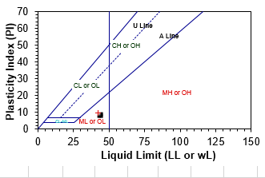

Table 7, Procter Compaction Test (sample data). Determination of Procter Compaction Test (ASTEM D 698) Date of sample: 10-April- 2020 date tested 16- April- 2020

BLOWS PER LAYER | 56 |  |  |  | No. OF LAYERS |  |  |  |  |  |  | 5 |  |  |  | RAMMER WEIGHT  4.5kg
MOLD DIAMETER | 152mm |  |  |  | VOLUME OF MOLD (cm³) |  |  |  |  |  |  | 2104
WEIGHT OF WET SOIL + MOLD |  | (gm) |  |  |  | 7911 |  | 7998 |  | 8192 |  |  | 8429 |  | 8386 |  |  | 8469 |  |  | NMC
WEIGHT OF MOLD |  | (gm) |  |  |  | 4676 |  | 4676 |  | 4676 |  |  | 4676 |  | 4676 |  |  | 4676
WEIGHT OF WET SOIL |  | (gm) |  |  |  | 3235 |  | 3322 |  | 3516 |  |  | 3753 |  | 3710 |  |  | 3793
WET DENSITY |  | (gm/cm³) |  |  |  | 1.538 |  | 1.579 |  | 1.671 |  |  | 1.78 |  | 1.763 |  |  | 1.803
MOISTURE CONTENT : CONTAINER |  |  |  |  |  | B19 |  | B20 |  | B5 |  |  | E4 |  | BC1 |  |  | L4 |  |  | BC
WEIGHT OF WET SOIL + CONTAINER |  | (gm) |  |  |  | 60 |  | 70 |  | 62 |  |  | 64 |  | 68 |  |  | 78 |  |  | 90.0
WEIGHT OF DRY SOIL + CONTAINER |  | (gm) |  |  |  | 56 |  | 64 |  | 55 |  |  | 56 |  | 58 |  |  | 65 |  |  | 85
WEIGHT OF CONTAINER |  | (gm) |  |  |  | 20 |  | 21 |  | 20 |  |  | 22 |  | 19 |  |  | 23 |  |  | 19
WEIGHT OF MOISTURE |  | (gm) |  |  |  | 5 |  | 7 |  | 8 |  |  | 9 |  | 11 |  |  | 13 |  |  | 5.00
WEIGHT OF DRY SOIL |  | (gm) |  |  |  | 36 |  | 43 |  | 35 |  |  | 34 |  | 39 |  |  | 42 |  |  | 66.00
MOISTURE CONTENT |  | (%) |  |  |  | 12.68 |  | 15.29 |  | 21.74 |  |  | 25.3 |  | 27.27 |  |  | 30.95 |  |  | 7.58
DRY DENSITY |  | (gm/cm³) |  |  |  | 1.365 |  | 1.369 |  | 1.373 |  |  | 1.42 |  | 1.385 |  |  | 1.377

MAXIMUM DRY DENSITY (gm/cm³) | 1.423
OPTIMUM MOISTURE CONTENT (%) | 25.37

Table 8 Modified Compaction test with CBR test Result (sample data). Determination of Modified Compaction test with CBR test Result (AASHTO T 193). Date of sample: 10-April- 2020 date tested 16- April- 2020.
DENSITY DETERMINATION
SOAKING CONDITION |  |  |  |  | 10 Blows |  |  | 30 Blows |  |  | 65 Blows
 |  |  |  |  | Before | After |  | Before | After |  | Before | After
MOLD NUMBER |  |  |  |  | 10 |  |  | 19 |  |  | 23
WEIGHT OF SOIL + MOLD, g |  |  |  |  | 11133 |  |  | 11000 |  |  | 11010
WEIGHT OF MOLD, g |  |  |  |  | 7735 |  |  | 7551 |  |  | 7499
WEIGHT OF SOIL , g |  |  |  |  | 3398 |  |  | 3449 |  |  | 3511
VOLUME OF MOLD, g |  |  |  |  | 2125 |  |  | 2122 |  |  | 2116
WET DENSITY OF SOIL, g/cm³ |  |  |  |  | 1.599 | 0.000 |  | 1.625 | 0.000 |  | 1.659 | 0.000
DRY DENSITY OF SOIL, g/cm³ |  |  |  |  | 1.327 | 0.000 |  | 1.400 | 0.000 |  | 1.468 | 0.000
MOISTURE DETERMINATION
SOAKING CONDITION |  |  |  |  | 10 Blows |  |  | 30 Blows |  |  | 65 Blows
 |  |  |  |  | Before | After |  | Before | After |  | Before | After
CONTAINER NUMBER |  |  |  |  | T6 |  |  | T8 |  |  | D8
WET SOIL + CONTAINER, g |  |  |  |  | 67.0 |  |  | 74.0 |  |  | 85.0
DRY SOIL + CONTAINER, g |  |  |  |  | 59.0 |  |  | 66.5 |  |  | 77.5
WEIGHT OF CONTAINER, g |  |  |  |  | 20.0 |  |  | 20.0 |  |  | 20.0
WEIGHT OF WATER , g |  |  |  |  | 8.0 | 0.0 |  | 7.5 |  |  | 7.5
WEIGHT OF DRY SOIL, g |  |  |  |  | 39.0 | 0.0 |  | 46.5 |  |  | 57.5
MOISTURE CONTENT |  |  |  |  | 20.5 |  |  | 16.1 |  |  | 13.0
PENETRATION BOTTOM TEST
 |  |  |  |  |  |  |  | Ring Factor |  |  | 19.49 | N/DIV
 |  |  |  |  |  |  |  | c/s area of plunger (mm2) |  |  | 1962.5
PENETRATION (mm) | 10 Blows |  |  |  | 30 Blows |  |  |  | 65 Blows
PENETRATION (mm) | Dial rdg | Load (kn) | Resistance penetration (N/Sq.mm) | C.B.R (%) | Dial  rdg | Load (kn) | Resistance penetration (N/Sq.mm) | C.B.R (%) | Dial  rdg | Load (kn) | Resistance penetration (N/Sq.mm) | C.B.R (%)
0 | 0 | 0.00 | 0.00 |  | 0 | 0.00 | 0.00 |  | 0 | 0.00 | 0.00
0.64 | 45 | 877.05 | 0.45 |  | 100 | 1949.0 | 0.99 |  | 110 | 2143.9 | 1.09
1.27 | 90 | 1754.1 | 0.89 |  | 180 | 3508.2 | 1.79 |  | 340 | 6626.6 | 3.38
1.96 | 160 | 3118.4 | 1.59 |  | 290 | 5652.1 | 2.88 |  | 420 | 8185.8 | 4.17
2.54 | 205 | 3995.4 | 2.04 | 29.5 | 360 | 7016.4 | 3.58 | 51.8 | 620 | 12083.8 | 6.16 | 89.2
3.18 | 240 | 4677.6 | 2.38 |  | 450 | 8770.50 | 4.47 |  | 780 | 15202.2 | 7.75
3.81 | 270 | 5262.3 | 2.68 |  | 500 | 9745.0 | 4.97 |  | 820 | 15981.8 | 8.14
4.45 | 290 | 5652.1 | 2.88 |  | 650 | 12668.5 | 6.46 |  | 1020 | 19879.8 | 10.13
5.08 | 310 | 6041.9 | 3.08 | 29.9 | 651 | 12687.9 | 6.47 | 62.8 | 1160 | 22608.4 | 11.52 | 111.8
7.62 | 410 | 7990.9 | 4.07 |  | 920 | 17930.8 | 9.14 |  | 1360 | 26506.4 | 13.51
9.60 | 470 | 9160.3 | 4.67 |  | 1060 | 20659.4 | 10.53 |  | 1420 | 27675.8 | 14.10

Table 9, CBR GRAPH VS DRY DENSITY Result (sample data). Determination of Modified Compaction test with CBR test Result (AASHTO T 193) Date of sample: 10-April- 2020 date tested 16- April- 2020.

 |  |  |  |  |  | Number of blows | % Moisture before soak | Dry Density | CBR % | % Moisture after 96 hours | Swell % | % Swell | Standard Load (Mpa)
M.D.D (gm/cm3) |  |  |  |  |  |  |  |  |  |  |  |  | 2.54 mm | 5.08 mm
1.385 |  |  |  |  |  | 10 | 20.5 | 1.327 | 29.9 | 0.1 | 0.10 | 0.097 | 6.90 | 10.30
O.M.C. % |  |  |  |  |  | 30 | 16.1 | 1.400 | 62.8 | 0.1 |  | 0.097 | 6.90 | 10.30
27.3 |  |  |  |  |  | 65 | 13.0 | 1.468 | 111.8 | 0.1 |  | 0.097 | 6.90 | 10.30

CBR GRAPH

CBR Value at 95% MDD =1.32 | 35.0%

Table 10, Dynamic Cone Penetration Test Result (Sample data)
No. of Blow | Total Blows | Measured Depth (cm) | Penetration Between Reading(cm) | cumulative penetration (cm) | Penetration per blow (cm/blow) | log10CBR | CBR Value % | Average  CBR %
1 | 0 | 4.5 | 0.00 | 0.00 | 0.00 | 0.00 | 0.00 | 36.75
1 | 1 | 6.0 | 1.50 | 1.50 | 1.50 | 2.29 | 196.73 | 36.75
1 | 2 | 7.2 | 1.20 | 2.70 | 1.20 | 2.02 | 105.69 | 36.75
1 | 3 | 8.0 | 0.80 | 3.50 | 0.80 | 1.90 | 80.34 | 36.75
1 | 4 | 8.5 | 0.50 | 4.00 | 0.50 | 1.84 | 69.76 | 36.75
1 | 5 | 9.1 | 0.60 | 4.60 | 0.60 | 1.78 | 60.18 | 36.75
1 | 6 | 9.5 | 0.40 | 5.00 | 0.40 | 1.74 | 55.10 | 36.75
1 | 7 | 10.2 | 0.70 | 5.70 | 0.70 | 1.68 | 47.98 | 36.75
1 | 8 | 10.7 | 0.50 | 6.20 | 0.50 | 1.64 | 43.90 | 36.75
1 | 9 | 11.4 | 0.70 | 6.90 | 0.70 | 1.59 | 39.20 | 36.75
1 | 10 | 11.7 | 0.30 | 7.20 | 0.30 | 1.57 | 37.48 | 36.75
1 | 11 | 12.0 | 0.30 | 7.50 | 0.30 | 1.56 | 35.90 | 36.75
1 | 12 | 12.4 | 0.40 | 7.90 | 0.40 | 1.53 | 33.98 | 36.75
1 | 13 | 12.8 | 0.40 | 8.30 | 0.40 | 1.51 | 32.25 | 36.75
1 | 14 | 13.2 | 0.40 | 8.70 | 0.40 | 1.49 | 30.69 | 36.75
1 | 15 | 13.3 | 0.10 | 8.80 | 0.10 | 1.48 | 30.32 | 36.75
1 | 16 | 13.4 | 0.10 | 8.90 | 0.10 | 1.48 | 29.96 | 36.75
1 | 17 | 13.5 | 0.10 | 9.00 | 0.10 | 1.47 | 29.61 | 36.75
1 | 18 | 13.7 | 0.20 | 9.20 | 0.20 | 1.46 | 28.93 | 36.75
1 | 19 | 13.9 | 0.20 | 9.40 | 0.20 | 1.45 | 28.28 | 36.75
1 | 20 | 14.0 | 0.10 | 9.50 | 0.10 | 1.45 | 27.96 | 36.75
1 | 21 | 14.1 | 0.10 | 9.60 | 0.10 | 1.44 | 27.65 | 36.75
1 | 22 | 14.3 | 0.20 | 9.80 | 0.20 | 1.43 | 27.06 | 36.75
1 | 23 | 14.5 | 0.20 | 10.00 | 0.20 | 1.42 | 26.49 | 36.75
1 | 24 | 16.5 | 2.00 | 12.00 | 2.00 | 1.34 | 21.84 | 36.75
1 | 25 | 16.7 | 0.20 | 12.20 | 0.20 | 1.33 | 21.46 | 36.75
1 | 26 | 17.0 | 0.30 | 12.50 | 0.30 | 1.32 | 20.92 | 36.75
1 | 27 | 17.2 | 0.20 | 12.70 | 0.20 | 1.31 | 20.57 | 36.75
1 | 28 | 17.5 | 0.30 | 13.00 | 0.30 | 1.30 | 20.07 | 36.75
1 | 29 | 17.8 | 0.30 | 13.30 | 0.30 | 1.29 | 19.59 | 36.75
1 | 30 | 18.0 | 0.20 | 13.50 | 0.20 | 1.29 | 19.29 | 36.75
1 | 31 | 18.3 | 0.30 | 13.80 | 0.30 | 1.28 | 18.84 | 36.75
1 | 32 | 18.4 | 0.10 | 13.90 | 0.10 | 1.27 | 18.70 | 36.75
1 | 33 | 18.5 | 0.10 | 14.00 | 0.10 | 1.27 | 18.56 | 36.75
1 | 34 | 18.7 | 0.20 | 14.20 | 0.20 | 1.26 | 18.28 | 36.75
1 | 35 | 18.9 | 0.20 | 14.40 | 0.20 | 1.26 | 18.01 | 36.75
1 | 36 | 19.2 | 0.30 | 14.70 | 0.30 | 1.25 | 17.63 | 36.75
1 | 37 | 19.4 | 0.20 | 14.90 | 0.20 | 1.24 | 17.38 | 36.75

Appendix E
Modelling Result
GET
FILE='C: \Users\Dani\Desktop\august these22\from Dani Thesis\mg\1 mg\Untitled Hawassa University to Loke hospital NEW DUST DATA_2.mg.sav'.
DATASET NAME DataSet1 WINDOW=FRONT.
REGRESSION
/DESCRIPTIVES MEAN STDDEV CORR SIG N
/MISSING LISTWISE
/STATISTICS COEFF OUTS CI (95) R ANOVA COLLIN TOL ZPP
/CRITERIA=PIN (.05) POUT (.10)
/NOORIGIN
/DEPENDENT Dust
/METHOD=STEPWISE MMP PI pass75um CBR AADT
/PARTIALPLOT ALL
/SCATTERPLOT= (Dust,*ZPRED) (Dust,*ZRESID) (Dust,*SRESID) (Dust,*SDRESID) (*ZRESID,*DRESID) (*ZPRED,*ADJPRED) (*ZRESID,*ZPRED)
/RESIDUALS HISTOGRAM (ZRESID) NORMPROB (ZRESID)
/CASEWISE PLOT (ZRESID) ALL
/SAVE MAHAL COOK ZRESID DFBETA SDBETA DFFIT SDFIT.
Descriptive Statistics
 | Mean |  | Std. Deviation |  | N
Dust | 119883.0000 |  | 1671.96173 |  | 150
MMP | 108.7056 |  | 34.34922 |  | 150
PI | 10.2785 |  | .51949 |  | 150
pass75um | 8.6505 |  | 1.12346 |  | 150
CBR | 38.0991 |  | 2.86222 |  | 150
AADT | 120.1000 |  | 30.08796 |  | 150
Correlations
 |  |  |  | Dust |  | MMP |  | PI | pass75um | CBR | AADT
Pearson Correlation |  | Dust |  | 1.000 |  | .877 |  | .671 | .912 | -.623 | .321
 |  | MMP |  | .877 |  | 1.000 |  | .396 | .837 | -.290 | .577
 |  | PI |  | .671 |  | .396 |  | 1.000 | .364 | -.919 | -.262
 |  | pass75um |  | .912 |  | .837 |  | .364 | 1.000 | -.359 | .416
 |  | CBR |  | -.623 |  | -.290 |  | -.919 | -.359 | 1.000 | .386
 |  | AADT |  | .321 |  | .577 |  | -.262 | .416 | .386 | 1.000
Sig. (1-tailed) |  | Dust |  | . |  | .000 |  | .000 | .000 | .000 | .000
 |  | MMP |  | .000 |  | . |  | .000 | .000 | .000 | .000
 |  | PI |  | .000 |  | .000 |  | . | .000 | .000 | .001
 |  | pass75um |  | .000 |  | .000 |  | .000 | . | .000 | .000
 |  | CBR |  | .000 |  | .000 |  | .000 | .000 | . | .000
 |  | AADT |  | .000 |  | .000 |  | .001 | .000 | .000 | .
N |  | Dust |  | 150 |  | 150 |  | 150 | 150 | 150 | 150
 |  | MMP |  | 150 |  | 150 |  | 150 | 150 | 150 | 150
 |  | PI |  | 150 |  | 150 |  | 150 | 150 | 150 | 150
 |  | pass75um |  | 150 |  | 150 |  | 150 | 150 | 150 | 150
 |  | CBR |  | 150 |  | 150 |  | 150 | 150 | 150 | 150
 |  | AADT |  | 150 |  | 150 |  | 150 | 150 | 150 | 150

Model Summary^{b}
Model | R | R Square | Adjusted R Square | Std. Error of the Estimate | Change Statistics
 |  |  |  |  | R Square Change | F Change | df1 | df2 | Sig. F Change
1 | .995ª | .991 | .990 | 164.61193 | .991 | 3045.501 | 5 | 144 | .000
a. Predictors: (Constant), AADT, PI, pass75um, MMP, CBR b. Dependent Variable: Dust

ANOVAª
Model |  | Sum of Squares | df | Mean Square | F | Sig.
1 | Regression | 412620969.469 | 5 | 82524193.894 | 3045.501 | .000^{b}
1 | Residual | 3901980.531 | 144 | 27097.087
1 | Total | 416522950.000 | 149
a. Dependent Variable: Dust
b. Predictors: (Constant), AADT, PI, pass75um, MMP, CBR

Coefficientsª
Model |  | Unstandardized Coefficients |  | Standardized Coefficients | t | Sig. | Correlations |  |  | Collinearity Statistics
 |  | B | Std. Err | Beta | t | Sig. | Zero-o | Partial | Part | Tolerance | VIF
1 | (Constant) | 105728.03 | 1303.98 |  | 81.08 | .000
1 | MMP | 10.456 | .962 | .215 | 10.87 | .000 | .877 | .671 | .088 | .167 | 6.002
1 | PI | 882.912 | 74.754 | .274 | 11.81 | .000 | .671 | .701 | .095 | .121 | 8.292
1 | pass75um | 786.080 | 24.063 | .528 | 32.66 | .000 | .912 | .939 | .263 | .249 | 4.018
1 | CBR | -94.428 | 14.127 | -.162 | -6.684 | .000 | -.623 | -.487 | -.054 | .111 | 8.990
1 | AADT | 6.170 | .777 | .111 | 7.940 | .000 | .321 | .552 | .064 | .333 | 3.006
a. Dependent Variable: Dust

Residuals Statisticsª
 | Minimum | Maximum | Mean | Std. Deviation | N
Predicted Value | 117289.7344 | 122331.3672 | 119883.0000 | 1664.11185 | 150
Std. Predicted Value | -1.558 | 1.471 | .000 | 1.000 | 150
Standard Error of Predicted Value | 27.223 | 44.304 | 32.656 | 4.195 | 150
Adjusted Predicted Value | 117287.4375 | 122342.3359 | 119882.2251 | 1663.61234 | 150
Residual | -331.82135 | 342.20084 | .00000 | 161.82642 | 150
Std. Residual | -2.016 | 2.079 | .000 | .983 | 150
Stud. Residual | -2.064 | 2.135 | .002 | 1.005 | 150
Deleted Residual | -347.72119 | 360.78030 | .77486 | 169.13150 | 150
Stud. Deleted Residual | -2.087 | 2.162 | .003 | 1.010 | 150
Mahal. Distance | 3.082 | 9.800 | 4.967 | 1.602 | 150
Cook's Distance | .000 | .041 | .008 | .010 | 150
Centered Leverage Value | .021 | .066 | .033 | .011 | 150
a. Dependent Variable: Dust

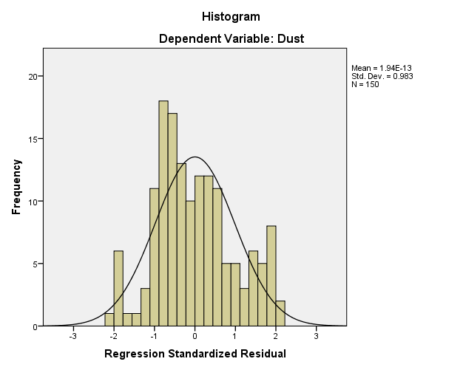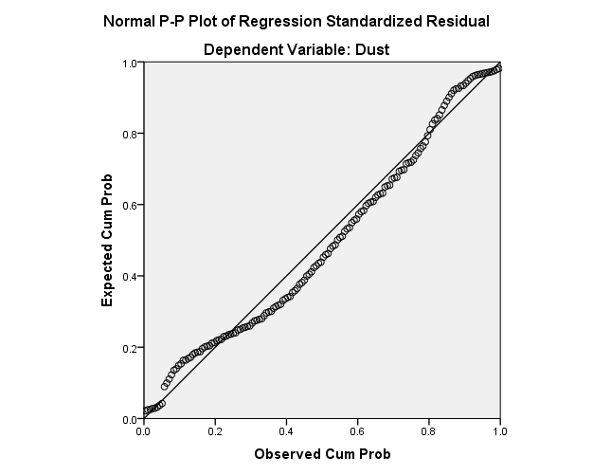
Charts

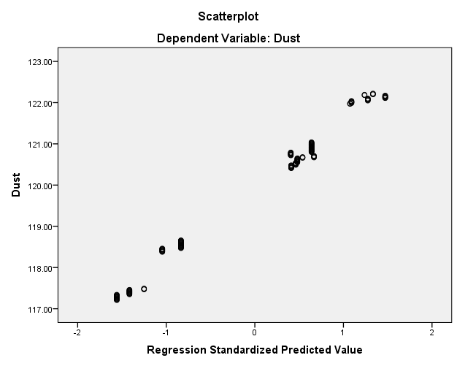

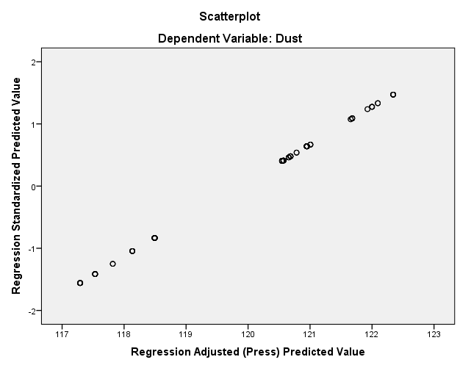

REGRESSION
/DESCRIPTIVES MEAN STDDEV CORR SIG N
/MISSING LISTWISE
/STATISTICS COEFF OUTS CI (95) R ANOVA COLLIN TOL CHANGE ZPP
/CRITERIA=PIN (.05) POUT (.10)
/NOORIGIN
/DEPENDENT Dust
/METHOD=STEPWISE MMP PI pass75um CBR AADT
/PARTIALPLOT ALL
/SCATTERPLOT= (Dust,*ZPRED) (Dust,*ZRESID) (Dust,*SRESID) (Dust,*SDRESID) (*ZPRED,*ZRESID) (*ZPRED,*DRESID) (*ZPRED,*ADJPRED) (*ZRESID,*ZPRED)
/RESIDUALS HISTOGRAM (ZRESID) NORMPROB (ZRESID)
/CASEWISE PLOT (ZRESID) ALL
/SAVE MAHAL COOK ZRESID DFBETA SDBETA DFFIT SDFIT COVRATIO.
Descriptive Statistics
 |  |  | Mean |  |  |  |  |  |  |  | Std. Deviation |  |  |  |  |  | N
Dust |  |  | 116135.5705 |  |  |  |  |  |  |  | 1490.80598 |  |  |  |  |  | 149
MMP |  |  | 110.2227 |  |  |  |  |  |  |  | 34.75832 |  |  |  |  |  | 149
PI |  |  | 10.1034 |  |  |  |  |  |  |  | .84027 |  |  |  |  |  | 149
pass75um |  |  | 11.3217 |  |  |  |  |  |  |  | 1.64866 |  |  |  |  |  | 149
CBR |  |  | 35.0207 |  |  |  |  |  |  |  | 3.70240 |  |  |  |  |  | 149
AADT |  |  | 96.0470 |  |  |  |  |  |  |  | 31.81499 |  |  |  |  |  | 149
Correlations
 |  |  |  |  |  |  |  |  |  |  |  |  | Dust |  |  |  |  | MMP |  |  |  |  | PI |  |  |  |  | pass75um |  |  |  |  |  | CBR |  |  |  |  |  | AADT
Pearson Correlation |  |  |  |  |  | Dust |  |  |  |  |  |  | 1.000 |  |  |  |  | .766 |  |  |  |  | .547 |  |  |  |  | .539 |  |  |  |  |  | -.912 |  |  |  |  |  | .414
 |  |  |  |  |  | MMP |  |  |  |  |  |  | .766 |  |  |  |  | 1.000 |  |  |  |  | .364 |  |  |  |  | .694 |  |  |  |  |  | -.706 |  |  |  |  |  | .715
 |  |  |  |  |  | PI |  |  |  |  |  |  | .547 |  |  |  |  | .364 |  |  |  |  | 1.000 |  |  |  |  | -.110 |  |  |  |  |  | -.411 |  |  |  |  |  | -.039
 |  |  |  |  |  | pass75um |  |  |  |  |  |  | .539 |  |  |  |  | .694 |  |  |  |  | -.110 |  |  |  |  | 1.000 |  |  |  |  |  | -.434 |  |  |  |  |  | .708
 |  |  |  |  |  | CBR |  |  |  |  |  |  | -.912 |  |  |  |  | -.706 |  |  |  |  | -.411 |  |  |  |  | -.434 |  |  |  |  |  | 1.000 |  |  |  |  |  | -.249
 |  |  |  |  |  | AADT |  |  |  |  |  |  | .414 |  |  |  |  | .715 |  |  |  |  | -.039 |  |  |  |  | .708 |  |  |  |  |  | -.249 |  |  |  |  |  | 1.000
Sig. (1-tailed) |  |  |  |  |  | Dust |  |  |  |  |  |  | . |  |  |  |  | .000 |  |  |  |  | .000 |  |  |  |  | .000 |  |  |  |  |  | .000 |  |  |  |  |  | .000
 |  |  |  |  |  | MMP |  |  |  |  |  |  | .000 |  |  |  |  | . |  |  |  |  | .000 |  |  |  |  | .000 |  |  |  |  |  | .000 |  |  |  |  |  | .000
 |  |  |  |  |  | PI |  |  |  |  |  |  | .000 |  |  |  |  | .000 |  |  |  |  | . |  |  |  |  | .092 |  |  |  |  |  | .000 |  |  |  |  |  | .319
 |  |  |  |  |  | pass75um |  |  |  |  |  |  | .000 |  |  |  |  | .000 |  |  |  |  | .092 |  |  |  |  | . |  |  |  |  |  | .000 |  |  |  |  |  | .000
 |  |  |  |  |  | CBR |  |  |  |  |  |  | .000 |  |  |  |  | .000 |  |  |  |  | .000 |  |  |  |  | .000 |  |  |  |  |  | . |  |  |  |  |  | .001
 |  |  |  |  |  | AADT |  |  |  |  |  |  | .000 |  |  |  |  | .000 |  |  |  |  | .319 |  |  |  |  | .000 |  |  |  |  |  | .001 |  |  |  |  |  | .
N |  |  |  |  |  | Dust |  |  |  |  |  |  | 149 |  |  |  |  | 149 |  |  |  |  | 149 |  |  |  |  | 149 |  |  |  |  |  | 149 |  |  |  |  |  | 149
 |  |  |  |  |  | MMP |  |  |  |  |  |  | 149 |  |  |  |  | 149 |  |  |  |  | 149 |  |  |  |  | 149 |  |  |  |  |  | 149 |  |  |  |  |  | 149
 |  |  |  |  |  | PI |  |  |  |  |  |  | 149 |  |  |  |  | 149 |  |  |  |  | 149 |  |  |  |  | 149 |  |  |  |  |  | 149 |  |  |  |  |  | 149
 |  |  |  |  |  | pass75um |  |  |  |  |  |  | 149 |  |  |  |  | 149 |  |  |  |  | 149 |  |  |  |  | 149 |  |  |  |  |  | 149 |  |  |  |  |  | 149
 |  |  |  |  |  | CBR |  |  |  |  |  |  | 149 |  |  |  |  | 149 |  |  |  |  | 149 |  |  |  |  | 149 |  |  |  |  |  | 149 |  |  |  |  |  | 149
 |  |  |  |  |  | AADT |  |  |  |  |  |  | 149 |  |  |  |  | 149 |  |  |  |  | 149 |  |  |  |  | 149 |  |  |  |  |  | 149 |  |  |  |  |  | 149
Model Summary^{b}
Model | R |  |  | R Square |  |  |  | Adjusted R Square |  |  |  | Std. Error of the Estimate |  |  |  |  |  |  | Change Statistics
 |  |  |  |  |  |  |  |  |  |  |  |  |  |  |  |  |  |  | R Square Change |  |  |  |  |  |  |  | F Change |  |  |  | df1 |  |  |  | df2 |  |  |  | Sig. F Change
1 | .971ª |  |  | .943 |  |  |  | .941 |  |  |  | 362.45773 |  |  |  |  |  |  | .943 |  |  |  |  |  |  |  | 472.148 |  |  |  | 5 |  |  |  | 143 |  |  |  | .000
a. Predictors: (Constant), AADT, PI, CBR, pass75um, MMP
b. Dependent Variable: Dust

ANOVAª
Model |  |  |  |  |  |  | Sum of Squares |  |  |  |  |  |  | df |  |  |  |  |  | Mean Square |  |  |  |  |  | F |  |  |  |  |  | Sig.
1 |  | Regression |  |  |  |  | 310143654.984 |  |  |  |  |  |  | 5 |  |  |  |  |  | 62028730.997 |  |  |  |  |  | 472.148 |  |  |  |  |  | .000^{b}
 |  | Residual |  |  |  |  | 18786711.162 |  |  |  |  |  |  | 143 |  |  |  |  |  | 131375.603
 |  | Total |  |  |  |  | 328930366.147 |  |  |  |  |  |  | 148
a. Dependent Variable: Dust
b. Predictors: (Constant), AADT, PI, CBR, pass75um, MMP

Coefficientsª
Model |  |  |  |  | Unstandardized Coefficients |  |  |  |  |  |  |  |  |  | Standardized Coefficients |  |  |  |  |  | t |  |  |  | Sig. |  |  |  | Correlations |  |  |  |  |  |  |  |  |  |  |  | Collinearity Statistics
 |  |  |  |  | B |  |  |  |  | Std. Error |  |  |  |  | Beta |  |  |  |  |  |  |  |  |  |  |  |  |  | Zero-or |  |  |  | Partial |  |  | Part |  |  |  |  | Tolerance |  |  |  |  | VIF
1 | (Constant) |  |  |  | 118377.918 |  |  |  |  | 857.923 |  |  |  |  |  |  |  |  |  |  | 137.982 |  |  |  | .000
1 | MMP |  |  |  | -11.498 |  |  |  |  | 2.247 |  |  |  |  | -.268 |  |  |  |  |  | -5.116 |  |  |  | .000 |  |  |  | .766 |  |  |  | -.393 |  |  | -.102 |  |  |  |  | .145 |  |  |  |  | 6.874
1 | PI |  |  |  | 636.385 |  |  |  |  | 47.570 |  |  |  |  | .359 |  |  |  |  |  | 13.378 |  |  |  | .000 |  |  |  | .547 |  |  |  | .746 |  |  | .267 |  |  |  |  | .556 |  |  |  |  | 1.800
1 | pass75um |  |  |  | 224.527 |  |  |  |  | 31.023 |  |  |  |  | .248 |  |  |  |  |  | 7.237 |  |  |  | .000 |  |  |  | .539 |  |  |  | .518 |  |  | .145 |  |  |  |  | .339 |  |  |  |  | 2.947
1 | CBR |  |  |  | -315.899 |  |  |  |  | 13.400 |  |  |  |  | -.785 |  |  |  |  |  | -23.575 |  |  |  | .000 |  |  |  | -.912 |  |  |  | -.892 |  |  | -.471 |  |  |  |  | .361 |  |  |  |  | 2.773
1 | AADT |  |  |  | 11.623 |  |  |  |  | 1.777 |  |  |  |  | .248 |  |  |  |  |  | 6.539 |  |  |  | .000 |  |  |  | .414 |  |  |  | .480 |  |  | .131 |  |  |  |  | .278 |  |  |  |  | 3.603
    - Dependent Variable: Dust

Residuals Statisticsª
 |  |  |  |  |  |  |  |  | Minimum |  |  |  |  |  |  | Maximum |  |  |  |  |  |  |  | Mean |  |  |  |  |  | Std. Deviation |  |  |  |  |  |  |  | N
Predicted Value |  |  |  |  |  |  |  |  | 113799.1094 |  |  |  |  |  |  | 118042.9453 |  |  |  |  |  |  |  | 116135.5705 |  |  |  |  |  | 1447.60673 |  |  |  |  |  |  |  | 149
Std. Predicted Value |  |  |  |  |  |  |  |  | -1.614 |  |  |  |  |  |  | 1.318 |  |  |  |  |  |  |  | .000 |  |  |  |  |  | 1.000 |  |  |  |  |  |  |  | 149
Standard Error of Predicted Value |  |  |  |  |  |  |  |  | 45.904 |  |  |  |  |  |  | 119.794 |  |  |  |  |  |  |  | 70.811 |  |  |  |  |  | 16.673 |  |  |  |  |  |  |  | 149
Adjusted Predicted Value |  |  |  |  |  |  |  |  | 113785.5625 |  |  |  |  |  |  | 118032.4766 |  |  |  |  |  |  |  | 116133.7722 |  |  |  |  |  | 1448.36718 |  |  |  |  |  |  |  | 149
Residual |  |  |  |  |  |  |  |  | -799.83093 |  |  |  |  |  |  | 1127.84216 |  |  |  |  |  |  |  | .00000 |  |  |  |  |  | 356.28252 |  |  |  |  |  |  |  | 149
Std. Residual |  |  |  |  |  |  |  |  | -2.207 |  |  |  |  |  |  | 3.112 |  |  |  |  |  |  |  | .000 |  |  |  |  |  | .983 |  |  |  |  |  |  |  | 149
Stud. Residual |  |  |  |  |  |  |  |  | -2.233 |  |  |  |  |  |  | 3.297 |  |  |  |  |  |  |  | .002 |  |  |  |  |  | 1.006 |  |  |  |  |  |  |  | 149
Deleted Residual |  |  |  |  |  |  |  |  | -819.29724 |  |  |  |  |  |  | 1266.14893 |  |  |  |  |  |  |  | 1.79828 |  |  |  |  |  | 373.23329 |  |  |  |  |  |  |  | 149
Stud. Deleted Residual |  |  |  |  |  |  |  |  | -2.265 |  |  |  |  |  |  | 3.418 |  |  |  |  |  |  |  | .003 |  |  |  |  |  | 1.013 |  |  |  |  |  |  |  | 149
Mahal. Distance |  |  |  |  |  |  |  |  | 1.381 |  |  |  |  |  |  | 15.173 |  |  |  |  |  |  |  | 4.966 |  |  |  |  |  | 2.932 |  |  |  |  |  |  |  | 149
Cook's Distance |  |  |  |  |  |  |  |  | .000 |  |  |  |  |  |  | .222 |  |  |  |  |  |  |  | .008 |  |  |  |  |  | .022 |  |  |  |  |  |  |  | 149
Centered Leverage Value |  |  |  |  |  |  |  |  | .009 |  |  |  |  |  |  | .103 |  |  |  |  |  |  |  | .034 |  |  |  |  |  | .020 |  |  |  |  |  |  |  | 149
a. Dependent Variable: Dust

Charts
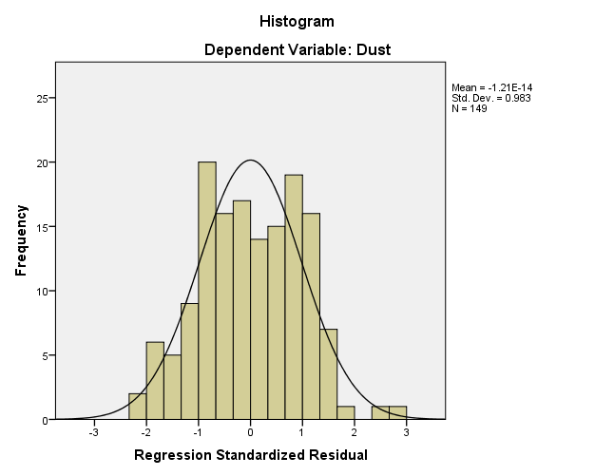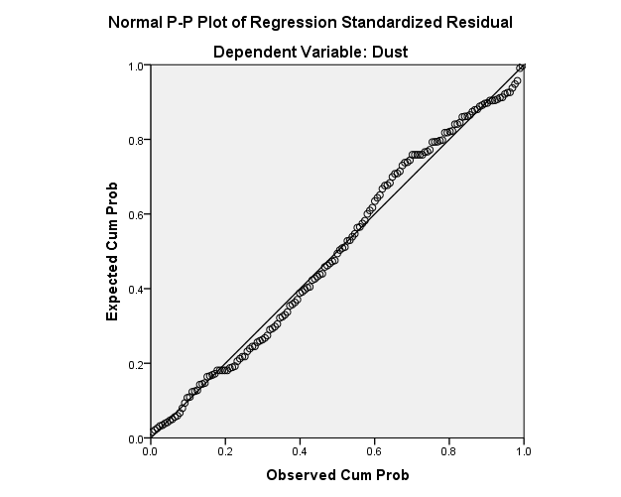

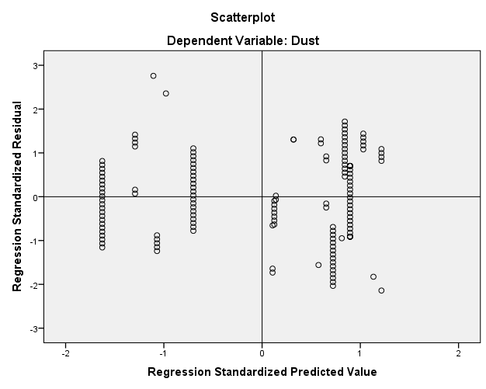

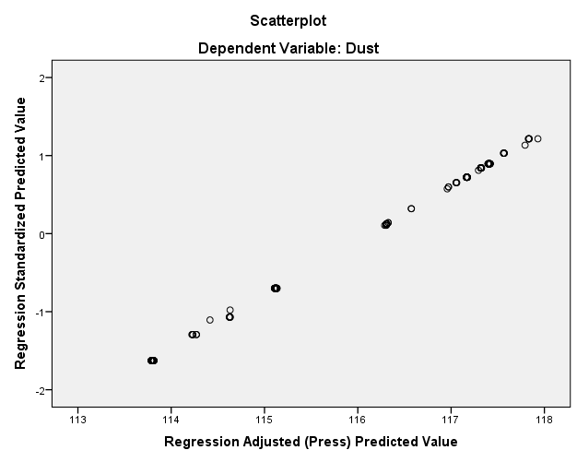
REGRESSION
/DESCRIPTIVES MEAN STDDEV CORR SIG N
/MISSING LISTWISE
/STATISTICS COEFF OUTS CI (95) R ANOVA COLLIN TOL CHANGE ZPP
/CRITERIA=PIN (.05) POUT (.10)
/NOORIGIN
/DEPENDENT Dust
/METHOD=STEPWISE MMP PI pass75um CBR AADT
/PARTIALPLOT ALL
/SCATTERPLOT= (Dust,*ZPRED) (Dust,*ZRESID) (Dust,*DRESID) (Dust,*SRESID) (Dust,*SDRESID) (*ZPRED,*ZRESID) (*ZPRED,*DRESID) (*ZPRED,*SDRESID)
/RESIDUALS HISTOGRAM (ZRESID) NORMPROB (ZRESID)
/CASEWISE PLOT (ZRESID) ALL
/SAVE MAHAL COOK ZRESID DFBETA SDBETA DFFIT SDFIT COVRATIO.
Descriptive Statistics
 | Mean | Std. Deviation | N
Dust | 113617.6000 | 2986.81188 | 150
MMP | 109.4401 | 34.83477 | 150
PI | 8.0237 | .67982 | 150
pass75um | 9.8549 | 1.52125 | 150
CBR | 33.6931 | 3.44642 | 150
AADT | 84.9933 | 27.16504 | 150

Correlations
 |  |  |  |  |  |  |  |  |  |  |  | Dust |  |  |  | MMP |  |  |  | PI |  |  |  |  | pass75um |  |  |  |  | CBR |  |  |  |  |  |  | AADT
Pearson Correlation |  |  |  |  |  | Dust |  |  |  |  |  | 1.000 |  |  |  | .872 |  |  |  | .252 |  |  |  |  | .397 |  |  |  |  | -.943 |  |  |  |  |  |  | .538
 |  |  |  |  |  | MMP |  |  |  |  |  | .872 |  |  |  | 1.000 |  |  |  | .413 |  |  |  |  | .435 |  |  |  |  | -.741 |  |  |  |  |  |  | .627
 |  |  |  |  |  | PI |  |  |  |  |  | .252 |  |  |  | .413 |  |  |  | 1.000 |  |  |  |  | .293 |  |  |  |  | -.019 |  |  |  |  |  |  | .514
 |  |  |  |  |  | pass75um |  |  |  |  |  | .397 |  |  |  | .435 |  |  |  | .293 |  |  |  |  | 1.000 |  |  |  |  | -.272 |  |  |  |  |  |  | -.163
 |  |  |  |  |  | CBR |  |  |  |  |  | -.943 |  |  |  | -.741 |  |  |  | -.019 |  |  |  |  | -.272 |  |  |  |  | 1.000 |  |  |  |  |  |  | -.416
 |  |  |  |  |  | AADT |  |  |  |  |  | .538 |  |  |  | .627 |  |  |  | .514 |  |  |  |  | -.163 |  |  |  |  | -.416 |  |  |  |  |  |  | 1.000
Sig. (1-tailed) |  |  |  |  |  | Dust |  |  |  |  |  | . |  |  |  | .000 |  |  |  | .001 |  |  |  |  | .000 |  |  |  |  | .000 |  |  |  |  |  |  | .000
 |  |  |  |  |  | MMP |  |  |  |  |  | .000 |  |  |  | . |  |  |  | .000 |  |  |  |  | .000 |  |  |  |  | .000 |  |  |  |  |  |  | .000
 |  |  |  |  |  | PI |  |  |  |  |  | .001 |  |  |  | .000 |  |  |  | . |  |  |  |  | .000 |  |  |  |  | .408 |  |  |  |  |  |  | .000
 |  |  |  |  |  | pass75um |  |  |  |  |  | .000 |  |  |  | .000 |  |  |  | .000 |  |  |  |  | . |  |  |  |  | .000 |  |  |  |  |  |  | .023
 |  |  |  |  |  | CBR |  |  |  |  |  | .000 |  |  |  | .000 |  |  |  | .408 |  |  |  |  | .000 |  |  |  |  | . |  |  |  |  |  |  | .000
 |  |  |  |  |  | AADT |  |  |  |  |  | .000 |  |  |  | .000 |  |  |  | .000 |  |  |  |  | .023 |  |  |  |  | .000 |  |  |  |  |  |  | .
N |  |  |  |  |  | Dust |  |  |  |  |  | 150 |  |  |  | 150 |  |  |  | 150 |  |  |  |  | 150 |  |  |  |  | 150 |  |  |  |  |  |  | 150
 |  |  |  |  |  | MMP |  |  |  |  |  | 150 |  |  |  | 150 |  |  |  | 150 |  |  |  |  | 150 |  |  |  |  | 150 |  |  |  |  |  |  | 150
 |  |  |  |  |  | PI |  |  |  |  |  | 150 |  |  |  | 150 |  |  |  | 150 |  |  |  |  | 150 |  |  |  |  | 150 |  |  |  |  |  |  | 150
 |  |  |  |  |  | pass75um |  |  |  |  |  | 150 |  |  |  | 150 |  |  |  | 150 |  |  |  |  | 150 |  |  |  |  | 150 |  |  |  |  |  |  | 150
 |  |  |  |  |  | CBR |  |  |  |  |  | 150 |  |  |  | 150 |  |  |  | 150 |  |  |  |  | 150 |  |  |  |  | 150 |  |  |  |  |  |  | 150
 |  |  |  |  |  | AADT |  |  |  |  |  | 150 |  |  |  | 150 |  |  |  | 150 |  |  |  |  | 150 |  |  |  |  | 150 |  |  |  |  |  |  | 150
Model Summary^{b}
Model |  | R |  | R Square |  |  |  | Adjusted R Square |  |  | Std. Error of the Estimate |  |  |  |  |  | Change Statistics
 |  |  |  |  |  |  |  |  |  |  |  |  |  |  |  |  | R Square Change |  |  |  |  |  |  | F Change |  |  |  |  | df1 |  |  | df2 |  |  |  | Sig. F Change
1 |  | .984ª |  | .969 |  |  |  | .968 |  |  | 536.35099 |  |  |  |  |  | .969 |  |  |  |  |  |  | 895.332 |  |  |  |  | 5 |  |  | 144 |  |  |  | .000
a. Predictors: (Constant), AADT, pass75um, CBR, PI, MMP b. Dependent Variable: Dust
ANOVAª
Model |  |  |  |  |  |  | Sum of Squares |  |  |  |  |  |  | df |  |  |  | Mean Square |  |  |  |  | F |  |  |  |  | Sig.
1 |  |  | Regression |  |  |  | 1287810913.19 |  |  |  |  |  |  | 5 |  |  |  | 257562182.638 |  |  |  |  | 895.332 |  |  |  |  | .000^{b}
 |  |  | Residual |  |  |  | 41424822.808 |  |  |  |  |  |  | 144 |  |  |  | 287672.381
 |  |  | Total |  |  |  | 1329235736.00 |  |  |  |  |  |  | 149
a. Dependent Variable: Dust b. Predictors: (Constant), AADT, pass75um, CBR, PI, MMP
Coefficientsª
Model |  |  |  |  | Unstandardized Coeffic |  |  |  |  |  |  |  | Standardized Co |  |  |  |  |  | t |  |  | Sig. |  | Correlations |  |  |  |  |  |  |  |  |  |  | Collinearity Statist
 |  |  |  |  | B |  |  |  |  | Std. Err |  |  | Beta |  |  |  |  |  |  |  |  |  |  | Zero-or |  |  | Partial |  |  |  | Part |  |  |  | Tolerance |  |  | VIF
1 | (Constant) |  |  |  | 127454.769 |  |  |  |  | 840.60 |  |  |  |  |  |  |  |  | 151.62 |  |  | .000
1 | MMP |  |  |  | 17.401 |  |  |  |  | 2.902 |  |  | .203 |  |  |  |  |  | 5.996 |  |  | .000 |  | .872 |  |  | .447 |  |  |  | .088 |  |  |  | .189 |  |  | 5.293
1 | PI |  |  |  | 382.760 |  |  |  |  | 97.665 |  |  | .087 |  |  |  |  |  | 3.919 |  |  | .000 |  | .252 |  |  | .310 |  |  |  | .058 |  |  |  | .438 |  |  | 2.283
1 | pass75um |  |  |  | 188.989 |  |  |  |  | 47.237 |  |  | .096 |  |  |  |  |  | 4.001 |  |  | .000 |  | .397 |  |  | .316 |  |  |  | .059 |  |  |  | .374 |  |  | 2.675
1 | CBR |  |  |  | -634.862 |  |  |  |  | 21.638 |  |  | -.733 |  |  |  |  |  | -29.340 |  |  | .000 |  | -.943 |  |  | -.926 |  |  |  | -.432 |  |  |  | .347 |  |  | 2.880
1 | AADT |  |  |  | 8.416 |  |  |  |  | 3.257 |  |  | .077 |  |  |  |  |  | 2.584 |  |  | .011 |  | .538 |  |  | .211 |  |  |  | .038 |  |  |  | .247 |  |  | 4.054
a. Dependent Variable: Dust
Residuals Statisticsª
 |  |  |  |  |  |  |  |  | Minimum |  |  |  |  |  | Maximum |  |  |  |  |  | Mean |  |  |  |  | Std. Deviation |  |  |  |  |  |  |  | N
Predicted Value |  |  |  |  |  |  |  |  | 108236.2344 |  |  |  |  |  | 116588.6484 |  |  |  |  |  | 113617.6000 |  |  |  |  | 2939.90242 |  |  |  |  |  |  |  | 150
Std. Predicted Value |  |  |  |  |  |  |  |  | -1.830 |  |  |  |  |  | 1.011 |  |  |  |  |  | .000 |  |  |  |  | 1.000 |  |  |  |  |  |  |  | 150
Standard Error of Predicted Value |  |  |  |  |  |  |  |  | 82.989 |  |  |  |  |  | 159.562 |  |  |  |  |  | 106.201 |  |  |  |  | 15.162 |  |  |  |  |  |  |  | 150
Adjusted Predicted Value |  |  |  |  |  |  |  |  | 108222.4844 |  |  |  |  |  | 116594.5547 |  |  |  |  |  | 113616.2437 |  |  |  |  | 2939.07844 |  |  |  |  |  |  |  | 150
Residual |  |  |  |  |  |  |  |  | -1063.47278 |  |  |  |  |  | 1179.91528 |  |  |  |  |  | .00000 |  |  |  |  | 527.27502 |  |  |  |  |  |  |  | 150
Std. Residual |  |  |  |  |  |  |  |  | -1.983 |  |  |  |  |  | 2.200 |  |  |  |  |  | .000 |  |  |  |  | .983 |  |  |  |  |  |  |  | 150
Stud. Residual |  |  |  |  |  |  |  |  | -2.032 |  |  |  |  |  | 2.234 |  |  |  |  |  | .001 |  |  |  |  | 1.002 |  |  |  |  |  |  |  | 150
Deleted Residual |  |  |  |  |  |  |  |  | -1116.57922 |  |  |  |  |  | 1217.10388 |  |  |  |  |  | 1.35630 |  |  |  |  | 548.35100 |  |  |  |  |  |  |  | 150
Stud. Deleted Residual |  |  |  |  |  |  |  |  | -2.054 |  |  |  |  |  | 2.266 |  |  |  |  |  | .002 |  |  |  |  | 1.007 |  |  |  |  |  |  |  | 150
Mahal. Distance |  |  |  |  |  |  |  |  | 2.574 |  |  |  |  |  | 12.194 |  |  |  |  |  | 4.967 |  |  |  |  | 1.833 |  |  |  |  |  |  |  | 150
Cook's Distance |  |  |  |  |  |  |  |  | .000 |  |  |  |  |  | .034 |  |  |  |  |  | .007 |  |  |  |  | .008 |  |  |  |  |  |  |  | 150
Centered Leverage Value |  |  |  |  |  |  |  |  | .017 |  |  |  |  |  | .082 |  |  |  |  |  | .033 |  |  |  |  | .012 |  |  |  |  |  |  |  | 150
Charts
