

Integrated energy optimization of smart home appliances with cost-effective energy management system
(Case Study: Mid-Size Residential Home at Hawassa City)
By Tesfahun Molla
(ID No. : PGEng/013/08)

A Thesis
Submitted in partial fulfillment of the requirements for the degree of
MASTER OF SCIENCE
In Power system and Energy Engineering

Advisor: Dr Baseem Khan
Co Advisor: Bezabh Moges

HAWASSA UNIVERSITY
2018/2019



CANDIDATE’S DECLARATION

I hereby declare that the thesis “Integrated energy optimization of smart home appliances with cost-effective energy management system” is my own work conducted under the guidance of Baseem Khan, (PhD), Department of Electrical Engineering, Hawassa University, Institute of Technology, Hawassa (SNNPRS), Ethiopia.

I further declare that to the best of my knowledge the thesis does not contain any part of work that has been submitted for the award of any degree either in this university or any other university without proper citation.

(Tesfahun Molla)
PGEng/013/08

This is to certify that the statement made above by the candidate is true to the best of our knowledge.

Date: ______________________
Name of Advisor: Baseem Khan (PhD) _ Signature: _______________
Name of Co Advisor: Bezabih Moges (MSc) Signature: _______________
Department of Electrical and Computer Engineering
Hawassa University
Hawassa, SNNPRS, 05

Acknowledgement
I would like to express my gratitude to Dr. Baseem Khan for the opportunity gave to me to work on this research title and for his guidance and support during all this time preparing my master thesis. It was difficult to achieve all this success without his encouragement, continuous comment and supervision throughout my work. It was a wonderful experience to learn under his guidance.
Another person, I would like to thank is Mr. Bezabih Moges for the excellent cooperation and his valuable advices.
I would also like to thank Mr. Tewodros Tesfaye and all Hawassa University Electrical and computer engineering staff members for their support in giving valuable comments and encouragement while I was doing my MSc thesis.
Finally, I would like to thank all my family and friends for their love and supporting me throughout the graduate program.

Abstract
With the development of smart grid technology, residents have the opportunity to schedule their power consumption pattern in their home by themselves for the purpose of minimizing electricity expense, reducing the peak-to-average ratio (PAR) and peak load demand. The two way flow of information between electric utilities and consumers in smart grid opened new areas of applications. In this thesis, a general architecture of home energy management system (HEMS) would be introduced in a home area network (HAN) based on the smart grid scenario and then an efficient scheduling method for home power usage would be proposed. The energy management controller (EMC) receives the demand response (DR) information indicating the Time-of use electricity price (TOUP) through the home gateway (HG). With the DR signal, the EMC achieves an optimal power scheduling scheme that can be delivered to each electric appliance by the HG. The rooftop photovoltaic system used as local generation micro grid in the home and can be integrated to the national grid. These results in reduction of electricity bill and when solar energy production is more than the demand of the home, the excess energy could be exported to the national grid. Accordingly, all appliances in the home operate automatically in the most cost-effective way. Detail explanation and discussion of four scheduling techniques would be designed under TOUP. To calculate the fitness function; two powerful swarm intelligence based Meta-heuristic algorithms i.e. Grey wolf optimizer (GWO) and Particle swarm optimization (PSO) algorithms had been used. Finally, detail comparison and analysis between proposed methods and algorithms could be carried out. To display the result, MAT LAB 16(a) software environment would be used.

Contents
Acknowledgement i
Abstract ii
List of Tables v
List of Figures vii
List of Abbreviations ix
1 Introduction 1
1.1 Back ground 1
1.2 Smart grid 2
1.2.1 Smart building 3
1.3 Levels of energy management under smart grid communication network (SGCN) 4
1.3.1 Consumers under Home area network (HAN) 4
1.3.2 Aggregator under Neighborhood Area network (NAN) 4
1.3.3 Electric power Utility under Wide Area Network (WAN) 5
1.4 Demand Response 5
1.5 Demand side Management 6
1.6 Time based pricing programs 7
1.7 The Structure of home energy management system in smart grid 8
1.8 Statement of the problem 9
1.9 Objective of the Thesis 9
1.9.1 Main Objective 9
1.9.2 Specific Objective 9
1.10 Literature Review 10
1.11 Methodology 14
1.12 Contribution of the Thesis 15
1.13 Organization of the Thesis 15
2 Demand side Management and optimization of Residential Demand Response 17
2.1 Load type categorization 17
2.2 Description of home appliances Used 17
2.3 Energy management controller Unit 19
2.4 Micro Grid 19
3 Modeling Grid-Tied Roof top Solar PV system 21
3.1 Introduction 21
3.1.1 Direct type PV system 21
3.1.2 Off-grid (Stand-alone) PV system 21
3.1.3 Grid-Tied PV System without Energy storage 22
3.1.4 Grid-Tied PV System with Energy storage 22
3.2 Sizing of roof top solar PV modules 25
3.3 Electricity tariff 29
4 Optimization of home appliance scheduling Problem formulation and proposed solution 32
4.1 Proposed Approach to manage Energy consumption 32
4.1.1 Power usage Pattern of home appliances 32
4.1.2 Problem Definition 32
4.1.3 The ON and OFF Decision Variable 34
4.1.4 The Objective function 34
4.1.5 Constraints 36
4.2 Grey wolf optimizer (GWO) Algorithm 40
4.3 Particle Swarm Optimizer (PSO) Algorithm 42
4.4 Grey wolf optimizer optimization algorithm formulation 43
5 Simulation results and discussion 50
5.1 Optimization result and analysis of energy cost, PAR and peak load 50
5.2 Optimization result and analysis of customer’s dissatisfaction value 79
6 Conclusion and Future work 82
6.1 Conclusions 82
6.2 Future work 84
References 85
Appendix A 91
Appendix B 91
Appendix C 92

List of Tables
Table 1 Comparative Analysis of Mathematical and Heuristic based methods
Table 2.1 List of electric appliances
Table 3.1 Daily load profile of appliance
Table 3.2 Parameters of the PV system with their calculated values
Table 3.3 Parameters of the Inverter and DC cable with their calculated values
Table 3.4 EEU electricity pricing categories
Table 3.5 Two level TOUP electricity pricing tariffs in Ethiopian electric utility
Table 4.1 Parameters of schedulable load appliances
Table 4.2 Parameters used for the simulation in GWO
Table 4.3 Parameters used for the simulation in PSO
Table 5.1 Non-interruptible Flexible load appliance and Interruptible flexible load appliances with their power rating and energy consumption.
Table 5.2 Load profile of Baseline load appliances (non-schedulable load appliances)
Table 5.3 Parameters of schedulable load appliances showing the start and end time of operation with their operation time interval (OTI) for fixed time scheduling.
Table.5.4 The operation start and End time for restricted time scheduling with their OTI
Table 5.5 The operation start and end time for Multi-restricted time range scheduling with their OTI
Table 5.6 Parameters of schedulable appliances showing the start and end time of operation interval used in the simulation
Table 5.7 Detail summery and result comparison between fixed time range scheduling and a system without scheduling.
Table 5.8 Detail summery and result comparison between restricted time range scheduling, Multi-restricted time range scheduling and variable time scheduling with and without PV generation.
Table.6.1 Specification of the PV module
Table 6.2 Specifications of Su-Kam 5Kw Grid Tie Inverter (Type SRS - 5K)
Table 6.3 Monthly solar radiation data
Table 6.4 Daily solar radiation data of typical summer day in Hawassa, Ethiopia
Table 5.9 DTR value of schedulable load appliances under restricted time scheduling technique
Table 5.10 DTR value of schedulable load appliances under Multi- Restricted time scheduling technique

List of Figures
Figure.1.1 Over view of Smart grid [7]
Figure.1.2 Demand side management techniques [10]
Figure.1.3 Overview of home energy management system
Figure 3.1 PV generation profile
Figure.3.2 Block diagram of integrated HEMS
Figure.3.3 Single line diagram of rooftop facility for net metering interconnection [55]
Figure.3.4 TOU Pricing within typical summer days
Figure 4.1 The relationship between all the parameters of appliances.
Figure 4.2 Illustration which shows the range of operation starts time of appliances. a) Earliest start time and b) latest start time
Figure 4.3 The hierarchy of grey wolf and their dominance decreases from top down [60]
Figure 4.4 GWO Algorithm flowcharts
Figure 4.5 The General flow chart of PSO Algorithm
Figure 5.1 Residential daily load demand pattern in fixed time scheduling
Figure 5.2 PAR in fixed time scheduling
Figure 5.3 Residential daily load demands in fixed time range without scheduling
Figure 5.4 The daily load demand pattern under restricted time scheduling and PV generation profile
Figure 5.5 PAR under restricted time range scheduling without PV integration
Figure 5.6 Cost of electricity under restricted time range scheduling without PV integration
Figure 5.7 Energy consumption per slot pattern under restricted time range scheduling without PV integration within a day
Figure 5.8 The daily load demand pattern under multi-restricted time scheduling and showing PV generation profile
Figure 5.9 PAR under Multi-restricted time range scheduling without PV integration
Figure 5.10 Cost of electricity multi-under restricted time range scheduling without PV integration
Figure 5.11 Energy consumption per slot pattern under Multi-restricted time range scheduling without PV integration within a day
Figure 5.12 Residential daily load pattern demands under variable time range
Figure 5.13 PAR under variable time range scheduling
Figure 5.14 Daily electricity cost in under variable time range scheduling
Figure 5.15 The net daily load profile pattern integrated with PV energy under fixed time scheduling.
Figure 5.16 The PAR of daily load profile under fixed time scheduling.
Figure 5.17 The daily load profile pattern of unscheduled load appliances integrated with PV energy.
Figure 5.18 The net daily load demand pattern integrated with PV generation for minimization of electricity cost under restricted time range scheduling.
Figure 5.19 The PAR of the net daily load profile with PV integration under variable time scheduling.
Figure 5.20 Daily electricity cost under variable time range scheduling
Figure 5.21 The net daily load demand pattern integrated with PV generation for minimization of electricity cost under restricted time range scheduling.
Figure 5.22 The PAR of the net daily load profile with PV integration under Multi-restricted time scheduling.
Figure 5.23 Daily electricity cost under Multi-restricted time range scheduling
Figure 5.24 The diagram which shows the daily load demand in some summer weekend, the power generation profile of solar PV system and TOUP profile.
Figure 5.25 The daily net load profile pattern of scheduled load appliances integrated with PV energy under variable time scheduling.
Figure 5.26 The PAR of the net daily load profile with PV integration under variable time scheduling.

List of Abbreviations
ICT Information and communication technology
AMI Advanced Metering Infrastructure
LAN Local area network
NAN Neighborhood area network
WAN Wide area network
RTEP Real time electricity pricing
TOUP Time of use Pricing
DSM Demand side management
SCADA Supervisory control and data acquisition
DMS Distribution management system
RTP Real time Pricing
CPP Critical peak pricing
HID Home-in-display
MG Micro generators
DG Distributed generators
DLC Direct load control
ESS Energy storage system
VPP Variable peak Pricing
EMC Energy management controller
HAN Home area network
PAR Peak to average ratio
DEMS Demand side energy management system

PV Photo voltaic system
HEMS Home energy management system
MILP Mixed integer linear programming
PSO Particle swarm optimizer
GWO Gray wolf optimizer
DR Demand response
HG Home gate way
RES Renewable energy source

CERTIFICATE

This is to certify that the work entitled “Integrated energy optimization of smart home appliances with cost-effective energy management system” submitted by Tesfahun Molla (PGEng/013/08) Department of Electrical Engineering, Hawassa University Institute of Technology, Hawassa, Ethiopia is a record of a bona fide research carried out by him under our supervision and guidance. The thesis work in our opinion, has reached the requisite fulfilling the requirement of Master of Science Degree. The results contained in the thesis have not been submitted in part or full to any other University or Institute for the award of any degree.

Date: ______________________
Name of Advisor: Baseem Khan (PhD) _ Signature: _______________
Name of Co Advisor: Bezabih Moges (MSc) Signature: _______________
Department of Electrical and Computer Engineering
Hawassa University
Hawassa, SNNPRS, 05

Chapter One

1 Introduction

1.1 Back ground
Due to the ever growing demand of electrical energy, the percentage of renewable energy generation is greatly raised along with the increased in energy prices. Various environmental constraints also posed a limit on energy generation from conventional energy sources [1]. These all the challenges motivate power industry to shift their focus on smart demand side management techniques. According to [2], out of 100% of energy utilized in USA by residential and commercial consumers, at least 30% energy is wasted. In Europe, as target by 2020, 20% share of renewable energy production and 20% of energy efficiency have been fixed to be met. The advancement of information and communication technologies (ICTs) increased the demand of reliable and quality power supply [3]. These ICTs are important part of smart grid system that transfers information from one system to another one. This information transfer is very helpful to control and coordinate various smart grid technologies to respond immediately under varying demand situation. Smart grids can use local renewable energies like wind and solar energy to solve environmental problems, increase reliability of equipment and system and reduce the costs of infrastructure [4]. Further to control the demand from consumer premises, these ICT systems are very helpful. These are the integral part of smart home appliances energy management system, which is a one aspect of smart grid [5].
Today, the concept of micro-grid is being used for purpose of helping the environment through using several renewable and available resources such as wind and solar energy, along with other energy generators such as micro-turbines and fuel cells to reduce generation costs and reduce environmental pollutions. The resources are not only interrelated, but also the interaction continues in higher levels such as distribution networks. Restriction of fossil fuels and increasing growth of demand for energy, enhanced living standards, global warming and environmental problems have led to increasing advancements in technology and use of modern energies. The idea of smart grid was begun with idea of Advanced Metering Infrastructure (AMI) to develop demand side management, increase energy efficiency and a self-repair electric grid, so that it could improve reliability and responding to natural disasters or deliberate sabotage [4]. Advancement of smart grid system allows consumers to reduce their energy consumption through proper scheduling of different appliances. This is possible with the information of different electricity pricing techniques such as real time electricity pricing (RTEP) and time of use pricing (TOUP). The demand side management (DSM) techniques are very old in power system that incorporates DR techniques with load shifting, energy efficiency and conservation program. Shifting of consumers’ load from peak hours to off peak hours is the main function of DR techniques. For that purpose incentives are offered to consumers.
DR programs transfer customers’ load during periods of high-demand to off-peak periods by offering them incentives and can reduce critical peak demand or daily peak demand [6]. In smart grid environment there are different DR pricing schemes. The most common pricing schemes include real-time pricing (RTP), time of use pricing (TOUP) and critical peak pricing (CPP). Within the concept of demand-side energy management, residential energy management recently evokes increasing desire from the research community. The traditional grid has demand response programs for only large-scale consumers such as commercial buildings and industrial plants. However, for the residential consumers it does not have a similar mechanism due to two main reasons. First, it has been difficult to handle a large number of residential customers without efficient automation tools, sensors and communication. The Second reason is, compared with their implementation cost; the impact of demand response programs has been considered to be relatively small. However, in smart grid system, smart appliances, low-cost sensors and efficient communication system set a stage for efficient energy management technique with the interaction between the utility grid, the users and electrical devices.

1.2 Smart grid
Traditional power grid is insufficient to meet the electricity demand. In order to meet these challenges the concept of smart grid was introduced. Smart grid increases efficiency of the power, storage capacity, grid sustainability and customer engagement [7]. The traditional power grid is known to be service provider and centralized controlled networked system. It allows the transmission of power in one way from the generating station to the consumers. In developed countries to satisfy the fluctuating demand of the consumers, the electricity suppliers supply sufficient power and the consumers utilize without consumption limit. When the power demand and fluctuation of consumption increases abruptly, it could be problematic to operate without using the feedback technology. For this reason, it is important to change the power grid in to a much smarter one. There is no common definition for a smart grid. Generally, smart grid can be defined as; it is a modern electric power grid that is sustainable and technically superior to that of traditional power grid. A smart grid is an autonomous electricity environment which delivers electricity in a smarter and much controlled way from the point of generating station in to the consumers. It is integrated with power electronic devices, sensors, actuators and communication devices. The consumers are known to be the integral part of a smart grid because they can affect the pattern of the electricity consumption behaviour based on the information received and the incentives provided by the electric utility.
Smart grid has four common features.
- An indoor home-in-display (HID) and feedback interface to display the information, controlling and schedule the appliances in remote way using tablets or PCs.
- A smart meter for monitoring the energy consumed by the customer and the energy sell back to the grid when there is DG connected to the grid.
- A distribution network for bidirectional communication between the utility and the consumer.
- An interface in the utility side
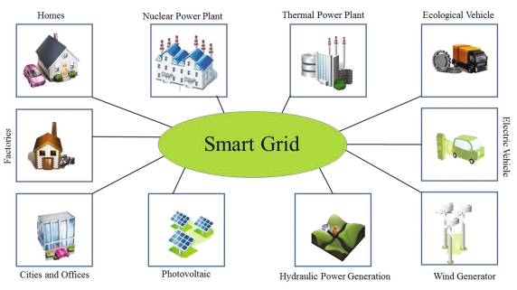
Figure.1.1: Over view of Smart grid [7]

1.2.1 Smart building
What is a smart building?
A smart building is an automated type of building which monitors the operations of the building such as lighting, heating, ventilation, air conditioning, internal and external security and other related systems automatically. In order to collect data and monitor the entire system and services based on the desire of the users, the building uses different sensors, microchips and actuators. The owners, facility managers and operators are benefited from this type of infrastructure due to maximization of reliability and performance, minimum energy usage, optimization of the space requirement and reduction of the environmental impact on the building. Traditional buildings are not integrated with automation technologies, sensors and communication system. It used as shelters and provide temperature control and safely with the same efficiency level for years. But, the oldest traditional structures and newer buildings have been converted in to smart buildings, are changing constantly. Smart buildings connected to highly adaptable and intelligent software environment makes the way of living easy, increase comfort of occupants, increase security and have low impact on environment than buildings which are not connected.
There are different smart buildings around the world. Those include educational facilities, hospitals, stadiums and others.
According to the Navigant research it was estimated that the market share of smart building technology will generate $8.5 billion revenue in 2020 up from $4.7 billion in 2016 which was growing with a compound annual growth rate of 15.9% over the forecasted period [8]. Making buildings smart begins by interconnecting the core systems like lighting systems, heating systems, water pumps, fire alarms etc. with sensors and efficient advanced control system. In this thesis, the main focus is limited to lowering energy consumption of appliances without highly affecting comfort level of occupants, reduction of electricity billing and regulating the peak load demand while maintaining the horizontal load distribution within a day by using demand side management technique (DSM) based on the demand response signal received from the electric utility company.

1.3 Levels of energy management under smart grid communication network (SGCN)
There are different levels of communication network in smart grid which helps to effectively monitor energy management system and transfer information between electric utility company and consumers. Those network includes Local area network (LAN), Neighborhood Area network (NAN), Wide Area Network (WAN).

1.3.1 Consumers under Home area network (HAN)
HAN is a type of local area network which is located to buildings and facilitates the communication or exchange of information between EMC and home appliances. This enables the EMC to identify each schedulable home appliances based on its’ address and efficiently monitor their operation within a day. A feedback signal which shows the electric pricing data and billing cost are displayed via home in display. The electricity consumption data are sent to the utility grid via smart meter after receiving the information from each appliance. Therefore, HAN is a backbone of the communication between schedulable appliances at home and the smart meter.

1.3.2 Aggregator under Neighborhood Area network (NAN)
The exchange of information between utility companies’ WANs and smart metering communications on customer premises are facilitated by neighborhood area network (NAN). It covers from the start point of smart meters on customer side which is the most important element known as heart of smart grid revolution up to Utilities’ WAN. The smart meter records real time or nearly real time data. The net energy which is the difference between energy consumed from utility grid and energy exported to utility grid recorded by smart meters sent to Utility Company. Similarly, a feedback signal like real time energy pricing data and other important information sent to the customer from utility company via smart meter or home in display (HID) to view the information received. NAN acts as an aggregator between the smart meter domain and WAN domain to facilitate the two way communication or exchange of information. NAN is the most crucial element in smart grid communication system which transfers a huge amount of data and distributing control signals among electric utility companies and an abundant volume of devices installed at customers’ premises.

1.3.3 Electric power Utility under Wide Area Network (WAN)
A WAN is used as an aggregator of data from multiple NANs and sends it to the private network owned by the electric utility company. It covers long-haul distances from NAN to a control center. WAN applications, including wide-area control, wide-area monitoring and protection, have been identified as the next-generation solution to achieve power system operation, power system planning and power system protection in the smart grid Wide-area monitoring, protection and control applications which provides higher data resolution and shorter response time than classical supervisory control and data acquisition (SCADA) and energy management (EMS) systems [9].

1.4 Demand Response
Demand response is a technique in which end-users are involved in demand side management of electrical power consumption based on electrical pricing signal received from electric power utility company. When end-users are creating awareness about their energy consumption, they tend to manage their total usage. The demand response program in traditional grid system mostly applied for large scale consumers such as commercial buildings and industrial plants; however, such mechanism does not exist for residential users mainly due to two reasons. The first reason is it is too difficult to handle a large number of home appliances without using automation technology, sensors and communication system. The second reason is, compared to their implementation cost the impact of demand response program is relatively small [6]. Studies have suggested that by employing automated energy management strategies, it is possible to let the users to participate in demand response program and control their load consumption pattern based on the pricing information. In order to implement this strategy, different techniques can be adopted, for example by using internet and controlling the energy consumption via software installed on PC. Demand response can be categorized into two. The first demand response program is price-based demand response such as time-of-use (TOU) pricing, critical peak pricing (CPP) and real-time pricing (RTP), which provides time-varying rates of electricity consumption at different periods of time. This encourages customers to use less electricity during when the prices of electricity is high and they tends to shift their loads to non-peak hours which electricity pricing is low. The second type of demand response programs are incentive-based demand response program in which the utility company pays the customers who are participating in the program to reduce their loads in the time requested by the utility company or program sponsor, which is triggered by reliability problem in the grid system or highest electricity prices.
Demand response techniques uses smart appliances, sensors, actuators, smart meters and two-way communication. So, it is considered to be part of smart grid technologies.

1.5 Demand side Management
In demand side management (DSM), customers will contribute to:
- Reduction of peak load in peak-hours of the day and reduction of pollutant power plants by using renewable energy sources, thus minimizing operation and maintenance cost.
- Integration in to the main distribution grids of micro generators (MG) and distributed generators (DG) which mostly exposed to generation volatility.
- Maximizing stability of the main distribution network and, thus minimizing interruption problems of power supply, grid maintenance and operational cost.
The DSM consists of all activities that manage time of energy. One of the most important goals of DSM is to reduce the peak load. The most frequently used techniques in demand side management are the following [6].
1) Peak clipping: It refers to demand reduction or load cutting during heavy load periods of the day using a method of direct load control (DLC) of customer appliances by the utility via a remotely controllable switches. The duration for which peak occurs is reduced by methods like distributed generation and shutting down the consumers equipment.
2) Valley filling: refers when the cost of production is lower compared to peak hours, it promotes the consumption of energy during off-peak hours. So, low demand periods are filled by building off-peak capacities. There are various incentives like discounts that motivate consumers to change their habits of energy consumption.
3) Strategic conservation: refers to the reduction of seasonal energy consumption mainly by minimizing the energy wastage, to increase the efficiency of energy consumption. In this method, load shape optimization is achieved by applying demand reduction methods on customer premises.
4) Strategic load growth:
It monitors the maximum consumption of electrical energy in seasonal pattern. This technique optimizes the significant daily demand response when the demand exceeds beyond valley filling technique. The method is based on maximizing the market share of loads which is supported by a combination of energy conversion technique and energy storage systems (ESS) or distributed energy resources (DG).
5) Load shifting: It shifts the energy usage from the peak period to off-peak periods during which the consumption of energy is lower on recurring basis.
This is often done by using the energy stored during off-peak periods and using it during peak hours. It may also be supported by using distributed generation.
6) Flexible modeling: It consists of actions, following an integrated plan between the consumer and concessionaire, according to the need of moment. Through installation of the load-limiting devices, it limits the energy use of a consumer during certain moments without affecting the actual security conditions.
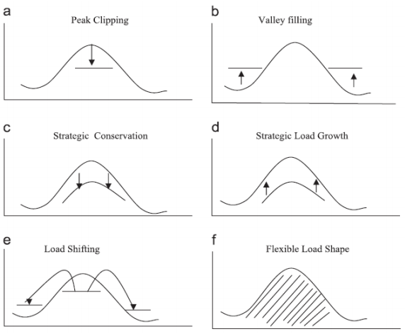
Figure.1.2: Demand side management techniques [10]

1.6 Time based pricing programs
Time based pricing programs also known as time based rate programs are prices incurred on customers that vary on different times of the days. In traditional grid system it consisting of small commercial and residential customers and those customers are incurred two types of pricing schemes known as flat rates and tiered rates. In flat rates, customers are charged with the same rate for their consumption during a given period of time (e.g., during one month or 30 days of billing cycle). In tiered rates, certain blocks of consumption on a given period of time (e.g., first 100 kwh vs. next 100 kWh) are charged based on different pricing (this might be season to season, day to day or hour to hour). Time based pricing generally grouped in to the following types [11]:
- Time of use pricing (TOU): This type of pricing is applied to a certain broad blocks of hours. For example in a typical summer week day on-peak 6 hours; off-peak hours in other hours in summer days of the month.
- Real time pricing (RTP): The pricing rates are applied to consumption on an hourly basis.
- Variable peak pricing (VPP): This is the combination of time of use and real time pricing.
- Critical peak pricing (CPP): when utility companies anticipate or consider a high wholesale market prices or emergency conditions in power system, for a specified period of time they may call critical events (e.g., on a hot summer weekday 4 p.m. to 6 p.m.), during these time ,the electric price may be substantially raised.
Except TOU pricing, the pricing are not known with certainty ahead of time. So, all the electricity pricing listed excluding TOU pricing scheme are known as Dynamic pricing.

1.7 The Structure of home energy management system in smart grid
It is assumed that a smart home consists of various appliances having the adequate and proper communication interfaces in order to facilitate the exchange of information with the EMC. It also assumed that each of the appliances communicates with the EMC only and cannot communicate with each other. Fig.1.3 presents the structure of home energy management system with different data communication domains, those domains includes the internet domain, home area network (HAN) domain and the smart meter domain (AMI).
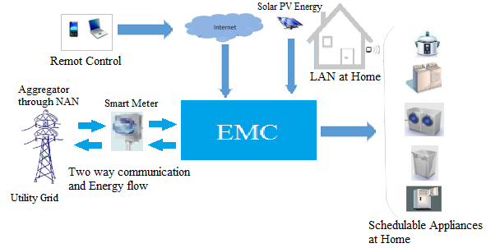
Figure.1.3: Overview of home energy management system
The internet domain enables consumers to monitor and control their power consumption profile, the scheduling of their appliance power consumption and etc. through an in-home display (IHD) which consists of computer, tablet or smart phone. The smart meter domain includes a large number of interconnected smart meters called “Automatic metering infrastructure (AMI)” which is installed and monitored by utility companies in order to transmit load information and DR signals between the smart homes and power market. Based on the pricing signals received 24 hours day ahead, the home energy management controller (EMC) schedules the electricity usage pattern for the next day.

1.8 Statement of the problem
Due to population growth each year and expansion of industries, as in Ethiopia, many new industrial parks are developed as well as more will come in near future, therefore, the demand for electric power has been increasing abruptly. Unless a proper supply side and demand side measures have taken, the power grid may be faced to instability and reliability problems which may ranges up to total blackout. In Hawassa also, the load growth is increasing greatly with the expansion of new residential areas as well as the development of industrial park. Therefore, to minimize the effect of high power demand during peak hours of the day from utility companies and simultaneously to minimize billing cost for consumption of electric power, it is necessary to apply demand side energy management systems (DEMS). With an appropriate scheduling of home appliances manually by the user and shifting the operating time position to non-peak hours, the power peak-to-average ratio (PAR) and billing cost can be minimized. Integrating the system with renewable energy like on-grid Photo voltaic (PV) generation enables us to supply energy in the sunny days to the loads at home and when there is excess energy, it could be supplied to the main grid. So, with the help of demand side management (DSM) and integrating with Local micro grid, the peak demand on peak hours of the day and cost of electricity consumption can be minimized with minimum peak to average ratio.

1.9 Objective of the Thesis

1.9.1 Main Objective
The main objective of this thesis is to reduce the cost of electric energy consumption (billing cost) and peak load demand with minimum power peak to average ratio (PAR) in residential buildings of Hawassa city by using demand side energy management techniques with on-grid roof top solar PV energy generation.

1.9.2 Specific Objective
The specific objectives include the following;
- Reducing the cost of Energy storage system (ESS) with the help of Micro grid and cost effective scheduling of home appliances
- Increasing customer satisfaction
- Maintaining the load duration curve
- Minimizing environmental pollution (produced by diesel generator) by using renewable energy sources
- Increase use of smart grid capability in more reliable and flexible way than the traditional grid system
- Enabling customers power producer from renewable sources like PV generation, to supply their loads demand on their own power production and sell surplus energy

1.10 Literature Review
In the study of dynamic DSM, different techniques and algorithms have been proposed, where the basic idea has been to reduce the energy bill corresponding to the time-of use (TOU) tariffs, incentives offered by the utility based on the supply and demand, TOU tariffs are varied throughout the day and Consumers can also generate renewable energy, consume some portion of it locally, and sell the excess energy to the utility companies when permitted [6].
Arikiez et al. [12] investigated the use of linear programming based heuristics for solving the cost minimization problem of air conditioning system for residential and commercial loads and Melhem et al. [13] proposed an optimal residential load scheduling model by using the mixed integer linear programming. Sou et al. [14] solved scheduling problem of smart home appliances for reducing electricity cost by using mixed integer linear programming. Angelis et al. [15] developed an approach, which is based on mixed-integer linear programming technique. The developed approach provided an optimal solution in terms of minimum power consumption with an integration of renewable energy resources. Yao et al. [16] investigated a problem of a smart home energy management system (HEMS). It consist of photovoltaic (PV) module and the household appliances with three different types of load characteristics (i.e., interruptible, uninterruptible and time-varying). To solve the HEMS problem mixed integer linear programming (MILP) algorithm was used. Kim et al. [17] developed a mixed-integer linear programming based model for an effective scheduling of the operational periods and power levels of home appliances. Arora et al. [18] proposed a mixed integer linear programming based optimal scheduling technique for centralized air conditioning load. Same author proposed an optimal scheduling mechanism for residential appliances in a smart home equipped with photovoltaic panel and energy storage device [19]. In order to reduce both the CO2 emissions and the electricity bill, Paridari, et al. [20] proposed a novel based on MILP method for smart home appliances scheduling and batteries, Same author [21] proposed a robust approach based on MILP model for scheduling of smart home appliances by incorporating electrical energy storage system (ESS) in active buildings with the aim of minimizing both the CO2 emissions and electricity billing. Zavala et al. [22] developed a proactive energy management framework based on online solution of mixed-integer nonlinear programming. It is an integrated predictive dynamic home models and day-ahead forecasting of disturbances which affects the efficiency of the system and electricity costs. In order to jointly monitor the electricity consumption of home appliances and plug-in EVs, Hossain et al. [23] proposed an optimal centralized scheduling method, which is based on MILP. For an efficient management of smart home appliances under real time pricing (RTP) environment, Wang et al. [24] proposed a Mixed Integer Linear Programming (MILP) based rolling optimization. The proposed smart home equipped with a Battery Energy Storage System (BESS) and a solar PV system in order to maximize the efficiency of the system. Giorgio et al. [25] proposed the design of a Smart home Controller which provides an efficient management of electric energy in a residential building. To solve the problem, binary linear programming scheme was used. Dogaheh et al. [4] optimized the performance of smart grids in relation with residential energy centers equipping with solar power units or PV. For that purpose authors utilised YALMIP toolbox in MATLAB software. Mohammadi et al. [26] proposed a real time integer linear programming based Home Energy Management system (HEMS), to manage home appliances and storage system. Due to the presence of the index of the binary decision variable which decides the on and off status of appliance, the problem is convex type in nature. So, it is difficult to solve this convex type problem which has non-linear characteristics with LP technique. The methods discussed above that uses mixed integer linear programming (MILP) are the best way to solve mixed integer type problems. But, to utilize both LP and MILP algorithms for solving minimization problem, a combination of global solvers are required. For example, a decision making variable in YALMIP tool box of MATLAB software in combination with a commercial state-of-the-art solver for mathematical programming like Gurobi solver, CPLEX, FICO Xpress etc. should be used. The external solvers are expensive to conduct an advanced research. In [27], Hussain et al. proposed a particle swarm optimization (PSO) based scheduler using demand side management (DSM) technique based on demand response (DR). Six shiftable appliances are considered in 24 hour time horizon. But, PAR is not included as objective function. Shah et al. [28] presented a HEMS using multi-agent system (MAS) for smart homes. The HEMS uses priority techniques with integration of energy storage system (ESS). Further, bio-inspired technique, binary particle swarm optimization (BPSO) is used for the optimal scheduling of appliances in a smart home. Mahmood et al. [29], proposed a realistic scheduling mechanism (RSM) to reduce user frustration and enhance appliance utility by classifying appliances with respective constraints and their time of use effectively. Further, binary particle swarm optimization (BPSO) is utilized for optimal scheduling of appliances with constraints. Huang et al. [30] studied a convex optimization problem to manage the energy consumption of different households in an automatic way. In addition to this optimal scheduling is performed by hybrid PSO-DE algorithm. Zhu et al. [31] utilized cooperative PSO algorithm for developing the optimal schedule and control of energy and time shiftable appliances in smart homes. Abdalla et al. [32] studied the energy management of chiller plant in optimal way. PSO and Fuzzy are utilized for optimally managing the energy consumption of plant. To find the set point, fuzzy is utilized while for optimizing the objective function PSO is used. For plug-in hybrid electric vehicles, Chen et al. [33] developed an optimum energy management method under uncertain driving conditions. Authors utilized PSO for optimizing the threshold parameters for the rule based energy management scheme. Kazemi et al. [34] developed a method that depends on Gray wolf optimization and genetic algorithm to achieve the optimal schedule for appliances in terms of cost and PAR. Interruptible tasks are divided in to smaller sub tasks, in terms of time, using GWO algorithm and the output of this component was the input of genetic algorithm scheduler (GAS). The inclining block rate (IBR) pricing model was proposed to restrict the overusing electricity power in each time slice. Even if it takes large time to converge to the solution, the performance of the optimization technique seems interesting and had a good result than other methods discussed above. Zhao et al. [3] introduced an EMS in HAN based smart grid. Further, GA is utilized to solve the problem of energy scheduling for home appliances. An EMS and automated DR structure for household is developed by Khomami et al. [1] to schedule the different appliance in smart household. Further, for optimizing the results GA is utilized by the authors. For optimal DR management in smart grid Meng et al. [35] developed a real time pricing technique. A Stackelberg Game and Genetic Algorithm Approach are utilized for that purpose. Talha et al. [36] evaluated the performance of heuristic Algorithms: GA and Artificial Fish Swarm Algorithm (AFSA) for Demand Side Management. Li et al. [37] developed an EMS for industrial microgrids with high renewable energy penetration. The scheme is developed for both isolated and grid connected mode with day ahead operation. For optimizing the results, regrouping particle swarm optimization (RegPSO) is utilized by the authors. To reduce the PAR and energy cost, Naseem et al. [38] scheduled the residential loads by four different heuristic optimization techniques i.e. GA, Binary Particle Swarm Optimization (BPSO), wind driven optimization (WDO) and Bacterial Forging Optimization Algorithm (BFOA). A comparative analysis of all the above mentioned techniques is presented by the authors. For future smart grid with large devices, Logenthiran et al. [39] developed a DSM scheme that depends on load shifting. Evolutionary Algorithm (EA) is utilized for optimizing the results. Allerding et al. [40] focused on a flexible EMS for Smart households. A “plug-and-play” type Evolutionary Algorithm is developed for optimizing distributed generation. Zhang et al. [41] proposed an EMS for household appliances. It is also utilized Bee colony algorithm to implement DR schemes for residential consumers and for facilitating integration of renewable energy sources. For optimizing the results an improved artificial bee colony algorithm is used. An internet of things (IOT) based EMS for households are proposed by Geng et al. [2]. For finding an optimum scheduling scheme, discrete multi-objective bacterial colony chemotaxis algorithm (DMOBCC) is utilized by the authors. Lin et al. [42] presented an EMS for micro grid system. For optimizing the results of economic dispatch, enhanced bee colony optimization (EBCO) is developed by the authors. Rahim et al. [43] developed an optimization model for DSM that combined tariff and block rates. Multiple knapsacks are utilized to form the optimization problem and ant colony optimization is utilized to solve it. However, most of those techniques cannot tackle large number of different household appliances having unpredictable, non-linear and complex energy consumption patterns due to randomness in human behavior. Moreover, to attain electricity cost minimization objective, they ignore user comfort level and their electricity pricing model is also not compatible with real scenarios. In addition, the proposed algorithmic solutions become very slow when the number of appliances in the system grows past a certain limit or the scheduling window is very large. In this work GWO based optimization technique will be implemented to reduce the electricity billing and peak to average ratio without highly affecting the comfort level of the user.
Table 1: Comparative Analysis of Mathematical and Heuristic based methods
S.No. | Properties | Mathematical Technique | Heuristic Techniques
1. | Model Formulation | Model is used to simulate a system when the system is not extremely complicated. | Meta-heuristic Techniques try to imitate natural phenomenon to solve the complex practical problems.
2. | Prerequisites | Physical laws are derived and utilized to find the relationships between system parameters. | Dependent on data to determine the structure and parameters
3. | Non-linearity integration | Possible if prior knowledge of the nature of the non-linearity exists. | The prior information of the nature of the non-linearity is not required.
4. | Hypothesis | Simplify the problem or incorporating assumptions to make model more understandable. | No need to simplify the model and/or add assumptions
5. | Precision & Accuracy | Provide highest level of accuracy. | Provide greater precision and accuracy.
6. | Efficiency | Time consuming in complex problem | repetitive and time-consuming tasks easily carried out with efficiency
7. | Renewable Energy Integration | Requires complex mathematical modelling | With meta-heuristic model renewable energy, source incorporation is easy.

1.11 Methodology
In order to encode the problem with the stated energy, timing and power balance constraints, the following procedures have been used. After converting the power matrix in to energy consumption per slot for each appliance, we get the scheduled load matrix. Hours in a day are devided in to time slotes. There are 120 time slots within aday, the length of each time slot is 12 minutes and 8 shiftable appliances would be scheduled. The power consumption per slot for each scheduled appliance is selected stochastically up to the maximum iterration is reached within aday. The problem could be non-linear binary type problem. After coumputing the the scheduled load marrix which is 1×120 vector, the cost fitness function, power peak-to-average ratio (PAR) and peak demand could be computed using swarm intelligence based Metaheuristic Grey wolf optimizer (GWO) and Particle swarm optimizer (PSO) algorithm. Since the problem is minimization type, the initial population and the position of each search agent could be initialized arbitrarly at any point in the hyper space.
The proposed GWO and PSO based algorithm could be used to demonstrate its effectiveness for reduction of electricity billing (energy cost), PAR and peak load minimization through optimized appliances scheduling.
The fitness function could be solved for the following eight case studies and the output would be displayed in the simulation result.
- Scheduling of shiftable home appliances using fixed time scheduling without integrating with PV power generation would be computed.
- Scheduling of shiftable home appliances using restricted time scheduling without integration of PV power generation would be computed.
- Scheduling of shiftable home appliances using multi-restricted time scheduling without integration of PV power generation would be computed.
- Scheduling of shiftable home appliances using variable time scheduling without integration of PV power generation would be computed.
- Scheduling of shiftable home appliances using fixed time scheduling with integration of PV power generation would be computed.
- Scheduling of shiftable home appliances using restricted time scheduling with integration of PV power generation would be computed.
- Scheduling of shiftable home appliances using multi-restricted time scheduling with integration of PV power generation would be computed.
- Scheduling of shiftable home appliances using variable time scheduling with integration of PV power generation would be computed.
After computing the fitness function and run the algorithm, detail analysis and comparison between the DSM techniques and algorithms used have done. To simulate and solve the problem using both GWO and PSO algorithm, MATLAB 2016(a) software environment has been used.

1.12 Contribution of the Thesis
This thesis has contributed in study of smart building energy management and control under TOUP in the following ways;
- The first contribution in this thesis is the development of an optimal control model on building appliance load scheduling. Due to the complexity of the system models most of the literatures have simplified these models to linear models. This thesis has extended these models to binary non-linear Meta-heuristic optimization problem.
- This research has tried to solve different constrained problems simultaneously. The peak load demand, PAR and cost of electricity consumption has been monitored without highly affecting the comfort level of the user due to scheduling of appliances to inconvenient times within a day.
- A novel idea called ‘restricted’ and ‘Multi-restricted’ time range scheduling technique have been adopted in order to efficiently schedule the appliances at home. These techniques give unlimited freedom for the user to schedule the schedulable load appliances at home to different alternative times within a day. This idea improves the tradeoff between comfort level of the user and scheduling of appliances to inconvenient times during optimization within 24 hours of a day and contributed to energy management techniques for the next smart building research.
- Incentive based demand response technique has adopted to balance the load demand during peak and off-peak hours of the day. This enables customers to curtail some of the loads during peak time hours in response to the incentives offered.
- A 5 KW roof top solar PV power generation has integrated to the system. This mechanism further reduces the cost of electricity by shifting the load demand partially or fully from utility grid to PV power. In addition to minimizing energy cost, it enables the user to export surplus power to utility grid and benefited from feed in tariff.

1.13 Organization of the Thesis
Chapter 1 provided the introduction Chapter which explains the literature study and back ground of related topics those are important for the study of the next chapters.
Chapter 2 entitled as “Demand side management and optimization of residential demand response” deals with categorization of different household appliances and describing them with its power ratings.
Chapter 3 entitled as “Modeling Grid-Tied Roof top Solar PV system”, which explains about appropriate sizing of a 5 KW on-grid rooftop solar PV system.
Chapter 4 entitled as “Optimization of home appliance scheduling problem formulation and proposed solution” that deals with developing mathematical modeling of the fitness function to solve the proposed minimization problem using meta-heuristic algorithms.
Chapter 5 entitled as simulation results and discussion” that displays the simulation results after computing the fitness function using both GWO and PSO swarm intelligence based algorithms. In depth comparative analysis using different scheduling techniques would be discussed.
Chapter 6 is the conclusion and future work chapter, which concludes the main findings in the thesis and also explain the future work.

Chapter Two

2 Demand side Management and optimization of Residential Demand Response

2.1 Load type categorization
In energy management system of residential building, scheduling of different loads can be achieved by specifying the type of load to be scheduled and characteristics of the given load. Those characteristics include the operation duration and the average energy consumption of each appliance.
Generally, Home appliances classified into three major groups as follows [44]
- Base line Loads (non-shift able): Those are type of appliances which operates immediately when the residents are requested. Such appliance includes Light, Television, computer, Refrigerator, etc. the energy supplied to such appliances are considered to be non-schedulable.
- Uninterruptible flexible loads: Those types of home appliances are operated continuously until the completion of the task. The starting and ending time of such appliances can be set flexibly. Such appliances include washing machine, dish washer and Electric Oven.
- Interruptible flexible loads: It refers to the appliances which are allowed to operates continuously and can be interrupted when the user desire to shut down in the specified interval of time. Such appliances include clothes dryer, air conditioner, pool pump and floor cleaning robot.
In the home area network (HAN) domain the Electric vehicles (EV) and Energy storage system (ESS) may be available and integrated in to the system. The EV can be used as a load during charging mode or grid to vehicle (G2V) modes of operation and it can also be used as energy storage system during discharging mode or vehicle to grid (V2G) modes of operation. To maximize the comfort level of the user baseline loads are left uncontrollable in home energy management system problem.
In this study, in order to improve the demand response uninterruptible loads and interruptible loads known as schedulable loads are scheduled by considering TOUP. It also assumed that all the home appliances operate at their rated power during their working periods of time and all constraints needs to be met.

2.2 Description of home appliances Used
In this thesis, for the study and analysis of a given problem amid-size home is considered and the load profiles of each home appliance are discussed below. Roof top on-grid photo voltaic (PV) energy has integrated in to the system.
Each of the appliances has a definite interval of time for the completion of the operation and thus has a definite power usage vector which has to be determined either from the specification of the given appliance or can be determined experimentally at equal duration of operation time. In this work it is assumed that all the appliances are working with their maximum power rating specified in their specification sheet.
Table 2.1: List of electric appliances
Group of Appliance | Appliances
Non-interruptible Flexible load appliance | Electric Oven-1  Washing machine with dryer  Electric Oven-2  Refrigerator
Interruptible flexible load appliances | Electric Iron  Water heater  Table Fan  Coffee Grinder
Baseline loads appliance (non-schedulable load appliances) | Light-1  Light-2  Light-3  Light-4  LED Television 32’

Electric oven in the morning (Electric oven 1):
The electric oven in the morning is used for cooking the breakfast and preparing different important tasks which has to be boiled or heated with oven for using in the morning. It is assumed that the electric oven is working with the maximum power rating which is 2.15 KW [45]. In the evening, it is also used to heat or boil foods for dinner. To make it easy for programming, Electric oven 1 for morning and Electric oven 2 for evening are used.
Washing machine with dryer:
The washing machine is used to wash cloths. There are different washing machines in the market. Those washing machines are different in their power consumption, type of technology used, brands and sizes. Some of the washing machines have a dryer and working in tendon where as others have no dryer and needs dryer after washing. The type of washing machine assumed to be scheduled in this work is the one which has dryer. There are three phases of operation in washing i.e. washing, spinning and drying. The maximum power rating of washing machine which is assumed to be scheduled is 3KW [45]. Based on power consumption requirement for each operation load phases, the required number of time slots could be allocated.
Refrigerator:
The refrigerator is used to preserve foods, fruits, beverages and different materials which have to be kept cool based on the user requirement. Refrigerator works almost 24 hours of the day. The maximum power rating which could be used in this work is 0.225 KW [45].
Electric Iron:
Electric iron known as cloth iron is used to remove wrinkles from fabric. It uses electrical energy to heat the iron. The maximum power rating for the electric iron in this work is 1.5 KW [45].
Water heater:
Water heater is used to heat or boil water. Domestic use of hot water includes cleaning, washing, food preparation space heating and bathing. The maximum power rating of water heater used in scheduling is 1.5 KW [45].
Table Fan:
The function of table fan is to circulate air and cool down the temperature inside the building. Based on the ambient temperature inside the building, the operation time is decided by the residents. The maximum power rating of table fan used in this work is 0.025 KW [45].
Coffee bean Grinder:
The function of coffee bean grinder is to grind coffee which has to be drunk during a day. The maximum power rating of coffee bean grinder used is 0.1 KW [46].

2.3 Energy management controller Unit
Building energy management controller (EMC) is an intelligent device composed of both hardware and software which is known as the brain of the system. It facilitates the information exchange and acts as a gate way between the smart meter domain and the HAN domain. It is responsible for load scheduling and integration of the DGs. In different papers it has different names with the same purpose; for example in [25] it is known as Smart home controller (SHC). In this work, to monitor and control the loads, the proposed EMC uses a LAN connection with smart home appliances, smart plugs and smart meters.

2.4 Micro Grid
Renewable electrical power production can help countries to utilize reliable, secure and clean affordable energy and meet their development goals in sustainable manner. The release of harmful gases from the burning of fossil fuels, the rise of fuel prices and scarcity of conventional energy resources encourages increasing the development of power production from renewable sources. Besides the challenge of the world’s energy demand, currently in developing countries approximately around two billion people needs access to electricity [47]. The power trading and load scheduling in smart buildings could be overcome by using renewable energy sources or distributed energy resources [7].
Photovoltaic (PV) refers to the conversion of sunlight in to useful electricity. The whole system is composed of PV modules in the form of an array which can be installed nearby or inside the building. The direct current (DC) produced by the PV system converted to alternate current (AC) by the inverter in order to supply AC loads and supply the grid in the time when there is surplus power production.
Globally, there are two main routes for the development of solar PV projects [48]. The first one is the development of utility based solar projects. A large MW scale solar power is generated centrally by the utility company to meet renewable purchase obligation (RPO) of the utility or third party for their procurement. The second one is the development of customer driven solar project. The development of decentralized small-scale solar projects on the premises of the customers motivated by incentives by the utility company like minimum cost of energy during off-peak hours of the day, feed in tariffs, net metering, the reduction cost of solar energy and increasing the cost grid based conventional energy or highest cost of energy from the grid (greed-in tariff) during peak hours of the day.

Chapter Three

3 Modeling Grid-Tied Roof top Solar PV system

3.1 Introduction
Photovoltaic (PV) energy and solar thermal energy are the two forms of energy which are obtained from the solar energy reaching the earth’s surface from the sun. The solar thermal system collects the solar radiation from the sun and uses it to directly boil water or to create steam which drives the steam turbine to generate electricity [49]. Using the principle of photovoltaic effect solar light is converted in to direct current electricity using solar modules which consisting of solar cells of PV material.
The grid-Tied solar PV system are the most common type of PV system used by residential, commercial and industrial sectors which can be deployed either with the battery storage system or without battery storage system. Further it can be classified based on the size of the system as small, medium and large scale solar System. Small scale rooftop solar PV system is mostly used by residential and commercial sectors. In this thesis, small scale 5 kW capacity roof top solar PV system would be used without the battery storage system. The initial cost of the battery energy storage is very high and since there is higher solar radiation intensity in the stated area (Hawassa, Ethiopia), the battery energy storage system has been ignored. Further the grid itself can be used as a backup instead of storage system.
The proposed smart residential building is equipped with roof top PV energy generation system. Compared to the other renewable energy sources (i.e. wind, tidal, geothermal, biomass and biogas), solar PV system is less costly. Most of the populated areas on the earth receives huge amount of solar radiation with an insolation level of 150-300 watts/m² or 3.5 to 7.0 kWh/ m² [50] Generally, there are four basic configurations of PV system based on the connection of system components between the PV modules and the load discussed in the following sections[51].

3.1.1 Direct type PV system
Basically, this type of PV system is configured by directly connecting the loads to the PV panels or modules, to supply the loads directly from the PV system. This type of configuration of PV system works only when the PV shines and since there are fewer components, the cost of the system is lower. Mostly this type of configuration of PV system is used for supplying DC loads, ventilation and for solar powered water pumping systems.

3.1.2 Off-grid (Stand-alone) PV system
This type of PV system is mostly build on residential buildings. The PV system is equipped with backup batteries in order to store the solar energy during sunny days and the energy from the grid during off-peak hours of the day. This system contains an inverter, charge controller and other components.
The inverter converts the dc voltage from the PV panels or modules to AC voltage to supply AC loads. While the charge controller prevents the overcharging and deep discharge of battery and maintain the charge of the battery in optimum condition.

3.1.3 Grid-Tied PV System without Energy storage
Most of the grid-Tied configurations of the solar PV systems are configured in this way [52]. Due to the absence of energy storage systems and fewer components, less maintenance cost and environmental friendless most of the customers adopt this system. The drawback of this system is that when there is a cloudy condition and during night time the system tends to shut down until there is a power in the utility grid and supply the loads. The inverter connected from the PV panels or modules converts the DC voltage in to AC voltage and the supply the AC loads or supplies directly the utility grid when there is surplus solar energy, to be benefited from the feed in tariff. The type of PV system configuration used in this thesis is grid-tied PV system without energy storage.

3.1.4 Grid-Tied PV System with Energy storage
The most of the components of Grid-Tied PV system is similar to the stand-alone (off-grid) PV system except the Grid-tied PV system is connected to the main grid (Utility grid). Connecting the PV system to the utility grid has several advantages. The first advantage is the customer (the owner of the Grid-Tied PV system) can sell excess energy to the utility to be benefited from the feed in tariff and the second one is the battery can be charged during off peak hours from the utility grid and the energy flow between the main grid, the PV system and the load appliances can be managed properly with energy management system to minimize electric billing cost incurred by electric utility company and maximize the comfort of users. Even if the initial investment cost is higher, this arrangement of PV system is advantageous than other PV system configurations in terms of maximizing user benefits and comfort level. Due to the higher cost of energy storage, the Grid-Tied PV system without energy storage configuration is adopted in this study.
The power output of the PV panel is given in equation (3.1) below [53].
P_{PV_out} = P_{p,av} ×$( \frac{G}{G_{ref}}$) × [1 + K_{T}( T_{C} - T_{ref} )] (3.1)
Where, P_{PV_out} is the power generated by the PV system, P_{p,av} is the PV rated power at the reference, G is the solar irradiation in the given area, G_{ref} is the reference solar irradiation (1000W/m²), K_{T} is the temperature coefficient of the PV panel (K_{T} = - 3.7 x 10⁻³ (1/°C) for both mono and poly crystalline silicon) [54].
T_{ref} is the cell temperature at reference condition (T_{ref} = 25ºC). T_{C} is the cell temperature which can be calculated using equation (3.2).
T_{C} = T_{amb} + (0.0256 × G) (3.2)
T_{amb} is the ambient temperature in °C and the rated power can be calculated using equation (3.3)
P_{p,av} = (E_{d} × S_{F}) / (η_{inv}×$S_{H,av}$) (3.3)
Where E_{d} is the daily energy demand, S_{F} is known as stacking factor which is used to compensate the resistive and PV temperature losses (in this case S_{F} =1), η_{inv} are efficiencies of inverter respectively, $S_{H,av}$ is the peak sunshine hours (which are numerically equivalent to the daily average solar radiation at specific location). By using equation 3.1 and using the PV data in appendix 1, the PV generation profile becomes as follows. The data had taken on National renewable energy laboratory [66] by inserting specific site information and necessary data at Hawassa city, Ethiopia.
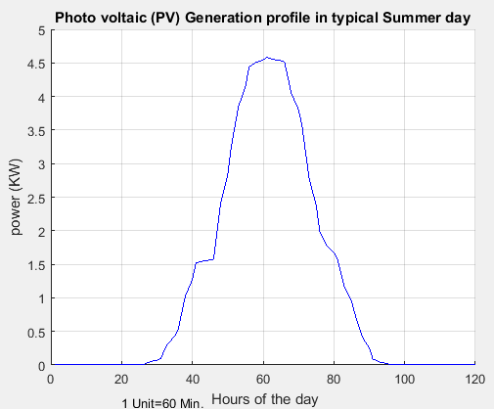
Figure 3.1: PV generation profile
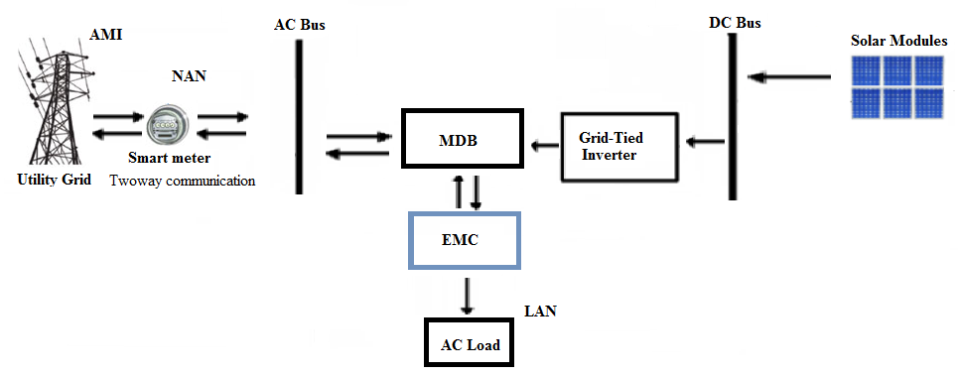
Figure.3.2: Block diagram of integrated HEMS
Solar PV system can be utilized in two different forms. The first one is standalone (off grid) and the second one is grid connected (On-Grid) system.
A typical residential solar power system consists of photovoltaic (PV) panels, a dc disconnect switch, a collector fuse box, lightning protection, appropriately sized inverter, support structure for the PV system and other miscellaneous components like wires and electrical conduits. The detail single line diagram of rooftop facility for net metering interconnection is shown in fig 3.3.
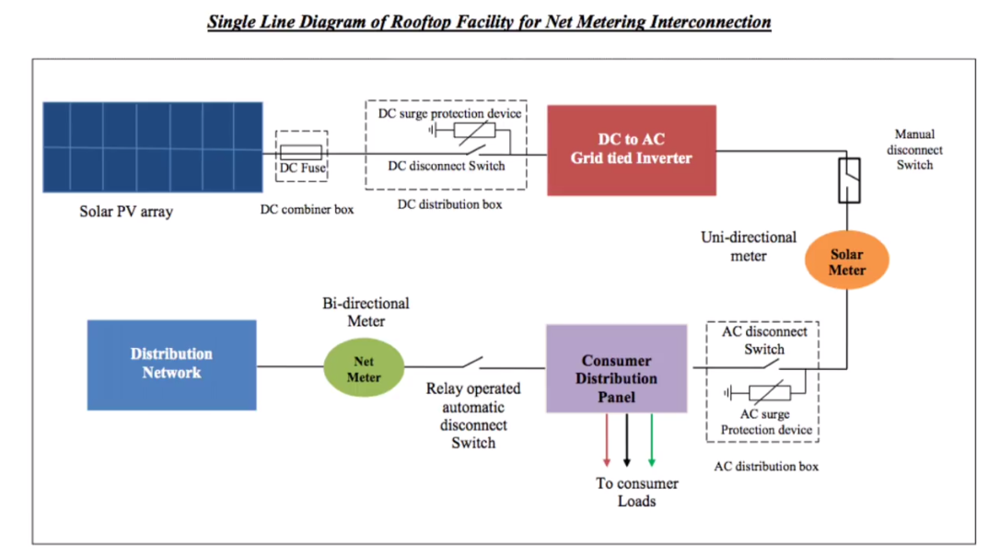
Figure.3.3: Single line diagram of rooftop facility for net metering interconnection [55]

3.2 Sizing of roof top solar PV modules
In the design of roof-top solar PV system, the following parameters and steps are considered. The procedures for sizing the roof top solar PV system are as follows.
Step 1: Estimation of the daily average Load demand:
For sizing the average load demand, the first task would be determining the average load demand within a day. By specifying all the AC and DC loads and the operation hours for each appliance would be estimated. The hourly energy consumption of each appliance can be calculated by multiplying the maximum load demand in each appliance by their operation hour.
Table 3.1 daily load profile of appliance
NO. | Electrical load appliances | Quantity | Power rating (KW) | Operation Duration  (hr) | Power consumption (Kwh)
1 | Electric Oven | 2 | 2.15 | 0.8 | 3.44
2 | Washing machine | 1 | 3 | 3 | 9
3 | Refrigerator | 1 | 0.225 | 23 | 5.175
4 | Electric Iron | 1 | 1.5 | 0.4 | 0.6
5 | Water heater | 1 | 1.5 | 1 | 1.5
6 | Table Fan | 1 | 0.025 | 2 | 0.05
7 | Coffee Grinder | 1 | 0.1 | 0.2 | 0.02
8 | Light-1 Fluorescent (Living room) | 1 | 0.04 | 4 | 0.16
9 | Light-2 CFL Bed room | 1 | 0.011 | 1 | 0.011
10 | Light-3 LED Bed room | 1 | 0.011 | 1 | 0.011
11 | Light-3 LED Toilet and Bath | 1 | 0.011 | 3 | 0.033
12 | Light-4 CFL Kitchen | 1 | 0.018 | 1.5 | 0.027
13 | LED Television 32’ | 1 | 0.055 | 3 | 0.165
Total Power consumption within a day |  |  |  |  | 20.192

The daily load demand of the residence is 20192 watt-hours and this used for the PV array component sizing.
Step 2: Sizing of PV Array:
The second step in the procedure of sizing the PV system would be determining the required energy from the PV array.
$E_{Ed,pv}$ ₌ $\frac{E_{d}}{ɳ_{inv}}$ (3.4)
Where,$E_{Ed,pv}$is daily energy demand from PV modules ,
$E_{d}$ is the average daily energy demand
$ɳ_{inv}$ is efficiency of inverter.
The peak power is obtained by dividing the energy required from the PV array to the average sun-hours of the day.
$P_{P,av}$ ₌ $\frac{E_{Ed,pv}}{S_{H,av}}$ (3.5)
Then the total dc current is obtained by dividing the peak power to the system dc voltage.
$I_{dc}$ ₌ $\frac{P_{P,av}}{V_{dc}}$ (3.6)
Finally, to obtain the array size the number of series and parallel modules would be determined.
The number of rooftop solar PV modules in series,
$N_{sm}$ ₌ $\frac{V_{dc}}{V_{rm}}$ (3.7)
The number of rooftop solar PV modules in parallel:
$N_{Pm}$ ₌ $\frac{I_{dc}}{I_{rm}}$ (3.8)

Total Number of modules:
$N_{Tm}$ = $N_{sm}$×$N_{Pm}$ (3.9)
Total cost of Array:
A_{cost} = N_{Tm} × M_{cost} (3.10)

Table 3.2: Parameters of the PV system with their calculated values
Parameters of PV system Values obtained
$E_{d}$ 20.192 KWh
$E_{Ed},pv$ 22.44 KWh
$P_{P,av}$ 4.684 KW
$I_{dc}$ 13.01 A
$N_{sm}$ 15
$N_{Pm}$ 2
$N_{Tm}$ 30
Cost of Array 243000 Birr

Since there is no PV module which has 360 V nominal Voltage, with two trails of 15 modules (Specification shown Appendix.1 Table.6.1) which have 24 V nominal voltages could be connected in parallel (i.e. 2 modules in series and 15 modules in parallel combination, total number of 30 modules connected) .
Step 3: Sizing of grid-tied inverter:
The power rating of the proposed solar inverter should be 125% times the sum of the power rating of non- inductive load appliances and the sum of the power rating of all the inductive load appliances. This is because the size of the inverter could be 25-50 % larger than the sum of total wattage of appliances [56].
The proposed inverter in this thesis is Su-Kam 5KW grid-Tied inverter. In grid-tied system the grid itself is used as a backup power and when the demand exceeds the rated value of the PV generation system and inverter, EMC will shifts the loads partially or fully from the PV in to grid power.
Total inverter Power =1.25 ($\sum_{i=1}^{I}{P_{RL,i}}$ +$\sum_{k=1}^{K}{P_{IL,k}}$)
The maximum input current to the inverter:
$I_{in,inv}$ = $I_{DC}$= 13.01 A
$P_{out,inv}$ = 4.684 KW ×0.9 = 4.216 KW
The output inverter current
$I_{out,inv}$ ₌ $\frac{P_{out,inv}}{V_{out,inv}×Pf}$ (3.11)
= $\frac{4216 W}{230×0.9}$ = 20.37 A
This is less that the maximum inverter rated output current in the specification sheet.
The maximum inverter output current can be calculated as follows:
$I_{out,rated,inv}$ ₌ $\frac{P_{out,inv}}{V_{out,inv}×Pf}$
₌ $\frac{5000}{230×0.9}$ = 24 A
Inverter Cost =20,812.67 Birr [65]
Step 4: Sizing of the DC Cable:
For an appropriate wiring of the components of roof top solar PV system together, a correct cable size must be selected. To select the proper cable size and for safety reason, the current rating of DC cable should be scaled by 125% of the calculated value.
The current rating of the DC cable is given by:
I_{DC,cab} = I_{PV} *1.25 (3.12)
I_{DC,cab} = 24A×1.25 = 30 A
The voltage drop (V_{Drop}) of the DC cable is given by:
V_{Drop,DC} = $\frac{2*L_{DC,Cable}*I_{DC}*ρ }{A_{DC,Cable}}$ (3.13)
A_{cable} = 8.4 mm² (Type 8 AWG), for 3-4.5m 3% voltage drop on critical condition. (Specification sheet is shown on [64]). $ρ$ = 1.72×10⁻⁸ Ωm.

Table 3.3 Parameters of the Inverter and DC cable with their calculated values
Parameters of inverter and cable Values obtained
$P_{T,inv}$ 5 KW
$I_{in,inv}$ 13.01 A
$I_{out,inv}$ 20.37 A
$I_{out,rated,inv}$ 24 A
I_{DC,cab} 30A
V_{Drop,DC} 0.98%
$L_{DC,Cable}$ 10 m
Cable cost 5400 Birr

Total cost = PV modules cost + inverter cost + cable cost + Labor cost =324,000Birr, the Labor cost is 20% other cost.

3.3 Electricity tariff
Both Ethiopian Electric power (EEP) and Ethiopian electric utility (EEU) have done several tasks to change the traditional grid system in to smart grid in different parts of the country. Among these tasks, SCADA system have been installed in seven selected cities (in Mekele, Bahirdar, Dessie, Jimma,Nazareth, Diredawa and Hawassa) under the distribution rehabilitation project which is financed by the world bank. It is expected that the new SCADA and DMS system improves operational efficiencies, reliability and quality of electric power supply. This reduces the power interruption problem and the time taken to trace and repair the network during fault conditions. In other words, the SCADA automation in the distribution network could improve SAIDI and CAIDI with fast restoration. [57].
In addition to this the EEU has increase the electricity price for attracting power companies to invest in power generation and distribution sectors in the country. The current electricity price in Ethiopia is shown in Table 3.3 as follows:

Table 3.4 EEU electricity pricing categories
Power consumption price of Electricity
( KWh) (Birr/KWh)
1-50 0.2730
50-100 0.7670
100-200 1.6250
200-300 2.0000
300-400 2.2000
400-500 2.4050
> 500 2.4810

The pricing list in table 3.3 is for residential, commercial and industrial customers. The first two categories are for residential customers and the second two categories are for commercial customers and the rest are known as tariff categories for industrial customers. EEU are working with US DVentus Technologies plc. to replace already existing postpaid and pre-paid meters by smart meters and changing the grid in to smart grid system. Four to six months trial Pilot installment is already done in Addis Ababa [58].
In this thesis the effectiveness of the proposed system while solving the fitness function is explained by taking Hwassa city, Ethiopia as case study and taking the following assumption to implement the TOUP model.
Assumption 1: In order to promote the production of electricity by the users, the electric utility company gives incentives for those customers generating their power from renewable energy sources. Beyond satisfying their energy demand, when there is surplus production they tend to sell that surplus energy to utility grid (Main grid) and benefited from the net metering. In actual situation, to attract the users and produce energy from renewable sources, the feed in tariff is higher than the grid tariff. But, to show the effectiveness of the system model, in this study the grid tariff (TOUP) and feed in tariff have taken with the same value. In addition, to let the users shift their energy consumption from peak hour in to off-peak hours, the cost of electricity in off-peak hours must be lower than that of peak hour time. This reduces higher energy demand and following stress and instability problems in the utility grid.
Assumption 2: As we have seen in table 3.3 the cost of the first 50 KWh is 0.2730 Birr/KWh. Assume that if the cost of electricity during peak hours is 50% higher than that of off-peak hours then, the cost of electricity during peak hours will be 0.4095 Birr/KWh.

Table 3.5: Two level TOUP electricity pricing tariff Model in Ethiopian electric utility
Hours Price (TOUP)
(Birr/Kwh)
10:00 PM – 7:00 AM 0.2730

7:12 AM –9 :48 PM 0.4095

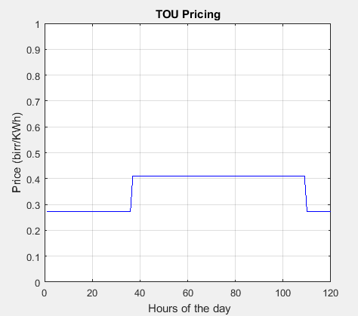
Figure.3.4 TOU Pricing within typical summer days
Feed in tariff (FIT) is a payment from the electric utility companies for electricity fed in to the utility grid. The production of electricity is mainly from renewable energy sources like solar and wind. The mandate of FIT is given by the government or offered by an electricity retailer voluntarily. Even if the design of FIT has several goals like economic, environmental and industrial objectives, the primary aim is to encourage adoption of RES.

Chapter Four

4 Optimization of home appliance scheduling Problem formulation and proposed solution

4.1 Proposed Approach to manage Energy consumption
In this section, an optimal approach for scheduling the power usage of all schedulable appliances in the home is proposed based on TOUP.

4.1.1 Power usage Pattern of home appliances
The EMC can make decision on power schedule for all schedulable appliances in the home after the home gateway (HG) located between the smart meter and appliances which receives the DR information and TOUP profile from the electric utility company. Residents usually need to operate each schedulable appliance at a certain time interval to avoid peak price time or schedule home appliances to finish their job before a specific time. For example, the washing machine may start to work at night when the residents are sleeping because the electric price is low. On the other hand, if residents desire to have dinner as soon as they arrive home in the afternoon, they must ensure that the electric cooker needs to finish its job before they arrive home. From this point of view, it is necessary for residents to set the necessary time parameters for each of schedulable appliances in home such as the length of operation time (LOT), the power consumption per hour of each appliances and the operation time interval (OTI) during which the appliance is valid to be scheduled. All of these parameters can be set on the in home display (IHD) device like computers, tablets and mobile phones to be transmitted to the EMC via HG. It seems impractical to set time parameters for each non-schedulable appliance and we only consider the impact of schedulable appliances on electricity cost and PAR. However, the proposed scheme is still effective when the operation of non SAs is involved.

4.1.2 Problem Definition
Before applying the proposed approach, hours of the day are divided in to time slots. There are 24 hours in a day and 1440 minutes in 24 hours. Each hour is divided into 5 time slots; in other words, the time resolution is 12-minute, and there are 120 time slots in a day, which are denoted by the symbol:$s S ≜ \{1, 2 …120\}$. The resolution time is short enough as a time unit for the operation intervals of all the home appliances, and it is much more convenient to solve the optimization problem using GWO. Hence, the shortest operation time of any appliance is set to be 12 minutes. Therefore, the LOT of each schedulable appliance in home is set to integer multiples of the 12-minute interval of time. However, there are also some other schedulable appliances whose LOTs once are fixed, such as a washing machine and Electric oven.
The operation time of these appliances do not needs to be controlled manually and can be operated automatically. The operation times should be integer multiples of 12 minutes and these should be greater than and be the nearest numbers from the actual LOTs of these appliances. The unit of LOT in this study is assumed to be the number of time slots. For example, if the washing machine needs 58 minutes to finish its’ job, then the LOT parameter should be set as 5 (60 minutes). On the other hand; if the coffee grinder needs 9 minutes to grind coffee the LOT should be set as 1 (12 minutes). This indicates there must be some errors in the final results. But, the errors are just few minutes and are small enough to be ignored.
Let A represents the set Schedulable appliances. For each appliance a∈A, a set of schedulable appliances represented as;
A= [a₁, a₂,…………..,a_{m}] (4.1)
The number of time slots in 24 hours’ time horizon is given by;
S = [1, 2, 3,……..……n,..N] (4.2)
The lengths of operating time of schedulable appliances are;
la= [l₁, l_{2,} … ,l_{m}] (4.3)
Starting time of schedulable appliances is denoted by;
t_{a} = [t_{s1},t_{s2},.......,t_{sm}]^{T} (4.4)

The power consumption scheduling vector P_{a} is assumed to be:
P_{a} ≜ [P ⁽¹⁾, P ⁽²⁾. …….. P⁽¹²⁰⁾] (4.5)
Where P_{a}^{(s)} denotes the power consumption value for appliance a during s^{th} time slot, and the unit is given by kWh. Considering the specification for each of electric appliances, the power consumption values per hour are all fixed. When the power consumption value per hour of appliance a is denoted by$xa$, during the time slot s, the corresponding power consumption denoted by:
P_{a}^{(s)} =$\frac{xa}{5}$ (4.6)
In other words, equation (4.6) represents the power rating of shiftable appliances per slot. The number of slots per hour is 5 in this situation. By inserting power rating per slot of all shiftable appliances in an exclusive row for each of appliances in set “A” starting from column T_{s} up to T_{a} + la for respective appliances the “Power Matrix” would be developed. The number of time slots in 24 hours indicated by column numbers.
For all schedulable appliances, the power consumption scheduling matrix P can be defined as:
P = $\left\{\begin{aligned}P | P_{a}^{\left(s\right)}=\frac{Xa}{5}, ⩝a ϵA s ϵ [ta , ta+la ] \\ P_{a}^{\left(s\right)} =0 , ⩝a ϵA s ϵ S\backslash [ta , ta+la ]\end{aligned}\right.$ (4.7)
The scheduling vector is given by adding the “Power Matrix” column wise as shown below:
P_{sch} = {Psch |${ P}_{sch}^{(s)}$= $\sum{P_{ak}^{s}}$ , $⩝$s$ϵ S$ }. (4.8)
“P_{sch}” is a vector which represents the total power requirement of shiftable appliances in each time slot “s”.
The main purpose is to optimize the power consumption scheduling vector which is transmitted to appliance at home by HG via a suitable wireless network.

4.1.3 The ON and OFF Decision Variable
The decision variable $Y_{ak}^{s}$ determines the on and off status of the schedulable appliances. When the appliance is in the on state the value of $Y_{ak}^{s}$ is 1 in the time slot S.
When the schedulable appliances are in the off state or after finishing their job the binary decision variable $Y_{ak}^{s}$ will be changed to 0.

4.1.4 The Objective function
The first objective of the home energy management system is to minimize the billing cost by minimizing the pick to average ratio of the load demand. The minimum electricity cost is determined based on the TOUP within 24 hours of the day. Let C^{s} be the price of electricity based on TOUP in the time slot S.
The fitness function which represents the total cost of electricity consumption, f_{cost} becomes as follows.
F_{cost, 1} = min $\sum_{s=1}^{n}{C^{s}}\left(\sum_{a=1}^{m}{\sum_{k=1}^{u}{P_{ak}^{s}Y_{ak}^{s}}}\right)$ (4.9)
Subject to αa ≤ ta ≤ βa – la
F_{cost} is the fitness function which has to be minimized by reducing the peak to average ratio of the load in 24 hours of the load pattern. P_{ak}^{S} is the load demand in each appliance a in phase k at time slot S. Y_{ak}^{S} represents the on and off binary decision variable which shows the on and off status of the appliance.
We have to note that once if each appliance starts operation, it must finish its load phases sequentially without interruption. The binary decision variable Y_{ak}^{S} ϵ $\left\{0,1\right\}$ decides the on and off status of each appliances. Until the phases of each appliance complete its operation the Y_{ak}^{S} remains in the on status or 1. If the operation competed in the corresponding allocated time slot, then the Y_{ak}^{S} changed to binary 0. ta is a variable which shows the optimal time for the operation of the appliance a. this variable is greater than or equal to αa and less than or equal to βa – la.
When the stand alone roof-top Solar PV micro grid is incorporated in to the above equation, it becomes:
F_{cost, 2} = min $\sum_{s=1}^{n}{\sum_{a=1}^{m}{\sum_{k=1}^{u}{\left(C^{s}P_{ak}^{s}Y_{ak}^{s}- {g^{s}ρ}_{ak}^{s}Y_{ak}^{s}\right)}}}$ (4.10)
Where C represents the grid in tariff known as TOUP and g is the feed-in tariff.$ρ_{ak}^{s}$ represents the power produced by the roof top solar PV system in a given time slot.
$γ_{ak}^{s}$ ϵ $\left\{0,1\right\}$ is the binary decision variable.
By replacing the variable $P_{ak}^{s}Y_{ak}^{s}$ with $P_{sch,ak}^{s}$ and $ρ_{ak}^{s}Y_{ak}^{s}$ with $G_{schm,ak}^{s}$ , the objective function without including the solar PV system is shown in equation (4.11).
- Reduction of consumer’s electricity bill
$$Minimize\sum_{s=1}^{120}{({C^{s}P}_{sch}^{s}}) (4.11)$$
Subject to α_{a} ≤ ta ≤ β_{a} – l_{a}
When the solar PV system is included in to the system, the objective function will be updated as shown in equation (4.12).
$$Minimize\sum_{s=1}^{120}{({C^{s}P}_{sch}^{s}}-g^{s}G_{schm}^{s} ) (4.12)$$
Subject to αa ≤ ta ≤ βa – la
- Reduction of Peak to Average Ratio (PAR)
$$Minimize PAR = \frac{Max (Psch) }{Avg (Psch)} (4.13)$$

- Minimization of customer’s dissatisfaction value due to scheduling
One of the objectives of this paper is to minimize customer’s discomfort level while minimizing the cost of electricity and reducing the peak load. In order to model and quantify user dissatisfaction, a delay time rate function is introduced.
$$minimize\sum{a}ϵA f_{sn} (4.14)$$
Where, $f_{sn}$ is the discomfort associated with a shiftable appliance which is obtained by defining the delay time rate (DTR) of shift able home appliances as shown in equation (4.15) [59]:
$$DTR=\left(\frac{t_{a}-α_{a}}{β_{a}-la-α_{a}}\right) ⩝ a ϵ A (4.15)$$
Where, $α_{a}$ and $β_{a}$ are the start and end time limits to finish operation of appliance which is set by the user. ‘l_{a}’ is length of operation duration for a given appliance and $t_{a}$ is the actual starting time of a given appliance. If the appliance starts operation lately than the actual operation starting time (t_{a}), the DTR would be increase. The Value of DTR for an appliance varies between 0 and 1. Assume t_{a} ϵ [$α_{a}$, β_{a}] and LOT is l_{a}, if the appliance started its’ operation at time slot $α_{a}$ the DTR could be 0. This is because, there is no any delay time to start operation. If the appliance start its’ operation at time slot${ β}_{a}-la$, the value of DTR could be 1. Further a delay parameter ᵷ >1 may be introduced to equate $f_{sn}$ as ᵷ^{DTR}. Thus, discomfort associated with shift able appliance would be as follows:
$$f_{sn}=\sum_{aϵA}{ᵷ^{DTR} (4.16)}$$

4.1.5 Constraints
The following constraints are considered to solve the objective function.
- Energy constraints
The load phases of each appliance must fulfil their energy requirements. This constraint is explained as follows:
$\frac{1}{5}$ $( \sum_{s=1}^{S}{P_{ak}^{s}})=ϵ_{ak}$ $⩝\{a,k\}$ (4.17)
Where $P_{ak}^{s}$ is the load demand of appliance a with load phase k at time slot s, $ϵ_{ak}$ is the energy needed for appliance a with its load phase k, s is the total available time slots within a day (in this case S = 120). The time interval taken for the load profile in this case is 12 minutes (0.2 hr). The peak load demands for residential, commercial and industrial loads are restricted by the electric utility company. The upper limits of the load demanding for all appliances are restricted to a certain predefined limit ɵ.
$\left( \sum_{s=1}^{S}{P_{ak}^{s}}\right) ≤ɵ^{s}$ (4.18)
The peak demand signal ɵ send by the grid operator is known as the demand response signal. The maximum power demand allowed for domestic consumers in Ethiopian electric utility is 5.5 kW. So, the maximum power demand in this work is restricted to 5.5 kW. The other power constraint is the power generated by the PV system which is in between the minimum and the maximum power produced by the PV panel capacity within a day.
Pgmin ≤ ρ ≤Pgmax (4.19)
Where Pgmin is the minimum power production and Pgmax is the maximum power production using the PV system within a day integrated to the grid system. When the power production from PV is minimum i.e. ρ < Pgmin, all the power demand by appliances would be fed from Utility grid. When the peak power demand exceeds the maximum PV production and inverter capacity then, the power demanded by appliances would be fed from the grid partially or fully which is decided by the EMC.
- Power balance constraint
$J+Q=n$ (4.20)
Where J is the number of appliances which can be controlled and Q is the number of appliances which is uncontrolled and n is the total number of appliances.
- Timing constraint
The other important constraint is the timing constraints. Each scheduled load appliances can’t be interrupted until it has finished its operation of load phases. It is also known that the next load phases can’t be started unless the previous load phases finished their operation.
$Y_{ak}^{s}$ + $ɣ_{ak}^{s}$ =1 (4.21)
When the value of binary decision variable $Y_{ak}^{s}$ is binary 1, then the value of the auxiliary decision variable $ɣ_{ak}^{s}$ is binary 0 and vice versa. Both $Y_{ak}^{s}$and $ɣ_{ak}^{s}$ can’t be 0 or 1 at the same time. The auxiliary binary decision variable indicates whether the previous task of operation have finished or not. $ɣ_{ak}^{s}$ = 1 indicates the previous task of operation have already finished. It is assumed that all the appliances need to operate at their rated power during their working periods and a collection of constraints need to be met in the load management as follows:
Let l_{a} be the length of operation time interval (LOT), the power consumption of each appliance is valid within the proper scheduling.
Let α_{a} and βa be the start and end time slots of the operation of each appliance (βa > α_{a}), then the length of operation time is less than or equal to the end time minus the start time of operation as follows.
βa - α_{a} ≥ l_{a} (4.22)
For example, if the time required for water heater to finish its operation is one hour, then the value βa - α_{a} would be any number which is greater than or equal to 5, and in the meantime less than or equal to the end time slot i.e. 120.
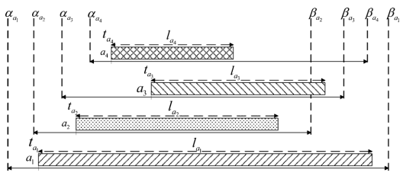
Figure 4.1: The relationship between all the parameters of appliances.
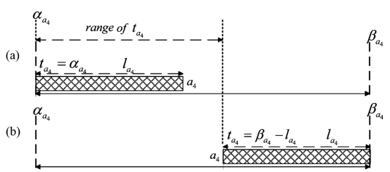
Figure 4.2: Illustration which shows the range of operation starts time of appliances. a) Earliest start time and b) latest start time.
The higher value of βa - α_{a} indicates the most possible solution there could be. Selecting four different appliances the relationships between different parameters of those appliances are illustrated in figure 4.1. Once we have α_{a} , βa and l_{a} the value of t_{a} is greater than α_{a} and less than βa - l_{a}. In other ways it means the range of the operation start time is in between α_{a} and βa - l_{a.} The range of t_{a} is shown in figure 4.2.
t_{a} ϵ [α_{a} , βa - l_{a}] (4.23)
The number of cycles or possible positions for the operation of the appliance can be obtained as follows:
ʘ = $s_{t,end}-$ $S_{t,st} – l_{a}+2$ (4.24)
Where,
ʘ is the number of cycles available for an appliance to operate
$S_{t,st}$ the starting time for the operation of appliance in the range which is selected by the user,
$s_{t,end}$ the ending time for the operation of appliance in the range which is selected by the user,
and $l_{a}$ is the load profile of an appliance.
This formula is designed based on the relationship of the possible probable operation time of all schedulable smart home appliances within a day.
For example, consider an appliance washing machine having load profile of energy consumption per slot as follows:
$ϵ_{1k}=\frac{1}{5}\sum_{k=1}^{u}{P_{ak}^{s}}$ = [0.6 0.6 0.6 0.6 0.6 0.6 0.6 0.6 0.6 0.6 0.6 0.6 0.6 0.6 0.6]
Where, a = 1 refers to washing machine and its length of load profile is $l_{a}$= 15 has three phases of operation i.e. washing, Spinning and drying. The washing phase takes 3.6 kWh while the spinning and drying takes 3.6 kWh and 1.8 kWh respectively.
Further each phase is divided in to smaller time preferences or slots and we have a total number of 15 time slots. Each of the washing and drying phase takes six time slots to complete its operation while the rinse phase takes three time slots.
The range for starting and ending time of appliance is given as $S_{t,st}=76$ (3:00PM) and $S_{t,end}$= 90 (5:48 PM). All the units of the time resolution in this work are given in number of time slots. Using equation (4.26), the number of cycles or available positions to schedule the washing machine within a day is ʘ = 6 i.e. we have six alternative ways to schedule the washing machine within the given operation time range. Similarly, using equation (4.6) the power consumption per slot of each home appliances are shown in table 4.1.

Table 4.1: Parameters of schedulable load appliances
List of Appliances | Power rating (KW) | Actual OTD  (min) | Daily power consumption  (KWh) | Power consumption per slot  (Kwh) | Number of slots assigned
Washing machine  with dryer  Electric Oven-1  Electric Oven-2  Refrigerator  Electric Iron  Water heater  Table Fan  Coffee Grinder | 3  2.15  2.15  0.225  1.5  1.5  0.025kw  0.1 | 180  45  45  1380  24  60  120  12 | 9  1.72  1.72  5.175  0.6  1.5  0.05  0.02 | 0.6  0.430  0.43  0.045  0.3  0.3  0.005  0.02 | 15  4  4  115  2  5  10  1

4.2 Grey wolf optimizer (GWO) Algorithm
For HEM optimization problems, heuristic tools are being used for robust solution in very short computational time for the last decade. These tools have solved different difficult or impossible optimization problems in the past.
The grey wolf optimizer (GWO) is a new meta-heuristic which mimics the leadership hierarchy and hunting mechanism of the grey wolves (canis lupus) [60]. To simulate the leadership hierarchy, four types of grey wolves are employed. Those include the alpha, beta, delta and omega. The basis of GWO algorithm is the democratic behavior and the hunting mechanism of the grey wolves [61]. Both the male and the female are the leaders in the pack and known as alpha (α). The second levels of the grey wolves (subordinate wolves) are known as beta (β) wolves. The work tasks of the beta grey wolves are helping the alpha wolves in the decision making and other activities in the pack. The Third level of the grey wolves are known as delta (δ) wolves and which has to submit to alphas and betas, but dominate the lowest rank grey wolf in the hierarchy which is called omega (ω) wolves. Omega (ω) wolves act as scapegoat in the pack.
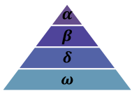
Figure 4.3: The hierarchy of grey wolf and their dominance decreases from top down [60]
The mathematical modeling of GWO is discussed as follows:
- Social hierarchy
In order to design GWO and mathematically model the social hierarchy of grey wolves, the fittest solution is considered as alpha (α). The second and the third best solutions are known as beta (β) and delta (δ) respectively. Omega (ω) is the rest of candidate solution. The hunting (optimization) is guided by α, β and δ. The ω wolves follow those three wolves [60].
- Encircling prey
The first step during hunting is encircling the prey. The following equations are employed in order to mathematically model the encircling behavior [62].
$\vec{X}\left(t+1\right)=\vec{Xp}\left(t\right)-\vec{A.}\vec{D}$ (4.25)
$\vec{D}=|\vec{C} \vec{Xp}(t)-\vec{X}(t)|$ (4.26)
Where, $\vec{A} and \vec{C}$ are coefficient vectors,$\vec{Xp} is the prey^{'}s position vector$, $\vec{X}$ is the grey wolfs position vector and ‘t’ stands for the current iteration.
The coefficients A and C can be calculated as follows [63].
$\vec{A}$ = $2a .\vec{ r_{1}}-a$ (4.27)
$\vec{C}$= 2$\vec{ r_{2}}$ (4.28)
Where the value of the vectors $r_{1}$ and $r_{2}$ are in between [0 1]. Within the course of iterations the value of ‘$\vec{a }$’ are reduced linearly from 2 to 0.
- Hunting
In order to estimate the information of the prey potential location, the alpha, beta and delta are leading the hunt. All the other search agents update their position in accordance with the best search agents’ position. This update is as follows [64].
$\vec{X}(t+1)$ = $\frac{( \vec{X_{1} }+ \vec{X_{2}} + \vec{X_{3}} )}{3}$ (4.29)
Where, $\vec{X_{1}}$ $\vec{X_{2}}\vec{X_{3}}$ are defined in equation (4.30) as follows
$\vec{X_{1}}$ = | $\vec{ X_{α}}-\vec{A_{1}} \vec{D_{α}}$|
$\vec{X_{2}}$= | $\vec{ X_{β}}-\vec{A_{2}} \vec{D_{β}}$| (4.30)
$\vec{X_{3}}$ = | $\vec{ X_{δ}}-\vec{A_{3}} \vec{D_{δ}}$|
Where, $\vec{ X_{α}}\vec{ X_{β}}$ and $\vec{ X_{δ}}$ are considered to be the first three best solutions in the swarm in the given iteration t and A1, A2 and A3 is given in equation (4.27). $\vec{D_{α}} , \vec{D_{β}} and \vec{D_{δ}}$ are defined in equation (4.31)
$\vec{D_{α}}$ = | $\vec{C_{1}} \vec{ X_{α}}- \vec{X }$ |
$\vec{D_{β}}$ = | $\vec{C_{2}} \vec{ X_{β}}- \vec{X }$ | (4.31)
$\vec{D_{δ}}$ = | $\vec{C_{δ}} \vec{ X_{δ}}- \vec{X }$ |
Where,$\vec{C_{1}}$, $\vec{C_{2}}$ and $\vec{C_{3}}$ are defined in equation (4.28)
The other important parameter in the GWO is ‘a’ which controls the tradeoff between exploration and exploitation and the value of ‘a’ varies between 2 and 0 in each iteration according to equation (4.32).
$a=2-t\frac{2}{Max.Iter}$ (4.32)
- Search for Prey and attacking Prey
The value of ‘A’ is arbitrarily in between [-2a 2a] and when |A| <1, the wolves are forced to attack the prey. The mechanism of searching for prey is known as exploration whereas exploitation is attacking the prey. When |A| >1, the grey wolves are enforced to move away from the prey. The general flowchart of the GWO is as shown in figure 4.4.

4.3 Particle Swarm Optimizer (PSO) Algorithm
Particle swarm optimization (PSO) is meta-heuristic algorithm which is based on swarm behavior of birds and schooling of fishs known as swarm intelligence. It is simple; converges faster; has avery large search space; and solve large variety of difficult optimization problems very quickly.First, population of random solutions known as particles will be generated which moves towards the best position with a random velocity in search space. Each particle in the search space remember its own best and global or swarm’s best positions and moves with “j^{th}” particle velocity (in “i^{th}” iteration) as Vj (i) = Vj (i-1) + c1r1[Pbest - Xj (i-1)] + c2r2 [Gbest - Xj (i - 1)]; j = 1, 2, . . . ,N; where c1 and c2 are cognitive and social learning parameters, and r1 and r2 are uniformly distributed random numbers between 0 and 1. The new position of j^{th} particle is found as: Xj(i) = Xj(i-1) + Vj(i) ; j= 1,2…..,N. Which corresponds to the fitness function values relating to particles as f(X1(i)), f(X2(i)),…..f(XN(i)).

Start
Population size initialization N, Coefficient vectors A and C, Max.iteration, Number of generation and its limit

Defining the initial cost function

Generation of the initial population randomly

Calculate X_{α}, X_{β}, X_{δ}
Update the position of current search agent X (t+1);
X (t+1) = $\frac{X1+X2+X3}{3}$
iter +1

Updating a. A and C, Calculate the fitness
For each search agent Update Xα, X_{β}, X_{δ}

iter <Max.iter
NO
Yes
Stop

Figure 4.4: GWO Algorithm flowchart

4.4 Grey wolf optimizer optimization algorithm formulation
In the scheduling of smart home appliances, first we initialize α, β, δ and ω with some value and generate the random population. Then in order to calculate the fitness function for each search agent the objective function would be calculated using equation (4.33) – (4.35).
The first three best solutions are selected and saved as the best solutions obtained so far. Based on the positions of the best search agents, the other search agents update their positions using equation (4.29). The first objective is reduction of consumer’s cost of electricity billing without integration of Photo voltaic (PV) energy.
$Fitness 1=\sum_{s=1}^{120}{({C^{s}P}_{sch}^{s}}) (4.33)$
The second objective is reduction of consumer’s cost of electricity billing with integration of Photo voltaic (PV) energy.
$$Fitness 2=Minimize\sum_{s=1}^{120}{({C^{s}P}_{sch}^{s}}-g^{s}G_{schm}^{s} ) (4.34)$$
The first and second objective is achieved while satisfying the PAR value at minimum value. So, the PAR can be calculated using the mean value of the scheduled power (P_{sch}).
$$Fitness 3 = \frac{Max (Psch) }{Avg (Psch)} (4.35)$$
In the flow chart of GWO algorithm from figure (4.4), POP represents the total number of populations, D represents the number of appliances, Max.iter is the maximum iterations, and fitness is the objective function. The best solution or the best participant in hunting is represented by α, while β and δ are considered to be the second and the third optimal solutions, respectively. In each of the iteration, the fitness function is compared with the fitness of α, β and δ to evaluate the best optimal solution. Their final positions are updated according to equations (4.29)–(4.31). The initial populations of grey wolves are generated randomly.
There are a number of ways to calculate the fitness function in Math Lab. Let us see two methods. By multiplying the on and off binary decision variable row vector with the transpose of energy consumption per slot for each appliance in their allocated operation time slot, we would get energy consumption per operation cycle. So, by summing the energy consumption per operation cycle for each appliance we could get the total energy consumption per slot of the scheduled load appliances.

Start
Initialize particles with random position and velocity vectors

Evaluate the fitness of each particle using fitness function

Find the local best (Pbest) and global best (Gbest) value

Calculate and update the velocity of particles

Calculate and update the velocity of particles
Calculate and update the position of particles

Termination criteria satisfied?

NO

Yes
Display the global best (Gbest) optimal solution

Finish

Figure 4.5: The General flow chart of PSO Algorithm
For each scheduled appliance, one energy consumption cycle (i.e.$ϵ_{ak}^{s}$) is taken out of all available possible operation cycles randomly. For example, in each iteration energy consumption per slot of a washing machine at operation cycle one discussed below i.e. $ϵ_{1k}^{1}$ has 2^{106×R} probability of being selected. Where, ‘R’ is the product of the operation cycles of the other load appliances. The ON and OFF binary decision variable ($Y_{ak}^{s}=0 or 1$) decides which appliance must be on or off in the specified time slot.
Using equation (4.6) the energy consumption per slot of appliance a at timeslot s is represented by${ ϵ}_{ak}$
h₁= [ $Y_{1}^{1}$ $Y_{1}^{2}$ $Y_{1}^{3}$…………..$Y_{1}^{106}$] × [$ϵ_{1k}^{1}$ $ϵ_{1k}^{2} ϵ_{1k}^{3}$…………$ϵ_{1k}^{106}]$^{T} ⩝ {k}

$ϵ_{1k}^{1}$= [0.6 0.6 0.6 0.6 0.6 0.6 0.6 0.6 0.6 0.6 0.6 0.6 0.6 0.6 0.6 ……….0 0 0 0 0 0 0 0 0]
$ϵ_{1k}^{2}$= [0 0.6 0.6 0.6 0.6 0.6 0.6 0.6 0.6 0.6 0.6 0.6 0.6 0.6 0.6 0.6 0 0 0 ……….0 0 0 0]
$ϵ_{1k}^{3}$= [0 0 0.6 0.6 0.6 0.6 0.6 0.6 0.6 0.6 0.6 0.6 0.6 0.6 0.6 0.6 0.6 0 0 ……….0 0 0 0]

$ϵ_{1k}^{4}$= [0 0 0 0.6 0.6 0.6 0.6 0.6 0.6 0.6 0.6 0.6 0.6 0.6 0.6 0.6 0.6 0.6 0 ……….0 0 0 0]

$ϵ_{1k}^{5}$= [0 0 0 0 0.6 0.6 0.6 0.6 0.6 0.6 0.6 0.6 0.6 0.6 0.6 0.6 0.6 0.6 0.6 ……….0 0 0 0]
.
.
.
$ϵ_{1k}^{115}$= [0 0 0 0 0 0 0 0 0………. 0.6 0.6 0.6 0.6 0.6 0.6 0.6 0.6 0.6 0.6 0.6 0.6 0.6 0.6 0.6 0]
$ϵ_{1k}^{106}$= [0 0 0 0 0 0 0 0 0 ………. 0 0.6 0.6 0.6 0.6 0.6 0.6 0.6 0.6 0.6 0.6 0.6 0.6 0.6 0.6 0.6]
Subject to constraint
$$\sum_{s=1}^{106}{Y_{1}^{s} =1 (4.36)}$$Rather than using a row and column vectors, we can also express the energy consumption per slot of each appliance in matrix form to solve the problem easily. For example, the energy consumption per slot of washing machine (i.e.$ϵ_{ak}^{s}$) can be expressed in 106×120 matrix which contains the row vector listed above. Similarly, the on and off binary decision variable matrix would also be 106×120 size. Equation (4.36) shows the binary decision variable selects only one time slot out of 106 time slots and tells the starting and ending time for the operation of the washing machine. So, the objective function from equation (4.9) - (4.13) can be solved. Using similar procedure like the washing machine explained above, the power consumption per slot for each appliance would be calculated easily. Since the PV panel is source of power and not load consuming appliance, it is considered as negative. Using the relationship between the energy consumption per slot and load demand, in equation (4.34) the objective function in Mat lab syntax becomes as follows:
In order to calculate the PAR, first we have to calculate the scheduled load power and then calculate the mean value by dividing the maximum value in the row vector to the sum of the scheduled load power per time slot.
$$Psch=\left(\left(\frac{(sum[{h1+h2+h3+…+h8] }^{T})}{0.2}\right)-h9\right)$$
$$PAR=\frac{max⁡(Psch)}{ave(Psch)}$$
Where, h1, h2, h3,…..… h8 are column vectors which represent the power consumption per slot of each schedulable load appliance and h9 is row vector which represents the load profile of the PV panel in the specified time slot. Since the GWO is Meta-heuristic swarm intelligence based optimizer, to form the scheduled load demand matrix; the binary decision variable index selects only one column in the power consumption per slot matrix by excluding the zero rows and columns within the maximum cycle of operation time. Then, P_{sch} can be calculated stochastically for each schedulable load appliances up to the maximum number of iteration. After computing the objective function, the best score obtained on each of the iteration is represented by α. The second and the third best score which are less than α are represented by β and δ respectively. The rest of the candidates solutions are known as ω.
As explained in equation (4.6), the energy consumption per slot can be calculated by summing the area under the load demand per slot with the operation hours in the given time slot i.e. $\int{P_{sch,a}ds}$. Since the load varies in a given time to calculate the energy usage, we have to add each of the smallest rectangles formed in each sequence of time slots.
In order to get better approximation the time duration of each time slot must be lower as much as possible. In this case, the time duration for each time slot is taken to be 12 minutes. There are 120 time slots within a day with ones in operating time slots and zeros in non-operating time slots.
$$ϵ_{ak}=0.2*\left( \sum_{a=1}^{8}{P_{psc,a}^{s}}\right)$$
The total cost of electricity becomes as follows:
$$Fcost=\left(\left(\left(\sum_{a=1}^{8}{P_{sch,a}}\right)×0.2\right)\right)×{[TOUP]}^{T}$$
Where, TOUP is the time of use pricing vector and a is the schedulable load appliance.
Table 4.2: Parameters used for the simulation in GWO
Parameter | Description of the parameter | Value
N_{I} | Number of iteration | 500
w_{n} | The number of wolves in the pack | 18
POP | Population Size | 200
r1, r2 | Random vectors | r1,r2 are in between 0 and 1
$$\vec{a }$$ | Coefficient vector | 2 to 0

Table 4.3 Parameters used for the simulation in PSO
Parameter | Description of the parameter | Value
V_{max} | Maximum particle velocity | 10
V_{min} | Minimum particle velocity | -10
w_{min} | Minimum Inertia coefficient | 2
w_{max} | Maximum inertia coefficient | 0.9
C₁ | Acceleration coefficient 1 | 2
C₂ | Acceleration coefficient 2 | 2

Chapter Five

5 Simulation results and discussion

5.1 Optimization result and analysis of energy cost, PAR and peak load
In order to optimize scheduling of home appliances and to reduce electricity cost (monthly billing cost), PAR and minimizing the peak load based on the objective function provided in equation (4.9)-(4.13), both GWO and PSO algorithm program code are implemented.
In order to solve the objective function and display the simulation result, eight case studies with four different scheduling techniques are considered as shown below:
- Shiftable load appliances are scheduled with fixed time range within its length of the load profile without integrating with PV system, in relation to un scheduled load appliances could be considered.
- Shiftable load appliances are scheduled with Restricted time range within a day started at any time slot from time slot 1 up to any time slot which is less than end time slot. i.e time slot 120 and ends at any time slot from starting time slot up to time slot 120. But the length of operation time is greater than or equal to the starting time slot and less than or equal to end time slot minus starting time slot. The simulation and analysis of this system running without integrating with PV system is considered.
- Shiftable load appliances are scheduled with multi-restricted time slot within aday. Except appliaces working thought the day like refrigerators, all scheduled appliances have more than one restricted time range positions. The simulation and analysis of this scheduling scheme running without integrating with PV system would be considered.
- Shiftable load appliances are scheduled with variable time range within a day started from time slot 1 up to the end time slot i.e, time slot 120 without integrating with PV system.
- Shiftable load appliances are scheduled with fixed time range within its length of the load profile and integrating with PV system in relation to un scheduled load appliances are considered.
- The simulation and analysisis of Case b integrated with PV system has considered.
- The simulation and analysisis of Case c integrated with PV system has considered.
- Shiftable load appliances are scheduled with variable time range within a day started from time slot 1 up to the end time slot i.e. time slot 120 and integrating with PV system.
By using MATLAB 2016(a) software environment and coding with both GWO and PSO algorithm the problem could be solved easily.
Most of the electricity utility company in traditional grid system restricts the maximum load demand using circuit breaker installed with the KWh meter. If the maximum load current is beyond the name plate specifcation of the circuit breaker, it trips and switch off.
In smart grid system there are different electricity tariffs. Using those electricity tariffs, they can control the maximum energy consumption by discriminating with high price rate in peak hours for their over consumption from utility grid and lower price rates during off-peak hours of the day as an incentive to appreciate customers for their energy consumption. Time of use pricing (TOUP) is one of the electricity pricing tariff system used by electricity provider companies in smart grid system. TOUP is a type of pricing scheme in which the price per KWh for electricity varies within a day or a week at different times aiming to minimize the peak load demand and filling the valleys and maintain the horizontal load distribution within a day. The maximum load demand constraint control the peak load demand in home and it is less than or equal to 5.5 KW in this case. Both schedulable and non schedulable residential load appliances are listed in table 5.1 and table 5.2.
Table 5.1: Non-interruptible Flexible load appliance and Interruptible flexible load appliances with their power rating and energy consumption.
Group of Appliance | Appliances | Power rating (KW) | Actual OTD  (hr.) | Power consumption  (Kwh)
Non-interruptible Flexible load appliance | Washing machine  With dryer  Electric Oven-1  Electric Oven-2  Refrigerator | 3  2.150  2.150  0.225 | 3  0.8  0.8  23 | 9  1.72  1.72  5.175
Interruptible flexible load appliances | Electric Iron  Water heater  Table Fan  Coffee Grinder | 1.500  1.500  0.025  0.100 | 24  60  120  12 | 0.6  1.5  0.05  0.02
Total power consumption |  |  |  | 19.785

Table 5.2: Load profile of Baseline load appliances (non-schedulable load appliances)
Baseline load appliance | Power Consumption  (KW) | Operation time duration  (hr.) | Power consumption  (Kwh)
Light-1 CFL (Living room)  Light-2 CFL Bed room  Light-3 LED Bed room  Light-3 LED Toilet and Bath  Light-4 CFL Kitchen  LED Television 32’ | 0.040  0.011  0.011  0.011  0.018  0.055 | 4  1  1  3  1.5  3 | 0.16  0.011  0.011  0.033  0.027  0.165
Total power consumption |  |  | 0.407

The total power consumption of schedulable load appliances are 19.785 KWh and the power consumption of non-schedulable load appliances are only 0.407 KWh within a day. Compared to the schedulable load appliances, the power consumption of non-schedulable load appliances are very small. For this reason we ignore the effect of non-schedulable load appliances in the simulation.
Case 1: Load appliances scheduled with fixed time:
In fixed time scheduling, the operation time range for each appliance is adjusted by the user on the assigned timeslots. In this type of scheduling, there is one or more operation cycle for each schedulable appliance in a day. In this scheduling mechanism, the users always have to schedule and adjusted the parameters of the appliances manually following the utility electricity pricing (TOUP) signal. If the user needs to schedule appliances in less price time, most of the appliances are scheduled in off peak hours and the comfort level of the user will be minimized. So, the user must decide on balancing energy and timing constraints while reducing the discomfort level due to scheduling. In table 5.3 parameters of residential load appliances for fixed time range scheduling are provided.

Table 5.3: Parameters of schedulable load appliances showing the start and end time of operation with their operation time interval (OTI) for fixed time scheduling.
Appliances | Power rating (KW) | Power consumption per slot  (Kwh) | Number of slots assigned | Start time  (hour) | End  time  (hour) | OTI  (time slot)
Washing machine  With dryer  Electric Oven-1  Electric Oven-2  Refrigerator | 3  2.150  2.150  0.225 | 9  1.72  1.72  5.175 | 15  4  4  115 | 12:00PM  7:00AM  7:15PM  12:00PM | 2:48AM  7:45AM  8:00PM  10:48PM | 1-15  36-39  97-100  1-115
Electric Iron  Water heater  Table Fan  Coffee Grinder | 1.500  1.500  0.025  0.100 | 0.6  1.5  0.05  0.02 | 2  5  10  1 | 7:15AM  10:00AM  2:00PM  12:15PM | 7:30AM  11:00AM  3:00PM  12:20PM | 37-38  51-55  71-80  62

Figure 5.1 shows the residential daily load demands under fixed time scheduling with TOUP. It also shows the maximum load demand within 24 hours a day.
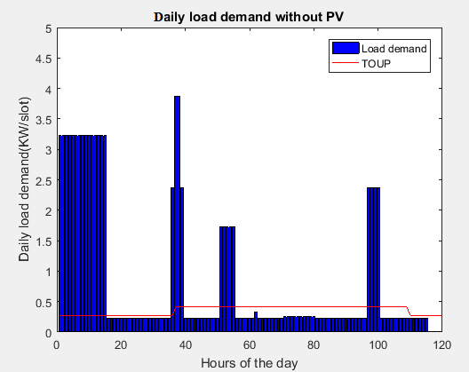
Figure 5.1: Residential daily load demand pattern in fixed time scheduling
(1unit =12 minute)
The maximum peak load in a day is found at time slot 38 up to time slot 39 (i.e. 7:24AM to 7:36AM) which is not preferable in terms of cost minimization. For example, rather than using Electric iron on this time the user can shift it from 6:00AM to 6:48 AM which is off-peak hours. But, it might be good in terms of maximizing comfort for the user who isn’t interested to use early in the morning. Most of time slots from time slot 1 up to time slots 15 which are off-peak hours during night are occupied.
Optimization of peak load, PAR and Cost of electricity on fixed time scheduling:
To measure the PAR during the day, the mean value of the scheduled load demand could be calculated. For minimizing the peak load demand, the appliances scheduled should have to be distributed to all time slots within a day without disturbing the comfort level of the resident. To simulate the peak load, the fitness function in equation (4.13) is optimized within 24 hours of the day irrespective of the TOUP.
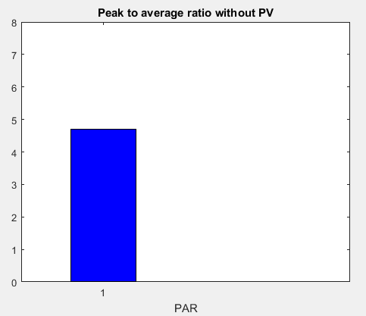
Figure 5.2: PAR in fixed time scheduling
The PAR calculated during 24 hours’ time horizons is 4.7005. The fitness function in equation (4.11) is calculated while minimizing the PAR within a day. The total cost of electricity in fixed time range scheduling with the mean value of 4.7005 is 6.5568 birr/day. The total energy consumption per day is 19.785 Kwh. As we have seen in table 5.3 above, the Washing machine is scheduled to operate between 12:00PM and 2:48AM during night time. If the operation time of washing machine has shifted to day time during peak hours, for example from 9:00 AM up to11:48 AM then, the cost of electricity will rise to 7.7853 Birr/day and the PAR will be 5.7316.
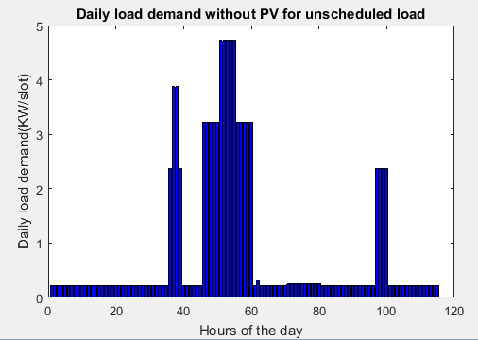
Figure 5.3: Residential daily load demands in fixed time range without scheduling
The maximum peak load is 4.725 KW which is between time slots 51 up to time slot 55.
Case 2: Load appliances scheduled with restricted time range
In restricted time range scheduling the starting time slot and the end time slot range for the operation of appliances that the user wants the appliance to operate in between are specified. Between these time ranges the position of the appliance to operate are determined by the load scheduler stochastically. The load scheduler calculates the number of possible available operation cycles in which the appliance tends to operate. Between these operation cycles, one cycle is selected at a time stochastically for each appliance in their length of load profile and available operation cycle range. Then, the proposed algorithm selects the best combination of operation with minimum PAR and cost of electricity within available swarms’ size and maximum iteration. In GWO, among all possible combinations, the best combination known as alpha (α) which satisfies all energy, timing and other constraints are selected as the best solution obtained so far at a given iteration.
In PSO, the best local combinations are selected and among all those local possible solutions, the global best solution could be selected within the given swarm size and iteration range. The parameters used to schedule the appliances under restricted time range are shown in table 5.4.

Table 5.4: The operation start and End time for restricted time scheduling with their OTI
Group of Appliance | Appliances | Power rating (KW) | Possible Operation Start and end time range  (hour) | Number of slots assigned | OTI
Non-interruptible Flexible load appliance | Washing machine  With dryer  Electric Oven-1  Electric Oven-2  Refrigerator | 3  2.150  2.150  0.225 | 12:00PM -5:48 AM  6:24 AM-8:36 AM  6:12PM-9:00PM  12:00PM-10:48PM | 15  4  4  115 | 1-30  33-44  92-106  1-115
Interruptible flexible load appliances | Electric Iron  Water heater  Table Fan  Coffee Grinder | 1.500  1.500  0.025  0.100 | 6:24AM-8:12AM  9:00AM-10:48AM  12:48PM-3:48PM  11:36AM-1:24PM | 2  5  10  1 | 33-42  46-55  65-80  59-68

In restricted time scheduling, the appliances are scheduled in the allowed operation cycle ranges and this minimizes the allocation of appliances to inconvenient time slots. As we have seen figure 5.4, the peak load demand per slot of appliances is below 5.5 KW which satisfies the power demand constraint. The peak load demand during the day is from time slot 3-15 (i.e. 12:24AM - 2:48AM) which is 3.225 KW using GWO scheduler and from time slot 35-36 (i.e. 6:48AM- 7:00AM) which is 3.875 KW using PSO scheduler.
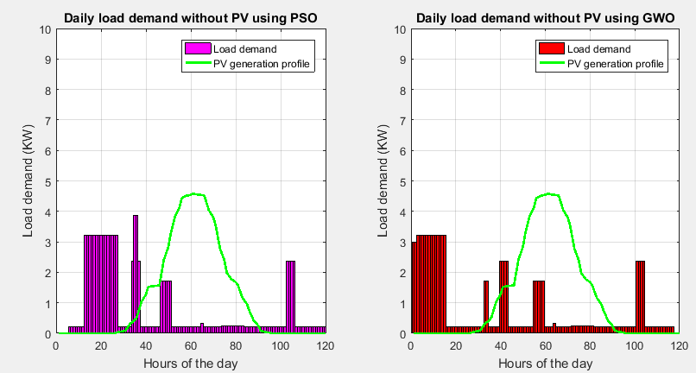
Figure 5.4: The daily load demand pattern under restricted time scheduling and PV generation profile
Optimization of peak load, PAR and Cost of electricity under restricted time range scheduling:
The peak to average ratio obtained with restricted time scheduling using GWO is 3.9121 and using PSO it is 4.7005. The cost of electricity is 6.2988 birr/day using GWO scheduler and 6.4394birr/day using PSO scheduler. In restricted time range scheduling, using GWO scheduler, the electric energy cost and PAR are 3.9% and 16.8% lower than that of fixed time scheduling respectively. The detail result summary using PSO and GWO load schedules are shown below:
- The PAR without PV using GWO is: 3.9121
- The PAR without PV using PSO is: 4.7005
- The minimum cost without PV using GWO is: 6.2988 Birr/day
- The minimum cost without PV using PSO is: 6.4394 Birr/day
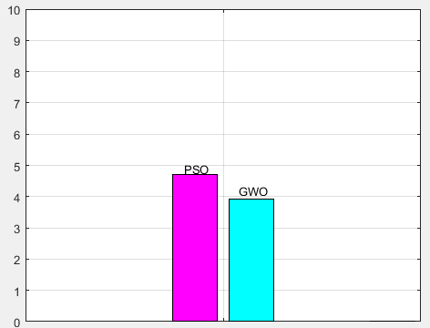
Figure 5.5: PAR under restricted time range scheduling without PV integration
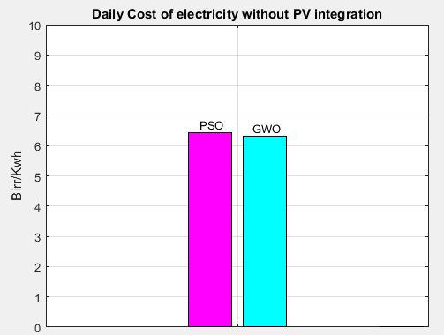
Figure 5.6: Cost of electricity under restricted time range scheduling without PV integration
The daily energy consumption pattern is shown in figure 5.7 within twelve minutes of time interval with an assumption the appliances are operating at rated power. At time slot 36 (i.e. 7:00AM) the peak energy consumed calculated with PSO scheduler is 0.775 kWh and from time slot 15-31 (i.e. 2:48AM - 6:00AM) peak energy consumed is 0.645 kWh calculated with GWO scheduler. The peak energy consumption is mainly due to washing machine.
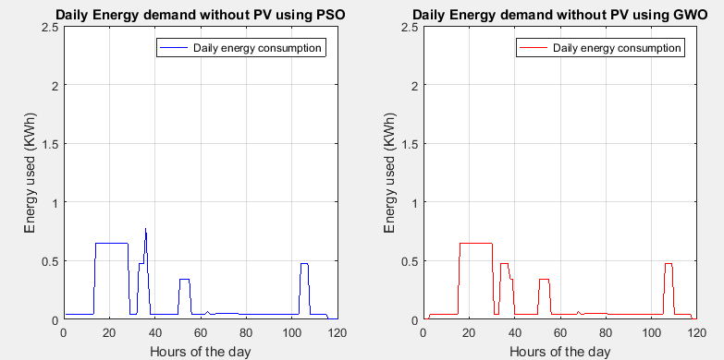
Figure 5.7: Energy consumption per slot pattern under restricted time range scheduling without PV integration within a day
Case 3: Multi - Restricted time range appliance scheduling
A novel Multi - restricted time range scheduling is a type of scheduling in which it is composed of one or more constrained non-overlapping restricted operation cycles and home appliances are allowed to be scheduled within those operation time ranges. Without violating all energy and timing constraints, the load scheduler has a freedom to search the best combination of operation cycles in which the appliance tends to operate. The fitness function would be calculated at minimum peak load while maintaining smooth horizontal load distribution within hours of the day as much as possible.
Between these non-overlapping restricted operation cycles, one cycle is selected at a time stochastically for each appliance within their length of operation duration and available operation cycles.
In multi-restricted time range scheduling, the length of operation duration and operation starting times are expressed as follows:
$$la=\left\{\begin{aligned}l_{a,1} , if t_{a,1} ϵ \left[α_{a,1} , β_{a,1} - l_{a,1}\right] \\ l_{a,2} , if t_{a,1} ϵ \left[α_{a,2} , β_{a,2} - l_{a,2}\right] \\ 0 else \end{aligned}\right\}$$
Subjected to
$$α_{a,1} {≤l}_{a1}≤ β_{a,1} - α_{a,1}$$
$$α_{a,2} {≤l}_{a2}≤ β_{a,2} - α_{a,2}$$
And the operation starting time are on the range of t_{a,1} and t_{a,2} .
t_{a,1} ϵ [α_{a,1} , β_{a,1} - l_{a,1}]
t_{a,2} ϵ [α_{a,2} , β_{a,2} - l_{a,2}]
Where, $l_{a,1}$ ,$l_{a,2}$ are the length of operation times and $α_{a,1}$ , $α_{a,2}$ are the starting time slot.$β_{a,1}$, $β_{a,2}$ are the end time slot and t_{a,1,} t_{a,2} are possible starting times between starting and end time slot ranges in the given operation cycle range.

Table 5.5: The operation start and end time for Multi-restricted time range scheduling with their OTI
Schedulable  Appliances | Power rating (KW) | Possible Operation Start and end time range  (hour) | Number of slots assigned per operation cycle | OTI
Washing machine  With dryer  Electric Oven-1  Electric Oven-2  Refrigerator | 3  2.150  2.150  0.225 | 12:00PM- 3:12AM or  3:36AM-6:36AM  6:00AM-6:48AM or  8:00AM-9:36AM  5:00PM-6:12PM or  7:12PM-8:00PM  12:12AM-11:48PM | 15  4  4  115 | 1-17 or 19-34  31-35 or 41-49  86-92 or 97-101  1-115
Electric Iron  Water heater  Table Fan  Coffee Grinder | 1.500  1.500  0.025  0.100 | 6:00AM-7:00AM or  7:36AM-8:24AM  8:00AM-9:24AM or  9:48AM-11:48AM  12:00AM-1:48PM or  2:12PM-4:00PM  9:00AM-10:36AM or  12:00AM-1:48PM | 2  5  10  1 | 31-36 or 39-43  41-48 or 50-60  61-70 or 72-81  46-54 or 61-70

Optimization of peak load, PAR and Cost of electricity under Multi-restricted time range scheduling:
The daily peak power demand from grid without PV integration within a day using GWO is 3.225 kW from time slot 1-15 (12:00PM- 2:48AM). The net daily peak power demand from grid without PV integration within a day using PSO is 5.375 kW from time slot 32-34 (i.e. 6:12AM - 6:36AM). Due to low pricing time during off-peak hours, from time slots 31-50 are occupied in case of PSO load scheduler. With GWO scheduler low peak load has been achieved compared to PSO load scheduler.
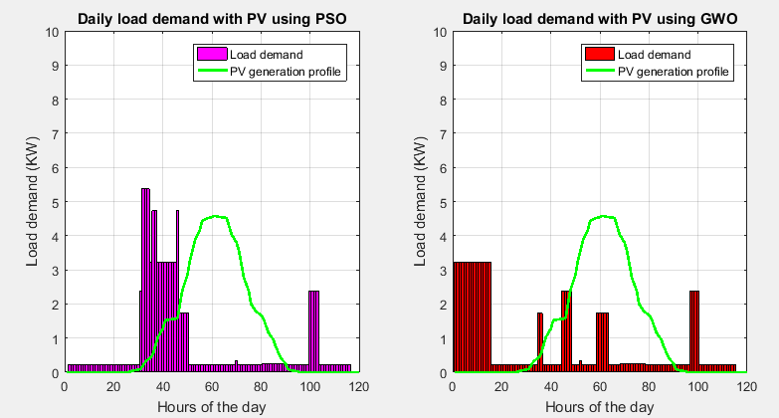
Figure 5.8: The daily load demand pattern under multi-restricted time scheduling and showing PV generation profile

The results are summarized as follows:
- The PAR without PV using GWO is: 3.9121
- The PAR without PV using PSO is: 6.5201
- The minimum cost without PV using GWO is: 6.2988 Birr/day
- The minimum cost without PV using PSO is: 6.3397 Birr/day
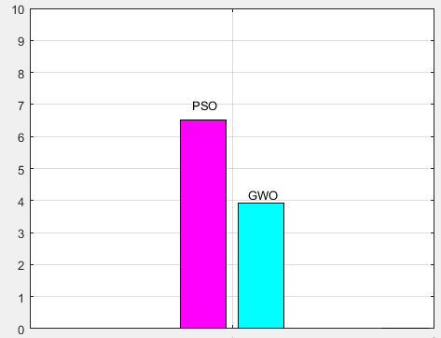
Figure 5.9: PAR under Multi-restricted time range scheduling without PV integration
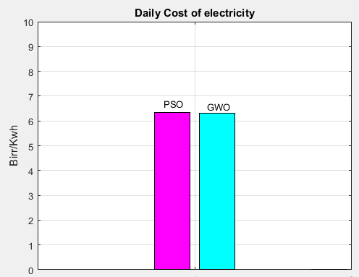
Figure 5.10: Cost of electricity multi-under restricted time range scheduling without PV integration
If all appliances are working with their rated power, the daily energy consumption per slot profile is shown in figure 5.11. The peak energy consumption is found at time slot 40 (i.e. 7:48AM) with PSO scheduler which is 1.075 KWh. This is because, the electric iron and electric oven are working parallely in the morning time in addition to other appliances. Similarly, the peak energy consumption during the day using GWO is from time slot 8-24 (i.e 1:24AM- 4:36AM), which is 0.645KWh.
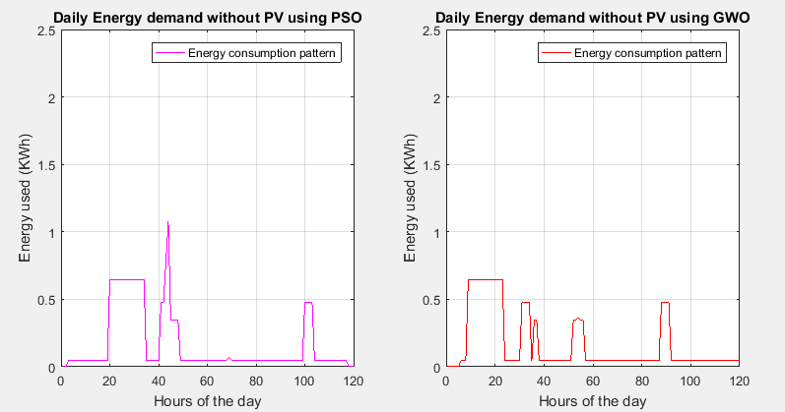
Figure 5.11: Energy consumption per slot pattern under Multi-restricted time range scheduling without PV integration within a day. (1 unit =12 minutes)
Case 4: Load appliances scheduled with variable time scheduling
In variable time range scheduling, the possible operation starting time slot is between time slot 1 and end time slot i.e. time slot 120. But the length of operation time duration is grater than or equal to the starting time slot and less than or equal to end time slot minus the starting time slot. The operation starting time slot of the appliances are within their available operation cycle range for an appliance which has to be scheduled. It is assumed that, it is possible for the appliance to finish its operation earlier than its operation duration time (between earliar starting and ending times). But, it is not allowed to finish operation later than the allocated operation duration time. Table 5.6 shows parameters used for the simulation of schedulable load appliances under variable time range scheduling.

Table 5.6: Parameters of schedulable appliances showing the start and end time of operation interval used in the simulation.
List of Appliances | Daily power consumption  (KWh) | Power consumption per slot  (Kwh/slot) | Number of slots assigned | OTI  (Slot No.) | No. of available operation cycles
Washing machine with dryer  Electric Oven-1  Electric Oven-2  Refrigerator  Electric Iron  Water heater  Table Fan  Coffee Grinder | 9  1.72  1.72  5.175  0.6  1.5  0.05  0.02 | 0.600  0.430  0.430  0.045  0.300  0.300  0.005  0.020 | 15  4  4  115  2  5  10  1 | 1-120  1-120  1-120  1-120  1-120  1-120  1-120  1-120 | 106  117  117  6  119  116  111  120

The daily load demand pattern under variable time scheduling scheme is shown in figure 5.12.
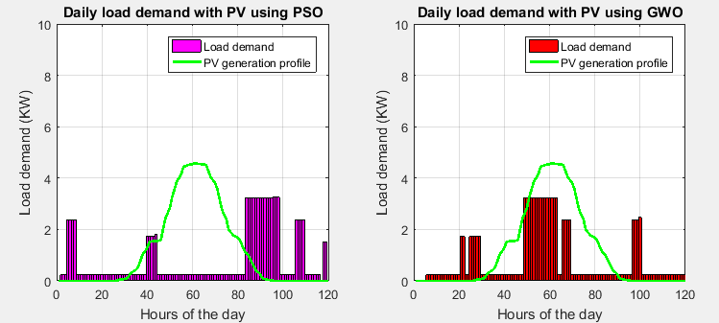
Figure 5.12: Residential daily load pattern demands under variable time range

Optimization of peak load, PAR and Cost of electricity under variable time range scheduling:
At maximum iteration (max. iter = 500), the load demand pattern during the day is shown in figure 5.12 and the peak load demand with GWO scheduler is 3.225 KW which is from time slot 50 up to 64 (i.e. from 9:48AM to 12:36PM). Even if most of time slots within a day are occupied, few of the loads are occupied between those time ranges which increase the peak demand. Using PSO load scheduler, the calculated peak load demand within a day is 3.25 KW which is from time slot 96-98 (i.e. 7:00PM-7:24PM). In variable time range scheduling, the load scheduler assigns each load stochastically to the available time slots within a day while satisfying all constraints. The drawback of this type of scheduling mechanism is it assigns some of the appliances to inconvenient time slots to operate. For example, it is inconvenient to schedule the washing machine from 3:48PM to 6:36PM which is peak hours and the price of electricity is high on this time. It might also be too early to schedule electric oven for dinner and late to schedule Table fan to operate on this time. The main concern of this type of scheduling is minimizing peak load while maintaining the load distribution within a day smooth as much as possible. The PAR obtained on variable time scheduling at maximum iteration (max iter =500) using GWO and PSO are 3.9121 and 3.9424 respectively. The cost of electricity calculated using GWO and PSO are 5.8497 Birr/KWh per day and 6.0906 Birr/day respectively.
The peak load in restricted, multi-restricted and variable time range scheduling with the absence of PV generation is similar which 3.225 KW within a day using GWO load scheduler. But, 16.8% lower than fixed time range scheduling. The results are summarized as follows:
- The daily Peak Power demand from grid without PV using GWO is: 3.225
- The daily peak Power demand from grid without PV using PSO is: 3.25
- The PAR without PV using GWO is: 3.9121
- The PAR without PV using PSO is: 3.9424
- The electricity cost with PV using GWO is : 5.8497 Birr/day
- The electricity cost with PV using PSO is : 6.0906 Birr/day
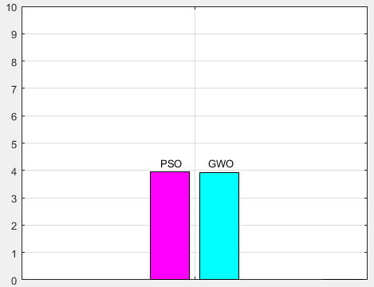
Figure 5.13: PAR under variable time range scheduling
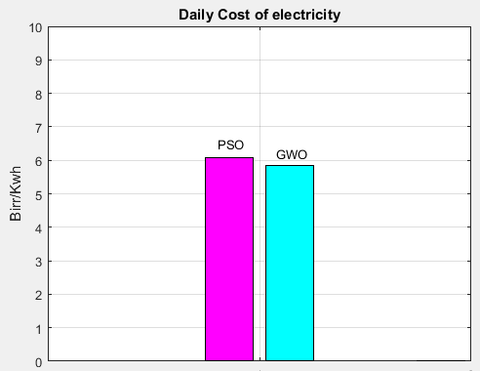
Figure 5.14: Daily electricity cost in under variable time range scheduling
Case 5: Load appliances scheduled with fixed time scheduling integrated with PV generation System
In addition to using electric energy from utility grid, a 5KW roof top solar PV system has been installed to be used during day time. The energy generated from the PV pannels is supplied via inverter which is intergrated with HAN. The priority to supply appliances is given primarily to PV pannels under all scheduling scenarios .
If the power generated from the PV pannels is not sufficient to supply the load appliances, the energy demanded is fed from Utility grid. If the energy generated from PV pannels have surpless energy after supplying the load demad, then this surpless energy could be exported to national grid (Utility grid). To optimize the objective function, the same procedure is used in case-1 and parameters in table 5.3 is used with integration of PVgeneration. The simulation result is explained as shown below.
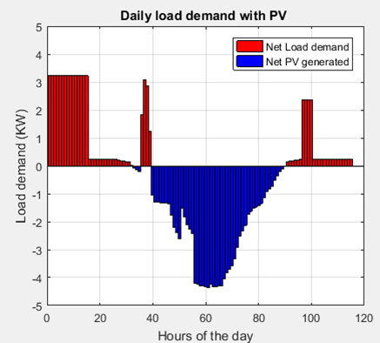
Figure 5.15: The net daily load profile pattern integrated with PV energy under fixed time scheduling. One unit = 12 minutes.

Optimization of peak load, PAR and Cost of electricity on fixed time range scheduling integrated with PV generation System:
As we have seen on figure 5.8, the net peak load demand during the day is 3.225 KW while the net peak PV generation after satisfying the load demand is -4.3566 KW (the negative sign indicates the PV Pannels are source of power) per slot in 24 hours time horizon. 8.69852 KWh energy would be sold to Utility grid based of TOUP tariff. Beyond satisfying the daily energy demand, the resident sold excess energy to the main grid and have got 5.0485 birr per day.
- The results are summarized as follows:
- Peak load during the day = 3.225 KW
- PAR=3.9121
- Total energy demand per day of appliances = 19.785 KWh
- Net Energy imported from Utility grid in KWh = 0
- Net energy exported to Utility grid = 8.69852 KWh
- Net Energy Cost = -5.0485 Birr/day based on TOUP

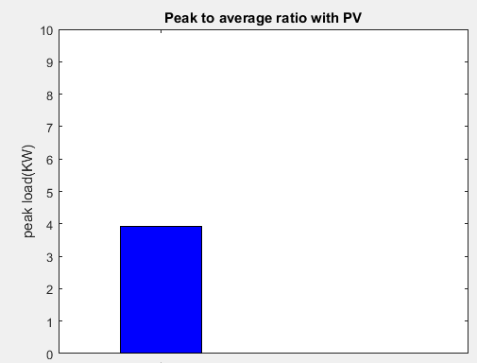

Figure 5.16: The PAR of daily load profile under fixed time scheduling.
Even, if we shift the position of washing machine to day time during peak hours for example from 9:00 AM up to11:48 AM then, the cost of electricity will rise to -3.82Birr/day (energy exported to utility grid) which is 149% higher than unscheduled load without PV. The PAR will be 3.7523 which is 34% lower than unscheduled load without integrating with PV energy production. Daily load demand pattern for un-scheduled load is shown in figure 5.10.
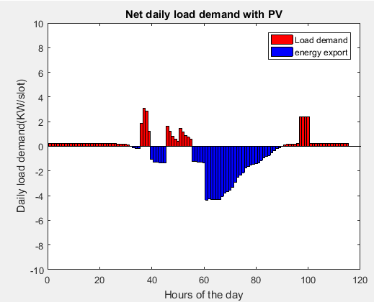
Figure 5.17: The daily load profile pattern of unscheduled load appliances integrated with PV energy. One unit = 12 minutes.
Table 5.7 Detail summery and result comparison between fixed time range scheduling and a system without scheduling.
Type of scheduling mechanism | Working Mechanism | Peak load | PAR | Energy cost  (Birr/day)
 |  |  |  | Utility Paid for the user | User Paid to the Grid
Unscheduled | System without integration of PV power generation | 4.725 | 5.7316 | 0 | 7.7853
Unscheduled | System integrated with PV power generation | 3.0933 | 3.7523 | 3.82 | 0
Fixed time scheduling | System without integration of PV power generation | 3.875 | 4.7005 | 0 | 6.5568
Fixed time scheduling | System integrated with PV power generation | 3.225 | 3.9121 | 3.9121 | 0

Energy cost, peak load and PAR are lower in home appliances scheduled using fixed time scheduling method than that of unscheduled load appliances for both the system integrated and not integrated with PV power generation. For a system not integrated with PV power generation both the peak load and PAR in fixed time range scheduling are 17.99% lower than unscheduled load. The energy cost in a system not integrated with PV power production using fixed time range scheduling is 15.78% lower than energy cost of unscheduled load. Similarly, for a system integrated with PV power generation using fixed time range scheduling the peak load and PAR are higher than unsheduled load. This is becase of the shape of the PV power production profile. Most of the load demand in unscheduled load profile are compansated with PV power generation than that of fixed time range scheduling technique. Rather than compensating the load demand fully, most of the PV power production in fixed time scheduling are exported to utility grid. The cost of energy that the utility should pay for the user in a system integrated with PV generation using fixed time range scheduling is 2.35% higher than the energy cost in unscheduled load.
Case 6: Load appliances scheduled with restricted time scheduling integrated with PV generation System
In restricted time range scheduling, the same parameters used in case-2 and Table 5.4 could be used with integration of 5 KW PV generation. The inverter connected with HAN supply AC load appliances at home. If the power production from PV pannels are insufficient to meet the daily load demand, the appliances would be supplied from the Utility grid (Main grid). After supplying the load if the PV pannels have surpluss production, the remaining enrgy is sold to the Utility grid. Figure 5.18 shows the net daily load demand pattern. The upper portion which is greater than zero are showing import from the utility grid. The lower portion which is less than zero (negative) shows export to utility grid.
Optimization of peak load, PAR and Cost of electricity on restricted time range scheduling integrated with PV generation System:
In a system integrated with PV energy generation, energy cost in restricted time range scheduling is 4.86% and the PAR 1% lower than fixed time range scheduling respectively with GWO load scheduler. The net daily load pattern is shown in figure 5.18.
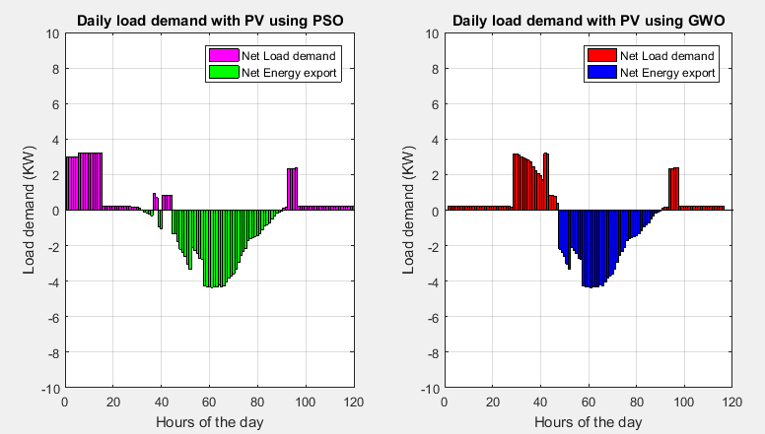
Figure 5.18: The net daily load demand pattern integrated with PV generation for minimization of electricity cost under restricted time range scheduling: 1 unit of time = 12 minutes.
The net daily peak power demand from Utility grid with PV integration using GWO scheduler is 3.1909 kW and using PSO scheduler it is 3.225 kW within a day. The results are summarized as follows:
- The PAR with PV using GWO is : 3.8707
- The PAR with PV using PSO is : 3.9121
- Total energy demand per day of appliances = 19.785 KWh
- Net Energy imported from Utility grid= 0 KWh
- Net Energy exported to Utility grid = 8.6985 KWh
- The energy cost with PV using GWO is: -5.3065 Birr per day based on TOUP
- The cost with PV using PSO is: -5.2478 Birr per day based on TOUP
The negative sign in the net daily peak PV generation value indicates it is surplus power after satisfying the load demand at that time and which has to be exported to the utility grid.
The negative sign in the minimum cost for a system integrated with PV generation value indicates, the cost of energy is due to the energy exported to national grid and the utility has to pay for the user.
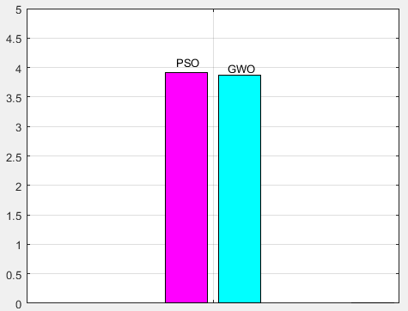
Figure 5.19: The PAR of the net daily load profile with PV integration under variable time scheduling.
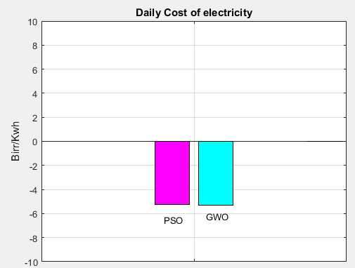
Figure 5.20: Daily electricity cost under variable time range scheduling
Case 7: Load appliances scheduled with Multi-restricted time range scheduling integrated with PV generation System
All the data used in case-3 and table 5.5 are used to optimise PAR,energy cost and peak load in multi restricted time range scheduling. The net daily load demand pattern for a system integrated with PV generation is shown in figure 5.21.
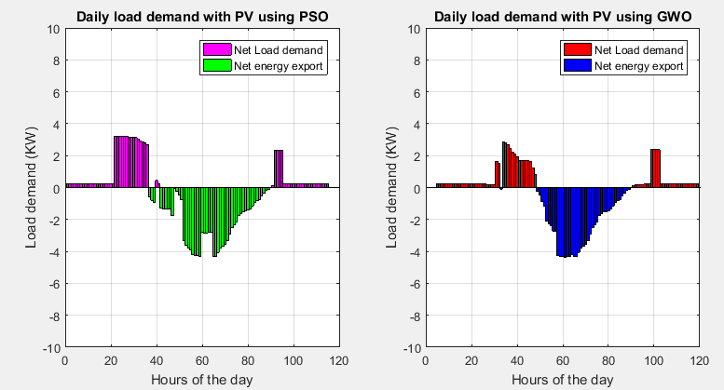
Figure 5.21: The net daily load demand pattern integrated with PV generation for minimization of electricity cost under Multi-restricted time range scheduling: 1 unit of time = 12 minutes.
- The results are summarized as follows:
- The net daily peak Power demand from grid with PV integration using GWO is: 2.8543
- The net daily peak Power demand from grid with PV integration using PSO is: 3.225
- The minimum PAR with PV integration using GWO is: 3.4624
- The minimum PAR with PV integration using PSO is: 3.8707
- The minimum cost with PV integration using GWO is: -5.3065 Birr/day
- The minimum cost with PV integration using PSO is: -5.2246 Birr/day
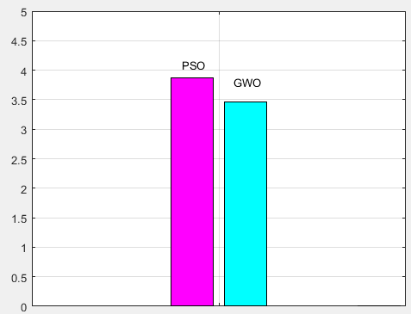
Figure 5.22: The PAR of the net daily load profile with PV integration under Multi-restricted time scheduling.
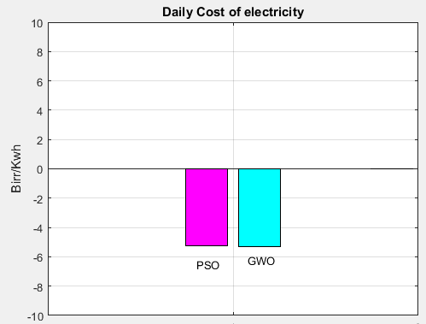
Figure 5.23: Daily electricity cost under Multi-restricted time range scheduling
The negative sign in the cost of electricity is to indicate the cost is due to the export of surplus power produced from on-grid roof top PV system. The utility pay back for the user for the net energy exported. For example, in multi-restricted time range scheduling using GWO scheduler; the Utility Company should pay 5.3065 Birr/day for the user. At the end of the month the net sum of costs per day would be delivered to the customer for supplying energy to the Utility (national grid).
Case 8: Load appliances scheduled with variable time scheduling integrated with PV generation System
Since the load profile of the scheduled load for each appliance is selected stochastically up to the maximum iteration point, the shape of the load profile could be slightly changed in each iteration. The fitness function converges better if the number of iteration is higher. Let us see figure 5.24 which shows the daily load demand in summer weekend days, the power generation profile of solar PV system and TOUP profile.
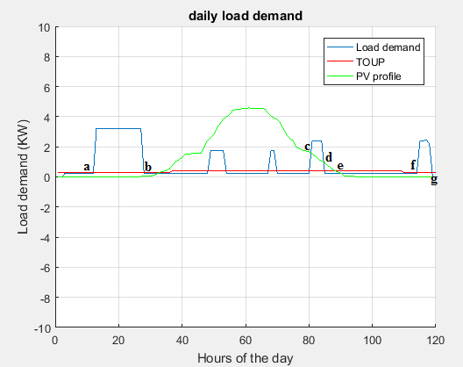
Figure 5.24: The diagram which shows the daily load demand in some summer weekend, the power generation profile of solar PV system and TOUP profile.
From point a up to point b the load demand is higher than the power generated from the PV panels. So, the energy demands by home appliances are fed from the utility grid. From point b up to point c the power production from the PV panels are higher than the load demanded per slot of home appliances. So, all the energy demanded by appliances is met by energy generated from PV Panels. At point c, due to lower sun shine the power production from PV panels are lower than the load demand and the load demand could be partially fed from Utility grid. From point d to point e the load demand is lower than the power production from PV panels. At these time slots the power demand could be met by PV panels. From point e up to end time slot (i.e. point g) load demand could be fed from main grid (Utility grid). By using the same parameters used in table 5.6 and integrating the system with 5KW solar PV panels, the net daily load demand pattern is shown in figure 5.25.
Optimization of peak load, PAR and Cost of electricity on variable time range scheduling integrated with PV generation System:
It is obtained that, for the system which is not integrated with PV power generation, energy cost in variable time range scheduling using GWO load scheduler are 7.13 % lower than restricted time range scheduling. Compared to fixed time range scheduling, the energy cost and PAR in variable time range scheduling are 24.86% and 16.77% lower respectively. For a system which is not integrated with PV energy generation, the peak load in variable time range scheduling and restricted time range scheduling are similar, having a value 3.225 KW within a day. But, it is 20.16% lower than fixed time range load scheduling.
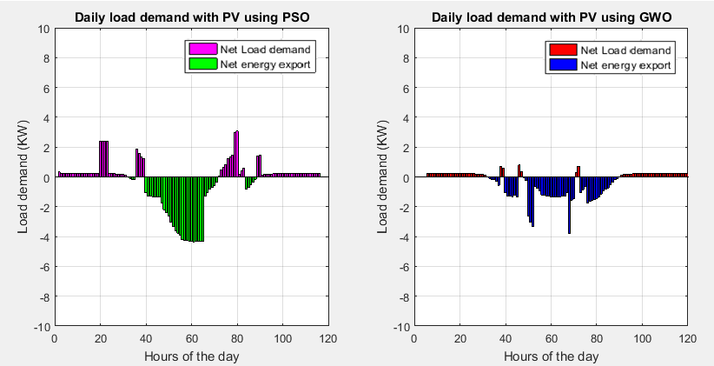
Figure 5.25: The daily net load profile pattern of scheduled load appliances integrated with PV energy under variable time scheduling. One unit = 12 minutes.
- The net daily peak load demand from grid with PV integration using GWO is: 0.79773
- The net daily peak load demand from grid with PV integration using PSO is: 3.875
- The minimum PAR with PV integration using GWO is: 1.0026
- The minimum PAR with PV integration using PSO is: 2.881
- The minimum total energy demand per day of appliances = 19.785 KWh
- Net Energy imported from Utility grid = 0 KWh
- The minimum cost with PV generation using GWO is: -5.7555 Birr per day based on TOUP
- The minimum cost with PV generation using PSO is: -5.5139 Birr per day based on TOUP
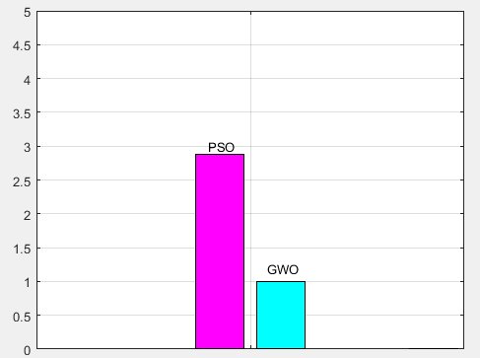
Figure 5.26: The PAR of the net daily load profile with PV integration under variable time scheduling.
The net total cost of electricity per day under Variable time pricing with integration of PV power using GWO scheduler is -5.7555 birr per day and using PSO load scheduler is -5.5139 Birr per day (the negative sign indicates the energy is sold to utility grid and the utility pay to the customer or owner of the PV Panel) based on TOUP tariff. The detail summery is shown below.
Table 5.8 shows the system integrated with PV power production are efficient and advantageous than a system which is not integrated with PV power generation in terms of minimization of peak load, PAR and electric energy cost (monthly billing cost) in which the users have to pay to utility company for their energy consumption from Utility grid. The detail comparative analysis between PSO algorithm and GWO algorithm in solving fitness function is provided. In terms of peak load, cost and PAR minimization, GWO is much better than PSO algorithm.
In restricted time scheduling technique for a system which is not integrated with PV power generation, using GWO load scheduler, the peak load, energy cost and PAR are 16.77%, 2.18%, 16.77% lower respectively than PSO load scheduler. If the system is integrated with PV power production using GWO scheduler, both the peak load and PAR are 1% lower than PSO load scheduler. After supplying the load, due to surplus PV generation, energy exported to the utility grid in both scheduling algorithms. Using GWO scheduler, the user has got 5.3065 Birr/day from Utility Company and this is 1.1% higher than that of using PSO load scheduler. In Multi-restricted time scheduling technique for a system which is not integrated with PV power generation, using GWO load scheduler, the peak load, energy cost and PAR are 40%, 0.65%, 40% lower respectively than PSO load scheduler.

Table 5.8 Detail summery and result comparison between restricted time range scheduling , Multi-restricted time range scheduling and variable time scheduling with and without PV generation.
Type of scheduling mechanism | Type of load scheduler used and Working Mechanism | Peak load | PAR | Energy cost  (Birr/day)
 |  |  |  | Utility Paid for the user | User Paid to the Grid
Restricted time range scheduling | PSO for system not integrated with PV power production | 3.875 | 4.7005 | 0 | 6.4394
Restricted time range scheduling | PSO for a system integrated with PV power production | 3.225 | 3.9121 | 5.2478 | 0
Restricted time range scheduling | GWO for system not integrated with PV power production | 3.225 | 3.9121 | 0 | 6.2988
Restricted time range scheduling | GWO for a system integrated with PV power production | 3.1909 | 3.8707 | 5.3065 | 0
Multi-restricted time range scheduling | PSO for system not integrated with PV power production | 5.375 | 6.5201 | 0 | 6.3397
Multi-restricted time range scheduling | PSO for a system integrated with PV power production | 3.225 | 3.8707 | 5.2246 | 0
Multi-restricted time range scheduling | GWO for system not integrated with PV power production | 3.225 | 3.9121 | 0 | 6.2988
Multi-restricted time range scheduling | GWO for system integrated with PV power production | 2.8543 | 3.4624 | 5.3065 | 0
Variable time scheduling | PSO for system not integrated with PV power production | 3.25 | 3.9424 | 0 | 6.0906
Variable time scheduling | PSO for system integrated with PV power production | 3.225 | 2.881 | 5.5139 | 0
Variable time scheduling | GWO for system not integrated with PV power production | 3.225 | 3.9121 | 0 | 5.8497
Variable time scheduling | GWO for system integrated with PV power production | 0.79773 | 1.0026 | 5.7555 | 0

If the system is integrated with PV power production using GWO scheduler, the peak load and PAR are 11.49% and 10.55% lower than PSO load scheduler respectively. Surplus PV production would be exported to the utility grid in both scheduling algorithms. Using GWO scheduler, the user has got 5.3065 Birr/day from Utility Company and this is 1.54% higher than that of using PSO load scheduler. In Variable time scheduling technique for a system which is not integrated with PV power generation using GWO load scheduler peak load, energy cost and PAR are 0.77%, 3.96% % and 0.77% lower than PSO load scheduler respectively. If the system is integrated with PV power production using GWO load scheduler, the peak load and PAR are 75.26% and 65.2% lower than PSO load scheduler respectively. Surplus PV production would be exported to the utility grid in both scheduling algorithms. Using GWO scheduler, the user has got 5.7555 Birr/day from Utility Company and this is 4.2 % higher than that of energy exported using PSO load scheduler. As we have seen in Table 5.8, interms of peak load, energy cost and PAR minimization, the variable time scheduling combined with GWO algorithm is better than the other scheduling algorithms. But , the draw back of variable time scheduling is it allocates few of the appliances to inconvinient time slotes to operate. Multi-Restricted time scheduling gives alternative choice for the user to scheduled the appliances at different time slot positions without highly affecting the comfort level of the user.

5.2 Optimization result and analysis of customer’s dissatisfaction value
To measure the dissatisfaction value of the user, the delay time rates for each of schedulable appliance have to be calculated. The equation of the fitness function from equation (4.14)-(4.16) have calculated for all schedulable appliances under fixed, restricted, multi-restricted and variable time scheduling technique as shown below:
In the case of fixed time scheduling, the DTR is assumed to be zero and this is considered to be the users’ best reference wishing to schedule their appliance because of lower discomfort level due to improper time slot allocation of appliances in scheduling. In all the calculations it is assumed that the value of the delay parameter i.e.ᵷ = 5.
Table 5.9: DTR value of schedulable load appliances under restricted time scheduling technique
NO. | Load appliances | DTR value
1 | Washing machine with dryer | 0.5714
2 | Electric Oven-1 | 0.1250
3 | Electric Oven-2 | 0.8817
4 | Refrigerator | 0.0088
5 | Electric Iron | 0.6571
6 | Water heater | 0.9348
7 | Table Fan | 0.0328
8 | Coffee Grinder | 0.8793

With Restricted time scheduling technique, the calculated value of the discomfort due to delay time associated with all shift able appliance scheduling within a day using GWO load scheduler is 21.4539 ≈ 22 time slots (1.83 hours) and using PSO load scheduler, it is 23.4604≈ 24 time slots (2 hours).
Table 5.10: DTR value of schedulable load appliances under Multi- Restricted time scheduling technique
NO. | Load appliances | DTR value
1 | Washing machine with dryer | 0.8571
2 | Electric Oven-1 | 0.1220
3 | Electric Oven-2 | 0.0244
4 | Refrigerator | 0.0351
5 | Electric Iron | 0.2069
6 | Water heater | 0.0556
7 | Table Fan | 0.0784
8 | Coffee Grinder | 0.2000

With Multi-Restricted time scheduling technique, the calculated value of the discomfort due to delay time associated with all shift able appliance scheduling within a day using GWO load scheduler is 8.55≈ 9 time slots (0.75 hour) and using PSO load scheduler, it is 9.39 ≈ 10 time slots (0.83 hour).
Table 5.11: DTR value of schedulable load appliances under Variable time scheduling technique
NO. | Load appliances | DTR value
1 | Washing machine with dryer | 0.7143
2 | Electric Oven-1 | 0.1875
3 | Electric Oven-2 | 0.0215
4 | Refrigerator | 0.0439
5 | Electric Iron | 0.3889
6 | Water heater | 0.8000
7 | Table Fan | 0.2131
8 | Coffee Grinder | 0.9655
With Variable time scheduling technique, the calculated value of the discomfort due to delay time associated with all shift able appliance scheduling within a day using GWO load scheduler is 14.69≈ 15 time slots (1.25 hours) and using PSO load scheduler, it is 30.11 ≈ 31 time slots (2.58 hours).
As we have seen the optimization result, Multi restricted time scheduling technique are better than restricted and variable time scheduling technique in terms of maximizing comfort level of the users. This is because multi-restricted time scheduling technique gives alternative time range positions to schedule an appliance while maintaining energy cost, peak load and PAR at optimum value compared to other scheduling techniques. Compared to restricted time range scheduling, variable time range scheduling technique is better in terms of minimizing the discomfort due to scheduling of shift able appliances. Using GWO scheduler, the discomfort due to delay time in multi-restricted time scheduling is 40% and 59.02% lower than variable and restricted time scheduling respectively. In variable time range scheduling also it is 31.69% lower than restricted time scheduling technique.

Chapter Six

6 Conclusion and Future work

6.1 Conclusions
Demand side management is the most effective technique used in optimization of appliance load scheduling in smart grid environment to minimize cost of electricity billing and peak to average ratio with minimum peak load and nearly optimum horizontal load distribution within 24 hours of the day. The fitness function used to calculate the cost of electric energy with and without integration of PV energy generation described in equation (4.11), equation (4.12) and also the fitness function which used to solve the PAR described in equation (4.13) are the problems which are supposed to be solved under several constraints. The problem can be solved in different ways like using Mathematical programming or Metaheuristic programming techniques. For example it can be solved with mathematical programming such as linear programing (LP) and mixed integer linear programming (MILP). Due to the presence of the index of the binary decision variable which decides the on and off status of appliance, the problem has convex type nature. So, it is difficult to solve this convex type problem which has non-linear characteristics with LP technique. Due to these and other reasons like easiness and convergence performance the swarm intelligence based grey wolf optimizer (GWO) algorithm had been used to solve the fitness function under different energy and timing constraints. The result is obtained using core i3 processor with math lab 2016(a) software environment.
To show the simulation result, eight different case studies has been considered. In the first case study, the possible available operation cycle is always one for each appliance. The operation position of appliance is determined by the user and the EMC switch the appliance based on the status of the binary decision variable index. In both variable time range scheduling and restricted time range scheduling there are more than one complete operation cycle for each scheduled appliance. It was also assumed that, the schedule load appliance can finish its task earliest to its ending time. But, it must complete its operation time within the allocated time range. So, the length of operation time is grater than or eual to the starting time slot and less than or equal to end time slot minus the starting time slot. The simulation result showed that , a novel multi-restricted time range scheduling technique also helps to miximize the comfort level of the user by giving alternative choice to schedule an appliance within aday without violation all energy and timing constraints at minimum PAR and minimum peak load. It is also assumed that if the appliance is not working within a day, the allocated time slot will be assigned to zero. Tota number of 8 appliances are scheduled to operate under TOUP tariff.But, the number of appliances can be increased without violating the power balance and energy constraints.
The energy cost and peak load with integration of the PV energy is better than that of not integrated. Interms minimization of energy cost, peak load and PAR for a system integrated with PV energy generation, variable time range scheduling is better than restricted time range ,multi restricted time range and fixed time range scheduling. While, fixed time range scheduling is better than that of unscheduled load. For a system integrated with PV energy generation, the PAR in variable time scheduling is better than restricted time range, multi-restricted time range and fixed time range scheduling technique. Restricted time range scheduling is also better than fixed time range load scheduling interms of PAR reduction.
Even if variable time range scheduling is effective interms of minimum energy cost and PAR, sometimes it allocates some appliances to improper time slot positions. This reduces the comfort level of the user due to improper scheduling of appliance. For this reason, restricted time range load scheduling has better advantage in reduction of the discomfort level due to inappropriate load scheduling. But, A novel Multi-restricted time range scheduling technique is better than all scheduling techniques interms of minimization of discomfort to inappropriate scheduling.
The optimization result shows that the discomfort due to delay time associated with appliance scheduling in A novel Multi-restricted time scheduling technique is 40% and 59.02 % lower than variable and restricted time range scheduling. This is because, multi ristricted time range scheduling mechanism gives a chance schedule appliances in more than one scheduling time positions and a number of operation cycles in those restricted operation time slots.

6.2 Future work
Future research can integrate other types of renewable energy sources like biomass and small wind turbine generators with the proposed system besides with rooftop PV energy generation in demand side energy management technique. The rooftop PV energy generation is working without the use of energy storage system (ESS) like battery storage, fly wheel and super capacitors. The system is working as on-grid. Rather than using ESS, the grid itself can be used as a backup power during sun shine hours of the day. This is because the cost of energy storage is high. The ESS can be used during on-peak hours of the day. when there is no grid power at night and during cloudy days, it can also supply the load. In the future research, if ESS would be included, cost comparison and effectiveness between on-grid and off-grid systems can be studied. In addition to this, the cost benefit analysis and internal rate of return in relation to carbon foot print reduction can be studied.

References
[1] Hadis. Khomami, Mohammad. Javidi, “An Efficient Home Energy Management System for Automated Residential Demand Response” 13th IEEE International Conference on Environment and Electrical Engineering (EEEIC), 2013.
[2] L. Geng, Z. Lu, “A Novel Model for Home Energy Management System Based on Internet of Things”, IEEE International Conference on Power and Renewable Energy, 2016.
[3] Z. Zhao, W. Lee, Y. Shin, K. Song “An Optimal Power Scheduling Method for Demand Response in Home Energy Management System”, IEEE Trans. on Smart Grid, Volume 4, Issue 3, Sept. 2013.
[4] Z. Dogaheh, M. Dogaheh, “Optimizing the Performance of Smart Grids in Relation with Residential Energy Centers Equipping with Solar Power Units (PV)”, Sindhological Studies, 2017 (1): 14-22.
[5] S. Mohammadi, M. Momtazpour and E. Sanaei, "Optimization-based home energy management in the presence of solar energy and storage," 21st Iranian Conference on Electrical Engineering (ICEE), Mashhad, 2013, pp. 1-6.
[6] F. A. Qayyum, M. Naeem, A. S. Khwaja, A. Anpalagan, L. Guan, and B. Venkatesh, “Appliance Scheduling Optimization in Smart Home Networks” , Special section on smart grids, IEEE, October 29, 2015.
[7] C.H. Anwar ul Hassan, M. Sufyan Khan, A. Ghafar, S. Aimal, S. Asif and N. Javaid “Energy Optimization in Smart Grid Using Grey Wolf Optimization Algorithm and Bacterial Foraging Algorithm”, Advances in Intelligent Networking and Collaborative Systems, Springer International Publishing, AG 2018, Islamabad, Pakistan.
[8] Smart Building, https://www.rcrwireless.com/20160725/business/smart-building-tag31-tag99 , (Accessed date: 02 September 2018).
[9] M. Kuzlu, M. Pipattanasomporn, S. Rahman, “Communication network requirements for major smart grid applications in HAN, NAN and WAN”, Computer Networks 67 (2014) 74–88.
[10] G. Gaur, N. Mehta, R.Khanna, S. Kaur, “Demand Side Management in a Smart Grid Environment”, IEEE International Conference on Smart Grid and Smart Cities, PEC University of Technology, Chandigarh, India, 2017.
[11] Time based rate programs, https://www.smartgrid.gov/recovery_act/time_based_rate_programs.html , (accessed date on 8 September 2018).
[12] M. Arikiez, F. Grasso and M. Zito, "Heuristics for the cost-effective management of a temperature controlled environment," IEEE Innovative Smart Grid Technologies - Asia (ISGT ASIA), Bangkok, 2015, pp. 1-6.
[13] F. Y. Melhem, O. Grunder, Z. Hammoudan and N. Moubayed, "Optimal residential load scheduling model in smart grid environment," IEEE International Conference on Environment and Electrical Engineering and IEEE Industrial and Commercial Power Systems Europe (EEEIC / I&CPS Europe), Milan, 2017, pp. 1-6.
[14] Kin Cheong Sou, James Weimer, Henrik Sandberg, and Karl Henrik Johansson, “Scheduling Smart Home Appliances Using Mixed Integer Linear Programming”, 50th IEEE Conference on Decision and Control and European Control Conference (CDC-ECC) Orlando, FL, USA, December 12-15, 2011.
[15] F. De Angelis, M. Boaro, D. Fuselli, S. Squartini, F. Piazza and Q. Wei, "Optimal Home Energy Management Under Dynamic Electrical and Thermal Constraints," in IEEE Transactions on Industrial Informatics, vol. 9, no. 3, pp. 1518-1527, Aug. 2013.
[16] L. Yao, Z. Damiran and W. H. Lim, "Energy management optimization scheme for smart home considering different types of appliances," IEEE International Conference on Environment and Electrical Engineering and IEEE Industrial and Commercial Power Systems Europe (EEEIC / I&CPS Europe), Milan, 2017.
[17] Seung-Jun Kim and G. B. Giannakis, "Efficient and scalable demand response for the smart power grid," 4th IEEE International Workshop on Computational Advances in Multi-Sensor Adaptive Processing (CAMSAP), San Juan, 2011, pp. 109-112.
[18] M. Arora, S. Chanana and A. Kumar, "A real time price based optimal scheduling mechanism for centralized air conditioning load," Eighteenth National Power Systems Conference (NPSC), Guwahati, 2014, pp. 1-5.
[19] M. Arora and S. Chanana, "Residential demand response from PV panel and energy storage device," IEEE 6th India International Conference on Power Electronics (IICPE), Kurukshetra, 2014, pp. 1-6.
[20] Kaveh Paridari, Alessandra Parisio, Henrik Sandberg and Karl Henrik Johansson, “Energy and CO2 efficient scheduling of smart appliances in active houses equipped with batteries”, IEEE International Conference on Automation Science and Engineering (CASE) Taipei, Taiwan, August 18-22, 2014.
[21] K. Paridari, A. Parisio, H. Sandberg and K. H. Johansson, "Robust Scheduling of Smart Appliances in Active Apartments With User Behavior Uncertainty," in IEEE Transactions on Automation Science and Engineering, vol. 13, no. 1, pp. 247-259, Jan. 2016.
[22] Victor M. Zavala, Jianhui Wang, Sven Leyffer, “proactive energy management for next-generation building systems”, Fourth National Conference of IBPSA-USA New York City, New York .August 11 – 13, 2010.
[23] M. H. K. Tushar, C. Assi, M. Maier and M. F. Uddin, "Smart Microgrids: Optimal Joint Scheduling for Electric Vehicles and Home Appliances," in IEEE Transactions on Smart Grid, vol. 5, no. 1, pp. 239-250, Jan. 2014.
[24] H. Wang, K. Meng, Z. Y. Dong, Z. Xu, F. Luo and K. P. Wong, "Efficient real-time residential energy management through MILP based rolling horizon optimization," IEEE Power & Energy Society General Meeting, Denver, CO, 2015, pp. 1-6.
[25] Alessandro Di Giorgio, Laura Pimpinella, Alessandra Quaresima and Simone Curti, “An event driven Smart Home Controller enabling cost effective use of electric energy and automated Demand Side Management”, 19th Mediterranean Conference on Control and Automation Aquis Corfu Holiday Palace, Corfu, Greece June 20-23, 2011.
[26] S. Mohammadi, M. Momtazpour and E. Sanaei, "Optimization-based home energy management in the presence of solar energy and storage," 21st Iranian Conference on Electrical Engineering (ICEE), Mashhad, 2013, pp. 1-6.
[27] B. Hussain and Qadeer-Ul-Hassan, "Demand side management for smart homes in Pakistan," International Conference on Emerging Technologies (ICET), Islamabad, 2016, pp. 1-6.
[28] S. Shah, R. Khalid, A. Zafar, S. M. Hussain, H. Rahim and N. Javaid, "An Optimized Priority Enabled Energy Management System for Smart Homes," IEEE 31st International Conference on Advanced Information Networking and Applications (AINA), Taipei, 2017, pp. 1035-1041.
[29] Danish Mahmood, Nadeem Javaid, Nabil Alrajeh, Zahoor Ali Khan, Umar Qasim,Imran Ahmed and Manzoor Ilahi, “Realistic Scheduling Mechanism for Smart Homes”, Energies 2016, 9(3), 202.
[30] Yantai Huang, Lei Wang, and Qidi Wu, “A Hybrid PSO-DE Algorithm for Smart Home Energy Management”, ICSI 2014, Part II, LNCS 8795, pp. 292–300, 2014.
[31] Jiawei Zhu, Fabrice Lauri, Abderrafiaa Koukam, and Vincent Hilaire, “Scheduling Optimization of Smart Homes Based on Demand Response”, AIAI 2015, IFIP AICT 458, pp. 223–236, 2015.
[32] E. A. H. Abdalla, P. Nallagownden, N. M. Nor, M. F. Romlie, M. E. Abdalsalam and M. S. Muthuvalu, "Intelligent approach for optimal energy management of chiller plant using fuzzy and PSO techniques," 6th International Conference on Intelligent and Advanced Systems (ICIAS), Kuala Lumpur, 2016, pp. 1-6.
[33] Zeyu Chen, Rui Xiong, Jiayi Cao,” Particle swarm optimization-based optimal power management of plug-in hybrid electric vehicles considering uncertain driving conditions”, Energy, Volume 96, 1 February 2016, Pages 197-208.
[34] S. F. Kazemi, S. A. Motamedi and S. Sharifian, "A home energy management system using Gray Wolf Optimizer in smart grids," 2nd Conference on Swarm Intelligence and Evolutionary Computation (CSIEC), Kerman, 2017, pp. 159-164.
[35] Fan-Lin Meng, Xiao-Jun Zeng,” An Optimal Real-time Pricing for Demand-side Management: A Stackelberg Game and Genetic Algorithm Approach”, International Joint Conference on Neural Networks (IJCNN) July 6-11, 2014, Beijing, China.
[36] Muhammad Talha, Muhammad Shahid Saeed, Ghulam Mohiuddin,Musa Ahmad, Muhammad Junaid Nazar, and Nadeem Javaid, “Energy Optimization in Home EnergyManagement System Using Artificial FishSwarm Algorithm and Genetic Algorithm”, Advances in Intelligent Networking and Collaborative Systems, Lecture Notes on Data Engineering and Communications Technologies 8.
[37] Han Li1, Abinet Tesfaye Eseye, Jianhua Zhang and Dehua Zheng, “Optimal energy management for industrial microgrids with high-penetration renewables”, Protection and Control of Modern Power Systems (2017) 2:12.
[38] Mudassar Naseem, Samia Abid, Rabia Khalid, Ghulam Hafeez, Sardar Mahboob Hussain, Nadeem Javaid, “Towards Heuristic Algorithms: GA, WDO, BPSO, and BFOA for Home Energy Management in Smart Grid”, Advances on Broad-Band Wireless Computing, Communication and Applications, Lecture Notes on Data Engineering and Communications Technologies 2.
[39] T. Logenthiran, D. Srinivasan and T. Z. Shun, "Demand Side Management in Smart Grid Using Heuristic Optimization," in IEEE Transactions on Smart Grid, vol. 3, no. 3, pp. 1244-1252, Sept. 2012.
[40] F. Allerding, Ingo Mauser, and Hartmut Schmeck,” Customizable Energy Management in Smart Buildings Using Evolutionary Algorithms”, EvoApplications 2014, LNCS 8602, pp. 153–164, 2014.
[41] Y. Zhang, Peng Zeng, Chuanzhi Zang, “Optimization Algorithm for Home Energy Management System Based on Artificial Bee Colony in Smart Grid”, 5th Annual IEEE International Conference on Cyber Technology in Automation, Control and Intelligent Systems June 8-12, 2015, Shenyang, China.
[42] Whei-Min Lin 1, Chia-Sheng Tu 1 and Ming-Tang Tsai,” Energy Management Strategy for Micro grids by Using Enhanced Bee Colony Optimization”, Energies 2016, 9, 5.
[43] S. Rahim et al., "Ant Colony Optimization Based Energy Management Controller for Smart Grid," IEEE 30th International Conference on Advanced Information Networking and Applications (AINA), Crans-Montana, 2016, pp. 1154-1159.
[44] B. Ruan, Q. Yang, X. Fang, and W. Yan, “Demand Response under Real-Time Pricing for Domestic Energy System with DGs”, International Conference on Power System Technology (POWERCON 2014), Chengdu, 20-22 Oct. 2014.
[45] Power rating of home appliances, https://www.daftlogic.com/information-appliance-power-consumption.html , (accessed date: 15 October 2018).
[46] Power rating of coffee bean grinder, https://www.alibaba.com/showroom/100w-coffee-grinder.html , (accessed date: 11 July 2018).
[47] M. Amer, A. Namaane and N. K. M’Sirdi, “Optimization of Hybrid Renewable Energy Systems (HRES) using PSO for Cost Reduction”, The Mediterranean Green Energy Forum 2013, MGEF-13, Science Direct: Energy Procedia 42 ( 2013 ) 318 – 327.
[48] R. S. Meena, J. S. Rathore, S. Johri, “A Review on Grid Connected Roof Top Solar Power Generation’’, International Journal of Engineering Development and Research, 2014 IJEDR, Volume 3, Issue 1.
[49] Akash Kumar Shukla, K. Sudhakar, Prashant Baredar, Design, simulation and economic analysis of standalone roof top solar PV system in India, Solar Energy, Volume 136, 2016,Pages 437-449.
[50] Solar Energy, https://en.wikipedia.org/wiki/Solar_energy , (accessed date: on 8 October 2018).
[51] Ahmed R. Abul'Wafa, “Energy Storage Sizing for Rooftop Grid-Connected PV System”, Electric Power Components and Systems, 45(3):331–343, 2017.
[52] Dan Chiras, “The home owner’s guide to Renewable energy”, Achieving energy independence through solar wind, biomass and hydropower, New society publishers, August 2006, New Society Publishers, Gabriola Island, Canada.
[53] Abdel-Karim Daud , Mahmoud S. Ismail, “Design of isolated hybrid systems minimizing costs and pollutant emissions”, Renewable energy 44 (2012) 215-224.
[54] M.S. Ismail, M. Moghavvemi, T.M.I. Mahlia, “design of a PV/Diesel standalone hybrid system for a remote Community in Palestine”, Journal of Asian Scientific Research 2(11):599-606.
[55] Smita S. Kathar, A.G. Thosar and Gunvant C. Patil, “Design of Rooftop Solar PV”, March- April 2017,International Journal of Electrical Engineering and Technology (IJEET), 8(2), 2017, pp. 81–92.
[56] Inverter sizing, https://www.solar-electric.com/learning-center/inverters/inverter-basics-selection.html , (accessed date on 10 October 2018).
[57] DMS in Ethiopia, http://www.nrec.com/en/case/protection_automation_control-469.html , accessed date on 26 October 2018.
[58] Presentation on pilot instalment of smart meters in Addis Ababa by DVentus technologies, http://shuraako.org/sites/default/files/images/srefpresentations/1c/dVentus%20Presentation.df , (accessed date on 21 August 2018).
[59] Z. Zhao, W. Cheol Lee, Y. Shin, and Kyung-Bin Song, “An Optimal Power Scheduling Method for Demand Response in Home Energy Management System”, IEEE transactions on smart grid, February 23, 2013.
[60] S. Mirjalili , S. M. Mirjalili, A. Lewis, “Grey Wolf Optimizer”, Advances in Engineering Software 69 (2014) 46–61.
[61] Zeinab G. Hassan, M. Ezzat, Almo Y. Abdelaziz, “Enhancement of Power System Operation using Grey Wolf Optimization Algorithm”, Nineteenth International Middle East Power Systems Conference (MEPCON), Menoufia University, Egypt, 19-21 December 2017.
[62] M.Naz , Z. Iqbal , N. Javaid, Z.Ali Khan, W.Abdul , A. Almogren and A.Alamri, “Efficient Power Scheduling in Smart Homes Using Hybrid Grey Wolf Differential Evolution Optimization Technique with Real Time and Critical Peak Pricing Schemes”, Energies 2018, 11, 384.
[63] E. Emary, Hossam M. Zawbaa, Aboul Ella Hassanien, Binary grey wolf optimization approaches for feature selection, Neurocomputing, Volume 172, 2016, Pages 371-38.
[64] Cable Sizing Selection Chart, https://www.enerdrive.com.au/wp-content/uploads/cable-table-web.pdf , (accessed date on 1 July 2018).
[65] https://www.alibaba.com , (accessed date on 25 July 2018).
[66] https://pvwatts.nrel.gov/ , (accessed date on 22July2018).
[67] http://www.solardesigntool.com/components/module-panel-solar/Suntech/81/STP200-18-Ub-1/specification-data-sheet.html , (accessed date on 3 August 2018)

Appendix A

Table.6.1 Specification of the PV module
Solar Module: SUNTECH STP200-18-UB-1,
V_{rm} = V_{mp} = 26.2 V
I_{rm} = Imp = 7.63 A
I_{sc} = 8.12
Cost of Module = $300 = 8100 Birr
System Voltage (V_{dc}) = 24 V
Average Sun-hours for Hawassa (S_{H}) = 4.79
Daily Average Demand (E_{d}) from Table 1.1 = 16922 Watt-hours
Efficiency of Inverter (ɳ_{inv}) = 0.90

Appendix B

Table 6.2 Specifications of Su-Kam 5Kw Grid Tie Inverter (Type SRS - 5K)
Input (DC) Parameters
Maximum DC input power 5500 W
Maximum DC input voltage 600 Vdc
MPPT operating voltage range 150V - 500V
Maximum input current (per MPP tracker) 15A X 2
Output (AC) Parameters
Maximum AC output power 5100 W
Rated AC output power 5000W
Output voltage range 184 to 276 V
Maximum output current 24 A
Rated ouput voltage 230 Vac
Rated output current 21.7 A
Output frequency range 50/60 Hz (+-5Hz)

PV Module specification: The specification of the PV module is found on [67].

Appendix C

Table 6.3 Monthly solar radiation data
Month | AC System Output(kWh) | Solar Radiation (kWh/m^2/day) | Plane of Array Irradiance (W/m^2) | DC array Output (kWh)
1 | 669.2003 | 5.792835 | 179.5779 | 698.143
2 | 622.3649 | 6.021951 | 168.6146 | 649.2694
3 | 706.4198 | 6.055898 | 187.7328 | 737.317
4 | 615.538 | 5.462506 | 163.8752 | 642.9921
5 | 671.8409 | 5.747839 | 178.183 | 701.2783
6 | 605.8745 | 5.261226 | 157.8368 | 632.7006
7 | 575.0087 | 4.792144 | 148.5565 | 601.0798
8 | 623.4895 | 5.232611 | 162.2109 | 651.2963
9 | 609.7838 | 5.375268 | 161.2581 | 636.9572
10 | 638.3613 | 5.499036 | 170.4701 | 666.1184
11 | 649.6853 | 5.837066 | 175.112 | 677.564
12 | 659.4094 | 5.74484 | 178.09 | 687.9633
Total | 7646.976 | 66.82322 | 2031.518 | 7982.679

Table 6.4 Daily solar radiation data of typical summer day in Hawassa, Ethiopia (Lat (deg N7.07, Long (deg E38.05)
Month | Day | Hour | Beam Irradiance (W/m^2) | Diffuse Irradiance (W/m^2) | Ambient Temperature (C) | Wind Speed (m/s) | Plane of Array Irradiance (W/m^2) | Cell Temperature (C) | DC Array Output (W) | AC System Output (W
7 | 22 | 0 | 0 | 0 | 19.2 | 0 | 0 | 19.2 | 0 | 0
7 | 22 | 1 | 0 | 0 | 18.4 | 0 | 0 | 18.4 | 0 | 0
7 | 22 | 2 | 0 | 0 | 17.7 | 0 | 0 | 17.7 | 0 | 0
7 | 22 | 3 | 0 | 0 | 16.9 | 0 | 0 | 16.9 | 0 | 0
7 | 22 | 4 | 0 | 0 | 16.2 | 0 | 0 | 16.2 | 0 | 0
7 | 22 | 5 | 0 | 0 | 15.4 | 0 | 0 | 15.4 | 0 | 0
7 | 22 | 6 | 14 | 18 | 14.7 | 0 | 19.066 | 11.971 | 95.581 | 68.318
7 | 22 | 7 | 27 | 100 | 16.1 | 0 | 107.241 | 17.672 | 535.718 | 499.507
7 | 22 | 8 | 185 | 230 | 17.6 | 0 | 321.355 | 29.092 | 1519.7 | 1458.272
7 | 22 | 9 | 223 | 178 | 19.1 | 0.7 | 331.656 | 29.917 | 1577.265 | 1514.139
7 | 22 | 10 | 391 | 390 | 20.5 | 1.3 | 718.575 | 40.774 | 3255.485 | 3132.021
7 | 22 | 11 | 769 | 299 | 22 | 2 | 1019.829 | 48.717 | 4438.473 | 4166.667
7 | 22 | 12 | 781 | 290 | 23.2 | 3 | 1050.268 | 48.326 | 4581.645 | 4166.667
7 | 22 | 13 | 760 | 309 | 24.4 | 4 | 1028.096 | 46.893 | 4518.015 | 4166.667
7 | 22 | 14 | 654 | 229 | 25.6 | 5 | 789.72 | 41.394 | 3565.385 | 3428.488
7 | 22 | 15 | 146 | 323 | 25.1 | 3.3 | 427.109 | 35.295 | 1986.021 | 1910.128
7 | 22 | 16 | 236 | 217 | 24.5 | 1.7 | 340.466 | 33.72 | 1572.932 | 1509.935
7 | 22 | 17 | 129 | 126 | 24 | 0 | 164.797 | 31.636 | 749.554 | 708.475
7 | 22 | 18 | 20 | 17 | 23.5 | 0 | 18.867 | 23.551 | 87.752 | 60.636
7 | 22 | 19 | 0 | 0 | 23 | 0.4 | 0 | 23 | 0 | 0
7 | 22 | 20 | 0 | 0 | 22.4 | 0.9 | 0 | 22.4 | 0 | 0
7 | 22 | 21 | 0 | 0 | 20.7 | 1 | 0 | 20.7 | 0 | 0
7 | 22 | 22 | 0 | 0 | 19 | 1 | 0 | 19 | 0 | 0
7 | 22 | 23 | 0 | 0 | 17.3 | 1.1 | 0 | 17.3 | 0 | 0

Data taken on the Day: 22July2018.

