

IMPACT OF LAND USE/LAND COVER DYNAMIC ON HYDROLOGY REGIME: A CASE STUDY IN THE UPPER BARO BASIN, GAMBELLA, SOUTHWEST ETHIOPIA.

MSc. THESIS
By
Tewodros getu engida

HAWASSA UNIVERSITY, HAWASSA, ETHIOPIA

October, 2019

IMPACT OF LAND USE/LAND COVER DYNAMIC ON HYDROLOGY REGIME: A CASE STUDY IN THE UPPER BARO BASIN, GAMBELLA, SOUTHWEST ETHIOPIA.

By
Tewodros getu engida

MAJOR ADVISOR: tewodros assefa (PhD)
CO-ADVISOR: Mr. TESHALE TADESSE

A THESIS SUBMITTED TO THE DEPARTMENT OF WATER RESOURCE AND IRRIGATION ENGNEERING.
INSTITUTE OF TECHNOLOGY, HAWASSA UNIVERSITY
Hawassa, ETHIOPIA

IN PARTIAL FULFILLMENT OF THE REQUIREMENTS FOR THE DEGREE OF
MASTER OF SCIENCE IN IRRIGATION AND DRAINAGE ENGINEERING

October, 2019

HAWASSA UNIVERSITY
EXAMINERS APPROVAL SHEET
As members of the Board of examiners of the final Master`s degree open defense by Tewodros Getu Engida have read and evaluated this thesis under the title “Impact of land use/land cover dynamic on hydrology regime at Upper Baro Basin ,Gambella, Southwest Ethiopia” and examined the candidate. This is, therefore, to certify that the thesis has been accepted in partial fulfilment of the requirement for the Master`s with specialization in Irrigation and Drainage Engineering of the Graduate program in the Department of Water Resource and Irrigation Engineering.
Dr. Mihret D. | _____________________ | _____________________
Name of the Chairperson | Signiture | Date
Dr. Moltot Z. | _____________________ | _____________________
Name of Internal Examiner | Signiture | Date
Dr. Tekalegn A. | _____________________ | _____________________
Name of External Examiner | Signiture | Date
Dr. Tewodros A. | _____________________ | _____________________
Name of Major Advisor | Signiture | Date
Mr. Teshale T. | _____________________ | _____________________
Name Co-Advisor | Signiture | Date
 | _____________________ | _____________________
SGS Approval | Signiture | Date

Final approval and acceptance of this thesis is contingent upon the submission of the Final copy of the thesis to the School of Graduate Studies (SGS) through the Department/School Graduate committee (DGC/SGC) of the candidate`s Department.

DECLARTION
I, Tewodros Getu, declare that this thesis is my own original work and that it has not been presented and will not be presented by me to any other university for similar or any other degree award. Library users are granted permission for individual, research and non-commercial reproduction of this work for educational purposes only. Any further digital posting of this document requires specific permission from the author.

Signature: _________________
Tewodros Getu Engida
tewodros.getu@yahoo.com

ACKNOWLEDGMENT
First, I thank the almighty God for his mercy and endless love in my entire life and giving me strength during my study period. I would like to express my sincere heartfelt appreciation, & gratitude to my advisor Dr. Tewodros Assefa for his precious advice, encouragement and continuous decisive comment throughout the research period. I would also like to say thanks my co-advisor Teshal Tadesse for his guidance and assistance for the execution for the whole work organization from proposal approval to finishing the final thesis was never forgotten.
I am grateful to Ministry of Water, Irrigation and Energy and National Metrological Service Agency for giving me the necessary data, which is helpful to accomplish this thesis, work.
I also extend my special thank for Hawassa University School of Graduate Studies staff members for their knowledge sharing and libraries for their provision of necessary reference books during my study.
I am also very grateful to all my friends especially Mr. Abraham Berta for their support and encouragement. Finally, my heartfelt thanks go to my families for their support during my study.

Table of Contents
LIST OF TABLE 5
LIST OF FIGURE 6
LIST OF APPENDICES 7
List of Acronyms & Abbreviations 8
ABSTRACT 9
1. INTRODUCTION 10
1.1 Background 10
1.2 Statement of the Problem 12
1.3 Objective of the Study 13
1.3.1 General objective 13
1.3.2 Specific objectives 13
1.4 Research Questions 13
1.5 Significance of the Study 13
1.6 Scope of the Study 13
2. LITERATURE REVIEW 14
2.1 Theories of Landuse/Land Cover 14
2.1.1 Definition 14
2.1.2 Trends of Landuse/land Cover Change 14
2.1.3 Determinants/driving forces for Landuse/Land Cover Change 15
2.2 Effect/impact of Landuse/Land cover Change on Erosion and Sediment Load 16
2.2.1 Impacts of landuse/land cover on watershed hydrology 17
2.3 Hydrological Models 17
2.3.1 Types of hydrological model 18
2.3.2 Hydrological model selection criteria 19
2.3.3 The Soil and Water Assessment Tool (SWAT) model 20
2.4 Application of Remote Sensing for LULC change 21
2.4.1 Image classification 22
2.6.1.1 Unsupervised Classification 22
2.6.1.2 Supervised Classification 22
2.7 Soil Erosion Model 23
2.7.1 Invest model 24
3. MATERIALS AND METHODS 25
3.1 Description of the Study Area 25
3.1.1 Location 25
3.1.2 Climate 26
3.1.2.1 Rainfall 26
3.1.2.2 Temperature 27
3.1.3 Topography 28
3.1.4 Soil 28
3.1.5 Landuse/land cover 29
3.1.6 Hydrology of the Study area 29
3.2 Data Collection and Analysis 30
3.2.1 LULC Change Detection 30
3.2.1.1 Image pre-processing 30
3.2.1.2 Image Classification 31
3.2.1.3 Evaluation of the land cover classification results 33
3.2.2 Data collection and analysis for Hydrological Response Model. 34
3.2.2.1 Meteorological data 34
3.2.2.2 Hydrological data 36
3.2.2.3 Spatial data 36
3.2.2.3.1 Digital Elevation Model 36
3.2.2.3.2 Soil data 37
3.2.2.3.3 Landuse/land cover 37
3.2.2.4 Conceptual Frame Work 38
3.2.3 Sediment delivery modeling 39
3.2.3.1 Data for soil loss potential 39
3.2.3.1.1 Erosivity factor (R) 39
3.2.3.1.2 Soil erodibility /K_ Factor/ 41
3.2.3.1.3 Crop Management Factor (C) 42
3.2.3.1.4 Supporting Practices (P) factor 43
3.2.3.2 Conceptual Frame Work 45
3.3 Data Quality Control 45
3.3.1 Meteorological data analysis 45
3.3.1.1 Filling of missing data 45
3.3.1.2 Test for consistency of precipitation (Double-mass analysis) 46
3.3.1.3 Test for homogeneity of the record 47
3.4 Hydrological Modeling 48
3.4.1 Hydrological component of SWAT 48
3.4.1.1 Peak runoff rate 48
3.4.1.2 Surface runoff generation 49
3.4.1.3 Potential evapotranspiration 50
3.4.1.4 Ground water flow 50
3.4.1.5 Lateral flow 51
3.5 Arc SWAT Set up 51
3.5.1 Digital Elevation Model (DEM) 51
3.5.2 HRU definition 53
3.5.3 Weather Data Definition 57
3.5.4 SWAT Model Simulation, Sensitivity Analysis, Calibration and Validation 58
3.5.4.1 Sensitivity analysis 58
3.5.4.2 Model calibration and validation 59
3.5.5 Model performance evaluation 59
4 RESULTS AND DISCUSSION 61
4.1 Landuse/Land Cover Change Analysis 61
4.2 Accuracy Assessment of Landuse/Land Cover Classification 65
4.3 Stream Flow Modeling Using SWAT 67
4.3.1 Sensitivity analysis 67
4.3.2 SWAT model Calibration and Validation 68
4.4 Landuse/land cover change response to hydrological process 71
4.4.1 Comparison of mean monthly surface runoff and groundwater 71
4.4.2 Spatial variability of surface runoff over sub-basin 72
4.4.3 Mean monthly wet and dry month streamflow simulation and their variability 73
4.5 Impact of LULCC on Soil loss potential 74
4.5.1 Soil loss areas identification and mapping 74
4.5.2 Soil erosion potential per land cover 76
4.6 DISCUSSION 77
5 SUMMARY, CONCLUSIONS AND RECOMMENDATIONS 80
5.1 SUMMARY 80
5.2 CONCLUSIONS 82
5.3 RECOMMENDATIONS 83
REFERENCES 84
APPENDEX 98

LIST OF TABLE
Table 3.1: The acquisition dates, image type, sensor, path, row, resolution and the producers of the three Landsat images. 30
Table 3.2: LULC Classification scheme for the Upper Baro Basin 32
Table 3.3: Summary of meteorological station 34
Table 3.4: Stations erosivity factor (R) and the mean annual rainfall (P) in mm. 40
Table 3.5: Soil erodibility (K factor) 42
Table 3.6: The C-value for different landuse/land cover types 43
Table 3.7: Supporting practice factor according to the types of cultivation slope 44
Table 3.8: P_ factors for each land use 44
Table 3.9: Coefficient of correlation for double mass curve analysis (Nemec, 1973) 47
Table 3.10: Soil type’s area coverage and SWAT code in Upper Baro Basin 55
Table 3.11: LULC class SWAT code and their coverage 56
Table 3.12: Slope classes in the watershed 57
Table 4.1: Magnitude of land use/land cover type for 1987, 2002 and 2017in Upper Baro Basin 62
Table 4.2: Accuracy Assessment of Classified Landuse/Land Cover Maps of 1987 65
Table 4.3: Accuracy Assessment of Classified Landuse/Land Cover Maps of 2002 66
Table 4.4: Accuracy Assessment of Classified Land Use/Land Cover Maps of 2017 66
Table 4.5: Result of Sensitivity analysis of flow parameters of the study Upper Baro Basin 67
Table 4.6: Result of final calibrated flow parameters for upper Anger watershed 69
Table 4.7: Summary of model performance evaluation for calibration and validation period on monthly time steps 70
Table 4.8: Average annual hydrological summaries under different LULC 71
Table 4.9: Mean monthly wet and dry month streamflow simulation and their variability 73
Table 4.10: The mean annual soil losses per hectare for the three study years. 74
Table 4.11: Class assigned for degree of severity 76
Table 4.12: Annual soil loss for 1987,2002 and 2017 per each LULC class in the study area. 76

LIST OF FIGURE
Figure 3.1: Location map of the study area 25
Figure 3.2: Average monthly areal rainfall distribution from (1987-2017) 26
Figure 3.3: Annual areal rainfall distribution from (1987-2017) 26
Figure 3.4: Mean monthly max and min temperature from (1987-2017) 27
Figure 3.5: Topography map of Upper Baro Basin 28
Figure 3.6: Spatial distribution of soil type in Upper Baro Basin (Source MoWIE, 2008) 29
Figure 3.8: Location of selected metrological station 35
Figure 3.9: Average monthly ﬂow of Upper Baro Basin from a period of 1990-2009 36
Figure 3.10: General conceptual methodology used for modelling in the Upper Baro basin 38
Figure 3.11: Map of Erosivity factor 41
Figure 3.12: Framework to sediment delivery model Using InVEST model 45
Figure 3.13: DEM of Upper Baro Basin 52
Figure 3.14: Sub Watershed classification in Upper Baro Basin 53
Figure 3.15: Swat soil reclassification for Upper Baro Basin(Source MoWIE) 55
Figure 3.16: Swat Slope reclassification for Upper Baro Basin 57
Figure 4.2: Land use land cover Map of 1987,2002 and 2017. 64
Figure 4.3:Global sensitivity analysis for stream flow. 68
Figure 4.4: Calibration of average monthly observed and simulated flow (1990-2002) 70
Figure 4.5: Validation of average monthly observed and simulated flow (2003-2009). 70
Figure 4.6: Mean monthly Surface Runoff(mm) 72
Figure 4.7: Mean monthly Groundwater(mm) 72
Figure 4.8: Spatial distribution predicted annual surface runoff (SURQ) (mm) for different LULC conditions. 73
Figure 4.9: Spatial distribution soil loss potential for the years of 1987, 2002 and 2017 75

LIST OF APPENDICES
Appendix A: Mean monthly from 1987-2017 and annual average rainfall for different stations 98
Appendix B: Average weighted monthly precipitation of all station 103
Appendix C: Mean measured flow (m³/sec) at Upper Baro basin station (1990 – 2011) 105
Appendix D: Monthly Observed discharge variability from the period of 1990-2009 108
Appendix E: Weather data definition and Weather Generator Statistic and Probability Value 111
Appendix F: Accuracy assessment report for LULC Map 1987, 2002, and 2017 114
Appendix G: Sub Watershed outlet location and their area of coverage 117
Appendix H : Reference point for accuracy assessment 118

List of Acronyms & Abbreviations
CSA | Central Statistical Agency
CN | Curve Number
DEM | Digital Elevation Model
EMA | Ethiopian Mapping Agency
EPA | Environmental Protection Authority of Ethiopia
ETM+ | Enhanced Thematic mapper plus
ERDAS | Earth Resources Data Analysis System
FAO | Food and Agriculture Organization
GPS | Global Positioning System
GIS | Geographic Information System
HEC- HMS | Hydrologic Engineering Center-Hydrologic Modeling System
HRU | Hydrological Response Unit
IDW | Inverse Distance weighting
IPCC | Intergovernmental Panel on Climate Change
ITCZ | Inter-tropical convergence zone
LULC | Land use and Land Cover
MoWIE | Ministry of Water, Irrigation and Electricity
MSS | Multi spectral scanner
NMA | National Meteorological Agency
NSE | Nash Sutcliff Efficiency
OWWDSE | Oromia Water Works Design and Supervision Enterprise
PBIAS | Percentage of Bias
PET | potential evapotranspiration
SUFI-2 | Sequential Uncertainty Fitting Version 2
SWAT | Soil and Water Assessment Tool
SWAT-CUP | Soil and Water Assessment Tool- Calibration and Uncertainty Programs
WXGEN | Weather Generator
InVEST | Integrated Valuation of Ecosystem Services and Tradeoffs

ABSTRACT
The principal driving forces for land use/land cover change(LULCC) are rapid increases of population and forest clearing. Those are important factors that influence the hydrological condition of a catchment. Land use/land cover change can also result in change of flood frequency, increase peak flows, base flow, and annual mean discharge. To reverses such kind of problems, assessment of hydrological condition in relation to LULC and finding solution at a watershed level is necessary. The objective of this study was to assess the impacts of LULC change on the hydrology of Upper Baro Basin using Soil and Water Assessment Tool model. The LULC change analysis was performed by using supervised classification method using ERDAS imagine 2014. The accuracy of the classified maps was assessed using error matrix of each selected period. Consequently, 92.14%, 94.63% and 95.63% were found for LULC classification of 1987 ,2002 and 2017 study years, respectively. The result show that there was a drastic decreased of grass land by15.64 % and an increase of agricultural land and settlement by 18.01% and 13.01%, respectively over period. SWAT model was adopted to perform simulation of the main hydrological component in order to finding the effect of LULCC using in 1987,2002 and 2017 and also calibration, validation and uncertainty analysis were performed using sequential uncertainty fitting (SUFI-2). The result showed that there was a reasonable agreement between observed and simulated streamflow with coefficient of determination (R²) and Nash-Sutcliffe efficiency values 0.87 and 0.76 for calibration periods 1990-2002 and 0.77and 0.72 for validation period of 2003 to 2010 respectively. Further, the model was predicting the impact of LULC change on streamflow for period 1987,2002 and 2017. Evaluation of hydrologic response unit (HRU) due to LULCC showed that mean monthly streamflow was increased by 35.8% in wet months and decreased by 21.05% in dry months between the years 1987 and 2002. While betwee 2002 and 2017, it was increased by 47.1% and 3.49% for wet and dry months, and the year 2017 and 1987, it was increased by 82.9% and 15.54% for wet and dry months respectively. InVEST model was used to assess the total soil loss potential for each LULCC, these result show that increased from 276462.8 in 1987 to 391741.2 ton/year in 2017 and the mean annual soil loss was also increased from 67.67ton/ha/year in 1987 to 70.84ton/ha/year in 2017. The trend of soil loss and sediment export indicates that an increase in LULCC. Deforestation and soil erosion problems need to be give attention urgently to maintain the stability and resilience of the ecosystem.
Keywords: Upper Baro Basin, LULCC, Hydrology, ERDAS imagine2014, ArcSWAT, InVEST.

INTRODUCTION

Background

Global environmental changes including climate, land use and bio-diversity have become top of the scientific and political agenda. Land use/land cover change are widespread, accelerating and significant process driven by human factor but also producing changes that affect humans (Legesse et al., 2003).

The relationship between landuse and water resource is of global attention. In many developing countries, changes in landuse/land cover are rapidly taking place and the largest change in terms of land area, and perhaps also in terms of water resource impact, is arising from deforestation activities (Githui and Mutua, 2007). The dynamic nature of landuse emanating from increasing population and infrastructural development is of paramount stage in Ethiopia and needs primary concern(Tekle and Hedlund, 2000), as it common in developing countries. Expansion and intensification of agriculture, growth of urban areas, and extraction of timber and other natural resources will likely accelerate over the coming decades to satisfy demands of increasing population (Mengistu, 2009) .

Ethiopia is a country highly affected by desertification and droughts (UNCCD, 1999) . The situation is aggravated by a number of other problems such as over-cropping of marginally productive land, poor water use and water management, and deforestation. These human and natural factors cause devastating effects on the socio-economic activities, ecological systems and general development of the region (Abraha, 2009) .LULC changes that results from the alteration of earth`s surface by human beings have potential large impact on water resource.
The degree of soil erosion and land degradation in Ethiopia are high. Poor agricultural exercise and other practices affect runoff characteristics resulting in the increased of erosion, siltation and reduced water quality (Awulachew et al., 2008). According to (Hurni, 1989) Ethiopia loses about 1.3 billion metric tons of fertile soil every year and the degradation of land through soil erosion is increasing at a high rate. Soil erosion intensity has a strong correlation with land use, even stronger than the relationship between soil erosion and rainfall variability(Abdulmenan, 2014).
The development of residential and commercial buildings increases imperviousness which reduces the time of runoff concentration so that peak discharges are higher and occur sooner after rainfall starts in catchments. The volume of runoff and flood damage potential will greatly increase. The hydrology of local watersheds can vary drastically and water quality as well as water flow patterns is dependent on a combination of soil type, LULC and elevation characteristics unique to the area(Mango et al., 2011; Wang et al., 2015) .

Effective watershed management and ecological restoration require a thorough knowledge of the hydrological processes going on in the watersheds. The influence of landuse/land cover change on catchment water balance is a priority in hydrological study because such change influences landuse/land cover type, alters surface runoff generation and then affects the catchment hydrological process. The processes dominating watershed hydrological response differ at various spatial scales these response to rainfall is dominated mainly by the runoff generating processes at the hillslopes and the near-stream areas (Anderson and Burt, 1990; Stewart et al., 1999).

Improved water resources management tools and a thorough understanding of the interaction of water with landuse and hydrology are required to solve the most significant of water resources problem. Hydrologic modeling and water resources management studies are inter-related with each other to the spatial processes of the hydrologic cycle at watershed, sub-watershed and basin level. This cycle is intensified by numerous factors which include natural and anthropogenic activities. Especially, landuse/land cover (LULC) change has a significant impact on the watershed hydrology by affecting the magnitude and pattern of surface runoff, groundwater and soil moisture content (Githui and Mutua, 2007; Setyorini et al., 2017).

Many hydrological studies that stated that LULC changes have affected the hydrology of various watersheds of the World (Deng et al., 2015). The LULC change can alter the hydrologic response of sub basin and change in water availability both the infiltration and runoff amount by following the falling of precipitation whereas, the high vegetation covers increase, evapotranspiration and decrease the mean annual river ﬂow (Mengistu, 2009; Yin et al., 2017).

Upper Baro Basin is found at Baro-Akobo Basin. In this study area the research has been done before was climate change impact on stream flow (Adugna and Molla, 2018; Kebede et al., 2014) . and This would focus LULC change impact on the hydrology of Upper Baro Basin.

Hydrologic modeling and water resources management studies are closely related to the spatial process of the hydrologic cycle. Hydrologic cycle is continuous movement of water on, above and below the surface of the earth. This cycle is affected by several factors like LULC and climate change. Therefore, the interaction between LULC change in relation to hydrological cycle should be well understood. Providing a scientific understanding of the process of LULC change impacts on hydrology and the ways that decision are affected the hydrological cycle and increasing variability priority areas of research (Tarigan, 2016) . The focus of this study was to know the trends of LULC their impact on the hydrology at Upper Baro Basin. This study was done using ERDAS imagine 2014, GIS, SWAT and InVEST model application.

Statement of the Problem
Both global climate changes and landuse/land cover change are key factor that modify the hydrological regimes and availability of water resource that has been of great concern in the past few decades (Githui and Mutua, 2007; Sherwood and Fu, 2014; Wang et al., 2014) . Landuse/Land Cover change (LULCC) changes have become major problems contributing to ecosystems, hydrological process and environmental degradation of watersheds (Ballard et al., 2013; Schulze, 2000; Yang et al., 2012; Zheng et al., 2012).
LULC changes are most common problem in developing countries like Ethiopia, whose their economies are mainly dependent on agriculture and with rapid human population growth rapidly take place (Tufa et al., 2014). The expansions of human activities result in an expansion of agricultural land, extraction of timber and urbanization thereby deforestation while these changes in land cover and vegetation have affected the hydrological cycle and flood vulnerability of various regions(Githui and Mutua, 2007).

According to (Denboba, 2005; Reid et al., 2000) as stated that the increase of human factors on landuse/land cover change has significant impact of water resource southwest part of Ethiopia; while water resources are affected by many factor like for instance climate change. Providing more study were required on spatial and temporal change of land use/land cover are critical concern since LULC change are sensitive parameter for watershed hydrology.

Several studies were carried out on hydrology of the watershed by utilizing LULC data in the different regions of the in Ethiopia using Soil and Water Assessment Tool (SWAT) (Beyene et al.; Getachew and Melesse, 2012; Legesse et al., 2010; Setegn et al., 2008b; Zeleke and Hurni, 2001). However, to date there have been no studies carry out on the Impact of Landuse/Land Cover dynamic on the Hydrology regime of the Upper Baro Basin. Assessing the impacts of LULC changes on hydrological characteristics is vital for both understanding the effects of LULC changes on hydrological processes over the earth surface and managing and developing watersheds. In addition to poor land, management without protective measures accelerated the rate of erosion degradation, which lead to high runoff, soil erosion. Thus, understanding the impacts and modeling runoff and soil erosion of Upper Baro Basin is important.

Objective of the Study

General objective
The general objective of the study was to assess the impacts of landuse/land cover dynamic on the hydrology regime of on Upper Baro Basin, Southwest Ethiopia.

Specific objectives
- To analyze the extent of changes in landuse/land cover in the Upper Baro Basin over the period 1987, 2000 and 2017.
- To assess the implication of landuse/land cover change on the hydrological regime in the Upper Baro Basin.
- To determine the rate of soil erosion in the basin and identify hot spot areas with the LULC change period in the Upper Baro Basin.

Research Questions
- What is the extent of landuse/land cover change over past 31-year period in the Upper Baro Basin?
- Does the LULC change have impact on the hydrology? And How LULCC affect the Hydrology of Upper Baro Basin?
- What is the extent of soil erosion under different landuse/land cover change? which area are severity affected?

Significance of the Study
The research will have a weighty significance role to look at the impact of landuse/land cover change on the rainfall-runoff relationship and stream flow response of the in Upper Baro Basin in Gambella, southwest Ethiopia. The output of this study would have a profound significance to bring the attention of land use planner’s, decision makers and concerned person to understand the consequences of LULC change impacts on natural resource and stream flow and soil erosion in particular. Besides, the outputs of this research can be used as an input for decision support for future sustainable water resources planning, development, and management in the basin.

Scope of the Study
The scope of this research were limited due to the area coverage and time constraints, thus it deals with model identify high landuse/land cover, and evaluation of impact of LULCC on the hydrology of Upper Baro Basin using ERDAS imagine Soil Water Assessment Tools (SWAT) and Invest model.

LITERATURE REVIEW

Theories of Landuse/Land Cover

Definition
LULC is a word that includes categories of land cover and categories of land use/practice. Land cover is the physical or other kind of material that covers the terrestrial surface. Land use is the practice of human activity on the land; it is usually but not always related to the land cover (Hurni, 1988).

Land use include both the manner in which the biophysical attributes of the land are manipulated and the intent underlying that manipulation the purpose for which the land is used (Turner et al., 1995). similar element, Meyer (1995) states that "land use is the way in which, and the purpose for which concern for land is used by the human beings employ the land and its resources whereas Turner and Meyer (1994) state that a single land use may correspond fairly well to a single land cover. Land cover is describing that the physical, chemical, the terrestrial surface, e.g. grazing land, forest, or building, whereas land use refers to the human purposes that are associated with that cover, e.g. raising cattle, recreation, or urban living.

According to the Turner et al. (1995) stated that Land cover changes are the results of natural processes such as climatic variations, volcanic eruptions, changes in river channels or the sea level, etc. hence, the majority of the land cover changes of the current and the recent past are due to human actions i.e. to uses of land for production or settlement. Turner and Meyer (1994) describe that landuse (both deliberately and inadvertently) alters land cover in three ways: converting the land cover, or changing it to a qualitatively different state; modification of it or quantitatively varying its condition without full conversion; and maintaining it in its condition against natural agents of change.

Trends of Landuse/land Cover Change
Since natural resource very essential to human being, land resources gives rise to "land use" which varies with the purposes it serves, for food production, provision of shelter, recreation, extraction and processing of resources, and so on, as well as the bio-physical characteristics of land itself. While, land use is being shaped under the influence of two broad sets of forces human needs and environmental features and processes.

According to Noe (2003) Landuse changes are dynamic processes that take place from modifications process in land cover to land conversion process throughout the time of entire history of mankind, from human utilization of land resources has resulted in significant changes on the landuse/land cover. Since the era of industrialization (globalization) and population growth, land-use change phenomena have extremely accelerated in many regions of the world (Bronstert et al., 2002).

Determinants/driving forces for Landuse/Land Cover Change
Basically there are two main categories widely accepted :biophysical and socio-economic driver (Briassoulis, 2000). The biophysical drivers include the characteristics and processes of the natural environment such as climate variation/change, land form, and geomorphic process, plant succession, soil types and process and drainage patterns. The socio-economic drivers comprise demographic, social, economic, technological, market, political and institutional factors and their processes (Briassoulis, 2000). similarly According to Veldkamp and Verburg (2004), landuse changes are often driven by the relations in space and time between biophysical and human dimensions.

Döös (2002) stated that due to high population growth the amount of suitable land is very limited in most developing countries; as result there is a large extra of cultivable land, human settlements especially in urban areas and land is often under rain forest or in marginal areas required. Similar as stated by Gessesse and Bewket (2014) LULC changes are driven by a combination of proximate and underlying drivers such as economic, demographic, biophysical and institutional factors. The degree of land use change varies with the time period being examined as well as with the geographical area.

Landuse/land cover change cause increasing the rates of deforestation in many developing countries due the land demand is increase as result of most commonly related with population increase and reduction of agriculture product (Mather and Needle, 2000). Landuse/land cover change is extremely affected by man-made induced activities rather than natural events. This driving force to this activity could be population, economic, industrialization and other factors. Consequently landuse/land cover change are the result of composite interactions between a number of biophysical and socio-economic conditions which may occur at various temporal and spatial scales (Reid et al., 2000). Basically, the complex relationship between human development and the environment is what causes land degradation, in which the use and management of the natural resources is a central issue.

Effect/impact of Landuse/Land cover Change on Erosion and Sediment Load
Erosion and sedimentation is the process solid particles movement from certain place, called sediment. The natural processes of erosion, transportation and sedimentation. Soil erosion is the dynamics (complex) of the processes of soil erosion and sediment yield are influenced by the spatial and temporal characteristics of the input variables affecting them and by controls exerted by the land surface. On steep slopes, the net stabilizing effect of trees is usually positive.

The process of erosion can be classified as based on natural causes called geological erosion and accelerated erosion due to human intervention. In the case of geological erosion there is equilibrium between soil formation and erosion. The other one is accelerated erosion happens as a result human interferences on the nature and it is more aggressive than geological erosion (Hudson, 1995).

Human activities generally speed up the processes of erosion, transport, and sedimentation. For example, soil erodibility is enhanced by plowing and tillage. Besides producing harmful sediment, erosion may cause serious on-site damage to agricultural land by reducing the productivity of fertile soils(Julien, 2010).Soil erosion can be accelerated by human activity through removal of vegetation cover and disturb the balance of nature. Followed by this human intervention natural resource will be disturbed as loss of top fertile soil, loss water availability, siltation of water storage and flooding are some of the damages caused by accelerated erosion(Taffa, 2002).

Since erosion by water is also a combination of slope (gradient), slope length, and shape of land scope, which change the energy of the hydrologic inputs. When the slope gradient increases, the ability of overland flow alone to erode and transport sediments rapidly until the erosion by the surface flow(velocity) becomes the dominant mechanism contributing to the sediment transport (Stern, 1990). similarly to Zeleke and Hurni (2001) reported a serious trend of land degradation resulting from the expansion of cultivation on steep slopes at the expense of natural forests in the north-western highlands.

Hagos et al. (1999) stated that land degradation is a major and severe challenge problem our Ethiopia. As Bewket (2003) noted that the problem of downstream sedimentation caused by upstream degradation resulting from land use/cover changes in the Chemoga watershed, north-western highlands, in which the problem resulted extensive flooding and damage on important agricultural lands.

Impacts of landuse/land cover on watershed hydrology
The word watershed hydrology is defined as that branch of hydrology that deals with the combination of hydrologic processes at the watershed balance to determine the watershed response. Watershed and area of land from which above the surface runoff and below the surface (from rain, springs, and snow) drains to a stream, river, lake, sea or other body of water. Moreover, runoff production is influenced by several factors such as the condition of the soil surface and its vegetative cover (Brown et al., 2005).

According to Tadele and Förch (2007) LULC has different properties that help to regulate the flows of water both above and below surface of the land. For example, tree canopy and leaf litter can help reduce the impact of raindrops/splash on the ground, hence reduce the detachment of the soil, while roots provide stable aggregate of the structure of the soil and also suck up water.

Hydrological Models
Hydrological model is tool that describe the application of mathematical expressions that explain quantitative relationships between inputs parameter and outputs parameters. It is related to the spatial processes of the hydrologic cycle of the formation of precipitation and is often used to estimate basin water resources (stream flow) and enhance understanding of the effects of urbanization on the hydrological cycle.(Githui and Mutua, 2007).

Those mathematical simulation and optimization models package within interactive computer programs provide a common way for planners and managers to predict the behavior of any proposed water resources system design and management policy before it is implemented (Tessema, 2011). However, a number of research were till has been ongoing and increasingly focuses on watershed hydrological models used to simulate environmental changes in watershed responses, investigating impact of internal and external factors on landscape and hydrological processes. In recent years, an increasing number of studies have referred to the concept of land cover and climate change impacts to explain watershed hydrological responses. This process requires improved water resources management tools i.e. watershed modeling techniques based on sound scientific principles (Romanowicz, 2005).

Types of hydrological model
Watershed hydrological models can minimize highly complex processes in the watershed to outputs. While these hydrological models are developed for mulit-purposes, they require a large quality and quantity of data. For this reason, model can be classify based on the data requirement and the purpose of the model. According to Singh (1995) classified hydrologic models to them into three major different classes as follow based on the process description, the time and space scale, needed technique to get solution and model use.
- Lumped models (conceptual): Lumped models are hydrological model that do not take in to account spatial heterogeneity in the entire of the modeling environment and models describe the watershed as a single unit with a single rainfall input (mean rainfall). The Parameters of lumped hydrologic models does not vary spatially within the basin and thus, basin response is evaluated only at the outlet, without explicitly accounting for the response of individual sub basins.

As the study of Refsgaard (1990) conceptual mode are mainly well appropriate for the simulation of the rainfall-runoff process when hydrological time series exist that are sufficiently long for a model calibration. Parameters of lumped models often do not represent physical features of hydrologic processes and usually involve certain degree of empiricism while it commonly employed procedure is an area-weighted average.

Typical examples of lumped hydrological models include IHACRES, WATBAL and TOPLATS. Those models are not frequently being not capable of representing all hydrologic processes for investigating the impacts of land use and climate change on the hydrological regime.

- Semi-distributed models: it also some time call as spatially distributed. Parameters of semi-distributed models are partially allowed to vary in space such as precipitation, temperature, humidity and other climatic parameters, and the spatially occurrence of watershed characteristic factor by dividing the basin into a number of smaller sub-basins(Chow et al., 1988).Lumped hydrological models include HEC-HMS,SWAT,HSPF,TOPMODEL and others. SWAT is a semi-distributed model, which divides the watershed into sub-basins. These are further subdivided into Hydrologic Response Units (HRU), i.e. lumped areas within a sub-basin with a unique combination of land use, soil type and slope.

As result it is very important model because the advantage of these models is that their structure is more physically-based than the structure of lumped models, and that they are less requiring on input data than fully distributed models throughout. Therefore, spatially distributed models are the best way towards understanding the impacts of land use/land cover changes rather than the lumped ones. Hence, the following spatially distributed model is fall in to the consideration during the model selection time.

    - Distributed models: are hydrological model, parameters of distributed models are allowed to vary in space at a resolution usually chosen by the user. Its modeling approach attempts to incorporate data concerning the spatial distribution of parameter variations together with computational algorithms to evaluate the influence of this distribution on simulated precipitation-runoff behavior. Distributed models commonly require large amounts of (often unavailable) data for parameterization in each grid cell. Hence, the governing physical processes are modeled in detail, and if right way applied, they can provide the highest degree of accuracy.

Hydrological model selection criteria
The appropriate model selection must be carry out in order to meet the objective of the research to be pass and the most critical issue to get acceptable result to a given problem.
There are various criteria which can be used for choosing the right hydrological model for a specific problem. These criteria are always project dependent, since every project has its own specific aim and needs. Further, some criteria are also user-depended (and therefore subjective). Among the various project-dependent selection criteria, there are four common, fundamental ones that must be always answered(Cunderlik, 2003):
- Availability of input data (can all the inputs required by the model be provided within the time and cost constraints of the project?).
- Required model outputs important to the project and therefore to be estimated by the model (Does the model predict the variables required by the project?).
- Hydrologic processes that need to be modelled to estimate the desired outputs adequately (Is the model capable of simulating single-event or continuous Processes?)
- Price (Does the investment appear to be worthwhile for the objectives of the project?).
The selection of model were by considering the above criteria's with inclusive of availability of
data, level of application, purpose, required accuracy, space and time scale, catchment area,
simplicity, previous trends (studies) in the surrounding area and Ethiopia as a whole.
Considering all the criteria's set above, physically based models (SWAT) were adopted for this
study. SWAT model was selected due to the following reasons:
Considering the criteria, set above physically based models (SWAT) was selected for this study for the following reasons:
- First, because it is free. It does not have a financial cost, does not require a license, and can be operated by anyone.
- It is supported by big institutions and scientific communities
- It always being updated, documentation, tutorials and manuals are available.
- Its application to large scale catchments and allows considerable spatial detail for basin scale modeling
- There are a lot of research, projects and publications related to them and the model was tested for modeling runoff and sediment yield in Ethiopia and worldwide.

The Soil and Water Assessment Tool (SWAT) model
According toArnold et al. (1998) SWAT is a semi-distributed, was developed at United States Department of Agriculture Agricultural Research Service in modeling experiences that span roughly 30 years’ time (Arnold, 1998). The model is a semi-distributed and basin scale, physically based simulation model and can continuous watershed (basin) simulator working on a daily time step. Predict the impact of land management practices on water, sediment, and agricultural yields in large complex watersheds characteristic with varying soils, land use and management conditions over long periods of time. The model is semi-physically based, and allows simulation of a high level of spatial detail by dividing the watershed into a large number of sub-watersheds.

It is developed for assessing the impact of management and climate on water supplies, sediment, and agricultural chemical yields in watersheds and larger river basins. Large scale watershed can be divided in to sub-basins in which each sun-basin will further discredited in to hydrological response unit (HRU). Soil water content, surface runoff, nutrient cycles, sediment yield, crop growth and management practices are simulated at each HRU and then aggregated for the sub basin by a weighted average (lumped type).

Each watershed in a SWAT application can be subdivided into sub- watersheds linked by stream networks. Again these sub- watersheds are subdivided into a number of HRUs of homogeneous land use, management and soil characteristics. The HRUs are treated as a fraction of a local sub- catchment and need not be differentiated in space.

Application of Remote Sensing for LULC change

According to Lillesand et al. (2014) showed that Remote sensing is defined as the science or art of obtaining information about an object, area, or phenomenon through the analysis of data acquired through a tools that is not in physical contact with the object, area, or phenomenon under investigation. Under LULC detection such condition, accurate, meaningful and availability of data on land use land cover is highly essential form many group like planning and decision making. Hence to attain this information, remotely sensed data can be used since it provides land cover information among the various sources. Sensor is device that measure measuring electromagnetic radiation.

As stated by Lillesand et al. (2014) those sensors record the radiation from the land surface and will be provide for many uses of land cover detection analyses. Similarly Zheng et al. (2012) stated this can be done though sensing and recording of either reflected or emitted energy and the information being processed, analyzed and applied to a given problem . Remote sensing satellite images are greatly used in natural resources monitoring and management, in the study period to period changes due to its repetitive coverage especially in natural Resource estimation and monitoring.

According to Mather and Koch (2011) stated that Multispectral sensor Obtain multiple images of the same mark object at different wavelengths bands ,therefore, multiple band images can be used to classify different features as each band measures unique spectral characteristics about the target. A spectral band is a data set gathered by the sensor with information from discrete portions of the electromagnetic spectrum which ranging from cosmic waves to radio waves.

Image classification
Image classification is the process of formulating/creating thematic maps from satellite imagery. A thematic map is an informational representation of a visual image that shows the spatial distribution of particular classes. Similarly (Weng, 2012) stated image classification refers to the extraction of differentiated classes or themes, usually land cover and land use categories, from raw remotely sensed digital satellite data. Since image classification as part of the change detection process, accuracy needs to be assessed to evaluate the degree of acceptability of the classification process. There are two main spectrally oriented classification procedures for land cover mapping: unsupervised and supervised classifications.

Unsupervised Classification
As stated by (Al-doski et al., 2013; Chipman et al., 2004)the unsupervised classification approach is a computer-automated classification method that creates a thematic raster layer from a remotely sensed image and it enable user to specify by letting the software which identifies statistical patterns in the data without using any ground truth data. The patterns are basically clusters of pixels with similar spectral characteristics. In some cases, it may be more important to identify group (classes) of pixels with similar spectral characteristics than it is to sort pixels into recognizable categories according to the magnitude of similarity of their brightness value in each spectral band.

Supervised Classification
Supervised classification is the process of grouping pixels using a known identity of Specific sites in the remote sensing data source based on the idea that a user can select sample of pixels in an image that are representative of specific classes and then direct the image processing software to use these training sites as references for the classification of all other pixels in the image. Training sites are selected based on the knowledge of the user. The consumer also organizes the bounds for how related other pixels must be to group them together. These bounds are frequently set depend on the spectral character of the training area, plus or minus a certain increment (often based on "brightness" or strength of reflection in specific spectral bands).

Soil Erosion Model
Field studies for predicting and assessing of soil erosion is expensive and time consuming, because of complexity of the soil erosion system, with its numerous interacting factors. Erosion modeling is based on understanding of the physical laws of landscape processes that occur in the natural environment. Erosion models can provide a better understanding of natural phenomena such as transport and deposition of sediment by overland flow and allow for reasonable prediction and forecasting. Many different models have been proposed to describe and predict soil erosion by water and associated sediment yield. They vary considerably in their objectives, time and spatial scales involved.
The models available in the literature for sediment yield estimation can categorized in to
two main groups:
- Physical process based models and
- Empirical models
Physical process based models are intended to represent the essential mechanisms controlling erosion process by solving the corresponding equations. These models are the synthesis of individual components that affect the erosion processes and it is argued that they are highly capable to assess both the spatial and temporal variability of the natural erosion processes.

The physical based models include AGNPS (Young et al., 1987), ANSWERS (Beasley et al., 1980), WEPP (Nearing et al., 1989) and SHE (Abbott et al., 1986; Wick and Bathurst, 1996). Physical based models are expected to provide reliable estimates of the sediment yield. However, these models have the major drawback, since they require many parameters related with each processes as these models are organized in physical-based sub-models related to hydrology, hydraulics, meteorology and soil mechanics.

The application of physical based models in many areas is further limited due to lack of data set required for the model simulation. Empirical models are like the Universal Soil Loss Equation (USLE) (Wischmeier and Smith, 1965), Existing models include Modified Universal Soil Loss Equation (MUSLE) (Li et al., 2011; Tesfahunegn et al., 2014) , Morgan-Morgan-Finney (MMF)(Morgan, 2001), Limburg Soil Erosion Model (LISEM) (De Roo et al., 1996; Jetten and de Roo, 2001) , Agricultural Nonpoint Source Model (AGNPS)(Young et al., 1989), Erosion Productivity Impact Calculator (EPIC), Water Erosion Prediction Project (WEPP) (Favis-Mortlock et al., 2001), Soil and Water Assessment Tool (SWAT) (Ngo et al., 2015) and integrated evaluation of Ecosystem Services and Tradeoffs (InVEST) (Sharp et al., 2016).

Invest model
Among these models, InVEST is considered most appropriate for rapid assessment and visualization of the general patterns and changes in the hydrological ecosystem services due to changes in the land use and land cover(Vigerstol and Aukema, 2011). It is a geospatial modelling framework tool widely used for assessing ecosystem services particularly sediment yield and flood control (Sharp et al., 2016) ) and evaluation of the impact of landuse change on ecosystem services (Arunyawat and Shrestha, 2016; Nelson et al., 2009; Polasky et al., 2011; Vigerstol and Aukema, 2011). It provides formulations that can be easily adapted to a specific context and is relatively fewer data intensive than other models like SWAT (Vigerstol and Aukema, 2011). For this reason, we have adopted the InVEST model to quantify of sediment yield has the potential of different landuse/land cover classes in the study watershed. The InVEST Sediment Retention Model determines which areas of the landscape contribute the greatest sediment loads to a hydrological network and conversely evaluate the ecosystem service of sediment retention on a watershed (Sankey et al., 2015). It has been applied all over the world for such assessments (Gao et al., 2017). For instance, Hamel et al. (2017) used to InVEST to assess soil conservation in the Cape Fear basin, North Carolina.

MATERIALS AND METHODS

Description of the Study Area

Location

Baro-Akobo Basin is one of the largest surface water potential rivers in Ethiopia. It covers an area of approximately 75,912km². The major rivers within the Baro-Akobo basin are Baro river and its tributaries Alwero, Gilo and the Akobo (Woube, 1999).The Upper Baro Basin drains the in upper part of the Baro-Akobo Basin and is located in Southwest of Addis Ababa (Figure 3.1). This research would focus on the upper Baro Basin which covers about an area of 23,461 km². It is located in the south west of the country, between latitudes 7.44 and 9.410 N and longitude 34.520 and 36.310 E and it has far a distance of 777km from Addis Ababa. Baro River has created by the confluence of the Birbir and Gebba Rivers, east of Mettu in the Illubabor zone of the Oromiya Regional State and other rivers from west of Masha in SNNRP.
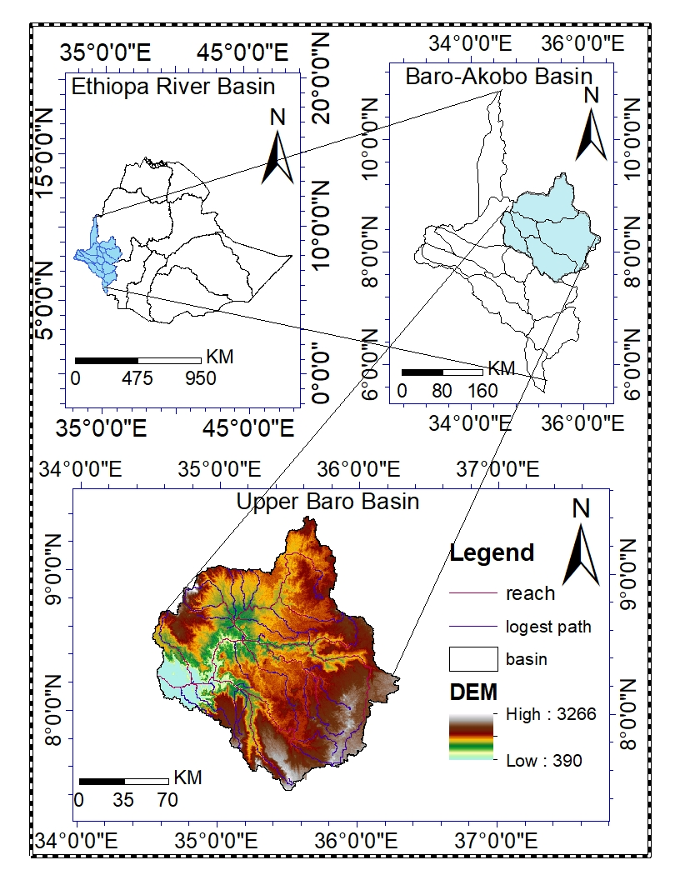
Figure 3.1: Location map of the study area

Climate

Rainfall
The rainfall distribution is highly variable both spatial and temporal scale. The Upper Baro basin, had a long rainy season in the summer from June-September which is commonly call as Kiremt, it represents 60-65% of the mean annual rainfall the main rainy season starting from mid-May September.

Figure 3.2: Average monthly areal rainfall distribution from (1987-2017)
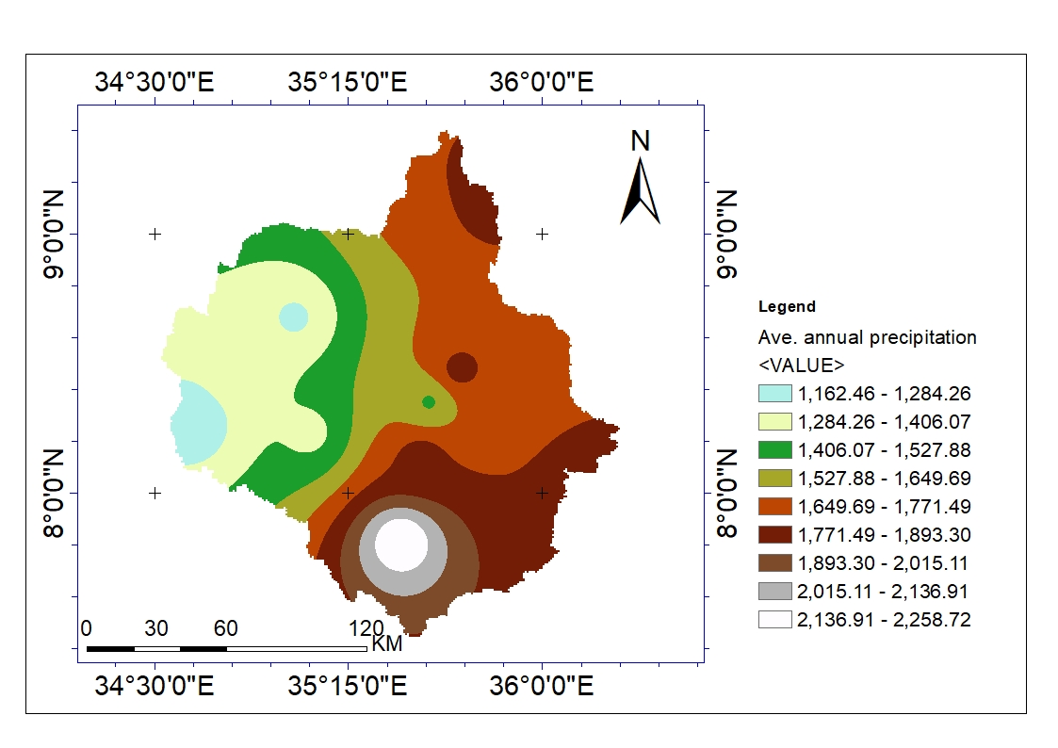
Figure 3.3: Annual areal rainfall distribution from (1987-2017)

The area of Upper Baro Basin shows that there were mono-modal, bi-modal and triple-modal rainfall pattern, and tropical rainy climates dominate the area with average annual precipitation varying from about 1163.03 mm to over 2258.36 mm for the stations in the period 1987-2017 (Figure. 3.3) And receives high mean monthly rainfall between May to September is above 240mm, with monthly maximum rainfall record 302.79 in August, while relative to the rainy seasons, the dry seasons occur in the months between December to March show the lowest mean monthly rainfall record 13.75mm for the period of time (Figure. 3.2). Annual rainfalls show very pronounced annual and seasonal fluctuations. Moreover, the local rainfall pattern highly depends on the topography as show figure a above.

Temperature
Since temperature in the study area is highly influenced by the altitude where the temperature decreases with increase in altitude at a mean rate of 0.7ºc for every 328 feet (de Castro and Fetcher, 1998). This similar in Ethiopia where temperature decreases with increasing elevations. The maximum temperature of Upper Baro Basin ranges between 27.7⁰c (in wet season) to 37.20c (in dry season) occur in June to August, while the minimum falls between 10.8⁰c to 13.7⁰c in the year (figure 3.4).

Figure 3.4: Mean monthly max and min temperature from (1987-2017)

Topography
The topography of the Upper Baro Basin as a whole is characterized by its physical variation from flat to mountainous terrain and falls in the altitude range of below 390 m to over 3000 m.a.s.l. with 42% in between 1000 m and 2000 m.a.s.l. The eastern two-third of the basin area lies between 1,000 m and 2,400 m a.m.s.l. and gently sloping plain lies in the western between 380 m and 500 m.a.s.l.
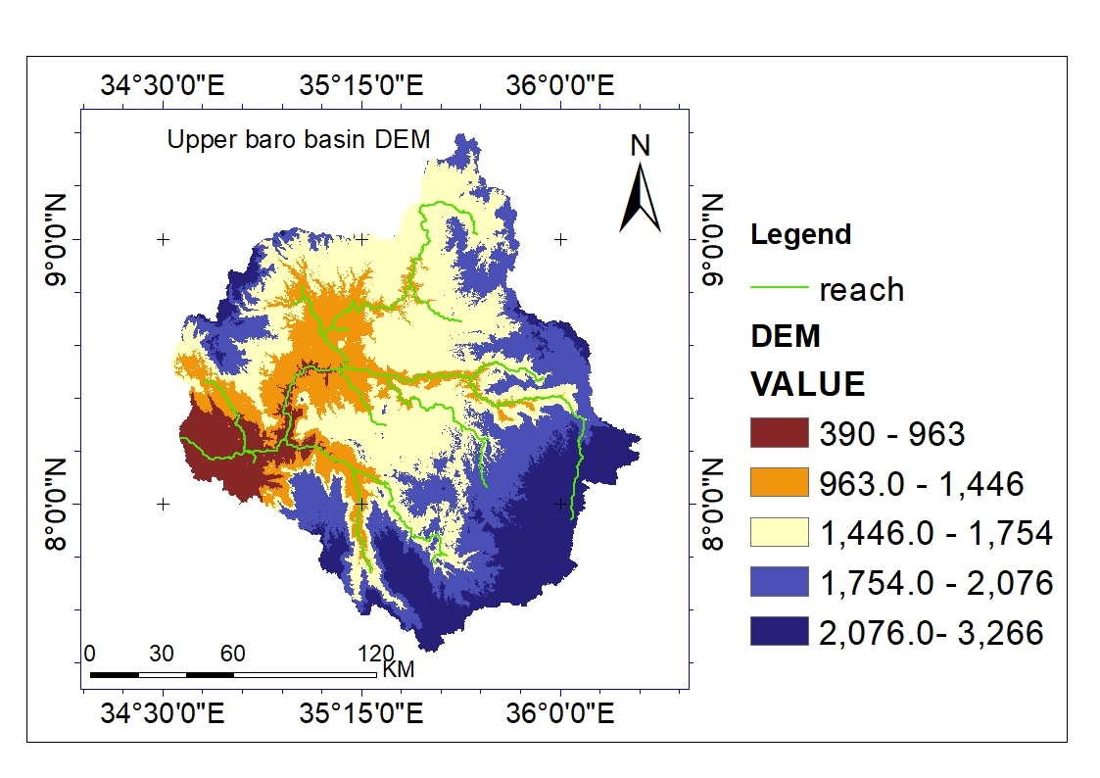
Figure 3.5: Topography map of Upper Baro Basin

Soil
There are seventy soil type has been identified at Upper Baro Basin. the spatial data where obtain from the Ministry of Water, Irrigation and Electricity (MWIE) of GIS department, which is prepare according to FAO classification. The most dominate soil in Upper Baro Basin are dystric nitisols, dystric gleysols. The type and the spatial distribution and area coverage of soil type is describing below (figure 3.6)

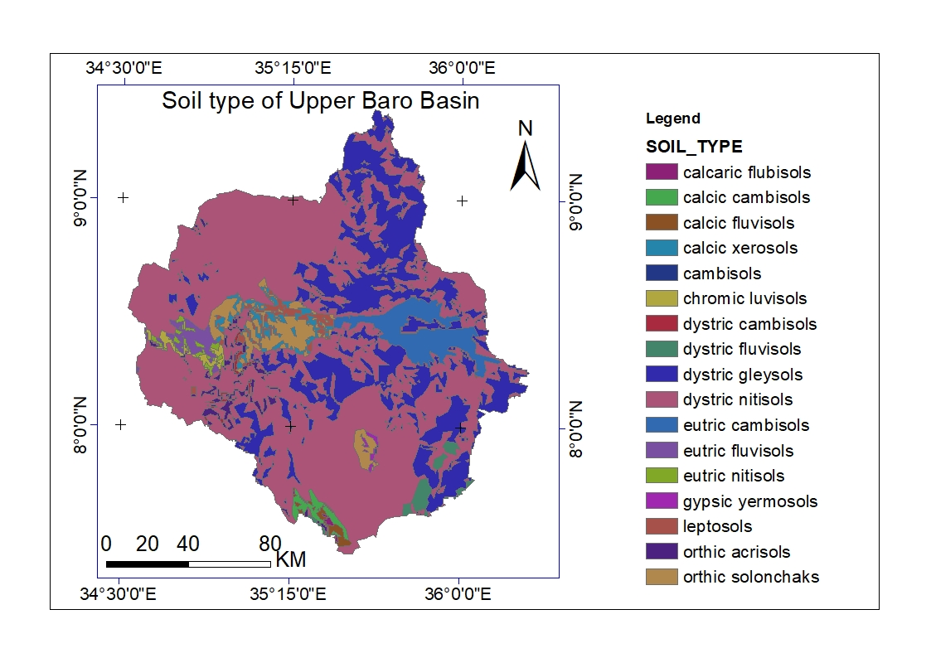
Figure 3.6: Spatial distribution of soil type in Upper Baro Basin (Source MoWIE, 2008)

Landuse/land cover
Land use/land cover can be characterized by the complex interaction of behavioral and structural factors associated with demand, technological capacity, and social relations, which affect both demand and environmental capacity, as well as the nature of the environment in question (Lane, 1982).
According to MoWIE, there are several type of land use land cover in the Upper Baro Basin these characterized by a majority dominate landuse is an intensive agriculture of seasonal and annual crops. The major type of crop cultivated Coffee, Vegetable, Sorghum, Teff, Maize, Chat, horticulture (Fruit), Enset and rearing of livestock production are the common production practice in Upper Baro Basin. Based on the topographic different type (natural and Plantation) of forest type existing such as woodland, forest, shrub, bush, grasslands in basin. The dominated land use/land cover based on the area coverage in the watershed are, Forest, cropland and Urban with 26.2, 20.48 and 14.26% respectively.

Hydrology of the Study area
Baro river, which is a major tributary to Baro-akobo basin, originates from the mountainous area of southwest of Ethiopia at an elevation between 3300m and 390m above sea level. It originated from number of streams, within the watershed area. Some of the major tributary stream includes the upper side of the watershed which collects surface runoff from Sore near Mettu, Birbir near yubdo, keto near chanka, Uka near uka, Geba near suppi, Gumero near Gore, Baro near Masha in the middle part of the Basin which collects surface runoff from and contributes the main Baro river.

Data Collection and Analysis

LULC Change Detection

Image pre-processing
LULCC detection analysis is the process in which detecting differences in the state of an object or phenomenon by observing it at different period of times (Singh, 1989) . For this study Landsat image obtain from Global land cover facility (GLCF) website (www.glovis.USGS.gov) where satellite images of Multi-spectral scanner (MSS), Thematic Mapper (TM) and Enhance Thematic Mapper plus (ETM+) image were downloaded for the study area. Three land use and land cover maps acquired from 1986, 2002, and 2017 were produced following the step-by-step detection and quantification procedures of satellite images. The rational of choice of the period of different data relatively contribution for LULC change detection. The image was extract to tiff format for the pre-processing and the acquisition dates, sensor, path/row, resolution and the producers of the satellite images used in this study are summarized in the below Table 3.1
Table 3.1: The acquisition dates, image type, sensor, path, row, resolution and the producers of the three Landsat images.
Reference Data | Path/ Row | Acquisition data | Image | Sensor | Resolution | Season | Cloud cover
1987 | 170/054 | 22/01/1987 | Landsat  4-5 | TM | 60M*60M | Dry | Cloud free
1987 | 170/055
1987 | 171/054
2002 | 170/054 | 23/01/2002 | Landsat7 | ETM+ | 30M*30M | Dry | Cloud free
2002 | 170/055
2002 | 171/054
2017 | 170/054 | 27/01/2017 | Landsat8 | ETM+ | 15M*15M | Dry | Cloud free
2017 | 170/055
2017 | 171/054
Three sets of geo-referenced Landsat images where used for land use land cover classification (see Section 3.2.1.1) and those Landsat satellite images showing false color composites bands red, green and blue (RGB) bands 3,2,1 for Landsat MSS and 4,3,2 for Landsat7 ETM+ and 5,4,3 Landsat8. The attempt for image pre-processing was calibration to radiance, atmospheric correction or normalization, image registration, geometric and radiometric correction/rectification, sub-setting and masking.

Image Classification
Supervised digital image classification technique was employed, using ERDAS IMAGINE 2014 software which was complemented with field surveys that provided on the-ground information about the types of landuse/land cover classes. Many classification systems are being used throughout the world. However, there is no single internationally system (FAO, 1997) .Therefore, different organization setup their classifications, differently because they are interested in different aspect of landuse/land cover. Therefore, there eight landuse/land cover classes were recognized. These include built up areas, cultivated land, Woodland, grassland, forest and Schruble land (shrub+bush), and waterbody and by using the satellite imagery from the previous local knowledge, visual and digital interpretations the different landuse/land cover categories were identified. Google earth Global and Positioning System (GPS) was used during training site collection and ground verification of image interpretations. Main classes were grouped to merge classes with a similar value like the center class (Geosystems, 2006). In general, eight land cover classes were identified, verified by field survey.

According to a rule of thumb, the number of training samples is at least ten times the number of variables used in the classification to be considered sufficient (Im and Jensen, 2005; Jia and Richards, 1999). In this study, a total of 60-70 training polygons for each class were created and used in the study for the 2017 image. The polygons were selected randomly in the imagery but ensured good distribution in space and land cover classes. About 60-45 training polygons were created for the 2002 and 1987 imagery, respectively. The choice of the training polygons for different cover types was based on the combination of field information, high resolution imagery (from GooglenEarth) of the study area.

Table 3.2: LULC Classification scheme for the Upper Baro Basin
Type | Description
Forest | - An area with high density of trees which include deciduous  forest land, ever green forest land, mixed forest land and  plantation forests that mainly are eucalyptus, junipers and conifers.These are natural forests found in reserved areas of Yayu, Masha, keffa and Gore forests and other protected areas with a canopy cover over 90%.
Woodland | - All Woodland area with tree cover >60% closed stand tree
Schruble land | - Refers to those areas covered with tree, shrub, bushes and some grasses that dominate the foot slopes and riverine landscapes. There exists variation in vegetation between dense shrub/bush lands with an estimated cover of >50% and open shrub/bush lands with less than 50% cover. The latter are not bare at all, but being degraded from competing use of grazing, cultivation, and deforestation as some of the degraded shrub/ bush lands serve for grazing purposes.
Grassland | - Are those lands where small grasses are the predominant natural vegetation. It also includes land with scattered or patches of trees and it is used for grazing and browsing
Waterbody | - River, pond and water reservoir
Urban | - Settlement Areas where there is a permanent concentration of people building, and other man-made structures and other activities.
Agricultural land | - Area of land covered with low density and scattered trees with crop cultivation activities
Bare Land | - Land of limited ability to support life and in which less than one-third of the area has Vegetation or other cover. In general, it is an area of thin soil, sand, or rocks or The area with no dominant vegetation cover on at least 90% of areas covered lichens or mosses.

Evaluation of the land cover classification results
Classification accuracy is typically taken to mean the degree to which the derived image classification agrees with reality or conforms to the ‘truth’ (Foody, 2000; Janssen, 2001; Lucas et al., 1994). Accuracy assessment for the 2017 landuse/land cover classification was performed based on ground data collected and Google Earth imagery for the time period of 2017. A total of 340 points were collected for the nine land cover classes. A stratified sampling approach was used in collecting reference data for accuracy assessment. Each land cover class was treated as a strata and reference data were collected randomly within the strata from different parts of the Basin. A part from the reference data collected from the ground truth from the field additional data from high resolution imagery within the Google Earth platform were used. Due to lack of field observations at the time of the earlier images, Google Earth for image history for 1987 and 2002 and visual interpretation of the raw Landsat images were used. This method has been reported in other studies for example (Biro et al., 2013; Sulieman, 2008).

An error matrix or confusion matrix is a widely used way to represent thematic accuracy (Congalton, 1991, 2007; Congalton and Green, 2008). This matrix shows the accuracy of a classification result by comparing a classification result with ground truth information. In each classified image, the confusion matrix, an overall accuracy, producer and user accuracies, and kappa coefficient were calculated. The confusion matrix was calculated by comparing the location and class of each ground truth pixel with the corresponding location and class in the classification image. The producer’s accuracy shows the probability that a pixel location of a landuse class is correctly shown on the map, while the user’s accuracy shows the probability that a pixel location on the map correctly identifies the land use class location as it exists in the field (Story and Congalton, 1986). Overall accuracy is an indication of the correctness of the map and is calculated by dividing the total number of correctly classified points by the total number of points
$Overall accuracy=\frac{\sum_{i=1}^{n}{C_{1}}}{N}--------$Equation 3.1
Where C is the number of correctly classified points of the particular land cover and N is the total number of points. The Kappa coefficient is a measure of classifier performance derived from the error matrix but which is free of any bias resulting from chance agreement between the classifier output and the reference data (Campbell and Wynne, 2011; Richards and Richards, 1999) Kappa provides information about the map quality and its value ranges from -1 to 1.

Data collection and analysis for Hydrological Response Model.
The spatial differences in streamflow trends can occur as a result of spatial differences in the changes in rainfall and temperature, and spatial differences( soil , landuse and slope ) in the catchment characteristics that translate meteorological inputs into hydrological response (Aziz and Burn, 2006; Burn and Elnur, 2002). SWAT model largely depends on hydro-meteorological data such as precipitation, temperature, relative humidity, wind speed and solar radiation.

Meteorological data
The accessibility and quality of meteorological data is crucial for any hydrological model. SWAT model requires daily meteorological (Weather) data that consist of the variables used for driving the hydrological balance, daily precipitation, minimum and maximum air temperature, relative humidity, wind speed, and daily sunshine. These data were obtained from National Meteorological Agency (NMA) and data should be stationary, consistent, and homogeneous when they are used to simulate a hydrological system. Thiessen method goes to adjust for non-uniform meteorological station distribution by proportion to the area which is closer .
Table 3.3: Summary of meteorological station
Station | Coordinate |  | Altitude  (m a.s.l) | Station Class | Period of data
Station | Longitude | Latitude
Gambella | 34.5833 | 8.25 | 430 | C2 | 1983-2017
Mettu | 35.56667 | 8.2833 | 1711 | C2 | 1981-2017
Denbi Dolo | 34.8 | 8.5167 | 1850 | C2 | 1982-2017
Ayira | 35.55 | 9.1 | 1555 | C2 | 1987-2017
Gatira | 36.2 | 7.983 | 2358 | C2 | 1987-2017
Masha | 35.4667 | 7.75 | 2282 | C1 | 1981-2017
Gore | 35.5333 | 8.1333 | 2033 | C1 | 1981-2017
Seko.humbi | 34.9833 | 8.7166 | 1860 | C2 | 1987-2017
Gimbi | 35.7833 | 9.1666 | 1970 | C2 | 1983-2017
Bure | 35.1 | 8.2333 | 1750 | C2 | 1981-2017
Alge | 35.6667 | 8.5333 | 1880 | C2 | 1987-2017
Source: Ethiopian National Meteorological Agency (ENMA)

Although there are many meteorological gauging stations in the study area, most of the gauges have either short record periods, or have plenty of missing and erroneous data. So, the construction of a high-quality observed dataset is compulsory for successful hydrological modeling. To achieve the objective of the study, eleven meteorological where selected based on their quantity, quality, time period and their uniform distribution within and around the Upper Baro Basin. The data from these stations were collected from Ethiopian National Meteorological Agency in the time period 1987-2017. These selected meteorological stations furthermore presented in those above table and were located below the figure.
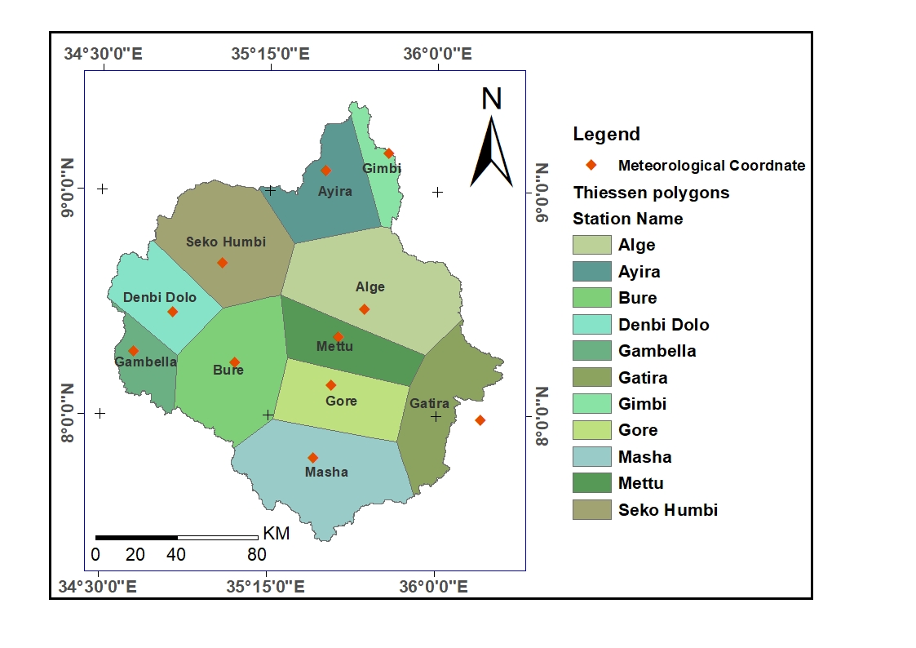
Figure 3.7: Location of selected metrological station

If any of these data was not available, which is very likely, SWAT can generate data using weather generator (WXGEN). Daily precipitation and temperature of all gauging stations were prepared in text format. Solar radiation, relative humidity, and wind speed data were available only for principal station (Gore and Masha synoptic stations).

Estimating Missing Data using weather generator model
The SWAT weather generator model (WXGEN) was used to fill missing values weather data. The daily precipitation and temperature of all gauging stations were prepared in comma delimited (.csv) format. Solar radiation, relative humidity, and wind speed data was available only for principal Gore and Masha station (appendix VI).

Hydrological data
The stream flow data was collected from MWIE hydrology department for calibrate and validate the simulated stream flow from 1990-2009 the time resolution of data, at Baro Gambella gauging. The reason this gauging station considered was that this is the biggest contributor of the river flow of the of Baro river basin. The hydrological flow data of Upper Baro Basin were shown figure 3.9 and Appendices C.

Figure 3.8: Average monthly ﬂow of Upper Baro Basin from a period of 1990-2009

Spatial data

Digital Elevation Model
DEM is a digital cartographic/geographic dataset of elevations in xyz coordinates (USGS 2012). SRTM 30 × 30 DEM of anger sub Basin was downloaded from United States Geological Survey https://earthexplorer.usgs.gov/ and extracted from Upper Baro Basin.

Soil data
There are seventeen soil types were identifying at upper Baro Basin. Those soil data were obtaining from MoWIE of GIS department which is prepared according to FAO classification and MoA Soil is one of spatial data, which used as input of SWAT model. It requires different soil physic-chemical properties such as available water content, soil texture, hydraulic conductivity, bulk density and organic carbon content for the different layers of each soil type. The most dominate soil were describing section 3.3.1 at Table 3.10 and figure 3.15 below.

Landuse/land cover
Landuse/land cover is one of the influencing factor the hydrological properties of the catchments. Landuse land cover is one of spatial data, which used as input of SWAT model. The prepared LULC was given as input of SWAT model, that describe the HRUs of the Upper Baro basin. there were eight LULC cover identifying in the study area that are describe below Section 4 section 3.3.1 at Table 3.11 below.

Conceptual Frame Work
Conceptual framework showing the components and relationships that have been used as a
framework for the analysis of landuse/land cover change in research is indicated in below Figure. Figure 3.9: General conceptual methodology used for modelling in the Upper Baro basin
Research objective
Impact of LULCC on hydrological regime
DEM setup
Watershed delineation
Watershed Outlet
locating

Outlet-Inlet Definition

DEM input
Stream definition
Calculation of Sub basin
parameters

Soil map
Hydrological response unit (HRU)
DEM for slope
LULC for 1987, 2002, 2017 years
Write input table
Weather input data
- Precipitation
- Relative humidity
- Solar radiation
- Wind speed
- Temperature (max & min)

Run SWAT model
Sensitivity Analysis
Observed stream flow data
Model calibration and validation
Run the Calibration & validation model
using 1987 LULC

Run the Calibration & validation model
using 2017 LULC

Run the Calibration & validation model
using 2002 LULC

ERDAS imagine 2014
LULC detection analysis

Sediment delivery modeling
Integrated Valuation of Ecosystem Services and Tradeoffs (InVEST 3.3.5) modeling software for the modeling of sediment delivery and it is a general purpose ecosystem service (ES) modeling toolkit which quantify and map sediment regulation state through a sediment delivery ratio model (Bogdan et al., 2016; Hamel et al., 2015; Sharp et al., 2016). The model is fully distributed and GIS-based, accepting inputs of the raster of climate, soil, topography, and land use and land cover (LULC) data (Hamel et al., 2015). The outputs represent average annual sediment delivery (soil loss potential and sediment export) per watershed, as well as maps representing the per-pixel contribution to sediment delivery. For each pixel, the algorithm first computes the average annual amount of eroded sediment within the watershed and then the sediment delivery ratio (SDR), which corresponds to the proportion of soil loss actually reaching the stream (Hamel et al., 2015). This approach was proposed by Borselli et al. (2008), which is based on the concept of hydrological connectivity.

Data for soil loss potential
Soil loss is computed with the revised universal soil loss equation (RUSLE) for each pixel using InVEST model at grid scale together with a sediment retention approach for sediment deposition (Hamel et al., 2017). The information on land use pattern, rainfall, soil characteristics, and topography was prepared at grid i level to estimate potential soil erosion as:
$USLE_{i}=(R*K{*LS*C*P)}_{i}$ Eq (1)
Where, R is the rainfall erosivity factor (MJ mm/ha/year), K is the soil erodibility factor (MJ mm/ton/ha), LS is the topographic factor (dimensionless), C is the crop management factor (dimensionless) and P is the conservation practices factor (dimensionless).
DEM is provided for the InVEST model to extract LS factor, the rests factors are prepared in map form and table independently from different sources.

Erosivity factor (R)
The R factor reflects the ability of rainfall-runoff to erode the soil particles due to the joint effect of rainfall kinetic energy, duration, and potential (Owusu, 2012). There are different ways of analyzing the R-factor. For instance, the following formulas have been applied to different parts of the world (Woldemariam et al., 2018).
R = [38.46 + (3.48 * P)] (Eq. 2)
However, the erosivity factor was calculated according to the equation given by Hurni (1985) derived from a spatial regression analysis for Ethiopian conditions, based on the easily available mean annual rainfall (P). The R-factor is given by a regression equation as:
R = -8.12 + 0.562P (Eq. 3)
Where R is the erosivity factor and P is the mean annual rainfall (mm/yr).
A total of thirty (30) year monthly rainfall data (1987-2017) were collected from Ethiopia Metrological Agency (EMA) which is collected from eleven meteorological stations. After analyzing the mean annual rainfall (P) for each station, the R factor was computed using the above formula (Eq. 3) and converted into a raster map. The spatial interpolation techniques were used along with rainfall data for each meteorological stations based on ground control points (GCPs) for each station for assessing the spatial variability of rainfall and rainfall erosivity. In order to make the R-factor value most reliable, the spatial distribution of R was calculated from the available rainfall data by considering that the area experiences relatively uniform rainfall
within using ordinary IDW (Inverse Distance weighted interpolation method in Spatial Analyst Tool of ArcGIS 10.3 software (Figure 3.11). This method effectively transforms station data into surface data. The individual average R-values interpolated was used as input for InVEST model.

Table 3.4: Stations erosivity factor (R) and the mean annual rainfall (P) in mm.

Station | Mean annual rainfall (mm) | Erosivity factor (R)
Mettu | 1860.5 | 1053.7
Denbi Dolo | 1292.1 | 734.3
Gambella | 1056.2 | 601.7
Bure | 1440.2 | 817.5
Alge | 2115.1 | 1196.8
Gore | 2001.6 | 1133.0
Gimbi | 1829.8 | 1036.5
Masha | 2325.9 | 1315.3
Ayira | 2327.8 | 1316.3
Gatira | 2263.9 | 1280.4
Seko | 1478.7 | 839.1
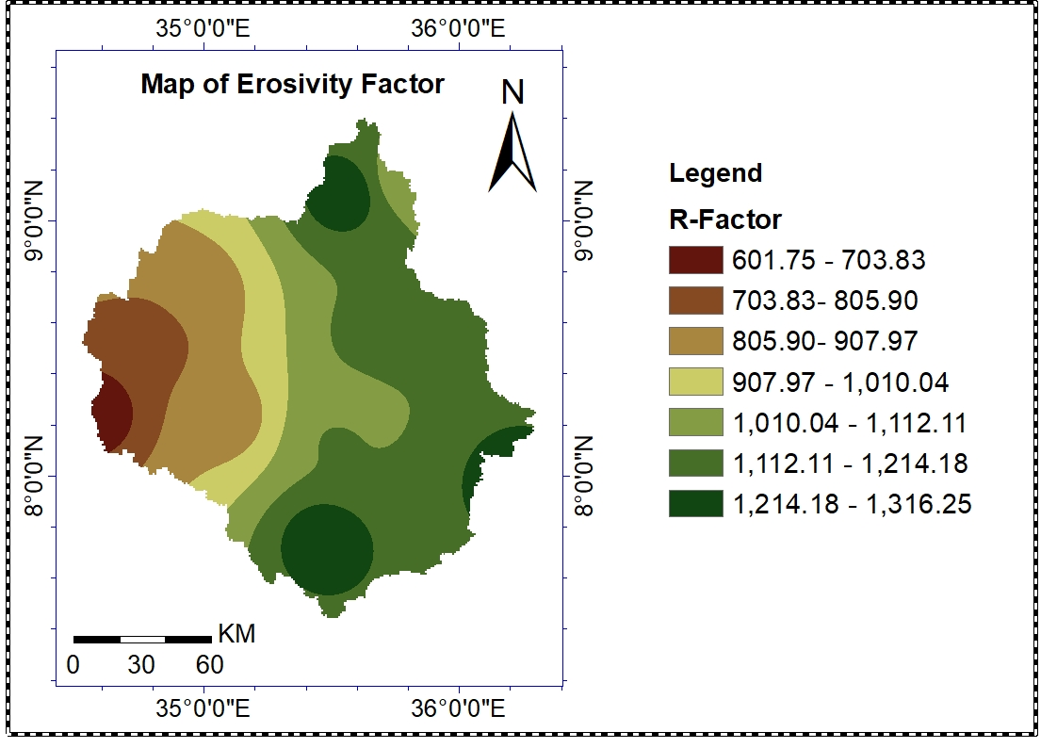
Figure 3.10: Map of Erosivity factor

Soil erodibility /K_ Factor/
vector format soil data was the source of analyzing the soil erodibility factor (K factor) which is obtained from Ethiopia Water, Irrigation and electric minister. seventy major soil categories, namely listed below (table 3.5), were identified in the study area. Attribute table of ArcGIS 10.3 and its editor are used to assign the K factor value based on the soil types. However, the basic soil data set was found in vector format and need to change it into raster grid, the grid data set was re-classified based on K_ value of each soil class in ArcGIS 10.3 Spatial Analyst Tool. After assigning values for each soil types, the soil map was reclassified using the adopted K values by (Kaltenrieder, 2007) . The K factor values for Upper Baro Basin watershed has ranged from 0.41 to 0.19 (Table 3.5).

Table 3.5: Soil erodibility (K factor)
Value | SOIL_TYPE | Area(Km²) | Area covered | K
1 | Dystric nitisols | 14151.76 | 60.32 | 0.29
2 | Dystric gleysols | 5423.52 | 23.12 | 0.31
3 | Acrisols | 326.87 | 1.39 | 0.37
4 | Chromic luvisols | 120.45 | 0.51 | 0.26
5 | Solonchaks | 778.06 | 3.32 | 0.22
6 | Ccalcic xerosols | 363.20 | 1.55 | 0.38
7 | Leptosols | 255.95 | 1.09 | 0.3
8 | Eutric cambisols | 1041.60 | 4.44 | 0.35
9 | Eeutric nitisols | 108.43 | 0.46 | 0.24
10 | Eutric fluvisols | 276.99 | 1.18 | 0.33
11 | Dystric cambisols | 58.40 | 0.25 | 0.16
12 | Gypsic yermosols | 43.39 | 0.18 | 0.27
13 | Dystric fluvisols | 231.44 | 0.99 | 0.36
14 | Cambisols | 2.54 | 0.01 | 0.33
15 | Calcic fluvisols | 92.40 | 0.39 | 0.23
16 | Calcic cambisols | 167.83 | 0.72 | 0.19
17 | Calcari fluvisols | 19.17 | 0.08 | 0.41

Crop Management Factor (C)
The crop management factor (C) is defined as the ratio of soil loss under specific cropping conditions to soil loss occurring in bare soil (Olioso et al., 2013; Uddin et al., 2016). It reflects the effect of cropping, availability of vegetation and other management practices on erosion rates (Uddin et al., 2016).
Remote sensing technology can provide a lot of information about the land surface through the Normalized Difference Vegetation Index (NDVI), which is positively correlated with the amount of green biomass and gives an indication of differences in green vegetation coverage (Pham et al., 2018). The land use land covers and normalized difference value index (NDVI) of the different years (1987, 2002 and 2017) were used to determine the C-value. The thematic land use and land cover were changed to vector format to assign the NDVI of each land use. The land use map and NDVI for each year were mapped together in the ArcGIS of spatial analysis tool using zonal statistic and zonal statistic Table and the corresponding average C-value was given to each land use classes (Table 3.6). The landuse/land cover change map of 1987,2002 and 2017 were found in above figure 4.2.
Many researchers calculated the C factor with different equations (Durigon et al., 2014; Karaburun, 2010; Van der Knijff et al., 2000) but the equation suggested by Durigon et al. (2014) is used in this study:
$C=\frac{(-NDVI+1)}{2}$ --------------------------------------------Equation 3.2
$NDVI=\frac{(NIR-RED)}{(RED+NIR)}$ ----------------------------------------------------Equation 3.3
where NIR is the surface spectral reflectance in the near-infrared band and RED is surface spectral reflectance in the red band were extracted from Landsat images. the bands (NIR and RED) were extracted from Landsat images for each reference years. The USLE_C of InVEST model requires in table form associated with each land use code (lucode) and the C-value ranges for the study watershed are range 0.0 to 0.26 (Table 3.6). On this map, the lower value of C factor indicates the area possesses good vegetative cover and a higher value indicates barren/open land.
Table 3.6: The C-value for different landuse/land cover types
LULC_ description | lucode | usle_C
Bare land | 1 | 0.06
Built up | 2 | 0.09
Shcruble land | 3 | 0.042
Cultivated land | 4 | 0.26
Forest land | 5 | 0.01
Grass land | 6 | 0.05
Waterbody | 7 | 0
Woodland | 8 | 0.01

Supporting Practices (P) factor
The P factor indicates the significance of support practices, which reduce soil loss by modifying the flow pattern, grade or direction of surface runoff and by reducing the rate of runoff (Hao et al., 2017). It determines conservation practice and land management directly affects the overall soil erosion problem and solutions on a farm.
Based on local knowledge, it is possible to modify the soil loss equation factors in the model by altering the R, K, C, P inputs to reflect findings from local studies (Sougnez et al., 2011). To derive the P-factor, field observation was conducted in the upper, middle and lower part of the watershed about the agricultural conservation practices. These practices are contour tillage, strip cultivation, and terrace in the watershed. According to Shin (1999) P values of counter plowing, strip cropping and terracing are given based on the slope of the land (Table 6).
Table 3.7: Supporting practice factor according to the types of cultivation slope
Slop (%) | Contouring | Strip cropping | Terracing
0.0-7.0 | 0.55 | 0.27 | 0.10
7.0-13.3 | 0.60 | 0.30 | 0.12
13.3-17.6 | 0.80 | 0.40 | 0.16
17.6-26.8 | 0.90 | 0.45 | 0.18
26.8> | 1 | 0.50 | 0.20
(Shin, 1999)
The thematic landuse/land cover and slope map of the watershed were changed to vector format to assign the P-value, and raster map of P-factor was produced. The value of P factor ranges from 0 to 1, depending on the soil management activities employed in the specific plot of land, the value approaching 0 indicates good conservation practice and the value approaching 1 indicates poor conservation practice. In this study lands containing schruble land, and forest, woodland and grazing land were assigned the P value of 1.00 because there are no control practice measures whereas the agricultural land is 0.5. Table form of USLE_P for the InVEST model is prepared (Table 3.8).

Table 3.8: P_ factors for each land use
LULC_desc | lucode | usle_p
Bare land | 1 | 0
Built up | 2 | 0
Schruble land | 3 | 1
Cultivated land | 4 | 0.5
Forest land | 5 | 1
Grass land | 6 | 1
Woodland | 8 | 1

Conceptual Frame Work
Conceptual framework showing the components and relationships that have been used as a
framework for the analysis of soil erosion rate in research is indicated in Figure 3.13.
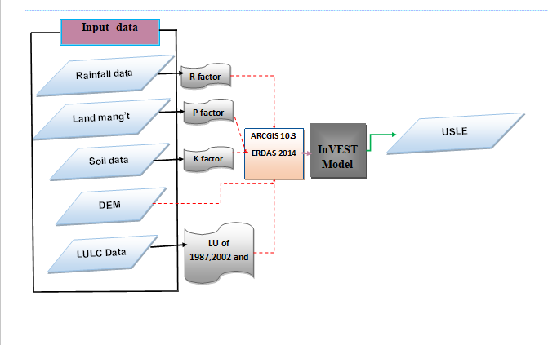
Figure 3.11: Framework to sediment delivery model Using InVEST model

Data Quality Control

Meteorological data analysis
There is an intermittent or break of data for a short period of time or even for a particular month. According to (Alemseged and Rientjes, 2007) Stated that the main challenge associated with applying successfully rainfall-runoff model lies in the lack of monitoring data, mainly rainfall spatial distribution over the catchment area, since rainfall is the primary input in any hydrological model. Another potential problem is having no reliable flow data that can lead to reliable calibration and validation of catchment parameters. Missing rainfall data within such gauging stations have been calculated and in addition, their consistency and homogeneity were also checked.

Filling of missing data
In any meteorological data analysis for hydrologic analysis and design or other purpose, quality of the data at hand is required to be with a negligible inaccuracy. A data gap may appear due to different reasons, like: instrument failure (due to mechanical or electrical malfunctioning), observer failure to visit the gauging station frequently or vandalism of recording gauges, which leads for the users of this data to incorrect decisions and conclusions on their targeted purpose, in such case users must need to be responsible in filling these missing data using appropriate methods therefore For this case before using any data for analysis, we have to test and fill missing error.

For this case, missing climatic data of each station were estimated from other stations around the missed record station considering that at least three nearby stations and evenly spaced around the station with the missing record are there (K.Subramanya, 2006) . A number of methods have been proposed for estimating missing rainfall data. For this study the missing values was estimated from other stations around the missed record station by using both arithmetic mean method and normal ratio method. Arithmetic mean method is used when the normal annual precipitations at surrounding gauges are within the range of 10% of the normal annual precipitation of the station under consideration.
$P_{X}=\frac{1}{N}\left(P_{1}{+P}_{2}+P_{n}\right)$…........................................................................................Equation 3.4
Where, $P_{x}$ is missing rainfall at station x is and $P_{1}, P_{2},………, P_{n}$are the rainfalls at the n surrounding stations(Reddy, 2005). Usually the data from three surrounding gauges will give good results.
Normal ratio method was used to fill precipitation data when normal annual precipitation at the neighboring station differs from the missed station by more 10%. Therefore, in this case Normal Ratio Method (equation 3.3) where apply to estimate the filling precipitation data.
$P_{X}=\frac{1}{n}\left[\frac{N_{X}}{N_{A}}P_{A}+\frac{N_{X}}{N_{B}}P_{B}+…\frac{N_{X}}{N_{C}}P_{C}…..\frac{N_{X}}{N_{N}}P_{N}\right].......................................$Equation 3.5
Where, Px is the precipitation for the station with missed record, PA, PB, PC….PN are the corresponding precipitation at the index station and NA, NB, NC……NN and NX are the long term mean monthly precipitation at the index station and at station X under consideration respectively. At least minimum of three surrounding meteorological stations which had closer area , generally used in the normal ratio method (Reddy, 2005).

Test for consistency of precipitation (Double-mass analysis)
Similarly estimate missing data, consistency test occurs when the selected station of the recorded data is inconsistent over the period of time and adjustment of measured data is necessary to provide a consistent record. Double mass curve analysis is a commonly used data analysis approach for investigating the behavior of records made of meteorological data at a number of locations and used to check the spatial consistency of the meteorological data as it has got wider applications in hydrological areas and is considered to be reliable (Dingman, 2002). Inconsistency is detected by plotting accumulated annual rainfall of reference stations against accumulated annual rainfall of the evaluation station and inspecting for abrupt changes in slope. Slope changes are considered to be significant if they persist for at least five years (Dingman, 2002).

Double mass curve analysis were determined by plotting the cumulative values of observed time
series of a station for which consistency needs to be checked on x-coordinate versus the cumulative value of observed time series of group of station on y-axis, and if the station is affected by the trend, a break in the slope of the curve would indicate that conditions have changed at that location then the record precipitation data should be adjusted. Therefore, the station needs to be adjusted for the consistency of the record using the (equation 3.4).
$P_{C}=P_{x}*\frac{S_{c}}{S_{O}}……..................…………$Equation 3.6
Where, PC is the corrected precipitation at any period, P_{x} original recorded precipitation at a time SC is the corrected slope of the Double mass curve and S_{O} is the original slope of the double mass curve. To check the degree of consistency, the values of coefficient of correlations are summarized in the table 3.2.
Table 3.9: Coefficient of correlation for double mass curve analysis (Nemec, 1973)
S.no | Correlation (r) | Rate of correlation
1 | r = 1 | direct linear correlation
2 | 0.6 ≤ r < 1 | good direct correlation
3 | -0.6 < r < 0 | insufficient – reciprocal correlation
4 | -1 < r < 0.6 | good reciprocal correlation
5 | r = -1 | reciprocal linear correlation
For this study, the variation of the recorded data for the missing station has been tested by the double mass curve technique. This technique can easily identify which of nearby precipitation station are to be filled corresponding to fill the missing observed data at station. Therefore, it helps to determine the best correlation out of difference station used for the hydrological modeling.

Test for homogeneity of the record
Homogeneity analysis is used to identify a change in the statistical properties of the time series data caused by either natural or man-made. This includes alterations to land use and relocations of the observation station. The homogeneity of the gauging stations monthly rainfall records was carried out by non-dimensional homogeneity test. The non-dimensional values of the monthly precipitation of each station were computed by using the following formula. One of the methods to check homogeneity of the selected stations in the watershed is the non-dimensional rainfall records and plotted to compare the stations with each other. Non-dimensional values of the monthly precipitation of each station can be computed by:
$P_{i}=100*\frac{\overline{P_{i}}}{\overline{p}}--------------$Equation 3.7
Where, Pi =is non-dimensional value of rainfall for month
i, = Over year-averaged monthly rainfall at the station

Hydrological Modeling

Hydrological component of SWAT
The hydrologic cycle simulated by the SWAT is based on water balance equation (Neitsch et al., 2011).
${SW}_{t=}{SW}_{o}+\sum_{i=1}^{t}{\left[R_{i}-Q_{i}-{ET}_{i}-P_{i}-{QR}_{i}\right]}$--------------------------------- 3.8
Where,
Sw_{t} and Sw₀ are the final and initial soil water content respectively (mm),
Q _{i}= daily surface runoff (mm),
R_{i} = daily rainfall (mm),
ET_{i} = daily evapotranspiration (mm),
R_{i} = daily lateral flow (mm)
P_{i} = daily percolation (mm) and Q

Peak runoff rate
The peak runoff rate is a result of the erosive power of a storm and is used to predict sediment loss. SWAT calculates the peak runoff rate with a modified rational method for each HRU as follow:
$Qpeak=\frac{α_{tc}*Q_{surf}*A}{t_{conc}}$-------------------------------- 3.9
Where Qpeak is peak runoff rate (m³/s),
$α$_{tc}the fraction of daily rainfall that occurs during the time of concentration,
Q_{surf}is the surface runoff (mm);
A is the sub -basin area (km²),
tconc Time of concentration (hr)

Surface runoff generation
Runoff results from surplus precipitation occurring on the watershed. Excess rainfall is part of the rainfall that is not lost to infiltration, depression storage and interception. Surface runoff contributes a great deal to stream flow in most catchments. In classical hydrology, stream flow is defined in term of three components: 1) surface runoff, 2) interflow, 3) groundwater flow. The excess rainfall is then transformed by the catchment into direct runoff. Conceptually, surface runoff occurs in SWAT model whenever the rate of water application to the ground surface exceeds the rate of infiltration.

SWAT 2005 provides two surface runoff computation methods; a modification of the Soil Conservation Service (SCS) Curve Number (CN) method (USDA SCS, 1972) or the Green & Ampt infiltration method(Green and Ampt, 1911; King et al., 1999) cited in(Ndomba et al., 2008).
The CN method was initially developed for small agricultural watersheds and the CN varies non-linearly with the moisture content of the soil. It drops to zero as the soil approaches the wilting point and increases to near 100 as the soil approaches saturation, with higher CNs associated with higher runoff potential watershed. This method is widely used(Arnold et al., 1998).
According to (USDA, 1985) this can be mathematically express as;
$Q_{s}=\frac{{\left[R_{a}-I_{a}\right]}^{2}}{\left[R_{a}-I_{a}+S\right]}$------------------------------------------3.10
For Ra >Ia, Q = 0 for Ra ≤ Ia
Where Q_{s} is the accumulated runoff (mm),
Ra the rainfall depth for the day (mm),
Ia is initial abstraction (mm, surface storage, canopy Interception, Infiltration prior to runoff and S is the potential maximum moisture retention after runoff begins (mm).
The retention parameter varies spatially due to changes with land surface features such as soils, land use, slope and management practices. This parameter can also be affected temporally due to changes in soil water content. It is mathematically expressed as:
$S=25.4*\left(\frac{100}{CN}-10\right)$---------------------------------3.11
Where, CN is the curve number for the day and its value is the function of land use practice,
soil permeability and soil hydrologic group.
The initial abstraction, Ia, is commonly approximated as 0.2S and equation 2.2 becomes:
$Q_{sw}=\frac{{\left[R_{a}-0.2S\right]}^{2}}{R_{a}-0.8s}$------------------------------------- 3.12
For the definition of hydrological groups, the model uses the U.S. Natural Resource Conservation Service (NRCS) classification. The classification defines a hydrological group as a group of soils having similar runoff potential under similar storm and land cover conditions. Thus, soils are classified in to four hydrologic groups (A, B, C, and D) based on infiltration which represent high, moderate, slow, and very slow infiltration rates, respectively.

Potential evapotranspiration
Potential Evapotranspiration is a collective term that includes evaporation from the plant (transpiration) and evaporation from the water bodies and soil. Evaporation is the primary mechanism by which water is removed from a watershed. An accurate estimation of evapotranspiration is critical in the assessment of water resources and the impact of land use change on these resources. There are number of methods that are developed to estimate potential evapotranspiration (PET). SWAT provides three options for PET calculation: (Hargreaves et al., 1985; Priestley and Taylor, 1972) methods. Those methods have needs various data of climate variables. Penman-Monteith method are requires solar radiation, air temperature, relative humidity and wind speed.
The Penman-Monteith form of the combination equation is:
$$PET=\frac{∆\left(R_{n}-G\right)+ρ_{a}C_{p}\frac{\left(e_{s-e_{a}}\right)}{r_{a}}}{∆+γ\left(1+\frac{r_{s}}{r_{a}}\right)}--------------- STYLEREF 1 \backslash s 3. SEQ Equation \backslash * ARABIC \backslash s 1 13$$
where R_{n} is the net radiation, G is the soil heat flux, (e_{s} - e_{a}) represents the vapour pressure deficit of the air, r _{a} is the mean air density at constant pressure, c_{p} is the specific heat of the air, D represents the slope of the saturation vapour pressure temperature relationship, g is the psychrometric constant, and r_{s} and r_{a} are the (bulk) surface and aerodynamic resistances.

Ground water flow
To simulate the ground water, SWAT partitions groundwater into two aquifer systems: a shallow, unconfined aquifer which contributes return flow to streams within the watershed and a deep, confined aquifer which contributes return flow to streams outside the watershed (Arnold et al., 1998). SWAT the water balance for a shallow aquifer is calculated with:
$aqshi={aqshi}_{-1}+W_{rchg}-Q_{gw}-W_{revap}-W_{deep}-W_{pump,sh}$---------3.14

Where,
aqsh, i is the amount of water potentially stored in the shallow aquifer on day i (mm),
aqsh, i-1 is the amount of water stored in the shallow aquifer on day i-1 (mm),
Wrchrg is the amount of potentially recharge entering the aquifer on day i (mm),
Qgw is the ground water flow, or base flow, or return flow, into the main channel on day i (mm),
Wrevap is the amount of water moving in to the soil zone in response to water deficiencies on day i (mm),
Wdeep is the amount of water percolating from the shallow aquifer in to the deep aquifer on day i (mm), and
Wpump, sh is the amount of water removed from the shallow aquifer by pumping on day i (mm).

Lateral flow
$Q_{lat}=\frac{0.24\left[2SSCsinα\right]}{θ_{d}C}$------------------------ --------------------------3.15
Where, Q_{lat}= lateral flow (mm/ day);
S = drainable volume of soil water per unit area of saturated thickness (mm/day),
SC = saturated hydraulic conductivity (mm/h);
L = flow length (m), α = slope of the land. ө_{d} = drainable porosity.

Arc SWAT Set up

Digital Elevation Model (DEM)
DEM describe the elevation of any point in a given area at specific spatial resolution as a digital format file. A projected DEM were one of the essential inputs required by SWAT to delineate the watershed into a number of sub watershed or sub basins. SRTM 30 × 30 DEM was downloaded from United States Geological Survey https://earthexplorer.usgs.gov/ those used to analyze the drainage pattern of the watershed, slope, stream length, width of channel within the watershed. The elevation of the Upper Baro Basin it ranges from 390-3230m (Figure 3.12).
Watershed delineation
Watershed delineation tool in Arcswat2012 allow the user to delineate the watershed and sub watershed using the digital elevation model (DEM) of the study area. This tool uses and expanded ArcGIS 10.3 and spatial extension (Chaubey et al., 2005; Reddy and Reddy, 2015). The flow direction and accumulation are concept behind the definition of the stream network of the DEM in the SWAT model. the user determines the original of stream with a threshold area was required to form the origin of a stream at last to form sub-basin /sub-watershed.
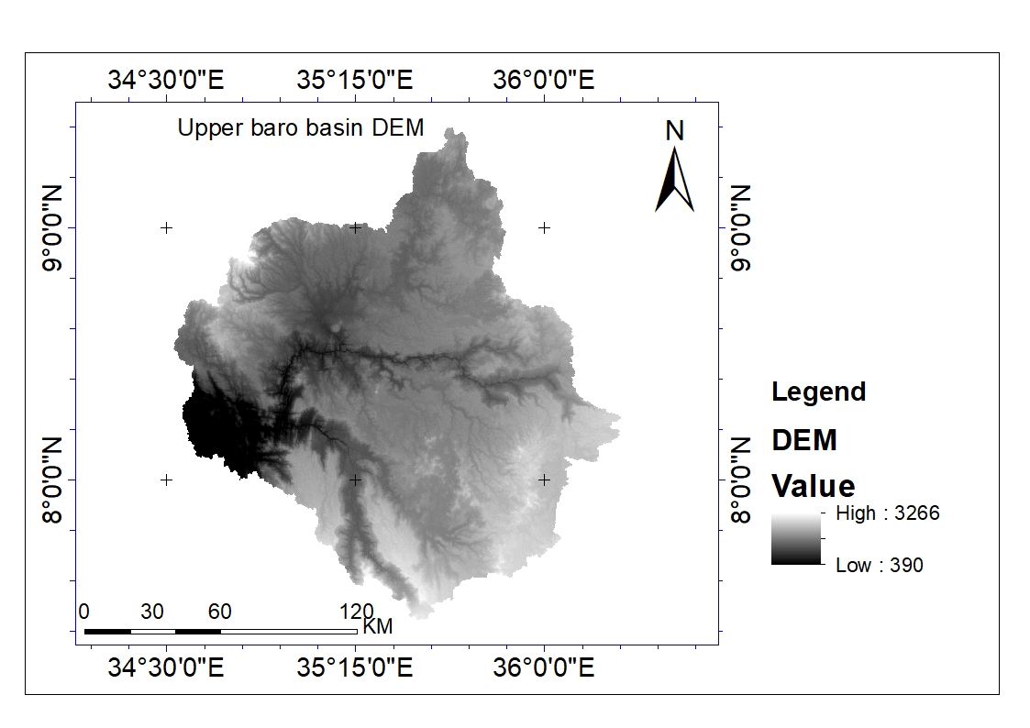
Figure 3.12: DEM of Upper Baro Basin

The watershed and sub watershed delineation were carried out using 30 m DEM using ArcSWAT version 2.3.4 and SWAT version 2012 on ArcGIS 10.3 platform. The watershed delineation process consists of five major stages such as DEM setup, stream definition, outlet and inlet definitions, watershed outlets selection, definition and calculation of sub-basin parameters. The size of sub-basin in the watershed will affect the assumption of homogeneity.

The subdivision of a watershed into discrete sub-watershed areas enables the modeling process to characterize the heterogeneity of the watershed. SWAT works on a sub-basin basis and the interface delineates the watershed in to such sub-basins or sub-watersheds based on topographic information. The size of sub-basin in the watershed will affect the assumption of homogeneity. Hence, definition of watershed, sub-basin boundaries and streams is decided by selecting a threshold area or the minimum drainage area to define streams. In this study the threshold area was taken 40,000 ha and the watershed outlet is manually added and selected for finalizing the watershed delineation. The reason for taking these threshold values was in order to keep the HRUs to a reasonable and manageable number and also considering computer processing time required. Even though, application of these thresholds eliminates the land uses and soils that covered relatively small areas in the sub-basins it creates a total of 1172 HRUs for 35 sub-basins which is having a total area of 23449 km2. for detail description of each sub basin were found at appendix G and below Figure 3.14.
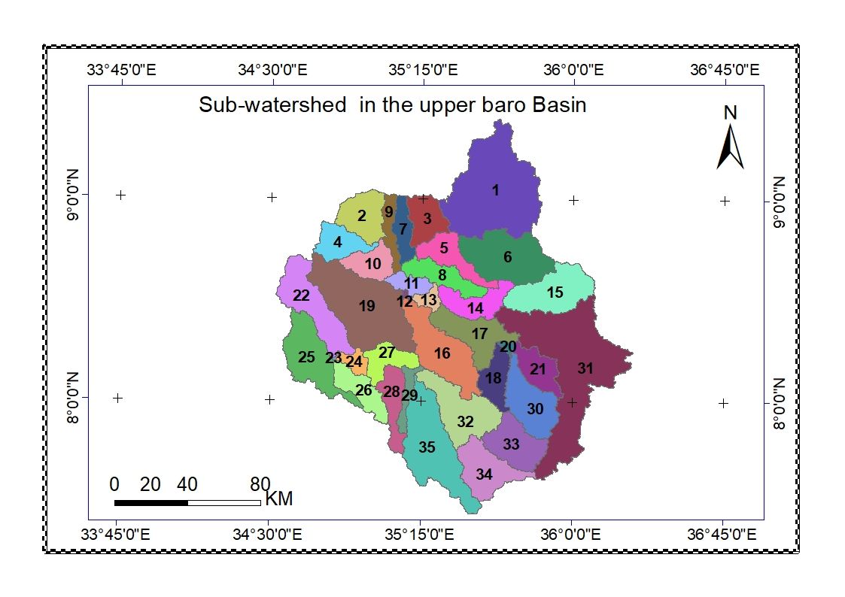
Figure 3.13: Sub Watershed classification in Upper Baro Basin

HRU definition
After watershed delineation, it is important to go through hydrological response unit definition.
The Arc SWAT interface was also used to create hydrologic Response Units (HRUs) that consist of homogeneous soil, vegetative cover, slope, aspect, altitude, and precipitation distribution. The soil, land use land cover and slope map were reclassified in order to correspond with the parameters in SWAT data base. The LULC and soil data in projected shape file format were loaded into SWAT interface to determine the area and hydrological parameters of each LULU-soil categories to simulate within each sub-watershed.

Hydrological response units are portions of a sub basin/watershed that possess unique land use/management/soil attributes. An HRU is not a synonymous to a field; rather it is the total area in the basin with the particular land use, management and soil. While individual fields with specific land use, management and soil may be scattered throughout a sub basin, these areas are lumped together to form one HRU. HRUs are used in most SWAT runs since they simplify a run by lumping all similar soil and land use areas in to a single response unit. It is often not practical to simulate individual fields.

SWAT has predefined land use classes in its crop data base. So it is necessary to prepare look up table, which refers land use land cover classes found in hand with SWAT land use land cover codes. So, well preparation of the lookup-table of the land use/cover types in the SWAT compatible way is basic for the loading of the land use/cover of the study area. A look up table that identifies the 4-letter SWAT code for the different categories of LULC and reclassification was done. Similar to a land use, the soil layer was linked to the user soil data base information by loading soil lookup table and reclassification applied for LULC, soil and slope.

DEM data used during the watershed delineation was also used for the slope classification. The selection of slope classification option (single or multiple) and if multiple slope option is select then defines the range of slope. for this study, multiple slope option (an option for considering different slope classes for HRU definition) was selected and the slope class was classified three-slope class and the range was 0-5% ,5-10% ,10-15% ,15-20%, >20%. After reclassification of LULC, Soil and slope overlay operation was performed.

The next step in HRU analysis were the HRU definition. The HRU distribution in this study was determined by assigning multiple HRU to each sub-watershed. In multiple HRU definition, a threshold level was used to eliminate minor LULC, soil class in each sub watershed. LULC or soil, which over less than the threshold level, was eliminated. Lastly by definition the HRU within sub watershed complete the HRU setup. For this study, the option of multiple HRU was selected with 5% ,5% and 10% threshold area of LULC, soil, and slope in each HRU were used to get better result in Upper Baro Basin.

Soil in HRU
SWAT model require physical and chemical soil properties and LULC data in the simulation of hydrological component. Soil data is spatial data require input in SWAT model. It requires different types soil physical chemical properties such as available water content, soil texture, hydraulic conductivity, bulk density and organic carbon content for the different layers of each soil type where shown. The major soils of Upper Baro Basin are as show below table. parallel look up table was prepared for each type of soil.
Table 3.10: Soil type’s area coverage and SWAT code in Upper Baro Basin
Value | SOIL_TYPE | Area(Km²) | area covered | SWAT CODE
1 | dystric nitisols | 14151.76 | 60.32 | DYNITISOLS
2 | Dystric gleysols | 5423.52 | 23.12 | DYGLEYSOLS
3 | Orthic acrisols | 326.87 | 1.39 | ACRISOLS
4 | Chromic luvisols | 120.45 | 0.51 | CHLUVISOLS
5 | Orthic solonchaks | 778.06 | 3.32 | SOLONCHAKS
6 | Calcic xerosols | 363.20 | 1.55 | CLXEROSOLS
7 | Leptosols | 255.95 | 1.09 | LEPTOSOLS
8 | Eutric cambisols | 1041.60 | 4.44 | EUCAMBISOLS
9 | Eutric nitisols | 108.43 | 0.46 | EUNITISOLS
10 | Eutric fluvisols | 276.99 | 1.18 | EUFLUVISOLS
11 | Dystric cambisols | 58.40 | 0.25 | DYCAMBISOLS
12 | Gypsic yermosols | 43.39 | 0.18 | GYYERMOSOLS
13 | Dystric fluvisols | 231.44 | 0.99 | DYFLUVISOLS
14 | Cambisols | 2.54 | 0.01 | CAMBISOLS
15 | Calcic fluvisols | 92.40 | 0.39 | CLFLUVISOLS
16 | Calcic cambisols | 167.83 | 0.72 | CLCAMBISOLS
17 | Calcaric flubisols | 19.17 | 0.08 | CLFLUBISOLS
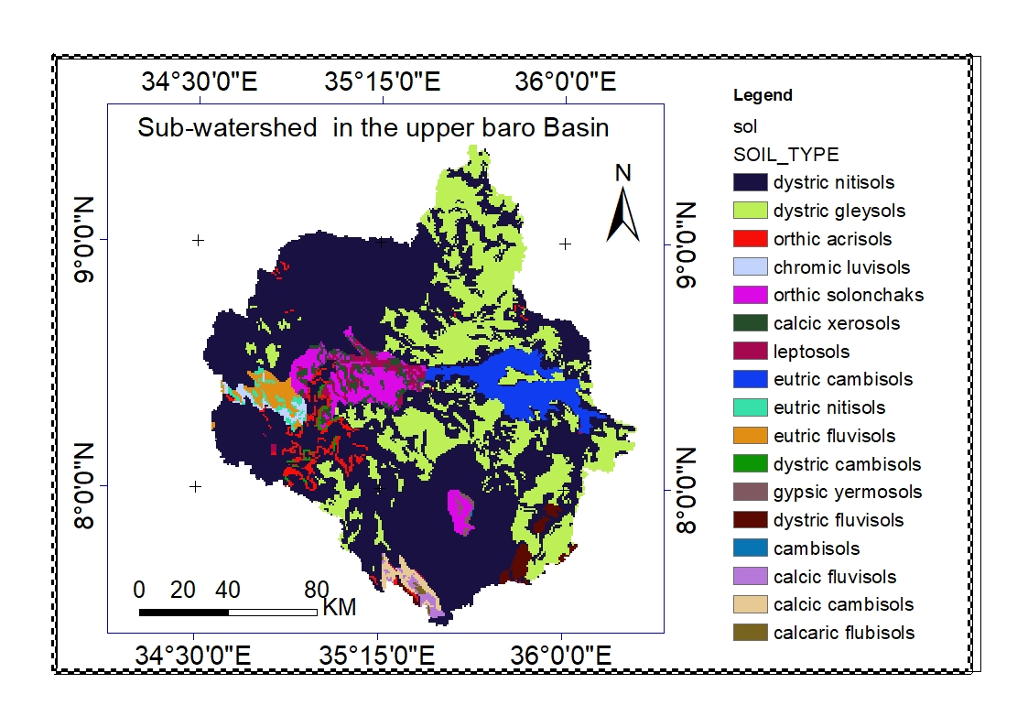
Figure 3.14: Swat soil reclassification for Upper Baro Basin(Source MoWIE)
LULC in HRU
Land use/ land cover is one of the influence factor the hydrological properties of the sub watershed. The prepared LULC was given an input of SWAT model, that to describe the HRU of the sub watershed. Therefore, the impact of each LULC was considered in SWAT Model to calculate the runoff, evaporation and sediment load in each sub watershed. It was reclassified accordingly to the SWAT land use / land cover type.

LULC is one spatial data input for SWAT Model for description HRU of the study watershed. The SWAT Model has predetermined four letter codes for each LULC categories (Table 3.11). These codes were used to link the LULC map of the study area with SWAT land data base. To make compatible prepare LULC with SWAT model look up table was prepared for each type of LULC.
Table 3.11: LULC class SWAT code and their coverage
VALUE | LULC class | SWAT Data Base | SWAT Code
1 | Forest land | Forest Evergreen | FRSE
2 | Wood land | Forest-Mixed | FRST
3 | Grass land | Range-Grasses | RNGE
4 | Schruble land | Range-Brush | RNGB
5 | Settlement | Residential-Medium Density - | URMD
6 | Agricultural land | Agricultural Land-Generic | AGRL
7 | Bare land | Barren | BARR
8 | waterbody | Water | WATR

Slope classes in sub watershed
The slop is an input parameter to develop the hydrological response unit (HRU) in SWAT model. It generates from the resolution of 30m*30m DEM for the study area. Slope classification may be (single or multi) class. For this study slope option (an option of for considering different slope class for HRU definition) was selected. Therefore slope class in this study was classified in to four class. According to Setegn et al. (2008a), slop classification was used to account lower range in hydrological modeling. As shown (Table 3.12) depending on the slop of 0-5%, 5-10 %, 10-15%, 15-20 % and >20% were selected for HRU creation of the study Upper Baro Basin, finally, HRU definition analysis in SWAT helps to load LULC and soil type project.

Table 3.12: Slope classes in the watershed
Slope classes in % | Area (coverage) KM² | watershed area%
0-5 | 1198.55 | 5.16
5-10 | 3176.21 | 13.47
10-15 | 3999.1 | 17.06
15-20 | 3889.71 | 16.71
>20 | 11161.78 | 47.61

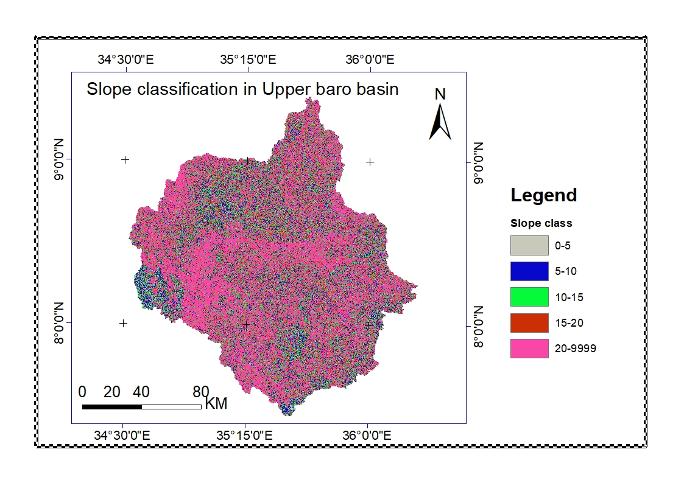
Figure 3.15: Swat Slope reclassification for Upper Baro Basin

Weather Data Definition
SWAT requires long-term daily records of meteorological data which includes precipitation, maximum and minimum temperature, solar radiation, relative humidity and wind speed. These data records were prepared according to the SWAT model table format. The weather generator model called WXGEN (Neitsch, 2001) was used in the SWAT to generate climatic data or to fill missing data using monthly statistics. The WXGEN was provided with all the necessary statistical information from the meteorological records of the watershed to fill the missing portion properly. All meteorological stations were having both temperature and precipitation data but only two of them were having relative humidity, sun shine hour, wind and solar radiation data apart from temperature and precipitation. Gore and Masha metrological stations were synoptic stations (having all type of weather data) used for generating remaining weather data for others (weather generator stations).
After loading WXGEN parameter and location table, the daily meteorological data (daily precipitation, daily minimum and maximum air temperature) with the missing data filled with a missing data identifier of -99 and including the corresponding location table prepared according to the SWAT format were loaded to the model. SWAT takes data of each climatic variable for each sub-basin from the nearest weather station measured from the centroid of the sub-basin.

SWAT Model Simulation, Sensitivity Analysis, Calibration and Validation
After loading all the data that are required by SWAT model, finally it is necessary to run the model with the require time series and read the simulated output. It was adjusted the model to run the simulation for 31 years including 3year warm up period (1987- 2017) years of data. The result from the simulation cannot be directly used for further analysis. Instead, the ability of the model to sufficiently predict the constituent stream flow should be evaluated through sensitivity analysis, model calibration and model validation (White and Chaubey, 2005) .

Sensitivity analysis
Model sensitivity is a technique for assessing the effect of uncertainty on the system performance and to evaluate the effect change of one parameter to another. The purpose of sensitivity analysis is to control the sensitivity of the input parameter compare with the model output parameters. Sensitivity analysis describes how model output varies over a range of a given input variable. Some researchers noted that sensitivity analysis and calibration are more challenged with large number of parameters. In general, an important aim of the parameter sensitivity analysis is to allow the possible reduction in the number of parameters that must be estimated, thereby reducing the computational time required for model calibration. It is necessary to identify key parameters and the parameter precision required for calibration. The sensitivity analysis was carryout to identify the sensitivity parameters of the SWAT model.
Generally, 15 hydrological parameters related to stream flow were selected considered for sensitivity analysis in the study area. The sensitivity of each parameter was identified using the T- test, and P values. P-values were used to determine the significance of the sensitivity a value close to zero has more significance. T-test provides a measure of sensitivity and The most sensitive parameters usually appear with P-values less than the alpha level of 0.05 (larger absolute values are more sensitive) (Abbaspour et al., 2015) .

Model calibration and validation
The SUFI-2 algorithm were applied frequently used in this study of calibration of the SWAT model at the large scale due to its easy application and the reduced number of model runs needed to achieve good prediction (Abbaspour, 2013; Narsimlu et al., 2015). During the calibration process, model parameters were subjected to adjustments in order to obtain model results that correspond better to the measured datasets. After the sensitive parameters were selected, the model simulates the stream flow using default parameter values for the years 1987-2002 with 3year warmup period. In this study, automatic calibration was made on a monthly basis from January 1, 1990 to December 31, 2002 until the average simulated value came closer to the measured value. Automatic calibration makes use of a numerical algorithm to increase the performance of the model and to optimize the numerical objective functions.
After the simulation result for the calibration period had fulfilled the above statistical criteria, validation was performed for an independent period of records from January 1, 2003 to December 31, 2010 and the results were compared against an independent set of measured Upper Baro Basin.

Model performance evaluation
Model performance was carried out to verify the robustness of the model to simulate
hydrological processes. A model performance framework proposed by (Moriasi et al., 2007b) was used in this study. We used the Nash-Sutcliffe Efficiency (NSE) (Nash and Sutcliffe, 1970), percent bias (PBIAS), and ratio of the root mean square to the standard deviation of measured data (RSR) as well as the R2 for model evaluation. These methods are commonly used in judging model performance in many hydrological modeling studies (Baker and Miller, 2013; Moriasi et al., 2007b).
Nash and Sutcliffe simulation efficiency (NSE): indicates the degree of fitness of observed and simulated data and it is calculated using the equation 3.8.
$NSE=1-\frac{\sum_{i=0}^{N}{(Q_{obs}-Q_{Sim})^{2}}}{\sum_{i=0}^{N}{(Q_{obs}-{\overline{Q}}_{obs})^{2}}}$
Where N=number of compared values, Q_{obs}- observed data,${\overline{Q}}_{obs}$observed mean , Q_{sim}:simulated
data
The NSE indicates how well the plot of observed versus simulated value fits the 1:1 line. The closer the model efficiency is to 1, the more accurate the model and if it is between 0 and 1, it indicates deviations between measured and predicted values. If NSE is negative, predictions are very poor, and the average value of output is a better estimate than the model prediction(Nash and Sutcliffe, 1970).
Coefficient of determination R² a measure the ability of a model to predict or explain an outcome in the linear regression setting. R² ranges from 0 to 1, with higher values indicating less error variance, and typically values greater than 0.5 are considered acceptable (Moriasi et al., 2007b; Santhi et al., 2001b; Van Liew et al., 2003).
$R^{2}=\frac{\sum{\left(X_{i}-X_{av}\right)\left(Y_{i}-Y_{av}\right)}}{\sqrt{\sum{(X_{i-X_{av}})^{2}}} \sqrt{\sum{(Y_{i-Y_{av}})^{2}}}}$
Where: $X_{i}$ is measured value, $X_{av}$ is average measured value, ܻ$Y_{i}$ is simulated value, $Y_{av}$ is average simulated value.
Percent bias (PBIAS) measures the average difference between the simulated and measured values for a given quantity over a specified period (usually the entire calibration or validation period) and it is calculated using the equation 3.6.(Gupta et al., 1999; Shi et al., 2011):
$PBIAS=\left[\frac{\sum{Y_{i}-\sum{X_{i}}}}{X_{i}}\right]$
Where: $X_{i}$ is measured value, $Y_{i}$ is simulated value

Where Model evaluation classifies as follow: -
- 0.75 < NSE < 1.00, PBIAS < ±10 - better predictor
- 0.65 < NSE ≤ 0.75, ±10 < PBIAS < ±15 - Good
- 0.50 < NSE ≤ 0.65, ±15 < PBIAS < ±25 – Satisfactory
- NSE≤0.50, PBIAS>±25)-Unsatisfactory.

RESULTS AND DISCUSSION

Landuse/Land Cover Change Analysis
Spatial analysis was carried out to describe the LULC change for 1987, 2002 and 2017.
The statistical result of LULC change also carried out for each year and briefly discussed
as follows:
Landuse/land cover map of 1987
The land cover map of 1987 in Figure 4.2 and the histogram of the LULC class coverage in Figure 4.1 and Table 4.1 showed that the dominantly by Forest covered with 36.74% of the total coverage followed by Grassland, schruble land and Woodland and with 19.77, 19.76% & 11.32% respectively. Waterbody and Bare soil, covers small percentage i.e. 1.19% & 0.4% respectively. Generally major parts of cropland found at the North and northwest of the watershed, settlement were found at Middle West part of the watershed and forest found at South, southwestern and Southern eastern part of the Upper Baro Basin.
Landuse land/cover map of 2002
The land cover map of 2002 in Figure 4.2 and the histogram of the LULC class coverage in Figure 4.1 with Table 4.1 showed that the dominantly by Forest covered with 33.33% coverage followed by Agricultural land schruble land and woodland with 15.60 %, 15.1% & 11.99% respectively. Waterbody and Bare soil small percentage i.e. 0.71%, & 0.54% respectively. Generally major parts of cropland found at the North, northeast northwest and middle part of the watershed, settlement were found at Middle West and North part of the watershed and forest found at South, Southwestern and Southern eastern part of the Upper Baro Basin.
Landuse/land cover map of 2017
The land cover map of 2017 in Figure 4.2 and the histogram of the LULC class coverage in Figure 4.1 and Table 4.1 showed that the dominantly by Forest covered with 31.21% coverage followed by Agricultural land/Cultivation land/, Urban/settlement/ Woodland and schruble land with 26.81%, 15.51%, 10.43 & 10.20% respectively. Bare land & Waterbody covers small percentage i.e. 0.93% & 0.35%.
Generally major parts of cropland found at the North, northeast northwest and middle part of the watershed, settlement were found at Middle West, eastern and north part of the watershed and forest found at South, southwestern and Southern eastern part of the Upper Baro Basin.

Table 4.1: Magnitude of land use/land cover type for 1987, 2002 and 2017in Upper Baro Basin
Land use class | Spatial Converge |  |  |  |  | Change between years
Land use class | 1987  (KM²) | % | 2002  (KM²) | % | 2017  (KM²) | % | 2002-1987 |  | 2017-2002 |  | 2017-1987
 |  |  |  |  |  |  | (KM²) | % | (KM²) | % | (KM²) | %
Grass Land | 4639.21 | 19.77 | 3272.15 | 13.95 | 969.34 | 4.13 | -1367.05 | -5.83 | -2302.81 | -9.82 | -3669.87 | -15.64
Agricultural | 2065.92 | 8.81 | 3659.08 | 15.60 | 6290.56 | 26.81 | 1593.15 | 6.79 | 2631.48 | 11.22 | 4224.63 | 18.01
Bareland | 92.81 | 0.40 | 166.24 | 0.71 | 217.43 | 0.93 | 73.43 | 0.31 | 51.19 | 0.22 | 124.62 | 0.53
Urban | 471.30 | 2.01 | 2060.52 | 8.78 | 3638.16 | 15.51 | 1589.23 | 6.77 | 1577.64 | 6.72 | 3166.86 | 13.50
Woodland | 2656.81 | 11.32 | 2812.80 | 11.99 | 2,447.74 | 10.43 | 155.98 | 0.66 | -365.06 | -1.56 | -209.08 | -0.89
Forestland | 8619.97 | 36.74 | 7819.91 | 33.33 | 7323.35 | 31.21 | -800.06 | -3.41 | -496.56 | -2.12 | -1296.62 | -5.53
Schruble land | 4635.94 | 19.76 | 3544.63 | 15.11 | 2393.95 | 10.20 | -1091.31 | -4.65 | -1150.69 | -4.90 | -2241.99 | -9.56
Waterbody | 280.04 | 1.19 | 126.66 | 0.54 | 81.48 | 0.35 | -153.37 | -0.65 | -45.18 | -0.19 | -198.56 | -0.85

It is apparent that the forest cover has decreased markedly from 36.74 to 33.33% in 1987-2002 land use map (Table 4.1), especially for the regions in the south and Southwest of the Upper baro basin and also forest cover decrease from 34.2 to 31.21 in 1987-2017. This could be attributed to increasing the population growth that cause increase demand of cultivation land, firewood, timber and clearing for agricultural purposes. In contrast, the agricultural area has dramatically increased over in 8.8% (2065.95 km²) in 1987 to 15.60% (3659.08 km2) 2002, to 26.81 % (6090.56 km2) in 2017. Generally, the LULC image (Figure 4.2) and data (Table 4.1) of three periods indicate both conversion and modification of LULC types take place.

Compared to the periods of 1987–2017 LULC are show that there where contracting and expanding rates. This might be because of the deforestation activities that have taken place for the purpose of agriculture and urban expansion pressure in the area. similar study (Tilahun, 2015) study on Baro akobo basin results show a rapid shrinking of area covered by forests, Woodland, schrubleland, Grassland and wetland especially in the uplands. The decrease of forests Woodland, schrubleland, and Grassland due to increase the demand and over timber production and increases in croplands and Agricultural/cultivation/ land was also noticeable over the period of time 1987-2017.

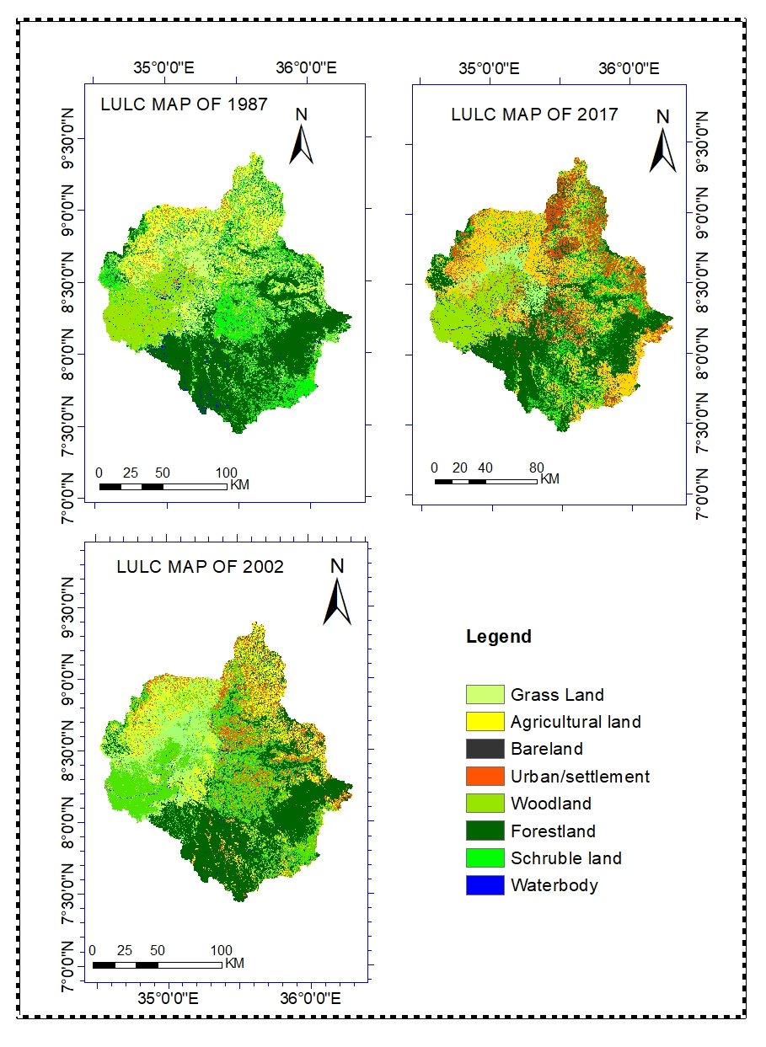
Figure 4.1: Land use land cover Map of 1987,2002 and 2017.

Accuracy Assessment of Landuse/Land Cover Classification
Accuracy assessment is an important step in the process of analyzing remote sensing data (Okeke and Karnieli, 2006) and it is an important to determine the value of the resulting data quality to a particular user classification, i.e. the information value. The accuracy assessment was used to determine the degree of ‘correctness’ of a map or classified image. In this study the accuracy assessment was performed using the 340 referenced points which were collected through stratified sampling. Overall accuracies obtained were 92.14%, 94.63% and 95.93% for the 1987, 2002 and 2017 images, respectively. The overall accuracy was computed by dividing the correct classified to the total number of reference pixel in the error matrix. The accuracy assessment is usually a matter of comprise between the ideal and affordable (Wondrade et al., 2014) . Based on the overall accuracy and Kappa coefficient, the classified maps achieved a satisfactory classification accuracy. According to (Anderson, 1976) and (Foody, 2002) suggested that a good overall classification map accuracy are accepted if and only possess accuracy of at least 85 percent. Further description of producer`s, user`s and overall accuracy were describe at the (table 4.1,4.3 and 4.3) for LULC 1987,2002, and 2017 respectively for each period of the study.
Table 4.2: Accuracy Assessment of Classified Landuse/Land Cover Maps of 1987
LULC class  Classified data | Reference data
LULC class  Classified data | FT | WD | GR | UB | SL | AG | WB | BL | Total Row | User`s accu(%)
Forest land(FT) | 65 | 0 | 0 | 0 | 3 | 0 | 0 | 0 | 67 | 95.59
Woodland(WD) | 0 | 57 | 3 | 0 | 1 | 0 | 0 | 0 | 60 | 93.44
Grass land(GR) | 0 | 3 | 30 | 0 | 0 | 3 | 0 | 0 | 37 | 83.33
Urban(UB) | 0 | 0 | 0 | 42 | 0 | 0 | 0 | 3 | 48 | 93.33
Schruble (SL) | 2 | 0 | 0 | 0 | 44 | 0 | 0 | 1 | 48 | 93.62
Agriculture(AG) | 0 | 0 | 1 | 3 | 0 | 35 | 0 | 0 | 38 | 89.74
Waterbody(WB) | 0 | 0 | 0 | 0 | 0 | 0 | 30 | 0 | 30 | 100
Bare land(BL) | 0 | 0 | 3 | 3 | 0 | 0 | 0 | 37 | 41 | 86.05
Total Column | 67 | 60 | 37 | 48 | 48 | 38 | 30 | 41 | 340
Prod. accu(%) | 97.0 | 95.0 | 81.01 | 87.50 | 91.67 | 92.11 | 100 | 90.24
Overall classification accuracy= 92.14% and overall Kappa statistics =0.9094

Table 4.3: Accuracy Assessment of Classified Landuse/Land Cover Maps of 2002
LULC class  Classified data | Reference data
LULC class  Classified data | FT | WD | GR | UB | SL | AG | WB | BL | Total Row | User`s accu(%)
Forest land(FT) | 49 | 0 | 0 | 0 | 0 | 0 | 1 | 0 | 50 | 98.00
Woodland(WD) | 0 | 38 | 0 | 0 | 0 | 0 | 0 | 0 | 38 | 100.00
Grass land(GR) | 0 | 0 | 29 | 0 | 0 | 3 | 0 | 0 | 32 | 90.63
Urban(UB) | 0 | 0 | 0 | 45 | 0 | 4 | 0 | 4 | 53 | 84.91
Schruble (SL) | 2 | 0 | 0 | 0 | 46 | 0 | 0 | 0 | 48 | 93.88
Agriculture(AG) | 0 | 1 | 2 | 2 | 0 | 45 | 0 | 0 | 50 | 91.84
Waterbody(WB) | 0 | 0 | 0 | 0 | 0 | 0 | 38 | 0 | 38 | 100.00
Bare land(BL) | 0 | 0 | 0 | 0 | 0 | 0 | 0 | 45 | 45 | 100.00
Total Column | 51 | 39 | 31 | 47 | 46 | 52 | 39 | 49 | 340
Prod. accu(%) | 96.08 | 97.44 | 93.55 | 95.74 | 100.00 | 86.54 | 97.44 | 91.84
Overall classification accuracy= 94.63 and overall Kappa statistics =0.9385

Table 4.4: Accuracy Assessment of Classified Land Use/Land Cover Maps of 2017

LULC class  Classified data | Reference data
LULC class  Classified data | FT | WD | GR | UB | SL | AG | WB | BL | Total Row | User`s accu(%)
Forest land(FT) | 57 | 2 | 0 | 0 | 0 | 0 | 0 | 0 | 59 | 96.61
Woodland(WD) | 0 | 50 | 0 | 0 | 0 | 0 | 0 | 0 | 50 | 100.00
Grass land(GR) | 0 | 0 | 47 | 0 | 0 | 3 | 0 | 0 | 50 | 94.00
Urban(UB) | 0 | 0 | 0 | 44 | 0 | 2 | 0 | 4 | 60 | 88.00
Schruble (SL) | 0 | 0 | 0 | 0 | 45 | 0 | 0 | 0 | 45 | 100.00
Agriculture(AG) | 0 | 0 | 4 | 0 | 0 | 51 | 0 | 0 | 55 | 92.73
Waterbody(WB) | 0 | 0 | 0 | 0 | 0 | 0 | 33 | 0 | 33 | 100.00
Bare land(BL) | 0 | 0 | 0 | 0 | 0 | 0 | 0 | 27 | 27 | 100.00
Total Column | 57 | 52 | 51 | 44 | 45 | 56 | 33 | 31 | 340
Prod. accu(%) | 100.00 | 96.15 | 92.16 | 100.00 | 100.00 | 91.07 | 100.00 | 87.1
Overall classification accuracy=95.93% and overall Kappa statistics =0.9533

Stream Flow Modeling Using SWAT

Sensitivity analysis
Sensitivity analysis was carried out for stream flow to identify parameters that affect stream discharge from selected 15 (fifteen) parameters were reported as sensitive were selected.
Sensitivity analysis was carried out to identify which model parameter is most important or
sensitive. Flow sensitivity analysis was carried out for a period of 13years, which
the calibration period (from January 1, 1990 to December 31, 2002) . About a number of iterations have been done by the model at the point where Baro gambella gauging station was found. From the sensitivity result about fifteen Parameters were taken as governing parameters which were believed to have effect on the simulated values are considered for calibration.
Table 4.5: Result of Sensitivity analysis of flow parameters of the study Upper Baro Basin

Parameter Name | Description | t-stat | P-Value | Rank
1:R_CN.mgt | SCS runoff curve number | -28.38 | 0 | 1
5:R_SOL_AWC(..).sol | Available water capacity of the soil layer | 6.63 | 0 | 2
7:V_ESCO.hru | soil evaporation composition factor | -5.11 | 0 | 3
10:V_CH_N2.rte | Manning's "n" value for the main channel | 3.75 | 0 | 4
6:R_SOL_K(…).sol | Saturated hydraulic conductivity | -2.18 | 0.29 | 5
3:V_GW_GELAY.gw | Groundwater delay (days) | -0.73 | 0.45 | 6
4:V_GWQMN.gw | Threshold depth water in the shallow aquifer for return flow to occur. | -0.67 | 0.50 | 7
8:V_REVAPMN.gw | Threshold depth of water at the aquifers | -0.49 | 0.62 | 8
9:V_GW_REVAP.gw | Ground water “revap” coefficient | -0.32 | 0.96 | 9
2:V_ALPHA_BF.gw | Base flow alpha factor (days) | 0.27 | 0.99 | 10
11:R_HRU_SLP.hru | Average slope steepness of hru | 0.2 | 0.28 | 11
14:R_SOL_Z(…).sol | Total Soil depth (mm) | 0.18 | 0.30 | 12
13:R_SOL_BD(..).sol | Moist bulk density | -0.1 | 0.35 | 13
12:R_OV_N.HRU | Manning's n value for overland flow | 0.09 | 0.47 | 14
15:R-CH_K2RTE | Effective hydraulic conductivity in main channel alluvium | 0.06 | 0.3 | 15

The result shows that 10 parameters have a significant influence in controlling the streamflow in the watershed i.e. the hydrological process of the study watershed mainly depends on the action of these parameters. Curve number (CN2), Available water capacity (SOL_AWC),), soil evaporation composition (ESCO), Manning's "n" value for the main channel (CH_N2), Saturated hydraulic conductivity (SOL_K), Groundwater delay (GW_GELAY), Threshold depth water in the shallow aquifer for return flow to occur (GWQMN), Threshold depth of water at the shallow aquifers (REVAPMN), Ground water evaporation coefficient (GW_REVAP).

SWAT model Calibration and Validation
The calibration and validation model were performed to improve the model performance at main gauging station. Ten parameter, which were the most influential of monthly observed stream flow simulation analysis were selected. The most sensitivity parameter responsible for the stream flow assessment of the Upper Baro Basin.
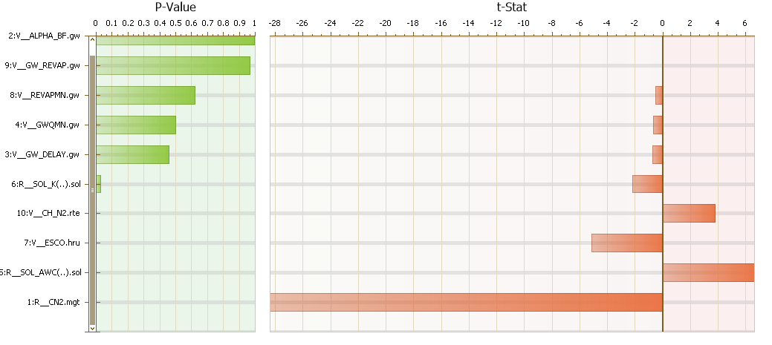
Figure 4.2:Global sensitivity analysis for stream flow.
For the calibration period of thirteen years (1990 -2002) the simulated monthly flows showed good agreement with monthly observed discharge of Upper Baro basin with a coefficient of determination (R² = 0.87), Nash-Suttcliffe efficiency (NSE = 0.76), and percent bias (PBIAS = -17%). However, the model overestimated the peak monthly flow for some year in calibration period; it followed the trend of observed monthly Upper Baro basin discharge and gave a good response to extreme rainfall events, which resulted in high runoff volume.
The SWAT model also successfully validated streamflow for an independent period (2003 – 2010) with R²=0.77, NS=0.72 and PBIAS = -4.5% during validation period; the values fulfilled the statistical model performance criteria R² > 0.6 and NSE > 0.5 recommended by SWAT developer(Santhi et al., 2001a). The percent bias (PBAIS) values (-17% and 4.5%) during calibration and validation periods respectively also fulfilled the statistical model performance criteria PBAIS>±15(Moriasi et al., 2007a).
The percentage of observations bracketed by the 95PPU was 75% for calibration and 72% for validation. The r- factor, which is the average thickness of the 95PPU band divided by the standard deviation of the measured data, was 1.08 for calibration and 0.84 for validation. According to Abbaspour (2015) suggested a p-factor greater than 0.70 and r- factor less than 1.5 show that the model is accurate in simulating streamflow. Thus, the results show that the model accurately simulated the biophysical processes influencing flow in the study area.
Table 4.6: Result of final calibrated flow parameters for upper Anger watershed
Parameter Name | Fitted Value | Range
R_CN2 | -0.230 | ± 0.25
V_ALPHA_BF | 0.053 | 0-1
V_GW_DELAY | 113.50 | 0-500
V_GW_REVAP | 0.1343 | 0.02-0.2
V_CH_N2 | 0.3436 | 0.01-1
R_SOL_K | 0.5450 | 0-1
R_SOL_AWC | 0.755 | 0-1
V_ESCO.hru | 0.2530 | 0-1
V_REVAPMN.gw | 0.3700 | 0-10
V_GWQMN.gw | 1.982 | 0-2
Generally, the above information showed that the performance of the model was better during the calibration period more than the validation period.
The figure in calibration and validation show that the model does not capture fully and adulation flow in the observed and simulated discharge. Such kind of error and discrepancy occur by errors occurs during flow measurement, uncertainty in stream flow and the model by itself has limitation to capture the high flow values(Tolson and Shoemaker, 2004). Though there were such gaps, the model shows good correlation with the measured flow in both calibration and validation period, and can be applicable for Upper Baro Basin in the characterization of the hydrological balance.
Table 4.7: Summary of model performance evaluation for calibration and validation period on monthly time steps
Period | Mean annual water yield (m³/s) |  | Monthly model efficiency measures
 | Observed | Simulated | R² | NSE | PBAIS (%)
Calibration | 422.461 | 535.96 | 0.87 | 0.76 | -17.4
Validation | 374.42 | 451.12 | 0.77 | 0.72 | -4.5

Figure 4.3: Calibration of average monthly observed and simulated flow (1990-2002)

Figure 4.4: Validation of average monthly observed and simulated flow (2003-2010).

Landuse/land cover change response to hydrological process
To evaluate the effects of landuse/land cover change on the hydrology, Scenario simulation is a common method of using a model to study the hydrological responses of LULC changes. Landuse/land cover of three different years 1987,2002 and 2017 were used as input variables in SWAT model in order to compare output as a result of their differences in LULC. The simulated results of the Upper Baro Basin under different landuse/land cover scenarios shown in Table4.8.
Table 4.8: Average annual hydrological summaries under different LULC
Parameter | LULC  1987(mm) | LULC  2002(mm) | LULC  2017(mm) | Change Detection
 |  |  |  | 1987-2002 | 2002-2017 | 1987-2017
SUR Q | 773. | 793.05 | 816.53 | 20.05 | 23.48 | 43.53
GW Q | 270.8 | 259.29 | 243.22 | -11.08 | -16.07 | -27.58
LAT Q | 87.37 | 85.49 | 81.74 | -1.88 | -3.75 | -5.63
WYLD | 1131.71 | 1137.83 | 1141.49 | 6.12 | 3.66 | 9.78
PERC | 302.62 | 291.17 | 275.00 | -11.45 | -16.17 | -27.62
ET | 807.1 | 800.4 | 797 | -6.7 | -3.4 | -10.1
SEDI | 62.72 | 106.02 | 124.49 | 43.3 | 18.47 | 61.77
CN | 76.89 | 77.83 | 78.82

According results (Table 4.8) indicate that land use/land cover change between 1987 and 2017
has contributed to the increase in annual surface runoff by 43.53mm and decrease in annual
base flow by 27.58mm. Evapotranspiration 10.1mm decreased by. As explained by (Kashaigili 2008) that decrease in forest cover influence the increase in surface flow by decreasing opportunity of infiltration which in turn impact water yield. The annual water yield has increased by 9.78mm.

Comparison of mean monthly surface runoff and groundwater
Decreases in base flow had a potential effect on the change in annual river flow (Figure 4.7). Results from land use/land cover change scenarios show Table 4.9, the mean monthly (wet and dry) flow has increased from 82.9mm and decrease 20.54mm with respect to the change of land use and land cover from 1987 to 2017.

Figure 4.5: Mean monthly Surface Runoff(mm)

Figure 4.6: Mean monthly Groundwater Recharge(mm).

Spatial variability of surface runoff over sub-basin
Spatial variability of surface runoff in figure 4.8 show that surface runoff is highly sensitive to the change from LULCC over sub-watersheds in the period of 1987,2002 and 2017.
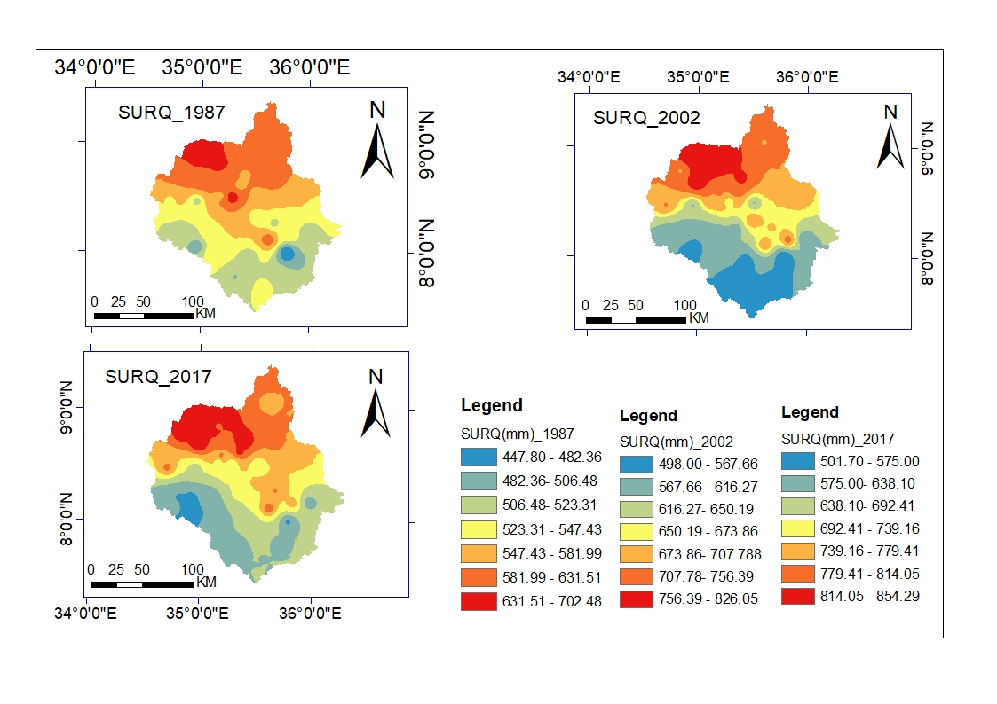

Figure 4.7: Spatial distribution predicted annual surface runoff (SURQ) (mm) for different LULC conditions.

Mean monthly wet and dry month streamflow simulation and their variability
Months July, August, and September were considered as wet period and dry (Jan, Feb, and March) months, these seasonal variability of streamflow was evaluated.

Table 4.9: Mean monthly wet and dry month streamflow simulation and their variability
Mean monthly streamflow (m³/s) |  |  |  |  |  | Mean monthly streamflow change
1987 |  | 2002 |  | 2017 |  | 2002-1987 |  | 2017-2002 |  | 2017-1987
Dry | Wet | Dry | Wet | Dry | Wet | Dry | Wet | Dry | Wet | Dry | Wet
84.2 | 871.2 | 72.15 | 907 | 63.66 | 954.1 | -12.05 | +35.8 | -8.49 | +47.1 | -20.54 | +82.9

The wet and dry mean monthly streamflow of 1987, 2002 and 2017 LULC and its variability during the study period are presented in Table 12. The mean monthly streamflow of dry period was decrease by 12.05% and increase by 35.8% in wet period for the 2002 to 1987 and mean monthly of dry period decrease by 20.54 and increase 82.9 for the wet period of 2017 to 1987.

Impact of LULCC on Soil loss potential

Soil loss areas identification and mapping
Three soil erosion potential maps of the study area based on the InVEST model was obtained (Figure 4.9). The areas with mainly increasing of soil erosion are located in the central and western parts of the study area in the year of 1987 to 2002 and 2002 to 2017 due to characterized by high slope, continuous plowing, and some area no little change shown, this is due to characterized by low rainfall, low slope, and good plant coverage. According to result of 2017 LULC shows the soil loss rate in the study area were increasing the level within 30 years these result indicate there were directly relationship with corresponding to LULC change. The change of soil erosion between 1987 and 2017 is due to mainly the increase of agricultural land and changing of vegetation cover. It was also found that the mean annual soil loss rate of the study basin was 67.77 t/ha/yr, 70.84 t/ha/yr and 103.64 t/ha/yr in 1987 ,2002 and 2017 respectively (table 10).

Table 4.10: The mean annual soil losses per hectare for the three study years.
Year | Mean soil loss(t/ha/yr | Annual soil loss(t/yr)
1987 | 67.77 | 276462.8
2002 | 70.84 | 305342
2017 | 103.64 | 391741.2

Spatial analysis revealed that the disappearance of forest patches from relatively flat areas, increased in wasteland in steep slope, and intensification of cultivation practice in relatively more erosion-prone soil were the main factors contributing toward the increased soil erosion potential of the watershed during the study period.

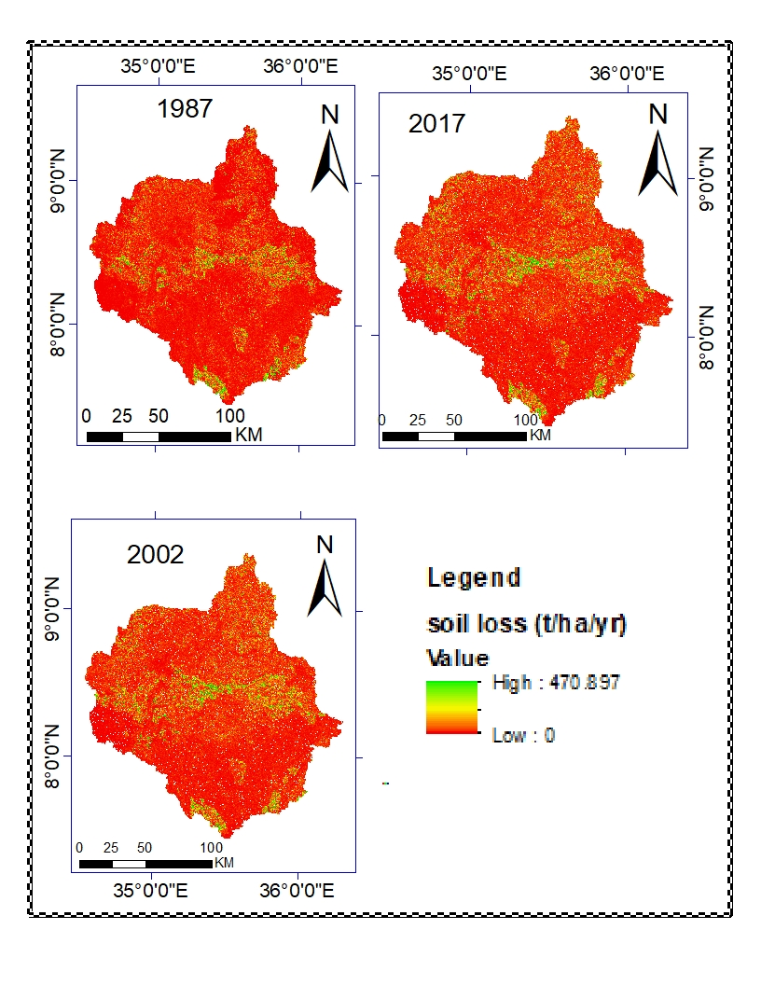
Figure 4.8: Spatial distribution soil loss potential for the years of 1987, 2002 and 2017

Soil erosion potential per land cover
A study of soil formation rates in the different agro-ecological zone of Ethiopia indicates that the range of the tolerable soil loss level for the various agro-ecological zones of Ethiopia was 2 to 18 t/ha/yr (Hurni H., 1985). Based on these, classes were assigned for the study area depending on their average annual soil loss yield loading as per coverage; the map was reclassified into three major categories of soil erosion hazards region i.e. low, moderate and high erosion conditions as shown in Table 4.11.
Table 4.11: Class assigned for degree of severity
Severity Class | Soil loss yield (ton/ha/yr.) | Remarks
1 | 0 – 5 | low
2 | 5_10 | moderate
3 | >10 | High

Table 4.12: Annual soil loss for 1987,2002 and 2017 per each LULC class in the study area.

LULC Class | Year
LULC Class | 1987 | 2002 | 2017
Urban | 10.26 | 5.73 | 4.97
Forestland | 5.33 | 5.53 | 6.99
Schruble land | 9.45 | 12.27 | 19.17
Agricultural land | 14.68 | 21.42 | 27.28
Bareland | 0.72 | 0.52 | 0.47
Grass | 3.55 | 3.13 | 9.56
Woodland | 6.18 | 5.56 | 5.65

Based on the estimated rate of mean annual soil loss, the area was classified into seven erosion risk classes based on land use land cover to show spatial distribution and the area coverages start from the year 1987 to 2017. During the study periods, increase the trend of soil loss these indicates a sharp increase in landuse /land cover change.

DISCUSSION
LULC changes analysis showed that there was dynamic transition from one land use to the other classes that did not follow a similar pattern during specific period (1987–2017). From the analysis in section 4.1, it is clear that the land use/land cover along the Upper Baro Basin significantly changed. Following the fall of the Dergue government, Ethiopia’s agricultural development policy by the EPRDF government has aggravated deforestation by promoting intensive farming practices, and strongly advocate large-scale intensification and commercialization of agriculture (Tadesse et al., 2014). The forces driving the frequent transfer and conversion primarily included intensive agriculture, economic development, population and macro-policy forces.

Consequently, agricultural investment policies encouraged further deforestation that leads to land conversion (Gebreselassie, 2006) and various types of natural forests and woodlands in the Western part of the Ethiopia, being cleared and replaced by commercial agriculture (Gobena and Gan, 2010; Stebek, 2011). In the study basin, cultivated land has gained/increased by 18.01%, mainly converted from the grazing land by 15.64%. Forest and shrubland conversion also contribute to increasing the cultivated land. The increasing conversion of cultivated land was due to farmers focusing on cash cropping which was encouraged by government like providing agricultural inputs such as improved seed and inorganic fertilizers. In addition, farmers have adjusted the structure of agricultural production to increase their income, and more young people in rural areas have sought better jobs in large cities. All of these factors have indirectly affected land use patterns.

Since 1990, the fast economic development, the Upper Baro Basin has accelerated the urbanization process, which has resulted in the conversion of cropland to other types of land use and has resulted in a greater amount of land under construction. Population is an important factor that could lead to land use change. A population increase results in greater residential land. However, additional croplands are required to feed the growing population. Due to the continuing population growth, Industrial development and the expansion of farming areas in Upper Baro Basin were inevitably resulted in decreasing Forestland, schruble land, woodland and grassland areas. Population pressure and human activities are the main reasons for the dramatic changes in the LULC.

The study findings indicate that the change in the land use/land covers has a significant impact
to the hydrological response of Upper Baro Basin. Studies from different countries have also show LULC change alters the hydrologic cycle which has direct effects on hydrological processes such as precipitation, runoff generation ,evapotranspiration regime and surface runoff etc (Setyorini et al., 2017).
The results indicate an increase in surface runoff increased from 773 mm/yr in 1987 to 793.05 mm/yr in 2002 and 816.53 mm/yr in 2017 those due to drastic increase of agriculture and urban at the expense of other land covers while groundwater was decreased from 283.21 mm to 257.13 mm in 1987as compared to 2017 due to LULC change (Table 4.11 and Figure 4.6-4.8). Similarly (Anaba et al., 2017; Ngo et al., 2015) reported that an increase in annual surface runoff increased when forest lands were converted to the other classes especially cultivated land . The expansion of agricultural land by displacing forest and schruble land results in an increase of surface erosion generation following rainfall events and causes reduce in soil moisture conditions and groundwater recharge to shallow aquifers. similarly studies suggest that grassland and lateral flow are positively correlated (Gyamfi et al., 2016; Shukla and Gedam, 2019).

The spatial variability of surface runoff in the study area results indicate that the contribution of surface runoff was highly variable. Surface runoff is generated from the sub-watersheds located in the uplands and mostly where agricultural land and human activities are dominant these show that more surface runoff was generated in sub-watersheds in the uplands. While The south, southeast and east parts are dominated by vegetation cover, which have not experienced a significant change in runoff between 1987 ,2002 and 2017. These differences in the response among landuse types can be attributed to the changes in canopy structure, CNII value and surface roughness, as was also found by (Lahmer W, 2001).

The wet and dry mean monthly streamflow of 1987, 2002 and 2017 LULC and its variability during the study period are presented in Table 12. The mean monthly streamflow of dry period was decrease by 12.05% and increase by 35.8% in wet period for the 2002 to 1987 and mean monthly of dry period decrease by 20.54 and increase 82.9 for the wet period of 2017 to 1987.

Similar, studies were also conducted in Ethiopian region to evaluate the impact of LULC change on streamflow. Haile and Fetene (2012) reported that the mean wet monthly streamflow was increased by 39 % and dry average monthly flow decreased by 46 % for 2011 as compared to 1985 due to LULC change in Angereb Watershed. According to different study, The net effect of vegetation cover loss is increased water yield (Bosch and Hewlett, 1982). Additionally, a reduction in dry season flow is often cited as a consequence of deforestation (Bruijnzeel, 1988; Liu et al., 2015).

Spatial analysis of soil erosion/loss shows that the disappearance of forest patches, the vegetation of grazing land increased of the bare land, and intensification of cultivation practice were the main factors contributing toward the increased soil erosion potential of the watershed during the study period. There also a directly proportional increment of land use/land cover change for cultivated land and soil erosion. The increasing of soil loss in the cultivated areas was not surprising because larger cultivated area meant larger areas the most disturbed and exposed to different erosion agents. There is observed the insignificant variation of soil loss is observed in the forest land is due to the protective capacity of trees in the forest is high.

The soil loss rate increased over time as cultivation continued after forest clearing. Clearing one hectare of forest to agriculture increases the sediment load in the Upper baro Basin crossing into Sudan by 25 tons/yr (Sutcliffe, 2009). The study analysis also shows that cultivated land is more prone to erosion than other land used (forest, shrub and grazing land). Because there has been frequent crop cultivation without fallowing, the absence of proper conservation activities and planting crops/trees to recover soil fertility.
Soil erosion is a serious problem in the Ethiopian highland that leads to increased sedimentation of reservoirs and lakes (Bezuayehu, 2006). However, deforestation locally has been connected with processes of sediment transport to the main river (Broothaerts et al., 2012).The study analysis shows that deforestation is increasing within 30 years within forest land only and the conversion of vegetation cover to cultivated land.

SUMMARY, CONCLUSIONS AND RECOMMENDATIONS

SUMMARY
The economy of Ethiopia largely depends on agriculture. However, the sector has been
constrained by land degradation. Poor landuse practices and improper management systems have played a significant role in causing watershed hydrology, high soil erosion rates, sediment transport and loss of agricultural nutrients. So far limited measures have been taken to combat the problems. Providing the more study are required the spatial and temporal change of landuse/land cover are critical concern were LULC change are sensitive parameter for hydrology of Upper Baro Basin since magnitude pattern of hydrology vary from time to time. The main objective of this study was to assess the impacts of LULC change on the hydrology of Upper Baro Basin.

In this study, Earth Resources Data Analysis System (ERDAS) imagine 2014 were utilized supervised classification method are performed for the LULC change detection analysis and a physically based semi-distributed (SWAT) were applied to the Upper Baro Basin for modeling the hydrology and also Integrated Valuation of Ecosystem Services and Tradeoffs(InVEST) used for performed impact of soil loss due to LULCC. From the analysis of processed satellite images, it is evident that land cover changes had been occurred between 1987 and 2017. forest cover has decreased from 36.74% to 31.21%, attributable to logging for timber, firewood, and clearing for agricultural purposes. In contrast, the agricultural area increased over the years from 8.81% to 26.81%. Similarly, grasslands and bushes have also been converted to agricultural areas.
On the other hand, systematic data preparation was performed to carry out soil and water assessment tool (SWAT) model to simulation the impacts in Upper Baro Basin analysis of spatial-temporal interaction and variations of different hydrological processes in relation to landuse/land cover. As discussed in chapter four, Upper Baro basin has experienced significant LULC changes during the past three decades. Landuse/Land covers at three different years thus 1987,2002 and 2017 were used as input variables in the SWAT model in order to compare output as a result of their differences in LULCs. Sensitivity analysis, calibration, validation and uncertainty analysis were performed on the selected models before they are further used for scenario analysis. Sensitivity analysis of the SWAT parameters indicates that runoff is most sensitive to curve number, available water capacity of the soil layer, soil evaporation composition factor, manning's "n" value for the main channel and saturated hydraulic conductivity.

To accommodate these situations, hydrology simulations were made and analyzed using SWAT2012 under current conditions using the 2002 landuse/land cover map and under “what if scenario of the 1987 and 2017 landuse/land cover continues till the present time. Seasonal streamflow variability due to the LUCC was assessed and comparisons were made on surface runoff, lateral flow and ground water flow contributions to streamflow based on the three simulation outputs. Surface runoff was increased from 713.85 mm to 760.49 mm while groundwater was decreased from 283.21mm to 257.13 mm in the years 1987 and 2017. Also, surface runoff was increased from 737.67 mm to 760.49 mm while groundwater was decreased from 266.32 mm to 257.13 mm in the year 2002 and 2017.

Soil loss is estimated using Integrated Valuation of Ecosystem Services and Tradeoffs (InVEST) model. Its manifestations are detected by high annual total soil loss rate which reach up to 391741.2 tone/year in 2017 to 276462.8 tone/year in 1987. However, the mean annual soil loss for the Upper Baro Basin was 103.64 ton/ha/year in 2017 to 67.77 ton/ha/year in 1987.

CONCLUSIONS
Lack of appropriate and reliable data is a major constraint in deriving information that help in developing strategies for sustainable water resources management at the landscape and watershed scale. In this study, impact of landuse/land cover change on hydrology was investigate at Upper Baro Basin and the study include landuse/land cover change and their relation on the hydrology.

The result of Analysis show that the area undergone LULC transformation during the study period that for the thirty years (1987-2017). The combine estimate of forestland, Woodland, Schruble land and Grassland which account 87.59% in 1987 have been reduced to 55.98 in 2017 and the cultivation, Urban, Grassland and forestland have higher magnitude of the change. The agricultural and settlement area have experienced the highest annual rate of change over the study area. This indicate that revealed conversion of one land cover class to other land cover class in Upper Baro Basin.

The rapid expansion of cultivated land at the expense of grazing and shrub lands imply the increase of local community’s interest on producing annual crops instead of livestock production. To increase the crop production, farmers have been increasing the size of cultivated land. Of course this could have been achieved by intensifying agricultural practices on the existing cultivated land. The other cause of rapid conversion of other LULC to cultivated land was the reduction of land productivity. As a result of LULC change and continuous soil erosion, the productivity of land can decline from time to time. To compensate the reduction of yield, farmers believed increasing the size of cultivated land for annual crop production as a right solution achieved by clearing the natural vegetation which would have been important in mitigating the climate change and soil erosion had it been used sustainably.

Physically based semi-distributed continuous time-scale hydrological model were used to simulate different spatial, temporal, time series data to predict flow components and hydrologic characteristics over the watershed. The results of this study show that landuse/land cover change plays a dominant role in changing basin hydrology and stream flow in the Upper Baro Basin. The LULC change caused increase in the surface flow and actual evapotranspiration while the reduction of ground water discharge, percolation to ground water, lateral flow and water yield at mean annual basis in the study period.

The study has shown that the change in landuse from natural areas to cropland and grassland areas leads to an increase in the peak flows which have an implication in the magnitude of floods. The change in landuse had also caused a decrease in low-flow duration. These change were attributed by combine impact of decrement of vegetation cover and increase of cultivated land and urban/settlement throughout the study period.

The increasing soil erosion hazard among the three references years were considerable indicating that changes in land cover affect significantly the soil erosion rate. This indicates that there is a directly proportional increment of soil loss potential and land use land cover change. The trend of soil loss in the three study years indicates increasing and the highest erosion rate (sediment export and soil loss) was observed in the cultivated land next to grazing land. Finally, this study urges an intervention from concerned body looking into sustainable landuse management by reversing the common direction of LULC change seen in the area.

RECOMMENDATIONS
Based on the findings of this research study the following important recommendation were made for the sustainable natural resource management:

- There should be an appropriate LULC planning and scenarios, in order to use a given local land resource with maximum output in a sustainable manner.
- Create awareness, understanding of environmental, and resource issue among the local community to reverse the rapidly increase LULCC.
- It is recommended to set up more hydro-meteorological gauging stations in the watershed in corresponding with precise measurement.
- It should be providing SWC practices in general and farmland terracing and exclosure in particular played important role to halt land degradation and to restore degraded lands
- Manager’s/decision makers should integrate and implement river basin managing as well as development of the adaptation and adaptation strategy based land use so that the hydrological behavior of the watersheds will be improved.
- Further studies which incorporate the interaction and feedback of climate and landuse/land cover changes should be undertaken using a physically distributed hydrological modeling and other climate change model.

REFERENCES
Abbaspour, K. C. (2013). SWAT-CUP 2012. SWAT Calibration and Uncertainty Program—A User Manual.
Abbaspour, K. C., Rouholahnejad, E., Vaghefi, S., Srinivasan, R., Yang, H., and Kløve, B. (2015). A continental-scale hydrology and water quality model for Europe: Calibration and uncertainty of a high-resolution large-scale SWAT model. Journal of Hydrology 524, 733-752.
Abdulmenan, S. (2014). Sediment yield estimation of upper Awash River Watershed.
Abraha, G. G. (2009). "Land use change effects in Northern Ethiopia: runoff, soil and nutrient losses, soil quality, and sediment as nutrient sources," Norwegian University of Life Sciences, Department of Plant and Environmental ….
Adugna and Molla, T. S. (2018). INVESTIGATING CLIMATE CHANGE IMPACT ON STREAM FLOW OF BARO-AKOBO RIVER BASIN CASE STUDY OF BARO CATCHMENT.
Al-doski, J., Mansorl, S. B., and Shafri, H. Z. M. (2013). Image classification in remote sensing. Department of Civil Engineering, Faculty of Engineering, University Putra, Malaysia.
Alemseged, T., and Rientjes, T. (2007). Uncertainty issues in hydrodynamic flood modeling. In "Proceedings of the 5th international symposium on spatial data quality SDQ", Vol. 36, pp. c43.
Anaba, L. A., Banadda, N., Kiggundu, N., Wanyama, J., Engel, B., and Moriasi, D. (2017). Application of SWAT to assess the effects of land use change in the Murchison Bay catchment in Uganda. Comput. Water Energy Environ. Eng 6, 24-40.
Anderson, J. R. (1976). "A land use and land cover classification system for use with remote sensor data," US Government Printing Office.
Anderson, M. G., and Burt, T. P. (1990). "Process studies in hillslope hydrology."
Arnold, J. G., Srinivasan, R., Muttiah, R. S., and Williams, J. R. (1998). Large area hydrologic modeling and assessment part I: model development 1. JAWRA Journal of the American Water Resources Association 34, 73-89.
Arnold, J. G., Srinivasan, R., Muttiah, R. S., and Williams, J. R. (1998). Large area hydrologic modeling and assessment part I: model development 1. JAWRA Journal of the American Water Resources Association 34, 73-89.
Arunyawat, S., and Shrestha, R. (2016). Assessing land use change and its impact on ecosystem services in Northern Thailand. Sustainability 8, 768.
Awulachew, S. B., McCartney, M., Ibrahim, Y., and Shiferaw, Y. S. (2008). Evaluation of water availability and allocation in the Blue Nile Basin. CGIAR Challenge Program on Water and Food, 6.
Aziz, O. I. A., and Burn, D. H. (2006). Trends and variability in the hydrological regime of the Mackenzie River Basin. Journal of hydrology 319, 282-294.
Baker, T. J., and Miller, S. N. (2013). Using the Soil and Water Assessment Tool (SWAT) to assess land use impact on water resources in an East African watershed. Journal of hydrology 486, 100-111.
Ballard, C., Bulygina, N., Cluckie, I., Dangerfield, S., Ewen, J., Frogbrook, Z., Geris, J., Henshaw, A., Jackson, B., and Marshall, M. (2013). "Land use management effects on flood flows and sediments–guidance on prediction," CIRIA.
Bewket, W. (2003). "Towards integrated watershed management in highland Ethiopia: the Chemoga watershed case study."
Beyene, S. K., Kemal, A., and Pingale, S. M. Impact of Land Use/Land Cover Change on Watershed Hydrology: A Case Study of Upper Awash Basin, Ethiopia.
Bezuayehu, T. O. (2006). "People and dams: environmental and socio-economic changes induced by a reservoir in Fincha'a watershed, western Ethiopia."
Biro, K., Pradhan, B., Buchroithner, M., and Makeschin, F. (2013). Land use/land cover change analysis and its impact on soil properties in the northern part of Gadarif region, Sudan. Land Degradation & Development 24, 90-102.
Bogdan, S.-M., Pătru-Stupariu, I., and Zaharia, L. (2016). The assessment of regulatory ecosystem services: the case of the sediment retention service in a mountain landscape in the southern Romanian Carpathians. Procedia Environmental Sciences 32, 12-27.
Borselli, L., Cassi, P., and Torri, D. (2008). Prolegomena to sediment and flow connectivity in the landscape: a GIS and field numerical assessment. Catena 75, 268-277.
Bosch, J. M., and Hewlett, J. (1982). A review of catchment experiments to determine the effect of vegetation changes on water yield and evapotranspiration. Journal of hydrology 55, 3-23.
Briassoulis, H. (2000). Analysis of land use change: theoretical and modeling approaches. Regional Research Institute, West Virginia University Morgantown, WV.
Bronstert, A., Niehoff, D., and Bürger, G. (2002). Effects of climate and land‐use change on storm runoff generation: present knowledge and modelling capabilities. Hydrological processes 16, 509-529.
Broothaerts, N., Kissi, E., Poesen, J., Van Rompaey, A., Getahun, K., Van Ranst, E., and Diels, J. (2012). Spatial patterns, causes and consequences of landslides in the Gilgel Gibe catchment, SW Ethiopia. Catena 97, 127-136.
Brown, A. E., Zhang, L., McMahon, T. A., Western, A. W., and Vertessy, R. A. (2005). A review of paired catchment studies for determining changes in water yield resulting from alterations in vegetation. Journal of hydrology 310, 28-61.
Bruijnzeel, L. (1988). TROPICS: A CLOSER LOOK. Journal of Tropical Forest Science 1, 229-243.
Burn, D. H., and Elnur, M. A. H. (2002). Detection of hydrologic trends and variability. Journal of hydrology 255, 107-122.
Campbell, J. B., and Wynne, R. H. (2011). "Introduction to remote sensing," Guilford Press.
Chaubey, I., Cotter, A., Costello, T., and Soerens, T. (2005). Effect of DEM data resolution on SWAT output uncertainty. Hydrological Processes: An International Journal 19, 621-628.
Chipman, J. W., Lillesand, T. M., Schmaltz, J. E., Leale, J. E., and Nordheim, M. J. (2004). Mapping lake water clarity with Landsat images in Wisconsin, USA. Canadian journal of remote sensing 30, 1-7.
Chow, V., Maidment, D., and Mays, L. (1988). Applied hydrology. McGraw-Hill, New York. Applied hydrology. McGraw-Hill, New York., -.
Congalton, R. G. (1991). A review of assessing the accuracy of classifications of remotely sensed data. Remote sensing of environment 37, 35-46.
Congalton, R. G. (2007). Thematic and positional accuracy assessment of digital remotely sensed data. In "In: McRoberts, Ronald E.; Reams, Gregory A.; Van Deusen, Paul C.; McWilliams, William H., eds. Proceedings of the seventh annual forest inventory and analysis symposium; October 3-6, 2005; Portland, ME. Gen. Tech. Rep. WO-77. Washington, DC: US Department of Agriculture, Forest Service: 149-154.", Vol. 77.
Congalton, R. G., and Green, K. (2008). "Assessing the accuracy of remotely sensed data: principles and practices," CRC press.
Cunderlik, J. (2003). Assessment of water resource risk and vulnerability to changing climate conditions.
de Castro, F., and Fetcher, N. (1998). Three dimensional model of the interception of light by a canopy. Agricultural and Forest Meteorology 90, 215-233.
De Roo, A., Wesseling, C., and Ritsema, C. (1996). LISEM: a single‐event physically based hydrological and soil erosion model for drainage basins. I: theory, input and output. Hydrological processes 10, 1107-1117.
Denboba, M. A. (2005). "Forest Conversion, Soil Degradation, Farmers' Perception Nexus: Implications for Sustainable Land Use in the Southwest of Ethiopia," Cuvillier Verlag.
Deng, Z., Zhang, X., Li, D., and Pan, G. (2015). Simulation of land use/land cover change and its effects on the hydrological characteristics of the upper reaches of the Hanjiang Basin. Environmental Earth Sciences 73, 1119-1132.
Dingman, S. (2002). Water in soils: infiltration and redistribution. Physical hydrology 575.
Döös, B. R. (2002). Population growth and loss of arable land. Global Environmental Change 12, 303-311.
Durigon, V., Carvalho, D., Antunes, M., Oliveira, P., and Fernandes, M. (2014). NDVI time series for monitoring RUSLE cover management factor in a tropical watershed. International Journal of Remote Sensing 35, 441-453.
FAO (1997). Africover Land Cover Classification. Environment and Natural Resources Service, Sustainable Development Dept., Rome. .
Favis-Mortlock, D., Boardman, J., and MacMillan, V. (2001). The limits of erosion modeling. In "Landscape erosion and evolution modeling", pp. 477-516. Springer.
Foody, G. M. (2000). Estimation of sub-pixel land cover composition in the presence of untrained classes. Computers & Geosciences 26, 469-478.
Foody, G. M. (2002). Status of land cover classification accuracy assessment. Remote sensing of environment 80, 185-201.
Gao, J., Li, F., Gao, H., Zhou, C., and Zhang, X. (2017). The impact of land-use change on water-related ecosystem services: a study of the Guishui River Basin, Beijing, China. Journal of cleaner production 163, S148-S155.
Gebreselassie, S. (2006). Intensification of smallholder agriculture in Ethiopia: options and scenarios. In "Future Agricultures Consortium Meeting at the Institute of Development Studies", pp. 20-22.
Geosystems, L. (2006). Erdas imagine tour guides. Leica Geosystems Geospatial Imaging, LLC USA, 305-310.
Gessesse, B., and Bewket, W. (2014). Drivers and Implications of Land Use and Land Cover Change in the Central Highlands of Ethiopia: Evidence from Remote Sensing and Socio-demographic Data Integration. Ethiopian Journal of the Social Sciences and Humanities 10, 1-23.
Getachew, H. E., and Melesse, A. M. (2012). The impact of land use change on the hydrology of the Angereb Watershed, Ethiopia. International Journal of Water Sciences 1.
Githui, F. W., and Mutua, F. (2007). Assessing the impacts of environmental change on the hydrology of the Nzoia catchment, in the Lake Victoria Basin.
Gobena, A., and Gan, T. (2010). Incorporation of seasonal climate forecasts in the ensemble streamflow prediction system. Journal of hydrology 385, 336-352.
Green, W. H., and Ampt, G. (1911). Studies on Soil Phyics. The Journal of Agricultural Science 4, 1-24.
Gupta, H. V., Sorooshian, S., and Yapo, P. O. (1999). Status of automatic calibration for hydrologic models: Comparison with multilevel expert calibration. Journal of Hydrologic Engineering 4, 135-143.
Gyamfi, C., Ndambuki, J., and Salim, R. (2016). Hydrological responses to land use/cover changes in the Olifants Basin, South Africa. Water 8, 588.
Hagos, F., Pender, J., and Gebreselassie, N. (1999). Land degradation in the highlands of Tigray and strategies for sustainable land management.
Haile, G., and Fetene, M. (2012). Assessment of soil erosion hazard in Kilie catchment, East Shoa, Ethiopia. Land degradation & development 23, 293-306.
Hamel, P., Chaplin-Kramer, R., Sim, S., and Mueller, C. (2015). A new approach to modeling the sediment retention service (InVEST 3.0): Case study of the Cape Fear catchment, North Carolina, USA. Science of the Total Environment 524, 166-177.
Hamel, P., Falinski, K., Sharp, R., Auerbach, D. A., Sánchez-Canales, M., and Dennedy-Frank, P. J. (2017). Sediment delivery modeling in practice: Comparing the effects of watershed characteristics and data resolution across hydroclimatic regions. Science of The Total Environment 580, 1381-1388.
Hao, C., Oguchi, T., and Pan, W. (2017). Assessment for soil loss by using a scheme of alterative sub-models based on the RUSLE in a Karst Basin of Southwest China. Journal of integrative agriculture 16, 377-388.
Hargreaves, G. L., Hargreaves, G. H., and Riley, J. P. (1985). Irrigation water requirements for Senegal River basin. Journal of Irrigation and Drainage Engineering 111, 265-275.
Hudson, N. (1995). Soil conservation. Ames. Iowa: Iowa State University.
Hurni (1989). Soil Formation Rates in Ethiopia in: Proceedings of the4th International Conference on Soil Conservation, . 654–674.
Hurni, H. (1985). Erosion-productivity-conservation systems in Ethiopia.
Hurni, H. (1988). Degradation and conservation of the resources in the Ethiopian highlands. Mountain research and development, 123-130.
Im, J., and Jensen, J. R. (2005). A change detection model based on neighborhood correlation image analysis and decision tree classification. Remote Sensing of Environment 99, 326-340.
Janssen, J. A. M. (2001). "Monitoring of salt-marsh vegetation by sequential mapping," Rijkswaterstaat Meetkundige Dienst Delft.
Jetten, V. G., and de Roo, A. P. (2001). Spatial analysis of erosion conservation measures with LISEM. In "Landscape erosion and evolution modeling", pp. 429-445. Springer.
Jia, X., and Richards, J. A. (1999). Segmented principal components transformation for efficient hyperspectral remote-sensing image display and classification. IEEE Transactions on Geoscience and Remote Sensing 37, 538-542.
Julien, P. Y. (2010). "Erosion and sedimentation," Cambridge University Press.
K.Subramanya (2006). Engineering Hydrology, Tata McGraw-Hill 2nd Edition.
Kaltenrieder, J. (2007). Adaptation and validation of the universal soil loss equation (USLE) for the Ethiopian-Eritrean Highlands. Unpublished thesis. University of Bern, Switzerland.
Karaburun, A. (2010). Estimation of C factor for soil erosion modeling using NDVI in Buyukcekmece watershed. Ozean Journal of applied sciences 3, 77-85.
Kebede, A., Diekkrüger, B., and Moges, S. A. (2014). Comparative study of a physically based distributed hydrological model versus a conceptual hydrological model for assessment of climate change response in the Upper Nile, Baro-Akobo basin: a case study of the Sore watershed, Ethiopia. International journal of river basin management 12, 299-318.
King, K. W., Arnold, J., and Bingner, R. (1999). Comparison of Green-Ampt and curve number methods on Goodwin Creek watershed using SWAT. Transactions of the ASAE 42, 919.
Lahmer W, P. B., Becker A. (2001). Assessment of land use and climate change impacts on the mesoscale. Physics and Chemistry of the Earths 26: 565–575. DOI: 10.1016/S1464-1909(01)00051-X.
Lane, L. J. (1982). Distributed model for small semi-arid watersheds. Journal of Hydraulic Engineering 108, 1114-1131.
Legesse, D., Abiye, T., Vallet-Coulomb, C., and Abate, H. (2010). Streamflow sensitivity to climate and land cover changes: Meki River, Ethiopia. Hydrology and Earth System Sciences 14, 2277.
Legesse, D., Vallet-Coulomb, C., and Gasse, F. (2003). Hydrological response of a catchment to climate and land use changes in Tropical Africa: case study South Central Ethiopia. Journal of Hydrology 275, 67-85.
Li, X., Wu, B., Wang, H., and Zhang, J. (2011). Regional soil erosion risk assessment in Hai Basin. Yaogan Xuebao- Journal of Remote Sensing 15, 372-387.
Lillesand, T., Kiefer, R. W., and Chipman, J. (2014). "Remote sensing and image interpretation," John Wiley & Sons.
Liu, Y., Bralts, V. F., and Engel, B. A. (2015). Evaluating the effectiveness of management practices on hydrology and water quality at watershed scale with a rainfall-runoff model. Science of The Total Environment 511, 298-308.
Lucas, I., Janssen, F., and van der Wel, F. J. (1994). Accuracy assessment ofsatellite derived landcover data: A review. Photogrammetric Engineering & Remote Sensing 60, 479-426.
Mango, L. M., Melesse, A. M., McClain, M. E., Gann, D., and Setegn, S. (2011). Land use and climate change impacts on the hydrology of the upper Mara River Basin, Kenya: results of a modeling study to support better resource management. Hydrology and Earth System Sciences 15, 2245-2258.
Mather, A., and Needle, C. (2000). The relationships of population and forest trends. Geographical Journal 166, 2-13.
Mather, P. M., and Koch, M. (2011). "Computer processing of remotely-sensed images: an introduction," John Wiley & Sons.
Mengistu, K. T. (2009). Watershed hydrological responses to changes in land use and land cover, and management practices at Hare Watershed, Ethiopia.
Meyer, W. B. (1995). Past and present land use and land cover in the USA. Consequences 1, 25-33.
Morgan, R. (2001). A simple approach to soil loss prediction: a revised Morgan–Morgan–Finney model. Catena 44, 305-322.
Moriasi, D. N., Arnold, J. G., Van Liew, M. W., Bingner, R. L., Harmel, R. D., and Veith, T. L. (2007a). Model evalution guidline for systematic quanification of accuracy in watershed simulations. Trans. Asabe., 57,885-900.
Moriasi, D. N., Arnold, J. G., Van Liew, M. W., Bingner, R. L., Harmel, R. D., and Veith, T. L. (2007b). Model evaluation guidelines for systematic quantification of accuracy in watershed simulations. Transactions of the ASABE 50, 885-900.
Narsimlu, B., Gosain, A. K., Chahar, B. R., Singh, S. K., and Srivastava, P. K. (2015). SWAT model calibration and uncertainty analysis for streamflow prediction in the Kunwari River Basin, India, using sequential uncertainty fitting. Environmental Processes 2, 79-95.
Nash, J. E., and Sutcliffe, J. V. (1970). River flow forecasting through conceptual models part I—A discussion of principles. Journal of hydrology. 10, 282-290.
Ndomba, P., Mtalo, F., and Killingtveit, A. (2008). SWAT model application in a data scarce tropical complex catchment in Tanzania. Physics and Chemistry of the Earth, Parts A/B/C 33, 626-632.
Neitsch, S. L., Arnold, J. G., Kiniry, J. R., and Williams, J. R. (2011). "Soil and water assessment tool theoretical documentation version 2009." Texas Water Resources Institute.
Neitsch, S. L., Arnold, J. G., Kiniry, R. J., & Williams, J. R. (2001). Soil and water assessment tool theoretical documentation version 2009 Texas Water Resources Institute Technical Report No.406, Texas A&M University System, College Station, Texas.
Nelson, E., Mendoza, G., Regetz, J., Polasky, S., Tallis, H., Cameron, D., Chan, K. M., Daily, G. C., Goldstein, J., and Kareiva, P. M. (2009). Modeling multiple ecosystem services, biodiversity conservation, commodity production, and tradeoffs at landscape scales. Frontiers in Ecology and the Environment 7, 4-11.
Nemec (1973). Engineering Hydrology. Mc Graw –Hill publishing company Limited. New Delhi.
Ngo, T. S., Nguyen, D. B., and Rajendra, P. S. (2015). Effect of land use change on runoff and sediment yield in Da River Basin of Hoa Binh province, Northwest Vietnam. Journal of Mountain Science 12, 1051-1064.
Noe, C. (2003). The Dynamics of land use changes and their impacts on the wildlife corridor between Mt. Kilimanjaro and Amboseli National Parks.
Okeke, F., and Karnieli, A. (2006). Methods for fuzzy classification and accuracy assessment of historical aerial photographs for vegetation change analyses. Part I: Algorithm development. International journal of remote sensing 27, 153-176.
Olioso, A., Lecerf, R., Baillieux, A., Chanzy, A., Ruget, F., Banton, O., Lecharpentier, P., Trolard, F., and Cognard-Plancq, A.-L. (2013). Four Decades of Progress in Monitoring and Modeling of Processes in the Soil-Plant-Atmosphere System: Applications and Challenges Modelling of drainage and hay production over the Crau aquifer for analysing impact of global change on aquifer recharge. Procedia Environmental Sciences.
Owusu, G. (2012). A GIS-based estimation of soil loss in the Densu Basin in Ghana. West African Journal of Applied Ecology 20, 41-51.
Pham, T. G., Degener, J., and Kappas, M. (2018). Integrated universal soil loss equation (USLE) and Geographical Information System (GIS) for soil erosion estimation in A Sap basin: Central Vietnam. International Soil and Water Conservation Research 6, 99-110.
Polasky, S., Nelson, E., Pennington, D., and Johnson, K. A. (2011). The impact of land-use change on ecosystem services, biodiversity and returns to landowners: a case study in the state of Minnesota. Environmental and Resource Economics 48, 219-242.
Priestley, C., and Taylor, R. (1972). On the assessment of surface heat flux and evaporation using large-scale parameters. Monthly weather review 100, 81-92.
Reddy, A. S., and Reddy, M. J. (2015). Evaluating the influence of spatial resolutions of DEM on watershed runoff and sediment yield using SWAT. Journal of Earth System Science 124, 1517-1529.
Reddy, J. R. (2005). A Text Book of Hydrology: Double Mass Curve Laxmi Publications, India.
Refsgaard, J. (1990). Terminology, modelling protocol and classification of hydrological model codes. In "Distributed hydrological modelling", pp. 17-39. Springer.
Reid, R. S., Kruska, R. L., Muthui, N., Taye, A., Wotton, S., Wilson, C. J., and Mulatu, W. (2000). Land-use and land-cover dynamics in response to changes in climatic, biological and socio-political forces: the case of southwestern Ethiopia. Landscape Ecology 15, 339-355.
Richards, J. A., and Richards, J. (1999). "Remote sensing digital image analysis," Springer.
Romanowicz, A. A. (2005). "The impacts of environmental change on water resources: A case study in the Dyle catchment (Belgium) in support of the implementation of the Water Framework Directive," Presses univ. de Louvain.
Sankey, J. B., McVay, J. C., Kreitler, J. R., Hawbaker, T. J., Vaillant, N., and Lowe, S. (2015). Predicting watershed post-fire sediment yield with the InVEST sediment retention model: Accuracy and uncertainties. In "3rd Joint Federal Interagency Conference", pp. 987-998.
Santhi, C., Arnold, J. G., Williama, J. R., Dugas, W. A., Srinivasan, R., and Hauck, L. M. (2001a). Validation of the swat model on a large rwer basin with point and nonpoint sources. JAWRA Journal of the American Water Resources Association, 37, 1169-1188.
Santhi, C., Arnold, J. G., Williams, J. R., Dugas, W. A., Srinivasan, R., and Hauck, L. M. (2001b). validation of the swat model on a large RWER basin with point and nonpoint sources 1. JAWRA Journal of the American Water Resources Association 37, 1169-1188.
Schulze, R. E. (2000). Modelling hydrological responses to land use and climate change: a southern African perspective. Ambio, 12-22.
Setegn, S., Ragahavan, S., and Bijan, D. (2008a). Hydrological modelling in the Lake Tana basin, Ethiopia using SWAT model, Open Hydrol. J 2, 49-62.
Setegn, S. G., Srinivasan, R., and Dargahi, B. (2008b). Hydrological modelling in the Lake Tana Basin, Ethiopia using SWAT model. The Open Hydrology Journal 2.
Setyorini, A., Khare, D., and Pingale, S. M. (2017). Simulating the impact of land use/land cover change and climate variability on watershed hydrology in the Upper Brantas basin, Indonesia. Applied Geomatics 9, 191-204.
Sharp, R., Tallis, H., Ricketts, T., Guerry, A., Wood, S., Chaplin-Kramer, R., Nelson, E., Ennaanay, D., Wolny, S., and Olwero, N. (2016). InVEST+ VERSION+ User’s Guide. The Natural Capital Project. Stanford University, University of Minnesota, The Nature Conservancy, and ….
Sherwood, S., and Fu, Q. (2014). A drier future? Science 343, 737-739.
Shi, P., Chen, C., Srinivasan, R., Zhang, X., Cai, T., Fang, X., Qu, S., Chen, X., and Li, Q. (2011). Evaluating the SWAT model for hydrological modeling in the Xixian watershed and a comparison with the XAJ model. Water resources management 25, 2595-2612.
Shin, G. (1999). The analysis of soil erosion analysis in watershed using GIS, Ph. D. Dissertation, Department of Civil Engineering, Gang-won National ….
Shukla, S., and Gedam, S. (2019). Evaluating hydrological responses to urbanization in a tropical river basin: A water resources management perspective. Natural Resources Research 28, 327-347.
Singh, A. (1989). Review article digital change detection techniques using remotely-sensed data. International journal of remote sensing 10, 989-1003.
Sougnez, N., van Wesemael, B., and Vanacker, V. (2011). Low erosion rates measured for steep, sparsely vegetated catchments in southeast Spain. Catena 84, 1-11.
Stebek, E. N. (2011). Between ‘land grabs’ and agricultural investment: Land rent contracts with foreign investors and Ethiopia’s normative setting in focus. Mizan law review 5, 175-214.
Stern, R. (1990). Effects of soil properties and chemical ameliorants on seal formation, runoff and erosion.
Stewart, M., Bates, P., Anderson, M., Price, D., and Burt, T. (1999). Modelling floods in hydrologically complex lowland river reaches. Journal of hydrology 223, 85-106.
Story, M., and Congalton, R. G. (1986). Accuracy assessment: a user’s perspective. Photogrammetric Engineering and remote sensing 52, 397-399.
Sulieman, H. M. (2008). "Mapping and modelling of vegetation changes in the Southern Gadarif Region, Sudan, using remote sensing: land-use impacts on biophysical processes," TUDpress, Verlag der Wiss.
Sutcliffe, J. (2009). The extent and economic costs of deforestation in south-west Ethiopia: a preliminary analysis. Forested Landscapes and Livelihoods, NTFPPFM.
Tadele, K., and Förch, G. (2007). Impact of land use/cover change on streamflow: the case of Hare River Watershed, Ethiopia. In "Catchment and lake research, proceedings 2nd Lake Abaya research symposium (LARS), Arba Minch, Ethiopia".
Tadesse, G., Zavaleta, E., Shennan, C., and FitzSimmons, M. (2014). Local ecosystem service use and assessment vary with socio-ecological conditions: A case of native coffee-forests in southwestern Ethiopia. Human ecology 42, 873-883.
Taffa, T. (2002). Soil and Water Conservation for Sustainable Agriculture Mega publishing enterprise. Addis Ababa.
Tarigan, S. D. (2016). Land cover change and its impact on flooding frequency of Batanghari Watershed, Jambi Province, Indonesia. Procedia Environmental Sciences 33, 386-392.
Tekle, K., and Hedlund, L. (2000). Land cover changes between 1958 and 1986 in Kalu District, southern Wello, Ethiopia. Mountain research and development 20, 42-52.
Tesfahunegn, G. B., Tamene, L., and Vlek, P. L. (2014). Soil erosion prediction using Morgan-Morgan-Finney model in a GIS environment in Northern Ethiopia catchment. Applied and Environmental Soil Science 2014.
Tessema, S. M. (2011). Hydrological modeling as a tool for sustainable water resources management: a case study of the Awash River Basin, KTH Royal Institute of Technology.
Tilahun, A. K. (2015). Land use land cover change and its implication on surface runoff: a case study of Baro River basin in south western Ethiopia. J. Environ. Earth Sci 5.
Tolson, B. A., and Shoemaker, C. A. (2004). Watershed Modeling of the Cannonsville Basin Using SWAT2000: Model Development, Calibration and Validation for the Prediction of Flow, Sediment and Phosphorus Transport to the Cannonsville Reservoir; Cornell University Library: Ithaca, NY, USA, .
Tufa, D. F., Abbulu, Y., and Srinivasarao, G. (2014). Watershed Hydrological Response to Changes in Land Use/Land Covers Patterns of River Basin: A Review. International Journal of Civil, Structural, Environmental and Infrastructure Engineering Research and Development (IJCSEIERD) 4, 157-170.
Turner, B., Skole, D., Sanderson, S., Fischer, G., Fresco, L., and Leemans, R. (1995). Land-Use and Land-Cover Change (LUCC): Science/Research Plan, HDP Report No. 7.
Turner, B. L., and Meyer, W. B. (1994). Global land-use and land-cover change: an overview. Changes in land use and land cover: a global perspective 4.
Uddin, K., Murthy, M., Wahid, S. M., and Matin, M. A. (2016). Estimation of soil erosion dynamics in the Koshi basin using GIS and remote sensing to assess priority areas for conservation. PloS one 11, e0150494.
UNCCD (1999). United Nations Convention to Combat Desertification, Article 1 United Nations, Bonn, Germany.
Van der Knijff, J., Jones, R., and Montanarella, L. (2000). Soil erosion risk: assessment in Europe. European Soil Bureau, European Commission Brussels.
Van Liew, M., Arnold, J., and Garbrecht, J. (2003). Hydrologic simulation on agricultural watersheds: Choosing between two models. Transactions of the ASAE 46, 1539.
Veldkamp, A., and Verburg, P. (2004). Modelling land use change and environmental impact. Elsevier.
Vigerstol, K. L., and Aukema, J. E. (2011). A comparison of tools for modeling freshwater ecosystem services. Journal of environmental management 92, 2403-2409.
Wang, K., Zhang, Q., Chen, Y. D., and Singh, V. P. (2015). Effects of land-use/cover change on hydrological processes using a GIS/RS-based integrated hydrological model: case study of the East River, China. Hydrological Sciences Journal 60, 1724-1738.
Wang, R., Kalin, L., Kuang, W., and Tian, H. (2014). Individual and combined effects of land use/cover and climate change on Wolf Bay watershed streamflow in southern Alabama. Hydrological Processes 28, 5530-5546.
Weng, Q. (2012). Remote sensing of impervious surfaces in the urban areas: Requirements, methods, and trends. Remote Sensing of Environment 117, 34-49.
White, K. L., and Chaubey, I. (2005). Sensitivity analysis, calibration, and validations for a multisite and multivariable SWAT model 1. JAWRA Journal of the American Water Resources Association 41, 1077-1089.
Woldemariam, G., Iguala, A., Tekalign, S., and Reddy, R. (2018). Spatial Modeling of Soil Erosion Risk and Its Implication for Conservation Planning: the Case of the Gobele Watershed, East Hararghe Zone, Ethiopia. Land 7, 25.
Wondrade, N., Dick, Ø. B., and Tveite, H. (2014). GIS based mapping of land cover changes utilizing multi-temporal remotely sensed image data in Lake Hawassa Watershed, Ethiopia. Environmental monitoring and assessment 186, 1765-1780.
Woube, M. (1999). Flooding and sustainable land–water management in the lower Baro–Akobo river basin, Ethiopia. Applied Geography 19, 235-251.
Yang, X., Ren, L., Singh, V., Liu, X., Yuan, F., Jiang, S., and Yong, B. (2012). Impacts of land use and land cover changes on evapotranspiration and runoff at Shalamulun River watershed, China. Hydrology Research 43, 23-37.
Yin, J., He, F., Xiong, Y. J., and Qiu, G. Y. (2017). Effects of land use/land cover and climate changes on surface runoff in a semi-humid and semi-arid transition zone in northwest China. Hydrology and Earth System Sciences 21, 183-196.
Young, R., Onstad, C., Bosch, D., and Anderson, W. (1989). AGNPS: A nonpoint-source pollution model for evaluating agricultural watersheds. Journal of soil and water conservation 44, 168-173.
Zeleke, G., and Hurni, H. (2001). Implications of land use and land cover dynamics for mountain resource degradation in the Northwestern Ethiopian highlands. Mountain research and development 21, 184-191.
Zheng, X.-Q., Zhao, L., Xiang, W.-N., Li, N., Lv, L.-N., and Yang, X. (2012). A coupled model for simulating spatio-temporal dynamics of land-use change: A case study in Changqing, Jinan, China. Landscape and Urban Planning 106, 51-61.

APPENDEX
Appendix A: Mean monthly from 1987-2017 and annual average rainfall for different stations

Appendix B: Average weighted monthly precipitation of all station
Year/Month | Jan | Feb | Mar | Apr | May | Jun | Jul | Aug | Sep | Oct | Nov | Dec | average
1987 | 11.90 | 28.18 | 69.50 | 100.85 | 247.16 | 252.55 | 261.25 | 199.33 | 202.04 | 177.19 | 51.52 | 26.95 | 135.70
1988 | 13.79 | 29.17 | 29.93 | 100.79 | 162.46 | 248.63 | 215.12 | 300.84 | 266.95 | 178.74 | 14.79 | 4.55 | 130.48
1989 | 2.93 | 12.70 | 76.15 | 120.15 | 224.13 | 228.00 | 259.65 | 217.24 | 227.57 | 123.81 | 37.68 | 60.96 | 132.58
1990 | 11.39 | 35.43 | 47.79 | 93.87 | 155.64 | 221.49 | 258.80 | 294.80 | 210.36 | 97.14 | 31.02 | 5.57 | 121.94
1991 | 9.99 | 15.52 | 65.19 | 127.78 | 122.37 | 197.93 | 258.61 | 226.36 | 172.83 | 76.70 | 21.46 | 15.00 | 109.15
1992 | 10.38 | 17.93 | 47.35 | 54.35 | 201.25 | 229.58 | 266.93 | 278.31 | 207.39 | 168.00 | 57.33 | 27.30 | 130.51
1993 | 11.36 | 30.41 | 27.02 | 145.59 | 197.19 | 276.98 | 237.95 | 272.46 | 194.33 | 153.39 | 47.49 | 4.25 | 133.20
1994 | 8.75 | 7.41 | 18.81 | 75.12 | 249.33 | 242.77 | 241.56 | 262.28 | 160.72 | 56.56 | 34.27 | 7.37 | 113.75
1995 | 4.49 | 8.52 | 27.76 | 92.86 | 250.05 | 212.35 | 225.95 | 260.81 | 194.64 | 147.90 | 42.63 | 30.98 | 124.91
1996 | 59.12 | 15.39 | 22.12 | 102.81 | 262.33 | 255.30 | 218.40 | 284.52 | 286.29 | 114.21 | 45.34 | 20.04 | 140.49
1997 | 17.01 | 2.07 | 54.28 | 213.29 | 239.11 | 213.34 | 240.99 | 266.65 | 198.44 | 235.22 | 86.71 | 36.03 | 150.26
1998 | 19.45 | 10.54 | 68.87 | 70.99 | 174.20 | 242.62 | 266.05 | 259.51 | 247.82 | 197.09 | 34.99 | 2.01 | 132.85
1999 | 23.51 | 9.66 | 14.58 | 137.60 | 265.75 | 223.56 | 249.41 | 196.73 | 191.65 | 255.19 | 20.35 | 20.40 | 134.03
2000 | 2.69 | 1.38 | 7.53 | 136.70 | 254.39 | 231.04 | 239.07 | 213.66 | 207.62 | 211.72 | 40.94 | 3.34 | 129.17
2001 | 0.81 | 12.54 | 42.70 | 93.72 | 166.21 | 274.78 | 242.55 | 291.27 | 192.03 | 167.94 | 55.31 | 34.66 | 131.21
2002 | 22.39 | 8.69 | 54.20 | 58.27 | 117.37 | 228.57 | 268.97 | 266.69 | 221.89 | 213.32 | 55.45 | 31.02 | 128.90
2003 | 3.98 | 23.23 | 40.65 | 48.56 | 65.56 | 263.66 | 313.74 | 254.50 | 261.41 | 111.76 | 72.18 | 32.63 | 124.32
2004 | 16.28 | 13.29 | 11.64 | 127.07 | 137.84 | 260.01 | 306.23 | 337.36 | 336.76 | 171.11 | 63.34 | 28.79 | 150.81
2005 | 9.35 | 3.85 | 48.50 | 80.47 | 226.64 | 292.18 | 292.31 | 333.13 | 257.26 | 141.15 | 45.64 | 5.16 | 144.64
2006 | 7.65 | 6.09 | 43.73 | 49.22 | 269.47 | 361.89 | 366.60 | 330.23 | 272.79 | 203.51 | 65.15 | 54.38 | 169.23
Year/Month | Jan | Feb | Mar | Apr | May | Jun | Jul | Aug | Sep | Oct | Nov | Dec | average
2007 | 26.72 | 29.34 | 41.27 | 104.74 | 228.07 | 390.99 | 294.17 | 334.25 | 408.16 | 122.85 | 41.50 | 4.70 | 168.90
2008 | 31.73 | 9.29 | 16.22 | 237.68 | 335.27 | 409.01 | 356.42 | 343.32 | 305.36 | 152.26 | 74.13 | 23.64 | 191.19
2009 | 28.92 | 52.08 | 49.77 | 117.88 | 177.41 | 245.17 | 288.40 | 317.10 | 258.06 | 219.93 | 33.48 | 84.78 | 156.08
2010 | 24.06 | 52.04 | 44.11 | 147.96 | 468.63 | 305.60 | 362.81 | 334.07 | 376.37 | 177.64 | 83.25 | 29.34 | 200.49
2011 | 31.27 | 7.60 | 83.11 | 94.03 | 524.79 | 517.51 | 444.42 | 508.72 | 396.48 | 201.30 | 194.73 | 37.76 | 253.48
2012 | 16.87 | 10.48 | 59.75 | 116.61 | 361.13 | 520.68 | 459.51 | 552.48 | 520.43 | 190.30 | 184.13 | 68.03 | 255.03
2013 | 24.77 | 21.41 | 63.62 | 55.31 | 525.76 | 451.08 | 458.56 | 417.31 | 420.94 | 321.77 | 188.92 | 25.80 | 247.94
2014 | 8.68 | 8.37 | 23.75 | 101.25 | 221.66 | 353.20 | 368.70 | 335.46 | 264.73 | 171.69 | 58.02 | 28.66 | 162.01
2015 | 11.56 | 5.57 | 33.04 | 99.74 | 279.43 | 333.66 | 329.68 | 325.25 | 290.61 | 169.58 | 57.64 | 22.22 | 163.17
2016 | -52.57 | 13.52 | 32.51 | 71.62 | 212.14 | 267.05 | 311.51 | 344.47 | 304.97 | 160.11 | 32.15 | 10.83 | 142.36
2017 | 7.18 | 12.68 | 14.20 | 110.12 | 236.82 | 247.85 | 256.14 | 227.42 | 235.79 | 248.68 | 143.69 | 138.57 | 156.60
Average | 13.76 | 16.59 | 41.28 | 106.03 | 243.86 | 290.29 | 295.50 | 302.79 | 267.51 | 172.19 | 65.01 | 29.86 | 153.72

Appendix C: Mean measured flow (m³/sec) at Upper Baro basin station (1990 – 2011)
Year | Jan | Feb | Mar | Apr | May | Jun | Jul | Aug | Sep | Oct | Nov | Dec
1990 | 112.25 | 89.33 | 56.25 | 49.41 | 92.84 | 424.82 | 649.49 | 1196.59 | 1304.51 | 835.17 | 304.16 | 130.70
1991 | 79.58 | 45.61 | 50.80 | 102.32 | 209.77 | 474.75 | 820.82 | 1025.64 | 1162.49 | 959.00 | 376.72 | 167.50
1992 | 66.87 | 56.91 | 44.39 | 75.43 | 190.07 | 363.07 | 680.14 | 920.31 | 1209.41 | 1082.83 | 449.29 | 204.30
1993 | 113.26 | 99.08 | 61.62 | 140.83 | 200.74 | 670.21 | 1002.10 | 1016.97 | 1130.68 | 751.74 | 363.68 | 158.89
1994 | 104.37 | 63.75 | 43.49 | 58.31 | 201.23 | 432.90 | 753.35 | 935.29 | 1051.95 | 420.65 | 221.08 | 136.06
1995 | 69.73 | 45.57 | 45.16 | 54.61 | 119.42 | 276.95 | 474.92 | 784.54 | 1058.85 | 639.45 | 239.14 | 154.78
1996 | 111.42 | 66.17 | 77.34 | 76.16 | 284.80 | 610.10 | 912.89 | 1060.85 | 1051.09 | 739.20 | 270.52 | 157.02
1997 | 105.89 | 63.50 | 65.79 | 126.25 | 241.27 | 547.73 | 703.47 | 1023.37 | 878.92 | 713.92 | 684.74 | 230.16
1998 | 127.64 | 64.52 | 78.00 | 56.13 | 166.50 | 488.72 | 810.76 | 1065.71 | 1092.00 | 1096.85 | 464.58 | 168.49
1999 | 111.68 | 64.60 | 39.87 | 53.50 | 351.45 | 662.93 | 747.65 | 1009.17 | 919.65 | 1108.40 | 400.00 | 170.13
2000 | 106.74 | 61.04 | 39.56 | 71.06 | 219.92 | 518.33 | 800.97 | 874.83 | 954.50 | 978.04 | 461.14 | 182.20
2001 | 95.43 | 63.46 | 51.58 | 53.61 | 154.59 | 451.99 | 772.93 | 925.60 | 1022.47 | 755.97 | 325.68 | 147.99
2002 | 113.56 | 56.52 | 41.81 | 62.87 | 52.73 | 296.00 | 552.01 | 727.93 | 815.49 | 490.03 | 220.46 | 104.50
2003 | 52.14 | 30.09 | 38.74 | 38.91 | 34.83 | 203.09 | 551.00 | 647.90 | 933.50 | 591.02 | 188.63 | 112.38
2004 | 56.94 | 43.40 | 22.37 | 23.81 | 76.61 | 261.59 | 681.15 | 724.98 | 984.46 | 676.03 | 233.53 | 132.12
2005 | 69.54 | 35.77 | 38.00 | 12.49 | 43.14 | 97.02 | 242.33 | 469.29 | 815.20 | 867.92 | 826.70 | 335.43
2006 | 115.90 | 48.47 | 19.05 | 11.35 | 8.44 | 78.59 | 372.49 | 719.63 | 1021.88 | 1067.90 | 708.93 | 325.66
2007 | 126.57 | 67.74 | 37.08 | 51.41 | 175.58 | 349.57 | 668.92 | 993.86 | 1161.63 | 621.34 | 217.18 | 104.17
2008 | 111.68 | 64.58 | 38.64 | 71.75 | 379.62 | 547.12 | 846.56 | 930.57 | 830.25 | 548.14 | 422.27 | 165.54
2009 | 97.85 | 58.71 | 52.22 | 75.07 | 133.87 | 357.36 | 605.60 | 792.47 | 766.97 | 776.41 | 944.09 | 676.60
Average | 97.45 | 59.44 | 47.09 | 63.26 | 166.87 | 405.64 | 682.48 | 892.28 | 1008.29 | 786.00 | 416.12 | 198.23
Max | 127.64 | 99.08 | 78.00 | 140.83 | 379.62 | 670.21 | 1002.10 | 1196.59 | 1304.51 | 1108.40 | 944.09 | 676.60
Min | 52.14 | 30.09 | 19.05 | 11.35 | 8.44 | 78.59 | 242.33 | 469.29 | 766.97 | 420.65 | 188.63 | 104.17
STDEV | 23.095648 | 16.07519 | 15.31694 | 32.59786 | 101.142 | 169.4729 | 181.2376 | 174.13408 | 145.49115 | 209.00679 | 216.37208 | 128.6275

Appendex A: Double mass curve of stations (Sample)

Appendix D: Monthly Observed discharge variability from the period of 1990-2009

Appendix E: Weather data definition and Weather Generator Statistic and Probability Value

Definition of Weather Generator Parameters

parameter | Definition
TMPMX | Average or Mean maximum air temperature for month (⁰C)
TMPMN | Average or Mean minimum air temperature for month (⁰C)
TMPSTMX | Standard deviation for daily maximum temperature for month (⁰C)
TMPSTDMN | Standard deviation for daily maximum temperature for month (⁰C)
PCPMM | Average or Mean total monthly precipitation (mm H₂o)
PCPSTD | Standard Deviation for daily precipitation in month (mm H₂o/day)
PCPSKW | Skew Coeffiecnt For daily Precipitation in month
PR_W(1) | PR_W1 Probability of a wet following a dry day in the month
PR_W(2) | PR_W2 Probability of a wet following a wet day in the month
PCPD | Average number of days of precipitation in month
SOLARAV | Average daily solar radiation for month (MJ/m²/day)
RAINHHMX | Average maximum half hour rainfall (mm)
DEWPT | Average daily dew point temperature in month(⁰c)
WINDAV | Average daily Wind Speed in month(m/s)

Gore station Weather generator data for swat model
MONTH | JAN | FEB | MAR | APR | MAY | JUN | JUL | AUG | SEP | OCT | NOV | DEC
TMPMX | 25.57 | 27.36 | 28.16 | 27.55 | 24.31 | 21.28 | 19.94 | 20.23 | 21.43 | 22.59 | 24.36 | 24.36
TMPMN | 13.76 | 14.99 | 15.00 | 14.87 | 14.06 | 13.38 | 12.56 | 13.14 | 13.50 | 13.07 | 12.99 | 13.07
TMPSTDMX | 3.00 | 3.38 | 3.52 | 4.08 | 3.75 | 2.73 | 2.43 | 2.37 | 2.39 | 2.67 | 2.91 | 2.76
TMPSTDMN | 2.46 | 2.24 | 2.29 | 1.96 | 2.04 | 1.89 | 2.05 | 1.91 | 2.09 | 2.45 | 2.37 | 2.49
PCPMM | 40.13 | 38.17 | 73.45 | 124.09 | 280.83 | 283.22 | 303.29 | 298.47 | 269.91 | 244.82 | 118.98 | 51.20
PCPSTD | 4.91 | 3.92 | 5.17 | 7.95 | 14.36 | 10.82 | 12.39 | 11.27 | 9.73 | 11.29 | 7.91 | 4.31
PCPSKW | 8.83 | 4.17 | 2.94 | 3.11 | 4.31 | 1.99 | 2.28 | 1.84 | 1.88 | 2.22 | 2.72 | 3.58
PR_W1 | 0.12 | 0.17 | 0.22 | 0.30 | 0.52 | 0.80 | 0.90 | 0.93 | 0.83 | 0.40 | 0.23 | 0.15
PR_W2 | 0.53 | 0.50 | 0.65 | 0.69 | 0.83 | 0.89 | 0.88 | 0.90 | 0.92 | 0.83 | 0.69 | 0.59
PCPD | 6.52 | 7.10 | 11.87 | 14.87 | 23.23 | 26.26 | 27.42 | 27.90 | 27.39 | 21.58 | 12.81 | 8.45
RAINHHMX | 5.41 | 4.67 | 5.68 | 9.38 | 14.59 | 14.27 | 14.53 | 14.06 | 12.21 | 13.07 | 8.13 | 4.34
SOLARAV | 14.13 | 15.43 | 17.15 | 19.13 | 18.29 | 14.83 | 12.83 | 13.81 | 16.14 | 18.60 | 17.66 | 14.69
DEWPT | 0.59 | 0.52 | 0.59 | 0.72 | 0.86 | 0.89 | 0.91 | 0.91 | 0.90 | 0.86 | 0.77 | 0.69
WNDAV | 1.77 | 1.93 | 2.06 | 2.11 | 1.82 | 1.61 | 1.53 | 1.55 | 1.73 | 1.75 | 1.78 | 1.69

Masha station Weather generator data for swat model
MONTH | JAN | FEB | MAR | APR | MAY | JUN | JUL | AUG | SEP | OCT | NOV | DEC
TMPMX | 25.13 | 26.87 | 27.18 | 25.67 | 22.97 | 20.09 | 18.73 | 19.09 | 20.31 | 21.56 | 23.44 | 23.92
TMPMN | 12.28 | 13.35 | 13.30 | 13.10 | 12.16 | 11.34 | 11.04 | 11.57 | 11.98 | 11.23 | 11.07 | 11.21
TMPSTDMX | 4.65 | 4.67 | 4.57 | 4.66 | 4.02 | 3.54 | 3.55 | 3.34 | 3.36 | 3.71 | 3.60 | 4.17
TMPSTDMN | 3.47 | 3.39 | 3.39 | 2.72 | 2.74 | 2.60 | 2.55 | 2.43 | 2.47 | 2.73 | 2.87 | 3.06
PCPMM | 56.12 | 58.31 | 116.93 | 177.68 | 254.10 | 292.70 | 310.10 | 298.10 | 279.93 | 215.24 | 112.77 | 81.43
PCPSTD | 4.66 | 5.60 | 6.84 | 9.96 | 11.99 | 11.71 | 10.94 | 9.45 | 9.21 | 9.07 | 7.29 | 6.71
PCPSKW | 4.27 | 4.36 | 2.59 | 3.15 | 2.29 | 1.94 | 1.73 | 1.43 | 1.43 | 2.16 | 3.75 | 4.40
PR_W1 | 0.24 | 0.22 | 0.32 | 0.35 | 0.60 | 0.84 | 0.87 | 0.89 | 0.85 | 0.50 | 0.36 | 0.26
PR_W2 | 0.62 | 0.60 | 0.71 | 0.78 | 0.89 | 0.92 | 0.94 | 0.96 | 0.94 | 0.89 | 0.80 | 0.71
PCPD | 11.90 | 10.10 | 16.39 | 18.23 | 26.23 | 27.26 | 29.06 | 29.52 | 27.87 | 25.32 | 19.35 | 14.68
RAINHHMX | 5.74 | 6.01 | 8.01 | 11.30 | 14.80 | 14.75 | 14.28 | 11.62 | 11.71 | 11.61 | 8.71 | 8.52
SOLARAV | 13.33 | 14.76 | 16.91 | 19.87 | 18.58 | 13.32 | 10.66 | 11.43 | 15.20 | 18.30 | 17.69 | 14.22
DEWPT | 0.69 | 0.62 | 0.70 | 0.80 | 0.89 | 0.94 | 0.95 | 0.95 | 0.94 | 0.89 | 0.82 | 0.76
WNDAV | 1.42 | 3.36 | 1.95 | 3.66 | 2.14 | 1.34 | 1.33 | 1.29 | 1.42 | 1.55 | 1.51 | 1.37

Appendix F: Accuracy assessment report for LULC Map 1987, 2002, and 2017

For LULC 1987
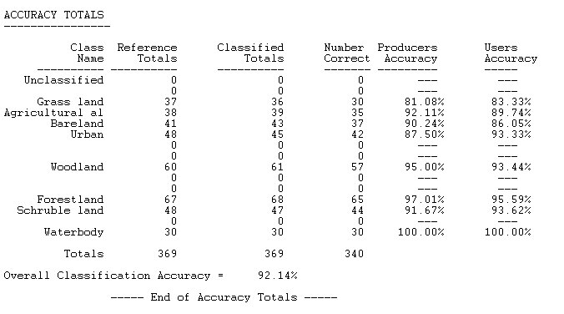
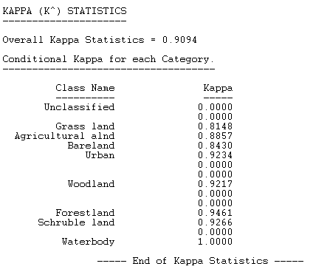

For LULC 2002
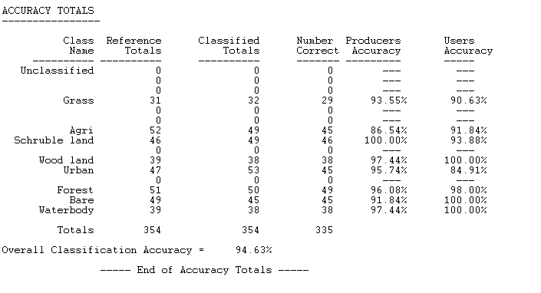
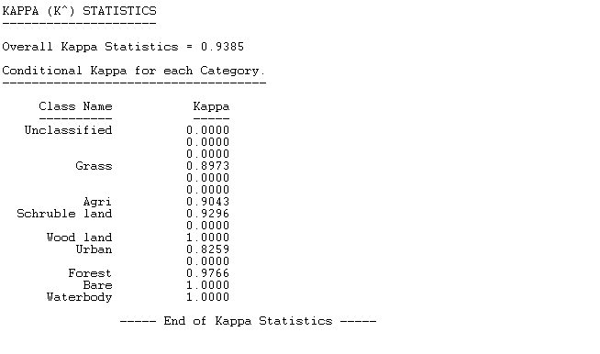

For LULC 2017
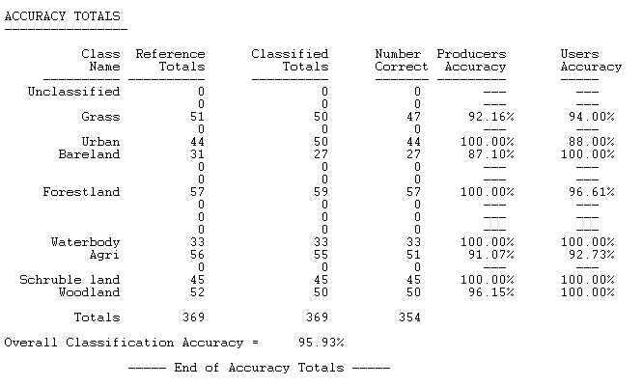
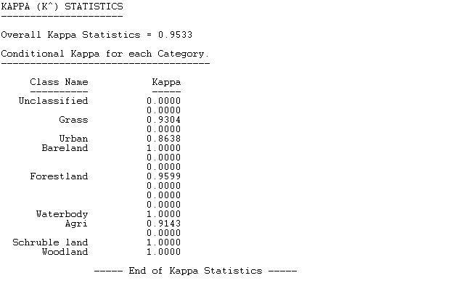

Appendix G: Sub Watershed outlet location and their area of coverage
Sub Watershed | Area (ha) | Latitude | Longitude | Average elevation
Sub Watershed 1 | 223895.2 | 9.043174 | 35.60269 | 1836
Sub Watershed 2 | 56562.06 | 8.911071 | 34.95723 | 1489
Sub Watershed 3 | 44462.1 | 8.898396 | 35.26656 | 1464
Sub Watershed 4 | 41853.09 | 8.776326 | 34.84135 | 1836
Sub Watershed 5 | 48625.37 | 8.710442 | 35.39508 | 1457
Sub Watershed 6 | 110857.5 | 8.713008 | 35.67022 | 1711
Sub Watershed 7 | 30172.23 | 8.840816 | 35.15551 | 1489
Sub Watershed 8 | 46074.48 | 8.613955 | 35.3527 | 1497
Sub Watershed 9 | 23506.44 | 8.844305 | 35.09321 | 1480
Sub Watershed 10 | 39384.65 | 8.678749 | 34.9968 | 1434
Sub Watershed 11 | 20862.78 | 8.577714 | 35.18916 | 1061
Sub Watershed 12 | 1895.352 | 8.522695 | 35.1685 | 959
Sub Watershed 13 | 12890.27 | 8.503847 | 35.28525 | 995
Sub Watershed 14 | 48547.17 | 8.49293 | 35.51732 | 1513
Sub Watershed 15 | 88976.04 | 8.54656 | 35.89852 | 1825
Sub Watershed 16 | 102878.3 | 8.247419 | 35.35184 | 1628
Sub Watershed 17 | 70626.4 | 8.332806 | 35.50778 | 1648
Sub Watershed 18 | 40636.44 | 8.11287 | 35.62078 | 1715
Sub Watershed 19 | 171206.5 | 8.463868 | 34.95904 | 1283
Sub Watershed 20 | 3852.976 | 8.26914 | 35.67824 | 1572
Sub Watershed 21 | 42869.31 | 8.160093 | 35.83056 | 1916
Sub Watershed 22 | 90122.4 | 8.467617 | 34.70923 | 1344
Sub Watershed 23 | 331.4357 | 8.204714 | 34.81872 | 490
Sub Watershed 24 | 15401.19 | 8.189761 | 34.92017 | 627
Sub Watershed 25 | 88823.02 | 8.208391 | 34.70757 | 612
Sub Watershed 26 | 43878.68 | 8.046829 | 34.95242 | 1127
Sub Watershed 27 | 37369.3 | 8.19641 | 35.08427 | 1183
Sub Watershed 28 | 42720.64 | 7.984183 | 35.11447 | 1956
Sub Watershed 29 | 18759.37 | 8.023964 | 35.18161 | 1620
Sub Watershed 30 | 75091.08 | 7.9906 | 35.79281 | 2120
Sub Watershed 31 | 267763 | 8.16509 | 35.97955 | 2257
Sub Watershed 32 | 90297.15 | 7.956589 | 35.45054 | 1792
Sub Watershed 33 | 66125.23 | 7.787625 | 35.7198 | 2008
Sub Watershed 34 | 71226.61 | 7.661553 | 35.57537 | 2042
Sub Watershed 35 | 136693.1 | 7.766504 | 35.31615 | 1823

Appendix H : Reference point for accuracy assessment
For 1987 LULC class reference point collected

EASTING | NORTHING | LULC  class | EASTING | NORTHING | LULC  class | EASTING | NORTHING | LULC  class | EASTING | NORTHING | LULC  class
53170.954 | 955237.218 | 5 | 710704.9 | 899968.302 | 5 | 677336.7 | 917092.996 | 8 | 721072.4 | 932408.4 | 8
769395.55 | 996164.908 | 5 | 768543.6 | 997630.703 | 5 | 708160.7 | 940131.635 | 8 | 715674.9 | 918552.2 | 8
767522.297 | 998360.954 | 5 | 770914.3 | 998413.871 | 5 | 718162 | 944894.145 | 8 | 699773.4 | 919602.6 | 8
783753.458 | 997625.411 | 5 | 740761.2 | 952073.471 | 5 | 676807.5 | 917939.664 | 8 | 705170.9 | 921587 | 8
52686.766 | 954165.654 | 5 | 704179.6 | 904297.556 | 5 | 712843.8 | 945687.897 | 8 | 709033.8 | 924470.9 | 8
767194.213 | 996223.117 | 5 | 702406.9 | 903325.21 | 5 | 708160.7 | 940343.303 | 8 | 709695.3 | 928492.6 | 8
780594.327 | 997900.578 | 5 | 742835.5 | 948189.38 | 5 | 716257 | 935051.625 | 8 | 699879.2 | 913432.5 | 8
52309.734 | 954903.843 | 5 | 702962.5 | 904218.181 | 5 | 717143.3 | 931684.796 | 8 | 717527 | 925344 | 8
707665.498 | 909830.004 | 5 | 739237.2 | 948189.38 | 5 | 708054.9 | 940078.719 | 8 | 709986.3 | 928624.9 | 8
708591.541 | 911367.237 | 5 | 706924.7 | 908196.199 | 5 | 707949 | 940131.635 | 8 | 709827.6 | 928254.5 | 8
52099.39 | 955534.875 | 5 | 702327.5 | 907680.26 | 5 | 716600.9 | 918742.676 | 8 | 714775.3 | 926905.1 | 8
706891.59 | 908156.511 | 5 | 703055.1 | 909069.326 | 5 | 705012.2 | 933225.997 | 8 | 712129.5 | 909966.4 | 8
706600.548 | 910798.381 | 5 | 741808.9 | 945369.974 | 5 | 703609.9 | 921683.526 | 8 | 716706.8 | 921010.2 | 8
50309.48 | 953987.059 | 5 | 707936.7 | 912002.238 | 5 | 708980.9 | 945158.729 | 8 | 725438 | 920586.8 | 8
705614.973 | 911614.622 | 5 | 708280.7 | 911129.111 | 5 | 717103.6 | 942248.306 | 8 | 700858.2 | 917729.3 | 8
706597.24 | 910807.642 | 5 | 702195.2 | 907663.062 | 5 | 698133 | 917794.143 | 8 | 717394.7 | 931879.3 | 8
708502.244 | 911945.352 | 5 | 740146 | 948070.052 | 5 | 710012.8 | 922579.142 | 8 | 715304.5 | 907452.9 | 8
712437.929 | 912494.364 | 5 | 712355.2 | 911764.112 | 5 | 700620.1 | 913212.873 | 8 | 700011.5 | 916565.2 | 8
707622.503 | 908779.606 | 5 | 708902.4 | 911830.258 | 5 | 720252.2 | 923081.851 | 8 | 716362.8 | 914834.8 | 8
708462.557 | 911376.497 | 5 | 744008.9 | 948023.75 | 5 | 698529.9 | 909582.783 | 8 | 702339.9 | 918919.9 | 8
740771.749 | 951046.885 | 5 | 702301.1 | 907663.062 | 5 | 701175.7 | 927328.422 | 8 | 711468 | 903986.8 | 8
708495.63 | 910314.193 | 5 | 702830.2 | 904158.649 | 5 | 716548 | 919020.489 | 8 | 716389.3 | 914596.6 | 8
706633.621 | 910834.1 | 5 | 741045.6 | 946079.059 | 5 | 699045.8 | 913630.916 | 8 | 716362.8 | 919158.1 | 8
706921.356 | 907139.186 | 5 | 706944.5 | 907107.436 | 5 | 710065.7 | 928836.55 | 8 | 716336.3 | 918602.4 | 8
736369.074 | 949671.049 | 5 | 735109.7 | 948756.647 | 5 | 725252.8 | 932673.016 | 8 | 716124.7 | 914501.4 | 8

700302.567 | 912876.852 | 8 | 814760.8 | 930787.861 | 11 | 814032.6 | 886921.789 | 11 | 830900.9 | 855137.3 | 12
698767.981 | 913088.519 | 8 | 812346.5 | 933235.262 | 11 | 826931.1 | 887159.915 | 11 | 866147.3 | 851267.7 | 12
719564.272 | 913908.729 | 8 | 802144.8 | 956576.454 | 11 | 826772.3 | 887477.415 | 11 | 822550 | 857730.2 | 12
708928.001 | 901023.495 | 8 | 804766.2 | 953548.688 | 11 | 817961.7 | 867633.626 | 11 | 822566.5 | 855170.4 | 12
713293.635 | 902214.122 | 8 | 802168.6 | 955937.484 | 11 | 815699.5 | 899645.627 | 11 | 833794.8 | 858031.2 | 12
704244.867 | 912551.414 | 8 | 820085.6 | 961631.725 | 11 | 818636.3 | 886405.851 | 11 | 835878.4 | 857998.1 | 12
719431.98 | 911228.494 | 8 | 814000.2 | 965236.68 | 11 | 839154.8 | 900836.254 | 11 | 822649.2 | 855137.3 | 12
705885.287 | 921600.182 | 8 | 802341.3 | 954203.533 | 11 | 826216.7 | 887517.103 | 11 | 822847.6 | 863716.4 | 12
706282.163 | 909908.221 | 8 | 832322.6 | 941715.175 | 11 | 828478.9 | 898097.811 | 11 | 830950.5 | 855104.2 | 12
712367.591 | 901176.953 | 8 | 802193.1 | 926137.8 | 11 | 816096.3 | 899685.315 | 11 | 833232.6 | 861847.8 | 12
799745.695 | 893812.267 | 11 | 836258.3 | 932851.615 | 11 | 823597.3 | 882556.155 | 11 | 806561.1 | 964654.3 | 12
829577.525 | 898905.506 | 11 | 834637.7 | 927129.989 | 11 | 824827.6 | 885993.1 | 11 | 804973.6 | 963932 | 12
829246.795 | 898111.754 | 11 | 821673.1 | 938341.731 | 11 | 826573.9 | 886802.726 | 11 | 808553.4 | 962844.6 | 12
815653.799 | 898740.141 | 11 | 786652 | 889651.862 | 11 | 825264.2 | 880516.214 | 11 | 812966.7 | 963051 | 12
826204.081 | 886040.116 | 11 | 750536.3 | 905447.518 | 11 | 805460.1 | 877277.707 | 11 | 831164.2 | 889953.5 | 12
818828.806 | 886007.043 | 11 | 722596.2 | 896240 | 11 | 821136.7 | 900995.005 | 11 | 812030 | 964209.8 | 12
825046.527 | 882666.671 | 11 | 729025.6 | 873776.83 | 11 | 824430.7 | 882833.968 | 11 | 809958.3 | 963265.3 | 12
825244.964 | 881905.993 | 11 | 737280.6 | 873618.08 | 11 | 813397.6 | 887596.478 | 11 | 808736 | 966546.6 | 12
806393.364 | 881839.847 | 11 | 742995.6 | 893938.12 | 11 | 831574.5 | 859386.547 | 12 | 963276.4 | 963276.4 | 12
800010.279 | 911942.876 | 11 | 735613.7 | 884730.602 | 11 | 822814.6 | 863683.346 | 12 | 806592.8 | 966062.5 | 12
823988.191 | 914721.006 | 11 | 732827.1 | 876303.454 | 11 | 831049.7 | 863319.543 | 12 | 804068.7 | 965594.1 | 12
813338.691 | 919880.392 | 11 | 736309 | 883620.52 | 11 | 833331.8 | 861682.43 | 12 | 827577.1 | 883910.8 | 12
813371.764 | 909726.986 | 11 | 723370.9 | 891558.036 | 11 | 833877.5 | 858226.304 | 12 | 829465.5 | 829465.5 | 12
826600.957 | 920376.486 | 11 | 715433.3 | 881437.703 | 11 | 833166.4 | 861938.746 | 12 | 835580.7 | 885713.3 | 12
814496.245 | 939763.869 | 11 | 723847.1 | 895685.544 | 11 | 824054.8 | 866221.697 | 12 | 834251.9 | 886889.7 | 12
809138.422 | 940987.569 | 11 | 753335 | 879532.699 | 11 | 822649.2 | 868139.93 | 12 | 823955.6 | 866271.3 | 12
804045.182 | 918782.369 | 11 | 725791.8 | 897034.922 | 11 | 832885.3 | 861657.626 | 12 | 835332.7 | 874597.4 | 12
799977.206 | 929696.453 | 11 | 812683.2 | 888231.479 | 11 | 830719 | 869297.485 | 12 | 823955.6 | 866271.3 | 12
829346.014 | 935616.517 | 11 | 827248.6 | 888191.792 | 11 | 830702.5 | 862682.888 | 12 | 807854.9 | 964340 | 12
807815.503 | 926521.447 | 11 | 815183.5 | 877833.333 | 11 | 857730.2 | 866147.283 | 12 | 805322.8 | 962276.3 | 12

812958.717 | 963149.383 | 12 | 730692.5 | 938978.008 | 14 | 839920.4 | 951811.508 | 3 | 781007.6 | 961314 | 2
817248.944 | 963133.508 | 12 | 730740.2 | 938972.981 | 14 | 841829.4 | 951894.852 | 3 | 776302.3 | 961174.3 | 2
817320.382 | 963181.133 | 12 | 727025.4 | 939488.919 | 14 | 841666.6 | 950561.349 | 3 | 778816.9 | 960475.8 | 2
815883.691 | 964403.511 | 12 | 731184.7 | 938261.25 | 14 | 841706.3 | 950573.255 | 3 | 776575.3 | 958735.9 | 2
814701.002 | 962220.694 | 12 | 729517.8 | 936628.239 | 14 | 836298.9 | 951930.571 | 3 | 777794.5 | 960513.9 | 2
812772.185 | 965697.326 | 12 | 727001.6 | 939433.357 | 14 | 836334.6 | 952208.384 | 3 | 769161.7 | 960501.2 | 2
811938.746 | 962482.632 | 12 | 729867 | 934516.859 | 14 | 837215.7 | 950692.318 | 3 | 769993.6 | 959618.6 | 2
816399.63 | 958265.43 | 12 | 731084.1 | 937782.353 | 14 | 836271.1 | 951934.539 | 3 | 773822.6 | 958088.2 | 2
813645.312 | 957884.429 | 12 | 726525.4 | 938303.054 | 14 | 836255.2 | 950366.88 | 3 | 759033.4 | 959421.7 | 2
677360.499 | 909973.566 | 14 | 828210.1 | 934239.435 | 3 | 836100.5 | 950443.874 | 3 | 758150.8 | 959898 | 2
672248.739 | 911735.06 | 14 | 830346.6 | 932929.745 | 3 | 835850.4 | 950939.969 | 3 | 757376.1 | 961047.3 | 2
674024.626 | 911995.41 | 14 | 830015.9 | 936963.988 | 3 | 839807.3 | 948919.871 | 3 | 768650.5 | 958691.5 | 2
718032.465 | 891241.194 | 14 | 829923.2 | 936904.456 | 3 | 835572.6 | 950693.906 | 3 | 763199 | 960958.4 | 2
718651.803 | 892396.135 | 14 | 829162.6 | 934437.212 | 3 | 838279.3 | 950725.656 | 3 | 770860.3 | 959828.1 | 2
721858.559 | 905968.228 | 14 | 832674.9 | 937228.571 | 3 | 836271.1 | 950308.936 | 3 | 767031.3 | 961047.3 | 2
721022.474 | 898936.648 | 14 | 829202.3 | 934423.983 | 3 | 837830.8 | 949880.31 | 3 | 764440.5 | 960355.2 | 2
718101.469 | 899074.231 | 14 | 828183.6 | 934246.05 | 3 | 834387.9 | 949804.904 | 3 | 763224.4 | 961015.6 | 2
720588.557 | 897705.803 | 14 | 832053.1 | 939683.248 | 3 | 833828.3 | 950900.281 | 3 | 764173.8 | 958634.3 | 2
723371.979 | 899319.765 | 14 | 828580.5 | 940655.594 | 3 | 837086.7 | 950086.686 | 3 | 767875.8 | 959993.2 | 2
722027.893 | 898801.181 | 14 | 837217.7 | 949107.99 | 3 | 742310.7 | 961142.587 | 2 | 760182.8 | 959682.1 | 2
721075.391 | 899023.431 | 14 | 833653.7 | 947542.712 | 3 | 746031.8 | 961314.038 | 2 | 764059.5 | 961485.5 | 2
718080.302 | 899086.931 | 14 | 834872.1 | 947679.237 | 3 | 742050.3 | 961307.688 | 2 | 771320.7 | 960850.5 | 2
723467.229 | 899351.515 | 14 | 835026.9 | 947443.493 | 3 | 748813.1 | 958818.483 | 2 | 758023.8 | 958348.6 | 2
717191.3 | 895063.14 | 14 | 833610.1 | 947544.299 | 3 | 746412.8 | 958862.933 | 2 | 776264.2 | 958316.8 | 2
720546.223 | 897652.887 | 14 | 827634.6 | 949011.152 | 3 | 763237.1 | 961028.287 | 2 | 699372.1 | 979829.6 | 4
719117.471 | 896086.55 | 14 | 834991.2 | 950356.561 | 3 | 751308.6 | 961028.287 | 2 | 700681.8 | 981483.2 | 4
719286.804 | 896097.134 | 14 | 833129.8 | 949445.334 | 3 | 741961.4 | 961206.088 | 2 | 700976.8 | 977018.4 | 4
717138.383 | 895112.882 | 14 | 829228.7 | 949070.684 | 3 | 757376.1 | 961002.887 | 2 | 703465.2 | 977935.2 | 4
718736.47 | 892374.968 | 14 | 835348.4 | 950840.75 | 3 | 755829.8 | 958196.181 | 2 | 703663.7 | 978190.4 | 4
717921.552 | 891253.132 | 14 | 827641.2 | 948997.923 | 3 | 743021.9 | 958145.381 | 2 | 700992.7 | 977010.5 | 4

703548.571 | 977686.333 | 4 | 700814.4 | 981370.154 | 4 | 701340.9 | 978980.962 | 4 | 702965.5 | 979703.8 | 4
701004.597 | 976482.609 | 4 | 700518.1 | 982010.447 | 4 | 703809.5 | 978596.257 | 4 | 690715.3 | 964069 | 4
703100.429 | 983887.934 | 4 | 703079.3 | 983909.101 | 4 | 705106 | 979442.925 | 4 | 698136.4 | 980483.5 | 4
702264.344 | 984639.352 | 4 | 703163.9 | 984279.518 | 4 | 703894.2 | 977183.379 | 4 | 689921.5 | 962730.2 | 4
702073.843 | 984660.519 | 4 | 698094 | 980409.45 | 4 | 705100.7 | 979448.217 | 4 | 693612 | 982515.5 | 4
698195.044 | 980544.652 | 4 | 693601.4 | 982520.829 | 4 | 703648.1 | 978190.385 | 4 | 703021.1 | 977421.5 | 4
700983.758 | 980560.528 | 4 | 690694.1 | 964323.023 | 4 | 693590.8 | 982510.246 | 4 | 704944.6 | 979756.7 | 4
698089.21 | 980431.411 | 4 | 689974.5 | 962730.228 | 4 | 698109.9 | 980435.909 | 4 | 702949.6 | 979687.9 | 4
703457.617 | 978058.093 | 4 | 699200.5 | 980531.952 | 4 | 700065.7 | 982404.148 | 4
698988.795 | 979727.618 | 4 | 700766.8 | 981317.237 | 4 | 697877.5 | 978965.616 | 4

For 2002 LULC class reference point collected
EASTING | NORTHING | LULC  class | EASTING | NORTHING | LULC  class | EASTING | NORTHING | LULC  class | EASTING | NORTHING | LULC  class
67934.539 | 951549.08 | 3 | 74942.73 | 948402.6 | 3 | 722328.7 | 952676.8 | 3 | 726816.9 | 955792.08 | 3
73755.384 | 947448.03 | 3 | 59737.75 | 950330.5 | 3 | 724911.6 | 949332.8 | 3 | 697955.7 | 963347.87 | 6
73556.946 | 948374.074 | 3 | 63006.74 | 953364.8 | 3 | 732811.3 | 958795.6 | 3 | 132971.7 | 974793.34 | 6
61816.492 | 954528.21 | 3 | 68974.73 | 937341.7 | 3 | 729363.2 | 958725.8 | 3 | 132716.2 | 1033867.3 | 6
68773.566 | 950823.358 | 3 | 74121.29 | 945924.9 | 3 | 728131.3 | 955861.9 | 3 | 137087.7 | 1033317 | 6
64314.333 | 949901.336 | 3 | 58698.38 | 942924.1 | 3 | 726797.8 | 958344.8 | 3 | 135432.5 | 1034015.5 | 6
66443.365 | 948526.686 | 3 | 68941.21 | 937325 | 3 | 733812.8 | 947523.1 | 3 | 133784.5 | 974890.71 | 6
66409.837 | 957109.871 | 3 | 57089.04 | 944801.7 | 3 | 727439.2 | 957424 | 3 | 131977.5 | 1033361.5 | 6
68387.993 | 949549.292 | 3 | 60223.91 | 942873.9 | 3 | 727636 | 952256.4 | 3 | 132015.6 | 1033835.6 | 6
66426.601 | 957260.747 | 3 | 69092.08 | 937341.7 | 3 | 725896.1 | 952116.7 | 3 | 133926.9 | 1033416.5 | 6
75043.315 | 948560.214 | 3 | 72193.43 | 945388.5 | 3 | 740694.8 | 950878.4 | 3 | 133106.1 | 974357.31 | 6
60039.505 | 950353.965 | 3 | 57206.38 | 944852 | 3 | 728988.6 | 956300.1 | 3 | 8751.452 | 948088.97 | 6
68723.274 | 949666.64 | 3 | 61497.98 | 931561.5 | 3 | 739678.8 | 949310 | 3 | 10453.26 | 948774.77 | 6
66292.489 | 948519.98 | 3 | 67264.8 | 934830.5 | 3 | 738402.5 | 952072.2 | 3 | 134899.1 | 1033949.9 | 6
74959.494 | 948251.755 | 3 | 68471.81 | 929935.4 | 3 | 728937.8 | 949386.2 | 3 | 132939.9 | 973681.56 | 6
57390.787 | 945016.297 | 3 | 68337.7 | 929851.6 | 3 | 741850.5 | 952015.1 | 3 | 151830.2 | 847434.91 | 6
150748.035 | 845594.072 | 6 | 79506.66 | 910718.8 | 6 | 27549.87 | 918818.7 | 9 | 98882.53 | 902378.73 | 7
151181.953 | 847512.966 | 6 | 80586.16 | 904853 | 6 | 29377.15 | 903707.6 | 9 | 94712.69 | 911521.69 | 7
150879.004 | 846758.902 | 6 | 80689.35 | 912334.1 | 6 | 26057.87 | 925038.1 | 9 | 103211.1 | 906876.65 | 7
132934.656 | 973468.832 | 6 | 80673.47 | 906131.3 | 6 | 25018.5 | 902349.7 | 9 | 101380.2 | 902590.39 | 7
151006.005 | 845496.176 | 6 | 153244.9 | 845709.2 | 6 | 15680.93 | 15680.93 | 9 | 97781.86 | 910167.02 | 7
150566.795 | 847231.184 | 6 | 22858.39 | 911115.5 | 9 | 33182.58 | 904696.7 | 9 | 94765.6 | 911511.1 | 7
153381.174 | 845390.342 | 6 | 32224.66 | 902384.3 | 9 | 33450.81 | 897706.1 | 9 | 102459.7 | 911331.18 | 7
133736.875 | 973931.325 | 6 | 25655.28 | 934246.1 | 9 | 20777.2 | 919539.5 | 9 | 98776.7 | 903341.81 | 7
150590.608 | 845018.602 | 6 | 23420.07 | 932744.3 | 9 | 17055.58 | 899902.2 | 9 | 95421.77 | 903825.47 | 7
151896.329 | 847027.455 | 6 | 25255.23 | 933312.7 | 9 | 911455.9 | 911455.9 | 9 | 106354.4 | 908812.35 | 7
132845.756 | 973074.92 | 6 | 24702.78 | 930681.2 | 9 | 31489.42 | 915764.3 | 9 | 95961.52 | 102216.29 | 7
151201.797 | 845039.769 | 6 | 20877.78 | 899097.5 | 9 | 21900.39 | 897287 | 9 | 104756.3 | 905857.47 | 7
132833.056 | 973082.328 | 6 | 25718.78 | 928071.4 | 9 | 33819.62 | 910601 | 9 | 105285.5 | 926012.41 | 7
132239.938 | 1032175.696 | 6 | 29090.64 | 933039.6 | 9 | 18463.76 | 914792 | 9 | 100470 | 923578.24 | 7
133840.141 | 1032679.463 | 6 | 23604.23 | 932814.2 | 9 | 23124.16 | 903288.5 | 9 | 96395.44 | 905031.97 | 7
132988.632 | 970415.852 | 6 | 24079.71 | 900891.2 | 9 | 97728.94 | 898377.2 | 7 | 102904.2 | 916186.83 | 7
132248.404 | 1032186.279 | 6 | 26156.93 | 932566.5 | 9 | 101793 | 901150 | 7 | 101507.2 | 917224 | 7
133099.306 | 1030041.033 | 6 | 33534.63 | 905132.5 | 9 | 79080.96 | 881424 | 7 | 99051.86 | 902237.97 | 7
150837.994 | 846876.642 | 6 | 23083.52 | 929011.2 | 9 | 78879.88 | 881979.6 | 7 | 95855.69 | 914673.41 | 7
132981.223 | 970404.21 | 6 | 25934.68 | 928084.1 | 9 | 78308.37 | 881664.7 | 7 | 100173.7 | 904756.8 | 7
133379.765 | 1028204.821 | 6 | 22570.95 | 911187.7 | 9 | 99792.7 | 895572.6 | 7 | 101549.5 | 914292.41 | 7
133094.014 | 1030607.243 | 6 | 15949.16 | 925138.7 | 9 | 79745.06 | 881574.8 | 7 | 97009.28 | 916440.83 | 7
80542.501 | 904825.18 | 6 | 23040.34 | 903573.5 | 9 | 79025.4 | 882635.7 | 7 | 99030.7 | 901380.71 | 7
133088.723 | 1029988.116 | 6 | 27432.52 | 918801.9 | 9 | 79533.4 | 882024.6 | 7 | 96152.02 | 909307.65 | 7
81117.971 | 907353.675 | 6 | 32662.9 | 904260.8 | 9 | 95432.36 | 898620.6 | 7 | 96310.77 | 909529.9 | 7
82130.004 | 905603.056 | 6 | 16468.84 | 926077.5 | 9 | 99718.61 | 895480.5 | 7 | 98067.61 | 903698.47 | 7
83106.319 | 906139.236 | 6 | 21146.01 | 910265.7 | 9 | 106460.2 | 893469.7 | 7 | 95337.11 | 913720.91 | 7
81169.565 | 912139.601 | 6 | 33601.69 | 925725.5 | 9 | 99327.03 | 892824.1 | 7 | 99644.53 | 901317.21 | 7
152735.589 | 845268.634 | 6 | 19318.73 | 903456.1 | 9 | 99115.36 | 903486.8 | 7 | 100353.6 | 908251.43 | 7
131421.844 | 1028448.238 | 6 | 19955.76 | 903741.1 | 9 | 101877.6 | 907215.3 | 7 | 101835.3 | 901264.3 | 7

78570.312 | 880942.143 | 7 | 105089.9 | 982904.7 | 10 | 123241.3 | 967719.6 | 12 | 129813.6 | 960964.81 | 12
78628.521 | 880606.122 | 7 | 36448.31 | 966030.1 | 10 | 159881.5 | 886660.8 | 12 | 142970.7 | 865651.48 | 12
78919.563 | 880852.185 | 7 | 101904.3 | 981039.9 | 10 | 141287.4 | 943045.7 | 12 | 144931.2 | 869097.95 | 12
78922.209 | 881857.868 | 7 | 35976.02 | 965986.4 | 10 | 138608.5 | 941640.1 | 12 | 51021.76 | 887601.74 | 12
95178.355 | 902968.217 | 7 | 90959.47 | 871104 | 10 | 159273 | 886687.2 | 12 | 143954.9 | 864175.1 | 12
98591.69 | 988011.706 | 10 | 101660.3 | 973837.4 | 10 | 142378.9 | 936183.1 | 12 | 146911.6 | 869316.23 | 12
35862.253 | 961675.423 | 10 | 37299.87 | 962575.1 | 10 | 153342.6 | 941805.5 | 12 | 147149.8 | 868367.7 | 12
35493.159 | 961655.579 | 10 | 36158.59 | 965553.8 | 10 | 160437.2 | 899810.6 | 12 | 143970.8 | 864163.19 | 12
100920.028 | 984868.449 | 10 | 101482.5 | 974172.4 | 10 | 136078.5 | 936976.8 | 12 | 47934.06 | 889189.24 | 12
36182.4 | 961667.485 | 10 | 36600.05 | 962497.1 | 10 | 134772.1 | 939506.9 | 12 | 144478.8 | 866139.64 | 12
102952.032 | 984635.615 | 10 | 101234.9 | 974066 | 10 | 170200.3 | 886131.6 | 12 | 51212.26 | 889086.06 | 12
35498.45 | 961633.09 | 10 | 36535.22 | 962423 | 10 | 137765.2 | 940697.5 | 12 | 52267.95 | 890951.37 | 12
35507.711 | 961642.35 | 10 | 36873.89 | 962145.2 | 10 | 152945.7 | 939176.2 | 12 | 146356 | 866179.32 | 12
102973.199 | 984635.615 | 10 | 91189.66 | 871762.8 | 10 | 169829.9 | 908028.6 | 12 | 50942.38 | 887657.3 | 12
36857.088 | 961727.017 | 10 | 37191.39 | 962801.4 | 10 | 143189.1 | 936976.8 | 12 | 144570.1 | 145641.64 | 12
35894.003 | 960376.052 | 10 | 37167.58 | 962827.8 | 10 | 166337.4 | 899863.5 | 12 | 142775.5 | 939926.93 | 13
103158.408 | 988821.332 | 10 | 91188.07 | 871551.7 | 10 | 138658.1 | 941458.2 | 12 | 173555 | 886991.33 | 13
36144.035 | 965982.451 | 10 | 36218.12 | 966002.3 | 10 | 169697.6 | 895630.2 | 12 | 100116.5 | 898337.75 | 13
36364.962 | 966421.396 | 10 | 37187.42 | 964857.7 | 10 | 129099.2 | 963488.9 | 12 | 100237.2 | 898928.3 | 13
102327.614 | 987233.829 | 10 | 101419 | 973723.1 | 10 | 141836.9 | 888565.8 | 12 | 133546.3 | 894430.01 | 13
35813.305 | 966113.156 | 10 | 91256.33 | 868899 | 10 | 130496.2 | 961710.9 | 12 | 142413 | 940040.7 | 13
36046.139 | 966639.678 | 10 | 91061.07 | 868562.4 | 10 | 132115.5 | 964473.2 | 12 | 174380.5 | 887767.88 | 13
101168.737 | 986461.244 | 10 | 91305.55 | 871349.5 | 10 | 158214.7 | 889068.5 | 12 | 175433.6 | 887274.43 | 13
36239.285 | 966123.739 | 10 | 90959.47 | 870817.6 | 10 | 123320.7 | 967799 | 12 | 173744.5 | 887666.28 | 13
35683.659 | 966433.302 | 10 | 101244.4 | 974066 | 10 | 133734.7 | 965640 | 12 | 142417 | 940040.7 | 13
100639.569 | 987614.83 | 10 | 154351.7 | 890444.3 | 12 | 160384.3 | 885110.3 | 12 | 172610.5 | 887417.31 | 13
35661.169 | 966252.062 | 10 | 127829.2 | 965274.9 | 12 | 123050.8 | 964385.9 | 12 | 963732.6 | 963732.56 | 13
35489.19 | 966539.136 | 10 | 129448.5 | 960734.6 | 12 | 130543.8 | 961576 | 12 | 153353.4 | 962315.71 | 13
101957.197 | 979605.876 | 10 | 146255.5 | 886528.5 | 12 | 143077.8 | 865897.5 | 12 | 152071.5 | 962891.18 | 13
35782.878 | 966052.302 | 10 | 130845.5 | 961814.1 | 12 | 130051.7 | 961520.4 | 12 | 152083.4 | 962930.87 | 13

150630.751 | 935612.709 | 13 | 150363.5 | 935502.9 | 13 | 93501.92 | 968147.8 | 14 | 82390.42 | 901366.92 | 14
152103.26 | 964457.651 | 13 | 172605.2 | 887454.3 | 13 | 94771.93 | 969024.9 | 14 | 109788.3 | 872028.45 | 14
151813.541 | 964981.527 | 13 | 150302.7 | 935489.7 | 13 | 12338.7 | 914455.3 | 14 | 81560.16 | 901927.31 | 14
152762.074 | 963712.715 | 13 | 172986.2 | 887382.9 | 13 | 41065.34 | 908741.3 | 14 | 81596.67 | 901928.89 | 14
151788.537 | 964958.509 | 13 | 150069.8 | 935446 | 13 | 48030.51 | 908781.6 | 14 | 110676 | 871674.3 | 14
150354.261 | 935498.938 | 13 | 175436.2 | 887285 | 13 | 48211.49 | 908711.7 | 14 | 81922.11 | 901903.49 | 14
101169.853 | 899596.461 | 13 | 150542.1 | 935606.1 | 13 | 41065.34 | 908754.6 | 14 | 110682.6 | 871675.62 | 14
100238.518 | 898945.584 | 13 | 42590.05 | 986648.2 | 13 | 48744.89 | 908656.1 | 14 | 82641.25 | 902111.46 | 14
153325.637 | 962319.681 | 13 | 134145 | 894734.3 | 13 | 49542.61 | 908721.2 | 14 | 12580.79 | 914387.86 | 14
173187.267 | 887380.265 | 13 | 150179.6 | 935374.6 | 13 | 42441.18 | 908490 | 14 | 94434.58 | 969068.59 | 14
149983.843 | 935255.52 | 13 | 42684.15 | 986618.5 | 13 | 50903.89 | 908672 | 14 | 94434.58 | 969068.59 | 14
173576.205 | 887525.786 | 13 | 42272.55 | 986476.3 | 13 | 50154.59 | 908556.1 | 14 | 94446.49 | 967409.65 | 14
113479.915 | 894515.094 | 13 | 43119.39 | 986279.9 | 13 | 110074.1 | 872113.1 | 14 | 50593.54 | 908576.77 | 14
172994.121 | 887388.202 | 13 | 42889.2 | 986331.5 | 13 | 45960.14 | 908377.5 | 14 | 43287.85 | 908595.82 | 14
150624.136 | 935562.438 | 13 | 133586 | 894459.8 | 13 | 49645.8 | 908738.7 | 14
100048.017 | 898691.584 | 13 | 10834.54 | 914078.3 | 14 | 48947.3 | 908770.4 | 14
113224.261 | 894344.438 | 13 | 93450.33 | 968052.6 | 14 | 50799.12 | 908602.2 | 14
100476.643 | 898474.625 | 13 | 94454.43 | 969060.7 | 14 | 45973.37 | 908397.4 | 14
150523.594 | 935591.542 | 13 | 11211.57 | 914169.6 | 14 | 48586.14 | 908959.4 | 14
102910.815 | 896950.093 | 13 | 93744.02 | 967564.4 | 14 | 48706.79 | 908776.8 | 14

For 2017 LULC class reference point collected
EASTING | NORTHING | LULC  class |  | EASTING |  | NORTHING |  | LULC  class |  | EASTING |  | NORTHING |  | LULC  class |  | EASTING |  | NORTHING |  | LULC  class
826617.2 | 907467.076 | 8 |  | 830161.3 |  | 905489.4 |  | 8 |  | 748327 |  | 904651.7 |  | 8 |  | 736036.6 |  | 968769 |  | 2
748869.549 | 905722.822 | 8 |  | 749708.1 |  | 904356.4 |  | 8 |  | 827776 |  | 920984.3 |  | 8 |  | 739712.7 |  | 854102.9 |  | 2
712399.639 | 883275.537 | 8 |  | 756256.1 |  | 892324.5 |  | 8 |  | 748887 |  | 905782.4 |  | 8 |  | 735515.3 |  | 971648.4 |  | 2
828716.673 | 917448.899 | 8 |  | 749898.6 |  | 898223.1 |  | 8 |  | 752088 |  | 904080 |  | 8 |  | 740005.3 |  | 854275.2 |  | 2
712314.972 | 888884.715 | 8 |  | 826660.9 |  | 905048.9 |  | 8 |  | 754390 |  | 903905.4 |  | 8 |  | 732372.1 |  | 962220.8 |  | 2
829649.331 | 914176.658 | 8 |  | 749319.2 |  | 901816.4 |  | 8 |  | 827406 |  | 921695.5 |  | 8 |  | 734475 |  | 971554.5 |  | 2
729629.34 | 892038.555 | 8 |  | 753176.4 |  | 894534.3 |  | 8 |  | 751400 |  | 906149.1 |  | 8 |  | 735795.8 |  | 967094.4 |  | 2
755964.007 | 894312.071 | 8 |  | 753272 |  | 899382 |  | 8 |  | 674908 |  | 941141.3 |  | 8 |  | 740528.5 |  | 855190.3 |  | 2
826533.856 | 913394.812 | 8 |  | 748279.3 |  | 901541 |  | 8 |  | 748033 |  | 904881.9 |  | 8 |  | 736711.3 |  | 957139.4 |  | 2
749728.124 | 905183.07 | 8 |  | 828597.6 |  | 904290.9 |  | 8 |  | 728237 |  | 965880.5 |  | 2 |  | 740466.4 |  | 854929.9 |  | 2
723893.162 | 890429.885 | 8 |  | 752891 |  | 906191.6 |  | 8 |  | 735957 |  | 963411.4 |  | 2 |  | 740257.3 |  | 854171.4 |  | 2
827565.733 | 906609.824 | 8 |  | 747961.8 |  | 904659.6 |  | 8 |  | 763081 |  | 936823.8 |  | 2 |  | 736382.7 |  | 967842.9 |  | 2
725586.498 | 881349.367 | 8 |  | 827327.6 |  | 922038.4 |  | 8 |  | 758707 |  | 936589.7 |  | 2 |  | 741375.9 |  | 858323 |  | 2
753023.951 | 892210.217 | 8 |  | 674471.5 |  | 941895.4 |  | 8 |  | 728045 |  | 967992.5 |  | 2 |  | 739079.3 |  | 959070.9 |  | 2
752020.649 | 893702.47 | 8 |  | 677289.3 |  | 942166.6 |  | 8 |  | 760255 |  | 932624.5 |  | 2 |  | 740015 |  | 853999.7 |  | 2
748903.945 | 905762.51 | 8 |  | 828657.1 |  | 904354.4 |  | 8 |  | 739836 |  | 856204.3 |  | 2 |  | 734697.8 |  | 966480.6 |  | 2
826902.951 | 907498.826 | 8 |  | 672208.1 |  | 943112.4 |  | 8 |  | 727848 |  | 965871 |  | 2 |  | 741395.7 |  | 856390.2 |  | 2
729227.172 | 892123.222 | 8 |  | 827327.6 |  | 917194.9 |  | 8 |  | 740061 |  | 856148.7 |  | 2 |  | 736618.7 |  | 957020.4 |  | 2
827776.078 | 911186.992 | 8 |  | 675724.9 |  | 942021.1 |  | 8 |  | 758977 |  | 937772.4 |  | 2 |  | 740447.8 |  | 854912.7 |  | 2
751576.148 | 894458.121 | 8 |  | 826371.1 |  | 916020.1 |  | 8 |  | 740272 |  | 855628 |  | 2 |  | 735515.3 |  | 969811.4 |  | 2
724506.996 | 892017.388 | 8 |  | 675638.9 |  | 940549.3 |  | 8 |  | 728278 |  | 967536.3 |  | 2 |  | 739139.3 |  | 854042.2 |  | 2
751938.098 | 893785.02 | 8 |  | 672994.7 |  | 943217.2 |  | 8 |  | 760212 |  | 936903.2 |  | 2 |  | 740441.2 |  | 854957 |  | 2
827133.139 | 908189.39 | 8 |  | 826859.3 |  | 921186.7 |  | 8 |  | 759128 |  | 938030.3 |  | 2 |  | 739348 |  | 853858.9 |  | 2
757551.51 | 894807.372 | 8 |  | 749654 |  | 905604 |  | 8 |  | 739872 |  | 856160.6 |  | 2 |  | 732755.7 |  | 958330.1 |  | 2
748120.587 | 904642.166 | 8 |  | 753797.4 |  | 906048.5 |  | 8 |  | 728568 |  | 966091.1 |  | 2 |  | 759648 |  | 932092.7 |  | 2
762972.538 | 942961.324 | 2 | 717787.7 |  | 975297.2 |  | 13 |  | 823601 |  | 858307.9 |  | 13 |  | 698267.2 |  | 894772.5 |  | 16
761266.501 | 942228.956 | 2 | 721743.2 |  | 975707.3 |  | 13 |  | 828353 |  | 858673 |  | 13 |  | 690991.2 |  | 893661.3 |  | 16
762977.83 | 933910.36 | 2 | 741854.3 |  | 871781.5 |  | 13 |  | 825945 |  | 856032.5 |  | 13 |  | 679763.5 |  | 919432.4 |  | 16
749935.083 | 945304.154 | 2 | 739955.9 |  | 860284.6 |  | 13 |  | 722781 |  | 982345.5 |  | 13 |  | 688222.2 |  | 931663.4 |  | 16
761283.17 | 942816.649 | 2 | 739843.4 |  | 861237.1 |  | 13 |  | 675464 |  | 902737.1 |  | 16 |  | 688234.1 |  | 931679.3 |  | 16
759648.042 | 931914.074 | 2 | 741457.4 |  | 870776 |  | 13 |  | 683468 |  | 908161.1 |  | 16 |  | 691272.9 |  | 912751.6 |  | 16
748739.164 | 942954.649 | 2 | 718495.5 |  | 972633.5 |  | 13 |  | 685287 |  | 910674.7 |  | 16 |  | 689778 |  | 931099.9 |  | 16
762572.487 | 946937.278 | 2 | 721723.4 |  | 971535.5 |  | 13 |  | 694232 |  | 932393.7 |  | 16 |  | 693356.4 |  | 927469.1 |  | 16
758766.978 | 932275.231 | 2 | 757290.5 |  | 943946.3 |  | 13 |  | 710994 |  | 933428.2 |  | 16 |  | 693502 |  | 934712.1 |  | 16
755501.927 | 944563.319 | 13 | 828723.3 |  | 873701.9 |  | 13 |  | 692552 |  | 929988.6 |  | 16 |  | 690009.5 |  | 933495 |  | 16
751554.336 | 943494.4 | 13 | 833469.5 |  | 876256.6 |  | 13 |  | 681814 |  | 914808.8 |  | 16 |  | 673347.3 |  | 915926.6 |  | 16
827682.215 | 892483.306 | 13 | 824177.8 |  | 865851.7 |  | 13 |  | 693994 |  | 932219.1 |  | 16 |  | 686781.5 |  | 933255.3 |  | 16
829462.6 | 877760.961 | 13 | 829335.6 |  | 869575.8 |  | 13 |  | 693505 |  | 927580.9 |  | 16 |  | 676820 |  | 921879.8 |  | 16
831437.454 | 893731.878 | 13 | 826633.1 |  | 865894 |  | 13 |  | 694411 |  | 931774.6 |  | 16 |  | 687484 |  | 933418 |  | 16
756211.012 | 945568.738 | 13 | 829100.6 |  | 871531 |  | 13 |  | 681450 |  | 914147.3 |  | 16 |  | 689222.3 |  | 933358.5 |  | 16
830034.101 | 888362.307 | 13 | 823595.7 |  | 865079.1 |  | 13 |  | 694653 |  | 930770.5 |  | 16 |  | 687491.9 |  | 933279.1 |  | 16
831373.954 | 878776.963 | 13 | 739876.5 |  | 861250.4 |  | 13 |  | 713825 |  | 904006.5 |  | 16 |  | 686765.7 |  | 931361.8 |  | 16
833024.957 | 888311.507 | 13 | 825257.3 |  | 864105.5 |  | 13 |  | 695092 |  | 903265.7 |  | 16 |  | 687666.6 |  | 933136.2 |  | 16
721690.325 | 979557.673 | 13 | 742390.1 |  | 858287 |  | 13 |  | 701283 |  | 898688.4 |  | 16 |  | 690194.7 |  | 933547.9 |  | 16
743759.283 | 863750.676 | 13 | 829223.4 |  | 869522.9 |  | 13 |  | 713296 |  | 903689 |  | 16 |  | 688801.6 |  | 935800.1 |  | 16
718912.194 | 981182.879 | 13 | 718038 |  | 980777 |  | 13 |  | 693059 |  | 914411.9 |  | 16 |  | 688432.5 |  | 930429.1 |  | 16
719262.768 | 979703.194 | 13 | 829786.5 |  | 870593.3 |  | 13 |  | 712317 |  | 893907.3 |  | 16 |  | 681317.9 |  | 932502.8 |  | 16
742006.415 | 856432.286 | 13 | 740412.3 |  | 878780.4 |  | 13 |  | 697235 |  | 890176.7 |  | 16 |  | 687531.6 |  | 933429.9 |  | 16
740405.683 | 856743.172 | 13 | 718863.5 |  | 980948.5 |  | 13 |  | 697368 |  | 917717.2 |  | 16 |  | 690181.4 |  | 933124.6 |  | 16
717662.035 | 976925.063 | 13 | 828926 |  | 870410.2 |  | 13 |  | 697050 |  | 887795.4 |  | 16 |  | 771328.8 |  | 839069.1 |  | 15
756348.596 | 945568.738 | 13 | 720012.9 |  | 979475.3 |  | 13 |  | 697421 |  | 917743.7 |  | 16 |  | 793597 |  | 1014583 |  | 15
742826.625 | 863796.978 | 13 | 823310 |  | 857127.9 |  | 13 |  | 676059 |  | 920457.6 |  | 16 |  | 793595.7 |  | 1013199 |  | 15
827995.747 | 876325.858 | 13 | 826125.1 |  | 856672.8 |  | 13 |  | 692393 |  | 910758.7 |  | 16 |  | 794480.7 |  | 1013926 |  | 15
741530.164 | 863942.499 | 13 | 823955.5 |  | 858366.1 |  | 13 |  | 690065 |  | 901492.9 |  | 16 |  | 794512.5 |  | 1013249 |  | 15
756602.596 | 943205.475 | 13 | 717193.5 |  | 979526.1 |  | 13 |  | 698849 |  | 888192.3 |  | 16 |  | 793624.8 |  | 1013201 |  | 15

793951.562 | 1013267.464 | 15 | 773206.1 | 845941.4 | 15 | 781056 | 781056.4 | 4 | 840116.29 | 948499.8 | 5
793890.708 | 1014827.715 | 15 | 770396.2 | 843995.5 | 15 | 757526 | 906038.2 | 4 | 839766.24 | 948407.72 | 5
772582.959 | 839640.558 | 15 | 776614.5 | 980954.4 | 15 | 781061 | 859722.4 | 4 | 839578.92 | 948339.46 | 5
683592.791 | 961225.322 | 15 | 770693.8 | 841976.6 | 15 | 688826 | 962273.9 | 4 | 839951.19 | 840021.83 | 5
794183.073 | 1012668.314 | 15 | 794224.1 | 1012693 | 15 | 765523 | 924777.8 | 4 | 840021.83 | 840019.45 | 5
677003.396 | 962528.375 | 15 | 772035.3 | 842121.8 | 15 | 689004 | 963067.7 | 4 | 840104.7 | 948502.89 | 5
683047.748 | 960997.78 | 15 | 770411 | 852734.7 | 15 | 762888 | 925292.2 | 4 | 809631.38 | 975063.99 | 5
676153.553 | 958187.718 | 15 | 771475.7 | 848869.1 | 15 | 690605 | 964417 | 4 | 808999.02 | 975327.25 | 5
770312.829 | 839692.151 | 15 | 770935.9 | 842637.8 | 15 | 768248 | 996650.1 | 4 | 809648.58 | 975057.38 | 5
676816.071 | 962614.947 | 15 | 676659.6 | 911081 | 4 | 730921 | 968080.3 | 4 | 809189.52 | 975269.04 | 5
677129.338 | 962534.514 | 15 | 676667.5 | 911038.7 | 4 | 731629 | 965630.4 | 4 | 840099.94 | 948499.72 | 5
737226.864 | 983357.713 | 15 | 729437.7 | 965767.9 | 4 | 730869 | 968377.7 | 4 | 809628.73 | 975069.94 | 5
737351.748 | 983764.114 | 15 | 727818.4 | 964333.9 | 4 | 760827 | 897168 | 4 | 807075.89 | 973863.29 | 5
794673.876 | 1012079.615 | 15 | 727881.9 | 964519.1 | 4 | 731305 | 967744.7 | 4 | 809611.53 | 975067.3 | 5
675613.802 | 960883.299 | 15 | 760813.7 | 895805.4 | 4 | 759927 | 898371.9 | 4 | 810489.9 | 961146.84 | 5
674775.388 | 957760.151 | 15 | 729437.7 | 965884.4 | 4 | 730829 | 965492.8 | 4 | 840196.77 | 948598.14 | 5
676862.638 | 960838.849 | 15 | 762050.6 | 898583.5 | 4 | 767947 | 998491.6 | 4 | 810535.54 | 961201.08 | 5
673473.636 | 958130.568 | 15 | 726484.9 | 965005.9 | 4 | 730946 | 966854.2 | 4 | 807075.89 | 973863.29 | 5
770146.141 | 838529.305 | 15 | 677717.9 | 911472.6 | 4 | 731415 | 966177.4 | 4 | 811181.78 | 961230.18 | 5
678224.715 | 961842.574 | 15 | 690472.8 | 964476.6 | 4 | 731101 | 966275.3 | 4 | 808558.7 | 973855.35 | 5
770272.348 | 852822.523 | 15 | 780954.8 | 859385.5 | 4 | 772423 | 1006920 | 4 | 810649.97 | 961095.24 | 5
778667.662 | 981676.746 | 15 | 690373.5 | 964397.2 | 4 | 730720 | 969397.9 | 4 | 810788.88 | 960883.64 | 5
770904.174 | 843071.946 | 15 | 677702.1 | 911533.5 | 4 | 730950 | 966175.3 | 4 | 809002.88 | 975307.41 | 5
771828.895 | 838191.961 | 15 | 779918.7 | 863870.5 | 4 | 731209 | 971069.8 | 4 | 810879.5 | 960844.62 | 5
771447.894 | 848920.704 | 15 | 759338.6 | 904688.8 | 4 | 774487 | 997793.1 | 4 | 810473.36 | 960693.14 | 5
777310.347 | 981565.62 | 15 | 690638.1 | 963940.8 | 4 | 731108 | 970762.8 | 4 | 808131.21 | 960055.51 | 5
770352.517 | 843321.978 | 15 | 780997.4 | 859390.8 | 4 | 731028 | 969273 | 4 | 807523.86 | 974799.41 | 5
770336.642 | 845473.044 | 15 | 688991.1 | 963061 | 4 | 730828 | 970929 | 4 | 808129.83 | 960064.69 | 5
769999.297 | 842586.17 | 15 | 676884.5 | 912142 | 4 | 764216 | 991459 | 4 | 808988.44 | 975315.35 | 5
769689.734 | 838890.462 | 15 | 781114.6 | 862870.4 | 4 | 839881 | 947883.3 | 5 | 702,307.10 | 976,350.74 | 5

702,228.47 | 976,057.64 | 5 | 749686.7 | 940977.8 | 12 | 762936 | 880912.3 | 12 | 678140.6 | 909951.54 | 12
697,334.73 | 975,426.43 | 5 | 677473.1 | 910043.9 | 12 | 679547 | 907866.4 | 12 | 677241.02 | 910036.21 | 12
702,292.50 | 976,065.31 | 5 | 750964.9 | 940032.6 | 12 | 673701 | 912082.2 | 12 | 678637.18 | 909290.93 | 12
699,389.48 | 974,829.26 | 5 | 751530.7 | 939409.6 | 12 | 680068 | 907867.5 | 12 | 679289.43 | 908090.46 | 12
696,608.44 | 974,472.60 | 5 | 673447.2 | 912114 | 12 | 679646 | 907838.9 | 12 | 677280.18 | 910016.1 | 12
672132.698 | 911713.932 | 12 | 753591.2 | 939021.1 | 12 | 678622 | 909277.8 | 12 | 762664.67 | 881393.09 | 12
749154.882 | 940603.411 | 12 | 675174.4 | 911269.4 | 12 | 763426 | 880225.3 | 12 | 673612.25 | 912107.63 | 12
757568.252 | 938599.982 | 12 | 756631 | 938778.6 | 12 | 677302 | 910026.7 | 12 | 763349.15 | 880265.04 | 12
673370.95 | 912082.233 | 12 | 678864.7 | 908950.1 | 12 | 679251 | 908602.7 | 12 | 678471.55 | 909723.36 | 12
762786.243 | 938088.277 | 12 | 748636.3 | 940668.2 | 12

Land use class | Classes code
Land use class | 1987 | 2002 | 2017
Grass Land | 2 | 3 | 2
Agricultural | 3 | 6 | 13
Bareland | 4 | 13 | 5
Urban | 5 | 10 | 4
Woodland | 8 | 7 | 16
Forestland | 11 | 12 | 8
Schruble land | 12 | 9 | 15
Waterbody | 14 | 14 | 12

