IMPACT OF SOIL EROSION ON CHELELEKA WETLAND AREA OF TIKURWUHA CATCHMENT, LAKE HAWASSA WATERSHED, SOUTHERN ETHIOPIA

M.Sc THESIS
BY
ASHAGO AGARO ALITO

HAWASSA UNIVERSITY, HAWASSA, ETHIOPIA

JULY, 2017
IMPACT OF SOIL EROSION ON CHELELEKA WETLAND AREA OF TIKURWUHA CATCHMENT: LAKE HAWASSA WATERSHED, SOUTHERN ETHIOPIA.
ASHAGO AGARO
MAJOR ADVISOR: BROOK ABATE (PhD)
CO-ADVISOR: FETO ESIMO (PhD)
A THESIS SUBMITTED TO THE SCHOOL OF BIOSYSTEMS AND ENVIRONMENTAL ENGINEERING INSTITUTE OF TECHNOLOGY
HAWASSA UNIVERSITY
HAWASSA, ETHIOPIA

IN PARTIAL FULFILMENT OF THE REQUIREMENTS FOR THE DEGREE OF MASTER

MASTER OF SCIENCE IN BIOSYSTEMS AND ENVIRONMENTAL ENGINEERING
(SPECIALIZATION: SOIL AND WATER CONSERVATION ENGINEERING)

JULY, 2017

SCHOOL OF GRADUATE STUDIES
HAWASSA UNIVERSITY

APPROVAL SHEET
This is to certify that the thesis entitled “Impact of Soil Erosion on Cheleleka Wetland of Tikur Wuha catchment, Lake Hawassa Watershed, Southern Ethiopia” submitted in partial fulfillment of the requirement for the degree of masters with specialization in soil and water conservation Engineering, the Graduate program of the school of Bio systems and Environmental Engineering, and has been carried out by Ashago Agaro Id Nº SGSs/ 001/05, under our supervision. Therefore we recommend that the student has fulfilled the requirements and hence hereby can submit the thesis to the department.
Brook Abate (PhD) _________________ _______________
Major Advisor Signature Date
Feto Esimo (PhD) __________________ _______________
Co –Advisor Signature Date

SCHOOL OF GRADUATE STUDIES
HAWASSA UNIVERSITY

EXAMINERS’APPROVAL SHEET-1
We, the undersigned, members of the board of examiners of the final open defense by Ashago Agaro have read and evaluated his thesis entitled “Impact of Soil erosion on Cheleleka wetland of Tikurwuha catchment, Lake Hawassa Watershed , Southern Ethiopia” and examined the candidate . This is, therefore, to certify that the thesis has been accepted in partial fulfillment of the requirements for the degree of master’s in school of Bio- systems and Environmental Engineering Specialization in Soil and Water conservation Engineering.
______________________ _________________ _______________
Chairperson Signature Date
______________________ _________________ _______________
Internal Examiner Signature Date
______________________ _________________ _______________
External Examiner Signature Date
______________________ _________________ _______________
SGS Approval Signature Date
Final approval and acceptance of the thesis is contingent upon the submission of the final copy of the thesis to the school of graduate studies (SGS) through the department /school of graduate committee (DGC/SGC) of the candidate’s department.

Stamp of SGS Date: ______________

SCHOOL OF GRADUATE STUDIES
HAWASSA UNIVERSITY

EXAMINERS’APPROVAL SHEET-2
As members of the board of examiners of the final Master’s degree open defense, we certify that we have read and evaluated the thesis prepared by Ashago Agaro under the tittle “Impact of Soil Erosion on Cheleleka Wetland of Tikurwuha catchment, Lake Hawassa watershed, Southern Ethiopia”, and recommend that it be accepted as fulfilling the thesis requirements for the degree of Master of science in Bio- systems and Environmental Engineering with specialization in Soil and Water Conservation Engineering.
______________________ _________________ _______________
Chairperson Signature Date
______________________ _________________ _______________
Internal Examiner Signature Date
______________________ _________________ _______________
External Examiner Signature Date
Final approval and acceptance of the thesis is contingent upon the submission of the final copy of the thesis to the SGS through DGC/SGC of the candidate’s department/school.
Thesis approved by
______________________ _________________ _______________
DGC/SGC Signature Date
Certification of the final thesis
I hereby certify that all the corrections and recommendations suggested by the board of examiners are incorporated into the final thesis “Impact of Soil Erosion on Cheleleka Wetland of Tikur wuha catchment, Lake Hawassa watershed”, Southern Ethiopia by Ashago Agaro.
______________________ _________________ _______________
Name of designate Signature Date

Dedication
I dedicate this thesis manuscript to my family and friends for their sacrifice to coppice my life back

STATEMENT OF THE AUTHOR
First, I declare that this thesis is my original work and all sources of material used for this thesis have been duly acknowledged. This thesis has been submitted in partial fulfillment of the requirements of MSc. Degree at Hawassa University and is deposited at the University Library to be made available to users under rules of the Library. I also declare that this thesis can be submitted to any other institutions, if the University found it necessary.
Brief quotations from this thesis are allowable without special permission provided that accurate acknowledgement of source is made. Requests for permission for extended quotation from or reproduction of this manuscript in whole or in part may be granted by the head of the Department of Bio-systems and Environmental Engineering or the Dean of the School of Graduate studies when in his or her judgment the proposed use of the material is in the interests of scholarship. In all other instances, however, permission must be obtained from the author.
Name: Ashago Agaro Signature
Place: Hawassa University
Submission Date

BIOGRAPHICAL SKETCH
The author was born in Hawassa zuria Woreda in 1984 E.C. He pursued his Elementary and Junior schools in Tula sub city and Hawassa city respectively. In 1999 E.C, he completed his high school education in Hawassa Tabor Senior Secondary and preparatory School. He then joined Hawassa University College of Agriculture in November 2000E.C and graduated with B.Sc. Degree in Agricultural Resource Economics and Management in July 2002 E.C.
After graduation, he worked in the Office of Agriculture and Rural Development in
Hawassa zuria woreda of Sidama Zone in Southern Nations Nationalities and Peoples Regional State in different capacities and responsibilities. He joined the School of Graduate Studies at Hawassa University in October 2005 E.C.

ACKNOWLEDGEMENTS
First and foremost, I would like to extend my thanks to the Almighty God for providing me the opportunity of all aspects regarding my study.
I feel great to express my thanks to Dr. Brook Abate who put me in the right track of the research. Successful completion of this study would have been very difficult without his generous time devotion from the inception of the research idea till the final write up of the thesis through adding his constructive and extremely useful comments. I am again thankful to my co-advisor, Dr. Feto Esimo, for his willingness to advise me as well as his valuable comments and suggestions throughout my research work.
I strongly appreciate Melkamu Barasa (MSc) for his dedication to sharing knowledge, and his contribution was a lot. Last but not least, I thank Mr. Alemu Adiso who gave me comments and support during my work.
Finally, I would like to express my deepest thanks to my families and relatives for being with me all the time providing me with moral support and encouragement.

Table of contents
APPROVAL SHEET I
EXAMINERS’APPROVAL SHEET-1 II
EXAMINERS’APPROVAL SHEET-2 III
Dedication IV
STATEMENT OF THE AUTHOR V
BIOGRAPHICAL SKETCH VI
ACKNOWLEDGEMENTS VII
Table of contents VIII
List of Tables XI
List of Figures XII
Abstract XV
1. Introduction 1
1.1. Background and Justification 1
1.2. Statement of the problem 3
1.3.1. General Objective 4
1.3.2. Specific Objectives 4
1.4. Research Questions 5
1.5. Significance of the Study 5
2. Literature Review 6
2.1. Land use/ Land cover change /LU/LCC/ 6
2.1.1. Land use /Land cover change, soil erosion and land degradation on study watershed. 8
2.1.2. Land use/ Land cover change in the cheleleka wetland sub-catchment 8
2.2. The significance of Land use and Land cover Change 9
2.3. Deforestation, soil erosion and its impact on wetland sub-catchment 10
2.4. Factors determining soil erosion and causes of wetland loss 13
2.4.1. Deforestation and Agricultural practices 13
2.5. Deforestation, Soil erosion and Siltation on Ethiopia Rift Valley wetlands 16
2.6. Soil Erosion Models 17
2.6.1. Revised Soil Loss Equation (RUSLE) 18
2.6.2. Development of RUSLE Model 18
2.6.3. Limitation of the Model 19
2.6.4. Geographic Information System (GIS) and Soil erosion Modeling 20
2.6.5. Digital Elevation Model (DEM) 21
3. Material and Methods 23
3.1. Description of the study area 23
3.1.1. Climate 25
3.1.2. Topography and Soil type 27
3.1.3. Agricultural systems 28
3.2. Source of data and Methodology employed 29
3.3. General methodology 30
3.4. Spatial Data Processing and Analysis 31
3.4.1. Pre-processing 31
3.4.2. RUSLE parameter analysis 34
3.4.3. Rainfall-runoff erosivity factor (R) 35
3.4.4. Soil erodibility factor (K) 36
3.4.5. Vegetation cover and Management factor (C) 38
3.4.6. Slope length and Slope steepness (LS) 39
3.4.7. Support practice factor (P) 41
4. RESULTS AND DISCUSSIONS 45
4.1. RUSLE Parameter Estimation for Soil Loss 45
4.1.1. Rainfall erosive factor estimation 45
4.1.2. Estimation of land use land cover factor management (C factor) 47
4.1.3. Estimation of soil erodibility factor (k-factor). 49
4.1.4. Estimation of slope length gradient factors (LS-factor) 52
4.1.5. Estimation of erosion conservation /land Management practice factor (P-value) 53
4.1.6. Slope influence on the soil erosion in the study area 55
4.2. Soil loss estimation 56
4.2.1. Summary of Results for soil loss estimation 57
4.2.2. Data Quality assessment 61
4.3. Land use land cover change analysis of 1985, 2000 and 2015 on catchment. 61
4.4. Result analysis of respondents view on manmade /natural factors for soil erosion contributing to the loss of cheleleka sub- catchment. 73
5. CONCLUSION AND RECOMMENDATION 78
5.1. Conclusion 78
5.2. Recommendations 79
6. References 80
7. Appendix 90

List of Tables
Table 1: Causes of wetland loss 13
Table 2: According FAO Soil type identification in the study area (MOWR, 2008). 28
Table 3 List of satellite images used for spatial processing. 29
Table 4: Source, description, and purpose of the data used in the study 34
Table 5: Soil Erodibility factor value in the study area based soil color (Hellden, 1987) 37
Table 6 : determination of K-factor from soil organic matter and texture analysis from the same study area (Oruk et al., 2012; Wang et al., 2013, cited in Wolka et al, 2015). 38
Table 7: Land covers/ C- factor values from different references. 39
Table 8: Mean annual Rainfall and corresponding R-factor value of the study area from 2000-2014 45
Table 9 : slope classification with area coverage in the catchment 56
Table 10: Influences of slope classification on soil loss. 60
Table 11: six land use classification of catchment of 1985 64
Table 12: Land use classification of the 2000 66
Table 13: Land use classification of the 2015 69
Table 14: comparison of land use land cover change in different land use classification within catchment in the 1985, 2000 and 2015. 71
Table 15 : The rating of farmers attitudes/perception on types, degree of severity, history of phenomena ,history of catchment and soil erosion contributing factors in the catchment. 74

List of Figures
Figure 1: Map of study the area 24
Figure 2: Rain gauge points 26
Figure 3 : General methodology of RUSLE factors for soil loss estimation. 42
Figure 4 : Map of R-factor 46
Figure 5 : Map of Thissen polygon of four stations in the study area 47
Figure 6 : Map of C factor of the area 49
Figure 7: K-factor map 51
Figure 8 : LS factor map of the area 53
Figure 9: Land management (P) factor map of the study area 55
Figure 10 : Estimated annual soil loss within slope category 58
Figure 11: Land use land cover map of 1985 of the Tikurwuha catchment. 63
Figure 12: Land use land cover map of 2000 of the Tikurwuha catchment. 65
Figure 13: Land use land cover map of 2015 of the Tikurwuha catchment. 68
Figure 14 : Temporary or recent settlements nearby swampy areas 77
Figure 15 : Highly degraded grazing areas at hill slope areas in the catchment 77
Figure 16 : Dried up areas with long grown grass at the wetland areas and grazing land. 77

Abbreviations
ASTER Advanced Space borne Thermal Emission and Radiometer
AGNPS Agricultural Non Point Source Pollution
DEM Digital Elevation Model
EMA Ethiopian Mapping Authority
ERDAS Earth Resources Data Analysis System
EPA Environmental Protection Authority
EPE Environmental Policy of Ethiopia
EPIC Erosion Productivity Impact Calculator
FAO Food and Agricultural Organization
GCP Ground Control Points
GIS Geographic Information System
IUCN International Union for the Conservation of Nature
LS Slope length and slope steepness
LULC Land Use Land Cover
MUSLE Modified Universal Soil Loss Equation
MSS Multi Spectral Scanner
MOWR Ministry of Water Resources
NASA National Aeronautics and Space Administration
NBSAP National Biodiversity Strategy Action Plan
SRTM Shuttle Radar Topographic Mission
SPSS Statistical Package for Social Science
RUSLE Revised Universal Soil Loss Equation
t/ha/yr Tons per hectare per year
TM Thematic Mapper
USGS United States Geological Survey
USLE Universal Soil Loss Equation
WEPP Water Erosion Prediction Project
WWDSE Water Works Design and Supervision Enterprise

Abstract
Environmental depletion and loss of wetland ecosystem due to soil erosion from the nearby catchment is an alarming issue because of its adverse impact on the environment that aggravated due to human pressure. This research was carried out on Tikurwuha catchment that has faced tremendous environmental problems in the last 30 years. The objective of the research was to assess the current status of soil erosion from the catchment and to detect changes on each land use /land land cover in the catchment in 1985, 2000 and 2015 time periods. The study related to estimating soil erosion from the catchment was undertaken using Revised Universal Soil Loss Equation (RUSLE) model integrating with Geographic Information System (GIS). Change in the area detected using 1985, 2000 and 2015 year satellite images. Questionnaires and focused group discussion were employed to identify major contributed factors for soil erosion in the catchment within 30 years. The result indicated that the annual soil loss in the catchment within slope classification, ranges from 0.003 to 19,886.5 t//yr and the average soil loss ranges 0.004 t/ha/yr to 13.61 t/ha/y and about 60.8% of the study area were identified to experience very low annual soil loss, whereas 21.16% of the study area experienced low annual soil losses and 18 % of the study area experienced as its high contribution for annual soil loss in the catchment. Significant change has occurred and observed in the wetland sub- catchment by analyzing three years Land sat images in the last 30 years. The areas that were covered with marsh land in 1985 were 3609.92 ha this was changed to 2441.40ha in the 2000 and this was decreased to 1651.74 ha in the 2015 and has shown 54.22% decrease from 1985 to 2015. The area that were covered with forest in 1985 was 2950.78ha and this was changed to 4409.01ha in 2000 and this was decreased to 1261.97ha in 2015 and has shown 57.14% decrease from 1985 to 2015. The area that were covered with cultivated land in 1985 was 20932ha and this increased to 31912.55 ha in 2000 and this has increased to 33080.75 ha in 2015 and it has shown 58.02% increase from 1985 to 2015. Farmers’ attitudes were also analyzed and they replied that forest degradation, agricultural land expansion and unwise use of catchments are the main causes for the decrease of wetland areas and for the soil loss in the catchment.

Key words: Cheleleka Wetland, GIS, Soil erosion, TikurWuha Catchment,

Introduction

Background and Justification
It is globally understood that wetlands play important role in ecological, economic, social and cultural functions. They have played a noticeable role in the growth of human civilizations and cultural development. This is true globally, where major pre-historic civilizations, including those on the Nile, Euphrates and Tigris, have emerged and developed (Finlayson and Moser, 1991). They are the link between land and water, and are some of the most productive ecosystems in the world. Some common names for different types of wetlands are swamp, marsh and bog. Depending on the type of wetland, it may be filled mostly with trees, grasses, shrubs or moss. They are variable that their appearance and boundaries fluctuate over time (Abebe and Geheb, 2003).

According to Finlayson and Moser (1991), wetlands occupy about 6 percent of the land surface of the world, or approximately 890 million ha but an estimate of 50% of world’s wetlands may have been already altered or lost in the last 50 years (Dugan, 1993). However, wetlands conservation requires an overview on their distribution and status, but in most cases not all wetlands are easily accessible and many countries lack or have insufficient capacity to assess wetland resources (Dixon, 2000). There are number of Ethiopians who depends on the wetland resources for their survival (Wood and Dixon, 2002). With the exception of coastal and marine related wetlands and extensive swamp forest complexes, all forms of wetlands are present in Ethiopia (Dixon and Wood, 2003).
According to FAO (1984) and EPA (2004), wetlands accounts for 2% of the total land mass of Ethiopia. In Ethiopia, wetlands are distributed across different ecological ranges. The Ethiopian Rift valley wetland ecosystem is one of these ecological systems and provide ecological functions which maintain and protect nature and human systems through services such as the maintenance of water quality, flow and storage, flood control, sand storm protection, nutrient retention and micro climatic stabilization, along with the production and consumption activities that they support (Lemlem, 2003). The whole Rift valley ecosystem including its wetland drainage system and up lands is regarded as a rich strategic site for a wide variety of resident and migratory fauna population (Hillman, 1993). They have considerable socio-economic and ecological values. Wetlands support crop production, fishing and sources of medical plants among others. Ecologically, wetlands are instrumental in water storage, filtration and supply, flood control, sediment trap, nutrient and toxins retention functions and habitats for biodiversity of both flora and fauna (Abebe and Geheb, 2003). Despite all these values, Ethiopian wetlands are under severe pressure and degradation due to improper extraction and misconceptions towards wetlands system, the health of the wetlands is continuously decreasing from time to time that in doubt their existence in the near future (Zerihun 2003; Yilma 2003). Increasing human population pressure, agricultural encroachment, intensive livestock grazing, deforestation, and construction are major threat to Ethiopian wetlands (Zeleke and Hurni, 2001; Dixon, 2002; Abunie, 2003; Desta, 2003).
Cheleleka wetland which is found in TikurWuha catchment is one among many Ethiopian important wetland resources.
The catchment and wetland areas are presently facing serious ecological problems due to deleterious anthropogenic activities in the catchment. Land use land cover change on the catchment that poses vast soil erosion and siltation on the area are serious catchment problem by clearing of forest contributed to the damage of these ecosystems by erosion (Yacob, 2010).
The fast decline of the size of Cheleleka swamp which act as transitional storage of runoff and then feeds Lake Hawassa through TikurWuha River is explained in terms of the increasing siltation caused by alarming deforestation of the catchment. Loss of this transitional reservoir, runoff and sediments enter directly in to Lake Hawassa through TikurWuha will results in level rise for Lake Hawassa which poses problem on town and farm lands surrounding lake (WWDSE, 2001 and Yemane, 2004). Many researchers have been done considering the catchment, but intention of this study was to analyze particularly the status of wetland in this study time periods.

Statement of the problem
Ethiopia possesses a great diversity of wetland ecosystems (shallow lakes, rivers and streams, swamps/marshes, flood plains, reservoirs and ponds, and high mountain lakes) as a result of the formation of diverse landscape and its dynamic ecosystems which continually change natural functioning due to subsidence, drought, erosion and siltation. Natural change is normal and expected but the direct and indirect anthropogenic measures are the one considerably affecting the vital functions, values and attributes of wetlands.
The Ethiopian rift valley wetland systems are among such type of resources that have enormous environmental, socio-economic services as well as sustenance of local community in another way it facing serious problem. Cheleleka Wetland is found in Tikur Wuha catchment which has lost its function currently as a result of siltation and sedimentation due to soil erosion from the catchment.
The mountain ranges on both sides of the watershed have faced serious problems of deforestation and agricultural expansion, the impact of which accelerates the loss of biodiversity in the catchment and wetlands. These problems are the result of a combination of social, economic and climatic factors, which have increased pressure on the natural resources of the wetlands eco-system. This has resulted in degradation of watersheds, increased soil erosion, decreased water quality and caused immeasurable loss to wetland and biological diversity. These overall impacts are threat to the function and future existence of wetlands and catchment as whole (Abebe and Geheb, 2003).
Different studies have been done previously in related to this catchment as whole like, study that links land use land/ land cover change and water and sediment yield to Tikur Wuha River, study relates degradation and deforestation of the natural vegetation cover and the continuous process of erosion in the watershed, water balance of lake Hawassa and Hydro Dynamic of the Catchment. But, no detailed study has been done particularly on the current status of wetland eco-system that links it with soil erosion impact. So, this study tries to see and detect changes in detail particularly recent status of the wetland, soil erosion status from the catchments and its impact on the wetland areas.
  - Objectives of the Study

General Objective
The overall objective of this study is to assess status of soil erosion and its impact on the catchment and to detect changes on the cheleleka wetland areas.

Specific Objectives
- To estimate mean annual soil loss from the Tikurwuha catchment by using RUSLE model and its effect on the cheleleka wetland areas.
- To detect land use land cover change in the Tikurwuha catchment by using 1985, 2000 and 2015 year Landsat images.
- To investigate farmers' perceptions on influencing factors for soil erosion on the catchment and decrease of cheleleka wetland areas within 30 years from (1985-2015).

Research Questions
- Is it possible to detect soil erosion on the Tikurwuha catchment with Land sat image?
- Within which year (1985, 2000 and 2015) were more significant land use land cover changes have occurred within the last 30 years in the catchment and at what magnitude?
- What are the main factors that contributed for soil erosion in the catchment and for decrease of cheleleka wetland?

Significance of the Study
Although different studies have been taken on the area in different scopes, still there are gaps to sustain the wetland areas and the catchment as whole. This needs integration of research findings and efforts of different stakeholders who have taken sustaining contribution on the issue. Hence, findings of this research intended to fill the gap and will pave the path to take further action and to look in to the area for finding the solution by doing further research. So, researchers, environmental planners, Government institutions and Non Governmental organizations will be user of these findings for further action on Management and Conservation of the catchment with a major emphasis of Wetland areas.

Literature Review

Land use/ Land cover change /LU/LCC/
As cited in Loppiso ( 2010), although the terms land use and land cover are related they are distinct from one another.
Land use is the term that is used to describe human uses of the land (Turner and Meyer, 1994), or the social, economic, cultural, political or other value and function of land resources. Land use is considered a central part of the functioning of the Earth system (GLP, 2005) and reflects human interactions with the environment at scales from local to global. In contrast, land cover refers to the biophysical properties of the land surface or the natural vegetative cover types that characterize a particular area (Turner et al., 1995).
Land use land cover change involves both conversion and modification of cover (Lesslie et al., 2006) and may be gradual or episodic (Lambin et al., 2003). Land cover change is associated with changes in biotic diversity , actual and potential primary productivity , soil quality, and runoff and sedimentation rates. Land cover is one of the most important elements for description and study of the environment as it changes quickly over time and is the basic geographic feature that other environmental applications can use as reference base. The main resource controlling primary productivity for terrestrial ecosystems can be defined in terms of land and its cover. Land cover is also the easiest detectable indicator of human interventions on the land.
Change detection involves the use of multispectral data sets to discriminate area of land cover change between dates of imagining. Ideally change detection procedures should involve data acquired by the same or similar sensor and be recorded using the same spatial resolution, viewing geometry , spectral bands, radiometric resolution, and the time of day .Often the anniversary dates are used to minimize sun angle and seasonal differences.
Timely and accurate change detection of earth`s surface features is extremely important for understanding relationships and interactions between human and natural phenomena in order to promote better decision making. Different change detection algorithms have their own merits and no single approach is optimal and applicable to all cases. Some aspects of change detection application using remote sensing are LULCC analysis, forest and vegetation change analysis, wetland change analysis, forest fire, landscape change etc.
Important aspects of change detection for monitoring natural resources.
They are: Detection if change has occurred, measuring the extent of change, assessing spatial pattern of change and identifying the magnitude of the change.

Land use /Land cover change, soil erosion and land degradation on study watershed.

Land use/ Land cover change in the cheleleka wetland sub-catchment
Different studies in different time with issues related to geology, hydrogeology, engineering, environmental, land degradation, interaction of LU/LCC (Vegetation cover), etc. are conducted in the catchment as general and which poses influence on wetland areas.
Yacob, (2004) conducted study in the catchment and he attributed to increasing need for fuel wood charcoal, construction pole and the expansion of cultivated land adversely affected the natural vegetation cover and there by resulted in high rate of soil erosion in the catchment.
As a result total transformation of the lake Cheleleka in to a marsh area has also affected Lake Hawassa to be loaded by sediment.
Study on lake water pollution (SNNP water resource development bureau, 2007), land cover change due to natural and anthropogenic effect of together with other factor that has adverse effect on lake water quantity which the result shows land changed high on Lake Hawassa catchment. Lake Hawassa and its basin affected from highly uncontrolled human intervention which needs appropriate attention to restore or at least to reduce the accelerated human impact.
Abebe, and Geheb, (2003), reported that the Shallo Swamp has a surface area of 77 km2. The water is slightly acidic (humicacid) due to the large biomass degrading in the standing water.
In addition they revealed that Lake Hawassa basin is severely deforested especially the eastern part is without trees. Because of this highly accelerated is taking place damping large volume of sediment in to the lake this will be have significant impact on the lake ecosystem
The shrinking of the cheleleka wetland is due to the increasing sedimentation as a result of catchment degradation.
(WWDSE, 2001 and Yemane, 2004), the implications and possible causes of lake Hawassa level rise, looked at land cover and land use in the catchment.
The study also indicated that Lake Cheleleka was covered 12 km² in the 1972 had changed from open water to grassland as the shallow lake has become filled with sediment.
The lake floor which once was covered by water is now filled by sediment transported from the eastern high land as result of deforestation that has taken place in the last 30 years. Prior to filling up basin with silt, Lake Cheleleka used to serve as a sediment trap for TikurWuha River that flow in to Lake Hawassa.
As a result of losing its function as sediment trap, water and sediment load to TikurWuha is now directly going to Lake Hawassa.

The significance of Land use and Land cover Change
Important aspect of change detection is to determine what is actually which land use class is changing to another. This information will reveal desirable and undesirable changes and the classes that are relatively stable over time. This information will serve as a vital tool for the management decisions, Zabair, 2006 as cited in Lophisso, 2010. The trend and magnitude of change is described on change detection statistics table in each sub-section.
Land use affects land cover and changes in land cover affect land use. A change in either however is not necessarily the product of the other. Changes in land cover by land use do not necessarily imply degradation of the land. However, many shifting land use patterns driven by a variety of social causes, result in land cover changes that affects biodiversity , water and radiation budgets, trace gas emissions and other processes that come together to affect climate and biosphere (Riebsame et al, 1994).
Land cover can be altered by forces other than anthropogenic. Natural events such as weather, flooding, fire, climate fluctuations, and ecosystem dynamics may also initiate modifications upon land cover. Globally, land cover today is altered principally by direct human use by agriculture and livestock raising, forest harvesting and management and urban and suburban construction and development. There are also incidental impacts on land cover from other human activities such as forest and lakes damaged by acid rain from fossil fuel combustion and crops near cities damaged by troposphere ozone resulting from automobile exhaust (Lambin, 1997).
Change detection is the process of identifying differences in the state of an object or phenomenon by observing it at different times (Singh, 1989). Change detection is an important process in monitoring and managing natural resources and urban development because it provides quantitative analysis of the spatial distribution of the population of interest.
The basis of using remote sensing data for change detection is that changes in land cover result in changes in radiance values which can be remotely sensed. Techniques to perform change detection with satellite imagery have become numerous as a result of increasing versatility in manipulating digital data and increasing computer power

Deforestation, soil erosion and its impact on wetland sub-catchment
Wetlands are not isolated entities in the environment. They exist in close interaction with all other ecosystem components in the landscape. Thus, they are part of ecosystem process and share problems that occur in a watershed in their surroundings. Wetlands in degraded area can share biological, chemical and physical problems. For example, if the vegetation covers of a catchment drain to a wetland decline, sediment loads will be increased. This can also alter the biological chemical and physical features of wetlands and then this in turn modifies species composition, distribution, abundance and the activities of organisms that rely on these aquatic ecosystems (Abebe and Geheb, 2003). Among wetlands which have been converted to dry lands due to siltation and unregulated water abstraction is Lake Alemaya so that the wetlands which were associated with it (EWNRA, 2008).
Deforestation in the catchment of wetlands areas also represents a significant threat to wetland survival and induces increased runoff and flash flooding in the catchment area, hence bringing a shorter residence time for water in the wetland and a reduction in groundwater recharge. The absence of forest cover on the uplands may also contribute to a movement of people into wetlands, where alternative subsistence strategies can be pursued.
Further, deforestation within a wetland catchment will be a starting point for accumulation of silt within a wetland ecosystem. Loss of vegetation within the Catchment will result in accelerated soil erosion and consequently will lead to land degradation, which in general is a major cause for an accumulation of silt within the wetland. The accumulation of silt within the wetland will lead to a complete change in the wetland ecosystem. It might result in a complete change in the biodiversity, affect the water holding capacity of the wetland, and in the worst cases, cause a collapse of the wetland itself.
Sedimentation is also the direct result of the loss (erosion) of sediments from other aquatic areas or land-based areas. Sedimentation in one area is linked to erosion or impoverishment in another area and is a natural process of all water bodies.
Aquatic sediments are derived from and composed of natural physical, chemical, and biological components generally related to their watersheds. Soil erosion is a major watershed problem in many developing countries causing significant loss of soil fertility, loss of productivity and environmental degradation, Soil erosion, soil loss, and sediment yield are terms with distinct meanings in soil erosion processes. Soil erosion is the gross amount of soil moved by drop detachment or runoff. Soil loss is the soil moved off a particular slope or field. Soil erosion and sedimentation by water involves the processes of detachment, transportation, and deposition of sediment by raindrop impact and flowing water (Foster and Meyer, 1977, Wischmeier and Smith, 1978).
The dynamics of the processes of soil erosion and sediment yield are influenced by the spatial and temporal characteristics of the input variables affecting them and by controls exerted by the land surface. The controls related to land surface include elevation, soil, vegetation cover, and underlying geology. The major classification of erosion type is by erosive agents, wind or water, which causes the erosion.
The main types of erosion are rill erosion, sheet erosion and gully erosion. The sheet and rill erosion classification is based on a concept of progressive erosion severity. Sheet erosion, which is a uniform removal of soil from the surface, is assumed to be the first phase of the erosion process, and sheet erosion rates are assumed to be low. As erosion becomes increasingly sever, rill erosion is assumed to begin. Rill erosion progresses to gully erosion, which produces deeply incised channels.
Loss of wetland water depth and storage volume due to anthropogenic sedimentation has important ecological implications (van der Valk and Davis 1978).
Erosion and deposition of top soil from cropland can reduce wetland storage volume, which alters hydrologic services such as water storage and groundwater recharge (Brun et al. 1981).

Factors determining soil erosion and causes of wetland loss
Humans usually and very dramatically accelerate natural processes often unintentionally but usually in the course of activities like agriculture, industry and urban development.
These activities can involve anything from drainage and diverting water, to dredging and loading water sources with toxic chemicals. Perhaps the most destructive of all activities is mining (Williams, 1990) which permanently destroys the substrate and prevents the natural restoration of a site. Wetlands whose biotic balance has been disturbed can often recover. Dugan (1990) claims that 65% of wetland disturbances are of human origin, while the remainder have natural origins. Out of these, 73% of disturbances are thought to result from direct human actions, while the remaining 27% are believed to come from indirect sources.
Table 1: Causes of wetland loss
Human activities |  | Natural phenomena
Direct | Indirect
- Filling  - Conversion  - Construction  - Discharging  - Mining  - Abstraction | - Erosion  - Sedimentation  - Hydrological alternation  - Subsidence  - Biotic effect | - Subsidence  - Sea level rise  - Drought  - Hurricanes and storms
Source: (Dugan, 1990 cited in Abebe and Geheb, 2003)

Deforestation and Agricultural practices
Tree cutting is a common occurrence which has been taking place over the centuries because of the need for more land for cultivation, for use as fuel wood, for production of charcoal and for construction purposes. A long time back in history some parts of Northern Ethiopia, which are today suffering from conditions caused by land degradation, were covered with forests (EFAP, 1991). Over the last 3000 years, there has been progressive deforestation, which has accelerated tremendously during the last century. Rapid population growth (3% per year), extensive forest clearing for cultivation, over-grazing, movement of political centers, and exploitation of forests for fuel wood and construction materials without replanting has reduced the forest area of the country to 16% in the 1950s and to 3.1% by 1982 (UNEP, 1983).
Deforestation and consequent land degradation are global menaces, and so are they in Ethiopia. The forest degradation in Ethiopia is closely linked to the ongoing population growth. Increments of population generally lead to an increasing demand on land for living and for agricultural production. The situation got more severe in the eightieth when large numbers of people moved to South West Ethiopia in scope of organized resettlement programs. Consequently the pressure on the forest resources themselves increased due to a higher demand on fuel wood and construction timber. The natural regeneration of the forest resources is difficult due to high populations of grazing and browsing livestock within the forests (Reusing, 2000).
The total global annual forest loss is 9.4 million ha (FAO, 2000 cited in the loppisso, 2010) and in Ethiopia the forest cover has decreased to less than 3-3.6% in the past half-century (Reusing 1998).
Deforestation can therefore cause an acceleration of soil erosion, as it removes the natural vegetation and leaves areas of bare soil in its place. Severe erosion occurs in cases such as this, causing stream sedimentation and the loss of nutrient rich top soil. In an undisturbed forest, the mineral soil is protected by a layer of leaf litter and humus that covers the forest floor. These two layers form a protective mat over the soil that absorbs the impact of rain drops. They are porous and highly permeable to rainfall, and allow rainwater to slow percolate into the soil below, instead of flowing over the surface as runoff (Sands, 2005).
Deforestation increases erosion rates due to exposure of mineral soil by removing the humus and litter layers from the soil surface, removing the vegetative cover that binds soil together, and causing heavy soil compaction from logging equipment. Once trees have been removed by fire or logging, infiltration rates become low and erosion high to the degree the forest floor remains changed.
Vast Expansion of agriculture practice is human causes of erosion because humans move the top soil and result in the acceleration of soil erosion.
Unsustainable agricultural practices are the greatest contributor to the global increase in erosion rates. Tillage and other practices performed up and down field slopes create pathways for surface water runoff and can accelerate the soil erosion process. Cross-slope cultivation and contour farming techniques discourage the concentration of surface water runoff and limit soil movement (Ritter, 2012).
Hurni et al., (2005) estimated that cultivated and degraded land generates 10-20 times more runoff than do forests. The onsite activities that contributed and are still contributing towards wetland degradation and loss are directly those that are associated with human intervention in the ecological system of the wetlands. The intervention happens in order to fulfill human needs through resource collection and harvest, drainage to grow food crops, grazing by livestock, resource extraction, and others. The tillage of agricultural lands, which breaks up soil into finer particles, is one of the primary factors. Crop growing requires fields to be cleared of vegetation and ploughed, and the bare earth this leaves can cause an increase in erosion.
The World Wildlife Fund (2004) indicates that growing of crops such as soy, coffee, cotton, tobacco and wheat can have a negative impact on soil erosion, with an estimated 10 million hectares a year affected. Overgrazing by farm animals can also leave agricultural land degraded, and this can lead to an increase in the rate of erosion (Farquhar son, 1999).
According Abera, (2010) in the Ethiopia, cultivated area has increased from 9.44 million hectare in 2001 to 15.4 million ha hectares in 2009 alone (6 million ha in 8 years).

Deforestation, Soil erosion and Siltation on Ethiopia Rift Valley wetlands
The Ethiopian Rift Valley, which is characterized by a rich fauna and flora, has impressive hydrological networks endowed with a chain of several lakes with very important biological resources. The Ethiopian Rift Valley Lakes Basin (RVLB) is among other Ethiopian highland river basin ecosystems threatened by serious environmental degradation, increased soil erosion, decreased water quality and loss of biological diversity on land and in the lakes (Sissay, 2003).
Land degradation due to soil erosion is the major problem facing Ethiopia today. There is rapid LULCC especially the conversion of natural forests to cultivated land and grazing lands hold the widest part. Food and agricultural organization of the United Nations (FAO, 2005) illustrated that, in the year between1990-2000 the total natural forest cover of the country has decreased by 9% with the estimated rate of 40,000ha per year while plantation has been increased only by 1%. The change in LULCC can change the hydrological pattern of runoff, reduce infiltration and disturb the stream flow (Selamyehun &Tekalegn, 2003). It also has paramount effect on the stability of soils.

Soil Erosion Models
As cited in Yacob (2010), stated that erosion modeling is based on understanding of the physical laws of landscape processes that occur in the natural environment. Many different models have been developed to describe and predict soil erosion by water and associated sediment yield. The models are considerably in their objectives, time and spatial scales involved.
The models available for erosion estimation can categorized in to two main groups:
(1) Physical process based models and
(2) Empirical models
Physical process based models: required many parameters related with each processes as these models are organized in physical-based sub-models related to hydrology, hydraulics, meteorology and soil mechanics. They are to represent the essential mechanisms controlling erosion process by solving the corresponding equations. These models are the synthesis of individual components that affect the erosion processes and it is argued that they are highly capable to assess both the spatial and temporal variability of the natural erosion processes. The physical based models include AGNPS (Young et al., 1987), WEPP (Nearing et al., 1989) and SHE (Abbott et al., 1986; Wick and Bathurst, 1996).
Empirical models: are a synthesis and a summary of field or experimental observations.
Their fundamental parameters are not compulsory physically related. Such models
are based on defining important factors through field observation, measurement, experiments and statistical methods (Petter,1992).They are useful in predicting the hydrology or soil erosion, but are site specific and require long-term data (Elirehema, 2001). They are the result of several years of research data and numerically evaluate the effects of climate, soil properties, topography and crop management (Stone, 2000). They are like the Universal Soil Loss Equation (USLE) (Wischmeier and Smith, 1965), the Modified Universal Soil Loss Equation (MUSLE) (Williams, 1975), or the Revised Universal Soil Loss Equation (RUSLE) (Renard et al., 1991), Erosion Productivity Impact Calculator (EPIC) (Williams et al., 1984) and Agricultural Non point Source Pollution Model (AGNPS) (Young et al., 1987) are examples of commonly used watershed models based on USLE methodology to compute soil erosion.

Revised Soil Loss Equation (RUSLE)
The Universal Soil Loss Equation (USLE), developed by Wischmeier and Smith in 1978, is the most frequently used empirical soil erosion model worldwide and was later modified into a Revised Universal Soil Loss Equation model by including improved means of computing soil erosion factors (Shi et al., 2002). These improved means for computing soil erosion factors generally fit into two categories: incorporation of new/better data and consideration of selected erosion processes. The inclusion of these factors into RUSLE has “the potential for broader prediction improvements” (Sonneveld and Nearing, 2003; Jones et al, 1996).
The RUSLE model can predict erosion potential on a cell-by-cell basis, which is effective when attempting to identify the spatial pattern of soil loss present within a large region. GIS can then be used to isolate and query these locations to identify the role of individual variables in contributing to the observed erosion potential value (Shi et al, 2002).

Development of RUSLE Model
The Universal Soil Loss Equation (USLE) model and its derivative, the Revised Universal Soil Loss Equation (RUSLE), are commonly used throughout the world to calculate average annual soil loss per unit land area resulting from rill and sheet (interrill) erosion. Traditionally, the two models have been used primarily for local conservation planning at an individual farmstead scale.
In fact, the USLE model (Wischmeier and Smith, 1978) was originally developed for gently sloping cropland situations, although subsequent research leading to the RUSLE model (Renard et al., 1997) has broadened the applicability of the models to include soil loss estimation for rangeland, forests, disturbed sites, and steep slopes. The term soil loss something of a misnomer, since eroded soil could be subsequently deposited down slope on lesser sloping surfaces (Haan et al, 1994). In this sense, USLE and RUSLE are primarily erosion models with some limited linkages to sediment yield models. Revised Universal Soil Loss Equation model by including improved means of computing soil erosion factors (Shi et al., 2002).
In generally, these improved means for computing soil erosion factors generally fit into two categories:
- Incorporation of new/better data
- Consideration of selected erosion processes.
The inclusion of these factors into RUSLE has “the potential for broader prediction improvements” (Sonneveld and Nearing, 2003; Jones et al, 1996).

Limitation of the Model
There are several limitations to the RUSLE model and they appear to be in three main categories: 1).The research location in which RUSLE is applied,
2). Limitations inherent in the mathematical calculations and
3). Limitations in scale.

Research location limitations:
RUSLE was designed primarily for agricultural regions. Soil-erosion potential as identified in non-agricultural regions may be inconsistent (Hickey et al., 2005.

Limitations in Mathematical Calculations:
The environmental variables used in RUSLE are relatively constant over the timescale of tens of years (at a minimum), while the management variables may change over the course of a year or less. Consequently, it is difficult to obtain current and accurate management variable coverage (Hickey et al., 2005).
Several algorithms are required when processing data for input into RUSLE. Each of those algorithms may accentuate existing errors in data. Because RUSLE requires on six input data layers to be multiplied together, the errors inherent in each layer are similarly multiplied, contributing to an even greater error in the derived soil loss values (Shi et al., 2002) calculate sediment loads unless further validation or correction of the data occurs (Hickey et al., 2005).
Limitations in Scale:
The erosion processes which are considered by RUSLE are often driven by relatively small features. Therefore, any output should be treated as qualitative, not quantitative, and the pattern of erosion, or vulnerability, should be examined (Hickey et al., 2005).

Geographic Information System (GIS) and Soil erosion Modeling
A Geographic Information System (GIS) is an arrangement of computer hardware, software, and geographic data that people interact with to integrate, analyze, and visualize data; identify relationships, patterns, and trends; and find solutions to problems. The system is designed to capture, store, update, manipulate, analyze, and display studied data and used to perform analyses (ESRI, 2005). GIS have been used in various environmental applications since the 1970s; however, extensive application of GIS to hydrologic and hydraulic modeling and flood mapping and management did not begin until the early 1990s (Moore et al., 1991; Vieux and Gauer, 1994; Maidment and Djokic, 2000). The ability to represent elevation in terms of topographic surfaces is central to geomorphologic analyses and thus to the importance of representing topography using DEM.
Soil erosion is affected by the spatial topography, vegetation, soil properties, and land use. A GIS is a very useful tool to deal with the large number of spatial data and the relationship from various sources in the erosion modeling process. Spatial and temporal information on runoff, soil erosion, and sediment yield of a catchment can provide a useful perspective on the availability of water, rate of soil erosion, and soil loss in the catchment.
There are some advantages of linking soil erosion models with a GIS such as the following:
1) The possibility of rapidly producing input data to simulate different scenarios.
A GIS provides an important spatial/analytical function performing the time-consuming geo referencing and spatial overlays to develop the model input data at various spatial scales (Sharma et al., 1996).
2) The ability to use very large catchments with many pixels, so the catchment can be simulated with more detail (De Roo, 1996).
3) The facility of displaying the model outputs. Visualization can be used to display and animate sequences of model output images across time and space.

2.6.5. Digital Elevation Model (DEM)
DEM. are point elevation data stored in digital computer files. These data consists of x, y grid locations and point elevation or z variables. They are generated in a variety of ways for a different map resolutions or scales. Under an agreement with the National Aeronautics and Space Administration (NASA) and the Department of Defense’s National Geo Spatial Intelligence Agency (NGA), the US Geological Survey (USGS) distribute elevation data from the Shuttle Radar Topographic Mission (SRTM). Shuttle Radar Topography Mission (SRTM) obtains elevation data on a near-global scale with a radar system that flew onboard a space shuttle.
The SRTM DEM is a high quality product with a horizontal ground resolution of 90 meters.
A stereoscopically pair of optical imageries like the ASTER data has a good potential to produce DEM with better ground resolution. However, it is rarely possible to find dust or cloud free image pairs in tropical conditions. Moreover, critical information such as their exact location is not readily available. The unfinished SRTM data acquired from NASA contained unfilled pixels and few overtly erroneous pixels (around forests and water bodies). These anomalies must have been overcome either through replacing them with external data or correcting the SRTM itself through triangulation, (Bedru Shefa, 2006). For most parts of the world, this data set provides a dramatic improvement in the availability of high-quality and high-resolution elevation data (Jarvis et al., 2004). Digital Elevation Models (DEM) is a commonly used digital elevation source and an important part of using for watershed characterization. Many agencies provide DEM data with 90-m, 30-m and 10-m resolutions. The point elevation data are very useful as an input to the GIS. This data is used to yield important derivative products such as slope, aspect, flow accumulation, flow direction and curvature in process of watershed delineation.

Material and Methods

Description of the study area
Tikurwuha catchment found in Lake Hawassa watershed that includes cheleleka Wetland that is found in the Central Rift Valley of Ethiopia. The study area was located in the area where chain of mountains stretched out and occupy a wide flat marshy land called Lake Cheleleka (Wolka et al, 2015) the whole catchment is geographically located at 6°47’ to 7°10’ N latitude and 38°27’ to 38°42’ E longitude and with altitudinal ranges of 1680 to 2987 meters above sea level. It covers an area of about 648.10 km² from this the Cheleleka wetland sub-catchment accounts for 79.71 km²
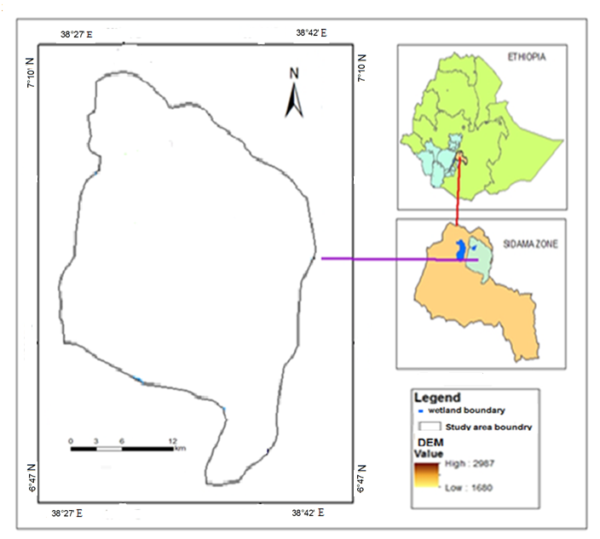
Figure 1: Map of the study the area

Climate
The climate of the catchment is dominated by Tropical climate with distinct dry winter in the western part of the study area and Warm temperate rainy climate in the eastern part highlands of the area. Altitude range 1680 to 2987 meters above sea level. The main rainy season in the catchment area is from May to October, but the dry season goes from November to February, similar to the rain pattern of most Ethiopian plateaus.
The average annual rainfall of the catchment estimated to be about 975mm. Depending on the metrological information the mean annual temperature of the catchment is about 19.5 ^{O}C. The mean monthly temperature varies from 17ºC to 22ºC.
The precipitation spatially varied within the catchment therefore, it was more accurate to have multiple rain gauge stations. Figure 2 shows gauging station, Wondo Genet, Hassawita, Hawassa and Shashamene. The gauge stations at Wondo Genet and Hassawita are situated near the rift escarpment, while the gauging station of Hawassa is located in the lowland areas of the catchment, and the Shashamene station is located at the upper of the catchment.
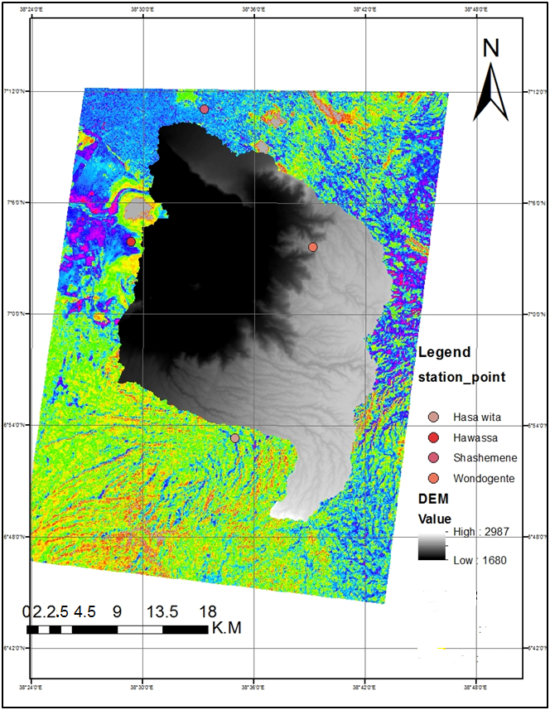
Figure 2: Rain gauge points

Topography and Soil type
The whole cheleleka wetland areas situated in the caldera depression. The nested Hawassa-Korbetti Caldera complex forms a giant elliptical depression 30-40 km wide on the rift floor (Woldegabriel, 1987). This catchment is located in the central part of the higher Ethiopian Rift Valley region, which is surrounded by gently to steeply sloping escarpments and hills forming concave closed system.
The soil of study area examined in detail, and reported in Rift valley Lake basin Integrated Resources Development Master Plan study Project. In general, four major soil types have been identified: Andosols, Cambisols, Luvisols and Aerosols (MOWR, 2008).
The most dominant soil type in this area is Cambisol and second is Luvisols. In compare with the highland area of Ethiopia, these soils are relatively young and inherently more fertile (FAO, 1993).
Soil colors in the study area vary from very dark brown to pale brown. Soil in the study area is moderately acidic to very alkaline; the pH varies between 5.8 and 9.8.

Table 2: According FAO Soil type identification in the study area (MOWR, 2008).
Soil Group | Depth | Colour | Texture | Structure | Consistence | Dominant locations
Ando-sols  (An) | Moderate deep to very deep | Dark greyish to brown to yellowish brown | Medium to course  Texture | Weak fine &medium sub-angular Blocky | Very friable, slightly sticky | North and north western
Cambisols  (Cm) | Moderately deep to very deep | Dark grayish to brown to dark reddish brown | Fine and medium  Texture | Weak to moderate medium | Friable, slightly sticky to very sticky | Central and East to west
Luvisols  (LV) | Deep to very deep | Dark brown to dark reddish brown | Fine and medium  Texture | Moderate medium to coarse | Friable to firm, sticky to very sticky | Central to South East and south to west
Aerosols  (AR) | Very shallow | Dark brown to dark yellowish brown | Medium | Weak to moderate medium | Friable slightly sticky & slightly plastic | Central low land

Agricultural systems
In the study area mixed agriculture in with livestock production is an important component. They are the major assets of the household and play an important role in crop production. The composition of livestock was such that cattle, sheep and goats, horses, mules, donkeys. Feed for livestock comes from communal grazing land, cultivated fields and private grazing land.

Source of data and Methodology employed
- Satellite images
Table 3 List of satellite images used for spatial processing.
Image | Acquisition date | Sensor | Land sat Mission | Processed resolution
1985 | Dec, 12/13/1985 | TM | 1 | 30mx30m
2000 | Dec, 12/17/2000 | TM | 5 | 30m x30m
2015 | Dec, 12/24/2015 | ETM+ | 7 | 30mx30m
(Source: EMA, 2015)
Projection: UTM: Zone: 37
- Primary Data
In order to analyze major contributing factors for soil erosion in the catchment, interview of elders with questioners, focused group discussion with mostly above 50 years elders who have lived for longer in the study area were used.
- Field Data
The field data collection were done randomly to verify the image classified in supervised way and to collect the necessary land use/land cover data. Additionally, systematically field data were collected to validate the result. All field data were collected using Garmin GPS model 76H device. Different variables that have taken in to considerations during field visit are: Current land use types observed in the catchment, water lost areas now known by marshland areas.
- Rain fall data
The monthly amounts of precipitation for the cheleleka watershed were collected over 15 years by the South Regional Meteorological Agency.
Monthly rainfall of four stations (Hawassa, Wondogenet, Hassawita and Shashemene) Mean annual rainfall data ware generated from the monthly rainfall data from 1985 to 2015 years well adopted for the analysis.
- Soil data
For this study a soil data of the major soil groups of South Region as per FAO soil group were collected from Ethiopian Southern Water Resource Bureau and Energy according Ministry of Water Resources and Energy (MWRE), GIS department. The soil polygon feature map is obtained by clipping the FAO soil map of Rift Valley Lake Basin Integrated Resource Development Master Plan Study with the study watershed in the GIS environment.

General methodology
The general methodology employed here are pre- field work, at field work and post field work.
Pre -field work
Reviewing relevant literature on the soil loss, LULC, Conservation measures and application of GIS and RUSLE model, Selection of field areas and preparation of questionnaires were taken.

At field work
During field work the primary data using questionnaires, interviewing experts and group discussion with local leaders was used to collect necessary data.
Post field work
After completion of collecting necessary pre- field data field data the post field work were undertaken.
The main activities were;
- Supervised classification of land cover change in wetland system,
- Analysis of RUSLE factors and generation of map layers for each factors,
- Analysis of annual soil loss from the catchment,
- Analysis of temporal change detection on cheleleka wetland sub-catchment and

3.4. Spatial Data Processing and Analysis

3.4.1. Pre-processing
Pre-processing of satellite images prior to image classification and inference of change in the area is important task that must be under taken by researcher. This task involves operations that are normally required to the main data analysis and extraction of information. Selection of appropriate satellite image is the first task in image data processing. Due to limited amount of budget and availability of longer date of acquisition of satellite images, the land sat images are preferred which have lower resolution which may affect the level of information that can be extracted from the images.
Land sat Image
TM and ETM+ images have relatively medium resolution of 30mx30m. For the detection of change in this wetland sub-catchment using different years of images, date of data acquisition and resolution of images must be similar as much as possible.
Methods of classification used
Image classification is defined as the extraction of distinct classes or themes, land use and land cover classification categories, from satellite imagery .
There are two primary methods of image classification methods utilized by image analysts,
- Unsupervised and
- Supervised classification.
The classification method used in this thesis is supervised image classification. Supervised image classification is a method in which the analyst defines small areas, called training sites, on the image which are representative of each desired land cover category. The delineation of training areas representative of a cover type is most effective when an image analyst has knowledge of the geography of a region and experience with the spectral properties of the cover classes (Taylor and Francis, 2004 cited in loppiso,2014).
The image analyst then trains the software to recognize spectral values or signatures associated with the training sites. Training sites were developed from the ground truth data obtained by Global Positioning System (GPS) during field data collection. Land sat image of 1985, 2000 and 2015 and because of its good classification capacity of the software.
Identification of thematic classes of classification schemes
A classification scheme effectively defines the legend that will be used in LULC map of the study area. Numerous classification schemes used for land cover classification throughout the world. Some of common classification schemes were used in this study to determine the thematic classes based on the first survey in the area by the researcher for the digital analysis were identified as follows:
Grass land: are land cover covered by grass
Marsh/Swamp areas: are land covers with more a marsh and better drainage than a bog
Forest land: Land covered with permanent natural vegetations
Mixed forest land: Land covered with forest mixed with different type of tress and it is more of mixed type with grass and shrubs.
Cultivated land: Land covers class which is used for agricultural production.
Built up land: Land covered with different type of building
Bush land: Land covered with shorter trees that are not more than 3 metres
Shrub land: Land covered wood plants smaller than trees having multiple permanent stems branching from or near the ground.

Table 4: Source, description, and purpose of the data used in the study
Types of data | Source | Description | Purpose
DEM | USGS | 30m spatial resolution | For delineation, slope flow direction & flow accumulation generation
Land sat images | Ethiopia Mapping agency | 30m*30m spatial resolution | For supervised LULC classification
Digital Soil map | Ministry of Water Resources (MOWR, 2008 ) | FAO (1986) | To generate soil map for the model
Rainfall | Hawassa Meteorological Agency | RF data from 4 stations near the study area | To extract the R-map from mean monthly RF data
GCP | Ground control point | Random coordinates from each land use using Garmin GPS model 76H device | To make supervised classification simple.

RUSLE parameter analysis
RUSLE model for soil loss analysis used in this study because of its broadened the applicability of soil loss estimation for rangeland, forests, disturbed sites, and steep slopes and study area have related land use land cover.
When we compute the RUSEL model, six factors considered in the model are; climate (erosivitiy), soil characteristics, topography, land cover management and support practice integrated with Arc GIS 10.3 techniques for estimate status of soil loss. By apply GIS technique with computer model in analysis of soil erosion. All the six factors were multiplied by applying the following equation in Arc GIS10.3 using algebraic/ raster calculator (Renard et al., 1997). RUSLE computes average annual erosion from cover slopes as:
A = R * K * L * S * C * P……………………………………………………….. (1)

Where, A is computed average annual soil loss in (tons/ha/year), R is rainfall and runoff erosivity factor [(MJ mm)/ (ha yr)], K is soil erodibility factor [(ton ha)/ (MJ mm)], L is slope length factor, S is slope steepness factor, C is cover management factor, and P is conservation practice factor.

Rainfall-runoff erosivity factor (R)
Wischmeier and Smith (1958) derived the rainfall and runoff erosivity factor from research data from many sources. The rainfall – runoff erosivity factor is defined as the mean annual sum of individual storm erosion index values, EI30, where E is the total storm kinetic energy and I30 is the maximum rainfall intensity in 30 minutes. To compute storm EI30, continuous rainfall intensity data are needed. The erosivity (R) factor quantifies the effect of raindrop impacts. The R-factor requires long term rainfall data that records the energy available to erode soil. Various equations have been adapted to compute the R-factor; one option is that the erosion index for this parameter is calculated from the total storm energy multiplied by maximum 30 minute intensity. The data layers for each RUSEL parameters were created in the Arc GIS and map for each factor were created in order to analyze soil loss. The mean annual rainfall was first interpolated to generate continuous rainfall data for each grid cell in Arc GIS environment.
Data layers for the R factor also needed to be created. Each layer was created as a shape file and clipped to the catchment and added to the Arc Map environment for each RUSLE model. The shape files were created so that each shape file represented a single polygon that would be represented by a single value.
To further prepare the spatial data for modeling, the data layers would need to be converted from features to raster. The R factor vector Shape files were converted to raster format. This was completed using the Convert Features to Raster function within the Spatial Analyst extension in Arc GIS.
The rainfall erosivity factor R in the study area was calculated according to the equation given by Hurni (1985), which is derived from spatial regression analysis (Hellden,1987) for Ethiopian conditions based on the availability of mean annual rainfall (P).
According to regression equation (2) R factor obtained as follows:
$$R=-8.12+0.562*P… ………………………………………………………… (2)$$
Where,
R=rainfall erosivity factor,
P= mean annual rainfall in mm
The raster rainfall data of the study area was converted to erosivity map of the area using the regeration equation (2) and as the erosive map shown in the Figure 4.

Soil erodibility factor (K)
Soil erodibility (K) is an estimate of the ability of soil to resist erosion, based on physical characteristics of each soil types vary in their susceptibility to erosion. The soil erodibility factor K represents the combined effect of susceptibility of soil to detachment, transportability of the sediment, and the amount and the rate of runoff given particular rainfall erosive .
It also represents the effect of soil properties and soil profile characteristics on soil loss (Renardet al., 1997).
Soil erodibility factor (K) rate of soil loss per unit of R for standard condition of bare soil, recently tilled up-and-down with slope with no conservation practices and on a slope of 50 and 22 m length (Morgan, 1994). The value of K ranges from 0 to 1 Hellden , (1987) developed a USLE for Ethiopian.
Table 5: Soil Erodibility factor value in the study area based soil color (Hellden, 1987)
Soil colour | Black | Brown | Red | Yellow
K- factor | 0.15 | 0.2 | 0.25 | 0.3

The K factor defines the resistance of the soil to both detachment and transport. The K factor (soil erodibility factor) depends on the following soil parameters in combinations: physical characteristics of particle size, permeability y and structure. Since soil has different drainage capacity due to physical and chemical characteristics, the k values were assigned to the soil map generated based on the soil texture and soil color type respectively as shown in the Figure7&8 . So k-factor can be also determined based on the organic matter contents of the soil.

Table 6 : determination of K-factor from soil organic matter and texture analysis from the same study area (Oruk et al., 2012; Wang et al., 2013, cited in Wolka et al, 2015).
Basic textural class | Average k-value | Organic matter content
Basic textural class | Average k-value | <2 | >2
Sandy loam | 0.13 | 0.14 | 0.12
Sandy clay loam | 0.2 | 0.2 | 0.2
Clay loam | 0.305 | 0.33 | 0.28
Loam | 0.3 | 0.34 | 0.26
Clay | 0.225 | 0.24 | 0.2

Vegetation cover and Management factor (C)
The C-factor shows land cover/vegetation management. It is the most important factor in reducing soil erosion activities especially in mountainous watersheds (Zhou et al. 2008; Beskow et al. 2009). The land cover may vary in type including forest, shrub land, agricultural crops, and others. The cover management factor (C) represents the effects of vegetation, management, and erosion control practices on soil loss.
It exerts a strong moderating impact on dissipating the energy supplied by agents of soil erosion. Soil erosion potential increases if the soil has no or very little vegetative cover of plants and/or crops residue. Plant and residue cover protects the soil from raindrop impacts and splash, tends to slow down the movement of surface runoff and allows excess surface water to infiltrate.
The erosion-reducing effectiveness of plant and /or residue covers depends on type, extent, and quantity of cover. Vegetation and crop residue completely cover the soil that intercepts all falling raindrops at and close to the surface and the most efficient in controlling soil.
It is a simple relation between erosion on bare soil and erosion observed under a cropping system. The C factor combines plant cover, its production level and the associated cropping techniques. It varies from 1 on bare soil and less than 1 depending on the land cover type.
Table 7: Land covers/ C- factor values from different references.
Land-use and land-cover type C | C-_factor value | References
Forest/wood Land | 0.02 | Hurni (1988)
Grassland | 0.05 | Eweg and van Lammeren (1996)
Cultivated land | 0.15 | Hurni (1988)
Shrub Land | 0.20 | Wischmeier and Smith (1978)
Swampy | 0.001 | Berket & Teferri, (2009)

Slope length and Slope steepness (LS)
The LS-factor characterizes the effect of topography on erosion in RUSLE
The DEM of resolution 30m was used to derive the L and S factors for the study area using ArcGIS10.3 software on raster calculator. LS map generated as shown Figure 9 by using “Spatial Analyst Tool Surface Slope” in Arc GIS 10.3 environment. These base data sets for mean slope gradient and slope length were then used as inputs to generate the L and S factor for the RUSLE.
In RUSLE, the LS factor represents a ratio of soil loss under given conditions to that at a site with the "standard" slope steepness of 9º and slope length of 22 m plot (Robert &Hilborn, 2000).
The steeper and longer the slope, the higher is the erosion. The upslope drainage area for each cell in a DEM was calculated with multiple flow algorithms. Moreover slope (%) also directly derived from the DEM using the same software).
The remaining factor of LS (slope length and slope steepness) was calculated using the slope and flow accumulation grids generated earlier.
The longer the slope length the higher amount of cumulative runoff and the steeper the slope the higher the runoff velocity which contributes to erosion.
The equation has undergone some minor changes including the equation published by Moore and Burch in, (1986).
The LS empirical equation used for this study is:
$$LS = (Flow Accumulation grid * cell size / 22.13)0.4* (Sin(Slope grid * 0.01745) / 0.0896)1.4*1.4…………………………………………(3)$$
The Raster Calculator in the Spatial Analyst extension of ArcMap was used to calculate the LS grid. The Raster Calculator expression of the equation above was:
$LS = Pow([Flow Accumulation grid] * 10 / 22.13, 0.4) * Pow(Sin[Slope grid] * 0.01745) / 0.0896, 1.4) * 1.4………………………………………………………………($4)

Support practice factor (P)
The Support Practice Factor (P) defined as the ratio of soil loss with a specific support practice to the corresponding soil loss with straight row upslope and down slope tillage. The P factor accounts for control practices that reduce the erosion potential of the runoff by their influence on drainage patterns, runoff concentration, runoff velocity, and hydraulic forces exerted by runoff on soil. The supporting mechanical practices include the effects of contouring, strip cropping, or terracing. P-factor also analyzed using land use type like shrub land, forest land, cultivated land and all land use type etc.
Attributes of Overall RUSLE Data
Prior to converting the R factor, and P factor vector data layers into raster grids, a new field needed to be added to each layer’s attribute table. The new field added to the attribute table housed the C factor values for each land cover polygon in the sub catchment.
The new field added to the attribute tables housed the K factor values for each soil unit in the sub watershed
The K factor values, including a diversity of other soil property characteristics, are found in separate tabular data that were added to the ArcMap environment, queried and joined to the spatial data layers attribute tables based on common fields.
Lastly, a new field was added to each of the R and P factor attribute tables in ArcMap.
To reiterate, each spatial data layer consists of a single polygon that fits the entire extent of the catchment formed. Then the final stage is now set to begin calculating for RUSLE soil loss by multiplying in the raster calculator.
Preparing k- factor
Preparing R -factor

0

91985

LS- Factor
Rainfall Data

DEM
Soil data

Satellite image
K- Map

0

91985
R- Map

0

91985
Preparing p- factor

0

91985
P- Map

0

91985
LS- Map

0

91985
Preparing C- factor

0

91985
C- Map

0

91985
Overlay all RUSEL factors
Slope %
Fill
Flow direction
Flow Acc.
Land use land cover Change map of each year
Estimated Annual soil loss
Detecting temporal LULC change using 1985, 2000and 2015 land sat image 2015catchment
Figure 3 : General methodology of RUSLE factors for soil loss estimation.

Determining temporal changes on the wetland catchment through 1985, 2000 and 2015
Land sat images of 1985, 2000 and 2015 were used to determine change in the mentioned years using Arc GIS 10.3. Shape file was created in Arc catalog 10.3 and displayed on ArcMap 10.3. The area of the created shape file for each land use class was calculated and compared for each year. The temporal trend of change in hectare was analyzed using excel 2007 software.
Changes through these periods analyzed for each land use land cover on the wetland areas. These changes within each land use classification were analyzed and compared. Different comparison statistics were employed: area coverage for each land use class and percentage of coverage calculated. Temporal change detection employed within each land use within the last 30 years.
$$\% T RC =(C A – PA /PA)*100………..(5)$$
Where, TRC is temporal rate of change in each land use land cover, CA is current area, PA is previous area
Analyzing farmer’s perception on manmade or natural factors contributed to soil erosion in the catchment
To address objective of identifying contributing factors for soil erosion in the catchment that resulted in the devastation of wetland sub- catchment, prepared questionnaires, focus group discussion with key informants were used. Views and perception of respondents who have longer residence in the area and have enough knowledge on the area analyzed through statically method using of Mean, percentage and frequency.
In order to analyze such factors stratified sample method undertaken. Dividing targeted population in to strata or group i.e., those are living within wetland areas /at lower part of the catchment and those are living upper part of wetland. Since the catchment located within south people nations nationalities region and Oromia region, the consideration of the both community have taken in to account because the human impact on the area is sum effect of both community and the also have deep knowledge on the area. In this study by considering all situation in the account 40 of sample size from both community were used whose age above 45 years. To obtain sampled households for the interview simple random sampling method were employed in the interested area. Among these 25 respondents from lower part of the catchment areas and 15 respondents from upper part of the catchment selected randomly. Here different value range of rating farmer’s perception taken in to consideration like value ranges (0-5%) rates very low (5-10% ) rates low, (10-20%) value ranges rate as moderate, value a ranges (20-30%) rated as high and value ranges above 30% rated as very high.

RESULTS AND DISCUSSIONS

RUSLE Parameter Estimation for Soil Loss

Rainfall erosive factor estimation
The mean annual rain fall according the data obtained from three gauge stations is 914 mm. According to regression equation (1) given in the methodology R factor obtained as the equation given by Hurni,(1985 ), which is derived from spatial regression analysis (Hellden,1987) for Ethiopian conditions based on the availability of mean annual rainfall (P).
Table 8: Mean annual Rainfall and corresponding R-factor value of the study area from 2000-2014
Station  Name | Elevation  (m.a.s.l) | Mean annual Rf mm | R- Factor  (MJ mm ha⁻¹ hr⁻¹ yr⁻¹)
Shashemene | 1943 | 762 | 420.124
Wodo genet | 1770 | 1021 | 562.682
Hawassa | 1701 | 960 | 531.4
Mean |  | 914.33 | 504.735

As shown in the Table 5 Rainfall erosivity factor (R-factor) value in the study area is ranges 420.124 MJ mm ha⁻¹ hr⁻¹ yr⁻¹_531.4 MJ mm ha⁻¹ hr⁻¹ yr⁻¹and the average value is 504.735 MJmm ha⁻¹yr⁻¹. Since R-factor is proportional and depends to annual rain fall, the R- factor is varying due to the variation in annual rain fall. This indicates that areas having high annual rain fall has greater erosive factor which aggravated with slope factors. The gauging station with high R-factors also contributed to soil erosion. According to this analysis gauging station that situated in the Wondogenet area have high influence in the catchment.
The analysis for R factor of mean annual rain fall for three stations in the study area showed R- value ranges from 420.2 to 1789. The average rainfall for each gauge stations was calculated and a point shape file was created using ArcCalalog10.3 software and finally R-map produced.
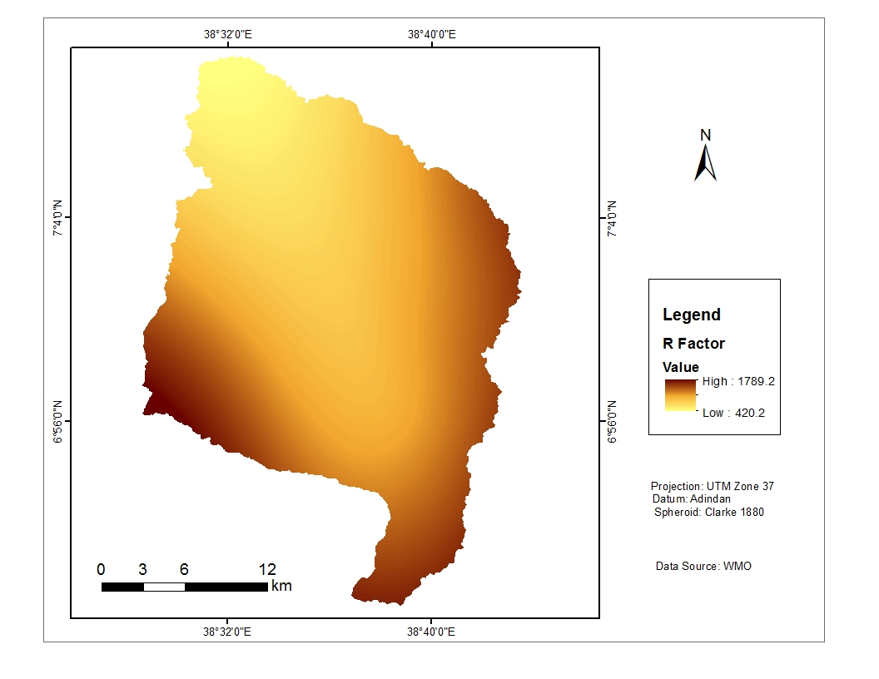
Figure 4 : Map of R-factor
As shown in the Figure 5, four gauging stations have played greater role for the erosion impact in the study area. According analysis of R- map in the study area, station situated in the eastern part of the Wondogenet is most influential to the catchment because it covers highest area compared to other. The next is Haissawita that found at escarpments of the catchment is second influential gauging station. Whereas, Hawassa gauging station that found at lower part of the catchment is third the influential station and the other fourth is Shashemene gauging station that found in the upper Northern part of the catchment.
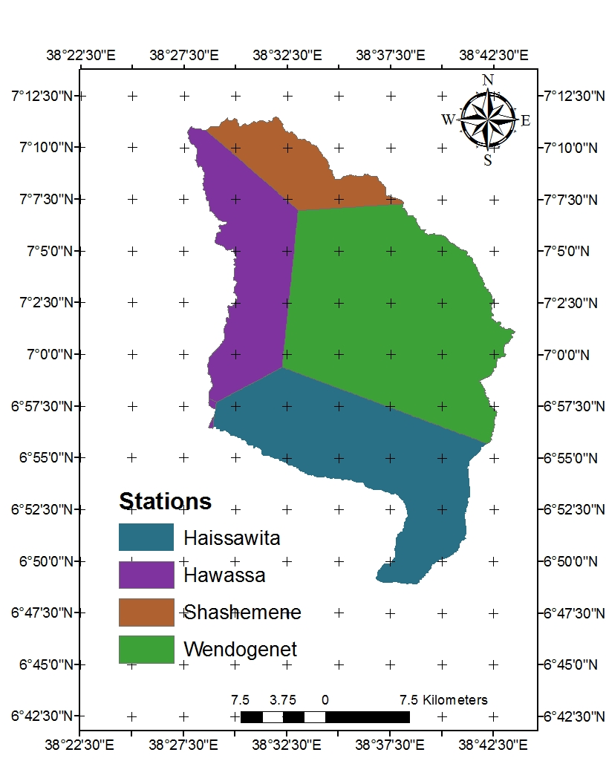

Figure 5 : Map of Thissen polygon of four stations in the study area

4.1.2. Estimation of land use land cover factor management (C factor)
The cover management factor (c-factor) reflects the effect of cropping and management practices on the soil erosion. The C factor is a numerical value ranges from 0 to 1 in which cover management values closer to 0 are less prone to soil erodibility high erodibility of value prone 1.
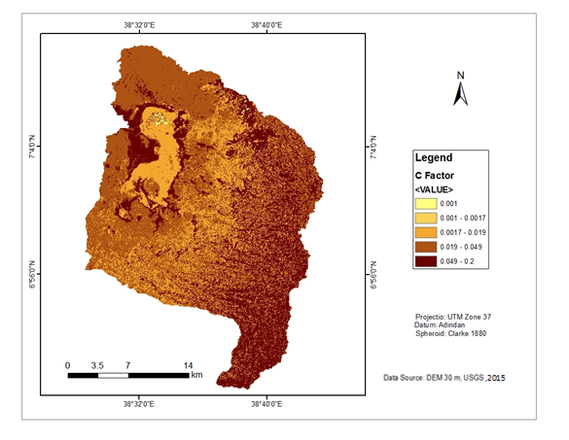
Figure 6 : Map of C factor of the area
As shown on the Figure 6 land cover factor value in the study area classified in the five classes according main land uses types. This C values ranges from low 0.001 to high 0.2. High c value depicts that there is land cover that protects soil erosion and less value shows less land cover effect on soil erosion. This shows that even if there were highest forest degradation in the last 30 years in the catchment, there is shrub land in the high slope areas.
As also stated in the Wolka et al, (2015) in the study area, the increasing population pressure is a serious problem that increases forest land conversion into arable land, leading to land degradation. Most of the watershed area, with a high LS-factor and low C-factor has ‘high’ to ‘very severe’ soil loss values. The combination of these important factors, along with erosive rainfall, contributed to a non tolerable soil erosion problem. This shows that in mountainous watersheds, vegetation cover is the most important factor in reducing soil erosion. In general C-factor value increase with increasing of slope in the catchment and this depicts that even if there were high conversion of forests in the upper catchment, still it has wood and shrub land at the escarpment of the catchment.

4.1.3. Estimation of soil erodibility factor (k-factor).
The K-factor can also be determined in two ways the by identifying color of the soil (Hellden, 1987) and based on the structure of the soil. According to the FOA division of soil based on structure, the study area has clay and loam soils with organic matter content less than 2%. Addition to this, K-factors were also selected from the structure since the two different soil types have different k-factor values.
The soil erodibility factor (K-factor) is derived on soil physical characteristics of particle size, permeability and structure. Since soil has different drainage capacity due to physical and chemical characteristics, the k values were assigned to the soil map.
For the analysis of K-factors in the study area, the major textural classes of the soil were used based on the other study undertaken in the area since the two different soil types have different k-factor values.
k-factor map area was generated assigning the corresponding k-value for each soil types according to Table 6.
Based on the FAO soil classification, an attribute table for k-factor was created and the corresponding k-value for each soil type was assigned according to Table 6. Finally feature class of study area was converted to raster (grid) using k-value attribute as value field and k-factor map of study area was obtained as displayed by Figure 6.
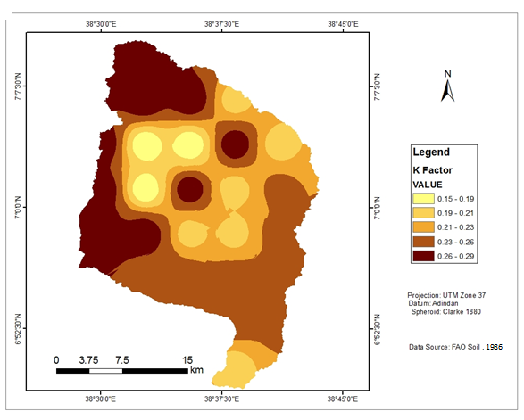Figure 7: K-factor map
According to the FOA division of soil based on texture, the study area has Clay, Loam, Clay loam, Sandy loam and sandy loam soils. In this study addition to the color type of the soil, soil textures used for the classification.
Analysis of K factor in major texture classes the value rages from 0.15 to 0.29. The higher k value shows the higher prone of topsoil to erosion.
This shows that most of the area in the catchment dominated by the k –value range of 0.23 to 0.26 and this implies the most part of the catchment characterized with erodible soil.

4.1.4. Estimation of slope length gradient factors (LS-factor)
It is important to note that there are number of problems unique to the DEMs that need to be addressed.
The slope gradient (S-factor) influences flow velocity and thus the rate of erosion. Slope length (L-factor) describes the distance between the origin and termination of inter-rill processes. LS is referred to be known slope length gradient.

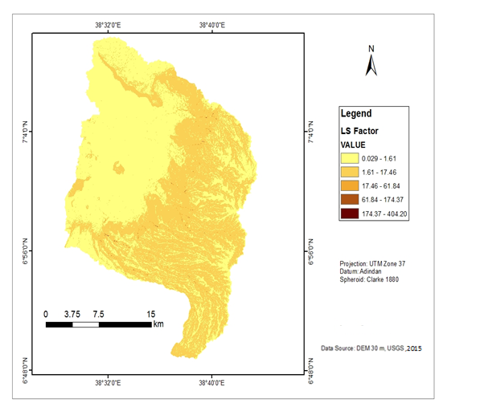
Figure 8 : LS factor map of the area
The overall process (steps) to determine LS factor is presented in equation 3&4 the value of slope length and slope gradient were derived from DEM (figure 3) of resolution 30mx30m. To estimate factor, flow accumulation and slope gradient layers are required. The flow accumulation layer was used to estimate slope length (x). The technique is based on the principle the flow algorism distribution flow according to relative slope of downhill pixels.
The Ls factor value in the study area ranges from 0.029 to high as 404.20 and hill slope part of catchment has high Ls factor and an area within these slope classification played greater role on soil loss in the catchment than lower part of the catchment.
According to this analysis, LS factor in the study area have greater influencing potential for soil loss in the catchment. This also facilitated with longer the slope length the higher amount of cumulative runoff and the steeper the slope the higher the runoff velocity which contributes to erosion.

4.1.5. Estimation of erosion conservation /land Management practice factor (P-value)
The conservation practices factor (p-values) reflects the effects of practices that will reduce the amount and rate of the water runoff and thus reduce the amount of erosion. It depends on the type of conservation measures implemented and requires mapping of conserved areas for it to be quantified. The values suggested for the P-factor are presented in (Wischmeier and Smith 1978).
As shown below Figure 9, the land management factor in the study area classified according land use type within slope classification. The larger value in the area shows less land management practice there but, those areas with have high slope in the catchment is susceptible to the erosion due to deforestation that have taken place in the last years while the area with small value of P factor shows even if, no enough land management practice in the area slope has greater influence because the most of the area situated within this area.
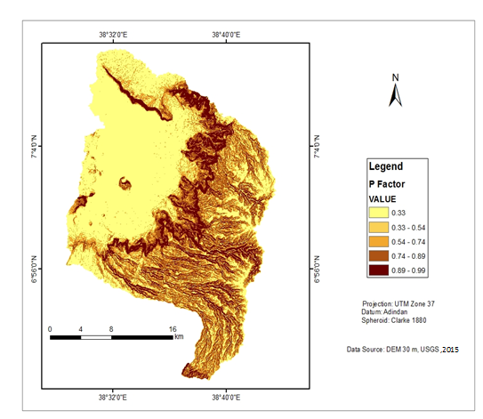
Figure 9: Land management (P) factor map of the study area
According analysis of DEM of the study area, P- factor depends on the type of conservation measures implemented and requires mapping of conserved areas for it to be quantified.
As analysis of p factor value in the catchment ranges from 0.33-0.99, and areas characterized with higher slope have higher land management value (p-value ) and which shows no viable land management/conservation have practiced but there were viable formal land covers that acts as protective from high runoff in the area. In general P value near to 1, means no soil conservation practices are used, the lower p-value, the more conservation practices is deemed to reduce soil erosion.

Slope influence on the soil erosion in the study area
Table 9 : slope classification with area coverage in the catchment
Slope degree | Area (ha) | %
0-10 | 39426 | 60.83
10-20 | 13717 | 21.16
20-30 | 7774 | 11.99
30-40 | 2432 | 3.75
>40 | 1461 | 2.23
Total | 64810 | 100

The slope steepness in the study area varies from 0º to >40º (Table 11). The slope of the study area ranges from 0 to >40º. About 39426 ha (60.83%) area of the catchment has situated within lower slope gradient between (0-10º) slopes where high deposition of eroded materials taken place. About 13717 ha (21.16%) of the area situated within slope ranges between (10 -20º), 7774 ha (11.99%) of the area situated within slope ranges between (20-30º), whereas, 2373 ha (3.66%) of the area situated within slope gradient between (30-40º), and 1461ha ( 2.23%) of the area situated within slope ranges >40º where high erosion taken place in the catchment It also shown on the Figure 6 Ls factor in the study area increase with slope gradient and area of higher slope has larger Ls factor. This shows that higher Ls factors value with sloppy area is leads the soil susceptible to the erosion. The fact also shows that higher deforestation has been occurred in the last years at upper escarpments of the catchment
Slope steepness is one of the criteria for the estimation of erosive potential. Runoff and erosion potential will increases as the slope steepness increase. Based on FAO, (2001) five classes are identified from the slope map of the study area. The lower the slope gradient represents low the lowest runoff potential and where deposition of eroded materials taken place and the higher the slope gradient the highest run off and higher erosion taken place.

Soil loss estimation
After we have formulated the C, K, R, and P factor values next we added to the attribute tables and R factor, P factor, slope, and flow accumulation layers converted from features to raster.
The Raster Calculator was again used to calculate both RUSLE model grids to determine potential soil erosion risk in the sub watershed
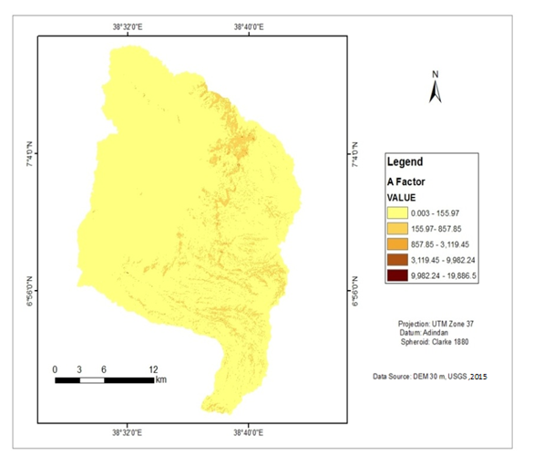
Figure 10 : Estimated annual soil loss within slope category

Summary of Results for soil loss estimation
All map layers were generated for implementation of Rivised Universal Soil loss Equation (RUSLE) in a raster GIS environment approach have developed as an equation of the main factors controlling soil erosion, namely climate (R-factor), soil characteristics (K-factor), topography (LS-factor), land cover management (C-factor) and support practice (P-factor) for soil conservation. Then all the factors were multiplied in raster calculator (ArcView10.3) and the result (output) layer was generated which gives the rate of soil loss by erosion at a pixel level in a raster format.
From the result analysis of the soil loss in the study area using a RUSLE model, estimated mean annual soil loss in terms of whole catchment ranges from 0.003 ton/ha to 19886.5 ton/ha and the average soil loss rate of the study area is 0.004 to 13.61 ton/ha/yr.
As stated in the other studies, the average soil loss rate in the Ethiopia is estimated to be 12t/ha/ yr, and it can be higher than this on steep slopes with soil loss greater than 300 tons per hectare per year where vegetation cover is scant (USAID, 2000). The result this study also agrees with USAID report of the 2000. As also stated in FOA (1984) , the annual soil loss rate of Ethiopia ranges from 1248-23400 million tons per year from 78 million of hectare of pasture, ranges and cultivated fields throughout Ethiopia.

Table 10: Influences of slope classification on soil loss.

Slope classification (in degree) | Rank of soil loss within each of area coverage depending on slope classification
Slope classification (in degree) | Total area (in ha) | Very low |  | Low |  | Moderate |  | High |  | Very high
Slope classification (in degree) | Total area (in ha) | Area(in ha) | % | Area(in ha) | % | Area(in ha) | % | Area(in ha) | % | Area(in ha) | %
0-10 | 39426 | 39425 | 60.83 | 0 | 0 | 0 | 0 | 0 | 0 | 0 | 0
10-20 | 13717 | 0 | 0 | 13717 | 21.16 | 0 | 0 | 0 | 0 | 0 | 0
20-30 | 7774 | 0 | 0 | 0 | 0 | 7774 | 11.99 | 0 | 0 | 0 | 0
30-40 | 2432 | 0 | 0 | 0 | 0 | 0 | 0 | 2432 | 3.75 | 0 | 0
>40 | 1461 | 0 | 0 | 0 | 0 | 0 | 0 | 0 | 0 | 1461 | 2.3
area (in ha) | 64810 | 39426 |  | 13717 |  | 7774 |  | 2432 |  | 1461
Average soil loss |  | 0.004 |  | 0.063 |  | 0.41 |  | 4.11 |  | 13.61
Rank |  | 1 |  | 2 |  | 3 |  | 4 |  | 5
(1=very low, 2=low, 3=moderate, 4=high, 5=very high). According to above illustration, ranks used to show soil loss rate within in the catchment. The value of rank runs from 1 to 5 this shows that the lower the value, the lower characterization of soil loss in the catchment. In this case the rank value 1 indicates that the very soil loss character of sub-catchment which is character of lower part of this catchment and the rank value 5 indicates that the high soil loss character of the sub-catchment and this is mostly shows character of higher slope areas of this catchment.
The soil loss estimated using RUSLE within the catchment showed that, the soil loss rate from high slope areas is highest as compared to the other lower slope areas of the catchment.
In generally, from the total area, 18% of the catchment have characterized with medium to high slope. But, this part known by its more contribution to soil erosion to the other lower part of the sub- catchment. On other hand, other part of the catchment characterized with very low soil loss at lower slope area indicates that the soil loss from the upper area of the sub- catchments is almost deposited within the flat swampy areas of the lower part of the study area.
Generally, this finding indicated that the rate of soil loss increase with increasing slope steepness in the catchment which facilitated by high rain fall and from destructed areas of former forest cover. This method provide that the identification of different useful factors for the assessing soil loss rate at different slopes by using different criteria’s is reasonable and acceptable. Therefore, according to this findings, more attention should be given to slope classes greater than 40⁰, and ranges between 30⁰-40⁰ and 20⁰-30⁰, respectively and also due attention should be considerable for the low slope areas which susceptible to the deposition and siltation from overall whole catchment while planning and implementing soil and water conservation measures is in the study area. This doesn’t mean that to give less attention to those slope category with very low to low soil loss classes in the areas this is to indicate the parts of the slope that need high priority for SWC implementation using the available resource.

Data Quality assessment
The validity assessment was done during the estimation of each factors of RUSLE so that a quality output could be obtained and in order to prevent introduction of wrong input through specific type of factor estimation which may lead to wrong output and conclusion.
The attempts made to increase quality of output in generation of each factors is elaborated as follows:
R factor: The rainfall stations which are within the altitudinal range to the study area are used. Those stations which have high range of mean rainfall were rejected.
K factor: Since the erodibility of the soil is affected by soil type, texture and organic matter content, an attempt was made to include these parameters.
LS factor: DEM of 30m resolution was used instead of 90m which results better output.
C factor: The supervised classification of LULC was done with higher overall accuracy
P factor: collection of primary data and field observation for soil conservation practices using questioner and interview of senior residents of the area.

Land use land cover change analysis of 1985, 2000 and 2015 on catchment.

Changes in land cover driven by land use can be categorized into two types: modification ion and conversion (Loppiso, 2010). In this study different land use class were identified in catchment are cultivated land, shrub land, grass land, forest land, marsh land and mixed forest land and built ups. In the 1985 six land use classes were indentified in the catchment like forest land, mixed forest, shrub land, cultivated land and grass land.
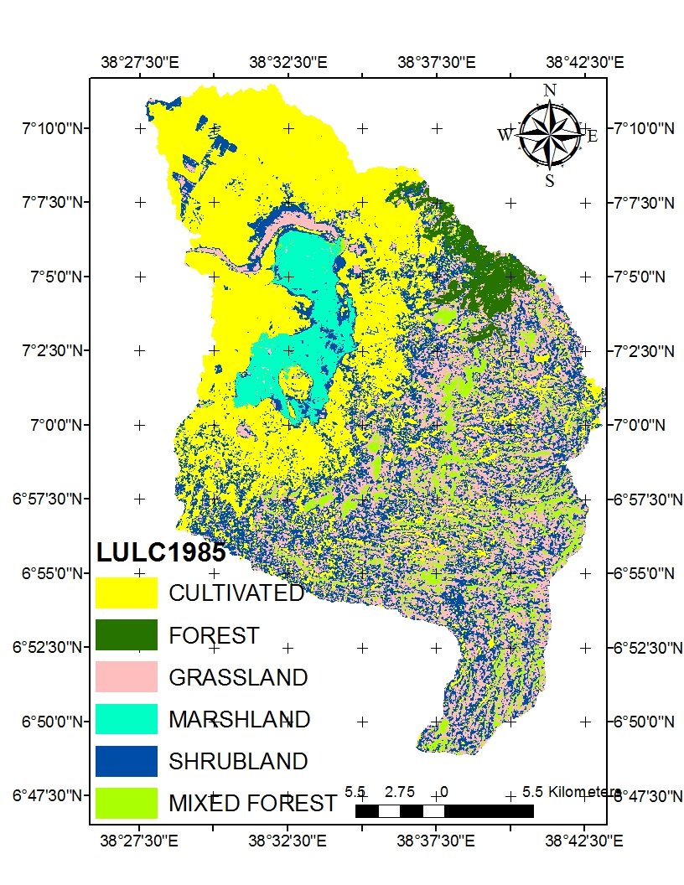
Figure 11: Land use land cover map of 1985 of the Tikurwuha catchment.
To explain briefly and as shown on Figure 12 in the 1985 there are six land use classification in the catchment identified: cultivated land, forest land, shrub land, marsh land, grass land and mixed forest land.
At the beginning in this system cultivated land and shrub land were covered the most of the area in the catchment while marsh land and forest land were covered smaller area compared to others land class in this system.
Table 11: six land use classification of catchment of 1985
 | Land use classes | Area coverage in Ha | Area coverage in %
1 | Forest | 2950.78 | 4.55
2 | Mixed Forest | 10347.14 | 15.96
3 | Cultivated land | 20932.41 | 32.30
4 | Shrub land | 13513.60 | 20.85
5 | Marsh land | 3609.92 | 5.57
6 | Grass land | 13456.50 | 20.76
 | Total | 64810 | 100

Figure 13 below shows that six land use classes of 2000 years in the catchment. They are, land forest land, shrub land, mixed forest, cultivated land, marsh land and built ups lands. The grass land use class which were observed in the former classification of 1985 was absent in the 2000 years. This is because of expansion of agricultural lands and built ups lands have taken place in the catchment in this time years.
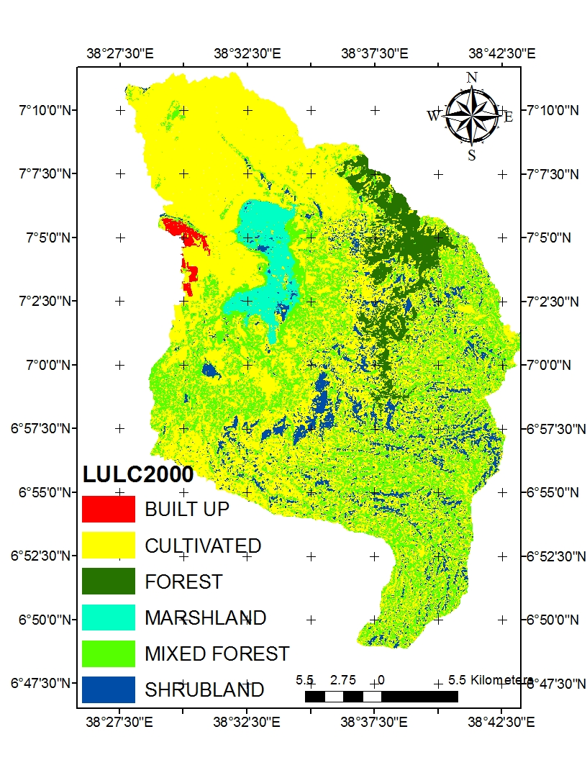

Figure 12: Land use land cover map of 2000 of the Tikurwuha catchment.

Table 12: Land use classification of the 2000

No | Land use classification | Area coverage in Ha | Area coverage in %
1 | Forest | 4409.01 | 6.80
2 | Mixed forest | 18549.32 | 28.62
3 | Cultivated land | 31912.55 | 49.24
4 | Shrub land | 6876.45 | 10.61
5 | Marsh land | 2441.40 | 3.77
6 | Built up | 621.27 | 0.96
 | Total | 64810 | 100
Here as depicted in the table 13, in the 2000 there were also six land use classes are cultivated lands, forest land, mixed forest land, shrub land and built up land. Mixed forest and cultivated land were covered larger area while forest, marsh land and built up were covered smaller area compared to the other land use class respectively. Formerly in the 1985 years there were no such a significant built up areas so it is reason why it not appear in this year land use classes but, in the 2000 years it appears as other land use class.
As shown on the table 12 and 13, the cultivated land has been increased at some extent while marsh land has shown decrease at the highest rate within in the same period.
As illustrated by Table 12, at the initial state of in the 1985, the area covered with marsh land were 3609.92ha (5.57%) of whole catchment. But, in 2000, this was decreased to 2441ha (3.77%) on the expense of grass land and cultivated land. In this system expansion of cultivated land is much more than any other land cover. On the other hand cultivated land were 20932ha (32.30%) in the 1985 but this increased to 31912.55 ha (49.24%) in the 2000 and has shown increase within 15 years. The area were covered with mixed forest in the 1985 were 10347.14 ha (15.96%) but this increased to 18549.32 ha (49.24%) in the 2000

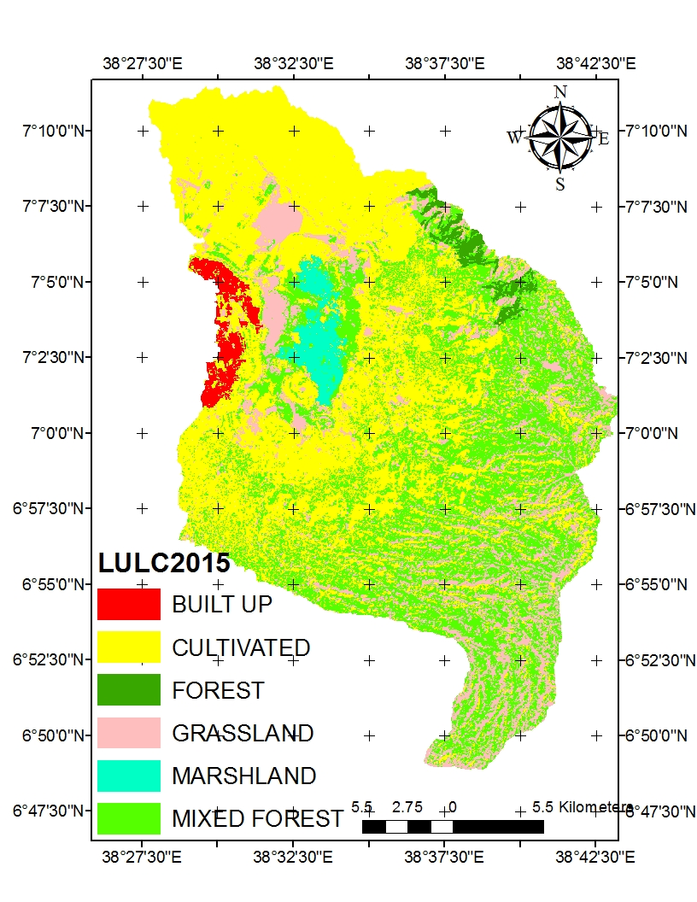
Figure 13: Land use land cover map of 2015 of the Tikurwuha catchment.

Table 13: Land use classification of the 2015

No | Land use classification | Area coverage in Ha | Area coverage in %
1 | Forest | 1261.97 | 1.95
2 | Cultivated land | 33080.50 | 51.04
3 | Mixed forest | 15092.25 | 23.29
4 | Marsh land | 1651.74 | 2.55
5 | Grass land | 12744.90 | 19.67
6 | Built up | 1179.54 | 1.82
 | Total | 64810 | 100

Generally, the areas occupied by in each land use land cover have shown fluctuation between 1985, 2000 and 2015 years. However, as human settlement expanded, land became scarce and, most of the land was turned into crop land for the food security reason and destruction of forests for fuel and other purpose. The decrease of an area that were covered with marsh land has observed at the lower part of areas of the wetland areas and also water dried up lands assessed during primary observation. An area covered with grass land in 1985 in the system was 13456.50 ha and (20.76%) of the whole system. In the 2000 years, the area that were covered with grass land was totally changed to other land use type of built ups and cultivated lands. But, in 2015 years this reappeared again by conversion of shrub land to grass land in the catchment and this has shown 12544 ha (19.36%) of the system in the catchment.
Reasons for decrease in the grass land area in the 2015 compared to 1985 were high rate expansion of cultivated land in the catchment. An area covered with cultivation was 20932 ha (32.30%) in the 1985 and 30680.50 ha (47.54%) in the 2015. Within this year intervals, removal of forests from escarpment of high slope areas of the catchment and conversion of shrub land to grass land and then finally over all conversion to agricultural land have taken place. Forest area that was covered with 19507 ha (3.03%) in the 1985 increased to 2809.01 ha (4.33%) in 2000 this has shown increase because of the some extents of rehabilitation activities that have taken place within this period in the different parts of catchment. An area that were covered with marsh land in the 1985 was 3609.92 ha and (5.57%) But, in the 2015 this was decreased to 1651 ha and (2.55%) and collapse of this marsh land contributed to expansion of agricultural land and grass land in the surrounding areas of wetland.
An area covered with shrub land in the 1985 was 13513.60 ha (20.48%) but this was converted in to grass land and cultivated land in the 2000 years.
No built-up areas observed in the 1985 but, in the 2000, it has shown 621.27 ha (0.96%) area coverage and this also has shown increase to 1251 ha (1.82%) in the 2015.

Table 14: comparison of land use land cover change in different land use classification within catchment in the 1985, 2000 and 2015.

No | Land use classification | Area in Ha |  |  |  |  |  | Temporal change rate in each land use cover type
No | Land use classification | 1985 |  | 2000 |  | 2015 |  | 1985-2000 | 2000-2015 | 1985-2015
No | Land use classification | Ha | % | Ha | % | Ha | % | % | % | %
1 | Forest | 2950.78 | 4.55 | 4409.01 | 6.80 | 1261.97 | 1.95 | 49.45 | -71.32 | -57.23
2 | Mixed forest | 10347.14 | 15.96 | 18549.32 | 28.62 | 15092.25 | 23.29 | 79.32 | -18.62 | 45.93
3 | Cultivated land | 20932 | 32.30 | 31912.55 | 49.24 | 33080.75 | 51.04 | 52.44 | 3.66 | 58.02
4 | Shrub land | 13513.60 | 20.85 | 6876.45 | 10.61 | 0 | 0 | -49.11 | -100 | -100
5 | Marsh land | 3609.92 | 5.57 | 2441.40 | 3.77 | 1651 | 2.55 | -34.65 | -29.95 | -54.22
6 | Grass land | 13456.50 | 20.76 | 0 | 0 | 12744.9 | 19.67 | -100 | - | -6.74
7 | Built up | 0 | 0 | 621.27 | 0.96 | 1179.5 | 1.82 | - | 89.58 | -
 | Total | 64810 | 100 | 64810 | 100 | 64810 | 100

According to the table 15, between 1985- 2000 & 2000-2015 years, fluctuations have taken place on the each land use class in the catchment. High collapse in the marsh land was observed in progressively within these three decades. But, within 15 years interval from 1985 to 2000 some extent of increase was observed on the forest land coverage this is as a result of some practical activities that have taken place in this periods but some extent decrease have observed in this land class within 15 years from 2000 to 2015 because of search for more agricultural lands whereas, where as conversion of shrub land to cultivated land and grass land from 1985 to 2015 years was observed. The coverage of forest in the 1985 were 2950.78 ha (4.55%) but this was increased to 4409.01 ha (6.80%) in the 2000 and collapsed to 1261.97 ha (1.95%) in 2015, this indicates that within 15 years 49.45% temporal increase has observed because of some better management activities have taken place in this time interval in the catchment. On the other hand 57.14% temporal decrease has observed within 30 years on the forest cover in the catchment. This is because of vast devastation and conversion forest land covered with forest for the expansion of agricultural land and other land use.
The coverage of cultivated land in the 1985 were 20932 ha (32.30%) but this was increased to 31912.55 ha (49.24%) in the 2000 and 33080.75 ha (51.04%) in the 2015, this indicates that within 15 years from 1985 to 2000 years 52.44% temporal increase has observed and 3.66. % temporal increase has observed from 2000 to 2015years within cultivated land in the catchment. While within 30 years interval from 1985 to 2015 years 58.02% temporal increase in cultivated land has observed in the catchment.
The coverage of shrub land in the 1985 were 13513.58 ha (20.85%) but this was decreased to 6876.45ha (10.61%) in the 2000 and total conversion to grass land and other land uses has taken place within 30 years from1985 to 2015. The coverage of marsh land in the 1985 were 3609.92ha (5.57%) but this was decreased to 2441.40 ha (3.77%) in the 2000 and to the 1651 ha (2.55%) in 2015, this indicates that within 15 years from 1985 to 2000 years, 34.65% temporal decrease has observed on the marsh land and 54.22% temporal decrease has observed in the 30 years on the marsh land in the catchment. This indicates that the conversion on this land use contributed to the expansion of grass land, built up and cultivated lands. Also visitation of areas showed that there were agricultural practices undertaken around wetland areas by following expanded water dried up swampy areas.
The coverage of grass land in the 1985 were 13456.50 ha (20.76%) but this was totally changed to cultivated land and other land uses in the 2000 and in the 2015 these also observed again by the total conversion of shrub land to other land use class but slow rate when compared with the previous one. There were a insignificant area covered with built up at the beginning of the 1985 as shown on the classification but, this land use class observed as 621.27 ha (0.96%) in the 2000 and this has shown increase to 1179 ha (1.82%) in the 2015, and some increase has observed within 30 years on the built up areas. Sub- catchment around the swamp areas is subject to high fluctuations in the water availability in dry periods. When some parts of the swamp turn into grassland, on the other hand in wet period’s this area become part of the swamp again. Fluctuations in rates of precipitation during previous months can also cause differences in water availability throughout the years and can cause variations in size of grassland, swamp and water body. In the past 3(three) decades, the catchment experienced a negative feedback between the demand of water and the expansion of agricultural fields. As a result of the expansion of agricultural fields, more water is pumped from water interring in to wetland as tributary for irrigation in the upstream area of the wetland, which results in drying up of the wetland and can be used for the expansion of agricultural fields. The water body which previously was named as Lake Cheleleka decreased to nil or 0 % in 2015 and only tall grass and wider flat land seen in the area. Loss of forest cover in the upper catchment resulted with significant erosion effects in the wetland system and for the whole catchment.
This effect of soil erosion in the catchment can be considered in two categories. The first one is on-site effect which refers to the consequences of soil erosion on the upslope areas where it occurred. This causes loss of productive soil from upper layer of the soil surface, soil textural change, fragmentation of productive land and others. The second one is off-site effect which refers to the damage out of the areas where soil erosion occurred. This has greatly contributed to siltation (sedimentation) on the cheleleka wetland and its surrounding swampy area. Moreover, off site impact of the erosion seen by the sedimentation of sand and coarse materials coming from the upslope areas has damaged the downstream of these wetland areas.

Result analysis of respondents view on manmade /natural factors for soil erosion contributing to the loss of cheleleka sub- catchment.
Table 15 : The rating of farmers attitudes/perception on types, degree of severity, history of phenomena ,history of catchment and soil erosion contributing factors in the catchment.

No | Farmers  perception on  factors of the soil  erosion | No of respond-ents | % farmers perception on identifying major factors | Farmers perception ranking factors | No of respondents | % farmer perception ranking factors | Farmers perception on history of the phenomena | No of respon-dents | % farmers perception on history of the catchment
1 | Deforestation | 32 | 80 | Very High | 19 | 47.5 | Recent | 15 | 37.5
2 | Over grazing | 1 | 3 | Very low | 5 | 12.5 | Old | 5 | 12.5
3 | Climate  Change and variability /drought | 3 | 7 | Moderate | 8 | 20 | Recent | 7 | 17.5
4 | Expansion of agricultural land | 4 | 10 | Moderate | 8 | 20 | Old | 13 | 32.5
 | Total | 40 | 100 |  | 40 | 100 |  | 40 | 100
Value range and Rate 0-5 very low, 5-10 low, 10-20 moderate, 20-30 high and above 30 very high. As result obtained from the intended respondents, in the catchment both natural and man - made factors contributed to soil erosion and for the loss of wetland sub- catchment. Natural factors contributing to the occurrence of high soil erosion are the nature of catchment.
Topography, rainfall, soil characteristics frequent droughts that resulted in shortage of rain fall. According their view Man made factors also facilitate and contributed for these factors and speeds up natural factors. These are deforestation, unwise use of the catchment, agricultural land expansion, over grazing etc. According information obtained from, 32(80%) respondent who have lived longer in the area, the main cause for loss of wetland sub catchment is degradation of land and removal former natural forest contributed very high rate in the upper part of the catchment and 4(10%) respondents replied searching of additional agricultural land and cutting of natural trees and wood for fuel as a result this end up with high siltation in the lower part of the catchment and finally resulted loss of formerly Lake known as cheleleka. Among respondents of 19(47.5%) responded that deforestation played very high contribution for soil erosion in the catchment. While, 8(20%), 8(20%) recognized and they have knowledge that factors climatic change and agricultural expansion played significant role and in other way overgrazing have moderate influences in the area respectively. According their views the catchment is found between two regions of South Nations Nationalities and Peoples and Oromia region and border of both Oromo and Sidama peoples so they compete for grazing land and poses greater negative impact to the catchment by clearing forest grown naturally in the catchment in the past years.
Farmers in the study area perceived the change phenomena in the catchment in the different ways.
Among Respondents 15(37.5) perceived changes in the catchment as a recent phenomena result by the removal of former forest, 13(32%) perceived changes in the catchment as old phenomena as a result of overgrazing on the catchment, 7(17.5%) perceived changes in the catchment as recent phenomena because of climate change and variability. They answered that they believed that the disappearance of the lake is due to unwise utilization of land by clearing of forests from the surrounding catchment for the expansion of agricultural lands and for the fuel. Moreover, according to the survey data interviewed farmers who have farm land in nearby dried lake shores, 96% of the respondents said that the coverage of the lake before drying up was covered larger area including now wider flat grazing land but now it has shown maximum shrinkage to non existence. Majority of the respondents, who have been ploughing temporarily and settled around the lost area, responded that once dried up area filled with water at the rainy season and they moved away and on the other hand they return back and settled there again at rain off season. Others responded that they used dried area for grazing purpose at rain off season.
In the study area, the different study also revealed that the increasing population pressure in the last decades is a serious problem that increases conversion of forest land into arable land, leading to land degradation (Gessesse, 2007). As stated in the previous studies the Wondo Genet catchment was also subject to many small settlements during the last decades, which resulted in major land use changes. Before immigration started, the Wondo Genet catchment consisted of extensive natural forest cover on the upland area and the rift escarpments (Caroline Herder, 2013).
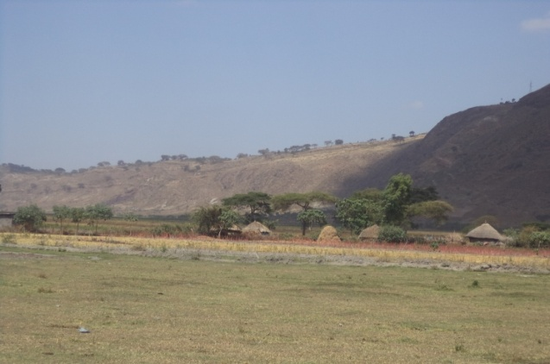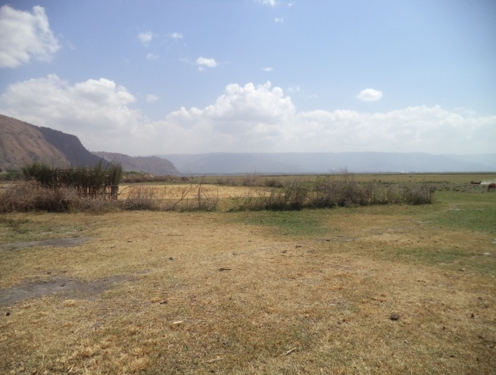
Figure 14 : Temporary or recent settlements nearby swampy areas (Source: own, 2015)

Deforestation is a serious problem in this study area. The major causes of deforestation are population growth, agriculture, resettlement, grazing, fuel wood and timber exploitation (Tulu, 2011). As observer in the area up slope areas at the both edge of wetland is degraded areas as result of deforestation and unwise management of the catchment is a serious problem in this area.
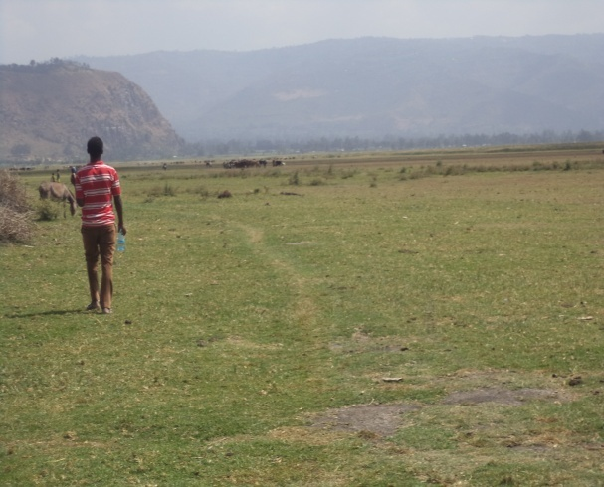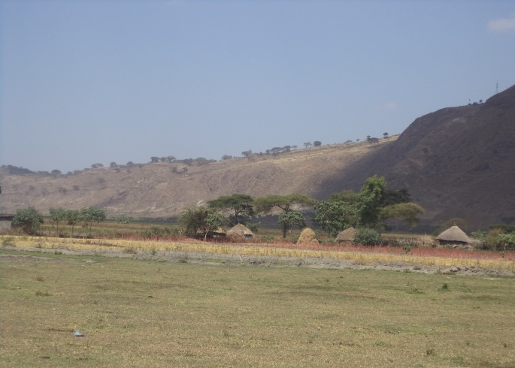
Figure 15 : Highly degraded grazing areas at hill slope areas in the catchment (Source: own, 2015)

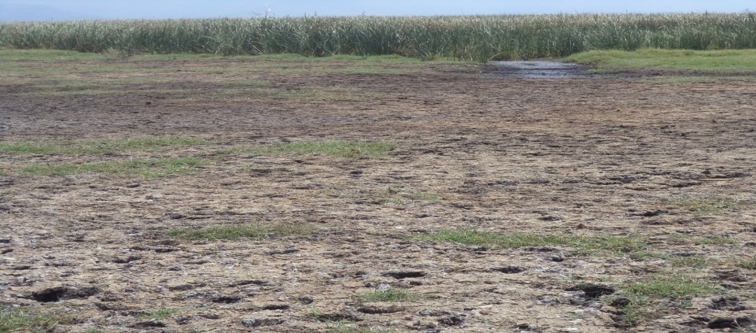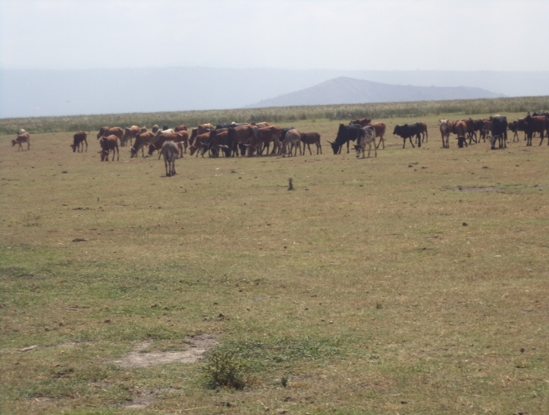
Figure 16 : Dried up areas with long grown grass at the wetland areas and grazing land (Source: own, 2015)

CONCLUSION AND RECOMMENDATION

Conclusion
Natural factors contributing to the occurrence of high soil erosion are the nature of catchment topography, rainfall, soil characteristics. Human factors are deforestation and unwise use of resource and adequate conservation practices. Consequently, the cheleleka wetland catchment has suffered a high sedimentation and siltation problem from the highland areas of its sub-basins. The catchment is characterized with high slope topography ranging from 0.00 to >40% of slope and enclosed with mountain range at its edge. Almost all Water body in study area lost during 1985-2015 and changed to swampy. Annual soil loss in terrns of whole catchment ranges from 0.003 ton/ha to 19,886.5 ton/ha and average soil loss in the catchment 0.004 to 13.61 ton/ha/yr. The expansion of cultivated land, bare land and decrease of forest lands are the main cause for the increasing of soil erosion and loss of wetland in. According model applied, the area of high slope is characterized with severe soil erosion. In generally, this study found that 6.05 % of the high slope area have annual soil loss rate near to the upper tolerable limit from cultivated land according to Hurni ( 1985) (>16t/ha/y r). In order to sustain catchment currently continues integrated physical and biological soil and water conservation intervention on managing and conserving the catchment resources for sustain wetland system is very crucial issue. Moreover, this measures intended to control and manage the surface flow, should aim at measuring, estimating and temporarily or permanently and it should be integrated with and based on the study of the hydrology, sedimentology, agronomic and other aspects. The interaction between surface and ground water should have to be studied as well since it would ease the decision in conjunctive water use and efficient water storage mechanism. Erosion, sediment transport and deposition should be precisely estimated. The source, size and concentration of sediments have to be measured or simulated with utmost care. The crops, cropping pattern and irrigation practices of the area has to be carefully studied.

Recommendations
Sever soil erosion in watershed improved with effective LULC management that implemented in a sustainable way as soon as possible. If not, it will not take longer to face whole wetland loss consequently which may cause negative impact on the climate of local, regional and as well as globally. Soil conservation and management practices must be done giving priority to deforested areas, wetland and cultivated lands.
Participatory reforestation activities must be practiced in deforested area in the catchment.
Effective community participatory wetland management and protection must be practice to restore lost part of the Cheleleka Lake.
Further study on the geological aspects of for the loss of the lake cheleleka wetland must be undertaken.

References
Abbott, M.B., Bathurst, J.C., Cunge, J.A., O’Connell, P. E and Rammussen (1986).
An introduction to the European Hydrologic System, SHE. J. Hydrology; 87: 45- 49.
Abera, (2010).Accelerating Ethiopian Agriculture Development for Growth, Food Security
Equity.
Abebe ,Y.D and Geheb K (2003). Wetlands of Ethiopia. Proceedings of a
on the resources and status of Ethiopia's wetlands, IUCN, Switzerland, 116pp.
Anderson, J.R., Hardy, E.E., Roach, J.T. and witmer, R.E. (1976):
A Land Use and Land Cover Classification System for Use with Remote
Sensor Data. U.S. Geological Survey Professional Paper 964.
BAHC. (1993).. Biospheric Aspects of t he Hy drological Cycle (BAHC):
The Operational Plan IGBPReport No. 27. BAHC Core Project Office, Berlin.
Bewket W. and Teferi E (2009). Assessment of soil erosion hazard and prioritization for treatment at thewatershed level: case study in the Chemoga watershed, Blue Nile basin, Ethiopia. Land degradation &development. Published online in Wiley InterScience (www.interscience.wiley.com) DOI:10.1002/ldr.944).
Beskow S, Mello CR, Norton LD, Curi N, Viola MR, Avanzi JC, (2009) Soil erosion
prediction in the Grande River Basin, Brazil using distributed modeling.
Catena 79:49–59

Breiby, Todd. (2006). Assessment of Soil Erosion Risk within a Subwatershed using GIS and RUSLE with a Comparative Analysis of the use of STATSGO and SSURGO Soil Databases. Volume 8, Papers in Resource Analysis. 22pp. Saint Mary’s University of Minnesota Central Services Press. Winona,MN. Retrieved (date) from http://www.gis.smumn.edu.
Brun, L. J., J. L. Richardson, J. W. Enz, and J. K. Larsen., (1981)..Stream flow changes in the southern Red River Valley ofNorth Dakota. North Dakota Farm Research Bulletin 38:
11–14.
Caroline H, (2013) .Impacts of land use changes on the hydrology of Wondo
Genet catchment in Ethiopia.
Cunningham P and. Saigo B (1995). Environmental Science: A Global Concern.ed. W. C. Brown Publishers, Boston, MA, 612pp.
Dixon A , (2002). The hydrological impacts and sustainability of wetlands drainage cultivation
In Illubabur, Ethiopia. Land degradation and development. 13(1): 17-31.
Dixon, A.B. and Wood, A.P. (2003). Wetland Cultivation and hydrological Management
in eastern Africa: Matching community and hydrological needs through sustainable
wetland use. Natural Resource Forum. 27:117 129
Dugan P (1990). Wetland Conservation: A Review of Current Issues and Required
Action. IUCN, Gland, Switzerland 94pp.
Dugan P (1993). Wetlands in Danger. Oxford University Press, New York, NY, USA.
Eastman Ronald J. (2006), IDRISI Andes Guide to GIS and Image Processing; Clark Labs, Clark University.
Elirehema YS. (2001). Soil water erosion modelling in selected watersheds in Southern
Spain. IFA; ITC, Enschede.
EPU, (2004). Proceedings of the “National Consultative Workshop on the Ramsar
Convention and Ethiopia, the environmental protection Authority in collaboration
with the Ramsar Bureau, Addis Ababa, Ethiopia.
EWNRA, (2008). Proceedings of the National Stakeholders’ Workshop on Creating
National Commitment for Wetland Policy and Strategy Development in Ethiopia,
7 - 8 August (2008), Addis Ababa.
Fang N, Shi Z, Li L, Guo Z, Liu Q, Ai L (2012) The effects of rainfall regimes and
land use changes on runoff and soil loss in a small mountainous watershed.
Catena 99:1–8
FAO /UNEP, (1978). Methodology for Assessing Soil Degradation, FAO/UNEP, New York.
FAO, 1984. Land-use, Production regions and farming systems: Assistance to land-use
planning. Technical report No. 3, Rome.
FAO, (1986). Highlands Reclamation Study of Ethiopia Final Report. Vol. I & II. Rome, Italy
FAO. 2005. FAOSTAT database. Available at http://faostat.fao.org/default.aspx
Finlayson M and Moser M (1991). Wetlands’ international waterfowl and wetlands
research bureau. Facts on File Ltd. Oxford, UK 224pp
Foster, G. R. (1988). Modeling soil erosion and sediment yield, (Lal, R. (Ed.),
Soil erosion research methods, Soil and Water Conservation Society.
Fu, B.J., Chen, L.D., Ma, K.M., Zhou, H.F., and Wang, J., (2000),.
The relationships between land-use and soil conditions in the hilly area
of the Loess Plateau in northern Shaanxi, China. Catena 36, 69–78.
Gete Z. &Hurni, H., (2001). Implications of land use and land cover dynamics for mountain resource degradation in the Northwestern Ethiopian highlands. Mountain Research and Development 2001; 21(2): 184-191.
GLP, (2005): Science Plan and Implementat ion Strategy . IGBP Report No. 53/IHDP Report No. 19. IGBP Secretariat, Stockholm. 64pp
Hickey, R., Burns, E., Bolte, J., and D. Walker. (2005). Development of a Statewide Erosion Vulnerability
Hillman J (ed.) (1993). Ethiopia: Compendium of Wildlife Conservation Information.
NYZS - The Wildlife Conservation Society - International, New York Zoological
Park, Bronx, NY and Ethiopian Wildlife Conservation Organization, Addis Ababa,
Vol. 2. 332 pp.
Hellden, U., (1987). An Assessment of Woody Biomass, Community Forests, Land Use and Soil
Erosion in Ethiopia. Lund University Press.
Hudson, N. (1996). Soil conservation (Second edition). London: B.T. Batsford.
Hurni, H., (1983). Soil erosion and soil formation in agricultural ecosystems in Ethiopia and Northern Thailand. Mountain research and development 1983; 3(2):131-142.
Hurni, H., (1985). Soil conservation manual for Ethiopia. SCRP, CFSCDD, Ministry of Agriculture, Addis Ababa.
Hurni, H., (1988). Climate, soil and water. Degradation and conservation of the resources in the Ethiopian Highland. University of Berne, Switzerland.
Hurni, H., (1993). Land degradation, famine, and land resource scenarios in Ethiopia.
Hurni, H., T. Kebede, and Z. Gete. (2005). The implications of changes in population,
land use, and land management for surface runoff in the
upper Nile basin area of Ethiopia. Mountain Research and
Development 25/ (2):147–154.
Kheir RB, Abdallah C, Runnstrom M, Mart-Ensson U (2008) Designing erosion
management plans in Lebanon using remote sensing, GIS and decision-tree
modeling. Landsc Urban Plan 88(2–4):54–6
Lal. R., (1998). Soil erosion impact on agronomic productivity and environment quality. Critical Reviews in Plant Sciences 17.
Lambin, E.F., Ehrlich, D. , (1997). Land-cover changes in
Sub-saharian Africa (1982-1991): applicat ion of a change index based on remotely
Sensed surface temperature and vegetation indices at a continental scale.
Remote Sensing of Environment 61:181-200
Lardinois I and Klundert V (1993). Organic Waste: Options for small-scale Resource
Recovery. Urban Solid Waste Series 1. WASTE/TOOLE, Amsterdam 132pp.
Lee, G.S., and K.H. Lee. (2006). Scaling Effect for Estimating Soil Loss in the
RUSLE Model using Remotely Sensed Geospatial Data in Korea.
Lesslie, R., Barson, M., and Smith, J. (2006). Land-use information for integrated natural
resources management- a coordinated national mapping program for Australia.
Journal of Land-use Science 1(1), 45–62.
Lemlem,(2003). Biodiversity potentials and threats to the southern Rift Valley lakes of Ethiopia
Loppiso Shamebo , (2010). Assessment of Land Use Land Cover Dynamics and Its
Impact on soil loss: UsingGIS and Remote Sensing,
in Shashogo Woreda, Southern Ethiopia.
Makuria Agaw, (2005). Forest conversion, soil degradation, farmers perception nexus,
implication for sustainable land use in south west of Ethiopia. Ecology and
environment series. No26 P61-86.
Meyer, W.B., (1995). Past and Present Land-use and Land-cover in the U.S.A. Consequence.
Mill ward A. A. and. Mersey J. E (1999) Adapting the RUSLE to model soil erosion potential in a mountainous tropical watershed, CATENA, 38 (2), 109-129
Mirco, G., Robert, J.A.J., Ezio, R. & Luca, M., (2003). Soil Erosion Risk in Italy: a revise USLE approach. European Soil Bureau Research Report No.11, EUR 20677 EN. Office
for Official Publications of the European Communities, Luxembourg. 2003:28.
Mkhonta, M.M., (2000). Use of geographical information system (GIS) in the assessment of soil erosion in the Ghayimane and Mahhuku catchment area with special attention on soil erodibility (k-factor). Msc, thesis. ITC, Enschede, the Netherland.
Morgan, R. P. C., (2005). Soil Erosion and Conservation (3rd. ed.). Malden, Mass.:
Blackwell Publishing.
Moore, I. D., and C. L. Larson., (1979).. Effects of drainage projects on surface
runoff from small depressional watersheds in the north central region.
Water ResourcesResearch Center Bulletin 99. Department of Agricultural Engineering,University of Minnesota, Minneapolis, Minnesota, USA.
Moore, I., and G. Burch. (1986). Physical Basis of the Length-Slope Factor in the
Universal Soil Loss Equation
Nearing MA, Foster GR, Lane LJ and Flinkener SC. (1989). A process based soil erosion
model for USDA water erosion prediction project technology. ASCE; 32(5):1587– 1593.
Petter P. (1992). GIS and Remote Sensing for Soil Erosion Studies in Semi-arid
Environments. PhD, University of Lund
Pohjonen V and Pukkala T (1990). Eucalyptus saligna in Ethiopia forestry.
Forest ecosystem & management. 36:19-31.
Raissouni A, Khali Issa L, El Arrim A, Maâtouk M, Passalacqua R (2012) GIS-based
model to assess erosion sensitivity in Northern Morocco. Laou watershed
case study. Int J Geosci 3:610–626
Reusing M, Schneider T, and Ammer U., (2000). Modelling soil loss rates in the Ethiopian Highlands by integration of high resolution MOMS-02/D2-stereo-data in a GIS. International J. of Remote Sensing 21.
Renard, K.G., Foster, G.R., Weesies, G.A., McCool, D.K., and D.C. Yoder.(1997). Predicting Soil Erosion by Water: A Guide to Conservation Planning with the Revised Universal Soil Loss Equation (RUSLE).
Riebsame , W.E, Mey er, W.B, and Tuner , B.L. II. (1994). Modelling land-use and land- cover as part of global environmental change. A climate change. Vol.28. P 45
Robert PS and Hilborn D, (2000). Factsheet: Universal Soil Loss Equation (USLE).Index No 572/751, Queen’sprinter for Ontario.
Saavedra, C., (2005). Estimating spatial patterns of soil erosion and deposition in the Andean region using geo-information techniques: a case study in Cochabamba, Bolivia PhD. dissertation, Wageningen University, The Netherlands.
Selamyehun K and Tekalegn M (2003). Land Use Changes and Erosion on the High Land
Soils of Ethiopia. Natural Resource Journal of Ethiopia 5(2): pp. 215-231
Shi, Z.H., Cai, C.F., Ding, S.W., Li, Z.X., Wang, T.W., and Z.C. Sun. (2002).
Assessment of Erosion Risk with the RUSLE and GIS
Shibiru, (2002). An investigation of physical and socio-economic determinants of soil erosion
in the Hararghe highlands, eastern Ethiopia. Land degradation and development
Singh, A. (1989). , Digital change detection techniques using remotely sensed data.
International journal of remote sensing Vol 10, P989-1003, vol 14 P 69-81
Singh, D. Herlin I, Berroir J.P, Silva E.F, and Meirelles M.S., (2004). An approach to correlate NDVI with soil color for erosion process using NOAA/AVHRR data. Advances inSpace Research 33.
Toy , J.T. Foster, G.R. and Renard, K.G. (2002). Soil Erosion, Processes, Prediction,
Measurement and Control. New York. USA. pp.338
Trojacek, P. &Kadlubiec, R., (2004). Detailed mapping of agricultural plots using satellite
imagers and aerial orthophoto maps. In: Remote Sensing in Transition, edited by R
Goossens (Mill-press, Rotterdam) 253-257.
Turner, B.L. II and B.L. Mey er. (1994). "Global Land-use and Land-cover Change: An
Overview." In Changes in Land-use and Land-cover: A Global Perspective, eds .
W.B. Mey er and B.L. Turner II, 3-10. Cambri dge: Cambridge Universit y Press.
UNEP (United Nations Environment Programme) (1983). Ecology and environment: What do
we know about desertification? Desertification Control 3: 2–9.
UNEP, (2005): Prpgramme of work on the biological diversity of dry and sub-humid lands:
review of implementation. UNEP/CBD/SBSTTA/11/INF/7, Montreal.
UNEP (United Nations Environment Programme). (2006), Africa environment outlook 2:
Our environment, our wealth. Nairobi, Kenya: UNE
USAID, (2000). Strengthening emergency response abilities. Disaster management and
preparedness commission (DPPC), United states for international development
(USAID). Southern nations, nationalities and peoples region. .
Williams, J.R.,( 1975). Sediment-yield prediction with universal equation
using runoff energy factor. Present and prospective technology for
predicting sediment yield and sources: Proceedings of the sedimentyield workshop,
Oxford, Great-Britain.
Wilkie, D.S., and Finn, J.T. (1996). Remote Sensing Imagery for Natural Resources
Monitoring. Columbia University Press, New York; 295
Wischmeier, W.H. and D.D. Smith. (1978). predicting rainfall erosion losses:
a guide to conservation planning. Agriculture Handbook 282. USDA-ARS
Wischmeier, W. H., and Smith, D. D. (1978). Predicting rainfall erosion losses: A guide
to conservation planning. U.S. Department of Agriculture. Agriculture Handbook
No. 537, Washington, D.C., U.S. Government Printing Office.
Wolde Gebrie Kidane, (1987). An inventory of climate, UN Development Program.
LUPRD/FAO, March 1987, Addis Ababa.
W.W.D.S.E. (2001). The study of Lake Awassa level, lake Awassa study
and design project. Water Works Design and Supervision Enterprise, Addis Ababa.
Yacob E,(2010) . Evaluating the Impact of Land use Land cover change on Soil
Erosion and runoff using SWAT model at TikurWuha watershed,
AdisAbeba University.
Yemane G, (2004). Assessment of Water Balance of Lake Awassa Catchment, MSc
ITCEnschede, the Netherlands
Young RA., Onstad CA., Bosch DD. , Anderson WP. (1987). AGNPS: an agricultural point
source pollution model. Conservation research report 35,
US Dept. Agric. Res. Services, Washington, DC, USA.

Zeleke, G. & Hurni, H. (2001): Implication of Land Use und Land Cover Dynamics for
Mountain Resource Degradation in the Northwestern Ethiopian Highlands. – In:
Mountain Research Development, 21, 2, pp.184-191.
Zerihun D, (2003). Challenges and opportunities of Ethiopian wetlands:
the case of Lake Awassa and its feeders
Zhou., (2004). Enhancement of carbon sequestration in U.S.soils. BioScience 54:895–908.
Zhou P, Luukkanen O, Tokola T, Nieminen J (2008) Effect of vegetation cover on
soil erosion in a mountainous watershed. Catena 75:319–325
Zingg, A.V., (1940) Degree and length of land slope as it affects soil loss in runoff,
Agr. Ingi, no. 21, pp. 59
Zubair, Ayodeji Opeyemi, (2006).A study on change detection and land ues/land cover of
Ilorin and its environs in Kwara State M Sc. Thesis, University of IBADAN, Nigeria.

Appendix

QUESTIONARES
The following questions was asked during semi-structured interview with individual farmers for assessment of Man- made and Natural factors on soil erosion from the catchment and loss of cheleleka wetland.
Questioner Number: ___________________
Date of interview: Day ______ Month _________ Year __________ Interviewed by: _________
Data Entered: Day _______________ Month _____________ Year ___________
Region: _______________ Zone: ____________
Woreda: ______________ PA: __________Household Number: _________
Part-1 past history of catchment and attitudes of farmers
- Where is location of your home and land?
A, at upper part of the wetland catchment B, at lower/in the wetland catchment C, outside of catchment
- When did you start to live around this area?
A, between 1950-1980 E.C B, between 1980-2000 E.C C, between 2000-2007 E.C
- Is there any problem on cheleleka wetland catchment? A, Yes B,No
- What type of problem do you observed on cheleleka wetland catchment?
A, Sedimentation on wetland B, soil erosion on wetland C ,loss on wetland
D, Deforestation E, unknown
- Did the cheleleka wetland exist in these places when you started living here?
A, Yes B, No
- How do you describe the factors related to loss of of cheleleka wetland catchment?
A, Very old B, Young C, Recent phenomena D, unknown
- How do you describe the severity of soil erosion in this cheleleka wetland area?
A, sever B, moderate C, no erosion D, Low erosion E, unknown
- What do you think the major cause of soil erosion in the wetland catchments?
A, Deforestation B, Repeated cultivations, or decimation by fire
C, land use change D, soil erodibility E, Slope Gradient and Length
- Any other information you can give about the factors for soil erosion and its evolution in the catchment?

- Describe how understand the soil erosion in the cheleleka wetland catchment

- What are the visible impacts of soil erosion in the wetland catchment?
A, Land productivity reduction B, wetland land destructions C, Sedimentation on wetland
E, destruction of settlement and infrastructure
- Describe the noticeable changes on wetland over time due to soil erosion?
- How do you describe the factors related to loss of wetland in the catchment.

List of tables

Table 1: attributes of land use land cover classification of 1985
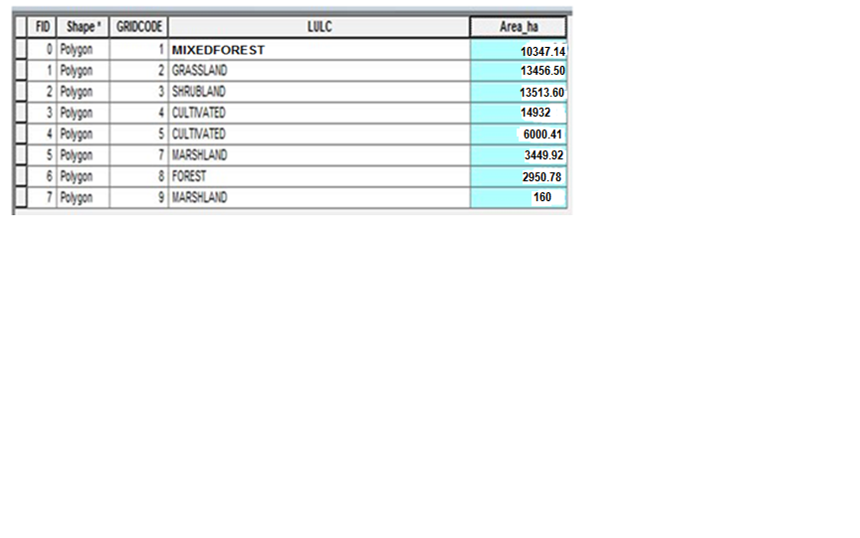

Table 2: attributes of land use land cover classification of 2000
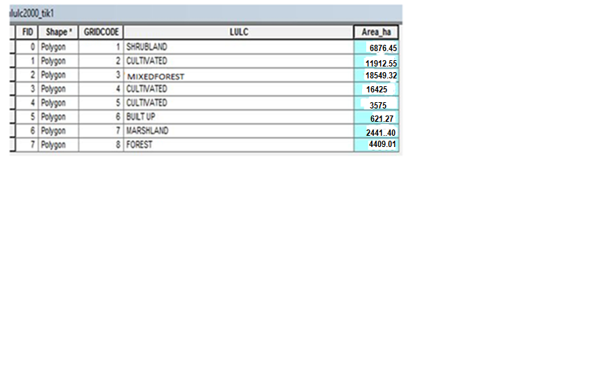

Table 3: Attributes of land use land cover classification of 2015
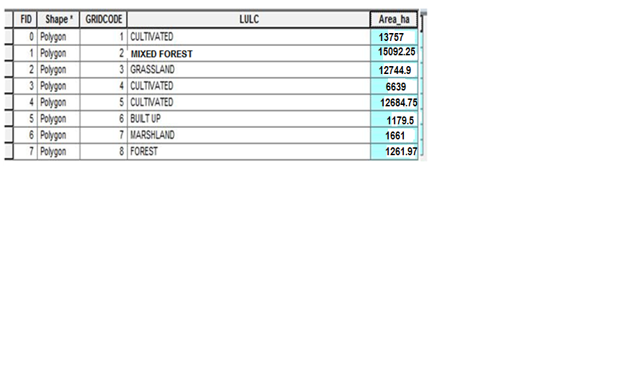

Table 4: GPS Points taken from cheleleka wetland areas for three land use type.
 | X | Y | Elevation | Remark
1 | 0449686 | 0785809 | 1690 | Grass land
2 | 0449794 | 0785779 | 1690 | Grass land
3 | 0449885 | 0785447 | 1691 | Cultivated land
4 | 0449973 | 0785726 | 1691 | Cultivated land
5 | 0450070 | 0785693 | 1689 | Grass land
6 | 0450046 | 0785588 | 1691 | Cultivated land
7 | 0450014 | 0785491 | 1687 | Water body
8 | 0449885 | 0785541 | 1687 |  | Water body
9 | 0440923 | 0785569 | 1687 |  | Water body
10 | 0449725 | 0785720 | 1688 |  | Grass land

List of Figure

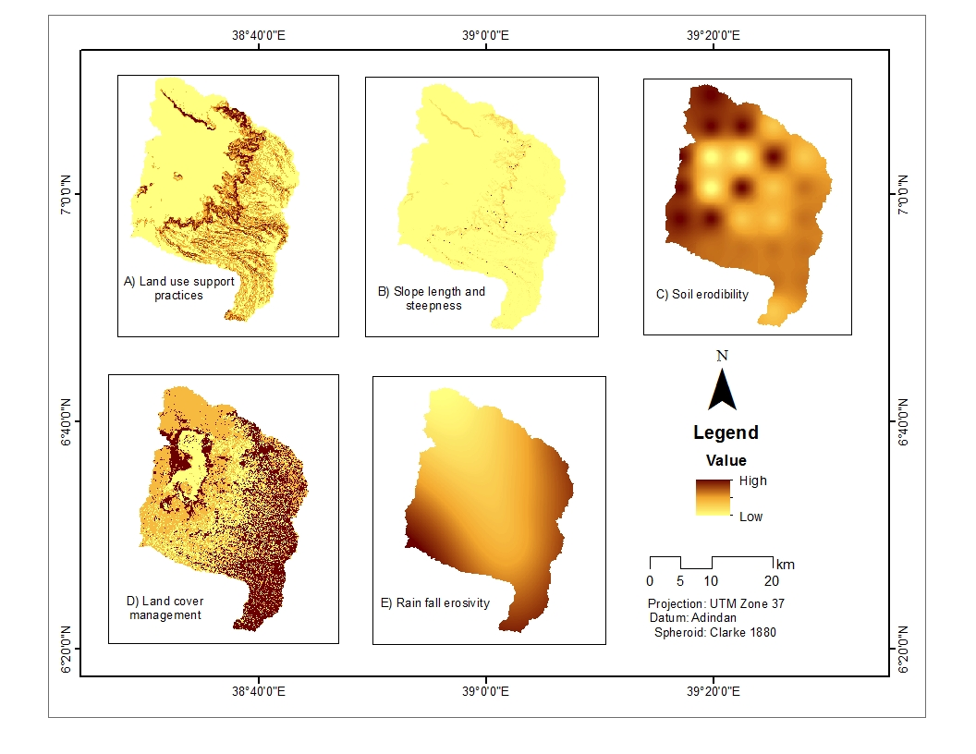
Figure 1: RUSLE factors

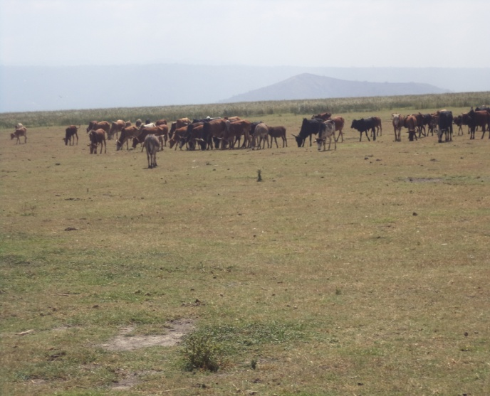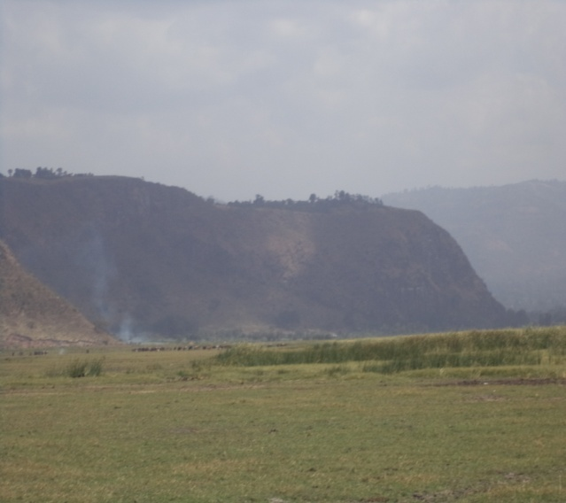
Figure 2: Grazing area lost area of wetland Figure 3: high slope at upper part of wetland

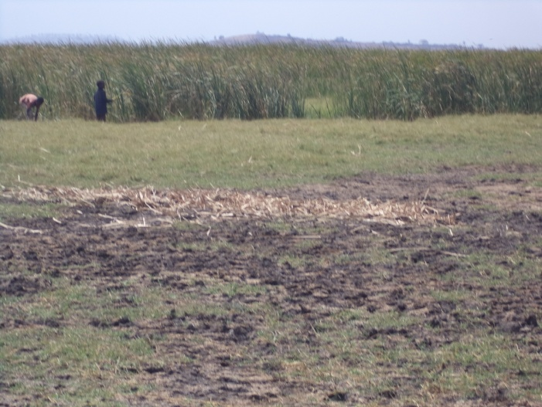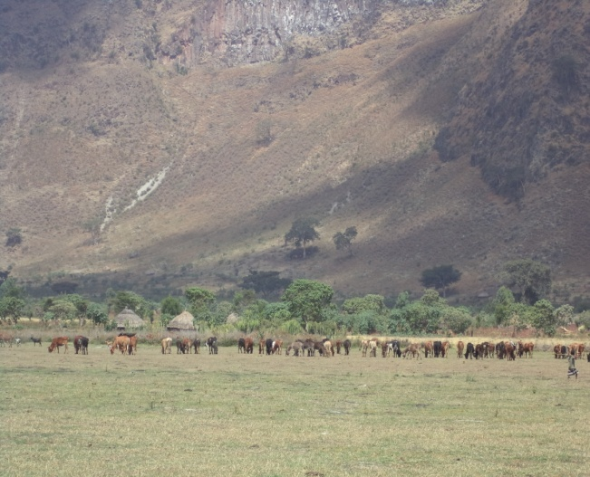
Figure 4: Tall grass at water lost area Figure 5: Settlement at edge of the wetland

