

FACILITY LAYOUT DESIGN TO EFFICIENT SPACE UTILIZATION AND INSPECTION PERFORMANCE: CASE OF MODJO DRY PORT

MSc. THESIS

BY

BONDE ASSEFA SHULISHA

JUNE, 2018
HAWASSA, ETHIOPIA

FACILITY LAYOUT DESIGN TO EFFICIENT SPACE UTILIZATION AND INSPECTION PERFORMANCE: CASE OF MODJO DRY PORT
BY
BONDE ASSEFA SHULISHA

MAJOR ADVISOR: FASIKA BETE GEORGISIE (Dr:-Ing.)
CO-ADVISOR: HABTE BEKELE (MSc.)

THESIS SUBMITTED TO
DEPARTMENT OF INDUSTRIAL ENGINEERING PARTIAL FULFILLMENT OF MASTER OF SCIENCE IN INDUSTRIAL ENGINEERING AND LOGISTICS MANAGEMENT

JUNE, 2018
HAWASSA UNIVERSITY

SCHOOL OF GRADUATE STUDIES
HAWASSA UNIVERSITY
ADVISORS’ APPROVAL SHEET

This is to certify that the thesis entitled “______________________________________ _____________________________________________________” submitted in partial fulfillment of the requirements for the degree of Master of Science in Industrial Engineering and Logistics management, the Graduate Program of the School of Industrial Engineering, and has been carried out by Bonde Assefa Id. No. IELM-R/003/09 under our supervision. Therefore, we recommend that the student has fulfilled the requirements and hence hereby can submit the thesis to the school of Industrial Engineering.

………………......................................... ………………. ……..…..…..
NAME OF MAJOR ADVISOR SIGNATURE DATE
…………………………………………. ……………… ……..………
NAME OF CO ADVISOR SIGNATURE DATE

SCHOOL OF GRADUATE STUDIES
EXAMANERS’ APPROVAL SHEET
We, the undersigned, the member of the board of examiners of the final open by have read and evaluated his/her thesis entitled ____________________________________________________ _______________________________________________________________________’’ and examined the candidate. This is, therefore, to certify that the thesis has been accepted in partial fulfillment of the requirements for the masters of Science in Industrial Engineering and Logistics Management.
……………………………………….… ………………… ……..………
NAME OF THE CHAIR PERSON SIGNATURE DATE
………………......................................... ………………. ……..………
NAME OF INTERNAL EXAMINER SIGNATURE DATE
………………......................................... ………………. ……..………
NAME OF EXTERNAL EXAMINER SIGNATURE DATE
................................................................. …………………. …………..…
SGS APPROVAL SIGNATURE DATE

DECLARATION
I hereby declare that the work which is being presented in this thesis Entitled Facility layout design to efficient space utilization and inspection performance: The case of Modjo dry port is original work of my own, has not been presented for a degree of any other university and that all sources of material used for the thesis has been appropriately acknowledged.
BONDE ASSEFA SHULISHA SIGNATURE: _______________ DATE___________
PLACE: Hawassa University, Hawassa

ACKNOWLEDGEMENTS
I would like to express my sincere appreciation to the Department of Industrial Engineering, Faculty of Manufacturing Engineering for the opportunity given to me to prepare this thesis.
I am thankful to my advisor Fasika Bete georgisie (Dr:-Ing.) for his valuable support and close follow up throughout completion of the thesis.
Also, I would like extend thanks to my Co-advisor Habte Bekele (MSc.) for his continuous follow up and advice as well as giving direction to complete this thesis.
Finally, I would like say thanks to modjo dry port employees and customers, my family and friends without their support the accomplishing of this study would have been much more difficult.

ABBREVATIONS
ALDEP Automated Layout Design Program
ATM Automated teller machine
CAD Computer Aided Drawing
CRAFT Computerized Relative Allocation of Facilities Technique
ESLSE Ethiopian Shipping and Logistics Services Enterprise
FEU Forty Equivalent Units
GIS Geographical Information System
GPS Global Positioning System
I/O Input or Output
ISO International Organization for Standardization
SKU Stock keeping units
TEU Twenty Equivalents Units
USD United States Dollar(s)
UNCTAD United Nation’s Conformance on Trade and Development

LIST OF TABLES
Table of Contents page
ABBREVATIONS v
LIST OF TABLES vi
LIST OF FIGURES x
LIST OF TABLES xii
ABSTRACT xiii
1. INTRODUCTION 1
1.1. Background of study 1
1.2. Statement of the problem 2
1.3. Research objective 3
1.4. Research questions 3
1.5. Significance of the study 3
1.6. Scope of the study 3
1.7. Limitation of the study 4
1.8. Organization of the thesis 4
2. LITERATURE REVIEW 5
2.1. Dry port concept 5
2.2. Cargo handling equipments 6
2.3. Role of dry port 6
2.4. Dry port in Ethiopia 7
2.5. Economic aspects of dry ports 8
2.6. Operations of container terminals 9
2.7. Warehouse in supply chain 9
2.8. Functional areas of warehouse 10
2.9. Warehouse as a distribution centre 11
2.10. Operations 11
2.11. Routing methods 12
2.12. Receiving and shipping 12
2.13. Storage 13
2.14. Order picking 13
2.15. Aisle pattern & layout 16
2.16. Layouts design and steps 17
2.17. Literature gap 19
3. MATERIALS AND METHODOLOGY 21
3.1. Description of study area 21
3.1.1. Currently existing layout of warehouse and its capacity 22
3.2. Research design 23
3.3. Data collection techniques 26
3.4. Data collection tools 26
3.5. Sample design 27
3.6. Sampling techniques 28
3.7. Analyses and reporting 28
3.8. Data inputs 29
3.9. Output validation 31
4. RESULTS AND DISCUSSIONS 32
4.1. Demographic Profile of Respondents 32
4.2. Area of Modjo dry port warehouse 35
4.1.1. The analysis of existing layout of warehouse 37
4.1.2. The aisle facilitation of existing warehouse of modjo dry port 37
4.1.3. Fright / cargo handling system and handling material in warehouse 39
4.2. Design steps of modified facility layout at modjo dry port warehouse 40
4.2.1. The overall warehouse structure determination 40
4.2.2. Analyze total area and areal capacities of modjo dry port 41
4.2.3. Establish unit load to be used and analyze the data 49
4.2.4. Determine the operating procedures and its definitions 51
4.2.5. Design the alternative layouts 54
4.2.6. Cost expectation for the provided alternative layouts 58
4.2.7. Volumes capacity of alternative layouts 59
4.2.8. Comparison of existing with alternative 60
4.2.7. The simulation model to evaluate the existing and alternative layouts 61
4.2.8. Outputs or Results of existing warehouse 62
4.2.9. The descriptive event simulation of alternative layouts 64
4.2.10. General outputs of the simulation 69
5. CONCLUSIONS AND RECOMMENDATIONS 70
5.1. CONCLUSIONS 70
5.2. RECOMMENDATIONS 72
5.3. FUTURE RESEARCH AREAS 73
6. REFERENCE 74
APPENDIX I 80
APPENDEX II 81
APPENDEX III 84
APPENDEX IV 84
APPENDIX V 85
APPENDIX VI 86

LIST OF FIGURES
Figure 2.1: Components of container transport cost (Stopford, 2002) 9
Figure 2. 2: Configuration of picking systems (Source: Yanyan et.al., 1978). 14
Figure 2. 3: Typical warehouse functions and flows (Tompkins et.al., 2003). 15
Figure 2. 4: Aisle Pattern & Layout (Fabregas, 2017). 16
Figure 4. 1: The area of warehouse drawn depending on the point of GPS at appendix I 36
Figure 4. 2: Picture show freight handling system and the congestion of warehouse 38
Figure 4. 3: Picture Fright / cargo handling system in modjo dry port warehouse 39
Figure 4. 4: Materials handling equipments 40
Figure 4. 5: Area of dry port and warehouses 42
Figure 4. 6: Container throughput from year 2014 to 2017 in E.C. 43
Figure 4. 7: comparison of annual Containers throughput of 2008 with 2009 in E.C. 44
Figure 4. 8: The annual difference flow of full and empty containers 45
Figure 4. 9: The annual growth of importing container at modjo dry port 46
Figure 4. 10: Total unstuffing containers to warehouse through years 48
Figure 4. 11: Illustration of pallet container capacity (https://www.indiamart.com) 49
Figure 4. 12: Illustration of standard pallet used for design of alternative layouts (https://www.indiamart.com) 50
Figure 4. 13: Activity flowing diagram 51
Figure 4. 14: Alternative layout I with one pallet deep of double deep racks with cross aisles configuration of warehouse 55
Figure 4. 15: Alternative layout II with two pallets deep of double deep racks with cross aisles configuration of warehouse 56
Figure 4. 16: Alternative layout III with one pallet deep of double deep rack with angled aisles configuration or fishbone arrangement of warehouse 57
Figure 4. 17: Alternative layout IV with two pallets deep of double deep racks with angled aisles of warehouse 58
Figure 4. 18: The output of existing warehouse performance 62
Figure 4. 19: The result of modified layout I warehouse performance 64
Figure 4. 20: The result of modified layout II warehouse performance 65
Figure 4. 21: The result of modified layout III warehouse performance 67
Figure 4. 22: The result of modified layout IV warehouse performance 68

LIST OF TABLES
Table 3. 1: Sample Size Determination 27
Table 3. 2: Standard pallet sizes 30
Table 4. 1: Gender Frequency…………………..……………………………….…………….…32
Table 4. 2: Respondents’ frequency distribution of age 33
Table 4. 3: Respondents’ frequency distribution of Experience 34
Table 4. 4: Respondents’ frequency distribution of qualifications 34
Table 4. 5: coordinate points of dry port, warehouses 41
Table 4. 6: Container throughput 43
Table 4. 7: The annual difference flow of full and empty containers 44
Table 4. 8: The annual difference flow of full and empty containers 45
Table 4. 9: The annual growth of importing container at Modjo dry port 46
Table 4. 10: Amount of floor space area paid to pallet footprint, clearance and aisles 59
Table 4. 11: Volume capacity of alternative layouts 60
Table 4. 12: Comparison of existing layout with modified alternative layouts of warehouse 60
Table 4. 13: The general output comparison of existing and modified alternative layout 69

ABSTRACT
Ethiopia is landlocked country which uses the Ethio-Djibouti corridor the main outlet to the sea. However, this generates high demurrage cost at Djibouti port. To overcome these challenges, Ethiopian government established about eight dry ports in Ethiopia. From those, the Modjo dry port is large and 95 % of goods are flow through it. This makes congestion in the warehouse and terminal due to lack of suitable facility layout for inspection performance. So, this paper proposes an alternative facility layout design of warehouse. This done by using primary and secondary source of data which collected from warehouse managers, drivers, loading and unloading labors, customers of Modjo dry ports. However, the researcher use surveying, different journal, website and report from dry port as basic inputs for models to propose modified alternative layouts. The models used were classified in different levels regarding their compatibility to execute paper works as per requirement. Those were mathematical, Computer aided design model (AutoCAD) and simulation Model. The mathematical model was mainly used to calculate areas, volumes of existing and modified alternative layouts of the warehouse. The AutoCAD model was used to draw out the alternative facility layouts by feeding the input data collected from field survey by using Global Positioning System GPS and dimensions measured by using standard meter. The results of the study were validated by descriptive event simulation software which is known as any logic software. Finally, depending on the result of simulation, and model output of AutoCAD the alternative layouts were proposed. The capacity of space dedicated for existing warehouses could accommodate the 120 TEU. However, for the alternative layouts of I, II, III & IV are 564, 752, 556 & 796 TEU respectively. Depending on these results the alternative scenarios were proposed in order to mitigate the challenges facings to Modjo dry port. The contribution of this study is to realize the gaps of knowledge in using pallet racks for space utilization with aisle or passageway in the warehouse and point out the future research directions in facility layout design to efficient space utilization and inspection performance around the dry port area.

Keywords: Ethiopia, Facility layout design; Space utilization, Dry port, Warehouse

INTRODUCTION

Background of study
In fact human needs are unlimited, but resources are limited. Due to these reason, sourcing the resource from different countries is a sole option to fulfill the needs of human being. These take place when only, if there is international trade between different countries. To transport bulk freight/cargo or generally the resource most dominant mode of transportation is maritime transportation. However, Ethiopia, as a landlocked country, has established its trade route along the Ethio-Djibouti corridor. The Ethio-Djibouti corridor is the main outlet to the sea and 925 Kilometers from Addis Ababa. It is the main route for Ethiopia’s import and export trade which is dominated by freight transport.
According to ESLSE, in response to the steadily growing volume of cross boundary trade, as a result, Ethiopia has moved to establish various inland dry ports. Ports are well known to play an important role in multimodal transport systems and international supply chains, apart from their traditional role as clusters of economic activities. Ports engage in various activities: loading/discharging cargo onto/from vessels; providing value added services such as labeling, packaging, cross-docking, and others; and acting as a warehouse and distribution centers (World Bank, 2007). Optimizing space utilization has been one of the main goals in designing and operating warehouses (Van den Berg, 1999).
This shows that using the volume of warehouse with a facilitated layout design increases the performance of warehouses efficiently and effectively. According to (Gue et. al., 2014), requests for high speed delivery or same-day delivery forces companies to build their warehouses and distribution centers near major metropolitan area where real estate is very expensive and therefore efficient use of space becomes more important. Various approaches from the design to the operational phase of a warehouse have been developed to better utilize storage space. These make it an inexpensive storage system or indirectly reduce the cost as well as give accesses to use volume of space and facilitate picking and receiving stock from warehouse.
Warehouses are essential components of any supply chain. Their major roles include: buffering the material flow along the supply chain to accommodate variability caused by factors such as product seasonality and/or batching in production and transportation; consolidation of products from various suppliers for combined delivery to customers; and value-added-processing such as kitting, pricing, labeling, and product customization.

Statement of the problem
Many landlocked developing countries continuously face the challenge of physical isolation, supply chain related barriers from the sea and the high costs of trading with the rest of the world (United Nations Economic Commission for Africa, 2011). Ethiopia is landlocked country which uses Ethio-Djibouti corridor as main outlet to the sea. It is the main route for Ethiopia’s import and export trade; which is dominated by freight transport. These produce delay time at Djibouti port. To overcome this challenges Ethiopia has moved to establish various inland dry ports at Modjo/Adama, Semera, Kombolcha, Dire Dawa, Mekele, Gelan and Comet (Addis Ababa) to mitigating demurrage charge that are paid to Djibouti port; which is more than 70 million Ethiopian birr per year.
However, according to the Modjo dry port and Terminal director response, more than 95% percent of the country’s imports are accommodated at Modjo dry port. Also, according to the response of respondents, the port was established to reduce transit cost and time. So, Modjo dry port is under substantial expansion work on additional 88 hectares of land to meet international standard. Currently, the port covers 62 hectares of land. The holding capacity of the Modjo Port has also improved from 950 to 14,900 containers and the interest of customers increased to take freight after inspection process performed. So, the flow of containers to warehouse increased from year to year and it becomes beyond the capacity of warehouse. Due to, the approach of the warehouse management is conventional based and lack of experience to use volume space of the warehouse the congestions were created in warehouses. These makes the existing layouts of warehouses become overcrowded.
Also, some stock keeping units are not generate any new pallet positions if put on floor, and lose pallet positions due to increments of staffed freight/cargo to the warehouse. These, enforce the warehouse operators to use the height of 2.446m from the 11m height of existing warehouse. Therefore, passageways or aisles provided for the movement were covered by cargos; which unstuffed from containers. These reduce easy accessibility of freight for the inspection and results to delay of time and increase the demurrage cost in the warehouse. These are obviously affecting productivity of dry port, in turn growth of country. Therefore, these needs modified facility layout design to space utilization and inspection performance of warehouse to save this cost which hard to quantify by providing modified alternative layouts.

Research objective
The general objective of the study is to develop modified alternative facility layouts to efficient space utilization in the warehouse at modjo dry port.
The research has the following Specific objectives
- To assess the layouts of existing warehouses and their accommodation capacity
- To evaluate the space utilized of existing warehouse with the help of alternative layouts
- To propose alternative facility layout for space utilization in the warehouse

Research questions
The research addresses the following research questions:
- What are the challenges in to existing warehouse?
- How the existing facility layout can be modified to utilize the space in the warehouse?
- How the alternative layouts could be evaluated by descriptive event simulation software?

Significance of the study
The layout has significant effect on space utilization and increment of performance in the warehouse. These lead to enhance operational performance or improve efficiency of dry ports and terminal services delivery by reducing the delay time. In addition , it give the direction to mitigate extra time cost for any factors related and it provides new insights to the stakeholders, government and managers of dry ports by providing awareness. Finally the study can give direction for other researchers who deal with related area of study like dry ports and warehouse specifically and manufacturing industry as generally.

Scope of the study

This study is delimited on facility layout design to efficient space utilization in warehouse of Modjo dry port. The study area focuses on the space utilization of warehouse as well as design of facility specially aisle, location marking and coding to facilitate fast picking and receiving activity in warehouse. Furthermore, the study did not include all important space utilizing variables to provide alternative layouts rather than using double deep rack, cross and angled or fishbone arrangement aisle and 1.2m x 1m standard industrial pallets to efficient alternative layouts as per specific objectives.
  - Limitation of the study
This study is conducted to assess the existing layouts of modjo dry port warehouse and how the company was in challenge, due to lack of the pallet rack in the warehouse. Currently Among the planned dry ports, Modjo dry ports have become operational and more than 95% percent of import goods flow through this port. However, the increments of flow of freight from year to year increase congestion in the warehouse. So, study was to propose alternative layouts to efficient space utilization in the warehouse to accommodate more freight than existing warehouse. Due to Scarcity of funds as well as time constraints was not permit to the study to incorporate all service giving area rather than warehouses as well as, the sample did not incorporate all the operation areas like banking, customs service and chemical storage areas due to security.

Organization of the thesis
The thesis organized to five main topics. The topic one contain introduction, statement of problem, Research questions, significance of study, scope of study and structure of study. The second topic incorporates the review of literature. The third point of study includes the methodology used to execute the study. The fourth point of study incorporates the results discussion of study. Finally the conclusion and recommendation were proposed.

LITERATURE REVIEW
In addition to warehouse design, a number of reviews of the literature have concluded that relatively little has been written in academic journals on the systematic approach that should be taken by designers of warehouse of distribution centers. The case warehouse accommodates freight of unstaffed from containers. Therefore, the review of literature involves the information of both terminal and warehouse of dry ports.

Dry port concept
The word dry port has been defined by many scholars and the definitions reflect the broad view of the concept from different perspectives. Important to note the definitions emanate from the perspective of the physical facility, function and purpose. The definitions were also born of the fact that the periodical steep rise in container flows resulted in crowded terminals, congestion and prolonged dwell time for containers. As a solution to these problems at the main sea ports, the trans-ocean vessels started to call at single hub port while feeder vessels, haulages, trucks and trains connected to many smaller inland or dry ports (Baird A & J, 2002).
Leveque and Roso (2002), defined a dry port as “an inland intermodal terminal directly linked to seaport(s) with high capacity transport means, where customers can leave or pick up their standardized unit as if directly as a seaport. This definition takes into account the fact that a dry port does not only do the traditional role of transshipment as inland terminals but in addition to this role, it provides other services like; consolidation, storage (both cargo and empty containers), maintenance and repair of containers, and customs clearance.
Dry port functions include distribution, consolidation, storage, customs services, and possibly equipment maintenance (Wang and Wei, 2008). According to the United Nations Conference on Trade and Development (1991), a dry port is “a common user facility with public authority status, equipped with fixed installations and offering services for handling and temporary storage of any kind of goods (including containers) carried under customs transit by any applicable mode of transport, placed under customs control and with customs and other agencies competent to clear goods for home use, warehousing, temporary admissions, re-export, temporary storage for onward transit and outright export.” This definition though broad is not far from (Weigmansetall, 1999). That takes into account, the value adding role of dry ports like freight consolidation and distribution of cargo.
According to Jarzemskisetall (2007), a dry port means a common user facility with public authority status equipped with fixed installations and provides temporary storage of goods and containers including customs clearance. Allen (2008), further qualified dry ports in developing Country studies as being positioned away from typical borders, but with access to major metropolitan areas, highways, and labor bases. The following key terminologies are defining and deriving a proper meaning from the word „dry port”. The three terms give the understanding from the perspective of form and function of dry port and they include; Containerization: This relates to the fact that dry ports are linked with container handling, both maritime and domestic, as well other intermodal activities like swap bodies, consolidation, trans loading, deconsolidation and small scale manufacturing. Dedicated Link: A dry port must be linked with a high capacity corridor. Normally; rail and barge are the recommended links although haulages or trucks may also be used.

Cargo handling equipments
Similar to seaports, container handling equipment are used in dry ports, which include rubber-tired gantry cranes, mobile cranes, top handlers, side handlers, reach stackers, forklifts and so forth. Usually container handling equipment are viewed as the main machines for dry ports as well as seaports, and they can greatly influence both the container handling capacities and, in turn, the performance of the dry port (Gujar,2011)

Role of dry port

A dry port is an inland intermodal terminal directly connected to seaport(s) with high capacity transport mean(s), where customers can leave/pick up their standardized units as if directly to a seaport. Apart from the basic service, transshipment, that a conventional inland terminal provides; services like storage, consolidation, depot-storage of empty containers, maintenance and repair for containers, custom clearance, etc. should be available at full-service dry ports. Dry ports are used much more consciously than inland terminals with the aim to improve the situation caused by increased container flows, focus on security and control by use of information and communication systems.
Girish Gujar (2010), presented three types of dry ports and they include; Gateway (Sea) Terminals, Rail Terminals and Distribution centers. First, a sea terminal creates the interface between inland and sea activities of freight distribution. Second, the rail terminal serves as a link to gateway terminals while, the third category (distribution center) as its popularly known in Europe performs many value adding activities like sorting, de bulking, labeling, grading and inventory control in addition to transportation and warehousing.

Dry port in Ethiopia
As one of the landlocked developing countries Ethiopia continuously face the challenge of physical isolation, supply chain related barriers from the sea and the high costs of trading with the rest of the world (United Nations Economic Commission for Africa, 2011). In order to counter these challenges associated with landlocked-ness, Ethiopia established several dry ports to take the advantage of dry port.
The Economic Commission for Africa has undertaken a feasibility study that could see the construction of more dry ports in Ethiopia. Ethiopia started developing dry ports following a 2007 study by the Ministry of Transport & Communication, which suggested that the country could save foreign currency from seaport expenses at Djibouti, by building an inland port within the country. Such ports handle the customs inspections, documentation of cargo and packaging for import and export. The saving, according to the study, could be seven to eight dollars for every container that is transported through Djibouti.
Consequently the Modjo Dry Port, 73Km east of the capital, was built at a cost of 20 million birr on a 63 hectar plot and started operations back in 2009. An additional 617 million birr was spent to expand its capacity. Another dry port, in Semera, 580Km north of Addis Ababa, also started operations at the same time, although it is not used quite as regularly. Use of the Modjo dry port increased in February 2012, when the multi-modal transport system, whereby the ESLSE handles the transport of goods from port of origin to an inland destination port, was launched. The port has 40ft containers, too, but they are statistically recorded as two 20ft containers.
The ESLSE set up satellites at Comet (Addis Ababa); Gelan, in Oromia Special Zone, 25Km east of the capital; Dire Dawa, 317Km east of Addis; Mekelle, 780Km north of Addis and Kombolcha, 380Km north of Addis, to ease the congestion at Modjo. Out of these, Addis Ababa, Dire Dawa and Kombolcha are now being recommended by the Maritime Affairs Authority to become full-scale dry ports. The Maritime Affairs Authority has also recommended Mekelle, according to research & planning expert at the Authority, but the Ministry of Transport already approved a dry port for the town in December 2012. Four of the 12 suggested sites are located in Amhara region, followed by two in Oromia.
A single site was identified in Somalia, Gambella and Southern regions, each. (Source: fortune February, 2012). Ostensibly, the ports are to create logistic chains to ports in Somaliland, Djibouti, Kenya, Sudan and South Sudan. This strategic drive also aims to take advantage of the growing international and regional trade including the country’s burgeoning economic relation with its trading partners in the region.

Economic aspects of dry ports
A dry port must generate economies of scale inform of reduced costs and time within the distribution process. Handling large volumes at a minimum unit cost and shortest time is paramount in positively impacting on the supply chain network. It’s however important to note the difference between a dry port and an inland container depot. Where as an Inland container depot handles only containerized cargo, a dry port handles various types of cargo in addition to other services. The advantages are divided over the actors: shippers, rail and road operators, the government (city, province or country), seaport, and the community. The main advantage for the shippers is that a dry port increases the efficiency; therefore, it will reduce the costs of transportation of a shipment (UNCTAD, 2009). The main way how a dry port reduces the cost is by consolidating the shipments and therefore utilizing the economies of scale. Dry port can be used, according to Henttu (2011), to balance out the stress (congestion in terminals). The dry port does not only have advantages, but it also has few limitations. The first disadvantage is that the complexity of the transport system increases (Johan, et.al, 2004). To give an example, the times that a shipment has to be handled may sometimes increase. Furthermore navigation of the containers becomes more complicated, when more dry ports get involved in the shipment. These limitations may be understood as examples of organizational boundaries.

Operations of container terminals
A container terminal is a place where cargo is loaded onto ships, unloaded from ships, and stowed on the pier at which the receipt and delivery of freight take place. A container terminal management system consists of a ship-operations system, a cargo-moving system, a storage system, a receipt and delivery system, a gate-operations system, and a management and operation information system (Lee et.al. 2003).
Stopford (2002), identified five cost elements in container transport. The components of container transport cost are illustrated at figure 2.1. The key elements of the container transport cost are inland transport cost (25%), ship cost (23%), terminal cost (21%), container cost (18%), and other costs (13%).
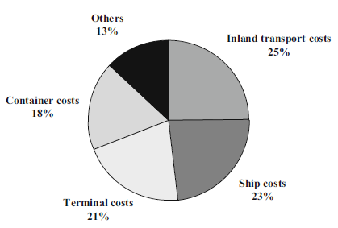
Figure 2.1: Components of container transport cost (Stopford, 2002)

Warehouse in supply chain
Warehouses are a key aspect of modern supply chains and play a vital role in the success, or failure, of businesses today (Frazelle, 2002). Although many companies have examined the possibilities of synchronized direct supply to customers, there are still many circumstances where this is not appropriate. This may be because the supplier lead times cannot be reduced cost effectively to the short lead times required by customers, and hence these customers need to be served from inventory rather than to order (Harrison and van Hoek, 2005). Similarly, it may be beneficial to hold strategic inventory at decoupling points in the supply chain to separate lean manufacturing activities (which benefit from a smooth flow) from the downstream agile response to volatile market places (Christopher and Towill, 2001).
Warehouses are essential components of any supply chain. In a warehouse items are handled
in order to level out the variability and imbalances of the material flow caused by factors such as
seasonality in demand, production scheduling, transportation, and consolidation of items (Gu
et.al. 2007). Inventories in warehouses are capital intensive assets that require storage areas,
handling equipment, and information systems. In addition, warehouse operations are repetitive,
labor intensive activities. The capital and operating costs of warehouses represent about 20-
25% of the logistics costs (Frazelle, 2002.Baker and Canessa, 2009). Therefore, improvements
in the planning and control of warehousing systems can contribute to the success of any supply
chain.

Functional areas of warehouse
A warehouse is typically divided into functional areas that are designed to facilitate the material flow (Tompkins et.al., 2010). The main warehouse areas are as: receiving area, reserve and forward storage area, and shipping area. Operations in the receiving area include the processing (i.e., unloading) of carriers, item identification, and quantity and
quality inspection. Received items are then moved to a storage area or directly to the shipping
area. The storage area is often divided into a reserve and a forward storage area. The reserve
storage area covers typically distant and heavily accessible locations, e.g., the uppermost part
of a rack, and is used to ensure the replenishment for the forward storage area.
Customer demand is primarily satisfied from the forward storage area, where the items are typically stored in convenient size and the storage locations are easily accessible. In the shipping area, items are sorted, consolidated and loaded on the carriers. While this is a general material flow in a warehouse, the actual material flow depends mainly on the role of the particular warehouse in the supply chain.

Warehouse as a distribution centre
Distribution warehouse or distribution center handles, in addition, the distribution of items.
In this case, the general objective is to achieve high throughput at minimum operational and
investment costs. In a cross-dock or transshipment center, storage is scarcely presented, incoming items are immediately sorted and new customized shipments are created (DeKoster et .al., 2007). In a typical warehouse 65% of the operating expenses are consumed by order picking (Rubenand Jacobs, 1999), which includes the item picking to replenish the forward area and to fulfill customer order.
According to Goetschalckx and Ashayeri (1989), customer oriented objectives are increasingly pursued, e.g., minimize mean processing time (De Koster and Van der Poort, 1998. Jarvis and McDowell, 1991), or minimize tardiness (Chan and Kumar, 2009). For instance, Kovács (2011) shows the contradiction between minimizing the maximum of response time (also called order cycle time) and minimizing the average response time (also called average picking time).

Operations
Operation decisions define the material flow in a warehouse, which is elaborated in the following. First, items arrive and received in the facility. Then the item is either forwarded to the shipping area or allocated in a storage location. The best storage location is close to a dock so that the cost of (i) unloading the items at a dock and transporting them to the storage area and (ii)
accessing items and transferring them to a dock for loading is minimized. As a result, items
compete for storage locations that are closest to the docks (Ahuja et.al., 1993). When an order
is received, the picker retrieves the ordered items. Note that the retrieval can be triggered
either by an order for item replenishment in the forward storage area or by a customer order.
To ensure efficiency, the picker should follow a route that minimizes the cost of the retrieval.
Order consolidation can be considered to facilitate an efficient picking. The sorting is necessary
if items have to be clustered by customer order after the completion of the picking (De Koster
et. al., 2007). Finally, items are loaded on the carriers and shipped. The main stages in this
process are: receiving, storage, order picking, and shipping.

Routing methods
The objective of routing policies is to guide order pickers through the warehouse on their
picking tour. In general, warehouse routing is a modified situation of the travelling
salesman problem, in which the goal is to find the shortest possible way to visit a set of
given locations. In practice, the problem of routing order pickers is mainly solved either by allowing the pickers to freely choose their route or by using heuristic approaches. The
benefit of heuristics is that they provide solutions that are easily understandable by
warehouse employees and often yield close to optimal results (Petersen & Aase, 2004).
Some heuristic methods may also help avoid congestion which is a general problem in
many warehouses with narrow aisle width or high picking density (de Koster et. al., 2007).

Receiving and shipping
Receiving and shipping are warehouse operations, which represent two extreme connection
points of the warehouse procedures. Receiving includes typically carrier processing (i.e., unloading), item identification, recording the goods receipt, quantity and quality inspection, un-
packing, and sorting activities; whereas, shipping includes finishing, batching, packing, and
loading operations. The truck to dock assignment problem emerges in multi door warehouses, where a set of docks are available to process a set of carriers and the problem is to assign the docks to the carriers so that some performance criteria are meet.
The paper of Tsui and Chang (1990), is among the first studies on the truck to dock assignment problem with the objective to minimize total travel time inside the facility. When several trucks are to be processed at a facility with limited number of docks, the truck scheduling policy determines the order of trucks. That is, the truck scheduling problem is the problem of defining the start and completion times for the processing of each truck so that some performance criteria are met. Here, the time dimension is taken into account; hence the objective function also tends to be time-related, such as the minimization of makes pan, defined as the completion time of the last outbound vehicle (Boysen and Fliedner, 2010). For excellent reviews on truck scheduling the reader is referred to Agustina et al. (2010), Boysen and Fliedner, (2010), and Van Belle et al. (2012).

Storage
Storage is the process of allocating items in the warehouse. Since warehouse storage locations
and pickers are generally scarce resources, therefore high allocation efficiency is required in
terms of utilization of both picker effort and storage capacity. Storage includes the following
interrelated activities: sequencing and consolidation, storage location assignment, and shuffling. Item sequencing determines the order, according to which items are sorted to be processed,
e.g., allocated or shuffled. Item sequencing is typically based on a first come, first served or on an earliest due date order. However, items can be consolidated (or clustered) according to decisions and restrictions determining whether different items can be placed in the same compartment.
A dedicated compartment accommodates only one item. While in a mixed compartment, more items can be allocated. e.g., a stored pallet may consist of several different products, or a rack location may cover several slots and a product can be assigned to each slot. Item consolidation may yield both improved storage utilization and increased complexity (Anken et.al., 2011).

Order picking
Order picking (OP) appears as one of the most significant activities in a warehouse. The picking tasks may contribute by over 65% in the warehouse operating costs. In fact, the retrieval cost exceeds by far the storage cost of any given item (Coyle et.al., 1996). The factors affecting the efficiency of OP typically include the product demand, the warehouse layout, the location of the items, the picking method in combination with the routing methods, the experience of the employees, and the extent of automation (Gattorna, 1997).
The high cost associated with the automation of the procedure forces the majority of companies to use manual operation, usually at the expense of efficiency and time. An order consists of a set of order lines, which indicate the product code and the required
quantity. Orders may be clustered to increase the efficiency of the retrieval; this is referred to
as order consolidation.
A cycle is a route from the input /out point to the requested storage location(s) and back to the input /out out point. Single command cycle policy or single-address system allows only
either ones storage or one retrieval activity at a cycle. A single storage and a single retrieval
activity are combined in a dual-command cycle policy or dual address system.
Finally, multi command cycle policy allows several storage and several retrieval activities within one cycle. When multiple orders request the same product, the items can be picked in batches. In this case sorting is required before delivering the items, i.e., the picked products are divided into smaller quantities corresponding to the orders. Sorting can pursue a sequential or a simultaneous approach (Roodbergen and Vis, 2006). The former is called pick-and-sort, i.e., sorting is done
after items have been accumulated during picking. The latter is called sort while-pick, i.e.,
sorting is done during picking. Order picking can be manual, mechanical or automatic. The configuration of picking systems, including the level of mechanization, may vary among different departments and product groups.
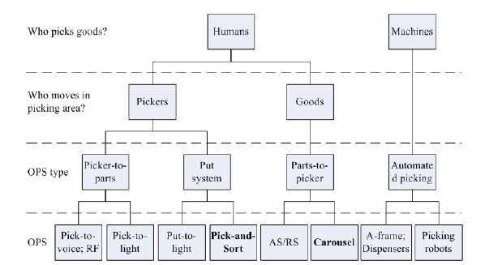
Figure 2. 2: Configuration of picking systems (Source: Yanyan et.al., 1978).
The main types of picking systems are the following: picker-less, picker-to-product, and product-to-picker. A picker-less system is a completely automatic system, e.g., items are loaded on a conveyor from an A-frame. In a product-to-picker system the item is transported to the location of the picker, e.g., by using mini-load or carousel. In a picker-to-product system a picker goes to the location of the product, retrieves it, and delivers it to an I/O point or he
may place the item on a conveyor belt, the latter case is called a pick-to-belt system (Anken
.et.al., 2011). Picker-to-product systems can be divided into sequential and parallel picking processes.
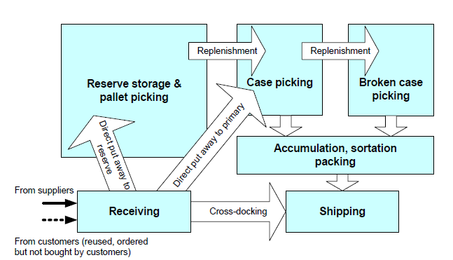

Figure 2. 3: Typical warehouse functions and flows (Tompkins et.al., 2003).
In a sequential picking process only one picker works on an order. It can be further divided into discrete or single order picking and batch picking depending on the number of orders handled simultaneously by the picker. On the other hand, in a parallel picking process several pickers may work simultaneously on the same order but on different order lines. To increase the familiarity of the picker with the locations of the products, pickers can be assigned to zones, which are groups of storage locations.
In general, zones have determined boundaries; therefore the order can be split based on the location of the ordered products. Jane and Laih (2005), present a clustering model to construct a set of zones assuming a parallel picking process. Parikh and Meller (2008), show that the workload-imbalance is greater in zone picking systems when compared to the case that orders are first consolidated and then picked sequentially. According Bartholdi III et.al., (2001), presents the advantages of a flexible setup based on sequential picking, called the bucket-brigade policy, where pickers work in a line and as soon as one becomes idle he moves up the line and takes over the order from an adjacent picker.
Picker-to-product systems are traditionally connected to pick-to-paper systems, where the
orders are printed, and the picker follows the instructions on the hard copy. However, pick to-light and pick-to-voice (or pick-by-voice) systems are also available, in these cases the items
are indicated by light or the picker is informed via radio, respectively. In a manual or semi-mechanical picker-to-product system the picker is typically a warehouse employee with a picking cart or a vehicle, whereas in a heavily-mechanical or automated picker-to-product system the picker may be a crane.

Aisle pattern & layout
As a pick, pack, and ship operation, my packing area is centrally located between stocks shelves, with aisles (A) that directly feed to our busiest production zone, the packing area.
Figure 2. 4: Aisle Pattern & Layout (Fabregas, 2017)

Layouts design and steps
The fundamental points mentioned by (Baker and Canessa, 2009), for warehouse design is first, design of a warehouse is a high complex activity. Second, different researchers proposed different number of steps in designing warehouses. Third, all steps are interrelated and repetition may be needed in some steps. Fourth, identifying an optimum solution may not be possible since there are different possibilities in each step.
Some designers of warehouse provided the different steps as framework for designing of warehouse. According to Hassan (2002), the framework of designing a warehouse can be explained in 14 steps as follow
- Specifying the type and purpose of the warehouse: the type of the warehouse should be specified in this step in order to gives designers an initial over view of operation levels and requirements.
- Forecasting and analysis of expected demand: capacity of the warehouse, repairing information, determining inventory levels, equipment, and assignment of items to the storages are forecasted in this step.
- Establishing operating policies: warehouse operations policies should be considered in early steps of warehouse designing since they have high impact on the design of the layout.
- Determining inventory levels: it is an operational decision and since has high impacts on warehouse’s size and helps to estimate space requirements should be determined in early stage of design.
- Class formation: it will help to reduce time and distance for picking items.
- Departmentalization and the general layout: a warehouse should have several departments in order to run the process flow in the warehouse and have to be identified in this step based on information of first and third steps.
- Storage partition: storage area is the biggest department in any warehouse and should be partitioned in to picking and reserve areas in order to facilitate operations and reduce movements.
- Design of material handling, storage, and sorting systems: this step is also an important step and should be considered as a part of layout designing since it is related to aisles, space utilization, storage assignment, and movement in the warehouse.
- Design of aisles: this step is determining of number, location, orientation, length, and width of aisles within the warehouse layout design based on the equipment that are going to use in the warehouse.
- Determining space requirements: estimation of needed space will be determined in this step, and objectives like cost of land, overhead, and scarcity of land may affect this step.
- Number and location of Input / Output points’ determination: this step is determination of number and location of I/O points. It is an important step since it has impacts on storage assignment policy, throughput, picking time and distance, and congestion.
- Number and location of docks determination: this step is necessary in order to reduce delays and congestion, provide routing flexibility, and more frequent shipping without interference with other departments.
- Arrangement of storage: arrangement of storage is also an important step in warehouse designing since it has impact on movement time and cost, throughput and congestion.
- Zone formation: picking area can be divided in to different zones and picker just take items from specified zones. The number, size and composition of these zones should be determined during design of the warehouse in order to reduce picking time and distance (Hassan, 2002).
According to Baker and Canessa (2009), warehouse design is in three main areas: determining the requirements, designing the material handling systems, and developing the layout. Based on these main headlines following designing Steps will be determined: system requirements, define and obtain data, analyze data, establish unit loads to be used, determine operating procedures and methods, consider equipment types and characteristics, calculate equipment capacities and quantities, define services and ancillary operations, prepare possible layout, evaluate and assess, identify the preferred design.
However they believed that the most important step in warehouse designing is the layout design and presents five steps methodology for layout designing:

- Space requirements planning which is determining the required space for each zone.
- Material flow planning which is the determination of the overall flow pattern.
- Adjacency planning that uses a warehouse activity relationship chart in order to form the input for computer-aided facility layout tools.
- Process location which is dividing of areas by low-bay and high-bay usage.
- Expansion/contraction planning that is Consideration of future changing of the facility
Also, according to Gu et. al., (2010), Warehouse design steps can be more general and be limited to five major steps;
- The overall warehouse structure determination: it is also called as conceptual design and determines the material flow pattern within the warehouse, the characteristics of each department, and the relationships between departments.
- Sizing and dimensioning the warehouse and its departments: it determines the size and dimension of the warehouse and also the space allocation among various warehouse departments.
- The detailed layout determination within each department: it is the most important configuration in designing a warehouse and it includes decisions about aisle configuration in the retrieval area, pallet block-stacking pattern in the reserve storage area, and etc.
- Warehouse equipment selection: this step is for identifying the warehouse equipment types for storage, transportation, order picking, and sorting as well as appropriate automation level for the warehouse.
- Both in storage and order picking. Operation strategies are those decisions that have global effect. Operational strategies selection: it is used for determining of how the warehouse will be operated ts on other design decisions, and therefore have to be considered in the design phase. Decisions like the choice of different storage methods, whether or not to do zone picking, and the choice of types of different order picking methods. More detail operational policies, are not considered in design phase.

Literature gap
There are some important points that should be considered in designing warehouses; as mentioned, warehouse design decisions are strongly related to each other and it is difficult to separate them completely from each other and define a border between them. Therefore, any classification of warehouse designing should not be considered as unique, nor does it mean that any of the decisions should be made independently. In addition, it is important that operational performance measures be considered in the design phase since it is strongly affected by the design decisions, and it can be very expensive or impossible to change the design when the warehouse is actually built (Gu et.al., 2010).
According to Bodner et.al., (2001), even though there are varieties of researches that have been done about how to design a warehouse which some of them discussed above, practitioners use the results of these researches really seldom. Rather, they prefer to rely on their experience and expertise (Bodner et. al., 2001). Even if they have no similar theoretical frame work most of their concept followed are close related to reach modified layout. However, many designers follow their own methods or procedures to design the warehouse. Some of their ideas are interrelated, but, others are different according by their type, functionality and product or process flows in warehouse. All designers provide their own theoretical framework for warehouse design. But when came to this thesis layout design follow the theoretical frame work of Baker and Canessa, (2009) and (Gu et. al., 2010), because they are most recent and more clarify the how the layouts would be designed in warehouse. ). From their framework the first step of layout design which is known as activity relationship diagram which categories the area of warehouse to different departments. ELDEP and CRAFT are important tools to this steps to partitions the available area to different departments. Therefore, Modjo dry port warehouses’ were basically giving services as temporary storages of freight until to completion of customs performance. Due to lack of more departments rather than inspection and storage area as main activity areas in the warehouse the first step is omitted from the procedures of Baker and Canessa, (2009) and (Gu et. al., 2010 because of unnecessary of areal partitions rather than proposing layouts to storage at center and inspection areas at inter dock of Modjo dry port’s warehouses.

MATERIALS AND METHODOLOGY

Description of study area
As one of the landlocked developing countries Ethiopia continuously face the challenge of physical isolation, supply chain related barriers from the sea and the high costs of trading with the rest of the world (United Nations Economic Commission for Africa, 2011). In order to counter these challenges associated with landlocked-ness, Ethiopia established several dry port to take the advantage of dry port. The Spatial Scope limited to Modjo dry ports at modjo city .Modjo is town in central Ethiopia named after the nearby Modjo River. It is administrative center of Lome Woreda. It is at a latitude and longitude 8⁰ 39’ N 39⁰ 5’ E with an elevation between 1788 and 1825 meter above sea level.
The Economic Commission for Africa has undertaken a feasibility study that could see the construction of more dry ports in Ethiopia. Ethiopia started developing dry ports following a 2007 study by the Ministry of Transport & Communication, which suggested that the country could save foreign currency from seaport expenses at Djibouti, by building an inland port within the country. Such ports handle the customs inspections, documentation of cargo and packaging for import and export. The saving, according to the study, could be seven to eight dollars for every container that’s transported through Djibouti. Consequently the Modjo Dry Port, 73Km east of the capital, was built at a cost of 20 million birr on a 63 hectare plot and started operations back in 2002 E.C. An additional 617 million birr was spent to expand its capacity. Use of the Modjo Dry Port increased in February 2012, when the multimodal transport system, whereby the ESLSE handles the transport of goods from port of origin to an inland destination port, was launched. The terminal has cargo volume of the 14,908 TEU containers in the 2008 E.C. The port has 40ft containers, too, but they are statistically recorded as two 20ft containers.
Figure 3. 1: Location map of study area

Currently existing layout of warehouse and its capacity
The warehouse has the area of 128m x 41m and can accommodate 120 TEU containers. The flow of containers beyond the capacity of warehouse and the most activities performed in the warehouse is manual based operation system. These make the existing layouts of warehouse become overcrowding. Therefore, passageways provided for the movement were covered by cargos; which unstuffed from containers. These reduce easy accessibility of freight for inspection and these reduce the inspection performance in the warehouses. The warehouse occupies the area of 41m x 128m and the volume of the warehouse approximately equivalent with 41m x 128m x 11m. From this, the researcher can appreciate the warehouse has the capacity to give the service more than the current storing capacity by using the existing layout. The total capacity the warehouse to store freight of the existing layout is not more than 60 containers of 40 ft or 120 containers of 20ft. i.e. the total capacity of warehouse to accommodate unstaffed containers is approximately 60 FEU and 120 FEU. This can be proved by depending on the layout of which allocated to TEU and FEU in warehouse.
From Figure 4.2, the existing layout of warehouse is assigned to store the fright of duration of completing customs formality and inspection process. This layout does not follow sharing policy principle store containers rather than using dedicated storage system. These make the warehouse to use the dedicated storage policy system. A dedicated compartment accommodates only one item. While in a mixed compartment, more items can be allocated. e.g., a stored pallet may consist of several different products, or a rack location may cover several slots and a product can be assigned to each slot. Item consolidation may yield both improved storage utilization and increased complexity (Anken et. al., 2011).
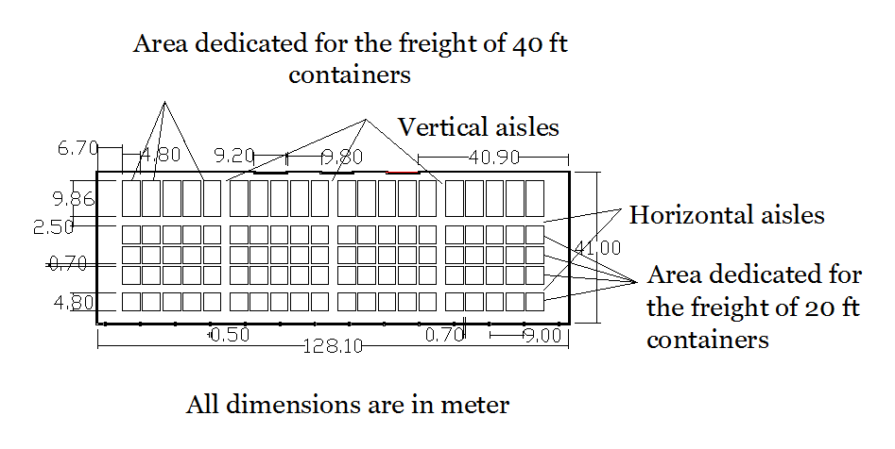
Figure 3. 2: The existing layout of warehouse

Research design
The research design was non-experimental and survey type i.e. it categorized under the description research study depending on the output from descriptive event simulation.

Figure 3. 3: Flow of research design
Global Positioning System (GPS) data:-an instrument used to know the total area and the dimensions of warehouse and dry ports. The extracts points and give the approximate value of the dimensions and locations of warehouse and dry port. This give the initial awareness for dimensions of the warehouse and dry port’s Table 4.1.
Documented data: - Is data which collected from the different journals, reports of the modjo dry port and terminals as well as data different websites were used to as inputs of the AutoCAD.
AutoCAD:- Is software which provide 2D and 3D of the computer aided design model (AutoCAD) and was used to draw out the alternative facility layouts by feeding the input data collected from field survey by using the Global Positioning System , dimensions measured by using standard meter and documented data.
As Rouwenhorst et al., (2000), cited in Baker P. & Canessa (2009), the research into the individual tools and techniques used within each of the steps was undertaken both from the literature and from the warehouse design companies. It was found that the literature provides useful tools for some steps but does not appear to cover all of the steps involved. This is supported by Rouwenhorst et. al., (2000),who concluded that the existing literature tends to concentrate on a small numbers of specific areas within the total warehouse design problem, with areas such as conventional equipment solutions and staffing calculations being largely neglected. The results showed that warehouse designers use a variety of tools during the design process.
The main areas of commonality (i.e. used by more than half the respondents) were the use of:
- Database and spreadsheet models for data analysis;
- Spreadsheet models for considering equipment types;
- Formal spreadsheet models to calculate equipment capacities and quantities;
- Computer-aided design (CAD) software for drawing up the layouts;
- Simulation software and formal spreadsheet models for evaluation and assessment.
From those warehouse layout design instruments the autoCAD was selected to execute the study. Because, to provide the alternative layout of warehouse with fishbone arrangements or angled aisle; autoCAD is more proper tool even if, it is bad for warehouse layout design. The others have more proper to provide layouts with crossed aisle and to categorize area to different departments. Therefore, to provide all alternative layout of the warehouse with similar warehouse design tools, the researcher preferred the autoCAD software for drawing up the layouts with fishbone arrangements or angled aisle and cross aisle configurations.
Anylogic software: - There is much of different descriptive event simulation software. However, their functionality and running capacities are different from one to others. The maximum number of dynamically running agents is 50000 for anylogic descriptive event simulation software. However, some other available descriptive vent simulation software’s couldn’t be function for this thesis validation purposes due to the capacity of dynamic running items. Therefore, the researcher preferred the anylogic software to execute the thesis as per objectives.
Data source: - Data were collected from primary and secondary sources. The respondent categories for the primary source ware the operators of warehouse and dry ports and terminal’s importers/exporters, loading/unloading, transistors, drivers, and warehouse manager. In addition to the primary sources of data, the researcher collected secondary data which was related to the facility layout design for space utilization and inspection performance from different journals, documented materials and reports of dry ports and terminal’s.

Data collection techniques
Primary as well as secondary data which are needed for this study is collected using different data collection techniques. These are:
- By interviewing concerned bodies from Modjo dry port and terminal directors, drivers, warehouse managers and operators as well as customers of Modjo dry port and terminals.
- By direct observation and informal discussions
- Surveying by using different instruments like GPS and Standard meters
- By consulting advisors and discussing with friends.
- Searching for thesis, publishing’s journals, newspapers, books, etc. on different web sites which are helpful for meeting the secondary objective and the primary objectives.

Data collection tools
The research design can be thought of as the logic or master plan of a research that throws light on how the study is to be conducted. The study utilized quantitative and qualitative design to give answer for the research question. GPS (global positioning system), open ended questionnaires and observations were critical way or instrument to collect data. Also the observation and interview response from the organization helped to describe the describe detail of research study.

Sample design
The study had a population group from the port and terminals operators of warehouse importers/exporters, loading /unloading, transistors, drivers, and warehouse managers. Therefore, the sample was drawn from the population groups. For quantitative and qualitative data collection, data were collected within one month from the port and terminals operators of warehouse importers/exporters, loading /unloading, transistors, drivers, and warehouse managers.
The researcher used a sample size of 40 customers as a sample unit by taking into consideration of time and cost as sample size determination. The interview was made on selected days and time particularly Monday, Wednesday and Friday. But, remaining days were assigned to observation and measure the layout of by using GPS and Meter as well as reading the reports and different magazines. Basically, the researcher interviewed 40 customers within six days with the help of researcher administered interview questions. To determine the sample size the researcher preferred to use a method developed by Carvalho, (1984), as cited in Malhorta Naresh, K. (2007).
Table 3. 1: Sample Size Determination
POPULATION SIZE | Sample size
POPULATION SIZE | Low | Medium | Large
51-90 | 5 | 13 | 20
91-150 | 8 | 20 | 32
151-280 | 13 | 32 | 50
281-500 | 20 | 50 | 80
501-1200 | 32 | 80 | 125
1201-3200 | 50 | 125 | 200
3021-10,000 | 80 | 200 | 315
1001-35000 | 125 | 315 | 500
35001-150000 | 200 | 500 | 800
Source: Malhorta Naresh, 2007
Total number of modjo dry port, including the daily workers is 964. However, the study basically focuses on the warehouse of dry port. Therefore, researcher enforced to take the information from the operators of warehouses, Managers of warehouses, drivers, transistors and customers of warehouse. Their total number categorized under the population size of 501-1200. From this researcher take low sample size to get inputs for which reflects the congestions in the warehouse, this means 32 sample ware extracted from the total population size to assess the congestion in the warehouse.

Sampling techniques
The study analyzed the background information of the respondents by using the following parameters: gender, level of education, type of organization, name of department section/unit, position held by the respondents. The respondent categories for primary source are the operators of warehouse and dry ports and terminal’s importers/exporters, loading/unloading, transistors, drivers, and warehouse manager.

Analyses and reporting
Mathematical models: to design the modified layout the researcher used mathematical models for calculation of volume and area of warehouse.
Area =Length X Width; which is abbreviated as A=L X W
Volume = Area X Height; which is abbreviated as V=A X H
Canen and Williamson, (1996).provide a review the literature on computer-based layout packages and concludes that there is considerable software available. However, their research concluded that specialist warehouse layout software appeared to be little used by companies, who tend instead to use non-specialist software, such as AutoCAD. Such software tends to be an aid for an experienced designer to help draw the layout, as exemplified by one respondent who stated that layouts are prepared “by experience and use of AutoCAD to draft layouts”.
This is recognized as a key step and some approaches are proposed in the literature as to how to formulate draft layouts. Some of these refer to plant layout tools, such as route sheets, operation schedules, and movable templates drawn to scale to represent freight and equipment, as mentioned by Heskett et.al., (1973). Mulcahy, (1994), explains the complexity of the warehouse layout problem by listing ten different objectives that need to be maximized, including for example space minimization, access to products, efficient flows, safe working environment and expansion potential. He goes on to explain four methods to help design and present the layout.
Auto-CAD software: The area of modified layout of existing facility layout drawn by the length and width of warehouse, those dimensions are very crucial parameters which was get from the by using GPS tools. Depending on this parameters layout was designed by taking standard pallet size which stored in Double-deep rack. To get depth and width of lane and aisle dimensions the Double-deep rack, Standard pallet size and standards was determined by using Table 2.2. Those were basic input for auto CAD software to draw modified alternative layouts of warehouse. Generally, there are two types of data analysis techniques namely: qualitative and quantitative where by the choice of these methods greatly depends on the type of information the researcher had at hand.

Data inputs
The inputs to provide the double deep rack with single pallet deep and double pallet deep, pallet size, forklift dimensions as well as its lifting heights and warehouse dimensions with height were a basic inputs for alternative layouts design. This is proposed to obtain the cross aisle and fishbone or angled aisle arrangements’ layouts as outputs with double pallet depth and single pallet depth.
Double-deep rack: Essentially consists of two single-deep racks placed one behind the other, and so pallets are stored two deep. Due to rack supports each 2-deep lane is independently accessible, and so any stock keeping units can be stored in any lane at any level of the rack. To avoid double-handling, it is usual that each lane be filled with a single stock keeping units, which means that some pallet locations will be unoccupied whenever some stock keeping units is present in an odd number of pallets.
Another disadvantage of deep lanes is that slightly more work is required to store and retrieve product. However, deep lanes have the advantage of requiring fewer aisles to access the pallets, which means that the warehouse can hold more products (Hackman and Bartholdi, 2011), A special truck is required to reach past the first pallet position. Common storage modes include pallet rack for bulk storage, carton flow rack for high-volume picking, and (static) shelving for slower, lower-volume picking. This paper is generally provided alternatively with double deep racks of cross aisle and angled aisle or fishbone arrangements. Also, the depth of pallets allocated with single deep and double deep. Selection of depth of pallets is constrained by fork depth which extends to depth of rack cells. Selection of the height of each cell is also constrained by the capacity of forklifts raise and holding capacity of pallets.
Table 3. 2: Standard pallet sizes
Stringer length x deck board length | Most prevalent in
1219 x 1016mm (48.00 x 40.00 in) | North America
1000 x 1200mm (39.37x 47.24 in) | Europe, Asia
1165 x 1165mm (44.88 x 44. 88 in) | Australia
1067 x1067mm (42.00 x 42.00 in) | North America, Europe, Asia
1100 x1100mm (43.30 x 43.30 in) | Asia
800 x1200mm (31.50 x 47. 24 in) | Europe
Source :(Hackman and Bartholdi, 2011).
The six standard sizes of pallet, from ISO Standard 6780: Flat pallets for intercontinental materials handling – Principal dimensions and tolerances. (The stringers are the supports underneath that are spanned by the deck boards. (Hackman and Bartholdi, 2011).
standard pallet dimension with supportive double deep rack, aisle depth which lie between two double deep rack for movement of Reach and double-reach lift truck or Turret Truck will be designed depending on their require aisle width to design facility layout at warehouse.
Turret Truck: uses a turret that turns 90 degrees, left or right, to put-away and retrieve loads. Since the truck itself does not turn within the aisle, an aisle width of only 5–7 feet (1.5–2.1 meters) is required, its lift height is limited to 40–45 feet (12.2–13.7 meters), and it travels at about 75 feet/minute (22.9 meters/minute). Because this truck allows such narrow aisle, some kind of guidance device, such as rails, wire, or tape, is usually required. It only operates within single deep rack and super flat floors are required, which adds to the expense of the facility.
This type of truck is not easily maneuverable outside the rack (Hackman and Bartholdi, 2011).

Output validation
The final step of the study is model evaluation to determine and show the alternative facility layouts proposed is economically selective based on time of service giving without congestion of warehouse. The modified layouts were evaluated by using descriptive event simulation software. Inputs were used for queuing or simulation model Arrival rate, service rate; and queue capacity after layout modified are basic inputs for queuing or simulation model. The output from the modified facility layout design could reduce the delay time. Since, the delay time is reduced; demurrage cost will be also reduced when compared with the existing layout. This output presented graphically, tubular and chart for detail interpretation.

RESULTS AND DISCUSSIONS
This chapter basically consists of the results and discussions interpreted depending on the data gathered from the surveying, interview, observations, and reports of modjo port as well as review of literature from different journals and data from different websites. The scope for the research is the design phase from the time a specific need is identified for a warehouse (for example, following a distribution strategy review) through to an operational specification being produced, detailing for example, operating methods, equipment, staffing levels to warehouse as well as alternative layouts and layout foot print costs also provided.

Demographic Profile of Respondents
The demographic profile of the sample respondents is presented and analyzed below. The Purpose of assessing respondents’ age, sex, is that, to determine whether the researcher Considered heterogeneity of sample units. On the other hand assessing the work experience and education level of the respondents’ is that, when the respondents are more experienced and educated they have better opportunity to understand the case and give better response than else.
Table 4. 1: Gender Frequency
Gender | Frequency | Percent | Valid Percent | Cumulative Percent
Male | 24 | 77.4 | 77.4 | 77.4
Female | 6 | 19.4 | 19.4 | 80.6
Missing | 1 | 3.2 | 3.2 | 3.2
Total | 31 | 100.0 | 100.0 | 100.0
Gender frequency of the respondents shows that the numbers of male respondents were almost three times as female respondents. This is 77.4% of the respondents were male, while 19.4 % were female respondents and one respondent (3.2%) is invalid because this respondent did not voluntary to give right information. As table 4.2 below shows that, the researcher divided the age of the respondents in to five categories, starting from 20- 25 years of age to above 40. In this study, the researcher can conclude that most of the respondents were above 40 ages. This group covers 29% of the respondents from whole interviewed.
Table 4. 2: Respondents’ frequency distribution of age
Validity | Age of respondents | Frequency | Percent | Valid Percent | Cumulative Percent
Valid | 20-25 Years | 5 | 16.7 | 16.7 | 16.7
Valid | 26-30 Years |  | 25.8 | 26.7 | 43.3
Valid | 31-35 Years | 5 | 16.1 | 16.7 | 60.0
Valid | 36-40 Years | 3 | 9.7 | 10.0 | 70.0
Valid | Above 40 Years | 9 | 29.0 | 30.0 | 100.0
Valid | Total | 30 | 96.8 | 100.0
Missing | - | 1 | 3.2
Total |  | 31 | 100.0
The next age group with valid percent of 25.8 is respondents gain aging between 26- and 30. On the other hand, respondents within age group of 20-25 and 31-35 show similar percentage, which is 16.1%. In addition, 36-40 age groups represent 9.7 % of valid respondents. At last, one respondent (3.2) did not mention in which age group he/she is open ended questionnaires. Surprisingly, there was no respondent below age of 20. As table 4.3 below clearly shows the frequency distribution of respondents work experience, the largest of the respondents 43.33 % (13) have less than eleven (4) years of work experience. In the same case, 36.67% (11) of respondents have from 4-6 years of work experience and followed by above7 years of experience, which accounts 20 (6) respondents. The remaining one respondent (3.2%) did not respond. This implies that in total around 56.67 % of the respondents have more than 3 years of work experience with in the dry port and it is sufficient to judge and give views. This is because when the respondents are more and more experienced within the organization they have better opportunity to know more and more about the organization.

Table 4. 3: Respondents’ frequency distribution of Experience
Validity | Year of  Experience | Frequency | Percent | Valid Percent | Cumulative Percent
Valid | 1-3 years | 13 | 41.93 | 43.33 | 43.33
Valid | 4-6 years | 11 | 35.48 | 36.67 | 80
Valid | 7and above | 6 | 19.35 | 20 | 100
Valid | Total | 30 | 96.76 | 100 | 100
Missing | Missing | 1 | 3.2 | - | -
Total |  | 31 | 100.0 | - | -
As shown below in table 4.4 the highest education level attained by most of the respondents was college diploma holders which represents, (9) 29% out of the valid respondents and followed by first degree holders which accounts (8) 25.8%. Surprisingly three education levels that are Grade 10 completed, Grade 12 completed and certificate levels shows similar results that is 9.7% each out of the valid respondents.
Table 4. 4: Respondents’ frequency distribution of qualifications
Validity | Qualifications | Frequency | Percent | Valid Percent | Cumulative Percent
Valid | Below grade 8 | 2 | 6.5 | 6.9 | 6.9
Valid | Grade10 completed | 3 | 9.7 | 10.3 | 17.2
Valid | Grade12 completed | 3 | 9.7 | 10.3 | 27.6
Valid | Certificate | 3 | 9.7 | 10.3 | 37.9
Valid | College diploma | 9 | 29.0 | 31.0 | 69.0
Valid | First degree | 8 | 25.8 | 27.6 | 96.6
Valid | Second degree and above | 1 | 3.2 | 3.9 | 100.0
Valid | Total | 29 | 93.5 | 100.0
Missing | Missing | 2 | 6.5 | - | -
Total |  | 31 | 100.0 | - | -

Only two (6.9%) respondents are below grade eight. Out of the valid response, the least percentage was second degree and above education level, which is one (3.2%). Finally, two (6.5%) respondents were not responding their education level. Therefore, out of valid respondents about 57% are diploma and above diploma holders. so, depending on data which the researcher get from the dry port by observation, reading different magazines and measured data from warehouses analyzed and discussed as follows.

Area of Modjo dry port warehouse
There are four warehouses at modjo dry port. From those, two warehouses have been giving the service and remaining two warehouses are new and not give the service. Therefore, the study basically focused on one warehouse to propose similar alternative layouts to all warehouses in modjo dry port warehouses’. The reason is their functionality, layouts, designs, number of employers, and total capacity of warehouses including floor area, volume, and inspection system formulate both warehouse analogous.
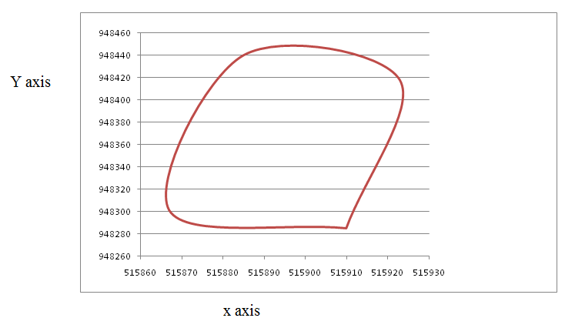
Figure 4. 1: The area of warehouse drawn depending on the point of GPS at appendix I
The figure 4.1; the warehouse looks like approximately irregular shape. This mimics that closed loop of chart approximately indicate the total area of existing warehouse. Depending on this area, the researcher provides exact shape for area of warehouse for study purpose. This is generally approximated to rectangular shape of 41m x 128m by using additional instrument called meter. As indicated in figure 4.1; the existing warehouse contains only the management room and storage location which dedicated to freight or cargo stuffed to warehouse. As indicated in Figure 4.2, the 80 locations allocated to 20 ft containers are 4.8m x 4.8 m which equal with 23.04m². From this, it was focused total area of warehouse which dedicated to 20 ft containers. This is equivalent with the 80x 23.04m² or 1843.2 m². In addition to this, the existing layouts allocated to 40 ft containers are equivalent to the 4.8m x 9.86m or 47.328 m² and equivalent with the 20x 47.328 m² or 946.56 m². The total area dedicated is summation of all area of existing layouts which allocated to containers of 20 ft and 40ft. which equivalent with 2789.76 m². The management offices internally partitioned, which can occupy the 3.3m horizontally and vertically it approximately 40m. Therefore, the area occupied by the office approximately equivalent to 3.3m x 40m or 132m².

The analysis of existing layout of warehouse
The existing warehouse of Modjo dry port is basically accommodated by the number of containers; those inspected in the warehouse when directions are given by customs to be inspected in warehouse. In Figure 4.2, the layouts provided for 40 ft container is 20 in number and layout provided for 20 ft container is 80 in number. The reference size is the 20 foot box of 20 feet long, 8'6" feet high and 8 feet wide, or one TEU. Special purpose containers, such as “High Cube” containers are also common and they are one foot higher (9'6") than the standard.
According to www.PONL.com, the standard volume of 40ft and 20ft is 67.3 m³ and 33.2 m³ respectively. This indicate that the total functional volume of existing layout can be calculated as the total number of existing layout for TEU available in warehouse times the volume single container either for 40ft or 20ft. The number of existing layout is 80 for 20ft and 20 for 40ft. Therefore,
- Total volume for 20ft containers equivalent to 80 x volume of TEU is 80 x 33.2 m³ or 2656 m³
- Total volume for 40ft containers equivalent to 20 x volume of FEU is 20 x 67.3 m³ or 1346 m³
Therefore the Modjo dry port is using their warehouse is approximately equal to 4002 m³ for 20ft containers and total volume for 40ft containers, which equivalent to 4002 m³.

The aisle facilitation of existing warehouse of modjo dry port
”As a pick, pack, and ship operation, packing area is centrally located between stocks shelves, with aisles (A) that directly feed to busiest production zone, the packing area” (Fabregas 2017). However, the Modjo dry port warehouses are allocated with the aisle to speed up the productivity of the truck at during un stuffing and stuffing of freight or cargo container during inspection time of imported container as per order of customs. These pathways are comfortable for movement different machines to perform the activities takes place inside of warehouse which require more effort than human beings. This allocated with the size of 2.5m and which is sufficient the movement of standardized machine those specially perform in the warehouse. However, the functionality of this passage is not attractive and serviceability of this aisle is conventionally based. While, the part of aisles were used store the freight or cargo in the warehouse. This makes the layout of warehouse uncomfortable to the movement of transistors and managers inside of it as well as it increase the delay time of performance of warehouse. Therefore, this indirectly will lead to less productivity of machines and inspection performance. Total number of aisle are four horizontally and five vertically in number.
Therefore, the warehouse horizontally occupied by 4x 2.5m or equivalent to 10m². While, vertically the warehouse accommodated with the five aisles this equivalent with the 5x 2.5m or 12.5m. This shows that the total area of warehouse occupied by pathway or aisle is equal to 10m x 12.5m or 125m².
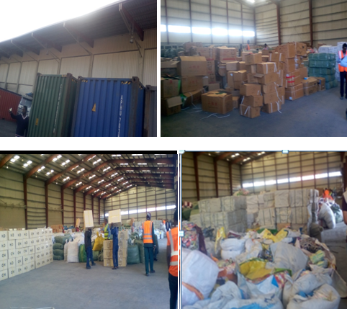
Figure 4. 2: Picture show freight handling system and the congestion of warehouse

Fright / cargo handling system and handling material in warehouse
According the yearly and fist half round report of dry port (2016 – 2017), the Modjo dry port has the material handling equipment as indicated in the APPENDIX V. From those machines a few fork lift used in the warehouse, the remaining the function at the terminal of dry port. The reason is the warehouse management system is conventionally based and lack of pallet rack in warehouse lead warehouse to use labor rather than using the fork lift. In addition to this, the warehouse volume utilization is 2m. Therefore, most activities performed in warehouse are manual based as indicated below Figure 4.4.
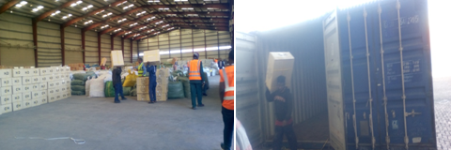
Figure 4. 3: Picture Fright / cargo handling system in modjo dry port warehouse
As report of 2009 and researcher observation the Modjo dry port have been purchased standard forklift for operational performance of the warehouse. Those can give the function at height more than 7m. However, those have not been giving the functionalities due to lack of pallet rack in warehouse. This shows that, reserving of those equipments additionally rising the cost of dry port due to reduction of the life time without giving any function to warehouse as shown at Figure 4.5.
Figure 4. 4: Materials handling equipments

Design steps of modified facility layout at modjo dry port warehouse

The overall warehouse structure determination
This step explores the partition of areas for different departments. This is done depending on the activities performed in the warehouse. Therefore, for this step no activity relationship was used to determine the exact locations of the each location. The reason basically warehouse is dedicated to store the freight which unstaffed from the container. No other activity performs rather than inspecting freight. So, expectation of location for inspection and for pallet rack is enough to provide location determination. The overall structure of warehouse is basically composed the more than 90% of storage and remaining part composed by aisle and offices for warehouse management for existing warehouse from the area of 128m x 41m . However, modified alternative layouts are expected to be store at 110.60m x 26.70m from the 128m x 26.70m of existing warehouse. But, the remaining parts are expected for inspections area, lockers, and offices and for movement of operators and other visitors.
Define and obtain data
- GPS data: This used to measure the location and dimensions in addition to the standard measurements of distances.
- ISO standards containers: Daily, monthly and yearly amount of containers delivering to warehouse and dry port are 40 feet and 20 feet containers.
- Industrial pallets 1200mm x 1000mm
- Forklifts: Are material handling equipments in the warehouse where the materials are stored above manual operation as well as used to fast delivering of pallet to inspection area in the warehouse.

Analyze total area and areal capacities of modjo dry port
Even if study focus on the warehouse layout and its congestion, analyzing the total area and its capacity was included in the step of analyze data. The reason is this step explores how the congestion increases in the terminal which in turn raises the congestion in the warehouse.
Table 4. 5: coordinate points of dry port and warehouses
Points | X | Y | Z
DRY PORT | X | Y | Z
C11 | 516424 | 948628 | 1819
C12 | 516266 | 948149 | 1814
C13 | 516202 | 947945 | 1803
C14 | 515936 | 947995 | 1803
C15 | 515673 | 948055 | 1805
C16 | 515700 | 948492 | 1816
C17 | 515733 | 948962 | 1819
C11 | 516424 | 948628 | 1819
Warehouse 1 | X | Y | Z
W1 | 515910 | 948285 | 1837
W2 | 515867 | 948301 | 1814
W13 | 515885 | 948440 | 1822
W14 | 515923 | 948418 | 1834
W11 | 515910 | 948285 | 1837
Warehouse 2 | X | Y | Z
W21 | 515927 | 948444 | 1825
W22 | 515890 | 948456 | 1818
W23 | 515907 | 948595 | 1790
W24 | 515951 | 948593 | 1790
W25 | 515927 | 948444 | 1825

As indicated in Figure 4.6, the Modjo dry port enclosed the area of 914m X 540m. From this around 75% of area occupied by imported full and empty containers. But, remaining part of dry port is occupied by the warehouses, offices, work shop, and other service. The serviceability of dry port is increasing through year to year as increasing of container throughput from year to year. Initially the port was giving the service for a few containers. However, currently more than 534,355 containers getting throughput service in the Modjo dry port. This increment flow of container through port leads to the congestion in warehouse from year to year.

Figure 4. 5: Area of dry port and warehouses

Container throughput of Modjo dry port
Table 4. 6: Container throughput
Years in E.C | Container throughput
2006 | 207,645
2007 | 341,712
2008 | 484,173
2009 | 534,355

Figure 4. 6: Container throughput from year 2014 to 2017 in E.C.
According to the annual report of the modjo dry port, total amount of the containers throughput become increasing as shown figure 4.7.
Figure 4. 7: comparison of annual Containers throughput of 2008 with 2009 in E.C.
As in Figure 4.8, above indicate the throughput of the containers from year 2008 to 2009 become increase. I.e. the total number of containers those inter to the port becomes from 124,949 to 133,070.how ever the total number of container shipping from the dry port after completing the formalities of customs increased from 120,704 to 134,408. While the annual container in and out from the port also become increased from the 119,759 to133, 643 and 118,761 to 133,234 in number.
Table 4. 7: The annual difference flow of full and empty containers
S .No | Activities | 2008 | 2009
1 | Full in | 124949 | 133,070
2 | Full out | 120,704 | 134,408
Difference of full in and out |  | 4245 | -1338
3 | Empty in | 119,759 | 133,643
4 | Empty out | 118,761 | 133,234
Difference of empty in and out |  | 998 | 409

As the report indicates in Table 4.7, neither empties container nor the full containers are totally out the dry port. I.e. Depending on the above table and observation, the researcher concludes that, there is congestion at Modjo dry port terminal. This can be proved from above table there are 1407 empty containers and 2907 full containers; totally 4314 containers remain without getting service from year 2008 to 2009 E.C.

Service offering capacity of Modjo dry port and terminal: Terminal of Modjo dry port was increasing its storing capacity; due to the increment of container throughput from year to year. At the beginning, the terminal was the capacity of accommodating 945 containers of TEU. However, its capacity increased to the 14,908 in 2008 E.C.
Table 4. 8: The annual difference flow of full and empty containers
Year in E.C | Terminal capacity to accommodate the container in TEU
2002 | 945
2003 | 1575
2007 | 12,726
2008 | 14,908

Figure 4. 8: The annual difference flow of full and empty containers
The annual growth of importing container at modjo dry port:
As indicated in the report of World Bank 2010, the 95 percent of Ethiopian freight/ cargo has flowed through the Modjo dry ports. Due to increasing the number of importers; the number of containers directly increases similar approach with the number of importers. This can be understood in Table 4.9 and Figure 4.10.
Table 4. 9: The annual growth of importing container at Modjo dry port
Years in E.C. | Annual growth of importing container to dry port
2002 | 12,337
2003 | 10,786
2004 | 26,951
2005 | 39,461
2006 | 54,044
2007 | 86,160
2008 | 124,949
2009 | 133,070

Figure 4. 9: The annual growth of importing container at modjo dry port
Total capacity of Stuffing/ unstuffing containers: Through month the number of stuffing /un stuffing container become increasing time to time. Yearly the 3997 TEU planned to stuffing/ unstuffy services. However the service has been given to 4,192 TEU containers. The performance also increased to 104.87%. This shows that, the performance more than the forecasted plan. The reason for rising of performance of warehouse service is the importers receiving their freights or cargo after inspection in the warehouse. While, through the year number of containers gets service of stuffing and unstuffing were 47,962 TEU containers, however; the yearly performance rise to 52,192 TEU containers. This shows that, 108.82% of containers are performed with in year as shown in the report of 2009 E.C. Generally, how the congestions become increasing in the Modjo dry port.
Total capacity of unstuffing containers to truck: Through the month, the number of unstuffy container to truck become increasing. According the plan of Modjo dry port, monthly 262 TEU containers are planned to unstuffed truck. However, the service has been given to 241 TEU containers at the time of beginning. But, performance decreased to 91.98% TEU containers. These indicate that, total capacity of unstaffing containers to truck increasing from year of 2008 to 2009 E.C. The reason for decreasing the performance of unstuffed containers to the truck service was unwillingness of importers to receive their containers by truck. The number of containers gets service of unstuffing to truck were 3,058, however; the performance was decreased to 2,736 TEU containers. This shows that, 89.47% containers unstaffed to truck performed. This reflects that, when the total container unstaffing to truck decreases; the number of unstaffing container to warehouse increase due to interest of importers to take their container from warehouse. This leads to increase amount of freights in the warehouse beyond the capacity of existing warehouse.
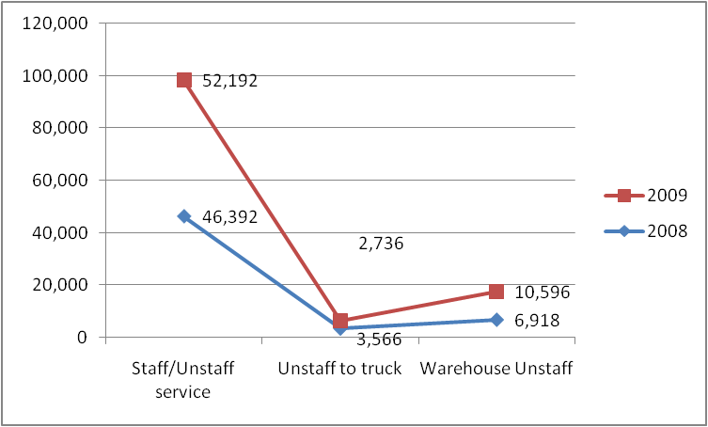

Figure 4. 10: Total unstuffing containers to warehouse through years
As indicated figure above the amount of the container unstuffed to the warehouse increased from the year to year. However, the total number of containers to unstuff to truck becomes too decreased from year to year. From the reports and field observation, researcher understand increasing the number of containers unstuffed in the warehouse makes the existing layouts of warehouse less attractive and increase the congestion as well as delay for the inspection.
While, the response of operators reflects that, the inspection process performed in the warehouse takes place by moving each location or area dedicated for FEU and TEU containers. This reflects that, there is no inspection area allocated for inspection process in the warehouse. Also, customers’ responded that, dry port has been increasing the demurrage cost due to dalliance of customs clearance and warehouse inspection performance. Due to this reason, the customers haven’t been satisfied by the performance of the dry port.

Establish unit load to be used and analyze the data
Most probably there are two standard containers are delivered to Modjo dry ports. These are 40 ft and 20 ft containers are also named as forty equivalent units (FEU) and twenty equivalent units (TEU). However, FEU have the capacity to accommodate 24 or 20 standard pallets as well as TEU container has the capacity of 12 or 10 stardard pallets.
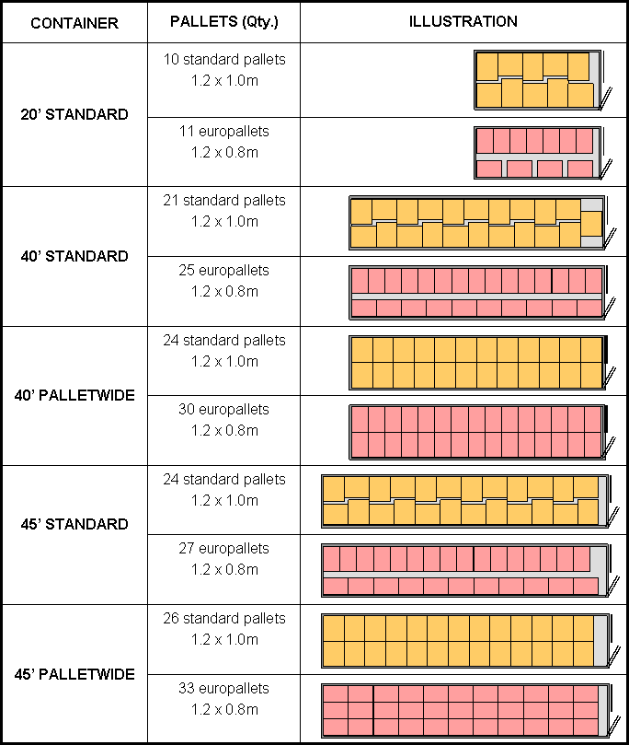
Figure 4. 11: Illustration of pallet container capacity (https://www.indiamart.com)

Parameters used to design modified layout
- Total amount of standard pallets staffed to 40 ft
- The pallet number from the standard containers are 24
- Forklift has carrying capacity of 2100 kg
- The aisle width is 2.7m
- Lifting height is 7m
- Pallet height 2000mm
- The pallet type is 1.2 x 1m
- The area of warehouse is 128m x 41m
- The height of warehouse approximately equal to 11 m excluding the roof of warehouse
- Volume of containers 63.1m³ and 32.m³ of 40ft and 32 ft respectively
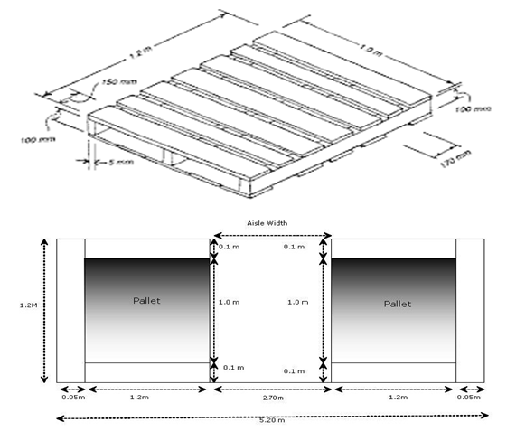
Figure 4. 12: Illustration of standard pallet used for design of alternative layouts (https://www.indiamart.com)
Considerations
- The thickness of rack assumed to be neglected to develop 3D space allocation
- The double deep and single deep racks are used for design.
- Cross, diagonal and angle aisle are used to provide modified layout

Determine the operating procedures and its definitions
According to Rushton et al., (2006), in this step describe the warehouse zoning .This means the area distinguished on the basis of a particular characteristic, use, restriction, etc.
Figure 4. 13: Activity flowing diagram
Terminal: In container transport, a container terminal is a vital part of the transport infrastructure (Bichou et al., 2007). Container terminals are nodes that link with other inland transport modes such as highways, railways, and inland waterway systems (Lun et al., 2008). Therefore, terminal is the area which accommodates containers which delivered from the Djibouti by rail transportation or road transportation.
Container: Steel box which accommodate the freight or cargo inside of it. Also it has the capacity of accommodating 20 or standard pallets length x width of (1.20m x1.0m) within 40 ft length container. Typically there are two standard containers flow to Modjo dry port.
- Twenty equivalent unit container (TEU), which has 20ft length or 20 feet long, 8'6" feet high and 8 feet wide, or 1 Twenty-foot Equivalent Unit (TEU) and has the capacity to accommodate 10 or 12 pallets of 1.2m x1m areal dimensions.
- Forty equivalent unit container (FEU), which has 40ft length or 20 feet long, 8'6" feet high and 8 feet wide, or 2 Twenty-foot Equivalent Unit (TEU) and has the capacity to accommodate 20 or 24 pallets of 1.2m x1m areal dimensions.
Pallet: Made by wood or steel which handle efficient unit load for this design case it is used 1.2m x 1m pallets because there are so, different standard pallets available as shown in table 2.2. However, it is so difficult to design layout of warehouse by considering by taking all these separately. In fact Pallet helps protect product from damage, for example, by forklifts. This savings is hard to quantify except by comparison to past experience and it also, provide a safer work environment by avoiding unstable pallet stacks. This savings is also hard to quantify. Depends on how easily it can be rented and so the extent of savings depends on the market for space.
Carton: Is stock keeping unit or box which used stock freight or cargo.
Aisles: Are the passageways or paths which lead to wise destinations to access stock easily or with less interference. Most warehouses have parallel aisles aligned with the receiving and shipping docks, perhaps with orthogonal cross-aisles; but this need not always is the case. (K.R.Gue and R.D.Meller, 2009). There different types of aisles configurations which applicable in warehouse depending on the activity flow in warehouse.
Cross aisle: Alternative layout I and II are designed by using the cross aisle configuration. To reduce travel between storage and receiving/shipping, it is generally preferable to orient aisles so that they run parallel with the direction of material flow (Hackman and Bartholdi, 2011).
Angled aisles: Alternative layouts III and IV are designed by using angle aisle configuration or fishbone arrangements. Most warehouses have parallel aisles aligned with the receiving and shipping docks, perhaps with orthogonal cross-aisles; but this need not always is the case (K.Gue and R.Meller, 2009).
Double deep rack: Essentially consists of two single-deep racks placed one behind the other, and so pallets are stored two deep. Due to rack supports each 2-deep lane is independently accessible, and so any sku can be stored in any lane at any level of the rack. To avoid double-handling, it is usual that each lane be filled with a single sku, which means that some pallet locations will be unoccupied whenever some sku is present in an odd number of pallets. Another disadvantage of deep lanes is that slightly more work is required to store and retrieve product. However, deep lanes have the advantage of requiring fewer aisles to access the pallets, which means that the warehouse can hold more products (Hackman and Bartholdi, 2011).
Lane depth: Is the depth of racks or sum of the depth of pallet and some clearances with including the thickness of rack along the depth of rack.
Lane length: The summation of length of all pallets and any gaps between the pallets including the thickness of rack along the length of rack.
Floor space charged to a lane: It includes storage space, any gap between lanes, and one-half the aisle width in front of the lane.
Rack height: It depend on type of warehouse, pallets, stock keeping units and forklift capacity, pallet capacity and forklift lifting height. Generally according field study and from different website for this case the parameters to provide efficient alternative layout are
Parameters of observation, field survey are:
- Warehouse height is approximately equal to 11m
- Forklift has the capacity to lift about 2000 kg capacity
- The pallet can handle 1900kg without defecting
- Stock keeping units are carton. On which many cartons can be stack on each other up to reach efficient unit loads of pallet or up to 1900 kg.
- Pallet size is 1.2m x 1m
- Aisle configuration are cross aisle and angled aisle configuration
- Type of racks double deep rack, which, means two single-deep racks placed one behind the other.
- Aisle and pallet rack dedicated at center of shipping and receiving docks after considering basic necessity of warehouse
- Area aisle and pallet rack 110.60m x 26.70m.

Design the alternative layouts
Knowing the material flows and activity, warehouse storage area classification and others like inspection area, offices and lockers as additional area for facilitation of easily access of freight or cargo provided by modifying the existing layout design of warehouse. Different warehouse designers said it very difficult to provide optimal facility layout because they have no fixed theoretical procedures and theoretical frame works to reach optimal space allocation.
According Baker and Canessa (2009), by detail studying activity flow in warehouse and also, by following different approaches. There it is important to provide a few alternatives of the layout in order to have the point of reference for comparison. The design has started from the drawing the borders of the facility according to the actual dimensions. The walls, doors and shipping docks were applied to the plan because it was unlikely for those elements to be removed from the layout. The layouts are evaluated by changing the different factors, the type aisle configuration such as crossed aisle and angled aisle and depth of pallets which stored in rack cells. However, consideration to provide modified layout is not only those two factors. By considering others factor such as; changing type of standard pallets, increasing or decreasing of depth of rack as well as reorienting the area of different activities and others main considerations.
Design of alternative layout I: The first layout alternative was inspired by two factors, by considering the closeness to shipping and receiving docks. Also inspection area is very close to receiving as docks. The reason is during the pallets are interring to the warehouse some of them inspected randomly and then, it stored until the customers complete their clearance until get permission to unstaff from warehouse. This provided at receiving docks to avoid double trip of forklift. However, office and lockers are also allocated at left and right side in warehouse. So, the area allocated for inspections are four with equal area. The allocated for this layout is cross aisle, which is allows more direct and therefore shorter travel between storage locations (Hackman and Bartholdi, 2011).
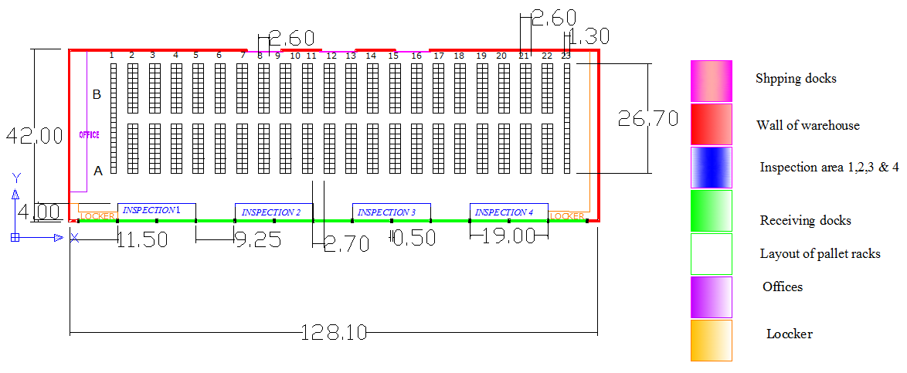
Figure 4. 14: Alternative layout I with one pallet deep of double deep racks with cross aisles configuration of warehouse
As the legend indicates the different facility are provided to efficient space utilization and inspection performance. From the layout I the area allocated to accommodate two deep racks with single pallet and aisle is 110.60m x 26.70m or 2953.02m². The total pallets can accommodated are 844 pallets the size of 1.2m x1m.
Design of alternative layout II: Second layout alternative does not differ much from the previous one. All operations system same with layout I; However, the depth of pallet in cells of rack increased from one to two. Due to this, the location of aisle shifted to other locations. This reduces the wastage of aisle.
The single-deep layout has twenty one aisles and provides 844 pallet storage locations, all of which are directly accessible, which means that they are available for reassignment as soon as the current pallet is shipped out. In contrast, the double-deep layout has only fourteen aisles and provides 1128 pallets storage locations but, only 564 of them are directly accessible. Generally, the 564 that are directly accessible are not available for reuse until the interior pallet location in the same lane becomes available. However, according operation system of modjo dry port warehouse the pallets unstaffed to the warehouse and it stored in two deep pallet and the both are picked at once to delivered to importers. Then all the cells become free after picking restored by others pallets of importers. Generally, the deeper lanes produce more pallet storage locations but they are of diminishing value.
According to Hackman and Bartholdi (2011), by storing product in lanes, additional pallet positions can share the same aisle space and so amortize that cost. There are many issues to consider, but the most important one is effective utilization of space. Double deep layout (lanes that are two pallet-positions deep) fits about 25.2 % more pallet positions in the same floor area than does the single-deep layout of alternative layout I.
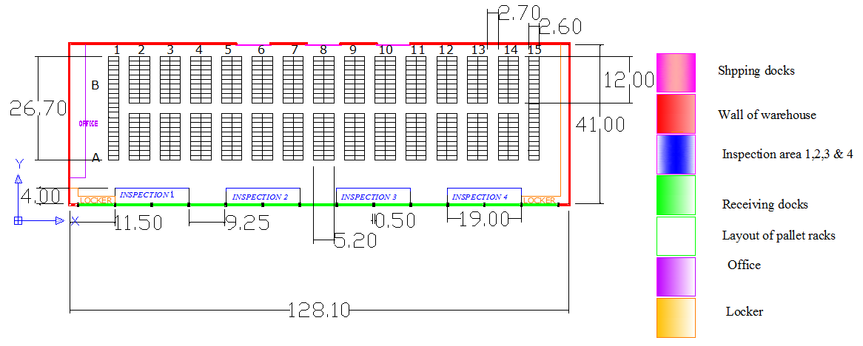
Figure 4. 15: Alternative layout II with two pallets deep of double deep racks with cross aisles configuration of warehouse
Design of alternative layout III: Third layout alternative was partially motivated by the angled aisle configuration or fishbone arrangement suggestions. Again, all the activity takes place in equal area as layout I and II activity. However the activity takes take place within different aisle configurations which call aisle configuration or fishbone arrangement. Angled aisles, suggested by Gue and Meller;(2009), allow more direct travel between storage and a central location of receiving/shipping (at the bottom). The single-deep layout has short path aisles and provides 834 pallets storage locations, all of which are directly accessible, which means that they are available for reassignment as soon as the current pallet is shipped out as layout I.
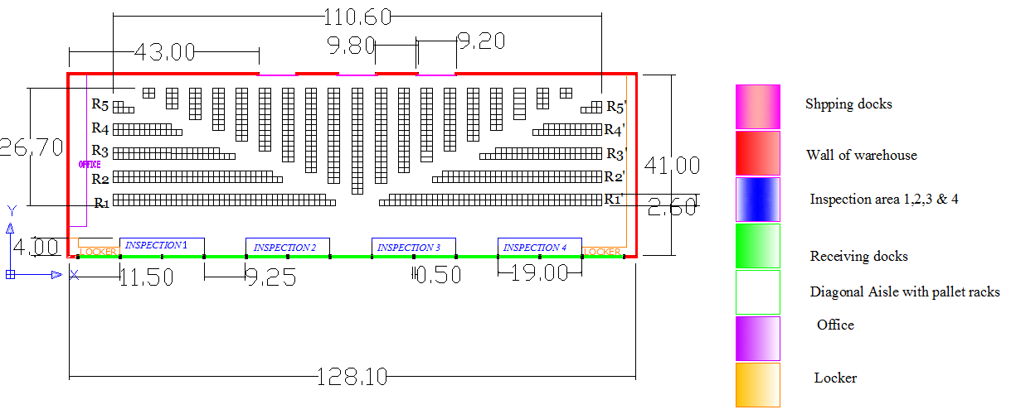
Figure 4. 16: Alternative layout III with one pallet deep of double deep rack with angled aisles configuration or fishbone arrangement of warehouse
Design of alternative layout IV: The forth layout alternative does not differ much from the previous one. All operations of Agility are located in the same area of allocated for layout III; however, the depth of pallet in cells of rack increased from one to two. Due to this, the location of aisle shifted to other locations. This reduces the wastage of aisle as layout III. The single-deep layout has short travel paths but aisles less in number when compared with the layout III and provides 834 pallet storage locations, all of which are directly accessible, which means that they are available for reassignment as soon as the current pallet is shipped out.
In contrast, the double-deep layout has only fourteen aisles and provides 1194 pallets storage locations but, only 597 of them are directly accessible. Generally, the 597 that are directly accessible are not available for reuse until the interior pallet location in the same lane becomes available. Generally, the deeper lanes produce more pallet storage locations but they are of diminishing value. According to Hackman and Bartholdi,(2011). by storing product in lanes, additional pallet positions can share the same aisle space and so amortize that cost. There are many issues to consider, but the most important one is effective utilization of space. Double deep layout (lanes that are two pallet-positions deep) fits about 30.2% more pallet positions in the same floor area than does the single-deep layout of alternative layout I.
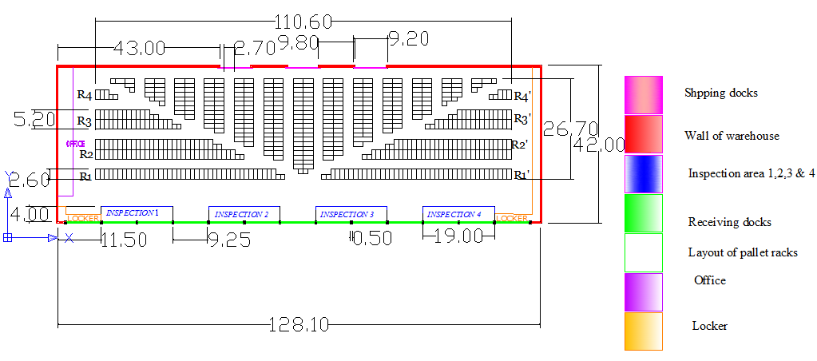Figure 4. 17: Alternative layout IV with two pallets deep of double deep racks with angled aisles of warehouse

Cost expectation for the provided alternative layouts
According to Hackman and Bartholdi (2011), recall that the second revenue source of the 3rd party warehouse is to charge rent by the pallet. But because the warehouse typically bills its own expenses by the square-foot (for example, rent of the building, climate control, cleaning, and so on), the warehouse naturally wants many pallet positions per square-foot. It can achieve this in two ways: by taking advantage of vertical space and by using deep lanes. By pallet position we mean the floor space required to hold a pallet. This includes not only the footprint of the pallet but also any required gap between one pallet and an adjacent one. Let the lanes be k pallet positions deep. Each lane requires aisle space at its head so that pallets can be inserted and removed. Let the aisle space in front of the pallet be of area a, measured in pallet positions. Then the total area charged to one lane is k +a/2 pallet positions. This area is the sum of space devoted to storage (k) and space that provides accessibility (a/2) (Hackman and Bartholdi, 2011). Depending on this cost estimation methods the cost of provided layout is generated as following methods in Table 4.10.
Table 4.10: Amount of floor space area paid to pallet footprint, clearance and aisles
Layouts | Total number pallets | Land covered by pallets ,any gaps and aisles110.60m x 26.70m | Land area paid to floor space of pallets store  No. of pallets x area of pallet (1.2m²) | Area paid for clearance and Aisle (m²)
Alternative layout 1 | 844 pallets | 2953.02m² | 1012.8 m² | 1940.22
Alternative layout 2 | 1128 pallets | 2953.02m² | 1353.6m² | 1599.42
Alternative layout 3 | 834 pallets | 2953.02m² | 1000.8m² | 1952.22
Alternative layout 4 | 1194 pallets | 2953.02m² | 1432.8m² | 1520.22

Volumes capacity of alternative layouts
The height of warehouse is approximately 11m without including the roof of warehouse however, the available forklift can raise more than 7m. Depending on this, the calculation of the volume of warehouse for use of space above the floor is 8m. Because allowable maximum heights of standard pallets are 1.2m x1m is 2m. The reason what the 9m used is the fork can only access the bottom of the pallets. The carton picked from the pallets are 1m³ and either if they are blow 1m³ it can be stack one carton to on other up to 1m³ as researcher observations.
The double carton each 1m³ volumes stacked one on top of other 2m carton can be put on the one pallet. The maximum capacity of selected pallet is 2m height carton. If 1m long carton taken as for the height of rack cell; eight cells are stacked vertically in order to use the volume of warehouse. Depending on this view the total number of the pallets can be calculated as follows.
Table 4. 11: Volume capacity of alternative layouts
Layouts | Total number pallets at floor space | Vertical cell allowed  in meter | Total number of pallets in volume of space | Total number of containers  (FEU)
Alternative layout 1 | 844 | 8 | 6752 | 282
Alternative layout 2 | 1128 | 8 | 9024 | 376
Alternative layout 3 | 834 | 8 | 6672 | 278
Alternative layout 4 | 1194 | 8 | 9552 | 398

Comparison of existing with alternative
Table 4. 12: Comparison of existing layout with modified alternative layouts of warehouse
Layouts | Capacity to accommodate TEU Containers | Capacity to accommodate FEU Containers
- Existing layouts | 120 | 60
- Alternative layout I | 564 | 282
- Alternative layout II | 752 | 376
- Alternative layout III | 556 | 278
- Alternative layout IV | 796 | 398

As indicated in the graph above the capacity of existing layout of Modjo dry port warehouse have the capacity of 120 TEU. However, increment of unstuffed container to warehouse makes the performance of warehouse become less and increasing in congestion and terminals. So, to mitigate this problem the modified layout was designed according parameters selected for and the result of comparison is also presented as follows. The performance of existing and modified warehouse is evaluated by simulating the input parameter. The input parameters are arrival rate, service rate or the capacity of containers served in day. The input data’s for First In First Out (FIFO) queue disciplines were applied.

The simulation model to evaluate the existing and alternative layouts
Source: represents the terminal of modjo dry port in model of simulation. From this source the container comes to warehouse for temporary storage until to finish the customs performance and inspection process in warehouse. As input it feeds the number of containers and gives the output to warehouse. This is represented by arrival rate of the containers to warehouse. This is equitant to 7 per a day.
Queue: represents the storage area of the warehouse to model the simulation of warehouse performance. This directly feeds the freight or cargo of containers; which comes from the transfer to service area. The warehouse has maximum amount freights or cargos of containers to be stored at dedicated area. Therefore, the maximum capacity of storage is 120 TEU containers as shown layout of existing warehouse. However, capacity of modified warehouse was calculated as the expectation to alternative layouts redesign the pallet rack height is 8. Because the lifting height and the aisle size of forklift is designed by using the parameters to lift the height of 7m. Which can lift the above 7 meter and the size of aisle are 2.7. Therefore; depending on the calculation of volume capacity the alternative layouts I, II, III and IV redesign of warehouse can accommodate the 564, 752, 556 and 796 TEU of freight of containers.
Delay: represents the service or inspection time of freight of containers in the warehouse. This equivalent expressed in triangular form to run the simulation. The result of simulation is generated by using the time of triangular (0.99, 1, 1.5) or (minimum, mean, maximum) and triangular (0.9, 1, 1.2) or (minimum, mean, maximum) in days for capacity of 6 TEU containers at inspection area for existing layout of warehouse and modified layout of the warehouse respectively.
Sink: represents the customers of modjo dry port those take the inspected containers after the inspection process completed.

Outputs or Results of existing warehouse
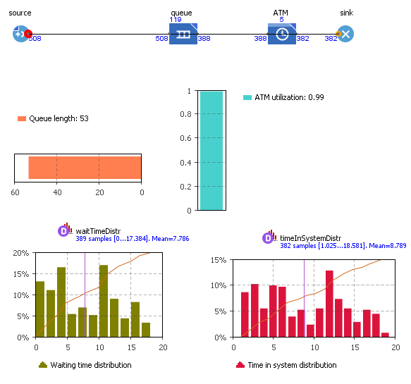
Figure 4. 18: The output of existing warehouse performance
Existing layout of warehouse’s result of time in queue distribution within run of 76.14 days shown below: Existing layout of warehouse’s result of time in queue distribution within run of 76.14 days ware:
- Minimum wait time in the queue distribution is zero
- Maximum wait time in the queue distribution is 17.384 days
- The mean wait time in the queue distribution is 7.786 days
- The maximum capacity of storage reach peak of 120 container
- The queue length is 53
- The numbers of containers entering in to queues are 508 TEU.
- The numbers of containers leaves from the queues are 388 TEU.
- But, one container is at the exit of queue in the model. The delay utilization at inspection area is 0.99.
This shows there is idle time for 1 containers with in triangular (0.9, 1, 1.5) or (minimum, mean, maximum) times of warehouse in days. The run error shows the storage capacity of warehouse is reach the maximum. At this time simulation stops run and shows flow of container is remain at inter of terminal or source. This in turn leads to congestion at terminal of dry port. However, duration of functionality of warehouse and terminals very long as compared with the existing ware house and terminal of modjo dry port. Existing warehouse of modjo dry port’s the result of time in distribution system within run of 76.14 days.
- Minimum time in the system distribution is 1.025
- Maximum time in the system distribution is 18.58 days
- The mean time in the system distribution is 8.789 days
- The 382 TEU containers are leave from warehouse out of 508 unstuffed to warehouse

The descriptive event simulation of alternative layouts

Simulation of alternative layout I
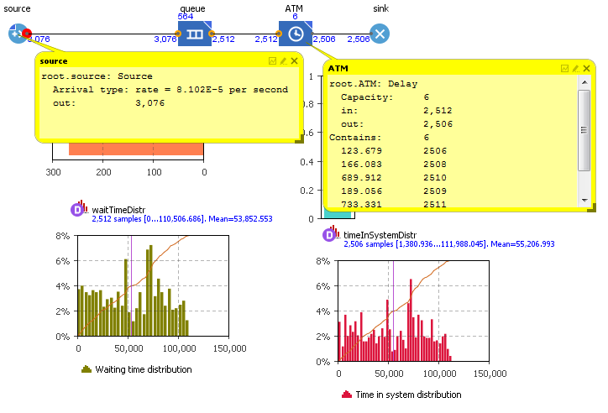
Figure 4. 19: The result of modified layout I warehouse performance
Modified alternative layout I warehouse of modjo dry port’s the result of time in queue distribution within run of 624577.32 minutes.
- Minimum wait time in the queue distribution is zero
- Maximum wait time in the queue distribution is 110507 minutes
- The mean wait time in the queue distribution is 53853 minutes
- The maximum capacity of storage reach peak of 564 container
- The queue length is 26
- The numbers of containers entering in to queues are 3076 TEU.
- The numbers of containers leaves from the queues are 2512 TEU.
Modified warehouse of modjo dry port’s the result of time in distribution system within run of 624577.32 minutes.
- Minimum time in the system distribution is 1381 minutes
- Maximum time in the system distribution is 111988 minutes
- The mean time in the system distribution is 55207 minutes
- The 2508 TEU containers are leave from warehouse
- Simulation of alternative layout II
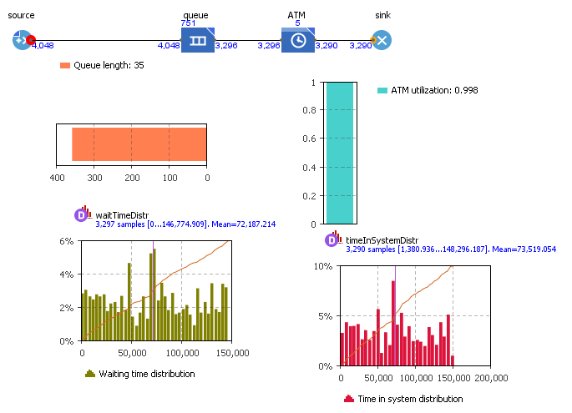
Figure 4. 20: The result of modified layout II warehouse performance

Modified alternative layout of II warehouse of modjo dry port’s the result of time in queue distribution within run of 819363.06 minutes.
- Minimum wait time in the queue distribution is zero
- Maximum wait time in the queue distribution is146775 minutes
- The mean wait time in the queue distribution is 72188 minutes
- The maximum capacity of storage reach peak of 751container
- The queue length is 35
- The numbers of containers entering in to queues are 4048TEU.
- The numbers of containers leaves from the queues are 3296TEU.
Modified warehouse of modjo dry port’s the result of time in distribution system within run of 819364 minutes.
- Minimum time in the system distribution is 1381 minutes
- Maximum time in the system distribution is 148297 minutes
- The mean time in the system distribution is 73520 minutes
- The 3290 TEU containers are leave from warehouse.
- One container is at exist of sink

Simulation of alternative layout III
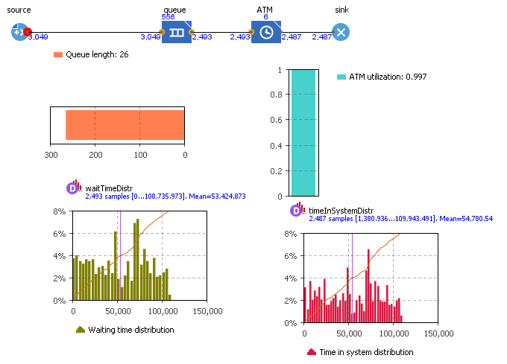
Figure 4. 21: The result of modified layout III warehouse performance
Modified alternative layout of III warehouse of modjo dry port’s the result of time in queue distribution within run of 619643minutes.
- Minimum wait time in the queue distribution is zero
- Maximum wait time in the queue distribution is 108736 minutes
- The mean wait time in the queue distribution is 53425 minutes
- The maximum capacity of storage reach peak of 556container
- The queue length is 26
- The numbers of containers entering in to queues are 3049TEU.
- The numbers of containers leaves from the queues are 2403TEU.
Modified alternative layout of III warehouse of modjo dry port’s the result of time in distribution system within run of 619643minutes.
- Minimum time in the system distribution is 1381 minutes
- Maximum time in the system distribution is 109944 minutes
- The mean time in the system distribution is 54781 minutes
- The 2487 TEU containers are leave from warehouse out of 3049.

Simulation of alternative layout IV
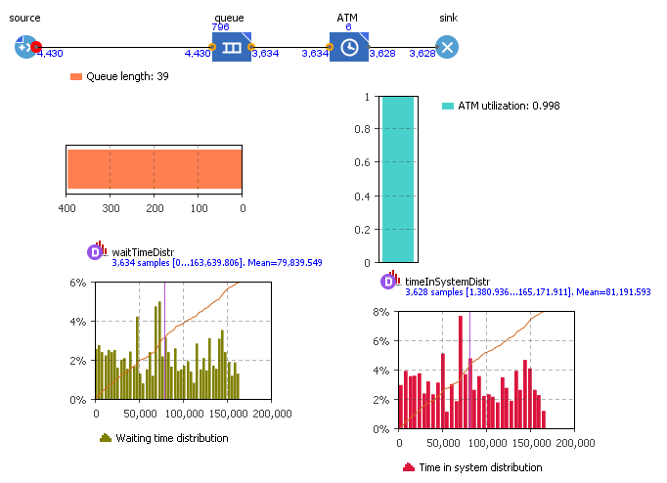
Figure 4. 22: The result of modified layout IV warehouse performance
Modified alternative layout of IV warehouse of modjo dry port’s the result of time in queue distribution within run of 903323 minutes.
- Minimum wait time in the queue distribution is zero
- Maximum wait time in the queue distribution is 163640 minutes
- The mean wait time in the queue distribution is 79840 minutes
- The maximum capacity of storage reach peak of 796 container
- The queue length is 39
- The numbers of containers entering in to queues are 4430 TEU.
- The numbers of containers leaves from the queues are 3634TEU.
Modified alternative layout of IV warehouse of modjo dry port’s the result of time in distribution system within run of 903323 minutes.
- Minimum time in the system distribution is 1381 minutes
- Maximum time in the system distribution is 165172 minutes
- The mean time in the system distribution is 81192 minutes
- The 3628 TEU containers are leave from warehouse out of 4430 TEU.

General outputs of the simulation
Table 4. 13: The general output comparison of existing and modified alternative layout
Simulation attribute | Existing layout | Alternative layout I | Alternative layout II | Alternative layout III | Alternative layout IV
Time of congestion begun in days | 76.14 days | 443.73 | 569 | 430.3 | 627.3
Minimum waiting time in warehouse | 0 | 0 | 0 | 0 | 0
Maximum waiting time in warehouse | 17.384 | 76.74 | 101.93 | 75.52 | 136.64
Mean waiting time in warehouse | 7.786 | 39.4 | 50.2 | 37.2 | 55.5
Queue capacity in TEU | 120 | 564 | 751 | 556 | 796
Queue length | 53 | 26 | 35 | 26 | 39
Total number of TEU inter the queue | 508 | 3076 | 4048 | 3049 | 4430
Total number of TEU leaves the queue | 388 | 2512 | 3296 | 2403 | 3634
The minimum time in the system distribution | 1.025 | 0.96 | 0.96 | 0.96 | 0.96
The maximum time in the system distribution | 18.58 | 77.77 | 102.99 | 76.35 | 114.7
Mean time in the system distribution | 8.789 | 38.34 | 51.055 | 38.04 | 56.38
Total container inter the warehouse (TEU) | 508 | 3076 | 4048 | 3049 | 4430
Total container leaves system (TEU) | 382 | 2508 | 3290 | 2487 | 3628

CONCLUSIONS AND RECOMMENDATIONS

CONCLUSIONS
This study has conducted on the modjo dry ports and terminals in Ethiopia to design facility layout to efficient space utilization and inspection performance. Data was collected from secondary source like reports and documented materials. While the primary data of field observations, survey and interviews of transistors, importers /exporters, drivers and managers. These lead to get the modified layout design of warehouse after consuming all necessary data which organized in proper manner.
In terms of congestion of warehouse
- Due to increasing the flow of unstuffed containers from the terminal to the warehouse, the existing dedicated space or volume of operating at warehouse was not accommodate the whole freight flowing into warehouse. Due to this reason, the operators and inspectors have been using the aisle as storage area rather using it for movement of min-truck, carts and operators. These create the congestion in warehouse and at dock of inter.
- The pass way or aisle not free for movement from one location to another. These increased the delay time during the inspection of freight and reduce the speed of operations.
In terms warehouse managements system
- The warehouse management system is the traditionally based management system. These obviously affect the performance of warehouse with regard to cost and delay of time and inspection of process takes place manually at dedicated place of freight store .This reflects that, lack of inspection area provided in the warehouse.
- Even if there is availability of the forklifts Modjo dry port and terminal enterprise does not use them and some other small tone rising trucks are not functional effectively and efficiently due to lack of pallet racks in the warehouse. So, movement of freight or cargo was takes place manually.
- Layout of warehouse is not standardized for the flow of freight inside the warehouse. The warehouse applied with layout of rectangular area for dispatched container in order to occupy freight single container at single area layout.
- No pallet racks in Modjo dry port warehouse. These enforced the operators to use floor space Modjo dry port warehouse has no more capacity to use more than 2.446 meter of warehouse.
- The alternative layouts provided has the more performance to store the freight and cargo as well as it increase the efficiency accessibility of freight in warehouse during the picking the pallets as table 4.9.
In terms of layouts proposed
After analyzing the collected empirical data and deal with it with the literature review, the four alternative layout designs were suggested. The cost of land with pallet allocation and total aisle numbers by scheming the as cross aisle and angled aisle as well as the pallet depth and their accessibility was considered as a reference point in the comparison among those four scenarios.
- The alternative layout one and two proposed with the cross aisle, however, the alternative layout three and four proposed by using fishbone arrangements or an angled aisle configuration. This comparison is based on the aisle number. From the aisle point of view, the alternative layout four layout looks like the most promising. However, it does not much differ from the layout two incase of storing pallets. The first and third alternative layouts are very not much shows potential to create awareness to be used them rather than using the layouts of four and two.
- The second comparison point of view is cost of land to allocate the pallets in the floor space rather than whole volume of warehouse. From this point of view, for the layout one the enterprise would be charged to foot print area of 1012.8 m² to store 844 pallets. However, layout two would be charged to foot print area of 11353.6m² to store 1128 pallets in area which equal with the alternative layout one as well as the layouts III and IV would be charged to area of 1000.8m² and 1432.8m² area of foot print to store pallets of 834 and 1194 respectively. Therefore, using alternative layouts is better option to mitigate congestion from warehouse. These in turn reduce the congestion from the terminal of Modjo dry port.

RECOMMENDATIONS
From the analysis made from the observation, survey, secondary data and modification of existing layout of warehouse the following recommendations can be made.
- Up to complete the customs formality and inspection performance the freight temporary stored in warehouse. Therefore, the warehouse managers should have provide pallet rack to store more freight of containers in warehouse as per alternative layouts provided to mitigate the charge of dalliance of existing warehouse of Modjo dry port.
- There are many numbers of forklifts available in dry ports. They weren’t giving the service due to lack of pallet racks. This itself another cost to dry port; which, indirectly affects the growth of country. Therefore, the organization should have provided the remedies by implementing the pallet rack to use the value forklift within their service time.
- Warehouse managements and stakeholders initiate regular meetings to change layouts of warehouse. The intention for this would be identify, discuss and decide on the use of pallet racks as key measures that to reduce dwell time and improve warehouse efficiency and effectiveness.
- This reflects; if the enterprise proposes one layout from the alternative layouts proposed the capacity to accommodate TEU would be four times of that of preferred layout. The reason is Modjo dry port and terminal has four warehouses. But, the study done on one warehouse to propose all warehouses. For example, if the layout I, II, III and IV selected; their capacity to store would be 2256, 3008, 2224 and 3184 TEU containers can be stored in warehouse respectively as indicated table 4.8. This, directly reduce congestion from the terminal. Therefore, Modjo dry port and terminal should use pallet racks as per the alternative layout proposed.

FUTURE RESEARCH AREAS
This study basically incorporates the assessment of the existing layouts of warehouse of modjo dry port to provide alternative layouts to propose scenarios to the efficient space utilization for inspection performance. Also, study improves the storage capacity, increase the accessibility pallet from pallet rack to reduce time of dalliance and improve the inspection performance by speeding up the process of operation. Besides, it provides the recommendation depending comparison of existing layout with modified alternative layouts. The alternative layouts proposed depending on the type of aisles, pallets and racks with the constraints of forklift raising height, fork depth for accessibility of pallets, area dedicated to plant the pallet racks. Regarding to type of aisle, the study incorporates only cross aisle and fishbone arrangement configuration of aisle to propose alternative layouts. Also, with regard to type of pallets the Industrial pallets with area of 1.2m x 1m were used. From the type of the racks double deep rack used altering the depth of pallets to be single and double. While, study proposed by taking central area for pallet rack and inspection area at inlet dock side of warehouse. No activity relationship analysis, CRAFT, ALDEP and others software used rather than AutoCAD due to lack basic operations other than storage and inspections in warehouse. However, storage was expected to be at center of warehouse and inspection to be at inlet side of dock to avoid double handling of forklifts during inspections. Hence, further study should be done in the future by considering the different types of pallets, racks and aisle by using different alternative models by more reliable, timely and cost-effective methods to mitigate the congestion from the warehouses. Moreover, latest software like CRAFT, ALDEP and other layout design software suit to propose optimal facility layouts.

REFERENCE
Ackerman K. B. 1990. Practical Handbook of Warehousing.Van Nostrand Reinhold, NY.
Apple J. 1977. Plant Layout and Material Handling third ed. John Wiley, New York.
Ashayeri J. & Gelders L.F. 1985. Warehouse design optimization zamieszczony, European Journal of Operational Research 21 (1985), lsevier. pp. 285-294.
Bodner D., Govindaraj T., Karathur K.N., Zerangue N.F. & McGinnis L.F. 2002. A process model and support tools for warehouse design. 02 NSF Design Service and Manufacturing Grantees and Research Conference.
Buil R. Piera M.A. 2007. New warehouse design methodology at strategic and operational levelAutonomous University of Barcelona, Spain, 6th WSEAS International Conference on System Science and Simulation in Engineering, Venice, Italy, November 21-23, 2007, pp. 196-201.
Ahuja R. K., T. L. Magnanti. & J. B. Orlin. 1993. Network Flows. Theory, Algorithms,
and Applications (1 ed.), Prentice Hall: New Jersey.
Allen R. S. 2008. In land Port Savings. Retrieved from Journal of Commerce Online. http://www.joc.com/ (Accessed on January 2018).
Anken N., J.P. Gagliardi., J. Renaud. & A. Ruiz. 2011. Space allocation and aisle positioning for an industrial pick-to-belt system. Journal of the Operational Research Society 62 (1), 38–49.
Agustina D., C. K., M. Lee. & R. Piplani. 2010. A review mathematical models for cross docking planning. International Journal of Engineering Business Management 2(2), 47-54.
Baker P. & Canessa M. 2009. Warehouse design: a structured approach. European Journal of Operational Research (Elsevier) 193, no. 2 (March 2009): 425–436.
Bartholdi III J., J.D., D. Eisenstein & R. D. Foley.2001. Performance of bucket brigades
when work is stochastic. Operations Research 49(5), 710–719.
Baird A. J. 2002. The economics of Container transshipment in Northern Europe. International journal of maritime economics, Vol 4, 249 -250.
Bodner D.A. et al., 2001. A Process Model and Support Tools for Warehouse Design. Atlanta, USA, September 19, 2001.
Boysen N. & M. Fliedner. 2010. Cross dock scheduling: Classification, literature review
and research agenda. Omega 38(6), 413–422.
Chan F. T. S. & V. Kumar. 2009. Hybrid TSSA algorithm-based approach to solve
warehouse-scheduling problems. International Journal of Production Research 47 (4), 919– 940.
Christopher M. & Towill D. 2001. An integrated model for the design of agile supply chains. International Journal of Physical Distribution & Logistics Management 31 (4), 235-246.
Coyle J.J. et al. 1996. The Management of BusinesLogistics. 6th.ed, West Publishing, St Paul, MN.
De Koster R., B. M., T. Le-Duc. & K. J. Roodbergen .2007. Design and control of warehouse order picking: A literature review. European Journal of Operational Research 182 (2),481–501.
De Koster R. B. M. & E. S.Van der Poort .1998. Routing orderpickers in a warehouse. A
comparison between optimal and heuristic solutions. IIE Transactions 30(5), 469–480.
Fabregas , K. 2017. Planning Your Warehouse Layout – How to Set Up Efficient Storage,
Packing & Shipping Areas.
Frazelle E., 2002. Supply Chain Strategy.The Logistics of Supply Chain management.McGraw-Hill, New York.
Fijalkowski J. 2011. Warsaw University of Technology, private communication.
Firth D., Apple J., Denham R., Hall J., Inglis P. & Saipe A. 1988. Profitable Logistics Management. McGraw-Hill Ryerson, Toronto, 1988
Goetschalckx M. and J. Ashayeri.1989. Classification and design of order picking systems.
Logistics Information Management 2(2), 99–106.
Grochowski L., Sosinski P. 2007. Warehousing Space Modeling, the Archives of Transport No. 3 vol. 19.
Gattorna J., 1997. Handbook of Logistics and Distribution management, 4th ed., Gower Publisher Company.
Govindaraj T., Blanco E., Bodner D., Goetschalckx L., McGinnis L., Sharp P. 2000. Design of warehousing and distribution systems. Conference on Systems, Man and Cybernetics, Nashville, Tennessee, USA, p. 1099–1104.
Gu J., M. Goetschalckx & L. F. McGinnis. 2007. Research on warehouse operation. A
comprehensive review. European Journal of Operational Research 177(1), 1–21.
Gu J., Goetschalckx Marc & McGinnis Leon F. 2010. Research on warehouse design and performance evaluation. A comprehensive review European Journal of Operational Research (Elsevier) 203, no. 3 (June 2010), 539–549.
K. R. Gue and R. D. Meller. 2009. Aisle configurations for unit-load warehouses. IIE Transactions, 41(3):171–182.
Gue, Kevin R., Elif A., Alan E., Bill F. and Gary F. 2014. The U.S. Roadmap for Material Handling & Logistics.
Gujar G.C. 2011. Essays on Dry Ports.Erasmus University.
Hackman J. J. B. a. S. T. 2011. Warehouse & Distribution Science. The Supply Chain and Logistics Institute School of Industrial and Systems Engineering Georgia Institute of Technology Atlanta, GA 30332-0205 USA.
Harrison A. & Hoek R. 2005. Logistics Management and Strategy (2nd ed.). Pearson Harlow.
Heskett J., Glaskowsky N. & Ivie R.1973. Business Logistics, Physical Distribution and Materials Handling, second ed. Ronald Press, NY.
Hassan Mohsen M.D. 2002. A framework for the design of warehouse layout. Facilities (Emerald) 20, no. 13/14: 432 - 440.
Hatton G. & Gattorna J.L. 1990. Designing a warehouse or distribution center. Fourth ed. Gower Publishing, Aldershot, p. 175–193.
https://www.indiamart.com/proddetail/me-315-masted-forklift-truck-16607160848.html
Jane C.C. & Y.W. Laih . 2005. A clustering algorithm for item assignment in a synchronized zone order picking system. European Journal of Operational Research 166 (2), 498–496.
Jarvis J. M. & E. D. McDowell.1991. Optimal product layout in an order picking warehouse.
IIE Transactions 23, 93–102.
Jarzemskis A., & A.V. V. 2007. Research on dry port concept as intermodal node. Transport, vol 22, 207-213.
Johan W., Violet. R & Kenth L. 2004. The Dry Port Concept connecting Seaports with their Hinterland by Rail, Department of Logistics and Transportation, Chalmers University of Technology.
Kovács A. 2011. Optimizing the storage assignment in a warehouse served by milkrun logistics. International Journal of Production Economics 133 (1), 312–318.
Kostrzewski M. 2010. Warehouse Geometry Studies with Using Simulation Methods. Proceedings, Intertech, Poznan.
Lee T.W., Park N.K. & Lee D.W .2003. A simulation study for the logistics planning of a container terminal in view of SCM. Marit Policy Manag 30(3), 243–254.
Leveque P. & Roso V. 2002. Dry port concept for seaport inland access with intermodal solutions. Chalmers University of technology.
Malhorta & Naresh K. 2007. Marketing Research. An applied approach, 5th ed, Prentice Hall.
Mulcahy D. 1994. Warehouse Distribution and Operations Handbook McGraw-Hill, NY.
Oxley J. 1994. Avoiding inferior design, Storage Handling and Distribution 38. p. 28–30.
Parikh P. J. & R. D. Meller .2008. Selecting between batch and zone order picking strategies in a distribution center. Transportation Research Part E, Logistics and Transportation Review 44(5), 696 – 719.
Petersen C.G. & Aase G.R. 2004.A comparison of picking, storage, and routing policies in manual order picking.International Journal of Production Economics, Vol. 92, No 1. p.11 19.
Roodbergen K. J. & I. F. A. Vis .2006.A model for warehouse layout. IIE Transactions 38 (10), 799 – 811.
Rouwenhorst B., Reuter B., Stockrahm V., van Houtum G., Mantel R., & Zijm, W., 2000. Warehouse design and control. Framework and literature review, European Journal of Operational Research 122 (3), 515-533.
Rowley J. 2000. The principles of warehouse design, The Institute of Logistics & Transport, Corby.
Rushton A., Oxley J. & Croucher P. 2000. The Hand-book of Logistics and Distribution Management.second ed,Kogan Page, London.
Rushton A., Croucher P. & Baker P.2006. The Hand-book of Logistics and Distribution Management, third ed, London.
Stopford M .2002. is the drive for ever bigger containerships irresistible. Lloyd’s List Shipping Forecasting Conference, London.
Tompkins J. A., J. A. White, Y. A. Bozer, E. H. Frazelle, & J. M. A. Tanchoco .2010. Facilities Planning. 4th ed.
Tsui L. Y. & C.H. Chang .1990. A microcomputer based decision support tool for assigning dock doors in freight yards. Computers & Industrial Engineering, 19 (1-4), 309–312.
UNCTAD (United Nations Conference on Trade and Development).1991. Handbook on the management and operations of dry ports.
UNCTAD (United Nations Conference on Trade and Development).2009.Transport and Communications Bulletin for Asia and the Pacific, No. 78.

Van Belle J., P. Valckenaers and D. Cattrysse. 2012. Cross-docking State of the art.
Omega 40(6), 827–846.
Van den Berg & Jeroenp.1999. A literature survey on planning and control of warehousing systems. IIE Transactions 31 (8): 751–762.
Wang C. H. & J. Y. W. 2008. Research on the Dry Port Location of Tianjin Port.
Weigmans B., E. Masurel and P.N. 1999. Intermodal freight terminals. an analysis of the terminal market. Journal of Transport Planning and Technology, vol 23, 105-128.
Yanyan, etal., 1997. Selecting between pick and sort system and carousel system based on order clastering and generic algorithm international of control and automation vol.7,No.4(2014),pp.89-102.
Waters D.2003.Logistics.An Introduction to Supply Chain Management, Palgrave Macmillan, NY.
World Bank .2007.World Bank Seaport Toolkit edition.Washington USA, World Bank.

APPENDIX I
Corner Points of warehouse1 and 2 by GPS at of accuracy between (4.5 – 3) m
Compound points |  | Warehouse points (mega1)
Co1 | 30-MAR-18 09:43 | W01 | 30-MAR-18 08:09
Co1 | 37P 0516424 m | W01 | 37P 0515905 m
Co1 | UTM 0948628 m | W01 | UTM 0948289 m
Co1 | 1819m | W01 | 1838m
Co2 | 30-MAR-18 10:02 | W02 | 30-MAR-18 08:27
Co2 | 37P 0516266 m | W02 | 37P 0515852 m
Co2 | UTM 0948149 m | W02 | UTM 0948282m
Co2 | 1814m | W02 | 1836m
Co3 | 30-MAR-18 10:52 | W03 | 30-MAR-18 08:45
Co3 | 37P 0516202 m | W03 | 37P 0515875 m
Co3 | UTM 0947945 m | W03 | UTM 0948446 m
Co3 | 1803m | W03 | 1822m
Co4 | 30-MAR-18 10:57 | W04 | 30-MAR-18 08:49
Co4 | 37P 0515936 m | W04 | 37P 0515932 m
Co4 | UTM 0947995 m | W04 | UTM 0948430 m
Co4 | 1805m | W04 | 1834m
Co5 | 30-MAR-18 11:05 | Warehouse points (mega2)
Co5 | 30-MAR-18 11:05 | W11 | 30-MAR-18 08:51
Co5 | 37P 0515673 m | W11 | 37P 0515927m
Co5 | UTM 0948055 m | W11 | UTM 0948444 m
Co5 | 1816m | W11 | 1825m
Co6 | 30-MAR-18 11:11 | W12 | 30-MAR-18 08:54
Co6 | 37P 0515700 m | W12 | 37P 0515890 m
Co6 | UTM 0948492 m | W12 | UTM 0948446 m
Co6 | 1816m | W12 | 1818m
Co7 | 30-MAR-18 11:21 | W13 | 30-MAR-18 08:59
Co7 | 30-MAR-18 11:21 | W13 | 37P 0515907 m
Co7 | 30-MAR-18 11:21 | W13 | UTM 0948595 m
Co7 | 37P 0515733 m |  | 1790m
Co7 | 37P 0515733 m | W14 | 30-MAR-18 09:02
Co7 | 37P 0515733 m | W14 | 37P 0515951 m
Co7 | UTM 0948962 m | W14 | UTM 0948593 m
Co7 | 1819m | W14 | 1790m

APPENDEX II
Waiting time of container in warehouse
Container number | In to ware house | Out from warehouse | Type of container in feet(TEU or FEU)
1 | 7-03-2018 | 8-03-2018 | 40
2 | 7-03-2018 | 12-03-2018 | 20
3 | 7-03-2018 | - | 40
4 | 7-03-2018 | 10-03-2018 | 20
5 | 8-03-2018 | 9-03-2018 | 40
6 | 8-03-2018 | 9-03-2018 | 40
7 | 8-03-2018 | - | 20
8 | 8-03-2018 | - | 20
9 | 8-03-2018 | - | 20
10 | 8-03-2018 | 9-03-2018 | 40
11 | 8-03-2018 | 14-03-2018 | 40
12 | 8-03-2018 | 9-03-2018 | 20
13 | 8-03-2018 | 14-03-2018 | 40
14 | 8-03-2018 | 14-03-2018 | 40
15 | 8-03-2018 | 22-03-2018 | 40
16 | 8-03-2018 | - | 20
17 | 8-03-2018 | 10-03-2018 | 20
18 | 9-03-2018 | 10-03-2018 | 40
19 | 9-03-2018 | 12-03-2018 | 20
20 | 9-03-2018 | 13-03-2018 | 20
21 | 9-03-2018 | - | 20
22 | 9-03-2018 | 13-03-2018 | 20
23 | 9-03-2018 | 15-03-2018 | 40
24 | 9-03-2018 | 15-03-2018 | 20
25 | 10-03-2018 | 13-03-2018 | 20
26 | 10-03-2018 | 14-03-2018 | 40
27 | 10-03-2018 | 13-03-2018 | 40
28 | 10-03-2018 | 13-03-2018 | 20
29 | 10-03-2018 | 12/3/2018 | 20
30 | 10-03-2018 | 13-03-2018 | 20
31 | 10-03-2018 | - | 20
32 | 12-03-2018 | 24-03-2018 | 40
33 | 12-03-2018 |  | 20
34 | 12-03-2018 | 17-03-2018 | 40
35 | 12-03-2018 | 13-03-2018 | 40
36 | 12-03-2018 | 15-03-2018 | 40
37 | 12-03-2018 | - | 40
38 | 12-03-2018 | 16-03-2018 | 20
39 | 13-03-2018 | - | 20
40 | 13-03-2018 | -- | 40
41 | 13-03-2018 | 16-03-2018 | 20
42 | 13-03-2018 | 15-03-2018 | 40
43 | 13-03-2018 | - | 20
44 | 13-03-2018 | 15-03-2018 | 40
45 | 14-03-2018 | 15-03-2018 | 40
46 | 14-03-2018 | - | 20
47 | 14-03-2018 | - | 20
48 | 14-03-2018 | 19-03-2018 | 20
49 | 14-03-2018 | - | 40
50 | 14-03-2018 | 20-03-2018 | 20
51 | 14-03-2018 | 15-03-2018 | 20
52 | 14-03-2018 | - | 40
53 | 14-03-2018 | 20-03-2018 | 20
54 | 15-03-2018 | - | 40
55 | 15-03-2018 | - | 40
56 | 15-03-2018 | - | 40
57 | 15-03-2018 | 19-03-2018 | 40
58 | 15-03-2018 | - | 40
59 | 15-03-2018 | 21-03-2018 | 20
60 | 15-03-2018 | 20-03-2018 | 20
61 | 15-03-2018 | - | 40
62 | 15-03-2018 | 20-03-2018 | 20
63 | 16-03-2018 | 20-03-2018 | 40
64 | 16-03-2018 | 24-03-2018 | 20
65 | 16-03-2018 | 20-03-2018 | 20
66 | 16-03-2018 | 20-03-2018 | 20
67 | 16-03-2018 | 20-03-2018 | 40
68 | 17-03-2018 | - | 40
69 | 17-03-2018 | - | 20
70 | 17-03-2018 | 20-03-2018 | 40
71 | 17-03-2018 | 21-03-2018 | 20
72 | 17-03-2018 | - | 40
73 | 17-03-2018 | 22-03-2018 | 20
74 | 19-03-2018 | - | 40
75 | 19-03-2018 | 21-03-2018 | 20
76 | 19-03-2018 | 29-03-2018 | 40
77 | 19-03-2018 | - | 40
78 | 19-03-2018 | - | 40
79 | 19-03-2018 | 21-03-2018 | 20
80 | 19-03-2018 | 20-03-2018 | 40
81 | 20-03-2018 | 21-03-2018 | 20
82 | 20-03-2018 | 21-03-2018 | 40
83 | 20-03-2018 | - | 40
84 | 20-03-2018 | 22-03-2018 | 20
85 | 20-03-2018 | 22-03-2018 | 40
86 | 20-03-2018 | - | 40
87 | 20-03-2018 | 23-03-2018 | 20
88 | 20-03-2018 | 21-03-2018 | 20
89 | 20-03-2018 | 28-03-2018 | 40
90 | 21-03-2018 | - | 40
91 | 21-03-2018 | - | 40
92 | 21-03-2018 | 22-03-2018 | 20
93 | 21-03-2018 | 26-03-2018 | 20
94 | 21-03-2018 | - | 40
95 | 21-03-2018 | 23-03-2018 | 40
96 | 21-03-2018 | - | 20
97 | 21-03-2018 | - | 20
98 | 21-03-2018 | 24-03-2018 | 40
99 | 21-03-2018 | 22-03-2018 | 40
100 | 21-03-2018 | 23-03-2018 | 40
101 | 22-03-2018 | 24-03-2018 | 20
102 | 22-03-2018 | 23-03-2018 | 40
103 | 22-03-2018 | 24-03-2018 | 40
104 | 22-03-2018 | 26-03-2018 | 20
105 | 22-03-2018 | - | 20
106 | 22-03-2018 | - | 40
107 | 22-03-2018 | - | 20
108 | 22-03-2018 | - | 20
109 | 23-03-2018 | - | 20
110 | 23-03-2018 | 26-03-2018 | 20
111 | 23-03-2018 | - | 40
112 | 23-03-2018 | - | 20
113 | 23-03-2018 | - | 40
114 | 23-03-2018 | 24-03-2018 | 20
115 | 23-03-2018 | 26-03-2018 | 40
116 | 23-03-2018 | - | 20
117 | 23-03-2018 | 28-03-2018 | 20
118 | 23-03-2018 | - | 20
119 | 23-03-2018 | 26-03-2018 | 40
120 | 24-03-2018 | - | 40
121 | 24-03-2018 | - | 20
122 | 24-03-2018 | - | 20
123 | 24-03-2018 | 28-03-2018 | 20
124 | 24-03-2018 | - | 20
125 | 26-03-2018 | 28-03-2018 | 20
126 | 26-03-2018 | 29-03-2018 | 20
127 | 26-03-2018 | 23-03-2018 | 20
128 | 26-03-2018 | 28-03-2018 | 40
129 | 26-03-2018 | - | 40
130 | 26-03-2018 | 28-03-2018 | 20
131 | 26-03-2018 | - | 20
132 | 26-03-2018 | 29-03-2018 | 20

APPENDEX III
Table of arrival and service rate of containers at warehouse in day
Days | Arrival rate container per a day | Container leaves warehouse per a day
1,07 | 4 | 0
2,08 | 13 | 1
3,09 | 7 | 4
4,10 | 7 | 3
5,12 | 7 | 3
6,13 | 6 | 7
7,14 | 9 | 4
8,15 | 9 | 7
9,16 | 5 | 2
10,17 | 6 | 1
11,19 | 7 | 2
12,20 | 7 | 10
13,21 | 11 | 7
14,22 | 8 | 7
15,23 | 11 | 6
16,24 | 4 | 6
17,26 | 8 | 5
AVERAGE | 129/17 | 75/17

APPENDEX IV
Table: The annual reports of modjo dry port of 2016/2017
S.No. | Actvities | Measure | Annual Plan | Annual Performance |  | Percentage
1 | Imported full container | TEU | 137,272 | 133,070 | 94.94%
2 | Delivered full container services | TEU | 132,862 | 134,408 | 101.16%
3 | Empty container receiving services | TEU | 131,803 | 133,643 | 101.40%
4 | Empty container return services | TEU | 130,748 | 133,234 | 101.90%
5 | Imported goods stuffing and / un stuffing | TEU | 47,96 | 52,192 | 108.82%
6 | Un stuffing to truck | TEU | 3058 | 2,736 | 89.47%
7 | Un stuffing to warehouse | TEU | 5,185 | 10,596 | 204.36%
8 | Container through out | TEU | 532,685 | 534,355 | 100.31%
1 | Imported full container | TEU | 69,621 | 78,873 | 113.30%
2 | Delivered full container services | TEU | 70,487 | 76,741 | 108.87%
3 | Empty container receiving services | TEU | 70,237 | 75,719 | 107.80%
4 | Empty container return services | TEU | 70,237 | 74,868 | 106.59%
5 | Imported goods stuffing and / un stuffing | TEU | 27,264 | 35,853 | 131.50%
6 | Un stuffing to truck | TEU | 2,284 | 1,793 | 78.50%
7 | Un stuffing to warehouse | TEU | - | 5,029 | -

APPENDIX V
Table of available machines at modjo dry port
S.No | Machine Type | Total Available | Condition |  | Reason for Non Functionality
S.No | Machine Type | Total Available | Functional | Non Functional
01 | Terex Reach taker | 3 | 1 | 2 | Under Maintenance
02 | Kalmar Reach taker | 7 | 4 | 3 | Under Maintenance
03 | Terminal Tractor | 11 | 9 | 2 | Under Maintenance
04 | 20 tone fork lift | 1 | 1 | 0
05 | 10ton fork lift | 4 | 2 | 2 | Under Maintenance
06 | 7ton fork lift | 3 | 2 | 1 | Under Maintenance
07 | 6ton fork lift | 2 | 2
08 | 3ton fork lift | 9 | 8 | 1 | Under Maintenance
09 | 2.5ton forklift | 3 |  | 3 | Under Maintenance
10 | Empty Container Handler | 3 | 2 | 1 | Under Maintenance
11 | Terminal Chasis | 16 | 16 |  | Under Maintenance
 | Total | 62 | 47 | 15

APPENDIX VI
Interview questionnaires

- Annual/monthly/weakly/daily numbers of container delivered to dry port and identify its type either 20ft or 40ft?
- Annual/monthly/weakly/daily numbers of container inspected in warehouse and identify its type either 20ft or 40ft?
- How much time it will take to deliver the container to docks of warehouses?
- What do you expect about to delay of time take fright from docks of warehouses to warehouse? Explain it relative with layout of warehouse?
- What do you say space utilization of warehouse?
- Does modjo dry port warehouse have experience of using racking system?
- What do say about the using of volume of warehouse for modjo dry ports?
- What do you expect using floor space rather than using volume of ware house or racking with regard of performing at the required time picking and retrieving?
- What do you expect lack appropriate racking and aisle or pathways for performance of warehouse regarding to the delay of time?
- Annual/monthly/weakly/daily numbers of container delivered to importers after finishing the customs formality and identify its type either 20ft or 40ft?

