

PERFORMANCE EVALUATION OF STORMWATER DRAINAGE SYSTEM OF BEDELE TOWN
MASTERS OF SCIENCE DEGREE

YEROSAN KEBEDE AYANA

HAWASSA UNIVERSITY, HAWASSA, ETHIOPIA
12 NOVEMBER 2020
PERFORMANCE EVALUATION OF STORMWATER DRAINAGE SYSTEM OF BEDELE TOWN

YEROSAN KEBEDE AYANA

A THESIS SUBMITTED TO THE
FACULTY OF BIO-SYSTEMS AND WATER RESOURCE ENGINEERING
DEPARTMENT OF WATER RESOURCE AND IRRIGATION ENGINEERING
HAWASSA UNIVERSITY INSTITUTE OF TECHNOLOGY
SCHOOL OF GRADUATE STUDIES
HAWASSA UNIVERSITY
HAWASSA, ETHIOPIA

IN PARTIAL FULFILLMENT OF
THE REQUIREMENTS FOR THE DEGREE OF
MASTERS OF SCIENCE IN WATER RESOURCE ENGINEERING AND MANAGEMENT

12 NOVEMBER 2020
SCHOOL OF GRADUATE STUDIES
HAWASSA UNIVERSITY
ADVISORS’ APPROVAL SHEET
This is to certify that the thesis entitled “PERFORMANCE EVALUATION OF STORMWATER DRAINAGE SYSTEM OF BEDELE TOWN” submitted in partial fulfillment of the requirements for the degree of Master's with specialization in Water Resource Engineering and Management, the Graduate Program of the Faculty of Bio-systems and Water Resource Engineering, Department of Water Resource and Irrigation Engineering, and has been carried out by Yerosan Kebede Id. No. PGWREMR/0018/11, under our supervision. Therefore, we recommend that the student has fulfilled the requirements and hence hereby can submit the thesis to the department.
Major Advisor: Mihret Dananto (PhD) ____________ __________________
Signature Date
Co-Advisor: Tewodros Assefa (PhD) _____________ _________________
Signature Date

ACKNOWLEDGMENT
Above all and for the most, my Praise and thanks go to the Almighty God who enables me to perform things through his strengthening arm and guides me to the complete success that has been predestined by him. My deepest heartfelt gratitude and appreciation is for my Major Advisor Dr. Mihret Dananto and Co-Advisor Dr. Tewodros Assefa for their invaluable guidance and consultation to their ultimate knowledge by spending most of their time to give me advice. Also, my acknowledgment is for my bosom friend Yona Tsegaye for all the constructive ideas and moral support he equipped me to pass through all challenging conditions in achieving my goal. Those who contributed to the work of this thesis directly or indirectly, I'm so grateful for your vital moral and material support during the ongoing state of this thesis.

TABLE OF CONTENTS
ACKNOWLEDGMENT iii
DECLARATION vii
LIST OF ABBREVIATIONS AND ACRONYMS viii
LIST OF TABLES ix
LIST OF FIGURES x
ABSTRACT xii
1. INTRODUCTION 1
1.1 Background 1
1.2 Statement of the Problem 3
1.3 Objectives of the Study 4
1.3.1 General Objective 4
1.3.2 Specific Objectives 4
1.4 Research Questions 4
1.5 Significance of the Study 4
1.6 Scope of the Study 5
1.7 Limitation of the Study 5
2. LITERATURE REVIEW 6
2.1 Historical Perspectives of Urban Storm Drainage System 6
2.2 Current Urban Storm Drainage Systems Perspectives 6
2.3 Problems in the Urban Storm Drainage System 7
2.4 Urban Storm Drainage Systems Practice in World 7
2.4.1 Urban Stormwater Drainage Practice in Africa 8
2.5 Urban Stormwater Drainage Practice in Ethiopia 9
2.6 Review on the Methods Used for Hydrological and Hydraulic Analysis of Urban Drainage System 9
2.6.1 Hydrological Analysis 9
2.6.2 Analysis of Hydraulics of Storm Drainage Systems 12
2.7 Frequency Analyses Based Drainage Performance Analysis 12
2.7.1 Frequency Analysis of Rainfall 13
2.7.2 Gaps of IDF Curve developed by ERA 13
2.8 Review of Urban Stormwater Models 13
2.9 EPA's Stormwater Management Model (SWMM) 17
2.9.1 Modeling Capabilities of the SWMM 18
2.9.2 Application of SWMM 18
3. MATERIALS AND METHODS 20
3.1 Description of the Study Area 20
3.1.1 Location and Topography 20
3.1.2 Climate 20
3.1.3 Population 21
3.1.4 Soil Type 22
3.1.5 Land Use Land Cover 22
3.1.6 Hydrological Information 24
3.2 Data Collection 24
3.2.1 Assessing the Condition of the Existing Drainage System 24
3.2.2 The Intensity Duration Frequency Curve for the Various Return Periods 26
3.2.3 Peak Discharge Estimation 27
3.2.4 Stormwater Management Model (SWMM) 33
3.3 Data Analysis 40
3.3.1 Rainfall Data 40
3.3.2 Estimating Missing Rainfall Data 42
3.3.3 Homogeneity and Consistency Test of the Data 43
3.4 Rainfall Frequency Analysis Methods 45
3.4.1 Normal Distribution Method 45
3.4.2 Gumbel Distribution Method 46
3.4.3 Log- Pearson Type III Distribution Method 46
3.5 Goodness-of-fit (GOF) Measures 47
3.6 Indicators of Stormwater Drainage System 50
4. RESULTS AND DISCUSSION 52
4.1 Assessing the Condition of the Existing Drainage System 52
4.1.1 Drainage Networks 52
4.1.2 Poorly Maintained Drainages in the Study Area 53
4.1.3 The Hydraulic Capacity of the Existing Stormwater Drainage System 57
4.1.4 Water Level Profile in Canals by SWMM 5.1 58
4.2 The Intensity Duration Frequency Curve for the Various Return Periods 62
4.3 Peak Discharge Estimation 64
4.3.1 Rational Method 64
4.3.2 Simulating Peak Flow Rate by using SWMM 5.1 65
5. CONCLUSIONS AND RECOMMENDATIONS 68
5.1 Conclusions 68
5.2 Recommendations 69
6. REFERENCES 70

DECLARATION
I hereby declare that this MSc thesis is my original work and has not been presented for a degree in any other university, and all sources of material used for this thesis have been duly acknowledged.

Name: Yerosan Kebede
Signature: _________________
This MSc thesis has been submitted for examination with my approval as Thesis advisor.

Name: Mihret Dananto (PhD)
Signature: _________________

Place and Date of Submission: Hawassa University, 12/11/2020

LIST OF ABBREVIATIONS AND ACRONYMS
CN Curve Number
DDM Drainage Design Manual
DPLG Department of Planning and Local Government
DEM Digital Elevation Map
DEFRA Department for Environment Flood and Rural Affairs
EPA Environmental Protection Agency
ERA Ethiopia Road Authority
FHWA Federal Highway Administration
GIS Geographic Information System
GUI Graphical User Interface
ILLUDAS Illinois Urban Drainage Area Simulator
IDF Intensity Duration Frequency
LID Low Impact Development
MOUSE Modeling of Urban Sewers
NRCS Natural Resources Conservation Service
NURP Nationwide Urban Runoff Program
PSURM Penn State Model Urban Runoff Model
RAFTS Runoff Analysis and Flow Training Simulation
SCS Soil Conservation Service
STORM Stormwater Runoff Model
SUDS Sustainable Urban Drainage System
SWMM Stormwater Management Model
UDFCD Urban Drainage and Flood Control District
USDA United States Department of Agriculture
USGS U.S. Geological Survey
USWD Urban Storm Water Drainage
QLD Queen Land
QQS Quality Quantity Simulator
UDFC Urban Drainage and Flood Control
WBNM Watershed Bounded Network Model

LIST OF TABLES
Table 3.1: Average monthly temperature of Bedele……………………………………………..21
Table 3.2: Bedele Town Soil type……………………………………………………………..…22
Table 3.3: GTZ Standards of Drainage Condition……………………………………………….25
Table 3.4: Weighted Runoff Coefficient of the study area……………………………………....30
Table 3.5: Sub-Catchment Properties……………………………………………………………37
Table 3.6: Rain Gage Properties………………………………………………………………....37
Table 3.7: Outfall Properties……………………………………………………………………..38
Table 3.8: Junction Properties……………………………………………………………………38
Table 3.9: Conduit Properties……………………………………………………………………39
Table 3.10: Outlet Properties………………………………………………………………….…39
Table 3.11: Some key parameters used for sensitivity……...…………………………………...40
Table 3.12: Rainfall stations and their descriptions…………………………………………...…41
Table 3.13: Values for checking Outlier…………………………………………………………42
Table 3.14: Goodness of fit tests with Easy fit 5.6 software…………………………………….49
Table 3.15: Maximum rainfall values for different probability distributions and return periods..49
Table 4.1: Drainage networks in the study area……………………………………………….…52
Table 4.2: Drainage conditions in the sub-catchment SC-1, SC-2, SC-3(around Lideta sefer)...55
Table 4.3: Drainage conditions in the sub-catchment SC-4-SC-6 (around Aba Boku area) ...….55
Table 4.4: Drainage conditions in the sub-catchment SC-7-SC-12 (around Dagagina area) .......56
Table 4.5: Hydraulic capacity of existing drainage structures in the study area………………...57
Table 4.6: The hydraulic capacity of the existing drains against the potential stormwater……...58
Table 4.7: 24hr Rainfall Depth…………………………………………………………………..62
Table 4.8: Rainfall intensity in the study area for the different return period…………………...63
Table 4.9: Estimated Discharge by Rational Method……………………………………………65
Table 4.10: Estimated peak discharge by SWMM 5.1…………………………………………..66

LIST OF FIGURES
Figure 3.1: Map of the Study area ……………………………………………………………....20
Figure 3.2: Average monthly Precipitation of Bedele…………………………………………...21
Figure 3.3: Land use land cover of Bedele Town………………………………………………..23
Figure 3.4: Land use Land Cover of modeled Area……………………………………………...23
Figure 3.5: Sub-catchments in the study area……………………………………………………32
Figure 3.6: Schematic procedure of SWMM Model………………………………………….…36
Figure 3.7: Theissen Polygon……………………………………………………………………41
Figure 3.8: Homogeneity graph of three stations……………………………………………...…44
Figure 3.9: Graph of Consistency check for rainfall data of Bedele station and its neighbors….45
Figure 3.10: Correlation Coefficient of Probability distribution functions…………………...…50
Figure 3.11: Flow chart of procedures considered in this study…………………………………51
Figure 4.1: Drainage networks and its coverage in Bedele Town……………………………….53
Figure 4.2: Solid waste disposal into drainage canals…………………………………………...54
Figure 4.3: Solid and liquid waste disposal into drainage canals………………………………..54
Figure 4.4: Water Elevation Profile: Node J7-J11…………………………………………….…59
Figure 4.5: Water Elevation Profile: Node J11-OUTLET-1…………………………………….60
Figure 4.6: Water Elevation Profile: Node J23-J25……………………………………………...60
Figure 4.7: Water Elevation Profile: Node J29-J31…………………………………………..….61
Figure 4.8: Water Elevation Profile: Node J53-J54…………………………………………..….61
Figure 4.9: Water Elevation Profile: Node J54-J56…………………………………………...…62
Figure 4.10: Developed IDF curve of Bedele Town…………………………………………......63
Figure 4.11: Projected summary of the modeled area in SWMM5.1…………………..……..…66
Figure 4.12: Discharge Comparison by Graph………………………………………….....…….67

LIST OF APPENDICES
APPENDIXES 76
Appendix-1: Meteorological Data 76
Appendix-2: Outlier test 79
Appendix-3: Cumulative Rainfall of Each Station for Consistency Checking 80
Appendix-4: Summary of Goodness of Fit (EasyFit5.6 Test) 82
Appendix-5: IDF Curve and its Elements 83
Appendix-6: LULC and Related Data 85
Appendix-7: Rainfall Regions and 24hr Rainfall Depth 88
Appendix-8: Different Parameters used in Manning, Rational Equation and Others 89
Appendix-9: Model Input Properties 92
Appendix-10: Summary Results from SWMM 5.1 Simulation 97

ABSTRACT
Various factors can degrade the drainage system and reduces its performance. As the role of drainage infrastructure is very high in preventing urban floods, their performance should be monitored and quantified. This study aimed to assess the performance of stormwater drainage systems in Bedele Town. Primary and secondary data were used in this study. The catchment that contributes runoff was delineated using ArcGIS 10.4 software. The Stormwater Management Model (SWMM 5.1) was used to simulate the peak flow rate and water level in the drainage canals by considering the current land use. The intensity duration frequency (IDF) curve was developed by using the Log-Pearson Type III. The peak runoff for 10-year and 25-year return periods was estimated by using the Rational Method. The condition of the existing drainage system was assessed and poor solid waste management, lack of well-connected drainage lines, poor liquid waste disposal, and the existence of fully uncovered areas in the town with drainage structures were identified to be the drainage problem of the Town. From the total area of Bedele Town, 41.1% is uncovered with the drainage systems. The total peak runoff generated from this study area is 15.59 m³/s and the average velocity was 2.5m/s for a 10-year return period. The result from the Rational method as well as SWMM 5.1 shows there is an overflow problem in this study due to the presence of drainage canals with insufficient capacity to carry the runoff generated from this catchment. For a sustainable drainage system, the appropriate use of hydrological analysis, hydraulic design, and stream morphological study should be implemented before carrying out the construction of drainage structures for they were not considered during the construction of the drainage system of the Town. Regular maintenance and frequent clearance of drainage lines, proper integration between roads and drainage structures, provision of additional drainage canals, and improved stormwater management were recommended to solve the stormwater drainage problem of the Town.
Keywords: Bedele Town, Storm drainage systems, SWMM, Runoff, Performance

INTRODUCTION

Background
The influence of humans on the physical and biological systems of the Earth’s surface is not a recent manifestation of modern societies; instead, it is ubiquitous throughout history. As human populations have grown, so has their footprint, such that between 30 and 50 percent of the Earth’s surface has now been transformed (Vitousek et al., 1997). However, urbanization causes extensive changes to the land surface beyond its immediate borders, particularly in ostensibly rural regions, through alterations by agriculture and forestry that support the urban population (Lambin et al., 2001). Within the immediate boundaries of cities and suburbs, the changes to natural conditions and processes wrought by urbanization are among the most radical of any human activity and this has been one of the main causes of urban flood.
Flood is a hydrologic phenomenon that is characterized by both precipitation and soil water contributions. Flooding in urbanized areas has become a very important issue around the world. Cities are growing fast and large amounts of impervious surfaces replace the natural landscape as a result of urban development. Also, with urbanization, impermeability increases with the increase in impervious surfaces (i.e. residential houses, commercial buildings, paved roads, etc.), drainage pattern changes, the overland flow gets faster flooding and environmental problems like land degradation increases. (Belete, 2011). Impervious surfaces can affect local streams and flooding characteristics (Barreto Cordero, 2012). Due to an increase in impervious surface in urbanized area stormwater drainage problem is on the cause of flooding.
Flooding due to urbanization is becoming more frequent and severe owing to the impermeabilization of the soil and the construction of storm drain systems. Due to urban development, obstructions to runoff, such as sanitary landfills, bridges, inadequate drainage, obstructions of runoff and conduits, and clogging can also be created. The impacts such as an increase in peak flow increased sediment production from unprotected surfaces and production of solid waste, deterioration in the quality of surface and groundwater owing to street cleaning, transport of solid material, and clandestine sewage and stormwater connections can occur as the city develops (Carlos, 2006).
The urban drainage system is a major part of city infrastructure, which is imperative and necessary for the needs of interactions between human’s civil activities and the water cycle within and even beyond an urban area. The urban drainage system can drain surface runoff from urban infrastructures such as paved streets, parking lots, sidewalks, and building roofs during storm events (Qing and Wanyan, 2018). Drainage infrastructure is one of the essential elements in the process of urbanization, wellness, and continuity of urban growth. However, in developing countries like Ethiopia, numerous problems have made the supply of physical infrastructure and services to continually lag behind the urban population growth rate (GTZ-IS, 2006).
Urban drainage systems handle two types of flow: wastewater and stormwater. Stormwater (surface runoff) is then the second major urban flow of concern to the drainage engineer. Stormwater is generated by rainfall and consists of that proportion of rainfall that runs off from urban surfaces. Hence, the properties of stormwater, in terms of quantity and quality, are intrinsically linked to the nature and characteristics of both the rainfall and the catchment (Butler and Davies, 2011).
Stormwater is a term that is used widely in both scientific literature and regulatory documents. Most broadly, stormwater runoff is excess water associated with rain or snowstorm that can be measured in a downstream river, stream, ditch, gutter, or pipe shortly after the precipitation has reached the ground. What constitutes “shortly” depends on the size of the watershed and the efficiency of the drainage system, and several techniques exist to precisely separate stormwater runoff from its more languid counterpart, “base flow” (Council Report of National Research, 2008).
In the cities of the developing world, the urban poor often inhabits marginal land that has less commercial value but is the only available land where they can afford to live. This includes land that is poorly drained and floods frequently, or on steep hillsides that are prone to landslides. The consequences of flooding can sometimes be devastating, especially for poor communities who lack the financial resources to rebuild their homes (Parkinson, 2002).
In many urban areas of Ethiopia, drainage was based on a completely artificial system of drains and sewers: pipes and structures that collect and dispose of stormwater and wastewater. In contrast, isolated or low-income communities normally have no access to the main drainage system (Dibaba, 2018). Traditionally, drainage systems mainly consist of pipe networks with underground structures. Such systems are very costly to build; therefore, a service level is often proposed to indicate an acceptable frequency of system overloading, thus achieving a balance between the capital investments and the risk level of flooding. This means even with a functioning drainage system, the design capacity is still limited to cope with the extreme rainfalls and floods are expected to occur when the system gets overloaded (Zhou and Qianqian, 2012).
The major causes of flooding are the blockage of urban stormwater drainage lines along with inadequate/poor integration between the road and urban stormwater drainage infrastructures (Belete, 2011). The control of runoff at the source, flood protection, and safe disposal of excess water/runoff through proper drainage facilities becomes essential at where watersheds of many urban centers receive a significant amount of annual rainfall and where rainfall intensity is high (Ayele, 2018).

1.2 Statement of the Problem
The practice of urban drainage in developing countries encounters more serious problems than those of developed countries because urban development occurs under more difficult socio-economic, technological, and climatic conditions (Silveira, 2002).
Lack of urban stormwater drainage management represents one of the most common sources of complaint from the residents in many urban centers of Ethiopia. This problem gets worse and worse with the rate of urbanization (GTZ-IS, 2006).
Currently, in Bedele Town, there are serious drainage problems. The overtopping of the flood and road closure due to this overtopping during the rainy season is one of the problems facing the town. The runoff generated in the town causes traffic disruption, soil erosion that causes the failure of different structures and devastation on properties. Due to this, most of the time the dwellers of the town encounter serious problems in the rainy season around residential houses and roads due to the flooding.
Generally, to solve these problems the stormwater drainage systems of the town should be evaluated by assessing the existing drainage condition and performing the capacity analysis of the existing stormwater drainage network to identify the locations of overflow to come up with preventive and mitigation measures. Then, different stormwater drainage related measures should be taken.

1.3 Objectives of the Study

1.3.1 General Objective
The general objective of this study was to evaluate the performance of the existing stormwater drainage system of Bedele Town.

1.3.2 Specific Objectives
The specific objectives of the study include:
- Assessing the condition of the existing stormwater drainage system;
- Developing the intensity duration frequency (IDF) curve of Bedele Town for the various return periods;
- Estimating the peak flow rate of the stormwater drainage system of the study area.

1.4 Research Questions
- What is the condition of the existing stormwater drainage system?
- What is the intensity duration frequency (IDF) curve of Bedele town for various return periods?
- What is the peak flow rate of the stormwater drainage system of Bedele Town?

1.5 Significance of the Study
It is anticipated that uncoordinated practices associated with the design and construction of drainage structures could be curtailed hence health and safety concerns will be improved and stormwater drainage-related accidents would be mitigated. This study may contribute to current efforts by governments and others concerning bodies to solve the problem of drainage schemes for better service coverage. To understand problems of damage and preserve the structures by avoiding further deterioration for taking corrective measures. It also may help in filling the gaps by identifying problems to sustainability, taking proper designing of the stormwater drainage system, and proper functioning of drainage schemes in the Town.
For further investigation, this research can contribute to the solution for stormwater drainage problems and sustainable drainage systems for future use in the area. Additionally, this study contributes valuable significances to Ethiopia Road Authority (ERA), Bedele Town Administration, academicians, researchers, and other stakeholders who will conduct similar researches on other stormwater drainage systems. Finally, it can be used in preserving the drainage network and save the asset value, identifying the existing situation to know the real problems of the drainage systems, finding possible solutions based on the recommendations to avoid the problems.

1.6 Scope of the Study
This study is geographically limited to Bedele Town Administration. Generally, it addresses issues related to urban stormwater drainage and its integration with road provision. The focus of this study was the analysis of urban drainage systems and sustainability in drainage schemes that contribute to better service. Based on the available data, the analysis of the existing drainage systems in Bedele Town has been done and possible mitigation measures are recommended.

1.7 Limitation of the Study
There is no research done before in this town and to the surrounding districts relating to drainage problems. This made challenging to enrich this study with information from the literature to address the drainage problem in the study area. On the other hand, it is impossible to identify gaps in Bedele Town on the condition of the existing drainage system, the intensity duration frequency (IDF) curve of Bedele Town for the various return periods, and on how the hydraulic capacity of the existing stormwater drainage system was determined in the past. In our country, measuring the water level in the junction points and outfalls by sensor installation is not common unlike in developed countries. For instance, there is no recorded data of runoff at different junction points and outfalls to calibrate the simulated result of the model at the junctions as well as outfalls. So, the model results are simulations without calibrations.

2. LITERATURE REVIEW

2.1 Historical Perspectives of Urban Storm Drainage System
Urban drainage is a very old field, dating back to at least 3000 BC (Burian and Edwards, 2002), with a primary focus on the conveyance of water away from urban areas. From the earliest times, people in cities and towns devised drainage systems to remove surface water from their streets and houses. These systems normally took the form of an open drain in the street into which flowed rainfall run-off from the surrounding surfaces. Often there was the strict demarcation between surface water and wastewater or wastes and it was a punishable offense to contaminate surface water sewers with waste or manure: though in the days of animal-drawn transport, dung deposited on roads would have contaminated street runoff (Evans and Tim, 2013). Traditionally, drainage systems mainly consist of pipe networks with underground structures. Such systems are very costly to build; therefore, a service level is often proposed to indicate an acceptable frequency of system overloading, thus achieving a balance between the capital investments and the risk level of flooding (Zhou and Qianqian, 2012).
In early civilizations, the provision of water, the disposal of household wastewater, and human wastes were performed locally at either the level of single or small groups of houses (Evans and Tim, 2013). Traditional approaches of stormwater management aiming to maintain public hygiene and protect urban dwellings from local flooding have focused on the rapid removal of stormwater away from urban areas using rather standardized methods and designs with little consideration for downstream secondary effects (Chocat et al., 2007).

2.2 Current Urban Storm Drainage Systems Perspectives
Urban drainage in the early parts of the twentieth century was firmly established as a vital public works system. Engineers continued to improve design concepts and methods. During the second half of the twentieth century, regulatory elements promulgated in the United States, Europe, and other locations addressing urban drainage issues (Burian and Edwards, 2002). Notwithstanding all advancements in the design of urban drainage systems due to new technologies and ongoing research, drainage systems are still facing a breakdown in their function in the 21st century (Yazdanfar and Ashok, 2015). Extensive monitoring efforts vastly improved the understanding of urban drainage quantity and quality characteristics. Computer modeling tools advanced the methods used to design and analyze urban drainage systems. Regulations, monitoring, computer modeling, and environmental concerns have altered the perspective of urban drainage from a public health and nuisance flooding concern during the first half of the twentieth century into a public health and nuisance flooding with additional concerns for ecosystem protection and urban sustainability.
Methods to design and construct sustainable urban drainage systems are currently being researched and tested. Alternative development concepts (e.g., low-impact development) are influencing development practices to minimize the impacts of development on stormwater drainage. Urban drainage has indeed expanded significantly during the past few decades beyond a technical challenge to drain the urban area expeditiously to include the consideration of social, economic, political, environmental, and regulatory factors (Burian and Edwards, 2002).

2.3 Problems in the Urban Storm Drainage System
Berggren and Karolina, 2007, stated that the urban water systems are somewhat complex, even though the design criteria are relatively straightforward. Problems in connection with the urban drainage system can arise from different causes such as the system design cross-connections in the pipe system, damage, roots, and sediments, exfiltration of water leaking out from the pipes into the surrounding soil, infiltration into sewers via cracks and interstices. These problems can be summarized as technical and environmental and they can also be intensified due to climate change, and more intense rainfall events (Berggren and Karolina, 2007). Socio-economic factors in developing countries make it more difficult to solve problems of urban drainage than in countries that are more advanced (Silveira, 2002).

2.4 Urban Storm Drainage Systems Practice in World
Traditionally, the urban drainage systems developed within the state hydraulic paradigm have been historically centralized and configured to rid the city of stormwater as quickly as possible resulting in increased imperviousness in urban areas.
According to United Kingdom’s Department for Environment Flood and Rural Affairs (DEFRA) research framework for implementing integrated urban drainage, it is defined as management of the risk arising from drainage and flooding in urban areas through a portfolio of approaches. The Worldwide number of different countries is working toward integrated drainage, either on its own or as part of a broader approach to managing the water cycle. In the United Kingdom, the term Sustainable Urban Drainage System (SUDS) is used to mean the integrated urban drainage system, as the integration of drainage system with the environment ultimately lead to sustainability (Balmforth et al., 2009).
Drainage systems are needed in developed urban areas because of the interaction between human activity and the natural water cycle. This interaction has two main forms: the abstraction of water from the natural cycle to provide a water supply for human life, and the covering of land with impermeable surfaces (MoWUD, 2008).

2.4.1 Urban Stormwater Drainage Practice in Africa
For many urban dwellers in sub-Saharan African cities like Dar es Salaam and Addis Ababa, unprecedented urbanization and the inability of public agencies responsible for the development and management of especially physical infrastructure to keep pace with rapidly growing population and increasing needs worsen the problem of poor stormwater drainage systems. Lack of adequate financial and human resources worsens the problem, particularly where the construction of expensive large-scale or even small-scale stormwater drainage systems have been viewed as the solution to the problem of stormwater (Kombe et al., 2015).
Zumrawi (2014) reported that recently Khartoum is facing extensive water logging during the rainy season (July to September) as a result of a serious problem of poor drainage. Inadequate drainage problems become one of the most common sources of compliant from the residents in Khartoum. Poor existing drains and their improper operation and management mainly cause severe flooding which creates damages and problems for road pavement and road users (Zumrawi, 2014).
Different types of structures are employed in the drainage systems are open channels whether artificial or natural convey the flows of water surface and sub-surface drainage systems: culverts and bridges convey flows under road cross-section; energy dissipaters used to control the velocities of flows, especially at culvert outlets (Kalantari, 2011). Besides, the main challenge in developing countries of Africa has to do with the lack of an adequate number of skilled personnel who can plan and implement urban drainage promptly and the lack of funding needed to pay for the work (Armitage, 2010).

2.5 Urban Stormwater Drainage Practice in Ethiopia
In Ethiopia context, where watersheds of many urban centers receive a significant amount of annual rainfall and where rainfall intensity is generally high, control of runoff at the source, flood protection, and safe disposal of excess water/runoff through proper drainage facilities is very essential (MoWUD, 2008). Urban stormwater influences the service life of urban infrastructures and the rainfall intensity and characteristics of the catchment area are the major factors for designing urban stormwater drainage facilities. These facilities have a paramount advantage to safely dispose of the generated floods to the ultimate receiving systems. According to the urban stormwater drainage design manual, stormwater management is concerned with the collection, conveyance, storage, treatment, and disposal of storm runoff in a way that minimizes accelerated channel erosion increased flood damage (Meraf, 2015).
Belete (2011) depicts the major causes of flooding as the blockage of urban stormwater drainage lines along with inadequate/poor integration between the road and urban stormwater drainage infrastructure. Also, with the rapid expansion of urbanization, impermeability increases with the increase in impervious surfaces, drainage pattern changes, the overland flow gets faster flooding, and environmental problems such as land degradation increases.
The drainage problems in urban areas include flooding, deterioration of roads, land degradation, sedimentation, blockage of drainage facilities, waterlogging, etc. With urbanization, impermeability increases with the increase in impervious surfaces (i.e. residential houses, commercial buildings, paved roads, parking lots, etc.), drainage pattern changes, the overland flow gets faster, flooding and environmental problems such as land degradation increases (FUPCOB, 2008).

2.6 Review on the Methods Used for Hydrological and Hydraulic Analysis of Urban Drainage System

2.6.1 Hydrological Analysis
For the hydrological analysis of the stormwater drainage system, various methods are applicable and available with their respective suitability for analysis. Some of them were discussed below.

2.6.1.1 Rational Method
The Rational Method is the most common method in use for the design of storm drains, where the momentary peak flow rate is desired (ERA, 2002). It provides an estimation of peak runoff rates of small urban and rural watersheds of less than 50ha (0.5 square km) and in which natural and synthetic storage is small. It is best suited to the design of urban storm drain systems, small side ditches and median ditches, and driveway pipes. It will be used with caution if the time of concentration exceeds 30minutes.
Characteristics of the rational method that generally limit its use to 50 ha include:
- The rate of runoff resulting from any rainfall intensity is a maximum when the rainfall intensity lasts as long as or longer than the time of concentration;
- The frequency of peak discharges is the same as that of the rainfall intensity for the given time of concentration;
- The fraction of rainfall that becomes runoff is independent of rainfall intensity or volume;
- The peak rate of runoff is sufficient information for the design.
In using the rational method for the estimation of Peak Discharge time of concentration, rainfall intensity, drainage area, and runoff coefficients are the required parameters.

2.6.1.2 Soil Conservation Services (SCS) Method
This method is developed by the U.S. Soil Conservation Service for calculating rates of runoff and requires the same basic data as the rational method: Catchment area, a runoff factor, time of concentration, and rainfall. The SCS approach, however, is more sophisticated in that it considers also the time distribution of the rainfall, the initial rainfall losses to interception and depression storage, and an infiltration rate that decreases during a storm (ERA, 2002). With the SCS method, the direct runoff can be calculated for any storm, either real or synthetic, by subtracting infiltration and other losses from the rainfall to obtain precipitation excess. It relates rainfall intensities to catchment parameters and uses a standard unit hydrograph to calculate the time of distribution of the runoff. It is, therefore, potentially more accurate than the rational method and is applicable when the catchment area is greater than 50 ha and less than 65,000 ha (ERA, 2013). The SCS method should be used only when the CN is 50 or greater and the TC is greater than 0.1 hour and less than 10 hours. The computed value of Ia/P should be between 0.1 and 0.5 (ERA, 2013).

2.6.1.3 Statistical Analysis of Stream Gauge Data
Many gauging stations exist throughout Ethiopia where data can be obtained and used for hydrologic studies. If a concerning area is located near one of these gauges and the gauging record is of sufficient length, frequency analysis may be made (ERA, 2002). If the gauging record covers a sufficient time, it is possible to develop a flow-frequency relation by statistical analysis of the series of recorded annual maximum flows. Frequency analysis has been applied to estimate the quantiles for the annual maximum rainfall and flood data. The common methods of Frequency analysis are Normal, lognormal, gamma, log-Pearson type III, Generalized Extreme Value (GEV), Gumbel (GUM), log-Gumbel, Weibull, Wakeby, Generalized logistic, Generalized Pareto, and Kappa probability distributions. The chi-square-test, Kolmogorov-Smirnov test, Cramer von Mises test and, probability plot correlation coefficient (PPCC) test are used for the goodness of fit test in this software (Jeonghwan et al., 2014). In addition to this, the Easy-Fit 5.5 professional software and Hydrognomon 4 software are used.
The method commonly used for estimating the peak discharges is usually Log-Pearson Type III distribution. The recent data analysis demonstrated that GEV can be used to estimate the peak flow in Ethiopia. It is recommended that the distribution method which gives the best fit to the fit to the record data should be used.

2.6.1.4 Regional Regression Equations
Regional flood frequency analysis is applied when data at a site are insufficient for the reliable estimation of flood quantiles (Cunderlink and Burn, 2001). Peak flow can be calculated by using regression Equations developed for specific geographic regions. Regional regression analyses use stream gauge data to define hydrologic regions. These are geographic regions having very similar flood frequency relationships and as such commonly display similar watershed channels and meteorological characteristics; they have often termed hydrologically homogeneous geographic areas (ERA, 2002). From the hydrological analysis methods discussed above, the Rational and SCS methods are applicable in our country.

2.6.2 Analysis of Hydraulics of Storm Drainage Systems

2.6.2.1 Flow Type Assumptions
The design procedures presented here assume that flow within each storm drain segment is steady and uniform. This means that the discharge and flow depth in each segment is assumed to be constant concerning time and distance. Also, since storm drain conduits are typically prismatic, the average velocity throughout a segment is considered to be constant. In actual storm drainage systems, the flow at each inlet is variable, and flow conditions are not truly steady or uniform. However, since the usual hydrologic methods employed in storm drain design are based on computed peak discharges at the beginning of each run, it is a conservative practice to design using the steady uniform flow assumption (Debo and Reese, 2003).

2.6.2.2 Hydraulic Capacity
The hydraulic capacity of a storm drain is controlled by its size, shape, slope, and friction resistance. Several flow friction formulas have been advanced which define the relationship between flow capacity and these parameters. The most widely used formula for gravity and pressure flow in storm drains is Manning's Equation (ERA DDM, 2013).

2.7 Frequency Analyses Based Drainage Performance Analysis
Stormwater management systems depend on Intensity Duration Frequency (IDF) curves as a standard design tool (Fadhel et al., 2017). Today, due to urban development, urban flooding has increased in terms of intensity and frequency. Various tools such as structural or non-structural are used for urban flooding management and control. Estimating the design storm has an important role in designing and operating structural hard-engineered solutions for urban runoff management. The use of rainfall IDF curves is a critical method for estimating the design storm. Changes in rainfall conditions lead to changes in rainfall IDF curves. Sometimes rainfall IDF curves prepared via old data needs to be updated or reformed. Many studies have focused on urban flood characteristics estimation based on rainfall IDF curves update (Watt et al., 2003). Drainage systems are usually dimensioned for design storms based on intensity-duration frequency (IDF) curves of extreme precipitation. For each location, different IDF curves are established based on local hydrological conditions. Recent research shows that these curves also vary with time, and should be updated with recent data (Martins et al., 2018).

2.7.1 Frequency Analysis of Rainfall
The frequency of rainfall of various intensities and duration is used in the hydrologic design of structures that control storm runoff and floods, such as storm sewers, high way culverts. Rainfall frequency analysis typically provides rainfall accumulation values at a point for a specified exceedance probability and various durations. Rainfall frequency analysis is used extensively for the design of engineering works that control storm runoff. These include municipal storm sewer systems, high way and railway culverts, and agricultural drainage systems. Precipitation frequency analysis also plays an important role in a diverse range of nonstructural problems involving natural hazards associated with extreme rainfall events (Maidment, 1993).

2.7.2 Gaps of IDF Curve developed by ERA
ERA developed IDF Curve for 8 rainfall regions in Ethiopia. Those regions were divided based on the monthly rainfall depths and patterns in 1989 by Dr. Admassu Gebeyehu (ERA, 2013). Depending on the current meteorological condition of the country, it is difficult to accept the similarity of the rainfall patterns in the same region. This classification needs further research and the data should be revised. Bedele Town rainfall pattern was classified under the B1 rainfall region. This rainfall region includes Wollega, Ilu Aba Bora, Buno Bedele, Jimma, Kefa, Gamo. But, the geological and hydrological patterns of these areas have variety and the rainfall depth of those places is different. The data ERA used for developing the IDF curve was taken from the data available up to 2010 G.C. So, further refinement in both values and regional boundaries is needed. The developed IDF curve for rainfall region B1 cannot represent the real rainfall pattern of the Bedele Town. As a result of this, developing a new IDF curve for Bedele Town was aimed to be done for this research.

2.8 Review of Urban Stormwater Models
Urban drainage models are important tools used by both practitioners and scientists in the field of stormwater management (Cintia et al., 2012). The first computerized models of urban storm drainage were developed during the late 1960s, and since that time a multitude of models have been in utilization (Zoppou, 2001; Mitchell, 2001). These models can be classified as design models, flow prediction models, and planning models (Rangari et al, 2015; Hunter et al., 2007). Some of these models are illustrated below.
I) The EPA’s Stormwater Management Model (SWMM)
The SWMM model has been used in many studies related to urban stormwater, and the capabilities of this model have been well proved in all these studies (Kebede and Adugna, 2015; Paule-Mercado et al., 2017; Leitao, et al., 2018; Eyosias, 2018; Tuomela et al., 2019). As Jackson, 2018 states, SWMM is the standard approved hydrologic and hydraulic modeling of the latest version software for drainage and wastewater collection facilities in Seattle. EPA SWMM is a public domain software that can run dynamic wave simulation (i.e. St. Venant Equations) coupled with the Aldrich, Roesner et al. Surcharge Algorithm to compute simultaneous flow depths (or pressures) and velocities throughout any dendritic or looped conveyance system (Jackson, 2018).
II) XP Stormwater Management Model (XP-SWMM)
XP-SWMM is a friendly, graphics-based stormwater and wastewater decision support system. It is a link node model that performs hydrology, hydraulics, and quality analysis of stormwater and wastewater drainage systems including wastewater treatment plants, water quality control devices, and best management practices (DPLG, 2010).
III) XPSTORM
XPSTORM, a link-node based, integrated stormwater modeling software, can be used for the design, simulation, and analysis of stormwater collection and conveyance systems. It can also simulate the natural flow systems of lakes, rivers, floodplains with groundwater interaction, etc. It can predict stormwater flows for rural and urban catchments by adequately delineating sub-catchments (Akram et al., 2014). It is now becoming a widely used stormwater modeling software worldwide (XPSTORM, 2011).
IV) MUSIC
MUSIC is designed to simulate urban runoff systems operating at a range of temporal and spatial scales and provides a user-friendly interface to allow complex stormwater management scenarios to be quickly and efficiently created, with results viewed using a range of graphical and tabular formats. MUSIC provides the ability to simulate both the quantity and quality of runoff from catchments and the effect of treatment facilities on these components (DPLG, 2010).

V) MIKE URBAN
It is a flexible system for modeling and design of water distribution networks and collection systems for wastewater and stormwater. MIKE URBAN is based on a database for storing network as well as hydraulic modeling data. The software contains a GIS-based model building and management tool, integrated water quality, fire flow, real-time control, and water hammer simulation. Thematic mapping and integrated dynamic result visualization can be done (Graham and Butts, 2005; Johanna, 2015).
VI) DR3M–QUAL (Distributed Routing Rainfall-Runoff model)
The model has been used in some of the EPA Nationwide Urban Runoff Program (NURP) studies that were conducted by USGS. The runoff generation and subsequent routing are based on the kinematic wave method using either characteristic implicit or explicit finite difference schemes with time steps as small as a minute. Rainfall excess is calculated using soil moisture, evaporation, pervious and impervious areas, length and slope of the sub-catchment, and parameter optimization. The model can be executed using any time step over any time (Zoppou, 2001).
VII) PSURM
It was developed for combined sewers drainage analysis. PSURM uses curve number methodology and a nonlinear reservoir routing system with a user-defined lag time. A hydraulic design capability is also included in the model, which helps to size pipes. No quality routines are included. The original DOS-based program is now available in a window-based version (Rangari et al., 2015).
VIII) Hydro Planner
The main purpose of Hydro Planner to understands how water, wastewater, and stormwater systems interact with each other and with natural water systems in terms of water, contaminant, and nutrient flow at the city and regional scale (Mirza et al., 2013).
IX) ILLUDAS
The model uses time-area methods to generate hydrographs from the directly connected paved area and the pervious area. The Horton infiltration Equation is used to generate typical infiltration rates based on the input of soil’s SCS hydrologic group category. A design routine is included that will resize pipes of insufficient hydraulic capacity. User-defined stage/discharge/storage relationships are used to provide detention facilities anywhere in the system (Zoppou, 2001).
X) QQS
This model can perform continuous or single event simulation using five-minute time intervals. It can simulate flows in pipes and channels using an implicit finite difference approximation of the kinematic wave Equations, storage routing, backwater analysis, and pipes under pressure. Looped networks, weirs, and pumps can be simulated. Dry weather flow and quality based on empirical relationships have diurnal and population dependency (Zoppou, 2001). Wash off function is dependent on the accumulation of dust and the time interval between storms and street sweeping.
XI) MOUSE
MOUSE stands for Modeling of Urban Sewers and is a hydrologic-hydraulic model applicable only for modeling of urban catchments. This model is used extensively for sewerage design compared to the design of stormwater drainage networks (Lindberg and Car, 1992). The hydrologic part of the model deals with the simulation of runoff using two methods: a simple method based on the time-area diagram and a complex method based on kinematic wave theory and continuity Equation. The hydraulic part of the model simulates flow routing in closed conduits or open channels. MOUSE, like SWMM, is well suited for analyzing the hydraulic performance of complex looped sewer systems including overflows, storage basins, and pumping stations. Water quality modeling and prediction are also included in the MOUSE model (Lindberg and Car, 1992).
XII) WBNM
The WBNM (Boyd et al., 2002) model is an event-based nonlinear runoff routing model, capable of modeling runoff from small and large catchments. The catchment to be studied is defined by sub-catchments based on drainage lines and catchment boundaries with the capacity for distribution of rainfall inputs, main modeling catchment characteristics, and generated excess (Droopa and Boughtonb, 2003). Five alternative loss models (i.e. initial loss-constant loss rate, initial loss-loss rates varying in steps, initial loss–runoff proportion, Horton continually varying loss rate, and Green-Ampt varying loss) are available in WBNM to model rainfall losses. Overland flow in each sub-catchment is modeled by a nonlinear reservoir with a time lag (Boyd et al., 2002).
XIII) ILSAX
The ILSAX computer model is capable of describing the behavior of a catchment and a pipe system for real storm events, as well as statistically based design storms. To use the ILSAX model, the catchment is divided into several sub-catchments according to land use or other physiographic conditions. It uses storm rainfall as input, subtracts infiltration and other losses, and routes the resultant rainfall excess through the sub-catchment and the pipe system. It models dendritic or tree-like networks, but cannot handle looped systems (O’Loughlin and Stack, 1998, Dayaratne, 2000).
On the other hand, Geographical Information System (GIS) software like ArcGIS, QGIS, etc., has made the work still simpler for extracting data for direct inputs to the model (Hasheyman et al., 2015). The availability of DEM has made the simulation to more extensive simplification of reality when data availability is less (Magesh et al., 2012).
Several researchers were used different models in Ethiopia for the design of storm drainage systems in different studies. For instance, storm CAD, Terra Model, GIS and Flow Master, GIS, SWMM 5.1 (Mekonnen, 2014; Belete, 2011; Nora and Reddy, 2018; Meraf, 2015; Eyosias, 2018). Generally, for this study, the Stormwater management model (SWMM 5.1) was selected due to its simplicity and availability.

2.9 EPA's Stormwater Management Model (SWMM)
EPA SWMM is a public domain software that can run dynamic wave simulation (i.e. St. Venant Equations) coupled with the Aldrich, Roesner et al Surcharge Algorithm to compute simultaneous flow depths (or pressures) and velocities throughout any dendritic or looped conveyance system (Jackson, 2018). SWMM simulates dry and wet-weather flows and is suitable for both continuous long-term predictions as well as calculations of single events (Johanna, 2015).
Various computer programs are widely available to analyze, design, and perform multiple computations associated with storm drainage systems to assist with performing hydrologic and hydraulic computations.
For this study, SWMM was selected for the rainfall-runoff simulating process, and flood routing in the stormwater network. This is because SWMM is the strongest hydrological model (Lowe, 2010), which consists of a dynamic model of rainfall-runoff simulation (Burger et al., 2014) used to plan, analyses, and design infrastructure related to rainfall-runoff, combined sewage and sanitation, and other urban drainage networks (Huber et al. 2005; Zhao et al., 2009). It is also used for mapping flooded areas and natural drainage systems. EPA SWMM.5.1 shows the quantity produced in each subwatershed, water discharge, and flow depth (Ermalizar and Junaidi, 2018). The Stormwater Management Model is one-dimensional models that allow the flow properties to vary along or within the channel only rather than to account for the changes across the channel (Rossman, 2015). Also, its availability as open-source and its simplicity to use is the reason why the SWMM5.1 model was selected in the case of this study.

2.9.1 Modeling Capabilities of the SWMM
SWMM accounts for various hydrologic processes that produce runoff from urban areas. These include time-varying rainfall, evaporation of standing surface water, snow accumulation and melting, rainfall interception from depression storage, infiltration of rainfall into unsaturated soil layers, percolation of infiltrated water into groundwater layers, interflow between groundwater and the drainage system, nonlinear reservoir routing of overland flow, Capture and retention of rainfall/runoff with various types of low impact development (LID) practices. SWMM also contains a flexible set of hydraulic modeling capabilities used to route runoff and external inflows through a drainage system network of pipes, channels, storage/treatment units, and diversion structures (Rossman, 2015).

2.9.2 Application of SWMM
Since its inception, SWMM has been used in thousands of sewer and stormwater studies throughout the world. Typical applications include:
- design and sizing of drainage system components for flood control
- sizing of detention facilities and their appurtenances for flood control and water quality protection
- flood plain mapping of natural channel systems
- designing control strategies for minimizing combined sewer overflows
- evaluating the impact of inflow and infiltration on sanitary sewer overflows
- generating non-point source pollutant loadings for waste load allocation studies
- Evaluating the effectiveness of best management practices for reducing wet weather pollutant loadings (Rossman, 2015).
Generally, as it is described above the identified gap on the IDF curve that was developed by ERA is going to be filled by developing a new IDF curve for Bedele Town using the recently updated hydrological data that found from the Ethiopian Meteorological Agency. As this stormwater drainage system based study is the first for Bedele Town, the condition of the existing drainage system will be assessed; the (IDF) curve of Bedele Town will be developed; the hydraulic capacity of the existing stormwater drainage system will be evaluated, and finally, the peak flow rate of the stormwater drainage system of the Town will be estimated.

3. MATERIALS AND METHODS

3.1 Description of the Study Area

3.1.1 Location and Topography
Bedele is a town and separate woreda in southwestern Ethiopia located in the Buno Bedele zone of the Oromia Region and is about 483 km west of Addis Ababa. This town has a longitude and latitude of 8°28′N 36°22′E and an elevation between 1986-2037 meters above sea level. The principal natural constraints for the physical expansion of the town are the steep topography of the land. The study area is delineated by using ArcGIS and shown below in Figure 3.1.
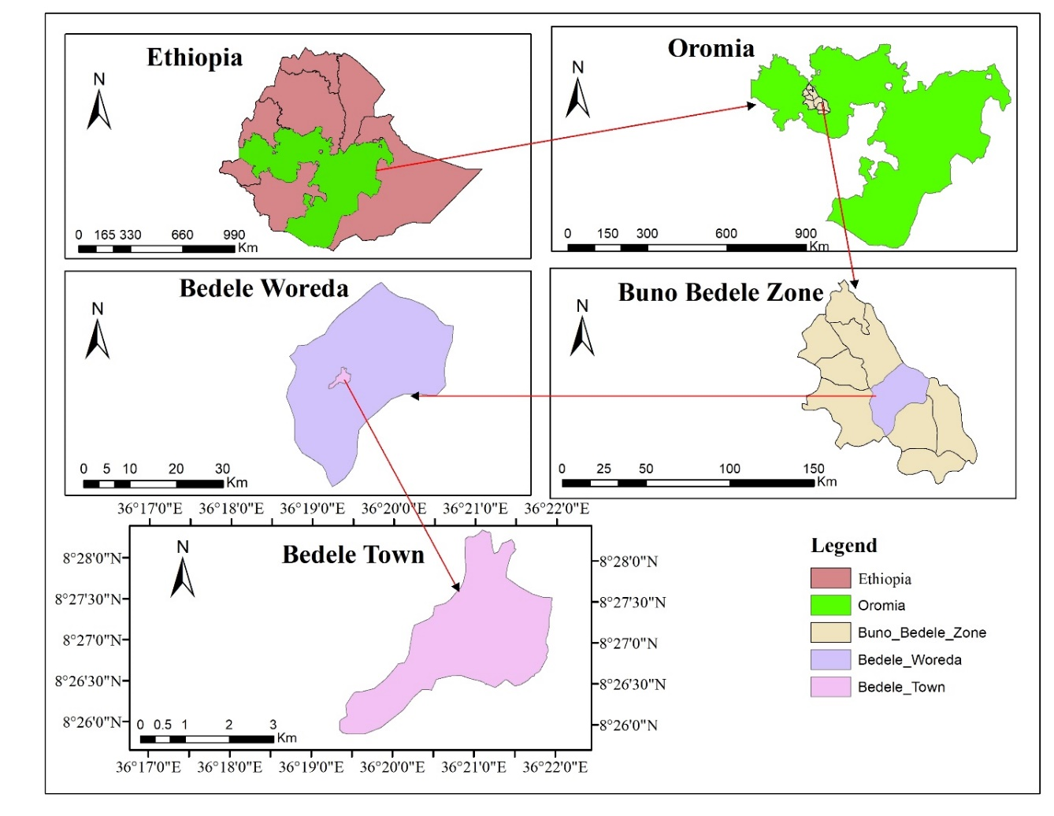
Figure 3.1: Map of the Study area

3.1.2 Climate
The climate is warm in Bedele. In winter, there is much less rainfall than in summer. The average temperature in Bedele is 18.4 °C. About 1850mm of precipitation falls annually. The average temperature varies during the year by 3.1 °C. The average monthly temperature of Bedele for 34 years is tabulated in the following Table 3.1.
Table 3.1: Average monthly temperature of Bedele
Months | Jan | Feb | Mar | Apr | May | Jun | Jul | Aug | Sep | Oct | Nov | Dec
Avg. temp(°C) | 17.9 | 19.4 | 20.3 | 20.1 | 19.6 | 18.7 | 17.3 | 17.3 | 17.7 | 17.7 | 17.5 | 17.2
The warmest month of the year is March with an average temperature of 20.3 °C. In December, the average temperature is 17.2 °C. It is the lowest average temperature of the whole year. The following Figure 3.2 shows the average monthly precipitation of Bedele.

Figure 3.2: Average monthly Precipitation of Bedele
From March to October, it is the rainy season and a shortfall of rain occurs from January to February and November to December.

3.1.3 Population
Bedele Town is a home for different nations and nationalities of peoples of Ethiopia. The total population of the Town is 46882 as it was recorded in 2017 for team-building purposes by the Municipality Bureau of the Town. From the total number of the population, 22747 were men and 24135 were women (Source: Bedele Town Municipality).

3.1.4 Soil Type
As FAO soil classification of 2007, the soil type of Bedele town is Dystric Gleysols, which can be included under D hydrologic soil group depending on its characteristics, which are clarified by the Harmonized world soil database.
Table 3.2: Bedele Town Soil type
Soil unit Name (FAO 90) | Topsoil USDA Texture Classification | Subsoil USDA Texture Classification | Drainage class
Dystric Gleysols | clay loam | clay loam | Poor
Source: HWSD (Harmonized World Soil Database)

3.1.5 Land Use Land Cover
The land use land cover of Bedele Town was done by using Google Earth Pro and ArcGIS 10.4.1 and it is verified by field observation of the study area. Bedele Town is largely covered by residential houses and it covers about 34.9% of the total land use land cover area of the town. About 25.1% of the area is classified as suburban. The business and commercial, institutional, industrial, and road covers 3.2%, 3.4%, 2.2%, 7.5% of the area respectively. The other 23.7% of the town falls under different land use land cover as shown in the following Figure 3.3. The details of land use land cover are presented in Appendix-6B.
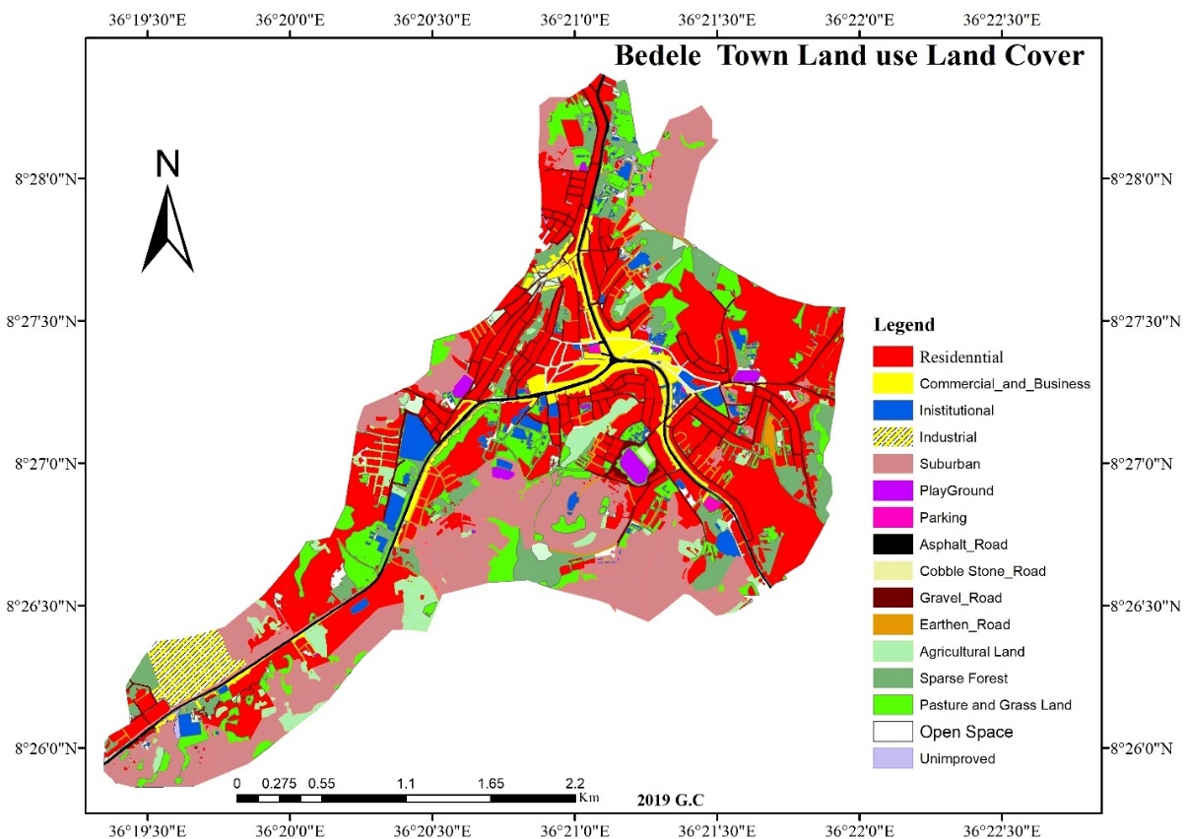
Figure 3.3: Land use land cover of Bedele Town
From the total area of Bedele Town, the following is selected to be used in runoff analysis and its land use land cover is presented as follows.
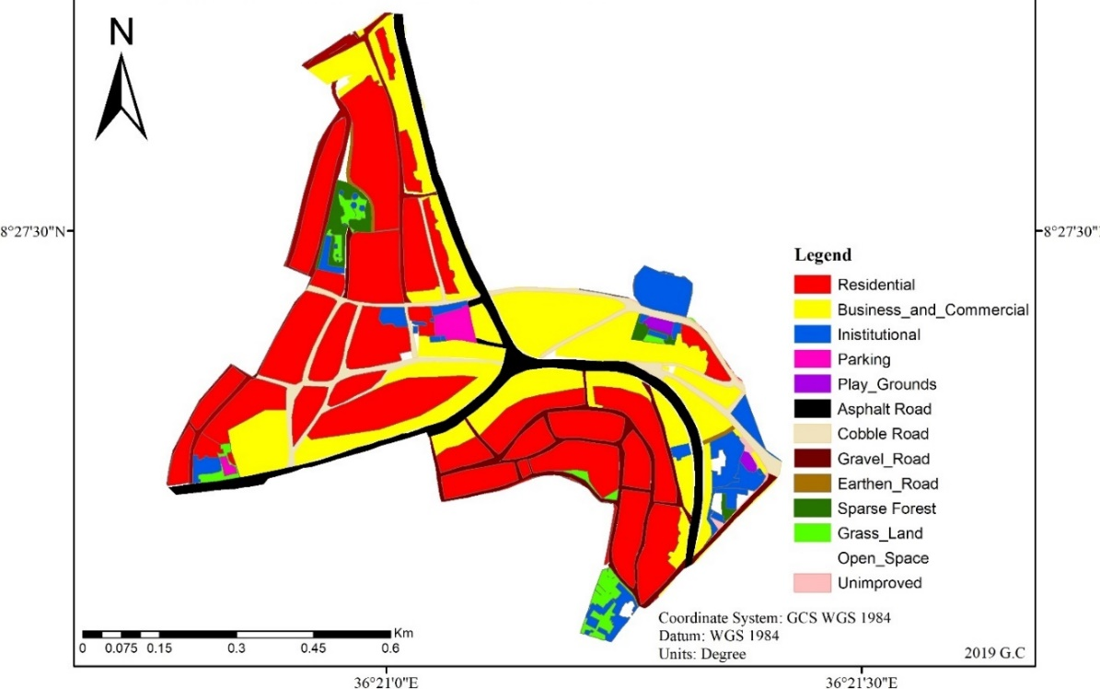
Figure 3.4: Land use Land Cover of modeled Area

3.1.6 Hydrological Information
The required hydrological information for estimating the design floods was obtained by developing the IDF curve of Bedele Town. As ERA classification, there are four major rainfall regions and eight sub-rainfall regions in the country. ERA developed four IDF curves for rainfall regions in the country for A1 & A4, A2 &A3, B, C & D, and Bahir Dar & Lake Tana rainfall regions. Accordingly, this study area falls under the B1 rainfall region/hydrologic region as per the ERA Drainage Manual 2013.
The maximum peak flood computed using the return period recommended in ERA Drainage Design Manual 2011 considering the road standard and the design life span of the structure, 10 years for design, and 25-year check (review) return period was adopted.

3.2 Data Collection
Before using and processing any data, the primary task was collecting relevant information and data of the study area. This section identifies and discusses the types of data and sources used for the study.

3.2.1 Assessing the Condition of the Existing Drainage System
A field survey (visit) of the study area was carried out to determine the existing performance condition of drainage structures. Observing flood marks, measuring the size of the existing drainage structures, measuring the elevation difference between river/stream bed and flood mark as well as gathering information about the overall performance of drainage structures during the rainy season. The materials used are a digital camera, GPS device and measuring tape, Surveying data, and design Review Reports. These materials were used during field visits to get primary data.
Methods Used to Assess the Condition of Existing Drainage System
The condition of existing drainage was assessed by the following methods to identify the drainage problem of Bedele Town.
- Reviewing documented file- to some extent, the data of the existing designed and constructed drainage system of the town found from the Municipality Bureau. This is secondary data that was documented by the responsible body of governmental workers. The
- Field Surveying- the most relevant and reliable data was obtained by field investigation/field survey/. Such is primary data and more crucial in assessing the existing drainage condition of the Town. Field surveying consists of observing damaged drainage structures and measuring different dimensions of the existing drainage structures as well as taking GPS records and pictures of the existing drainage condition of the Town. This was done by using a measuring tape, camera and GPS recorder. The data collected are drainage line dimensions (depth, width, length, diameter), the shape of available drainage structures (rectangular, trapezoidal, circular), type of drainage canals construction material (Masonry, Concrete, Earthen) and slope of the channel. Also, the location of drainage canals’ junctions and outlets were assessed by field observation.
- Using Software- To know the size and percent of coverage of the drainage infrastructures of the Town ArcGIS and Google Earth Pro were used. Also, the spatial data collected during the field survey and taken from Google Earth were inserted in ArcGIS and the map of the drainage network was drawn.
Also in assessing the drainage condition of the existing drainage system the GTZ standard has been used.
Table 3.3: GTZ Standards of Drainage Condition
Indicators Classification | Surface Condition
Very good | Shapes of USWD lines as still in original design condition
Good | No significant depressions, undulations and deformation
Light | The shape of the USWD lines deteriorate, but still sheds water
Severe | The total collapse of the USWD lines structure and barely passable
Source: GTZ, 2006)

3.2.2.1 The Hydraulic Capacity of the Existing Stormwater Drainage System
Hydraulic properties and design of the existing drainage systems of Bedele Town were collected from some secondary data and field measurements. The following method was used to estimate the hydraulic capacity of the existing drainage system of the Town.
Manning Formula
Manning’s formula is used for calculating the cross-sectional area, wetted perimeter, and hydraulic radius for the flow of a specified depth in a canal of known diameter. The formula is applicable for a constant flow rate through the channel with a constant slope, size, and shape, roughness, geometry, and canal type. The hydraulic design of the existing drainage system will be checked using the Manning formula as:
Q = 1/n * AR^{2/3} *S^{1/2}………………………………………………………...………………...Equation 3.1
Where,
Q = the volumetric flow rate in m³/sec.
A = the cross-sectional area of flow normal to the flow direction in m²
S = the bottom slope of the channel in m/m (dimensionless).
P = the wetted perimeter of the cross-sectional area of flow in m.
n = a dimensionless empirical constant called the Manning roughness coefficient.
R = the hydraulic radius, which is the cross-sectional area of flow normal to the flow direction in m² divided by the wetted perimeter of the cross-sectional area of flow in m.
For storm drains flowing full, the above equations become:
$Q=\frac{0.312D^{8/3}S^{1/2}}{n}$………………………………………………………………………………Equation 3.1
$V=\frac{0.397D^{2/3}S^{1/2}}{n}$……………………………………………………………………………….Equation 3.2
Where: D = diameter of the pipe, m

3.2.2 The Intensity Duration Frequency Curve for the Various Return Periods
Rainfall intensities of various frequencies and durations are important parameters for the hydrologic design of storm sewers, culverts, and other hydraulic structures. This can be achieved by the rainfall Intensity-Duration-Frequency (IDF) relationship, which is determined through rainfall frequency analysis. The order statistics approach is applied for the determination of distributional parameters to estimate rainfall and develop IDF relationships for different return periods. The intensity duration frequency curve for Bedele Town is developed for a set of selected return periods of 2, 5, 10, 25, 50, and 100 years. Data like rainfall, rainfall intensity, return period, and rainfall duration are required to develop this curve. Goodness-of-Fit (GoF) tests were employed for checking the adequacy of fitting the distributions to the recorded data. Model Performance Indicator (MPI) such as the root mean square error and the correlation coefficient are used to analyze the performance of IDF relationships given by the probability distribution function.

3.2.3.1 Design Rainfall of Shorter Duration
The rainfall depths obtained from the gauging station were 24hr duration depth. Design and analysis of drainage structures require a rainfall intensity-duration relationship of shorter duration. However, for such rainfall data were not available, the intensity of a short time rainfall is calculated by using a reduction formula, which is suggested by the Ethiopian Road Authority (ERA, 2013). Drainage Design Manual of 2013 suggests the following Equation 3.4 for calculation of shorter duration rainfall from 24-hour duration rainfall was used.
$R_{Rt}=\frac{t{\left(b+24\right)}^{n}}{24(b+t)^{n}}$………………………………………………………………………….……...Equation 3.3
Where; R_{Rt} = Rainfall depth ratio
Rt= Rainfall depth in a given duration t
R24 = 24hr rainfall depth
Coefficients b = 0.3 and n = 0.78 - 1.09
Log-Pearson type III method was employed to develop the IDF curve for the shorter duration events using the above Equations which were identified depending on the best fit test that has been done for checking the adequacy of fitting the distributions to the recorded data for 2, 5, 10, 25,50- and 100-year return period.
Rearranging the above Equation:
$R_{t}=\frac{t{\left(b+24\right)}^{n}}{24(b+t)^{n}}*R_{24}$…………………………………………………………...………….……Equation 3.4
Substituting Intensity (mm/hr) in the above Equation
$I_{t}=\frac{R_{t}}{t}$….........................................................................................................................Equation 3.5
$I_{t}=\frac{R_{24}{\left(b+24\right)}^{n}}{24(b+t)^{n}}$………………………………………………………...…………….………. Equation 3.6
Using b = 0.3 and n = 0.92 as suggested by ERA manual and results are tabulated for rainfall durations 5, 10, 15, 20, 25, 30, 60, 90, 120, 150, and 180 minutes.

3.2.3 Peak Discharge Estimation
The hydrological study is the basic step that should be done carefully in every flood management and road drainage facilities. The hydrological investigation is dealt with by analyzing rainfall data, high watermark observations, topographical maps, satellite image, and aerial photographs for the estimation of design discharge. The investigation is supplemented by field inspection of the watershed area and interviews. It is known that there are many methods used for peak flood calculation, but their applicability depends mainly on the availability of hydrological data.

3.2.3.1 Rational Method
Mulvaney developed the rational method, in 1851 for peak flow estimation in small to medium watersheds with no significant storage. It takes into account the steady-state condition to estimate peak runoff discharge resulting from a rainfall event of specific recurrence interval, which is usually in the range of 2–10 years and occasionally up to 25 years (Watt et al., 2003). The Rational method has been the most common because it is simple, and also because urban drainage design typically requires peak discharge data only (Methods and Durrans, 2003).
According to ERA Drainage Design Manual 2013, this method estimates the peak runoff rate for small urban and rural watersheds of less than 50ha. The rational formula estimates the peak rate of runoff at any location in a catchment area as a function of the catchment area; runoff coefficient; and mean rainfall intensity, for a duration equal to the time of concentration. The rational formula is expressed as in Equation 3.7.
$Qp=0.00278CiA$.........................................................................................................Equation 3.7
Where: Qp=Peak run-off of the catchment (m³/sec), C=Runoff coefficient of the catchment,
i = rainfall intensity in (mm/hr.), A = catchment area in (ha).
How to Calculate the Peak Flow Rate of Bedele Town Stormwater Drainage System
The peak flow rate of the Bedele Town stormwater drainage system is aimed to be calculated by using the Rational Method. This method is selected depending on the size of each watershed of sub-catchments in the study area. As it is stated above Rational method is used to estimate the peak flow rate of the watershed sized up to 50ha. The size of all sub-catchments in this study area is under 50ha. This makes possible the use of the Rational method to estimate the peak flow rate of the Bedele Town stormwater drainage system. Also, the simulation from the SWMM 5.1 is done following the peak flow rate estimation of the Bedele Town stormwater drainage system.
Steps to Peak flood Estimation using the Rational Method
The following procedure outlines the rational method for estimating peak discharge:
- Determine the watershed area in hectares;
- Determine the time of concentration;
- Assure consistency with the assumptions and limitations for application of the Rational Method;
- Determine the rainfall IDF coefficients. Extract the Rainfall Intensity-Duration;
- Frequency Coefficients b, and n values from the list in Hydrology according to the locality in Ethiopia and the design frequency;
- calculate the rainfall intensity in mm/hr or use developed IDF curves;
- Select appropriate runoff coefficients for the watershed and estimate a weighted C value;
- Calculate the peak discharge for the watershed the desired frequency.
And the main input variable of the rational method: Rainfall intensity, Time of concentration, Rainfall duration, Rainfall frequency, Catchment area.
A. Runoff Coefficient (C)
The runoff coefficient C is the function of the land use land cover of the study area and used as input for peak discharge estimation. The more the surface is impervious the higher the runoff would be as the infiltration decreases. The rainfall intensity directly affects the runoff coefficient. Vegetation cover reduces the impact of a raindrop on the ground and intercepts some of the rain on its leaves and branches letting them evaporate. This directly decreases the runoff coefficient. A weighting method is employed to obtain the representative runoff coefficient i.e. the individual areas multiplied by their specific runoff coefficient and their values added together and divided by the cumulative area (Chow et al...2012). This can be calculated as the following Equation 3.8.
Cw = (A1*C1 + A2*C2 +…+ An*Cn) / (A1 + A2 +…+ An) …...................................Equation 3.8
Where: Cw= Weighted Runoff Coefficient, C1, C2, ---- Cn = coefficient of runoff for parts of the drainage area. A1, A2, An = parts of drainage areas with different runoff coefficients.
The weighted runoff coefficient is determined by using the above Equation after determining the runoff coefficient that can represent each land use land cover that is found in each sub-catchment in the study area. It is tabulated in Table 3.4 below. The detail of the Runoff coefficient is presented in appendix (Appendix-6B)

Table 3.4: Weighted Runoff Coefficient of the study area
Sub-Catchment | Cw | Sub-Catchment | Cw
SC-1 | 0.67 | SC-7 | 0.75
SC-2 | 0.59 | SC-8 | 0.66
SC-3 | 0.7 | SC-9 | 0.76
SC-4 | 0.77 | SC-10 | 0.72
SC-5 | 0.75 | SC-11 | 0.6
SC-6 | 0.73 | SC-12 | 0.7
B. Time of Concentration (Tc)
The time of concentration is the time required for runoff to flow from the most remote point of the basin to the point of interest. In a rational method, it is used to determine the rainfall duration, which would result in maximum runoff. Tc is calculated as expressed in Equation 3.9.
$Tc = Tc inlet + Tt$ ……………………………………………………….………Equation 3.9
Where: Tc = time of the concentration (minute), Tci = time of concentration inlet (hrs.) and
Tt = the travel time (hr)
- Time of concentration inlet (Tci)
The time of concentration of the drainage area is the time required for runoff from the farthest part of the drainage area to reach the outlet used as the duration for the design storm. The inlet time for the time of concentration is estimated using the Kirpich Equation method. The Equation is considered applicable to a watershed from 1 ha to 80 ha. This is appropriate for an urban area or a steep area by multiplying tc value with 0.4 of adjustment factor (AASHTO, 2009). This Equation is as follows (Equation 3.10).
$tc={\left[\frac{{0.948L}^{3}}{H}\right]}^{0.385}$…………………………………………….……...……….........Equation 3.10
Where: tc= time of concentration (hr)
L= overland flow path length (Km)
H= Difference in Elevation between the point in question (m)

Travel Time
Travel time (Tt) is the time it takes water to travel from one location to another. The travel time between two points is determined using the following relationship (Equation 3.11).
$Tt = L/ (3600V)$…………………………..………………….………...Equation 3.11
Where: T_{t} = travel time, hr.
L = length of the main drainage canal (m)
V = flow velocity in the channel (m/s)
3600 = conversion factor from seconds to hours.
Flow velocity (V)
The flow velocity is computed using the Manning formula as shown in Equation 3.12.
$V=\frac{1}{n}* R^{\frac{2}{3}}* S^{1/2}$…………………………………………………..Equation 3.12
Where: V = the flow velocity (m/s), R = the hydraulic radius (m),
S = the channel slope (m/m) and n = the Manning roughness coefficient.
The Time of Concentration is calculated as overland flow time (Inlet Time of Concentration) and as Travel Time. But at some part of the sub-catchments in the study area, the estimated time of concentration value is less than 5 minutes. When such a situation happens, using a minimum tc value of 5 minutes for urbanized areas is recommended (FHWA, 2013; UDFCD, 2018). Depending on this, a minimum Tc value of 5min is used wherever the minimum calculated value of Tc has occurred.
C. Rainfall Intensity (I)
The rainfall intensity is the average rainfall rate in mm/hr for a duration equal to the time of concentration for a selected return period. Once a particular return has been selected for design and time of concentration calculated for the drainage area, the rainfall intensity can be determined from Rainfall-Intensity-Duration data.
D. Catchment Area (A)
The catchment area can be determined considering land cover with runoff coefficient depending on land types of the study area from topographic maps that contribute to the canal. For large catchment areas, it is necessary to divide the area into sub-catchment areas to account for major land-use changes, obtain analysis results at different points within the catchment area, and for locating stormwater drainage systems and assess their effects on the flood flows.
The catchment of this study area is divided into 12 sub-catchments to make it suitable for the estimation of peak discharge and presented in the following Figure 3.5 after it is delineated by using ArcGIS10.4.1.
From the total area of Bedele town, the area presented in Figure 3.5 is selected for modeling and runoff estimation. The reason behind this is, this area is more affected by stormwater runoff and the problem is very serious than other parts of the town. This area is also more developed and this cause the runoff generated in the study area is with a high rate while the infiltration rate in this area is very less with such an increased percent of impervious surface. Particularly, the flooding and drainage problem seems serious around the bus station, Aba Boku Area, Municipality Office, and at around the Gebiya Sefer area. For this reason, this study mainly focused on the analysis of the drainage condition in those mentioned areas.
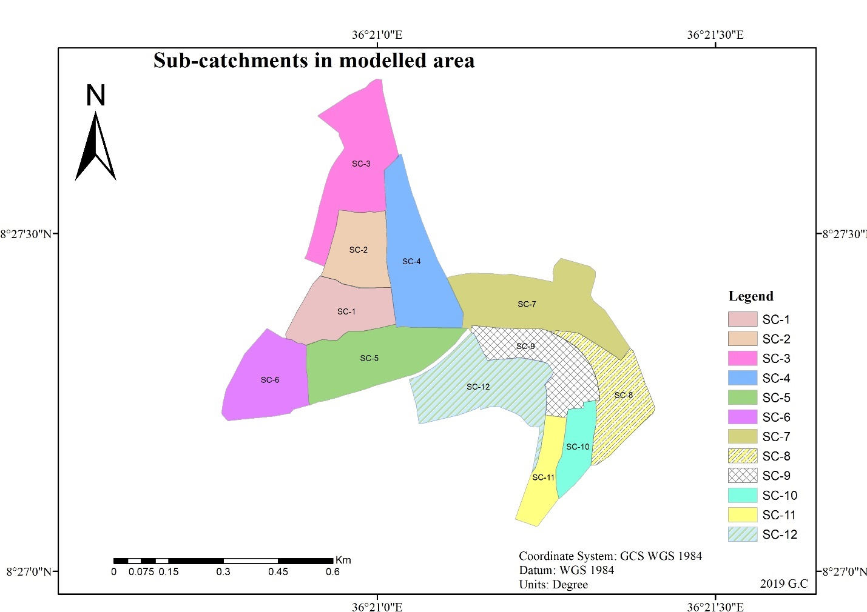Figure 3.5: Sub-catchments in the study area

3.2.4 Stormwater Management Model (SWMM)

3.2.4.1 Computational Methods of the SWMM
SWMM is a physically-based, discrete-time simulation model. It employs principles of conservation of mass, energy, and momentum wherever appropriate. This section briefly describes the methods SWMM uses to model stormwater runoff quantity and quality through the following physical processes:
- Surface Runoff
Each sub-catchment surface is treated as a nonlinear reservoir. Inflow comes from precipitation and any designated upstream sub-catchments. There are several outflows, including infiltration, evaporation, and surface runoff. Surface runoff per unit area occurs only when the depth of water in the "reservoir" exceeds the maximum depression storage, in which case the outflow is given by Manning's Equation.
- Infiltration
Infiltration is the process of rainfall penetrating the ground surface into the unsaturated soil zone of pervious sub-catchments areas. SWMM offers choices for modeling infiltration. These choices are Horton's Method, Modified Horton Method, Green-Ampt Method, Modified Green-Ampt Method, and Curve Number Method.
Horton's Method
This method is based on empirical observations showing that infiltration decreases exponentially from an initial maximum rate to some minimum rate throughout a long rainfall event. Input parameters required by this method include the maximum and minimum infiltration rates, a decay coefficient that describes how fast the rate decreases over time, and the time it takes a fully saturated soil to completely dry.
Modified Horton Method
This is a modified version of the classical Horton Method that uses the cumulative infiltration over the minimum rate as its state variable (instead of time along the Horton curve), providing a more accurate infiltration estimate when low rainfall intensities occur. It uses the same input parameters as does the traditional Horton Method.
Green-Ampt Method
This method for modeling infiltration assumes that a sharp wetting front exists in the soil column, separating soil with some initial moisture content below from saturated soil above. The input parameters required are the initial moisture deficit of the soil, the soil's hydraulic conductivity, and the suction head at the wetting front. The recovery rate of moisture deficit during dry periods is empirically related to the hydraulic conductivity.
Modified Green-Ampt Method
This method modifies the original Green-Ampt procedure by not depleting moisture deficit in the top surface layer of soil during initial periods of low rainfall as was done in the original method. This change can produce more realistic infiltration behavior for storms with long initial periods where the rainfall intensity is below the soil’s saturated hydraulic conductivity.
Curve Number Method
This approach is adopted from the NRCS (SCS) Curve Number method for estimating runoff. It assumes that the total infiltration capacity of a soil can be found from the soil's tabulated Curve Number. During a rain event, this capacity is depleted as a function of cumulative rainfall and remaining capacity. The input parameters for this method are the curve number and the time it takes a fully saturated soil to completely dry.
SWMM also allows the infiltration recovery rate to be adjusted by a fixed amount on a monthly basis to account for seasonal variation in such factors as evaporation rates and groundwater levels. This optional monthly soil recovery pattern is specified as part of a project's Evaporation data.
From the infiltration modelling methods mentioned above, the Modified Green-Ampt Method is used for this study for it can produce more realistic infiltration behavior for storms.
Flow Routing
Flow routing within a conduit link in SWMM is governed by the conservation of mass and momentum Equations for gradually varied, unsteady flow (i.e., the Saint Venant flow Equations). The SWMM user has a choice on the level of sophistication used to solve these Equations:

Steady Flow Routing
Steady Flow routing represents the simplest type of routing possible (actually no routing) by assuming that within each computational time, step flow is uniform and steady. Thus, it simply translates inflow hydrographs at the upstream end of the conduit to the downstream end, with no delay or change in shape. The normal flow Equation is used to relate the flow rate to the flow area (or depth). It can only be used with dendritic conveyance networks, where each node has only a single outflow link (unless the node is a divider in which case two outflow links are required). This form of routing is insensitive to the time step employed and is only appropriate for preliminary analysis using long-term continuous simulations.
Kinematic Wave Routing
This routing method solves the continuity Equation along with a simplified form of the momentum Equation in each conduit. The latter assumes that the slope of the water surface equals the slope of the conduit. The maximum flow that can be conveyed through a conduit is the full normal flow value. Any flow over this entering the inlet node is either lost from the system or can pond atop the inlet node and be re-introduced into the conduit as capacity becomes available. Kinematic wave routing allows flow and area to vary both spatially and temporally within a conduit.
Dynamic Wave Routing
Dynamic Wave routing solves the complete one-dimensional Saint Venant flow Equations and therefore produces the most theoretically accurate results. These equations consist of the continuity and momentum Equations for conduits and a volume continuity Equation at nodes. With this form of routing it is possible to represent pressurized flow when a closed conduit becomes full, such that flows can exceed the full normal flow value.
It is the method of choice for systems subjected to significant backwater effects due to downstream flow restrictions and with flow regulation via weirs and orifices. This generality comes at the price of having to use much smaller time steps, on the order of thirty seconds or less (SWMM can automatically reduce the user-defined maximum time step as needed to maintain numerical stability) (Rossman, 2015).
From the flow routing methods discussed above, Dynamic Wave Routing is selected for flow routing in this study due to its capability to consider the backwater effects.
The schematic procedures of SWMM have been presented below in Figure 3.6.
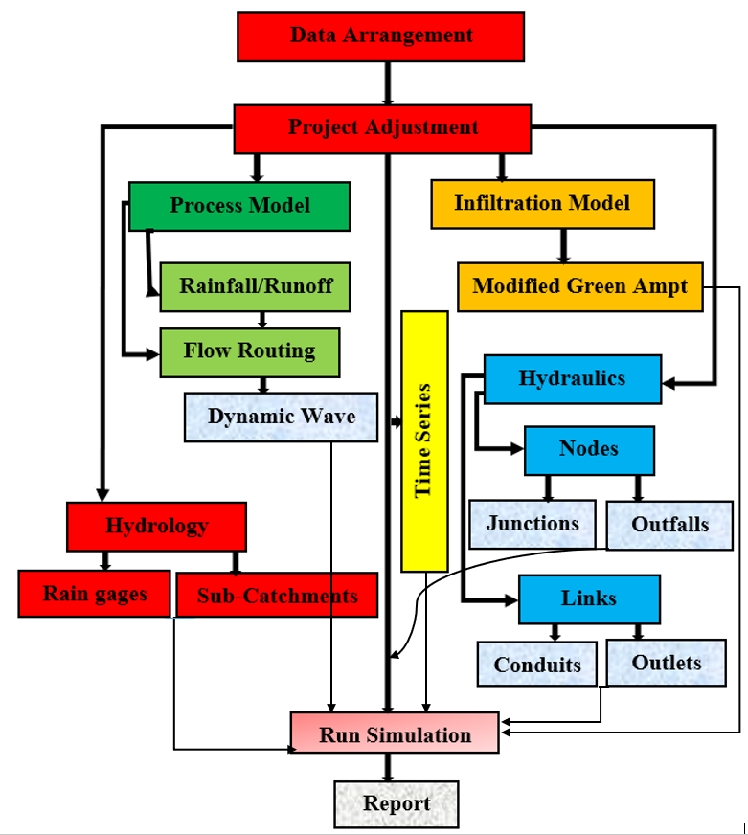
Figure 3.6: Schematic procedure of SWMM Model

3.2.4.1Input Parameters for SWMM and Their Properties
Sub-Catchment Properties
The SWMM model uses different sub-catchment properties as input parameters. These inputs are presented below in Table 3.5.
Table 3.5: Sub-Catchment Properties
No. | Input | Description
1 | Name | User Assigned
2 | Rain Gage | Name of the rain gage associated with the sub-catchment.
3 | Outlet | Name of the node or sub-catchment which receives the sub-catchment runoff
4 | Area | Area of the sub-catchment in acres or ha.
5 | Width | Characteristic width of the overland flow path for sheet flow runoff (m).
6 | %Slope | Average Percent slope of the sub-catchment
7 | %Imperv. | Percent of the land area which is impervious.
8 | N-Imperv | Manning’s n for overland flow over the impervious portion of the sub-catchment
9 | Infiltration | Used to edit infiltration parameters for the sub-catchment.
10 | Land Uses | Uses to assign land uses to the sub-catchment.
Rain Gage Properties
Rain Gages supply precipitation data for sub-catchment areas in a study area. The rainfall data can be either a user-defined time series or come from an external file. The following Table 3.6 describes the Rain Gage properties.
Table 3.6: Rain Gage Properties
 | Input | Description
1 | Name | User Assigned
2 | Rainfall data type | Can be inserted in the form  Intensity: Each rainfall value is an average rate over the recording interval(mm/hr)  Volume: Volume of rain that falls in the recording interval(mm)  Cumulative: the cumulative rainfall that has occurred(mm)
3 | Data Source | User-supplied time-series data or file for external data file

Outfall Properties
Outfalls are terminal nodes of the drainage system used to define final downstream boundaries under Dynamic Wave flow routing. For other types of flow routing, they behave as a junction. The inputs used in outfall in fixing outfall properties are presented below in Table 3.7.
Table 3.7: Outfall Properties
No. | Input | Description
1 | Name | User Assigned
2 | Invert Elevation | Invert elevation of the outfall (m).
3 | Type of outfall boundary condition | FREE: outfall stage determined by the minimum of critical flow depth and normal flow depth in the connecting conduit.  NORMAL: outfall stage based on normal flow depth in the connecting conduit  FIXED: outfall stage set to a fixed value.
Junction Properties
Junctions are drainage system nodes where links join together. Physically they can represent the confluence of natural surface channels, manholes in a sewer system, or pipe connection fittings. The junction properties are tabulated below in Table 3.8.
Table 3.8: Junction Properties
No. | Input | Description
1 | Name | User Assigned
2 | Invert Elevation | Invert elevation of the junction (m).
3 | Maximum Depth | Maximum depth at the junction (m).
4 | Initial Depth | Depth of water at the junction at the start of the simulation (m).
Conduit Properties
Conduits are pipes or channels that move water from one node to another in the conveyance system. Their cross-sectional shapes can be selected from a variety of standard open and closed geometries. The conduit properties are presented below in Table 3.9.

Table 3.9: Conduit Properties
No. | Input | Description
1 | Name | User Assigned
2 | Inlet Node | Name of the node on the inlet end of the conduit at a higher elevation
3 | Outlet Node | Name of the node on the outlet end of the conduit at the lower elevation.
4 | Shape | Used to edit the geometric properties of the conduit’s cross-section
5 | Length | Conduit length (m).
6 | Roughness | Manning’s roughness coefficient for opened conduit and closed channel values
7 | Inlet offset | Height of the conduit invert above the node inverts at u/s end of the conduit.
8 | Outlet offset | Height of the conduit invert above the node inverts at d/s end of the conduit.
9 | Initial Flow | The initial flow of the conduit at the start of the simulation (flow units)
Outlet Properties
Outlets are flow control devices that are typically used to control outflows from storage units. The input used in fixing the outlet is presented below with their properties.
Table 3.10: Outlet Properties
No. | Input | Description
1 | Name | Use Assigned
2 | Inlet Node | Name of the node on the inflow side of the outlet
3 | Outlet Node | Name of the node on the discharge side of the outlet.
4 | Height | Height of outlet above inlet node invert (m)
5 | Flag Gate | YES, if a flagged gate exists which prevents backflow through the outlet, or NO if no flap gate exists
Sensitivity Analysis
Sensitivity analysis done for parameters of the model indicated that the output by the SWMM model is sensitive to the roughness coefficient for impervious areas (N-Imperv) the most. The parameters used for sensitivity analysis and their allowable range of change proposed by Li et al. (2014) are presented in Table (3.11).

Table 3.11: Some key parameters used for sensitivity analysis
Parameter | Description | The allowed range of change
N-Imperv | Manning’s roughness coefficient for impervious  areas | 0.005-0.05
N-Perv | Manning’s roughness coefficient for pervious  areas | 0.05-0.5
Dstore-Imperv | Depth of surface storage in impervious areas  (mm) | 1.3- 2.5
Dstore-Perv | Depth of surface storage in pervious areas  (mm) | 2.5- 7.6
Zero-Imperv | Impervious areas without surface storage (%) | 50-80
Design Flood Computation and Analysis with SWMM
One typically carries out the following steps when using EPA SWMM to model a study area:
- Specify a default set of options and object properties to use.
- Draw a network representation of the physical components of the study area.
- Edit the properties of the objects that make up the system.
- Select a set of analysis options.
- Run a simulation.
- View the results of the simulation.
For building larger systems from scratch, it will be more convenient to replace Step 2 by collecting study area data from various sources, such as CAD drawings or GIS files, and transferring these data into an SWMM input file (Rossman, 2015).

3.3 Data Analysis

3.3.1 Rainfall Data
For this study area, the rainfall data sets in one rain gage station have been used. To fill the missing data, the neighboring stations were used. The rainfall data of each station were obtained from Ethiopia Meteorological Agency. Three meteorological stations used to get rainfall data are tabulated as follows.

Table 3.12: Rainfall stations and their descriptions
No. | Stations | Latitude | Longitude | Altitude | Used data Record Year | %missed data | Sub-basin
1 | Bedele | 8.45 | 36.34 | 2002 | 1986-2019 | 3.8 | Abay
2 | Dabena | 8.4 | 36.28 | 1950 | 1986-2019 | 4.4 | Abay
3 | Kone | 8.69 | 36.28 | 2013 | 1986-2019 | 5.6 | Abay
The spatial distribution of rainfall with the corresponding station is shown in the following figure (Figure 3.7) which was developed by Theissen Polygon Method in ArcGIS.
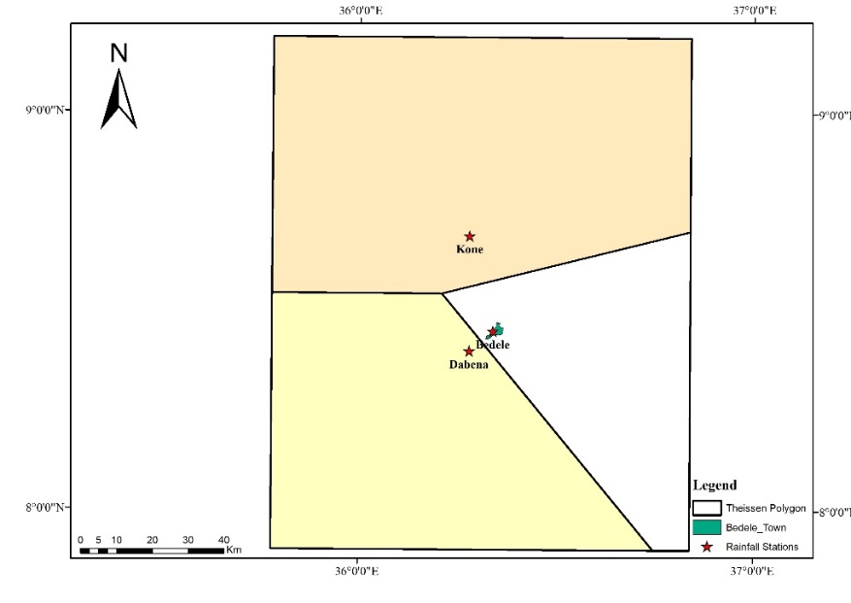
Figure 3.7: Theissen Polygon
Outlier check
A check on outliers has been undertaken on the recoded rainfall to identify any low or high outliers. Outliers are data points, which depart significantly from the trend of the remaining data. The retention, modification, deletion of these outliers can significantly affect the statistical parameters computed from the data, especially for small samples. All procedures for treating outliers ultimately require judgment involving both mathematical and hydrologic considerations. The presence of outliers in the data causes difficulties when fitting a distribution to the data. Low and high outliers are both possible and have different effects on the analysis. The lowest datum and the highest datum were calculated by using the following Equations.
$yH=\overline{y}+K_{n}*Sy$………………………………………...………………………Equation 3.13
$yL= \overline{y}-K_{n}*Sy$………….……………………………………………………...Equation 3.14
Where: yH = Highest outlier threshold in log units
yL= Lowest outlier threshold in log units
Kn = Constant given for sample size N
𝑆𝑦 = Standard deviation of N sample size
The maximum value of daily rainfall of Bedele Town was analyzed for 34 years (1986-2019) as presented under Appendix (Appendix-1B)
Table 3.13: Values for checking Outlier
 | N | Kn | Sy | $$\overline{y}$$ | yL | yH
Values | 34 | 2.616 | 0.1 | 1.8 | 1.5 | 2
When the antilog of (yL= 1.5) is 31.62mm and (yH=2) is 100mm there is no data below and above the outlier values through the rainfall data used and all the available data satisfies the condition and no modification, retention, and deletion is required.

3.3.2 Estimating Missing Rainfall Data
Due to the absence of observer or instrumental failure, rainfall data records occasionally are incomplete. In such a case, one can estimate the missing data by using the nearest station rainfall data. There are different approaches for estimating missing rainfall data varying with and based on the effect of orography on rainfall, the distance between the rainfall stations, and the variation of rainfall amount recorded on the stations. These are the average method, normal ratio method, inverse-distance weighting method, and regression methods. Among different methods, the Normal ratio method is one that is recommended to estimate missing rainfall data in regions where annual rainfall between stations differ by more than 10%. For this study, the Normal ratio method used to fill the missing rainfall data from stations for the annual rainfall between stations differs by more than 10%. Three meteorological stations Bedele, Dabena, and Kone were used for this study. Depending on the number of stations used in this study the Normal ratio method Equation for filling the missing data as expressed below in Equation 3.15.
$P_{x}={Nx}/2(\frac{P1}{N_{1}}+\frac{P2}{N_{2}})$ …………………..………………….………………….……Equation 3.15
Where: P_{x} - missing rainfall data (daily, monthly, or yearly)
P1, P2, - rainfall data at the nearest different station (daily, monthly, or yearly)
Nx - mean annual rainfall at missed station
N₁, N₂, - mean annual rainfall at the different nearest station

3.3.3 Homogeneity and Consistency Test of the Data
Homogeneity test
The quality and reliability of the data recorded at meteorological stations depend on many factors. Precipitation records at gauging stations are affected by the location of the station, the tool and method of data recording and collection and the observation quality and the time series might have inhomogeneity. For this reason, the reliability and quality of the data to be used in the hydrological analysis of stormwater drainage systems should be tested statistically. The methods for testing the homogeneity of the series may be classified into two groups as ‘absolute method’ and ‘relative method’. In the first method, the test is applied to each station individually. Alternatively, in the second method, neighboring (reference) stations are also used for the testing process. However, it is difficult to find reference stations with a high correlation and a homogeneous structure in wide regions. The homogeneity of rainfall data from the stations used in this study was checked by drawing the graph of the average value of the same month in a given 34 years of record data. As we can see from the below graph (Figure 3.8) the homogeneity of the data was good and can be applicable for this study.
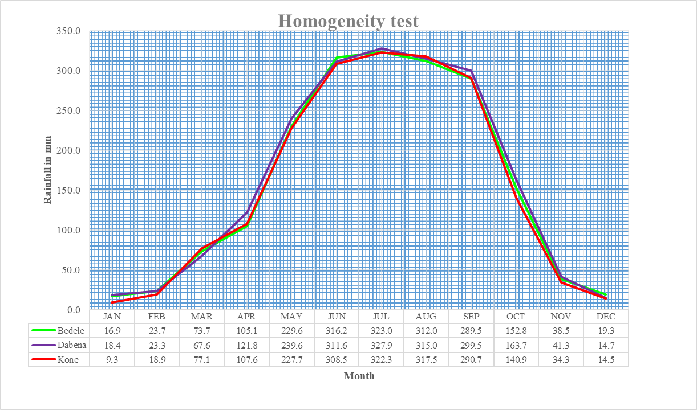
Figure 3.8: Homogeneity graph of three stations
Consistency Test
The consistency of precipitation data from individual stations checked using a double mass analysis. The double mass curve is a plot of the successive cumulative annual precipitation Σyi at the gauge that is checked versus the successive cumulative annual precipitation Σxi for the same period of a control gauge (or the average of several gauges in the same region). If the stations are close to each other and lie in a climatically homogeneous region, the annual values should be correlated to each other (Koutsoyiannis, 2010). Depending on the consistency of rainfall, data from three stations used in this study was checked by using a double mass curve as described below in Figure 3.9.
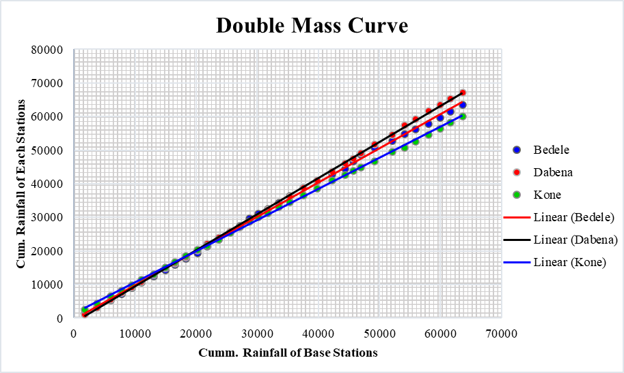
Figure 3.9: Graph of Consistency check for rainfall data of Bedele station and its neighbors

3.4 Rainfall Frequency Analysis Methods
Hydrologic processes such as floods are complex natural events. The maximum discharge expected in T years can be analyzed by using different frequency distribution functions. But our data may fit only one of them. Some of the commonly used frequency distribution functions for the prediction of extreme maximum values are; Normal distribution method, the Gumbel distribution method, General Extreme Value (GEV), the Log-Pearson type III distribution method, and Log-normal distribution method (Subramanya, 2008). The method commonly used for estimating the peak discharges is usually Log-Pearson Type III distribution. However, as the record length is increased, a Log-Normal distribution or General Extreme Value (GEV) distribution could also be used. The recent data analysis demonstrated that GEV can be used to estimate the peak flow in Ethiopia. It is recommended that the distribution method, which gives the best fit to the record data, should be used (ERA, DDM, 2013).

3.4.1 Normal Distribution Method
It is one of the probability distribution functions used for estimation of peak or maximum rainfalls and expressed by the following Equation (3.16).
XT= X̅ +K_{T}* 𝜹n-1………………………………………………….……………. Equation 3.16
Where: XT=annual mean maximum flow of T year return period.
X̅ = mean of annual maximum flow
𝛿n-1 = standard deviation of the sample size
K_{T} = frequency factor expressed as,
K=W((2.51557+0.80285w+0.01033w²)/ (1+1.143279 W+0.1992W²+0.00135W³))
W = (ln (1/Pr)²)^{1/2} where, Pr=1/T
$δ_{n-1}=\sqrt{\frac{Σ(Xi-\overline{X})^{2}}{N-1}}$…………………………………………………………….……Equation 3.17
$$\overline{X}=\frac{Σxi}{N}$$
Where: N=Number of sample size

3.4.2 Gumbel Distribution Method
It is one of the widely used probability distribution functions for the estimation of peak or maximum rainfalls and expressed by Equation 3.18.
X_{T} = X̅ + K_{T}*n-1 ……………………………………...…………………………...Equation 3.18
Where; X_{T}=annual maximum of the mean flow of T year return period
n-1=standard deviation of the sample size
K_{T}=frequency factor and expressed as;
$$K=\frac{y_{T}-\overline{y}n}{S_{n}}$$
Y_{T} be a reduced variety, a function of T and is given by,
$$y_{T}=-\left[ln. ln\frac{T}{T-1}\right]$$
Yn = reduced mean, it is a function of sample size.
Sn=reduced standard deviation which is also a function of the sample.
Yn and Sn are obtained from the Gumbel Table.

3.4.3 Log- Pearson Type III Distribution Method
In this method, the flow data is first transformed into logarithmic form (base ten) and the transformed data is then analyzed. If X is the variety of random flow series, then, the series of Z varieties where Z are obtained for this series for any recurrence interval T.
Z = log X Z_{T}= $\overline{Z}$+K_{Z}* z …………………………………………………………. Equation 3.19
Where, kz = a frequency factor which is a function of T and the coefficient of skewness, Cs z= standard deviation of Z variety sample.
$δ_{n-1}=\sqrt{\frac{Σ(Zi-\overline{Z})^{2}}{N-1}}$…………………………………………….……………………. Equation 3.20
$Cs=\frac{NΣ(Z-Z)^{3}}{(N-1)(N-2)(δz)}$………………………………………….…...…………………Equation 3.21
The variation of Kz = f (CS, T) is given in the Table as a function of Cs and T.
Lastly, convert to X_{T} as follows for comparison with the others. X_{T} = antilog (Z_{T}).
    - Log-Normal Distribution Method
The log-normal distribution is a special type of Pearson type III distribution with Cs = 0,
Z_{T}= Z̅ +K_{Z}*Z ……………………………………………………………………………………………..Equation 3.22
Finally, select the best-fit probability distributions, and return periods for maximum monthly rainfall and use the selected one for developing IDF curves for different return periods.

3.5 Goodness-of-fit (GOF) Measures
For the selection of a particular distribution representing a rainfall series, for the dependable projection of a storm event, it is essential to find the best fit method of frequency analysis. The three different most widely used GOF tests, viz., Kolmogorov-Smirnov (K-S), Anderson- Darling (A-D), and Chi-Squared (χ²) tests are implemented to select the most appropriate model. EasyFit software can be used while identifying the best fit frequency distribution function for a given study (Sharma et al. 2016a; Mamoon, 2018)
Kolmogorov-Smirnov test:
Kolmogorov-Smirnov test is used to determine whether a sample has come from an assumed continuous probability distribution. This test is based on the empirical cumulative distribution function (ECDF), which is given by:
$F_{n}\left(x\right)=\frac{1}{n}\left[Number of observations=<x\right]$……………………...Equation 3.23
The Kolmogorov-Smirnov test statistic (D) is given by the largest vertical difference between the theoretical and empirical cumulative distribution functions:
$D=\max_{1=<i=<n}\left(F\left(x_{i}\right)-\frac{i-1}{n}, \frac{i}{n}-F(x_{i})\right)$………………………………...Equation 3.24
Anderson-Darling test:
Anderson-Darling test compares the fit of an observed cumulative distribution function to an expected cumulative distribution function. This test gives more weight to the tails of the distribution than the Kolmogorov-Smirnov test. The Anderson-Darling test statistic (A²) is given by:
$A^{2}=-n-\frac{1}{n}\sum_{i=1}^{n}{(2i-1)\left[ln F\left(X_{i}\right)+ln⁡(1-F\left(X_{n-i+1}\right))\right]}$………Equation 3.25
Chi-squared test:
A chi-squared test is used to find if a sample has come from a population with a given distribution. This is applied to the binned data, and hence the value of the test statistic depends on how the available data is binned. The Chi-squared test statistic is given by:
$x^{2}=\sum_{i=1}^{k}{\frac{(O_{i}-E_{i})^{2}}{E_{i}}}$………………………………………………………...Equation 3.26
Where O_{i} is the observed frequency, i is the number of observations (1, 2, …, k) and Ei is the expected frequency for bin i obtained by:
$E_{i}=F\left(x_{2}\right)-F(x_{1})$………………………………………………………Equation 3.27
where, F is the cumulative distribution function of the probability distribution being tested, and x₁, x₂ are the limits for bin i. The observed number of observations (k) in the interval ‘i’ for the sample size of N is computed by:
$k=1+\log_{2}N$……………………………………………………………. Equation 3.28
The test statistics were computed and the probability distributions were ranked based on the lowest values of the test statistics. Statistical Analysis and frequency analysis were made by using Easy Fit 5.6 professional software and the Correlation Coefficient method. In this analysis maximum daily rainfall of 34 years records used as input. Some of the common distribution method output from Easy Fit 5.6 software are listed below according to their rank to be accepted.

Table 3.14: Goodness of fit tests with Easy fit 5.6 software
No. | Distribution | Kolmogorov Smirnov |  | Anderson Darling |  | Chi-Squared
No. | Distribution | Statistic | Rank | Statistic | Rank | Statistic | Rank
1 | Log-Pearson 3 | 0.07978 | 2 | 0.19782 | 1 | 0.22231 | 1
2 | Gumbel Max | 0.07989 | 3 | 0.1984 | 2 | 0.22354 | 2
3 | Lognormal | 0.07751 | 1 | 0.21693 | 3 | 0.71292 | 5
4 | Gen. Extreme Value | 0.09195 | 7 | 0.35674 | 12 | 4.2592 | 38
5 | Gen. Pareto | 0.10619 | 20 | 7.9819 | 54 | N/A
6 | Normal | 0.16294 | 43 | 0.98219 | 40 | 5.3623 | 40
As we can see from the above Table, the Log Pearson Type III distribution method is the best fit for this data.
Correlation Coefficient (R²)
The coefficient of correlation is also used for the selection of the best-fit probability distribution in this study and presented in Figure 3.10 below. Maximum rainfall for different probability distributions and return periods used for the Correlation Coefficient is presented in Table 3.15.
Table 3.15: Maximum rainfall values for different probability distributions and return periods
Return Period(T) | Maximum Rainfall (mm)
Return Period(T) | Log-Pearson III | Gumbel | Log-Normal
2 | 62.37 | 57.94 | 63.10
5 | 70.15 | 70.18 | 70.49
10 | 85.31 | 78.28 | 84.76
25 | 96.61 | 88.51 | 94.43
50 | 104.95 | 96.11 | 101.25
100 | 113.24 | 103.64 | 107.80

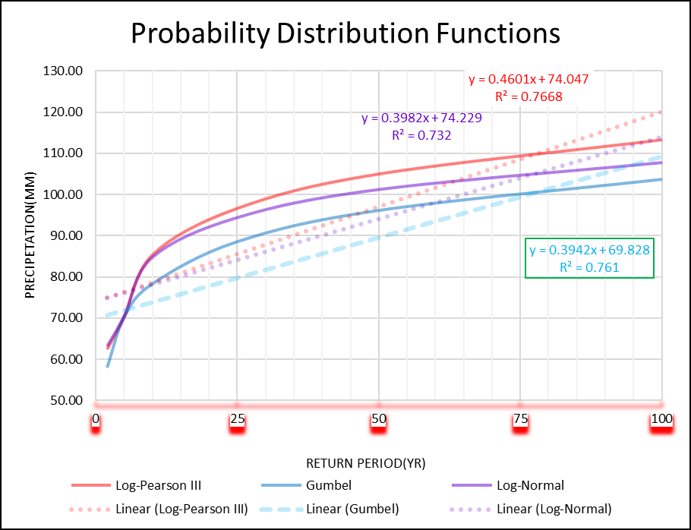
Figure 3.10: Correlation Coefficient of Probability distribution functions
As we can see from the above graph, the R² value of Log-Pearson III is greater than of others (i.e.; 0.7668>0.761>0.732). As a result of this, the Log-Pearson III more applicable than other methods listed above.

3.6 Indicators of Stormwater Drainage System
Stormwater indicators specifically address urban stormwater runoff impacts and the evaluation of stormwater programs and practices. Stormwater indicators are designed to assess the effectiveness of specific management strategies. These indicators are as follows:
Water quality indicators: Group of indicators used to measure specific water quality or chemistry parameters
Physical/hydrological indicators: Group of indicators used to measure changes to, or impacts on the physical environment.
Biological indicators: Indicators which use biological communities to measure changes to, or impacts on biological parameters.
Social indicators: Group of indicators which use responses to surveys or questionnaires to assess various parameters.
Programmatic indicators: Indicators which quantify various non-aquatic parameters for measuring program activities.
Site indicator: Indicators adapted for assessing specific conditions at the site level.

The general procedures followed in this thesis has been presented below in Figure 3.11 by chart form.
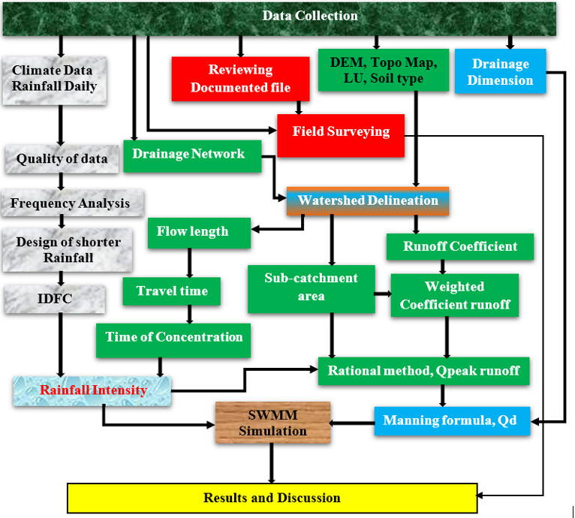
Figure 3.11: Flow chart of procedures considered in this study.

4. RESULTS AND DISCUSSION

4.1 Assessing the Condition of the Existing Drainage System
In assessing the condition of the existing drainage system of the Town Reviewing documented file, Field survey, and software (ArcGIS and Google Earth Pro) were used. Inventory of the drainage network was obtained from report reviews that were documented by the Municipality Bureau. During the field visit, the dimensions of drainage structures were measured by using a measuring tape while the elevation and geographic coordinates were recorded by GPS. The pictures of damaged drainage structures were taken by using a Camera. The size and percent of drainage infrastructure coverage of the Town were determined by the use of ArcGIS and Google Earth Pro.

4.1.1 Drainage Networks
There is 150.585 Km of a drainage line in Bedele Town. From this, Open drains are about 4147.643 Km and the piped concrete drains are 2.942 Km of the drainage line. Most of these drainage lines are found on the secondary road while the drains on the primary roads ranked to be the 2nd depending on the length. From the total drainage lines of the town, about 14.72 Km found on the local roads of the Town. The reality of these drainage network data was confirmed by field surveying.
Table 4.1: Drainage networks in the study area
No. | Drainage Type | Drains on Primary Road (Km) | Drains on Secondary Road (Km) | Drains on Local Road (km) | Total Drains (km) | % of Coverage
1 | Open Drains | 41.271 | 91.652 | 14.72 | 147.643 | 98.1
2 | Piped Concrete Drains | 1.878 | 1.064 | - | 2.942 | 1.9
Total |  | 43.149 | 92.716 | 14.72 | 150.585 | 100
(Source: Bedele Town Municipality Bureau)
As the field observation and the delineation in the ArcGIS show, from the total area of town, about 58.9% of the area is covered with drainage network while 41.1% has no drainage coverage. This classification was done depending on the flow direction and the presence of the receiving drainage canal to downstream of the flow. The most of drainage canals in this study area are not well connected. Also, some of them are allocated at improper places without having any inflow to them. The map of the drainage network and coverage is presented in Figure 4.1below.
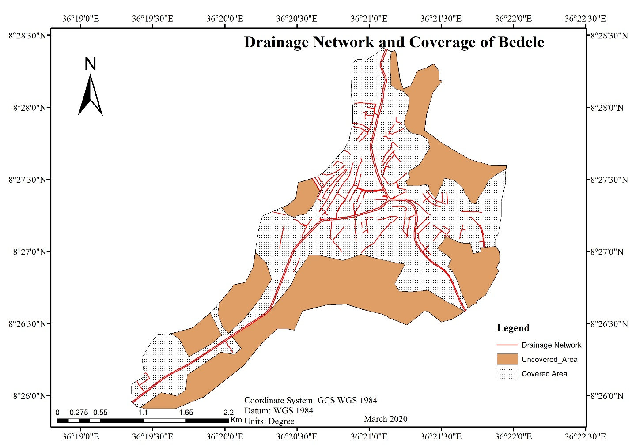
Figure 4.1: Drainage networks and its coverage in Bedele Town

4.1.2 Poorly Maintained Drainages in the Study Area
Drainage lines in Bedele Town are poorly maintained in a different area of the town. From the total drainage canals of the Town, 70% is poorly maintained. This includes 35.1% of drains on the primary roads, 20.4% of drains on the secondary roads and 14.5% of the drains on the local roads. This analysis was done after the field observation and measuring the total length of the drainage lines. Most of the drainage lines are not well connected. Solid materials from poor solid waste management close most of the drainage structures in this study area. Others are damaged by Vehicles during they cross the drainage structures. The Lack of proper maintenance of damaged drainage canals also indicates the poorly maintained drainage system in Bedele Town. The figure presented below shows the disposal of solid wastes into drainage canals in the Town.
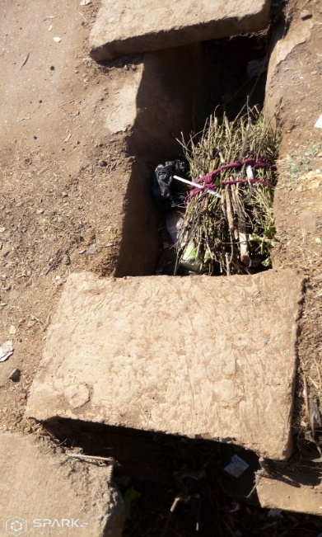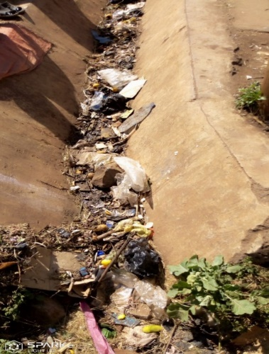
Figure 4.2: Solid waste disposal into drainage canals.
The following picture was taken from a drainage canal in this study area and it confirms the presence of poor liquid and solid waste disposal by the residents in this area.
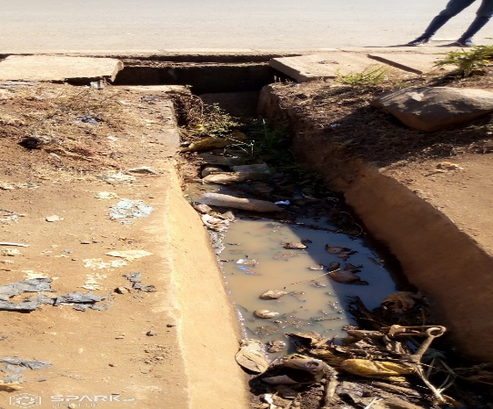
Figure 4.3: Solid and liquid waste disposal into drainage canals
The existing drainage condition of drainage lines in the study area is presented below by field surveying and observation. Their material, Geometry, and their condition are obtained by field observation while the length of canals was measured by using measuring tape. This drainage condition is stated depending on GTZ standards of drainage conditions.
Table 4.2: Drainage conditions in the sub-catchment SC-1, SC-2, SC-3(around Lideta sefer)
Code | Material | Geometry | L(m) | Condition | %
DL-1 | M | R | 123 | Severe | 8.4
DL-2 | M | R | 197 | Severe | 13.4
DL-3 | M | R | 168 | Severe | 11.4
DL-4 | M | R | 189 | Good | 12.8
DL-5 | M | R | 190 | Light | 12.9
DL-6 | M | R | 187 | Light | 12.7
DL-7 | Con | C | 8 | Severe | 0.5
DL-8 | M | R | 42 | Light | 2.9
DL-9 | M | R | 367 | Light | 24.9
 |  | Total | 1471 |  | 100
Notation: M-masonry, Con-Concrete, R-Rectangular, C-Circular, L-Length, DL- Drainage Line
From the total (1471m) length of drainage lines, those feed to outlet-1 496m (34%) are severely damaged and they are barely shedding the runoff. Also about 786m (53%) of the total length of the drainage lines lightly deteriorated. The drainage line with about 189m (13%) is in good condition with no significant depressions, undulations, and deformation.
Around the Aba Boku area, the drainage canals are found in different conditions. This has been presented as follows in Table 4.3.
Table 4.3: Drainage conditions in the sub-catchment SC-4-SC-6 (around Aba Boku area)
Code | Material | Geometry | L(m) | Condition | %
DL-10 | Con | R | 126 | Severe | 5.2
DL-11 | Con | R | 153 | Light | 6.3
DL-12 | Con | R | 48 | Severe | 2.0
DL-13 | Con | R | 70 | Light | 2.9
DL-14 | Con | R | 507 | Good | 21.0
DL-15 | Con | Trap | 167 | Light | 6.9
DL-16 | Con | Trap | 250 | Light | 10.3
DL-17 | Con | R | 463 | Light | 19.1
DL-18 | Con | R | 153 | Severe | 6.3
DL-19 | Con | R | 238 | Good | 9.8
DL-20 | M | R | 244 | Severe | 10.1
 |  | Total | 2419 |  | 100
Notation: Trap – Trapezoidal
There is about 2419m length of drainage lines in sub-catchment (SC-4, SC-5, SC-6) and 571m (23.6%) is severely damaged while about 745m (45.6%) is deteriorated and but, still shedding the runoff. From the total drainage lines found in these sub-catchments, 1103m (30.8%) are in good condition and there are no significant depressions, undulations, and deformation.
Most of the drainage canals around Dagagina have deteriorated. This condition has been presented below in Table 4.4.
Table 4.4: Drainage conditions in the sub-catchment SC-7-SC-12 (around Dagagina area)
Code | Material | Geometry | L(m) | Condition | %
DL-21 | Con | R | 44 | Light | 1.3
DL-22 | Con | Trap | 250 | Severe | 7.4
DL-23 | Con | R | 350 | Good | 10.4
DL-24 | M | R | 192 | Light | 5.7
DL-25 | Con | R | 494 | Light | 14.7
DL-26 | Con | C | 21 | Severe | 0.6
DL-27 | Con | R | 543 | Light | 16.2
DL-28 | Con | R | 33 | Severe | 1.0
DL-29 | M | R | 15 | Good | 0.4
DL-30 | Con | C | 5 | Light | 0.1
DL-31 | M | R | 38 | Severe | 1.1
DL-32 | M | R | 325 | Good | 9.7
DL-33 | Con | C | 5 | Severe | 0.1
DL-34 | M | R | 60 | Light | 1.8
DL-35 | M | R | 320 | Light | 9.5
DL-36 | M | R | 282 | Good | 8.4
DL-37 | Con | C | 7 | Severe | 0.2
DL-38 | M | R | 93 | Severe | 2.8
DL-39 | M | R | 279 | Good | 8.3
 |  | Total | 3356 |  | 100

The drainage lines presented above feeds to the outlet-3. From the total (3356m) of these drainage lines, 447m (13.3%) is severely damaged. About 1658m (49.4%) are lightly damaged while 1251m (37.3%) are found in good condition.

4.1.3 The Hydraulic Capacity of the Existing Stormwater Drainage System
The hydraulic properties of the existing drainage systems of Bedele Town were collected from some secondary data and fields. The hydraulic capacity of the existing drainage system was calculated by the use of the Manning formula and tabulated below.
Table 4.5: Hydraulic capacity of existing drainage structures in the study area
In Bedele Town, most of the drainage canals are undersized and cannot carry the runoff generated from sub-catchments as presented in Table 4.6. Except for drains of four catchments (SC-6, SC-9, SC-10, SC-11) all main drains from other sub-catchments of this study area are undersized and potential stormwater flow from successive sub-catchment is greater than the existing designed capacity. This is because of inappropriate hydrological analysis, hydraulic design, and missing the stream morphological study before the construction of drainage structures in the town.
Table 4.6: The hydraulic capacity of the existing drains against the potential stormwater
Drains | Station | Existing designed capacity (CMS) | Potential stormwater flow (CMS) T=10yr | Status of the existing drains | Condition
DL-4 | SC-1 | 0.6 | 1.05 | -0.45 | Undersized
DL-6 | SC-2 | 0.8 | 0.82 | -0.02 | Undersized
DL-9 | SC-3 | 1.5 | 1.79 | -0.29 | Undersized
DL-14 | SC-4 | 0.6 | 1.56 | -0.96 | Undersized
DL-17 | SC-5 | 1.3 | 1.83 | -0.53 | Undersized
DL-19 | SC-6 | 3.3 | 1.34 | 1.96 | Oversized
DL-23 | SC-7 | 0.7 | 2 | -1.3 | Undersized
DL-25 | SC-8 | 0.8 | 0.85 | -0.05 | Undersized
DL-35 | SC-9 | 1.8 | 1.33 | 0.47 | Oversized
DL-32 | SC-10 | 1.9 | 0.61 | 1.29 | Oversized
DL-36 | SC-11 | 1.4 | 0.54 | 0.86 | Oversized
DL-39 | SC-12 | 1.4 | 1.86 | -0.46 | Undersized
Notation: T- Return period, CMS- Cummecs
The above result shows, at wherever the existing drainage canals capacity is undersized there is a runoff overtopping problem. The undersized condition of the drainage canals is caused by improper construction of drainage structures without appropriate use of hydrological analysis and stream morphological study implementation.

4.1.4 Water Level Profile in Canals by SWMM 5.1
The water elevation profile at links in the drainage networks resulting from SWMM simulation are presented and discussed as follows:

I) Drainage at Outlet-1
The water elevation profile in nodes presented below shows the over flooded runoff generated from their feeding sub-catchments. This verifies that some part of the canal (DL-6) is insufficient to carry the flood from its upstream part sub-catchments.
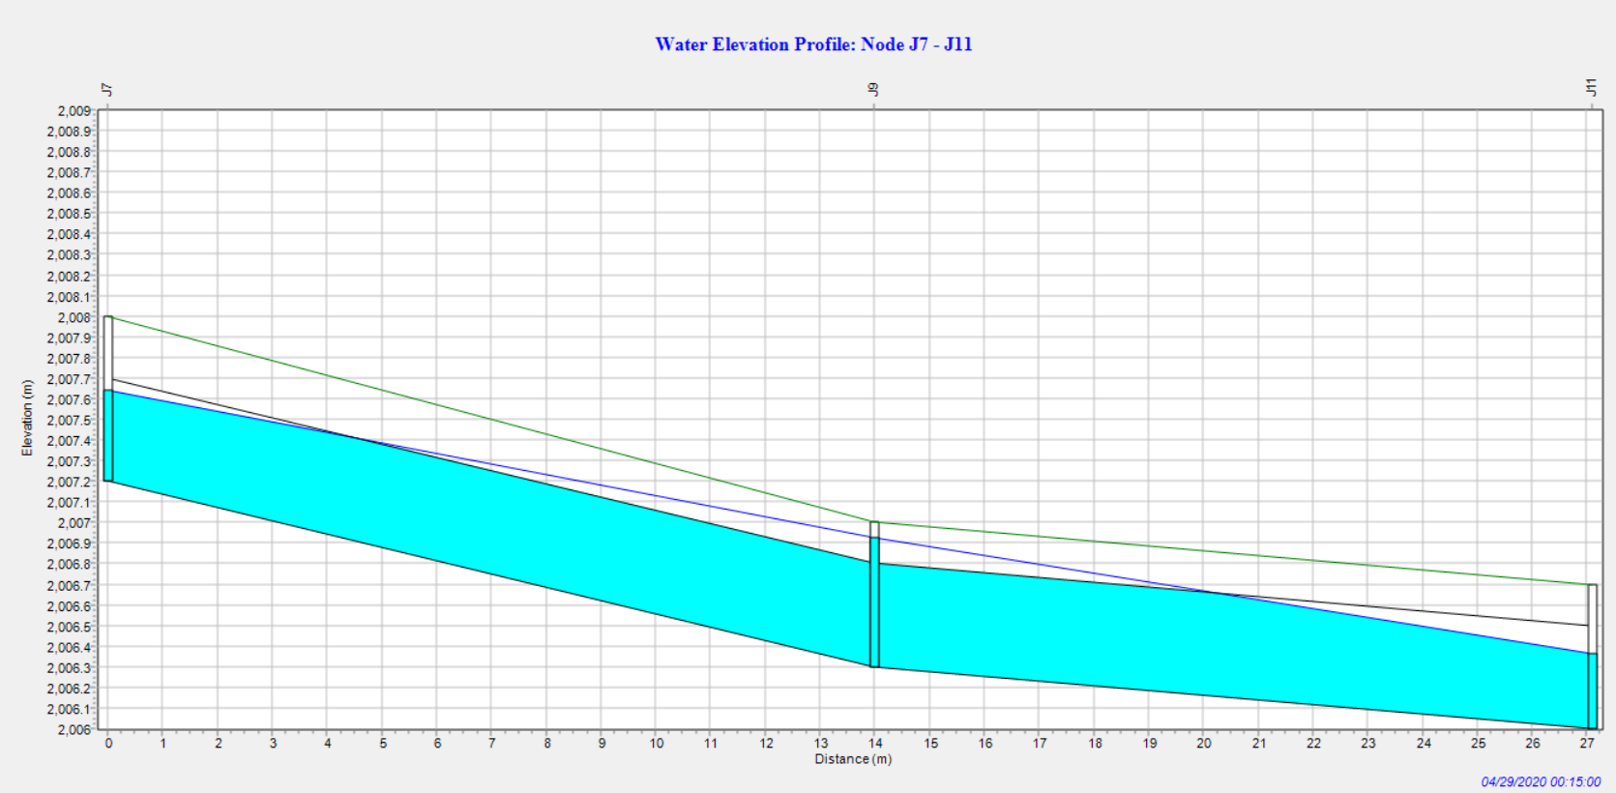
Figure 4.4: Water Elevation Profile: Node J7-J11
The above figure represents the water elevation profile of the conduit which was found between Junction J7 and J9 as well as J9 and J11. The blue color represents the runoff level in the canal. The x-axis shows the length of the canal while the y-axis shows the elevation that helps to know the depth of the canal and the depth of the runoff flowing in the canal. The fluctuation in the runoff level is because of the difference between the maximum depth at the junctions.
As we can see from Figure 4.5 below, the water level at outlet-1 is very high and the canal insufficiency recognised to carry the runoff that comes from its upstream. The conduit from the junction (J11) to (J12) and some part of conduit DL-8 are capable of carrying the runoff.
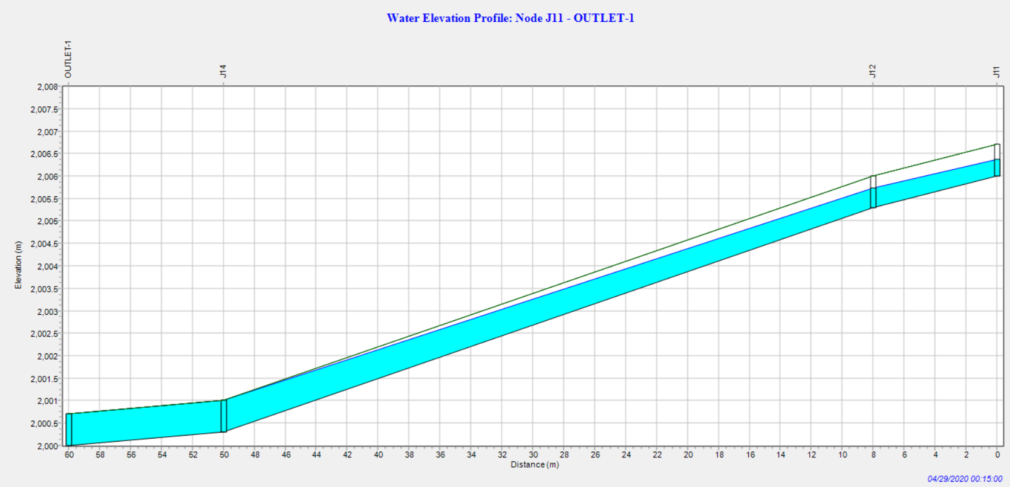
Figure 4.5: Water Elevation Profile: Node J11-OUTLET-1
II) Drainage at Outlet-2
Several drainage canals that were constructed to feed Outlet-2 are out of service fully or partially due to different damage caused to them. The water elevation profile in Node J23-J25 shows there is overflow mostly at J25. This is because there is the additional inflow which comes from DL-14 and DL-15. The overtopping at this Junction causes traffic disturbance for the difficulty of road access during the rain.
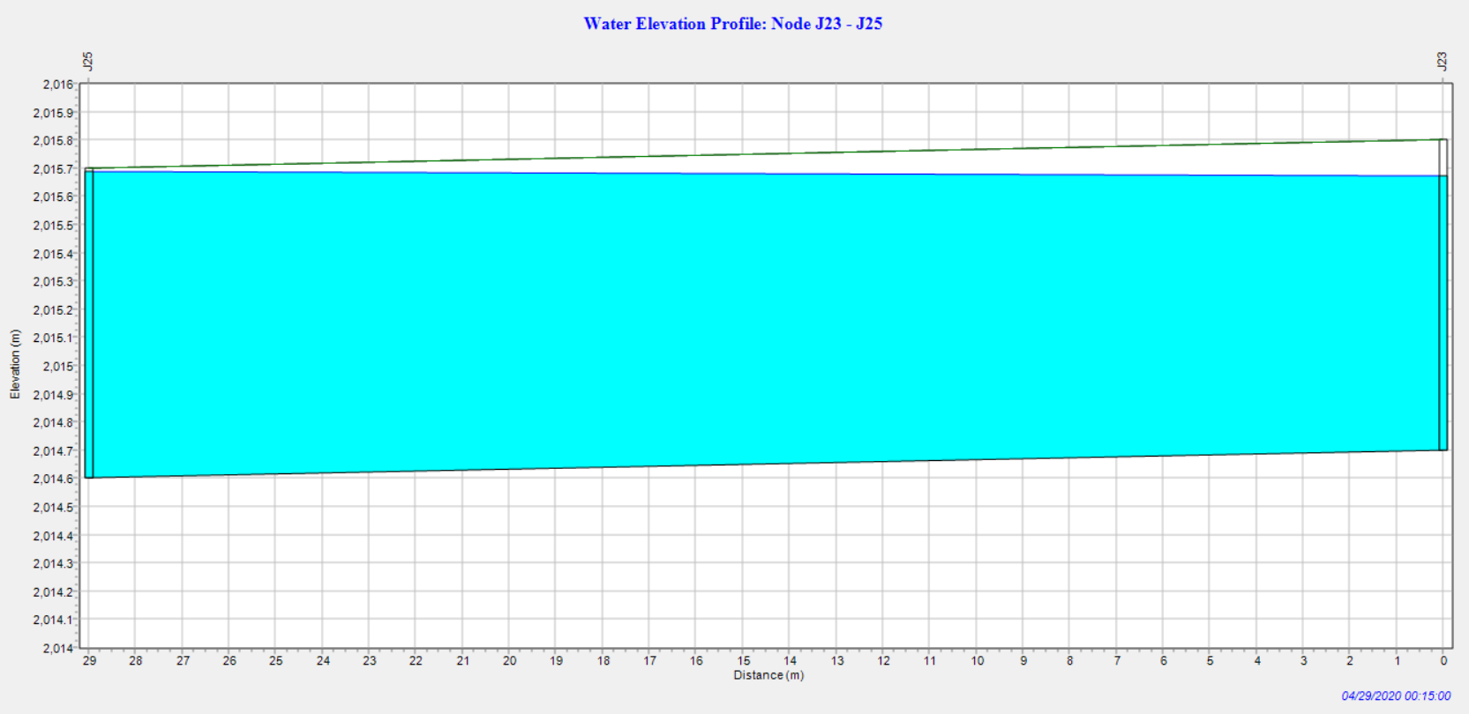
Figure 4.6: Water Elevation Profile: Node J23-J25
The Figure presented below (Figure 4.7) shows that the drainage canal at upstream of outlet-2 from J29 to J31 is insufficient to carry the flooding from the upper sub-catchment.
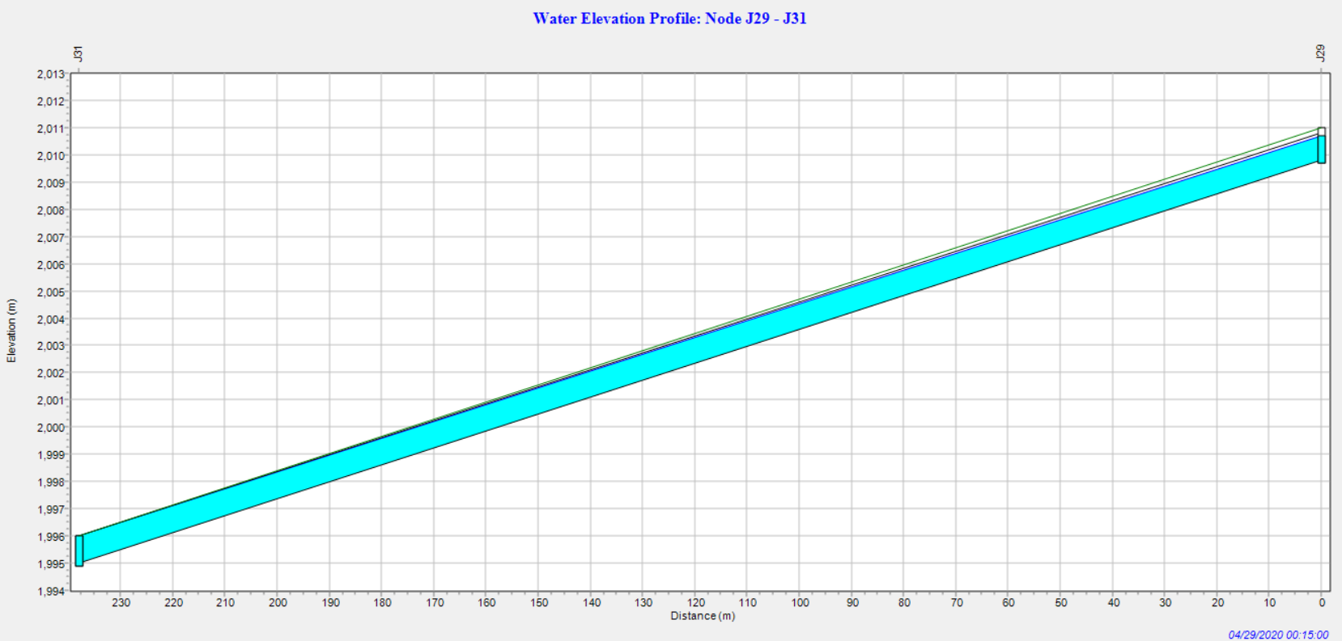
Figure 4.7: Water Elevation Profile: Node J29-J31
The flood which comes from the SC-4 and SC-5 gets together at junction J29. This increases the amount of discharge that should be carried by the canal which is found at the downstream side J29.
III) Drainage at Outlet-3
At the outlet side of the drainage canal (DL-37) the overflow is seen for it was constructed without considering the discharge from its upstream part of the study area. The water elevation profile in Node (J54) verify this condition.
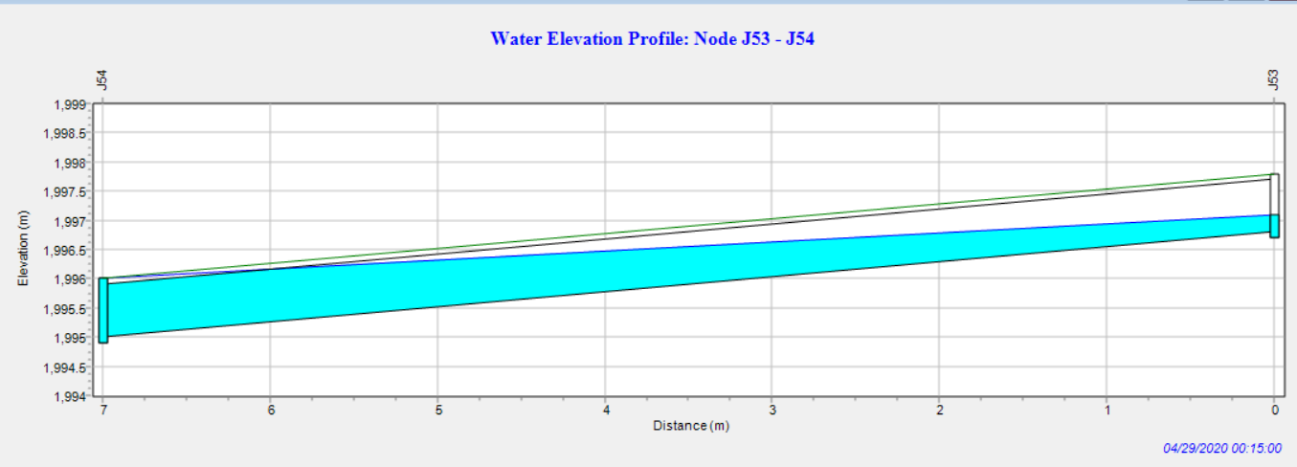
Figure 4.8: Water Elevation Profile: Node J53-J54
The drainage canal that carries the flood from junction J54 to J56 has no sufficiency and undersized to carry the runoff from the upper sub-catchments. The junction J54 receives runoff from four sub-catchments (i.e: SC-7, SC-8, SC-9, SC-10, SC-11) and transfer to the DL-38 drainage canal. Due to this, starting from this junction(J54) to the end of DL-38 the overtopping of the flood due to an inadequacy of the existing drainage canal is seen.
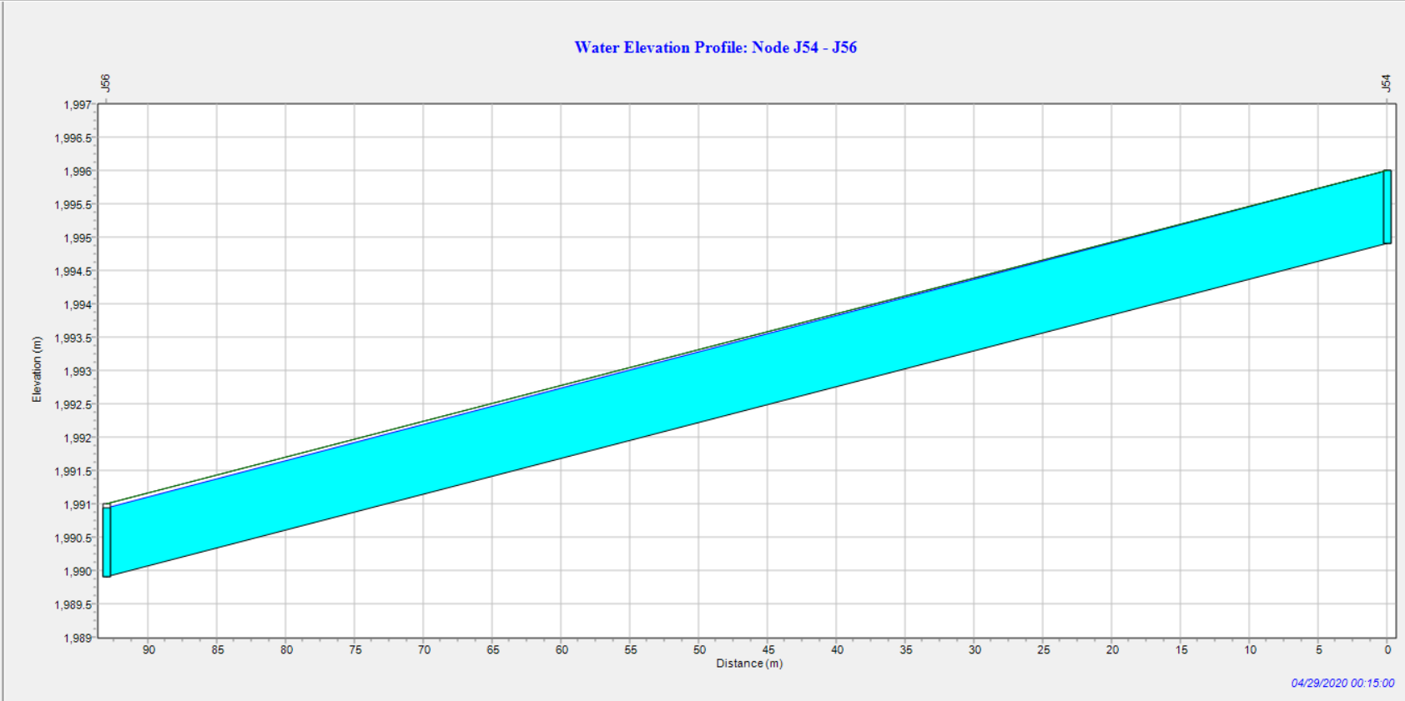
Figure 4.9: Water Elevation Profile: Node J54-J56

4.2 The Intensity Duration Frequency Curve for the Various Return Periods
To develop the IDF Curve of Bedele Town the rainfall depth ratio (R_{Rt}) was calculated as summarized in Appendix (5A). The value of two constant coefficients ‘b’ and ‘n’ used in the rainfall depth ratio formula is 0.3 and 0.92 as it is recommended in the ERA Drainage Design Manual. The 24hr rainfall depth (XT) was calculated as follows by using the Log-Pearson Type III method and tabulated below in Table 4.7.
Table 4.7: 24hr Rainfall Depth
T | 2 | 5 | 10 | 25 | 50 | 100 | 200 | 1000
KZ | -0.05 | 0.735 | 1.309 | 1.849 | 2.211 | 2.544 | 2.856 | 3.525
ZT | 1.795 | 1.874 | 1.931 | 1.985 | 2.021 | 2.054 | 2.086 | 2.153
XT | 62.37 | 74.82 | 85.31 | 96.61 | 104.95 | 113.24 | 121.90 | 142.23
By using the calculated rainfall depth ratio and 24hr rainfall depth the depth of rainfall at a given duration (i.e.; 5, 10, 15, 20, 25, 30, 60, 90, 120, 150, and 180 minutes) was estimated. This is tabulated in Appendix (5B). The rainfall Intensity used to develop the IDF Curve of this study area was calculated by using the recommended Equation presented under Equation 3.5. This rainfall intensity is as follows (Table 4.8).
Table 4.8: Rainfall intensity in the study area for the different return period
Duration
min
T | 2 | 5 | 10 | 25 | 50 | 100 | 200 | 1000 | Duration  min
Intensity in mm/hr | 118.204 | 141.763 | 161.645 | 183.047 | 198.867 | 214.567 | 230.974 | 269.503 | 5
Intensity in mm/hr | 98.636 | 118.330 | 134.926 | 152.791 | 165.996 | 179.100 | 192.795 | 224.956 | 10
Intensity in mm/hr | 84.798 | 101.721 | 115.987 | 131.344 | 142.696 | 153.961 | 165.734 | 193.380 | 15
Intensity in mm/hr | 74.470 | 89.331 | 101.860 | 115.346 | 125.315 | 135.209 | 145.547 | 169.826 | 20
Intensity in mm/hr | 66.476 | 79.743 | 90.927 | 102.966 | 111.864 | 120.696 | 129.925 | 151.597 | 25
Intensity in mm/hr | 60.075 | 72.064 | 82.171 | 93.050 | 101.092 | 109.073 | 117.413 | 136.999 | 30
Intensity in mm/hr | 38.432 | 46.102 | 52.568 | 59.528 | 64.673 | 69.779 | 75.114 | 87.644 | 60
Intensity in mm/hr | 28.491 | 34.176 | 38.970 | 44.129 | 47.943 | 51.728 | 55.683 | 64.972 | 90
Intensity in mm/hr | 22.737 | 27.275 | 31.100 | 35.217 | 38.261 | 41.282 | 44.438 | 51.851 | 120
Intensity in mm/hr | 18.973 | 22.759 | 25.951 | 29.387 | 31.927 | 34.448 | 37.082 | 43.267 | 150
Intensity in mm/hr | 16.312 | 19.567 | 22.311 | 25.265 | 27.449 | 29.616 | 31.881 | 37.199 | 180
By using the above-estimated rainfall intensity versus selected return periods, the IDF curve of Bedele Town was developed and presented in Figure 4.10 below.

Figure 4.10: Developed IDF curve of Bedele Town
The self-developed IDF Curve for Bedele Town was used for estimation of peak discharge. For the scale of this study area is less than the area that was considered during the IDF curve development was carried out for this rainfall region the specific IDF curve that represents the rainfall pattern of Bedele Town is the self-developed one.

4.3 Peak Discharge Estimation
The peak discharge from this study area was estimated by using the Rational method and SWMM 5.1 model. The case of using the Rational method is depending on the area of sub-catchments in the study area (i.e.; <50 ha) as it is mentioned in chapter 3. The result from these two methods was discussed below.

4.3.1 Rational Method
The peak flow from each sub-catchment in this study area was calculated and tabulated as presented below in Table 4.9. This estimation was carried out after the all needed parameters were analyzed. The delineation of each sub-catchment area was done by ArcGIS software and the Land use the Land cover of the area was worked out by using Google Earth Pro and ArcGIS after all needed data like Coordinates were collected. Land use Land cover is also verified by field observation. By using the Land use Land Cover types of the study area the weighted runoff coefficient was calculated for each sub-catchments. The time of concentration is found by calculating the inlet time of concentration and travel time of the runoff in the canals by the selected Equations for this purpose in chapter 3. The rainfall Intensity (in mm/hr) is obtained from the developed IDF curve of Bedele Town.

Table 4.9: Estimated Discharge by Rational Method
SC | Cw | A(ha) | Tc(min) | I(10yr) | I(25yr) | Q10yr(m3/s) | Q25yr(m3/s)
SC-1 | 0.67 | 3.51 | 5.1 | 161.12 | 182.44 | 1.05 | 1.31
SC-2 | 0.59 | 3.1 | 5.0 | 161.65 | 183.05 | 0.82 | 1.02
SC-3 | 0.7 | 5.9 | 6.1 | 155.77 | 176.39 | 1.79 | 2.23
SC-4 | 0.77 | 5.7 | 11.8 | 128.11 | 145.07 | 1.56 | 1.95
SC-5 | 0.75 | 5.7 | 6.4 | 154.18 | 174.58 | 1.83 | 2.28
SC-6 | 0.73 | 4.1 | 5.0 | 161.65 | 183.05 | 1.34 | 1.68
SC-7 | 0.75 | 6.7 | 8.5 | 142.94 | 161.87 | 2.00 | 2.49
SC-8 | 0.66 | 3.43 | 10.1 | 134.55 | 152.36 | 0.85 | 1.05
SC-9 | 0.76 | 3.9 | 5.0 | 161.65 | 183.05 | 1.33 | 1.66
SC-10 | 0.72 | 1.9 | 5.0 | 161.65 | 183.05 | 0.61 | 0.77
SC-11 | 0.6 | 2 | 5.0 | 161.65 | 183.05 | 0.54 | 0.67
SC-12 | 0.7 | 5.9 | 5.0 | 161.65 | 183.05 | 1.86 | 2.31
 |  |  |  |  | Cf | 1 | 1.1
As we can see from this peak rate flow estimation, the runoff that is generated from sub-catchment (SC-1, SC-2, SC-3, SC-4, SC-5, SC-7, SC-8, SC-12) is potentially greater than the estimated hydraulic capacity of main drains which are incapable of carrying this much discharge.

4.3.2 Simulating Peak Flow Rate by using SWMM 5.1
The simulation of the peak flow rate by using SWMM 5.1 was done by using different inputs that were collected from the study area. These inputs are presented in chapter 3 under the sub-title ‘Input parameters for SWMM and their properties’. The model required parameters were inserted properly and the following Figure 4.11shows the result of the projected summary of the modeled area. The simulation was carried out for two scenarios. One is for 10-year design storm frequency while the second 25-year return period scenario is for checking. The detail of the summary results from SWMM5.1 is presented under Appendix (10A, B). The peak runoff result from SWMM 5.1 simulation is presented in Table 4.10.
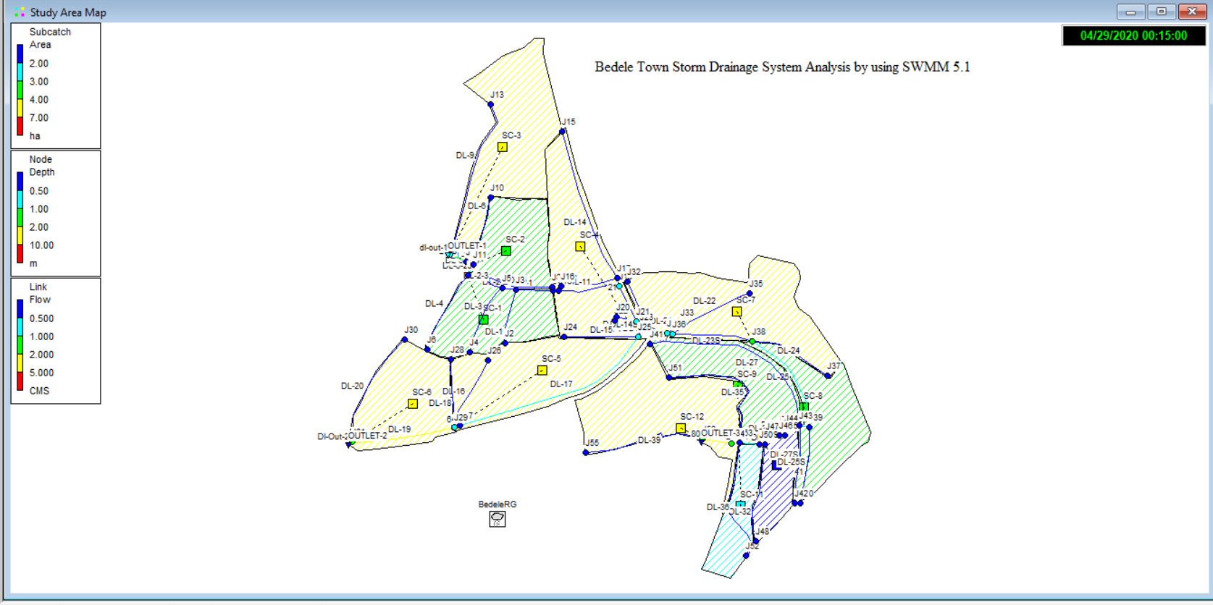
Figure 4.11: Projected summary of the modeled area in SWMM5.1
Table 4.10: Estimated peak discharge by SWMM 5.1
 | Q from SWMM(CMS)
SC | Q10yr | Q25yr
SC-1 | 0.97 | 1.3
SC-2 | 0.71 | 0.96
SC-3 | 1.61 | 2.09
SC-4 | 1.48 | 1.9
SC-5 | 1.74 | 2.28
SC-6 | 1.24 | 1.63
SC-7 | 2.09 | 2.43
SC-8 | 0.85 | 1
SC-9 | 1.2 | 1.65
SC-10 | 0.61 | 0.73
SC-11 | 0.53 | 0.62
SC-12 | 1.82 | 2.32
The result of total discharge by the rational method and SWMM 5.1 from the study area were 15.59 and 14.85 m³/s within a design period of 10 years, whereas for check 25 years were 19.42 and 18.91 m³/s with an R² value of 0.98 and 0.99 respectively. As we can see from these values, using the SWMM 5.1 model with the Rational Method for this research in this study area is acceptable with very good performance.

Figure 4.12: Discharge Comparison by Graph
Notation: QR-Discharge by Rational method, QSWMM- Discharge by SWMM, Qm- hydraulic capacity by Manning

5. CONCLUSIONS AND RECOMMENDATIONS

5.1 Conclusions
As per this study, the existing drainage system of Bedele Town is currently exposed to different problems. Through the whole town, the waste material management problem from each household is observed. The absence of a properly separated sewer system for the removal of liquid waste material from the residential, commercial, and industrial areas strengthened the problem in the area. Totally, from the total drainage canals of the Town 70% is poorly maintained.
The hydraulic capacity of the existing stormwater drainage system was evaluated for 10 and 25-years of the return period. Except for drains of four catchments (SC-6, SC-9, SC-10, SC-11) all main drains from other sub-catchments of this study area are undersized and potential stormwater flow from successive sub-catchment is greater than the existing designed capacity of the drainage canals. This is caused by poor design of drainage systems in the town for the consideration of rainfall intensity of Bedele Town as per it’s particular IDF curve were not taken
The IDF curve was developed for this particular study area in order to know the rainfall intensity of Bedele Town. This was done by using Log-Pearson Type III after the maximum daily rainfall of 34 years was identified. This IDF curve was developed after the 24-hr rainfall depth was estimated.
The peak flow rate of the stormwater from each sub-catchment was estimated by using the Rational Method. As per this estimation, the runoff generated from this study area is much greater than the hydraulic capacity of the drainage structures of the Town except at a few sub-catchments. Also, the water level at links was simulated by using SWMM 5.1 and the result shows the flood level is greater than the designed water level at most of the junctions and links of conduits in the study area.

5.2 Recommendations
Finally, the following measures are recommended as a result of this study. While recommending measures for improving the drainage problem in the Bedele Town in general and for several damaged areas in particular, the ERA manual 2013 was generally followed.
The recommendations are as follows:
- For improving local drainage, a tertiary drainage network is to be planned, preferably following the road network.
- Provisions for drainage by the side of all primary and secondary roads are to be made mandatory.
- The waste disposal to the drainage canals should be avoided.
- The provision of proper connections or integrations between the road network and drainage network systems is required with regular maintenance.
- To handle the increased runoff due to the increment of the built-up area, the existing stormwater management system needs to be improved.
- Regular maintenance and frequent clearance of drainage lines should be at regular terms for the sustainable stormwater drainage system.
- In general, the appropriate use of hydrological analysis, hydraulic design, and stream morphological study should be implemented before carrying out the construction of drainage structures in the town.

6. REFERENCES
Akram F., Mohammad G. R., Mohammad M., Sharif I. 2014. Comparison of Different Hydrograph Routing Techniques in XPSTORM Modelling Software: A Case Study. International Journal of Environmental, Ecological, Geological, and Mining Engineering 8 (3).
American Association of State Highway and Transportation Officials (AASHTO). 2009. Highway Drainage Guidelines. In Hydrologic Design Policies.
Armitage N. 2010. The challenges of sustainable urban drainage in developing countries. Cape Town, South Africa: Urban Water Management Group, University of Cape Town.
Balmforth D., Digman C., Butler D. Z., Shaffer P. 2009. The implementation of Integrated Urban Drainage, Bristol: Environmental Agency. Research Framework.
Barreto Cordero, W.J. 2012. Multi-Objective Optimization for Urban Drainage Rehabilitation, Ph.D. Thesis. Delft University of Technology, Netherlands.
Belete D. A. 2011. Road and urban stormwater drainage network integration in Addis Ababa: Addis Ketema Sub-city. Journal of Engineering and Technology Research 3 (7): 217-225.
Berggren, K. 2007. Urban drainage and climate change: impact assessment, Doctoral dissertation, Luleå tekniska universitet.
Boyd M. J., Rigby R. Van D., Schymitzek I., 2002. Details of the theory used in WBNM. University of Wollongong 38.
Burger G., Sitzenfrei R., Kleidorfer M., Rauch W. 2014. Parallel flow routing in SWMM5. Environmental Modelling and Software 53, 27–34.
Burian S. J., Findlay G. E. 2002. Historical Perspectives of Urban Drainage. Research Gate (284): 13.
Butler D., Davies J.W. 2011. Urban Drainage. 3rd Edition. London, New York: Spon Press.
Carlos E. M. Tucci. 2006. Urban Flood Management. The World Meteorological
Organization. Porto Alegre - RS - Brazil
Chocat B. Ashley R., Marsalek J., Matos M. R., Rauch W., Schilling W., Urbonas B. 2007. Toward the sustainable management of urban storm-water. Indoor and Built Environment 273–285.
Chow V. T., David R. M., Larry W. M. 2012. Applied Hydrology. New Delhi: McGraw Hill.
Cintia B.S. Dotto G. M., Manfred K., Luca V., Malte H., David T. M., Gabriele F., Wolfgang R., Ana D. 2012. Comparison of different uncertainty techniques in urban stormwater quantity and quality modeling. Water Research 1.
Council Report of National Research, 2008. Urban Stormwater Management in the United States. Washington, D.C.: The National Academies Press, 11-12.
Cunderlink J.M., Burn, D.H. 2001. The use of flood regime information in regional flood frequency analysis, Hydrological Sciences Journal, 47 (1): 77-92
Daniela M., Nadiane S. K., Paulo I. B., Wilson C., Souza J., Gabriele V. T. 2018. Prediction vs. Performance of IDF curves from precipitation data of regional climate models for a Brazilian coastal county.
Dayarante S. 2000. Modeling of urban stormwater drainage systems using ILSAX.
DPLG. (Department of Planning and Local Government) 2010. Modeling Process and Tools. In Water Sensitive Urban Design Technical Manual for the Greater Adelaide Region, 13. Adelaide: Government of South Australia.
Dibaba T. W. 2018. A Review of Sustainability of the urban drainage system: Traits and Consequences. Journal of Sedimentary Environments (3): 131-137.
Droopa O.P. and Boughtonb W.C. 2003. Integration of WBNM into A Continuous Simulation System for Design Flood Estimation. Griffith University, Brisbane, Australia.
ERA. (Ethiopia Road Authority) 2002. Drainage Design Manual. Addis Ababa.
ERA. (Ethiopia Road Authority) 2011. Drainage Design Manual. Addis Ababa.
ERA. (Ethiopia Road Authority) 2013. Drainage Design Manual. Addis Ababa.
Ermalizar L. M., Ahmad J. 2018. Flood simulation using EPA SWMM 5.1 on small catchment urban drainage system. MATEC Web of Conferences. Padang, Indonesia.
Evans T. 2013. Urban Drainage and the Water Environment: A sustainable future? A Review of Current Knowledge 2: 5.
Eyosias Birhanu. 2018. Performance Assessment of Stormwater Drainage Systems (Case study of Debere Berehan Town), MSc Thesis, School of Civil and Environmental Engineering, Addis Ababa University Institute of Technology, Addis Ababa, Ethiopia.
Fadhel Sh., Miguel A. R., Dawei H. 2017. Uncertainty of Intensity-Duration-Frequency (IDF) curves due to varied climate baseline periods. Journal of Hydrology.
Fekadu Zeleke. 2018. Analysis of stormwater runoff drainages In Addis Ababa city Case study: CMC road, MBA Thesis, Addis Ababa Science and Technology University, Addis Ababa, Ethiopia.
Firat M., Dikbas F., Koc A.C.¸ Gungor M. 2010. Missing data analysis and homogeneity test for Turkish precipitation series. Indian Academy of Sciences 35(6): 707–720.
FUPCOB. (Federal Urban Planning Coordinating Bureau) 2008. Urban Stormwater Drainage Design Manual.
Ghazavi R., Ali M. R., Mohsen A. R. 2016. Modeling and assessment of urban flood hazards based on rainfall intensity-duration-frequency curves reformation. National Hazards Earth System Science.
Ghosh S.N. 2014. Flood control and Drainage Engineering. 4th Edition. London, UK: Taylor and Francis Group.
Graham D.N. and Butts M. B. 2005. Flexible Integrated Watershed Modeling with MIKE SHE. In Watershed Models, Eds. V.P. Singh and D.K. Frevert, CRC Press 245-272.
GTZ-IS. 2006. Urban drainage manual series on infrastructure. Addis Ababa, Ethiopia, 17-54.
Huber W.C., Dickinson R., Rossman L.A. 2005. Stormwater Management Model, SWMM 5.0, Documentation Manual. Cincinnati, OH. National Risk Management Research Laboratory, Office of Research and Development, U.S. Environmental Protection Agency.
Jackson E. 2018. Drainage and Wastewater System Modeling. In SPU Design Standards and Guidelines. Seattle.
Jeonghwan A., Woncheol Ch., Taereem K., Hongjoon Sh., Jun-Haeng H. 2014. Flood Frequency Analysis for the Annual Peak Flows Simulated by an Event-Based Rainfall-Runoff Model in an Urban Drainage Basin. Journal of Water 6: 3841-3863
Johanna L. 2015. Stormwater modeling tools: A comparison and evaluation, Department of Earth Sciences, Uppsala University, Uppsala.
Kalantari Z. 2011. Adaptation of Road Drainage Structures to Climate change. Trita LWR LIC.
Karabork M. C¸ Kahya E, Komuscu A. U. 2007. Analysis of Turkish precipitation data: Homogeneity and the Southern Oscillation forcing’s on frequency distributions. Hydrological Processes 21: 3203–3210
Kirubel Worku. 2014. Investigation on Storm Drainage System Problem of Hawassa City. MSc Thesis, Institute of Technology, Hawassa University, Hawassa, Ethiopia.
Kombe W., Tatu M. L., Martha J. Mkupasi, Katema A., Liku W. 2015. City Level Institutional Comparisons of Landscape Based Stormwater Management in Dar es Salaam and Addis.
Koutsoyiannis D. 2010. A note of caution for consistency checking and correcting methods of point precipitation records. Topic 4 Instrumentation and novel precipitation observing systems, International Precipitation Conference (IPC10) Coimbra, Portugal.
Lambin E. F., Turner B. L., Geist H. J., Agbola S. B., Angelsen A., Bruce J. W., Coomes O. T., Dirzo R., Fischer G., Folke C., George P. S., Homewood K., Imbernon J., Leemans R., Li X., Moran E. F., Mortimore M., Ramakrishnan P. S., Richards J. F. 2001. The causes of land-use and land-cover change: Moving beyond the myths. Global Environmental Change. 445–469.
Laouacheria F., Said K., Moncef CH. 2019. Modeling the impact of design rainfall on the urban drainage system by Stormwater Management Model. Journal of Water and Land Development 119–125.
Leitao J., Carbajal J., Rieckermann J., Simões N., Marques A.S., Sousa L. 2018. Identifying the best locations to install flow control devices in sewer networks to enable in-sewer storage. Journal of Hydrology 371–383.
Li, Ch., Wang, W., Xiong, J., and Chen, P. 2014. Sensitivity analysis for urban drainage
modeling using mutual information. Entropy, 16(11), 5738-5752
Lindberg S. and Car R.S. 1992. MOUSE- Towards on On-Line Modelling System. International Symposium on Urban Stormwater Management. Sydney. 294-297.
Lowe S.A. 2010. Sanitary sewer design using EPA stormwater management model (SWMM). Computer Applications in Engineering 18: 203–212.
Maidment D.R. 1993. Hand Book of Hydrology, Flood Frequency Analysis. USA Rao, K.H, and Hamed: McGraw-Hill. Inc.
Abdullah Al Mamoon. 2018. Rainfall Analysis under Changing Climate Regime in Qatar, PhD. Thesis, School of Computing, Engineering and Mathematics, Western Sydney University, Australia.
Meraf Elias. 2015. Highway drainage facilities Problems Case Study: Assessment of Drainage Problems in Adama, MSc Thesis, School of Graduate Studies Institute of Technology, Addis Ababa University, Addis Ababa, Ethiopia.
Methods H. and Durrans S.R. 2003. Stormwater Conveyance Modeling and Design. 1st Edition. Waterbury, CT, USA. Haestad Press.
Mirza F. Shiroma M., Stephanie A., Luis N., Daniel K., Esther C. 2013. HydroPlanner: A Prototype Modelling Tool to Aid Development of Integrated Urban Water Management Strategies. Urban Water Security Research Alliance Technical Report 108, East QLD 4002.
MoWUD. 2008. Urban Stormwater Drainage Design Manual. 1. Addis Ababa,
Nora M.B. and Reddy N. S. 2018. Performance Assessment of Road Drainage Systems of Burayu Town, International Journal of Research in Engineering and Management 2 (2): 40-55.
O’Loughlin G. and Stack B. 1998. Drains User’s Manual. Sydney: Watercom Pty Ltd.
Parkinson J. 2002. Urban drainage in developing Countries-challenges and opportunities. Waterlines 20 (4): 1.
Paule-Mercado M., Lee B., Memon S. Umer S., Salim I., Lee C.H. 2017. Influence of land development on stormwater runoff from mixed land use and land cover catchment. Sci. Total Environment 2142–2155.
Qing F. Q. and Yachi W. 2018. Influencing Factors and Strategies for Sustainable Urban Drainage System. Civil Engineering Research Journal 3 (4): 1.
Rangari V. A., Ajey K. P., Umamahesh N V. 2015. Review of urban stormwater models. Water and Environment Division, National Institute of Technology, Warangal 506004, India.
Rossman L. A. 2015. Stormwater Management Model User’s Manual Version 5.1. Cincinnati, OH 45268: United States Environmental Protection Agency.
Sharma R., Choudhury N., Alam R., Seleyi V., Sangtam Y. 2016a. Development of Intensity-Duration-Frequency curves for precipitation in western watershed of Guwahati (Assam), International Journal of Latest Trends in Engineering and Technology, 6 (4), 575-579
Silveira A. L. 2002. Problems of modern urban drainage in developing countries. Water Science and Technology 45 (7): 1.
Subramanya K. 2008. Engineering Hydrology. 3rd Edition. New Delhi: Tata McGraw Hill.
Swathi V., Srinivasa R., Ajit P. S. 2018. Application of Stormwater Management Model to an Urban Catchment. Singapore: Springer.
Tayanc M., Dalfes H. N., Karaca M., Yenigun O. 1998. A comparative assessment of different methods for detecting inhomogeneities in Turkish temperature data set. International Journal Climatol. 18: 561–578
Tuomela C., Sillanpaa N., Koivusalo H. 2019. Assessment of stormwater pollutant loads and source area contributions with stormwater management model (SWMM), Journal of Environmental Management 719–727.
Urban Drainage and Flood Control District (UDFCD). 2018.Urban Storm Drainage Criteria Manual. 1
U.S. Department of Transportation, Federal Highway Administration. 2013. Hydraulic
Engineering Circular No. 22, Second Edition “Urban Drainage Design Manual,” FHWA-
NHI-10-009
Vitousek P. M., Mooney H. A., Lubchenco J., Melillo J. M. 1997. Human domination of Earth's ecosystems. Science 277(5325): 494–499.
Vivekanandan N. 2013. Analysis of hourly rainfall data for the development of IDF relationships using the order statistics approach of probability distributions. Internal Journal of Management Science and Engineering Management.8 (4): 283-291
Watt W. E., Waters D., McLean R. 2003. Climate Change and Urban Stormwater Infrastructure in Canada: Context and Case Studies. Waterloo, Ontario, Canada: Meteorological Service of Canada, 27.
Wijngaard J. B., Klein T. A., Konnen G. P. 2003. Homogeneity of 20th century European daily temperature and precipitation series. International Journal Climatol. 23: 679–692.
Williamsburg. 2019. Stormwater Drainage Conveyance Systems (Non-BMP related) General Design and Construction Guidelines. James City County, Virginia.
XPSTORM. 2011. Stormwater Management Model, Getting Started Manual.
Yazdanfar Z. and Ashok Sh. 2015. Urban drainage system planning and design-challenges with climate change and urbanization: a review. Water Science and Technology 166.
Zhao D., Chen J., Wang H., Tong Q., Cao S., Sheng Z. 2009. GIS-based urban rainfall-runoff modeling using an automatic catchment-discretization approach: A case study in Macau. Environmental Earth Science 59: 465–472.
Zhou Q. 2012. Urban drainage design and climate change adaptation decision making.
Zoppou Ch., 2001. Review of urban stormwater models. Environmental Modelling and Software 16: 195–231.
Zumrawi M. M. 2014. The Impacts of Poor Drainage on Road Performance in Khartoum. International Journal of Multidisciplinary and Scientific Emerging Research 3 (1): 901.

APPENDIXES

Appendix-1: Meteorological Data
Station Name: Bedele
Element: Monthly rainfall (mm)

Station Name: Dabena
Element: Monthly rainfall (mm)

Station Name: Kone
Element: Monthly rainfall (mm)

B: Daily Maximum Rainfall of Bedele Town (1986-2019)
Bedele Town Maximum Daily Rainfall
Year | Rainfall(mm) | Year | Rainfall(mm)
1999 | 95 | 2009 | 58.5
2011 | 85 | 1989 | 58.4
2007 | 83.5 | 2004 | 57
2013 | 77.5 | 1993 | 56
2010 | 75.3 | 2005 | 55
2003 | 69 | 2019 | 53.8
2016 | 66.4 | 1990 | 53.2
1988 | 64.6 | 1986 | 51.7
2000 | 63.5 | 2014 | 51
2001 | 63 | 1995 | 50.1
2008 | 63 | 2006 | 50
1987 | 62.2 | 1992 | 49.5
1997 | 61 | 2015 | 48.3
1998 | 60.1 | 2002 | 47.9
2012 | 60 | 1991 | 46.8
2018 | 59.2 | 1996 | 40
2017 | 59 | 1994 | 39

Appendix-2: Outlier test
A: Data for Outlier test
Bedele Rainfall Data
Year | MDR(mm) | Y=LogX | Year | MDR(mm) | Y=LogX
1999 | 95 | 2.0 | 1989 | 58.4 | 1.8
2011 | 85 | 1.9 | 2004 | 57 | 1.8
2007 | 83.5 | 1.9 | 1993 | 56 | 1.7
2013 | 77.5 | 1.9 | 2005 | 55 | 1.7
2010 | 75.3 | 1.9 | 2019 | 53.8 | 1.7
2003 | 69 | 1.8 | 1990 | 53.2 | 1.7
2016 | 66.4 | 1.8 | 1986 | 51.7 | 1.7
1988 | 64.6 | 1.8 | 2014 | 51 | 1.7
2000 | 63.5 | 1.8 | 1995 | 50.1 | 1.7
2001 | 63 | 1.8 | 2006 | 50 | 1.7
2008 | 63 | 1.8 | 1992 | 49.5 | 1.7
1987 | 62.2 | 1.8 | 2015 | 48.3 | 1.7
1997 | 61 | 1.8 | 2002 | 47.9 | 1.7
1998 | 60.1 | 1.8 | 1991 | 46.8 | 1.7
2012 | 60 | 1.8 | 1996 | 40 | 1.6
2018 | 59.2 | 1.8 | 1994 | 39 | 1.6
2017 | 59 | 1.8 |  | Mean | 1.8
2009 | 58.5 | 1.8 |  | SD | 0.1
B: Kn Value for Different Sample Size used for Outlier
Sample size n | Kn | Sample size n | Kn | Sample size n | Kn | Sample size n | Kn
10 | 2.036 | 24 | 2.467 | 38 | 2.661 | 60 | 2.837
11 | 2.088 | 25 | 2.486 | 39 | 2.671 | 65 | 2.866
12 | 2.134 | 26 | 2.502 | 40 | 2.682 | 70 | 2.893
13 | 2.175 | 27 | 2.519 | 41 | 2.692 | 75 | 2.917
14 | 2.213 | 28 | 2.534 | 42 | 2.7 | 80 | 2.94
15 | 2.247 | 29 | 2.549 | 43 | 2.71 | 85 | 2.961
16 | 2.279 | 30 | 2.563 | 44 | 2.719 | 90 | 2.981
17 | 2.309 | 31 | 2.577 | 45 | 2.727 | 95 | 3
18 | 2.335 | 32 | 2.591 | 46 | 2.736 | 100 | 3.017
19 | 2.361 | 33 | 2.604 | 47 | 2.744 | 110 | 3.049
20 | 2.385 | 34 | 2.616 | 48 | 2.753 | 120 | 3.078
21 | 2.408 | 35 | 2.628 | 49 | 2.76 | 130 | 3.104
22 | 2.429 | 36 | 2.639 | 50 | 2.768 | 140 | 3.129
23 | 2.448 | 37 | 2.65 | 55 | 2.804
 |  | Source:(Chow, 1988)

Appendix-3: Cumulative Rainfall of Each Station for Consistency Checking
Year | Cumulative Rainfall of Each station (mm)
 | Bedele | Dabena | Kone | Cumm. of Base Stations
1986 | 1392.7 | 1119.9 | 2428.1 | 1774
1987 | 3384.5 | 3162.5 | 4382.8 | 3772.65
1988 | 5386 | 5597.2 | 6516.4 | 6056.8
1989 | 7196.3 | 7562.7 | 8135.3 | 7849
1990 | 8907.8 | 9259.7 | 9732.6 | 9496.15
1991 | 10581.7 | 10758.5 | 11462.2 | 11110.4
1992 | 12490.9 | 12900 | 13148.8 | 13024.4
1993 | 14279.1 | 14842 | 15148.5 | 14995.3
1994 | 15787.8 | 16288.2 | 16696.7 | 16492.5
1995 | 17630.4 | 18118.6 | 18503.1 | 18310.9
1996 | 19365.4 | 20065.5 | 20351.9 | 20208.7
1997 | 21367 | 22083.3 | 21545.1 | 21814.2
1998 | 23311.3 | 24010 | 23404 | 23707
1999 | 25633.8 | 25740.7 | 25380.8 | 25560.8
2000 | 27461.6 | 27090.3 | 27206.4 | 27148.4
2001 | 29626.6 | 28631.5 | 28936.4 | 28784
2002 | 31076.1 | 30309.5 | 30137.8 | 30223.7
2003 | 32521.6 | 32278.5 | 31319.7 | 31799.1
2004 | 34422.6 | 33933.8 | 33073.1 | 33503.5
2005 | 36442.8 | 36168.5 | 34566.6 | 35367.5
2006 | 38801.1 | 38824.1 | 36448.3 | 37636.2
2007 | 40783.5 | 41043 | 38492 | 39767.5
2008 | 42780 | 43667.8 | 40933.1 | 42300.4
2009 | 44547.8 | 46157.4 | 42686 | 44421.7
2010 | 46610.3 | 47563.2 | 43869.3 | 45716.2
2011 | 48654.1 | 49117.4 | 44855.4 | 46986.4
2012 | 50715.9 | 51802 | 46573.5 | 49187.8
2013 | 52660 | 54646.8 | 49600.5 | 52123.7
2014 | 54679.7 | 57495.8 | 50784.8 | 54140.3
2015 | 56279.2 | 59228.4 | 52609.5 | 55919
2016 | 57738.7 | 61613.7 | 54579.6 | 58096.7
2017 | 59601.5 | 63481.7 | 56344.2 | 59912.9
2018 | 61411.9 | 65253.1 | 58123.6 | 61688.3
2019 | 63448.4 | 67139 | 60084.8 | 63611.9

Appendix-4: Summary of Goodness of Fit (EasyFit5.6 Test)

Appendix-5: IDF Curve and its Elements
A: Rainfall of Shorter duration in mm using Log-Pearson III

B: Rainfall Depth in a given Duration
C: Rainfall intensity in mm/hr in the study area
D: Design point rainfall and return period (24-hr Rainfall Depth vs Frequency)
24 hr Rainfall Depth(mm) vs Frequency (yr.)
T | 2 | 5 | 10 | 25 | 50 | 100 | 200 | 1000
RR-B1 | 58.87 | 71.26 | 79.29 | 89.35 | 96.84 | 104.37 | 112.02 | 122.41
Bedele | 62.37 | 70.15 | 85.31 | 96.61 | 104.95 | 113.24 | 121.90 | 142.23

E: IDF Curve Developed by ERA for Rainfall Region B1

Appendix-6: LULC and Related Data
A: Bedele Town LULC by percent of Coverage
LULC | Area(ha) | %coverage
Residential | 297.25 | 34.9
Business and commercial | 27.114 | 3.2
Institutional | 28.686 | 3.4
Industrial | 19.036 | 2.2
Pasture and Grass Land | 94.754 | 11.1
Agricultural Land | 31.728 | 3.7
Sparse Forest | 48.37 | 5.7
Open Space | 15.462 | 1.8
Unimproved | 2.974 | 0.3
Play Grounds | 7.992 | 0.9
Parking | 1.251 | 0.1
Asphalt Road | 13.42 | 1.6
Cobble Stone Road | 3.391 | 0.4
Gravel Road | 27.829 | 3.3
Earthen Road | 18.893 | 2.2
Suburban | 214.14 | 25.1
Total Area | 852.29 | 100.00

B: Detail of LULC of the Study Area with Their Corresponding Runoff Coefficients

Appendix-7: Rainfall Regions and 24hr Rainfall Depth
A: Rainfall Regions
Bedele(B1)
Source: (ERA DDM, 2013)

B: 24hr Rainfall Depth (mm) vs Frequency (yr.)
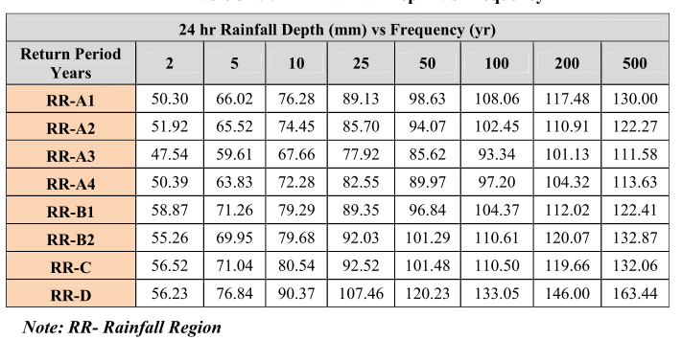
Source: (ERA DDM, 2013)

Appendix-8: Different Parameters used in Manning, Rational Equation and Others
A: Design Storm Frequency(yrs.) by Geometric Design Criteria
Structure Type | Geometric Design Standard
 | DS1/DS2 | DS3/DS4 | DS5/DS6/DS7 | DS8/DS9/DS10
Gutters and Inlets | 10 or 5 | 2 | 2
Side Ditches | 10 | 10 | 5 | 5
Ford/low water bridge |  |  |  | 5
Culvert Pipe(span<2m) | 25 | 10 | 5 | 5
Culvert (2m<span<6m) | 50 | 25 | 10 | 10
Short span bridges
(6m<span<15m) | 50 | 50 | 25 | 25
Medium span
bridges (15m<span<50m) | 100 | 50 | 50 | 50
Long span bridges (span>50m) | 100 | 100 | 100 | 100
Check/review flood | 200 | 100 | 100 | 100
 | Source: (ERA DDM, 2011)

B: Frequency Factors for Rational Formula Cf
Recurrence Interval (years) | Cf
5 | 1
10 | 1
25 | 1.1
50 | 1.2
100 | 1.25
Source: (ERA DDM, 2013)
C: Recommended Runoff Coefficients for various Land Uses
Description of Area | Runoff Coefficients
Business: Downtown areas | 0.70-0.95
Neighborhood areas | 0.50-0.70
Residential: Single-family areas | 0.30-0.50
Residential: Multi-units, detached | 0.40-0.60
Residential: Multi-units, attached | 0.60-0.75
Suburban | 0.25-0.40
Residential (0.5ha lots or more) | 0.30-0.45
Apartment dwelling areas | 0.50-0.70
Industrial: Light areas | 0.50-0.80
Industrial: Heavy areas | 0.60-0.90
Parks, cemeteries | 0.10-0.25
Playgrounds | 0.20-0.40
Railroad yard areas | 0.20-0.40
Unimproved areas | 0.10-0.30
(Source: Hydrology, Federal Highway Administration, HEC No.19, 1984)
D: Coefficients for Composite Runoff Analysis
Surface | Runoff Coefficients
Street: Asphalt | 0.70-0.95
Concrete | 0.80-0.95
Drives and walks | 0.75-0.85
Roofs | 0.75-0.95
(Source: Hydrology, Federal Highway Administration, HEC No.19, 1984)

E: Kz=F (Cs, T) for use in Log-Pearson Type III Distribution Used for R24
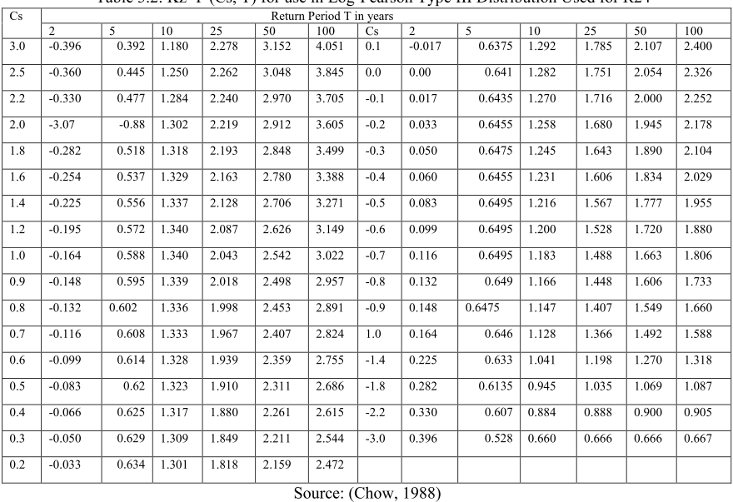
F: Inlet Time of Concentration
SC | U/S EL(m) | D/S EL(m) | H(m) | LP(Km) | tc(hr) | tc(min) | 0.4tc(min)
SC-1 | 2023 | 2008 | 15 | 0.35 | 0.10272 | 6.2 | 2.5
SC-2 | 2019 | 2008 | 11 | 0.423 | 0.14406 | 8.6 | 3.5
SC-3 | 2016 | 2001 | 15 | 0.523 | 0.16336 | 9.8 | 3.9
SC-4 | 2022 | 2016 | 6 | 0.25 | 0.09911 | 5.9 | 2.4
SC-5 | 2022 | 2011 | 11 | 0.328 | 0.10739 | 6.4 | 2.6
SC-6 | 2015 | 1994 | 21 | 0.42 | 0.1114 | 6.7 | 2.7
SC-7 | 2032 | 2014 | 18 | 0.402 | 0.11238 | 6.7 | 2.7
SC-8 | 2017 | 2011 | 6 | 0.328 | 0.13562 | 8.1 | 3.3
SC-9 | 2015 | 1997 | 18 | 0.411 | 0.11529 | 6.9 | 2.8
SC-10 | 2016 | 2004 | 12 | 0.3 | 0.09368 | 5.6 | 2.2
SC-11 | 2017 | 2004 | 13 | 0.354 | 0.10998 | 6.6 | 2.6
SC-12 | 2014 | 1994 | 20 | 0.425 | 0.11507 | 6.9 | 2.8

G: Travel time
SC | V(m/s) | Tt(min) | SC | V(m/s) | Tt(min)
SC-1 | 1.2 | 2.6 | SC-7 | 1.0 | 5.8
SC-2 | 2.2 | 1.2 | SC-8 | 1.2 | 6.9
SC-3 | 2.8 | 2.2 | SC-9 | 3.1 | 1.7
SC-4 | 0.9 | 9.4 | SC-10 | 3.4 | 1.6
SC-5 | 2.0 | 3.9 | SC-11 | 4.0 | 1.2
SC-6 | 5.1 | 0.8 | SC-12 | 2.8 | 1.7
H: Total Time of Concentration
SC | Tt(min) | Tci(min) | TC (min) | Used Tc Value(min)
S1 | 2.6 | 2.5 | 5.1 | 5.1
S2 | 1.2 | 3.5 | 4.7 | 5
S3 | 2.2 | 3.9 | 6.1 | 6.1
S4 | 9.4 | 2.4 | 11.8 | 11.8
S5 | 3.9 | 2.6 | 6.4 | 6.4
S6 | 0.8 | 2.7 | 3.5 | 5
S7 | 5.8 | 2.7 | 8.5 | 8.5
S8 | 6.9 | 3.3 | 10.1 | 10.1
S9 | 1.7 | 2.8 | 4.5 | 5
S10 | 1.6 | 2.2 | 3.8 | 5
S11 | 1.2 | 2.6 | 3.8 | 5
S12 | 1.7 | 2.8 | 4.4 | 5

Appendix-9: Model Input Properties
A: Sub-Catchment Properties
SC | X(m) | Y(m) | Cw | A(ha) | Slope(%) | LP(m) | Width(m)
SC-1 | 208079 | 935744 | 0.67 | 3.51 | 4.29 | 350.0 | 100.1
SC-2 | 208147 | 935918 | 0.59 | 3.1 | 2.60 | 423.0 | 73.2
SC-3 | 208088 | 936106 | 0.7 | 5.9 | 2.87 | 523.0 | 112.7
SC-4 | 208293 | 935873 | 0.77 | 5.7 | 2.40 | 250.0 | 226.3
SC-5 | 208190 | 935596 | 0.75 | 5.7 | 3.35 | 328.0 | 172.8
SC-6 | 207895 | 935557 | 0.73 | 4.1 | 5.00 | 420.0 | 96.5
SC-7 | 208635 | 935764 | 0.75 | 6.7 | 4.48 | 402.0 | 166.7
SC-8 | 208817 | 935530 | 0.66 | 3.43 | 1.83 | 328.0 | 104.6
SC-9 | 208671 | 935609 | 0.76 | 3.9 | 4.38 | 411.0 | 95.0
SC-10 | 208758 | 935413 | 0.72 | 1.9 | 4.00 | 300.0 | 63.0
SC-11 | 208667 | 935313 | 0.6 | 2 | 3.67 | 354.0 | 57.6
SC-12 | 208514 | 935493 | 0.7 | 5.9 | 4.71 | 425.0 | 137.7
B: Junction Properties
Junction | Easting(m) |  | Northing(m) | Elevation(m) | Inv.Elevation(m) | Max.Depth (m)
J1 | 208241 |  | 935811 | 2023 | 2022.2 | 0.8
J2 | 208127 |  | 935695 | 2021 | 2020.55 | 0.45
J3 | 208160 |  | 935813 | 2020 | 2019.2 | 0.8
J4 | 208053 |  | 935672 | 2017 | 2016.5 | 0.5
J5 | 208128 |  | 935819 | 2017 | 2016.2 | 0.8
J6 | 207957 |  | 935685 | 2009 | 2008.3 | 0.7
J7 | 208051 |  | 935847 | 2008 | 2007.2 | 0.8
J8 | 208241 |  | 935820 | 2023 | 2022.4 | 0.6
J9 | 208058 |  | 935859 | 2007 | 2006.3 | 0.7
J10 | 208102 |  | 936024 | 2011 | 2010.5 | 0.5
J11 | 208062 |  | 935871 | 2006 | 2005.3 | 0.7
J12 | 208055 |  | 935875 | 2007 | 2006.3 | 0.7
J13 | 208104 |  | 936237 | 2011 | 2010.2 | 0.8
J14 | 208009 |  | 935894 | 2001 | 2000.3 | 0.7
J15 | 208266 |  | 936173 | 2018 | 2017 | 1
J16 | 208263 |  | 935820 | 2023 | 2022.5 | 0.5
J17 | 208386 |  | 935837 | 2017 | 2015.9 | 1.1
J18 | 208253 |  | 935810 | 2022 | 2021.4 | 0.6
J19 | 208392 |  | 935820 | 2016 | 2014.9 | 1.1
J20 | 208384 |  | 935751 | 2018 | 2017.55 | 0.45
J21 | 208430 |  | 935739 | 2016 | 2014.8 | 1.2
J22 | 208380 |  | 935743 | 2018 | 2017.55 | 0.45
J23 | 208438 |  | 935729 | 2016 | 2014.9 | 1.1
J24 | 208267 |  | 935705 | 2023 | 2022.65 | 0.35
J25 | 208435 |  | 935701 | 2016 | 2014.9 | 1.1
J26 | 208094 |  | 935655 | 2017 | 2016.5 | 0.5
J27 | 208029 |  | 935507 | 2012 | 2010.7 | 1.3
J28 | 208011 |  | 935655 | 2015 | 2014.4 | 0.6
J29 | 208017 |  | 935504 | 2011 | 2009.7 | 1.3
J30 | 207908 |  | 935701 | 2003 | 2002.5 | 0.5
J31 | 207782 |  | 935467 | 1996 | 1994.9 | 1.1
J32 | 208410 |  | 935828 | 2016 | 2015 | 1
J33 | 208531 |  | 935737 | 2016 | 2015.4 | 0.6
J34 | 208501 |  | 935713 | 2015.1 | 2014 | 1.1
J35 | 208686 |  | 935801 | 2019 | 2018.5 | 0.5
J36 | 208510 |  | 935712 | 2015 | 2013.9 | 1.1
J37 | 208860 |  | 935612 | 2017 | 2016.35 | 0.65
J38 | 208691 |  | 935692 | 2015 | 2013.85 | 1.15
J39 | 208818 |  | 935498 | 2013 | 2011.85 | 1.15
J40 | 208795 |  | 935325 | 2013 | 2012 | 1
J41 | 208460 |  | 935690 | 2014 | 2013 | 1
J42 | 208783 |  | 935323 | 2012 | 2011 | 1
J43 | 208796 |  | 935501 | 2011 | 2009.85 | 1.15
J44 | 208763 |  | 935495 | 2008 | 2007 | 1
J45 | 208764 |  | 935480 | 2007 | 2006 | 1
J46 | 208759 |  | 935479 | 2006.1 | 2005 | 1.1
J47 | 208721 |  | 935477 | 2004 | 2002.9 | 1.1
J48 | 208693 |  | 935237 | 2016 | 2014.9 | 1.1
J49 | 208719 |  | 935460 | 2004 | 2002.85 | 1.15
J50 | 208715 |  | 935459 | 2002.1 | 2001 | 1.1
J51 | 208504 |  | 935613 | 2009 | 2008 | 1
J52 | 208673 |  | 935206 | 2017.7 | 2017 | 0.7
J53 | 208660 |  | 935461 | 1998 | 1996.7 | 1.3
J54 | 208652 |  | 935462 | 1996 | 1994.9 | 1.1
J55 | 208314 |  | 935442 | 1999 | 1998.2 | 0.8
J56 | 208576 |  | 935467 | 1991 | 1989.9 | 1.1

C: Conduit Properties
D: Outfall Properties
Outfall Properties
Outfall | X(m) | Y(m) | Elevation(m) | Depth(m) | Inverted Elevation(m)
Outlet-1 | 208009.00 | 935894.00 | 2000 | 0.8 | 1999.2
Outlet-2 | 207781.00 | 935467.00 | 1995.8 | 1 | 1994.8
Outlet-3 | 208576.00 | 935466.00 | 1990 | 0.8 | 1989.2

Appendix-10: Summary Results from SWMM 5.1 Simulation
A: Peak rate of Bedele Town stormwater drainage(10yrs.)
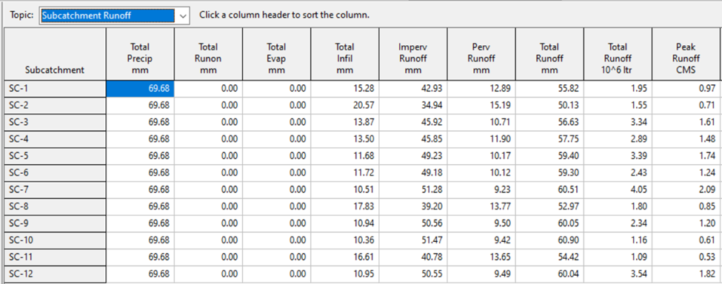
B: Peak rate of Bedele Town stormwater drainage(25yrs.)
