

ENHANCING CONCRETE MECHANICAL PROPERTY USING LIQUID PHASE SHEAR EXFOLIATED GRAPHENE NANO PLATES

MSc. THESIS

KIBROM GETACHEW BELAY

HAWASSA UNIVERSITY, HAWASSA, ETHIOPIA

OCTOBER, 2019
ENHANCING CONCRETE MECHANICAL PROPERTY USING LIQUID PHASE SHEAR EXFOLIATED GRAPHENE NANO PLATES

KIBROM GETACHEW BELAY

A THESIS SUBMITTED TO THE DEPARTMENT OF CIVIL ENGINEERING, HAWASSA INSTITUTE OF TECNOLOGY, SCHOOL OF GRADUATE STUDIES
HAWASSA UNIVERSITY
HAWASSA, ETHIOPIA

IN PARTIAL FULFILLMENT OF THE REQUIREMENTS FOR THE DEGREE OF MASTERS OF SCIENCE IN CIVIL ENGINEERING
(STRUCTURAL ENGINEERING)

OCTOBER, 2019
HAWASSA, ETHIOPIA
HAWASSA UNIVERSITY
SCHOOL OF GRADUTE STUDIES
DEPARTMENT OF CIVIL ENGINEERING
DECLARATION SHEET
I hereby declare that this MSc. Thesis “Enhancing Concrete Mechanical Property Using Liquid Phase Shear Exfoliated Graphene Nano Plates)” is my original work and has not been presented for a degree in any other university, and all sources of material used for this work are clearly acknowledged.
Name: Dr. TEMESGEN WONDIMU
Signature: __________________
This MSc dissertation has been submitted for examination with my approval as Thesis advisor.
Name: ASNAKE KEFELEGN
Signature: __________________
Place: Hawassa University
Date of submission: ___________________

HAWASSA UNIVERSITY
SCHOOL OF GRADUTE STUDIES
DEPARTMENT OF CIVIL ENGINEERING
ADVISOR APROVAL SHEET
This is to certify that the Thesis entitled “Enhancing Concrete Mechanical Property Using Liquid Phase Shear Exfoliated Graphene Nano-Plates” submitted in Partial Fulfillment of the Requirements for the Degree of Masters of Science with specialization In Structural Engineering, the Graduate Program of the Department of Civil Engineering, has been carried out by Kibrom Getachew Belay ID.No PGstru/006/10, under our supervision. Therefore, we recommend that the student has fulfilled the requirements and hereby can submit the thesis to the department.
Submitted by
------------------------------ ------------------------ ------------------------
Student Name Signature Date
Approved by
1. ------------------------------------- --------------------- -------------------------- Major Advisor Signature Date

2. --------------------------------------- ----------------------- -----------------------
Co-Advisor Signature Date

HAWASSA UNIVERSITY
SCHOOLS OF GRADUATE STUDIES
EXAMINER’S APPROVAL SHEET
As members of the Board of examiners of the final Master’s degree open defense, we certify that we have read and evaluated the thesis prepared by kibrom Getachew Belay under the title “Enhancing Concrete Mechanical Property Using Liquid Phase Shear Exfoliated Graphene Nano-Plates" and recommend that it be accepted as fulfilling the thesis requirement for the degree of Masters of science in civil engineering with specialization in Structural Engineering.
Name of Chair Person Signature Date ________________ ________ ____________
Name of Internal Examiner Signature Date ________________ ____________ ___________
Name of External Examiner Signature Date ________________ ____________ ____________
Final approval and acceptance of the thesis is contingent upon the submission of the final copy of the thesis to the school of Graduate Studies (SGS) through the Department/School Graduate Committee (DGC/SGC) of the candidate’s department. Thesis approved by
__________________ __________________ __________________ DGC/SGC Signature Date
Certification of the Final Thesis
I hereby certify that all the corrections and recommendation suggested by the Board of Examiners are incorporated into the final Thesis “Enhancing Concrete Mechanical Property Using Liquid Phase Shear Exfoliated Graphene Nano-Plates” by Kibrom Getachew Belay.
__________________ __________________ __________________
Name of the Designate Signature Date

DEDICATION

To
My Families
I can’t thank you enough for what you do in my life!!!

ACKNOWLEDGMENT
First of all, I would like to thank the almighty GOD who makes everything possible and for his blessings throughout my research in success.
My heart-felt thanks will go to my supervisor Dr. Temesgen Wondimu for giving me the chance to do research with him and gave his precious time and effort, I cannot even think to begin a research titled like this, without his supervision. His energy, vision on this paper makes me energized and work with motivation, his continuous and critical way of advising make this work possible. I would also like to thank him for his understanding and great personality.
My special thanks goes to Dr. Getachew, who is assistant professor at Addis Ababa Science and Technology University, for making a professional test on my samples using scanning electron microscope (SEM) and verifications on the results and for his patience and great sense of humor.
I would also like to thank Mr. Endalkachew Asefa, who is chemistry lecturer at Hawassa University for his very close and critical way of advising and the many important discussions we had during my study.
I am extending my thanks to my co-advisor Mr. Asenak kefelegn (MSc.) for his kind
help during the entire tenure of my research. He made the skeleton and sole for research
work.
Last but not list, I would like to acknowledge my father Getachew Belay and my mother Etifwork Goli for their endless love and support throughout my life.

TABLE OF CONTENTS
ACKNOWLEDGMENT vii
TABLE OF CONTENTS viii
LIST OF FIGURE xi
LIST OF TABLE xii
LIST OF APPENDIX FIGURE xiii
LIST OF APPENDIX TABLE xiv
LIST OF ABBREVIATIONS xv
ABSTRACT xvii
CHAPTER ONE 1
INTRODUCTION 1
1.1. Back Ground of the Study 1
1.2 Graphene Reinforced Concrete 3
1.3 Objective of this Research 3
1.3.1 General Objective 3
1.3.2 Specific Objective 4
1.4 Problem Statement 4
1.5 Research Question 5
1.6 Significant of the Study 5
1.7 Scope of the Study 6
1.8 Structure of the Thesis 6
CHAPTER TWO 8
LITERATURE REVIEW 8
2.1 Introduction 8
2.2 Classification of Concrete 10
2.3 Properties of Concrete 11
2.3.1 Fresh Concrete (plastic property) 11
2.3.2 Harden State Properties (Mechanical properties) 12
2.4 Graphite 15
2.4.1 Availability of Graphite in Ethiopia 16
2.5 Graphene 16
2.5.1 General Properties of Single Graphite Layer (Graphene) 17
2.5.2 Methods of Graphene Production 18
2.6 Comparison of different Graphene Production Methods 21
2.6.1 Comparison between the Shear Exfoliation Methods 22
2.7 Graphene Based Concrete 23
CHAPTER THREE 24
MATERIAL AND METHODOLGY 24
3.1 Introduction 24
3.2 Materials 25
3.2.1 Fine Aggregate 25
3.2.2 Coarse Aggregate 25
3.2.3 Water 25
3.2.4 Cement 26
3.2.5 Graphite 26
3.2.6 Surfactant 26
3.3 Methods 27
3.3.1 Chemical Experiment (Graphene Production) 27
3.3.2 Mechanical Experiment 28
3.4 Mix Design 29
3.4.1 Concrete Casting 30
3.4.2 Concrete Curing 30
3.5 Experimental Tests 30
3.5.1 Slump Test 32
3.5.2 Compression Strength 33
3.5.3 Splitting Tensile Strength 33
3.5.4 Scanning Electron Microscope (SEM) 34
CHAPTER FOUR 35
RESULT AND DISCUSSION 35
4.1 Introduction 35
4.2 Workability 35
4.3 Compressive Strength 36
4.5 Modulus of Elasticity 42
4.6 SEM Results and Discussion 45
4.6.1 Compressive and Tensile Strength Evaluation based on SEM 45
4.6.2 Permeability of Graphene Reinforced Concrete based on SEM 48
CHAPTER FIVE 49
CONCLUSION AND RECOMENDATION 49
5.1 Conclusion 49
5.2 Recommendation 50
References 51
APPENDIX 55
Appendix A: Graphene production 55
Appendix B1: Material Quality Tests and Mix Design 57
Appendix B2; Mix Design 72
Appendix C: Graph of compressive test result 77

LIST OF FIGURE
Figure 1; Initial tangent, Tangent and Secant modulus of elasticity. (James g. Macgregor and 2005, 67) 15
Figure 2; Chemical structure of Graphite 17
Figure 3; Method of production of Graphene 19
Figure 4; Mechanical exfoliation of Graphene 20
Figure 5; Image of the collected supernatant 28
Figure 6; Image specimens for curing 29
Figure 7; Image of slump test 33
Figure 8; Image of compression Test 34
Figure 9; Image of the splitting tensile test 34
Figure 10.Image of the slump of the mix 36
Figure 11; Comparison of 7 days compressive strength 38
Figure 12; 14 days compressive strength test result 39
Figure 13; Comparison of 28 days’ average strength 40
Figure 14; Percentage improvement of Graphene reinforced concrete 41
Figure 15; Comparison of splitting tensile strength 42
Figure 16; Calculated modulus of elasticity percentage improvement 45
Figure 17; SEM image of conventional concrete 46
Figure 18; SEM image of 50% mixing water replaced Graphene reinforced concrete 47
Figure 19; SEM image of100% mixing water replaced Graphene reinforced concrete 48

LIST OF TABLE
Table 1; Properties of Graphene (Abro, 2015) 18
Table 2; Comparison between some Graphene production methods 22
Table 3; Portions of ingredients for concrete to make 30
Table 4; Abbreviations to the sample identification 32
Table 5; 7 days compressive result 36
Table 6; 14 days compressive test result 37
Table 7; 28 days compression test result 38
Table 8; Tensile strength test result 41
Table 9; Calculated 7 days modulus of elasticity 42
Table 10; Calculated 14 days modulus of elasticity 43
Table 11; Calculated 28 days modulus of elasticity 43

LIST OF APPENDIX FIGURE
Figure A 1; Philips 7761 house hold blender (food processer) 55
Figure A 2; Collected supernatant 56
Figure A 3;First sieve analysis for coarse aggregate 62
Figure A 4; Second sieve analysis for coarse aggregate 63
Figure A 5; First sieve analysis for fine aggregate 65
Figure A 6; Load- time for 7 days obtained from compression machine 77
Figure A 7; Load- time for 14 days obtained from compression machine 78
Figure A 8; Load- time for 28 days obtained from compression machine 79

LIST OF APPENDIX TABLE
Table B 1; summary of dry density of coarse aggregate 59
Table B 2; Summary of specific gravity of fine aggregate 61
Table B 3; First sieve analysis for coarse aggregate 62
Table B 4; Second sieve analysis for coarse aggregate 63
Table B 5; First sieve analysis for fine aggregate 66
Table B 6; Second sieve analysis for fine aggregate 67
Table B 7; Second sieve analysis for fine aggregate 67
Table B 8; Summary of specific gravity for fine aggregate 71
Table B 9; Summary of test value for mix design 73
Table B 10; Mix ratio for concrete 77

LIST OF ABBREVIATIONS

C-S-H…………………………Calcium-silicate-hydrate
ES-EN……………………… Ethiopian Standard based on European Norm
GNP…………………………...Graphene Nano plates
mJ/m² ………………...……….mega-joule per meter square
CO₂ ……….…………………..Carbon di-oxide
SP2……………………………Hybridization of atomic 1s orbital with 2p orbitals
HOPG…………………………Highly oriented pyrolytic Graphite
GICs ………………………….Graphite intercalation compounds
STM…………………………...Scanning electron micro-scope
HBr……………………………Hydrogen bromide acid
HCL…………………………...Hydrochloric acid
HNO₃………………………….Nitric acid
H₂SO₄…………………………Sulfuric acid
Pt ……………………………..Lead
2D …………………………….Two dimensions
3D …………………………….Three dimensions
CVD ……………………………Chemical vapor disposition
NMP…………………………….N-methyle-2- pyrrolidone
ASTM …………………………..American Society for Testing and Material
nm …………………………........Nano meter=10⁻⁹
Pa pressure /stress……………….Newton per meter square
TPa………………………………Tera Pascal=10¹²
GPa ………………….……….....Giga Pascal=10⁹

ABSTRACT
Present investigation deals with the methods adopted to produce and introduce Liquid phase shear exfoliated multi-layered Graphene. Recently, the development of an ideal Nano-material called graphene in modern science create an opportunity to develop better performing Nano-engineered materials. Thus, the compression and splitting tensile test result for 50% and 100% replacement of mixing water by produced Graphene solution, related modulus of elasticity is calculated based on compression result obtained. Such way that 28 days’ compression capacity show 33.4% and 16.5% improvement for 50% and 100% replacement of mixing water with Graphene solution. Moreover, the 28 days splitting tensile strength test result show 43% and 10% improvement for 50% and 100% replacement of mixing water with Graphene solution. The chemical crystalline matrix crushed pieces of test samples of Graphene solution made concrete were confirmed by using scanning electron microscope (SEM). Here we report that a significant enhancement of mechanical properties of the Graphene solution produced concrete than the conventional concrete.
Keywords: Graphene, Graphene solution, SEM, Concrete

CHAPTER ONE

INTRODUCTION

1.1. Back Ground of the Study
Nano-technology is a relatively new technology and deals with particles having at least one dimension between approximately 1 and 100 nm called Nano-materials (Rattan A, Sachdeva P, & Chaudhary A, 2016)
The Nano-materials properties can be very different from the properties of the same materials at micro (10^{–6} m) or macro scale (10^{–6} -10^{–3} m). Nano-materials is being integrated into many applications including composites, electronics, biomedicine and many more. Manipulation at the nanoscale can change chemical reactions; temperature, electricity, and magnetism of a material (Rattan A et al., 2016).
Graphite is the combination of millions of the two dimensional layers called Graphene, which consists of atomic layers of sp2-bonded carbon atoms with hexagonal atomic configuration (Bharech, 2015). Graphene has unique physical and chemical properties including outstanding mechanical properties such as 200 times stronger than structural reinforcing steel, high current density and charge mobility, optical transmittance, and thermal conductivity. Graphene is considered as the thinnest possible material in the world and the strongest material ever tested, with a tensile strength of 130 GPa and a Young’s Modulus of 1 TPa respectively (Abro, 2015)

There are but efforts have been done to develop production methods for Graphene. Some of the method of production are mechanical, electro-chemical and liquid phase shear and ultra-sonication. From these different methods used to achieve high yield of Graphene for different application, has their own pros and cons based on quality, quantity and scalability to industrial level (Abro, 2015).
The exfoliation of Graphite in aqua medium can be effectively done by exploiting shear mixing and ultra-sound waves to extract individual layers of Graphene. The aqua medium production of Graphene pass-through three stages: First stage is to dissolve Graphite in a solvent which have a surface tension (γ) close to 40 mJ/ m², second stage is shear exfoliation by using the shear force mechanism either rotation or ultra-sound wave and third stage is Purification (Bernal & Milano, 2014; Haar et al., 2016).
Recently, Nano-technology has been applied in the production of concrete to improve its mechanical and plastic properties. Concrete is a Nano-structured, composite material that develops strength over time. Concrete property based on its constituents: cement, coarse aggregate, fine aggregate and water. The paste produced by reaction between the cement and water produces calcium silicate hydrate (C-S-H) crystal (Paton et al., 2014).
Calcium silicate hydrate (C-H-S) are Nano-scale building blocks of concrete which determine its mechanical properties. Concrete have limitation on resisting applied stress, which directly related to the Nano-scale building blocks. Therefore, to overcome those limitations many researchers have been investigated to improve concrete mechanical property. But the best approach to improve the mechanical performance improvement at Nano-scale building blocks is necessary, since every limitation is traced back to defects in the Nano-scale cement structure (Dimov et al., 2018).

1.2 Graphene Reinforced Concrete
Graphene has initiate vast interests from the day it was discovered and has opened up a
new way to field of nanotechnology applications. The remarkable mechanical, higher surface area and low density, together enable Graphene with the possibility to develop a high-performance, and multi-functional cementitious composites (Zheng, Han, Cui, Yu, & Ou, 2017).
Graphene is an ideal Nano-material to modify cementitious materials, but single layer Graphene is hard to synthesize and very expensive. In practical applications multilayer Graphene Nano platelets (GNP) are used, because GNP can be more easily produced from Graphite (Zheng et al., 2017).
In this research mechanical performance of Graphene reinforced concrete is investigated relative to the ordinary concrete prepared from identical ingredients at same time and conditions. Additional investigations also conducted to assess the chemical structure of the Graphene reinforced concrete relative to control concrete specimens.

1.3 Objective of this Research

1.3.1 General Objective
This research is aimed to enhancing Concrete Mechanical Property Using Liquid Phase Shear Exfoliated Graphene Nano Plates

1.3.2 Specific Objective
- To evaluate the effect of Graphene based solution on workability of concrete at different level of concentration.
- To investigate the effect of addition of Graphene based solution as partial or full replacement of mixing water on tensile property of concrete
- To investigate the effect of Graphene solution concentration on concrete mechanical behavior improvement.

1.4 Problem Statement
The behavior of harden concrete basically depends on the paste formed due to reaction between water and cement known as calcium-silicate-hydrate(C-S-H). The size, number and distribution of voids at Nano-scale which are found on C-S-H will determine the mechanical properties of concrete.
Concrete has low tensile strength which makes it brittle material, if its ultimate stress is reached a structure undergoes a sudden collapse, sudden collapse of a structure is catastrophic and appropriate measures should be taken. Usually reinforcing steel is used to resist the tensile stress on concrete members and let the concrete member only to resist compression stress. Due to higher tension capacity of steel and compression capacity of concrete the collapse behavior of concrete member is changed from brittle to ductile. But, due to unknown bond between reinforcing steel and concrete, the coupled effect of resistance variable and significantly affect the transition of failure mode from brittle to ductile.
Cement production one of the main constitute of concrete is hazardous to the environment. The cement industry is second largest producer of carbon dioxide (CO₂), creating 5% of world man made emissions of this gas, of which 50% is from the chemical process and 40% from burning fuel according to the cement sustainability initiative.
This research is envisioned to investigate the addition of Graphene based solution to concrete affect the mechanical property, at what concentration of the solution be maximum improvement can be obtained and how this material mechanical improvements allow concrete structures to be safe, economic, environmental friendly and meet service requirements.

1.5 Research Question
1. Does Graphene based solution introduction affect the workability of concrete?
2. Does Graphene based solution improve the mechanical property of concrete?
3. At what concentration of Graphene solution better mechanical improvement is obtained?

1.6 Significant of the Study
The result of this study would provide back ground information for other researchers who would be interested to conduct similar studies. Graphene is promising material in modern science, from the day of it discovery Graphene triggered many interest in different field of technology. Due to Graphene ideal properties makes it suitable for modification of existing materials like concrete. Incorporation of Graphene change the Nano-structure of concrete, this cause significant change on tensile strength of concrete by minimizing size and number of void formation in the cement paste. Such chemical structure change in concrete, also have significant increment on compressive capacity due to improvement in capacity of stress resistance of the cement paste. Such an ideal change in tensile and compressive strength significantly change the concrete based construction industry, by making concrete structurally efficient, economical and meet functional requirements.

1.7 Scope of the Study
This study is specifically focused on Graphene reinforced concrete mechanical property made using Graphene based solution. Thus, the test conducted on both the control (conventional) concrete and Graphene reinforced concrete for compressive and splitting tensile strength, using compressive testing machine. Further analysis on the crushed sample is done using Scanning electron microscope (SEM).
This study is limited to normal weight concrete grade 30, due to limitation of the Graphene Nano plate’s production using house hold blender. Flexural strength test is also not conducted due to un-available of the flexural testing machine at Hawassa University. Permeability and conductivity of Graphene reinforced concrete is not conducted because of the un-availability of measuring instrument. But the permeability of concrete is assessed based on the image obtained from the scanning electron microscope (SEM).

1.8 Structure of the Thesis
In Chapter 1 introduction to this research and elaborating the intent of this investigation were presented.
On Chapter 2 a brief discussion on workability and mechanical property of concrete based on literature reviews is presented. It also covers Graphite availability in Ethiopia which is the source of Graphene, detail discussion is followed about Graphene and its method of production, at the end in-depth literature review on Graphene reinforced concrete is presented.
Chapter 3 discuss on the materials used to this research and methodology for preparation and testing of experimental specimens. The chapter discuss materials and equipment used on two categories:1) Graphene production based on shear exfoliation and 2) concrete ingredient preparation and production. The chapter also explained the procedures followed for production of Graphene based solution, concrete constituent and concrete production. At the end of this chapter concrete testing procedure is presented.
Chapter 4 based on the material and methods used to production of concrete specimens and conducted test on specimens, the obtained result is presented and discuss in depth, with their implication in comparison between Graphene reinforced and conventional control samples.
On chapter 5 conclusion are made based on the results and detailed scientific discussion made on chapter 4. Further investigations points are recommended based on the results and discussions made in chapter 4.

CHAPTER TWO

LITERATURE REVIEW

2.1 Introduction
Nanomaterials are physical substances with dimension between 1 to 100 nm (1 nm = 10^{–9} m). The Nano-science represents the study of occurrences and the manipulation of materials at Nano-scale. The Nano-technologies can be defined as the design, characterization, production and application of Nano-materials to structures, devices and systems by controlling shape and size at the nanoscale. Nano-materials properties are very different from the properties of the same materials at micro (10^{–6} m) or macro scale (10^{–6} -10^{–3} m) (Rattan A et al., 2016).
Graphite is the combination of the millions of the Graphene layers. Graphene is two dimensional nanomaterials which create Graphite, consists of atomic layer sp2-bonded carbon atoms. Graphene have hexagonal configuration with a single free electron, which make it the only non-metal conductor (Kauppila, 2014).
There are enormous efforts have been done to develop production methods for Graphene. Some of the method of production are mechanical, electro-chemical and liquid phase shear and ultra-sonication. Novoselov and his colleagues studied Graphene preparation from Graphite using scotch-tape in 2004 have successfully exfoliated monolayers of Graphene and awarded the Nobel prize in Physics. From different methods used to achieve high yield of Graphene for different application, each of the methods have their own pros and cons based on quality, quantity and scalability to industrial level (Jones & Safron, 2004).
The exfoliation of Graphite in aqua medium can be effectively done by exploiting shear mixing and ultra-sound waves to extract individual layers of Graphene. The aqua medium production of Graphene follows three stages: First stage is to dissolve Graphite in a solvent which have a surface tension (γ) close to 40 mJ/ m2, second stage is shear exfoliation by using the shear force mechanism either rotation or ultra-sound wave and third stage is Purification (Bernal & Milano, 2014; Haar et al., 2016).
Concrete is a composite material made through mixing a cementing material and a mineral aggregate with sufficient water to cause the cement to set and bind the entire ingredient. Reaction between the cement and water produces calcium silicate hydrate (C-S-H), which determines the mechanical properties of concrete (Shetty Be, 2000).
The property of concrete basically depends on the ingredients property (cement, sand,
aggregate and water), and the paste produced by water –cement reaction. Concrete made from nanoscale building blocks and the finest approach to enhance mechanical performance of concrete is enhancement at Nano-scale, since most of the damage caused to concrete can be traced back to chemical and mechanical defects in the cement structure (Dimov et al., 2018).
Recently, Nano-technology has been applied in the production of concrete to improve its properties. the Nano modification can result in improvements in strength, shrinkage, ductility, and impact resistance.
The properties of concrete may be altered in so many ways; one of the best ways is the incorporation of Nano materials to concrete. Nano materials in terms of Nano silica (SiO₂), Nano Iron (Fe₂O₃), Nano alumina (Al₂O₃), carbon nanotube etc. Incorporation of Nanomaterials in concrete will improve; the pore structure of concrete, alter pore distribution on chemical structure and speed up the C-S-H gel formation and improve the concrete mechanical properties (Rattan A et al., 2016).

2.2 Classification of Concrete
Structural concrete can be classified based on their strength as normal strength concrete and high strength concrete.
- Normal Strength Concrete
Concretes with matured compressive strength is in between 20-40 Mpa can be categorized as a normal-strength concretes. No additional additive is introduced which have a significant effect on concrete strength. The stress–strain curve of normal strength concrete is nonlinear and appears to be somewhat ductile. This is because of the gradual development of micro cracking within the concrete chemical structure and the resulting redistribution of stress from one ingredient element make up to the other within the concrete (James g. Macgregor 2005).
- High Strength Concrete
Concretes with matured compressive strength greater than 41Mpa can be categorized as a high-strength concretes. The production of high-strength concrete based on the addition of admixtures such as superplasticizers to improve the dispersion of cement in the mix and produce workable concrete, with much lower water to cement ratios than normal strength concrete, producing much lower void formation which made stronger concrete (James g. Macgregor 2005).
High-strength concrete is more brittle in nature than normal strength concrete because cracks in this material do not follow the aggregate-hardened cement paste interfaces due to the improved interfacial bond strength of high-strength concrete, but may cut right through the hardened cement paste and even the aggregate particles leading to rapid propagation of the cracks and sudden failure of the concrete (Pam, Kwan, & Islam, 2001).

2.3 Properties of Concrete
Concrete undergoes two states: the fresh concrete/plastic state and the harden state a state, when the plastic concrete harden through time due to the process called hydration.

2.3.1 Fresh Concrete (plastic property)
Property of Concrete at a state of semi-fluid, which can be molded into any shape. Strength and durability of concrete has direct relation with the plastic/semi-fluid state property.

2.3.1.1 Workability
Workability is the ability of mix being easily mixed, transported and placed as simple as possible without any an acceptable loss of uniformity or specified quality on concrete product. generally, the mix should be capable of being mixed and casted easily and provide the intended quality of harden concrete (Wong et al., 2001).

2.3.1.2 Consistency
Consistency is measure of uniform dispersion all the constituent materials including any admixture throughout the mix with a minimum energy requirement. Acceptable uniformity of the mix with in a batch and with successive batch’s providing the relatively same quality concrete imply consistency (Wong et al., 2001).

2.3.2 Harden State Properties (Mechanical properties)
Concrete performance is determined based on the mechanical property which include compression strength, tensile strength, flexural strength, and modulus of elasticity. But it is general assumed that an improvement in compressive capacity of concrete will improve other mechanical properties. Mechanical properties of concrete are closely related to its porosity and pore dispersion (Shetty Be, 2000),the addition of Nano fine particles could improve the properties of concrete due to increased surface area of cement matrix and through filling the Nano pores of the cement paste (Jafarbeglou, Abdouss, & Ramezanianpour, 2015).

2.3.2.1 Drying Shrinkage and Creep
Drying shrinkage property of concrete is related to the loss of adsorbed water from concrete to the environment. shrinkage property is very much related to the porosity of concrete. As increment in porosity increase in shrinkage of concrete, this directly increases in shrinkage stress. Increment in shrinkage is not only related to porosity of concrete, but it also varies with temperature change (Ayub, Khan, & Memon, 2014).
Creep strain is developed when concrete member is under load which causes an instantaneous Elastic deformation, if the applied load maintained for some period the adsorbed water layers tend to become thinner between C-S-H gel particles transferring compressive stress and new bond is created between C-S-H gels in the new position. If the load is removed, the concrete recover elastically but there will be residual strain due to the C-S-H gel formation on deformed position (James g. Macgregor 2005).

2.3.2.2 Compressive Strength
Compressive Strength is the maximum compressive stress that under progressively applied load a given solid will sustain without fracture. Compressive strength of concrete is property which expresses the carrying capacity of compressive load. Therefore, determining this important property is the foremost priority while dealing with any type of concrete (Ayub et al., 2014).

2.3.2.3 Tensile Strength
Tensile strength of concrete is property which imply the capacity of concrete to survive under tensile stress. Due to the difficulty of testing concrete tensile capacity directly, it is convent to adopt indirect approach to determine concrete tension capacity. The two conventional indirect testing methods are presented below.
- Splitting Tensile Strength Test
Splitting tensile strength is the measure of tensile strength of the concrete which is determined by splitting a cylinder specimen across its diameter (Ayub et al., 2014).
- Flexural Tensile Strength Test (Modulus of Rupture)
Flexural tensile strength is the measure of tensile strength of the concrete, by applying bending stress on plain concrete beam specimen, which cause tensile stress on the bottom surface and compressive stress at top. Using the tensile stress at the bottom surface the concrete tensile capacity is determined (Ayub et al., 2014).

2.3.2.4 Modulus of Elasticity
A modulus of elasticity is the measure of unit rate of change in strain due to unit rate of change in stress on elastic boundary of the material. Modulus of elasticity describes the material stiffness to deformation (James g. Macgregor, 2005)
Modulus of elasticity can be determined using the stress-strain curve, slope a line at different ordinate to stress-strain curve give three modulus of elasticity: tangent modulus which is determined from slope of a line which pass tangentially at point on stress-strain curve which represented by point A in the figure 1, initial tangent modulus of elasticity is based on the slope of a line which passes tangentially to the origin of the stress-strain curve and the secant modulus of elasticity is determined by using the slope of a line generate from the origin and pass through some point on the stress-strain curve on figure 1 the point is described as B. All the three modulus of elasticity are described using figure 1 below(James g. Macgregor, 2005).
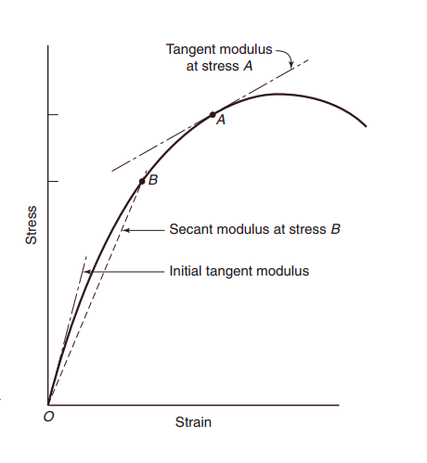
Figure 1; Initial tangent, Tangent and Secant modulus of elasticity. (James g. Macgregor 2005, 67)
The modulus of elasticity of the concrete is affected by the modulus of elasticity of the cement paste and coarse aggregate. Reduction in cement paste modulus of elasticity meaning an increases of porosity of the cement paste, reduce modulus of elasticity and strength of concrete. Coarse aggregate modulus of elasticity significantly affects the modulus of elasticity of the concrete, as increase in aggregate modulus of elasticity improve the modulus of elasticity of the concrete overall (James g. Macgregor, 2005).
According to ES-EN 1992-2015 part 1-1 the secant modulus of Elasticity normal strength concrete can be estimated using the compression capacity of the concrete.
$$Ecm=22*{\left(\frac{fcm}{10}\right)}^{0.3}$$
Where fcm compressive strength of concrete in Mpa.

2.4 Graphite
Graphite is one of the allotropes of carbon, which occurs as mineral in some rocks. Formation of Graphite is known as “Graphitization”, Graphitization denotes the transformation of carbonaceous debris to amorphous or crystalline Graphite. Graphite is collective gathering of thin Graphite plates called Graphene, which are made from hexagonally attached carbon atoms (Liam A. Bullock & Owen J. Morgan, 2015).
Natural Graphite is classified as flake or microcrystalline Graphite and vein or lump Graphite, based on its underlying physical and chemical properties. Graphite is now recognized as important mineral worldwide due to its rarity, unique chemical composition, and physical characteristics (Tripathi, Patel, Shaz, & Srivastava, 2013).

2.4.1 Availability of Graphite in Ethiopia
Ethiopia is a blessed country with so many naturally available minerals, Graphite also found in Ethiopia at different location and amount, here only two Graphite sources are presented: Moyale Graphite and Assosa Graphite.
Graphite was recently discovered by GP Resource Mining PLC (GPRM) near the town of Assosa in the Benishangul-Gumuz region of western Ethiopia. As a part of an extensive quartz graphitic-schist unit. The importance and extent of the Graphite, together with the known occurrence of gold in area, makes this a potentially prosperous resource area. According to Liam A. Bullock and Owen J. Morgan the “assosa” natural Graphite deposit has yield potential up to 95%. (Liam A. Bullock & Owen J. Morgan, 2015).
According to geological survey of Ethiopia research and report, potential Graphite deposit is found around town of Moyale in Oromia region of southern Ethiopia. The Graphite occurrences in the Moyale area are accommodated by quartzite, quartz-feldspar-mica schist and rarely by amphibole schist. The Moyale area contains an indicated mineral resource of about 450,000 tons of Graphite (ASTM Committee, 2001).

2.5 Graphene
Graphene is a single atom-thick sheet of hexagonally arranged sp²-bonded carbon atoms which are represented as shown below figure 2. Its lateral dimensions may vary from several Nano-meters to micro-meters (Abro, 2015).Single layer is the purest form known and with multi-application in electronics, composites, water-treatment, biomedicine etc.
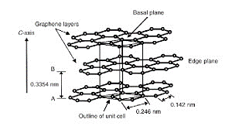
Figure 2; Chemical structure of Graphite

2.5.1 General Properties of Single Graphite Layer (Graphene)
The properties of single layer Graphene are much different from what it makes called Graphite. Graphene has remarkable physical and chemical properties. Some of the important properties are shown in the table 1 below.
Property | Measured value of Graphene
Larger Surface Area | ~3000m2g⁻¹
Stretch elasticity | ~20%
Optical transparency | ~97.7%
Tensile strength | ~130 GPa
Thermal conductivity | ~(3000-5000)WmK⁻¹
Breaking Strength | ~ 42Nm-1
High Carrier Mobility | ~ 10,000 cm²V⁻¹S⁻¹
Young’s Modulus | ~ 1.0 *10¹² Pa
Large spring constant | ~(1-5)Nm⁻¹
Electrical conductivity | ~3000 W m⁻¹ K⁻¹

Table 1; Properties of Graphene (Abro, 2015)

2.5.2 Methods of Graphene Production
There are different approaches for production of Graphene, the methods are categorized as: top-down and bottom-up methods. Top-down methods intend to use natural or synthetic Graphite and in various ways to peel off single Graphene sheets from Graphite called exfoliation. Bottom-up methods, usually make use of small carbon containing molecules or some other carbon source and build up Graphene structures by joining carbon atoms together to grow up and make Graphene (Abro, 2015), some of the methods are presented figure 3 below.

Figure 3; Method of production of Graphene

2.5.2.1 Mechanical Exfoliation (Scotch-Tape Method)
Production of Graphene based on applying a mechanical force to separate Graphene sheets in Graphite from each as shown figure 4 below. This method does not cause any chemical change to Graphene product. Mechanical methods are especially desired when the highest possible quality is needed, e.g., in the investigation of the fundamental properties of Graphene(Jones & Safron, 2004).
In its simplicity, the tape method works by placing Graphite between two strips of tape and detaching Graphite into thinner and thinner layers with the tape. After transferring the so-formed few and single layer sheets to a substrate, the latter sheets must be manually searched on the substrate. This method is highly inefficient but the formed Graphene sheets are near to perfection (Jones & Safron, 2004).
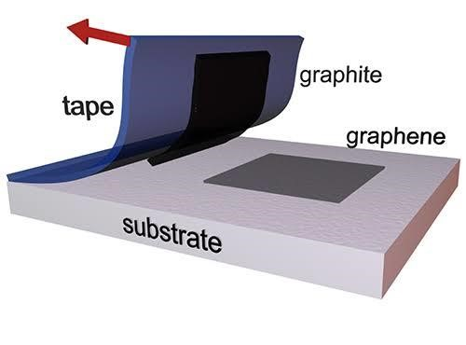
Figure 4; Mechanical exfoliation of Graphene

2.5.2.3 Liquid Phase Exfoliation with Sonication
Ultra sonication has emerged as one of the most powerful methods to produce Graphene from Graphite under liquid medium. The liquid-phase exfoliation method to prepare Graphene generally involves three steps: 1) dispersion of the Graphite in a liquid medium, 2) exfoliation through ultra-sonication and 3) purification. Exfoliation based on shear forces due to the propagation of high amplitude sonication waves act on the surface of Graphite inducing Graphene (Bernal & Milano, 2014; Haar et al., 2016). In order to stabilize the produced Graphene plates, the interfacial tension between the Graphene and the liquid medium needs to be minimized. Hence, the choice of liquid medium for the dispersion of the materials is very important on the effectiveness of the ultra-sonication (Varrla et al., 2014).

2.5.2.4 Chemical Vapor Deposition (CVD)
Chemical vapor deposition is the widely used technique for Graphene production, since it can produce large area Graphene sheets, with lateral dimensions up to several centimeters’. CVD allows control of layer thickness and coverage of large area and produces high quality Graphene sheets. Two drawbacks of CVD are the requirement of a substrate with a matching surface crystallinity, which will enable Graphene to build up properly, and the poly-crystallinity of the produced Graphene films. The polycrystalline structure is created when multiple small Graphene islands are growing simultaneously on the substrate until they eventually merge together. As with most of polycrystalline materials, there are some defects at the crystal boundaries. These defects slightly obstruct both the mechanical and electrical properties of Graphene(Bernal & Milano, 2014).

2.5.2.5 Liquid Phase Exfoliation based on Shear
Shear mixing is a process of exfoliation of Graphene in the liquid phase (Liquid medium base on surfactant- water or organic solvents) by using the shear force mechanism. In this process, a mixing machine is used to generate high shear force on the solution containing Graphite. The purpose of this machine is to mix the solution of solvent and Graphite powder by applying shear force to exfoliate the Graphene layer. In shear mixing process, the Graphite is mixed with the organic solvent like ethanol, Cyclohexanone and NMP or with distilled water with some surfactant compound like sodium cholate. Hence, high-shear mixing is a scalable alternative to the sonication process for the separating crystal layer of Graphite. Shear mixing, generally used to disperse Nano-particles in solvents. It includes separating of micro-particle agglomerates that are weakly attached compare with the inter-sheet binding strength in Graphite. In shear mixing, the layered material is initially swelled by intercalation, significantly reducing the interlayer binding strength between Graphene layers (Varrla et al., 2014; Yang et al., 2013).
The shear mixing process has much more ability to exfoliate the untreated Graphene plates into liquid solution. In addition, Shear mixing process utilizes less power densities as compared to Ultra-sonication method.

2.6 Comparison of different Graphene Production Methods
 | Rotational Shear | Ultra-Sonication | CVD | Scotch Tape
Longer Production time | No | Yes | Yes | No
High quality yield | Yes | Yes | No | Yes
Scalability to industrial level | Yes | No | Yes | No
Large dimension of Graphene | No | No | Yes | No
Manageability of production | No | No | Yes | No
From the literature review presented above, according to Abro reported, it is evident that large production of Graphene can attained through liquid phase exfoliation, but the advantage and disadvantage of liquid phase exfoliation method with respect to other Graphene production methods have shown in table 2 below (Abro, 2015).

Table 2; Comparison between some Graphene production methods

2.6.1 Comparison between the Shear Exfoliation Methods
As mentioned above there are many shear exfoliation techniques which differ based on liquid medium used to produce few layer Graphene and the method used to apply shear force: shear mixer and ultra-sonication. Despite that there is difference in quantity and quality of product using different shear mixer. Varrla et al, reported that difference between using laboratory shear stator and house hold kitchen blender used to apply the shear force on the solution. Thus, they show that there is difference in amount of Graphene product, number of layers of Graphene produced and quality of Graphene product. The comparison shows that there is more product quantity, less time for production and less defect on the product is obtained using house hold blender (Varrla et al., 2014)

2.7 Graphene Based Concrete
K.R. Mohammed, et.al, show that addition of different concentration of Graphene oxide in concrete improves the mechanical behavior of concrete, they show there is 7% improvement on compression capacity for 1% of Graphene oxide content and increase up to 17% for 2% of Graphene oxide at 28 days’ strength relative to the ordinary concrete (Zheng et al., 2017).
Another study Keith R Paton by, showed that addition of 0.1% Graphene oxide improved the flexural strength about 4% and the compressive by 11%, by alteration of Cement matrix (Paton et al., 2014).
Qiaofeng et al, paper on Graphene based cementitious composite show a 197.2% increase of tensile strength with 0.02% replacement by weight of cement by Graphene Oxide, a 160.1% increase of compressive strength, a 184.5% increase of flexural strength and a 175% increase of flexural toughness with 0.6% replacement by weight of cement by Graphene Nano plates, a 73% increase of ductility with 0.1% replacement by weight of cement by Graphene Nano plates, 51% increase of fracture strength with 1.5% replacement by weight of cement by Graphene Oxide, 20% increase of damping ratio with 5% by volume of cement by Graphene Nano plates, a 150% increase of hardness with 5% by volume of cement by Graphene Nano plates, 37.3% increase of shear modulus with 0.5% replacement by weight of cement by Graphene Nano plates, 500% increase of Young’s modulus with 3% replacements by weight of cement by Graphene oxide, and 71% decrease of abrasion loss with 5% by volume of cement by Graphene Nano plates (Zheng et al., 2017).
Dimitar and his collages try to incorporated liquid phase shear exfoliated produced using surfactant sodium cholate made using a laboratory shear stator, using the produced solution as partial replacement of mixing water. The result obtained by the investigators show that 146% improvement in compression, 79.5% in flexure and 78% reduction in strain at maximum stress (Dimov et al., 2018).

CHAPTER THREE

MATERIAL AND METHODOLGY

3.1 Introduction
To analyze this experiment, the ingredients which make 36 specimens made with Graphene solution at different concentration with 9 control specimens. From the 36 specimens 9 of them are made with half replacement of Graphene solution and 9 made with full concentration of the Graphene solution. The test conducted based on 7, 14 and 28 old strengths, on each age category 9 of the specimens are made for compression test and reaming 3 for splitting tensile test.
For production this specimen the ingredients (cement, coarse and fine aggregate and water) are prepared and tested based ASTM specification and all the necessary laboratory equipment’s to conduct the experiment were used.
For the production of Graphene under liquid medium, the ingredients Graphite powder, Ariel detergent powder and distilled water were used. The exfoliation of Graphene in liquid medium conducted using Philips 7761 model house hold blender, to create shear force on the solution.

3.2 Materials

3.2.1 Fine Aggregate
Locally available natural fine aggregate, used that came from “langano” river from Oromia regional state, Ethiopia. The sand was prepared and tested based on ASTM specification. To determine the quality of sand the necessary tests: sieve analysis, silt content and specific gravity tests were conducted. The test results of each test and related computed parameter values presented in appendix B1.

3.2.2 Coarse Aggregate
The coarse aggregate is obtained from crushing site in “Hawassa” located around “Addisu Gebeya”. The coarse aggregate was prepared based on ASTM specification. The quality of coarse aggregate determined based on testes: sieve analysis, dry rod density and specific gravity. The results from those test used to express and calculate other aggregate quality evaluation parameters, the results and calculation of the conducted tests presented in the appendix B1.

3.2.3 Water
For production of concrete ASTM specify that, water meting quality to drink met quality for concrete production. In this research drinkable tap water is used for concrete mixing. Despite that for the production of Graphene solution di-ionized water was used, in interest of eliminating the effect of dissolved solids in water on Graphene production.

3.2.4 Cement
Dangote 42.5 grade ordinary Portland cement (OPC) was used, to prepare the concrete samples. The main chemical ingredient is calcium silicate (3CaO.SiO₂(C3S)), which is the most abundant and important cement mineral, which form C-S-H gel after reaction with water. In Dangote cement 60% is accompanied by calcium silicate. For this research C-S-H gel formation is for most important, modification at Nano scale is related to this formation, since every insufficiency of concrete arise from here.

3.2.5 Graphite
Graphene containing solution made through shear exfoliation of Graphite. It is source of Graphene. In this research Abron chemical products (chemicals and other) were purchased from Addis Ababa at “Kirkos” sub-city from Atomic chemical providers.

3.2.6 Surfactant
To enable production of Graphene in water, surface energy of water has to be minimized, so that the Graphite could dissolve in water. Reducing the surface energy of water can be effectively done based on applying surfactant (soap), Ariel washing powder is used to initiate solubility of Graphite in water and to stabilize Graphene after production.

3.3 Methods
This study based on both chemistry and material engineering knowledge. This research contains two main experimental sections: preparing the Graphene based solution which is ready to mix with the concrete and making the test specimens. Production is done on controlled environment at Hawassa university construction material laboratory.

3.3.1 Chemical Experiment (Graphene Production)
All the chemicals and apparatus used were purchased from local supplies. Philips kitchen blender (model HR 7761) to disperse and separate Graphene layers in Ariel added aqueous medium were purchased. Experiment on producing Graphene is based on applying rotational shear force to the solution. To do so each mix batches was prepared: first 100gm of Graphite powder was added in 500ml de-ionized water by stirring, Ariel powder was added based on surfactant (Ariel) to Graphite ratio was one to eight, to the tapered blender jug containing water and Graphite. Water-Ariel-Graphite solution left for a minute to undergo chemical interaction by itself, then the blender was operated at full speed (>18,000rpm) for 45-minute, with 2-minute operation and 2-minute off procedure, this due to such blenders are not designed for continuous operation at high speeds for long time as a consequence of excessive heating. After the blender is turned on, the Graphite was rapidly lifted off the bottom of the vessel and the liquid turns a black colour as the Graphite starts to disperse and small bubbles begin to form. In general, a considerable amount of foam was produced but the solution was poured in to some other jug and let to settle down for month, then the supernatant solution was collected which are represented as shown figure 5 below.
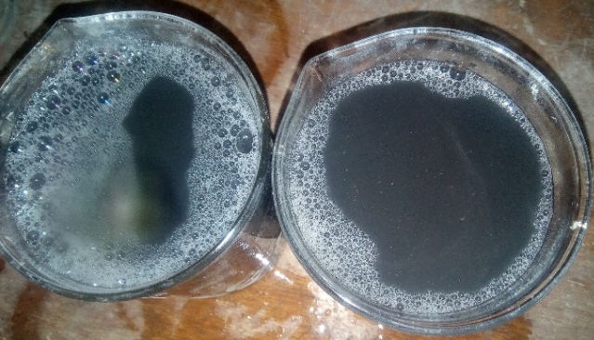
Figure 5; Image of the collected supernatant

3.3.2 Mechanical Experiment

3.3.2.1 Concrete Specimen Preparation
C-30 grade concrete was designed and 27 concrete cubes having dimension of 150mm*150mm*150mm were prepared for compression test and 9 cylinders with dimension 300mm depth by 150mm diameter for splitting tensile strength test were made. All the specimens prepared and casted with three different concentration replacement of mixing water with Graphene solution: zero replacement (control), 50% replacement and100% replacement.
The concrete made with only ordinary tap water as controlling specimen which has no Graphene solution was added. Second class of specimens made with 50% replacement of the mixing tap water with Graphene solution. The other group specimens made with 100% replacement of the mixing tap water with Graphene solution. Despite the concentration difference of Graphene, all the other concrete producing parameters kept the same for all samples which are represented as shown figure 6 below.
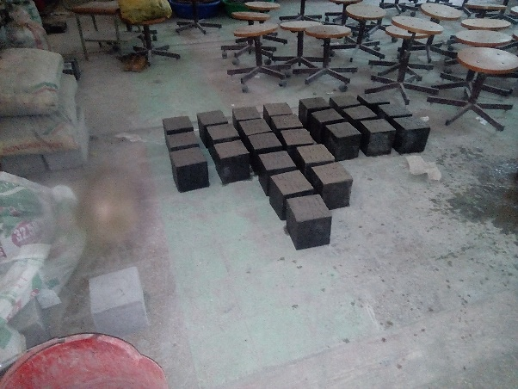
Figure 6; Image specimens for curing

3.4 Mix Design
The mixing ratio has been calculated based on ACI mix design to make C-30 grade concrete. The mix design was calculated using the values obtained from the test conducted on each ingredient of concrete. The mass based ingredient ratio of concrete is shown in table 3 below, the mix design of concrete based on ACI is presented in Appendix B2.
Ingredients | Mixing ratio by weight in Kg | Relative Mixing ratio
Fine aggregate | 857.342 | 2.79
Coarse aggregate | 894.01 | 2.92
Water | 181.27 | 0.59
Cement | 306.56 | 1

Table 3; Portions of ingredients for concrete to make

3.4.1 Concrete Casting
Each of concrete ingredients was weighed according to the above design ratio. The weighed ingredients for each three categories of Graphene concentration were blended before any water or solution added. For the control specimens the prepared dry mix was mixed with water with specified amount on mix design. For experimental specimen’s preparation 50% and 100% of the mixing water was replaced by Graphene solution and applied to the dry mix to obtain 50% and 100% Graphene solution made concrete respectively.
Each mix was casted on lubricated mold in three levels; each level was vibrated as ASTM specification before the next batch poured to the mold. The specimen was left for few minute to dry, then the casted specimens was trimmed.

3.4.2 Concrete Curing
The casted specimens were carefully de-mold after 24 hours, then the specimens were immediately submerged to curing bath containing tap water, which fulfill the requirements: promotion of hydration, elimination of shrinkage and absorption of the heat of
hydration.

3.5 Experimental Tests
One of the important mechanical properties of concrete is the development of compressive strength over time. Therefore, we have tested concrete cubes for 7, 14 and 28 days’ age, in order to know the early age and long term strength values. The Graphene-reinforced concrete samples were compared with standard concrete; control sample group was produced following the same procedure. Compressive and tensile strength tests conducted on concrete cubes and cylinders respectively, which are the most widely used methods for assessing the mechanical properties of concrete. Therefore, in the following sections we have focused on these types of measurements to characterize the mechanical properties of Graphene-reinforced concrete and evaluate the effectiveness of this type of reinforcement.
To identify the samples easily each sample and group are labeled with abbreviations, the signification of each abbreviations are presented in table 4 below.
Symbol | Description of the symbol
C1 | compressive control specimen 1.
C2 | compressive control specimen 2.
C3 | compressive control specimen 3
HG1 | compressive specimen made with 50% replacement of water by Graphene solution 1.
HG2 | compressive specimen made with 50% replacement of water by Graphene solution 2
HG3 | compressive specimen made with 50% replacement of water by Graphene solution 3
FG1 | compressive specimen made with 100% replacement of water by Graphene solution 1
FG2 | compressive specimen made with 100% replacement of water by Graphene solution 2
FG3 | compressive specimen made with 100% replacement of water by Graphene solution 3
T1 | Tensile control specimen 1.
T2 | Tensile control specimen 2.
T3 | Tensile control specimen 3
HGT1 | Tensile specimen made with 50% replacement of water by Graphene solution 1.
HGT2 | Tensile specimen made with 50% replacement of water by Graphene solution 2
HGT3 | Tensile specimen made with 50% replacement of water by Graphene solution 3
FGT1 | Tensile specimen made with 100% replacement of water by Graphene solution 1
FGT2 | Tensile specimen made with 100% replacement of water by Graphene solution 2
FGT3 | Tensile specimen made with 100% replacement of water by Graphene solution 3

Table 4; Abbreviations to the sample identification

3.5.1 Slump Test
Slump test was taken to evaluate workability of concrete paste prepared and if the slump result conforms the assumed value in mix design stage. In this case, the slump was chosen according to the desired grade of concrete for C-30, slump is chosen to be from 25mm to 75mm which are represented as shown figure 7 below.
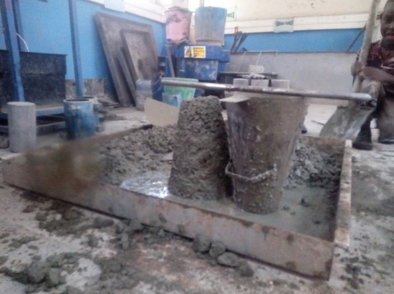
Figure 7; Image of slump test

3.5.2 Compression Strength
The compressive strength of concrete specimens was conducted on three age intervals, 7,14 and 28 days old, using the test machine called ADR Touch Control PRO range. The test was done by applying incremental axial load on the cubic specimen until the specimen failed by crushing.
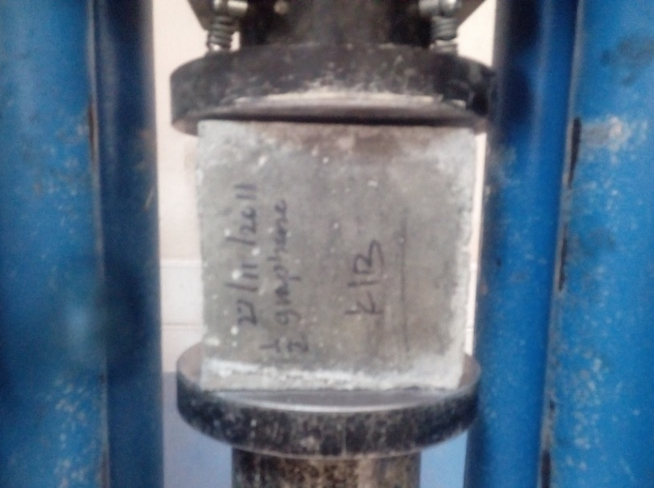
Figure 8; Image of compression Test

3.5.3 Splitting Tensile Strength
As compression test the splitting tensile test was conducted using the same machine. Despite compressive strength test, Tensile strength test conducted for samples 28 days older. The test was done by applying incremental line load across its length on the cylinder specimen until the specimen fail by splitting which are represented as shown figure 9 below.
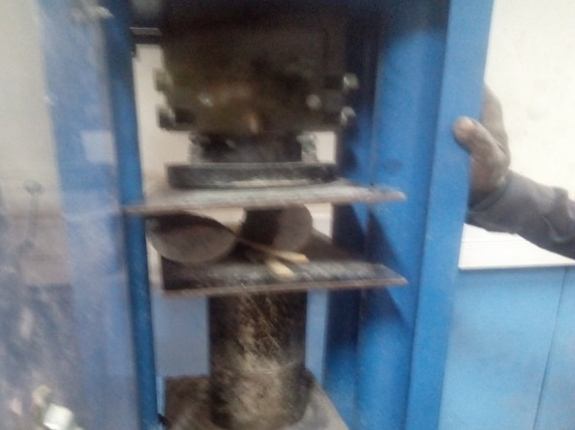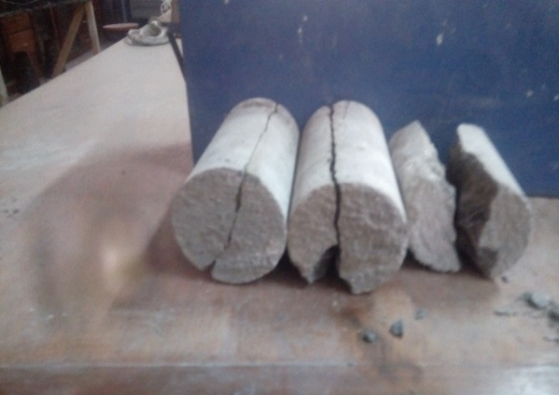
Figure 9; Image of the splitting tensile test

3.5.4 Scanning Electron Microscope (SEM)
Dealing with Nano-materials it is mandatory to evaluate how using those materials affect the concrete C-S-H gel. To analyze how the Graphene incorporated with concrete were evaluated using scanning electron microscope at Addis Ababa science and Technology University. The test is conducted on all concentration level of Graphene solution made concrete specimens, at different level of lens magnification power.

CHAPTER FOUR

RESULT AND DISCUSSION

4.1 Introduction
Here the result obtained based on test conducted on concrete specimens is presented and discussed in detail. The chapter presents the results on three categories: test results at plastic state of concrete, test results of harden concrete specimens and test results of crushed samples using SEM.

4.2 Workability
Workability of the mix was tested through slump test. The slump values for all mix the three mixes presented in figure 10 below. As the graphical representation that there is not much significant effect on the workability of concrete, Graphene solution show slight increment on workability; 3mm increment for 50% Graphene solution replacement of mixing water to 5mm for 100% replacement with Graphene solution.

Figure 10.Image of the slump of the mix

4.3 Compressive Strength
Determining compressive capacity is important and foremost priority while dealing with any type of concrete, the production methodology and the compressive strength test conducted was explained in the previous chapters. As described in chapter 3 the compressive test was conducted on 7, 14 and 28 days old concrete specimens. The obtained results have presented, comparing ordinary concrete with Graphene reinforced concrete and cross comparison between each concentration level of Graphene reinforced specimens.
The compressive strength test results for 7 days’ strength conducted to know the early strength of concrete which is very important parameter in the construction industry, for example determination of the rate of gain in strength of concrete paste. The 7 days’ strength shown in table 5 below.
 | Concrete test specimens
7 days old | C1 | C2 | C3 | HG1 | HG2 | HG3 | FG1 | FG2 | FG3
Failure load in KN | 395.4 | 442 | 478.6 | 547.9 | 527.27 | 621.4 | 521.7 | 450.2 | 552.9
Strength in Mpa | 17.57 | 19.64 | 21.27 | 24.35 | 23.43 | 27.62 | 23.18 | 20.01 | 24.57
Average strength | 19.5 Mpa |  |  | 25.13 Mpa |  |  | 22.59 Mpa

Table 5; 7 days compressive result
The Graphene reinforced concrete show an average 22.435 % more compressive strength at 7 days of age than conventional concrete sample, with 50% replacement of mixing water by Graphene solution. The compressive strength specimens made 100% replacement of mixing water by Graphene solution show an average 13.695 % more compressive strength than the conventional concrete which is represented as shown figure 11 below.

Figure 11; Comparison of 7 days compressive strength
The 14 days of age Graphene reinforced concrete test results, which presented in table 6. The 14 days’ test was conducted to evaluate the effect of Graphene on strength development of concrete. The result obtained show an average 14.456% and 8.393 % increment in compression capacity than the conventional control concrete by replacing the mixing water 50% and 100% with Graphene solution as shown figure 12 below.
 | Concrete test specimens
14 days old | C1 | C2 | C3 | HG1 | HG2 | HG3 | FG1 | FG2 | FG3
Failure load in KN | 466.4 | 577.8 | 539.4 | 764.55 | 643.5 | 715.05 | 595.8 | 640.57 | 500.17
Strength in Mpa | 20.73 | 25.68 | 24.30 | 33.98 | 28.60 | 31.78 | 26.48 | 28.47 | 22.23
Average strength | 23.57Mpa |  |  | 27.55Mpa |  |  | 25.73Mpa

Table 6; 14 days compressive test result

Figure 12; 14 days compressive strength test result

The 28 days’ result also show an average 33.45% more compression capacity than the control by replacing 50% of mixing water by Graphene solution, specimens made with entirely mixing by the Graphene solution test result show an average 16.49 % improvement on compression strength as shown in figure 13 below. The results obtained from compression test are presented in table 7 below.
 | Concrete test specimens
28 days old | C1 | C2 | C3 | HG1 | HG2 | HG3 | FG1 | FG2 | FG3
Failure load in KN | 764.6 | 643.6 | 715 | - | 1081 | 1046 | 842.8 | 746.9 | 919.6
Strength in Mpa | 33.98 | 28.6 | 31.78 | - | 48.04 | 46.95 | 37.46 | 34.67 | 40.87
Average strength | 31.45Mpa |  |  | 47.5Mpa |  |  | 37.67Mpa

Table 7; 28 days compression test result

Figure 13; Comparison of 28 days’ average strength

The obtained result of Graphene solution on compressive capacity of concrete is quit mandatory and formost important since, concrete not doughted for its compresstion stress resistance. Such imense increment in compression strength entirly change the concrete based constructon industry and make concrete to be more structural effecent material. Using such structural capable material has made structures to be lighter and stronger, which provide two advantantages at time. The obtained increment in compression capacity is sumrized in figure 14 below.
Increment in compression strength can be utilized by reducing the cross-sectional dimenstion of structural elements, for structures mass is not mandatory like Dam. In such case, the structure become lighter makes the structures subjected to less deadload because of reduction in selfweight of the structure. Lighter have crusial advantage withstanding seviour Earth force like earth quake.

Figure 14; Percentage improvement of Graphene reinforced concrete

Such compression capacity improvement not only affect the structural aspect, but also have economical and enviromenntal impact. Material having enough early strength has made structures to built in much shorter period of time and cost. Not only the time and cost of construction will be affect but also the cost of material specially cement can be reduced due to the possiblity of reducing the cement content needed for concrete production. As consiquence of cement reduction needed for concrete production, provide additional benefit on reduction of global carbon emission, since cement industry contrbute about 5% emission of carbon per year.
4.4 Tensile Strength
As desried in chapter 3 the tensile strength of concrete specimens were collected from splitting tensile strength test. The resuts obtained show improvement in the tension capacity of concrete. The 28 days tensile strength each specimens shown in table 8 below.
 | Concrete specimens
28 Days Old | C1 | C2 | C3 |  | HG1 | HG2 | HG3 | FG1 | FG2 | FG3
Failure Load In KN | 74.18 | 63.74 | 68.96 |  | 104.8 | 137.5 | 121.2 | 78.62 | 76.52 | 74.41
Strength In Mpa | 3.31 | 2.83 | 3.06 |  | 4.66 | 6.12 | 5.38 | 3.31 | 3.40 | 3.49
Average Strength | 3.07 Mpa |  |  | 5.39 Mpa |  |  |  | 3.46 Mpa

Table 8; Tensile strength test result

The specimens made with Graphene solution show improvement in tension capacity,the specimens made with repacing 50% of mixing water with Graphene solution shows 43% improvement in tension capacity and the specimens made with 100% replacment of mixing water with Graphene solution shows 7% improvement in tension capacity.The average tensile strength of each samples presented figure 15 below.

Figure 15; Comparison of splitting tensile strength

4.5 Modulus of Elasticity
Modulus of elasticity is calculated based on ES-EN 1992-2015 as presented in chapter 2 the calculated values of each of the sapmles presented and descussed in this chapter. This only to implicate the effect of Graphene solution on Modulus of Elasticity.
The Graphene reinforced concrete shows improvement in modulus of elasticity, this is one of the crtical parameter needed to be considered in structural material evaluation, because of material having high modulus of elasticity has exhibited elastic high range of elastic deformation to resist the applied stress than those with less modulus of elasticity.
From compressive strength test results for 7 days’ strength conducted to know the early strength of concrete, the Graphene reinforced concrete show 10% more calculated Modulus of elasticity than conventional concrete sample with 50% replacement of mixing water, and 7% more modulus of elasticity for 100% replacement of Graphene solution as shown in table 9 below.
 | Concrete Test Specimens
7 days old | C1 | C2 | C3 | HG1 | HG2 | HG3 | FG1 | FG2 | FG3
Strength in Mpa | 17.57 | 19.64 | 21.27 | 23.18 | 20.01 | 24.57 | 24.35 | 23.43 | 27.62
Modulus of Elasticity | 26.05 | 26.94 | 27.59 | 28.31 | 27.09 | 28.81 | 28.73 | 28.40 | 29.84
Average Modulus of elasticity | 26.86 Mpa |  |  | 28.07 Mpa |  |  | 28.99 Mpa

Table 9; Calculated 7 days modulus of elasticity

 | Concrete Test Specimens
14 days old | C1 | C2 | C3 | HG1 | HG2 | HG3 | FG1 | FG2 | FG3
Strength in Mpa | 17.57 | 19.64 | 21.27 | 23.18 | 20.01 | 24.57 | 24.35 | 23.43 | 27.62
Modulus of elasticity | 27.38 | 28.72 | 29.19 | 30.11 | 27.96 | 29.46 | 31.95 | 33.56 | 32.7
Average Modulus of elasticity | 28.43 |  |  | 29.17 |  |  | 32.74
The 14 days of age Graphene reinforced concrete show 13% and 3% increment in Modulus of elasticity than the control concrete specimens for replacing the mixing water by 50% and 100% respectively as shown in table 10 below.

Table 10; Calculated 14 days modulus of elasticity

Calculated modulus of elasticity using 28 days’ compressive strength values also show enhanced value of modulus of elasticity. The calculated values presented in table 11 below.
 | Concrete Test Specimens
28 days old | C1 | C2 | C3 | HG1 | HG2 | HG3 | FG1 | FG2 | FG3
Strength in Mpa | 17.57 | 19.64 | 21.27 | 23.18 | 20.01 | 24.57 | 24.35 | 23.43 | 27.62
Modulus of elasticity | 30.66 | 29.21 | 29.54 | 31.75 | 30.15 | 31.12 | 34.88 | 35.23
Average Modulus of elasticity | 29.80 |  |  | 31.07 |  |  | 35.05

Table 11; Calculated 28 days modulus of elasticity
Based on the calculated values, 15% improvement on average modulus of elasticity than the conventional concrete by replacing 50% of mixing water by Graphene solution was obtained. For specimens made with 100% replacement of mixing water by the Graphene solution calculated results show 4% improvement on average Modulus of elasticity. The effect of Graphene on Modulus of elasticity of concrete is quit important. Since concrete modulus of elasticity used as vital parameter to select a material as structural frame work.

Figure 16; Calculated modulus of elasticity percentage improvement
Based on this resarch the Graphene incorporation shows improvement to compressive, tensile and calculated modulus of elasticity as shown in figure 16, thus the maximum improvement to the concrete property is obtained using 50% replacement of the mixing water by the Graphene solution.

4.6 SEM Results and Discussion
Until this point I have shown that how much Graphene based solution improved the mechanical capacity of concret, now I will discuss how this improvement are came from and how Graphene cause such termendious improvement on conrete based on the result obtained from scanning electron micro-scope. The obtaind result disscused on two catagories, 1) compressive strength and tensile stength and 2) permiability of concrete.

4.6.1 Compressive and Tensile Strength Evaluation based on SEM
Concrete is composite material made from cement, fine and coarse aggretgate blended with water as mixer, such blending of cement is cause chemical reaction and hence the cement powder transform to fibrous crystals (Figure 17) containing mainly calcium silicates, alumina ferrites, and calcium hydroxide (Ca(OH)₂).
Figure 17; SEM image of conventional concrete
These silicate crystals form the calcium silicate hydrate (C–S-H) gel have given the mechanical properties of concrete. Addition of Graphene improves the mechanical property of concrete by integrating and forming bond with these crystal formations as presented (figure 18 and 19).

Figure 18; SEM image of 50% mixing water replaced Graphene reinforced concrete

Due to Graphene high modulus of elasticity and wide surface area, the formed crystalline have meshed crystal structure by making Graphene as center of boding, this create much strong crystal because of high modulus of elasticity of Graphene the concrete elastic stress resistance capacity is increased. Moreover, the incorporation of Graphene minimized capillary cavities and crack voids in concrete crystalline matrix, this is very much important because compressive and other mechanical property are highly dependent on capillary cavities of concrete.
Figure 19; SEM image of100% mixing water replaced Graphene reinforced concrete

4.6.2 Permeability of Graphene Reinforced Concrete based on SEM
Permeability of concrete is one of the crucial properties of concrete, which determine the durability of concrete. Generally, the durability of concrete depends on the capacity of a water to enter its crystalline matrix of concrete. The addition of Graphene solution to concrete mix in replacement of mixing water show change on crystalline matrix of concrete.
As presented in figure 18 and 19 the Graphene plate minimizes and cover the capillary cavities formed, which is critical to minimize the permeability, since one of two main pathways to infiltrate into concrete is through capillary cavities, the other is due to shrinkage, creep and load caused cracks.

CHAPTER FIVE

CONCLUSION AND RECOMENDATION

5.1 Conclusion
The effect of Graphene was studied based on applying two concentration level of Graphene based solution to replace the mixing tap water. The production of Graphene is choosing to be as simple as possible, can be upgrade to industrial level mass production and much easy to incorporate Graphene Solution Onsite production of concrete, also Graphene production to be environmental friendly.
Based on this, shear exfoliation method satisfied all the conditions described. The Graphene reinforcement effect was investigated by classifying the specimens by ages 7,14 and 28 for compressive strength and 28 days old for splitting tensile strength.
Based on result obtained and disscussed in chapter 4, the following conclusions are made:
- Addition of Graphene sloution shows improvement on basic compression capacity of concrete specially on compressive capacity of concrete by 33% more capacity than the conventional concrete. There for Graphene reinforced concrete is better than the conventional concrete.
- Due to addition of the Graphene based solution tensile strength capacity is improvemed by 43%, From this, Graphene reinforced concrete have much better tensile capacity than convental concrete.
- From the obtained results the 50% replacement of mixing water by Graphene solution show much more improvement than those made with 100% replacement of mixing water. Therefor,better concrete capacity is obtained by using 50% replacement than 100% replacement of mixing water.

5.2 Recommendation
The present study describes a convenient, economic and user-friendly protocol for the successful produce of Graphene reinforced concrete using liquid phase shear exfoliated Graphene Nano-plates.
The outcomes from this research revealed that most of the Graphene solution could serve as lead for the development of better structural material.
It is expected that additional progress could contribute further development of Graphene reinforced concrete, for these reason the following recomendtions will be set:
- Further investigation on the effect of Graphene solution for other different strength of concrete classes.
- Analysis of modulus of elasticity based on direct test approch has to investigated.
- Another investigation has to made on the effect of using the locally avaliable natural Graphite for Graphene production.

References
Abro, M. (2015). Modelling the exfoliation of graphite for production of graphene Mehwish Abro.
ASTM Committee. (2001). ASTM C 33 SPECIFICATION FOR Concrete Aggregates1. Annual Book of ASTM Standards, 04(4), 4–7.
Ayub, T., Khan, S. U., & Memon, F. A. (2014). Mechanical characteristics of hardened concrete with different mineral admixtures: A review. The Scientific World Journal, 2014. https://doi.org/10.1155/2014/875082
Bernal, M. M., & Milano, D. (2014). Two-dimensional nanomaterials via liquid-phase exfoliation: synthesis, properties and applications. Carbon Nanotechnology, 159–185.
Bharech, S. and R. K. (2015). A review on the properties and applications of perfluorocarbon emulsions. Journal of Material Science and Mechanical Engineering (JMSME), 2(1), 70–73.
Dimov, D., Amit, I., Gorrie, O., Barnes, M. D., Townsend, N. J., Neves, A. I. S., … Craciun, M. F. (2018). Ultrahigh Performance Nanoengineered Graphene–Concrete Composites for Multifunctional Applications. Advanced Functional Materials, 28(23). https://doi.org/10.1002/adfm.201705183
Haar, S., Bruna, M., Lian, J. X., Tomarchio, F., Olivier, Y., Mazzaro, R., … Samorì, P. (2016). Liquid-Phase Exfoliation of Graphite into Single- and Few-Layer Graphene with α-Functionalized Alkanes. Journal of Physical Chemistry Letters, 7(14), 2714–2721. https://doi.org/10.1021/acs.jpclett.6b01260
Jafarbeglou, M., Abdouss, M., & Ramezanianpour, A. (2015). Nanoscience and Nano Engineering in Concrete Advances , A Review. International Journal of Nanoscience and Nanotechnology, 11(4), 263–273.
Jones, A., & Safron, N. (2004). Mechanical Exfoliation to Make Graphene and Visualization Instructor Preparation and Discussion Mechanical Exfoliation to Make Graphene and Visualization Student Instructions Background. 2–4.
Kauppila, J. (2014). Graphene From Graphite By Chemical and Physical.
Liam A. Bullock, & Owen J. Morgan. (2015). A New Occurrence of (Gold-Bearing) Graphite in the Assosa Region, Benishangul-Gumuz State, W Ethiopia. Journal of Earth Science and Engineering, 5(7), 417–435. https://doi.org/10.17265/2159-581x/2015.07.003
Pam, H. J., Kwan, A. K. H., & Islam, M. S. (2001). Flexural strength and ductility of reinforced normal- and high-strength concrete beams. Proceedings of the Institution of Civil Engineers: Structures and Buildings, 146(4), 381–389. https://doi.org/10.1680/stbu.2001.146.4.381
Paton, K. R., Bhuvaneshwari, B., Sasmal, S., Iyer, N. R., Nie, Q., Zhou, C., … Engineer, M. (2014). Edited by. Procedia Materials Science, 7(2), 3772–3785. https://doi.org/10.1016/j.mspro.2015.06.032
Rattan A, Sachdeva P, & Chaudhary A. (2016). Use of Nanomaterials in Concrete. In International Journal of Latest Research in Engineering and Technology (IJLRET) www.ijlret.com || (Vol. 02, pp. 81–84). Retrieved from www.ijlret.com
Shetty Be, M. S. (2000). CONCRETE TECHNOLOGY THEORY AND PRACTICE Multicolour Illustrative Edition (An ISO 9001 : 2000 Company). 055. Retrieved from https://www.amieindia.in/downloads/ebooks/concrete-tech.pdf
Tripathi, P., Patel, C. R. P., Shaz, M. A., & Srivastava, O. N. (2013). Synthesis of High-Quality Graphene through Electrochemical Exfoliation of Graphite in Alkaline Electrolyte. Retrieved from http://arxiv.org/abs/1310.7371
Varrla, E., Paton, K. R., Backes, C., Harvey, A., Smith, R. J., McCauley, J., & Coleman, J. N. (2014). Turbulence-assisted shear exfoliation of graphene using household detergent and a kitchen blender. Nanoscale, 6(20), 11810–11819. https://doi.org/10.1039/c4nr03560g
Wight, J. g. M. and J. k. (2005). Reinforced Concrete Mechanics And Design. Retrieved from http://www.ghbook.ir/index.php?name=فرهنگ و رسانه های نوین&option=com_dbook&task=readonline&book_id=13650&page=73&chkhashk=ED9C9491B4&Itemid=218&lang=fa&tmpl=component
Wong, G. S., Alexander, A. M., Haskins, R., Poole, T., Malone, P., & Wakeley, L. (2001). Portland-cement concrete rheology and workability: Final Report. FHWA-RD-00-025. (April), 117.
Yang, H., Hernandez, Y., Schlierf, A., Felten, A., Eckmann, A., Johal, S., … Casiraghi, C. (2013). A simple method for graphene production based on exfoliation of graphite in water using 1-pyrenesulfonic acid sodium salt. Carbon, 53(0), 357–365. https://doi.org/10.1016/j.carbon.2012.11.022
Zheng, Q., Han, B., Cui, X., Yu, X., & Ou, J. (2017). Graphene-engineered cementitious composites: Small makes a big impact. Nanomaterials and Nanotechnology, 7, 1–18. https://doi.org/10.1177/1847980417742304

APPENDIX

Appendix A: Graphene production
A method of shear-exfoliation of Graphite to give Graphene that is industrially scalable. This involves using a high-shear, house hold mixer in this case Philips 7761 model to produce Graphene in stabilizing solvents as well as polymer- or surfactant solutions.
Equipment’s and ingredients’
Shear applying machine –Philips 7761 model house hold food processing machine. With rotation capacity up to 21000rpm, with blender capacity 1000ml for things that foam but for others 1750ml and 2 min working capacity for blender with 750Watt motor power.
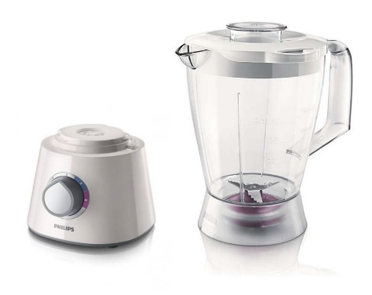
Figure A 1; Philips 7761 house hold blender (food processer)
The blender is mixing Graphite powder in an aqueous surfactant solution. The surfactant used is the household detergent, Ariel.
Producing Graphene was done by adding 500ml of distilled water to blending jar, adding 100mg/ml of Graphite powder and one to eight by ratio (1:8) to the Graphite the surfactant will be added meaning for 1mg of surfactant 8mg of Graphite. Applying shear by starting the mixer and operate the mixer for two minute without any interruptions and let to rest for about 1minute and doing this for 45 operation minutes. Then the solution poured out from the jug and let to decant for two weeks and the supernatant is collected.
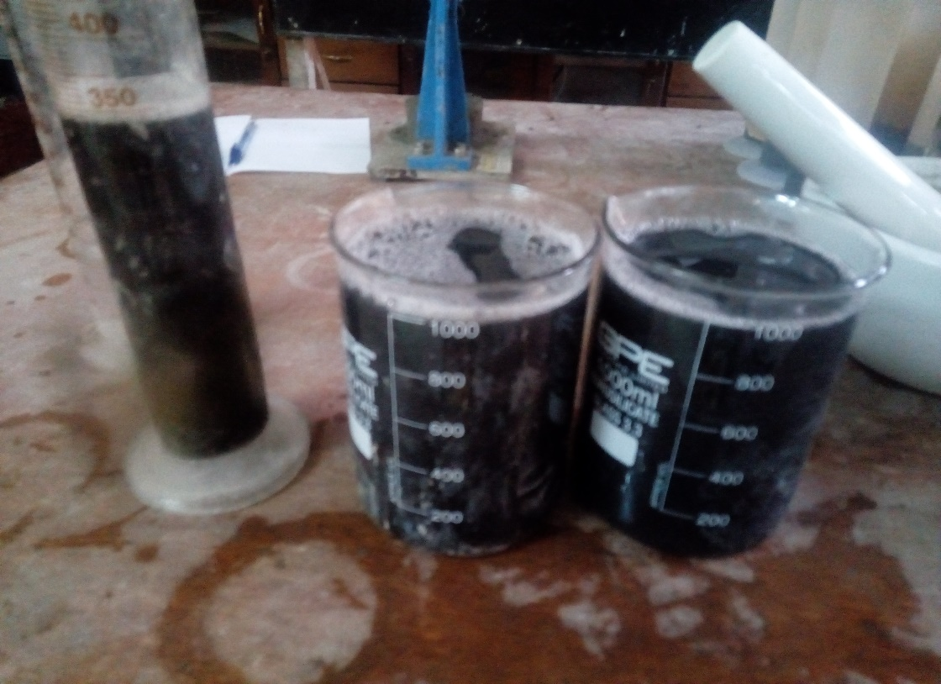
Figure A 2; Collected supernatant

Appendix B1: Material Quality Tests and Mix Design
The quality of material has been evaluated based ASTM procedures and used when they meet the required quality.
Coarse Aggregate
First of all the purchased aggregate was washed to clean the dust and mud on its surface and set to dry on plastic rug after that the following aggregate quality test has been conducted.
The Bulk Density
The bulk density of aggregate was done based on ASTM C29-99 method and procedure. The materials used to calculate the Balace, tamping rod and measure cylinder should be water tight capacity of the measure is depends on maximum aggregate size see table on ASTM C29-99.Since our aggregate maximum size is less than 37.5mm can use the Jigging Procedure.
Jigging Procedure
Step1 seive the aggregate sample on seive size 37.5mm remove the retained and collect the passed samples.
Step2 fill the measure in three layer by blowing each layer 25 times by the tamping rod and roll the rod over the measure to trime the fill.
Step3 determine the measure containing the aggregate mass (G) and the measure alone (T) and record the values.
Step4 determine the voume of the measure (V) using water by filling the measure or by calculation of its internal dimenstion using water is accurate and specifed by the ASTM.
Step 5 calculating the bulk density (M) using the formula given
$$M=\frac{G-T}{V}$$
# in this case I measure the following
G=15.3 Kg ,T=8.15Kg and 0.05m³
$$M=\frac{15.3-8.15}{0.05}$$
M=1347.9Kg/m³
The values obtained from the test are summerized below
Dry Density
Mold + Sample Aggregate | 15.27
Mold Mass | 8.13
Mold Volume | 0.053
Silt Content | 3.8%
 | dry density |  | 1347.9Kg/m³

Table B 1; summary of dry density of coarse aggregate
Specific gravity and absorption
The test is conducted based on ASTM C127 procedure. Equpment needed for this test procedure are balance, nested can to submerge the sample, towl to dry the surface and oven.
A sample of aggregate is immersed in water for approximately 24 h to essentially fill the pores. It is then removed from the water, the water dried from the surface of the particles, and
weighed. Subsequently the sample is weighed while submerged in water. Finally, the sample is oven-dried and weighed a third time. Using the weights thus obtained and formulas in this test method, it is possible to calculate three types of specific gravity and absorption. (from ASTM)
A=weight of oven dry test sample
B=weight of saturated-surface-dry test sample in air
C1= weight of saturated test sample in water before soaking in water
C2= weight of saturated test sample in water after soaking in water
Bulk Specific gravity (Bsp)
Bsp==A/(B-C1)
A=4.98Kg, B=5.035Kg and C1=3.04Kg
Bsp=4.98/ (5.035-3.04)
Bsp=2.49624
Bulk saturated Specific gravity (Bssp)
Bssp==A/(B-C2)
A=4.98Kg, B=5.035Kg and C=3.07Kg
Bssp=4.98/ (5.035-3.07)
Bssp=2.53435
Absorption (Ab)
Ab=(B-A)/A
Ab= (5.035-4.98)/4.98
Ab=1.10%
The sumirzed calculated values are presented below in table B2.
SPECIFIC GRAVITY OF COARSE
submerged weight before 24hr | 3.04kg |  | Bulk Specific Gravity
submerged weight after 24hr. | 3.07kg |  | Bulk Specific Gravity Saturated Surface Dry | 2.53
saturated surface dry | 5.035kg |  | Absorption | 1.10%
 |  |  | Apparent | 2.56
oven dry | 4.98kg |  | Moisture | 0.40%
Table B 2; Summary of specific gravity of fine aggregate

Sieve Analysis
Coarse Aggregate
For increasing accuracy the gradition test id done twice for a sample.the test is done based on ASTM C136. The equpments used are balance, seives and shaker machine.
Procedure is that assembling the seives in desending order and fix on the shaking machine, aplly 2Kg weighted sample on the top and start saking for several meinutes, after doing this measure each saple retained on the seive and record the data, the value obtained in this research presented Table B 3 below.
SIEVE NO | SIEVE SIZE | RETAINED MASS | CUMULATIVE % RETAINED | % Finer by mass
 | 37.5 | 0 | 0 | 100
 | 25 | 0.38 | 19 | 81
 | 19.5 | 0.995 | 49.75 | 50.25
 | 14 | 1.64 | 82 | 18
 | 10 | 1.92 | 96 | 4
 | 9.5 | 1.945 | 97.25 | 2.75
 | 4.75 | 1.995 | 99.75 | 0.25
Pan | 0 | 2 | 100 | 0

Table B 3; First sieve analysis for coarse aggregate

Figure A 3;First sieve analysis for coarse aggregate

SIEVE NO | SIEVE SIZE | RETAED MASS | CUMULATIVE % RETAINED | % Finer by mass
 | 37.5 | 0 | 0 | 100
 | 28 | 0.14 | 7 | 93
 | 25 | 0.28 | 14 | 86
 | 20 | 0.582 | 29.1 | 70.9
 | 14 | 1.245 | 62.25 | 37.75
 | 10 | 1.66 | 83 | 17
 | 9.5 | 1.705 | 85.25 | 14.75
 | 4.75 | 1.99 | 99.5 | 0.5
Pan | 0 | 2 | 100 | 0

Table B 4; Second sieve analysis for coarse aggregate

Figure A 4; Second sieve analysis for coarse aggregate
To determine the gradition quality using D10, D30 and D60 percentage pass for this aggregate size calculated the uniformity coefficent.

For 1st analysis
Uniformity coefficent (UC) finess modulus (FM)and cofficent of curvature (CC)
D10=12, D30=16 and D60=21
FM=$(\sum{\% finer)}$/100
FM= 4.4375
$$UC=\frac{D60}{D10}$$
$$CC=\frac{{D30}^{2}}{(D10*D60)}$$
UC=21/12 CC=(16²)/(12*21)
UC=2.27 CC=1.09
There for the Aggregate is WELL GRADED
For second Analysis
Uniformity coefficent (UC) finess modulus (FM)and cofficent of corilation (CC)
D10=7.9, D30=13 and D60=18
FM=$(\sum{\% finer)}$/100
FM= 3.08
$$UC=\frac{D60}{D10}$$
$$CC=\frac{{D30}^{2}}{(D10*D60)}$$
UC=18/13 CC=(13²)/(7.9*18)
UC=1.81 CC=1.035
There for the Aggregate is WELL GRADE
Fine Aggregate
Seive Analysis for fine aggregate is done based on ASTM C136 as of the coarse aggregate here we only use 500gm of fine aggregate sample. Since the procedure is the same only calculation the results are presented in Table B 5.

Sieve No | Sieve Size | Retained Mass | Cumulative % Retained | % Finer By Mass
4 | 4.75 | 0.00 | 0.00 | 100.00
8 | 2.36 | 0.05 | 10.10 | 89.90
16 | 1.18 | 0.17 | 33.33 | 66.67
30 | 0.6 | 0.35 | 70.71 | 29.29
50 | 0.3 | 0.46 | 92.93 | 7.07
100 | 0.15 | 0.49 | 98.99 | 1.01
pan | 0 | 0.50 | 100.00 | 0.00

Table B 5; First sieve analysis for fine aggregate

Figure A 5; First sieve analysis for fine aggregate

Sieve No | Sieve Size | Retained Mass | Cumulative % Retained | % Finer By Mass
4 | 4.75 | 0.00 | 0.00 | 100.00
8 | 2.36 | 0.02 | 4.08 | 95.92
16 | 1.18 | 0.18 | 36.73 | 63.27
30 | 0.6 | 0.37 | 75.51 | 24.49
50 | 0.3 | 0.45 | 91.84 | 8.16
100 | 0.15 | 0.49 | 100.00 | 0.00
pan | 0 | 0.49 | 100.00 | 0.00

Table B 6; Second sieve analysis for fine aggregate

Table B 7; Second sieve analysis for fine aggregate
To determine the gradition quality using D10, D30 and D60 percentage pass for this aggregate size has been calculated the uniformity coefficent.
For 1st analysis
Uniformity coefficent (UC) finess modulus (FM)and cofficent of curvature (CC)
D10=0.34, D30=0.61 and D60=1.08
FM=$(\sum{\% finer)/100}$
FM= 3.06
$$UC=\frac{D60}{D10}$$
$$CC=\frac{{D30}^{2}}{(D10*D60)}$$
UC=1.08/0.34 CC=(0.61²)/(0.34*1.08)
UC=3.18 CC=1.02
Therefor the Aggregate is WELL GRADED
For second Analysis
Uniformity coefficent (UC) finess modulus (FM)and cofficent of corilation (CC)
D10=0.33, D30=0.68 and D60=1.06
FM=$(\sum{\% finer)}$/100
FM= 3.08
$$UC=\frac{D60}{D10}$$
$$CC=\frac{{D30}^{2}}{(D10*D60)}$$
UC=1.06/0.33 CC=(0.68²)/(0.33*1.06)
UC=3.17 CC=1.32
Therefor the Aggregate is WELL GRADED
Specific gravity of fine aggregate
The test is conducted based on ASTM C128,the equipment needed for this test are balance, picometer,Flask and mold and tamper for surface moisture test,sample 500mg of fine aggregate
Test Procedure
Partially fill the pycnometer with water. Introduce into the pycnometer 500 gm of saturated surface-dry fine aggregate prepared, and fill with additional water to approximately 90 % of capacity. Agitate the pycnometer manually roll, invert, and agitate the pycnometer to eliminate all air bubbles. Remove the fine aggregate from the pycnometer, dry to constant mass at a temperature of 110 °C, cool in air at room temperature for 1.5 hr., and determine the mass. Determine the mass of the pycnometer filled to its calibrated capacity with water. Record all the data available
A=mass of oven dry specimen
B= Mass of pycometer filled with water at calibration mark
C=Mass of pycometer filled with water and fine aggregate to calibration mark.
S = mass of saturated surface-dry (initial sample= 500mg))
In this test
A=0.48Kg, B=2.32Kg, S=and C=2.61Kg
Specific Gravity (SD)
$$SD=\frac{A}{B+S-C}$$
$$SD=\frac{0.5}{2.32+0.5-2.61}$$
= 2.41
Saturated Specific Gravity (SSD)
$$SSD=\frac{S}{B+S-C}$$
$$SSD=\frac{0.48}{2.32+0.5-2.61}$$
=2.53
Absorption
$$Ab=\frac{S-A}{A}*100$$
$$Ab=(\frac{500-480}{480})*100$$
=4.17%
The calculated values are summarized in table B8 below.
SPECIFIC GRAVITY OF SAND
Sample SIZE | 500mg
Sample + pycometer+ water | 2.61kg
mass of pycometer | 0.335kg |  |  | bulk specific gravity | 2.41
pycometer fill with water till the indication | 2.32kg |  |  | apparent=2.53
volume of pycometer | 2000 ml |  |  | absorption | 4.17%
sample oven dry mass | 0.48 kg |  |  | moisture | 4.17%

Table B 8; Summary of specific gravity for fine aggregate
Silt Content of Fine Aggregate
The test is conducted to determine the amount of silt content on fine aggregates the ASTM stets maximum limitation for to 6% of the fine aggregate by volume.
Equipment’s used are cylinder which have volume measurement on its surface and capable of having 1000ml of water, balance.
Procedure
Weigh 500mg of fine aggregate and poured to the cylinder then add water until the reading is equal to 1000ml, know cover the top of cylinder with hand and sake for few minutes and set to precipitate by itself in leveled place, after 1 hr read the amount of dust which accumulate at the top of the fine aggregate.

Calculation
Silt content= (volume of silt /total volume of sand) *100
Silt content in our case
S=3.08%

Appendix B2; Mix Design
All the calculated values necessary for mix design are tabulated below
 | Parameters | tested value
Fine
 | Bulk specific gravity | 2.41
 | Absorption | 4.20%
 | Silt content | 3.80%
 | Fines modules | 3
Coarse
 | Bulk specific gravity | 2.496
 | Bulk saturated surface dry specific gravity | 2.534
 | Absorption | 1.10%
 | Dry density | 1347.9

Table B 9; Summary of test value for mix design
Choosing appropriate slump value between 75 to 100 mm and having the maximum
aggregate size of 28 mm weight of water and air contents can be estimated using ACI (
A1.5.3.3 TABLE A1.5.3.3 ) therefore the approximate weight of water estimated from
the code is 187 kg/m3 and with non-air entrained concrete with water to cement ratio 0.61 value from the above table.
W/C=0.61 since W=187Kg/m³
Cement Content =(187Kg/m³)/0.61
= 306.557 Kg/m³
Using Table A1.5.3.6 the content of coarse aggregate calculated after having the value of
fineness modulus is 3 and maximum aggregate size 28mm. Interpolation the vale from table became then the weight of course aggregate calculated as, 0.6596 *1347.9Kg/m³
Weight of course aggregate = 0.6596 *1347.9Kg/m³ =889.01 Kg/m³
Fine Aggregate content can be estimated by volume can be determined by dividing each sample weight by density of itself.
Water
$$Vw=\frac{\frac{187Kg}{m3}}{1000}$$
Were 1000 is unit weight of water
Vw =0.187 m³
Cement
$$Vc=\frac{\frac{306.557Kg}{m3}}{\left(3.15*1000\right)}$$
Vc =0.0973 m³
Coarse Aggregate
$$Vca=\frac{\frac{889.01Kg}{m3}}{\left(2.45*1000\right)}$$

Vca =0.3629 m³
Assuming 1% of air contribution of the whole volume Va=1%
V of concrete =Va + Vw + Vc + Vca + Vfa
1m³=Vfa-(0.187+0.0973+0.3629)
Vfa=0.3428m³
Calculating the weight of fine aggregate
$$Wfa=SSD*1000*Vfa$$
$$=826.195 Kg$$
Correction absorption and moisture content of the aggregates
Absorption fine aggregate Apfg=4.17%
Absorption coarse aggregate Apcg=1.10 %
Moisture content coarse aggregate Mpfg=0.4%
Moisture content fine aggregate Mpcg=0.5%
Net absorption =Ap - Mp
Were Ap= absorption and Mp= moisture content
For fine aggregate
Net absorption=4.17-0.4
=3.77%
For coarse aggregate
Net absorption=1.10-0.5
=0.6%
Corrected weight of Fine aggregate
= (1+0.0377) *826.195
=857.342 Kg
Corrected weight of coarse aggregate
= (1+0.006) *889.01
=894.01 Kg
Proportioning to my size of sample
27 cubes of 150*150*150 mm sized are used for compression and 9 cylinders of 150 diameters with 300mm depth are used for splitting test
Total volume needed 10% wastage
=27*(0.003375) m³+9*(0.0052988) m³
=1.1*0.138813
=0.15269m³
Amount of ingredients for 0.15269m³
Water = 181.26*0.15269
=27.67 Kg
Coarse aggregate = 0.15269*894.01
=136.506 Kg
Fine Aggregate = 0.15269*857.342
=130.91 Kg
Based on mass basis all in kg |  | Mixing ratio
fine aggregate | 857.342 | 2.79668
coarse aggregate | 894.01 | 2.91629
water | 181.27512 | -
cement | 306.55738 | 1

Table B 10; Mix ratio for concrete

Appendix C: Graph of compressive test result

Figure A 6; Load- time for 7 days obtained from compression machine

Figure A 7; Load- time for 14 days obtained from compression machine

Figure A 8; Load- time for 28 days obtained from compression machine

