

HAWASSA UNIVERSITY
INSTITUTE OF TECHNOLOGY, FACULTY OF INFORMATICS
DEPARTMENT OF COMPUTER SCIENCE

Improving delay tolerant network buffer management approach for rural area’s health professionals’ information exchange system.
Prepared By
Mulusew Abebe
A Thesis submitted to the Department of Computer Science, Faculty of Informatics, Hawassa University, Institute of Technology, and School of Graduate Studies, in meeting the partial fulfillment for the award of Degree of Master in Computer Science.

Principal Advisor: Dr. Basant Tiwari (HU)

Co-Advisor: Mr. Zemenu Haile (HU)

Hawassa University
March, 2022
Hawassa, Ethiopia

APPROVAL SHEET
Hawassa University School of Graduate Studies Thesis Approval Sheet

Submitted by:
Mulusew Abebe Jofe _____________________ ___________________
Student Date Signature
Approved by:
Basant Tiwari (PhD) _______________________ ___________________ Principal Advisor Date Signature
Zemenu Haile (MSc) _______________________ ___________________
Co- Advisor Date Signature
_____________________ _______________________ ___________________
Chairman Dep’t Date Signature
_____________________ ________________________ ___________________
Graduate Committee Date Signature

Table of Contents
Acknowledgement vi
List of Figures vii
List of tables viii
Acronyms ix
Abstract 1
CHAPTER ONE 2
INTRODUCTION 2
1.1. Background 2
1.2. Problem Statement 3
1.3. Research Question 5
1.4. Objectives of the study 5
1.4.1. General Objective 5
1.4.2. Specific Objectives 5
1.5. Scope and Limitation of the study 6
1.6. Significance of the study 6
1.7. Thesis Structure 6
CHAPTER TWO 7
LITRATURE REVIEW 7
2.1. Introduction 7
2.2. History of Delay Tolerant Networks (DTNs) 7
2.3. Delay Tolerant Networks 8
2.4. Architecture of DTN 9
2.4.1. Bundle layer 10
2.4.2. Store-carry-forward technique 12
2.4.3. Custody transfer mechanism 13
2.5. Routing in Delay Tolerant Network 13
2.5.1. Description of the selected routing protocol for the proposed framework 15
2.6. DTN Buffer Management 15
2.6.1. Policies that do not require global knowledge or network-wide information: 16
2.6.2. Policies that require partial or complete network information: 17
2.7. Types of Contacts in DTN 18
2.7.1. Persistent Contacts 18
2.7.2. On-Demand Contacts 19
2.7.3. Intermittent - Scheduled Contacts 19
2.7.4. Intermittent - Opportunistic Contacts 19
2.7.5. Intermittent - Predicted Contacts 19
2.8. Background Overview of Ethiopian Healthcare system 20
2.8.1. Background of the Study Area 22
2.9. Related Work 22
2.9.1. DTN in Health Care System 22
2.9.2. Buffer Management approaches in DTNs 25
2.10. Summary 31
CHAPTER THREE 32
RESEARCH METHODOLOGY 32
3.1. Introduction 32
3.2. Research Design 32
3.3. Data source and Data Collecting Methods 33
3.4. Proposed framework 34
3.5. Routing Protocol /Algorithm 35
3.6. Proposed Queue management Model 36
3.7. Proposed Buffer management Approach 38
3.8. Definition of Terms in the Proposed Buffer Management Scheme 39
3.9. Summary 47
CHAPTER FOUR 48
IMPLEMENTATION 48
4.1. Experimental Environment Setup 48
4.2. The Simulation Scenario 50
4.3. Message Generation 51
4.4. The Mobility Model 51
4.5. Reporting and Visualization 52
4.6 Summary 54
CHAPTER FIVE 56
RESULT AND DISCUSSION 56
5.1. Performance Metrics 56
5.2. Performance Evaluation 57
5.3. Result Analysis and Discussion 57
5.3.1. Generated report by ONE Simulator for MPRMTP with different buffer size and with fixed number of nodes 60
5.3.2. Generated report by ONE Simulator for default Maxprop with different buffer size and with fixed number of nodes 61
5.4. Summary 64
CHAPTER SIX 65
CONCLUSIONS AND FUTURE WORK 65
6.1. Conclusions 65
6.2. Future Work 65
Reference 67
APPENDICES 72
APPENDIX I: Proposed Scenarios 72

Acknowledgement
I would like to thank God for his mercy and grace enabled me to finish this research. I would also like to express my deepest gratitude to my principal advisor Dr. Basant Tiwari (Ph.D.) and co-advisor Mr. Zemenu Haile (MSc.) for their endless support and for the ideas and suggestions that they provided me. Finally, I would like to express my love for my family and friends for being beside me in every situation during my study.

List of Figures
Figure 1. The DTN architecture in action on a single node……………………………..……..10
Figure 2. Differences between TCP/IP and DTN layers………………………………..……....11
Figure 3: DTN Forward and Store Method……………………………………………….…….12
Figure 4: Ethiopian health system structure………………………………………………..…...20
Figure 5: Message transmission between health centers using DTN mechanism…..…….….....23
Figure 6: Illustration of a VDTN network ……………………………………………….……..24
Figure 7: DTN Telemedicine Framework………………………………………………….....…25
Figure 8: Epidemic Routing based on Message Replication Rate and Time to leave Priority….27
Figure 9. Processes in the design cycle………………………………………………………….32
Figure 10. The Proposed Framework for the Health Information Exchange………..…………..34
Figure 11: The MaxProp routing strategy………………………………………………….……36
Figure 12 Priority queuing and system overview………………………………………….…….37
Figure 13. The Proposed buffer management approach (MPRMTP)………………….….….…..39
Figure 14: Simulated Map of SIDAMA region of Ethiopia (ONE Simulator) ……………….…49
Figure 15: Screenshot of the ONE simulator’s GUI………………………….…………….……53
Figure 16: Node connections and the message path in the network….…………......….………..54
Figure 17: Percentage of delivery probability as function of buffer size……..…….…...…..…..58
Figure 18.: Overhead Ratio as function of buffer size………………………………….......……59
Figure 19: Latency Average as function of buffer size……………………………………..…...60
Figure 20. Message with different traffic class…………………………………………………63

List of tables
Table 1: Summary of related work…………………………………………...…...……………..28
Table 2: Simulation Environment Parameters …………………………….……………...….….50
Table 3. Experimental result gets by varying buffer size for MPRMTP…………………………….61
Table 4. Experimental result gets by varying buffer size for default Maxprop…………...…………62

Acronyms

BP: Bundle Protocol
CLA: Convergence Layer Adaptors
CoS: Class-of-Service
DARPA: Defense Advanced Research Projects Agency
DD: Direct Delivery
DF: Drop Front
DL: Drop Last
DLA: Drop Largest
DR: Drop Random
DTN: Delay-Tolerant Networks
DY: Drop Youngest
EMR: Electronic Medical Record
FIFO: First In First Out
GBD: Global Knowledge-Based Drop
GP: General Practitioner
HC: Health Center
HEW: Health Extension Workers
HBD: History-Based Drop
HP: Health Post
ICMN: Intermittently-Connected Mobile Networks
IP: Internet Protocol
IPN: Interplanetary Internet
ICT: Information Communication Technology
IEEE: Institute of Electrical and Electronics Engineers
JPL: Jet propulsion Laboratory
MANET: Mobile Ad hoc Network
MCI: Microwave Communications, Inc
MOFO: Evict Most Forwarded First
MOPR: Evict Most Probable First
MPRMTP: MaxProp Routing based on Message Type Priority
MULE: Mobile Ubiquitous LAN Extension
NASA: National Aeronautics and Space Administration
ONE: Opportunistic Networking Environment
PDA: Personal Digital Assistant
PHCU: Primary Health Care Unit
POI: Points of Interest
SIGCOMM: Special Interest Group on Data Communications
TCP: Transmission Control Protocol
TCP/IP: Transmission Control Protocol / Internetworking Protocol
TTL: Time to Live
VANETs: Vehicular Ad hoc Networks
VDTNs: Vehicular Delay-Tolerant Networks
WKT: Well Known Text

Abstract
Delay-tolerant networks (DTNs) are mobile networks in the field of wireless network which are emphasized to provide end-to-end connectivity in the areas where the networks are not reliable and often susceptible to interferences. Despite the rapid advancement of communication technology, there are still rural places that are not connected to the Internet. Health information exchange between rural area and the urban areas still hampered by in adequate telecommunication infrastructures coverage, intermittent connectivity and absence of end-to-end connectivity. The term Delay Tolerant Network (DTN) is invented to bridged communication gaps that have not been connected to the Internet. In current TCP/IP technology communication is possible only when end-to-end path is available. As a result, the usual Internet and TCP/IP network cannot be valid for some hard environments which are characterized by lack of direct path between nodes, lot of power outages and intermittent connectivity.
In this work, the researcher investigated the performance of various delay tolerant network routing protocols and selected MaxProp which is convenient for the proposed framework. Most routing algorithm of delay tolerant network assume the nodes buffer space as unlimited but, it is not the case in reality. As flooding-based routing relies on buffer to have a copy of every message at every node, buffer space has substantial impact on delivery probability. The existing buffer management policies compute in biased way, directed by a single parameter in a random manner while other relevant parameters are completely neglected, resulting in an inability to make a reasonable selection. Therefore, the researcher proposed a reasonable buffer management approach on the situations where there is a short contact duration, limited bandwidth and buffer. The proposed buffer management approach improves buffer availability by implementing three buffer management strategies: scheduling, dropping, and clearing buffers entirely for computing purposes, using three parameters: message type, hop count and time to live.
The performance of proposed approach is validated through simulation by using opportunistic Network Environment (ONE) simulator. They were analyzed on three metrics, namely delivery probability, average latency and overhead ratio. The simulation results collected in this thesis shows that when the nodes buffer get constrained the proposed method MaxProp Routing based on Message Type Priority (MPRMTP) perform better than the existing buffer management policy by increasing the message delivery quality and decreasing overhead ratio. However, when there is sufficient buffer space, both MaxProp, and MPRMTP shows comparable performance.

Keywords: Delay Tolerant Network, Routing Buffer Management approach, Opportunistic Network Environment (ONE) Simulator, MaxProp Routing based on Message Type Priority (MPRMTP)

CHAPTER ONE

INTRODUCTION

Background
Delay Tolerant Networks (DTN) is a type of networks in the field of wireless Networks which are more suitable to enable communication in environments where end-to-end connectivity are not reliable. Kevin Fall a member of Intel research group introduced DTN in 2002 to support Interplanetary network (IPN) [1]. The traditional TCP/IP protocols could not work in the challenged networks which lead to the invention of a new architecture. The key feature of DTN architecture store-carry-forwards paradigm, allowing the data to be stored until proper communications between nodes are established and data can be forwarded.
Healthcare providers particularly in rural part of Ethiopia, are currently confronted with technological challenges related to communication (i.e., low bandwidth, low telecommunication infrastructure coverage, low access to road networks, intermittent connectivity, high connectivity charges, and even no end-to-end connectivity) in order to exchange health information for better healthcare[2], [3]. The above-mentioned difficulties will not be handled in a timely manner due to a lack of financial resources and other circumstances. The healthcare providers down the tier should get ways to use cost effective Information and Communication Technology (ICT) tools to significantly improve information exchange. However, due to the predominantly rural nature of the population, these efforts have been hampered [4], [5]. The government must invest significant expenses of network deployment due to the rural population's higher size, but given the country's current economic situation, this is too impossible to do in a short period of time. As a result, the country lags far behind other countries in ICT measures.
The best way to solve this problem is to integrate cost effective technology that will provide significant benefits for the success of health information exchange among health professionals between the rural and urban healthcare providers. As a result, prevention of medical errors, the reduction of unnecessary costs, and advancement of patient centered medical service and improvement in the efficiency are just a few of the advantages [6]. By doing so we can address the country's current healthcare system's problem of insufficient access and unbalanced resource distribution. As a result, it is critical for health professionals working in rural areas to receive professional support from specialists working in higher-level hospitals, which will improve healthcare services in those areas.
To Support the exchange of health information among health professionals to rural environments Delay Tolerant Network (DTN) is offered as a solution. Delay Tolerance Network is popularly known as disruption tolerance network. Initially as a concept it was proposed by NASA for interplanetary communication. Delay-Tolerant Networks (DTNs) are composed of nodes that cooperate to forward messages despite connectivity issues, which is characterized by: intermittent connectivity, long and/or variable delay, asymmetric data rates, high error rates, and even no end-to-end connectivity [7]. As described in [8], DTNs propose a store-and-forward architecture in which data units, termed bundles, can be temporarily stored at nodes (during network disruptions) until an appropriate next hop can be found. Accordingly, delay-tolerant principles can offer connectivity resilience through store-and-forward in disrupted environments.
Buffer is a fundamental issue on Delay Tolerant Network protocol. So that it is necessary to understand the influence of buffer space that has a considerable impact on network performance, as it is limited in reality. Thus, an efficient buffer management technique is required at a point in which the messages stored in the buffer are to be dropped when buffer overflows to give the room for other new messages. The buffer management techniques help to provide the priority for the messages to be transmit based on the priority criteria when another node encounter. Therefore, this thesis is aimed to consider the buffer problem in to an account and propose a buffer management approach for the proposed framework.

Problem Statement
As noted in [5], Ethiopia has the lowest Internet penetration in the world, with around 17.9% of the population using the Internet in 2021. The low Internet penetration is due to the high cost of Internet connection, low telecommunication infrastructure coverage, and limited access to road networks, as well as inconsistent connectivity, high connectivity charges, and even no end-to-end connectivity in many sections of the country.
A better health is a key to individual happiness and a countries development. However, several factors influence the healthcare system in rural communities, preventing them from providing better service. One of the factors is unbalanced health professionals especially the proportion of specialist is too small with available healthcare providers throughout the country and specialized services are focused at the highest levels of the healthcare system. The government is required to increase the number of specialists to serve the bulk of the population living in rural areas in order to achieve universal health coverage. This method is more supporting, but it takes time and a lot of money. Another option for health professional in rural areas is to use technology to exchange health information about patients under treatment with specialist. Because specialist advice is critical for health professionals working in rural areas to treat patients based on the advice they receive from specialists. However, most health professionals in rural areas are unable to exchange health information with specialists and hospital inter-communication is poor due to limited telecommunication infrastructure coverage, sporadic access, and the lack of end-to-end connectivity. As a result, health professionals servicing the majority of the population in rural areas are cut off from specialist support and unable to provide better healthcare.
Unpredictability in connections and extreme network partition become a concern when messages must be exchanged in common since the healthcare providers are sparsely located and there is no end-to-end connectivity between them. Because establishing a communication link to rural areas using traditional solutions is very expensive due to the cost of trenches, towers, and satellite dishes [9]. Health professionals in rural areas are looking for alternative ways to use cost-effective Information and Communication Technology tools to significantly improve health information exchange.
Most of the DTN routing protocols do not have any message scheduling mechanism. The reason behind that, they are assuming infinite bandwidth without any interruptions and unlimited node buffer space, which is an unrealistic assumption, related to the DTN application scenarios. These constraints can severely affect the relative and absolute performance of DTN routing schemes and consequently applications.

Research Question
The proposed work deal with following research questions:
- Which DTN routing protocol is used for message delivery?
- How the existing buffer management policy works and what makes them inefficiency?
- Using the proposed buffer management policy, how to improve the existing buffer management technique to maximize of average delivery probability while minimizing overhead ratio?
- How to design a buffer management and message scheduling policy with optimality and priority considerations?
- Which parameter used to compute to drop, schedule and buffer clearing in order to manage buffer space properly?

Objectives of the study

General Objective
The main objective of this study is designing a frame work to improve delay tolerant network buffer management approach for rural area’s health professionals’ information exchange system and prepare for use in healthcare providers in the near future.

Specific Objectives
To achieve the above general objective, the following specific objectives are developed:
- Reviewing literature to gain understanding about the problem domain.
- To design a frame work to improve the existing delay tolerant network buffer management approach.
- To choose the best routing algorithm of DTN in terms of message delivery probability.
- To propose a priority-based buffer management policy and embed with the selected routing algorithm.
- To evaluate the Performance of the proposed buffer management approach.

Scope and Limitation of the study
This thesis only limited to propose a framework and implementing buffer management approach for DTNs for rural health professionals’ health information exchange system and also the implementation is limited to simulation only. The study focuses on health professionals particularly in rural area who needs specialist advice during the patient treatment process. As a result, the optimal routing algorithm which is suitable for the proposed framework has been selected. Therefore, a buffer management strategy is integrated for the chosen routing algorithm to improve its performance.

Significance of the study
This study benefits for DTNS research communities. We hope that this research will create awareness to application developers that consider information exchange system for rural Health professionals’ who need advisory services from the specialist typically receive messages with a higher priority order before those with a medium and lower priority that they are posted to the queue. Furthermore, it will use as a knowledge sharing tool for the rural health sector. As a result, this research is a step forward in the investigation of such a helpful strategy. Finally, it is useful for other researchers in pointing to areas that need further investigation to propose better system that can be usable in the health sector.

Thesis Structure
This thesis is organized into six chapters. Chapter I introduces background of the study, describes statement of the problems, states questions that needs to be answered, define the objective, scope and significance of the study. Chapter II is devoted in reviewing history of delay-tolerant network, its architecture with buffer management and related technique. This chapter also explored existing related work done by other researchers in the field. Chapter III focus on research methodology, data source and collection mechanism, the design scenario with the proposed framework. Chapter IV focuses on implementation and experimental data analysis in detail. Chapter V presents and discusses the results obtained from simulation of proposed framework. Further, results of the simulation are analyzed and interpreted in this chapter. Finally, chapter VI summarizes the result, reveals the final findings, forwarding conclusion and point out the area for further studies.

CHAPTER TWO

LITRATURE REVIEW

Introduction
This chapter review different kinds of literature on Delay Tolerant Network. The chapter briefly introduces the evolution of DTN from early beginning, its potential benefits, and the reason to use it for the health information exchange system in rural areas. It also provides an overview of healthcare delivery arrangements, existing information exchange practices, and the information exchange gap that prevents healthcare professionals from exchanging health related data in their daily operations. Finally, the chapter discusses several approaches presented by various researchers for managing the DTNs' limited nodes buffer space. As a result, based on the discovered gap from the related works presented by various researchers so far, a buffer management strategy is proposed in this thesis to manage the limited nodes buffer space.

History of Delay Tolerant Networks (DTNs)
In the 1970s researchers began creating technology for routing between non-fixed locations of computers. While ad hoc routing was inactive during the 1980s, the widespread use of wireless protocols revived the field in the 1990s. As a result, mobile ad hoc networking (MANET) and vehicular ad hoc networking became areas of increasing interest [11]. Concurrently with (but apart from) the MANET activities DARPA had financed NASA, MITRE, and others to develop a proposal for the Interplanetary Internet (IPN). Much of the credit for the initial inspiration has to go to Vinton Grey (Vint) Cerf, who was working at MCI, and Adrian Hooke of the NASA Jet propulsion Laboratory (JPL). At this time Adrian Hooke was already leading a small team at JPL looking into how to adapt TCP/IP to the very long delays and intermittent communication sessions that characterize communications between ground stations and spacecraft, especially those in the further reaches of the solar system.
The Interplanetary Internet (IPN) project's first phase lasted around four years and produced a description of the difficulties as well as a suggested design for a communication overlay network that would facilitate message transmission in the IPN environment. This was first published in 2001 as IPN: Architectural Definition [IPNarch00], and it served as the architectural foundation for most of the DTN work since that time. The IPN architecture was designed to target cases with long delays caused by interplanetary distances and limited communication options, which are common in spacecraft operations.
Following the publication of the IPN document, researchers began to think about how the architecture may be used in other situations where communications were exposed to delays and disruptions that rendered traditional Internet protocols (particularly TCP) inefficient. In 2002, Kevin Fall started to adapt some of the ideas in the IPN design to terrestrial networks and coined the term delay-tolerant networking and the DTN acronym. A paper published in 2003 SIGCOMM conference gives the motivation for DTNs. The mid-2000s brought about increased interest in DTNs, including a growing number of academic conferences on delay and disruption-tolerant networking, and growing interest in combining work from sensor networks and MANETs with the work on DTN. This field saw many optimizations on classic ad hoc and delay-tolerant networking algorithms and began to examine factors such as security, reliability, verifiability, and other areas of research that are well understood in traditional computer networking [12].

Delay Tolerant Networks
A delay-tolerant network (DTN) is a network architecture that is designed to operate effectively in heterogeneous networks that may lack continuous network connectivity. In such environment, long latency sometimes measured in hours or days is inevitable. There have been various studies on a delay-tolerant network. According to [13], DTN is a new networking paradigm that enables device interconnection that is not possible with present networking technologies. The primary goal in such networks is to get the information from a source to the destination; these networks can tolerate a relatively higher delay. Traditional routing protocols for wired and wireless networks fail to work in this environment because they assume the existence of continuous end-to-end connections between sources and destinations. Delay-tolerant networking is a term invented to describe and encompass all types of long-delay, disconnected, disrupted or intermittently-connected networks, where mobility and outages or scheduled contacts may be experienced [14]. Therefore, DTNs are sometimes also called Intermittently-Connected Mobile Networks (ICMNs).

According to the authors of [11], DTN plays four important roles in their wireless networking concept:
- DTN takes into account the fact that mobile edge networks may lack complete source-to-destination paths. It makes use of drop boxes, opportunistic links, and data MULEs.
- DTN allows each hop in the network to be optimized uniquely and independently, as opposed to the traditional model, which assumes end-to-end connection and does not allow each hop to be optimized individually. As a result, it deals with latency, congestion, and loss on a local, bilateral, and global level, as well as the content cached at each hop (whether encrypted or "clear").
- The DTN bundle is an information interface but not packet interface. Any description of a node is an Address. Nodes supply to and request content from network using same structure - network is aware of information, not just addresses. Cognitive management decides on data storage, replication and other attributes of a router.
- DTN hides internal network details (protocols, routing, name services). Allows non-IP networks and DNS dependence.
Delay Tolerant Network (DTN) is similar to the current TCP/IP driven Internet, but with the significant difference that it aims to be disruption and delay-tolerant. DTN, like IP, creates an overlay network by operating on top of existing link layer and network protocols and technology [15]. The main advantage of DTN over IP is that it can easily handle extended delays, large error rates, and long link disruptions, allowing the interconnection of networks with a variety of characteristics.

Architecture of DTN
Originally, the DTN architecture was proposed as a way to make the InterPlaNetary Internet [16] a practical networking environment. Its goal was to create a global network of networks. As a result, additional emphasis was placed on issues such as interconnection and interoperability, the bundle layer and its forwarding capabilities in terms of custody transfers, naming and addressing systems, and intermediate node store-and-forward capabilities.
The authors discuss various DTN architecture designed so far with their sole goal, and they lay the foundation for DTN enhancement today and in the future. The well-known DTN architecture designed so far includes IPN [16], which was designed with the primary goal of space exploration in mind, ZebraNet [17], which was designed for wildlife tracking for biological interest, DakNet [18], which was designed for connectivity to developing countries, DieselNet [19], which was designed for vehicular DTNs for road communications, and Haggle [20], which was designed for social and pocket switched networks.
The architecture of Delay tolerant network is designed as an overlay of existing networks which works on the following concepts [21]:

Bundle layer
DTN implement store-and-forward message switching by covering a different layer protocol known as Bundle Layer. The middle layer of the application and transport layer is Bundle Layer Messages are known as bundle in DTN.
A bundle layer may break an entire bundle into pieces based on this information, just as an IP layer may break a whole datagram into fragments. If bundles are fragmented, the final destination’s bundle layer reassembles them. Figure 1 shows the structure of a DTN architecture that is implemented within a single node.
Figure 1. The DTN architecture in action on a single node [7].
As shown in figure 1 from [7], the bundle forwarder, is the backbone of the system that controls the bundles within the node. During communication, the node can connect to other nodes by a variety of delivery protocols, including as TCP/IP, Bluetooth, Wi-Fi, or hand-held storage devices. A group of convergence layer adaptors (CLAs) hide the different semantics of the various protocols from the bundle forwarder by mapping the capabilities of the separate protocols to the functions needed to transmit bundles to a peer node during a communications opportunity. The bundle forwarder will begin and manage a link to the peer node using the relevant CLA when a communications opportunity arises, either because it has been scheduled by the node management process or because a peer node has been discovered, often by some wireless means. Before being transmitted, the bundle may be encrypted or supplied with integrity protection if policy requires [8].
Many studies have used DTN architecture, and its architectural layers have been compared with the existing TCP/IP (internet) levels [7], [8]. Internet layer and DTN layers are similar except that DTN architecture implements store and forward message switching by overlaying a new protocol layer called bundle layer on top of the internet layer. It sits on top of the transport layers and connects the transport layers and application programs underneath to allow communication across many areas. When two nodes come into contact with each other, the bundle layer is proposed to function above the existing protocol layers and offer the function of a gateway. The difference between TCP/IP layer and DTN layer is shown in figure 2

Figure 2. Differences between TCP/IP and DTN layers [8].
As shown in figure 2 [8] which is taken from [8], DTN architecture can easily be integrated with existing TCP/IP protocol networks or used to connect two or more networks together due to its flexibility. All networks that make up a DTN employ the same bundle layer protocol. The layers beneath the bundle layer, such as the transport layer and lower, are chosen for their appropriateness to each region's communication environment

Store-carry-forward technique
In DTN routing, a message is delivered using a 'store-carry-forward' strategy, where a message is stored locally in the buffer of a node, a node carries the message while moving, and the message is forwarded to another node when a contact occurs. A delay-tolerant network requires hardware such as hard disk that can store large amounts of data. These storage devices are known as persistent storage which holds messages for a long period of time. Such media must be able to extended power loss and system restarts. It must also be readily available at all times. Hard drives and high-volume flash memory are ideal solutions for this. Software that ensures accurate and reliable store-and-forward functionality must organize and prioritize the data stored on these media. The store and forward method in DTN are shown in figure 3.
Figure 3: DTN Forward and Store Method [22].
In figure 3 [22] each node in DTN must have a storage media such as hard drives to store data before it is moved to another node. Storage at DTN node should be a reliable storage so that the data may be stored for an extended period.

Custody transfer mechanism
Bundle layer uses the custody transfer mechanism to realize the message retransmission and confirm among nodes, thus increasing the reliability of message transmission. It consists of bundle header, control information & application data unit that provide services such as custody transfer, authentication, priority, announcement of forwarding bundle.

Routing in Delay Tolerant Network
Many studies have focused and explored routing in delay tolerant networks, which is the most important aspect of DTN. Routing's main goal is to maximize the number of messages that can be sent. Routing is made up of a set of self-sufficient, local forwarding decisions. This is based on the present connectivity and future connectivity information [22]. Network in Delay-tolerant networks may not be existed at any given time instant due to absence of end-to-end connectivity, this makes routing/forwarding decision in DTN is more difficult. However, it allows routing in networks where end-to-end paths are unstable at the same time. Unstable paths can be the result of several challenges at the link layer which are high node mobility, low node density, short radio range, intermittent power, environmental interfaces and denial-of -service of attacks.

In contrast to traditional networks, where routing procedures must identify the quickest path to destinations, routing protocols in DTN has to take more issues in to consideration before making decisions. In conventional ad hoc networks an end-to-end path is assumed to exist before data transmission is started as described in [23]. In DTNs, however, this assumption/rule does not apply. As a result, data is delivered via a store-carry-forward mechanism in a DTN.
In DTN, message routing is done hop by hop, with the next hop selected dynamically based on the application scenario and the algorithm used. When a node receives a bundle (or message), the algorithm instructs it to look for a good relay node to which it can send the bundle. Depending on the type of algorithm used, message transmission in DTN can be done by replicating or forwarding the message. The discussion of the main routing protocol among delay tolerant network are as follows [24]:
A. Epidemic routing
In nature, epidemic routing protocol is flooding based routing protocol as it continuously replicates message to all encountered node. When two node comes in communication range of each other then they exchange summery vector and transmit those messages which are not in another node buffer. Receiving node has complete autonomy to accept or reject new message. In this routing no acknowledgment when message reaches its destination [24].
B. Spray and wait protocol
The epidemic routing protocol which is no limit in replicas lead to buffer overflow. Therefore, to put limit on replicas Controlled Flooding Schemes spray and wait protocol is used. As name suggests, in this protocol node sprays some specific number of replicas and wait until one of those replicas reach to destination [25].
C. Prophet routing
This is probability or History-Based routing as delivery predictability is calculated when two nodes come in communication range exchange summery vector and update their delivery predictability towards destination. High delivery predictability of message will get chance to forward first [28].
D. MaxProp routing
This is also probability-based routing. Probability is calculated in the same as PROPHET routing but the difference is, in MaxProp routing it sorts messages with hope count so high delivery predictability and low hope count will forward first and low delivery predictability and high hope count will drop first in case buffer full. Performance overhead ratio and delivery ratio of this routing is good as compare to other [18].
E. Context-aware Adaptive Routing (CAR)
CAR is History based protocol scheme for delay-tolerant unicast communication in intermittently connected mobile ad hoc networks. The protocol performs based on the idea of exploiting nodes as carriers of messages among network partitions to achieve their delivery. The choice of the best carrier is made using Kalman filter-based prediction techniques and utility theory [27].

Description of the selected routing protocol for the proposed framework

social-based ap-
proaches, which attempt to exploit social behaviors of DTN nodes
to make better routing decision,
The researcher selected a protocol from the flooding-based family called MaxProp routing protocol, because of having the following best features. According to [28], the MaxProp routing protocol improves earlier techniques greatly. MaxProp routing is the most modern iteration of the flooding family of protocols. It extends previous routing work to address several problems that are observed in our real network topology. Existing approaches have a bias towards short-distance destinations, which MaxProp addresses by using hop counts in packets as a measure of network resource fairness. Additionally, existing approaches fail to remove stale data from network buffers. MaxProp uses acknowledgments that are propagated networkwide, and not just to the source. Finally, MaxProp stores a list of previous intermediaries to prevent data from propagating twice to the same node. For the proposed framework MaxProp is considered as the main optimal to help in routing decision, since unlike others protocol.

DTN Buffer Management
Buffer Management technique is a fundamental approach that manages the various resources among different situations as per the technique used. An efficient buffer management technique decides at each step that which of the messages is to be dropped first when buffer is full likewise which of the messages are to be transmitted, when bandwidth is limited. According to [33] there are a number of buffer management policies that can be adopted by various DTN applications. These can be broadly classified into two categories: policies that do not require global knowledge or network-wide information and policies that require partial or complete network information.

Policies that do not require global knowledge or network-wide information:
Is a buffer management policy which select the message to drop/schedule using local information like arrival time, time-to-live (TTL) and size, etc. These network policies which does not keeps the knowledge of remaining network are quite useful as it is independently working, and it does not require any specific routing scheme to be implemented. Some examples of such policies are as follows:
- Drop Front (DF). This policy has the capability or mechanism of message dropping from the front of memory as the buffer becomes overflow. Drop front works on the first-in first-out mechanism. The main problem with this policy is that maximum end-to-end connectivity is mandatory for it, which is quite impossible in DTNs [34].
- Drop Last (DL). This scheme works in contrary to drop front. It uses the LIFO algorithm where the last incoming message is selected for dropping upon buffer overflow. This policy increases the probability of message dropping which directly increases the availability of free buffer space for new messages. On the other hand, it leads towards biasness by selecting every time the last message to drop [34].
- Drop Random (DR). This policy works on random selection of messages for dropping as buffer becomes overflow. The random deletion property ensures unbiasedness towards message selection. In this technique, each and every message has an equal priority of deletion. In contrast, it may lead towards the wastage of valuable information by dropping such messages which has to travel a lot in future in the network [35].
- Drop Youngest (DY). In DTN, every message has its life time called tme-to-live (TTL). TTL of a message depends upon how much time it spends and for how much time it will travel in a network. Drop youngest buffer management policy drops a very recent and freshly arrived message, whose TTL is the highest amongst all the arrived messages. The reason behind this policy is to minimize the overhead ratio as it is very much clear that the message whose TTL is long has consumed very little resources [36].
- Drop Oldest (DOA). In disrupted networks, a message which traveled for more time in a network and left with very less TTL is considered to be the oldest message. Drop oldest is that type of policy, who’s specific and targeted victims are the oldest messages. It always selects those messages to drop who are left with lowest TTL [34].
- Drop Largest (DLA). DLA selects size as a criterion for dropping of message as buffer becomes saturated. It selects largest size messages in the buffer for dropping to free up space for the incoming messages. This scheme also ensures that messages having small size will be left for more time in the network, and they can live better with. Hence, they got more forwarding predictability as compared to large size messages [33].

Policies that require partial or complete network information:
Other group of buffer management schemes keeps the information about network components such that the number of nodes in the network, number of copies of each message, gathering or meeting time, and ratio of the nodes. These policies take its decisions to drop messages on the basis of available information. Some examples of such schemes are as follows.
- Evict Most Forwarded First (MOFO). In DTN, messages move from sender to receiver through hop-to-hop count. MOFO drop policy considers the quantity of hop counts as a parameter to drop a message from buffer as it gets overflow. MOFO first sets a sending counter value for a message and then a message with the highest counter value that is selected to drop from buffer. This property of MOFO ensures that the messages with a lower counter value may have good chance to travel more within the network [37].
- RAPID’s Utility-Based Drop. In 2007 [38], developed a new message drop policy which considers the information of network knowledge named as RAPID or resource allocation policy. This scheme intends to keep the information, based on locally optimizing variable which is the estimated delay in function per message used. In general, this can be stated as “the expected contribution of message to the given routing metric.” This means that the variable or utility it considers is the expected delay of the message.
- Global Knowledge-Based Drop (GBD). Every message in the buffer will have some statistical attributes like message size, time-to-live (TTL), sending node information, and arrival time. In 2008, [39] presented a buffer management policy, that considers all such statistical information to originate every message value on the basis of contact history of a node in the network. The maximization of average delivery ratio and minimization of average delivery delay makes the GBD a very special dropping policy.
- History-Based Drop (HBD). Sustaining full and wide network knowledge is much difficult and impossible in real scenarios. That was the reason that global knowledge-based drop policy (GBD) failed in a real sense as it cannot be implemented easily. A. Balasubramanian et al., [38] introduced another message drop policy called history-based drop (HBD). In contrast to (GBD), (HBD) uses local information of the network to calculate its parameters and other useful information. HBD is similar to GBD in few aspects like it must have the information of deterministic node mobility, and it also have the mandatory requirement of unlimited bandwidth and as well as the requirement of identical message size.
- Evict Most Probable First (MOPR). In DTN, a node may contain one or more than one messages at a time. Every message has its own local information like its (TTL) and size. (MOPR) is adding another variable to the forwarding message naming it the forwarding predictability (FP) value. This (FP) value starts from zero (0) and getting increments as far as the message travels in the network. This means that when buffer overflow occurs (MOPR), it will select this (FP) value as a parameter and will target a message for deletion having greater (FP) value amongst all. This mechanism produced quite reasonable results but this much statistical calculations and values were much hard to sustain [39].
- Evict Least Probable First. As discussed, MOPR used the high FP value for selection of message to drop. As opposed to MOPR, [28] introduced a new policy known as “Evict Least Probable First”. It also first calculates the FP value like MOPR, but in contrast to MOPR, it drops the message with the least FP value [40].

Types of Contacts in DTN
The delay tolerant network depends on contacts which may be defined as a period of time or interval during which the network & communication capacity is highly positive and continuous. Contacts in Delay tolerant network are classified in to one of the several groups based on the predictability of their performance characteristics & whether some action is required to bring them into existence. The following are the major types of contacts as noted in [7]:

Persistent Contacts
Persistent contacts are always available (i.e., no connection initiation action is required to instantiate a persistent contact). An 'always-on' Internet connection such as a DSL or Cable Modem connection would be a representative of this class.

On-Demand Contacts
On-Demand contacts require some action in order to instantiate, but then function as persistent contacts until terminated. A dial-up connection is an example of an On-Demand contact (at least, from the viewpoint of the dialer; it may be viewed as an Opportunistic Contact, below, from the viewpoint of the dial-up service provider).

Intermittent - Scheduled Contacts
A scheduled contact is an agreement to establish a contact at a particular time, for a particular duration. An example of a scheduled contact is a link with a low-earth orbiting satellite. A node's list of contacts with the satellite can be constructed from the satellite's schedule of view times, capacities, and latencies. Note that for networks with substantial delays, the notion of the "particular time" is delay-dependent.

Intermittent - Opportunistic Contacts
Opportunistic contacts are not scheduled, but rather present themselves unexpectedly. A good example for this type of contacts is an unscheduled aircraft flying overhead and beaconing, advertising its availability for communication. Another type of opportunistic contact might be via an infrared or Bluetooth communication link between a personal digital assistant (PDA) and a kiosk in an airport concourse. The opportunistic contact begins as the PDA is brought near the kiosk, lasting an undetermined amount of time (i.e., until the link is lost or terminated).

Intermittent - Predicted Contacts
Predicted contacts are based on no fixed schedule, but rather are predictions of likely contact times and durations based on a history of previously observed contacts or some other information. Given a great enough confidence in a predicted contact, routes may be chosen based on this information.
From the contact types discussed above, the researcher of this study considered the Intermittent-Opportunistic Contacts for the proposed framework.

Background Overview of Ethiopian Healthcare system
According [3], Ethiopia is the second most populous country in Africa, after Nigeria with a population of 116.4 million. Ethiopia is one of the least urbanized countries in the world, with 78.1% of the population residing in rural areas and 21.9% in urban areas [3]. The country is subdivided in to 10 national regional states and 2 administrative states. The Regional States are administratively divided into 78 Zones and 710 Woredas [41].
Ethiopia established a three-tier health service delivery structure, as described in [4]. The tier's levels are described below. The Primary Health Care Unit (PHCU) is the first level, which consists of a Primary Hospital, a Health Center (HC), and five satellite Health Posts (HP). These serve a total population of 25,000 people. Two Health Extension Workers work at the Health Post (HEWs). An average of 20 staffs works in a health center. These HC provides both preventative and therapeutic services. It serves as a referral center and practical training institution for HEWs. A Primary Hospital provides inpatient and ambulatory services to an average population of 100,000. It is staffed by an average of 53 persons. It serves as a referral center for HCs under its catchment areas, a practical training center for nurses and other paramedical health professionals.
The second level is General Hospital (Secondary Level Health Care) which provides inpatient and ambulatory services to an average of 1,000,000 people. It is staffed by an average of 234 professionals. It serves as a referral center for primary hospitals. It serves as a training center for health officers, nurses and emergency surgeon’s categories of health workers.
The third level is a specialized hospital (Tertiary Level Health care) serves an average of five million people. It is staffed by an average of 440 professionals. It serves as a referral general hospital. Figure 4 which is referred from [4], illustrates the tiers in health service delivery system.
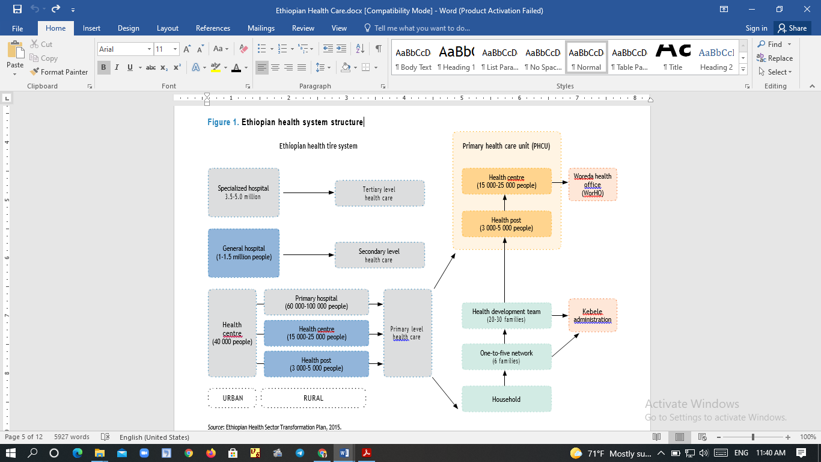
Figure 4. Ethiopian health system structure [4].
There are major health disparities and challenges with access to care that are unique to rural communities. Many factors distinguish rural and urban locations, including demography, environment, economy, social structure, and resource availability.
Research on the health system has been undertaken utilizing the DTN principle to enhance poor communication among health professional, despite the fact that present networking technology is inadequate. DTN is used in situations where mobility and scheduled contacts are affected by long-delay, disconnected, disturbed, or intermittently connected networks. However, the researcher of this study believe that health information exchange based on the delay tolerant network principle should be done from the perspective of Ethiopian health service arrangements. Now a day Poor health information exchange among health professionals is a problem domain in Ethiopian health service arrangements. This problem is driven by technological challenges associated with communication and a lack of financial resources to establish already available communication technologies for health professionals to exchange health information among them particularly in rural area. As a result, the researcher of this study is motivated to propose a framework based on the DTN principle that will bridge the health information exchange gaps among health professionals in rural areas, addressing the limitations experienced by present networking.

Background of the Study Area
This study is carried out in Sidama regional state, Southern Ethiopia. Sidama regional state is one of the 10th regions in Ethiopia and located 275 km south of Addis Ababa, the capital city of country. The region has consisted of six town administrations and thirty districts with an overall of 576 kebeles (lowest administrative units in Ethiopia with approximately 1,000 households). Based on the Ethiopian Population Census Report 2007 estimates, the overall population of the region in 2020 has reached 5,493,516 [42].
The Sidama regional state has overall of 5,806 health professionals of diverse disciplines and 624 health posts, 127 health centers, two general hospital, 13 primary hospitals and 1 comprehensive and specialized hospital owned by the government. There are also thirty-two private medium and six non-governmental (NGO) clinics, and 73 private drug stores. The Hawassa city is the capital city of the Sidama regional state. The rural part of the community is suffering due to lack of better health service delivery [42].

Related Work

DTN in Health Care System
In the last more years, several studies related to Delay Tolerant Network has been done to address the issues of poor network problem in rural areas, which is different from the traditional one where end to end connectivity is expected and hop in the network is not optimized individually.

R. Johari et al. (2015) [43] designed a hybrid routing method that uses multiple sorts of contacts in a partitioned, hybrid, and sparse network and is persistent, on-demand, planned, opportunistic, and predicted. These networks could be used to provide assistance from specialists to junior doctors working in primary care centers. They propose it for the Indian state of Uttarakhand, which is located in the foothills of the Himalayan range, with the majority of communities located in mountainous areas. As a result, the state capital has a super specialty hospital, 12 district hospitals, and 322 state allopathic hospitals or primary health centers in villages. People in remote villages depend more on district level hospitals due to a shortage of trained medical staff at primary health centers. Within the state, wired networks connect super specialty hospitals and district level hospitals for information exchange, but connectivity between district level hospitals and primary health centers in semi-urban and remote communities is weak. The existence of persistent communication is not suitable due to physical constraints and a lack of economic feasibility. As a result, the authors propose the DTN method, which is a feasible solution for providing information connectivity for areas, as shown in figure 5 [43]. People's smart phones was used as relay nodes for providing opportunistic and predicted contacts for information exchange. In addition to opportunistic contacts, nodes were mounted and installed on ambulances to act as on-demand contacts.
Figure 5: Message transmission between health centers using DTN mechanism [43].
V. N. G. J. Soares et al. [44] proposed VDTNs (vehicular delay-tolerant networks) as new network architecture that is based on the DTN concept. VDTN allows delay-tolerant data traffic from a variety of vehicular applications to be routed over time, taking advantage of the physical movement of vehicles and the opportunistic links they establish with each other and other network nodes. Figure 6 from [45] shows three different types of VDTN nodes: terminal nodes, relay nodes, and mobility nodes. Terminal nodes connect end-users to the VDTN network by acting as access points. Mobile nodes (such as cars) are in responsible of physically transporting data between terminal nodes. Relay nodes are devices with store-and-forward capabilities that allow data bundles to be dropped and picked up without going through mobile nodes. In sparse scenarios, these nodes enhance the number of contact possibilities, helping to improve the delivery ratio and reduce delivery delay. Figure 6 is an example of a VDTN network in a rural connectivity scenario.

Figure 6: Illustration of a VDTN network [45].
Mansur As et al. [46], proposed DTN technology that has been created to provide a low-cost solution that can be used to deploy Telemedicine services for isolated and remote rural locations that are not accessible via the Internet, as shown below in figure 7.
Figure 7: DTN Telemedicine Framework [46].
The proposed method succeeded in sending and receiving data in the form of a news portal health and e-mail, and produces scalability by overcoming lack of links for few days. This is due to the buffering capability at every node. But buffering the message for the long period of time introduces the problem as nodes buffer is limited in reality.

Buffer Management approaches in DTNs
As described in section 2.5. most of the approaches mentioned so far provides best effort service. The main drawbacks with the best effort service are its failure to offer any mechanism to prioritize the messages to be dropped in a situation when the buffer is full and transmitted the buffered message to other nodes in a prioritized manner to offer a room for new incoming messages in the future. To avoid these drawbacks many researchers have proposed various mechanisms to prioritize the messages to be dropped and scheduled for transmission in order to manage limited resources, particularly the buffer in challenging environments. The following studies are done by various researchers to address this problem and they are more related with the proposed approach in this research work but the methodology followed makes it different from them.
Anita Rani, et al. [47], evaluate the performance of MOFO buffer management technique with three routing protocols i.e. Epidemic, Prophet and MaxProp under variable message buffer sizes (5MB to 40MB). Such evaluation can improve the performance of the opportunistic networks by reducing the overhead ratio, enhancing the delivery rate, minimizing latency average and hop count average in a certain degree. The delivery probability of MaxProp is much higher than Epidemic and Prophet routing protocols at all the message buffer sizes. Overhead ratio under MaxProp is lower than Epidemic and Prophet routing protocols. But as the message buffer size increased, the latency average under MaxProp drops significantly in contrast to Epidemic and Prophet routing protocols.
Anita Rani et al. [48] have evaluated the performance of four buffer management techniques namely FIFO, DL, DLA and MOFO with MaxProp routing protocol under variable message buffer size. The results has been shown that MOFO gave the best results for the parameters Delivery Probability and Overhead Ratio among all the four buffer management techniques under study. However, the suitability of all the above three mentioned proposed buffer management approaches under MaxProp routing protocol is for node-based but not for the scenario which is message-based.
Author [49] proposed Epidemic Routing based on Message Replication Rate Priority (ERMRRP) to manage the buffer by assigning the priority for the messages to be dropped and transmit. Meta-message provides information about messages stored in the node’s buffer. Beside this, a novel module called buffer checker is introduced to check whether the available buffer is sufficient or not to accommodate the new incoming messages before the message transmission begins. Message indexer indexes the messages in the message table based on each message replication rate and their remaining lifetime. The buffer management system is shown below in figure 8.
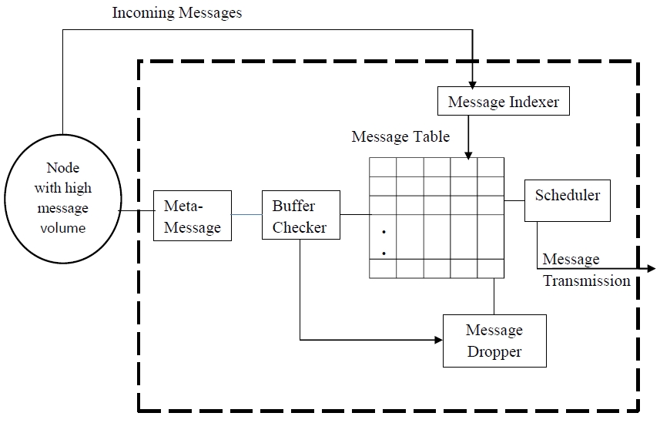
Fig 8. Epidemic Routing based on Message Replication Rate and Time to leave Priority [49].
As shown in figure 8, since all the above-mentioned buffer management approaches are unsuccessful in preparing room for new incoming message to be buffered before the message transmission start. Thus, the approaches provide best effort service under epidemic routing protocol.
The design framework and scenario used in [49] is almost similar with the proposed approach. The reason for using some common scenario is due to the presence of the potential problem for the healthcare professionals in rural areas to exchange health information among each other in common or with the specialists using communication links and to contribute my own study and to lay foundation for near future implementation in the health care system. However as described in [28], [47], and [48] among the latest version of flooding-based routing protocol MaxProp routing gives better result in term of delivery of messages, network overhead ratio and average latency.
Despite inherent Delay Tolerant network service of applications, MaxProp routing protocol is unsuccessful to offer any mechanism to prioritize the messages based on Class of Service. There can be situations where some messages may be more important than the other. For e.g., in VANETs it is reasonable to assume that Specialist message is more important than GP and Nurses. Under such requirement, a different forwarding policy will be needed to serve different types of traffic. Consequently, it would be necessary to prioritize messages and ensure that they get best possible service. The order of message transmission is an issue. The above discussed issue and problem statement motivated the author of this research to propose a buffer management technique under MaxProp routing protocol which improve the message delivery or equivalently minimize the overall loss probability of high priority messages for the proposed framework. Summary of some of the related work of Scheduling and Dropping policies are summarized in the table 1 below.

Scheduling policy Name | Parameter | Methods | Gaps
FIFO [34] | Time of Arrival | Schedule the 1st incoming msg | The message of the highest priority may have to wait much longer for delivery to the destination.
LIFO [34] | Time of arrival | Schedule the last incoming msg | The high priority message wait for long periods of time.
Random [35]. | None | Schedule a randomly chosen message to transfer. | It is random nature; the messages have no order set in the buffer.
MaxProp [56] | No of Hops | A hop list in each packet stores peers that the packet has  already traversed, including peers to which the current node has sent the packet. | The message of the highest priority having high hop count might be stay longer in the buffer.
ERMRRP [49] | Message Replication Rate and TTL value. | The message having small number of replication rate and high ttl value will be scheduled first. | They do not have acknowledgement of delivered data and unsuccessful to offer any mechanism to prioritize the messages based on Class of Service.
POSOP [43] | Priority and time to live (ttl). | A message is sent based on their priority value. | Since there is no acknowledgement of packet delivery, there will be an attempt of sending (reception) of the same packet twice. This increases the network overhead cost.
Dropping policy
Dropping Policy Name. | Parameter | Methods | Gaps
Random [35] | None | The dropped Message is chosen randomly among every stored Message | It is random nature; the messages have no order set in the buffer.
Drop Last | Time of arrival | Drop the last incoming message | Towards biasness by selecting every time the last message to drop
Drop Largest [33] | Size | Drop the largest size of message | Towards biasness by selecting every time the largest size message to drop. The high priority message might be dropped.
Drop Oldest [34] | Time to live | Drop the oldest messages,  who are left with lowest TTL. | The message of the highest priority having lowest ttl may drop.
Drop Youngest [36] | Time of arrival | Drops a very recent and freshly arrived message, whose TTL is the highest amongst all the arrived messages. | The message of the highest priority having highest ttl may drop.
MaxProp [56] | No of Hops | Drop the msg with the maximum no hops count. It also drops the message having acknowledgments which are propagated network wide, and not just to the source. | It doesn’t consider situations like equal number of hops. Also, it cannot identify the type of high priority message.
ERMRRP [49] | Message Replication Rate and TTL value. | Highly replicated and having small remaining lifetime dropped from the message table. | The message of the lowest priority having lowest replication rate and high ttl value might be stored for long time.
POSOP [43] | Priority and time to live (ttl). | A message is dropped based on their priority value. | There is no acknowledgement of packet delivery. When the buffer gets full there will be a chance of dropping high priority message.

Table 1: Summary of related work.

Summary
In a summary, DTNs is referred to network in which end-to-end connectivity is rarely exists. In such networks, store-carry and forward paradigm is used to achieve a successful sending of messages to destination. This chapter concludes with a detailed survey of similar studies from the past to date, as well as an explanation of the advantages and disadvantages associated with the various strategies discussed. Most of the existing buffer management policies, both global and local, focus on either dropping policy or scheduling policy, and most of them compute in an unfair manner, to drop and schedule decision guided by blindly in a random manner only used a sole metric parameter while other important parameter have been totally ignored which means that a fair selection cannot be made.

From the routing protocol types discussed above, the researcher found important points such as the methodologies and processes used to propose health information exchange system, tools used for the implementation purpose and performance evaluation techniques. in this study, the proposed approach is incorporated to existing MaxProp routing algorithm to manage the limited buffer space of the node by applying buffer management policy. This protocol has been shown to perform well in a wide variety of DTN environments, it has their own buffer management policy and it is the latest and the upgrade protocol of all flooding type routing protocol. It is also noted by scholars that, the integrated approach is better than a single approach to getting a better result. As a result, this study is initiated to explore the integration of DTN protocol called MaxProp with the proposed buffer management system to get better performance.

CHAPTER THREE

RESEARCH METHODOLOGY

3.1. Introduction
This chapter is devoted to explaining methods which is followed by this study. It provides information on what methods used and why it is chosen for the proposed framework. It also describes the design scenario and the proposed framework.

3.2. Research Design
A research design is a plan, structure, and strategy of an investigation so conceived as to obtain answers to research questions or problems [50]. In this study, a design science research approach is used to design health information exchange system for rural healthcare providers. According to Peffers [51] and Hevner [52] design science is an outcome-based information science research methodology, which offers special guidelines for evaluation and iteration within the research design. As per their recommendation design science is an effective research methodology for artifact design researches. In design science, the process is structured in three main phases which are problem identification, solution design, and evaluation that can interact with each other within the research process [53].
The design science research methods follow a model in creating the artifacts and its end result is knowledge creation [54].
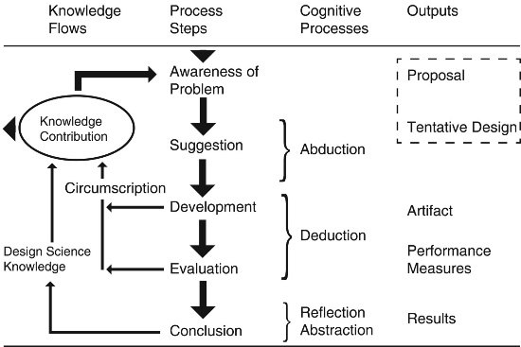
Figure 9. Processes in the design cycle [54].
Awareness of Problem: an awareness of an interesting research problem may come from multiple sources, including new developments in industry or identification of problems within a reference discipline. Reading in an allied discipline may also provide the opportunity for application of new findings to the researcher’s field. The output of this phase is a Proposal, formal or informal, for a new research effort.
Suggestion: The Suggestion phase immediately follows the proposal and is intimately connected with the proposal developed based on the Awareness of a Problem
Development: The Tentative Design is further developed and implemented in this phase. The techniques for implementation will vary depending on the artifact to be created. An algorithm may require construction of a formal proof to show its correctness. An expert system embodying novel assumptions about human cognition in an area of interest will require software development, probably using a high-level package or tool.
Evaluation: Once constructed, the artifact is evaluated according to criteria that are always implicit and frequently made explicit in the Proposal (Awareness of Problem phase).
Conclusion: This phase could be just the end of a research cycle or is the finale of a specific research effort. The finale of a research effort is typically the result of satisficing, that is, though there are still deviations in the behavior of the artifact from the (multiple) revised hypothetical predictions; the results are adjudged “good enough.”
The goal of this study is to use the theory of delay tolerant networks to overcome the health information exchange gap amongst health professionals with respect to Ethiopian context. DTNs allow internetworking over heterogeneous networks (regions) using diverse transmission media by overlaying a bundle protocol layer above the transport layer, which provides store-carry-and forward functionalities for connectivity resilience. Due to the node's store-carry-and-forward functionalities, buffer space restrictions are well-known difficulty in DTN.

Data source and Data Collecting Methods
Collecting and organizing data are an integral and critical part of the research process in order to identify and understand the problem of information exchange practices in the level of healthcare system. In this study secondary data sources are used. Secondary data is collected by reviewing relevant books, journals, different published and manual document analysis is used.

Proposed framework
This thesis purpose is to develop the framework based on the problem identified in the previous section of this research work. Currently the majority healthcare centers in rural Ethiopia encounter with inconsistent or non-existent end-to-end connectivity due to a number of obstacles encountered, including a lack of Internet and telecommunications infrastructure, high costs, and difficult to reach rural geographical conditions. To address this problem, the researcher proposed a framework to connect rural healthcare providers with the city/town healthcare providers based on the delay tolerant networks principle. Figure 10 below shows the proposed framework how healthcare professionals can exchange Information to each other using Delay Tolerant Network.
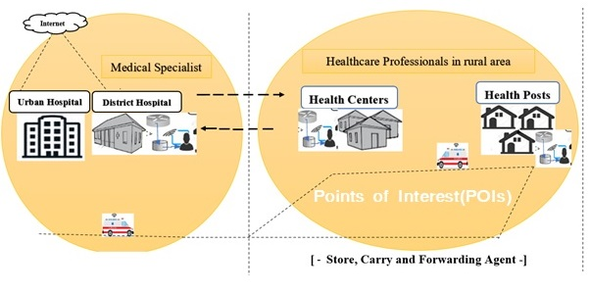
Figure 10. The Proposed Framework for the Health Information Exchange
As shown in figure 10 in the given problem scenario, health information can be exchanged among health professionals using our proposed framework on DTN in a place where there is no end-to-end connectivity or an intermittent connectivity. Thus, they need specialized physicians in a sub-specialty on the consult. When health professionals in rural hospital, health center and health post need to exchange the recorded data of the patient with medical specialist still difficult due to intermittent connectivity or absence of end-to-end connectivity. Therefore, the proposed framework uses stationary nodes and mobile nodes. Each stationary node at the hospitals, health centers, and health posts is assumed to have a high and persistent storage capacity. To collect patient data bundles from remote villages to city/town, we involve movable nodes mounted and installed on ambulances to act as on-demand contacts. It collects end-users required healthcare data from the Administrative Server at town and then transfers it to the remote villages by traveling in a round trip [55]. However, mobile nodes (intermediate nodes) have limited buffer space, they are prone to buffer overflows at specific points in time due to message flooding when the nodes encounter each other.

Routing Protocol /Algorithm
Delay Tolerant Network (DTN) has various routing strategies as it is clearly described in section 2.5. Depending on its suitability for the proposed framework on the network scenario the researcher selected the best routing protocol.
MaxProp routing is one of known routing protocol which grouped under the routing category history based or probabilistic base routing protocol which sorts the message based on hope count in order to forward or drop message. In MaxProp if a contact is occurred, then all the messages not held by the contact will be replicated and transferred. The MaxProp routing protocol intelligently determines that which messages should be transmitted first and which of the messages should be dropped first. Here an ordered queue is maintained by this protocol based on the destination of each message, ordered by the probability of a future transitive path to that particular destination. When two nodes meet each other, firstly, they exchange their estimated node meeting likelihood vectors. Preferably, each node will have an up-to-date vector from every other node. With these “n” vectors at hand, the node can compute the shortest path on the basis of a depth-first search where path weights indicate the probability that the link does not occur [56].
MaxProp protocol makes use of several novel techniques to arrange the packet order of transmission and deletion. MaxProp protocol works by ranking the stored packets in node’s memory on the basis of cost assigned and is based on delivery likelihood. It makes use of acknowledgement technique which is transmitted to all the nodes regarding delivery of packets. MaxProp gives high priority to new packets and prevent duplication of packets in network. The priorities to the packet is given on the basis of historical data, hop count, acknowledgement, head start for new packets and previous intermediary nodes. As shown in figure 10 J. Burgess et al. (2006) [56] clearly present the mechanism of MaxProp protocol working is:
- All the messages designated to the peer neighbor are transmitted in the network.
- Routing information is transmitted among the nodes.
- Acknowledgements regarding data delivered is done regardless of source and destination node.
- Packets not transmitted in the network till now, are given higher priority for transmission.

Figure 11: The MaxProp routing strategy [56].
As shown in Figure 11 the buffer of this protocol is divided into two phases. First, messages are stored from low to high based on hop count information. Secondly, messages are arranged by cost from high to low. The first phase uses the front end of the buffer, while the second phase uses the back end of the buffer. Each peer carries all messages until the next meeting occurs. A peer will continue to forward a message to any number of other peers until its copy of the message times out, it is notified of delivery by an ack, or the message is dropped due to a full buffer. However, the approaches implemented in MaxProp routing protocol is unsuccessful in prioritizing the incoming and outgoing message traffic in the node buffer space. The proposed approach in this thesis is designed to address this particular gap.

Proposed Queue management Model
A queue is usually a first-in, first-out (FIFO) structure, and consumers typically receive messages in the same order that they are posted to the queue. However, some message queues support priority messaging. The application posting a message can assign a priority and the messages in the queue are automatically reordered so that those with a higher priority will be received before those with a lower priority. The figure 12 illustrates a queue with priority messaging. This pattern is useful in applications that offer different service level guarantees to individual clients.
In DTN, bundle protocol is used for transfer of messages. Bundle Processing Control Flags Bit is used to differentiate the traffic through Class-of-Service (CoS) field. The hop count and Lifetime field, available in the bundle block used for prioritization.
Suppose that there is three prioritized class traffic: nurse, General Practitioner (GP) and specialist. Nurse messages have lowest priority, GP messages have medium priority and Specialist messages have high priority. In some cases, it's necessary to prioritize specific requests. These requests should be processed earlier than lower priority requests that are sent previously by the application. The policy gives preference to Specialist. The available buffer is divided into numerous queues to hold the incoming bundles in the suggested approach. Priority queuing and system overview illustrated in figure 12.
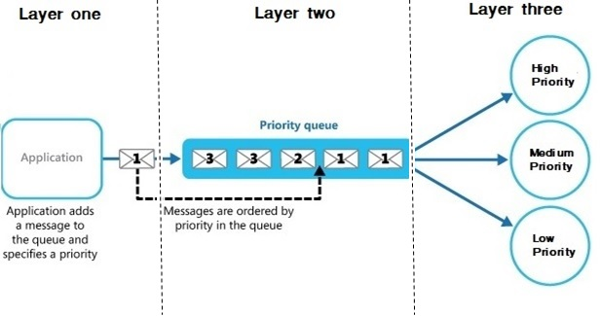
Figure 12 Priority queuing and system overview
As shown in Figure 12, in proposed queue management system there are three layers. Layer one is responsible for packet generation and label, Layer two is network management plain, and Layer three is process packet to be arrived based on their priority. For each type of service, a separate queue is kept. At this point the size of the queues is not determined. Their sizes can be either defined at the beginning or varied as the correlation of traffic changes. The goal is to determine how the buffers are best shared among messages of different classes, so that the overall delivery ratio is maximized.

Proposed Buffer management Approach
Since DTN are intermittently connected networks, messages in these networks must be buffered for long periods of time. This means that the intermediate nodes require enough buffer space to store all messages until that intermediate node meet the specific destination nodes.
Buffer Management policy is crucial for DTN to manage the limited buffer of the node as discussed in chapter 2, in section 2.6. The performance of a DTN can be deteriorated as the network has high load of packets or message since the limited buffer size of each node leads to serious traffic congestion. The researcher proposed buffer management policy which consider the following assumptions:
- There can be situations where some messages may be more important than the other. For e.g., in VANETs it is reasonable to assume that specialist notification message is more important than GP and nurses. Consequently, it would be necessary to prioritize messages and ensure that they get best possible service.
- Due to mobility of the nodes and limited bandwidth, it is not possible to transmit all messages during the short available period of contact. Which message should be transmitted first?
- The buffer management should consider differentiating the message traffic, hop count and time to leave to transmit and drop messages.
However Existing MaxProp routing protocol results in efficient use of the network resources such as buffer space at each node, bandwidth and incapability to differentiate message traffic classes that are generated by different hosts. In order to achieve the above three cases, the buffer of the nodes is required to be managed mandatorily to obtain the required message delivery quality.
The proposed system uses the metrics named message type, hop count and time to live to manage buffer for the message to be dropped and transmit. Thus, it is embedded with MaxProp routing due to its enhanced performance among other protocols. As a result, the proposed method is named as MaxProp Routing based on Message Type Priority (MPRMTP). It consists of Bundle classifier which classifies the bundles according to their priority as soon as they arrive and stores them in appropriate queue, Buffer checker compute the meta-message to identify the message which is unknown to the receiving node then the computation of total required size to accommodate them. Bundle scheduler which is invoked when the contact opportunity arises and schedules the bundles based on the policy, and Bundle dropper which is invoked when buffer is full and drops the bundle according to the policy. This system is illustrated in Figure 13.

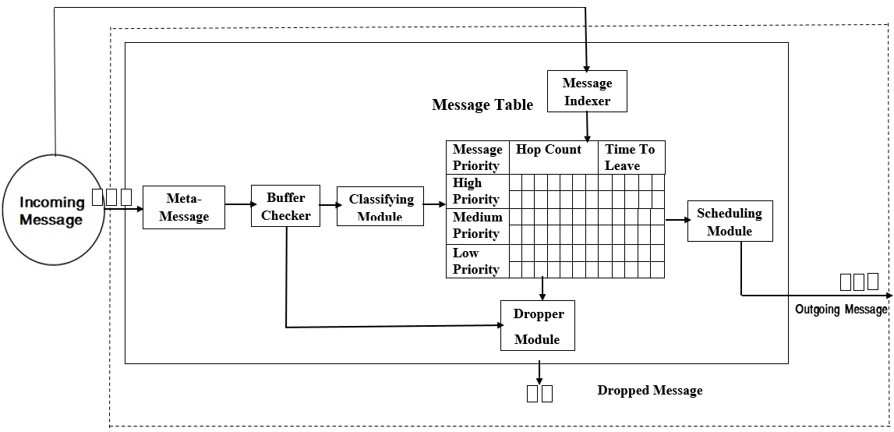
Figure 13. The Proposed buffer management approach (MPRMTP).

Definition of Terms in the Proposed Buffer Management Scheme
- Hop count
In networking, a hop count is the total number of intermediate devices such as routers through which a given piece of data must pass between the source and destination, instead of flowing directly over a single wire. The hop count is considered a basic measurement of the distance in a given network. In other words, it gives an approximate measure of the distance between two given hosts. Packets that have already been sent to the node are not sent again. A hop list in each packet stores peers that the packet has already traversed, including peers to which the current node has sent the packet.

- Message Life time (expiry)
A Message Expiration is a timestamp (date and time) that specifies how long the message will live or when it will expire. A message might have a limited life time, and if it is not processed within this period, it is useless and should be discarded.
- Message Priority
Message priority is defined by the message type; after a message is created, its priority cannot be changed. The message priority provides to nodes more chance to obtain the medium access, which will reduce latency along the path between the source and the destination. Packets that are ranked with highest priority are the first to be transmitted during a transfer opportunity.
- Meta Message
When two nodes in an opportunistic network come into contact, they normally need to exchange certain meta-messages in order to avoid delivering duplicate data bundles. Because MaxProp routing is the examined routing protocol in this study, the discussion that follows is related to it. In the considered routing each node's buffer contains both messages initiated by the node and messages relayed on behalf of other nodes. When two nodes meet to exchange messages stored in their buffers, they first establish a connection using three steps (probing phase, meta-message exchange phase, and message exchange phase) that are common in opportunistic networks.
The probing phase allows the node to broadcast a beacon on a regular basis and listen for beacons from nearby nodes. The link between two nodes is established based on the beacons they receive from each other when they come into contact (i.e. in the same radio transmission range). The meta-messages exchange then takes place based on the established connection. Meta-message offers information about the messages in the buffer of the node. So that each node can figure out which message to transmit, how many messages it may send, and other essential details. Finally, following the computation based on the meta-message, one node sends a message to the other node or they exchange messages that they did not previously have in common.
In the proposed approach the meta-message comprises the prioritized message Id, hop count and TTL which used to identify the messages uniquely in the network and messages size for computation at buffer checker to make the required room for the incoming messages. Therefore, with these Meta message exchange, we can achieve high delivery rate and low transmission overhead.
- Message Indexer
Message indexer indexes the messages in the message table based on each message traffic classes, hop count and remaining lifetime. The message indexer considers prioritized message in the message table, for messages that have already been buffered and propagated to other encountered nodes. The message having high priority, low hop count and high life time assigned high index value and in reverse the message having low priority, high number of hop count and short life time assigned low index value. The index value of the message in message table help the message dropper and scheduler to make decision when they are invoked.
- Buffer checker
When two nodes come into contact as a result of the beacon's periodic broadcast, the connection is established. The nodes exchange meta-messages based on the established connection. The buffer checker computes the meta-message to identify the message that is unknown to the receiving node prior to message exchange between the two encountered nodes, then computes the total required size to accommodate them. The total size needed to accommodate the incoming message is the sum of the sizes of all new incoming messages that haven't been buffered at the receiving node yet, as determined by the meta-message computation.
TS_{incoming Messages} = the sum of each messages size unknown to receiving node.
Where TS is total size for the incoming messages.
Buffer checker compares the available buffer size to the computed total size of the incoming messages once the total size necessary to handle the new arriving messages is known. If the available buffer space exceeds the total amount of the incoming messages, the request will be passed to the encountered node, which will receive the new (unknown) messages. However, if the available buffer size is less than the total size necessary to accommodate the incoming message, the buffer checker instructs the message dropper to drop the message based on the message table's index value, making room for incoming messages. After estimating the total size required to store the incoming messages based on the received meta-message, the buffer checker at the receiving node runs the following method. The algorithmic design of the buffer checker is shown in algorithm 3.1
Notation
NABS - Available buffer space of the node
TS_{incomingMessages} - Total Size of incoming messages
Initiate -When the nodes available buffer is insufficient to
accommodate the incoming messages
If (NABS > TS_{incomingMessages})
{
Forward request message to get new incoming messages
Exit buffer checking
}
else
{
Invoke message dropper
}

Algorithm 3.1: Algorithm for Buffer checker
- Message Dropper
When the node's buffer became full, the existing dropping functionality work based on hop count and acknowledgement. Dropping messages based on hop count in spare networks has a direct influence on delivery probability. The message should be dropped if and only if, when the new incoming message is required to be accommodate and if the available buffer space is not enough to accommodate the new incoming messages. The message selection for dropping should have to be decided carefully to increase the message delivery quality in the network. To do so, the nodes make decision based on network-wide information or Local information.
In proposed approach and considered scenario, the dropper at each node buffer drops message based on metrics from the message table namely message priorities, hop count, and time to leave mechanisms, including acknowledgments in order to give room for the new incoming message. The message having low, medium and high priority along with high hop count and low time to leave to be dropped from the message table respectively to give a room for the new incoming message.
Alongside this, each node’s buffer contains messages initiated by the node as well as messages relayed on behalf of other nodes. The message dropper does not drop its own message (source) to give room for newly arrived messages. The idea of giving priority to source message is to increase the message's delivery probability. Thus, the message dropper drops the message which are relayed and stored on behalf of others from the buffer when request come from the buffer checker to drop the message and then to give room for the new incoming messages. The algorithm 3.2. shows how the message dropper drops the message from the buffer of the node based on the message priority, hop count and message remaining lifetime. The algorithmic design of the message dropper is shown below.
Notation
M_{indexValue} - Index value of a message
MT - Message Table
MP – Message priority
MHC – Message hop count
M_{ttl} - Messages remaining lifetime
NABS - Available buffer space of the node
N_{self} - The node it self
TS_{incomingMessages} - Total Size of incoming messages
If message is initiated by N_{self} && M_{ttl} > 0
Move to the next step
While NABS < TS_{incomingMessages}
For each message in M_{T} do
If (Incoming Packet Priority==Low)
{
Get Low Priority ()
}
else if (Incoming Packet Priority== Medium)
{
Get Low Priority ()
If (Data is Null)
{
Get Medium Priority ()
}
}
else if (Incoming Packet Priority==High)
{
Get Low Priority ()
If (Data is Null)
{
Get Medium Priority ()
}
If (Data is Null)
{
Get High Priority ()
}
}
If (Data is not Null)
{
Add Data
}
else
{
Reject
}
}

Get Low Priority ()
{
Data= Get High Hop Count ()

If (Data is null)
{
Data = Get Low TTL ()
}
Return Data
}
Get Medium Priority ()
{
Data=Get High Hop Count ()

If (Data is null)
{
Data=Get Low TTL ()
}
Return Data
}
Get High Priority ()
{
Data=Get High Hop Count ()

If (Data is null)
{
Data=Get Low TTL ()
}
Return Data
}
Get High Hop Count ()
{
Return High Hop Count Data
}
Get Low TTL ()
{
Return Low TTL Data
}
End if
End For
End While
Algorithm 3.2: Algorithm for message dropper
- Message Scheduler
To ensure that messages are distributed fairly throughout the network, messages stored in nodes' buffers should be scheduled before transmission begins when another node is detected. As a result, the proposed approach schedules messages based on their index value. The index value is kept based on the information in the buffer about the message. As stated in section V, the indexer uses each message's priorities, hop count and remaining life time to maintain the index value. In reverse to message dropper, the scheduler. Message scheduler transmits the message from high priority to low priority along with low hop count and high life time in a round robin fashion.
Moreover, due to mobility of the nodes and limited bandwidth, it is not possible to transmit all messages a node has during the short available period of contact. In such case the order in which the messages are transmitted is significant. Bundles are transmitted according to their message priority and ordered.
- Buffer- Cleaning policy
Buffer clearing policy used three parameters namely acknowledgment, hop count, and TTL Acknowledgments of delivered data are transferred, regardless of source and destination. An acknowledgment consists of the cryptographic hash of the content, source, and destination of each message, and is therefore about 128 bits. This mechanism serves to clear out buffers in the network of old data at little cost if the acknowledgment are small compared to data packets. Packets ranked with lowest priority are the first to be deleted to make room for an incoming packet. When TTL expires then message is automatically removed from nodes.

Summary
It is clear from a Literature review and related works that buffer management is an important tool or mechanism to control and manage the buffer resources. Buffer management is responsible for scheduling of messages, at a contact opportunity, the scheduler decides the order by which messages should be replicated or transmitted as contact durations are limited. So as to achieve the objectives the idea of this research to improve the buffer management scheme for DTNs. Therefore, to construct the proposed buffer management we follow the following steps i.e., proposed model by implementing the three strategies of a buffer management policy namely: Dropping, Scheduling and buffer cleaning policy. Among Delay Tolerant Network (DTN) routing strategies, history based or probabilistic base routing protocol named MaxProp routing is selected for the proposed health information exchanges system. The proposed system differentiates the message traffic through Class-of Service (CoS) field and sort accordingly to manage buffer for the message to be dropped and transmit.

CHAPTER FOUR

IMPLEMENTATION

4.1. Experimental Environment Setup
To simulate and evaluate the proposed scheme, the ONE Simulator has been used. ONE is an Opportunistic Network Environment simulator which is designed specifically for DTN environment. It is a discrete event based simulator. It is a Java-based tool which provides DTN protocol simulation capabilities in a single framework It has rich GUI for creation of mobile node as well as it helps to simulate the node movement using multiple movement models, routing messages between nodes using various DTN routing algorithms, and observing both mobility and message passing in real time [57]. In the simulator, many of the routing algorithms that are applicable to the DTN environment have been pre-implemented. The proposed approach is embedded with MaxProp routing algorithm to handle the node's limited buffer space.
The ONE simulator is used along with the shortest path map-based movement model (the sophisticated version of the map-based movement model). The well-known text (WKT) file is used for representing vector geometry objects, generated using OpenJUMP is used for simulation. OpenJUMP is a Geographical Information System (GIS), which has been developed originally by the two Canadian companies Vivid Solutions and Refractions Research under the name JUMP [58]. The name JUMP is an abbreviation for Unified Mapping Platform. The “J “represent to the used programming language “Java’’, “Open’’ is for ‘‘Open Source’’. As a result, the movement model gets its configuration data from files that are a subset of the well-known text format, and the mobile nodes in the mobility model move using roads from the map data.
The simulation environment consists of sparsely distributed mobile nodes and they communicate when they are in the communication range of one another. Healthcare providers (i.e., Health Posts, Health Centers, Primary and District hospitals) are grouped under the cluster of Hawassa University comprehensive specialized hospitals that are used as points of interest in this thesis. Accordingly, eleven stationary nodes and ten mobile nodes which is respective to the ten points of interests are deployed in the simulation. One of the stationary nodes don’t have mobile node as it is a common contact point for the other POIs mobile nodes. The stationary nodes are located at fixed points at each POI that are accessible to mobile nodes (i.e., with store-carry-forward capabilities) and allow passing mobile nodes to collect (pick up) and leave data on them.
The stationary and mobile nodes in the network are also assumed to use the standard IEEE 802.11b with a data rate of 6 Mbits/s (approximate throughput according to [59]), but the mobile nodes are configured to have a data rate of 2 Mbits/s in the simulation because DTNs include various link technologies such as Bluetooth, and the standard data rate for Bluetooth is also similar to the data rate of the nodes configured for the nodes.
The parameters used for simulation are stationary nodes, mobile nodes which are configured with opportunistic contacts, messages generated, buffer capacity of stationary nodes and mobile nodes, transmission speed of nodes, bit-rates, time to live for the generated messages and simulation time (duration). The detail of various simulation parameters is listed in the table 1.
The researcher selected eleven healthcare institutions from 5 different area of Sidama region in order to implement the proposed framework using ONE Simulator. The selected study area and healthcare institutions are illustrated in figure 14 below.
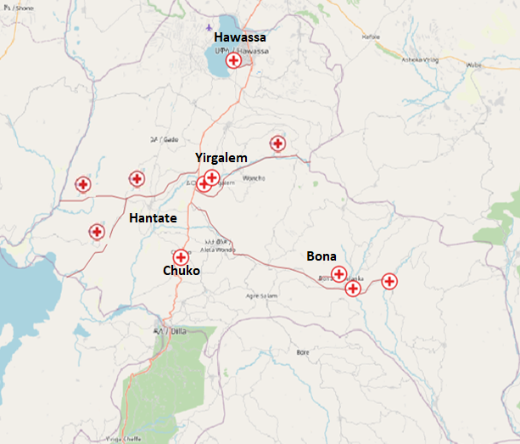
Figure 14: Simulated Map of SIDAMA region of Ethiopia (ONE Simulator)

4.2. The Simulation Scenario
The suggested framework is described in the analysis phase using the ONE simulator modeling on node movement, inter-node connections, routing, and message handling. The simulation's outcome is evaluated using the metrics specified in section 5.1.
For the simulated scenario in this study, the following points are taken into account. The scenario is established by defining the simulated nodes and their capabilities in order to share the created messages in common among all POIs with the help of mobile nodes that store-carry and convey the stored message when adjacent nodes are encountered opportunistically. Basic parameters such as storage capacity, transmit range, bit rates, movement and routing models, and simulation duration are included in the defined nodes and their capabilities. There are stationary nodes and mobile nodes in the scenario. Each stationary node at the POIs is believed to have a high and persistent storage capacity. However, because mobile nodes (intermediate nodes) have limited buffer space, they are prone to buffer overflows at specific points in time owing to message flooding when the nodes collide. Table 2 shows the details of several simulation parameters for the simulated scenario.
Simulation Parameters | Values of Simulation Parameter
Routing Protocol | MaxProp
Buffer Management Technique | MaxProp Routing based on Message Type Priority (MPRMTP)
Drop Policy | Message Priority - MaxHopCount – Low Time to leave
Simulation Time | 36000S (10hr)
World size | 4500x3400 meters
Number of Mobile Nodes | 10
Number of Stationary Nodes | 11
Buffer Size of Mobile Nodes | 5, 10, 15, 20, 25, 30, 35, 40, 45, 50, 55, 60
Buffer Size of Stationary Nodes | Unlimited
Mobile Node Speed | 30-80 km/hr.
Node Movement | Shortest Path Map Based Movement - Random walk
Interface | High Speed Interface
Transmission Range (meters) | 100
Data Rate | 2 Mbit/s
Message Size | 500kB-2MB
Message Creation Interval (Minutes) | 20-30
Message TTL (time to live) | 43200 seconds (12 hr.)

Table 2: Simulation Environment Parameters

4.3. Message Generation
Within the ONE simulator, there are two ways to generate application messages. Message generators and external event files are examples of this. The ONE simulator includes a built-in method of message generating (i.e., message generators). It sends messages with a fixed or random source, destination, size, and interval. External event files are the second method of message generation. The message generated by the message generator, which is pre-implemented in ONE simulator, is used in the simulated scenario. Message event generator is programmed to generate messages every 20 to 30 minutes, and the message size can be changed from 500 Kb to 2Mb at any moment.

4.4. The Mobility Model
This section contains the node movement models selected for node mobility in the ONE simulator. Because DTN networks rely heavily on the actual movement of devices that can store, carry, and forward messages with other DTN devices, the performance of a DTN appears to be influenced by the assumed mobility of vehicles carrying DTN equipped devices. The mobile nodes placed on vehicles in this study are considered to buffer and exchange messages with other DTN enabled devices from one point of interest to another node in the network.
The mobile nodes in the proposed framework are supposed to be nodes mounted on ambulances, each with a Wi-Fi interface to exchange information when they come into contact with other nodes with Wi-Fi interfaces. When a mobile node encounters another mobile node in the network on an opportunistic basis, information is exchanged. The ambulance's mobility, which allows the network's range to be extended by the mobile node mounted on it, allows data paths to exist throughout time in networks that have experienced long periods of disconnection. As a result, the mobile nodes serve as the network's communication backbone, collecting, carrying, and disseminating data as needed. It is expected that once the generated message has been delivered to the stationary node, the end user can access the data from the local device over the local router.
The shortest path map-based movement model, which is already pre-implemented in the ONE simulator, is used to simulate node mobility in this study. It is a derivative of the Random Way point concept, in which a random destination is chosen at the decision point's node and then the map-based shortest path to that destination is followed. Since the node is set up using a shortest path map movement models can use the map data that contains Points of Interest (POIs), the simulation's nodes follow deterministic paths based on the configuration files rather than random routes. The POIs are a unified entity (i.e. hospitals, health centers and health posts) that are positioned at various coordinates inside the supplied map area in the simulation.

4.5. Reporting and Visualization
This section explains how the simulation's results are represented graphically. These are accomplished through an interactive Graphical User Interface (GUI) and created graphics based on the data collected during the simulation. Figure 15 shows a graphical user interface (GUI) that displays the simulation in real time and is created for demonstration purposes. Node locations, current paths, connections between nodes, quantity of messages carried by a node, and so on are all visualized in the main window. A filtered record of simulation events, such as contacts and message transfers, is also generated by the GUI. While the GUI is useful for gaining a quick overview of what's going on during the simulation. Post-processed report files provide more detailed visualizations of node relationships, message pathways, and performance summaries.
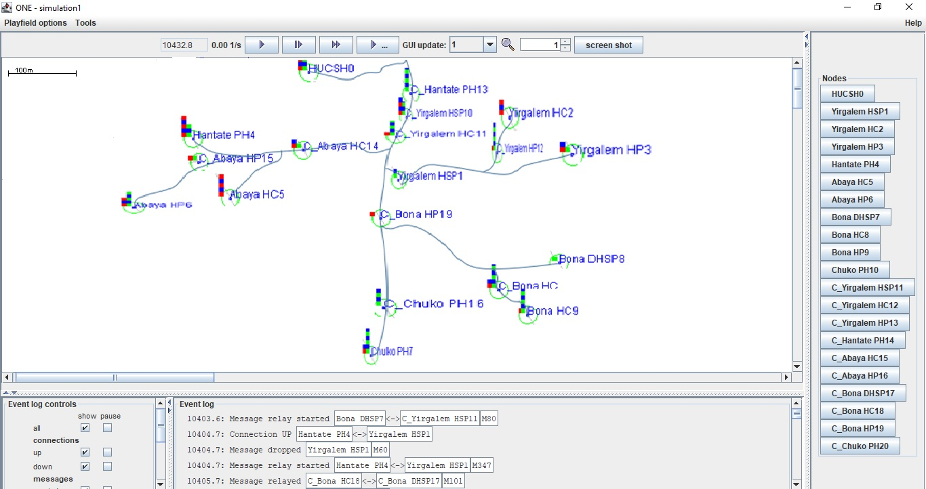
Figure 15: Screenshot of the ONE simulator’s GUI
According to the above report file which is generated by the ONE simulator, the node connections and other reports module files are used for further analysis. Figure 16 shows the node connections and the path that the messages have traveled in the network which is drawn by GVEdit graph file editor based on message Graph viz report file as an input from the ONE simulator reports module.

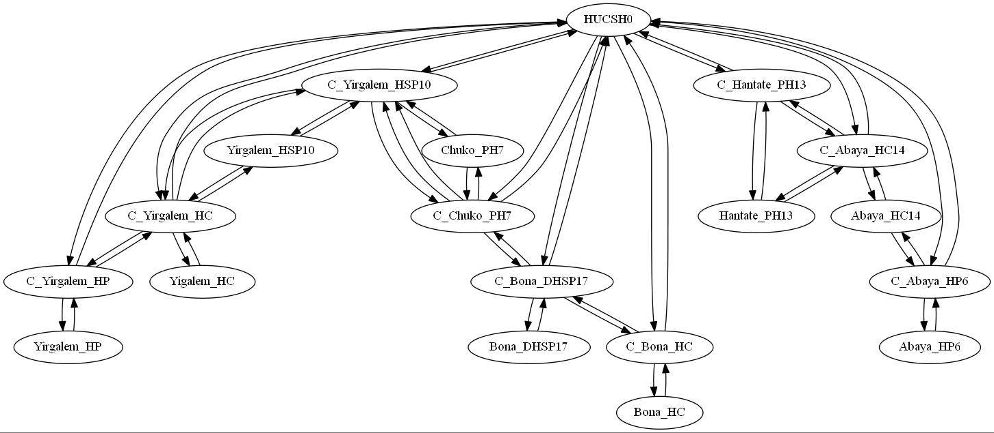
Figure 16: Node connections and the message path in the network

The reports generated by report modules during the simulation run used to collect the simulation results of the GUI for further analysis. It receives events like message or connectivity events from the simulation engine and generate results based on them [57]. During the simulation, the simulator creates a message statistics file in the repot module, which collects overall performance statistics (i.e. the number of created messages, message delivery ratio, how long messages stay in node buffers etc.). As a result, the output from the report module is utilized to display a graph for the various message statistics reports provided by the ONE simulator.

4.6 Summary
This chapter devoted to simulate and evaluate the proposed system along with different parameters by using Opportunistic Networking Environment (ONE) simulator for the design scenario. The simulator is configured using text based configuration files that contains the simulation, event generation and reporting parameters. This file also has the defining parameters for the nodes like the storage capability, transmit range, bit rates as well as the routing model to use. As already described on the above figures above it can be seen that the researcher established a network between various rural and urban healthcare providers for providing opportunistic contacts for information exchange. A message is forwarded to its destination through relay nodes. The mobile nodes act as message carriers that receive a message from stationary nodes and finally deliver it to its destination. The researcher categorized the messages based on three parameters: priority, hop count, and Time To Live (TTL).

CHAPTER FIVE

RESULT AND DISCUSSION
This chapter presents the results analysis and discussion of the scenarios targeted based on the simulation result. The simulation performed with various configuration files based on predetermined parameters is analyzed and discussed, and the performance metrics for the designed simulation scenario are briefly discussed.

Performance Metrics
This section of the chapter describes the metrics adopted for evaluating the considered routing algorithms. The routing algorithm considered in this thesis are analyzed based on three routing metrics namely delivery probability, average latency and overhead ratio. Detail description of each metrics is explained as follow [60], [61]:
- Delivery Probability: It is the fraction of generated messages that are correctly delivered to the final destination within given time period. This is the ratio of the total number of packets that are delivered to their destinations against the total number of packets that are created. Thus, this is a direct measurement of how reliably packets are routed in the network by a routing protocol under consideration. It is defined as

Delivery Probability = Number of Message delivered
Number of Message created
2. Average Latency: It is defined as the average time taken from the source node to transfer the message to the destination node. It is the measure of average time between messages is generated and when it is received by the destination. In other word average latency is the time it takes for a delivered message to reach its destination. Average latency includes all types of delay such as buffer delay, route discovery process, and delay during retransmission of the message, and propagation time etc. The lower value of the end-to-end delay means better performance of the protocol.
3. Overhead Ratio: This metric is used to estimate the extra number of messages needed by the routing protocol for actual delivery of the messages. It is defined as follow

Overhead Ratio = Number of Messages Relayed - Number of Messages Delivered
Number of Messages Delivered
Here, the term relayed messages refer to the messages that have been forwarded by the source to an intermediate node to be forwarded towards the destination. This number is a measure for the number of packets or copies of packets that have been inducted into the network. The number of delivered messages refers to the total number of created packets that are successfully delivered to the destination. The overhead ratio also shows the amount of the network resources required to deliver a packet from source to its destination.

Performance Evaluation
Network performance is defined by the overall quality of service provided by a network as perceived by the user. There are different ways to measure the performance of a network, depending upon the nature and design of the network. The performance of the default routing and the proposed system is evaluated based on different nodes buffer size and their dropping policies. Each simulation run generates a trace file including all of the data packets that are transmitted between the nodes during the simulated scenario. As a result, the performance of the considered routing protocols based on different buffer size and policy settings is determined by analyzing the simulation's generated trace file. The analysis of simulation results is presented in the next section of this chapter.

Result Analysis and Discussion
This section contains a detailed analysis of the simulation outcome using a chart based on the simulation's generated trace file. The delivery probability of the proposed buffer management technique with the existing routing algorithm on the mobile nodes under variable message buffer size is shown in figure 16. When the buffer size of the node increases (greater than the size of messages generated in the network) the delivery probability is increased. As a result, both algorithms show similar performance. However, when the nodes buffer becomes constrained, the MPRMTP shows significance difference and performs better. MaxProp and MPRMTP routing protocols under variable message buffer size is shown below in figure 17.
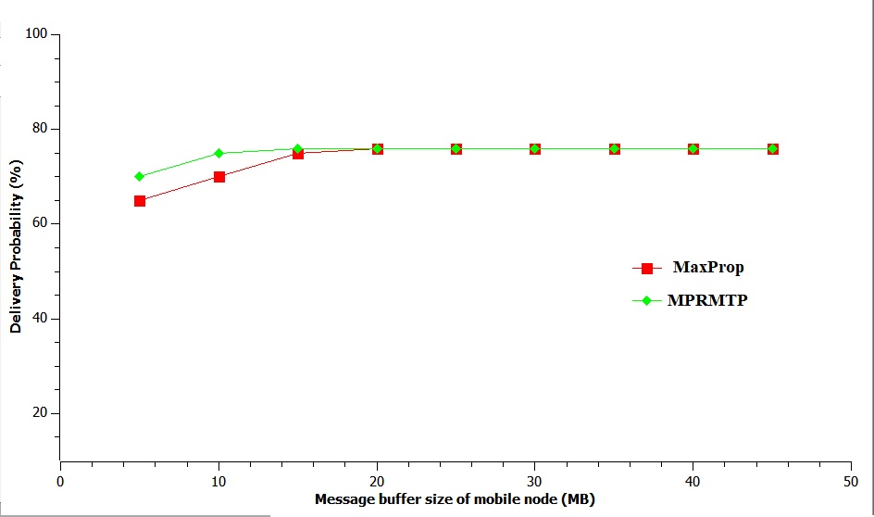
Figure 17: Percentage of delivery probability as function of buffer size

As shown in graph 16 we can easily observe and understand that when the buffer size of the nodes gets constrained MPRMTP has better than MaxProp. This is due to the new incorporated policies.
The overhead ratio also shows the amount of the network resources required to deliver a packet from source to its destination. It can be observed from the graph that MPRMTP has less overhead ratio value as compared with MaxProp routing when the nodes buffer is highly constrained. The proposed approach uses scheduling and dropping mechanism early before message transmission start. As a result, it prevents multiple computation and more node overhead that rises during message transmission. Also, it improves network performance.
Battery is a key problem in DTNs since many scenarios rely on devices with limited energy supplies, and these issues are exacerbated when the network has additional overhead. As a result, considering the issue of overhead in the algorithm design is critical, and we obtained decreased overhead with the proposed approach in addition to managing the nodes' limited buffer. The overhead ratio of MPRMTP technique with the existing MaxProp under variable message buffer size is shown in figure 18.
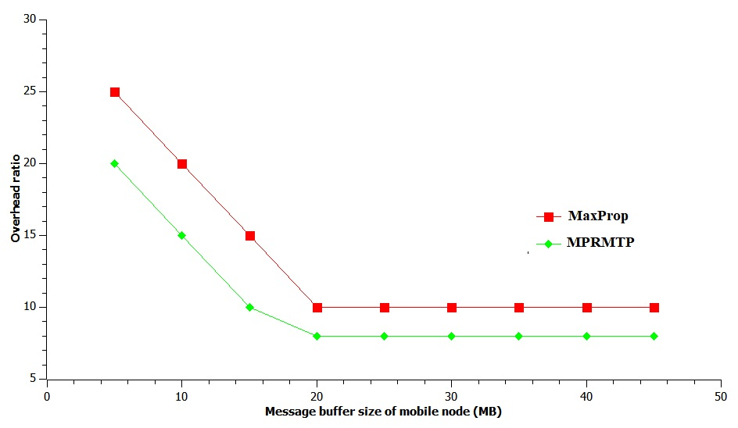
Figure 18: Overhead Ratio as function of buffer size

As shown in figure 18, when the message buffer size increased further, the decline in overhead ratio under both routing protocols continues very slowly.
The average latency of the proposed routing protocol with the existing MaxProp buffer management techniques under variable message buffer size is shown in the graph. From the graph it is clear that as the message buffer size of the nodes is increased further, the average latency for both routing shows reduction due to absence of computation except computation done at meta-message receiving phase to compute and list out the messages which are unknown to the receiving node. However, when the node buffer becomes constrained between 5MB and 20MB the proposed routing algorithm results in high average latency due to the presence of computation done at buffer checker. From the figure 19 we can see that when the nodes buffer space is 20 MB and above, both the MaxProp and MPRMTP routing algorithm shows almost similar result in average latency.

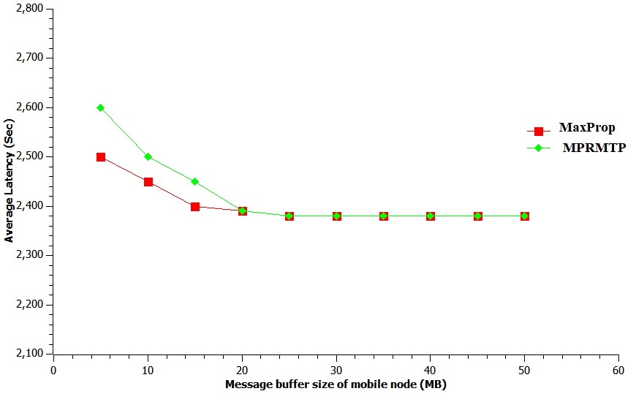
Figure 19: Average Latency as function of buffer size

Generated report by ONE Simulator for MPRMTP with different buffer size and with fixed number of nodes
Table 3. Shows the report generated by the ONE network simulator by varying the buffer size to the proposed policy MPRMTP. When buffer size is set to 20M and the number of nodes is 80 simulated for 43200s then simulation result shows 1634 messages are created in the network and 1457 messages are delivered to the destination. As the buffer size increased 20M to 60M the number of messages created is the same as in Bs=20M 1464 messages are created in 43200s. But the number of delivered messages is increased from 1457 to 1488 thus the delivery ratio of the network is increased from 0.892 to 0.911. This shows that when the buffer size increases the performance of the network is increased. When the buffer size is set to message there is a probability to be delivered but the performance of the network will be affected.

No. | Message status | Buffer size =20  Node = 80 | Buffer size =30  Node = 80 | Buffer size =40  Node = 80 | Buffer size =50  Node = 80 | Buffer size =60  Node = 80
 | Simulation Time | 36000S | 36000S | 36000S | 36000S | 36000S
 | Created | 1634 | 1634 | 1634 | 1634 | 1634
 | Delivered | 1457 | 1464 | 1473 | 1481 | 1488
 | Delivery probability | 0.892 | 0.896 | 0.901 | 0.906 | 0.911

Table 3. Experimental result gets by varying buffer size for MPRMTP.

Generated report by ONE Simulator for default Maxprop with different buffer size and with fixed number of nodes

Table 4 shows the performance of default Maxprop with varied buffer size from (20M, 30M, 40M, 50M and 60M.) and the number of nodes is fixed 80. By using the same setting as used in MPRMTP the simulation time is set to 36000s. As the report implies the number of messages created in the network is 1634 and when buffer size is set to 20M and delivered messages is 1314 to 1341 and the delivery ratio also increase from 0.804 to 0.821. Thus, the research work concludes that when buffer size is increased the opportunities of messages stored in the buffer for transmitting will increase to be delivered. This is because as the buffer size increases, buffer of the nodes becomes available to store and carry more messages to be delivered to the destination, thereby enhancing the performance. In contrary the delivery probability of proposed policy (MPRMTP) shows higher performance than the others. This is due to message scheduling and dropping priority mechanism implemented in the nodes buffer space when the new nodes encounter.

The report generated by the ONE network simulator also shows that when low number of nodes is set the performance of the buffer management policy and also performance of the network will be affected.

No. | Message status | Buffer size =20  Node = 80 | Buffer size =30  Node = 80 | Buffer size =40  Node = 80 | Buffer size =50  Node = 80 | Buffer size =60  Node = 80
 | Simulation Time | 36000S | 36000S | 36000S | 36000S | 36000S
 | Created | 1634 | 1634 | 1634 | 1634 | 1634
 | Delivered | 1314 | 1320 | 1327 | 1333 | 1341
 | Delivery probability | 0.804 | 0.807 | 0.812 | 0.816 | 0.821

Table 4. Experimental result gets by varying buffer size for default Maxprop.

The system is further evaluated to check the performance behaviors of different priority message at different rate of generation which is discussed in the following section.
Scenario 1
When there is a limited buffer size and increase in traffic load of medium and low priority messages, the delivery probability of high priority messages is not affected and remains higher. Only the delivery probability of low priority message is affected due to short duration of contact and bandwidth restrictions. The following figure 20 shows the comparison between original MaxProp and the proposed algorithm.

Figure 20. Message with different traffic class

Scenario 2:
In scenario 2, when the message traffic load of medium priority messages is increased, the delivery probability of low priority messages gets decreased. It can be observed in the result of Figure 20. The justification behind this result is that only low priority messages dropped to give room for medium priority messages when there is an overflow. Moreover, due to bandwidth limitations, almost all medium priority messages are transmitted and only few low priority messages are transmitted. Therefore, the delivery probability of low priority message decreases.
Scenario 3:
In scenario 3, when messages are generated such that if there is only the same message type traffic and the bandwidth and the buffer size are set to be limited, according to the policy, only those who have higher hop count and lower TTL value messages are dropped to give room for incoming messages. Therefore, the delivery probability of message with low hop count and high TTL value increased. The delivery probability of message with high hop count and low TTL value is affected due to short duration of contact and bandwidth restrictions. Therefore, under limited network capacity it ensures prioritized message delivery in opportunistic DTN environment. Moreover, it has less overhead than other approaches as there is no exchange of control traffic before bundle exchange.

Summary
In this chapter the results, analysis and discussion of the scenarios targeted based on the simulation result is described. Additionally, the performance metrics for the designed simulation scenario was briefly described and simulation run with various configuration files based on the Predefined parameters were analyzed and discussed. Accordingly, the proposed buffer management technique performs better in delivery probability and overhead ratio by preventing multiple computation and more node overhead that rises during message transmission. As a result, when the network traffic and buffer is constrained, it provides guarantee for high priority message to be received and scheduled firs to transmit in to the next node. However, when the node buffer becomes constrained between 5MB and 20MB the proposed routing algorithm results high average latency due to the presence of computation done at buffer checker. It also prevents not to be dropped first among medium and low priority messages.

CHAPTER SIX

CONCLUSIONS AND FUTURE WORK

6.1. Conclusions
Delay-Tolerant Networks (DTNs) are one of the special kinds of the network environments which are recommended in networks where concurrent end-to-end paths are unstable or unlike. DTN addresses challenging connectivity issues enabling communication on scenarios with limited internet and telecommunication infrastructure by following store carry and forward approach. Most of the DTN routing protocols operate with the assumption of infinite buffer and bandwidth. However, these resources are limited in a realistic environment. Therefore, the work focused on effective buffer management. A flooding family of routing protocol called MaxProp is used for the considered scenario since it uses some mechanism for fastening the delivery rate and low latency for deciding the order of packets transmitted and deleted. The approach presented in this thesis prioritizes the traffic based on message priority along with hop count and expiration time and performs the scheduling and dropping based on priority. The proposed system in this thesis is analyzed based on three routing metrics namely delivery probability, average latency and overhead ratio. The results shows that when the buffer get constrained the suggested approach performs better in terms of message delivery quality and overhead ratio than the existing system. However, when the node buffer becomes constrained between 5MB and 20MB the proposed routing algorithm results in high average latency due to the presence of computation done at buffer checker.
The proposed buffer management system solves the problem of messages priority scheduling for transmission to other peers and determining which packets should be deleted when buffers are low on space. Unlike other previous works, the proposed system performs better in simulated environment.

6.2. Future Work
This research work will provide a good direction for future researcher to improve the buffer occupancy problem occurs in DTNs. The proposed buffer management policy shows higher performance than the existing schemes in terms of delivery probability and overhead ratio.

As can be seen in results and discussion of this thesis we can understand that prioritizing messages based on the degree of their importance, hop count and time to live by combining different local parameter attributes improve the performance of routing protocols in DTN. But in addition to different metrics considered in this thesis our future work is to use this strategy in all routing protocols like Epidemic, PHROPHET, Spray and wait etc. and analyze the result with different parameters like Average Latency, Average Buffer time, message generation rate, message size etc.

Reference

[1] R. Sehgal and H. Peyravi, “End to End Delay Analysis in Delay Tolerant Networks,” IJCA, vol. 22, no. 3, 2015.
[2] D. K. Challa, “The challenges of using information communication technologies in the healthcare systems in ethiopia from provider’s perspectives,” 2021. [Online]. Available: https://core.ac.uk/download/pdf/43174794.pdf
[3] H. W. V. Cerf, S. Burleigh, A. Hooke, L. Torgerson, R. Durst, K. Scott, K. Fall, “Delay-Tolerant Networking Architecture”, [Online]. Available: https://datatracker.ietf.org/doc/html/rfc4838(accessed Oct. 27, 2021)
[4] S. B. K. Scott, “Bundle Protocol Specification.” https://datatracker.ietf.org/doc/html/rfc5050 (accessed Oct. 27, 2021).
[5] F. U. Khattak, Delay Tolerant Networks in Rural Area. [Online]. Available: https://www.netlab.tkk.fi/opetus/s383155/k2010/DTN-Rural-Areas.pdf
[3] “Digital in Ethiopia: All the Statistics You Need in 2021 — DataReportal – Global Digital Insights.” https://datareportal.com/reports/digital-2021-ethiopia (accessed Oct. 27, 2021).
[4] H. Sector, “Federal Democratic Republic of Ethiopia Ministry of Health,” 2010.
[5] “Africa Internet Users, 2021 Population and Facebook Statistics.” https://www.internetworldstats.com/stats1.htm (accessed Oct. 27, 2021).
[6] J. A. Kim, “Telehealth in the Developing World,” Healthcare Informatics Research, vol. 16, no. 2, p. 140, 2010, doi: 10.4258/hir.2010.16.2.140.
[7] H. W. V. Cerf, S. Burleigh, A. Hooke, L. Torgerson, R. Durst, K. Scott, K. Fall, “Delay-Tolerant Networking Architecture”, [Online]. Available: https://datatracker.ietf.org/doc/html/rfc4838(accessed Oct. 27, 2021)
[8] S. B. K. Scott, “Bundle Protocol Specification.” https://datatracker.ietf.org/doc/html/rfc5050 (accessed Oct. 27, 2021).
[9] F. U. Khattak, Delay Tolerant Networks in Rural Area. [Online]. Available: https://www.netlab.tkk.fi/opetus/s383155/k2010/DTN-Rural-Areas.pdf(accessed Oct. 27, 2021)

[10] R. Wootton, “Papers Keynote presentation Q Telemedicine support for the developing world”, doi: 10.1258/jtt.2008.003001.
[11] B. Fransson, “Networking for Communications Challenged Communities: Architecture, Test Beds and Innovative Alliances Contract no: 223994 D2.1 DTN-The State of the Art.” [Online]. Available: www.folly.org.uk(accessed Nov. 27, 2021)
[12] K. Fall, SIGCOMM: A Delay Tolerant Network Architecture, 2003 [Online]. Available: http://conferences.sigcomm.org/sigcomm/2003/papers.html#p27-fall(accessed Oct. 27, 2021)
[13] S. Kapadia, B. Krishnamachari, and L. Zhang, “Data Delivery in Delay Tolerant Networks: A Survey,” Mobile Ad-Hoc Networks: Protocol Design, Jan. 2011, doi: 10.5772/12944.
[14] L. Wood, “Assessing and improving an approach to delay-tolerant networking.”
[15] S. Burleigh et al., “Delay-tolerant networking: An approach to interplanetary internet,” IEEE Communications Magazine, vol. 41, no. 6, pp. 128–136, Jun. 2003, doi: 10.1109/MCOM.2003.1204759. (accessed Oct. 27, 2021)
[16] P. Romano, P. Schrotter, O. Koudelka, and M. Wittig, “Developments towards an interplanetary internet,” IWSSC’09 - 2009 International Workshop on Satellite and Space Communications - Conference Proceedings, pp. 310–314, 2009, doi: 10.1109/IWSSC.2009.5286360.
[17] “(PDF) Energy-efficient computing for wildlife tracking: Design tradeoffs and early experiences with ZebraNet.” https://www.researchgate.net/publication/220939031_Energy-efficient_computing_for_wildlife_tracking_Design_tradeoffs_and_early_experiences_with_ZebraNet (accessed Oct. 27, 2021).
[18] “DakNet: Rethinking connectivity in Developing Nations,” 2004. [Online]. Available: www.grameenphone.com
[19] J. Burgess, B. Gallagher, D. Jensen, and B. N. Levine, “MaxProp: Routing for Vehicle-Based Disruption-Tolerant Networks.”
[20] J. Scott, J. Crowcroft, P. Hui, and C. Diot, “Haggle: a Networking Architecture Designed Around Mobile Users,” Les Ménuires, pp. 78–86, 2006, Accessed: Oct. 27, 2021. [Online]. Available: https://hal.inria.fr/inria-00001012
[21] A. A. Dabhi and R. Dayma, “International Journal on Recent and Innovation Trends in Computing and Communication Analysis of Different Buffer Management Strategies in Delay Tolerance Network Routing”, [Online]. Available: http://www.ijritcc.org
[22] H. S. Modi and N. K. Singh, “Survey of Routing in Delay Tolerant Networks,” 2017.
[23] I. F. Akyildiz, W. Y. Lee, and K. R. Chowdhury, “CRAHNs: Cognitive radio ad hoc networks,” Ad Hoc Networks, vol. 7, no. 5, pp. 810–836, Jul. 2009, doi: 10.1016/j.adhoc.2009.01.001.
[24] S. Shukla, A. Munjal, and Y. N. Singh, “Routing Protocol Approaches in Delay Tolerant Networks.”
[25] M. Nikunj, A. Dudharejiya, M. Ashish, V. Nimavat, M. Jay, and M. Patel, “Comparative Study of Routing Protocols in Delay Tolerant Networks,” 2007. [Online]. Available: www.ijareeie.com
[26] “Performance Improvement of DTN Routing Protocols with Enhanced Buffer Management Policy,” International Journal of Recent Technology and Engineering, vol. 8, no. 4, pp. 9852–9857, Nov. 2019, doi: 10.35940/ijrte.d9145.118419.
[27] M. Musolesi and C. Mascolo, “Context-aware Adaptive Routing for Delay Tolerant Networking,” 2006.
[28] Puneet Dwivedi1, Ravi Singh Pippal: Performance of various DTN routing protocol under several mobility models breach. Journal of article review VOL 7, ISSUE 19, 2020
[29] T. Spyropoulos, T. Turletti, and K. Obraczka, “Routing in Delay-Tolerant Networks Comprising Heterogeneous Node Populations,” IEEE Transactions on Mobile Computing, vol. 8, no. 08, pp. 1132–1147, Aug. 2009, doi: 10.1109/TMC.2008.172.
[30] S. Jain, K. Fall, and R. Patra, “Routing in a Delay Tolerant Network,” 2004.
[31] “(PDF) Multicasting in delay tolerant networks: Semantic models and routing algorithms.” https://www.researchgate.net/publication/262407650_Multicasting_in_delay_tolerant_networks_Semantic_models_and_routing_algorithms (accessed Oct. 28, 2021).
[32] M. Demmer and K. Fall, “DTLSR: Delay Tolerant Routing for Developing Regions,” 2007.
[33] O. U. Rehman, I. A. Abbasi, H. Hashem, K. Saeed, M. F. Majeed, and S. Ali, “SS-Drop: A Novel Message Drop Policy to Enhance Buffer Management in Delay Tolerant Networks,” Wireless Communications and Mobile Computing, vol. 2021, 2021, doi: 10.1155/2021/9773402.
[34] S. Rashid, Q. Ayub, M. Soperi, M. Zahid, and A. H. Abdullah, “E-DROP: An Effective Drop Buffer Management Policy for DTN Routing Protocols,” International Journal of Computer Applications, vol. 13, no. 7, pp. 975–8887, 2011.
[35] G. Yao Théophile, T. K. Augustin, and T. Yves, “ASSESSMENT OF THE PERFORMANCE OF A BUFFER MANAGEMENT SYSTEM TO IMPROVE HIGH PRIORITY MESSAGE DELIVERY TIME LIMIT,” Int. J. Adv. Res, vol. 9, no. 01, pp. 1092–1104, doi: 10.21474/IJAR01/12396.
[36] S. Rashid, Q. Ayub, and A. H. Abdullah, “Reactive Weight Based Buffer Management Policy for DTN Routing Protocols,” Wireless Personal Communications, vol. 80, no. 3, pp. 993–1010, Feb. 2015, doi: 10.1007/s11277-014-2066-7.
[37] V. K. Samyal and N. Gupta, “Comparision of MOFO Drop policy with New Efficient Buffer Management Policy.” [Online]. Available: http://ijirs.in/
[38] A. Balasubramanian, B. N. Levine, and A. Venkataramani, “DTN Routing as a Resource Allocation Problem,” 2007.
[39] A. Krifa and C. Barakat, “Optimal Buffer Management Policies for Delay Tolerant Networks.”
[40] A. P. Silva, S. Burleigh, K. Obraczka, and C. M. Hirata, “DTN congestion control unplugged: A comprehensive performance study,” in CHANTS 2015 - Proceedings of the 10th ACM MobiCom Workshop on Challenged Networks, co-located with MobiCom 2015, Sep. 2015, pp. 43–48. doi: 10.1145/2799371.2799383.
[41] S. Yilmaz and V. Venugopal, “International Studies Program International Studies Program Local Government Discretion and Local Government Discretion and Accountability in Ethiopia,” 2008. [Online]. Available: http://isp-aysps.gsu.edu
[42] A. Yoseph, A. Tamiso, and A. Ejeso, “Knowledge, attitudes, and practices related to COVID-19 pandemic among adult population in Sidama Regional State, Southern Ethiopia: A community based cross-sectional study,” PLoS One, vol. 16, no. 1 January, pp. 1–19, 2021, doi: 10.1371/journal.pone.0246283.
[43] R. Johari, N. Gupta, and S. Aneja, “POSOP Routing Algorithm: A DTN Routing Scheme for Information Connectivity of Health Centres in Hilly State of North India:,” http://dx.doi.org/10.1155/2015/376861, vol. 2015, Jun. 2015, doi: 10.1155/2015/376861.
[44] V. N. G. J. Soares, F. Farahmand, and J. J. P. C. Rodrigues, “A Layered Architecture for Vehicular Delay-Tolerant Networks
[45] B. M. C. Silva, V. N. G. J. Soares, and J. J. P. C. Rodrigues, “Towards Intelligent Caching and Retrieval Mechanisms for Upcoming Proposals on Vehicular Delay-Tolerant Networks”.
[46] M. A. S. Amaluddin, “Implementing Telemedicine for Isolated and Remote Rural Areas using Delay Tolerant Network,” vol. 1, pp. 1–4, 2013.
[47] A. Rani, S. Rani, and H. S. Bindra, “PERFORMANCE EVALUATION OF MOFO BUFFER MANAGEMENT TECHNIQUE WITH DIFFERENT ROUTING PROTOCOLS IN DTN UNDER VARIABLE MESSAGE BUFFER SIZE,” pp. 82–86, 2014.
[48] A. Rani, S. Rani, and H. S. Bindra, “Performance Evaluation of MaxProp Routing Protocol with DL, FIFO, DLA and MOFO Buffer Management Techniques in DTN under Variable Message Buffer Size,” vol. 3, no. 2, pp. 2258–2263, 2014.
[49] Z. Teferi, “Bridging Health Information Exchange Gaps Among Health Practitioners in Underserved Areas Using Delay-Tolerant Networks Principal Advisor : Mr . Dessalegn Mequanint ( AAU ),” 2016.
[50] K. Ranjit, “Research Methodology A Step-by-Step Guide for Beginners”, 3rd ed. Singapore: SAGE, 2011.
[51] K. Peffers, T. Tuunanen, M. A. Rothenberger, S.Chatterjee, “A Design Science Research Methodology for Information Systems Research.” Journal of Management Information Systems, vol. 24(3), pp. 45-77, 2008.
[52] R.A. Hevner, “Design science in information systems research”, Vol. (28)1, pp. 75-105, USA, 2009
[53] Khondokar Habibul Kabir, Ashir Ahmed, and Masahiro Sasabe Ferry assisted Delay-Tolerant Networking approach for Carrying Healthcare Digital Data in Disconnected Communities, 2017
[54] V. K. W. a. P. S. Vaishnavi, "Design Science Research in Information Systems," 20 January 2004.
[55] O. Philipp, L. Olga, S. Marten, B. Udo “Outline of a Design Science Research Process, Deutsche Telekom Laboratories,” German, vol. 6, pp 2-11. 2009.
[56] J. Burgess, B. Gallagher, D. Jensen, B.N. Levine. MaxProp: Routing for Vehicle-Based Disruption-Tolerant Networks. Published in INFOCOM 2006, 25th IEEE International Conference on Computer Communications, pp 1-11.
[57] Ari K., Jörg O. and Teemu K. The ONE Simulator for DTN Protocol Evaluation, Italy, 2009.
[58] Dalluege U. and Hamburg H, “OpenJUMP,” Available: http://www.openjump.org, Aug. 2011 [Nov 21, 2021].
[59] Cisco Systems, Inc., "Capacity Coverage & Deployment Considerations for IEEE 802.11g," [Online]. Available:http://www.cisco.com/en/US/products/hw/wireless/ps430/products_white_paper09186a00801d61a3.shtml [Sep. 20, 2021].
[60] Anjula M. and Meenu C. “Comparing Delay Tolerant Network Routing Protocols for Optimizing L-Copies in Spray and Wait Routing for Minimum Delay,” Conference on Advances in Communication and Control Systems (CAC2S), Bhopal, Madhya Pradesh, 462051, India, 2013.
[61] Mehta N. and Shah M. “Performance Evaluation of Efficient Routing Protocols in Delay Tolerant Network under Different Human Mobility Models.” International Journal of Grid Distribution Computing. [Online]. 8(1), pp. 169-178. Available: http://dx.doi.org/10.14257/ijgdc. [Dec. 18, 2021].

APPENDICES
HAWASSA UNIVERSITY
INSTITUTE OF TECHNOLOGY, FACULTY OF INFORMATICS
DEPARTMENT OF COMPUTER SCIENCE

APPENDIX I: Proposed Scenarios
Scenario.nrofHostGroups = 21
## Group-specific settings:
# groupID : Group's identifier. Used as the prefix of host names
# nrofHosts: number of hosts in the group
# movementModel: movement model of the hosts (valid class name from movement package)
# waitTime: minimum and maximum wait times (seconds) after reaching destination
# speed: minimum and maximum speeds (m/s) when moving on a path
# bufferSize: size of the message buffer (bytes)
# router: router used to route messages (valid class name from routing package)
# activeTimes: Time intervals when the nodes in the group are active (start1, end1, start2, end2, ...)
# msgTtl : TTL (minutes) of the messages created by this host group, default=infinite

## Group and movement model specific settings
# pois: Points Of Interest indexes and probabilities (poiIndex1, poiProb1, poiIndex2, poiProb2, ... )
# for ShortestPathMapBasedMovement
# okMaps : which map nodes are OK for the group (map file indexes), default=all
# for all MapBasedMovent models
# routeFile: route's file path - for MapRouteMovement
# routeType: route's type - for MapRouteMovement

# Common settings for groups
Group.movementModel = ShortestPathMapBasedMovement
Group.router = MPRMTP Router
Group.bufferSize = 5M
Group.waitTime = 0, 120
# All nodes have the bluetooth interface
Group.nrofInterfaces = 1
Group.interface1 = btInterface
# Walking speeds
Group.speed = 0.5, 1.5
# Message TTL of 300 minutes (5 hours)
Group.msgTtl = 300
Group.nrofHosts = 21

Group1.groupID = HUCSH
Group1.nrofHosts = 1

Group2.groupID = Yirgalem HSP
Group2.nrofHosts = 1

Group3.groupID = Yirgalem HC
Group3.nrofHosts = 1

Group4.groupID = Yirgalem HP
Group4.nrofHosts = 1

Group5.groupID = Hantate PH
Group5.nrofHosts = 1

Group6.groupID = Abaya HC
Group6.nrofHosts = 1

Group7.groupID = Abaya HP
Group7.nrofHosts = 1

Group8.groupID = Bona DHSP
Group8.nrofHosts = 1

Group9.groupID = Bona HC
Group9.nrofHosts = 1

Group10.groupID = Bona HP
Group10.nrofHosts = 1

Group11.groupID = Chuko PH
Group11.bufferSize = 50M
Group11.nrofHosts = 1

Group12.groupID = C_Yirgalem HSP
Group12.bufferSize = 5M
Group12.routeFile = data/car1.wkt
Group12.routeType = 2
Group12.waitTime = 10, 30
Group12.speed = 3, 5
Group12.nrofHosts = 1

Group13.groupID = C_Yirgalem HC
Group13.bufferSize = 5M
Group13.movementModel = MapRouteMovement
Group13.routeFile = data/car2.wkt
Group13.routeType = 2
Group13.waitTime = 10, 30
Group13.speed = 3, 5
Group13.nrofHosts = 1

Group14.groupID = C_Yirgalem HP
Group14.bufferSize = 5M
Group14.movementModel = MapRouteMovement
Group14.routeFile = data/car3.wkt
Group14.routeType = 2
Group14.waitTime = 10, 30
Group14.speed = 3, 5
Group14.nrofHosts = 1

Group15.groupID = C_Hantate PH
Group15.bufferSize = 5M
Group15.movementModel = MapRouteMovement
Group15.routeFile = data/car4.wkt
Group15.routeType = 2
Group15.waitTime = 10, 30
Group15.speed = 3, 5
Group15.nrofHosts = 1

Group16.groupID = C_Abaya HC
Group16.bufferSize = 5M
Group16.movementModel = MapRouteMovement
Group16.routeFile = data/car5.wkt
Group16.routeType = 2
Group16.waitTime = 10, 30
Group16.speed = 3, 5
Group16.nrofHosts = 1

Group17.groupID = C_Abaya HP
Group17.bufferSize = 5M
Group17.movementModel = MapRouteMovement
Group17.routeFile = data/car6.wkt
Group17.routeType = 2
Group17.waitTime = 10, 30
Group17.speed = 3, 5
Group17.nrofHosts = 1

Group18.groupID = C_Bona DHSP
Group18.bufferSize = 5M
Group18.movementModel = MapRouteMovement
Group18.routeFile = data/car7.wkt
Group18.routeType = 2
Group18.waitTime = 10, 30
Group18.speed = 3, 5
Group18.nrofHosts = 1

Group19.groupID = C_Bona HC
Group19.bufferSize = 5M
Group19.movementModel = MapRouteMovement
Group19.routeFile = data/car9.wkt
Group19.routeType = 2
Group19.waitTime = 10, 30
Group19.speed = 3, 5
Group19.nrofHosts = 1

Group20.groupID = C_Bona HP
Group20.bufferSize = 5M
Group20.movementModel = MapRouteMovement
Group20.routeFile = data/car10.wkt
Group20.routeType = 2
Group20.waitTime = 10, 30
Group20.speed = 3, 5
Group20.nrofHosts = 1

Group21.groupID = C_Chuko PH
Group21.bufferSize = 5M
Group21.movementModel = MapRouteMovement
Group21.routeFile = data/car11.wkt
Group21.routeType = 2
Group21.waitTime = 10, 30
Group21.speed = 3, 5
Group21.nrofHosts = 1

## Message creation parameters
# How many event generators
Events.nrof = 1
# Class of the first event generator
Events1.class = MessageEventGenerator
# (Following settings are specific for the MessageEventGenerator class)
# Creation interval in seconds (one new message every 25 to 35 seconds)
Events1.interval = 25,35
# Message sizes (500kB - 1MB)
Events1.size = 500k,1M
# Range of message source/destination addresses
# Note: This shouldn’t be greater than # of nodes
Events1.hosts = 0,4
# Message ID prefix
Events1.prefix = M

## Movement model settings
# seed for movement models' pseudo random number generator (default = 0)
MovementModel.rngSeed = 1
# World's size for Movement Models without implicit size (width, height; meters)
MovementModel.worldSize = 4500, 3400
# How long time to move hosts in the world before real simulation
MovementModel.warmup = 1000

## Map based movement -movement model specific settings
MapBasedMovement.nrofMapFiles = 3
MapBasedMovement.mapFile1 = data/roads.wkt
MapBasedMovement.mapFile2 = data/main_roads.wkt
MapBasedMovement.mapFile3 = data/hospitals.wkt

## Reports - all report names have to be valid report classes
# How many reports to load
Report.nrofReports = 4
# length of the warm up period (simulated seconds)
Report.warmup = 0
# default directory of reports (can be overridden per Report with output setting)
Report.reportDir = reports/DRBASANT TIWARI
# Report classes to load
Report.report1 = MessageDelayReport
Report.report2 = MessageDeliveryReport
Report.report3 = MessageStatsReport
Report.report4 = MessageGraphvizReport

Scenario.name = [Health Information Exchange1]
Group.router = [MPRMTP]

## Optimization settings -- these affect the speed of the simulation
## see World class for details.
Optimization.cellSizeMult = 5
Optimization.randomizeUpdateOrder = true

## GUI settings
# GUI underlay image settings
GUI.UnderlayImage.fileName = data/sidama_underlay.png
# Image offset in pixels (x, y)
GUI.UnderlayImage.offset = 64, 20
# Scaling factor for the image
GUI.UnderlayImage.scale = 4.75
# Image rotation (radians)
GUI.UnderlayImage.rotate = -0.015

# How many events to show in the log panel (default = 30)
GUI.EventLogPanel.nrofEvents = 100
# Regular Expression log filter (see Pattern-class from the Java API for RE-matching details)
#GUI.EventLogPanel.REfilter = .*p[1-9]<->p[1-9]$

