FINITE ELEMENT ANALYSIS OF REINFORCED CONCRETE COLUMN WITH CORE DRILLING

M.Sc. THESIS IN CIVIL ENGINEERING
(SPECIALIZATION: STRUCTURAL ENGINEERING)

BILISUMMAA ARARSA DEMISSIE

HAWASSA UNIVERSITY, HAWASSA, ETHIOPIA

OCTOBER 2021
FINITE ELEMENT ANALYSIS OF REINFORCED CONCRETE COLUMN
WITH CORE DRILLING

BILISUMMAA ARARSA DEMISSIE

A THES SUBMITTED TO THE
DEPARTMENT OF CIVIL ENGINEERING,
FACULTY OF CIVIL ENGINEERING AND BUILT ENVIRONMENT,
INSTITUTE OF TECHNOLOGY, SCHOOL OF
GRADUATE STUDIES
HAWASSA UNIVERSITY
HAWASSA, ETHIOPIA

IN PARTIAL FULFILLMENT OF THE
REQUIREMENTS FOR
DEGREE OF

MASTER OF SCIENCE IN CIVIL ENGINEERING
(SPECIALIZATION: STRUCTURAL ENGINEERING)

OCTOBER 2021

APPROVAL PAGE
This M.Sc. thesis entitled with “Finite element analysis of reinforced concrete column with core drilling” submitted in partial fulfillments for the degree of masters with specialization in Structural Engineering, the graduate program of department of Civil Engineering has been carried out by, Bilisummaa Ararsa ID.No. Gpstru/R/005/11 under our supervision. Therefore, we recommend that the student has fulfilled the requirements and hence hereby can submit the thesis to the department.
Dr. Binaya Patnaik _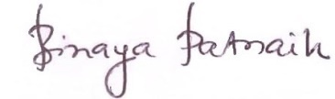 _________________ Major Advisor Signature Date
Asnake Kefalign. (MSC) ____________________ __________________ Co-advisor Signature Date
EXAMINERS’ APPROVAL SHEET
We, the undersigned, members of the Board of Examiners of the final open defense by Bilisummaa Ararsa have read and evaluated his/her thesis entitled “Finite element analysis of reinforced concrete column with core drilling”, and examined the candidate. This is, therefore, to certify that the thesis has been accepted in partial fulfillment of the requirements for the degree.
Zelalem Mekuria (Msc) …………………….. …..……………….
Name of Chairman Signature Date
Dr Binaya patnaik 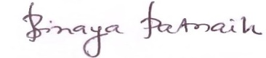 .……………………..
Name of Advisor Signature Date
Beharu Demissie (PhD candidate)  …..……………….
Name of Internal Examiner Signature Date
Dr Temesgen Wondimu  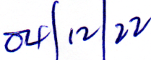
Name of External Examiner Signature Date
…………………………………..… ..…………………….. …..……………….
SGS Approval Signature Date
Final approval and acceptance of the thesis is contingent upon the submission of the final copy of the thesis to the School of Graduate Studies (SGS) through the Department/School Graduate Committee (DGC/SGC) of the candidate’s department.
Stamp of SGS
Date:____________

DECLARATION
I hereby declare that, this Master of Science thesis in Structural Engineering is my original work and has not been presented for a degree in any other university, and all sources of material used for this thesis have been duly acknowledged.
Name: - Bilisummaa Ararsa
Signature: _______________
This MSc thesis in Structural Engineering has been submitted form examination with my approval as thesis advisor.
Name:- Dr Binaya patnaik
Signature:
Place and Date of Submission: Hawassa, Ethiopia; April,12/2022

ACKNOWLEDGMENT
I would like to thank the “Waka” for the commitment and tolerance to pass various evil and come up to the accomplishment of this study. My great thanks go to my advisor Dr. Binaya Patnaik who has provided me knowledge in all the procedures and guidance during this thesis work. Next, gratitude to my sponsorship Ethiopian Roads Authority (ERA) for sponsored this program. I am also happy to have unlimited thanks giving for Professor Engineer Girma Zerayohannes and Fayisa Dufera (Cha member) for their initiation towards my work. I would like to praise to all those who support me including my co-advisor Mr. Asnake Kefalign for giving me relevant information without hesitation. Lastly, but not least I thank my brother Shimellis Ararsa and his wife Birtukan Girma for their support toward my thesis work.

LIST OF ACRONYMS AND ABBREVIATION
(n-1) Factor area of transformed
μ Viscous parameters
Ԑmax Maximum strain
3-D Three dimensions
Ac Area of concrete
ACI American concrete institute
Ag Gross cross sectional area,
Asc Area of compression steel
Ast Area of total reinforcement
ASTM American society for testing and materials
BC Boundary condition
BS British Standard
C3D8 Eight-node brick element
CFRP Carbon fiber reinforced concrete polymers
dc Uniaxial compression damage
dt Uniaxial tension damage
e Plastic potential eccentricity
eb Balanced eccentricity
EC European code
Es Elastic modulus of concrete
Ɛ_{c}^{pl} Compressive plastic strain
Ɛ_{cr} Cracking strain of concrete
Ɛ^{el} Elastic strain
Ɛ_{o} Initial strain of undamaged material
Ɛ_{t}^{pl} Tensile plastic strain
f’c Concrete compressive strength
fbo/fco Ratio of strength in biaxial to strength in uniaxial state
fcd Design value of concrete compressive strength
fck Characteristic compressive cylinder strength of concrete
fcr Cracking stress of concrete
FEA Finite element analysis
fu Ultimate stress of steel
fy Yield strength of steel
K Ratio of second stress tensile meridian to compressive meridian
Mb Balanced moment
P Nominal axial load
Pb Balanced load
R3D3 Three node three dimension rigid triangular facet
R3D4 Four node three dimension rigid bilinear quadrilateral facet
RC Reinforced concrete
SLS Serviceability limit state
T3D2 Two-node truss element
ULS Ultimate limit state
Wc Compression stiffness recovery
Wt Tension stiffness recovery
Δ Axial deformation
Φ Reduction factor of column load
Ψ Dilation angle
Ԑu Ultimate strain

ABSTRACT
Reinforced concrete column is one of the compression structural member carry axial or slightly slanted compressive loads, with or without moment. In RC column opening provided for multiple purpose such as plumbing of pipes and electric wiring. The provision of such openings may result in the loss of strength, stiffness and ductility. Therefore, providing core hole needs some precaution in account of failures of the column. Most of researchers have studied effect of opening considering, hole position, hole diameter, hole shape and grade of concrete. However, there is lack of study on drilling concrete core with considering of steel grade, reinforcement area ratio, level of service load. Therefore, this study demonstrates finite element analysis of reinforced concrete column with drilled concrete core considering effect of opening in account of steel grade, reinforcement area ratio, level of service, cross section of column and drilling location. It shows deformation versus column capacity, concrete vertical strain, bar strain distribution around hole, capacity reduction relative to controlling specimen, core position effect and P-delta effect. Finite element analysis consist initial step associated with boundary condition and first step which nonlinear static stress analysis takes place. For checking accuracy of finite element analysis validation performed with available experimental literature. The results from finite element simulation of hole effect indicates; Increase grade of reinforcement; improve capacity of drilled column and axial deformation decreased by the range 6.18 % up to14.59 % relative to solid column. Reinforcement area ratio reduces axial deformation 31.2% between drilled specimens and cross-section of column increases; deformation decrease 18.18% axial deformation. In addition to this; hole position at end side has large reduction in axial capacity of column and resulted increase lateral deformation. Hole at end side has greater effect in lateral deformation relative to axial deformation.
TABLE OF CONTENTS
Contents
APPROVAL PAGE m
DECLARATION i
LIST OF ACRONYMS AND ABBREVIATION iii
LIST OF FIGURES ix
CHAPTER 1 1
INTRODUCTION 1
1.1. Background 1
1.2. Problem Statement 2
1.3. Research Question 3
1.4. Objective of the Study 3
1.4.1. General Objective 3
1.4.2. Specific Objective 3
1.5. Scope of the Study 4
1.6. Significance of Study 4
CHAPTER 2 5
LITERATURE REVIEW 5
2.1 General 5
2.2 Tied and Spiral Column 5
2.3 Failure Mechanism of RC Column 11
2.4 Mechanical Behavior of Concrete 13
2.5 Finite Element Analysis 15
2.5.1 Advantages of Finite Element Analysis 16
2.5.2 Introduction to Non-linear Analysis Systems in Solid Mechanics 17
2.6 Related Research Work 20
CHAPTER 3 26
MATERIAL AND METHODOLOGY 26
3.1 General 26
3.2 Abaqus Modeling of Reinforced Concrete Column 28
3.3 Material Modeling 29
3.3.1. Concrete Damaged Plasticity Model 29
3.3.2 Reinforcement Modeling 39
3.3.3 Concrete - Reinforcement Interaction Modeling 40
3.4 Element Type 40
3.4.1 Mesh Density of Plain Concrete and Reinforcement 41
3.4.3 Step Module 43
3.5 Loading and Boundary Condition 43
CHAPTER 4 44
RESULTS AND DISCUSSIONS 44
4.1 Introduction 44
4.2 Finite Element Model and Validation 44
4.3 Parametric Study of Core Drilling Capacity and Axial Deformation Capacity of Reinforced Concrete Column 60
4.3.1 Cross-section of Column 61
4.3.2 Grade of Steel 62
4.3.3 Hole Position 65
4.3.4 Level of service load 66
4.3.5 Reinforcement Area Ratio 69
CHAPTER 5 72
CONCLUSIONS AND RECOMMENDATIONS 72
5.1 Conclusions 72
5.2 Recommendations 73
REFERENCES 75
APPINDEX 79

LIST OF TABLES
Table 3.1: Slenderness effect of study specimen 27
Table 3.2: Concrete damage plasticity model parameters 31
Table 3.3: Yield stress, in-elastic strain and compression damage of concrete 36
Table 4.1: Validation parameter (Lei, Qinfeng, Xiangmin and Chunming, 2010.) 44
Table 4.2: Detail of column used for validation and material specification (Lei, Qingfeng, Xiangmin, & Chunming, 2010) 45
Table 4.3: Study parameters of RC column with core drilling 60
Table B.1: Plastic strain PE of x, y and z direction and stress 81

LIST OF FIGURES
Figure 2.1: Spiral column and deformation of RC column under axial load (Wight & MacGregor, 2012) 6
Figure 2.2: Tri-axial stress in core of spiral column (Wight & MacGregor, 2012) 8
Figure 2.3: Lateral deflection of slender column 10
Figure 2.4: Interaction diagram of nominal column strength of bending and axial load 12
Figure 2.5: Compressive and tensile stress-strain of concrete (Hognestad, 1951) 14
Figure 2.6: Tensile stress-strain curve of reinforcing steel (Eurocode 2, 1992) 15
Figure 2.7: Linearity in structural systems 17
Figure 2.8: Non-linearity in solid mechanics (Kim, 2014) 18
Figure 2.9: Tied column destroyed in1971 San Fernando earthquake (Wight & MacGregor, 2012) 24
Figure 3.1: Detailing cross section of study parameter 28
Figure 3. 2: Yield surface in deviatoric plane (Abaqus/CAE, 2011) 30
Figure 3. 3: Definition of damage parameter in CDPM in (ABAQUS: Analysis user's manual, 2014) 31
Figure 3.4: Uni-axial compression loading 33
Figure 3.5: Uniaxial tension response of concrete (Water et al. 199) 34
Figure 3.6: Hognestad parabolic pre and post- peak concrete compression response (Hognestad, 1951) 36
Figure 3.7: Concrete compressive strength 37
Figure 3.8: Compression damage of concrete 37
Figure 3.9: Concrete tension damage vs Cracking strain 38
Figure 3.10: Tensile stress- strain of concrete 39
Figure 3.11: Typical uniaxial stress strain behavior of reinforcement (Mosley, Bungey, & Hulse, 1999) 40
Figure 3.12: Two node truss element (T3D2) and eight-node brick element (C3D8) 41
Figure 3.13: Meshing of controlled a. (mesh by part) and b. drilled column (swept mesh) 42
Figure 3.14: Study specimens hole location for core drilling 42
Figure 4.1: Dimensions and reinforcement of specimens (Lei, Qingfeng, Xiangmin, & Chunming, 2010) 45
Figure 4.2:- Layout of rebar strain gauges of C5 and C6 (Lei.et.al, 2010) 46
Figure 4.3:- Layout of concrete strain gauges, core drilling location and LVDT of C5 and C6 (Lei.et.al, 2010) 47
Figure 4.4: Hole position of validation modeling 47
Figure 4.5: P- delta of specimen C1, C2 of Abaqus, and Experimental result of (Lei.et.al, 2010.) 48
Figure 4.6: P- delta of specimen C4, C6 of Abaqus, and Experimental results of (Lei.et.al, 2011.) 49
Figure 4.7: Axial load versus delta of specimen C7,C8 and C9 of Abaqus and Experimental of (Lei.et.al, 2010.) 49
Figure 4.8: Rebar strain of C3 and C4 column specimen of Abaqus and Experimental result of (Lei.et.al, 2010.) 50
Figure 4.9: Rebar strain of column specimen of Abaqus and Experimental result of (Lei.et.al, 2010.) 51
Figure 4.10: Stirrup strain of C2 of Abaqus and Experimental value of (Lei.et.al, 2010.) 52
Figure 4.11: Rebar strain of C2 of Abaqus and Experimental value of (Lei.et.al, 2010.) 53
Figure 4.12: Rebar strain at core hole of specimen C3, C4 and C5 of Abaqus and Experimental value of (Lei. et.al, 2010.) 54
Figure 4.13: Concrete vertical strain of specimen C3 of Abaqus and Experimental result of (Lei.et.al, 2010.) 55
Figure 4.14: Concrete vertical strain of specimen C4, C5 of Abaqus, and Experimental result of (Lei.et.al, 2010.) 55
Figure 4.15: Maximum load of column specimen (300x300) for Abaqus and Experiment result of ( Lei.et.al, 2010.) 56
Figure 4.16: Maximum load of column specimen (400x400) for Abaqus and Experiment result of (Lei.et.al, 2010.) 56
Figure 4.17: Maximum load of column specimen (400x600) for Abaqus and Experiment result of lei.et.al, 2010 57
Figure 4.18: Maximum displacement of column specimen (300x300) for Abaqus and Experimental result 57
Figure 4.19: Maximum displacement of column specimen (400x400) for Abaqus and Experiment result 58
Figure 4.20: Maximum displacement of column specimen (400x600) for Abaqus and Experiment result 58
Figure 4.21: Ultimate axial load and axial displacement of C1, C5 and C8 of Abaqus result for validation 59
Figure 4.22: Displacement of specimen C450x450 and C450x500 61
Figure 4.23: Concrete strain of different cross section of column 61
Figure 4.24: Load-displacement graph of C450x450 62
Figure 4.25: Strain of concrete at maximum principal specimen with 300 Mpa, 420 Mpa and 520 Mpa respectively 63
Figure 4.26: Horizontal displacement and stress of 520 Mpa and 300 Mpa specimens 64
Figure 4.27: Load versus axial displacement graph of TC1, TC2 and TC3 65
Figure 4.28:- P- delta curve of specimen TC1, TC2 and T3 66
Figure 4.29:-Axial load for increasing level of load specimen 66
Figure 4.30:- Axial displacement of specimen with level load 67
Figure 4.31: -Maximum horizontal displacement of specimen TC10, TC11 and TC12 67
Figure 4.32:- Concrete stresses of columns with level of load 68
Figure 4.33:- Bar stress around the hole of TC12 69
Figure 4.34 Axial load and displacement graph of C450x450 69
Figure A.1: Rebar strain of Abaqus and Experimental result of Lei.et.al, 2010 79
Figure A.2: Stirrup strain of C1 of Abaqus and Experiment of Lei et.al 79
Figure A.3: Rebar strain of C1 of Abaqus and Experiment of Lei et.al 79
Figure A.4: Rebar strain of C5 and C6 of Abaqus and Experiment of Lei et.al 80
Figure A.5: Concrete vertical strain of C6 of Abaqus and Experiment of Lei et.al 80
Figure A.6: Strain of concrete of specimen C450x450 with 520 Mpa 80

CHAPTER 1

INTRODUCTION

1.1. Background
Reinforced concrete column is one of the compression structural member carry axial or slightly slanted compressive loads, with or without moment. Numerous characteristics of a reinforced-concrete column affects the overall strength of the column are length, load eccentricity, cross-section area, end connections, concrete and reinforcement strength. RC structural members are critical elements subjected to different loads under adverse condition such as wind loads, seismic load, snow, live load, dead load etc. (Wight & MacGregor, 2012). The loading capacity of column depends on the materials used in its’ construction, length, shape of cross-section, and the rigidity applied to its ends. Failure of column in a critical location can cause the progressive collapse of the adjoining floors and the ultimate total collapse of the entire structure. For design purpose column may be short or slender. In Short columns material strength and geometry of the cross section govern its strength; whereas, slender column strength reduced by lateral deflections and buckle before concrete or steel reinforcement yields (Neway, 2009).
In RC members plumbing, electric wiring and other facilities installed in structural members by providing holes. For multiple purpose openings and drilled holes often provided in those concrete structural elements to allow access for services, such as pipes for plumbing and electric wiring. Core hole changes the response of a structure by stressing around hole, which leads to cracking then after failure may occur. The provision of such openings may result in loss of strength, stiffness and ductility. Therefore, providing core hole needs some precaution in account of column failure. Application facilities of core test techniques in engineering raised in China since 1981 (Lei, Qingfeng, Xiangmin, & Chunming, 2010). Variety of cylinder’s height to diameter ratios cut out from the in-situ concrete. Cutting machines determine core diameter, element thickness control and height of hole. For indication, it has varied through thickness of column, beam, slab, wall and footing.
Hole position should be selected as diameter not crossing with reinforcement. Nevertheless, sometimes these criteria may not possible in critical area where reinforcements are closely spaced. Therefore, reinforcement cut during drilling follows the condition of rebar closely spaced or position undetermined. Reinforcement found in the core has been ambiguous matter. Some consider that rebar increases sample strength; while others believe that strength deduction when rebar exist; the others believe in very low effect of rebar. (Neville A. , 1996).
Different code and standards for instance, ACI, ASTM, EC, Iranian Concrete code and other Iranian codes, there is no account taken for rebar consequences on core. As a result, there is no any correction available for core test result. Still now, there is scarcity in code for concrete core for many countries. Although, some codes BS 1881:1983 and Concrete Society presented corrections for rebar existing in concrete cores (Neville A. , 1996). Rebar discontinuity at hole is confusing as mentioned in above literature; the study give more understanding of core drilling effect. It necessary to investigate the effect of cut reinforcement on solid reinforced column.

1.2. Problem Statement
There is no enough guidelines codes and research on concrete core drilling. This problem frequently creates doubts and concerns in engineering practice. Drilling core has significant reduction stiffness, strength and capacity reduction reinforced concrete column (Lotify, 2013). This results failures by initiating of cracking around hole. Drilling of concrete core effect has studied with considering of steel grade, reinforcement area ratio, level of service load. Therefore, careful analysis and detailing of RC column around the hole is required.

1.3. Research Question
- What are the effects of hole on the axial deformation of column?
- Does a reinforcement discontinuity at hole of RC column affect the stress strain distribution across the cross-section?
- What is the effect of reinforcement area ratio (steel diameter), level of load and steel grade on core-drilled column with respect strength of reinforced concrete column?
- How much these parameters reinforcement area ratio (steel diameter), level of load and steel grade has effect on core drilled column?

1.4. Objective of the Study

1.4.1. General Objective
The objective of this study is finite element analysis of reinforced concrete column with core drilling considering axial load for a better understanding the influence on its capacity due to drilled core.

1.4.2. Specific Objective
- Investigation of factors such as:- steel grade, reinforcement ratio, level of load, column effective cross section, drilling location, and reinforcement discontinued by drilling, that have impact on RC column capacity
- Comparing and contrasting response of on reinforced concrete column with and without core
- Investigating the effect of core drilling on deformation of reinforced concrete column
- Determining bar strain at core hole position, concrete vertical strains and P-delta effect of reinforced concrete column.

1.5. Scope of the Study
In this research finite element analysis of RC column with drilled core under axial load of column limited to short rectangular column. Transverse core selected for RC column. Longitudinal core not considered for this study. RC column is subjected to concentric load on the top of column and circular hole diameter is constant. Hole position at end side and end center selected for this study.

1.6. Significance of Study
This study will contribute and increase understanding the response of the drilled reinforced concrete column by using finite element method. It will provide good way of repairing of existing structure. The results obtained will be helpful for construction industry, designers, educational purpose and for next coming researchers on this area.

CHAPTER 2

LITERATURE REVIEW

2.1 General
RC structures are widely used to build infrastructures. These structures are consist structural elements such as column, foundation and beam. Reinforced concrete column is vertical elements support the floor system. They are compression member subjected to axial load, axial load and bending. If structural system composed of horizontal compression members, such members will be considered as beam columns (Neway, 2009). Columns are part of structural member that carry loads from the beams and slab down to the foundation. Columns are primarily compression members; they may also resist moment due to continuity with other structural members. In general, concrete columns defined as compression members whose greatest lateral dimension is less than four times its least lateral dimension; and whose unsupported length is more than three times the least lateral dimensions of the section.

2.2 Tied and Spiral Column
According to MacGregor, more than 95% of all columns in buildings in non-seismic regions are tied columns. From various category of shape-based classification, tied columns are may be L-shaped, circular, rectangular or square. In spiral columns reinforcement bent and ties with helix or spiral for high strength ductility achievement. Accordingly, ductility in columns could ensure by providing spirals or closely spaced ties. Axial loads applied and concrete core expands laterally in out of plane. Nevertheless, spiral prevents concrete expansion which providing concrete core delay and then ductility achieved (Wight & MacGregor, 2012). In seismic region among that spiral column governed. The figure 2.1.b below diagrams shows as the concrete spalls off and concrete core fails out ward of spiral after ultimate load applied soon after indicating vertical cracks. When this occurs in a tied column, the core capacity that remains is less than the load column. The concrete core crushes and the reinforcement buckles outward between the ties. This kind of concrete failures happens in brittle without warning sign indication. Spiral reinforcement confine core results triaxial stress, which yields core strength. In case of concrete inside spiral expands out ward and spall of concrete core. However, there is no sudden failure; which means it shows warning preceding failure. Consequently, column deforms largely by preceding collapses (yielding of spirals). This kind of failure is recommendable because of ductile the impending failure. The load deflection diagrams (see figure 2.1.b) shows the behavior of tied and spiral columns subjected to axial load.
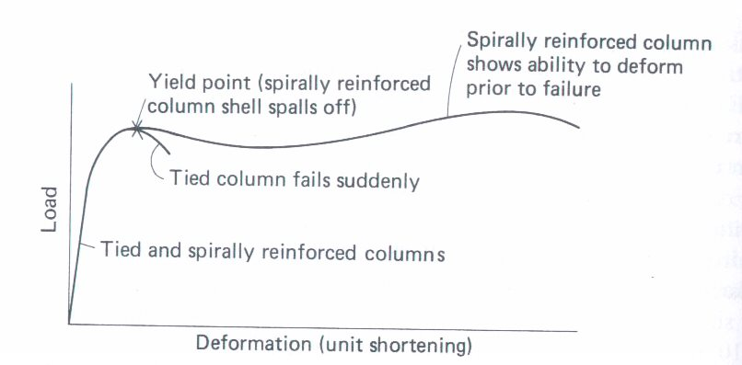
Figure 2.1: Spiral column and deformation of RC column under axial load (Wight & MacGregor, 2012)
Behavior of Tied and Spiral Column
Spiral column core portion enclosed with one and half turns of as illustrated in figure 2.2.a. Column subjected to load f1 in stress form vertically; then after concrete core shortens longitudinally as compressive load exerted and so to satisfy poison ratio. The compressive load results lateral expansion of concrete up to 70% of cylindrical strength. As presented in figure 2.2.b in a spiral column, lateral expansion of concrete core inside the spiral stirrup. The spiral gives tension stress response as concrete core restrained inside the spiral. In order to equilibrate the condition, concrete subjected to lateral compressive stresses, f2 an element taken from within the core (Figure 2.2.c) subjected to tri-axial compression. Tensile fracture failure type under tri-axial compressive stresses created. This Failure formed in direction of maximum compressive stress and this perpendicular to maximum tensile strain or a shear mode of failure. The strength and ductility of concrete under tri-axial compression exceed those under uniaxial compression.
$f_{1} =fc^{'}+4.1f_{2}$ ………. (Equation 2.1)
Equation (2.1) used to derive an equation for the quantity of spiral steel bar needed in a column. Tied column of seismic area has roughly spaced tie and result a small lateral restraint to the core material. Hoop stress effect formed by outward pressure on sides of tie due to lateral expansion of concrete. Therefore, normal stirrup has a little effect on strength of core in tied column. However, act to decreasing buckling danger as reinforcement stress approaches to yield with in deduction of unsupported length of main bar.
Figure 2.2 presents’ load-deflection diagrams for a spiral column subjected to axial loads and tied column. The initial conditions of these diagrams are similar. Maximum load produces vertical cracks and crushing developed in concrete out sides of spiral. Moreover, this concrete spalls off. When this occurs in a tied column, load of column is beyond the capacity of the core. Therefore, as shown in figure 2.2 stress in spiral reinforced concrete column expressed tri-axial load is applied.

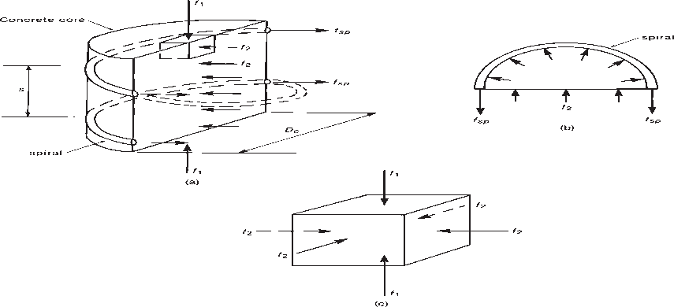

Figure 2.2: Tri-axial stress in core of spiral column (Wight & MacGregor, 2012)
The concrete core crush is occurring suddenly without warning when shell spalls off the spiral column and reinforcement buckles outward between ties. On the other hand, column does not fail immediately because; the strength of the core enhanced by the tri-axial stresses resulting from the effect of the spiral reinforcement. Therefore, column under goes large deformation and reaching maximum second load; then the spirals yield and the column finally collapses. This kind of failure is more ductile relative to tied column and shows warning of the before failure, along with possible load redistribution to other members. This is takes place at very high strains. In spiral columns of eccentrically applied, the second maximum load may be below the initial maximum, nevertheless, the deformations at failure are large, allowing load redistribution (figure 2.2.b). Since their larger ductility, compression-controlled failures of spiral assigned a strength-reduction factor Ø of 0.75, rather than the value 0.65 used for tied columns (Wight & MacGregor, 2012). When compare spiral stirrup relative to a normal stirrup it has good confining effect core by protecting of concrete expansion and buckling resistance as ultimate stress of column applied specially in circular column.
Short Column
A short column is defined as one in which the ultimate load is not reduced by the bending deformations because of additional eccentricities delta are either negligible or occur away from the critical section. They are columns with low slenderness ratio and their strength governed by the strength of the materials and the geometry of the cross section (Pauly, 1974). Short axially loaded compression member indicated that for lower loads at which steel and concrete materials remain in elastic range. Steel support small portion of total load. In case of both elastic materials, this stress equivalent to n times concrete stress. Fs= nfc, where n, modular ratio is the ratio of steel modulus to concrete modulus. As a result, axial load, p is formed as in equation 2.2.
P = fc [Ag+ (n-1)Ast] ………(Equation 2.2)
Ag= gross cross sectional area, Ast= area of total reinforcement, (n-1) is area of transformed section. For elastic material of steel and concrete, equation 2.2 used to calculate stresses in concrete. Nominal strength of column axial load is the sum of stress in concrete plus stress in steel, this shown as P= Acfc + Astfy. Considering non-linear response of material, some reduction factors for concrete stress used. The reason is why concrete during curing decrease its strength until it sustains to get sufficient strength. As statement of ACI, code reduction factor of column is lower than that of the beam due to big importance in structure. Stress in beam lead to local failure whereas in column will result in collapse of overall structure. Hence reduction factors 0.85 used here for concrete stress, fc= 0.85fc’ and axial load is derived as equation 2.3. According to ACI code 10.3.6, design strength of axially loaded column formed based on equation 2.3.
$P =0.85f_{c}^{'}A_{c}+A_{st}f_{y}$ ………… (Equation 2.3)
Ac= Ag-Ast, net area of concrete. Strength contributions of steel and concrete are different. At this stage, steel has high fraction of load than at lower total load. (H.Nilson, David, & W.Dolan, 2010)
Slender Column
A slender column is defined as one in which the ultimate load is reduced by the amplified bending moment caused by additional eccentricity. They are columns with high slenderness ratio and lateral deflection may significantly reduce their strength. When an unbalanced moment or as moment due to eccentric loading is applied to a column, the member responds by bending as shown below in figure 2.3. If the deflection at the center of the member is, delta, then at the center there is a force P and a total moment of M + Pδ. The second order-bending component, Pδ, is due to the extra eccentricity of the axial load, which results from the deflection. If the column is short δ is small and this second order moment is negligible. On the other hand, if the column is long and slender, δ is large and Pδ must be calculated and added to the applied moment M.
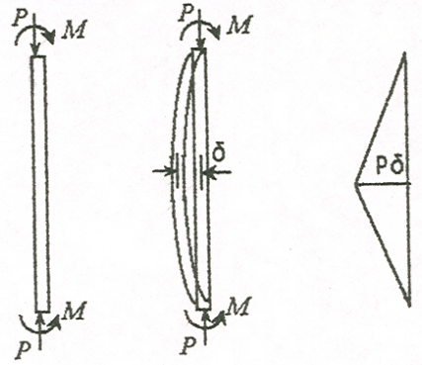
Figure 2.3: Lateral deflection of slender column
Behavior of straight concentrically loaded slender column has long history more than two centuries. Euler developed it and he formed general formula based on failure of member induced by buckling at critical load.
$P_{c}=\frac{π^{2}E_{t}I}{{\left(KL\right)}^{2}}$ ….………. (Equation 2.4)
According to equation 2.4, slenderness has inverse relation with critical load. For hinged column at two ends and column made of elastic material, kl is equivalent value with actual length of column (l). Originally, straight column bents half sine wave as shown in figure 2.3; bending, Pẟ is at any section and ẟ is deflection. (H.Nilson, David, & W.Dolan, 2010)

2.3 Failure Mechanism of RC Column
Slenderness ratio is one factor that control failure mechanism of RC column. Interaction curves in failure mechanism classified in two regions. Failure modes classified as compression failure, combined failure and elastic instability. This assumed concentrically loaded column. a). Pure compression: - when reinforced concrete columns are axially loaded the reinforcement steel and concrete experiences stresses. As the load are increases compared to cross sectional area of column; reinforcement and concrete reach yield stress and column fail without any lateral deformation. Means, concrete reach ultimate strength value before steel. Concrete column crushed and collapse of the column due to material failure. This kind of failure is non-recommendable due to concrete not shows any warning. It crushes suddenly before over coming failure. Consequently, sufficient cross-section should be providing to control material failure. b) Combined failure: -this occurs when tensile of steel reaches yield strain, e_{y} at the same time concrete arrive at ultimate strain eu condition. It demonstrates the corresponding parameter balanced eccentricities (e_{b}), balanced load (P_{b}) and balanced moment (M_{b}) integrally acted to found failure. As shown below in figure 2.4-balanced point is lies between compression and tension region as figure indicates in tension region eccentricities are larger. On the other hand, at far end of compression zone eccentricities becomes small. Short columns commonly subjected to axial load, lateral loads and moment. Short columns subjected to action of lateral load and moments undergo lateral deflection and bending. c). column failure due to elastic instability: - in this condition carrying capacity of reinforced concrete column reduced for given cross-section and steel reinforcement ratio. A slender column defined as a column that has a significant reduction in its axial-load capacity due to moments resulting from lateral deflections of the column. This kind of failure steel reinforcement yields before concrete. It can show warning sign before failures and tension failure recommended among those failures. (H.Nilson, David, & W.Dolan, 2010)
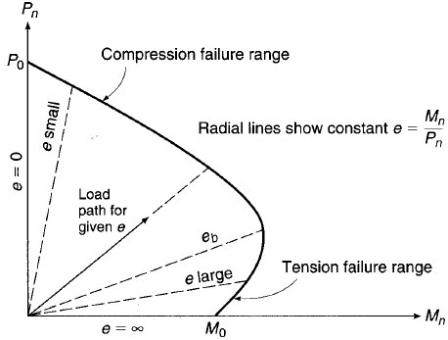
Figure 2.4: Interaction diagram of nominal column strength of bending and axial load
Concrete
Concrete is stone like material obtained artificially by hardening of the mixture of cement, inert-aggregate materials (fine & course) and water in predetermined proportions. When these ingredients are mixed, they form a plastic mass, which poured in suitable molds and set-on standing into hard solid mass, because of exothermic chemical reaction between cement and water. To produce a workable mix, more water used over and above that needed for this chemical reaction. The reaction between cement and water is relatively slow and requires time and favorable temperature for its completion. Concrete has large compressive behavior, but it has larger factor safety than steel. Because, in field concrete mix with poorly of accurate measurements; whereas steel with accurate measurements in laboratory.

2.4 Mechanical Behavior of Concrete
Many factors affect compressive strength of concrete such as water cement ratio, type of cement, aggregate properties, age of concrete, and time of curing. Among these water cement ratio has great role in factor affecting concrete. Lower water cement ratio provides good workability as concrete grade rises. Increase water cement ratio from 0.45 to 0.65 can decrease the compression strength by 30-40%. (Prof. Mashhour Ghoneim, 2008). Concrete classified as fresh and hardened concrete depend up on mixing time. Fresh concrete give and possess best results of greater workability which indicated in grey color; whereas, hardened concrete are attained its full strength within 28 days. This hardened concrete has mechanical properties such as - compressive strength, flexural strength, modulus of elasticity, creep and shear friction strength. Concrete is generally weak in tension but, strong in compression. This is because of aggregate-mortar interface has lower strength than mortar and this yield to weak concrete under tension. (H.Nilson, David, & W.Dolan, 2010).The stress-strain relationship for concrete under compression is initially linear elastic until micro-crack initiation. After that, the behavior becomes nonlinear. After the ultimate compressive strength, the stress decreases with increasing strain. See figure 2.5a. Under uniaxial tension, the stress–strain response follows a linear elastic relationship until the value of the failure stress reached. The failure stress corresponds to the onset of micro cracking in the concrete material. Beyond the failure stress, the formation of micro-cracks represented with a softening stress–strain response, figure 2.5b. The softening curve of concrete under tension represented as follows.
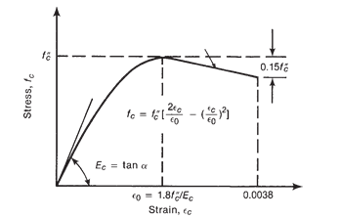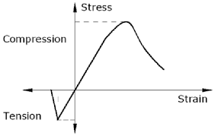
Figure 2.5: Compressive and tensile stress-strain of concrete (Hognestad, 1951)
Reinforcement
Steel reinforcements for concrete are available in the form of round bars, wire and welded wire fabric. Most important properties of reinforcing steel are young modulus, yield strength, ultimate strength, steel grade designation and size of bar or wire (Neway, 2009). The most commonly used bars have projected ribs on the surface of bar. Such bars named as deformed bars. The ribs of deformed bar improve the bond between steel and the surrounding concrete in RC members by providing mechanical keys. A wide range of reinforcing bars is available with nominal diameter ranging 6mm to 35mm. Most bars except 6mm diameter are deformed one
Strength of Reinforcement
Reinforcing steel exhibits an elastic-plastic behavior where the elastic limit is equal to the yield strength of the steel. Initially stress-strain has direct relationship [Rijkswaterstaat (RTD)]. Steel is initially linear elastic for stress less than the initial yield stress. At ultimate tensile strain, the reinforcement begins to neck and strength is reduced. At a maximum strain, the steel reinforcement fractures and load capacity lost, [ASTM A615]. This steel response may have defined by a few material parameters as identified in Figure 2.6. These include the elastic modulus, Es, the yield strength, f_{y}, the strain at which peak strength is achieved, Ԑ_{u}, the peak strength, f_{u}, the strain at which fracture occurs, Ԑmax, and the capacity prior to steel fracture, f_{s}.
Figure 2.6: Tensile stress-strain curve of reinforcing steel (Eurocode 2, 1992)
All steel has similar shape of stress-strain, and differs only in the steel strength value, the modulus of elasticity, E_{S} being for all practical purposes constant and E_{S} taken as 200GPa. For a design of RC members, reinforcing steel up to grade of 550MPa can used. If steel with grade beyond 550MPa used for RC member, the sections are under utilizing the reinforcement. This is because the width of concrete crack is wide if the steel fully stressed.

2.5 Finite Element Analysis
Numerical analysis introduced first in engineering practice in the 1960. Among analysis method, finite element difference and boundary element method were in use. (Basravi, 2010). The rapid development of computers has completely revolutionized research and practice in every scientific and engineering field. The dream that every office and home would have a computer terminal and personal computers has become a reality. Finite element method used to physical problems in engineering analysis and design. The physical problem typically involves an actual structure or structural component subjected to certain loads. The identification of physical problem to mathematical model requires a certain assumptions that together lead to differential equation governing the mathematical model (Bathe & Klaus-Jurgan, 1966). The general numerical technics in approximation behavior of continua by integration finite parts (elements). The continua divided into integral parts for relevant approximation of solution. Simple regular geometry easier in analyze than that of actual structure. Most of the time actual structure is so more complicated and need critical judgment in analytical situation. However, approximate complicated solution consists piecewise continuous simple solution. (Basravi, 2010). Abaqus standard uses newton ‘s method to solve nonlinear problems. Exact implementation of newton’s method used. This implies jacobian of system exactly defined and estimate solution is within radius of convergence of algorithm results quadratic convergence. (Abaqus/CAE, 2011)

2.5.1 Advantages of Finite Element Analysis
Over time, finite element method was more applicable due to efficiency in numeric and generality. Some other methods are hinder advance in certain application so that difficult to perform different type of analyses. In contrast other, FEM used in various feasibility of different engineering application. In wider engineering application, the FEM considered as versatile one. Wide spread of finite element analysis adapted to engineering problems and increase demand market of commercial analysis software. It merits with irregular geometries routinely and higher order implement with ease. It also makes finite element formulation in modeling of heterogonous or anisotropic. Handling of mixed boundary condition, that encounter in problem can be included in complex finite element formulation. (Basravi, 2010). Finite element simulation also provides checking up of experimental work. It also allows the user to modeling of complex geometry and irregular shapes. It accommodates different type of material properties in element. In addition to this in finite element analysis, higher order software implemented. Among FE software packages abaqus is the one uses for numerical method of analysis.

2.5.2 Introduction to Non-linear Analysis Systems in Solid Mechanics
Before explain nonlinear systems, it is necessary to describe linear system. In relation when displacement doubled, force also doubled. As different load magnitude is applied, it is not valid to use linear system. This makes to use superposition. Linearity can be explained using linear operator by super position principle when it satisfies A(αu + βw) ¼ αA(u) + βA(w) for any u and w, in D_{A} and for any scalars α and β. This is the reason behind to understand in detail about linear system before proceed to non-linearity (Kim, 2014). Linear system described in figure 2.7 and any system differ from linear is called nonlinear as shown in figure 2.8.
Global Linear Local Linear Local Linear Global
Displacement

Force
Strain
Stress

Figure 2.7: Linearity in structural systems
Nonlinear Analysis
Non-linear analysis used for both ULS and SLS, if equilibrium and compatibility are satisfied and an adequate non-linear behavior for materials assumed. The analysis may be first or second order. At the ultimate limit state, the ability of local critical sections to withstand any inelastic deformations implied by the analysis should be check, taking appropriate account of uncertainties. For structures predominantly subjected to static loads, the effects of previous applications of loading may generally ignored, and a monotonic increase of the intensity of the actions may assumed. P the use of material characteristics that represent the stiffness in a realistic way but, take account of the uncertainties of failure shall use when using non-linear analysis. Only those design formats that are valid within the relevant fields of application used. (European Standard 2, 1992). Nonlinear analysis may be geometrical, material non-linearity and kinematic non-linearity. Some objects may have curved shape. Therefore, such kind of non-linearity named as non-linear in geometrical shape
Strain
Stress
Displacement
Non-linear Non-linear
Displacement-strain stress-strain
Non-linear displacement. BC Nonlinear force BC
Applied force
Prescribed displacement

Figure 2.8: Non-linearity in solid mechanics (Kim, 2014)
2.5.2.1 Material Non-linearity
It occurs when, relationship stress and strain created. This relation often referred as constitutive relation. In linear relation written as σ= [D]*{ε} where D is elastic modulus matrix, since, D is constant; stress- strain relation is linear when strain double, stress also doubled. Relations will become nonlinear when D, is not represented constant matrix (Kim, 2014). Material non-linearity in solid mechanics involves comparison of rate dependent and rate independent material non-linearity. Yield surface concept described based on their applicability to particular classes of material. The macroscopic behavior of material adopted in nonlinear material models as a result, approximations of real behavior material when real behavior related to micromechanical effects with in material. Rate independent material non-linearity assumed to under goes without time dependence. It focuses on immediate approximations as all materials are dependent to degree up on rate at which load is applied and nonlinear stress-strain relationship is category of this non-linearity. Finite element simulation used rate independent material non-linearity for this paper.
2.5.2.2 Geometrical Non-linearity
Geometrical non-linearity represents the cases relation among kinematic quantities (i.e. displacement, rotation and strains) are nonlinear. This kind of non-linearity occurs when deformation is large. As couple tip force applied laterally at top of column since large rotation nonlinear analysis accurately represent the deformation. Therefore, relationship between lateral force at tip and displacement is nonlinear. This large deformation creates nonlinear in displacement, strain and rotation.
2.5.2.3 Kinematic Non -linearity
This nonlinearity named as boundary non-linearity type of deformation structure determines its displacement boundary conditions. Using boundary conditions and applied loads, unknown displacements solved. When boundary condition changes as a function of displacements, there are two unknown: - boundary condition and displacements. Therefore, in this case difficult to solve structural equations as both sides of [K]*{Q} =F has unknown variables. There are two categories of kinematic non-linearity. Location on boundary where boundary conditions are applied known, but unknown values. Both locations on boundary where boundary conditions are applied and values are unknown. The second one is more challengeable than first. For instance, deformation of rubber like cylinder through contact with rigid bodies is key example (Kim, 2014).

2.6 Related Research Work
This section provides an overview of previous studies that have conducted on core drilling by researchers in the fields of structural engineering. Different articles have reviewed in order to understand the techniques and key studies that have conducted.
(Salahuddin A. Ahmed, 2016) has worked on experimental evaluation of repairing techniques for holes made in reinforced concrete column for core tests. The experiment result showed that filling hole with cement base grout and wrapping it with CFRP sheets increase drilled hole strength. Increment load carrying capacity 50.5% and 19.5% relative to drilled column and control specimen respectively. Whereas drilled hole repaired with steel pipe and WFRP sheets enhanced bearing capacity by 13.6% and 43%respectively when compared to drilled column and control specimen. He concluded that core drilling can remarkable reduction on the structural elements strength, moreover as influence of cross section reduction is temporal effect.
(A. Masi, 2012); Identified the effect of core drilling and subsequent restoration on RC column strength. He focused on the evaluation of drilling hole and subsequent restoration of reinforced concrete (RC) column by core testing. For evaluating the drilling effect on RC column member, various tests have performed on solid columns and cores. For this aim after hole drilling compression tests of monotonic loading, un-loading has carried out. Depend on the experiment results core drilling effect and subsequent restoration on structural element strength evaluated with the performance of a solid column, drilled column and restored column. He expressed the effect of drilling hole on the structural members after installed and after possible restoration.
(Ayatullah Khomeni, 2018) Studied experimental investigation and numerical simulation on effect of drilled cores on axial capacity of columns. Different columns with varies of core sizes, compressive strengths, lateral confinement analyzed by FEA for purpose to insure safe core drilling. Stirrup spacing has significance percentage of reduction on core-drilled column. He summarized core size 50 mm diameter reduction varieties between 10 to 23% and for tie bar spacing 33% to 46%. Hence, columns with good confinement will less influenced by core extraction. Concrete compressive strength less than 13.6Mpa capacity reduction will be 16% with 100mm core diameter, which drilled from 300*300mm column. In case of higher strength concrete 34.5Mpa 4% reduction for the same condition. As result, columns with lower strength exposed to higher damage because of core drilling. Nevertheless, lateral core drilling is not taking into account.
(Ortiz, 1985; Resende, 1987; Carol et al., 2001), the strain split into elastic and plastic parts, represents realistically the observed deformations in confined compression, so that unloading and path-dependency described well. However, plasticity models are not able to describe the reduction of the unloading stiffness that observed in experiments. Conversely, damage mechanics models based on the concept of a gradual reduction of the elastic stiffness.
(Lotify, 2013) Nonlinear analysis of reinforced concrete columns with holes including several parameters investigated. Dimension of hole are 0.1*column height, 0.15*column height, 2*column height and 0.3*column height. The hole positioned at middle third, edge third with circular and square hole shape. The study expressed the effect of the investigated parameters on deformation and maximum resisting load. Diameter of hole more than 0.15 of columns length has significant effect of the column behavior; reducing toughness of tested columns. The increasing hole dimensions to more than 0.15 of columns length leads to reduction in ultimate loads of tested columns to 80%. Using square hole in tested column has a significant effect on the behavior of tested columns. Nevertheless, he not considered “effect of repairing’’ of hole after installation.
(Khanan & Ahmed, 2019) He studied experimental and finite element modeling of reinforced concrete column having opening. This study deals with the finite element modeling of reinforced concrete beam and column using ANSYS. Study of the work includes the modeling of beam and column with specific cross sections and reinforcement details. Further, the column with a lateral hole at the center evaluated in terms of cracking response around the hole. However, he has not taken in to account different column cross sections, opening position and repairing after installation.
(Paul & Nair); Investigated the behavior and ultimate strength of the reinforced concrete columns with transverse openings with different shape size, location and shape. Transverse openings often provided in reinforced concrete columns to allow access for services, such as pipes for plumbing, electrical wiring air conditioner pipes. They concluded as the size of the opening increases stiffness reduces. Regarding the shape of opening circle has more stiffness than square.
(Basravi, 2010); Investigated the effect of positioning hole along reinforced concrete short braced columns in multi-story buildings. Different size and reinforcement of RC columns with holes positioned at the centers of their cross-sections modeled by non-linear finite element analysis. The investigation shows that the factors of safety for the models with hole obtained from the finite element analysis results vary from 1.42 to 1.98 (experimental work results vary from 1.09 to 1.82) according to BS 8110 code. Based on ACI code evaluation, similar factors vary from1.29 to 1.94 (experimental work results vary from 1.12 to 1.70).
(Zhang, 2018), Behavior of reinforced concrete walls with circular openings is research on water-filled reinforced concrete wall panels for energy efficiency and multi-hazards mitigation. The concept of this wall panel is that it contains various openings allowing water to circulate. Hot and cold water used in winter and summer, respectively, to achieve energy efficiency.
(Al-Azzawi & .Abed, 2017), Investigation of the behavior of reinforced concrete hollow-core thick slabs The experimental part of this investigation includes testing eight specimens of solid and hollow-core slab models having (2.05 m) length, (0.6 m) width and (25 cm) thickness under two monotonic line loads. The cracking and ultimate strength of the moderately thick solid and hollow-core slab lead to be decrease with increasing the diameter of the cores and with increasing the ratio of shear span to effective depth.
(Nishitha & Kavitha, 2016), The effect of opening on deep beams; the shear behavior and capacity of concrete beams depends on various factors and among them overall span to depth ratio of beam plays a crucial role. The behavior of beams varies depending on the span to overall depth ratio. The position of openings were provided depending upon the strut and tie formation in deep beam when it is loaded.
Strength of Axially Loaded Columns Capacity (ACI Code)
Concentric axial applied, P on symmetrical column and then after longitudinal strains, 𝜀 develop uniformly across the section-as shown in Figure 2.9 bonding together of steel and concrete make, the strains in the concrete and steel are equal. Stresses in steel and concrete are computed from stress-strain diagram for strain available. As P reaches, maximum capacity damage occurs. According to ACI 10.3.6 code column well defined yield strength; the axial
Figure 2.9: Tied column destroyed in1971 San Fernando earthquake (Wight & MacGregor, 2012)
Load capacity is equivalent to total load on column. Load on column is sum of forces of concrete stress and steel stress forces. This force obtained by the corresponding stress of concrete and stress in steel reinforcement multiplied by their respective area of concrete, A_{c} and area of steel reinforcement, Ast respectively. Therefore, axial load capacity of column is equivalent to the following formula. (H.Nilson, David, & W.Dolan, 2010).
$P_{n}=0⋅85f_{c}^{'}\left(A_{g}-A_{St}\right)+f_{y}A_{st}$ ……… (Equation 2.5)
Net Area of concrete, A_{c} is resulted when steel area deducted from gross concrete area and 0.85 is certain strength reduction factor. A_{s} ACI states strength reduction factor of column is smaller than that of beam, which reflects greater importance in structure. Beam failure may result local failure whereas column failure in collapse of structure. In addition, there is factors, φ reflect difference behavior in tied reinforced and spirally concrete column. Value of φ is 0.75, 0.65, 0.9 for spirally RC column, tied RC column and most of beams respectively. As per ACI code Section 10.3.6 of the code, the axial load capacity of columns may not be greater than the following values:

For spiral columns (φ=0.75)
${φP}_{n}\left(max\right)=0.85{φ[0.85f}_{c}^{'}\left(A_{g}-A_{St}\right)+f_{y}A_{st}$ ..…… (Equation 2.6)
For tied columns (φ=0.65)
${φP}_{n}(max)=0.8{φ[0.85f}_{c}^{'}\left(A_{g}-A_{St}\right)+f_{y}A_{st}]$ ….….. (Equation 2.7)
Reinforcement-the minimum distance between adjacent bars should not be less than the diameter of the bar or hagg + 5 mm. The area of longitudinal reinforcement should lie in the limits: 0.4%A_{col ≤} A_{sc} ≤ 6%A_{col} in a vertically cast column.
Strength of Axially Loaded Columns Capacity (Euro Code)
According to Euro code 2, column is structural member with smaller dimension, b less than one-fourth of larger dimension, h. In case of main reinforcement is not less than diameter. Polygon cross-section of column minimum of one reinforcement placed at corner. This indicates minimum number of main are should not less than four. Total longitudinal reinforcement is not less than A_{smin}. The value of A_{smin} may calculated using the equation 0.1N_{Eds}/fyd = or 0,002 Ac; where: - fyd, design yield strength of reinforcement, N_{Eds,} design axial compressive force. Transverse reinforcement is the stirrup such as helical spiral, links, and loops. The diameter may not less than 6mm or one-fourth maximum diameter of longitudinal reinforcement. In case of the wires of welded mesh fabric for stirrup bar should not less than 5mm. Stirrup should be spaced with minimum of 20*minimum diameter of main bar, lesser dimension of column or 400 mm. Spacing reduced by 0.6 factor for case one, section with distance equal to the larger column cross-section above or below beam or slab. For case two, maximum diameter of main bar greater than 14mm for near lapped joints. Minimum of evenly spacing of three bars around lap required. Direction of main reinforcements changes, for instance, column sizes, spacing of stirrup calculated in considering of lateral forces.

CHAPTER 3

MATERIAL AND METHODOLOGY

3.1 General
The main goal of this study is analysis of drilled reinforced concrete column performance using finite element analysis with various parameter of study. This chapter conducted to describe method and modeling nonlinear mechanical analysis of concrete, reinforcement as time independent. Under this material non-linearity selected to perform the study. Computational simulation of program based on 3D FEA program documentation of guidelines abaqus version 6.14.
Factors Affect Drilling Core
Cores are certain part of concrete cut out from main part to assess reinforced concrete of new structures stand with strength. Numerous factors can affect drilling core strength. As literature reviews discussed in chapter two; factors affect opening strength primarily on reinforced concrete structures such as slab, column, beam or foundation is varying. Factors related to core preparation, cross section, grade of steel, grade of concrete, reinforcement area ratio, stirrup arrangement, core length to diameter ratio, core diameter, hole number, load level and core orientation in relation to placement direction. In this research, study parameters also selected based on its effect of drilling core.
Slenderness Effect
According to ACI code column may classified as braced column: where walls or some other form of bracing and unbraced column resists the lateral loads: where the lateral load resisted by bending action of the columns. All columns in models assumed to be braced column, which means no bending action considered in this study. ACI Code Section 10.10.1 states that it is permissible to neglect slenderness effects for columns braced against sideways if.
$\frac{kl_{u}}{r}≤34-12\left(\frac{M_{1}}{M_{2}}\right)≤40$ …….. (Equation 3.1)
Where, k, effective length factor for a braced (non-sway) frames. $l_{u}$, unsupported length of column between floors; r, Radius of gyration; M1/M2, ratio of the moments at the two ends of the column, which (for compression members in a frame braced against sides way) will generally be between +0.5 and -0.5. K value used equal to two for cantilever column according to ACI code and ratio of the moments +0.5 will usually conservative.
$r=\sqrt{\frac{I}{A}}$ ; Where $I=\frac{bh^{3}}{12}$ and $A=bh$
I = $\frac{450{(450}^{3})}{12}$ = 3417.1875*10⁶ mm⁴ and A = 450*450=202500 mm²
$r=\sqrt{\frac{3417187500 }{202500}}$ =129.9038
$$λ=\frac{{kl}_{u}}{r}=\frac{2*1200}{129.9038} =18.4752*1200≤34-12\left(\frac{M_{1}}{M_{2}}\right)≤40$$
$λ_{limit}=34-12\left(\frac{M_{1}}{M_{2}}\right)=34-12\left(0.5\right)=28≤40$ Ok.
$λ=18.4752<$ $λ_{limit}$ =28 ok. Neglect slenderness effect. Therefore, column is short
Table 3.1: Slenderness effect of study specimen
Specimen | l (mm) | B  (mm) | h  (mm) | A=b*h (mm²) | $I=\frac{bh^{3}}{12}$ (mm⁴) | $$r=\sqrt{\frac{I}{A}}$$ | $$λ=\frac{{kl}_{u}}{r}$$ | Type
TC1, TC2, TC3,TC4, TC5,TC6,TC7,TC9,  TC10, TC11,TC12 | 1200 | 450 | 450 | 202500 | 3417187500 | 129.9 | 18.47 | short
TC13 | 1200 | 450 | 500 | 202500 | 4687500000 | 152.14 | 15.77 | short
TC13 | 1200 | 500 | 450 | 202500 | 3796875000 | 136.93 | 17.52 | short

Colum Specification and Detailing
Specimens TC1~TC12 are similar, but only TC5 and TC6 different in diameter; use Ø24 for TC5 and Ø30 for TC6
Specimen TC1~TC12 Specimen TC13
450
3Ø16

2Ø16

3Ø16
200 250
Y

x

450
20
Y

x

20

3Ø16
2Ø16

400

3Ø16
Stirrup

400
Main bar Ø16 Lt 1160; Section Y-Y Ø8 c/c 50; Section X-X Ø8 c/c 172
Figure 3.1: Detailing cross section of study parameter

3.2 Abaqus Modeling of Reinforced Concrete Column
(Abaqus/CAE, 2016) is finite element packages software with various products in various applications with own facilitation. Abaqus manage simulation in engineering analysis from simple to most challenging nonlinear analysis. It is widely used software in geometric and material non-linearity since flexibility facilitates various ways of material modeling, analysis and solution techniques. Before processing stage: - geometry, material properties, boundary condition, loading, interaction and nonlinear analysis solution to be defined. Library elements of abaqus enable to model any geometry and material. Material library intended to provide most extensive engineering materials through linear and nonlinear, isotropic and anisotropic material behavior. For example, reinforced concrete, soils, resilient foams metals, polymers, composites and rubber ways of execution in abaqus are, Abaqus/Explicit and Abaqus/ Standard perform analysis and Abaqus/CFD for grphical environment of pre and post processing. Abaqus/CEA environment relies simple, consistent interface of creating, submitting, monitoring and evaluating results from Abaqus/ Standard and Abaqus/Explicit simulations. For graphical environment for pre and post, processing Abaqus/standard generally issued to analysis program for solving static, dynamic, linear and nonlinear problems. Whereas, Abaqus/Explicit considered as special purpose analysis uses explicit dynamic finite element formulation. Collectively finite element is a powerful tool for analyzing geometric and material non linearity through consecutive ten module stages such as: - part module, property module, step module, interaction module, load module, mesh module, job module, visualization module and sketch module. In these modules from defining material properties, assembling, boundary condition, loading and meshing performed.

3.3 Material Modeling

3.3.1. Concrete Damaged Plasticity Model
Concrete damaged plasticity is one of constitutive models. Material models used in finite element specify stress strain relationship. Constitutive models specify constitutive behavior that innumerate simplified true material behavior. The concrete damage plasticity model in Abaqus Standard/Explicit available isotropic damage and designed for applications in concrete that subjected to monotonic, cyclic and dynamic loading under low confining pressures. This model ability of modeling concrete and some quasi-brittle materials in all structures such as: - solids, shells, beams and truss. For isotropic, damaged elasticity integrated with isotropic tensile and compressive plasticity used to indicate the inelastic behavior of concrete. The model takes into account degradation of elastic stiffness induced by plastic straining in compression and tension. Stiffness recovers effects issued in cyclic loading in concrete damaged plasticity. It can also use with reinforcement to model reinforced concrete structures and alone plain concrete is modeled. (ABAQUS: Analysis user's manual,2014)
There are parameters defined in concrete damaged plasticity model: - dilation angle (ψ), plastic potential eccentricity (Ɛ), shape factor stress ratio (f_{bo}/f_{co}), k value and viscous parameter (μ). Parameter dilation angle, ψ= 35° mean that concrete internal friction angle. Plastic potential eccentricity is rate approach of plastic potential hyperbola to its asymptote. In other definition small positive value length measured along hydrostatic axis of segment between vertex of hyperbola and intersection asymptote of this hyperbola. This parameter is ratio of tensile strength to compressive strength. According to recommendation of CDP eccentricity assumed e=0.1. Shape factor stress ratio (f_{bo}/f_{co}), is the ratio strength in biaxial to strength in uniaxial state specified default in abaqus user manual as 1.16. It is state of material point, in which concrete undergoes failure under biaxial compression.
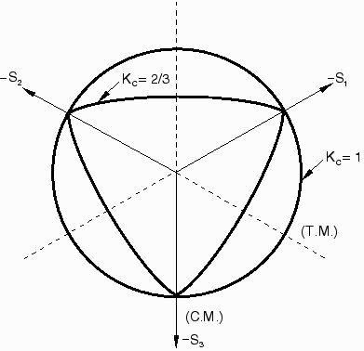

Figure 3. 2: Yield surface in deviatoric plane (Abaqus/CAE, 2011)
Another parameter K defined as ratio of distance between the hydrostatic axis and respectively the compression meridian and tension meridian in deviatoric cross section. The value lies in interval 0.5 and1. From the interval in most of literatures k value stated as 0.667. Plasticity model constitutes various parameters according to abaqus analysis user manual to execute nonlinear behavior of concrete.
Table 3.2: Concrete damage plasticity model parameters
Dilation angle (ψ) | Eccentricity (e) | f_{bo}/f_{co} | K | Viscous parameters, μ=0.
35 | 0.1 | 1.16 | 0.6667 | 0
3.3.1.1Mechanical Behavior of Concrete
The model is plasticity based, continuum, damage model of concrete. It suggests tensile cracking and compressive crushing of concrete material. Two hardening variables έt^{pl} and έ_{c}^{pl} is failure or yield surface. These variables: - έ_{t}^{pl} related to tension and έ_{c}^{pl}, compression-loading mechanism. Under this main assumption on mechanical behavior of concrete is compressive and tensile equivalent strain. Other variables also incorporated as function compressive or tensile stress and damage parameters.
$σ_{t}=σ_{t}\left({\tilde{ε}}_{t}^{pl},{\dot{ε}}_{t}^{pl},θ,f_{i}\right)$ And $σ_{c}=σ_{c}\left({\tilde{ε}}_{c}^{pl},{\dot{ε}}_{c}^{pl},θ,f_{i}\right)$ ……..(Equation 3.1)$σ_{t}=\left(1-d_{t}\right)E_{0}\left(ε_{t}-{\tilde{ε}}^{pl}\right)$; $σ_{c}=\left(1-d_{c}\right)E_{0}\left(ε_{t}-{\tilde{ε}}^{pl}\right)$ ……….( Equation 3.2)
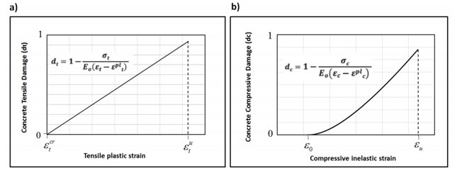

Figure 3. 3: Definition of damage parameter in CDPM in (ABAQUS: Analysis user's manual, 2014)

Compressive Behavior
Outside of elastic range stress-strain behavior of plain concrete are described in tabular function of inelastic or (crushing strain). Based on importance field variables, temperature and strain rate are ingredients of compressive strain data. Positive values shall be given for compressive stress and strain. Softening regime is indicating behavior of stress-strain curve beyond ultimate stress value. Hardening data provided in-terms of inelastic strain, ε^{in} instead of plastic strain, ε^{pl}. The compressive inelastic strain defined as total strain minus the elastic strain corresponding to undamaged material. ε_{c}^{in} = ε_{c}-ε_{oc}^{el}, where ε_{oc}^{el}=σ/E and data are provided to abaqus in terms of compressive curves d_{c -} ε_{c}^{in}. Abaqus by default automatically converts inelastic strain values to plastic strain using relationship.
${\tilde{ε}}_{c}^{pl}={\tilde{ε}}_{c}^{in}\frac{ⅆ_{c}}{\left(1-ⅆ_{c}\right)}\frac{σ_{c}}{E_{0}}$ ……….. (Equation 3.3)
In compressive damage, curves must be in correct manner. Abaqus plastic strain values should not be negative and/or decreasing with increasing inelastic strain. Values of inelastic strain of concrete equivalent to plastic strain of concrete incase absence of compressive damage. Similarly, absence of tension damage cracking strain, ε_{t}^{ck} of concrete equals to tension plastic strain, ε_{t}^{pl} of concrete. In condition, d_{t} and d_{c} are not specified model behaves as plasticity model. According to abaqus user manual damage variables d_{t} and d_{c} are non-decreasing material point quantities. During analysis increment, new value of damage variable found as maximum between value at end of previous increment and value corresponding to current state.
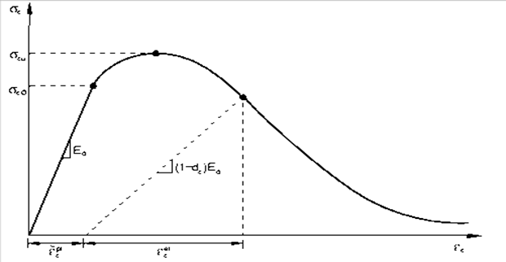
Figure 3.4: Uni-axial compression loading
${\left.d_{t}\right|}_{t+Δt}=\max{ {\left.\{d_{t}\right|}_{t, }}d_{t}({ \left.{\tilde{ε}}_{t}^{pl}\right|}_{t+Δt},{\left.θ\right|}_{t+Δt},{\left.f_{i}\right|}_{t+Δt})\}$ ……….. (Equation 3.4)
${\left.d_{c}\right|}_{t+Δt}=\max{ {\left.\{d_{c}\right|}_{t, }}d_{c}({ \left.{\tilde{ε}}_{c}^{pl}\right|}_{t+Δt},,{\left.θ\right|}_{t+Δt},{\left.f_{i}\right|}_{t+Δt})$} ……….. (Equation 3.5)
Selection of damage properties are indispensable due to excessive damage has critical effect on convergence rate. A normal value of damage variables lies in interval between zero and one, i.e. 0 ≤ d_{c} ≤ 1 and 0 ≤ d_{t} ≤ 1. Zero damage variables mean no damage, whereas one value of damage variable means total damage of material. It is advisable to damage effect is not greater than 0.99 which equivalents to 99% reduction of stiffness.
$ⅆ_{t}=d_{t}\left({\tilde{ε}}_{t}^{Pl},θ,f_{i}\right); {0≤ ⅆ}_{t}≤1$ ….. (Equation 3.6)
$ⅆ_{c}=d_{c}\left({\tilde{ε}}_{c}^{Pl},θ,f_{i}\right); {0≤ ⅆ}_{c}≤1$ …….. (Equation 3.7)
Stiffness Recovery
The force removed after yielding in simple plasticity model, and then there rebound of modulus of elasticity. Unlike of plasticity model, damage effects are included in modified manner in concrete damage plasticity model. In mechanical behavior, response of concrete stiffness recovery has significant aspects. Factors of stiffness recovery in abaqus user manual w_{c} and w_{t}. The experimental observation in most quasi-brittle materials, including concrete is that compressive stiffness recovered up on crack closure as load changes tension to compression. In other way, tensile stiffness not recovered as load changes from compression to tension once crushing of micro cracks have developed. According to default used in abaqus the factors of recovery which corresponds to w_{c} =1 and w_{t} =0. (Abaqus/CAE, 2014)
Tension Behavior of Concrete
Uniaxial tensile is included in damaged plasticity as shown in figure 3.4 below; stress strain response demonstrates a linearly elastic until failure stress, f_{cr} or f_{t} at peak point. To show tensile behavior exponential softening is better one. Nevertheless, for illustration if exponential softening does not exist, we can use multi linear approximation of exponential uniaxial stress strain diagram. Micro cracking started when tensile stress transferred to concrete that produce equal to tensile stress concrete. Cracking after crack initiation apparent poison ratio deduced. Above failure, stress there is strain localization in concrete structure due to micro-cracks represented with in softening stress strain. The exponential softening like hordijk diagram more localize crack and reduce distribution of it over the area. The diagram uses parameters such as- equivalent length, heq, tensile strength, f_{t}, and fracture energy, GF. (ABAQUS: Analysis user's manual,2014)
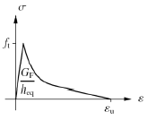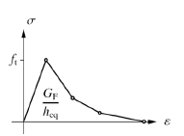
a) Hordijk softening b) Multi linear softening
Figure 3.5: Uniaxial tension response of concrete (Water et al. 199)
For ascending part (ε₁ ≤ 𝜀_{cr})
$σ_{1}^{C}=E_{c}×ε_{1}$ …….. (Equation 3.8)
For descending part (ε₁ >ε_{cr})
$σ_{1}^{C}=f_{cr}{\left(\frac{ε_{cr}}{ε_{1}}\right)}^{0⋅4}$ …….. (Equation 3.9)
Where: - f_{cr} is cracking stress of concrete, equivalent to f_{t}, taken as 0.31 √f′c MPa
Abaqus input data for concrete tension stiffening for fc′=24.375 MPa
Pre -Post Compression Failure of Concrete
Under uniaxial compression, linear response is progress until initial yield. After that follows hardening strain until maximum stress. For simplicity uniaxial stress strain curves automatically converted to stress versus plastic-strain curves by abaqus. In reinforced concrete specification of post, failure behavior generally means giving the post failure stress as a function of cracking strain. According to ABAQUS user’s manual, the cracking strain defined as the total strain minus the elastic strain corresponding to the undamaged material. The inelastic strain equals the total strain minus the elastic strain in the plastic stage corresponding to the undamaged material. (Abaqus/CAE, 2014). In concrete damaged plasticity model constitutes various parameters according to Abaqus analysis user manual to execute nonlinear behavior of concrete. The Hognestad model selected for both the pre and post-peak compression response of the concrete. This model is a simple compression response curve and it is suitable for normal concrete strength (<40MPa).

Figure 3.6: Hognestad parabolic pre and post- peak concrete compression response (Hognestad, 1951)
Table 3.3: Yield stress, in-elastic strain and compression damage of concrete
Yield stress in (MPa) | Inelastic strain (mm/mm) | Concrete compression damage (dc)
9.75 | 0.000305782 | 0
12.08830327 | 0.000486283 | 0
15.00654372 | 0.000654659 | 0
17.52972134 | 0.000831295 | 0
19.65783614 | 0.001016191 | 0
21.3908881 | 0.001209347 | 0
22.72887724 | 0.001410763 | 0
23.67180355 | 0.00162044 | 0
24.21966704 | 0.001838376 | 0
24.3750000 | 0.002038546 | 0
24.0657945 | 0.002332011 | 0.012685354
23.13817798 | 0.002638406 | 0.050741416
21.59215046 | 0.002957731 | 0.114168186
19.42771194 | 0.003289985 | 0.202965664
16.6448624 | 0.003635169 | 0.31713385
13.24360186 | 0.003993283 | 0.456672744
9.181410005 | 0.004368034 | 0.623326769

Figure 3.7: Concrete compressive strength

Figure 3.8: Compression damage of concrete

Table 3.4: Concrete tensile strength
Stress (MPa) | Cracking Strain(mm/mm) | Concrete tension damage dt
0.746119905 | 0 | 0
1.530502369 | 0.000048 | 0
1.162816407 | 0.000134688 | 0.24023874
0.989553361 | 0.00021731 | 0.353445391
0.882360983 | 0.000298551 | 0.423482772
0.807220024 | 0.000379123 | 0.47257839
0.750572342 | 0.000459307 | 0.509590865
0.705774714 | 0.000539244 | 0.53886075
0.669126942 | 0.00061901 | 0.56280568
0.638378135 | 0.000698653 | 0.582896343
0.612067624 | 0.000778203 | 0.600087111
0.589199405 | 0.000857681 | 0.615028753

Figure 3.9: Concrete tension damage vs Cracking strain

Figure 3.10: Tensile stress- strain of concrete

3.3.2 Reinforcement Modeling
Reinforcement used in concrete structure to achieve tensile strength of structure. It mutates with concrete and deformed bars create good bond strength. In abaqus bar described as singly or embedded oriented surface. Reinforcing steel characterized an elastoplastic behavior. In this study to define plasticity of the steel yield and ultimate stress of reinforcement is considered. Load transmission across cracks through reinforcement in concrete modeling achieved by the means of tension stiffening. As shown in figure 3.10, post yielding called hardening and elastic limit equivalent with yield strength. Hardening modeling is according to specification. Concrete mass density 2400 kg/m³ and poison ratio 0.2, whereas, steel density, ρ can be considered 7850 kg/m³, modulus of elasticity, E=20000 Mpa and poison ratio of v=0.3 is assumed (European standard 3, 2002).
- Stress strain curve of mild steel b) Simplified stress strain curve
Figure 3.11: Typical uniaxial stress strain behavior of reinforcement (Mosley, Bungey, & Hulse, 1999)

3.3.3 Concrete - Reinforcement Interaction Modeling
The main mechanism for stress redistribution after cracking in concrete with bonded reinforcement. Embedded technique is used to create solid concrete interact with and reinforcement to form good bond performance. Concrete considered as host region and reinforcement as embedded region. Other interaction type used is tie in which steel plate tied with column for purpose of avoiding crushing effect of applied point load.

3.4 Element Type
Three-dimensional solid element described in finite element analysis with field variables depending on coordinate x, y and z. Three-dimensional solid has variable vector arbitrary in the direction in space. Not only that but also arbitrary boundary condition, material properties and shape. As a result, there are six possible components of forces includes - three normal stresses and three shear stress. Three-dimensional elements used to model actual structures such as beam, plates and shells. Stress/ displacement elements family assigned to mesh in choosing of element geometric order and shape with specified element controls. Truss elements are used to model three-dimensional slender like structures that support loading along centerline of element. In this method, reinforcement modeled with no moments or forces orthogonal to centerline supported. Among 3-D stress displacement elements two-node linear displacement are associated to model the reinforcement. Consequently, reinforcement modeled in two-node truss element (T3D2); whereas from stress/displacement elements family eight-node linear brick element (C3D8) selected for plain concrete modeling.
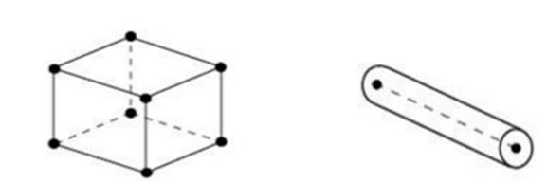
Figure 3.12: Two node truss element (T3D2) and eight-node brick element (C3D8)

3.4.1 Mesh Density of Plain Concrete and Reinforcement
For the purpose of reduction of degree of freedom, we can create varying density mesh. At areas of importance, finer mesh needed at areas of stress concentration, slots, notches, hole and re-entrant corners. Very fine mesh is for accuracy of analysis result as closer to actual value. Mesh seed control mesh density after 3D geometry has created and before meshing. Mesh density for reinforcement and plain concrete column equally meshed recommended. Due to the presence of hole in drilled plain concrete cannot mesh by part. Therefore, it is better to use meshed with swept type using partition of mesh by region whereas, plain concrete of solid column meshed by part. For plain concrete with opening first, using partition by cell and use extrude/swept edges by selecting of hole; then after select sweep direction of the hole. This is to separate hole part as from the other for meshing process only. The second is using partion define cutting plane in order to splice the column for purpose of mesh by part. Mesh size used for all part is 25mm.
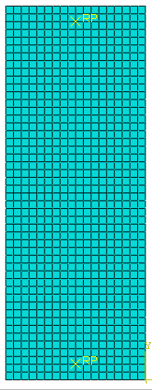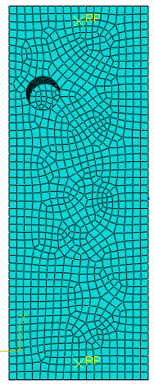
- Mesh by part b) swept mesh
Figure 3.13: Meshing of controlled a. (mesh by part) and b. drilled column (swept mesh)
Study Specimen Drilling Core Location
End side hole found at 100mm horizontally from side of column and 920mm vertically from bottom of column. Opening located at end side at long dimension also has similar location to end side hole. End center hole existed at center of column horizontally and 920mm from bottom of column. All dimension measured up to center of hole.
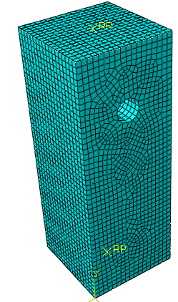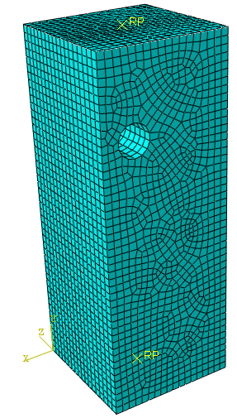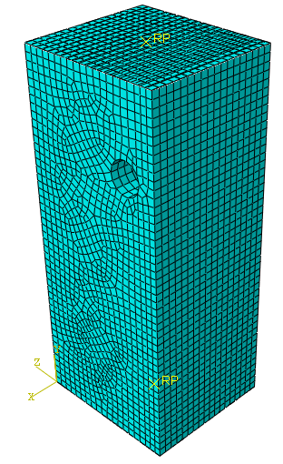
- end center b) end side c) end side at long dimension
Figure 3.14: Study specimens hole location for core drilling
Supporting Plate Mesh
Supporting plates used to transmit load to concrete without pointed concentration of load that makes concrete from sudden failure. Abaqus provide two types of plates for this purpose three-node three-dimension rigid triangular facet (R3D3) and four-node three-dimension bilinear rigid quadrilateral facet (R3D4). The size is equal to the corresponding element on the surface. Supporting plate may have specified thickness. In abaqus standard or explicit if no thickness is available, unit thickness is assumed is the thickness required in abaqus standard/explicit (Abaqus/CAE, 2011). Cross sectional area used for defining body forces and transmits only in plane forces. Hence, we use rigid discrete shell element R3D4 plate on the top of column with tie interaction for loading of column.

3.4.3 Step Module
A general analysis of step module one among which affect any non-linearity exist in the model is included. Ending condition from last general step is the beginning condition for each general step. With the state of modeling involving throughout the history of general analysis steps as it is responds to the history of loading. Step module has two steps. The first one is initial step, which allows defining boundary condition, predefined fields and interactions. The second one is analysis step performs static stress analysis in this study. In this analysis step, the model had initial increment size of 0.0001. Each increment was controlled by the minimum increment size was by default 1*e*10⁻¹⁵ and maximum increment size was 0.001.

3.5 Loading and Boundary Condition
As per experimental program both top and the bottom face of the column, steel plate applied to avoid crushing at the point of loading. Column is fixed in four faces of three-dimensional RC column with boundary condition encastre U1=U2=U3=URx=URy=URz=0 for bottom support.
Static Analysis
Nonlinear analysis of abaqus simulation large displacement formulation used. This formation of large displacement in step module NIgeom is on. In nonlinear of static stress analysis structure is may shows material non-linearity. Structure is fail in indicating local failure or collapse depends up on maximum load applied relative to structure’s capacity.

CHAPTER 4

RESULTS AND DISCUSSIONS

4.1 Introduction
In this study, the results obtained from validation and parameters enumerated within finite elements accuracy of reinforced concrete column with core drilling. From validation of abaqus program various hole position for different cross-section with axial load resistance capacity of column, vertical deformation, p-Δ effect, opening effect and column response at different column cross section were comparatively displayed using finite element analysis.

4.2 Finite Element Model and Validation
Finite element analysis for opening performance of reinforced concrete column on concentrated axially loaded column of different cross-section has investigated
Table 4.1: Validation parameter (Lei, Qinfeng, Xiangmin and Chunming, 2010.)
Column  ( mm²) | Hole location | Steel ratio | Rebar strength |  | Drilled core strength(Mpa) | Column height (mm)
Column  ( mm²) | Hole location | Steel ratio | Yield  (Mpa) | Ultimate (Mpa) | Drilled core strength(Mpa) | Column height (mm)
C1 300x300 | - | 1 | 385 | 551 | - | 1200
C2 300x300 | Offset center | 1 | 385 | 551 | 19.2 | 1200
C3 400x400 | - | 1 | 367 | 525 | - | 1200
C4 400x400 | Offset center | 1 | 367 | 525 | 20.7 | 1200
C5 400x400 | Center | 1 | 367 | 525 | 21 | 1200
C6 400x400 | Center and repaired hole | 1 | 367 | 525 | 18 | 1200
C7 400x600 | - | 0.84 | 367 | 525 | - | 1200
C8 400x600 | Center offset at short dimension | 0.84 | 367 | 525 | 20.2 | 1200
C9 400x600 | Center at long dimension | 0.84 | 367 | 525 | 21.9 | 1200
In this study column subjected to drilled core of experimental available in (Lei, Qingfeng, Xiangmin, & Chunming, 2010) used for validation purpose presented in table 4.1.
Table 4.2: Detail of column used for validation and material specification (Lei, Qingfeng, Xiangmin, & Chunming, 2010)
Description | Specification
Hole direction | Transversal
Hole cylinders diameter | 100mm
Hole cylinder depth | 140mm
Longitudinal reinforcement diameter | 12mm for C1 and C2  16mm for C3-C9
Leaving diameter core holes on columns | 110mm
Experimental applied | 10000KN
Specimen applied at speed | 0.3mm/min
Concrete cover | 25mm
Stirrup | 8mm
Average compressive strength (fc’) | 19.5Mpa
Concrete mix ratio of water, cement, sand, aggregate, cementitious (fly ash) and chemical admixture | 132:267:856:1052:47:3.5

stirrup

1-1 of C7~C9
1

1 1-1 of C1~C2

1-1 of C3~C6 C7~C9

Figure 4.1: Dimensions and reinforcement of specimens (Lei, Qingfeng, Xiangmin, & Chunming, 2010)
Strain gauges were layout to assess drilled core impact and to read the strain of bar, stirrup and concrete strain gauges deployed. Core drilling location, layout of strain gauges and LVDT of C5 identified as shown below in figure 4.2
14#

200
16#

8#
1#

4# 7#
15# 5# 17# 18# 19#
11#
10# 12# 13#
21# 23# 20#
3# 6# 9#

200 200 200 200 200 200 200
400 400 400 400
Rebar gauge

Figure 4.2:- Layout of rebar strain gauges of C5 and C6 (Lei.et.al, 2010)
As described in figure 4.2 rebar strain gauges are set at different position for recording the strain of bar at various position for specimen C5 and C6 (Lei, Qingfeng, Xiangmin, & Chunming, 2010). In addition, figure 4.3 also shows drilled location, LVDT and concrete strain gauges. Gauge was fixed at different surface of concrete in order to record resulted concrete strain. Two specimens drilled at the same position around column mid height. However, C6 patched with concrete after drilled hole to understand patched concrete performance. (Lei.et.al, 2010)
1#

200 200
400
2#

C#
D#

2#
400
Concrete gauge
1#

I#
J#

K#
L#
A#

#

100
4#

G#
H#

4#

200
400
LVDT
200 200
400
3#

E#

F#

100

3#

200
200 200

Location of core

Figure 4.3:- Layout of concrete strain gauges, core drilling location and LVDT of C5 and C6 (Lei.et.al, 2010)
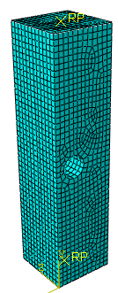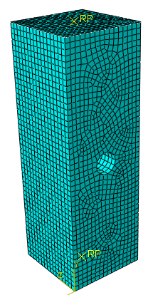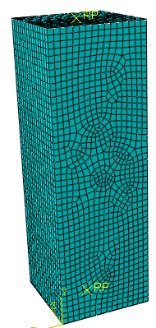
a) Offset center b) Center c) Center and restored
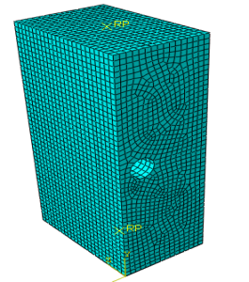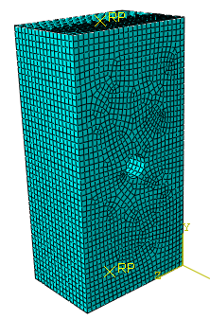
d) Center at short dimension f) Center at long dimension
Figure 4.4: Hole position of validation modeling

Figure 4.5: P- delta of specimen C1, C2 of Abaqus, and Experimental result of (Lei.et.al, 2010.)
Column specimen, C1 stress distributed over four sides of column with axial compressive failure. However, C2 drilled column initial cracking on the top of drilled part. As described the axial load capacity versus delta, C1 and C2 shown above figure 4.5 expresses comparison of abaqus versus experimental result. For column, C1 at initial values of abaqus graph lies below correspondence of its experimental result and abaqus result of C1 continues with small value difference. Maximum axial capacity of C2 abaqus and experiment value is approach to each other with difference value of axial load 4.82%. Percent shows maximum axial capacity difference of abaqus and experiment. Initially abaqus is less than experimental up to value of 1220 KN. Afterwards, abaqus value crosses experimental and goes up to end with value above experimental correspondence.

Figure 4.6: P- delta of specimen C4, C6 of Abaqus, and Experimental results of (Lei.et.al, 2011.)
In the figure 4.6, two drilled columns in comparison of experimental and finite element simulation by abaqus indicated. As column capacity plotted with axial deformation; initially finite element simulation is smaller and tends to certain value. Then after going to cross experiment value and rises up to end for C4. Opposite to this specimen C6 larger initially and goes to cross-experimental value after that graph continues up to end below experiment.

Figure 4.7: Axial load versus delta of specimen C7,C8 and C9 of Abaqus and Experimental of (Lei.et.al, 2010.)
Figure 4.7 above displays axial capacity relation with delta effect of C7, C8, and C9. As this graph describes; the difference in experiment and abaqus has smooth relation to each other. For all specimens’ maximum axial capacity of C7, C8, and C9 abaqus lied beyond experiment through the graph. When we come to delta, all abaqus values found below its experiment. This displacement varied in 5.303%, 4.14% and 3.42% for C7, C8, and C9 respectively.

Figure 4.8: Rebar strain of C3 and C4 column specimen of Abaqus and Experimental result of (Lei.et.al, 2010.)
Strain under axial loading after core drilled of abaqus C3-2 is greater than initially abaqus value is above the experimental value up to certain value. Then after experimental result cross and continue with good approaching value to each other. For C3-11 from initially up to end abaqus result greater than experimental one with maximum percent, not exceeding 8.5% result gradually cross-experimental one and finally continue to end. Experiment of C3-2 in small value from zero to 2280.57 KN. In case of C4-2 experiment, reverse abaqus small, value greater than experimental C3-11 value. In addition to this abaqus C4-2 has also good approach relation to experimental value. Abaqus strain result has good value of approach to its correspondence of experimental value.

Figure 4.9: Rebar strain of column specimen of Abaqus and Experimental result of (Lei.et.al, 2010.)
In the same manner rebar strain distribution of C6 as shown in figure 4.9; Abaqus value greater C6-2 with difference range between 4.5% - 6.5% as compared to experimental value. The same cases for C6-11 both experiment and abaqus value was in small difference not exceeding around 9.13%. Strain of main reinforcement, which indicted in different position after core drilled illustrated in the figure 4.9; with different strain distribution.

Figure 4.10: Stirrup strain of C2 of Abaqus and Experimental value of (Lei.et.al, 2010.)
Strain of stirrup found at adjacent hole region is resulted in figure 4.10; strain distribution taken at unique nodal point were selected. Specimen C2 of unique nodal point of experiment compared with finite element analysis. For instance, C2-17 initially greater value in abaqus and continues up to end in value not more than 6.5%. In contrary, C2-19 abaqus value is smaller throughout the graph with maximum difference in 9%. C2-18 at beginning abaqus result is smaller than experiment from beginning up to value 1221.58KN. Then abaqus result rises up with variation less than 8%. To sum up strain result of unique nodal point adjacent drilled core had good result close to each other means abaqus and experiment. Stirrup strain around drilled core is larger than stirrup of undrilled area. This due to concrete core cut will provide sufficient increase of strain stirrup. Tensile strain nearby drilled area is speed up the tensile crack formation. However, for reason patched concrete strain distribution is like that solid column. Nevertheless, cracking starts on surface of cored area for core patched specimen and propagates to outer edges of column. It is not distributing evenly to side corner; which left around center of column. Patched drilled column decreased its strain than drilled one. Consequently, it is smallest strain in solid column among three specimens. In general cracking development is slow in patched specimen comparatively to drilled specimen.

Figure 4.11: Rebar strain of C2 of Abaqus and Experimental value of (Lei.et.al, 2010.)
Total strain, E11 distribution of longitudinal bar descried at different sides of column in figure 4.9 as per experiment. C2-2 specimen shows longitudinal reinforcement strain distribution on side of opening exists. Bar strain near opening at this side selected nodal point of abaqus C2-2 maximum among other sides. This abaqus strain distribution has similar with experiment C2-2. C2-5 longitudinal bar strain found at adjacent side which closer to hole area. In this abaqus value shows small difference with experiment in strain distribution. Other C2-13 longitudinal bar strain occurred at side opposite to side with hole. This value is smallest strain as result of opposite side which far from opening side.

Figure 4.12: Rebar strain at core hole of specimen C3, C4 and C5 of Abaqus and Experimental value of (Lei. et.al, 2010.)
As illustrated in figure 4.12 rebar strain of selected nodal point of specimens, C3, C4, and C5 as per experimental information (Lei, Qingfeng, Xiangmin, & Chunming, 2010). Reinforcement strain of specimen C4 around hole at unique odal point is greater than C3 for the same load level. By comparing abaqus versus experiment, initially abaqus C3 value less than experiment and around end of the graph experiment lied above abaqus value. Applying of drilled hole provided large strain of bar at core hole for C4 value. The abaqus value of C4 also has good approach to its experiment. Generally, as graph shows each abaqus values are close to their correspondent experiment value.

Figure 4.13: Concrete vertical strain of specimen C3 of Abaqus and Experimental result of (Lei.et.al, 2010.)
As figured above 4.13 concrete strains on each side of column plotted in graph; abaqus result of strain distribution of C3-C and C3-G are crosses experiment around middle of graph and sustain up to end with value beyond experiment.

Figure 4.14: Concrete vertical strain of specimen C4, C5 of Abaqus, and Experimental result of (Lei.et.al, 2010.)
Concrete vertical strain of three specimens displayed on figure 4.14 for both abaqus and experiment. The total vertical strains, E₂₂ taken at different side of column face. Strain at side of drilled face of column value compared with its abaqus and experiment. Therefore, as figure describes abaqus result has good approach with experiment correspondence.

Figure 4.15: Maximum load of column specimen (300x300) for Abaqus and Experiment result of ( Lei.et.al, 2010.)
As load versus column specimen described for C1, C2, and C3; maximum displacement at point of load exerted is expressed with experimental value for purpose of accuracy checking. Load value of abaqus greater in C1 and C3 whereas below experimental value for column C2. Percentage variation in both cases is below 9% difference. Which means abaqus and experiment are more close to each other.

Figure 4.16: Maximum load of column specimen (400x400) for Abaqus and Experiment result of (Lei.et.al, 2010.)

Figure 4.17: Maximum load of column specimen (400x600) for Abaqus and Experiment result of lei.et.al, 2010

Figure 4.18: Maximum displacement of column specimen (300x300) for Abaqus and Experimental result
Specimen 300x300mm and 400x400 deformations as shown in figure 4.18 each deformation has closed to finite element result. The abaqus result of C1, C2 and C3 are smaller experimental value. Deformation of abaqus results are 2.487mm, 1.986mm and 2.167mm and their variation are -7.96%, -5.518% and -9.8% respectively relative to the experiment. Abaqus simulation in this three specimens are resulted the good agreement with experiment. Negative value of variation present shows finite element analysis of abaqus result is below experiment.

Figure 4.19: Maximum displacement of column specimen (400x400) for Abaqus and Experiment result
Deformation comparison of experiment versus abaqus for C400x400; 2.201mm, 2.328mm and 2.3702mm for C4, C5 and C6 for abaqus respectively and the difference between experiments is -8.25%, -0.086% and 7.82% respectively. Therefore, they are more close to each other for checking of finite element accuracy.

Figure 4.20: Maximum displacement of column specimen (400x600) for Abaqus and Experiment result
Axial displacement of column C7, C8 and C9 described in figure 4.18 their values are in small difference to experimental value. For instance, abaqus result greater than experiment for column C7 and C8. However, C9 abaqus value smaller than experiment.
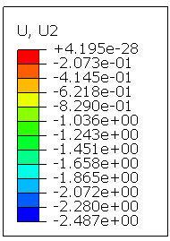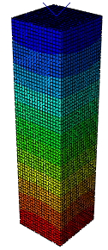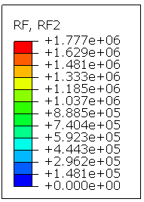
a) C1
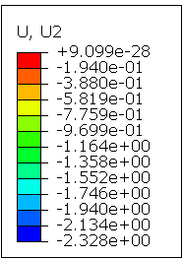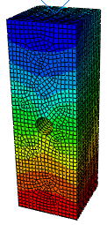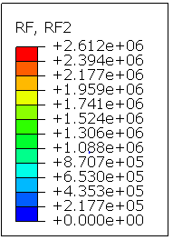
b) C5
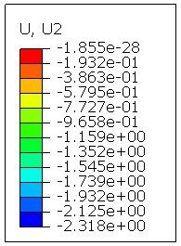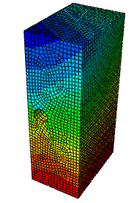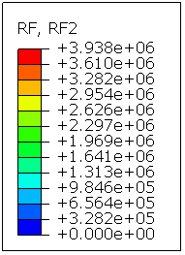
c) C8
Figure 4.21: Ultimate axial load and axial displacement of C1, C5 and C8 of Abaqus result for validation
Validation modeling for specimen C1, C5 and C8 are described in above figure 4.21. It shows maximum axial load and axial displacement for each specimen. Maximum axial load equivalent with vertical reaction force take at bottom of support condition. Whereas maximum axial displacement taken at top of free end. Values of displacement numbered in mm unit and axial load in KN unit. Blue color, which found at top area of column, is indicating maximum axial displacement ad decreases as go from top to bottom area of column.

4.3 Parametric Study of Core Drilling Capacity and Axial Deformation Capacity of Reinforced Concrete Column
For detail recognizing open performance reinforced concrete column and measurements, the following parameters expected to affect axial resistance capacity of column. Grade of steel, diameter of bar, level of service load, hole position and cross section of column are parametric considered for real expectation are tabulated in the following table. Hole diameter 110mm and depth 170mm is used for all parameters of study. Hole provision set as ratio of column length and diameter of core ratio.
Table 4.3: Study parameters of RC column with core drilling
Column Code | Load (KN) | Hole position | Grade of steel | Yield of steel | Diameter of bar (mm) | Cross section(mm²)
TC1 | 2500 | - | 300Mpa | 260.87 Mpa | 16 | 450x450
TC2 | 2500 | End center
TC3 | 2500 | End side
TC4 | 3500KN | - | 420 Mpa | 365.22 Mpa | 16 | 450x450
TC5 | 3500KN | end center | 420 Mpa | 365.22 Mpa | 24 | 450x450
TC6 |  |  |  |  | 30 | 450x450
TC7 | 4500KN | - | 300 Mpa  420Mpa  520Mpa | 260.87 Mpa  365.22 Mpa  452.17Mpa | 16 | 450x450
TC8 | 4500KN | End center  end side
TC9
TC10 | 1500  2500  3500 | - | 300 | 260.87 | 16 | 450x450
TC11  TC12 | 1500  2500  3500 | End center  end side
TC13 | 2500 | End center | 300 | 260.87 | 16 | 450x450 and 450x500

4.3.1 Cross-section of Column
Column cross section of study parameters were consisted 450x450mm, and 450x500mm. each cross section has controlled specimen without drilling.

Figure 4.22: Displacement of specimen C450x450 and C450x500
Cross-section difference also varying of deformation; cross section increase has direct relation with axial capacity of column. In conclusion, as cross-section of column increase effect of hole reduced for the same applied load with increasing capacity of column. However, deformation reduced, which means that column rise in axial capacity with small deformation.
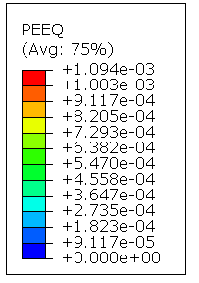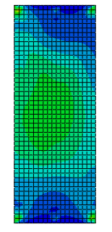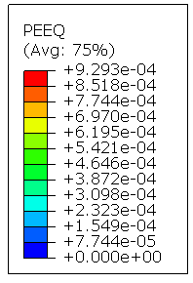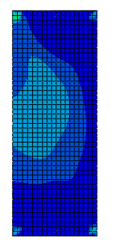
- C450x450 b) C450x500
Figure 4.23: Concrete strain of different cross section of column

4.3.2 Grade of Steel
To study performance of reinforced concrete column on hole effect grade of reinforcement were accounted. Under this parameter steel grade effect on resistance capacity and axial deformation of column with hole is performed in grade of steel 300Mpa, 420 Mpa and 520 Mpa used and Axial deformation of column with different grade of steel.

Figure 4.24: Load-displacement graph of C450x450
As indicated in figure 4.24 steel grade 520 Mpa has less deformation than 300 Mpa, 420, and deformation of specimen 420 Mpa less than that of 320 Mpa. In general, as grade of steel increase deformation of drilled column is decrease.
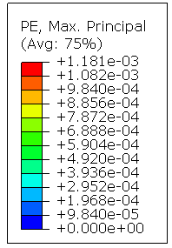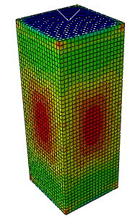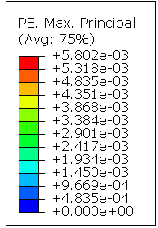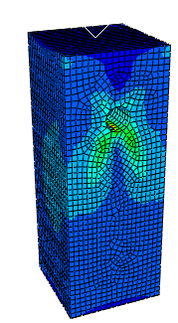
- 300 Mpa b) 420 Mpa
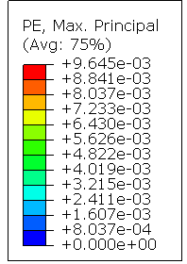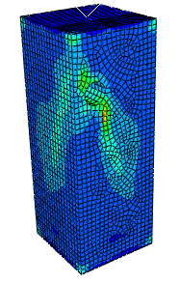
- 520 Mpa
Figure 4.25: Strain of concrete at maximum principal specimen with 300 Mpa, 420 Mpa and 520 Mpa respectively
In figure, 4.25 above column the failure method of these three columns are different. Solid column C450x450 with steel grade 300 Mpa tries to crack in four sides at middle of column. Whereas C450x450 and steel grade 420mpa with opening at end center cracking initiation starts around hole and propagates diagonally towards the side face of column. Large diagonal cracking formed beneath the hole rather than above hole. This is due to concrete that cover reinforcement below hole has small area relative to above hole. In relative to solid column, it is proceeding in failure due to discontinuity of stress at hole. In the same manner specimen having reinforcement grade 520 Mpa cracking initially around mouth of hole and follow diagonally on side of opening. However, this specimen has better cracking resistance than that of column with steel grade 420. Steel grade effect on hole cracking resistance has direct relationship as steel grade increase. As shown in figure above among grade of 300, 420 and 520 Mpa; 520 Mpa largely improve capacity of drilled column and deformation decreased by 6.18 % as compared to TC4. Axial deformation reduced for column with 520Mpa by 14.59% relative to column with 420Mpa. Capacity of column with 300mpa is 2040KN and column with hole at side with steel grade 420 Mpa has 3765KN whereas discontinuity of steel with specimen of steel grade 520 affect the capacity of column increased to 3500 KN. Therefore, as grade of steel increase axial capacity of drilled column increase except for specimen with rebar cut. Nevertheless, rear cut reduces axial capacity for column with steel grade 520 Mpa.
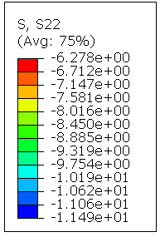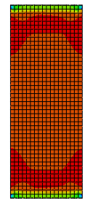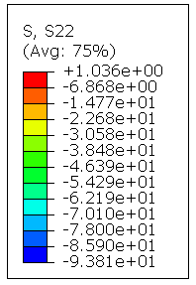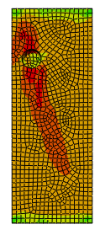
a) S, 300 Mpa b) S, 520 Mpa
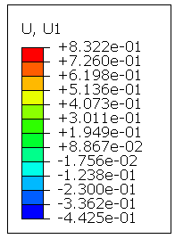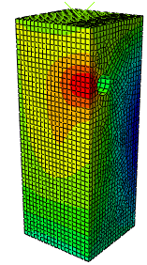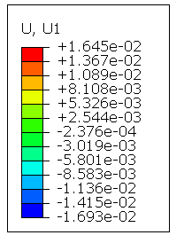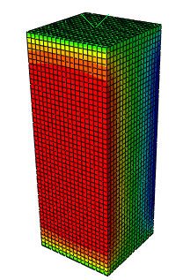
c) U, 520 Mpa d) U, 300 Mpa
Figure 4.26: Horizontal displacement and stress of 520 Mpa and 300 Mpa specimens
Hole presence results concentration of maximum deformation around the hole. This enumerates rise of delta effect due to hole is displayed. However, opposite to undrilled column creates evenly distribution of maximum deformation through the surface of column.

4.3.3 Hole Position
Hole position at top of column with center and one third top side are considered. The values compared relative to the solid column without drilled. Hole consideration simulation in abaqus of column specimen in accounting of rebar cut at hole.

Figure 4.27: Load versus axial displacement graph of TC1, TC2 and TC3
Column specimen named as one of the controlled specimen. TC1, TC2 and TC3 have axial deformation -1.21611mm, -1.4399mm and -1.23085mm respectively. Maximum deformation of TC2 and TC3 increased in 18% and 1.212% as compared to TC1. Deformation of TC2 are large due to rebar cut at hole which creates discontinuity of stress through bar and transferred to nearby concrete area. This affects reduction of column capacity. From two-drilled position; hole at center of column with rebar discontinuity has greater effect relative to hole at side.

Figure 4.28:- P- delta curve of specimen TC1, TC2 and T3
As figure 4.28 illustrates maximum horizontal displacement of TC1, TC2 and TC3 were 0.1606mm,0.2481mm and 0.2526mm respectively. Presence of hole for TC3 produce horizontal deformation by increment of 57.285% and TC2 with rebar cut increased by 54.48%. Existence of drilled hole at side results smaller in axial deformation. Nevertheless, it has large effect on increment of lateral deformation. Therefore, hole at side almost no effect on axial deformation increment as compared to TC1.

4.3.4 Level of service load
To study the effect of load performance on drilled column the following load quantities used. 1500KN, 2500KN and 3500KN simulated in abaqus software. The value of results-

Figure 4.29:-Axial load for increasing level of load specimen
Level of service load for low service load applied below capacity of column has no effect on its axial capacity. Nevertheless, increasing of load beyond column capacity decreases axial capacity of column. Specially with rebar cut has significant effect on axial capacity by creating yielding of reinforcement due to bar discontinued at hole results large effect on axial capacity.

Figure 4.30:- Axial displacement of specimen with level load

Figure 4.31: -Maximum horizontal displacement of specimen TC10, TC11 and TC12
As figure 4.31 above shown horizontal displacement as compared to axial displacement is very small due to column is short and there is no lateral force applied on the specimen. This Implies fail in compression rather than buckling. Therefore, without existence of lateral load for short column delta effect has no much significant on impact on axial capacity of column. As load increase, deformation of specimen increase in both laterally and axially hole tries to produce lateral deformation. In general, larger lateral deformation produces around the hole which opening creates discontinuity of strain and more strain formed results large deformation. maximum lateral deformation of specimen with load 3500 KN and 2500 KN increased by 61.34% and 40.724% as compared to solid column with load 1500KN. In general, increment of load increase lateral deformation of column.
Concrete vertical stress
Concrete stress in vertical direction is occur at four sides of column surface has similar distribution for solid column. In case of drilled column, area of hole has smaller stress than other sides. This shows hole reduces stress capacity of column. As figure shows (S, S22 Avg 75%) of TC11 and TC12 have similar pattern of stress location except their value.
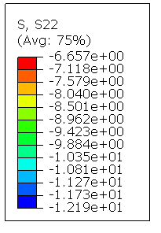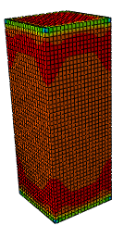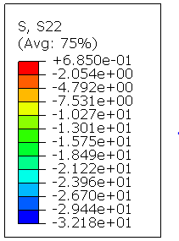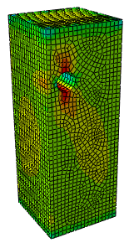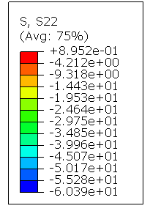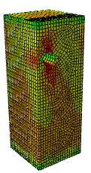
a) TC10 b) TC11 c) TC12
Figure 4.32:- Concrete stresses of columns with level of load
Bar Stress Around Hole
Stress of all bars for solid column is almost similar. However, for drilled column found nearby hole is more affected than other. Hole and increment create much difference due to stress distribute in concrete are directly transferred to bar.
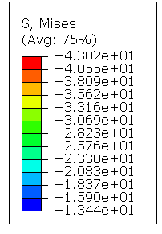
Figure 4.33:- Bar stress around the hole of TC12

4.3.5 Reinforcement Area Ratio
Reinforcement size also had own reduction capacity on the effect of reinforced concrete column of drilled core. Various size of longitudinal reinforcement diameter understood in parametric studies were used 0.7145%, 1.607%, and 2.52% for diameter φ16, φ24 and φ30 respectively. Each diameter of bar effect on reinforced concrete column deformation and axial load briefly explained in this section.

Figure 4.34 Axial load and displacement graph of C450x450
Diameter 16, 24 and 30 considered for specimen C450x450 as shown above figure 4.34; as diameter of main reinforcement increase, axial capacity increase and decrease of deformation. Therefore, reinforcement diameter also has effect on drilled core reinforced concrete column. Displacement of specimen with reinforcement area ratio of 2.52%, 1.607% and 0.7145% are 1.04935mm and 1.54316mm and 2.3741mm respectively. Increase reinforcement area ratio reduces axial deformation between drilled specimens. Steel area ratio of 2.52% specimen reduced in axial deformation in 31.2% as compared to specimen with steel area ratio of 1.60%. This indicates as reinforcement diameter increase in column with opening; column enables to decrease axial deformation.
Failure Criteria
Finite element analysis of short reinforced concrete column modeled using various parameters for core drilled at end side and end center location. Specimen of TC1, TC14 and TC7 are solid columns fails in axial compression failure and cracks started around center of column are uniformly distributed over four sides of column. TC10 fail in axial compression and cracking started at ends vertex of column equally distributed over four sides.
As modeled in parameter of study TC2 with hole at end center. Initially TC2 cracking formed in interior of hole at bottom. In addition, two diagonal cracks developed to outside of hole such that crosses hole. However, below hole diagonal cracking largely occurred. TC3 started cracking at interior surface of hole at bottom and top. This tries to develop diagonal crack around opening. Specimen TC3 fail in axial compression and reinforcement is not yield. TC3 opening at end side with one diagonal cracking distributed to nearby side.
TC5 specimen crack starts in side hole around mouth and growth diagonally by crossing hole. Larger cracking found below hole than above hole area. Not only side having hole but also two adjacent sides also developed vertical crack. Finally, side opposite to side with hole also created certain cracking, but small relative to other three sides. Both column TC5 and TC6 indicated compression failure. Cracking line of TC6 specimen similar to TC5 crack starts in side hole around mouth, but out of two diagonal cracks one diagonal cracks is larger and cracking not occur in other three sides.
TC9 starts to fails in side opening on top mouth of drilled core and one diagonal crack lays on side with opening and other lies on adjacent side. Initial Cracking formation of TC11 and TC12 started inside the top soon after developed to inside bottom of opening.

CHAPTER 5

CONCLUSIONS AND RECOMMENDATIONS

5.1 Conclusions
The core-drilled effect of reinforced concrete column conducted through two steps of stress analysis in finite elements for both parametric studies and experimental validation. Primarily study focused on grade of steel, diameter of reinforcement, level of service load, hole position and different cross section of column. Based on the results of those studies; the following conclusions were drawn.
Displacement of reinforcement area ratio decreased in 55.8% and specimen with reinforcement area ratio of 1.607%, axial displacement decreased by 44.19% due to diameter of main reinforcement increased. Existence of drilled hole at side produce large lateral deformation increment of 57.285% whereas, hole at center around hole 54.48% relative to undrilled column. In addition, axial deformation is large in case of hole at center with rebar cut is greater by 18% relative to undrilled one. From steel grade of 300, 420 and 520 Mpa; 520Mpa largely improve capacity of drilled column and deformation decreased by 6.18 % as compared to TC4. Therefore, as grade of steel increase axial capacity of drilled column also increase. For parameter level of service load maximum lateral deformation of specimen with load 3500 KN and 2500 KN increased by 61.34% and 40.724% as compared to solid column with load 1500KN. In conclusion, as applied load become large column with opening fail by proceeding of solid column. In general, the following concluded.
- Stress distribution of column cross section is increasing from top surface of column to area around hole and it affected by hole drilled core.
- From two hole positions of analysis hole at middle end mostly decreases axial capacity of column with rebar cut witch fasten after yielding of main reinforcement.
- Increasing grade of steel, diameter of steel, cross-section of column has direct relationship on axial capacity of column with in decreasing of core drilling effect. In addition, decrease axial deformation of column.
- Increment level of load is directly affecting concrete strength and large decrease in axial capacity of drilled column and then after column failure mode in compression.
- Column with hole is starting to fail in production of small crack around opening due to discontinuity of stress around that.
- Lateral deformation on short column has no much significant effect on its axial capacity. Short column fails in compression rather than deformation or buckling. Nevertheless, presence of lateral load may create lateral deformation on short column that reduces axial capacity.

5.2 Recommendations
The work was conducted parametric study on effect of hole performance for reinforced concrete column with core drilling by limiting different factors due to scarcity of time, budget and availability of experimental instruments. For instance, only Grade of steel, diameter of reinforcement, level of service load, hole position and different cross section of column are considered for his study. However, in the future out of listed parameters we can use many other parameters to study reinforced concrete with hole. To sum up this; the following studies are recommended for future studies.
- On the current study it was only considering concentric axial on core drilled effect of reinforced concrete column and in the future someone else can study in account of eccentric axial load effect of reinforced concrete column with hole.
- Medium class of concrete used in this study. For the future, it can be using high class of concrete grade effect on reinforced concrete column with core drilling.
- Present study considered rectangular RC column. Nevertheless, in the future Effect of hole on L-shape, T shape Composite column.
- This study assumed fully dried that column is fully dried and axial load is used. However, in the next study including the moisture content exist in column and including cycling load on effect reinforced concrete column with core drilling

REFERENCES
A. Masi, D. N. (2012). Effect of core drilling and subsequent restoration on RC column strength. University of Basilicata Potenza, Italy, Department of Structures, Geotechnics, Engineering Geology.
Abaqus/CAE . (2011). Abaqus 6.11 Analusis user's manual (Elements) (Vol. IV). RI, USA: Dassault system simulia corporation.
Abaqus/CAE. (2011). Abaqus 6.11 User manual Analysis (Vol. II). Providence, RI, USA: Dassault systems simulia corp.
Abaqus/CAE. (2011). Abaqus Analysis User Manual, Elements (Vol. IV). Providence,RI, USA: Dassault systems smulia corp.
Abaqus/CAE. (2014). Abaqus 6.14 Analysis user's Guide; Priscribed Conditions, Constraints and Interactions (Vol. V). Providence, RI, USA: Dassault systems simulia corp.
ACI 318. (2011). Building code requirements for Structural Concrete (ACI 318-11) and commentary. American Concrete Institute Commitee.
ACI 318. (2014). ACI 318-14. Building Code Requirements for Structural Concrete,. Farmington Hills, Michigan.: American Concrete Institute.
Al-Azzawi, A. A., & .Abed, S. A. (2017). Investigation of the behavior of reinforced concrete hollow-core thick slabs . Article in Computers and Concrete, 19.
ASTM.C109. (2004). “Standard Test Method for Compressive Strength of cube Concrete Specimens. American Society for Testing and Materials Standard Practice C109,, Philadelphia, Pennsylvania, 2004. Retrieved 2004
Ayatullah Khomeni, M. (2018). Experimental investigation and numerical simulation. Master of Science in Civil Engineering (Structural), Bangladesh University of Engineering & Technology, Department of Civil Engineering, Dhaka.
Basravi, A. ( 2010). Finite element analysis of reinforced concrete column with longitudinal hole. Faculty of Civil Engineering Universiti Teknologi Malaysia.
Bathe, & Klaus-Jurgan. (1966). FInite Element Procedures. Upper Saddle River, New Jersey 07458, USA: Smon and schuster/ A Viacon Company.
Boukais, S. A. (1989). Three Dimensional Finite Element Analysis of Damages Reinforced Concrete Columns. University of Dundee.
Eurocode 2. (1992). Euro code 2: Design of concrete structures ; part 1:General rules and rules for buildings. European standard Committee. European Committee.
European Standard 2. (1992). Draft prEN1992-1-1 Design of concrete structures.
H.Nilson, A., D. D., & W.Dolan, C. (2010). Design of concrete structures (fourteenth ed.). (L. K.Buczek, Ed.) Newyork, America: McGraw-Hill companies.
Hognestad, E. (1951). Study of Combined Bending and Axial Load in Reinforced Concrete Members. University of Illinois, Engineering Experment Station, University of Illinois, engineering experiment station.
Khanan, S., & Ahmed, M. (2019). Experimental Study and Finite Element Modelling of Reinforced Concrete. Taxila,Pakistan. doi:DOI: 10.7176/IEL
Kim, N.-H. (2014). Introduction to Nonlinear Finite Element Analysis. Gainesville, F L, USA. doi:10.1007/978-1-4419-1746-1
Korea Concrete Institute. (2012). Code requirement reinforced concrete structure. Korea Concrete Institute (KCI 2012).
Lee, D.-J. (2008). Experimental and Theoretical Study of Normal and High StrengthConcrete Wall Panels with Openings. PhD Thesis Dissertation, Griffith University., Australia.
Lei, Z., Qingfeng, X., Xiangmin, L., & Chunming, Z. (2010). Experimental Studies of Reinforced Concrete Column Capacity Affected by Core Drilling. Advanced Materials Research, 133-134, 1195-1200. doi:10.4028/www.scientific.net/AMR.133-134.1195
Lotify, E. M. (2013, January). Nonlinear analysis of reinforced concrete columns with holes. International Journal of Civil and Structural Engineering, 3(3), 655-665. Retrieved March 2013
M., O. (1985). A constitutive theory for the inelastic behavior of concrete. In Mechanics of Materials (pp. (67-93).b).
Mansur, M., & Kiang.Hwee. (1999). Concrete beam with opening: analysis &design. Florida: CRC press LLc.
Mosley, W., Bungey, J., & Hulse, R. (1999). Reinforced Concrete Design (5 ed.). Bristol: J.w. Arrowsmith Ltd.
Neville, A. (1996). ''Properties of aggregate'' fourth edition. (S. Wiley, Ed., & H. Famili, Trans.) New-york.
Neville, A. a. (2008). Concrete Technology, 438.
Neway, E. G. (2009). Reinforced concrete fundamental approach (6 ed.). United state of America.
Nishitha, N. 1., & Kavitha, P. E. (2016). Effect of openings in deep beams with varying span to depth ratios using strut and tie model method. IOSR Journal of Mechanical and Civil Engineering (IOSR-JMCE), 78-81.
P., P. (2001). Non local plasticity models for localized failure. Ph.D. Thesis, Technische University at Wien, Austria, Wein.
Paul, W. P., & Nair, D. .. (n.d.). International Research Journal of Engineering and Technology (IRJET), 04 (05), 1393-1395.
Pauly, R. P. (1974). Reinforced Concrete Structures. Toronto, Newzealand: A- WILEY INTER SCIENCE PUBLICATION.
Prof. Mashhour Ghoneim, D. M.-M. (2008). Design oF Reinforced Concrete Structures (2 ed., Vol. 2). Cairo, Egypt.
Salahuddin A. Ahmed. (2016). “experimental evaluation of repairing techniques for holes made in reinforced concrete columns for core tests”. ZANCO Journal of Pure and Applied Sciences, 28(5), 8-18.
Werken, Water, & Wegen. (2017). Guidelines for Nonlinear Finite Element Analysis of Concrete Structures . Rijkswaterstaat Technical Document, Rijkswaterstaat Ministry of Infra-structure and Development. Retrieved 2017
Wight, J. K., & MacGregor, J. (2012). Reinforced Concrete Mechanics and Design (six ed.). (T. I. Pavithra Jayapaul, Ed.) Pearson Education, Inc., Upper Saddle River, New Jersey 07458.
Zhang, Y. (2018). Behavior of reinforced concrete walls with circular openings. MSC thesis, Iowa State University, Capstones.

APPINDEX
A1. Abaqus and Experimental result of Lei.et.al 2010

Figure A.1: Rebar strain of Abaqus and Experimental result of Lei.et.al, 2010

Figure A.2: Stirrup strain of C1 of Abaqus and Experiment of Lei et.al

Figure A.3: Rebar strain of C1 of Abaqus and Experiment of Lei et.al

Figure A.4: Rebar strain of C5 and C6 of Abaqus and Experiment of Lei et.al

Figure A.5: Concrete vertical strain of C6 of Abaqus and Experiment of Lei et.al
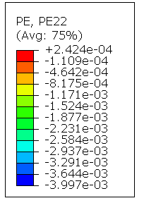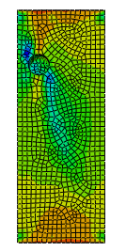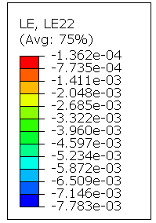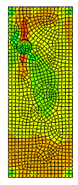
C 450X450 520 Mpa
Figure A.6: Strain of concrete of specimen C450x450 with 520 Mpa

B. Plastic strain of concrete and stress in x, y and z direction
Table B.1: Plastic strain PE of x, y and z direction and stress
0 | 0 | 0 | 0 | 0
0 | 0 | 0 | 0 | 0.001932107
0 | 0 | 0 | 0 | 0.003864213
0 | 0 | 0 | 0 | 0.006762373
0 | 0 | 0 | 0 | 0.011109613
0 | 0 | 0 | 0 | 0.017630471
0 | 0 | 0 | 0 | 0.027411761
0 | 0 | 0 | 0 | 0.042083688
0 | 0 | 0 | 0 | 0.064091578
0 | 0 | 0 | 0 | 0.097103409
0 | 0 | 0 | 0 | 0.146621108
0 | 0 | 0 | 0 | 0.22089763
0 | 0 | 0 | 0 | 0.332312286
0 | 0 | 0 | 0 | 0.499434054
4.17699E-08 | 7.47451E-09 | -2.46289E-08 | 4.16243E-08 | 0.693471432
4.38244E-07 | -1.8555E-07 | 4.37703E-07 | -6.62973E-07 | 0.91039139
7.96823E-07 | 7.69273E-07 | -3.88815E-07 | 9.53048E-08 | 1.085846066
2.53917E-06 | 2.14756E-06 | -1.85147E-06 | 1.74548E-06 | 1.222706437
4.28125E-06 | 2.8356E-06 | -2.52549E-06 | 2.46942E-06 | 1.35725069
5.56336E-06 | 3.05349E-06 | -2.53408E-06 | 2.38348E-06 | 1.48514533
6.7977E-06 | 2.98989E-06 | -2.16549E-06 | 1.81139E-06 | 1.621940017
7.05237E-06 | 3.90654E-06 | -3.12153E-06 | 2.85185E-06 | 1.73385036
7.93419E-06 | 5.26554E-06 | -4.47633E-06 | 4.20106E-06 | 1.847550392
1.04569E-05 | 7.81391E-06 | -6.76256E-06 | 6.68613E-06 | 1.967984676
1.45127E-05 | 1.18635E-05 | -8.67263E-06 | 7.1682E-06 | 2.193921089
2.87272E-05 | 2.36004E-05 | -1.83625E-05 | 1.5791E-05 | 2.192748308
4.90284E-05 | 3.57621E-05 | -3.19584E-05 | 2.90004E-05 | 2.202693939
6.94667E-05 | 4.89202E-05 | -4.76448E-05 | 4.27291E-05 | 2.224789381
9.11345E-05 | 6.67391E-05 | -6.18024E-05 | 5.25716E-05 | 2.301064491
0.000120244 | 9.55027E-05 | -7.24215E-05 | 6.12518E-05 | 2.497474194
0.000178808 | 0.000145137 | -0.000232133 | 7.81934E-05 | 2.665137291
0.000337281 | 0.000272631 | -1.87358E-05 | 0.000157791 | 2.665556431
0.000505458 | 0.000399122 | -0.000124101 | 0.000252534 | 2.533412457
0.000592049 | 0.000463891 | -0.000155653 | 0.000300176 | 2.373053312
0.000667056 | 0.000519469 | -0.000188087 | 0.000342386 | 2.245246887
0.000736039 | 0.000570372 | -0.000225434 | 0.000382266 | 2.124567747
0.000877931 | 0.000676227 | -0.000291768 | 0.000464682 | 1.953841805

