REACTIVE POWER COMPENSATION AND LOAD FREQUENCY CONTROL OF GRID CONNECTED MICRO GRID SYSTEM USING STATIC VAR COMPENSATOR (CASE STUDY: DILLA SUBSTATION)

A THESIS SUBMITTED
IN PARTIAL FULFILLMENT OF THE REQUIREMENTS
FOR THE DEGREE OF
MASTER OF SCIENCE
In
POWER SYSTEM AND ENERGY ENGINEERING
By
KUMILACHEW CHANE

HAWASSA UNIVERSITY
HAWASSA UNIVERSITY INSTITUTE OF TECHNOLOGY
SCHOOL OF ELECTRICAL AND COMPUTER ENGINEERING
HAWASSA (ETHIOPIA)
SEPTEMBER 2021

REACTIVE POWER COMPENSATION AND LOAD FREQUENCY CONTROL OF GRID CONNECTED MICRO GRID SYSTEM USING STATIC VAR COMPENSATOR (CASE STUDY: DILLA SUBSTATION)

By
Kumilachew chane

A thesis submitted to Hawassa University, institute of technology, school of graduate studies, for the partial fulfillment of the requirement for the degree of masters of Science in power system and energy engineering.

ADVISOR: Dr. Bassem .K

CO- ADVISOR: Mr. Isayas. G

Hawassa, Ethiopia
SEPTEMBER 2021

Declaration
I, the undersigned, declare that the thesis comprises my own work. In compliance with internationally accepted practices, I have acknowledged and refereed all materials used in this work. I know that non-adherence to the principles of academic honesty and integrity, misrepresentation/fabrication of any idea/data/fact/source will constitute sufficient ground for disciplinary action by the University and can evoke penal action from the sources, which have not properly cited or acknowledged.

Kumilachew chane ________________
Student’s Name signature
Place: Hawassa institute of technology, Hawassa University, Hawassa

Date of submission ________________________
This thesis have submitted for examination with my approval as a university advisor

Dr. Bassem .K __________
Advisor Name signature

Mr. Isayas. G ___________
Co-Advisor signature

Acknowledgement
First of all, I would like to thank the Almighty of God for his endless support For the completion of this work.
It is my proud privilege to express my deepest gratitude and admiration to my Advisors Dr. Baseem Khan and Mr.Isayas G. for their good guidance and support,
I wish to give my sincere thanks to ECE power staff members and Ethiopian electric utility office HAWASSA branch SNNP metrology agency office for their help when I collect the data.

HAWASSA UNIVERSITY
INSTITUTE OF TECHNOLOGY
SCHOOL OF RESEARCH AND POSTGRADUATE STUDIES
FACULTY OF ELECTRICAL AND COMPUTER ENGINEERING
ADVISOR’S APPROVAL SHEET ONE
This is to certify that the thesis entitled “REACTIVE POWER COMPENSATION AND LOAD FREQUENCY CONTROL OF GRID CONNECTED MICRO GRID SYSTEM USING STATIC VAR COMPENSATOR (CASE STUDY: DILLA SUBSTATION)’’ submitted in partial fulﬁllment of the requirements for the degree of Masters of Science in Electrical Engineering with specialization in “POWER SYSTEM AND ENERGY ENGINEERING”. The Graduate Program of the Department of Electrical and Computer Engineering, and carried out by kumilachew chane ID No- PGPSER/0005/11, under my supervision. Therefore, I recommend that the student has fulﬁlled the requirements and hence hereby can submit the thesis to the department.

Dr. Bassem.K ___________ _____________
Major Advisor signature Date

Mr. Isayas. G ___________ ______________
Co-Advisor signature Date

Contents
CHAPTER ONE 1
Introduction 1
1.1 General 1
1.1.1Reactive Power compensation in the grid connected system 3
1.1.2 Basic principle of reactive power compensation 5
1.2 Statement of problem 5
1.3 Objectives 6
1.3.1General objective 6
1.3.2 Specific objectives 6
1.4 Scope of the thesis 6
1.5 Significance of the thesis 6
1.6 Methodology 7
1.7 organization of the thesis 8
CHAPTER TWO 9
LITRETURE RIVEW 9
2.1 Introduction 9
2.2 MICROGRID COMPONENTS AND FORMATION 12
2.3 METHOD USED FOR REACTIVE POWER COMPENSATION 14
2.4 Static VAR Compensators (SVCs) for reactive power compensation 15
2.5 Need of Reactive Power Compensation 17
CHAPTER THREE 19
METHODOLOGY 19
3.1General work flow of the thesis 19
3.2 The proposed System Model 20
3.3 MAIN GRID POWER FLOW AND RATING 21
3.3.1reactive Power Varation In The Syetem 24
3.4 Frequency control 30
3.4.1Automatic load Frequency control 32
3.4.2 Designing and Mathematical formulation of SSILFC( frequency controlling) 32
3.5 Modeling and sizing of PV System 34
3.5.1 Sizing the solar array 34
3.5.2 Sizing of the Battery 36
3.5.3 Sizing of the charge Controller 37
3.6 Mathematical formulation of SVC 39
3.6.1Thyristor control reactor (TCR-FC) 40
3.6.2OPERATING PRINCIPLE OF TCR-FC based SVC 42
3.7 Neural network 43
3.8 Problem Formulation 47
3.8.1 objective function and constrint condtions 47
3.8 .2)Minimize Var Cost and Real Power Losses 48
CHAPTER -4 50
4. RESULT AND DISCUSSION 50
4.1 Result 50
4.2 Grid connected system during peak load condition 52
4.3GRID CONNECTED MICRO GRID SYSTEM DURING CONTINGENCY 54
4.3 STATIC VAR COMPENSETOR (SVC) with TCR-FC 56
4.4 LOAD FREQUENCY CONTROLLE 57
4.5 Grid connected micro grid system with controlling system 58
4.6 Power Loss & cost minimization 64
4.6.1Cost analysis of the real power loss in the GCMG system 67
Chapter five 71
5. Conclusions and recommendation 71
5.1Conclusions 71
5.2Recommendation 72
5.3 Future work 72
Reference 73
APPENDIX 77

List of figure
Figure1.1block diagram for methodology arrangement 7
Figure 2.1Configuration of grid connected a micro grid system 13
Figure 3.1 work flow by flow chart of the thesis 19
Figure 3.2 grid connected micro grid proposed model 20
Figure 3.3grid connected Micro gird configuration model 21
Figure 3.4 Single line diagram of the DILLA sub station………………………………………...22
Figure 3.5 Fig a) the graphical representation and b) the bar graph representation 25
Figure 3.6 Fig a) graphical representation of VAR fluctuation b) bar graph representation of VAR fluctuation 25
Figure 3.7 V,I representation during contingency conditions of DILLA 27
Figure 3.8 representation of real and reactive power variation before contingency 29
Figure 3.9 real and reactive power fluctuation during contingency condition 29
Figure 3.10 block diagram of proposed frequency controller loop…………...…………………..30
Figure 3.11 integral control of load frequency…………………………………………………..32
Figure 3.12block digram of grid connected PV system 33
Figure 3.13 circiut diagram of the grid connected PV system configration………………...…………….38
Figure 3.14: TCR-FC Equivalent circuit and Circuit diagram of TCR .….39
Figure 3.15graphical representation of TCR-FC opreation 40
Figure 3.16 Flow chart of operation of ANN 44
Figure 3.17 ANN Architecture including different layer ……………………………………………….…...44
Figure 4.1simulation of grid connected micro grid load flow and feeder arrangement by ETAP 51
Figure 4.2Simulink diagram for grid connected micro grid system during peak load 52
Figure 4.3 Simulink of active and reactive power of GCMGS 53
Figure 4.4Simulink graph of Active power for peak load condition 53
Figure 4.5Simulink of GCMG system during contingency condition 54
Figure 4.6of Simulink result of active and reactive power flow of GCMG during contingency condition 55
Figure 4.7of Simulink result of voltage disturbance during contingency condition 55
Figure 4.8Voltage and current disturbance during contingency condition 56
Figure 4.9of Simulink diagram for of thyristor control reactor with fixed capacitor of SVC 56
Figure 4.10of Simulink diagram of load frequency controller with integral controller 57
Figure 4.12Simulink of GCMG system reactive power compensation by ANN of SVC 58
Figure 4.13Simulink of active and reactive power after compensation process 59
Figure 4.14Simulink result of Active and reactive power after compensation 60
Figure 4.15reactive power flow of based on artificial neural network controlled SVC 60
Figure 4.16active power flow of the based on artificial neural network controlled SVC 60
Figure 4.17 graphical representation of improved active power of the GCMG system in variable load 61
Figur 4.18 Comparative of ANN with FUZZY and MOFA based SVC…………….……………………71
Figure 4.19 power factor improvement graph……………………………………………………...73

List of table

Table2.1  Table3.1 | Comparision of different implemented divice…………….…….. …….…………………….17  The main grid station of DILLA during peak load condition ……..…….……30
Table3.2 | Max, min and average recorded value during peak load …………………. 32
Table3.3 | Average recorded value of during contingency condition ……………...... 34
Table 3.4 | Real and reactive power variations before and after contingency ……..…...36
Table3.5 | Average temperature and solar radiation data ……. ……………………… 39
Table 4.1  Table 4.2  Table 4.3 | Compression analysis of with and without SVC….……………………….….. 69  Comparission of ANN,FUZZY and MOFA controller ………..……….………….71  Total annual power loss in birr with and with out SVC……………………..74

List of acronyms
AFDR | actual feeder rat of day
AI | artificial interagency
ANN | artificial neural network
CRPC | central reactive power compensation
DF | disturbance frequency
DRPC | decentralized reactive power compensation
ES | expert system
FC | harmonic filter
FDR | feeder rat of day
FI | frequency interruption
FT | fuzzy theory
GCMG  LFC | grid connected micro grid  load frequency control
LFC | load frequency control
MG  MOFA | micro grid  multi objective fire flow algorithm
MSC | capacitor bank
MSR | inductor bank
PCC | point of common coupling
PV | photo voltaic
QS | Quality service
RPC | point of common coupling
SVC | static VAR compensator
TCR | thyristor control reactor
TCR-FC | thyristor control reactor with fixed capacitor
TSC | thyristor switched controller
TG | wind turbine generator

ABSTRACT
In the modern power system, reactive power compensation and load frequency control are two of the main issues. The aim of this thesis is to study reactive power compensation and load frequency control of the grid-connected micro grid system (GCMG) under variable load .In this work, an Artificial Neural Network based Static VAR compensator (ANN-SVC) and Load Frequency Controller (LFC) will be proposed for reactive power compensation and load frequency control of the grid-connected micro grid system, The artificial neural network (ANN) is used to control the the SVC gete signal for proper controlling of the thyristor valve in the circulated system current management. Power system Planning and management provide the strategy for reactive power compensation and load frequency disturbance control. The ANN-controlled SVC is used for managing and compensating of reactive power in the system and LFCis control the system load frequency disturbance and the LFC controlling loop component is control and managed by ANN signal for proper controlling of the load frequency error. The real and reactive powers before applying the SVC at the peak load conditions are 40.56MW and 27.16MVAr, respectively, before reactive power compensation. During contingency conditions, the real and reactive powers are 36.03MW and 30.42MVAr, respectively, and the frequency is highly disturbed for a fraction of a second, but after compensation, the real power is improved to 50.54MW, while the reactive power is reduced to 17.34MVAr. Therefore, real power is improved by 52.18% while reactive power is compensated by 87.02%. The steady-state load frequency error is reduced by 95%, while the system power factor is improved by 94%. A detailed comparative analysis of the proposed ANN-based SVC with the fuzzy-based and multi-objective fire fly (MOFA) algorithm SVC is presented, which shows that the ANN-based SVC has better performance, fast and accuracy, in case of the above justification ANN is more prifereble than MOFA and FUZZY algorithem. The general GCMG structure with the compensation and controlling process was designed by ETAP and MATLAB/Simulink

Key word Static VAR compensator (SVC), Thyristor Control Reactor for Fixed Capacitor (TCR-FC), Artificial Neural Network (ANN), Grid Connected Micro Grid System (GCMG)

CHAPTER ONE

Introduction

1.1 General
Reactive power (VAR) compensation is demarcated as the management of reactive power to improve the performance of the ac power system. Reactive power can best be defined as the quantity of idle power that is developed by reactive components such as inductors or capacitors. Reactive power is necessary to move active power through the transmission and distribution system to the customer. Power factor correction is one of the best investments to reduce energy costs with a short payback in [1].
Reactive power is important in the power system operation in different situations. If the voltage on the system is small, active power cannot be supplied. Reactive power is used to provide the voltage ranks essential for active power to do suitable work. Reactive power is essential to move active power through the transmission and distribution system to the customer by different methods in the power system controlling and voltage maintaining strategy. Reactive power compensation scheduling provides the opportunity of power loss reduction and voltage profile improvement for the network operator. Herein, capacitor banks and other electronic components are widely incorporated for reactive power compensation in electric power systems because of their more economic justifiably than series VAR compensation. There are two important factors in reactive power compensation, including demand power and the optimal deployment of installed capacitor banks in the case of different operation modes. Optimal reactive power control of power systems can lead to minimal active power loss, improved voltage profile, and minimization of the cost of reactive power generation. Micro grid refers to a low voltage generation and distribution network that includes small-scale generation sources, energy storage devices, controllable and uncontrollable loads, local controllers, a central controller as well as telecommunication system micro grids are small-scale versions of standard grids. They supply nearby produced energy openly to a group of users. MGs are generally joined to the main grid, while in emergency situations they may operate in is landed mode. Hence, it is deliberated as active flexible cells in an electric power system. Different Renewable energy are being connected to power systems worldwide in large numbers. As a result of the intermittent nature of these sources, in addition to the steadily increasing overall load demand, electricity systems currently are faced with many challenges in security and operational reliability. With modern advanced grid-integration methods, these energy resources are empowered to become reactive power sources. effective Reactive power management should address three basic requirements in the power system.To maintain voltage within predefined limits, it seeks to minimize congestion of real power flows and, it seeks to minimize power losses. Load Frequency Control (LFC) is a system to keep wisely constant frequency to load between the generators and to control the tie-line interchange schedules. Load Frequency Control is seriously needed for power system because of the quality of power. Load frequency control (LFC) in power system maintains frequency deviation & tie-line power flow deviation. Load frequency control is the basis of many advanced concepts of the large scale control of the power system. There are two kinds of power in an AC power stream reactive power and active power (real or true power). Reactive power is moved from the source to the load and then returns from the load to the source, then the average power supplied is zero. Reactive power compensation is required to keep the system voltage within the appropriate limit. According to speed and capacity to absorb or produce reactive power, can be classified as dynamic and static. Reactive Power is less exposed to competitive mechanisms.it is one kind of ancillary service that system operators need to procure to maintain network stability within the right voltage limits in [2].
The power system operates on an AC system and most of the loads used in our daily life demand reactive power. Thus reactive power or VAR compensation is described as the management of reactive energy to increase the routine of the AC system. The subject of reactive power compensation is realized in two ways: load and voltage support. The aim is to attain a better-quality power factor and real power balance from the load point of view. Reactive power generation has been normally used voltage profile enhancement in power systems. However, the opportunity price of reactive power generation should be measured. since it affects the frequency control capability of the system in [3]. Active power is necessary for running of any type of the electrical load. To transmit this active power from generation to the electrical loads, Reactive power is necessary to adjusts the voltage level of system. If voltage of the system is not sufficient, essential active power cannot be supplied. So reactive power is used to maintain the enough voltage for active power to do useful work in [4].
Our power system operates on an AC system and most of the loads used in our daily life are inductive in nature which requires reactive power. Additional reactive power requirement is observed at the load side to maintain voltage profile or power factor improvement. In general, the problem of reactive power compensation is seen from two facets: load compensation and voltage support. In load compensation, the goals are to increase the system power factor, to balance the real power drawn. Voltage support is generally required to reduce voltage fluctuation at a given terminal of a transmission/distribution line. In both cases, the reactive power that movements through the system can be successfully controlled. Reactive power compensation in power systems also improves the stability of the ac system by increasing the maximum active power that can be transmitted in[5].
Reactive power compensation by suitable means has developed the most economically pretty and effective solution technically for both traditional and new problems at different voltage levels in a power system. VAR compensation near load center has gained more importance in recent times in [6].

1.1.1Reactive Power compensation in the grid connected system
In order to agitate the realities of electrical energy and dynamical energy methods, planners confirm to place voltage management measures .The voltage is often management led by providing reactive power control margin to modulate the provision wants through the subsequent compensations as given below.
a. Series compensation.
b. Shunt compensation.
c.. Dynamic compensator.
These classes square measure primarily supported the strategies of connecting the capacitance bank with the system. Series and Shunt volt-ampere compensation techniques square measure accustomed modify the natural electrical characteristics of electrical facility.

1.1.1 a) SERIES COMPENSATION
Series capacitors on the opposite hand haven't any management over the flow of current. As these square measure connected serial with the load, the load current perpetually passes through the series capacitance bank. The voltage regulation of the system is improved. Therefore series capacitance should have refined and elaborate protecting instrumentality.
There square measure some specific benefits of victimization sires capacitors (SCB) like,
- It reduces the road current of the system.
- It improves the voltage level of the load.
- It conjointly reduces system Losses.
- It improves the ability issue of the supply current.
- It reduces the load of the generator.

1.1.1 b)Shunt compensation.
Shunt capacitance is connected, which attracts current resulting in the supply voltage A shunt capacitance attracts virtually fastened quantity of leading current that is superimposed on the load current and consequently reduces reactive parts of the load and therefore improves the ability issue of the system. Moreover, capacitance banks that square measure put in in load points with low demanded power square measure unable to share their excess capability with load points than have a high demanded power.

1.1.1 c) Dynamic compensation
The dynamic reactive compensation is to share the compensation characteristic of the shunt system and series compensation system They will be utilized in single-phase or three-phase systems, in substations, on the distribution lines or at the doorway of a selected client. We can distinguish the subsequent styles of reactive power in the dynamic mejore.
- Shifting reactive power: caused by inductive and/or electrical phenomenon masses. These guarantee current ‘lags/runs late’ behind the voltage
- Distortive reactive power: this is often the ‘unwanted’ a part of the apparent power related to harmonic pollution caused by non-linear masses.

1.1.2 Basic principle of reactive power compensation
In the basic principle of the reactive power controlling and compensation process consists of three parts:
- Stratified by voltage,
- partition by the power grid and
- Local equilibrium.
Researchers have considered load regulation to obtain high energy efficiency for steady-state situations.. The system has been tested under resistive-inductive load without examining phase inequality in [16]. For this, an economic model predictive control has addressed in this study.

1.2 Statement of problem
The rate of electrification for the rural part of Ethiopia is less than three percent (3%), while 85 percent of the rural population is distributed in villages. Providing electricity access to such dispersed populations using different old electrification process but the government have a plan to construct different micro grid and improve the traditional micro grid until 2024 .In the GCMG system the micro grid is used to an additional source of power in the grid integrated area when we connect the MG system disturbance will be developed in the point of common connection(PCC) and around load. The main problems of the systems are
- Large amount of reactive power flow and real power loss.
- Voltage disturbance/ unbalanced voltage developed .
- Load frequency disturbance or variations will be developed.
The micro grid will be additional source to main grid system in the case study area and for the large amount of reactive power flow and system load frequency disturbance management different controlling method and technices will be used that is ANN based SVC and load frequency controller will be used for the managing and controlling process of the reactive power and load frequency disturbance.The prime aim of the study in the Reactive Power Controlling or Management ( RPCM) and minimize the real power loss and load frequency variation as well as minimizing the expected total hourly voltage deviation of all load in the grid-connected micro grid.

1.3 Objectives

1.3.1General objective
To study reactive power compensation and load frequency control in grid connected micro grid system by using ANN control SVC and LFC in the MATLAB/ Simulink environment.

1.3.2 Specific objectives
- To study the existing system
- To Model grid connected micro grid system under variable load
- To develop reactive power compensation mechanism by ANN controlled SVC
- Control load frequency disturbance (LFC) using LFC.
- Compare the ANN based SVC with FUZZY based SVC and MOFA based SVC

1.4 Scope of the thesis
The thesis will be focus on reactive power management and frequency control by using ANN based Static VAR Compensator (SVC) andload frequency control system.that are including real power loss and variation of reactive power flow that caused by sudden disturbance, the peoduced power from the MG are used to additional source of the grid in the case study area.

1.5 Significance of the thesis
- Managing and Minimizing the reactive power in the system
- Minimizing of the real power loss
- Improving of active power of the system and the power factor
- Reduction of load frequency disturbance
- Ensure the security of electric power continuity and Reduce power shortage and real power loss cost.

1.6 Methodology
The methods employed to achieve the objectives of this thesis are:
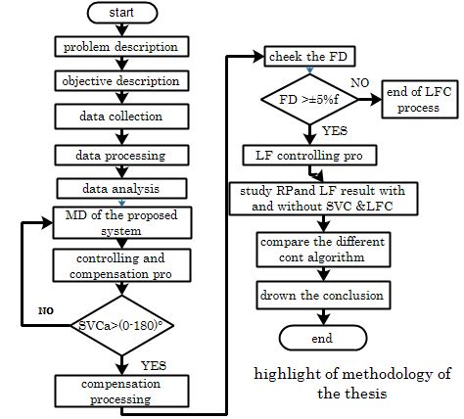
Figure 1. work flow for methodology arrangement
Under the topic called literature review the work of different authors; articles, journals, books, thesis done in similar topics and others have been reviewed and it has been considered one of the methodology used to do this Thesis. The total task of data collection is accomplished through
- Conducting interviews with the respective personnel of the case study area
- Direct measurement From recorded data and equipment specifications
- Physical observation (filed study) in the substations.
- Data from Ethiopian Electric Utility (EEU) engineering offices SNNPREEU
Computer analysis or Simulation There are different types of software which can be applicable on electrical power controlling for frequency and reactive power simulation Power world, PSS, MAT-LAB,ETAP, PSO and Dig SILENT. From software mentioned above the MAT-LAB, ETAP is most recent, highly compatible and combined reliability and flexible system. The data is organized using EXCEL sheet and the single layout diagram and analysis using Power Factory Software the preferable solution.
Data analysis: Analysis has been done using power software load profile and different mechanism. Comparison has been done between the systems with SCB compensation, with the SVC during fault and peak load condition.

1.7 organization of the thesis
This thesis work is organized as in following chapters:-
In Chapter one presents about the introduction and background of the study, briefs about reactive power, statement of the problem, describes the objective of the thesis work and scope of the project.
In Chapter two describes about reactive power. It provides brief understanding of GCMG system, about micro grid, controlling and comparison about different technics.
In Chapter three methodologies about the research and its proposed model, presents a literature review of other related works that has been done for both general power system and grid connected system. A brief discussion on active power controlling mechanisms , mathematical model of micro grid (PV system and battery ) ,load frequency controller and working principle and definition of ANN. reduction and reactive power compensation techniques.
In Chapter four present result and discussion about the system of GCMG system during normal condition , peak lead condition and during contingency condition and loss and cost calculation presents the ETAP and MATLAB/SIMULINK modeling, simulation results and analysis of the reactive power consumption in different cases for GCMG power network with and without SVC .
In Chapter five the conclusions and recommendation of this research work can be found. Moreover, some suggestions on the extensions to potential topics for future research are presented.

CHAPTER TWO

LITRETURE RIVEW

2.1 Introduction
The aim of this chapter is to critically review of many research works which are more related to this work, in order to have a clear understanding of the subject matter. In this part we will try to study the different grid connected micro grid system in the reactive power compensation and micro grid power plant are presented for the power generation perpuse. In addition to this, Reactive power compensation method , component that are used to reactive power compensation ,the main components of micro grid connected grid system , the components that are used to synchronize the MG to the grid are studied and discussed based on the different scholars idea and document as well as brief experiment. We always in applied to reduce reactive power to improve system competence .this is acceptable at same level if the system is purely resistive it make Couse same problem in electrical system.
Voltage and reactive power is closely related to the maintenance of the voltage level of the whole system, it must have sufficient reactive power to meet the system load demand for reactive power and reactive power compensation of losses and voltage control of power systems are mainly by controlling the reactive power generation, flow and consumption to achieve.
Reactive power controlling has become a most interesting task in power system operation and management. Some of the characteristics of the power systems and their loads can deteriorate the quality of the power supply in [1].
In the power scheme, reactive power should be maintained stable, or otherwise, it would worsen the system voltage, and even cause the voltage collapse accidents. Therefore, the optimized and recompense of the grid system have abundant significance to improving the voltage quality, power factor and the efficiency of the power supply. It is also suitable to reduce the system losses. It is a foremost energy saving technical measure with small investment and quick returns in [3].
For this reason it can be compensated by VAR producers, avoiding its circulation between the load (inductive or capacitive) and the source, and therefore improving voltage stability of the power system. Load compensation is the controlling of the reactive power to increase the quality of the supplying ac power systems. Reactive power compensation can be implemented with VAR generators connected in parallel or in series in[4].
A reactor or a capacitor stores the reactive power produced by the ac power source during a single operation. In other words, the reactive power fluctuates among the source and the load at a frequency equal to twice the rated charge. However in nature, most of the loads are inductive loads absorbing reactive power and resulting in low lagging power factor in [6]
A Micro-grid could be defined as a low-voltage distribution network .Generally speaking, Micro-grid could be operated in either grid-connected or islanding mode. Reactive power is organized the difficult and the solution to system voltage regulator. There are many authors and researchers who have worked voltage and reactive power control for power loss minimization using different techniques ’A network of low voltage power generating units, storage devices and loads capable of supplying a local area such as suburban area, an industry or any commercial area with electric power and heat’. The components of Micro grid are interfaced through quick response power electronics and present itself as a single entity and therefore can be connected to traditional power grid or can also be operated in stand-alone mode as a self-sustained power system in [7]
Transformers, asynchronous motors and different inductive component can absorb reactive power from the grid throughout their operation periods, which, to a particular extent, can cut back the system power issue. The reactive power demand will be salaried by reactive power compensation device that is useful to cut back the reactive power flow within the grid, cut back the electrical energy loss because of the delivery of reactive power, and successively, improve the operative condition of the grid. This development is termed reactive power compensation in[8].
The basic principle of reactive power compensation consists of three parts: stratified by voltage, partition by the facility grid and native equilibrium. Within the installation, reactive power ought to be maintained balanced, or otherwise, it might worsen the system voltage, and even cause the voltage collapse accidents. Additionally, if the voltage is lower, it'll cut back instrumentation utilization and increase the real power loss. Therefore, the optimization and compensation of the grid system have nice significance to up the voltage quality, power issue and therefore the potency of the facility offer. it's additionally helpful to cut back the system losses. it's a foremost energy saving technical live with tiny investment and fast returns in[8].
Many researchers has done on reactive power composition or related to load characteristics to solve the problem with voltage stability done on management of dynamic reactive power reserves based on optimal power flow and the Bender’s decomposition technique to improve voltage stability. Unbalanced system reaction for different load models and network situations by chalking Impact of Fault Locations on Induction Motor Responses, Impact of Fault Duration on Induction Motor Responses and impact of generator response in[9].
Reactive power compensation should be consisting of the compensation for both the fundamental wave reactive power and the disturbance of reactive power. Reactive power compensation play an important role in this current time because supplier /customer take charges of it, if it exceeds a predetermined value so different customer /companies enforce users to compensate it, and to reduce the power consumption. The consumer has to pay electricity charges for his maximum demand in kVA plus the unit consumed if the value of power factor is improved by the customer so there will be annual saving. Power factor improvement results increasing making capacity of plant.in[10].
Reactive Power Management is a critical issue when dealing with the planning and operation of power networks with high wind energy penetration. Reactive Power Management entails the requested operation and planning actions to be implemented in order to improve the voltage profile and the voltage stability in power networks. An efficient reactive power planning could be obtained by choosing an optimum location of VAR sources during the planning stage, whereas efficient reactive power dispatch could be achieved by scheduling an optimum regulation of the voltage set point at the generators connection point and at the VAR settings during the reactive power dispatch in[11].
Reactive power compensation using power electronics, in this research he investigated the various fact device and he come up with the best compensator for ac system that is the shunt compensator. It gives a good line of regulation of the power transfer capability. SVC is a very good compensator for dynamic heavy electrical loads in[12].
The main thing is to reduce the reactive power flow so as result reducing the electrical energy charges. Most appropriate method for compensating reactive power flow is power capacitor, which is economical and efficient as well compare to filter and compensating by synchronous condenser. The capacitor bank to compensate the reactive power flow automatically, for that we will discuss single, group and bulk power factor correction techniques according to level of customer used but capacitor banking will be low efficiency and less reliable in[13].
Reactive power compensation is one of the most effective ways to reduce Consumed electric energy and improve power quality. How reactive power compensation can improve the technical-and-economic indexes of the power grid are as follows:
- reduce cost and generate higher revenue for the customer
- reduce network losses, increase system capacity and save costs on new installations
- improve system power factor and increase power availability
Same Electronic device are used to improve and control the mini micro grid level according to this Any device which is connected in series or parallel with the load and which is capable of supplying reactive power demand to the load is called reactive power compensation device in [14].

2.2 MICROGRID COMPONENTS AND FORMATION
The micro grid will be connected to the utility grid through single point of Common Coupling (PCC). The analytic device is employed to isolate the small grid from the utility grid A small grid integration of assorted units. Basically, it consists of metric weight unit energy-storage unit, controller unit and traditional load. The metric weight unit once more compromises of assorted micro-generating devices. Therefore, small grid modeling varies from one configuration to alternative looking on the parts used. varied approaches for the modeling and management of small grid will be found within the literature in[15]
The micro grid contain Meany mini micro grid sources
- PV (photo voltaic ) system
- Battery storage system
All mini micro grids have its own generating methods and generated component and its generating limit with respect to the selected location and material or equipment rated value[16]. The PV system are mainly produce the DC power but after production or generation of the DC power the DC-DC converter to convert and transform the DC input to DC out then the inverter are convert the dc input to AC output and different researcher are to explain the micro grid component and its converter without any controller and its smart communication midume in [12].
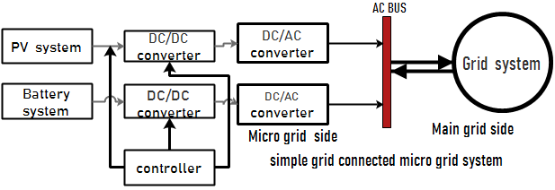
Figure 2.Configuration of grid connected a micro grid system
Solar power, an important renewable power, has been on the increase in most parts of the world in terms of installations .This is as a result of abundant sunlight shining on the earth from the sun every year and making conversion of this source to usable sustainable electric power a top priority for most developed and developing countries. A technology utilizing the principle of thermal power plants called concentrated solar power (CSP) or solar thermal (CST) is one of them The other technology uses the photovoltaic effect and is known as solar photovoltaic (PV) power in[17].but the controller and production limit will be the drow back of the implemented system .
Wind is a renewable energy source and wind power generation means getting the electrical energy by converting wind energy into rotating energy of the blades and converting that rotating energy into electrical energy by the generator. Wind energy increases with the cube of the wind speed, therefore WTGs should be installed in the higher wind speed area in[18]
Wind power technology will contribute to the distribution system by control its active power output to boost the system responsibility. to boot, it may be economically helpful to enhance voltage quality similarly as load sharing with generation at varied times, avoiding load shedding and risk of potential blackouts. But when we study wind system thechallenge will be the out put of the generation is variable because the output of the generator is depend on wind speed and terbine activity so we must understand when we use renewable source of micro grid parallaly develop and prepear the large energy storage divice.

2.3 METHOD USED FOR REACTIVE POWER COMPENSATION
Generally two methods are there for reactive power compensation.
A. Decentralized Method (DM)
In decentralized reactive power compensation, the individual controlling device is installed locally in the network. The optimal size of controlling device can be obtained and install it wherever it is required for different period of times.
B. Centralized Method (CM)
The entire individual controlling device installed in the network is centralized. This will use for maintaining bus voltages and power factors. Reactive power control units are used for central compensation .The current industry practice uses the decentralized method for reactive power compensation. In decentralized reactive power compensation, the individual controlling device is installed locally in the network. It is very costly and uneconomical to buy a controlling device and install it wherever it is required for different period of times in [19].
When I study the different researcher document all of the above mentioned studies introduced decentralized reactive power compensation (DRPC) system. Herein, the DRPC planning problems specify optimal locations and sizes of capacitor banks for a specific load profile of the grid connected micro grids. The optimal locations of capacitor banks might be changed along with variations of micro grid load profile. Herein, the capacitor banks should be allocated for each prospective load profile to optimally benefit from the installed capacitor banks. However, the location of capacitor banks cannot be changed because this action is neither economically nor technically justifiable in [20]
But know the DRPC method will be not advisable according to
- Economic aspect and Technical constraint
- Flexibility and reliability when I compered to centralized method

The centralized method will be more advisable for grid connected micro grid system because of different point of view. Centralized reactive power compensation (CRPC) system can inject reactive power to different load points to improve the QoS level for grid connected micro grids in [20]

The objective function of the devised CRPC system is to minimize the expected total hourly cost of grid connected micro grid operation and voltage deviation of load points. Moreover, the uncertainties of the problem including the demanded power of micro grid, output power of renewable energy resources, and electricity price are considered in the proposed formulation to more comprehensively determine the optimal capacity of the CRPC system. the performance of the proposed CRPC system is compared with a DRPC system to evaluate the effectiveness of the proposed system in the methodology in[21].
During this context, there ar many energy generation ways to confirm high-quality energy provide from the cell unit to the demand-side. the most purpose of energy management is to supervise the facility exchange between generation unit associated an electrical grid. it's utilized to rearrange swish power exchange from the cell to grid/load or contrariwise in[22].
Hence, the energy management methods associated with grid integration is considerable for
(1) Improvement of energy qualification and the minimization of grid interferences
(2) Optimal energy supply,
(3) Sustainable and reliable operation.

2.4 Static VAR Compensators (SVCs) for reactive power compensation
SVC is ready to manage the voltage at a selected bus by activity or engrossing reactive power. The benefits of simplicity, low losses, low harmonics production and low price have created SVC to be used extensively compared to different FACTS devices. SVC may be a shunt connected FACTS device whose output is often adjusted to exchange either capacitive or inductive currents to the connected system.This Current is Controlled to manage specific parameters of the power system (typically bus voltage). It is a variable electric resistance device wherever this through a reactor is controlled victimization back to back connected Thyristor valves. The Thyristor has been AN integral half in realizing the SVC and to modify management of its reactive power flow. It's used either as a switch or as a unceasingly controlled valve by dominant the firing angle. It ought to be noted that the SVC current can contain some harmonic content, one thing that wants attention within the style method in[17].Within the steady-state, to take care of a predefined level at a high voltage bus some steady-state management of voltage is provided by the SVC in [23].
Table 2.1 Comparision and observation of different implemented compensation divice
Selected component | Implemented and application | Observation and Advantage | Disadvantage
Capacitor | Power system operation and reactive power compensation [16][20] | -reactive power compensation for a limited power flow  -economical cheep | -it is old and raged when we compare to anther fact device  -performance of voltage profile mentenance
SVC-TSC | Large power flow and reactive power compensation with voltage profile [23] | -it have good performance for compensation process  - it is smart and modernized when we study CB | -It required single program for large load operation  -it required Large stage of iteration
SVC-TCR | Reactive power compensation in the large power industry[29] | -it has well accuracy and performance in the power system operation and compensation process  -more modernized and minimum time required for the convergence stage  -it is more reliable, small and effective  - | -Large power industry and less harmonic filtration process

2.5 Need of Reactive Power Compensation
When I observe the reactive power and frequency the necessity for reactive power compensation can be divided into three basic classes:
i.) The necessity to preserve the stability of synchronous machines. We shall see that voltage control by reactive power compensation can have a positive stabilizing effect on the system during disturbances because the rotor angles of synchronous machines to change quickly. Both the transient stability and the dynamic stability of a system can improve. It is even possible with controlled compensators to drive voltages purposely out of their normal steady-state bounds for several seconds following a fault or other major disturbance to enhance the stabilizing influence still more.and the voltage profile will be improved with releted to frequency controlling process.
ii) The need to control voltage within suitable bounds about the preferred steady-state value to provide quality service to consumer loads. Following certain abrupt changes in the load, or in the network arrangement as a result of switching actions, it may be necessary to make a voltage improvement in as short a time as a few cycles of the power frequency. For other voltage disturbances, a improvement within a few seconds will suffice. Uncorrected voltage deviations, even if momentary,
iii) The need to adjust voltage profiles in the network to prevent Unnecessary flows of reactive power on transmission lines. To this end, reactive power compensation can be used to preserve transmission losses to a practical minimum. While the reactive compensation must be adjusted or changed intermittently to maintain minimum losses, the adjustments can be made fairly rarely with several minutes to effect the preferred change.
But different researchers are to study reactive power compensation by using capacitor bank and load frequency disturbance by manual adjestemnt way. in my observation reactive power controlling and compensation is highly important by using SVC than capacitor bank and integeral load frequency controlling system is more efficient the manual system because the above new controlling method will be are more reliable and efficient than old system and it is modernized and latest than the privies component but when we see the cost of the material capacitor bank is cheaper than SVC but the reliability , flexibility , performance as well accuracy of controlling and compensation SVC are more than ather and advisable.and the ANN-SVC in the reactive power compenseation is more prifereble and acceptable when we study reactive power compenseation process related to different researcher .the compenseation of reactive power by ANN-SVC are fast and acuret because the ANN controlled and order the SVC fring angle in the thyristor valve. In case of the thyristor valve the circulated current in the TCR-FC based SVC are control properly. But in the simple capacitor and anther fact divice is not good closeness and relation to the ANN and ather aretificial intelegent controller famile because the simple capacitor and same fact divec is not moderated and properly mached to the controller.The load frequency controller are more important to contro the disturbed frequency in the load terminal. And the LCF system component is managed and controlled the ANN controlling signal then the LCF system is control the steady state error and frequency divation perfectly.

CHAPTER THREE

METHODOLOGY
For controlling the reactive power and frequency, ANN based SVC and LFC system is proposed. The proposed system reduces the GCMG frequency deviation and reactive power during peak loads and contingencies. The micro grid is additional source of the system or the main grid and during the reactive power management the system active power will be improved.In this thesis ANN controlled SVC and LFC system for the analysis and study of the reactive power compensation and load frequency control.

3.1General work flow of the thesis
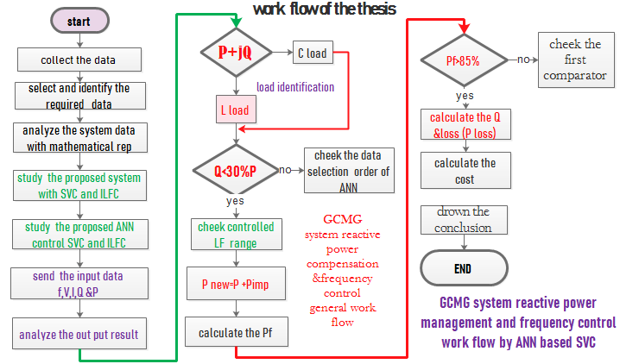
Figure 3.1of work flow by flow chart of the thesis

3.2 The proposed System Model
In the grid connected micro grid system, the proposed model of the micro grid side include different renewable energy generation source are photo voltic(PV) the major renewable source to study and model in this thesis.
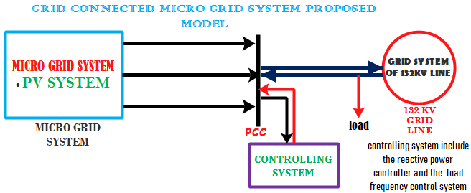
Figure 3.2 grid connected micro grid proposed model
The proposed system include controlling block components that are used to compensate and control the reactive power and load frequency. the load frequency disturbance will be developed during the micro grid are connected to the main grid in the different situation around PCC (point of common coupling ) and load side. Static VAR Compensators (SVCs) are the most useful devices to control and compensate the dynamic reactive power at the integrated grid level. The methods that are used to control the reactive power in different power stage are decentralization method or Local secondary control and centralization method or grid central control (GCC).but centralization method is the most effective and advisable method in this thesis.
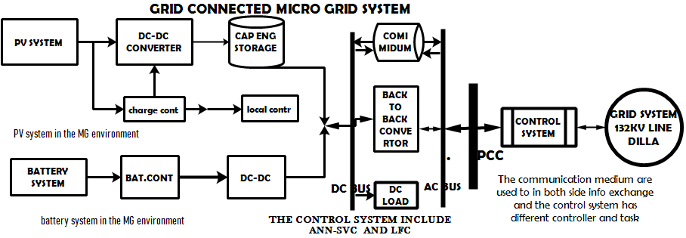
Figure 3.3 grid connected Micro gird configuration model
The control system includes ANN-based SVC and integral load frequency controllers that are used to controlling mechanisms of reactive power and load frequency in the GCMG system. each mini grid connected micro grid has its Owen energy production, controlling mechanisms, and technic to including reactive power controlling , managing and frequency variation. We can to controlled the Voltages and reactive power by providing sufficient reactive power control margin to supply. When I develop / model the micro grid I will try to include the renewable part of the energy generation of the PV system. Each energy generation system and stage is designed with standard declaration of IEEE rule.

3.3 MAIN GRID POWER FLOW AND RATING
In DILLA we have 132kv incoming TRAFFO or feeder that are connected from national main grid station and contain or included five different rate outgoing feeder that are 33kv and 15KV the 15KV rate feeder are used around DILLA and YIRGACHEFFE the rest feeder will be transmit and distribute energy to SOLLOMO and GOLOLCHA city line station.
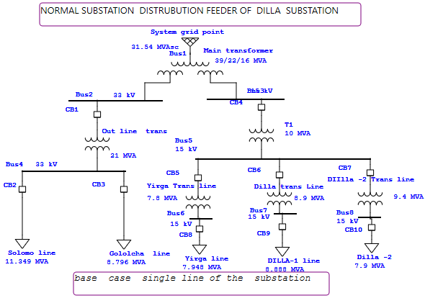
Fig 3.4 single line diagram of dilla substation
Table3.1 of the main grid station of DILLA during peak load condition
Feeder name | Feeder rate | Active power | Reactive power | Cf
DILLA -1 | 15KV | 5424.000KW | 2394.000KVAR | 0.66
DILLA -2 | 15KV | 5424.000KW | 2394.000KVAR | 0.66
YIRGA CHEFFE | 15KV | 5424.000KW | 2394.000KVAR | 0.66
SOLOMO | 33KV | 6550.500KW | 3399.000KVAR | 0.66
GOLOLCHA | 33KV | 6550.500KW | 3399.000KVAR | 0.66
Active power per month for the 15KV feeder loads
In the system we have three 15KV feeders that has totally 45KV rate
5424000KW =5424000/1000
= 5424 MW
Individual feeder rate in MW
= 5424/3=1808MW
Feeder rate per day will be FRD
$FRD=\frac{FR}{dayofthemonth} =\frac{FR}{30DAY}$ 3.1
=60.266MW
The FDR value are ideal power until the FDR value are mix with the total station feeder consistence constant C_{f} and the actual FDR is AFDR that is
$AFDR= FDR*Cf 3.2$
=39.78MW
The reactive power will be of the 15KW feeder load
=2394MVAR
Individual feeder rate in MVAR = 2394/3=798MVAR
Feeder rate per day will be FRD
$FRD=\frac{FR}{dayofthemonth} =\frac{FR}{30DAY} 3.3$
=26.66MVAR
Total flow of reactive power in the system during peak load condition
$28\% \left(RP\right)+RP$
= (26.66+7.9) MVAR= 33.16MVAR
The total frequency interruption of the 132KV grid line station system 273.19.
The total frequency interruption FI per second will be
$FI=TFC/60s$
4.55
The normal variation will be 5% the normal frequency in both side of the regular value that means 2.5 of the left and right. And the nominal frequency Nf will be constant
Disturbance on frequency will be Df
$Df=Nf-FI 3.4$
45.45
At the left side 45.45 and 54.55 at the right Based on the recorded and give information the system has frequency disturbance problem during peak load and contingency conditions.

3.3.1REACTIVE POWER VARATION IN THE SYETEM
For the power grid and micro grid power flow will be vary time to time according to the power flow and demand requirement of the system voltage and required of electric demand the Reactive power will be vary within time to time. Show the fluctuation of reactive power as well as the required limit of reactive power in the system.
Table3.2 of max, min and average recorded value of current, active and reactive power during peak load condition
Time  In H | line arrangement and rate | Average current during peak load condition (KA) |  |  | Average reactive  power during peak load  condition (Mvar) |  |  | Average power  during peak load  condition (MW)
Short | Bay | Max | Min | Average | Maxll | Min ave | Average | Max | Min | Avera
All | 132/15 TR1 | 1730 | 1655 | 1692 | 37 | 21 | 29 | 6.4 | 5.6 | 9.0
All | 132/15 TR 2 | 1940 | 1502 | 1615 | 33.12 | 22.43 | 27.8 | 6.34 | 5.59 | 8.85
1 | Line 1/line 3 | 394/350 | 230/245 | 312/298 | 67/41 | 4.1/2.2 | 6.4/21 | 10.3 | 8.9 | 9.6
2 | Line2/line3 | 620/452 | 389/380 | 504/416 | 53/31 | 3.8/2.46 | 4.1/24 | 10.8 | 9.9 | 10.35
3 | Line 3/line 2 | 550/453 | 453/398 | 502/426 | 41/19 | 3.9/2.18 | 3.5/19 | 12.1 | 10.2 | 11.15
4 | Line 1/line3 | 434/390 | 344/320 | 389/355 | 43/23 | 2.7/2.21 | 3.5/17 | 12.0 | 11.1 | 11.55
5 | Line 2/line 1 | 389/390 | 280/230 | 335/310 | 34/23 | 3.9/2.3 | 3.7/18 | 12.8 | 10.1 | 11.45
6 | Line 5/line3 | 430/395 | 342/321 | 386/358 | 38/27 | 3.4/2.5 | 3.1/21 | 8.48 | 7.83 | 8.155
7 | Line2/line 5 | 453/345 | 231/301 | 342/323 | 40/19 | 3.8/2.1 | 3.4/15 | 7.95 | 7.74 | 7.845
8 | Line2/line3 | 542/580 | 230/299 | 386/440 | 42/29 | 2.4/2.0 | 3.3/29 | 9.07 | 8.1 | 8.585
9 | Line5/line 1 | 280/394 | 180/167 | 230/281 | 39/33 | 3.1/2.12 | 3.5/25 | 10.3 | 9.17 | 9.735
10 | Line 2/line3 | 467/380 | 420/321 | 444/351 | 38/21 | 2.93/2.1 | 4.1/15 | 11.4 | 9.75 | 10.575
11 | Line 2/line4 | 450/354 | 430/234 | 440/294 | 39/26 | 2.7/1.4 | 3.3/20 | 9.8 | 8.73 | 9.265
12 | Line 1/line4 | 357/399 | 245/321 | 301/360 | 41/29 | 2.8/1.9 | 3.9/19 | 10.3 | 7.95 | 9.125
The above tables are containing the individual and average value of the incoming TRAFFO and outgoing feeder in DILLA city. The incoming feeder/TRAFFO that has 132 KV from the grid and the related value is selected according to the data required.

Figure 3.5 Fig a) the graphical representation and b) the bar graph representation
the above figure fig a) that show the active power flow of the city during peak load condition when we select the peak load for all feeder based on the recorded EEU data and fig b) the bar graph representation that shows the indicate of power flow with respect to specific time.

Figure 3.6graphical representation of VAR fluctuation b) bar graph representation of VAR fluctuation
The above indicates the reactive power variation of grid connected system in the case of peak load condition.during peak load condition large amount of active and reactive power will exist. Reactive power (VARS) is essential to keep the voltage to deliver active power (watts) through the system. Motor loads and other loads require reactive power to transform the flow of electrons into suitable work. When there is not sufficient reactive power, the voltage sags depressed and it is not possible to push the power required by loads through the lines.

Generally the contingency condition including different stage contingency and each contingency level for intermes of foult. In this case study area severe type of contingency will be developed that included included three phase sysmetrical foult.
Three-phase symmetrical faults are known to be the most severe in a power system due to large fault currents. However, single phase phase to ground faults are more common faults that occurs. If not checked in due time, these faults may grow to symmeterical fault which is uncommon but most severe.
Table3.3 of average recorded value of voltage, current and reactive power during contingency
Time in Hour | Voltage during fault condition (V) | during fault condition (A) | during contingency MVAR&MW
2:30-5:40H 03/05/2019 | 185 | 389 | 35 | 44
7-9:45H 09/07/2019 | 200 | 504 | 54 | 47
7:45-8:30H 17/08/2019 | 195 | 502 | 55 | 39
2:45-4:00H 19/10/2019 | 180 | 453 | 41 | 37
13:38-19:40H 02/04/2020 | 170 | 342 | 39 | 32
8:20-9:35H 20/06/2020G.C | 201 | 386 | 37 | 41
10:45-12:37H 27/07/2020 | 175 | 398 | 31 | 33
Contingency can be definite as the non-functionality in the power system of a device. There are three levels of problems in case a contingency occurs:
- None- In this case it is possible to balance out the power system without overloading any other element.
- Severe- Damaging of various elements for example, different load ,lines and transformers, due to their overload falls under this category. Including of the balanced and controlled disturbance or foult in the power system
- Critical- When chances of power system collapse are high and swift due to its instability.in the critical contingency catagori large disturbance and havy types of foult will be mentioned. In case of thise the critical catagori is difficult in the power system opration.

Figure. 3.7V &I representation during contingency conditions
When we study reactive power during contingency condition the overall analysis based on the EEU recorded data of the case study area. Around seven (7) times the fault will be generated due different reson. During the Fault occurrence in a system the flow of current highly rises and the flow of voltage will be declines. the reactive power flow is increase because of inflation of system current and when manage the system voltage we can to control the system disturbance reactive power flow in [27].
In the GCMG system reactive power management during contingency condition is to carry out the contingency selection by calculating the two kinds of performance indices; Active Performance Index (API) and reactive power performance index (RPI) for each out going feeder line outage.
The real and reactive power variations are mentioned and the contingency current and voltage as well as the frequency disturbance error will be considered and the average contingency schedule will be selected and sampled from the utility excel sheet.
Contingency Analysis actually provides and prioritizes the impacts on an electric power system when problems occur. A contingency is the loss or failure of a small part of the power system.
The contingency condition includes sudden disturbance and unexpected power existence throughout system voltage profile. The Contingency analysis with the use of AC power flow gives the advantage that it provides power flows in terms of MW, MVAR. Using the AC power flow overloads and accurate voltage limit violations can be found. Performance indices (PI) are considered for ranking the severity of a particular contingency. Conventional power flow methods are used in calculating the indices. There are two types of performance index.
- Line flow performance index (PIlf) : This is the index which helps in determining the extent of line over loads and existence of ac power variation
- Reactive power performance index (PIrp) : This is the index which helps in determining the reactive power flow and system bus Voltage limit
. Bus voltages are also influenced by the reactive power which is produced by the generating units and Reactive power performance index provides information regarding severity of abnormal voltage still the reactive power are within the limits or not
Table 3.4of real and reactive power difference before and after system disturbance
The real and reactive power difference befor and after system disturbance
NO | Start bus | End bus | Pri-conti in MW | MVAR | Post-conti in MW | MVAR  Varation
1 | 4 | 3 | 4.14 | 2.18 | 2.73 | 2.93
2 | 12 | 7 | 2.1 | 1.12 | 2 | 1.53
3 | 12 | 6 | 3.2 | 1.45 | 2.4 | 1.98
4 | 12 | 13 | 6.42 | 2.8 | 3.5 | 2.9
5 | 12 | 14 | 2.4 | 2.01 | 2.2 | 2.03
6 | 14 | 15 | 1.55 | .92 | 1.34 | 0.98
7 | 16 | 16 | 3.65 | 2.34 | 3.3 | 2.77
8 | 15 | 17 | 6.02 | 3.21 | 4.03 | 2.9
9 | 18 | 18 | 2.7 | 1.54 | 2.2 | 2.01
10 | 19 | 19 | 4.7 | 2.31 | 3.2 | 2.43
11 | 10 | 20 | 5.1 | 3.93 | 4.32 | 3.43
12 | 10 | 20 | 5.3 | 2.9 | 5 | 2.97

The above table show bus to bus connection real and reactive power variation before and after contingency. The sampled data are collected from the SNNP electric utility office and the selected and average result of the real and reactive power variation limit is based on the given data short term estimation process.

Figure 3.8 graph representation of reactive power variation before contingency
The reactive power variation before the contingency condition will be same as small when I comper the reactive power existe during contingency condition and the graph show the VAR variation and flow of the reactive power.

Figure 3.8 reactive power fluctuation during contingency condition
The above figure indicates the fluctuation of reactive power during system disturbance or contingency condition ,most of a time same disturbance will be happened the reactive power will be highly rise and at the same time real power will be reduce and power factor of system is low this indicates to that the grid connected system has the problem of load disturbance and reactive power management.

.

3.4 Frequency control
A novel control strategy which can be applied to MG in both the modes is introduced. This scheme of control allows a DG to control its real & reactive power components in grid-connected mode and to control the voltage & frequency in autonomous mode.
It gives the variations of frequency with respect to time for a given step change in load demand. By considering the first order approximation and the system is assumed to be under free governor operation.
$$\frac{∆F\left(s\right)}{∆P_{c}\left(S\right)}=0=-\frac{P_{p}}{\frac{T_{t}}{[\frac{s\left[S^{2}+R+K_{p}\right]}{R+T_{p}}]}*∆P_{D}}$$
The change of load frequency variation with respect to time will be

$$∆f\left(t\right)=-\frac{{RK}_{P}}{R+K_{P}}\left\{1-e^{[-t/T_{p[\frac{R}{R+Kp}+}} | ∆t\right\}*∆P_{d}$$
$${= ∆f(t)}_{var}=\left(f_{∆t}-{∆f}_{distu}\right)*t$$
$={∆f}_{var}=(\left({∆f\left(dist\right)}_{time}\right)*60/{\begin{aligned}(±5\%) \\ \%∆f\end{aligned}}_{normal}$)
$${=\left(50-4.55\right)1*60/∆\%f(47.5)}_{0.22}$$
$${=57.41}_{sec}$$
$${∆(57.41-50)}_{distu}=7.41sec$$
$${var\left(dist\right)*1*\left(7.41-2.5\right)}_{SSFE}^{\%±5}=4.91sec$$
$${L∆f}_{disturbance}=4.91sec$$
The system load frequency disturbance in the different loading condition will be 4.91per sec with out the acceptable limit or the total disturbance of the steady state load frequency disturbance will be 7.41 per second so the existeing system frequency disturbance will be 4.91/sec.
When the Micro grid is connected to the upstream network, inverters of the renewable energy sources operate in the PQ control mode, and the voltage magnitude and frequency references are determined, assuming the upstream network as an infinite bus. However, as soon as the MG disconnects from the upstream network, the VSI inverter provides new references for voltage magnitude and frequency in [30]
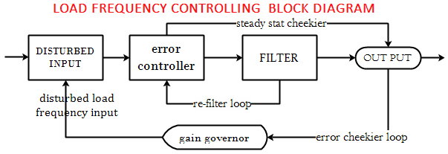
Figure 3.10 block diagram of proposed frequency controller loop
The LFC system will be represented in the fig 10 it has different component that are input side component integral controller signal filter and steady state result displayer. In the input side the disturbed ferequency will be recived and to cheek the variation of disturbance the IC will be control and manage the disturbed signal and sent to signal chheker the signal cheeker are to cheek the rate of the steady stste error and displaye the result.when we control the disturbed frequency the error will be more than the accepted rage the re filter loop will be sent the signal to IC for re controlling and managing process.
A frequency cutter de-loading control strategy based on the partition control idea for the grid connected AC micro grid containing high-power junk and disturbance system. It can support the frequency stability in the system, and it will not cause the system large impact, which affects the power quality of the system.
At the same time, the priority of distributed power and load is considered in the frequency control strategy, which can realize more economical dispatching and generation tasks, protect the use of important loads, and complete system power distribution and balance in [31]
The frequency control strategy proposed in this paper aims to provide high quality power supply for the grid connected micro grid and distributed load point mountainous areas, small islands and other areas that cannot be covered by traditional large power grid.
In addition, as an important part of the frequency control of the grid connected and islanded micro grid, the service life of the battery is related to the economic benefits of the islanded micro grid in [32]
The limitation and dis advantage of the junk method or system are it can’t resist the large load area or not to control easily the steady state frequency error of the system not very fast, accurate and modernized method to solve and reduce the steady state frequency error . In case of this the integral load frequency control method will be important and acceptable.in [33]

3.4.1Automatic load Frequency control
Frequency governor is a process to maintain stability in the power system. In power systems, when the load is more than the supplying power, the frequency in the system will drop. ... Automatic Load Frequency Control (ALFC) is the best approach to control the frequency around the load during different condition in [34]. including self-system integral load frequency controller (SSILFC).
The two main objective of Load Frequency Control (LFC) are
1. To maintain the real frequency and the desired power output.
2. To control the frequency change in the PCC power between governed areas [35]

3.4.3 Designing and Mathematical formulation of SSLFC( frequency controlling)
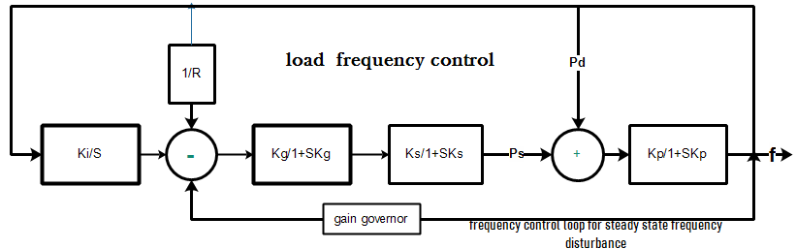
Figure 3.11 load frequency controller
Kg = constant of the micro grid governor
Ks =constant of system control
Kp = constant of frequency generation cheekier component
$Kp=1/D$…………………………………………………….. 3.46
$Ks=\left(2*\frac{H}{fD}\right)……………$………………………………………..3.47
$Ki=\left(\frac{1}{4Kp*Ks}\right)*\left(1+\frac{Kp}{R}\right)………………………………………….$ 3.48
Ki = 0.312

The change of frequency ∆f in the steady state is the change of load frequency expectations L with result of maximum regulation change β or frequency response characteristics.
$$∆f =-\frac{L}{β}$$
The area frequency response characteristics β
$β=D+\frac{\left(1\right) }{R} …………………………………………………………$ 3.49
=0.51
$D=dPd/df$ AND R is the regulation
$D=\frac{\left(20\%system expected disterbance \right)}{the material divation arc }$

=0.01 pu
The maximum regulation is 5%= 0.05 or based on line of micro grid specification document
Controlled frequency will be f new that is
$$fnew =fold+ ∆f$$
Total disturbance of load frequency in the system will be 273.33
Disturbance of frequency per second (DFS)
$$DFS=\frac{TDF}{60sec}=4.915$$
= 4.915 Hz
$$DLFC=5\%*DFS=0.22$$
=0.22 Hz
Disturbance of Load Frequency Control (DLFC) of the new system will be the product of disturbance frequency system per second with normal version of frequency in the system. f_{old} means the nominal or decaled frequency is 50 Hz but without controller the frequency is not reach and approximate to the nominal value ..
In an electric power system, Load Frequency Control (LFC) is a system to maintain reasonably uniform frequency, to divide the load between the generators and to control the tie-line interchange plans. Load Frequency management badly needed for power system because if the standard frequency is 50 Hertz and the system frequency vary both said 5%.in[36].

Steps of Micro grid system designing and studing
When we model or design the micro grid we must understand and know different tasks. Those are
- Filed study for the case study area (temperature, radiation, wind speed and.…)
- Identification of the micro grid components
- Selecting the cost effective element of the MG source
- Decide the way of mode operation (islanded mod and connected )
- Identify the source component types (renewable ,nonrenewable and mixed )
- The size of designed system
- Governmental declaration and social contraction
The micro grid ( PV, battery invertor , controller and etc…) include the renewable source grid connected large power generation. When we designed the MG try to include all principle that is mentioned in the above.

3.5 Modeling and sizing of PV System
Solar System sizing is the process of evaluating the adequate voltage and current ratings for each component of the photovoltaic system to meet the electric demand at the facility and at the same time calculating the total price of the entire system from the design phase to the fully functional system. As a first step, the electrical devices available at the residence itemized with their power ratings and time of operation during the day to obtain the average energy demand in Watt-hour per day. The monthly average solar radiation data of DILLA city is given in below.
Table3.5 Average temperature and solar radiation data for DILLA from SNNPR energy management office and NASA
Month | Jan | Feb | May | Apr | Mar | June | July | Aug | Sep | Oct | Nov
Temperature/c | 34.3c | 33.54 | 35.2 | 29.74 | 29.4 | 32.21 | 31.76 | 33.3 | 29.6 | 35.5 | 33.7
Solar radiation in kwh/m2/day | 6.9 | 6.54 | 6.19 | 6.05 | 5.85 | 5.33 | 6.85 | 3.94 | 5.76 | 5.97 | 4.79
In the micro grid PV system designing we have different photovoltaic (PV) energy geaneration component that are PV araye,different converter ,inverter and controller . the degining of PV system are connected with grid system in the point of comment coupling(PCC).the average temepreatur and solar radiation will be recorded the designing craiteria will be follow the standared rule.
Fig 3.12 block diagram of grid connected PV system configuration

3.5.1 Sizing the solar array
The daily energy requirement from the solar panel is based on minimum monthly average solar radiation for the design because this is the worst radiation of the month, which is 5.34kwh/day. The system design 48V system and two different 6MW distributed generation with average of selected 3hour near the optimal location the city distribution system outgoing feeder. The design assumes the DG to operate 4hr per day in the peak load time. The total daily energy demand becomes 8 Mwah.
Er =energy required = $\frac{daily average energy consumption}{product of component efficiency} 3.5$
9.75MWh
To obtain the peak power of the PV:
Pv = $\frac{daily energy requirement from panel}{minimum monthly average solar radation} 3.6$
1.82MW
The total current needed can be calculated by:
$I_{dc}$ = $\frac{peak power of the PV }{system DC voltage*opreating hour} 3.7$
1763.88Amp
Select PV Module Type
Optimum or peak amps of solar module used. See module specifications.
Chosen PV module:
Model Topsun TS-S420TA1
Max Power =802.0526W
Max Current = 11.62Amps
Max Voltage = 48.73V
Nominal Output Voltage 48 Volt
Now the number of module to be connected in series and parallel will be calculated to meet the desired voltage and current.the total dereted of module 0.2mm
First, the number of parallel modules:
$N_{p}$ = $\frac{whole module current}{rated current of one module* Module Derate Factor } 3.8$
$N_{p}=I_{dr }/I_{r*Mf}$ =747
Second the number of series module which equals to:
Ns = $\frac{system DC voltage}{module rated voltage} 3.9$
1
Finally, the total number of module Nm equals the series module multiplied by the parallel module:
$$T_{nm }=N_{s}*N_{p} 3.10$$
=747
Therefore the system have 747 panel connected in parallel.

3.5.2 Sizing of the Battery
The amount of rough energy storage required is equal to the multiplication of the total power demand and the number of autonomy days. The total average energy required is 1.82 Mwah and assuming number of autonomy day to be three hour. The total power production will be MW
$$Es=total power per day*duration 3.11$$
= 5.46MW
Reserve time have taken is1.5 days and batteries are not 100% efficient assuming 80% efficiency. For safety, the result obtained is divided by the maximum allowable level of discharge:
Esafe = $\frac{energy storage required}{maximum depth of discharge} 3.12$
= 6.82MWh
The capacity of the battery bank needed can be calculated:
C = $\frac{safe energy storage}{DC voltage of single battery} 3.13$
=142187.5Ah
The total number of battery is determined by:
Lead acid batteries with model of S1900
Rated Capacity = 1400Ah
Battery voltage=12V
This is the total number of batteries in parallel required (Divide line 4 by line 5).
Number of Batteries in Parallel =$\frac{Required Battery Capacity}{Capacity of selected Battery} 3.14$
=$\frac{142187.5Ah}{1400Ah}$=102 batteries
≈102 batteries
To determine the number of batteries required in series, divide the system voltage (48V) by the voltage of the chosen battery (12V).
Number of Batteries in Series =$\frac{Nominal System Voltage}{Nominal Battery Voltage} 3.15$
$\frac{48V}{12V}$=4
Total number of the chosen battery needed for the system (Multiply line 2 by line 3)
Total number of the chosen battery needed=Batteries in parallel*Batteries in series

=102*4=408Batteries

3.5.3 Sizing of the charge Controller(MPPT)
There are two types of charge controller these are: MPPT charge controller and PWM charge controller .But PWM charge controllers are cheaper than MPPT but create large power losses; up to 60% of power can be lost. This is because PWM do not optimize the voltage going to the batteries; this limitation makes the PWM controller is a poor choices for large system. But MPPT charge controllers optimize the voltage coming from solar panels so that the maximum amount of energy is transferred to the battery. MPPT controllers are 93-97% efficient in converting power. The power output required per house hold (residential), commercial and institution if all appliances are functional at the same time is 1903.645kw and the voltage required for the solar home system which is greater than 4kwh is usually 48V. So the charge controller must work at a maximum current of I_{T}. Since the system is rated at 48v then the charge controller is also 48v and the power generated from solar panels are 704.35kw.
Current rating (I_{T}) = $\frac{power output of pannels}{voltage} 3.17$
I_{T}= $\frac{704.35kw}{48v}$=14,673.93A
Then multiply the current rating by a safety factor (1.25-1.3) gives14,673.93A*1.25=18,342.41A
Therefore, the MPPT charge controller of 48v and the minimum current rating of 9,342.41A is chosen. MPPT charge controller enables up to 30% more energy yields than PWM charge controller.the current of short circuit of the module is 9.12.
Charge controller current=no. of module*I_{sc} of module*safety factor
Charge controller current=236*9.12*1.25=2690.8A
Therefore 60A charge controller is selected.
Number of Charge controller=2690.8A /30=89.89=90
Arrays controlled by charge controller=9342.41A /90*1.25=83

4.1.4 Inverter Sizing and Rating
The sizing of inverter is basically dependent up on the total demand of the system. There are three types of inverter from these inverters more preferable one should be selected. These are:
- Square wave inverters: This is the cheapest type but not suitable for all appliances
- Modified sine wave: The output is also not suitable for certain appliances like fridge and microwave oven.
- Pure sine wave: This is preferable for this thisis work.
The power rating of inverter should be equal or more than the total load in watt at any instant. By taking some margin choose an inverter having 48v DC to 400v/50Hz and minimum power rating of f 1603.645kwAC pure sine wave inverter. For standalone systems, the inverter must be large enough to handle the total amount of watts that will be using at one time the inverter size should be 25-30% bigger than the total watts (w) of appliances. In this case the maximum load at any instant is equal to 1603.645kw
$$selected panel rated power*safty factor 3.18$$
Size of inverter= $704.348kw*1.3$=915.65kw
$Size of inverter≈916kw$

Fig 3.13Circuit diagram of grid connected PV system configuration

3.7 Mathematical formulation of SVC
SVC regulates the voltage by controlling the amount of reactive power absorbed from or injected into the power system.
An SVC can assure perfect voltage stabilization and perfect reactive power compensation at the same time. The requirement for highest power quality precedes the need for perfect reactive power compensation. For optimum voltage stabilization, the variable reactive power output of the SVC hence needs to compensate not only the reactive power of the load, but also correct the voltage variations in [28]
$$Q_{SVC= }Q_{load}+\frac{nP^{2 }}{2*Ssc}+KP_{load }3.19$$
With K=R/X (the resistance reactance ratio of impedance )
Where Q_{load} and Pl_{oad} are the reactive and active power of load respectively and Ssc is short circuit power
Instantaneous power in a lagging system can be represented by
$$P=V_{max}*I_{max} coswtcos\left(wt-ϴ\right)$$
$$P=V_{max}+\frac{V_{max}*I_{max}}{2}Cos\left(1+cos2wt\right)+\frac{\left(V_{max}*I_{max}sin ϴsin2wt\right)}{2} 3.20$$
SVC reactive power generation limit is constrained by the physical range of
the firing angle. It is considered that the angle is allowed to be set between a
maximum and a minimum value.
$$α_{svc min}≤α_{svc}≤α_{svc\max{ }3.21}$$
The main function of a SVC is to absorb or supply reactive power based on the changing VAR requirement of the load. The current is controlled by the firing angle, which at zero degree the switch is permanently closed, then slowly limits current as firing angle increases to 180 degree where current is then zero. Limiting the current ultimately limits the reactive current which results in how much reactive power can be added to or subtracted from the system.

3.7.1Thyristor control reactor (TCR-FC)
A basic TCR includes an anti-parallel connected pair of thyristor valves, 𝑇1 and𝑇2, in series with a linear air-core reactor, shown in the blow Figure. The anti-parallel thyristor pair performances like a bidirectional switch, per thyristor valve 𝑇1 conducting in positive half-cycles and the second thyristor (𝑇2) conducting in negative half-cycles of the supply voltage.
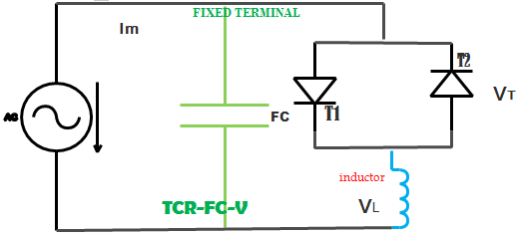
Figure 3.14: TCR-FC Equivalent circuit and Circuit diagram of TCR
The opration of the The circuit of TCR system is The thyristor-controlled reactor consists of a reactor in series with two parallel inverse thyristors. The two inverse parallel thyristors are gated symmetrically. They control the time for which the reactor conducts and thus control the fundamental component of the curren and the full opration of the system is depend on positive gate signal and the wave reprseantation of the opration in the positive get signal will be below.
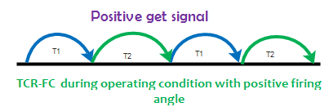
Fig 3.15 graphical representation of opration of TCR-FC in the firing angle subject
The basic operation of single phase as well as three phase TCR can be as follows. The source voltage as

𝑉𝑠 (𝑡)=𝑉𝑠𝑖𝑛 𝜔𝑡
From the basic Kirchhoff’s voltage equation
$L\frac{di}{dt}-v_{s}=0 (3.22)$
Where V is peak value of the applied voltage, 𝜔 is the angular frequency of the supply voltage and L is inductance of the TCR, then the line current can be written as
$${ (t)=1/L ∫Vs(t)dt +C (3.23)}^{ }$$
$(t)=-V/ωL cosωt +C$
For the boundary condition is (𝜔𝑡=𝛼)= 0
$(t)=-V/ωL (cosα- cosωt)$
Where α is the firing angle measured from positive going zero crossing of the applied voltage.
The Fourier analysis of equation can be written as
$(α)=a1 cosωt +b1 sinωt (3.24)$
Where 𝑏1=0, because of odd symmetry i.e, f(x) = f (-x). Also not even harmonics are generated because of half wave symmetry i.e, (𝑥+𝑇/2 ) =−𝑓(𝑥)
The coefficient 𝑎1 is given by
$$a1=4/T ∫(x) Cos (2πx/T) dx$$
Solving,
$$A=I1(α)=V/ωL(1-2α/π-1/πsin2α) (3.25)$$
Equation 3.45 can be written as
$I_{1\left(α\right) =}V*B_{TCR(α)}$
$$(α)=(1-2α/π-1/πsin2α)$$
Where 𝐵𝑚𝑎𝑥=1/𝜔𝐿

The TCR is act like a variable susceptance. Variation of firing angle changes the susceptance and consequently the fundamental-current component which leads to a variation of reactive power absorbed by the reactor because the applied ac voltage is constant.

3.7.2OPERATING PRINCIPLE OF TCR-FC based SVC
A thyristor-controlled reactor (TCR) is a reactance connected in series with a bidirectional thyristor valve. The thyristor valve is phase controlled, which allows the value of delivered reactive power to be adjusted to meet varying system conditions. Thyristor-controlled reactors can be used for limiting voltage rises on lightly loaded system. The current in the TCR is varied from maximum to almost zero by varying the firing delay angle. Shunt connected to the line in order to inject variable current. As long as the current injected is in phase quadrature with the line voltage, the shunt Controllers only supplies or consumes variable reactive power.
Simultaneous application of gate pulses a thyristor valve can be brought into conduction .and the valve get automatically blocked the valve immediately after the ac current crosses zero, unless there is reapplication of gate signal through firing angle control method. The current in the reactor can be controlled from maximum (thyristor valve closed) to zero (thyristor valve open).
Valves of thyristor connected in series with the reactor and Circulating current through the reactor (Ir) is controlled. Capacitor supplies the Leading VARs to the system. Rating of TCR is generally higher than the capacitor for supplying lagging VARs to the system in[29]

3.8 Neural network
ANNs improves and checked the performance corresponding to the different parameters provided by environmental sensors, if needed it changes the line parameters within the specified range to achieve the desired performance of the line.
Since the processing speed is directly proportional to the number of neurons, therefore, to improve the performance up to the desired level, a number of hidden layers and a number of neurons in each layer can be varied. To acquire desired output, networks take different activation functions between input and hidden layer and hidden and output layer. Similarly, different neurons can also be taken for different layers
The theory of ANN is inspired by the animal brain neuron structure and its ability to deal with huge information. Artificial Neural Network is one of the artificial representations of the human brain that always tries to simulate the learning process in the human brain. There are several Artificial Neural Network Algorithms that are often used for different among others: Back propagation Algorithm, Conjugate Gradient Fletcher-Reeves (CGFR) And Resilient.Artificial Neural Network (ANN) is a computational model, which is based on Biological Neural Network. Artificial Neural Network is often called as Neural Network (NN) Back propagation (BP) algorithm was used to develop the ANN model The typical topology of BPANN (Back propagation Artificial Neural Network). When we apply the ANN controller in the SVC divice .ANN is used to control and varing the fring angle of the SVC in order to achive smooth ,better and adaptive control of the reactive power in the GCMG system. In figure 18 show that ANN working flow in the reactive power compensation and disturbed load frequency controlling mechanisim. After initialization of the input and declaration of stage of epoch and hidden layer arrangement the the ANN signal cheeker will be to cheek and dicide the stage ,itration and performance then the controlling signal pakage of the ANN to control the SVC fringe anle and gate signal then the SVC to perform the compensation process as well at the same time the ANN control signal to cheek and control the integral load frequency controller with net, acuret and with few itration satge finally the ANN will be design and displaye each the toll box,performance indicator, Validation indication and gradient indicator.
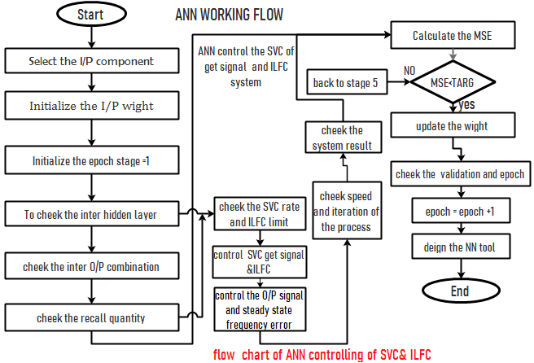
Figure 3.16. Flow chart of operation of ANN
Artificial neurons are similar to their biological counterparts. It has input connections which are summed together to determine the strength of their output, which is the result of the sum being fed into an activation function. Though many activation functions exist, the most common is the sigmoid activation function, which produces a number between 0 (for low input values) and 1 (for high input values). The resultant of this function is then passed as the input to other neurons through more connections, each of which are weighted these weights determine the behavior of the network Typical artificial neural network consists of three layers.
- input layer,
- hidden layer and
- Output layer.
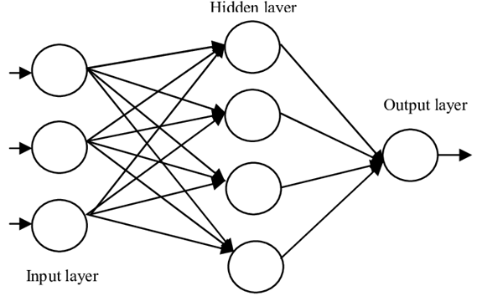
Fig3.16 ANN Architecture including different layer
Input layer where the data are introduce to the network and send to ANN data reciver layer. Hidden layer where the data are processed to select and control the the accuret combination. Output layer where the result of given input and processed the combination of hidden layer network and to display the controlled and specified output.
The potential of Artificial Neural networks for nonlinear adaptive filtering and management, their ability to predict solutions from the past trends, their huge processing capability, and their ability to produce a quick response in mapping information makes them a really promising tool for their application to power systems the primary work towards the facility system security analysis by pattern recognition technology has been rumored the unreal Neural Network has been used for varied installation applications like load statement
Artificial neural networks (ANNs) have the potential advantage over conventional techniques in significantly improving the performance of the other techniques. The artificial neural networks (ANNs) have been recognized as useful tools for the identification and control of the system with different nonlinearities. This is so by virtue of the fact that ANNs have the capability of non-linear mapping, parallel processing and learning; these attributes make them ideally suited for power system control application. In the power systems (ANNs) have been successfully used for short term load forecasting, power system control, reactive power compensation, fault detection, harmonic propagation, and so on. The block diagram of the new back propagation neural network (BPNN) system for reactive power compensation and optimization is shown in blow Fig. The method is based on using linear programming technique to generate different training patterns and obtain the input data to ANN. In this respect, the ANN is trained to determine the proper adjustment of the control variables required to alleviate over-voltages, under-voltages and generator reactive power limit violations
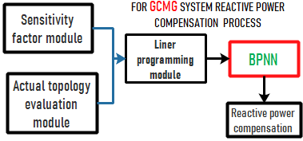
Figer.3.18 block diagram of the BPNN system for reactive power compenseation
The BPNN system consists of four fundamental components which are: Sensitivity Factor Module (SFM), Actual Topology Evaluation Module (ATEM), Linear Programming Module (LPM), and Back propagation (BP).
This BPNN system is used to adjest the wight and basis of the network to minimize the mean squer error of the artificial neural network and give reasonable answer to the final controller and result displayer of the system.

3.9 Problem Formulation

3.9.1 objective function and constrint condtions
The objective and constraint function of the system reactive power compensation will be
- Objective function
$$P_{D}=P_{DO}+\left(1+λ\right). (3.26$$
$$Q_{D}=Q_{DO}+\left(1+λ\right) (3.27$$
P_{DO} and Q_{DO} correspond to original load or base case and $λ$ load ability parameter of the load
- Constraints.
Basic equality constraints correspond to the power flow equations in every load
$${∆P}_{i}=P_{gi}-P_{di}-P_{i} (3. 28$$
$${∆Q}_{i}=Q_{gi}-Q_{di}-Q_{i} (3.29$$
Where P_{gi} and Q_{gi} and real and reactive power of the generator; P_{di} and Q_{di} the real and reactive power of the load and Q_{i} and P_{i} is the power injected of the system
The load Voltage in the final load reading position
$U_{i }=U_{i<θi}$
Power consumed by loads connected system
Loads are characterized by a static exponential model, considering a power constant model
( =$β$ = 0), in which active and reactive power consumed by the load is expressed as:
$$P_{Di }=P_{DO}\left(U/Uo\right)p^{α}$$
$$Q_{Di}=Q_{Do}\left(U/Uo\right)Q^{β}$$
Where Uo, P_{DO} and Q_{DO} are the reference voltage, active and reactive power of the system
Reactive power injected by the SVC in load terminal will be
$$Q_{SVC}\left(α_{SVC}\right)=\frac{U^{2}}{X_{C }}-U^{2}B_{SVC}\left(α_{SVC}\right)$$
Inequality constraints constitute the physical limits of the components or operational constraints in the system. The maximum power injected by micro grid system is constrained by the maximum capability of each wind turbine and PV system. At the same time the reactive power limit and injection and observation will be presented Active power injected by the Active power output is restricted by lower and upper limits:
$$P_{l min}≤P_{li}≤P_{l max} 3. 30$$
$$Q_{l min}≤Q_{li}≤Q_{l max} 3. 31$$
Where P_{limin} and P_{limax} are the minimum and maximum operating power. The capability constraints are related to the Reactive Power capability

3.8 .2)Minimize Var Cost and Real Power Losses
${Model}_{1} = {minC}_{Q} +{CP}_{loss} . 3.32$
=${\left(VAR\right)}^{n}=\sum_{k=0}^{n}{C0+C^{k}*Q+{aC}^{n-k}*}Qn$
$F_{min}^{cost} =C_{1}{(Q)}_{c}+\sum_{k=0}^{n}{\left({n \atop k}\right)C_{2}(P_{loss})}$
$P_{loss}= {\sum_{m=1}^{n}{g_{m}(}V}_{1m +}^{2} V_{2m}^{2})-{2V1}_{m}2V_{m}\cos{θ}$
${Model}_{2} = min\left(C_{o}+C_{1}\left(Qc\right)\right)*X+C_{2}\left(P_{loos}\right) .3.33$
The boundary of reactive power and loss that are expect and exist in the system will be
$P_{loss max}>P_{loss } and P_{loss }>P_{loss min}$
$${ P}_{l0ss min}≤P_{loss}≤P_{loss max} 3.34$$
Under integrated grid arrangement the compensated reactive power constraint or boundary will be
$Q_{\exp{ }}> Q_{\max{ }}and Q_{\exp{ }}≤ Q_{\min{ }}$
$${ Q}_{l0ss min}≤Q_{loss}≤Q_{loss max} 3.35$$

CHAPTER -4

4. RESULT AND DISCUSSION

4.1 Result
ETAP is the most comprehensive analysis boards for the design, simulation, operation, and mechanization of generation, distribution, and industrial power systems. ETAP is advanced under recognized quality declaration program and is used worldwide as a high impression software. ETAP is totally localized in four languages with interpreted output reports in six languages. As a fully unified initiative solution, ETAP extends to a Real-Time Intelligent Power Supervision System to monitor, control, automate, simulate, and optimize the operation of power systems Different power distribution system simulation for consistency analysis is done using ETAP software. In ETAP the Distribution System Reliability Analysis employs a new analytical algorithm to assess the consistency indices of mixed radial and meshed distribution systems. This algorithm essentially uses the algorithm for radial distribution systems since the meshed network, if any, is first transformed to a radial network. Therefore, the employed algorithm is fairly effective and suitable for large-scale distribution systems of general configurations. This simulation result shows basic reliability indicator at each of section of the models. And show brifly the real and reactive power flow with resepect to system real power loss.
When we came to the Grid Connected Micro Grid system we have 132/33/15KV distribution feeder transformer in the grid-connected system and from the grid-connected line five large outgoing line will be existed that is DILLA line1, DILLA line 2, GOLOLCHA line, YERGACHEFFE line, and SOLOMO power line are the grid-connected TRAFFO and each out ging feeder or traffo are instolled frome different rated output transformer(15 KV&33KV) in addition to that we have four sub feeder in side the 15KV feeder side. I will try to analyze and study only DILLA city and all feeder are arranged and installed from the 15 KV feeder line total In the DILLA city we have four different rated distribution sub feeder system and each feeder have different power flow rate.
.
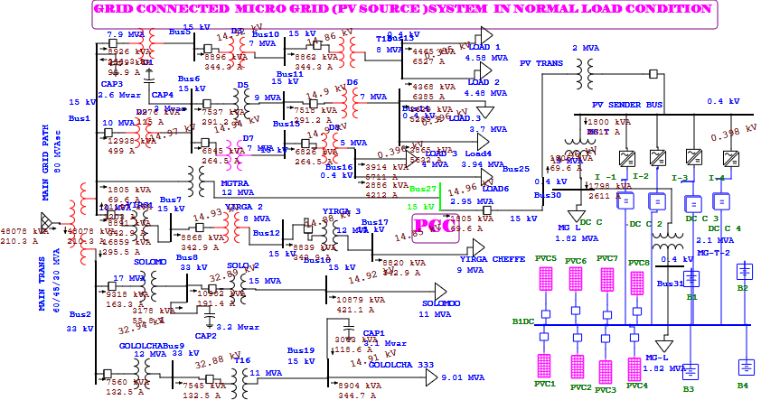
Figure4.1 normal grid connected micro grid load flow and feeder arrangement by ETAP
In the micro grid side we have mini micro grid sources component that are PV. PV panel that is used to collect and absorbed solar energy then the DC-DC converter converts the produced dc voltage to the required quality and limit of dc power then connect to the DC bus by using bi-directional inverter converts the produced DC power to AC then install to ac bus finally the produced power flows through ac system to grid. large amount of real and reactive power will be developed because of the controlling device will be the manual series capacitor bank system. The general system load flow, the real and reactive power flow and loss will be presented in appendix –C.

4.2 Grid connected system during peak load condition
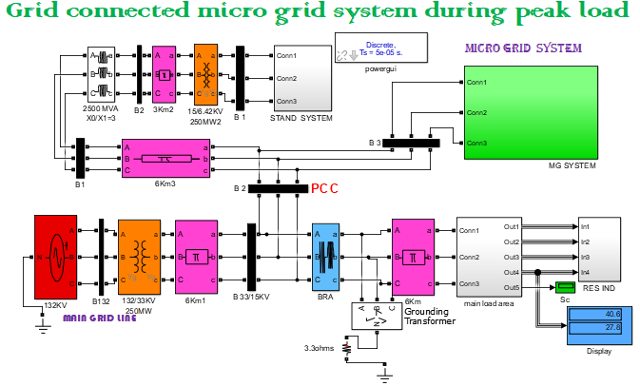
Figure 4Simulink diagram for grid connected micro grid system during peak load
The grid-connected micro grid systems are the combination or integration of different renewable energy generation systems with the national grid line. The designed Micro grid system includes PV system. On the grid side, the controlling and compensation device will be a manual capacitor bank system and it has a large amount of real and reactive power loss . Totally we have around 40.56MW and 27.0816 MVAR amount of power is flow. At the point of PCC disturbance will be developed because of load unbalance and frequency deviations as well as a large amount of reactive power flow. In case of this, reactive power management and frequency control mechanisms will be required for the reactive power management, rated flow of power, and reduction of steady-state frequency error at the common coupling terminal and system load .
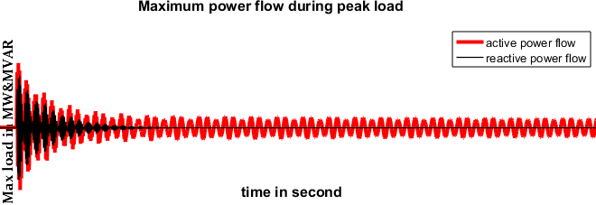
Figure 4.3 graphical representation of active and reactive power of GCMGS
The above Simulink scope diagram expressed the flow of active and reactive power flow in the general system of grid-connected micro grid system without controlling of SVC device or by manual/old capacitor bank and the red and black color are indicate the real power and reactive power flow throughout the system respectively and additionally we can express a large amount of reactive power flow will be presented in because of the existing controlling device. 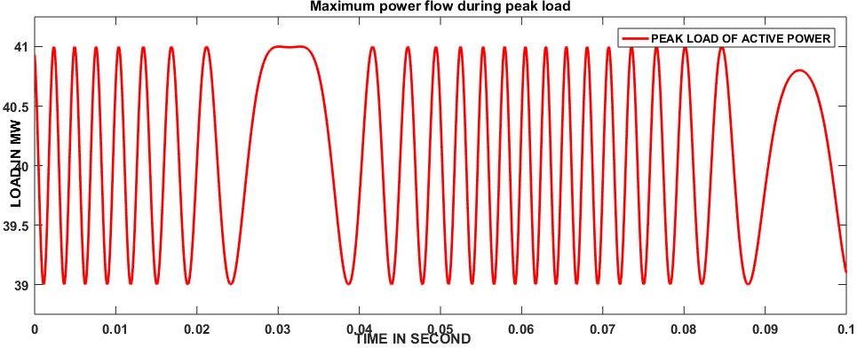
Figure 4.4Simulink graph of Active power for peak load condition
Above fig. 4.4 show the flow of active power through the system during peak load condition during this time the micro grid is send large amount of energy to the grid in case of this large amount of real power will be flow when we compear to the normal condition power flow.

4.3GRID CONNECTED MICRO GRID SYSTEM DURING CONTINGENCY
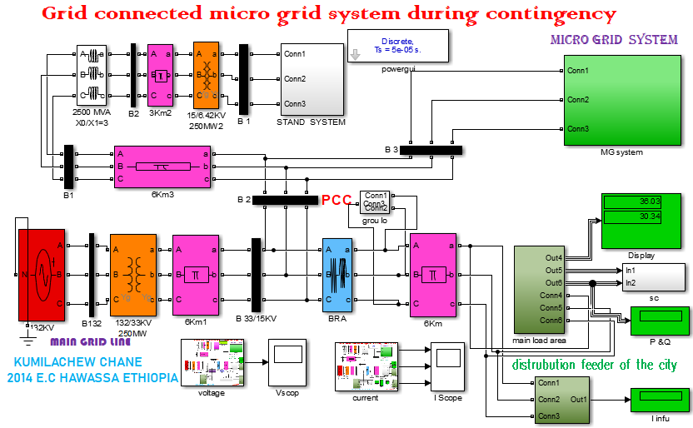
Figure 4.5Simulink of GCMG system during contingency condition
During contingency condition the real and reactive power flow through will be fluctuated when we compare the peak load condition. the current that are flow the system will be increase and the average voltage at the load and PCC terminal will be disturbed.and the power flow during contingency condition (three phase sysmetrical foult )36.89MW and 30.34MVAR active and reactive power will be flowed respectively.
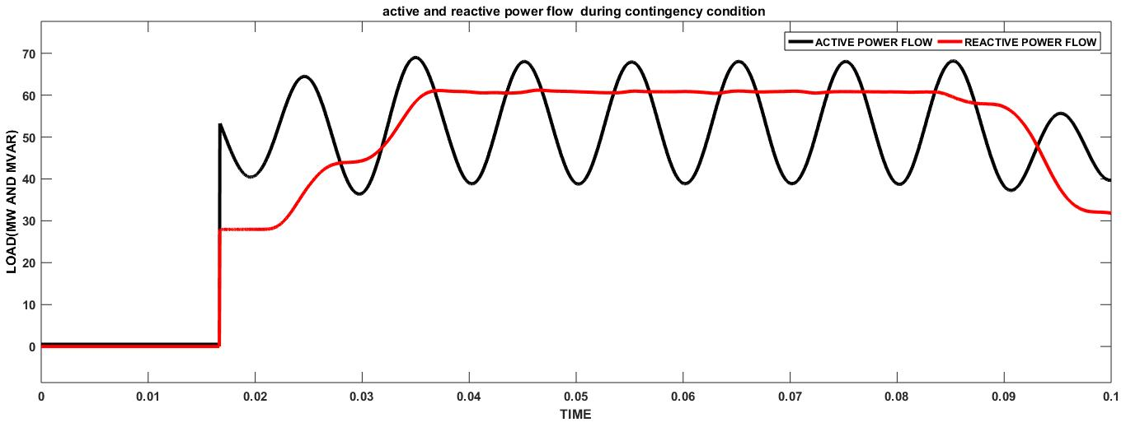
Figure 4.6of Simulink result of active and reactive power flow of GCMG during contingency condition
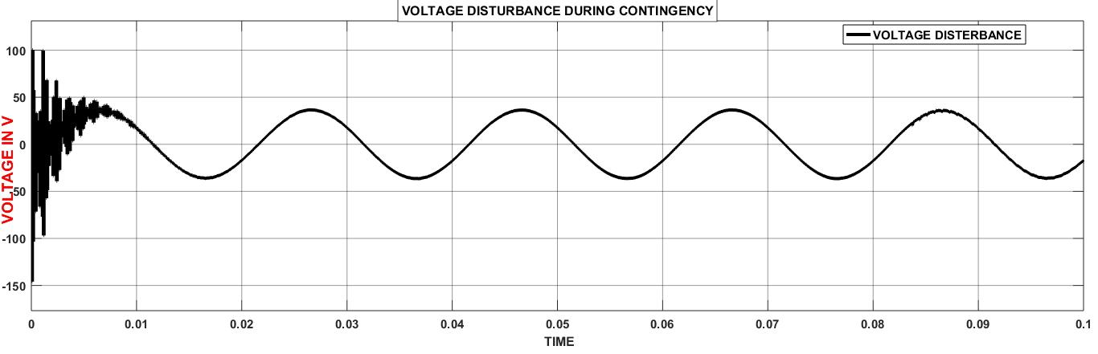
Figure 5of Simulink result of voltage disturbance during contingency condition
During the contingency condition the reactive power will be increase highly as well as fluctuated and the active power existed in the system will be reduced parallel because during contingency condition the system voltage is disturbed and the current passing thought the GCMG power line are rise. So current during system disturbance is increase and large amount of reactive power produced. The current that exist in the GCMG system during contingency condition will be increase up to the disturbance is maintain.
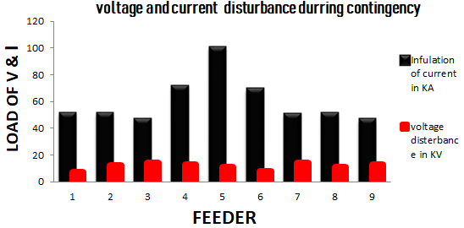
Figure 4.8 Voltage and current disturbance during contingency condition
During contingency condition the voltage and current will highly disturbed the current inflation will be high during disturbed and at the same time the voltage flow in the system will be decline.

4.3 STATIC VAR COMPENSETOR (SVC) with TCR-FC
The TCR is act like a variable susceptance. Variation of firing angle changes the susceptance and consequently the fundamental-current component which leads to a variation of reactive power absorbed by the reactor because the applied ac voltage is constant.
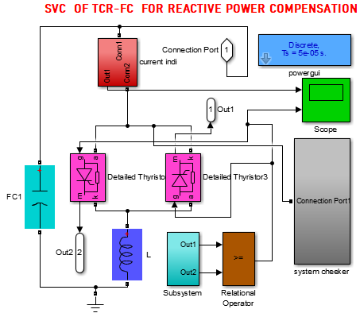
Figure 4.9of Simulink diagram for of thyristor control reactor with fixed capacitor of SVC

4.4 LOAD FREQUENCY CONTROLLE
When we study and control the frequency the main and important thing will be to control and reduce the change / variation of frequency in the PCC load area from the disturbed nominal frequency.
$Ki=\left(\frac{1}{4Kp*Ks}\right)*(1+Kp/R)2$
Ki = 0.212
The controller is the most important in the system frequency controlling and steady state error minimization.
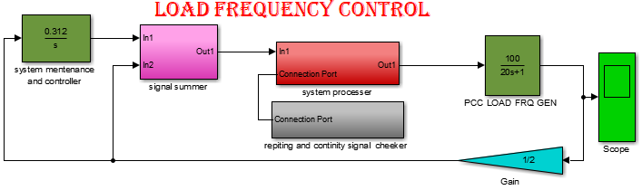
Figure 4.10of Simulink diagram of load frequency controller with integral controller
Frequency variation go to nearest point of zero when we use load frequency integral controller in the grid frequency controller this integral controller used to reduce the steady state frequency error and dynamic disturbance error GCMG system operation.
$$inperoved percent=\sum_{n=1}^{∞}{(DFS}-DFLC)/DFS$$
$FI=\sum_{n=1}^{∞}{\frac{\left(4.55-0.22\right)}{4.55}*100= 96\%}$
The steady state frequency error in the Point of Common Coupling (PCC) and load are reduced and the system frequency will be improved.
General the steady state error declination and improved frequency performance graph will be presented in APPENDIX-II .The function of ILFC (integral load frequency controller) completely control the steady state frequency variation and error within fraction of second. By single programming order of ANN. The ANN are used to control the integral Ki and Kp component the controlling process and the load frequency controller to control the frequency disturbance properly and acuretly deu to ANNcontrolthe ILFC in the load terminal.

4.5 Grid connected micro grid system with controlling system
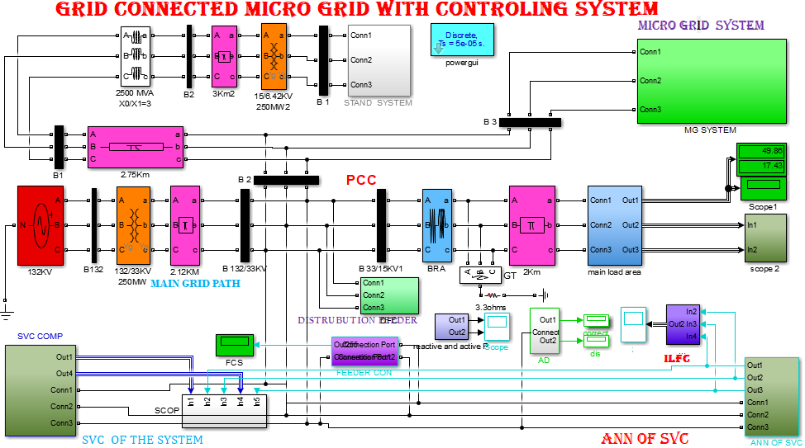
Figure4.12 Simulink of GCMG system reactive power compensation by ANN of SVC and LFC system .
For simulation, the three phase AC voltage source is of 132KV, 50 Hz is taken. Different power feeders for different power flow rate is taken in the grid connected micro grid system the real power and reactive power in the load is measured using the Active & Reactive Power measurement Block. By different firing angle and Load Characteristics has been studied. In the grid connected micro grid system large amount of reactive power, load disturbance and real power loss is existed. For the controlling and compensation process the SVC component is very important for the above mentioned problem. The General GCMG Simulink structure have different sub system one of them are SVC COPM. It is used to reactive power managing process and real power improvement. But in addition to the SVC we have ANN of SVC it ordered by single program that are used to reduction and compensation of the system reactive power, indication of percent of improvements for each general feeder controlling point and identification of the system reactive power for each feeder and to control the SVC compensation process for accurate operation result of the system. the general ILFC system are used to reduce and correct the steady state frequency error of the load system. And the feeder continuity controller is used to control and maintain the continuity of the each sub feeder and load during different conditions.
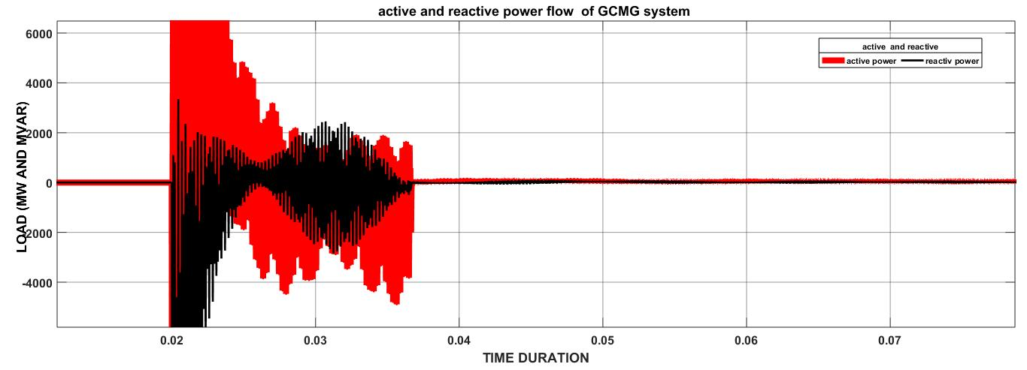
Figure 4.13Simulink of active and reactive power after compensation process
The above fig.4.13 show the flow active and reactive power existence During ANN based SVC controlling and compensation process the active power will be improved and the reactive power will be compensated properly.
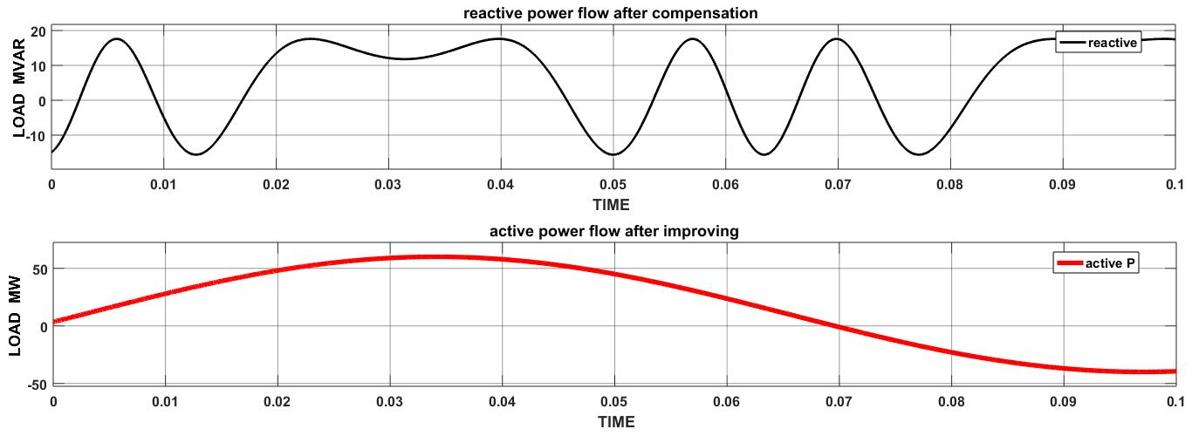
Figure 4.14Simulink result of Active and reactive power after compensation
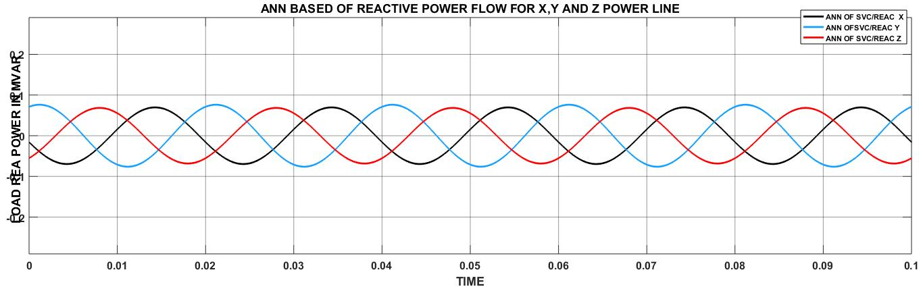
Figure 4.15reactive power flow of artificial neural network controlled SVC
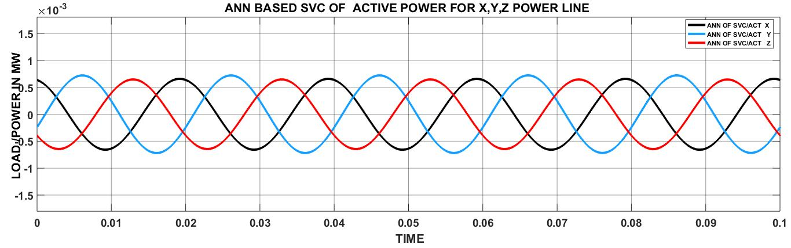
Figure 6active power flow of the based on artificial neural network controlled SVC
In the figure 33) Simulink result of active and reactive power after compensation when we use SVC for the compensation process the real and reactive power flow will be improved 40.56MW to 50MW and the reactive power is compensated to 17.34 MVAR and the voltage and current flow of the GCMG system after applaying SVC the disturbance of voltage and inflation of current will be maintain or controlled. The system at the same time to controls the current and voltage flow, the load side frequency disturbance and steady state frequency error will be reduced and controlled by using an integral load frequency controller. In the fig 4.14 shows that the three phase reactive and active power flow of the GCMG system. fig 4.15 indicate the reactive power flow of the three individual line of the system around load and PCC based on ANN of SVC and fig 17 show the active power flow individual line of the GCMG system in the process of reactive power compensation process of the ANN control of SVC and the real power will be improve. The improved power in each feeder will be represented in the blow figure.
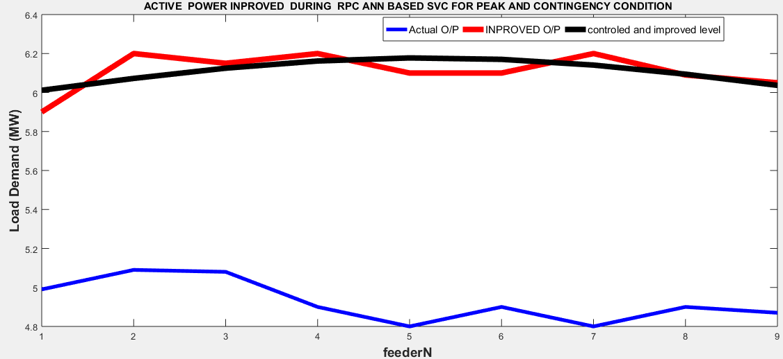
Figure 4.17 of graphical representation of improved active power of the GCMG system in variable load
The improved power of each feeder during variable load will be different that means the power improved during contingency, peak load and normal power flow are different power flow rate. The ANN system neural network tanning, validation and performance will be presented in the APPENDIX -II
In the existing system when we substitute the static VAR compensator (SVC) in the place of the capacitor bank (CB) the reactive power and loss of the system will be reduced. The SVC is more important than capacitor bank CB because the existing system reactive power compensation process is by manual capacitor bank CB system. In the case of the capacitor bank (CB ) a large amount of reactive power flow and real power loss is developed but when we use static VAR compensator (SVC) in place of CB the existed reactive power and real power loss reduction. So the static VAR compensator is more reliable and smart for the operation of reactive power compensation and controlling the process.
Table 4.1 comparession analysis of with and without SVC
comparison of result with and without SVC
 | Without SVC |  | With SVC
 | Peak load | contingency
Real power | 40.56MW | 36.03 MW | 50.5285MW
reactive | 27.08 MVAR | 30.84MVAR | 17.34MVAR
Power factor | 83.3.0% | 76.0% | 94.0%
The expected system disturbance is based on contingency condition power flow rate because in the contingency condition the GCMG system voltage and current will be highly disturbed within fraction of second in case of this load frequency and reactive power will be disturbed and finally the outcome active power flow through the system is highly decline and reduced.
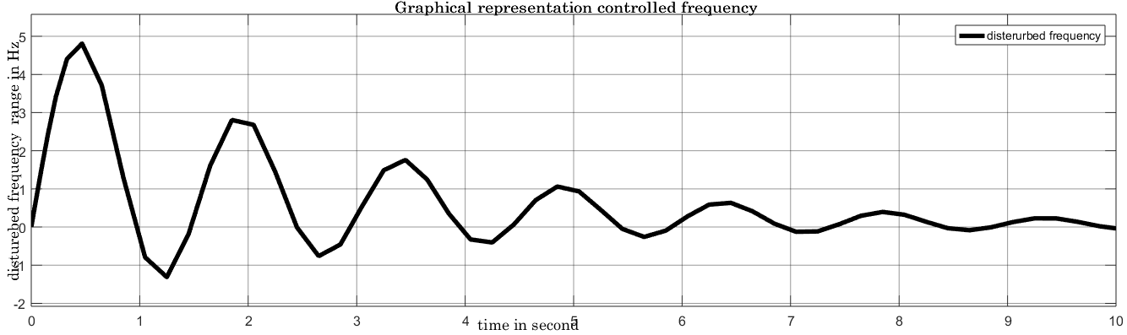
Fig. 4.18 Simulink graphical representation of maintenance and controlling of steady state frequency error
The ANN are used to control the integral Ki and Kp component during the controlling process. the load frequency controller to control the frequency disturbance properly and acuretly deu to ANN control the LFC in the load terminal.by single controlling program of the ANN in the load frequency area.
Befor the controlling process the disturebed frequency range will be 4.92Hz and the after controlling process the steady state frequency error will be 0.22Hz.
The disturbance of the system depends on the general power flow rate and the feeder flow rate or load capacity. When we apply artificial disturbance in the general GCMGsystem the system load frequency will be highly disturbed and the .. The total power of the max load condition will be 41.504MW and the contingency condition power will be 36.803MW.
When we compare the compensation process with the different controllers to present a different result. in the previous and the first controlling technic, that is ANN controlled SVC the reactive power will be highly compensated 17.34MVAR and applying of the fuzzy system in the general system the reactive power will be compensated around 18.23MVAR result will be recorded and finally when I use the MOFAinthe GCMG system reactive power compenseation and controlling process the the optimal reactive power will be 17.84MVAR. In thegeneral comparison and finding of the optimal VARvalue. the optimized result between ANN-based SVC , FUZZY based SVC and MOFA system. the ANN will be effective and more prifereble than the FUZZY and MOFA. And the best and effective controlling algorithm for a finding of optimal result in the compensation and the controlling process is artificial neural network (ANN) more prifereable and acceptable alegorithim the the above.
Table4.2 Comparission of ANN,FUZZY and MOFA controller for finding of optimal MVAR
Optimal power in the GCMG of both controller in the MOFA
 | ANN of SVC | FUZZY of SVC | MOFA
Reactive power | 17.74MVAR | 18.28MVAR | 17.84MVAR
Active power | 50.53MW | 48.463MW | 49..53MW
In the above comparission table the different algorithem(ANN,MOFA and fuzzy system) will be presented and to indicate the optimal result of reactive power in the gride connected micro grid system for reactive power compensation.
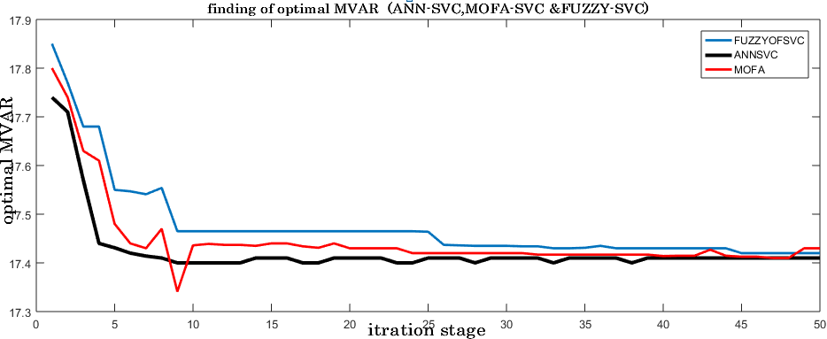
Figur4.18 optimal reactive power indication of ANN and FUZZY system with MOFA
In the finding of optimal value of system reactive power the ANN between FUZZY and MOFA system .the artificial nural network controlling in the SVC will be well performed than the fuzzy system and MOFA and the selected algorithem will be used to indicat the optimal value of the system. When we see the above optimized graph .

4.6 Power Loss & cost minimization
Before applying any controlling and compensation process GCMG system total load flow will be 50.56MW and 33.16MVAR of peak load.The loss which is existed before compensation and real power improvement with regards to grid connected and SVC compensation was calculated in the combination of eq 3.12, 3.24, 3.30. We get
$Ploss=Psourc-Pload$
Before compensation the active and reactive power will be mentioned. the active power loss in all feeder or load category load area will be 3.9MW.according to the first GCMG system by ETAP. After compensation the improved power will be
P loss =p source – p load
=10.046MW
Previously when we study the system without SVC controller is like existing system of the grid connected system has and installs old controlling and compensating method that are including manual controlling system. This method are not that much important because in the existing system present large amount of real and reactive power loss.
In the privies system the active power loss will be highly generated around 3.95MW per year presented this means in the privies controlling and compensation device will be is not control and compensate properly.
In the normal flow 39.78 MW active powers will be flow with time and after compensation the active and reactive power will be 50.5285MW and 17.34 MVAR. When we see the difference of the reactive power before compensation and after compensation, when we can to re call the reactive power variation formula 3.25 &3.33 we get
$∆Q= Q_{old -}Q new$
Cheng of reactive power is the difference of the privies system reactive power with the reactive power that are existed after compensation
∆Q = 27.16Mvar -17.43 MVAR
= 10.34Mvar
The real and reactive power at the city load terminal after compensation and controlling process for all feeder will be 50.5284MW and17.34 MVAR. The percent of improved power
$$\%P=\frac{\left(Pimproved -Ploadnormal\right)}{Ploadnormal}*100$$
$$\%P=\frac{\left(∆P\right)}{Plnormal}*100$$
$\%P=\frac{\left(60.84.0 -39.78\right)}{39.78}*100$
= 52.18%

The percent of reactive power improved (compensated)
$$\%Q=\frac{\left(Qcomp-Qload\right)}{Qload}*100$$
$$\%Q=\frac{\left(∆Q\right)}{Ql}*100 \\ =\frac{\left(33.16-17.83\right)}{17.83}*100$$
=87.02%
The percent of improved real and reactive power 52.18% and 87.02%respectively and the existing real and reactive power management is not sufficient because the privues load real and reactive power reading and recording indicates the grid connected micro grid system without SVC controlling and compensation have big difference from the power flow and system disturbance that are existing after compensation.
In the reactive power compensation process the real and reactive power will be improved and compensated in the grid connected micro grid system without the SVC compensation device will be 40.56MW and 27.16MVAR respectively.
The power factor before compensation process
$S=P+jQ$
= 40.56+j27.16
S_{old} = $\sqrt{3674.13}$ =48.8
The power factor will be
$Pf=active power/ Apparent power$
=0.837=0.83
The power factor before SVC compensation Pf_{old} is 83%
After compensation the active power and reactive power will be improved and reduce respectively 50.5284MWand 17.34MVAR
The apparent power will be S_{new}
S = $\sqrt{4116.2}$ =53.16
Pf=active power /Apparent
= 50.024/53.16 =0.94
After compensation process the power factor Pf_{new} of the grid connected micro grid system will be improved to 94%
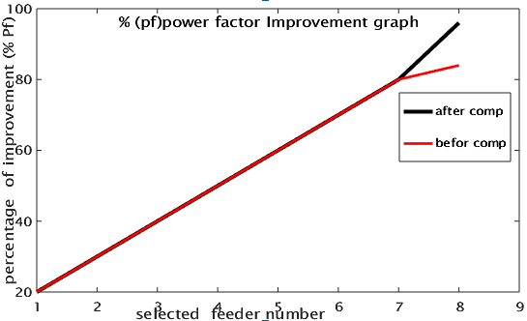
Figure 4.19 power factor improvement graph
The fig 39 show the the existence of power factor befor and after compenseation process .after compenseation of reactive power the active power flow will be inprove in case of this thepower factor of the system will be improved.

4.6.1Cost analysis of the real power loss in the GCMG system
The annual power loss will be calculated with and without controlling device (SVC). System power loss without SVC is
$${Anual energy}_{loss}\left({AE}_{L}\right)=P_{L}*8760h$$
$=451.6kw*8760h=3950760kwh$
Total power loss in birr ${CT}_{1}=.65*3950760kwh=2567994birr$
After reactive power managing process the active power loss will be 101.82kw per day. The annual power loss with SVC is
$${Anual energy}_{loss}\left({AE}_{L}\right)=P_{L}*8760h$$
$=101.82kw*8760h=891417.6kwh$
Total power loss in birr ${CT}_{2}=0.65*891417kwh=579421.1birr$

Net power loss of the system in birr
${net cost}_{cheng}={CT}_{1}-{CT}_{2 }$
$=1988572.95$ ET. BIRR

Table 4.3 The total annual power loss in birr with and with out SVC
Mesurment/unit  Of power | Without SVC | With SVC | Difference /saved
Net in KW | 3950760 KW | 891417KW | 3059343KW
Net in MW | 3.95MW | 0.892MW | 3.06MW
In ET. birr | 2567994 birr | 579421.1birr | 1988572.95
So the total loss power with out ANN-SVC controlling and compensation process 2567994 birre per year will be existed and after applying of ANN-SVC the total power loss of GCMG system will be 579421.1 birr per year will be losted.
When I compenseat the reactive power flowe in the grid connected micro grid system to reduce the large amount of reactive power flowe and active power loss by compensation process. During this time the active power flow will be improved and the var cost is highly reuced.
Cheng of reactive power is the difference of the privies system reactive power(before the compensation and controlling process) and the reactive power that are existed after compensation
$∆Q= Q_{old -}Q new$
∆Q = 27.16Mvar -17.43 MVAR
= 10.43Mvar
The total compensated vare rate will be 10.43MVAR and the minimized VARcost will be
$${VAR}_{cost}={∆Q}_{reduced}^{year}*{Billing}_{birate}$$
$${Var}_{cost}=10430*365d*0.65birr$$
$$=2,474,517.5Et. birr$$
The reduced var cost in the general grid connected micro grid system will be 3660767.5 ethiopian birr. That means the annual seved birr deu to reactive power compensation and load frequency control 10430KVar or 247417.5 ET.birr.

Dilla substations the total energy loss before and after compensation and controlling process in a year:
- Before compensation total power loss = 3950760 KW
- Before compensation power loss in one year = $451.6kw*8760h$
= $3950760kwh$ KWh
Then after compensation can be saved is: 3059343KW
- After compensation can be saved in one year = 3059343KWh
- After compensation the reactive power will be =$${Var}_{cost}=10430*365d*0.65birr$$
$=2,474,517.5Et. birr$
Table 4.4 the investment cost of The MG system for selected material
No | Name of material | Price in birr | quantity | Total price in ETB
1 | PV module | 4155 | 747 | 381,375
2 | inverter | 1980 | 3 | 5940
3 | converter | 2500 | 3 | 7500
4 | battery | 260 | 102 | 26520
5 | Controller(MPPT) | 4500 | 102 | 459000
6 | Controller radii | 1450 | 1 | 1450
7 | Add sour stand | 7260 | 1 | 7260
8 | Integral cont FCS | 2974.23 | 9 | 26768.07
9 | Senser BBTI | 11470.39 | 1 | 11470.39
10 | System controler | 21845.67 | 1 | 21845.67
 | Total birr |  |  | 1,651,511

The material investment cost will be 1,651,511 birr is invested during the micro grid is developed
When we calculate the total payback period to calculate and find the 10%instalation cost and 2%of the maintenance cost. And total loss of the system is
2474517+2567994= 5042511ETB
Assuming that the installation cost 10% and annual maintenance cost are 2% in distribution system.
- 10% of 5042511= 504251.1ETB
- 2% of 5042511= 100850 ETB
Total investment cost = 504251.1ETB +100850 ETB ETB+1,651,511ETB
= 2256612ETB
Total back payment = $\frac{Total gained power loss}{Total Ivestment cost}$ = $\frac{5042511ETB}{2256612ETB}$ = 2.24
Total back payment = 2year in 2 monthly

Chapter five

5. Conclusions and recommendation

5.1Conclusions
The three-phase AC voltage source is 132KV, 50 Hz is taken. Different power feeders for the different power flow rate is taken in the grid-connected micro grid system. the real power and reactive power in the load is measured using the Active & Reactive Power measurement Block. By altered firing angle controlling system and mechanism, different Load Features have been studied. The GCMG systems are having problems with reactive power management and frequency disturbance in the system load and PCC. ANN-based SVC and load frequency controller will be proposed for the controlling of the reactive power and frequency disturbance of the system and the feeder continuity controller are used to control the feeder continuity during the different loading condition. Reactive power planning and management provide the strategy of reactive power compensation so that the real power loss can be reduced and the system voltage profile and power factor can be improved. In our country, several Micro grid in off-grid mode, where many of them are shut down due to grid connection challenges of active and reactive power management and with high frequency variation.
The thesis was aimed Reactive Power compenseation and load frequency disturbance by using ANN-SVC and LFC system in the Grid connected micro grid system (GCMG). The reactive power compensation and load frequency controller are studied with a mathematical modeling. the complete micro grid and national grid path system including different electrical components and the existing grid system have and respond small amount of electric power when we consider the installed capacity. For prevention of power wastage (power loss) and frequency variation in grids connected systems system manager and control will be model or designed by mat lab Simulink. the real and reactive power will be analysis and managed for each moment, the real and reactive power during peak load condition will be 40.56MW, 27.16MVAR, during contingency condition the real and reactive power will be 36.03MW and 30.42MVAR additionally large amount of current flow will be existed or developed and the frequency will be highly disturbed or fluctuated with a fraction of second. but after controlling and compensation the real power improved to 50.5284MW, the reactive power will be compensated to 17.34MVAR this means the real power 52.18% improved, and the reactive power 87.02%compensated, the steady-state load frequency error, and the GCMG system power factor will be improved to 96%and94%respectivly . Without compensation of SVC or existing system is a design by ETAP software and based on the model we get the load flow and real and reactive power loss. the general system and proposed controller are modeled and design by Matlab Simulink package.

5.2Recommendation
The major issue to be addressed in the grid connected micro grid system for the 132KV line path system should be the issue of power quality problem such as large amount reactive power consumption and frequency distortion will be developed because of the old manual capacitor banking system and unbalance load combination in the PCC. So, the Ethiopian electric power utility should give attention to overcome this reactive power management declination of steady state frequency error development for the power quality problems and their consequence.
In addition, it should take remedial actions and deal on techniques how to reduce the un wanted reactive power flow voltage disturbance and frequency distortion in the grid connected micro grid system and to compensate big reactive power consumption.

5.3 Future work
The proposed AAN based SVC system give better results for GCMG system problems with reactive power management and frequency disturbance. Proposed system with different algorithms can be applied task to another case study area and optimization tecnic including like energy forecasting, unit commitment, Economic dispatch and maintenance scheduling.

Reference
[1] V. M. Awasth and V. A. Huchche, “Reactive power compensation using D-STATCOM,” 2016 Int. Conf. Energy Effic. Technol. Sustain. ICEETS 2016, pp. 583–585, 2016, doi: 10.1109/ICEETS.2016.7583821.
[2] N. K. Roy, H. R. Pota, and M. J. Hossain, “Reactive power management of distribution networks with wind generation for improving voltage stability,” Renew. Energy, vol. 58, pp. 85–94, 2013, doi: 10.1016/j.renene.2013.02.030.
[3] A. Jafari Aghbolaghi, N. Mahdavi Tabatabaei, N. S. Boushehri, and F. Hojjati Parast, Reactive Power Control in AC Power Systems. 2017.
[4] B. N. Farah, “A_simulation_model_for_machine.,” vol. 48, no. June, pp. 214–221, 2019.
[5] A. Águila Téllez, G. López, I. Isaac, and J. W. González, “Optimal reactive power compensation in electrical distribution systems with distributed resources. Review,” Heliyon, vol. 4, no. 8, 2018, doi: 10.1016/j.heliyon.2018.e00746.
[6] IEEE researche group “ Reactive Power Compensation and,” pp. 43–56, 2017.
[7] S. Aminzadeh, M. Tarafdar Hagh, and H. Seyedi, “Reactive power management for microgrid frequency control,” Int. J. Electr. Power Energy Syst., vol. 120, no. March 2019, p. 105959, 2020, doi: 10.1016/j.ijepes.2020.105959.
[8] H. Hu, W. Wu, S. Xiao, M. Tan, and C. Han, “Summary on Reactive Power Compensation Technology and Application,” no. Icicci, pp. 225–229, 2015, doi: 10.2991/icicci-15.2015.48.
[9] F. Ayalew, S. Hussen, and G. K. Pasam, “Reactive Power Compensation: a Review,” Int. J. Eng. Appl. Sci. Technol., vol. 03, no. 11, pp. 1–7, 2019, doi: 10.33564/ijeast.2019.v03i11.001.
[10] G. Chicco and G. Gross, “Current issues in reactive power management: A critical overview,” IEEE Power Energy Soc. 2008 Gen. Meet. Convers. Deliv. Electr. Energy 21st Century, PES, no. August 2008, 2008, doi: 10.1109/PES.2008.4596731.
[11] H. Amaris, M. Alonso, and C. A. Ortega, “Reactive Power Management of Power Networks with Wind Generation,” Lect. Notes Energy, vol. 5, 2013, doi: 10.1007/978-1-4471-4667-4.
[12] Hu, Hong Wu, Wenmei Xiao, Shaohua Tan, Min Han, Chuanjia , Reactive Power Compensation Technology and Application issu Icicci” pp. 1–27, 2015.
[13] F. Muhammad, “Reactive Power Compensation by Power Capacitor Method,” Eng. Technol.OpenAccessJ.,vol.1, no. 3, pp. 92–95, 2018, doi: 10.19080/etoaj.2018.01.555565.
[14] L. Liudvinavičius, “The methods of reactive power compensation in the 25 kV, 50 Hz contact network,” Transp.Probl.,vol.13,no.1,pp.59–68,2018,doi: 10.21307/tp.2018.13.1.6.
[15] E. Rokrok, M. Shafie-khah, and J. P. S. Catalão, “Review of primary voltage and frequency control methods for inverter-based islanded microgrids with distributed generation,” Renew. Sustain. Energy Rev., vol. 82, no. November, pp. 3225–3235, 2018, doi: 10.1016/j.rser.2017.10.022.
[16] M. S. Mahmoud, S. Azher Hussain, and M. A. Abido, “Modeling and control of microgrid: An overview,” J. Franklin Inst., vol. 351, no. 5, pp. 2822–2859, 2014, doi: 10.1016/j.jfranklin.2014.01.016.
[17] V. Huchche, “Reactive Power Compensation of the Grid Connected PV System,” Helix, vol. 9, no. 6, pp. 5830–5840, 2019, doi: 10.29042/2019-5836-5840.
[18] N. K. Roy, H. R. Pota, and M. J. Hossain, “Reactive power management of distribution networks with wind generation for improving voltage stability,” Renew. Energy, vol. 58, no. October, pp. 85–94, 2013, doi: 10.1016/j.renene.2013.02.030.
[19] S. S. Kanojia and S. Rajyaguru, “Reactive power compensation for LV distribution network,” Int. J. Innov. Technol. Explor. Eng., vol. 8, no. 6, pp. 1734–1741, 2019.
[20] M. E. Elkhatib, R. El Shatshat, and M. M. A. Salama, “Decentralized reactive power control for advanced distribution automation systems,” IEEE Trans. Smart Grid, vol. 3, no. 3, pp. 1482–1490, 2012, doi: 10.1109/TSG.2012.2197833.
[21] U. Holmberg, T. Sjögren, and J. Hellström, “Comparing Centralized and Decentralized Banking: A Study of the Risk-Return Profiles of Banks,” pp. 1–33, 2012.
[22] S. X. Chen, Y. S. F. Eddy, H. B. Gooi, M. Q. Wang, and S. F. Lu, “A centralized reactive power compensation system for LV distribution networks,” IEEE Trans. Power Syst., vol. 30, no. 1, pp. 274–284, 2015, doi: 10.1109/TPWRS.2014.2326520.
[23] H. BOUDJELLA and F. GHERBI, “Modelling and Simulation of Static Var Compensator (Svc) in Power System Studies By Matlab,” vol. 53, no. 9, pp. 1689–1699, 2013.
[24] Y. Saratkar and A. Pachori, “Reactive Power Compensation in Transmission Line using Fuzzy Control Method : A Survey,” no. 1, pp. 1–4, 2013.
[25] G. Sheng, G. Tu, and Y. Luo, “Application of Artificial Intelligence Techniques in Reactive Power/Voltage Control of Power System,” Electron. Sci. Technol. Appl., vol. 1, no. 1, p. 5, 2014, doi: 10.18686/esta.v1i1.2.
[26] R. Hooshmand and M. Joorabian, “Application of artificial neural networks in controlling voltage and reactive power,” Sci. Iran., vol. 12, no. 1, pp. 99–108, 2005.
[27] A. Mishra and V. N. K. Gundavarapu, “Contingency management of power system with Interline Power Flow Controller using Real Power Performance Index and Line Stability Index,”AinShamsEng.J., vol. 7, no. 1, pp. 209–222, 2016, doi: 10.1016/j.asej.2015.11.004.
[28] Y. T. GEBREYES, “Studies on Voltage Control of Distribution Substations Using Static Var Compensators,” no. January, p. 88, 2019.
[29] J. K. Dash, “Control Strategy for Reactive Power Using Fc-Tcr By Matlab Simulink,” Int. J. Electr. Electron. Eng., vol. 2, no. 4, pp. 39–43, 2015.
[30] T. Bharath Kumar & M. Uma Vani, “Load Frequency Control in Two Area Power System Using Anfis,” Int. J. Electr. Electron. Eng. Res., vol. 4, no. 1, pp. 85–92, 2014, [Online]. Available:http://www.tjprc.org/view_archives.php?year=2014&jtype=2&id=46&details=archives.
[31] P. Si, A. P. Hu, S. Malpas, and D. Budgett, “A frequency control method for regulating wireless power to implantable devices,” IEEE Trans. Biomed. Circuits Syst., vol. 2, no. 1, pp. 22–29, 2008, doi: 10.1109/TBCAS.2008.918284.
[32] Y. Liu, X. Wang, and S. Wang, “Research on frequency control of islanded microgrid with multiple distributed power sources,” Processes, vol. 8, no. 2, 2020, doi: 10.3390/pr8020193.
[33] N. K. Bahgaat, M. Ibrahim, M. A. Moustafa Hassan, and F. Bendary, “Load frequency control based on modern techniques in two areas power systems,” Adv. Syst. Dyn. Control, no. April, pp. 163–191, 2018, doi: 10.4018/978-1-5225-4077-9.ch006.
[34] R. Umrao, S. Kumar, M. Mohan, and D. K. Chaturvedi, “Load Frequency Control methodologies for power system,” ICPCES 2012 - 2012 2nd Int. Conf. Power, Control Embed. Syst., no. December, 2012, doi: 10.1109/ICPCES.2012.6508133.
[35] J. Lee and H. Kim, “Load Frequency Control of Power System using Energy Storage System,” pp. 8–11, 2013.
[36] D. L. D and D. Z. R, “Load Frequency Control in Deregulated Power System,” Int. J. Res. Arts Sci., vol. 5, no. Special Issue, pp. 124–133, 2019, doi: 10.9756/bp2019.1002/11.
[37] Madhavanunni, A. N. Baby, Jithin Arya, S. S. George, Jisha George, Jobin Renjith Kumar, D.Fuzzy logic controller for reactive power compensation. page 54-59year -2016 issu ,febrewary

[38]. Desai, Dhavalkumar ,Arya, SwapnilReactive Power Compensation Using FACTS Device vol -1,issu jan 2008 page 157- 188 ,year 2018,

[39]. Al-rubaiey, Hasan I Al-rubayi, Rashid H ,An Artificial Neural Network Based Real-Time Optimal Reactive Power Flow for Improving Operation Efficiency vol -7 issu -3 page 1159-1169 ,year 2017 .

APPENDIX
APPENDIX – A
2012 E.C SNNPR DILLA CITY DISTRUBUTION FEEDER POWER FLOW
Bay / Feeder Name |  | Peak Load September 2013
 |  | Power (MW) |  |  |  | Current (Amp) |  |  |  | Date |  | Time
 |  |  |  |  |  | R | S | T
TRAF 1 (15 KV) |  | 9.9 |  |  |  | 446 | 446 | 446 |  | 2/13/2012 |  | 20:00
TRAF 2 (33 KV) |  | 3.45 |  |  |  | 76 | 76 | 76 |  | 3/13/2012 |  | 20:00
LINE 1 (15 KV) |  | 0.17 |  |  |  | 8 | 8 | 8 |  | 22/12/2012 |  | 20:00
LINE 2 (15 KV) |  | 1.06 |  |  |  | 48 | 48 | 48 |  | 22/12/2012 |  | 20:00
LINE 3 (15 KV) |  | 4.1 |  |  |  | 185 | 185 | 185 |  | 23/12/2012 |  | 18:00
LINE 4 (15 KV) |  | 2.6 |  |  |  | 117 | 117 | 117 |  | 12/1/2013 |  | 15:00
LINE 5 (15 KV) |  | 1.53 |  |  |  | 69 | 69 | 69 |  | 30/12/2012 |  | 19:00
LINE 6 (15 KV) |  | 1.97 |  |  |  | 89 | 89 | 89 |  | 27/12/2012 |  | 20:00
LINE 1 (33 KV) |  | 1.09 |  |  |  | 24 | 24 | 24 |  | 7/1/2013 |  | 16:00
LINE 2 (33 KV) |  | 2.45 |  |  |  | 54 | 54 | 54 |  | 14/1/2013 |  | 19:00
Minimum Load September 2013 |  |  |  |  |  |  |  |  |  |  | Average/Day Load
Power (MW) | Current (Amp) |  |  |  | Date |  |  |  | Time |  | MW |  | Amp
Power (MW) | R |  | S | T
1.28 | 58 |  | 58 | 58 | 30/12/2013 |  |  |  | 4:00 |  | 5.59 |  | 252
0.27 | 6 |  | 6 | 6 | 30/1/2013 |  |  |  | 7:00 |  | 1.86 |  | 41
0.08 | 4 |  | 4 | 4 | 2/1/2013 |  |  |  | 1:00 |  | 0.12 |  | 6
0.35 | 16 |  | 16 | 16 | 6/1/2013 |  |  |  | 6:00 |  | 0.7 |  | 32
1.1 | 53 |  | 53 | 53 | 4/1/2013 |  |  |  | 5:00 |  | 2.6 |  | 119
0.7 | 32 |  | 32 | 32 | 7/1/2013 |  |  |  | 4:00 |  | 1.65 |  | 74.5
0.17 | 8 |  | 8 | 8 | 27/12/2013 |  |  |  | 9:00 |  | 0.85 |  | 38.5
0.17 | 8 |  | 8 | 8 | 27/12/2013 |  |  |  | 20:00 |  | 1.07 |  | 48.5
0.04 | 1 |  | 1 | 1 | 17/1/2013 |  |  |  | 18:00 |  | 0.56 |  | 12.5
0.27 | 6 |  | 6 | 6 | 13/1/2013 |  |  |  | 7:00 |  | 1.36 |  | 30

Bay / Feeder Name |  | 2013 octobre Peak Load
 |  | Power (MW) |  |  | Current (Amp) |  |  |  |  | Date |  |  | Time
 |  |  |  |  | R |  | S | T |  |  |  |  | Time
TRAF 1 (15 KV) |  | 10.71 |  |  | 482 |  | 842 | 842 |  | 6/3/2013 |  |  | 19:00
TRAF 2 (33 KV) |  | 3.54 |  |  | 78 |  | 78 | 78 |  | 6/3/2013 |  |  | 19:00
LINE 1 (15 KV) |  | 1.31 |  |  | 59 |  | 59 | 59 |  | 5/3/2013 |  |  | 14:00
LINE 2 (15 KV) |  | 1.13 |  |  | 51 |  | 51 | 51 |  | 6/3/2013 |  |  | 19:00
LINE 3 (15 KV) |  | 4.35 |  |  | 196 |  | 196 | 196 |  | 6/3/2013 |  |  | 19:00
LINE 4 (15 KV) |  | 2.62 |  |  | 118 |  | 118 | 118 |  | 6/3/2013 |  |  | 19:00
LINE 5 (15 KV) |  | 1.33 |  |  | 60 |  | 60 | 60 |  | 6/3/2013 |  |  | 19:00
LINE 6 (15 KV) |  | 1.97 |  |  | 89 |  | 89 | 89 |  | 3/3/2013 |  |  | 20:00
LINE 1 (33 KV) |  | 1.09 |  |  | 24 |  | 24 | 24 |  | 9/3/2013 |  |  | 18:00
LINE 2 (33 KV) |  | 2.54 |  |  | 54 |  | 54 | 54 |  | 6/3/2013 |  |  | 19:00
Octobere Minimum Load |  |  |  |  |  |  |  |  |  |  | Average/Day Load
Power (MW) | Current (Amp) |  |  |  |  | Date |  |  | Time |  | MW | Amp
Power (MW) | R |  | S | T
1.97 | 89 |  | 89 | 89 |  | 10/3/2013 |  |  | 5:00 |  | 6.34 | 285.5
0.22 | 5 |  | 5 | 5 |  | 2/3/2013 |  |  | 22:00 |  | 1.88 | 41.5
0.17 | 8 |  | 8 | 8 |  | 12/2/2013 |  |  | 17:00 |  | 0.74 | 33.5
0.35 | 16 |  | 16 | 16 |  | 12/2/2013 |  |  | 1:00 |  | 0.74 | 33.5
1.11 | 50 |  | 50 | 50 |  | 29/2/2013 |  |  | 2:00 |  | 2.73 | 123
0.55 | 25 |  | 25 | 25 |  | 19/2/2013 |  |  | 4:00 |  | 1.58 | 71.5
0.17 | 8 |  | 8 | 8 |  | 12/2/2013 |  |  | 23:00 |  | 0.75 | 34
0.11 | 5 |  | 5 | 5 |  | 13/2/2013 |  |  | 10:00 |  | 1.04 | 47
0.22 | 5 |  | 5 | 5 |  | 2/3/2013 |  |  | 12:00 |  | 0.655 | 14.5
0.36 | 8 |  | 8 | 8 |  | 28/2/2013 |  |  | 20:00 |  | 1.45 | 31

Appendix- B
%***** DILLA GRID CONNECTED MICRO GRID SYSTEM **********
% REACTIVE POWER CONTROLING DURING CONTINGENCY CONDITION by using ANN
% cells using feed forward, radial basis and recurrent current neural network
%*****kumilachew chane January 2021******
% MATLAB data file given below.
%inputR, targetRP and actual data
% THE reactive power in the point of common coupling RPIPCC.
%reactive power during contingency condition reactivePC
%reactive power during normal condition reactivePN
%reactive power compensation of the following feeder/traffo
%reactive power compensation by SVC controled by ANN
%reactive power variation during contingency of each feeder RPVCF
% existance of the reactive power in pu expression ERPINPU .
% the targeted data will be the compensated reactive power.
nntool
feederN=[1 2 3 4 5 6 7 8 9 ];
inputR[ feeder rate ];
TRPSVC=[ reactive power of each ];
net = newff(inputR,targetRP, 3);
net.trainParam.epochs=2000;
net.trainParam.goal=0.01;
net = train(net,inputR,targetRP );
COMPENSATIONP = sim(net,inputR);
eg = 0.02;
% sum-squared error goal
sc = 5;
% spread constant
net = newrb(feederN, targetRP,eg,sc);
COMPENSATIONP = sim(net,feederN);
cheek the SVC of ANN,
selecte the rate of max real power feeder,
reed the large reactive power feeder,
%feeder disturbance rate during sever disturbance FDR
FDR=totalFeederrate*0.75*9;
%feeder disturbance rate during au sever disturbance UFDR
UFDR=totalfeederrate*.25*9;
%reactivepower generation due to disturbance RPGD
%total reactive power of the system TRPS
RPGD=TRPS*0.28;
plot(feederN,targetRP,'r');
hold on;
plot(feederN,COMPENSATIONP,'-');
%compensated reactive power value in the SVC
legend('Actual O/P','COMPENSATIONRP O/P');
title('REACTIVE POWER COMPENSATION ANN BASED SVC ') ;
xlabel('feederN ');
ylabel('Load Demand (KVAR)');
cheek the SVC of ANN,
selecte the rate of max real power feeder,
reed the large reactive power feeder,
%feeder disturbance rate during sever disturbance FDR
FDR=totalFeederrate*0.75*9;
%feeder disterbace rate during au sever disturbance UFDR
UFDR=totalfeederrate*.25*9;
%reactivepower generation due to disturbance RPGD
%total reactive power of the system TRPS
RPGD=TRPS*0.28;
reactivePC=(targetRP+0.33*inputR);
reactivePN=(0.50*inputR)
COMPENSATIONRP=132*(.28*9*targetRP)
RPCV=reactivePC-reactivePN
RPCVF=RPCV./(.95*targetRP)
percentofinprovedCRP=((maxRP-minRP)*100)./minRP
CRP=9*(0.85*(0.95*inputR+0.85*targetRP))./(targetRP*.95)
RPIPCC=((targetRP- COMPENSATIONP)*.95)./ targetRP;
ERPINPU= RPIPCC*100;
MAPE=sum(ERPINPU)/9;
disp([feederN' targetRP' COMPENSATIONP' RPIPCC' ERPINPU' RPCV' RPCVF' CRP'])

% THE reactive power in the point of common coupling RPIPCC.
%reactive power during contingency condition reactivePC
%reactive power during normal condition reactivePN
%reactive power compensation of the following feeder/traffo
%reactive power compensation by SVC controlled by ANN
%reactive power variation during contingency of each feeder RPVCF
% existence of the reactive power in pu expression ERPINPU .
% the targeted data will be the compensated reactive power.
nntool
feederN=[1 2 3 4 5 6 7 8 9 ];
inputR=[ reactive power of a feeder ];
targetRP=[ reactive power in MVAR of each feeder ];
net = newff(inputR,targetRP, 3);
net.trainParam.epochs=2000;
net.trainParam.goal=0.01;
net = train(net,inputR,targetRP );
COMPENSATIONP = sim(net,inputR);
eg = 0.02;
% sum-squared error goal
sc = 5;
% spread constant
net = newrb(feederN, targetRP,eg,sc);
COMPENSATIONP = sim(net,feederN);
plot(feederN,targetRP,'r');
hold on;
plot(feederN,COMPENSATIONP,'-');
legend('Actual O/P','COMPENSATIONRP O/P');
title('REACTIVE POWER COMPENSATION ANN BASED SVC ') ;
xlabel('feederN ');
ylabel('Load Demand (KVAR)');
reactivePC=(targetRP+0.33*inputR);
reactivePN=(0.50*inputR)
COMPENSATIONRP=132*(.28*9*targetRP)
RPCV=reactivePC-reactivePN
RPCVF=RPCV./(.95*targetRP)
percentofinprovedCRP=((maxR-minR)*100)./minR
CRP=9*(0.85*(0.95*inputR+0.85*targetRP))./(targetRP*.95)
RPIPCC=((targetRP- COMPENSATIONP)*.95)./ targetRP;
ERPINPU= RPIPCC*100;
MAPE=sum(ERPINPU)/9;
disp([feederN' targetRP' COMPENSATIONP' RPIPCC' ERPINPU' RPCV' RPCVF' CRP'])
%inputR, targetRP and actual data
%the GCMG SYSTEM active power flow after compensation APF
% THE SYSTEM REAL POWER IMPROVEMENT after compensation process API
%IMPROVED POWER FACTORIN THE GCMG SYSTEM IPF
%ACTIVE POWER IN EACH TRAFFO PT
%TOTAL POWER IN THE GCMG SYSTEM TP
% MINIMUM MICRO GRID POWER GENERATION LIMIT of mg power generation LMGPG
nntool
feederN=[1 2 3 4 5 6 7 8 9 ];
inputP=[ active power of a feeder ];
targetIP=[ active power of each feeder in the system ];
net = newff(inputP,targetIP, 3);
net.trainParam.epochs=2000;
net.trainParam.goal=0.01;
net = train(net,inputP,targetIP );
INPROVED = sim(net,inputP);
eg = 0.02;
% sum-squared error goal
sc = 5;
% spread constant
net = newrb(feederN, targetIP,eg,sc);
INPROVED = sim(net,feederN);
plot(feederN,targetIP,'r');
hold on;
plot(feederN,INPROVED,'-');
legend('Actual O/P','INPROVED O/P');
title('ACTIVE POWER INPROVED BASED ON RPC ANN BASED SVC ') ;
xlabel('feederN ');
ylabel('Load Demand (KW)');
activePC=(targetIP+0.23*inputP);
INPROVED=132*(.23*9*targetIP)
APCVF=RPCV./(.95*targetRP)
activePF=activePC./(.95*targetIP)
percentofinprovedCAP=((max-min)*100)./min
CAP=9*(0.85*(0.95*inputP+0.85*targetIP))./(targetIP*.95) APIPCC=((targetIP-INPROVED)*.95)./ targetIP;
ERPINPU= RPIPCC*100;
MAPE=sum(ERPINPU)/9;
disp([feederN' targetIP' INPROVED'])

APPENDIX -C
LOAD FLOW AND LOSS REPORT FOR GCMG SYSTEM
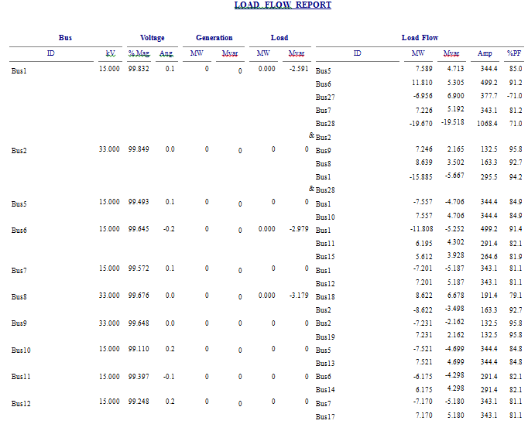
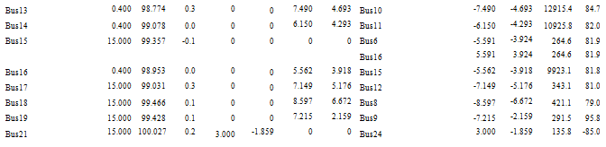
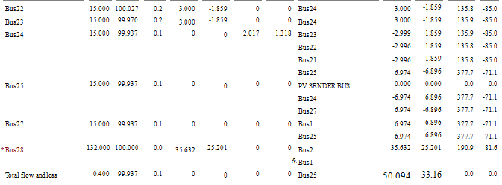
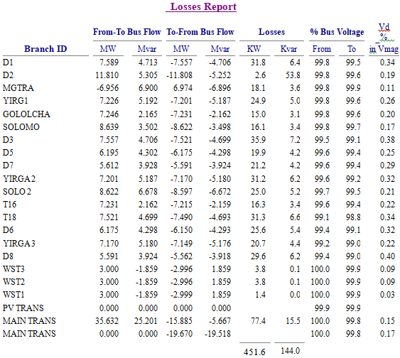

APPENDIX -D
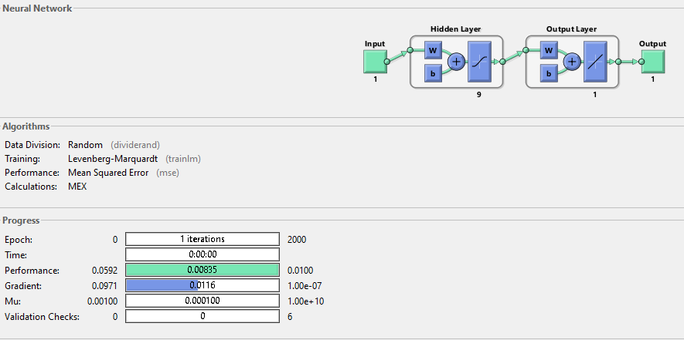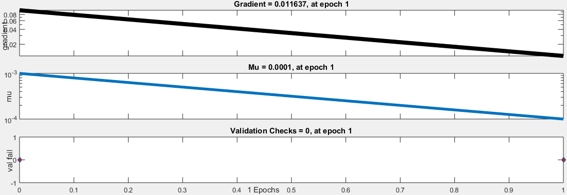
Fig a) Neural network tanning of the system with the neural network structure and Fig b)of Gradient training unit and validation of the ANN of SVC in the NN train tool
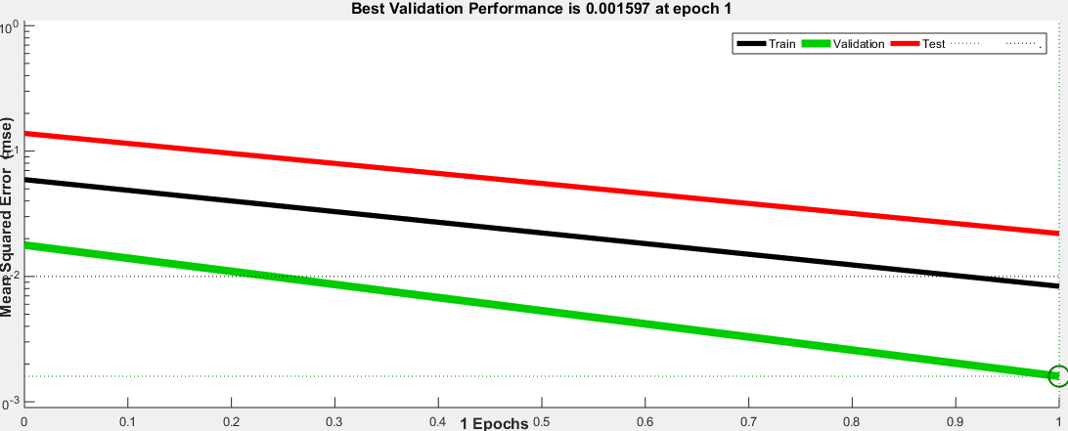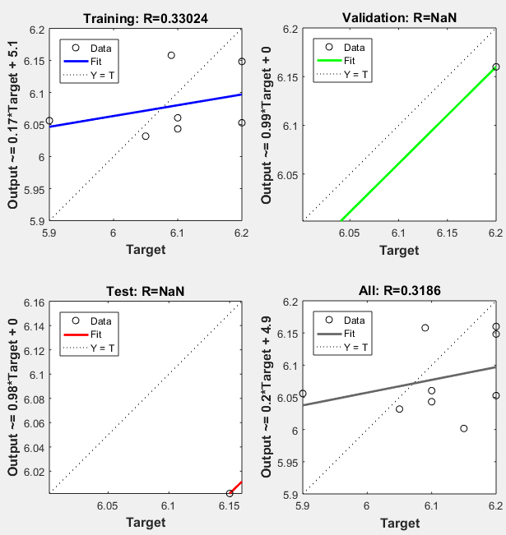
Fig a) fig b)
Fig a) of Validation indication and fig b) ANN result indicator for train ,validation and test of the ANN controller of the neural neuron surface
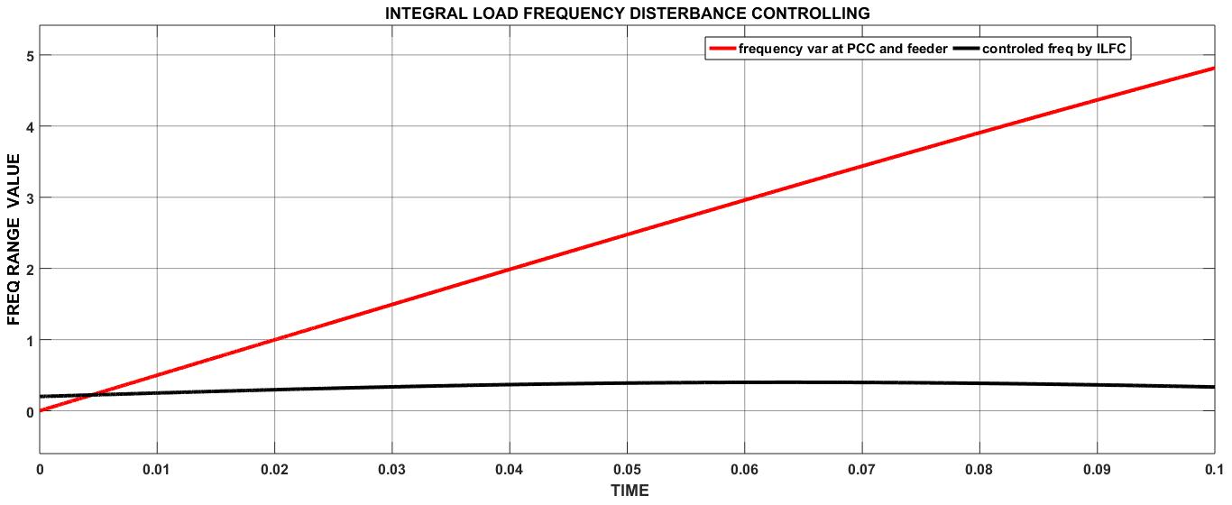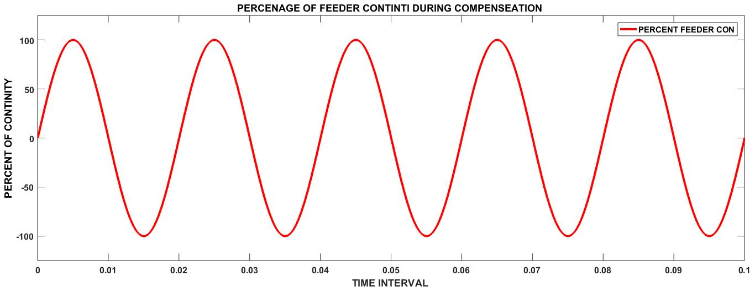
Fig a) Simulink of system frequency improvement by using ILFC system and fig b) Simulink of feeder rate and power flow continuity of the system

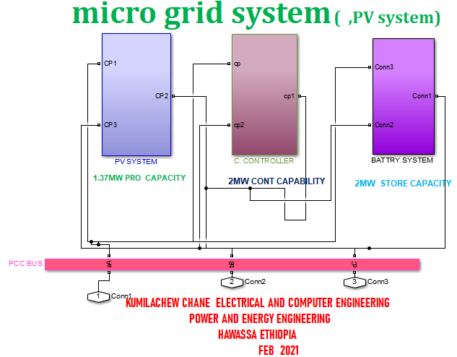
Simulink of General system and sub system of MG in the mat lab Simulink surface

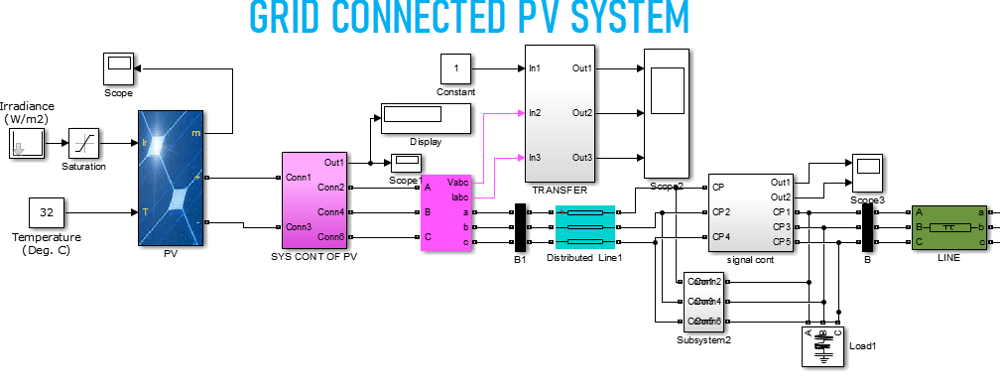
Simulink of Grid connected PV system in the mat lab Simulink surface
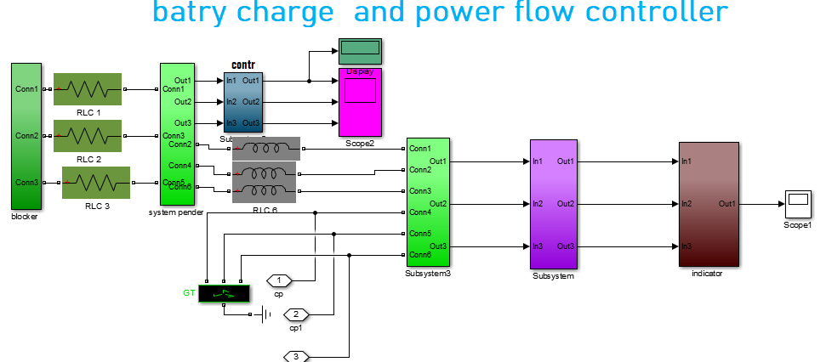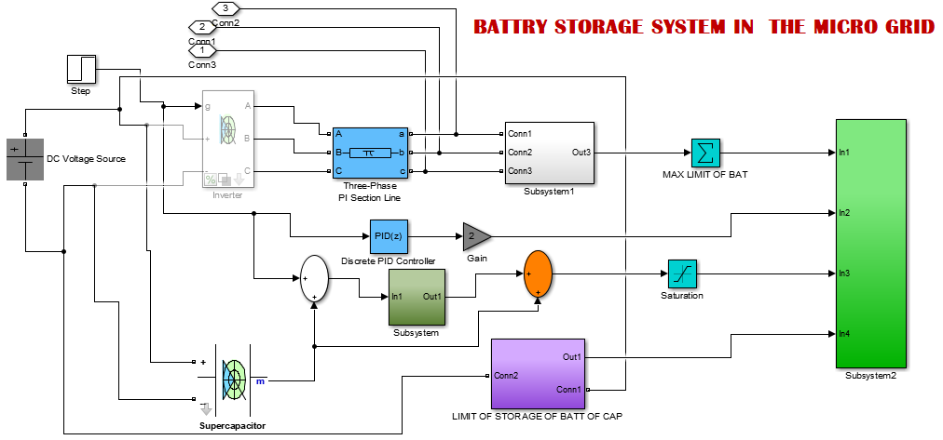

Mat lab Simulink of Battery charge controller and storage system in the MG system
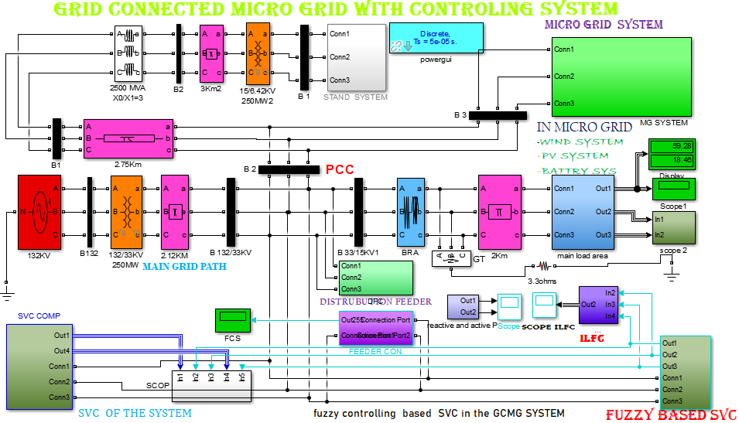
Grid connected micro grid system with fuzzy based SVC controller

