
ASSESSING THE IMPACT OF LU/LC CHANGE ON HYDROLOGICAL RESPONSE BY USING SWAT MODEL: A CASE STUDY AT DEDABA WATERSHED, ETHIOPIA.

MASTER OF SCIENCE THESIS

IBSA DIBO DEKO

HAWASSA UNIVERSITY, HAWASSA, ETHIOPIA

APRIL, 2021
ASSESSING THE IMPACT OF LU/LC CHANGE ON HYDROLOGICAL RESPONSE BY USING SWAT MODEL: A CASE STUDY AT DEDABA WATERSHED, ETHIOPIA

IBSA DIBO DEKO

MASTER’S THESIS SUBMITTED TO
FACULTY OF BIO-SYSTEMS AND WATER RESOURCES ENGINEERING,
DEPARTMENT OF WATER RESOURCE AND IRRIGATION ENGINEERING
HAWASSA UNIVERSITY, INSTITUTE OF TECHNOLOGY,
SCHOOL OF GRADUATE STUDIES
HAWASSA UNIVERSITY,
HAWASSA, ETHIOPIA

IN PARTIAL FULFILLMENT OF THE REQUIREMENTS FOR THE DEGREE OF
MASTER OF SCIENCE IN WATER RESOURCE AND IRRIGATION ENGINEERING
(SPECIALIZATION: WATER RESOURCE ENGINEERING AND MANAGEMENT)

APRIL, 2021

SCHOOL OF GRADUATE STUDIES
HAWASSA UNIVERSITY
ADVISORS’ APPROVAL SHEET
This is to certify that the thesis entitled “Assessing the Impact of LU/LCChange onHydrological Responseby Using SWAT Model: A Case Study at Dedaba Watershed, Ethiopia” submitted in partial fulfillment of the requirements for the Degree of Master's Science with specialization in Water Resource Engineering and Management, the Graduate Program of the Faculty of Bio-systems and Water Resources Engineering, Department of Water Resource and Irrigation Engineering, and has been carried out by IbsaDiboId.No.PGWREMR/0008/11. Therefore, we recommend that the student has fulfilled the requirements and hence hereby can submit the thesis to the department.

TewodrosAssefa (PhD) ___________________ _____________
Name of Major Advisor Signature Date

Acknowledgment
First of all, I thank the almighty Allah for his help and grace upon me during all my works and in all my life.
Secondly, I would like to express my deepest gratitudeand appreciation to my advisor TewodrosAssefa (PhD) forhis professional advice since the commencement of the study and valuable suggestions, encouragement, and guidance throughout thisresearch work.
Thirdly, I gratefully acknowledge all offices and personalities who have provided me the necessary data for my study: Ministry of Water, Irrigation and Energy, National Metrological Service Agency, and Ethiopian Mapping Agency.
Finally, special thanks to my classmate MohammadreshidAbdalafor his uninterrupted help and encouragement in moral support through the works by reading and providing me the necessary data during study time.

IbsaDibo.

Hawassa, Ethiopia

April, 2021

List of Acronyms and Abbreviations
CN Curve Number
CSA Central Statistics Agency
DEM Digital Elevation Model
DMC Double Mass Curve
DS Standard Deviation
ERDAS Earth Resources Data Analysis System
EROS Earth Resources Observation and Science
ETM+ Enhanced Thematic Mapper Plus
FAO Food and Agricultural Organization
GIS Geographic Information System
GLCF Global Land Cover Facility
GLUE Generalized Likelihood Uncertainty Estimation
GW_Q Groundwater Flow
HRUs Hydrologic Response Units
LU/LC Land Use and Land Cover
MCMC Markov Chain Monte Carlo
MLC Maximum Likelihood Classification
MoWIE Ministry of Water, Irrigation, and Energy
NMAE National Metrological Agency of Ethiopia
NRCS Natural Resources Conservation Service
NSE Nash Sutcliff Efficiency
OLI Operetional Landsat Imaginer
ParaSol Parameter Solution
R² Coefficient of Determination
RS Remote Sensing
RV Rift Valley
SCS Soil Conservation Service
SRTM Shuttle Radar Topographic Mission
SUFI 2 Sequential Uncertainty Fitting
SURQ Surface Runoff
SWAT Soil and Water Assessment Tool
SWAT_CUP Soil and Water Assessment Tool, Calibration and Uncertainty Program
TM Thematic Mapper
UNESCOUnited NationsEducational, Scientific and Cultural Organization
USGS United States Geological Survey
UTM Universal Traverse Mercator
WGENWeather Generator
WGS World Geodetic System

Table of Contents
Acknowledgment I
List of Acronyms and Abbreviations II
List of Figures VI
List of Tables VII
List of Figures in Appendix VIII
List of Tables in Appendix IX
Abstract X
1. INTRODUCTION 1
1.1 Background 1
1.2. Statement of the Problem 2
1.3. Objective of the Study 3
1.3.1. General Objective 3
1.3.2. Specific Objectives 3
1.4. Research Questions 3
1.5. Significance of the Study 4
1.6. Scope of the Study 4
2. LITERATURE REVIEW 5
2.1 Definition and Concepts of LU/LC Changes 5
2.1.2 Landuse and Land Cover Change Studies in Ethiopia 5
2.1.3 Landuse and Land Cover Change Impacts on Hydrology 7
2.2 Application of Remote Sensing on LU/LC 8
2.3 Classification of Hydrological Model 9
2.4 Hydrological Model Selection Criteria 9
2.4.1 SWAT Model Selection Criteria 10
2.4.2 Description of SWAT Model 10
2.5 Hydrological Components of SWAT 11
2.5.1 Surface Runoff 12
2.5.2 Ground Water Flow 14
2.5.3 Flow Routing Phase 15
2.6 SWAT Model Application in Ethiopia 15
2.6.1 Watershed Delineation 16
2.6.2 Weather Generator 17
2.6.3 Determination of Hydrologic Response Units (HRU’s) 17
2.6.4 SWAT Calibration and Uncertainty Procedures (SWAT-CUP) 18
2.6.5 Model Performance Evaluation 18
3. MATERIAL AND METHODS 20
3.1 Description of the Study Area 20
3.1.1 Topography 21
3.1.2 Climate 21
3.1.3 Soil Type 22
3.2 Data Collection and Analyses 23
3.2.1 Digital Elevation Model 23
3.2.2 Hydro-Meteorological Data 24
3.3 Method 29
3.3.1 Assessment of LU/LC Changes 29
3.3.2 SWAT Model Setup and Performance Evaluation. 34
3.3.3 Impacts of Land Use and land Cover Change on Stream Flow 40
4. RESULT AND DISCUSSION 42
4.1 LU/LC Change Analysis 42
4.1.1 Accuracy Assessment 42
4.1.2 LU/LC Change of Dedaba Watershed 44
4.2 Performance Evaluation of the SWAT Hydrological Model 47
4.2.1 Sensitivity Analysis of Stream Flow Parameters 47
4.2.2 Model Calibration and Validation 47
4.3. Impact of Landuse and Land Cover Change on Stream Flow 49
5. SUMMARY AND CONCLUSION 52
5.1. Summary 52
5.2. Conclusion 53
5.3 Recommendations 54
REFERENCES 55
APPENDICES 64

List of Figures
Figure 3.1 Location map of the study area. 20
Figure 3.2 Mean annual rainfall for the different stations from a period of 1990 - 2018 21
Figure 3.3 Maximum and minimum temperature around Dedaba Watershed. 22
Figure 3.4 Map of the soil types of Dedaba Watershed 23
Figure 3.5 Digital elevation model of Dedaba Watershed. 24
Figure 3.6 Homogeneity test analysis for all Meteorological stations 26
Figure 3.7 Double mass curve plot for metrological stations. 28
Figure 3.8 Watershed delineation of the study area using SWAT 35
Figure 3.9 Slope class of study area 36
Figure 3.10 Over all frame work of the study. 41
Figure 4.1 LU/LC map of (a) 1990, (b) 2001 and (c) 2018. 46
Figure 4.2 Graph of land use and land cover change of 1990, 2001& 2018. 46
Figure 4.3 Simulated and observed discharge for calibration period (1993-2001). 48
Figure 4.4 Simulated and observed discharge for validation period (2002-2006). 49

List of Tables
Table 2.1 Statistical Parameters of Model performance (Santhi, 2001; Moriasi, 2007). 19
Table 3.1 Soil types of Dedaba Watershed with their areal coverage. 22
Table 3.2 Location of meteorological stations in and around the Dedaba watershed (NMAE) 24
Table 3.3 The acquisition dates, sensor, path/row, and resolution of the satellite image 29
Table 3.4 LU/LC classes of Dedaba Watershed 31
Table 3.5 Kappa statics ranges (Monserud, 2003). 33
Table 3.6 The Slope Class of Dedaba Watershed. 36
Table 4.1 Confusion Matrix for LU/LC Map of 1990 43
Table 4.2 Confusion Matrix for LU/LC Map of 2001 44
Table 4.3 Confusion Matrix for LU/LC Map of 2018 44
Table 4.4 Magnitude and proportion of LU/LC 45
Table 4.5 Parameters acquired through Calibration. 47
Table 4.6 Monthly calibration and validation of model performance 49
Table 4.7 Mean monthly simulated streamflow change due to LU/LC change 50
Table 4.8 Mean annual simulated surface runoff and groundwater flow. 50

List of Figures in Appendix
Appendix Figure 1: Mean monthly rainfall distribution for kuyera station (1990-2018) 68
Appendix Figure 2: Mean monthly rainfall distribution for kofale station (1990-2018) 68
Appendix Figure 3: Mean monthly rainfall distribution for shashemene station (1990-2018) 69
Appendix Figure 4: Mean monthly rainfall distribution for ziway station (1990-2018) 69
Appendix Figure 5: False color composite satellite image of (a) 1990, (b) 2001 and (c) 2018 70
Appendix Figure 6: Hydrology change due to (a) LU/LC 1990, (b) LU/LC 2001, and (c) LU/LC 2018. 71

List of Tables in Appendix
Appendix Table 1: Parameters Used in Sensitivity Analysis 64
Appendix Table 2: Sensitivity Analysis of Parameters (Monthly) 65
Appendix Table 3: Mean Monthly Flow of Dedaba River (m3/s) 66
Appendix Table 4: Annual Rainfall Stations used in developing double mass curve 67

Abstract
Water is a precious and finite resource and must be managed in sustainable way to
meet human as well as environmental needs. Land use/land cover change has an
impact for alteration of watershed hydrology. The watershed is undergoing land use change due to intensive cultivation andurbanization as a result of population growth which has an impact on hydrologicresponse of the watershed. This study quantified watershed runoff volume using SWAT modeland assessed the effect of land use/land cover change on the stream flow. In this study, the impact of LU/LCchange was carried out by using the Soil Water Assessment Tool (SWAT2012) model, which was integrated with GIS10.3 software. GIS and ERDAS IMAGINE2014 were used to generate LU/LCmaps from Landsat TM, TM, and OLI acquired in the years 1990, 2001 and 2018 respectively. The land cover maps were generated using the maximum likelihood algorithm of supervised classification. The classified maps were assessed using confusion metrics. The results of the analysis showed that the Agricultural land has expanded during the study period of 1990-2018. During the study period, forest land, and shrub and grassland decreased by 19.5% and 15.61% respectively while Agricultural land and Built-up area increased by 33..63% and 1.48% respectively. Using three land cover maps, three SWAT model setup were run to evaluate the impacts of LU/LC changes on the streamflow of the study watershed. The performance of the SWAT model was evaluated through sensitivity analysis, calibrationand validation by using SWAT-CUP. The Coefficients of determination and Nash–Sutcliffe were used to evaluate the model and it resulted in 0.87 and 0.73 for calibration and 0.82 and 0.68 for validation respectively. During the study periods, the simulation result indicated that streamflow increased in the wet season and short rainy season streamflow by 9.64% and 3.05% respectively, while decreasing by 5.6% in the dry season. The Surface Flow (SURQ) increased by 12.58% while Groundwater Flow (GW_Q) decreased by 14.83% due to the increment of Agricultural land. The study resultsshowed change in flow with change in land use/landcover, so it needs landuse planning and sustainable water resource management.

Keywords: GIS, Dedaba Watershed, LU/LCCange, SWAT, Hyrdological Response.

1. INTRODUCTION

1.1 Background
Nowadays water resources are a critical component for any type of socio-economic development all over the world. Thus, its availability and use have to be at the center of any discussion of development. Deterioration of the global freshwater resources becomesthe forefront of scientific and political agenda concerning global environmental changes in landuse and bio-diversity (Montoya and Raffaelli, 2010; Miranda et al., 2011). Landuse land cover change has become a serious environmental concern at the global, regional, and local scales (Mishra et al., 2014; Zhan et al., 2014 and Kumar et al., 2015). Changes in LU/LCplay important roles in global environmental change because the changes have affected the sustainability, biodiversity, and interactions between the earth and atmosphere (Zhan et al., 2014 and Kumar et al., 2015).
LU/LCchange has been also challenging in Ethiopia. At the beginning of the 19th century, 40% of land in the country was covered by forests (Abebe, 2005; Mengistie et al., 2013 and Birhanu, 2014). Ethiopia has a population of more than 100 million with a growth rate of 2.7%, of this about 80% of the population solely depends on agricultural practices as a source of employment and income (CSA, 2015). The increase of population density leads to clear-cutting, shrinking forests and grasslands, the expansion of cultivated areas, and intensified landuse resulting in almost complete abandonment of the fallow systems (Hurni et al., 2005).
Ethiopia has twelve river basin, from those Rift Valley Basin was one of Ethiopia river basin. Studies in a different part of the Rift Valley basin revealed that there were many factors which caused LU/LCchanges among which population density was one of the major factors which further has caused change on streamflow(Haregeweyn et al., 2015).
Quantifying the effects of landuse change on streamflow has recently been given much attention by the scientific communities (e.g. Jiang et al., 2011; Yang et al., 2012). Landuse change was caused by multiple interacting factors of the coupled human and environment systems (Lambin, 2003).This was attributed to different anthropogenic activities, e.g. intensive land cultivation, deforestation, overgrazing, urbanization, afforestation, and reforestation. The heterogeneity of topography, land use, soil, and geology, on the one hand, and limitation of hydro-meteorological data on the other hand is considered to be the major scientific challenges often preclude to studylanduse change impact on hydrology(DeFries and Eshleman, 2004).
In Ethiopia, Rientjes et al., (2011b) showed that the LU/LCchange was the cause of streamflow changes. Most recently, Kidane et al., (2018) reported a decrease of the dry season flows, attributed to the clearance of natural vegetation cover and increased agricultural expansion. On the Dedaba Watershedstreamflowunder the impact of LU/LC change was particularly very important in improving water management efficiency and benefiting various water use needs such as irrigation and also it might be used for recreation, and environmental protection. Besides the mentioned purposes, highly it would be used for better management and planning of rivers.
Based on the process description, the SWAT model has been more efficient than other models (Sith and Nadaoka, 2017; Polanco et al., 2017). SWAT is a well-developed tool for analyzing the effects of water resource practices in the most challenging watersheds. Therefore, the SWAT model was the best modeling of a semi-distributed physical-based simulation model. The interface of the SWAT model was compatible with a GIS that can integrate numerous available geospatial data (Neitsch et al., 2005).

1.2. Statement of the Problem
The relationship between land and water was the interest of worldwide. The change in landuse emanating from expanding the agricultural land in Ethiopia needs primary concern (FDRE, 2004). Lack of proper landuse plan and management practices that could increase agricultural products with limited land and economic resource. This was further affecting the water resource of the country (Teferi et al., 2010;Hadgu, 2008).
The LU/LC change has a significant impact on natural resources. However, to model the impact of LU/LCchange on streamflow, it is important to have an understanding of the past LU/LCchangeand the hydrological processes of the catchments. Understandingthe types and impact of LU/LC changewas an essential indicator for water resourcebase analysis and development of effective and appropriate response strategies for sustainablemanagement of natural resources in the country in general and particularly in the study area.
In Dedaba Watershed nothing research was done concerning the impact of LU/LCon streamflow in particular attention. Therefore, this research was initiated with the focus on streamflow under the impact of LU/LCin the Dedaba Watershed And to minimize the adverse impact of LU/LCchange at the headstream of the watershed. The importance of streamflow for the sustainable development of water resources and LU/LCchange on watersheds were not yet well understood. Therefore, it was required to give more attention to LU/LCand streamflow. Hence SWAT model was selected because their structure was more physically- based and they are less demanding on input data than fully distributed models and can evaluate the impact of landuse change in the watershed with varying soils, landuse and management conditions over the long periods, and primarily as a strategic planning tool (Neitsch et al., 2005).
Specifically, this study attempted to understand and assess the impact of LU/LCchanges on the streamflow of Dedaba Watershedto contributing a lot on the way toward tackling the above problems.

1.3.Objectiveof the Study

1.3.1. General Objective
The general objective of this study was to assess the impact of LU/LCchange onthe Streamflowof the Dedaba Watershedusing the SWAT model.

1.3.2.Specific Objectives
The specific objectives of this study were:
- To assess theLU/LCchangesfor the past 29 years from 1990 to 2018 in Dedaba Watershed.
- To evaluate the performance of the SWAT hydrological model in simulating the streamflow of the study area and identify the most sensitive parameters of the watershed.
- To assess the impact of LU/LCchange on streamflow in the study area for the year 1990, 2001 and 2018 using the SWAT model.

1.4. Research Questions
To attain the objective of the study, these questions should be answered:
- What magnitude of LU/LCchange has occurred in the Dedaba Watershed for the time range between1990-2018?
- How much the SWAT model is applicable to assess LU/LCimpact on streamflow at Dedaba Watershed?
- How the LU/LC change impacts on the streamflow of the watershed?

1.5. Significance of the Study
This research finding measures the knowledge of how the LU/LCchange affects on streamflow of the watershed. The knowledge of how LU/LCchanges influence watershed properties and the compressive analysis of the watershed will enable local governments, farmers and policymakers about proper land use and different management options.
The findings of this research are used to make the stakeholders an effective integrate participatory to take action on the protection of watershed management.Besides, this study is expected to help concerned sectors in planning, developing, and managing water resource projects in the study area and be input for those who are interested in further research in related fields and area of study.

1.6. Scope of the Study
The period considered in the study was from 1990-2018 and particular at the Dedaba watershed which covers 148.79Km². Moreover, the study quantifies the impact of LU/LCchange and evaluate the LU/LCchange on the hydrological regime, especially on streamflow. Based on the available data, the types and impact of LU/LCchange wasan indicator for resource base analysis and the development of effective and appropriate response strategies for sustainable management of natural resources for the study area. This would be achieved through a method that combines the hydrological model (SWAT) to simulate the hydrological processes.

2. LITERATURE REVIEW

2.1Definition and Concepts of LU/LCChanges
The definition of landuse is physical and biophysical characteristics or state of Earth's surface which way establishes a direct link between land cover and the actions ofpeople in their environment (FAO and MoWIE, 2013).Factors driving LU/LC change include an increase in the human population and population response to economic opportunities (Lambin et al., 2000).
Landuse and land cover can be defined as how land is utilized. For example, residential and industrial landuse would be considered one type of developed landuse. Land cover is slightly different. A park could be a forest, in this landuse is a park and land cover is a forest (Golosov, V. and Panin A., 2006).
Hydrological effects of land use/land cover change manifested in many ways and at different spatial and temporal scales. Most obvious is the immediate and direct effects on the quantity and quality of watershed runoff. For example, land cover change is the most significant factor driving hydrologic changes such as runoff volume, timing and variability (Fohrer, 2001). The simplest method to assess these effects on the hydrologic response of watersheds is by comparing streamflow and runoff generated from the watershed areas with the contrasting landuse types (Barkhordari, 2003). The main causes for landuse change are due to manmade and natural causes, where the man-made causes are mainly attributed to the reach for resources to meet human needs. For instance, deforestation is a result of the need for timber for construction, fuelwood and clearing for agricultural development and for settling the ever-increasing population (Chemelil,2016).

2.1.2Landuse and Land Cover Change Studies in Ethiopia
In Ethiopia, the land used to grow crops, trees, animals for food, as building sites for houses and
roads, or for recreational purposes. Most of the land in the country is being used by smallholders
who farm for subsistence. With the rapid population growth and in the absence of agricultural
intensification, smallholders require more land to grow crops and earn a living; it results in
deforestation and land use conversions from other types of land use cover to cropland. The
researches that have been conducted in different parts of Ethiopia have shown that there wereconsiderable land use land cover changes in the country. Most of these studies indicate that
croplands have expanded at the expanse of natural vegetation including forests and shrublands; forexample Minichil, (2016); Haile (2011): Gashaw (2017): Sileshi (2016) and Getahun (2015) inBlue Nile basin of Ethiopia.
In their study, they reported the decline of natural forests and grazing lands due to conversions to
cultivated lands. In Didessa basin much of the original forest have already been converted to
agricultural lands. These changes would aggravate serious problems related to water scarcity in
dry periods and hill slope erosion during wet periods (Minichil.J, 2016). The changes of land use
land cover from (1986–2001) in Upper GilgelAbbay catchment, Blue Nile basin –Ethiopia showsan increase in agricultural land by 67.34% while it decreased in forest area by 50.9%. The
expansion of agricultural land from (1986–2001) is larger than in the previous time (Haile TA,
2011). And also, the changes of Land Use/Cover in Gumara Watershed, Upper Blue Nile Basin,
Ethiopia shows the expansion of cultivated land by 98.7% and built-up area and the withdrawing
of forest area, shrub land and grassland by 75.19% were further continued in 2030 and 2045
(Gashaw G. and Mamaru A, 2015). Lastly, the change of Land-Use from 2009 to 2025 in the UpperBlue Nile Basin shows the agricultural land will continue to expand from 69.5% in 2009 to 77.5%in 2025 in the catchment albeit at a declining rate when compared with the period from 1986 to2009 (Seleshi G. Yalew& A., 2016).
The changes of Land Use-Cover from 1986 to 2003 in MelkaKuntrie Sub basin, Upper Awash River Basin-Ethiopia shows an expansion of cultivated land by63% and reduction in forest, grass, or shrub land by 44% in sub basin. Land use in 2003, whichwas mostly converted to agriculture land from forest, grass, or shrub land than land use during1986 (Getahun YS, 2015).The changes of land use land cover that occurred from 1971/71 to 2000 in Yerer Mountain and itssurrounding results an expansion of cultivated land by 25% in 1971/72 to 56.4% in 2000. The
increase in cultivated land in three decades was 125%, which was mainly at the expense of the
grasslands. At the same time, grasslands decreased from 65.35% in 1971/72 to 32.7% in 2000.
(Gebrehiwet, 2004).Hadgu (2008) identified that decrease of natural vegetation and expansion ofagricultural land over the period of 41 years in Tigray, northern part of Ethiopia. He concludedthat population pressure was an important deriver for expansion and intensification of agriculturalland in recent periods. Garedew, (2010) in the semiarid areas of the central Rift valley of Ethiopia,during the period of 1973-2000 cropland coverage has increased and woodland cover lost. Similarly, Feoli, et al, (2002) reported the expansion of evergreen vegetation with increase ofpopulation. According to many literatures, population growth has a paramount impact on the environment. For instance, population pressure has been found to have negative effect on Riverinetree in Chemoga watershed (Bewket W. a., 2005), and natural forest cover in DembechaWoredanorth-western Ethiopia (Zeleke, 2001). And also, Pender et al, (2001) exhibited that the populationgrowth has significant effect on land degradation, poverty and food insecurity in the northernEthiopia highlands. However, most of the empirical evidences indicated that land use land coverchanges and socioeconomic dynamics have a strong relationship (i.e. as population increases the need for cultivated land, grazing land, fuel wood; settlement area also increases to meet the growing demand for food and energy, and livestock population). Thus, population pressure, lack of awareness and weak of management are considered as the major causes for the deforestation and degradation of natural resources in Ethiopia.

2.1.3Landuse and Land Cover Change Impacts on Hydrology
Water on earth exists in a space called the hydrosphere and lithosphere, circulates, and forming the hydrologic cycle. The cycle has no beginning and no ending and can beaffected by different factors. Among those factors, manmade activities, landuse, and land cover change can affect hydrological processes such as infiltration, runoff, and groundwater recharge. Different studies indicate that land use and land cover changehave an impact on hydrologic components. For instance, (Adamu, 2013) concluded that land use and land cover changes have major impacts on hydrological processes, such as runoff and groundwater flow, (Melesse, 2012) concluded that the decrease of forest land and grassland was accompanied by the increase in agricultural and built-up areas and this change in land use and land cover increased surface runoff during wet seasons and reduced base flow during the dry seasons. (Gebrie, 2016) Concluded that land use and land cover change have a great influence on streamflowespecially during the wet season than the dry season.

2.2 Application of Remote Sensing on LU/LC
Remote Sensing (RS) is defined as the science of obtaining information about an object, area, or phenomenon through the analysis of data acquiring by a device that is no in contact with the object, area or phenomenon under investigation (Bawahidi, 2005). It provides a large amount of data about the earth's surface for detailed analysis and change detection with the help of sensors.
Most of the data inputs to the hydrological (SWAT) model are directly or indirectly extracted from remotely sensed data. Some of the important data used in the hydrological modeling that are obtained from remote sensing data are digital elevation model (DEM), land cover map, land use mapand soil map. Some of the application of remote sensing technology in mapping and studying the land use and land cover changes are; map and classify the land use and land cover, assess the spatial arrangement of land use and land cover, allow an analysis of time-series images used to analyze landscape history, report and analyze results of inventories including inputs to Geographic Information System (GIS), provide a basis for model building (Williamet al 1991).
Land use and land cover is changing rapidly in most parts of the world. In this situation, accurate, meaningful and availability of data is highly essential for planning and decision making. Remote sensing is particularly attractive for the land cover data among the different sources. (Stefanov,2001) Reported that in the 1970s satellite remote sensing techniques have started to be used as a modern tool to detect and monitor land cover change at various scales with useful results.
(William, 1991), Showed that the information on land use and land cover change which is extracted from remotely sensed data is vital for updating land cover maps and the management of natural resources and monitoring phenomena on the surface. The importance of land cover mapping is to show the land cover changes in the watershed area and to divide the land use and land cover into different classes of land use and land cover. For this purpose, remotely sensed imagery plays a great role in obtaining information on both temporal trends and spatial distribution of watershed areas and changes over the time dimension for projecting land cover changes but also to support changes impact assessment (Atasoy, 2006).

2.3Classification of Hydrological Model
There are many classifications of hydrologic models, deterministic versus stochastic, lumped
versus distributed, etc. Based on the process description, the hydrological models can be
classified into three main categories such as lumped, semi-distributed, and distributed model
(Cunderlik and Simonovic, 2004).
Lumped models: Parameters of lumped hydrologic models do not vary spatially within the basin
and thus, basin response is evaluated only at the outlet, without explicitly accounting for the
theresponse of individual sub-basins. The parameters often do not represent the physical features ofhydrologic processes and usually involve a certain degree of empiricism. These models are not
usually applicable to event scale processes. If the interest is primarily in the discharge prediction
only, then these models can provide just as good simulations as complex physically-based
models (Geographica and Comenianae, 2010).
Semi-distributed Models: Parameters of semi-distributed (simplified distributed) models are
partially allowed to vary in space by dividing the basin into several smaller sub-basins. The main
types of semi-distributed models: 1) kinematic wave theory models such as HEC-HMS, and 2)
probability distributed models such as SWAT. The kinematic wave models are simplified
versions of the surface and/or subsurface flow equations of physically-based hydrologic models
(Campling, 2002).
Distributed models: Parameters of distributed models are fully allowed to vary in space at
resolution is chosen by the user. The distributed modeling approach attempts to incorporate data
concerning the spatial distribution of parameters together with computational algorithms to
evaluate the influence of this distribution on simulated precipitation runoff behavior (Campling,
2002). Distributed models generally require a large amount of data.

2.4 Hydrological Model Selection Criteria
Various criteria can be used for choosing the right hydrological model for a specific problem. These criteria's are always project dependent, every project has its specific requirements and needs. Further, some criteria are user-dependent (and therefore subjective). Among the various project-dependent selection criteria there are common, fundamental that must be always answered (Cunderlik, 2003). Choosing the most appropriate model for simulating the hydrological flows in a particular watershed and the specific climate was consistently a major part of the global modeling process. For example, the SWAT model has been more efficient than other models (Sith and Nadaoka, 2017; Polanco et al., 2017).
SWAT is a well-developed tool for analyzing the effects of water resource practices in the most challenging watersheds. Researchers used the SWAT model for hydrological modeling and water resource practices in various climate and terrain features (Panhalkar, 2014; Costa et al., 2015; Tuppad et al., 2011, Mankin, L. and Haron et al., 2016). The SWAT model simulates various water functions such as filtration, evapotranspiration, runoff water production, underground recharge, other processes such as watershed growth, vegetation and crops, nitrate, and phosphorus progress, and surface waters (Jha, 2011; Khatun, 2018).

2.4.1 SWAT Model Selection Criteria
The chosen hydrological model in this study was SWAT. It was successfully used for various studies of water resources area (KassaTedele, 2007) applied SWAT model in analyzing the impact of land use and land cover change on streamflow in the case of Hare River watershed, Ethiopia and proved the model’s acceptance in hydrological performance was applied to assess its simulating capacity through calibration and validation on monthly basis and recommended to use the model for further simulations and analysis of land use/land cover change on the hydrologic regime of Ketar watershed for future research. Also, the model software with some tutorial video is freely available on the SWAT website (Soil and Water Assessment Tool http://swat.tamu.edu/) to download.

2.4.2Description of SWAT Model
The large-scale spatial heterogeneity of the study area is represented by dividing the watershed into sub-watersheds. Each sub-watershed is further discretized into a series of hydrologic response units (HRUs), which are unique soil-land use combinations. Soil water content, surface runoff, nutrient cycles, sediment yield, crop growth, and management practices are simulated for each HRU and then aggregated for the sub-watershed by a weighted average(Neitsch, 2005).
Physical characteristics, such as slope, reach dimensions, and climatic data are considered for each sub-watershed. For climate, SWAT uses the data from the station nearest to the centric of each sub-watershed. Calculated flow, sediment yield, and nutrient loading obtained for each sub-watershed then routed through the river system. Channel routing is simulated using the variable storage or Muskingum method. The water in each HRU in SWAT is stored in four storage volumes: snow, soil profile, shallow aquifer, and deep aquifer. Surface runoff from daily rainfall is estimated using a modified SCS curve number method, which estimates the amount of runoff based on local land use, soil type, and antecedent moisture condition. Peak runoff predictions are based on a modification of the Rational Formula (Chow, 1988).
The watershed concentration time is estimated using Manning’s formula, considering both overland and channel flow. The soil profile is subdivided into multiple layers that support soil water processes including infiltration, evaporation, plant uptake, lateral flow, and percolation to lower layers. The soil percolation component of SWAT uses a water storage capacity technique to predict flow through each soil layer in the root zone. Downward flow occurs when the field capacity of a soil layer is exceeded and the layer below is not saturated. Percolation from the bottom of the soil profile recharges the shallow aquifer. Daily average soil temperature is simulated as a function of the maximum and minimum air temperature. If the temperature in a particular layer reaches less than or equal to 0ºC, no percolation is allowed from that layer. Lateral sub-surface flow in the soil profile is calculated simultaneously with percolation. Groundwater flow contribution to total streamflow is simulated by routing a shallow aquifer storage component to the stream. The model computes evaporation from soils and plants separately(Neitsch, 2005).

2.5 Hydrological Components of SWAT
Hydrological components simulated in the land phase of the Hydrological cycle are canopy storage; infiltration, redistribution, and Evapotranspiration, lateral subsurface flow, surface runoff, ponds, and tributary channels return flow. The simulation of the hydrology of a watershed is done in two separate components. First, the land phase of the hydrologic cycle that controls the water movement in the land and determines the water, sediment, nutrient, and pesticide amount that was loaded into the mainstream. The second component is the routing phase of the hydrological cycle in which the water is routed in the channels network of the watershed, carrying the sediment, nutrients, and pesticides to the outlet. In the land phase of the hydrologic cycle, SWAT simulates the hydrological cycle based on the water balance Equation
(Neitsch, 2005).
$Swt=Swo+\sum_{i=1}^{t}{(Rday-Qsurf-Ea-Wseep-Qgw)}$-----------------------------------(2. 1)
Where:-Swt = soil water content (mm)
SWo= initial water content (mm)
T = time in (days)
Rday= the amount of precipitation on the day i (mm)
Qsurf= the amount of surface runoff on the day i (mm)
Ea = the amount of Evapotranspiration on the day i (mm)
Wseep= the amount of water entering the vadose zone from the day i(mm), and
Qgw = the amount of return flow on the day i (mm)
For the complete model description, one may refer to SWAT theoretical documentation (Neitsch, 2005).

2.5.1 Surface Runoff
Surface runoff refers to the portion of rainwater that is not lost to interception, infiltration, and Evapotranspiration (Solomon, 2005). Surface runoff occurs whenever the rate of precipitation exceeds the rate of infiltration. SWAT offers two methods to estimate the surface runoff: the soil conservation service (SCS) curve number method (SCS, 1972) or the Green and Ampt infiltration method (Green and Ampt, 1911). The Green and Ampt method needs sub-daily time step rainfall which made it difficult to be used due to the unavailability of sub-daily time step rainfall data. Therefore, the SCS curve number method was adopted.
The general equation for the SCS curve number method is expressed in Equation (2.2).
$Qsurf=\frac{{(Rday-Ia)}^{2}}{(Rday-Ia+S)}$---------------------------------------------------------------------------------------(2.2)
Where:-Qsurf = accumulated runoff or rainfall excess (mm),
Rday= rainfall depth for the day (mm water),
Ia= an initial abstraction which includes surface storage, interception,
and infiltration before runoff (mm water),
S = retention parameter (mm water).
The retention parameter varies spatially due to changes with land surface features such as landuse, slope, and management practices. This parameter can also be affected temporal due to changes in soil water content. It is mathematically expressed as:-
𝑆=25.4∗$(\frac{1000}{CN})$−10)--------------------------------------------------------------------------------------(2.3)
Where:- CN = the curve number for the day its value is the function of landuse
soil permeabilityand soil hydrologic group.
The initial abstraction, Ia, is commonly approximated as 0.2S, and Equation (2.2) becomes:
𝑄𝑠𝑢𝑟𝑓= $\frac{{(Rday-0.2s)}^{2}}{(Rday+0.8s)}$--------------------------------------------------------------------------------------(2.4)
SWAT includes two methods for calculating the retention parameter; the first one is retention parameter varies with soil profile water content and the second method is the retention parameter varies with accumulated plant evapotranspiration. The soil moisture calculation method overestimates runoff in shallow soil. However, calculating daily CN as a function of plant Evapotranspiration, the value is less dependent on soil storage and more dependent on antecedent climate.
$S=S_{max}*(1-\frac{Sw}{\left(sw+\exp\left(w1-w2*sw\right)\right)})$------------------------------------------------------------------(2.5)
Where S is the retention parameter for a given day (mm), Smax is the maximum value the retention parameter can achieve on any given day (mm), SW is the soil water content of the entire profile excluding the amount of water held in the profile at wilting point (mm), and w1 and w2 are shape coefficients. The maximum retention parameter value, Smax is calculated by solving Equation 2.3 using CN1
$S_{max}=25.4(\frac{1000}{CN1}-10)$--------------------------------------------------------------------------------(2. 6)
When the retention parameter varies with plant Evapotranspiration, the following equation is used to update the retention parameter at the end of every day
$S=S_{prev}+E_{o}*\exp\left(\frac{-cncoef-S_{prev}}{S_{max}}\right)-R_{day}-Q_{surf}$---------------------------------------------(2.7)
Where S is the retention parameter for a given day (mm), Sprev is the retention parameter for the previous day (mm), Eo is potential Evapotranspiration for the day (mm per day), cncoef is the weighting coefficient used to calculate the retention coefficient for daily curve number calculations dependent on plant Evapotranspiration, Smax is the maximum value the retention parameter can achieve on any given day (mm), Rday is the rainfall depth for the day (mm) and Qsurf is the surface runoff (mm). The initial value of the retention parameter is defined as S=0.9*Smax.
The SCS curve number is a function of the soil permeability, landuse, and antecedent soil water condition. SCS defines three antecedent moisture conditions: I dry (wilting point), II average moisture, and III wets (field Capacity). The moisture condition I curve number is the lowest value the daily curve number can assume in dry conditions. The curve number for moisture conditions III and I are calculated with Equations 2.8 and 2.9 respectively.
${CN}_{1}={CN}_{2}-\frac{20*(100-{CN}_{2})}{(100-{CN}_{2}+\exp\left(2.533-0.0636*\left(100-{CN}_{2}\right)\right))}$--------------------------------------------------(2.8)
${CN}_{3}={CN}_{2}*exp⁡(0.00673*(100-{CN}_{2})$-----------------------------------------------------------(2.9)
Where:- CN₁ = moisture condition I curve number, CN2= moisture condition II curve number and CN3 = moisture condition III curve number.
For the definition of hydrological groups, the model uses the U.S. Natural resources conservation service (NRCS) classification. The classification defines a hydrological model group as a group of soils having similar runoff potential under similar storm and land cover conditions. Thus, soils are classified into four hydrological groups (A,B, C, and D) based on infiltration which represents high, moderate, slow, and very slow infiltration rates, respectively.

2.5.2 Ground Water Flow
To simulate the groundwater, SWAT partitions groundwater into two aquifer systems: a shallow, unconfined aquifer that contributes return flow to stream within the watershed and a deep, confined aquifer which contributes return flow to streams outside the watershed (Arnold et al., 2012). In SWAT the water balance for a shallow aquifer is calculated with Equation (2.10).
aqshi = aqshi −1+ W rchrg − Qgw − Wrevap − W deep –Wpumpsh----------------------------(2.10)
Where:-aqshi = amount of water stored in the shallow aquifer on a day I (mm),
Aqsh i-1 = amount of water stored in the shallow aquifer on day i-1(mm),
W rchrg= amount of recharge entering the aquifer on a day I (mm),
Qgw= groundwater flow, or base flow, or return flow,
into the main channel on a day I (mm)
Wrevap= amount of water moving into the soil zone in response
to water deficiencies on a day I (mm),
Wdeep= amount of water percolating from the shallow aquifer into the deep
aquifer on day I (mm), and
Wpumpsh= amount of water removed from the shallow aquifer
by pumping on a day I (mm).

2.5.3 Flow Routing Phase
The second component of the simulation of the hydrology of watershed is the routing phase of the hydrological cycle. It consists of the movement of water, sediment, and other constituents (E.g. nutrients, pesticides) in the stream network. Two options are available to route the flow in the channel network: the available storage and Muskingum methods.
The available storage method uses a simple continuity equation in routing the storage volume, whereas the Muskingum routing method models the storage volume in channel length as a combination of wedge and prism storages. In the latter method, when a flood wave advances in to reach the segment, inflow exceeds outflow, and wedge storage is produced. As a flood wave recedes or withdrawals, outflow exceeds inflow in the reach segment and a negative wedge is produced. In addition to the wedge storage, the reach segment contains a prism of storage formed by a volume of the constant cross-section along the reach length. The available storage method was used for this study. The method was developed by (Williams, 1981). The Equation of the available storage routing is given by:
𝛥𝑉𝑠𝑡𝑜𝑟𝑒𝑑=𝑉𝑖𝑛−𝑉𝑜𝑢𝑡------------------------------------------------------------------------------------(2.11)
Where:-∆V stored = change in the volume of storage during the time step (m³ water)
𝑉𝑖𝑛= volume of inflow during the time step (m³ water), and
𝑉𝑜𝑢𝑡= volume of outflow during the time step (m³ water)

2.6SWAT Model Application in Ethiopia
The SWAT model application was calibrated and validated in some parts of Ethiopia, frequently in the Abbay Basin. The modeling of Didessa Watershed (in Abbay Basin) (Minichil, 2016) indicated that streamflow and sediment yield simulated with SWAT were reasonably accurate. The same study conducted on similar long term data can be generated from ungauged watershed using the SWAT model and modeling of Lake Tana Basin with SWAT also showed that the SWAT model was successfully calibrated and validated (Setegn, 2008). This study reported that the model can produce reliable estimates of streamflow and sediment yield from complex watersheds. (Rabo, 2018) used the SWAT model performed to simulate runoff under the impact of past LU/LC and climate change of the Anger Sub-basin. According to this study, the SWAT model performed well in the simulation of runoff to Anger Sub-basin. The study further put that the model proved to be useful in capturing the process of streamflow.
In addition to the above, the SWAT model was tested for prediction of sediment yield in Anjeni gauged watershed by (Setegn, 2008). The study found that the observed values showed a good agreement at Nash-Sutcliff efficiency (NSE) of 80%. In light of this, the study suggested that the SWAT model can be used for further analysis of different management scenarios that could help different stakeholders to plan and implement appropriate soil and water conservation strategies.
The SWAT model showed a good match between measured and simulated flow and sediment yield in Gumara watershed both in calibration and validation periods (Asres and Awulachew, 2010). Tekle, (2010) through modeling of Bilate watershed also indicated that the SWAT model was able to simulate streamflow at a reasonable accuracy. The literature reviewed and presented above showed that SWAT is capable of simulating hydrological and soil erosion process with reasonable accuracy and can be applied to the large and complex watershed.

2.6.1Watershed Delineation
The watershed delineation is primarily made on the sub-watershed level and is determined based on the relative spatial location of each sub-watershed, the direction of hydrologic flow, and the natural divisions of stream networks determined by elevation. A digital elevation model (DEM) is the only required data set for this step. Generally, the smaller the threshold area, the more detailed are the drainage networks, and the larger is the number of sub-watershedand HRUs. However, this needs more processing time and space. As a result, the optimum size of a watershed that compromises both should be selected (ARCSWAT, User manual interference for SWAT2009).

2.6.2Weather Generator
The weather generator parameters were developed by using excel (pivot table), to calculate average monthly and average daily precipitation, standard deviation, skew coefficient, probability of a wet day following a dry day, and an average number of days of precipitation in a month. The weather data definition was divided into six tabs: weather generator data, rainfall data, temperature data, solar radiation data, wind speed data, and relative humidity data. In developing countries, there was a lack of a full and realistic long period of climatic data. Therefore, the weather generator solves this problem by generating data from the observed one (Danuso, 2002).
The Model requires the daily values of all climatic variables from measured data or generated from values using monthly average data over several years. This study used measured data for all climatic variables. Weather data of one station with continuous records were used as input to determine the values of weather generator parameters. Hence, for weather generator data definition, the weather generators data file WGEN_user, rainfall data, temperature data, relative humidity data; solar radiation data, and wind speed data were selected and added to the model respectively. Lastly next to the added input tables run the simulations daily(Danuso, 2002).

2.6.3 Determination of Hydrologic Response Units (HRU’s)
The HRU Analysis section takes land use, soil, and slope data and divides each sub-watershed into hydrologic response units, with specific combinations of the three layers' respective characterizations. The layer produced by this process is crucial to the ultimate analysis performed by the SWAT model because it determines the land, soil, and slope category assigned to each HRU. This category determines how the land was responded to precipitation, runoff, infiltration, and other hydrologic processes during the simulation. Each sub-watershed can then have one or more major HRUs defined within it (Arc SWAT User manual interference for SWAT2009). The required land cover and soil data are accompanied by preparing a look-up table with attribute information for each specific land cover and soil type and provides these tables for each layer.
The last layer needed for the HRU Analysis setup is the slope, which is determined from the DEM supplied during watershed delineation. Once each layer is loaded, it must be overlaid to determine the HRU features. For every unique combination of slope, land use, and soil class then an HRUwascreated, although within the study area there can be multiple HRUs with the same combination. The last step is to define how HRU classifications wereaggregated or transferred to the sub-watershed level. The Multiple HRU option was chosen for defining HRU. This option allows the user to select a threshold for each category individually, starting with land use, then soil class, and finally ending with slope. According to (Luzio et al. 2002) and the user manual for SWAT, the threshold levels set for multiple HRUs are a function of the project goal, and the amount of detail desired by the modeler. For most applications, the default settings for land use threshold (10 %) soil threshold (20%), and slope (10%) were applied in research work(Luzio et al. 2002).

2.6.4 SWAT Calibration and Uncertainty Procedures (SWAT-CUP)
Distributed watershed models are increasingly being used to support decision making in land-use change. These models should pass through careful calibration and uncertainty analysis. Large-scale distributed models are difficult to calibrate and interpret calibration because of large model uncertainty, input uncertainty, and parameter nonuniqueness. To perform parameter calibration and uncertainty analysis different programs are introduced.
SWAT-CUP is one of the programs which arecurrently used by different researchers. SWAT-CUP is a public domain and any calibration, uncertainty, or sensitivity can be linked to SWAT. The program links Generalized Likelihood Uncertainty Estimation (GLUE), Parameter Solution (ParaSol), Sequential Uncertainty Fitting (SUFI2), and Markov Chain Monte Carlo (MCMC) procedures to SWAT (Abbaspour, 2015). It enables sensitivity analysis, calibration, validation, and uncertainty analysis of SWAT models. SUFI method determines uncertainty through the sequential and fitting process in which iteration and unknown parameter estimates are achieved before the final estimates(Abbaspour, 2015).

2.6.5Model Performance Evaluation
To evaluate the model simulation outputs in relative to the observed data, model performance evaluation is necessary. There is various method to evaluate the model performance during calibration and validation periods. For this study coefficient of determination (R²) and Nash and Sutcliff simulation efficiency (NSE) were used. Each method was ranked by model performance values (NSE and R²) monthly (Arnold et al., 2012). For this study, the monthly time interval was used, because the monthly values of all streamflow data were used for SWAT input over several years.
Determination Coefficient describes the linear relationship between simulated and observed data. Its value ranges between 0 to one. The higher value close to 1 indicates good co-relation, and typically values greater tha 0.6 are considered acceptable (Santhietal., 2001).
Table 2.1Statistical Parameters of Model performance(Santhi, 2001; Moriasi, 2007).
Performance Rating | NSE |  | R²
Very good | x > 0.75 |  | x > 0.80
Good | 0.65 < x ≤ 0.75 |  | 0.70 < x ≤ 0.80
Satisfactory | 0.50 < x ≤ 0.65 |  | 0.60 < x ≤ 0.70
Unsatisfactory | x ≤ 0.50 |  | x ≤ 0.60
The evaluation was performed by visual and statistical comparison of the measured and simulated data. The graphical method provided an initial overview. The statistical criteria were used to evaluate the performance of the model(Santhi, 2001; Moriasi, 2007).
The above literature review indicated that the SWAT model is capable of simulating the hydrological processes with reasonable accuracy and can be applied to large and complex watersheds.

3. MATERIAL AND METHODS

3.1 Description of the Study Area
Dedaba watershed is located in the West Arsi Zone of Oromia Regional State of Ethiopia and a part of the Rift ValleyShalla Lake basin. In terms of the geographic coordinate system, the basin lies between 7° 8' 0" to 7° 19′ 0" north latitudes and 38° 32' 0" to 38° 56' 0" east longitudes. Its tributaries start from the Kore and Kofeleworeda and drain to LakeShalla. The total area of the watershedupstream of the gauging station is estimated to be 148.79 Km².
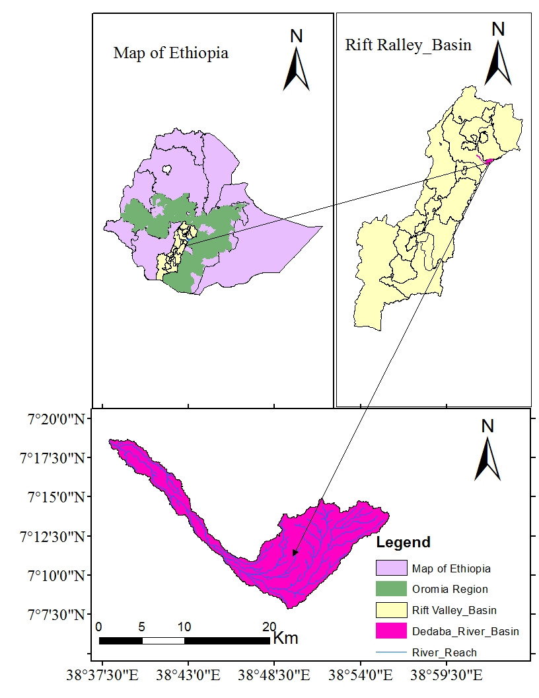
Figure 3.1Location map of the study area.

3.1.1 Topography
The study area lays almost in the central part of the Rift Valley Lake Basin andTopographically, the Dedaba watershed shows the variation with altitude ranging from around 1837m near Kuyera(at gauging station) to about 3086m above mean sea level on the Shire. The river flows from the east to the west.

3.1.2 Climate
Rainfall:
The watershed has an annual rainfall ranging from 737.25mm at the ShashemaneMeteorological gauging station and 1234.22 mm at Kofale stations (from NMAE). The mean annual rainfall was stated as follows. The mean monthly rainfall distribution for each station is shown in the appendix.
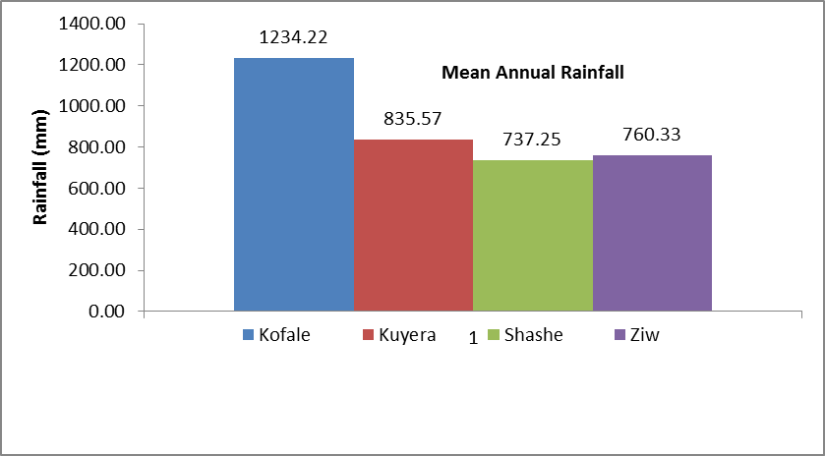
Figure 3.2Mean annual rainfall for the different stations from a period of 1990 - 2018
Temperature:
According to the data obtained from the national metrological agency of Ethiopia (NMAE) indicated the average annual maximum and minimum temperature around the watershed varies between 20⁰C–28⁰C and 7⁰C–14⁰C respectively.Temperature is higher at the Ziway metrological gauging station with a maximum of 28⁰C and a minimum at the Kofalemetrological gauging station of 7⁰C as shownin Figures 3.3 below.

Figure 3.3Maximum and minimum temperature aroundDedaba Watershed.

3.1.3 Soil Type
Soil data is a significant component in the study of land use and land cover changeimpact on hydrological components of watershed.According to the FAO/UNESCO soil classification system the study area comprisesof twomajor dominant soil types in the Dedaba watershed are presented in Table 3.1.SAWT model requires soil chemical and physicalproperties such as soil texture, available water content, hydraulic conductivity, bulk density andorganic carbon content for different layers of each soil type. These data were obtained fromMinister of Water irrigation and Energy (MoWIE).
Table 3.1Soil types of Dedaba Watershed with their areal coverage.
Soil Type | Area
Soil Type | Km² | %
HaplicLuvisols | 148.53 | 99.82
vitric andosols | 0.26 | 0.18
The areal coverage of the soil type is shown in figure 3.4 and Watershed was dominated by HaplicLuvisols and vitric andosols were shown below.
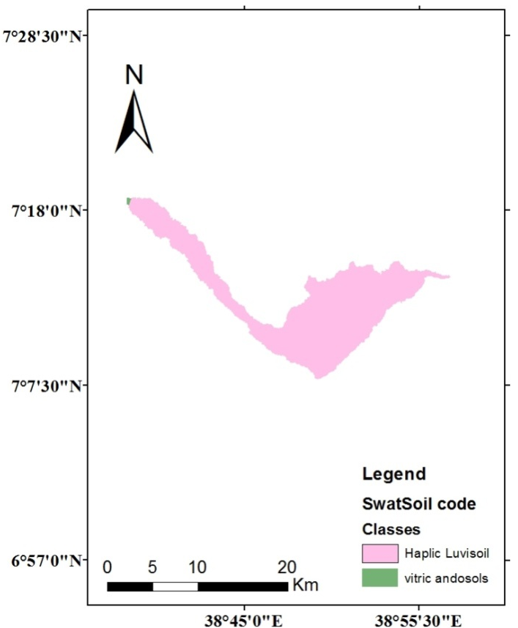
Figure 3.4Map of the soil types of Dedaba Watershed

3.2 Data Collection and Analyses

3.2.1 Digital Elevation Model
The digital elevation model is the basic input data for any hydrological modeling study, including SWAT. A30 m × 30 m DEM wasobtained from the shuttle radar topography mission (SRTM) of https://earthexplorer.usgs.gov/. From the relevant basic information of the basin-like physiographic characteristics of the watershed, including slope and elevation were extracting in the ArcGIS program.
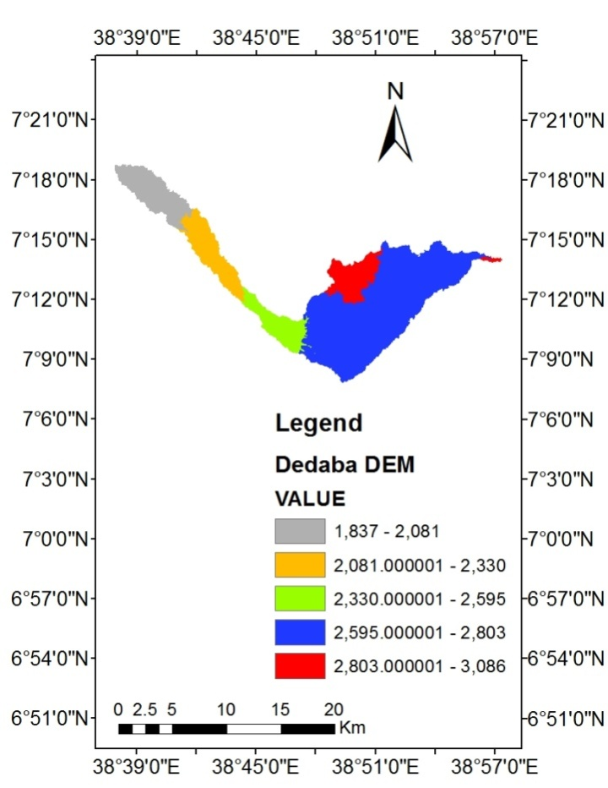
Figure 3.5Digital elevation model of Dedaba Watershed.

3.2.2Hydro-Meteorological Data
Meteorological data was collected from the National Metrological AgencyEthiopian. Thisdata collected includes daily data of precipitation, maximum and minimum temperature, relative humidity, wind speed, and solar radiation forfour stations in and around the watershed. Such as Kofale, Kuyera, Shashemane and Ziway stations as shown in Table 3.2
Table 3.2 Location of meteorological stations in and around the Dedaba watershed (NMAE)
No | Name  of station | latitude  (deg) | longitude  (deg) | rainfall  (mm) | max  temp | min  temp | relative humidity | sunshine hours | wind  speed
1 | Kofale | 7.07 | 38.48
2 | Ziway | 7.93 | 38.70
3 | Shashemene | 7.20 | 38.60 |  |  |  | x | x | x
4 | Kuyera | 7.29 | 38.65 |  | x | x | x | x | x
Note:-√contain all parameters and xis not contain all parameters.
The climatic data used for this study covers 29 years from 1990-2018. Based on the class of the stations, the number of weather variables collected varies from station to station that is grouped into two. Kofale and Ziway contain all parameters (rainfall, maximum and minimum temperature, humidity, sunshine hours, and wind speed) while Shashemene contains variables like rainfall, Max and Min temperature data and Kuyera contain only rainfall data.

3.2.2.1Filling Missing Rainfall Data
Missed measured precipitation data may face many problems in hydrologic analysis and design. The cost associated with data collection and some natural and man-made conditionssometimes make it very difficult to have complete records of data at every station.The conditions above mentioned sometimes prevent obtaining quantitative and qualitative data of thestudy area. For gauges that require periodic observation, the failure or absence of the observer tomake the necessary visit to the gauge, destruction of recording gauges and instrument failurebecause of mechanical or electrical malfunctioning can result in missing data. Any such causes ofinstrument failure reduce the length and information content of the precipitation record.
Hence, there are different methods for filling the missing data from those methods, station averageand the normal ratio method was used for the rainfall in this study area.The station average method is simple and used for flat areas with very little rainfall variability. It is conceptually simple, but may not be accurate when the total annual catch at any of the n regional gages differ from the annual catch at the point of interest by more than 10% (Richards, 1998).
The station average method is given by the Equation.
$Px=\frac{1}{n}\sum_{i=1}^{n}{Pi}$---------------------------------------------------------------------------------------------------- (3.1)
Where:-p_{X} is mean precipitation of missed and Pi is catch at gage i.
The normal ratio method is used when the average annual catches differ by more than 10%. Such differences might occur in regions where there are large differences in elevation.
The normal ratio method is a given Equation.
$Px=\frac{1}{n}*\{(\frac{Nx}{N1})*P1+(\frac{Nx}{N2})*P2+…+(\frac{Nx}{Nn})*Pn\}$--------------------------------------------------(3.2)
Where:- P_{X} = missing data at station x,
N_{x}= missing data stations normal annual rainfall,
N_{1,}N_{2,} N_{n} = normal annual rainfall at the station and n is the number of nearby gauges.

3.2.2.2 Homogeneity Test
Homogeneity analysis was used to separate a change in the statistical properties of the time-series data. The causes can be either natural or man-made. These include alterations to land use and relocation of the observation gauging station. Therefore to select the representative meteorological station for the analysis of areal rainfall estimation, checking the homogeneity of group stations is essential, the homogeneity of the selected gauging stations daily rainfall records was carried out by a non-dimensional Equation:(Tadesse T., 2016).
$Pi=\overline{\frac{Pi}{P}}$-------------------------------------------------------------------------------------------------------------(3.3)
Where: - Pi = Non-dimensional Value of precipitation for the month i
Pi¯ = Over years averaged monthly precipitation for the station i
P = Over year’s average yearly precipitation of the station
According to the Homogeneity test analysis, the selected stations were plotted for comparison with each other for illustration Figure 3.6below shows the result of the homogeneity analysis.The rainfall distribution in the study area (Dedaba Watershed) is found to be a mono-modal pattern (one peak) value observed during the rainy season especially from June to August and hence group stations selected are homogenous.

Figure 3.6 Homogeneity test analysis for all Meteorological stations

3.2.2.3Consistency of Rainfall Data
A double mass curve (DMC) was used to check the consistency of rainfall for adjustment of inconsistent data. This technique is based on the principle that when each record data comes from the same parent sample, they are consistent. A group of three base stations in the neighborhood of the station was selected. A consistent record is one where the characteristics of the record have not changed with time.
A double-mass curve is a graph of the cumulative catch of rain gage of interest versus the cumulative catch of one or more gage in the region that has been subjected to a similar metrological occurrence and is known to be consistent. If a rainfall record is a consistent estimator of the meteorological occurrences throughout the record, the double-mass curve wasa constant slope. A change in the slope of the double mass curves would suggestthat an external factor has caused changes in the character of the measured values. If a change in slope is evident, then either the record needs to be adjusted with the early or the later period of record adjusted (H.Hardision, 1960).
$\frac{Pa}{Pd}=\frac{\frac{Y}{X}}{\frac{Yd}{XD}}=\frac{The slope of the original line}{The slope of the deviated line}=Correction Factor$-----------------------------(3.4)
Where:-pa=adjusted amount
Pd=deviated amount for the concurrent period for which pa is desired.
According to the double mass curves analysis, all the stations in and around the Dedaba watershed were consistent. For illustration, the double mass curves for stations are presented below.
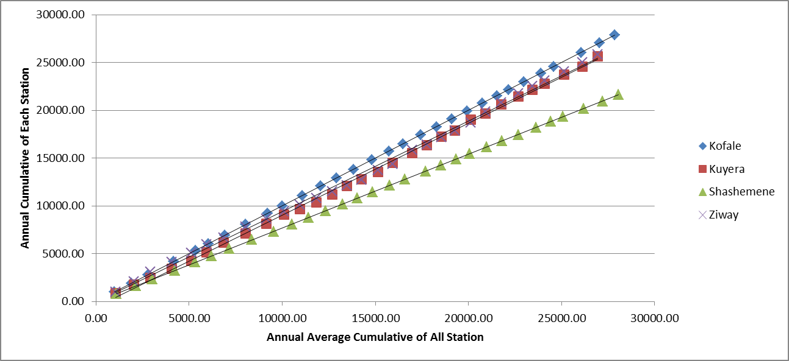
Figure 3.7Double mass curve plot for metrological stations.

3.2.2.4 FillingMissing Stream FlowData
The flow data was also collected from the Ministry of Water, Irrigation, and Energy of Ethiopia (MoWIE). Three gauging stations were found at upstream of Dedaba River. As per the Ministry of Water, Irrigation and Energy of Ethiopia (MoWIE) data indicates from those Turge and Huluka gauging station has no long recorded data. So those stations were used only for filling missing data for Dedaba gauging station; the missing data were filled by using the regression method for Dedaba gauging station.
Regression provides a means of finding the values of the coefficients a and b for straight line;
$y=a+bx$-------------------------------------------------------------------------------------------------(3.5)
The coefficients a and b can be found by the least square method using two simultaneous equations;
.$\left.\begin{aligned}\sum{y=na+b\sum{x}} \\ \sum{xy}=a\sum{x+b\sum{x^{2}}}\end{aligned}\right\}$---------------------------------------------------------------------------------(3.6)
Where; y = monthly rainfall, x= annual rainfall, n = number of year
The flow data at Dedaba gauging station were arranged as per the requirement of the SWAT_CUP software.Flow data was required for sake of calibration and validation of the model. The flow data at Dedaba has only a period of 14 years from 1993 to 2006.

3.3 Method

3.3.1 Assessment of LU/LC Changes

3.3.1.1Data from Satellite Images
The image for LU/LC change has been obtained using three Landsat images; Landsat of 1990, 2001 and 2018. These Landsat images selected throughout the study period and with a cloud cover of zero were collected from U.S. Geological Survey (USGS) Center for Earth Resources Observation and Science (EROS) via node of (https://earthexplorer.usgs.gov/). The image data files were downloaded in zipped files from the Global land cover facility (GLCF) website and extracted to Tiff format files. The acquisition dates, sensor, path/row, and resolution of satellite images used in this study were summarized in Table 3.4.
Table 3.3The acquisition dates, sensor, path/row, and resolution of the satellite image
Satellite name | Sensor | Path/raw | Date of acquisition | Reference data | Pixel size
LANDSAT_5 | TM | 168/55 | Jan/18/1990 | 1990 | 30m*30m
LANDSAT_5 | TM | 168/55 | Feb/06/2001 | 2001 | 30m* 30m
LANDSAT_8 | OLI | 168/55 | April/27/2018 | 2018 | 15m* 15m

3.3.1.2 Image Processing and Classification
Each land sat image was georeferenced to WGS_84 datum and Universal Traverse Mercator (UTM) Zone 37N. Preprocessing images such as layer stacking and band color combination were carried out. The satellite image of each band stacking was processed using Remote Sensing (RS) software packages by Erdas Imagine2014 software. Then the study area was clipped from the stacked images using Erdas Imagine2014. To make a better view of surface features clearly, the satellite images were performed by color composition.
Image classification was the process of assigning pixels of a continuous raster image to the predefined land cover classes. Different issues to keep in mind to avoid overlapping features and finish with effective classification parallel with the ground truth. The result of the classification was mostly affected by various factors such as classification methods, algorithms, collecting of training sites, etc. In most cases, the category of image classification technique was classified into three major categories: supervised, unsupervised, and hybrid. The hybrid classification technique (Teferi et al., 2010; Solomon et al., 2014), which involves unsupervised classification followed by a supervised classification technique. Unsupervised classifications were carried out using Iterative Self-Organizing Data Analysis (ISODATA) clustering algorithm (Boakye et al., 2008; Teferi et al., 2010) while supervised classifications were undertaken with the Maximum Likelihood Classification (MLC) algorithm (Solomon et al., 2014; Temesgen et al., 2014) by collecting training areas for the LU/LC classes.

For this study, the supervised classification type was applied. It was the most common type of classification technique in which all pixels with similar spectral values are automatically categorized into land cover classes or themes (Solomon et al., 2014; Temesgen et al., 2014). The supervised classification which relies on the prior knowledge of pattern recognition of the study area was used. It requires the manual identification of the point of interest areas as a reference or ground truth within the images, to determine the spectral signature of identified features. For this study, the land cover map was produced based on the pixel-based supervised classification through the step such as: first, selecting the training sites which are typically representative for the land cover classes. The training sites were collected based on the analyst’s personal experience and knowledge of the physiographical area from Google Earthand visiting the site of each year. Also, image enhancement and composition were applied for better discriminating the land cover classes. Then, perform the classification using the Maximum Likelihood classifier.

3.3.1.3LU/LCClasses
Before starting the analysis the LU/LC change studies usually need the development and the definition of homogeneous LU/LC units. These have to be differentiated using the available data source such as remote sensing, any other relevant information and the previous local knowledge. Hence, based on the prior knowledge of the study areathe types of LU/LC have been identified into four classes. The descriptions of theseLU/LC are given as follows.
- Agricultural land:- areas, used for crop cultivation, both annuals and perennials. Due to the difficulty encountered in identifying the dispersed rural settlements some kind of land cover was combined with the Agricultural land during classification.
- Forest land:- land covered which includes evergreen forest land, mixed forest, and plantation forests.
- Shrub and grassland:- areas covered with shrubs, bushes, small trees, grass, pastureland, and little wood mixed with the same grass.
- Built-up Area:- area covers Settlement areas of a building, rural residential houses, infrastructures, and roads.
The LU/LC map of the study area was coded to the SWAT four-letter codes and linked to the SWAT landuse database. This identifies the 4-letter SWAT code for the different categories of LU/LC would prepare to relate the grid values to SWAT LU/LC classes. Hence, after preparing the lookup table the landuse types were made compatible with the input required by the model.
Table 3.4LU/LC Classes of Dedaba Watershed
Landuse/ Landcover type | Land use according to SWAT database | SWAT code
Cultivated land | Agricultural Land-Close-grown | AGRC
Forest land | Forest-mixed | FRST
Shrub and grassland | Pasture | PAST
Built-up Areas | Residential-Medium Density | URMD

3.3.1.4 Classification Accuracy Assessment
One of the most important final steps in the classification process was accuracy assessment. Accuracy assessment aimed to quantitatively assess how effectively the pixels were sampled into the correct land cover classes.
Depending on the goal of the accuracy assessment, the number of ground truth sample plots can be calculated with different methods, which are Binomial distribution and Rule of thumb. If the project objective was to test not only right versus wrong but also to look at the multiple classes of wrong then a Binomial distribution should be used to calculate the sample size (Rosenfield, 1982). These computations allow the calculation of overall accuracy. This function describes the probability of getting misclassifications in a sample drawn from a parametric accuracy proportion (Ginevan, 1979). However, in the Rule of thumb, the number of samples for each category might be adjusted based on the relative importance of that category for a particular application. However, these techniques are not designed to choose a sample size for filling in an error matrix (Congalton, 1991). So for this study, Binomial distribution was used.
The following equation to calculate the sample number (cumulative binomial probability distribution):
$N=\frac{Z^{2}PQ}{E^{2}}$---------------------------------------------------------------------------------------------------( 3.7)
Where:-N = number of samples
Z= 2 * DS (DS: the standard deviation which was taken from
metadata of classified image)
P = expected percent accuracy
Q = 100 − p and
E = allowable error
In classifying 1990, 2001 and 2018 images, reference data from Google Earth images of the corresponding periods were collected. A total of 111, 183, and 201 ground truth points (locations) were randomly collected for the year 1990, 2001, and 2018 respectivelyand the result was presented in the result and discussion section. Accuracy assessment was employed concerning the corresponding each year of Google Earth imagesand site observationto illustrate the representativeness of the classified images on the ground.
Producer’s Accuracy:
The producer’s accuracy tells us how well a certain area can be classified. It is obtained by dividing the number of correctly classified pixels in the category by the total number of pixels of the category in the reference data. The producer’s accuracy is also known as an Omission Error, whichis the probability of a reference pixel being classified correctly. It gives only the proportion of correctly classified pixels.
User’s Accuracy:
It is the ratio between the total numbers of pixels correctly belonging to a class (diagonal elements) and the total number of pixels assigned to the same class by the classification procedure (row total). This quantity describes the probability that a pixel of the classified image truly corresponds to the class to which it has been assigned.
Overall Accuracy:
The overall accuracy was calculated by dividing the total number of correct pixels (diagonals) by the total number of pixels in the confusion matrix. The recommended standard of accuracy in the identification of LU/LC mapping from the remote sensor data should be 85%–95% (Anderson et al, 1976).
Kappa coefficient:
The kappa coefficient gives the agreement between the classified image and reference or ground truth. A Kappa coefficient equal to 1 means perfect agreement whereas a value close to zero means that the agreement is no better than would be expected by chance(Monserud, 2003). According to (Monserud, 2003) the acceptable ranges of the kappa coefficient were presented as shown in Table 3.6.
Table 3.5 Kappa statics ranges (Monserud, 2003).
 | Kappa statics ranges
1 | < 0.00 | Poor
2 | 0.00 - 0.20 | Slight
3 | 0.21 - 0.40 | Fair
4 | 0.41 - 0.60 | Moderate
5 | 0.61 - 0.80 | Substantial
6 | 0.81 - 1.00 | Almost perfect
The Kappa statistic was computed as;
$K=\frac{\sum_{i=1}^{r}{Xii}-\sum_{i=1}^{r}{(Xi+Xi+1)}}{N^{2}-\sum_{i=1}^{r}{(Xii+Xi+1)}}$--------------------------------------------------------------------------------( 3.8)
Where:-r = number of rows and columns in the error matrix,
N = total number of observations (pixels),
Xii = observation in row i and column i,
Xi = a marginal total of row I, and
Xi+1 = a marginal total of column i

3.3.2 SWAT Model SetupandPerformance Evaluation.

3.3.2.1 SWAT Model Setup
Arc SWAT version 2012 was extension of Arc GIS and its toolbar was added to Arc GIS10.3 to meet the objective of this study. SWAT project setup, watershed delineation and HRU analysis, write input tables, Edit SWAT input and SWAT simulation were the procedures in SWAT model setup.

3.3.2.2 Watershed Delineation
The first step in generating the SWAT model is watershed delineation. In SWAT project set up the project name and its file location was specified. Then the next stepwas watershed delineation. The watershed delineation was performed using 30m by 30mresolution of DEM. DEM data was projected to UTM under zone 37N. After loading DEM, thestream definition was the next step.
The stream definition was done by selecting threshold area.The threshold area required to form stream to be 5000 hectares to decrease the number of subwatershedand delineated into 5sub-watersheds having an estimated total area of 148.79km². Watershed delineation was more refined in the section by defining the outlet point forthe whole watershed. Outlet location of Dedaba watershed was added manually to the defined streamline.
Finally, stream networks, sub-watershedand topographic parameters were calculated using the respective tools. During the watershed delineation process, the topographic parameters such as elevation and slopes of the watershed and its sub-watershed were generated from the DEM data. The elevation of the watershed ranges from 1837 to 3086m above mean sea level. The highest elevation is at the Shireand the lowest elevation is near kuyera.

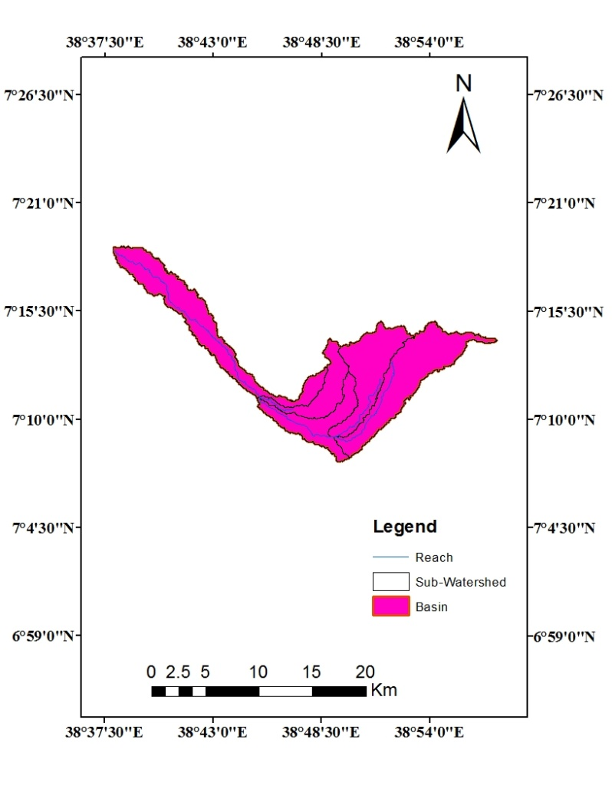
Figure 3.8Watershed delineation of the study area using SWAT

3.3.2.4 Hydrologic Response Units
After watershed delineation, LU/LC, soil and slope characterization for watershed was performedusing commands from HRU analysis menu of the Arc SWAT toolbar. These tool was used toloading LU/LC and soil layers of Dedaba watershed into the current project. Therefore,LU/LC, soil and slope combinations and distribution for the delineated Dedaba watershed wasdetermined in HRU analysis.
Finally, the watershed was divided into HRU which have similar soiland LU/LC combination.The prepared composite LU/LC map and soil map were given as input to the model in this step.The look up table containing various SWAT LU/LC class codes was prepared. This prepared Lookup table was linked to the SWATLU/LC data base. To link the prepared LU/LC data to SWATdatabase, lookup table was first prepared. This lookup table has two column named as value andname. The value in lookup table corresponds to the value of LU/LC class in attribute table for theclassified image and name corresponds to the name of LU/LC classes which corresponds to thename in SWAT data base.
Similarly soil physical attributes were initially stored to the SWAT database through an interface,relevant information required for hydrologic modelling. This Arc SWAT soil database and the soildata of the study area were linked by using lookup table.For defining HRU distribution, multiple HRUs option, which creates multiple HRU within eachsub watershed was chosen. The number of HRU in the watershed was controlled by thresholdvalue given during HRU definition. Melese, (2008)suggested that 10% LU/LC, 20% soil and 10%
slope gives better estimation of streamflow. Therefore, this study 10%, 20%, and 10%
threshold value was used to create LU/LC, soil and slope combination.
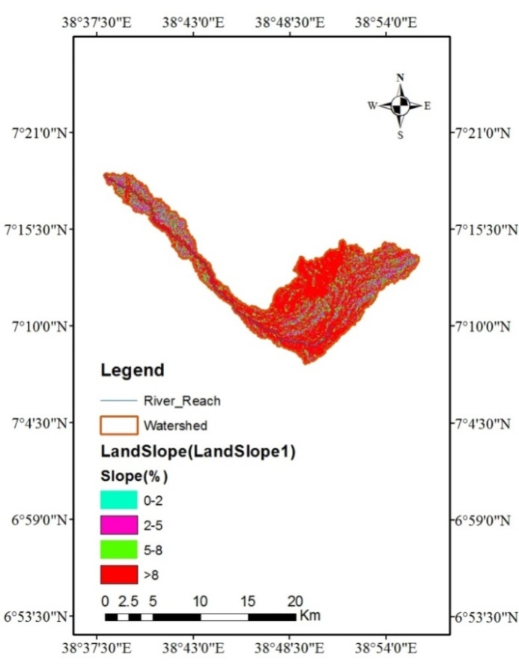
Figure 3.9 Slope class of study area
Table 3.6 The Slope Class of Dedaba Watershed.
Slope | Area(km²) | %
0-2 | 6.56 | 4.41
2-5 | 28.02 | 18.83
5-8 | 29.43 | 19.78
>8 | 84.78 | 56.98
It was reclassified into four classes (0-2, 2-5, 5-8 and >8) as recommended by the FAO slope definition (FAO, 1999). The slope of the watershed was classified into four classes as shown in Table 3.7.

3.3.2.5 Sensitivity Analysis.
Sensitivity analysis is defined as the process of determining the significance of one ora combination of parameters concerning the objective function or model output (Arnold J. G., 2012). Therefore, beforethe calibration and validation process, a sensitivity analysis was carried out to reduce the number of parameters that need optimization.
In this research semi-automated Sequential Uncertainty Fitting (SUFI 2) was used to identify the sensitive parameters. This was done to select the most flow influencing parameters in the watershed. Two kinds of sensitivity analyses are performed, local (one at a time) and global analysis. The sensitivity of one parameter often depends on the value of other related parameters (Arnold J. G., 2012), which is a problem with local sensitivity analysis. Global analysis requires a large number of simulations (Arnold et al, 2012).
In this research global sensitivity analysis was performed in SUFI-2 before calibration and the results were examined. However, in this research, the number of simulations used for calibration was 200, which is large enough to get accurate results for global sensitivity analysis. The global sensitivity analysis approach was used in SUFI2 because it takes into account the sensitivity of one parameter relative to the other to give their statistical significance. SUFI-2 is superior to other algorithms because it involves stochastic calibration, where the errors and uncertainties in the model are recognized and expressed as ranges accounting for all driving variables.
The inclusion of a large number of parameters representing different processes in the objective function, in SUFI-2 helpsto make the model result enveloping most of the observations well.
In this study, the t-Stat and P-Values of the parameters were used to rank the different parameters that may influence the flow and finally to select the ranked values. The model was run on monthlytime steps with observed data of the Dedaba River. For this analysis, 6 parameters were identified to have a significant influence in controlling the streamflow in the watershed.In the sensitivity process, the SWAT simulated TxtInout was copied to the workingdirectory and SWAT_CUP SUFI-2 was used for performing the sensitivity of selected parameters with the default lower and upper parameter bounds.
Thelarger the absolute value of t_Stat and the smaller of the p_Value, the more sensitive the parameter. The p_value tests the null hypothesis that the coefficient is equal to zero (no effect). A low p_valueof less than 0.05 indicates that the null hypothesis can be rejected. That means a predictor that has a low p_value is likely to be a meaningful addition to the model because changes in the predictor’s value are related to changes in the response variable. Conversely, a large p_value suggests that changes in the predictor are not associated with changes with the response. So that the parameter is not very sensitive.A p_value of less than 0.05 is a generally accepted point at which to reject the null hypothesis (SWAT_CUP user manual). Based on the above criteria, parameters were selected for the calibration process and the results were presented in the result and discussion section.

3.3.2.6 Calibration
After sensitivity analysis, the sensitive parameters were used for model calibration 1993-2001 including 2 years of warm-up period to optimize the values of those sensitive parameters. In this research first,manual calibration was done and parameters were adjusted in the SWAT model. Then, auto-calibration (SUFI-2) was applied for the calibration of the SWAT model. In the SWAT-CUP calibration procedure, the SWAT simulation was specified forperforming the calibration and the location of the sub-watershed where the observed flow could be compared against simulated output (Dedaba gauging station). Then, the desired parameters for optimization observed data,and methods of calibration were selected. Hence, 6 flow parameters monthly were selected in the calibration process according to SWAT CUP user manual criteria.
After the calibration was completed, the model was run using the best parameter output values and the simulations were compared with observed streamflow data using the Nash Sutcliffe coefficient (NS), coefficient of determination (R²).
Generally, model calibration entails the modification of parameter values and comparison of the output of interest to measured data until model efficiency was achieved (James and Burges, 1982).

3.3.2.7 Validation
Validation was described as the process of demonstrating that a given site-specificmodel is capable of making sufficiently accurate simulations, also sufficientlyaccurate results can vary based on project goals (Arnold et al, 2012). It is used to testthe calibrated parameters with an independent set of data without further changes tothe parameters. In this study, the validation was performed to compare the modeloutputs with an independent data set without making a further change to parametersobtained during the calibration process. The measured data of average monthly streamflow from 2002-2006 at Dedaba gauging station was used for modelvalidation.

3.3.2.7 Model Performance Evaluation
According to Arnold et al., (2012) the calibration and validation model performances can be assessed using two model evaluation criteria, Nash and Sutcliffe Coefficient of Efficiency (NSE)and Coefficient of Determination (R²).Model evaluation was an essential measure to verify the toughness of the model.
The determination coefficient (R²) describes the proportion of the variance in measured data by the model (Arnold et al., 2012). It was the magnitude linear relationship between the observed and the simulated values. R² ranges from 0 (which indicates the model is poor) to 1 (which indicates the model is very good), with higher values indicating less error variance, and the flow calibration procedure made by SWAT developers in Santhi, (2001) and Neitsch et al., (2005) was carefully followed. SWAT developers assumed an acceptable calibration for hydrology R²>0.6 (Arnold et al., 2012).
The R² was calculated using the following Equation:
$R^{2}=\frac{\sum_{i=1}^{n}{{[\left(Qi-Qav\right)*\left(Pi-Pav\right)]}^{2}}}{{\sum_{i=1}^{n}{(Qi-Qav)}}^{2}*\sum_{i=1}^{n}{(}{Pi-Pav)}^{2}}$------------------------------------------------------------------------(3.9)
Where:- Qi = measured value, Pi = simulated value, Qav = average observed value and
Pav= average simulated value
The Nash and Sutcliffe Coefficient of efficiency (NSE) describes the deviation from the unit of the ratio of the square of the difference between the observed and simulated values and the variance of the observations. The value of the coefficients varies from minus infinity to one with the latter value indicating perfect agreement between the simulated and observed data. A smaller NSE value indicates a poorer fit between the simulated and observed data(Santhi, 2001; Moriasi, 2007).
NSE was recommended and widely used in literature (Moriasi, 2007) therefore there is a lot of reported values for use as evaluation guidelines. NSE, in a simplified explanation by (Moriasi, 2007) is an indication of how well the plot of observed versus simulated data fits the 1:1 line and NSE > 0.5 (Santhi, 2001; Moriasi, 2007).
$ENS=1-\frac{\sum_{i=1}^{n}{{(Qi-Pi)}^{2}}}{\sum_{i=1}^{n}{{(Qi-Qav)}^{2}}}$-------------------------------------------------------------------------------(3.10)
Where:- Qi = measured value ,
Pi = simulated value and
Qav= average observed value

3.3.3 Impacts of Land Use and land Cover Change on Stream Flow
Assessement of the impacts of LU/LC change on stream flow is one of the most significant parts of thisstudy. The study was carried out for three different years (1990, 2001 and 2018). The threeclassified LU/LC maps, soil, climatic and stream flow data values was used to assesement the impactsof land use and land cover change on stream flowusing the SWAT model.
To asses the variability of streamflow due to LU/LC change, the three LU/LC maps were usedindependently in the three simulation while by keeping other variables constant. Once the streamflow was simulated using the SWAT model, the impact was computed by comparing each flow together.
To see the seasonal variation of stream flow, driest and wettest month in the studyarea was identified first. Then contributors of stream (SURQ and GW_Q) flow values for eachLU/LC map was compared to each other.

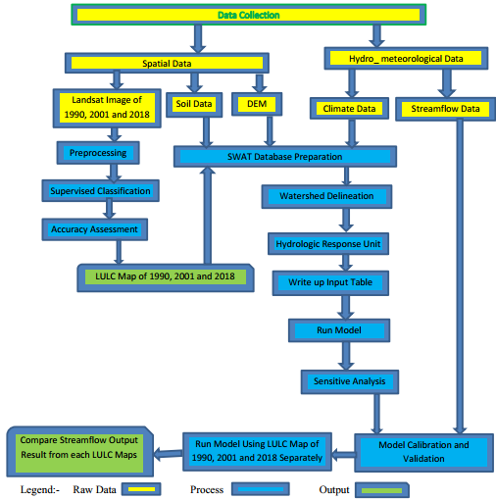
Figure 3.10Over all frame work of the study.

4. RESULT AND DISCUSSION

4.1 LU/LC Change Analysis

4.1.1Accuracy Assessment
Post-classification enhancements are used to reduce the classification faults stemming from base
fields, cities and classes which have similar responses like some crop areas and grasslands. As the classes which were among the fallow fields and perceived as extraction were accepted as fallowploughed at the time the image was taken, they were included in the category of farm lands.There are numerous grasslands in the study area and these have the same spectral responses assmall grains in agricultural areas. Therefore they were accept as small grains most of time, butwere sometimes accepted as grass lands, depending on the growing areas.
Having made the enhancements of post classification mistakes, it is necessary to test the
accuracy of the classification. Because changes in land use are discovered through the estimation
of total squares of land use classes in the land use cover maps created for each different years
(1990, 2001 and 2018), errors in the classification can lead to the misinterpretation of change
analysis. The main technique for accuracy assessment is using change maps for evaluating each
class and calculating the expected accuracy (Yuan et al., 1998). Another method leading to more
exact results is by checking points accurately classified or not, after the selection of the points
where changes are available or not upon the map. An accuracy assessment test was applied by
using an accuracy matrix with 150 randomly selected points. The accuracy assessment was
performed by using land use maps, ground truth points and Google Earth. Great importance was
given to the representation of different LU/LC classes by these randomly chosen points.
The accuracy of the classification was performed by using visual/ spatial comparison by linking
the view with the collected training site and Google earth. Evaluation of classification results is
an important process in satellite image classification procedure.
The accuracy assessment is used to determine the precision of the classified image. It was performed using a confusion matrix. Using the original mosaic image and the Google Earth Image as a reference, randomly selected points were compared with the corresponding classification.
Overall accuracy:
As the results indicated the overall accuracy for 1990, 2001 and 2018LU/LC map were 91.89%, 91.26%, and 95.52% respectively. According to (Anderson et al, 1976), the minimum accuracy value for reliable land cover classification is 85 %. Therefore, as shownin Tables 4.2, 4.3, and 4.4the classification carried out in this study produces an overall accuracy that full fills the minimum accuracy level defined by Anderson for those land cover maps of the Dedaba watershed.
Kappa coefficient:
The results indicated that the Kappa coefficient for the maps of 1990, 2001 and 2018 were0.92, 0.91 and 0.96respectively for each year. According to (Monserud, 2003) suggested the classification in this study hasa perfectagreement with the validation data set.
Producer’s Accuracy:
The overall result of the producer’s accuracy ranges from 57% to 100%. The lowest values were misclassified due to the similar spectral value of different land cover classes. For instance, Agricultural land with forest covers, Agricultural land during the dry season with the urban area,(which is classified as a Built-up area), etc. somehow affects the level of classification.
User’s Accuracy:
In this study, the user’s accuracy ranges from 57% to 100%. The lowest value shrub and grassland were to some extent misclassified because of the similar spectralproperties of builtupand forest.
Table 4.1 Confusion Matrix for LU/LC Map of 1990
Classified Data | Reference Data
Classified Data | BUA | SHGL | FRST | AGRC | Total | Users Accuracy
BUA | 2 | 0 | 0 | 0 | 2 | 100%
SHGL | 0 | 23 | 4 | 0 | 27 | 85.19%
FRST | 1 | 0 | 21 | 2 | 24 | 87.50%
AGRC | 0 | 0 | 2 | 56 | 58 | 96.55%
Total | 3 | 23 | 27 | 58 | 111
Producers’ Accuracy | 66.67% | 100% | 77.78% | 96.55%
Overall Classification Accuracy = 91.89%; Kappa coefficient= 0.92
Note: AGRC=Agricultural land; FRST = Forest land, SHGL = Shrub and Grassland; BUA = Built Up Area.
Table 4.2 Confusion Matrix for LU/LC Map of 2001
Classified Data | Reference Data
Classified Data | BUA | SHGL | FRST | AGRC | Total | Users Accuracy
BUA | 4 | 3 | 0 | 0 | 7 | 57%
SHGL | 1 | 42 | 0 | 4 | 47 | 89%
FRST | 2 | 0 | 29 | 3 | 34 | 85%
AGRC | 0 | 1 | 2 | 92 | 95 | 97%
Total | 7 | 46 | 31 | 99 | 183
Producers’ Accuracy | 57% | 91% | 94% | 93%
Overall Classification Accuracy = 91.26%
Kappa coefficient= 0.91
Table 4.3 Confusion Matrix for LU/LC Map of 2018
Classified Data | Reference Data
Classified Data | BUA | SHGL | FRST | AGRC | Total | Users Accuracy
BUA | 16 | 1 | 0 | 3 | 20 | 80%
SHGL | 0 | 47 | 0 | 2 | 49 | 96%
FRST | 0 | 0 | 26 | 1 | 27 | 96%
AGRC | 2 | 0 | 0 | 103 | 105 | 98%
Total | 18 | 48 | 26 | 109 | 201
Producers’ Accuracy | 89% | 98% | 100% | 94%
Overall Classification Accuracy =95.52%
Kappa coefficient= 0.96

4.1.2LU/LC Change of Dedaba Watershed
In the watershed, the area covered by different land use land cover in percent during 1990 was 50.80% Agricultural land, 20.07 %Forest land, 28.96% Shrub and Grassland and 0.17% Built-up area And also, during 2001 were 81.30% Agricultural land, 2.92 % Forest land, 15.47 % Shrub, and Grassland and 0.31 %Built-up area. Lastly, during 2018 were 84.43% Agricultural land, 0.57% Forest land, 13.35% Shrub and Grassland, and 1.65% Built-up area.
Table 4.4 Magnitude and proportion of LU/LC
Class Name | 1990 |  | 2001 |  | 2018 |  | 1990-2001 | 2001-2018 | 1990-2018
Class Name | Area (Km²₎ | % | Area (Km²₎ | % | Area (Km²₎ | % | % | % | %
AGRC | 75.59 | 50.80 | 120.97 | 81.30 | 125.62 | 84.43 | 30.50 | 3.13 | 33.63
FRST | 29.86 | 20.07 | 4.34 | 2.92 | 0.85 | 0.57 | -17.15 | -2.35 | -19.50
SHGL | 43.10 | 28.96 | 23.02 | 15.47 | 19.87 | 13.35 | -13.49 | -2.12 | -15.61
BUA | 0.25 | 0.17 | 0.47 | 0.31 | 2.46 | 1.65 | 0.14 | 1.34 | 1.48
Total | 148.8 | 100 | 148.8 | 100 | 148.8 | 100

So Agricultural land, Shruband Grassland have dominated the watershed during the study period and Built-up area and Forest land also the parts of the watershed. For detailed information presented Table 4.4 and Figures below.
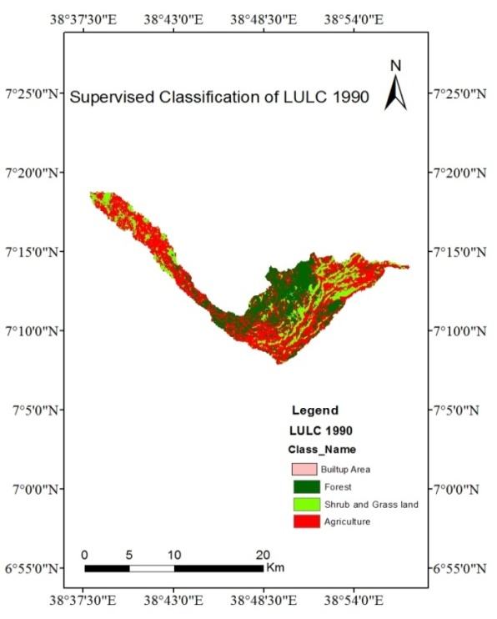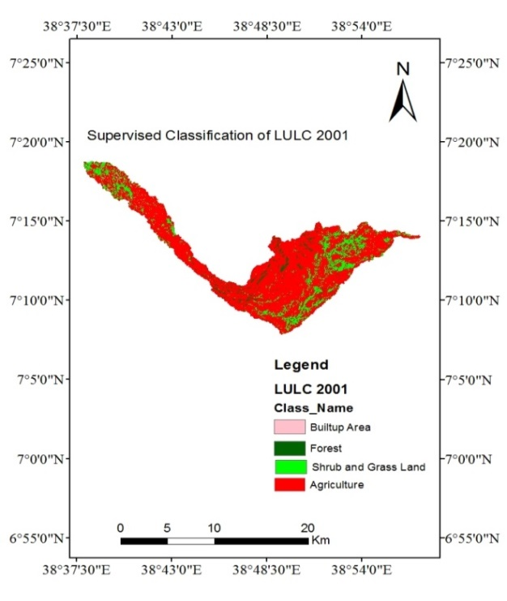

(a)(b)
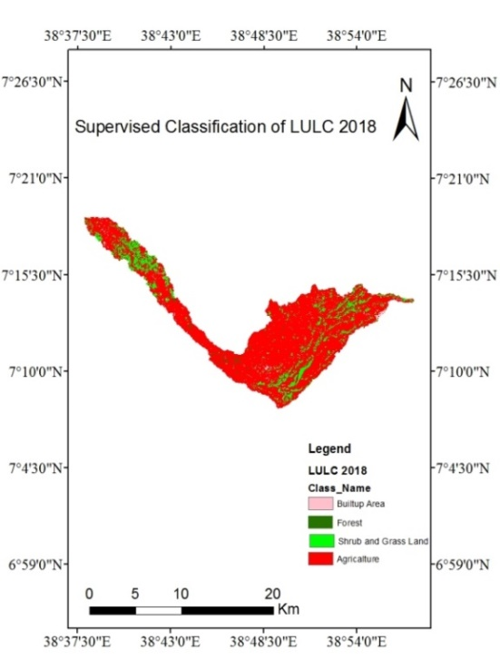
(c)
Figure4.1LU/LC mapof (a) 1990, (b) 2001 and (c) 2018.
From Table 4.1the land use and land cover map of the Built-up area increased by 1.48% and agricultural land expansion by33.63%. In contrast, shrubs and grassland decreased by15.61% andforest decreased by 19.5% from 1990 to 2018.

Figure 4.2Graph of land use and land cover change of 1990, 2001& 2018.
Halcrow, (2008) conducted that a study on the Rift Valley Lakes Basin Integrated Resources Development Master plan and reported that there are Agriculture and urban expansion. Agricultural expansion is one of the major causes of LU/LC change in the study area. This implies that population pressure is believed to be one of the major driving forces for the change of land use/land cover (Molla, 2014).According to this study, the extent of forests was converted into cultivation and also, conversion of grassland to cultivation land in the watershed. Because for the seek of agriculture land, timber and fuelwoodthe forest were disappeared.

4.2PerformanceEvaluation of the SWAT Hydrological Model

4.2.1 Sensitivity Analysis of Stream Flow Parameters
Sensitivity analysis of simulated stream flow for the sub_watershed was performed using the monthlyobserved flow data for identifying the most sensitive parameter and for further calibration of thesimulated stream flow. 19 flow parameters were checked for sensitivity and 6 of themwere found to be highly sensitive. For, detail information presented in (Table. 4.5) and in appendix.
Table 4.5Parameters acquired through Calibration.
No | Parameter_Name | Fitted_Value | Min_value | Max_value
1 | 14:R__SOL_BD(..).sol | 1.98 | 0.9 | 2.5
2 | 1:R__CN2.mgt | 65.87 | 35 | 98
3 | 18:R__ESCO.hru | 0.23 | 0 | 1
4 | 2:V__ALPHA_BF.gw | 0.71 | 0 | 1
5 | 7:R__RCHRG_DP.gw | 0.88 | 0 | 1
6 | 5:R__GW_REVAP.gw | 0.05 | 0.02 | 0.2

4.2.2 Model Calibration and Validation

4.2.2.1 Calibration
The monthly flow of Dedaba watershed from 1993 to 2001 was used for calibration. The first two years from the recorded data 1993 and 1994 were used as a model warm-up Period to establish proper initial conditions and stabilize the model as suggested by SWAT manual users.
As shown from Figure 4.3 model was calibrated using monthly streamflow of observed data from the Dedaba hydrological Station. The simulated and observed flow data during the calibration periods resulted in a goodagreement using R² and NSE with the result of 0.87 and 0.73 respectively.The coefficient of determination (R²) and Nash-Sutcliffe efficiency (NSE) for the Dedaba gauged stations fulfilled the acceptable requirement of R²> 0.6 and NSE > 0.5, which was recommended by (Santhi, C. J. 2001).
Based on the result, the model was efficient enough to represent and evaluate the impact of LU/LC change on streamflowvariability (Table 4.6).This indicated that the model performance assessment a good correlation and agreement between the monthly measured data and simulated flow.
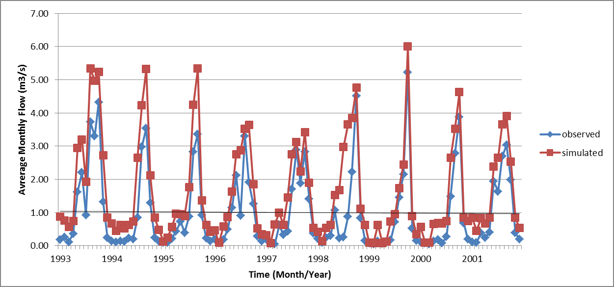
Figure 4.3Simulated and observed discharge for calibration period (1993-2001).

4.2.2.2 Validation
Model validation was done for the period of 2002 to 2006 monthly flow data. Using the same parameter values of the calibrated model setup were validated and found to prove the applicability and the result showed that the coefficient of determination (R²) and the Nash-Sutcliff efficient (NSE) are 0.82and 0.68respectively. The validation period has shown a good agreement between monthly observed and simulated flow.

Figure 4.4Simulated and observed discharge for validation period (2002-2006).
The result indicated that the model is capable of predicting the watershed streamflow in good manner. Hence, themodel simulations can be used for various water resource management and development aspects.
Table 4.6 Monthly calibration and validation of model performance
Period | Performance Evaluation Criteria
Period | R² | NSE
Calibration (1993-2001) | 0.87 | 0.76
Validation (2002-2006) | 0.82 | 0.68
Generally, the graphical and statistical results both during the calibration and validation period showed adequate model performance.

4.3. Impact of Landuse and Land Cover Change on Stream Flow
To assess the impacts of LU/LC change on streamflow, the SWAT model was calibrated and validated for streamflow. After calibration and validation of the SWAT model, the model was run using the three LU/LC maps (1990, 2001 and 2018) while maintaining the other parameters the same to estimate the change of streamflow.The simulated stream flows due to the three LU/LCmapswere compared to estimate the effects of LU/LC change on the streamflow.
The output of the simulated stream flow was classified as the wet season(June to August), dry season(December to January), short rainy season (March to May)and annual flow (January to December).The simulated streamflow for the 2018 LU/LC result revealed that the flow was increased by 9.64% and 3.05% during the wet season and short rainy respectively. This result can be characterized as a positive impact (increasing streamflow) on the flow record because of LU/LC change in the watershed whereas, the result also simultaneously shows the change in LU/LC has a negative (decrease in streamflow) impact on the dry season which contributes to a decrease in the streamflow by 5.6%.
Table 4.7Mean monthly simulated streamflow change due to LU/LC change
Flow season | 1990 | 2001 | 2018 | 1990 -2001 | 2001-2018 | 1990-2018 | % of change
wet season (m3/s) | 121.67 | 126.71 | 133.4 | 5.04 | 6.69 | 11.73 | 9.64
Dry season (m3/s) | 27.70 | 26.47 | 26.15 | -1.23 | -0.32 | -1.55 | -5.6
short rainy season (m3/s) | 90.52 | 92.82 | 93.28 | 2.3 | 0.46 | 2.76 | 3.05
Annual flow (m3/s) | 70.54 | 72.92 | 74.60 | 2.38 | 1.68 | 4.06 | 5.76
Therefore, discharge during the dry months (baseflow) decreased, and discharge during the wet month increased.
The surface runoff and groundwater flow were the most important watershed processes and the assessment was done depending on these processes at the watershed outlet. These processes can be affected by LU/LC change. It was done to see the streamflow change as a result of LU/LC change during the years 1990, 2001 and 2018.
Table 4.8Mean annual simulated surface runoff and groundwater flow.
Flow season | LU/LC change |  |  | Difference
Flow season | 1990 | 2001 | 2018 | 1990 -2001 | 2001-2018 | 1990-2018 | % change
SURQ(mm) | 20.10 | 21.56 | 22.63 | +1.46 | +1.07 | +2.53 | +12.58
GW_Q(mm) | 2.40 | 2.20 | 2.09 | -0.2 | -0.11 | -0.31 | -14.83
The variation was associated with the land use/land cover change during the study period. As it can be seen from Table 4.8 the simulated SURQ and GW_Q (mm) using the 2018 LU/LC result revealed that the surface runoff was increased by 12.58% and the groundwater contribution was decreased by 14.83% when it was compared with 1990 LU/LC (the negative result shows the decreased of GW_Q).
Different studies have been conducted in different parts of Ethiopia to evaluate the effects of LU/LCC on streamflow. As stated by Turner et al., (1993) and Tracy et al., (2007), from past studies Surface runoff recorded in the area of cultivation and grassland, was much higher than forest area. Cultivation land can keep less soil moisture and higher runoff than forests. Therefore the rainfall quickly satisfies the soil moisture in cultivation land and converted to a rapid runoff in areas where cultivation land was dominant. Forest land can intercept the rainfall by a canopy structure and gives the water more time to satisfy soil moisture and infiltrate to the ground which decreases the number of waters to generate runoff (Scott et al., 2002; Teferi et al., 2010).
Decreasing forest vegetation cover, expansion of cultivation land, and urbanization at a cost of natural forest are known causes to increase streamflow during the wet and short rainy season,While it decreases the baseflow during the dry season by decreasing infiltration, which reduces the amount of water to be percolated to recharge the groundwater.
In general, from this study, the impact of land use/land cover change on hydrological components of Dedaba streamflow showed that the baseflow and surface flow have been changed in the study period. The baseflow decreased while surface runoff increased as a result of urbanization, agricultural land expansion, and the decrease of the forest.

5. SUMMARY AND CONCLUSION

5.1. Summary
In this study,the SWAT model was applied to assess the impacts of land use/land cover changes on the hydrologic regime of the Dedaba watershed. To do this, satellite images were used to produce the map of the different cover classes of the Dedaba Watershed using Erdas IMAGINE2014 during the past twenty-nine years (1990-2018). This was done to map the land use/cover classes and assess classification accuracy. The SWAT model was calibrated and validated in the Dedaba Watershed and Statistical performance of the model was seen. Then, the impacts of land use/cover change on streamflow were done. The preparation of hydro-meteorological data and land use/land cover data, sensitivity analysis, calibration, validation and evaluation of model performance were done beforeassessment of land use/land cover impact on the hydrologic response of the Dedaba Watershed. Processing of soil and DEM data were done using GIS whereas, land use/land cover processing was done using Erdas IMAGINE2014.
The land use /land cover analysis during the study period (1990-2018) indicated a significant change of LU/LC in the Dedaba Watershed. The study shows the expansion of land area under cultivation by 33.63 % and builds up the area by 1.48% of a total area but the shrubs and grassland and forest land decreased by 15.61% and 19.50respectively due to agricultural encroachment to marginal land and expansion of settlement area during the study period.
For global sensitivity analysis using SWAT CUP (SUFI-2) 19 flow parameters that may affect streamflow were considered 6 parameters were selected to influence in controlling the hydrological processes in the watershed. The graphical and statistical results during the calibration period showed adequate model performance withNSE values of 0.73and R² 0.87whilethe validation value of NSE 0.68andR² 0.82.
The impacts of land use/land cover change on streamflow were done after calibration and validation of the model at the gauging location. The result shows that the mean wet monthly flow increased by 9.64% and the mean dry monthly flow decreased by 5.6% during the study period (1990-2018). The surface runoff (SURQ) increased by 12.58%whereas; the groundwater flow (GW_Q) contribution was decreased by14.83%(1990 to 2018).

5.2. Conclusion
Generally, the massive change was recorded between Agricultural land, shrub and Grassland, forest landand built-up area. It was easily shown that there was an increase of Agricultural land, built-up area, and decrease of forested areas and shrub and grassland over 29 years in selected three times series (1990, 2001 and 2018).
Using estimated LU/LC change the SWAT model produced the required performance. The parameters were allowed to vary during the calibration and validation process within acceptable ranges across the watershed until an acceptable fit between the measured and simulated values was obtained. The SWAT model showed the required performance for both calibration and validation on the watershed.
The impacts of LU/LC change on streamflow in four flow periods; wet season,dry season, short rainy season and annual flow. The simulated streamflow revealed that the streamflow was increased during the wet season whereas; the result also simultaneously showed that the streamflow decreased during the dry season due to the impacts of LU/LC change. Therefore, it was very important to study the impact of LU/LC on streamflow in particular attention.

5.3 Recommendations
Generally, based on the results of the study, the following recommendations were made:
- Reforestation of marginal land upstream of the watershed should beimplemented to develop the hydrology
- Due to significant LU/LC change, it needs effective participatory integrated watershed management.
- The watershed was sensitive toLU/LCchange, so the government should give orientation for every stockholder to protect the watershed by protecting their farmland as well as the surrounding area from deforestation.Otherwise, deforestation leads to flooding during the wet season and water scarcityduring the dry season in the watershed.
- The model simulation only considered land use land cover change effect on streamflow by assuming all other parameters like change in climate, soil management, and other landuse variableswas contributeda great effect on the hydrological process of the watershed are constant.
- Further researches like the impact of climate change on basin hydrologyand sedimentation effects on Lake Shallashould be done.

REFERENCES
Abbaspour, K.C., Rouholahnejad, E., Vaghefi, S., Srinivasan, R., Yang, H. and Klove, B. (2015). A continental-scale hydrology and water quality model for Europe: Calibration and uncertainty of a high-resolution large-scale SWAT mode. Journal of Hydrology, 524, 733–752.
Abebe, S. (2005). Land-Use and Land-Cover change in headstream of Abbay watershed, Blue Nile Basin. Addis Ababa University, Ethiopia.
Adamu, A. (2013). Assessing The Impacts of Land Use and Cover Change on Hydrology ofWatershed: The Case Study on Gilgel Abbay Watershed, Lake Tana Basin, Ethiopia.
Anderson, J., Hardy, E., Roach, J. and Witmer, R. (1976). A Land Use and Land Cover Classification System for use with Remote Sensor Data. Geological Survey Professional Paper . 964.
Arnold J. G. and D. N. (2012). SWAT Model Use, Calibration, and Validation. American Society of Agricultural and Biological Engineers, Vol. 55(4), 1491-1508.
Arnold, J. G. W., Moriasi, P. , J. G. Gassman, K. C. Abbaspour, M. J. White, R. Srinivasan, C.
Asres M. and Awulachew S. (2010). SWAT based runoff and sediment yield modeling: A case study of Gumera Watershed in Blue Nile basin. Ecohydrology and Hydrology, Ecohydrology for water ecosystems and society in Ethiopia.
Atasoy, M., R.B. Palmquist, and D.J. Phaneuf. (2006). Estimating the effects of urban residentialdevelopment on water quality using microdata. Journal of Environmental Management. 794: 399 408. .
Barkhordari, J. (2003). Assessing the Effects of Land Use Change on Hydrologic Regime by Remote Sensing and GIS: A case study in the Minab watershed, Hormozgan Province Iran, Masters Thesis,the Netherlands.
Bawahidi, K. S. ( 2005). Integrated land-use change analysis for soil erosion study in ulu kinta Watershed. Universiti Sains Malaysia.
Birhanu, A. (2014). Environmental Degradation and Management in Ethiopian Highlands: Review of Lessons Learned. International Journal of Environmental Protection and Policy, 2, 24-34. https://doi.org/10.11648/j.ijepp.20140201.14.
Boakye, E., Odai, S., Adjei, K., and Annor, F. . (2008). Landsat images for assessment of the impact of land use and land cover changes on the Barekese Watershed in Ghana. Eur. J. Sci. Res., 22 (2), 269–278.
Campling, P., Gobin, A., Beven,K and Feyen, J. . (2002). Rainfall-runoff modelling of a humi tropical catchment: The TOPMODEL approach. Hydrological Processes, 16(2), pp. 231– 253.
Chemelil, M. C. (1995). The Effects of Human-Induced Watershed Changes on Stream Flows, Doctoral Thesis.
Chow, V. T. (1988). Applied Hydrology. McGraw-Hill, New York.
Congalton, R. (1991). A Review of Assessing the Accuracy of Classifications of Remotely Sensed Data. Remote Sensing of Environment. 37:35{46.).
Costa, D., Avelino, R., Sára, S., Thomazini, L., Aurélio, M. & Caiado, C. (2015). Application of the SWAT hydrologic model to a tropical watershed at Brazil. Catena. 125, 206-213. doi:10.1016/j.catena.2014.10.032.
CSA. (2015). Statistical Abstract of Ethiopia. Addis Ababa. Central Statistical Agency.
Cunderlik, J., and Simonovic, S. . (2004). Inverse Modeling of Water Resources Risk and Vulnerability to Climatic Conditions,57th Canadian Water Resources Association Annual Congress, Water, and Climate Change. Knowledge for Better Adaptation. June 16-18, Montreal,Qc,Canada.
Cunderlik, M. J. (2003). Hydrologic model selection for the CFCAS project: Assessment of Water Resources Risk and Vulnerability to Changing Climatic Conditions. Project Report I University of Western Ontario, Canada.
Danuso, F. (2002). A Stochastic Model for weather data generation. Italian, Journal of Agronomy.
DeFries and Eshleman. (2004). Predicting discharge at ungauged catchments : parameter estimation through the method of regionalisation.MSc-thesis. University of Twente, Enschede.
Elfert, S., & Bormann, H. (2010). Simulated impact of past and possible future land use changes on the hydrological response of the Northern German lowland “Hunte” watershed. Journal of Hydrology, 383, 245–255.
Eshleman., D. a. (2004). Predicting discharge at ungauged watersheds : parameter estimation through the method of regionalisation.MSc-thesis. University of Twente, Enschede.
FAO. (1999). Soil salinity assessment: Methods and interpretation of electrical conductivity measurements.
FDRE, (Federal Democratic Republic of Ethiopia). (2004). The new coalition for food security
in Ethiopia: Food Security Programme, Monitoring and Evaluation Plan (October 2004–September 2009). Addis Ababa: Food Security Coordination Bureau.
Fohrer, N. H. (2001). Hydrologic Response to Land Use Changes on the Watershed Scale. Phys. Chem. Earth. 26, 577-582.
Gashaw G. and Mamaru A. (2015). Assessing the Land Use/Cover Dynamics and its Impact on
the Low Flow of Gumara Watershed, Upper Blue Nile Basin, Ethiopia.
Gebrie, M. J. (2016). Evaluation of Land Use Land Cover Change on Stream Flow: A Case Study of Dedissa Sub Basin, Abay Basin, South-Western Ethiopia. International Journal of Innovations in Engineering Research and Technology.
Geographica, A. and Comenianae,A. . (2010). Rainfall-Runoff Modelling : Its Development, Classification. 54(2), pp. 173–181.
Getachew Tegegne, D. H. (2013). Lake Tana Reservoir Water Balance Model. International Journal of Application or Innovation in Engineering and Management (IJAIEM), 2 (3), ISSN 2219-4847.
Getahun YS, V. L. (2015). Assessing the Impacts of Land Use-Cover Change on Hydrology of
Melka Kuntrie Subbasin in Ethiopia, Using a Conceptual Hydrological Model. Hydrol
Current Res 6: 210. doi:10.4172/2157- 7587
Getachew, H. a. ( 2012). The Impact of Land Use Change on the Hydrology of the Angereb Watershed, Ethiopia. International Journal of Water Sciences, Vol. 1(4).
Ginevan, M. (1979). Testing land-use map accuracy: another look. Photogrammetric another look. Photogrammetric Engineering and Remote Sensing, . 45(10):1371{1377}.
Golosov, V. a. (2006). Century-scale Stream Network Dynamics in the Russian Plain in Response to Climate and Land Use Change. 66, 74-92.
Green, W. H., and Ampt, G. A. (1911). Studies on soil physics-I. The flow of air and water through soils. The Journal of Agricultural Science, 4(1), 1–24 .
H.Hardision, J. K. (1960). General Surface Runoff Techniques. Usa: Usa Government Printing Office Washington.
Hadgu, K. M. (2008). Temporal and Spatial Changes in Land Use Patterns and Biodiversity in Relation to Farm Productivity at Multiple Scales in Tigray, Ethiopia. Ph.D. Thesis at Wageningen University, Wageningen, The Netherlands.
Haile TA, E. K. (2011). Changes in land cover, rainfall and stream flow in Upper Gilgel Abbay
catchment, Blue Nile basin – Ethiopia.
Halcrow, M. o. (2008). Rift Valley Lakes Basin Integrated Resources Development Master Plan Study Project. https:earthexplorer.usgs.gov/, U. .
Haron, S. H., Khalid, K., Ali, M. F., Faiza, N. and Rahman, A. (2016). Application of the SWAT Hydrologic Model in Malaysia : Recent Research Application of the SWAT Hydrologic Model in Malaysia :, (March).
Hurni, H., Kebede, T. and Zeleke, G. . (2005). . The Implications of Changes in Population, Land Use, and Land Management for Surface Runoff in the Upper Nile Basin Area of Ethiopia. Mountain Research and Development, 25(2): pp. 147–154.
James, L. D., & Burges, S. (1982). Selection, calibration, and testing of hydrologic models. In H. J. C. T. Haan & J. A. Basselman (Eds.), Hydrologic modeling of small watersheds, ASAE Monograph . (pp. 437–472). St. Joseph, MI: American Society of Agricultural Engineers.
Jha, M. K. (2011). Evaluating Hydrologic Response of an Agricultural Watershed for Watershed Analysis. 604-617. doi:10.3390/w3020604.
Jiang, S., Ren, L., Yomg, B., Singh, V.P., Yang, X., and Yuan, F. . (2011). Quantifying the effects of climate variability and human activities on runoff from the Laohahe basin in northern China using three different methods. Hydrological Processes. doi: 10.1002/hyp.8002.
Kaimowitz, D. and Angelsen, A. . (1998). Economic Models of Tropical Deforestation Review by the Center for International Forestry Research. (In Indonesia).
Kassa, T. (2007). Impact of Land Use/Cover Change on Stream Flow: The Case of Hare River Watershed, Ethiopia. Arba Minch Water Technology Institute, Arba Minch University.
Khatun, S. (2018). Simulation of surface runoff using semi distributed hydrological model for Simulation of surface runof using semi distributed hydrological model for a part of Satluj Basin : parameterization and global sensitivity analysis using SWAT CUP. . Modeling Earth Systems and Environment,, 0(0), 0. doi:10.1007/s40808–018–0474–5.
Kidane M, Terefe T, Bezie A, Kessete N, and Endrias M. (2018). Evaluating the impacts of climate and land use/land cover (LU/LC) dynamics on the Hydrological Responses of the Upper Blue Nile in the Central Highlands of Ethiopia,. Spatial Information ResearchAmbo University, Ethiopia, DOI 10.1007/s41324-018-0222-y , 18-19p.
Kumar, S.K., Valasala, S., Subrahmanyam, V.J., Mallampati, M., Shaik, K. and Ekkirala. (2015). Prediction of Future Land-Use Land-Cover Changes of Vijayawad City Using Remote Sensing and GIS. International Journal of Innovative Research in Advanced Engineering. 2, 91-97.
Lambin, E. F. (2003). Dynamics of land use and land cover change in tropical regions. Annu. Rev. Environ. Resource., 28: 205- 41.
Legesse, D., and Ayenew, T. . (2006). Effect of Improper Water and Land Resource Utilization on the Central Main Ethiopian Rift Valley Lakes. Quaternary International , 148,8-18.
Legesse, D., Vallet-Coulomb, C., & Gasse, F. . (2003). Hydrological response of a watershed to climate and land use changes in Tropical Africa: Case study South Central Ethiopia Journal of Hydrology, 275, 67–85.
Lin, Y. P., Verburg, H. P., Chang, C. R., Chen, H. Y., & Chen, M. H. (2009). Developing and comparing optimal and empirical land-use models for the development of an urbanized watershed forest in Taiwan. Landscape and Urban Planning, 92, 242–254.
Lørup, J. K. (1998). . Assessing the eﬀect of land use change on watershed runoff by combined use of statistical tests and hydrological modelling: Case studies from Zimbabwe. Journal of Hydrology, 205, 147–163.
Mao, D., & Cherkauer, K. A. . (2009). Impacts of land-use change on hydrologic responses in the Great Lakes region. Journal of Hydrology, 374, 71–82.
McColl, C. (2007). Improved land use decision support, land use forecasting and hydrologic model Integration, RGIS Pacific Northwest. Central Washington University.
Melesse, H. E. (2012). The Impact of Land Use Change on the Hydrology of the Anger Watershed, Ethiopia. International Journal of Water Sciences, 1.
Mengistie, K., S., Demel, T., and Knoke, T. (2013). Land Use/Land Cover Change Analysis Using Object-Based Classification Approach in Munessa-Shashemene Landscape of the Ethiopian Highlands. Journal of Remote Sensing, 5, 2411-2435. https://doi.org/10.3390/rs5052411.
Minichil.J. (2016). Evaluation of land use land cover change on Stream flow. a case study of
dedissa sub basin, abay basin, south western Ethiopia,Ariba Minch University.
Miranda, J. D., Armas, C., Padilla, F. M. and Pugnaire, F. I. . (2011). Climatic Change and Rainfall Patterns: Effects on Semi-Arid Plant Communities of the Iberian Southeast. Journal of Arid Environments, 75(12): pp1302–1309.
Mishra, V.N., Rai, P.K. and Mohan, K. (2014). Prediction of Land Use Changes Based on Land Change Modeler Using Remote Sensing: A Case Study of Muzaffarpur (Bihar), India. . Journal of the Geographical Institute “Jovan Cvijic” SASA, , 64, 111-127. https://doi.org/10.2298/IJGI1401111M.
Molla, M. (2014). Land Use/land Cover Dynamics in the Central Rift Valley Region of Ethiopia: The Case of Arsi Negele District. Academia Journal of Environmental Sciences, 2(5), 074-088.
Monserud, R. A. (2003). Evaluating forest models in a SFM context. Forest Biometry, Modelling and Information Sciences . 1(1). Pp. 35-47.
Montoya, J. M. and Raffaelli, D. . (2010). Climate Change, Biotic Interactions and Ecosystem Services. . Phil. Trans. R. Soc. B., 365(1549): pp. 2013–2018.
Moriasi, N. D. (2007). Model Evaluation Guidelines for Systematic Quantification of Accuracy in Watershed Simulations. American Society of Agricultural and Biological Engineers.
Neitsch, S.L., Arnold, J.R., and Kiniry, J.R. . (2005). Soil and Water Assessment Tool (SWAT) Input/output File Documentation, Version 2005, Grassland Soil and Water Research Laboratory. Agricultural Research Service, Blackland Research Center, Texas Agricultural Experiment station.
Niehoﬀ, D., Fritsch, U., & Bronstert, A. (2002). Land-use impacts on storm-runoﬀ generation: scenarios of land-use change and simulation of hydrological response in a meso-scale watershed in SW-Germany. Journal of Hydrology, 267, 80–93.
Panhalkar, S. S. (2014). Hydrological modeling using SWAT model and geoinformatic techniques. . the egyptian journal of remote sensing and space., doi:10.1016/j.ejrs.2014.03.001.
Polanco, E. I., Fleifl, A., Ludwig, R. & Disse, M. ( 2017). Improving SWAT model performance in the upper Blue Nile Basin using meteorological data integration and subwatershed discretization,. 4907-4926.
Pontius, R.G. and Chen, H. ( 2006). GEOMOD Modelling, Land-Use & Cover Change Modelling. Clark University, Worcester.
Rabo, G. (2018). Simulation of Runoff under the past impacts of land use land cover and future climate change (Case Study of Anger sub basin). Master of thesis. Addis Ababa University, Ethiopia, 49,50p.
Richards, H. M. (1998). Hydrologic Analysis and Design. Department of Civil Engineering University of Maryland, Prentice Hall Upper Saddle River. New Jersey 074582ndEdition.
Rosenfield, G. (1982). Analysis of variance of thematic mapping experiment data. Photogrammetric Engineering and Remote Sensing. 47(12):1685(1692).
Santhi, C. J. (2001). Validation of the SWAT model on a large river basin with point and non point sources the American water resources association. 1169-1188.
Santhi, R. D. Harmel, A. van Griensven, M. W. Van Liew, N. Kannan, & M. K. Jha. (2012). Swat: Model Use, Calibration, and Validation. Transactions of the ASABE Vol.55(4):. American Society of Agricultural and Biological Engineers ISSN 2151-0032, 1491-1508.
Scott, N. M., William, G. K., & Megan, H. M. (2002). Integrating Landscape Assessment and Hydrologic Model for Land Cover Change Analysis. Journal of the American Water Resources Association, 28(4), 915–929.
SCS, U. (1972). National Engineering Handbook, Section 4: Hydrology. Washington, DC: U.S.
Setegn, S. S. (2008). Spatial delination of soil erosion vulnerability in the Lake Tana
Basin,Ethiopia. Hydrological Processes, Hydrol. Process. (2009)
Sith, R. & Nadaoka, K. . (2017). . Comparison of SWAT and GSSHA for High Time Resolution Prediction of Stream Flow and Sediment Concentration in a Small Agricultural Watershed. Hydrology, 4(2), 27. doi:10.3390/hydrology4020027.
Solomon, G., Trier, G., Woldeamlak, B., Gardenas, A., and Bishop, K. ( 2014). Forest cover change over four decades in the Blue Nile Basin, Ethiopia: comparison of th watersheds. Reg. Environ. Change , 14, 253–266.
Solomon, H. (2005). GIS-Based Surface Runoff Modeling and Analysis of Contributing Factors; a Case study of the Nam Chun watershed. Thailand. M.Sc Thesis, ITC, the Netherlands.
Stefanov, W. L., Ramsey, M. S., Christensen, P. R. . (2001). . Monitoring urban land cover change: An expert system approach to land covers the classification of semiarid to arid urban centers. Remote sensing of Environment 77 (2001) 173 - 185. http://swat.tamu.edu/.
Tadesse, T. (2016). Development of Water Allocation and Utilization System for Koka Reservoir under Climate Change and Irrigation Development Scenarios (Case Study Downstream of Koka Dam to Metahara). Addis Ababa Ethiopia. 28.
Teferi, E., Uhlenbrook, S., Bewket, W., Wenninger, J., and Simane, B. ( 2010). The use of remote sensing to quantify wetland loss in the Choke Mountain range, Upper Blue Nile
Tekle, A. (2010). Assessment of Climate change impact on Water availability of Bilate watershed, Ethiopian Rift valley basin. M.Sc Thesis, Arba Minch University, Ethiopia.
Temesgen, G., Amare, B., and Abraham, M. . (2014). Evaluations of land use/land cover changes and land degradation in Dera District, Ethiopia: GIS and remote sensing based analy Int. J. Sci. Res. Environ. Sci., 2 (6), 199–208.
Tibebe D. and Bewket W. . (2010). Surface Runoff and Soil Erosion Estimation Using the SWAT Model in the Keeta Watershed, Ethiopia. Land Degradation and Development.
Tolba, M.K., and El-Kholy, O.A. (1992). The World Environment 1972–1992: Two Decades of Challenge, Chapman & Hall, London.
Tracy, J. B., Scott, N. M., & Kenneth, L. D. (2007). Assessing land cover change in Kenya’s Mau Forest region using remotely sensed data. African Journal of Ecology. 46(1), 46–54.
Tuppad, P., Mankin, K. R. D., Lee, T., Srinivasan, R. & Arnold, J. G. (2011). soil and water assessment tool (swat) hydrologic/water quality model: extended capability and wider adoption. American Society of Agricultural and Biological Engineers, ISSN 2151–0032, 54(2007), 1677-1684.
Turner, B. L., Moss, R. H., & Skole, D. L. (1993). Relating land use and global land cover change: A proposal for an IGBP-HDP core project. Stockholm: International Geosphere-Biosphere Programme: A Study of Global Change and the Human Dimensions of Global Environmental Change Programme.
Verburg, P. H., Schot, P. P., Dijst, M.J., & Veldkamp, A. . (2004). Land use change modelling: current practice and research priorities. GeoJournal, 61, 309–324.
William, B. M., Billie, L. T. . (1991). Changes in Land Use and Land Cover: A Global Perspective, University Corporation of America Office for Interdisciplinary Earth Studies, Cambridge University Press.
Williams, J. (1981). Testing the modified Universal Soil Loss Equation, in Estimating Erosion and Sedinzent Yield on Rangelands, USDA. ARM-W-26: 157-1 64 .
Yang, Z., Zhou, Y., Wenninger, J., and Uhlenbrook, S. . (2012). The cause of flow regime shift in the semi- arid Humiliate River Northwest China. Hydrology and. Earth System Science, 16: 87–103, doi: 10.5194/hess-16-87.
Yuan, D., Elvidge, C. D., & Lunetta, R. S. (1998). Survey of multispectral methods for landcover
change analysis. Remote sensing change detection: Environmental monitoring methods
an d applications (pp. 21–39). Michigan: Ann Arbor Press.
Zeleke, G. a. (2001). Implications of Land use and land cover dynamics for mountain resource
degradation in the northwestern Ethiopia. highlands Mountain Research and
Development, 21: 184-191.
Zhan, J., Liu, J., Lin, Y., Feng, W.Y. and Ma, E. . (2014). Chapter 2, Land Use Change Dynamics Model Compatible with Climate Models. https://doi.org/10.1007/978-3-642-54876-5_2.

APPENDICES
Appendix Table 1: Parameters Used in Sensitivity Analysis
parameters | Definition
CN2 | SCS runoff curve number
OV_N | Manning’s “n” value for overland flow
SLSUBBSN | Average slope length (m)
HRU_SLP | Average slope steepness (m/m)
EPCO | Plant uptake compensation factor (dimensionless)
ESCO | Soil evaporation compensation factor (dimensionless)
CH_K2 | Effective hydraulic conductivity in main channel alluvium (mm/h)
ALPHA_BF | Baseflow alpha-factor (days)
GW_REVAP | Groundwater revap coefficient (dimensionless)
GW_DELAY | Groundwater delay (days)
GWQMN | Threshold depth of water in the shallow aquifer required for return flow to occur (mm)
REVAPMN | Threshold depth of water in the shallow aquifer for revap to occur (mm)
RCHRG_DP | Deep aquifer percolation fraction (dimensionless)
SOL_AWC | Available water capacity of the soil layer (mm H2O/mm soil)
SOL_BD | Moist bulk density (Mg/m3)
SOL_Z | Depth of soil (mm)
SOL_K | Saturated hydraulic conductivity (mm/h)
CH_N2 | Manning’s “n” values for the main channel
CANMX | Maximum canopy storage

Appendix Table 2: Sensitivity Analysis of Parameters (Monthly)
Parameter Name | t-Stat | P-Value | Sensetivity Rank
14:R__SOL_BD(..).sol | 6.077 | 0.000 | 1
1:R__CN2.mgt | 4.192 | 0.000 | 2
18:R__ESCO.hru | 2.928 | 0.004 | 3
2:V__ALPHA_BF.gw | 2.919 | 0.004 | 4
7:R__RCHRG_DP.gw | 2.891 | 0.004 | 5
5:R__GW_REVAP.gw | 2.837 | 0.005 | 6
15:R__SOL_K(..).sol | 2.621 | 0.010 | 7
17:R__CH_N2.rte | 2.590 | 0.010 | 8
9:R__SLSUBBSN.hru | 2.566 | 0.011 | 9
16:R__CH_K2.rte | 2.435 | 0.016 | 10
10:R__HRU_SLP.hru | 2.290 | 0.023 | 11
3:V__GW_DELAY.gw | 1.866 | 0.064 | 12
13:R__SOL_AWC(..).sol | 1.860 | 0.065 | 13
12:R__SOL_Z(..).sol | 1.849 | 0.066 | 14
4:V__GWQMN.gw | 1.756 | 0.081 | 15
19:R__EPCO.hru | 1.196 | 0.233 | 16
6:R__REVAPMN.gw | 1.167 | 0.245 | 17
8:R__CANMX.hru | 0.961 | 0.338 | 18
11:R__OV_N.hru | 0.662 | 0.509 | 19

Appendix Table 3: Mean Monthly Flow of Dedaba River (m3/s)
1993 | 0.18 | 0.26 | 0.11 | 0.36 | 1.62 | 2.20 | 0.93 | 3.72 | 3.31 | 4.33 | 1.32 | 0.24
1994 | 0.13 | 0.10 | 0.14 | 0.13 | 0.22 | 0.19 | 0.85 | 2.98 | 3.54 | 1.30 | 0.24 | 0.13
1995 | 0.09 | 0.10 | 0.22 | 0.44 | 0.73 | 0.39 | 0.87 | 2.83 | 3.36 | 0.93 | 0.22 | 0.14
1996 | 0.20 | 0.07 | 0.18 | 0.50 | 1.15 | 2.12 | 0.90 | 3.30 | 1.91 | 1.26 | 0.28 | 0.13
1997 | 0.19 | 0.06 | 0.05 | 0.62 | 0.33 | 0.44 | 1.70 | 2.89 | 1.88 | 2.82 | 1.41 | 0.37
1998 | 0.21 | 0.10 | 0.24 | 0.31 | 1.06 | 0.22 | 0.25 | 0.87 | 2.22 | 4.52 | 0.83 | 0.15
1999 | 0.08 | 0.05 | 0.14 | 0.07 | 0.09 | 0.17 | 0.72 | 1.45 | 2.15 | 5.22 | 0.52 | 0.15
2000 | 0.11 | 0.07 | 0.05 | 0.13 | 0.18 | 0.08 | 0.28 | 1.49 | 2.78 | 3.88 | 0.69 | 0.20
2001 | 0.11 | 0.10 | 0.38 | 0.25 | 0.40 | 1.94 | 1.63 | 2.69 | 3.03 | 1.98 | 0.38 | 0.20
2002 | 0.13 | 0.06 | 0.16 | 0.06 | 0.25 | 0.16 | 0.40 | 1.77 | 2.66 | 1.07 | 0.20 | 0.17
2003 | 0.08 | 0.05 | 1.12 | 1.96 | 3.68 | 4.13 | 5.24 | 5.73 | 5.87 | 5.22 | 1.32 | 0.15
2004 | 0.11 | 0.07 | 0.05 | 0.13 | 0.18 | 0.15 | 0.34 | 1.68 | 3.08 | 3.65 | 0.30 | 0.09
2005 | 0.08 | 0.04 | 0.13 | 0.20 | 1.20 | 0.43 | 1.81 | 2.25 | 4.72 | 1.74 | 0.40 | 0.09
2006 | 0.05 | 0.08 | 0.20 | 1.72 | 2.19 | 0.88 | 3.06 | 4.16 | 5.15 | 1.93 | 0.48 | 0.15

Appendix Table 4: Annual Rainfall Stations used in developing double mass curve
Year | Kofale | Kuyera | Shaashemene | Ziway
1990 | 1218.19 | 909.00 | 956.60 | 689.40
1991 | 1179.80 | 729.30 | 594.00 | 801.60
1992 | 1807.90 | 970.10 | 907.40 | 794.20
1993 | 1537.00 | 864.00 | 991.60 | 958.90
1994 | 905.50 | 942.50 | 754.60 | 517.30
1995 | 1161.24 | 1080.90 | 852.60 | 564.00
1996 | 1497.00 | 967.20 | 1197.70 | 912.10
1997 | 1515.52 | 1064.80 | 1188.40 | 848.60
1998 | 1064.20 | 966.40 | 1178.90 | 756.20
1999 | 1418.50 | 621.60 | 812.70 | 545.50
2000 | 1274.00 | 708.00 | 986.30 | 704.30
2001 | 1121.80 | 911.80 | 797.20 | 725.70
2002 | 1199.64 | 891.80 | 424.90 | 457.60
2003 | 1321.60 | 720.60 | 599.70 | 850.80
2004 | 1207.13 | 796.70 | 685.90 | 773.60
2005 | 994.90 | 1017.20 | 615.80 | 842.10
2006 | 1218.85 | 1065.90 | 614.60 | 776.50
2007 | 1141.90 | 849.40 | 588.60 | 803.60
2008 | 1070.10 | 921.50 | 569.60 | 1042.10
2009 | 1101.90 | 697.70 | 401.20 | 728.70
2010 | 1078.00 | 1175.50 | 455.00 | 863.30
2011 | 1008.70 | 686.30 | 421.30 | 672.90
2012 | 844.70 | 999.10 | 653.00 | 783.00
2013 | 1078.40 | 825.90 | 881.90 | 764.60
2014 | 1169.10 | 726.60 | 555.70 | 775.10
2015 | 939.80 | 377.70 | 405.30 | 611.00
2016 | 1924.10 | 467.10 | 563.30 | 1015.10
2017 | 1281.80 | 624.10 | 807.70 | 718.90
2018 | 1078.40 | 373.90 | 405.30 | 611.00

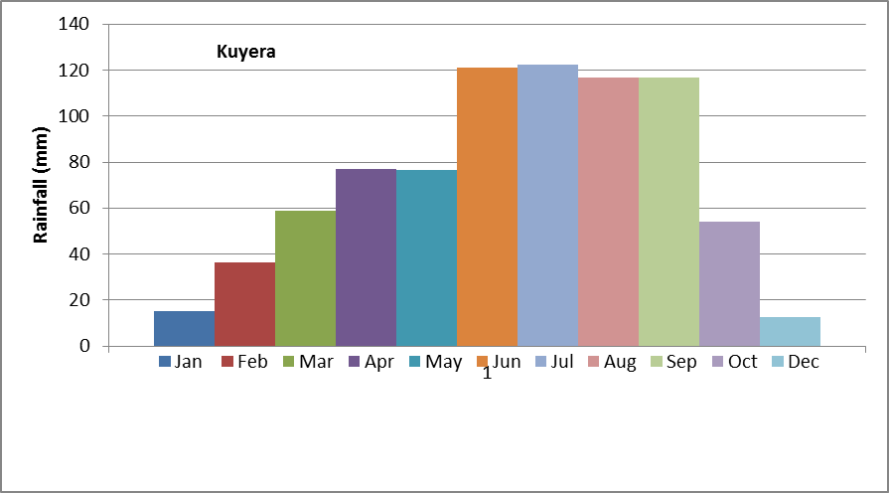
Appendix Figure 1:Mean monthly rainfall distribution for kuyera station (1990-2018)
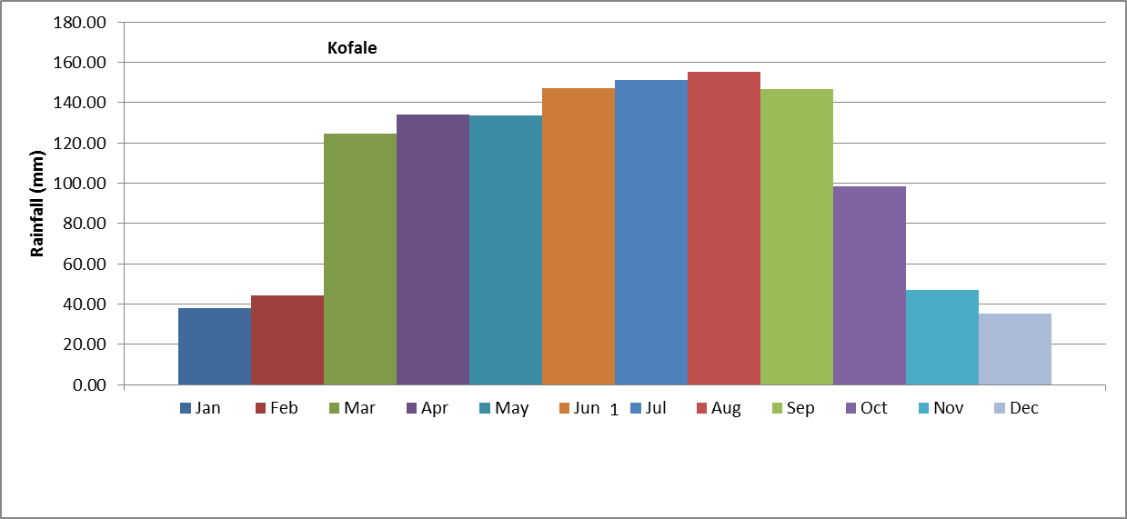
Appendix Figure 2: Mean monthly rainfall distribution for kofale station (1990-2018)
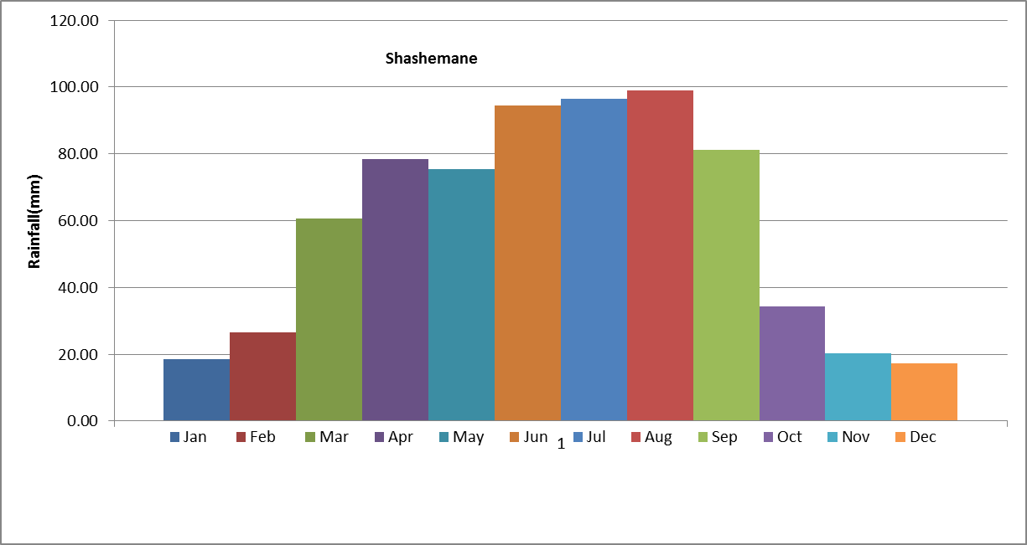
Appendix Figure 3: Mean monthly rainfall distribution for shashemene station (1990-2018)
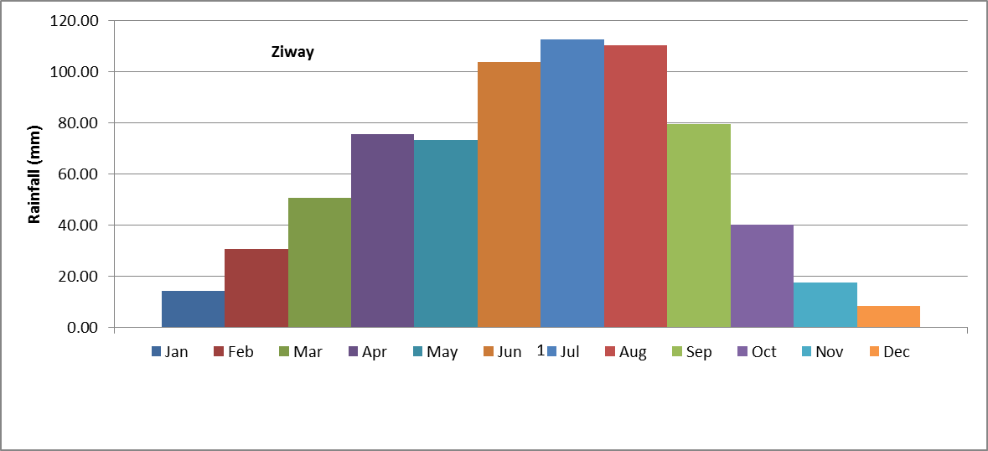
Appendix Figure 4: Mean monthly rainfall distribution for ziway station (1990-2018)

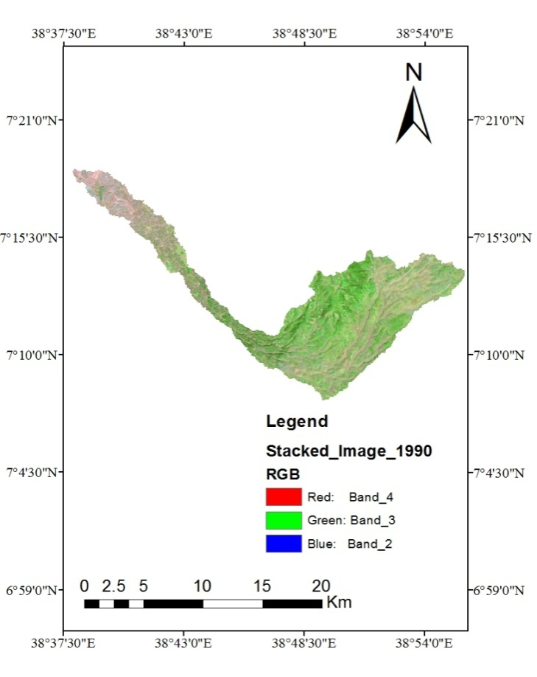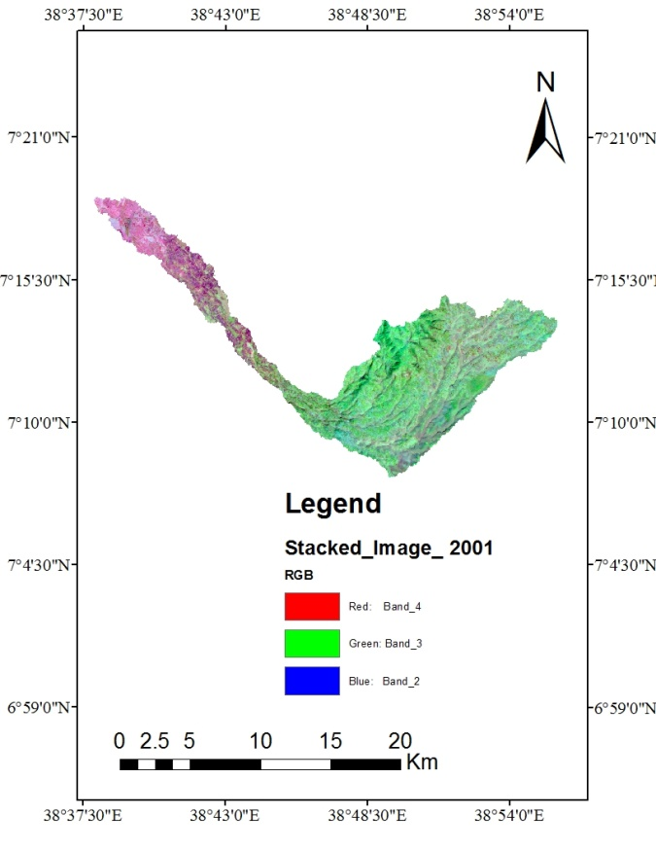
- (b)
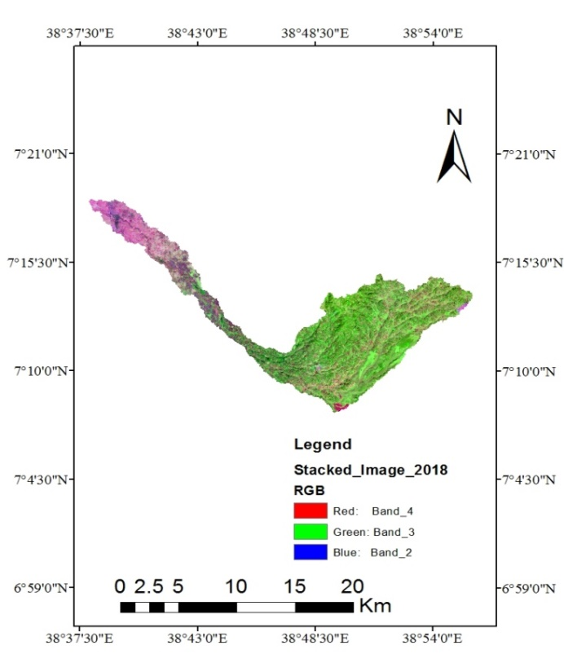
(c)
Appendix Figure 5: False color composite satellite image of (a) 1990, (b) 2001 and (c) 2018

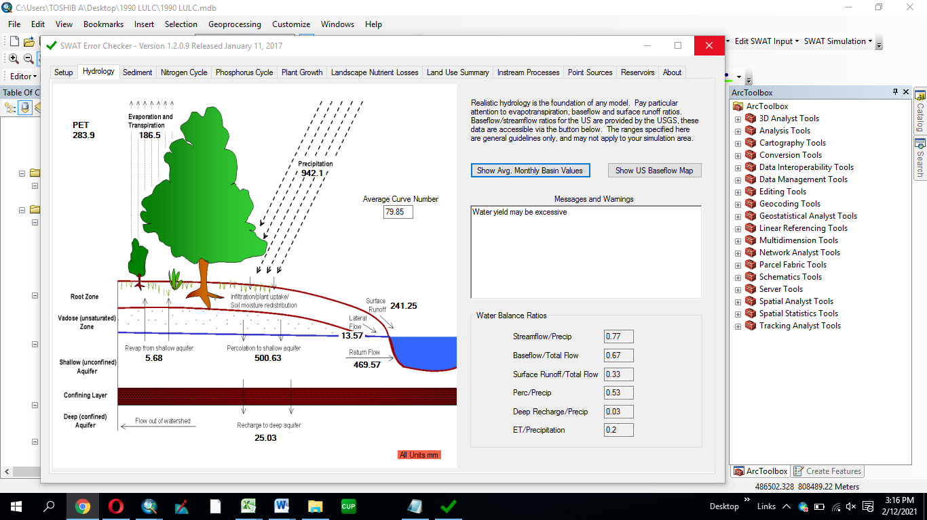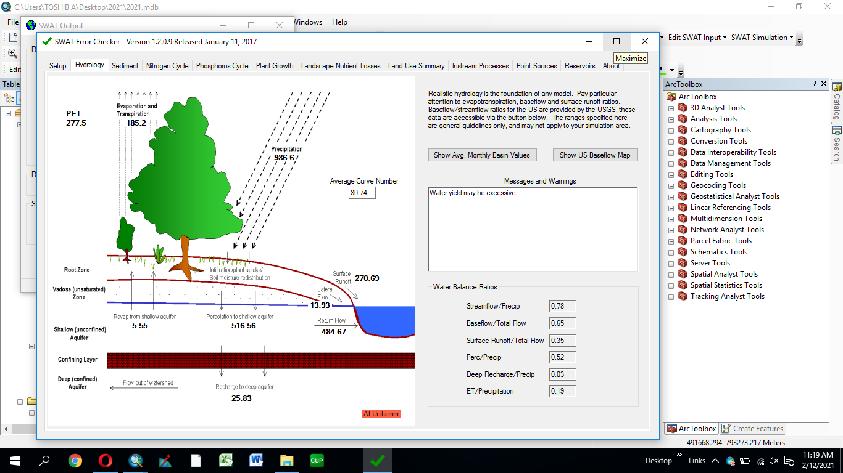
- (b)
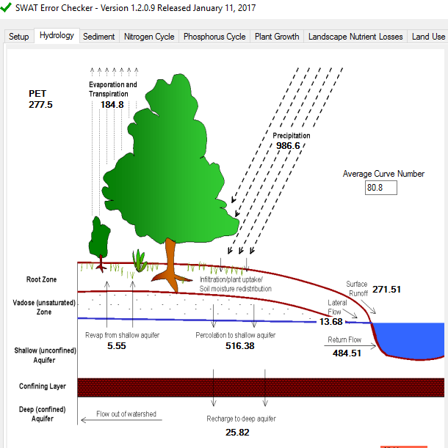

(c)
Appendix Figure 6: Hydrologychangedue to (a) LU/LC1990, (b) LU/LC2001, and (c)LU/LC 2018.

