

HAWASSA UNIVERSITY
Institute of Technology

Predictions of the Status of Undernutrition for Children below Five Using Ensemble Method

Natnael Abate Choreno

Major Advisor: Dr. V. Anitha
Co-Advisor: Mulat Shiferaw (M.Sc.)

Hawassa, Ethiopia
March 2023
Predictions of the Status of Undernutrition for Children below Five Using Ensemble Method

Natnael Abate Choreno

Major Advisor: Dr. V. Anitha
Co-Advisor: Mulat Shiferaw (M.Sc.)

THESIS SUBMITTED TO THE DEPARTMENT OF COMPUTER SCIENCE, INSTITUTE OF TECHNOLOGY, FACULTY OF INFORMATICS, AND SCHOOL OF GRADUATE STUDIES IN PARTIAL FULFILLMENT OF THE REQUIREMENTS FOR THE DEGREE OF MASTER OF SCIENCE IN COMPUTER SCIENCES.

HAWASSA, ETHIOPIA
March 2023
ADVISORS APPROVAL SHEET
SCHOOL OF GRADUATE STUDIES
HAWASSA UNIVERSITY
This is to certify that the thesis entitled “Predictions of the Status of Undernutrition for Children below Five Using Ensemble Method” submitted in partial fulfillment of the requirement for the degree of Master of Science specialization in Computer Science, the Graduate Program of the Department of Computer Science. The thesis was carried out by Natnael Abate Choreno, ID Number GPCoScW/0013/13, under our supervision. As a result, we recommend that the student has fulfilled the requirements and hence hereby can submit the thesis to the Department.

Name of Major Advisor Signature Date
Dr. V. Anitha ------------------------------ -----------------------------

Name of Co-Advisor Signature Date
Mulat Shiferaw (MSc.) -------------------------------- ---------------------------

EXAMINERS’ APPROVAL SHEET
SCHOOL OF GRADUATE STUDIES
HAWASSA UNIVERSITY
We, the undersigned, members of the Board of Examiners of the final open defense by Natnael Abate Choreno have read and evaluated his thesis entitled “Predictions of the Status of Undernutrition for Children below Five Using Ensemble Method” and examined the candidate. This is, therefore, to certify that the thesis has been accepted in partial fulfillment of the requirements for the master’s degree in Computer Science.

______________________ _______________ ___________________
Name of Major Advisor Signature Date
______________________ _______________ ___________________
Name of Co-Advisor Signature Date
______________________ _______________ ___________________
Name of the Internal Examiner-I Signature Date
______________________ _______________ ___________________
Name of Internal Examiner-II Signature Date
______________________ _______________ ___________________
Name of External Examiner Signature Date
______________________ _______________ ___________________
SGS Approval Signature Date
Final approval and acceptance of the thesis is contingent upon the submission of the final copy of the thesis to the School of Graduate Studies (SGS) through the Department/School Graduate Committee (DGC/SGC) of the candidate's department.
Stamp of the SGS

Date: ______________________

DEDICATION
This thesis is dedicated to my mother Mrs. Tewabech Cherano. She has always been supportive; a source of strength and her continuous encouragement has been a major factor in my life's success

DECLARATION
I hereby declare that this M.Sc. thesis is my original work and has not been presented for a degree in any other university, and all sources of material used for this thesis have been fully acknowledged.

Name: Natnael Abate Choreno
Signature: _________________

Place: Institute of Technology, Hawassa University, Hawassa, Ethiopia
Date of Submission: ____________________

ACKNOWLEDGEMENTS
I thank the Almighty God for his infinite blessings and grace, for giving me the strength, courage, and wisdom to conduct this research work, and blessed me in every step of my life. My deepest and heartfelt thank goes to my thesis advisor, Dr. V. Anitha, and co-advisor, Mr. Mulat Shiferaw, for their guidance and helpful comments on my work. I would like also to express my deepest gratitude to Dr. Zenebe Markos, who gave me constructive comments and inspiring suggestions that helped me very much to complete this research work.
Finally, I would like to extend my acknowledgments to my wife Tsion Daniel, my sons Nahom and Naod Natnael who have rendered me all their care, love, and encouragement, also my brother Girum Yasin who helped me in the completion of this thesis.

Table of Contents
ACKNOWLEDGEMENTS vi
LIST OF TABLES iv
LIST OF FIGURES v
LIST OF ABBREVIATIONS AND ACRONYMS vi
ABSTRACT vii
CHAPTER ONE 1
INTRODUCTION 1
1.1 Background 1
1.2 Motivation 2
1.3 Statement of the Problem 3
1.4 Research questions 4
1.5 Objectives 4
1.5.1 General Objective 4
1.5.2 Specific Objectives 4
1.6 Significance of the study 5
1.7 Scope and Limitations of the Study 5
1.8 Method and Materials 5
1.9 Organization of the thesis 7
CHAPTER TWO 8
LITERATURE REVIEW AND RELATED WORK 8
2.1 Undernutrition and Machine learning 8
2.1.1 Undernutrition 8
2.1.1.1 Trends in undernutrition status 9
2.1.2 Machine learning 9
2.1.2.1 Machine learning and its applications in healthcare 10
2.1.2.2 Machine learning algorithms 10
2.1.2.2.1 Logistic Regression 10
2.1.2.2.2 Decision Tree Classifier 11
2.1.2.2.3 K-Nearest Neighbors 11
2.1.2.2.4 Naive Bayesian classifier 11
2.1.2.2.5 Support Vector Machine (SVM) 12
2.1.2.2.6 Ensemble method 12
2.1.2.2.7 Combining algorithms into ensemble predictions 13
2.2 Related work 13
CHAPTER THREE 16
METHODS AND MATERIALS 16
3.1 Understanding and preprocessing the 2019 EDHS dataset 17
3.1.1 Data understanding 17
3.2 Data preprocessing 18
3.2.1 Data preparation 18
3.2.2 Feature/attribute/ selection 18
3.2.3 Selection of instances 20
3.2.4 Managing missing values 21
3.2.5 Splitting the dataset 23
3.2.6 Data transformation 23
3.3 Machine learning models selection 24
3.4 Method of Evaluation of model performance 26
3.4.1 Confusion matrix 26
3.4.2 K-fold cross-validation 28
CHAPTER FOUR 29
RESULTS AND DISCUSSIONS 29
4.1 Results 29
4.1.1 Feature selection 31
4.1.2 Feature importance 36
4.1.3 Label encoder 37
4.1.4 Model building 38
4.1.4.1 Experimentations with Decision Tree 38
4.1.4.2 Experimentations with SVM 40
4.1.4.3 Experimentations with Gaussian Naive Bayes 41
4.1.4.4 Experimentations with KNN Classifier 42
4.1.4.5 Meta Classifier with Logistic Regression 43
4.2 Discussions 45
4.2.1 Performance evaluation and comparison of classifiers 45
4.2.2 Rule extraction 48
4.2.2.1 Rules extracted for ‘Stunted’ or class 0 48
4.2.2.2 Rules extracted for ‘underweight’ or class 1 49
4.2.2.3 Rules extracted for ‘Wasted’ or class 2 50
CHAPTER FIVE 52
CONCLUSION AND RECOMMENDATION 52
5.1 Conclusion 52
5.2 Recommendations 54
REFERENCES 55
APPENDIXES 60
ANNEX 1: The Selected Attributes' Description 60
ANNEX 2: Summary of the classifiers' results 64
ANNEX 3: Rules generated by Decision Tree 67

LIST OF TABLES
Table 1: Summary of the dataset 24
Table 2: Confusion matrix with three classes of the classification result 27
Table 3: Correlation ranking with their descriptions 31
Table 4: Feature importance 36
Table 5: Results of the Decision tree with 10-fold stratified cross-validation 38
Table 6: Results of SVM with 10-fold stratified cross-validation 40
Table 7: Results of Gaussian Naive Bayes with 10-fold stratified cross-validation 41
Table 8: Results of KNN Classifier with 10-fold stratified cross-validation 42
Table 9: Results of Meta Classifier with 10-fold stratified cross-validation 43
Table 10: Models performance summary 47

LIST OF FIGURES
Figure 1: Trends of undernutrition in Ethiopia [8] 9
Figure 2: Architectural framework for prediction of undernutrition status 16
Figure 3: Conceptual framework of determinants of under-nutrition (UNICEF 2013) [35] 19
Figure 4: The distribution of undernutrition status among the selected dataset 21
Figure 5: Selected attributes and their distribution 30
Figure 6: The visualizations of correlations with Cmap 35
Figure 7: Visual representations of feature importance 37
Figure 8: Confusion matrix for Decision Tree 39
Figure 9: Confusion matrix for SVC 40
Figure 10: Confusion matrix for Naive Bayes 41
Figure 11: Confusion matrix for KNN 42
Figure 12: Confusion matrix for Stacking with logistic regression 44
Figure 13: Performance comparison of model 46
Figure 14: Accuracy of each model 47

LIST OF ABBREVIATIONS AND ACRONYMS
AI Artificial Intelligence
BDHS Bangladesh Demographic and Health Survey
CBFS Correlation-Based Feature Selection
CSA Central Statistical Agency
CSV Comma-Separated Values
DT Decision Tree
EDHS Ethiopia Demographic Health Survey
EMDHS Ethiopia Mini Demographic Health Survey
EPHI Ethiopian Public Health Institute
FMoH Federal Ministry of Health
HAZ Height for Age Z-score
IDD Iodine Deficiency Disorders
KNN K-Nearest Neighbors Algorithm
ML Machine learning
NGO Non-Governmental Organization
NNP National Nutrition Program
SD Standard Deviation
SPSS Statistical Package for the Social Sciences
SVC Support Vector Classifier
SVM Support Vector Machine
WAZ Weight for Age Z-score
WEKA Waikato Environmental for Knowledge Analysis
WHO World Health Organization
WHZ Weight for Height Z-score
ZDHS Zambia Demographic Health Survey

ABSTRACT
Undernutrition is one of the main causes of morbidity and mortality in children under five in most developing countries, including Ethiopia. It increases the risk of infectious diseases, impairs cognitive and physical development, reduces school performance and productivity, and perpetuates intergenerational cycles of poverty and malnutrition. The primary goal of this thesis is to build an ensemble model that predicts the undernutrition status of children under five using data from the 2019 EMDHS. The experiments covered 15082 instances and 20 attributes. Ensemble methods combine several models to deliver better results. Typically, results from an ensemble approach are more accurate than those from a single model. The selected method consists of preprocessing, feature selection, k-fold cross-validation, model building, an ensemble classifier, and final prediction steps. In this work, different machine learning classification models such as the Decision Tree, Support Vector Machine, K-Nearest Neighbors, and Naive Bayes classifiers have been used as base model algorithms with an accuracy rate of 0.92%, 0.94%, 0.92%, and 0.75% respectively. The final result was combined by the stacking ensemble method with logistic regression. The most accurate predictive model, with a 96 % accuracy rate was created using the stacking ensemble method. HAZ, WAZ, WHZ, age in 5 years groups, region, source of drinking water, education level, type of toilet facility, wealth index, total children born, number of antenatal visits, vaccination, breastfeeding duration, ever had nutritious food and plain water has given are the major features that contribute to undernutrition in children under-five. The findings of this study provided encouraging evidence that using the ensemble method could support the development of a predictive model that predicts the nutritional status of children under five in Ethiopia. Future research could produce better results by combining large datasets from clinical and hospital datasets. Future research may also include children over the age of five and children with obesity as a malnutrition status.

Keywords: Machine learning, Ensemble method, Stacking, Undernutrition, 2019 EMDHS, Children

CHAPTER ONE

INTRODUCTION

Background
Health is mandatory for human beings, especially for children under five, because it is critical for their growth and development. Nutrition for under-five children is fundamental to a child’s continued health from birth through adulthood. Feeding children correctly during the first five years of life is particularly important because it can lower morbidity and mortality rates, reduce the risk of chronic diseases throughout their lifespan, and promote regular mental and physical development [2, 7]. Undernutrition is a type of malnutrition that refers to nutrient deficits and is characterized by stunting, being underweight, wasting, and lacking vital vitamins and minerals [1]. Good nutrition is one of a human being's basic needs to live a healthy lifestyle, particularly for children under five. Globally, undernutrition is one of the leading causes of disease and death, particularly in developing countries, where it is directly or indirectly responsible for half of all child deaths [2, 3]. More than 10 million children under the age of five die from preventable diseases each year in the world [3]. Among the world's children as a whole, one-fourth of them are stunted [4]. Children who are affected by malnutrition suffer from frequent diseases. Due to this, half of the world’s children’s deaths are caused by malnutrition [5].
One of the major problems in developing countries, including Ethiopia, is undernutrition [6]. It leads to child morbidity, mortality, a decreased immune system for disease, and poor mental and physical development [7].
According to the Ethiopian Mini Health Data Survey, 21% of children under five are underweight (thin for their age), 37% of children under five are stunted (short for their age), and 7% are wasting (thin for their height) [8].
The Ethiopian Public Health Institute (EPHI), in collaboration with the CSA and the FMoH, collected and carried out the 2019 EMDHS dataset. To identify children’s nutritional factors, they provide data using different file formats like SPSS, STAT, SAS, and FLAT for further analysis [8].
Machine learning technology is a significant area of research that aims to create an artificial intelligence system. It can improve healthcare concerns by providing quicker and more precise solutions. Throughout the last few decades, the scientific community has paid close attention to the development of ensemble approaches in machine learning and data mining. In machine learning ensemble approaches, different learning algorithms are combined to produce higher predicted performance than any one of the individual learning algorithms could. Theoretically and experimentally, it has been proven that combining multiple learning models results in much greater performance than using just one base model. The use of ensemble learning algorithms has been demonstrated in a variety of practical applications, including face recognition, text classification, medical diagnosis, and financial forecasting. They are considered a dominant and state-of-the-art method for achieving maximum performance in the literature [9].

Motivation
We are motivated to conduct this study because children under five are particularly susceptible to undernutrition because they are still growing and developing. Undernutrition in children can cause stunted growth, cognitive impairment, and increased morbidity and mortality. Undernutrition is linked to around 28% of deaths among children under five years of age in Ethiopia [10]. Therefore, it is crucial to focus on this age group to identify the factors contributing to undernutrition and develop effective interventions to prevent and treat it.
Also, we are motivated by machine learning, which is a rapidly growing field with the potential to revolutionize many industries. By researching machine learning, we can gain a deeper understanding of how it works and how it can be applied to solve real-world problems. With the right tools and techniques, we can develop more accurate and efficient models that can help us make better decisions and improve our lives in countless ways. Also, we are so excited about the advancement of machine learning algorithms and how they can learn from data, extract hidden patterns, and respond accordingly without the intervention of humans.

Statement of the Problem
When we think of a generation that will take over the country, we consider children. A child who is not physically and mentally healthy is bound to be a burden to the country. We focused on children under the age of five because these groups are one of the most vulnerable populations.
Undernutrition is harmful, particularly for mothers and children, as it contributes to one-third of all child deaths. During the early stages of development, undernutrition can have negative and severe effects on growth and intellectual development. This impairment of intellectual abilities makes it increasingly challenging for children to reach their full potential in later stages of life [15].
Undernutrition is one of the leading causes of illness and death for children under five, especially in Ethiopia. According to UNICEF reports, undernutrition is a factor in 28% of child mortality in Ethiopia. Ethiopia has one of the highest rates of undernutrition in sub-Saharan Africa [10].
Even though the prevalence of undernutrition has slowly decreased over the past 10 years, under-five children still have the highest rates of undernutrition. Undernutrition is a major public health problem that affects the survival, growth, and development of children. It is reported that 1 in 17 Ethiopian children does not survive until their 5th birthday. Undernutrition can manifest as stunting (low height-for-age), wasting (low weight-for-height), and underweight (low weight-for-age). According to the 2019 Ethiopia Demographic and Health Survey, 7% of them were wasting, 21% were underweight and 37% were stunted. The under-five mortality rate is 59 deaths per 1,000 live births [8]. These figures indicate a high burden of undernutrition among under-five children in Ethiopia.
Undernutrition has serious consequences for child health and development. It increases the risk of morbidity and mortality from infectious diseases, impairs cognitive and physical development, reduces school performance and productivity, and perpetuates intergenerational cycles of poverty and malnutrition [56].
With the above-mentioned problems, it is reasonable to study the problem area. Therefore, addressing undernutrition among children under five years is essential for achieving sustainable development goals in Ethiopia.

Research questions
To achieve the study’s main purpose, the following three research questions were formulated for investigation.
- What is the best ensemble method for predicting the level of undernutrition in Ethiopian children under five?
- Which attributes significantly affect the status of undernutrition?
- How can the accuracy of predictions be improved to better predict the status of undernutrition in under-five children?

Objectives

General Objective
This thesis’ main goal is to predict the undernutrition status of under-five children using machine learning techniques from the 2019 Ethiopia Mini Demography Health Survey dataset.

Specific Objectives
The specific objectives of the study are:
- Explore related literature reviews on machine learning and the status of undernutrition for children below five
- Transforming the 2019 EMDHS dataset for the machine by applying preprocessing tasks
- To build a model that predicts the undernutrition status of under-five children based on the prepared data set.
- To extract rules for undernutrition
- To compare the results with related works and report the findings for further studies.

Significance of the study
The results of this study will be used to create a future where all children have the opportunity to grow up healthy and strong. Essentially, the research is useful for other researchers to develop knowledge and is used as a benchmark for exploring local issues. Information on children's undernutrition status and causes of undernutrition is important to monitor the impact of regional and national health policies and other collaborative partners on children's health and to decrease children’s mortality. The study’s results will provide insight into the hidden knowledge and model used to predict the causes of undernutrition by understanding the hidden characteristics of the EMDHS 2019 dataset, including socio-demographic characteristics, causes, and other related issues.
Through the Seqota Declaration, Ethiopia also pledged to end undernutrition in children under the age of two by 2030. The National Nutrition Program (NNP) I (2008–2015) and the NNP II (2016–2020) were created in Ethiopia to hasten the reduction of malnutrition. Specific attention is paid to the coordination of nutrition interventions across sectors [8]. So this work aligns with the national goals.

Scope and Limitations of the Study
In this study, we focused on the population of children below five. Among the types of malnutrition, we are only focused on undernutrition status like stunted, underweight, and wasted. We used a dataset from the 2019 Ethiopia Mini Demography Health Survey. Topics that were discussed include undernutrition, machine learning, and ensemble methods. The geographical location covered in this study was all regions in Ethiopia.
The study's limitation was the lack of related work in Ethiopia on predicting the status of undernutrition children using the ensemble method. Time is also another limitation of the study

Method and Materials
This thesis followed ensemble learning approaches, which use multiple learning algorithms to improve the classification and prediction accuracy of the undernutrition status of the under-five children from the EDHS 2019 dataset. The main goal of the proposed ensemble learning method is to combine a group of diverse base classifiers into one strong predictive model.
The main steps of the proposed approach are described as follows.
Step 1: Preprocessing
If the machine learning stage is conducted with low-quality data, it will produce low-quality outcomes. To obtain good machine learning models, the dataset is preprocessed to enhance the quality of the data. To remove data quality issues like missing values, data preparation, or preprocessing, is carried out.
Step 2: Feature extraction
Essential features that are most beneficial for analysis, classification, and prediction were chosen in this process.
Step 3: K-fold cross-validation
In K-fold cross-validation, the entire data set is randomly divided into k mutually exclusive subsets of approximately equal size in k-fold cross-validation, also known as rotation estimation. To reduce the bias associated with a random sampling of training problems, k-fold cross-validation was applied in this work.
Step 4: Base algorithms
Different experiments were conducted using a Naïve Bayes classifier, decision tree, support vector machine, and k-nearest neighbors,
Step 4: Ensemble classifiers
The ensemble learning method uses multiple learning algorithms to obtain better predictive performance. Then the best classifier is chosen and applied to the remaining test dataset of the data in this step.
Step 5: Prediction and evaluation:
After obtaining the best classifier, we determined performance evaluation metrics with a confusion matrix such as accuracy, sensitivity, and specificity. In this study, the main emphasis is placed on accuracy to determine which classifier is best suited for predicting the status of undernutrition. The predictive model is based on the output derived from the machine learning classifier.

Organization of the thesis
The research work is organized into five chapters. The first chapter covers the research framework by introducing the burden of undernutrition, the problem statement and its justification, the objective of the study, the methodology of the study, the scope and limitations of the study, and the importance of the research. The second chapter briefly discusses undernutrition, trends in undernutrition status among children below five in Ethiopia, an overview of machine learning, its applications in healthcare, machine learning algorithms, and related work on machine learning and undernutrition. The third chapter mainly focuses on the method we applied in this work like the ensemble learning method to combine a group of diverse base classifiers into a strong one. In this chapter, the architectural framework for undernutrition status prediction was explained in detail. It also shows data preparation, data preprocessing, feature extraction, model building, ensemble classifier, and final predictions. Chapter four presents the results and discussions of machine learning algorithms through the ensemble method. Finally, in chapter five, we were provided with conclusions and recommendations.

CHAPTER TWO

LITERATURE REVIEW AND RELATED WORK

Undernutrition and Machine learning
This section discusses the literature review and the findings of other researchers on machine learning and undernutrition.

Undernutrition
Undernutrition in children manifests when children don't get enough micronutrients, calories, or protein to maintain a healthy life [11]. It is widespread throughout the world and may have irreversible negative health effects in both the short and long term. Malnutrition can refer to either undernutrition or overnutrition, even though the terms are occasionally used interchangeably (which causes childhood obesity). According to the WHO, malnutrition kills 1 million children every year globally [12, 13]. Also, another study by the WHO stated that nearly 35% of all worldwide children's deaths under five are related to childhood underweight [14].
Malnutrition is harmful, particularly for mothers and children, as it contributes to one-third of all child deaths. Malnourished mothers typically have undernourished babies during pregnancy, which can result in physically and mentally underdeveloped children, repeating the undernutrition cycle. Children under the age of five are one of the most vulnerable populations [15]. During the early stages of development, malnutrition can have negative and severe effects on growth and intellectual development. It becomes more difficult for children to achieve their full potential later in life as a result of this impact on their intellectual capacity. Stopping the cycle of malnutrition in the earliest childhood years can interrupt the transmission of poverty from one generation to the next within poor communities [15].
Malnutrition can have many different effects on the body. 162 million children globally show malnutrition-related symptoms such as stunting, an indicator of malnutrition [15]. Another type of malnutrition that affects kids is protein-energy malnutrition (PEM), which can manifest as the disorder’s marasmus, kwashiorkor, or a stage between marasmus and kwashiorkor. Malnourished women and children can have serious and long-lasting health consequences, yet they are also vulnerable to other water-related risks [15].
According to a report from the WHO, 40 percent of all children who are stunted have their residence in southern Asia, and Africa is the only area where the number of stunted children is rising [16]. Common micronutrient deficiencies are vitamin A, zinc, iron, and iodine. Due to a weakened immune system, micronutrient deficiencies can lead to an increase in sickness [17].

Trends in undernutrition status
For the past 15 years, stunting has decreased in Ethiopia, from 51 percent to 37 percent from 2005 to 2019, while the prevalence of severe stunting has decreased by more than half (from 28 percent to 12 percent). The percentage of underweight children has declined consistently since 2005, from 33% to 21% (Figure 1). Also, the prevalence of wasting has decreased from 12 percent to 7 percent [8].
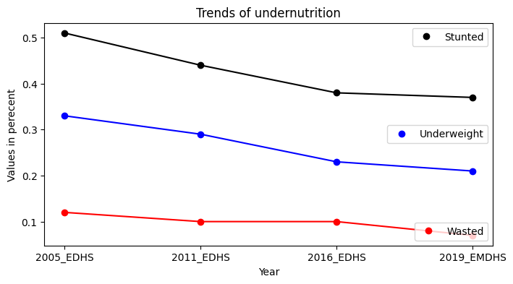
Figure 1: Trends of undernutrition in Ethiopia [8]

Machine learning
Machine learning can be defined as the process of building a computer system that automatically improves with experience and implements a learning process. Machine learning is the idea that computers could be trained to learn what they need to know about the environment and how to carry out tasks on their own, and it is credited to IBM's Arthur Samuel, who first suggested it in 1959. AI in the form of machine learning is conceivable. One way to think of machine learning is as a type of AI [18].

Machine learning and its applications in healthcare
Healthcare applications of machine learning (ML) have attracted a lot of attention. Increased computing power and big data give us a chance to use ML algorithms to enhance healthcare. To predict labeled data using techniques like linear or logistic regression, support vector machines, decision trees, LASSO regression, K-Nearest Neighbor, and the Naive Bayes classifier, supervised learning can be used [19].
A significant area of research is machine learning technology, which aims to create an artificial intelligence system. The field of healthcare can benefit from the use of machine learning. It can improve healthcare concerns by providing them with quicker and more precise solutions, but it cannot take the place of actual doctors. The most crucial field for developing computational methods automatically is machine learning [20].
The medical industry of the future will need to be familiar with the ideas, potential, and terms required to understand machine learning (ML) in light of all recent developments in the field, the growing use of various ML algorithms, and the constant demand for better data utilization in healthcare. Understanding and interpreting relevant literature or leading research involving machine learning algorithms would be easier with knowledge of machine learning and related terminology. The numerous ML terminologies need to be explained to public health experts, epidemiologists, clinicians, pathologists, radiologists, and other medical specialists [21].

Machine learning algorithms
The following machine learning algorithms that are related to our work were reviewed in this section.

Logistic Regression
Logit regression, often known as logistic regression, was created by statistician David Cox in 1958 and is frequently used for binary classification issues. For instance, using logistic regression, one can determine if a patient will have an adverse reaction to a specific drug, whether they will likely need to be readmitted to the hospital or not, or even whether they have a specific illness diagnosis.
The model's output, in contrast to linear regression, is a probability between 0 and 1. By utilizing the logistic function h(x) = 1/ (1 + e^ – x) and log-transforming the x input, the expected output is produced. This probability is converted into a binary classification using a predetermined threshold. In logistic regression, an S-shaped curve called the sigmoid function is used to transform any continuous data into a probability value between 0 and 1 for a default class [22].

Decision Tree Classifier
Instance space is divided into decision regions by internal or test nodes produced by decision tree classifiers using a divide-and-conquer strategy. A decision or discriminant function, denoted by f_{m}(x), is implemented by each internal node, m, for this reason. The input symbol x stands for feature vectors with the form x=[x1, x2,... xd]^{T}, where d is the number of features. The functional form of f_{m}(x) is one of the key differences between decision tree algorithms. In univariate decision trees, each internal node uses only one feature to define a decision or a model in the form of f_{m}(x) = xi + bm, where bm is a constant. The main tasks in the generation of the decision function are choosing the best attribute x_{i} and corresponding b_{m} for the instance subset reaching node m [23].

K-Nearest Neighbors
For classification and regression, the K-Nearest Neighbors (K-NN) algorithm is another supervised machine learning method. The underlying data distribution is not subject to any assumptions in K-NN. Pattern recognition and predictive analysis are two areas where it excels. The initial step in using K-NN to analyze a new data point is to collect nearby data points. The distance between data points may be significantly influenced by any attributes that are subject to large-scale variation [24].

Naive Bayesian classifier
One of the statistical classifiers, the Bayesian classifier, can be used to estimate probabilities of class membership, such as the likelihood that a given sample will belong to a particular class. Bayes' theorem is the foundation of a Bayesian classifier. The assumption made by naive Bayesian classifiers is that the impact of each attribute on a particular class is separate from the values of the other attributes. The term "class conditional independence" refers to this presumption. It is viewed as "naive" in this sense because it is designed to make the computation involved simpler [25].

Support Vector Machine (SVM)
One of the supervised machine learning (ML) classification methods that are frequently used in the field of the health sector is SVM. SVM separates the classes by creating a linear function that divides them as broadly as feasible using these key samples from all classes, which are known as support vectors. As a result, it can be claimed that SVM is used to map an input vector to a high-dimensional space to find the best hyperplane to categorize the data set [26]. Finding the most appropriate hyperplane is the goal of this linear classifier, which seeks to optimize the marginal distance between the decision hyperplane and the closest data point [27].

Ensemble method
The development of the ensemble method in the fields of machine learning and data mining has drawn a lot of attention from the scientific community during the past recent decades. In machine learning ensemble approaches, different learning algorithms are combined to produce higher predicted performance than any one of the individual learning algorithms could. Theoretically and experimentally, it has been demonstrated that combining multiple learning models results in much greater performance than using just one base model. Many real-world problems have been solved using ensemble learning methods, from face and emotion detection to text categorization, medical diagnosis, and financial forecasting. They are considered a dominant and cutting-edge method for achieving maximum performance in the literature [9].
Instead of using only one ML classification, ensemble approaches may employ a number of them. This method significantly increases the model's accuracy. Ensemble techniques are recognized as supervised learning algorithms. Different training algorithms benefit from ensemble approaches to increase training accuracy, resulting in improved testing accuracy. Various training algorithms can be used with the ensemble approach to creating flexible training.

Combining algorithms into ensemble predictions
Ensemble methods are a powerful tool in the world of machine learning, as they can provide significant improvements to model performance. Among these different types of ensemble methods, bagging and boosting have become increasingly popular due to their ability to combine multiple weak learners into one strong learner. However, stacking is an even more effective approach that combines multiple heterogeneous algorithms instead of homogenous algorithms like those used in bagging and boosting. The most common technique for combining the predictions of various algorithms, stacking, was employed to improve the algorithms' accuracy. Using stacking, different algorithms can be established, and a supervisor algorithm that learns how to optimally combine the predictions of the primary algorithms can subsequently be developed [28]. The predictions of the chosen caret algorithms were thus merged in this study via stacking.

Related work
Researchers from Ethiopia named F. Bitew et al. conducted their research on “Machine Learning Techniques for Predicting Undernutrition in Children under Five in Ethiopia." The researcher revealed that among the five models they used (eXtreme gradient boosting, random forest, k-nearest neighbors (k-NN), neural network, and generalized linear models), the xgbTree algorithms showed better predicting ability with an accuracy rate of 75.5%. They also used a total of 9471 children under five as a secondary data source from the 2016 EDHS [29].
In their study, Z. Markos et al. aimed to develop a model that could predict the undernutrition status of children under the age of five using data mining techniques. The 2011 EDHS dataset was used in their analysis as the secondary data source and followed the hybrid approach of the Knowledge Discovery Process to achieve the goal of building a predictive model utilizing data mining techniques. They have used the J48 decision tree, Nave Bayes, and PART rule induction classifiers to address their proposed problems. They observed that the predictive model created utilizing PART pruned rule induction performed the best, with 92.6% accurate results and a 97.8% WROC area. These results were encouraging. They carried out their experiment using WEKA data mining tools [22].
The research paper “Predicting Undernutrition Among Elementary School Children in the Philippines Using Machine Learning Algorithms” conducted by Van et al. compares four machine learning algorithms' accuracy based on household and individual risk factors. The research team used data from a household socioeconomic and demographic survey conducted in the Philippines in a rural province (310 children) and a highly urbanized city (308 children). Four algorithms (support vector machine, random forest, logistic regression, and linear discriminant analysis) were used to predict children's undernutrition status. According to their findings, the random forest algorithm predicts superiorly to other machine learning algorithms, with a 78.6 percent accuracy rate [30].
Chilyabanyama et.al conducted their work under the titled “Performance of Machine Learning Classifiers in Classifying Stunting among Under-Five Children in Zambia” by using secondary datasets from the 2018 ZDHS consisting of 6799 children less than five years. They have also utilized five well-known machine learning methods, including Random Forest (RF), Naïve Bayes (NB) algorithms, XG Boost (XgB), SV classification (SVC), and Logistic regression (LR). According to their analysis of their data and usage of several performance criteria, random forest is marginally superior to other ML algorithms used to predict undernutrition by an accuracy of 79% [31].
Zhang et al. conducted their study "Comparing Data Mining Method with Logistic Regression in Childhood Obesity Prediction" by using 16,653 instances. They compared six data mining strategies, like Decision Tree (C4.5) with association rules, Neural Networks (NNs), Naïve Bayes, Support Vector Machines (SVMs), and Bayesian networks. According to their findings, Bayesian algorithms appear to be the best algorithms with an accuracy rate of 60% for predicting overweight and obesity [32].
The work of Ndagijimana et al. focused on applying machine learning techniques to predict stunting in children under the age of five in Rwanda. They used 4052 instances from the 2019–2020 RDHS dataset. To compare their results, they used classification techniques such as Logistic Regression, Support Vector Machine, Random Forest Classifier, Naïve Bayes, eXtreme Gradient Boosting, and Gradient Boosting for predicting the stunting of children under five in Rwandan children. According to their findings, the most effective classifier for predicting stunting among children under the age of five appears to be the gradient-boosting classifier with 10 attributes and a classification accuracy of 80.49% [33].
Talukder et al. also researched a title called “Machine Learning Algorithms for Predicting Malnutrition among Under-Five Children in Bangladesh." They used the secondary records from the 2014 BDHS using 6863 children of 0 to 59; the researcher used five well-known data mining methods such as support vector machines (SVM), random forest (RF), linear discriminant analysis (LDA), k-nearest neighbors (k-NN), and logistic regression. Their research indicates that the random forest method, with an accuracy rate of 68.51%, performs best in predicting malnutrition [34].
As we observed from the above-mentioned work, there is a promising result gained by different machine learning techniques. Since accuracy is crucial in medical cases, most works have an accuracy rate below 81%, except for the work of Zenebes Markos et al. Before machine learning algorithms can give useful results, they often require large amounts of data. So in terms of data size, the work of Van et al. is relatively small.
Most of their work depends on comparing the results of a single model and taking the best one. As we reviewed in section 2.1.2.2.6, the ensemble method can produce the highest result compared to the single model. Using the well-known technique known as the ensemble method, we still have the chance to improve the prediction's accuracy. Therefore, we proposed to work on an ensemble method with stacking to improve the accuracy of the predictions of the status of undernutrition for under-five children in Ethiopia. The ensemble method with stacking is a powerful tool that can be used to improve the accuracy and performance of predictive models. The main advantage of the ensemble method with stacking is that it combines the predictions of multiple models. By combining multiple weak models, the ensemble model can create a stronger, more accurate model.

CHAPTER THREE

METHODS AND MATERIALS
This research follows ensemble learning approaches, which use multiple learning algorithms to predict the status of undernutrition for children below the age of five from the EDHS 2019 dataset. The main goal of the proposed ensemble learning method is to combine a group of diverse base classifiers into one strong predictive model. Figure 2 demonstrates the overall architectural framework for the undernutrition status prediction of under-five children with the ensemble method.

EMDHS 2019
Dataset
Feature Selection
K-fold Cross validation

Classifier1, Classifier2, Classifier n

Preprocessing
Ensemble classifier
Level 1

Level 0

Final Prediction
Processed dataset
Prediction 1, Prediction 2 … Prediction n

Figure 2: Architectural framework for prediction of undernutrition status

Understanding and preprocessing the 2019 EDHS dataset

Data understanding
The survey, which was carried out between March 21 and June 28, 2019, using a representative sample across the country, offered estimates for both urban and rural areas, as well as for the national and regional levels. A representative sample across the country of 8,663 households, or 8,855 women of reproductive age (aged 15 to 49), were questioned for the survey. The background characteristics of the respondents, factors influencing fertility, marriage, knowledge of and use of family planning techniques, child-feeding practices, children's nutritional status, childhood mortality, and the height and weight of infants aged 0 to 59 months were all thoroughly recorded. This study includes full survey results for Ethiopia’s all regional states, two municipal administrations, and the country as a whole.
According to the WHO, the main categories of undernutrition are wasting, stunting, and underweight, or, in other terms, low weight-for-height, low height-for-age, and low weight-for-age, respectively.
The 2019 Ethiopia Mini Demographic and Health Survey are the country's second EMDHS and fifth DHS. A survey was conducted by the EPHI in collaboration with the CSA and the FMoH, with technical assistance from ICF as well as financial and technical support from development partners. The 2019 EMDHS generates data for measuring the progress of the health sector goals set under the Growth and Transformation Plan (GTP), which is closely aligned with the Sustainable Development Goals (SDG) [8]. Understanding the data step starts with initial data collection and proceeds with activities to get familiar with and detect appropriate subsets of the 2019 EMDHS dataset being accessed from EMDHS by formal request. In this study, the 2019 EMDHS dataset served as a secondary source of data. Data on children's nutritional status, family planning, fertility methods, child, adult, and maternal mortality rates, use of maternal and child health services, awareness of HIV/AIDS, and the prevalence of anemia in children and mothers were gathered nationally by the FMOH and ECSA in collaboration with non-governmental organizations. The survey was conducted in nine regions (Tigray, Afar, Amhara, Benishangul-Gumuz, Gambela, Harari, Oromia, SNNPRS, and Somali) and two city administrations (Addis Ababa and Dire Dawa).

Data preprocessing
If the machine learning stage is conducted with low-quality data, it will produce low-quality outcomes. The dataset is preprocessed to improve the level of data quality and build strong machine-learning models. To remove data quality issues like missing values, data preparation, or preprocessing, is carried out.

Data preparation
Initially, all raw data sets for machine learning are often large; many have the potential to be messy and need to be cleaned. Data cleaning (filling in missing values and identifying external components) and relevance analysis are performed using various descriptive statistics such as SPSS, Excel, and Python tools. The cleaned data was transformed into a machine-understandable format like comma-separated values (.csv). The result is high-quality data that meets the specific input requirements for selected machine learning tools. The cleaned data were further processed by feature selection and extraction algorithms.

Feature/attribute/ selection
Attribute selection is a method of creating predictive models by minimizing the number of input variables. Many factors, such as the data's relevance to the machine learning objectives, as well as technical restraints like limits on data amount or type, were taken into account when choosing the data that would be used for the analysis. As a result, the attributes in this study were chosen with the assistance of a domain expert and a thorough literature analysis because it may not be effective to feed all the variables in our database into the machine learning tool and then look for the ones that are the best predictors. One explanation is that the more variables there are, the longer it takes to build a model. Another reason is that incorporating extra columns can result in inaccurate models. In the EDHS data set, there are 1072 variables, which is too many for the machine to analyze. Therefore, it should be reduced to its optimum level, which is 20 attributes.
The relationship between child undernutrition and various predictors was examined in many books and journals, and experts in the field were consulted regarding child undernutrition to analyze the major impacts of predictors on child health.
Short term consequences
Inadequate dietary intake
Disease
Household food insecurity
Inadequate care and feeding practices
Unhealthy household environment and inadequate health services
Household access to adequate quantity and quality of resources land, education, employment, income, technology
Inadequate financial, human, physical and social capital
Sociocultural, economic and political context
Intergenerational consequences
Maternal and child under nutrition
Long term consequences
Immediate Causes
Underlying Causes
Basic Causes

Figure 3: Conceptual framework of determinants of under-nutrition (UNICEF 2013) [35]

Using a conceptual framework suggested for this kind of study by Lenters et al. [35] and incorporating some significant variables that affect children's health, as shown in Figure 3, it was possible to assess the many elements affecting children's undernutrition. The goal of this study is to build a model that predicts the undernutrition status of Ethiopian under-five children from the EMDHS data set. This work did not take into account all of the attributes from the original dataset. Only relevant attributes were considered.
This thesis uses a correlation-based methodology to address the issue of feature selection for machine learning. The correlation-based feature selection algorithm (CBFS) is an important tool for machine learning. It is a technique used to select the most relevant features from a given dataset to reduce its dimensionality and improve model accuracy. CBFS uses the correlation between feature variables as the basis for selecting which features are most useful in predicting or classifying data points. This algorithm can be applied to both supervised and unsupervised learning tasks, making it highly versatile and applicable across different types of problems [36]. Therefore, we used this method to select the attributes.

Selection of instances
The original dataset with SPSS was exported to a CSV file, whose size was 28.7 MB before any processing activity was performed on it. The raw data, which is 23,007 instances, was redundant and contained many unrelated variables; we took 15082 instances that are directly correlated with our work. The 23007 instances include information on stunted, wasted, underweight, and overnutrition children. As we explained in the introduction sections, undernutrition is a type of malnutrition that refers to nutrient deficits and is characterized by stunting, being underweight, and wasting. Based on our scope, which predicts the status of undernutrition children under the age of five, we had to remove data from an original dataset of 23007 instances that contained normal and overnutrition statuses. To do this, we used a Python code that removed all records containing values for nutrition status as normal and overweight. After running this procedure, our new dataset contained 15082 instances with only stunted (8514 instances), underweight (4959 instances), and wasted (1609) statuses remaining in it. These are the ones on which we conducted our experiment.
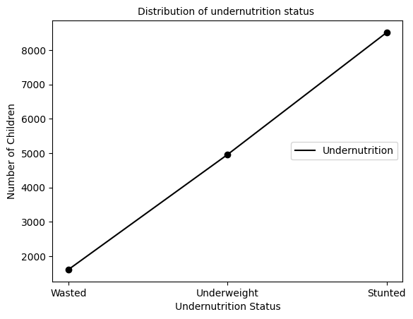
Figure 4: The distribution of undernutrition status among the selected dataset

Managing missing values
Missing values are frequently attributed to human error while handling data, machine error caused by faulty machinery, respondents' refusal to answer specific questions, study dropout, and merging unrelated data [36, 37]. All data-related fields typically experience the missing values problem, which can cause many issues, including performance degradation, challenges with data processing, and biased results [1].
Identification and proper handling of missing values are crucial steps in data preprocessing. If it is not done properly, the conclusions and inferences from the data may be incorrect and flawed.
Research papers often include missing data, and it is commonly accepted that between 15% and 20% of the data can be considered missing [38].
We have used the following three techniques to handle missed data: These are:
Removing attributes: In our datasets, all attributes that have more than 20% of their values missing are removed. We have used this approach only when the dataset has adequate samples. Also, the attributes that are not related to the undernutrition of children are removed.
The process of attribute selection is an important step in the development of any data-driven model. To ensure that the best possible results are obtained, it is essential to identify and remove those attributes that contribute little or nothing towards the goal at hand. This can be done with assistance from domain experts who have a deep understanding of what factors are most likely to influence a given outcome. In this case, we discussed with domain experts removing those attributes that either had no impact on undernutrition status or had too many missing values (above 20%). The removal of these irrelevant features allows us to better focus our efforts on more relevant ones as well as reduce noise in our dataset. Furthermore, for those variables whose missing value percentage was less than 20%, the imputation method was applied to fill up these gaps. Therefore, they could still be used by our model without introducing bias into its predictions.
Overall, this careful approach to feature selection ensures that only meaningful information is included within our dataset and thus helps improve accuracy when making predictions about undernutrition status using machine learning techniques.
Imputation: Imputation is a method for handling missing values that involves replacing them with potential or estimated values in place of the missing values. Certain predicted values are used to fill in for missing values during the imputation process. The values used to replace the missing values are typically predicted using the data set without missing values [39].
A quantitative attribute or a qualitative attribute of all the non-missing values is used for each value in the simple imputation strategy to replace missing values [40]. Simple imputation uses the mode, mean, or median of the values that are available to address missing data. Due to their simplicity and ability to serve as quick references, simple imputation approaches are most frequently used in research [41]. On high-dimensional data sets, basic imputation algorithms, however, may result in biased or unrealistic conclusions. Additionally, as the creation of huge data sets grows, this approach appears to be underperforming and is hence unsuitable for use with such data sets [42].
Mean Imputations: We have used this technique for features that contain numerical data, such as age, weight, height, etc. Here, we can determine the mean of a specific feature that contains a missing value and substitute the result for the missing value. The dataset may be given more variance using this technique, and any data loss can be effectively corrected. As a result, it produces better results than omitting rows and columns.
Mode imputations: we have used this method to replace the missing data with the mode, or most frequent value, of the available data. This technique is beneficial when the data is categorical, as it prevents the data from being significantly altered.

Splitting the dataset
All experiments were performed on the entire dataset, and stratified 10-fold cross-validation was used to randomly sample the training and test sets. During stratified 10-fold cross-validation, the entire dataset is randomly divided into 10 mutually exclusive subsets of approximately equal size. In stratified 10-fold cross-validation, it is trained on 9 folds and tested on the remaining single fold each time [43].

Data transformation
Before performing data analysis on machine learning, data transformation is a crucial data preprocessing technique that must be applied to the data to produce patterns that are easier to understand. It's challenging to track or understand raw data. To extract any information from it, it must first be preprocessed. Data transformation is the procedure of converting raw data into a format that facilitates the use of machine learning algorithms and the retrieval of vital information. To change the data into the right form, data transformation techniques also include data cleaning and data reduction. The dataset that was used as a source of information is described at the beginning of this chapter. Then, a variety of operations have been carried out on the dataset to prepare it for machine learning algorithms and create a representative model. There is often a need to remove large numbers of instances and attributes from datasets to reduce the complexity of the model and eliminate the possibility of inaccurate predictions caused by noise. Different corrective measures were applied to the remaining attributes. The dataset has undergone several activities to develop a representative model and make it appropriate for the machine learning method. Since it does not affect the undernutrition status of the children, large numbers of attributes are removed. For the remaining attributes, various corrective actions were taken. Table 1 provides a final summary of the dataset that is ready for the experiment.
Table 1: Summary of the dataset
No. | Parameters | Original dataset | Preprocessed dataset
 | Total Number of records | 23007 | 15082
 | Total number of attributes | 1072 | 20
 | File format | SPSS | .xls | .csv
 | Size of data | 28.7 MB | 1.8 MB | 1.9 MB

Machine learning models selection
Our main goal is to build a model that predicts the undernutrition status of children under the age of five. To achieve this goal, we are going to assess which machine learning method is more effective at predicting the undernutrition status of children under five in Ethiopia. Several base machine learning algorithms were investigated throughout this work. Once the effectiveness of every machine learning model is tested using useful features that were selected from the dataset during the feature selection stage, the meta-classifiers combined them. As we briefly reviewed in Chapter 2, Logistic Regression, Decision Tree, K-Nearest Neighbors, Bayesian Classifier, Support Vector Machine, and Ensemble Learning were the machine learning algorithms chosen for this thesis.
The following factors led to the choice of the machine learning model:
SVMs employ the structural risk minimization principle, which seeks to reduce an upper bound on the generalization error rather than minimizing the training error, in contrast to the majority of traditional neural network models, which implement the empirical risk minimization principle. The generalization error is constrained by the sum of the training error and a confidence interval term, which forms the foundation of this induction principle [44]. It is also known for the improvement of predictive performance with appropriate parameter tuning, and it is demonstrated to be extremely resistant to the over-fitting problem [45]. Logistic regression is selected because, when attempting to determine whether a new sample most closely fits a particular category, it is a helpful analysis technique [46]. Contrary to its name, logistic regression is more of a classification model than a regression model. For linear and binary classification issues, logistic regression is a quicker and more effective solution. With linearly separable classes, it performs extremely well and is a very simple classification model to implement. It is a widely used algorithm for classification in the industry [47].
One of the nonparametric classification techniques is KNN. KNN is the most comprehensive and has helped it become a well-known and simple algorithm. It can store all of the cases or problems that are available and organize them into new clusters based on their similarity. Finding the nearest neighbor and categorizing them by their similarity Euclidean distance is frequently used by KNN to find the best similar data for the group [48].
With each attribute reduction being calculated and given information, DT is similar to a graph that uses a branching concept to describe the outcome of a choice. A new branch then begins at the position where that attribute has more information. In this way, it grows new branches to represent a tree and collects data on all attributes. Discrete set values and continuous values are the two different types of values in DT. As the target variable, classification trees will use a discrete range of values. The target variable for regression trees will be continuous values [49]. To partition the data and fit a prediction model with this partition, all the easy tests in the DT model can be grouped. The results of this DT can be represented graphically as a decision tree [50].
Certain hypotheses are eliminated by other learning algorithms if they do not match a training example. As opposed to this, Bayesian learning merely lowers the likelihood of an inconsistent hypothesis. As a result, Bayesian learning is more flexible. The a posteriori probability of a hypothesis is obtained using Bayesian learning algorithms by combining training data and a priori knowledge. Therefore, using the training data, it is possible to determine which hypothesis is the most likely. The Bayes Rule serves as the cornerstone of all Bayesian learning algorithms [51].
Stacking is an ensemble technique in which multiple classification models are combined by a meta-classifier. This approach allows for the combination of different types of models with various strengths, resulting in more accurate predictions than any single model could provide. The most common type of stacking involves combining the predictions from several base learners into one final prediction by using a meta-learner to make the final decision. As such, it can be used to improve predictive accuracy and reduce overfitting when compared with using only one model or algorithm [52].
The process begins by training each base learner on its dataset and then making predictions about unseen data points based on these trained models. These individual results are then fed as input features into another machine learning algorithm that combines them and makes a final prediction about new data points not seen before during training time (i.e., test set). This second stage is called "stacking," since it stacks all those separate algorithms together so they work as one unified system instead of many independent ones working separately from each other but still contributing their unique insights towards achieving better overall performance metrics like accuracy or precision-recall scores, etc.

Method of Evaluation of model performance
After building the model, evaluating the classifiers' predictive abilities is important. To assess the effectiveness of predictive modeling, unknown tuples are frequently useful. With this evaluation method, we evaluate how often specific class instances are correctly or incorrectly identified as belonging to that class.

Confusion matrix
The ability of the classifier to identify the classes is examined using the confusion matrix. The row corresponds to the correct classification, and the column corresponds to the predicted classification. For a classifier to have better accuracy, the majority of the tuples must be labeled along the diagonal of the confusion matrix, with the remaining entries being closed to zero [53]. There are classifier evaluation metrics like accuracy, error rate, sensitivity, specificity, precision, recall, and F-measure in the confusion matrix. The simple confusion matrix in Table 2 contains both predicted and actual classes and displays the results of two class classifications.
Here are some performance evaluation computational techniques on the confusion matrix that are used in this study. Accuracy is the first parameter, which is commonly used to evaluate how well the model works. It measures the percentage of test-set tuples that are correctly classified [54].
Accuracy = TP + TN = (TP + TN)/ (TP + TN + FP + FN)
Table 2: Confusion matrix with three classes of the classification result
 | Predicted
Actual |  | C1 | C2 | C3
Actual | C1 | N11 | N12 | N13
Actual | C2 | N21 | N22 | N23
Actual | C3 | N31 | N32 | N33
True Negative is abbreviated as TN. TP=True Positive False Negative (FN) and False Positive (FP)
Sensitivity: The model's performance enables it to correctly classify the positive cases. It is the true positive recognition rate or the probability of having a positive test result among those with a positive diagnosis for the disease [54].
TP / (TP + FN) = Sensitivity (True Positive Rate).
Specificity refers to a model's capacity to classify negative cases. It is described as the likelihood of receiving a negative test result among people who have received a negative disease diagnosis, or the "true negative recognition rate":
TN/TN + FP = Specificity (True Negative Rate) or False Class Recall
The recall is the proportion of positive tuples that the classifier marked as positive for both true and false classes. Precision is another specific performance metric for the classifier, measuring the proportion of tuples that the classifier correctly classified as positive.
Precision = TP/ TP+ FP --------------------------------- For True Class
Precision = TN/TN+FN ---------------------------------- For False Class
Lastly, the F measure is the inverse relationship between precision and recall (F1 or F-). It is crucial to notice that the model's precision and recall are significantly balanced [54].
To calculate the classifier's error rate, which is usually computed as the difference between one and accuracy, use the formula
F-Measure= 2xPrecision*Recall (Precision + Recall) [54].

K-fold cross-validation
When performing k-fold cross-validation, we usually use the most common 10-fold fold cross-validation. Because of a larger k (number of folds), each model is trained on a larger training set and tested on a smaller test fold. As the models see more of the available data, the prediction error should decrease. The possibility of the data distribution in the test fold differing from the training set is greater, and we should thus expect a higher average prediction error.
The entire dataset is randomly divided into 10 mutually exclusive subsets of approximately equal size in 10-fold cross-validation. It is trained on 9 folds and tested on the remaining single fold each time. When compared to the traditional single split (1/3 testing, 2/3 training) experimentation, 10-fold cross-validation requires fewer data. In fact, in the data mining and machine-learning community, 10-fold type of experimentation methods are recommended for method comparison studies with relatively smaller datasets. The main advantage of 10-fold (or any number of folds) cross-validation is that it reduces the bias associated with a random sampling of training and holdout data samples by repeating the experiment 10 times, each time using a different portion of the data as a holdout sample [22, 43].
Furthermore, the Stratified k-fold cross-validation method has been implemented here to improve the performance of ML models.
Stratified k-fold is a useful tool for conducting cross-validation on datasets with classifications. It is similar to the k-fold but goes one step further by ensuring that each classification category is equally divided across all folds. This ensures that each fold has an equal representation of all classes in the dataset and helps minimize any bias from unevenly distributed data points [55].

CHAPTER FOUR

RESULTS AND DISCUSSIONS
To predict the nutritional status of children under five, the 2019 EDHS dataset was explored in this study. The goal of the classification studies is to build a model that can classify Ethiopian under-five children's nutritional status as stunted, wasted, or underweight with the given set of variables. In this work, we followed the experimental design.

Results
Predictive model building starts with a cleaned dataset. The experiments covered in these sections are run with 15082 instances and 20 attributes. The attributes chosen include WHZ, HAZ, WAZ, number of antenatal visits, wealth index, region, when the child was placed in the breast, breastfeeding duration, type of toilet facility, whether the child has ever had nutritious food, place of residence, source of drinking water, education level, place of delivery, current marital status, the total number of children born, age in 5-year groups, vaccination, plain water being given, and unde_Nut_status.
The unde_nut_status attribute is a dependent and class attribute used to build a predictive model based on the values of other attributes like WHZ, HAZ, and WAZ. The file format is changed to a CSV file, and it is given to the classifier to build a model.
For predicting and classifying data, there are a variety of tools available as open source. In our experiment, we used the latest version of Python, which is 3.11, to build predictive models for the undernutrition status of the children. We also used Scikit-Learn, NumPy, Pandas, and the Matplotlib library in Python. Depending on the platform and the parameters provided to the learning algorithms, the performance of similar algorithms may differ.
Logistic Regression, Decision Trees, K-nearest Neighbors, Naive Bayes, and Support Vector Machines (SVM) are among the base algorithms chosen for their good performance and literature support. The dataset is passed through K- fold cross-validation to reduce the bias associated with random sampling. With different types of ensemble methods, we have used the stacking method to combine the algorithms for better accuracy.
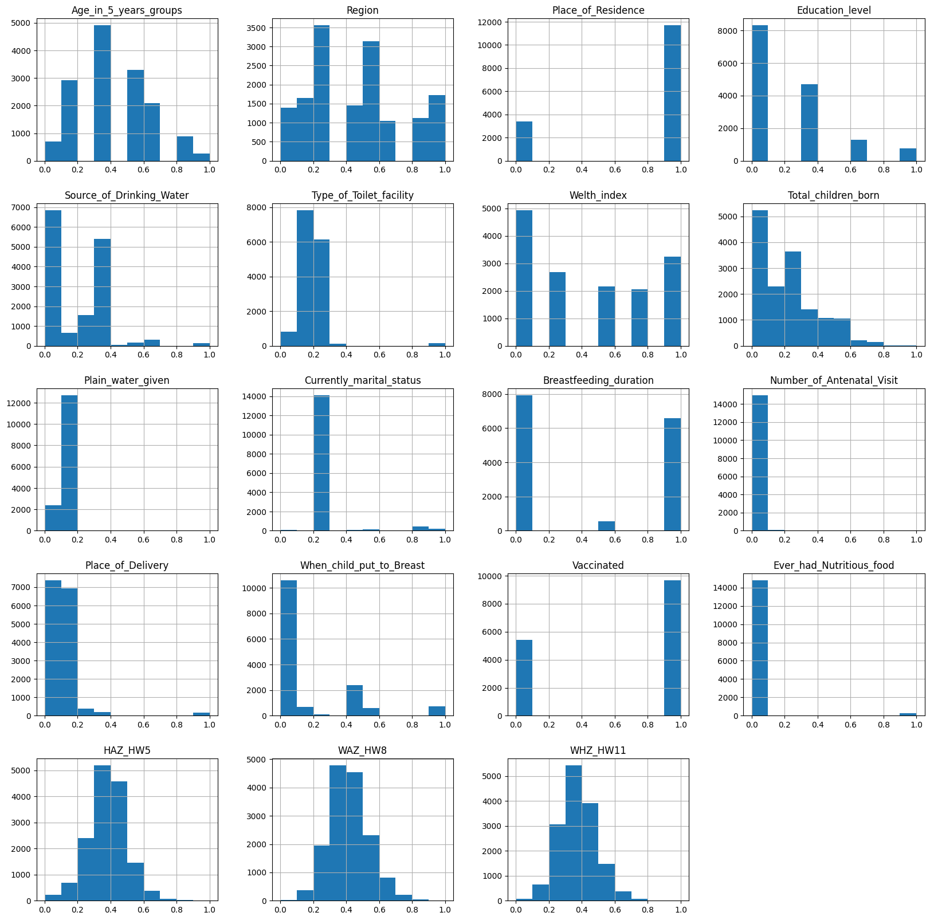
Figure 5: Selected attributes and their distribution

Feature selection
It is a technique for developing predictive models by reducing the number of input variables. To gain good accuracy, irrelevant data and attributes should be removed. In the EDHS data set, there are 1072 variables, which is too many for the machine to make an analysis, so it should be reduced to its optimum level. The concept of correlation describes the relationship between one or more variables. In medical cases, the final results are determined by the correlations of many variables. When two variables have a strong correlation, we can predict one variable based on the other. So, using their correlation coefficients, we ranked the attributes. Based on their coefficient values, 19 attributes were selected.
Table 3: Correlation ranking with their descriptions
No | Correlation Ranking | Ranked attributes: | Type | Descriptions
 | 0.48608 | WHZ | Numeric | Weight/Height standard deviation (new WHO)
 | 0.33601 | HAZ | Numeric | Height/Age standard deviation (new WHO)
 | 0.21115 | WAZ | Numeric | Weight/Age standard deviation (new WHO)
 | 0.04817 | Number of antenatal visits | Numeric | Number of antenatal visits during pregnancy
 | 0.04427 | Wealth index | Numeric | Wealth index combined
 | 0.03601 | Region | Nominal | Region
 | 0.0353 | When a child put to the breast | Nominal | When a child put to the breast
 | 0.02863 | Breastfeeding duration | Numeric | Duration of breastfeeding
 | 0.02849 | Type of toilet facility | Nominal | Type of toilet facility
 | 0.02752 | Ever had nutritious food | Nominal | Ever had Nutritious food?
 | 0.02727 | Place of residence | Nominal | Type of place of residence
 | 0.02552 | Source of drinking water | Nominal | Source of drinking water
 | 0.02379 | Education level | Nominal | Highest educational level
 | 0.02092 | Place of delivery | Nominal | Place of delivery
 | 0.01939 | Currently marital status | Nominal | Current marital status
 | 0.01644 | Total children born | Numeric | Total children ever born
 | 0.01429 | Age in 5 years groups | Numeric | Age in 5-year groups
 | 0.01391 | Vaccinated | Nominal | Ever vaccinated?
 | 0.01133 | Plain water given | Nominal | Plain water is given to children?
Based on their correlation values, the following features WHZ, HAZ, WAZ, number of antenatal visits, wealth index, region, when a child is put to the breast, breastfeeding duration, type of toilet facility, and ever had nutritious food? Place of residence, source of drinking water, education level, place of delivery, current marital status, the total number of children born, age in 5-year groups, vaccination, and plain water given are selected. With these selected attributes we are going to create a target feature called "Unde_Nut_status", which is used to classify those instances as stunted, underweight, and wasted.
The newly developed "Under_Nut_status" feature is designed to classify instances as stunted, underweight, or wasted. By leveraging this data, we can more accurately identify individuals who are at risk of undernutrition and provide the necessary support and resources to help them reach a healthier state. This Target feature provides important information about the nutritional status of individuals by taking into account their sex, age, weight, and height measurements. The target feature "Unde_Nut_status" has been designed with great care taken into consideration while selecting certain attributes according to its international standards set forth by WHO guidelines.
The following images show the graphical representation of the correlations of one feature related to the others.

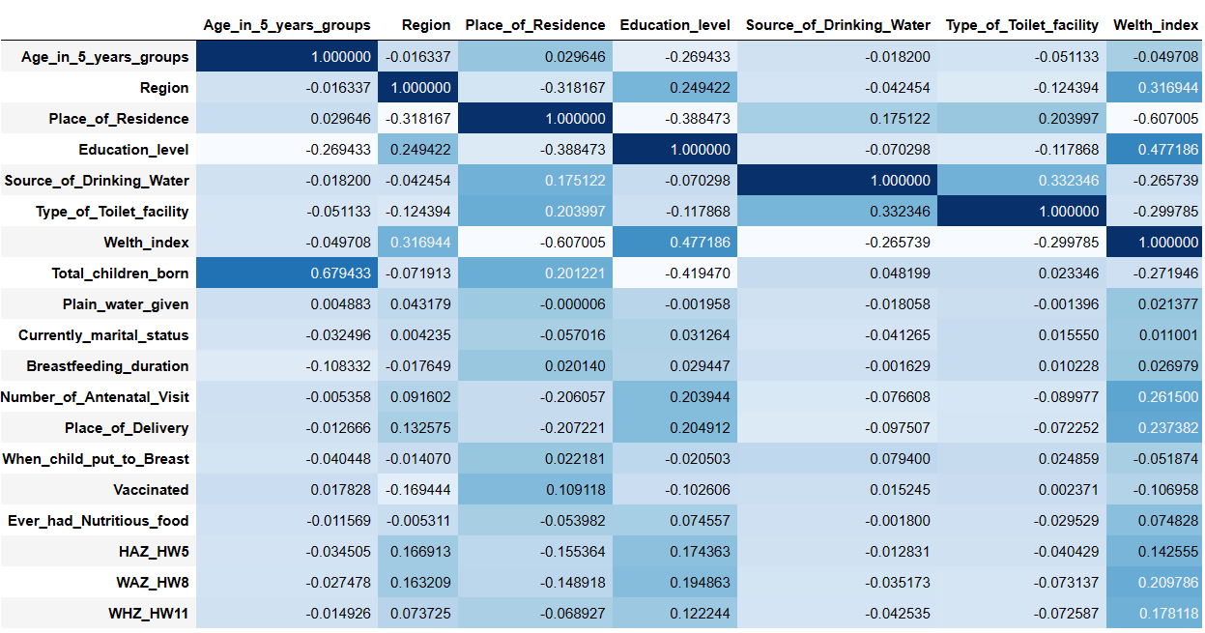
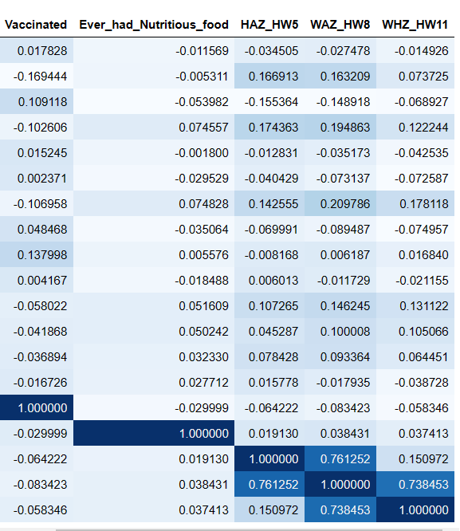

Figure 6: The visualizations of correlations with Cmap

Feature importance
Feature importance expresses how much influence each feature has on the model's prediction. In principle, it determines the level of usefulness of a particular variable for the current model and prediction. As we observed from Table 4, the importance of the features is sorted in descending order to show which features are more important to predict the undernutrition status of the children.
Table 4: Feature importance
No | Feature | Importance | Label Assigned
1 | HAZ | 0.454116 | A
2 | WHZ | 0.423714 | B
3 | WAZ | 0.068966 | C
4 | Number of antenatal visits | 0.008420 | D
5 | Source of drinking water | 0.006552 | E
6 | Region | 0.005544 | F
7 | When a child put to the breast | 0.004312 | G
8 | Place of delivery | 0.004223 | H
9 | Total children born | 0.003826 | I
10 | Breastfeeding duration | 0.003816 | J
11 | Wealth index | 0.002662 | K
12 | Plain water given | 0.002458 | L
13 | Age in 5 years groups | 0.001865 | M
14 | Type of toilet facility | 0.001537 | N
15 | Education level | 0.000895 | O
16 | Vaccinated | 0.000688 | P
17 | Place of residence | 0.000433 | Q
18 | Ever had nutritious food | 0.000312 | R
19 | Currently marital status | 0.000078 | S

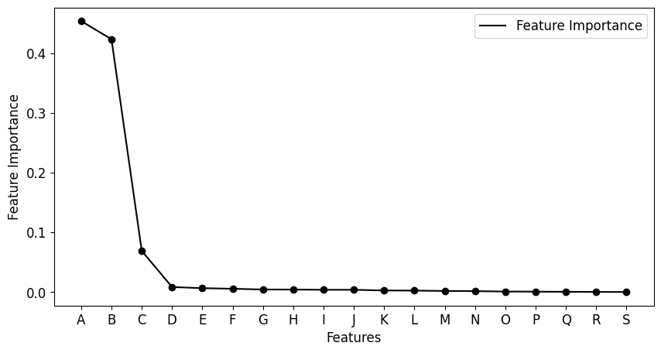
Figure 7: Visual representations of feature importance

Label encoder
A label encoder is a method for turning labels into numbers so they may be fed into a machine-learning model. It is a crucial stage in the preparation of data for the supervised learning method. The Sklearn Library can be used to implement label encoding in Python. Sklearn is a very effective method for converting categorical feature levels into numerical values. Labels that fall into the range of 0 and n classes-1, where n represents the number of labels, are encoded using LabelEncoder.
From sklearn.preprocessing import LabelEncoder
x=dataset.iloc[:,:-1].values
y=dataset.iloc[:,-1].values
le=LabelEncoder()
y=le.fit_transform(y)
To be understood by machine learning algorithms, the last feature, which a class label is named "Nut_Status," is categorical data, which should be converted to numerical values.

Model building
To build the model, different experiments were conducted using a Naive Bayes, Decision Tree, Support Vector Machine, K-Nearest Neighbors, and finally combined by stacking with a Logistic Regression algorithm. Various experiments were done through k- fold cross-validations. In this section, the researcher used various techniques to get the model to perform as well as possible. To increase the accuracy of the model, we have done different experiments with different parameters. So the parameter which gave the best result was documented in this work.

Experimentations with Decision Tree
Table 5: Results of the Decision tree with 10-fold stratified cross-validation
Models | Class | Models Performance Summary
Models | Class | Precision | Recall | F1-Score | Support | Accuracy | Sensitivity | Specificity
Decision Tree | Stunted | 0.94 | 0.96 | 0.95 | 8514 | 0.92 | 0.88 | 0.95
Decision Tree | Underweight | 0.89 | 0.89 | 0.89 | 4959 | 0.92 | 0.88 | 0.95
Decision Tree | Wasted | 0.95 | 0.79 | 0.86 | 1609 | 0.92 | 0.88 | 0.95
Decision Tree | macro avg | 0.92 | 0.88 | 0.90 | 15082 | 0.92 | 0.88 | 0.95
Decision Tree | weighted avg | 0.92 | 0.92 | 0.92 | 15082 | 0.92 | 0.88 | 0.95

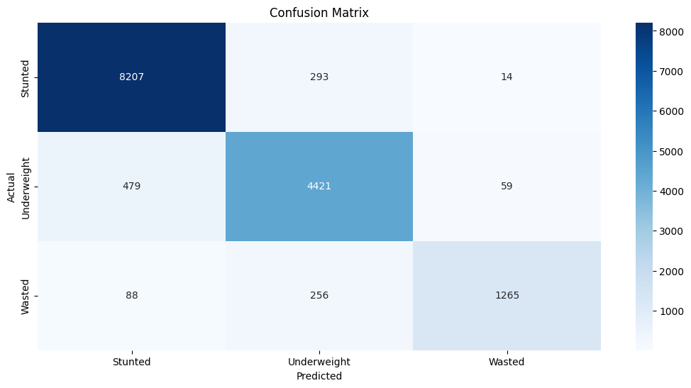
Figure 8: Confusion matrix for Decision Tree
The first experiment demonstrates that the decision tree algorithm can predict nutritional status as stunted, wasted, or underweight with a 99 percent accuracy rate before pruning. This result seems to be overfitting. Overfitting is a problem with decision trees. As the dataset and the number of attributes grow, we can create more complicated trees. By doing this, an overfitting problem may occur, which then introduces the idea of pruning as a solution. Pruning refers to the removal of branches from the classification tree to keep it simple and compact, with the fewest leaf nodes possible. The second experiment used the pruned decision tree classifier with all attributes limiting the size of the maximum leaf nodes to 30 and the minimum leaf nodes to 5. With pruned decision tree experiments, we get the nutritional status predictions to result in an accuracy performance of 92%.
The algorithm classifies 8207 cases of stunted classes correctly; 4421 cases have been correctly grouped into the underweight class, and 1264 cases have also been correctly predicted as wasted. The rest of the predictions are errors or misclassified cases.

Experimentations with SVM
Table 6: Results of SVM with 10-fold stratified cross-validation
Models | Class | Models Performance Summary
Models | Class | Precision | Recall | F1-Score | Support | Accuracy | Sensitivity | Specificity
SVM | Stunted | 0.96 | 0.98 | 0.97 | 8514 | 0.94 | 0.91 | 0.97
SVM | Underweight | 0.91 | 0.93 | 0.92 | 4959 | 0.94 | 0.91 | 0.97
SVM | Wasted | 0.96 | 0.81 | 0.88 | 1609 | 0.94 | 0.91 | 0.97
SVM | macro avg | 0.95 | 0.91 | 0.94 | 15082 | 0.94 | 0.91 | 0.97
SVM | weighted avg | 0.94 | 0.94 | 0.94 | 15082 | 0.94 | 0.91 | 0.97

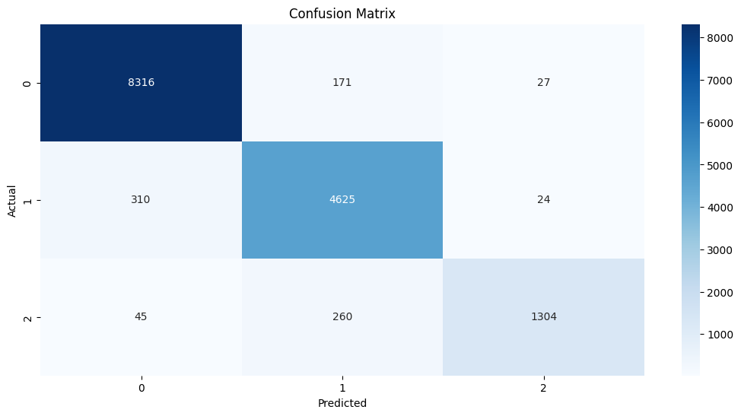
Figure 9: Confusion matrix for SVC
In this experiment, we took different kernel types and we got better accuracy with the ‘poly’ kernel type. The experiment with SVM demonstrates that the algorithm can predict nutritional status as stunted, wasted, or underweight with 94 percent accuracy. The result gained by this model is best compared with the decision trees.
The SVM algorithm classifies 8316 cases of stunted classes correctly; 4625 cases have been correctly grouped into the underweight class, and 1304 cases have also been correctly predicted as wasted. The rest of the predictions are errors or misclassified cases.

Experimentations with Gaussian Naive Bayes
Table 7: Results of Gaussian Naive Bayes with 10-fold stratified cross-validation
Models | Class | Models Performance Summary
Models | Class | Precision | Recall | F1-Score | Support | Accuracy | Sensitivity | Specificity
Gaussian Naive Bayes | Stunted | 0.89 | 0.71 | 0.79 | 8514 | 0.75 | 0.71 | 0.86
Gaussian Naive Bayes | Underweight | 0.61 | 0.87 | 0.71 | 4959 | 0.75 | 0.71 | 0.86
Gaussian Naive Bayes | Wasted | 0.76 | 0.56 | 0.65 | 1609 | 0.75 | 0.71 | 0.86
Gaussian Naive Bayes | macro avg | 0.75 | 0.71 | 0.72 | 15082 | 0.75 | 0.71 | 0.86
Gaussian Naive Bayes | weighted avg | 0.78 | 0.75 | 0.75 | 15082 | 0.75 | 0.71 | 0.86
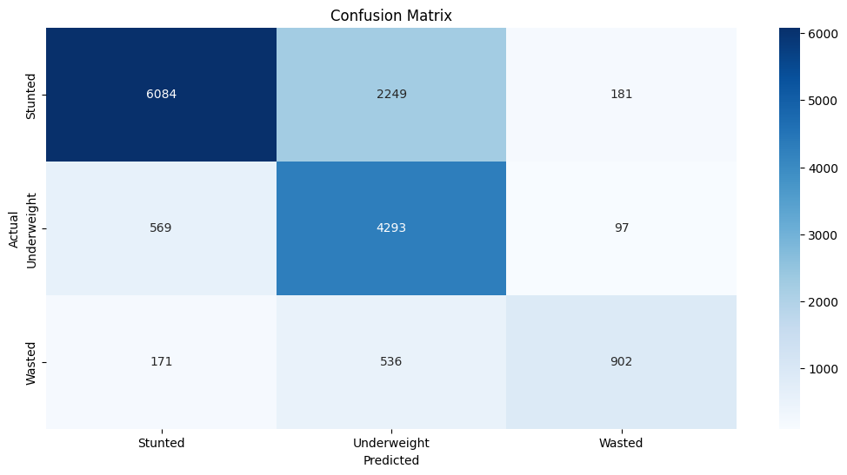
Figure 10: Confusion matrix for Naive Bayes
The experiment with Naive Bayes demonstrates that the algorithm can predict nutritional status as stunted, wasted, or underweight with 75% accuracy. The result gained by this model is comparable with the decision tree classifier.
The Naive Bayes algorithm correctly classifies 6084 cases as stunted, 4293 cases as underweight, and 902 cases as wasted. The rest of the predictions are errors or misclassified cases.

Experimentations with KNN Classifier
Table 8: Results of KNN Classifier with 10-fold stratified cross-validation
Models | Class | Models Performance Summary
Models | Class | Precision | Recall | F1-Score | Support | Accuracy | Sensitivity | Specificity
KNN Classifier | Stunted | 0.93 | 1.00 | 0.96 | 8514 | 0.92 | 0.79 | 0.95
KNN Classifier | Underweight | 0.89 | 0.94 | 0.92 | 4959 | 0.92 | 0.79 | 0.95
KNN Classifier | Wasted | 1.00 | 0.43 | 0.60 | 1609 | 0.92 | 0.79 | 0.95
KNN Classifier | macro avg | 0.94 | 0.79 | 0.83 | 15082 | 0.92 | 0.79 | 0.95
KNN Classifier | weighted avg | 0.92 | 0.92 | 0.91 | 15082 | 0.92 | 0.79 | 0.95
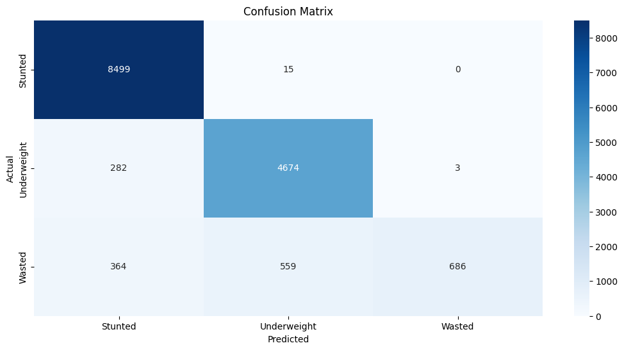
Figure 11: Confusion matrix for KNN
The number of nearest neighbors utilized to create predictions in the k-nearest neighbor (KNN) method depends on the value of k. In our experiments, the model became smoother and more stable as the value of k increased, whereas the model became more flexible and more prone to overfitting as the value of k decreases. So the optimum value of k in our experiments was six.
The experiment with the KNN classifier yields an accuracy of 92% for the predictions of undernutrition status as stunted, wasted, and underweight.
The KNN algorithm correctly classifies 8499 cases of stunted classes; 4674 cases have been correctly grouped into the underweight class, and 686 cases have also been correctly predicted as wasted. The rest of the predictions are errors or misclassified cases.

Meta Classifier with Logistic Regression
Table 9: Results of Meta Classifier with 10-fold stratified cross-validation
Models | Class | Models Performance Summary
Models | Class | Precision | Recall | F1-Score | Support | Accuracy | Sensitivity | Specificity
Stacking with Logistic Regressions | Stunted | 0.96 | 1.00 | 0.98 | 8514 | 0.96 | 0.93 | 0.99
Stacking with Logistic Regressions | Underweight | 0.94 | 0.94 | 0.94 | 4959 | 0.96 | 0.93 | 0.99
Stacking with Logistic Regressions | Wasted | 0.97 | 0.79 | 0.87 | 1609 | 0.96 | 0.93 | 0.99
Stacking with Logistic Regressions | macro avg | 0.96 | 0.91 | 0.93 | 15082 | 0.96 | 0.93 | 0.99
Stacking with Logistic Regressions | weighted avg | 0.96 | 0.96 | 0.95 | 15082 | 0.96 | 0.93 | 0.99
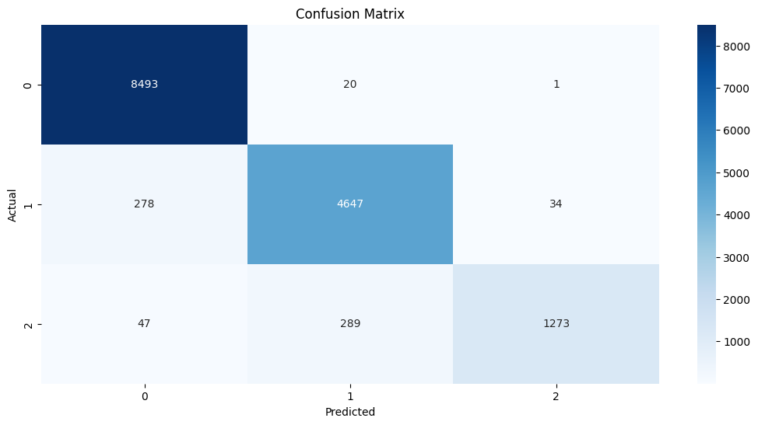
Figure 12: Confusion matrix for Stacking with logistic regression
Ensemble types of machine learning techniques take a machine learning model to the next level with the highest accuracy. Stacking is one of the popular ensemble techniques that train multiple models to solve similar problems, combining their outputs to create a new, improved model with a higher level of performance. The above experiment reveals that the prediction of undernutrition status like stunted, underweight, and wasted was labeled by 0, 1, and 2 respectively. The experiment was performed by stacking with a logistic regression model, which yields a 96 percent rate of accuracy and is the best performance compared with the others.
The Meta Classifier algorithm, called "Logistic Regression," classifies 8493 cases of stunted classes correctly; 4647 cases have been correctly grouped into the underweight class, and 1273 cases have also been correctly predicted as wasted. The rest of the predictions are errors or misclassified cases.

Discussions
In this work, different machine learning classification models such as the Decision Tree, K-Nearest Neighbors, Support Vector Machine, and Naive Bayes classifiers have been used as base model algorithms and finally combined by stacking the ensemble method with logistic regression. These selected classification algorithms have been selected because they have good accuracy and have literature support.
The prediction performance of the pruned decision tree model is 92%, meaning that 13,875 instances were correctly classified whereas 1207 instances (8%) were misclassified.
The SVM model achieved 94% accuracy in its predictions, correctly classifying 14,177 instances while misclassifying only 905, which is 6%.
The Naive Bayes algorithm’s prediction accuracy is 75%, which means that 11,312 cases were correctly classified and 3,771 instances (25% were incorrectly misclassified).
The KNN algorithm correctly classifies 92% of the cases or 13,875 cases, and incorrectly classifies 8% of the cases, or 1207 cases.
With a prediction accuracy of 96%, the stacking ensemble method correctly predicted 14,479 instances and misclassified only 603 which is 4% of it.

Performance evaluation and comparison of classifiers
The confusion matrix contains data about the actual and predicted classifications performed by a classifier. The information in the matrix is used to assess how well the classifier is performing. The letters TN, TP, FP, and FN stand for True Negative, True Positive, False Positive, and False Negative, respectively.
The popular metrics of accuracy, True-Positive Rates, False-Positive Rates, and ROC are used to assess and compare the performance of each classifier used in this study.
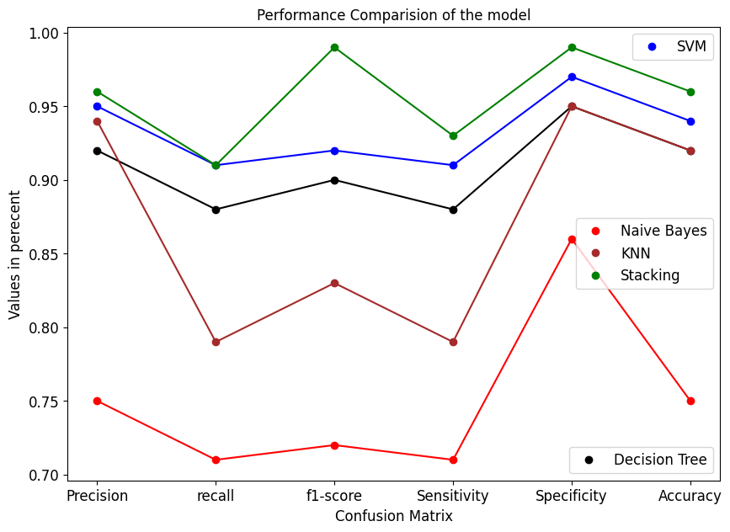
Figure 13: Performance comparison of model
In this work, different machine learning models have been examined and used to predict the undernutrition of children. The best performance on predicting the nutritional status as stunted, underweight, or wasted was achieved by the ensemble method through stacking. Naive Bayes exhibit the lowest performance.
The confusion matrix is a way of visualizing the accuracy of the prediction model. It contains key information on how well the model is performing by displaying the number of correctly and incorrectly classified classes.
To pass the results of each model to the Meta classifier, the accuracy of each model is important. The Meta classifier's output should be greater than the output of the individual classifier. In this study, classification base algorithms, or level 0 algorithms, such as nearest neighbors, decision trees, support vector machines, and naive Bayes, are used and combined by logistic regression with Meta classifiers, or level 1 algorithms.
Comparing and evaluating the results of algorithms like decision trees, k-nearest neighbors, support vector machines, and Naive Bayes classifiers is important before combining the results with stacking. Hence the results gained by stacking should be greater than those of individual algorithms.
To compare each classifier's performance, precision, recall, f1-score sensitivity, specificity, and accuracy metrics were used.
Table 10: Models performance summary
Models performance summary
Models | precision | Recall | f1-score | Sensitivity | Specificity | Accuracy
Decision Tree | 0.92 | 0.88 | 0.90 | 0.88 | 0.95 | 0.92
SVM | 0.95 | 0.91 | 0.92 | 0.91 | 0.97 | 0.94
Gaussian Naive Bayes | 0.75 | 0.71 | 0.72 | 0.71 | 0.86 | 0.75
KNN Classifier | 0.94 | 0.79 | 0.83 | 0.79 | 0.95 | 0.92
Stacking | 0.96 | 0.91 | 0.99 | 0.93 | 0.99 | 0.96

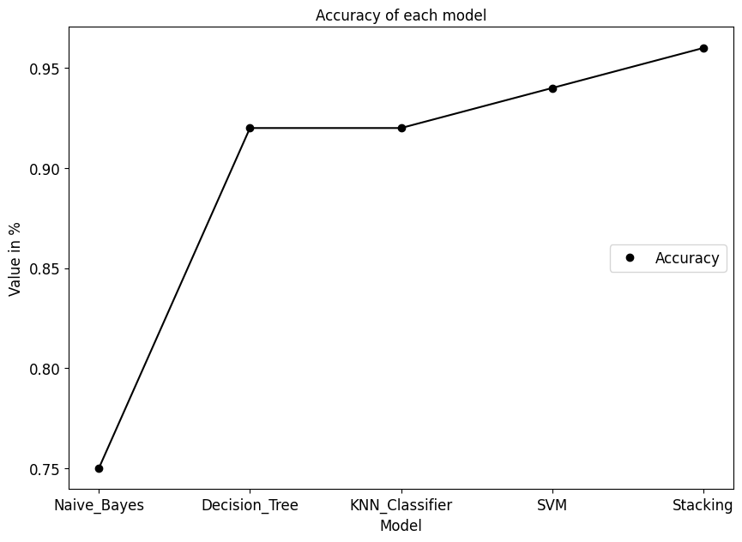
Figure 14: Accuracy of each model
As can be seen in Figure 14, the experiments are mostly divided into models based on the name of the employed algorithm and the accompanying parameters. The Decision Tree, Logistic Regression, K-Nearest Neighbors, Support Vector Machines, and Naive Bayes classifiers have all produced different results. The first experiment demonstrates that the decision tree algorithm can accurately predict nutritional status as stunted, wasted, and underweight with a 99 percent accuracy rate before pruning. The second experiment shows that applying the hypo parameter to the pruned decision tree classifier with all attributes significantly affects categorization and nutritional status prediction (accuracy is 92%). The third experiment was created to evaluate the SVM algorithm's ability to predict nutritional status with a 96 percent accuracy rate. With an accuracy rate of 75%, the fourth experiment was done by Naive Bayes. The fifth experiment was conducted by the KNN classifier, with an accuracy rate of 92 percent. And the final experiments are combined by stacking logistic regression algorithms with a 96 percent accuracy rate.
In general, as we observed from the above experiments, stacking does produce better results than an individual model, so it is found to have strong predictive performance for the undernutrition status of children under five.

Rule extraction
Classification techniques that use decision tree classifiers are common for rule extraction because they are accurate and have an easy-to-understand working model. In this section, we look at how to extract IF-THEN rules from a decision tree to build a rule-based classifier. The IF-THEN rules may be simpler for humans to understand than a decision tree, especially if the decision tree is very large. For each path leading from the root to a leaf node of a decision tree, one rule is created to extract the rules. The rule antecedent (also known as the "IF" part) is created logically AND for each splitting criterion along a specific path. The class prediction that makes up the rule consequent (the "THEN" part) is held by the leaf node.

Rules extracted for ‘Stunted’ or class 0
Rule 1: If HAZ < -2 and WHZ > -47.18 and Education level =’ Secondary’ and Region = ‘Gambela’ Then the class is Stunted
Rule 2: If HAZ < -2 and WHZ <= -240 and Age in 5 years groups = ‘30-34’ and Ever had nutritious food= ‘No’ Then the class is Stunted
Rule 3: If HAZ < -2 and Region =’Harai’ and Region = ‘Addis Ababa’ Then the class is Stunted
Rule 4: If HAZ < -2 and WHZ > 41.67 and HAZ <= 131.15 and Education level=‘No education’ and Type of toilet facility = ‘No Facility’ Then the class is Stunted
Rule 5: If HAZ <-2 and WHZ <= -194 and Total children born <= 7 and Region = ‘Somali’ and Source of Drinking Water = ‘Rainwater’ Then the class is Stunted
Rule 6: If HAZ < -2 and Wealth index = ‘Poorest’ and Region = ‘Benishangul’ and Age in 5 years groups = ‘40-44’ Then the class is Stunted
Rule 7: If HAZ < -2 and Total_children_born > 2 and Region = ‘Oromia’ and Region = ‘Afar’ Then the class is Stunted

Rules extracted for ‘underweight’ or class 1
Rule 1: If WAZ< -2 and HAZ <= -83.11 and WHZ <= -245.85 Then the class is Underweight
Rule 2: If WAZ< -2 and WHZ > -333.57 and Source of drinking water = ‘Dug Well (Open/Protected)’ and Place of delivery = ‘Public Sector’ and Number of antenatal visit’ =1 and Total children born >2 Then the class is Underweight
Rule 3: If WAZ< -2 and Total children born > 4 and Wealth index = ‘Poorer’ and HAZ <= -159.61 and Type of toilet facility’ = ‘No Facility’ Then the class is Underweight
Rule 4: If WAZ< -2 and HAZ > -267 and WHZ <= -283 and HAZ <= -192 and HAZ <= -215 and Total children born <= 2 and Education level <= ‘Secondary’ Then the class is Underweight
Rule 5: If WAZ< -2 and WHZ > -345 and Region = ‘Tigray’ and Age in 5 years groups <= ‘20-24’ Then the class is Underweight
Rule 6: If WAZ< -2 and WHZ >-356 Then the Wealth index <= ‘Poorer’ and Plain water has given = ‘No’ and Ever had nutritious food= ‘No’ Then the class is Underweight
Rule 7: If WAZ< -2 and HAZ > -28 and Region = ‘Harari’ and Wealth index <= ‘Poorer’ and WHZ <= -207 and HAZ <= -28 Then the class is Underweight

Rules extracted for ‘Wasted’ or class 2
Rule 1: If WHZ < -2 and Number of antenatal visits <= 1 and the Total children born > 2 Then the class is Wasted.
Rule 2: If WHZ < -2 and Type of toilet facility = ‘No facility/bush/field’ and WAZ > -217.08 and Region= ‘Oromia’ Then the class is Wasted.
Rule 3: If WHZ < -2 and WAZ > -234.44 and HAZ > -27.36 and Vaccinated = ‘No’ and Source of drinking water = ‘Unprotected spring’ and Region = ‘Amhara’ Then the class is Wasted.
Rule 4: If WHZ < -2 and Number of antenatal visits> 3 and HAZ > -0.88 And WAZ > -68.63 Then the class is Wasted.
Rule 5: If WHZ < -2 and HAZ > 13.05 and Breastfeeding duration = ‘Never breastfed’ and Ever had nutritious food= ‘No’ Then the class is Wasted.
Rule 6: If WHZ < -2 and Type of toilet facility= ‘No Facility’ and Region = ‘Afar’ and WHZ <= -85.84 and Age in 5 years groups= ‘30-34’ and Place of residence = ‘Urban’ and HAZ <= -51.21 Then the class is Wasted
Rule 7: If WHZ < -2 and Region = ‘Tigray’ and HAZ <= -42 and Breastfeeding duration = ‘Never breastfed’ and the number of antenatal visits <= 5 Then the class is Wasted.
As we observed from the above experimentation, rules produced by a Decision Tree model are displayed in the IF-THEN to categorize the nutritional status as stunted, underweight, or wasted. When combined with height and age, HAZ becomes a predictor for stunting. Also, the values of HAZ, WHZ, age in 5-year groups, region, source of drinking water, education level, type of toilet facility, having ever had nutritious food, wealth index, and the total number of children born are the most significant indicators of a child under five being stunted.
The other rule extracted by the decision tree model to predict the undernutrition status of children below the age of five is being underweight. For underweight status, the value of WAZ alone determines the status of children as being underweight. As the rules are extracted from the decision tree model, it states that the values of HAZ, WHZ, age in 5-year groups, region, source of drinking water, wealth index, the total number of children born, type of toilet facility, education level, plain water given, and ever having eaten nutritious food affect the children being underweight.
The final rules extracted by the decision trees to determine the undernutrition status of children under five are wasted. WAZ, HAZ, WHZ, age in 5-year groups, WHZ, number of antenatal visits, the total number of children born, type of toilet facility, region, source of drinking water, vaccination, and whether they have ever eaten nutritious food or been breastfed for an extended period are the most important features that determine the status of children to be wasted.
As shown by the rule that was extracted, children who are stunted and wasted also tend to be underweight.

CHAPTER FIVE

CONCLUSION AND RECOMMENDATION

Conclusion
This research seeks to assess the potential of the ensemble method for predicting the status of undernutrition in children below the age of five. In many industries, including the healthcare sector, the use of machine learning technology has grown in popularity and relevance. Examples include patient survival analysis, diagnosis prediction, patient care improvement, and decision-making. However, machine learning's potential hasn't yet been used to predict children's nutritional status under age five in Ethiopia.
Undernutrition is one of the leading causes of illness and death for children under five, especially in Ethiopia. It increases the risk of morbidity and mortality from infectious diseases, impairs cognitive and physical development, and reduces school performance and productivity. The goal of this study was to build a predictive model for the undernutrition status of children under five using the ensemble method and the 2019 EMDHS dataset. Future policymakers and healthcare professionals in the nation will be able to identify at-risk children with the help of the model.
The attributes used in this study are WHZ, HAZ, WAZ, number of antenatal visits, wealth index, region, when the child was placed to the breast, breastfeeding duration, type of toilet facility, ever having had nutritious food, place of residence, source of drinking water, education level, place of delivery, currently marital status, total children born, age in 5-year groups, vaccinated, plain water is given, and unde_Nut_status. The class attribute, which is required when creating predictive models, is represented by the last attribute called "Unde_Nut_status" on the list.
To understand the undernutrition status of under-five children, a total of 23007 instances and 1072 attributes were collected from the EMDHS. By applying different preprocessing techniques, we reduced the instances to 15082 and the attributes to 20. The data from the demographic and health survey strongly indicated that the above features were related to the nutritional status of children under five.
To improve the performance of machine learning models the Stratified 10-fold cross-validation (SKCV) method has been implemented. With Stratified 10-fold cross-validations, each fold has an equal representation of all classes in the dataset and helps minimize any bias from unevenly distributed data points.
The country's prevention and control efforts for undernutrition among children under five may also benefit from the use of such a predictive model. The four base algorithms like the Naive Bayes classifier, decision tree, Support Vector Machine, and k-nearest neighbors were used in this study. These algorithms were combined with an ensemble type of stacking called Logistic Regression. Through experimentation, several models that could predict the undernutrition status of children under five were developed.
An ensemble method is a powerful tool for increasing the accuracy of machine learning models. In our work, "stacking ensemble" approaches can make predictions that are more accurate than those made by a single model by mixing several diverse models. This is because each model has its strengths and weaknesses, and by stacking them together, they can amplify their advantages.
One conclusion that we can draw from using the ensemble method is that it allows us to create better predictive models with higher accuracy rates than traditional single-model approaches. Additionally, these types of techniques allow us to reduce overfitting as well as improve generalization performance on unseen data points. Furthermore, since there are numerous different types of algorithms available for use in an ensemble method, this approach also provides flexibility when choosing which type of algorithm works best for a given task.
Overall, the stacking ensemble method provides great potential when it comes to creating highly accurate prediction systems. It enables us not only to increase the overall accuracy rate but also helps prevent overfitting issues, allowing our system’s results to remain consistent even with new inputs. Finally, having access to multiple algorithms means we have greater control regarding which type performs best under certain conditions.
In this work, the stacking ensemble method is found to have strong predictive performance for the status of undernourished children below the age of five. As compared to the works mentioned in the related work section, we were able to achieve the highest level of accuracy.
HAZ, WAZ, WHZ, age in 5-year groups, region, source of drinking water, education level, type of toilet facility, wealth index, the total number of children born, having ever had nutritious food, the number of antenatal visits, vaccination, breastfeeding duration, and plain water have all been identified as major factors contributing to undernutrition in children under the age of five.

Recommendations
In this study, machine learning techniques were used to predict the undernutrition status of children under the age of five using the 2019 EMDHS dataset. Through appropriate interventions, it is necessary to reduce child undernutrition and improve the health of children. The researcher provided the recommendations below.
- This study used data from the EMDHS datasets to predict the undernutrition status of children under the age of five. Datasets from other domains, such as hospitals and clinical datasets, should be focused on to find datasets that may be needed for future studies.
- This study focused on the status of undernutrition for children under five. Future research could focus on childhood malnutrition, such as obesity.
- This study focused on the status of undernutrition for children under five. Future work might also focus on children whose ages are above five.

REFERENCES
- Ayilara, O. F., Zhang, L., Sajobi, T. T., Sawatzky, R., Bohm, E., & Lix, L. M. (2019). Impact of missing data on bias and precision when estimating the change in patient-reported outcomes from a clinical registry. Health and quality of life outcomes, 17(1), 1-9.
- UNESCO Report. (2012). The Review of Health and Nutrition Indicators in early childhood,
- Ethiopia Federal Ministry of Health. (2007). Ethiopia, Addis Ababa. Protocol for the management of severe acute malnutrition
- Save the Children. (2012). Tackling child malnutrition.
- Aweke, K. A., Habtamu, F., & Akalu, G. (2012). Nutritional status of children in food insecure households in two districts of North Showa Zone, Ethiopia. African Journal of Food, Agriculture, Nutrition and Development, 12(2), 5915-5927.
- ECA, U. (2013). MDG report 2013: assessing progress in Africa toward the Millennium Development Goals: food security in Africa: issues, challenges, and lessons: summary.
- Beyene, T. T. (2012). Predictors of nutritional status of children visiting health facilities in Jimma Zone, South West Ethiopia. Int J Adv Nurs Sci Pract, 1(1), 1-13.
- EPHI, I. (2019). Ethiopian Public Health Institute (EPHI)[Ethiopia] and ICF. Ethiopia Mini Demographic and Health Survey 2019: Key Indicators.
- Pintelas, P. E., & Livieris, I. E. (Eds.). (2020). Ensemble algorithms and their applications. MDPI-Multidisciplinary Digital Publishing Institute.
- Kang, H. (2013). The prevention and handling of the missing data. Korean Journal of Anesthesiology, 64(5), 402-406.
- Young, E. M. (2013). Food and development. Routledge.
- Duggan, C., Watkins, J. B., Koletzko, B., & Walker, W. A. (Eds.). (2016). Nutrition in pediatrics: basic science, clinical applications (Vol. 1). PMPH USA, Ltd.
- Trehan, I., Goldbach, H. S., LaGrone, L. N., Meuli, G. J., Wang, R. J., Maleta, K. M., & Manary, M. J. (2016). Research Article (New England Journal of Medicine) Antibiotics as part of the management of severe acute malnutrition. Malawi Medical Journal, 28(3), 123-130.
- Pruss-Ustun, A., & World Health Organization. (2008). safer water, better health: costs, benefits and sustainability of interventions to protect and promote health. World Health Organization.
- Mabhaudhi, T., Chibarabada, T., & Modi, A. (2016). Water-food-nutrition-health nexus: Linking water to improving food, nutrition, and health in Sub-Saharan Africa. International Journal of environmental research and public health, 13(1), 107.
- Unicef, & WHO, W. (2020). Levels and trends in child malnutrition: key findings of the 2019 Edition of the Joint Child Malnutrition Estimates. Geneva: World Health Organization.
- Black, R. (2003). Micronutrient deficiency: an underlying cause of morbidity and mortality. Bulletin of the World Health Organization, 81(2), 79-79.
- Panesar, A., & Panesar, A. (2021). Machine learning and AI ethics. Machine Learning and AI for Healthcare: Big Data for Improved Health Outcomes, 207-247.
- Alanazi, A. H., Cradock, A., Ryan, J., & Rainford, L. (2022). Machine learning and deep learning-based Natural Language Processing for auto-vetting the appropriateness of Lumbar Spine Magnetic Resonance Imaging Referrals. Informatics in Medicine Unlocked, 30, 100961.
- Nayyar, A., Gadhavi, L., & Zaman, N. (2021). Machine learning in healthcare: review, opportunities, and challenges. Machine Learning and the Internet of Medical Things in Healthcare, 23-45.
- Kolachalama, V. B., & Garg, P. S. (2018). Machine learning and medical education. NPJ digital medicine, 1(1), 54.
- Markos, Z., Doyore, F., Yifiru, M., & Haidar, J. (2014). Predicting Under nutrition status of under-five children using data mining techniques: The Case of 2011 Ethiopian Demographic and Health Survey. J Health Med Inform, 5(2).
- Altınçay, H. (2007). Decision trees using model ensemble-based nodes. Pattern recognition, 40(12), 3540-3551.
- Gareth, J., Daniela, W., Trevor, H., & Robert, T. (2013). An introduction to statistical learning: with applications in R. Springer.
- Leung, K. M. (2007). Naive Bayesian classifier. Polytechnic University Department of Computer Science/Finance and Risk Engineering, 2007, 123-156.
- Williams, G. (2011). Data mining with Rattle and R: The art of excavating data for knowledge discovery. Springer Science & Business Media.
- Kourou, K., Exarchos, T. P., Exarchos, K. P., Karamouzis, M. V., & Fotiadis, D. I. (2015). Machine learning applications in cancer prognosis and prediction. Computational and structural biotechnology journal, 13, 8-17.
- Hastie, T., Tibshirani, R., Friedman, J., Hastie, T., Tibshirani, R., & Friedman, J. (2009). Overview of supervised learning. The elements of statistical learning: Data mining, inference, and prediction, 9-41.
- Bitew, F. H., Sparks, C. S., & Nyarko, S. H. (2022). Machine learning algorithms for predicting undernutrition among under-five children in Ethiopia. Public Health Nutrition, 25(2), 269-280.
- Van, V. T. S., Antonio, V. A., Siguin, C. P., Gordoncillo, N. P., Sescon, J. T., Go, C. C., & Miro, E. P. (2022). Predicting undernutrition among elementary schoolchildren in the Philippines using machine learning algorithms. Nutrition, 96, 111571.
- Chilyabanyama, O. N., Chilengi, R., Simuyandi, M., Chisenga, C. C., Chirwa, M., Hamusonde, K., & Bosomprah, S. (2022). Performance of Machine Learning Classifiers in Classifying Stunting among Under-Five Children in Zambia. Children, 9(7), 1082.
- Zhang, S., Tjortjis, C., Zeng, X., Qiao, H., Buchan, I., & Keane, J. Comparing Data Mining Methods with Logistic Regression.
- Ndagijimana, S., Kabano, I. H., Masabo, E., & Ntaganda, J. M. (2023). Prediction of Stunting Among Under-5 Children in Rwanda Using Machine Learning Techniques. Journal of Preventive Medicine and Public Health, 56(1), 41-49.
- Talukder, A., & Ahammed, B. (2020). Machine learning algorithms for predicting malnutrition among under-five children in Bangladesh. Nutrition, 78, 110861.
- Lenters, L., Wazny, K., & Bhutta, Z. A. (2016). Management of severe and moderate acute malnutrition in children. Reproductive, maternal, newborn and child health: disease control priorities. 3rd edition. Washington, DC: World Bank, 205-223.
- Gopika, N., & ME, A. M. K. (2018, October). Correlation-based feature selection algorithm for machine learning. In 2018 3rd international conference on Communication and electronics systems (ICCES) (pp. 692-695). IEEE.
- Suthar, B., Patel, H., & Goswami, A. (2012). A survey: classification of imputation methods in data mining. International Journal of Emerging Technology and Advanced Engineering, 2(1), 309-12.
- Dong, Y., & Peng, C. Y. J. (2013). Principled missing data methods for researchers. SpringerPlus, 2, 1-17.
- Donders, A. R. T., Van Der Heijden, G. J., Stijnen, T., & Moons, K. G. (2006). A gentle introduction to the imputation of missing values. Journal of clinical epidemiology, 59(10), 1087-1091.
- García-Laencina, P. J., Sancho-Gómez, J. L., Figueiras-Vidal, A. R., & Verleysen, M. (2009). K nearest neighbors with mutual information for simultaneous classification and missing data imputation. Neurocomputing, 72(7-9), 1483-1493.
- Jerez, J. M., Molina, I., García-Laencina, P. J., Alba, E., Ribelles, N., Martín, M., & Franco, L. (2010). Missing data imputation using statistical and machine learning methods in a real breast cancer problem. Artificial intelligence in medicine, 50(2), 105-115.
- Khan, S. I., & Hoque, A. S. M. L. (2020). SICE: an improved missing data imputation.
- Olson, D. L., & Delen, D. (2008). Advanced data mining techniques. Springer Science & Business Media.
- Tan, P. N., Steinbach, M., & Kumar, V. (2006). Introduction to Data Mining, Boston: Person Education.
- Han, J., & Kamber, M. (2008). Data Mining: Concepts and Techniques Slides for Textbook—Chapter 7.
- Alpaydin, E. (2010). Introduction to machine learning, 2nd edition. Adaptive computation and machine learning.
- Mohammed, A. A. (2019). Design and implementation of a prototype data mining agent system (Master's thesis, Altınbaş Üniversitesi).
- Weiss, S. M., & Zhang, T. (2003). Performance analysis and evaluation. In The Handbook of data mining (p. 425).
- Tay, F. E., & Cao, L. (2001). Application of support vector machines in financial time series forecasting. omega, 29(4), 309-317.
- Zamri, N., Pairan, M. A., Azman, W. N. A. W., Abas, S. S., Abdullah, L., Naim, S., ... & Gao, M. (2022). River quality classification using different distances in the k-nearest neighbors algorithm. Procedia Computer Science, 204, 180-186.
- Edgar, T., & Manz, D. (2017). Research methods for cyber security. Syngress.
- Latha, C. B. C., & Jeeva, S. C. (2019). Improving the accuracy of prediction of heart disease risk based on ensemble classification techniques. Informatics in Medicine Unlocked, 16, 100203.
- Lameski, P., Zdravevski, E., Mingov, R., & Kulakov, A. (2015). SVM parameter tuning with grid search and its impact on the reduction of model over-fitting. In Rough Sets, Fuzzy Sets, Data Mining, and Granular Computing: 15th International Conference, RSFDGrC 2015, Tianjin, China, November 20-23, 2015, Proceedings (pp. 464-474). Springer International Publishing.
- Subasi, A. (2020). Practical machine learning for data analysis using Python. Academic Press.
- Prusty, S., Patnaik, S., & Dash, S. K. (2022). SKCV: Stratified K-fold cross-validation on ML classifiers for predicting cervical cancer. Frontiers in Nanotechnology, 4, 972421.
- Kassie, G. W., & Workie, D. L. (2020). Determinants of under-nutrition among children under five years of age in Ethiopia. BMC Public Health, 20(1), 1-11.

APPENDIXES

ANNEX 1: The Selected Attributes' Description
No | Correlation Ranking | Ranked attributes | Type | Descriptions | Respective values
 | 0.48608 | WHZ | Numeric | Weight/Height standard deviation (new WHO) | <-2SD, -2SD-2SD, >2SD (Standard deviations)
 | 0.33601 | HAZ | Numeric | Height/Age standard deviation (new WHO) | <-2SD, -2SD-2SD, >2SD (Standard deviations)
 | 0.21115 | WAZ | Numeric | Weight/Age standard deviation (new WHO) | <-2SD, -2SD-2SD, >2SD (Standard deviations)
 | 0.04817 | Number of antenatal visits | Numeric | Number of antenatal visits during pregnancy | No antenatal visits, Don't know
 | 0.04427 | Wealth index | Numeric | Wealth index combined | Poorest, Poorer, Middle, Richer, Richest
 | 0.03601 | Region | Nominal | Region | Tigray, Afar, Amhara, Oromia, Somali, Benishangul, SNNPR, Gambela, Harari, Addis Adaba, Dire Dawa,
 | 0.0353 | When a child put to the breast | Nominal | When a child put to the breast | Immediately, Within the first hour, Hours: 1, Hours: number missing, Days: 1, Days: number missing
 | 0.02863 | Breastfeeding duration | Numeric | Duration of breastfeeding | Ever breastfed, not currently breastfeeding, Never breastfed, Still breastfeeding, Breastfed until died, Inconsistent, Don't know,
 | 0.02849 | Type of toilet facility | Nominal | Type of toilet facility | FLUSH TOILET, Flush To Piped Sewer System, Flush To Septic Tank, Flush To Pit Latrine, Flush To Somewhere Else, Flush, Don't Know Where, PIT TOILET LATRINE, Ventilated Improved Pit Latrine (VIP), Pit Latrine With Slab, Pit Latrine Without Slab/Open Pit, NO FACILITY, No Facility/Bush/Field, Composting Toilet, Bucket Toilet, Hanging Toilet/Latrine, Other,
 | 0.02752 | Ever had_utritious_food | Nominal | Ever had Nutritious food? | Yes, No
 | 0.02727 | Place of residence | Nominal | Type of place of residence | Urban, Rural
 | 0.02552 | Source of drinking water | Nominal | Source of drinking water | PIPED WATER, Piped Into Dwelling, Piped To Yard/Plot, Piped To Neighbor, Public Tap/Standpipe, TUBE WELL WATER, Tube Well Or Borehole, DUG WELL (OPEN/PROTECTED), Protected Well, Unprotected Well, SURFACE FROM SPRING, Protected Spring, Unprotected Spring, River/Dam/Lake/Ponds/Stream/Canal/Irrigation Channel, Rainwater, Tanker Truck, Cart With Small Tank, Bottled Water, Other
 | 0.02379 | Education level | Nominal | Highest educational level | No Education, Primary, Secondary, or Higher
 | 0.02092 | Place of Delivery | Nominal | Place of delivery | HOME, Respondent's Home, Other Home, PUBLIC SECTOR, Government Hospital, Government Health Center, Government Health Post, Other Public Sector, PRIVATE SECTOR, Private Hospital, Private Clinic, Other Private Sector, NGO, NGO: Health Facility, NGO: Other Health Facility, Other
 | 0.01939 | Currently marital status | Nominal | Current marital status | Never In Union, Married, Living With Partner, Widowed, Divorced, No Longer Living Together/Separated
 | 0.01644 | Total children born | Numeric | Total children ever born | Open
 | 0.01429 | Age in 5 years groups | Numeric | Age in 5-year groups | 15-19, 20-24, 25-29, 30-34, 35-39, 40-44, 45-49
 | 0.01391 | Vaccinated | Nominal | Ever vaccinated? | Yes, No
 | 0.01133 | Plain water given | Nominal | Plain water is given to a child? | Yes, No

ANNEX 2: Summary of the classifiers' results
Experiment 1: Implementation of Decision Tree
Confusion Matrix:
[[8207 293 14]
[479 4421 59]
[88 256 1265]]

Precision recall f1-score support

0 0.94 0.96 0.95 8514
1 0.89 0.89 0.89 4959
2 0.95 0.79 0.86 1609

Accuracy 0.92 15082
Macro avg 0.92 0.88 0.90 15082
Weighted avg 0.92 0.92 0.92 15082

#Sensitivity
Sensitivity = 0.88
#Specificity or true negative rate
Specificity = 0.95
#Accuracy
Accuracy= 0.86
Experiment 2: Implementation of SVM
[[8316 171 27]
[310 4625 24]
[45 260 1304]]

Precision recall f1-score support

0 0.96 0.98 0.97 8514
1 0.91 0.93 0.92 4959
2 0.96 0.81 0.88 1609

Accuracy 0.94 15082
Macro avg 0.95 0.91 0.92 15082
Weighted avg 0.94 0.94 0.94 15082

# Sensitivity
Sensitivity = 0.91
# Specificity
Specificity = 0.97
# Accuracy
Accuracy =0.94
Experiment 3: Implementation of Gaussian Naive Bayes
Confusion Matrix:
[[6084 2249 181]
[569 4293 97]
[171 536 902]]

Precision recall f1-score support

0 0.89 0.71 0.79 8514
1 0.61 0.87 0.71 4959
2 0.76 0.56 0.65 1609

Accuracy 0.75 15082
Macro avg 0.75 0.71 0.72 15082
Weighted avg 0.78 0.75 0.75 15082

# Sensitivity
Sensitivity = 0.71
# Specificity
Specificity = 0.86
# Accuracy
Accuracy =0.75
Experiment 4: KNN Classifier Implementation
Confusion Matrix:
[[8499 15 0]
[282 4674 3]
[364 559 686]]

Precision recall f1-score support

0 0.93 1.00 0.96 8514
1 0.89 0.94 0.92 4959
2 1.00 0.43 0.60 1609

Accuracy 0.92 15082
Macro avg 0.94 0.79 0.83 15082
Weighted avg 0.92 0.92 0.91 15082
# Sensitivity
Sensitivity = 0.79
# Specificity
Specificity = 0.95
# Accuracy
Accuracy =0.92
Experiment 5: Meta Classifier with Logistic Regression
Confusion Matrix:
[[8493 20 1]
[278 4647 34]
[47 290 1272]]

Precision recall f1-score support

0 0.96 1.00 0.98 8514
1 0.94 0.94 0.94 4959
2 0.97 0.79 0.87 1609

Accuracy 0.96 15082
Macro avg 0.96 0.91 0.93 15082
Weighted avg 0.96 0.96 0.95 15082
# Sensitivity
Sensitivity = 0.93
# Specificity
Specificity = 0.99
# Accuracy
Accuracy =0.96

ANNEX 3: Rules generated by Decision Tree
|--- feature_16 <= -83.11
| |--- feature_18 <= -245.85
| | |--- class: 1
| |--- feature_18 > -245.85
| | |--- feature_18 <= -157.60
| | | |--- feature_16 <= -307.22
| | | | |--- class: 0
| | | |--- feature_16 > -307.22
| | | | |--- class: 1
| | |--- feature_18 > -157.60
| | | |--- feature_18 <= 83.48
| | | | |--- feature_18 <= -2.89
| | | | | |--- feature_17 <= -343.54
| | | | | | |--- class: 0
| | | | | |--- feature_17 > -343.54
| | | | | | |--- feature_18 <= -24.76
| | | | | | | |--- feature_16 <= -224.82
| | | | | | | | |--- class: 0
| | | | | | | |--- feature_16 > -224.82
| | | | | | | | |--- feature_18 <= -112.88
| | | | | | | | | |--- class: 1
| | | | | | | | |--- feature_18 > -112.88
| | | | | | | | | |--- feature_18 <= -103.76
| | | | | | | | | | |--- class: 1
| | | | | | | | | |--- feature_18 > -103.76
| | | | | | | | | | |--- feature_16 <= -143.53
| | | | | | | | | | | |--- class: 0
| | | | | | | | | | |--- feature_16 > -143.53
| | | | | | | | | | | |--- class: 1
| | | | | | |--- feature_18 > -24.76
| | | | | | | |--- class: 0
| | | | |--- feature_18 > -2.89
| | | | | |--- class: 0
| | | |--- feature_18 > 83.48
| | | | |--- class: 0
|--- feature_16 > -83.11
| |--- feature_6 <= 3.90
| | |--- feature_17 <= 45.28
| | | |--- feature_16 <= 56.51
| | | | |--- feature_16 <= 7.65
| | | | | |--- feature_18 <= 25.67
| | | | | | |--- feature_18 <= -102.47
| | | | | | | |--- feature_16 <= -11.71
| | | | | | | | |--- class: 1
| | | | | | | |--- feature_16 > -11.71
| | | | | | | | |--- class: 2
| | | | | | |--- feature_18 > -102.47
| | | | | | | |--- feature_17 <= -28.36
| | | | | | | | |--- class: 1
| | | | | | | |--- feature_17 > -28.36
| | | | | | | | |--- class: 0
| | | | | |--- feature_18 > 25.67
| | | | | | |--- class: 0
| | | | |--- feature_16 > 7.65
| | | | | |--- class: 2
| | | |--- feature_16 > 56.51
| | | | |--- class: 2
| | |--- feature_17 > 45.28
| | | |--- feature_16 <= 63.69
| | | | |--- class: 0
| | | |--- feature_16 > 63.69
| | | | |--- feature_18 <= 82.29
| | | | | |--- class: 2
| | | | |--- feature_18 > 82.29
| | | | | |--- class: 0
| |--- feature_6 > 3.90
| | |--- feature_16 <= 61.88
| | | |--- feature_18 <= -45.14
| | | | |--- feature_16 <= -26.45
| | | | | |--- class: 1
| | | | |--- feature_16 > -26.45
| | | | | |--- class: 2
| | | |--- feature_18 > -45.14
| | | | |--- feature_18 <= 42.10
| | | | | |--- feature_18 <= -20.68
| | | | | | |--- class: 1
| | | | | |--- feature_18 > -20.68
| | | | | | |--- feature_16 <= 25.81
| | | | | | | |--- class: 0
| | | | | | |--- feature_16 > 25.81
| | | | | | | |--- class: 2
| | | | |--- feature_18 > 42.10
| | | | | |--- class: 0
| | |--- feature_16 > 61.88
| | | |--- feature_18 <= 120.93
| | | | |--- class: 2
| | | |--- feature_18 > 120.93
| | | | |--- class: 0

