

PREDICTING EARLY DIABETES MELLITUS WITH MACHINE LEARNING TECHNIQUES AT ADARE GENERAL HOSPITAL,
SIDAMA REGION, ETHIOPIA

MSc. THESIS

EPHESON TIMOTEWOS DELELEW

HAWASSA UNIVERSITY, HAWASSA, ETHIOPIA

PREDICTING EARLY DIABETES MELLITUS WITH MACHINE LEARNING TECHNIQUES AT ADARE GENERAL HOSPITAL, SIDAMA REGION, ETHIOPIA

MSc. THESIS
EPHESON TIMOTEWOS DELELEW ADVISOR: Dr. ANITHA. V

A THESIS SUBMITED TO THE DEPARTMENT OF COMPUTER SCIENCE, FACULTY OF INFORMATICS INSTITUTE OF TECHNOLOGY, HAWASSA UNIVERSITY,
HAWASSA, ETHIOPIA

IN PARTIAL FULFILLMENT OF THE REQUIREMENT FOR THE MASTER DEGREE IN COMPUTER SCIENCE
HAWASSA, ETHIOPIA

DECLARATION
I, the undersigned, declare that this thesis work entitled “Predicting early diabetes mellitus with machine learning techniques at Adare general hospital, Sidama Region, Ethiopia” is my original work, has not been presented for a degree in this or any other universities, and all sources of materials used for the thesis work have been duly acknowledged.

Name: Epheson Timotewos

Signature: Date of Submission: May 12, 2023

I, hereby certify that, this thesis has been submitted for examination with my approval as thesis advisor.

Name: Dr Anitha V


Signature:
Date: 10/05/2023

APPROVAL SHEET

As members of the Examining Board of the Final MSc. Open Defense, we certify that we have read and evaluated the thesis prepared by Epheson Timotewos entitled “Predicting early diabetes mellitus with machine learning techniques at Adare general hospital, Sidama Region, Ethiopia” and examined the candidate. This is, therefore, to certify that the thesis has been accepted in partial fulfillment of the requirements for the degree.

Dr. Anitha. V May 10, 2023

Name of Major Advisor Signature Date

Solomon Damena (MSc) May 12, 2023
Name of Co-advisor Signature Date

Name of Internal Examiner - I Signature Date

Name of Internal Examiner - II Signature Date


Dr. Dereje Teferi _______________ July 17, 2023
Name of External Examiner Signature Date

SGS Approval Signature Date

Final approval and acceptance of the thesis is contingent upon the submission of the final copy of the thesis to the School of Graduate Studies (SGS) through the Department/School Graduate Committee (DGC/SGC) of the candidate's department.
Stamp of SGS Date:

DEDICATION

I dedicate this thesis to my families for their unwavering love and support throughout my academic journey. Their encouragement and belief in me have been the driving force behind my success, and I am deeply grateful for their presence in my life.

ACKNOWLEDGMENTS

I would like to express my sincere gratitude to my thesis advisor, Dr. Anitha V. for providing me with invaluable guidance, support and encouragement throughout the entire research process. Her valuable insights, constructive feedback, and encouragement have been instrumental in shaping my research and improving my writing.
I would like to express my sincere gratitude to my co-advisor Solomon Damena (MSc), who provided me with valuable feedback and encouragement throughout the research process and shared important resources throughout the course of my research.
I would like to express my sincere gratitude to Dr. Efrem Yonannes, who generously provided me with valuable feedback and shared important resources throughout the course of my research. His guidance and support helped me to shape my ideas and refine my research. I am truly grateful for his contributions and his willingness to invest his time and expertise in my research.
I would like to express my heartfelt gratitude to my best friend and classmate Sami (Samson Mazengiya) for his unwavering encouragement throughout our MSc class and research. His support and motivation helped me stay focused and determined to accomplish my goals.
I would like to express my sincere gratitude to my best friend Lydia Seyoum, (SNNP RHB HITD director) for the support, encouragement and understanding throughout my MSc program and research.
Finally, I want to acknowledge the participants of this study for their time and effort in contributing to the research. Their experiences were essential in developing a nuanced understanding of the phenomenon under investigation.
I am honored to have had the opportunity to pursue this research, and the journey has been made possible by the support of these individuals and many more.

LIST OF ACRONOMY
ACC | Accuracy
ADA | American Diabetes Association
AFR | Africa Region
AI | Artificial Intelligence
ANN | Artificial Neural Network
AUC | Area under the Curve
BMI | Body Mass Index
BP | Blood Pressure
CDC | Center of Disease Control
CNN | Convolutional Neural Network
COVID-19 | Coronavirus Disease 2019
CV | Cross-Validation
CVDs | Cardiovascular Disease
DL | Deep Learning
DM | Diabetes Mellitus
DSRM | Design Science Research Methodology
DT | Decision Tree
ET | Excessive Thirsty
EH | Excessive Hunger
EU | Excessive Urine
F1 | F1 Score
FL | Fuzzy Logic
FN | False Negative
FP | False Positive
FPG | Fasting Plasma Glucose
GDM | Gestational Diabetes Mellitus
GRU | Gated Recurrent Unit

LIST OF ACRONOMY (Contd…)

GUI | Graphical User Interface
ICD | International Classification of Diseases
IDF | International Diabetes Federation
KNN | K-Nearest Neighbors
LDA | Linear Discriminant Analysis
LR | Logistic Regression
MDR | Multifactor Dimensionality Reduction
ML | Machine Learning
NB | Naive Bayes
NN | Neural Network
NPV | Negative Predictive Value
OPD | Outpatient Department
PPV | Positive Predictive Value
PR | Precision-Recall
RF | Random Forest
ROC | Receiver Operating Characteristic
ROC | Receiver Operating Characteristic
SMOTE | Synthetic Minority Over-sampling Technique
SVD | Singular Value Decomposition
SVM | Support Vector Machines
T1DM | Type 1 Diabetes Mellitus
T2DM | Type 2 Diabetes Mellitus
TN | True Negative
TP | True Positive
WEKA | Waikato Environment for Knowledge Analysis
WHO | World Health Organization
XGBoost: | Extreme Gradient Boosting

TABLE OF CONTENTS
Contents Page
ACKNOWLEDGMENTS 1
LIST OF ACRONOMY 2
LIST OF FIGURES 6
LIST OF TABLES 7
ABSTRACT 8
Chapter One 9
1.Introduction 9
1.1. Problem statement 10
1.2. Objectives 12
1.3. Research Questions or Hypothesis, 12
1.4. Scope and limitation of the study 13
1.5. Significance of the study 13
1.6. Methodology 13
1.7. Thesis organization 14
Chapter Two 15
2. Literature review 15
2.1. Introduction 15
2.2. Machine learning algorithms 15
2.3. Machine Learning in Diabetes Mellitus prediction 25
2.4. Feature Selection 25
2.5. Related work 27
2.6. Chapter Summary 34
Chapter Three 35
3. Material and Methods 35
3.1. Business Understanding 35
3.2. Data source and description 35
3.3. Data Collection Methods 35
3.4. Sampling techniques 35
3.5. Data pre-processing 36
3.6. Data Exploration 39
3.7. Machine learning algorithms used 39
3.8. Features Extraction 40
3.9. Features Selection 40
3.10. Information gain 43
3.11. Working Environment 43
3.12. Evaluation Metrix 45
3.13. Modeling 48
3.14. Chapter Summary 49
Chapter Four 50
4. Result and Discussion 50
4.1. Distribution of the dataset after data cleaning 50
4.2. Feature Importance 51
4.3. Correlation 51
4.4. Outcome/Target variable 52
4.5. Model Result 54
4.6. Comparison of the Models 63
Chapter Five 64
5. Conclusion and future work 64
5.1. Conclusion 64
5.2. Future work 65
5.3. Conflict of Interest Statement 66
6. References 67
7. Appendix 72

LIST OF FIGURES
Contents Page
Fig 1. Diagram explains the working flow of random forest [24] 21
Fig 2. Support vector machine [26] 23
Fig 3. Distribution of diabetes status of the patients 39
Fig 4.The number of features used in models (RF and XGBoost) and their associated accuracies (coefficient of determination, R² 42
Fig 5.Graphical interface of Jupyter notebook. 44
Fig 6. Confusion matrix 46
Fig 7.Dataset distribution for training and testing the model 47
Fig 8. Frame work of the new model 48
Fig 9.Dataset distribution 50
Fig 10. Feature importance 51
Fig 11.Correlation 52
Fig 12.Outcome 52
Fig 13.Correlation glucose with outcome 53
Fig 14..Correlation glucose with outcome/target variables 53
Fig 15.Result of Support Vector Machine (SVM) Algorithm 54
Fig 16.Results for Decision (DT) Tree Algorithm 56
Fig 17.Result for Logistic Regression Algorithm 57
Fig 18. Result of K-Nearest Neighbor (KNN) Algorithm 58
Fig 19.Result for Naive Bayes Algorithm 60
Fig 20. Result for Artificial Neural Network (ANN) algorithm 61
Fig 21.Result for Random Forest Algorithm 62

LIST OF TABLES
Contents Page
Table 1. Various types of machine learning techniques [16]. 16
Table 2. Summarizes some of the related work with diabetes mellitus prediction. 32
Table 3. Sample Dataset before data pre-processing 37
Table 4. Sample Dataset after Data Pre-Processing 38
Table 5. Tabular view showing the original variables, their variable type with specified range 39
Table 6. Features selected by different techniques 41
Table 7.Confusion Matrix for SVM Algorithm 54
Table 8.Confusion Matrix for Decision Tree Algorithm 55
Table 9.Confusion Matrix for Logistic Regression Algorithm 57
Table 10.Confusion Matrix for KNN Algorithm 58
Table 11.Confusion Matrix for Naive Bayes Algorithm 59
Table 12.Confusion Matrix for ANN Algorithm 61
Table 13.Confusion Matrix for Random Forest Algorithm 62
Table 14.Comparison of the Models 63

LIST OF APPENDIX

Appendix 1.Data collection tool for Diabetes Mellitus (DM) early prediction 72
Appendix 2. Python- Jupyter notebook working environment 73
Appendix 3. Read the dataset using python library 73
Appendix 4. Dataset with transpose 74

ABSTRACT

Diabetes mellitus is a chronic metabolic disorder that affects a large proportion of the global population. About 422 million people worldwide have diabetes, the majority living in low-and middle-income countries, and 1.5 million deaths are directly attributed to diabetes each year. Both the number of cases and the prevalence of diabetes have been steadily increasing over the past few decades according to World Health Organization (WHO) Global Report on Diabetes 2016.
According to the IDF Diabetes Atlas 10th Edition, an estimated 24 million adults aged 20-79 years were living with diabetes in the IDF Africa Region in 2021, representing a regional prevalence of 4.5%. 54% of people living with diabetes in the region are undiagnosed, the highest proportion of all IDF Regions. It is also predicted that the total number of people with diabetes will increase by 129% to 55 million by 2045. As per the data provide by IDF, Ethiopia has total adult population of 57,503,700, out of this, prevalence of diabetes in adults is 3.3%, while total cases of diabetes in adults in Ethiopia is 1,920,000[7]. Early detection of diabetes is critical for successful management and prevention of long-term complications. Machine learning (ML) has emerged as a promising approach for the early prediction of diabetes. In this research, we developed an ML- based diabetes mellitus prediction model using a dataset of patient clinical data from Adare General Hospital, including age, gender, body mass index (BMI), Glucose, blood pressure, and various blood test results. In this research, we used the popular ML algorithms, including K-Nearest Neighbor (KNN), Decision Trees (DT), Support Vector Machine (SVM), Artificial Neural Network (ANN), Logistic Regression, Naive Bayes and Random Forest classifier for early diabetes mellitus prediction. Our results showed that the random forest algorithm outperformed other methods, achieving an accuracy of 97.4% in predicting diabetes. Additionally, our research identified blood glucose, age, BMI levels, blood pressure, history of hypertension, polyphagia and polydipsia as the most significant predictors of diabetes. Our findings suggest that ML-based models can be a useful tool in the early detection of diabetes and have the potential to improve patient outcomes by enabling timely interventions and prevention strategies.

Keywords: Machine learning, Support Vector Machine (SVM), Decision Tree (DT), K-Nearest Neighbor (KNN), Artificial Neural Network (ANN), Logistic Regression, Naive Bayes and Random Forest, Diabetes Mellitus (DM).

Chapter One

Introduction

Diabetes mellitus (DM) is a metabolic disorder that causes abnormal blood glucose (BG) regulation that might result in short and long-term health complications and even death if not properly managed.
The most common is type 2 diabetes, usually in adults, which occurs when the body becomes resistant to insulin or does not make enough insulin. In the past three decades, the prevalence of type 2 diabetes has risen dramatically in countries of all income levels. Type 1 diabetes, once known as juvenile diabetes or insulin-dependent diabetes, is a chronic condition in which the pancreas produces little or no insulin by itself. For people living with diabetes, access to affordable treatment, including insulin, is critical to their survival [1].
There are different causes of diabetes. For instance, type 1 diabetes mellitus (T1DM) can develop due to an autoimmune reaction that destroys the cells in the pancreas that make insulin, called beta cells [2], whereas type 2 diabetes is mainly caused by age, family history of diabetes, high blood pressure, high levels of triglycerides, heart disease or stroke [3]. Early detection of diabetes can be great benefit, especially because the progression of prediabetes to type 2 diabetes is quite high. According to Centers for Disease Control and Prevention (CDC) national diabetes statistics report [4], diabetes can affect any part of the body over time, leading to different types of complications. The most common types are divided into micro-and macro-vascular disorders [5].
About 422 million people worldwide have diabetes, the majority living in low-and middle-income countries, and 1.5 million deaths are directly attributed to diabetes each year. Both the number of cases and the prevalence of diabetes have been steadily increasing over the past few decades according to World Health Organization (WHO) Global Report on Diabetes 2016.
The IDF (International Diabetes Federation) Africa Region (AFR) includes 48 diverse sub-Saharan countries and territories and currently represents 32 diabetes organizations in 27 countries.
According to the IDF Diabetes Atlas 10th Edition, an estimated 24 million adults aged 20-79 years were living with diabetes in the IDF Africa Region in 2021, representing a regional prevalence of 4.5%. 54% of people living with diabetes in the Region are undiagnosed, the highest proportion of
1

all IDF Regions[6]. It is also predicted that the total number of people with diabetes will increase by 129% to 55 million by 2045.
As per the data provide by IDF, Ethiopia has total adult population of 57,503,700, out of this, prevalence of diabetes in adults are 3.3%, while total cases of diabetes in adults in Ethiopia are 1,920,000 [7].
The latest development of Machine Learning (ML) has increased the capacity of the computer system to recognize and label images, predict diseases, and improve decision-making by analyzing the data. The objective of ML are mathematical model mapping methods used to learn or uncover underlying patterns embedded in the data. Machine learning comprises a group of computational algorithms that can perform pattern recognition, classification, and prediction on data by learning from existing data (training set) [8 ] [9].

Problem statement
The world health organization (WHO) in 2016, noted that about 8.5% of adults aged seventeen (17) years and above are diabetic patients. In the year twenty thirteen (2013) diabetes 1.5 million deaths were linked to diabetes, while high blood glucose resulted to 2.3 million deaths [10].
In the last ten years, diabetes patients have doubled across the world [11]. Over two hundred (200) million people are diabetic with an annual predominance of seven percent in the world.
Diabetes Mellitus is a growing public health concern in Ethiopia, with an estimated prevalence of 3.3%. Early detection and management of diabetes can prevent the onset of complications and reduce the burden of the disease [7].
Diabetes is becoming increasingly common in Ethiopia, due in part to changes in lifestyle and an aging population. The majority of people with diabetes in Ethiopia have type 2 diabetes, which is often linked to obesity, physical inactivity, poor diet and other.
The actual prevalence of diabetes in Ethiopia may be higher than the estimated figures, as many cases of diabetes go undiagnosed and unreported. Furthermore, access to healthcare services, including diabetes screening and management, can be limited in some areas of the country, which can further contribute to under diagnosis and poor disease management.
Diabetes is a disease in which the body's ability to make insulin is impaired. In other words, the body is powerless to counteract insulin production. This leads to abnormal carbohydrate metabolism and elevated blood glucose levels. Because of the reasons stated above, early identification of diabetes is critical. This disease can damage many vital organs hence the early detection will help the medical organization in its treatment.
When a person has diabetes, their blood glucose levels rise to dangerously high levels. Following a meal, the body produces glucose. Insulin is a hormone generated by the body that helps balance glucose levels and regulate blood sugar levels; insulin insufficiency causes diabetes. Type 1 diabetes is a condition in which the body does not create any insulin to keep blood sugar levels in check. Type 2 diabetes occurs when the body generates insulin but does not fully utilize it to keep blood sugar levels in check. The most common type of diabetes is Type 2. Prediabetes is a condition in which a person's blood glucose level is elevated but not to the point where he or she is diagnosed with diabetes. People with prediabetes, on the other hand, are more likely to develop type 2 diabetes.
Many essential organs of the body, such as the kidneys, heart, nerves, and eyes, can be severely harmed by this condition. Gestational diabetes is a kind of diabetes that develops in a pregnant woman. [12]
For a long time, people have suffered from various diseases that could have been prevented in some cases, but due to a lack of prompt diagnosis of symptoms in patients, this may lead to disastrous consequences. Several studies have been done in the field of prediction for several diseases recently, to the level that some of today's clinicians now make use of machine learning models to predict different diseases. It is, therefore, imperative to design a diabetes classifier that is convenient, accurate, and cost-efficient. Artificial Intelligence techniques provide a wide range of ideas that are useful to human-related fields of application like, a medical diagnosis, which is a process where a physician has to analyze lot of factors before diagnosing diabetes which makes the physician’s job difficult and time consuming. Machine learning and data mining techniques have been considered very helpful in the design of automatic diagnosis systems for various health conditions [13].
Machine learning algorithms can forecast chronic illnesses such as heart disease, infections, and intestinal ailments. There are also machine learning models for predicting non-communicable diseases, which is benefiting the area of healthcare more and more. Researchers are developing machine learning models that will provide very early prediction of a specific disease in a patient, resulting in efficient disease prevention approaches. Patients will spend less time in hospitals because of this. Healthcare organizations will greatly benefit from this transition [14].
This research intends to develop a prediction model with a high degree of accuracy for diabetes in people at an early stage before it becomes escalated to a point of morbidity or mortality using Decision Trees (DT), Support Vector Machine (SVM), Logistic Regression, K-Nearest Neighbor (KNN), Naive Bayes classifier, Artificial Neural Network (ANN) and Random Forest algorithms.
The objective of this study was to build an effective predictive model to identify whether patients have Diabetes Mellitus or not based on patient demographic data and the laboratory results during their visits to medical facilities.
This research will contribute to the health sector by providing people with accurate prior knowledge about their health status as related to diabetes hence, reducing the rate of complications, morbidity, and mortality being caused by this disease.

Objectives
    - General Objective
The general objective of this research is to Predicting Diabetes Mellitus with Machine Learning Techniques at Adare General Hospital, Sidama Region, Ethiopia.
    - Specific Objective
To achieve the general objective, the following specific objectives are accomplished:

- To investigate the existing methods and literature related to Diabetes Mellitus.

- To collect the data and prepare the dataset with rich features that have the most influence on diabetes type-2.
- To explore and identify appropriate machine learning approaches suitable to implement for the Prediction of Diabetes Mellitus.
- To compare the performances of classifiers on the test datasets and identify the efficient algorithm for the dataset by using confusion matrix-based evaluation metrics like accuracy, precision, recall and F1 score.

Research Questions or Hypothesis,
- What are the most important features and risk factors associated with diabetes mellitus?

- Which model is most suitable for the prediction task i.e. which machine learning classifier has the best performance on the prediction of diabetes mellitus?
- How does data preprocessing and feature selection affect the performance of machine learning models for diabetes prediction?

Scope and limitation of the study
The scope of the study is to focus on getting the best model that can predict diabetes in people at an early stage, after the collection of data, pre-processing and feature selection. The dataset will be trained using Decision Trees (DT), Support Vector Machine (SVM), Logistic Regression, K-Nearest Neighbor (KNN), Naive Bayes, Artificial Neural Network (ANN) and Random Forest clarifiers. Finally the best model would be picked and used for implementation on the dataset to predict the future.
As reviewed various types of medical literature related to diabetes mellitus, there are various types of diabetes including Type-1, Type-2, gestational diabetes (diabetes while pregnant). This study will only focus on Type-2 diabetes.

Significance of the study
Diabetes Mellitus is a growing public health concern in Ethiopia with an estimated prevalence of 3.3% (1.9 million people living with the disease). Early detection and management of diabetes can prevent the onset of complications and reduce the burden of the disease. A study on diabetes mellitus prediction using machine learning techniques in Ethiopia would have significant implications to identify individuals at high risk of developing diabetes and enable early intervention and prevention and, country’s healthcare system.
However, many people with diabetes are undiagnosed, and the country's healthcare system is not adequately equipped to manage the disease.
Machine learning algorithms have shown great promise in improving the accuracy and efficiency of predicting diabetes. By analyzing the data, these algorithms can identify patterns and relationships that not be immediately apparent to human analysts. This can help healthcare providers make more informed decisions and reduce the risk of misdiagnosis or ineffective treatment.
Diabetes is a complex disease with many contributing factors, including genetics, lifestyle, and environmental factors. Machine learning algorithms can help identify specific risk factors for the patient, allowing healthcare providers to personalize treatment plans and interventions. This can lead to better outcomes for patients and reduce healthcare costs by avoiding unnecessary treatments and procedures.

Methodology
In order to create a prediction model that is able to accurately predict Diabetes Mellitus, following methodology will be implemented.

1.6.1. Study design
The dataset used in this study is original taken from Adare General Hospital adult outpatient department (OPD) and diabetes mellitus (DM) center. The main objective of using the dataset will be used to predict through diagnosis whether a patient has diabetes, based on certain diagnostic measurements included in the dataset. The dataset will be used as a training dataset to build the model. For testing the model, the datasets will be divided into k groups. Based on the algorithms every single attempt will be recorded to evaluate the algorithms and build the model. As a result, the best classifier will be chosen, which can predict more accurately and this benefit the health professionals to detect the status of the patient at early stage.

Study Methodology
The proposed research uses the Design Science Research Methodology (DSRM). This research method allows starting with the problem identification in the prediction of Diabetes Mellitus (Type- 2). After we identify the problem, collect the dataset with preprocessing techniques for optimizing the features,

Design and Implementation
This step is used to investigate literature and research articles as the basis for the development of proposed model and algorithm for prediction of Diabetes Mellitus (Type-2). To do so, the machine learning classification algorithms implemented using Python language. All the results obtained in this phase recorded accordingly.

Thesis organization
This thesis is constituted of five core chapters. The first chapter focused on a broad introduction of diabetes mellitus (DM), statement of the problem, objectives, research questions or hypothesis, scope and limitation of the study, significance of the study, and methodology. The second chapter is devoted to a review of the literature on machine learning and related work on diabetes mellitus (DM) prediction using machine-learning techniques. The third chapter explains about materials, methods, and tools used, and the design and implementation of the proposed method. The fourth chapter describes the result and discussion. The result of the experiments is analyzed, interpreted, and compared with the previous related work. Chapter five stated the conclusion that summarizes major points of the research and recommendations for improvements to this work.

Chapter Two

Literature review
Scientific literature is explored in this chapter in order to gain a better understanding of the problem domain and review most relevant and related activities that are used for classifying and predicting diabetes mellitus (DM).

Introduction
Diabetes mellitus is regarded as a syndrome, a group of illnesses characterized by hyperglycemia and glucose intolerance, which can be caused by insulin shortage, insulin ineffectiveness, or a combination of these factors. To Figure out diabetes mellitus, first should understand the physiological processes that occur during and after a meal. Food is digested and absorbed into the bloodstream, where nutrients such as proteins, fats, and carbs are absorbed. Sugar, a carbohydrate, causes the pancreas to secrete the hormone insulin. Insulin causes practically all tissue types in the body to absorb and store sugar, particularly the liver, muscle, and fat tissues. The cause of diabetes continues to be anonymity, although both genetics and environmental factors such as obesity and lack of exercise appear to play roles. Diabetes mellitus is a serious health problem with continuously increasing rates of incidence and mortality [15].
Diabetes is caused by instabilities in glucose levels. Insulin regulates blood glucose levels in the body, and its lack causes diabetes. Machine learning is used to predict diabetes; it involves a number of processes, including data preprocessing, feature extraction, and selection. To forecast this disease, we implemented using Decision Trees (DT), Support Vector Machine (SVM), Logistic Regression, K-Nearest Neighbor (KNN), Naive Bayes, Artificial Neural Network (ANN) and Random Forest classifier algorithms.

Machine learning algorithms
Machine learning algorithms are mainly divided into four categories: Supervised learning, unsupervised learning, Semi-supervised learning, and Reinforcement learning.

Table 1. Various types of machine learning techniques [16].

Learning type | Model building | Examples
Supervised | Algorithms or models learn from labeled data (task-driven approach) | Classification, regression
Unsupervised | Algorithms or models learn from unlabeled data (Data-Driven Approach) | Clustering, associations, dimensionality  reduction
Semi-supervised | Models are built using combined data (labeled  + unlabeled) | Classification, clustering
Reinforcement | Models are based on reward or penalty (environment-driven approach) | Classification, control

Supervised: Supervised learning is typically the task of machine learning to learn a function that maps an input to an output based on sample input-output pairs. It uses labeled training data and a collection of training examples to infer a function. Supervised learning is carried out when certain goals are identified to be accomplished from a certain set of inputs.
Unsupervised: Unsupervised learning analyzes unlabeled datasets without the need for human interference; this is widely used for extracting generative features, identifying meaningful trends and structures, groupings in results, and exploratory purposes. The most common unsupervised learning tasks are clustering, density estimation, feature learning, dimensionality reduction, finding association rules, anomaly detection, etc.
Semi-supervised: Semi-supervised learning can be defined as a hybridization of the above- mentioned supervised and unsupervised methods, as it operates on both labeled and unlabeled data, thus, it falls between learning “without supervision” and learning “with supervision”. In the real world, labeled data could be rare in several contexts, and unlabeled data are numerous, where semi- supervised learning is useful. The ultimate goal of a semi-supervised learning model is to provide a better outcome for prediction than that produced using the labeled data alone from the model. Some application areas where semi-supervised learning is used include machine translation, fraud detection, labeling data, and text classification.
Reinforcement: Reinforcement learning is a type of machine learning algorithm that enables software agents and machines to automatically evaluate the optimal behavior in a particular context or environment to improve its efficiency, i.e., an environment-driven approach. This type of learning is based on reward or penalty, and its ultimate goal is to use insights obtained from environmental activists to take action to increase the reward or minimize the risk. It is a powerful tool for training AI models that can help increase automation or optimize the operational efficiency of sophisticated systems such as robotics, autonomous driving tasks, manufacturing, and supply chain logistics, however, not preferable to use it for solving the basic or straightforward problems.[9][16].
The proposed method uses a supervised machine learning method as the classifier for the diagnosis of diabetes. The machine learning method focuses on classifying diabetes disease from the high dimensional medical dataset and predict the patient is diabetes or not.
Naive Bayes

The Naive Bayes Classifier is sometimes referred to as a Generative Learning Model. The Bayes Theorem is used to classify the data, and independent predictors are assumed. To put it another way, this classifier will presume that the presence of specific features in a class is unrelated to the presence of any other feature. If there is a dependency between features or on the presence of other features, each of these will be treated as an independent contribution to the output's likelihood. This classification technique works well with huge datasets and is simple to implement. Naïve Bayes is based on Bayes theorem and an attribute independence assumption. Its competitive performance in classification is surprising, because the conditional independence assumption on which it is based, is rarely true in real world applications [17].
Naive Bayes is useful for classifying attributes and by computing the probability of each attribute separately. Naive Bayes algorithm is utilized for prediction. This classifier determines whether a person has diabetes based on probability results. The range of each attribute influences diabetes prediction. Before all of the calculations, the prediction will be based on the cut-offs set by default. As a result, the forecast will indicate the level of diabetes risk. Prediction is based on probability. The results reveal whether or not a person is at risk for diabetes. This prediction is made using the Naive Bayes classifier, which classifies the attributes based on the information provided [18].

Principle of Naive Bayes Classifier:

A Naive Bayes classifier is a probabilistic machine-learning model that is used for classification task. The crux of the classifier is based on the Bayes theorem.

Bayes Theorem:

P(A\B) = P(B\A)P(A)
P(B)

(1)

Using Bayes theorem, we can find the probability of a happening, given that B has occurred. Here, B is the evidence and A is the hypothesis. The assumption made here is that the predictors/features are independent. That is presence of one particular feature does not affect the other. Hence, it is called naive [18].
Logistic Regression

Predictive Learning Model uses Logic Regression. Here, the dataset is analyzed using a statistical method to decide output in this classifier. These data sets may contain one or more independent values. The output is calculated using data that could have two outputs. The goal of this classification technique is to discover a link between the dichotomous category and the predictor factors. To determine the value of a single dependent variable with a binary result, logistic regression is utilized. The result of linear regression may be affected by one or more independent factors, but it also has one dependent variable. However, the outcome is typically a range of values, which is the main distinction. Predicting a range of future values for a variable based on a range of input independent variables is an illustration of how linear regression is used (s). It is common to represent predictions with linear regression using charts.
Logistic regression is easy to implement, interpret, and train. The logistic regression technique has been around since the 1970s, so it's easy for data scientists to reuse a robust implement from open- source repositories or any commercial toolkit. Since it is one of the most widely used algorithms in machine learning, it is also convenient to train data with it and do other downstream machine learning on it, e.g. deploy it, monitor the model performance, and iterate on it.
Logistic regression is used to predict the categorical dependent variable. It has used when the prediction is categorical, for example, yes or no, true or false, 0 or 1. For instance, insurance companies decide whether to approve a new policy based on a driver’s history, credit history and other such factors [19].
Logistic regression is commonly applied to all sorts of NLP tasks, and any property of the input can be a feature. Consider the task of period disambiguation: deciding period disambiguation if a period is the end of a sentence or part of a word, by classifying each period into one of two classes EOS (end-of sentence) and not-EOS [20].
Decision Trees

A decision tree is a supervised machine learning tool that may be used to classify or forecast data based on how queries from the past have been answered. The model is supervised learning in nature, which means that it is trained and tested using data sets that contain the required categorization.
The decision tree might not always offer a simple solution or choice. Instead, it might give the data scientist choices so they can choose wisely on their own. Decision trees reflect human thought processes, making it generally simple for data scientists to interpret and evaluate the findings [21].
Some key terms of a decision tree

- Root node: The base of the decision tree.
- Splitting: The process of dividing a node into multiple sub-nodes.
- Decision node: When a sub-node is further split into additional sub-nodes.
- Leaf node: When a sub-node does not split further into additional sub-nodes; represents possible outcomes.
- Pruning: The process of removing sub-nodes of a decision tree.
- Branch: A subsection of the decision tree consisting of multiple nodes.

A decision tree resembles, well, a tree. The base of the tree is the root node. From the root node flows a series of decision nodes that depict decisions to be made. From the decision nodes are leaf nodes that represent the consequences of those decisions. Each decision node represents a question or split point, and the leaf nodes that stem from a decision node represent the possible answers. Leaf nodes sprout from decision nodes similar to how a leaf sprouts on a tree branch [22].
Types of Decision Trees

There are two main types of decision trees: categorical and continuous. The divisions are based on the type of outcome variables used.
Tree with Categorical Variables

The solution neatly falls into one of the two categories in a categorical variable decision tree. The coin flip resulted in heads or tails. Is the animal a mammal or a reptile? This kind of decision tree classifies data into a single category depending on choices made at various nodes along the way.
Tree with Continuous Variables

There is no straightforward yes/no response in a continuous variable decision tree. Because the decision or outcome variable depends on other decisions further up the tree or the kind of choice being made, it is sometimes referred to as a regression tree.
A continuous variable decision tree has the advantage that numerous variables can be used to predict the outcome as opposed to only one variable, as in a categorical variable decision tree. Predictions are made using continuous variable decision trees. If the right method is used, the system can be applied to both linear and non-linear interactions [21].
Random Forest

Random Forest: as the name implies, is made up of a large number of individual call trees that work together as an associate degree ensemble. Every tree in the random forest produces a category prediction, and the class with the highest votes becomes the prediction of our model. It is based on the concept of ensemble learning, which is a process of combining multiple classifiers to solve a complex problem and to improve the performance of the model.
This classification algorithm are similar to ensemble learning method of classification. The regression and other tasks, work by building a group of decision trees at training data level and during the output of the class, which could be the mode of classification or prediction regression for individual trees. This classifier accuracy for decision trees practice of overfitting the training dataset [21]. Due to its effectiveness, Random Forest is one of the top high-performance techniques that is used across many sectors. Whether the data is categorized, continuous, or binary, it can manage it very successfully. In terms of performance, Random Forest is difficult to beat. It goes without saying that we can always find a model that works better, such neural networks. They can handle a variety of data kinds, such as binary, category, and numerical, but they take longer to construct.
The ability of the Random Forest to handle missing values is one of its best features, giving it a great option for anyone looking for a rapid and effective way to build a model. It is a fast, simple, dynamic, and durable model with very few limitations [23].

The diagram below explains the working of the Random Forest algorithm

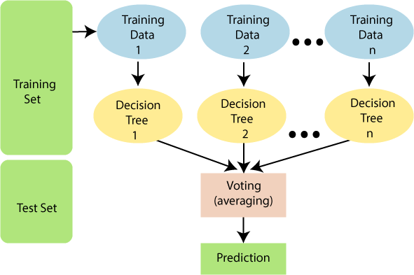

Fig 1. Diagram explains the working flow of random forest [24]
Assumptions for Random Forest
Since the random forest combines multiple trees to predict the class of the dataset, it is possible that some decision trees may predict the correct output, while others may not. But together, all the trees predict the correct output. Therefore, below are two assumptions for a better Random forest classifier: [24]
- There should be some actual values in the feature variable of the dataset so that the classifier can predict accurate results rather than a guessed result.
- The predictions from each tree must have very low correlations.
Below are some points that explain why we should use the Random Forest algorithm:
- It takes less training time as compared to other algorithms.
- It predicts output with high accuracy, even for the large dataset it runs efficiently.
- It can also maintain accuracy when a large proportion of data is missing.

Artificial Neural Network

Neural Network: As the name implies, this classifier is made up of neurons that are stacked in layers and turn the input vector into useful output. Each neuron receives an input, which is usually non- linear, and passes it to a function, which is then sent to the next layer to obtain the output. This classification technique uses a feed-forward mechanism, with the input given to the first layer acting as an output for the following layer and so on. However, because there is no feedback to the previous layer in this manner, the signals travelling through the neurons and layers are given weighting, and these signals are then put into a training phase, which finally becomes a network to handle any particular problem.
An artificial neural network (ANN) is a data processing system made up of a large number of simple, highly interconnected processing components in a topology inspired by the cerebral cortex. The neural network performs the function of the human nervous system and brain in terms of information processing, attempting to recreate how humans learn. Neurons are the brain's most basic cellular unit. Neurons are in charge of receiving sensory information from the outside world via dendrites, processing it, and sending it out via axons. Similarly, an artificial neural network has an input layer with many neurons that accepts data and an output layer that sends the data to the outside world. In most cases a hidden layer is present between the input and output layers which transforms the input into something which can be used by the output layer [11].
K-Nearest Neighbor

Nearest Neighbor: As the name implies, the nearest neighbor algorithm is based on the nearest neighbor, and it is a supervised classification algorithm. The k-nearest neighbor classification algorithm is another name for it. A cluster of labeled points are utilized to understand how the other points should be labelled. It checks the already labelled points that are closest to the point to be labelled, i.e. closest to the neighbor, before labeling a new point. As a result of the votes of the neighbors, the new point is given the same label as the majority of the neighbors. The number of neighbors checked in the algorithm is k.
KNN is a classification algorithm that uses feature space training samples to classify objects. The simplest sort of instance-based learning, sometimes known as lazy learning, is KNN. It is assumed that all instances are n-dimensional points in space. To establish the "closeness" of occurrences, a distance metric is required. KNN categorizes an instance by locating its closest neighbors and selecting the most popular class among them [22].
Features of KNN

- In an n-dimensional Euclidean space, all instances of the data correspond to points.

- Classification is postponed until a new instance is available.

- In KNN, classification is accomplished by comparing feature vectors from various places in a space region.
- The goal function could be discrete or continuous.

Normalizing & Splitting the Data

When training any machine learning model, it is important to split the data into training and test data. The training data is used to fit the model. The algorithm uses the training data to learn the relationship between the features and the target. It tries to find a pattern in the training data that can be used to make predictions on new, unseen data. The test data is used to evaluate the performance of the model. The model is tested on the test data by using it to make predictions and comparing these predictions to the actual target values.
When training a KNN classifier, it's essential to normalize the features. This is because KNN measures the distance between points. Researchers often use the Euclidean Distance, which is the square root of the sum of the squared differences between two points.
Normalize the data after splitting it into training and test sets. This is to prevent ‘data leakage’ as the normalization would give the model additional information about the test set if we normalized all the data at once [25].
Support Vector Machine

Support vector machine (SVM): This is another supervised and straightforward classification approach. It can be utilized in both classification and regression applications, however it is most well-known for classification. Each data item is plotted in a dimensional space, often known as an n- dimensional plane, where n represents the number of characteristics in the data. The classification is based on the differentiation between the classes, which are data set points in various planes [23].
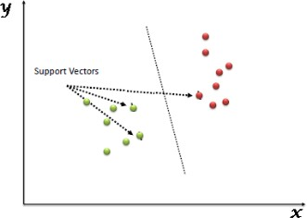

Fig 2. Support vector machine [26]

Support Vectors are simply the coordinates of individual observation. The SVM classifier is a frontier that best segregates the two classes (hyper-plane/ line) [27].
The support vectors in a support vector machine algorithm are the data points that lie closest to the separating line between the two classes. These vectors are used to calculate the optimal decision boundary for a classifier. When performing classification using the Support Vector Machine algorithm, the algorithm finds the hyperplane that best separates the two classes of data, and the support vectors are the points on the hyperplane that is closest to the points in the training data.
How Support Vector Machine works

Support Vector Machine works by constructing a hyperplane between the two classes of data, and then finding the best line that separates them. The best line that separates the data is the one that has the most distance from all the data points in one class and the least distance from all the data points in the other class.
To find this line, SVM uses a technique called “linear regression”. Linear regression finds the best line that fits a set of data points. It does this by trying to find the line that has the smallest “error”. Error is just a fancy word for the distance between a data point and the line.
Then SVM uses a technique called “support vectors” which is illustrated in the graph. Support vectors are nothing but the data points that lie on the hyperplane. They are the most important data points because they help to define the hyperplane that can separate the data points [28].
The decision boundary or decision hyperplane including all the support vectors is the one that maximizes the margin between the two classes. In fact, the main aim of SVM is to increase the marginal distance as much as possible so as to reduce the generalization error. This means increasing the marginal distance will improve the performance of the model on unseen data. So here what happens is that when the margin distance increases the possibility of predicting the wrong class will decrease since the decision boundary is now far from the points of the two separate classes. When considering a new data point, if it lies near to negative hyperplane it is more likely to belong to the negative class and if it lies near the positive hyperplane it is more likely to belong to the positive class. When training the SVM model, we first need to find the support vectors. Then we need to find the line that maximizes the margin between the two classes. This line is the decision boundary. Once we have the decision boundary, we can use it to predict the class of new data points. To do this, we just need to see which side of the decision boundary the new data point falls on. If it falls on the side of the class that we’re trying to predict, then we predict that class for the new data point [28].

Machine Learning in Diabetes Mellitus prediction
Machine learning is a branch of science that studies how computers learn from their experiences. For many scientists, the terms "machine learning" and "artificial intelligence" are interchangeable, because the ability to learn is the most important feature of an entity that is considered intelligent in the broadest sense. Machine learning aims to create computer systems that can adapt and learn from past experiences.

Feature Selection
Feature selection is a process of selecting a subset of the most relevant and informative features (also known as predictors, independent variables, or input variables) from a larger set of available features for use in a machine learning model. The goal of feature selection is to improve the model's performance by reducing the complexity of the model and reducing the risk of overfitting.
In machine learning, feature selection is important because the performance of the model often depends on the quality and relevance of the features used as input. Selecting the right features can lead to a more accurate and interpretable model, while selecting irrelevant or redundant features can increase the model's complexity and reduce its performance.
There are different methods for feature selection, including filter methods, wrapper methods, and embedded methods [29].
2.4.1. Filtering methods
Filtering methods typically involve ranking the features based on some statistical or other relevant measures, and then selecting the top-ranked features for the final model. Some common criteria used for filtering include:
      - Correlation: Features with high correlation to the target variable are more likely to be important for prediction. Therefore, selecting features with high correlation to the target variable can improve the model's accuracy.
      - Mutual Information: This measures the dependence between two variables and can be used to identify features that have high information gain with respect to the target variable.
      - Variance: Features with low variance do not contribute much to the variability of the data and are often not informative. Therefore, they can be eliminated from the model.
      - Statistical tests: Various statistical tests can be used to determine the significance of each feature and select the most important ones.
Filtering methods are generally quick and easy to implement, and can be useful in identifying the most relevant features for a given model. However, they can sometimes miss important features that are not highly ranked by the selected criteria. Therefore, filtering is often used in combination with other feature selection methods, such as wrapper or embedded methods [30].
2.4.2. Wrapper feature selection
Wrapper feature selection is a technique for selecting a subset of relevant features from a dataset that are most predictive of the target variable. It involves selecting a set of features and then training a machine learning model using those features, evaluating the performance of the model, and then selecting a new set of features based on the model's performance. This process is repeated until a subset of the most predictive features is identified.
The wrapper approach is different from other feature selection methods, such as filter and embedded methods, in that it uses the performance of a specific machine learning model as a criterion for selecting features. The wrapper approach can be more computationally expensive than filter methods, as it involves training and evaluating a machine learning model multiple times. However, it can be more effective than other methods at identifying complex, nonlinear relationships between features and the target variable.
There are several different types of wrapper feature selection methods, including forward selection, backward elimination, and recursive feature elimination. In forward selection, the algorithm starts with an empty set of features and adds the most predictive feature one at a time until a stopping criterion is met. In backward elimination, the algorithm starts with all the features and removes the least predictive feature one at a time until a stopping criterion is met. In recursive feature elimination, the algorithm starts with all the features and recursively eliminates the least predictive features until the desired number of features is reached.
Wrapper feature selection can be a powerful tool for improving the performance of a machine learning model and reducing overfitting. However, it is important to keep in mind that the wrapper approach can also be sensitive to noise and may not be effective if the dataset is too small or the number of features is too large [31].
2.4.3. Embedded feature selection
Embedded methods for feature selection are algorithms that integrate the feature selection process into the process of model training. These methods aim to find the optimal set of features that will maximize the performance of the machine learning model.
The model is designed to select the most relevant features from the dataset during training, rather than having the features selected beforehand. This can help to improve model performance, reduce overfitting, and speed up the training process.
Embedded methods combine the qualities’ of filter and wrapper methods. It’s implemented by algorithms that have their own built-in feature selection methods.
Some of the most popular examples of these methods are LASSO and RIDGE regression which have inbuilt penalization functions to reduce overfitting.
Lasso regression performs L1 regularization which adds penalty equivalent to absolute value of the magnitude of coefficients.
Ridge regression performs L2 regularization which adds penalty equivalent to square of the magnitude of coefficients [32].

Related work
[14] Presented Predictive Modelling and Analytics for Diabetes using a Machine Learning Approach. They used linear kernel support vector machine (SVM-linear), radial basis kernel support vector machine (SVM-RBF), K Nearest Neighbor (k-NN), Artificial Neural Networks (ANN), and Multifactor Dimensionality Reduction (MDR) algorithms were used to develop five different models for the detection of diabetes. The Boruta wrapper algorithm was used to choose features from the dataset, taking into account several assessment metrics such as accuracy, recall, precision, F1 score, and Area Under the Curve (AUC). The experimental findings showed that all of the models performed well, with the SVM-linear model delivering better accuracy and precision of 0.89 and 0.88, respectively. According to the findings of this study, the linear kernel support vector machine (SVM-linear) and k-NN are the two (2) most accurate diabetes predicting models based on all parameters. This research also showed that the Boruta wrapper technique may be employed for feature selection because it improved accuracy.
[33] Presented A Novel Diabetes Health Care Disease Prediction Framework Using Machine Learning Techniques. In this study, diabetes data has been examined using a variety of data mining approaches, including support vector machine (SVM), an integrated learning model, and the decision tree approach. Prediction and detection of disease were made by adopting many predictive, quantitative, and statistical models and used individuals records who were examined using the Synthetic Minority Over-sampling Technique (SMOTE) algorithm, based on the selected features such as BMI, glucose level, and age.
The researchers expressed concern that most present diagnostic models constructed to have a knowledge base collecting hospital data and symptoms associated with a certain illness.
In order to increase the performance efficiency of machine learning methods in two stages. The researchers have chosen the most relevant characteristics in the first stage that, have had been accomplished using a correlation-based feature selection method. Furthermore, the random forest technique used to categorize the heart disease and diabetes illness in the second stage. Following analysis of results, it discovered that the suggested random forest technique considerably improves the prediction efficiency of heart disease and diabetes illness.
In this work four classifiers model like LR, RF, SVM, and KNN were built. ML algorithm comparison was indicated and RF and SVM had a high accuracy of 83%. Hyper parameter applied to LR and were able to improve the accuracy level of prediction by 3%.
[34] Presented logistic regression and SVM based diabetes prediction system. They conducted research with the goal of establishing a system that can accurately detect diabetes in patients at an early stage using a combination of machine learning approaches. The study uses two (2) different supervised machine-learning approaches to predict diabetes: SVM and Logistic Regression. It took into account seven (7) characteristics of the patients. They conclude that SVM performed better than logistic regression, with a performance accuracy of 79% compared to logistic regression, which had a performance accuracy of seventy-eight percent (78%).
[35] Presented Early Prediction of Diabetes Disease & Classification of Algorithms Using Machine Learning Approach. In this paper, the authors used Machine Learning approaches such as Decision Trees, SVM, and Naive Bayes to detect diabetes in the early phase. The Pima Indian Diabetes that are obtained from UCI library test to measure although these algorithms are used to predict diabetes in order to save time and get accurate results.
The dataset included the clinical data of 767 female patients. It also included the numerical values of 7 attributes whereas one class was treated as ‘0’for the test negative for the disease of diabetic and also with the of class‘1’ was tested as positive for diabetic disease. Three classification algorithms were used in this study to generate a framework that aids in the early-stage prediction of Diabetic using significant features related to this illness. The algorithms were Naïve Bayes, SVM, DT. These algorithms were used from the dataset of PIDD obtained from the UCI database.
In this study, structured efforts were made to design a Framework that can predict diabetes. The three Machine Learning approach classification algorithms were analyzed and tested on different measures as part of this research. The PIDD was used in the experiments. Using the NB classification algorithm, the experimental results show that a built method was adequate with an accuracy of 74.28 percent. In this paper the accuracy is 74.28.

- Presented an Analysis of diabetes mellitus for early prediction using optimal features selection. They conducted a study to identify the features that aid in the early detection of diabetes mellitus using a predictive analysis tool (WEKA).The performance evaluation of the classification techniques was done through the various performance measure such as accuracy, sensitivity, specificity, and recall, precision. The research paper was focused on the five classification techniques such as support vector machine, random forest, Naïve Bayesian, decision tree, and K-nearest neighbor. They concluded that the decision tree algorithm and the Random Forest Algorithm had the best predictive analyses, with 98.20 percent and 98.00 percent accuracy, respectively. While the performance accuracy of Nave Bayesian outcomes is the best at 82.30 percent.
- Presented A Predictive Model For Diabetes Using Machine Learning Techniques (A Case Study of Some Selected Hospitals In Kaduna Metropolis). This paper was based on the prevalence of diabetes amongst the masses of Kaduna metropolis using some selected hospitals as a case study after which a predictive model was designed for diabetes, using some selected supervised learning algorithms like Decision tree algorithm, K- Nearest Neighbor algorithm, and Artificial Neural Networks and used the dataset from 44 Army Reference Hospital and Yusuf Danstoho Memorial Hospital Kaduna which constitutes of nine (9) attributes that was considered. The results indicated that ANN produced the highest accuracy with 97.40% followed by the decision tree algorithm with 96.10% accuracy and the K-NN algorithm with 88.31% accuracy.
The results obtained from developing the models for the diabetes prediction system using a case study of Kaduna metropolis were achieved using the KNN, ANN, and the decision trees algorithm. The models were trained using ten input variables (sex, number of pregnancies, glucose level, blood pressure level, body mass index, height, weight, and regular exercise) then the diabetic status of the individual was used as the target output that was compared with the predicted output.
From the various experiment applied in this study, ANN produces the best performance with an accuracy of 97.40% and was used to predict diabetes using some of the data.
- Presented Prediction of Diabetes using Classification Algorithms. The author used to classify diabetic. In this research, systematic efforts are undertaken to build a system that can forecast diseases such as diabetes. Three machine learning classification techniques are investigated and compared in this research. The Pima Indians Diabetes Database is used in the experiments. Using the Naive Bayes classification algorithm, the experimental results show that the designed system is adequate, with an accuracy of 76.30 percent. This research focused on classifying PIMA diabetic data using decision trees and SVM. A 10-fold approach of cross-validation is used to partition the dataset. In this word the Data pre-processing was not done by the authors and only three algorithms are used including Naïve Bayes, decision tree and SVM. The final accuracy is 76.30% and should be improved by applying other ensemble or hybrid methods.
- Presented Predicting Type 2 Diabetes: A Machine Learning Approach. This paper elaborated on predicting Type 2 Diabetes Mellitus using classification models. A suitable secondary dataset was used to build classification models and the more suitable model was selected via the valid performance measures. In this line, the Random Forest, Support Vector Machine, Naïve Bayes, and Artificial Neural Network models were built. Based on the performance measures, Random Forest was identified as the more suitable classifier with an accuracy of 90%, a recall, and a precision value of 0.90.
The Pima Indian Diabetes dataset from the National Institute of Diabetes and Digestive Kidney Diseases was chosen.. The dataset was used to build a more effective machine learning predictive model that could predict whether a patient has diabetes or not based on certain diagnostic measurements found in the dataset. The dataset contains 768 rows, 8 features, and 1 target variable.
The output results from the respective predictive models were recorded and compared, where the RF model obtained the best accuracy (89.6%) value than the other models
- Presented Optimal Predictive analytics of Pima Diabetics using Deep Learning. Both type 1 and type 2 diabetes were predicted using the RNN model. The authors used the PIMA dataset to forecast that the attribute "Glucose" is the most important, followed by BMI, age, births, diabetes pedigree feature, blood pressure, skin thickness, and insulin.' The training dataset was separated into 80 percent and the testing dataset was split into 20% to validate the analysis.
On the data sets, the deep neural network was trained, tested, and implemented. The results were more than adequate, and they may be much better if the data set was expanded to include information gathered by incoming patients in a hospital or a network of hospitals. Furthermore, diabetes prediction can be influenced by other characteristics not included in the data set. Taking these parameters into account will help to increase the proposed system's accuracy even more. In addition, the comparison indicates that deep learning models are far more precise than the crude set theory model.
- Presented Analysis and prediction of diabetes diseases using machine learning algorithm: Ensemble approach. In this study, the dataset was used from the public UCI repository PIDD (Pima Indian Diabetes Database) which is available online and used for analysis and prediction of diabetes diseases. This diabetes dataset was consisted of 768 records and eight attributes and used Weka 3.8.1 and java using NetBeans 8.2 tools to for analysis, classification, and prediction.
In this paper, the author used input pregnancies, Glucose, Blood Pressure, skin thickness, insulin, BMI, Diabetes pedigree Function, and Age. In this study, they used the four most known machine learning algorithms (Random Forest (RF), KNN, Naïve Bayes, and J48) classification algorithms and ensemble/combined them using base learner.
In the above-mentioned research papers, diabetes prediction was performed using supervised and semi-supervised learning algorithms mostly using PIMA Dataset (PIDD) which has only 768 rows and 9 columns. Their prediction and accuracy is based on same dataset, which results in somehow less accuracy. Some of the commonly used ML algorithms are SVM, NB, DT, RF, KNN etc.
- Presented Diabetes Prediction using Machine Learning Algorithms. They implemented using Support Vector Machines, Random Forest Classifier, Decision Tree Classifier, Extra Tree Classifier, Ada Boost algorithm, Perceptron, Linear Discriminant Analysis algorithm, Logistic Regression, K-NN, Gaussian Nave Bayes, Bagging algorithm, and Gradient Boost Classifier were among the machine learning algorithms used. For assessing the various models, they employed two separate datasets: the PIMA Indian and another Diabetes dataset. They had a 96 percent accuracy rate using Logistic Regression.
- Presented Reduction of Overfitting in Diabetes Prediction Using Deep Learning Neural Network. The use of the dropout strategy is presented in this study to reduce data overfitting in prediction models. This model is used to predict the progression of diabetes. For this objective, a unique type of deep neural network for diabetes prognosis with higher accuracy is discussed. In this approach, the accuracy achieved over the PID Data Set is 88.41%. Experimentation is used to improve accuracy by reducing the influence of overfitting in the suggested model. As a result, diabetic predictive models can now achieve higher prediction scores or performance gains, potentially leading to future advancements in health prognostication. The PIMA dataset was used to test this method. The authors did not pre-process the dataset because DNN can filter the data and produce biases. The dataset is separated into 192 samples for the research collection and the rest of the study.
- Presented Prediction and Detection of Diabetes using Machine Learning. The purpose of this paper is to evaluate data mining methods and their performances that can be used for analyzing the collected data about the diabetes. The researchers identified the most appropriate data mining methods to analyze the data by comparing them theoretically and practically. Some attributes of this dataset are: Age, Body Mass Index, Insulin, Glucose, diastolic blood pressure, Number of times pregnant. In this work Naïve Bayes, Support Vector Machine (SVM), Decision Tree, ANN, Logistic Regression, C4.5 methods are applied on these data to determine their effectiveness in analyzing and preventing diabetes. The researchers used 270 records with seven attributes and used WEKA tool for the prediction. Evaluations on the data showed that the method with a higher performance is “Decision Tree”. This was achieved by some performance measures, such as the number of instances correctly classified, accuracy 79.3%. C4.5 algorithm has better results compared to other methods. The researchers concluded that the data mining methods and machine learning contribute to the predictions on the possibility of occurrence of the diabetes. In this research the researches used 270 recorded with 7 attributes. The sample size is very small and it divided in to training and test dataset.

Table 2. Summarizes some of the related work with diabetes mellitus prediction.
Author’s | Method/Algorithm | Contribution | Limitation | Result  in (%)
[38] | Naive Bayes, Decision tree and SVM | Presented Prediction of Diabetes using Classification Algorithms. The author used to classify diabetic. In this research, systematic efforts are undertaken to build a system that can forecast diseases such as diabetes. Three machine learning classification techniques are investigated and compared in this research. The Pima Indians Diabetes Database is used in the experiments. Using the Naive Bayes classification algorithm, the experimental results show that the designed system is adequate, with an accuracy of 76.30 percent. This research focused on classifying PIMA diabetic data using decision trees and SVM. A 10-fold approach of cross-validation is used to partition the dataset. | In this word the Data pre-processing was not done by the authors and only three algorithms are used including Naïve Bayes, decision tree and SVM. The final accuracy is 76.30% and should be improved by applying other ensemble or hybrid methods. | 76.30%
[33] | Decision tree,  LR, RF, SVM, and KNN | The researchers have chosen the most relevant characteristics in the first stage that, have had been accomplished using a correlation-based feature selection method. Furthermore, the random forest technique used to categorize the heart disease and diabetes illness in the second stage. Following analysis of results, it discovered that the suggested random forest technique considerably improves the prediction efficiency of heart disease and diabetes illness. | The size of dataset is very small, that is further divided into training and testing dataset, which become smaller that may affect the accuracy of prediction.  The final accuracy also low 83% | 83%.
[37] | KNN, ANN, and DT | The results obtained from developing the models for the diabetes prediction system using a case study of Kaduna  metropolis were achieved using the  KNN, ANN, and the decision trees algorithm. The models were trained using ten input variables (sex, number of pregnancies, glucose level, blood pressure level, body mass index, height, weight, and regular exercise) then the diabetic status of the individual was used as the target output that was compared with the predicted output. | In this work the researchers derived BMI from the  attributes height and  weight. However they are used both derived the original attributes. The attributes are duplicated and might be leading to wrong conclusion. | 97.40%
[39] | Random Forest, Support Vector Machine, Naïve Bayes, and Artificial Neural Network models were built | The Pima Indian Diabetes dataset from the National Institute of Diabetes and Digestive Kidney Diseases was chosen. The dataset was used to build a more effective machine learning predictive model that could predict whether a patient has diabetes or not based on certain diagnostic measurements found in the dataset. | The dataset contains only 768 rows, 8 features, and 1 target variable. The accuracy is 89.6 and it will improve if the researchers implement using ensemble or hybrid methods | 89.6%
[43] | DT, RF, KNN | As a result, diabetic predictive models can now achieve higher prediction scores or performance gains, potentially leading to future advancements in health prognostication | Dataset (PIDD) has 768 rows and 9 columns. Their prediction and accuracy are based on the same dataset, which results in somehow less accuracy | 88.41%

Chapter Summary
Diabetes mellitus is regarded as a syndrome, a group of illnesses characterized by hyperglycemia and glucose intolerance, which can be caused by insulin shortage, insulin ineffectiveness, or a combination of these factors. To comprehend diabetes, one must first comprehend the physiological processes that occur during and after a meal. Food is digested and absorbed into the bloodstream, where nutrients such as proteins, fats, and carbs are absorbed. Sugar, a carbohydrate, causes the pancreas to secrete the hormone insulin. Insulin causes practically all tissue types in the body to absorb and store sugar, particularly the liver, muscle, and fat tissues. The cause of diabetes continues to be anonymity, although both genetics and environmental factors such as obesity and lack of exercise appear to play roles. Diabetes mellitus is a serious health problem with continuously increasing rates of incidence and mortality.
To reduce mortality due to diabetes mellitus machine learning plays a key role. Machine learning is a branch of science that studies how computers learn from their experiences. For many scientists, the terms "machine learning" and "artificial intelligence" are interchangeable, because the ability to learn is the most important feature of an entity that is considered intelligent in the broadest sense. Machine learning aims to create computer systems that can adapt and learn from their experiences.

Chapter Three

Material and Methods
This chapter addresses the methodological approach. Following is a description of the study's primary data source, including the data collection process, sampling strategy, and development stage. Processes for gathering data using various methods will be examine, and the data analysis plan will be discusses.

Business Understanding
In order to understand the business domain, the researcher reviewed different scholars, national and international reports, world health organization (WHO) guidelines, international diabetes federation (IDF) and consulted domain experts.

Data source and description
The primary source of data for this research is diabetic and pre-diabetes patient data from the patient individual folder and from the diabetic clinic and other general medical checkup chronic follow-up units from August and October 2022.
These data amounted to six thousand one hundred forty nine (6149) samples, which consist of two parts: the diabetic and pre-diabetes, with two thousand nine hundred seventy three (2973) the diabetic and three thousand one hundred seventy six (3176) non-diabetic patients sample. The original dataset consists of seventeen (17) attributes including Age, Sex, Resident, BMI, BP, Glucose, History of physical activity, diet type, history of hypertension, First degree Family History of DM, Alcohol consumption, History of CVDs, Polydipsia -Have excessive thirsty, Polyphagia excessive hunger, Visual complaints, Polyuria excessive urine, and diabetes status.
To identify the most relevant features that contribute to the predictive power of a model, feature selection performed and twelve (12) attributes: Age, Sex, BMI, BP, Glucose, history of hypertension, First degree Family History of DM, Alcohol consumption, History of CVDs, Polydipsia ET, Polyphagia EH, and Polyuria EU are selected.

Data Collection Methods
From Adare general hospital diabetes and pre-diabetes patient individual folders, and other medical registration tools/systems were used to obtain the data.

Sampling techniques
Convenience sampling approaches are used as the sample procedures for this research study.
The sample size is determined by the amount of time needed for data collection, and the study subject is a defined population of people with diabetes and pre-diabetes. The sample size was six thousand one hundred forty nine (6149) in total for three consecutive months between August and October 2022.

Data pre-processing
It is crucial to preprocess the data after the entire dataset has been gathered in order to train the model effectively. In order to address the issue of missing data, the following steps must be taken: solving the problem of missing values, data normalization, and data standardization. The average of nearby values is used to fill in the missing data. The learning algorithm may become confused if variables of different magnitude are mixed together, hence, it is imperative to complete the data normalization phase before parsing the input data.

𝑋𝑛𝑜𝑟𝑚
= 𝑋−𝑋𝑚𝑖𝑛
𝑋𝑚𝑎𝑥−𝑋𝑚𝑖𝑛
(2)

Where x is a data point in the dataset, min(x) is the minimum value of x in the dataset, max(x) is the maximum value of x in the dataset, and xnorm is the normalized value of x that falls within the range of 0 to 1.
3.5.1. Data cleaning
Data cleaning consists of filling the missing values and removing noisy data. Noisy data contains outliers which are removed to resolve inconsistencies. In our dataset, glucose, blood Pressure, and BMI, Family History of DM, History of Cardiovascular Disease - CVDs have some zero (0) values. Thus, all the zero values were replaced with the median value of that attribute.
    - Data Description
The dataset used in carrying out this research was obtained from Adare general hospital. The dataset amounted to a total of six thousand one hundred forty nine (6149) samples, which consist of two parts: two thousand nine hundred seventy three (2973) the diabetic and three thousand one hundred seventy six (3176) non-diabetic patients.
The original dataset contains seventeen (17) variables, including age, sex, BMI, BP, glucose, history of physical activity, diet type, history of hypertension, first-degree family history of diabetes, alcohol consumption, history of CVDs, Polydipsia_ET, Polyphagia_EH, visual complaints, Polyuria_EU & Outcome.

Table 3. Sample Dataset before data pre-processing

Age | Sex | resident | Glu | hxofRFA | food type | hxofHPT | BP | Hist OfDM | Alc | Hist OfCVD | Polyd. | Polyph. | Vis Blur | Polyu | Status | W | H
37 | Male | urban | 89 | yes | fat | yes | 86 | No | No | No | Yes | Yes | Na | No | No | 66.2 | 1.8
39 | Female | urban | 129 | no | carbo | yes | 86 | Yes | No | Yes | Yes | Yes | No | Yes | Yes | 63.4 | 1.69
49 | Female | urban | 135 | no | protein | Na | 87 | Yes | No | No | Yes | Yes | Yes | No | Yes | 74.4 | 1.64
0 | Male | urban | 129 | yes | protein | yes | 86 | No | No | No | No | Yes | No | No | No | 75 | 1.7
1 | Male | urban | 114 | yes | protein | Unkn. | 85 | No | No | No | No | No | No | No | No | 62.5 | 1.58
71 | Female | urban | 136 | no | protein | yes | 88 | No | Unkn | No | Yes | No | No | Yes | Yes | 101 | 1.75
48 | Female | rural | 98 | yes | protein | no | 82 | Yes | Na | No | No | No | 0 | No | No | 68 | 1.72
28 | Female | urban | 93 | yes | protein | no | 74 | No | No | No | No | No | 0 | No | No | 75 | 1.68
41 | Male | Na | 128 | no | protein | no | 79 | No | No | No | No | No | No | No | No | 81 | 1.65
53 | Female | urban | 136 | yes | protein | no | 70 | No | No | No | Yes | No | No | No | No | 60 | 1.7
33 | M | urban | 96 | no | carbo | yes | 0 | No | No | No | No | No | No | No | No | 75 | 1.69
49 | Male | urban | 173 | yes | fat | yes | 70 | No | 0 | No | Yes | Yes | No | No | No | 80 | 1.75
43 | F | urban | 112 | no | protein | no | 84 | No | No | No | No | No | No | Yes | No | 75.6 | 1.77
74 | Female | Na | 136 | no | protein | no | 80 | Yes | No | Yes | Yes | Yes | No | No | Yes | 80 | 1.64
43 | Female | Na | 106 | no | protein | yes | 0 | No | No | No | No | No | Yes | No | No | 62 | 1.61
51 | Female | Na | 136 | yes | fat | no | 3 | No | No | No | Yes | Yes | No | No | No | 78.2 | 1.73
33 | F | urban | 134 | no | protein | no | 76 | No | No | No | No | No | No | No | No | 68 | 1.63
40 | Male | urban | 131 | no | carbo | yes | 71 | No | No | No | No | No | Yes | No | No | 57 | 1.56
64 | Male | urban | 143 | no | fat | yes | 83 | Yes | No | Yes | Yes | Yes | No | No | Yes | 77.8 | 1.74

36

Table 4. Sample Dataset after Data Pre-Processing

Age | Sex | Res. | Glu. | Diet  Type | Hisof  PhyAct | Visual  Blurring | BP | BMI | Hist.  OfDM | HisOf  Hyp | Alc  . | Hist  OfCVD | Poly  _ET | Polyp  _EH | Polyu  _EU | Outcome
37 | 1 | 1 | 89 | 1 | 1 | 0 | 86 | 22.74 | 0 | 0 | 0 | 0 | 1 | 1 | 0 | 0
39 | 0 | 1 | 129 | 2 | 0 | 0 | 86 | 26.84 | 1 | 1 | 0 | 1 | 1 | 1 | 1 | 1
49 | 0 | 1 | 171 | 3 | 0 | 1 | 87 | 19.98 | 1 | 1 | 0 | 0 | 1 | 1 | 0 | 1
31 | 1 | 1 | 129 | 3 | 1 | 0 | 86 | 22.87 | 0 | 0 | 0 | 0 | 0 | 1 | 0 | 0
26 | 1 | 1 | 114 | 3 | 1 | 0 | 85 | 17.21 | 0 | 1 | 0 | 0 | 0 | 0 | 0 | 0
71 | 0 | 1 | 136 | 3 | 0 | 0 | 76 | 28.1 | 0 | 0 | 0 | 0 | 1 | 0 | 1 | 1
48 | 0 | 0 | 98 | 3 | 1 | 0 | 82 | 21 | 1 | 0 | 0 | 0 | 0 | 0 | 0 | 0
28 | 0 | 1 | 93 | 3 | 1 | 0 | 74 | 16.16 | 0 | 0 | 0 | 0 | 0 | 0 | 0 | 0
41 | 1 | 1 | 128 | 3 | 0 | 0 | 79 | 19.31 | 0 | 0 | 0 | 0 | 0 | 0 | 0 | 0
53 | 0 | 1 | 136 | 3 | 1 | 0 | 70 | 18.47 | 0 | 0 | 0 | 0 | 1 | 0 | 0 | 0
33 | 1 | 1 | 96 | 2 | 0 | 0 | 77 | 18.1 | 0 | 0 | 0 | 0 | 0 | 0 | 0 | 0
49 | 1 | 1 | 173 | 1 | 1 | 0 | 70 | 17.7 | 0 | 0 | 1 | 0 | 1 | 1 | 0 | 0
43 | 0 | 1 | 112 | 3 | 0 | 0 | 84 | 20.96 | 0 | 0 | 0 | 0 | 0 | 0 | 1 | 0
74 | 0 | 1 | 136 | 3 | 0 | 0 | 80 | 18.02 | 1 | 0 | 0 | 1 | 1 | 1 | 0 | 1
43 | 0 | 1 | 106 | 3 | 0 | 1 | 87 | 18.17 | 0 | 1 | 0 | 0 | 0 | 0 | 0 | 0
51 | 0 | 1 | 136 | 1 | 1 | 0 | 65 | 22.61 | 0 | 0 | 0 | 0 | 1 | 1 | 0 | 0
33 | 0 | 1 | 134 | 3 | 0 | 0 | 76 | 22.74 | 0 | 1 | 0 | 0 | 0 | 0 | 0 | 0
40 | 1 | 1 | 131 | 2 | 0 | 1 | 71 | 21.71 | 0 | 0 | 0 | 0 | 0 | 0 | 0 | 0
64 | 1 | 1 | 143 | 1 | 0 | 0 | 83 | 23.67 | 1 | 0 | 0 | 1 | 1 | 1 | 0 | 1
77 | 0 | 1 | 136 | 3 | 0 | 0 | 85 | 26.73 | 0 | 1 | 0 | 0 | 1 | 1 | 1 | 1

37

Table 5. Tabular view showing the original variables, their variable type with specified range

Attribute No. | Attribute | Variable Type | Range
A1 | Age | Integer | 18 and above
A2 | Sex | Binary | 0 or 1
A3 | Resident Area | Binary | 0 or 1  (Rural or Urban)
A4 | Diet Type | Real | 1, 2 and 3  (carbohydrate, protein and fat)
A5 | History of physical activities | Binary | 0 or 1
A6 | Visual Blurring | Binary | 0 or 1
A7 | Glucose | Real | 0 and above
A8 | BP (Diastolic) | Real | 0 and above
A9 | BMI | Real | 0 and above
A10 | History of hypertension | Binary | 0 or 1
A11 | First degree Family History of DM | Binary | 0 or 1
A12 | Alcohol consumption | Binary | 0 or 1
A13 | History of Cardiovascular Disease – CVDs | Binary | 0 or 1
A14 | Polydipsia -Have excessive | Binary | 0 or 1
A15 | (Polyphagia) Have excessive hunger | Binary | 0 or 1
A16 | Polyuria) Have excess urine? | Binary | 0 or 1
A17 | Outcome/Diabetes status | Binary | 0 or 1

38

Data Exploration
Exploratory data analysis was performed on the dataset, this encompassed looking at the disruptions of diabetic and non-diabetic patients and gender distributions. From this initial exploration 2973 diabetic and 3176 non-diabetic patients were identified from the total 6149 records. The gender composition of patients was 48.6% was male and 51.4% female.

Distribution of diabetes status of patient
51.7
48.3
Diabetic

Non Diabetic
Fig 3. Distribution of diabetes status of the patients

Machine learning algorithms used
Following the data collection and pre-processing, the dataset will be trained using supervised learning algorithms like Decision Trees (DT), Support Vector Machine (SVM), Logistic Regression, K-Nearest Neighbor (KNN), Naive Bayes, Artificial Neural Network (ANN) and Random Forest classifier.
Decision Trees (DT) is a popular machine learning algorithm used for classification and regression problems. They work by recursively splitting the data into smaller subsets based on the most significant features. In the case of diabetes prediction, decision trees can help identify the most significant risk factors for diabetes and how they interact with each other. [45]
Support Vector Machines (SVM) is another popular algorithm used for classification problems. SVMs work by finding the hyperplane that best separates the data into different classes. SVMs is particularly useful in situations where the data is non-linearly separable. [46]

Logistic Regression is a statistical method used for binary classification problems. It works by estimating the probability of a binary outcome based on a set of input variables. In the context of diabetes prediction, logistic regression can help determine the probability of developing diabetes based on risk factors such as age, BMI, and family history. [47]
K-Nearest Neighbor (KNN) is a simple and effective algorithm used for classification problems. KNN works by identifying the k-nearest neighbors to a new data point and classifying it based on the majority class among those neighbors. In the case of diabetes prediction, KNN can help identify similar patients who have a high probability of developing diabetes. [48]
Naïve Bayes is a probabilistic algorithm used for classification problems. It works by calculating the probability of each input variable given a class and then combining those probabilities to calculate the probability of each class. In the context of diabetes prediction, Naïve Bayes can help estimate the probability of developing diabetes based on a set of risk factors. [35]
Artificial Neural Networks (ANN) is a powerful machine learning algorithm used for classification and regression problems. In the case of diabetes prediction, ANN can help identify the most significant risk factors for diabetes and how they interact with each other. [47]
Random Forest is a powerful algorithm used for classification and regression problems. It works by constructing multiple decision trees and combining their predictions to obtain a more accurate result. In the context of diabetes prediction, Random Forest can help identify the most significant risk factors for diabetes and how they interact with each other. [45]
The selected seven algorithms are have been widely used in diabetes prediction research. Each algorithms are known for their ability to handle noisy data and avoid overfitting.
After this, their respective prediction accuracies will be compared, and the best model will be chosen and used for implementation on the dataset to predict future occurrence.

Features Extraction
Attribute/ feature extraction is performed in the original dataset by creating new features from the existing/original dataset. The attribute body mass index (BMI= (kg/m2) is extracted from the attributes weight and lengths to reduce and make the attributes more suitable for the predicting model.

Features Selection
In a dataset, there may be features that are not completely relevant or insignificant in model building. The contribution of these types of features is often low for predictive modeling compared to the most significant features obtained as the result of feature selection. The purpose of feature selection is to:
1) improve the prediction performance of the predictors; 2) provide faster and more cost-effective predictors; 3) provide a better understanding of the underlying process that generated the data; 4) Decreases over-fitting, fewer redundant data or fewer chances of making decisions based on noise filters, wrappers, and embedded methods are the methodologies and techniques that can be used to subset feature space and improve and increase model performance. Filter methods are used as a preprocessing step. The selection of features is independent of any machine learning algorithms. Instead, features are selected based on their scores in various statistical tests for their correlation with the outcome variable. Wrapper methods use a subset of features and train a model with them. The Variance Inflation Factor (VIF) is a filter method, while Sequential Forward Feature Selection (SFFS), Sequential Backward Elimination Feature Selection (SBEFS) are wrapper methods. Extreme Gradient Boosting based upon feature importance and Random Forest based upon feature importance are embedded methods [49] [50].
Table 6. Features selected by different techniques

Features | Feature selection techniques
Features | Forward | Backward | VIF | XGBoost | Random Forest
Age
Sex
Glucose
BloodPressure
DietType
HistoryOfDM
HistoryOfHyp
VisualBlurring
HistoryOfCVDs
Polydipsia_ET
Polyphagia_EH
Polyuria_EU
Resident
BMI
HisofPhyAct
Alcohol
R2 | 76.9 | 77.8 | 57.3 | 92.0 | 92.5

Table 6 contains the features selected by each of the feature selection techniques and their R² values. The R² value explains the proportion of variance in the dependent variable that is explained by the independent predictor variables. It has been observed that the R2 for VIF was the lowest with a value of 0.57.3, SFFS had 76.9, and SBEFS 77.8, XGBoost feature importance and Random Forest feature importance had 0.920 and 0.925, respectively. [49] [51].
The performance of SFFS and SBEFS had nearly similar result, XGboost and Random forest also had close result. However the result of VIF scored 0.57 and the lowest from the other techniques. Each model was developed with one, two, three, and so on up to the total number of predictors (n = 16) in our dataset and compared. There were significant differences among models run with varying numbers of predictors.

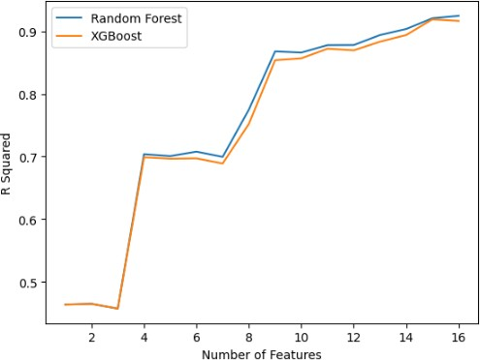

Fig 4.The number of features used in models (RF and XGBoost) and their associated accuracies (coefficient of determination, R²
(Fig.4). For instance, with XGBoost when the numbers of predictors were n=16, n=15, n=14,n=13, n=12, n=11, n=10, n=9, n=8, n=7, n=6, n=5, n=4, n=3, n=2, and n=1, model accuracies (coefficient of determination expressed as a percent) were 0.991, 0.988, 0.988, 0.985, 0.984, 0.981, 0.978, 0.977
0.944, 0.899, 0.895,0.893, 0.868, 0.475, 0.470, and 0.446; respectively. Similarly, with Random Forest, with a sequential decrease in the number of predictors, model accuracies dropped from 0.990 to 0.465. In both cases, the decrease or asymptotic leveling off of inaccuracy was generally observed with less than n=12 predictors. From this, we hypothesized that our algorithm needs an optimal number of features less than the maximum number of features to make improved predictions. Therefore, we chose to compare the five feature selection algorithms based on their R2 value and the number of predictors they use. The feature composition produced by the feature selection method with the highest R² is chosen as the best. Accordingly, the Random Forest algorithm (embedded methods) outperformed the others by selecting twelve (12) attributes including Age, Sex, BMI, BP, Glucose, History of Hypertension, First Degree Family History of DM, Alcohol Consumption, History of CVDs, Polydipsia ET, Polyphagia EH, and Polyuria EU were chosen as the most pertinent features to identify that contribute to the predictive power of a model.

Information gain
Information gain is a technique commonly used in machine learning to select the most relevant features for a given classification task. In the context of diabetes mellitus prediction, information gain can be used to identify which features or attributes of the dataset are most informative in predicting whether a patient has diabetes or not.
In particular, information gain measures how much a given feature reduces uncertainty about the target variable (i.e., whether the patient has diabetes or not). It is based on the concept of entropy, which is a measure of the randomness or unpredictability of a set of values. The higher the entropy, the more difficult it is to predict the target variable based on that feature.
Information gain is calculated as the difference between the entropy of the target variable before and after considering a specific feature. Features that result in a large information gain are considered more informative and are more likely to be included in the final model.
In this research, some of the features that considered for information gain analysis could include glucose, body mass index (BMI), age, Polyphagia EH, Polydipsia ET and blood pressure (BP). By identifying the most informative features, machine learning models can be developed that accurately predict whether a patient has diabetes or not, which can be useful in clinical settings for early detection and prevention of the disease.

Working Environment
    - Software
In this study, the researcher used python 3.9.14 software for diabetes mellitus prediction. Python is a general-purpose, high-level, object-oriented, and easy to learn programming language. It was created by Guido van Rossum, who is known as the godfather of “Python”.
Python can be used to develop a wide variety of applications ranging from Web, Desktop GUI-based programs/applications to science and mathematics programs, and Machine learning, and other big data computing systems. Machine learning is a relatively new and evolving system development paradigm that has quickly become a mandatory requirement for companies and programmers to understand and use
Due to the complex, scientific computing nature of machine learning applications, Python is considered the most suitable programming language. This is because of its extensive and mature collection of mathematics and statistics libraries, extensibility, ease of use and wide adoption within the scientific community. Python can build a wide range of different data visualizations, like line and bar graphs, pie charts, histograms, and 3D plots. Python also has a number of libraries that enable coders to write programs for data analysis and machine learning more quickly and efficiently [52].
In this study, the researcher used Jupyter notebook to implement the prediction model. The Jupyter Notebook is an open-source web application that allows to create and share documents that contain live code, equations, visualizations, and narrative text. Its uses include data cleaning and transformation, numerical simulation, statistical modeling, data visualization, machine learning, and much more. Jupyter Notebook (formerly IPython Notebooks) is a web-based interactive computational environment for creating Jupyter notebook documents.
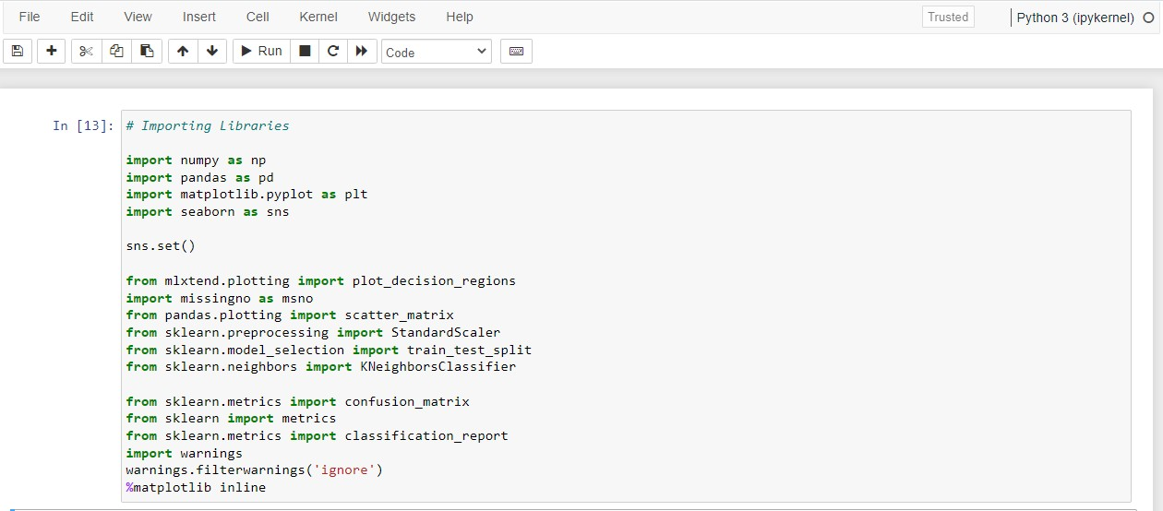
As a result, Python has become the recommended programming language for diabetes mellitus prediction in this research.
Fig 5.Graphical interface of Jupyter notebook.
    - Hardware
Table 8: Hardware tool for diabetes prediction

Operating System | Windows 11 Pro
Processor | Intel(R) Core(TM) i5-7200U CPU @ 2.50GHz (4 CPUs), ~2.7GHz
Installed Memory | 8GB
System Type | X64 based-PC

Evaluation Metrix
Evaluation metrics are used to measure the quality of the statistical or machine learning model. Evaluating machine learning models or algorithms is essential for any research [53][54].
3.12.1. Performance Evaluation Metrics.
Here we evaluate performance according to the metrics identiﬁed in the literature as standard for the task of predicting diabetes. These metrics are accuracy, speciﬁcity, recall and precision, and F-score. Additionally as is convention, the area under the receiver operating characteristic (ROC) curve is also reported. The evaluation metrics are deﬁned as follows: In the following equations, TP, FP, FN and TP are deﬁned as:
- True Positive (TP):
  - The predicted value by the model matches the actual value
  - The actual value was positive, and the machine learning model predicted a positive value
  - E.g., Person is diabetic and predicted to be diabetic.
- False Positive (FP):
  - The predicted value by the model matches the actual value
  - The actual value was positive, and the machine learning model predicted a positive value
  - A false positive is also known as the Type 1 error
  - E.g. Person is non-diabetic and predicted to be diabetic.
- True Negative (TN):
  - The predicted value by the model matches the actual value
  - The actual value was positive, and the machine learning model predicted a positive value
  - E.g. Person is non-diabetic and predicted to be non-diabetic
- False Negative (FN):
  - The machine learning model made a false prediction
  - The actual value was positive, but the machine learning model predicted a negative value
  - A false negative is also known as the Type 2 error
  - E.g., Person is diabetic and predicted to be non-diabetic.
    - Confusion Matrix
A confusion matrix is a performance measurement technique for machine learning classification. It is a kind of table which helps you us to know the performance of the classification model on a set of test data for that the true values are known [55].
Actual Values
 |  | Positive (1) | Negative (0)
Predicted Values | Positive (1) | TP | FP
Predicted Values | Negative (0) | FN | TN
Fig 6. Confusion matrix
Precision measures the ratio of true positively predicted diabetics to all true and false positive predicted diabetics. In other words it measures the proportion of true positives out of all positive predicted instances. Thus the higher the precision the lower the false positives that the model predicts.

𝑃𝑟𝑒𝑐𝑖𝑠𝑖𝑜𝑛 = 𝑇𝑃
𝑇𝑃+𝐹𝑃
(3)

Recall (sensitivity) on the other hand measures the ratio of true positives compared to total number of true positives cases, thus it measures how many diabetics are incorrectly classiﬁed as non-diabetic.
As a false negative diagnosis can result in serious negative implications for the patient, recall is important to maximize.

𝑅𝑒𝑐𝑎𝑙𝑙 = 𝑇𝑃
𝑇𝑃+𝐹𝑁
(4)

The F1 - Score is the harmonic mean of precision and recall. It measures how well the model balances between precision and recall. As minimizing the number of false positives is also important, the F1-Score can give us a good indication of the general model performance, particularly if the dataset is not balanced, as is the case here.
𝐹1 𝑠𝑐𝑜𝑟𝑒 = 2 ∗ 𝑃𝑟𝑒𝑐𝑖𝑠𝑖𝑜𝑛∗𝑅𝑒𝑐𝑎𝑙𝑙 (5)
𝑃𝑟𝑒𝑐𝑖𝑠𝑖𝑜𝑛+𝑅𝑒𝑐𝑎𝑙𝑙

Accuracy measures the number of correctly classiﬁed instances divided by the total number of instances. Accuracy is generally a good measure of model performance in balanced datasets and for non-medical applications. As the dataset is not balanced, besides for training purposes and given the medical application of the models, accuracy will be used as a secondary metric to evaluate model performance.
𝐴𝑐𝑐𝑢𝑟𝑎𝑐𝑦 = (𝑇𝑃+𝑇𝑁) ₍₆₎
(𝑇𝑃+𝐹𝑃+𝑇𝑁+𝐹𝑁)
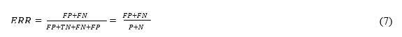
Error rate (ERR) is calculated as the number of all incorrect predictions divided by the total number of the dataset. The best error rate is 0.0, whereas the worst is 1.0.

Fig 7.Dataset distribution for training and testing the model
In this research the 70:30 ratio used to split the dataset into a training set and a testing set. The reason for doing this is to evaluate the performance of the model on data that it has not seen during training. The 70% training dataset is used to train the machine learning model to learn the patterns and relationships between the input features (such as Age, Sex, BMI, BP, Glucose, History of hypertension, First Degree Family History of DM, Alcohol Consumption, History of CVDs, Polydipsia ET, Polyphagia EH, and Polyuria EU) and the target variable (the presence or absence of diabetes). The remaining 30% testing dataset is then used to evaluate the performance of the trained model by measuring how well it predicts the target variable on the unseen data. Therefore, the choice of the training/testing split should be made with careful consideration to ensure that the resulting model is accurate and reliable.

Modeling
After the data preprocessing and selection processes were completed, supervised learning algorithms like Decision Trees (DT), Support Vector Machine (SVM), Logistic Regression, K-Nearest Neighbor (KNN), Naive Bayes, Artificial Neural Network (ANN) and Random Forest classifiers were applied using python version 3.10 (Jupyter environment).
Test Data 30%
Validate the models

Data Collection
Data Pre-processing

Training Data 70%
Train and test the machine using the following algorithms
- Random Forest,
- K-Nearest Neighbor (KNN)
- Decision Trees (DT)
- Support Vector Machine (SVM)
- Artificial Neural Network (ANN).
- Logistic Regression
- Naive Bayes
- Pre-processed data
- Feature selection

Compare model performance

Select model with best performance

Fig 8. Frame work of the new model.

Chapter Summary
This chapter addressed the methodological used, primary data source, including the data collection process, sampling strategy, and development stage.
The primary source of data for this research is diabetic and pre-diabetes patient data from the patient individual folder and from the diabetic clinic and other general medical checkup chronic follow-up units from August and October 2022.
The dataset used in carrying out this research was obtained from Adare general hospital. The dataset amounted to a total of six thousand one hundred forty nine (6149) samples, which consist of two parts: two thousand nine hundred seventy three (2973) the diabetic and three thousand one hundred seventy six (3176) non-diabetic patients.
The data after the entire dataset has been gathered in order to train the model effectively. In order to address the issue of missing data, the following steps must be taken: solving the problem of missing values, data normalization, and data standardization. The average of nearby values is used to fill in the missing data. The learning algorithm may become confused if variables of different magnitude are mixed together, hence it is imperative to complete the data normalization phase before parsing the input data.
Following the data collection and pre-processing, the dataset will be trained using supervised learning algorithms like Decision Trees (DT), Support Vector Machine (SVM), Logistic Regression, K-Nearest Neighbor (KNN), Naive Bayes, Artificial Neural Network (ANN) and Random Forest classifier. After this, their respective prediction accuracies will be compared, and the best model will be chosen and used for implementation on the dataset to predict future occurrence. The goal of this research is to find the best model that can predict diabetes in people at an early stage.

Chapter Four

Result and Discussion
In this chapter, the design and experimentation of different algorithms with major activities during the experiment were discussed. The results obtained from developing the models for the diabetes prediction system using seven algorithms such as, Decision Trees (DT), Support Vector Machine (SVM), Logistic Regression, K-Nearest Neighbor (KNN), Naive Bayes, Artificial Neural Network (ANN) and Random Forest algorithm. The models were trained using twelve input variables (Age, Sex, Glucose level, Blood pressure level (BP), Body mass index (BMI), History of first degree DM, History of Hypertension, History of Alcohol consumption, History of CVDs, Polydipsia, Polyphagia, Polyuria) then the diabetic status of the individual was used as the target output that was compared with the predicted output.

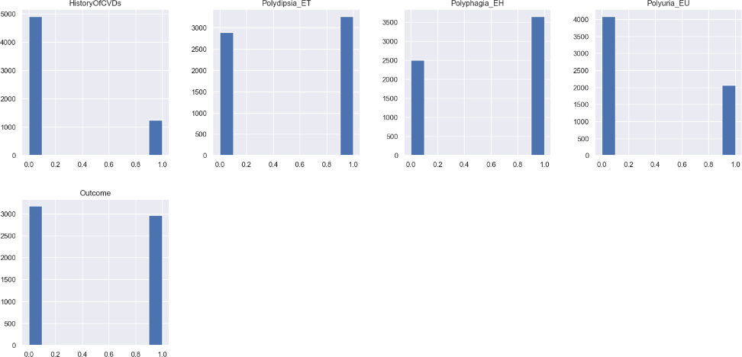
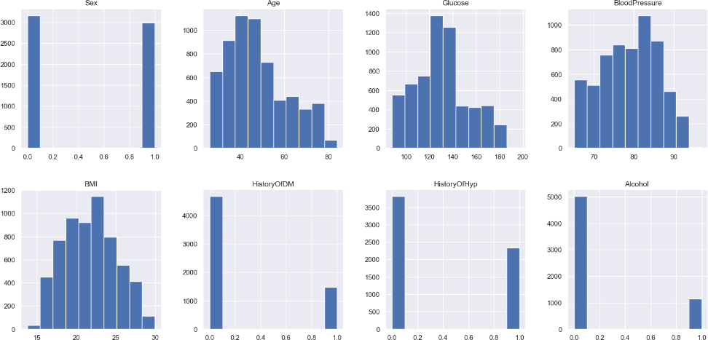
Distribution of the dataset after data cleaning
Fig 9.Dataset distribution
The distribution of each feature, whether dependent or independent, is shown in the above Fig 9. Because it displays the occurrence of every type of value in the graphical structure, it helps in the study of the dataset.

Feature Importance
Feature importance rates how important each feature during the prediction. It is a number between 0 and 1 for each feature.
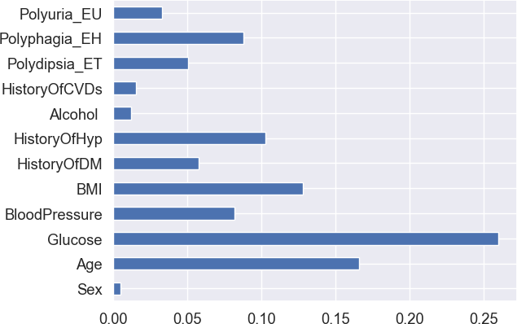
Fig 10. Feature importance
Feature Glucose, Age, BMI, HistoryOfHyp, Polyphagia EH, Polydipsia ET, Blood Pressure are by far the most important feature in our dataset from the total selected twelve attributes.

Correlation
Correlation is helps to find the feature importance and clean the dataset before implementing the model. The correlation describes the frequency and direction of a straight-line link between two quantitative variables. Moreover, the correlation sums up the strength of the linear association. R represents the range of values between 1 and 0. Sex and alcohol use has less impact on either of these variables as evidenced by the negative and smaller value connection in Fig 11.

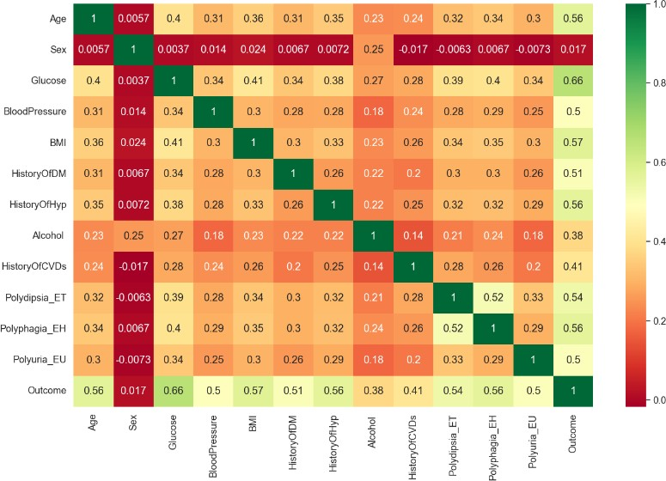
Fig 11.Correlation
According to observation, features like Glucose, Age, BMI, HistoryOfHyp, Polyphagia EH, Polydipsia ET and Blood Pressure are more correlated with the target variable.

Outcome/Target variable
Outcome has 1 and 0 values where 1 indicates that person has diabetes and 0 shows person has no diabetes. This is my label column in dataset.
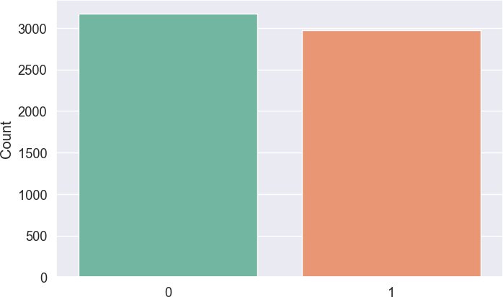
Fig 12.Outcome
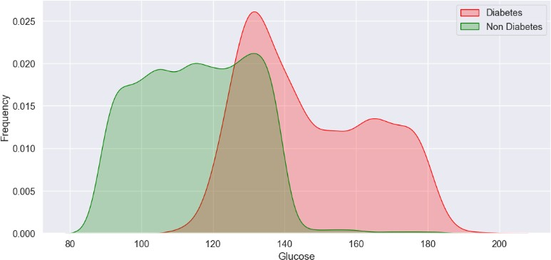
Fig 13.Correlation glucose with outcome
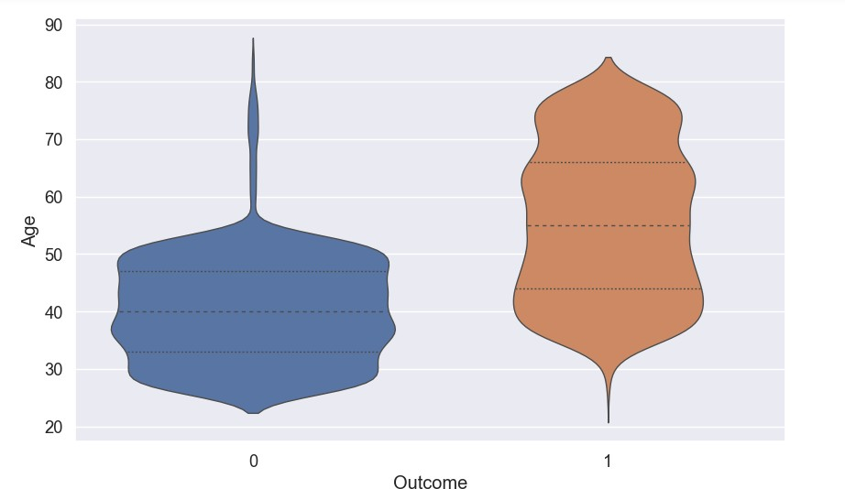
In the above Fig 13 shows, the probability of being diabetes is gradually increasing with level of Glucose increase.
Fig 14.Correlation glucose with outcome/target variables
In the above Fig 14 shows, the probability of developing type 2 diabetes increases with age, particularly after the age of 45. This is due to a variety of factors, including a decrease in insulin sensitivity, changes in hormone levels, and a higher likelihood of carrying excess weight. Additionally, older adults may be more sedentary and may have poorer dietary habits, which can also increase the risk of developing diabetes.

Model Result
A confusion matrix is used in the Machine Learning model to evaluate how effectively the algorithms perform. The confusion matrices have been applied to examine the various machine learning techniques by statistical metrics like precision, recall, F- measure, MCC, and ROC Area. It features a tabular layout where the rows are the actual values and the columns are the predicted values. In Figs to these classifiers confusion matrices are depicted.
4.5.1. Support Vector Machine (SVM) Algorithm
In this study, we used the Support Vector Machine (SVM) Algorithm to predict diabetes mellitus based on a dataset of patient information. We trained the algorithm on 70% of the data and tested it on the remaining 30%. The Support Vector Machine (SVM) algorithm achieved an overall accuracy of 91.8% on the test data.
Actual
 | 1 | 0
1 | 816 | 78
0 | 72 | 879

Predicted

Table 7.Confusion Matrix for SVM Algorithm

RESULT FOR SUPPORT VECTOR MACHINE (SVM)
ALGORITHM
100

98

96

94
92
92
92
92
90
PRECISION
91
RECALL
0
F1 - SCORE
1
Fig 15.Result of Support Vector Machine (SVM) Algorithm

The precision, recall, F1 score, support, and confusion matrix metrics were also evaluated. The precision for the positive class (patients with diabetes) was 0.92, indicating that 92% of the predicted positive cases were truly positive. The recall for the positive class was 0.91, indicating that 91% of the actual positive cases were correctly identified by the model. The F1 score for the positive class was 0.92, which is a combined measure of precision and recall. The support for the positive class was 894, indicating the number of instances in the positive class.
In the table 7 the confusion matrix showed that the model correctly classified 816 patients with diabetes and 879 patients without diabetes. However, the model incorrectly classified 72 patients as having diabetes when they did not and 78 patients as not having diabetes when they did. This highlights the importance of balancing precision and recall, as false positives and false negatives can have significant consequences in medical diagnosis.
Overall, the support vector machine (SVM) algorithm performed better in predicting diabetes mellitus, achieving better accuracy and reasonable precision and recall metric.
4.5.3. Results for Decision Tree Algorithm
In this study, we used the Decision Tree (DT) Algorithm to predict diabetes mellitus based on a dataset of patient information. We trained the algorithm on 70% of the data and tested it on the remaining 30%. The Decision Tree (DT) algorithm achieved an overall accuracy of 92.9% on the test data.
Actual
 | 1 | 0
1 | 820 | 74
0 | 56 | 895

Predicted

Table 8.Confusion Matrix for Decision Tree Algorithm

Fig 16.Results for Decision (DT) Tree Algorithm

The precision, recall, F1 score, support, and confusion matrix metrics were also evaluated. The precision for the positive class (patients with diabetes) was 0.94, indicating that 94% of the predicted positive cases were truly positive. The recall for the positive class was 0.92, indicating that 92% of the actual positive cases were correctly identified by the model. The F1 score for the positive class was 0.93, which is a combined measure of precision and recall. The support for the positive class was 894, indicating the number of instances in the positive class.
In the table 8 the confusion matrix showed that the model correctly classified 820 patients with diabetes and 995 patients without diabetes. However, the model incorrectly classified 56 patients as having diabetes when they did not and 74 patients as not having diabetes when they did. This highlights the importance of balancing precision and recall, as false positives and false negatives can have significant consequences in medical diagnosis.
Overall, the Decision Tree (DT) algorithm performed better in predicting diabetes mellitus, achieving better accuracy and reasonable precision and recall metrics.
4.5.4. Result for Logistic Regression Algorithm
In this study, we used the Logistic Regression Algorithm to predict diabetes mellitus based on a dataset of patient information. We trained the algorithm on 70% of the data and tested it on the remaining 30%. The Logistic Regression algorithm achieved an overall accuracy of 93.9% on the test data.
Actual
 | 1 | 0
1 | 837 | 57
0 | 55 | 896

Predicted

Table 9.Confusion Matrix for Logistic Regression Algorithm

RESULT FOR LOGISTIC REGRESSION
100
98
96
94
94
94
94
94
94
94
92
90
PRECISION
RECALL
F1 - SCORE
0
1
Fig 17.Result for Logistic Regression Algorithm

The precision, recall, F1 score, support, and confusion matrix metrics were also evaluated. The precision for the positive class (patients with diabetes) was 0.94, indicating that 94% of the predicted positive cases were truly positive. The recall for the positive class was 0.94, indicating that 94% of the actual positive cases were correctly identified by the model. The F1 score for the positive class was 0.94, which is a combined measure of precision and recall. The support for the positive class was 894, indicating the number of instances in the positive class.
In the table 9 the confusion matrix showed that the model correctly classified 837 patients with diabetes and 896 patients without diabetes. However, the model incorrectly classified 55 patients as having diabetes when they did not and 57 patients as not having diabetes when they did. This highlights the importance of balancing precision and recall, as false positives and false negatives can have significant consequences in medical diagnosis.
Overall, the Logistic Regression algorithm performed better in predicting diabetes mellitus, achieving better accuracy and reasonable precision and recall metrics.
4.5.4. Result for K-Nearest Neighbor (KNN) Algorithm
In this study, we used the K-Nearest Neighbor (KNN) Algorithm to predict diabetes mellitus based on a dataset of patient information. We trained the algorithm on 70% of the data and tested it on the remaining 30%. The K-Nearest Neighbor (KNN) algorithm achieved an overall accuracy of 93.2% on the test data.
Actual
 | 1 | 0
1 | 825 | 69
0 | 55 | 896

Predicted

Table 10.Confusion Matrix for KNN Algorithm

Fig 18. Result of K-Nearest Neighbor (KNN) Algorithm

The precision, recall, F1 score, support, and confusion matrix metrics were also evaluated. The precision for the positive class (patients with diabetes) was 0.94, indicating that 94% of the predicted positive cases were truly positive. The recall for the positive class was 0.92, indicating that 92% of the actual positive cases were correctly identified by the model. The F1 score for the positive class was 0.93, which is a combined measure of precision and recall. The support for the positive class was 894, indicating the number of instances in the positive class.
In the table 10 the confusion matrix showed that the model correctly classified 825 patients with diabetes and 896 patients without diabetes. However, the model incorrectly classified 55 patients as having diabetes when they did not and 69 patients as not having diabetes when they did. This highlights the importance of balancing precision and recall, as false positives and false negatives can have significant consequences in medical diagnosis.
Overall, the K-Nearest Neighbor (KNN) algorithm performed better in predicting diabetes mellitus, achieving better accuracy and reasonable precision and recall metrics.
4.5.5. Result for Naive Bayes Algorithm
In this study, we used the Naive Bayes Algorithm to predict diabetes mellitus based on a dataset of patient information. We trained the algorithm on 70% of the data and tested it on the remaining 30%. The Naive Bayes algorithm achieved an overall accuracy of 95.3% on the test data.
Actual
 | 1 | 0
1 | 863 | 31
0 | 54 | 897

Predicted

Table 11.Confusion Matrix for Naive Bayes Algorithm

Fig 19.Result for Naive Bayes Algorithm
The precision, recall, F1 score, support, and confusion matrix metrics were also evaluated. The precision for the positive class (patients with diabetes) was 0.94, indicating that 94% of the predicted positive cases were truly positive. The recall for the positive class was 0.97, indicating that 97% of the actual positive cases were correctly identified by the model. The F1 score for the positive class was 0.95, which is a combined measure of precision and recall. The support for the positive class was 894, indicating the number of instances in the positive class.
In the table 11 the confusion matrix showed that the model correctly classified 863 patients with diabetes and 897 patients without diabetes. However, the model incorrectly classified 54 patients as having diabetes when they did not and 31 patients as not having diabetes when they did. This highlights the importance of balancing precision and recall, as false positives and false negatives can have significant consequences in medical diagnosis. Overall, the Naive Bayes algorithm performed better in predicting diabetes mellitus, achieving high accuracy and reasonable precision and recall metrics.
4.5.6. Result for Artificial Neural Network (ANN) algorithm
In this study, we used the Artificial Neural Network (ANN) Algorithm to predict diabetes mellitus based on a dataset of patient information. We trained the algorithm on 70% of the data and tested it on the remaining 30%. The Artificial Neural Network (ANN) algorithm achieved an overall accuracy of 95.1% on the test data.
Actual
 | 1 | 0
1 | 841 | 53
0 | 36 | 915

Predicted

Table 12.Confusion Matrix for ANN Algorithm
RESULT ARTIFICIAL NEURAL NETWORK (ANN)
ALGORITHM
100
98
96
94
92
90
PRECISION
RECALL
0
F1 - SCORE
1

96  95 | 96  94 | 95

Fig 20. Result for Artificial Neural Network (ANN) algorithm
The precision, recall, F1 score, support, and confusion matrix metrics were also evaluated. The precision for the positive class (patients with diabetes) was 0.96, indicating that 96% of the predicted positive cases were truly positive. The recall for the positive class was 0.94, indicating that 94% of the actual positive cases were correctly identified by the model. The F1 score for the positive class was 0.95, which is a combined measure of precision and recall. The support for the positive class was 894, indicating the number of instances in the positive class.
In the table 12 the confusion matrix showed that the model correctly classified 841 patients with diabetes and 915 patients without diabetes. However, the model incorrectly classified 36 patients as having diabetes when they did not and 53 patients as not having diabetes when they did. This highlights the importance of balancing precision and recall, as false positives and false negatives can have significant consequences in medical diagnosis. Overall, the Artificial Neural Network (ANN) algorithm performed better in predicting diabetes mellitus, achieving high accuracy and reasonable precision and recall metrics.
4.5.7. Result for Random Forest Algorithm

In this study, we used the Random Forest algorithm. The RF algorithm is a type of ensemble method that makes predictions by averaging over predictions of several independent base models. To predict diabetes mellitus based on a dataset of patient information. We trained the algorithm on 70% of the data and tested it on the remaining 30%. The Random Forest algorithm achieved an overall accuracy of 97.4% on the test data.
Actual
 | 1 | 0
1 | 873 | 21
0 | 26 | 925

Predicted

Table 13.Confusion Matrix for Random Forest Algorithm

Fig 21.Result for Random Forest Algorithm

The precision, recall, F1 score, support, and confusion matrix metrics were also evaluated. The precision for the positive class (patients with diabetes) was 0.97, indicating that 97% of the predicted positive cases were truly positive. The recall for the positive class was 0.98, indicating that 98% of the actual positive cases were correctly identified by the model. The F1 score for the positive class was 0.97, which is a combined measure of precision and recall. The support for the positive class was 894, indicating the number of instances in the positive class.
In the table 13 the confusion matrix showed that the model correctly classified 873 patients with diabetes and 925 patients without diabetes. However, the model incorrectly classified 26 patients as having diabetes when they did not and 21 patients as not having diabetes when they did. This highlights the importance of balancing precision and recall, as false positives and false negatives can have significant consequences in medical diagnosis.
Overall, the Random Forest algorithm performed well in predicting diabetes mellitus, achieving high accuracy and reasonable precision and recall metrics.

Comparison of the Models
From the results obtained for each of the model. Considering the different performance evaluation techniques, it is evident that they produced different performance levels as shown in the table below.
Table 14.Comparison of the Models
Model | Accuracy | Precision | Recall | F1-score | Support | Rank
Random Forest | 97.4 | 98 | 97 | 98 | 951 | 1
Naïve Bayes | 95.3 | 97 | 94 | 95 | 951 | 2
Artificial Neural Network | 95.1 | 95 | 96 | 95 | 951 | 3
Logistic Regression | 93.9 | 94 | 94 | 94 | 951 | 4
K-Nearest Neighbor | 93.2 | 93 | 94 | 94 | 951 | 5
Decision Tree | 92.9 | 92 | 94 | 93 | 951 | 6
Support Vector Machin | 91.8 | 92 | 92 | 92 | 951 | 7

In Table 14 the result shows the various performance levels it shows that Random Forest produces the best performance with an accuracy of 97.4%, precision 97%, recall 98% and F1 score 97%. Therefore, Random Forest would be selected to predict early diabetes mellitus in this research.

Chapter Five

Conclusion and future work
This chapter highlights the research's primary findings and provides recommendation for what needs to be done moving ahead as a useful contribution for other researchers who are interested in working in this field.

Conclusion
Diabetes mellitus is a chronic metabolic disorder that occurs when the body is unable to produce or use insulin effectively, resulting in high blood sugar levels. There are several risk factors associated with the development of diabetes discovered in this research,
The probability of developing type 2 diabetes increases with age, particularly after the age of 45. This is due to a variety of factors, including a decrease in insulin sensitivity, changes in hormone levels, and a higher likelihood of carrying excess weight. Moreover, older adults may be more inactive and may have poorer dietary habits, which can also increase the risk of developing diabetes.
Being overweight or obese is a significant risk factor for diabetes, as excess body fat can lead to insulin resistance. Hypertension or high blood pressure is a significant risk factor for diabetes, as it can damage the blood vessels and impair blood flow to the organs. Having a family member with diabetes also increases the risk of developing the disease. Having one or more of these risk factors does not necessarily mean that an individual will develop diabetes.
However, maintaining a healthy lifestyle, including regular physical activity and a balanced diet, can help reduce the risk of developing diabetes. Furthermore, early diagnosis and treatment of diabetes can help prevent or delay complications associated with the condition, cardio vascular disease such as heart disease, kidney disease, and nerve damage and it is essential to monitor these risk factors and take steps to reduce the risk of developing diabetes.
Research has shown that in recent times that diabetes mellitus (DM) is a growing public health concern in Ethiopia, with an estimated prevalence of 3.3%. Early detection and management of diabetes can prevent the onset of complications and reduce the burden of the disease. This has further estimated the number to double in a few decades to come.
Early stage detection of diabetes, is a major key for treatment. This research developed a supervised machine learning model such as Decision Trees (DT), Support Vector Machine (SVM), Logistic Regression, K-Nearest Neighbor (KNN), Naive Bayes, Artificial Neural Network (ANN) and Random Forest classifier. The models are trained and test considering 70/30 ration by using the selected twelve (12) attributes which includes; Age , Sex , Glucose , Blood Pressure (BP) , Body Mass Index (BMI), History Of diabetes mellitus ,History of hypertension , History of Alcohol consumption , History of CVDs , Polydipsia, Polyphagia ,Polyuria. Random Forest is the most promising algorithm in terms of performance evaluation criteria. Random forest algorithm performed an accuracy of 97.4%, precision 97%, recall 98% and F1 score 97%. This Random Forest would assist healthcare centers in taking precise and prompt decisions about the disease status at a quite early stage.
The main contribution of this research is providing, effective model for early prediction diabetes mellitus and has emphasized the significance of feature selection and appropriate data management.
Early prediction can reduce the burden on health facilities by preventing complications associated with diabetes. Individuals with diabetes are at higher risk of developing other chronic conditions, such as cardiovascular disease, kidney disease, eye problems and other. By identifying individuals at risk of developing diabetes early on and providing preventive measures, healthcare providers can reduce the risk of developing these complications. This can help in reducing the burden on health facilities by preventing the need for hospitalization and expensive treatments. This can help in improving the health outcomes of individuals, increase productivity and the overall health of the local community.
Moreover, early prediction of diabetes mellitus can also have a significant impact on reducing the individual and health facility costs associated with the disease. Diabetes is a chronic condition that requires lifelong management and treatment, which can be expensive. By identifying individuals at risk of developing diabetes early on, healthcare providers can provide preventive measures, such as lifestyle modifications and medication, to delay or prevent the onset of the disease. This can significantly reduce the individual costs associated with managing the disease.

Future work
Blood-insulin levels were generally the most relevant factor in prior research that predicted diabetes in non-critical care situations. Therefore complementing our dataset with blood-insulin and levels and Gestational Diabetes Mellitus as an additional feature would greatly improve the model performance.
In the future, a thorough comparison analysis between multiple datasets and their features can be undertaken in order to uncover all the key elements for forecasting diabetes. To discover the best and most accurate diabetes prediction algorithm, a number of various algorithms and combinations of algorithms can be studied.
In future, the built system with the applied machine learning classification algorithms can be used to predict or diagnose different diseases. The technique can be extended and enhanced for the automation of diabetes analysis including some additional machine learning algorithms.
Clinical validation: Finally, it is important to validate the performance of machine learning models in a clinical setting. Researchers can collaborate with clinicians and medical experts to conduct clinical trials to evaluate the performance of the diabetes mellitus prediction models on real-world data. This will help to ensure that the models are safe, effective, and reliable for use in clinical practice.

Conflict of Interest Statement
The researchers affirm that no financial or commercial ties that might be viewed as having a conflict of interest existed during the research's execution.

6. References
- T. Shimels ., “Magnitude and associated factors of poor medication adherence among diabetic and hypertensive patients visiting public health facilities in Ethiopia during the COVID-19 pandemic,” PLoS One, vol. 16, no. 4 April, pp. 1–13, 2021, doi: 10.1371/journal.pone.0249222.
- C. for D. C. and P. (CDC), “What Is Type 1 Diabetes? | CDC.” https://www.cdc.gov/diabetes/basics/what-is-type-1-diabetes.html (accessed Apr. 26, 2022).
- C. for D. C. and P. (CDC), “How to Prevent Diabetes: MedlinePlus.” https://medlineplus.gov/howtopreventdiabetes.html (accessed Apr. 26, 2022).
- C. for D. C. and P. (CDC), “Prevent Diabetes Complications | CDC.” https://www.cdc.gov/diabetes/managing/problems.html (accessed Apr. 26, 2022).
- W. T. Cade, “Macrovascular Diseases in the Physical Therapy Setting,” vol. 88, no. 11, 2008.
- A. T. Sahile and G. E. Bekele, “Prevalence of diabetes mellitus and associated factors in addis Ababa public health facilities, Addis Ababa, Ethiopia, 2016,” Diabetes, Metab. Syndr. Obes. Targets Ther., vol. 13, pp. 501–508, 2020, doi: 10.2147/DMSO.S237995.
- S. Webber, International Diabetes Federation, vol. 102, no. 2. 2013. doi: 10.1016/j.diabres.2013.10.013.
- S. Ray, “A Quick Review of Machine Learning Algorithms,” Proc. Int. Conf. Mach. Learn. Big Data, Cloud Parallel Compute. Trends, Perspectives Prospect. Com. 2019, pp. 35–39, 2019, doi: 10.1109/COMITCon.2019.8862451.
- M. Mohammed, M. B. Khan, and E. B. M. Bashie, Machine learning: Algorithms and applications, no. December. 2016. doi: 10.1201/9781315371658.
- N. Pradhan, G. Rani, V. S. Dhaka, and R. C. Poonia, “Diabetes prediction using artificial neural network,” Deep Learn. Tech. Biomed. Heal. Informatics, pp. 327–339, Jan. 2020, doi: 10.1016/B978-0-12-819061-6.00014-8.
- A. A. Al-Mobayed, Y. M. Al-Madhoun, and ..., “Artificial Neural Network for Predicting Car Performance Using JNN,” https://philpapers.org/rec/ALMANN
- K. Patil, S. D. Sawarkar, and N. Swati, “Designing a Model to Detect Diabetes using Machine Learning,” Int. J. Eng. Res. Technol., vol. 8, no. 11, pp. 333–340, 2019, [Online]. Available: www.ijert.org
- D. Adeloye “Estimating the prevalence, hospitalization and mortality from type 2

diabetes mellitus in Nigeria: A systematic review and meta-analysis,” BMJ Open, vol. 7, no. 5, pp. 1–16, 2017, doi: 10.1136/bmjopen-2016-015424.
- H. Kaur and V. Kumari, “Predictive modelling and analytics for diabetes using a machine learning approach,” vol. 18, no. 1, pp. 92–102, 2020, doi: 10.1016/j.aci.2018.12.004.
- A. Rayar and R. Manivannan, “Evaluation of Antidiabetic Activity From the Root Extracts of Pavonia Odorata Wild in Alloxan Induced Diabetic Rates,” vol. 4, no. 5, pp. 46–52, 2015.
- I. H. Sarker, “Machine Learning: Algorithms, Real-World Applications and Research Directions,” SN Comput. Sci., vol. 2, no. 3, p. 4, 2021, doi: 10.1007/s42979-021-00592-x.
- H. Chen and D. Fu, “An Improved Naïve Bayes Classifier for Large Scale Text,” vol. 146, no. Icaita, pp. 33–36, 2018.
- “Naive Bayes Classifier. What is a classifier? | by Rohith Gandhi | Towards Data Science.” https://towardsdatascience.com/naive-bayes-classifier-81d512f50a7c (accessed Dec. 19, 2022).
- “How Does Logistic Regression Work? - KDnuggets.” https://www.kdnuggets.com/2022/07/logistic-regression-work.html (accessed Dec. 19, 2022).
- H. Poirot, “Logistic Regression,” 2023.
- “What Is a Decision Tree?” https://www.mastersindatascience.org/learning/machine-learning- algorithms/decision-tree/ (accessed Dec. 22, 2022).
- “Decision Tree Algorithm in Machine Learning.” https://www.enjoyalgorithms.com/blog/decision-tree-algorithm-in-ml (accessed Dec. 22, 2022).
- “Random Forest Algorithm - How It Works and Why It Is So Effective.” https://www.turing.com/kb/random-forest-algorithm (accessed Dec. 22, 2022).
- “Machine Learning Random Forest Algorithm - Javatpoint.” https://www.javatpoint.com/machine-learning-random-forest-algorithm (accessed Mar. 11, 2023).
- “K-Nearest Neighbors (KNN) Classification with scikit-learn | Data Camp.” https://www.datacamp.com/tutorial/k-nearest-neighbor-classification-scikit-learn (accessed Mar. 12, 2023).
- “SVM | How to Use Support Vector Machines (SVM) in Data Science.” https://www.analyticsvidhya.com/blog/2017/09/understaing-support-vector-machine-

example-code/ (accessed Apr. 12, 2023).
- “SVM | Support Vector Machine Algorithm in Machine Learning.” https://www.analyticsvidhya.com/blog/2017/09/understaing-support-vector-machine- example-code/ (accessed Dec. 22, 2022).
- “A Detailed Overview to the Basics of Support Vector Machines in Machine Learning - PyCodeMates.” https://www.pycodemates.com/2022/07/support-vector-machines-detailed- overview.html (accessed Mar. 12, 2023).
- D. Mishra, R. Dash, A. K. Rath, and M. Acharya, “Feature selection in gene expression data using principal component analysis and rough set theory,” Adv. Exp. Med. Biol., vol. 696, no. 1994, pp. 91–100, 2011, doi: 10.1007/978-1-4419-7046-6_10.
- “Feature Selection: Filter method, Wrapper method and Embedded method - iZen.ai.” https://www.izen.ai/blog-posts/feature-selection-filter-method-wrapper-method-and- embedded-method/ (accessed May 09, 2023).
- “Wrapper Method of Feature Selection – Cloudy ML.” https://www.cloudyml.com/data- science/wrapper-method-feature-selection/ (accessed May 09, 2023).
- A. Jović, K. Brkić, and N. Bogunović, “A review of feature selection methods with applications,” 2015 38th Int. Conv. Inf. Commun. Technol. Electron. Microelectron. MIPRO 2015 - Proc., pp. 1200–1205, 2015, doi: 10.1109/MIPRO.2015.7160458.
- R. Krishnamoorthi ., “A Novel Diabetes Health Care Disease Prediction Framework Using Machine Learning Techniques,” 2022.
- P. M. Joshi, T. N., & Chawan, “Logistic Regression and Svm Based Diabetes,” Int. J. Technol. Res. Eng., vol. 5, no. July, pp. 4347-4350., 2018.
- S. Shafi and G. Ahmad Ansari, “Early Prediction of Diabetes Disease & Classification of Algorithms Using Machine Learning Approach,” 2021. https://ssrn.com/abstract=3852590
- N. Sneha and T. Gangil, “Analysis of diabetes mellitus for early prediction using optimal features selection,” J. Big Data, vol. 6, no. 1, 2019, doi: 10.1186/s40537-019-0175-6.
- A. E. Evwiekpaefe and N. Abdulkadir, “Digital Commons @ Kennesaw State University A Predictive Model For Diabetes Using Machine Learning Techniques ( A Case Study of Some Selected Hospitals In Kaduna Metropolis ) A Predictive Model For Diabetes Using Machine Learning Techniques ( A CASE STUDY ,” 2021.
- D. Sisodia and D. S. Sisodia, “Prediction of Diabetes using Classification Algorithms,” Procedia Comput. Sci., vol. 132, no. Iccids, pp. 1578–1585, 2018, doi: 10.1016/j.procs.2018.05.122.
- Lim Zi Hao, “Predicting Type 2 Diabetes: A Machine Learning Approach,” Int. J. Recent Technol. Eng., vol. 9, no. 2, pp. 603–608, Jul. 2020, doi: 10.35940/ijrte.b3484.079220.
- H. Balaji, N. C. S. . Iyengar, and R. D. Caytiles, “Optimal Predictive analytics of Pima Diabetics using Deep Learning,” Int. J. Database Theory Appl., vol. 10, no. 9, pp. 47–62, 2017, doi: 10.14257/ijdta.2017.10.9.05.
- M. Alehegn and R. Joshi, “Analysis and prediction of diabetes diseases using machine learning algorithm: Ensemble approach,” Int. Res. J. Eng. Technol., 2017, [Online].
Available: www.irjet.net
- A. Mujumdar and V. Vaidehi, “Diabetes Prediction using Machine Learning Aishwarya Mujumdar Diabetes Prediction using Machine Learning Aishwarya Mujumdar Aishwarya,” Procedia Comput. Sci., vol. 165, pp. 292–299, 2019, doi: 10.1016/j.procs.2020.01.047.
- A. Ashiquzzaman , “Reduction of overfitting in diabetes prediction using deep learning neural network,” Lect. Notes Electr. Eng., vol. 449, pp. 35–43, 2017, doi: 10.1007/978-981-
10-6451-7_5.
- O. Llaha and A. Rista, “Prediction and Detection of Diabetes using Machine Learning”.
- Q. Zou, K. Qu, Y. Luo, D. Yin, Y. Ju, and H. Tang, “Predicting Diabetes Mellitus With Machine Learning Techniques,” Front. Genet. vol. 9, no. November, pp. 1–10, 2018, doi: 10.3389/fgene.2018.00515.
- S. Sistla, “Predicting Diabetes u sing SVM Implemented by Machine learning,” Int. J. Soft Comput. Eng., vol. 12, no. 2, pp. 16–18, 2022, doi: 10.35940/ijsce.b3557.0512222.
- P. Rahimloo and A. Jafarian, “Prediction of Diabetes by Using Artificial Neural Network, Logistic Regression Statistical Model and Combination of Them,” Bull. la Société R. des Sci. Liège, pp. 1148–1164, 2016, doi: 10.25518/0037-9565.5938.
- B. Premamayudu, K. Muralikrishna, and K. Pramodh, “Diabetes Prediction Using Machine Learning KNN-Algorithm Technique,” Int. J. Innov. Sci. Res. Technol., vol. 7, no. 5, pp. 941– 944, 2022, [Online]. Available: www.ijisrt.com941
- E. Y. Obsie, H. Qu, and F. Drummond, “Wild blueberry yield prediction using a combination of computer simulation and machine learning algorithms,” Comput. Electron. Agric., vol. 178, no. May, p. 105778, 2020, doi: 10.1016/j.compag.2020.105778.
- “Feature Selection Techniques in Machine Learning (Updated 2023).” https://www.analyticsvidhya.com/blog/2020/10/feature-selection-techniques-in-machine- learning/ (accessed May 09, 2023).
- S. Beniwal and J. Arora, “Classification and Feature Selection Techniques in Data Mining,”
Int. J. Eng. Res. Technol., vol. 1, no. 6, pp. 1–6, 2012.
- “Python for Data Science and Machine Learning.” https://www.aezion.com/blogs/python-for- data-science-and-machine-learning/ (accessed Dec. 08, 2022).
- A. Ragab, “Machine Learning for Diabetes Mellitus Prediction in the Intensive Care Unit,” no. June, 2021.
- “Machine Learning - Performance Metrics.” https://www.tutorialspoint.com/machine_learning_with_python/machine_learning_algorithms
_performance_metrics.htm (accessed May 09, 2023).
- “Confusion Matrix in Machine Learning with EXAMPLE.” https://www.guru99.com/confusion-matrix-machine-learning-example.html (accessed Dec. 08, 2022).

Appendix
Appendix 1.Data collection tool for Diabetes Mellitus (DM) early prediction

Age | Sex (M/F) | Residence 1=Urban 0=Rural | Body mass index BMI  (kg/m2) | Insulin | Cholesterol level | Gluco se level | BP  (Sys/Dia) | Low Density (LDP) | (Polyuria  )  Have excess urine? (Y/N) | (Polyphagia  )  Have excessive hunger? (Y/N) | Cigarette Smoking Never smoker= 0  Former smoker  =1  Current smoker=  2 | Alcohol consumption Abstainers=0 Occasional drinker=1 Moderate drinker=2 Heavy drinker=3 | Regular Exercise (Y/N) | History of Cardiovascular Disease - CVDs (Y/N) | Women with history of gestational diabetes (GDM) or  history of delivering baby > 4kg (Y/N) | First degree Family History of DM (Y/N) | Diabetes pedigree function non- diabetes  = 0  diabetes  =1

85

Importing Python libraries
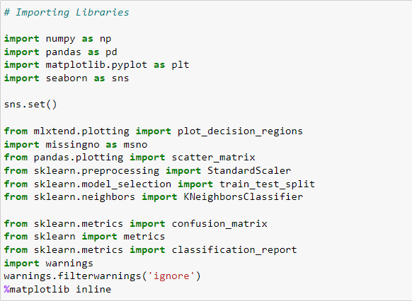

Appendix 2. Python- Jupyter notebook working environment
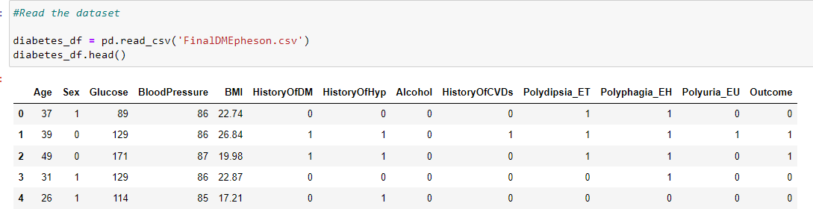

Appendix 3. Read the dataset using python library

86

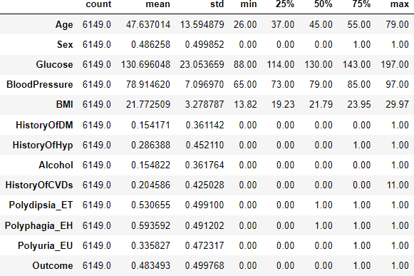

Appendix 4. Dataset with transpose

