ANALYSIS OF THE EFFECTS OF THREE WHEELERS ON PERFORMANCE MEASUREMENT PARAMETERS OF INTERSECTIONS:
A CASE STUDY: ROUNDABOUTS AND SIGNALIZED INTERSECTIONS IN HOSSANA CITY

MSc THESIS

DAWIT DAMISSIE ERGICHO

HAWASSA UNIVERSITY, HAWASSA, ETHIOPIA

DECEMBER , 2020
ANALYSIS OF THE EFFECTS OF THREE WHEELERS
ON PERFORMANCE MEASUREMENT PARAMETERS OF INTERSECTIONS:
A CASE STUDY: ROUNDABOUTS AND SIGNALIZED INTERSECTIONS IN HOSSANA CITY

DAWIT DAMISSIE ERGICHO

A THESIS SUBMITTED TO THE DEPARTMENT OF CIVIL ENGINEERING
HAWASSA INSTITUTE OF TECHNOLOGY,
SCHOOL OF GRADUATE STUDIES
HAWASSA UNIVERSITY
HAWASSA, ETHIOPIA

IN PARTIAL FULFILLMENT OF THE REQUIREMENT FOR THE DEGREE OF
MASTER OF SCIENCE IN CIVIL ENGINEERING
(SPECIALIZATION: ROAD AND TRANSPORT ENGINEERING)

DECEMBER , 2020

ADVISORS’ APPROVAL SHEET
This is to certify that the thesis entitled: "Analysis of The Effects of Three wheelers on Performance Measurement Parameters of Intersections: A Case Study: Roundabouts and Signalized Intersections in Hosanna City” submitted in partial fulfillment of the requirements for the Degree of masters with specialization in Road and transport engineering the graduate program of the department of civil engineering and has been carried out by Dawit Damissie Ergicho, Id number GPRO/009/11 under my own supervision, therefore, I recommended that the student has fulfilled the requirements and hence hereby can submit the thesis to the department office.
Approved by: -
Prof. EmerT.Quezon,P.E., Dr.(hc)  04/12/20 G.C
Name of Major Advisor Signature Date

Belete Tsegaye (MSc) ________________ ______________
Name of Co-advisor Signature Date

SCHOOL OF GRADUATE STUDIES
HAWASSA UNIVERSITY

EXAMINERS’ APPROVAL SHEET-1
We, the undersigned, members of the Board of Examiners of the final open defense by Dawit Damissie Ergicho, have read and evaluated his thesis entitled “Analysis of the effects of Three wheelers on Performance Measurement Parameters of Intersections: A Case Study: Roundabouts and Signalized Intersections in Hosanna City," and examined the candidate. Therefore, this is to certify that the thesis has been accepted in partial fulfillment of the requirements for the Degree.

Prof. Emer T.Quezon.P.E., Dr.(hc) _ __04/12/20 G.C_
Name of Advisor Signature Date
Mandefro Terefe (MSc) ________________ ________________
Name of Internal Examiner Signature Date
Robeam Solomon (PhD)  __29/12/20 G.C_
Name of External examiner Signature Date
Thomas Bezabih (MSc) _______________ _______________
Name of the Chairperson Signature Date
_________________________ _______________ ______________
SGS Approval Signature Date

DECLARATION
I hereby declare that this MSc thesis entitled “Analysis of The Effects of Three wheelers on Performance Measurement Parameters of Intersections: A Case Study: Roundabouts and Signalized Intersections in Hosanna City," is my original work and has not been presented for a degree in any other university, and all sources of material used for this thesis have been duly acknowledged.

Name: Dawit Damissie
Email: demissietadudawit@gmail.com
Phone: +251-916-72-57-15
Hawassa University, Ethiopia
Signature: _______________

This MSc thesis entitled “Analysis of The Effects of three wheelers on Performance Measurement Parameters of Intersections: A Case Study: Roundabouts and Signalized Intersections in Hosanna City, "has been submitted for examination with my approval as thesis advisor.
Name: Prof. EmerT.Quezon,P.E., Dr.(hc)
Signature: 
Place and Date of Submission: 04/10/20G.C Hawassa-Ethiopia

ACKNOWLEDGMENTS
I would like to express my sincere gratitude to my advisors, Prof. Emer T.Quezon and Mr. Belete Tsegaye for their kind encouragement, follow up, guidance, support and supervision throughout this research work. I would also like to thank all my friends for their great encouragement and support. Finally, sincere appreciation and acknowledgement is due to Hawassa University and the Ethiopian Road Authority at large and Department of Civil Engineering, Faculty of Civil Engineering and Built Environment, Institute of Technology and post-graduate program Coordinator who gave me the opportunity to be engaged in such advanced study, for their Continuous encouragement and tolerance.
God made it all, I have no words to tell how much grateful I am except to say, THANK YOU GOD!

TABLE OF CONTENTS
ADVISORS’ APPROVAL SHEET i
EXAMINERS’ APPROVAL SHEET-1 ii
DECLARATION iii
ACKNOWLEDGMENTS iv
ABBREVIATIONS vii
LIST OF TABLES viii
LIST OF FIGURES xiii
ABSTRACT xvi
1. INTRODUCTION 1
1.1. Background of the Study 1
1.2 Statement of the Problem 2
1.3 Research Questions 3
1.4 Objectives of the Research 3
1.4.1 General Objective 3
1.4.2 Specific Objectives 3
1.5. Scope and limitations of the Research 3
1.6. Significance of the Study. 4
1.7. Structure of the thesis 4
2. LITERATURE REVIEW 5
2.1. General Overview 5
2.2 Roundabouts 6
2.2.1 Performance Analysis of roundabout 8
2.2.2 Capacity and Degree of saturation 9
2.2.3 Queue Length Control delay 10
2.2.4 Level of service 10
2.3 Signalized Intersection. 11
2.3.1. Performance evaluation of Signalized intersections. 12
2.4. Factors which affect intersection performances. 16
2.4.1. The Effect of Vehicle Types on Intersection Performance 17
2.5. SIDRA Intersection Software 18
2.5.1. General Introduction about the SIDRA Intersection 18
2.5.2. Calibration of SIDRA Intersection Software 20
3. MATERIALS AND METHODS 21
3.1. Introduction 21
3.2.1 Road network 23
3.2.2 Traffic nature 23
3.3 Study Period 24
3.4 Research Design 24
3.5 Software and Instruments 24
3.6 Data Collection Process. 25
3.6.1 Traffic Volume Data 25
3.6.2 Geometric Data 27
3.7 Data Processing and analysis 28
3.7.1 Evaluation of Performance Measurement parameters of signalized intersections and roundabouts 28
3.7.2 Analysis of the effects of three wheelers on performance measurement parameters of intersections. 32
3.7.3 Comparison of the performance change of intersections by replacing three wheelers with mini bus. 35
4. RESULTS AND DISCUSSION 38
4.1 Introduction 38
4.2. Performance evaluation of intersections. 38
4.2.1 Performance evaluation of Menharya signalized intersections. 38
4.2.2 Performance evaluation of Maryam signalized intersections. 41
4.2.3 Performance evaluation of Bezabh Petros roundabout. 43
4.2.4 Performance evaluation of Eyerusalem roundabout. 45
4.2.5 Summary on existing intersections performances. 47
4.3. The consequences of three wheelers with performance parameters. 48
4.3.1 Performance evaluation of Menharya signalized intersection without three wheelers 48

4.3.2. Performance evaluation of Maryam signalized intersection without three wheelers. 55
4.3.3. Performance evaluation of Bezabh Petros roundabout without three wheelers. 59
4.3.4. Performance evaluation of Eyerusalem roundabout without three wheelers. 65
4.3.5 Summary on the effects of three wheelers on intersection performances. 69
4.4. Comparing the performance change of intersections when three wheelers replaced by minibus. 70
4.4.1. Performance evaluation of Menharya signalized intersection when three wheelers replaced by minibus. 71
4.4.2. Performance evaluation of Maryam signalized intersection when three wheelers replaced by minibus. 77
4.4.3. Performance evaluation of Bezabh Petros roundabout when three wheelers replaced by minibus. 81
4.4.4. Performance evaluation of Eyerusalem roundabout when three wheelers replaced by minibus. 85
4.4.5 Summary on intersection performances when three wheelers replaced by mini bus. 90
5. CONCLUSIONS AND RECOMMENDATIONS 91
5.1. Conclusions 91
5.2. Recommendations 93
REFERENCES 94
APPENDICES 97

ABBREVIATIONS
FHWA= Federal Highways of America
HCM= Highway Capacity Manual
LOS= Level of Service
PCU= Passenger Car Equivalent
SNNPR= Southern Nations Nationalities and Peoples Region
SIDRA= Signalized and Un-Signalized Intersection Design and Research Aid

LIST OF TABLES
Table 2. 1 Description of key roundabout feature…………...…………………………………8
Table 2. 2 level of service for roundabout…………………………………………………….10
Table 3. 1 Types and number of vehicles recorded in Hosanna City..........…………………..23
Table 3.2 Passenger car units for vehicles………………………………………….................26
Table 3.3 Existing roundabouts geometry data….…………………………………………....27
Table 3. 4 Signalized intersections geometric data……..…………………………………..…27
Table 3. 5 Peak hour traffic volumes (PCU) of signalized intersections……………………...29
Table 3. 6 Peak hour traffic volumes (PCU) of roundabouts…………………………………30
Table 3. 7 Pedestrian volume of intersections at peak hour………………………………..…31
Table 3. 8 Default values used in this thesis…….………………………………………..…...31
Table 3. 9 Traffic volume (PCU) data of signalized intersections without three wheelers.......33
Table 3. 10 Traffic volume (PCU) data of roundabouts without three wheelers……………...34
Table 3. 11 Traffic volume (PCU) data of signalized intersections when three wheelers
Replaced by mini bus……………………………………………………………..36
Table 3. 12 Traffic volume (PCU) data of roundabouts when three wheelers replaced by mini
bus ……………………………………………………………………………......37
Table 4. 1 The lane use and performance output for Menharya signalized intersection for an
existing condition………………………………………………….………..……...38
Table 4. 2 The lane use and performance output for Maryam signalized intersection for an
existing condition…………………………………………………………………..41
Table 4. 3 The lane use and performance output for Bezabh Petros roundabout for an existing
condition …………………………………………………………………………..43
Table 4. 4 The lane use and performance output for Eyerusalem roundabout for an existing
condition…………………………………………………………………….……..45
Table 4. 5 the lane use and performance output for Menharya signalized intersection without
three wheelers…………………………….……………………………………….48
Table 4. 6 Comparison of the difference between previous and current level of services (with
and without three wheelers) of Menharya Signalized intersection………………..51
Table 4. 7 Comparison of the difference between previous and current signal delay time (sec)
(with and without three wheelers)………………………………………………....51
Table 4. 8 Comparison of the difference between previous and current degree of saturation
(with and without three wheelers)………………………………………………....52
Table 4. 9 Comparison of the difference between previous and current 95% back of queue
length (m) (with and without three wheelers) of Menharya intersection...……….53
Table 4. 10 Comparison of the difference between previous and current level of services
(with and without three wheelers) of Maryam intersection ……………………...56
Table 4. 11 Comparison of the difference between previous and current signal delay time
(sec) (with and without three wheelers) of Maryam intersection………………...56
Table 4. 12 Comparison of the difference between previous and current degree of saturation
(with and without three wheelers) of Maryam intersection…..…………………..57
Table 4. 13 Comparison of the difference between previous and current 95% back of queue
distance (m) (with and without three wheelers) of Maryam intersection……..….58
Table 4. 14 The lane use and performance output for Bezabh Petros roundabout without three
wheelers………………………………………………………………………......59
Table 4. 15 Comparison of the difference of level of services with and without three wheelers
of Bezabh Petros roundabout……………………………………………………..60
Table 4. 16 Comparison of the difference of delay time (sec) with and without three wheelers
at Bezabh Petros roundabout ………………………………………...…………..61
Table 4. 17 Comparison of degree of saturation with and without three wheelers at Bezabh
Petros roundabout…………………………………………………………….......62
Table 4. 18 Comparison of the difference between previous (with three wheelers) and current
(without three wheelers) 95% back of queue length (m) of Bezabh Petros
roundabout………………………….……………………………………...…….63
Table 4. 19 Comparison of the difference between previous (with three wheelers) and current
(without three wheelers) level of services of Eyerusalem roundabout ...………..66
Table 4. 20 Comparison of the difference between previous and current delay time (sec) (with
and without three wheelers of Eyerusalem roundabout..……………..……..........66
Table 4. 21 Comparison of the difference between previous and current (with and without
three wheelers) degree of saturation of Eyerusalem roundabout….…………...…67
Table 4. 22 Comparison of the difference between previous (with three wheelers) and current
(without three wheelers) 95% back of queue length (m)……………………...….68
Table 4. 23 The lane use and performance output for Menharya signalized intersection when
three wheelers replaced by minibus……………………………………………....71
Table 4. 24 Comparison of the difference between previous (with three wheelers) and current
(when three wheelers replaced by minibus) level of services for Menharya
intersection…..........................................................................................................73
Table 4. 25 Comparison of the difference between previous (with three wheelers) and current
(when three wheelers replaced by minibus) signal delay time (sec) of Menharya
intersection…………………………………………………….............................73
Table 4. 26 Comparison of the difference between previous (with three wheelers) and current
(when three wheelers replaced by minibus) degree of saturation of Menharya
intersection..............................................................................................................74
Table 4. 27 Comparison of the difference between previous (with three wheelers) and current
(when three wheelers replaced by minibus) queue length of Menharya
intersection………………………………………………………….……….……75
Table 4. 28 Comparison of the difference between previous (with three wheelers) and current
(when three wheelers replaced by minibus) level of services for Maryam
intersection……………………………………………………………………......78
Table 4. 29 Comparison of the difference between previous (with three wheelers) and current
(when three wheelers replaced by minibus) signal delay time (sec) of Maryam
intersection………………………………………………………………….…….78
Table 4. 30 Comparison of the difference between previous (with three wheelers) and current
(when three wheelers replaced by minibus) degree of saturation of Maryam
intersection…………………………………………………………………….....79
Table 4. 31 Comparison of the difference between previous (with three wheelers) and current
(when three wheelers replaced by minibus) queue length of Maryam
intersection………………………………………………………………………..80
Table 4. 32 The lane use and performance output for Bezabh Petros roundabout when three
wheelers replaced by minibus………………………………………………….....81
Table 4. 33 Comparison of the difference between previous (with three wheelers) and current
(when three wheelers replaced by minibus) level of services for Bezabh Petros
roundabout……………………………………………………………………..…82
Table 4. 34 Comparison of the difference between previous (with three wheelers) and current
(when three wheelers replaced by minibus) signal delay time (sec) of Bezabh
Petros roundabout ..................................................................................................82
Table 4. 35 Comparison of the difference between previous (with three wheelers) and current
(when three wheelers replaced by minibus) degree of saturation of Bezabh Petros
roundabout……………..........................................................................................83
Table 4. 36 Comparison of the difference between previous (with three wheelers) and current
(when three wheelers replaced by minibus) queue length (m) of Bezabh Petros
roundabout…………………………………………..…………………………....84
Table 4. 37 Comparison of the difference between previous (with three wheelers) and current
(when three wheelers replaced by minibus) level of services for Eyerusalem
roundabout………………………………………………………………………..86
Table 4. 38 Comparison of the difference between previous (with three wheelers) and current
(when three wheelers replaced by minibus) signal delay time (sec) of Eyerusalem
roundabout…….……………………………………………………………….....86
Table 4. 39 Comparison of the difference between previous (with three wheelers) and current
(when three wheelers replaced by minibus) degree of saturation of Eyerusalem
roundabout…………………………………………….………………………….87
Table 4. 40 Comparison of the difference between previous (with three wheelers) and current
(when three wheelers replaced by minibus) queue distance (m) of Eyerusalem
roundabout… …………………..………………………………………………...88

LIST OF FIGURES
Figure 2. 1 Geometric elements of a roundabout……………………………………….....……7
Figure 3. 1 The study Area, Hosanna City…………………………………………...…….....22
Figure 4. 1 The layout and LOS values of Menharya intersection for an existing
condition..................................................................................................................40
Figure 4. 2 The layout and level of service values of Maryam intersection for an existing
condition…………………………………………………….……………………42
Figure 4. 3 The layout and level of service values of Bezbh Petros roundabout for an existing
condition………………………………………………….………………………44
Figure 4. 4 The layout and level of service values of Eyerusalem roundabout for an existing
condition….…………………………………………………………………..…..46
Figure 4. 5 The layout and level of service values of Menharya intersection without three
wheelers...................................................................................................................50
Figure 4. 6 Comparison of the difference between previous and current signal delay time (sec)
(with and without three wheelers.............................................................................52
Figure 4. 7 Comparison of the difference between Previous and Current Degree of saturation
(with and without three wheelers) of Menharya intersection………...…………..53
Figure 4. 8 Comparison of the difference between previous and current 95% back of queue
length (m) (with and without three wheelers…......................................................54
Figure 4. 9 The layout and level of service values of Maryam intersection without three
wheelers...................................................................................................................55
Figure 4. 10 Comparison of the difference between previous and current signal delay time
(sec) (with and without three wheelers) of Maryam intersection………………..57
Figure 4. 11 Comparison of the difference between previous and current degree of saturation
(with and without three wheelers) of Maryam intersection………………….…..58
Figure 4. 12 The layout and level of service values of Bezabh Petros roundabout without
three wheelers…………………………………………………………………...60

Figure 4.13 Comparison of the difference of delay time (sec) with and without three wheelers
at Bezabh Petros roundabout….……….……………………...............................62
Figure 4. 14 Comparison of degree of saturation with and without three wheelers at Bezabh
Petros roundabout……………………………………………………………….63
Figure 4. 15 Comparison of the difference between previous (with three wheelers) and current
(without three wheelers) 95% back of queue length (m) of Bezabh Petros
roundabout…….……….......................................................................................64
Figure 4. 16 The layout and level of service values of Eyerusalem roundabout without three
wheelers………………………………………………………………………….65
Figure 4. 17 Comparison of the difference between previous and current delay time (sec)
(with and without three wheelers of Eyerusalem roundabout..…...…………….67
Figure 4. 18 The layout and level of service values of Menharya signalized intersection when
three wheelers replaced by minibus..……...……………………………………..72
Figure 4. 19 Comparison of the difference between previous (with three wheelers) and
current (when three wheelers replaced by minibus) signal delay time (sec) of
Menharya intersection………………………………………………………...….74
Figure 4. 20 Comparison of the difference between previous (with three wheelers) and
current (when three wheelers replaced by minibus) degree of saturation of
Menharya intersection……………...…………………………………………….75
Figure 4. 21 Comparison of the difference between previous (with three wheelers) and
current (when three wheelers replaced by minibus) queue distance of Menharya
intersection……………….…...……………………………………………...…..76
Figure 4. 22 The layout and level of service values of Maryam signalized intersection when
three wheelers replaced by minibus………………………………………….….77
Figure 4. 23 Comparison of the difference between previous (with three wheelers) and current
(when three wheelers replaced by minibus) signal delay time (sec) of Maryam
intersection............................................................................................................79
Figure 4. 24 Comparison of the difference between previous (with three wheelers) and current
(when three wheelers replaced by minibus) degree of saturation of Bezabh Petros
roundabout............................................................................................................83
Figure 4. 25 The layout and level of service values of Eyerusalem roundabout when three
wheelers replaced by minibus………...................................................................85
Figure 4. 26 Comparison of the difference between previous (with three wheelers) and
current (when three wheelers replaced by minibus) signal delay time (sec) of
Eyerusalem roundabout........................................................................................87
Figure 4. 27 Comparison of the difference between previous (with three wheelers) and
current (when three wheelers replaced by minibus) degree of saturation of
Eyerusalem roundabout.....................................................................................88
Figure 4. 28 Comparison of the difference between previous (with three wheelers) and
current (when three wheelers replaced by minibus) queue length (m) of
Eyerusalem roundabout.......................................................................................89

ABSTRACT
Traffic intersections are complex locations on highways. This is because vehicles moving in different direction want to occupy same space at the same time. Traffic volume is one of the variables that have the biggest effect on intersection performances. The traffic volume of Menharya and Maryam signalized intersections, Bezabh Petros and Eyerusalem roundabouts at Hosanna city is highly occupied by three wheelers. So it is vital to study the effects of three wheelers on performance measurement parameters of intersections. The other purposes of the study were, analysis of existing intersection performances, evaluation of the consequences of three wheelers with performance parameters and comparing the performance change of intersections by replacing three wheelers with a minibus. All data were collected by using video camera for traffic data and measuring tape for geometric data. By taking peak hour volume, the performance measurement parameters of intersections were done using HCM 2010 methodologies incorporated in SIDRA Intersection Software 5.1. The effects of three wheelers on intersection performances were evaluated by excluding three wheelers from analysis and by comparing each performance parameter changes with and without three wheelers. By replacing three wheelers with minibus of 12 seats, the performance changes of intersections were evaluated and compared well. From the result of the study, Menharya signalized intersection is operating above its capacity because, the degree of saturation of this intersection is 1.374 which is greater than one and Maryam signalized intersection also shows congested condition with degree of saturation 0.852. 70.5% cause for delay, 85.5% cause for a degree of saturation, and 93.8% cause for the queue distance of Menharya signalized intersection is the presence of three wheelers. In the same manner for Maryam signalized intersection, 17.1% cause of delay. 82.2% cause of degree of saturation, and 90.7% cause of queue length is three wheeler's presence. The performances of both roundabouts are also affected highly due to presence of three wheelers. For Menharya signalized intersection, 54.1% Average delay, 31.7% degree of saturation and 59.5% queue distance, For Maryam signalized intersection, 19.3% Average delay, 32.4% degree of saturation and 45.6% queue distance is improved when Three wheelers replaced by minibus.
Keywords:, Intersection, Performance, Roundabout, SIDRA intersection software, Three wheelers.

1. INTRODUCTION

1.1. Background of the Study
Intersection is an area shared by two or more roads. This area is designated for the vehicles to change their flow course to different directions to reach their desired destinations. Its main function is to guide vehicles to their respective directions. Traffic intersections are complex locations on any highway. This is because vehicles moving in different direction want to occupy same space at the same time. In addition, the pedestrians also seek same space for crossing (Roess, 2004).
The high volume of vehicles, the inadequate infrastructure and the irrational distribution of the development are the main reasons for decreasing intersection performances. From the above factors, Traffic volume is the variable that has the biggest effect on intersection performances and associated with the characteristics of the traffic stream on the intersections of the highway. These include the distribution of the different types of vehicles in the traffic stream or traffic composition such as cars, trucks, buses etc. and the directional and lane distribution of the traffic volume on intersections including peaking characteristics and proportions of turning movements on it (Ahmed, 2018).
Hosanna city is one of the most pursued after cities in the country with traffic conformation of pedestrian and motorized vehicles such as three wheelers, taxi, bus, and truck etc. The City has about two signalized intersections and two roundabouts. During peak hours, it is becoming common to see congestion, long queues and delay at some of these intersections. Their capacity and level of service was not well studied and the effects of vehicles on intersection performances were also not studied. The belongings of different vehicle categories on the performance of intersections are very dissimilar in nature. Therefore, analyses of the effects of vehicle on intersection performance are essential in the study of traffic flows. Specifically, the relationship between three wheelers composition and performance parameters are needed to be studied since three wheelers mode of transportation is major public transportation mode in Hosanna city (Transportation office of Hosanna city, 2019). So the assessment of the effects of three wheelers on performance parameters of selected intersections is important to know the extent of problems and for improvement measures to be taken.

1.2 Statement of the Problem
Traffic intersections are complex locations on any highway. This is because vehicles moving in different direction want to occupy same space at the same time. The high volume of vehicles, the inadequate infrastructure and the irrational distribution of the development are the main reasons for decreasing intersection performances. From the above factors, Traffic volume is the variable that has the biggest effect on intersection performances and associated with the characteristics of the traffic stream on the intersections of the highway. So it is very essential to study the performance evaluation of intersections related with vehicle types (Ahmed, 2018).
Hosanna is the City which has intersections with high traffic flows. Because of that, during peak hours, it is becoming common to see congestion, long queues and delay at some of these intersections and the intersections are highly occupied with High number of three wheelers because 75 % of the city’s transportation mode is covered by three wheelers (Transportation office of Hosanna City, 2019). Since, three wheeler is the main public transportation mode in Hosanna city, it is very essential to analyze the effects of three wheelers on intersection performance parameters and performance evaluations of intersections to improve junctions by assessing solutions.
Most of the researches related to performance evaluation of intersection in Ethiopia are focused only on highly congested junction areas in Addis Ababa. And there is no sufficient study on the performance of intersections in other cities of the country to handle the problem of congestion, delay, accident and emissions in the intersection areas before they become congested like in Addis Ababa (Nurhussen, 2015). Regarding this topic, (Syoum.B, 2018) Conducted study on effects of three wheelers on of performance measurement parameters of unsignalized intersections only in Harar City of Ethiopia. So this research can partially fill this gap.

1.3 Research Questions
The basic research questions are:-
- What are the parameters to evaluate the performance of intersections under the given traffic and road conditions?
- What are the consequences of three wheelers with intersection Performance measurement parameters?
- Are there any possible measures to improve the performance of intersections?
1.4 Objectives of the Research

1.4.1 General Objective
This research aims to study the effects of three wheelers on performance measurement parameters of selected intersections in Hosanna city.
1.4.2 Specific Objectives
The specific objectives of this research are the following:
- To analyze the intersection performance measurement parameters, capacity, Degree of saturation, control delay, queue length, and level of service for intersection approaches.
- To evaluate the consequence of three wheel drive with performance parameters.
- To compare the performance change of intersections by replacing three wheel drive with a minibus.

1.5. Scope and limitations of the Research
This research is carried on two roundabouts and two signalized intersections which are located in Hosanna city. These intersections are considered as the major intersections in the city and located on the major road within the city. The findings of this research are specific to these selected intersections. The study analyzes the effect of three wheelers on intersection performance parameters (capacity, degree of saturation, control delay, queue length and level of service). In comparing the effect of three wheelers and minibus taxis on intersections, the comparison is from traffic performance point of view only. Detail cost benefit analysis of the comparison is not discussed in this research. The analysis methods used in this research are based on Highway Capacity Manual (HCM 2010) procedures incorporated with SIDRA intersection software. There are some used assumed input values including PCU which may not fit exactly in a local condition. In addition, the data collection period is limited to a single day for an intersection and only for six hours per day based on the recommendations from FDOT manuals. It may be difficult to capture the actual fluctuation of traffic flows for the intersections during this time periods.

1.6. Significance of the Study.
The research result helps to counter on the problems on signalized intersections and roundabouts by recommending a number of countermeasures and gives notice to the policy developers to put some plans of policy on the transportation infrastructures especially on urban road networks and intersections. If the objective of this study was achieved the following advantages can be attained: reducing the congestion on the traffic junctions especially during peak hours, reducing the cost of traveling for the public, increasing the efficiency of the road network, improving traffic flow and traffic operations.

1.7. Structure of the thesis
This thesis consists of five chapters: The first chapter of this thesis gives a general introduction of the overall thesis content and the general background of parameters involved in the analysis. The problem statements and objectives are discussed in this chapter .The second chapter reviews the relevant literatures related capacity and other performance analysis of roundabouts and signalized intersections. Chapter three discusses the study methodology carried out for this study. The relevant data collected for this research, the methodologies and equipments used for data collection are discussed. Chapter four discusses data analysis and results. The findings and theirs interpretation are discussed in this chapter. Chapter five is about conclusion of the findings and recommendations based on the findings of this thesis.

2. LITERATURE REVIEW

2.1. General Overview
Intersection is an area shared by two or more roads. This area is designated for the vehicles to turn to deferent directions to reach their desired destinations. Its main function is to guide vehicles to their respective directions. Traﬃc intersections are complex locations on any highway. This is because vehicles moving in diﬀerent direction want to occupy same space at the same time. In addition, the pedestrians also seek same space for crossing. Intersections are generally classified into three general categories: At-grade intersections, Grade separated without ramps and Grade-separated with ramps (commonly known as interchanges). Most highways intersect at grade, and the intersection area should be designed to provide adequately for turning and crossing movements, with due consideration to sight distance, signs, and alignments. The basic types of at-grade intersections are T, Y or three-leg intersections, which consist of three approaches; four-leg or cross intersections, which consist of four approaches; multi leg intersections, which consist of five or more approaches; and roundabouts. At grade intersections can be also classified as signalized and unsignalized intersections based on the traffic control mechanisms. Intersections at grade can be eliminated by the use of grade separation structures that permit the cross flow of traffic at different levels without interruption. The advantage of such separation is the freedom from cross interference with resultant saving of time and increase in safety for traffic movements (Kumar, 2014).
Intersection design is a complex process where factors related to operational efficiency such as capacity, delay and emissions are an important consideration along with safety features and geometrical constraints. A poorly designed intersection may contribute to traffic congestion, increase in vehicular emissions and road accidents. The operational efficiency of intersections largely depends on the prevailing road, traffic and control conditions. In recent years, vehicular emissions have also been a major factor in intersection design. Environmentally-friendly alternatives are more important than ever before to minimize carbon footprints contributed by transport sector (Borkloe et al, 2013).

2.2 Roundabouts
Roundabouts are a type of circular intersections in which traffic travels counterclockwise (in right-hand traffic countries) around a central island. Specific design and traffic control features define and distinguish roundabouts from traffic circles. These features include yield control of all entering traffic, channelized approaches that deflect traffic flow, and appropriate geometric curvature to ensure that travel speeds on the circulatory roadway within the specified limit (FHWA, 2000). Roundabout is Suitable for relatively balanced approach volumes, safer for vehicular travel, can result in less delay and emissions, can accommodate aesthetic treatments, lower injury and fatality rates, less suitable for high volume/multilane approaches, less intuitive for pedestrians/bicycle lists than other intersection type (MASS HIGHWAY, 2006).
The key geometric elements of Roundabouts are shown in Figure 2.1.Roundabouts introduces an entry curve to slow entering traffic down to give-way to circulating traffic. The entry and exit curves are separated by a raised median called a splitter island, which is designed to deflect and slow entering traffic in conjunction with the entry curve. The vehicles then enter the roundabout when a sufficient gap is presented, then travels within the circulating carriageway until they reach their desired exit. Roundabouts are becoming more popular based on the multiple opportunities to improve safety and operational efficiency, and provide other benefits. Of course, roundabouts are not always feasible and do not always provide the optimal solution for every problem. But it is more useful for traffic safety, increasing operational performances, providing environmental benefits, pedestrian safety, Aesthetics, Land Use and Access Management (FHWA, 2009).

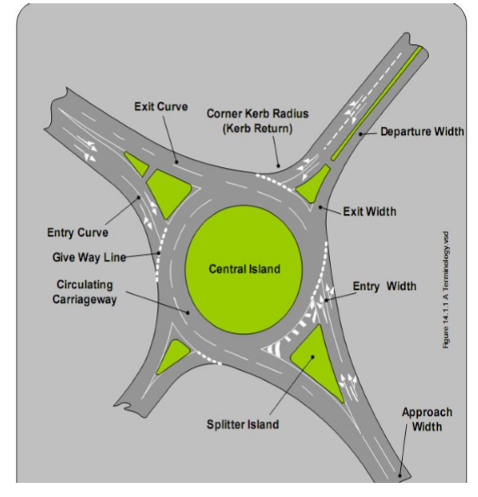Figure 2.1 Geometric elements of roundabout (AACRA Manual, 2004).
Table 2.1 Description of key roundabout features. (AACRA Manual, 2004)
Feature | Description
Approach Curve | Approach Curve is used to slow down the operating speed of vehicles  coming from a high speed environment
Entry Curve | Entry Curve is used to deflect and slow entering vehicles to an appropriate  Speed to safely circulate the roundabout.
Entry Width | Entry Width is the width of the entry where it meets the circulating carriage way.
Holding Line | Holding Line is pavement marking that defines where the vehicles have to give way to the circulating traffic. It is generally marked along the inscribed circle.
Circulating  Carriageway | Circulating Carriageway is a curved path used by vehicles to travel around the Central island. This is defined by line marking.
Circulating  Carriageway  Width | Circulating Carriageway Width defines the roadway width for vehicle circulation Around central island. The Circulating Carriageway Width has to be wide enough to accommodate the largest design vehicles turning path.
Exit Width | Exit Width is the width of the exit where it meets the circulating carriageway.
Exit Curve | Exit Curve is generally bigger/flatter than the entry curve to allow vehicles to exit at faster speed to improve traffic capacity and flow.

2.2.1 Performance Analysis of roundabout
An operational analysis produces two kinds of estimates: (1) the capacity of a facility, i.e., the ability of the facility to accommodate various streams of users, and (2) the level of performance, often measured in terms of one or more measures of effectiveness, such as degree of saturation, delay and queues. The Highway Capacity Manual (HCM) defines the capacity of a facility as “the maximum hourly rate at which persons or vehicles can reasonably be expected to traverse a point or uniform section of a lane or roadway during a given time period under prevailing roadway, traffic, and control conditions”. While capacity is a specific measure that can be defined and estimated, level of service (LOS) is a qualitative measure that characterizes operational conditions within a traffic stream and their perception by motorists and passengers. To quantify level of service, the HCM defines specific measures of effectiveness for each highway facility type (TRB, 2000). The capacity of each entry to a roundabout is the maximum rate at which vehicles can reasonably be expected to enter the roundabout from an approach during a given time period under prevailing traffic and roadway (geometric) conditions. Roundabout approach capacity is dependent on the conflicting circulating flow and the roundabout’s geometric elements (FHWA, 2000).

2.2.2 Capacity and Degree of saturation
Capacity is the maximum sustainable flow rate that can be achieved during a specified time period under given (prevailing) road, traffic and control conditions (HCM, 2010)
According to HCM 2010 capacity of roundabout is calculated as follows.
Cp= $Ae^{(-BVc)}$……………………………………………………………………….equation 2.1
Where: $A=\frac{3600}{tf}$
B= $\frac{tc-(\frac{tf}{2})}{3600}$
Cp=Capacity (pc/h)
Vc=traffic flow (pc/h)
tc=critical Gap, s
tf=follow up times, s
According to HCM 2010 degree of saturation can also be evaluated by using the following formulas
Xi=$\frac{Vi}{Ci}$………………………………………………………………………………..equation 2.2
Where:
Xi =degree of saturation.
vi =Demand flow (the recorded peak vehicle flow/hr.)
ci=Capacity.

2.2.3 Queue Length Control delay
Based on HCM 2010 Queue Length can be calculated as follows
Q₉₅₌900T$\left[\frac{Vx}{Cm,x}-1+\sqrt{{\left(\frac{Vx}{Cm.x}-1\right)}^{2}+\frac{\left(\frac{3600}{Cm,x}\right)\left(\frac{Vx}{Cm,x}\right)}{150T}}\right]\left(\frac{Cm,x}{3600}\right)$………...........................equation 2.3
Control delay can also be calculated as follows
$d=\frac{3600}{Cm,x}+900T\left[\frac{Vx}{Cm,x}-1+\sqrt{{\left(\frac{Vx}{Cm.x}-1\right)}^{2}+\frac{\left(\frac{3600}{Cm,x}\right)\left(\frac{Vx}{Cm,x}\right)}{450T}}\right]$ +5…………...............equation 2.4
Where:
d = average control delay (s/veh),
vx = flow volume of a subject lane (veh/h),
Cm,x= capacity of the subject lane (veh/h), and
T= time period (h) (T= 0.25 h for a 15 – min analysis)

2.2.4 Level of service
By using the following table the level of service of intersection approaches can be identified.
Table 2.2 level of service for roundabout (source HCM 2010)
Control  Delay (s/veh) | LOS by volume to capacity ratio
Control  Delay (s/veh) | v/c ≤1.0 | v/c > 1.0
0-10 | A | F
>10-15 | B | F
>15-25 | C | F
>25-35 | D | F
>35-50 | E | F
>50 | F | F

2.3 Signalized Intersection.
Signalized intersections are intersections where vehicle and pedestrian movements are controlled by traffic signals. A traffic signal is a signal that controls vehicle and pedestrian traffic at an intersection or in a road by means of red, yellow, green or white light displays, and includes circular and arrow signals, pedestrian signals, bicycle crossing signals, bus signals, light rail or tram signals, and overhead lane control signals. This system is controlled by an automatic device so called traffic signal controller that regulates the sequence and duration of illumination of red, yellow, green and white vehicle signal aspects and pedestrian walk and don’t walk signal aspects (Akçelik, 2017).
Reducing crashes should always be one of the objectives whenever the design or operational characteristics of a signalized intersection are modified. As described by the Federal Highway Administration (FHWA), the “mission is not simply to improve mobility and productivity, but to ensure that improved mobility and productivity comes with improved safety” In general, two types of traffic signal controller unit are in use today. They are broadly categorized as pre timed or actuated according to the type of control they provide. These two types of control are described as follows:
- Pretimed control consists of a fixed sequence of phases that are displayed in repetitive order. The duration of each phase is fixed. However, the green interval duration can be changed by time of day or week to accommodate traffic variations. The combination of a fixed phase sequence and duration produces a constant cycle length.
- Actuated control consists of a defined phase sequence in which the presentation of each phase depends on whether the phase is on recall or the associated traffic movement has submitted a call for service through a detector. The green interval duration is determined by the traffic demand information obtained from the detector, subject to preset minimum and maximum limits. The termination of an actuated phase requires a call for service from a conflicting traffic movement. An actuated phase may be skipped if no demand is detected.

2.3.1. Performance evaluation of Signalized intersections.
Capacity, degree of saturation, delay, queue length, and level of service are the main performance measures of intersections (HCM, 2010). The updated procedures described in the HCM 2010 are used to evaluate the associated automobile performance measures for signalized intersection. They are;

2.3.1.1. Capacity and volume-to-capacity ratio
Capacity is the maximum sustainable flow rate that can be achieved during a specified time period under prevailing road, traffic and control conditions. The proviso "prevailing conditions" is important since capacity is not a constant value, but varies as a function of traffic flow levels. It is often estimated based on assumed values for saturation flow, and width of lanes, grades, and lane use allocations, as well as signalization conditions.
Capacity represents the service rate (queue clearance rate) in the performance (delay, queue length, stops) functions, and therefore is relevant to under saturated conditions. Conceptually, this is different from the "maximum volume that the intersection can handle" which is the practical capacity (based on a target degree of saturation) under increased demand volumes (e.g. in the future as relevant to design life analysis), not the capacity under prevailing conditions.
Two distinct methods are possible for measuring capacities at real-life intersections:
I. Measuring departure (saturation) flow rates during saturated (queued) portions of
individual green periods at signals or gap-acceptance cycles at unsignalized intersections,
and the associated proportion of time available for queue discharge, and
II. Measuring departure flow rates (volume counts) at the stop or give-way / yield line under
continuous queuing (saturated) conditions over sufficiently long observation periods.
Under the HCM 2010 procedure, intersection capacity is measured for critical lane groups (those lane groups that have the highest volume-to-capacity ratios). Critical intersection volume-to capacity ratios are based on flow ratio for the critical phase. A critical phase is one phase of a set of phases that occur in sequence and whose combined flow ratio is the largest for the signal cycle. The volume-to-capacity (v/c) ratio, also referred to as degree of saturation, represents the sufficiency of an intersection to accommodate the vehicular demand. A v/c ratio less than 0.85 generally indicate that adequate capacity is available and vehicles are not expected to experience significant queues and delays. As the v/c ratio approaches 1.0, traffic flow may become unstable, and delay and queuing conditions may occur. Once the demand exceeds the capacity (a v/c ration greater than 1.0), traffic flow is unstable and excessive delay and queuing is expected (FWHA, 2009).

2.3.1.2 Delay
Delay is defined in the HCM 2010 as “the additional travel time experienced by a driver, passenger, bicyclist, or pedestrian beyond that is required to travel at the desired speed.” In other words, it is the difference between interrupted and uninterrupted travel times through the intersection.
The signalized intersection chapter (Chapter 18) of the HCM 2010 provides equations for calculating control delay, the delay a motorist experiences that is attributable to the presence of the traffic signal and conflicting traffic. This includes time spent decelerating, in the queue, and accelerating. Expectation of delay at a signalized intersection is different than at an unsignalized intersection. The control delay equation comprises three elements: uniform delay, incremental delay, and initial queue delay. The primary factors that affect uniform delay are lane group volume, lane group capacity, cycle length, and effective green time. Two factors that account for incremental delay are
- the effect of random and cycle-by-cycle fluctuations in demand that occasionally exceed capacity, and sustained oversaturation during the analysis period, when the aggregate demand exceeds the aggregate capacity. The third component of the control delay illustrates the delay
- Due to an initial queue, as a result of unmet demand in the previous time period.

2.3.1.3. The Back-of-queue and Queue Storage Ratio
Practitioners should evaluate vehicle queuing, an important performance measure, as part of all signalized intersections analyses. Vehicle queue estimates help determine the amount of storage required for turn lanes and whether spillover occurs at upstream facilities (driveways, unsignalized intersections, signalized intersections, etc.). Queues that extend upstream from an intersection can spill back into and block upstream intersections, causing side streets to begin to queue back. The back-of-queue is the maximum backward extent of queued vehicles during a typical cycle.
This back-of-queue length depends on the arrival pattern of vehicles and the number of vehicles that do not clear the intersection during the previous cycle. Approaches that experience extensive queues also may experience an over-representation of rear-end collisions.
Vehicle queues for design purposes are typically estimated based on the 95-percentile queue that is expected during the design period. This is the length at which 95 percent of lane queues are less than in a given study period. The queue storage ratio represents the proportion of the available queue storage distance that is occupied at the point in the cycle when the back-of-queue position is reached. If this ratio exceeds1.0, then the storage space will overflow and queued vehicles may block other vehicles from moving forward. Volume 3 of the HCM 2010 provides procedures for calculating back-of-queue length and the queue storage ratio. In addition, all known simulation models provide ways of obtaining queue estimates (FHWA, 2009).

2.3.1.4. Level of service (LOS)
Level of Service (LOS) is a grading-scale based descriptor that attempts to relate relative
operational quality (based on certain measures of effectiveness) to that of driver perception in simple fashion (FHWA, 2009). LOS can be characterized for the entire intersection, each intersection approach, and each lane group. Control delay alone is used to characterize LOS for the entire intersection or an approach. Control delay and volume-to-capacity ratio are used to characterize LOS for a lane group. Delay quantifies the increase in travel time due to traffic signal control. It is also a surrogate measure of driver discomfort and fuel consumption. The volume-to-capacity ratio quantifies the degree to which a phase's capacity is utilized by a lane group. HCM (2010) describes each LOS as follows LOS A describes operations with a control delay of 10s/veh or less and volume-to-capacity ration greater than 1.0. This level is typically assigned when volume-to-capacity is low and either progression is exponentially favorable or the cycle length is very short. If it is due to favorable progression, Most Vehicles Arrive during the green Indication and travel through the intersection without stopping.
LOS B describes operations with control delay between 10 and 20s/veh and a volume-to-capacity ratio no greater than 1.0. This level is typically assigned when volume-to-capacity is low and either progression is highly favorable or the cycle length is short. More vehicles stop
than with LOS A.
LOS C describes operations with control delay between 20 and 35s/veh and a volume-to-capacity ratio no greater than 1.0. This level is typically assigned when progression is favorable or the cycle length is moderate. Individual cycle failures may begin to appear at this level.
LOS D describes operations with control delay between 35 and 55s/veh and a volume-to-capacity ratio no greater than 1.0. This level is typically assigned when volume-to-capacity is high and either progression is ineffective or cycle length is long. Many vehicles stop and
individual cycle failures are noticeable.
LOS E describes operations with control delay between 55 and 80s/veh and a volume-to-capacity ratio no greater than 1.0. This level is typically assigned when volume-to-capacity ratio is high; progression in unfavorable and the cycle length is long. Individual cycle failures are frequent.
LOS F describes operations with control delay exceeding 80s/veh or a volume-to-capacity ratio greater than 1.0. This level is typically assigned when the volume-to-capacity is very high, progression is very poor, and the cycle length is long.

2.4. Factors which affect intersection performances.
The main factors which affect the traffic movements at intersections can be categorized as
human factors, traffic factors and features of physical elements. Human factors includes driving habits, ability to make decisions, driver expectancy, decision and reaction time, conformance to natural paths of movement, and pedestrian use and habits. The following features also affects intersection performances; Number of lanes, design speed ,gradient lane, shoulder and median width, traffic volume and composition of highway users, including trucks and transit vehicles, turning volumes, Horizontal curve radii, sight distance, proximity of adjacent intersections and Types of adjacent intersections.
All roadway users are affected by intersection design as described below: (Nurhussien, 2015).
- Pedestrians: Key elements affecting intersection performance for pedestrians are: Amount of right-of-way provided for the pedestrian including both Sidewalk and crosswalk width, accuracy of slopes and cross slopes on curb, Cut ramps and walkways, audible and/or tactile cues for people with Limited sight, and absence of obstacles in accessible path, Crossing distance and resulting duration of exposure to conflicts with motor vehicle and bicycle traffic, Volume of conflicting traffic, and Speed and visibility of approaching traffic.
- Bicyclists: Key elements affecting intersection performance for bicycles are:
Degree to which pavement is shared or used exclusively by bicycles, Relationship between turning and through movements for motor vehicle And bicycles, Traffic control for bicycles, Differential in speed between motor vehicle and bicycle traffic and Visibility of the bicyclist.
- Motor vehicles: Key elements affecting intersection performance for motor Vehicles are: Type Of traffic control, Vehicular capacity of the intersection, determined primarily from the Number of lanes and traffic control (although there are other factors), Ability to make turning movements, Visibility of approaching and crossing pedestrians and bicycles, and Speed, visibility of approaching and crossing motor vehicles.
- Transit: When transit Operations Involve buses, They Share the Same key characteristics as vehicles. In addition, transit operations may involve a transit stop at an intersection area, and influence pedestrian, bicycle, and motor vehicle flow and safety. In some cases, the unique characteristics of light-rail transit must be taken into account.

2.4.1. The Effect of Vehicle Types on Intersection Performance
Different Classes of vehicles such as cars, vans, Buses, trucks, auto rickshaw, motor cycles, by-cycles, etc. are found to use the common roadway facilities without segregation on most of the roads in developing countries .The flow of traffic with unrestricted mixing of different vehicle classes on the roadways forms the heterogeneous traffic flow or the mixed traffic flow. The different vehicle classes have a wide range of static characteristics such as length, width etc. and the dynamic characteristics such as speed and acceleration. As a result of this the performances of intersections can be affected highly at heterogeneous traffic condition than homogeneous traffic conditions (Saha.K, 2013).
A study made by Rao (2015) in India indicated that different vehicle categories have different effects on the traffic flow around the intersection. Mallikarjuna (2014) also showed that heavy vehicles and light vehicles have different kind of effects on performance parameters of intersections.
Heavy trucks influence their surrounding traffic characteristics. The space gaps between heavy trucks and their front/ rear vehicles are larger than the corresponding values in light trucks and passenger cars. The large space gaps in vicinity of Heavy trucks and the limitations in adjusting their speed according to surrounding vehicles’ speed produce a disproportionate effect on traffic flows and this affects road performances (Moridpour.S, 2014).

2.4.1.1. The Effect of Three wheelers on Intersection Performances
There is not a much research conducted regarding this topic but Syoum (2018) took the research regarding the effects of vehicle compositions including three wheelers on performance measurement parameters of three unsignalized intersections in Harar city. The analysis was made in 15 minute interval over a range of 24 consecutive time series to indicate the trends of change of the performance of intersections in relation to the change of vehicle compositions and flow characteristics. Multiple regression was the analysis method applied to indicate the effects of vehicle classes in the study. According to the results of his study, the presences of three wheelers were significantly affecting the performances of unsignalized intersection highly in Harar City.

2.5. SIDRA Intersection Software

2.5.1. General Introduction about the SIDRA Intersection
The SIDRA Intersection software acronymed for Signalized & Unsignalized Intersection Design and Research Aid is for apply as an serve for design and evaluation of individual intersections and networks of intersections. It can be used to analyze signalized intersections (fixed-time / pretimed and actuated), signalized and unsignalized pedestrian crossings, roundabouts (unsignalized), roundabouts with metering signals, fully signalized roundabouts, two-way stop sign and give-way / yield sign control, all-way stop sign control, single point interchanges (signalized), freeway diamond interchanges (signalized, roundabout, sign control), diverging diamond interchanges. It can also be used for uninterrupted traffic flow conditions and merge analysis. SIDRA Intersection allows modeling of separate Movement Classes (Light Vehicles, Heavy Vehicles, Buses, Bicycles, Large Trucks, Light Rail / Trams and two User Classes) with different vehicle characteristics. These movements can be allocated to different lanes, lane segments and signal phases, for example for modeling bus priority lanes at signals. Signal timing calculations for single intersections and network timings including signal offsets for signal coordination are carried out. A unique method is used to determine signal timings for a number of intersections operating under a single signal controller (common control groups). SIDRA Intersection is an advanced micro-analytical traffic evaluation tool that employs lane-by lane and vehicle path (drive-cycle) models coupled with an iterative approximation method to provide estimates of capacity and performance statistics (delay, queue length, stop rate, etc). All input and output data and modeling are based on Origin-Destination movements. This improves handling of movements at intersections with diagonal legs and U turns. The SIDRA Network model determines the backward spread of congestion as queues on downstream lanes block upstream lanes (queue spillback), and applies capacity constraint to oversaturated upstream lanes, thus limiting the flows entering downstream lanes. These two elements are highly interactive with opposing effects. A network-wide iterative process is used to find a solution that balances these opposing effects. Unlike traditional network models that use aggregate models of "links" or "lane groups", SIDRA Intersection uses a lane-based model to create second-by-second platoon arrival and departure patterns for signalized Sites (at-grade intersections, interchanges, pedestrian crossings) to calculate signal coordination effects as a function of signal offsets for internal approaches in network analysis.
The model takes into account midblock lane changes that apply to signal platoon patterns. This is particularly important in evaluating closely spaced (paired) intersections with high demand flows where vehicles have limited opportunities for lane changes between intersections. These lane-based modeling requirements are important in emulating the forward movements of platoons for estimating performance measures (delay, back of queue, stop rate) at an individual lane level. SIDRA Intersection provides various facilities for calibration of its traffic models for local conditions. The US HCM software setups (Customary and Metric units) of SIDRA INTERSECTION are based on the calibration of model parameters against the Highway Capacity Manual. In the USA, SIDRA intersection is recognized by the US Highway Capacity Manual, TRB Roundabout Guide (NCHRP Report 672) and various local roundabout guides. SIDRA Intersection is the most widely used software tool in the USA for roundabout capacity and performance analysis. In Australia and New Zealand, SIDRA Intersection is endorsed by AUSTROADS and various local guidelines (the Association of Australian State, Territory and Federal Road and Transport Authorities). Since its first release in 1984, the use of SIDRA Intersection has grown steadily over the years to make it a best-selling software package. In February 2017, the latest versions of the software were in use by about 1930 organizations with about 8200 licenses in 84 countries. The countries where SIDRA Intersection was used most extensively were (with the approximate number of organizations shown) USA (650), Australia (440), Europe (190), New Zealand (70), South Africa (120), Canada (100), Malaysia & Singapore (110), Arabian Peninsula (90) and Latin America (60).

2.5.2. Calibration of SIDRA Intersection Software
Since the Sidra Intersection was developed for Australian conditions as default, it requires calibration for other countries. Calibration of the Sidra Intersection is performed by changing values of the parameters affecting capacity. This can be done in a few different ways, either by changing the value of the critical gap and the follow-up headway directly or by using the calibration parameters; environment factor and entry/circulating flow adjustment. The environment factor can be seen as a collection factor that includes everything at the Junction environment e.g. design type, visibility, grade, speed, driver response time and aggressiveness, amount of heavy vehicles and pedestrians and parking near the Junction. On the one hand, factors in the environment with positive effects on traffic are for example; good visibility, small volumes of pedestrians, short driver response times, and low levels of heavy vehicles and parking on the approaches. In cases like that, environment factor should be lower which leads to higher capacity. On the other hand, situations such as bad visibility, large volumes of pedestrians, long driver response times and large volumes of heavy vehicles have negative effects on capacity. Environment factor should therefore be higher which will lead to lower capacity. The default environment factor is set to 1, which is also the same in Australia. According to Myre (2010) studies in Norway have shown that 1.1 is a good value of environment factor for Norwegian conditions. Similarly, the Anna-Karin Ekman studies in Sweden have shown that 1.1 is also a good value of environmental factor for Swedish condition and he also suggested that the range of interesting values should be within 1.0 ± 0.2. The HCM version of the SIDRA Intersection model uses 1.2 as environment factor.

3. MATERIALS AND METHODS

3.1. Introduction
The methodology employed in the research work was the critical aspect for ensuring the proper result, which aligns with the objective. Hence, this part of the Thesis discusses the methodology applied to address the research problem and software programs that are available to analyze traffic operations at the roundabouts and signalized intersections.
3.2. Description of Study Area
Hosanna is found in southern Nation, Nationalities and peoples Region in Hadiya Zone, locally known as Wachemo, is located at 232km south from the capital Addis Ababa, 168kms away from Hawassa, and 89kms away from Butajira. It is the City of Hadiya zone. Hosanna town lies on an elevation ranges from 2130m-2417meters above mean sea level across the main high way leading from Addis Ababa via Butajira to Wolayita Sodo. It is found 7°30’30’’N-7°35’30’’N Latitude and 37°48’30’’E-37°54’30’’E longitude. It is surrounded by Lemo wereda, one of the weredas of Hadiya zone. The town has a total area of 37.13square kilometers. It serves as a major business center for inhabitants in the area. Hosanna is the administrative center of the Hadiya zone, with a population of 133,764. Out of which 65,132 are males and 68,632 are females (Hosanna Municipality, 2019).
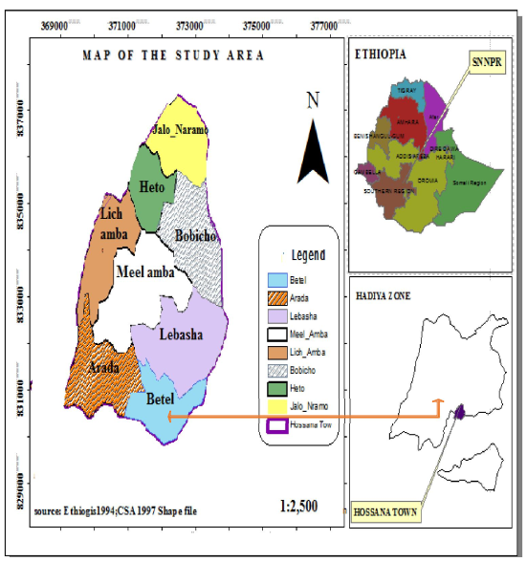
Figure 3.1 The study area, Hosanna City (Source: Ethiogis;CSA 1997 Shape file).

3.2.1 Road network
The road is a very important infrastructure and used as an indicator of the level of development of a particular country. A road network is the geographical expression of roads with line features. Hosanna Town has a network of 431.45kms of roads. Out of which 13.97kms were asphalt roads, 76.03kms were gravel roads, 53.57kms were cobblestone roads, and 287.88kms were earth roads (Hosanna Municipality, 2019). There are two signalized intersections and two main roundabouts currently in use in Hosanna City. This thesis was done on those two signalized intersections and two roundabouts in Hosanna City; those were areas where traffic congestions were frequently observed during peak hours. The names of intersections are Menharya signalized intersection and Mariyam signalized intersection. Roundabouts are also named as Bezabh Petros roundabout and Eyerusalem roundabout. Among the signalized intersections, both are four-legged, and Bezabh Petros roundabout has five approaches, and Eyerusalem roundabout has four approaches of different geometry with one another.

3.2.2 Traffic nature
The traffic movements in Hosanna are characterized by a lot of small vehicles like three wheelers, small taxis, passenger cars, buses and trucks. As shown below in table, the high recorded numbers of three wheelers exist in the city. So the transportation mode is highly occupied with three-wheelers.
Table 3.1 Types and number of vehicles recorded in Hosanna City. (Source: Transportation office of Hosanna City)
Types of vehicles | Number of vehicles
Three-wheelers | 1358
Passenger Car | 300
Public buses | 595
Medium trucks | 300
Large trucks | 69

3.3 Study Period
The research was started at October 20, 2019 by site observation and identification of the problems. The geometric data was recorded from the road intersections, for a week from February 23 up to February 28, 2020 and the traffic data was conducted from March 5- March 9, 2020. Since the survey time this study was conducted up to October, 2020 by referring related materials and by analyzing the results of collected data.

3.4 Research Design
The research designs that are used by the researcher are quantitative and descriptive type of research. Quantitative data were used to determine all parameters which are related to performance characteristics of intersections like capacity, level of service, delay, queue length and degree of saturation. Descriptive type of research is chosen by the researcher to assess the performance evaluation of intersections. After the performances of the intersections were analyzed, the change of the parameters over the time period and the variables which has a significant effect on the change was analyzed.

3.5 Software and Instruments
The FHWA Guideline lists available computer Software programs that analyze traffic operations at roundabouts and signalized intersections. The Software can be divided into two types: macroscopic and microscopic models. The Macroscopic Models use traffic volume flows to model intersections as isolated locations. On the other hand, the Microscopic Models simulate individual vehicles' movement, thereby allowing a network-wide analysis. One of the macroscopic models (SIDRA intersection 5.1) software program was applied to analyze traffic operations at roundabouts and signalized intersections for this study. In fact, AACRA also recommends Sidra Intersection software for capacity analysis, which is developed using analytic methods with some geometric elements. The SIDRA Intersection 5.1 software is preferred for capacity analysis in this research due to the following reasons:
- It is a commercially available tool to offer full geometric and gap acceptance modeling capability within a single product;
- It has employed a combined (hybrid) geometry and gap-acceptance modeling approach in order to take into account the effect of roundabout geometry on driver behavior directly through gap-acceptance modeling; and
- It can be calibrated for local conditions, and it is highly flexible
Excel software was also used for the purpose of comparison of performance measurement parameters and Measuring tape was also used to measure geometric features. Detail explanation is found in analysis section.

3.6 Data Collection Process.

3.6.1 Traffic Volume Data
The traffic count surveys were carried out at all selected junctions for six hours; in the morning 7:00 am-10:00 am and in the afternoon 3:00 pm-6:00 pm at 15-minute intervals from March 5- March 9, 2020 by setting up video cameras. The peak hour was determined by finding the four consecutive 15-minute periods with the highest total volume. The highest traffic volume in each direction was recorded for use in the analysis of this research. Traffic volumes can vary greatly throughout the day, by day of the week, by the time of year, and even at 5-minute intervals during the peak hour. Traffic volumes can also experience additional fluctuations due to accidents, special incidents, or weather and will also change over time, depending on the City's growth dynamism. However, normally, traffic surveys are performed using the average weekday peak hour traffic counts. On normal commuter routes, there are morning and afternoon peak hours. The high pedestrian volume also has a significant effect on capacity. Because of this, numbers of pedestrians were recorded at peak hours along the direction of their movements. The number of counted vehicles and pedestrians are shown in the tables below.

3.6.1.1 Video with Manual Transcription Method
Video recording and manual transcription were used to collect traffic and pedestrian flow data. This data collection method relies on video cameras to collect or capture the traffic and pedestrian flows in the field and data recorders in others. According to the travel time collection handbook, though costly, video capturing techniques are preferred to the manual collection. This was because of the following reasons:
- It provides a permanent, easily-review record and shows traffic conditions at any time;
- It permits reading of required parameters in a controlled environment in which plate characters can be closely examined
- It provides additional information about traffic flow characteristics such as traffic volume and vehicle headways; and
- It provides time for accurate determination of arrival times and has better accuracy than manual counts.
Therefore, in order to utilize the above advantages and due to its convenience, the video camera was arranged at a convenient height where the maximum view could be captured, and visibility was also maximized. The locations of video capturing were on floors of high rising buildings in the area of the study locations.

3.6.1.2 Passenger Car Unit (PCU)
To conduct traffic volume, it is necessary to have a single unit counting the number of vehicles because different vehicles in a traffic stream have different effects. So, all vehicles which use the condor must be converted to a common unit called passenger car unit. In this research PCU were acquired from the High way Capacity Manual 2010 are depicted in the table shown below.
Table 3. 2. Passenger car units for vehicles
vehicle type | Passenger Car Equivalent (PCE)
Heavy vehicles | 2.0
Passenger Car | 1.0
*Three wheelers | 0.4
*Motor cycle | 0.25
*The PCU values of three wheelers and Motor cycle was taken from ERA Manual 2013.

3.6.2 Geometric Data
As per the requirement of the SIDRA Intersection Version 5.1, the collected geometric data include; island diameter, circulatory width, number of circulatory lanes, entry lane number and average lane width at the entry for roundabout junction; and number of lanes, lane width, grade, the width of the median for the signalized junction. These data were measured with a tape meter, and the collected geometric data are summarized as shown below.
Table 3.3 Existing roundabouts geometry data.
S.N. | Junction Name | Approach Leg | Entry Lane | Number of Circulatory Lane | Island Diameter (m) | Average lane width | Circulatory Road width (m)
1 | Bezabh Petros roundabout | Mesalemya | 2 | 2 | 24 | 3.3 | 10
1 | Bezabh Petros roundabout | Menharya | 2 | 2 | 25.4 | 3.3 | 10
1 | Bezabh Petros roundabout | Hadiyya pharmacy | 1 | 1 | 19 | 3.1 | 10
1 | Bezabh Petros roundabout | Mobile | 2 | 2 | 18 | 3.3 | 10
1 | Bezabh Petros roundabout | Maremya | 1 | 1 | 24 | 3.1 | 10
2 | Eyerusalem round about | Gombera | 2 | 2 | 19 | 3.3 | 9
2 | Eyerusalem round about | Mesalemiya | 2 | 2 | 19 | 3.1 | 9
2 | Eyerusalem round about | Inatkalehiwet | 1 | 1 | 16 | 3.2 | 9
2 | Eyerusalem round about | Maryam | 2 | 2 | 15 | 3.3 | 9

Table 3.4 Signalized intersections geometric data
S.N. | Junction Name | Approach name | No. of Entry Lane | No. of Exit Lane | Lane width(m) | Median width(m)
1 | Menharya signalized intersection | Hospital | 1 | 1 | 3.5 | No median
1 | Menharya signalized intersection | Lucy | 1 | 1 | 3.5 | No median
1 | Menharya signalized intersection | 18 Mazorya | 2 | 2 | 3.3 | 0.9
1 | Menharya signalized intersection | Handa Mall | 2 | 2 | 3.1 | 0.9
2 | Maryam signalized intersection | Eyerusalem | 1 | 1 | 3.5 | No median
2 | Maryam signalized intersection | Stadium | 1 | 1 | 3.5 | No median
2 | Maryam signalized intersection | Mobile | 2 | 2 | 3.3 | 0.9
2 | Maryam signalized intersection | Ambicho | 2 | 2 | 3.1 | 0.9

3.7 Data Processing and analysis
3.7.1 Evaluation of Performance Measurement parameters of signalized intersections
and roundabouts.
There are two intersection analysis models which are Empirical models and Analytical p[models. The concern of Empirical models is on field data to build relationships between geometric design features and performance measures. As a substitute Analytical models are based on the concept of gap acceptance theory. The choice of an analysis approach depends on the calibration data available (HCM, 2010). The researcher used analytical model for this specific research intersection analysis. This is done through the use of SIDRA INTERSECTION version 5.1 software incorporated with Highway Capacity Manual (HCM 2010) which is the most widely adopted method for analysis of intersections. The HCM defines intersection performance in terms of average vehicle delay (seconds per vehicle) and then maps this delay against predefined boundaries to define intersection performance in terms of six levels of service (i.e. LOS A through LOS F).
To evaluate the performance of the signalized intersections and roundabouts, the traffic data was converted to Passenger Car Equivalents shown in the tables below.

Table 3.5 Peak hour traffic volumes (PCU) of signalized intersections.
Intersection | Approach | Direction | Traffic volume  (PCU) | Traffic volume  Of  Three Wheeler  (PCU) | %Three Wheeler | Traffic volume  Of  Heavy vehicles  (PCU) | %Heavy vehicles
Menharya signalized intersection | Hospital | Left | 125 | 110 | 88 | 8 | 6
Menharya signalized intersection | Hospital | Through | 40 | 33 | 83 | 3 | 8
Menharya signalized intersection | Hospital | Right | 160 | 145 | 91 | 10 | 6
Menharya signalized intersection | Hospital | Total | 325 | 288 | 89 | 21 | 6
Menharya signalized intersection | Lucy | Left | 45 | 37 | 82 | 4 | 9
Menharya signalized intersection | Lucy | Through | 20 | 16 | 80 | 0 | 0
Menharya signalized intersection | Lucy | Right | 60 | 50 | 83 | 6 | 10
Menharya signalized intersection | Lucy | Total | 125 | 103 | 82 | 10 | 8
Menharya signalized intersection | 18 Mazorya | Left | 10 | 7 | 70 | 0 | 0
Menharya signalized intersection | 18 Mazorya | Through | 470 | 441 | 94 | 23 | 5
Menharya signalized intersection | 18 Mazorya | Right | 10 | 6 | 60 | 1 | 10
Menharya signalized intersection | 18 Mazorya | Total | 490 | 454 | 93 | 24 | 5
Menharya signalized intersection | Handa Mall | Left | 35 | 27 | 77 | 0 | 0
Menharya signalized intersection | Handa Mall | Through | 574 | 523 | 91 | 34 | 6
Menharya signalized intersection | Handa Mall | Right | 18 | 17 | 94 | 0 | 0
Menharya signalized intersection | Handa Mall | Total | 627 | 567 | 90 | 34 | 5
Maryam signalized intersection | Eyerusalem | Left | 58 | 43 | 74 | 9 | 16
Maryam signalized intersection | Eyerusalem | Through | 21 | 17 | 81 | 3 | 14
Maryam signalized intersection | Eyerusalem | Right | 33 | 24 | 73 | 5 | 15
Maryam signalized intersection | Eyerusalem | Total | 112 | 84 | 75 | 17 | 15
Maryam signalized intersection | Stadium | Left | 58 | 44 | 76 | 6 | 10
Maryam signalized intersection | Stadium | Through | 21 | 16 | 76 | 1 | 5
Maryam signalized intersection | Stadium | Right | 33 | 24 | 73 | 1 | 3
Maryam signalized intersection | Stadium | Total | 112 | 84 | 75 | 8 | 7
Maryam signalized intersection | Mobile | Left | 6 | 3 | 50 | 0 | 0
Maryam signalized intersection | Mobile | Through | 343 | 310 | 90 | 21 | 6
Maryam signalized intersection | Mobile | Right | 21 | 13 | 62 | 2 | 10
Maryam signalized intersection | Mobile | Total | 370 | 326 | 88 | 23 | 6
Maryam signalized intersection | Ambicho | Left | 32 | 27 | 84 | 0 | 0
Maryam signalized intersection | Ambicho | Through | 543 | 503 | 93 | 31 | 6
Maryam signalized intersection | Ambicho | Right | 15 | 14 | 93 | 0 | 0
Maryam signalized intersection | Ambicho | Total | 590 | 544 | 92 | 31 | 5
Table 3.6 Peak hour traffic volumes (PCU) of roundabouts.
 | Intersection | Approach | Direction | Traffic volume  (PCU) | Traffic volume  Of  Three Wheeler  (PCU) | %Three Wheeler | Traffic volume  Of  Heavy vehicles  (PCU) | %Heavy vehicles
Bezabh Petros roundabout |  | Mesalemya | Left | 211 | 90 | 43 | 41 | 19
 |  | Mesalemya | Through | 456 | 220 | 48 | 96 | 21
 |  | Mesalemya | Right | 63 | 33 | 52 | 8 | 13
 |  | Mesalemya | U-turn | 13 | 10 | 77 | 0 | 0
 |  | Mesalemya | Total | 743 | 443 | 60 | 145 | 20
 |  | Menharya | Left | 15 | 12 | 80 | 0 | 0
 |  | Menharya | Through | 529 | 318 | 60 | 132 | 25
 |  | Menharya | Right | 450 | 225 | 50 | 68 | 15
 |  | Menharya | U-turn | 25 | 13 | 52 | 0 | 0
 |  | Menharya | Total | 1019 | 568 | 56 | 200 | 20
 |  | Hadiyya pharmacy | Left | 43 | 12 | 28 | 9 | 21
 |  | Hadiyya pharmacy | Through | 21 | 10 | 48 | 2 | 10
 |  | Hadiyya pharmacy | Right | 6 | 4 | 67 | 0 | 0
 |  | Hadiyya pharmacy | U-turn | 2 | 2 | 100 | 0 | 0
 |  | Hadiyya pharmacy | Total | 72 | 28 | 39 | 11 | 15
 |  | Mobile | Left | 466 | 155 | 33 | 98 | 21
 |  | Mobile | Through | 32 | 19 | 59 | 2 | 6
 |  | Mobile | Right | 312 | 184 | 59 | 37 | 12
 |  | Mobile | U-turn | 3 | 3 | 100 | 0 | 0
 |  | Mobile | Total | 813 | 361 | 44 | 137 | 17
 |  | Maremya | Left | 23 | 20 | 87 | 0 | 0
 |  | Maremya | Through | 4 | 4 | 100 | 0 | 0
 |  | Maremya | Right | 21 | 11 | 52 | 0 | 0
 |  | Maremya | U-turn | 1 | 1 | 100 | 0 | 0
 |  | Maremya | Total | 49 | 36 | 73 | 0 | 0
Eyerusalem roundabout |  | Gombera | Left | 45 | 20 | 44 | 5 | 11
 |  | Gombera | Through | 621 | 311 | 50 | 168 | 27
 |  | Gombera | Right | 47 | 25 | 53 | 2 | 4
 |  | Gombera | Total | 713 | 356 | 50 | 175 | 25
 |  | Mesalemiya | Left | 24 | 14 | 58 | 1 | 4
 |  | Mesalemiya | Through | 594 | 346 | 58 | 101 | 17
 |  | Mesalemiya | Right | 63 | 28 | 44 | 11 | 17
 |  | Mesalemiya | Total | 681 | 388 | 57 | 113 | 17
 |  | Inat kalehiwet | Left | 52 | 29 | 56 | 5 | 10
 |  | Inat kalehiwet | Through | 41 | 23 | 56 | 1 | 2
 |  | Inat kalehiwet | Right | 68 | 27 | 40 | 5 | 7
 |  | Inat kalehiwet | Total | 161 | 79 | 49 | 11 | 7
 |  | Maryam | Left | 103 | 64 | 62 | 13 | 13
 |  | Maryam | Through | 11 | 6 | 55 | 1 | 9
 |  | Maryam | Right | 76 | 44 | 58 | 14 | 18
 |  | Maryam | Total | 190 | 114 | 60 | 28 | 15
Table 3. 7 Pedestrians volume of intersections at peak hour.
S.N | Junction Name | Approaches | Number of Pedestrians
1 | Menharya signalized intersection | Hospital | 396
1 | Menharya signalized intersection | Lucy | 435
1 | Menharya signalized intersection | 18 Mazorya | 501
1 | Menharya signalized intersection | Handa Mall | 523
1 | Menharya signalized intersection | Total | 1855
2 | Maryam signalized intersection | Eyerusalem | 365
2 | Maryam signalized intersection | Stadium | 421
2 | Maryam signalized intersection | Mobile | 396
2 | Maryam signalized intersection | Ambicho | 323
2 | Maryam signalized intersection | Total | 1505
3 | Bezabh petros roundabout | Mesalemya | 365
3 | Bezabh petros roundabout | Menharya | 345
3 | Bezabh petros roundabout | Hadiyya pharmacy | 402
3 | Bezabh petros roundabout | Mobile | 293
3 | Bezabh petros roundabout | Maremya | 323
3 | Bezabh petros roundabout | Total | 1728
4 | Eyerusalem roundabout | Gombera | 311
4 | Eyerusalem roundabout | Mesalemiya | 274
4 | Eyerusalem roundabout | Inat kalehiwet | 306
4 | Eyerusalem roundabout | Maryam | 265
4 | Eyerusalem roundabout | Total | 1156

Table 3.8 Default values used in this thesis
Parameters | Default Values
Basic Saturation Flow | 1800 veh/hr
Follow up headway | 2.6 sec
Critical Gap | 4.5 sec
Lane utilization | 100%

According to (Roper 1999, Akçelik and Besley 2002, TRB 2000), Two different basic saturation flows for two environment classes (area types) representing two different sets of road and traffic conditions. The definitions of the two environment classes (Ideal and Average to Poor) are based on past and recent research on queue discharge characteristics at signalized intersections. The Average to poor conditions indicated by adequate to poor intersection geometry, usually closely spaced intersection environment, possibly poor visibility, moderate to large numbers of pedestrians and interference from standing vehicles. In this case basic saturation flow of 1800 veh/h was recommended. Since all this are physical characteristics of intersections in Hosanna city 1800veh/h was taken as basic saturation flow.
The HCM, 2010 recommended to use critical gap between 4.1 and 4.6 and follow up time from 2.6 to 3.1. So because of this and from the literatures done in the same conditions as of Hosanna City, the critical value of 4.5 and follow up time of 2.6 used as default value in this condition.

3.7.2 Analysis of the effects of three wheelers on performance measurement

parameters of intersections.
The effects of three wheelers on performance measurements parameters of intersections were evaluated by analyzing each intersection performances again excluding three wheelers by using SIDRA INTERSECTION as explained above and the performance measurement parameters of intersections after excluding three wheelers and the former are not the same. So by comparing the performance parameters, with and without three wheelers, the differences were clearly shown. Since other input parameters were the same as used to evaluate the first objective, the differences were considered as effects of three wheelers on performance measurement parameters of intersections.

Table 3. 9. Traffic volume (PCU) data of signalized intersections without three wheelers.
Intersection | Approach | Direction | Traffic volume  (PCU) | Traffic volume  O f  Heavy vehicles  (PCU) | %Heavy vehicle
Menharya signalized intersection | Hospital | Left | 15 | 8 | 53
Menharya signalized intersection | Hospital | Through | 7 | 3 | 43
Menharya signalized intersection | Hospital | Right | 15 | 10 | 67
Menharya signalized intersection | Hospital | Total | 37 | 21 | 57
Menharya signalized intersection | Lucy | Left | 8 | 4 | 50
Menharya signalized intersection | Lucy | Through | 4 | 0 | 0
Menharya signalized intersection | Lucy | Right | 10 | 6 | 60
Menharya signalized intersection | Lucy | Total | 22 | 10 | 45
Menharya signalized intersection | 18 Mazorya | Left | 3 | 0 | 0
Menharya signalized intersection | 18 Mazorya | Through | 29 | 23 | 79
Menharya signalized intersection | 18 Mazorya | Right | 4 | 1 | 25
Menharya signalized intersection | 18 Mazorya | Total | 36 | 24 | 67
Menharya signalized intersection | Handa Mall | Left | 8 | 0 | 0
Menharya signalized intersection | Handa Mall | Through | 51 | 34 | 67
Menharya signalized intersection | Handa Mall | Right | 1 | 0 | 0
Menharya signalized intersection | Handa Mall | Total | 60 | 34 | 57
Maryam signalized intersection | Eyerusalem | Left | 15 | 9 | 60
Maryam signalized intersection | Eyerusalem | Through | 4 | 3 | 75
Maryam signalized intersection | Eyerusalem | Right | 9 | 5 | 56
Maryam signalized intersection | Eyerusalem | Total | 28 | 17 | 61
Maryam signalized intersection | Stadium | Left | 14 | 6 | 43
Maryam signalized intersection | Stadium | Through | 5 | 1 | 20
Maryam signalized intersection | Stadium | Right | 9 | 1 | 11
Maryam signalized intersection | Stadium | Total | 28 | 8 | 29
Maryam signalized intersection | Mobile | Left | 3 | 0 | 0
Maryam signalized intersection | Mobile | Through | 33 | 21 | 64
Maryam signalized intersection | Mobile | Right | 8 | 2 | 25
Maryam signalized intersection | Mobile | Total | 44 | 23 | 52
Maryam signalized intersection | Ambicho | Left | 5 | 0 | 0
Maryam signalized intersection | Ambicho | Through | 40 | 31 | 78
Maryam signalized intersection | Ambicho | Right | 1 | 0 | 0
Maryam signalized intersection | Ambicho | Total | 46 | 31 | 67

Table 3. 10. Traffic volume (PCU) data of roundabout without three wheelers.
Roundabout | Approach | Direction | Traffic volume  (PCU) | Traffic volume  O f  Heavy vehicles  (PCU) | %Heavy vehicle
Bezabh  petros roundabout | Mesalemya | Left | 121 | 41 | 34
Bezabh  petros roundabout | Mesalemya | Through | 236 | 96 | 41
Bezabh  petros roundabout | Mesalemya | Right | 30 | 8 | 27
Bezabh  petros roundabout | Mesalemya | U turn | 3 | 0 | 0
Bezabh  petros roundabout | Mesalemya | Total | 390 | 145 | 37
Bezabh  petros roundabout | Menharya | Left | 3 | 0 | 0
Bezabh  petros roundabout | Menharya | Through | 211 | 132 | 63
Bezabh  petros roundabout | Menharya | Right | 225 | 68 | 30
Bezabh  petros roundabout | Menharya | U turn | 12 | 0 | 0
Bezabh  petros roundabout | Menharya | Total | 451 | 200 | 44
Bezabh  petros roundabout | Hadiyya pharmacy | Left | 31 | 9 | 29
Bezabh  petros roundabout | Hadiyya pharmacy | Through | 11 | 2 | 18
Bezabh  petros roundabout | Hadiyya pharmacy | Right | 2 | 0 | 0
Bezabh  petros roundabout | Hadiyya pharmacy | U turn | 0 | 0 | 0
Bezabh  petros roundabout | Hadiyya pharmacy | Total | 44 | 11 | 25
Bezabh  petros roundabout | Mobile | Left | 311 | 98 | 32
Bezabh  petros roundabout | Mobile | Through | 13 | 2 | 15
Bezabh  petros roundabout | Mobile | Right | 128 | 37 | 29
Bezabh  petros roundabout | Mobile | U turn | 0 | 0 | 0
Bezabh  petros roundabout | Mobile | Total | 452 | 137 | 30
Bezabh  petros roundabout | Maremya | Left | 3 | 0 | 0
Bezabh  petros roundabout | Maremya | Through | 0 | 0 | 0
Bezabh  petros roundabout | Maremya | Right | 10 | 0 | 0
Bezabh  petros roundabout | Maremya | U turn | 0 | 0 | 0
Bezabh  petros roundabout | Maremya | Total | 13 | 0 | 0
Eyerusalem roundabout | Gombera | Left | 25 | 5 | 20
Eyerusalem roundabout | Gombera | Through | 310 | 168 | 54
Eyerusalem roundabout | Gombera | Right | 22 | 2 | 9
Eyerusalem roundabout | Gombera | Total | 357 | 175 | 49
Eyerusalem roundabout | Mesalemiya | Left | 10 | 1 | 10
Eyerusalem roundabout | Mesalemiya | Through | 248 | 101 | 41
Eyerusalem roundabout | Mesalemiya | Right | 35 | 11 | 31
Eyerusalem roundabout | Mesalemiya | Total | 293 | 113 | 39
Eyerusalem roundabout | Inatkalehiwet | Left | 23 | 5 | 22
Eyerusalem roundabout | Inatkalehiwet | Through | 18 | 1 | 6
Eyerusalem roundabout | Inatkalehiwet | Right | 41 | 5 | 12
Eyerusalem roundabout | Inatkalehiwet | Total | 82 | 11 | 13
Eyerusalem roundabout | Maryam | Left | 39 | 13 | 33
Eyerusalem roundabout | Maryam | Through | 5 | 1 | 20
Eyerusalem roundabout | Maryam | Right | 32 | 14 | 44
Eyerusalem roundabout | Maryam | Total | 76 | 28 | 37

3.7.3 Comparison of the performance change of intersections by replacing three wheelers

with mini bus.
From passenger carrying capacity point of view, one 12 seat minibus taxi can accommodate a passengers accommodated by four Three wheelers. This will definitely improve the performance of the traffic streams in many aspects. In this section the researcher tried to indicate the performance improvement that will be gained by replacing the Three wheelers vehicles with 12 seat taxis from the traffic engineering point of view. Cost benefit analysis between the two transport modes is out of the scope of this study.
The comparison was made for the peak hour traffic volumes of intersections under the following assumptions;
- All Three wheelers vehicles will be replaced by minibus taxis at the ratio of 1:4. When three wheelers are removed, traffic will be improved. These will improve the performance measurement parameters of intersections.
- The analysis is made with assumptions that the geometric conditions, the pedestrian characteristics and the roadway conditions will not be changed due to the replacement of three wheelers with minibus taxis.

Table 3. 11 Traffic volume (PCU) data of signalized intersections when three wheelers
replaced by mini bus
Intersection | Approach | Direction | Traffic volume  (PCU) | Traffic volume  O f  Heavy vehicles  (PCU) | %Heavy vehicle
Menharya signalized intersection | Hospital | Left | 84 | 8 | 10
Menharya signalized intersection | Hospital | Through | 28 | 3 | 11
Menharya signalized intersection | Hospital | Right | 106 | 10 | 9
Menharya signalized intersection | Hospital | Total | 217 | 21 | 10
Menharya signalized intersection | Lucy | Left | 31 | 4 | 13
Menharya signalized intersection | Lucy | Through | 14 | 0 | 0
Menharya signalized intersection | Lucy | Right | 41 | 6 | 15
Menharya signalized intersection | Lucy | Total | 86 | 10 | 12
Menharya signalized intersection | 18 Mazorya | Left | 7 | 0 | 0
Menharya signalized intersection | 18 Mazorya | Through | 305 | 23 | 8
Menharya signalized intersection | 18 Mazorya | Right | 8 | 1 | 13
Menharya signalized intersection | 18 Mazorya | Total | 320 | 24 | 8
Menharya signalized intersection | Handa Mall | Left | 25 | 0 | 0
Menharya signalized intersection | Handa Mall | Through | 378 | 34 | 9
Menharya signalized intersection | Handa Mall | Right | 12 | 0 | 0
Menharya signalized intersection | Handa Mall | Total | 414 | 34 | 8
Maryam signalized intersection | Eyerusalem | Left | 42 | 9 | 21
Maryam signalized intersection | Eyerusalem | Through | 15 | 3 | 21
Maryam signalized intersection | Eyerusalem | Right | 24 | 5 | 21
Maryam signalized intersection | Eyerusalem | Total | 81 | 17 | 21
Maryam signalized intersection | Stadium | Left | 42 | 6 | 14
Maryam signalized intersection | Stadium | Through | 15 | 1 | 7
Maryam signalized intersection | Stadium | Right | 24 | 1 | 4
Maryam signalized intersection | Stadium | Total | 81 | 8 | 10
Maryam signalized intersection | Mobile | Left | 5 | 0 | 0
Maryam signalized intersection | Mobile | Through | 227 | 21 | 9
Maryam signalized intersection | Mobile | Right | 16 | 2 | 12
Maryam signalized intersection | Mobile | Total | 248 | 23 | 9
Maryam signalized intersection | Ambicho | Left | 22 | 0 | 0
Maryam signalized intersection | Ambicho | Through | 354 | 31 | 9
Maryam signalized intersection | Ambicho | Right | 10 | 0 | 0
Maryam signalized intersection | Ambicho | Total | 386 | 31 | 8
Table 3.12 Traffic volume (PCU) data of roundabouts when three wheelers replaced by mini
bus
Roundabout | Approach | Direction | Traffic volume  (PCU) | Traffic volume  O f  Heavy vehicles  (PCU) | %Heavy vehicles
Bezabh  petros  roundabout | Mesalemya | Left | 177 | 41 | 23
Bezabh  petros  roundabout | Mesalemya | Through | 374 | 96 | 26
Bezabh  petros  roundabout | Mesalemya | Right | 51 | 8 | 16
Bezabh  petros  roundabout | Mesalemya | U turn | 9 | 0 | 0
Bezabh  petros  roundabout | Mesalemya | Total | 577 | 145 | 25
Bezabh  petros  roundabout | Menharya | Left | 11 | 0 | 0
Bezabh  petros  roundabout | Menharya | Through | 410 | 132 | 32
Bezabh  petros  roundabout | Menharya | Right | 366 | 68 | 19
Bezabh  petros  roundabout | Menharya | U turn | 20 | 0 | 0
Bezabh  petros  roundabout | Menharya | Total | 806 | 200 | 25
Bezabh  petros  roundabout | Hadiyya pharmacy | Left | 39 | 9 | 23
Bezabh  petros  roundabout | Hadiyya pharmacy | Through | 17 | 2 | 12
Bezabh  petros  roundabout | Hadiyya pharmacy | Right | 5 | 0 | 0
Bezabh  petros  roundabout | Hadiyya pharmacy | U turn | 1 | 0 | 0
Bezabh  petros  roundabout | Hadiyya pharmacy | Total | 62 | 11 | 18
Bezabh  petros  roundabout | Mobile | Left | 408 | 98 | 24
Bezabh  petros  roundabout | Mobile | Through | 25 | 2 | 8
Bezabh  petros  roundabout | Mobile | Right | 243 | 37 | 15
Bezabh  petros  roundabout | Mobile | U turn | 2 | 0 | 0
Bezabh  petros  roundabout | Mobile | Total | 678 | 137 | 20
Bezabh  petros  roundabout | Maremya | Left | 16 | 0 | 0
Bezabh  petros  roundabout | Maremya | Through | 3 | 0 | 0
Bezabh  petros  roundabout | Maremya | Right | 17 | 0 | 0
Bezabh  petros  roundabout | Maremya | U turn | 1 | 0 | 0
Bezabh  petros  roundabout | Maremya | Total | 36 | 0 | 0
Eyerusalem round about | Gombera | Left | 38 | 5 | 13
Eyerusalem round about | Gombera | Through | 504 | 168 | 33
Eyerusalem round about | Gombera | Right | 38 | 2 | 5
Eyerusalem round about | Gombera | Total | 580 | 175 | 30
Eyerusalem round about | Mesalemiya | Left | 19 | 1 | 5
Eyerusalem round about | Mesalemiya | Through | 464 | 101 | 22
Eyerusalem round about | Mesalemiya | Right | 53 | 11 | 21
Eyerusalem round about | Mesalemiya | Total | 536 | 113 | 21
Eyerusalem round about | Inatkalehiwet | Left | 41 | 5 | 12
Eyerusalem round about | Inatkalehiwet | Through | 32 | 1 | 3
Eyerusalem round about | Inatkalehiwet | Right | 58 | 5 | 9
Eyerusalem round about | Inatkalehiwet | Total | 131 | 11 | 8
Eyerusalem round about | Maryam | Left | 79 | 13 | 16
Eyerusalem round about | Maryam | Through | 9 | 1 | 11
Eyerusalem round about | Maryam | Right | 60 | 14 | 23
Eyerusalem round about | Maryam | Total | 147 | 28 | 19

4. RESULTS AND DISCUSSION

4.1 Introduction
This chapter contains the results of analysis for each specific objective and discussions for the results. Since it is the main portion, the researcher, tried to elaborate the specific objectives step by step and clearly.

4.2. Performance evaluation of intersections.

4.2.1 Performance evaluation of Menharya signalized intersection.
Menharya signalized intersection is one of the main intersections at Hosanna city. According to the output of SIDRA intersection, the summary of performance measurement parameters for each lane, approaches, and the intersection is summarized as follows.
Table 4.1 The lane use and performance output for Menharya signalized intersection for an
existing condition
Approaches | Demand flows |  |  |  | H.V.  % | Cap  veh/h |  | Deg  Satn | Lane  Util | Average  Delay  Sec | Level of service | 95% of Queue
Approaches | L  veh/h | T  veh/h | R  veh/h | Total  veh/h |  |  |  |  |  |  |  | Vehicles  Veh | Length  M
South: Lucy approach
Lane 1 | 49 | 22 | 65 | 136 | 8.0 | 231 |  | 0.587 | 100 | 65.7 | LOS E | 8 | 62.9
Approach | 49 | 22 | 65 | 136 | 8.0 |  |  | 0.587 |  | 65.7 | LOS E | 8 | 62.9
East: Handa mall approach
Lane 1 | 38 | 38 | 0 | 76 | 0.0 | 55 |  | 1.374 | 100 | 311.8 | LOS F | 10 | 68.4
Lane 2 | 0 | 536 | 19 | 555 | 0.0 | 404 |  | 1.374 | 100 | 234.6 | LOS F | 71 | 497.4
Approach | 38 | 574 | 19 | 631 | 0.0 |  |  | 1.374 |  | 243.9 | LOS F | 71 | 497.4
North: Hospital approach
Lane 1 | 132 | 44 | 168 | 344 | 6.3 | 257 |  |  | 100 | 234.3 | LOS F | 42 | 312.2
Approach | 132 | 44 | 168 | 344 | 6.3 |  |  | 1.341 |  | 234.3 | LOS F | 42 | 312.2
West: 18 Mazorya approach
Lane 1 | 11 | 191 | 0 | 202 | 4.7 | 264 | 0.766 |  | 100 | 71.7 | LOS E | 13 | 95.2
Lane 2 | 0 | 289 | 11 | 299 | 5.2 | 391 | 0.766 |  | 100 | 61.9 | LOS E | 19 | 136.4
Approach | 11 | 480 | 11 | 501 | 5.0 |  | 0.766 |  |  | 65.8 | LOS E | 19 | 136.4
Intersection |  |  |  | 1612 | 3.6 |  | 1.374 |  |  | 171.5 | LOS F | 71 | 497.4
In the software analysis, the lane LOS was done by using both average delay and volume to capacity ratio (degree of saturation) as it was stated in HCM 2010. Lane LOS values are based on average delay and v/c ratio (degree of saturation) per lane. LOS F will result if v/c > irrespective of lane delay value (does not apply for approaches and intersection). Intersection and Approach LOS values are based on average delay for all lanes (v/c not used as specified in HCM 2010). HCM Delay Model used.
As it is shown on the table above, Hospital and Handa mall approaches of this intersection are operating above their capacity because the volume to capacity ratio (degree of saturation) for both approaches is greater than one. Currently, the intersection is operating in congested condition with LOS F during the peak hour. Overall, the intersection is experiencing an average control delay of 171.5 seconds per vehicle with Degree of saturations as 1.374 and average queue length of 497.4 m. The Handa mall approach is experiencing major operational difficulties.

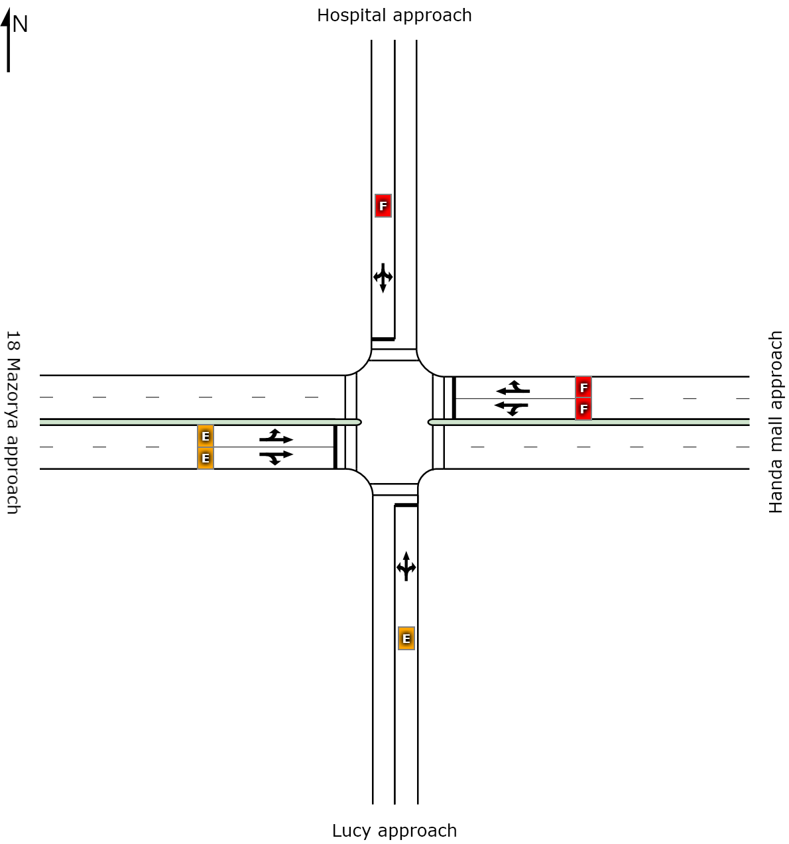
 | South | East | North | West | Intersection
LOS | E | F | F | E | F

Figure 4.1 The layout and LOS values of Menharya Intersection for an existing condition.

4.2.2 Performance evaluation of Maryam signalized intersection.
Table 4.2 The lane use and performance output for Maryam signalized intersection for an
existing condition
Approaches | Demand flows |  |  |  | H.V  % | Cap  veh/h | Deg  Satn | Lane  util | Average  Delay  Sec | Level of services | 95% of Queue
Approaches | L  veh/h | T  veh/h | R  veh/h | Total  veh/h |  |  |  |  |  |  | Vehicles  Veh | Length  M
South: Stadium approach
Lane 1 | 66 | 23 | 36 | 126 | 7.0 | 158 | 0.796 | 100 | 93.1 | LOS F | 8 | 62.6
Approach | 66 | 23 | 36 | 126 | 7.0 |  | 0.796 |  | 93.1 | LOS F | 8 | 62.6
East: Ambicho approach
Lane 1 | 34 | 29 | 0 | 63 | 2.8 | 74 | 0.852 | 100 | 130.6 | LOS F | 5 | 32.4
Lane 2 | 0 | 525 | 16 | 541 | 5.8 | 635 | 0.852 | 100 | 53.5 | LOS D | 35 | 253.3
Approach | 34 | 554 | 16 | 604 | 5.5 |  | 0.852 |  | 61.5 | LOS E | 35 | 253.3
North: Eyerusalem approach
Lane 1 | 61 | 24 | 35 | 119 | 15.3 | 153 |  | 100 | 91.4 | LOS F | 8.0 | 63.3
Approach | 61 | 24 | 35 | 119 | 15.3 |  | 0.778 |  | 91.4 | LOS F | 8.0 | 63.3
West: Mobile approach
Lane 1 | 6 | 134 | 0 | 140 | 5.7 | 383 | 0.367 | 100 | 46.1 | LOS D | 8 | 56.1
Lane 2 | 0 | 209 | 22 | 231 | 6.4 | 630 | 0.367 | 100 | 34.1 | LOS C | 11 | 81.1
Approach | 6 | 343 | 22 | 371 | 6.1 |  | 0.367 |  | 38.7 | LOS D | 11 | 81.1
Intersection |  |  |  | 1220 | 6.8 |  | 0.852 |  | 60.7 | LOS E | 35 | 253.3

In the software analysis, the lane LOS was done by using both average delay and volume to capacity ratio (degree of saturation) as it was stated in HCM 2010. Lane LOS values are based on average delay and v/c ratio (degree of saturation) per lane. LOS F will result if v/c > irrespective of lane delay value (does not apply for approaches and intersection). Intersection and Approach LOS values are based on average delay for all lanes (v/c not used as specified in HCM 2010). HCM Delay Model used.
As it is shown on the table above, all approaches of this intersection are operating below capacity because the volume to capacity ratio (degree of saturation) for all approaches is less than one. Since most approaches of the intersection have degree of saturation around 1, Currently, the intersection is operating in congested condition with LOS E during peak hour (at PM peak time). Overall, the intersection is experiencing an average control delay of 60.7 seconds per vehicle with Degree of Saturation as 0.852 and average queue length of 253.3 m. Ambicho approach is experiencing major operational difficulties.
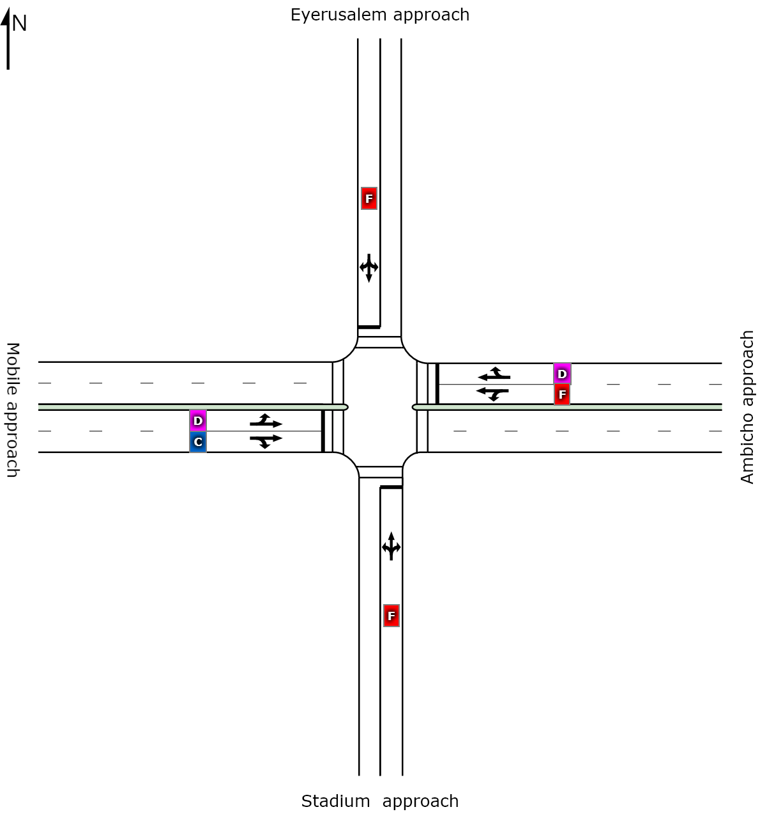

 | South | East | North | West | Intersection
LOS | F | E | F | D | F
Figure 4.2 the layout and level of service values of Maryam Intersection for an existing condition

4.2.3 Performance evaluation of Bezabh Petros roundabout.
Table 4.3 The lane use and performance output for Bezabh Petros roundabout for an existing
condition.
Approaches | Demand flows |  |  |  | H.V.  % | Cap  veh/h | Deg  satn | Lane  Util | Average  Delay  sec | Level of service | 95% of Queue
Approaches | L  veh/h | T  veh/h | R  veh/h | Total  veh/h |  |  |  |  |  |  | Vehicles  Veh | Length  M
South: Menharya Approach
Lane 1 | 16 | 499 | 0 | 515 | 24.2 | 781 | 0.660 | 100 | 16.4 | LOS B | 6 | 48.8
Lane 2 | 0 | 69 | 500 | 569 | 15.5 | 863 | 0.660 | 100 | 15.2 | LOS B | 6 | 46.3
Approach | 16 | 569 | 500 | 1085 | 19.7 |  | 0.660 |  | 15.7 | LOS B | 6 | 48.8
South East: Maremiya approach
Lane 1 | 28 | 0 | 28 | 56 | 0.0 | 342 | 0.164 | 100 | 13.4 | LOS B | 1 | 6.5
Approach | 28 | 0 | 28 | 56 | 0.0 |  | 0.164 |  | 13.4 | LOS B | 1 | 6.5
East: Mobile approach
Lane 1 | 529 | 0 | 0 | 529 | 19.9 | 540 | 0.980 | 100 | 17.2 | LOS E | 20 | 162.7
Lane 2 | 0 | 0 | 328 | 328 | 12.0 | 603 | 0.980 | 100 | 8.8 | LOS B | 4 | 31.8
Approach | 529 | 0 | 328 | 858 | 16.9 |  | 0.980 |  | 14.8 | LOS D | 20 | 162.7
North: Mesalemiya approach
Lane 1 | 237 | 157 | 0 | 217 | 19.1 | 539 | 0.731 | 100 | 26.3 | LOS C | 8 | 62.6
Lane 2 | 0 | 323 | 68 | 206 | 19.6 | 535 | 0.731 | 100 | 26.5 | LOS C | 8 | 62.6
Approach | 237 | 480 | 68 | 422 | 19.4 |  | 0.731 |  | 26.4 | LOS C | 8 | 62.6
South West: Hadiyya pharmacy approach
Lane 1 | 46 | 0 | 31 | 77 | 15.5 | 294 | 0.262 | 100 | 17.9 | LOS B | 2 | 12.3
Approach | 46 | 0 | 31 | 77 | 15.5 |  | 0.262 |  | 17.9 | LOS B | 2 | 12.3
Intersection |  |  |  | 2860 | 18.2 |  | 0.980 |  | 27.1 | LOS C | 20 | 162.7

The Bezabh Petros roundabout has five approach legs as shown in Figure below. The analysis is done by using Level of Service (LOS) Method: Delay& v/c (HCM 2010) and Roundabout LOS Method: Same as Signalized Intersections. In addition, lane LOS values are based on average delay and v/c ratio (degree of saturation) per lane. LOS F will result if v/c > irrespective of lane delay value (does not apply for approaches and intersection). Intersection and Approach LOS values are based on average delay for all lanes (v/c not used as specified in HCM 2010). Roundabout Capacity Model: SIDRA Standard. SIDRA Standard Delay Model used. From the table above, Bezabh Petros roundabout for existing situation, All approaches are operating in under saturated condition. Currently, the roundabout was observed to be operating better performance with LOS “B” for Menharya approach, Hadiyya Pharmacy and Maremya Approach. Mesalemiya approach has LOS of C and mobile approach has LOS of D. Generally the roundabout has LOS of C and Overall, the roundabout is experiencing an average control delay of 27.1 seconds per vehicle with Degree of saturation as 0.98 and average queue length of 162.7 m.
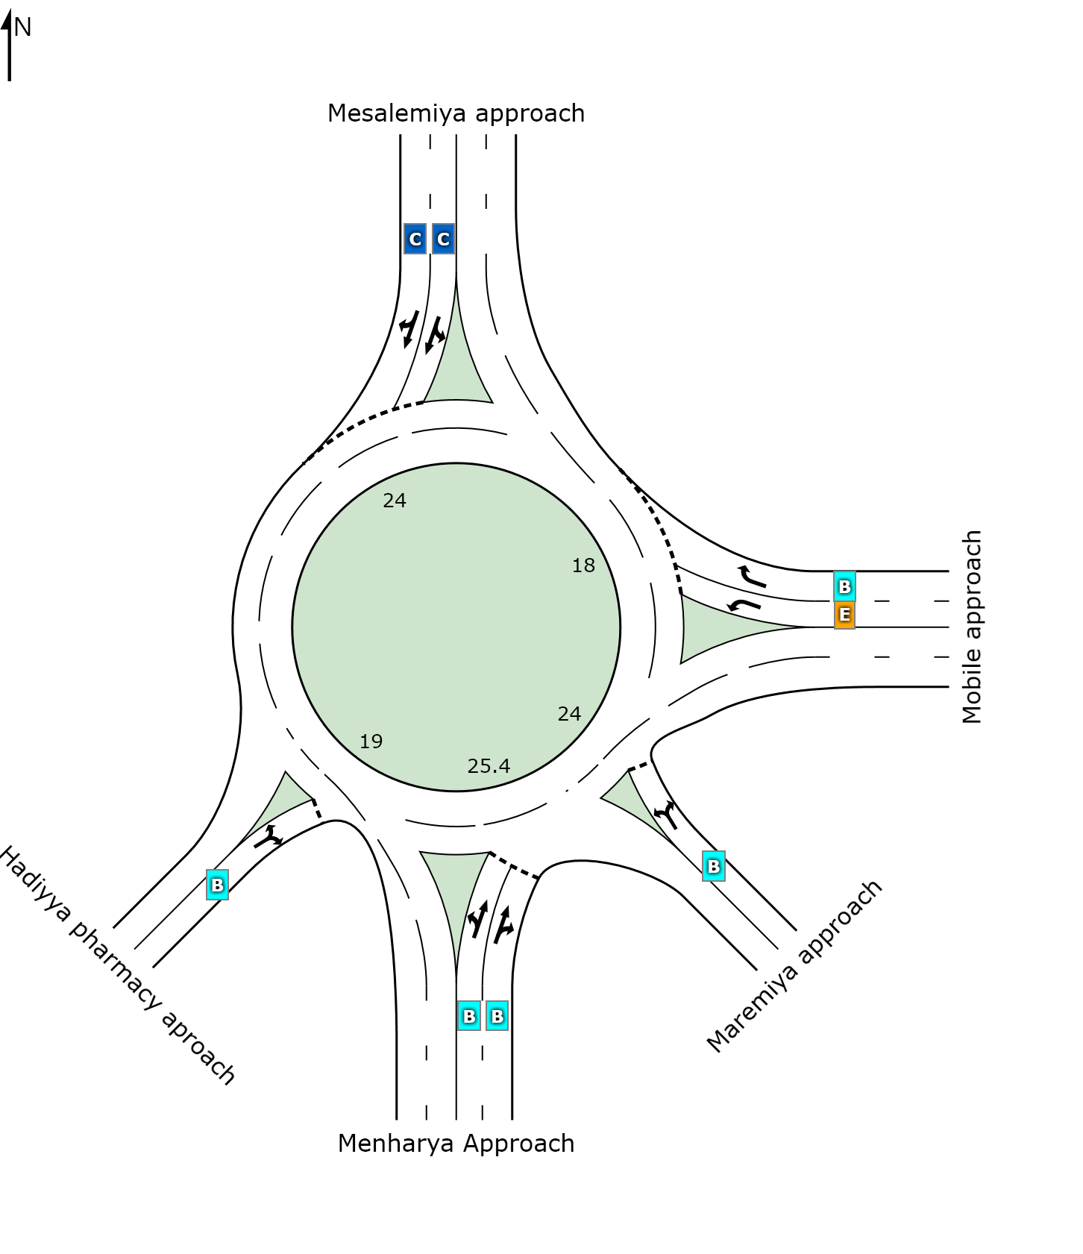
 | South | Southeast | East | North | Southwest | Intersection
LOS | B | B | D | C | B | C

Figure 4. 3 The layout and level of service values of Bezbh Petros roundabout for an existing condition.

4.2.4 Performance evaluation of Eyerusalem roundabout.
Table 4.4 The lane use and performance output for Eyerusalem roundabout for an existing
condition
Approaches | Demand flows |  |  |  | H.V.  % | Cap  veh/h | Deg  satn | Lane  Util | Average  Delay  Sec | Level of service | 95% of Queue
Approaches | L  veh/h | T  veh/h | R  veh/h | Total  veh/h |  |  |  |  |  |  | Vehicles  Veh | Length  M
South: Mesalemiya Approach
Lane 1 | 25 | 341 | 0 | 367 | 16.1 | 947 | 0.387 | 100 | 8.1 | LOS A | 2 | 17.9
Lane 2 | 0 | 297 | 66 | 364 | 17.0 | 939 | 0.387 | 100 | 8.2 | LOS A | 2 | 18.0
Approach | 25 | 639 | 66 | 730 | 16.6 |  | 0.387 |  | 8.1 | LOS A | 2 | 18.0
East: Maryam approach
Lane 1 | 108 | 12 | 80 | 200 | 14.8 | 540 | 0.370 | 100 | 12.4 | LOS B | 2 | 16.1
Approach | 108 | 12 | 80 | 200 | 14.8 |  | 0.370 |  | 12.4 | LOS B | 2 | 16.1
North: Gombera approach
Lane 1 | 47 | 326 | 0 | 374 | 25.0 | 847 | 0.441 | 100 | 9.8 | LOS A | 3 | 22.5
Lane 2 | 0 | 327 | 49 | 377 | 24.0 | 854 | 0.441 | 100 | 9.7 | LOS A | 3 | 22.4
Approach | 47 | 654 | 49 | 751 | 24.5 |  | 0.441 |  | 9.7 | LOS A | 3 | 22.5
West: Inat kalehiwet approach
Lane 1 | 55 | 43 | 72 | 169 | 6.7 | 401 | 0.423 | 100 | 17.5 | LOS B | 2 | 16.3
Approach | 55 | 43 | 72 | 169 | 6.7 |  | 0.423 |  | 17.5 | LOS B | 2 | 16.3
Intersection |  |  |  | 1850 | 18.7 |  | 0.441 |  | 10.1 | LOS B | 3 | 22.5

The Eyerusalem roundabout has four approach legs as shown in Figure below. The analysis is done by using Level of Service (LOS) Method: Delay& v/c (HCM 2010) and Roundabout LOS Method: Same as Signalized Intersections. In addition, lane LOS values are based on average delay and v/c ratio (degree of saturation) per lane. LOS F will result if v/c > irrespective of lane delay value (does not apply for approaches and intersection). Intersection and Approach LOS values are based on average delay for all lanes (v/c not used as specified in HCM 2010). Roundabout Capacity Model: SIDRA Standard. SIDRA Standard Delay Model used. From the table above, Eyerusalem roundabout for existing situation, All approaches are operating in under saturated condition. Currently, the roundabout was observed to be operating better performance with LOS “A” for Mesalemya approach and Gombera Approach. Inat kalehiwet approach and Maryam approach has LOS of B. Generally the roundabout has LOS of B and overall, the roundabout is experiencing an average control delay of 10.1 seconds per vehicle with Degree of saturation as 0.441 and average queue length of 22.5m.

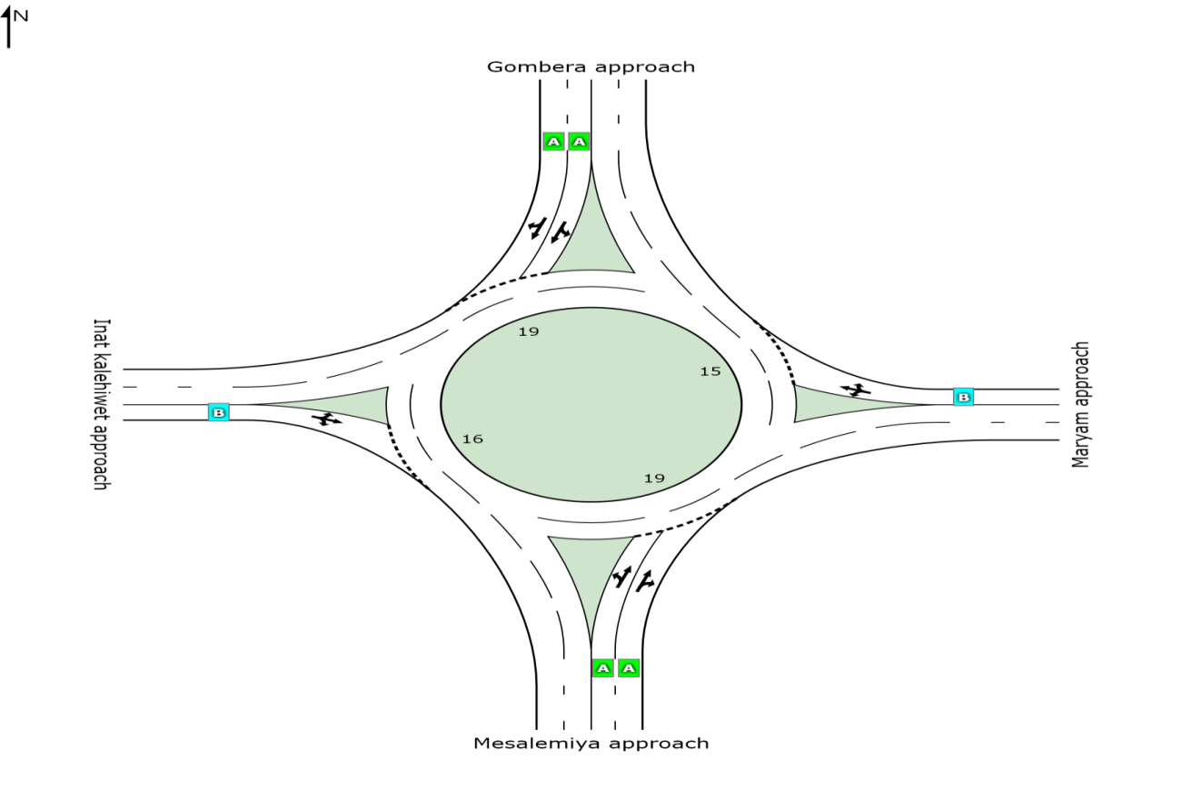
 | South | East | North | West | Intersection
LOS | A | B | A | B | B

Figure 4. 4 The layout and Level of Service values of Eyerusalem roundabout for an existing condition

4.2.5 Summary on existing intersections performances.
The volume-to-capacity (v/c) ratio also referred to as degree of saturation, represents the sufficiency of an intersection to accommodate the vehicular demand for Menharya signalized intersection and Maryam signalized intersection is 1.374 and 0.852 respectively. As the v/c ratio approaches 1.0, traffic flow may become unstable, and delay and queuing conditions may occur. Once the demand exceeds the capacity (a v/c ration greater than 1.0), traffic flow is unstable and excessive delay and queuing is expected (FWHA, 2009). So in these both signalized intersections, traffic flow is unstable and excessive delay occurred.
Menharya signalized intersection has LOS of F and Maryam signalized intersection has LOS of E. HCM (2010) describes; LOS F indicates operations with control delay exceeding 80 s/veh or a volume-to-capacity ratio greater than 1.0. This level is typically assigned when the volume-to-capacity is very high, progression is very poor, and the cycle length is long. So both signalized intersections have poor progression and long queue length of 497.4m for Menharya and 253.3m for Maryam signalized intersections.
Performance measures of Bezabh Petros roundabout and Eyerusalem roundabout show that Eyerusalem roundabout is performing relatively in a good operating condition than Bezabh Petros round about because both have LOS of B and C respectively. Bezabh Petros roundabout is experiencing an average control delay of 27.1 seconds per vehicle with Degree of saturation as 0.98 and average queue length of 162.7 m and Eyerusalem roundabout is experiencing an average control delay of 10.1 seconds per vehicle with Degree of saturation as 0.441 and average queue length of 22.5m.

4.3. The consequences of three wheelers with performance parameters.
To know the effects of three wheelers on performance measurement parameters of Intersections, it is very important to evaluate intersection performances excluding three wheelers again and comparing the differences between performance measurement parameters with and without three wheelers.

4.3.1 Performance evaluation of Menharya signalized intersections without

three wheelers.
Table 4.5 the lane use and performance output for Menharya signalized intersection without
three wheelers.
Approaches | Demand flows |  |  |  | H.V.  % | Cap  veh/h | Deg  Satn | Lane  Util | Average  Delay  Sec | Level of services | 95% of Queue
Approaches | L  veh/h | T  veh/h | R  veh/h | Total  veh/h |  |  |  |  |  |  | Vehicles  Veh | Length  M
South: Lucy approach
Lane 1 | 9 | 4 | 11 | 25 | 45.4 | 212 | 0.116 | 100 | 52.7 | LOS D | 1.4 | 13.8
Approach | 9 | 4 | 11 | 25 | 45.4 |  | 0.116 |  | 52.7 | LOS D | 1.4 | 13.8
East: Handa mall approach
Lane 1 | 8 | 7 | 0 | 16 | 28.4 | 81 | 0.196 | 100 | 64.2 | LOS E | 1.0 | 8.9
Lane 2 | 0 | 51 | 4 | 55 | 58.2 | 282 | 0.196 | 100 | 44.8 | LOS D | 2.9 | 30.9
Approach | 8 | 58 | 4 | 71 | 51.6 |  | 0.196 |  | 49.1 | LOS D | 2.9 | 30.9
North: Hospital approach
Lane 1 | 16 | 8 | 16 | 39 | 56.6 | 198 | 0.199 | 100 | 55.1 | LOS E | 2.3 | 24.3
Approach | 16 | 8 | 16 | 39 | 56.6 |  | 0.199 |  | 55.1 | LOS E | 2.3 | 24.3
West: 18 Mazorya approach
Lane 1 | 3 | 3 | 0 | 6 | 39.4 | 55 | 0.114 | 100 | 64.5 | LOS E | 0.4 | 3.9
Lane 2 | 0 | 26 | 4 | 30 | 71.4 | 264 | 0.114 | 100 | 43.4 | LOS D | 1.6 | 17.8
Approach | 3 | 29 | 4 | 36 | 65.9 |  | 0.114 |  | 47.1 | LOS D | 1.6 | 17.8
Intersection |  |  |  | 171 | 54.9 |  | 0.199 |  | 50.6 | LOS D | 2.9 | 30.9

In the software analysis, the lane LOS was done by using both average delay and volume to capacity ratio (degree of saturation) as it was stated in HCM 2010. Lane LOS values are based on average delay and v/c ratio (degree of saturation) per lane. LOS F will result if v/c > irrespective of lane delay value (does not apply for approaches and intersection). Intersection and Approach LOS values are based on average delay for all lanes (v/c not used as specified in HCM 2010). HCM Delay Model used.
As it is shown on the table above, all the approaches of this intersection are operating below their capacity because the volume to capacity ratio (degree of saturation) for all approaches is less than one. In this case, the intersection is operating in congested condition with LOS E for Hospital approach and Lucy approach, 18 Mazorya approach and Handa Mall approaches have LOS of D. Overall, when Three wheelers removed from analysis, the intersection is experiencing an average control delay of 50.6 seconds per vehicle with Degree of saturations as 0.199 and average queue length of 30.9m.

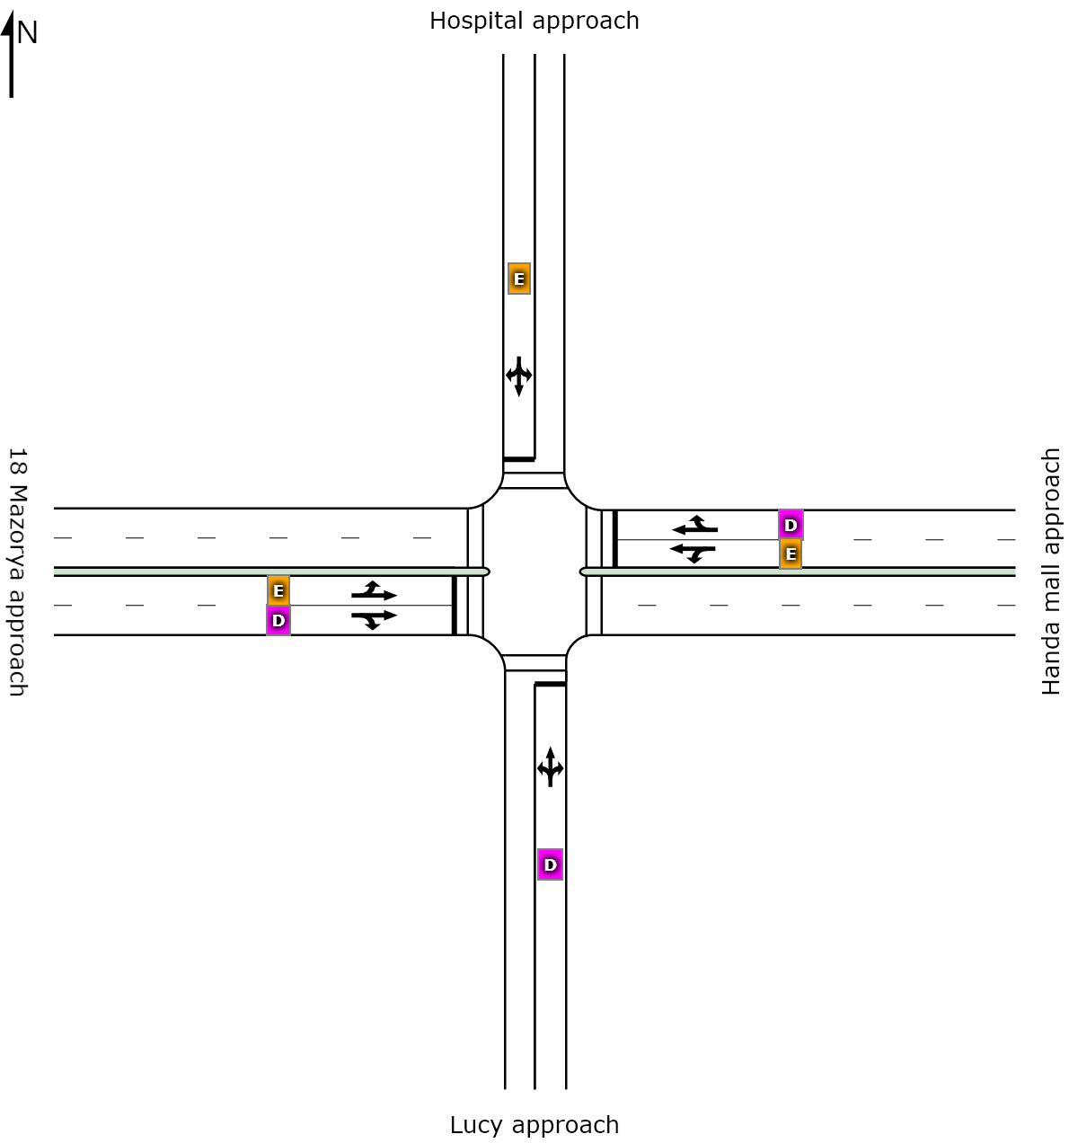
 | South | East | North | West | Intersection
LOS | D | D | E | D | D

Figure 4.5 the layout and Level of Service values of Menharya intersection without Three wheelers.

4.3.1.1. Comparison of Menharya signalized intersection performance measurement

parameters with and without three wheelers.
It is essential to compare the performance measurement parameters of intersections with and without three wheelers to understand the effect of three wheelers on performance measurement parameters easily. The performance evaluation in both cases is already analyzed, as shown above. On the analysis without three wheelers, three wheelers were totally removed from analysis by considering other parameters the same. So based on those results, the difference in previous (including three wheelers) and current (excluding three wheelers) is shown below clearly.

Table 4.6 Comparison of the difference between previous and current level of services (with
and without three wheelers) of Menharya signalized intersection.
Approach name | Previous Level of Service (LOS) | Current Level of Service (LOS) | Remark
Hospital | F | E | Improved
Lucy | E | D | Improved
18 mazorya | E | E | Same
Handa Mall | F | D | Improved
Intersection | F | D | Improved

All approaches have a big difference in LOS because it shows LOS difference from F to D except 18 Mazorya approach. When three wheelers is excluded, the intersection LOS improved from F to D.

Table 4.7 Comparison of the difference between previous and current signal delay time (sec)
(with and without three wheelers).
Approach name | Previous Signal Delay time in sec | Current Signal Delay time in sec | Difference
Hospital | 234.3 | 55.1 | 179.2
Lucy | 65.7 | 52.7 | 13
18 Mazorya | 65.8 | 47.1 | 18.7
Handa Mall | 243.9 | 49.1 | 194.8
Intersection | 171.5 | 50.6 | 120.9

Figure 4.6 Comparison of the difference between Previous and Current signal delay time (sec) (with and without three wheelers).
From the above output, 76.5% cause for delay of the Hospital approach, 19.8% cause for delay of Lucy approach, 28.4% cause for delay of 18 mazorya approaches, and 79.9% cause for delay of Handa mall approach is the presence of three wheelers.
Generally, Menharya signalized intersection delay is 70.5% caused due to the presence of three wheelers.
Table 4. 8 Comparison of the difference between previous and current degree of saturation
(with and without three wheelers)
Approach | Previous Degree of saturation | The current Degree of saturation | difference
Hospital | 1.341 | 0.199 | 1.142
Lucy | 0.587 | 0.116 | 0.471
18 Mazorya | 0.766 | 0.114 | 0.652
Handa Mall | 1.374 | 0.196 | 1.178
Intersection | 1.374 | 0.199 | 1.175

Figure 4. 7 Comparison of the difference between previous and current degree of saturation (with and without three wheelers) of Menharya intersection
From the above output, 85.2% degree of saturation of the Hospital approach, 80.2 % degree of saturation of Lucy approach, 85.1% degree of saturation of 18 mazorya approach, and 85.7% degree of saturation of Handa mall approach is due to the presence of Three wheelers.
Generally, Menharya signalized intersection degree of saturation is 85.5% caused due to the presence of three wheelers.
Table 4.9 Comparison of the difference between previous and current 95% back of queue
length (m) (with and without three wheelers) of Menharya intersection.
Approach | Previous 95% back of Queue length (m) | Current 95% back of Queue length (m) | Difference
Hospital | 312.2 | 24.3 | 287.9
Lucy | 62.9 | 13.8 | 49.1
18 Mazorya | 136.4 | 17.8 | 118.6
Handa Mall | 497.4 | 30.9 | 466.5
Intersection | 497.4 | 30.9 | 466.5

Figure 4.8 Comparison of the difference between previous and current 95% back of queue length (m) (with and without three wheelers)
From the above output 92.2 % Queue length of the Hospital approach, 78.1% Queue distance of Lucy approach, 87.0% Queue distance of 18 mazorya approach, and 93.8% Queue distance of Handa mall approach is due to the presence of Three wheelers.
Generally, Menharya signalized intersection Queue distance of 93.8 % is caused due to the presence of three wheelers.
Based on the above results, it can be concluded easily that, three wheelers is affecting the performance measurement parameters of Menharya signalized intersection highly than other vehicle types.

4.3.2. Performance evaluation of Maryam signalized intersections without

three wheelers.
As discussed above, by analyzing the performance measurement parameters of Maryam intersection without three wheelers, it has a delay of 54.7cm, degree of saturation of 0.366, 95% queue length of 54cm and LOS of D. the parameters in detail for each approach is shown in tabular form at appendixes.

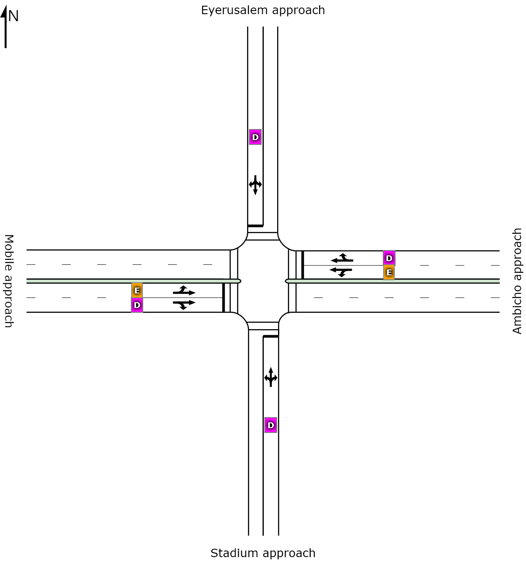

 | South | East | North | West | Intersection
LOS | D | D | D | D | D
Figure 4.9 The layout and level of service values of Maryam intersection without three wheelers

4.3.2.1 Comparison of Maryam signalized intersection performance measurement parameters

with and without three wheelers.
It is essential to compare the performance measurement parameters of intersections with and without three wheelers to understand the effect of three wheelers on performance measurement parameters easily. The performance evaluation in both cases is already analyzed, as shown above. So based on those results, the differences in previous (including three wheelers) and current (excluding three wheelers) are shown below clearly.
Table 4.10 Comparison of the difference between Previous and Current level of services (with
and without three wheelers) of Maryam intersection.
Approach name | Previous Level of Service (LOS) | Current Level of Service (LOS) | Remark
Eyeruslem | F | D | Improved
Stadium | F | D | Improved
Mobile | D | D | Same
Ambicho | F | D | Improved
Intersection | E | D | Improved

There is a difference of LOS on each approach, including the whole intersection. The Eyerusalem approach and Stadium approach shows the difference of LOS from F to D. And Ambicho approach is improved from F to D. When three wheelers is excluded, the LOS of Maryam Signalized intersection shows the improvement from E to D.
Table 4.11 Comparison of the difference between Previous and Current signal delay time (sec)
(with and without three wheelers) of Maryam intersection.
Approach | Previous Signal Delay time in sec | Current Signal Delay time in sec | Difference
Eyeruslem | 91.4 | 52.2 | 39.2
Stadium | 93.1 | 54.2 | 38.9
Mobile | 47.9 | 38.7 | 9.2
Ambicho | 61.5 | 48.9 | 12.6
Intersection | 60.7 | 50.3 | 10.4

Figure 4. 10 Comparison of the difference between Previous and Current signal delay time (sec) (with and without three wheelers) of Maryam intersection.
From the above output, 42.9 % cause for delay of the Eyeruslem approach, 41.8% cause for delay of Stadium approach, 19.2 % cause for delay of Mobile approach, and 20.5% cause for delay of Ambicho approach is the presence of three wheelers.
Generally, Maryam signalized intersection delay is 17.1% caused due to the presence of three wheelers.
Table 4.12 Comparison of the difference between previous and current degree of saturation
(with and without three wheelers) of Maryam intersection.
Approach | Previous Degree of saturation | Current Degree of saturation | difference
Eyeruslem | 0.778 | 0.138 | 0.64
Stadium | 0.796 | 0.152 | 0.644
Mobile | 0.367 | 0.134 | 0.233
Ambicho | 0.852 | 0.152 | 0.7
Intersection | 0.852 | 0.152 | 0.7

Figure 4. 11 Comparison of the difference between previous and current degree of saturation (with and without three wheelers) of Maryam intersection.
From the above output 82.3 % degree of saturation of Eyeruslem approach, 80.9% degree of saturation of Stadium approach, 63.5% degree of saturation of Mobile approach, and 82.2% degree of saturation of the Ambicho approach is due to the presence of three wheelers.
Generally, 82.2 % degree of saturation of Maryam signalized intersection is caused due to the presence of three wheelers.
Table 4.13 Comparison of the difference between Previous and Current 95% back of queue
distance (m) (with and without three wheelers) of Maryam intersection.
Approach | Previous 95% back of Queue length(m) | Current 95% back of Queue length (m) | Difference
Eyeruslem | 63.3 | 18.3 | 45
Stadium | 62.6 | 16.1 | 46.5
Mobile | 81.1 | 20.0 | 61.1
Ambicho | 253.3 | 23.6 | 229.7
Intersection | 253.3 | 23.6 | 229.7
From the above output 71.1% Queue distance of the Eyerusalem approach, 74.3% Queue distance of Stadium approach, 75.3% Queue distance of Mobile approach, and 90.7% Queue distance of the Ambicho approach is due to the presence of three wheelers.
Generally, Maryam signalized intersection Queue distance of 90.7% is caused due to the presence of three wheelers.
Based on the above results, it can be concluded easily that three wheelers is affecting the performance measurement parameters of Maryam's signalized intersection more than other vehicle types.

4.3.3. Performance evaluation of Bezabh Petros roundabout without three wheelers.
Table 4.14 the lane use and performance output for Bezabh Petros roundabout without three
wheelers.
Approaches | Demand flows |  |  |  | HV  % | Cap  veh/h |  |  | Deg  satn | Lane  util |  |  | Average  Delay  sec | Level of services | 95% of Queue
Approaches | L  veh/h | T  veh/h | R  veh/h | Total  veh/h |  |  |  |  |  |  |  |  |  |  | Vehicles  Veh | Length  M
South: Menharya Approach
Lane 1 | 3 | 203 | 0 | 206 | 62.0 | 538 |  |  | 0.384 |  | 100 |  | 12.7 | LOS B | 2.0 | 21.1
Lane 2 | 0 | 24 | 249 | 273 | 31.5 | 711 |  |  | 0.384 |  | 100 |  | 10.1 | LOS B | 2.1 | 18.5
Approach | 3 | 227 | 249 | 480 | 44.6 |  |  |  | 0.384 |  |  |  | 11.2 | LOS B | 2.1 | 21.1
South East: Maremiya approach
Lane 1 | 17 | 0 | 11 | 29 | 0.0 | 595 |  |  | 0.048 |  |  | 100 | 6.6 | LOS A | 0.2 | 1.7
Approach | 17 | 0 | 11 | 29 | 0.0 |  |  |  | 0.048 |  |  |  | 6.6 | LOS A | 0.2 | 1.7
East: Mobile approach
Lane 1 | 342 | 0 | 0 | 342 | 31.3 |  |  | 588 | 0.582 |  |  | 100 | 17.2 | LOS B | 4.1 | 36.6
Lane 2 | 0 | 0 | 135 | 135 | 29.0 |  |  | 603 | 0.582 |  |  | 100 | 8.8 | LOS A | 1.1 | 9.4
Approach | 342 | 0 | 135 | 477 | 30.6 |  |  |  | 0.582 |  |  |  | 14.8 | LOS B | 4.1 | 36.6
North: Mesalemiya approach
Lane 1 | 142 | 75 | 0 | 217 | 34.2 |  | 510 |  | 0.425 |  |  | 100 | 14.3 | LOS B | 2.4 | 21.6
Lane 2 | 0 | 173 | 32 | 206 | 38.8 |  | 484 |  | 0.425 |  |  | 100 | 14.9 | LOS B | 2.4 | 22.1
Approach | 142 | 248 | 32 | 422 | 36.4 |  |  |  | 0.425 |  |  |  | 14.6 | LOS B | 2.4 | 22.1
South West: Hadiyya pharmacy approach
Lane 1 | 33 | 0 | 14 | 47 | 25.0 |  | 390 |  | 0.121 |  |  | 100 | 11.1 | LOS B | 0.6 | 5.3
Approach | 33 | 0 | 14 | 47 | 25.0 |  |  |  | 0.121 |  |  |  | 11.1 | LOS B | 0.6 | 5.3
Intersection |  |  |  | 1454 | 36.1 |  |  |  | 0.582 |  |  |  | 13.3 | LOS B | 4.1 | 36.6

Level of Service (LOS) Method: Delay & v/c (HCM 2010). Roundabout LOS Method: Same as Signalised Intersections. Lane LOS values are based on average delay and v/c ratio (degree of saturation) per lane. LOS F will result if v/c > irrespective of lane delay value (does not apply for approaches and intersection). Intersection and Approach LOS values are based on average delay for all lanes (v/c not used as specified in HCM 2010). Roundabout Capacity Model: SIDRA Standard. HCM Delay Model used.

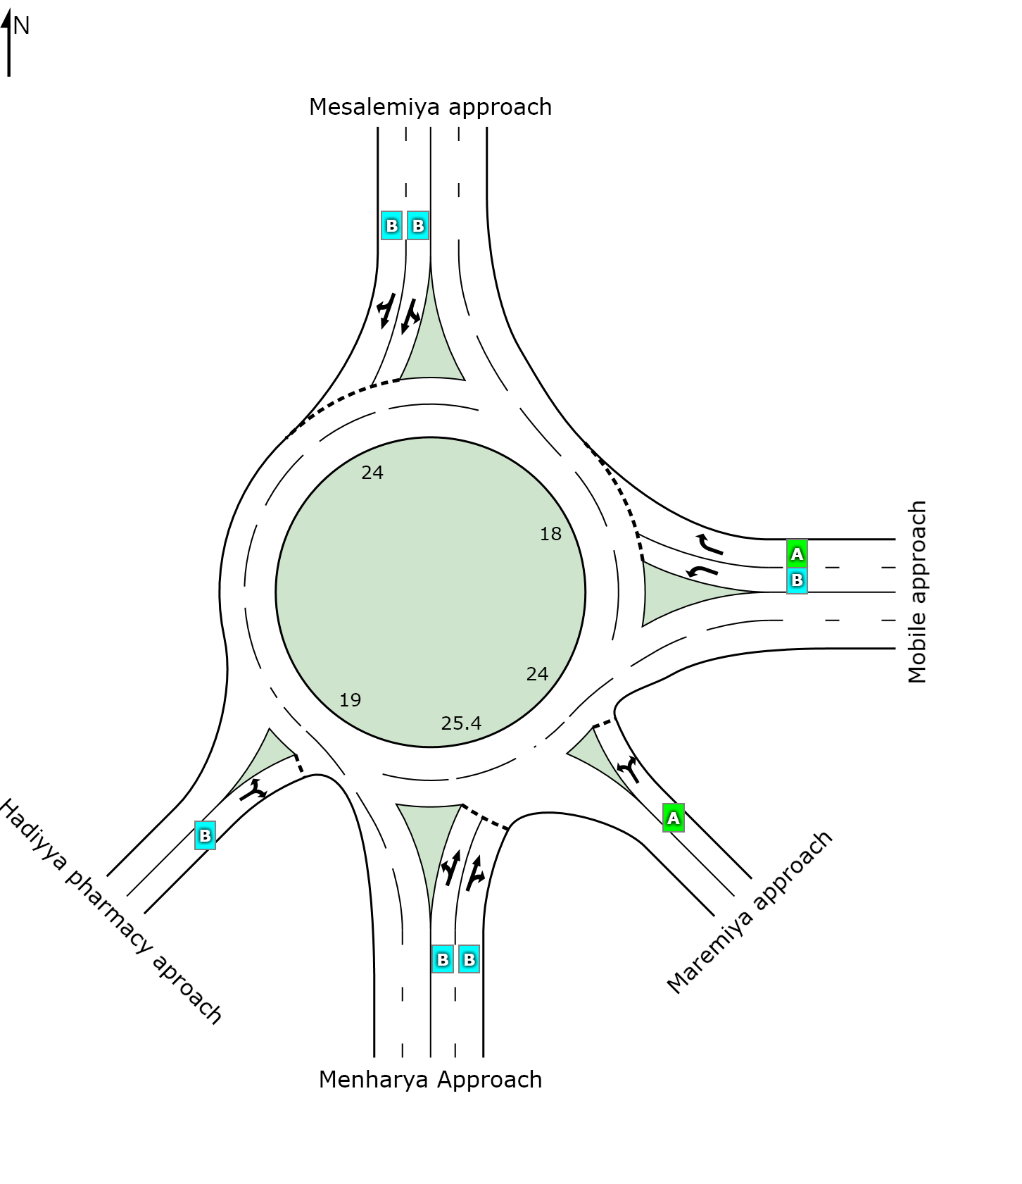
 | South | Southeast | East | North | Southwest | Intersection
LOS | B | A | B | B | B | B

Figure 4.12 The layout and level of service values of Bezabh Petros roundabout without three wheelers.

4.3.3.1 Comparison of Bezabh petros roundabout performance measurement parameters with and without three wheelers.
Table 4.15 Comparison of the difference of level of services with and without three wheelers
of Bezabh Petros roundabout
Approach name | Previous Level of Service (LOS) | Current Level of Service (LOS) | Remark
Menharya | B | B | Same
Mesalemiya | B | B | Same
Mobile | D | B | Improved
Hadiyya pharmacy | B | B | Same
Maremiya | B | A | Improved
Intersection | C | B | Improved

There is a visible difference of LOS on some approaches, including the whole intersection. The mobile approach shows the difference of LOS from D to B and the Maremiya approach from B to A.
When three wheelers are excluded, the LOS of Bezabh Petros roundabout shows the improvement from C to B.
Table 4.16 Comparison of the difference of delay time (sec) with and without three wheelers
at Bezabh Petros roundabout
Approach name | Previous delay time in sec | Current delay time in sec | Difference
Menharya | 15.7 | 11.2 | 4.5
Mesalemiya | 26.4 | 14.6 | 11.8
Mobile | 43.9 | 14.8 | 29.1
Hadiyya pharmacy | 17.9 | 11.1 | 6.8
Maremiya | 13.4 | 6.6 | 6.8
Intersection | 27.1 | 13.3 | 13.8

Figure 4.13 Comparison of the difference of delay time (sec) with and without three wheelers at Bezabh Petros roundabout.
From the above output, 29.0% cause for delay of Menharya approach, 44.7% cause for delay of Mesalemiya approach, 66.3% cause for delay of Mobile approach, 38.0% cause for delay of Hadiyya pharmacy approach and 50.1% cause for delay of Maremiya approach is the presence of three wheelers.
Generally, the Bezabh Petros roundabout delay is 51% caused due to the presence of three wheelers.
Table 4.17 Comparison of Degree of saturation with and without three wheelers at Bezabh
Petros roundabout.
Approach name | Previous Degree of saturation | Current Degree of saturation | difference
Menharya | 0.66 | 0.384 | 0.276
Mesalemiya | 0.731 | 0.425 | 0.306
Mobile | 0.98 | 0.582 | 0.398
Hadiyya pharmacy | 0.262 | 0.121 | 0.141
Maremiya | 0.164 | 0.048 | 0.116
Intersection | 0.980 | 0.582 | 0.398

Figure 4.14 Comparison of degree of saturation with and without three wheelers at Bezabh Petros roundabout.
From the above output 42.0% degree of saturation of Menharya approach, 42.0% degree of saturation of Mesalemiya approach, 41.0% degree of saturation of Mobile approach, 54.0% degree of saturation of Hadiyya pharmacy approach and 71.0 % degree of saturation of Maremiya approach is due to the presence of Three wheelers.
Generally, Bezabh Petros degree of saturation is 41.0 % caused due to the presence of three wheelers.

Table 4.18 Comparison of the difference between previous (with three wheelers) and current
(without three wheelers) 95% back of queue length (m) of Bezabh Petros roundabout.
Approach name | Previous 95% back of queue length (m) | Current 95% back of queue length (m) | Difference
Menharya | 48.8 | 21.1 | 27.7
Mesalemiya | 62.6 | 22.1 | 40.5
Mobile | 162.7 | 36.6 | 126.1
Hadiyya pharmacy | 12.3 | 5.3 | 7
Maremiya | 6.5 | 1.7 | 4.8
Intersection | 162.7 | 36.6 | 126.1

Figure 4. 15 Comparison of the difference between previous (with three wheelers) and current (without three wheelers) 95% back of queue length (m) of Bezabh Petros roundabout.
From the above output 56.7% queue length of the Menharya approach, 64.7% queue length of Mesalemiya approach, 77.5% queue length of Mobile approach, 57.0% queue length of Hadiyya pharmacy approach and 73.8% queue length of Maremiya approach is due to the presence of three wheelers.
Generally, the Bezabh Petros roundabout queue length of 77.5% is caused due to the presence of three wheelers.
Based on the above results, it can be concluded easily that, three wheeler is affecting the performance measurement parameters of Bezabh Petros roundabout highly than other vehicle types.

4.3.4. Performance evaluation of Eyerusalem roundabout without three wheelers.
The performance measurement parameters output of Eyerusalem roundabout from SIDRA intersection excluding three wheelers indicates that, the roundabout has average delay of 7.3 sec, degree of saturation of 0.247, 95% queue length of 12.1m and LOS of A. So it indicates that the roundabout has free traffic stream.

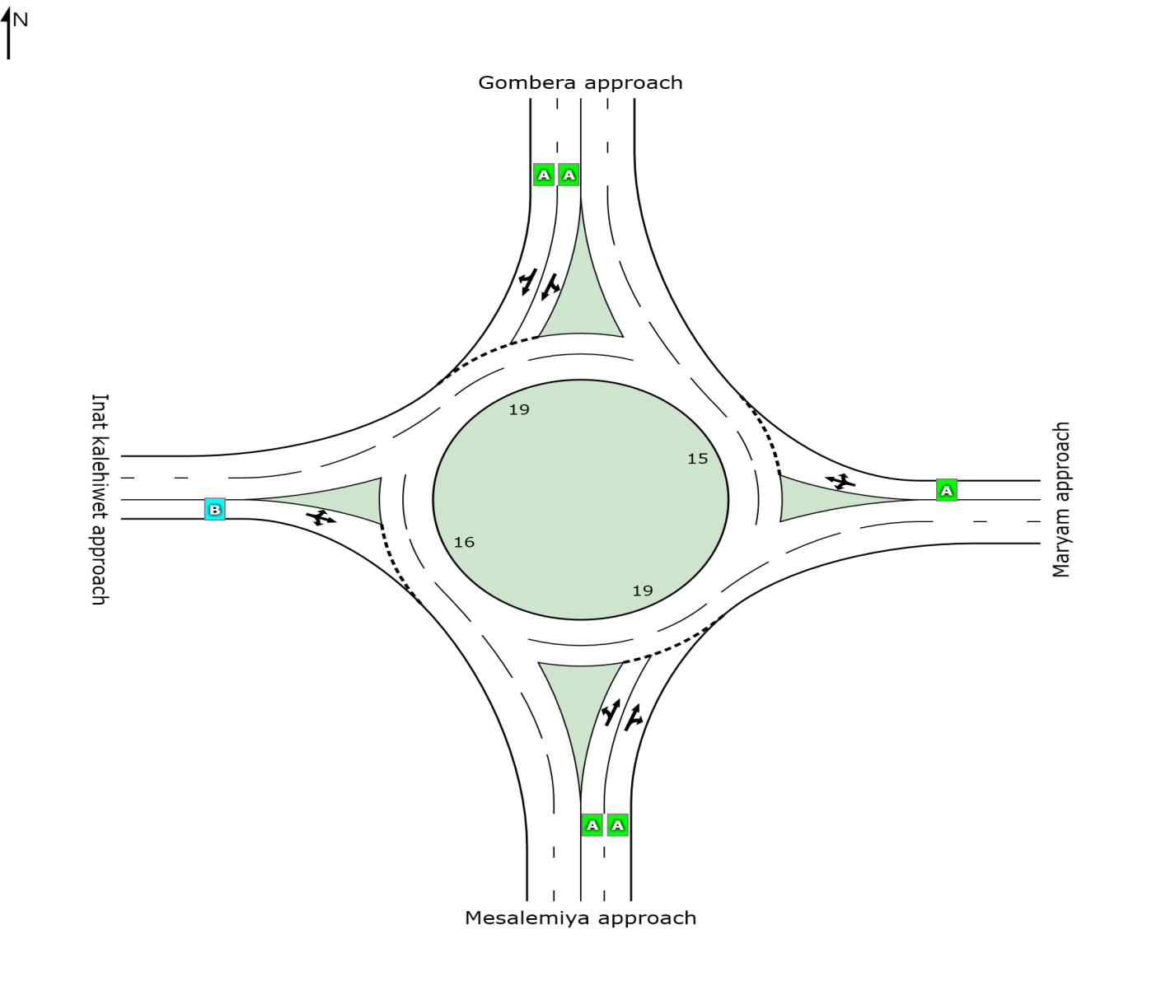
 | South | East | North | West | Intersection
LOS | A | A | A | B | A
Figure 4. 16 The layout and level of service values of Eyerusalem roundabout without three wheelers.

4.3.3.1 Comparison of Eyerusalem roundabout performance measurement parameters with

and without three wheelers.
Table 4.19 Comparison of the difference between Previous (with three wheelers) and current
(without three wheelers) level of services of Eyerusalem roundabout.
Approach name | Previous Level of Service (LOS) | Current Level of Service (LOS) | Remark
Mesalemiya | A | A | Same
Maryam | B | A | Improved
Gombera | A | A | Same
Inatkalehiwet | B | B | Same
Intersection | B | A | Improved

LOS of Maryam approach is improved from B to A, and Eyerusalem roundabout shows the improvement of LOS from B to A.

Table 4.20 Comparison of the difference between previous and current delay time (sec) (with
and without three wheelers of Eyerusalem roundabout).
Approach name | Previous delay time in sec | Current delay time in sec | Difference
Mesalemiya | 8.1 | 6.3 | 1.8
Maryam | 12.4 | 7.6 | 4.8
Gombera | 9.7 | 7.4 | 2.3
Inatkalehiwet | 17.5 | 10.6 | 6.9
Intersection | 10.1 | 7.3 | 2.8

Figure 4.17 Comparison of the difference between previous and current delay time (sec) (with and without three wheelers of Eyerusalem roundabout).
From the above output, 22.2% cause for delays of Mesalemiya approach, 38.7% cause for the Maryam approach, 23.7% cause for delay of Gombera approach, and 39.4% cause for delay of Inat kalehiwet approach is the presence of three wheelers.
Generally, the Eyerusalem roundabout delay is 28 % caused due to the presence of three wheelers.
Table 4.21 Comparison of the difference between previous and current (with and without three
wheelers) degree of saturation of Eyerusalem roundabout.
Approach name | Previous Degree of saturation | Current Degree of saturation | difference
Mesalemiya | 0.387 | 0.189 | 0.198
Maryam | 0.37 | 0.134 | 0.236
Gombera | 0.441 | 0.247 | 0.194
Inatkalehiwet | 0.423 | 0.189 | 0.234
Intersection | 0.441 | 0.247 | 0.194

From the above table, 51.2% degree of saturation of Mesalemiya approach, 64.0% degree of saturation of Maryam approach, 44.0% degree of saturation of Gombera approach, and 55.4 % degree of saturation of Inat kalehiwet approach is due to the presence of three wheelers.
Generally, Eyerusalem roundabout degree of saturation is 44.0 % caused due to the presence of three wheelers.
Table 4.22 Comparison of the difference between previous (with three wheelers) and current
(without three wheelers) 95% back of queue length (m)
Approach name | Previous 95% back of queue length (m) | Current 95% back of queue length (m) | Difference
Mesalemiya | 18 | 8.2 | 9.8
Maryam | 16.1 | 5.5 | 10.6
Gombera | 22.5 | 12.1 | 10.4
Inat kalehiwet | 16.3 | 5.8 | 10.5
Intersection | 22.5 | 12.1 | 10.4

From the above output, 54.4% queue length of Mesalemiya approach, 65.8% queue length of Maryam approach, 46.2% queue length of Gombera approach, and 64.4% queue length of Inat kalehiwet approach is due to the presence of three wheelers.
Generally, the Bezabh Petros roundabout Queue length of 77.5% is caused due to the presence of three wheelers.
Based on the above results, it can be concluded easily that three wheeler is affecting the performance measurement parameters of Eyerusalem roundabout highly than other vehicle types.

4.3.5 Summary on the effects of three wheelers on intersection performances.
From the result of analysis, three wheeler is highly affecting Menharya and Maryam signalized intersections. For Menharya signalized intersection When Three wheelers removed from analysis, average delay reduced from 171.5 sec to 50.6 sec, degree of saturation reduced from 1.374 to 0.199, queue length reduced from 497.4m to 30.9m and LOS improved from F to D. For Maryam signalized intersection, When Three wheelers removed from analysis, average delay reduced from 60.7 sec to 50.3 sec, degree of saturation reduced from 0.852 to 0.152, queue length reduced from 253.3m to 23.6m and LOS improved from E to D. So according to the output of analysis, three wheeler is highly affecting the performance measurement parameters of signalized intersections in Hosanna City.
In Bezabh Petros roundabout and in Eyerusalem roundabout, the effects of three wheeler on performance parameters are also high. For Bezabh Petros roundabout When Three wheelers removed from analysis, average delay reduced from 27.1 sec to 13.3 sec, degree of saturation reduced from 0.980 to 0.582, queue length reduced from 162.7m to 36.6m and LOS improved from C to B. For Eyerusalem roundabout, When Three wheelers removed from analysis, average delay reduced from 10.1 sec to 7.3 sec, degree of saturation reduced from 0.441 to 0.247, queue length reduced from 22.5m to 12.1m and LOS improved from B to A.

4.4. Comparing the performance change of intersections when Three wheelers

replaced by minibus.
This portion explained one of the solutions for reducing the effects of three wheelers on performance measurement parameters of intersections at Hosanna city. The comparison was made for the peak hour traffic volumes of intersections under the following assumptions;
- All Three wheelers vehicles will be replaced by minibus taxis at the ratio of 1:4. When three wheelers are removed, the traffic of the road will be improved. These will improve the LOS.
- The analysis is made with assumptions that the geometric conditions, the pedestrian characteristics, and the roadway conditions will not be changed due to the replacement of three wheelers with minibus taxis.
To compare the changes in performance measurement parameters of intersections when three wheelers are replaced by minibus, new intersection performances must be evaluated with a minibus. After that, the difference in performance measurement parameters of intersections was analyzed.

4.4.1. Performance evaluation of Menharya signalized intersection when three wheelers

replaced by minibus.
Table 4.23 The lane use and performance output for Menharya signalized intersection when
three wheelers replaced by minibus.
Approaches |  | Demand flows |  |  |  | HV  % | Cap  veh/h | Deg  satn | Lane  util | Average Delay  Sec | Level of service | 95% of Queue
 |  | L  veh/h | T  veh/h | R  veh/h | Tot veh/h |  |  |  |  |  |  | Vehicles  Veh |  | Length  M
South: Lucy approach
Lane 1 |  | 34 | 16 | 44 | 93 | 8.0 | 229 | 0.408 | 100 | 59.4 | LOS E |  | 6 | 42.3
Approach |  | 34 | 16 | 44 | 93 | 8.0 |  | 0.408 |  | 59.4 | LOS E |  | 6 | 42.3
East: Handa mall approach
Lane 1 |  | 27 | 25 | 0 | 52 | 2.9 | 56 | 0.939 | 100 | 166.4 | LOS F |  | 4.0 | 28.8
Lane 2 |  | 0 | 353 | 13 | 366 | 5.8 | 390 | 0.939 | 100 | 83.2 | LOS F |  | 27.0 | 201.5
Approach |  | 27 | 378 | 13 | 418 | 5.4 |  | 0.939 |  | 93.6 | LOS F |  | 27.0 | 201.5
North: Hospital approach
Lane 1 |  | 88 | 31 | 112 | 231 | 6.3 | 251 | 0.918 | 100 | 95.3 | LOS F |  | 17 | 123.4
Approach |  | 88 | 31 | 112 | 231 | 6.3 |  | 0.918 |  | 95.3 | LOS F |  | 17 | 123.4
West: 18 Mazorya approach
Lane 1 | 8 |  | 122 | 0 | 129 | 4.7 | 255 | 0.508 | 100 | 58.2 | LOS E |  | 8 | 56.4
Lane 2 | 0 |  | 190 | 9 | 198 | 5.2 | 391 | 0.508 | 100 | 50.3 | LOS D |  | 11 | 82.1
Approach | 8 |  | 311 | 9 | 328 | 5.0 |  | 0.508 |  | 53.4 | LOS D |  | 11 | 82.1
Intersection |  |  |  |  | 1070 | 5.7 |  | 0.939 |  | 78.7 | LOS E |  | 28 | 201.5

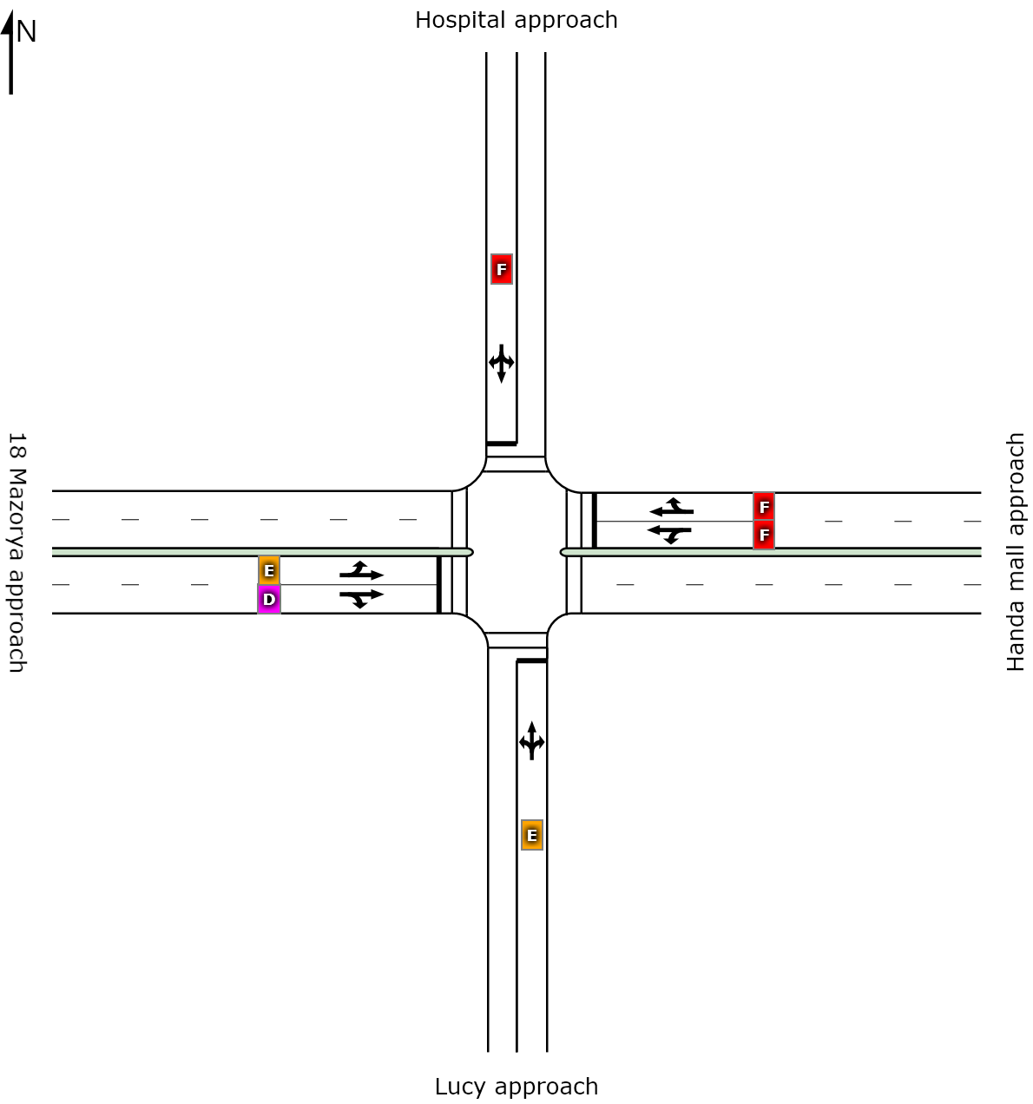
 | South | East | North | West | Intersection
LOS | E | F | F | D | E

Figure 4.18 the layout and level of service values of Menharya signalized intersection when three wheelers replaced by minibus.

4.4.1.1 Comparing the performance change of Menharya signalized intersections when three

wheelers replaced by mini bus.
Table 4.24 Comparison of the difference between previous (with three wheelers) and current
(when three wheelers replaced by minibus) level of services for Menharya intersection.
Approach name | Previous Level of Service (LOS) | Current Level of Service (LOS) | Remark
Hospital | F | E | Improved
Lucy | E | E | Same
18 mazorya | E | E | Same
Handa Mall | F | F | Same
Intersection | F | E | Improved

When three wheelers replaced by minibus at Menharya signalized intersection, the intersection was improved by LOS from F to E.

Table 4.25 Comparison of the difference between previous (with three wheelers) and current
(when three wheelers replaced by minibus) signal delay time (sec) of Menharya intersection.
Approach | Previous Signal Delay time in sec | Current Signal Delay time in sec | Difference
Hospital | 234.3 | 95.5 | 138.8
Lucy | 65.7 | 59.4 | 6.3
18 Mazorya | 65.8 | 53.4 | 12.4
Handa Mall | 243.9 | 93.6 | 150.3
Intersection | 171.5 | 78.7 | 92.8

Figure 4.19 Comparison of the difference between previous (with three wheelers) and current (when three wheelers replaced by minibus) signal delay time (sec) of Menharya intersection.
As a result, shows above, there was a clear improvement in delay when Three wheelers replaced by minibus as an approach and as an intersection. 59.2% delay of Hospital approach, 9.6 % delay of Lucy approach, 18.8% delay of 18 mazoriya approaches, and 61.6% delay of Handa mall approach is improved when Three wheelers replaced by minibus.
Generally, 54.1% delay of Menharya signalized intersection is improved when Three wheelers replaced by minibus.
Table 4.26 Comparison of the difference between previous (with three wheelers) and current
(when three wheelers replaced by minibus) degree of saturation of Menharya intersection.
Approach | Previous degree of saturation | The current degree of saturation | difference
Hospital | 1.341 | 0.918 | 0.423
Lucy | 0.587 | 0.408 | 0.179
18 Mazorya | 0.766 | 0.508 | 0.258
Handa Mall | 1.374 | 0.939 | 0.435
Intersection | 1.374 | 0.939 | 0.435

Figure 4.20 Comparison of the difference between previous (with three wheelers) and current (when three wheelers replaced by minibus) degree of saturation of Menharya intersection.

From the above output 31.5% degree of saturation of the Hospital approach, 30. 5% degree of saturation of Lucy approach, 33.7% degree of saturation of 18 mazoriya approaches, and 31.7% degree of saturation of Handa mall approach is improved when Three wheelers replaced by minibus. Generally, a 31.7% degree of saturation of Menharya signalized intersection is improved when Three wheelers replaced by minibus.
Table 4.27 Comparison of the difference between previous (with three wheelers) and current
(when three wheelers replaced by minibus) queue length of Menharya intersection.
Approach | Previous 95% back of queue length (m) | Current 95% back of queue length (m) | Difference
Hospital | 312.2 | 123.4 | 188.8
Lucy | 62.9 | 42.3 | 20.6
18 Mazorya | 136.4 | 82.1 | 54.3
Handa Mall | 497.4 | 201.5 | 295.9
Intersection | 497.4 | 201.5 | 295.9

Figure 4.21 Comparison of the difference between previous (with three wheelers) and current (when three wheelers replaced by minibus) queue distance of Menharya intersection.
As a result, shows above, there was a clear improvement in queue distance when three wheelers replaced by minibus as an approach and as an intersection. 60.5% queue distance of the Hospital approach, 32.8% Queue distance of Lucy approach, 39.8% queue distance of 18 mazoriya approaches, and 59.5% queue distance of Handa mall approach is improved when three wheelers replaced by minibus.
Generally, 59.5% queue length of Menharya signalized intersection is improved when three wheelers replaced by minibus.
As a summary, performance measurement parameters of the Menharya signalized intersection improved when three wheelers replaced by minibus.

4.4.2. Performance evaluation of Maryam signalized intersection when three wheelers

replaced by minibus.
When three wheelers replaced by minibus, Maryam signalized intersection has a summarized performance measurement parameters of 58.9sec delay, 0.499 degree of saturation, 95% queue length of 127m and LOS of D.
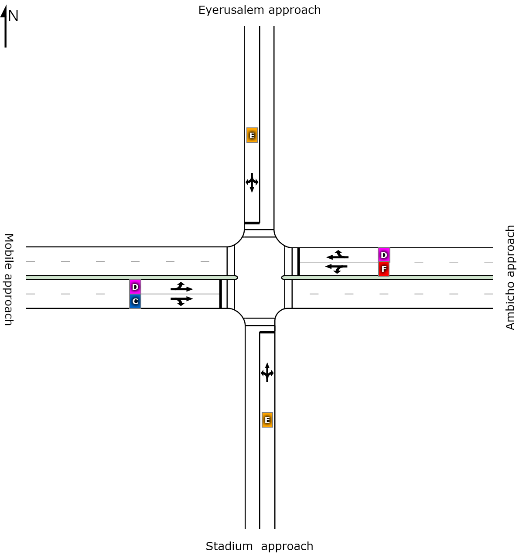
 | South | East | North | West | Intersection
LOS | E | D | E | D | D

Figure 4. 22 The layout and level of service values of Maryam signalized intersection when three wheelers replaced by minibus.

4.4.2.1 Comparing the performance change of Maryam signalized intersections when

three wheelers replaced by mini bus.
Table 4.28 Comparison of the difference between Previous (with three wheelers) and Current
(when three wheelers replaced by minibus) level of services for Maryam intersection.
Approach name | Previous Level of Service (LOS) | Current Level of Service (LOS) | Remark
Eyeruslem | F | E | Improved
Stadium | F | E | Improved
Mobile | D | D | Same
Ambicho | F | D | Improved
Intersection | E | D | Improved

There is a LOS improvement for all approaches except Mobile approach.
Table 4.29 Comparison of the difference between previous (with three wheelers) and current
(when three wheelers replaced by minibus) signal delay time (sec) of Maryam intersection.
Approach | Previous Signal Delay time in sec | Current Signal Delay time in sec | Difference
Eyeruslem | 91.4 | 72.6 | 18.8
Stadium | 93.1 | 72.8 | 20.3
Mobile | 47.9 | 38.3 | 9.6
Ambicho | 61.5 | 45.3 | 16.2
Intersection | 60.7 | 49 | 11.7

Figure 4.23 Comparison of the difference between previous (with three wheelers) and current (when three wheelers replaced by minibus) signal delay time (sec) of Maryam intersection.
As a result, shows above, there was a clear improvement in delay when Three wheelers replaced by minibus as an approach and as an intersection. 20.6% delay of Eyeruslem approach, 21.8 % delay of Stadium approach, 20.0% delay of Mobile approach, and 26.3% delay of Ambicho approach is improved when Three wheelers replaced by minibus.
Generally, a 19.3% delay of Maryam signalized intersection is improved when three wheelers replaced by minibus.
Table 4.30 Comparison of the difference between previous (with three wheelers) and current
(when three wheelers replaced by minibus) degree of saturation of Maryam intersection.
Approach | Previous degree of saturation | The current degree of saturation | difference
Eyeruslem | 0.778 | 0. 553 | 0.225
Stadium | 0.796 | 0. 563 | 0.233
Mobile | 0.367 | 0.269 | 0.098
Ambicho | 0.852 | 0.576 | 0.276
Intersection | 0.852 | 0.576 | 0.276

From the above output, 28.9% degree of saturation of the Eyeruslem approach, 29.3% degree of saturation of Stadium approach, 26.7% degree of saturation of Mobile approach, and 32.4% degree of saturation of the Ambicho approach is improved when three wheelers replaced by minibus.
Generally, a 32.4 % degree of saturation of Maryam signalized intersection is improved when three wheelers replaced by minibus.
Table 4.31 Comparison of the difference between previous (with three wheelers) and current
(when three wheelers replaced by minibus) queue length of Maryam intersection.
Approach | Previous 95% back of queue length (m) | Current 95% back of queue length (m) | Difference
Eyeruslem | 63.3 | 45.7 | 17.6
Stadium | 62.6 | 44.1 | 18.5
Mobile | 81.1 | 56.9 | 24.2
Ambicho | 253.3 | 137.9 | 115.4
Intersection | 253.3 | 137.9 | 115.4

As a result, summarized above, there was a clear improvement in queue length when three wheelers replaced by minibus as an approach and as an intersection. 27.8% queue length of the Eyeruslem approach, 29.6% queue length of Stadium approach, 29.8% queue length of Mobile approach and 45.6% queue length of the Ambicho approach is improved when Three wheelers replaced by minibus.
Generally, 45.6% queue distance of Maryam signalized intersection is improved when three wheelers replaced by minibus.
As a summary, performance measurement parameters of Maryam signalized intersection improved when three wheelers replaced by minibus.

4.4.3. Performance evaluation of Bezabh Petros roundabout when three wheelers

replaced by minibus.
Table 4.32 the lane use and performance output for Bezabh Petros roundabout when three
wheelers replaced by minibus.
Approaches | Demand flows |  |  |  | HV  % | Cap  veh/h | Deg  satn | Lane  util | Average  Delay  Sec | Level of service | 95% of Queue
Approaches | L  veh/h | T  veh/h | R  veh/h | Total  veh/h |  |  |  |  |  |  | Vehicles  Veh | Length  M
South: Menharya Approach
Lane 1 | 9 | 363 | 0 | 373 | 34.1 | 640 | 0.583 | 100 | 16.1 | LOS B | 4.1 | 37.1
Lane 2 | 0 | 46 | 384 | 431 | 20.7 | 739 | 0.583 | 100 | 14.3 | LOS B | 4.1 | 34.0
Approach | 9 | 410 | 384 | 803 | 26.9 |  | 0.583 |  | 15.2 | LOS B | 4.1 | 37.1
South East: Maremiya approach
Lane 1 | 16 | 0 | 20 | 36 | 0.0 | 388 | 0.094 | 100 | 10.7 | LOS B | 0.5 | 3.5
Approach | 16 | 0 | 20 | 36 | 0.0 |  | 0.094 |  | 10.7 | LOS B | 0.5 | 3.5
East: Mobile approach
Lane 1 | 442 | 0 | 0 | 442 | 24.0 | 511 | 0.866 | 100 | 41.7 | LOS D | 11.1 | 94.0
Lane 2 | 0 | 0 | 239 | 239 | 16.0 | 569 | 0.866 | 100 | 12.9 | LOS B | 2.4 | 19.5
Approach | 442 | 0 | 239 | 681 | 21.2 |  | 0.866 |  | 31.6 | LOS C | 11.1 | 94.0
North: Mesalemiya approach
Lane 1 | 187 | 120 | 0 | 307 | 24.5 | 481 | 0.639 | 100 | 23.0 | LOS C | 5.2 | 44.3
Lane 2 | 0 | 252 | 52 | 304 | 25.3 | 476 | 0.639 | 100 | 23.2 | LOS C | 5.2 | 44.4
Approach | 187 | 373 | 52 | 611 | 24.9 |  | 0.639 |  | 23.1 | LOS C | 5.2 | 44.4
South West: Hadiyya pharmacy approach
Lane 1 | 40 | 0 | 22 | 62 | 18.7 | 302 | 0.205 | 100 | 16.0 | LOS B | 1.1 | 9.0
Approach | 40 | 0 | 22 | 62 | 18.7 |  | 0.205 |  | 16.0 | LOS B | 1.1 | 9.0
Intersection |  |  |  | 2194 | 23.9 |  | 0.866 |  | 22.4 | LOS C | 11.1 | 94.0

As shown above table, when Three wheelers replaced by mini bus, Bezabh petros roundabout has average delay of 22.4sec, degree of saturation of 0.866, 95% queue length of 94m and LOS of C. So there is an improvement of performances in this condition and detail comparisons are discussed below.

4.4.3.1 Comparing the performance change of Bezabhpetros roundabout when three wheelers

replaced by mini bus.
Table 4.33 Comparison of the difference between Previous (with three wheelers) and Current
(when three wheelers replaced by minibus) level of services for Bezabh Petros roundabout.
Approach name | Previous Level of Service (LOS) | Current Level of Service (LOS) | Remark
Menharya | B | B | Same
Mesalemiya | B | B | Same
Mobile | D | C | Improved
Hadiyya pharmacy | B | B | Same
Maremiya | B | B | Same
Intersection | C | C | Same

There is a LOS improvement of only the mobile approach from D to C., But as a roundabout, there is no improvement of LOS when Three wheelers replaced by minibus.
Table 4.34 Comparison of the difference between previous (with three wheelers) and current
(when three wheelers replaced by minibus) signal delay time (sec) of Bezabh
Petros roundabout.
Approach name | Previous delay time in sec | Current delay time in sec | Difference
Menharya | 15.7 | 15.2 | 0.5
Mesalemiya | 26.4 | 23.1 | 3.3
Mobile | 43.9 | 31.6 | 12.3
Hadiyya pharmacy | 17.9 | 16 | 1.9
Maremiya | 13.4 | 10.7 | 2.7
Intersection | 27.1 | 22.4 | 4.7

As a result, shows above, there was a clear improvement in delay when Three wheelers replaced by minibus as an approach and as a roundabout. 3.2% delay of the Menharya approach, 12.5% delay of Mesalemiya approach, 28.0 % delay of Mobile approach, 10.6% delay of Hadiyya pharmacy approach, and 20.1% delay of Maremiya approach is improved when Three wheelers replaced by minibus.
Generally, a 17.3% delay of Bezabh Petros roundabout is improved when Three wheelers replaced by minibus.
Table 4.35 Comparison of the difference between previous (with three wheelers) and current
(when three wheelers replaced by minibus) degree of saturation of Bezabh Petros roundabout.
Approach name | Previous degree of saturation | The current degree of saturation | Difference
Menharya | 0.66 | 0.583 | 0.077
Mesalemiya | 0.731 | 0.639 | 0.092
Mobile | 0.98 | 0.866 | 0.114
Hadiyya pharmacy | 0.262 | 0.205 | 0.057
Maremiya | 0.164 | 0.094 | 0.07
Intersection | 0.980 | 0.866 | 0.114

Figure 4.24 Comparison of the difference between previous (with three wheelers) and current (when three wheelers replaced by minibus) degree of saturation of Bezabh Petros roundabout.
From the above output 11.7% degree of saturation of Menharya approach, 12.6% degree of saturation of Mesalemiya approach, 11.6% degree of saturation of Mobile approach, 21.8% degree of saturation of Hadiyya pharmacy approach and 42.7% degree of saturation of Maremiya approach is improved when three wheelers replaced by minibus.
Generally, an 11.6% degree of saturation of Bezabh Petros roundabout is improved when three wheelers replaced by minibus.
Table 4.36 Comparison of the difference between previous (with three wheelers) and current
(when three wheelers replaced by minibus) queue length (m) of Bezabh Petros roundabout.
Approach name | Previous 95% back of queue length (m) | Current 95% back of queue length (m) | Difference
Menharya | 48.8 | 37.1 | 11.7
Mesalemiya | 62.6 | 44.1 | 18.5
Mobile | 162.7 | 94.0 | 68.7
Hadiyya pharmacy | 12.3 | 9.0 | 3.3
Maremiya | 6.5 | 3.5 | 3
Intersection | 162.7 | 94.0 | 68.7

As a result, shows above, there was a clear improvement in queue length when Three wheelers replaced by minibus as an approach and as an intersection. 24.0% queue length of the Menharya approach, 29.6% queue length of Mesalemiya approach, 42.3% queue length of Mobile approach, 26.9% queue length of Hadiyya pharmacy approach and 46.2% queue length of Maremiya approach is improved when Three wheelers replaced by minibus.
Generally, 42.3% queue distance of Bezabh Petros roundabout is improved when Three wheelers replaced by minibus.
As a summary, there is an improvement in performance measurement parameters of Bezabh Petros roundabout when three wheelers replaced by minibus.

4.4.4. Performance evaluation of Eyerusalem roundabout when three wheelers replaced

by minibus.
When Three wheelers replaced by minibus, Eyerusalem roundabout has an average delay of 8.2 sec, degree of saturation of 0.345, 95% queue length of 16.8m and LOS of A. there is improvement on performance of the roundabout and the detail comparison was shown clearly at next portion.
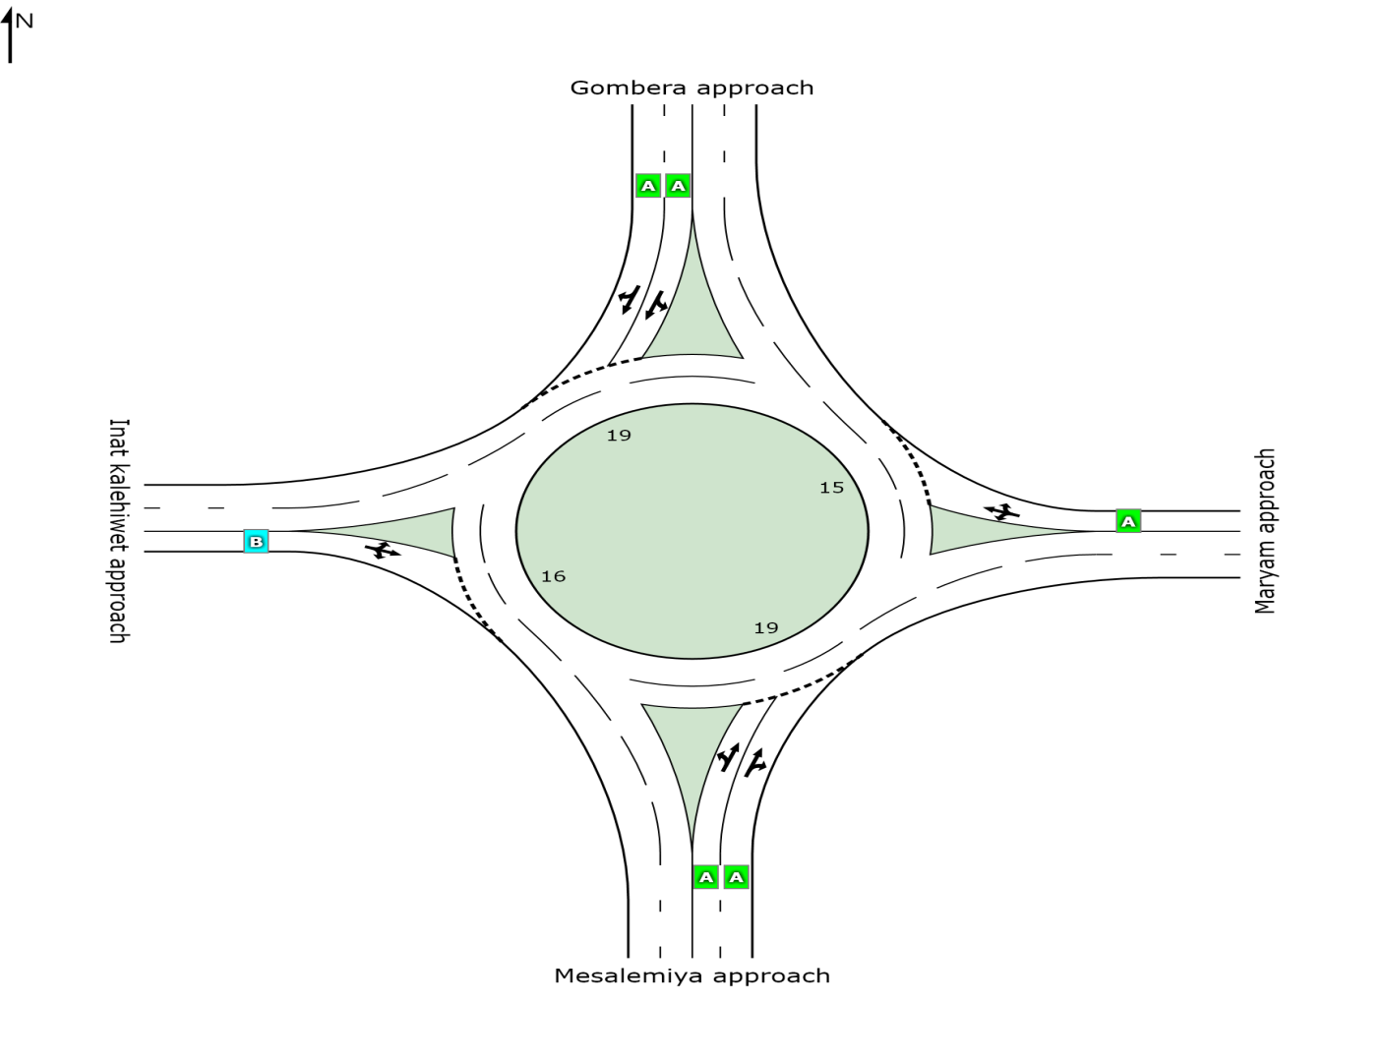
 | South | East | North | West | Intersection
LOS | A | A | A | B | A

Figure 4.25 The layout and level of service values of Eyerusalem roundabout when three wheelers replaced by minibus

4.4.4.1. Comparing the performance change of Eyerusalem roundabout when three wheelers

replaced by mini bus.
Table 4.37 Comparison of the difference between previous (with three wheelers) and current
(when three wheelers replaced by minibus) level of services for Eyerusalem roundabout.
Approach name | Previous Level of Service (LOS) | Current Level of Service (LOS) | Remark
Mesalemiya | A | A | Same
Maryam | B | A | Improved
Gombera | A | A | Same
Inatkalehiwet | B | B | Same
Intersection | B | A | Improved

There is LOS improvement at Maryam approach from B to A, and as a roundabout, LOS is improved from B to A when three wheelers replaced by minibus.
Table 4.38 Comparison of the difference between Previous (with three wheelers) and Current
(when three wheelers replaced by minibus) signal delay time (sec) of Eyerusalem roundabout.
Approach name | Previous delay time in sec | Current delay time in sec | Difference
Mesalemiya | 8.1 | 4.5 | 3.6
Maryam | 12.4 | 5.5 | 6.9
Gombera | 9.7 | 8.7 | 1
Inat kalehiwet | 17.5 | 13.7 | 3.8
Intersection | 10.1 | 8.5 | 1.6

Figure 4.26 Comparison of the difference between previous (with three wheelers) and current (when three wheelers replaced by minibus) signal delay time (sec) of Eyerusalem roundabout.
As a result, shows above, there was a clear improvement in delay when three wheelers replaced by minibus as an approach and as a roundabout. 44.4% delay of Mesalemiya approach, 55.6% delay of Maryam approach, 10.3% delay of Gombera approach, and 21.7% delay of Inat kalehiwet approach is improved when three wheelers replaced by minibus.
Generally, an 15.8% delay of Eyerusalem roundabout is improved when three wheelers replaced by minibus.
Table 4.39 Comparison of the difference between previous (with three wheelers) and current
(when three wheelers replaced by minibus) degree of saturation of Eyerusalem roundabout.
Approach name | Previous degree of saturation | The current degree of saturation | difference
Mesalemiya | 0.387 | 0.085 | 0.302
Maryam | 0.37 | 0.1 | 0.27
Gombera | 0.441 | 0.37 | 0.071
Inatkalehiwet | 0.423 | 0.318 | 0.105
Intersection | 0.441 | 0.37 | 0.071

Figure 4.27 Comparison of the difference between previous (with three wheelers) and current (when three wheelers replaced by minibus) degree of saturation of Eyerusalem roundabout.
From the above output, 78.0% of the Mesalemiya approach, 73.0% degree of saturation of Maryam approach, 16.1% degree of saturation of Gombera approach, and 24.8% degree of saturation of Inat kalehiwet approach is improved when three wheelers replaced by minibus.
Generally, a 16.1% degree of saturation of Eyerusalem roundabout is improved when three wheelers replaced by minibus.
Table 4.40 Comparison of the difference between previous (with three wheelers) and current
(when three wheelers replaced by minibus) queue length (m) of Eyerusalem roundabout.
Approach name | Previous 95% back of queue length (m) | Current 95% back of queue length (m) | Difference
Mesalemiya | 18 | 3.1 | 14.9
Maryam | 16.1 | 4.1 | 12
Gombera | 22.5 | 17 | 5.5
Inat kalehiwet | 16.3 | 10.6 | 5.7
Intersection | 22.5 | 17 | 5.5

Figure 4.28 Comparison of the difference between previous (with three wheelers) and current (when three wheelers replaced by minibus) queue length (m) of Eyerusalem roundabout.
As a result, shows above, there was a clear improvement in Queue length when three wheelers replaced by minibus as an approach and as an intersection. 82.8% queue length of Mesalemiya approach, 74.5% queue length of Maryam approach, 24.4% Queue length of Gombera approach, and 35.0% queue length of Inat kalehiwet approach is improved when three wheelers replaced by minibus.
Generally, 24.4% Queue distance of Eyerusalem roundabout is improved when three wheelers replaced by minibus.
As a summary, there is an improvement in performance measurement parameters of Bezabh Petros roundabout when three wheelers replaced by minibus.

4.4.5 Summary on intersection performances when three wheelers replaced by mini bus.
When three wheelers replaced by minibus, there was improvement on performance of intersections. For Menharya signalized intersection When Three wheelers replaced by mini bus, average delay changed from 171.5 sec to 78.7sec, degree of saturation reduced from 1.374 to 0.939, queue length reduced from 497.4m to 201.5m and LOS improved from F to E. For Maryam signalized intersection, When three wheelers replaced by mini bus, average delay reduced from 60.7 sec to 49sec, degree of saturation reduced from 0.852 to 0.576, queue length reduced from 253.3m to 137.9m and LOS improved from E to D.
In Bezabh Petros roundabout and in Eyerusalem roundabout, there is also clear improvement of intersection performances when three wheelers replaced by mini bus. For Bezabh Petros roundabout When three wheelers replaced by mini bus, average delay reduced from 27.1 sec to 22.4 sec, degree of saturation reduced from 0.980 to 0.866 and queue length reduced from 162.7m to 94.0m.For Eyerusalem roundabout, When three wheelers replaced by mini bus, average delay reduced from 10.1 sec to 8.5 sec, degree of saturation reduced from 0.441 to 0.37, queue length reduced from 22.5m to 17m and LOS improved from B to A.

5. CONCLUSIONS AND RECOMMENDATIONS

5.1. Conclusions
Based on the findings of the analysis in this study, the result of analysis for Menharya signalized intersection of the Hosanna City indicated that the intersection is in serious condition and Maryam signalized intersection is also in congested condition.
- During the peak periods, Menharya signalized intersection has the average delay of 171.5sec, queue length of 497.4m, degree of saturation of 1.374 and the level of service was "F."
- Maryam signalized intersection also has a high average delay of 60.7sec, the queue length of 253.3m, degree of saturation of 0.852, and level of service of "E."
- Both Bezabh Petros roundabout and Eyerusalem roundabouts have relatively good LOS of C and B, respectively.
Three wheelers are highly affecting the performance measurement parameters of intersections. For Menharya signalized intersection when three wheelers removed,
- The Average delay decreases from 171.5sec to 50.6 sec, degree of saturation decreases from 1.374 to 0.199, LOS improved from F to D and queue length decreases from 497.4m to 30.9m. That means 70.5% cause for delay, 85.5% cause for a degree of saturation, and 93.8% cause for the queue distance of Menharya signalized intersection is three wheeler's presence.
- In the same manner for Maryam signalized intersection, 17.1% cause of delay. 82.2% cause of degree of saturation, and 90.7% cause of queue length is three wheeler's presence.
- As explained in the last chapter, Bezabh Petros roundabout and Eyerusalem roundabout's performance measurement parameters are also affected highly due to the presence of three wheelers.

By replacing three wheeler vehicles by minibus taxis as a means of public transport in Hosanna city, performance improvement will be gained under the prevailing conditions. The improvement is significant for all intersections.
- For Menharya signalized intersection, 54.1% Average delay, 31.7% degree of saturation and 59.5% queue distance improved when three wheelers replaced by minibus. LOS also improved from F to E.
- For Maryam signalized intersection, 19.3% Average delay, 32.4% degree of saturation and 45.6% queue distance improved when three wheelers replaced by minibus. LOS also improved from E to D.
- For Bezabh Petros roundabout, 17.3% Average delay, 11.7% degree of saturation and 42.25% queue distance improved when three wheelers replaced by minibus and
- For Eyerusalem roundabout, 15.8% Average delay, 16.1% degree of saturation and 24.4% queue distance is improved when three wheelers replaced by minibus. LOS also improved from B to A.

5.2. Recommendations
- One way to improve intersection performances is to replace the three wheelers with minibus as a public transport option. So the concerned body should apply this recommendation.
- The assumptions made in replacing three wheelers vehicles by minibus taxis shall be studied thoroughly, and the cost-benefit analysis shall be done in replacing the two-vehicle classes.
- The effect of heavy vehicles on performance measurement parameters of intersection should also be done.
- The passenger car unit used in this research is from manuals so it is necessary to assess passenger car unit of vehicles in Hosanna city.
- Since this research assessed only the effect of three wheelers on performance measurement parameters of signalized intersections and roundabouts, it should be analyzed for unsignalized intersections also.

REFERENCES
Abojaradeh M, 2013 “Travel Time and Delay Study to Improve Public Transit Systems in
Jordan” Journal of Environment and Earth Science issued from IISTE USA
Volume 3, No. 4, pp 85-97.
AACRA (Addis Ababa City Roads Authority), 2004 “Geometric Design Manual".
Ahmed, 2018 “Analysis of traffic congestion and remedial measures at traffic mor in pabna
city” Bangladesh.
Akcelik R, 2002 “Evaluating Roundabout Capacity, Level of Service and Performance”
Paper presented at the ITE 2009 Annual Meeting. Texas, USA.
Akcelik, R, 2017 “Roundabout model comparison table”.Akcelik and Associates Pty Ltd,
Melbourne, Australia.
Akcelik & Associates Pty Ltd, 2011.“SIDRA INTERSECTION user guide part 4” output
Guide, Australia.
Borkloe J K, Nyantakyi E K and Mohammed G, 2013“Capacity Analysis of Selected
Intersections on Mampong Road, Kumasighana Using Micro Simulation Model”.
International Journal of Structural and Civil Engineering Research.
FHWA (Federal Highway Administration), 2009. ROUNDABOUTS: An Informational
Guide U.S Department of Transportation (USDOT), Washington, DC.
FHWA (Federal Highway Administration), 2009 ROUNDABOUTS: An Informational
Guide U.S Department of Transportation (USDOT), Washington, DC.
Fisk, C.S, 1991 “Traffic Performance Analysis at Roundabouts” Transportation Research,
Vol. 25B, Bi 2/3. pp. 89-102.
Garber, 2010.Traffic and Highway Engineering 4th SI Edition, USA.
HCM (Highway Capacity Manual) 2010 Transportation Research Board's (TRB) fifth edition
of the Highway Capacity Manual HCM, Washington D.C USA.

Henry X. Liu, Wenteng Ma, Xinkai Wu, and HengHu ,2009 “Development of a Real Time
Arterial Performance Monitoring System Using Traffic Data Available from Existing
Signal System” Department of Civil Engineering University of Minnesota 500
Pillsbury Dr. SE Minneapolis, Minnesota 55455-0220, 2009.
Hossana Municipality, 2019.
Kumar N and Nagakumar M S, 2014 “Performance Evaluation of At-Grade Intersections and
Improvement Using Signal Coordination”.
Mallikarjuna R, 2014 “Operational Analysis of Roundabouts under Mixed Traffic Flow
Condition” M. Tech Thesis National Institute of Technology, Rourkela, India.
MASS HIGHWAY, 2006, Chapter 6 intersection January 2006.
McShane W, and Roess R, 1990 Traffic Engineering, New Jersey, Prentice Hall, Inc, pp 509
548 Papacostas C., Prevedonros P, 2008, Transportation Engineering and Planning,
Fourth Edition, USA.
Mordidpour, S, 2014 “Impact of heavy vehicles on surrounding traffic characteristics”
September 12, 2014.
Nurhussien Belay,2015 “Performance Evaluation of Selected Intersections in Bahirdar City”
Msc Thesis.Department of Civil Engineering, Addis Ababa University,Addis Ababa.
Papacostas C, Prevedonros P, 2008 Transportation Engineering and Planning, Fourth
Edition, USA.
RaoSh , 2015. “Performance Analysis of Roundabouts Using Empirical Method for Indian
Scenario” National Institute of Technology, Rourkela, India.
Roess, 2004 “Traffic engineering 3rd edition ”.
Saha.K, 2013 “Analysis of traffic congestion and remedial measures at traffic mor in pabna
City, Bangladesh”.
Syoum.B, 2018 “The Effects of Traffic Mixes with 3-Wheelers on Performance of
Unsignalized Intersections in Harar City” MSc Thesis, Department of Civil
Engineering, Addis Ababa University, Addis Ababa.

Tewodros G,2017 “Capacity Evaluation of Roundabout Junctions in Addis Ababa” MSc
Thesis, MSc Thesis.Department of Civil Engineering, Addis Ababa University,
Addis Ababa.
Tom V. Mathew and K V Krishna Rao, 2006 “Introduction to Transportation Engineering”
NPTEL, May 24, 2006.
Transportation office of Hosanna City, 2019.
Transportation Research Board, 2000 Highway Capacity Manual,National Research Council,
Washington D.C, chapter 19.

APPENDICES
Appendix I
Signalization data existing in signalized intersection

For Menharya Signalized Intersection

Phase | A | B | C | D
Green Time (sec) | 29 | 24 | 24 | 29
Yellow Time (sec) | 4 | 4 | 4 | 4
All-Red Time (sec) | 2 | 2 | 2 | 2

For Maryam Signalized Intersection

Phase | A | B | C | D
Green Time (sec) | 25 | 28 | 28 | 25
Yellow Time (sec) | 4 | 4 | 4 | 4
All-Red Time (sec) | 2 | 2 | 2 | 2

Appendix II

Layouts and performance outputs of intersections.

Table 1.The lane use and performance output for Maryam signalized intersection without three
wheelers.
Approaches | Demand flows |  |  |  | HV  % | Cap  veh/h | Deg  satn | Lane  Util | Average  Delay  Sec | Level of services | 95% of Queue
Approaches | L  veh/h | T  veh/h | R  veh/h | Total  veh/h |  |  |  |  |  |  | Vehicles  Veh | Distance  M
South: Stadium approach
Lane 1 | 16 | 6 | 10 | 31 | 28.8 | 207 | 0.152 | 100 | 54.2 | LOS D | 1.8 | 16.1
Approach | 16 | 6 | 10 | 31 | 28.8 |  | 0.152 |  | 54.2 | LOS D | 1.8 | 16.1
East: Ambicho approach
Lane 1 | 5 | 4 | 0 | 9 | 32.1 | 59 | 0.152 | 100 | 65.9 | LOS E | 0.6 | 5.3
Lane 2 | 0 | 37 | 1 | 38 | 75.8 | 251 | 0.152 | 100 | 45.0 | LOS D | 2.0 | 23.6
Approach | 5 | 41 | 1 | 47 | 67.5 |  | 0.152 |  | 48.9 | LOS D | 2.0 | 23.6
North: Eyerusalem approach
Lane 1 | 16 | 4 | 9 | 30 | 61.0 | 216 | 0.138 | 100 | 52.2 | LOS D | 1.7 | 18.3
Approach | 16 | 4 | 9 | 30 | 61.0 |  | 0.138 |  | 52.2 | LOS D | 1.7 | 18.3
West: Mobile approach
Lane 1 | 3 | 5 | 0 | 8 | 39.1 | 61 | 0.134 | 100 | 63.1 | LOS E | 0.5 | 5.0
Lane 2 | 0 | 28 | 8 | 36 | 55.0 | 273 | 0.134 | 100 | 44.5 | LOS D | 1.9 | 20.0
Approach | 3 | 33 | 8 | 45 | 52.1 |  | 0.134 |  | 47.9 | LOS D | 1.9 | 20.0
Intersection |  |  |  | 153 | 53.8 |  | 0.152 |  | 50.3 | LOS D | 2.0 | 23.6

Table 2 .The lane use and performance output for Eyerusalem roundabout without three
wheelers.
Approaches | Demand flows |  |  |  | HV  % | Cap  veh/h | Deg  satn | Lane  util | Average  Delay  Sec | Level of services | 95% of Queue
Approaches | L  veh/h | T  veh/h | R  veh/h | Total  veh/h |  |  |  |  |  |  | Vehicles  Veh | Length  M
South: Mesalemiya Approach
Lane 1 | 11 | 146 | 0 | 157 | 38.9 | 841 | 0.186 | 100 | 6.2 | LOS A | 0.9 | 8.2
Lane 2 | 0 | 120 | 37 | 157 | 38.7 | 843 | 0.186 | 100 | 6.2 | LOS A | 0.9 | 8.2
Approach | 11 | 267 | 37 | 314 | 38.8 |  | 0.186 |  | 6.2 | LOS A | 0.9 | 8.2
East: Maryam approach
Lane 1 | 41 | 5 | 34 | 80 | 36.8 | 597 | 0.134 | 100 | 7.6 | LOS A | 0.6 | 5.4
Approach | 41 | 5 | 34 | 80 | 36.8 |  | 0.134 |  | 7.6 | LOS A | 0.6 | 5.4
North: Gombera approach
Lane 1 | 26 | 161 | 0 | 187 | 49.2 | 772 | 0.243 | 100 | 7.4 | LOS A | 1.2 | 11.8
Lane 2 | 0 | 165 | 23 | 188 | 48.5 | 776 | 0.243 | 100 | 7.3 | LOS A | 1.2 | 11.8
Approach | 26 | 326 | 23 | 376 | 48.8 |  | 0.243 |  | 7.4 | LOS A | 1.2 | 11.8
West: Inat kalehiwet approach
Lane 1 | 24 | 19 | 43 | 86 | 13.5 | 460 | 0.187 | 100 | 10.5 | LOS B | 0.7 | 5.8
Approach | 24 | 19 | 43 | 86 | 13.5 |  | 0.187 |  | 10.5 | LOS B | 0.7 | 5.8
Intersection |  |  |  | 856 | 40.5 |  | 0.243 |  | 7.3 | LOS A | 1.2 | 11.8

Table 3. The lane use and performance output for Eyerusalem roundabout when three
wheelers replaced by minibus.
Approaches | Demand flows |  |  |  | HV  % | Cap  veh/h | Deg  satn | Lane  util | Average  Delay  sec | Level of services | 95% of Queue
Approaches | L  veh/h | T  veh/h | R  veh/h | Total  veh/h |  |  |  |  |  |  | Vehicles  Veh | Distance  M
South: Mesalemiya Approach
Lane 1 | 83 | 0 | 0 | 83 | 16.0 | 980 | 0.085 | 100 | 4.4 | LOS A | 0.4 | 3.1
Lane 2 | 0 | 10 | 63 | 73 | 21.4 | 929 | 0.085 | 100 | 4.6 | LOS A | 0.4 | 2.9
Approach | 83 | 10 | 63 | 156 | 18.5 |  | 0.085 |  | 4.5 | LOS A | 0.4 | 3.1
East: Maryam approach
Lane 1 | 41 | 5 | 34 | 80 | 36.8 | 804 | 0.100 | 100 | 5.5 | LOS A | 0.4 | 4.1
Approach | 41 | 5 | 34 | 80 | 36.8 |  | 0.100 |  | 5.5 | LOS A | 0.4 | 4.1
North: Gombera approach
Lane 1 | 40 | 264 | 0 | 304 | 30.4 | 822 | 0.370 | 100 | 8.8 | LOS A | 1.9 | 17.0
Lane 2 | 0 | 267 | 40 | 307 | 29.3 | 829 | 0.370 | 100 | 8.7 | LOS A | 1.9 | 16.9
Approach | 40 | 531 | 40 | 611 | 29.9 |  | 0.370 |  | 8.7 | LOS A | 1.9 | 17.0
West: Inat kalehiwet approach
Lane 1 | 43 | 34 | 61 | 138 | 8.5 | 434 | 0.318 | 100 | 13.7 | LOS B | 1.4 |  | 10.6
Approach | 43 | 34 | 61 | 138 | 8.5 |  | 0.318 |  | 13.7 | LOS B | 1.4 |  | 10.6
Intersection |  |  |  | 984 | 25.6 |  | 0.370 |  | 8.5 | LOS A | 1.9 |  | 17.0

