
ASSESSING PERFORMANCE OF PEDESTRIAN ROAD CROSSWAY ON ADDIS ABABA LIGHT RAIL TRANSIT BASED ON PEDESTRIAN DELAY [A CASE STUDY ON ADDIS ABABA E-W (AYAT-MEGENAGNA LIGHT RAIL TRANSIT LINE)]

M.SC THESIS

KIDIST TESFAYE TADESSE

HAWASSA UNIVERSITY, HAWASSA, ETHIOPIA

DECEMBER, 2020

ASSESSING PERFORMANCE OF PEDESTRIAN ROAD CROSSWAY ON ADDIS ABABA LIGHT RAIL TRANSIT BASED ON PEDESTRIAN DELAY [A CASE STUDY ON ADDIS ABABA E-W (AYAT-MEGENAGNA LIGHT RAIL TRANSIT LINE)]

KIDIST TESFAYE TADESSE

MSC THESIS SUBMITTED TO

HAWASSA UNIVERSITY, DEPARTMENT OF CIVIL ENGINEERING,
INSTITUTE OF TECHNOLOGY, SCHOOL OF POSTGRADUATE
STUDIES, HAWASSA UNIVERSITY, HAWASSA, ETHIOPIA.

IN PARTIAL FULFILLMENT OF THE REQUIREMENT FOR THE DEGREE OF
MASTERS OF SCIENCE IN CIVIL ENGINEERING
(SPECIALIZATION: ROAD AND TRANSPORT ENGINEERING)

DECEMBER, 2020
SCHOOL OF GRADUATE STUDIES
HAWASSA UNIVERSITY
ADVISORS’ APPROVAL SHEET
This is to certify that the thesis entitled “ASSESSING PERFORMANCE OF PEDESTRIAN ROAD CROSSWAY ON ADDIS ABABA LIGHT RAIL TRANSIT BASED ON PEDESTRIAN DELAY: [A CASE STUDY ON THE ADDIS ABABA E-W (AYAT – MEGENAGNA LIGHT RAIL TRANSIT LINE)]” submitted in partial fulfillment of the requirements for the degree of Master of Science with specialization in Road and Transport Engineering, the Graduate Program of the Faculty of Civil Engineering and has been carried out by KIDIST TESFAYE Id. No PGRoTrR/015/11, under my/our supervision. Therefore I/we recommend that the student has fulfilled the requirements and hence hereby can submit the thesis proposal to the department.

Dr. Alemayehu Ambo  30 / 12 / 2020
Name of major advisor Signature Date

Mr. Belete Tsegaye (MSc)_ _______________ 30/ 12 / 2020
Name of the Co-advisor Signature Date

SCHOOL OF GRADUATE STUDIES
HAWASSA UNIVERSITY
EXAMINERS’ APPROVAL SHEET-1
(Submission Sheet-2)
We, the undersigned, members of the Board of Examiners of the defense by KIDIST TESFAYE have read and evaluated his/her thesis entitled ASSESSING PERFORMANCE OF PEDESTRIAN ROAD CROSSWAY ON ADDIS ABABA LIGHT RAIL TRANSIT BASED ON PEDESTRIAN DELAY: (A CASE STUDY ON ADDIS ABABA E-W (AYAT – MEGENAGNA LIGHT RAIL TRANSIT LINE) and examined the candidate. This is, therefore, to certify that the thesis has been accepted in partial fulfillment of the requirements for the degree.
Name of External Examiner Dr. Robeam Solomon Signature 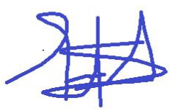 Date: 30 / 12 / 2020
Name of Internal Examiner Dr. Moltot Zewude Signature: Date _
Name of Chairperson Thomas Bezabih (MSc) _Signature: Date __
School Head _Signature: Date __
SGS Approval _Signature: Date __
Final approval and acceptance of the thesis is contingent upon the submission of the final copy of the thesis to the School of Graduate Studies (SGS) through the Department/School Graduate Committee (DGC/SGC) of the candidate’s department.

Stamp of SGS
Date: ____________
ACKNOWLEDGEMENT
I would like to express my deepest gratitude to numerous people, without whom, completing this thesis would not have been successful. The thesis appears in its current form due to the assistance and guidance of several people. First and foremost, I am grateful to the support, valuable guidance and encouragement from my advisors, Dr. Alemayehu Ambo and Mr. Belete Tsegaye. It is wonderful experience working with them.
Secondly, I would like to thank Addis Ababa city traffic management office staffs for their collaboration and positive reactions
Thirdly, I would like to extend my heart-felt gratitude to my family as a whole. I would like to offer my sincere thanks to Getachew Damte, Fikire Yohannes and Tewodros Atsimuye for their help during the data collection phase who gave me hands without hesitation and tolerance of the harsh weather in the field.
Fourthly, I would like to thank Ethiopian Roads Authority (ERA) for giving me this scholarship. Finally, to all people who participated in the research process such as survey respondents, as their involvement has contributed to the success of this work, and for that I am grateful too.

Declaration
I hereby declare that this MSc Specialty or equivalent thesis is my original work and has not been presented for a degree in any other university, and all sources of material used for this thesis / dissertation have been duly acknowledged.
Name: Kidist Tesfaye Tadesse
Signature: ____________
This MSc Specialty or equivalent thesis has been submitted for examination with my approval as thesis advisor.
Name: Dr. Alemayehu Ambo
Signature: ________
Place and Date of Submission: _____________________________

List of Abbreviations
AA Addis Ababa
AACRA Addis Ababa City Roads Authority
AALRT Addis Ababa Light Rail Transit
E-W East West
FDRE Federal Democratic Republic of Ethiopia
GTP Growth & Transportation Plan
HCM Highway Capacity Manual
LOS Level of Service
LRT Light Rail Transit
LRV Light Rail Vehicle
MOE Measure of Effectiveness
PHF Peak Hour Factor
P-delay Pedestrian delay
P-LOS Pedestrian Level of Service
SPSS Statistical Package for the Social Sciences
TCRP Transit Cooperative Research Program
TTI Texas Transportation Institute
TWSC Two-Way Stop Control
V/C Volume Capacity Ratio
VMT Vehicle Miles Traveled
W-E West East

Table of Contents
Declaration iv
List of Abbreviations v
List of Tables v
List of Figures vi
List of Tables in Appendices vii
Abstract viii
1. INTRODUCTION 1
1.1 Background of the Study 1
1.2 Statement of the Problem 2
1.3 Objectives 3
1.3.1 General objective 3
1.3.2 Specific objectives 4
1.4 Research Questions 4
1.5 Scope of the Study 4
1.6 Significance of the Study 5
1.7 Limitation of the Study 5
2. LITERATURE REVIEW 7
2.1 General 7
2.2 Light Rail Transit (LRT) Transport 7
2.3 Alignment-Based classification 7
2.4 Performance Measures of Pedestrian Facilities 9
2.5 Pedestrian Level of Service (P-LOS) 10
2.5.1 Pedestrian Level of Service Concepts 10
2.5.2 Interrupted-Flow Pedestrian Facilities 12
2.5.3 Uninterrupted-Flow Pedestrian Facilities 12
2.6 Factors Which Influence the Pedestrian Crossway Level of Service 13
2.6.1 Pedestrian Factors 13
2.6.1.1 Pedestrain Crossway Behaviour 13
2.6.1.2 Pedestrian Crossway Speed 13
2.6.1.3 Pedestrian Platoons 14
2.6.1.4 Pedestrian Start-Up Time 14
2.6.2 Crosswalk Factors 15
2.6.2.1 Pedestrian Space Requirement for Walking And Standing 15
2.6.2.2 Crosswalk Width 16
2.6.3 Environmental Factors 16
2.6.3.1 Safety 17
2.6.3.2 Convenience 17
2.6.3.3 Comfort 17
2.7 Studies on Pedestrian Level of Service Model 18
2.7.1 Pedestrian Level of Service Studies at Midblock Crosswalk Locations 18
2.7.2 Model Validation 22
3. MATERIALS AND METHODS 23
3.1 Location of the Study Area 23
3.2 Data Collection and Sample Selection Technique 25
3.2.1 Data collection 25
3.2.2 Sample Selection Techniques 29
3.2.3 Data Extraction 33
3.3 Data Analysis 33
3.3.1 Assessment on Pedestrian Crossway 34
3.3.1.1 Interrupted-Flow Pedestrian Facilities 34
3.3.1.2 Uninterrupted-Flow Pedestrian Facilities 42
3.3.2 Determine the Most Influencing Factors to Pedestrian Delay 44
3.4 Develop Regression Model for Pedestrian Delay 45
3.4.1 Assumptions Used for Model Development 46
3.4.2 Validation of The Model 47
4. RESULTS AND DISCUSSIONS 49
4.1 Assessment on Road Environment 49
4.2 LRT Stations and Crosswalk Facilities 49
4.3 Performance of Pedestrian Crossways 51
4.3.1 Interrupted Flow of Pedestrian Level of Service (P-LOS) Based on HCM2010 51
4.3.2 Uninterrupted Flow of Pedestrian Level of Service (P-LOS) Based on HCM2010 56
4.3.2.1 P-LOS based on flow rate (V_{p}) 56
4.3.2.2 P-LOS Based on Average Pedestrian Space (A_{p}) 59
4.3.2.3 P-LOS Based on Volume to Capacity Ratio (V/C) 60
4.4 Most Influencing Factors to Pedestrian Crossway Level of Service 62
4.5 Regression Model for Pedestrian Level of Service 65
4.5.1 Testing Multiple Linear Regression Assumptions 65
4.5.2 Model Development 69
4.5.3 Validation of the Model 71
4.6 Comparsion of Pedestrian Perception 73
4.6.1 LRT Effect on Disabilities 74
4.6.2 Pedestrians Attitude Survey 74
5. CONCLUSIONS AND RECOMMENDATIONS 76
5.1 Conclusions 76
5.2 Recommendations 77
References 79
APPENDIX A 81
APPENDIX B 90
APPENDIX C 93

List of Tables
Table 2.1: Classification of LRT alignments 8
Table 2.2: Main Considerations to Determine P-LOS from Different Publications 11
Table 2.3: Default start-up time (HCM, 2010) 15
Table 2.4: Comparison of Human Ellipse 16
Table 2.5: Various Pedestrian LOS Studies at Midblock Crosswalk Location…………………………………………………………. 20
Table 2.6: Various Pedestrian LOS Models Developed at Midblock Crosswalk Locations 21
Table 3.1: E-W LRT line station 24
Table 3.2: Selected pedestrian and vehicles counting days 31
Table 3.3: Passenger car units for vehicles 38
Table 3.4: Level-of-service criteria for pedestrian at TWSC (HCM, 2010) 41
Table 3.5: LOS for pedestrian at stairways (HCM, 2010) 44
Table 3.6: Factors considered in development of the model 45
Table 3.7: List of variables 47
Table 4.1: Pedestrian crossing location facilities along East-West route (Ayat-Megenagna) 50
Table 4.2: Summary of site measured stairway geometries 51
Table 4.3: Calculated P-LOS 52
Table 4.4: Calculated pedestrian flow rate for EW1 and EW2 53
Table 4.5: Calculated pedestrian flow rate for EW4 and EW8 54
Table 4.6: Calculated vehicular flow rate for EW1, EW2, EW4 and EW8 55
Table 4.7: Volume of pedestrians during peak periods 56
Table 4.8: P-LOS for uninterrupted flow based on flow rate 58
Table 4.8: P-LOS for uninterrupted flow based on flow rate 59
Table 4.9: Pedestrian speed in each station 59
Table 4.10: P-LOS for uninterrupted flow based on average pedestrian space 60
Table 4.11: P-LOS for uninterrupted flow based on volume to capacity values 61
Table 4.12: Correlations between short listed variables 63
Table 4.13: Correlations between dependent variable and constant variables 65
Table 4.14: Output after regression analysis 69
Table 4.15: Validation of the developed model 72
Table 4.16: Demographic characteristics of pedestrians 75

List of Figures
Figure 2.1: Pedestrian Body Ellipse and Pedestrian Walking Space Requirement (HCM, Highway Capacity Manual 2010, 2010) 15
Figure 3.1: Geographic location of the study area. 23
Figure 3.2: A case study on E-W LRT line from Ayat to Megenagna (CREC, Schematic Design of Addis Ababa East-West and North-South (phase 1) LRT Project, 2012) 25
Figure 3.3: Camera setup location at Ayat 2 LRT terminal station 27
Figure 3.4: Camera setup location at CMC 2/Meri LRT station 27
Figure 3.5: Camera setup location at St. Michael church LRT station 28
Figure 3.6: Location at Gurd Shola LRT station 28
Figure 3.7: Ground surface station of LRT line (CREC, 2009) 30
Figure 4.1: Histogram of Frequency vs. Regression standardized residual 66
Figure 4.2: Normal p-p plot of pedestrian delay 66
Figure 4.3: Scatter plot Regression standardized Predicted value vs. Pedestrian delay 66
Figure 4.4: Scatter plot: Pedestrian perceived safety vs. Pedestrian delay 66
Figure 4.5: Scatter plot: Age vs. Pedestrian delay 67
Figure 4.6: Scatter plot: Crossing marking vs. Pedestrian delay 67
Figure 4.7: Scatter plot: Waiting time vs. Pedestrian delay 67
Figure 4.8: Scatter plot: Pedestrian speed vs. Pedestrian delay 67
Figure 4.9: Scatter plot: Pedestrian perceived convenience vs. Pedestrian delay 67
Figure 4.10: Scatter plot: Pedestrian perceived comfort vs. Pedestrian delay 67
Figure 4.11: The comparison between the predicted and observed P-delay 73
Figure 4.12: Wheelchair users got difficulties to cross through the LRT line. 74

List of Tables in Appendices
Table A.1: Average pedestrian walking speed 82
Table A.2: Average headway and MYR 86
Table B-3: Descriptive statistics 91
Table B-4: Model summery 91
Table B-5: Residuals Statisticsª 91
Table B-6: Coefficients of variables 92

Abstract
This research focuses on Addis Ababa East-West Light Rail Transit (LRT) line road section of Ayat to Megenagna which have a length of 7.8 km. It also consists of eight zebra stripped pedestrian crossway. The study attempts to determine the pedestrian level of service of the existing pedestrian crossways by quantifying pedestrian delays, to determine the most influencing factors to pedestrian delays and to develop a regression model for pedestrian delays. Relevant data about pedestrian level of service, pedestrian crossing facilities and pedestrian traffic data was collected and investigated through statistical analysis. Crosswalk facilities were collected from the Addis Ababa Light Rail Transit bureau and directly from geometric measurement to analyze performance of pedestrian crossings, traffic count was conducted on the selected pedestrian crossings. A random survey was done through questioner and structured interviews in order to assess pedestrian’s overall satisfaction level in terms of safety, comfort and convenience for each crossing and usage of crossing facilities based on their experiences. The study analysis shows that the level of service of selected pedestrian midblock, stairways and strail in the road section is above a LOS C, which means pedestrian does not need to alter movement and found are found enough for pedestrians. In addition, the study analysis identifies that the basic parameters that influence the pedestrian delay were age, crosswalk marking, waiting time, pedestrian speed, pedestrian perceived safety, pedestrian perceived convenience and pedestrian perceived comfort through traffic analysis, observation, interview and questioners. Gender, frequency using crosswalk and crosswalk surface condition have not found the influencing factors to pedestrian delay. The effect of each predicted variables on pedestrian delay, multiple linear regression model was developed using SPSS software, seven variables were found statistically significant to predict pedestrian delay at 95% confidence level. The resulting general model has a good correlation coefficient R²=0.716 which means about 71.6% of the variation in pedestrian delay was explained by influencing factors. The regression model is validated and is applicable for midblock crossway integrated with LRT roads. Based on such findings, the following recommendations were drawn to solve those problems, build up off-street parking, discourage private cars, avoiding poor traffic management, and improve pedestrian crossing mark.
Key words: Pedestrian Delay, Traffic, Pedestrian Level of Service, Mid-block Crossways

INTRODUCTION

Background of the Study
It is well known that pedestrians are part of every roadway environment and so consideration is vital to their presence during the planning and design of all transportation projects through provision of efficient pedestrian access, safe and convenient crossway facilities and attractive walkways. In Ethiopia in general and in Addis Ababa, pedestrians are with a high volume due to low level of motorization as in other developing countries. Crossway behavior of pedestrian in Addis Ababa city is rarely in compliance with the regulations, though drivers contribute to this as they do not yield at pedestrian crossway (Tulu, 2013). If the entire transportation system is to function efficiently, planning for the needs and expectations of people who walk is must (Maricopa Association of Government, 2005). It is unquestionable that the purpose of providing adequate crossway facilities along the LRT line and roads is to enhance safe pedestrian’s mobility and increase the operational efficiency of roads for vehicular traffic.
Light Rail Transit (LRT) system is an alternative transportation mode and has been cited as a way to help influence development by promoting more desirable and suitable land uses near the LRT lines. It is also generally less expensive to construct and operate than other kind of rail transit systems. LRT is an attractive option because of its ability to be located in a variety of setting, from tracks on an exclusive right-of-way to shared lanes with vehicles in an urban street. To effectively solve the problem of urban transportation, especially that of the downtown area, the government of Ethiopia decided to build a light rail in the city of Addis Ababa. With the above background that the Federal Democratic Republic of Ethiopia (FDRE) Government in its Growth & Transformation Plan (GTP) is engaged in the implementation of a 475-million-dollar project for Addis Ababa Light Rail Transit (AALRT). It also intends to cover over 2,300 km of railway along eight corridors connecting the potential development areas of Ethiopia. Ethiopian Light rail project was among the 7 out of the 54 countries in Africa using this mode of transportation (CREC, 2009).
Pedestrian delays refer to any time spent waiting to cross, either at the curbside or at the middle of the road. It is natural to use pedestrian delays as a measure of pedestrian quality of service for mid-block street crossing. First, the amount of delay is typically used as the measure of effectiveness for intersections where conflicts frequently occur just as in the case with pedestrian mid-block street crossings. Secondly, the amount of delay also reflects several aspects of the operational conditions faced by pedestrians crossing streets as mid-block locations. These include speed, travel time, and convenience (Baltes & X. Chu, 2002).
Mid-block crosswalks are locations different traffic flow assemble; however, the problems of them are not so obvious as that of intersections, so mid-block crosswalks are always neglected by planners and designers. The unreasonable design and construction of mid-block crosswalks brought about a great deal of conflict and accidents. So, the road designers and managers have to investigate the measures that can make pedestrian feel safe and convenient when crossing the street. Modeling of LOS at mid-block crosswalks for pedestrians can provide an insight on how to accommodate pedestrian travel (Zhao, Y. Bian, J. Lu, & J. Rong, 2014).

Statement of the Problem
Light rail transit has both positive and negative impacts on users. The introduction of LRT system in existing road corridors has advantage of reducing the demand for vehicles, increase safety of train users, decrease pollution of air, waiting time, travel cost and time of train users but it was induced additional delays on vehicles, pedestrians and other public transport users due to interval of crossway.
There are high population densities in pure residential areas such as: condominium (Summit, Ayat 1 and 2, Chefe), CMC, real states (Sunshine, Tsehay, Ayat), etc. in the Eastern part of LRT. All of the residents use this route to come to the center of Addis Ababa to work and go back home since there is no alternative route. The Ayat-Megenagna corridor was selected for this study as it is one of the most congested roads in the city during the peak morning and evening travel times. The fact that the Kotebe Road is currently under construction and Wosen route which is highly congested has increased the pressure on the southern part of the street. In the morning, the main traffic flow is from Ayat, a major residential area in the capital to Megenagna and other commercial and business hubs in Addis Ababa.
From Ayat to Megenagna (E-W) LRT line is about 7.8 km. From Ayat to Megenagna there are about 8 stations and each station is located on ground. This LRT line divides the existing road into two parts and is placed as median. No signalized intersection is available. All LRT stations are at same grade with LRT, vehicle and pedestrian crossway causing high interruption with one another. The minimum distance to get a vehicle turn place is 0.8-km while the maximum is 1.8-km. The average pedestrian crossway interval between stations is 956.875m (Beyene, 2015), so a maximum distance to be covered by a pedestrian to find a crossway is half of the average crossway interval. This is 478.44m for East-West routes of Ayat to Megenagna section. Pedestrians cross four lanes without refuge and signal, waiting time to cross the road and LRT was approximately 1 min in North-South flow direction (Beyene, 2015). Due to this, people use the same station for loading and unloading of the LRT as well as to cross the main road. The faraway located intervals increase pedestrian mobility and travel times to the stations. So, people accommodate and merge at one spot and try to cross the road with high number of vehicles flow to east and west and additionally on-street parking is available around crossways. All of the above-mentioned realities end up with congestion at peak hours and most of the time vehicles give priority to pedestrians at each eight stations causing traffic delays. The installed signage indicates that the entire speed limit of the route is 40 km/h; with this speed, the ideal time (neglecting junctions and other interruptions) to travel the 7.8 km road between Ayat and Megenagna is about 11.7 minutes. However, the maximum time taken to cover the distance during peak hours is 40 minutes (AACRA, 2019). Therefore, it is the main reason for delay of traffic.
This study has a goal to identify whether the pedestrian road crossway is adequate or not adequate leading to decrease traffic delays along the 7.8-km road corridor by determining the pedestrian level of service at the crosswalks. By suggesting the available remedial measurements, it is envisaged to improve the transport management system on the corridor.

Objectives

1.3.1 General objective
The general objective of this study is to assess the performance of pedestrian crossways on Addis Ababa Light Rail Transit based on pedestrian delays: a case study on Addis Ababa E-W (Ayat – Megenagna) light rail transit line.

1.3.2 Specific objectives
The main objectives of the study have been divided into three different specific objectives. These are:
- Determine the P-LOS of the existing pedestrian crossways by quantifying pedestrian delays;
- Determine the most influencing factors to pedestrian delays; and
- Develop a regression model for pedestrian delays.

Research Questions
Keeping in view the research statement of the problem, this study tries to answer the following questions:
- What are the performance levels of the pedestrian crossways along the subject corridor?
- What are the most influencing factors that accounts for pedestrian delays?
- How could the pedestrian delays be minimized?

Scope of the Study
As the topic of pedestrian delay assessment widely touches lots of areas. It is necessary to define the scope of the study so that the untreated topics could be left for other researchers. Accordingly, the scope of this study was limited to the E-W line route of Addis Ababa LRT corridor to assess the pedestrian delays along the Ayat - Megenagna section. Therefore, other road sections and intersections were not included in this study. Furthermore, the analysis was segment-study rather than area wide or regional study. Hence, it is focused mainly on the midblock crossway segments at the entry of selected LRT stations and the relative effect of consecutive intersections was not discussed. The analysis was made based on data collected through video survey, design documents of the AALRT, from questionnaire and field survey. Since the main objective of the study is assessing and quantifying the delay level, the delay management procedures and measures were not discussed as it is a wide and need its own investigation.

Significance of the Study
Evaluating pedestrian midblock crossing facilities along the study route is important for the following main reasons:
- To determine how well the midblock crossway are fulfilling their intended level of service,
- To assess the performance of level of service of existing pedestrian midblock crossway is important to ensure that the facility is able to service the needs of handicapped, elderly and child pedestrians.
- Other than advancing knowledge, the findings could be a significant input for future plans in the city regarding provision of this kind of pedestrian treatment by extracting best practices made in the review part.
- Assessing the existing facilities which would greatly help for future plans by revealing the hindering factors related with pedestrian’s experience of crossing activity. This is necessary because, crossing demand and the current capacity of the facilities may not be the same during the initial years of its provision.
In general, this study will help to motivate further investigation by any stakeholder for supplementary actions; provide contributions for policy development and decision-making in the planning process; assist as reference materials, can be used for educational purpose, and foremost contributes knowledge on midblock crossway facilities.

Limitation of the Study
The limitations of this study are the following:
- The Highway Capacity Manual (HCM2010) was the only source found to assess the level of service of midblock crossway under investigation as there are no local manuals and guidelines. Using the HCM2010, which is adopted for traffic pattern in developed countries, can be considered as the limitation of this study because the assumptions used to calculate the pedestrian delay like start up time, the pedestrian body dimension (Human Ellipse), the traffic composition and behavior of pedestrians in case of Addis Ababa might be different from that of western pedestrians.
- The study did not include disabled pedestrians taking into account that the crossing behaviors of disabled pedestrians has to be studied independently as a major study since there are many different factors and characteristics to be considered.
- This research was carried out only for the Megenagna to CMC Michael urban street roads due to heterogeneity of traffic flows, road conditions and driving characteristics, and insufficiency of secondary data of vehicle volume.
- During the questionnaire survey, many of the people who were initially approached to answer questions were not comfortable and therefore not cooperative. Due to the nature of the traffic congestion, many of the passengers were very tired, exhausted and sometimes angry and disappointed. It was therefore not an easy task convincing them to answer the questions. Some of the respondents refused to answer the questions and as such were replaced.

LITERATURE REVIEW

General
In urban areas, there are five main passenger transport modes available: walking, cycle, motorcycle, private car, and some form of public transport. Walking and cycling are for short distance journeys. If motorcycle activity is recognized as catering for a relatively small proportion of trips, then the main competition between modes in urban areas lies between the private car and some form of public transport. Passengers need availabilities of public transport facilities for different access like work, school, church, etc. (Lindley, 1987).

Light Rail Transit (LRT) Transport
LRT is defined as “a metropolitan electric railway system characterized by its ability to operate single cars or short trains along exclusive rights of way at ground level, on aerial structures, in subways or, occasionally, in streets, and to board and discharge passengers at track or car floor level”. It is the most common mode of semi rapid transit and is a form of urban rail public transportation that generally has a lower capacity and lower speed than heavy rail and metro systems, but higher capacity and higher speed than traditional street-running tram systems. LRT operating mostly in private rights-of-way separated from other traffic but sometimes, mixed with other traffic in city streets on edge sides or along center of the road. LRT are modern, high quality and environmentally–acceptable modes of transport. LRT systems are introduced into high degree of segregation and priority over other traffic. This can be achieved either through construction of purpose–built track, fences and bridges or through the use of redundant railway lines in combination with preferential traffic management and control (TCRP, 2017).

Alignment-Based classification
The use of alignment types as the basis for classification would be the most appropriate method to categorize systems for planning and operations purposes. LRT alignments are typically categorized into three right-of-way types for planning purposes. These classifications are also used for operations and safety. The alignment classification system includes three basic alignment classes (TCRP, 2017) as follows:
Type A (Exclusive): Exclusive alignments use full grade separation of both motor vehicle and pedestrian crossway facilities. Exclusive alignments eliminate grade crossways and operating conflicts, and maximize safety and operating speeds
Type B (Semi-exclusive): Semi-exclusive alignments keep the LRT apart from road vehicles and pedestrians, except where road vehicles and pedestrians intersect at an at grade crossway. This means that it is with grade crossways as well as segments of separate right-of-way protected between crossways by fencing, barriers, curbs, etc.
Type C (Non-exclusive): Non-exclusive alignments allow for mixed flow operation or a shared right-of-way with motor vehicles or pedestrians, resulting in higher levels of operating conflicts and lower-speed operations.
Therefore, the Addis Ababa Light Rail Transit system is a semi-exclusive (Type B) of Light Rail Transit alignment based on alignment-based classification system with category (Type B.2) shared right of way protected by high curbs and fences. Table 2.1 below shows classification of LRT alignments as provided by TCRP.
Class | Category | Description of access control
Exclusive | Type A | Fully grade-separated or at grade without crossways
Semi-Exclusive | Type B.1 | Separate right-of-way
Semi-Exclusive | Type B.2 | Shared right-of-way protected by 6-inch-high curbs and fences
Semi-Exclusive | Type B.3 | Shared right-of-way protected by 6-inch-high curbs and fences
Semi-Exclusive | Type B.4 | Shared right-of-way protected by mountable curbs, striping and/or lane designation
Semi-Exclusive | Type B.5 | LRT/Pedestrian mall adjacent to a parallel roadway
Non-Exclusive | Type C.1 | Mixed traffic operation
Non-Exclusive | Type C.2 | Transit-only mall
Non-Exclusive | Type C.3 | LRT/Pedestrian mall adjacent to a parallel roadway
Table 2.1: Classification of LRT alignments
Source: TCRP,2017.

Performance Measures of Pedestrian Facilities
The level of service (LOS) concept was first developed by traffic engineers for vehicular capacity studies connected with street and highway design. It is a powerful quantitative tool for planning, designing, and assessing transportation facilities serving vehicular movement. It was therefore not surprising that engineer’s arid planners adopted the LOS concept for designing pedestrian facilities also. Pedestrian capacity analysis is a relatively new area of study, beginning with Fruin's Pedestrian Planning and Design (Fruin, 1987). In recent years the 1985 Highway Capacity Manual (HCM) has provided guidelines for designing walkways, crosswalks, and street corners using the LOS concept (HCM, Special Report 209: Highway Capacity Manual., 1985).
For each facility type, one or more of the stated performance measures has been selected to serve as the primary determinant of level of service. This LOS-determining parameter is called the service measure or sometimes is referred to as the measure of effectiveness (MOE) for each facility type. These measures reflect operating conditions of a facility given a set of roadways, traffic, and control conditions. Travel speed and density on freeways, delay at signalized crossways, and walking speed for pedestrians are examples of performance measures which characterize flow conditions on a facility (HCM, 2010).
The criteria for various levels of service (LOS) for pedestrian flow are based on subjective measures that may be somewhat imprecise. However, it is possible to define ranges of space per pedestrian, flow rates, and speeds which can be used to develop quality of flow criteria. Speed is an important level of service criterion because it can be easily observed and measured, and because it is a descriptor of the service pedestrians perceive. At speeds of 0.7 m/s or less, most pedestrians resort to an unnatural shuffling gait (HCM, 2010).
Interrupted flow is more complex than uninterrupted flow because of the time dimension involved in the allocation of space to conflicting traffic streams. Flow on an interrupted flow facility is usually dominated by points of fixed operation, such as traffic signals and stop signs. These control measures have differing impacts on overall flow. The operational state of traffic at an interrupted traffic flow facility is defined by the following measures: volume and/or flow rate, saturation flow and/or departure headways, control variables (stop or signal control), gaps available in the conflicting traffic streams, and delay (HCM, 2010).
The maximum flow is therefore limited to the capacity of the facility. Where demand exceeds capacity and a growing queue is forming, it is advisable to survey traffic demand further upstream, before the influence of the congestion (HCM, 2010).

Pedestrian Level of Service (P-LOS)
Pedestrian facilities need to be designed to provide adequate level of service (LOS) during the period of greatest activity. LOS analysis can be used to determine whether the effective width of any facility is enough in order for pedestrians to have a satisfactory trip across. The HCM (2010) defines 6 ranges of LOS (from A to F) depending on space per pedestrian, flow rates, speed and V/C ratio. Urban areas usually adopt standards varying between "C" and "E" depending on the area's size and characteristics to evaluate pedestrian facilities (Sambhu , 2013). A LOS of C or better is considered acceptable for pedestrian paths and for designated accessible routes; a LOS of B or better is desirable to accommodate persons with disabilities who require more space (WMATA, 2005).

2.5.1 Pedestrian Level of Service Concepts
Understanding the relation between number of pedestrian’s demand or existing flow level a given facility can accommodate and the geometric characteristics (operating conditions) of the facility is one of the most critical requirements in traffic engineering related to walking mode. Estimation of P-LOS is the most common approach to assess quality of operations of pedestrian facilities (Singh & Jain, 2011). It is a measure used by traffic engineers to estimate the effectiveness of the elements of transportation infrastructure. Pedestrian LOS is defined as an overall measure of walking conditions on a facility, path or route which is directly linked to factors that affect pedestrian mobility, comfort and safety and reflects the pedestrian’s perceptions of the degree to which the facility is pedestrian friendly (Kadali & P . Vedagiri, 2015). Table 2.2 below shows the main considerations to determine passenger level of service.
LOS is a quantitative measure used to measure the quality of service from a user’s perspective (Robert & Brunswick, 2002). LOS analysis is used to determine whether the effective width of footbridge or any other pedestrian facility is enough in order for the pedestrians to have a satisfactory trip across (Rigel, 2008). In general, P-LOS analysis is used to qualitatively describe operating conditions of transport facilities based some basic indicators detecting the condition derived from pedestrian traffic flow rate, pedestrian occupant space, pedestrian density and pedestrian mean speed (HCM, 2010).
Table 2.2: Main Considerations to Determine P-LOS from Different Publications
Issue | HCM 2010 Method | Australian Method | Trip Quality Method | Landis Method | Conjoint Method
Geometry | Pedestrian Space | Path Width | Pedestrian path components | Motor path width | Width and separation
Geometry | v/c ratio | Path Width | Pedestrian path components | On-street parking | Width and separation
Flow | Pedestrian Space | Pedestrian volume | Not considered | Vehicle flow | Flow rate
Flow | Speed | Mix of users | Not considered | Speed | Flow rate
Path | Not considered | Obstructions | Route | Sidewalk and | Obstructions
Path | Not considered | Connectivity | Buffer | Buffer widths | Obstructions
Path | Not considered | Environment | Trees/ Overhangs |  | Obstructions
Vehicle Conflicts | Not considered | Potential for conflicts | Not considered | Not considered | Bicycle events
Vehicle Conflicts | Not considered | Crossway opportunities | Not considered | Not considered | Bicycle events
Security | Not considered | State of security | Buffer | Not considered | Not considered
Security | Not considered | State of security | Transition to other spaces | Not considered | Not considered
Support facilities | Not considered | Exist or not | Not considered | Not considered | Not considered
Quality of path | Not considered | Surface quality | Path condition | Not considered | Not considered
Source: Viriginia, Jonathan, & Johnnie, 2006.

The basic indicator identifying the condition of pedestrian facilities is pedestrian level of service (below, LOS). Pedestrian LOS can generally be derived from pedestrian traffic rate, pedestrian occupant space, pedestrian density, pedestrian mean speed, and pedestrian signal delay. These components are considered when pedestrians use facilities (HCM, 2010).
Pedestrian facilities consist of pedestrian roads, stairs, waiting areas, pedestrian crossways (signalized or non-signalized) and so on. Pedestrian flow rate is used for pedestrian roads or stairs while mean pedestrian delay caused by signal stages is used for signalized pedestrian crossways. Pedestrian occupant areas can be calculated for waiting areas. The 1965 edition of HCM was the first to define the concept of level of service, which has become the basis for determining the performance of transportation facilities from the perspectives of planning, design, and operations. HCM2010 addresses the capacity and level of service analysis of pedestrian facilities. And defines 6 ranges of LOS (from A to F), depending flow rates (V_{P}), space available per pedestrian (A_{P}), speeds and volume to capacity ratios (V/C) (HCM, 2010).

2.5.2 Interrupted-Flow Pedestrian Facilities
Another procedure applies to an unsignalized intersection with a pedestrian crossway against a free-flowing traffic stream or an approach not controlled by a stop sign. However, if there are zebra-striped crossways at an unsignalized intersection, this procedure does not apply, because pedestrians have the right-of-way; instead, pedestrian delay can be estimated using the method for two-way stop-controlled (TWSC) crossways. Pedestrian LOS at Two-way STOP-controlled (TWSC) crossways is defined for pedestrian’s crossway a traffic stream not controlled by a STOP sign; it also applies to midblock pedestrian crossways. Table 2.3 below shows LOS criteria for pedestrian at TWSC (HCM, 2010).

2.5.3 Uninterrupted-Flow Pedestrian Facilities
Uninterrupted pedestrian facilities include both exclusive and shared pedestrian paths (both indoor and outdoor) designated for pedestrian use. These pedestrian facilities are unique because pedestrians do not experience any disruption except the interaction with other pedestrians and, on shared paths, with other non-motorized modes of transportation (HCM, 2010).
One of uninterrupted flow is stairway. Research has developed level-of-service thresholds utilizing Institute of Transportation Engineering (ITE) stairways standards, which provide space and flow values as shown in Table 2.4 below. These modified level-of-service criteria are to ensure that the basic equation of traffic flow is satisfied. The volume to capacity ratios is based on a stairway capacity of 49 p/min/m (HCM, 2010).

Factors Which Influence the Pedestrian Crossway Level of Service

2.6.1 Pedestrian Factors
Pedestrian are vulnerable road users and because of that it is necessary to analyze their behavior in order to define quality measures to influence their behavior. In some studies, researchers obtained pedestrian movements with cameras and by conducting surveys so that they could collect data on the perceptions of pedestrians about the crossway environment (Gang, et al., 2011). In developing countries vehicles usually do not give right of way to pedestrian leaving them with the only choice to wait until an accepted gap is available. Therefore, pedestrians lose the reason for crossway at designed locations pushing them to cross at arbitrary locations increasing their safety risk (Deepty, et al., 2017).

2.6.1.1 Pedestrain Crossway Behaviour
Many different researches indicate those pedestrian crossways while there is green light on the traffic light are very common. In a recent study, the pedestrian sudden behavioral changes while crossway at signalized crosswalk were analyzed and found that pedestrians change their crossway behavior in terms of speed and direction due to some factors (long crossway distance, change in signal indication, etc.) without paying attention to the surrounding conditions (Alhajyaseen & Asano, 2017). Pedestrians violating behavior could be influenced by personal characteristic (in hurry or not crowd behavior) situational characteristic (vehicle volume, pedestrian volume environment conditions like crossway length, pedestrian crossway facilities, count down timers & waiting duration (Koh, 2014). Many researches have been done on pedestrian crossway behavior. Few studies analyzed pedestrian characteristics at signalized crossways for the development of pedestrian models for evaluating walking facilities and examined pedestrian’s crossway behavior variation by providing count down display signal (Marisamynathan, 2014). Crossway behaviors that have been mentioned in these researches are crossway speed, crossway signal compliance and crosswalk compliance.

2.6.1.2 Pedestrian Crossway Speed
Pedestrian walking speed is highly dependent on the proportion of elderly pedestrians (65 years and above) in the walking population. If 0 to 20 percent of pedestrians are elderly, the average walking speed is 1.2 m/s in terminals. If elderly people constitute more than 20 percent of the total pedestrians, average walking speed decreases to 1.0 m/s. In addition, on an upgrade of 10 percent or above, a walking speed reduction of 0.1 m/s is recommended. On sidewalks, free-flow speed of pedestrians is approximately 1.5 m/s. There are several other conditions that could reduce average pedestrian speed such as a high percentage of slow walking children in the pedestrian flow (HCM, 2010).
Different researches have shown that crossway speed alters with different factors. The average crossway speeds at different study locations are varied with respect to various pedestrian characteristics like gender and age category (Akash, et al., 2014). Pedestrian age, gender and departure signal had the most significant effect on crossway speed (Marisamynathan, 2014).
The average pedestrian crossway speed is estimated to be 1.36m/s for perpendicular conditions and 1.98m/s for oblique movement conditions. Among various categories of pedestrian’s children are found to cross at higher speed than others. Males have higher crossway speed than females (Akash, et al., 2014) (Jiang, et al., 2015). A comparative study done in China and Germany showed that the crossway speed of elderly pedestrians in both countries is found to be lower than the average speed of all samples (Jiang, et al. 2015).

2.6.1.3 Pedestrian Platoons
The average flow rates at different levels of service are of limited usefulness unless reasonable time intervals are specified. The maximum 15-min flow rates average 4.5 and 6.0 p/min/m of effective walkway width during the periods measured. However, flow during a 1-min interval can be more than double the rate in another, particularly at relatively low flows. Even during the peak 15-min period, incremental variations of 50 to 100 percent frequently occur from one minute to the next. Although the magnitude and frequency of platoons should be verified by field studies, the LOS occurring in platoons is generally one level poorer than that determined by average flow criteria, except for some cases of LOS A and E, which encompasses a broad range of pedestrian flow rates (HCM, 2010).

2.6.1.4 Pedestrian Start-Up Time
Pedestrian start-up time of 3 seconds is a reasonable midrange value for evaluation of crosswalks at traffic signals. A capacity of 75 p/min/m or 4500 p/h/m is also a reasonable value for a pedestrian facility if local data are not available. At capacity, a walking speed of 0.8 m/s is considered a reasonable value. It was found that being in a platoon did not affect the start-up time of either older or younger pedestrians. As a reasonable overall default value, 3.0 seconds can be used (HCM, 2010).
Table 2.3: Default start-up time (HCM, 2010)
 | 50th Percentile Start-Up Time(s) | 85th Percentile Start-Up Time(s)
Younger male | 1.8 | -
Younger female | 2.0 | -
Older male | 2.4 | 3.7
Older female | 2.6 | 4.0

2.6.2 Crosswalk Factors

2.6.2.1 Pedestrian Space Requirement for Walking And Standing
The primary performance measure of pedestrian facilities is space, the inverse of density. A body depth and shoulder breadth for minimum space standards is used by pedestrian facility designers. A simplified body ellipse of 0.5m(1.5ft) x 0.6m(2.0ft), with total area of 0.3m² (3ft²), is used as the basic space for a single pedestrian (HCM, 2010). This represents the practical minimum for standing pedestrians. In evaluating a pedestrian facility, an area of 0.75m² (8ft²) is used as the buffer zone for each pedestrian. A walking pedestrian requires a certain amount of forward space. This forward space is a critical dimension since it determines the speed of the trip and the number of pedestrians that are able to pass a point in a given time period. The forward space is categorized into a pacing zone and a sensory zone (HCM, 2010).
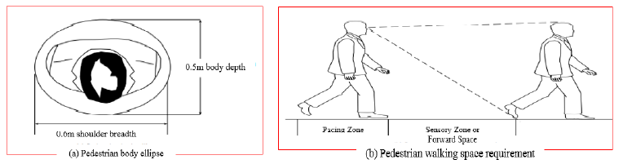
Figure 2.1: Pedestrian Body Ellipse and Pedestrian Walking Space Requirement (HCM, 2010)
The space zone for locomotion as Pacing Zone (area required to walk) and Sensory Zone (area in front of the pedestrian required for a smooth unobstructed flow). Individual pacing distance combined with perception and reaction times give the sensory zone (Fruin, 1987). A body buffer zone of 0.75m2 for walking (Fruin, 1987) (Natasha, 2016). Longitudinal spacing for walking including for pacing and avoiding conflicts, would be 2.5m to 3m (Fruin, 1987). The personal space required for comfortable movement on stairs is less than walking because of the limitations imposed by the treads and concerns for safety. Pedestrian space cannot be directly observed in the field (HCM, 2010).
Table 2.4: Comparison of Human Ellipse
Source/Author | Country | Body Dimension | Body Dimension (Converted into SI Units)
Fruin (1987) | USA | 13in x 23in | 0.33m x 0.58m
Still (2000) | UK | 0.5m x 0.3m | 0.50m x 0.30m
HCM (2010) | USA | 1.5ft x 2.0ft | 0.50m x 0.60m
TCRP Report 165 | USA | 20in x 24in | 0.50m x 0.60m
Source: Natasha,2016.

2.6.2.2 Crosswalk Width
The concept of a pedestrian lane has sometimes been used to analyze pedestrian flow, comparable to the analysis of a highway lane. The lane should not be used in pedestrian analysis, because studies have shown that pedestrians do not walk-in organized lanes. The lane concept is meaningful only in determining how many persons can walk abreast on a given walkway width, as in the case of determining the minimum sidewalk which permits two pedestrians to conveniently pass by each other. To avoid interference while passing each other, two pedestrians should each have at least 0.8 m of walkway width (Pushkarev & Zupan, 1975).

2.6.3 Environmental Factors
The LOS concept is used in both quantitative and qualitative methods. Although the quantitative measures of flow, density, and speed affect such convenience factors as the ability to select walking speeds, bypass slower pedestrians, and avoid conflicts, the HCM makes it abundantly clear that additional environmental factors, such as comfort, convenience, safety, security, and the economy of the walking system, should be taken into account because these factors contribute to the walking experience and ultimately to the perceived level of service (HCM, 2010). However, no guidelines are given on how to measure or make use of these environmental factors in designing or assessing pedestrian facilities.

2.6.3.1 Safety
The reduction of pedestrian-vehicle conflicts can be considered a basic factor promoting safety. Ease of movement in walking, even in vehicle-free areas such as malls, passageways, sidewalks, stairs, elevators, ramps, and escalators, is considered part of safety. Particularly in heavily trafficked street networks, the provision of properly designed control devices, providing adequate time and space separation from vehicular movement is art essential part of safety (Beyene, 2015).

2.6.3.2 Convenience
Walking distances connected with attributes such as pathway directness, grades, sidewalk ramp locations, directional signing, activity maps and directories, convenient connections between frequently used locations, and other features making walking easy and uncomplicated are qualities of convenience. Sidewalk obstructions and circuitous trip linkages are considered a source of inconvenience to pedestrians. Properly ramped curb cuts for the handicapped and tactile trails for the blind are considered assets (Beyene, 2015).

2.6.3.3 Comfort
Such factors as weather protection, climate control, properly designed shelters, condition of walking surface, cleanliness of terminals, and provision of adequate seating arrangements can be considered to provide comfort. One could even include such factors as odor, ventilation, noise, vibration, and crowding (Beyene, 2015).
Major urban traffic generators produce considerable pedestrian activity and movement, and therefore an important factor is the planning, designing, operating, and evaluating of transportation systems. The HCM provides guidance in designing and evaluating pedestrian facilities based only on quantitative measures of pedestrian flow, walking speed, and flow density, resulting in six levels of service, similar to those for vehicular flow. However, it recommends that additional environmental factors that contribute to the walking experience, and therefore to the perceived level of service, be considered, but does not spell out a methodology of how to do so (Beyene, 2015).
Additional environmental factors that contribute to the walking experience and to perceived level of service are the comfort, convenience, safety, security, and economy of the walkway system. Comfort factors include weather protection, climate control, arcades, transit shelters, and other pedestrian amenities. Convenience factors include walking distances, pathway directness, grades, sidewalk ramps, directional signing, directory maps, and other features making pedestrian travel easy and uncomplicated (HCM, 2010).

Studies on Pedestrian Level of Service Model
Delay has been widely accepted as the key performance index for midblock crossway, thus it is necessary to estimate delays accurately for all kind of traffic participants at cross walkway. Crosswalks are more critical locations as compared with sidewalks because of the higher interaction with vehicle traffic, and at these locations, the severity of the conflict with vehicles is greater. Commonly, pedestrians may cross the road at (a) a signalized intersection as well as at an unsignalized intersection and (b) midblock crosswalks. When pedestrians cross at signalized crossways, they have a particular signal time during which to cross the road (the pedestrian green signal) and the rest of the time they have to wait for the pedestrian green signal. Studies have obtained pedestrian LOS on the basis of pedestrian waiting time, holding area, and pedestrian flow characteristics at signalized crosswalks. If pedestrians are crossway at uncontrolled crossways and unsignalized midblock crosswalks, sometimes they have to wait a long time to get the required gap in vehicle flow to cross the road. Hence, pedestrian gap acceptance behavior varies with vehicle movement. The pedestrian LOS varies with different factors at a midblock crosswalk as well as at unsignalized crossways when compared with that at signalized crossways (HCM, 2010).

2.7.1 Pedestrian Level of Service Studies at Midblock Crosswalk Locations
The pedestrian midblock crossway is a completely different and complex crossway location when compared with signalized and unsignalized intersection crosswalks. Midblock crosswalks are hazardous when compared with intersection crosswalks even though there are no turning vehicles. Studies have shown that midblock crosswalks account for the highest number of pedestrian accidents because of higher vehicle speed and the increase in risk-taking behavior of pedestrians due to an increase in waiting time (Diogenes & L. A, 2010). In developed countries, vehicle drivers may yield to pedestrians while a pedestrian is waiting at the curb, whereas in developing countries such driver yielding behavior is not noticed unless pedestrians are using the crosswalk (HCM, 2010).
Further, studies have found that with an increase in vehicle speed, there is a decrease in the probability of a driver’s yielding to pedestrians at unprotected crosswalks (Garder , 2004). Limited studies have been carried out on pedestrian LOS at midblock crosswalks. Researchers have developed the pedestrian LOS based on the crossway difficulty experienced by preselected participants considering factors such as pedestrian and vehicle flow, signal operation criteria, turning vehicles, and pedestrian safety, and a regression model was developed for the midblock location (Baltes & X. Chu, 2002). The study results concluded that the difficulty in crossway increases with an increase in vehicle volume, speed of the vehicle, crossway width, and length of traffic signal cycles, whereas it decreases with the presence of a marked crosswalk, traffic signals, and restricted medians.
Some research studies have been carried on pedestrian LOS considering the effect of group behavior at a midblock crosswalk under mixed traffic conditions (Chutani, S. Ram, & P . Parida, 2013). A recent study shows the importance of the pedestrian perception of safety and crossway difficulty to the pedestrian perceived LOS at midblock crosswalks under mixed traffic conditions (Kadali & P . Vedagiri, 2015). Several research studies about pedestrian LOS at midblock crosswalks are summarized in table 2.5 and table 2.6. However, in the authors’ view, no pedestrian LOS studies are available that consider the impact of important factors such as pedestrian safety and crossway difficulty as MOEs for the pedestrian LOS model at unprotected midblock locations under mixed traffic.

Author (Reference Number) | Country | Factors considered |  |  |  |  |  |  | Limitations
Author (Reference Number) | Country | Type of  Survey  Conducted | Walking  Speed or  Delay | Operational (signal timing) | Traffic (pedestrian and vehicle) | Pedestrian Behavior | Traffic (left and right) | Roadway Geometry | Limitations
(Baltes & X. Chu, 2002) | United States | Video and opinion survey | ✔ | ✔ | ✔ | NA | ✔ | ✔ | Pedestrian behavioral characteristics and factors affecting pedestrian with disability at midblock crosswalks were not considered.
(NCHRP, 2008) | United States | Video and opinion survey | ✔ | ✔ | ✔ | NA | ✔ | ✔ | Pedestrian accessibility and security factors were not explored, and this study's results were limited to nondisabled pedestrians.
(Chutani, S. Ram, & P . Parida, 2013) | India | Video and opinion survey | ✔ | NA | ✔ | ✔ | NA | ✔ | This study did not consider pedestrian behavior and safety with LOS.
(Zhao, et. al, 2014) | China | Opinion survey | ✔ | NA | ✔ | NA | ✔ | ✔ | The study did not quantify pedestrian safety and comfort for threshold values.
(Kadali, B. R, & P. Vedagiri, 2013) | India | Video and opinion survey | ✔ | NA | ✔ | ✔ | NA | ✔ | This study is completely based on pedestrian perception; safety and difficulty were not quantified.
Table 2.5: Various Pedestrian LOS Studies at Midblock Crosswalk Location………………………………………………………….
Table 2.6: Various Pedestrian LOS Models Developed at Midblock Crosswalk Locations
Author (Reference Number) | Country | LOS Model | Remarks
(Baltes & X. Chu, 2002) | United States | L_{CDiff} = −2.4778 + 0.4937 * 65yearolder + 0.0758 * TV+ 0.0016 * CTM + 0.0107 * VS + 0.0195 * CCW − 0.0661 * WOM + 0.0712 * WOPM − 0.2762 * POC − 0.4930 * POS + 0.0284 * ACL + 0.0007 * Signal spacing | This model does not truly represent the average number of vehicles encountered by pedestrians. Furthermore, the model cannot be used at other locations with absences of markings or sign boards under mixed traffic conditions.
(HCM, 2010) | United States | F_{cd} = 1+$\frac{0.10dpx-(0.318Ip,link+1.606}{7.5}$ | This model mainly focused on segment LOS; however, the model did not address pedestrian safety.
(Zhao, et. al, 2014) | China | Ped_{LOS} = a₁V _{m}^{0.1535} + a₂ [$\frac{Lb}{\left(Nm+1\right)*\left(Nm+1\right)+\left(Nm+1\right)*(Nu=1)}]$ + c | This model was developed for unsignalized midblock crosswalk locations but did not consider pedestrian safety with vehicle gap acceptance.
(Kadali, B. R, & P. Vedagiri, 2013) | India | y_{LOS} = −1.385 + 0.152 * LU + 0.368 * PPCD + 0.616 * PPCS+ 0.053 * WOM − 0.369 * NOL + 0.023 * NOVE | This study is completely based on pedestrian perceived safety and difficulty and further study is needed in order to explore threshold for safety as well as difficulty
Note: L_{CDiff} = level of crossway difficulty; TV = total volume of traffic; CTM = combined turning movements; VS = vehicle speed; CCW = combined crossway width; WOM = width of median; WOPM = width of painted median; POC = presence of crosswalk; POS = presence of signal; ACL = average cycle length; F_{cd} = street crossway difficulty; d_{px} = diverted delay; I_{p,link} = pedestrian link LOS; I_{p,int} = pedestrian intersection LOS; V_{m} = two-way motor vehicle flow; L_{b} = length being crossed; N_{m} = number of marked crosswalks; N_{u} = number of unmarked crosswalks; y_{LOS} = observed LOS; LU = land use type; PPCD = pedestrian perceived crossway difficulty; PPCS = pedestrian perceived crossway safety; WOM = width of median; NOL = number of lanes; NOVE = number of vehicles encountered while crossway; C = constant.

2.7.2 Model Validation
Application of modeling techniques without subsequent performance analysis of the obtained models can result in poorly fitting results that inaccurately predict outcomes on new subjects (Arboretti & Salmaso, 2003). Model validation refers to the stability and reasonableness of regression coefficients, the plausibility and usability of fitted regression function and the ability to generalize inferences drawn from the analysis (Sohel, Rana, Midi, & S , 2015). On the process of model validation use independent data when a researcher is interested in demonstrating the generalizability of the model in order to use it to predict outcomes for future subjects. The authors also state that external validation technique is the most stringent and unbiased test especially for logistic regression model (Hosmer & S, 2000).

MATERIALS AND METHODS

Location of the Study Area
Addis Ababa city has four major corridors in the road network. These are the East-West, North-South, the ring road and the central business districts. Currently, LRT project is built in the two corridors; the East-West and North-South corridors. However, this research considers only the East-West corridor due to time and budget constraints. The East-West corridor is one of the highly populated and congested area. It consists of the busiest commercial area associated with high traffic flow (Beyene, 2015). The LRT has three different station types. These are underground station, ground surface station and elevated station. From these, the study was basically concerned about one type of station that is ground surface station. The ground surface station along the EW1 to EW8 and the assessment covered along E-W line dealing with all the stations located at the spot where the train and pedestrians share the ground surface stations. Figure 3.1 below shows the geographic location of the study area.
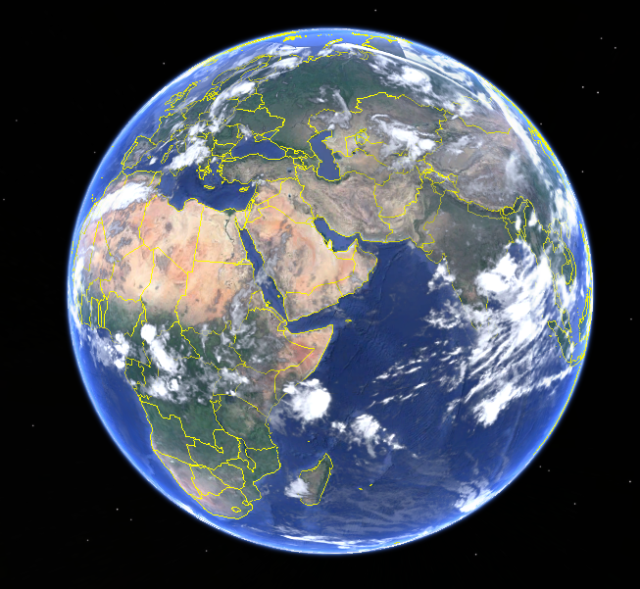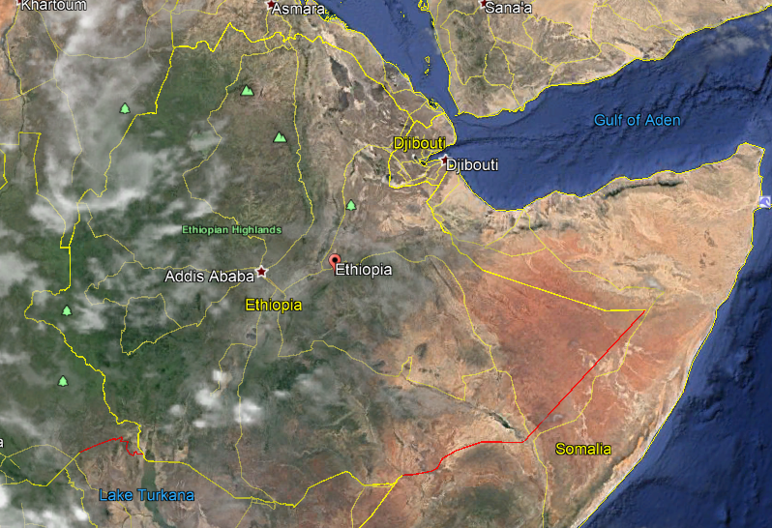
Ethiopia’s location on Earth
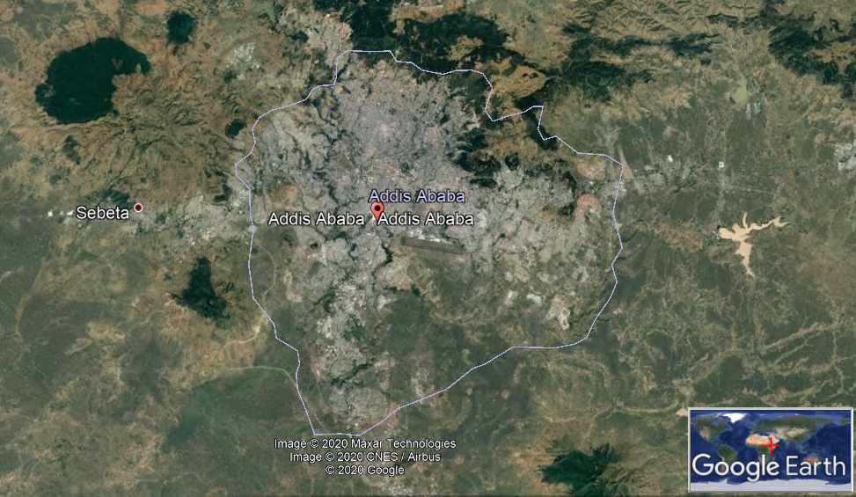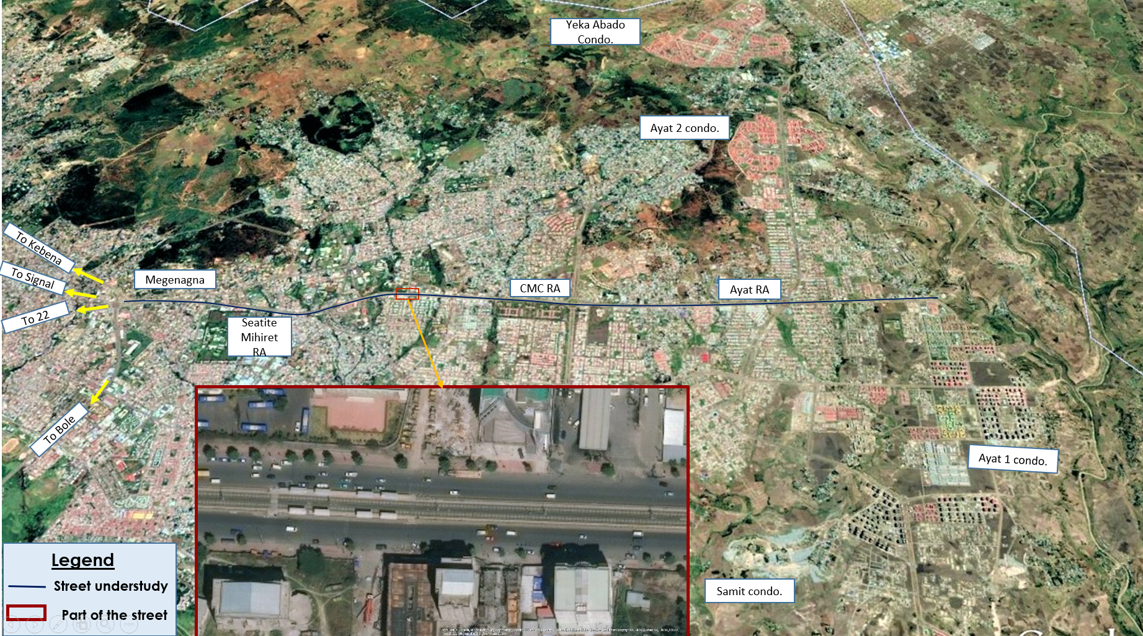
Addis Ababa
Figure 3.1: Geographic location of the study area.
Source: Google Earth Pro-2019
It is about 7.9 km long along the East-West side of the LRT line. The study area was selected due to the presence of low performance on the available crossways, a long interval between crossways, continuity of ground surface stations compared with other sections of LRT. Table 3.1 below shows the E-W LRT Station details and subsequently Figure 3.2 shows a case study on E-W LRT line from Ayat to Megenagna.
Table 3.1: E-W LRT line station
No | Station Name | Central Mileage | Station Type | Location
1 | EW1 | 22+300.000 | Ground surface station | Ayat before Zone2
2 | EW2 | 21+040.000 | Ground surface station | Front of Meri central hotel
3 | EW3 | 19+948.000 | Ground surface station | After CMC roundabout
4 | EW4 | 19+085.000 | Ground surface station | Before Saint Michael church
5 | EW5 | 18+225.000 | Ground surface station | Southeast of Ethiopia Institute of Civil Engineering Service
6 | EW6 | 17+500.000 | Ground surface station | South gate of Ethiopia Institute of Management
7 | EW7 | 16+530.000 | Ground surface station | South east of Ethiopia Telecom Company
8 | EW8 | 15+444.000 | Ground surface station | North of Ethiopia Geology Survey Bureau
9 | EW9 | 14+615.000 | Semi-underground island station | East of Megenagna loop interchange

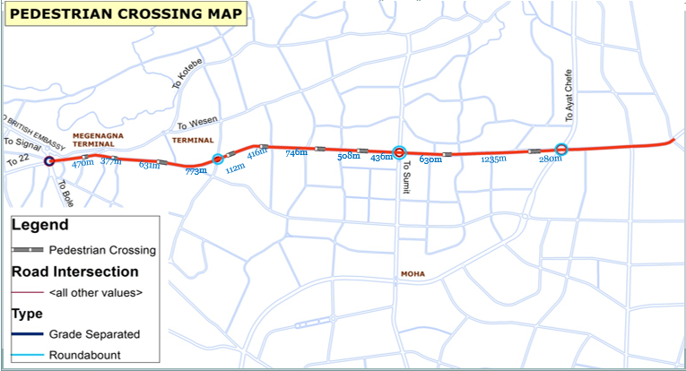
Figure 3.2: A case study on E-W LRT line from Ayat to Megenagna (CREC, Schematic Design of Addis Ababa East-West and North-South (phase 1) LRT Project, 2012)

Data Collection and Sample Selection Technique

3.2.1 Data collection
The data required for this research contains both quantitative and qualitative data with data collection and analysis process.
- Site investigation (visual observation)
- Spot crossways within pedestrians’ flow,
- Pedestrian behavior.
- Geometry (direct measurement survey ERC document)
- LRT stations and crosswalk facilities like crossway interval, length, width and height,
- Ramp gradient.
- Video survey (waiting time)
- Pedestrian waiting time while crossing,
- Pedestrian movement and interaction with vehicles.
- Pedestrian and traffic data (count)
- Pedestrian volume,
- Vehicles volume and existence of on street parking.
- Perception of pedestrians (questionnaires)
- Number of travelers with the capacity of the crossway,
- Qualitative measurement (comfort, safety, convenience and security.
The methodology used in conducting this study included: literature review, desk study of previously conducted researches, study area survey, geometric survey, interviews and content analysis of relevant documents, discussion and analysis. Therefore, in the study both primary and secondary data sources were used.
- Primary Data
Most of the data were primary data acquired through field survey, geometric survey, video survey and pedestrian opinion.
Field survey: this was conducted through visual inspection and identification of stations which have pertinent problems with regard to pedestrian delays.
Geometric survey: this study focused on measurement of crossing facilities at midblock and stairways of crossways geometries, which included: length of crossways, width of crossways, intervals between crossways, number of lanes and ramp gradient of the crossing facilities. These were investigated from as-built drawing of the road plan and profile. These data are available at the Ethiopian Railway Corporation (ERC). However, problems were encountered due to documentation problem at the ERC to get the necessary data. Hence, it was done by actual measurements and visual inspection at the site.
Video survey: this activity was conducted to estimate waiting time of pedestrians to cross the two road ways and the LRT line at crossway facilities, record pedestrian movements and their interaction with vehicles and LRT, to count both pedestrian and vehicular flow at peak hour, analyze crossway difficulties and study delays and pedestrian flow characteristics patterns. This was conducted using recording videos for three randomly selected weekdays at each site at the morning time that is AM peak hour from 07:00 AM to 09:00 AM and at the evening time PM peak hour from 04:00 PM to 06:00PM.
Below; Figures 3.3, 3.4, 3.5 and 3.6 show the camera setup locations at Ayat 2 LRT terminal station; at CMC 2/Meri LRT station, at St. Michael church LRT station, the Gurd Shola LRT station respectively.
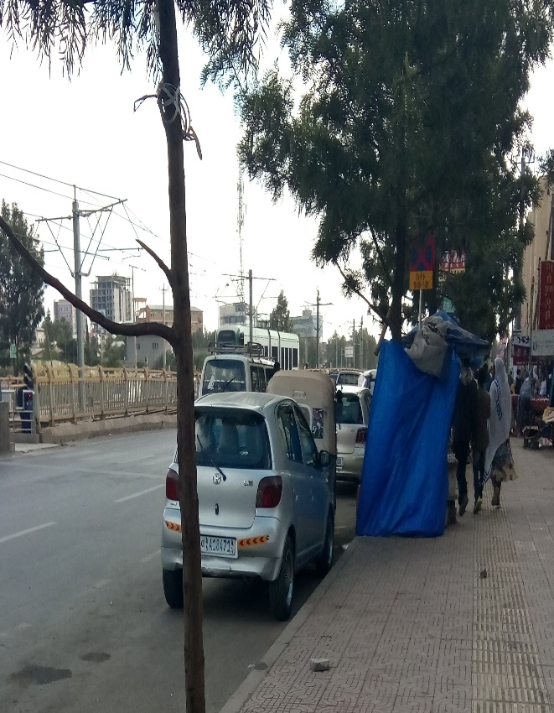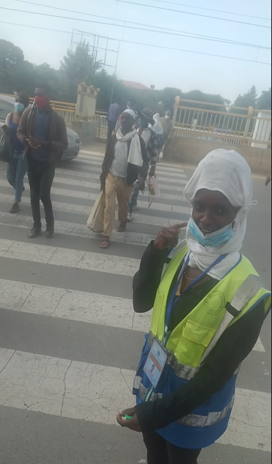
Figure 3.3: Camera setup location at Ayat 2 LRT terminal station
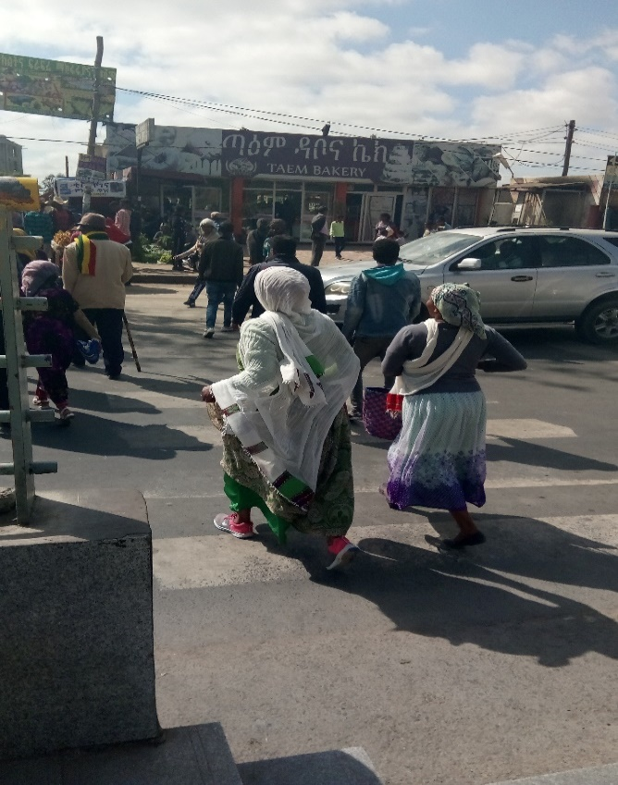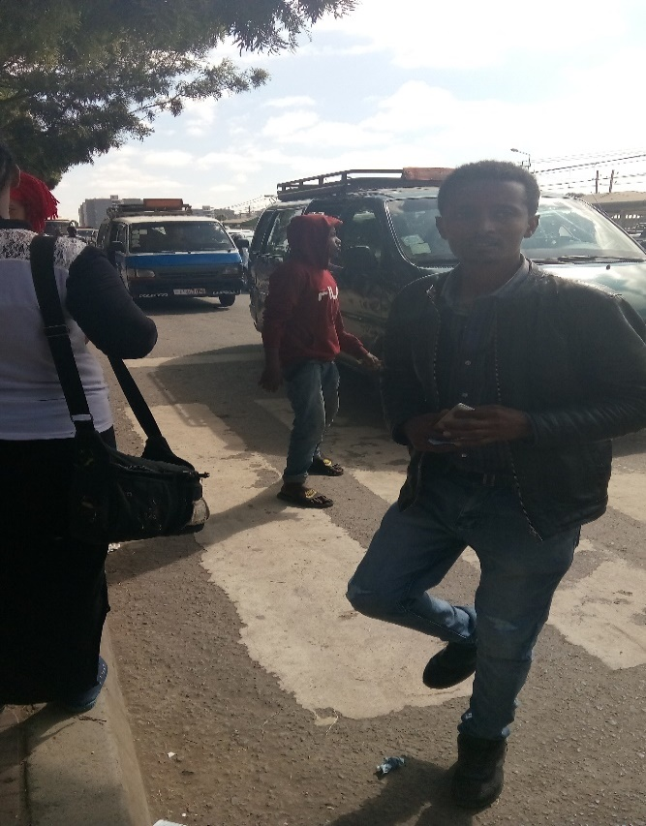
Figure 3.4: Camera setup location at CMC 2/Meri LRT station
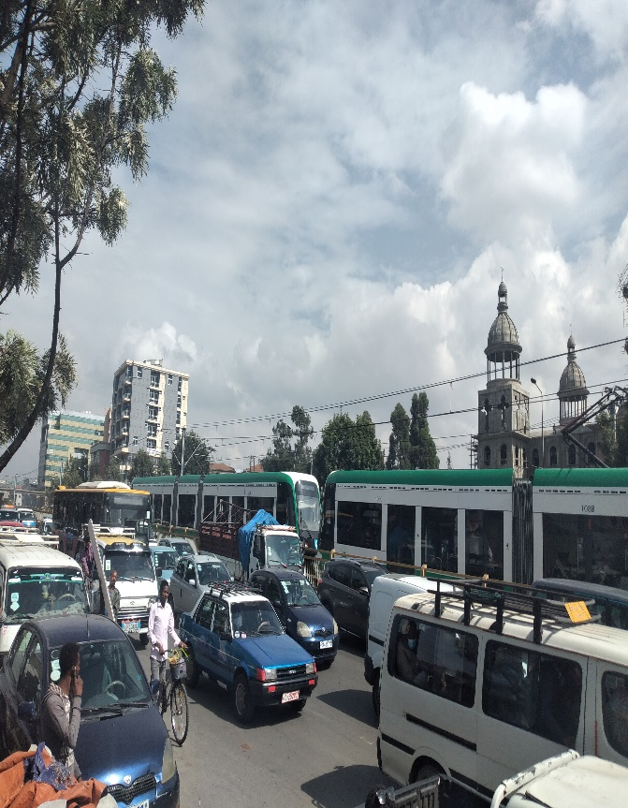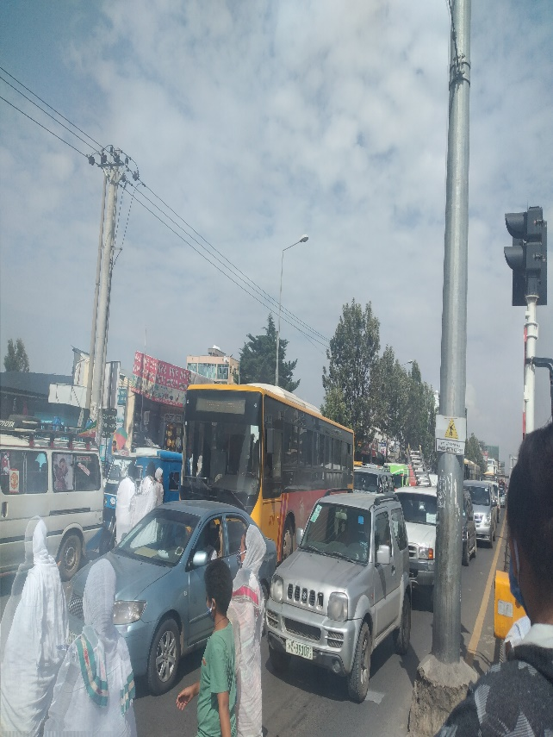
Figure 3.5: Camera setup location at St. Michael church LRT station
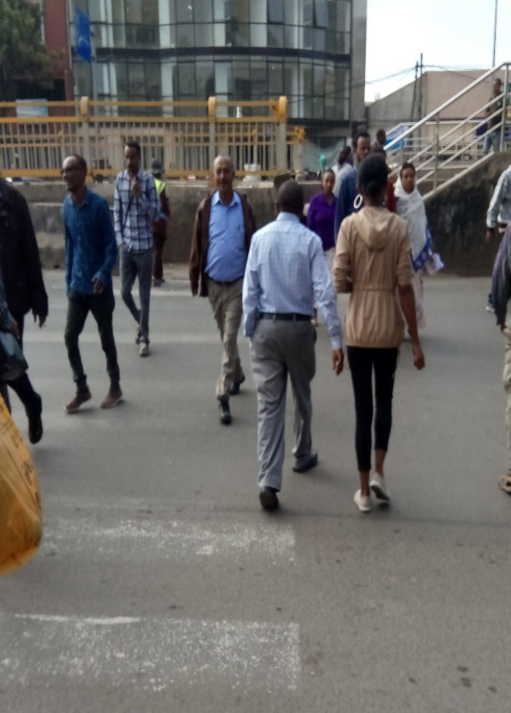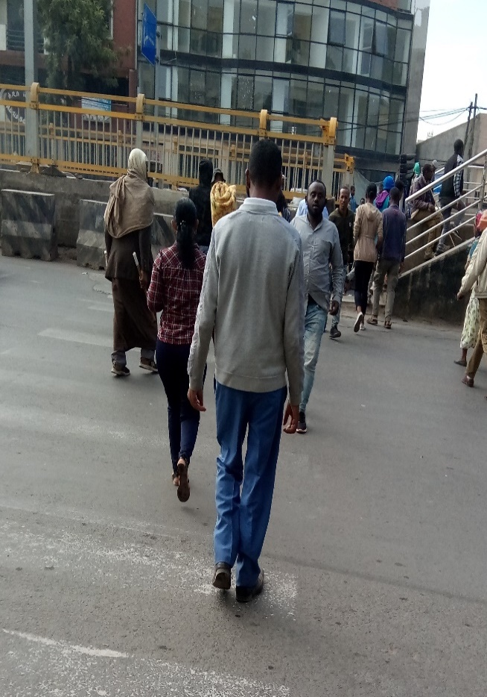
Figure 3.6: Location at Gurd Shola LRT station
- Secondary Data
In addition to primary data, the study examined other necessary documents that were obtained from various past studies documents, government administrative offices at various levels. Moreover, theoretical basis of the study focused upon pertinent literatures: books, articles and any other published and unpublished materials.

3.2.2 Sample Selection Techniques
The following data were collected in order to meet the objective of the research. Due to time and budget constraints, representative samples were taken at different locations of the road to derive a generalized conclusion.
- Pedestrian crossing facilities
Since it was unable to get full geometric data of the road section due to documentation problem at the source, same were collected by actual measurements and visual inspection at the site. Actual measurement was taken along selected crossways using tape meter and odometer. From Ayat to Megenagna, the road is 7.9 km long having 8 LRT stations with zebra crossways, which provided for pedestrians to cross the road as well embarking to disembarking the LRT. The measurement was conducted to obtain the following characteristics of the facilities:
- Location of crossing facilities: this measured the distance between the crossways from Ayat 2 to Megenagna by using odometer of vehicle by setting 0+00 at Ayat 2 roundabout and driving to Megenagna roundabout along the road section. This expressed the actual position of the midblock crossways.
- Length, width and ramp of gradients of crossway facilities: this measured the total length through which pedestrian moves to cross the road, the horizontal width provided for pedestrian crossway and slope of gradient was measured manually by using tape meter.
- Spacing between each crossing facilities: having the distance of all midblock location from Ayat 2 roundabout to Megenagna roundabout. It was possible to have the spacing of each facility using subtraction calculation.
There are 8 stations and midblock crossways from Ayat 2 roundabout to Megenagna round about. Among 8 stations and midblock crossways, 4 stations and midblock crossways were selected because during field survey and very high pedestrian volumes were observed at these locations relative to the rest. For a better analysis and generation of rational results and conclusion, 3 midblock crossway data were collected and additional 1 midblock crossway data accounted for validation. To recall, the following stations were considered:
- EW1 => at Ayat 2 LRT Terminal Station,
- EW2 => at CMC 2/Meri LRT Station,
- EW4 => at St. Michael church LRT Station, and
- EW8 => at Gurd Shola LRT station.
Figure 3.7 below shows the ground surface station of LRT line
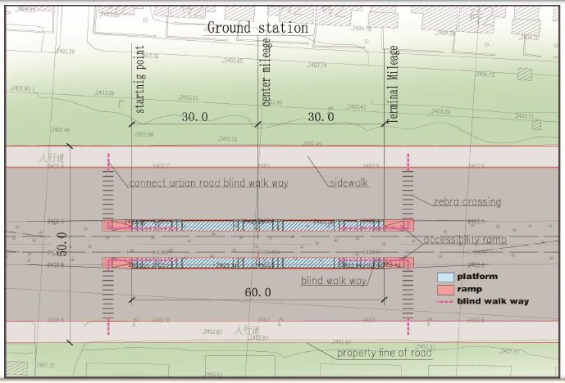
Figure 3.7: Ground surface station of LRT line (CREC, 2009)

- Pedestrian and traffic volume data
The data used for the performance analysis of pedestrian midblock crossway and stairs were obtained by conducting automatic traffic count using video recording technique by capturing movement of pedestrian at midblock crossway and extraction is done manually. Lenovo tablets were used to record video data of pedestrian movement at the crossways. The tablets were placed at different convenient positions so that clear view of pedestrians’ movements could be captured. Data collection was conducted at the specified 4 midblock crossways (Ayat 2 LRT Terminal Station, CMC 2/Meri LRT Station, St. Michael church LRT Station, and Gurd Shola LRT station) on 3 different weekdays that is from 12-02-2020 to 16-03-2020 from morning peak hour 07:00 AM to 09:00 AM and at the evening peak time from 04:00 PM to 06:00 PM.
For EW1, there is school around the station so there was always equivalent number of flows, the data were gathered at three different days using non probably sampling techniques. For EW2, there is market around the stations so the selected days were market days. For EW4, there is St. Michael church around the station so two days out of three days were selected because there was a festival and used to get rush flow of the stations. For EW8, there is business center around the station so there was always equivalent number of flows, the data were gathered at three different days using non probably sampling techniques. Finally, the data were converted to 15-minute volume to provides a peak 15-minute pedestrian and vehicle crossing volume. Table 3.2 below shows the selected pedestrian and vehicle counting days.
Table 3.2: Selected pedestrian and vehicles counting days
Crossways | Selected Counting Days
EW1  (Ayat 2) | Day – 1 | Tuesday | February 18/2020
EW1  (Ayat 2) | Day – 2 | Thursday | February 20/2020
EW1  (Ayat 2) | Day – 3 | Monday | March 2/2020
EW2  (CMC 2/Meri) | Day – 1 | Wednesday | February 12/2020
EW2  (CMC 2/Meri) | Day – 2 | Saturday | February 14/2020
EW2  (CMC 2/Meri) | Day – 3 | Monday | March 16/2020
EW4  (St. Michael church) | Day – 1 | Tuesday | February 25/2020
EW4  (St. Michael church) | Day – 2 | Thursday | February 27/2020
EW4  (St. Michael church) | Day – 3 | Wednesday | March 4/2020
EW8  (Gurd Shola) | Day – 1 | Friday | February 28/2020
EW8  (Gurd Shola) | Day – 2 | Tuesday | March 10/2020
EW8  (Gurd Shola) | Day – 3 | Thursday | March 12/2020

The times required by pedestrians to cross the road through the facilities were also recorded using stop watch which enabled to determine the followings but not limited:
- Pedestrian speed: this is the average pedestrian walking speed calculated by dividing the total walking length of the crossing facility by the average time taken by pedestrians, expressed in meter per second.
- Pedestrian flow rate: this is the number of pedestrians passing a point per unit of time, expressed as pedestrians per 15 minute or pedestrians per minute. Point refers to a line of sight across the width of a walkway perpendicular to the pedestrian path.
- Space per pedestrian: - this is the average area provided for each pedestrian in a walkway or queuing area, expressed in terms of square meter per pedestrian.
- Volume to capacity (V/C) ratio of crossing facilities.

- Pedestrian behavior and attitude survey
It is usual, when using statistics, to plan data size at the same time planning data collection. This enables to have high level of confidence as well as a small margin of error (Hosmer & S, 2000).
Population size is how many people in totality fit the demographic and margin error (confidence interval). No sample will be perfect, so need to decide how much error to allow. The confidence intervals determines how much higher or lower than the population means to let the sample mean fall. Confidence level means how confident do the researcher want to be that the actual means falls within its confidence interval. The most common confidence intervals are 90% confident, 95% confident and 99% confident. In this study, 95% confident level was considered. To determine the sample size, Morgan table value was developed using Equation 3.1 below as recommended for use when the population is greater than 100,000. This equation was utilized in this study to estimate sample size as follows.
$\text{n}=\frac{Z^{2}xP(1-P)}{e^{2}}$……………………………………………… (Eq 3.1)
$\text{n}=\frac{{1.96}^{2}x0.5(1-0.5)}{{0.05}^{2}}$ = 384.16 $≈$ 400
Where
n = Sample size required for the study.
Z = Critical value (i.e.=1.96) at 95 percent confidence level, the amount of
uncertainty that can be tolerated. Most researches recommended 95 percent
Confidence level.
P = Proportion of people expected to have the basic knowledge about the problem
(i.e. 0.5) because the Morgan table value recommended for 50 percent for the value of” P”, and

e = Margin of error that can be tolerated: it is the discrepancy between the sample size
and the population. The recommended value is 5% percent (i.e., =0.05).
The 400-sample size was divided equally for each of the 4 crossways based on quota sampling technique which is 100 for a single crossway. For a better statistical analysis result and conclusion, 300 numbers of pedestrian data was accounted for and the balance 100 was used for the purposes of validation. The data used in the analysis was the overall peak hour data calculated at the crossways.
Similarly, the method used for statistical data sample size determination was applied for attitude survey sample size determination. At 95 percent confidence interval (CI) and $±$ 5 percent margin of error, 388 respondents were taken as a sample size. Questionnaire papers were distributed for pedestrians and collected the same day. It was distributed to randomly selected pedestrians of different ages, gender, educational background, etc. A close-ended questionnaire types had been used by which respondents can simply select from closed question and give opinion on some of the question to answer the qualitative performance measures like comfort, safety and security. Here, response rate was determined to be 100% since it was self-administered by the researcher and took an interview form.

3.2.3 Data Extraction
Pedestrian and crossing characteristics data were extracted from the recorded video manually by using video playback technique and using stop watch for speed measurement.

Data Analysis
The research data analysis employed in this study plans the steps used to answer research questions which are described under Section 1.4 above. The research design used for this research was observational, qualitative and quantitative survey. After identifying the basic parameters that affect the performance of crossways of the road and major factors for pedestrian delay, the possible counter measures were suggested to mitigate the respective problems.

3.3.1 Assessment on Pedestrian Crossway
The analysis was based on the indicators stated in HCM (pedestrian speed, both pedestrian and vehicular flow rate, space, V/C, pedestrian start-up time, cross walk length, cross walk width) and other qualitative indicators.

3.3.1.1 Interrupted-Flow Pedestrian Facilities
Pedestrian LOS at Two-way STOP-controlled (TWSC) crossways is defined for pedestrian’s crossway a traffic stream not controlled by a STOP sign; it also applies to midblock pedestrian crossways. LOS criteria for pedestrians are given below in table 3.4 (HCM, Highway Capacity Manual 2010, 2010). This methodology for the pedestrian mode is applied through a series of steps requiring input data related to the vehicle and pedestrian volumes, geometric conditions, and motorist yield rates to pedestrians. The required steps are stated below (HCM, Highway Capacity Manual 2010, 2010): -

Step 1: Identify the crossways

Step 2: Determine Critical Headway

Step 3: Estimate Probability of a Delayed crossing

Step 4: Calculate Average Delay to wait for Adequate Gap

Step 5: Estimate Delay Reduction due to Yielding Vehicles

Step 6: Calculate Average pedestrian Delay and Determine LOS

Step 1: Identify Two-Stage crossings
When a raised pedestrian-median refuge island is available, pedestrians typically cross in two stages. Determination of whether a pedestrian median refuge exists may require engineering judgment. The main issue to determine is whether pedestrians cross the traffic streams in one or two stages. When pedestrians cross in two stages, pedestrian delay should be estimated separately for each stage of the crossing by using the procedures described in steps 2 to 6. To determine pedestrian LOS, the pedestrian delay at each stage should be summed to establish the average pedestrian delay associated with the entire crossing. This service measure is used to determine pedestrian LOS for a TWSC intersection with two-stage crossings.
Step 2: Determine critical headway
The critical headway is the time in seconds below which a pedestrian will not attempt to begin crossing the street. Pedestrians use their judgment to determine whether the available headway between conflicting vehicles is long enough for a safe crossing. If the available headway is greater than the critical headway, it is assumed that the pedestrian will cross, but if the available headway is less than the critical headway, it is assumed that the pedestrian will not cross.
For a single pedestrian, critical headway is computed using Equation 3.2 below:
t_{c}= $\frac{L}{Sp}$+t_{s}……………………………………………… (Eq. 3.2)
Where
t_{c} = critical headway for a single pedestrian(s),
S_{p} = average pedestrian walking speed (m/s),
L = crosswalk length (m), and
t_{s} = pedestrian start-up time (s).
Average travel speed is determined using Equation 3.3 below:
S_{p} = $\frac{nL}{\sum_{i=1}^{n}{t_{i}}}$………………………………………………… (Eq 3.3)
Where
S_{p} = average travel speed, km/h,
L = length of the highway segment, km, and
t_{i} = travel time of the i^{th} pedestrian to traverse the section, h.
If pedestrian platooning is observed in the field, then spatial distribution of pedestrians should be computed using Equation 3.4 below. If no platooning is observed, the spatial distribution of pedestrians is assumed to be 1.
N_{p}=Int $\frac{0.75(Nc-1)}{Wc}$……………………………………………… (Eq 3.4)
Where
N_{p} = spatial distribution of pedestrians (ped-m),
N_{c} = total number of pedestrians in the crossing platoon (ped),
W_{c} = effective crosswalk width (ped), and
0.75 = default clear effective width used by a single pedestrian to avoid interference
when passing other pedestrians.
Total number of pedestrians in the crossing platoon is determined using Equation 3.5 below:
N_{c} = $\left[\frac{V{pe}^{Vptc}+V{ e}^{-vtc}}{(V{p+V)e}^{\left(Vp-V\right)tc}}\right]$………………………………..………… (Eq 3.5)
Where
N_{c} = total number of pedestrians in the crossing platoon (ped),
V_{p} = Pedestrian flow rate (ped/s),
V = vehicular flow rate (veh/s), and
t_{c} = critical headway for a single pedestrian (s),
Effective crosswalk width is determined with using Equation 3.6 below:
W_{E} = W_{T} - W_{O} ………………………………………… (Eq 3.6)
Where
W_{E} = effective crosswalk width (m),
W_{T} = total crosswalk width at a given point along crosswalk, and
W_{O} = sum of fixed object effective widths and linear feature shy distances at a given
point along the facility.

Pedestrian flow rate is determined using Equation 3.7 below:
$\text{Vp}=\frac{V15}{900*WE}$ ………………………………………… (Eq 3.7)

Where
V_{p} = Pedestrian flow rate (ped/s),
V₁₅ = Peak flow of pedestrians (ped/15-min), and
W_{E} = Effective crosswalk width (m),
Vehicular flow rate is determined using Equation 3.8 below:
$\text{Vv}=\frac{V}{PHF*3600}$ ………………………………………… (Eq 3.8)
Where
V_{v} = vehicular flow rate of a peak 15-min period (veh/s),
V = peak-hourly volume (veh/h),
PHF = peak-hour factor.
Peak-hour factor (PHF) represents the temporal variation in traffic flow within an hour. Observations of traffic flow consistently indicate that the flow rates found in the peak 15-minute period within an hour are not sustained throughout the entire hour (HCM, Highway Capacity Manual 2010, 2010).
Peak-hour factor is determined using Equation 3.9 below:
$\text{PHF}=\frac{V}{4* V15}$ ………………………………………… (Eq 3.9)
Where
PHF = peak-hour factor,
V = hourly volume (veh/h), and
V₁₅ = volume during the peak 15 min of the peak hour (veh/15 min),
In order to estimate traffic volume, it is necessary to have a single unit to count the number of vehicles because different types of vehicles in a traffic stream have different effects. So, all vehicles which use the condor must be converted to common unit called passenger car unit (PCU). Therefore, traffic volumes must be adjusted to reflect an equivalent flow rate expressed in passenger cars. The passenger car category includes vehicle types namely; Cars and Taxis, 4WD, Minibus Taxis, Mid-Bus and Standard Bus, whereas the Goods Vehicle category includes vehicle types namely; Small truck, Medium truck and Heavy trucks. In this research, PCU were acquired from the Highway Capacity Manual 2000 and are depicted in Table 3.3 below.
Table 3.3: Passenger car units for vehicles
Vehicle | Passenger vehicle |  |  |  |  | Goods vehicles
Type | Car &  Taxi | 4WD | Small bus | Medium  bus | Large bus | Small track | Medium  truck | Large truck
PCU | 1 | 1 | 1.5 | 1.5 | 3 | 1.5 | 3 | 3
Source: HCM, 2010
Group critical headway is determined using Equation 3.10 below:
tc, _{G} = tc + 2(Np – 1) ……………………………………………… (Eq 3.10)
Where
t_{c, G} = group critical headway (s),
t_{c} = critical headway for a single pedestrian(s), and
N_{p} = spatial distribution of pedestrians (ped-m),
Step 3: Estimate probability of delayed crossings
On the basis of calculation of the critical headway t_{c, G} the probability that a pedestrian will not incur any crossing delay is equal to the likelihood that a pedestrian will encounter a gap greater than or equal to the critical headway immediately upon arrival at the crossway.
The likelihood that a gap in a given lane does not exceed the critical headway is thus the complement as shown in Equation 3.11. Because traffic is assumed to be distributed independently in each through lane, Equation 3.12 shows the probability that a pedestrian incurs nonzero delay at a TWSC crossing.
P_{b} = 1- e ^{-tc,GV /L} ……………………………………………… (Eq 3.11)
P_{d} = 1- (1-P_{b}) ^{L} ……………………………………………… (Eq 3.12)
Where
P_{b} = probability of a blocked lane,
P_{d} = probability of a delayed crossing,
L = number of through lanes crossed,
t_{c, G} = group critical headway (s), and
v = vehicular flow rate (veh/s).
Step 4: Calculate average delay to wait for adequate gap
Research indicates that average delay to pedestrian at unsignalized crossings, assuming that no motor vehicles yield and the pedestrian is forced to wait for an adequate gap, depends on the critical headway, the vehicular flow rate of the subject crossing, and the mean vehicular head way (Gerlough & M. J, 1975) . The average delay per pedestrian to wait for an adequate gap is determined using Equation 3.13.
d_{g} = $\frac{1}{V}$(e^{vtc, G} -Vtc, G -1) ……………………………………………… (Eq 3.13)
Where
d_{g} = average pedestrian gap delay (s),
t_{c, G} = group critical headway (s), and
v = vehicular flow rate (veh/s).
The average delay for any pedestrian who is unable to cross immediately upon reaching the crossway (e.g., any pedestrian experiencing nonzero delay) is thus a function of Pd and dg, as shown in Equation 3.14 below.
d_{gd} = $\frac{dg}{Pd}$……………………………………………… (Eq 3.14)
Where
d_{gd} = average gap delays for pedestrians who incur nonzero delay,
d_{g} = average pedestrian gap delay (s), and
P_{d} = probability of a delayed crossing,
Step 5: Estimate delay reduction due to yielding vehicles
When a pedestrian arrives at a crossing and finds an inadequate gap, that pedestrian is delayed until one of two situations occurs:
(a) a gap greater than the critical headway is available, or
(b) motor vehicles yield and allow the pedestrian to cross.
Equation 3.13 above estimates pedestrian delay when motorists on the major approaches do not yield to pedestrians. Where motorist yield rates are significantly higher than zero, pedestrians will experience considerably less delay than that estimated by Equation 3.13.
It is possible for pedestrians to incur less actual delay than average pedestrian gap delays because of yielding vehicles. The likelihood of this situation occurring is a function of vehicle volumes, motorist yield rates, and number of through lanes on the major street. Consider a pedestrian waiting for a crossing opportunity at a crossway, with vehicles in each conflicting through lane arriving every h seconds. On average, a potential yielding event will occur every h seconds, where P(Y) represents the probability of motorists yielding for a given event. As vehicles are assumed to arrive randomly, each potential yielding event is considered to be independent.
For any given yielding event, each through lane is in one of two states:
- Clear—no vehicles are arriving within the critical headway window, or
- Blocked—a vehicle is arriving within the critical headway window. The pedestrian may cross only if vehicles in each blocked lane choose to yield (data were collected through video recordings of the general population).
If not, the pedestrian must wait an additional h seconds for the next yielding event. On average, this process will be repeated until the wait exceeds the expected delay required for an adequate gap in traffic (d_{gd}), at which point the average pedestrian will receive an adequate gap in traffic and will be able to cross the street without having to depend on yielding motorists.
Thus, average pedestrian delay can be calculated with Equation 3.15, where the first term in the equation represents expected delay from crossings occurring when motorists yield, and the second term represents expected delay from crossings where pedestrians wait for an adequate gap.
d_{p} = $\sum_{i=1}^{n}{h\left(i-0.5\right)}$P(Y_{i})+ P_{d} - $\sum_{i=1}^{n}{P}$(Y_{i}) dgd ……………………………… (Eq 3.15)
Where
dp = average pedestrian delay (s),
i = crossing event (i= 1 to n),
h = average headway for each through lane
P(Y_{i}) = probability that motorists yield to pedestrian on crossing event i, and
n = Int (d_{gd} /h), average number of crossing events before an adequate gap is available.
Equation 3.15 requires the calculation of P(Y_{i}). The probabilities P(Y_{i}) that motorists will yield for a given crossing event are considered below for pedestrian crossings of one, two, three, and four through lanes.
Four-Lane Crossing
Under the scenario in which a pedestrian cross four through lane, P(Y_{i}) is found simply.
P(Y_{i}) = P_{d} - $\sum_{j=0}^{i-1}{P}$(Y_{j}) x $\frac{{Pb}^{4 }{My}^{4 }+4{Pb}^{3 }\left(1-Pb\right){My}^{3 }+6{Pb}^{2 }{(1-Pb)}^{2 }{My}^{2 }+ 4Pb\left(1-{Pb}^{3 }\right)My}{Pd}$… (Eq 3.16)
Where P(Y₀) = 0
My = motorist yield rate (decimal), and
i = crossing event (i = 1 to n).
Step 6: Calculate average pedestrian delay and determine LOS
Table 3.4: Level-of-service criteria for pedestrian at TWSC (HCM, 2010)
LOS | Control Delay (s/pedestrian) | Comments
A | 0 - 5 | Usually, no conflicting traffic
B | 10-May | Occasionally some delay due to conflicting traffic
C | 20-Oct | Delay noticeable to pedestrians, but not inconveniencing
D | 20 - 30 | Delay noticeable are irritating, increased like hood of risk taking
E | 30 - 45 | Delay approaches tolerance level, risk- taking behavior likely
F | >45 | Delay exceeds tolerance level, high like hood of pedestrian risk taking
Note: Control delay may be interpreted as s/pedestrian group if groups of pedestrians were counted as opposed to individual pedestrians.

The delay experienced by a pedestrian is the service measure. Table 3.4 above lists LOS criteria for pedestrians at TWSC crossways based on pedestrian delay. Pedestrian delay at TWSC crossways with two-stage crossings is equal to the sum of the delay for each stage of the crossing.

3.3.1.2 Uninterrupted-Flow Pedestrian Facilities
Evaluation of LOS of pedestrian stairways: Traffic flow and capacity concepts, pedestrian flow rates and speeds are directly related to the average space occupied by a pedestrian. These values are given for reference in the space-based LOS tables along with the corresponding range of volume-to-capacity ratios; however, the actual LOS in those tables are based on space per pedestrian, which is a measure of pedestrian comfort and mobility. The LOS thresholds are based on user’s perception research where available and in other cases on expert judgment.
The next chart illustrates the steps taken to determine the LOS for pedestrian stairways.
Step 1: Determine the effective walkway width

Step 2: Calculate the pedestrian flow rate

Step 3: Calculate the average pedestrian space

Step 4: Calculate the volume-to-capacity ratio

Step 5: Determine LOS

Step 1: Determination of Effective Walkway Width (W_{E})
Effective walkway width is the portion of a walkway that can be used effectively by pedestrians. The effective walkway width at a given point along pedestrian facilities is computed using Equation 3.17 as follows:
W_{E} = W_{T} - W_{O} ………………………………………… (Eq 3.17)
Where
W_{E} = effective width
W_{T} = total walkway width at a given point along walkway, and
W_{O} = sum of fixed object effective widths and linear feature shy distances at a given
point along the facility.

Step 2: Calculation of Pedestrian Flow Rate (V_{P})
Pedestrian flow rate is the number of pedestrians passing a point per unit of time, expressed as pedestrians per minute per meter. Point refers to a line of sight across the width of a walkway perpendicular to the pedestrian path. Determination of the peak 15- minutes count and the effective walkway width is required to compute pedestrian unit flow rate, V_{P}. Pedestrian flow per unit of width (V_{P}) is the peak flow of pedestrians (V₁₅) per unit of effective walkway width (W_{E}), expressed as pedestrians per minute per meter (p/min/m) and is formulated in Equation 3.18 below.
$\text{Vp}=\frac{V15}{15*WE}$……………………………………………… (Eq 3.18)
Where
V_{P}: Pedestrian flow per unit of width,
Step 3: Calculation of Average Pedestrian Space (AP)
Pedestrian space is the average area provided for each pedestrian expressed in square meters per pedestrian. It is the most important parameter for designing and evaluating a pedestrian facility at it is the area required by a pedestrian to stand comfortably or make a comfortable movement which is referred as Body Ellipse and depends on shoulder width and body depth (Natasha, 2016). In evaluating a facility, an area of 0.75m² is used as the buffer zone for each pedestrian. A walking pedestrian requires forward space which is a critical dimension, since it determines speed and the number of pedestrians able to pass a point in a given time period.
The pedestrian unit flow rate (V_{P}) can be related to pedestrian space (A_{P}) and speed (S_{P}) using equation below.
$\text{A}\text{p}=\frac{Sp}{Vp}$……………………………………………… (Eq 3.19)
Step 4: Calculation of Volume to Capacity Ratio (V/C)
HCM (2010) computes volume to capacity (v/c) ratio assuming 75ped/min/m (23ped/min/ft) and 49ped/min/m (15ped/min/ft) for capacity analysis of walkways and stairs respectively in case of no local data is available.
Step 5: Determine LOS
Research had developed LOS thresholds based on the institute of transportation engineer’s stairway standards, which provide the space and flow value given in Table 3.5. Stairway LOS described by the service measure of pedestrian space, expressed as square meter per pedestrian. Table 3.5 below shows LOS for pedestrians at stairways.
Table 3.5: LOS for pedestrian at stairways (HCM, 2010)
LOS | Space (m²/p) | Flow Rate (p/min/m/) ª | V/C Ratio ^{b} | Comments
A | > 1.9 | ≤ 16 | ≤ 0.33 | No need to alter movements
B | > 1.6 - 1.9 | > 16 – 20 | > 0.33 - 0.41 | Occasional need to adjust path to avoid conflicts
C | > 1.1 - 1.6 | > 20 – 26 | > 0.41 - 0.53 | Frequent need to adjust path to avoid conflicts
D | > 0.7 - 1.1 | > 26 – 36 | > 0.53 - 0.73 | Limited ability to pass slower pedestrians
E | > 0.5 - 0.7 | > 36 – 49 | > 0.73 - 1.00 | Very limited ability to pass slower pedestrians
F | ≤ 0.5 | Variable | Variable | Speeds severely restricted, frequent contact with other users
Notes: ª Pedestrians per minute per meter of walkway width.
^{b} V/C ratio = flow rate/15. LOS is based on average space per pedestrian.

3.3.2 Determine the Most Influencing Factors to Pedestrian Delay
Level of service is an overall measure of walking conditions on a route, path, or facility and it is influenced by a lot of factors. Pearson correlation was used for identification of most appropriate factors influencing P-delay. Factors which have high correlation with the P-delay were considered in the model development. With perceived P-delay as dependent variable and significant factors obtained from correlation as independent variables, regression analysis was done to develop the model that fit the urban mixed traffic condition. Correlation is mainly intended to identify the relation between dependent and independent variable is linear, exponential or logarithmic.
Researcher selected a set of some parameters that distinguish the facility under analysis of pedestrian by referring previous research works and field survey. The P-delay model consisted of a dependent variable and 14 independent variables. The dependent variable was the P-delay Score obtained through mathematical calculation. Independent variables were obtained through questionnaires, observations and geometrical measurements. Table 3.6 below shows various factors that can be considered in the development of the model can be grouped into 5 main categories.
Table 3.6: Factors considered in development of the model
No | Different factors | Independent variables
1 | Pedestrian factors | Pedestrian flow,
1 | Pedestrian factors | Pedestrian speed,
1 | Pedestrian factors | Pedestrian crossing time and,
1 | Pedestrian factors | Pedestrian delay.
2 | Vehicles factors | Vehicle Speed,
2 | Vehicles factors | Vehicle density and,
2 | Vehicles factors | Vehicle volume.
3 | Roadway factors | Roadway width and,
3 | Roadway factors | No. of lane.
4 | Crosswalk factors | Pedestrian holding area,
4 | Crosswalk factors | Crosswalk width,
4 | Crosswalk factors | Crosswalk surface condition and,
4 | Crosswalk factors | Crosswalk marking.
5 | Environmental factors | Safety,
5 | Environmental factors | Convenience and,
5 | Environmental factors | Comfort.

Develop Regression Model for Pedestrian Delay
After extraction of all the satisfaction survey data in the excel sheet performed some mathematical analysis on the data for performing regression analysis using SPSS software. For statistical analysis, the SPSS software was used. Originally, it was called as “Statistical Package for Social Scientists” but now stands for “Statistical Product and Service Solutions”, one of the most popular statistical packages which can perform highly complex data manipulation and analysis with simple instructions. The SPSS statistical package is one of the most popular statistical packages which can perform highly complex data manipulation and analysis with simple instructions. SPSS is a Windows based program that can be used to perform data entry and analysis and to create tables and graphs. SPSS usually creates commonly used graphics in the fields of social science, such as histograms, scatter plots, and regression line, etc. Accordingly, SPSS was utilized in this study. The dependent variable is the level of pedestrian at midblock crossways whereas pertinent inputs were used as independent variables.

3.4.1 Assumptions Used for Model Development
The following assumptions were made, prior to the development of the model using the step wise multiple regression analysis method. Table 3.7 below lists pertinent variables.
- For each value of the independent variables (X), there is an array of possible values for the dependent variables (Y) which is normally distributed about the regression line.
- The mean of the distribution of possible Y values is on the regression line, that is, the expected value of the error term is zero.
- There should be Continuous dependent variable
- There should be linear relationship between dependent and each of independent variables.
- There should be no significant outlier.
- The standard deviation of the distribution of the possible Y values is constant regardless of the X values.
- The error terms are statistically independent of each other, that is, there is no serial correlation.
- The error terms are statistically independent of X values.
- Where Y = Dependent value and X = Independent value

Table 3.7: List of variables
Type | Variables | Description (unit)
Dependent variable | Pedestrian delay | Based on HCM2010 calculated value
Independent variable | Age | Elder (>60 years) = 0
Independent variable | Age | Middle (30 - 60 years) = 1
Independent variable | Age | Young (< 30 years) = 2
Independent variable | Gender | Female = 0
Independent variable | Gender | Male = 1
Independent variable | Frequency using crosswalk | First time = 0
Independent variable | Frequency using crosswalk | Every day = 1
Independent variable | Frequency using crosswalk | Few times = 2
Independent variable | Frequency using crosswalk | Very rare = 3
Independent variable | crosswalk marking | Not visible = 0
Independent variable | crosswalk marking | Slightly visible = 1
Independent variable | crosswalk marking | Highly visible = 2
Independent variable | Crosswalk surface condition | Poor = 0
Independent variable | Crosswalk surface condition | Moderate = 1
Independent variable | Crosswalk surface condition | Good = 2
Independent variable | Total number of lanes | In number
Independent variable | Crossing width | The crossed width between curb on one side excluding the median or opposite curb from the other side (m).
Independent variable | Median width | width in meter
Independent variable | Size of median opening | width in meter
Independent variable | waiting time | Time spent at the curb or median for suitable gap (sec)
Independent variable | pedestrian speed | Speed of pedestrian while crossing the road (m/sec)
Independent variable | Pedestrian perceived safety | Not safe = 0 to,
Independent variable | Pedestrian perceived safety | Highly safe = 3
Independent variable | Pedestrian perceived convenience | Not convenience = 0 to,
Independent variable | Pedestrian perceived convenience | Highly convenience = 3
Independent variable | Pedestrian perceived comfort | Not comfortable = 0 to,
Independent variable | Pedestrian perceived comfort | Highly comfortable = 3

3.4.2 Validation of The Model
Based on the summary output from the regression analysis, a series of statistical tests were performed to validate the model and are discussed as follows:
- Coefficient of Determination (R-Square)
From the multiple regression analysis performed, the coefficient of determination or R-square value reflects how well the model fits the data and measures the proportion of variation in the reported level of difficulty across the sample that is explained by the explanatory variables in the model. One property of the R² is that it increases with the number of explanatory variables. It is customary to report the adjusted R² that accounts for the number of explanatory variables. The R-square value obtained is expected to be nearly 1 or -1 and it indicates that the model is almost a perfect fit or not perfectly fit respectively.
- T-Test
The T value, which is the square root of ratio between the Mean Square Regression (MSR) and the Mean Square Error or Residual (MSE). The significance level (a) and degree of freedom (d.f.) were considered in the analysis. Since T is greater than critical-t, therefore it can be concluded that the relationship is significant and the model can be used to calculate the P-delay Score.

- Comparison between predicted and observed P-delay Scores
The comparison between the predicted and observed P-delay Scores indicates that if the P-delay model which was developed through this study yielded results which are close to the observed values. Thus, it can be used to predict the P-delay Scores.

RESULTS AND DISCUSSIONS

Assessment on Road Environment
The spot crossways that had been observed depend on number of pedestrians those are used the LRT stations as crossing facilities. Station crossways with the highest pedestrian flows observed on the visual survey were EW1, EW2, EW4 and EW8 compared with the other stations. At these four crossways, it was observed that pedestrians push each other while crossing at peak hours more than the other four crossways. EW1 station is located around Ayat and it is a school area and the starting station for LRT; so, high flows of pedestrians exist at this point. EW2 station is located around Meri and it is a market and school area; so, high flows of pedestrians exist (especially on market days of Wednesday and Saturday). EW4 station is located around St. Michael church close to CMC with many residential places; so, high number of pedestrians travels from home to the church and vice versa. EW7 station is located around Gurd Shola with many residential places and business centers; so, high flows of pedestrians exist within the Gurd Shola area and also travel to other city centers and vice versa. So, the above listed stations (EW1, EW2, EW4 and EW8) were selected for the analysis purpose.

LRT Stations and Crosswalk Facilities
Analysis of pedestrian crossing locations by taking the geometric effects of LRT system was performed. Analyzing crossing facilities of LRT crosswalks: intervals of the crosswalk, capacity of stairways ramp gradient, crosswalk area with capacity of users and no existence of refuge area between the road and LRT that serve as waiting area.
According to the schematic design of the AALRT, pedestrian crossings are provided at LRT station locations. Those stations had a long-distance interval between them and fenced along the whole LRT alignment except at pedestrian crosswalks and at-grade vehicular crossings. This is because left and right side of the stations will serve as pedestrian and passenger crossing facility and at-grade vehicular crossing serve for vehicles. So, it made the pedestrian walks long to get access. In this regard, analysis showed that a maximum distance to be covered by pedestrians to find a crossing was half of the average crossing interval. This was 478.44m for E-W routes on Ayat-Megenagna stretch. But if there is no LRT route corridor, the minimum distance to cross the road will only be the carriageway of the road that is 50m. So, the introduction of LRT line has led to additional walking of 428.44m. Table 4.1 below shows pedestrian crossing location facilities on the East-West route of the LRT.
Table 4.1: Pedestrian crossing location facilities along East-West route (Ayat-Megenagna)
Crossing Stations | Location | Interval Distance(m) | Maximum distance to crossing facility (m)
EW1 | 22+300 |  | = $\frac{Average distance}{2}$  = $\frac{956.88}{2}$  = 478.44m
EW2 | 21+040 | 1260
EW3 | 19+948 | 1092
EW4 | 19+085 | 863
EW5 | 18+225 | 860
EW6 | 17+500 | 725
EW7 | 16+530 | 970
EW8 | 15+444 | 1056
EW9 | 14+615 | 829
Average distance between stations (m) |  | 956.875

Pedestrians conflicts occur at station while crossing the pathway where pathways are oriented in such a way those pedestrians tend to cross both tracks at the same time. As Light Rail Vehicles approach from both directions, there is safety concern for crossing pedestrians. Stations preliminary design one-way and two-way walking stairs preferred minimum width was 1.8m and 2.4m respectively and length 2.8m. Also the clear width of station platform was 2.5m and length of 60m. Ground stations are two-way walking stairs; so, the preferred minimum width is 2.4m and a length of 2.8m. These are the standards applied for evaluation (CREC, 2012).
From the geometric condition survey, the geometry configurations of crosswalk area to each station have different widths and lengths. The direct measurement of the average width was 2.5m and the average length was 2.8m; thus, giving the total area of 7m². It was also observed that the width of the crosswalk was the same as the width of the platform on the stairs and ramps. The pedestrian flow density on the crosswalk was 0.5m²/ pedestrian (CREC, 2009). Therefore, taking 0.5m²/pedestrian as pedestrian buffer zone space, the number of persons on each side was calculated and found as 14 person capacities of the crosswalk that serve as waiting area until vehicles and/or train pass. Therefore, there was a lack of refuge space between the railway and roadway for pedestrians to wait. So, there is a pedestrian’s safety concern. Table 4.2 below shows summary of site measured stairway geometrics.
Table 4.2: Summary of site measured stairway geometries
Station |  | Stairway
 |  | Width  (m) | Length  (m) | Area  (m²) | Capacity  (Person) | Remark
EW1 | EW | NA | NA | NA | NA | NA
EW1 | WE | NA | NA | NA | NA | NA
EW2 | EW | 1.4 | 2.5 | 3.5 | 9 | Less than minimum length & width
EW2 | WE | 2.5 | 2.5 | 6.25 | 13 | Less than minimum length
EW4 | EW | 2.1 | 4 | 8.4 | 16 | Less than minimum width
EW4 | WE | 2.1 | 4 | 8.4 | 16 | Less than minimum width
EW8 | EW | 2.5 | 2.8 | 7 | 14 | Good
EW8 | WE | 2.5 | 2.8 | 7 | 14 | Good

Performance of Pedestrian Crossways
As has been noted, the level of service was the overall measure of all service characteristics that affect users of a system. The HCM provides guidelines for evaluating level of service, based primarily on performance elements, such as flow, speed and density.

4.3.1 Interrupted Flow of Pedestrian Level of Service (P-LOS) Based on HCM2010
This evaluation was based on HCM2010. Accordingly, pedestrian traffic a data was collected by manual counting for the four randomly selected representative crossways. Table 3.4 should be used to determine the LOS. A value of total average pedestrian delay for EW1 4.82sec corresponds to LOS A, since 0-5, which means pedestrian does not need to alter movement. A value of total average pedestrian delay for EW2 2.85sec corresponds to LOS A, since 0-5, which means pedestrian does not need to alter movement. A value of total average pedestrian delay for EW4 1.98sec corresponds to LOS A, since 0-5, which means pedestrian does not need to alter movement. And also, the value of total average pedestrian delay for EW8 2.71sec corresponds to LOS A, since 0-5, which means pedestrian does not need to alter movement.
Table 4.3: Calculated P-LOS
Station | Approach | Average pedestrian delay | Total Average pedestrian delay | P-LOS
Station | Approach | (sec) | (sec) | P-LOS
EW1 | E-W | 2.18 | 4.82 | A
EW1 | W-E | 2.64 | 4.82 | A
EW2 | E-W | 1.51 | 2.85 | A
EW2 | W-E | 1.34 | 2.85 | A
EW4 | E-W | 0.76 | 1.98 | A
EW4 | W-E | 1.23 | 1.98 | A
EW8 | E-W | 1.42 | 2.71 | A
EW8 | W-E | 1.29 | 2.71 | A

Table 4.4 had shown the calculated pedestrian flow rate for EW1 and EW2 and table 4.5 had shown the calculated pedestrian flow rate for EW4 and EW8. Also, table 4.6 had shown the calculated vehicular flow rate for EW1, EW2, EW4 and EW8.

Table 4.4: Calculated pedestrian flow rate for EW1 and EW2
Station | Approach | Day | Counting period |  | 15-min volume | Max 15-min volume | WE | VP
EW1 | E-W | Day – 1 | AM | From 07:00 to 08:00 | 199
EW1 | E-W | Day – 1 | PM | From 04:30 to 05:30 | 184
EW1 | E-W | Day – 2 | AM | From 07:00 to 08:00 | 206
EW1 | E-W | Day – 2 | PM | From 04:00 to 05:00 | 192 | 206 | 3 | 0.076296
EW1 | E-W | Day – 3 | AM | From 07:00 to 08:00 | 169
EW1 | E-W | Day – 3 | PM | From 04:15 to 05:15 | 194
EW1 | W-E | Day – 1 | AM | From 07:00 to 08:00 | 219
EW1 | W-E | Day – 1 | PM | From 04:30 to 05:30 | 205
EW1 | W-E | Day – 2 | AM | From 08:00 to 09:00 | 198
EW1 | W-E | Day – 2 | PM | From 04:00 to 05:00 | 188 | 219 | 3 | 0.081111
EW1 | W-E | Day – 3 | AM | From 07:00 to 08:00 | 186
EW1 | W-E | Day – 3 | PM | From 04:30 to 05:30 | 205
EW2 | E-W | Day – 1 | AM | From 07:00 to 08:00 | 312
EW2 | E-W | Day – 1 | PM | From 04:30 to 05:30 | 261
EW2 | E-W | Day – 2 | AM | From 07:15 to 08:15 | 265
EW2 | E-W | Day – 2 | PM | From 04:30 to 05:30 | 230 | 312 | 3 | 0.115556
EW2 | E-W | Day – 3 | AM | From 08:00 to 09:00 | 269
EW2 | E-W | Day – 3 | PM | From 04:00 to 05:00 | 265
EW2 | W-E | Day – 1 | AM | From 07:00 to 08:00 | 286
EW2 | W-E | Day – 1 | PM | From 04:00 to 05:00 | 245
EW2 | W-E | Day – 2 | AM | From 07:15 to 08:15 | 279
EW2 | W-E | Day – 2 | PM | From 04:45 to 05:45 | 216 | 286 | 3 | 0.105926
EW2 | W-E | Day – 3 | AM | From 07:15 to 08:15 | 263
EW2 | W-E | Day – 3 | PM | From 04:00 to 05:00 | 255

Table 4.5: Calculated pedestrian flow rate for EW4 and EW8
Station | Approach | Day | Counting period |  | 15-min volume | Max 15-min volume | WE | VP
EW4 | E-W | Day – 1 | AM | From 07:00 to 08:00 | 313 | 325 | 3 | 0.12037
EW4 | E-W | Day – 1 | PM | From 04:30 to 05:30 | 325 | 325 | 3 | 0.12037
EW4 | E-W | Day – 2 | AM | From 07:00 to 08:00 | 265 | 325 | 3 | 0.12037
EW4 | E-W | Day – 2 | PM | From 05:00 to 06:00 | 299 | 325 | 3 | 0.12037
EW4 | E-W | Day – 3 | AM | From 07:00 to 08:00 | 299 | 325 | 3 | 0.12037
EW4 | E-W | Day – 3 | PM | From 04:45 to 05:45 | 300 | 325 | 3 | 0.12037
EW4 | W-E | Day – 1 | AM | From 07:00 to 08:00 | 315 | 315 | 3 | 0.116667
EW4 | W-E | Day – 1 | PM | From 04:00 to 05:00 | 299 | 315 | 3 | 0.116667
EW4 | W-E | Day – 2 | AM | From 07:00 to 08:00 | 309 | 315 | 3 | 0.116667
EW4 | W-E | Day – 2 | PM | From 05:00 to 06:00 | 294 | 315 | 3 | 0.116667
EW4 | W-E | Day – 3 | AM | From 07:00 to 08:00 | 281 | 315 | 3 | 0.116667
EW4 | W-E | Day – 3 | PM | From 04:45 to 05:45 | 310 | 315 | 3 | 0.116667
EW8 | E-W | Day – 1 | AM | From 07:30 to 08:30 | 269 | 299 | 3 | 0.110741
EW8 | E-W | Day – 1 | PM | From 05:00 to 06:00 | 299 | 299 | 3 | 0.110741
EW8 | E-W | Day – 2 | AM | From 08:00 to 09:00 | 249 | 299 | 3 | 0.110741
EW8 | E-W | Day – 2 | PM | From 04:45 to 05:45 | 239 | 299 | 3 | 0.110741
EW8 | E-W | Day – 3 | AM | From 07:15 to 08:15 | 216 | 299 | 3 | 0.110741
EW8 | E-W | Day – 3 | PM | From 05:00 to 06:00 | 269 | 299 | 3 | 0.110741
EW8 | W-E | Day – 1 | AM | From 08:00 to 09:00 | 285 | 285 | 3 | 0.105556
EW8 | W-E | Day – 1 | PM | From 05:00 to 06:00 | 284 | 285 | 3 | 0.105556
EW8 | W-E | Day – 2 | AM | From 08:00 to 09:00 | 265 | 285 | 3 | 0.105556
EW8 | W-E | Day – 2 | PM | From 05:00 to 06:00 | 249 | 285 | 3 | 0.105556
EW8 | W-E | Day – 3 | AM | From 07:30 to 08:30 | 230 | 285 | 3 | 0.105556
EW8 | W-E | Day – 3 | PM | From 05:00 to 06:00 | 253 | 285 | 3 | 0.105556

Table 4.6: Calculated vehicular flow rate for EW1, EW2, EW4 and EW8
Counting period |  |  | AM |  |  | PM |  |  | Peak hour volume | Max 15-min volume | PHF | Flow Rate
Day
 |  |  | Day - 1 | Day - 2 | Day - 3 | Day - 1 | Day - 2 | Day - 3
Hourly Volume | EW1 | E-W | 2879.1 | 2488.1 | 2121.4 | 987.5 | 885 | 922.8 |  | 911.4 | 0.8 | 0.1
Peak 15 min volume | EW1 | E-W | 911.4 | 638.1 | 548.6 | 317.5 | 244 | 305.9 | 2879.1 | 911.4 | 0.8 | 0.1
Hourly Volume | EW1 | W-E | 1263 | 1564.1 | 932.8 | 2536.5 | 1687.5 | 2175.2 | 2536.5 | 667 | 1 | 0.07
Peak 15 min volume | EW1 | W-E | 450 | 449.8 | 285.9 | 667 | 505.5 | 587.3
Hourly Volume | EW2 | E-W | 3367.2 | 2416.6 | 2288.5 | 868.5 | 1066.2 | 1353.9 | 3367.2 | 1026.1 | 0.8 | 0.11
Peak 15 min volume | EW2 | E-W | 1026.1 | 634.6 | 624.4 | 230.5 | 342.8 | 437.8
Hourly Volume | EW2 | W-E | 1413.8 | 1271.5 | 1056.4 | 2190.9 | 3355.2 | 2585.8 | 3355.2 | 1029.9 | 0.8 | 0.11
Peak 15 min volume | EW2 | W-E | 356 | 342 | 342 | 579.6 | 1029.9 | 688.5
Hourly Volume | EW4 | E-W | 3576.2 | 2774.5 | 6052.5 | 1463.5 | 1342.5 | 1237 | 6052.5 | 1802 | 0.8 | 0.2
Peak 15 min volume | EW4 | E-W | 1180.9 | 726 | 1802 | 415 | 437 | 392
Hourly Volume | EW4 | W-E | 1392.5 | 1045 | 1325.5 | 3669.7 | 2618 | 2607.5 | 3669.7 | 1167.4 | 0.8 | 0.13
Peak 15 min volume | EW4 | W-E | 360.5 | 321 | 355 | 1167.4 | 683.5 | 708
Hourly Volume | EW8 | E-W | 4290 | 3735.5 | 2256.5 | 1392.5 | 1459.5 | 1461 | 4290 | 1265.5 | 0.8 | 0.14
Peak 15 min volume | EW8 | E-W | 1265.5 | 1187.5 | 610 | 359 | 392.5 | 442.5
Hourly Volume | EW8 | W-E | 1233 | 1461 | 6996 | 2770.5 | 6459.5 | 2773.5 | 6996 | 3086 | 0.6 | 0.34
Peak 15 min volume | EW8 | W-E | 380.5 | 442.5 | 3086 | 735 | 1823 | 735

4.3.2 Uninterrupted Flow of Pedestrian Level of Service (P-LOS) Based on HCM2010
This evaluation was based on HCM 2010. Accordingly, pedestrian traffic data was collected by manual counting for the four randomly selected representative crossways.

4.3.2.1 P-LOS based on flow rate (V_{p})
The volume of pedestrians every 15-minutes of the peak period was counted manually (for 4-hours) for three randomly selected weekdays (labeled as Day – 1, Day – 2 and Day – 3) at each site. The maximum 15-minute pedestrian volume who used the crossways to cross the road was presented here under in a tabulated form. A maximum value of the three-day count will be used for the analyses. Table 4.7 shows the volume of pedestrian during peak periods.
Table 4.7: Volume of pedestrians during peak periods
Station | Approach | Day | Counting period |  | 15-min volume
EW1 | E-W | Day - 1 | AM | From 07:00 to 08:00 | 199
EW1 | E-W | Day - 1 | PM | From 04:30 to 05:30 | 184
EW1 | E-W | Day - 2 | AM | From 07:00 to 08:00 | 206 *
EW1 | E-W | Day - 2 | PM | From 04:00 to 05:00 | 192
EW1 | E-W | Day - 3 | AM | From 07:00 to 08:00 | 169
EW1 | E-W | Day - 3 | PM | From 04:15 to 05:15 | 194
EW1 | W-E | Day - 1 | AM | From 07:00 to 08:00 | 219 *
EW1 | W-E | Day - 1 | PM | From 04:30 to 05:30 | 205
EW1 | W-E | Day - 2 | AM | From 08:00 to 09:00 | 198
EW1 | W-E | Day - 2 | PM | From 04:00 to 05:00 | 188
EW1 | W-E | Day - 3 | AM | From 07:00 to 08:00 | 186
EW1 | W-E | Day - 3 | PM | From 04:30 to 05:30 | 205 *
EW2 | E-W | Day - 1 | AM | From 07:00 to 08:00 | 312 *
EW2 | E-W | Day - 1 | PM | From 04:30 to 05:30 | 261
EW2 | E-W | Day - 2 | AM | From 07:15 to 08:15 | 265
EW2 | E-W | Day - 2 | PM | From 04:30 to 05:30 | 230
EW2 | E-W | Day - 3 | AM | From 08:00 to 09:00 | 269 *
EW2 | E-W | Day - 3 | PM | From 04:00 to 05:00 | 265
EW2 | W-E | Day - 1 | AM | From 07:00 to 08:00 | 286
EW2 | W-E | Day - 1 | PM | From 04:00 to 05:00 | 245

Table 4.7: Volume of pedestrians during peak periods

EW2 | W-E | Day - 2 | AM | From 07:15 to 08:15 | 279 *
EW2 | W-E | Day - 2 | PM | From 04:45 to 05:45 | 216
EW2 | W-E | Day - 3 | AM | From 07:15 to 08:15 | 263
EW2 | W-E | Day - 3 | PM | From 04:00 to 05:00 | 255
EW4 | E-W | Day - 1 | AM | From 07:00 to 08:00 | 313
EW4 | E-W | Day - 1 | PM | From 04:30 to 05:30 | 325 *
EW4 | E-W | Day - 2 | AM | From 07:00 to 08:00 | 265
EW4 | E-W | Day - 2 | PM | From 05:00 to 06:00 | 299
EW4 | E-W | Day - 3 | AM | From 07:00 to 08:00 | 299
EW4 | E-W | Day - 3 | PM | From 04:45 to 05:45 | 300
EW4 | W-E | Day - 1 | AM | From 07:00 to 08:00 | 315
EW4 | W-E | Day - 1 | PM | From 04:00 to 05:00 | 299
EW4 | W-E | Day - 2 | AM | From 07:00 to 08:00 | 309 *
EW4 | W-E | Day - 2 | PM | From 05:00 to 06:00 | 294
EW4 | W-E | Day - 3 | AM | From 07:00 to 08:00 | 281
EW4 | W-E | Day - 3 | PM | From 04:45 to 05:45 | 310 *
EW8 | E-W | Day - 1 | AM | From 07:30 to 08:30 | 269
EW8 | E-W | Day - 1 | PM | From 05:00 to 06:00 | 299 *
EW8 | E-W | Day - 2 | AM | From 08:00 to 09:00 | 249
EW8 | E-W | Day - 2 | PM | From 04:45 to 05:45 | 239
EW8 | E-W | Day - 3 | AM | From 07:15 to 08:15 | 216
EW8 | E-W | Day - 3 | PM | From 05:00 to 06:00 | 269 *
EW8 | W-E | Day - 1 | AM | From 08:00 to 09:00 | 285
EW8 | W-E | Day - 1 | PM | From 05:00 to 06:00 | 284
EW8 | W-E | Day - 2 | AM | From 08:00 to 09:00 | 265 *
EW8 | W-E | Day - 2 | PM | From 05:00 to 06:00 | 249
EW8 | W-E | Day - 3 | AM | From 07:30 to 08:30 | 230
EW8 | W-E | Day - 3 | PM | From 05:00 to 06:00 | 253
*- peak values used for strail analysis and bold ones used for stairway analysis

Table 3.5 should be used to determine the LOS. A value of flow rate for EW1 strail 6ped/min/m corresponds to LOS A, since ≤ 16, which means pedestrian does not need to alter movement. There is no stair around EW1 so no need to compete the stairway LOS. A value of flow rate for EW2 strail 8ped/min/m corresponds to LOS A, since ≤ 16, which means pedestrian does not need to alter movement. A value of flow rate for EW2 stairway E-W 13ped/min/m corresponds to LOS A, since ≤ 16, which means pedestrian does not need to alter movement. A value of flow rate for EW2 stairway W-E 17ped/min/m corresponds to LOS B, since 16 < 17 < 20, which means pedestrian occasionally need to adjust their path to avoid conflicts. This shows that stairway EW2 on this path which is located on W-E reduces the LOS of the overpass from A to B. Because the stairway width is less than the minimum requirement. A value of flow rate for EW4 strail 9ped/min/m corresponds to LOS A, since ≤ 16, which means pedestrian does not need to alter movement. A value of flow rate for EW4 stairway E-W 14ped/min/m corresponds to LOS A, since ≤ 16, which means pedestrian does not need to alter movement. A value of flow rate for EW4 stairway W-E 14ped/min/m corresponds to LOS A, since ≤ 16, which means pedestrian does not need to alter movement. A value of flow rate for EW8 strail 8ped/min/m corresponds to LOS A, since ≤ 16, which means pedestrian does not need to alter movement. A value of flow rate for EW8 stairway E-W 14ped/min/m corresponds to LOS A, since ≤ 16, which means pedestrian does not need to alter movement. A value of flow rate for EW4 stairway W-E 13ped/min/m corresponds to LOS A, since ≤ 16, which means pedestrian does not need to alter movement. Table 4.8 below shows P-LOS for uninterrupted flow based on flow rate.
Table 4.8: P-LOS for uninterrupted flow based on flow rate
Stations flow rate (Vp) values and P-LOS |  | Strail | Stairway
 |  | Strail | E-W | W-E
EW1 | V₁₅ | 219 | NA | NA
EW1 | W_{E} | 2.54 | NA | NA
EW1 | Vp | 6 | NA | NA
EW1 | P-LOS | A | NA | NA
EW2 | V₁₅ | 312 | 312 | 286
EW2 | W_{E} | 2.54 | 1.55 | 1.15
EW2 | Vp | 8 | 13 | 17
EW2 | P-LOS | A | A | B

Table 4.8: P-LOS for uninterrupted flow based on flow rate
EW4 | V₁₅ | 325 | 325 | 315
EW4 | W_{E} | 2.54 | 1.55 | 1.55
EW4 | Vp | 9 | 14 | 14
EW4 | P-LOS | A | A | A
EW8 | V₁₅ | 299 | 299 | 285
EW8 | W_{E} | 2.54 | 1.45 | 1.45
EW8 | Vp | 8 | 14 | 13
EW8 | P-LOS | A | A | A

4.3.2.2 P-LOS Based on Average Pedestrian Space (A_{p})
Pedestrian facilities designers use body depth and shoulder breadth for minimum space standards. A simplified body ellipse of 0.5m x 0.6m width a total area of 0.3m² was used as the basic space for a single pedestrian as this represents the practical minimum for standing pedestrians. In evaluating pedestrian facility, an area of 0.75 m² was used as the buffer zone for each pedestrian (HCM, 2010).
P-LOS for the stairways was computed by considering the ascending and descending speed independently. Table 4.9 below shows pedestrian speed in stair ascending and descending and also strail.
Table 4.9: Pedestrian speed in each station
Station | Pedestrian Speed(m/min)
Station | Stair Ascending | Strail | Stair Descending
EW1 | 79.84 | 72.13 | 75.14
EW2 | 81.31 | 71.99 | 72.93
EW4 | 73.88 | 69.83 | 71.74
EW8 | 82.33 | 70.19 | 84.15

Table 3.5 should be used to determine the LOS. A value of average pedestrian space for all EW1, EW2, EW4 and EW8 strail, stair ascending (E-W and W-E) and stair descending (E-W and W-E) corresponds to LOS A, since > 1.9, which means pedestrian does not need to alter movement. The results indicate that all the pedestrian facilities along the study route fulfill the requirement of basic area for standing pedestrian (0.3 m²) and an area used to evaluate pedestrian facility (0.75 m²) as a buffer zone of each pedestrian specified on HCM2010. Table 4.10 below shows P-LOS for uninterrupted flow based on average pedestrian space.
Table 4.10: P-LOS for uninterrupted flow based on average pedestrian space
Station |  | P-LOS based on average pedestrian space
 |  | Strail | Stair Ascending |  | Stair Descending
 |  | Strail | EW | WE | EW | WE
EW1 | AP | 12.55 | NA | NA | NA | NA
EW1 | P-LOS | A
EW2 | AP | 8.79 | 6.06 | 4.9 | 5.43 | 4.4
EW2 | P-LOS | A | A | A | A | A
EW4 | AP | 8.19 | 5.29 | 5.45 | 5.13 | 5.3
EW4 | P-LOS | A | A | A | A | A
EW8 | AP | 8.94 | 5.99 | 6.28 | 6.12 | 6.42
EW8 | P-LOS | A | A | A | A | A

4.3.2.3 P-LOS Based on Volume to Capacity Ratio (V/C)
The volume to capacity ratio (V/C) of the facilities along the study route was computed by dividing the flow rate values by 75ped/min/m and 49ped/min/m for the strail and stairway respectively as per the HCM2010.
Table 3.5 should be used to determine the LOS. A value of volume to capacity ratio for EW1 strail 0.08 corresponds to LOS A, since ≤ 0.33, which means pedestrian, does not need to alter movement. There is no stair around EW1 so no need to compete the stairway LOS. A value of volume to capacity ratio for EW2 strail 0.11 corresponds to LOS A, since ≤ 0.33, which means pedestrian does not need to alter movement. A value of volume to capacity ratio for EW2 stairway E-W 0.27 corresponds to LOS A, since ≤ 0.33, which means pedestrian does not need to alter movement. A value of flow rate for EW2 stairway W-E 0.34 corresponds to LOS B, since 0.33 < 0.34 < 0.41, which means pedestrian occasionally need to adjust their path to avoid conflicts. This shows that stairway EW2 on this path which is located on W-E reduces the LOS of the overpass from A to B. Because the stairway width is less than the minimum requirement. A value of volume to capacity ratio for EW4 strail 0.11 corresponds to LOS A, since ≤ 0.33, which means pedestrian does not need to alter movement. A value of volume to capacity ratio for EW4 stairway E-W 0.29 corresponds to LOS A, since ≤ 0.33, which means pedestrian does not need to alter movement. A value of flow rate for EW4 stairway W-E 0.28 corresponds to LOS A, since ≤ 0.33, which means pedestrian does not need to alter movement. A value of volume to capacity ratio for EW8 strail 0.10 corresponds to LOS A, since ≤ 0.33, which means pedestrian does not need to alter movement. A value of volume to capacity ratio for EW8 stairway E-W 0.28 corresponds to LOS A, since ≤ 0.33, which means pedestrian does not need to alter movement. A value of flow rate for EW4 stairway W-E 0.27 corresponds to LOS A, since ≤ 0.33, which means pedestrian does not need to alter movement. Table 4.11 below shows the P-LOS for uninterrupted flow based on volume to capacity values.
Table 4.11: P-LOS for uninterrupted flow based on volume to capacity values
Stations volume to capacity ratio (V/C) values and P-LOS |  | Strail | Stairway
 |  | Strail | E-W | W-E
EW1 | V/C | 0.08 | NA | NA
EW1 | P-LOS | A | NA | NA
EW2 | V/C | 0.11 | 0.27 | 0.34
EW2 | P-LOS | A | A | B
EW4 | V/C | 0.11 | 0.29 | 0.28
EW4 | P-LOS | A | A | A
EW8 | V/C | 0.10 | 0.28 | 0.27
EW8 | P-LOS | A | A | A

Most Influencing Factors to Pedestrian Crossway Level of Service
Pearson correlation and factor analysis of the extensive array of midblock and variables with respect to the pedestrian level of service model for midblock were employed. The short list of variables represented the best surrogate measures for some of the more complex operational measures. Subsequently, the following two relevant variables with positively correlation were selected in the next step of the model development process ranging between positive 1 to 0.3 i.e., Pedestrian speed, Pedestrian perceived safety. And, the following five relevant variables with negatively correlation were selected in the next step of the model development process ranging between positive -1 to -0.3 i.e., Age, Crosswalk marking, Waiting time, Pedestrian perceived convenience and Pedestrian perceived comfort. Pedestrian perceived comfort, Pedestrian perceived convenience, waiting time, Age, and Crosswalk marking, were found having high correlation with the pedestrian overall satisfaction level at crosswalk of midblock in descending order.
Other variables were dropped from further consideration because of their poor correlation with the dependent variable, Level of service score for the pedestrians crossing at midblock, or because of their collinearity with more strongly correlated variables. The following three variables with poor correlations or showed no relation with dependent variables ranging between -0.3 to 0.3: Gender, frequency using crosswalk and Crosswalk surface condition.
And the correlation is shown in the table 4.12 below.

Table 4.12: Correlations between short listed variables
Correlations
 |  | Pedestrian Delay | Age | Gender | Frequency using crosswalk | Crosswalk marking | Crosswalk surface condition | Waiting time | Pedestrian speed | Pedestrian perceived safety | Pedestrian perceived convenience | Pedestrian perceived comfort
Pearson Correlation | Pedestrian Delay | 1.000 | -.555 | -.027 | -.061 | -.476 | -.069 | -.713 | .527 | .350 | -.667 | -.871
Pearson Correlation | Age | -.555 | 1.000 | -.087 | -.092 | -.003 | .039 | .006 | -.087 | -.057 | -.014 | .001
Pearson Correlation | Gender | -.027 | -.087 | 1.000 | .023 | .123 | .078 | -.051 | .059 | .027 | -.054 | -.007
Pearson Correlation | Frequency using crosswalk | -.061 | -.092 | .023 | 1.000 | .044 | -.080 | .033 | -.062 | .058 | .104 | .001
Pearson Correlation | Crosswalk marking | -.476 | -.003 | .123 | .044 | 1.000 | -.025 | .008 | .032 | .079 | .034 | .013
Pearson Correlation | Crosswalk surface condition | -.069 | .039 | .078 | -.080 | -.025 | 1.000 | .043 | .071 | .048 | .020 | -.002
Pearson Correlation | Waiting time | -.713 | .006 | -.051 | .033 | .008 | .043 | 1.000 | .035 | .016 | .063 | -.036
Pearson Correlation | Pedestrian speed | .527 | -.087 | .059 | -.062 | .032 | .071 | .035 | 1.000 | -.101 | .048 | -.058
Pearson Correlation | Pedestrian perceived safety | .350 | -.057 | .027 | .058 | .079 | .048 | .016 | -.101 | 1.000 | -.069 | .009
Pearson Correlation | Pedestrian  perceived convenience | -.667 | -.014 | -.054 | .104 | .034 | .020 | .063 | .048 | -.069 | 1.000 | -.010
Pearson Correlation | Pedestrian  perceived comfort | -.871 | .001 | -.007 | .001 | .013 | -.002 | -.036 | -.058 | .009 | -.010 | 1.000
Sig.  (1-tailed) | Pedestrian Delay | . | .000 | .322 | .146 | .095 | .116 | .026 | .014 | .194 | .126 | .110
Sig.  (1-tailed) | Age | .000 | . | .067 | .057 | .479 | .251 | .458 | .067 | .164 | .404 | .496
Sig.  (1-tailed) | Gender | .322 | .067 | . | .349 | .017 | .091 | .189 | .157 | .321 | .176 | .453
Sig.  (1-tailed) | Frequency using crosswalk | .146 | .057 | .349 | . | .226 | .083 | .286 | .144 | .158 | .036 | .495
Sig.  (1-tailed) | Crosswalk marking | .095 | .479 | .017 | .226 | . | .334 | .447 | .291 | .086 | .281 | .413
Sig.  (1-tailed) | Crosswalk surface condition | .116 | .251 | .091 | .083 | .334 | . | .232 | .111 | .202 | .366 | .488
Sig.  (1-tailed) | Waiting time | .026 | .458 | .189 | .286 | .447 | .232 | . | .274 | .394 | .139 | .269

Table 4.12: Correlations between short listed variables
 | Pedestrian speed | .014 | .067 | .157 | .144 | .291 | .111 | .274 | . | .040 | .206 | .160
 | Pedestrian perceived safety | .194 | .164 | .321 | .158 | .086 | .202 | .394 | .040 | . | .116 | .438
 | Pedestrian perceived convenience | .126 | .404 | .176 | .036 | .281 | .366 | .139 | .206 | .116 | . | .434
 | Pedestrian perceived comfort | .110 | .496 | .453 | .495 | .413 | .488 | .269 | .160 | .438 | .434 | .
N | Pedestrian Delay | 299 | 299 | 299 | 299 | 299 | 299 | 299 | 299 | 299 | 299 | 299
N | Age | 299 | 299 | 299 | 299 | 299 | 299 | 299 | 299 | 299 | 299 | 299
N | Gender | 299 | 299 | 299 | 299 | 299 | 299 | 299 | 299 | 299 | 299 | 299
N | Frequency using crosswalk | 299 | 299 | 299 | 299 | 299 | 299 | 299 | 299 | 299 | 299 | 299
N | Crosswalk marking | 299 | 299 | 299 | 299 | 299 | 299 | 299 | 299 | 299 | 299 | 299
N | Crosswalk surface condition | 299 | 299 | 299 | 299 | 299 | 299 | 299 | 299 | 299 | 299 | 299
N | Waiting time | 299 | 299 | 299 | 299 | 299 | 299 | 299 | 299 | 299 | 299 | 299
N | Pedestrian speed | 299 | 299 | 299 | 299 | 299 | 299 | 299 | 299 | 299 | 299 | 299
N | Pedestrian perceived safety | 299 | 299 | 299 | 299 | 299 | 299 | 299 | 299 | 299 | 299 | 299
N | Pedestrian perceived convenience | 299 | 299 | 299 | 299 | 299 | 299 | 299 | 299 | 299 | 299 | 299
N | Pedestrian perceived comfort | 299 | 299 | 299 | 299 | 299 | 299 | 299 | 299 | 299 | 299 | 299
*. Correlation is significant at the 0.05 level (2-tailed).

For models with dependent variables pedestrian delay, the following four variables are constants: total number of lanes, crossing width, median width and size of median opening. They had been deleted from the analysis. For the final model with dependent variable pedestrian delay, influence statistics cannot be computed because the fit was perfect. Table 4.13 below shows correlations between dependent variable and constant variables.
Table 4.13: Correlations between dependent variable and constant variables
Correlations
 |  | Pedestrian Delay |  | Total number of lanes | Crossing width | Median width | Size of median opening
Pedestrian Delay | Pearson Correlation |  | 1 | .ª | .ª | .ª | .ª
Pedestrian Delay | Sig. (2-tailed) |  |  | . | . | . | .
Pedestrian Delay | N |  | 6 | 6 | 6 | 6 | 6
Total number of lanes | Pearson Correlation |  | .ª | .ª | .ª | .ª | .ª
Total number of lanes | Sig. (2-tailed) |  | . |  | . | . | .
Total number of lanes | N |  | 6 | 6 | 6 | 6 | 6
Crossing width | Pearson Correlation |  | .ª | .ª | .ª | .ª | .ª
Crossing width | Sig. (2-tailed) |  | . | . |  | . | .
Crossing width | N |  | 6 | 6 | 6 | 6 | 6
Median width | Pearson Correlation |  | .ª | .ª | .ª | .ª | .ª
Median width | Sig. (2-tailed) |  | . | . | . |  | .
Median width | N |  | 6 | 6 | 6 | 6 | 6
Size of median opening | Pearson Correlation |  | .ª | .ª | .ª | .ª | .ª
Size of median opening | Sig. (2-tailed) |  | . | . | . | .
Size of median opening | N |  | 6 | 6 | 6 | 6 | 6
a. Cannot be computed because at least one of the variables is constant.

Regression Model for Pedestrian Level of Service

4.5.1 Testing Multiple Linear Regression Assumptions
Before conducting the regression analysis, the following major assumptions of multiple linear regressions need to be checked for violation. In order to get an appropriate result these assumptions of MLR have to be met.
Assumption 1: Continuous dependent variable
The assumption in regression is that the dependent variable is continuous that it can take on any value within a range of values. The dependent variables in the regression model are pedestrian delay, which is a continuous variable taking value in between 1.98 and 4.82 as shown in the descriptive statistics above.
Assumption 2: Linear relationship between dependent and each of independent variables.
To check if the pedestrian delay data came from normal distribution SPSS software was used. Two familiar and reliable methods were applied to the data and the following results was obtained.
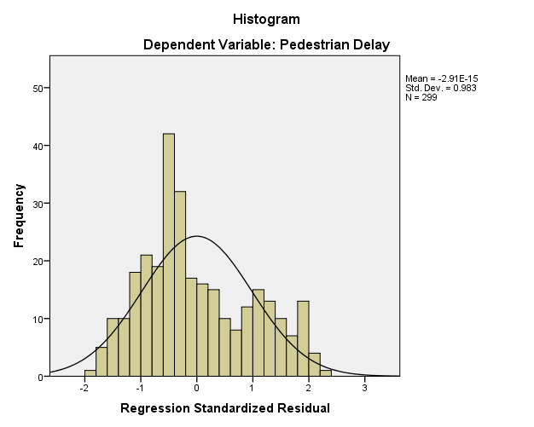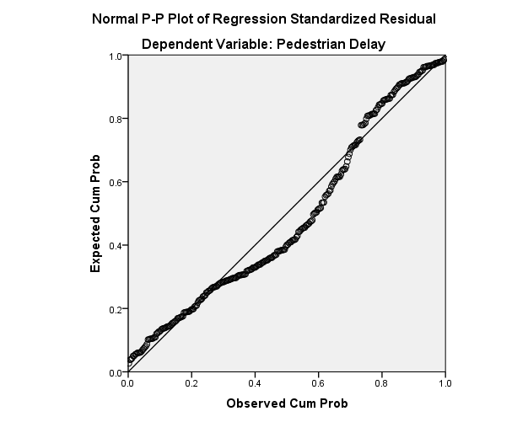
Figure 4.1: Histogram of Frequency Figure 4.2: Normal p-p plot
vs. Regression standardized residual of pedestrian delay
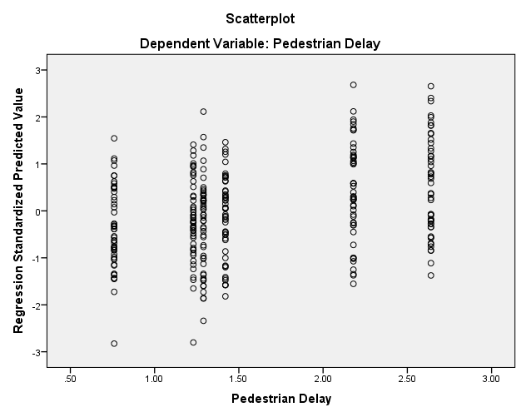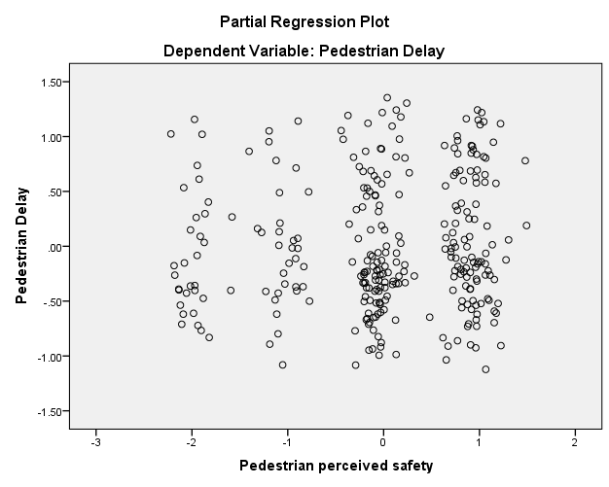

Figure 4.3: Scatter plot Regression standardized Figure 4.4: Scatter plot: Pedestrian
predicted value vs. Pedestrian delay perceived safety vs. Pedestrian delay
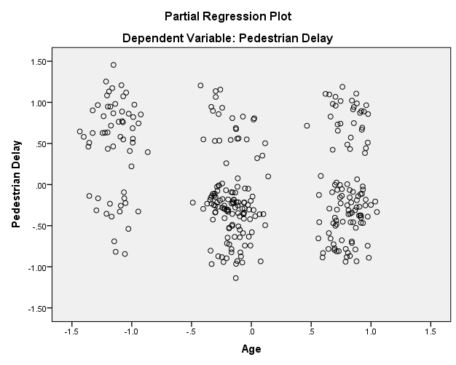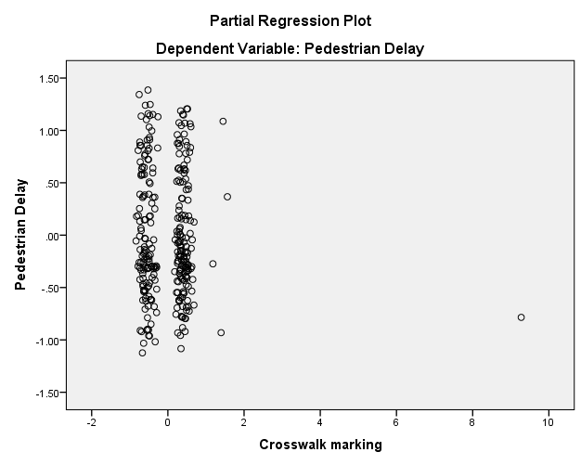
Figure 4.5: Scatter plot: Figure 4.6: Scatter plot:
Age vs. Pedestrian delay Crossing marking vs. Pedestrian delay

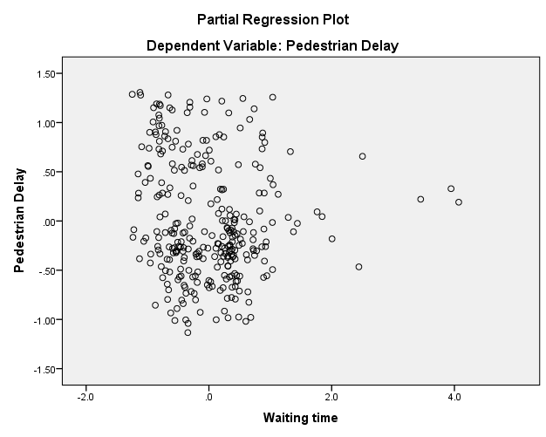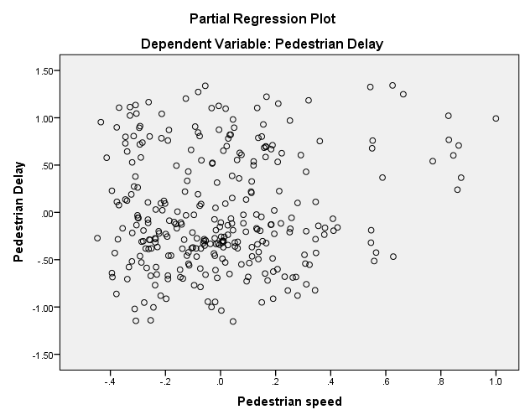
Figure 4.7: Scatter plot: Figure 4.8: Scatter plot:
Waiting time vs. Pedestrian delay Pedestrian speed vs. Pedestrian delay
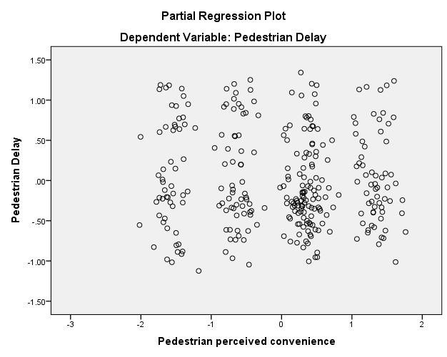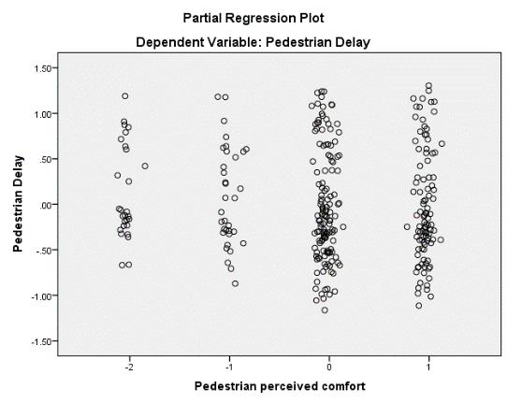

Figure 4.9: Scatter plot: Pedestrian Figure 4.10: Scatter plot: Pedestrian
perceived convenience vs. Pedestrian delay perceived comfort vs. Pedestrian delay
Interpretation:
Figure 4.1 shows the histogram of the data. As it can be seen from the figure the shape of the curve on the histogram approximates to a bell shape with a peak value at the middle. This shows that the data is from a normal distribution.
The errors should be approximately normally distributed. Figure 4.2 shows the normal probability plot graph of the pattern for the data approximately following the straight line strengthening the conclusion that the data is from normal distribution.
The relationship between the dependent and each independent variable should be linear. A scatter plot was developed by applying the SPSS, in order to study the relationships developed between the dependent variable and the regression variables so as to determine the model that best suits the test results. Consequently, the scatter plot of the same is presented from Figure 4.3 up to Figure 4.10: above scatter plot of independent variables versus each of the independent variables is presented showing that there is no significant evidence for the existence of nonlinear relationship.
The above scatter plots provide a visual method of displaying a relationship between variables as plotted in a two-dimensional coordinate system. Inspection of the scatter plots indicate that, there is a reasonable indication that the points lie scattered randomly around a straight line. Relatively, the above scatter plot shows a linear response and hence, a linear regression model expresses the association between the subject parameters.
Assumption 3: Multicollinearity (the independent variables should not highly correlated with each other)
Computing a correlation analysis in SPSS gives the following correlation matrix presented in table 4.12 above. If there exists a correlation coefficient greater than .0.8 then it is concluded that there is multicollinearity. The correlation coefficient for all variables were lesser than 0.8(<<0.8) so the independent variables are not strongly correlated with each other.
Assumption 4: There should be no significant outlier.
High leverage point or highly influential points in the data set considered as significant outliers are identified and removed in order to obtain same amount of information in developing the predicted model from all the data points.

4.5.2 Model Development
These variables were selected from Pearson correlation, for model development: Age (AGE), crosswalk marking (CM), waiting time (WT), pedestrian speed (PS), pedestrian perceived safety (PPS), pedestrian perceived convenience (PPC1) and pedestrian perceived comfort (PPC2). With stepwise regression analysis was conducted using the combined 300 observations. The model is developed by considering pedestrian delay as dependent variable and various factors as independent variables. The predicted model and its coefficients are given as follows:
P-delay= B_{o} - B₁*AGE - B₂*CM - B₃*WT + B₄*PS + B₅*PPS – B₆*PPC1 – B₇*PPC2
Where,
B_{o} = Regression equation constant and,
B_{1,} B_{2,} B_{3,} B₄ and B₅ = Multiple regression coefficients of variables.
Table 4.14 shows the result obtained after regression analysis the terms, coefficients and T-statistics for the model.
Table 4.14: Output after regression analysis
Model | B | T | Sig.
(Constant) | 1.966 | 7.516 | .000
Age | -.216 | -4.452 | .000
Crosswalk marking | -.062 | -1.324 | .018
Waiting time | -.092 | -2.010 | .045
Pedestrian speed | .273 | 2.130 | .034
Pedestrian perceived safety | .040 | 1.090 | .046
Pedestrian perceived convenience | -.036 | -1.009 | .014
Pedestrian perceived comfort | -.048 | -1.237 | .017

Interpretation
As shown in table 4.14 P value for the constant estimator and all explanatory variables are less than the significant level. This implies all predictors variables significantly predicted pedestrian delay with R² = 0.716. This was interpreted as, about 71.6% of the variation in pedestrian delay was explained by age, crosswalk marking, waiting time, pedestrian speed, pedestrian perceived safety, pedestrian perceived convenience and pedestrian perceived comfort based on the averaged observations from the 6 midblock crossings.
Therefore, the predicted model becomes,
P-delay = 1.99 – 0.216*AGE – 0.062*CM – 0.092*WT + 0.273*PS + 0.040*PPS – 0.036*PPC1 – 0.048*PPC2
Where:
P-delay = Pedestrian delay,
AGE = Age,
CM = Crosswalk marking,
WT = Waiting time,
PS = Pedestrian speed,
PPS = Pedestrian perceived safety,
PPC1 = Pedestrian perceived convenience, and
PPC2 = Pedestrian perceived comfort.
- Age is negatively correlated with pedestrian delay (coded as, Elder=0, Middle=1 and Young=2), indicating that elder pedestrians have larger pedestrian delay.
- Crosswalk marking is negatively correlated with pedestrian delay (coded as, not visible=0, slightly visible=1 and highly visible=2), indicating the not visible crossways have caused larger pedestrian dely.
- Waiting time is negatively correlated with pedestrian delay. The larger the pedestrian waiting time at curb as well as at median have larger pedestrian delay.
- Both pedestrian speed and pedestrian perceived safety are positively correlated with pedestrian delay. The faster the pedestrian has caused the smaller pedestrian delay and also while the pedestrians perceived safety the pedestrian delay will reduce.
- Both pedestrian perceived convenience and pedestrian perceived comfort are negatively correlated with pedestrian delay. While the pedestrians did not perceive both convenience and comfort the large pedestrian delay occur.
- Beta values (unstandardized variables) had measured in their natural units and had represented the slope of the line between the predictor variables and the pedestrian delay.
- Beta value for pedestrian speed and pedestrian perceived safety coefficients are positive which means for every 1-unit increase in the pedestrian speed and pedestrian perceived safety, the pedestrian delay will increase by the beta coefficient value. Beta value for age, crosswalk marking, waiting time, pedestrian perceived convenience and pedestrian perceived comfort coefficients are negative which means for every 1-unit increase in the age, crosswalk marking, waiting time, pedestrian perceived convenience and pedestrian perceived comfort, the pedestrian delay will decrease by the beta coefficient value.
- T value had calculated difference represented in units of standard error. The greater the magnitude of T, the greater the evidence against the two sample sets.

4.5.3 Validation of the Model
Based on the summary output from the regression analysis, as shown in Appendix 2, a series of statistical tests were performed to validate the model.
- Coefficient of determination (R-Square)
From the multiple regression analysis performed, the coefficient of determination or R-square value was 0.716, (refer Appendix 3), which indicates that 71.6% of the variation in the predicted pedestrian delay has been explained by the explanatory variables, or in other words, the regression line. The R-square value obtained is exceptionally high and it indicates that the model is almost a good fit (an R-square value of 1 is a perfect fit).
- T-Test
The T value which is the square root of ratio between the mean square regression (MSR) and mean square error or residual (MSE), or square root of F (=3.905) in appendix 3, with the significance level (a) and degree of freedom (d.f.) being 0.000 and 10 respectively, the critical t-value is 1.009 and T-value for the model is 7.516. Since T is greater than critical -t, therefore it can conclude that the relationship is significant and the model can be used to the pedestrian delay score.
- Comparison
The validation of the developed correlation is conducted by using two known test results which follows similar testing procedures with the subject research. These control test results were obtained from CMC/Meri E-W and W-E locations. Subsequently, using the control test results and the developed correlation equation, the predicted P-delay is determined so as to compare it with the actual P-delay as shown in Table 4.15.

Table 4.15: Validation of the developed model
On the other hand, the developed correlation predicted the P-delay value with average variation of 33.5% from actual P-delay value.
The comparison between the predicted and observed pedestrian delay shown in figure 4.11. The graph indicates that pedestrian delay model which was developed through this study yielded results which are close to the observed values. Thus, it can be used to predict the P-LOS scores. So, it showed that the model was accurately validated.

Figure 4.11: The comparison between the predicted and observed P-delay
- Outcome from the validation tests
The pedestrian delay model which was developed through this study has passed the validation tests (R-square value and T-test). Therefore, it can be summed up that this model is valid and can be used to determine the P-LOS score.

Comparsion of Pedestrian Perception
To perceive the pedestrian opinion about safety, convenience and comfort, an interview with total number of 15 questions was provided for 400 pedestrians. The interview questions are divided into two parts. The 1st part inquires for personal information of the respondent i.e., gender, age, educational level, types of occupation and position. The 2nd part holds 10 questions inquiring perception and attitude of pedestrian about the crossing facilities. Results of questions included in part present in table 4.16. The format of the interview can be referred from appendix section.

4.6.1 LRT Effect on Disabilities
Most respondents answered that 72% of disabilities had faced difficulties while crossing through LRT crossways; 15% responded that the LRT crossing had no effect on disabilities and 13% responded that they had not seen any disable person while crossings the LRT line. These difficulties on disabilities are encountered while crossing through stairs and high gradients (for wheelchair users). Difficulties to cross LRT are due to crosswalks like ramps and stairs. The ramps used to access train but to cross the LRT crosswalk there exist stairs so wheelchair users could not cross LRT crossways. Also, ramps have high gradient so it may accelerate or decelerate their movements and there is height difference on the crosswalk creating difficulties to cross by wheelchair.
Figure 4.12: Wheelchair users got difficulties to cross through the LRT line.

4.6.2 Pedestrians Attitude Survey
Referring to the below table 4.16, pedestrians’ attitude on present crossing facilities is discussed as follows.
- During the survey it was tried to get a balanced number of male and female respondents though, 188 participants were male 214 were female. Among 400 respondents 144 were Elder, 100 were Middle and 156 were Young.
- Among 400 respondents 113 were first time users, 142 were few times users and 101 were very rare users of crosswalk.
- More than half of the respondents had not got visible the crosswalk marking condition and poor crosswalk surface condition.
- Out of 400 respondents 265 were used 3-6 minutes wait to cross the LRT and used to travel about 200-500m to cross the LRT.
- 69% of respondents answered that the width of the crosswalk was not enough for their free movement given high number of pedestrians while 31% responded that the width was enough. By using CREC, 2009 all geometries (the width of crosswalks and the width of the platform on the stairs) are less than minimum requirements for safe and comfortable movements.
- Among half of the surveyed pedestrians perceived moderate safety, convenience and comfort while the rest chose highly safe and feel normal safety. A small number of respondents did not perceive any safety, convenience and even comfort and all demographic characteristics of pedestrians had shown in Table 4.16 below.
Table 4.16: Demographic characteristics of pedestrians
Demographic characteristics |  | Pedestrians Response |  | Demographic characteristics |  | Pedestrians Response
 |  | NO | % |  |  | NO | %
Age | Elder (>60 years) | 144 | 36 | Gender | Female | 212 | 53
Age | Middle (30 - 60 years) | 100 | 25 | Gender | Male | 188 | 47
Age | Young (< 30 years) | 156 | 39 | Gender | Total | 400 | 100
Age | Total | 400 | 100 | Pedestrian perceived convenience | Not | 52 | 13
Frequency using crosswalk | First time | 44 | 11.00 | Pedestrian perceived convenience | Convenience | 98 | 24.5
Frequency using crosswalk | Every day | 113 | 28.25 | Pedestrian perceived convenience | Moderate | 163 | 40.75
Frequency using crosswalk | Few times | 142 | 35.50 | Pedestrian perceived convenience | Highly | 87 | 21.75
Frequency using crosswalk | Very rare | 101 | 25.25 | Pedestrian perceived convenience | Total | 400 | 100
Frequency using crosswalk | Total | 400 | 100.00 | Pedestrian perceived comfort | Not | 37 | 9.25
Pedestrian perceived safety | Not safe | 39 | 9.75 | Pedestrian perceived comfort | Comfort | 132 | 33
Pedestrian perceived safety | Safe | 48 | 12.00 | Pedestrian perceived comfort | Moderate | 185 | 46.25
Pedestrian perceived safety | Moderate safe | 179 | 44.75 | Pedestrian perceived comfort | Highly | 46 | 11.5
Pedestrian perceived safety | Highly safe | 134 | 33.50 | Pedestrian perceived comfort | Total | 400 | 100
Pedestrian perceived safety | Total | 400 | 100

CONCLUSIONS AND RECOMMENDATIONS

Conclusions
This study set out to determine the performance of the existing pedestrian crossway by quantifying pedestrian delay. In addition, it was designed to determine the most influencing factors to pedestrian delay and develop regression model for pedestrian delay. In doing so, from the above stated results and discussions the main conclusions of the study are the followings:
- Geometry of LRT crossing facility has some problems. These are all LRT crossways are located at a long distance from pedestrians’ origin and destination; ramps have high gradients; crossway width and area are not enough for pedestrians resulting in slow passenger’s flow; there is also lack of refuge space between the railway and roadway having safety concerns for pedestrians. Walkway width and pedestrian volume affects the serviceability level of pedestrian crosswalks. So, it needs same adjustment to make is compatible for the users.
- Even if there is zebra crossing (pedestrians have priority to cross the road that the vehicles), pedestrians have to incurred more actual delay than average pedestrian gap delay. So, motorists should yield to minimize additional pedestrian delays.
- Quantitative assessment (based on pedestrian delay) for interrupted flow, all crosswalks resulted in a P-LOS of “A”, which means pedestrian can move with their desire speed without much more delay. The larger volume of pedestrians using the crossways doesn’t alter movement.
- Similarly, for uninterrupted flow (based on flow rate, average pedestrian space, V/C), all stairway and strail resulted in a P-LOS of “A” while EW2 (WE) for stairway based on flow rate and V/C resulted in a P-LOS of “B”. Therefore, the available crosswalk, stairway and strail are enough for pedestrians. And it also needs some adjustments.
- The paper selected four typical mid-block crosswalks with no signal control. The data regarding crossing behavior of three groups of pedestrians were collected by video capture and observed indoor. The similarities and differences of the three groups of pedestrians were analyzed by statistical method. The result showed that gender differences were no significant difference in term of pedestrian delay.
- Age, crosswalk marking, waiting time, pedestrian speed, pedestrian perceived safety, pedestrian perceived convenience and pedestrian perceived comfort were found having high correlation with the pedestrian overall satisfaction level at crosswalk of midblock.
- Gender, frequency using crosswalk and crosswalk surface condition were no the influencing factors to pedestrian delay. Similarly, total number of lanes, crossing width, median width and size of median opening were excluded during correlation analysis due to constant values.
- To study the effect of each predicted variables on pedestrian delay multiple linear regression model was developed, five variables were found statistically significant to predict pedestrian delay at 95% confidence level. The calculated R²adj for the regression model is 0.716. This was interpreted as, about 71.6% of the variation in pedestrian delay was explained by age, crosswalk marking, waiting time, pedestrian speed, pedestrian perceived safety, pedestrian perceived convenience and pedestrian perceived comfort based on the averaged observations from the 6 midblock crossings.
- External validation was performed to validate the multiple linear regression model and the model’s predictive ability, R², is 0.949. And conclude that the regression model is validated and is applicable for midblock crossway integrated with LRT roads of Addis Ababa.

Recommendations
Depending on the final results of this study, the following are recommended for possible consideration by policy makers so that it adds its own positive impact on the improvement of road users’ lives, especially of pedestrians.
- Provide advance crosswalk warning signs for vehicle traffic. Unsignalized mid-block crosswalks should be provided on streets where traffic volumes do not have gaps in traffic stream long enough for pedestrian to walk to the other side or to a median refuge. At locations with inadequate gaps that also meet MUTCD signalization warrants, consider a signalized mid-block crossing (including locator tone and audio pedestrian signal outputs as well as visual pedestrian countdown signal heads).
- Provide overhead safety lighting on the approach sides of both ends of midblock crosswalks. Adequate lighting helps to warn oncoming drovers of pedestrians crossing the street at mid-block locations and also helps guide pedestrians across the street at night.
- Provide wheelchair ramps or at-grade channels at mid-block crosswalks with curbs and medians to make the road facilities compatible to all users.
- Use high-visibility crosswalk markings to increase visibility longitudinally. And stripe the crosswalk, regardless of the paving pattern or material. Otherwise, drivers are not likely to see it, especially at night.
- Introduce provision of free parking lots near LRT stations during the revision of the city’s master plan which is proposed to be revised in order to incorporate different things including off-street parking on major street highways.
- Omit unused zebra crossing paint around closed LRT gate, because most of the ramps are not giving function. This causes confusion on pedestrians and makes liable to unnecessary traffic crashes. Therefore, remove the pedestrian crossing marks located at the LRT ramp gate which are not working.
Further research areas
- During collecting travel speed and headway, modern data collection methods should be introduced instead of continue using the manual method in order to minimize the error and for work simplification.
- Further research should be conducted on disabled pedestrians crossing behavior at midblock.
- Further research should be conducted at pedestrian crossing behavior at un-signalized intersection and at midblock.

References
(n.d.).
AACRA. (2019). Addis Ababa City Roads Authority for A-A East-West Road. Addis Ababa.
Akash, Jain, A. G., & R. R. (2014). Pedestrian Crossing Behavior Analysis at Intersections. International Journal for Traffic and Transport Engineering, 103-116.
Alhajyaseen , W., & Asano, M. I. (2017). Studing Critical Pedestrian Behavioural Change for Safety Assesment at Signalized Crosswalk. Safety Science.
Arboretti, R. G., & Salmaso, L. (2003). Modeling Performance Analysis and Model Validation in Logistic Regression. Journal of Royal Statistical Society.
Baltes, M., & X. Chu. (2002). Pedestrian Level of Service for Midblock Street Crossings. Journal of the Transportation Research Record(1818), 125-133.
Beyene, E. A. (2015). Effects of Light Rail Transit System on Pedestrians and Public Transport Users’ Mobility.
Chutani, C., S. Ram, & P . Parida. (2013). LOS for Pedestrian at Uncontrolled Mid-Block Crossing. Presented at Urban Mobility India Conference. New Delhi.
CREC, C. R. (2009). Addis Ababa LRT Project East-West and North-South Line Project Study Report.
CREC, C. R. (2012). Schematic Design of Addis Ababa East-West and North-South (phase 1) LRT Project.
Deepty, Muley, Karbache Mohammed, Alhagyaseen Wael, & Al-salem Mohammed. (2017). Pedestrian crossing behavior at marked crosswalks on chinnalized right turn lane at intersection. Science direct, 233-240.
Delhi Integrated Multi-Modal Transit System. (2014). Feasibility and Operational Planning Study of BRT – B2 Corridor – Demand and Forecasting Report.
Diogenes, M., & L. A, L. (2010). Evaluation of Pedestrian Safety at Midblock Crossings. Transportation Research Board of the National Acadamies, 37-43.
Ethiopian Transport Authority. (2017). Road Sector Development Program. Addis Ababa.
Fruin, J. J. (1987). Designing for Pedestrians. In Pedestrian Planning and Design. Elevator World Magazine.
Gang, Ren, Zhu Zhuping, Wang Wei, Zhang Yong, & Wang Weijie. (2011). Crossing Behaviour of Pedestrian at Signalized Intersection. Transport Research Board.
Garder , P. (2004). The Impact of Speed and Other Variables on Pedestrian Safety in Maine. Accident Analysis and Prevention, 36(4).
Gerlough, D., & M. J, H. (1975). Traffic Flow Theory: A Monograph. Washington, D.C: Transportation Research Board, National Research Council.
HCM. (1985). Special Report 209: Highway Capacity Manual. Washington, D. C: TRB, National Research Council.
HCM. (2010). Highway Capacity Manual 2010. Washington D.C.: Transportation Research Board.
Hosmer, D., & S, L. (2000). Applied Logistic Regression 2nd Edition. Newyork: John Wiley and sons.
Jiang, Xiaobie, Wuhong, W., Klause, B., & Weiwei, G. (2015). Analysis of Pedestrian Behavior on Mid-Block Unsignalized Crosswalk Comparing Chinese and German Cases. Advance in Mechanical Engineer, 1-7.
Kadali, B. R, & P. Vedagiri. (2013). Modelling Pedestrian Road Crossing Behaviour Under Mixed Traffic Condition. European Transport, 55(3), 1-17.
Kadali, B., & P . Vedagiri. (2015). Evaluation of Pedestrian Crosswalk Level of Service(LOS) in Perspective of Type of Land-Use. Policy and Practice, 73, 113-124.
Koh, P. (2014). Safety Evaluation of Pedestrian Behaviour and Violations at Signalized Pedestrian Crossings. Safety Science, 5-7.
Lindley, J. (1987). Urban freeway congestion: quantification of the problem and effectiveness of potential solutions. ITE, 27-32.
Maricopa Association of Government. (2005). Pedestrian Policies and Design Guidelines.
Marisamynathan, V. P. (2014). Study on Pedestrian Crossing Behavior at Signalized Intersections. Journal of Traffic and Transportation Engineering(1(2)), 103-110.
Natasha, S. (2016). Human Ellipse of Indian Pedestrians. International Symposium on Enhancing Highway. 15, pp. 150-160. India: Transportation Research Procedia.
NCHRP. (2008). Multimodal Level of Service Analysis for Urban Streets. Washington D.C.: Transportation Research Board of the National Academies. Retrieved from http://www.trb.org/Main/Blurbs/160228.aspx
Pushkarev, B., & Zupan, J. (1975). Urban Space for Pedestrians. Cambridge, MA: MIT Press.
Rigel, K. (2008). Factors Influencing Footbridge Usage Along Epifanio Delos Santos Avenue. Manilia: De La Salle University.
Robert, M., & Brunswick, V. (2002). Estimating Capacities for Pedestrian Walkways and Viewing Platforms. Dunstan, Brunswick: Geo-Dimensions Pty Ltd.
Singh , K., & Jain, P. (2011, January-March). Method of Assessing Pedestrian Level of Service. Journal of Engineering Research and Studies, II(I), 116-124.
Sohel, Rana, Midi, H., & S , K. S. (2015). Validation and Performance Analysis of Binary Logistic Regression Model. WSEAS International Conference on Environmental Medicine and Health Science. Serdag, Malasia.
TCRP. (2017). Guidebook on Pedestrian Crossings of Public Transit Rail Service. Transit Cooperative Research Program.
WMATA, W. (2005). Guidelines for Station Site and Access Planning. Washington Metropolitan Area Transit Authority: Wahington D.C.
WSDOT. (2013). Design Manual M 22 01.10 .
Zhao, L., Y. Bian, J. Lu, & J. Rong. (2014). Method to Determine Pedestrian Level of Service for the Overall Unsignalized Midblock Crossings of Road Segments. Advances in Mechanical Engineering, 1-9.

APPENDIX A

Sample calculation for P-LOS

Evaluation of Interrupted Flow of Pedestrian Level of Service (P-LOS) Based on
HCM2010
Step 1: Identify Two-Stage crossings
Sample calculation of pedestrian delay for defining LOS at EW2 (CMC 2/Meri) station during peak period.
Step 2: Determine critical headway
The critical headway was the maximum time in seconds below which a pedestrian will not attempt to begin crossing the street. The gap was measured between the passage of two successive vehicles (rear bumper to front bumper). To cross safely, the available headway should be greater than the critical headway. So, the necessary data were required to determine the critical headway average pedestrian walking speed (m/s), crosswalk length (m), and pedestrian start-up time (s) to be determined using equation 3.2 as follows:
t_{c}= $\frac{L}{Sp}$+t_{s}
There are four lanes with each 3.3m wide each; so, totally the crosswalk length is:
L = 4 x 3.3 = 13.2m
- Pedestrian start-up time of 3 seconds was a reasonable midrange value seconds can be used (HCM, Highway Capacity Manual 2010, 2010).
- Average pedestrian walking speed was determined using Equation 3.3 and are listed below. Table A.1 shows average pedestrian walking speed.
Table A.1: Average pedestrian walking speed
Station | Approach | Average time for crossing (sec) | Average length of highway segment (m) | Average travel speed (m/sec)
EW1 | E-W | 9.92 | 13.2 | 1.33
EW1 | W-E | 10.54 | 13.2 | 1.25
EW2 | E-W | 10.86 | 13.2 | 1.22
EW2 | W-E | 9.74 | 13.2 | 1.36
EW4 | E-W | 11.04 | 13.2 | 1.2
EW4 | W-E | 10.72 | 13.2 | 1.23
EW8 | E-W | 9.62 | 13.2 | 1.37
EW8 | W-E | 9.62 | 13.2 | 1.37

Sample calculation of pedestrian critical headway for defining LOS for EW2(CMC 2/Meri) for peak period is illustrated below:
t_{c}= $\frac{13.2 }{1.22}$+ 3 = 13.82s, (for E-W)
t_{c}= $\frac{13.2 }{1.36}$+ 3 = 12.71s, (for W-E)
The pedestrian platooning was observed in the field, and then spatial distribution of pedestrians had been computed with Equation 3.4.
N_{p}=Int $\frac{0.75(Nc-1)}{Wc} +1$
Before determining the pedestrian platooning, total number of pedestrians in the crossing platoon was determined with Equation 3.5:
N_{c} = $\left[\frac{V{pe}^{Vptc}+V{ e}^{-vtc}}{(V{p+V)e}^{\left(Vp-V\right)tc}}\right]$
The following inputs were needed for computing the number of pedestrians in crossing the platoon:
- Pedestrian flow rate (ped/s),
- Vehicular flow rate (veh/s), and
- Critical headway for a single pedestrian (s),
Effective crosswalk width was determined with Equation 3.6:
Wc = 4 – 1 = 3m, (for both E-W and W-E)
Pedestrian flow rate was determined with Equation 3.7:
$\text{Vp}=\frac{V15}{900*WE}$
$\text{Vp}=\frac{312}{900*3}$ = 0.116 ped/s, (for E-W)
$\text{Vp}=\frac{286}{900*3}$ = 0.106 ped/s, (for W-E)
Vehicular flow rate was determined with Equation 3.8:
$\text{V}=\frac{V}{PHF*3600}$
Peak-hour factor was determined with Equation 3.9:
$\text{PHF}=\frac{V}{4* V15}$
$\text{PHF}=\frac{3367.2}{4* 1026.1}$ = 0.82, (for E-W)
$\text{PHF}=\frac{3355.2}{4* 1029.9}$ = 0.81, (for W-E)
Therefore, vehicular flow rate was determined below:
$\text{V}=\frac{3367.2}{0.82*3600}$ = 0.114 veh/s, (for E-W)
$\text{V}=\frac{3355.2}{0.81*3600}$ = 0.114 veh/s, (for W-E)
Total number of pedestrians in the crossing platoon:
N_{c} = $\left[\frac{0.116 X e^{(0.116X13.82)} + 0.114 { e}^{(-0.114 X13.82)}}{(0.116{+0.114 )e}^{\left(0.116-0.114 \right)13.82}}\right]$ = 2.5, (for E-W)

N_{c} = $\left[\frac{0.106 X e^{(0.106X12.71)} + 0.114 { e}^{(-0.114 X12.71)}}{(0.106{+0.114 )e}^{\left(0.106-0.114 \right)12.71}}\right]$ = 2.187 $≈$ 2.2, (for W-E)
Spatial distribution of pedestrians had been computed with Equation 3.4.
N_{p}=Int $\frac{0.75(2.5-1)}{3}$ = 1, (for E-W)
N_{p}=Int $\frac{0.75(2.2-1)}{3}$ = 1, (for E-W)
Group critical headway was determined with Equation 3.10:
tc, _{G} = tc + 2(Np – 1)
tc, _{G} = 13.82 + 2(1 – 1) = 13.82s, (for E-W)
tc, _{G} = 12.71 + 2(1 – 1) = 12.71s, (for E-W)
Step 3: Estimate probability of delayed crossing
The following inputs were needed for estimating probability of delayed crossing:
- Number of through lanes crossed,
- Group critical headway (s), and
- Vehicular flow rate (veh/s).
Probability of a blocked lane had been computed with Equation 3.11,
P_{b} = 1- e ^{-tc,GV /L}
P_{b} = 1- e ^{-13.82*0.114} ^{/2} = 0.326, (for E-W)
P_{b} = 1- e ^{-13.82*0.114} ^{/2} = 0.304, (for W-E)
Probability of a delayed crossing lane had been computed with Equation 3.12,
P_{d} = 1- (1-P_{b}) ^{L}
P_{d} = 1- (1-P_{b}) ^{L =} 0.793, (for E-W)
P_{d} = 1- (1-P_{b}) ^{L} = 0.765, (for E-W)
Step 4: Calculate average delay to wait for adequate gap
The following inputs were needed for calculating average delay to wait for adequate gap:
- Group critical headway (s), and
- Vehicular flow rate (veh/s).
The average delay per pedestrian to wait for an adequate gap had been computed with Equation 3.13.
d_{g} = $\frac{1}{V}$(e^{vtc, G} -Vtc, G -1)
d_{g} = $\frac{1}{0.114}$(e^{0.114*13.82} -0.114*13.82 -1) = 19.802, (for E-W)
d_{g} = $\frac{1}{0.114}$(e^{0.114*12.71} -0.114*12.71 -1) = 15.861, (for W-E)
The average delay for any pedestrian who was unable to cross immediately upon reaching the crossway was thus a function of Pd and dg, as showed in Equation 3.14.
d_{gd} = $\frac{dg}{Pd}$
d_{gd} = $\frac{19.802}{0.793}$= 24.968, (for E-W)
d_{gd} = $\frac{15.861}{0.765}$= 20.731, (for W- E)
Step 5: Estimate delay reduction due to yielding vehicles
The following inputs were needed for estimating the delay reduction due to yielding vehicles:
- Average pedestrian delay,
- Crossing event (i= 1 to n),
- Average headway for each through lane,
- Motorist yield rate (decimal),
- Probability that motorists yield to pedestrian on crossing event i, and
- Average number of crossing events before an adequate gap was available.
Motorist yield rate (MYR) was calculated as a ratio of the number of vehicles that stopped or slowed down before a pedestrian crossing and the total number of vehicles that could have stopped or slowed down in order for pedestrians to cross the road. Table A.2 below shows average headway and Motorist yield rate.
Table A.2: Average headway and MYR
Station | Approach | Average headway for each through lane | Motorist yield rate (decimal)
Station | Approach | Average headway for each through lane | Total number of vehicles at 15-min | Total number of stopped vehicles | MYR
EW1 | E-W | 6.44 | 911.4 | 547 | 0.6
EW1 | W-E | 5.34 | 667 | 335 | 0.5
EW2 | E-W | 3.15 | 1026.1 | 516 | 0.5
EW2 | W-E | 4.64 | 1029.9 | 651 | 0.63
EW4 | E-W | 2.36 | 1802 | 971 | 0.54
EW4 | W-E | 2.14 | 1167.4 | 530 | 0.45
EW8 | E-W | 3.15 | 1265.5 | 645 | 0.51
EW8 | W-E | 3.53 | 3086 | 1987 | 0.64

Four-Lane Crossing, P(Y_{i}) was found simply, (for E-W).
P(Y_{i}) = P_{d} - $\sum_{j=0}^{i-1}{P}$(Y_{j}) x $\frac{{Pb}^{4 }{My}^{4 }+4{Pb}^{3 }\left(1-Pb\right){My}^{3 }+6{Pb}^{2 }{(1-Pb)}^{2 }{My}^{2 }+ 4Pb\left(1-{Pb}^{3 }\right)My}{Pd}$
Where P(Y₀) = 0
Average number of crossing events before an adequate gap was available, (for E-W)
n = Int (d_{gd} /h),
n = Int (24.968/3.15) = 8,
i = crossing event (i= 1 to 8),
P(Y₁)= 0.793 - $0$x $\frac{{0.326}^{4 }{*0.5}^{4 }+4{*0.326}^{3 }\left(1-0.326\right){0.5}^{3 }+6*{0.326}^{2 }{\left(1-0.326\right)}^{2 }{0.5}^{2 }+ 4*0.326\left(1-{0.326}^{3 }\right)0.5}{0.793}$
P(Y₁) = 0.718,
P(Y₂)= 0.793 – $0.718$x $\frac{{0.326}^{4 }{*0.5}^{4 }+4{*0.326}^{3 }\left(1-0.326\right){0.5}^{3 }+6*{0.326}^{2 }{\left(1-0.326\right)}^{2 }{0.5}^{2 }+ 4*0.326\left(1-{0.326}^{3 }\right)0.5}{0.793}$
P(Y₂) = 0.068,
.
.
.
P(Y₈) = 0.000.
Four-Lane Crossing, P(Y_{i}) was found simply, (for W- E).
P(Y_{i}) = P_{d} - $\sum_{j=0}^{i-1}{P}$(Y_{j}) x $\frac{{Pb}^{4 }{My}^{4 }+4{Pb}^{3 }\left(1-Pb\right){My}^{3 }+6{Pb}^{2 }{(1-Pb)}^{2 }{My}^{2 }+ 4Pb\left(1-{Pb}^{3 }\right)My}{Pd}$
Where P(Y₀) = 0
Average number of crossing events before an adequate gap was available, (for E-W)
n = Int (d_{gd} /h),
n = Int (20.731/4.64) = 4,
i = crossing event (i= 1 to 4),
P(Y₁)= 0.765-$0$ x $\frac{{0.304}^{4 }{*0.63}^{4 }+4{*0.304}^{3 }\left(1-0.304\right){0.63}^{3 }+6*{0.304}^{2 }{\left(1-0.326\right)}^{2 }{0.63}^{2 }+ 4*0.304\left(1-{0.304}^{3 }\right)0.63}{0.765}$
P(Y₁) = 0.872,
P(Y₁)= 0.765 –0.872 x $\frac{{0.304}^{4 }{*0.63}^{4 }+4{*0.304}^{3 }\left(1-0.304\right){0.63}^{3 }+6*{0.304}^{2 }{\left(1-0.304\right)}^{2 }{0.63}^{2 }+ 4*0.304\left(1-{0.304}^{3 }\right)0.63}{0.765}$
P(Y₂) = 0.121,
.
.
.
P(Y₄) = 0.002.
Step 6: Calculate average pedestrian delay and determine LOS
Pedestrian delay was equal to the sum of the delay for each stage of the crossing. Then, refer Table 3.4 lists LOS criteria for pedestrians at TWSC crossways based on pedestrian delay.
Thus, average pedestrian delay had been computed with Equation 3.15
d_{p} = $\sum_{i=1}^{n}{h\left(i-0.5\right)}$P(Y_{i})+ P_{d} - $\sum_{i=1}^{n}{P}$(Y_{i}) dgd
d_{p} = 1.511s/pedestrian, (for E-W)
Thus, average pedestrian delay had been computed with Equation 3.15
d_{p} = $\sum_{i=1}^{n}{h\left(i-0.5\right)}$P(Y_{i})+ P_{d} - $\sum_{i=1}^{n}{P}$(Y_{i}) dgd
d_{p} = 1.342s/pedestrian, (for W-E)
Thus, total average pedestrian delay had been computed by summing the two stages,
d_{TP} = 1.511 + 1.342 = 2.852s/pedestrian,
Average pedestrian delay 2.852 sec was classified as a P-LOS = “A” from HCM2010 level of service criteria tables.

Evaluation of Uninterrupted Flow of Pedestrian Level of Service (P-LOS) Based on
HCM2010
- Uninterrupted flow of pedestrian based on flow rate
Sample calculation of pedestrian unit flow rate and LOS for EW2(CMC 2/Meri) for peak period was illustrated below. The peak 15-minute volumes for strail were 312 at Day-1, 279 at Day-2 and 269 at Day-3 counted. Hence, for analysis purpose the maximum peak 15-minute volume in the morning peak period (V₁₅) =312 (from Day-1 count). The peak 15-minute volumes for EW were 312 at Day-1, 265 at Day-2 and 269 at Day-3 counted. Hence, for analysis purpose the maximum peak 15-minute volume in the morning peak period (V₁₅) =312 (from Day-1 count). and also, the peak 15-minute volumes for WE were 286 at Day-1, 279 at Day-2 and 263 at Day-3 counted. Hence, for analysis purpose the maximum peak 15-minute volume in the morning peak period (V₁₅) =286 (from Day-1 count).
Effective width of the strail;
W_{E} = W_{T} - W_{O}
W_{E} = 3m – 0.46m = 2.54m
Effective width of the stairway (EW);
W_{E} = W_{T} - W_{O}
W_{E} = 1.8m – 0.25m = 1.55m
Effective width of the stairway (WE);
W_{E} = W_{T} - W_{O}
W_{E} = 1.4m – 0.25m = 1.15m
Flow rate of the strail;
$\text{Vp}=\frac{V15}{15*WE}$
Vp = $\frac{312 pedestrians}{15-minutes*2.54m}$ = 8.19 $≈9$ pedestrians/minute/meter
Flow rate of the stairway (EW);
$\text{Vp}=\frac{V15}{15*WE}$
Vp = $\frac{312 pedestrians}{15-minutes*1.55m}$ = 13.42 $≈14$ pedestrians/minute/meter
Flow rate of the stairway (WE);
$\text{Vp}=\frac{V15}{15*WE}$
Vp = $\frac{286 pedestrians}{15-minutes*1.15m}$ = 16.58 $≈17$ pedestrians/minute/meter

- Uninterrupted flow of pedestrian based on average pedestrian space,
P-LOS Based on Average Pedestrian Space (A_{p})
Average space in the peak period (strail):
$\text{A}\text{p}=\frac{Sp}{Vp}$ = $\frac{71.99 m/min}{8p/min/m}$ = 9 m²/p, (P-LOS category A)
Average space in the EW peak period (Ascending on the stairway):
$\text{A}\text{p}=\frac{Sp}{Vp}$ = $\frac{81.31 m/min}{13p/min/m}$ = 6.25 m²/p, (P-LOS category A)
Average space in the WE peak period (Ascending on the stairway):
$\text{A}\text{p}=\frac{Sp}{Vp}$ = $\frac{81.31 m/min}{17p/min/m}$ = 4.78 m²/p, (P-LOS category A)
Average space in the EW peak period (Descending on the stairway):
$\text{A}\text{p}=\frac{Sp}{Vp}$ = $\frac{72.93 m/min}{13p/min/m}$ = 5.61 m²/p, (P-LOS category A)
Average space in the WE peak period (Descending on the stairway):
$\text{A}\text{p}=\frac{Sp}{Vp}$ = $\frac{72.93 m/min}{17p/min/m}$ = 4.29 m²/p, (P-LOS category A)
- Uninterrupted flow of pedestrian based on volume to capacity ratio,
P-LOS Based on Volume to Capacity Ratio(V/C)
V/C in the peak period (strail):
V/C = $\frac{8 ped/min/m }{75 ped/min/m}$ = 0.107, (P-LOS category A)
V/C in the peak period of stairway (EW);
V/C = $\frac{13 ped/min/m }{49 ped/min/m}$ = 0.265, (P-LOS category A)
V/C in the peak period of stairway (WE);
V/C = $\frac{17 ped/min/m }{49 ped/min/m}$ = 0.347, (P-LOS category B)

APPENDIX B

Outputs of the software

Table B-3: Descriptive statistics
Descriptive Statistics
 | Mean | Std. Deviation | N
Pedestrian Delay | 1.5879 | .63264 | 299
Age | 1.17 | .733 | 299
Gender | .54 | .499 | 299
Frequency using crosswalk | 1.80 | .986 | 299
Crosswalk marking | .58 | .757 | 299
Crosswalk surface condition | 1.12 | .787 | 299
Waiting time | 2.138 | .7695 | 299
Pedestrian speed | 1.312 | .2788 | 299
Pedestrian perceived safety | 2.06 | .959 | 299
Pedestrian perceived convenience | 1.63 | 1.008 | 299
Pedestrian perceived comfort | 2.04 | .910 | 299
Table B-4: Model summery
Model Summary
Model | R | R Square | Adjusted R Square | Std. Error of the Estimate | Change Statistics
 |  |  |  |  | R Square Change | F Change | df1 | df2 | Sig. F Change
1 | .846ª | .716 | .189 | .60385 | .120 | 3.909 | 10 | 288 | .000
a. Predictors: (Constant), Pedestrian perceived comfort, Age, Crosswalk marking, waiting time, Crosswalk surface condition, Pedestrian perceived convenience, Pedestrian perceived safety, Frequency using crosswalk, Pedestrian speed, Gender
b. Dependent Variable: Pedestrian Delay
Table B-5: Residuals Statisticsª
Residuals Statisticsª
 | Minimum | Maximum | Mean | Std. Deviation | N
Predicted Value | .9699 | 2.1747 | 1.5879 | .21871 | 299
Residual | -1.16552 | 1.35278 | .00000 | .59363 | 299
Std. Predicted Value | -2.825 | 2.683 | .000 | 1.000 | 299
Std. Residual | -1.930 | 2.240 | .000 | .983 | 299
a. Dependent Variable: Pedestrian Delay

Table B-6: Coefficients of variables
Coefficients’^{s}
Model |  | Unstandardized Coefficients |  | Standardized Coefficients | t | Sig. | 95.0% Confidence Interval for B
 |  | B | Std. Error | Beta | t | Sig. | Lower Bound | Upper Bound
1 | (Constant) | 1.966 | .262 |  | 7.516 | .000 | 1.451 | 2.481
1 | Age | -.216 | .048 | -.250 | -4.452 | .000 | -.311 | -.120
1 | Crosswalk marking | -.062 | .047 | -.074 | -1.324 | .018 | -.154 | .030
1 | Waiting time | -.092 | .046 | -.112 | -2.010 | .045 | -.182 | -.002
1 | Pedestrian speed | .273 | .128 | .120 | 2.130 | .034 | .021 | .524
1 | Pedestrian perceived safety | .040 | .037 | .061 | 1.090 | .046 | -.033 | .113
1 | Pedestrian perceived convenience | -.036 | .035 | -.057 | -1.009 | .014 | -.105 | .034
1 | Pedestrian perceived comfort | -.048 | .039 | -.069 | -1.237 | .017 | -.124 | .028

APPENDIX C

Interview Questions

Hawassa University
School of Civil Engineering and Built Environment
Dear Sir/Madam
I, the researcher, is a student in Hawassa University Institute of Technology, currently doing my M.Sc. in Civil Engineering under Road and Transport Engineering at Hawassa Institute of technology. I am doing my M.Sc. research/thesis entitled:
“Assessing Performance of Pedestrian Road Crossway on Addis Ababa Light Rail Transit Based on Pedestrian Delay: (A Case Study Along Addis Ababa E-W (Ayat – Megenagna Light Rail Transit Line)” with the aim of assessing the quantify the performance and the level of service of the selected crossways road segments and finally to develop a model for estimation of pedestrian delay of selected study area of Addis Ababa city.
Your best honest and good response to the questionnaire will have contribution to the success of the research. Your response will be kept as confidential data, Moreover, the information you provide will be used strictly for academic purpose. Filling the questionnaire will not take more than 10 minutes. I thank you in advance for the time you devote, effort you make, and consideration you give in filling this questionnaire.
If you have any question concerning the items of the questionnaire, please call on mobile:
+2519 14358239, or e-mail ducktesfaye@gmail.com
With great respect.
Kidist Tesfaye

I. INSTRACTION
Don’t write your name. Please circle in the given alternative choice as per requirement of the statement.
1. Sex:
A. Male B. Female
2. Age
- < 30 years B. 30 - 60 years C. >60 years
3. Educational level
- Primary level B. Secondary level C. Diploma D. Degree E. Masters and above
4. Type of occupation
- Public employed B. Private-employed C. Self-employed D. Student
5. Position
- Management level B. Middle level / line manager C. Operational level

II. Instruction
Read carefully each question and, circle the best answer based on your experience to appropriate the questions. Each question only one answer.

  - How many times you will cross the LRT line per day?
- First time B. Few times C. Every day D. Very rare
  - How do you get the crosswalk marking condition?
- Not visible B. Slightly visible C. Highly visible
  - How do you get the crosswalk surface condition?
- Poor B. Moderate C. Good
  - How much time you will wait to cross the LRT?
A.<1min B. 1-3min C. 3-6min D.>6min
5. How much distance you will travel to cross the LRT?
A.<50m B.50m-200m C.200m-500m D. >500m
6. How do you perceive crossing safety while crossing the LRT?
- Not safe B. Safe C. Moderately safe D. Highly safe
7. How do you perceive crossing convenience while crossing the LRT?
- Not convenience C. Convenience
- Moderately convenience D. Highly convenience
8. How do you perceive crossing comfort while crossing the LRT?
- Not comfort C. Comfort
- Moderately comfort D. Highly comfort
9. Do you think the travel demand and crossing facility capacity (stairs/ramps) that you use enough for pedestrians and public transport users to cross the LRT crosswalk?
A. Enough B. Not enough
10. Physical disabilities restricting walking cause of LRT system?
A. Difficult B. Not difficult C. Not seen

