

ASSESSEMENT OF URBAN WATER SUPPLY ADEQUACY AND EVALUATION OF HYDRAULIC INTEGRITY
(THE CASE IN SHONE TOWN, HADIYA ZONE SNNPR STATE)

M.Sc. THESIS
By

WAJANA SORSA BARATA

HAWASSA UNIVERSITY, HAWASSA, ETHIOPIA

NOVOMBER, 2023
HAWASSA, ETHIOPIA
ASSESSEMENT OF URBAN WATER SUPPLY ADEQUACY AND EVALUATION OF HYDRAULIC INTEGRITY
(THE CASE IN SHONE TOWN, HADIYA ZONE SNNPR STATE)
WAJANA SORSA BARATA

A THESIS SUBMITTED TO THE DEPRTMENT OF WATER RESOURCE AND IRRIGATION ENGINEERING

HAWASSA INSTITUDE OF TECHNOLOGY, SCHOOL OF GRADUATE STUDIES HAWASSA UNIVERSITY
HAWASSA, ETHIOPIA

IN PARTIAL FULFILLMENT OF THE REQUIREMENTS FOR THE DEGREE OF MASTER OF SCIENCE IN WATER RESOURCE ENGINEERING AND MANAGEMENT

NOVOMBER, 2023

SCHOOL OF GRADUATE STUDIES
HAWASSA UNIVERSITY
ADVISORS’S APPROVAL SHEET
This is to certify that the thesis entitled “ASSESSEMENT OF URBAN WATER SUPPLY ADEQUACY AND EVALUATION OF HYDRAULIC INTEGRITY: THE CASE IN SHONE TOWN, HADIYA ZONE SNNPR STATE, Submitted in partial fulfillment of the requirements for the degree of Master of Science in Water Resource Engineering and Management of the graduate program of the School of Biosystem and Water Resource Management, Hawassa University, and is a record of original proposal carried out by Wajana Sorsa Barata (ID No GPWREM/0016/12), under my supervision, and no part of the proposal has been submitted for any other degree or diploma. The assistance and help received during the course of this investigation have been duly acknowledged. Therefore, I recommend that it is accepted as fulfilling the proposal requirements.
Approved by:

Mihret Dananto (PhD Ass. Prof) __________________ ______________

Name of Major Advisor Signature Date

Desalegn Jewesa (PhD.) __________________ ______________

Name of Co-Advisor Signature Date

SCHOOL OF GRADUATE STUDES
HAWASSA UNIVERSITY EXAMONERS’APPROVAL SHEET
We, the undersigned, members of the Board of Examiners of the final open defense by WAJANA SORSA BARATA have read and evaluated his MSc thesis entitled “ASSESSEMENT OF URBAN WATER SUPPLY ADEQUACY AND EVALUATION OF HYDRAULIC INTEGRITY: THE CASE IN SHONE TOWN, HADIYA ZONE SNNPR STATE”, and examined the candidate. This is, therefore, to certify that the thesis has been accepted in partial fulfillment of the requirements for the degree.

__________________________ ______________________ __________________
Name of Major Advisor Signature Date
__________________________ ______________________ __________________
Name of Internal Examiner-I Signature Date
__________________________ ______________________ __________________
Name of Internal Examiner-II Signature Date
__________________________ ______________________ __________________
Name of External Examiner Signature Date
__________________________ ______________________ __________________
SGS Approval Signature Date

ACKNOWLEDGMENT
Above all, I thank God for his grace and mercy upon me during all my work journeys and in all my life and his grace definitely did all for good.
Very special thanks to my advisors Dr. Mihret Dananto and Dr. Desalegn Jewesa for their valuable guidance, support and encouragement throughout my research work. I am very grateful for their time and willingness to support and review my works.
I would like to thank the officials of Woreda Administration Office, Woreda Water Supply Office, Finance and Economic Development Office, Shone Town Municipality Office and SNNPRS Water and Energy Office for their help by providing the necessary materials and for their tireless effort during data collection to my thesis work.
At the last, but not least, I am very proud of my lovely wife and my family for their love, support and they are truly a special gift from God for me; and I don’t forget my close friends support and encouragements.

TABLE OF CONTENTS
CONTENTS PAGE
ACKNOWLEDGMENT iv
LIST OF FIGURE xii
LIST OF ACRONYMS & ABBREVIATIONS xiii
ABSTRACT xvii
1. INTRODUCTION 18
1.1 General Background of the Study 18
1.2 Statement of the Problem 20
1.3 Objectives of the Study 21
1.3.1 Main Objective 21
1.3.2 Specific Objectives 21
1.4 Research Questions 21
1.5 Significances of the Study 21
1.6 Research Limitations 22
1.7 Scope of the Study 22
2. LITRATURE REVIEW 23
2.1 General 23
2.2 Water Supply System Adequacy 23
2.3 Urban Water Supply and Coverage 24
2.4 Urban Water Quantity Requirements 25
2.5 Urban Water Demand and Demand Forecasting 25
2.5.1 Types of Urban Water Demand 27
2.6 Water Loss in Water Supply System 28
2.6.1 Water Loss Estimation Benchmarks from Literatures 29
2.6.2 Water Loss in Developing and Developed Countries 30
2.6.3 Possible Causes of Water Loss in WSS 30
2.6.3.1 Pressure and Water Loss 30
2.6.3.2 Pipe Age and Water Loss 31
2.6.3.3 Pipe Corrosion and Water Loss 31
2.6.3.4 Illegal Connection and Water Loss 32
2.7 Urban Water Supply Distribution System 32
2.7.1 Hydraulic Integrity of Water Distribution System 33
2.7.2 Causes of Loss of Hydraulic Integrity 34
2.7.3 Maintaining Hydraulic Integrity in Water Distribution System 35
2.7.4 Water Supply System in Distribution Network 36
2.7.5 Basic Problems in Urban Water Distribution System 36
2.8 Basic Principles of Hydraulic Modeling 37
2.8.1 Hydraulic Design Parameters 38
2.8.1.1 Pressure 38
2.8.1.2 Negative Pressure 38
2.8.1.3 Flow Rate 39
2.8.1.4 Nodal Demands 39
2.8.1.4.1 Water Nodal Demand Distribution 40
2.8.2 Hydraulic Model Selection Criteria 41
2.8.2.1 Water GEMS Connect Edition 41
2.8.2.2 Input Data for Building the Models 42
2.8.3 Water Distribution Network Simulation 43
2.8.3.1 Steady-State Simulations 44
2.8.3.2 Extended-Period Simulations 44
2.9 Hydraulic Modeling of Water Distribution System 44
2.9.1 Model Skeletonization & Sensitivity 44
2.9.2 Model Calibration 44
2.9.2.1 Model Calibration Parameters 45
2.9.2.1.1 Pipe Roughness Coefficient 45
2.9.2.1.2 Nodal Demand 45
2.9.3 Model Validation 46
3. MATERIALS AND METHODS 47
3.1 General Description of the Study Area 47
3.1.1 Location of the Study Area 47
3.1.2 Climate and Rainfall Distribution 49
3.1.3 Ground Water Quality in the Area 49
3.1.4 Socio-Economic Feature of Shone Town 49
3.2 Materials and Tools 50
3.3 Data Sources and Collections Methods 50
3.3.1 Primary Data Collection 50
3.3.2 Secondary Data Collection 51
3.3.2.1 Shone Town Water Supply System 51
3.3.2.2 Existing Water Sources 51
3.3.2.3 Water Production 52
3.3.2.4 Collectors and Transmission Mains 53
3.3.2.5 Water Service Reservoirs/Tank 54
3.3.2.6 Distribution Pipe Line Network 55
3.3.2.7 Existing Electro-Mechanical Equipment’s 56
3.3.2.8 Existing Water Pumps 57
3.3.2.9 Customers of Existing Water Supply System 57
3.3.2.10 Water Consumption 58
3.3.2.11 Population Data 58
3.3.2.12 Shone Town Master Plan 59
3.3.2.13 Nodal Elevation 61
3.4 Methods of Data Collection and Analysis 61
3.4.1 Water Supply Coverage Analysis 61
3.4.2 Population Forecasting 62
3.4.3 Water Demand Analysis 63
3.4.3.1 Domestic Water Demand Analysis 63
3.4.3.2 Non-Domestic Water Demand Analysis 68
3.4.3.2.1 Institutional, Public and Commercial Water Demand 68
3.4.3.2.3 Industrial Water Demand 69
3.4.3.2.4 Firefighting Water Demand 69
3.4.3.2.5 Non Revenue Water Demand 69
3.4.3.3 Patterns of Water Demand Variation 69
3.4.3.3.1 Average Day Demand (ADD) 69
3.4.3.3.2 Maximum Day Demand (MDD) 70
3.4.3.3.3 Peak Hour Demand (PHD) 70
3.4.3.3.4 Water Source Assessment 71
3.4.5 Maintaining Hydraulic Integrity & Modeling Water Distribution System 72
3.4.5.1 Maintaining Hydraulic Integrity 72
3.4.5.2 Modeling Water Distribution System 73
3.4.5.3 Selection Criteria for Hydraulic Simulation Software 73
3.4.5.4 Building/Skeletonizing the Model 73
3.4.5.5 Allocation of Nodal Demand by Area Proportional 74
3.4.6 Water Distribution Simulation 75
3.4.7 Model Calibration Analysis 75
3.4.7.1 Sampling Location for Calibration 75
3.4.7.2 Sampling Size for Calibration 75
3.4.8 Analysis for Model Calibration Parameters 76
3.4.9 Field Nodal Pressure Readings 76
4. RESULT AND DISCUSSION 77
4.1 Analysis of Domestic Water Supply Coverage 77
4.1.1 Average Per-Capita Consumption and Water Coverage Analysis 77
4.1.2 Average Daily Per-Capita Consumption at Keble Level 78
4.1.3 Level of Connection per Family 79
4.1.4 Discussions on Level of Connection 81
4.1.5 Water Supply Coverage Based on Existing Connection Types 82
4.2 Water Demand Computation 84
4.2.1 Present and Future Domestic Demand 84
4.3 Additional Water Source Estimation 88
4.4 Water Loss Analysis 89
4.4.1 Discussion of Water Loss Results Based on Literatures 91
4.4.2 Causes of Water Loss from Systems 93
4.5 Hydraulic Integrity & Performance of Shone Town Water Supply System 95
4.5.1 Type, Length and Diameter of Shone Town Water Distribution Network (WDN) 95
4.5.2 Distribution Network Development and Simulation 97
4.5.3 Demand Patterns 98
4.5.4 Extended Period Simulation 100
4.5.5 Analysis for Pressure and Velocity on Existing Water Distribution System-WDS 100
4.5.5.1 Analysis of Pressure 100
4.5.5.2 Analysis of Velocity 108
4.5.5.3 Storage Tank Features at Different Consumption Hours 112
4.6 Calibration of Hydraulic Network 113
4.6.1 Sampling Techniques and Location 113
4.6.2 Sampling Techniques and Location 113
5. CONCLUSION AND RECCOMMENDATION 117
5.1 Conclusion 117
5.2 Recommendations 120
6. REFRENCE 121
7. APPENDIX 130

LIST OF TABLE
TABLE PAGE
Table 2.1 IWA Standard of International Water Balance and Its Terminology 29
Table 2.2 Input Parameters and Primary Purposes of Water GEMS Tools 43
Table 3.1 Existing Water Sources 52
Table 3.2 Descriptions and Daily Production of Existing Boreholes 53
Table 3.3 Existing Service Water Reservoirs 54
Table 3.4 Existing Distribution Lines of Shone Water Supply System 56
Table 3.5 Existing Electro-Mechanical Equipment at Borehole 57
Table 3.6 Customers and User Groups of Existing System 58
Table 3.7 Urban Growth Rates by Range of Years, SNNPR 63
Table 3.8 Urban Growth Rates by Years, SNNPR 63
Table 3.9 Distribution of Mode of Services on Existing Water System 64
Table 3.10 Per-Capita Domestic Water Demand by Mode Service 65
Table 3.11 Projected Mode of Service 66
Table 3.12 Adjustment Due to Climatic Factor 67
Table 3.13 Adjustment Due to Socio-Economic Factor 67
Table 4.1 Average Daily Per Capita Consumption @ Kebele Level for Year 2023 78
Table 4.2 Level of Connection per Family of Shone Town for Year 2023 80
Table 4.3 Statistics of Per-Capita Consumption and Level of Connection Per Family 81
Table 4.4 Statistics of Per-Capita Consumption and Level of Connection Per Family 82
Table 4.5 Water Coverage of Shone Town Based on Existing Connection Types 83
Table 4.6 Population Projection of Shone Town 84
Table 4.7 Summary of Water Demand Computation 85
Table 4.8 Additional Water Source Computation 89
Table 4.9 Quantity of Water Loss Computation from Shone Town 90
Table 4.10 Classification and Description of Water Losses 92
Table 4.11 Pipe Size Distribution in Diameter and Length 95
Table 4.12 Material Type, Length & Coverage of Distribution Network 97
Table 4.13 Distribution of Pressure at Peak Hour Consumption 102
Table 4.14 Distribution of Pressure at Minimum Hour Consumption 106
Table 4.15 Simulated Range of Velocity at Peak Consumption Hour 108
Table 4.16 Simulated Velocity at Peak Consumption Hour after Pipe Re-Sizing 109
Table 4.17 Junction Pressures Measured for Calibration at Peak Consumption Hours 114

LIST OF FIGURE
FIGURE PAGE
Figure 2.1 Variation in System Capacity and Water Demand with Time 34
Figure 2.2 Screen shoot of User Interface of water GMES Connect Edition 42
Figure 3.1 Location Map of Shone Town 48
Figure 3.2 Layout of Existing Collector or Pressure Main from Two BH 53
Figure 3.3 Existing Service Reservoirs Feeds to the Town 55
Figure 3.4 Master Plan of Shone Town (New) 60
Figure 4.1 Correlation of Per Capita Consumption and Level of Connection 82
Figure 4.2 Population Projection of Shone Town for Design Period (2023-2042) 84
Figure 4.3 Yearly Distribution of Various Demands 87
Figure 4.4 Water Production and Consumption of the Town in m3 Per Year 91
Figure 4.5 Water Loss Trend in m3 per Year in Percentage in Past Eight Years 92
Figure 4.6 Existing Challenges in Shone Water Supply System 94
Figure 4.7 Shone Town Existing Water Supply Distribution System 96
Figure 4.8 Water Demand Usage Pattern 98
Figure 4.9 Water Distribution Network of Shone Town 99
Figure 4.10 Excessive Demand Resulted Negative Pressure during Peak Time 101
Figure 4.11 Demand Vs Pressure at Node 42 in Various Time Intervals 102
Figure 4.12 Profiles of Nodes Showing Distance from Storage Tank (T-2) 104
Figure 4.13 Relationship between Pressure and Elevation for Selected Nodes 105
Figure 4.14 Contour Map of Pressure Distribution 106
Figure 4.15 Water Distribution System at Extended Period Simulation in Peak Hour 107
Figure 4.16 Graph of Velocity Distributions for Selected Pipes 109
Figure 4.17 Velocity Distribution at Extended Period Simulation in Peak Period 110
Figure 4.18 Flow Condition at Different Time Intervals Patterns 111
Figure 4.19 Hydraulic Gradient and Head Loss at different Time Intervals 111
Figure 4.20 Tank-1 Water Volume Fluctuation Over 24 Hour Periods 112
Figure 4.21 Simulation Pressure Vs Measured Pressure 115
Figure 4.22 Correlation between Observed and Simulated Pressure 116

LIST OF ACRONYMS & ABBREVIATIONS
ADD  AADD  AWWA  AWWSC  BH  BOWRD  BWL  C  CAD | Average Day Demand  Average Annual Day demand  America Water Works Association  America Water Works Share Company  Bore Well  Bureo of Water Resource development  Bottom Water Level  Hazzan William Roughness Coefficient  Computer Aided Design
CSA  CWS  DCI  DEM  DN  DW  EC | Central Statistical Agency  Continous Water Supply  Ductile Iron Pipe  Digital elevation Model  Nominal Diameter  Drinking Water  Ethiopian calendar
EEPCO  EEU  EPA  EPS  EPANET | Ethiopia Electric Power corporation  Ethiopia Electric Utility  Environmental Protection Agency  Extended Period simulation  Environmental Protection Agency Network Evaluation Tool
ETB | Ethiopia Birr
EWRA | European Water Resource Association
HC  HDPE  HHS  HGL | House Connection  High Density Polyethylene  Households  Hydraulic Grade Line
GEMS  GI  GIS  GPS  GTP-1 | Geospatial Engineering Modeling System  Galvanized Iron Pipe  Geographic Information Systems  Geographic Position System  Growth and Transformations Program 1
GTP-2  IJIRSET  IRC  IWS  IWA | Growth and Transformations Program 2  International Journal of Innovative Research in Science, Engineering, and Technology  International Rescue Committee  Intermittent Water Supply  International Water Association
L/c/d  LULC  KVA | Liter per capita per day  Land Use Land Cover  Kilo Volt Ampere
m.a.s.l  MDD  MDF  MDG  MHF  MoWIE  MoWR  ND  NRW  OD  PHD  PN  PHF  PT  PRV  R | Meter above Sea Level  Maximum Day demand  Maximum Day Factor  Millennium Development Goal  Maximum Hour Factor  Ministry of Water, Irrigation, and Energy  Ministry of water Resource  Nodal Demand  Non-Revenue Water  Outside Diameter  Peak Hour Demand  Nominal Pressure  Peak Hour Factor  Public Tap  Pressure Reducing Valve  Regression Coefficient
RPS  RWS  SDG  SNNPRS | Rural pipe system  Rural Water Supply  Sustainable Development Goal  South Nation Nationality People Region State
SSA  STWSSE  TWL  UFW  UN | Sub-Saharan Africa  Shone Town Water Supply Service Enterprise  Top Water Level  Unaccounted for Water  United Nation
UNDP | United Nation Development Program
UNICEF | United Nations Children’s Fund
UWSS | Urban Water Supply System
uPVC  UWS  UTM | Un-Plastic Polyvinyl Chloride  Urban Water Supply  Universal Transverse Mercator
UWSSP | Urban Water Supply Project
WDN  WMEB  WHO | Water Distribution Network  Water Mineral Energy Bureau  World Health Organization
WSS Water Supply system
YCO Yard Connection Own
YCS Yard Connection Shared

DECLARATION
I hereby declare that this MSc thesis is my original work and that has not been presented for a degree in any other university and all sources of material used for this thesis have been duly acknowledged.
Name: Wajana Sorsa Barata
Signature: ________________
Date: _______________

ABSTRACT
The importance of water to living things cannot be overemphasized. Providing adequate and sustainable water supply to the rapidly growing population in expanding and developing towns of Ethiopia is getting a challenge from time to time. The main objective of this study focuses on assessing water supply adequacy and evaluating hydraulic integrity through: analysis of water supply coverage, assessing water supply source, assessing system water loss, analysis of current & future water demands and evaluating hydraulic integrity of existing water distribution system by using WaterGEMS software simulation in Shone town, which is located at Hadiya zone, SNNP Regional State of Ethiopia. Both primary and secondary data were collected and used during study and analysis. The primary data collected includes existing pipes network GPS data and water pressure gauge readings from customer faucets. The secondary data collected includes existing water supply system information, type and number of existing mode of service, water production & consumption data, pump & BH data and financial transactions from customer billings. The methods employed during the study include, collecting and analyzing both primary and secondary data & tools used were GPS, Water GEMS Connect edition, ArcGIS 10.3, AutoCAD and statistical analysis. Based on this pipe networks were created, model developed and water GEMS simulation was conducted to test and analyze the hydraulic integrity of existing water distribution system. Accordingly, the total calculated average per capita domestic water consumption of the town for the year 2023 was 15.76 l/capita/day and the amount of water lost from system as non-revenue (NRW) was 106,963.16m3 (36%).The current year 2023 and future 2042 maximum day water demand of the town was 3899.27m3/d and 11615.11m3/d respectively but the amount of water supply from the source to the system is only 1267.20m3/d. After modeling & simulation in peak hours, the distribution system analysis showed that 25.58% of the junctions have above the maximum and 51.16% of the junctions have below the minimum operating pressure and 1.5% of the pipes have above the maximum and 43.28% of the pipes have below the minimum permissible velocity ranges respectively. Therefore, the calculated average per capita domestic water consumption only satisfies 26.27% compared to 60 l/c/d set by GTP-II of the country for category 3 urban town like Shone and the town is under sever conditions in water loss balance as compared to GTP-II target to minimize (<20%), moreover, the amount of water supplying to the system from source can only satisfies 32.51% for current and 10.91% for future demands in 2042. So this points out that availing supplemental water sources becomes the key gap to meet the current and future water demand of the town. The hydraulic analysis result of the system indicates, presence of various shortcomings to existing water supply system in terms of hydraulic integrity, these are oversized and undersized pipes, irregular flow velocity and low pressure (-22.25m H2O) and extremely high pressure values (108.96m H2O), low source water supply and improper pipe size. Moreover, performance of the model was evaluated using statistical evaluating tool. As the result, the value of coefficient of determination (R-value) in pressure calibration calculated was 0.998. Therefore, findings of this research is promised to help the stakeholders to intervene and take timely actions by upgrading the existing water supply system to meet the current and future water demand of the town.

Keyword: Shone Town, Water Demand, Simulation, Water GEMS, Hydraulic Performance

1. INTRODUCTION

1.1 General Background of the Study
Water is an important resource needed for survival and sustenance of all living thing, which play important role in socio-economic development of country by transforming living standard, health status and thereby improving human productivity (Geleta and Fufa 2021). Provision of adequate and reliable potable water in urban areas especially in developing countries is crucial for the wellbeing of the people but due to the rapid growing of population number it is getting a challenge from time to time (Asmelash, 2014)
Both the developed and developing world face significant problems in maintaining reliable water supplies. The demand in developing countries has been escalating as result of the living standards that occur with economic progress, population increase from natural growth, rural-urban migration, climatic change and rising of per capital income (Kimey, 2008).
The access of enhanced clean water supply is one of the major factors that greatly contribute to the socio-economic transfer of country by improving the life style and health, thereby escalating life standard and economic productivity of the society (Bogale, 2016).
In the world fresh water that has been used for household (HH) purpose is not >3% of the natural available water resource on the earth (WHO/UNICEF, 2017). This is very small in amount of wholesome water, compared with the saline water body exists on earth. As a result, millions of people in the world are facing shortage of adequate safe drinking water DW in terms of coverage, quantity, quality and reliability.
The majority of the developing countries in Africa and Asia are greatly affected by the problems of access to clean and safe potable drinking water DW supply (UN, 2012). However, most of the developing countries like Ethiopia still unable to obtain adequate potable water and have low potable DW supply coverage. Ethiopia is very well- known by its massive water resource potential all of which is generated in its own and it is still known as the water tower of Africa (Mekonnen A, 2014).

Access to water supply and sanitation services in Ethiopia is amongst the lowest in sub-Saharan Africa and the entire world. Fast-growing urbanization, industrialization, rural-urban migration and population growth are the main reason for ever increasing demand and affects access to get adequate water for all in country level. So reducing the possible challenges and supplying reliable and sustainable potable water to users need much emphasis. Based on this, the Ethiopian government has been planning & working to attain clean water coverage in urban areas to 100% according to SDG target at the end of 2030 (Baye,2021)
In the case of Southern Nation, Nationalities and Peoples’ Regional State (SNNPRS), clean water supply access in terms of coverage has reached 53.9% (BoWRD, 2008). Majorly, well performing urban water supply system shall provide water for human consumption, livestock consumption, industrial and commercial consumptions and firefighting consumption interims of coverage, quantity, quality, accessibility and reliability including water for future use.
According to Shone town water utility; the existing water supply system have got modern piped water supply system since 1975EC and equipped with different water consumption patterns, which include private, commercial, institutional and industrial connection in the form of yard connection and public fountains. Since then, the water supply system of the town has been expanding through construction of additional water sources, distribution systems, and reservoirs by different bodies. However, the town's water demand is by far exceeded the current water supply and the system has been serving more than its designed and source capacity due to its fast population growth, town expansion, local rural-urban migration and socio-economic developments that driven water demand of the towns.
Therefore, this research paper was to assess and evaluate water supply adequacy and hydraulic integrity in terms of main indicators such as water demand and supply, water supply coverage, water loss balance and performance of hydraulic integrity & recommend possible solutions to improve system functionality and supply service.

1.2 Statement of the Problem
Provision of adequate water supply for urban population is major concern regarding development of urban towns. Urban water supply systems should meet national and international drinking water standards, these includes presence of adequate supply and demand, adequate water supply coverage, adequate water supply sources, records of minimum water loss and optimum hydraulic integrity in distribution system (World Bank, 2006)
Major problems of water supply in urban area of Ethiopia include low production levels, inadequate distribution systems, poor accessibility and significant leakages through pipes (Mandefro C, Habtamu K, 2017).
Shone town which is located at Hadiya zone, SNNP Regional State of Ethiopia, has been passing through various socio economic progresses i.e. increasing population, growing urbanization and socioeconomic change of the people which have driven water demand extremely high. Moreover, the area has been experiencing regular disruption of water supplies for day to day activities. The town administration office in collaboration with SNNPR, Water & Energy office has been trying to alleviate the problems by doing various activities; like distributing water by tracks for domestic users & in conducting water supply and design but delivering adequate water without interruption to the dwellers remains on question.
The key identified gaps of Shone town water system are; inadequate source supply, variability between water supply and demand, lack of adequate pressure/velocity in distribution system, significant water loss, long aged infrastructure & consequent leakages, lack of water access at town’s external escarpments & illegal connection and strong complaints from water user are most predominant.
So as to address these gaps, basic and actual field information should be collected and analyzed. Therefore, this research work investigated all the gaps successfully and suggested possible measures for all decision makers on upgrading & improving situations at the town for better service provision.

1.3 Objectives of the Study

1.3.1 Main Objective
The main objective of this research is to assess water supply adequacy and evaluate hydraulic integrity of Shone town existing water supply system in providing safe, adequate and reliable water service.

1.3.2 Specific Objectives
- To assess the existing water coverage of the town
- To assess the existing & future water demand, deficits and source needed as per future water demand
- To quantify total water loss of the town using water production and consumption as aggregated from individual meter reading data
- To analyze the existing distribution network by using Water GEMS software

1.4 Research Questions
Questions to be answered at end of this study are as follows;
- How much water is consumed? what is the level of water connection?
- What is the present status of water supply & demand and its adequacy to satisfy current and future water demand of the town? & What will be the additional source needed?
- How much water is lost in the system while compared with source production?
- What are problems related to existing water distribution network?

1.5 Significances of the Study
The key significance of this research is to narrow the gap between supply and demand by demand based water supply and complementing the existing supply with additional sources in safe, adequate and reliable manner. So, the result of this study is promised to be used as an input for developing policies and strategies in upgrading the existing urban water supply distribution system of Shone town.
Additionally, the research findings are expected to be applicable for various supporters and professionals; Implementing bodies, Strategy developers, policy makers and town planners to manage their projects in efficient and effective manner.

1.6 Research Limitations
There are a number of factors which impacts the efficiency and effectiveness of urban and rural water supply schemes. These factors divided into two categories; technical/Engineering aspects and Social aspects. Technical/Engineering aspects includes performance capacity of water supply scheme components such as sources, pipe networks, reservoirs, water points, and electromechanical and analyzing for hydraulic integrity requirements such as; pressure, velocity and water flow. Social aspects include assessment of socio-economic impacts including water scheme and utility management aspects.
Furthermore, inadequate documentation by the town's water utility office was an additional limitation for this study. It was difficult to get source documents in an organized manner. The study therefore relied on the broad field collected data and estimates. Because of the absence of in depth previous research on water supply of the town, it was not possible to see parameters thoroughly and to do a comparative study or deal with another side of the previous study. Financial and time limitation have constrained the researcher hiring field assistants to collect data on entire distribution network (tertiary distribution pipes were not included during model simulation), taking more pressure readings and measuring of pipe flow in all links of chosen area for the study.

1.7 Scope of the Study
The study will not cover aspects of water quality assessments, as the result it is out of the research objective because of the current high cost demanding from water sampling and laboratory testing process as the result of shortage in laboratory chemicals due to lack of foreign currency of the country. Moreover, lack of financial support from those who is willing to reimburse the cost. And evaluation does not include aspects such as tariff handling, billing system, water management and financial handling of water utility.

2. LITRATURE REVIEW

2.1 General
Several researches have been conducted studying on adequacy of water supply and performance evaluation of hydraulic integrity of water distribution systems and to reach optimal recommendation to improve demand based water supply and efficient hydraulic performance of water supply systems. In this section, the work of others that is more relevant to this study was reviewed.
Basically, water is the greatest component of the planet. It is one of the biotic components of the environment. Approximately, 97% of the total water is found in oceans, which is not appropriate for drinking, and only 3% is considered as fresh water, out of which 2.97% is found as glaciers and ice caps. Only the remaining little portion, 0.03%, is obtainable as surface and groundwater for human use (Muhammad et al., 2013).

2.2 Water Supply System Adequacy
Design of water supply system requires provision of water source that has adequate capacity to meet the demand in a reliable or sustainable manner. In order to provide efficient water supply system; water source should be reliable both from quantity and quality point of view. The selection of any source of water supply should be based on water availability, adequacy, quality, and ease of implementation and operation and give service up to the expected life of the scheme or end of its designed period (adopted from manual of (MoWR, 2011).
The two basic factors affecting adequacy of water supply system reliability are:
- Source Reliability: Source reliability depends on the availability of water to meet consumer demands in a design period. Protection of environment is one of the key measures to sustain source of water supply.
- Facility Reliability: Facility reliability depends on functional ability of water system scheme components or facilities, such as reservoirs, water points, pumps, storage tanks, treatment plants and pipelines, to deliver adequate quantities of water over specified scheme design period.

2.3 Urban Water Supply and Coverage
The percentages of population or households with or without pipe water connection are relevant indicator to measure coverage level of water supply in urban areas. Although the water supply coverage is better in urban areas while compared with the rural, the actual water supply coverage in cities of developing countries in general and African cities in particular is very low while compared to the demand (UN-Habitat, 2003). According to the Global Water Supply and Sanitation Assessment 2000 Report, the African largest cities are having 43% house connection or yard tap, 21 % served by public tap, 31% of the population are un-served while 5% of the population served by boreholes or hand pump and other means (WHO, 2000). The world community committed itself to halve by 2015 the proportion of people without access to safe water and sanitation at the World Summit in Johannesburg in September 2002 (WHO, 2005). From 1990 to 2006, approximately 1.56 billion people gained access to improved drinking-water sources. Currently 87% of the world uses drinking-water from improved sources as compared to 77% in 1990. Moreover, while the world was on track to meet the MDG drinking water supply target by 2015 at the global level, many countries in sub-Saharan Africa and in Oceania are currently projected to miss MDG country targets, leaving significant portions of the population without access to improved drinking water supplies. Reasonable access to water supply was defined by Cairn Ross and Valdmanis (2006) as the availability of at least 20 liters per capita per day from a source within 1 kilometer of the users’ dwelling place.
The first Growth and Transformation Plan (GTP-1) covering the period from 2011 to 2015 was also endorsed in 2010 by government of Ethiopia; the main objective of GTP-1 in the water supply sub-sector was to provide safe water supply of about 15 liters per capita within a distance up to 1.5 km for rural and about 20 liters per capita within a distance of 0.5km for urban population. As the first growth and transformation plan finalized on the mid of 2015 the Second Growth and Transformation Plan (GTP-2) covering the period from 2016-2020 was endorsed to achieve increased and sustained coverage of water supply and sanitation in rural and urban areas with basic water supply service levels in Ethiopia focusing to give access for rural water supply RWS with 25 l/c/d within a distance of 1km for 85% of rural population of which 20% is rural piped system RPS. And in urban areas UWS it is required to provide safe water with minimum service level of 100 l/c/day for category-1 towns/cities with a population more than one million, 80 l/c/day for category-2 towns/cities (with a population in range of 100,000- one million), 60 l/c/day for category-3 towns/cities (with a population in range of 50,000- one million), 50 l/c/day for category-4 towns/cities (with a population in range of 20,000-50,000), up to the premises and 40 l/c/day for category-5 towns/cities (with a population below 20,000) within a distance of 250m with piped system for 75% of the urban population (MoWR, 2006).
Urban water supply coverage provides a representation of the water supply situation in one specific region or town and helps to compare the standard of the town with others and interact town distribution within a specificity. One of the indicators to compare the coverage of water supply in urban areas is the percentage of the population with or without piped water connection (Ayala, 2018).
The water supply coverage of the town has been evaluated based on the average per capita consumption and level of connection per family. The average per capita consumption has been derived from the yearly consumption that was aggregated from the individual domestic water meters. Beside to the average per capita water consumption, the distribution of a number of domestic connections per family has been evaluated based on the average per capita consumption and level of connection per family (Muluken S, 2015)

2.4 Urban Water Quantity Requirements
During planning of water supply scheme for a town or city it is necessary to determine the total quantity of water required for various purposes by the city; in which the first role of water supply engineer is to determine this quantity of water, and then finding out the suitable water sources from where the demand can be satisfied. Actually, determination of quantity of water depends upon size of the community and the purpose for which it is needed. Based on this principle three conditional areas need to be addressed while estimating the total quantity of water required for an urban town or city i.e. per capita water demand, design population and design period (Babic et.al, 1962)

2.5 Urban Water Demand and Demand Forecasting
Water demand is the volume of water requested by users to satisfy their needs. In a simplified way, it is often considered equal to water consumption, although the two terms conceptually do not have the same meaning (Mekonnen, 2015). It is expressed as per capita demand per day (l/c/d). (Maher and Trifunovic, 2013) noted that, water demand is the algebraic sum of the quantity of water utilized by consumer and the amount of water physically lost from the system.
Water demand should be forecast in time. Many water resource projects have a relatively long useful life. Therefore, in studies of water demand forecasting the plan should have extended to about 50 years for long term. In medium scale development plans, a lead-time of 15 to 25 years may apply (Bangash, 2014)
Urbanization and population growth follow a very complex process and affected by a range of economic, political, social, cultural, and environmental factors. The design of water supply projects is done on basis of projected population since it is the main factor which affects the water supply project. Future population growth can be influenced by affecting birth, death, or migration rates due to social, economic, political, technological and scientific developments (Lee and Tuljapurkar, 1994 and O ‘Neill et al., 2001).
The design is always done on the basis of projected population at the end of the design period; otherwise a present scheme will be inadequate in the near future (Chatterjee, 2005).
One of the problems that is related to urban water supply provision is lack of adequate potable water supply services, it can be stated that quite often, household connections to a piped water are only available for better income group of the population. The reasons behind availability of water for many cities in developing countries are heavy rainfall or are close to major rivers. In other words, because of the limited access to a potable water supply, people may decide to consume water of a doubtful quality from a nearby unprotected river, wells or spring (Akbar and Minnery, 2007).
Thus, in developing countries, people that live in poor areas are not concerned with a safe water supply as an adequate source but more on the availability of water. Therefore, new water resources ought to be developed in order to meet the increasing water demand at present and in future (Abdo, 2009)

2.5.1 Types of Urban Water Demand
Urban water demand is usually quoted in terms of a liter per capita per day (l/cap/day) (Mwendera et al., 2003). In many developing towns, urban water demands are often non- homogeneous. It is classified into different categories: a) domestic water demand b) non-domestic demand and c) unaccounted water demand or NRW demand.
- Domestic water demand
It is quantity of water required for drinking, bathing, cooking, toilet flushing, gardening, and etc. Domestic water consumption varies according to mode of service, climatic conditions, socio-economic conditions, and other related factors (WHO, 2014). The domestic water demand analysis for town was made based on the urban water supply design criteria (MoWR, 2006). Commonly, there are three categories of mode of service, namely yard connection, public tap connection, and house connection. But, according to (MoWR 2006, p. 14), the mode of service is divided into four categories, these are House connection (HC), Own yard connection (YCO). Shared yard connection (YCS), and Public tap supplies (PT).
- Non-domestic demand-
Includes public (commercial and institutional), industrial and firefighting
b-1) Industrial Water demand-The amount of water demand required by industries and factories.
b-2) Public (Commercial and institutional water demand)-Both termed "public water demand. Institutional water demand includes demands for schools, universities, hospitals, health centers, government offices and services, religious institutions, and other public facilities. Similarly, water demand required for restaurants, shopping centers, local drinks, and other commercial purposes is classified as commercial water demand.
c. Unaccounted water demand (UFW)- is the amount of water physically lost from the system. According to (MoWR, 2011), water losses are function of quality of construction, the type and age of pipes in the distribution network and pressure within the distribution system.
Firefighting water demand- Thee recommended enlarging volume is 10% for firefighting (MoWR, 2006). Moreover, quantity of water required for firefighting can be calculated by using empirical formula (Alemayehu, 2010). Ethiopia National Board of Firefighting calculates fire demand:
Q_{F}= 231.6√P (1 − 0.01√P)……………………………………………………….(2.1)
Where, Q_{F} = Fire demand (m3/hr.), P = Population in 1000’s

2.6 Water Loss in Water Supply System
Water loss is problem that exists as permanent in all distribution systems, the variable volume of water is actually lost and this amount of water is targeted into the system for various reasons but fails to be delivered or charged to the consumer.
According to International Water Association (IWA) as shown on Table 2.1, it was developed and acknowledged best practice to measure water loss by using a standard terminology called Non-Revenue Water NRW. It is the difference between the volume of water put into the water distribution system and the volume that is billed to customers (IWA, 2000).
According to Environmental Protection Agency (EPA, 2010), it is an Unaccounted for Water UFW used to quantify water utility losses. It is stated as percentage water loss (total water produced minus total water billed) divided by total water produced.
Therefore, it is very important to properly estimate it at the planning stage taking into account the different factors that cause it. Causes of UFW differ from case to case but in most cases, it is pure leakage due to high pressure through distribution system, improper maintenance of the distribution network, illegal connections and unbilled water. UFW can also be caused by inadequate knowledge of the consumers with respect to water use and/or poor management capacity of the water supply services (Desalegn, 2005).
There are many factors contributing to water losses in water distribution system, such as age of scheme components/infrastructures, high pressure, external and internal pipeline corrosion, overflows from service tank, poorly designed and constructed WDS, metering errors, illegal connection and poor operation and maintenance (Sharma, 2008).
Water loss discussion should relate to a clear definition of the water balance components, the best practice from many countries, IWA task forces produced standard approach for Water

balance calculations, with definitions of all terms involved (Lambert, et al., 2001).

Table 2.1 IWA Standard of International Water Balance and Its Terminology
System Input  Volume | Authorized  Consumption | Billed Authorized  Consumption | Billed Metered Consumption (including water exported) | Revenue Water
System Input  Volume | Authorized  Consumption | Billed Authorized  Consumption | Billed Unmetered Consumption | Revenue Water
System Input  Volume | Authorized  Consumption | Unbilled Authorized  Consumption | Unbilled Metered Consumption | Non-Revenue  Water (NRW)
System Input  Volume | Authorized  Consumption | Unbilled Authorized  Consumption | Unbilled Unmetered Consumption | Non-Revenue  Water (NRW)
System Input  Volume | Water Losses | Commercial/Apparent Losses | Unauthorized Consumption | Non-Revenue  Water (NRW)
System Input  Volume | Water Losses | Commercial/Apparent Losses | Metering Inaccuracies | Non-Revenue  Water (NRW)
System Input  Volume | Water Losses | Physical/Real Losses | Leakage on Transmission  and/or Distribution Mains | Non-Revenue  Water (NRW)
System Input  Volume | Water Losses | Physical/Real Losses | Leakage and Overflows at  Utility’s Storage Tank | Non-Revenue  Water (NRW)
System Input  Volume | Water Losses | Physical/Real Losses | Leakage on Service Connections  up to point of Customer metering | Non-Revenue  Water (NRW)
Source (IWA, 2000)
The definitions of main components of IWA water balance are given as follows;
System Input Volume: The total annual volume input to that part of the water supply system
Authorized Consumption: Annual volume of metered & non-metered water taken by registered customers, the water supplier and others who are implicitly or explicitly authorized. It includes water exported, water leaked and overflows after the point of customer metering.
Non-Revenue Water (NRW): is the difference between System Input Volume and Billed Authorized Consumption. It is consisting of Unbilled Authorized Consumption (usually minor component of the Water Balance) and Water Losses.
Water Losses: The difference between System Input Volume and Authorized Consumption and consists of Apparent Losses and Real Losses.
Apparent Loss: Unauthorized Consumption and all types of metering inaccuracies and illegal connection whereas;
Real Loss: Annual volumes lost through all types of leaks, bursts and overflows on mains, service reservoirs and service connections, up to the point of customer metering.

2.6.1 Water Loss Estimation Benchmarks from Literatures
The two terminologies UFW or NRW can be used inter-changeably because most literature uses these two terms with the same meaning grounds but its scientific application broadly differ from country to country even among cities and towns in the same country.
According to McKenzie and Seago (2005), NRW level of 10% is a benchmark but NRW levels less than 10% is acceptable i.e. no need for monitoring action, whereas, NRW levels 10-25% is intermediate and could be reduced. NRW over 25% is very serious and it needs immediate action in water loss management. Last but not the least, GTP-2, urban water supply NRW was planned to reduce from 39% and more (in 2015) to 20% in 2020.

2.6.2 Water Loss in Developing and Developed Countries
Water loss in the distribution system vary widely between different countries and regions; in developed country it has well maintained distribution system so water loss ranges as low as 3-7% but in developing countries they do have less maintained distribution system as the result their water loss range lies as high as 45-50% respectively (Lambert, 2002).
International Journal of Innovative Research in Science, Engineering, and Technology IJIRSET reviewed water loss (unaccounted-for-water) UFW or NRW accounts up to 45-50% in developing countries. Due to these reason, 26.7 billion m³ of water /year is lost in developing countries and 12.2 billion m³ of water lost in developed countries (Dighade, et al., 2014).
In Ethiopia, water loss has not been fully discovered, yet as per the study conducted in Addis Ababa city indicated 32% water loss from system (Desalegn,2005), moreover, ministry of water and energy put the estimate, unaccounted for water (UFW), in range of 20-40% depending on age and complexity of water supply system (MoWR, 2011).

2.6.3 Possible Causes of Water Loss in WSS
The major causes of water loss from water supply system WSS in developing country like Ethiopia is; through leakages, overflow from water storage and illegal connections (Farley and Trow, 2003). Leakage is often large source of unaccounted for water UFW and is result of either lack of maintenance or failure to repair aged system components, poor management of pressure zones which results in pipe-join failure. Although some leakage may go unnoticed for long time, the detection of visible leakage also requires good monitoring and reporting from water utilities (WHO, 2001).

2.6.3.1 Pressure and Water Loss
The leakage from water distribution systems is directly proportional to the square root of the distribution system pressure (Wallingford HR, 2003). Pressure management "is the practice of managing system pressures to the optimum levels of service, ensuring sufficient and efficient supply while reducing unnecessary or excess pressures, eliminating transients and faulty level controls, and reducing the impact of theft, all of which cause the distribution system to leak unnecessarily" (IWA definition). Reduction of excess pressure and pressure transients assists all other interventions in leakage management. Active leakage control without pressure management is often ineffective. Service reservoirs are an excellent way of controlling pressures in the network as well as providing storage, but they can be a source of water loss from leakage and overflows.

2.6.3.2 Pipe Age and Water Loss
Pipe age and material types are important factors contributing to burst probability of pipes that, cause lots of water loss. Leakage is frequently the largest component of UFW and includes distribution losses from supply pipes, distribution and trunk mains, services up to the meter, and tanks. The amount of leakage varies from system to system, but there is a general correlation between the age of a system and the amount of UFW. Newer systems may have as little as 5% leakage, whereas older systems may have 40% leakage or more (Walski et al., 2003). Poor design, deterioration of pipe material, and unanticipated load conditions will also result in pipe breakage. In case of Shone town, the existing pipe system has aged around 12 years as the result the distribution system at some locations has deteriorated and separated from connecting points due to poor work man ship. As the result water loss at that points are predominant.

2.6.3.3 Pipe Corrosion and Water Loss
Corrosion is the problem that occurs as water supply pipelines are in continuous contact with the soil surrounding them and water moving through them with small velocity. The water itself or the surrounding soil may cause problems that will affect the performance and life of distribution pipes in the system. The majority of the main breaks occur at locations where the pipe walls were weakened due to corrosion. Recently, study shows that pipe corrosion issue is low at developing countries but it is high in developed countries like Canada the cost of water main breaks in Canada is about $80 million per year, one reason that this cost is so high is that most water mains in Canada are made from either cast or ductile iron. As these pipes age, they are weakened by corrosion, causing an increased number of breaks (IRC, 1996).

2.6.3.4 Illegal Connection and Water Loss
There are many cases in Ethiopia of people illegally tapping into water main in order to obtain water without paying for it. The cost of water people use is borne by others who do pay for the water produced by the utility. Apart from committing a crime (theft of water, thus depriving the water utility of revenue), people who make illegal connections to the water supply system both endanger safety of the mains water through possible contamination and affects water pressure of the supply (Abebaw M, 2020). So this type of action is commonly happening at Shone town especially at periphery of the town or external escarpment of existing distribution system (From Shone Town Water Utility Inventory Report, 2023 and actual site observations during field visit)

2.7 Urban Water Supply Distribution System
Water distribution system used to transport potable water from treatment plant to customers or demand areas. Water utilities worldwide face challenges to preserve the hydraulic and water quality integrity of their water distribution networks. These challenges increase due to growing populations and migration to urban cities that continue to increase loads on systems and inefficient & strained infrastructures (AWWA, 2005). Water distribution networks are very important lifeline infrastructure systems, where failures are inevitable.
Typical water distribution network WDN consists of pipes, nodes, storage tanks, reservoirs and pumps, additional appurtenances like valves. Water distribution systems represent a major portion of the investment in urban infrastructure and a critical component of public works. The main goal of designing water distribution systems is to deliver potable water over spatially extensive areas in required quantities and under satisfactory pressures. Therefore, hydraulic models for water distribution networks have become indispensable tools for understanding system behavior by simulating pressures and flows at different locations and times in the networks. The design of water distribution systems in general is based on assumption of continuous supply but not intermittent. However, in most of the developing countries, the water supply system is not continuous but intermittent (Khatri et al., 2008).

2.7.1 Hydraulic Integrity of Water Distribution System
The hydraulic integrity of water distribution system is defined as its ability to provide reliable water supply at an acceptable level of service. That means, meeting all demands placed upon the system with provisions of adequate pressure, fire protection, and reliability of uninterrupted supply (Cesario, 1995, AWWA, 2005). Pressure is the most important indicator of hydraulic integrity. System pressures are at their highest during the night, when flows and energy losses are at a minimum, conversely, system pressures are minimum during peak demand periods when flow rates and energy losses are maximum (AWWA, 2005)
A loss of hydraulic integrity can have severe consequences for service provision in water distribution system, including the following: inability to satisfy consumer demand due to inadequate system pressures, damage to pipes and linings due to negative pressures, contamination of the water in the system by external pollutants due to negative pressures, depletion of disinfectant residuals due to long retention times of water in the system, accumulation of sediments in pipes due to low velocities. Moreover, the main effects of loss of hydraulic integrity includes; excessive demands (population growth, rural-urban migration, economic development, life standard changes, large leakage etc.), reduction in system capacity (aging, water quality etc.), negative pressures (when demand exceeding the system capacity, air flowing, pumping directly from the network (fluctuation in pressure and sudden stop), pressure transients /water hammer (sudden close of valves and pump stop), excessive pressures (design problem, missing to provide pressure reducing valves & pressure breaks), low velocities (design problem), wrong operational settings (wrong open & close of isolation valves; wrong setting of control valves, etc.), air in the system (missing to provide air release valve at peak points, water interruption (empty pipe suck air from the surrounding area) (Cesario, 1995, & AWWA, 2005).
Cesario has generalized the following negative consequences due to loss in hydraulic integrity for service provision in water distribution system (Cesario, 1995)
  - Inability to satisfy consumer demand due to inadequate system pressures
  - Damage to pipes and linings due to negative pressures
  - Contamination of water in system by external pollutants due to negative pressures
  - Depletion of disinfectant residuals as long retention time of water in the system
  - Accumulation of sediments in pipes due to low velocities

2.7.2 Causes of Loss of Hydraulic Integrity
Numerous causes of loss of hydraulic integrity may be identified. In most cases an interaction between loss of hydraulic, physical and water quality integrity exists. The most common are comprehensively explained below (AWWA, 2010)
I- Excessive demands: The components of water distribution system are sized according to design peak demand, which is the maximum demand that the system is expected to experience over its design horizon (typically 10 to 20 years). Water demand is not constant, but varies with time: the average annual daily demand (AADD) tends to increase over time due to economic growth, densification and increased system leakage. There are cyclical variations in demand, such as seasonal, day-of-the-week and diurnal patterns. It is likely that the demand will exceed the capacity of water distribution system at some point in its life as shown in Figure 2.1 low pressures are most likely to be observed during periods of high demand such as during particularly hot and dry weather conditions and over holiday periods (MoWR, 2006a)
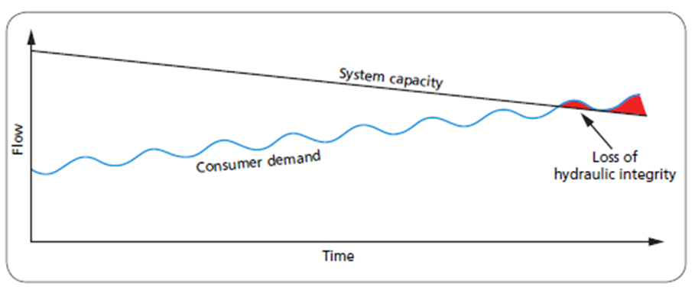

Figure 2.1 Variation in System Capacity and Water Demand with Time
Source: Ministry of Water and Energy Guide Line

II- Negative Pressure: In extreme cases demand exceeding system capacity can lead to pressures in the system dropping below atmospheric, i.e. become negative. This is a particularly undesirable situation; as negative pressures will suck in contaminated water from outside the system when a hole or crack is present in the pipe. Sources of contaminated water include sewage and chemical spills, ground water surrounding pipe leaks and flooded chambers.
If negative pressures are severe, pipe linings may be cracked or damaged, and in large diameter pipes may even cause pipe collapse (AWWA, 2005).)
III- Excessive Pressure: Pressures that are too high can also cause problems, including higher leakage rates (leakage has been found to be very sensitive to system pressure), more new leaks forming, reduction in pipe service life and the risk of damage to consumer fixtures such as faucets, house boilers, fountains and washing machines (AWWA, 2005)
IV- Low Velocities: The residence or retention time of water in the system (i.e. the time it takes water to move from the water treatment plant to the consumer) should be kept as short as possible since longer residence times increases the risk of chlorine depletion and disinfection by product formation (MoWE,2006a)

2.7.3 Maintaining Hydraulic Integrity in Water Distribution System
To maintain the hydraulic integrity in water distribution systems and ensure the best possible water quality; retention times in the system should be kept as short as possible, large fluctuations in flows and pressures, low flows and pressures should be avoided. Hydraulic modeling is an important operational tool and can be used to investigate alternative operational methods. The generic measures for maintaining hydraulic integrity of water distribution systems categorized into different considerations; such as design, construction and operation with maintenance (MoWR, 2006), but with related to this research only design aspect has selected to evaluate and give the feasible recommendations.
Design considerations which are important ensuring hydraulic integrity are:
- Provide system redundancy through the use of:
(a) A looped pipe network
(b) Minimum pipe diameters and
(c) Alternative water sources

- Keep pressures as low as possible in the allowed range (15<P>70)
- Avoid too low and high velocities (0.6<V>2)
- Minimize water retention time
- Provide water hammer protection
- Avoid excessive demands

2.7.4 Water Supply System in Distribution Network
There are two types of water supply system, (Walski et al., 2003);
Continuous water supply (CWS): In continuous supply systems, water is directly conveyed through the distribution network without interruptions. The consumers use water at any time without any interruption, the system is continuously full and under positive pressure.
Intermittent water supply (IWS): The distribution system usually designed as continuous based on assumption of continuous supply. However, in most developing countries water supply is not continuous. In IWS, consumers usually secure their water demand through use of ground or roof tanks, where water is stored during length of time that supply is provided.

2.7.5 Basic Problems in Urban Water Distribution System
Water flow is function of size and shape of pipe and pressure at the opening. Ethiopian urban water design manual restricts minimum and maximum pressure of 15m and 70m respectively (MoWR, 2006b).
Basic leading problems related to urban water distribution system are;
a) Water Pressure Drop due to Elevation
Elevation is the source of pressure loss in residential plumbing system. As the result, energy is required to push the water uphill (AWWA, 2005)
b) Water Pressure Drop due to Corrosion
If water pressure is poor in the distribution system, the most common cause is corroded galvanized steel piping. It is wise to replace with larger diameter pipe on the main feeds at least to improve pressure. When galvanized steel pipe is present, and pressure is low, it is common for accessible pipes running across the basement ceiling to be replaced first (Hutton et.al. 2007)
c) Water Pressure Drop due to Distance from the Source
If more water is flowing, the pressure drops more at each point along the pipe line due to head loss due to friction (Hutton et al., 2007). The more fixtures flowing at once, the greater the pressure drop at all fixtures and the lower the flow at each fixture (AWWA, 2005)

2.8 Basic Principles of Hydraulic Modeling
Modeling water supply system is to assist designers, managers and planners explore governing laws and analyze system behavior (Jalal, 2008). Model-based simulation is a mathematical approach to approximate real water distribution system behavior. To effectively utilize system simulation and interpret results produced, modeler must understand governing mathematical principles (Tomas, et al., 2003)
Flow of water in pipe network satisfies two basic principles (Munson et al, 1998)
- Law of conservation of mass
- Law of conservation of energy
- Law of Conservation of Mass
The principle of conservation of mass dictates that fluid mass entering any pipe will be equal to mass leaving the pipe since fluid neither created nor destroyed in hydraulic systems.
In network modeling, all outflows are lumped at nodes or junctions (Tomas, et al., 2003)
$\sum_{pipes}{Qi-U=0}$………………………………………………….…………………… (2.2)
Where, Qi= water flow to node in i^{th} pipe (L3/T)
U= water used at node (L3/T)
During extended-period simulations; accumulation of water at certain nodes are considered as water that can be stored and withdrawn from storage tanks (Tomas, et al., 2003).
$\sum_{pipes}{Qi-U-ds/dt=0}$……………………………………………………………. (2.3)
Where, ds/dt is change in storage (L3/T), therefore, the concept of conservation of mass is applied to all junction and tanks in a water distribution networks.
- Law of Conservation of Energy
According to Bernoulli’s equation; the principle of conservation of energy states that the difference in energy between two points must be the same regardless of the path that is taken (Tomas, et al., 2003). Within a hydraulic analysis, the equation is written as follows:
$Z1+\frac{p}{γ}{+\frac{v1^{2}}{2g}+\sum{hp=Z2+\frac{p}{γ}}+\frac{v2}{2g}}^{2}+\sum{hl}+\sum{hm}$……………………………………. (2.4)
Where Z1& Z2 = Elevation (L) at point 1 & 2
P = Pressure (M/L/T2)
= Fluid specific weight (M/L/T2)
V1²& V2²= Velocity (L/T) at two point 1 & 2
g= gravitational acceleration constant (L/T2)
_{p}= head added at pump (L) h_{l} = head loss in pipes (L)
_{m}= head loss due to minor losses (L)
Generally, in water distribution modeling, difference in energy at any two points connected in network is equal to energy gains from pumps and energy losses in pipes and fittings that occur in the path between them (Tomas, et al., 2003)
$ΔE=\sum{EP}+Hp+\sum{Hl}+\sum{Hm}$……………………………………………………..……(2.5)
ΔE= change in energy, Ep=Energy gain pump, H_{l}=head loss pipe, H_{f}= head loss fitting

2.8.1 Hydraulic Design Parameters
The main hydraulic design parameters in water distribution networks WDN are pressure, flow rate (discharge) and design factors (pipe diameters, pipe materials, velocities and hydraulic gradients), some of are defined in the following sections;

2.8.1.1 Pressure
The pressure at nodes depends on the adopted minimum and maximum ranges within the network, topographic circumstances, and the size of the network. The minimum pressure should be maintained to avoid water column separation and to ensure that consumer’s demands are delivered at all times. The maximum pressure constraints result from service performance requirements such as fire needs and depends on pressure bearing capacity of pipes (PN) & should avoid pipe bursts. This may require pressure boosting at strategic locations in the network (WHO, 2004).

2.8.1.2 Negative Pressure
Negative pressures should always be avoided from system; they typically indicate that the specified demand cannot be met. Hydraulic models can be used to identify where, when and how negative pressures can occur & preventative measures should be implemented. One possible way to avoid negative pressure is identifying pressure zones that are disconnected and feed them from an alternative reservoir (or fixed grade node) through a check valve at such a low head that all the pressures in the zone are negative. The negative pressures can then be used to indicate customers that will be without water. Excessive negative pressures can cause a pipeline to collapse (Farley and Trow, 2003)
Negative pressure occurs at area where there are:
- Where demands greater than design demand
- At the end of long lengths of pipe
- Pipes of inadequate capacity (too small diameter)
- Rough pipes (e.g. corroding iron pipes or pipes with a build-up of sediment)
- Failure of equipment’s such as pumps and valves
- At most high ground level

2.8.1.3 Flow Rate
It is the quantity of water that passes within certain time through certain section. Velocity is directly proportional to flow rate. For known pipe diameter and known velocity, the flow rate through a section can be estimated easily. Low velocities affect the proper supply and will be unwanted for hygienic reasons (sediment formation may cause the longtime of retention)

2.8.1.4 Nodal Demands
The physical characteristics of system are represented in a model by nodes and pipes. Base nodal demands allocation depends on population density at that node within the design period, with considerations of leakages and pattern of use. Nodal demands are computed by splitting the distribution areas into sub-areas. While splitting, as much as possible selected areas for which the demand is calculated should be homogeneous concerning the water use. Then the typical unit consumption is calculated for the unit area. Nodal demand has been determined by appropriate domestic, non-domestic and NRW demand served by each node.
Base nodal demand is calculated as follows (MoWR, 2006)
- First, the average total daily demand (domestic, Non-domestic (commercial, industrial and institutional) and NRW demand of the town is determined separately as well as totally.
- To each plot of the town development plan or parcel, the water demand category (domestic, non-domestic and NRW demand/non-user) is allocated by using either population density at node or proportional area method from which most technical method is selected (detail of these has explained on section 2.8.1.4.1)
- Then the nodal demand is allocated or estimated based on the feasibility from various alternative methods and available data
Node usually has one of the two main functions; it receives supply for the system and it delivers demand required by consumers.
Generally, acceptable in modeling to lump half of the demands along a line to the upstream node and the other half of the demands to downstream node (Morbi, 2014; Joshi et al., 2014).
Nodal demand allocation at consumption point or node estimated using:
N_{d}=∑Pi.dj.……………….….………………………………………….………........……. (2.6)
Where:
N_{d} = Nodal demand
Pi = population in each Kebele of the service area
dj = per capital demand for each pressure zones of the service area
i = subscript referring to the i-kebele in the service area
j = subscript referring to the j-th pressure zone in the service area

2.8.1.4.1 Water Nodal Demand Distribution
There are different methods of water demand distribution at each node/junction. It depends on the availability of data and information. The most known and recommended methods are:
1) Area proportion loading and 2) Population ratio loading method
So the demand loading or distribution methods are described in detail (Tomas, et al., 2003)
- Proportional Area Method
This load method proportionally distributes lump-sum flow among number of demand nodes based upon the ratio of total service area to area of the node's corresponding service polygon. This study has planned to conduct by this method as it is easy to manipulate and presence of data at hand.
- Proportional Area Method
Proportional Distribution by Population: This load method proportionally distributes lump-sum demand among number of demand nodes based upon the ratio of total population contained within the node's corresponding service polygon.

2.8.2 Hydraulic Model Selection Criteria
There are various computer software’s developed for purpose of design and analysis of water distribution networks. These are EPANET, Water CAD and Water GEMS Connect edition. Among this application software’s Water GEMS Connect edition at current time is well-known throughout the world by its availability, functionality, user interference and compatibility.
The advantages of Water GEMS Connect edition over other tools also includes simplified & easy for model building, water quality modeling, fire flow analysis, optimization and scenario management (Bentley Systems, Incorporated, 2014)

2.8.2.1 Water GEMS Connect Edition
This software is powerful tool for hydraulic modeling and easily integrated with ArcGIS and AutoCAD and equipped with other operations like optimization, model calibration and scenario management (Rudolf, & Liemberger, 2010).
The best part of Water GEMS Connect edition is the presentation of obtaining results which is very attractive and appealing and can be presented with a variety of graphical tools include Arc Map conception, thematic charting, contouring, outlining with color coding and symbology (Shinde, et al., 2018).
The interface of Water GMES Connect has shown below in the Figure 2.5
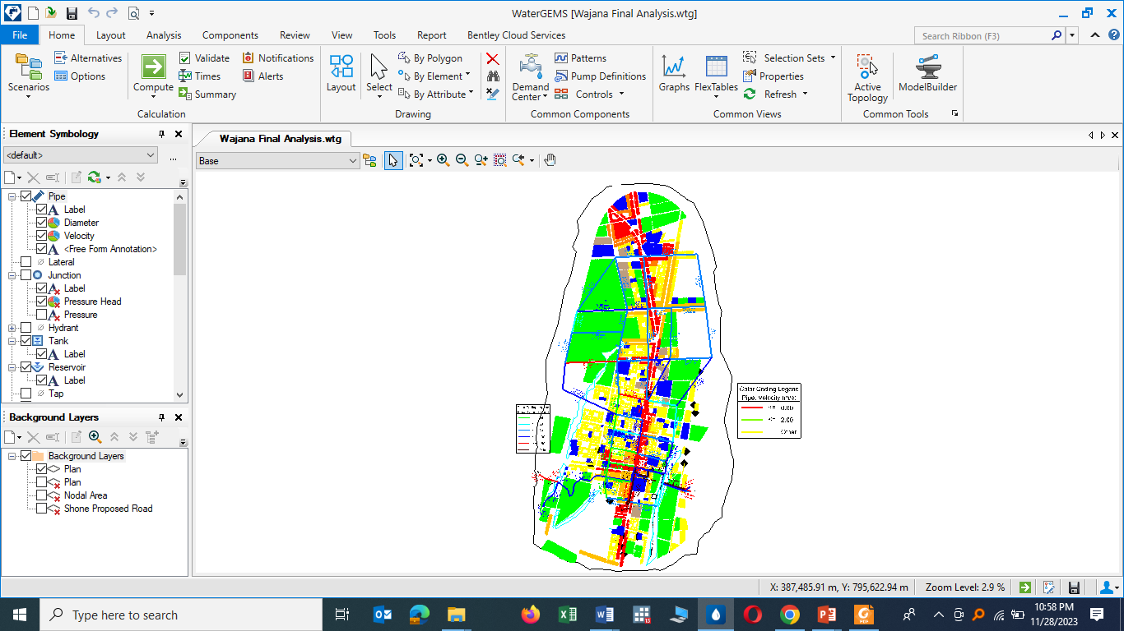

Figure 2.2 Screen shoot of User Interface of water GMES Connect Edition

2.8.2.2 Input Data for Building the Models
In general, water distribution network model is created using pipe-node formulation that is governed by two conservation laws; mass balance at nodes and energy management round hydraulic nodes (Brown, 2007).
The node is a point where water demand is allocated and its evaluation is valid only if the hydraulic pressure at all nodes is in acceptable range so that demand is autonomous of pressure. Therefore, making hydraulic simulation software, especially from hydraulic point of view using engineering approach is one of the method used for decision making on system, either is the system is within level of service based on pressure limit or not (Zyoud, 2003)
The following table shows all the input parameters used in Water GMES tools (Hussni,2003a).

Table 2.2 Input Parameters and Primary Purposes of Water GEMS Tools
Element | Type | Primary modeling purpose | Input data
Reservoir | Node | Provides water to the system | Hydraulic grade line (water surface elevation)
Tank | Node | Stores excess water within the system and releases that water at times of high usage | Base Elevation, Max. Elevation,  Min. Elevation, and Diameter
Junction | Node | Discharge the demand required or recharge the inflow water from/to the system | Elevation
Pipe | Link | transport water from one node to another | Elevation, Diameter, Material and  Roughness coefficient
Pump | Node | provide energy to the system and raise the water pressure to overcome elevation differences and friction losses | Elevation, Pump definition (Characteristics of max. operation and design discharge and head efficiency)
Valves | Node | Controls flow or pressure through a pipe and results in a loss of energy in the system | Elevation, Diameter, Valve type
(Source: Zyoud, 2003)

2.8.3 Water Distribution Network Simulation
The term simulation generally refers process of imitating the behavior of one system through the functions of another (Amdework, 2012). It can be used to predict system behavior/responses to events under wide range of conditions without disrupting the actual system. Using simulations, problems can be anticipated in proposed or existing systems and evaluated before time, money, and materials are invested in real-world project (Tomas, et al., 2003).
In water distribution networks most common type of model simulations are steady-state and extended-period simulation (Tomas, et al., 2003)

2.8.3.1 Steady-State Simulations
It is the type to determine operating behavior of system under static conditions. It computes the hydraulic parameters such as flows, pressures and pump operating characteristics by assuming demands and boundary conditions not change with respect to time. In general, this type of analysis is used to determine short-term effect of demand conditions on the system (Tomas, et al., 2003).

2.8.3.2 Extended-Period Simulations
The operating condition is under dynamic behavior of system over period of time, and assumes that hydraulic demands and boundary conditions changes with respect to time. Hence, extended period analysis used to evaluate system performance over time and allows the user to model pressures and flow rates changing, tanks filling & draining, regulating valves opening & closing throughout the system in response to varying demand conditions and automatic control strategies formulated by the modeler (Tomas, et al., 2003)

2.9 Hydraulic Modeling of Water Distribution System
Hydraulic modeling must be used in every water distribution system to supply water to the targeted customers in sufficient quantity, quality and optimum required pressure. Low water pressure, leakage, bursting pressure, minimum velocity, negative pressure, and other related problems can result in the distribution system due to lack of proper hydraulic modeling and poor input data usage. Model-based simulation is a method for mathematically approximating the behavior of real water distribution systems.
To effectively utilize capabilities of distribution system and interpret the results, the modeler must understand mathematical principles involved (Tomas et al., 2003)

2.9.1 Model Skeletonization & Sensitivity
Skeletonization is practical approach on modeling to allow the modeler on producing reliable and accurate results without wasting unnecessary time and money. Eggener and Polkowski (1976) did the first Skeletonization when they systematically removed pipes from model, to test sensitivity of model results. They found that under normal demands, they could remove large number of pipes and observed significant effect to pressure.

2.9.2 Model Calibration
The process of adjusting the values of uncertain parameters in the network to match the values of simulated parameters with those observed in the field is called calibration (Walski 1983; Ormsbee and Wood 1986; Bhave 1986).
(Walski et al., 2000) defined calibration as "a two-step process” consisting of:
1) Comparison of predicted versus measured values (pressures and flows) under known operating conditions (pump operation, tank level, and PRV settings);
2) Adjustment of input data, for example Hazen William roughness coefficient C, for the model to improve accuracy between observed and predicted values."
In model calibration, large number of input parameters can be involved (e.g., nodal elevations, nodal demands, pipe length, pipe diameter and roughness coefficients; the rate of water supply and water level at source; pump characteristics; valve settings, etc.) and strongly depends on accuracy of gathering data and preparation of these parameters.

2.9.2.1 Model Calibration Parameters
Once data for computer network model was assembled and encoded, the associated model parameters determined prior to actual model application. To this end two major parameters associated with hydraulic model calibration are pipe roughness and nodal demands.

2.9.2.1.1 Pipe Roughness Coefficient
It varies with material types, corrosiveness of water and aging of the pipe. Relatively speaking, when pipe flow is significant or roughness-coefficient is large, there will be more head loss that directly affects pressure head at that node.
Based on this relationship, the following are some recommendations for making adjustments to models (Herrin, 1997).
- If model HGLs are higher than field-recorded values, then the model is not predicting enough head loss. To produce larger head losses, reduce Hazen-Williams C-factor, increase junction demands in the area of the measurements, or both.
- If model HGLs are lower than field-recorded values, then the model is probably predicting too much head loss. To produce smaller head losses, try increasing the Hazen-William’s C-factor and/or decreasing the junction demands at area of the measurements.

2.9.2.1.2 Nodal Demand
Average nodal demand is other major calibration parameter that dictates calibration process to be assigned on each node. The initial average estimates of nodal demands can be obtained by identifying region of influence associated with each junction node, identifying types of demand units in the service area and multiplying number of each type by an associated demand factor. Alternatively, the estimate can be obtained by first identifying area associated with each type of land use in the service area and then multiplying the area of each type by an associated demand factor. In either case, the sum of these products will provide an estimate of the demand at the node (MoWR, 2006).

2.9.3 Model Validation
The two most suitable techniques to measure model performance are degree of accuracy (error of difference) and coefficient of determination (R) during calibration of model. The observed and simulated pressure giving correlation coefficient of determination which ranges between zero and one, that describes variance in measured data which is explained by model with higher values indicating less error variance (Walski et al., 2003)
In performing validation or (degree to which the simulated is applicable in real world) system requires; initial conditions and operational rules to be adjusted properly to match the conditions at the time the modeling data were collected. Model validation is comparison of model results with numerical data independently derived from experiment.
Model calibration and validation can be taken manually using correlation coefficient equation (R²), and performance of developed models will be evaluated using this statistical index, its formula is given by;
$R^{2}=\frac{\sum{\left(X-\overline{X}\right)\left(Y-\overline{Y}\right)}}{\sqrt{{{\sum{\left(X-\overline{X}\right)}}^{2}\sum{\left(Y-\overline{Y}\right)}}^{2}}}$………………………………...…………………………………… (2.7)
Where R², is correlation coefficient, X and Y are simulated and measured pressure, $\overline{X} and \overline{Y}$ are average value of simulated and measurement pressure respectively.
Therefore, coefficient of determination (R²) describes the degree of co-linearity between simulated and measured data. Ranging between 0 and 1, which describes the proportion of the variance in the measured data, which is explained by the model, with higher values indicating less error variance (Santhi C, 2001)

3. MATERIALS AND METHODS

3.1 General Description of the Study Area

3.1.1 Location of the Study Area
Shone town is situated in Southern Nation, Nationalities and Peoples Regional State, Hadiya Zone, Misrak Badiwacho woreda at a road distance of 305Km from Addis Ababa, through Addis Ababa-Butajira-Alaba-Shone main highway or 345Km through Addis Ababa-Shashamane-Alaba-Shone main highway. Similarly, it is found at road distance of 115 km from Hawassa, the previous regional capital, along Hawassa-Shashamane-Alaba-Shone route. Shone town is the administrative center for Misrak Badiwacho Woreda. The geographical location of the town, along the main highway leading to Soddo, Arba Mich and Jinka towns, makes it an important economic and political center for the surrounding towns and rural areas from three different zones, such as Wolyita, Hadiya & Kambata, within SNNPR State. According to the information found from the town’s municipality; the town has six lower administrative kebele units and spatially covers 1,936.12 hectares of land.
Currently, the town is estimated to be home for 41,837 residents. As observed during site visit and informed from town administrative units; it is found to be of medium size having better potential for future growth.
Geographically, the town is situated in 7º6’43.7”-7º11’45.2” latitude and 37º55’56.5”-37º58’25.7” longitude. Generally, the location of Shone town with respect to the country and region is depicted in Figure 3.1 below.

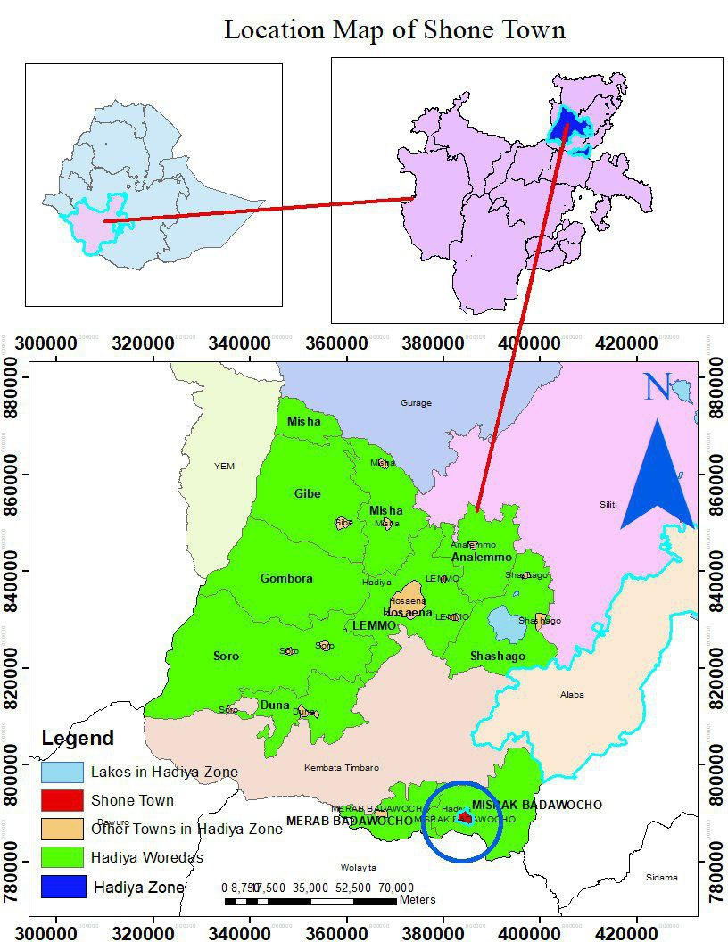

Figure 3.1 Location Map of Shone Town
(Source, Shone Town Administration)

3.1.2 Climate and Rainfall Distribution
Based on elevation variation above mean sea level; the climate of the catchment comprising Shone town is categorized under Woyina Dega (midland) climatic zone of the country. The study area is characterized with bi-modal rainfall pattern (Tao, M., et al, 2019).
The mean monthly rainfall distribution at Shone climate station, based on the National Meteorological Agency during the period 1990-2005, has two peaks, May and August. The peak average monthly rainfall appears through the months of May-September. The mean annual rainfall estimated at Shone station during the same period is 1276mm. Similarly, the highest mean maximum monthly temperature at Shone station computed during the period 1991-2004 is observed in the month of February with 28.6°C while the lowest mean maximum temperature is observed in the month of July with 22.4°C.

3.1.3 Ground Water Quality in the Area
As the area is located in rift valley center, the concentration of fluoride is greatest risk towards eastern face. Based on the hydrogeological study documents of the town conducted by private consultant, boreholes drilled around area of Harto Kontola, Korga and in the center affected with higher concentration of fluoride. But along escarpments and western parts of the town, wells have lower concentration of fluoride. And from the drilled data of the area concentration of fluoride is greater than 3gm/lit (Sub Sahara Consultants PLC, 2009)

3.1.4 Socio-Economic Feature of Shone Town
According to Shone town trade and market development office there are investment projects which are operational at the town and area. The major economic sectors of investment are small scale industry, social services, hotel and tourism.
Shone town and surrounding Keble’s are dominated by small holder subsistence farming of agriculture comprising cereal crop farming, cattle production, fattening and milk production and other agricultural production that largely depends on rainfall that can be transport up to the central market and manufacturing sector as well (Shone Town Trade & Industry Office, 2023)

3.2 Materials and Tools
Based on the research objectives, the following materials and tools were used for data collection, processing and analysis
- Water GEMS for model analyzing and automated calibration
- ArcGIS for delineating of nodal demand and locating for study area
- AutoCAD to produce pipe layout in the format required by WaterGEMS
- Pressure gauge of 25mm to take readings on pressure at individual faucets
- GPS to collect coordinate (x,y,z) coordinate
- Master plan map to allocate water demand
- Water meter to measure flow
- Tape meter to measure the existing length, depth, and width which helps to evaluate the capacity of the water supply components

3.3 Data Sources and Collections Methods
The data were collected from various sources so that evaluation and analysis of the collected data were made to meet the stated specific objectives. Shone town water supply office, Town Administration and Municipality office, Town finance and economic development office and SNNPR Water Resources are some of the data sources for this study.
The data collection method was performed using both primary and secondary data collection techniques to get all the required information.

3.3.1 Primary Data Collection
The primary data collected includes demographic features, GPS data with all the information of existing water supply components, sample water meter reading, water pressure gauge recordings, types of pipe materials, fittings and valves, photographs of relevant sites, physical field observations and water supply scheme conditions.

3.3.2 Secondary Data Collection
The secondary data includes various documents collected from town water utility office, SNNPR water and energy office, SNNPR design and supervision office. The secondary data include; ministry of water and energy guide lines, feasibility study documents and annual reports from utility office etc.
From Shone Town water utility, the following secondary data was collected.
- Data on volume of water between water distributed to system and the volume that is billed to customers
- Total number of population and per capita demand of the town with design standards
- Boundary of the water supply system as compared to the new master plan of the town
- Number of customers (3330) as per the level of connection to analyze water coverage
From field observation, the physical presence & actual location of existing distribution layout features was certified & the following basic design data was collected:
- Pipe layouts, location and elevation of bore wells, water points, reservoir
- Pipe type, size, length, valves, pump and material types

3.3.2.1 Shone Town Water Supply System
The first modern water supply system of Shone town was implemented in 1975EC from one boreholes drilled and developed by South Water Works Construction Enterprise. The current gap between the demand for water and supply from the water service is very high and incomparable due to the ever increase population of the town. These all derives development of additional water sources to minimize the ever increasing disparity between supply and demand.

3.3.2.2 Existing Water Sources
The source of existing water supply system of the town is ground water or borehole. Six boreholes were drilled by governmental and non-governmental organizations from adjacent rural kebele of Shone town at different times to serve the town and the surrounding community. The sources of water supply system of the town, which are functioning currently located at Buligeta Gote-7, Gote-9 and Lalogarbe. The other small boreholes, which are still functioning with very low discharges and their yields are decreasing dramatically, are located at Northern periphery of the town, around middle of the town and around route to Alaba exist Mazoriya. The potential yield of Buligeta Gote-7, Gote-9 and Lalogarbe are 5l/s, 8l/s and 9l/s respectively. Buligeta Gote-9 borehole is located around 4.3km from service reservoir and Buligeta Gote-7 is 3.6km from the same reservoir. In the boreholes water meter is installed at the head, the production reading recorded is collected and logged by the operators daily but not in uniform manner. Therefore, collected data for this study includes source production and consumption (what is reached to customers’ meters through bills). This is to estimate the amount of water produced and the amount of water delivered to the customers. In doing so, water loss of the system has estimated and calculated at the section of water loss analysis.
Summary of existing water sources in and around the Shone town are shown in Table 3.1 below.

Table 3.1 Existing Water Sources
S/No | Name of Boreholes | Yield (l/s) | Remark | Construction Year
1 | Mazoriya | 1.5 | Non functional | 1975
2 | Concern | 1.5 | Non functional | 1985
3 | Bulgita Gote-7 | 5.0 | Functional | 2004
4 | Bulgita Gote-9 | 8.0 | Functional | 2004
5 | Banchamo | 1.5 | Non functional | 1994
6 | Lalo Gerbe | 9.0 | Functional | 2008
7 | Wolyita Ber | 8 | Not for town | 1997
 | Total | 22
Source: Shone Town Water Utility Office

3.3.2.3 Water Production
The water production has been evaluated as total annual water supplied to the water distribution system WDS. Water production comes from three boreholes sources, which are administrated by Shone town water service utility.
There is big gap between demand and production as result of this water is distributed intermittently and even some compartment of the town cannot receive water for long period especially the outer escarpments are not getting water.
There is no precise information regarding the characteristic of the pump equipped with the boreholes but attempts tried to incorporate basic data from existing hard copy documents for purpose of system simulation. The daily production of water from the boreholes is around 1267.20m³ taking the optimum average working hours for the three pumps is 16 hours per day.

Descriptions and daily production of existing boreholes is shown in the following Table 3.2.

Table 3.2 Descriptions and Daily Production of Existing Boreholes
Name of the Sources | Constructed by | Year of construction, EC | Yield (l/s) | Daily production  (m³)
Buligeta Gote-7 | SNNPR | 2004 | 5 | 288
Buligeta Gote-9 | “ | 2004 | 8 | 460.8
Lalo Gerbe | “ | 2009 | 9 | 518.40
Wolyita Ber | SNNPR | 2008 | 8 | Not for Shone town
 | Total |  |  | 1267.20
Source: (Data collected from desk & field from STWSSE office data 2023),

3.3.2.4 Collectors and Transmission Mains
The transmission line which connects Wolyita Ber borehole to the 100m3 existing service reservoir is 2490m long and is made of OD90 uPVC pipe. The other 3 inches GI transmission line to transfer water from both Bulgita boreholes Bulgita-7 & Bulgita-9, to the 200m3 existing reservoir is 3.6km. The recently, 2009EC, constructed transmission line which convey water from Lalogarbe borehole to 100m3 reservoir is 3-inch GI pipe having 1.6km total length. In general, within the existing town water supply system there exists about 12.49Km total length of collectors and transmission mains from these around 8.7km was selected & included in simulation, which are meant to convey water from boreholes to the receiving service reservoirs as shown here under.

Figure 3.2 Layout of Existing Collector or Pressure Main from Two BH

3.3.2.5 Water Service Reservoirs/Tank
There are three concrete ground level circular reservoirs found in the town. The first two concrete reservoirs having sizes of 100m3 and 200m3 are located at adjacent to each other, at the middle of Shone mountain. The third and recently constructed concrete reservoir having size of 100m3 is found approximately 2km south of the former reservoirs and supply rural communities through 6 water public fountains in Lalogarbe Kebele and connected with the existing town system to serve only two water points located adjacently. In case of Shone, attempts should have made seriously while locating the reservoirs sites because the two reservoirs has located outside the town in long distance (5.7km) from command area. Any reservoir should be installed close to the service or distribution area in order to reduce excessive pipeline cost and hence head losses through the system.

Table 3.3 Existing Service Water Reservoirs
S/No | Type based on material | Capacity  (m3) | GPS coordinates (x,y,z) |  |  | Kebele | Remark
S/No | Type based on material | Capacity  (m3) | x | y | z | Kebele | Remark
1 | Concrete | 200 | 385824 | 788490 | 2023 | Licha | Functional
2 | Concrete | 100 | 385824 | 788490 | 2023 | Licha | Functional
3 | Concrete | 100 | 385705 | 786556 | 1997 | Lalogarbe | Rural
4 | Glass fiber tank (Roto) | 10m3 | 384728 | 794427 | 2021 | Mazoriya | Non-Functional
5 | Glass fiber tank (Roto) | 20m3 | 384158 | 791766 | 1989 | Weyra Lalo | Non-Functional
6 | Glass fiber tank (Roto) | 10m3 | 385323 | 790510 | 1990 | Licha | Non-Functional

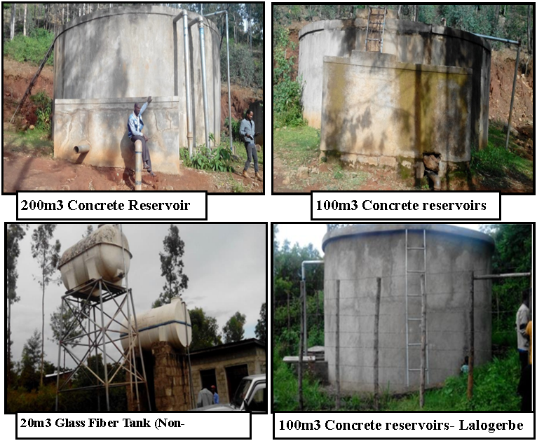

Figure 3.3 Existing Service Reservoirs Feeds to the Town

3.3.2.6 Distribution Pipe Line Network
The water distribution through main pipes is by gravity system from tanks. However, water from the second borehole is supplied to the distribution system only for a certain period of days when the pump in the borehole is operational due to absence of sufficient storage capacity which can stores water for longer period of time.
The distribution system of the town consists of GI and HDPE pipes with diameter ranges from 32mm to 90mm. The type, diameter and length of the pipe in the existing distribution system are summarized and shown at Table 3.4. There are 34 public fountains in the distribution systems which are located at different parts of the town out of which 23 are non-functional due to head problem and broken pipe lines.

The information collected from Shone town water supply utility shows that the pipes cannot resist huge pressure and burst at fitting joints & valves of the system especially during low demand period. In some parts of the town the pipes are exposed to surface and broken due to poor maintenance and repair. The only distribution system that serve town is generally old distribution and easily damages when pressure get maximum during low consumption period.

Table 3.4 Existing Distribution Lines of Shone Water Supply System
S/No | Diameter (MM) | Length (GI) | Length ( HDPE) | Length All Material | Remark
1 | 32 | 0 | 3,988 | 3,988 | 6 years
2 | 40 | 0 | 2,124 | 2,124 | 6 years
3 | 50 | 0 | 1,389 | 1,389 | 6 years
4 | 63 | 0 | 8,138 | 8,138 | 6 years
5 | 66 | 0 | 7,330 | 7,330 | 6 years
6 | 75 | 0 | 7,356 | 7,356 | 6 years
7 | 80 | 2,684 | 0 | 2,684 | Very old
8 | 90 | 0 | 9,491 | 9,491 | 6 years
9 | 100 | 5,696 | 0 | 5,696 | Very old
10 | 110 | 0 | 1,113 | 1,113 | 6 years
11 | 125 | 322 | 3,143 | 3,465 | Very old
12 | 140 | 0 | 821 | 821 | 8 years
13 | 160 | 0 | 1,038 | 1,038 | 8 years
14 | 225 | 0 | 1,668 | 1,668 | 8 years
All Diameters |  | 8,702 | 47,597 | 56,299

The distribution of the pipe layout in the town is limited to area that has been developed earlier and does not cover every corner of the town especially recently settled population and their surroundings are using by illegal connections. Even those communities which are under old distribution layout system getting water intermittently. The size of the pipes and source capacity of the distribution system is inadequate to provide required quantity of water & serve the area due to negative pressure at peak time demand.

3.3.2.7 Existing Electro-Mechanical Equipment’s
All the boreholes are equipped with submersible pumps during boreholes development. As per the information collected from the motor operators; the installed and operating three functional submersible pumps are forced to run for maximum duration of 16hr/day. The primary sources of power for the submersible pump are diesel generator and EEPC power transformers.
As per the information obtained from the water utility office and physical field visit, the power transformers are connected to the pump terminals by star delta connection switch control board having 3-phase, 380 volts and 4-wire cable while the standby diesel generating sets having 3-phase, 4 wire, 50Hz rating and 380/400v voltage outlet. The existing system also own standby power source diesel generator sets.

Table 3.5 Existing Electro-Mechanical Equipment at Borehole
S/No | Borehole name | Power Source | Pump hour | Remark
1 | Buligeta Gote-7 | EPPCO national grid | 13 hour | Stand by generator functional with 75KVA
2 | Buligeta Gote-9 | EPPCO national grid | 16 hour | Stand by generator functional with 114KVA
3 | Lalo Gerbe | Diesel generator | 16 hour | Stand by generator functional with 85KVA=> for rural community except two WP
 | Total |  | 45 hours
Source: Shone Town Water Utility Office

3.3.2.8 Existing Water Pumps
Pump adds energy to the water flow by converting the mechanical energy into potential energy to overcome the friction loss and hydraulic grade different within the system. In source of water pumping station there are three submersible centrifugal types of pumps and one surface horizontal centrifugal types for boosting purpose and their characteristic properties has attached at appendix C section.

3.3.2.9 Customers of Existing Water Supply System
The existing water supply system has total of 56.29 km and existing modes of services are in-house, yard connections and public water points. 25 households have in-house connection, 1749 HHs have yard connections, which covers approximately 20 percent of the population and 11 public water points, which served 17 percent of the town population. The water produced from the existing source is being distributed to the following connections as shown in Table 3.6.

Table 3.6 Customers and User Groups of Existing System
S/No | Mode of Service | Number of Connections/HHs | Remarks
1 | Number of in-house connection | 25
2 | Number of yard points | 1759
4 | Number of public water point | 1556 | 11 PT X 144.5 HHs
5 | Total estimated connected HHs | 3330
6 | Total estimated non-connected HHs | 5434
 | Total | 8764
Source: Data from field visit on date 12/12/2022

3.3.2.10 Water Consumption
In order to evaluate the water loss in water supply system, consumption data of each customer should be collected from reliable sources E.g. consumers billed data (Misirdaili, 2003). The rate of water consumption at certain node depends on population density at node, type of demand (domestic, public, commercial, etc.) and per capita demand per day. Even for the existing water distribution systems, the nodal demands change due to many factors, such as new users or an increase in the number of existing users (Ayala, 2018).

3.3.2.11 Population Data
Design of water supply system is based on present and projected population of the town, estimated for design period. Any underestimated value will make system inadequate for the purpose intended; similarly overestimated value will make it costly.
According to CSA (2007), the number of population at Shone was 27,408 which was collected from branch office of planning commission of the town. From this 14,250 are male and 13,158 are females.
According to Shone town municipal office; the total population of the town is 49,747 for year 2019. From this total population; 24,377 are male while the remaining 25,370 are female gender groups resulting in male to female ratio of 96:100 (female dominated population). Conversely, Water Resource Development Fund appraisal team’s report indicates the total population figure of 37,434 for year 2021. Since various sources provided different figures, the researcher has used average value for calculation of present population by triangulating all relevant sources, so the average population figure taken for base year (2023) of Shone town was taken as 41,837.
Population projection can be done by arithmetic progression, geometric progression, decreasing rate of increase and graphical extension (MoWR, 2006). From these the most common method of population forecasting was geometric progression method for the research. Because this, method is mostly applicable for large growing towns and cities having vast scope of expansion. But the only drawback of this method is, if it used for small, average or comparatively new town, it will give lower population estimate than actual value (CSA, 2007).

3.3.2.12 Shone Town Master Plan
The town master plan was collected from town administration office for purpose of finding alignment and direction where the existing pipe line installed so as to support during data collection. Because this new plan is a direct extension of the old one which water distribution system installed, the pipe line layout doesn’t cover all the master plan area. Water demand allocation and distribution line alignments were done based on common joints between collected data points and new master plan overlays because land covers of outer escarpments are newly added on old plan as the result these area was discarded during building of network of Shone town existing pipe line layout.
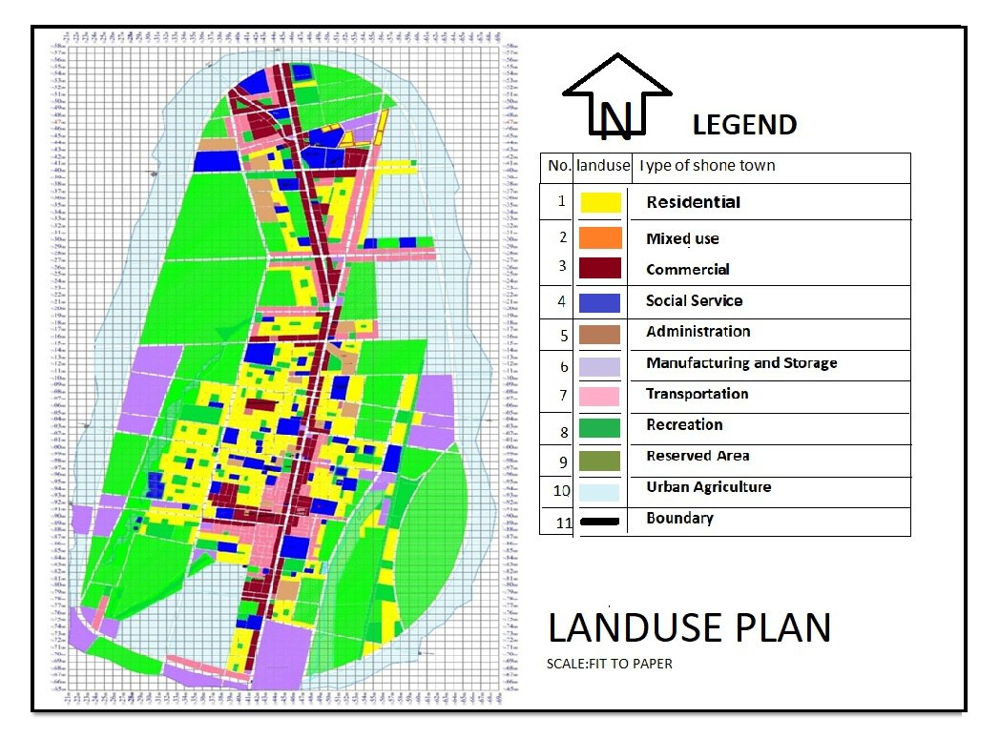

Figure 3.4 Master Plan of Shone Town (New)
(Source: Shown Town Administration)

3.3.2.13 Nodal Elevation
Nodal elevation is one of the significant requirements to simulate hydraulic characteristics of water in the distribution system. Nodal elevation data was collected by GPS tools during field collection.

3.4 Methods of Data Collection and Analysis
Both qualitative and quantitative data were collected but analysis and interpretation was done only for quantitative data as per research scope and objectives. From the quantitative methods, descriptive statistical methods like percentages, graphs, and cross-tabulation were used in order to reach on appropriate results and interpretation. Microsoft excel was used to analyze data collected from utility office, such as water production, consumption, water pressure reading and water meter bills.
Field survey data and data collected from utility office for distribution system were collected and evaluated. The possible engineering tools for analysis are; Water GEMS Connect edition, Global Mapper, AutoCAD and ArcGIS. Water GEM analysis was based on nodal pressure and velocity parameters to identify higher or lower pressure zones in the area. The standard values of nodal pressure and velocity were determined. The value that was under the normal value was taken as acceptable, and the values below and above the standard values were taken as unacceptable. Additionally, MoWR, 2006 guidelines and GTP-2 standard were used for interpretation of results. The current and future forecasted peak hour demands were load to nodes so as to check system capacity of existing network.

3.4.1 Water Supply Coverage Analysis
Water supply coverage is percentage of people with access to water supply service in the town. According to the data and information collected from the study area, the research has analyzed and evaluated water coverage of the town by the following angles;
a. Average per capita consumption and level of connection per family
b. Existing connection type of water supply network
c. Production and consumption data collected from water sales by bills
d. Production capacity of boreholes and the existing demands
Water supply coverage is used to determine how much of population get access to adequate water services, either as domestic water connection (individual or shared) or public water points can be calculated as (MoWR, 2005)
Coverage % =$[\frac{\left[\left(B+\left(C*D\right)\right)*E\right]}{A}*100$]…………………………...………….…..……….… (3.1)
Where, A=Total population of the town,
B=Number of domestic customers
C=Number of public water points
D= Number of households using public water
E= Average family size (CSA),
Average daily per capita consumption was calculated by combining the volume of water consumed for residential purposes in the town. This was used to examine the distribution of water supply coverage at various locations (Ayale, 2018). The following expressions were used to calculate the town's average daily per capita consumption:
Domestic Water Consumption (l/person/day) = $\frac{Annual Consumption(m3) *1000 l/m3 }{Population number *365 day }$ ...…… (3.2)
One method for assessing the town’s water coverage was to consider the number of water connections per family. According to the CSA (2007) average family size of Shone town is 5
The following equation was used to calculate the average number of connections per family.
Connection per family = $\frac{Total number of connection}{Number of population of the town/family size}$ …………..……..….… (3.3)

3.4.2 Population Forecasting
The study has compared different techniques of population forecasting methodologies; since the town is among fast growing with relatively high economic activities and presence of continuous expansion around boundary, geometric growth method has adopted, it is expressed as follows (CSA, 2007)
$P =Po{\left.\left(1 + \frac{r}{100}\right.\right)}^{n}$………………………………………………...…..…………. (3.4)
Where, P= projected population after n years
Po = Base Population or initial known population
r = Annual growth rate, in %
n = Number of years of the concerned period
The current and future projected population number was used as an input data for evaluation of existing water supply adequacy level and for estimation of water deficit of the population. The existing water source adequacy has also evaluated by taking into account the system whether can satisfy both current and projected water demand or not.
Based on the National Population and Housing Census of the country, (CSA, 2007), the percentage population number increment rate r at SNNPR, Hadiya Zone, and Shone town has shown on Table 3.7.

Table 3.7 Urban Growth Rates by Range of Years, SNNPR
Year | 2008-2011 | 2012-16 | 2017-2021 | 2022-2026 | 2027-2031 | 2032-36 | 2037 | 2042
Growth Rate, r | 6.10% | 5.61% | 4.80% | 4.58% | 4.05% | 3.65% | 3.65% | 3.65%
Source, CSA 2007, CSA, 2013
The yearly distribution of the growth rate r, shown in Table 3.8,

Table 3.8 Urban Growth Rates by Years, SNNPR
Year | 2017 | 2018 | 2022 | 2027 | 2032 | 2037 | 2042
Growth Rate (%) | 4.80% | 4.80% | 4.58% | 4.05% | 3.65% | 3.65% | 3.65%
Source: Shone Town administration and Finance and Economic Development office

3.4.3 Water Demand Analysis
Water demand analysis helps to ensure design of an appropriate size of water supply system, including pumping station, transmission and distribution pipe network, storage and treatment facilities (Dereje, 2022). Accordingly, water demand of Shone town was calculated with due consideration of actual conditions of town and by taking all relevant available data. Where gaps were observed in acquiring of data, estimates were made from general experiences of the country's utilized for similar standard towns, E.g. Boditi. Demand analysis of the town has carried out in two major categories: domestic and non-domestic.

3.4.3.1 Domestic Water Demand Analysis
Domestic water demand is the quantity of water required in-house drinking, cooking, sanitation, house cleaning, car washing, clothes washing and sprinkling of garden. It depends on economic, social, climatic and mode of service connection (Twort et.al. (1985).
Shone town mode of service connection:
Depending on living standard, hardship, water scarcity & water collecting challenges, there are only three types of mode of connection at Shone town water supply system.
These are House tap users (HTU), Yard tap users (YTU) and Public tap users (PTU).
House Tap Users (HTU): In house tap connection pipes connected with in-house plumbing to one or more taps, e.g. in the kitchen and bathroom. Usually 3/8 inch (9 mm) and 1/2 inch (12 mm) taps are used (Mays, 2000).
Yard Tap Users (YTU): A yard tap user is quite similar to house connection, only difference placing in yard outside the house. No in-house piping and fixtures are provided (Mays, 2000).
Public Tap Users (PTU): Single-tap and double-tap stand pipes are the most common types of public tap in urban areas. They are made of brickwork, masonry or concrete, or use wooden poles and similar materials (Mays et al., 2000)
According to the data obtained from Shone town water utility; the three types of mode of services do have the following distribution throughout in the town;
According to MoWR design, optimum public fountain serving capacity of 720 people, average household size of 4.8 (approximated to 5 for calculation) persons and private connection is divided into house and yard connection modes; the optimum percentage of population served with different modes of services shown in Table 3.9.

Table 3.9 Distribution of Mode of Services on Existing Water System
Mode of Service | Percentage of population Served
HC | 0.29%
YC | 20.07%
PF | 17.21%
Total Coverage | 37.57%
Source: Shone Town Water Supply Utility
Per Capita Water Demand,
The total quantity of water required for various purposes by town per year (Venkateswara, 2005):
P_{cd} = $\frac{Q}{P*365}$……………………………………………………………………………….. (3.5)
Where: Pcd=per capital
Q= Discharge
P= Population
The per capita water demand for various demand categories was adopted by taking into account different factors and standards used from Ministry of Water Resources (MoWR, 2006)

- Number of Population Served by Mode of Services
The standard approach for formulating the percentage of population served by different modes of service would normally involve detail analysis of past consumption trends and household survey result. Allocation of population number by mode of service was adopted by taking assumption as per the design standard of MoWR and Shone town water utility office records and documents.
- Per-Capita Water Demand (l/c/d) by Mode of Service Connection
The per-capita water demand for different mode of services was adopted from design guide line prepared for urban towns by ministry of water and energy for two design stages (stage I (>10years) and stage II (10<x<20 years) as indicated in Table 3.10 (MoWR, 2006).

Table 3.10 Per-Capita Domestic Water Demand by Mode Service
Mode of Service | Stage I | Stage II
HC- House connection (l/c/day) | 50 | 70
YCO- Yard connection own (l/c/day) | 25 | 30
YCS- Yard connection shared (l/c/day) | 30 | 40
PC- Public tap connection (l/c/day) | 20 | 25
Total Sum (l/c/day) | 125 | 165
Average (l/c/day) | 31.25 | 41.25
Source: Urban Water Supply Design Criteria (MoWR, 2006)
- Projection of Consumption by Mode of Service
As the socioeconomic condition and the living standard of the people improve, their water consumption will increase depending on their mode of service. The demand of public tap users will increase very little as the distance involved for fetching water will not change and the collection time is limited to day time only. As the society gets developed it is believed that more people tend to have their own yard and/or house connection.
The mode of services projection is made based on the target projected year of 2042 at which the town water supply coverage is expected to reach 100% and beneficiary communities will get sufficient amount of water considering the current mode of services as a reference. Based on the progressive development of the town & expected willingness to have their own connection; it can be forecasted that at end of 2042, the percentage of users in HC mode of services will reach 10% while yard connections 77% and public fountain users 13% from the current mode of service level. These figures are assumed based on 0.3% to 0.2% annual mode of service connection increment for house in first and second phases while 1.0% to 0.7% annual mode of service connection increment for yard connections in the first & second phases respectively (MoWR, 2006a)

Table 3.11 Projected Mode of Service
Mode of Service | Year
Mode of Service | 2023 | 2024 | 2027 | 2032 | 2037 | 2042
HC | 0.2% | 5% | 5.6% | 8% | 9% | 10
YC | 20% | 40% | 65% | 70% | 74% | 77%
PF | 17.21% | 35% | 28.5% | 22% | 17% | 13%
Coverage | 37.41 | 80% | 99.1% | 100% | 100% | 100%
Source: MoWR, 2006
- Adjustment of Climate and Socio-Economic Activity
The total average domestic water demand (for the mode of service) was adjusted for the effects of climate and socio-economic factors by peaking factor, P_{f}.
P_{f} = climate factor*socio-economic factor, (MoWR, 2006) ………………………….… (3.6)
In addition to the per capita water demand and mode of services which influence the quantity of water consumption, the climate of the area is also directly related to water consumption.
For this reason, those areas which get more rainfall annually (>1200) require a reduction in the water consumption pattern whereas those areas which receive lesser annual rainfall require an increase for the climatic condition.
Since Shone area, the mean annual temperature is between 15-20⁰C and altitude is under the range of 1500-2300 so factor of adjustment for climatic shall be 1.
According to MoWR (2006) the climatic adjustment factors for three different climatic groups are given in Table 3.12.

Table 3.12 Adjustment Due to Climatic Factor
Mean annual Temp.(°C) | Description | Altitude | Factor
<10 | Cool | >3300 | 0.8
10—15 | Cool Temperate | 2300--3300 | 0.9
15—20 | Temperate | 1500--2300 | 1
20—25 | Warm Template | 500--1500 | 1.3
25 and above | Hot | <500 | 1.5
Source: MoWR, Data Compilation and Analysis Report (1997)
The socio-economic development and the standard of living also affect the per capita water consumption. Towns with high living standards require an adjustment factor as compared to towns under normal conditions and so on.
According to MoWR (2006) factors related to socio-economic conditions of a town are given in the following table.

Table 3.13 Adjustment Due to Socio-Economic Factor
Group | Description | Factors
A | Towns enjoying high living standards & with high potential for development | 1.10
B | Towns having a very high potential for development, but lower living standards | 1.05
C | Towns under normal Ethiopian conditions | 1.00
D | Advance rural towns | 0.90
Source: MoWR, 2006, Urban water Supply design criteria
Considering the socioeconomic category, the town is categorized under group C-towns which is under normal Ethiopian conditions Therefore, a socio-economic adjustment factor of 1.0 has adopted.
- Projecting Domestic Water Demand
Estimation of water demand per mode of service and estimation of population by mode of service were to calculate the average per-capita water demand. The amount of water used for domestic purposes greatly depends on the lifestyle, living standard, climate condition, mode of service and affordability of the users (AAWSA, 2011)

In projecting the domestic water demand, the following procedures were strictly followed
a) Determining population percentage distribution by mode of service and its future projection
b) Establishing of per capital demand for each mode of service
c) Fixing appropriate design period (20 up to 25)
The average per-capita domestic demands of Shone were computed by combining water demand by mode of service and population percentage by mode of service for year 2023 to 2042.

3.4.3.2 Non-Domestic Water Demand Analysis
The quantity of water required for schools, hospitals, universities, government and non-government offices (Twort et al, 1985).
In Ethiopia, most of the towns have no well-defined growth trends and their development is immensely unknown, as the result, non-domestic water demands are estimated as percentage of the domestic water demand (MoWR, 2006)
Allocation of domestic water demand at nodes are assumed based on optimum fetching distance of 250m set in GTP-2 for single fetch distance but for non-domestic demands like (institutional & commercial) allocation is based on spatial location of the service area while industrial demand allocation is based on manufacturing and storage parcels in the town land use plan (GTP-2, Manual)
For analysis and estimation of non-domestic water demands the following procedures and standards has adopted.

3.4.3.2.1 Institutional, Public and Commercial Water Demand
Water demands for institutions, public areas and commercial centers be determined based on the type and nature of services available. The recommended value of these type of non-domestic demand by cost effective design guideline for urban water supply presented by Ministry of Water Resource (MoWR, 2006), is 20 to 40% of the domestic water demand, for this study 20% of adjusted domestic water demand has adopted.
3.4.3.2.2 Livestock Water Demand
The livestock water demand is considered where there are no traditional sources such as rivers and streams available within radius of 5km from water supply source (MoWR, 2001). But for Shone town there is no such enough and improved sources for animals. Considering this gap livestock water demand estimated 5% of adjusted domestic water demand.

3.4.3.2.3 Industrial Water Demand
Most of the time big industries, universities, and institutions generally planned to have their own water supply arrangements from the private water sources but small-scale industrial enterprises and small scale manufacturing centers. Hence, industrial demand for this study was assumed to be account for 10% of the domestic demand (MoWR, 2006)

3.4.3.2.4 Firefighting Water Demand
The volume of water required for firefighting is determined based on; fire incidence & duration, water flow in distribution system, density and size of buildings and building construction materials. The recommended enlarging total reservoir volume is up to 10% for firefighting (MoWR, 2006)

3.4.3.2.5 Non Revenue Water Demand
The volume of water required to compensation for; illegal connections, legitimate unmetered for flushing, overflow from reservoirs, improper metering and others for which bills are not paid are referred to as non-revenue water (Twort et.al, 1985).
According to MoWR (2006), the recommended value of non-revenue water demand is 25 to 40% of total domestic demand. Therefore, by considering other studies of similar towns the non-revenue water demand of Shone town was taken to be 25% of average total water demand.

3.4.3.3 Patterns of Water Demand Variation
The consumption patterns of different users of water supply services vary on hourly, daily and annual basis. Keeping records of these variations can help in developing standard peak factors for a given locality, which is the basis for design of different water supply components.
To evaluate the existing water supply scheme of Shone town, the following types of design demand were considered (MoWR, 2006)

3.4.3.3.1 Average Day Demand (ADD)
The average day demand is the total annual (average) water demand distributed over 365 days. It obtained by simply summing up the domestic and non-domestic demands as well as unaccounted for water (UFW). For computation of Shone Town average day demand, 16 hours of pumping was adopted as per the information collected from pump technician and the design guide line (MoWR, 2006)

3.4.3.3.2 Maximum Day Demand (MDD)
The maximum day water demand is considered to meet water consumption changes with seasons and days of the week. It also represents the changes in demand with season and some special events happening in any specified year. The maximum day demand was obtained by multiplying the average day demand with the maximum day factor, and it is important for design of economic diameter or pressure line, water storage and water treatment plants (MoWR, 2006)
Maximum Day Factor (MHF)
The maximum day water demand is the highest demand of any one 24-hour period over any specified year. The ratio of the maximum daily consumption to the mean annual daily consumption is the peak day factor. Thus the maximum daily demand is determined by multiplying peak day factor by the average daily demand. It is recommended to 1.0 to 1.3 (MoWR, 2006).
𝑃_{𝑑𝑓} = $\frac{Pdd}{Add}$ ……….……………….….……………………………………….……………(3.9) Where, 𝑃_{𝑑𝑓} = Peak day factor
Pdd= Peak day demand, Add= Average daily demand

3.4.3.3.3 Peak Hour Demand (PHD)
Peak hour demand is the amount of water required during the maximum hour in a given day. It is important for design of distribution line. It occurs when all the water taps are opened at a particular rush hour. Such event happens during morning hours when most people use water for bathing, cooking and could also occur towards the end of the day due to peoples’ need for water for the same purpose after working hours.
Peak Hour Factor (PHF)
The peak hour demand is the highest demand of any one hour over the maximum day. It represents the diurnal variations in water demand resulting from the behavioral patterns of the local population. The peak hour demand is obtained by multiplying the maximum day demand with the peak hour factor (MoWR, 2006)
𝑃_{𝑓} = $\frac{Phd}{Ahd}$ ……….……………….….………………………………………….…………..(3.10) Where, 𝑃_{𝑓} = Peak factor
Phd= Peak hour demand, Ahd= Average hour demand
Table 3.14 Recommended Maximum Day Factors & Peak Hour Factors
Number of Population Size | Maximum Day Factor-MDF | Peak Hour Factor-PHF | Remark
0 – 20,000 | 1.30 | 2.00 | Small Towns
20,001 - 50,000 | 1.25 | 1.90 | Moderate Towns
50,001 -100,000 | 1.20 | 1.8 | Large Towns
>100,000 | 1.20 | 1.6 | Large Towns
Source: MoWR, 2006
Because Shone town total number of population will be in range of 50,000-100,000 after projection to year 2042, therefore, 1.20 MDF and 1.8 PHF value was taken to calculate maximum day demand and peak hour demand respectively. So during demand analysis, knowing both maximum daily demand and peak hour demand are crucial (AWRDB, 2012)

3.4.3.3.4 Water Source Assessment
During analysis of existing water supply system; the basic components of water supply sources in urban environment are; existing water source conditions, socioeconomic condition, access to sources, sustainability in quantity & free from contamination or quality of the source should be given priority (Seidu Y. et al., 2021)
After demand projection, the next step while evaluating water supply system shall be calculating water deficit and evaluating adequacy of water and choosing the most suitable water source or combination of water sources. The source must be capable of supplying sufficient quantity of water for community throughout design period. The water sources shall be selected to meet the projected total water demand (including unaccounted for water) in anticipated design period (MoWR, 2006a)
The formula to determine number of required water sources or boreholes;
Number of borehole = $\frac{MDD at end of the design period}{Number of pumping hours*Safe Yield}$……….……….…….…...……..(3.11)
From here, the actual pumping discharge rate will be determined based on required maximum day demand MDD and suitable pumping yield.

3.4.4 Water Loss Analysis
Shone town water loss is majorly caused by leakages through main pipe due to high pressure during minimum consumption period, aged distribution network (pipe joints, cracked and broken pipes, faulty valves and fittings), unwise use of public tap during fetching, unauthorized and illegal connections and overflow at water tanks. Water production available for entire city and water consumption as aggregated from individual meter reading data collected and reported by water utility was used to evaluate total water loss of the city (EPA,2010).
Percentage method is used for analysis of water loss. In this method the total annual water produced and total distributed into the system and water billed was aggregated from individual customer meter readings to quantify total water loss (EPA,2010).
NRW (%) =$\frac{(Total Water Produced-Total Water billed)}{Total Water Produced}*100$…………………………...…….(3.12)
Water utility of the town made water loss assessment by hiring private consultant before 1o years back and the report says, NRW for Shone town water supply system was reported as 32% in year 2006 (Sub-Sahara Consultants 2006). So to conduct the comparative the researcher has planned to assess the possible and repeated causes of water loss & justify the figure based up on water production and consumption data afterward and give possible recommendations.

3.4.5 Maintaining Hydraulic Integrity & Modeling Water Distribution System

3.4.5.1 Maintaining Hydraulic Integrity
Hydraulic integrity is the ability of distribution system to meet all user demands, while ensuring desirable pressures, velocities and water age in the system. System pressures are at their highest during night when flows and energy losses are at a minimum. Conversely, system pressures are minimum during peak demand periods when flow rates and energy losses are at maximum. Design guidelines specify the minimum and maximum pressures in water distribution system are 15m and 70m and minimum and maximum flow velocity becomes 0.6m/s and 2m/s respectively (MoWR, 2006)

3.4.5.2 Modeling Water Distribution System
For building model of water distribution system, the following process steps were carried out;
- Preliminary data collection for distribution system
- Generating missed data while modeling
- Selection of appropriate model type
- Building model by Water GEMS
- Assigning all the parameters
- Analyzing, generating outputs & interpretation of results

3.4.5.3 Selection Criteria for Hydraulic Simulation Software
The selection criteria for GEMS Connect Edition was, too easy to build the model, model coding, exporting data to/from (Google earth, DEM, AutoCAD, ArcGIS), easy to import/export excel data and easy to integrate with other software (AutoCAD, ArcGIS).

3.4.5.4 Building/Skeletonizing the Model
Building model using Water GEMS Connect Edition for hydraulic analysis have significant impact to system behavior. The links represent pipes and nodes represent pumps and control valves (Rossman, 2000).
The various inputs collected for skeletonizing model are as follows;
Junctions: Data such as sources, reservoirs/tower, elevation of water level, base demand and pattern of demand variation, position (x, y), top and bottom water levels, initial water level during start of simulation, inlet/outlet arrangement.
Link: Pipe and pipe data (length, diameter, description of roughness, minor loss factor)
The head loss created by water flowing through pipe due to friction with pipe walls computed based on Hazen-Williams formula (Walski et al., 2003).
The Hazen-Williams equation is easier to use than the other equations (E.g. Darcy-Weisbach used for open channels) as it doesn't require any iterative calculations. And it estimates friction loss in pipeline with just few parameters. However, it is only applicable to water flow and cannot be used for other fluids.
The formula is,
h_{f} = $\frac{10.68*L*Q}{C^{1.852}D^{4.87}}$……….……….………………………………………….…...……..(3.13)
Where; For metric unit
h_{f} = Hydraulic head loss, D = diameter of the pipe in mm, L= Length of the pipe in m
Q= Flow rate in m3/s
C= Roughness coefficient
Roughness coefficient of different pipe materials and age category has shown in the following Table 3.15.
Table 3.15 Hazen-Williams Roughness Coefficients C for Pipe Materials
Age | Pipe Type
Age | uPVC/HDPE | GI | DCI
New | 150 | 150 | 130
10 years old | 125 | 105 | 105
≥20 years old | 105 | 96 | 96
Source: Walski et al., 2003
Where; uPVC is un-Plasticized Polyvinyl Chloride
GI is Galvanized Iron Pipe
DCI is Ductile Iron Pipe

3.4.5.5 Allocation of Nodal Demand by Area Proportional
Area proportional method for nodal demand distribution is selected for this research because of the availability of data and information. Present and projected peak hour demand was distributed to all nodes by applying proportional area distribution method in ArcGIS after generating Thiessen polygons. The proportional area ratio for each node were determined by generated Thiessen Polygon at specific node before loading the values manually. The bounding areas for demand distribution were determined over the geo-referenced aerial image by using Water GEMS/Global Mapper. The bounding polygon was segmented into Thiessen Polygons for model nodes in ArcGIS after exporting it from Water GEMS. This demand loading method proportionally distributes lump sum flow among all number of demand nodes based upon the ratio of total service area to area of single node’s corresponding service polygon, the detail analysis and allocation has shown on Appendix A, which is self-explanatory.

3.4.6 Water Distribution Simulation
The type of simulation referring in this research is hydraulic behavior of the distribution system. In hydraulic simulation the determining parameters are; pressure, velocity, head loss and flow rate. The only adopted type of simulation during conducting of this research was extended period simulation due to its applicability and practicability.
Extended-period simulations EPS break up the simulation into time-steps. For each time steps there are different values for dynamic variables (tank levels, pump operation, and nodal demand). The amount of water that is consumed in the morning when everyone is getting ready for work is different from at midnight.
Extended period simulation EPS was chosen for this research analysis because of its significance and capability to model in varying demands and total simulation time was 24 hours with a one-hour time-gap.

3.4.7 Model Calibration Analysis
Model performance was done by calibration nodal pressure in adjusting pipe roughness coefficient at sampled nodal points until the simulated value has come equal or within the acceptable range to that of field measurements Walski TM. (1983)
Only pressure calibration was considered to adjust pipe roughness coefficient for selected sample nodes (home faucets and public water point)

3.4.7.1 Sampling Location for Calibration
The limiting criteria used for selection of sampling location was adopted by (Walski et al., 2003) and (Mesalie et al. 2021).
- The sampling points be at extremities of the network and at considerable distance from the boundary nodes in the network (customer faucet, water points, and tanks)
- The selected points should also have relatively high discharges and pressures

3.4.7.2 Sampling Size for Calibration
The limiting criteria adopted for sample size in medium to highly detailed distribution network and from medium to low skeletonization (AWWA, 2005) & (Mesalie et al. 2021).
- 3% of nodes in the network should be tested for pressure readings
- 5% of the pipes in the network should be tested for flow readings

3.4.8 Analysis for Model Calibration Parameters
The primary parameters associated with hydraulic model calibration are pipe roughness, nodal demands and reservoir depletion rate. But due to limitation in financial and labor requirements during data collection, only pipe roughness was considered by taking pressure head readings on sampled nodes but number of sample size considered was 10 which is much greater than the minimum required (3%) number.

3.4.9 Field Nodal Pressure Readings
Pressures reading records were done at field for selected nodes using water pressure gauge mark called “flowdoctor” of size ½’’ at individual faucet and ¾’’ at public water points. Pressure reading was taken at high and low pressure nodes at randomly selected points from distribution network in different time scenario (Herrin, 1997). But in this research, it was difficult to take measurements at connection to main pipe nodes, due to unavailability of water pressure gauge and decline of permission from authorized body (water utility) for main pipe line excavation & disconnection.

4. RESULT AND DISCUSSION

4.1 Analysis of Domestic Water Supply Coverage

4.1.1 Average Per-Capita Consumption and Water Coverage Analysis
Access to water supply was evaluated by using the amount of water consumed with supply and level of connection. The water supply coverage of the town evaluated based on the average per capita consumption. To evaluate water consumption, the annual water consumption was converted to average daily per capita consumption using the population data of the town or Kebele as explained below by taking recorded data from water utility office for five consecutive years on water production and consumption. The number of domestic connection per family has been also used for analyzing the level of connection.
In order to determine water production, consumption and estimate on per capita consumption, records of the past five years (2019-2023) are taken from the utility office and analysis is made for five years’ water production and consumption data. Data on water production, consumption and per capita consumption are indicated on Appendix C.
So as per the data depicted from the table, the average domestic water production of the town in year 2023 (recorded on date, 04/03/2023) was found to be 25.53l/capita/day and the average domestic water consumption in the same year was 15.60l/capita/day, the same is true that the aggregated average per capita water consumption (domestic and non-domestic) of the town for five consecutive years has come to be 15.47l/person/day.
According to WHO (2008), the minimum quantity of domestic water required in urban areas of developing country is taken as 20 l/c/day. With respect to this value, the domestic water supply of Shone Town is below from the standard and required value of WHO standard.
Furthermore, according to the UWSUAP of the country standard the minimum quantity of water required is taken as 20l/c/day for domestic/household consumption and a non-domestic consumption 30% of the domestic (MoWR, 2011), so the water supply coverage of the town is still below from this standard.

In addition, according to GTP-II (Ethiopian Water Sector Strategy, 2015); the per capita consumption standard set for category-3 town like Shone is 60l/d and the population number is 50,000-100,000. From the current year 2023, per capita water consumption only satisfying around 26% of the demand. So volume of water delivered to network system from the available sources is very small and not adequate to cover the standard set during GTP-II.

4.1.2 Average Daily Per-Capita Consumption at Keble Level
The level of water consumed for domestic purpose has been aggregated to all Kebele of the town so as to analyze the distribution of water supply among different Kebele. Evaluating the domestic water supply coverage using volume of consumption may not allow observing distribution among the Kebele. As the result of this reason, the annual consumption data has been converted to average daily per capita consumption using the number of population. The average daily per capita consumption of each Kebele for this year 2023 was computed as shown in the table below.

Table 4.1 Average Daily Per Capita Consumption @ Kebele Level for Year 2023
S/No | Name of Kebele | Number of Population by Kebele | Annual consumption by Kebele(m3) | Per Capita Consumption (Liter/capita/day)
1 | Harancha | 12,806.00 | 71,644.00 | 15.33
2 | Licha | 8,117.00 | 48,703.00 | 16.44
3 | Woiyralalo | 7,060.00 | 39,072.65 | 15.16
4 | Lalogarbe | 5,982.00 | 30,892.00 | 14.15
5 | Mazoriya | 4,528.00 | 27,244.78 | 16.48
6 | Kancha | 3,344.00 | 20,732.34 | 16.99
 | Total | 41,837.00 | 238,288.77 | 15.76
Source: Data collected from Shone town water utility
From the above Table 4.2, the distribution of the water consumption varies among each Kebele of the town. From the above computation, consumption variation is observed in all Kebele, but relatively Kancha Kebele has better average consumption compared to the others. And from the Table 4.2, the average domestic water coverage of the town at Kebele level is found to be 15.76l/capita/day which is much similar to the average of the town calculated before which is unrealistic and unacceptable.
According to Wallingford HR (2003), a minimum quantity of 25 l/capita/day domestic water supply is categorized as basic level of service which is higher than the average domestic consumption of the town of Shone. On the other hand, according to WHO (2016), the average per capital demand for urban center was 50 l/c/d within a radius of 0.5km. According to this, WHO (2016) Shone town domestic water supply satisfies only 31.52% of the standard value without considering the distance. Therefore, compared with few literatures (Tufa and Abate, 2022)), design standard of Ethiopia and WHO guidelines on urban water supply the per capital of the town is getting water less than the basic service.
On the other hand, quantity of domestic water required in urban areas of Ethiopia was 50 l/c/day (MoWIE, 2015). Based on this value it is also true that, the average calculated per-capital domestic water consumption of the town (15.76L/C/d) cannot not satisfy the standard value, so the utility primarily should focus on upgrading and expanding the existing water distribution network.
Finally, according to GTP-II (Ethiopian Water Sector Strategy, 2015-2020); the per capita consumption standard set for category-3 towns like Shone is 60l/d for the population number of 50,000-100,000. From this side also the water supply coverages only satisfying almost 26.27 % of the demand.
As it is indicated in Table 4.1 & 4.2, the per capita water consumption of the town indicates an increasing trend. As the population number of the town is increasing through time, the demand is also increasing on the existing water supply system. Therefore, the existing water distribution systems needs to be improved incorporating current and future numbers of population and water demand. Thus, it is worthwhile to produce the maximum production capacity of the water supply system by improving more water sources to balance supply and demand in the town.

4.1.3 Level of Connection per Family
Level of water connection is an important element for evaluating the level of water coverage. The total numbers of domestic use connection or water meter in Shone town are about 3330 in 2021. In order to compare the distribution of the water connection among different Kebele of Shone town, the total numbers of connection per Kebele are converted to connection per family using the population data of each Kebele. According to the census of the 2007 and the town administration finance and economic development, average family size of 5 was adopted for calculating the average number of connection per family.
Similar to per capita consumption, the distribution of the connection per family at Keble level has evaluated and shown on Table 4.3 below. As can be seen from the Table, some of the Kebele are having higher level of connection per family when compared with the other Keble.
S/No  (A) | Name of Kebele  (B) | Number of Population per Kebele (C) | Average family size  (D) | Total Number of connection per Kebele  (E) | Level of Connection  F=(E*D)/C
1 | Harancha | 12,806.00 | 5.00 | 1223.00 | 0.48
2 | Licha | 8,117.00 | 5.00 | 634.00 | 0.39
3 | Woiyra Lalo | 7,060.00 | 5.00 | 420.00 | 0.35
4 | Lalogarbe | 5,982.00 | 5.00 | 456.00 | 0.38
5 | Mazoriya | 4,528.00 | 5.00 | 356.00 | 0.39
6 | Kancha | 3,344.00 | 5.00 | 241.00 | 0.48
 | Number of connection |  |  | 3330 | Average=0.42

Table 4.2 Level of Connection per Family of Shone Town for Year 2023
Source: Data collected from Shone town water utility
The distribution of domestic water at each Kebele level of Shone town has reviewed using descriptive statistics as shown in Table 4.4. From the Table the average connection per family for the entire town is found to be 0.42. This shows that on average, more than half of the town's families use water from the tap, indicating a significant imbalance between water supply and demand. The maximum level of domestic water supply connection per family required should be 100%, which means one connection for one family (Abduro S, Screenivasu G 2020). According to this study connection per family in Shone town is significantly lower. It implies that almost an average 2 families or eleven persons cannot share one connection or water meter. Or in other words, the average connection per family in house or yard connection of the town is 42% only.

Table 4.3 Statistics of Per-Capita Consumption and Level of Connection Per Family
Kebele (Number =6) | Per capita domestic water consumption (l/person/day) | Level of Connection per family
Average | 15.76 | 0.42
Median | 15.89 | 0.39
Std. Deviation | 1.06 | 0.06
Minimum | 14.15 | 0.30
Maximum | 16.99 | 0.48
Source: Data collected from Shone town water utility

4.1.4 Discussions on Level of Connection
From the above statistical overview shown on Table 4.4, level of connection per family is very low. At areas where water supply coverage is insufficient per capita domestic water consumption, the level of connection is also low. Areas having better level of connection are expected to consume more water as they can easily get it within their building or compound. Study for demand conducted in Africa shows an average water per capita was 22-30 l/day per capita over a long distance where water was obtained from the consumer own stand pipe, but distance is not big challenge in urban areas as compared to rural areas (ADB, 1993).
But in areas having insufficient supply like at Shone town, some areas may have relatively better level of connection may not necessarily mean they are consuming more volume of water as the possibility of getting water does not depend only on location and level connection but it depends on availability of adequate water supply source (Harancha & Kancha kebele) has relatively better level of connection per family 0.48 but has per capita consumption of 15.33 l/capita/day and 16.98 l/capita/day respectively.
From Figure 4.1 the regression model shows that there is a negative correlation between per capita consumption (l/person/day) and level of connection per family, the correlation value (p) is -0.368. Thus, majority of households did not have basic access of water for their domestic needs. It implies that water accessibility standards are not well exercised in the town.

Table 4.4 Statistics of Per-Capita Consumption and Level of Connection Per Family
Name of Kebele | Harancha | Licha | Woyira Lalo | Lalogarbe | Mazoriya | Kancha
Per Capita Consumption | 15.33 | 16.44 | 15.16 | 14.15 | 16.48 | 16.99
Level Of Connection | 0.48 | 0.39 | 0.35 | 0.38 | 0.39 | 0.48
Source: Data collected from Shone Town Water

Figure 4.1 Correlation of Per Capita Consumption and Level of Connection
The average daily per capital consumption which is 15.76l/p/d of the town is low because from total production of 24.66l/p/d around 37.15% water lost in the system.

4.1.5 Water Supply Coverage Based on Existing Connection Types
Based on the existing connection types Shone town water supply systems has the following coverage distribution.

Table 4.5 Water Coverage of Shone Town Based on Existing Connection Types
S/No | Mode of Service | Number of Connections/HHs | Coverage | Remarks
1 | Number of in-house connection | 25 | 0.29
2 | Number of yard points | 1749 | 20.07
4 | Number of public water point | 1556 | 17.21 | 11 PT X 141.5 HHs
5 | Total connected HHs to the system | 3330
6 | Total estimated non-connected HHs | 5434
 | Total | 8764 | 37.57%
Source: Shone Town Water Utility Office, 2009

As per the above Table 4.5, the water supply coverage of the town based on existing connection type to the system is 37.57%.
It is well known that Ethiopian government presented equally ambitious Growth and Transformation Plan in 2010 (GTP-I, 2011-2015 & GTP-II, 2016-2020) aimed on increasing drinking water supply coverage at urban towns of the country from 68.5% to 98.5% and presently the government of Ethiopia has entered covenant to bring the coverage to 100% through SDG of UN.
In comparison to the above plan and being at 2023 i.e ahead from GTP-II, the water supply coverage of Shone town is far behind from the target and also it is under sever risk condition in comparison to similar standard towns located adjacent to Shone cities, like, Bodditi, & the water coverage supply of the town is 74% (Hailu G, et al., 2016), and also far behind from capital city of the country Addis Ababa, water supply coverage, 60.67% (Shimelis Kabeto, 2011).

4.2 Water Demand Computation
Water supply system of the town should be capable of supplying adequate quantity to the user community. In order to estimate as correcting as possible, the total number of population and its demand must be computed carefully. Generally, water supply and demand should be balanced in water supply system.

4.2.1 Present and Future Domestic Demand
I. Population Computation and Forecasting
Based on data collected from different sources and Shone town finance & economic development office, the total number of base population in year 2023 was 41,837 and according to CSA, 2007, regional level annual growth rate of urban population for SNNPR and by using geometric increase method the forecasted population number has presented in the following Table 4.8.

Table 4.6 Population Projection of Shone Town
Year | 2023 | 2024 | 2027 | 2032 | 2037 | 2042
Growth Rate (%) | 4.80% | 4.58% | 4.05% | 3.65% | 3.65% | 3.65%
Projected Population | 41837 | 45837 | 56091 | 67284 | 79315 | 92569
Source: From Hadiya Zone, Shone Town Finance and Economic Development office, Shone and CSA, 2007 data conducted and compiled for SNNPR

Figure 4.2 Population Projection of Shone Town for Design Period (2023-2042)

At the start of the design period in 2023 and end of the design period in 2042, the town's total projected population was 41,837 and 92,569, respectively. According to the findings of this study, the population is rapidly expanding every year without significant gaps. As a result, more daily water consumption is required to meet the town’s demand. Because the town’s existing water supply and distribution systems are insufficient to meet the current population’s needs.
II. Demand Computation and Forecasting
The total capacity of water supplied by Shone town water supply system from the existing water source is 1,267.2m3/day. The computation for water demand analysis has done by using population growth rate, mode of service, population distributed by mode of service and per-capita domestic water demand and finally summarized in the table below.

Table 4.7 Summary of Water Demand Computation
Description | Unit | Population Distribution
Year (GC) |  | 2023 | 2024 | 2027 | 2032 | 2037 | 2042
Population Growth rate (%) | % | 4.58% | 4.58% | 4.05% | 3.65% | 3.30% | 3.10%
Population Projection | No | 41837 | 45837 | 55121 | 65628 | 77362 | 90290
Mode of service projection
HC | % | 0.29% | 5% | 6.5% | 8.00% | 9.00% | 10.00%
YC | % | 20.07% | 60% | 65.0% | 72.00% | 74.00% | 77.00%
PF | % | 17.21% | 35% | 28.5% | 20.00% | 17.00% | 13.00%
Total | % | 37.57 | 100 | 100 | 100 | 100 | 100
Population distribution by mode of Service
HC | No | 54 | 121 | 3646 | 5383 | 7138 | 9257
YC | No | 3609 | 8397 | 3 6459 | 48445 | 58693 | 71278
PF | No | 7243 | 7200 | 15986 | 13457 | 13483 | 12034
Other source users | No | 26119 | 0 | 0 | 0 | 0 | 0
Total | No | 41,837 | 45,837 | 55,121 | 65,628 | 77,362 | 90,290
Average per capita demand distribution by mode of service
HC | L/cap/d | 70 | 72 | 75 | 80 | 83 | 85
YC | L/cap/d | 50 | 52 | 55 | 60 | 63 | 65
PF | L/cap/d | 30 | 32 | 35 | 40 | 43 | 45
Total Domestic Demand | M3/d | 2016.85 | 2108.50 | 2789.14 | 3780.18 | 4750.05 | 5814.68
Total Domestic Demand | l/s | 23.34 | 24.40 | 32.28 | 43.75 | 54.98 | 67.30
Socio economic |  | 1.05 | 1.05 | 1.05 | 1.05 | 1.05 | 1.05
Climate factor |  | 1 | 1 | 1 | 1 | 1 | 1
Adjusted Domestic Demand (ADD) | M³/d | 2117.69 | 2213.93 | 2928.60 | 3969.18 | 4987.55 | 6105.41
Adjusted Domestic Demand (ADD) | l/s | 24.51 | 25.62 | 33.90 | 45.94 | 57.73 | 70.66
Non-domestic water demand-NDD
Public demand (10%*ADD) | m3/d | 211.77 | 221.39 | 292.86 | 396.92 | 498.75 | 610.54
Public demand (10%*ADD) | l/s | 2.45 | 2.56 | 3.39 | 4.59 | 5.77 | 7.07
Industrial demand (10% *ADD) | m3/d | 211.77 | 221.39 | 292.86 | 396.92 | 498.75 | 610.54
Industrial demand (10% *ADD) | l/s | 2.45 | 2.56 | 3.39 | 4.59 | 5.77 | 7.07
Animal demand  (3%*ADD) | m3/d | 60.51 | 63.26 | 83.67 | 113.41 | 142.50 | 174.44
Animal demand  (3%*ADD) | l/s | 0.70 | 0.73 | 0.97 | 1.31 | 1.65 | 2.02
Fire demand (10%*ADD) | m3/d | 211.77 | 221.39 | 292.86 | 396.92 | 498.75 | 610.54
Fire demand (10%*ADD) | l/s | 2.45 | 2.56 | 3.39 | 4.59 | 5.77 | 7.07
Peripheral demand (5%*ADD) | m3/d | 12.05 | 110.70 | 146.43 | 198.46 | 249.38 | 305.27
Peripheral demand (5%*ADD) | l/s | 0.14 | 1.28 | 1.69 | 2.30 | 2.89 | 3.53
Total non-domestic water-TNDD | m3/d | 707.86 | 838.13 | 1108.68 | 1502.62 | 1888.14 | 2311.33
Total non-domestic water-TNDD | l/s | 5.74 | 7.14 | 9.44 | 12.80 | 16.08 | 19.69
Non-Revenue Water 20%*(ADD+TNDD) | m3/d | 565.11 | 610.41 | 807.46 | 1094.36 | 1375.14 | 1683.35
Non-Revenue Water 20%*(ADD+TNDD) | l/s | 6.54 | 7.06 | 9.35 | 12.67 | 15.92 | 19.48
Average Day Demand-ADD | m3/d | 3390.67 | 3662.46 | 4844.74 | 6566.16 | 8250.83 | 10100.09
Average Day Demand-ADD | l/s | 39.24 | 42.39 | 56.07 | 76.00 | 95.50 | 116.90
Maximum day demand factor 1.15 |  |  | 1.15 | 1.15 | 1.15 | 1.15 | 1.15
Maximum Day Demand-MDD | m3/d | 3,899.27 | 4,211.83 | 5,571.45 | 7,551.09 | 9,488.45 | 11,615.11
Maximum Day Demand-MDD | l/s | 45.13 | 48.75 | 64.48 | 87.40 | 109.82 | 134.43
Peak hour factor |  | 1.8 | 1.8 | 1.8 | 1.8 | 1.8 | 1.8
Peak hour demand | m3/d | 6103.20 | 6592.44 | 8720.53 | 11819.10 | 14851.49 | 18180.17
Peak hour demand | l/s | 70.64 | 76.30 | 100.93 | 136.80 | 171.89 | 210.42
Total Supply Per Day (m3/day) | m3/day | 1267.60 | 1267.60 | 1267.60 | 1267.60 | 1267.60 | 1267.60
Supply Deficit (m3/day) | m3/day | 2631.67 | 2944.23 | 4303.85 | 6283.49 | 8220.85 | 10347.51
Water coverage by existing supply source capacity | % | 32.51 | 30.09 | 22.75 | 16.79 | 13.36 | 10.91

Figure 4.3 Yearly Distribution of Various Demands
The total water demand of the town was determined by aggregating both the adjusted domestic water demand and Non-domestic water demands as shown in the above table.
Therefore, the total maximum water demands are 3,899.27m3/day and 11,615.11m3/day in the year 2023 and 2042 respectively. The existing maximum water production capacity of the source is 1267.6m3/day which is far lower than the current demand. Currently, the gap between existing supply and demand or the deficit is 2,631.67m3/day. The gap will be 10,347.51m3/day after the next 20-years if additional water source will not construct. In other word there is need for development of additional water sources or drilling additional water boreholes to satisfy the deficit of 10,347.51m3/day water demand of Shone town for the next 20-years, and it has identified that the existing boreholes are currently estimated to supply only 22.25 l/s, as a result of these it was identified that the performance of water supply system is low. On the other hand, the water supply coverage of the town based on currently existing demand with relative to currently existing supply is only 32.51% and this coverage will be only 10.91% if no additional water source be added or if the water supply system not get upgraded by concerned body.

There have been similar studies carried out in some of Ethiopian towns. Generally, the studies revealed that the water demand is more than the supply. For instance, Fikre (2017) at Boditi town studied on sustainable water supply can be assured through demand based supply and supplementing the existing supply with additional sources, Tizazu (2012) at Yirgalem town showed that, water supply service could not meet water demands of the town with existing capacity. So when implementing water supply to urban areas, implementing proper demand management strategies and demand based water supply strategy development is required.

4.3 Additional Water Source Estimation
The following table shows additional source needed for Shone town water supply system based on the projected maximum day demand of the town at year 2042. The number of new boreholes required to satisfy maximum day demand at year 2042 is determined based on the positive trend of existing borehole yields and anticipated yield from the proposed new boreholes.
- Volume of water required in year 2042 (MDD) = 11,625.11x10³ l/d
- Volume of water from existing three boreholes, 1,267.2x10³ l/d (based on 16 hrs. pumping and yields from Bh1, Bh2 & Bh3 are 5l/s,9l/s & 8l/s respectively)
- Additional water required from new proposed boreholes (1-2), 10,357.91x10³ l/d
- Discharge required from the new proposed boreholes if water is pumped for 16 hours from the boreholes [(3)/16*3600] = [10,357.91x10³/16*3600] =179l/s
Assume yield from one boreholes 15l/s, the number of new boreholes required is 12, (Note that; The yield, the depth, static and dynamic water levels should be confirmed after the pump test)
Therefore, 9 new boreholes each of with yield of 15l/s is required in addition to the existing three boreholes to satisfy the maximum day demand for year in 2042.

Table 4.8 Additional Water Source Computation
S/N | Water Volume | Quantity | Remark
1 | Demand at 2042,MDD | 11,625.11x10³ l/d | Assume 16 hrs. pumping
2 | Supply from existing BH | 1,267.2x10³ l/d | Assume yield from one new boreholes 15l/s
3 | Supply Required (1-2) | 10,357.91x10³ l/d=179l/s
4 | Total number of BH | N=179/15=12 BH
5 | Additional BH needed | 12-3=9 BH

4.4 Water Loss Analysis
Major challenges of Shone town water utilities are high volume of water losses in system. The total water loss from the system was calculated from the total amount of water produced and distributed to the distribution system and from water billed and aggregated from individual customer’s water meter readings was used for computation.
Water loss computation that covers data rages from 2015-2023 G.C, was obtained from Shone town water utility office, which included water production supplied to the system, water consumption recorded per individual billed meter reader and aggregated.
The following formula was adopted as per (EPA,2010) to calculate Non-Revenue Water, NRW;
$$NRW=\frac{(Water Produced and entered the System-Water Consumption)*100}{Water Produced and Entered into the System}$$
According to Malcom, the main reasons for unsuccessful and insufficient efforts discharged to minimize water loss from system of water supply are, poor understanding on magnitude of water loss, cost of water loss and cause of water loss, in this section these three key effects will be assessed, computed & discuss in detail (Malcolm Farley, 2001)

Table 4.9 Quantity of Water Loss Computation from Shone Town
Year | Total Population | Total Water Production (m3/year) | Total Water Consumption (m3/year) | Quantity of the Loss (m3/year) | Water Loss (NRW) %
2015 | 29,875.00 | 225,567.00 | 160,234.00 | 65,333.00 | 0.29
2016 | 30,567.00 | 246,426.15 | 165,655.78 | 80,770.37 | 0.33
2017 | 31,426.00 | 265,678.00 | 169,345.00 | 96,333.00 | 0.36
2018 | 33,160.00 | 289,288.00 | 180,555.00 | 108,733.00 | 0.38
2019 | 34,011.00 | 304,336.00 | 190,832.00 | 113,504.00 | 0.37
2020 | 35,910.00 | 320,408.23 | 205,131.00 | 115,277.23 | 0.36
2021 | 37,361.00 | 339,780.45 | 215,603.00 | 124,177.45 | 0.37
2023 | 41,837.00 | 389,866.00 | 238,288.77 | 151,577.23 | 0.39
 | Average | 269,472.85 | 170,676.32 | 106,963.16 | 0.36
(Source: Shone town water utility office)
According to the above data high amount of water production is lost every year. The water production of the supply from 2015 to 2023 indicates that it was increasing, but the change was insignificant but in 2023 its increment is relatively improved. In 2023 production had significant change that is due to small shallow well had started pumping and added to system. Therefore, drilling additional BH had significant contribution to sustainable water supply to the town. This indicates that a few improvements were made to increase water production. The annual water produced and distributed to the system within the above specified year was 269,472.85m3 and the aggregated annual water loss as derived from the water loss calculation was 106,964.16m3 which accounted 36% of the total water production. And the expected amount of water to be reached to the consumers for domestic consumption accounts for 64% of the total production. This suggested that the town's water supply system is in poor condition, and the water utility is losing significant amount of money each year.
Utility manager and key operation and maintenance workers of the Town's water supply were asked about the abrupt cause on exaggerated loss balance, in year 2016 to 2021 recoded due to
excessive pressure from distribution and transmission pipes, poor workmanship and use of non-standard fittings, pipes, valves, illegal connections, and lack of immediate maintenance and operation during pipe breakdowns.
From Table 4.18, the total average amount of water loss in the year 2015-2023 is 106,964.16 m³/year so by considering the average tariff of birr 7birr per m3 of water consumption the loss in monetary value can be calculated easily. Based on this average water tariff price, the water loss was estimated to be 748,742.12ETB every single year.

Figure 4.4 Water Production and Consumption of the Town in m3 Per Year
In comparison with other similar standard towns like Boditi, water loss of Shone town is in sever condition. For example, average water loss of the town is 34.4% (Hailu G., 2016).

4.4.1 Discussion of Water Loss Results Based on Literatures
According to the literature reviews researcher, Motie et al (2007), put standards to generalize urban town water loss as; The total water loss or unaccounted for water (UFW) is the difference between the volume of water produced and the volume that is billed or consumed. The average percentage of water loss in the town water distribution system is given in Table 4.18, the average water loss for consecutive 8 years from 2015-2023 was 36%. The average the amount of water, which actually reached the consumers, therefore accounts only 64% of the total water produced. So, it can be concluded that, water loss or non-revenue water from the system is variable from year to year due to reasons such as high pressure during minimum consumption time, aging of main pipe network, customer meter inaccuracy that leads to leakage, pipe bursting, installation (expansion of network in new area), low operation and maintenance attention and illegal connection.
According to McKenzie and Seago (2005) classification and descriptions, the water loss of Shone Town is under alarm and at big concern stage as its loss is > 25%, acceptable which could be monitored and controlled, when the loss is <10% and intermediate, that could be controlled when the loss is 10-25%.

Table 4.10 Classification and Description of Water Losses
Water Losses | Level and Action needed
<10% | Level and Action needed
10-25% | Acceptable, Monitoring and Control
>25% | A matter of concern, reduction needed
Source: McKenzie and Seago, 2005
According to Figure 4.5 the average water loss of Shone Town water supply system by percentage is 36%, so based on McKenzie and Seago approaches its level action should be, a matter of concern & reduction to water loss by taking immediate actions.

Figure 4.5 Water Loss Trend in m3 per Year in Percentage in Past Eight Years
Based on GTP-2, Goal 3.1, urban water supply NRW was planned to reduce from 39% and more (in 2015) to 20% in 2020 by improving urban water supply continuity to 16 hours per day excluding water supply delivery through public taps. As the results, the water loss of Shone town i.e. 36% (actual measurement) is greater than 20% (GTP-2 target) so still it is under serious risk & needs close follow up on management of water supply system of the town.

4.4.2 Causes of Water Loss from Systems
As per the observation during the field visit, the main causes of water loss are;
And the other observed causes from field visits are the following;
- High leakage at main transmission and distribution lines due to high pressure at minimum consumption (see on pictures attached due to landslides)
- Large number of illegal connections at outer escarpments of the town
- Disconnection or loose of joints due to high pressure – see on the picture
- Overflow at water storage locations
- Aging of pipes in network system
- Water loss in metering accuracy
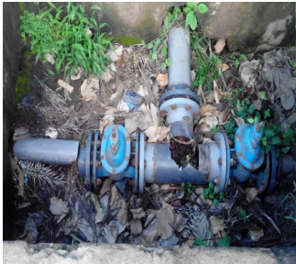
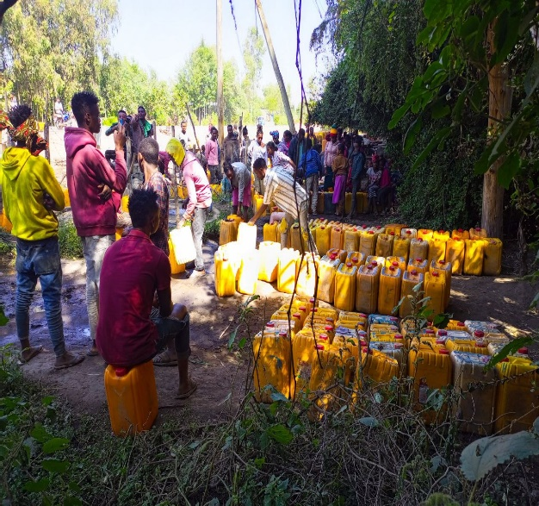
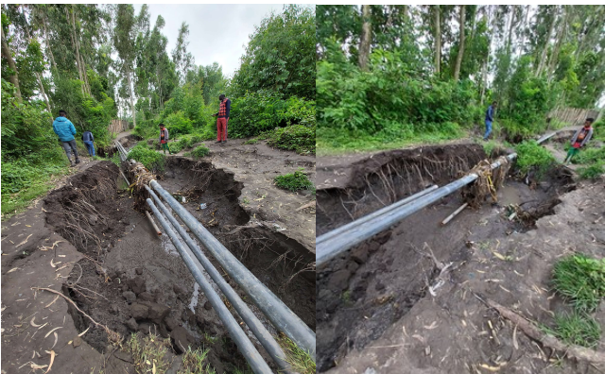
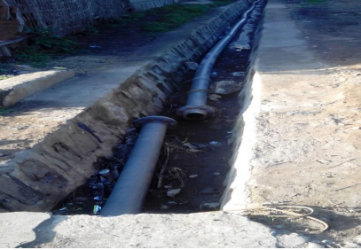
Exposed transmission line from boreholes highly vulnerable for damage due to erosion
Pipe Break
People waiting turn to fetch water
(Source: Own field visit photo)

Figure 4.6 Existing Challenges in Shone Water Supply System

4.5 Hydraulic Integrity & Performance of Shone Town Water Supply System
Hydraulic integrity is the ability of a distribution system to meet all user demands while ensuring desirable pressures, velocities and water age in the system.
The purpose of evaluating hydraulic integrity for water distribution system is to deliver adequate water supply through fast and efficient way which can easily predict; flows in pipe, velocities, head-loss, and pressure and tank level. Water distribution network of Shone town is a loop network system; it has two reservoir tanks installed at highest point elevations. The level of the reservoir tank is 2025.35m and distribution to customer end taps is by means of gravity. Pumping system has installed at source one (collection chamber) to 100m3 reservoir tank and second pump installed at source two (BH two) to 200m3 reservoir tank.

4.5.1 Type, Length and Diameter of Shone Town Water Distribution Network (WDN)
The distribution system consists of network of mains pipe with total length 8712m. The system contains different pipe materials size ranging from 32 to 225 mm in internal diameter and the total length becomes 56,352m. All these length of distribution pipe ranges from primary to tertiary but analysis is only limited to primary and secondary distribution pipes and Table 4.20 has given clear view of the network system with type of materials.

Table 4.11 Pipe Size Distribution in Diameter and Length
Diameter (mm) | Length (m)  GI | Length(m)  HDPE | Length (m)  All Material | % - Coverage
32.0 | 0 | 3,988 | 3,988 | 7.08
40.0 | 0 | 4,382 | 4,382 | 7.78
50.0 | 0 | 6,460 | 6,460 | 11.46
63.0 | 0 | 8,138 | 8,138 | 14.44
75.0 | 0 | 7,356 | 7,356 | 13.05
80.0 | 2,684 | 33 | 2,717 | 4.82
90.0 | 0 | 5,656 | 5,656 | 10.04
100.0 | 5,706 | 4,463 | 10,169 | 18.05
110.0 | 0 | 484 | 484 | 0.86
125.0 | 322 | 3,153 | 3,475 | 6.17
150.0 | 0 | 1,743 | 1,743 | 3.09
160.0 | 0 | 116 | 116 | 0.21
225.0 | 0 | 1,668 | 1,668 | 2.96
Total | 8,712 | 47,640 | 56,352 | 100.00
Source: Shone Town Water Utility Office, 2023
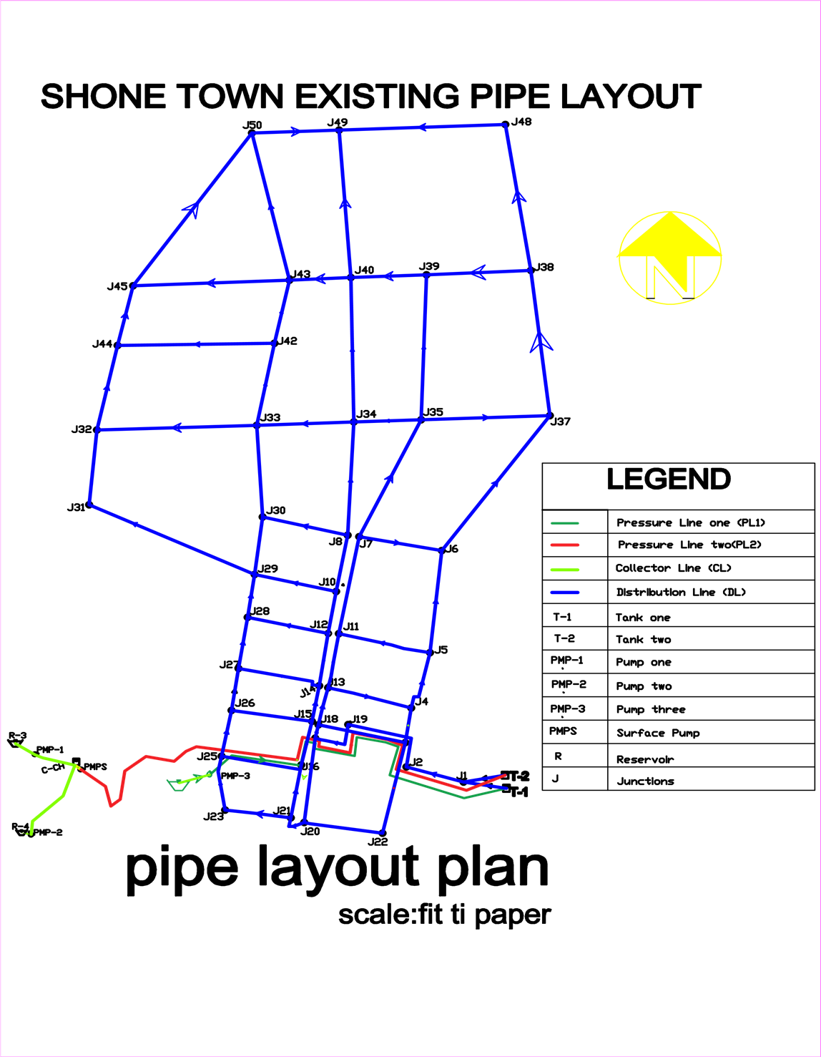

Figure 4.7 Shone Town Existing Water Supply Distribution System

To conduct evaluation of hydraulic integrity & performance level of distribution system, the above pipe layout showing all the distribution network classified by pipe sizes and age were collected from Shone town water utility and modeled in Water GEMS. So the researcher obtained these and all other relevant data from the utility office during desk study and field study but noting that the system was considered as an intermittent supply system. The details of all water supply networks such as collector pipe, transmission pipe, distribution pipe, reservoir, tank, junctions and pump are shown on Figure 4.7. In terms of material type, length and coverage the following distribution is clearly shown in Table 4.21

Table 4.12 Material Type, Length & Coverage of Distribution Network
Diameter (mm) | Length (m) | % coverage
GI | 8,712 | 15,5
HDPE | 47,640 | 84.5
Total | 56,352 | 100.0
Source: Shone Town Water Utility Office, 2023
Transmission Main Line
The pressure main of the system is cover 8.72km and with the length of this interval, the pipe diameter is 80 mm and material type is Galvanized Iron (GI)

4.5.2 Distribution Network Development and Simulation
For modeling, Water GEMS connect edition software was used. And the following valuable information was collected for development of the model.
- Pipe alignments, connectivity or pipe, material, diameter
- Location of all system components (Junctions, BH, Tanks, Pumps and valves)
- Elevations, pressure zones and various characteristics of BH, Tanks and Pumps
- Information, location of roadways, streams, planning zones and etc.

4.5.3 Demand Patterns
The hydraulic analysis was carried out using Water GEMS Connection edition and the adequacy of the system was checked in meeting for current and future demand. This has been conducted based on Maximum and Minimum day demand. The demand multipliers given below are considered to incorporate the various demand patterns within 24 hours’ consumption period (MoWR, 2006)
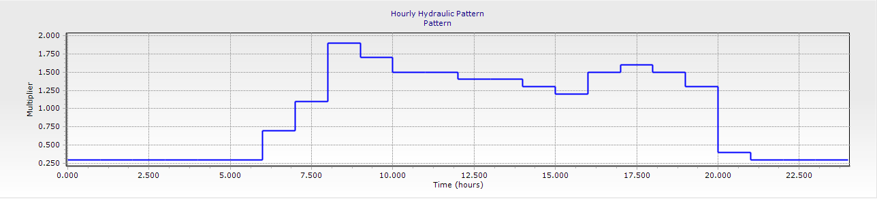

Figure 4.8 Water Demand Usage Pattern
From the demand pattern shown above, it can be concluded that, the critical scenarios have been identified at time range of both during high and low water consumption periods. During low consumption period, velocity in a pipe will be minimum and nodal pressure is extremely high while during peak hour consumption velocity is relatively high and nodal pressure is becoming minimum. Therefore, attention has taken into consideration to bring the model output results to be at an acceptable range as per the design manual of the country, MoWR 2006.

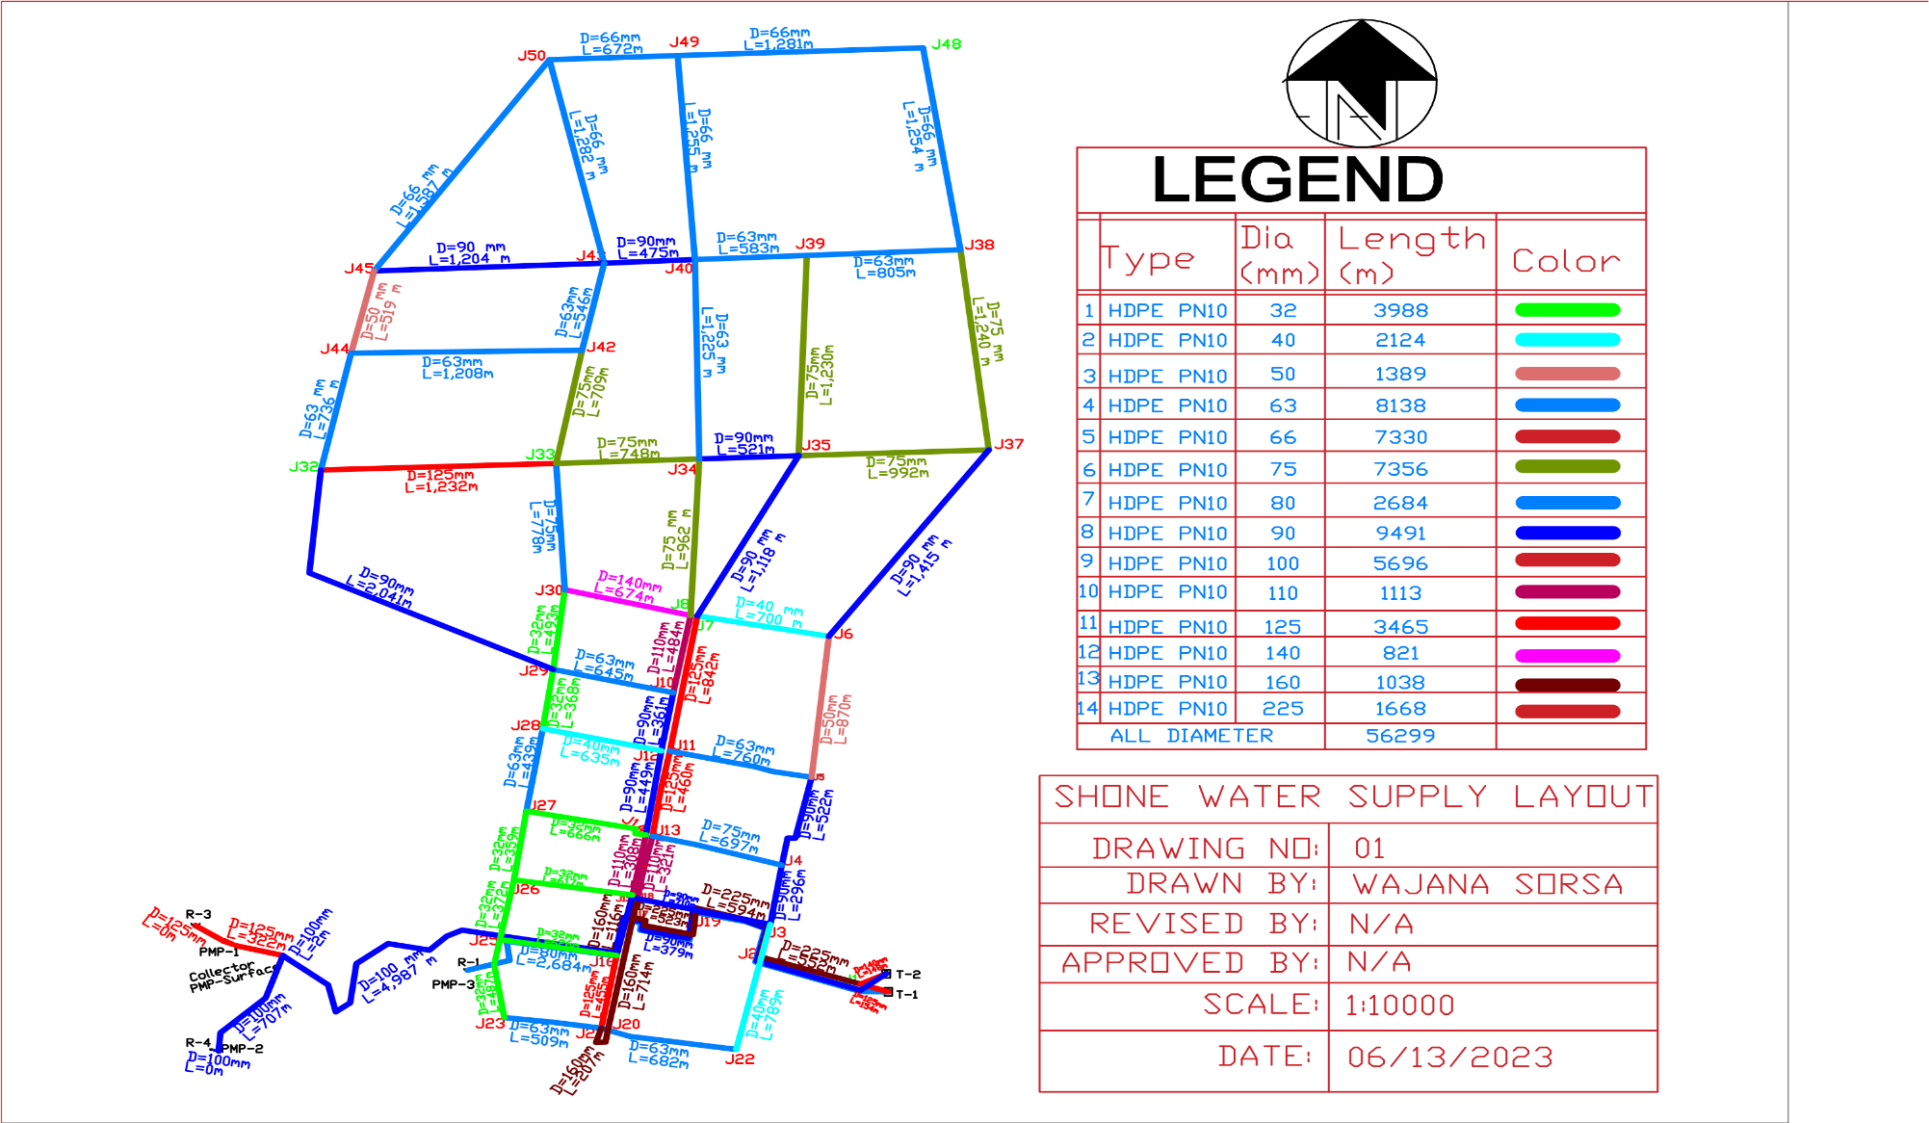

Figure 4.9 Water Distribution Network of Shone Town

All key procedures during building and analyzing the model were done based on scientific research approaches; (Ormsbee & Lingireddy, 1997: Sarbu & Valea, 2011: Datwyler, 2014).
These key approaches while evaluating for hydraulic integrity and its performance in water supply system are;
- Collecting of existing data during field and desk study
- Identification of water sources
- Schematization of water network
- Nodal demand allocation
- Modeling for pumps, tanks, reservoir and PRV
- Assigning network parameters and evaluating outputs

4.5.4 Extended Period Simulation
The system conditions have been computed over twenty-four hours with a specified time increment of one hour. To this end the model has power to simulate for any time setup within 24 hour durations. However, for the analysis peak and minimum hours, demand has been simulated to evaluate the hydraulic integrity and performance of the system and then identify the gap of the existing system based on the design criteria of water distribution system (MoWR), parameters like pressure and velocity.
Based on the urban water design criteria, the simulated model out puts of hydraulic parameters such as pressure, velocity & head loss has computed and results has interpreted & attached at appendix both for minimum and peak hour’s consumption periods.

4.5.5 Analysis for Pressure and Velocity on Existing Water Distribution System-WDS
Hydraulic design is primarily related to flow and pressure in the network, moreover, criteria for maximum and minimum pipe capacities; flow velocities, pressure fluctuation and pressure gradients are the relevant factors to be analyzed in urban water supply system, (MoWR 2006)

4.5.5.1 Analysis of Pressure
Optimum pressure shall be maintained in water supply distribution system. At minimum consumption hours through night the pressure in water system become high and the leakage losses expected to increase whereas at maximum consumption hours the pressure becomes small and the leakage losses expected to decrease.
In this evaluation study, the model was run for the existing input data a total of 43 nods and 67 primary and secondary pipes were identified, Pressure during peak and low consumption times were summarized in the appendix. Based on the design manual, minimum and maximum pressures in water distribution systems have to be 15m and 70m respectively (MoWR, 2006). Pressure is the most important indicator of hydraulic integrity. For Shone water supply system, the simulation process was done by extended period simulation for current existing demand and has resulted negative pressure in most nodes of the town at maximum peak hour demand, so this low pressures were observed during periods of high demand, i.e. demands much exceeded from existing capacity of water supply in distribution system at most nodal points & resulted negative pressure, as shown in Figures 4.10. Therefore, during peak demand times junctions located at out let to Alaba town and surrounding area experiencing negative pressure and a wide range of the area not getting water and damages to pipes are predominant due to sever negative pressure (pressures in the system dropping below atmospheric). As the result, most of the residences at the area getting and collecting water for their domestic use by shift or schedule, especially, at mid night when demand gets lowered.
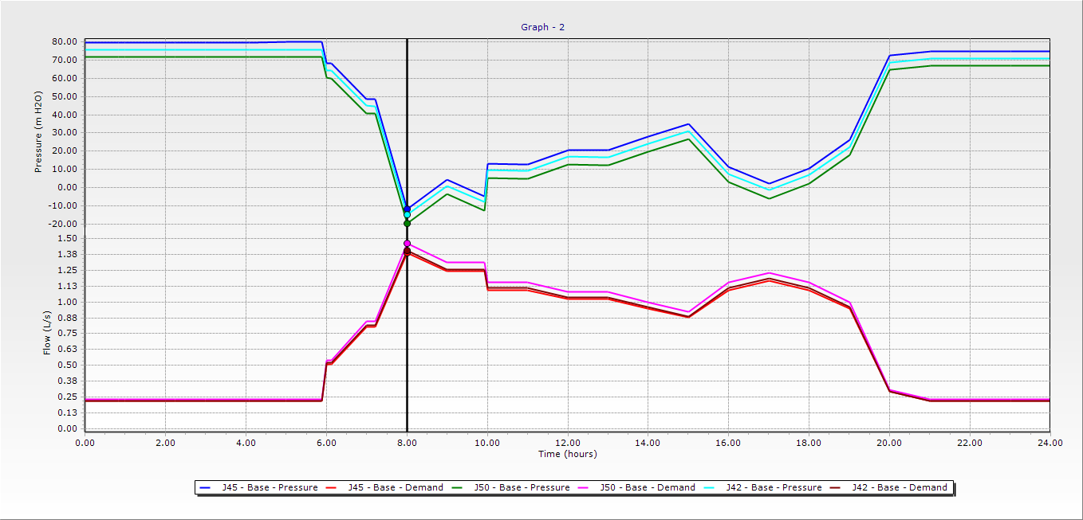

Figure 4.10 Excessive Demand Resulted Negative Pressure during Peak Time

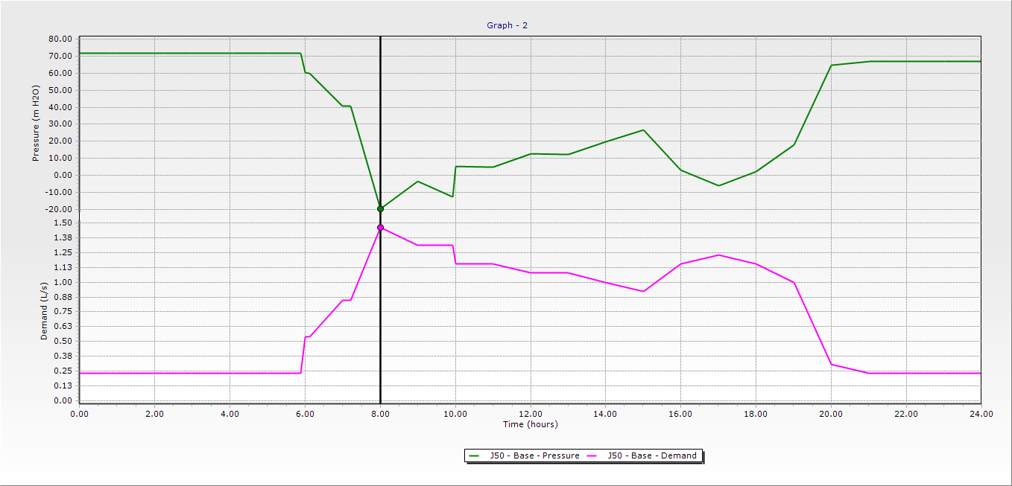

Figure 4.11 Demand Vs Pressure at Node 42 in Various Time Intervals
From Figure 4.11 it shows that as demand increases the pipe pressure falls down due to high consumption, on 8:00AM it is the peak hours that people needs water before leaving to work as the result the pressure falls automatically to compensate the high demand. From the Figure at 8:00AM the demand recorded is 1.38l/s but the corresponding pressure has become -15m.

Table 4.13 Distribution of Pressure at Peak Hour Consumption
Pressure (m) | Nodes | Percentage (%)
>70 | 11 | 25.58%
15-70 | 10 | 23.26%
<15 | 22 | 51.16%
Total | 43 | 100%

The network's conditions were analyzed over time that corresponded to the peak hourly and minimum hourly demand. From the above Figures and Table, about 51.16% of the nodes are below or under the desirable minimum pressure and only 23.26% of the nodes are in a permissible pressure range in extended period simulation. From these 76.74% of the pressure distribution is not in a suitable range based on Ethiopia's Urban Water Supply Design guideline criteria MoWR, 2006.
According to Agunwamba et al. (2018) and Gökçekuş et al. (2019), low-pressure head systems have a direct impact on user satisfaction due to the reduction in water quantity delivered, as well as making the system more prone to negative pressure heads and pollutant incursion.
As the pressure reduces further, the system becomes unable to supply the required water demand of users in higher parts and remote areas of the network. The simulated results for extended period simulation at 16 junctions (8,29,30,32,33,34, 35,38,40,42,43,45,48,49 and 50) showed that changes from positive pressure to negative pressure during high consumption period. These negative pressures indicate that the area supplied by all the above mentioned nodes could not gate water at maximum consumption hours.
Due to these negative pressures, hearing the noise or sounds of airs in locations where tap or valves locates at the town while residents opening their taps. Thus, lower pressures have been reducing the water supplying capacity and performance of the system. The town water utility has been using district gate valve or control system to deliver water in shift through shutting and opening part of the system. To maintain hydraulic integrity of water distribution systems fluctuations in pressure, velocity and flows should be avoided.
The effects of distance and elevation in pressure distribution at selected 13 junctions are shown in Figure 4-12 below.

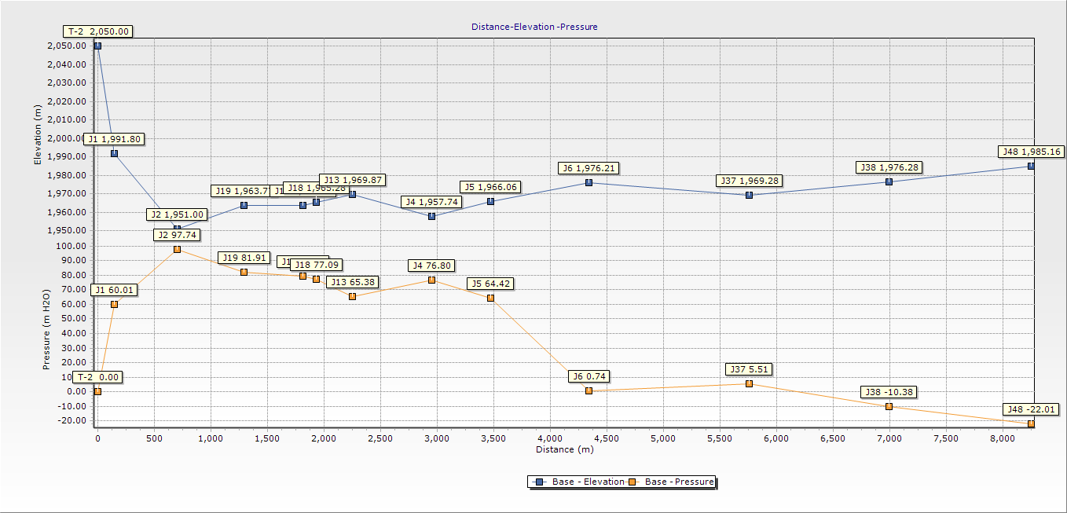

Figure 4.12 Profiles of Nodes Showing Distance from Storage Tank (T-2)
It is clear that from the above Figure, nodes which are furthest away from storage tanks always receive less water than those nodes located at middle or nearest to the source due to increase of pressure losses (Totsuka. et al.,2004). And the Figure also shows how distance and elevation affect pressure distribution for selected nodes. In Shone Town residents living around the outlet of town towards Alaba outlets get water at low pressure and this low water pressure creates poor beliefs on reliability of water as the results water users raising strong complains on utility office. The above figure also shows profile of pressure with distance and pressure with elevation from storage Tank-2 to points where some selected consumption nodes (6, 37, 38 and 48) are considered. On the other hand, Pressure increases as elevation decrease and vice versa. Household located at a higher elevation and near to service reservoir gets water with low pressure (Mekonnen, 2014).
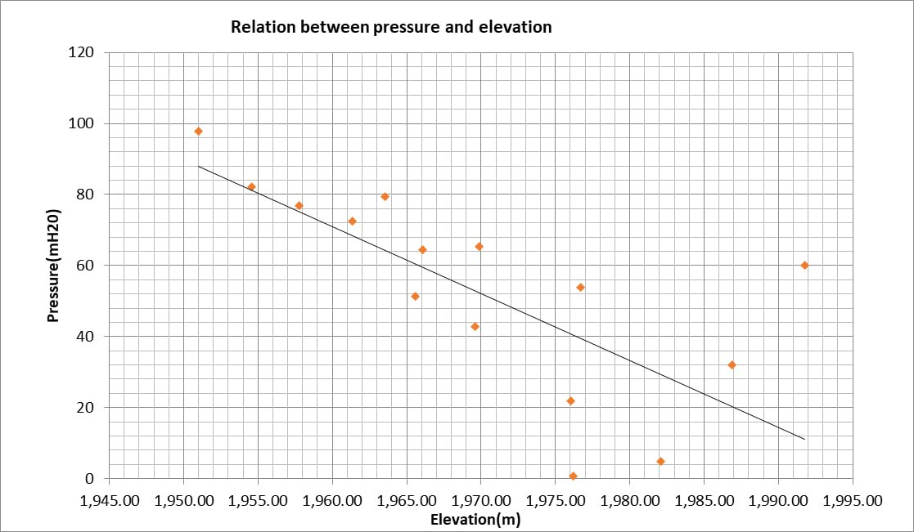
Figure 4.13 below confirms presence of an inverse relationship between pressure and elevation for selected sample nodes of the supply system.

Figure 4.13 Relationship between Pressure and Elevation for Selected Nodes
Conversely, in the following Table 4.24 shows, distribution of pressure in the system at minimum consumption period and as per the results indicates there is high pressure value of 108.96m and minimum pressure vale of 62.79m in the system and there is a consequent leakage at pipe line located at center of the town during night when consumption of water gets minimum demands. According to Farmani et al. (2017), the pipe bursts and increased energy demand are caused by a high-pressure head in distribution networks.

Table 4.14 Distribution of Pressure at Minimum Hour Consumption
Pressure (m) | Nodes | Percentage (%)
>70 | 37 | 86.05%
15-70 | 6 | 13.95%
<15 | 0 | 0%
Total | 43 | 100%

Figure 4.14 below shows a contour map of system pressure distribution, area highlighted in yellow color indicates pressure deficit of below 15m water head due to its high ground elevation and long distance from water supply point (Tank-2 and Tank-1).
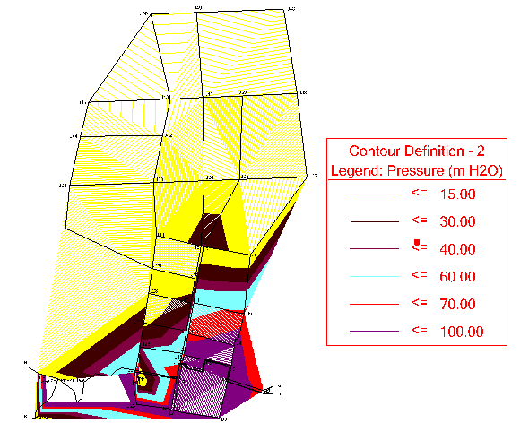

Figure 4.14 Contour Map of Pressure Distribution

From the above Figure 4.14 it can be concluded that, hydraulic analysis results of pressure distribution in the network at peak and minimum hour demand are summarized as follows;
At some parts of the town the network couldn’t meet minimum required pressure of 15m H₂O
during peak hour demand. These areas found around central part of the town and North East of Alaba outlet and Tele tower area. And the minimum pressures are varying from -22.5 to 11.39m as shown in yellow color of counter map pressure distribution.
The main probable reasons for such lower pressures are:
- The installed pipes at some parts were small in size. E.g. 32mm
- Relatively found on higher ground levels
- Increased number population and high demand to the nodes
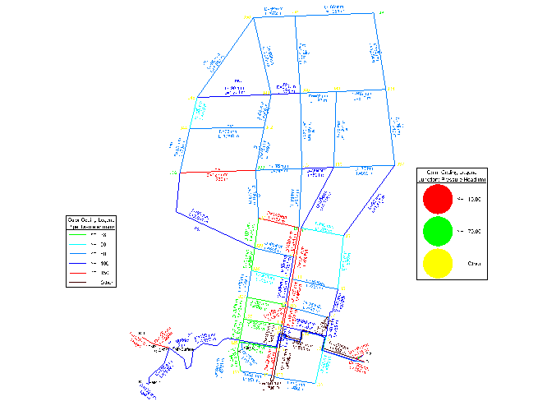

Figure 4.15 Water Distribution System at Extended Period Simulation in Peak Hour

4.5.5.2 Analysis of Velocity
Analysis of flow velocities in water distribution networks should be controlled to avoid structural problems or undesirable hydraulic regimes caused by high velocities, or in order to minimize the unfavorable consequences of too low velocities on the quality of the transported water (Tamminen et al, 2008). Velocity of water flow in a pipe is also one of the important parameters for evaluating hydraulic integrity & performance of distribution system. Low velocities are not preferred for water quality issues due to the accumulation of sediments, while too high velocities cause exceptional head-loss (Besner et al, 2011).
According to urban water supply design guide line approved by ministry of water and energy, the allowable permissible velocity shall range in water distribution system minimum of 0.6 m/s and maximum of 2m/s.
In Shone town water supply distribution system, velocities during peak and low consumption hours were summarized and attached in appendix G. Table 4.25, summarizes velocity in distribution system during peak consumption hours for primary and secondary pipes, hence, 43.28% of the pipes have velocity range of below 0.6 m/s whereas 55.22% of the pipes have in the recommended velocity range (0.6-2.0 m/s) and only 1.5% of pipes having velocity above 2m/s based on urban water supply design guideline criteria (MoWR, 2016b).

Table 4.15 Simulated Range of Velocity at Peak Consumption Hour
Velocity (m/s) | Number of pipes | Percentages (%) | Effects
< 0.6 | 29 | 43.28% | Water stagnation and sedimentation
0.6-2 | 37 | 55.22% | An acceptable level
>2 | 1 | 1.5% | Head loss and water hammer
Total | 74 | 100%
According to Adedoja et al. (2018) and Enbeyle et al. (2022), velocity in the distribution systems less than 0.5 m/s and greater than 2m/s will lead to deposition of sediment in the pipes and bursting pipes in distribution networks, respectively. Therefore, adjusting the minimum and maximum velocity compared to permissible velocity (average 0.5–2m/s) in the distribution networks was used to avoid deposition of sediment and bursting of pipes.
Based on this truth the researcher has recommended to replace the existing pipe size in spatial distribution round outlet of Alaba town to be replaced by smaller sized diameter to maintain hydraulic integrity of the system. The revised size and its velocity distribution after simulation has attached in appendix J and summarized in Table 4.26.

Table 4.16 Simulated Velocity at Peak Consumption Hour after Pipe Re-Sizing
Velocity (m/s) | Number of pipes | Percentage (%) | Effects
< 0.6 | 2 | 2.9% | Water stagnation and sedimentation
0.6-2 | 64 | 95.5% | An acceptable level
>2 | 1 | 1.6% | Head loss and water hammer
Total | 67 | 100%
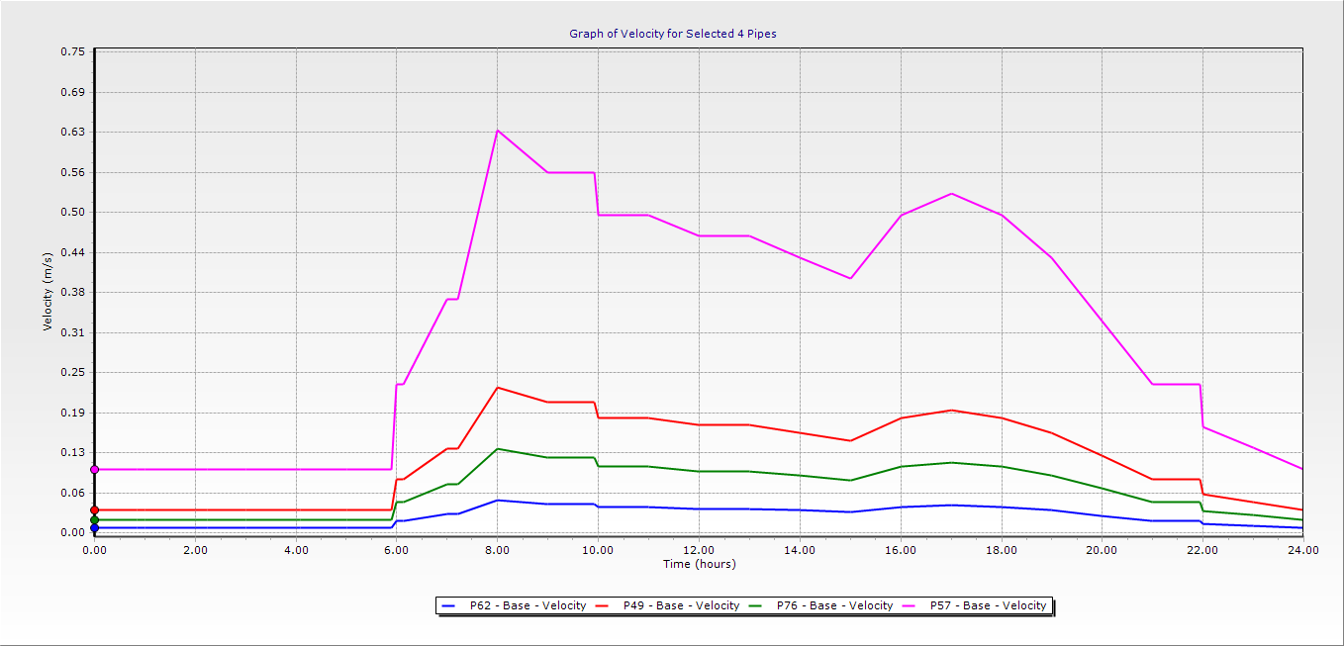

Figure 4.16 Graph of Velocity Distributions for Selected Pipes

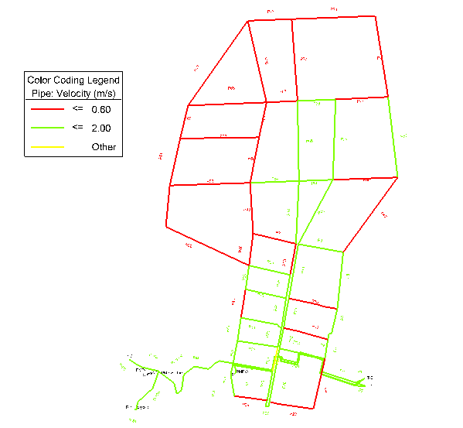

Figure 4.17 Velocity Distribution at Extended Period Simulation in Peak Period

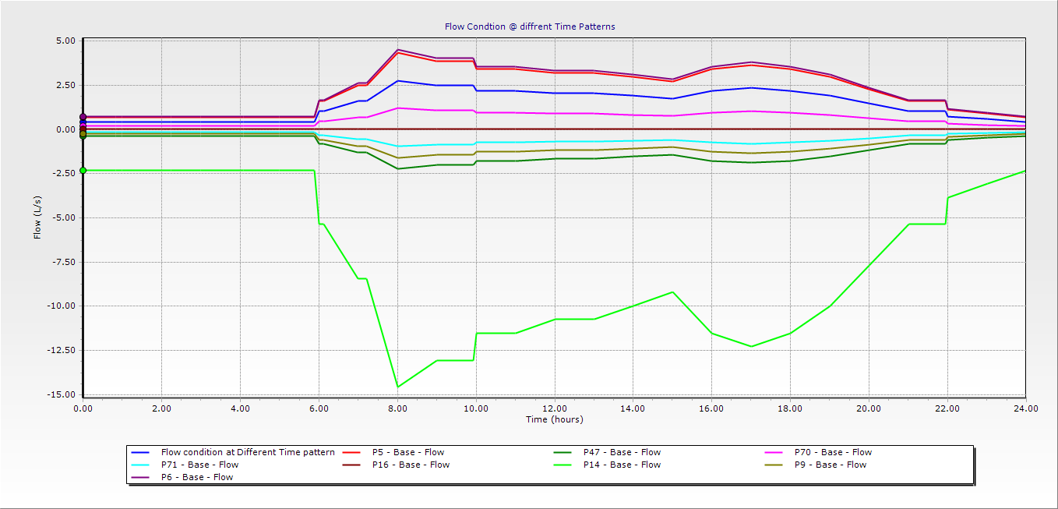

Figure 4.18 Flow Condition at Different Time Intervals Patterns
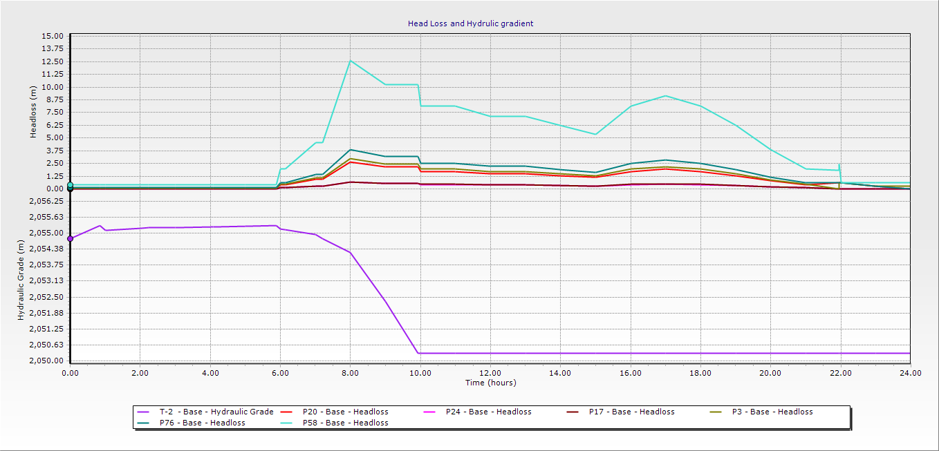

Figure 4.19 Hydraulic Gradient and Head Loss at different Time Intervals

4.5.5.3 Storage Tank Features at Different Consumption Hours
The storage tank is provided to balance supply rate from the water source with fluctuating water demand in distribution area. Extended period simulation result was used to show the fluctuating storage volume with time increments during high and low consumption. So in low demand hours when the water consumption of consumers is minimum, amount of water pumped is higher than system demand so that extra water coming from pumps are stored at storage tank.
In Figure 4.20, time varying simulation indicates that storage tank-1 starts to decrease its volume at 8:00 hour that means up to 8: hour the volume in the tank is 100% or full.

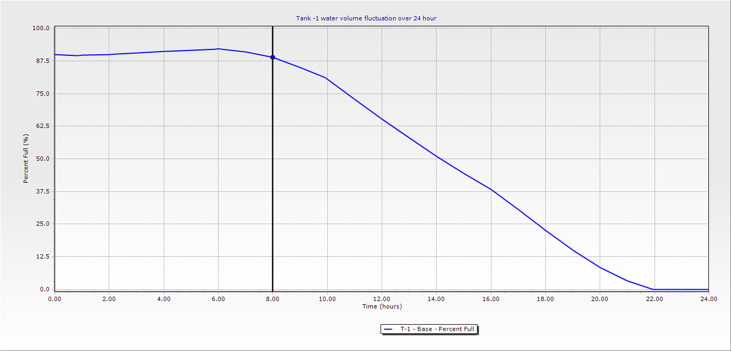

Figure 4.20 Tank-1 Water Volume Fluctuation Over 24 Hour Periods
It shows that in extended period simulation storage level of the tank fluctuate for all 24-hours which indicate the change in percent of fullness in different time interval. So during the start of the simulation the tank was full and then the volume starts to decrease up to 8 hours (morning, peak demand), so that the pumps should have to operate and replenish volume of the tank.

4.6 Calibration of Hydraulic Network
Calibration of the model is simply comparing model results with field observations and conducting necessary adjustments on parameters (pipe roughness coefficients and nodal demands) until model results reasonably agree with field measured values so as to confirm strong performance of developed model over range of operational conditions (AAWA, 2010). Although necessary data have been collected for water distribution modeling and simulated by hydraulic modeling software, the simulated results should not be expected as accurate mathematical representation due to various boundary conditions.
The hydraulic simulation software only solves continuity and energy equations using the input data. Thus, quality of the input data, sampling technique and number of sampling will determine the quality of model results. The accurate representation of hydraulic model depends on how well the simulated result and observed field data get similar to make decision (EPA, 2005a).
Therefore, calibration can be accomplished by adjusting only internal pipe roughness values or estimates of nodal demands until an agreement between observed and computed pressures and flows is obtained. The basis for this claim is that unlike pipe lengths, diameters, and tank levels, which are directly measured, pipe roughness values and nodal demands are typically estimated, and thus have room for adjustment (Thomas, et al., 2003).

4.6.1 Sampling Techniques and Location
In model calibration process all the pipes and nodes are expected to be adjusted, but, in this research due to constraints like finance and time on data collection and measuring, only representative sample nodes were selected for model calibration through random sampling techniques.

4.6.2 Sampling Techniques and Location
The pressure head measurements were taken near at junction of home faucet. So from here ten data sets were selected from field observation points and ten data sets were selected from simulated.
The main challenges during sample collections were: difficulty on taking measurement at direct connection to water main nodes due to lack of permission from authorities, need of deep depth excavation, lack of measuring pressure gauges and so on. As the result field measuring was taken at ½’’ and ¾” pipes.

Table 4.17 Junction Pressures Measured for Calibration at Peak Consumption Hours
Limitations- The data has taken at location where water is available only b/c it is difficult to take the records in areas where there is no water and water in the pipe is not available all the times due to high demand and low source capacity.
As shown in Table 4.28 the computed pressure values with in an average error of 1.67mH2O pressure from simulated to observed values.
According to (Bahre, 2021), the acceptable level of agreement between simulated and observed outputs is within an average difference of ±1.5 m to a maximum of ±5.0. Hence, the model output falls within the acceptable range of agreement.
The following graphical sketch Figure 4.21 shows the overall relationship of two data sets between observed field record and simulated model results to show overall relationship between the two data sets.

Figure 4.21 Simulation Pressure Vs Measured Pressure
The deviation between results of simulated and field observation could be caused by factors such as equipment measuring error and reading wrong value from measurement (Lingreddy, 1997), in the Figures above & data from Table 4.28, at junctions (7,11,12, 18, 21, 28 and 39), the simulated and measured result shows deviations in relationship so the model is over estimated at stated junctions, but at junctions (2,14 and 25) the values are under estimated.

The magnitude of correlation coefficient determined for observed and simulated data describes proportion of variance which is explained by the model. The diagonal line on the below plot represents line of perfect correlation. When all the points align to diagonal line, the observed pressure be equal to computed pressure giving correlation coefficient nearly 1 & it is the best correlation between observed and simulated. The coefficient of determination (R²) computed based on the collected data resulted 0.9986, that indicates the simulated and observed pressure do have strong correlation (Milkecha C. 2020 and Hajibabaei et al. 2019)

Figure 4.22 Correlation between Observed and Simulated Pressure

During calibration process, the simulated pressure values both at peak hour demand & minimum hour demand conducted in extended period simulation should be nearly equal to the measured pressure value after adjusting through either nodal demand or pipe roughness coefficient. For those junctions whose nodal pressure values were over-estimated, head loss was increased by decreasing the initial roughness coefficient C value 130-125 for HDPE pipe by taking different iterations as the existing HDPE pipe has served for more than 9 years. For those junctions whose nodal pressure were under estimated during simulation, head loss was decreased by increasing the roughness coefficient C value of 110-125 to GI pipes in taking various iterations. So after taking different iterations coefficient of roughness value has changed to 125 which is at reasonable extent and acceptable.

5. CONCLUSION AND RECCOMMENDATION
The main goal of this study was to assess the existing gap in water supply adequacy and evaluate hydraulic integrity of Shone town water supply network by using analysis results of water coverage, water supply and demand, present and future projected water demand, analysis of system water loss and evaluation of hydraulic behavior using Water GEMS software. Based on the evaluation results, the following conclusion and recommendations were done.

5.1 Conclusion
- The study has made an effort to observe the water supply and demand situation of Shone Town. The water demand of the town is increasing due to urbanization, population growth and infrastructure breakages. The assessment revealed that the town water supply cannot fulfill consumer demand for water. Excessively increasing demand, long age of the system, insignificant water source supply, high water loss and hydraulic gaps are the basic limitations
- From the analysis result of maximum day demand (m3/d) with respect to existing supply (m3/d) from existing functional sources; the estimated water supply coverage of the town was found 32.51%, 30.09%, 21.71%, 22.75, 10.79, 13.36 and 10.91% in 2023, 2024, 2027, 2032, 2037 and 2042 respectively. From these trends it can be judged that, water supply coverage of the town declines up to the end of projected period 2042, if additional potential sources not augmented timely. Therefore, these projections indicate a need for development of additional water sources to satisfy maximum day demand capacity of 11,615.11m3/day at final year of 2042.
- The average water supply consumption of Shone town is found to be 15.60 liter/person/day. This average per capita consumption is less than the recommended standard of WHO (2008), the minimum quantity of domestic water required in urban areas of developing country, which is taken to be 20 l/c/day. In line with this, the most frequent complaints by water users are regular interruption of water supply and unfair water distribution. The findings of the study lead to conclusion that there is a huge gap between the water supply and demand of the town. In order to satisfy this; measures should be taken could be upgrading of the system that match with the town’s development & the water requirements of the town.
- It needs an additional 9 new boreholes each of with yields 15l/s is required in addition to the existing three boreholes to satisfy the maximum day demand and a deficit of 10,347.51m3/day at the end the design year in 2042, but the number depends on capacity of the well.
- The average number of connection per family of the entire town is found to be 0.4. This shows that averages of two households or ten individuals are unable to share one connection or water tap. On the other hand, the difference in Kebele level also more clear i.e. Woiyralalo Kebele has per family connection of 0.35 which is far from the average and it is the worst, based on the standards mention above.
- The average annual quantity of water losses computed in the town were 108,808m3 and due to this reason the utility lost 748,742.12ETB at every single year. The cause for these losses were aging of pipe network and its consequent leakages, pressure and distribution pipe bursting, illegal installation at outer escarpments (expansion of network in new area), low repairing and maintenance attention from the utilities so water loss should be combat.
- For nodes where high demands from both domestic and non-domestic connections, water loss per number connection due to leakages is high, this is because of high pressure head during minimum demand period
- From the hydraulic modeling output it can be easily concluded that 25.58% of excessive pressure (>70m) in the town were obtained at 11 nodes but due to low elevation, 23.26% of the area have pressure within the recommended limit (15m-70m) at peak hour consumption and finally 51.16% of the nodes have pressure below 15m at peak hour consumption. During peak hour consumption, some area of the distribution system receive water with low or negative pressure as the result getting water is extremely uncertain because of pressure in the system is below from permissible minimum requirement due to excessive demand at the node. Moreover, for the parts of the system that are located far away from the sources, it is clearly identified that they are suffering from low-pressure or negative pressure vales. 55.22% of velocity in distribution network was in recommended range (0.6-2m/s) in peak consumption hours and 43.28% of velocity in the town was (<0.6m/s) and the last 1.5% is above from the permissible velocity range. Hence the distribution system is not maintaining minimum and maximum pressure and velocity; in order to rectify this, the excessive pressure in the system shall be solved by introducing pressure reducing valve and replacing pipe of higher PN value to resist the pressure at Lincha 200m3 water tank areas.

- The simulation results also indicated that hydraulic integrity of Shone town distribution system is not satisfactory. This doesn’t mean that the system is not functional, but, rate of service interruption at different locations of the town is extremely high. So this interruption is one of the contributing factors for shortage of water in the town.
In general, the main causes of loss of hydraulic integrity includes;
- Excessive demands- high population, migration, change of life style, large leakages
- Negative pressures-demand much greater than system capacity, pumping from distribution network, happening of pressure transit or water hammer
- Excessive pressures-miss of installing pressure reducing valve & pressure break valve
- Low Velocity-wrong close and open of valves, air in system (miss air release valves, sediment accumulation)

5.2 Recommendations
- Regarding the yield and condition of the existing water sources, is not sufficient to satisfy even water demand of the present dwellers of the town. To address the shortage of water supply of the town in terms of coverage and demand, the predominant approach (satisfy the supply deficit) should be developing new sources or additional borehole should be drilled to fulfill the current gap between water demand and water supply.
- Existing water distribution systems don’t cover all extremities of the town. And due to luck of enough source and uneven distribution of water distribution of pipe network, the system doesn’t satisfy the demand of Shone town communities.
- Installing pressure reducing valve devices, which decrease pressure, is recommended as a solution to control the occurrences of maximum pressures during low consumption hour for desirable pressure range
- Shone town water utility should plan to increase reliability of water supply coverage by augmenting ground water supply system by surface water supply as there is perennial lake within 10km from the town by planting proper water treatment system.
- As the simulated result has shown low pressure at nodes around exit area to Alaba town, the town water utility should introduce zoning as well as constructing boosting station so as to increase pressure by constructing additional service water reservoir.
- The existing 100m3 service water reservoir is very old and associated to its poor workmanship and cracked at the upper edge slab, it shall not have considered to be part of the next water supply system.
- It is most recommended that houses located at far end of town should have additional pressure tanks installed near their homes and use booster pumps to solve the problems of poor negative pressures at their locations.

6. REFRENCE
Abdo (2009) Evaluation of urban water supply options using Weap: The case of Nablus
City, Mali
Abduro S, Sreenivasu G (2020) Assessments of urban water supply situation of Adama Town. Adama, Ethiopia
Abebaw M (2020). Assessment of Water Loss in Water Supply Networks (A Case of Debre Markos Town) Civil Engineering Department, Addis Ababa University, Addis Ababa, Ethiopia
Abraham W. Brook A. Hailu G. (2016) Assessment of Water Supply and Demand of Boditi Town, Hydraulic and Water Resources Engineering Department, Wolyita Sodo University, Wolyita Sodo, Ethiopia
ADB (1993). Managing water resources to Meet Mega City Needs, Proceeding of Regional
Consultation
Adedoja OS, Hamam Y, Khalaf B, Sadiku R (2018) Towards development of an optimization model to identify contamination source in a water distribution network
Agunwamba JC, Ekwule OR, Nnaji CC (2018) Performance evaluation of a municipal water distribution system using water cad and Epanet
Akbar H.M. and Minnery J.R. (2007). “Community water supply for urban poor in developing countries: The case of Dhaka, Bangladesh.” Habitat International 31(1): 24- 35.
Alemayehu, Z., 2010. Water Supply Urban Drainage, Addis Ababa, Ethiopia.
Amdework, B. (2012). Hydraulic network modeling and upgrading of Legedadi subsystem water supply. Civil Engineering Department, Addis Ababa University, Addis Ababa, Ethiopia
Asmelash Zewdu (2014). Assessing Water Supply Coverage and Water Losses from Distribution System for planning Water Loss Reduction Strategies. Aksum
Assfaw MT (2016) Hydraulic Modeling of Water Supply Distribution Network: A Case Study on Debere Biryani Town, Amhara Regional State, Ethiopia.
AWWA. (1962) America water Works Association a Training Course in Water Distribution, Denver, CO, USA
AWWA. (2005) Computer modeling of water distribution systems: American Water Works Association.
AWRDB, 2012. Water Supply Design Guideline, Bahir-Dar, Ethiopia. AWRDB.
Ayala (2018) Assessing the performance of urban water utilities in Mozambique using a water utility performance index
Ayale RF (2018) Urban water supply system performance assessment (the case of Holeta Town, Ethiopia). Addis Ababa Science and Technology University, Addis Ababa, Ethiopia
Babić BAD. (2011) Estimation of water balance and water losses in water utilities –experiences from the Belgrade waterworks. Water Research and Management." Water Research and Management 1((4))
Bahre, (2021) Hydraulic Modelling of Water Distribution System of Aksum
Bangash RF,et al,. 2013 Ecosystem-tem services in Mediterranean river basin: climate change impact on water provisioning and erosion control. Sci Total Environ 2013;458–460:246–
Baye D. (2021) Sustainable Development Goals (SDG) Target 6.2 in Ethiopia: challenges and Opportunities
Belete Berhanu Kidanewold, Yilma Seleshi, Assefa M Melesse, “Surface Water and Groundwater Resources of Ethiopia: Potentials and, Challenges of Water Resources Development” 2014.
Berhe (2005). Water supply coverage and losses in distribution system: The case of Addis Ababa, Addis Ababa University.
Bahre T. (2021) Hydraulic Modelling of Water Distribution System of Aksum Town, Ethiopia
BESNER, M. C., PREVOST, M. & REGLI, S. 2011. Assessing the public health risk of microbial intrusion events in distribution systems: Conceptual model, available data, and challenges. Water Research, 45, 961-979.
Bhave, P. R. (1986). “Unknown pipe characteristics in Hardy Cross method of network analysis.” J. Indian Water Works Assoc., 18(2), India, 133–135.
BoWRD (2008).Water Resources Development Bureau of SNNPRS
Annual Report. Hawassa.
Brown, K. (2007). Florida State University Libraries Modeling Leakage in Water Distribution Systems.
Candelieri, A., Archetti, F., & Messina, E. (2013). Improving Leakage Management in Urban Water Distribution Networks Through Data Analytics and Hydraulic Simulation. Vii (107–117).
Cairncross, S; Valdmanis, V; (2006) Water supply, sanitation and hygiene promotion
Cesario, L. 1995, Modeling, analysis, and design of water distribution systems, Denver, CO, USA
Charles L. Eggener, Lawrence B. Polkowski (1976). Network Models and the Impact of Modeling Assumptions
Chatterjee A. K. (2005). Water Supply, Water Disposal and Environmental Engineering. Khanna publishers, Nai Sarak, Delhi-110006.
Chan C., Zalifah M.K. and Norrakiah A.S. (2007). Microbiological and Physicochemical Quality of Drinking Water. The Malaysian Journal of Analytical Science, 1(2): 417-419.
CSA (2007). Population and Housing Census of Ethiopia. Results for South Nations Nationality and Peoples State, Vol. 1.
Datwyler, T.T., 2014. Hydraulic Modeling: Pipe Network Analysis, 22(11), Pp, E391– E401
Dawe, P. (2000). Workshop on Hydraulic Network Modeling with Water CAD.
Dereje W. (2017) performance evaluation of distribution system (Case Study of Adama Town), Ethiopia. MSc Thesis. Addis Ababa University. International Journal of Engineering, Science and Technology 6: 03-45.
Desalegn WB. (2005) Water Supply Coverage and Water Loss in Distribution Systems: The Case of Addis Ababa. ITC.
Dighade R, Kadu M and Pande A. (2014) Challenges in water loss management of water distribution systems in developing countries. International Journal of Innovative Research in Science, Engineering and Technology
Enbeyle W, Hamad AA, Al-Obeidi AS, Abebaw S, Belay A, Markos A, Derebew B (2022) Trend analysis and prediction on water consumption in South-Western Ethiopia
Ermias (2014) Assessment of urban water supply and sanitation: the case of Bedesa Town,
Damot Woyde woreda, SNNP. MSc Thesis. Hawassa University.
EPA (1997), Environmental Policy. Ethiopian Environmental Protection Authority.
EPA (2000), Environmental Impact Assessment Guideline Document. Ethiopian Environmental Protection Authority.
EPA (2003, Environmental Impact Assessment. Procedural Guideline. Ethiopian Environmental Protection Authority
EPA (2010) "Control and mitigation of drinking water loss in distribution system. USA.". International Journal of Innovative Research in Science, Engineering and Technology 3: 13838-13846
Eggener, C. L., and Polkowski, L. B. 1975, "Network Models and the Impact of Modeling Assumptions," Journal of the American Water Works Association.
European Water Resources Association (EWRA), Water Utility Journal 1:1-40, 2011
Farmani R, Kakoudakis K, Behzadian K, Butler D (2017) Pipe failure prediction in water distribution systems considering static and dynamic factors
Fikere G. (2017) Assessing Sustainability of Urban Water Supply and Distribution System: (A Case Study of Boditi Town: Civil Engineering Department, Jimma University, Jimma, Ethiopia
Farley, M. and Trow, S.,2003, Losses in Water Distribution Networks. IWA Publishing
GTP_II (2016), Federal Democratic Republic of Ethiopia Growth and Transformation plan, Volume: II
Garg, S.K., 2004. Water Supply Engineering. 18th Edition, Khanna Publishers, Delhi. DOI.
Geleta Ebsa D, Fufa F (2021) Hydraulic performance Analysis of water supply distribution network using water GEM
Gökçekuşa H, Orhona D, Kebedea GG, Abatec B, Narayananc K, Sözena S (2019) Management strategy for safe drinking water in developing countries–a case study for Assela, Ethiopia.
Https://en.wikipedia.org/wiki/Water_supply_and_sanitation_in_Ethiopia#Access.
Hailu, G, Abraham W/M, Brook A. (2016) Water Distribution Network Analysis of Boditi Town by EPANET, School of Biosystem and Environmental Engineering, Hawassa University, Hawassa, Ethiopia
Hajibabaei M, Nazif S, Sitzenfrei R (2019) Improving the performance of water distribution networks based on the value index in the system dynamics framework.
Herrin, G. (1997), “Calibrating the model”, Practical guide to hydraulics and hydrology, Haestad Press, Waterbury, Connecticut, USA
Hussni, S. (2003a). Hydraulic Performance of Palestinian Water Distribution Systems: Jenin Water Supply Networks a case Study. An-Najah National University, Nablus, Palestine
Hutton G, Haller L and Bartram J. (2007) Global cost-benefit analysis of water supply and sanitation interventions. Journal of water and health 5: 481-502.
IRC, 1996. A Commitment to Change, Manuel prepared by IRC Office
IWA, 2006. Performance Indicators for Water Supply Services, Manual of Best practice series, London, UK: IWA.
Jalal, M.M. (2008). Performance measurement of water distribution systems: A critical and
constructive appraisal of the state of the art. Thesis Submitted to the Requirement for the Degree of Master of Civil Engineering, University of Toronto, Canada.
Joshi, M., Student, P.G. & Morbi, L.E.C., 2014. Design of Water Distribution Supply Network for Kuchhadi Village Assistant Engineer Narmda Water Resources Water Supply Depart- Pp.94–97
Khatri K, Vairavamoorthy K and Porto M. (2008) Challenges for urban water supply and sanitation in developing countries. Water for a Changing World-Developing Local Knowledge and Capacity. CRC Press, 93-112.
Kimey, V. (2008). Assessment of the Performance of Urban Water Supply Utilities: A case
study of Korogwe and Muheza towns, Tanzania. MSc Thesis. University of Zimbabwe, Harare
Lambert A. (2001) What do we know about pressure-leakage relationships in distribution systems. IWA Conf. Systems approach to leakage control and water distribution system management
Lambert A. (2002) International report: water losses management and techniques. Water Science and Technology: Water Supply 2: 1-2
Lee R. D. and Tuljapurkar S. (1994). Stochastic population forecasts for the United States: Beyond high, medium, and low. Journal of the American Statistical Association, 89, 1175–1189.
Lingireddy, L. (1997). Calibration of Hydraulic Network Models. Journal of American water works Associations, 89, 42-50.
Lee and Schwab, 2005. Deficiencies in drinking water distribution systems in developing countries
Maher Abu-Madi & Trifunovic (2013) Impacts of supply duration on the design and performance of intermittent distribution systems in West Bank. journal of water international, 38, 263-282.
Malcolm Farley, 2001, Leakage management and control, a best practice training
manual, WHO, 2001, Geneva, Switzerland
Mandefro C, Habtamu K. (2017). Water supply and demand scenario of Dilla Town, Southern Ethiopia.
Makonnen A. (2014). Assessment of Urban Water Supply and Consumption in Asayta Town, Awsiressu Zone, Afar National Regional State, Ethiopia, Thesis, Haramaya University.
Mays LW, Bouchart F. (2000) Water distribution systems handbook: McGraw-Hill New York.
Mekonnen, E. (2015). Assessment of urban water supply and sanitation: the case of Bedesa Town, Damot Woyde woreda, SNNP. MSc Thesis. Hawassa University, Ethiopia
Mesalie RA, Aklog D, Kifelew MS (2021) Failure assessment for drinking water distribution system the case of Bahir Dar institute of technology, Bahirdar, Ethiopia
McKenzie R and Seago C. (2005) Assessment of real losses in potable water distribution systems: some recent developments. Water Science and Technology: Water Supply 5: 33-40.
MoWR (2006) Ministry of Water Resources Urban water design criteria, 2006
Ministry of Water Resource, 2006. Cost Effective Design for Urban Water Supply. Addis Ababa Ethiopia
Mohammed, B.; Gabel, M.; Karlsson, L. M., 2013. Nutritive values of the drought tolerant food and fodder crop enset. Afr. J. Agric. Sci., 8 (20): 2326-2333
Motiee H, McBean E and Motiei A. (2007) Estimating physical unaccounted for water (UFW) in distribution networks using simulation models and GIS. Urban Water Journal 4: 43-52.
MOWR (2006a) Universal Access Program for Water Supply and Sanitation Services 2006 to 2012, International Calendar (1999 to 2005 Ethiopian Calendar)
MOWR (2006b) Urban Water Supply Design Criteria. Water Resources Administration Urban Water Supply and Sanitation Department.
MoWR. (2013). Universal Access Program for Water Supply and Sanitation Services
Milkecha C. (2020) Hydraulic performance analysis and modeling of water supply distribution system of Addis Ababa science and Technology University, Ethiopia
Mitchell, V.G., R.G., M. and T.A, M., 2000. Modelling the Urban Water Cycle.
Misirdali, M. (2003). A methodology for calculating hydraulic system reliability of water distribution networks. Civil Engineering. The Middle East Technical University.
Muluken S.2015 Hydraulic Modeling and Improvement of Addis Ababa Water Supply System: The Case of Bole Bulbula. Unpublished MSc Thesis, Addis Ababa University, Addis Ababa, Ethiopia.
Munson B., Young D. and Okiishi T. (1998) Fundamentals of Fluid Mechanics. 3rd Edition, John Wiley & Sons, Inc., New York.
Murenzi, (2020). Impacts of urbanization on Kicukiro water supply network and water security: spatio-temporal investigation using Geospatial models and WaterGEMS
Mwendera et al., 2003. Overcoming constraints to the implementation of water demand management in southern Africa
NM Bhadbhade (2009) Hydraulic Simulation Software for the City of Oilton, Oklahoma.
Omar Saeed, 2011.Customers‟ satisfaction with clean drinking water provided by the Lahore Cantonment Board (LCB)
Ormsbee, B.L.E. & Lingireddy, S., 1997. Calibration of Hydraulic Network Models, 89(2), Pp.42–50.
Rossman, L.A. (2000). EPANET 2 Users Manuel. Water Supply and Water Resources Division National Risk Management Research Laborator
Rudolf, F. & Liemberger, R. (2010). The Issues and Challenges of Reducing Non-Revenue Water. Mandaluyong City: Asian Development Bank
Sarbu, I. & Valea, E.S., 2011. Nodal Analysis of Looped Water Supply Networks. Journal of Energy, 5(3), Pp.452–460.
Santhi C, Arnold JG, Williams JR, et al. (2001) Validation of the SWAT Model on a large river
basin with point and nonpoint sources, JAWRA Journal of the American Water Resources Association 37: 1169-1188.
Seidu, Y, Kyei-Baffour, N,Bawa, A., Mohammed, A.M., Issaka, R. Z. and Ayuba, J. (2021). Assessment of Water Supply Sources in three Districts of Northern Ghana in terms of Availability, Use and Sufficiency

Seifu A Tilahun, Amy S. Collick and Manyahlshal Ayele. 2012, “Water Supply and Sanitation in Amhara Region,” Learning and Communication Research Report, Bahir Dar, Ethiopia
Sharma S. (2008) Performance indicators of water losses in distribution system. Delft, the Netherlands
Shinde, P Patil, P; Hodage, R. (2018). Design and Analysis of Water Distribution Network Using Water GEMS.
Sub-Sahara Consulting PLC,2000. Shone Town water supply system feasibility study & Detail engineering design
Tamminen, Ramos & Covas (2008) water supply system performance for different pipe
materials part i. water quality analysis, 8.
Tao, M.,et al (2019). Multi time scale variations in modeled stratospheric water vapor derived from three modern reanalysis products, Atmos. Chem. Phys., 19, 6509–6534.
Temesgen M., Y. A. (2018). Water Supply Distribution System Design in Holeta Town Wolmera Woreda West Shewa Zone of Oromia region, Ethiopia,
Tizazu T (2012) Technical Evaluation of Yirgalem Water Supply System SNNPR.
Tomas M, Walski, 2003 Advanced Water Distribution Modelling and Management. First edition, Haestad Press Publishers, Waterbury, CT USA
Totsuka, N., et al. (2004). Intermittent urban water supply under water starving situations. Manuscript prepared for the 30th international conference on people centered approaches to water and environmental sanitation.
Trifunovic, N. (2006). Introduction to Urban Water Distribution 2nd edition
Tufa G, Abate B (2022) Assessment of accessibility and hydraulic performance of the water distribution system of Ejere Town, Ethiopia
Wallingford (2003). Hand book for assessment of catchment water demand and use, second edition. Tokyo water works and design. Volume 3.
Walski TM. (1983) Energy efficiency through pipe design. Journal‐American Water Works Association 75: 492-495
Walski, T.M., 1983 “Techniques for calibrating network models, “Journal of Water Resources Planning and Management, ASCE, vol. 109, no. 4.

Walski TM et al., 2000 Walski, T.M., D.V.Chase and D.Savic, Water Distribution Modeling, Haestad Methods.
Walski, T. M., et al. (2003). "Advanced water distribution modeling and management."
Welday, B.D. (2005). Water supply coverage and water loss in distribution systems, the case of Addis Ababa. Thesis submitted to the International Institute for Geo-Information Science and Earth Observation, Enscede, The Netherland.
Wondimu E, Tadewos A. (2021), Water Supply and Demand Status of Areka Town, Southern Ethiopia.
World Health Organization (WHO). (1997). Guidelines for drinking water quality:
surveillance and control of community supplies, 2nd. Vol.3. Switzerland, Geneva.
World Health Organization (WHO), (2000). Global Water Supply & Sanitation assessment 2000 Report.
WHO, 2008. Guidelines for drinking-water quality-volume 1: recommendations (3rd ed.). World Health Organization (WHO), Geneva
World Health Organization WHO and World Health Organization Staff (2016) Guidelines for drinking-water quality volume 1. World Health Organization
WHO/UNICEF. (2017). Progress on drinking water and sanitation and hygiene.
Victor Kimey, “Assessment of the Performance of Urban Water Supply Utilities”, June 2008.
UN-HABITAT. (2003). Slums of The World; The Faces of Urban Poverty in The New Millennium
UN-Water Annual Report, 2017, Switzerland, Geneva
UN. (2012). The Millennium Development Goals Report. New York.
Zyoud, 2003. Hydraulic Performance of Palestinian Water Distribution Systems (Jenin Water Supply Network as a Case Study)

7. APPENDIX
Appendix-A
Nodal Demand Allocation
Method-Area Ratio & Thissen Polygon
Nodal Demand allocation for analysis of distribution line by base year peak hour demand
Locations |  |  | Label | Shape_Length | Shape_Area | Each Nodal Area (Ha) | Total Area (Ha) | Area Ratio | One Third Current Nodal Demand Allocation (l/s) | Full Nodal Demand Allocation (l/s) | Current peak hour demand
X__m_ | Y__m_ | Elevation |  |  |  |  |  |  |  |  | One third current demand (l/s) | Full current demand
A | B | C | D | E | F | G | H | I=G*H | J=I*L | K=I*M | L=1/3*M | M=Peak hour demand
385,706.49 | 788,458.33 | 1,991.80 | J1 | 3,012.19 | 357,675.04 | 35.77 | 1,936.12 | 0.018 | 0.41 | 1.35 | 22.13 | 72.93
385,180.85 | 788,625.68 | 1,951.00 | J2 | 2,437.30 | 220,917.47 | 22.09 | 1,936.12 | 0.011 | 0.25 | 0.83 | 22.13 | 72.93
385,234.79 | 788,824.76 | 1,954.59 | J3 | 1,640.78 | 140,879.33 | 14.09 | 1,936.12 | 0.007 | 0.16 | 0.53 | 22.13 | 72.93
385,278.96 | 789,117.33 | 1,957.74 | J4 | 2,891.15 | 330,488.42 | 33.05 | 1,936.12 | 0.017 | 0.38 | 1.24 | 22.13 | 72.93
385,425.19 | 789,587.92 | 1,966.06 | J5 | 4,703.15 | 731,354.37 | 73.14 | 1,936.12 | 0.038 | 0.84 | 2.75 | 22.13 | 72.93
385,515.67 | 790,453.06 | 1,976.21 | J6 | 3,922.75 | 1,061,424.77 | 106.14 | 1,936.12 | 0.055 | 1.21 | 4.00 | 22.13 | 72.93
384,827.35 | 790,577.40 | 1,986.86 | J7 | 2,237.08 | 284,966.21 | 28.50 | 1,936.12 | 0.015 | 0.33 | 1.07 | 22.13 | 72.93
384,791.33 | 790,581.75 | 1,986.67 | J8 | 2,191.46 | 240,948.55 | 24.09 | 1,936.12 | 0.012 | 0.28 8 | 0.91 | 22.13 | 72.93
384,701.93 | 790,105.88 | 1,982.11 | J10 | 3,493.35 | 309,473.33 | 30.95 | 1,936.12 | 0.016 | 0.35 | 1.17 | 22.13 | 72.93
384,683.44 | 789,747.67 | 1,976.67 | J11 | 3,228.00 | 172,158.42 | 17.22 | 1,936.12 | 0.009 | 0.20 | 0.65 | 22.13 | 72.93
384,640.13 | 789,750.01 | 1,976.03 | J12 | 2,030.17 | 139,462.27 | 13.95 | 1,936.12 | 0.007 | 0.16 | 0.53 | 22.13 | 72.93
384,604.77 | 789,295.01 | 1,969.87 | J13 | 1,661.88 | 124,802.07 | 12.48 | 1,936.12 | 0.006 | 0.14 | 0.47 | 22.13 | 72.93
384,572.29 | 789,306.06 | 1,969.59 | J14 | 2,358.01 | 127,331.21 | 12.73 | 1,936.12 | 0.007 | 0.15 | 0.48 | 22.13 | 72.93
384,514.87 | 789,004.04 | 1,965.59 | J15 | 1,999.68 | 89,773.97 | 8.98 | 1,936.12 | 0.005 | 0.10 | 0.34 | 22.13 | 72.93
384,433.19 | 788,634.05 | 1,961.36 | J16 | 2,658.37 | 233,756.34 | 23.38 | 1,936.12 | 0.012 | 0.27 | 0.88 | 22.13 | 72.93
384,517.16 | 788,866.84 | 1,963.56 | J17 | 2,599.93 | 84,621.38 | 8.46 | 1,936.12 | 0.004 | 0.10 | 0.32 | 22.13 | 72.93
384,541.48 | 788,980.64 | 1,965.28 | J18 | 975.38 | 32,199.63 | 3.22 | 1,936.12 | 0.002 | 0.04 | 0.12 | 22.13 | 72.93
384,849.97 | 788,925.03 | 1,963.77 | J19 | 1,979.56 | 177,805.94 | 17.78 | 1,936.12 | 0.009 | 0.20 | 0.67 | 22.13 | 72.93
384,385.07 | 788,164.95 | 1,958.45 | J20 | 3,002.37 | 207,771.49 | 20.78 | 1,936.12 | 0.011 | 0.24 | 0.78 | 22.13 | 72.93
384,351.32 | 788,185.98 | 1,957.69 | J21 | 1,657.73 | 140,808.52 | 14.08 | 1,936.12 | 0.007 | 0.16 | 0.53 | 22.13 | 72.93
385,058.01 | 788,055.67 | 1,945.05 | J22 | 2,668.56 | 393,964.80 | 39.40 | 1,936.12 | 0.020 | 0.45 | 1.48 | 22.13 | 72.93
383,846.29 | 788,252.41 | 1,949.02 | J23 | 1,960.19 | 232,580.39 | 23.26 | 1,936.12 | 0.012 | 0.27 | 0.88 | 22.13 | 72.93
383,823.72 | 788,731.55 | 1,952.38 | J25 | 2,123.06 | 260,086.59 | 26.00 | 1,352.61 | 0.019 | 0.43 | 1.40 | 22.13 | 72.93
383,895.70 | 789,097.10 | 1,959.53 | J26 | 4,232.63 | 299,391.39 | 29.94 | 1,936.12 | 0.015 | 0.34 | 1.13 | 22.13 | 72.93
383,949.13 | 789,452.58 | 1,966.92 | J27 | 5,874.00 | 408,990.90 | 40.90 | 1,936.12 | 0.021 | 0.47 | 1.54 | 22.13 | 72.93
384,020.04 | 789,885.65 | 1,971.76 | J28 | 3,606.50 | 482,411.92 | 48.24 | 1,936.12 | 0.025 | 0.55 | 1.82 | 22.13 | 72.93
384,073.47 | 790,249.54 | 1,977.56 | J29 | 3,446.23 | 564,944.17 | 56.49 | 1,936.12 | 0.029 | 0.65 | 2.13 | 22.13 | 72.93
384,135.67 | 790,738.01 | 1,979.20 | J30 | 6,155.49 | 684,622.90 | 68.46 | 1,936.12 | 0.035 | 0.78 | 2.58 | 22.13 | 72.93
382,859.04 | 791,474.20 | 1,982.89 | J32 | 3,908.92 | 784,937.89 | 78.49 | 1,936.12 | 0.041 | 0.90 | 2.96 | 22.13 | 72.93
384,090.01 | 791,514.75 | 1,982.84 | J33 | 3,720.85 | 752,318.75 | 75.23 | 1,936.12 | 0.039 | 0.86 | 2.83 | 22.13 | 72.93
384,837.08 | 791,542.73 | 1,977.00 | J34 | 3,932.30 | 620,333.80 | 62.03 | 1,936.12 | 0.032 | 0.71 | 2.34 | 22.13 | 72.93
385,357.27 | 791,561.91 | 1,982.00 | J35 | 4,974.97 | 869,214.55 | 86.92 | 1,936.12 | 0.045 | 0.99 | 3.27 | 22.13 | 72.93
386,348.91 | 791,597.41 | 1,969.28 | J37 | 4,927.40 | 783,350.50 | 78.34 | 1,936.12 | 0.040 | 0.90 | 2.95 | 22.13 | 72.93
386,202.38 | 792,828.27 | 1,976.28 | J38 | 5,646.33 | 706,271.54 | 70.63 | 1,936.12 | 0.036 | 0.81 | 2.66 | 22.13 | 72.93
385,398.27 | 792,790.82 | 1,964.00 | J39 | 6,124.58 | 916,164.03 | 91.62 | 1,936.12 | 0.047 | 1.05 | 3.45 | 22.13 | 72.93
384,815.77 | 792,767.61 | 1,974.00 | J40 | 5,756.45 | 626,778.97 | 62.68 | 1,936.12 | 0.032 | 0.72 | 2.36 | 22.13 | 72.93
384,225.74 | 792,210.80 | 1,976.00 | J42 | 6,410.07 | 653,153.87 | 65.32 | 1,936.12 | 0.034 | 0.75 | 2.46 | 22.13 | 72.93
384,340.99 | 792,744.84 | 1,976.00 | J43 | 4,591.63 | 709,567.07 | 70.96 | 1,936.12 | 0.037 | 0.81 | 2.67 | 22.13 | 72.93
383,018.13 | 792,192.83 | 1,968.00 | J44 | 4,198.50 | 487,821.24 | 48.78 | 1,936.12 | 0.025 | 0.56 | 1.84 | 22.13 | 72.93
383,138.36 | 792,697.33 | 1,972.00 | J45 | 5,045.67 | 646,582.72 | 64.66 | 1,936.12 | 0.033 | 0.74 | 2.44 | 22.13 | 72.93
386,005.19 | 794,066.62 | 1,985.16 | J48 | 3,353.31 | 736,616.81 | 73.66 | 1,936.12 | 0.038 | 0.84 | 2.77 | 22.13 | 72.93
384,725.24 | 794,018.76 | 1,981.00 | J49 | 3,608.01 | 855,785.41 | 85.58 | 1,936.12 | 0.044 | 0.98 | 3.22 | 22.13 | 72.93
384,053.51 | 793,993.80 | 1,980.00 | J50 | 3,315.17 | 676,820.18 | 67.68 | 1,936.12 | 0.035 | 0.77 | 2.55 | 22.13 | 72.93
Appendix-B
Nodal Population Density
Population Density, Each Nodal area And Nodal Population Number Allocated
X__m_ | Y__m_ | Elevation | Label | Each Nodal Area (Ha) | Total Town Area (Ha) | Total Population Number | Population Density @ Nodes | Population Number @ Nodes
385,706.49 | 788,458.33 | 1,991.80 | J1 | 35.77 | 1,936.12 | 41,837.00 | 21.61 | 773
385,180.85 | 788,625.68 | 1,951.00 | J2 | 22.09 | 1,936.12 | 41,837.00 | 21.61 | 477
385,234.79 | 788,824.76 | 1,954.59 | J3 | 14.09 | 1,936.12 | 41,837.00 | 21.61 | 304
385,278.96 | 789,117.33 | 1,957.74 | J4 | 33.05 | 1,936.12 | 41,837.00 | 21.61 | 714
385,425.19 | 789,587.92 | 1,966.06 | J5 | 73.14 | 1,936.12 | 41,837.00 | 21.61 | 1,580
385,515.67 | 790,453.06 | 1,976.21 | J6 | 106.14 | 1,936.12 | 41,837.00 | 21.61 | 2,294
384,827.35 | 790,577.40 | 1,986.86 | J7 | 28.50 | 1,936.12 | 41,837.00 | 21.61 | 616
384,791.33 | 790,581.75 | 1,986.67 | J8 | 24.09 | 1,936.12 | 41,837.00 | 21.61 | 521
384,701.93 | 790,105.88 | 1,982.11 | J10 | 30.95 | 1,936.12 | 41,837.00 | 21.61 | 669
384,683.44 | 789,747.67 | 1,976.67 | J11 | 17.22 | 1,936.12 | 41,837.00 | 21.61 | 372
384,640.13 | 789,750.01 | 1,976.03 | J12 | 13.95 | 1,936.12 | 41,837.00 | 21.61 | 301
384,604.77 | 789,295.01 | 1,969.87 | J13 | 12.48 | 1,936.12 | 41,837.00 | 21.61 | 270
384,572.29 | 789,306.06 | 1,969.59 | J14 | 12.73 | 1,936.12 | 41,837.00 | 21.61 | 275
384,514.87 | 789,004.04 | 1,965.59 | J15 | 8.98 | 1,936.12 | 41,837.00 | 21.61 | 194
384,433.19 | 788,634.05 | 1,961.36 | J16 | 23.38 | 1,936.12 | 41,837.00 | 21.61 | 505
384,517.16 | 788,866.84 | 1,963.56 | J17 | 8.46 | 1,936.12 | 41,837.00 | 21.61 | 183
384,541.48 | 788,980.64 | 1,965.28 | J18 | 3.22 | 1,936.12 | 41,837.00 | 21.61 | 70
384,849.97 | 788,925.03 | 1,963.77 | J19 | 17.78 | 1,936.12 | 41,837.00 | 21.61 | 384
384,385.07 | 788,164.95 | 1,958.45 | J20 | 20.78 | 1,936.12 | 41,837.00 | 21.61 | 449
384,351.32 | 788,185.98 | 1,957.69 | J21 | 14.08 | 1,936.12 | 41,837.00 | 21.61 | 304
385,058.01 | 788,055.67 | 1,945.05 | J22 | 39.40 | 1,936.12 | 41,837.00 | 21.61 | 851
383,846.29 | 788,252.41 | 1,949.02 | J23 | 23.26 | 1,936.12 | 41,837.00 | 21.61 | 503
383,823.72 | 788,731.55 | 1,952.38 | J25 | 26.00 | 1,352.61 | 41,837.00 | 30.93 | 804
383,895.70 | 789,097.10 | 1,959.53 | J26 | 29.94 | 1,936.12 | 41,837.00 | 21.61 | 647
383,949.13 | 789,452.58 | 1,966.92 | J27 | 40.90 | 1,936.12 | 41,837.00 | 21.61 | 884
384,020.04 | 789,885.65 | 1,971.76 | J28 | 48.24 | 1,936.12 | 41,837.00 | 21.61 | 1,042
384,073.47 | 790,249.54 | 1,977.56 | J29 | 56.49 | 1,936.12 | 41,837.00 | 21.61 | 1,221
384,135.67 | 790,738.01 | 1,979.20 | J30 | 68.46 | 1,936.12 | 41,837.00 | 21.61 | 1,479
382,859.04 | 791,474.20 | 1,982.89 | J32 | 78.49 | 1,936.12 | 41,837.00 | 21.61 | 1,696
384,090.01 | 791,514.75 | 1,982.84 | J33 | 75.23 | 1,936.12 | 41,837.00 | 21.61 | 1,626
384,837.08 | 791,542.73 | 1,977.00 | J34 | 62.03 | 1,936.12 | 41,837.00 | 21.61 | 1,340
385,357.27 | 791,561.91 | 1,982.00 | J35 | 86.92 | 1,936.12 | 41,837.00 | 21.61 | 1,878
386,348.91 | 791,597.41 | 1,969.28 | J37 | 78.34 | 1,936.12 | 41,837.00 | 21.61 | 1,693
386,202.38 | 792,828.27 | 1,976.28 | J38 | 70.63 | 1,936.12 | 41,837.00 | 21.61 | 1,526
385,398.27 | 792,790.82 | 1,964.00 | J39 | 91.62 | 1,936.12 | 41,837.00 | 21.61 | 1,980
384,815.77 | 792,767.61 | 1,974.00 | J40 | 62.68 | 1,936.12 | 41,837.00 | 21.61 | 1,354
384,225.74 | 792,210.80 | 1,976.00 | J42 | 65.32 | 1,936.12 | 41,837.00 | 21.61 | 1,411
384,340.99 | 792,744.84 | 1,976.00 | J43 | 70.96 | 1,936.12 | 41,837.00 | 21.61 | 1,533
383,018.13 | 792,192.83 | 1,968.00 | J44 | 48.78 | 1,936.12 | 41,837.00 | 21.61 | 1,054
383,138.36 | 792,697.33 | 1,972.00 | J45 | 64.66 | 1,936.12 | 41,837.00 | 21.61 | 1,397
386,005.19 | 794,066.62 | 1,985.16 | J48 | 73.66 | 1,936.12 | 41,837.00 | 21.61 | 1,592
384,725.24 | 794,018.76 | 1,981.00 | J49 | 85.58 | 1,936.12 | 41,837.00 | 21.61 | 1,849
384,053.51 | 793,993.80 | 1,980.00 | J50 | 67.68 | 1,936.12 | 41,837.00 | 21.61 | 1,463

Appendix-C
Water Production and Consumption of Shone Town for 2019-2023
Year | Total Population | Total Production (m3/yrs) | Total billed data/ Consumption (m3/yrs) | Water Production (l/person/day) | Per Capita Consumption (l/person/day)
2019 | 33,160.00 | 289,288.00 | 180,555.00 | 23.90 | 14.92
2020 | 34,011.00 | 304,336.00 | 190,832.00 | 24.52 | 15.37
2021 | 35,910.00 | 320,408.23 | 205,131.00 | 24.45 | 15.65
2022 | 37,361.00 | 339,780.45 | 215,603.00 | 24.92 | 15.81
2023 | 41,837.00 | 389,866.00 | 238,288.77 | 25.53 | 15.60
Average |  |  |  | 24.66 | 15.47

Source: Data collected from Shone Town water utility

Appendix-D-1
Pumps Characteristics for submersible pumps
No | Descriptions | Boreholes
1 | Static Head | BH2-Got5 | BH3-Got7 | BH4-Got9
1.1 | Parameters for boreholes
1.1 | Ground Elevation | 1,950.61 | 1914 | 1910
1.1 | Depth of the borehole (m) | 215 | 245 | 240
1.1 | Static water level-SWL | 135 | 150 | 150
1.1 | Drawdown | 45 | 69 | 69
1.1 | Maximum water level | 1765 | 1764 | 1760
1.1 | Minimum water level | 1694 | 1695 | 1691
1.1 | X-coordinate | 383,873.81 | 381430 | 381650
1.1 | Y-Coordinate | 788,603.32 | 786812 | 788500
1.2 | Parameters for collecting chamber
1.2 | Ground elevation |  | 1926 | 1926
1.2 | Depth of water in the collecting chamber |  | 2.5 | 2.5
1.2 | Minimum water level in the collecting chamber |  | 1924 | 1924
1.2 | Maximum water level in collecting chamber |  | 1925.5 | 1925.5
1.2 | Maximum static head between the boreholes and collecting chamber |  | 230.5 | 234.5
2 | Dynamic Head
2.1 | Collector pipe
2.1 | Length of collector pipe, m |  | 1100 | 1400
2.1 | Diameter of collector pipe, m |  | 0.08 | 0.08
2.1 | Roughness coefficient , C |  | 120 | 120
2.1 | Discharge, Q |  | 0.0065 | 0.0065
2.1 | Friction loss in collector pipe, hfc |  | 32.418 | 41.259
2.2 | Suction pipe/riser
2.2 | Diameter of suction pipe | 110mm | 0.08 | 0.08
2.2 | Maximum length of suction pipe | 189 | 235 | 230
2.2 | Roughness coefficient , C | 120 | 120 | 120
2.2 | Friction loss in suction pipe/riser | 9.8 | 6.9 | 6.8
3 | Total head, Total pump head , m 1+2 | 252.72 | 269.8 | 282.2
3 | HT, (adopted) | 252.72 | 271 | 284
Pumps Characteristics for surface or boosting pump
No | Descriptions | Collecting Chamber
1 | Static Head
1.1 | Parameters for collecting chamber | 1926
1.1 | Ground Elevation | 1924
1.1 | Maximum water level | 1925.5
1.1 | Minimum water level
1.2 | Parameters for service reservoir | 1995.6
1.2 | Ground elevation of the reservoir | 2.5
1.2 | Total depth of water in the reservoir, m | 1996.1
1.2 | Minimum water level in the reservoir | 1998.1
1.2 | Maximum water level in the reservoir | 74.1
1.2 | Maximum static head between the boreholes and collecting chamber
2 | Dynamic Head
2.1 | Transmission main | 5023
2.1 | Length of transmission main mains, m | 0.15
2.1 | Diameter of transmission mains, m | 0.013
2.1 | Discharge of transmission mains | 120
2.1 | Roughness coefficient, C | 25.02
2.1 | Friction loss between the collecting chamber and reservoir h_{fd}(m)
2.2 | Suction pipe | 2
2.2 | Length of suction pipe, L(m) | 0.15
2.2 | Diameter of suction pipe, D(m) | 0.013
2.2 | Discharge of suction pipe, Q (m/s3) | 120
2.2 | Roughness coefficient , C | 0.010
2.2 | Friction loss in suction pipe, h_{fs} (m)
3 | Total head, Total pumping head , HT(m) | 99.13
3 | H_{T}, (adopted) | 100
Source: From Shone water utility office
Appendix-D-2

Appendix-E
Collected Field Data
S/No | Type of Scheme |  | X |  | Y |  | Latitude |  | Longitude | Elevation |  | Field Pressure Readings
1 | Reservoir 200 |  | 385824 |  | 788490 |  | 7.132190272 |  | 37.96603593 | 2022 |  | Labels | Readings
2 | Reservoir 100 |  | 385824 |  | 788490 |  | 7.132190272 |  | 37.96603593 | 2022 |  | J28 | 5.52
3 | BH3 |  | 38140 |  | 786812 |  | 7.099313374 |  | 34.82114823 | 1914 |  | J14 | 44.55
4 | BH4 |  | 381650 |  | 788500 |  | 7.132194575 |  | 37.92824091 | 1910 |  | J39 | 1.76
5 | BH1-Buligita |  | 38488 |  | 787080 |  | 7.101759545 |  | 34.82426935 | 1918 |  | J21 | 80.68
7 | Catholic |  | 384990 |  | 789966 |  | 7.145522851 |  | 37.95845398 | 1971 |  | J25 | 63.42
8 | Primary School |  | 384466 |  | 789983 |  | 7.145665864 |  | 37.95370875 | 1980 |  | J18 | 75.56
9 | Fuel Station |  | 384678 |  | 789990 |  | 7.145733527 |  | 37.95562829 | 1972 |  | J2 | 98.98
10 | WV Camp |  | 384875 |  | 791232 |  | 7.156970706 |  | 37.95738667 | 1985 |  | J7 | 30.89
11 | Finance and Eco |  | 384374 |  | 789581 |  | 7.142028129 |  | 37.95288396 | 1966 |  | J11 | 52.87
12 | Orth Chur |  | 384449 |  | 788978 |  | 7.136575901 |  | 37.95357548 | 1962 |  | J12 | 20.45
13 | Tele Sefer |  | 384769 |  | 788984 |  | 7.136636726 |  | 37.95647294 | 1955
14 | Mazegaja |  | 384254 |  | 788975 |  | 7.136544763 |  | 37.95180983 | 1960
15 | Kalehiwot church |  | 383802 |  | 788806 |  | 7.135006953 |  | 37.9477205 | 1954
16 | Primary school-2 |  | 383855 |  | 788349 |  | 7.130874765 |  | 37.94820985 | 1944
17 | Shone High school |  | 384422 |  | 788454 |  | 7.131836085 |  | 37.95334176 | 1955
18 | Bus station |  | 384586 |  | 788906 |  | 7.135927515 |  | 37.95481748 | 1960
19 | Post office |  | 384526 |  | 789348 |  | 7.139923907 |  | 37.95426511 | 1965
20 | Mekanyesus |  | 384717 |  | 789426 |  | 7.140633286 |  | 37.95599302 | 1969
21 | Concern |  | 384848 |  | 789573 |  | 7.141965496 |  | 37.95717621 | 1971
Appendix-F
Water GEMS Simulation Junction Report on Peak Hour (8:00 Am)
Label |  | X (m) |  | Y (m) |  | Elevation (m) |  | Demand (L/s) | Hydraulic Grade (m) |  | Pressure (m H2O)
J1 |  | 385,706.49 |  | 788,458.33 |  | 1,991.80 |  | 0.78 | 2,051.93 |  | 60.01
J2 |  | 385,180.85 |  | 788,625.68 |  | 1,951.00 |  | 1.05 | 2,048.93 |  | 97.74
J3 |  | 385,234.79 |  | 788,824.76 |  | 1,954.59 |  | 0.3 | 2,036.84 |  | 82.08
J4 |  | 385,278.96 |  | 789,117.33 |  | 1,957.74 |  | 0.72 | 2,034.70 |  | 76.8
J5 |  | 385,425.19 |  | 789,587.92 |  | 1,966.06 |  | 1.58 | 2,030.61 |  | 64.42
J6 |  | 385,515.67 |  | 790,453.06 |  | 1,976.21 |  | 2.3 | 1,976.96 |  | 0.74
J7 |  | 384,827.35 |  | 790,577.40 |  | 1,986.86 |  | 0.61 | 2,018.92 |  | 31.99
J8 |  | 384,791.33 |  | 790,581.75 |  | 1,986.67 |  | 0.51 | 1,985.72 |  | -0.95
J10 |  | 384,701.93 |  | 790,105.88 |  | 1,982.11 |  | 0.66 | 1,987.09 |  | 4.97
J11 |  | 384,683.44 |  | 789,747.67 |  | 1,976.67 |  | 0.38 | 2,030.61 |  | 53.83
J12 |  | 384,640.13 |  | 789,750.01 |  | 1,976.03 |  | 1.06 | 1,997.87 |  | 21.8
J13 |  | 384,604.77 |  | 789,295.01 |  | 1,969.87 |  | 0.27 | 2,035.38 |  | 65.38
J14 |  | 384,572.29 |  | 789,306.06 |  | 1,969.59 |  | 0.27 | 2,012.53 |  | 42.86
J15 |  | 384,514.87 |  | 789,004.04 |  | 1,965.59 |  | 0.19 | 2,017.10 |  | 51.41
J16 |  | 384,433.19 |  | 788,634.05 |  | 1,961.36 |  | 0.51 | 2,034.10 |  | 72.59
J17 |  | 384,517.16 |  | 788,866.84 |  | 1,963.56 |  | 0.19 | 2,043.19 |  | 79.46
J18 |  | 384,541.48 |  | 788,980.64 |  | 1,965.28 |  | 0.08 | 2,042.52 |  | 77.09
J19 |  | 384,849.97 |  | 788,925.03 |  | 1,963.77 |  | 0.38 | 2,045.85 |  | 81.91
J20 |  | 384,385.07 |  | 788,164.95 |  | 1,958.45 |  | 0.46 | 2,039.77 |  | 81.15
J21 |  | 384,351.32 |  | 788,185.98 |  | 1,957.69 |  | 0.3 | 2,038.95 |  | 81.1
J22 |  | 385,058.01 |  | 788,055.67 |  | 1,945.05 |  | 1.42 | 2,036.97 |  | 91.74
J23 |  | 383,846.29 |  | 788,252.41 |  | 1,949.02 |  | 0.49 | 2,037.02 |  | 87.82
J25 |  | 383,823.72 |  | 788,731.55 |  | 1,952.38 |  | 0.8 | 2,014.14 |  | 61.64
J26 |  | 383,895.70 |  | 789,097.10 |  | 1,959.53 |  | 0.65 | 1,997.70 |  | 38.09
J27 |  | 383,949.13 |  | 789,452.58 |  | 1,966.92 |  | 1.63 | 1,978.33 |  | 11.39
J28 |  | 384,020.04 |  | 789,885.65 |  | 1,971.76 |  | 1.05 | 1,978.20 |  | 6.43
J29 |  | 384,073.47 |  | 790,249.54 |  | 1,977.56 |  | 1.22 | 1,969.11 |  | -8.43
J30 |  | 384,135.67 |  | 790,738.01 |  | 1,979.20 |  | 1.48 | 1,962.49 |  | -16.67
J32 |  | 382,859.04 |  | 791,474.20 |  | 1,982.89 |  | 1.69 | 1,963.15 |  | -19.7
J33 |  | 384,090.01 |  | 791,514.75 |  | 1,982.84 |  | 1.62 | 1,963.15 |  | -19.66
J34 |  | 384,837.08 |  | 791,542.73 |  | 1,977.00 |  | 1.33 | 1,975.71 |  | -1.29
J35 |  | 385,357.27 |  | 791,561.91 |  | 1,982.00 |  | 1.88 | 1,978.47 |  | -3.53
J37 |  | 386,348.91 |  | 791,597.41 |  | 1,969.28 |  | 1.69 | 1,974.81 |  | 5.51
J38 |  | 386,202.38 |  | 792,828.27 |  | 1,976.28 |  | 1.52 | 1,965.88 |  | -10.38
J39 |  | 385,398.27 |  | 792,790.82 |  | 1,964.00 |  | 1.98 | 1,965.88 |  | 1.87
J40 |  | 384,815.77 |  | 792,767.61 |  | 1,974.00 |  | 1.35 | 1,961.99 |  | -11.99
J42 |  | 384,225.74 |  | 792,210.80 |  | 1,976.00 |  | 1.41 | 1,961.03 |  | -14.94
J43 |  | 384,340.99 |  | 792,744.84 |  | 1,976.00 |  | 1.54 | 1,960.74 |  | -15.23
J44 |  | 383,018.13 |  | 792,192.83 |  | 1,968.00 |  | 1.05 | 1,960.95 |  | -7.04
J45 |  | 383,138.36 |  | 792,697.33 |  | 1,972.00 |  | 1.39 | 1,960.30 |  | -11.68
J48 |  | 386,005.19 |  | 794,066.62 |  | 1,985.16 |  | 0.27 | 1,963.11 |  | -22.01
J49 |  | 384,725.24 |  | 794,018.76 |  | 1,981.00 |  | 0.51 | 1,961.32 |  | -19.64
J50 |  | 384,053.51 |  | 793,993.80 |  | 1,980.00 |  | 1.46 | 1,960.29 |  | -19.67

Appendix-G
 | Water GEMS Simulation Pipe Report on Peak Hour (8:00 Am)
Length (Scaled) (m) | Label | Start Node | Stop Node | Diameter (mm) | Material | Hazen-Williams C | Velocity (m/s) | Head loss Gradient (m/km) | Pressure (Stop) (m H2O) | Pressure (Start) (m H2O) | Flow (L/s)
148 | P1 | T-2 | J1 | 140 | HDPE | 150 | 1.63 | 15.618 | 60.01 | 4.23 | 25.11
154 | P2 | T-1 | J1 | 125 | HDPE | 125 | 1.38 | 18.261 | 60.01 | 4.74 | 16.9
552 | P3 | J1 | J2 | 225 | HDPE | 125 | 1.04 | 5.438 | 97.74 | 60.01 | 41.23
594 | P4 | J2 | J19 | 225 | HDPE | 125 | 1.01 | 5.186 | 81.91 | 97.74 | 40.19
296 | P5 | J3 | J4 | 90 | HDPE | 125 | 0.68 | 7.243 | 76.8 | 82.08 | 4.32
521 | P6 | J4 | J5 | 90 | HDPE | 125 | 0.71 | 7.837 | 64.42 | 76.8 | 4.51
789 | P7 | J22 | J3 | 40 | HDPE | 125 | 0.05 | 0.167 | 82.08 | 91.74 | 0.07
674 | P7 | J30 | J8 | 140 | HDPE | 125 | 0.00 | 0.00 | -0.95 | -16.67 | 0.00
870 | P8 | J5 | J6 | 50 | HDPE | 125 | 1.49 | 61.675 | 0.74 | 64.42 | 2.93
699 | P9 | J6 | J7 | 40 | HDPE | 125 | 1.28 | 59.98 | 31.99 | 0.74 | -1.6
484 | P13 | J10 | J8 | 110 | HDPE | 125 | 0.46 | 2.837 | -0.95 | 4.97 | 4.42
842 | P14 | J7 | J11 | 125 | HDPE | 125 | 1.19 | 13.885 | 53.83 | 31.99 | -14.58
361 | P15 | J12 | J10 | 90 | HDPE | 125 | 1.46 | 29.853 | 4.97 | 21.8 | 9.29
760 | P16 | J5 | J11 | 63 | HDPE | 125 | 0.00 | 0 | 53.83 | 64.42 | 0.01
697 | P17 | J4 | J13 | 75 | HDPE | 125 | 0.21 | 0.982 | 65.38 | 76.8 | -0.91
711 | P18 | J18 | J3 | 90 | HDPE | 125 | 0.72 | 7.996 | 82.08 | 77.09 | 4.56
2,822 | P19 | PMP-3 | T-1 | 80 | GI | 120 | 0.00 | 0 | 4.74 | 103.93 | 0.00
523 | P20 | J19 | J17 | 225 | HDPE | 125 | 1.00 | 5.095 | 79.46 | 81.91 | 39.81
460 | P21 | J13 | J11 | 125 | HDPE | 150 | 1.22 | 10.383 | 53.83 | 65.38 | 14.95
321 | P22 | J18 | J13 | 110 | HDPE | 150 | 1.7 | 22.266 | 65.38 | 77.09 | 16.13
307 | P23 | J15 | J14 | 110 | HDPE | 150 | 1.36 | 14.831 | 42.86 | 51.41 | 12.95
116 | P24 | J17 | J18 | 160 | HDPE | 150 | 1.03 | 5.73 | 77.09 | 79.46 | 20.76
379 | P25 | J16 | J15 | 90 | HDPE | 150 | 2.18 | 44.875 | 51.41 | 72.59 | 13.89
714 | P26 | J20 | J17 | 160 | HDPE | 150 | 0.94 | 4.793 | 79.46 | 81.15 | -18.85
682 | P27 | J22 | J20 | 63 | HDPE | 150 | 0.48 | 4.094 | 81.15 | 91.74 | -1.49
207 | P28 | J21 | J20 | 160 | HDPE | 150 | 0.84 | 3.917 | 81.15 | 81.1 | -16.9
509 | P29 | J21 | J23 | 63 | HDPE | 150 | 0.46 | 3.796 | 87.82 | 81.1 | 1.43
455 | P30 | J21 | J16 | 125 | HDPE | 150 | 1.24 | 10.665 | 72.59 | 81.1 | 15.17
487 | P31 | J23 | J25 | 32 | HDPE | 150 | 1.17 | 47.005 | 61.64 | 87.82 | 0.94
617 | P32 | J16 | J25 | 32 | HDPE | 150 | 0.95 | 32.334 | 61.64 | 72.59 | 0.77
626 | P33 | J15 | J26 | 32 | HDPE | 150 | 0.93 | 30.983 | 38.09 | 51.41 | 0.75
666 | P34 | J14 | J27 | 32 | HDPE | 150 | 1.22 | 51.382 | 11.39 | 42.86 | 0.98
635 | P35 | J28 | J12 | 40 | HDPE | 150 | 1.07 | 30.983 | 21.8 | 6.43 | -1.35
645 | P36 | J10 | J29 | 63 | HDPE | 150 | 1.35 | 27.896 | -8.43 | 4.97 | 4.21
492 | P38 | J29 | J30 | 32 | HDPE | 150 | 0.59 | 13.432 | -16.67 | -8.43 | 0.48
368 | P39 | J28 | J29 | 32 | HDPE | 150 | 0.82 | 24.722 | -8.43 | 6.43 | 0.66
439 | P40 | J27 | J28 | 63 | HDPE | 150 | 0.12 | 0.295 | 6.43 | 11.39 | 0.36
359 | P41 | J26 | J27 | 32 | HDPE | 150 | 1.26 | 53.896 | 11.39 | 38.09 | 1.01
373 | P42 | J25 | J26 | 32 | HDPE | 150 | 1.13 | 44.142 | 38.09 | 61.64 | 0.91
449 | P44 | J14 | J12 | 90 | HDPE | 150 | 1.84 | 32.658 | 21.8 | 42.86 | 11.7
1,118 | P45 | J7 | J35 | 90 | HDPE | 150 | 1.94 | 36.179 | -3.53 | 31.99 | 12.36
1,416 | P47 | J37 | J6 | 90 | HDPE | 150 | 0.35 | 1.521 | 0.74 | 5.51 | -2.23
962 | P48 | J8 | J34 | 75 | HDPE | 150 | 0.88 | 10.4 | -1.29 | -0.95 | 3.9
778 | P49 | J30 | J33 | 75 | HDPE | 150 | 0.23 | 0.842 | -19.66 | -16.67 | -1
2,041 | P52 | J32 | J29 | 90 | HDPE | 150 | 0.5 | 2.918 | -8.43 | -19.7 | -3.18
1,232 | P53 | J33 | J32 | 125 | HDPE | 150 | 0.02 | 0.004 | -19.7 | -19.66 | -0.23
748 | P54 | J33 | J34 | 75 | HDPE | 130 | 0.99 | 16.806 | -1.29 | -19.66 | -4.38
521 | P55 | J34 | J35 | 90 | HDPE | 150 | 0.69 | 5.293 | -3.53 | -1.29 | -4.38
992 | P56 | J35 | J37 | 75 | HDPE | 150 | 0.51 | 3.69 | 5.51 | -3.53 | 2.23
1,240 | P57 | J37 | J38 | 75 | HDPE | 130 | 0.63 | 7.198 | -10.38 | 5.51 | 2.77
1,230 | P58 | J39 | J35 | 75 | HDPE | 150 | 0.88 | 10.24 | -3.53 | 1.87 | -3.87
709 | P60 | J33 | J42 | 75 | HDPE | 150 | 0.45 | 2.985 | -14.94 | -19.66 | 1.99
736 | P61 | J32 | J44 | 63 | HDPE | 150 | 0.4 | 2.989 | -7.04 | -19.7 | 1.26
1,208 | P62 | J44 | J42 | 63 | HDPE | 150 | 0.05 | 0.064 | -14.94 | -7.04 | -0.16
546 | P64 | J42 | J43 | 63 | HDPE | 130 | 0.14 | 0.523 | -15.23 | -14.94 | 0.43
1,204 | P65 | J43 | J45 | 90 | HDPE | 150 | 0.16 | 0.37 | -11.68 | -15.23 | 1.04
519 | P66 | J44 | J45 | 50 | HDPE | 130 | 0.19 | 1.259 | -11.68 | -7.04 | 0.37
475 | P67 | J43 | J40 | 90 | HDPE | 130 | 0.41 | 2.627 | -11.99 | -15.23 | -2.6
1,225 | P68 | J40 | J34 | 63 | HDPE | 150 | 0.82 | 11.2 | -1.29 | -11.99 | -2.57
1,254 | P70 | J38 | J48 | 66 | HDPE | 150 | 0.35 | 2.211 | -22.01 | -10.38 | 1.21
1,281 | P71 | J49 | J48 | 66 | HDPE | 150 | 0.28 | 1.396 | -22.01 | -19.64 | -0.94
1,254 | P72 | J40 | J49 | 66 | HDPE | 150 | 0.16 | 0.533 | -19.64 | -11.99 | 0.56
672 | P73 | J50 | J49 | 66 | HDPE | 150 | 0.29 | 1.529 | -19.64 | -19.67 | -0.99
1,282 | P76 | J43 | J50 | 66 | HDPE | 150 | 0.13 | 0.349 | -19.67 | -15.23 | 0.45
583 | P76 | J40 | J39 | 63 | HDPE | 150 | 0.62 | 6.663 | 1.87 | -11.99 | -1.94
1,587 | P77 | J50 | J45 | 66 | HDPE | 150 | 0.01 | 0.002 | -11.68 | -19.67 | -0.03
805 | P77 | J39 | J38 | 63 | HDPE | 130 | 0.01 | 0.008 | -10.38 | 1.87 | -0.04

Appendix-H
Water GEMS Simulation Nodal Report at Minimum Hour (0:00 Pm)
Label | X (m) | Y (m) | Elevation (m) | Demand (L/s) | Hydraulic Grade (m) | Pressure (m H2O)
J1 | 385,706.49 | 788,458.33 | 1,991.80 | 0.12 | 2,054.72 | 62.79
J2 | 385,180.85 | 788,625.68 | 1,951.00 | 0.16 | 2,054.62 | 103.42
J3 | 385,234.79 | 788,824.76 | 1,954.59 | 0.05 | 2,054.22 | 99.43
J4 | 385,278.96 | 789,117.33 | 1,957.74 | 0.11 | 2,054.15 | 96.22
J5 | 385,425.19 | 789,587.92 | 1,966.06 | 0.25 | 2,054.02 | 87.78
J6 | 385,515.67 | 790,453.06 | 1,976.21 | 0.36 | 2,052.26 | 75.9
J7 | 384,827.35 | 790,577.40 | 1,986.86 | 0.1 | 2,053.64 | 66.64
J8 | 384,791.33 | 790,581.75 | 1,986.67 | 0.08 | 2,052.55 | 65.75
J10 | 384,701.93 | 790,105.88 | 1,982.11 | 0.11 | 2,052.59 | 70.35
J11 | 384,683.44 | 789,747.67 | 1,976.67 | 0.06 | 2,054.02 | 77.2
J12 | 384,640.13 | 789,750.01 | 1,976.03 | 0.17 | 2,052.95 | 76.77
J13 | 384,604.77 | 789,295.01 | 1,969.87 | 0.04 | 2,054.18 | 84.14
J14 | 384,572.29 | 789,306.06 | 1,969.59 | 0.04 | 2,053.43 | 83.67
J15 | 384,514.87 | 789,004.04 | 1,965.59 | 0.03 | 2,053.58 | 87.81
J16 | 384,433.19 | 788,634.05 | 1,961.36 | 0.08 | 2,054.13 | 92.59
J17 | 384,517.16 | 788,866.84 | 1,963.56 | 0.03 | 2,054.43 | 90.68
J18 | 384,541.48 | 788,980.64 | 1,965.28 | 0.01 | 2,054.41 | 88.95
J19 | 384,849.97 | 788,925.03 | 1,963.77 | 0.06 | 2,054.52 | 90.56
J20 | 384,385.07 | 788,164.95 | 1,958.45 | 0.07 | 2,054.32 | 95.67
J21 | 384,351.32 | 788,185.98 | 1,957.69 | 0.05 | 2,054.29 | 96.41
J22 | 385,058.01 | 788,055.67 | 1,945.05 | 0.23 | 2,054.23 | 108.96
J23 | 383,846.29 | 788,252.41 | 1,949.02 | 0.08 | 2,054.23 | 105
J25 | 383,823.72 | 788,731.55 | 1,952.38 | 0.13 | 2,053.48 | 100.9
J26 | 383,895.70 | 789,097.10 | 1,959.53 | 0.1 | 2,052.94 | 93.23
J27 | 383,949.13 | 789,452.58 | 1,966.92 | 0.26 | 2,052.31 | 85.22
J28 | 384,020.04 | 789,885.65 | 1,971.76 | 0.16 | 2,052.30 | 80.38
J29 | 384,073.47 | 790,249.54 | 1,977.56 | 0.19 | 2,052.00 | 74.3
J30 | 384,135.67 | 790,738.01 | 1,979.20 | 0.23 | 2,051.79 | 72.44
J32 | 382,859.04 | 791,474.20 | 1,982.89 | 0.27 | 2,051.81 | 68.78
J33 | 384,090.01 | 791,514.75 | 1,982.84 | 0.26 | 2,051.81 | 68.83
J34 | 384,837.08 | 791,542.73 | 1,977.00 | 0.21 | 2,052.22 | 75.07
J35 | 385,357.27 | 791,561.91 | 1,982.00 | 0.3 | 2,052.31 | 70.17
J37 | 386,348.91 | 791,597.41 | 1,969.28 | 0.27 | 2,052.19 | 82.74
J38 | 386,202.38 | 792,828.27 | 1,976.28 | 0.24 | 2,051.90 | 75.47
J39 | 385,398.27 | 792,790.82 | 1,964.00 | 0.31 | 2,051.90 | 87.72
J40 | 384,815.77 | 792,767.61 | 1,974.00 | 0.21 | 2,051.77 | 77.61
J42 | 384,225.74 | 792,210.80 | 1,976.00 | 0.22 | 2,051.74 | 75.59
J43 | 384,340.99 | 792,744.84 | 1,976.00 | 0.24 | 2,051.73 | 75.58
J44 | 383,018.13 | 792,192.83 | 1,968.00 | 0.16 | 2,051.74 | 83.57
J45 | 383,138.36 | 792,697.33 | 1,972.00 | 0.22 | 2,051.72 | 79.56
J48 | 386,005.19 | 794,066.62 | 1,985.16 | 0.04 | 2,051.81 | 66.51
J49 | 384,725.24 | 794,018.76 | 1,981.00 | 0.08 | 2,051.75 | 70.61
J50 | 384,053.51 | 793,993.80 | 1,980.00 | 0.23 | 2,051.72 | 71.57

Appendix-I
 | WaterGEMS Simulation Pipe Report on Minimum Hour (0:00hour)
Length (Scaled) (m) | Label | Start Node | Stop Node | Diameter (mm) | Material | Hazen-Williams C | Velocity (m/s) | Head loss Gradient (m/km) | Pressure (Stop) (m H2O) | Pressure (Start) (m H2O) | Flow (L/s)
552 | P3 | J1 | J2 | 225 | HDPE | 125 | 0.16 | 0.178 | 103.42 | 62.79 | 6.51
594 | P4 | J2 | J19 | 225 | HDPE | 125 | 0.16 | 0.17 | 90.56 | 103.42 | 6.35
296 | P5 | J3 | J4 | 90 | HDPE | 125 | 0.11 | 0.237 | 96.22 | 99.43 | 0.68
521 | P6 | J4 | J5 | 90 | HDPE | 125 | 0.11 | 0.257 | 87.78 | 96.22 | 0.71
789 | P7 | J22 | J3 | 40 | HDPE | 125 | 0.01 | 0.005 | 99.43 | 108.96 | 0.01
674 | P7 | J30 | J8 | 140 | HDPE | 125 | 0 | 0 | 65.75 | 72.44 | 0
870 | P8 | J5 | J6 | 50 | HDPE | 125 | 0.24 | 2.021 | 75.9 | 87.78 | 0.46
699 | P9 | J6 | J7 | 40 | HDPE | 125 | 0.2 | 1.965 | 66.64 | 75.9 | -0.25
484 | P13 | J10 | J8 | 110 | HDPE | 125 | 0.07 | 0.093 | 65.75 | 70.35 | 0.7
842 | P14 | J7 | J11 | 125 | HDPE | 125 | 0.19 | 0.455 | 77.2 | 66.64 | -2.3
361 | P15 | J12 | J10 | 90 | HDPE | 125 | 0.23 | 0.978 | 70.35 | 76.77 | 1.47
760 | P16 | J5 | J11 | 63 | HDPE | 125 | 0 | 0 | 77.2 | 87.78 | 0
697 | P17 | J4 | J13 | 75 | HDPE | 125 | 0.03 | 0.032 | 84.14 | 96.22 | -0.14
711 | P18 | J18 | J3 | 90 | HDPE | 125 | 0.11 | 0.262 | 99.43 | 88.95 | 0.72
2,822 | P19 | PMP-3 | T-1 | 80 | GI | 120 | 0 | 0 | 4.79 | 103.98 | 0
523 | P20 | J19 | J17 | 225 | HDPE | 125 | 0.16 | 0.167 | 90.68 | 90.56 | 6.29
460 | P21 | J13 | J11 | 125 | HDPE | 150 | 0.19 | 0.34 | 77.2 | 84.14 | 2.36
321 | P22 | J18 | J13 | 110 | HDPE | 150 | 0.27 | 0.73 | 84.14 | 88.95 | 2.55
307 | P23 | J15 | J14 | 110 | HDPE | 150 | 0.22 | 0.486 | 83.67 | 87.81 | 2.04
116 | P24 | J17 | J18 | 160 | HDPE | 150 | 0.16 | 0.188 | 88.95 | 90.68 | 3.28
379 | P25 | J16 | J15 | 90 | HDPE | 150 | 0.34 | 1.47 | 87.81 | 92.59 | 2.19
714 | P26 | J20 | J17 | 160 | HDPE | 150 | 0.15 | 0.157 | 90.68 | 95.67 | -2.98
682 | P27 | J22 | J20 | 63 | HDPE | 150 | 0.08 | 0.134 | 95.67 | 108.96 | -0.24
207 | P28 | J21 | J20 | 160 | HDPE | 150 | 0.13 | 0.128 | 95.67 | 96.41 | -2.67
509 | P29 | J21 | J23 | 63 | HDPE | 150 | 0.07 | 0.124 | 105 | 96.41 | 0.23
455 | P30 | J21 | J16 | 125 | HDPE | 150 | 0.2 | 0.349 | 92.59 | 96.41 | 2.39
487 | P31 | J23 | J25 | 32 | HDPE | 150 | 0.18 | 1.54 | 100.9 | 105 | 0.15
617 | P32 | J16 | J25 | 32 | HDPE | 150 | 0.15 | 1.06 | 100.9 | 92.59 | 0.12
626 | P33 | J15 | J26 | 32 | HDPE | 150 | 0.15 | 1.015 | 93.23 | 87.81 | 0.12
666 | P34 | J14 | J27 | 32 | HDPE | 150 | 0.19 | 1.683 | 85.22 | 83.67 | 0.16
635 | P35 | J28 | J12 | 40 | HDPE | 150 | 0.17 | 1.015 | 76.77 | 80.38 | -0.21
645 | P36 | J10 | J29 | 63 | HDPE | 150 | 0.21 | 0.914 | 74.3 | 70.35 | 0.66
492 | P38 | J29 | J30 | 32 | HDPE | 150 | 0.09 | 0.44 | 72.44 | 74.3 | 0.08
368 | P39 | J28 | J29 | 32 | HDPE | 150 | 0.13 | 0.81 | 74.3 | 80.38 | 0.1
439 | P40 | J27 | J28 | 63 | HDPE | 150 | 0.02 | 0.009 | 80.38 | 85.22 | 0.06
359 | P41 | J26 | J27 | 32 | HDPE | 150 | 0.2 | 1.766 | 85.22 | 93.23 | 0.16
373 | P42 | J25 | J26 | 32 | HDPE | 150 | 0.18 | 1.446 | 93.23 | 100.9 | 0.14
449 | P44 | J14 | J12 | 90 | HDPE | 150 | 0.29 | 1.07 | 76.77 | 83.67 | 1.85
1,118 | P45 | J7 | J35 | 90 | HDPE | 150 | 0.31 | 1.185 | 70.17 | 66.64 | 1.95
1,416 | P47 | J37 | J6 | 90 | HDPE | 150 | 0.06 | 0.05 | 75.9 | 82.74 | -0.35
962 | P48 | J8 | J34 | 75 | HDPE | 150 | 0.14 | 0.341 | 75.07 | 65.75 | 0.62
778 | P49 | J30 | J33 | 75 | HDPE | 150 | 0.04 | 0.028 | 68.83 | 72.44 | -0.16
2,041 | P52 | J32 | J29 | 90 | HDPE | 150 | 0.08 | 0.096 | 74.3 | 68.78 | -0.5
1,232 | P53 | J33 | J32 | 125 | HDPE | 150 | 0 | 0 | 68.78 | 68.83 | -0.04
748 | P54 | J33 | J34 | 75 | HDPE | 130 | 0.16 | 0.551 | 75.07 | 68.83 | -0.69
521 | P55 | J34 | J35 | 90 | HDPE | 150 | 0.11 | 0.173 | 70.17 | 75.07 | -0.69
992 | P56 | J35 | J37 | 75 | HDPE | 150 | 0.08 | 0.121 | 82.74 | 70.17 | 0.35
1,240 | P57 | J37 | J38 | 75 | HDPE | 130 | 0.1 | 0.236 | 75.47 | 82.74 | 0.44
1,230 | P58 | J39 | J35 | 75 | HDPE | 150 | 0.14 | 0.335 | 70.17 | 87.72 | -0.61
709 | P60 | J33 | J42 | 75 | HDPE | 150 | 0.07 | 0.098 | 75.59 | 68.83 | 0.31
736 | P61 | J32 | J44 | 63 | HDPE | 150 | 0.06 | 0.098 | 83.57 | 68.78 | 0.2
1,208 | P62 | J44 | J42 | 63 | HDPE | 150 | 0.01 | 0.002 | 75.59 | 83.57 | -0.03
546 | P64 | J42 | J43 | 63 | HDPE | 130 | 0.02 | 0.017 | 75.58 | 75.59 | 0.07
1,204 | P65 | J43 | J45 | 90 | HDPE | 150 | 0.03 | 0.012 | 79.56 | 75.58 | 0.16
519 | P66 | J44 | J45 | 50 | HDPE | 130 | 0.03 | 0.041 | 79.56 | 83.57 | 0.06
475 | P67 | J43 | J40 | 90 | HDPE | 130 | 0.06 | 0.086 | 77.61 | 75.58 | -0.41
1,225 | P68 | J40 | J34 | 63 | HDPE | 150 | 0.13 | 0.367 | 75.07 | 77.61 | -0.41
1,254 | P70 | J38 | J48 | 66 | HDPE | 150 | 0.06 | 0.072 | 66.51 | 75.47 | 0.19
1,281 | P71 | J49 | J48 | 66 | HDPE | 150 | 0.04 | 0.046 | 66.51 | 70.61 | -0.15
1,254 | P72 | J40 | J49 | 66 | HDPE | 150 | 0.03 | 0.017 | 70.61 | 77.61 | 0.09
672 | P73 | J50 | J49 | 66 | HDPE | 150 | 0.05 | 0.05 | 70.61 | 71.57 | -0.16
1,282 | P76 | J43 | J50 | 66 | HDPE | 150 | 0.02 | 0.011 | 71.57 | 75.58 | 0.07
583 | P76 | J40 | J39 | 63 | HDPE | 150 | 0.1 | 0.218 | 87.72 | 77.61 | -0.31
1,587 | P77 | J50 | J45 | 66 | HDPE | 150 | 0 | 0 | 79.56 | 71.57 | 0
805 | P77 | J39 | J38 | 63 | HDPE | 130 | 0 | 0 | 75.47 | 87.72 | -0.01

Pump Report
Label | Elevation (m) | Pump Definition | Status (Initial) | Hydraulic Grade (Suction) (m) | Hydraulic Grade (Discharge) (m) | Flow (Total) (L/s) | Pump Head (m)
PMP-1 | 1,896.00 | PMP-1 | On | 1,900.00 | 1,936.90 | 19.17 | 36.9
PMP-2 | 1,928.99 | PMP-2 | On | 1,936.29 | 1,960.26 | 15.49 | 23.97
PMP-3 | 1,950.61 | PMP-3 | On | 1,949.83 | 2,202.55 | 9.10 | 252.72
PMP-Surface | 1,926.29 | Surface Pump | On | 1,929.96 | 2,147.74 | 9.12 | 217.78

Yearly Water Production and Consumption Recorded for Shone Town
Year | Total Population | Total Water Production (m3/year) | Total Water Consumption (m3/year) | Water Production (l/person/day) | Water Consumption Per Capita (l/person/day) | Loss (m3/year) | Water Loss %
2015 | 29,875.00 | 225,567.00 | 160,234.00 | 20.69 | 14.69 | 65,333.00 | 0.29
2016 | 30,567.00 | 246,426.15 | 165,655.78 | 22.09 | 14.85 | 80,770.37 | 0.33
2017 | 31,426.00 | 265,678.00 | 169,345.00 | 23.16 | 14.76 | 96,333.00 | 0.36
2018 | 33,160.00 | 289,288.00 | 180,555.00 | 23.90 | 14.92 | 108,733.00 | 0.38
2019 | 34,011.00 | 304,336.00 | 190,832.00 | 24.52 | 15.37 | 113,504.00 | 0.37
2020 | 35,910.00 | 320,408.23 | 205,131.00 | 24.45 | 15.65 | 115,277.23 | 0.36
2021 | 37,361.00 | 339,780.45 | 215,603.00 | 24.92 | 15.81 | 124,177.45 | 0.37
2022 | 41,837.00 | 389,866.00 | 238,288.77 | 25.53 | 15.60 | 151,577.23 | 0.39
 |  | 269,472.85 | 170,676.32 | 23.66 | 15.21 | 106,963.16 | 0.36

Level of Connection Per Family of Shone Town for the year 2022
S/No | Name Kebele | Population Number by Kebele | Average Family Size | Total Number of Connection by Kebele | Level of Connection
1 | Harancha | 12,806.00 | 5.00 | 1223.00 | 0.48
2 | Licha | 8,117.00 | 5.00 | 634.00 | 0.39
3 | Woiyralalo | 7,060.00 | 5.00 | 420.00 | 0.30
4 | Lalogarbe | 5,982.00 | 5.00 | 456.00 | 0.38
5 | Mazoriya | 4,528.00 | 5.00 | 356.00 | 0.39
6 | Kancha | 3,344.00 | 5.00 | 241.00 | 0.36

Pictures taken during data collection while users fetching water from public Water point with long queue

