
CONTRACTORS’ SUPPLY CHAIN MANAGEMENT PRACTICE IN HAWASSA CITY: FOCUS ON MANAGEMENT OF SUB-CONTRACTORS AND MATERIALS SUPPLIERS

MSc. THESIS

LEGESE MATE DIRA

HAWASSA UNIVERSITY, HAWASSA, ETHIOPIA

DECEMBER, 2020
CONTRACTORS’ SUPPLY CHAIN MANAGEMENT PRACTICE IN HAWASSA CITY: FOCUS ON MANAGEMENT OF SUB-CONTRACTORS AND MATERIALS SUPPLIERS

LEGESE MATE DIRA

A THESIS SUBMITTED TO THE DEPARTMENT OF CONSTRUCTION TECHNOLOGY AND MANAGEMENT, FACULTY OF CIVIL ENGINEERING AND BUILT ENVIRONMENT, INSTITUTE OF TECHNOLOGY, SCHOOL OF GRADUATE STUDIES, HAWASSA UNIVERSITY
HAWASSA, ETHIOPIA

IN PARTIAL FULFILLMENT OF THE REQUIREMENTS FOR THE DEGREE OF
MASTER OF SCIENCE IN CIVIL ENGINEERING
(SPECIALIZATION: CONSTRUCTION TECHNOLOGY AND MANAGEMENT

DECEMBER, 2020

ADVISORS’ APPROVAL SHEET
This is to certify that the thesis entitled “Contractors’ supply chain management practice in Hawassa city: focus on the management of sub-contractors and materials suppliers”, submitted in partial fulfillment of the requirements for the degree of Master's with specialization in Construction Technology and Management, the Graduate Program of the School of Civil Engineering, and has been carried out by Legese Mate, Id. No. PGCoTMR/028/11, under our supervision.
Therefore we recommend that the student has fulfilled the requirements and hence hereby can submit the thesis to the department.

Desalegn Girma (Ph.D.) ________________ ________________
Name of the Main Advisor Signature Date
Gashaw Assefa (MSc) ________________ ________________
Name of the Co-Advisor Signature Date

EXAMINER’S APPROVAL SHEET
We, the undersigned, members of the Board of Examiners of the final open defense by Legese Mate, Id. No. PGCoTMR/028/11 has read and evaluated his thesis entitled “Contractors’ supply chain management practice in Hawassa city: focus on the management of sub-contractors and materials suppliers”, and examined the candidate. This is, therefore, to certify that the thesis has been accepted in partial fulfillment of the requirements for the degree.
______________________ _______________ ___________
Name of Major Advisor Signature Date
______________________ _______________ ___________
Name of Internal Examiner-I Signature Date
______________________ _______________ ___________
Name of Internal Examiner-II Signature Date
______________________ _______________ __________
Name of External examiner Signature Date
______________________ _______________ __________
SGS Approval Signature Date

Stamp of SGS Date: ____________

DECLARATION
I hereby declare that this MSc thesis entitled “Contractors’ supply chain management practice in Hawassa city: focus on the management of sub-contractors and materials suppliers” is my original work and has not been presented for a degree in any other university, and all sources of material used for this thesis have been duly acknowledged.
Name: Legese Mate
Signature: _______________________
This MSc thesis entitled “Contractors’ supply chain management practice in Hawassa city: focus on the management of sub-contractors and materials suppliers” has been submitted for examination with my approval as a thesis advisor.
Name: Desalegn Girma (Ph.D.)
Signature: __________________________________
Place and Date of Submission: ______________________ Hawassa University, Ethiopia

ACKNOWLEDGMENTS
First of all, I would like to thank the Almighty God, who gave me the commitment and tolerance to pass various obstacles and come up with the accomplishment of this thesis.
I would like to express my deepest appreciation to my advisor, Dr. Desalegn Girma, for his supervision and excellent advice and also for spending his precious time on improving the quality of this research. I am also deeply grateful to Co-advisor Instructor, Gashaw Assefa, for lending me the necessary journals and materials in the field of study, and for his comments and excellent advice throughout the preparation of this thesis.
I am thankful to Hawassa University, and the sponsor Ethiopian Road Authority (ERA), for giving me the opportunity to attend this MSc program in Hawassa University. I would like to express my appreciation to all organizations and individuals who contributed directly or indirectly to this thesis and provided the necessary materials and support for the realization of this thesis.

TABLE OF CONTENTS
ACKNOWLEDGMENTS I
ABBREVIATION V
LIST OF TABLES VI
LIST OF FIGURES VII
ABSTRACT VIII
1. INTRODUCTION 1
1.1.Background of Study 1
1.2. Statement of Problem 2
1.3. Significance of the Research 3
1.4. Basic Research Questions 3
1.5. Objectives 3
1.5.1. General objective 3
1.5.2. Specific objectives 4
1.6. Scope and Limitations of the Study 4
2. LITERATURE REVIEW 5
2.1. Overview of Literature 5
2.1.1. Concept of supply chain management, subcontractors and material suppliers 5
2.2. Supply Chain Management and its Approaches to the Construction Industry 5
2.2.1. Characteristics of construction supply chain management 6
2.3. Benefits of Supply Chain Management in the Construction Industry 9
2.4. Subcontractors’, and Material Suppliers’ Management Practice 10
2.4.1. Subcontractors management practices 10
2.4.2. Material suppliers management practice 13
2.5. Challenges in Subcontractors’ Management 14
2.6. Challenges in Material Suppliers’ Management 17
2.7. Supply Chain Improvement in the Construction Industry 19
2.8. Supply Chain Management and Project Performance 20
2.8.1. Importance of effective supply chain management 22
3. MATERIALS AND METHODS 24
3.1. Introduction 24
3.2. Description of the Study Area 24
3.3. Study Subject 25
3.4. Study Design 25
3.4.1 The study type 25
3.4.2. Sample size and techniques 25
3.5. Method of Data Collection 26
3.5.1. Questionnaire 26
3.5.2. Interview. 26
3.6. Data management and Analysis 27
3.6.1. Quantitative data analysis 27
3.6.2. Qualitative data analysis 28
3.7. Validity and Reliability of the Research Design 28
3.7.1. Validity 28
3.7.2. Reliability 29
3.8. Ethical Consideration 29
4. RESULTS AND DISCUSSION 31
4.1. Introduction 31
4.2. Response Rate 31
4.3. General Information of Respondent 31
4.3.1. Type of position in which they are working 31
4.3.2. The educational status of respondents 32
4.3.3. The experience of respondents 32
4.4. The Management of Subcontractors 33
4.4.1 Subcontractors management practice. 33
4.5. The Management of Material Suppliers 36
4.5.1. Material suppliers management practice 36
4.6. Challenges on Contractors’ Supply Chain Management Practice Focusing on the Management of Subcontractors and Material Suppliers. 38
4.6.1 Challenges in subcontractors management 38
4.6.2 Challenges in material suppliers management 40
4.7. Impact of Supply Chain Management on Project Performance 42
4.7.1. Impact of subcontractors management 42
4.7.2. Impact of material suppliers management 43
5. CONCLUSION AND RECOMMENDATION 46
5. 1. Conclusions 46
5.2. Recommendation 47
5.3. Suggestion for Future Study 48
Reference 49
APPENDICES 57

ABBREVIATION
CoTM..................................................................Construction Technology and Management
IT..........................................................................Information Technology
Km.......................................................................Kilo meter
MC.......................................................................Main contractor
RII.........................................................................Relative Importance Index
SC.........................................................................Subcontractor
SCM.....................................................................Supply Chain Management
SCMC..................................................................Supply Chain Management in Construction
SMS.....................................................................Supplier Management Segmentation
SNNNPRS...........................................................South Nation Nationality People Region State
SPSS.....................................................................Statistical Package for Social Science
SRM.....................................................................Supplier Relationship Management

LIST OF TABLES
Table 2.1. Supply chain management application and its distinctive features. 6
Table 2.2. Represents the subcontractors' management practice on construction. 10
Table 2.3. Selection and evaluation criteria for subcontractors. 12
Table 2. 4. Challenges in subcontractors’ management. 15
Table 2.5. Benefits of long and short-term relationships between contractor and customer. 20
Table 3. 1. Represents pilot study Cronbach's alpha test. 28
Table 3. 2. Represent questionnaire analysis Cronbach’s Alpha coefficient test result. 29
Table 4. 1 Shows the experience of respondents. 32
Table 4. 2. Represent the RII result of variables to assess the subcontractor’s management practice. 33
Table 4. 3. Represents the questionnaire and interview results on subcontractors’ management practice. 35
Table 4. 4. Represent the RII result of variables to assess the material supplier’s management practice. 36
Table 4.5. Represents the questionnaire and interview results on material suppliers' management practices. 37
Table 4. 6. Determines the analysis of challenges in subcontractors' management. 39
Table 4. 7. Determines the results of challenges in material suppliers’ management. 41
Table 4. 8. Represents the impacts of subcontractors' management. 42
Table 4. 9. Impact of material suppliers’ management. 43
Table 4. 10. Represents the results of the questionnaire and interview on the impacts of material suppliers’ management. 44

LIST OF FIGURES
Figure 2. 1. Construction supply chain. 7
Figure 2. 2. The four roles of supply chain management in construction. 8
Figure 2. 3.The supplier evaluation and selection process.........................................................14
Figure 3.1. Map of Hawassa City.............................................................................................24

ABSTRACT
Unstructured communication and no clear responsibilities between the parties involved and the disintegration lead to low productivity, cost and time overruns, conflicts, and disputes. Due to this, construction supply chain management assists enterprises by helping to improve competitiveness, increase profits, and have more control over the different factors and variables within the project. It is in this light that, this study focuses on four specific objectives; assessing contractors’ supply chain management practice focusing on the management of subcontractors and material suppliers, identifying the challenges that affect contractors’ supply chain management practice focusing on the management of subcontractors and material suppliers and finally, assessing the impact of supply chain management on project performance in terms of subcontractors management, and material suppliers. These objectives were achieved through quantitative and qualitative analysis of primary; questionnaire survey and interview. Initially, different relevant literature was reviewed in-depth to understand the practice and identify the variables for the questionnaire to address the objectives. The finding shows the top-five Subcontractors’ management practice were: payment condition, coordination and communication, relationship, project progress review, planning/scheduling practice, also five most materials suppliers management practice were: coordination and communication, payment condition, planning and scheduling practice, materials quality control, relationship were most applicable management practice in Hawassa city building construction projects. The other five most challenges in subcontractors’ management were: payment delay, lack of proper communication, site coordination challenges, lack of continuity of work, managerial skills, also the most challenges in material suppliers management were: delay in delivery time of material. Finally, time were shows the most impacts in terms of subcontractors and material suppliers.
Keywords: Contractors, Management, Materials suppliers, Practice, Sub-contractors, Supply chain.

1. INTRODUCTION

Background of Study
The current economic environment in Ethiopia has been providing opportunities for the private sector to participate actively in investment activities. Among this investment areas construction sector is the one. Construction supply chain is all the construction process, from the demand by the client, conceptual design construction and maintenance, and organization, which are involved in the construction process, such as owner, general contractor, subcontractors, suppliers, consultants, etc. CSC is not a chain of construction business with business-to business relationship but a network of multiple organization and relationship, and the flow of funds between client, contractor and supplier (Dibaba 2015). Construction supply chain management assists enterprises by helping to improve competitiveness, increase profits, and have more control over the different factors and variables within the project (Al-werikat, 2017).
Supply chain management (SCM) is a notion that has been invented in the business industry to governor logistics. It represents an administration progression by which enterprises control and governor the international linkage of contractors, factories, warehouses, distribution centers, and retailers through which raw materials are acquired, transformed, and delivered to customers (Azhar, 2002). Supply chain management is recognized as the leading process improvement, cost-saving, and revenue-enhancing business strategy. It applies to all businesses involved in the delivery of construction projects (I, Gupta, and Desai, 2015).
Construction supply-chain management suggests fresh methods to decrease the cost and increase the consistency and quickness of facility construction. Supply-chain management takes a systems opinion of the manufacturing activities of self-governing production units (subcontractors and suppliers in construction) and pursues international optimization of these activities (Brien, 2014). Similarly, many parties involved in the construction project starting from professionals until the labors such as clients, consultants, main contractor, subcontractor, supplier, and labors which can cause problems between them, for example, the lack of trust, delay, lack of communication that can cause conflict leading to relationship problems among all this project stakeholder during the implementation of the construction project (Huang, 2008).
Building construction project is one of the most important project that operates construction activities in Hawassa and is the focus of this study. Building construction project creates work opportunities for different contractors. Contractors’ himself only not perform overall actives with in construction project but it needs other work support contractors’ such as ; subcontractors and material suppliers .Therefore, to study the concept of contractors’ supply chain management practice focus on the management of subcontractors and materials suppliers are basic instruments to identify the impact on project performance.

1.2. Statement of Problem
Global supply chains are increasingly complex, making a data-driven approach to supply chain management. Data-driven SCM provides visibility from end to end for monitoring the flow of information, services, and goods from procurement to manufacturing and delivery to the end consumer (Gomez,2020). According to Ejassa (2019), companies, strive to gain and sustain their competitive benefit in a fast-moving world. One of the most projecting approaches is through the practice of Supply Chain Management (SCM). Supply Chain Management is the systemic and strategic coordination of the traditional business functions and the tactics across all functions of the supply chain. Although, Quesada & Gazo (2012), specify the application of supply chain management in companies, across the world due to its demonstrated results such as delivery time reduction, improved financial performance, greater customer satisfaction, building trust among suppliers, and others. Also W. C. Benton & McHenry (2010), explain supply chain relationship management includes four behavioral dimensions. Based on this aspect, the collaboration (win-win) supply chain management relationship of contractors with subcontractors and material suppliers are addressed in the research.
Furthermore, Dibaba (2015), stated unstructured communication and no clear responsibilities between the parties involved and the disintegration lead to low productivity, cost and time overruns, conflicts, and disputes. Also, Kebede (2017), absorbed the impact of late and improper payments, design/ engineering interface, and problems in discovering out client‘s needs, changes of client‘s desires, long procedures to discuss changes are a few of them. Alemayehu (2019), revealed several factors hindering the smooth practices of construction materials supply chain management in Addis Ababa housing construction project such as; shortage of construction materials, late delivery, lack of strategic leadership, coordination, and information sharing among stakeholders. In addition to these, payment delay, lack of proper communication, site coordination challenges, lack of continuity of work, managerial skills are the challenges in Hawassa city subcontractors’ management. Also, delay in delivery time of material, long term supplier relationship, poor quality of material, planning and scheduling problems, unavailability of required material are the challenges in material suppliers management. So, this study fill the gap which are occurred in Hawassa city building construction projects focus on the management of subcontractors and material suppliers.

1.3. Significance of the Research
The application of supply chain management in a construction project is important for professionals such as engineers, contractors, client/owners, subcontractors, material suppliers to involving in supply chain management in overall Hawassa city building Construction projects related to sub-contractors and materials suppliers’ management practice. It also determines students to know the practice and encounters of sub-contractors and materials suppliers in building Construction project and improve contractors, sub-contractors, materials suppliers, to manage relationships in a building construction project. And finally, it serves as a benchmark for further studies.

1.4. Basic Research Questions
1. What are the current contractors' supply chain management practice focus on the management of subcontractors’ and material suppliers?
2. What are the challenges that affect contractors’ supply chain management practice focus on the management of subcontractors and material suppliers?
3. What are the impact of supply chain management on project performance?

1.5. Objectives

1.5.1. General objective
The general objective of this study to assess contractors’ supply chain management practice focusing on the management of subcontractors and materials suppliers and the impact on project performance.

1.5.2. Specific objectives
1. To describe contractors’ supply chain management practice focusing on the management of subcontractors and material suppliers.
2. To identify the challenges that affect contractors’ supply chain management practice focusing on the management of subcontractors and material suppliers.
3. To assess the impact of supply chain management on project performance

1.6. Scope and Limitations of the Study
Due to constraints of finance and time, the study was limited to both scope and depth. This study focused on the aspect of supply chain management; specifically on relationship management practice, and challenges of subcontractors and material suppliers on building construction projects contractor’s from grade 1-5 in Hawassa city. A semi-structured interview was conducted on 3 selected grade one contractor's building construction projects for triangulation questionnaire analysis.

2. LITERATURE REVIEW

2.1. Overview of Literature
Supply chain management is recognized as the leading process improvement, cost-saving, and revenue-enhancing business strategy. Collaboration between the main contractor with subcontractors and material suppliers to deliver the project within the given time, quality, and cost are important in the construction industry. The success of the construction project depends on the subcontractors and material suppliers because they are the party that executes the technical and the operation of the works. The main contractor needs to possess the ability to effectively coordinate and manage subcontractors and material suppliers. Despite this importance, there are relationship issues between the main contractor with subcontractors and material suppliers that are required to be reviewed.

2.1.1. Concept of supply chain management, subcontractors and material suppliers
There has no single definition of the above-mentioned concept. According to Deshmukh et al. (2014), SCM is a management process by which an organization controls the worldwide network of stockholders such as suppliers, retailers, and distributer through which raw material are procured, manufacture, final product and delivered to customers. The other concept which is discussed here is subcontractors and materials suppliers. The term sub-contracting has ambiguous definitions depending on the industry from which it is viewed and the terms subcontractors and suppliers are frequently used interchangeably (Vilasini et al., 2012). Specialist SCs are usually required particularly for building services works. However, beyond the need to subcontract specialist aspects of construction works, more generalized works such as reinforced concrete works, brickwork and interior works are subcontracted in a similar manner as a strategy to operate efficiently and to cope with variable work demands (Manu, 2014).

2.2. Supply Chain Management and its Approaches to the Construction Industry
Supply chain management is the network of facilities the raw materials into intermediate goods, final products, and deliver the products to customers through a distribution system (Shukla et al., 2011). SCM also describes how the organizations to apply the supply chains to achieve strategic advantages and coordinate the requirement of the client with materials and information flows along the supply chain, till accomplishment a balance between the client satisfaction and the cost (Serpell & Heredia, 2012).

2.2.1. Characteristics of construction supply chain management
The construction supply chain includes participants such as contractors, subcontractors, and material suppliers. On average material, cost contributes 50% to the project cost and hundreds of material and equipment suppliers take part in the supply chain. Separately from these suppliers, activities of the construction projects are also subcontracted to specialty contractors such as designers, electrical, engineering, plumbing, etc.(I et al., 2015). Satyajeet & Kulkarni (2013), demonstrated the characteristics of construction supply chain management as, increase contract revenues through niche marketing, decrease the total cost of construction, decrease overhead, increase other income and decrease expenses, decrease delays in deliveries of materials, equipment, and services to the project site. Also, Aloini et al. (2012), demonstrated seven construction industry SCM applications based on its distinctive features which can heavily affect that application and they can be summarized under the following table.
Table 2.1. Supply chain management application and its distinctive features.
SCM application | Distinctive features
Production systems | Construction is produced in the project through the production of industry operating within an environment of considerable complexity and uncertainty.
Customer influence | As the value of logistic parameters and its physical aspects of the final product relation, customers exercise greatly.
Fragmentation | It refers to market fragmentation, as well as process fragmentation.
Number and type of stakeholders | The main subjects are contractors, subcontractors, and suppliers. However, a typical linkage encompasses multiple organizations and relationships, including the flow of information, the flow of materials, services, and products, and the flow of funds between contractor, subcontractor, and supplier.
Buyer-supplier relationship | This is mostly transactional, strained by conflict and mistrust. In addition to this, it is widely known in the company, that in construction a tender price is the most substantial restriction used for a tender appraisal. This focus on price is the main reason for project delivery problems.
Temporary configuration | Production at a temporary site by a temporary organization leads to relationships focused on the short-term thinking, with performers attempting to leverage what they can out of the existing contract, resulting in an environment where opportunism reigns.
Change inertia | Construction organizations have a habit to be conservative stating to the need to change, because of the risks related to the procurement of projects
For this purpose, CSCM is defined as the CSC is not a real chain but a network of multiple organizations and relationships, which includes the flow of information, the flow of materials, services, or products, and the flow of funds between, contractor, subcontractors, and supplier (I et al., 2015).
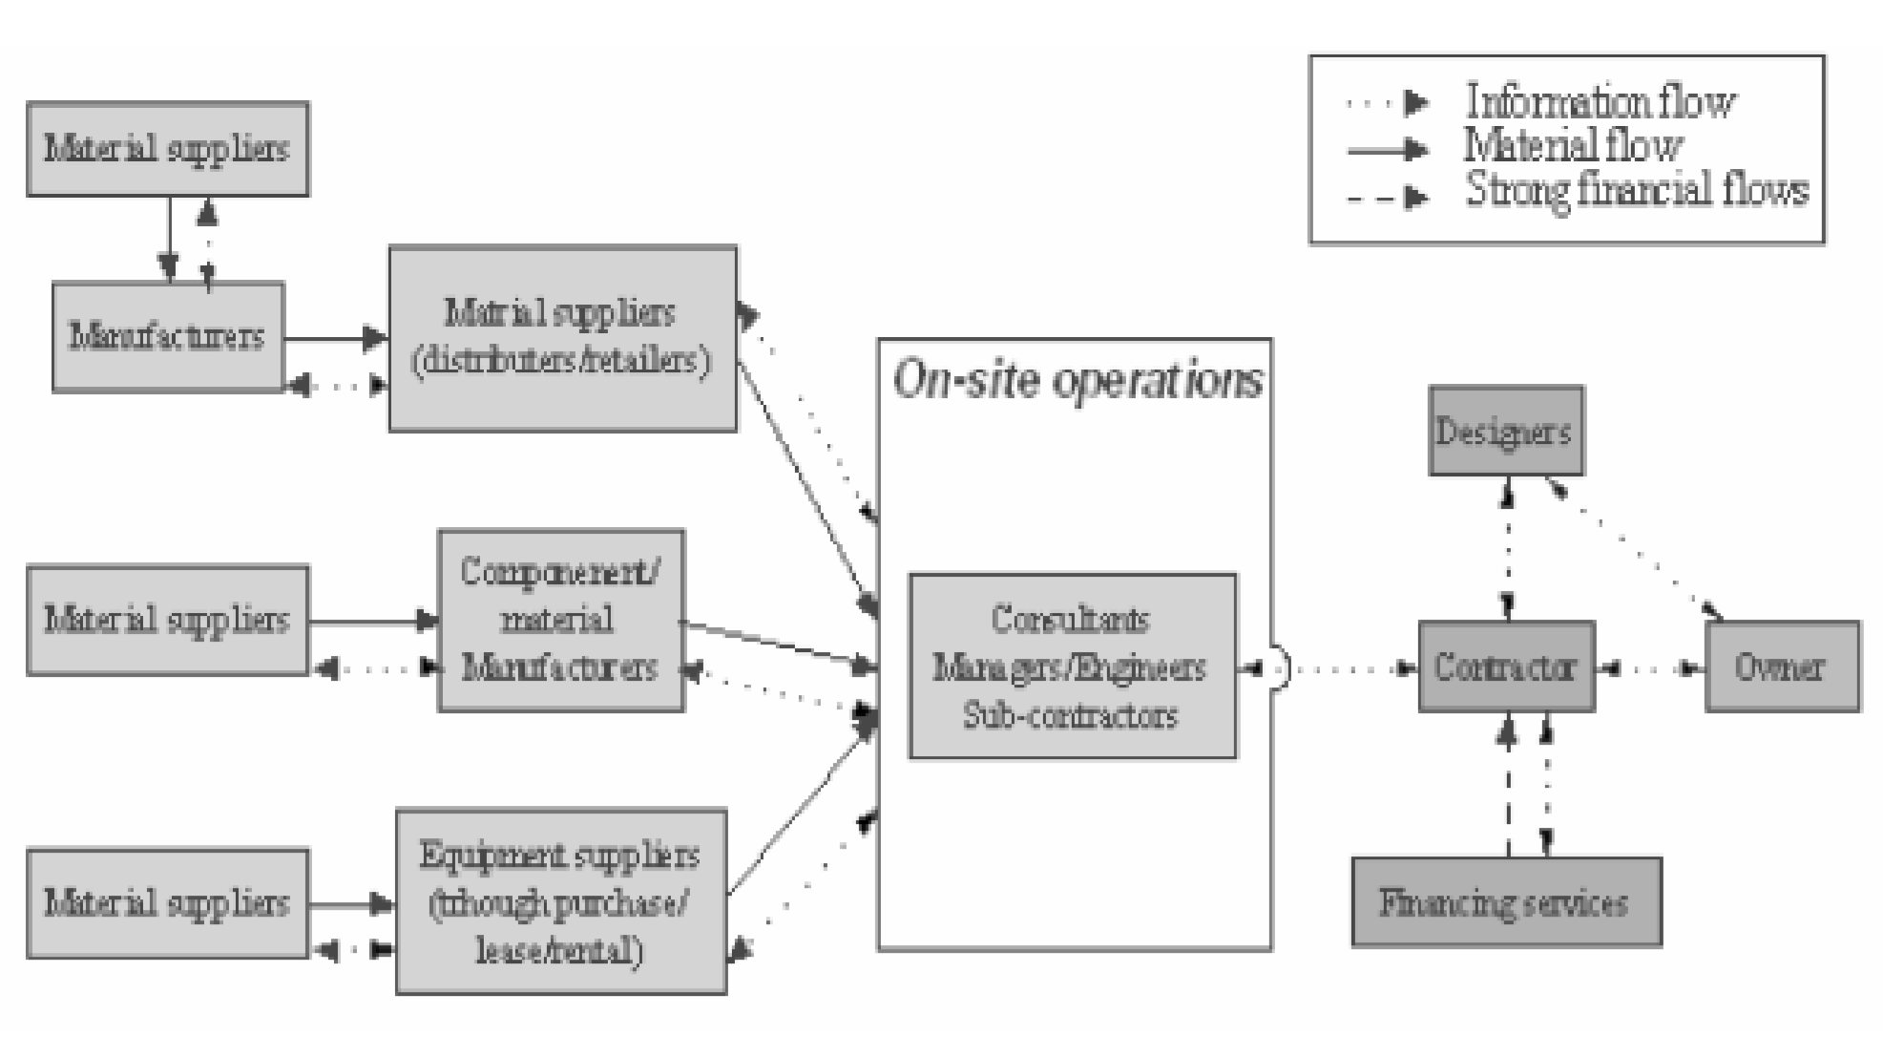
Figure 2. 1. Construction supply chain (I et al., 2015).
Vrijhoef & Koskela (2000), demonstrated that, the four major roles of supply chain management in construction. These four areas are focus on the impact of supply on the duration of site activities, supply chain itself, transferring activities from the site to earlier stages of the supply chain, and finally, the integrated management and improvement of the supply chain and the site production. The impact of supply on the duration of site activities is considered to ensure dependable material and labor flows to the site to avoid disruption to the workflow. Similarly, this may be achieved by simply focusing on the relationship between the site and direct suppliers. The contractor, whose main interest is in site activities, is in the best position to adopt this focus. Based on the supply chain itself, is considered to reduce costs, especially those relating to logistics, lead-time, and inventory. Material suppliers may also adopt this focus.
The other focus area is on transferring activities from the site to earlier stages of the supply chain. This justification may simply be to avoid the inferior conditions on-site or to achieve wider concurrency between activities, which is not possible with site construction with its many technical dependencies. The goal is again to reduce the total costs and duration. Suppliers or contractors may initiate this focus. The final focus may be on the integrated management and improvement of the supply chain and the site production. Thus, site production is included in SCM on suppliers, or contractors may initiate this focus.
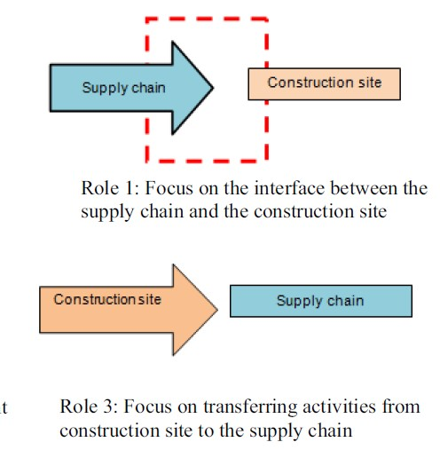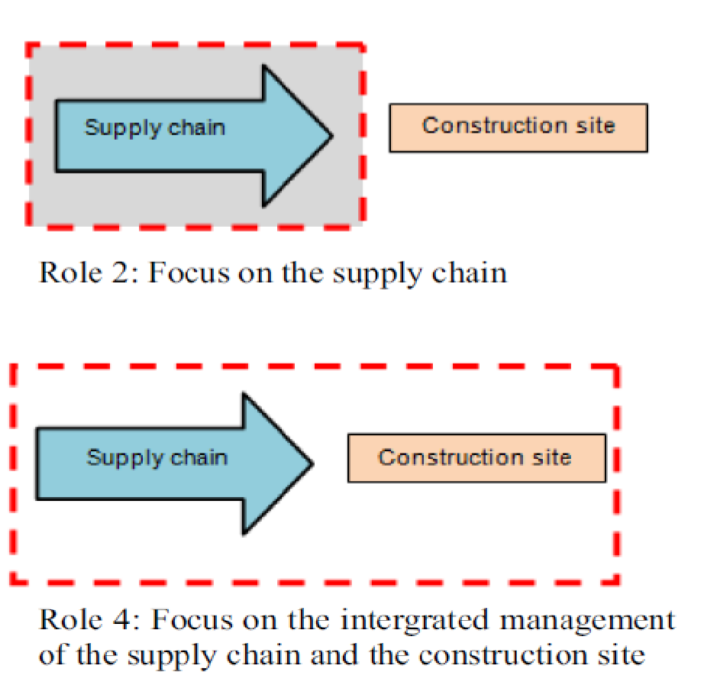

Figure 2. 2. The four roles of supply chain management in construction (Vrijhoef & Koskela, 2000).
Based on the above clarification, I focused on the contractors’ integrated management of the supply chain and construction site.

2.3. Benefits of Supply Chain Management in the Construction Industry
The use of information technology (IT) is considered a prerequisite for the effective control of today’s complex supply chains. Kauremaa & Kemppainen (2008), stated the role of information technology in supply chain management through, transaction processing, supply chain planning, and collaboration and order tracking, and delivery coordination. Pinheiro et al. (2015), propose a new conceptual model for the evaluation of the benefits or impacts of the adoption of IT in SCM, which is comprised of the following dimensions represented by the figure shown
1. Cost reduction.
2. Operational efficiency and process improvement (i.e. increase in productivity; improvement in asset management and inventory control; increased agility and flexibility; reduction of delivery times; improved coordination and elimination of redundancies in processes or functions).
3. Quality, reliability, and accuracy of information (i.e. customer service and satisfaction; increased knowledge; and improved planning and management).
4. Integration and collaboration (i.e. improvement of coordination; management of partnerships; and communication between the supply chain agents).
5. Differentiation of products or services (i.e. increase of value-added; innovation and development of new products or services).
According to Durai (2016), the following are the benefits of effective SCM:
1) Transparency, trust, and efficiency in the management of the supply chain present benefits to all parties involved in project delivery.
2) Clients can develop improved ability to identify strengths, weaknesses, opportunities, and threats in the chain and increased value for money and efficiency.
3) Contractors can access improved early and continuous communications with clients and stakeholders and a more competitive subcontractor base offering better skills, expertise, innovation, and value for money
4) Subcontractors can engender improved communication with contractors and assurance of continuity in business. Furthermore, Vorst (2004), stated profitability of the supply chain could be improved drastically via better delivery performance (improved responsiveness and reliability of deliveries, fewer stock-outs, higher product quality, more receiver-friendly loads) and increased information availability (better demand insight, more predictable order cycles, accurate, real-time) at the operational level and a reduction of time-to-market at the tactical and strategic level. The potential for improvement when applying SCM-concepts is based on the reduction of inventory carrying (reduced overstocks, faster inventory turns) and transportation costs (pooling of transport), the reduction of indirect and direct labor costs, and the increase of sales and sales margins. Many companies are re-engineering and rationalizing their supply chain network to obtain these benefits.

2.4. Subcontractors’, and Material Suppliers’ Management Practice
Papadopoulos et al. (2016), demonstrated the lines between construction companies and their subcontractors and material suppliers through the whole duration of a project. The overall performance of the project is influenced by the performance delivered by the subcontractor and material suppliers. In this sense, the major companies in the construction industry are related to subcontractors and material suppliers to obtain better results in terms of cost, quality, and dependability.

2.4.1. Subcontractors management practices
According to Flynn (2009), established the best subcontractor management practice in the construction industry. As his study, the following table shows the detailed practice in construction.
Table 2.2. Represents the subcontractors' management practice on construction.
Subcontractors management practice | The approach of management practice
1.Coordination and communication | - Develop a strong line of communication with subcontractors by sending frequent updates, regularly scheduling meetings, identifying key contact persons, and utilizing the same forms of communication (i.e. cellular phones or electronic mail).
2. Relationships | - Develop and maintain trusting relationships with subcontractors.  - Do not practice bid shopping; it is unethical.
3. Change Orders | - Establish a system for submittals to be followed by all subcontractors that include a schedule with due dates.  - Establish a system for change orders to be followed by all subcontractors.  - Do not pay for changes to work where there is not proper notice.  - Maintain a submittal and change order log.  - Require notice for any changes performed by subcontractors
4. Meetings | - Meet with subcontractors at a minimum of once every two weeks, more if necessary
5. Payment condition | - Pay subcontractors on time according to contract documents
6. Training | - Provide subcontractors with training on how to manage documents, before construction.  - Require toolbox safety meetings.  - Provide subcontractors with safety training, before construction.
7. Project progress Review | - Use a scorecard to rank subcontractor performance periodically or after a project.  - Conduct safety walks regularly to check for proper safety practices and ensure good housekeeping.
8. Subcontractor selection mechanism | - Explain the potential of repeat work with subcontractors if expectations are met or exceeded.
9. Clarity contract Guidelines | - Follow contract provisions accurately.
10. Planning / Scheduling | - Require superintendent or foreman to fill out daily field reports to assist in project review.  - Include lead subcontractors in the development of the schedule.
O. M. Ajayi et al. (2010), conducted on the selection criteria for subcontractors and suppliers in a building project in Lagos State in Nigeria. In the studies, open tendering, pre-registered tendering, negotiated to tender, and annual or invited tendering methods are used as selection criteria. As the finding shows, the pre-qualification stage is the main criterion for the evaluation of subcontractors’ to supply construction work equipment. In the same way, equipment and information technology were rated most as the standards for the selection of suppliers. İ et al. (2017), demonstrated the criteria for subcontractor selection in international construction projects were presented under a structured selection process. As a result of the survey conducted that found out based on three criteria such as shortlisting criteria, negotiation criteria, and final selection criteria. The following table shows three criteria for subcontractor selection.
Table 2.3. Selection and evaluation criteria for subcontractors.
Subcontractor selection and evaluation criteria | Area of considered criteria
Shortlisting stage | Experience, Past performance, Formal relationship, Financial strength, Workload, Safety records, Reputation, Litigation history, Personal relationship, and Location of home office
Negotiation criteria | Knowledge of project, Reliability, Selfless attitudes, Ability to solve problems, Enthusiasm for the project, Quality awareness, and Level of communication
Final selection criteria | Price, Technical personnel, Labor, Equipment, Payment plan, Amount of subcontracting, and Amount of compensation for the delay
As a result of the survey conducted, it was found out that the shortlisting stage is composed of a total of ten criteria where experience is the most important criterion. The negotiation stage was found to contain seven criteria where knowledge of project and reliability are the most significant two criteria. Finally, the final selection stage includes a total of seven criteria where the price is in the first rank in terms of importance.

2.4.2. Material suppliers management practice
Khalili et al. (2017), demonstrated the supplier evaluation and selection process for public procurement in the Swedish electricity industry follows as four steps such as identifying the needs and the sourcing method, setting the pre-requirements, supplier evaluation, and supplier selection. Handfield (2009), stated the process can be an intensive effort requiring a major commitment of resources. Furthermore, as shown in figure 2.3, according to Handfield (2009), the supplier evaluation and selection process consist of seven steps which are:
Recognize the Need for Supplier Selection: The first step of the evaluation and selection process usually involves recognizing that there is a requirement to evaluate and select a supplier for an item or service. A purchasing manager might begin the supplier evaluation process in anticipation of a future purchase requirement. Progressive purchasing groups increasingly anticipate rather than react to supplier selection needs. The complexity and value of a required purchase will influence the extent to which a buyer evaluates potential supply sources.
Identify Key Sourcing Requirements: Throughout the supplier evaluation and selection process, it is important to understand the requirements that are important to that purchase. These requirements, often determined by internal and external customers within the value chain, can differ widely from item to item. A later section discusses the various supplier performance areas where a purchaser should determine its critical sourcing requirements. Although different requirements may exist for each evaluation, certain categories of supplier quality, cost, and delivery performance are usually included in the evaluation
Determine Sourcing Strategy: No single sourcing strategy approach will satisfy the requirements of all purchases. Because of this, the purchasing strategy adopted for a particular item or service will influence the approach taken during the supplier evaluation and selection process.
Identify Potential Supply Sources: Purchasers rely on various sources of information when identifying potential sources of supply. The degree to which a buyer must search for information or the effort put forth toward the search is a function of several variables, including how well existing suppliers can satisfy cost, quality, or other performance variables. The strategic importance or technical complexity of the purchase requirement also influences the intensity of the search.
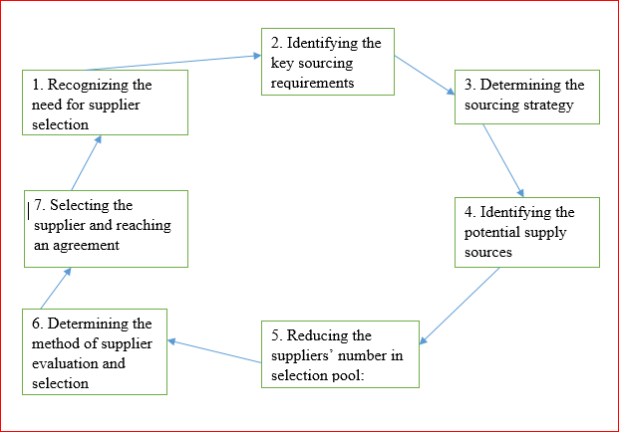
Figure 2. 3.The supplier evaluation and selection process; Sourced from (Handfield, 2009).
Handfield (2009), also argued that the needed criteria are different from the purchaser to purchaser, whereas the consistent delivery besides short lead times is preferred for those who operate with a Just-in-time production system. The supplier's processes and technological advancement, or the emphasis on research and development are preferred for those who work with the high-technology industry. In addition to this, the most significant management criteria for material suppliers include, coordination and communication, material quality control, planning, and schedule practice, the payment condition, personal relationship, types of inventory system, and supplier selection mechanism are basic considering criteria for material suppliers management.

2.5. Challenges in Subcontractors’ Management
The management of the subcontractor’s challenges is the basic important thing for the construction industry. According to Omoregie et al. (2016), the option of subcontracting how to manage the scheduled construction time, time to implement variation order, and time is taken to correct imperfections are the major time-related factors that are capable of causing poor project delivery if not properly evaluated by all parties involved. In a similar vein, the contractor’s expected profit, contractor’s cash flow, and the cost of materials and equipment are the major cost-related factors capable of causing poor project delivery under any of the subcontracting options. The other challenges identified in the Ghanian building construction industry were identified as the ten main challenges innate in subcontractor management such as lack of safety, site coordination challenges, Lack of Proper Communication, Non-Adherence to Schedule, insufficient working drawings, change order, delay in shop drawings and sample material approval, material shortage, and contractor's financial (Kadan, 2016).
Similarly, Anbessie (2018), stated the challenges in subcontractors’ management on public building projects in Addis Ababa mainly focused on these significant factors such as managerial skills, payment issues, subcontractors' qualifications, and experience, future work, poor attitudes, amendment, and safety requirements. In addition to this, he also stated the effect of material shortage on-site, change the order by the consultant, and late issuance of construction drawings from consultants can challenge the management of subcontractors. In addition to this, the other researcher also discussed on the above significant factors in the following table.
Table 2. 4. Challenges in subcontractors’ management.
Challenges in subcontractors management | How to challenge subcontractors management
Managerial Skills | According to Maturana et al. (2007), a very momentous way in which the subcontractor management procedure has influenced the construction industry is that it has encouraged specialization and helped in transferring risk from the general contractor to the subcontractor and further stated that, subcontractor management has achieved remarkable results when it performed correctly but may also hinder project progress if performed inaccurately.
Payment delay | According to Cidb (2013), delayed payments, whether from the main contractors or the client, are seen as the most critical issue facing subcontractors in the industry.  The “pay-when-paid‟ practice that is prevalent in the industry affects subcontractors more as they “cannot absorb the punches that main  Contractors can”.
Qualification and Experience | According to Kadan (2016), the performance and excellence of the subcontractor’s project team affect the project outcome concerning quality and timely delivery, thus a key determinant of a project’s economic performance.
Safety Requirements | According to Enshassi et al. (2010), the rate of an accident occurrence involving subcontractors „employees on different construction projects is very high, principally when multiple subcontractors are engaged in one project.
poor attitudes | According to Cidb (2013), many subcontractors, who are often new to join the construction industry, have a materialistic attitude and “are only in it to make a quick buck”.
Insufficient Work Drawings and Specifications | Alinaitwe et al. (2007), established that interface challenges between the main contractor and subcontractor due to incomplete drawing lead to low productivity.
Amendments | To endorse earlier observations Enshassi (2007), pointed out that design modifications and specifications in the course of construction lead to low productivity. The main contractor-subcontractor interface challenges arise out of low productivity.
Similarly, Cidb (2013), studied the challenges facing subcontractors in the South African construction industry. As he conducted, the key obstacles that affect subcontractor’s management were identified as, absences of payment security, bid price pressure from main contractors, weak management practices, poor attitudes, and lack of working capital are the factors that are caused by the main contractors and that affects the subcontractors and material suppliers.
Apart from delays, coordinating the activities of subcontractors has been cited as one of the major challenges affect construction labor productivity (Al & Tumi, 2009). Mccord & Gunderson (2013), conducted to determine the most important factors in general contractor-subcontractor relationships. Interviews were conducted with twenty-four subcontractors from eight disciplines to evaluate their opinions about the general contractor’s personnel, procedures, and practices that improve or damage their relationships. The study reveals the top three relationship factors to be bid shopping, project manager relationship, and superintendent capability, respectively.

2.6. Challenges in Material Suppliers’ Management
David & Berriors (2014), demonstrated the most significant factors that affect supply chain management such as the delivery time of materials, reasonable cost of material, and the quality of materials. Amade et al. (2016), stated the factors that affect construction supply chain management practices which can block the growth of construction supply chain management in construction such as, top management support, unclear strategic benefits, understanding of supply chain management concept, the application of information technology, poor communication share of information on the project, lack of mutual trust within and out of the organization, contribution, and needs of material suppliers.
Olaniyi et al. (2015), also stated the factors which limit the development of construction supply chain management practices such as, communication system between contractors with material suppliers. Furthermore, Gor & Pitroda (2018), demonstrated the most significant factors that affect material suppliers on construction such as, planning and scheduling problems, material management problems, and inadequacy of site inspection. Also, Akanni et al. (2014), stated the main causes that affect the cost of building material in Lagos state Nigeria. The study noted that the exchange rate of the Nigeria Naira, and changes in government policies and legislation are the main factors for the rising cost of building materials.
During the construction phase, contractors select construction material suppliers by using different procurement processes. To select an appropriate supplier there have been challenges in the procurement process. Khalfan et al. (2002), studied the main challenges related to the supplier in contractors’ material procurement processes that are affected by the long-term material supplier relationship, for the longer-term period for the contracting organization and visibility of the future work with the existing clients.
Additionally, Omondi et al. (2017), discussed the effects of procurement processes on the successful completion of construction projects in Usain gishu count. In this study, the result explained the significant factors such as the procurement quality in enhancing the successful completion of construction projects. Berecha (2016), conversed on the procurement process practice on Ovid Construction Company. The researcher identified the procurement practices process such as, need identification, delivery of goods, payment, and review practice are used as the input for procurement process practices. As a result, procurement need identification has standardized formant on Ovid Construction Company, but the work schedule is not used to determine the user's need. And also Ovid Construction Company has a supplier rooster, but it is not applicable on time; which indicated a lack of adequate information.
According to W. C. Benton & McHenry (2010), was identified as construction supplier selection affecting factors such as purchasing mistakes, supplier information, and strategic selection. Among the above-listed factors purchasing mistake and supplier information affects greatly construction supplier selection. Also, he identifies the three common methods that affect the evaluation system on construction suppliers such as, categorical method, cost–ratio method, and linear averaging.
Furthermore, Saruchera (2016), stated the main challenges facing procurement professionals in developing economies such as poor corporate governance, lack of an effective and sound regulatory framework, technological developments, and procurement costs. As his studied result shows, poor corporate governance are the main challenge faced by the procurement profession in the country. Similarly, Al-shorafa (2009), demonstrated the challenges in material suppliers management during the material procurement phase. As his study shown poor communication between the parties involved, unavailability of required material, incorrect of submittals by the suppliers, late approval of submittal by the supervisor engineer, and the contractor sets delivery dates that are impossible to meet by the suppliers. Besides, Mukund (2016), verified significant challenges in material suppliers management such as competitive pricing cost, reliable delivery, good quality, availability of material, flexibility in accommodating contract actors changes, financial facilities, sign long term agreement, personal relationship.

2.7. Supply Chain Improvement in the Construction Industry
Several researchers have discussed supply chain improvement in the construction industry. Voordijk & Vrijhoef (2003), conducted on improving supply chain management in construction to outcome application concept on supply chain management in construction based on a comparative study of supply chain management with aerospace. As a result indicated that, the practice of platform assemble is a fruitful concept to be applied in the construction industry. Shahvand et al. (2013), identifies construction projects' success factors such as cost, quality, and time. Also, construction supply chain management (which manages both suppliers and subcontractors relationship with the general contractor) is one of the most essential approaches in the improvement of these factors in the construction industry.
Similarly, Binti (2017), conducted the improvement of main contractors and subcontractors' relationship for the implementation of the construction project. The result shows many factors ( time and cost overrun factor, delay, trust, lack of quality, lack of communication, lack of safety, shortage of construction material, and skill labor) affect the relationship between the main contractor and subcontractor. The contractor company improves effectiveness in SCM in obtaining goods and services.
The study noted that a lack of a comprehensive approach for managing interactions with suppliers affected the realization of increased effectiveness on supply chain processes between an organization and the suppliers ( Brien, 2014). Ren & Cohen (2007), considered long-term relationships between supply chain parties’ gives each party chances to examine the credibility of the other party, reward truth-telling, punish otherwise, and therefore provides the right incentive for truthful information sharing. Furthermore, Prihadyanti (2015), specified short-term and long-term benefits of managing the contractor-customer relationships.

Table 2.5. Benefits of long and short-term relationships between contractor and customer.
Parties obtaining  benefit | Short-term Benefit | Long-term benefit | Long-term mutual  benefit
contractor | Obtaining source of  information for problem  solving or other innovation  activities | Assurance of market availability; resources support for innovation  activities; forming of innovation culture; increase in innovation  capability | Trust-building with  positive impact on  business process
Customer | Support for the achievement of QCD, business  effectiveness, and  efficiency | Creation of stronger barrier to entry

Similarly, Shin et al. (2019), stated on understand the appropriate partnership orientation for the desired level of commitment and firm performance, including innovation, operational, and financial performance.

2.8. Supply Chain Management and Project Performance
The management practice on the supply chain in construction companies affects performance on the project. Jusoh & Kasim (2017), demonstrated material management influential factors as classified into; site condition, planning, and handling on-site, management, materials, supplier and manufacturer default, transportation, contractual and governmental interfaces. Fekadie (2019), indicated on supply chains performance variables such as integration, reliability, responsiveness, agility, operational cost, and inventory management practice. The result of the study showed a downward supply chain is more reliable and flexible than the upstream supply chain.
Similarly, Patel (2015), conducted on the management of the construction material supply chains that constitute a major portion of total cost in the building. As the result shows unsuitable management of construction material affects the performance of the project due to delays in supply, price fluctuations, and lack of storage space. Ahmed (2017), also conducted on material management affecting factors on construction project delivery such as shortage of skilled manpower, the difficulty of inter-island transportation, and communication. And also he identifies the cause of ineffective material management such as, matching price to competitors’, non-qualified suppliers and unavailability of material.
Also, Abraham (2016), conducted the finding of contractors material management practice, the problem of material management in construction building sites, strategies for effective construction material management, congestion of the sites and improper placement of materials, and finally the impacts of ICT tools in material management in construction projects. Tagesse (2017), stated on the practice of supply chain management and its impacts on project performance on the company. The result of the research commonly focuses on dimensions of supply chain management practice relationships such, strategic supplier’s relationship of the company, customer relationship, level of information sharing, level of information quality, and information technology on the company.
Also, Tagesse (2017), identified the major performance problems that most frequently occurred on construction projects such as, cost, time, quality, and other critical factors that affect performance has been identified as, escalation of material price, unavailability of resources, disagreements between owners and project parties. Enshassi et al. (2009), stated on the factors affecting the performance of the construction project based on a group of project participants; contractors agree the most significant factors affecting project performance. A practice of supply chain management deals with the relationship between supply chain management and supply chain responsiveness.
According to Sukati et al. (2015), supply chain management practice, the strategic supplier partnership, customer relationship, and information sharing, make competitive advantages and responsiveness for the organization. Furthermore, Bezabh (2017), also indicated five supply chain management practice variables (Strategic supplier relationship, customer relationship, level information sharing, internal operation, and level of information quality) that has a significant impact on the operational performance.
Similarly, Skitmore (2008), determines supply chain management practice to improve awareness through the integration of trust and collaboration for the construction industry. For the relationship between supply chain management practice and customer satisfaction, information sharing has a positive and significant relationship with customer satisfaction (Manokaran, 2019). Kumar & Kushwaha (2018), also discussed three dimensions of supply chain management practice (customer relationship, information technology, and information quality) that are important for operational performance. Waluyowati & Aisjah (2018), established long-term relationships in SMEs directly and significantly affect the use of information technology, information sharing, and integration of supply chain and supply chain performance. Besides, long-term relationships indirectly and significantly affect the performance of the supply chain through information technology, supply chain integration, and information sharing.

2.8.1. Importance of effective supply chain management
Construction Company which are affected by effective supply chain management to satisfy the customer. The outcome of the study shows major barriers to effects a successful supply chain collaboration such as technology, information, and measurement system on supply chain management (Fawcett & Magnan, 2008). And, Agus (2013), conducted on the significances of supply chain management practice, supply chain performance, and financial optimization on Construction companies. The result shows a conceptual model for the relationship between supply chain management, supply chain performance, and financial optimization.
The managing of suppliers is considered one of the factors that affect the total cost of the supply chain management and therefore suppliers could help to reduce the cost and thus may contribute to improving performance through effectiveness (Ibrahim, 2014). Furthermore, Moharana et al. (2020), studied on achievement method of effective supply chain management such as information technology and information quality. According to Kleab (2017), supply chain management is a cross-functional method that comprises managing the drive of raw materials into an organization, definite features of the core dispensation of materials into finished goods, and the movement of finished goods out of the organization and toward the end consumer.
Similarly, effective supply chain management explains, the relationship of collaborative (win-win), relationship which is usually found with firms’ strategic suppliers, include the team component that is missing in a cooperative relationship. In collaboration, the two firms truly realize the benefits of working together to optimize outcomes for both firms. The two firms work together to develop a strategy to deliver a high-quality project on time and under budget. Strategic partners frequently share resources and information. However, the sharing of resources and some information may be illegal, as between the prime contractor and its subcontractor or between the prime contractor and disadvantaged business enterprises (DBEs) involved in federally funded highway projects and other public works (W. C. Benton & McHenry, 2010). Therefore, a collaboration between supply chain members is critical for the improvement of its performance and competitiveness. The link between supply chain collaboration and resilience has to be fully explored. Nonetheless, there are already clear benefits of collaboration with resilience (Banomyong, 2018).

3. MATERIALS AND METHODS

3.1. Introduction
The main purpose of the research methodology was to explain how the research has accomplished, what knowledge is required, what information is needed, and how information is collected. The research methodology consists of a description of the study area, study subject, study design, study type, method of data collection, an instrument for data collection, data management and analysis, validity, and reliability of the study and finally, ethical consideration was discussed on this chapter.

3.2. Description of the Study Area
The area of this research is conducted on Hawassa city which is found in Sidama nations, peoples region, Ethiopia. It is located at 7.06 latitude and 38.48 longitudes and it is situated at elevation 1697 meters above sea level. The general location of Hawassa city lies 275km south of Addis Ababa the capital city of Ethiopia, along the asphalt road to Moyale town at the border of Kenya.
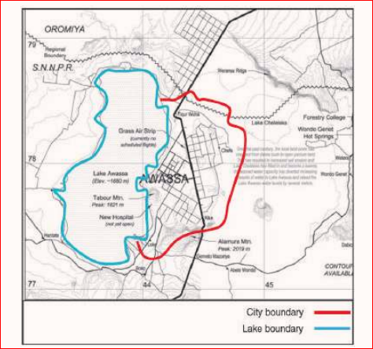
Figure 3.2. Map of Hawassa City. (Source: SNNPRS Finance and Economic Development Bureau).

3.3. Study Subject
The relevant building projects in Hawassa city for the study consisted of mainly those projects which are being administered by contractors. As supply chain management is a new conceptual framework and applied at the respondents are identified as; project managers, office engineer, and site engineers.

3.4. Study Design

3.4.1 The study type
There are two basic research designs is used for the study such as, quantitative and qualitative design. Quantitative approach involves the generation of data in quantitative form which can be subjected to rigorous quantitative analysis using statistical tools and qualitative approach is concerned with subjective assessment of attitudes, perceptions, opinions and behavior.

3.4.2. Sample size and techniques
Ajay & Micah (2014), defined as sampling is related to the selection of a subset of individuals from within a population to estimate the characteristics of the whole population. It would have been impossible to obtain data from all the professionals included in the study population due to time and cost constraints. Hence, sampling was used to have a size that will be representative of the population being studied. For quantitative research, simple random sampling techniques are used for the sample size. In addition to this, for a qualitative study, a purposive sampling technique was used. Cochran (1977), the formula was used to calculate the sample size of the infinite population.
n = z².p.q
e²
Where: q = 1-p, n is the sample size, P is the level of precision 0.5, e is a marginal error.
Z is the confidence level of our confidence level that corresponds to a Z-score. This is a constant value needed for this equation. Here are the z-scores for the most common confidence levels: -
90% – Z score = 1.645, 95% – Z score = 1.96, 99% – Z score = 2.326
For this study, the researcher chooses a 90% confidence level with a 10% marginal error and +/- 5 confidence interval.
n= (1.645)²*(0.5)*(0.5)/0.1². n=67.65062 =68
Based on this sample size formula, the minimum 68 respondents are needed.

3.5. Method of Data Collection
Muhammad & Kabir (2018), stated as data collection is the process of gathering and measuring information on variables of interest, in an established systematic fashion that enables one to answer stated research questions, test hypotheses, and evaluate outcomes. For this study questionnaire and interview were used as the method of data collection.

3.5.1. Questionnaire
According to Abawi (2013), a data collection instrument consisted of a series of questions and other prompts to gather information from respondents. For the collection of the quantitative data, 186 questionnaire was developed. The questionnaire consisted of closed-ended items developed in line with the objectives of the research. The questionnaire has 4 sections. The first section covers general information about the respondent. The 2nd section covers general information about the contractor’s supply chain management practice focus on subcontractors and material suppliers’ management. The 3rd section also covers the challenges on contractors’ supply chain management focus on the management of subcontractors and material suppliers and the 4th section determines the impact of supply chain management on project performance. Finally, the aims to address the quantitative approach instrument of data collection method was a fast and easy method of collecting data and were more accurate when starting, processing, and analyzing these data.

3.5.2. Interview.
For the collection of the qualitative data, a semi-structured interview question was set. In framing the interview question the objectives were considered as discussion. Hence, the questions focus on most top ranked results from questionnaire analyzed results. During the collection of qualitative data, the interview question was conducted on the participant who was involved in the top level of a building construction project employees. The 7 interview question was prepared and applied on three grade one contractors and their responses were used to triangulate questionnaire analysis based on their high-rank degree on subcontractors and material suppliers’ management practice, and challenges in subcontractors and material suppliers, and the impact of subcontractors’ management and material suppliers’ management, and finally the impact on project performance.

3.6. Data management and Analysis
Blaxter (2006), stated that research needs to adopt appropriate techniques of data analysis to correctly handle the data collected from the field survey. Two streams of data were collected, the qualitative and quantitative data.

3.6.1. Quantitative data analysis
In analyzing the quantitative data, SPSS (version 26) was used to support descriptive statistical data analysis. For descriptive statistics (including frequencies table, and correlation) be present to analyze general information of the respondents (working position of employees’, educational status, and the experience of the respondents), subcontractors, and material suppliers management practice, challenges in subcontractors and material suppliers management, and finally impact of subcontractors and material suppliers management are discussed through descriptive statistics. In addition to this, the relative importance index was used to analyze the subcontractors and material supplier management practice, and also analyze challenges in subcontractors and material suppliers’ management. Also, the Spearman correlation coefficient was used to determine the most ranked degree variables relationship on subcontractors and material suppliers’ management practice.
Finally, SPSS version 26 determines, the mean and frequency results to analyze and discussed the impact of supply chain management on project performance focus on subcontractors and material suppliers. Similarly, to determine quantitative data analysis the following relative importance index formula was applied. According to Ononuju et al. (2019), the following relative importance index formula was used to analyze descriptive data.
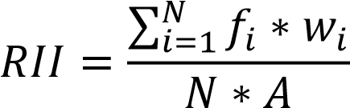
Where: N = Total number of respondents, w_{i} = the variable expressing the frequency of the i^{th} response, f_{i}= frequency or count of variables, A= the maximum scale.

3.6.2. Qualitative data analysis
With the preceding in mind, the qualitative data analysis of this research (responses from the semi-structured interviews) was done according to qualitative content analysis. For this, three grade one contractor's projects were selected to study qualitative data for triangulation of most ranked analysis with the questionnaire, and three projects manager were selected to answer the interview question. And finally descriptive and narrative description was used to analyze the data.

3.7. Validity and Reliability of the Research Design
Reliability and validity are terms that refer to the quality of the measures used in a research study. Reliability refers to the internal consistency and validity refers to the accuracy of the measure.

3.7.1. Validity
The researcher gives the draft questionnaire to the advisor for review and recommendations which are made part of the final questionnaire. In addition to this, the validity of questionnaires was studied the SPSS version 26 statistics for the pilot survey to accept or reject feedback from the participant.
Table 3. 1 Represents pilot study Cronbach's alpha test.
Variables | Cronbach's Alpha | N of Items
Subcontractors management practice | .758 | 10
Material suppliers management | .783 | 7
Challenges in subcontractors management | .780 | 18
Challenges in material suppliers management | .704 | 10
Impacts of subcontractors management | .847 | 3
Impacts of material suppliers management | .963 | 3
Besides, face to face interviews with the project professionals carried out to crosscheck the information collected through a semi-structured interview, validated the outcome of the analysis.

3.7.2. Reliability
The reliability of the questionnaire is tested by using Cronbach’s alpha or called the alpha coefficient to show the internal consistency of questionnaires as stated by (Gliem & Gliem, 2003). And, again Gliem & Gliem (2003), stated the closer the reliability coefficient of 1.0 is the better. In general, they conducted reliabilities less than 0.60 are considered as poor, those in the range of 0.60 to 0.80 are considered good and acceptable. Greener (2008), stated that reliability is required of research studies. Similarly, Drost (2004), stated that internal consistency measures consistency within the instrument and questions how well a set of items measures a particular behavior or characteristic within the test.
Jain1 & Angural (2017), stated that the Cronbach's alpha, α ≥0.9 they have excellent internal consistency, 0.9 > α ≥0.8 good, 0.8 > α ≥0.7 acceptable, 0.7 > α ≥0.6 questionable, 0.6 > α ≥0.5 poor, 0.5 > α unacceptable. Bernarda et al. (2018), recommended that 0.6 could be considered as acceptable in the research. In addition to this, SPSS version 26 (Cronbach’s alpha test) was used to check the internal consistency of all variables.
Table 3. 2. Represent questionnaire analysis Cronbach’s Alpha coefficient test result.
Reliability Statistics
variables | Cronbach's Alpha | N of Items
Subcontractors management practice | .839 | 10
Material suppliers management practice | .815 | 7
Challenges in subcontractors management | .950 | 18
Challenges in material suppliers management | .920 | 10
Impacts of subcontractors management | .958 | 3
Impacts of material suppliers management | .914 | 3

3.8. Ethical Consideration
Akaranga & Makau (2016) stated that the researcher is professionals hence, research ethics is a branch of applied ethics that has well-established rules and guidelines that define their conduct. And also they were stated as research ethics is important in our daily life research endeavors and requires that researchers should protect the self-esteem of their subjects and publish well the information that is researched. In this study, all ethical thoughts were to be considered. The major ethical issues like response confidentiality, source credit, data assembly, deliberate intention to produce data based on the researcher's conferred interest are the major issues that the researcher wants to protect during an action.

4. RESULTS AND DISCUSSION

4.1. Introduction
This study attempted to examine the contractor's supply chain management practices focus on subcontractors and materials suppliers management practice, the challenges that affect contractors’ supply chain management practice focus on the management of subcontractors and material suppliers, the impact of supply chain management on project performance, and finally to propose the framework to improve contractors’ supply chain management practice.

4.2. Response Rate
For this study, 186 questionnaires were distributed for contractors’ employees’ respondents such as project managers, office engineers, and site engineers. Among these questionnaires were distributed for contractors employees, 116 (62.4%) were properly filled and returned. Fellows (2015), stated that in the construction industry the minimum response rate of 25-30% is acceptable for analysis. Based on the above scholar finding, this response rate is acceptable for this study.

4.3. General Information of Respondent
In this research, the general information of the respondents is described by the employees' working position, educational status, and the experience of the respondents. Also, this section shows the quality of personnel information that are working in different building construction projects in Hawassa city.

4.3.1. Type of position in which they are working
For this study, 116 different levels and position contractors’ employees have participated. Among those 40 questionnaire papers were filled and submitted by the office engineer, 26 questionnaires paper were filled and returned by the project manager, and finally, 50 questionnaires paper were filled and submitted by the site engineer. From the above explanation site engineer was participated in the first ranking stages, the office engineer has participated in the second-ranking stage, and finally, the project manager has participated in the third stage.

4.3.2. The educational status of respondents
The educational status of respondents shows the degree of qualification that participants were qualified for. This study covers different educational qualified status like Diploma, BSc. Degree, MSc. Degree, and Ph.D.
Table 4.1 Shows the educational status of respondents.
 |  | Frequency | Percent | Valid Percent | Cumulative Percent
Valid | BSc. Degree | 88 | 75.9 | 75.9 | 75.9
Valid | MSc. Degree | 28 | 24.1 | 24.1 | 100.0
Valid | Total | 116 | 100.0 | 100.0

4.3.3. The experience of respondents
The respondents' experience in construction projects reveals whether they have dealt with enough experience to properly operate the business and execute the construction work. Also, they reflect the well-judged responses and the reliability of the questionnaire completed from those relatively experienced respondents in the construction project.
Table 4. 2 Shows the experience of respondents.
 |  | Frequency | Percent | Valid Percent | Cumulative Percent
Valid | A. 1-2 yrs. | 19 | 16.38 | 16.4 | 16.4
Valid | B. 3-5 yrs. | 31 | 26.72 | 26.7 | 43.1
Valid | C. 6-10 yrs. | 31 | 26.72 | 26.7 | 69.8
Valid | D. 11-15 yrs. | 21 | 18.10 | 18.1 | 87.9
Valid | E. >15yrs. | 14 | 12.07 | 12.1 | 100.0
Valid | Total | 116 | 100.0 | 100.0

As indicated in the above table, the questionnaire was responded to by 26.72% under the category of 3-5 years. This was shown as the 53.44% questionnaire was filled and responded by under the experience of 3-11 years.

4.4. The Management of Subcontractors

4.4.1 Subcontractors management practice.
In this case, ten different variables are used to measure subcontractor management practice. The total Cronbach’s alpha coefficient of ten variables result (0.839), which indicates that all variables are acceptable for this analysis. In general, appendix3A indicates the Cronbach's alpha coefficient for subcontractors' management practice. To assess subcontractors' management practice, the five Likert scale ranges are used to analyze the output of responses. Also, the relative importance index is used to rank the degree of practice in subcontractor’s management.
For measuring subcontractors management practice such as coordination and communication, relationship, change order, meetings, the payment condition, training to fill the gap, project progress review, subcontractor selection mechanism, clarity of contract guidelines, and finally, planning/ scheduling practice ( e.g. participation of the subcontractor in planning) was discussed based on the following table 4.3.
Table 4.3. Represent the RII result of variables to assess the subcontractor’s management practice.
No. | Subcontractors management practice | RII | Rank
1 | Payment condition | 0.843 | 1
2 | Coordination and communication | 0.838 | 2
3 | Relationship | 0.820 | 3
4 | Project progress review | 0.802 | 4
5 | Planning/scheduling practice (e.g. participation of the subcontractor in planning) | 0.779 | 5
6 | Training to fill the gap | 0.759 | 6
7 | Clarity of contract guidelines | 0.752 | 7
8 | Meetings | 0.741 | 8
9 | Change order | 0.738 | 9
10 | Subcontractor selection mechanism | 0.726 | 10
Table 4.3 illustrates the results of the subcontract's management practice on the construction project. Based on the above result, the payment condition indicates the 1st level of subcontractors’ management practices in Hawassa city construction projects. Whereas coordination and communication indicate the second subcontractor's management practice in construction projects. Also, the other subcontractors' management practice included relationship (RII=0.820) as third subcontractors management practice, project progress review (RII=0.802) as fourth subcontractors management practice, planning/scheduling practice (RII=0.779), training to fill the gap (RII=0.759), clarity of contract guidelines (RII=0.752), meeting ( RII=0.741), change order (RII=0.738), and subcontractors selection mechanism (RII = 0.726) indicated as 5th, 6th, 7th, 8th, 9th, and 10th subcontractors management practice in Hawassa city construction project with respectively.
Based on the above results spearman’s correlation test is used to draw 5 ranked subcontractors’ management practice variables to indicate the relationship between two variables. In addition to this payment condition, coordination, and communication, relationship, project progress review, planning/scheduling practice (e.g. participation of the subcontractor in planning) in Appendix 3B, determines the relationship of variables. According to Schober & Boer (2018), the value and sign of the coefficient show the strength of the association as a small, medium, large. If the strength of association starts from + ve 0.1 to 0.3 and -ve 0.1 to -0.3 has a small association between two variables. And 0.3 to 0.5 to 0.3to-0.5, has medium association, and 0.5 to 1.0, and -0.5 to -1.0.has large/ strong relationship.
Based on this, the result of the correlations indicated that there was a strong relationship between coordination and communication with the relationship at a correlation coefficient of (0.565) and the significance level of (0.00), that is less than 0.05, which indicates our coordination and communication with relationship have large (strongly positive) correlation and it is statically significant at the 5% significant level. Also, payment condition with planning and scheduling practice at a correlation coefficient of (0.539) and the significance level of (0.00) that is less than 0.05, which indicates our payment condition with planning and scheduling practice have a strong positive correlation and it is statically significant at the 5% significant level.

<< The above top five subcontractors management practice are taken to the interview process >>
Based on the above results payment condition, coordination, and communication, relationship, project progress review, and planning/ scheduling practices are the most subcontractors’ management practices in a construction project when we compare with the others. During the interview on subcontractors' management practice, coordination, and communication were ranked as the first degree for all three projects. But, in the case of questionnaire analysis payment condition was ranked as the first degree in subcontractors’ management practice, and also coordination and communication are ranked as a second degree, and relationship is ranked as third-degree most practice on subcontractors’ management. In addition to these project progress, reviews, and planning/scheduling practice was ranked as the fourth and fifth-degree for the questionnaire.
Table 4. 4. Represents the questionnaire and interview results on subcontractors’ management practice.
Measure of subcontractors’ management practice | Questionnaire rank | The interview rank
Measure of subcontractors’ management practice | Questionnaire rank | PX | PY | PZ
Payment condition | 1 | 2 | 2 | 3
Coordination and communication | 2 | 1 | 1 | 1
Relationship | 3 | 3 | 3 | 2
Project progress review | 4 | 4 | 4 | 4
Planning/scheduling practice (e.g. participation of the subcontractor in planning) | 5 | 5 | 5 | 5

From the above result, project progress review, Planning/scheduling practice (e.g. participation of the subcontractor in planning) of the questionnaire and interview analysis shows the similar subcontractors’ management practice in building construction projects. The remaining from both analyses show that there has a difference in the subcontractors’ management practice. From this result, the data obtained from the questionnaire differed from that of the interview. That means during the questionnaire different level of working position contractors’ employees was fill and return the question, but in the time of interview on three selected projects the participants such as the project manager only participate and return the response. Due to this reason, they make a difference in the analysis.

4.5. The Management of Material Suppliers

4.5.1. Material suppliers management practice
To address specific objective one which is focused on material supplier’s management practice, the seven different variables are used to assess the practice of material suppliers management in the Hawassa city building construction project. Based on these, Cronbach’s alpha coefficient is used to test the internal consistency of each variable. The total alpha value of material suppliers management practice assesses variables are (0.815) which are shown in Appendix 3C that are also represents each value of alpha for the individual variables.
Table 4. 5. Represent the RII result of variables to assess the material supplier’s management practice.
No. | Material suppliers management practice | RII | Rank
1 | Coordination and communication | 0.838 | 1
2 | Payment condition | 0.831 | 2
3 | Planning and scheduling practice | 0.810 | 3
4 | Materials quality control | 0.805 | 4
5 | Relationship | 0.757 | 5
6 | Type of inventory system | 0.728 | 6
7 | Supplier Selection mechanism | 0.640 | 7

Based on the above study discovers with Relative Importance Index, coordination, and communication that shows the most material suppliers management practice which is mostly applied in the different construction project in Hawassa city. While payment condition that shows us the second most material suppliers’ management practice. In addition to these planning and scheduling practices, material quality control, relationship, type of inventory system, and finally supplier selection mechanism results show as third, fourth, fifth, sixth, and seventh with respectively on the material supplier's management practice in the construction project.
From the analysis, the supplier selection mechanism shows the least practice on material suppliers’ management. This shows that in the construction project, the material supplier selection mechanism is very low and it needs more attention to material suppliers’ management. And although the above results illustrate the different ranked degrees on material suppliers management practice at a different level of the construction project. These show that there is not an equal level of material suppliers’ management practice in the different building construction projects. Based on the above results spearman’s correlation test is used to draw 5 most ranked material suppliers’ management practice variables to indicate the relationship between two variables.
In addition to this coordination and communication, materials quality control, planning and scheduling, the payment condition, relationship in Appendix 3D determines the relationship of variables. The result of the correlations indicated that there was a strong relationship between coordination and communication with materials quality control at a correlation coefficient of (0.510) and the significance level of (0.00), that is less than 0.05, which indicates our coordination and communication with materials quality control have large (strongly positive) correlation and it is statically significant at the 5% significant level. And also payment condition with planning and scheduling practice at a correlation coefficient of (0.566) and the significance level of (0.00) that is less than 0.05, which indicates our payment condition with planning and scheduling practice have a strong positive correlation and it is statically significant at the 5% significant level.
<< The above top five material suppliers management practice are taken to the interview process >>
In addition to these, interview results also reveals the material suppliers' management practice in 3 different construction project. For the interview analysis, the most top-five ranked questionnaire results are taken as the basis for the interview study. These conducted results are easily illustrated in the following table.
Table 4.6. Represents the questionnaire and interview results on material suppliers' management practices.
Measure of material suppliers' management practices. | Questionnaire rank | The interview rank
Measure of material suppliers' management practices. | Questionnaire rank | PX | PY | PZ
Coordination and communication | 1 | 1 | 1 | 1
Payment condition | 2 | 3 | 2 | 2
Planning and scheduling practice | 3 | 4 | 3 | 3
Materials quality control | 4 | 2 | 4 | 4
Relationship | 5 | 5 | 5 | 5

Based on the above results, all five ranked material suppliers’ management practice illustrates the different results. From those results, coordination and communication were ranked as a first degree in the questionnaire and interview. The other results on the interview such as payment condition, planning and scheduling practice, materials quality control, and relationship in project Y & X were ranked as 2nd, 3rd, 4th, & 5th with respectively. In general, coordination and communication, and relationship of the above result shows that they have similar practices for the management of material suppliers, and the remaining from both analyses show that there has a difference in the material suppliers’ management practice.

4.6. Challenges on Contractors’ Supply Chain Management Practice Focusing on the Management of Subcontractors and Material Suppliers.

4.6.1 Challenges in subcontractors management
To identify and rank the challenges which are more affect the subcontractors’ management are discussed through the analysis of the questionnaire. During the determination of the ranking level on challenges, the relative importance index is used. In addition to these to determine the internal consistency of the variables, Cronbach’s alpha coefficient test is used to determine all variables which are stated on the questionnaire. The total alpha reliability test results of 18 items on the challenges in subcontractors management (0.950) which is greater than the acceptable alpha value and all individual variable values also above the acceptable range (Appendix 3E).
Table 4. 7. Determines the analysis of challenges in subcontractors' management.
No | Challenges in subcontractors management | RII | Rank
1 | Payment delay | 0.824 | 1
2 | Lack of proper communication | 0.814 | 2
3 | Site coordination challenges | 0.802 | 3
4 | Lack of continuity of work | 0.790 | 4
5 | Managerial skills | 0.783 | 5
6 | Safety requirement | 0.776 | 6
7 | No-adherence to schedule | 0.769 | 7
8 | Insufficient working drawing | 0.769 | 7
9 | Material shortage | 0.747 | 9
10 | Lack of clarity in contractual requirements | 0.745 | 10
11 | Contractor’s financial challenges | 0.743 | 11
12 | Qualification and experience | 0.736 | 12
13 | Delay in shop drawings and sample material approval | 0.733 | 13
14 | Poor Relationship | 0.724 | 14
15 | Lack of mutual trust | 0.724 | 14
16 | Change orders | 0.717 | 16
17 | Poor attitudes | 0.707 | 17
18 | Bid pressure from main contractors | 0.700 | 18

Based on the above result, challenges discussed under subcontractors’ management had highly important potential to block contractor’s supply chain management in construction project development. From the results, payment delay in construction projects is the most challenge in subcontractors' management, whereas, bid pressure from main contractors is the least challenges in subcontractors’ management in building construction projects.

In addition to, the above result the most five challenges in subcontractors management are payment delay, lack of proper communication, site coordination challenges, lack of continuity of work, and managerial skills are the most challenges in subcontractors management when we compare with the other remaining challenges.
<< The above top five challenges in subcontractors’ management are taken to the interview process >>
The other results which are obtained from the interview were indicated as the managerial skill is highly affect subcontractors management in the building construction project. In addition to this, the lack of proper communication affects the next to managerial skills in the construction project. Although payment delay, site coordination challenges, and lack of continuity of work are indicated as 3rd, 4th, and 5th most challenges in subcontractors management. These results show that there has a big difference between questionnaire results and interview results on most ranked challenges in subcontractors’ management. Based on the above result, during the questionnaire analysis 116 different position contractors employees fill and return the intended questions, but the time of interview on 3 selected building construction projects managers only participated.

4.6.2 Challenges in material suppliers management
To identify the challenges in material suppliers’ management, the relative importance index is used to analyze the results of each variable. Before going to analysis, the internal consistency of the variables is checked through Cronbach's alpha. The total alpha reliability test results of 10 items on the challenges in material suppliers management are (0. 920) which is greater than the acceptable alpha value and all individual variable values also above the acceptable range. Based on these the following table results indicates which variables are highly challenges in material suppliers management and which one also have the least challenges in building construction project.

Table 4. 8. Determines the results of challenges in material suppliers’ management.
No | Challenges in material suppliers management | RII | Rank
1 | Delay in delivery time of material | 0.828 | 1
2 | Long term supplier relationship | 0.790 | 2
3 | Poor quality of material | 0.778 | 3
4 | Planning and scheduling problems (e.g. urgency in ordering materials) | 0.759 | 4
5 | Unavailability of required material | 0.755 | 5
6 | Competitive pricing cost | 0.741 | 6
7 | Lack of mutual trust | 0.731 | 7
8 | The problem of exchange rate/ hard currency | 0.731 | 7
9 | Unclear strategic benefit (i.e. self-interest serving behavior) | 0.716 | 9
10 | Poor communication share of information | 0.710 | 10

Depend upon the above result, delay in delivery time of material, long term supplier relationship, poor quality of material, planning and scheduling problems (e.g. urgency in ordering materials), unavailability of required material, competitive pricing cost, the problem of exchange rate/ hard currency and lack of mutual trust, unclear strategic benefit (i.e. self-interest serving behavior), and poor communication share of information are ranked as 1st,2nd,3rd,4th, 5th, 6th,7th, 9th, and 10th with respectively in the challenges of material suppliers management.
From the above results, delay in delivery time of material is the most challenging in material suppliers management in different building construction projects. Whereas long- term supplier relationships also make challenges in material suppliers’ management, and also poor quality of material, planning and scheduling problems (e.g. urgency in ordering materials), unavailability of required material is the most raked challenges in material suppliers’ management. These show that during the management of material suppliers the above-mentioned variables highly affect their management.
<< The above top five challenges in subcontractors’ management are taken to the interview process >>
Other results, which are obtained from the interviews also show that delay in delivery time of material is the most challenging in material suppliers management in building construction projects. Although, long term supplier relationship is the second most challenges in material suppliers management. All interview results which are obtained from 3 selected building project shows similar results to the questionnaire. That means these ranked variables are the most challenges in material suppliers management in the different construction projects.

4.7. Impact of Supply Chain Management on Project Performance

4.7.1. Impact of subcontractors management
To analyze, the impact of subcontractor management, the internal consistency of the three variables shows the alpha value of (0.958) which is greater than the acceptable alpha value, and these three individual items on the impacts of subcontractor management also above the acceptable range. 1= very low, 2= low, 3= moderate, 4= high, 5= very high.
Table 4. 9. Represents the impacts of subcontractors' management.
Impact of subcontractors management N=116 | 1 | 2 | 3 | 4 | 5 | Mean | Std. Deviation
Time |  | 1 | 2 | 53 | 60 | 4.48 | .582
Quality |  | 1 | 2 | 55 | 58 | 4.47 | .535
Cost |  |  | 2 | 58 | 56 | 4.47 | .581

According to the above table 4.9, the mean value of time (4.48) illustrates the very high impacts for subcontractors’ management. This implies that 0.7% of respondent agrees to time was low impact on subcontractors management, 1.3% of respondents agrees to time has a medium impact on subcontractor management, 35.6% of respondents agree to time has a high impact on subcontractors management, and finally, 40.3% of the respondents agree to time has very high impact on subcontractors management. In addition to this, the mean value of quality (4.47) shows the second high impact on subcontractors' management. Also, 1.3% of the respondents agree to quality has a medium impact on subcontractors management, 38.9% of respondents agree to quality has a high impact on subcontractors management, and finally, 37.6% of respondents agree to quality has a very high on subcontractors. In finally, the mean value of cost (4.47) indicates the least degree of impact on subcontractors' management. This implies that the mean value of quality and cost shows the equal result, at this time, we compare with standard deviation.
According to this, quality has a low standard deviation when we compare cost. For this reason, the cost has a low impact on subcontractors' management. In addition to this, 0.7% of respondent agrees to cost has low impact on subcontractors management, 1.3% of respondents agrees to cost has medium impact on subcontractors management, 36.9% of respondents agrees to cost has a high impact on subcontractors management, and finally, 38.9% of respondents agrees to cost has very high impact on subcontractors management.
<< The above 3 variables, which impact of subcontractors management are taken to interview process>>
Other results, which are obtained from the three construction projects, the interview results show quality, cost, and time has equal impacts on subcontractors management.

4.7.2. Impact of material suppliers management
To analyze, the impact of material suppliers’ management, the internal consistency of the three variables shows the alpha value of (0.914) which is greater than the acceptable alpha value, and these three individual items on the impacts of material suppliers’ management also above the acceptable range. 1= very low, 2= low, 3= moderate, 4= high, 5= very high.
Table 4. 10. Impact of material suppliers’ management.
Impacts of material suppliers management=116 | 1 | 2 | 3 | 4 | 5 | Mean | Std. Deviation
Time |  | 1 | 2 | 53 | 60 | 4.48 | .582
Cost |  | 2 | 2 | 57 | 56 | 4.45 | .580
Quality |  |  | 3 | 60 | 53 | 4.43 | .547
From the above table 4.10, tells the mean value of time (4.48) has the highest impact on material suppliers’ management. Although the different participants' responses the degree of impacts on material suppliers management. Based on this, 0.7% of respondents agree to time has a low impact on material suppliers management, 1.3% of respondents agree to time has a medium impact on material suppliers management, 35.9% of respondents agree to time has a high impact on material suppliers management, and finally, 40.3% of respondents agrees to time has very high impacts on material suppliers. In addition to this, the mean value of cost (4.45) reveals the second-highest impact on material suppliers’ management. Based on this 0.7% of respondent agree to cost has a low impact on material suppliers management, 1.3% of respondents agree to cost has a medium impact on material suppliers management, 38.3% of respondents agree to cost has a high impact on material suppliers management, and finally, 37.6% of respondents agree to cost has very high impact on material suppliers management.
Similar to the above results the mean value of quality (4.43) has the lowest impact on material suppliers’ management when we compare with time and cost. Besides, to this 2% of respondents agree to quality has a medium impact on material suppliers management, 40.3% of respondents agree to quality has a high impact on material suppliers management, and finally, 35.6% of respondents agree to quality has a very high impact on material suppliers management.
<< The above 3 variables which impact of material suppliers management are taken to interview process>>. Based on the above result, the other results which are obtained from the interview shows time has the highest impact on project X and project Z, but in the project Y, time was ranked as the second-highest impact on subcontractors’ management.
Table 4. 11. Represents the results of the questionnaire and interview on the impacts of material suppliers’ management.
Impacts of material suppliers’ management. | Questionnaire rank | PX | PY | PZ
Time | 1 | 1 | 1 | 1
Cost | 2 | 3 | 2 | 3
Quality | 3 | 2 | 3 | 2
From the above table data which are obtained from the interview, the time was ranked as the highest impact on material suppliers’ management on project X, Y, and Z. Also, cost was ranked as least impact on material suppliers’ management on project X and Z. In general, the interview results which are obtained from PX, and PZ show quality was ranked as the second- highest degree impact for material suppliers’ management. Although the interview results compared with questionnaire, time, cost, quality were ranked as the similar degree impact on project Y. Based on the above results which are obtained from the questionnaire mean, impacts from subcontractors management are high affects the project performance on the construction project. Also, the interview result reflects as impacts of subcontractors management related to time, cost, and quality have highly affected the project performance in construction.

5. CONCLUSION AND RECOMMENDATION

5. 1. Conclusions
Based on the results and discussion of quantitative and qualitative analysis the following conclusion was drawn as follows;
- From the quantitative finding for subcontractor management, payment condition practice was the most applicable subcontractor’s management practice on Hawassa city building construction project. In addition to this, the results of the interview reveal that coordination and communication were indicated as most of the subcontractor’s management practices. This implies that the data which are obtained from questionnaires was responded from the different contractors’ employees and interviews were conducted on some selected contractors’ project.
- From the quantitative result for material suppliers’ management, coordination and communication was the highest-ranked material supplier’s management practice. Based on the above results, the interview results also shows, coordination and communication were most ranked material suppliers management practices in building construction projects.
- Payment delay, lack of proper communication, site coordination challenges, lack of continuity of work, and managerial skills are the most challenges which are obtained from questionnaire responses and that affect the subcontractors’ management practice. During the time of the interview, the finding indicates that managerial skill was ranked as the most challenge in subcontractors’ management.
- Similarly, the challenges that affect the management of material suppliers the following top five quantitative result shows as; delay in delivery time of material, long term supplier relationship, poor quality of material, planning and scheduling problems (e.g. urgency in ordering materials), and unavailability of required material. From the above delay in delivery time of material was the most challenging in material suppliers management. Also, interview result shows similar ranked results with the questionnaire. That means these ranked variables are the most challenges in material suppliers management in the different construction projects.
- Based on the other quantitative results, the impacts of supply chain management on project performance focus on the impacts of subcontractors’ management were time, quality, and cost with respectively. Also, the interview results show quality, cost, and time has equal impacts on subcontractors' management.
- Besides, quantitative results on the impacts of supply chain management on project performance focus: on the impacts of material suppliers management were; time, cost, quality with respectively. From the interview result, the time was ranked as the highest impact on material suppliers’ management on project X, Y, and Z.

5.2. Recommendation
In light of the findings and conclusions of the study, the following recommendations are made;
- During the subcontractors’ management practice, selection mechanism of subcontractors was one of the most important mechanism in building construction project. So, contractors should have no ignore this practice as the least degree in subcontractors’ management practice.
- In material supplier management practice, supplier selection mechanism on building construction projects was the most basic essential one for contractors. So, contractors always should have to consider the selection mechanism as the most basic important one practice among the others.
- To minimize the challenges for contractor’s supply chain management practice in Hawassa city building construction project: focus on subcontractors and material suppliers, it is better to manage early existing problems that are occurred from the contractors as well as their supply chain.
- Time has a high degree impact for subcontractor management on project performance. So, the contractors should have been always considered the practice of time is better to avoid the coming impact on project performance.
- Also, the time has indicated a high degree impact for material suppliers’ management on project performance. So, the contractors should have been always considered the practice of time is better to minimize the impacts on project performance.

5.3. Suggestion for Future Study
This study identifies areas requiring further studies. These potential areas of investigating are highlighted in the paragraphs:
- This study was conducted only on Hawassa city-building construction project on contractor’s supply chain management practice focus on subcontractors and material suppliers’ management. So, additional studies should be done more on contractor’s supply chain management practice focus on subcontractors and material suppliers for overall part of the country's construction project provides better results for the researcher and contractors’.

Reference
Abawi, K. (2013). Data Collection Instruments ( Questionnaire & Interview ).
Abraham, M. (2016). Study of Contractors Materials Management in Private Building Construction Projects-A Study of Selected Building Sites, in Addis Ababa. Master degree of science. Addis Ababa University. 103 p.
Agus, A. (2013). The Importance of Supply Chain Management on Financial Optimization. Jurnal Teknik Industri, 15(2). 77-84.
Ahmed, Z. (2017). The Impact of Material Management on Construction Project Delivery In Maldives. International Journal of Scientific & Technology Research Volume . 8(4). 82-90.
Ajay, S., & Micah, B. (2014). Sampling Techniques & Determination of Sample Size In Applied Statistics Research : An Overview. International Journal of Economics, Commerce and Management, United Kingdom of, II(11), 3.
Ajayi, O. M., & Ayanleye. (2010). Criteria for selection of subcontractors and suppliers in a building project in Lagos state , Nigeria. Proceedings 5 Th Built Environment Conference 59/65.
Akanni, P. O., Oke, A. E., & Omotilewa, O. J. (2014). Implications of Rising Cost of Building Materials in Lagos State Nigeria. SAGE, 11(2), 1–7.
Akaranga, S. I., & Makau, B. K. (2016). Ethical Considerations and their Applications to Research : ACase of the University of Nairobi. Journal of Educational Policy and Entrepreneurial Research, 3(12), 1–9.
Al-shorafa, A. A. (2009). A Framework For Construction Materials Supply Chain Process in the Local Construction Industry. Master degree of science. Islamic University. Gaza. 165p.
Al-Werikat, G. (2017). Supply Chain Management In Construction ; Revealed. International Journal of Scientific & Technology Research Volume, 6(03), 1-23.
Al, S., & Tumi, H. (2009). Causes of Delay In Construction Industry In Libya. The International Conference on Economics and Administration, pp 265–272.
Alemayehu, A. (2019). The Practice of Construction Materials Supply Chain Management In Addis Ababa Housing Construction Project Office. Degree of Masters of Art. Addis Ababa University.77p.
Alinaitwe, H. M., Mwakali, J. A., & Hansson, B. (2007). Factors affecting the productivity of building craftsmen ‐ studies of Uganda. 8(3), 169–176.
Aloini, D., & Dulmin, R. (2012). Supply Chain Management : A Review of Implementation Risks. Business Process Management Journal, 18(5), 735–761.
Anbessie. (2018). The Practice and Challenges of Subcontracting to Micro and Small Enterprises : The Case of Addis Ababa Public Buildings. Master dgree of science .Addis Abeba Science and Technology.113p.
Azhar, S. (2002). Supply Chain Management In Construction. Delhi Business Review, 3(1), 1–6.
Banomyong, R. (2018). Collaboration in Supply Chain Management: A Resilience Perspective. International Journal of Physical Distribution & Logistics Management ., 40(8/9), 709-721.
Benedict, A., Peter, A., & Francis, A. (2016). Supply Chain Management and Construction Project Delivery : Constraints to its Application. PM World Journal, 5(5), 14–53.
Berecha, D. (2016). Assessment On Practice and Challenges of Procurement Case of Ovid Construction Plc. Master dgree of science. St.Mary’s University. 72p.
Bernarda, L., Gottems, D., Raquel, M., & Maia, G. (2018). Reliability analysis of an instrument by Cronbach ’ s Alpha 1. Rev. Latino-Am. Enfermagem, 26(10), 8.
Bezabh, S. K. (2017). The Effect of Supply Chain Management Practices on the Operational Performance : The Case of ethio telecom . Master of science. Addis Ababa University.pp. 33-38.
Binti, S. (2017). Improvement Of Relationship Between Main Contractor And Subcontractor For Successful Construction Project Implementation. Degree of Master of Science.
Tun Hussein Onn Malaysia Universit. 44p.
Blaxter, L. (2006). How to Research (Christina Hughes (Ed.); Third Edit). 306p.
Brien, W. J. O. (2014). Construction Supply-Chain Management : A Vision for Advanced Coordination , Costing , and Control. 5(2) 1- 23.
Cidb. (2013). Subcontracting in the south african construction industry; opportunities for development. SABS Campus. 48p.
Cochran. (1977). Sampling Techniques (Third Edi). 442p.
David, & Berriors. (2014). Challenges in Supply Chain Management. Second Edition. 173p.
Deshmukh, B, A., & Chavan, S. A. (2014). Supply Chain Management in Residential Construction Sector. International Journal of Engineering and Advanced Technology (IJEAT), 4(2), 87–90.
Dibaba, M. (2015). Practices and Challenges of Supply Chain Management on Ethiopian Private Grade One Road Construction Companies. Degree of Masters of Art. St. Mary’s University.101p.
Drost, E. A. (2004). Validity and Reliability in Social Science Research. 38.pp 105-125.
Durai, V. C. (2016). A Study on Supply Chain Frame Work In Construction. International Journal of Research, 4(8), 4-11.
Ejassa, T. G. (2019). Supply Chain Management Practices, Challenges and opportunities: The Case Of Elemtu Integrated Milk Industry Share Company. Degree of Masters of science. Addis Ababa Science and Technology. 108p.
Enshassi, A. (2007). The contractor – subcontractor relationship : the general contractor ’ s view. 4th edition. 1527p.
Enshassi, A., Arain, F. M., & Tayeh, B. (2010). Major causes of problems between contractors and subcontractors in the Gaza Strip. The International Journal of Construction Management., 10(4), 45-75.
Fawcett, S. E., & Magnan, G. M. (2008). Benefits , barriers , and bridges to effective supply chain management. Supply Chain Management: An International Journal, Volume 13, 35–48.
Fekadie, E. (2019). Supply Chain Performance Assessment of Brewery Industry : The case of Heineken Brewery. Degree of master of art. College of commerce in Addis abeba. 78p.
Fellows, R. (2015). Research Methods for Construction (Fourth Edi). 319p.
Flynn, C. J. (2009). The Best Practices For Subcontractor Management In Construction. Master degree of scince. The Pennsylvania State University. 121p.
Gliem, J. A., & Gliem, R. R. (2003). Calculating , Interpreting , and Reporting Cronbach ’ s Alpha Reliability Coefficient for Likert-Type Scales. Midwest Research to Practice Conference in Adult, Continuing, and Community Education, 82–88.
Gor, D., & Pitroda, J. (2018). The Impact of Supply Chain Management Practice on Construction Project Performance in the Central Gujarat. International Journal of Technical Innovation in Modern Engineering & Science (IJTIMES), 4(5), 269–275.
Handfield, R. B. (2009). Purchasing and Supply Chain Management. Fourth Edi. Robert M. Monczka, Robert B. Handfield, Larry C. Giunipero, James L. Patters. 417p.
Huang, R. (2008). Factor Analysis Of Interface Problems - A Case Study Of Mrt. Journal Of Marine Science and Technology, 16(1), 52–63.
I, M. A., Gupta, A. K., & Desai, P. D. B. (2015). Supply Chain Management : Effective Tool in Construction Industry. International Journal of Tecnology 2(1), 35–40.
Ibrahim, S. B. (2014). Supply Chain Management Practices and Supply Chain Performance Effectiveness. International Journal of Science and Research (IJSR), 3(8), 187–195.
Jain1, D. S., & Angural, D. V. (2017). Use of Cronbach’s Alpha in Dental Research. Medico Research Chronicles, 4(3), 285–291.
Jusoh, Z. M., & Kasim, N. (2017). Influential Factors Affecting Materials Management. International Journal of material management , 8(4), 82–90.
Kadan, R. (2016). Developing Guidelines for Managing Subcontractors within the Constraints of Cost and Time. Master of science. Kwame Nkrumah University. 161p.
Kauremaa, J., & Kemppainen, K. (2008). The roles of information technology in supply chain management. International Journal of Business and Social Science, 4(2),1-17.
Kebede. (2017). Assessment of Supply Chain Management in Public Building Construction
Projects in Addis Ababa. Degree of Master of Science. Addis Ababa Institute of Technology. 102p.
Khalfan, & Kyng, E. (2002). Procurement Impacts on Construction Supply Chains : UK Experiences. In SCRI Research Centre in the Built and Human Environment (BuHu) 5,( 4),323-331.
Khalili, Munawwar, A. (2017). Supplier Evaluation and Selection Process for Public Procurement in the Swedish Electricity industry. An International Journal,17(4),438- 453.
Kleab, K. (2017). Important of Supply Chain Management. International Journal of Scientific and Research Publications, 7(9), 397–400.
Kumar, A., & Kushwaha, G. S. (2018). Supply Chain Management Practices And Operational Performance of Fair Price Shops In India: An Empirical Study. International Journal Of Production Research, 14(1), 85–99.
Manokaran, R. (2019). The Relationship between Supply Chain Management Practices and Customer Satisfaction in Small and Medium Enterprises. Journal of Arts & Social Sciences, 2(2), 67–80.
Manu, E. (2014). Supply Chain Management and Construction Project Delivery: Constraints to its Application. PM World Journal, 5(5), 14-53.
Maturana, S., Alarcón, L. F., & Gazmuri, P. (2007). On-Site Subcontractor Evaluation Method Based on Lean Principles. Journal of Management in Engineering , 2(3), 1–9.
Mccord, P., & Gunderson, D. E. (2013). Subcontractor Perspectives : Factors that Most Affect Their Relationships with General Contractors - A Pacific Northwest Study. 49th ASC Annual International Conference Proceeding, 5/10.
Moharana, P. H. S., Murty, J. S., Senapati, S. K., & Khuntia, P. K. (2020). Importance of Information Technology For Effective Supply Chain Management. International Journal of Modern Engineering Research (Ijmer), 1(2), 747–751.
Muhammad, S., & Kabir, S. (2018). Methods of data collection.2nd edition. 202p.
Mukund, K. (2016). Construction Material Supply Chain Process In The Local. IJARIIE-ISSN, 2(3), 3605–3615.
Olaniyi, A., Bosede, A., & Olusola, O. (2015). Supply Chain Management Practices in Construction Procurement : Perceptions of Professional Quantity Surveyors in Ondo State , Nigeria. PM World Journal, IV(Vi), 1–14.
Omondi, O. J., Diang, S., & Robert, G. (2017). Effects of Procurement Processes on Successful Completion of Construction Projects in Uasin Gishu County. IOSR Journal of Business and Management (IOSR-JBM), 19(12), 42–50.
Omoregie, D., Emmanuel, A., Marcus, T., & Olusola, S. (2016). Assessment of the Use of Subcontracting Options for Construction Project Delivery.Journal of Civil and Environmental, 8(5), 43–49.
Ononuju, C. N., Amade, B., & Amaeshi, F. (2019). Extent Of The Application of Lessons Learned In Construction Projects : The. International Academic Journal Of Information Sciences and Project Management, 3(3), 45–58.
Papadopoulos, G. A., Zamer, N., Gayialis, S. P., & Tatsiopoulos, I. P. (2016). Supply Chain Improvement in Construction Industry. Universal Journal of Management, 4(10), 528–534.
Patel, H. (2015). A Review On Material Management Through Inventory Management. Journal Of International Academic Research For Multidisciplinary, 2(12),1-7.
Pinheiro, A., Barros, D., Satiko, C., Cordeiro, R., Francisco, C., & Gomes, S. (2015). Processes and benefits of the application of information technology in supply chain management : an analysis of the literature. Journal of Information Technology and Quantitative Management (JITQM), 55(5), 698–705.
Quesada, H., & Gazo, R. (2012). Critical success factors in agile supply chain management. International Journal of Physical Distribution & Logistics Management, 31 (4), 247-65.
Ren, Z. J., & Cohen, M. A. (2007). Information Sharing in a Long-term Supply Chain Relationship : The Role of Customer Review Strategy. Master degree of scince. Boston university.32p.
Saruchera, F. (2016). Challenges facing procurement professionals in developing economies : Unlocking value through professional international purchasing. Journal of Transport and Supply Chain Management, 9(1), 1–9.
Satyajeet, D., & Kulkarni, S. S. (2013). Improvement in Supply of Construction Material for Construction Industry in Satara City - By Applying Supply Chain Management Tool. Journal of Mechanical and Civil Engineering (IOSR-JMCE), 7(6), 47–53.
Schober, P., & Boer, C. (2018). Correlation Coefficients: Appropriate Use and Interpretation. International Anesthesia Research Society, 126(5), 1–7.
Serpell, A., & Heredia, B. (2012). Supply Chain Management In Construction: Diagnosis And Application Issues. Journal of Business Logistics, 12 (2), 11-19.
Shahvand, E., Sebt, M. H., & Banki, M. T. (2013). Supply Chain Management Improvement through Value Engineering Approach in the Construction Industr y. Amirkabir Journal of Science & Research (Civil & Environmental Engineering) (AJSR - CEE), 45(2), 9–11.
Shin, N., Park, S. H., & Park, S. (2019). Partnership-Based Supply Chain Collaboration : Impact on Commitment, Innovation, and Firm Performance.Journal of Operations Management,12(4), 1-14.
Shukla, R. K., Garg, D., & Agarwal, A. (2011). Understanding of Supply Chain: A Literature Review. International Journal of Engineering Science and Technolog, 3(3), 2059–2072.
Skitmore, H. A. And M. (2008). Supply Chain Management In The UAE. International Journal Of Construction Management, 8(1), 53–71.
Sukati, I., Abu, P., Abdul, B., Prof, A., & Baharun, R. (2015). A Study Of Supply Chain Management Practices : An Empirical Investigation On Consumer Goods Industry In Malaysia . International Journal of Business and Social Science, 2(17), 166–176.
Tagesse, B. (2017). Assessment of Construction Performance Challenges In Selected University Building Construction Projects. Master Degree of Scince. Addis Ababa Institute of Technology. 130p.
Vilasini,N., Neitzert,T.,Rotimi,J.O., & Windapo, A. O. (2012). A Framework For Subcontractor Integration. International Journal of Construction Supply Chain Management, 2(1),21-42.
Voordijk, H., & Vrijhoef, R. (2003). Improving Supply Chain Management In Construction : What Can Be Learned From the Aerospace Industry ? Journal of Purchasing and Supply Management, 2(3), 837–846.
Vorst, J. Van Der. (2004). Supply Chain Management : theory and practices. Journal of Supply Chain Management ,6(3),12-20.
Vrijhoef, R., & Koskela, L. (2000). The four roles of supply chain management in construction. European Journal of Purchasing & Supply Management, 6(6), 169–178.
W. C. Benton, J., & McHenry, L. F. (2010). Construction Purchasing & Supply Chain Management (B. Joy (Ed.); 2nd ed.). McGraw-Hill.
Waluyowati, N. P., & Aisjah, S. (2018). The Utilization of Long-Term Relationship and Supply Chain Performance in Improving SMEs Performance. American Journal of Theoretical and Applied Business., 4(3), 79–89.

APPENDICES
Appendix I: Questionnaire
Hawassa University
Institute of Technology
School of Civil Engineering and built environment
MSc. Thesis on Construction Technology and Management
Dear Sir/Madam,
My name is Legese Mate, a student of MSc in the Faculty of Civil Engineering and Built Environment, Department of Construction Technology and Management at Hawassa University Institute of Technology (HU-IoT). For the fulfillment of graduation, I have chosen a research topic entitled ‘’ Contractors’ Supply Chain Management practice in Hawassa City: Focusing on the management of subcontractors and material suppliers.
The concept of supply chain management involves the strategies and process of coordination of subcontractors, material suppliers, and information within the supply chain for improved project performance. This thesis aims to investigate the current practice of supply chain management the relationships of construction companies focusing on the management of their subcontractors and material suppliers. Therefore, I request you voluntarily to take some of your valuable time and complete the attached questionnaire. The information that you provide will be kept confidential. The accuracy, honesty, and fairness of your response will have a great impact on the outcome of the research. If you do have any questions or concerns about the study please do not hesitate to forward the addresses mentioned below.
With my best regards
Legese Mate
Cell phone: 0945152796
Email: biliseethiopia@gmail.com
Hawassa, Ethiopia
Section I- General information.
This part of the questionnaire tries to gather some general information about the background of the respondent and the organization.
1. Type of your position in which you are working
Project Manager
Office engineer
☐
Site engineer
2. Your educational status?
Diploma
BSc. Degree
MSc. Degree
Ph.D.
3. Your experience?
A. 1-2 yrs. B. 3-5 yrs. C. 6-10 yrs. D. 11-15 yrs. E. >15yrs.
Section II- Contractor’s supply chain management practice focusing on the management of subcontractors, and material suppliers.
Q1. From your experience, rate the level of most practice measuring variables stated in the table to improve subcontractors, and material supplier’s management practice for overall SCM contractors.
Please tick (√) to indicate the degree to which you reflect on each statement.
I. Subcontractor management practice | Strongly Disagree 1 | Disagree  2 | Neutral  3 | Agree  4 | Strongly Agree 5
1. Coordination and communication
2. Relationship
3. Change order
4. Meetings
5. Payment condition
6. Training to fill skill gap
7. Project progress review
8. Subcontractor Selection mechanism
9. Clarity of Contract guidelines
10.Planning/scheduling practice (e.g. participation of the subcontractor in planning)
II. Material suppliers management practice
1. coordination and communication
2. materials quality control
3 Supplier Selection mechanism.
4. Planning and scheduling practice
5. Payment condition
6. Relationship
7. Type of inventory system
Section III- Challenges on contractors’ supply chain management focusing on subcontractors, and material suppliers.
Q1. From your experience, rate the challenges indicated in the table affecting SCM
Please tick (√) to indicate the degree to which you reflect on each statement.
I. Challenges in subcontractors management | Negligible 1 | Low 2 | Moderate 3 | High 4 | Very high 5
Lack of proper communication
Site coordination challenges
No-adherence to schedule
Insufficient working drawing
Contractor’s financial challenges
Change orders
Delay in shop drawings and sample material approval
Material shortage
Lack of mutual trust
Managerial skills
Payment delay
Qualification and experience
Lack of continuity of work
Poor attitudes
Safety requirement
Bid pressure from main contractors
Lack of clarity in contractual requirements
Poor Relationship
II. Challenges in material suppliers management
Delay in delivery time of material
Poor quality of material
Unclear strategic benefit (i.e. self-interest serving behavior)
Poor communication share of information
Lack of mutual trust
Planning and scheduling problems (e.g. urgency in ordering materials)
Long term supplier relationship
The problem of exchange rate/ hard currency
Unavailability of required material
Competitive pricing cost

Section IV: Impact of supply chain management on project performance
1. From your experience, rate the overall impact of subcontractor management and material supplier management on project performance
Impact of subcontractors management | Very Low | low | medium | high | Very High
Time
Cost
Quality
Impact of material suppliers management
Time
Cost
Quality

ONCE AGAIN I THANK YOU A LOT!!!

GOOGLE FORM, PILOT QUESTIONNAIRE SAMPLE.
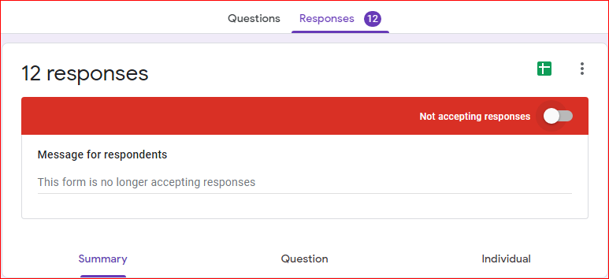
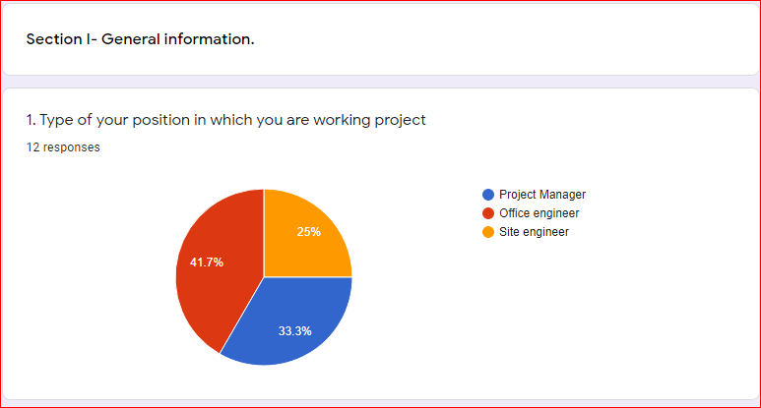
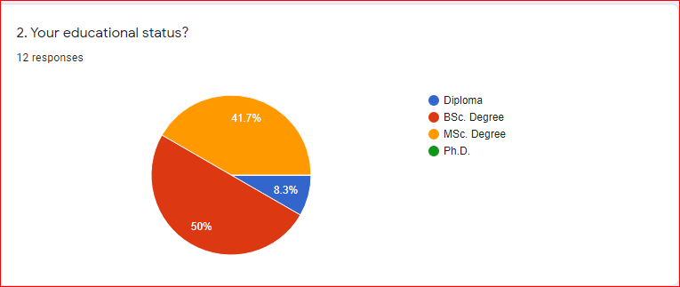
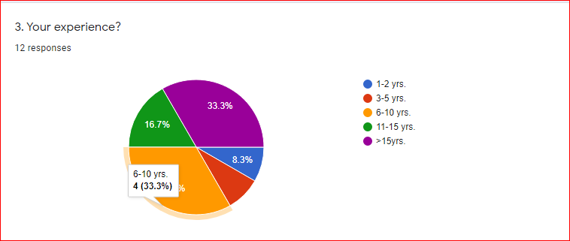
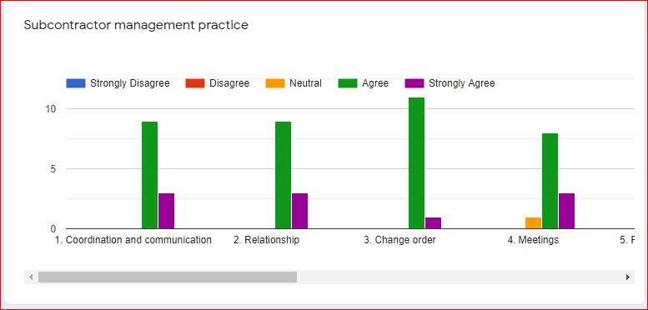
Interview part A.
Q1.What kind of practice to use for the management of subcontractors in your building construction project?
Q2.What kind of practice to use for the management of material suppliers in your building construction project?
Q3.What are the most challenges in the subcontractor’s management in your building construction project?
Q4.What are the supreme challenges in material supplier’s management in your building construction project?
Q5.What are the most impacts of subcontractor’s management in your building construction projects by considering time, cost, and quality?
Q6. What are the most impacts of material supplier’s management in your building construction projects by considering time, cost, and quality?
Q7. From the above impacts of contractors’ supply chain management, which impacts are more affects your project performance?

Appendix III: Sample SPSS Outputs
Cronbach alpha and spearman rank-order correlation for contractors’ supply chain management practice in Hawassa city: focus on the management of sub-contractors and materials suppliers.
* Case source is C:\Users\ ADMIN\Desktop\
Appendix 3A

Reliability Statistics
Cronbach's Alpha | Cronbach's Alpha Based on Standardized Items | N of Items
.839 | .837 | 10

Appendix 3B
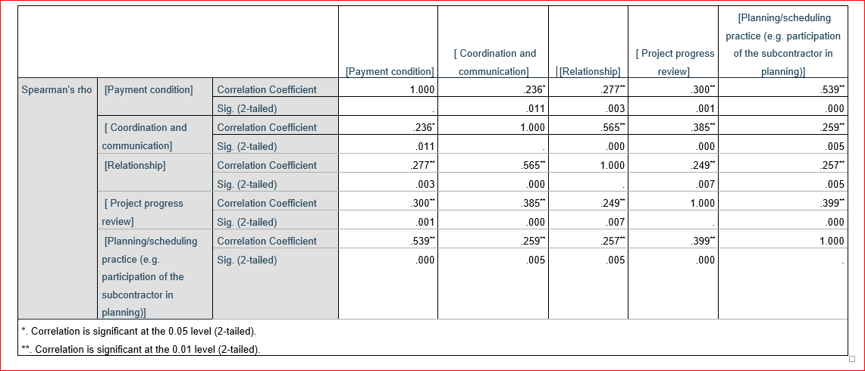

Appendix 3C

Reliability Statistics
Cronbach's Alpha | N of Items
.815 | 7

Appendix 3D

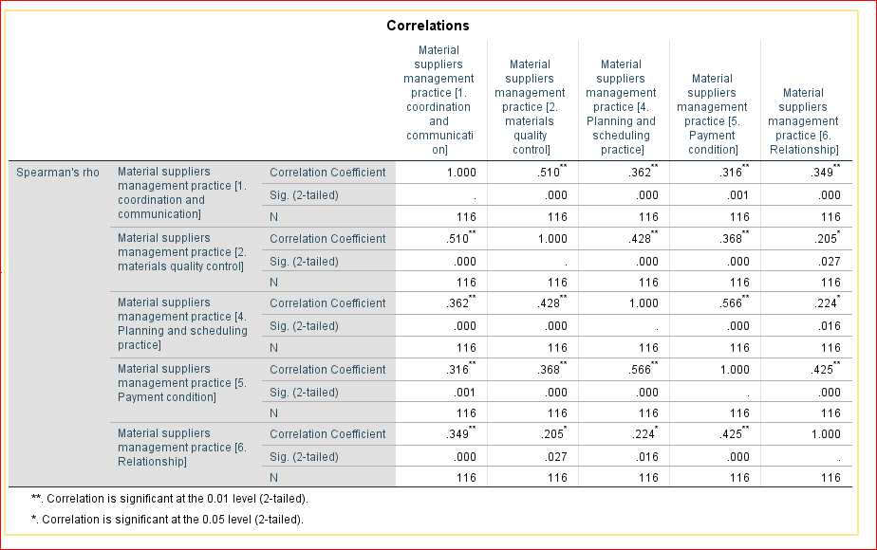

Appendix 3E

Reliability Statistics
Cronbach's Alpha | N of Items
.950 | 18
Appendix 4A. RII Sample manual.

Subcontractors management practice | Likert scale | wi | Frequency (fi) | fi*wi | $$\sum_{i=1}^{116}{fi*wi}$$ | RII | Rank
Coordination and communication | Strongly disagree | 1 | 0 | 0 | 486 | 0.838 | 2
Coordination and communication | Disagree | 2 | 2 | 4 | 486 | 0.838 | 2
Coordination and communication | Neutral | 3 | 4 | 12 | 486 | 0.838 | 2
Coordination and communication | Agree | 4 | 80 | 320 | 486 | 0.838 | 2
Coordination and communication | Strongly agree | 5 | 30 | 150 | 486 | 0.838 | 2
Relationship | Strongly disagree | 1 | 0 | 0 | 476 | 0.820 | 3
Relationship | Disagree | 2 | 0 | 0 | 476 | 0.820 | 3
Relationship | Neutral | 3 | 11 | 33 | 476 | 0.820 | 3
Relationship | Agree | 4 | 82 | 328 | 476 | 0.820 | 3
Relationship | Strongly agree | 5 | 23 | 115 | 476 | 0.820 | 3
Change order | Strongly disagree | 1 | 1 | 1 | 428 | 0.738 | 9
Change order | Disagree | 2 | 1 | 2 | 428 | 0.738 | 9
Change order | Neutral | 3 | 41 | 123 | 428 | 0.738 | 9
Change order | Agree | 4 | 63 | 252 | 428 | 0.738 | 9
Change order | Strongly agree | 5 | 10 | 50 | 428 | 0.738 | 9
Meetings | Strongly disagree | 1 | 0 | 0 | 430 | 0.741 | 8
Meetings | Disagree | 2 | 3 | 6 | 430 | 0.741 | 8
Meetings | Neutral | 3 | 36 | 108 | 430 | 0.741 | 8
Meetings | Agree | 4 | 69 | 276 | 430 | 0.741 | 8
Meetings | Strongly agree | 5 | 8 | 40 | 430 | 0.741 | 8
Payment condition | Strongly disagree | 1 | 1 | 1 | 489 | 0.843 | 1
Payment condition | Disagree | 2 | 1 | 2 | 489 | 0.843 | 1
Payment condition | Neutral | 3 | 3 | 9 | 489 | 0.843 | 1
Payment condition | Agree | 4 | 78 | 312 | 489 | 0.843 | 1
Payment condition | Strongly agree | 5 | 33 | 165 | 489 | 0.843 | 1
Training to fill the gap | Strongly disagree | 1 | 1 | 1 | 440 | 0.759 | 6
Training to fill the gap | Disagree | 2 | 3 | 6 | 440 | 0.759 | 6
Training to fill the gap | Neutral | 3 | 25 | 75 | 440 | 0.759 | 6
Training to fill the gap | Agree | 4 | 77 | 308 | 440 | 0.759 | 6
Training to fill the gap | Strongly agree | 5 | 10 | 50 | 440 | 0.759 | 6
Project progress review | Strongly disagree | 1 | 1 | 1 | 465 | 0.802 | 4
Project progress review | Disagree | 2 | 2 | 4 | 465 | 0.802 | 4
Project progress review | Neutral | 3 | 10 | 30 | 465 | 0.802 | 4
Project progress review | Agree | 4 | 85 | 340 | 465 | 0.802 | 4
Project progress review | Strongly agree | 5 | 18 | 90 | 465 | 0.802 | 4
Subcontractor selection mechanism | Strongly disagree | 1 | 1 | 1 | 421 | 0.726 | 10
Subcontractor selection mechanism | Disagree | 2 | 4 | 8 | 421 | 0.726 | 10
Subcontractor selection mechanism | Neutral | 3 | 44 | 132 | 421 | 0.726 | 10
Subcontractor selection mechanism | Agree | 4 | 55 | 220 | 421 | 0.726 | 10
Subcontractor selection mechanism | Strongly agree | 5 | 12 | 60 | 421 | 0.726 | 10
Clarity of contract guidelines | Strongly disagree | 1 | 1 | 1 | 436 | 0.752 | 7
Clarity of contract guidelines | Disagree | 2 | 2 | 4 | 436 | 0.752 | 7
Clarity of contract guidelines | Neutral | 3 | 33 | 99 | 436 | 0.752 | 7
Clarity of contract guidelines | Agree | 4 | 68 | 272 | 436 | 0.752 | 7
Clarity of contract guidelines | Strongly agree | 5 | 12 | 60 | 436 | 0.752 | 7
Planning/scheduling practice (e.g. participation of the subcontractor in planning) | Strongly disagree | 1 | 2 | 2 | 452 | 0.779 | 5
 | Disagree | 2 | 1 | 2 | 452 | 0.779 | 5
 | Neutral | 3 | 24 | 72 | 452 | 0.779 | 5
 | Agree | 4 | 69 | 276 | 452 | 0.779 | 5
 | Strongly agree | 5 | 20 | 100 | 452 | 0.779 | 5
Appendix 5A. Indicates the cronbach’s alpha coefficient for subcontractors’ management practice.

No | Subcontractors management practice | Cronbach’s Alpha if Deleted | Decision
1 | Coordination and communication | 0.832 | Accept
2 | Relationship | 0.837 | Accept
3 | Change order | 0.831 | Accept
4 | Meetings | 0.815 | Accept
5 | Payment condition | 0.830 | Accept
6 | Training to fill the skill gap | 0.817 | Accept
7 | Project progress review | 0.819 | Accept
8 | Subcontractor selection mechanism | 0.822 | Accept
9 | Clarity of contract guidelines | 0.819 | Accept
10 | Planning/ scheduling practice | 0.814 | Accept

