
HYDRAULIC PERFORMANCE EVALUATION OF CROSS DRAINAGE STRUCTURES
(THE CASE OF BOKOJI TO KERSA ROAD, OROMIA REGION)

M. Sc. THESIS

GOSA MICHAEL EDAO

HAWASSA UNIVERSITY, HAWASSA, ETHIOPIA

FEBRUARY, 2021

HYDRAULIC PERFORMANCE EVALUATION OF CROSS DRAINAGE STRUCTURES
(THE CASE OF BOKOJI TO KERSA ROAD, OROMIA REGION)

GOSA MICHAEL EDAO

A THESIS SUBMITTED TO THE
DEPARTMENT OF HYDRAULIC AND WATER RESOURCES ENGINEERING,
HAWASSA UNIVERSITY INSTITUTE OF TECHNOLOGY,
SCHOOL OF GRADUATE STUDIES,
HAWASSA UNIVERSITY
HAWASSA, ETHIOPIA

IN PARTIAL FULFILLMENT OF THE
REQUIREMENTS FOR THE
DEGREE OF

MASTER OF SCIENCE IN HYDRAULIC ENGINEERING

FEBRUARY, 2021
SCHOOL OF GRADUATE STUDIES
HAWASSA UNIVERSITY ADVISORS’ APPROVAL SHEET
This is to certify that the thesis entitled “Hydraulic Performance Evaluation of Cross Drainage Structures (The Case of Bokoji to Kersa Road, Oromia Region)” submitted in partial fulfillment of the requirements for the degree of Master's in Hydraulic Engineering, the Graduate Program of the Department of Hydraulic and Water Resources Engineering, and has been carried out by Gosa Michael Edao ID. No. GPHydR011/11, under our supervision. Therefore we recommend that the student has fulfilled the requirements and hence hereby can submit the thesis.

Moltot Zewdie (PhD) _________________ __________
Name of major advisor Signature Date
Gemado Gelgalu. (M. Sc.) _________________ __________
Name of co-advisor Signature Date

SCHOOL OF GRADUATE STUDIES
HAWASSA UNIVERSITY EXAMINERS’ APPROVAL SHEET
We, the undersigned, members of the Board of Examiners of the final open defense by Gosa Michael Edao have read and evaluated his thesis entitled “Hydraulic Performance Evaluation of Cross Drainage Structures (The Case of Bokoji to Kersa Road, Oromia Region)”, and examined the candidate. This is, therefore, to certify that the thesis has been accepted in partial fulfillment of the requirements for the masters of Science degree.
_______________________ _____________ _____________
Name of Major Advisor Signature Date
_______________________ ___________ _____________
Name of Internal Examiner-I Signature Date
_______________________ ___________ _____________
Name of Internal Examiner-II Signature Date
_______________________. ___________ _____________
Name of External examiner Signature Date
_______________________ ___________ _____________
SGS Approval Signature Date

DECLARATION
I hereby declare that this M.Sc. thesis is my original work and has not been presented for a degree in any other university, and all sources of material used for this thesis have been duly acknowledged.
Name: _______________________________________________
Signature: ________________________________________
This M.Sc. thesis has been submitted for examination with my approval as Thesis advisor.
Name: ____________________________________
Signature: __________________________________

Place and Date of Submission: _____________________________

ACKNOWLEDGMENTS
First of all, I would like to say Alhamdulillah (thanks to the Almighty Allah), the source of all knowledge and wisdom within and beyond my comprehension. Very special thanks to my advisors, Moltot Zewdie (Ph.D.) and Gemado Gelgalu (M.Sc.) for their constructive advice, guidance, encouragement, helping and directing me through all my works.
I also like to express my sincere gratitude to Hawassa University Institute of Technology (HU IoT) and the Ethiopian Road Authority (ERA) for providing me to study my M.Sc. I also offer my regards and thanks to Ethiopian metrological service agency, Mapping Agency, Ministry of water resource, and Lemu Bilbilo Administration for providing the necessary data to me.
Finally, I would like to thank everyone besides me including family, friends, and professionals who offered help and support in contributing towards the success of this work.

ACRONYMS
BC Box Culvert
BF Base Flow
CN Curve Number
DEM Digital Elevation Model
ERA Ethiopian Road Authority
ERADDM Ethiopian Road Authority Drainage Design Manual
FAO Food and Agricultural Organization
FHWA Federal High Way Administrations
GIS Geographical Information System
GPS Geographic positioning system
HEC-HMS Hydrologic Engineering Center-Hydrologic Modeling System
HEC-RAS Hydrologic Engineering Center-River Analysis System
HHA Hydrologic and Hydraulic Analysis
HM Hydrologic Model
HSG Hydrological Soil Group
IDF Intensity Flow Duration
LU/LC Land use/Land Cover
MoWIE Ministry of Water, Irrigation and Energy
NMSA National Meteorology Service Agency
OFEDB Oromia Finance and Economic Development Bureau
PC Pipe Culvert
RRM Rainfall-Runoff Model
SCS Soil Conservation Service
SCS CN Soil Conservation Service Curve Number
SWAT Soil and Water Assessment Tool
UH Unit Hydrograph
USACE US Army Corps of Engineers
USDOA United State Department of Agriculture
USGS United States Geological Survey
USSCS United States Soil Conservation Service
WMS Watershed Modelling System
WSP Water Surface Profile
XS Cross Section

TABLE OF CONTENTS
ACKNOWLEDGMENTS i
ACRONYMS ii
LIST OF TABLES viii
LIST OF FIGURES ix
LIST OF APPENDICES xi
ABSTRACT xii
1. INTRODUCTION 1
1.1. Background 1
1.2. Statement of Problem 2
1.3. Objectives 3
1.3.1. General Objective 3
1.3.2. Specific Objectives 3
1.4. Research Questions 3
1.5. Significance of the Study 4
1.6. Scope of the Study 4
2. LITERATURE REVIEW 5
2.1. Hydrologic and Hydraulic System 5
2.2. Hydrologic Factors Influencing Performance of Drainage Structures 5
2.3. Hydrological Model 7
2.3.1. Drainage Area Computation 7
2.3.2. Rainfall Runoff Process 8
2.3.3. Intensity Duration Frequency Curve 9
2.3.4. Peak Discharge Estimation 10
2.4. Hydraulic Models 11
2.4.1. Flow through Drainage Structures 12
2.4.2. Hydrologic Engineering Centers River Analysis System 12
2.4.3. Steady Flow Analysis 13
2.4.4. Backwater and Scour Analysis 14
2.5. Drainage Structures 15
2.5.1. Drainage Structures Design 16
2.5.2. Adequacy of Drainage Structure 17
2.5.3. Drainage Structures Inefficiency 17
2.5.4. Recent Studies in Drainage Structures Inefficiency 18
2.5.5. Sources of Drainage Structures Inefficiency 19
2.5.6. Mitigation Measures 23
3. MATERIAL AND METHODS 26
3.1. Descriptions of the Study Area 26
3.1.1. Location 26
3.1.2. Climate 27
3.1.3. Land use/Land cover and Soil 27
3.1.4. Drainage and Topography 29
3.2. Data collection and Analyses 30
3.2.1. Survey Data Collection 31
3.2.2. Spatial Data Processing 32
3.2.3. Rainfall Data Collection and Analysis 32
3.2.4. HEC RAS Data Collection and processing 36
3.3. Hydrological Investigation 40
3.3.1. Delineation of Catchments 41
3.3.2. Computation of Catchment Parameters 42
3.3.3. Estimation of Areal Rainfall 42
3.3.4. Data Distribution Fitting Process 43
3.3.5. Intensity Duration Frequency Curve Generation 44
3.3.6. Calculation of Concentration Time 45
3.3.7. Peak Discharge Estimation 47
3.4. Hydraulic Modeling 51
3.4.1. Selection of Flow Regime 52
3.4.2. Boundary Condition and Discharge Information 53
3.4.3. Steady Flow Simulation 53
3.5. Conveyance Capacity of the Structure 54
3.6. Assessing Sources of Structures Inefficiency 56
4. RESULT AND DISCUSSION 58
4.1. Hydrologic Investigation 58
4.1.1. IDF Curve 58
4.1.2. Watershed Area and other Catchment Characteristics 60
4.1.3. Land use/Land cover Classification 62
4.1.4. Time of Concentration 64
4.1.5. Discharge Estimation 65
4.2. Hydraulic Model 67
4.2.1. Water Surface Profiling 68
4.2.2. Bridge Hydraulic Computations 69
4.3. Adequacy Assessment 71
4.4. Sources of Structures Inefficiency 73
5. SUMMARY AND CONCLUSION 75
5.1. Summary and Conclusions 75
5.2. Recommendations 76
REFERENCES 78
APPENDICES 87

LIST OF TABLES
Table 3.1 Types and sources of data 30
Table 3.2 Precipitation data collected from National Metrological Agency 33
Table 4.1 Rain fall depth compared with ERA’s rainfall depth for region A₃ 58
Table 4.2 Catchment parameters used in peak discharge estimation by SCS CN method 62
Table 4.3 Land use/Land cover classes of the watershed under the study 64
Table 4.4 Slope and Time of concentration for different structures point taken as outlet 64
Table 4.5 Results for peak discharge calculated from rational method 65
Table 4.6 Peak discharge for design and check return period 66
Table 4.7 Peak discharge comparison with result from lognormal distribution 67
Table 4.8 Adequacy analysis using manning conveyance equation 72

LIST OF FIGURES
Figure 2.1 Catchment characteristics and factors that affect peak flood rates 6
Figure 3.1 Location map of the study area 26
Figure 3.2 Soil maps of the study area 28
Figure 3.3 Drainage and Topographic features of the study area 29
Figure 3.4 Employed tools and their uses in the study 31
Figure 3.5 Monthly average rainfall distribution of collected stations 33
Figure 3.6 Graph of rain fall data homogeneity 34
Figure 3.7 Double mass curve 35
Figure 3.8 River cross sections and some other data’s input in HEC RAS 36
Figure 3.9 Schematic view of River segment upstream and downstream of the Bridge site 37
Figure 3.10 Image of manning roughness coefficient for channel (a) and over bank (b) 38
Figure 3.11 Bridge Deck/Roadway data editor cross-section output 39
Figure 3.12 Procedural stepwise methods of hydrological analysis 40
Figure 3.13 DEM superimposed over topographic map of study area 41
Figure 3.14 Procedural method for IDF curve generation 44
Figure 3.15 Steady uniform flow in an open channel 55
Figure 3.16 Conceptual framework of methods and processes of the study 57
Figure 4.1 Intensity Duration Frequency curve developed for study area 59
Figure 4.2 Intensity Duration Frequency curve developed by ERA for region A3 59
Figure 4.3 Area and soil map result of the catchments drains towards the structure points 61
Figure 4.4 Classified Land use land cover of the catchments under the study 63
Figure 4.5 The 50 years and 100 years RP peak flood profile for the existing Bridge 68
Figure 4.6 Longitudinal flow profile ponding just upstream of the Bridge 70
Figure 4.7 Change in velocity from upstream as flow approaches the structure 71

LIST OF APPENDICES
Appendix A: Rain fall intensity for different return period of different duration 87
Appendix B: calculated Rain fall depth of different return period by Gumbel method 88
Appendix C: Peak discharge log transformed data for lognormal 89
Appendix D: Slope and time of concentration 90
Appendix E: SCS CN parameters and sample of computed peak discharge at Katar Bridge 90
Appendix F: Method fitness from Easy fit probability distribution analysis 91
Appendix G: Manning’s “n” values of different channel types and flood plains 92
Appendix H: River XS data of at Katar Bridge collected during site Survey 93
Appendix I: Structures geometry data collected from the site survey 94
Appendix J: Summary in cause, effect and mitigation measures to inefficiency 95
Appendix K: Observed problems found on cross drainage structures during site survey 96

ABSTRACT
Drainage problem is a major concern in the functionality of road. Raise in traffic interruption, structures damage and loss of life can be caused due to poor drainage. To cope with these problems, it is essential to determine the functionality routine of such structures through hydrologic and hydraulic investigation. The study attempted to analyze hydraulic performance of drainage structures found along Bokoji-Kersa road. Different datasets (spatial, hydrological, metrological, survey data) and models (SCS CN and HEC-RAS) were used. Arc-Hydro and image classification tools of ArcGIS, Easy-fit program, statistical methods (Gumble and Lognormal) are employed as processing tools to prepare model inputs. Watershed delineation, land use land cover classification, generation of IDF curves, peak discharge estimation, and steady flow simulation of water surface profile were the active tasks conducted in the study. It was found that the existing Katar Bridge has insufficient size even to convey 320.20m³/s peak design flow of 50 year return period. The resulted water surface elevation was 2496.82m, whereas the lower cord elevation of the Bridge is 2496m. Moreover, the hydraulic capacities of some drainage structures are adequate but inefficient. Limitations in the hydraulic and hydrologic investigation during the design and construction phase were identified as the cause of the problems. Subsequently, causes of gully erosion at the outlet and blockage by sediment led to reduced functionality, traffic interruption, and loss of property.

Key words; Drainage structure, Peak Discharge, Adequacy, SCS CN method, HEC-RAS and Katar Bridge.

INTRODUCTION

Background
Transport infrastructure systems have a major role in public mobility. Road is one of those infrastructures and drainage is the most important aspect of road design. Therefore, its appropriate management and capital investment in the design and maintenance are essential (Kalantari, 2011). Proper design of drainage infrastructure to accommodate water flow along and across road is necessary for its satisfactory and long life performance (Magdi, 2014). In other way, poor drainage causes early pavement distresses leading to traffic interruption and structural failures. Hence, it is important to provide adequate drainage to enhance road performance and prevent or minimize these failures before happen (Tiza et al., 2013).
UNECA (2020) reports, about 1.35 million people die and more than 50 million people are injured each year on the world’s roads as a consequence of road traffic crashes. The majority of deaths and injuries occur in Africa, more than doubled in the 12-year period between 2007 and 2018 in Ethiopia. Inconsequent recent years from 2016 to 2018, 4647 deaths and more than 17 million serious and slight injuries estimated only in Oromia regional states. From another point of view the country loses about 13 people per day, 19 percent occurs on gravel roads.
There is an increasing adaptation of road construction and rehabilitation in our country, Ethiopia. The nationwide inventory and condition survey conducted in 2013, reports about 33% of Bridges and Culverts are found under fair (11%) and bad (22%) condition. Ethiopian Road Authority (ERA) is owning its long-term plan for rehabilitation and replacement of those structures based on the damage extents and other requirements. This may lead changes to the existing road and environments (ERA, 2013).
But, understanding the hydrologic activates in the desired region of road construction is one of the most challenges which arise when determining the locations and dimensions of such structures (Ala et al., 2018). Adoption of these structures which are efficient, sufficient, and safe to convey floods through hydrologic and hydraulic analysis (HHA) can improve the hydraulic performance of roads. Hence, simulation through modeling, assessing adequacy, and identification of inefficiency sources at crossings have a crucial role in such improvements (Abera & Hailu, 2019).

Statement of Problem
Water is the biggest enemy of roads that most pavement erosion and damages are due to poor drainage systems (Petersen, 2006). Poor HHA coupled with lack of sufficient data especially in ungauged watersheds are common sources of drainage structures failures (Ala et al., 2018). The hydrological data available for Ethiopia are limited and flow estimation procedures are applied with caution and engineering judgments (Urgessa, 2016). Hence, there may be subjectivity in decision. Even though the drainage design manual of 2002 is updated by 2013, the same data collected before the first one is in use for design of drainage structures still today (ERA, 2013).
In Oromia region on Bokoji to Kersa road, drainage structures are not properly functioning. It is seen that the embankments, as well as the road-wearing course, are being eroded thoroughly which in-turn is taking many budgets yearly for maintenance. Runoff overtops the road embankment and makes it malfunction due to erosion, ponding, and loss in strength of pavements. Also, sediment deposition causing blockage of most culverts and its sudden consequences such as a reduction in capacity, water overtopping, increase flooding upstream, and frequent maintenance and operation are the main problems seen in the area.
Additionally, damage of farmers land in long stream and the structure itself at outlets by erosion, Bridge scours, undermining of pavement, soil loss in a slope, and flooding of the road corridor due to erosion are also problems seen at the area. Due to the above-specified problems, traffic interruption was common in Bokoji-Kersa road in the previous years and still today especially during the rainy season.

Objectives

General Objective
The general objective of this study is to evaluate hydraulic performance of cross drainage structures of Bokoji to Kersa road.

Specific Objectives
The specific objectives of this study includes;
- To model hydrologic and hydraulic phenomena of selective structures.
- To assess adequacy of drainage structures in the selected road route.
- To identify sources of structures inefficiency.

Research Questions
The questions of this study are;
- What are the hydrologic and hydraulic responses of the structures in the selected route?
- Are the structures adequate enough to accommodate peak discharge at crossings inlets due to selected storm events?
- What are the major sources of structures inefficiency?

Significance of the Study
The result of this study is to provide information about capacity of the drainage structures in the study area to the correspondent organization so that upgrading and maintenance are possible. The finding of this study also provides some information about sources of inefficiency and the area which maybe input for further study in identification of the flood risk management. This may reduce extra cost required for site selection of the road and hydraulic structures location. And hence, it will be used for ERA to identify the areas to be upgraded to reduce frequent operation and maintenance. It can also be helpful for planners to make better decision to identify areas vulnerable to flood to take and decide mitigation measures.

Scope of the Study
The study was conducted to evaluate the hydraulic performance of existing road cross drainage structures (Culverts and Bridges) in the selected route (5 Km) that are found on Bokoji-Kersa road. It was made to investigate hydrologic and hydraulic property and evaluate efficiency of drainage structures using models. The work does not include structural design of any types of drainage structures except conducting HHA required for drainage structures. Based on the result from HHA and identified inefficiency sources, mitigation measures were reviewed and proposed as general without detail study.

LITERATURE REVIEW

Hydrologic and Hydraulic System
A hydrological and hydraulic system model is an approximation of the actual system. It is tool to estimate the basin hydrological response due to precipitation by relating something unknown (output) to something known (input). The input and output can be expressed as functions of time and discharge respectively. Therefore transformation of the input into the output by a transformation operator or equation is done in the system through modeling (Chow et al., 1988).
Because of their great complications, it is not possible to describe all the physical processes within the watershed with exact physical laws. Thus, construction of a model representing the most important processes, and their interaction within the total system is in need. Estimating flood magnitudes as the result of precipitation is one process of what hydrology deals with. Floods are usually considered in terms of peak runoff and hydrographs as discharge per time to be used in drainage design (ERA, 2013).
In hydrologic terms model is a mathematical representation of hydrologic systems of the real world. For instance, the Unit Hydrograph (UH) model and the Soil Conservation Service Curve Number (SCS CN) model can be termed as Hydrologic Models (HM). A Hydrologic Computer Models (HCMs), such as Watershed Modeling System (WMS), Hydrologic Engineering center Hydrologic Modeling System (HEC-HMS), Soil and Water Assessment Tool (SWAT), and etc. could also be termed as a hydrologic model (Urgessa, 2016).

Hydrologic Factors Influencing Performance of Drainage Structures
As any hydrologic process is the input for hydraulic analysis in designing drainage structure, it is important to understand factors that affect floods on a site by site basis (ERA, 2013). Development of agricultural land has great role in reducing surface roughness. Natural storage consequently make improvements in the hydraulic conveyance of the drainage ways. The process increases runoff rates, resulted from decreased opportunity for infiltration which decrease base flow (BF) rates and hence, peak runoff rates, times to peak and volumes of the surface runoff will increase (McCuen, 2002).

Figure 2.1 Catchment characteristics and factors that affect peak flood rates
The knowledge of the influence of land use land cover (LU/LC) change on watershed hydrology are helpful for conducting any HHA. Impact of its spatiotemporal variability, climate change and management practice changes on stream flow affect health of the hydrological processes at watershed level. More mountainous and steeper slopes are cultivated, mostly without protective measures against land erosion and degradation in the area under the study. Hence, the investigated relationship between LU/LC and the hydrological condition (runoff volume, peak runoff rate, and total sediment yield) of the area are needed to know how the quantity of water flowing to the outlet is changed with the change of land use (Tufa et al., 2015).

Hydrological Model
There is no complete model as scope of refining it by incorporating recent, higher-resolution data and including recent scenarios always present (Thakur et al., 2017). The catchment HMs has been developed for many different reasons and have different forms and hence, more complicate in nature. They are designed to gain a better understanding of the hydrologic phenomena operating in a catchment and of how changes in the catchment may affect these phenomena. They are also developed to be used in generation of synthetic sequences of hydrologic data for facility design or for use in forecasting. They are providing valuable responses in studying the potential impacts of changes in land use or climate (Xu, 2002).
The study of Keleab (2015) on Goro-Akaki Road, Ala et al. (2018) on Arar-Anaz Road in Iraq, Abera and Hailu (2019) on Sebata-Mieso rail way in Ethiopia and other different road crossing structure inefficiency and/or failure related study shows, effectiveness of using the hydrologic and hydraulic modeling to simulate the watersheds that cross the road paths and estimating the amounts of surface runoff flows across the road both in gauged and ungauged watersheds. But, selection of the right HM depends primarily on the objective of the modeling task for which it was evaluated based on certain criteria to meet the requirements. Based on the hydro-climatological characteristics of study regions, different HMs evaluation criteria should be identified and the suitable applicable models need to be selected (ERA, 2013).

Drainage Area Computation
The longest flow path, location, elevation variation and drainage area coverage of the area under any study including drainage characteristics like LU/LC and soil type need to be determined. These are accompanied usually using computer program like; Arc Hydro tools and Arc SWAT. Arc Hydro model which is developed for building hydrologic information systems to synthesize geospatial and temporal water resources data is used in most situation. It supports hydrologic modelling and analysis in simulation models categories to divide water resources elements, such as network, drainage, channel, hydrographs and time series. The model is developed as an Add-on to Arc GIS software after installing it by adding it to the Arc toolbox. It is used to extract topologic variables from a digital elevation model (DEM) raster for building geometric networks for hydrologic analysis (Keleab, 2015).

Rainfall Runoff Process
Rainfall is one factor used to predict design discharge and peak flow in any drainage structure design. Changes in climate and land use can affect catchment hydrological responses and consequently influence the amount of runoff reaching roads (Kalantari, 2011). Hence, there is a need for modeling to relate the rainfall and other hydrological parameters of the watershed with the parameters of the runoff characteristics. This is mainly to estimate the amount of runoff generated from a given rainfall using simple to complex techniques. In other words, the model is intended to answer what runoff question either partly or fully. It may include applying of an enormous number of assumptions and simplifications in representing the actual processes but, rainfall is the main input (Chow et al., 1988).
Some models take a single parameter of the rainfall characteristics with a time resolution, which ranges from days to months. Others may consider multiple parameters of the rainfall (depth, intensity, and duration) with high time resolution that may range from minutes to hours. Therefore, purpose of the modelling task, the degree of comprehensiveness and expected accuracy need to be taken into consideration in application of any models (Urgessa, 2016).
To develop such a model, rainfall data require accurate and complete records as any causes of instrument failure reduce the length and information content of its record. There are methods used to estimate missing precipitation. Station average is not accurate in greater than 10 percent annual difference and does not account for closeness and density of gages. In such cases Normal ratio is preferable, and it accounts for orographic effects. Quadrant need dense gages, homogeneity of the meteorological conditions and orographic effects to be accurate. Isoheytal reduce usefulness of catch in closeness and weight decreased as the distance. But complex and need more understanding and there may be absence of gages in some quadrants.
There are also methods used to estimate areal rainfall to account for non-homogeneity of land use or soil characteristics. Arithmetic mean does not account for orographic effect and not accurate if gages are not uniformly distributed. In such cases Theissen is better, easier and more reproducible. It considers nearest gage precipitation and gives relative weights to a distance of halfway to the next. Isohyetal is time-consuming, need dense network of gages and knowledge of the factors affecting the catch at each gage into making a weighted estimate (Richard, 1998).

Intensity Duration Frequency Curve
Data on IDF curve are one of the most important information required for various hydrological studies (Akpen et al., 2018). But, often unavailable due to lack of enough rain gauging stations. It is impossible and tedious to calculate design rainfall directly from raw data due to lack or absence of short-duration rainfall data (Abdullah et al., 2018). Hence, regionalization of the IDF curves using appropriate probability distributions is very important in determination of peak discharge for drainage structures. It is also more effective tools for design to better resolve the classic conflict between safety and economy in drainage design (Zelleke, 2007).

Peak Discharge Estimation
In doing any kind of hydrologic modeling involves delineating watersheds and getting some basic properties such as area, slope, flow length, stream network density, then peak discharge estimation is the most important part (Keleab, 2015). Rational methods for area less than 50 hectares and SCS CN method for area between 50 hectares and 65km² is recommended. For large areas greater than 65km², empirical, statistical, Synthetic Hydrographs and computer programs can be used (ERA,2013).
From different number of such methods available to predict peak flows, flood frequency analysis is the most accurate method (FAO, 1998). But, Stream flow measurements at or near a site are usually unavailable. In such cases, it is accepted practice to estimate peak runoff rates and hydrographs using empirical or statistical methods in other hydrological homogenous catchment and then transposing it (Abera and Hailu, 2019).
If there is a long term stream gauge located near the drainage structure site, there is a possibility to use flood frequency analysis. Availability of a gauge near the site, with a difference in catchment area of less than 10%, make the possibility to be used directly. But, the calculated discharges need to be modified for the small differences in catchment area (Adicho, 2018). If the gauge is located further away, transposing method which need regression relationship and meteorological data similarity is recommended and can be used. In such a cases, similarity in hydrologic region and absence of major tributaries or diversions between the gage and the site of interest should be fulfilled (Taye, 2019).
Hence, in unavailability of sufficient discharge data for ungauged River basins, using indirect methods for deriving flood discharge amount based on area coverage is the best option.
It is application of hydrological models like SCS CN method for the estimation of peak discharge. To achieve this objective, field measurements, GIS technique, and several channel geometry equations are needs to be used (Mistri, 2013). The method is mainly, based on daily rainfall data and provides flood estimates, which are adequate for planning and design of various hydraulic structures and flood frequency analysis (Keleab, 2015).

Hydraulic Models
Flood damage can be mainly caused by failure in hydraulic investigation of drainage structures. Cause of increases in flow velocity, as it accompany the increases in runoff rates and scour rates of channel bottoms can induce such damages (McCuen, 2002). Bridges and culverts are some types of hydraulic structure those need to be designed hydraulically to accommodate peak flood without excessive restricting the flow of the stream. The model is important to check hydraulic structure size on stream cross section (XS) based on flood runoff from upstream.
It can be used to check whether the structures can safely pass peak discharge estimated during hydrologic analysis of a given watershed or not. Hence every structures related to flood runoff should be designed in order that flow could not cause damage to the structure itself or the surrounding environment (Abera and Hailu, 2019). Manning’s Formula, Hydrologic Engineering center River Analysis Center (HEC RAS), ISIS and Hy8 models can be used to design hydraulic structures of cross drainage (ERA, 2013). From such models, HEC-RAS is one of the most frequently used for Bridge and culvert hydraulic investigations. It is particularly useful for in-channel flows and when floodplain flows are minor. Most Bridge hydraulic studies use one dimensional analysis methods, though two dimensional models are becoming more common. Three dimensional models are used to analyze complex flow fields (Gautam, 2016).

Flow through Drainage Structures
Due to the structure constructed across the flow direction, rise in upstream water level usually called afflux depends on the type of flow regime. But, most Bridges are designed for subcritical flow conditions in order to minimize scour and fill passage space problems. The establishment of afflux levels is extremely important for the location of safe Bridge deck levels. This is mainly to avoid the flooding of the deck and any consequent structural damage (Novak et al., 2007). The hydraulic analysis of a channel determines the depth and velocity at which a given discharge will flow in a channel or known geometry, roughness, and slope. The depth and velocity of flow are necessary for the design or analysis of channel lining and highway drainage structures (USACE, 2016).

Hydrologic Engineering Centers River Analysis System
HEC-RAS is hydraulic modeling software developed by the US Army Corps of Engineers (USACE), which allows the user to perform one-dimensional and two dimensional steady and unsteady flow calculations. It has gained popularity among hydrologic modelers, by its prevalent use in modeling dams, Bridges, River flood hazards and culverts. It is freely available for download from the HEC website and is supported by the USACE. In two dimensional modeling, the hydraulic geometry of the River is essential for accurate model simulations and is basically dependent on the DEM (USACE, 2016).
It is the best and most recent method for hydraulic design of Bridges, and available documentation provides guidance for its use (Peck and Wesley, 2001). It is simple, commonly modeled and used for River flow analysis, freely available and easy to deal with (EPA, 2011).
Alaghmand et al. (2012) studied in comparison between HEC RAS and MIKE11 and deduced that, HEC-RAS has more capabilities for River flood risk mapping in comparison with MIKE11. Vargas et al. (2019) points to the validity of HEC RAS one dimensional model if specific conditions related to channel characteristics and discretization of the domain can be met than IBER and Flow 3D software in studying flow characteristics.

Steady Flow Analysis
In order to establish permissible upstream stage levels, detailed investigations of properties along the stream have to be investigated. Steady flow simulation is important in economic considerations of determining the minimum clear span length which not cause undesirable afflux. These levels can be established by backwater computation (Novak et al., 2007). In such kind of analysis, calibration and verification processes of the model need to be carried out by making use of the field measurements if available (Khafaji, 2008). It can be simulated by HEC RAS software application, which performs steady and unsteady flow of water surface profile (WSP) calculation.
In Bridge hydraulic modeling selection of one dimensional hydraulic analysis method is best suited and primary used for condition of narrow to moderate-width floodplains, minor floodplain constriction, low skew roadway alignment less than twenty degree, small tidal streams and in-channel flows (Mifta., 2017 and FHWA, 2019). HEC-RAS, 2016 manual guidelines deduced that, flows in small streams may encounter rapid transitions in channel geometry, likely leading to abrupt changes in cross sectional area and conveyance between sections. To help diminish abrupt transitions of area and conveyance, the maximum distance between open channel XSs need to be held to less than 150m.
The momentum equation is utilized in situation where the WSP is varied as such that, the situations include mixed flow regime calculation (i.e. hydraulic Jumps, hydraulics of Bridges, and evaluating profiles at River junctions).
Selection of RAS to run in subcritical or supercritical, somewhere in the system may not able to compute a valid subcritical or supercritical answer, then it defaults to critical depth and moves on. In selection of mixed flow, RAS will compute both a subcritical and supercritical profile and anywhere there is a valid solution for both regimes, RAS will select the one that has the higher specific force value. If, in mixed flow, there are any XSs that default to critical depth, that means there was a problem with RAS obtaining a solution. Usually, this means XS spacing is too far apart, or it may be in an area of rapidly varied flow with not enough XSs or just bad input data (Goodell, 2014).

Backwater and Scour Analysis
Streambed and bank material of River channel around the drainage structures can be eroded by flowing water. In such cases, the Bridge safety and stability can compromised by exposure of its elements to scour. Contraction, local and long term aggradation and degradations are combined to form total scour (UDOT, 2013).
Study conducted on the use of HEC RAS model for backwater and scour analysis by David and Andrew (2000), suggest it as an excellent model for determining WSPs for various scenarios. They stated that, the model is easy to construct in the windows-based program and accurate in modeling complicated situations such as multiple opening Bridges and looped channels. It is also suggested by Raymond et al. (2020) that, using HEC-RAS as a decision-making tool is the best option helping to manage floods risks vulnerability.

Drainage Structures
Adoption of sufficient cross-drainage structures following the road and natural drainage alignment and its gradient can improve hydraulic performance of the road. The flow through those structures may cause undesirable erosion at unprotected outlet which can lead to undermining of the structure. Also, presence of such structures across a stream creates constricted flow through its openings because of the reduction in the width of the stream due to structures. In other way, fluming of the stream itself (in the case of wide streams with flood plains) to reduce the costs of the structure can also cause flow constriction. Apart from scour around the piers and Bridge abutments and possible bed erosion, there is a considerable backwater effect of the structure (Novak et al., 2007).
Therefore, investigations of hydrologic and hydraulic characteristics are important for the design of any drainage structures. Though, results of this analysis are not always accurate as such that statistical uncertainties are inherent in HHA of culvert and Bridge, both of these analyses are required and must be performed first before any design. Analysis of the peak rate of runoff, volume of runoff, and time distribution of flow is fundamental to the design of road drainage structures. Potential environmental problems that would impact the specific design of such structures should be recognized and evaluated early in the design process while performing the hydrological and hydraulics analysis (ERA, 2013).
Developing hydrological models for the catchment area, conducting hydrological analysis, analyzing rainfall runoff characteristics of the catchment, calibrating and validating of hydrological modelling and developing hydraulics models of the reaches and structures are the most important aims in hydrological and hydraulic study of road cross drainage structures. Those all above expressed need consideration of diverse watershed characteristics in any planning and design of drainage structures. Today these analysis were accompanied by computer model like HEC HMS, HY-8 and HEC-RAS (Abera and Hailu, 2019).

Drainage Structures Design
Estimation of hydrological and hydraulic parameters such as peak flood discharge and high flood Level at a point of interest are important for the safe design and economic viable of hydraulics structures like Bridge, Culvert, Underpass, etc. If HHA is not carried out properly the structure can be fail (Atharvi et al., 2019). But, Complexity, difficulty in measurement and detail understanding are common characteristics of such analysis (McCuen, 2002).
Drainage structures that cross stream channels should be designed to withstand floods of extreme magnitude to prevent failure and accidental loss of life and property by runoff during high flow events. Being, adequate enough to pass, remain above the highest possible flood flows occurs during design life at each crossing, deep enough to remain undisturbed by scour and placed at the right location with additional miscellaneous structure such as energy dissipater not to scour and disturb downstream environment are required (Fishbeck et al., 2004).
But, to fulfill all the above requirements, understanding the hydrologic activates in desired region of road construction is one of the most challenges in roads construction. This challenge arise when determining the locations and dimensions of such structures that ensures efficient conveyance of the floods. Effects of future changes in climate and land use on the hydrological responses of the catchment area and the amount of runoff reaching roads should be estimated before construction (Ala et al., 2018).

Adequacy of Drainage Structure
Road hydraulic structures has a vital role in conveying, diverting, or removing surface water from the road in to right way, to reduce damage imposed on the road and other environment by water (Zumarawi, 2016). Relatively, the time and expense needed to implement adequate road drainage is less than that costs of trying to mitigate problems caused because of damage. Hence there is a need to know magnitude of flood for design of any drainage structure.
Extreme floods may occur once or twice in a century; and the cost of caring adequately for such a contingency is excessive and unwarranted in many instances. Here the best judgment of the Engineer is needed (Urgessa, 2016). Therefore, there is a need to take wisely under consideration to HHA of the structure to the design and maintenance of adequate road drainage. These may need consideration of many factors that affect the structure efficiency and safety to avoid frequent maintenance and costly repairs. Potential environmental degradation associated with the structure inefficiency at stream crossings should also be assessed during design phase (Abera and Hailu, 2019).

Drainage Structures Inefficiency
Effective road drainage is crucial to protect the road from damage and to keep its stability for the road quality (Kayhan et al., 2013). Drainage structures failures had serious negative impact on road users and leaves the organization to replace the asset which is the most expensive options. Such a problem is mainly caused by negligence regarding design, maintenance, rehabilitation and renewal. The growth of weeds, brush, and trees in a drainage channel reduced its hydraulic efficiency and the result being that a portion of the design flow may overflow the channel banks causing flooding and possible erosion (Alemu, 2015).
Bad drainage has damage and loss in serviceability of pavements much greater when structural section contains free water. The quality of drainage is an important parameter which affects the performance of the road pavement as such that, Poor drainage quality leads to a large amount of costly repairs. It may also leads to replacements of such structures before reaching their design life (Tiza et al., 2016). It is also, causes for land degradation and gully formation as such that, channel flow is usually confined to a lesser width and greater depth as it passes through a structure. An increased velocity results with potentially erosive capabilities as it exits the barrel leads to scour the bottom of culvert (Hadera & Asfaw, 2016).
On the other hand, if the culvert and Bridge is made unnecessarily large, the cost of construction is needlessly increased. Anyone can make a cross drainage large enough, but it is the province of the engineer to design one of sufficient but not extravagant size. The economy of designing a Bridge or culvert to take the maximum discharge from an area should be determined for sizing drainage structures. It would be economical to build the structure to meet maximum conditions if the interest on the first cost was less than the cost to repair whatever damage was incurred by the use of a structure furnishing a smaller water way (ERA, 2013).

Recent Studies in Drainage Structures Inefficiency
Few researchers, (Kassa, 2013; Alemu, 2015; Urgessa, 2016 and Chachu, 2018) studied similar problem on road drainage structures of different areas in Ethiopia. The first two mainly focuses on condition assessment while the letters tried to address hydrologic and hydraulic investigation using model simulation. Even though there is difference from one studies to others, the gap in use of models like arc hydro and GIS for determination of watershed characteristics, model supported mitigation measures, LU/LC classification and IDF generation were viewed.
In general, more or less within the same idea, they agreed that, drainage structure inefficiency or failure is due to inadequate size of drainage structures caused by negligence of hydrological analysis and hydraulic design. In addition to this, Changes in hydrological and hydraulic conditions due to changes in climate conditions, LU/LC and scouring of abutment and pier of Cross drainage structures in the adjacent area and where drainage structures placed have a significant impact on the function and efficiency of road drainage systems (Urgessa, 2016).
To sum up, the main causes for failure of the drainage structures are hydrologic and hydraulic (e.g. inadequately sized opening) failure, soil aggradation or degradation and improper location of the structures (Beza, 2010). These causes are due to factors related to basin, stream channel, flood plain and metrological characteristics (discussed in section 2.2). It may be occurs as a result of either one or in combination of the above causes. Human activities in relation to land use changes such as agricultural activities, urbanization, and commercial development of land resources are significant factors in cause of those problem. Of these activities, the removal of the protective vegetation and the loosening of the soil during cultivation results in a speeding up of the erosion process (Natnael, 2016).

Sources of Drainage Structures Inefficiency
- Poor Design and Construction
Improper site selection, poor construction, improper alignment for drainage structures at critical points can be sources of failure of carriageway due to over saturation and overtopping that cause scouring due to stream crosscurrent occurs on the road (Kassa, 2013 and Chachu, 2018). Under estimation of the design flood makes the structure inadequate to pass the design flood (Kefargachew, 2015).
Bridge pier and abutment alignment with respect to flow direction has direct effect on the Bridge Hydraulic capacity or performance. Sediment Aggradation can be caused at Bridge locations in the channel or in the floodplain of a natural Rivers as such that, an additional backwater due to the obstruction to the flow can occur. To minimize the problem the road cross drainage need to be aligned perpendicular to channel and floodplain flows (Natnael, 2016).
- Presence of Excess Water within the Roadway
Road may be adversely affected by presence of excess water in it. This may be through entering properties of the materials with which the road constructed. The water in the roadway can cause erosion, subgrades weakening and Cut or fill failures (FAO, 1998). During the rains, some amount of the rain water flows on surface, Some water is retained in the pores of the soil and others percolates through the soil mass until it reaches to the ground water. The retained one cannot be drained by normal gravitational methods. Presence of water in such mode may causes lack in efficiency and/or failure of the roads due to many reasons like increase in moisture content, decrease in strength, cutting of edges of pavement and so on (Jalindar, 2011).
Though the cause of lack of performance differs in many aspects, the ultimate failure mode of most drainage structures are a result of inadequate soil performance as they are soil-structure interaction systems. Poor soil component will detect itself in pavement distress, embankment settlement or collapse of the structure. When joints in structures are not watertight, there is no control over the amount of infiltration and water come fines from the surrounding backfill material. Through time, the continual loss of this material will create voids around the structures and undermine the structural integrity, resulting in pavement failures around the structures (ASCE, 2002).
These failures may result in the loss of the roadway, but as a minimum, they represent a functional inefficiency to the traveling public. Improper geometry, insufficient capacity and lack of proper maintenance can also force the water to enter the pavement from the sides as well as from the top surface especially during rainy seasons. Consequently, this phenomenon becomes more dangerous and the top layer gets detached from the lower layers in case of open graded bituminous layer (Zumarawi, 2016).
- Excessive Flow Velocities
Water velocity in the flow path is a critical parameter. High outlet velocities above permissible can cause bank erosion a significant distance downstream of an outlet (ERA, 2013). Due to runoff are flowing to concentration from the whole catchment to one direction at the location where cross drainage structure found it give speed to erode the soil (Hadera and Asfaw, 2016).
Total scour at Bridge footings is primarily sum of long-term lowering of the channel bed due to erosion, increase in local flow velocities and turbulence levels due to obstruction (local) and increased water velocity in the structure opening due to decrease in cross-sectional area of waterway at the crossing (Alemu, 2015).
The introduction of a Culvert or Bridge to convey stream flow beneath a road can cause an increase in flow velocity downstream of the structure. This may cause erosion and degradation of the channel profile that can be detrimental to downstream land users and to the culvert itself. If the natural stream velocity exceeds the erosive velocity, then the increased velocity at the culvert outfall will accelerate this naturally occurring process (Hadera and Asfaw, 2016). Provision of hydraulic structures such as Bridges and Culverts has induced some sort of instability in River.
The opening of these structures may understated or constricted and then the flood may force to increase velocity when it passes through them. Consequently, this high velocity may has erosive power and the bed material is eroded below the original bed level and the River bank is still being scoured heavily every wet season (Bisrat et al., 2015).
- Sedimentation
Blockage by debris is occur where the catchment contains significant woody riparian vegetation and hence, detailed assessment of the catchment and larger sizes of structures are required. It can occur through siltation or vegetation, although silt deposits can be removed by high velocity flows during flood events. The desirable minimum velocity in the culvert should be above 0.7 m/s to prevent siltation (ERA, 2013).
The reduction or decrease of clear opening height or the reduction of effective flow area due to sediment deposition around the structure location could be another likely reason for the failure of those structures. (Beza, 2010). Larger culvert sizes may be required where debris blockage is considered. For large cross drainage structures such as Bridge it is important to provide structures like masonry retaining wall, launching aprons and energy dissipation mechanisms such as cascading of the channel (Abera & Hailu, 2019).
Change in the shear stress/drag force from between the XSs may cause scouring or sedimentation as they take place thoroughly in the channel based on slope, grain size and flow rates velocities. As it is the tangential force exerted by the fluid its flows force over and around the grain at the bed and at the boundary will exceed the threshold or critical conditions for bed particle movement and bedload transport will become active.
Decreasing in shear value means that the structure is restricting the sediment transport in the downstream direction, which may lead to sediment deposition during this flow event. But, these assumption are based on long term aggradation or degradation and may not be observed in the site today (Edward, 2010).

Mitigation Measures
Provision for adequate drainage is of paramount importance in road design and cannot be overemphasized (FAO, 1998). Cause of failure of the existing drainage structures may have several reasons. Change in hydrological characteristics, improper alignment and insufficient opening due to in accuracy peak discharge estimation are some of them (Beza, 2010).
There are different mitigation measures that can be used to reduce adequacy and scouring problems, then to have safe adequate enough opening. Upstream watershed management and River training action may take long term activities to have safe structures against flood problem. However, Placement of rock Riprap, dredging (Adicho, 2018) and increasing in hydraulic opening of the structures mostly in case of overtop problem (IHRB, 2006) may be required to take a quick measures.
Flow velocity is higher at structure location than specified flow speed for earthen material. Maximum allowable target velocities in meter per second at the culvert outlet varies based on material found downstream of culvert end wall. It also depend on the type of soil, channel gradient and shape and vegetative cover (ERA, 2013). Therefore, to overcome such problems any activity related to this issue need measures. Some of those measures includes; replacement of the structures if the problem is so critical, well runoff drainage, design to permissible velocity, Erosion and siltation control mechanism, watershed management and river trainings. In case of failure or inefficiency due to presence of water, it is required that the surface water from the carriageway and shoulder should effectively be drained off without allowing it to percolate to subgrade. It is also important to prevent it from entering the road way if it is from adjoining land. Capacity of side drains and its longitudinal slope should be maintained adequate enough to carry away all the surface water collected (Jalindar, 2011).
Extent of erosion at abutments can be reduced by placing them away from the Riverbanks (Alemu, 2015). The value assigned for rock is 4.5 while 3.5 and 2.5 for stone with 150mm or greater diameter and for gravel with 100mm with grass cover respectively. An interval value of 1.2 to 2 is assigned for firm loam or stiff clay while 1 to 1.5 value is for sandy or silty clay. If this is impossible because of constraints, appropriate mitigation measures was needed. Therefore increasing channel roughness by watershed and stream management used in reduction of flow velocity and using energy dissipation is recommended (ERA, 2013).
The risk of scour depends on the slope and geometry of the channel, the soil conditions and the vegetation cover. Erosion control practices hold soil in place and reduce soil removal by runoff. The most effective way is to preserve existing vegetation and replant cleared or bare areas. Therefore to protect the culvert and adjacent areas from erosion by reducing the velocity of flow to acceptable limits, it is sometimes necessary to employ an energy dissipater (Hadera & Asfaw, 2016). Frohilich equation can be used in HEC RAS model to analyze scours at abutments (Bisrat et al., 2015). Placing a layer of large rocks against the earth around both ends of the culvert and Planting vegetation along the bank to keep the soil from being exposed are inexpensive methods. Sometimes there may be persistent erosion problems that need more expensive control mechanism.
In such cases, Placing a layer of geotextile material on top of the soil along the bank in the area prone to erosion and Placing rip-rap in layers interlocking like bricks to form sturdy retaining wall on top of the geotextile material may be required (Worcester, 2007). HEC RAS model can compute flow problem related to hydraulics of structures. It can also possible to compares the best hydraulic design by changing input factors to have safe structures. Such kind of analysis are mainly conducted to get counter measures for scouring problem found around the bridge abutment. Mostly, by changing manning roughness coefficient to see flow profile and reduction in scouring depth (Adicho, 2018).

MATERIAL AND METHODS

Descriptions of the Study Area

Location
The road of Bokoji to Kersa is an existing rural gravel road located in Arsi zone, Oromia region East part of Ethiopia. It starts from Bokoji town approximately (07º35’N; 39º10’E) which is located at around 225 km from Addis Ababa, ends at Kersa town (07°32′N 38°59′E) having total approximate length of 48km. Hydrological location of the project site is in Katar watershed of Lake Ziway sub-basin.
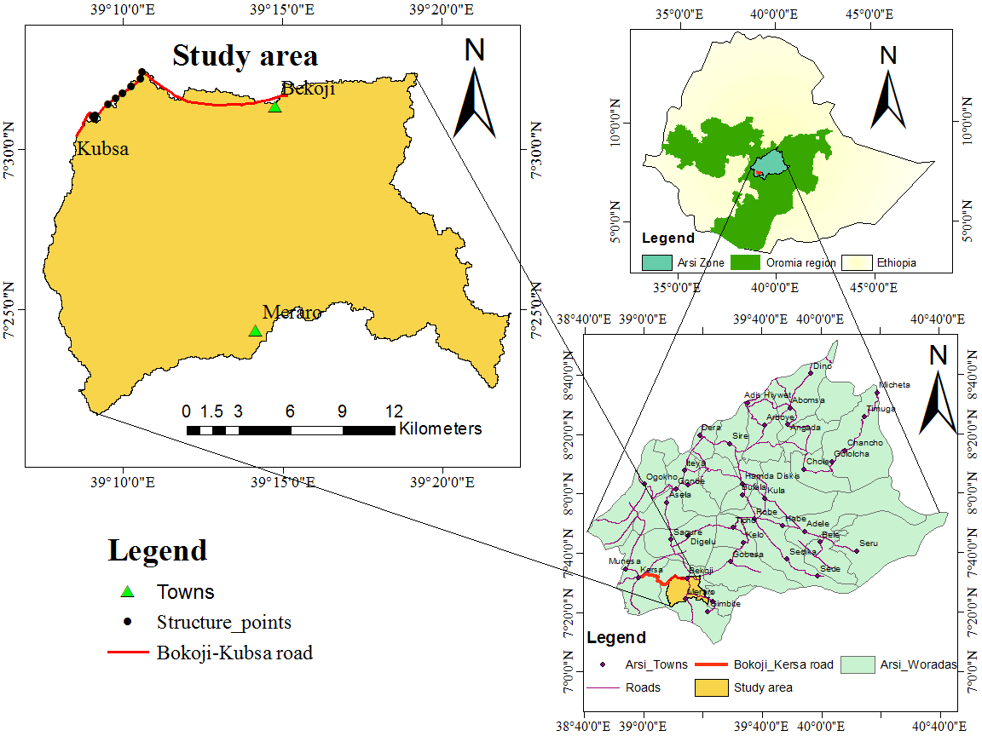
Figure 3.1 Location map of the study area
The road links two districts administration of Lemu-Bilbilo and Munessa in Arsi zone. It also links many towns, kebeles and villages from Bokoji-Kubsa-Gumguma-Kersa. From Bokoji to Kubsa the road have a total approximate length of 17km, about 12km from Kubsa-Gumguma and 18.5km from Gumguma-Kersa. It crosses different Rivers and streams of which Culverts and Bridges were constructed across them at different position.

Climate
The study area is mainly located in the temperate to cool agro-climatic zone with 2500m to 3500m and above topography respectively. The mean annual temperature of the area is between 10-15cº in the central high land. February to May is the hottest months while October to January is the coldest months that show availability in variation of temperature by months. It receives abundant and well-distributed rainfall both in amount and season, which is suitable for different types of vegetation growth and agricultural activities. 85 mm of monthly and 1020mm annual mean rainfall with 145 to 200 variation in number of rainy days in the highland zone characterize the area. 1059.3 mm recorded mean annual rainfall at Bokoji stations of altitude 2760m a.s.l. found the highest value of rain fall depth in the project area (OFEDB, 2011).

Land use/Land cover and Soil
Agricultural land dominantly characterize the area under the study. Most recent studies accompanied on LU/LC classification by (MoWIE, 2010; Tufa, 2015; Getachew and Suryabhagavan, 2018; Osore, 2018 and Kabeto, 2018) also shows the area under the study are mostly classified under agricultural area. LU/LC of the area includes agricultural land which is more dominant in the area, open wood land and some very small areas of urbanization.
The major soil types in the watershed (Figure 3.2) in contribution runoff to the structures are Vertic Luvi soils which is classified in HSG ‘C’ and Eutric Nito soils of HSG ‘B’ as gained from of MoWIE (2010). HSG B includes loam or silt loam having a moderately well drained course textures, low runoff potential with moderate infiltration rates. HSG C incudes Sandy clay loam Soils having a moderately fine texture, high runoff potential with slow infiltration rates. These soils mainly contain a layer which exists near the surface that obstructs the downward movement of water (ERA, 2013).
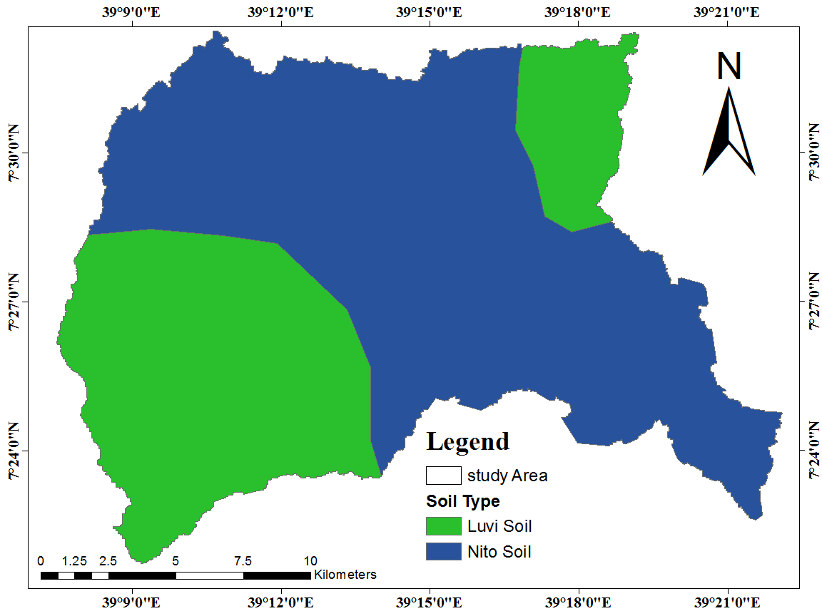
Figure 3.2 Soil maps of the study area (MoWIE, 2010)

Drainage and Topography
The project area is naturally featured with few perennial Rivers and many streams that drains to Lake Ziway. The major ones that crossed by project road are Warga and Katar River. The latter river which is Katar, is the biggest perennial River with total watershed area of 3350 km². It starts from Arsi high lands of Kaka mountain and flows towards Lake Ziway from southeast to northwest (Osore, 2018). The main topographic features in the area under the study are mountain peaks such as Kaka and Honkolo with a highest elevation of 4213 m above sea level. The topography of all catchments were varied between 2495 m up to 4213 m a.s.l and more than half of the area are located at an elevation greater than 2500 m.
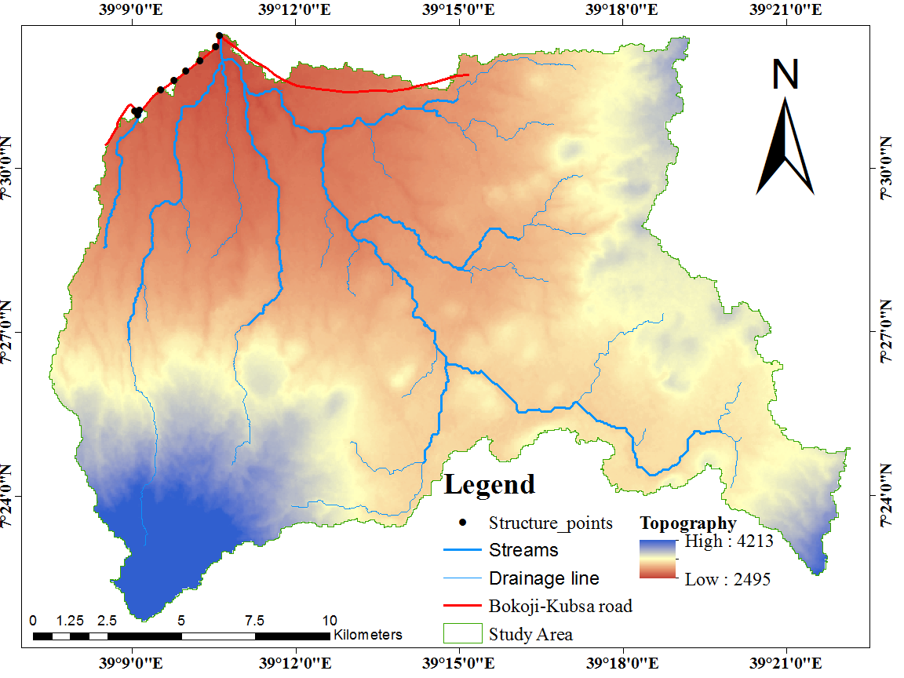
Figure 3.3 Drainage and Topographic features of the study area

Data collection and Analyses
Data collection process including both primary data from fields and secondary from concerned organization were conducted. Primary data includes; types, number, location, stream XS and size of each cross drainage structure in the selected route. This were accompanied through full survey by direct field measurement and using global positioning system. Table 3.1 shows types and sources of data used in the study.
Table 3.1 Types and sources of data
Types of data | Data sources
Shape files, hydrological data, Soils and land use maps | Ministry of water, irrigation and energy, hydrology and GIS department
Metrological data (Rain fall, temperature, sunshine and humidity) | National meteorological service agency
coordinates, locations, XSs, structure geometry, channel characteristics, | Site surveying using electronic survey equipment and camera
Information about risk of flooding and background history. | Local land owner and measurement at site, Lemu and Bilbilo districts office of road authority
Topographic maps, satellite image, DEM data (30m x 30m resolution) | Ethiopian mapping authority and downloaded from USGS landsat8, https//www.earthexplorer.usgs.gov
Data processing and analyses were conducted with the help of soft wares and programs after all required data were collected from different sources. Figure 3.4 presents tools employed and their uses in the study in different processing and analysis methods conducted to meet the objective set.

Figure 3.4 Employed tools and their uses in the study

Survey Data Collection
To obtain an overview of the structures, catchment in contribution of runoff to the structure, collect necessary data and identify functionality of the structures, direct field survey was conducted as a part of the study. General information about flood event, overtopping of structures and traffic interruption are gathered from community. In addition to the above, stream XS (Appendix H), Structure geometry (Appendix I), LU/LC, functionality of structures, and cause of inefficiency, flood plain and stream channel parameters were collected on survey.
Detail survey were conducted on seven existing drainage structures found only in 5km route which is from Katar to Kubsa. The structures includes three pipe culverts that divert side drains, two box culverts and two Bridges. The sites were chosen based on observed inefficiency (i.e. reduced functionality), diversity in structure type and densities in short distance.
Frequent maintenance and vulnerability to runoff coming from upstream were also considered in the selection criteria. Katar Bridge was selected to be modeled in HEC-RAS for detail hydrologic and hydraulic investigation. Data availability, Size of the stream, structure and watershed area were taken as a selection criteria. Additionally, manning value, channel boundary and coefficients are taken from the manuals by considering all what is observed on the site. Background history of structures gained from office shows that, some structures has been functioning for about 8 years (Bridges and BC’s were constructed at 2012). And the others PC’s has life of 4 years (culvert 3, 2016) and 3 years (culvert 1 and 2, 2017) years up to date. The last operation and maintenance of the road section under the study was conducted on 2017.

Spatial Data Processing
DEM, Soil map, LU/LC map, Topographic map, and Satellite image are all spatial data processed before using them. Converting data of different format to the same digital format and preprocessing was the first task in spatial data processing. This was accompanied in Arc GIS through geo-referencing into UTM zone 37, Northern Hemisphere and datum WGS-1984 if not in this format. LU/LC classification was also accompanied based 19 January 2020 taken recent satellite image downloaded from USGS. Using Arc GIS image classification extension, the area were classified. In general converting the raw collected data to usable form based on the objective set were conducted as spatial data processing.

Rainfall Data Collection and Analysis
Rainfall data (Table 3.2) of the area from the period of (1987 – 2018) has been collected from the National Meteorology Service Agency (NMSA). Four gauging stations of Asella, Bokoji, Sagure and Kulumsa within and near the watershed of the study area were used.
Table 3.2 Precipitation data collected from National Metrological Agency
Stations | Longitude (⁰) | Latitude (⁰) | Elevation (m) | Yearly Average (mm)
Asella | 39.14 | 7.96 | 2413 | 1064.80
Bokoji | 39.25 | 7.53 | 2810 | 1103.02
Kulumsa | 39.16 | 8.01 | 2211 | 844.31
Sagure | 39.09 | 7.46 | 2480 | 768.19

Figure 3.5 Monthly average rainfall distribution of collected stations

Filling Missing Data
From the four methods used to estimate missing precipitation data (section 2.3.2), Normal ratio was used in this study. It is preferable where there is orographic effect of elevation for stations and most of the missed data are greater than 10% of average annual rain falls of the stations.
As the result Bokoji and Asella stations are found near the kaka and Chilalo Mountains respectively. But, Kulumsa and Sagure stations are found on relatively flat area. Therefore, orographic effect was considered based on the elevation difference between these stations. And hence, this method was used as the best estimate of the proportion for the gage with the missing storm event rainfall. Equation 3.1 of normal ratio method as stated in McCuen (1998) was used in this infilling.
…..........……………………………………………………..…………. (3.1)
Where: n = Number of stations
P_{x} = Precipitation at the missing station and P_{i} = Precipitation at the neighbor station i
A_{x} = Annual precipitation at missing station, A_{i} = Annual average precipitation at the station i.

Homogeneity Test

Figure 3.6 Graph of rain fall data homogeneity
The graph of homogeneity test was plotted by monthly non dimensional value of rainfalls versus months within a year. Non dimensional value were gained from ratio of over year averaged monthly rainfall at the stations to the over year average yearly rainfall of the station multiplied by 100. The stations were considered homogeneous since it have the same trend of plots within each other with the same magnitude.

Checking Consistency
When characteristics of the rainfall record have changed with time, adjustment of the measured data is necessary to provide a consistent record. It is necessary as changes in observation procedures, exposure of the gage and land use that make it impractical to maintain the gage at the old location can cause inconsistent record. Double mass curve was used to check consistency.

Figure 3.7 Double mass curve
It is graph of the cumulative catch at the gage of interest versus the cumulative catch of gages in the region that has been subjected to similar hydro meteorological occurrences. Slope adjustment factor may be used to correct in case when inconsistency occur (Richard, 1998). The curve (Figure 3.7) shows all data from different stations are consistent enough that can be used for another analysis.

HEC RAS Data Collection and processing
HEC-RAS computes energy losses caused by structures at downstream, upstream and structure itself. Its default values for expansion and contraction coefficients was used for all of the XSs in the model. This was because of gradual transition steady flow type consideration in the analysis. Figure 3.8 presents some sample data input process of HEC RAS modeling. Boundary conditions; Normal depth slope and water surface elevations were collected from site survey. A main channel slope was computed using the average of streambed elevations from two surveyed XSs near the downstream limit of each stream reach.
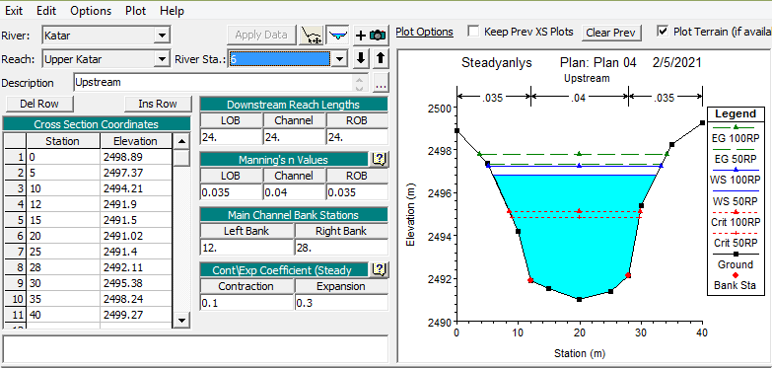
Figure 3.8 River cross sections and some other data’s input in HEC RAS
These slopes are assumed to approximate the respective energy slopes for the purposes of normal depth calculations. Others Input data for the models included stream XS and hydraulic-structure geometries, recommended RP based peak discharges and roughness coefficients were also used wisely. Some of those collected data and their method of collections are described in the following consequent sub sections. Rating curves, hydraulic properties like; energy grade line slope and elevation, flow area, velocity and cross sectional view of flow profiles, which shows the extent of flooding were then gained from the analysis.

River Cross-sections
River cross XSs data (Appendix H) around the Bridge location upstream and downstream were collected from site survey. These were accompanied at an interval of some preferable distance (7m-24m) along a stream.
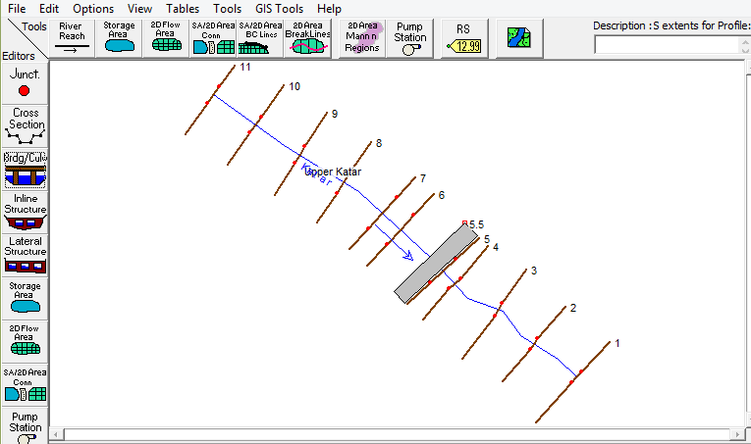
Figure 3.9 Schematic view of River segment upstream and downstream of the Bridge site
River floodplain data such as length, elevation, and distance between successive River cross-sections were also collected by the same manner as River channel data. Four user defined XSs and additional XSs both upstream and downstream are necessarily collected as the aim is to conduct WSP not to affect hydraulic results.

Manning Roughness Coefficient:
Channel and flood plain roughness is most sensitive parameter in development of hydraulic models for peak flood runoff forecasting and inundation mapping (Prabeer, 2013). It may be affected by many factors and its selection in natural channels depends heavily on land use type covering the River and the floodplain area. Its Selection is critical to the accuracy of computed WSPs and is of key importance in the study of open- channel flow particularly in hydraulic modeling. It is also, essential to calibrate the channel roughness coefficient by comparing the computed WSPs with observed one if available (Awad, 2016). But because of absence in observed flow data near the site, recent site visit to collect “n” was conducted in this study.
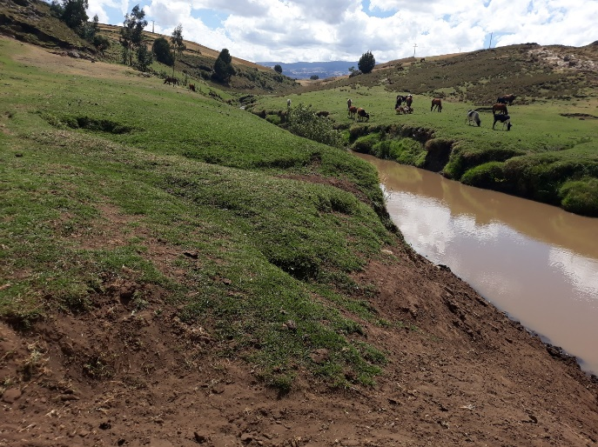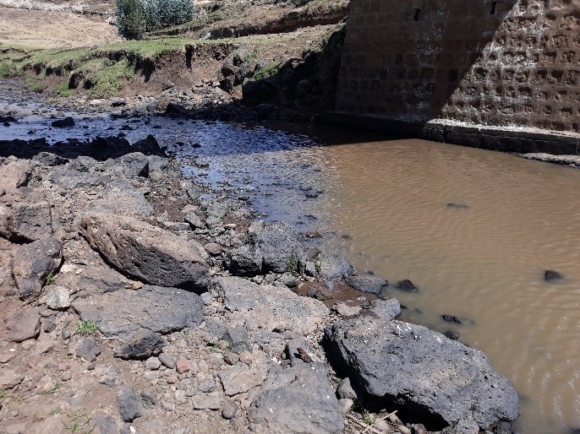
n= 0.035 (a) n= 0.04 (b)
Figure 3.10 Image of manning roughness coefficient for channel (a) and over bank (b)
Using both ERA and HEC - RAS user manual guidelines, the manning ‘n’ value for XSs were selected from the Tables based on bank land cover types and River bed material. The values were selected based on information taken during site survey and be 0.035 for channel to 0.04 for both over banks.

Bridge Geometry Data
Bridge geometry data such as span length, opening size and abutment dimensions were collected. It was stated in HEC – RAS guide lines that, two Bridges close to each other on the same stream should be modeled as one structure.
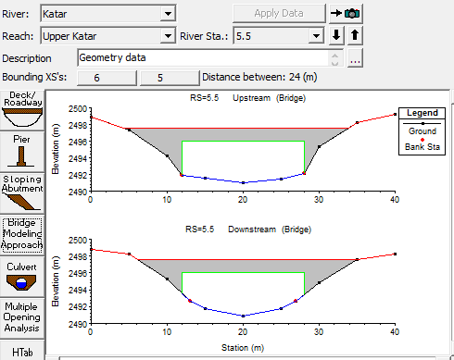
Figure 3.11 Bridge Deck/Roadway data editor cross-section output
This criteria is mainly based on the distance between the two successive Bridges of which flow transition losses are not considered. Hence, in the case of Bridge under this study, there were no considered flow losses between foot and vehicle Brides. The Bridges far apart only 4m from each other and the foot Bridge located at upstream. Collected data are presented in Appendix I at the end of this document.

Hydrological Investigation
Next to data processing, catchment area delineation and determination of catchment parameters (catchment area, stream length, HSG, LU/LC, CN) and rain fall data analysis were accompanied sequentially. Then, determining the design and review peak flood discharges by using statistical, SCS CN and Rational methods based on area difference were conducted. Figure 3.12 summarizes the procedural step of hydrological investigation conducted in this study.

Figure 3.12 Procedural stepwise methods of hydrological analysis

Delineation of Catchments
There are several tools used for water shed delineation such as arc hydro tools, Arch SWAT; HEC-Geo HMS; Map Windows; Quantum GIS; Global Mapper; Arc GIS and others (ERA, 2013). Arc Hydro tools with the help of ArcGIS 10.3 using the DEM (30m x 30m) were used for this study (Section 2.3.1). Topo map was used and delineated catchments were superimposed with Topographic Map and checked for reliability. The watershed catchment area at the structure crossing location as an outlet and its elevation varieties from high to low were identified.
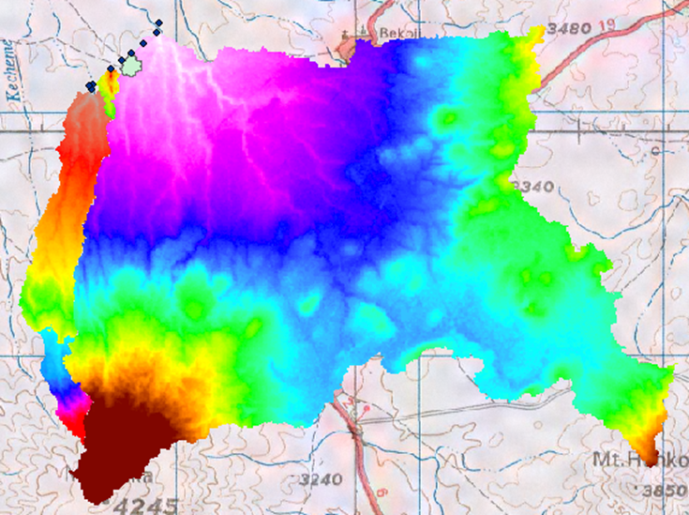
Figure 3.13 DEM superimposed over topographic map of study area

The steps followed for watershed and stream network delineation after DEM processing are:- fill sink, flow direction, flow accumulation, stream definition, stream segmentation, catchment grid delineation, catchment polygon processing, drainage line processing, joint catchment processing, drainage point processing, batch watershed delineation and slope generation.

Computation of Catchment Parameters
After the catchment area delineation, catchment properties like stream length are determined from the stream network generated by Arc view while the land use coverage , soil type and curve number are computed using Arc view spatial analyze from the digital GIS map of Ethiopia. Percent of the catchment cultivated, covered by urban and scarcely distributed open woods was identified. Different types of soils found in the water shed whether it is Eutric Nitosols or Vertic Luvisols of which dominant and which covers more percent of the total soil coverage as described in the section of study area were purely identified.

Estimation of Areal Rainfall
The rainfall data from different gauging stations near and/or in the area under the study was used to develop meteorological model that calculates precipitation inputs for the area. Real estimation of precipitation which is taking mean precipitation around an area of the total precipitation and its distribution within a watershed was accompanied by Theissen polygon method. It is accompanied by drawing perpendicular bisectors around each station and computing weightage area and precipitation (Subrmanya, 2008). ArcGIS tool can calculate weighted mean rainfall easily and it was used in this study. By the chance the project area lied only in one station of Bokoji, because of the others stations are far and can’t considered in averaging method of Theissen.

Data Distribution Fitting Process
There is a need for data fitting process in the cases of lack information about base distribution pattern of collected data. It involves using certain techniques which allow us to estimate fitness parameters in accordance to data sample. Easy fit program has the ability to automatically fit data with a variety of known distribution patterns simultaneously and desire to find the best distribution type. It is a data analyzer and simulation software which allows us to fit probabilistic distributions to given data samples, simulate them, choose the best fitting sample, and implement the results of analysis to take better decisions (Hossein & Alireza, 2014). Hence, this program was used to analyze data samples.
Frequency analysis has been accompanied for 31 year from (1987-2018) rainfall data using easy fit software and Gumbel method is the best fit statistical analysis from the most known and commonly used methods in hydrology. Generalized Extreme Value Distribution (GEV), Gumbel and Log Pearson type III distributions for the design rainfall of the project area are the most widely used methodology in probability analysis (McCuen, 2002).
The other reason why Gumbel distribution method was selected to perform the flood probability analysis is that, the method is most widely used for IDF analysis owing to its suitability for modelling maxima. Simplicity in relative to others and uses only extreme events maximum values or peak rainfalls make it selectable for such kind of analysis (Munshi et al., 2016). Mathematically the expression of random value (X_{T}) in Gumbel method taken from McCuen (2002) and used in this study is as follows.
……………………….………………………….……...…………….…… (3.2)
Where: X_{mean} is mean of observations and given by
………………...……………………….…………....…………………. (3.3)
K_{T} is frequency factor related with return period and given by K_{T} = - $\frac{\sqrt{6}}{ π}$[0.5772 + ln (ln ($\frac{T}{T-1}$))]
Sn is standard deviation from mean value of the observations; $Sn=\frac{1}{N-1}\sum_{i=1}^{n}{{(Xi-Xmean)}^{2}}$

Intensity Duration Frequency Curve Generation
It is recommended to develop IDF curve of any required duration to be used in peak discharge determination. After annual maximum rainfall depth over the specific durations commonly used for drainage is determined from every year of record, the theoretical distribution (Gumble) was used to estimate the rainfall events associated with given exceedance probabilities. Figure 3.14 shows procedural stepwise methods used in developing IDF curve.

Figure 3.14 Procedural method for IDF curve generation
Based on ERA’s formula (Equation 3.4), rainfall intensity at any required time was computed using the 24hr rainfall depth. The ERA regionalized map (region A3) to derive the rainfall intensities was compared to the developed IDF for the area under the study that was utilized in the SCS Model.
$R_{Rt} = \frac{t{\left(b+24\right)}^{n}}{24{\left(b+t\right)}^{n}}$……….……………………………………......………………………….. (3.4)
Where: R_{Rt} = Rainfall depth ratio Rt: R₂₄, R_{t} = Rainfall depth in a given duration’t’
R₂₄ = 24 hr. rainfall depth, b and n are constants, b= 0.3 and n = (0.78-1.09)

Calculation of Concentration Time
Slope and surface character can vary the time required for runoff to travel from the hydraulically most remote point of the watershed to the outlet. In a great variations of such factors it is calculated by adding the time for each type of flow along the flow path from the watershed divide to the watershed outlet. When runoff is not uniformly distributed, the watershed can be subdivided into areas with nearly uniform flow in which slope and flow length are the most driving factors (USDOA, 2008). The time of concentration for the structure crossing was identified using the following formula taken from ERA (2013).
- Overland Flow
In drainage system design, the overland flow path is not necessarily perpendicular to the contours shown on available mapping. Often, the land was graded and swales and streets will intercept the flow that reduces the time of concentration. Care should be exercised in selecting overland flow paths in excess of 60 m in urban areas and 120 m in rural areas. This flow occurs in small, flat or in upper reaches of catchments, where there is no clearly defined watercourse. The following formula is recommended for the calculation of Tc in this case. It is only applicable to parts where the slope is fairly even (ERA, 2013).
$T_{c}={0.604(rL/s}^{0.5})^{0.467}$……………………………………………………….………… (3.5)
Where: T_{C} = time of concentration (hours)
r = roughness coefficient obtained from Table.
L=hydraulic length of catchment, measured along flow path from the catchment boundary to
the point where the flood needs to be determined (km)
S=Slope of the catchment which is given by S =H/1000L (m/m)
H =height of most remote point above outlet of catchment (m)
- Defined Watercourses
In a defined watercourse, channel flow occurs. The recommended empirical formula for calculating the time of concentration in natural channels was developed by the USSCS.
$T_{C}=(0.87L^{2}/1000S_{av})^{0.385}$…………………………………...………...………………. (3.6)
Where: T_{C} = Time of concentration (hours).
L = hydraulic length of catchments measured along flow path from the catchment boundary to the point where the flood needs to be determined (km) and Average slope S_{av} (m/m) is given by
$S_{av}=\frac{H_{0.85L}-H_{0.0L}}{1000*0.75L}$……………………………………………………………..…………… (3.7)
Where: H 0.10L = elevation height at 10% of the length of the watercourse (m)
H 0.805L = elevation height at 85% of the length of the watercourse (m)
L = length of watercourse (km), H- elevation height = H 0.805L - H 0.10L (m)
The longest path includes both overland and channel flow in most cases of concentration time determination. But, the channel flow is usually dominant in large catchments and the sum of flow times for overland and channel flow is necessary to determine Tc in small catchments. When the average slope of the catchment is greater than 5% and the catchment itself is larger than 5km², a defined watercourse exits to be enough for time of concentration (ERA, 2013).
Because of the need for surveying in calculating elevation at 10% and 85% of the longest flow path it was difficult to conduct such survey in large catchments. In this case watershed with large catchments was divided into sub catchments based on length and slope similarity. And then catchment characteristics such as elevation and longest flow path are determined and slope was calculated for each divided catchments. Then, the weighted average slope (S_{av}) was found and taken as the slope for the whole catchment to minimize error in calculating time of concentration. The analysis slope and concentration time are shown in Appendix D.

Peak Discharge Estimation
Based on area of catchment and assumption behind derivation of the formula ERADDM recommends different methods and those methods were used in this study. Out of these methods, rational method for area less than 0.5km², SCS curve number method for area less than 65km² and statistical method for more area were used. But, because of lack of stream flow data at the structure location, result from statistical method for area greater than 65km² based. This includes consideration of the road standard and the design life span of the structure, intensity and duration of a peak rainfall event, peak event frequency, life of the road, traffic, and consequences of failure. Primary highways often incorporate frequency periods of 50 to 100 years secondary roads 25 years, and low volume rural roads 10 to 25 years (ERA, 2013).
- Rational Method
Using rational method which is applicable and recommended for area of less than 50 hectares for frequent storm of return period the formula used in this study was taken from ERA (2013). Drainage design manual which is written as Q = 0.00278CIA. In which, Q = maximum rate of runoff, m³/s, I is Intensity in mm/hr for duration equal to time of concentration taken from the developed IDF curve. A is catchment area tributary to the design location in hectare taken from topographic map with the help of GIS. C is runoff coefficient representing a ratio of runoff to rainfall taken from ERADDM table recommended runoff coefficient for rural catchment. The value of runoff coefficient depends on many factors such as slope, permeability of soil and vegetation type. Hence, the slope is found between 3.5-10% (Cs = 0.1), fair drained soil type of permeability (Cp=0.1) and cultivation (Cv = 0.2) was described for the catchments under the analysis. The results for peak discharges were shown in the Table 4.5.
- SCS-CN method
The method is most suited for computing flood peaks and run of volumes for catchments smaller than 65km², with slopes of less than 30% and a time of concentration less than 10 hours as recommended in ERDDMM. But, in the absence of flow data it is also suited for larger area as described in section 2.3.4 above. Hence this method was also used and checked for consistency with stream flow data found at far downstream. In the steps followed in this method, concentration time determination and catchment characteristics (area, LU/LC, HSG, CN) identification were first tasks. Then, 24 hour rain fall depth and ratio of initial abstraction to runoff depth continued with unit peak flood and peak discharge were. The equations of peak runoff estimation used in this study was taken from ERADDM.
………...…………………………………...……………………………. (3.8)
Where: Q_{PEAK} = accumulated direct runoff in mm and S = potential maximum retention, mm.
P = accumulated rainfall (potential maximum runoff), mm
Ia = initial abstraction including surface storage, interception, infiltration prior to runoff in mm. The relationship between Ia and S was developed to remove the necessity of estimating Ia in the SCS runoff equation is: Ia = 0.2S and Substituting 0.2S for Ia in, the equation becomes
…………………….……………………………………………...……….. (3.9)
In the SCS method S is related to the soil and cover conditions of the catchment area through the CN which has a range of 0 to 100 and in SIU, S is related to CN by:
………………………………………………………………….………. (3.10)
Then, the following equation were used for the estimation of the peak discharge in the method
$q_{p}=q_{u}AQ_{PEAK}$……………………………………………………………….…………. (3.11)
Where: q_{p} = peak discharge, m³/s A = drainage area, km²
q_{u} = unit peak discharge, m³/s/km²/mm Q_{PEAK} = peak depth of runoff, mm
The unit peak discharge is obtained from the following equation, which requires the time of concentration (t_{c}) in hours and the initial abstraction rainfall (I_{a}/p) ration as input:
$q_{u}= {∝10}^{c_{0}+c_{1}logt_{c}+c_{2}{\left(logtct_{c}\right)}^{2}}$…………………...……………………… (3.12)
Where: C₀, C₁ and C₂ = regression coefficients given taken from table for various I_{a}/p ratios their results shown in Appendix E and ∝ = unit conversion factor equal to 0.000431 in SI unit.
- Statistical Method
There is no single method for determining peak discharge that is applicable to all watersheds. It is the researcher’s responsibility to examine all methods that can apply to a particular study area and to make the decision as to which is the most appropriate. Though any hydrologic analysis is only estimation, there are many hydrologic flow estimation methods. If possible, the selected method should be calibrated to local conditions and verified for accuracy and reliability. Consequently, the designer must be familiar with the method sources of the various methods and their applications and limitations (ERA, 2013).
There is lack of stream flow data availability near the structures in the area of interest. Hence, the most applicable peak discharge estimation methods were used to estimate peak flood discharges at selected locations along the road route. Purposely, SCS CN method of discharge estimation was used and compared with available data for the sake of consistency. But, at far downstream on the same river hydrological data were collected and used to check reliability of peak discharge estimated from other methods.
The maximum annual stream flow data of Katar River at Fite near Sagure gauging station obtained from the MoWIE for the period of 1983 to 2007 were subjected to flood frequency analysis. Out of the most known and usable probability distribution functions in Hydrology such as Gumble maximum distribution (Extreme Value Type I), Lognormal and Log Pearson Type III, Log normal was used for this analysis. Easy fit program was used to determine the best fit flood frequency distribution analysis to be utilized for safe design (Appendix F). The method was used to predict corresponding peak discharge estimates at different return periods to check the reliability of estimated flow rates.
Equation 3.13 by McCuen (2002) of lognormal distribution method was used for this study.
$logY_{T}=\frac{1}{n}\sum_{n=1}^{n}{logY+{Kσ}_{logY}}$……………………………………………...………… (3.13)
Where: Y = Random variable and n = number of data K = standardized normal variate
Y_{T} = Required variable value at duration σ = Standard deviation
The observed annual maximum discharge values have been transformed to log values (Appendix C) for subsequent analysis using lognormal distribution. Excel spreadsheet was used to transform data to logarithm, calculate mean, standard deviation. The values k were taken from Table and skew equals zero for lognormal distribution. But, there is a need for hydrological homogeneity to transfer data from one basin to the other. There are many stream diversions and hydrological differences as it goes from highlands to lowland.
Also due to peak discharge estimation is based on many factors only discharge area based data transferring is not considered accurate in large hydrological characteristics differences (section 2.3.4). Errors in the estimates will result in a structure that is either undersized and causes more drainage problems or oversized costs more than necessary. Therefore the result from this analysis was used for comparison purpose.

Hydraulic Modeling
The hydraulic analysis model of latest version HEC-RAS 5.0.7 was used to determine steady-state water-surface profiles based on the peak discharges determined in the hydrologic analyses. The existing Bridge crossing Katar River of which largest watershed was modeled in HEC-RAS using the design flows of 50 years and check flows of 100 years RP. It is stated in HEC-RAS that, the system can handle a full network of channels, dendritic system or single reach.
In all case it is capable of modeling subcritical, supercritical, and mixed flow regime WSPs. For Rivers with simple geometry and preferably with a single Bridge, the HEC-RAS one-dimensional software is presented as the best alternative of use due to the ease of data entry, providing reliable results in a shorter time (Carlos et al., 2017). River channel slopes were also small in value less than one to ten ration and hence steady 1D flow analysis were selected. Any steps followed and written in this document about modeling with HEC-RAS was taken from the manual. The Bridge was modeled following five main steps in creating hydraulic model. Those are; starting a new project, entering geometric data, entering flow data and boundary condition, performing steady flow analysis in mixed flow regime and viewing result.

Selection of Flow Regime
Flow in an open channel can be classified as the flow parameter depth and velocity change based on time (steady or unsteady), space (uniform or non-uniform) and flow regime. In flow regime classification which was used in this study, the dimensionless fraud number is utilized. Flow regime is said critical when fraud number equals unit, supper critical when it exceeds unit and sub critical when it is less than unit (Chow, 1988). These three flow regime options; subcritical, supercritical, and mixed flow (both sub and supercritical) can be used for computing a steady flow run (USACE, 2016). Most Bridges are designed for subcritical flow conditions in order to minimize scour and fill passage space problems (Novak et al., 2007). The model was run for mixed flow condition because, RAS will select the one that has the higher specific force value, compute both a subcritical and supercritical profile and anywhere there is a valid solution for both regimes as described in section 2.4.3.

Boundary Condition and Discharge Information
Boundary conditions are important to establish starting water surface at the ends of both upstream and downstream River system for the program to begin calculations. It must be entered at all ends of the River system as it mainly based on flow regime of which mixed regime was selected in this study. The limits for XSs data collections upstream and downstream is that, to prevent effects of the channel configurations on existing condition and user defined boundary on the results of model respectively. Normal depth boundary condition was selected and require energy slope gained from average slope of the channel. The slope value was taken by averaging the slopes between successive XSs.
In addition to boundary condition, at least one flow value should be added for all XSs upstream of the structures of interest being modeled. Peak flow discharge gained from hydrological analysis was used in this study. Water-surface elevations for the crossing was established using the normal depth (slope conveyance) option in the model.

Steady Flow Simulation
Steady flow analysis of WSPs need to be addressed at the location of the structure to ensure safety of the drainage structure. It was used in calculating WSPs for steady gradually varied flow. Obtaining geometric data’s (cross sections) and manning roughness coefficient recently from field survey make the analysis very close to reality. Once, the XSs determined using preferable return period peak discharge obtained, the hydraulic calculation was accompanied. WSPs were computed from one XS to the next by solving the energy equation. The computation is basically based one dimensional energy equation (3.12) with an iterative procedure called standard step method.
Energy losses are evaluated by friction (manning’s equation) and contraction/expansion coefficient multiplied by the change in velocity head. On the basis of this computation, adequacy of the existing structure was calculated for estimated peak discharge of recommended RP. Based on the HEC-RAS model result of existing structure analysis, overtopping depth and scouring depth was computed in the analysis. Equation of Froehlich has been used as per the recommendation from the HEC RAS in modelling the scour at the banks.

Conveyance Capacity of the Structure
In order to determine the water surface elevations at different XSs in a channel, the flow rate and velocity must be known or calculated. For River hydraulic analysis, a steady gradually varied flow assumption is often used for both subcritical and supercritical flow regimes. Steady gradually varied flow applies to flow in which changes in flow depth and velocity occur gradually over a considerable length of channel. The discharge (Q) in channel is determined from manning equation (equation 3.14). An additional margin of safety up to 30 percent increment in design discharge for area less than 500km² is provided in the fixation of freeboard to take care of the unexpected flood intensities (Novak, 2007). And hence, greater than 1.3 safety factor was used as oversized structure in this study.
Q = AV = (1/n) AR^{2/3}S^{1/2}………………………………………………...………………. (3.14) Where: A= Cross sectional area
R = Hydraulic radius (m) =A/P while, P = Wetted perimeter
n = Manning roughness coefficient
S = Average slope between adjacent cross-sections
For determination of conveyance, the cross-section is subdivided based on manning coefficient. The model measures the effect of channel roughness on the flow of water in the left overbank, main channel, and right over bank. The conveyance (K in (m^{5/3})) for each subdivision is then calculated (K = (1/n) AR^{2/3}). The total conveyance for the cross-section is obtained by summing the individual subdivision conveyances (USACE, 2016). HEC-RAS model computes WSPs from one XS to next by solving energy equation with iterative approach procedure called standard step method. The energy equation is written as equation 3.15.
……………...……………………...….…… (3.15)
Where: Z₁, Z₂, = Elevation of main channel inverts g =gravitational acceleration
Y₁, Y₂= depth of water at XSs and α1, α2= Velocity weight coefficient
V₁, V₂= average velocity he = energy head loss
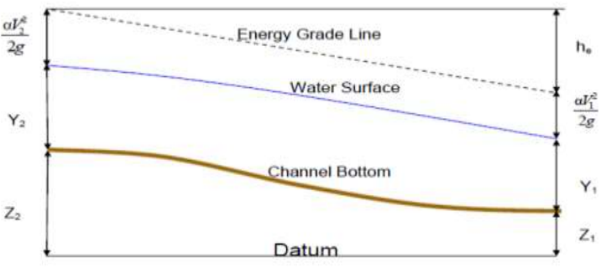
Figure 3.15 Steady uniform flow in an open channel (source: HEC RAS, 2016)

Assessing Sources of Structures Inefficiency
The initial site survey during identification of problem indicated the range of problems that encountered and shows need of measures to mitigate the problems. to identify the sources of problems that have led to pavement distresses and inefficiency of road, identification of current situation through survey, discussion with local land owners about vulnerability of the problem and evaluation of the existing condition at the inlet and out lets of structures was conducted. But design, type and size of remedial measure structure need more investigation which was not conducted in this study. In more general terms, sources of inefficiency was assessed mainly based on the result from hydrologic and hydraulic analysis, local population about historic event, direct field survey. The assessment was conducted in selected road crossings; Katar River Bridge and some stream crossing culverts found along the route.
The other way of inefficiency source assessment is modeling. For instance scouring and sedimentation can be modeled in HEC-RAS. Sediment transport modeling assumes quasi-unsteady flow, in which sediment data (bed gradation) and quasi-unsteady flow data (flow series data and water temperature) are needed (Gautam, 2016). Because of absence in gaged data in any of the study areas, in addition to the need for more investigation about the bed gradation, this type of analyses was not conducted in this study.
The general frame work of methodologies including collected data, used models and process conducted in the study is shown in Figure 3.16 below. The frame work shows summarized flow of works as the detail descriptions were established in the body part of this chapter.
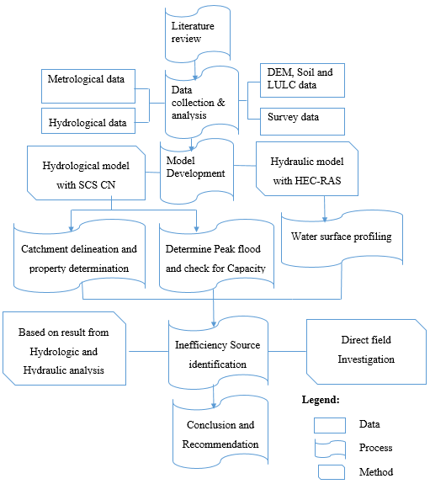
Figure 3.16 Conceptual framework of methods and processes of the study

RESULT AND DISCUSSION

Hydrologic Investigation
The results of hydrologic investigation in this study were presented in the form of Table and charts in the continuous sub-sections below. The results were also discussed separately as they are used thoroughly to get peak rate of runoff flow used in determination of adequate enough structure capacity. The analysis were based on reliability, consistency and accuracy of parameters (section 3.2.1) as mistakes in one factor determination can cause underestimation or overestimation of peak discharge. The results presented in sub-sections includes hydrological factors such as, rain fall intensity, catchments area, CN factor of LU/LC, HSG, slope and T_{C}.

IDF Curve
The IDF curve results of rainfall depth and intensity found using Gumble method were given in Table 4.1 and Figure 4.1 respectively being compared with the result of ERA-24 hours value.
Table 4.1 Rain fall depth compared with ERA’s rainfall depth for region A₃
RP (years) | K_{T} | Mean (mm) | S_{D} | P (mm) | ERA P (mm)
2 | -0.164272 | 47.55 | 10.46 | 45.84 | 47.54
5 | 0.7194574 | 47.55 | 10.46 | 55.08 | 59.61
10 | 1.3045632 | 47.55 | 10.46 | 61.20 | 67.66
25 | 2.0438459 | 47.55 | 10.46 | 68.93 | 77.92
50 | 2.592288 | 47.55 | 10.46 | 74.67 | 85.62
100 | 3.1366806 | 47.55 | 10.46 | 80.36 | 93.34
Note: S_{D} - Standard deviation, P – Rain fall depth, RP – Return Period, K_{T} – Frequency factor

Figure 4.1 Intensity Duration Frequency curve developed for study area
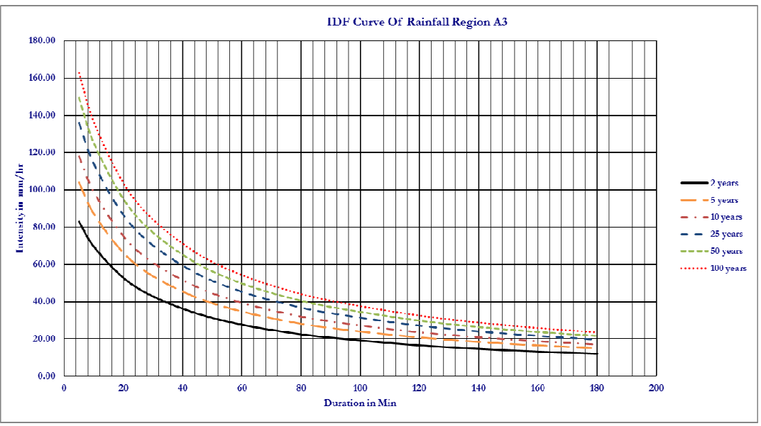
Figure 4.2 Intensity Duration Frequency curve developed by ERA for region A3
The comparison between the results showed some difference that may arise from the way in which the curve is developed and data set used. There is also difference in climatic conditions from large watershed to small catchments. The method gave relatively smaller rainfall intensity estimates compared to IDF developed by ERA. But, the results have the same trend and are very close to each other for most of the return periods and hence consistent. It reasonably assumed that the reason of this difference is because of data variance as this study used data which is recent and specific to the area.
The intensity result gained from generated IDF specifically for the study area (Figure 4.1) were used in this study. This was because of the area for which this analysis was done is larger in scale than that of done by ERA. It was also assumed that, using recent data in developing IDF curve results better estimation of discharges than that of used by ERA.

Watershed Area and other Catchment Characteristics
The DEM based method applied in ArcGIS 10.3 resulted the area under the study as four streams that were delineated as catchments (Figure 4.3). Three side drains pipe culverts are also crosses the road path in the selected route. Total of 7 structure points’ crosses the selected 5km (Katar -Kubsa) road route. Some of catchments areas specially those drains to side drain are very small and not appears in Figure. All of these catchment areas drain the surface runoff toward Katar River at far downstream of the study area and then enter Lake Ziway. The catchment areas drain to structure points ranges from 0.34km² to 304.24km² with about 46.42km longest flow path. Catchment that drain to Katar Bridge crossing was found the largest one in area. Diversity in hydrological property also increase as catchment area increase. Thus, it is selected for further hydraulic investigation in determining effect of water from the catchment to the structure point.
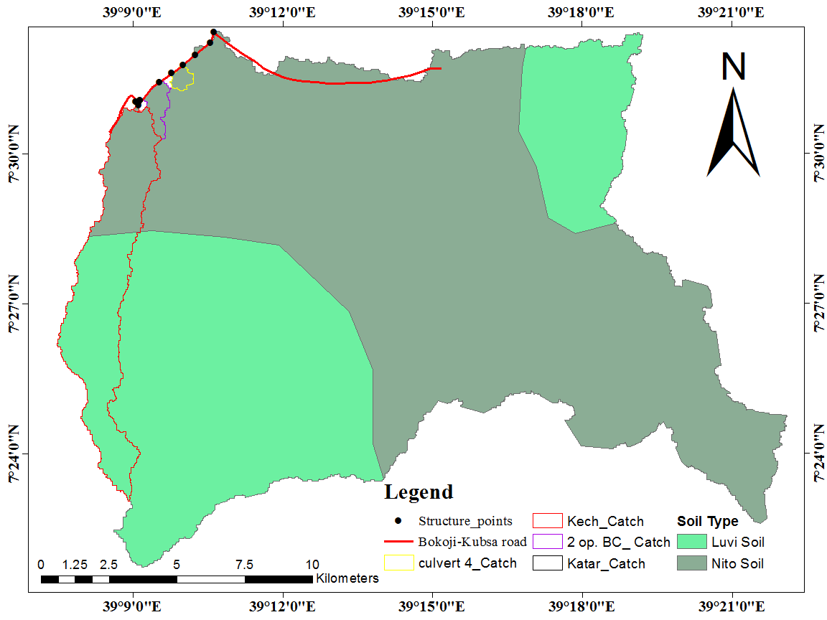
Figure 4.3 Area and soil map result of the catchments drains towards the structure points
Some parameters of watershed those determined from analysis are also presented in Table 4.2. Those parameters resulted from hydrological analysis used in peak flood estimation includes; hydrological soil group, weighted curve number values, initial abstraction and retention. The soil types are Eutric Nito soil and Vertic Luvi soil (section 3.1.3) which are classified under HSG ‘B’ and ‘C’ with CN value of 85 and 90 respectively. The values are taken assuming that Crop residue cover is on at least 5% of the surface throughout the year that consider poor hydrologic conditions factors impair infiltration and tend to increase runoff.
The values are consistent when compared to curve number values analyzed for the water shed by Osore (2018) based on the hydrological database of MoWIE (2010).
Table 4.2 Catchment parameters used in peak discharge estimation by SCS CN method
Catchment | Soil type | HSG | Area (Km²) | CN value | CN_{i} *A_{i} |  | Retention(S) | Initial abs.(I_{a}) | 0.8S
Katar | ENS | B | 197.67 | 85 | 16801.95 | 86.75 | 38.79 | 7.76 | 31.04
Katar | VLS | C | 106.57 | 90 | 9591.3
Culvert 4 | ENS | B | 0.513 | 85 |  | 85 | 44.82 | 8.96 | 35.86
2 op. BC | ENS | B | 1.16 | 85 |  | 85 | 44.82 | 8.96 | 35.86
kechama | ENS | B | 9.1 | 85 | 773.5 | 88.19 | 34.01 | 6.8 | 27.21
kechama | VLS | C | 16.07 | 90 | 1446.3
Note: ENS - Euritic Nito soil, VLS - Vertic Luvi Soil, CN, represents Curve Number, HSG -Hydrological Soil Group, A-Area, Ia- initial abstraction, S-retention, BC- box Culvert

Land use/Land cover Classification
Land use/land cover classification result (Table 4.3) shows that, the major cover type of the area was categorized as agriculture, wood land and urban area. The result indicted that, most of the area under the study which contribute runoff to the structure point as an outlet are dominated by agricultural land. This was because of the area under the study is small watershed more with identical characteristics.
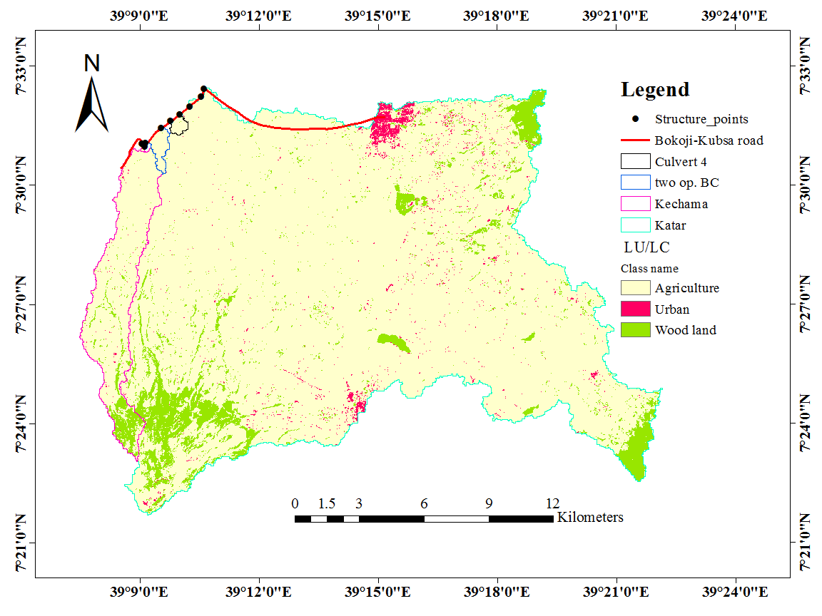
Figure 4.4 Classified Land use land cover of the catchments under the study
The results are consistent that, most recent studies by Nigussie (2018); Osore (2018) and Gurara (2020) on LU/LC of the study area also shows very close output with this. Few of the areas less than 10% of the overall area is covered by wood lands found around the mountains of Kakka and Honkolo. Very small area covered by urban of Bokoji, Kubsa and Marero towns. Densities of impervious cover less than 10 percent of the watershed generally do not affect peak discharges as deduced by ERA (2013). Hence the LU/LC in this study was used as agricultural land assuming it is safe and the result is not affected by other very scarce cover types.

Table 4.3 Land use/Land cover classes of the watershed under the study
Land use type | Area (km²) | Area (%)
Agricultural land | 303.51 | 91.36
Wood land | 24.24 | 7.3
Urban area | 4.46 | 1.34
Total | 332.21 | 100

Time of Concentration
Table 4.4 Slope and Time of concentration for different structures point taken as outlet
Nº | Name of catchment | Catchment area (km²) | L.F/path (km) | Elevation at U/S (m) | Elevation at D/S (m) | S_{av} | Tc₁ (hr.) | Tc₂ (hr.)
1 | Katar | 304.24 | 46.42 | 4213 | 2502 | 0.0504 | 5.51 | 9.53
2 | Culvert 1 | 0.41 | 0.580 | 2574 | 2545 | 0.0500 | 0.61 | 0.14
3 | Culvert 2 | 0.34 | 0.770 | 2586 | 2565 | 0.0273 | 0.81 | 0.22
4 | Culvert 3 | 0.38 | 0.410 | 2587 | 2577 | 0.0244 | 0.62 | 0.14
5 | Culvert 4 | 0.51 | 1.45 | 2601 | 2553 | 0.0533 | 0.74 | 0.19
6 | 2 op. BC | 1.16 | 11.98 | 2653 | 2560 | 0.0078 | 3.91 | 2.91
7 | Kechema | 25.17 | 24.36 | 3989 | 2575 | 0.0550 | 3.4 | 2.37
Note: Tc₁ = Time of concentration for overland flow, Tc₂ = Time of concentration for defined watercourses, S_{av} = Average Slope, BC = Box culvert U/S = Upstream, D/S = Downstream
The slope and Tc are analyzed (Appendix D) and their results are shown (Table 4.4). Some other constants used in the calculations are all taken from ERA (2013) based on the criteria assigned in the manual. Time of concentration results from defined water courses for large area more than 5km² and slope of greater than 5% were used as recommended. Flood magnitude of drainage structures mainly changed based on this parameter as it increases with decrease in time of concentration. Hence, one selected time of concentration based on slope and area was used for safe design and check return period peak discharge estimation.

Discharge Estimation
- Rational Method
The result of peak discharge with parameters for small catchments which determined based on empirical formula (section 3.3.6) indicated in Table 4.5. From those parameters, value of runoff coefficient depends on many factors. Slope, permeability of soil and vegetation type are some of such factors taken from Table of recommended runoff coefficient in ERDDM. Hence, the slope is found between 3.5-10% (Cs = 0.1), fair drained soil type of permeability (Cp = 0.1) and cultivation (Cv = 0.2), total of 0.4 was described for the catchments under the analysis.
Table 4.5 Results for peak discharge calculated from rational method
Structure type | Slope | Tc (min.) | 10yr RP I (mm/hr.) | 25yr RP I (mm/hr.) | Area (ha.) | 10yr RP Q (m³/s) | 25yr RP Q (m³/s)
Culvert 1 | 0.0500 | 36.6 | 56.4 | 64.2 | 41 | 2.57 | 2.93
Culvert 2 | 0.0273 | 48.6 | 46.1 | 52.3 | 34 | 1.74 | 1.98
Culvert 3 | 0.0244 | 37.2 | 55.5 | 60.1 | 38 | 2.35 | 2.54
Note: C-Runoff coefficient, Tc-Time of concentration, RP- Return Period, I-Intensity
- SCS CN Method
As one result depends on the others, peak discharges estimation from this method gained based on results of each catchments hydrological characteristics discussed in aforementioned sub sections. The results from these analysis were also used as input for further investigation of checking hydraulic capacity, hydraulic modeling and some hydraulics of selected structures.
Table 4.6 Peak discharge for design and check return period
Catchment of | Catchment characteristics and peak discharge
Catchment of | A (Km²) | Slope | Tc (hr.) | 25yr RP Q_{p} (m³/s) | 50yrs RP Q_{p} (m³/s)
Culvert 4 | 0.513 | 0.0533 | 0.93 | 2.85 | 3.24
2 opening BC | 1.16 | 0.0078 | 2.91 | 2.95 | 3.35
Kech. Bridge | 25.17 | 0.0550 | 2.37 | 87.85 | 97.8

Note: RP–Return Period, BC – Box Culvert, Tc – Time of concentration, Q- peak discharge
- Statistical Analysis
Analysis of flood discharge values gained from equation 3.13 (Appendix C) and SCS CN methods being compared with each other were presented in Table 4.7. Peak discharge estimation from stream records found at far downstream from area of 1975 km² were compared with peak discharge from SCS CN method. The result of peak discharge from hydrologic analysis at Katar Bridge were found 320.2m³/s and 359.34m³/s for 50 and 100 years return periods respectively. Mohammed et al. (2020) discovered that, the catchment under this study drains more discharge than others catchments in Katar watershed. This may be the reason for discharge values relation in magnitude though the area difference is vast.
Table 4.7 Peak discharge comparison with result from lognormal distribution
T | K_{T} | S_{DlogQ} | K_{T}* S_{DlogQ} | logQ_{av} | Y_{T} | Q_{g}=log⁻ Qp | Q_{CN} (m³/s)
2 | 0.000 | 0.223 | 0.00 | 2.131 | 2.13 | 135.21 | 137.25
5 | 0.842 | 0.223 | 0.19 | 2.131 | 2.32 | 208.34 | 192.34
10 | 1.282 | 0.223 | 0.29 | 2.131 | 2.42 | 261.15 | 230.91
25 | 1.751 | 0.223 | 0.39 | 2.131 | 2.52 | 332.26 | 281.51
50 | 2.054 | 0.223 | 0.46 | 2.131 | 2.59 | 388.19 | 320.20
100 | 2.326 | 0.223 | 0.52 | 2.131 | 2.65 | 446.37 | 359.34
Whatever the magnitude difference in each return periods individually, the discharge results from statistical analysis were used for comparison purpose to check the consistency of the value gained from SCS CN method. Peak discharge results from SCS CN method are consistent with R-squared value of 0.9996. These results of peak discharge were used in hydraulic analysis to check capacity of the structure with the help of HEC-RAS program. The results were also assumed better to use in terms of safety.

Hydraulic Model
The HEC RAS hydraulic model results of existing Bridge crossing Katar River were showed and discussed in continuous subsections below. The results were presented based on 320.2m³/s design flows of 50 years and 359.34m³/s check flows of 100 years Return period. The results of water surface elevations and flow velocity are presented using profile plot.
All the results are also presented in table form in the model and taken as their importance for further discussion of their impact on the structure and surrounding environment. The interpretations and discussions are given based on design discharge as they have the same trend in value with that of check flow rates.

Water Surface Profiling
The result from water surface profiling shows that, the minimum lower cord elevation of the Bridge is 2496m, whereas the resulted water surface elevation at Bridge location are about 2496.82m for 50 year and 2497.26m for 100yr RP peak flow. This indicated that, 0.82m for 50 years and 1.26m for 100 years RP depth of flows raise above lower cord elevation..
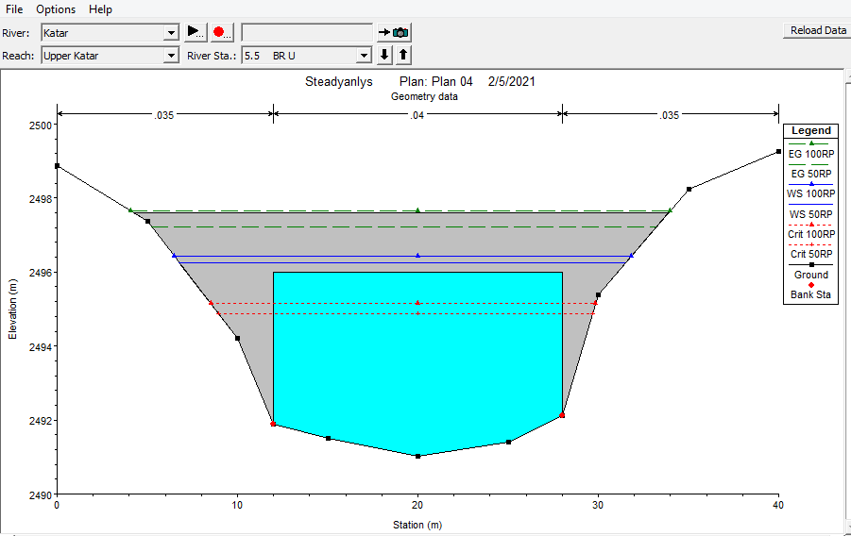
Figure 4.5 The 50 years and 100 years RP peak flood profile for the existing Bridge
The existing Bridge was designed to pass the design and check flows. The obtained WSP in different peak rates at the structure shows insufficiency in capacity of the Bridge to pass the design and check flood flow. Though this may occur once or twice in 50 and/or 100 years, there may be problem of road serviceability during their occurrence and hence, the need for mitigation is in request.

Bridge Hydraulic Computations
The model result from hydraulic computations shows that, the Bridge has total opening area of 67.67m² with depth of 5.00 m. But, flow area upstream of the structure was found about 96.26m² with hydraulic depth of 5.82m which is larger value than Bridge height even for design discharge. It also shows changes in values of fraud numbers which determine the flow regime from 1.14 some distance upstream to 0.46 just near the Bridge upstream and 0.61 inside the Bridge for design discharge rates. This value indicate the flow transition upstream from supercritical to sub critical which are mixed high flow. Upstream of the Bridge the flow is super critical as critical depth were found above normal depth.
Hence, the flow behaves rapid or unstable state as supercritical flow transitions to subcritical through a hydraulic jump represents a high energy loss with erosive potential (FishXing, 2006). But, subcritical flow is recommended for Bridge design to prevent scour (Novak et al., 2007). It is also seen that the River side erosion quit upstream of both side abutment were caused and can be taken as an evident (Appendix K). Slope adjustment is suggested, even though need to design the Bridge to low flow classes of subcritical regime. This is to have flow below the low chord to avoid such flow disturbance upstream and to reduce the River channel erosive potential of the flow energy.
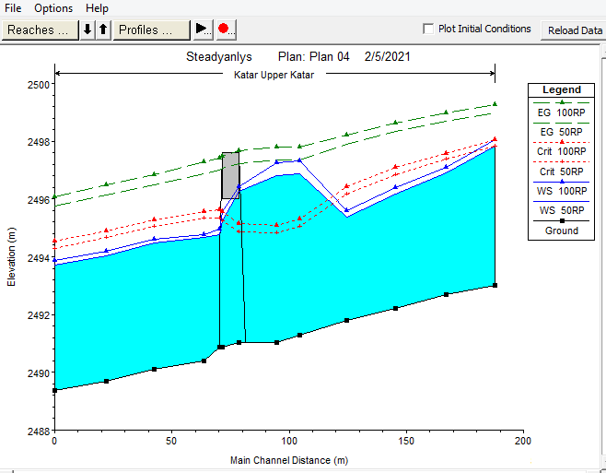
Figure 4.6 Longitudinal flow profile ponding just upstream of the Bridge
There are also more than half reduction in velocity at upstream XSs (Figure 4.7) as the flow approach to the structure. The velocity profile inside, just upstream and downstream of the bridge where flow losses occurs indicates reduction in value for about 60m distance. This can also be an evident to show that, the structure is restricting the movement of water and reducing the velocity. This may lead the flow to pond back (Figure 4.6) and cause River scour upstream of the structure location. The abrupt change in the velocity from upstream to downstream may affect the River bank up stream of the Bridge (Gautam, 2016).
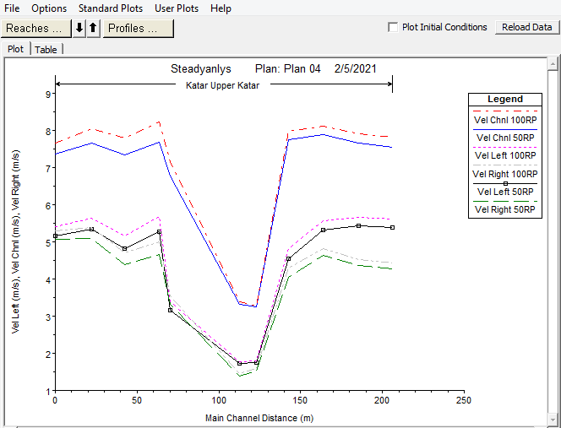
Figure 4.7 Change in velocity from upstream as flow approaches the structure

Adequacy Assessment
The result of Adequacy assessment based on equation 3.14 were shown in Table 4.8. The concept mainly based on structures dimension regardless of other surrounding factors such as channel and flood plain characteristics. But, for large structures like Bridges it is not enough to check structure capacity only based on its geometry. The results from adequacy assessment in this method shows that most of the structures except Katar Bridge found adequate and some oversized in terms of design capacity to pass peak flood runoff rate coming from upstream.

Table 4.8 Adequacy analysis using manning conveyance equation
Structure Name | Type | Span length (m) | Design/Check RP(year) | Design/Check Qp (m^{3/}s) | Conveyance  (m³/s) | Adequacy
Katar Bridge | Br. | 16 | 50/100 | 320.2/359.34 | 245.21 | Inadequate
Culvert 1 | PC | 0.8 dia. | 10/25 | 2.57/2.93 | 3.25 | Adequate
Culvert 2 | PC | 0.8 dia. | 10/25 | 1.74/1.98 | 2.3 | Adequate
Culvert 3 | PC | 0.9 dia. | 10/25 | 2.35/2.54 | 3.15 | Adequate
Culvert 4 | BC | 5.4 | 25/50 | 2.34/2.85 | 7.25 | Oversized
2 op. BC | BC | 6.4 | 25/50 | 2.95/3.35 | 25.29 | Oversized
Kech. Bridge | Br. | 8 | 25/50 | 91.11/102.6 | 106.88 | Adequate
Note: Br - Bridge, PC - Pipe Culvert, BC-Box Culvert, Q_{p}-Peak discharge, RP- Return Period
But, blockage by sediment accumulation reduce opening and bank erosion causes inefficiency and inadequacy of structures. In comparison to manning conveyance concept of adequacy assessment, the result from hydraulic analysis of HEC RAS model was taken as the best description of Bridge capacity. This is because of factors in consideration of the model simulation process are slope, manning roughness, elevation, location of structure alignment and estimated peak discharge of flood plain and the channel. The model simulates WSPs by computing conveyance between each XSs. It also computes more hydraulic property of structures and River channels both upstream and downstream of the structure in addition to water surface profiling. Hence, it is better for understanding of structures hydraulics and their effects on surrounding effects.
Inadequacy of the structure to accommodate the design and check flood flow arises from lack of HHA during the design phase. Absence of full data in both HHA can also lead such a problem as it stated by ERA that, “Previously, the drainage structure in our country was constructed by judgment due to lack of hydrological data.”
Due to an inadequate opening of the Bridge for both design and check return periods flow rates, channel erosion quit upstream abutment at both River side and width increment due to back water is observed (Appendix K). Hence, the Bridge capacity is found inadequate to accommodate the estimated peak discharge directed to the structure due to selected storm events. Provision of additional opening area to accommodate the coming flood in case of in adequacy may be costly. However, possibility in slope reduction upstream may reduce flow abrupt but, the need for additional investigation is pointed.

Sources of Structures Inefficiency
The following result of inefficiency sources assessment from individual structures but, described both as specific and in general as its importance.
The reduction or decrease of clear opening height or the reduction of effective flow area due to sediment deposition around the structures locations were found the reason for inefficiency of most drainage structures. Lack of proper maintenance which is most common causes of poor drainage, force the water to enter the pavement from the sides as well as from the top surface especially during rainy seasons. Consequently, the top layer gets detached from the lower layers because of open graded gravel layer. These also cause erosion of road pavements and ponding of water on the road carriageway. Hence, inefficiency and traffic interruption was caused as the result of continuous problem.
The flow velocity at the outlet of the roadway drainage should not exceed the erosive velocity of the channel or the natural velocity of the channel. But, it was assessed that greater high velocity and absence of energy dissipater cause downstream gully formation due to outlet erosion at structure culvert 1. This was the reason for loss of farmers land up to 60m long downstream and average depth of 3m and width of 3.5m that gained from direct field measurements.
Blockage at outlet by downstream land owners is seen and it cause ponding of water back at inlet and then on road carriage. Consequently, damage of side drain and road embankment, washout of pavements and cause for traffic interruption at culvert 2 and 3 was the result of assessment. Slope flatness at the structure location continuously some distance downstream and upstream of the structure is seen at culvert 4.
Then, Mixture of sediment and vegetation riparian from the watershed cause sediment accumulation and blockage of structure at this location. About half in reduction of culvert height as only 0.5m opening size out of 1 m depth of the culvert was measured. Box Culvert with two opening and Kechama Bridge were the only two structures safely functioning from the selected structures found on the route.
The general over view of assessment and mitigation measures were summarized in Appendix J. Water shed management, River training, use of energy dissipater and riprap can be used as mitigation measures. But, the first two may take long term activity to reduce the problem found on the site today. Hence, upgrading and use of energy dissipater for outlet erosion and riprap to reduce upstream abutment scour can prove the problem immediately.

SUMMARY AND CONCLUSION

Summary and Conclusions
The present study evaluates hydraulic performance of cross drainage structures found along Bokoji to Kersa road by using hydrologic and hydraulic models. Various data (Spatial, metrological, hydrological and survey data) were collected from different sources to develop the models. The hydrologic characteristics influencing performance of drainage structures such as; rain fall, LU/LC, HSG, slope and time of runoff concentration were analyzed. In the process, to meet the objective set, SCS CN, HEC RAS, Arc Hydro tools and Arc GIS were used in the characterization and determinations of such factors. IDF curve generation, peak flow rate determination, adequacy assessment, inefficiency source identification and steady flow simulation were conducted as the part of investigation.
Based on the result and discussion reached, the objective has been met. It has been seen that, steady flow simulation using HEC RAS gives clear hydraulics of drainage structures adequacy, safety and efficiency. It was also realized that factors like rain fall intensity, CN element of LU/LC and HSG, slope and time of runoff concentration greatly affect runoff magnitude. The hydrologic and hydraulic responses of the most structures shows sufficiency to accommodate estimated peak runoff when compared to design size of the structures while some others are inadequate. Particularly, Katar Bridge has insufficient size to provide accommodations to peak design and check flows of 320.2m³/s and 359.34m³/s respectively. The minimum lower cord elevation of the Bridge is 2496m, whereas the resulted water surface elevations are about 2496.82m for design and 2497.26m for check RP peak flow. This also indicates inadequacy and the accuracy of simulation by using HEC RAS through water surface profiling is reliable.
Other key findings of this study are that, decrease in opening size of most drainage structures due to sediment accumulation and gully erosion at outlets led to reduced function. The outlet velocity of flow for the drainage structures at culvert 1 is erosive, Culvert 2 and 3 are blocked with large gravel sediment at outlet and culvert 4 opening was reduced due to debris accumulation. Only two structures (Box culvert and Kechema Bridge) are safely functioning out of seven structures found on the selected route. Thus, the major sources of such inefficiencies were found a problem of sedimentation and erosion that arises from movable vegetation riparian, blockage by downstream land users and high velocity case. Consequently, traffic interruption, frequent operation and maintenance which is costly and loss of farmers land by gully formation were caused by inefficiency. Hence, erosion protection, slope adjustment and removal of accumulated debris based on identified problems are required. The findings will be useful for rehabilitation purpose as the problems were identified and indication for detail investigation was pointed.

Recommendations
Based on the major obtained findings and conclusions of the study, the following recommendations are forwarded.
- It is necessary to rehabilitate the road and its structures based on identified vulnerability. Similarly, as the findings mainly revealed to problems of sediment accumulation and scouring, evaluation and modeling of these process at the structures location is recommended.
- additional investigation of more structures using hydraulic models to design and cost comparison of the best mitigation measures that include type, size and future scenario modeling to overcome the problem are required.
- Lack of the required data such as stream flow records, bed gradation, full survey data, and sediment gauging near the structures, restrict the model to use more accurate method of peak flood estimation, obtain its verification for reliability, scour and sediment transport analysis. Hence, it is important to provide such data record stations near the structures for further understanding hydraulics of drainage structures.

REFERENCES
Abdullah, A. M. 2018. Estimation of short duration rainfall intensity from daily rainfall values in Klang Valley, Malaysia. Applied Water Science 8: 1-10.
Abera, Y. H. and D. Hailu. 2019. Assessment of failure on drainage structures along the Ethiopian rail way line of Sebeta to Miesso (Case study of Akaki River crossing drainage structure). International Journal of Research: 123-137.
Adicho, H. 2018. Investigating the effect of scouring on hydraulic performance of river cross drainage structures: case study of Ginchi Awash Bridge. M.Sc. Thesis. Addis Ababa University Institute of Technology, Addis Abeba, Ethiopia. 98 p.
Akpen, G. D., M. I. Aho, and A.A. Musa. 2018. Rainfall intensity duration frequency models for Lokoja Metropolis, Nigeria. Global Journal of Pure and Applied Science 24: 81-90.
Ala, H. N., H. S. Fouad and A. Saad. 2018. Hydrologic Investigations for Design of Road-Stream Crossing Using SWAT Model and Remote Sensing Techniques, Arar-Anaz Road as A Case Study. International Journal of Environmental and Water: 2052-3408.
Alaghmand, S. A. 2012. Comparison between capabilities of HEC-RAS and MIKE11 hydraulic models in river flood risk modelling (A case study of Sungai Kayu Ara River basin, Malaysia). International Journal of Hydrology Science and Technology 2(3): 270-291.
Alemu, T. 2015. Performance assessment of drainage systems on Alemgena-Butajira road. M.Sc Thesis. Addis Ababa University Institute of Technology, Addis Ababa, Ethiopia. 108 p.
Aliye, M. A. O. Aga, T. Tadesse and Y. Petros. 2020. Evaluating the performance of HEC-HMS and SWAT hydrological models in simulating the rainfall runoff Process for data scarce region of Ethiopia, Rift Valley Lake Basin. Open Journal of Hydrology: 105-122
American Society of Civil Engineers (ASCE). 2002. The Evolution of watertight storm drainage systems. ASCE Bulletin. Reston. A-LOK Products, Inc.
Atharvi, T., C. Shri, N. Akshay, G. Sahil and L. Sanket. 2019. Estimation of hydrological and hydraulics parameters for bridge design. International Research Journal of Engineering and Technology (IRJET) 06(03): 5039-5043.
Awad, A. M. 2016. Hydraulic model development using HEC-RAS and determination of manning roughness value for Shatt Al-Rumaith. Journal of Engineering and Technology (MJET): 9-13.
Beza, N. 2010. Investigation of cause of failures of highway cross drainage structures: (Case study on Raya River Bridge). M.Sc. Thesis, Addis Ababa University Institute of Technology, Addis Ababa, Ethiopia. 76 p.
Bisrat, T., G. Bogale, T. A. Gebiaw, S. Solomon and A. J. Mengistu. 2015. Investigating high way drainage problems in the Sile River Bridge, South Ethiopia. Journal of Multidisciplinary Engineering Science and Technology (JMEST) 2(4): 515-527.
Chachu, M. 2018. Hydraulic analysis of road drainage structures and proposed mitigation. M.Sc. Thesis, Addis Ababa University Institute of Technology, Addis Ababa, Ethiopia. 94 p.
Chow, V. T., David and Maidment. 1988. Applied Hydrology. New York: McGraw Hill Publishing Co. Ltd. 540 p.
David, A. P. and S. Andrew. 2000. HEC-RAS 2.2 for Back water and scour analysis - Phase one. The Kansas State University, K-Tran Research Project.
Edward, J. 2010, River Hydraulics and Channel Form. Docplayer. pp 1-17
Ethiopian Roads Authority (ERA). 2013. "Drainage Design Manual". Federal Democratic Republic of Ethiopia. Addis Ababa, Ethiopia.
Food and Agricultural Organization (FAO). 1998. Watershed Management Field Manual. Road design and construction in sensitive watersheds. Rome: Food and Agricultural Organization of the United Nations. http://www. FAO orgdrainage design.
Federal High Way Association (FHWA). 2019. Overview of Practices for adopting 2D hydraulic Modeling. Tech Brief, In R. T. Kilgore.
Fishbeck, ThomPson, Carr and Huberr. 2004. Hydrologic and Hydraulic Analysis. Allegan Conservation District, Allegan.
FishXing, 2006. Geowater. Hydraulic Reference Flow profiles. http://www.fsl.orst.edu/geowater.
Gautam, S. 2016. Hydraulic Modeling and Performance Evaluation of Low Water Crossings in Illinois. M.Sc. Thesis, University of Illinois at Urbana-Champaign, Illinois. 100 p.
Getachew, H. and K. V. Suryabhagavan. 2018. GIS-based approach for identification of potential rainwater harvesting sites in Arsi Zone, Central Ethiopia. Springer Nature, Switzerland.
Goodell, C. 2014. The RAS Solution. The Place for HEC RAS Modelers. Retrieved online from: https://www.kleinschmidtgroup.com/ras-post/critical-depth-primer
Gurara, M. A. 2020. Evaluation of land suitability for irrigation development and sustainable land management using ArcGIS. Journal of Water Resources and Ocean Science 9(3): 56-63.
Hadera, D. and B. Asfaw. 2016. Investigating causes of highway crossing (Bridges and Culverts) outlet erosion in selected structures of Mekelle to Adigrat highway, Tigray, Ethiopia. Journal of civil and environmental Engineering 6: p 246.
Hossein, M. and P. Alireza. 2014. Using easy fit software for goodness -of-fit test and data generation. International Journal of Mathematical Archive: 118-124.
Iowa Highway Research Board (IHRB). 2006. An illustrated guide for monitoring and protecting Bridge waterways against scour. Iowa Highway Research Board Project TR-515 Final Report.
Jalindar, P. 2011. Effects of bad drainage on roads. Civil and Environmental Research, ISSN 2224-5790, 1(1). www.iiste.org.
Carlos, J., M. P. Rincón. 2017. Comparative analysis between HEC-RAS models and IBER in the hydraulic assessment of Bridges: Scipedia Gaceta Technica. https://www.scipedia.com.
Kabeto, T. 2018. Assessment of land use/land cover change impact on stream flow using SWAT model (The case study of Katar catchment). Addis Ababa University Institute of Technology, M.Sc Thesis. Addis Ababa, Ethiopia. 76 p.
Kalantari, Z. 2011. Adaptation of road drainage structures to climate change. KTH Land and Water Resource Engineering. TRITA LWR LIC 2061.
Kassa, Y. 2013. Performance assessment of road drainage structures and proposed mitigation measures: (The case of Daleti-Odagodere gravel road in Benishangul-Gumuz region). M.Sc. Thesis. Addis Ababa university institute of technology, Addis Ababa, Ethiopia. 100 p.
Kayhan, M., C. B. Bayram and G. Alkan. 2013. Determining the type and places of drainage structures on forest roads using Remote Sensing and GIS. Journal of Food, Agriculture and Environment 11 (2): 1487-1491.
Kefargachew, K. 2015. Causes of failure of high way cross drainage structures (A case study on Sile River Bridge, Arbaminch, Ethiopia. M.Sc. Thesis, Addis Ababa University Institute of Technology, Addis Ababa, Ethiopia. 108 p.
Keleab, M. 2015. Application of GIS in cross drainage structure (Case study taken on major drainage structure on Goro-Akaki Road). M.Sc. Thesis, Addis Ababa University institute of technology, Addis Ababa, Ethiopia. 85 p.
Khafaji, M. S. 2008. Evaluating the Hydraulic Performance of Al Msharah River. Article in Engineering and Technology. Vol. 26, No. 3. University of Technology, Baghdad, Iraq. 338.
Magdi, Z. 2014. The impacts of poor drainage on road performance in Khartoum. University of Khartoum State Civil Engineering Department.
McCuen, R. H. 2002. Modeling hydrologic change, statistical method. Florida: Lewis CRC Press LLC. 433 p.
Mifta, S. 2017. Evaluation of Bridge hydraulics case study on Alaba-Sodo-Arbaminch Road Bridges. M.Sc. Thesis, Addis Ababa University Institute of Technology, Addis Ababa, Ethiopia. P 86.
Mistri, B. and S. Roy. 2013. Estimation of peak flood discharge for an ungauged river: A case study of the Kunur River, West Bengal. Geography Journal: 1-11.
Munshi, M. R. and Tashfique, U. C. 2015. Modeling rainfall intensity duration frequency (R-IDF) relationship for seven divisions of Bangladesh. European Academic Research 3(5): 5784-5801.
Natnael, H. 2016. Effect of sediment aggradation on the hydraulic performance of river cross drainage structures (The case of Mekanisa Bridge on Mekanisa to Gofa high way road). M. Sc. Thesis. Addis Ababa University, Addis Ababa, Ethiopia. 106 p.
Nigussie, W. 2018. Identification of groundwater potential zones by using radar and optical remote sensing: a case study of Ketar watershed, Ethiopia. Addis Ababa University Institute of Technology. M.Sc Thesis, Addis Ababa, Ethiopia. 86 p.
Oromia Finance and Economic Development Bureau (OFEDB). 2011. Physical and socio economic profile of Arsi zone and districts. Finfinnee, Oromia, Ethiopia.
Osore, A. 2018. Modeling sediment yield, transport and deposition in the data scarce region of Ethiopian Rift Valley Lake Basin. Ph. D. Dissertation. Addis Ababa University Institute of Technology, Addis Ababa, Ethiopia. 173 p.
Novak, P. M., A. C. Nalluri and R. Narayanan. 2007. Hydraulic Structure. Fourth Edition. New York: Tayler and Francis. 700 p.
Peck, W. W. 2001. Evaluation of alternatives for hydraulic design of Bridges with HEC-RAS. M. Sc. Thesis, University of Tennessee, https://trace.tennessee.edu/utk_gradthes/1983.
Petersen, N. E. 2006. Water from roads: A hand book for technicians and farmers on harvesting rain water from roads. Danida: Danish International development.
Prabeer, K. P. 2013. HEC-RAS Model for mannnig’s roughness: A case study of Mahanadi River in Odisha (India). Open Journal of Modern Hydrology: 97-101.
Raymond, D. S. Soussou, K. Seidou, L. Issa, D. Samo. 2020. Calibration of HEC-RAS model for one dimensional steady flow analysis - A Case of Senegal River Estuary downstream Diama Dam. Open Journal of Modern Hydrology: 45-64.
Richard, H. 1998. Hydrologic analysis and design. New Jersey: Prentice-Hall. 814 p.
Subrmanya, K. 2008. Engineering hydrology. New Delhi: McGraw-Hill. Ltd. 434 p.
Taye, W. 2019. Hydraulic performance of river crossing structure against sediment agradation and trash accumulation (The case of Arsema Bridge from German round about to Lebu Mebrate haile). Addis Ababa University Institute of Technology, Addis Ababa, Ethiopia. 84 p.
Thakur, B. P. 2017. Coupling HEC-RAS and HEC-HMS in precipitation runoff modelling and evaluating flood plain inundation map. World Environmental and Water Resources Congress: 240-251.
Tiza, M. T., V. T. Lorver and E. T. Lortyom. 2013. The effects of poor drainage system on road pavement. International Journal for Innovative Research in Multidisciplinary Field 2 (8): 216-223.
Tufa, D. F. 2015. Hydrological impacts due to land-use and land-cover changes of Ketar watershed Lake Ziway catchment, Ethiopia. International Journal of Civil Engineering and Technology: 36-45.
United Nations Economic Commission for Africa (UNECA). 2020. Road safety performance review in Ethiopia. 70 p.
United States army corps of Engineers (USACE). 2016. Hydrologic Engineering Center Hydrologic Modeling System (HEC RAS) User manual. 538 p.
United States Department of Agriculture (USDOA). 2008. National Engineering Hand Book. Pennsylvania.
Urgessa, K. 2016. Hydrologic and hydraulic analyses of drainage structures in case of Shishinda -Tepi Road. M.Sc. Thesis. Addis Ababa University Institute of Technology. Addis Ababa, Ethiopia. 109 p.
Utah Department of Transportation (UDOT). 2013. Bridge scour analysis report for structure 053030F Washington County, Utah North Creek. p 3.
Vargas, J. R. 2019. Comparative Study of the HEC-RAS, IBER AND FLOW 3D soft wares in studying flow characteristics across a dynamic meander in Colombia. In; CSCE Annual Conference Growing with youth. Laval: pp 10.
Worcester, M. 2007. Hunker. How-to-stop-erosion-around-culverts Retrieved from Hunker: https://www.hunker.com
Xu, C. Y. 2002. Text book of hydrologic models. Uppsala: Uppsala University department of earth sciences Hydrology.
Zelleke, A. 2007. Software development for hydrologic analysis and hydraulic design of minor highway drainage structures. M.Sc. Thesis. Addis Ababa University Institute of Technology Addis Ababa, Ethiopia. 76 p.
Zumarawi, M. M. 2016. Investigating Surface Drainage Problem of Road in Khartoum State. International Journal of Civil Engineering and Technology (IJCIET) 7(3): 91-103.

APPENDICES
Appendix A: Rain fall intensity for different return period of different duration
Return periods |  | Intensity (mm/hr.)
 |  | 2 Years | 5 Years | 10 Years | 25 Years | 50 Years | 100 Years
X_{t} /24h rf.(mm) |  | 45.83 | 55.08 | 61.20 | 68.93 | 74.67 | 80.36
Duration (in minutes) | 5 | 92.4 | 111.1 | 123.4 | 139.0 | 150.6 | 162.1
Duration (in minutes) | 10 | 76.9 | 92.4 | 102.7 | 115.7 | 125.3 | 134.8
Duration (in minutes) | 15 | 66.0 | 79.3 | 88.1 | 99.2 | 107.5 | 115.6
Duration (in minutes) | 20 | 57.8 | 69.5 | 77.2 | 86.9 | 94.2 | 101.4
Duration (in minutes) | 40 | 38.9 | 46.8 | 52.0 | 58.5 | 63.4 | 68.3
Duration (in minutes) | 60 | 29.5 | 35.5 | 39.4 | 44.4 | 48.1 | 51.7
Duration (in minutes) | 80 | 23.8 | 28.6 | 31.8 | 35.9 | 38.8 | 41.8
Duration (in minutes) | 100 | 20.0 | 24.1 | 26.8 | 30.1 | 32.6 | 35.1
Duration (in minutes) | 120 | 17.3 | 20.8 | 23.1 | 26.0 | 28.2 | 30.3
Duration (in minutes) | 140 | 15.3 | 18.3 | 20.4 | 22.9 | 24.8 | 26.7
Duration (in minutes) | 160 | 13.6 | 16.4 | 18.2 | 20.5 | 22.2 | 23.9
Duration (in minutes) | 180 | 12.4 | 14.8 | 16.5 | 18.6 | 20.1 | 21.7
Duration (in minutes) | 200 | 11.3 | 13.6 | 15.1 | 17.0 | 18.4 | 19.8
Duration (in minutes) | 360 | 6.8 | 8.1 | 9.0 | 10.2 | 11.0 | 11.8
Duration (in minutes) | 720 | 3.6 | 4.3 | 4.8 | 5.4 | 5.9 | 6.3
Duration (in minutes) | 1440 | 1.9 | 2.3 | 2.6 | 2.9 | 3.0 | 3.4

Appendix B: calculated Rain fall depth of different return period by Gumbel method
 | Rainfall depth(mm), T represents Return period
Duration(min) | T2 | T5 | T10 | T25 | T50 | T100
5 | 7.70 | 9.26 | 10.29 | 11.59 | 12.55 | 13.51
10 | 12.82 | 15.40 | 17.12 | 19.28 | 20.88 | 22.47
15 | 16.49 | 19.82 | 22.02 | 24.80 | 26.86 | 28.91
20 | 19.27 | 23.16 | 25.73 | 28.98 | 31.39 | 33.78
40 | 25.95 | 31.19 | 34.65 | 39.03 | 42.28 | 45.50
60 | 29.51 | 35.46 | 39.40 | 44.38 | 48.07 | 51.74
80 | 31.79 | 38.20 | 42.44 | 47.80 | 51.78 | 55.73
100 | 33.40 | 40.13 | 44.59 | 50.23 | 54.41 | 58.56
120 | 34.62 | 41.60 | 46.23 | 52.07 | 56.40 | 60.70
140 | 35.59 | 42.77 | 47.52 | 53.52 | 57.98 | 62.40
160 | 36.39 | 43.72 | 48.58 | 54.72 | 59.27 | 63.79
180 | 37.05 | 44.53 | 49.47 | 55.72 | 60.36 | 64.96
200 | 37.63 | 45.22 | 50.24 | 56.59 | 61.30 | 65.97
360 | 40.49 | 48.65 | 54.05 | 60.88 | 65.95 | 70.98
720 | 43.32 | 52.05 | 57.83 | 65.14 | 70.56 | 75.94
1440 | 45.83 | 55.08 | 61.20 | 68.93 | 74.67 | 80.36
Appendix C: Peak discharge log transformed data for lognormal
Year | Qp_{Fite} (m³/s) | logQ | logQ-avglogQ | (logQ-avglogQ)²
1983 | 310.478 | 2.492030832 | 0.361546772 | 0.130716068
1996 | 298.862 | 2.475470698 | 0.344986638 | 0.119015781
1988 | 296.567 | 2.472122824 | 0.341638764 | 0.116717045
2001 | 240.097 | 2.380386734 | 0.249902674 | 0.062451346
2006 | 238.034 | 2.376638995 | 0.246154935 | 0.060592252
1998 | 216.114 | 2.334682902 | 0.204198842 | 0.041697167
1995 | 183.689 | 2.26408315 | 0.13359909 | 0.017848717
2007 | 175.534 | 2.244361249 | 0.113877189 | 0.012968014
1993 | 155.238 | 2.190998039 | 0.060513979 | 0.003661942
1999 | 155.238 | 2.190998039 | 0.060513979 | 0.003661942
2005 | 152.558 | 2.183434987 | 0.052950927 | 0.002803801
2000 | 148.76 | 2.17248617 | 0.04200211 | 0.001764177
1991 | 139.311 | 2.14398541 | 0.01350135 | 0.000182286
2003 | 138.961 | 2.142892931 | 0.012408871 | 0.00015398
1992 | 121.375 | 2.084129243 | -0.046354817 | 0.002148769
1985 | 112.888 | 2.052647779 | -0.077836281 | 0.006058487
2004 | 110.129 | 2.041901696 | -0.088582364 | 0.007846835
1994 | 104.718 | 2.020021339 | -0.110462721 | 0.012202013
2002 | 94.777 | 1.976702958 | -0.153781102 | 0.023648627
1986 | 89.333 | 1.951011919 | -0.179472141 | 0.032210249
1990 | 78.624 | 1.895555135 | -0.234928925 | 0.0551916
1989 | 77.477 | 1.889172796 | -0.241311264 | 0.058231126
1987 | 65.444 | 1.815869836 | -0.314614224 | 0.09898211
1984 | 62.345 | 1.794801629 | -0.335682431 | 0.112682694
1997 | 47.393 | 1.675714201 | -0.454769859 | 0.206815625
SUM | 3813.944 | 53.26210149
MEAN | 152.55776 | 2.13048406
ST.DEV. | 76.33213527 | 0.222696791
Appendix D: Slope and time of concentration
Appendix E: SCS CN parameters and sample of computed peak discharge at Katar Bridge
Appendix F: Method fitness from Easy fit probability distribution analysis
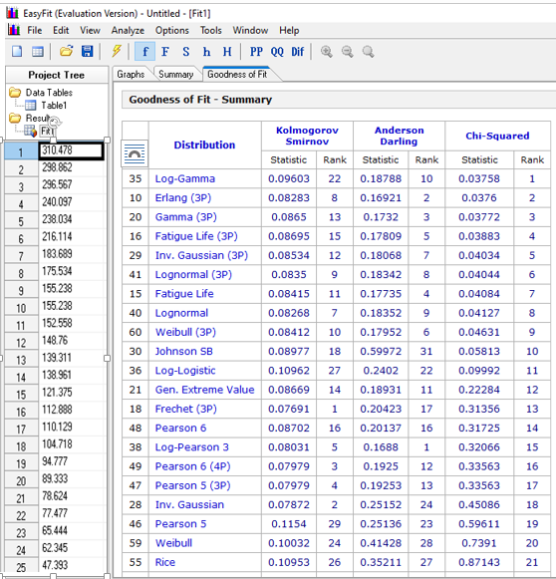

Appendix G: Manning’s “n” values of different channel types and flood plains
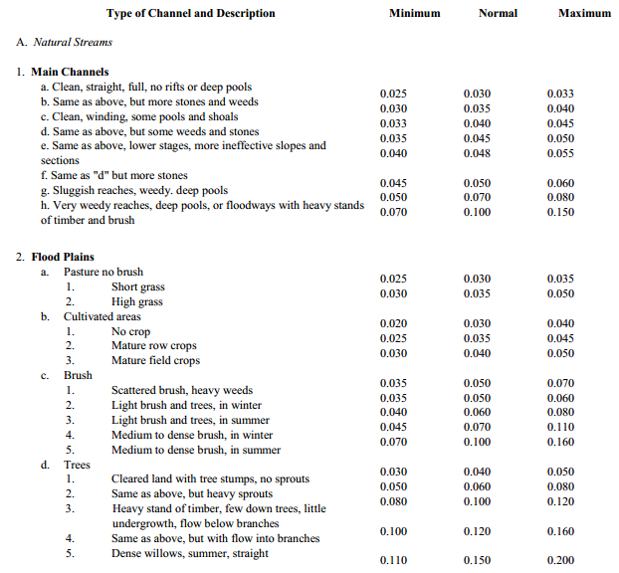 (Source: HEC RAS user manual, 2016)

Appendix H: River XS data of at Katar Bridge collected during site Survey
Upstream (S- represents station and E- represents elevation)
S-6 | E(m) | S-7 | E (m) | S- 8 | E (m) | S- 9 | E (m) | S-10 | E (m) | S- 11 | E (m)
0 | 2498.89 | 0 | 2500.3 | 0 | 2500.5 | 0 | 2500.7 | 0 | 2501 | 0 | 2501.7
5 | 2497.37 | 5 | 2497.2 | 5 | 2497.5 | 5 | 2498 | 5 | 2498.7 | 5 | 2499
10 | 2494.21 | 10 | 2493.9 | 10 | 2494.7 | 10 | 2495 | 10 | 2495.3 | 10 | 2495.8
12 | 2491.9 | 11.5 | 2492.41 | 14.5 | 2493.3 | 15 | 2493.8 | 15 | 2494.19 | 15 | 2494.7
15 | 2491.5 | 15 | 2491.7 | 15 | 2492.2 | 16.5 | 2493.3 | 16 | 2493.91 | 16 | 2494.45
20 | 2491.02 | 20 | 2491.3 | 20 | 2491.8 | 20 | 2492.2 | 20 | 2492.7 | 20 | 2493
25 | 2491.4 | 25 | 2491.7 | 25 | 2492.2 | 24.5 | 2493.17 | 24 | 2493.9 | 24 | 2494.62
28 | 2492.11 | 28.5 | 2492.5 | 25.5 | 2493.5 | 25 | 2493.6 | 25 | 2494.37 | 25 | 2494.87
30 | 2495.38 | 30 | 2494.6 | 30 | 2495 | 30 | 2495.4 | 30 | 2496 | 30 | 2496.4
35 | 2498.24 | 35 | 2497 | 35 | 2496.95 | 35 | 2496.93 | 35 | 2497 | 35 | 2497.3
40 | 2499.27 | 40 | 2500.1 | 40 | 2499.8 | 40 | 2500.2 | 40 | 2500.5 | 40 | 2500.9

Down Stream
S-5 | E (m) | S- 4 | E(m) | S-3 | E(m) | S-2 | E(m) | S-1 | E(m)
0 | 2498.8 | 0 | 2498.6 | 0 | 2498 | 0 | 2497.56 | 0 | 2497.32
5 | 2497.1 | 5 | 2497.7 | 5 | 2497.8 | 5 | 2497.2 | 5 | 2497.01
10 | 2495 | 10 | 2494.4 | 10 | 2494 | 10 | 2493.89 | 10 | 2493.41
13 | 2492.59 | 15 | 2492.2 | 15 | 2491.9 | 15 | 2491.5 | 15 | 2491.1
15 | 2491.37 | 17.5 | 2491.34 | 17 | 2490.99 | 17.5 | 2490.8 | 17 | 2490.86
20 | 2490.91 | 20 | 2490.4 | 20 | 2490.1 | 20 | 2489.7 | 20 | 2489.36
25 | 2491.23 | 23.5 | 2491.51 | 23 | 2490.95 | 22.5 | 2490.74 | 23 | 2490.62
27 | 2492 | 25 | 2492 | 25 | 2492.1 | 25 | 2491.5 | 25 | 2491.12
30 | 2494 | 30 | 2493.7 | 30 | 2493.3 | 30 | 2492.8 | 30 | 2492.4
35 | 2494.98 | 35 | 2494.8 | 35 | 2494.55 | 35 | 2494.1 | 35 | 2493.9
40 | 2497.7 | 40 | 2496.8 | 40 | 2496.2 | 40 | 2495.83 | 40 | 2495.2
 |  |  |  | 45 | 2500.2 |  |  | 45 | 2499.34
N0. | Easting | Northing | Elevation | Str. type | Cell No. | Width(m) | Height(m) | Dia.(m) | Katar Bridge Geometry(AL-Abutment length, HC-High cord,Y_{D} - depth of water)
1 | 39.177 | 7.54057 | 2491 | BR | 1 | 15 | 5 |  | AL = 18m (9m each side)
2 | 39.1758 | 7.53718 | 2545 | PC | 1 |  |  | 0.8 | HC width = 1.6m
3 | 39.1708 | 7.53297 | 2565 | PC | 1 |  |  | 0.8 | Deck thickness = 0.5m
4 | 39.1666 | 7.52967 | 2577 | PC | 1 |  |  | 0.9 | Bridge width = 16m
5 | 39.1629 | 7.52698 | 2573 | BC | 1 | 5.4 | 1.5 |  | Abutment height = 6.5m
6 | 39.1588 | 7.52394 | 2576 | BR | 2 | 6.4 | 2 |  | Bridge opening height = 5m
7 | 39.1519 | 7.51626 | 2563 | BR | 1 | 8 | 5 |  | Y_{D} at U/S = 0.5m (1,1,2020)
Appendix I: Structures geometry data collected from the site survey

Appendix J: Summary in cause, effect and mitigation measures to inefficiency
Cause | Effect | Remedial measures
High velocity | Erosion/scour at outlet, loss of farmers land | Energy dissipater such as check dams, cascades and channel linings
Runoff from Catchment | Sedimentation mix with woody riparian vegetation /reduction of structure opening | Increasing size of structure taking costs into consideration, sediment clearing or using silt trap at inlet
Land use land cover changes | Increased time of flow and hence increased discharge, consequently damage of structure, overtopping, ponding and then pavement distress | Watershed management/River training, reduction of water run-off towards the road
Natural drainage interruption by constructed road | Slopes and drainage channels have responded to the new drainage regime and concentration of discharge through structure leads to erosion | Proper design of drainage structure or replace, Controlling the rate and volume of water flows in the area.
Slope steepness and side drains deficiency in drainage capacity | Problem of erosion extends beyond the road environment itself and need to divert side drain and landslides problem, frequent OM. | Reducing the area of ground that is to be cleared, Quickly replanting cleared areas, maintaining the planted areas and Avoiding erosion sensitive alignments
Lack of community awareness | Blockage of structure opening by packed heavy soils and gravels | Aware of community, maintaining and manually clearing of structures outlet
Lack of HH investigation | Less energy dissipater and other miscellaneous structures | Maintaining, upgrading, change of location
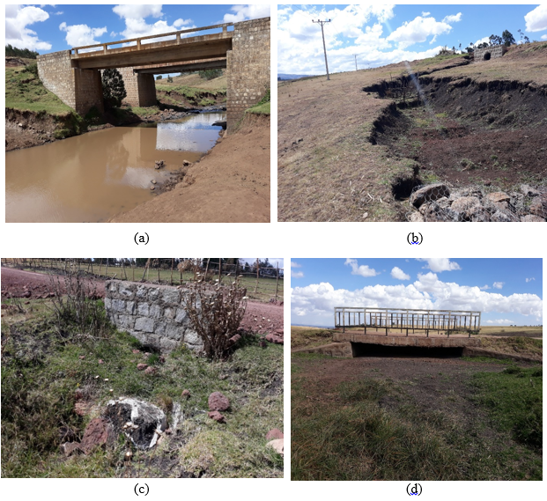
Appendix K: Observed problems found on cross drainage structures during site survey
a) Katar Bridge Channel bank eroded by flood. b) culvert 1 out let gully formation c) culvert 2 outlet blockage d) culvert 4 opening reduced by sedimentation (Photos captured January 1, 2020).

