STREAM FLOW RESPONSES TO CHANGES IN LAND USE/LAND COVER: THE CASE OF UPPER GIDABO CATCHEMENT, RIFT VALLEY LAKES BASIN, ETHIOPIA

M.SC. THESIS

TESFAHUN TADEWOS BATE

OCTOBER, 2017
HAWASSA, ETHIOPIA

STREAM FLOW RESPONSES TO CHANGES IN LAND USE/LAND COVER: THE CASE OF UPPER GIDABO CATCHEMENT, RIFT VALLEY LAKES BASIN, ETHIOPIA

TESFAHUN TADEWOS BATE

A THESIS SUBMITTED TO THE SCHOOL OF
WATER RESOURCES ENGINEERING, INISTITUTE OF TECHNOLOGY, SCHOOL OF GRADUATE STUDIES HAWASSA UNIVERSITY
IN PARTIAL FULFILLMENT OF THE REQUIREMENT FOR DEGREE OF MASTERS OF SCIENCE IN “DAM ENGINEERING”

OCTOBER, 2017
HAWASSA, ETHIOPIA
DECLARATION
I, TESFAHUN TADEWOS, declare that the content of this thesis is entirely my own work with the exception of such quotations or references which have been attributed to their authors or sources.
I also declare that all photographs are made or drawn by me except where I have acknowledged another as the author. This thesis has not been previously submitted to this or any other university for a degree.

-------------------------
TESFAHUN TADEWOS

SCHOOL OF GRADUATE STUDIES
HAWASSA UNIVERSITY
ADVISOR’S THESIS SUBMISSION APPROVAL SHEET
This is to certify that the thesis entitled “ ASSESSING THE STREAM FLOW RESPONSES TO CHANGES IN LAND USE/LAND COVER OF UPPER GIDABO CATCHEMENT, IN RIFT VALLEY LAKES BASIN, ETHIOPIA” submitted in partial fulfillment of the requirement for the degree of Master’s with specialization in DAM ENGINEERING, The graduate program of the school of water resource Engineering, Institute of Technology, Hawassa university and has been carried out by Mr. Tesfahun Tadewos, Id No PGDeng020/08, under my supervision. Therefore I recommend that the student has fulfilled the requirements and hence hereby can submit the thesis to the department for defense.
Sirak Tekleab Gebrekristos (PhD) ______________________ ___________________
Name of principal advisor Signature Date
Mulugeta Dadi (PhD) ______________________ ___________________
Name of Co_advisor Signature Date

SCHOOL OF GRADUATE STUDIES
HAWASSA UNIVERSITY
EXAMINERS’ THESIS SUBMISSION APPROVAL SHEET
This thesis entitled with“ ASSESSING THE STREAM FLOW RESPONSES TO CHANGES IN LAND USE/LAND COVER OF UPPER GIDABO CATCHEMENT, IN RIFT VALLEY LAKES BASIN, ETHIOPIA” Has been approved by the following examiners in partial fulfillment of the requirement for the degree of Master of Science in Dam Engineering.
Date of Defense: October/2017
Approved by Member of examining board:
1. Mr. Ayalew Shura ---------------------------- ------------------------
Chairman Signature Date
2. Dr. Sirak Tekleab ---------------------------- ------------------------
Major Adivisor Signature Date
3. Dr. Moltot Zewdie ---------------------------- ------------------------
Internal Examiner Signature Date
4. Dr. Adane Abebe ---------------------------- ------------------------
External Examiner Signature Date
5. Mr. Ayel Getachew ---------------------------- ------------------------
Department Head Signature Date

ACKNOWLEDGEMENT
First and above all, I praise God, the almighty for providing me this opportunity and granting me the capability to proceed successfully.
Next, I would like to forward heartfelt thanks for those who deserve it, for their assistance, guidance and realization of this work.
I wish to express my utmost gratitude to my major advisor Dr. Sirak Tekleab, for his precious advice, encouragement and decisive comment during the research period. His critical comments and valuable advices helped me to take this research in the right direction. I would also like to say thank my co- advisor Dr. Mulugeta Dadi for his valuable comments during the research period.
My gratitude also goes to the Ministry of Water Resources, particularly for staff members under the Department of Hydrology, GIS and Library and National Metrological Agency (NMA) for providing hydrological and metrological data for free.
Last but the bests, I would like to thank my wonderful family and friends for their ultimate support throughout my life.

LIST OF ACRONYMS AND ABBREVIATION
ABM Agent-Based Model
Arc SWAT the Arc GIS Integrated SWAT Hydrological Model
DEM Digital Elevation Model
EMA Ethiopian Mapping Agency
ETM+ Enhanced Thematic Mapper Plus
FAO Food and Agricultural Organization of the United Nations
GIS Geographic Information System
GPS Global Positioning System
HRU Hydrologic Response Unit
LULC Land Use / Land Cover
MSS Multi Spectral Scanner
NMA National Meteorological Agency
SRTM Shuttle Radar Topography mission
SWAT Soil and Water Assessment Tool
TM Thematic Mapper
UTM Universal Transverse Mercator
ENS Nash Sutcliffe simulation Efficiency
R² Coefficient of Determination
SNNPRS Southern Nation Nationality and People Regional States
MRS Mean Relative Sensitivity
WXGEN Weather Generator
WXPARM Weather Parameter Calculator
CSA Central statistical Agency
USGS United States. Geological Survey
ERDAS Earth Resources Data Analysis System

TABLE OF CONTENT
Acknowelegement VI
Acronyms And Abbreviations VI
List of Figures XII
List of Tables XIII
Abstract XIV
1 Introduction 1
1.1. Background 1
1.2. Statement of Problem 2
1.3. Objective of the Study 3
1.3.1. General Objective 3
1.3.2. Specific Objectives : 3
1.4. Research questions 4
1.5. Scope of the Study 4
1.6. Significance of the Study 4
1.7. Organazation of thesis 4
2. Litereature Reveiw 5
2.1. Land use/land cover change:defintion and concepts 6
2.2. Interact of land use/land cover change with the hydrology 6
2.3. Impact of land use/land cover change on streamflow 7
2.4. land use/land cover change in Ethiopia 8
2.5. Overview of Remote sensing and GIS 11
2.6. General principle of Remote sensing 11
2.7. Application of Remote sensing 12
2.7.1. ERDAS Imagine Model 12
2.8. Hydrological Models 13
2.9. Hydrological Model Selection 15
2.9.1. Introduction to SWAT Model 16
2.9.1.1. SWAT Model Application in world wide 17
2.9.1.2. SWAT Model Application in Ethiopia 18
2.9.1.3. SWAT Model Justification 18

3. Material and Methods 27
3.1. Description of the study area 27
3.1.1. Location 17
3.1.2. Climate. 27
3.1.3. Land use/land cover and soils 30
3.1.4. Geology 31
3.2. Data Input and Analysis 32
3.2.1. Spatial Data 33
3.2.2. Temporal Data 41
3.3. Data analysis 42
3.3.1. Filling missing weather data 43
3.3.2. Filling missing temperature data 44
3.3.3. Checking the conisistenc of the data 44
3.3.4. Hydrological data collection and analysis 45
3.3.4.1. Rainbow homogenity test 46
3.4.5. Hydrological data trend analysis. 48
3.4. Model setup 51
3.4.1. Watershed delinetion 51
3.4.2. Slope 52
3.4.3. Hydrological response unit analysis 52
3.4.4. Weather generator 53
3.4.5. Entering Weather Data 54
3.4.6. SWAT Simulation 56
3.5. Modeling of Total Sub basin of Upper Gidabo Catchment 56
3.6. Base Flow Separation 57
3.7. Senstivity analysis 58
3.8. Model calibration and validation 59
3.9. Model performance evaluation 60
3.10. Evaluation of stream flow due to land use/land cover change 61
4. Results and Discussions 63
4.1. Land use/land cover change analysis 63
4.1.1. Land use/Land cover maps 63
4.1.2. Accuracy assessement 66
4.2. Stream flow Modeling 68
4.2.1. Sensitivity analysis 68
4.2.2. Calibration and validation of stream flow simulation 70
4.3. Evaluation of stream flow due to land use/land cover change 74
4.3.1. Change in seasonal stream flows 75
4.3.2. Impact of lulc change on seasonal and annual stream flow variability 80
4.3.3. Hydrological trend evaluation 83
4.3.4. Average annual water balance component of the study area 86
4.3.5. Evaluation of extreme flows ... 87
5. Conclusions and Recomendations 88
5.1. Conclusions 88
5.2. Recomandation 90
6. References 83
APPENDEX………………….…………………………………………………………....…........91
Appendex A: Symbols and Description of Weather Generator Parameters (WGN) used by the SWAT Model …………………………….……………………………………….........................100
Appendex B: SWAT Parameters applicable ………………………………………………….…..101
Appendex C: Location of meteorological station ………………………………………………...102
Appendex D: Gidabo Average monthly flow at Aposto gauged station……………………..…..102
Appendex E: Soil types of the study area(upper gidabo catchment) (FAO-UNESCO
Soil Classification………………………………………………………………...……………......103
Appendex F: Cumulative annual rainfall for each meteorological station (mm) ………………....103
Appendex G: Sensitivity analysis result of flow in upper gidabo catchment……………………...104
Appendex H: Satellite images (Path/Row:168/55) (a) 01 January 1996 of TM (b) February
2011 of ETM+,. (Source: www.glovis.USGS.gov)…………………………………......................105

LIST OF TABLES
Table 1.Description of three selected semi-distributed hydrological models. 15
Table 2. Details of spatial data 33
Table 3.The acquisition dates, sensor, path/row, resolution and the producer’s of the images 34
Table 4. Land use/cover classification of upper Gidabo catchment as per SWAT model 39
Table 5. Soil types of upper gidabo catchment with their symbols and areal coverage 40
Table 6. Summary of available rainfall data 42
Table 7. SWAT parameters Sensitivity class 58
Table 8. General performance ratings for recommended statistics for a monthly time (D. N Moriasi,et al. 2007) 60
Table 9. Area of land covers types and change statistics of upper gidabo catchment for the period of 1996 and 2011 66
Table 10. Confusion matrix for the classification of 1996 LULC Map. 67
Table 11. Confusion matrix for the classification of 2011 LULC Map. Note: AL=Agricultural land ; WL=Wet land; F=Forest, SL=Shrub land; BL=Bare land 67
Table 12. List of Parameters and their ranking with MRS values for monthly flow 68
Table 13. List of parameters with calibrated values for average monthly stream flow 70
Table 14. Comparison of Measured and simulated monthly flow for calibration and validation simulations 72
Table 15. Mean monthly wet and dry month’s stream flow and their variability (1996-2011) 76
Table 16. Surface runoff and Ground water flow of the stream simulated using 1996 and 2011 land use/cover map 77
Table 17. Mean monthly dry and wet season simulated flow and their variability with Spearman`s trend test and statistical summary (1996-2011). 83
Table 18. Trend analysis of seasonal and annual stream flow series for the studied catchment. 86

LIST OF FIGURES
Figure 1. The range of electromagnetic Spectrum adopted from (ERDAS Field Guide, 2005) 13
Figure 2. Location map of Upper Gidabo catchment. 18
Figure 3. Long-term mean monthly rainfall of different station (1996-2011) 19
Figure 4. Long term Mean monthly rainfall distribution of selected meteorological stations for the period of 1996-2011. 20
Figure 5. Long-term mean monthly Min, Max and Average temperature (1996-2011) 21
Figure 6. Illustrates the general workflow of the study 32
Figure 7. The Standard “False Color” composite satellite image of the study area of the year 1996 & 2011 34
Figure 8. Spatial distribution of ground control points 36
Figure 9. Digital Elevation Model (DEM) of study area 39
Figure 10. Soil map of the study area 40
Figure 11. Long -term of mean annual rainfall from a period of (1996-2011) 44
Figure 12. Double mass curve plot made for three stations 45
Figure 13. Long-term Monthly average flow of Gidabo at Aposto site (1996-2011) 46
Figure 14. Commutative Deviation of annual flow at Aposto gauging station 47
Figure 15. Probability of Rejecting Homogeneity of annual Flow at Aposto gauging Station. 47
Figure 16. watersheds map of the upper Gidabo catchment 51
Figure 17. Slope map of upper Gidabo catchment 52
Figure 18. Location of meteorological stations in and around the watershed 55
Figure 19. Total Sub-basin of Upper Gidabo catchment 57
Figure 20. Land cover map of upper gidabo catchment using 1996 imagery. 64
Figure 21. Land cover map of upper gidabo catchment using 2011 imagery 64
Figure 22. Percentage changes of Upper Gidabo land use/land cover classes 65
Figure 23. Rank of sensitive parameter in upper gidabo catchment. 69
Figure 24. The result of calibration for average monthly stream flows 71
Figure 25. The result of Validation for average monthly stream flows 72
Figure 26. Scatter plots of the calibration periods show the correlation between of the observed flow and the simulated flow and their corresponding Nash-Sutcliffe simulation efficiency (ENS) and coefficient of determination (R2). 73
Figure 27. Scatter plots of the Validation periods show the correlation between of the observed flow and the simulated flow and their corresponding Nash-Sutcliffe simulation efficiency (ENS) and coefficient of determination (R2). 73
Figure 28. Parameters from annual simulations for 1996 and 2011 land covers of upper gidabo catchment. 75
Figure 29. Simulated monthly catchment stream flow for LU/LC of 1996 and 2011 77
Figure 30. Spatial distribution of Simulated SURQ AND GWQ at each sub basin using a) 1996 b) 2011 land use map 78
Figure 31. Simulated mean annual stream flow for LULC 1996 and 2011 at catchment outlet. 81
Figure 32. Spearman`s trend test for the change of mean annual stream flow 82
Figure 33. Time series plots for (a) Dry season flow and (b) Wet season flow 83
Figure 34. Time series plots for (a) Dry season mean flow, (b) Wet season mean flow, (c) Mean observed flow (d) 1-day annual maximum flow, (e) 1-day annual minimum flow and (f) 7-day minimum annual flow 85
Figure 35. Annual water balance components at different year 87
Figure 36. Discharge duration curve showing the percent of time in which the mean annual discharge was exceeded through the 16 years of record (1996-2011). 88

ABSTRACT
The study analyses the land cover change between the 1996, and 2011, and the effect these changes have had on stream flow on Upper Gidabo catchment. Within Upper Gidabo catchment land use is undergoing major changes due to pressures of human activities. Changes in land use have potentially large impacts on water resources by causing more surface runoff, decreased water retention capacity, loss of wetland and drying of river. In this study, both the Soil and Water Assessment Tool (SWAT) model and Spearman`s rank correlation statistical time series analysis for measured stream flow were applied to understand the stream flow variability and land use dynamics effect on stream flow of Upper Gidabo catchment. Land use maps of 1996, and 2011 were derived from satellite images and analyzed using ERDAS Imagine 2014 software. From the land cover change analysis results it was found that there has been a substantial decline of forest lands, shrub lands, wet lands and drastic expansion of agricultural land. The SWAT modeling results showed that an increase of stream flow by 21% comparing the two land use maps (1996 versus 2011). The analysis also revealed that flow during the wet months has increased by 9.53 % while the flow during the dry season decreased by 2.36 %. Furthermore the Spearman`s rank correlation test has been applied to detect the monotonic trend existence on the mean annual, seasonal, 1- and 7- days annual minimum and maximum flows. The Spearman`s rank correlation - test demonstrates that in the case of 1-day maximum flow, no significant trend is noticeable; however, the extreme low flows indicators (e.g.1day minimum,7 day minimum) and dry seasonal flows exhibited statistically significant decreasing trends.
Generally, the combined results of the SWAT model and the statistical tests revealed that land use change has caused a significant increase on mean annual stream flow and decrease dry season flows of the studied watershed during the period. The identified result is important to inform optimal water resource management and to plan and manage water resources development within the watershed in a sustainable manner.
Key words: Land Use Change, SWAT Modeling, Remote Sensing, Upper Gidabo Catchment.

- INTRODUCTION
  - Background
Land use planning and management are closely related to the sustainability of water resources as changes of land use are linked with amount of water through relevant hydrological processes (Guo et al, 2008). To maintain water sustainability, effective methods and mechanisms should be used. Nowadays, the hydrological models are good to represent the hydrological characteristics (Surur, 2010). Hydrologic modeling and water resources management studies are closely related to the spatial processes of the hydrologic cycle. Hydrological cycle is the continuous movement of water on, above and below the surface of the Earth. This cycle is affected by several factors like climate and land use/land cover change. Therefore, the interaction between land use/land cover and hydrological cycle should be well understood. Land use/land cover highly changes especially in the developing countries which have agriculture based economy and rapidly increasing population. The growing population and increasing socio-economic necessities creates a pressure on land use/land cover. This pressure results in unplanned and uncontrolled changes in LULC. Humans have used land and its resources to obtain food and to fulfill other essential basic needs. Hence, they have modified and are modifying land in various ways and intensities.
People need land for the food production and for housing and it is common practice to clear the forest for the farming and housing activities. Therefore, the result of these activities caused land use and land cover changes due to daily human intervention. Hence, understanding how the land cover changes influence on the stream flow of the catchment will enable planners to formulate policies to minimize the undesirable effects of future land cover changes. Providing a scientific understanding of the process of land use and land cover change, the impacts of different land use decisions, and the ways that decisions affect the hydrological cycle and increasing variability are priority areas of research (Abraha, 2007).
The main intention of this study is to analyze the effect of land use and land cover changes on the wet month and dry month stream flow and the components (surface and ground water flow) of stream flow of the catchment. Stream flow usually has high seasonal variability, and seasonal local water scarcity is a problem faced by many farmers in catchment (Jamtsho and Gyamtsho, 2003).

  - Statement of Problem
In developing countries like Ethiopia, 85% of the population live in rural area and directly depend on agriculture. This causes various effects on resource bases like deforestation, expansion of agricultural land and soil erosion. Land use and land cover change is a great concern to catchments development. This is because flows are sensitive to land use/land cover change. Major portion of Abaya Chamo basin is characterized by semi-arid agro climatic condition. Agricultural production being the mainstay of the population in the sub-basin, it has persistently been threatened by erratic rainfall distribution that resulted in food insecurity in the basin. Moreover, in the basin, farmers used to practice mixed farming system and the problem extends to their livestock's (Tilahun and Paulos, 2004). Gidabo catchment which is one of the sub catchment of Rift valley basin is densely populated with an annual growth rate of 2.3 % according to CSA(1998). This causes various effects on resource bases like deforestation, expansion of residential area, and agricultural land. Upper gidabo catchment which is one of the abaya-chamo sub basins of rift valley basin is facing these types of effects.
The land use change cause different problem in existing hydrological conditions. Change in land use type of certain area like increasing the percentage of Agricultural land will increase volume of surface run off and decrease time of concentration which makes several distraction by generating higher amount of runoff as well as decrease the amount of water percolated in to the ground that in turn decrease amount of water to be recharged in to the ground finally imbalances over all hydrological condition of catchment. Such and other issue should be assessed deeply to know how land uses affect different hydrological process. In additional to analysis of past effect on catchment hydrology with altering land use, consequence of land use change on future hydrological response should be evaluated so that different decision maker know how land use can affect certain catchment in order to take remedial measure for particular problem. Therefore, the need for a scientific research is absolute so as to contribute in exactness the relationship of LU/LC and hydrological condition of the area. Specifically this research is initiated to estimate the effect of LULC on the stream flow, which helps finally for a better use, and management of the natural resources. And the outcome of the research assumed also to contribute a lot to the use of the water resource and management of the catchment as well as input for further studies. Therefore, a strong need is identified for the hydrological techniques and tools that can assess the effects of land cover changes on the stream flow response of a catchment. Such techniques and tools can provide information that can be used for water resources management at a catchment.
  - Objective of the Study
    - General Objective

The main objective of this study was to assess the Stream Flow Responses to changes in land use/ land cover in the case of Upper Gidabo catchment.
    - Specific objectives
- To analyze the trends of land use and land covers changes and quantifies the impact of land use dynamics on stream flow.
- To evaluate the stream flow response to change in land use/land cover at mean annual and seasonal period.
- To investigate the statistical trends if exists in the mean annual and extreme flow
  - Research questions
To address the above objectives, the following research questions are designed.
- Which land use unit is prominent in changing the stream flow over the consider time period?
- How is the trend of land use/land cover changes from 1996 to 2011 in the study catchment?
- Can it be detected the statistical significance of extreme flows in the upper Gidabo catchment over the considered period.
  - Significance of the Study

The land use and land cover change has significant impact on natural resources, socioeconomic and environmental systems. However, to assess the effects of land use/land cover change on stream flow, it is important to have an understanding of the land use/land cover patterns and the hydrological processes of the Catchment. Knowing the types and impacts of land use/land cover change is essential indicator for resource base analysis and development of effective and appropriate response strategies for sustainable management of natural resources in the country in general and at the study area in particular.

Moreover, the study presents a method to quantify land use/land cover change and their impact on stream flow. This has been achieved through a method that combines the hydrological model (SWAT) to simulate the hydrological processes, GIS and remote sensing techniques to analysis the land use/land cover change and the spearman`s rank correlation test to understand the trend and variability of the stream flow.
  - Scope of the study
This study has investigated the rainfall and runoff relationship in the catchment. And hydrologic modeling has done using SWAT model incorporated with GIS. Moreover, this model is calibrated and the parameter values are used for further estimation of discharge in to the reach. Also the land use /land cover change has identified using 1996 and 2011 land use and land cover maps. Furthermore, using these maps the river discharge has estimated and its impact on the catchment has assessed. Although, water resources are affected by many factors like climate change, this study only focus on the impact of land use and land cover change on stream flow.
1.7. Organization of the Thesis
The paper is organized into five sections: Section one is an introduction section where the background, statement of the problem, objectives of the study, research questions, scope of the study and significance of the study are discussed.
In section two, review of related literatures where the definition and concepts of land use and land cover changes, land use and land cover changes in Ethiopia, Application of Remote sensing on land use and land cover changes, hydrological models, Hydrological model selection criteria, an Introduction to SWAT model, application of SWAT model worldwide and in Ethiopia are reviewed. Data and methodology section in which Description of the study area, image processing, classification and accuracy assessment, Collection of input data and analysis, model setup, model performance evaluation and evaluation of stream flow due to land use and land cover changes are elaborated in section three.
The fourth section describes with the result and discussion which are land use and land cover analysis, stream flow modeling and evaluation of stream flow due to land use and land cover change. The land use and land cover analysis including land covers maps and statistics, and accuracy assessment. the statistical evaluation of trends using spearman`s rank correlation test. The stream flow modeling includes sensitivity analysis, calibration and validation of stream flow simulation, and the performance evaluation of the model. Finally, in section five, conclusions and recommendations of the study are provided.
- LITERATURE REVIEW
Under this section, literatures were cited on relevant topics, such as: definition and concepts of land use and land cover change, Interaction of land use land cover changes with the Hydrology, Influences of the land use pattern on stream flow, land use and land cover change studies in Ethiopia, application of remote sensing on land use and land cover change, Introduction to hydrological models, worldwide perspective of the hydrological (SWAT) model, and SWAT model in Ethiopia. Generally, the reviews were focused on assessing the scientific works that are related to the subject of this study.
2.1. Land Use and Land Cover Change: Definitions and Concepts
According to the International Geosphere- Biosphere Program and The International Human Dimension Program (IGBP-IHDP, 1999), land cover refers to the physical and biophysical cover over the surface of earth, including distribution of vegetation, water, bare soil and artificial structures. Land use refers to the intended use or management of the land cover type by human beings such as agriculture, forestry and building construction.
Land use and land cover change (LUCC) is commonly grouped in to two broad categories: conversion and modification (Meyer and Turner, 1994). Conversion refers to a change from one cover or use category to another (e.g. from forest to grassland). Modification, on the other hand, represents a change within one land use or land cover category (e.g. from rain fed cultivated area to irrigated cultivated area) due to changes in its physical or functional attributes. These changes in land use and land cover systems have important environmental consequences through their impacts on soil and water, biodiversity, and microclimate (Lambin et al., 2003). Land cover changes have been influenced by both the increase and decrease of a given population (Lambin et al., 2003). In most developing countries like Ethiopia population growth has been a dominant cause of land use and land cover change than other forces (Sage, 1994).
There is a significant statistical correlation between population growth and land cover conversion in most of African, Asian, and Latin American countries (Meyer and Turner, 1994). Due to the increasing demands of food production, agricultural lands are expanding at the expense of natural vegetation and grasslands (Lambin et al., 2003). Land use and land cover characteristics have many connections with hydrological cycle. The land use and land cover type can affect both the infiltration and runoff amount by following the falling of precipitation (Hougton, 1995). Both surface runoff and ground water flow are significantly affected by types of land cover. Surface runoff and Ground water flow are the two components of the stream flow. Surface runoff is mostly contributed directly from rainfall, whereas ground water flow is contributed from infiltrated water. However, the source of stream flow is mostly from surface runoff during the wet months, whereas during the dry months the stream flows from the ground water. Increase of crop lands and decrease of forest, results increase of stream flow because of the crop soil moisture demand. Crops need less soil moisture than forests; therefore, the rainfall satisfies the shortage of soil moisture in agricultural lands more quickly than in forests there by generating more runoff when the area under agricultural land is extensive. Hence, this leads to an increases stream flow. In addition, deforestation also has its own impact on hydrological processes, leading declines in rainfall, and more rapid runoff after precipitation (Legesse et al, 2003). Therefore, such changes of land use and land cover may have impacts on the stream flow during the wet and dry months, and on the components of stream flow (surface runoff and ground water flow) and assessing such impacts is the core of this study.
Generally, knowing of the impacts of land use and land cover change on the natural resources like water resources depends on an understanding of the past land use practices, current land use and land cover patterns, and projection of future land use and land cover, as affected by population size and distribution, economic development, technology, and other factors. The land use and land cover change assessment is an important step in planning sustainable land management that can help to minimize agro-biodiversity losses and land degradation, especially in developing countries like Ethiopia (Hadgu, 2008).
2.2. Interact of land use land cover changes with The Hydrology
To understand how LULC affects and interacts with global earth systems, information is needed on what changes occur, where and when they occur, the rates at which they occur, and the social and physical forces that drive those changes. Human impact on global land cover change, especially in terms of change from forest cover to other land cover, has been one of the important issues on global change research. In the primitive times when there was little human population and low level of economic activity, deforestation was not a problem because the natural regeneration of forest was adequate to cover for any loss of forest by the human beings. However, with the advent of modern civilization and industrialization and the increase in population, the forest loss to meet the ever-growing needs of the human population became so huge that it posed a problem for the global environment.
The concept of different aspects of an effect of land use change on hydrology at local, regional and global scale is discussed in detail by (Maidment, 1993). Vegetation has a significant impact on infiltration both by providing canopy and litter cover to protect the soil surface from raindrop impacts and by producing organic matter, which binds soil particles and increases its porosity. Higher porosity increases infiltration and percolation rates and the water-holding capacity of the soil. Infiltration rates are positively related to litter and grass basal cover, being up to 9 times faster with 100% litter cover than for bare soil (Maidment, 1993). Therefore deforestation increases surface runoff and reduces recharge by affecting the above condition especially if the area is steeply sloped and recharge zone.
2.3. Impact of the land use/land cover change on stream flow
Land use and land cover characteristics have many connections with hydrological cycle. The land use and land cover type can affect both the infiltration and runoff amount by following the falling of precipitation (Hudson, 1995). Both surface and ground water flow are significantly affected by type of land cover (Abebe, 2005). The rational way to model the impact of land cover changes on Stream flow of a river catchment is through implementation of spatially distributed physical based hydrological model. In the process land use and land cover change highly affects infiltration, erosion, and evapotranspiration. To understand the future effects of land use and land cover on stream flow, it is mandatory to know the effect of historic land use changes have had on river flow. Change in land use and land cover alters both runoff behavior and the balance that exists between evaporation, groundwater recharge and stream flow discharge in specific areas and in the entire watershed.
A change of land use from lower to higher evapotranspiration will lead to a decrease in annual stream flow. From review of 97 catchment experiments, Bosch and Hawlet (1982) concluded that the establishment of forest cover on sparsely vegetated land decreases water yield. Conversely, a change from higher evapotranspiration plant to lower evapotranspiration plants will increase the mean surface runoff: reduction in forest cover increases water yield (Bosch and Hawlett, 1982; Calder, 1998). The impact, however, depends very much on the management practices and alternative land uses. The stream flow after maturation of the new plant cover may be higher, the same or lower than the original value, depending on vegetation (Bruijnzeel, 1990). Increasing water yield from changing plant cover does not necessarily increase water availability downstream. Stream flow might decrease because of other factors, e.g. water consumption by riparian vegetation or through transmission losses (Brooks et al., 1991). The role of land use and land cover on soil erosion was highlighted by Morgan (2005) that vegetation cover is able to neutralize the effect of precipitation on soil erosion. The change in land cover has caused the acceleration of the erosion, such as the clearance of the dense forest into agricultural land has increased soil erosion 3000 times (Morgan 2005)
The amount and type of vegetative land cover is one determinant of the water yield of a drainage basin. Forests produce higher rates of evapotranspiration and interception (the storage of water on leaf surfaces) than do grass or shrub lands, all of which influence the amount of water that is available for direct drainage into streams or for aquifer recharge (Farley et al., 2005). Trees have lower surface albedo, higher surface aerodynamic roughness, higher leaf surface area, and deeper roots than other types of vegetation, with each characteristic tending towards an increase in evapotranspiration of water and a decrease in stream flow discharge (Costa et al., 2003). Interception plays a more important role in water balance during precipitation events. Leaves and forest floor leaf-litter capture a considerable amount of water and thus encourage its slow infiltration into the soil and finally it recharges groundwater supplies stored in aquifers and supplies the return flow of water to stream beds during periods of dry weather (Knighton, 1998).
The conversion of the land surface from native cover to managed cropland has an effect on the evapotranspiration, infiltration and overland runoff characteristics of a catchment. Crops need less soil moisture than forests; therefore, the rainfall satisfies the shortage of soil moisture in agricultural lands more quickly than in forests there by generating more runoff. The increased removal of native vegetation and soil compaction decreases soil infiltration capacity. Hence, this leads to an increase in stream flow. Depending on the type of product being grown, croplands tend to have a percentage of bare ground even during the peak of the growing season, and may be completely bare prior to being planted. In both instances, most of the precipitation that lands on these denuded areas will be discharged directly into the stream channel rather than infiltrating into the soil or evaporating/transpiring from the plant surfaces. As a result, conversion to cropland tends to increase water yield compared to native vegetation (Fisher & Mustard, 2004).
Besides the above factors, physical changes resulting from urbanization also affects the water budget through reduction of interception of rainfall due to removal of trees; removal of natural vegetation and change in the drainage patterns; loss of natural depressions which temporarily store surface water (i.e. regarding of areas results in a change in topography); loss of rainfall absorbing capacity of humus on the forest floor; creation of impervious surfaces (rooftops, roads, sidewalks, driveways) etc. In urban and suburban areas, much of the land surface is covered by buildings and pavement, which do not allow rain and snowmelt to soak into the ground. Studies have indicated that soil compaction as a result of urban growth is more likely to influence flood responses than the presence of forests. Impervious surfaces prohibit infiltration of water to the soil during precipitation events, thus inhibiting groundwater recharge and increasing overland runoff during precipitation events (Fisher & Mustard, 2004).
Generally, such changes of land use/ cover may alter the hydrological cycle either through increasing high flows or through diminishing the low flows and assessing these flows is the core of this study. Information on flows in rivers, particularly low flows, became a greater priority to protect and quantify water resources and to meet the data requirements of ongoing developmental needs. The ability to estimate magnitude and frequency of low flows in river streams and ungauged catchments is important for water supply planning, waste-load allocation, reservoir storage design, maintenance of quantity and quality of water for irrigation, recreation and environmental flow requirements for wildlife conservation (Smakhtin, 2001).
2.4. Land Use and Land Cover Change Studies in Ethiopia
In Ethiopia, the land is used to grow crops, trees, animals for food, as building sites for houses and roads, or for recreational purposes. Most of the land in the country is being used by smallholders who farm for subsistence. With the rapid population growth and in the absence of agricultural intensification, small holders require more land to grow crops and earn a living; it results in deforestation and land use conversions from other types of land cover to cropland. The researches that have been conducted in different parts of Ethiopia have shown that there were considerable land use and land cover changes in the country.
As many researchers indicated that, in Ethiopia, several factors have been contributing towards modifying the original form of land cover. These include human activities such as an expansion of cultivated land at the expense of the grasslands Gebrehiwet (2004), the decrease of natural vegetation and expansion of agricultural land cover as a result of population pressure Hadgu (2008), reduction of natural vegetation cover, but an expansion of open grassland, cultivated areas and settlements Abebe and Bewket (2013), conversion of natural vegetation cover to cultivated land Genetu (2002), reduction of natural forest cover and grasslands, but an increase of croplands Kindu et al. (2013), increase of open areas and settlements as the expense of forests and shrub land Hedlund and Tekle (2000), decline of natural forests and grazing lands due to conversions to croplands Kassa (2003) and an increase in agricultural land at the expense of natural vegetation (Amsalu et al., 2007).
Most of these studies indicated that croplands have expanded at the expanse of natural vegetation including forests and shrublands; for example Belay, (2002); Bewket, (2003); Kidanu, (2004); Abebe, (2005) in northern part of Ethiopia, Zeleke and Hurni, (2001) in north western part of Ethiopia, Kassa, (2003) in north eastern part of Ethiopia; and Denboba, (2005) in south western part of Ethiopia. Kassa (2003) in his study, in southern Wello, reported the decline of natural forests and grazing lands due to conversions to croplands. Bewket (2003) have reported an increase in wood lots (eucalyptus tree plantations) and cultivated land at the expense of grazing land in both Chemoga watershed in north-western Ethiopia, and Sebat-bet Gurage land in south-central Ethiopian.
The changes of land use and land cover that occurred from 1971/72 to 2000 in Yerer Mountain and its surrounding results an expansion of cultivated land at the expense of the grasslands Gebrehiwet, (2004). Hadgu (2008) identified that decrease of natural vegetation and expansion of agricultural land over a period of 41 years in Tigray, northern part of Ethiopia. He concluded that population pressure was an important deriver for expansion and intensification of agricultural land in recent periods. Garedew, (2010) in the semiarid areas of the central Rift Valley of Ethiopia, during the period 1973-2000 cropland coverage has increased and woodland cover lost. Similarly, Feoli, et al.,(2002) also reported the expansion of evergreen vegetation with increase of population.
According to many literatures, population growth has a paramount impact on the environment. For instance, population pressure has been found to have negative effect on Riverine vegetation, scrublands and forests in Kalu district (Tekle and Hedlund, 2000), Riverine trees in Chemoga watershed (Bewket, 2003), and natural forest cover in Dembecha Woreda north-western Ethiopia (Zeleke and Hurni, 2001). Similarly, Pender et al., (2001) report that the population growth has significant effect on land degradation, poverty and food insecurity in the northern Ethiopian highlands. From most of these studies, it is evident that population pressure is one of the major drivers of land use and land cover changes through destruction of forest and vegetation cover for the purpose of agricultural and urban expansion as demonstrated by (Amsalu et al., 2007; Hurni & Zeleke, 2001).
According to Hurni and Zeleke (2001) Population growth coupled with migration from rural to cities leads to further expansion of urban areas at the expense of vegetation cover which is commonly practiced in western highlands of Ethiopia. In addition, Pender et al. (2001) reported that population growth has significant impact on land degradation, poverty and food insecurity. population pressure has been found to have negative effect on Riverine vegetation, scrublands and forests in Kalu district (Tekle and Hedlund, 2000), Riverine trees in Chemoga watershed (Bewket, 2003), and natural forest cover in Dembecha Woreda north-western Ethiopia (Zeleke and Hurni, 2001). Similarly, Pender et al., (2001) report that the population growth has significant effect on land degradation, poverty and food insecurity in the northern Ethiopian highlands.
The land degradation which appeared in the area particularly in the agriculture is a result of rapid LULC changes. Land degradation is an extreme form of land cover change that results from uses of land that over exploit its resources. Degrading land resources in turn have an impact on the human livelihoods that depend on them. In general, LULC changes are affected by human induced activities and growth, socio-economic factors, deterioration of vegetation cover, agricultural activities, government policies and environmental factors (Gol et al., 2010).
2.5. Overview of Remote Sensing and GIS
Planners and resource managers need a reliable mechanism to assess the consequence of the changes resulted by the stress imposed natural resource by detecting monitoring and analyzing land use changes quickly and efficiently. The conventional method of environmental data collection and analysis are not efficient in delivering the necessary information in a timely and cost effectively fashion. Hence viewing the Earth from space has become essential to comprehend the cumulative influence of human activities on its natural resource base.
Remote sensing technology however can play a vital role in providing accurate and reliable information with cost effective and lesser time compared to other methods. Remote sensing refers the technique of obtaining information about an object or feature through the analysis of data acquired by a device that is not in contact with the object or feature under investigation (Lille sand, 1994, Ahmed, 2001). Remote sensing has helped in the development of various environmental management methodologies, providing the following advantages when compared to conventional ground based methods.
Synoptic view: Remote sensing facilitates the study of various features of earth’s surface and the spatial relationship between features.
Accessibility: Remote sensing makes it possible to gather information about areas that are not accessible for ground surveys, like mountainous areas or foreign land.
Time: Since information about a large area can be gathered quickly, these techniques save time and effort.
2.6. General Principles of Remote Sensing
The sensors on remote sensing platforms usually record electromagnetic radiation. Electromagnetic radiation (EMR) is energy transmitted through space in the form of electric and magnetic waves. Remote sensors are made up of detectors that record specific wavelengths of the electromagnetic spectrum. The electromagnetic spectrum is the range of electromagnetic radiation extending from cosmic waves to radio waves.
The measured and recorded energy is converted and stored as a digital number (DN) value, which ranges from 0-255. Each pixel (picture element or unit area or ground cell) has a single DN value. Most sensors measure reflected sunlight however; some sensors detect energy emitted by the earth itself or provide their own source of energy (active remote sensing) (Ahmed, 2001). (Figure 1): The rage of electromagnetic spectrum (ERDAS Field Guide, 2005).
2.7. Application of Remote Sensing Fields
The utility of different remote sensing data from different satellites have been demonstrated in many fields such as agriculture, cartography, civil engineering, environmental monitoring, forestry, geography, water resources management land resources analysis and land use planning. The use of satellite images in any of fields mentioned above, demand the knowledge of the different bands that each sensor system onboard satellites use to take the imagery and how these bands of the electromagnetic spectrum interact with land surface features and with that of the atmosphere (Figure.1). As there are many satellites in the space providing remote sensing data, their application will vary with their way of data acquisition. The most popular satellite is the land sat, which operated since early 1970s till 2012. This long period of operation makes land sat very important for environmental systems analysis. All types of satellites vary with their sensors, flight height, bands, and spatial resolution, spectral resolution etc.
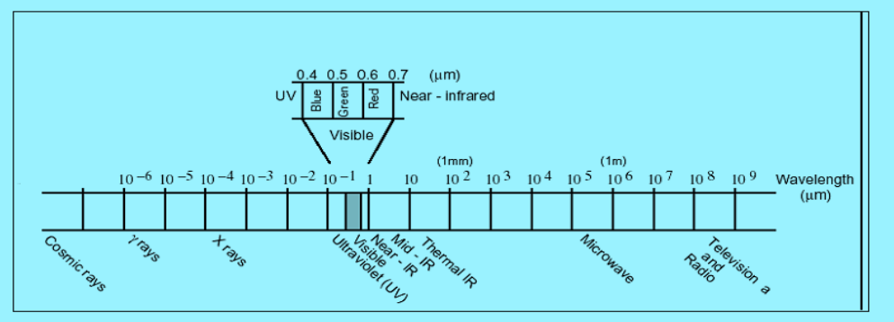
Figure 1.The range of electromagnetic Spectrum adopted from (ERDAS Field Guide, 2005)
2.7.1. ERDAS Imagine Model
It is a remote sensing application with raster graphics editor capabilities designed by ERDAS, Inc. for geospatial applications. Prior to the ERDAS IMAGINE Suite, Earth Resources Data Analysis System (ERDAS), Inc. developed various different products to process satellite imagery from Advanced Very High Resolution Radiometer (AVHRR), Land sat, Multiple Spectral Scanner (MSS) and Land sat TM and SPOT imagery into land cover / land use maps, map deforestation.
The latest version ERDAS IMAGINE is aimed primarily at geospatial raster data processing and allows the user to prepare, display and enhance digital images for mapping use in Geographic Information Systems (GIS) or in Computer Aided Design (CAD) software. It is a toolbox allowing the user to perform numerous operations on an image and generate an answer to specific geographical questions. By manipulating imagery data values and positions, it is possible to see features that would not normally be visible and to locate geo-positions of features that would otherwise be graphical. The level of brightness or reflectance of light from the surfaces in the image can be helpful with vegetation analysis, prospecting for minerals etc. Other usage examples include linear feature extraction, generation of processing work flows ("spatial models" in ERDAS IMAGINE), import/export of data for a wide variety of formats, orthorectification, mosaicking of imagery, stereo and automatic feature extraction of map data from imagery.

2.8. Hydrological Models
Hydrological models are mathematical descriptions of components of the hydrologic cycle. They have been developed for many different reasons and therefore have many different forms. However, hydrological models are in general designed to meet one of the two primary objectives. The objective of the watershed hydrologic modeling is to get a better understanding of the hydrologic processes in a watershed and of how changes in the watershed may these phenomena. The other objective is for hydrologic prediction (Tadele, 2007). They are also providing valuable information for studying potential impacts of changes in land use and land cover or climate.
On the basis of process description, the hydrological models can be classified in to three main categories (Cunderlik, 2003).
- Lumped models. Parameters of lumped hydrologic models do not vary spatially within the basin and thus, basin response is evaluated only at the outlet, without explicitly accounting for the response of individual sub-basins. The parameters often do not represent physical features of hydrologic processes and usually involve certain degree of empiricism. These models are not usually applicable to event-scale processes. If the interest is primarily in the discharge prediction only, then these models can provide just as good simulations as complex physically based models.
- Distributed models. Parameters of distributed models are fully allowed to vary in space at a resolution usually chosen by the user. Distributed modeling approach attempts to incorporate data concerning the spatial distribution of parameter variations together with computational algorithms to evaluate the influence of this distribution on simulated precipitation-runoff behavior. Distributed models generally require large amount of (often unavailable) data. However, the governing physical processes are modeled in detail, and if properly applied, they can provide the highest degree of accuracy.
- Semi-distributed models. Parameters of semi-distributed (simplified distributed) models are partially allowed to vary in space by dividing the basin in to a number of smaller sub-basins. The main advantage of these models is that their structure is more physically-based than the structure of lumped models, and they are less demanding on input data than fully distributed models. SWAT (Arnold,et al., 1993), HEC-HMS (US-ACE, 2001), HBV (Bergström, 1995), are considered as semi-distributed models.
Hydrologic models can be further divided into event-driven models, continuous process models, or models capable of simulating both short-term and continuous events. Event-driven models are designed to simulate individual precipitation-runoff events. Their emphasis is placed on infiltration and surface runoff. Typically, event models have no provision for moisture recovery between storm events and, therefore, are not suited for the simulation of dry-weather flows. On the other hand, continuous-process models simulate instead a longer period, predicting watershed response both during and between precipitation events. They are suited for simulation of daily, monthly or seasonal stream flow, usually for long-term runoff volume forecasting and for estimates of water yield (Cunderlik, 2003). Generally for this study, semi-distributed models are selected because of their structure is more physically-based than the structure of lumped model, and they are less demanding on input data than fully distributed models. Therefore, three selected semi-distributed models were reviewed (Table 1).
Description | SWAT | HEC-HMS | HBV
Model type | Semi-distributed  Physically-based  Long-term | Semi-distributed  Physically-based | Semi-distributed  Conceptual model
Model  Objective | Predict the impact of land management practices on water and sediment | Simulate the rainfall runoff process of watershed | Simulate rainfall runoff process and floods
Temporal  Scale | Day  + | Day  - | Day  -
Spatial scale | Medium + | Flexible | Flexible
Process  Modeled | Continuous | Continuous & event | Continuous & event
Cost | Public domain | Public domain | Public domain
Table 1.Description of three selected semi-distributed hydrological models.
2.9. Hydrological Model Selection
Hydrological models are mathematical formulations which determine the runoff signal which leaves a watershed basin from the rainfall signal received by this basin. They provide a means of quantitative prediction of catchment runoff that may be required for efficient management of water resources. Such hydrological models are also used as means of extrapolating from those available measurements in both space and time into the future to assess the likely impact of future hydrological change. Changes in global climate are believed to have significant impacts on local hydrological regimes, such as in stream flows which support aquatic ecosystem, navigation, hydropower, irrigation system, etc.
In addition to the possible changes in total volume of flow, there may also be significant changes in frequency and severity of floods and droughts. Many comprehensive spatially distributed hydrologic models have been developed in the past decade due to advances in hydrologic sciences, Geographical Information System (GIS), and remote sensing. Among the many hydrologic models developed in the past decade, the Soil and Water Assessment Tool (SWAT), developed by Arnold et al.(1993), has been used extensively by researchers.
This is b/c SWAT
- Uses readily available inputs for weather, soil, land, and topography,
- Allows considerable spatial detail for basin scale modeling, and
- It is capable of simulating change in catchment characteristics using different scenarios
Arnold and Allen (1996) compared multiple components of water budget including surface runoff, groundwater flow, groundwater ET, ET in the soil profile, groundwater recharge, and groundwater heights simulated by the SWAT model with measured data for three Illinois watersheds (122-246 km2). The predicted data compared well with the measured data for each component of the water budget and demonstrated that the interaction among different components of the model was realistic. Most 18 components of the water budget were within 5% of the measured data and nearly all were within 25%. SWAT is recognized by the U.S. Environmental Protection Agency (EPA) and has been incorporated into the EPA’s BASINS (Better Assessment Science Integrating Point and Nonpoint Sources). [BASINS is a multipurpose environmental analysis software system developed by the EPA for performing watershed and water quality studies on various regional and local scales.].
In order to optimally calibrate the model parameters, especially for large-scale modeling, an auto-calibration routine has been added to SWAT (Eckhardt and Arnold, 2001; Hence, SWAT will be used in this study to simulate the stream flow responses to changes in catchment characteristics.
2.9.1. Introduction to SWAT Model
The SWAT (Soil and Water Assessment Tool) watershed model is one of the most recent models developed at the USDA-ARS (Arnold et al.,1998) during the early 1970’s. SWAT model is semi-distributed physically based simulation model and can predict the impacts of land use change and management practices on hydrological regimes in watersheds with varying soils, land use and management conditions over long periods and primarily as a strategic planning tool (Neitsch, et al, 2005). The interface of SWAT model is compatible with ArcGIS that can integrate numerous available geospatial data to accurately represent the characteristics of the watershed.
In SWAT model, the impacts of spatial heterogeneity in topography, land use, soil and other watershed characteristics on hydrology are described in subdivisions. There are two scale levels of subdivisions; the first is that the watershed is divided into a number of sub-watersheds based upon drainage areas of the attributes, and the other one is that each sub-watershed is further divided in to a number of Hydrologic Response Units (HRUs) based on land use and land cover, soil and slope characteristics. The SWAT model simulates eight major components: hydrology, weather, sedimentation, soil temperature, crop growth, nutrients, pesticides, and agricultural management (Neitsch, et al, 2005). Major hydrologic processes that can be simulated by the this model include evapotranspiration, surface runoff, infiltration, percolation, shallow aquifer and deep aquifer flow, and channel routing (Arnold et al., 1998). Stream flow is determined by its components (surface runoff and ground water flow from shallow aquifer).
2.9.1.1. SWAT Model Application Worldwide
The SWAT model has good reputation for best use in agricultural watersheds and its uses have been successfully calibrated and validated in many areas of the USA and other continents (Ndomba, 2002; Tripathi et al., 2003). The studies indicated that the SWAT Model is capable in simulating hydrological process and erosion/sediment yield from complex and data poor watersheds with reasonable model performance statistical values. Ndomba (2002) was applied the SWAT model in modeling of Pangari River (Tanzania) to evaluate the applicability of the model in complex and data poor watersheds. Tripathi et al, (2003) applied the SWAT model for Nagwan watershed in India with the objective of identifying and prioritizing of critical sub watersheds to develop an effective management plan and the model was verified for both surface runoff and sediment yield.
Accordingly, the study concluded that the SWAT model can be used in ungauged watersheds to simulate the hydrological and sediment processes. SWAT has gained international acceptance as a robust interdisciplinary watershed modeling tool as evidenced by international SWAT conferences, hundreds of SWAT-related papers presented at numerous other scientific meetings, and large number of articles published in peer-reviewed journals (Gassman, 2007). However, Cibin et al. (2010) indicated that SWAT model parameters show varying sensitivity in different years of simulation suggesting the requirement for dynamic updating of parameters during the simulation. The same study also indicated that sensitivity of parameters during various flow regimes (low, medium and high flow) is also found to be uneven, which suggests the significance of a multi -criteria approach for the calibration of the model.
2.9.1.2. SWAT Model Application in Ethiopia
The SWAT model application was calibrated and validated in some parts of Ethiopia, frequently in Blue Nile basin. Through modeling of Gumara watershed (in Lake Tana basin), Awulachew et al. (2008) indicated that stream flow and sediment yield simulated with SWAT were reasonable accurate. The same study reported that similar long term data can be generated from ungauged watersheds using the SWAT model. A study conducted on modeling of the Lake Tana basin with SWAT model also showed that the SWAT model was successfully calibrated and validated (Setegn et al., 2008). This study reported that the model can produce reliable estimates of stream flow and sediment yield from complex watersheds. Gessese (2008) used the SWAT model performed to predict the Legedadi reservoir sedimentation. According to this study, the SWAT model performed well in predicting sediment yield to the Legedadi reservoir. The study further put that the model proved to be worthwhile in capturing the process of stream flow and sediment transport of the watersheds of the Legedadi reservoir. In addition to the above, the SWAT model was tested for prediction of sediment yield in Anjeni gauged watershed by Setegn et al., (2008). The study found that the observed values showed a good agreement at Nash-Sutcliff efficiency (ENS) of 80 %. In light of this, the study suggested that the SWAT model can be used for further analysis of different management scenarios that could help different stakeholders to plan and implement appropriate soil and water conservation strategies.
The SWAT model showed a good match between measured and simulated flow and sediment yield in Gumara watershed both in calibration and validation periods (Asres and Awulachew, 2010). Tekle (2010) through modeling of Bilate watershed also indicated that SWAT Model was able to simulate stream flow at reasonable accuracy. The literature reviewed and presented above showed that SWAT is capable of simulating hydrological and soil erosion process with reasonable accuracy and can be applied to large and complex watersheds.

2.9.1.3. SWAT Model Justification
SWAT is a river basin scale, continuous time, a spatially distributed model developed to predict the impact of land management practices on water, sediment and agricultural chemical yields in large complex watersheds with varying soils, land use and management conditions over long period of time (Neitsch et al., 2005). SWAT model (Arnold et al., 1998; Arnold and Fohrer, 2005) has proven to be an effective tool for assessing water resource and nonpoint source pollution problems for a wide range of scales and environmental conditions across the globe. SWAT can analyze both small and large watersheds by subdividing the area in to homogeneous parts.
a. Hydrologic Water Balance of SWAT
Water balance is the driving force behind everything that happens in the watershed. In SWAT simulation of hydrology of the watershed can be separated in to two major divisions. The first division is the land phase of hydrologic cycle controls the amount of water, sediment, nutrient and pesticide loadings in to the main channel in each sub basin. The second division is the routing phase of hydrological cycle which can be defined as the movement of water, sediments, etc through the channel network of the watershed to the outlet.
As far as this research work is concerned the hydrologic cycle mainly focused on only on the movement of water, which is the runoff generation. In the land phase of hydrologic cycles SWAT simulates the hydrological cycle based on the following water balance equation.
SW_{t} =SW_{o}+ [_{day} -Q _{surf} -E _{a} -_{Wseep}- Q_{gw}] ……………………….………...............................(1)
Where; SWt= the final water content (mm H2O), SWo= the initial soil water content on day I (mm H2O), t = time, days, Rday= is the amount of precipitation on day i (mm H2O), Qsurf = is the amount of surface runoff on day i (mm H2O), Ea= is the amount of evapotranspiration on day I (mm H2O), Wseep = is the amount of water entering the vadose zone from the Soil profile on day I (mm H2O), Qgw= is the amount of ground water flow on day i (mm H2O).
The subdivision of the watershed enables the model to reflect differences in evapotranspiration for various crops and soils. Runoff is predicted separately for each hydraulic response unit (HRU and routed to obtain the total runoff for the watershed. This increases accuracy and gives a much better physical description of the water balance.
b. Weather Generator.
SWAT includes the WXGEN weather generator model (Sharpley and Williams, 1990) to generate climatic data or to fill in gaps in measured records. The occurrence of rain on a given day has a major impact on relative humidity, temperature and solar radiation for the day.
The weather generator first independently generates precipitation for the day. Once the total amount of rainfall for the day is generated, the distribution of rainfall within the day is computed if the Green &Ampt method is used for infiltration, maximum temperature, minimum temperature, solar radiation and relative humidity are then generated based on the presence or absence of rain for the day. Finally, wind speed is generated independently. To Generate the data, weather parameters were developed by using the weather parameter calculator WXPARM (Williams, 1995) and dew point temperature calculator DEW02 (Liersch, 2003).
The daily precipitation generator is a Markov chain-skewed (Nicks, 1974) or Markov chain exponential model (Williams, 1995). A first-order Markov chain is used to define the day as wet or dry. When a wet day is generated, a skewed distribution or exponential distribution is used to generate the precipitation amount. In this research work a skewed distribution has been used.
Occurrence of Wet or Dry Day.
With the first-order Markov-chain model, the probability of rain on a given day is conditioned on the wet or dry status of the previous day. A wet day is defined as a day with 0.1 mm of rain or more Wet-Dry probabilities and monthly statistics value of rainfall, Maximum, Minimum Temperature, Solar radiation, Wind speed and Relative humidity for principal stations.
The weather generator stochastically determines the occurrence of rainfall in a particular day. The probability of a wet day on day i given a wet day on day i – 1, Pi(W/W), and the probability of a wet day on day i given a dry day on day i – 1, Pi (W/D), for each month of the year.
From these inputs the remaining transition probabilities can be derived:
P i(D/W) =1- P (W /W)i ………………………………....................…………….………....………..(2)
P i(D/ D)= 1- P (W / D)i ………………………………………....……..……..........................(3)
Where Pi (D/W) is the probability of a dry day on day i given a wet day on day i – 1 and Pi (D/D) is the probability of a dry day on day i given a dry day on day i – 1.
To define a day as wet or dry, SWAT generates a random number between 0.0 and 1.0. This random number is compared to the appropriate wet-dry probability, Pi (W/W) or Pi (W/D).
If the Random number is equal to or less than the wet-dry probability, the day is defined as wet. If the random number is greater than the wet-dry probability, the day is defined as dry. Skewed probability distribution function has been used for the study area to describe the distribution of rainfall amount.
c. Surface Runoff
Surface runoff occurs whenever the rate of precipitation exceeds the rate of infiltration. SWAT provides two methods for estimating surface runoff: the SCS curve number procedure (USDASCS, 1972) and the Green & Ampt infiltration method (1911).Using daily or sub daily rainfall, SWAT simulates surface runoff volumes and peak runoff rates for each HRU.
For these research work SCS curve number method has been used to estimate surface runoff because of the unavailability of sub daily data for Green & Ampt method.
The SCS curve number used (SCS, 1972).
Q_{surf}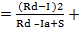………..........………………….........…………………….….....................…(4)
Where; Qsurf = is the accumulated runoff or rainfall excess (mmH2O), Rday = is the rainfall depth for the day (mm mmH2O), Ia = is the initial abstractions which includes surface storage, interception and infiltration prior to runoff (mm H2O), S= is the retention parameter (mm).
The retention parameter varies spatially due to changes in soils, land use, management and slope and temporally due to changes in soil water content.
The retention parameter is defined as:
S ¹⁰)……………………………..................………………........................…(5)
Where: CN is the curve number for the day.
The initial abstraction, Ia, is commonly approximated as 0.2S and Eq. (4) becomes,
Q_{surf}………..............................………………................................…………...(6)
Runoff will only occur when Rday> Ia.
Dual hydrologic groups are given for certain wet soils that can be adequately drained. The first letter applies to the drained condition, the second to the un drained. Only soils that are rated D in their natural condition are assigned to dual classes.
d. Antecedent Soil Moisture Condition
For the definition of the soil hydrologic groups, the model uses the U.S. Natural Resource Conservation Service (NRCS) classification, which classifies soils into four hydrologic groups (A, B, C, & D) based on infiltration characteristics of the soils. Group A, B, C and D soils have high, moderate, slow, and very low infiltration rates with low, moderate, high, and very high runoff potential, respectively. SCS defines three antecedent moisture conditions: I—dry (wilting point), II—average moisture and III—wet (field capacity). The moisture condition I curve number is the lowest value the daily curve number can assume in dry conditions.
Peak Runoff Rate.
The peak surface runoff rate is the maximum volume flow rate passing a particular location during a storm event. SWAT calculates the peak runoff rate with a modified rational method.
In rational method it assumed that a rainfall of intensity i begins at time t = 0 and continues indefinitely, the rate of runoff will increase until the time of concentration, t = t_{conc}.
The modified rational method is mathematically expressed as:
Q_{peak}=……………………………...................………………...........................(7)
Where: Qpeak is the peak runoff rate (m3/s), @tc is the fraction of daily rainfall that occurs during the time of concentration, Qsurf is the surface runoff (mm), Area is the sub-basin area (km²), tconc is the time of concentration (hr), and 3.6 is a conversion factor.
SWAT estimates the value of α using the following equation:
@tc = 1 - [exp 2 * t_{conc}* ln (1 -@_{0.5})] ……………………...................……..........................…(8)
Where: t_{conc} is the time of concentration (hr), and @_{0.5} is the fraction of daily rain falling in the half-hour highest intensity rainfall.
Time of Concentration.
The time of concentration, t_{conc}, is a time within which the entire sub basin area is discharging at the outlet point. It is calculated by summing up both the overland flow time of the furthest point in the sub basin to reach a stream channel (t_{ov}) and the upstream channel flow time needed to reach the outlet point (t_{ch}):
t_{conc}= t_{ov}+t_{ch}……………………………..................................……………....................…... (9)
The overland flow time (t_{ov}) is _{computed} as:
t_{ov}=…………………………………..……..................………...……...................…(10)
Where: L_{slp} is the average sub basin slope length (m), V_{ov} is the overland flow velocity (m/s), and 3600 is a unit conversion factor.
The overland flow velocity for a unit width along the slope is calculated by using the Manning’s
equation:
Vov = q_{ov}^{0.4}*Slp0.36………………………………………………………................…………........................................(11)
n^{0.6}
Where: qov is the average overland flow rate (m³/s), Slp is the average slope of the sub basin (m/m), n is Manning’s roughness coefficient of the sub basin. Assuming an average flow rate of 6.35 mm/hr and substituting the equation of Vov into tov,
The simplified equation of the overland flow becomes:
t_{ov} = L_{slp}^{0.6}*n^{0.6}……………………………………..............……..........……........................(12)
16*slp^{0.3}
Channel flow time is computed as:
t_{ch}= L_{c} ……………………………………………………………………..……….......(13)
3.6*V_{c}
Where: Lc is the average flow channel length (km), Vc is the average flow velocity (m/s), and 3.6 is a unit conversion factor.
The average flow channel length is calculated as:
L_{c}= (L*L_{cen})^{0.5}…………..…………....………………………………………....................(14)
Where: L is the channel length from the furthest point to the sub basin outlet (km), Lcen is the distance along the channel to the sub basin centroid (km).
Assuming Lcen = 0.5L, and using the Manning’s equation for Vc for a trapezoidal channel with side slope of 2:1 and bottom width to depth ratio of 10:1, channel flow time becomes:
t_{ch}= 0.62*L*n^{0.75} …………………......................………………...................................(15)
Area^{0.125}*Slp_{ch}^{0.375}
Where: t_{ch} is the time of concentration for channel flow (hr), L is channel length from the most distant point to the sub basin outlet (km), n is Manning’s roughness coefficient for the channel, Area is the sub basin area (km2), and Slp_{ch} is the channel slope (m/m).
Surface Runoff Lag.
In large sub basins with a time of concentration greater than 1 day, only a portion of the surface runoff will reach the main channel on the day it is generated. SWAT incorporates a surface runoff storage feature to lag a part of the surface runoff release to the main channel. Once surface runoff is calculated, the amount of surface runoff released to the main channel is calculated as:
Q_{surf}= (Q`_{surf}+ Q_{surf,i-1})*(1- exp[-surlag])……………………........................................…(16)
t_{conc}
Where: Qsurf is amount of surface runoff discharged to main channel in a day (mm), Q′surf is amount of surface runoff generated in a sub basin in a day (mm), Qstor,i-1 is the surface runoff stored or lagged from the previous day (mm), Surlag is the surface runoff lag coefficient, and tconc is the time of concentration for the sub basin (hrs)
Routing Method.
The routing phase is the second division of hydrological cycle which can be defined as the movement of water, sediments, etc through the channel network of the watershed to the outlet. Water is routed through the channel network using the variable storage routing method or the Muskingum River routing method.
The variable storage routing method was developed by Williams (1969) and used in the HYMO (Williams and Hann, 1973) and ROTO (Arnold et al., 1995) model has been used in this research work.
For a given reach segment, storage routing is based on the continuity equation:
ΔVstord= Vin-V_{out}………………………………………………..……............................(17)
Where: Vin is the volume of inflow during the time step (m³ water), Vout is the volume of outflow during the time step (m³ water), and Vstorage is the change in volume of storage during the time step (m³ water). This equation can also be detailed as follows:
V_{storage,2}-V_{stored,1}= Δt*(q_{in,1}+q_{in,2}) - Δt*(q_{out,1}+q_{out,2})………….……...........................…...(18)
2 2
Where: Δt is the length of the time step (s), qin, 1 is the inflow rate at the beginning of the time step (m³/s), qin, 2 is the inflow rate at the end of the time step (m³/s), qout, 1 is the outflow rate at the beginning of the time step (m³/s), qout, 2 is the outflow rate at the end of the time step (m³/s), Vstorage, 1 is the storage volume at the beginning of the time step (m³ water), and Vstorage, 2 is the storage volume at the end of the time step (m³ water).
Travel time is computed by dividing the volume of water in the channel by the flow rate.
TT = V_{storage}= V_{storage,1}= V_{storage,2}…………………………….......................................(19)
q_{out} q_{out,1} q_{out,2}
Where: TT is the travel time (s), Vstorage is the storage volume (m³ water), and qout is the Discharge rate (m³/s).
e. Potential Evapotranspiration
Potential evapotranspiration (PET) was a concept originally introduced by Thorns Waite (1948) as part of a climate classification scheme. He defined PET is the rate at which evapotranspiration would occur from a large area uniformly covered with growing vegetation that has access to an unlimited supply of soil water and that was not exposed to advection or heat storage effects. Because the evapotranspiration rate is strongly influenced by a number of vegetative surface characteristics, Penman (1956) redefined PET as “the amount of water transpired by a short green crop, completely shading the ground, of uniform height and never short of water”. Penman used grass as his reference crop, but later researchers (Jensen, et al., 1990) have suggested that alfalfa at a height of 30 to 50 cm may be a more appropriate choice. Numerous methods have been developed to estimate PET. Three of these methods have been incorporated into SWAT: the Penman-Monteith method (Monteith, 1965; Allen, 1986; Allen etal., 1989), the Priestley-Taylor method (Priestley and Taylor, 1972) and the Hargreaves method (Hargreaves et al., 1985).
The model will also read in daily PET values if the user prefers to apply a different potential evapotranspiration method. The three PET methods included in SWAT vary in the amount of required inputs. The Penman-Monteith method requires solar radiation, air temperature, relative humidity and wind speed. The Priestley-Taylor method requires solar radiation, air temperature and relative humidity. The Hargreaves method requires air temperature only.
Penman-Monteith Method.
The Penman-Monteith equation combines components that account for energy needed to sustain evaporation, the strength of the mechanism required to remove the water vapor and aerodynamic and surface resistance terms.
The penman-Monteith equation is:
λE = Δ(H_{net}-G)+ r_{air*}C_{p}.[e⁰_{z}-e_{z}]/ra…………………………….....…..…........................(20)
Δ+ γ.(1+r_{c}/r_{a})
Where λE is the latent heat flux density (MJ m-2 d-1), E is the depth rate evaporation (mm d-1), Δis the slope of the saturation vapour pressure-temperature curve, de/dT (kPa °C-1), Hnet is the net radiation (MJ m-2 d-1), G is the heat flux density to the ground (MJ m-2 d-1), ρair is the air density (kg m-3), cp is the specific heat at constant pressure (MJ kg-1 °C-1), is the saturation vapor pressure of air at height z (kPa), e⁰_{z}e_{z} is the water vapour pressure of air at height z (kPa), γ is the psychometrics constant (kPa °C-1), rc is the plant canopy resistance (s m-1), and ra is the diffusion resistance of the air layer (aerodynamic resistance) (s m-1).
For well-watered plants under neutral atmospheric stability and assuming logarithmic wind profiles, the Penman-Monteith equation may be written (Jensen et al., 1990):
λE_{t} = Δ(H_{net}-G)+ γ .k₁.(0.622.γ.r_{air}/P.[e⁰_{z}-e_{z}]/r_{a}……....................................................(21)
Δ+ γ.(1+r_{c}/r_{a})
Where λ is the latent heat of vaporization (MJ kg-1), Et is the maximum transpiration rate (mmd-1), K1 is a dimension coefficient needed to ensure the two terms in the numerator have the same units (for uz in m s-1, K1 = 8.64 x 104), and P is the atmospheric pressure (kPa).
f. Ground Water System.
Groundwater balance in SWAT model is calculated by assuming two layers of aquifers. SWAT partitions groundwater into a shallow, unconfined aquifer and a deep-confined aquifer and it simulates two aquifers in each sub basin. The shallow aquifer is an unconfined aquifer that contributes to flow in the main channel or reach of the sub basin. The deep aquifer is a confined aquifer. Water that enters the deep aquifer is assumed to contribute to stream flow somewhere outside of the watershed (Arnold et al., 1993). Groundwater flow contribution to total stream flow is simulated by creating shallow aquifer storage (Arnold et al, 1993). Percolate from the bottom of the root zone is recharge to the shallow aquifer. A recession constant, derived from daily stream flow records, is used to lag flow from the aquifer to the stream. Other components of groundwater system include evaporation, pumping withdrawals, and seepage to the deep aquifer.
Shallow Aquifer
The water balance for a shallow aquifer in SWAT is calculated with:
aq_{sh,i}= aq_{sh,i-1}+W_{rchrg}-Q_{gw}-W_{revap}-W_{deep}-Wpump,sh…..…………...............................................................(22)
where aq_{sh,i}is the amount of water stored in the shallow aquifer on day i (mm), aq_{sh,i-1} is the amount of water stored in the shallow aquifer on day i-1 (mm), W_{rchrg} is the amount of recharge entering the aquifer on day i (mm), Q_{gw} is the groundwater flow, or base flow, into the main channel on day i (mm), W_{revap} is the amount of water moving into the soil zone in response to water deficiencies on day i (mm), W_{deep} is the amount of water percolating from the shallow aquifer into the deep aquifer on day i (mm), and W_{pump,sh} is the amount of water removed from the shallow aquifer by pumping on day i (mm).
Deep aquifer
The water balance for the deep aquifer is:
aq_{dp,i}= aq_{dp,i-1}+ W_{deep}-Wpump,dp……………………………………………………………..………………...........................................(23)
where aq_{dp,i}is the amount of water stored in the deep aquifer on day i (mm), aq_{dp,i-1}is the amount of water stored in the deep aquifer on day i-1 (mm), W_{deep} is the amount of water percolating from the shallow aquifer into the deep aquifer on day i (mm), and W_{pump,dp} is the amount of water removed from the deep aquifer by pumping on day i (mm). If the deep aquifer is specified as the source of irrigation water or water removed for use outside the watershed, the model will allow an amount of water up to the total volume of the deep aquifer to be removed on any given day.

- MATERIALS AND METHODS
3.1. Description of the study area
    - Location
The study was carried out in Upper Gidabo catchment, Abaya Chamo lakes sub basin, SNNPR, Ethiopia. It is situated in the Main Ethiopian Rift valley (MER), North-east of Lake Abaya. The catchment is geographically located between 6°39’N to 6°12’North and 38°14’E to 38°21’ east covering an area of about 1205 km². The upper Gidabo catchment contains 23 sub-basins which includes some tributaries that contribute to the Gidabo River. According to WRCS (2013) topographically the Gidabo catchment is undulating and ranges from low relief characterized by high fault cliffs, steep hills and low flat land near Lake Abaya to high relief. The study area lies in Five Woredas which are Yirgalem, Dale, Wenesho, Gureche and Shabadino woredas.
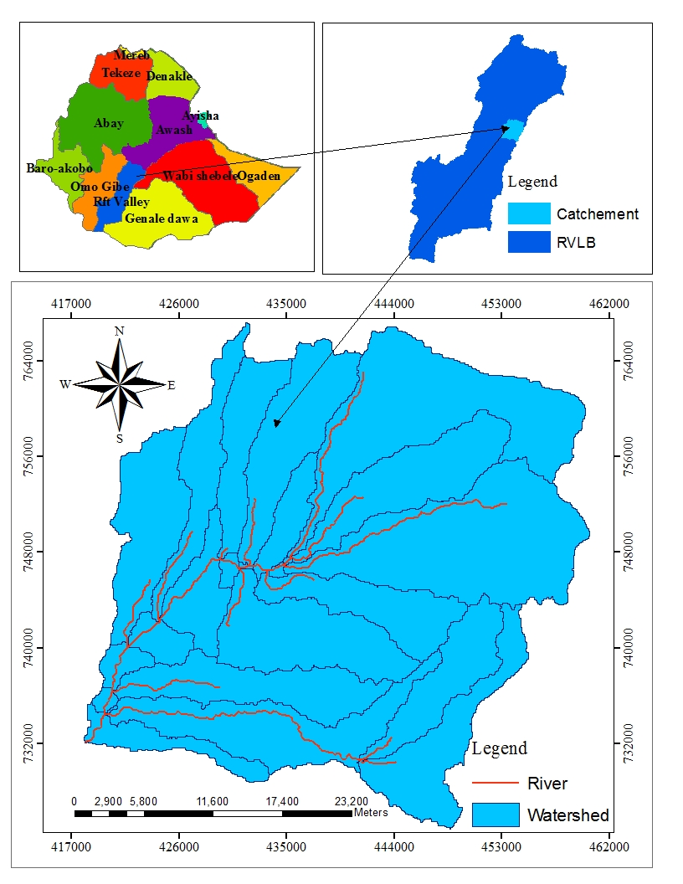
Figure 2. Location map of Upper Gidabo catchment.
    - Climate
- rainfall
The rainy season of the area start from March to May and from July to October. The mean annual rainfall and temperature is 1,100 mm and 20°C respectively. The weather condition of the area is mainly controlled by the seasonal migration of the inter-tropical convergence zone (ITCZ), which is adapted by the convergence of trade winds of the northern and southern hemispheres (Habtamu and Rapprich, 2014).
Based on the average annual monthly temperature and rainfall, the climate condition of the study area varies among temperate, subtropical, tropical and traditionally called “Dega” “Woina Dega” and “Kolla”, respectively (National Atlas of Ethiopia, 1988).

Figure 3. Long-term mean monthly rainfall of different station (1996-2011)

Figure 4. Long term Mean monthly rainfall distribution of selected meteorological stations for the period of 1996-2011.
- Temperature
The mean annul temperature in area lies between 20-25⁰c the highest temperature found in low land area of catchment. The hottest month are in spring before the rain start in march and April, with mean monthly temperatures in in lowlands around area laying in the range 25-30⁰c and falling to 20-30⁰c in the high lands. Temperature lowers during the rainy season and coldest month are July and December, with temperatures in the range 20-25⁰c in the low land and 15-20⁰c in the highest part of sub-basin.

Figure 5. Long-term mean monthly Min, Max and Average temperature (1996-2011)
    - Land Use/Land Cover and soil
The interference of human beings has exerted change on the physical environment of the catchment. Particularly, due to high population growth and urbanization the need of farmlands and infrastructure expansion has enhanced and resulted in the clearance of existing vegetation cover. According to Habtamu and Rapprich(2014) the vegetation cover in the study area varies in sub watershed. It depends on the altitude and soil type across the sub watershed. The major crops grown in the upper parts of the sub catchment are coffee, enset, maize and teff. However, in the lower and middle parts of the catchment, livestock production is the main activity of the community.
Soil property influences the relationship between runoff and infiltration rates of the soil. It determines the water storage capacity and affects the resistance of water flowing into the deeper layers. The development of soils depends primarily on geologic and climatic conditions. The main types of soil erosion in the catchment are sheet and gully erosion, yet large areas of the catchment have been subjected to sheet erosion. Cultivation and deforestation have considerably changed the natural vegetation cover over the area. They have accelerated the rate of weathering and erosion problem (Habtamu and Rapprich, 2014).
The soil associated with lacustrine sediments, River alluvium and pumice are poorly developed and unconsolidated. They are highly permeable and likely to make little surface runoff (Tenalem, 1998). According to FAO (1988) soil classification the major soil units in the catchment are categorized as chromic luvisols, Eutric Vertisols, Humic Nitisols and Lithic Leptosols.
    - Geology
According to WRCS (2013) the geology of the Main Ethiopian Rift Valley contains basic to felsic volcanics, lacustrine sediments and recent to sub-recent Quaternary cover. The volcanic rock varies between Tertiary to Quaternary rocks of basalt, rhyolite, locally trachyte, trachy basalt, ignimbrite, tuff, with minor obsidian, tephrites, scoria, and other rocks. The sediments are lacustrine, pyroclastic or reworked volcano sedimentary sediments that vary in composition and thickness from place to place. The geology of Gidabo catchment is classified in seven geologic formations Viz. Trachytic basalt and Rhyolit (NQs), Terrace gravel deposits (PNv), Nazareth group Alkaline and per alkaline stratoid silicics (N1_2n), Dino Formation (Qdi), Pyroclastic fall deposit (Qvs), Transitional mildy alkaline (Pv) and Bofa Basalts (N2b). The catchment is dominantly covered by Trachytic basalt and Rhyolit formation.
3.2. DATA INPUT AND ANALYSIS
Figure 6. The general framework of the study
Model Calibration & Validation
Hydrological Data
Run the Calibrated Model Using 1996 LULC map
Comparison of The Stream Flow Output
Sensitivity Analysis
Run the Model
DEM
Soil Map
Land Use/Land Cover Map Of 2011
Figure 3.5. Frame work of the study
SWAT Data Base Preparation
Run the Calibrated Model Using 2011 LULC map
Calibrated Model Using 1996 LULC map
)
Weather Generator Setup
Water Shade Delineation
Hydraulic Response Unit Analysis
Land Use/Land Cover Map Of 1996
Climate Data
Accuracy Assessment Of 1996 & 2011 Land Use/Land Cover Maps
Image Classification of ETM+(2011)
Band Composition of ETM+(2011)
Image Processing of ETM+(2011)
Image Processing of ETM+(2011)
Band Composition of TM(1996)
Image Processing of TM(1996)
Image Processing of TM(1996)
Image Classification of TM(1996)
Landsat Digital images of TM & ETM+
Data Collection
3.2.1. SPATIAL DATA
Spatial datasets that are collected for this study was digital elevation model (DEM), land use and soil. A DEM with a spatial resolution of 30 m by 30 m was used in this study obtained from Ministry of Water Resource (MoWR) GIS Department and land cover satellite image data files were downloaded in zipped files from the United State Geological Survey (USGS) website and extracted to Tiff format files, whereas the Soil data was collected from Ethiopian ministry of water, irrigation and electricity (MWIE) (see Table 2).
Table 2.Details of spatial data
No | Data type | Resolution | Data of acquisition | Sources
1 | DEM | 30M x30M |  | MWIE/GIS DEP`T/
2 | Land sat TM & ETM image | 30M x30M | Jan 01,1996 and Feb 02,2011 | USGS website
3 | Soil data | 90M x90M |  | MWIE/GIS DEP`T/

- Data Acquisition
For this study, various data are required that includes topographic data (DEM), Land use and land cover data, soil data, daily data of climatic variables (daily data of precipitation, maximum and minimum temperature, relative humidity, wind speed and solar radiation). The DEM and land cover satellite data were obtained from the Ministry of Energy and Water Resources of Ethiopia GIS Department. Soil and hydrological data were collected from the Ministry of Energy and Water Resources of Ethiopia. The climatic data were obtained from the National Meteorological Agency of Ethiopia.
- Image Processing
This study was done using Landsat imageries of six bands to identify changes in land use and land cover distribution in the Gidabo Upper Catchment over 16 years period from 1996 to 2011. Landsat TM and ETM+ were selected for the period of 1996 and 2011 respectively. To avoid a seasonal variation in vegetation pattern and distribution throughout a year, the selection of dates of the acquired data were made as much as possible in the same annual season of the acquired years. The images used in this study area were orthorectified to a Universal Transverse Mercator projection using datum WGS (World Geodetic System) 84 zone 37N.

In order to view and discriminate the surface features clearly, all the input satellite images were composed using the RGB color composition (Figure 7). The images provide complete coverage of upper Gidabo watershed. The image data files were downloaded in zipped files from the United State Geological Survey (USGS) website and extracted to Tiff format files. The acquisition dates, sensor, path/row, resolution and the producers of the satellite images used in this study are summarized in the Table 3.
Table 3. The acquisition dates, sensor, path/row, resolution and the producer’s of the images
Path/Row | Acquisition date | Sensor | Resolution(m) | Producer
168/055 | Jan 01,1996 | TM | 30 | USGS
168/055 | Feb 02,2011 | ETM+ | 30 | USGS
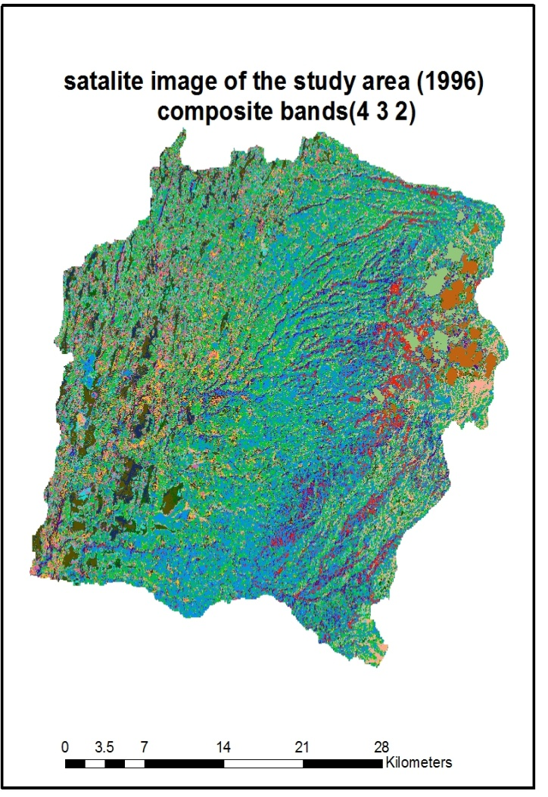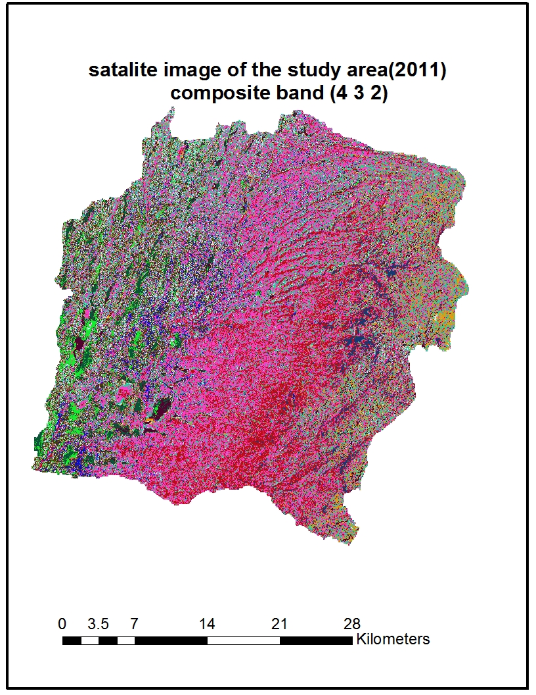
Figure 6. The Standard “False Color” composite satellite image of the study area of the year 1996 & 2011
- Land Use and Land Cover Mapping
- Land Use and Land Cover Classes
The Land use and land cover change studies usually need the development and the definition of homogeneous land use and land cover units before the analysis is started. These have to be differentiated using the available data source such as remote sensing, any other relevant information and the previous local knowledge. A pixel based supervised image classification with maximum likelihood classification algorithm was used to map the land use/ cover classification of the two period Landsat imageries with ERDAS Imagine 2014 Software. The references used to select the training sites for the supervised image classification was the google earth high resolution imagery and ground control points. Training areas were derived by connecting ERDAS Imagine 2014 software with google earth and then determine the cover type by examining the image in google earth for each colors having the same cluster from satellite image. The signature level taken was between 15 and 45 for each of the land cover classes over an image. Similar dates of the TM and google earth images were taken while selecting training areas. After the signature was achieved for each class using MLC algorithm five different land cover classes was made, namely: (1) agriculture (2) forest land; (3) shrub land; (4) bare land; and (5) wet land were selected for the two land use/ cover periods.
Hence, based on the priori knowledge of the study area and additional information from previous research in the study area (Geleta, 2016; Genetu, 2005), five different types of land use and land cover have been identified for the upper Gidabo catchment.
The descriptions of these land use and land covers are given as follows:
Agricultural land: Areas used for crop cultivation (both annual and perennials), scattered rural settlements, some pastures and plantations around settlements. Sparsely located settlements were included here as it was difficult to separate them from agricultural lands.
Forest land: Land covered with dense trees which includes ever green forest land, mixed forest and plantation forests.
Shrub land: Areas with shrubs, bushes and small trees, with little wood, mixed with some grasses.
Bare land: Completely uncovered with vegetation
Wet land: Land with shallow water.
Field investigations were done to collect training data for image classification and ground verification or validation. Samples of land cover were taken during the field survey. A ground truth points (Fig.8) collected from the field were used for image validation. Global positioning system (GPS) was used to locate the samples of ground truth data.
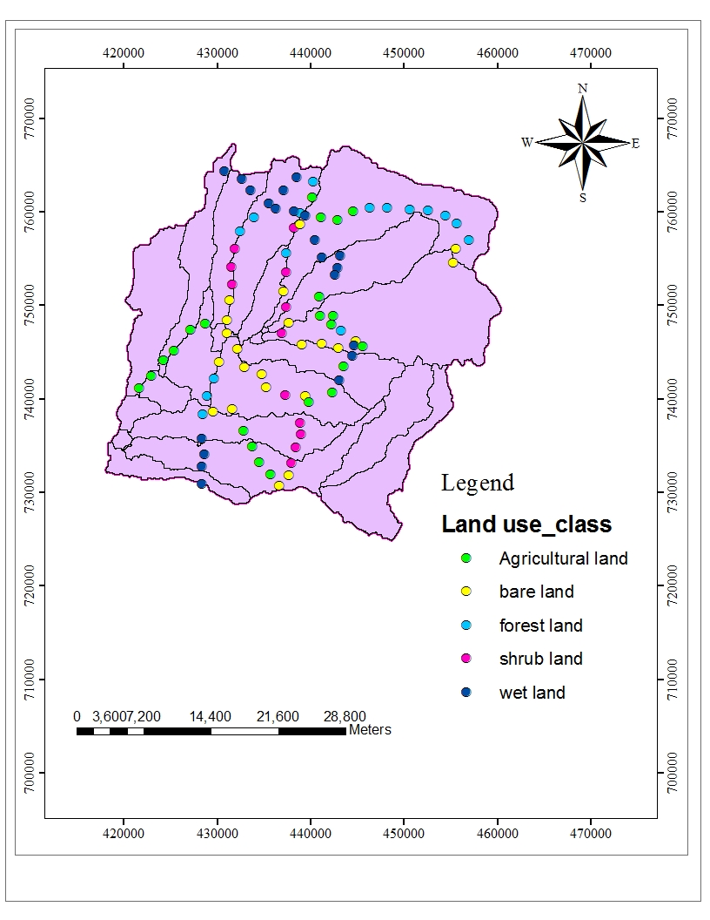
Figure 7: Spatial distribution of ground control points
- Image Classification
Image classification is the process of assigning of pixels of continuous raster image to the predefined land cover classes. It is always a difficult and time consuming task. Different issues to keep in mind to avoid overlapping features and finish with effective classification leis parallel with the ground truth. The result of the classification is mostly affected by various factors such as classification methods, algorithms, collecting of training sites etc. In remote sensing, there are various image classification methods. Their appropriateness depends on the purpose of land cover maps produced for and the analyst’s knowledge of the algorithms is using. However, in most cases the researchers categorized them in to three major categories: Supervised, unsupervised and hybrid. For this study, the supervised classification type was applied. It is the most common type of classification technique in which all pixels with similar spectral value are automatically categorized in to land cover classes or themes. Supervised classification which relies on the prior knowledge of pattern recognition of the study area was used. It requires the manual identification of point of interest areas as reference or Ground Truth within the images, to determine the spectral signature of identified features.
For this study, the land cover map was produced based on the pixel based supervised classification thought the steps such as: First, selecting of the training sites which are typically representative for the land cover classes. The training sites were collected based on the analyst’s personal experience and knowledge of the physiographical knowledge of the area. In addition, image enhancement and composition were applied for better discriminating the land cover classes. Using these approaches around 83 training sites were collected as from each image (1996 and 2011). Second, perform the classification using the Maximum Likelihood Classifier and finally the accuracy assessment of the classified images were assessed by using of the original mosaic and the Google Earth images as references, randomly samples of 81 and 83 points were selected for the 1996 and 2011 maps, respectively and analysis of the confusion matrix was done.
- Accuracy Assessment
Accuracy assessment is an important step in the image classification process. The objective of this process is to quantitatively determine how effectively pixels were grouped in to the correct features classes in the area under investigation. It is a process used to estimate the accuracy of image classification by comparing the classified map with a reference map (Caetano et al, 2005). The most widely used classification accuracy is in the form of error matrix which can be used to derive a series of descriptive and analytical statistics (Manandhar et al, 2009). The columns of the matrix depict the number of pixels per class for the reference data, and the rows show the number of pixels per class for the classified image. From this error matrix, a number of accuracy measures such as overall accuracy, user’s and producer’s accuracy determined. The overall accuracy is used to indicate the accuracy of the whole classification (i.e. number of correctly classified pixels divided by the total number of pixels in the error matrix), whereas the other two measures indicate the accuracy of individual classes. User’s accuracy is regarded as the probability that a pixel classified on the map actually represents that class on the ground or reference data, whereas product’s accuracy represents the probability that a pixel on reference data has been correctly classified. The accuracy assessment of the classified map is the comparison of the classified image and the sampling points from the orthophotos, Google Earth Imageries and existing land cover maps (Yesserie, 2009). In this study, the assessment was carried out using the original image for 1996 maps and the Google Earth Image for 2011 together with previous knowledge of the area was used as reference data to generate testing data set. A total of 81 and 83 testing sample points were selected randomly for the year 1996 and 2011 respectively.
- Digital Elevation Model (DEM)
From Spatial input data a Digital Elevation Model (DEM) gives the elevation, slope and defines the location of the streams network in a basin. Digital Elevation Model is one of the essential inputs required by SWAT to delineate the watershed in to number of sub watershed or sub basins. The DEM is used to analyze the drainage pattern of the watershed, stream lengths, and widths of channel within the watershed. The raw DEM was processed and projected using Arc GIS 10. A DEM with a spatial resolution of 30 m by 30 m was used in this study obtained from Ministry of Water Resource (MoWR) GIS Department.
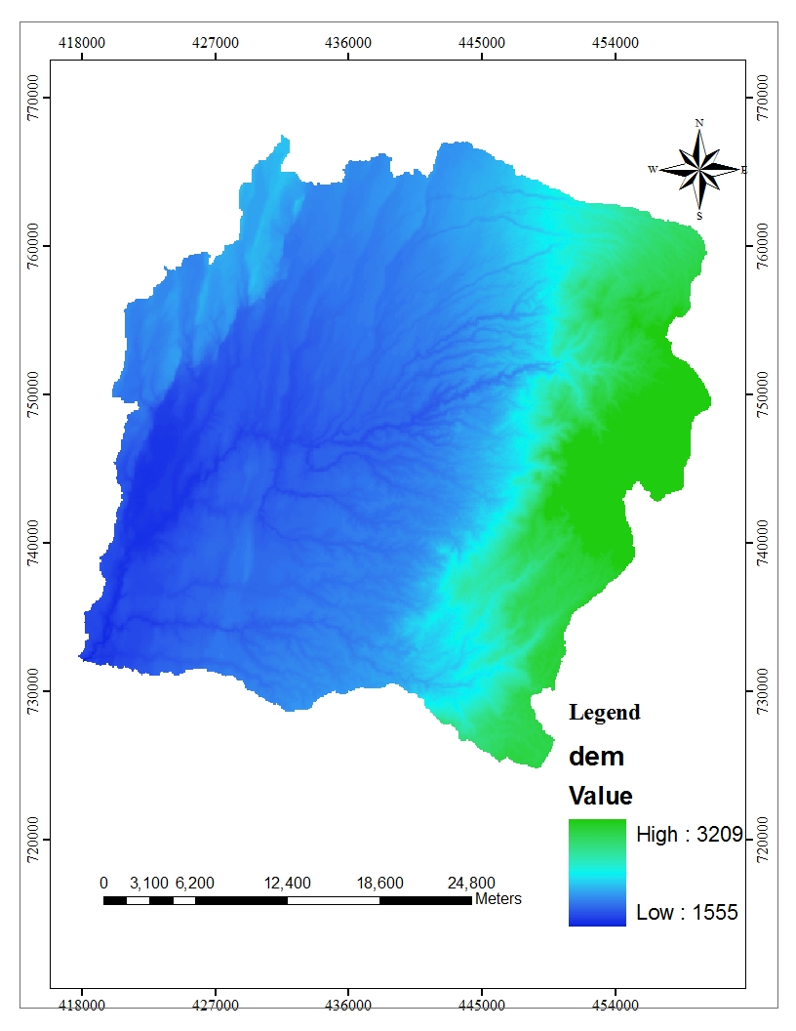

Figure 8. Digital Elevation Model (DEM) of study area
- Land Use/Cover Map
Land use is one of highly influencing the hydrological properties of the watersheds. It is one of the main input data of the SWAT model to describe the Hydrological Response Units (HRUs) of the watersheds. The SWAT model has predefined four letter codes for each land use category (Table 4). These codes were used to link or associate the land use map of the study area to SWAT land use databases. Hence, while preparing the lookup-table, the land use types were made compatible with the input needs of the model.
Table 4.Land use/cover classification of upper Gidabo catchment as per SWAT model
Land use/ Land cover | Land use according to SWAT database | SWAT code
Agricultural land | Agricultural land close to grown | AGRC
Forest | Forest mixed | FRST
Shrub land | Rang brush | RNGB
Bare land | Pasture land | PAST
Wet land | Water | WATR

- Soil Data
Soil data is one of the major input data for the SWAT model with inclusive and chemical properties. The soil map of the study area was also obtained from Ministry of Energy and Water Resources of Ethiopia. According to FAO/UNESCO – ISRIC classification, five major soil groups were identified in the watershed of upper gidabo catchment (Figure 10).
SWAT model requires soil physical and chemical properties such as soil texture, available water content, hydraulic conductivity, bulk density and organic carbon content for different layers of each soil type. To integrate the soil map with SWAT model, a user soil database which contains textural and chemical properties of soils was prepared for each soil layers and added the SWAT user soil databases using the data management append tool in ArcGIS. The symbol and areal coverage of the soil types are presented in Table 5.

Table 5.Soil types of upper gidabo catchment with their symbols and areal coverage
Soil type | Symbol | Area
Soil type | Symbol | Ha | %
Chromic Luvisols | Lvx | 50548.3 | 41.95
Lithic Leptosols | LPq | 13878 | 11.51
Chromic Vertisols | LVh | 36376.7 | 30.19
Humic Nitisols | NTu | 451.6 | 0.37
Eutric Vertisols | VRe | 19191.2 | 15.92

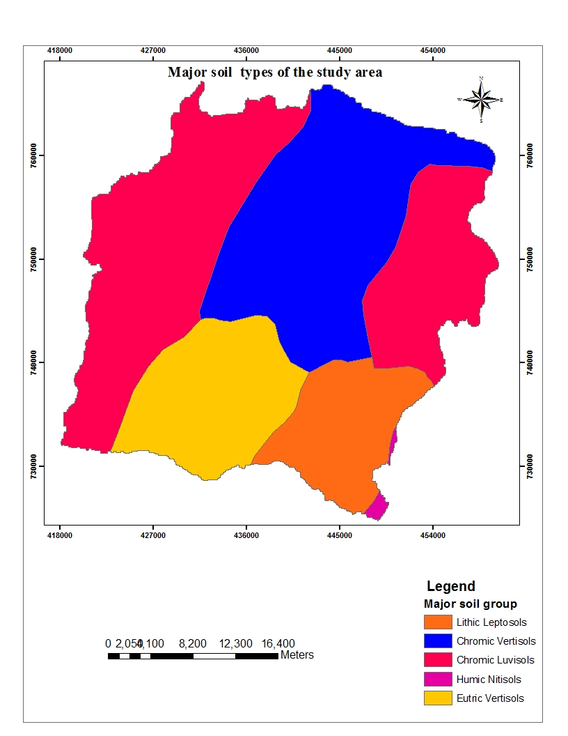
Figure 9. Soil map of the study area
3.2.2. TEMPORAL DATA
Temporal/Time series/ data that are collected for proper implementation of this study were precipitation, minimum and maximum temperature, wind speed, relative humidity and hydrological data. Climate data were obtained from the national meteorological agency (NMA) of Ethiopia whereas hydrological data were collected from Ethiopian ministry of water, irrigation and electricity(MWIE).
- Weather Data
SWAT also needs long years of climate data for the simulation of hydrological processes. For this specific study, the necessary climate data were collected from the National Meteorological Services Agency (NMSA). Since there may be few meteorological stations which have relatively long period of record inside the meteorological variables have been collected are like humidity, sunshine hours, and wind speed in addition to rainfall, maximum and minimum temperatures.
The number of meteorological variables collected varies from station to station depending on the class of the stations. Some stations contain only rainfall data. The other group includes maximum and minimum temperature in addition to rainfall data. There are also stations which contain variables like humidity, sunshine hours, and wind speed in addition to rainfall, maximum temperature and minimum temperature.
The first class station Dila which have all components of climatic variables mentioned above were used as weather generator station. Data of precipitation, maximum and minimum temperatures, sunshine hours, relative humidity, and wind speed were collected from three meteorological stations Dila, Yirgalem, and Aposto within and around the catchment.
SWAT requires daily values of precipitation, maximum and minimum temperature, solar radiation; relative humidity and wind speed daily climate data rainfall data were available from three recording stations in the catchment.
The collected data ranges in time between (1996 -2011), though there were quite a number of missing data. The other weather data was temperature maximum and minimum data ranging in time from (1986-2015) in the catchment. The other weather data was daily wind duration ranging in time from (1989-2012), daily sunshine hour ranging in time from (1989-2015) and relative humidity ranging in time from (1989-2015).

Table 6.Summary of available rainfall data
Rainfall Station  Name | Period Recorded | Percentage Missing
Dila | 1988-2015 | 0.05
Aposto | 1987-2015 | 5.4
Yirgalem, | 1987-2015 | 3.1
Table 7: Summary of available temperature data
Temperature  Station  Name | Weather  Parameter | Period Recorded | Percentage  Missing
Dila | Maximum  Temperature | 1988-2015 | 0.2
Dila | Minimum  Temperature | 1988-2015 | 2.2

- Solar Radiation
Once water is introduced to the system as precipitation, the available energy, specifically solar radiation, exerts a major control on the movement of water in the land phase of the hydrologic cycle. Processes that are greatly affected by temperature and solar radiation include snow fall, snow melt and evaporation. Since evaporation is the primary water removal mechanism in the watershed, the energy inputs become very important in reproducing or simulating an accurate water balance. Arc SWAT need daily solar radiation but the data acquired from National Meteorological Service Agency (NMSA) is sunshine hour but changed into solar radiation.
3.3. Data Analysis
The land use/cover and soil map layers provided spatial information of the study area for the watershed-modeling program. Both maps were provided by extracting large dataset land use/cover obtained from the Global Land Cover Facility (GLCF) and soil map from Ministry of Water Resource (MoWR) of Ethiopia after importing them into ArcGIS interface. Similar attribute classes of the two extracted maps that had different names either because of spatial variability or have no distinct difference in terms hydrological prospect had been reclassified and renamed before they have been used for further task. By doing this the same classes have been assigned in the same name and the comparable classes have also been combined in to one name.
To agreement all the layers be geometrically aligned and fit to the study area, they were geo-referenced to the corresponding coordinate projection of the study area which is North African spatial reference called Adindam_UTM_Zone_37N. As far as weather data is concerned, even though it was a long time-series data, it had several gaps of missing data values. To overcome such problem a technique that can help filling the missing data values was used section 3.4.
Data like daily precipitation; maximum and minimum temperature, wind speed, sunshine hours and relative humidity were collected in a soft copy format. After filling missing climate data arranged for the SWAT simulation daily 16 year (1996-2011).
3.3.1. Filling Missing Weather Data
Rain fall play a central role in developing rainfall-runoff. Measured precipitation data are important to many problems in hydrologic analysis and design. For gages that require periodic observation, the failure of the observer to make the necessary visit to the gage may result in missing data. Vandalism of recording gages is another problem that results in incomplete data records, and instrument failure because of mechanical or electrical malfunctioning can result in missing data. Any such causes of instrument failure reduce the length and information content of the precipitation record. A number of methods have for estimating missing rainfall data.
There are station average method, normal ratio method, quadrant method, and inverse-distance weighting method and regression methods. From five methods normal ratio is use for this study. In the normal ratio method, the rainfall PA at station A is estimated as a function of the normal monthly or annual rainfall of the station under question and those of the neighboring stations for the period of missing data at the station under question.
P_{A} ( 24)
n
Where, Pi = is the rainfall at surrounding stations,
NRA= is the normal monthly or seasonal meant at station A,
NRi = is the normal monthly or seasonal rainfall at station i, and
n = is the number of surrounding stations whose data are used for estimation.

Figure 10.: Long -term mean annual rainfall from a period of (1996-2011)
3.3.2. Filling Missing Temperature Data
The same method (Normal ratio method) is adopted to fill missing air temperature data which is use for filling data. Thus after filling both rainfall and air temperature daily 24 year data and their consistence checked by double mass curve none of the station needs to adjust for slop.
3.3.3. Checking the Consistency of Data
A consistent record is one where the characteristics of the record have not changed with time. Adjusting for gage consistency involves the estimation of an effect rather than a missing value. An inconsistent record may result from any one of a number of events; specifically, adjustment may be necessary due to changes in observation procedures, changes in exposure of the gage, changes in land use that make it unreasonable to maintain the gage at the old location, and where vandalism frequently occurs.
Double-mass-curve analysis is the method that is used to check for an inconsistency in a gage record. The curve is a plot on arithmetic graph paper, of cumulative rainfall collected at a gauge where measurement condition may have changed significantly against the average of the cumulative rainfall for the same period of record collected at several gauges in the same region.
The method for checking consistency of a hydrological or meteorological record is considered to be an essential tool is for taking it for analysis purposes. It is determined by plotting the cumulative values of observed time series of station for which consistency need to be checked on x-coordinate on versus cumulative value of observed time series of group of station on y-axis and the station affected by trend, a break in slop of the curve would indicate that conditions have changed that location. The data series, which is inconsistency, adjusted to consistent values by proportionality. Therefore the station to be adjusted for consistency of the recorded using equation.
Si = Yi……………………………….................….…………………………....................(25)
Xi
Where,
S i= is the slope of section i,
Yi = is the change in the cumulative catchment for gage Y between the endpoints of the section i,
Xi = is the change in the cumulative catchment for the sum of the regional gages between the endpoints of section i.
The graph double mass curve below shows (Figure 11) two of station that found in catchment has better correlation because plot of cumulative annual rainfall of neighboring versus Dila station are aliened on single straight line so that correction for consistency will not be done
.
Figure 11. Double mass curve plot made for three stations
3.3.4. Hydrological Data Collection and Analysis
The measured stream flow data Aposto were required for calibrating and validating the model. Stream flow data was available for one Station. The stations had data ranging in time from 1985 to 2015, and Stream flow data obtained from Ministry of Water Resource (MoWR) Hydrology Department. Water resource studies highly depend on stream flow data. These data should be consistent, stationary and homogenous. Monthly stream flow data from a period of 1996-2004 were used for model calibration and from 2005-2011 were used for mode validation.
Unlike rainfall, stream flow shows strong serial correlation; the value on one day is closely related to the value on the previous and following days especially during the period of low flow or recession. The runoff generated due to the small rainfall occurs on April and July and heavy rainfall on May and June and August to October is the main cause of variation of flow in the study area. The gauging station have good stream flow records with a small number of missing data in the study baseline, especially from 1999 to 2012 which was filled by making relation within the data of the gauge itself rather than connecting to the other stations, as the patterns of the recorded data are closely related to each other.

Figure 12.Long-term Monthly average flow of Gidabo at Aposto site (1996-2011)
A time series of hydrological data may exhibit jumps and trends owing to what call inconsistency and non-homogeneity (Yevjevich and Jeng, 1969). Inconsistency is a change in the amount of systematic error associated with the recording of data. It can arise from the use of different instruments and methods of observation. Non- Homogeneity is a change in the statistical properties of the time series. Its causes can be either natural or man-made. These include alterations to land use, relocation of the observation station and implementation of flow diversions. RAINBOW software was used for checking the Homogeneity of flow data for this thesis work.
3.3.4.1. RAINBOW HOMOGENEITY TEST
RAINBOW software has been used to check the homogeneity of data. Frequency analysis of rainfall data and flow data and their potential use in agro meteorological decision-making processes requires that the data be of long series; they should be homogeneous and independent. The restrictions of homogeneity assure that the observations are from the same population. In RAINBOW the test for homogeneity is based on the cumulative deviation from the mean. The following figures show the homogeneity test of flow data at Aposto gauging station.
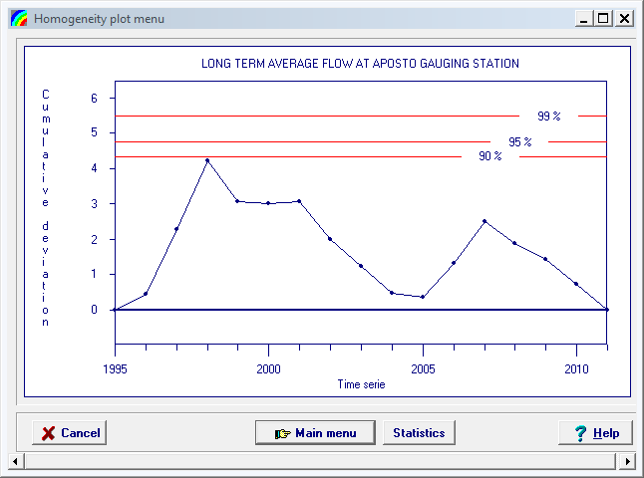
Figure 13.Commutative Deviation of annual flow at Aposto gauging station
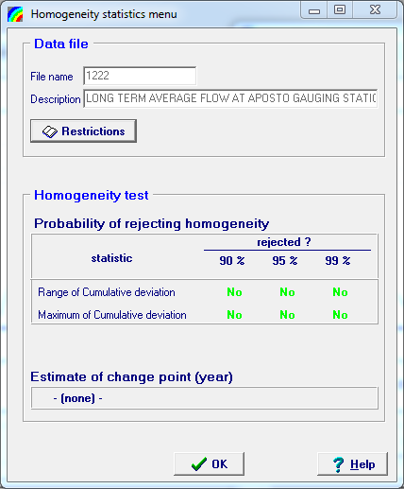
Figure 14.Probability of Rejecting Homogeneity of annual Flow at Aposto gauging Station.
3.3.5. Hydrological data trend analysis
Test for the historical variability of observed stream flow was examined using statistical trend analysis method to get an overall view of the possible changes in stream flow processes. This was done so as to reinforce the justification from hydrological modeling. Aposto gauging station was examined for 1 and 7-day minimum, 1-day maximum and mean annual and seasonal stream flow’s using the nonparametric, Spearman’s rank correlation test
A. The spearman's rank test; test for absence of trend
Statistical significance of trends was examined using a spearman`s Rank correlation non parametric test. The hypothesis is tested that there is no correlation between the order in which the data are observed and the increase (or decrease) in magnitude of those data. The test is usually performed on the whole data series but it is possible to select specific periods. Two series are compared related to the rank of the data. Kxi is the rank of the data as it was measured. Kyi is the series of the rank of the same data in ascending or descending order.
After plotting a time series, one must be sure that there is no correlation between the order in which the data have been collected and the increase (or decrease) in magnitude of those data. Accordingly test for absence trend is checked by applying spearman correlation method in this study as it was simple, distribution free and power full for both linear & nonlinear trend.
The Spearman coefficient of rank correlation Rsp is then defined as
$\text{R}\text{SP}=\frac{6*\text{∑D}\text{i}\text{2}}{n*(n\text{2}-1)}$------------------------------------------------------------------------------(25)
Where n is the total number of sample data’s, Rsp is spearman correlation coefficient and D_{i} is the difference. D_{i} = Kx_{i} - Ky_{i}
Where Kx_{i} is the rank of the variable and ky_{i} is chronological transformed series for observation y. When two or more observations have the same value, the average rank Kyi is calculated.
A test-statistic t_{t} is used to test the null hypothesis H_{o}: Rsp = 0 against the alternative hypothesis H1: Rsp < > 0. The test statistic is defined as
$\text{t}\text{t}=R\text{SP (}\frac{n-2}{1-R\text{SP}\text{2}})$ ..................................................................................................................(26)
The test statistic t_{t} has Student's t-distribution with v = n - 2 degrees of freedom, where n is the number of elements in a sample. Appendix B contains a table of the Student's-t distribution for a level of significance of 5% (two-tailed). The two sided critical region U of the test statistic t_{t} for a level of significance of 5% is bounded by
{ (-∞,t(v,2.5%)} U{t(v,97.5%),+∞} and the hypothesis H0 is accepted when the computed tt is not contained in the critical region. In other words, one concludes that there is no trend when t(v.2.5%) < t_{t} < t(v,97.5%)
B. F-test for the stability of the variance
The appropriate test statistic is the ratio of the variances of two non-overlapping sub-sets of a series. The distribution of the variance ratio of samples from a normal distribution is known as the F distribution or Fisher distribution. Even in the absence of the normal distribution it is generally accepted that the F-test provides a useful indication for the stability of the variance.
The number of data n in the test series should be equal to or greater than 10.
The test statistic is thus
$$\text{F}\text{t}=\frac{ἀ\text{1} \text{2}}{ἀ\text{2} \text{2}}=\frac{s\text{1} \text{2}}{s\text{2} \text{2}}$$
The null hypothesis for the F-test is the equality of variances, H0: s₁²=s₂² and the alternative hypothesis is H1: s₁²<> s₂². The rejection region is bounded by
{ (0,F(v₁,v₂,2.5%)} U{F(v₁,v₂,97.5%),+∞}
where v₁and v₂ are the respective numbers of degrees of freedom of the numerator and dominator. It should be noted that v₁= n₁-1 and v₂= n₂-1 where n₁ and n₂ are the number of observations in each sub-set. In other words, the variability of the data is considered to be stable and the standard deviation s can be used as an estimate for the population standard deviation, when
(F(v₁,v₂,2.5%)<F_{t}< F(v₁,v₂,97.5%)
The F-distribution is not symmetrical for the number of degrees of freedom of the numerator and dominator. Tables should therefore be applied properly with usually v₁ horizontally and v₂ vertically. See appendix C for a condensed table of the F-distribution with a confidence level of 5%.
The procedure to apply the F-test on data series is to subdivide the series in two or three(approximately) equal non-overlapping sub-sets. The standard deviation is computed for each subset. The limits of a sub-set can also be selected in such a way that the set will cover a suspect period. Such a period is then compared with a non-suspect period or periods.
C. T-test for stability of the mean
The t-test is only valid if the variance of the time series is stable. Hence, the F-test for the stability of the variance has to be performed before this test. The means of the same subsets can be compared to verify whether the mean is stable during the whole period of observations. A suitable test statistic for testing the null hypothesis H_{o}: Ẋ₁= Ẋ₂ against the alternative hypothesis H₁: Ẋ₁ < >Ẋ₂ is
t_{t} $=\frac{Ẋ\text{1}-Ẋ\text{2}}{\{\frac{(n\text{1}-1)*s\text{1} \text{2}+(n\text{2}-1)*s\text{2} \text{2}}{n\text{1}+n\text{2}-2}+[\frac{1}{n\text{1}}+\frac{1}{n\text{2}}]\} \text{0.5}}$
where:- n_{i} the number of data in subset i
x_{i} the mean of the subset i
$s\text{1}\text{2}$ the variance of the subset
The test statistic, t_{t} has Student's-t distribution for a sample which is normally distributed. The test may also be applied for non-normal distributions, best for approximately equal lengths of subsets.
The two sided critical region U for the test statistic is defined as
{ (-∞,t(v,2.5%)} U{t(v,97.5%),+∞} and the number of degrees of freedom is v = n₁+ n₂- 2
The null-hypothesis H0 is accepted when the computed t_{t} is not contained in the critical region. In other words, one concludes that Ẋ₁= Ẋ₂ when t(v.2.5%) < t_{t} < t(v,97.5%)

3.4. Model Setup
3.4.1. Watershed Delineation
The watershed and sub watershed delineation was performed using 30 m resolution DEM data using Arc SWAT model watershed delineation function. First, the SWAT project set up was created. The watershed delineation process consists of five major steps, DEM setup, stream definition, outlet and inlet definition, watershed outlets selection and definition and calculation of sub basin parameters. Once, the DEM setup was completed and the location of outlet was specified on the DEM, the model automatically calculates the flow direction and flow accumulation. Subsequently, stream networks, sub watersheds and topographic parameters were calculated using the respective tools. The stream definition and the size of sub basins were carefully determined by selecting threshold area or minimum drainage area required to form the origin of the streams. Using a threshold value suggested by the Arc SWAT interface, the upper gidabo catchment was delineated in to 23 sub watersheds having an estimated total area of 1205km2 (Figure 16).
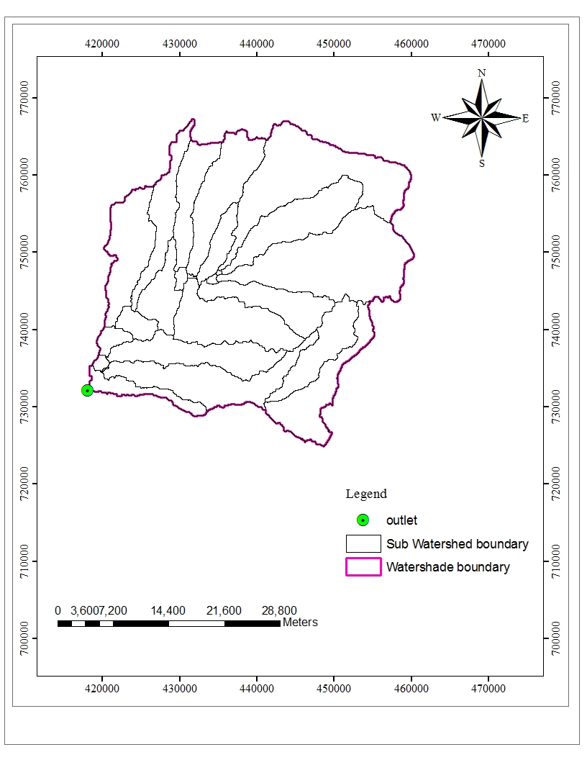
Figure 15.watersheds map of the upper Gidabo catchment
During the watershed delineation process, the topographic parameters (elevation, slope) of the watershed and its sub watershed were also generated from the DEM data. Accordingly the elevation of the watershed ranges from 1555 to 3209 above mean sea level.
3.4.2. Slope
The slope is derived from DEM input so that the model uses this slope for the development of Hydrological Response Unit in addition to land use and soil input parameters. Slope classification was carried out based on the height range of the DEM used during watershed delineation. Arc SWAT allows the integration of land slope classes (up to five classes) when defining hydrologic response units. There are possibilities to choose simply a single slope class, or choose multiple classes. This study considers two slope classes for upper Gidabo watershed such as Gidabo class_{1,}0-2%, Gidabo Class₂ Above 2% .
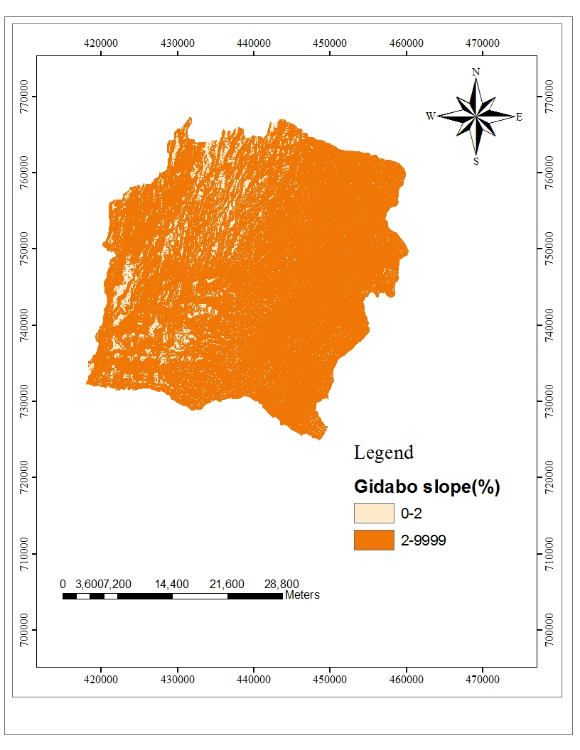
Figure 16. Slope map of upper Gidabo catchment
3.4.3. Hydrologic Response Units Analysis
The sub watersheds were divided into HRUs by assigning the threshold values of land use and land cover, soil and slope percentage. In general the threshold level used to eliminate minor land use and land covers in sub basin, minor soil with in a land use and land cover area and minor slope classes with in a soil on specific land use and land cover area. Following minor elimination, the area of remaining land use and land covers, soils and slope classes are reapportioned so that 100 % of their respective areas are modeled by SWAT. Land use, soil and slope characterization for the upper gidabo catchment was performed using commands from the HRU analysis menu on the Arc SWAT Toolbar. These tools allowed loading land use and soil maps which are in raster format in to the current project, evaluates slope characteristics and determining the land use/soil/slope class combinations in the delineated sub watersheds. In the model, there are two options in defining HRU distribution: assign a single HRU to each sub watershed or assign multiple HRUs to each sub watershed based on a certain threshold values. The SWAT user’s manual suggests that a 20 % land use threshold, 10 % soil threshold and 20 % slope threshold are adequate for most modeling application. However, Setegn et al, 2008, suggested that HRU definition with multiple options that account for 10% land use, 20% soil and 10% slope threshold combination gives a better estimation of runoff and sediment components. Therefore, for this study, HRU definition with multiple options that accounts for 10% land use, 20% soil and 10% slope threshold combination was used. These threshold values indicate that land uses which form at least 10% of the sub watershed area and soils which form at least 20% of the area within each of the selected land uses will be considered in HRU. Hence, the upper gidabo watershed was divided in to 128 HRUs, each has a unique land use and soil combinations. The number of the HRUs varies with in the sub watersheds.
3.4.4. Weather Generator
In developing countries, there is a lack of full and realistic long period of climatic data. Therefore, the weather generator solves this problem by generating data from the observed one (Danuso, 2002). The Model requires the daily values of all climatic variables from measured data or generated from values using monthly average data over a number of years. This study used measured data for all climatic variables. However, the weather data obtained for the stations in and around upper gidabo catchment had missed records in some of the variables. Therefore, these missed values were filled with the weather generator utility in the Arc SWAT Model from the values of weather generator parameters. Weather data of the station with continuous records were used as an input to determine the values of the weather generator parameters. Hence, for weather generator data definition, the weather generator data file wgnstations. dbf was selected first. Subsequently, rain fall data, temperature data, relative humidity data, solar radiation data and wind speed data were selected and added to the model.
The SWAT Model contains weather generator model called WXGEN (Shapley and Williams, 1990). It is used in SWAT model to generate climatic data or to fill missing data using monthly statistics which is calculated from existing daily data. From the values of weather generator parameters, the weather generator first separately generates precipitation for the day. Maximum temperature, minimum temperature, solar radiation and relative humidity are then generated. Lastly, the wind speed is generated independently. To generate the data, weather parameters were developed by using the weather parameter calculator WXPARM and dew point temperature calculator DEW02, which were downloaded from the SWAT website.
The WXPARM program calculates the monthly daily average and standard deviation as well as probability of wet and dry days, skew coefficient, and average number of precipitation days in the month by reading of the daily values of the variables from the station (Dila). Average Daily Dew Point Temperature was calculated using the Dew point calculator (Dew02) from daily maximum temperature, daily minimum temperature and average relative humidity. Moreover, daily solar radiation was calculated from the daily available sunshine hour’s data.
3.4.5. Entering Weather Data
Daily time-series of weather data, which includes precipitation and maximum and minimum air temperature data, is required for the SWAT modeling. The climatic stations which were used in the study are called Dila, Yirgalem and Aposto (Figure.18). The periods of the measured weather data, which was obtained from National Metrology Service Agency of Ethiopia (NMSA), was differ from station to station. From January 1st 1994 to December 31th 2011 including 2 year warm up period was used for SWAT simulation. To deal with the weather data, it should be stored in a specific tabular and supportive file format of Arc SWAT. In this case they were stored in DBF format which is read by Arc SWAT interface. The geographical coordinate’s names of the weather stations of the study area were introduced into Arc SWAT database. The data has provided the most representative precipitation and temperature data available. However some metrological data such as: wind speed, daily sunshine hour, daily wind duration and relative humidity data available only at Dila station. Even though they were less significant compare to the data which were obtained, they were generated by the model. The elevation of precipitation and temperature gages were entered. The elevation information help to correctly estimate the amount of rainfall and temperature for a given elevation band in the sub basin. In other words it helps to match orographic effect.
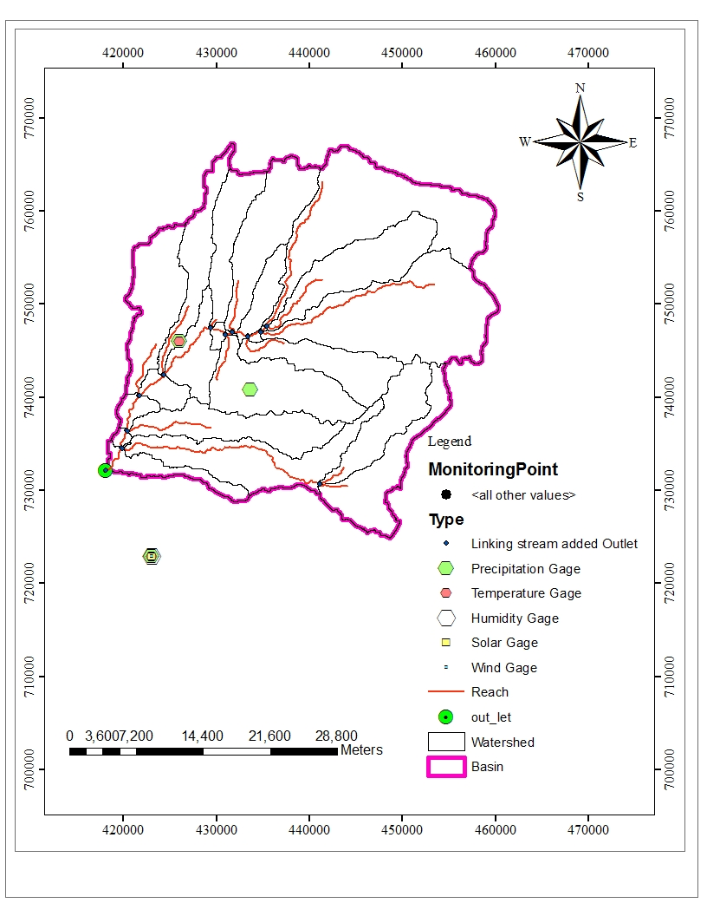
Figure 17. Location of meteorological stations in and around the watershed
3.4.6. SWAT Simulation
In the next task, the database files containing the information needed to generate default input for SWAT model were built. In SWAT, once the default input database files are built, the necessary parameters values can later be entered and edited manually. The HRU distribution was also modified whenever it was needed.
The soil parameters values of each type of soil were entered. The land use/cover parameters were edited where it was necessary. Since the Penman-Monteith equation requires detailed climatological data which are not easily available especially in developing nations (Khoob, 2007), the Hargreaves (Hargreaves et al, 2003) method was chosen to calculate evapotranspiration (ETo). Hargreaves equation can be used in the lack of sufficient or reliable data to solve the Penman Monteith equation (Allen, et al.1998). The equation can estimate the ETo using only daily mean, maximum and minimum air temperature, usually available at most weather stations worldwide and extraterrestrial radiation (Droogers, and Allen, 2002.). The curve number for runoff and the variable storage for channel routing were chosen.
Percolation component was modeled with a layered storage routing technique combined with a crack flow model. A skewed normal distribution was assumed for rainfall distribution. SWAT simulation run was carried out on the 1994-2011 climate data. Two year data was kept as warm up period. The warm-up period is important to make sure that there are no effects from the initial conditions in the model. The lengths of warm-up period differ from catchment to catchment. It is mainly depend on the objective of the study. The run output data imported to database and the simulation results were saved in different files of SWAT output. The file named basins.rch contains stream-flow and water quality parameters in streams and rivers. It is used for SWAT model calibration since most of the observations of the watershed’s behavior are obtained by measuring these parameters. The basins. subs file stores yearly outputs from HRU’s.
3.5. Modeling of Total Sub basin of Upper Gidabo Catchment
Using the SWAT Model Upper gidabo catchment was divide in to 23 sub–basin and 128 HRU determined by unique inter section of the LU/LC, slope and soil within the catchment (Figure 19)
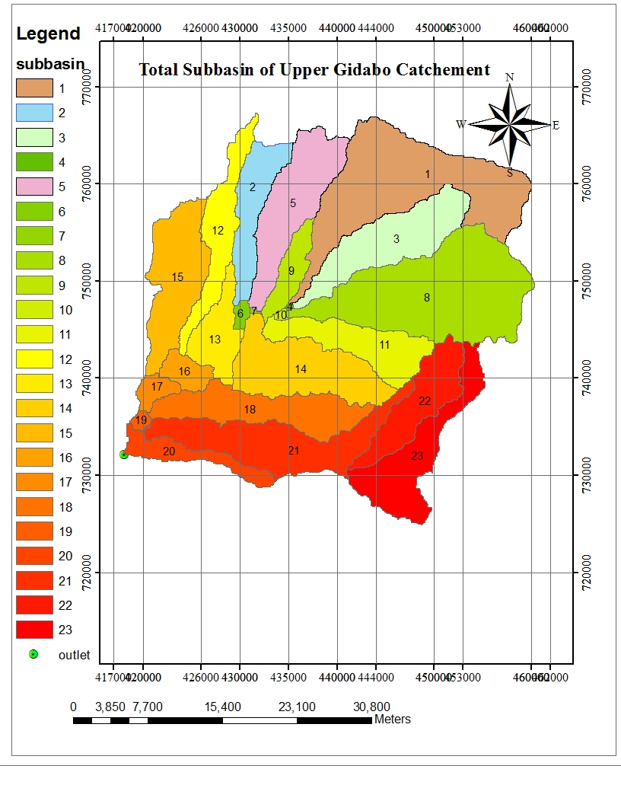
Figure 18. Total Sub-basin of Upper Gidabo catchment
3.6. Base Flow Separation
The base flow separation using the base flow separator program based on the daily flow data measured at the outlet of the upper gidabo catchment showed that the base flow recession constant (alpha factor), which is the rate at which groundwater is returned to the stream, is found to be 0.0167. The base flow days, which is the number of days for the base flow recession to decline through one log cycle, has a value of about 141.1days. In the calibration of the hydrology components of the model, it may be necessary to separate stream flow into direct or surface runoff and base flow and this was done using WHAT (Web-based Hydrograph Analysis Tool) is a base flow separation technique that use the time-series record of stream flow to derive the base flow and the surface flow.
3.7. Sensitivity Analysis
Calibration is necessary to optimize the values of the model parameters which help to reduce the uncertainty in the model outputs. However, such type of model with a multiple parameters, the difficult task is to determine which parameters are to be calibrated. In this case, sensitivity analysis is important to identify and rank parameters that have significant impact on the specific model outputs of interest (Van Griensven et al., 2006).
Therefore, for this study, sensitivity analysis was done prior to the calibration process in order to identify important parameters for model calibration. The average monthly stream flow data of 9 years from 1996 to 2004 of the watershed gauging station were used to compute the sensitivity of the stream flow parameters.
In the sensitivity process, by entering the Arc SWAT interface sensitivity analysis window, first the SWAT simulation was specified for performing the sensitivity analysis and the location of the sub basin where observed data was compared against simulated output. Then, selected parameters were entered for the sensitivity analysis with the default lower and upper parameter bounds. Hence, 26 flow parameters were included for the analysis with default values as recommended by (Van Griensven et al., 2006). Up on the completion of sensitivity analysis, the mean relative sensitivity (MRS) values of the parameters were used to rank the parameters, and their category of classification. The category of sensitivity was defined based on the (Lenhart et al., 2002) classification presented below (Table 7).
Table 7.SWAT parameters Sensitivity class
Class | MRS | Sensitivity category
1 | 0.00≤ MRS <0.05 | Small to negligible
2 | 0.05≤ MRS <0.20 | Medium
3 | 0.2≤ MRS <1 | High
4 | MRS >1 | Very high
Based on the above classification, parameter producing MRS values of medium, high and very high were selected for calibration process.
3.8. Model Calibration and Validation
Following the sensitivity analysis result, model calibration was done to obtain optimum values for sensitive parameters. SWAT provides three options for calibration: auto-calibration, manual calibration and combination of these two methods. For this study, first manual calibration was done to fine tone some of the parameters. First, some model parameters were adjusted by manual calibration. In this procedure, parameters values were adjusted by changing one or two parameters at a time within the allowable ranges either by replacement the initial value or addition or by multiplication of the initial value as per designed in the interface. Then, auto calibration procedure was used.
The calibration was done on monthly time steps using the average measured stream flow data of the upper gidabo catchment covering from January 1997 to December 2004. Auto calibration was performed for sensitivity flow parameters that produced medium, high and very high mean sensitivity index values. Arc SWAT includes a multi objective, automated calibration procedure that was developed by (Van Griensven, 2006).
The calibration procedure is based on a Shuffled Complex Evolution Algorithm (SCE-UA) and a single objective function. The auto calibration tool in SWAT can be run in either the Parasol or the Parasol with uncertainty analysis mode. For this study, the Parameter Solution (ParaSol) option was selected (Van Griensven et al., 2006). This method was chosen for its applicability to both simple and complex hydrological models. In this procedure, by entering the Arc SWAT interface Auto-Calibration window, first the SWAT simulation was specified for performing the auto-calibration and the location of the sub basin where observed data could be compared against simulated output. Then, the desired parameters for optimization, observed data file, and methods of calibration were selected. Hence, 10 flow parameters were considered in the calibration process.
After the auto calibration runs completed, the model was run using the best parameter output values and the simulations were compared with observed stream flow data using Nash and Sutcliffe coefficient of efficiency (E_{NS}) and coefficient of determination (R²).
Validation was also done to compare the model outputs with an independent data set without making further adjustment of the parameter values. Model validation is comparison of the model outputs with an independent data set without making further adjustment which may adjust during calibration process.

The measured data of average monthly stream flow data of 7 years from January 2005 to December 2011 were used for the model validation process. In this process, the two model performance values were also checked here to make sure that the simulated values are still within the accurate limits.
3.9. Model Performance Evaluation
To evaluate the model simulation outputs in relative to the observed data, model performance evaluation is necessary. There are various methods to evaluate the model performance during the calibration and validation periods. For this study, two methods were used: coefficient of determination (R²) and Nash and Sutcliffe simulation efficiency (E_{NS}).
The determination coefficient (R²) describes the proportion the variance in measured data by the model. It is the magnitude linear relationship between the observed and the simulated values. R² ranges from 0 (which indicates the model is poor) to 1 (which indicates the model is good), with higher values indicating less error variance, and typical values greater than 0.6 are considered acceptable (Santhi et al., 2001). The R2 is calculated using the following equation:
R² = Σ [Qoi - Qsi] [Qoi - Qsi] ------------------------------------------------------------------------(27)
$\sqrt{Σ\left[Qoi-Qo \right] }$²$\sqrt{Σ\left[Qoi-Qs \right] }$²
Where, Qoi – measured value (m³/s)
Qo – average measured value (m³/s)
Qsi – simulated value (m³/s) and
Qs – average simulated value (m3/s)
The Nash – Sutcliffe simulation efficiency (E_{NS}) indicates that how well the plots of observed versus simulated data fits the 1:1 line. ENS is computed using the following equation:
Σ (Qoi – Qsi)²
E_{NS} = 1 – Σ (Qoi – Qo)²………………………………..........………………...............(28)
Where, Qoi – measured value Qsi – simulated value and Qo – average observed value
Table 8.General performance ratings for recommended statistics for a monthly time (D. N Moriasi,et al. 2007)

Performance Rating For Stream Flow | RSR | E_{NS}
Very good | 0.0<=RSR<=0.5 | 0.75<E_{NS}<=1
Good | 0.5<RSR<=0.6 | 0.65<E_{NS}<=0.75
Satisfactory | 0.6<RSR<=0.7 | 0.5<E_{NS}<=0.65
Unsatisfactory | RSR>=0.7 | E_{NS}<=0.5
The value of E_{NS} ranges from negative infinity to 1 (best) i.e, (-∞, 1]. E_{NS} value < 0 indicates the mean observed value is better predictor than the simulated value, which indicates unacceptable performance. While E_{NS} values greater than 0.5, the simulated value is better predictor than mean measured value and generally viewed as acceptable performance (Santhi et al., 2001).
3.10. Evaluation of Stream Flow due to LULCC
Simulation of the impacts of land use and land cover change on stream flow was one of the most significant parts of this study. As discussed above, upper gidabo catchment has experienced land use and land cover changes from 1996 to 2011. There was high expansion of agricultural lands in the expenses of other lands during the study periods considered. The study was carried out for two different two years i.e. 1996 and 2011. The two generated land use and land cover maps, soil, climatic and stream flow data values were used to evaluate the impacts of land use and land cover change on stream flow.
To evaluate the variability of stream flow due to land use and land cover changes from 1996 to 2011, two independent simulation runs were conducted on a monthly basis using both land use and land cover maps for the period of 1996-2011 keeping other input parameters unchanged. Seasonal stream flow variability of 1996 and 2011 due to the land use and land cover change was assessed and comparison were made on surface runoff and ground water flow contributions to stream flow based on the two simulation outputs.
The study also attempts to examine low and high flows of Gidabo River for the two land use datasets. For this, the study used the flow duration curve (FDC) as a means of displaying how alterations to watershed’s land use can affect the distribution of flows. The flow rates for each LULC periods were plotted against percentage of exceedance and a smoothed line between each data point to produce flow duration curve.
FDC is a graphical representation of the frequency distribution of the complete flow regime (from low flows to flood events). It is a graph of any given discharge value plotted against percentage of time that this discharge is equaled or exceeded. In other words, the relationship between magnitude and frequency of stream flow discharges is shown (Smakhtin, 2001). Flow duration curves can be defined and constructed for different time series (daily, weekly or monthly stream flow data). In this study high and low-flow frequency were computed on a monthly basis and shows the percentage of time that a given monthly mean discharge is equaled or exceeded. According to Abdulwahab and Ihsan,(2014), the equation used to compute the exceedance probability, which also is referred to as the flow-duration percentile, is given as:
P= 100*$\frac{M}{n+1}$...............................................................................................................................(29)
Where; P- the probability that a given flow will be equaled or exceeded (% of time); M -the ranked position on the listing; n- the length of the sample.
In this study flow regimes were taken for a particular exceedance probability threshold e.g., the high flows were taken for 5% to 20% (Q5-Q20) of the time where as flow rates for 90% to 95% (Q90-Q95) of the time were taken as the low flows. Where, Q is flow rate and the subscript numbers are the percent of time that the specified mean monthly discharge is equaled or exceeded.

4. RESULTS AND DISCUSSION
4.1. Land Use and Land Cover Analysis
4.1.1. Land Use and Land Cover Maps
Figure 19 and 20 shows the two land use and land cover maps 1996 and 2011 that have been generated from Land sat TM and ETM+ imagery classification respectively. It is easily shown that the increase of bare land, agricultural land and decrease of shrub land, forest area, and wet land, over the last 16 years. The land use and land cover map of 1996 in figure 19 shows that the total Bare land coverage class was about 6.93 % of the total area of the watershed. It increased rapidly and became 7.66 % of the watershed in 2011 land use and land cover map (Figure 20). And also the total agricultural land coverage class was about 24.79 % of the total area of the watershed. It increased rapidly and became 39.92 % of the watershed in 2011 land use and land cover map. This is mainly because of the population growth that caused the increase in demand for new cultivation land and settlement which in turn resulted shrinking on other types of land use and land cover of the area.
On the land use and land cover map of the year 1996 the total forest coverage was about 46.09 % of the total area of the watershed. On the land use and land cover map of the year 2011 it reduced to almost 37.01 % of the total area. This is most probably because of the deforestation activities that have taken place for the purpose of agriculture.
In general, during the 16 years period the bare land and agricultural land increased almost 15.86 % whereas the forest land decreased 9.08 %. The individual class areas and change statistics for the two periods are summarized in table 9.
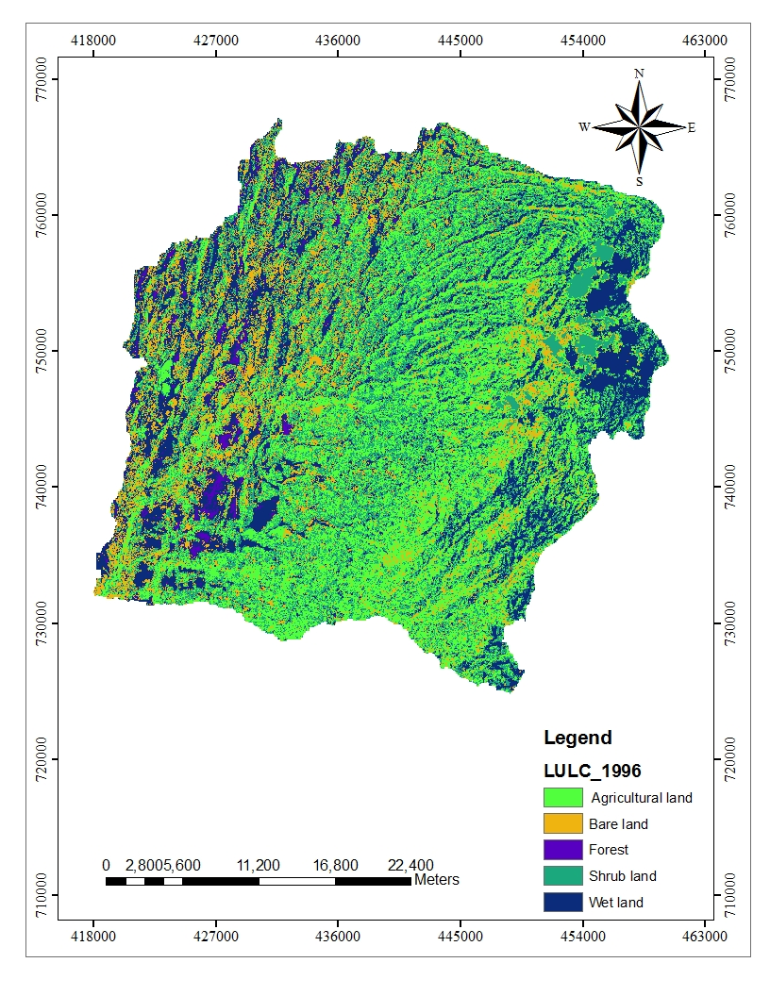
Figure 19.Land cover map of upper gidabo catchment using 1996 imagery.
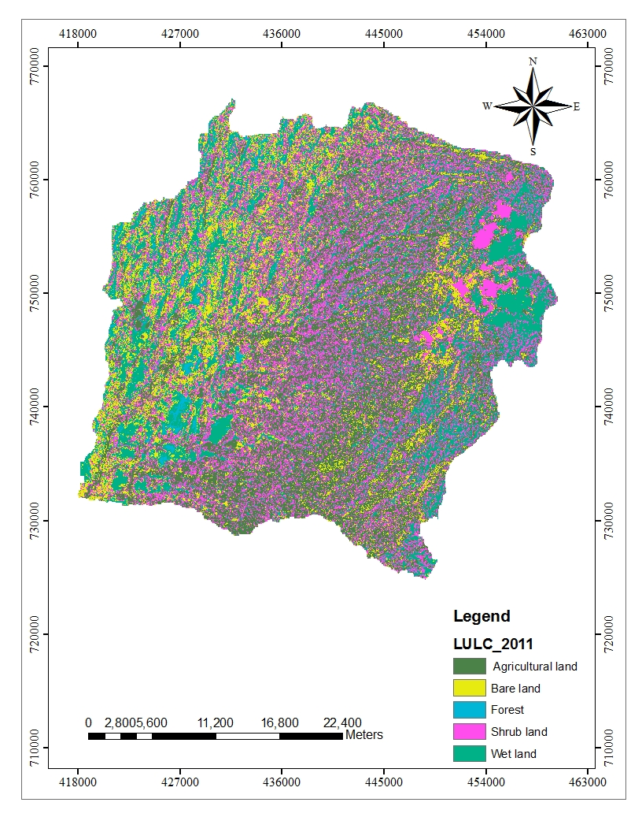
Figure 20.Land cover map of upper gidabo catchment using 2011 imagery
The spatial analysis result of the land use dynamics can be summarized as follows in figure 22 and in tabular form so that it is simple to compare land use/land cover change pattern and the overall land use dynamics with time.
LAND COVER TYPE | SWAT CODE | 1996 |  | 2011 |  | % OF LULC CHANGE FROM (2011-1996)
LAND COVER TYPE | SWAT CODE | LULC AREA (Km2) | LULC AREA COVERAGE(%) | LULC AREA (Km2) | LULC AREA COVERAGE(%) | LULC AREA (Km2) | LULC AREA COVERAGE(%)
Agricultural land | AGRC | 298.7 | 24.79 | 481.04 | 39.92 | 182.34 | +15.13
Forest | FRST | 555.4 | 46.09 | 445.97 | 37.01 | -109.43 | -9.08
Bare land | BARL | 83.3 | 6.93 | 92.3 | 7.66 | 9 | +0.73
Shrub land | RNGB | 250.5 | 20.79 | 171.35 | 14.22 | -79.15 | -6.57
Wet land | WETL | 17.1 | 1.42 | 14.34 | 1.19 | -2.76 | -0.26
Total |  | 1205 | 100 | 1205 | 100

Figure 21. Percentage changes of Upper Gidabo land use/land cover classes
Table 9.Area of land covers types and change statistics of upper gidabo catchment for the period of 1996 and 2011
4.1.2. Accuracy Assessment
The accuracy assessment is used to determine the correctness of the classified image. It was performed using confusion matrix. Using the original mosaic image and the Google Earth Image as a reference, randomly selected points were compared with the corresponding classification. 81 and 83 points were selected for the validation of 1996 and 2011 images respectively. Table 10 and 11 show a confusion matrix for the two Landsat images.
- Overall accuracy
The overall accuracy gives the overall results of the confusion matrix. It is calculated by dividing the total number of correct pixels (diagonals) by the total number of pixels in the confusion matrix. The results show that the overall accuracy for the maps of 1996 and 2011 were 85% and 90% respectively. According to Anderson et al, (1976), the minimum accuracy value for reliable land cover classification is 85%. The other author (Bedru, (2006), explains that the expected accuracy is determined by the users themselves depending on the type of application the map product will be used later. Accuracy levels are accepted by users may not acceptable by other users for certain task (Bedru, 2006). Therefore, based on table 10 and 11, the classification carried out in this study produces an overall accuracy that fulfills the minimum accuracy level defined by Anderson 1976 for both land cover maps of upper gidabo catchment.
- Producer’s Accuracy
The producer’s accuracy tells us how well a certain area can be classified. It is obtained by dividing the number of correctly classified pixels in the category by the total number of pixels of the category in the reference data. The producer’s accuracy is also known as an Omission Error, which is the probability of a reference pixels being classified correctly. It gives only the proportion of correctly classified pixels. The overall result of the producer’s accuracy ranges from 67 % to 100%. The lowest values were misclassified due to similar spectral value of different land cover classes. For instance, swampy with forest, crop cultivation areas with forest cover, crop lands during dry season with bare land (which is classified as grass land), etc somehow affects the level of classification.
- User’s Accuracy
It is the ratio between the total number of pixels correctly belonging to a class (diagonal elements) and the total number of pixels assigned to the same class by the classification procedure (row total). This quantity explains the probability that a pixel of the classified image truly corresponds to the class to which it has been assigned. In this study, the user’s accuracy ranges from 73% to 95%. The lowest value “water and marshy land” were, to some extent, misclassified because of the similarity spectral properties of water and marshy land and forest.
CLASSIFICATION DATA | REFERENCE DATA
CLASSIFICATION DATA |  | AL | WL | F | SL | GL | TOTAL | USER`S ACCURACY
CLASSIFICATION DATA | AL | 17 | 2 | 1 |  |  | 20 | 85%
CLASSIFICATION DATA | WL | 1 | 10 | 1 |  |  | 12 | 83%
CLASSIFICATION DATA | F |  | 2 | 11 | 2 |  | 15 | 73%
CLASSIFICATION DATA | SL |  |  | 1 | 12 |  | 13 | 92%
CLASSIFICATION DATA | BL | 1 | 1 |  |  | 19 | 21 | 90%
CLASSIFICATION DATA | TOTAL | 19 | 15 | 14 | 14 | 19 | 81
PRODUCER`S ACCURACY |  | 89% | 67% | 79% | 86% | 100% |  | OVERALL ACCURACY=85%
Table 10. Confusion matrix for the classification of 1996 LULC Map. Note: AL=Agricultural land ; WL=Wet land; F=Forest, SL=Shrub land; BL=Bare land
Table 11. Confusion matrix for the classification of 2011 LULC Map. Note: AL=Agricultural land; WL=Wet land; F=Forest, SL=Shrub land; BL=Bare land
CLASSIFICATION DATA | REFERENCE DATA
CLASSIFICATION DATA |  | AL | WL | F | SL | GL | TOTAL | USER`S ACCURACY
CLASSIFICATION DATA | AL | 18 |  | 1 |  |  | 19 | 95%
CLASSIFICATION DATA | WL |  | 12 | 1 | 1 |  | 14 | 86%
CLASSIFICATION DATA | F | 1 |  | 19 |  |  | 20 | 95%
CLASSIFICATION DATA | SL | 1 |  |  | 14 |  | 15 | 93%
CLASSIFICATION DATA | BL | 1 | 1 | 1 |  | 12 | 15 | 80%
CLASSIFICATION DATA | TOTAL | 21 | 13 | 22 | 15 | 12 | 83
PRODUCER`S ACCURACY |  | 86% | 92% | 86% | 93% | 100% |  | OVERALL ACCURACY=90%

4.2. Stream Flow Modeling

4.2.1. Sensitivity Analysis

Sensitivity analysis was performed on flow parameters of SWAT on monthly time steps with observed data of the Aposto gauge station. For this analysis, 26 parameters were considered and only 10 parameters were identified to have significant influence in controlling the stream flow in the watershed. Table 12 presents parameters that resulting greater relative mean senility values for monthly stream flow.
Table 12. List of Parameters and their ranking with MRS values for monthly flow
Parameters |  | Lower and Upper bound | Rank | MRS  index | Category
Name | Description
ALPHA_BF | Base flow alpha factor (days) | 0-1 | 1 | 0.617 | Very High
ESCO | Soil evaporation compensation factor | 0-1 | 2 | 0.395 | High
SOL_Z | Total soil depth (mm) | ±25% | 3 | 0.203 | High
SOL_AWC | AWC Soil available water capacity (water/mm soil) | ±25% | 4 | 0.188 | Medium
GWQMN | Threshold depth of water in the shallow aquifer required for return flow (mm | 0-10 | 5 | 0.177 | Medium
Revapmn | Threshold depth of water in the shallow aquifer for revap to occur (mm) | ±100% | 6 | 0.162 | Medium
slope | Average slop steepness (m/m) | ±25% | 7 | 0.0935 | Medium
Blia | Maximum potential leaf area index | 0-1 | 8 | 0.0686 | Medium
GW_Revep | Ground water evaporation coefficient | ±0.036% | 9 | 0.0683 | Medium
Sol_K | Soil conductivity (mm/h) | ±25% | 10 | 0.0468 | Medium

The result of the sensitivity analysis indicated that these 10 flow parameters are sensitive to the SWAT model i.e the hydrological process of the study catchment mainly depends on the action of these parameters. Alpha factor (ALPHA_BF), soil evapotranspiration factor (ESCO), Total soil depth (mm) (SOL_Z), AWC Soil available water capacity (water/mm soil) (SOL_AWC), Threshold depth of water in the shallow aquifer required for return flow (mm) (GWQMN) are identified to be highly sensitive parameters and retained rank 1 to 5, respectively. The other parameters such as Threshold depth of water in the shallow aquifer for revap to occur (mm)( (REVAPMN), Average slope steepness (m/m)(SLOPE), Maximum potential leaf area index(BLIA), Ground water evaporation coefficient(GW_REVEP),Soil conductivity (mm/h)(SOL_K) are identified as slightly important parameters that were retained rank 6 to 10, respectively.
The remaining parameters (16 parameters) were not considered during calibration process as the model simulation result was not sensitive to these parameters in the watershed. These parameters are related to ground water, runoff and soil process and thus influence the stream flow in the catchment. The result of the analysis was found that ALPHA_BF is the most important factor influencing stream flow in the upper gidabo catchment. The ALPHA_BF is a direct index of ground water flow response to changes in recharges. The gidabo catchment is characterized with tertiary basalt and volcanic regional geology that have good potential for ground water recharges.

Figure 22.Rank of sensitive parameter in upper Gidabo catchment.
In addition, (Geleta.,(2016) through SWAT Based Evaluation of the Effect of Land Use/Land Cover Change on Reservoir Sediment Yield (Case Study on Gidabo Reservoir Watershed, Ethiopia) found ten sensitive flow parameters (1.ESCO, 2.ALPHA_BF, 3.CANMAX,4.SOL_Z, 5.REVAPMN, 6.GWQMN, 7. SOL_AWC, 8. GW_REVAP, 9. BLIA, 10. EPCO) among them ALPHA_BF to retain rank 2. The other most influencing stream flow parameter in this analysis is the soil evaporation compensation factor (Esco). These may be an additional support to the result of the sensitivity analysis.
4.2.2. Calibration and Validation of the model
The simulation of the model with the default value of parameters in the upper gidabo catchment showed relatively weak matching between the simulated and observed stream flow hydrographs. Hence, calibration was done for sensitive flow parameters of SWAT with observed average monthly stream flow data. First, some sensitivity flow parameters were adjusted by manual calibration procedure based on the available information in literatures. In this procedure, the values of the parameters were varied iteratively within the allowable ranges until the simulated flow as close as possible to observed stream flow. Then, auto calibration was run using sensitive parameters that were identified during sensitivity analysis. Table 13 presents the result of calibrated flow parameters.
Table 13.List of parameters with calibrated values for average monthly stream flow

List of parameters with calibrated values for average monthly stream flow
Parameters |  | Lower and upper bound | Calibrated value
Name | Description | Lower and upper bound | Calibrated value
ALPHA_BF | Base flow alpha factor (days) | 0-1 | 0.1
ESCO | Soil evaporation compensation factor | 0-1 | 0.2
SOL_Z | Total soil depth (mm) | ±25% | -10
SOL_AWC | AWC Soil available water capacity (water/mm soil) | ±25% | 0.8
GWQMN | Threshold depth of water in the shallow aquifer required for return flow (mm | 0-10 | 0.93
Revapmn | Threshold depth of water in the shallow aquifer required for return flow (mm | ±100% | 21
slope | Average slop steepness (m/m) | ±25% | 10
Blia | Maximum potential leaf area index | 0-1 | 0.12
GW_Revep | Ground water evaporation coefficient | ±0.036% | 0.02
Sol_K | Soil conductivity (mm/h) | ±25% | 8

During this step, the model was run for period of 9 years from 1996 to 2004. However, as the first year was considered for model warm up period, calibration was performed for 8 years from 1997 to 2004. The calibration result for monthly flow is shown in the figure 24. The result of calibration for monthly flow showed that there is a good agreement between the measured and simulated average monthly flows with Nash-Sutcliffe simulation efficiency (E_{NS}) of 0.85 and coefficient of determination (R²) of 0.87 as shown in Figure 26. The model validation was also performed for 7 years from 2005 to 2011 without further adjustment of the calibrated parameters. The validation result for monthly flow is shown in the figure 25. The validation simulation also showed good agreement between the simulated and measured monthly flow with the E_{NS} value of 0.81 and R² of 0.86 as shown in Figure 27.

Figure 23.The result of calibration for average monthly stream flows

Figure 24.The result of Validation for average monthly stream flows

The measured and simulated average monthly flow for upper gidabo catchment at aposto gauging station was obtained. During the calibration period, they were 5.49 and 5.37 m3/s, respectively. The measured and simulated average monthly flow for the validation period was 5.51 and 5.72 m3/s, respectively. These indicate that there is a reasonable agreement between the measured and the simulated values in both calibration and validation periods (Table 14).
Table 14. Comparison of Measured and simulated monthly flow for calibration and validation simulations
Period | Average monthly flow(m3/s) |  | R² | E_{NS}
Period | Measured | Simulated | R² | E_{NS}
Calibration(1996-2011) Period | 5.49 | 5.37 | 0.87 | 0.85
Validation (1996 - 2011)Period | 5.51 | 5.72 | 0.86 | 0.81

As can be indicated in the Table 14, the model performance values for calibration and validation of the flow simulations are adequately satisfactory. This indicates that the physically processes involved in the generation of stream flows in the watershed were adequately captured by the model. Hence, the model simulations can be used for various water resource management and development aspects.
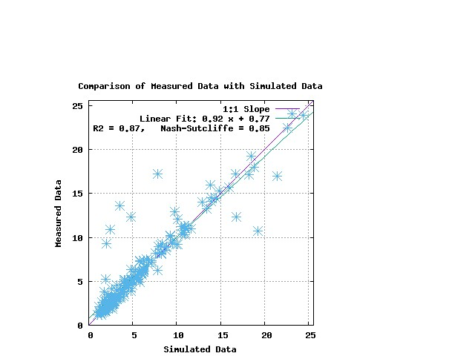
Figure 25. Scatter plots of the calibration periods show the correlation between the observed flow and the simulated flow and their corresponding Nash-Sutcliffe simulation efficiency (ENS) and coefficient of determination (R2).
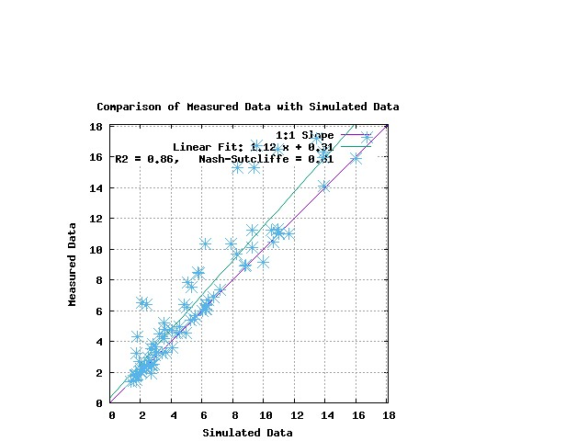
Figure 26. Scatter plots of the Validation periods show the correlation between the observed flow and the simulated flow and their corresponding Nash-Sutcliffe simulation efficiency (ENS) and coefficient of determination (R2).
In general, the Model performance assessment indicated that there is a good correlation and agreement between the monthly measured and simulated flows.
4.3. Evaluation of Stream Flow due to Land Use and land Cover Change
One of the most important things of the study was to evaluate the impact of land use and land cover changes on upper gidabo catchment. The evaluation was done in terms of the impact of land use and land cover changes on the seasonal stream flow and variations on the major components of stream flow including surface runoff and groundwater flow during the period (1996 – 2011). Land use and land cover has a great influence on the rainfall-runoff process.

Figure 27. Parameters from annual simulations for 1996 and 2011 land covers of upper gidabo catchment.

Average annual catchment stream flows are directly related to land cover type, soil characteristics and annual precipitation. In the study area, agricultural land, urban area and bare land areas have increased between1996 to 2011 with most of the increase occurring in previously areas of shrub land, wetland (marsh) and forest land. Urban areas have the highest potential for runoff because the land is impervious cover in a watershed and reduces infiltrations. To understand the flow processes during different seasons under different land cover conditions, the average monthly stream flows were plotted for the wet and dry season and compared.

4.3.1. Change in the Seasonal Stream Flows

After calibrating and validating of the model using the two land use and land cover maps for their respective periods of 1996 to 2004 and 2005 to 2011 respectively, SWAT was run using the two land cover maps (1996 and 2011 maps) for the period of 1996 to 2011 while putting the other input variables the same for both simulations to quantify the variability of stream flow due to the changes of land use and land cover. This process gave the discharge outputs for both land use and land cover patterns. Then, these outputs were compared and the discharge change during the wettest months of stream flow and driest stream flow were calculated and used as indicators to estimate the effect of land use and land cover change on the stream flow. In upper Gidabo catchment flow exhibit bimodal flow characteristics and the first peak is located around May/June and the second in October. Wet weather occurs in May, June, August, September and October. And the dry weather event occurs in January, February, March/December. This two season climate creates significant difference on stream flows. Table 15 presents the mean monthly wet and dry month’s stream flow for 1996 and 2011 land use and land cover maps and its variability.
Table 15. Mean monthly wet and dry month’s stream flow and their variability b/n (1996-2011)
Mean monthly flow(m³/s) |  |  |  | Mean monthly flow change
Land use/cover map of 1996 |  | Land use/cover map of 2011
Wet months (May, Jun, July, Aug, Sept, Oct) | Dry months (Jan, Feb, Mar) | Wet months (May, Jun, July, Aug, Sept, Oct) | Dry months (Jan, Feb, Mar) | Wet | Dry
52.03 | 6.89 | 61.56 | 4.53 | +9.53 | -2.36

As can be indicated in the table 15, the mean monthly stream flow for wet months had increased by 9.53 m3/s while the dry season decreased by 2.36 m3/s during the 1996-2011 periods due to the land use and land cover change. There are significant differences in stream flow during wet and dry months. Month’s variations predicted from the two land cover classifications 1996 and 2011 are presented in (Figure 29).

Figure 28. Simulated monthly catchment stream flow for LU/LC of 1996 and 2011
To assess the change in the contribution of the components of the stream flow due to the land use and land cover change, analysis were made on the surface runoff (SURQ) and ground water flow (GWQ). Table 16 presents the SURQ and GWQ of the stream simulated using 1996 and 2011 land use and land cover map for the same period.
Table 16. Surface runoff and Ground water flow of the stream simulated using 1996 and 2011 land use/cover map
Land use/cover map of 1996 |  | Land use/cover map of 2011 |  | Change of SURQ & GWQ
SURQ (mm) | GWQ (mm) | SURQ(mm) | GWQ (mm) | SURQ(mm) | GWQ (mm)
67.18 | 86.5 | 74.34 | 78.9 | +7.18 | -7.6

As the above table showed as the SURQ and GWQ components of the stream simulated using the 1996 land use and land cover map for the period of 1996 to 2011 were 67.18 mm and 86.5 mm while using 2011 land use and land cover map were 74.34mm and 78.9 mm, respectively. The contribution of surface runoff has increased from 67.18 mm to 74.34 mm whereas the ground water flow has decreased from 86.5 mm to 78.9 mm due to the land use and land cover change occurred between the periods of 1996 to 2011. This is because of the expansion of agricultural land and bare land over forest that results in the increase of surface runoff following rainfall events. We can explain this in terms of the crop soil moisture demands. Crops need less soil moisture than forests; therefore the rainfall satisfies the soil moisture deficit in agricultural lands more quickly than in forests there by generating more surface runoff where the area under agricultural land is extensive. And this causes variation in soil moisture and groundwater storage. This expansion also results in the reduction of water infiltrating in to the ground. These results demonstrate that the land use and land cover change have a significant effects on infiltration rates, on the runoff production, and on the water retention capacity of the soil.
Furthermore, analyses were made on change in Surface runoff (SURQ), Ground water flow (GWQ) and Lateral flow (LATQ) components of stream flow due to LULC change. The SURQ, GWQ and LATQ components of the stream simulated using the 1996 land use and land cover map for the same period were 37%, 48% and 15% while using the 2011 land use and land cover map were 40%, 42% and 18% respectively. The contribution of surface runoff has increased from 37% to 40% due to the LUCC occurred between the period 1996 to 2011.
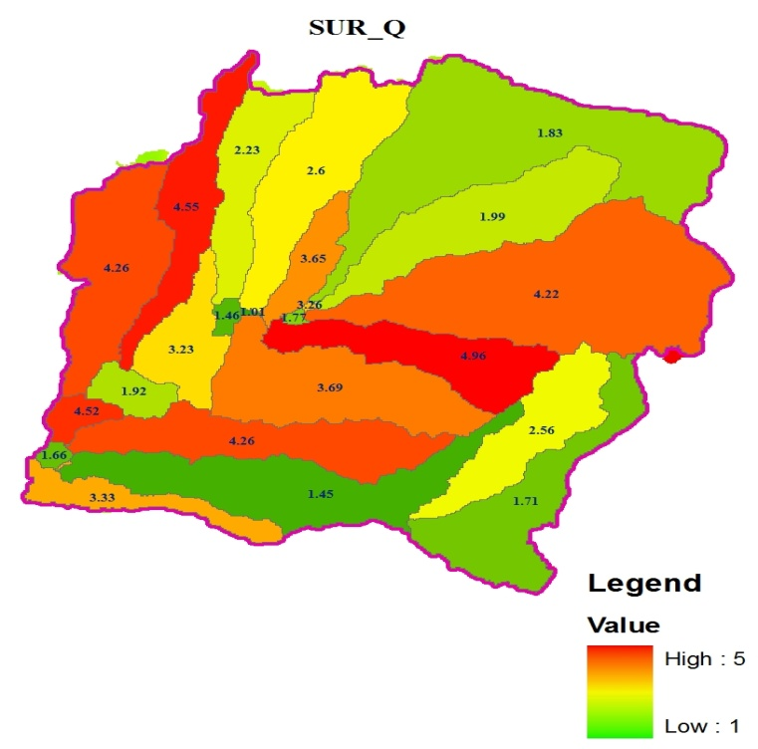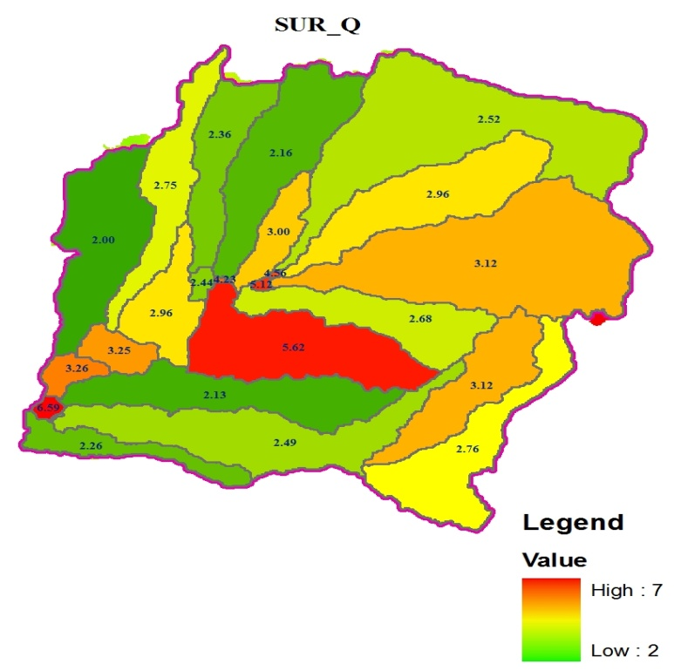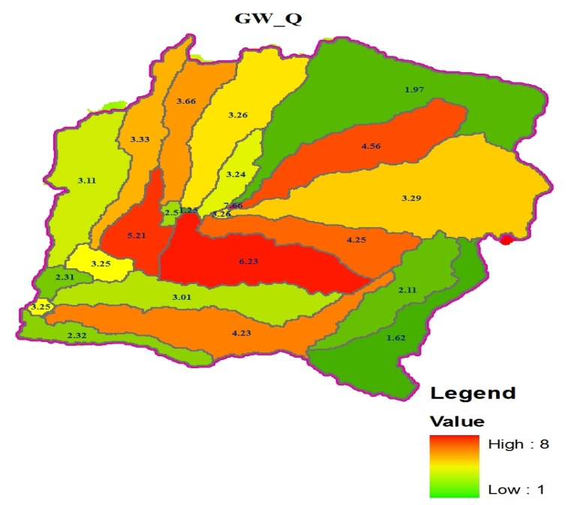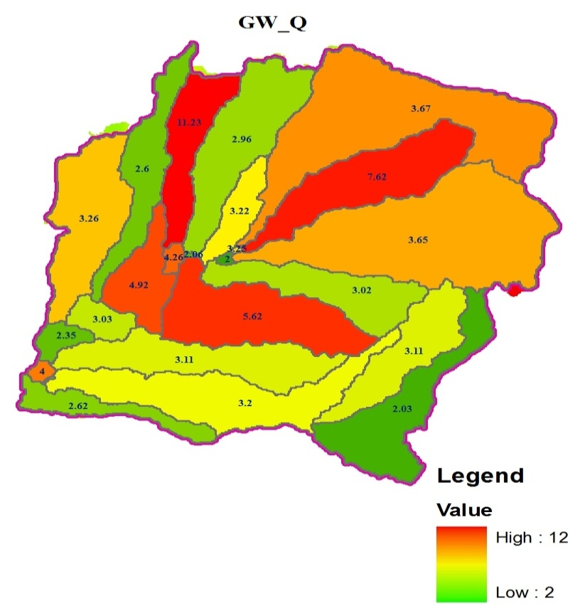
(a) (b)

Figure 29. Spatial distribution of Simulated SURQ AND GWQ at each sub basin using a) 1996 b) 2011 land use map

On the other hand, ground water flow has decreased from 48% to 42% due to the same reason. This is directly attributed by the expansion of agricultural land over forest that results in the increase of surface runoff following rainfall events and causes variation in soil moisture condition and groundwater storage. This expansion also results in the reduction of water infiltrating into the ground and supplying the shallow aquifer. Therefore, discharge during the dry months (which mostly comes from base flow) decreases, whereas discharge during the wet months increases. These results demonstrate that changes in land use and land cover have significant effects on infiltration rates, on the water retention capacity of soils, on sub-surface transmissivity and thus on the runoff production. All the components of the stream flow are predicted separately for each hydrological response unit (HRU) and routed to obtain their respective total amounts for the watershed, which increases the accuracy of stream flow predictions and provides a much better physical description of the water balance.
Different studies have been conducted in different parts of the country to evaluate the effects of land use and land cover changes on stream flow. A modelling study of Anger watershed, in Ethiopia, Brook et al,(2011) introduced that the surface runoff increased and the base flow decreased due to the expansion of agricultural land and declined of forest land. Study on a Hare watershed, in Southern Ethiopia, Tadele, (2007) reported that due to the replacement of natural forest in to farmland and settlements, the mean monthly discharge for wet months had increased while in the dry season decreased. In the study of Chemoga watershed, in Blue Nile basin, Abebe, (2005) reported that large volume of surface runoff occurs during the storm events since the area under forest cover decreased. Generally, the hydrological investigation with respect to the land use and land cover change within upper gidabo catchment showed that the flow characteristics have changed, with increase in surface flow and reduction of base flows thought the selected period of study.
4.3.2. Impact of land use/ cover change on seasonal and annual stream flow variability
Time series of stream flow for the upper Gidabo catchment were analyzed for the years 1996-2011 using statistical method. The method serves to assess to what extent changes in observed stream flow series can be observed. In stream flow frequency analysis most often cumulative distributions and probability of expedience are used. The stream flow data was sorted in ascending order and ranked.
The mean annual discharge in the Aposto gauging station for the period of 16 years have shown a significant increasing trend (Fig 31 and Fig 32). However, of significance to note is the dry season discharge which shows a greater decrease by about 0.2 m²/s. Although In upper Gidabo catchment flow exhibit bimodal flow characteristics and the first peak is observed around May/June and the second in October. Based on the two simulation outputs as illustrated in Fig.31, The 2011 land use/cover resulted in earlier, higher peaks and produced stream flow at rainfall magnitudes that did not generate any stream flow with the 1996 LULC periods. This implies that for the precipitation event in 2011, water flows faster from the watershed as surface overland flow and there is less time for water infiltration into subsurface layers, which is important for the dry season flows. This occurrence was associated with the loss of forest, wet land and shrub land in the catchment, compounded by an increased agricultural area, thereby reducing rainfall interception that contributed in increasing the surface runoff. As a result stream flow of the catchment has increased.
The change of the average simulated stream flow was examined using the non parametric, Spearman’s rank correlation test and the results indicated an increasing trend of stream flow between 1996 and 2011 as shown in Fig. 32. The Spearman’s rank correlation test shows that the simulated stream flow was significantly increased at 5% significance level with the R_{SP} and t_{t} value of 0.924 and 9.059 respectively. The significant changes in the flow regimes have occurred, with an increase of 21% for over 16 years period due to the above reasons.

Figure 30.Simulated mean annual stream flow for LULC 1996 and 2011 at catchment outlet.
Figure 31.Spearman`s trend test for the change of mean annual stream flow
The analysis of the effects of land cover change on the stream flow variability in the period 1996–2011 (Table 17) shows that mean monthly stream flow in wet months has increased by 18.31% m3/s while in the dry seasons decreased by 34.25%. This is because, the diminishing rate of forest land, shrub land and wet land over the analysis period aggravated runoff generation and decreased base flow in studied catchment. The expansion of agricultural and bare land results in the reduction of water infiltrating into the ground and supplying the shallow aquifer. Therefore, discharge during the dry months (which mostly comes from base flow) decreases, whereas discharge during the wet months increases.
The Spearman’s rank correlation test was also applied to the seasonal simulated stream flow pattern at the indicated catchment outlet. From the statistical analysis results, there were significant variability in simulated stream flow during wet (May, Jun, Jul, Aug, Sept, oct) and dry (Jan, Feb, Mar) seasons (Fig. 32 and Table 17). The results in Table 17 show a significant increasing trend of stream flow during the wet season, and a decreasing trend of stream flow during the dry season.

Figure 32. Time series plots for (a) Dry season flow and (b) Wet season flow
Table 17. Mean monthly dry and wet season simulated flow and their variability with Spearman`s trend test and statistical summary (1996-2011).
years | 1996_LULC | 2011_LULC | Change detection(m³/s) | F-value | T-value | Trend
Dry season(m³/s) | 6.89 | 4.53 | -2.36 | 14.083 | 1.569 | Significantly decreasing  trend
Wet season(m³/s) | 52.03 | 61.56 | +9.53 | 1.225 | 5.461 | Significantly increasing  trend
4.3.3. Hydrological trend evaluation
Based on the Spearman`s trend-test result, there was statistically significant change of seasonal stream flow. For instance, for dry season flows (January, February and March), the results of the Spearman`s trend test indicated the presence of downward trends. Moreover, during the wet season (May to October) the results were in the sequence of upward trends. The results of Spearman`s trend-test for the mean annual observed stream flow showed significant increasing trend. The statistical analysis result for 1 and 7-day minimum annual flows showed a consistently significant decreasing trend. The significant decreasing trend during dry season flow results in significant decreasing trend in 1 and 7-day annual minimum flows. It was also observed that the variability in 1-day maximum annual flows was insignificant (see figure 34 and Table 18). Fig. 34 and Table 18 shows the Spearman`s trend-test results (Spearman`s correlation coefficient(R_{SP}), F-test for the stability of the variance(F) and T-test for the stability of the mean (t_{t}) for stream flow time series.

Figure 33.Time series plots for (a) Dry season mean flow, (b) Wet season mean flow, (c) Mean observed flow (d) 1-day annual maximum flow, (e) 1-day annual minimum flow and (f) 7-day minimum annual flow
Table 18. Trend analysis of seasonal and annual stream flow series for the studied catchment.
spearman`s trend analysis | Stream flow series(m3/s)
spearman`s trend analysis | 1-day minimum flow | 7-day minimum  flow | 1-day maximum flow | mean annual flow pattern | Dry season flow | Wet season flow
R_{SP} | -0.625 | -0.784 | -0.283 | 0.924 | -0588 | 0.857
t_{t} | -2.996 | -4.889 | -1.104 | 9.059 | -2.722 | 6.232
F | 1.045 | 1.885 | 9.853 | 1.66 | 14.083 | 1.225
T | 2.165 | 2.907 | 1.012 | 5.223 | 1.569 | 5.461
Trend | * | * | NS | * | * | *
NS=No statistically significant trend;*= statistically significant trend; - = decreasing trend;+ = increasing trend.
Different studies have been conducted in different parts of the country to evaluate the effects of land use and land cover changes on stream flow by a combined use of a hydrologic model and statistical methods to detect statistical significance of the change of the hydrologic response by evaluating the trends. In Ethiopia, Bewket and Sterk (2005) reported a decrease of the dry season flows in the Chemoga catchment (adjacent to the Jedeb catchment), Most recently, Rientjeset al. (2011) showed that both LULC change and seasonal distribution of rainfall were the causes of stream flow changes of the Gilgel Abay River (source of the Abay/Upper BlueNile river). Tekleab et. al. (2013) showed that the rainfall trend from the Debre Markos climate station in close proximity to the Jedeb catchment reveals no evidence of increasing or decreasing trends on mean annual, monthly or seasonal time scales. Moreover, the same results have been obtained by evaluating the statistical significance of frequency of wet days above different threshold values, which can be an indicator of rainfall intensity (Orr and Carling, 2006). The results confirm no evidence of statistical trends of frequency of wet days above a threshold value at the Debre Markos and Rob Gebeya climate stations around the Jedeb catchment. However, the average annual temperature from the climate station at Debre Markos depicts a statistically increasing trend evaluated at the 5% significance level. Thus, land use change or agricultural management practices might have more pronounced effects than the precipitation change, which is responsible for the hydrological change in the catchment. Moreover, a flow variability indicator such as the 1-day annual maximum and minimum flows in the Jedeb catchment showed a statistically significant increasing trend for high flows and a decreasing direction of trend for low flows (Tekleab et al., 2013). Therefore, The results from the statistical analysis of the daily flows between 1973 and 2010 reveal a significant change in the response of the catchment.
4.3.4 : Average Annual Water Balance Components of the Study Area
SWAT model calculates the water balance for HRU as mentioned in equation 1. HRU is the basic spatial unit where the water balance features is estimated. The SWAT model estimated other relevant water balance components in addition to the daily and monthly discharge of the catchment. Average annual watershed values for different water balance components during a base simulation periods shows average annual watershed gains and losses with change in soil water storage. The most important elements of water balance of a basin are precipitation, surface runoff, lateral flow and evapotranspiration. Water balance components such as surface runoff, lateral flow, base flow and evapotranspiration have also been simulated. The simulated values have shown very close agreement with measured or alternately computed counter parts.

Figure 34.Annual water balance components at different year
The water balance results at Aposto stations predicted for the catchment from the 1996 and 2011 land use land cover data are shown in figure. It can be seen that around 10% of the precipitation were as surface runoff at Aposto catchment. Aquifer Recharge which takes place mostly in the upper part of the catchment and this indicated that more evapotranspiration took place in lower elevation areas with higher temperature and higher effect on evapotranspiration. In above figure shown surface runoff was increased during the study period. Therefore catchment management operations and planners should concentrate on the reduction of surface runoff and control of the accelerated degradation of land use as well as stream flow generation. This information is also important for the development of decision support tools for catchment farmers and managers and to inform policy. In order to ensure sustainable management of the catchment, soil and water conservation measures will be critical within the broader context of integrated water resources management.
4.3.5. Evaluation of extreme flows
From the analysis result of flow duration curve (Fig.36) for 1996 land use, the high flows of Gidabo River at Aposto gauging station, (the flow equal or exceeded 5% to 20% of the time) ranges in between 9.2 and 35.86 m3/s. These are higher flow rates in which the flow in the river is only at or greater than these flow rates for smaller portion of the year. Whereas for 2011 land use in between 5 and 20 percent exceedance probability the flow rate that is equaled or exceeded 5 to 20 percent of the time were in between 10.0 and 36.3 m3/s. However, for 1996 and 2011 land use for 90 to 95% exceedance probability the flow ranges in between 2.03 to 1.1 m3/s and 1.5 to 0.81 m3/s, respectively which are the lowest flow rate recorded, so the flow in the river is at these flow rate or more for 90 to 95% of the time. Hence, as we see from flow duration curve the high flows in the upper Gidabo catchment for 2011 land use was increased by 1.2 - 9.03 % and the magnitude of low flows were decreased by 26.3-28.8 %. This is due to the expansion of agricultural land over others and its strong influence on evapotranspiration, surface runoff and the amount of water that percolates to the underlying aquifer.
Figure 35. Discharge duration curve showing the percent of time in which the mean annual discharge was exceeded through the 16 years of record (1996-2011).
5. CONCLUSIONS AND RECOMMENDATIONS
5.1. Conclusions
The aim of this study was to assess the stream flow responses due to land use/ land cover changes over the past decades by considering the land use conditions of 1996 and 2011’s in upper Gidabo catchement using a calibrated and validated version of the SWAT 2005 model. In this study, statistical method and GIS were integrated with a hydrological model to evaluate the impacts of land use and land cover changes on the stream flow of the upper gidabo catchment of abaya_chamo sub basin. An integrated approach of GIS and remote sensing are excellent tools to map different land cover classes and to detect and analyse spatiotemporal land cover dynamics. These techniques were applied to enable and asses of the land cover dynamic effects on the stream flow of the catchment. The study shows that land use and land cover changes in upper gidabo catchment from 1996 to 2011 were identified from TM and ETM+ satellite images, respectively. The land use and land cover maps of the year 1996 and 2011 were produced and the accuracy assessments of the two maps were checked using the Confusion Matrix.
Based on the results, the following conclusions are drawn: From the land use and land cover change analysis, it can be concluded that the land use and land cover of the upper gidabo catchment for the period of 1996 to 2011 showed significantly changed. Agricultural land was drastically changed from 24.79 % in 1996 to 39.92 % in 2011 in the expenses of the other classes. The expansion of agricultural land and rural settlement has an impact on the decrement of forest land. Thus, the forest land which constituted 46.09 % in 1996 diminished to 37.01 % in 2011. Thus, by the expense of forest land and other land cover types, Bare land and the Agricultural land includes areas for crop cultivation and the scatter rural settlement that are closely associated with the cultivated fields dynamically increased in the period of the last 16 years (1996-2011).
The sensitivity analysis using SWAT model has pointed out ten most important parameters that control the stream flow of the studied catchment. On the other hand, model calibration and validation have showed that the SWAT model simulated the flow quit satisfactorily. Performance of the model for both the calibration and validation catchment were found to be reasonably good with Nash-Sutcliffe coefficients (ENS) values of 0.85 and 0.81 and coefficient of determination (R2) values of 0.87 and 0.86 for the calibration and validation respectively. Following calibration and validation of the model, impacts of the land use and land cover change on stream flow was carried out. Land use and land cover changes recognized to have major impacts on hydrological processes, such as runoff and groundwater flow. The modelling results are supported by the statistical test. The Spearman’s rank correlation-test analysis result showed that a significant increasing trends were observed in mean annual and wet season flows, while decreasing trends were revealed for dry season and 1 and 7-day annual minimum flows. However, 1-day maximum flow is characterized by insignificant increasing trend during the analysis period.
From the study the combined results from two different approaches, i.e. the SWAT modeling and statistical test, it can be inferred that the stream flow of upper Gidabo catchment is changed which attributed to the land use change. The analysis of flow regime using flow duration curve showed an increasing trend of high flow with a magnitude of 1.2% - 9.03% and decreased low flow with a magnitude of 26.3% - 28.8%. Generally, from the overall results of the study it can be concluded that the effects of changes in land use/ cover potentially change the stream flow of the catchment. However, this study cannot generalized that the land use change is the only driver for the changes in the flow regime. Thus, considering the influence of long-term climatic variability could also be further contribution in changing the stream flow.
5.2. Recommendations
Generally from this specific study the following recommendations could improve similar research for future work:
- Unless there is good data quality of input data, calibration and validation using SWAT 2005 is challenging.
- Land use and land cover map produced based on field work like ground control point will give better result. Therefore, for further research work field visit and taking more ground control point will be important to produce accurate map.
- This study considers only land use and land cover changes to compare the corresponding changes on stream flow. But other variables such as climate change and management activities might have a significant impact on stream flow. Hence, the future researchers are highly recommended to consider the climate change impact on stream flow.
- The continuations of the land use/land cover change are becoming a serious threat to the upper Gidabo catchment. The land use/land cover change should be controlled in the watershed and some measures should be taken for the stabilization of the land cover change.

referances

Abebe, S. (2005). Land-Use and Land-Cover change in headstream of Abbay watershed, Blue Nile Basin, Ethiopia. Addis Ababa University.
Abraha, L. (2007). Assessing the impact of land use and land cover change on groundwater recharge using RS and GIS; A case of Awassa catchment, Southern Ethiopia. M.Sc Thesis, Addis Ababa University, Department of Earth Sciences; GIS and Remote Sensing stream.
Allen, (1998) Crop evapotranspiration: Guidelines for computing crop requirements. Irrigation and Drainage Paper No. 56, FAO, Rome, Italy.
Arnold JG, Williams JR, Maidment DR. Continuous-time water and sediment routing model for large basins. Journal of Hydraulic Engineering 1995; 121(2): 171-183.
Arnold, J.G.,and P. M. Allen. (1996). Estimating hydrologic budgets for three Illinois watersheds. J. Hydrol. 176(1-4): 57-77.
Abbot, M.B., Bathurst, (1986). An introduction to European hydrology system – System hydrologique European “SHE”, 1: history and philosophy of a physically based, distributed modeling system
Amsalu, A., Stroosnijder, L., & de Graaff, J. (2007). Long-term dynamics in land resource use and the driving forces in the Beressa watershed, highlands of Ethiopia. Journal of environmental management, 83, 448 – 459.
Arnold, J.G., P.M. Allen, and G. Bernhardt.(1993). A comprehensive surface-groundwater flow model. J. Hydrol. 142:47-69.
Arnold,J.G., Srinivasan, R., Muttiah, and Williams, J.R. (1998). Large area hydrologic modeling and assessment; part I: model development. J. of Amer. Water Res. Assoc. 34(1):73-89.
Asres, M. and Awulachew, S. B. (2010). SWAT based runoff and sediment yield modeling: a case study of the Gumera watershed in the Blue Nile basin. Ecohydrology & Hydrology, Ecohydrology for water ecosystems and socity in Ethiopia.
Awulachew, S. B., Tenaw. M., Steenhuis. T., Easton. Z., Ahmed. A., Bashar. K. E. and Hailesellassie. A. (2008). Impact of watershed interventions on runoff and sedimentation in Gumera watershed. Arba Minch University, Ethiopia Research Service and Texas A & M Backland Research Center.
Belay, T. (2002). Land cover/use changes in the Derekolli catchment of the South Welo Zone of Amhara Region, Ethiopia. Eastern Africa Social Science Research Review 18 (1): 1-20.
Bergsrtom, S. (1995). The HBV model. In: V.P. Singh (Ed.) Computer models of watershed hydrology. Water Resources publications, Highlands Ranch, CO.
Bewket, W. (2003). Towards integrated watershed management in highland Ethiopia: the Chemoga watershed case study, PhD thesis, Wageningen University and Research Centre, ISBN 90-5808-870-7.
Bewket W, Sterk G. (2005). Dynamics land cover and its effect on the stream flow on the Chemoga watershed in the Blue Nile basin, Ethiopia. Hydrological Processes19: 445–458.
Bosch, J. M. and Hewlett, J. D., (1982). A review of catchment experiments to determine the effect of vegetation changes on water yield and evapotranspiration.
Brooks, K. N., Ffolliott, P. F., Gregersen, H. M. and Thames, J. L., (1991). Hydrology and the management of watersheds. Ames, Iowa: Iowa State University Press.
Bruijnzeel, L. A., (1990). Hydrology of moist tropical forests and effects of conversion: A state-of-knowledge review. Paris: UNESCO International Hydrological Programme.
Calder, I.R., (1998). Water-resource and land use issues. SWIM Paper 3. Colombo: IIMI.
Central Statistical Agency (CSA)(1998) Ethiopia national statistics. Retrieved, March, (1999) from http://www.csa.gov.et/AnnualAgriculturalSampleSurvey.htm
Chow, V.T. (1988). Applied Hydrology, McGraw HILL INTERNATIONAL EDITIONS. New York.
Cibin, R., Sudheer, K. P., Chaubey, I. (2010). Sensitivity and identifiability of stream flow generation parameters of the SWAT model. Department of Agricultural and Biological Engineering, Purdue University, West Lafayette, IN 47907, USA.
Costa, M. H., Botta, A., & Cardille, J. A. (2003). Effects of large-scale changes in land cover on the discharge of the Tocantins River. Journal of Hydrology, 283, 206–217.
CUBASCH, U., (2001). Projections of Future Climate Change in Climate Change (2001): The Scientific Basis. Contribution of Working Group I to the Third Assessment Report of the Intergovernmental Panel on Climate
Cunderlik, J. (2003). Hydrological model selection for CFCAS project, Assessment of water resource risk and vulnerability to change in climate condition, University of Western Ontario.
Danuso, F. (2002). Climak: A Stochastic Model for weather Data Generation. Italian Journal of Agronomy 6 (1): 57-7, 67-68pp.
Denboba, M. A. (2005). Forest conversion - soil degradation - farmers' perception nexus: Implications for sustainable land use in the southwest of Ethiopia. Ecology and Development Series No. 26, (2005).
Droogers, P. and R.G. Allen, (2002) Estimating reference evapotranspiration under inaccurate data conditions. Irrigation and Drainage Systems, Volume 16, Issue1,February,( 2002), Pages 33 - 45
Ethiopian Mapping Authority. (1988). National atlas of Ethiopian. Addis Ababa, Ethiopia.
Farley, K.A., Jobbagy, E.G., & Jackson, R.B. (2005). Effects of afforestation on water yield: a global synthesis with implications for policy. Global Change Biology, 11, 1565-1576.
Feddema, J.J. et al., (2005). The importance of land-cover change in simulating future climate.
Feoli, E., Gallizia, L., Zerihun, W. (2002). Evaluation of environmental degradation in northern Ethiopia using GIS to integrate vegetation, geomorphological, erosion and socio-economic factors. Agriculture, Ecosystems and Environment 91 (2002) 313-325.
Fisher, T., & Mustard, J. (2004). Land use and hydrology. In Gutman, G., Janetos, A., Justice, C., Moran, E., Mustard, J., Rindfuss, R., Skole, D., Turner, B.L. & Cochrane, M (Eds.), Land change science: Observing monitoring and understanding trajectories of change on the earth’s surface (pp. 257-276). Dordrecht, Netherland: Kluwer academic Publishers.
Fohrer, N., Haverkamp, S., and Frede, H.G. (2005). Assessment of the effects of land use patterns on hydrologic landscape functions: development of sustainable land use concepts for low mountain range areas. Hydrol Process 19:659–672.
Food and Agricultural Organization (FAO). (1988). Soil Map of the World, revised legened with corrections and updets world soil resource. Report 60, FAO, Rome, Italy.
Gassman, P. W., Reyes. M. R., Green. C. H., Arnold. J. G. (2007). The Soil and Water Assessment Tool: Historical Development, Applications, and Future Research Direction. American Society of Agricultural and Biological Engineers ISSN 0001-2351.
Gebrehiwet, K. B. (2004). Land use and land cover changes in the central highlands of Ethiopia: The case of Yerer mountain and its surroundings. M.Sc Thesis, Addis Ababa University, Environmental Science.
Gessese, A. (2008). Prediction of sediment inflow for Legedadi reservoir using SWAT watershed and CCHE1D sediment transport models. Faculty of Technology, Addis Ababa University.
Guo, H., Hu, Q., & Jiang, T. (2008). Annual and Seasonal Stream flow Responses to Climate and Land-Cover Changes in the Poyang Lake Basin, China. Journal of Hydrology, 355, 106-122. http://dx.doi.org/10.1016/j.jhydrol.2008.03.020
Guo, S., Wang, J., Xiong, L., Ying, A., & Li, D. (2002). A Macro-Scale and Semi-Distributed Monthly Water Balance Model to Predict Climate Change Impacts in China. Journal of Hydrology, 268, 1-15.http://dx.doi.org/10.1016/S0022-1694(02)00075-6
Habtamu, E. and Rapprich, V. (2014). Geological hazards and engineering geology maps of Dilla. Explanatory notes, Czech Republic, 1st ed., p 37-6, available on http: //www. kgs. ku. edu/ High Plains/ at las /apgengw. htm
Hadgu, K. M. (2008). Temporal and spatial changes in land use patterns and biodiversity in relation to farm productivity at multiple scales in Tigray, Ethiopia. PhD Thesis Wageningen University, Wageningen, the Netherlands..
Hedlund, L., & Tekle, K. (2000). Land cover changes between 1958 and 1986 in Kalu district, Southern Wello, Ethiopia. Mountain research and development, 20(1), 42–51.
Hargreaves, G.H. and Z.A. Samani.(1985). Reference crop evapotranspiration from temperature. Applied Engineering in Agriculture 1:96-99.
Hargreaves, G.H., Allen, R.G. (2003) History and evaluation of Hargreaves evapotranspiration equation. J. Irrig. Drain. Eng. ASCE 129 (1), 53–63.
Houghton, J. T., Ding, Y., Griggs, D. J., Noguer, M., van der Linden, P. J., Dai,X.,Maskell, K., And Johnson, C. A., Cambridge University Press, Cambridge, UK and New York, NY, USA, 881 pp., 2001
Hudson. (1995). "The factors determining the extent of soil erosion, Soil Conservation and Management in the Humid Tropics.,. " Surface Processes and Landforms 24,, p. 503–516.
IPCC: Climate Change 2001, in: The Scientiﬁc Basis, Contribution of Working Group I to the Third Assessment Report of the Intergovernmental Panel on Climate Change, edited by: Houghton,J.T., Ding,Y., Griggs, D. J., Noguer, M., van der Linden, P. J., Dai,X., Maskell,K.,and Johnson,C. A., Cambridge University Press, Cambridge UK and New York, NY, USA,881 pp., 2001.
Isik, S., Dogan, E., Kalin, L., Sasal, M., &Agiralioglu, N. (2008).Effects of Anthropogenic Activities on the Lower Sakarya River. Catena, 75, 172-181. http: //dx.doi.org/ 10.1016/ j. catena. 2008. 06. 001
Jamtsho, K and Gyamtsho, T. (2003). Effective watershed and water management at local level: challenges and opportunities. In Regional Workshop on Community Based Natural Resource Managment, 4-7 November. Natural Resources Training Institute, Lobeysa, Bhutan.
Jensen, M.E., R.D. Burman, and R.G. Allen (ed). (1990). Evapo transpiration and irrigation water requirements. ASCE Manuals and Reports on Engineering Practice No. 70, ASCE,N.Y. 332 pp.
Kassa, G. (2003). GIS based analysis of land use and land cover, land degradation and population changes: A study of Boru Metero area of south Wello, Amhara Region, MA Thesis, Department of Geography, Addis Ababa University. 110 pp.
Khoob, A. R. (2007) Comparative study of Hargreaves’s and artificial neural network’s methodologies in estimating reference evapotranspiration in a semiarid environment. Journal of irrigation science Journal of irrigation.
Kidanu, S (2004). Using Eucalyptus for soil and water conservation on the highland Vertisols of Ethiopia, PhD Thesis, Wageningen University, The Netherlands.
Kim, U. et al. , (2007) – Application of parameter estimation and regionalization methodologies to ungauged basins of upper Blue Nile River basin.
Knighton, D. (1998). Fluvial Forms & Processes. London: Arnold.
Lambin, E. F., Geist. H. J. and Lepers. E. (2003). Dynamics of land use and land cover change in tropical regions. Annu. Rev. Environ. Resour. 2003. 28: 205-41.
Legesse, D., Vallet-Coulomb, C. and Gasse, F. (2003): Hydrological response of a catchment to climate and land use change in Tropical Africa: case study South Central Ethiopia. In: Journal of Hydrology 275, p. 67 – 85.
Lenhart, T., Eckhardt, K., Fohrer, N., Frede, H.-G. (2002). Comparison of two different approaches of sensitivity analysis. Physics and Chemistry of the Earth 27: 645-654.
Magilligan, F. J., & Nislowb, K. H. (2005).Changes in Hydrologic Regime by Dams. Geomorphology, 71, 61-78. http://dx.doi.org/10.1016/j.geomorph.2004.08.017
Maidment, D.R. (1993). Handbook of Hydrology, McGraw-Hill
Manandhar, R., Odeh, I., and Ancev, T. (2009). Improving the Accuracy of Land use and land cover classification of Land sat Data using Post-Classification Enhancement.
Marland, G.,and eighteen others. “The climatic impacts of land surface change and carbon management, and the implications for climate-change mitigation policy.”Climate Policy, June 2003.
Meyer, W.B. and Turner, B. L. (1994). Changes in land use and land cover: A Global Perspective. Cambridge: Cambridge University Press. New York.
Mendoza, M., Bocco, G., and Bravo, B.: Spatial prediction in hydrology: status and implication in the estimation of hydrological processes for applied research, Prog. Phys. Geog., 26(3),319–338, 2002.
Monteith, J.L. (1965).Evaporation and the environment. p. 205-234. In The state and movement of water in living organisms. 19th Symposia of the Society for Experimental Biology. Cambridge Univ. Press, London, U.K.
Morgan, R.P.C.(2005). Soil erosion and conservation: Third edition. Victoria: Blackwell Publishing.
Ndomba, P. (2002). SWAT model application in a data scarce tropical complex catchment in Tanzania. Physics and chemistry of the Earth.
Neitsch, S.L., J.G. Arnold, J.R. Kiniry, and J.R. Williams. (2005). Soil and Water Assessment Tool Theoretical Documentation - Version 2005. Grassland, Soil & Water Research Laboratory, Agricultural Research Service, and Backland Agricultural Research Station, Temple, Texas at http://www.brc.tamus.edu/swat.
Nicks, A.D. (1974). Stochastic generation of the occurrence, pattern and location maximum amount of daily rainfall. p. 154-171. In Proc. Symp. Statistical Hydrology, Tucson, AZ.Aug.-Sept. 1971. USDA Misc. Publ. 1275. U.S. Gov. Print. Office, Washington, DC
Orr HG, Carling PA. 2006. Hydro-climatic and land use changes in the river Lune catchment, North West England, implications for catchment management. River Research and Applications22: 239–255. DOI:10.1002/rra.908.
Pender, J., Gebremedhin, B., Benin, S., and Ehui, S. (2001). Strategies for sustainable agricultural development in the Ethiopian highlands. EPTD discussion paper No. 77. Environment and Production Technology Division. Washington, USA.
Reggianti P. Rientges, T.H.M., 2005 Flux parameterization in the presentation elementary watershed approach
Rientjes THM, Haile AT, Kebede E, Mannaerts CMM, Habib E, Steenhuis TS. 2011. Changes in land cover, rainfall and stream flow in Gilgel Abbay catchment, Upper Blue Nile basin – Ethiopia.
Rinaldi, M. (2003).Recent Channel Adjustments in Alluvial Rivers of Tuscany, Central Italy. Earth Surface Process and Landforms, 28, 587-608. http://dx.doi.org/10.1002/esp.464
Sage, C. (1994). Population and Income. In Meyer, W.B. and Turner, B. L. Change in land use and land cover. A Global perspective Cambridge university press: Cambridge. (pp. 263-285).
Santhi, C., Arnold, J.G., Williams, J.R., Dugas, W.A., Srinivasan, R. and Hauck, L.M., (2001). Validation of the SWAT model on a large river basin with point and nonpoint sources, Journal of the American Water Resources Association, Vol. 37, No. 5.
Setegn, S., Srinivasan, R., Dargahi, B. and Melesse, A. (2008). Spatial delination of soil erosion vulnerability in the Lake Tana Basin, Ethiopia. Hydrological Processes, Hydrol. Process. (2009).
Sharpley, A.N. and J.R. Williams, eds. (1990). EPIC-Erosion Productivity Impact Calculator,1.Model documentation. U.S. Department of Agriculture, Agricultural Research Service, Tech. Bull. 1768.
Shi, P., M, X., Chen, X., Qu, S., & Zhang, Z. (2013a). Analysis of Variation trends in Precipitation in an Upstream Catchment of Huai River. Mathematical Problems in Engineering, 2013, Article ID: 929383. http://dx.doi.org/10.1155/2013/929383
Shi, P., Ma, X., Hou, Y., Li, Q., Zhang, Z., Qu, S., Chen, C., Cai, T., & Fang, X. (2013b). Effects of Land-Use and Climate Change on Hydrological Processes in the Upstream of Huai River, China. Water Resource Manage, 27, 1263-1278. http://dx.doi.org/10.1007/s11269-012-0237-4
Smakhtin, V. U. (2001). Low flow hydrology. Journal of hydrology, 240, 147-186.
Surur, A. (2010). Simulated Impact of Land use dynamics on hydrology during a 20- 65year period of Beles Basin in Ethiopia. M.Sc Thesis, Royal Institute of Technology (KTH), Sweden
Tadele, K. (2007). Impact of Land use/cover change on stream flow: the case of Hare River Watershed, Ethiopia. Arba Minch Water Technology Institute, Arba Minch University.
Tenalem. A. (1998). The hydrogeological system of the lake district basin, Central Main Ethiopian Rift. Published PhD thesis (ISBN. 9061641586), Free University of Amsterdam, The Netherlands,p 259.
Tekleab S, Mohamed Y, Uhlenbrook S. 2013. Hydro-climatic trends in the Abay/Upper Blue Nile basin, Ethiopia. Journal of Physics and Chemistry of the Earth61-62:32–42. DOI: 10.1016/j.pce.2013.04.017.
Tekleab, S., Mohamed, Y., Uhlenbrook, S., & Wenninger, J. (2014). Hydrologic responsesto land cover change, the case of Jedeb mesoscale catchment, Abay/Upper Blue Nile basin, Ethiopia, Hydrol. Process, doi:10.1002/hyp.9998, 28, 5149-5161.Tesfa, G. (2015).
Tekle, K. and Hedlund, L. (2000). Land Cover Changes between 1958 and 1986 in Kalu District, Southern Wello, Ethiopia. Mountain Research and Development, 20(1): 42 - 51.
Tekle, A. (2010). Assessment of Climate change impact on Water availability of Bilate watershed, Ethiopian Rift valley basin. M.Sc Thesis, Arba Minch University, Ethiopia.
Thornthwaite, C.W., (1948). An approach toward a rational classification of climate. Geographical Review 38:55-94
Tilahun, H. and Paulos D. (2004). Results to date and future plan of research on irrigation and its impact. Workshop on Impact of Irrigation on Poverty and Environment, Workshop Proceedings, April 2004
Trenberth, K. E.“Rural land-use change and climate.” Nature, 427:213, 2004.
Tripathi, M. P., Panda, R. K., and Raghuwanshi. N. S. (2003). Identification and prioritization of critical sub-watersheds for soil conservation management using SWAT model. Bio systems Engineering, Vol.85.
Van Griensven, A., Meixner, T., Grunwald, S., Bishop, T., Diluzio, M. and Srinivasan, R. (2006). A global sensitivity analysis tool for the parameters of multi-variable catchment models. Journal of Hydrology 324: 10-23.
Verburg, P., van Bodegom, P., van der Gon, H., Bergsma, A., van Breemen, N., 2006. Up scaling regional emissions of greenhouse gases from rice cultivation: methods and sources of uncertainty. Plant Ecology 182, 89–106.
Ward, G., and J. Benaman, (1999): Models for TMDL application in Texas water courses: screening and model review. Report to Texas Natural Resource Conservation Commission, Center for Research in Water Resources, University of Texas at Austin
Water Resources Consulting Service (WRCS). (2013). Groundwater potential study and mapping. Study on Boricha, Awassa Zuria, Dale, Aleta Wondo Woredas in Southern Nations, Nationalities and Peoples Region, Ethiopia.
Williams, J.R. (1969). Flood routing with variable travel time or variable storage coefficients. Trans. ASAE 12(1):100-103.
Williams,J.R. and R.W.Hann. (1973). HYMO, problem oriented language for hydrologic modeling-user manual USDA, ARS-5-9.
Williams, J.R. (1995). Chapter 25: The EPIC model. p. 909-1000. In V.P. Singh (ed). Computer models of watershed hydrology. Water Resources Publications, Highlands Ranch Co. Liersch S., August (2003). Dew02 Users’ Manual, Berlin, 5pp.
Wu, K., & Johnston, C. A. (2007). Hydrologic Response to Climatic Variability in a Great Lakes Watershed: A Case Study with the SWAT Model. Journal of Hydrology, 337, 187-199. http://dx.doi.org/10.1016/j.jhydrol.2007.01.030
Zeleke, G and Hurni, H. (2001). Implications of Land use and land cover dynamics for mountain resource degradation in the northwestern Ethiopia highlands. Mountain Research and Development 21: 184-191.

APPENDICES
Appendix “A.” Symbols and Description of Weather Generator Parameters (WGN) used by the SWAT Model.
S/NO | SYMBOL | DESCRPITION
A | TMPMX | Average or mean daily maximum air temperature for month (ºC).
B | TMPMN | Average or mean daily minimum air temperature for month (ºC).
C | TMPSTDMX | Standard deviation for daily maximum air temperature in month (ºC).
D | TMPSTDMN | Standard deviation for daily minimum air temperature in month (ºC).
E | PCPMM | Average or mean total monthly precipitation (mm H2O).
F | PCPSTD | Standard deviation for daily precipitation in month (mm H2O/day).
G | PCPSKW | Skew coefficient for daily precipitation in month
H | PR_W1 | Probability of a wet day following a dry day in the month.
I | PR_W2 | Probability of a wet day following a wet day in the month.
J | PCPD | Average number of days of precipitation in month.
K | SOLARAV | Average daily solar radiation for month (MJ/m2/day).
L | DEWPT | Average daily dew point temperature in month (ºC)
M | WNDAV | Average daily wind speed in month (m/S)
B. Student t-distribution
Percentile points of student t-distribution for a 5% level of significance
P=p(t≤t_{p}) | 0.025 | 0.975
V
4 | -2.78 | 2.78
5 | -2.57 | 2.57
6 | -2.54 | 2.54
7 | -2.36 | 2.36
8 | -2.31 | 2.31
9 | -2.26 | 2.26
10 | -2.23 | 2.23
11 | -2.20 | 2.20
12 | -2.18 | 2.18
14 | -2.14 | 2.14
16 | -2.12 | 2.12
18 | -2.16 | 2.16
20 | -2.09 | 2.09
24 | -2.06 | 2.06
30 | -1.94 | 1.94
40 | -2.02 | 2.02
60 | -2.00 | 2.00
100 | -1.97 | 1.97
160 | -1.96 | 1.96

Remark: Take the next higher value for v if the required number of degrees of freedom is not listed.

Appendix”C” SWAT Parameters applicable to water flow

S/NO | Name | Description
1 | ALPHA_BF | Base flow alpha factor (days)
2 | ESCO | Soil evaporation compensation factor
3 | SOL_Z | Total soil depth (mm)
4 | SOL_AWC | AWC Soil available water capacity (water/mm soil)
5 | GWQMN | Threshold depth of water in the shallow aquifer required for return flow (mm
6 | Revapmn | Threshold depth of water in the shallow  aquifer for revap to occur (mm)
7 | Slope | Average slop steepness (m/m)
8 | Blia | Maximum potential leaf area index
9 | GW_Revep | Ground water evaporation coefficient
10 | Sol_K | Soil conductivity (mm/h)

Appendix D. Gidabo Average monthly flow at Aposto gauged station.

Year | Jan | Feb | Mar | Apr | May | Jun | Jul | Aug | Sep | Oct | NoV | Dec
1996 | 2.862 | 1.867 | 5.976 | 11.293 | 14.826 | 14.5 | 15.923 | 18.215 | 18.784 | 19.228 | 4.131 | 2.596
1997 | 2.122 | 1.534 | 1.554 | 5.379 | 8.083 | 5.802 | 10.118 | 12.955 | 8.161 | 21.408 | 16.765 | 5.828
1998 | 2.06 | 1.05 | 1.193 | 3.336 | 10.1 | 4.48 | 7.578 | 23.145 | 10.925 | 29.748 | 6.108 | 2.733
1999 | 2.17 | 1.742 | 1.914 | 1.907 | 3.669 | 2.469 | 2.47 | 3.065 | 3.951 | 6.835 | 2.992 | 1.894
2000 | 1.406 | 1.304 | 1.271 | 1.965 | 4.91 | 3.018 | 2.511 | 7.83 | 7.204 | 18.478 | 6.272 | 2.453
2001 | 2.24 | 1.814 | 1.905 | 2.772 | 5.626 | 8.357 | 3.934 | 8.812 | 9.921 | 9.834 | 4.138 | 2.48
2002 | 2.009 | 1.558 | 2.041 | 2.929 | 3.939 | 5.288 | 2.712 | 3.657 | 4.893 | 3.526 | 2.185 | 2.242
2003 | 1.842 | 1.468 | 1.709 | 4.018 | 2.986 | 2.405 | 3.006 | 6.553 | 4.836 | 4.836 | 4.836 | 4.836
2004 | 3.244 | 3.244 | 3.244 | 3.244 | 3.244 | 2.789 | 4.019 | 6.212 | 7.941 | 2.617 | 2.17 | 2.17
2005 | 1.773 | 1.37 | 1.72 | 2.84 | 10.527 | 6.761 | 5.563 | 6.013 | 8.781 | 6.269 | 3.667 | 2.022
2006 | 1.647 | 1.666 | 2.746 | 4.564 | 9.252 | 5.268 | 10.964 | 13.929 | 8.866 | 10.985 | 6.368 | 4.535
2007 | 3.039 | 2.534 | 2.285 | 4.96 | 9.962 | 10.617 | 7.159 | 16.724 | 11.62 | 10.913 | 4.081 | 2.51
2008 | 2.007 | 1.73 | 1.53 | 2.005 | 3.428 | 4.055 | 4.338 | 5.474 | 6.198 | 6.25 | 6.25 | 2.93
2009 | 2.362 | 2.216 | 2.216 | 2.216 | 2.712 | 2.712 | 2.712 | 3.597 | 5.032 | 8.234 | 2.993 | 3.511
2010 | 3.408 | 2.794 | 5.743 | 10.934 | 13.407 | 6.197 | 8.289 | 9.552 | 13.836 | 7.857 | 3.51 | 2.407
2011 | 2.066 | 1.74 | 1.79 | 1.94 | 5.321 | 5.07 | 5.798 | 9.375 | 13.897 | 9.244 | 4.816 | 3.239

Apendex E:- Soil types of the study area(upper gidabo catchment) (FAO-UNESCO Soil Classification
Soil type | symbol | Area
Soil type | symbol | Area( Ha) | Watershade(%)
Chromic Luvisols | Lvx | 50548.3 | 41.95
Lithic Leptosols | LPq | 13878 | 11.51
Chromic Vertisols | LVh | 36376.7 | 30.19
Humic Nitisols | NTu | 451.6 | 0.37
Eutric Vertisols | VRe | 19191.2 | 15.92

Appendex F:- Cumulative annual rainfall for each meteorological station (mm)
Year | Dila | Yirgalem | Aposto
1996 | 1495.2 | 1496.0 | 1476.9
1997 | 1373.0 | 1711.0 | 1407.8
1998 | 936.8 | 1529.9 | 1773.7
1999 | 702.6 | 1177.9 | 1075.7
2000 | 928.3 | 1148.2 | 1107.7
2001 | 966.1 | 1311.8 | 1573.9
2002 | 848.2 | 1174.6 | 1018.3
2003 | 891.1 | 906.9 | 859.8
2004 | 981.0 | 1098.7 | 928.7
2005 | 1045.9 | 1260.2 | 1270.3
2006 | 1515.5 | 1510.6 | 1670.6
2007 | 1400.8 | 1700.9 | 1585.0
2008 | 1004.5 | 1538.1 | 1459.2
2009 | 1114.5 | 1204.5 | 1163.1
2010 | 1319.3 | 1692.9 | 1311.8
2011 | 1350.1 | 1688.1 | 964.9

Apendex G: Sensitivity analysis result of flow in upper gidabo catchment
Parameters |  | Lower and Upper bound | Rank | MRS  index | Category
Name | Description
ALPHA_BF | Base flow alpha factor (days) | 0-1 | 1 | 0.617 | Very High
ESCO | Soil evaporation compensation factor | 0-1 | 2 | 0.395 | High
SOL_Z | Total soil depth (mm) | ±25% | 3 | 0.203 | High
SOL_AWC | AWC Soil available water capacity (water/mm soil) | ±25% | 4 | 0.188 | High
GWQMN | Threshold depth of water in the shallow aquifer required for return flow (mm | 0-10 | 5 | 0.177 | High
Revapmn | Threshold depth of water in the shallow aquifer for revap to occur (mm) | ±100% | 6 | 0.162 | Medium
slope | Average slop steepness (m/m) | ±25% | 7 | 0.0935 | Medium
Blia | Maximum potential leaf area index | 0-1 | 8 | 0.0686 | Medium
GW_Revep | Ground water evaporation coefficient | ±0.036% | 9 | 0.0683 | Medium
Sol_K | Soil conductivity (mm/h) | ±25% | 10 | 0.0468 | Medium

Apendex:- H. Satellite images (Path/Row:168/55) (a) 01 January 1996 of TM (b) February 2011 of ETM+,.(Source: www.glovis.USGS.gov)

