COMPARISON OF CLASSICAL METHOD OF FLEXIBLE PAVEMENT ANALYSIS WITH ADVANCED NUMERICAL METHOD: A CASE STUDY OF KIBREMENGIST – SHAKISO ROAD

MSc THESIS

MENGISTU TENAGNE FERU

HAWASSA UNIVERSITY, HAWASSA, ETHIOPIA

JUNE, 2019

COMPARISON OF CLASSICAL METHOD OF FLEXIBLE PAVEMENT ANALYSIS WITH ADVANCED NUMERICAL METHOD: A CASE STUDY OF
KIBREMENGIST – SHAKISO ROAD

MENGISTU TENAGNE FERU

THESIS SUBMITEED TO THE
DEPARTMENT OF CIVIL ENGINEERING
HAWASS UNIVERSITY INSTITUTE OF TECHNOLOGY
GRADUATE STUDIES
HAWASSA UNIVERSITY
HAWASSA, ETHIOPIA

IN PARTIAL FULFILLMENT OF THE REQUIREMENT FOR THE
DEGREE OF MASTER OF SCIENCE IN CIVIL ENGINEERING
(SPECIALIZATION: GEOTECHNICAL ENGINEERING)

JUNE, 2019

SCHOOL OF GRADUATE STUDIES
HAWASSA UNIVERSITY
ADVISORS’ APPROVAL SHEET
This is to certify that the thesis title of “Comparison of Classical Method of Flexible Pavement analysis With Advanced Numerical Method: A Case Study of Kibremengist – Shakiso Road” submitted in partial fulfillment of the requirements for the degree of Master's with specialization in GEOTECHNICAL ENGINEERING, the Graduate Program of the Department of CIVIL ENGINEERING, and has been carried out by MENGISTU TENAGNE Id. No PGGEO/025/09, under my supervision. Therefore I recommend that the student has fulfilled the requirements and hence here by can submit the thesis to the department.

Name of major advisor – Dr. YOSEPH BIRRU Signature
Date___________________

SCHOOL OF GRADUATE STUDIES
HAWASSA UNIVERSITY
EXAMINERS’ APPROVAL SHEET-1
We, the undersigned, members of the Board of Examiners of the final open defense by MENGISTU TENAGNE have read and evaluated his thesis entitled “Comparison of Classical Method of Flexible Pavement analysis With Advanced Numerical Method: A Case Study of Kibremengist – Shakiso Road”, and examined the candidate. This is, therefore, to certify that the thesis has been accepted in partial fulfillment of the requirements for the degree MSc in Geotechnical Engineering.
Hanok G. (Chairperson) ____________________Signature____________ Date ___________
Dr. Yosef Birru (Advisor) _______________Signature ___________Date____________ MU Jugadisha (Internal Examiner) ___________ Signature____________Date ____________
Dr. Tensay Gebremedhin (External examiner) __ Signature____________Date ____________
SGS Approval __________________________ Signature____________Date ____________

DECLARATION

I hereby declare that this MSc thesis is my original work and has not been presented for a degree in any other university, and all sources of material used for this thesis have been duly acknowledged.

Name: MENGISTU TENAGNE Signature: __________________________________

This MSc Specialty has been submitted for examination with my approval as Thesis advisor.

Name: Dr. YOSEPH BIRRU Signature:

Place and Date of Submission: _____________________________

ACKNOWLEDGEMENTS
First, I would like to express my sincere appreciation to my advisor Dr. YOSEPH BIRRU, CEO, AYAT Share Company for his patience and guidance throughout the process of this thesis work. I am very grateful to him for devoting his valuable time and knowledge so generously in my thesis work.
Second; I would like to thank all my teachers who had taught me, department staffs, my class mates, my friends and my family specially my brother Dr. Tesfahun Tenagne for his valuable advice and my sister Agere.
In the last but not least, I am truly grateful to almighty Alpha and Omega for blessing me such a wonderful life.

ABBREVIATIONS
AASHTO American Association of State Highway and Transportation Official
AMAT (Ma) Average monthly air temperature
AMPT (Mp) Average monthly Pavement temperature
CAE Complete ABAQUS Environment
CBR California Bearing Ratio
DBST Double Bitumen Surface Treatment
ERA Ethiopian Road Authority
ESA Equivalent Standard Axle
FEM Finite Element Method
HMA Hot Mix Asphalt
K/Mengist Kibre Mengist
LV Low Volume
PC Personal computer

Symbols
a_{T} Time-Temperature shift factor
β Temperature shift coefficient
D/Dr Damage factor
ɛc Vertical compressive strain at the top of sub grade layer
Ɛr Radial strain
ɛt Horizontal tensile strain at the bottom of bituminous layer
Ɛz Vertical strain
F Deflection factor
G-7 Sub grade material with CBR greater than seven
G-15 Sub grade material with CBR greater than fifteen
K0 Active earth pressure
K1&K2 None linear constants
Nf Number of load application to fatigue failure
Ni Number of Actual load repetitions
Nr Number of load application to rutting failure (permanent deformation)
σz₁ Vertical stress at interface 1
σz₂ Vertical stress at interface 2
σ`r₁ Radial stress at the bottom of layer 1
σr₂ Radial stress at top of layer 3
σ`r₂ Radial stress at top of layer 3
Ø Angle of internal friction
q Contact pressure
S5 Subgrade strength class five
t_{T} Time to obtain a creep compliance temperature T
t_{To} Time to obtain a creep compliance at reference temperature To
T2 Traffic Class Two
RR1 Stress factor
RR2 Stress factor
W deflection
Z Depth below surface
ZZ1 Stress factor
ZZ2 Stress factor

TABLE OF CONTENTS
DECLARATION v
ACKNOWLEDGEMENTS vi
ABBREVIATIONS vii
TABLE OF CONTENTS x
LIST OF TABLES xii
LIST OF FIGURES xiv
ABSTRACT xvi
CHAPTER 1: INTRODUCTION 1
1.1 Back Ground of the Study 1
1.2 Statement of the Problem 1
1.3 Objective of the Study 2
1.3.1 General Objectives 2
1.3.2 Specific Objectives 2
1.4 Significance of the Study 2
1.5 Scope of the Study 3
1.6. Organization of Thesis 3
CHAPTER 2: LITERATURE REVIEW 5
2.1 Factors Affecting Flexible Pavement Design 5
2.1.1 Traffic & Loading 5
2.1.2 Structural Models 6
2.1.3 Material Characterization 7
2.1.4 Environment 8
2.2 Identification of Critical Strain Location in Pavement Analysis 9
2.3 Design methods of flexible pavement 9
2.4 Classical Models, Equations and Tables Used in this Analysis 14
2.4.1 Heukelom and klomp (1962) 14
2.4.2 Thompse and Elliott (1985) (Regression equation) 16
2.4.3 Asphalt institute (1982) 16
2.4.4 Jones’ tables of stress in a three-layer system 17
2.4.5 Huang Deflection Equation (1969c) 19
2.5 Advanced Numerical Method Used For Analysis 20
2.5.1 EVERSTRESS 21
2.5.2 ABAQUS/CAE Modules 21
2.5.3 KENLAYER 22
CHAPTER 3: GEOGRAPHICAL LOCATION, MATERIALS AND METHODS 28
3.1 Geographical Location 28
3.2 Material Secondary Data 29
3.3 Methodology 36
3.3.1 Advanced Numerical Method 36
3.3.2 Classical method of analysis 48
CHAPTER 4: RESULTS AND DISCUSSIONS 49
4.1 Introduction 49
4.2 Result 49
4.2.1 Comparison of Classical and Advanced Numerical Method by Pavement Response and Design Period of Flexible Pavement (Objective 1) 49
4.2.2 Sensitivity Analysis with Advanced Numerical Method (Objective 2) 54
4.2.3 Economic Analysis Comparison of Flexible Pavement Design (Objective 3) 58
4.3 Discussion 61
CHAPTER 5: CONCLUSIONS AND RECOMMENDATION 65
5.1 Conclusions 65
5.2 Recommendation 66
REFRENCES 67
APPENDIX 70
Annex I. AASHTO flexible pavement thickness design 70
Annex II Jones’ tables of stress in a three-layer system and Huang Deflection Equation (1969c) 72
Annex III Sample Output Everstress, Abaqus and Ken layer 76

LIST OF TABLES

Table2.1:- Three Methods for Analyzing Granular Materials Based on the PHI Value …..6
Table 3.1:- Unit Weight of Pavement Layers …………………..………………...….........30
Table 3.2:- CBR of Pavement Layers ………….…..………...……………………..…......30
Table 3.3:- Pavement Layers Modules of Elasticity ……………….………….……..…....30
Table 3.4:- Poisson’s ratio……………………...…..……...………………………….……31
Table 3.5:- None Linear Constants K1 and K2 for Granular Materials…………………....31
Table 3.6:- Range of K₁ and K₂ for Untreated Granular Materials ………………………..31
Table 3.7:- Value of K₀ for Granular Materials ………………………….……….…….…32
Table 3.8:- Seasonal Input Parameter for Granular Materials ……..…….………….……..32
Table 3.9:- Nonlinear Constants and PHI Data’s for Analysis Used as Input…………..….32
Table 3.10:- Thickness of Pavement Layers………………………………………….........33
Table 3.11:- Computed Creep-Compliances Used for Analysis ……………………….….35
Table 3.12:- Effect of Temperature on pavement response and design period…………….35
Table 3.13:- Tire pressure and Related Contact Radius for Analysis……………………...38
Table 3.14:- Pavement Response and Design Life Analysis with in Traffic Class ……….38
Table 3.15:- Material and Laying Cost for Pavement Materials ………………………….39
Table 4.1:- Vertical Stress at Critical Point……………………………………………......39
Table 4.2:- Deflection at Critical Point………………………...…………………...…..….39
Table 4.3:- Tensile and Compressive Strain at Critical Point………………..………….....40
Table 4.4:- Allowable Load Repetition at Critical Point………………………….…….....40
Table 4.5:- Damage Ratio at Critical Point………………………………………….…......41
Table 4.6:- Design Life in Year ………….……………………………………………......42
Table 4.7:- Effect of Temperature on Vertical Stresses and Strain……………………......43
Table 4.8:- Temperature Effect on Deformation, Allowable Load Repetition and
Design Life…………………………………………………………………....44
Table 4.9:- Effect of Tire Pressure on Vertical Stress and Deformation…..…….………..44
Table 4.10:- Effect of Tire Pressure on Strains……………...……………………….…...45
Table 4.11:- Effect of Tire Pressure on Allowable Load Repetition, Damage ratio and
Design Life……………………………….……....………...…………….....45
Table 4.12:- Effect of Increase in Traffic on Damage Ratio and Design Life…………....46
Table 4.13:- Pavement Layer Thickness Composition for Classical and
Advanced Numerical Method Used in the Analysis…………………..........47
Table 4.14:- Economic Comparison between Classical and Advanced
Numerical Method of Analysis ………………………………………….....49

LIST OF FIGURES
Figure 2.1:- Critical Locations for Fatigue Cracking and Rutting ………….……………….9
Figure 2.2:- Stresses at Interface of a Three – Layer System ……………………….….......18
Figure 2.3:- Flow Chart to Explain Advanced Numerical Method (KENLAYER)
Design Approach for Flexible Pavement …………………...............................24
Figure 2.4:- KENLAYER Program Structure for Various Input Parameter……....….……..25
Figure 3.1:- Location of Kibre Mengist to Shakiso Road ……………………………..........28
Figure 3.2:- in putting General Information of kenlayer ………………………...……........37
Figure 3.3:- in putting load information ………………………………................................38
Figure 3.4:- in putting nonlinear general information …………………………………........39
Figure 3.5:- in putting Nonseasonal Information ………………………………………........39
Figure 3.6:- in putting Nonseasonal Information for layer 2…………………………...........40
Figure 3.7:- in putting Nonseasonal Information for layer 3…………………………….......40
Figure 3.8:- in putting seasonal Information for layer 2……………………………..............40
Figure 3.9:- in Putting Seasonal Information for layer 3………………………………….....41
Figure 3.10:- in Putting Viscoelastic General Information ………………………….……....41
Figure 3.11:- in Putting Duration of Creep Compliances ………….….……………….........41
Figure 3.12:- in Putting Viscoelastic Layer Information ………………………………......42
Figure 3.13:- in Putting Computed Creep Compliances Data …………………………........42
Figure 3.14:- in Putting Layer Number and Fatigue Coefficients ……………………........43
Figure 3.15:- in Putting Layer Number and Permanent Deformation Coefficients.…............43
Figure 3.16:- in Putting Load Repetition…….…………………………………………........44
Figure 3.17:- Crating Part in Abaqus …………………………………………………........44
Figure 3.18:- Section Assignment in Abaqus...…………………………………………........45
Figure 3.19:- Defining Load and Boundary Condition …………………….…………........46
Figure 3.20:- Mesh generating………………..………………………………………….......47
Figure 3.21:- Mesh generating …………………………………………...............................49
Figure 3.22:- Shift Factor versus Temperature …………………………………………........34
Figure 4.1:- Design Period Comparison of Classical and Advanced Numerical
Methods …………………………….….………………………………….......42
Figure 4.2:- Effect of Temperature on Strain…………………..………………………...….43
Figure 4.3:- Effect of Increase in Design Traffic in Design Period…………………..……..46
Figure 4.4:- Layer Thickness Comparison for Classical and Advanced Numerical Method.48

ABSTRACT
Road construction industry turns in to a new dimension from classical flexible pavement analysis in to advanced numerical method. Classical method of analysis assumed pavement layers to be linearly elastic, homogeneous and isotropic but this assumption does not represent realty. Analysis should include non-linear, viscoelastic and combined structural model type. Advanced numerical method accommodate easily to change in load, traffic and temperature but it is problem to classical method in addition advance numerical method capable of examining locally available and artificially produced materials. Analysis in classical method is not precise especially when the number of layers increased. In this study advanced numerical method are applied mainly multi-layered program (KENLAYER) and finite element method (EVERE STRESS and ABAQUS) analysis compared with classical method. Analysis results show that the pavement responses and design life affected with change in structural model type used during pavement structure analysis. Under similar design period combined ( linear, non-linear and viscoelastic) advanced numerical analysis reduce total pavement thickness from 630mm to 240mm when compared with classical method used by case study project. Combined advanced numerical method of analysis decrease 11.2 % of total pavement layer cost when compared with classical and linear advanced numerical method. Analysis result leads to conclude that there is uneconomical increase in pavement thickness during classical method of analysis. Advanced numerical method is best computational tool with accuracy result and provide economic analysis output.

Key words: Classical method of analysis, advanced numerical method, KENLAYER, EVERE STRESS and ABAQUS

CHAPTER 1: INTRODUCTION

1.1 Back Ground of the Study
In developing countries like Ethiopia, the road traffic changes from time to time. This demands huge investment in road infrastructure, which needs economical design of roads. Flexible pavements are constructed of several layers of natural granular material covered with one or more water proof bituminous surface layers, and as the name imply, is considered to be flexible. A flexible pavement will flex (bend) under the load of a tire. The design of a flexible pavement is to avoid the excessive flexing of any layer, failure to achieve this will result in the over stressing of a layer, which ultimately will cause the pavement to fail. The reason for this is that at the surface the wheel load is applied to a small area, the result is high stress levels, deeper down in the pavement, the wheel load is applied to larger area and it lowers the stress levels thus enabling the use of weaker materials (Yoder and Witczack, 1975).
Models based on the elastic multi-layer programs and finite element method of analysis can more realistically represent complex pavement problems. There are various elastic multi-layer programs that run on personal computers (PC). The use of elastic multi-layer allows linear, nonlinear, viscoelastic and combination of all model (Huang, 2004).

1.2 Statement of the Problem
ERA manual recommends to use locally available material on crating the required design layer thicknesses. There is a problem in these classical based approach due to the fact that designers are forced to use only material types recommended in manuals and known with experience and located far from the project site so as incurring considerable portions of the cost for transportation. In order to solve this problem, advanced numerical methods have a solution these programs capable of examining locally available and artificially produced materials. Classical method of analysis assumed pavement layers to be linearly elastic, homogeneous and isotropic but this assumption does not represent realty because granular layer are nonlinear and bituminous are viscoelastic (Huang, 2004).Advanced numerical method uses linear, nonlinear, viscoelastic and combined structural model for analysis.
Advanced numerical method use computer programs would be highly desirable in the past, such program where restrictive and complicated and required the use of large main frame computer system the advancement of new algorithms and hard ware’s in recent years indicate that such an analysis can be performed efficiently on personal computer system. Classical method of analysis having problem of accommodate to change in load, traffic and temperature but advanced numerical method have solution for such problems. The primary motivation of this project is then to implement such an efficient computational analysis system which may serve as the foundation of rational pavement design procedure.

1.3 Objective of the Study

1.3.1 General Objectives
- The general objective of this study is to compare classical method of pavement analysis with advanced numerical method.

1.3.2 Specific Objectives
- To analysis pavement response and design life of flexible pavement and compare result of classical and advance numerical method.
- To analysis the effect increase in temperature, tire pressure and traffic on pavement response and pavement design life through advanced numerical method.
- To compare economic implementations of classical and advanced numerical analysis methods.

1.4 Significance of the Study
The major subject matter of the study is to compare classical method of pavement analysis with advanced numerical method. Government officers and policy makers would also find the results of the research as a useful information to understand which method is more efficient and effective concerning road pavement with advanced numerical method the effect of temperature, tire pressure and traffic on pavement response, and pavement design life; and economic perspective. The finding of the study will help to those sectors working on road design and construction activities. Because the findings will have a positive impact on economical design of road, provide more reliable performance prediction of flexible pavement, to implement efficient computational analysis, which serve as the foundation of a rational pavement design procedure based on elastic multi-layer theory and finite element method, better characterization of materials, can accommodate changing load/climate. Additionally, the study result will help to other individuals or institutions as input for further investigation on the issue. It will give the researcher the opportunity to gain deep knowledge in the area and it may be uses as a reference for further study

1.5 Scope of the Study
The scope of the research would be limited in subject matter space, and time. Then the thematic scope of the research is limited in the perspective of comparing classical method of pavement analysis with advanced numerical methods regarding the effect of temperature, tire pressure and traffic on pavement response, and pavement design life, and economic perspective. The geographic scope of the research is limited at the road that found in Kibremengist – Shakiso. Temporal Scope of the study conducted from September 2018 – May 2019.

1.6. Organization of Thesis
This thesis contains five chapters. The introduction Chapter gives a general discussion about the thesis and the chapter contain general background, statement of the problem, objectives and significance and scope of the study.
Chapter two deals with Literature Review: This chapter describes about the type and characteristic of classical and advanced numerical flexible analysis methods in pavement design. It includes the various factors affecting the road performances.
The third Chapter that is Material and Methods of the Study: This chapter presents descriptions of the approaches being taken to achieve the objectives.
Chapter four is the Results and discussion part; This chapter contains the data analyzed by classical and advanced method regarding the objectives of thesis i.e. pavement response and design period analysis with linear and combined ( linear, non-linear and viscoelastic) structural model using laboratory result, models, equations, standard and specification of manuals in order to compare classical and advanced numerical method. Analysis with advanced numerical method the effect of temperature, tire pressure and traffic on pavement response and pavement design life. Economic analysis for Comparison of classical and advanced numerical method in flexible pavement design.
The final chapter is chapter five this chapter contains summery of result, conclusions that can be drawn from analysis and recommendation.

CHAPTER 2: LITERATURE REVIEW

2.1 Factors Affecting Flexible Pavement Design
There are many factors that affect flexible pavement design which can be classified in to four categories traffic & loading, structural models, material characterization and environment (Harish, 2013 and Huang, 2004).

2.1.1 Traffic & Loading
Traffic is the most important factor in the pavement design. Various at tributes of traffic include contact pressure, wheel load, axle configuration, moving loads and load repetitions (Harish, 2013).
- Contact Pressure: The tire pressure is an important factor as it determines the contact area and the contact pressure between the wheel and the pavement surface. Even though the shape of the contact area is elliptical, for sake of simplicity in analysis, a circular area is often considered (Huang, 2004).
- Wheel Load: Then important factor is the wheel load which determines the depth of the pavement required to ensure that stresses in the subgrade soil are with in permissible limits (Harish, 2013).
- Wheel Configuration: Wheel configuration affects the stress distribution and deflection with in a pavement. Many commercial vehicles have dual and higher wheel configuration in rear axle, which ensures contact pressure within permissible limits. The normal practice is to convert dual wheel in to an equivalent single wheel load, so that the analysis is made simpler (Huang, 2004).
- Axle Configuration: The load carrying capacity of the commercial vehicle is further enhanced by the introduction of multiple axles (Huang, 2004).
- Moving Loads: The damage to the pavement is much higher if the vehicle is moving at creep speed. Studies show that when the speed is increased from 2 km/hr to 24 km/hr, the stresses and deflection reduced by 40% (Mathew and Rao, 2007).
- Repetition of Loads: The influence of traffic on pavement is not limited to the magnitude of the wheel load but also on the frequency of load applications. Each load application causes some deformation and the total deformation is summation of all these individual deformations. Although the pavement deformation due to single load application is very small, the cumulative effect of number of load repetition is significant (Harish, 2013).

2.1.2 Structural Models
The structural models have various analysis approaches to determine the pavement responses (stresses, strains and deflections) at various locations in a pavement due to the application of wheel load. The most common structural models are linear layered elastic, non-linear elastic and viscoelastic models.
Liner Layered Elastic Model: Layered elastic models assume that each pavement structural layer is homogeneous, isotropic, and linearly elastic. In other words, the material properties are same at every point in a given layer and the layer will rebound to its original form once the load is removed. The liner layered elastic approach is a simple mathematical model, that relates stress, strain and deformation with wheel loading and material properties like modulus of elasticity and Poisson’s ratio.
Nonlinear Elastic Model: The nonlinear elastic model is used for granular material. In granular material the modulus of elasticity varies with the state of stresses. Resilient modulus is considered as the modulus of elasticity based on their coverable strain under repeated loads. In nonlinear elastic model along with resilient modulus various parameters like Ø (angel of internal friction), nonlinear constants (K ₁ and K ₂ and K _{o)} used for analysis.
Table 2.1 Three Methods for Analyzing Granular Materials Based on the Ø Value
Method | Ø | Position of Stress Point
1 | 0 | The granular layer is subdivided in to a number of layers and the modulus is calculated at the mid-point of each layer.
2 | Minimum Modulus, K, | The granular layer is considered as a single layer, and an appropriate stress point is selected.
3 | Angle of internal friction | The layer is considered as a single layer with the stress Point at the mid height of the layer
Source: Huang, 2004
In method3, the granular layer is considered as a single layer with the stress point at the mid height of the layer. It is suggested that a Ø value of 40 be used for a weak subgrade with a modulus less than10, 000 psi (69MPa) and that a larger Ø, say, up to 60, be used for a stiff subgrade (Huang, 2004).
Viscoelastic Model: The behavior of bituminous mixes depends on the temperature and time of loading therefore the viscos elastic model is applied to analyzed bituminous layers. For a moving load at a speed of 65km per hours, a default value of 0.1sec load duration is recommended. The main material properties that are used for analysis include resilient modulus and creep compliance Creep compliances are measured at 11time intervals i.e. 0.001, 0.003, 0.01, 0.03, 0.1, 0.3, 1, 3, 10, 30 and 100 seconds (FHWA, 2002).

2.1.3 Material Characterization
The following material properties are important for both flexible and rigid pavements.
Poisson's Ratio: Poisson's ratio is the ratio of transverse contraction strain to longitudinal ex tension strain in the direction of stretching force. In case of bituminous material it is temperature dependent and increases with rise in temperature. For case study analysis by referring (Huang, 2004) the Poisson’s ratio values for bituminous mix and base course is 0.35 and for granular layer, a value of 0. 3 is recommended.
Modulus of elasticity: an elastic modulus, or modulus of elasticity, is the mathematical description of an objector substance's tendency to be deformed elastically (i.e. non-permanently) when a force is applied to it. The elastic modulus of an object is defined as the slope of its stress-strain curve in the elastic deformation region. For granular material modulus of elasticity can be calculated using Equations 2.2
Elastic modulus of granular material has to be determined by conducting repeated laboratory test on the granular material. In the absence of equipment, the modulus value is to be estimated from the expression given below by (NAASRA, 1950 sited in Elsa, Rao, Mannan, 2012) has been divided in to two parts.
For CBR less than 5
$E ={16.2 CBR}^{ 0.7 }\left(MPa\right)$…….…………………… (2.1)
Then, for CBR more than 5
$E =22.4 CBRr^{0.5 }(MPa)$…………………….…. (2.2)

2.1.4 Environment
Temperature and rainfall are the two major environmental factors that affect performance of pavements.
Temperature: The elastic and viscoelastic properties of HMA are affected significantly by pavement temperature. Pavement design must consider pavement temperature which can be related to air temperature. When temperature is low, the HMA becomes rigid and reduce the strains in the pavement. However, stiffer HMA has less fatigue life, which may neutralize the beneficial effects of smaller strains. Low temperature can cause asphalt pavements to crack. The effect of temperature on asphalt pavements is different from that of concrete pavements. In rigid pavements, due to difference in temperatures of top and bottom of slab, warping and frictional stresses are developed. While in flexible pavement, dynamic modulus of asphaltic concrete varies with temperature Equation 2.3 used to convert average monthly air temperature (AMAT) in to AMPT (average monthly pavement temperature). Calculation of Mean monthly pavement temperature (M_{P}) from mean monthly air temperature (Ma) (Huang, 2004).
$MP=1+\frac{1}{Z+4}-\frac{34}{Z+4}+6$ ………………………. (2.3)
$Z$ is depth below surface (in inches)
Precipitation: The precipitation from rain affects the quantity of surface water infiltrate in to the subgrade and the depth of ground water table. Saturation of subgrade due to poor drainage may result in weak foundation due to lack of shear strength and loss of support due to pumping out of fines (Huang, 2004).

2.2 Identification of Critical Strain Location in Pavement Analysis
Road surface failure is a critical issue on the flexible pavement where it involves a very high maintenance cost. Most common failure in flexible pavement. are fatigue cracking and rutting the cause for these two failure is strain developed at interface of layers at bottom of bituminous layer and at top of subgrade (bottom layer) (ERA, 2013). Many of the popular pavement design techniques are based on analytical method with an assumption that pavement performance is directly related to critical pavement responses under the traffic loads. The failure criterion relates allowable number of load repetitions to tensile strain. The critic allocations for the fatigue cracking and rutting are shown in figure 2.1.
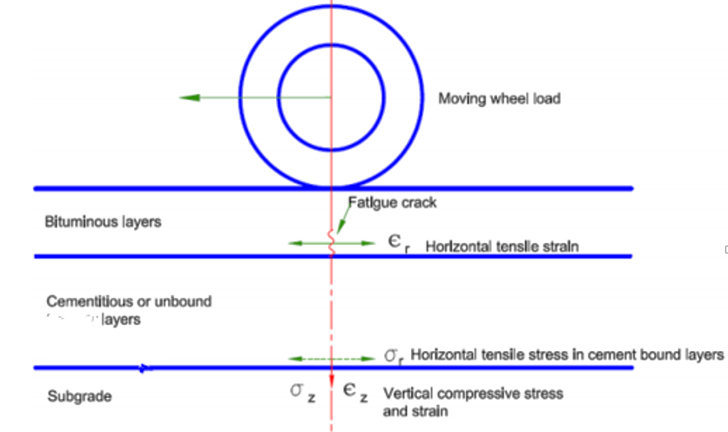
Source: ERA manual, 2013
Figure 2.1 Critical locations for the Fatigue Cracking and Rutting

2.3 Design methods of flexible pavement
Empirical method With a strength test was first used by the California high way department in 1929 (Porter, 1950) the thickness of pavement was related to California bearing ratio defined as the penetration resistance of a sub grade soil relative to standard crushed rock.
Limiting shear failure method is used to determine the thickness of pavement so that the shear failure will not occur. The major property of pavement compositions and subgrade soil to be considered are there cohesion and angel of internal friction to determine pavement thickness (Leod, 1953).
Limitation deflection method is used to determine the thickness of pavements so that the vertical deflection will not exceed the allowable limit easily measured in the field. But pavement failures are caused by excessive stresses and strains instead of deflections (Burmister, 1943).
Regression method based on pavement performance or road tests the AASHTO design equation is a regression relationship between the number of load cycles, pavement structural capacity, and performance, measured in terms of serviceability. The concept of serviceability was introduced in the AASHTO method as an indirect measure of the pavement’s ride quality. The serviceability index is based on surface distresses commonly found in pavements (Huang, 2004).
Mechanistic empirical method is based on mechanics of materials that relates an input, such as a wheel load to an output or pavement response such as stress or strain. This leads to the development of different computer programs (Huang, 2004).
Existing pavement analysis and design methods often follow several empirical procedures developed through investigations from specific type of pavement structure with limited conditions. The empirical methods have limitations for changes of loadings and environmental conditions. The main limitation of empirical methods is that they cannot be confidently extrapolated beyond those conditions on which they are based. The essential need for the pavement design procedures to properly account for varying design situations has led to widespread research efforts to develop so-called mechanistic analysis and design concepts. A major aspect of mechanistic based design is the proper characterization of pavement materials for more accurate response prediction (Loulizi, Qadi, & Elseifi, 2006).
Mechanistic-empirical methods represent one step forward from empirical methods. The induced state of stress and strain in a pavement structure due to traffic loading and environmental conditions is predicted using theory of mechanics. Empirical models link these structural responses to distress predictions. Incorporated strain-based criteria in their mechanistic-empirical procedures. Several studies over the past fifteen years have advanced mechanistic-empirical techniques. The availability of computer based packages for mechanistic analysis provided a powerful tool for pavement engineers. Because of the assumptions involved, including homogeneous isotopic and linear elastic material properties, no shear stresses at the surface and uniformly distributed load, strictly speaking, elastic layer theory is not a good model of a pavement structure yet the basic conclusion is that elastic layer theory is a useful model for the analysis of pavements provided the input data is properly formatted and the output is properly interpreted. Finite element and viscoelastic layer theory have seen more limited use, possibly because of the difficulty in obtaining the required materials input and the complexity involved (Alession, 2012).
Today the road construction has spun into a new dimension where the construction is carried out extensively, which intern requires tool for analysis and design of durable pavement structure to satisfy the increasing demand. It is well known fact that finite element method of analysis provides effective results than other methods of analysis with high accuracy and less time, hence a software based on finite element method serves the purpose and makes it handy for an engineer to analyses and design pavements. As a result the computed responses are significantly more accurate than in previous versions. New performance models to predict rut depth and fatigue life have been implemented. Each layer in a pavement cross section is assumed to extend infinitely in the horizontal direction. Displacements, stresses and strains due to a single circular wheel load are computed. Due to the assumptions used, the problem is reduced to an axisymmetric one (Srikanth, 2015).
The research carried out to develop the software successfully accomplished and the results it gives are as accurate as expected. The developed software can be used to design the flexible pavement by AASHTO, Group Index, and CBR methods. The design results obtained from each method could be compared and hence select the best design. The development of software for the pavement design is very important as it makes the design process accurate. Hence the design process can be done in accurately avoiding the computational and calculation errors of the conventional manual design method (Rafiullah, Muhammed and Afed, 2012).
Analytical methods for pavement structure analysis are used to study the effect of axle load and increases in pavement layer thicknesses in addition to the effect of the variation in temperature and elastic moduli of pavement layers on overall pavement life Limitations in empirical approach of pavement design have become more apparent primarily due to the prevalence of increasing traffic trends in highways relative to volume and axle loads given that the construction and characteristics of heavy vehicles considerably differ from those of vehicles that existed when these empirical methods were first proposed. The second problem relates to the application of new materials, particularly waste materials and industrial by-products, as their characteristics and behavior when inbuilt in a pavement layer are largely unexplored (Nino, Ivana and Sanja, 2017).
In the ﬁnite element method the pavement layers are considered as a solid continuum. The solid continuum domain of the problem is then divided into sub domains. These sub domains are then discretized into a number of ﬁnite size elements. Assembly of all these elements will then represent the problem in the analysis. Finite elements are interconnected by nodes at their common edges. This analysis provides an approximate solution for an engineering structure with various types of boundary conditions and under various types of loading using a stiffness or energy formulation. In the derivation of the stiffness matrix for elements, three factors such as the geometry of elements, the degrees of freedom allowed for the nodes to displace and the material properties of elements are considered. This solution yields displacements at the nodal periods and stresses, and strains at integration points (Muhammad, Bodhinayake, 2003).
In the mechanistic approach, the pavement is treated as a layered structure, and the components of this structure must be properly understood as the constituent materials. The material resilient behavior is characterized using mathematical models. First theoretical background is needed for understanding some of the idealizations and assumptions made in developing the models. Secondly, laboratory tests must be conducted to study the material behavior under similar field conditions such as loadings, environmental conditions, and construction effects expected to apply to the pavement in service. The laboratory data must be examined to develop models that can predict measured material behavior and field response. Several unbound granular material and subgrade soil models have been developed for pavement design and evaluation. These models have involved repeated loading tests and considered the nonlinear stress-dependent material behavior (Minkwan, 2007).
A very important factor when using a mechanistic–empirical design method is the need to use testing equipment and set-ups in the laboratory which adequately simulate the most important aspects of the real behavior of a pavement. Otherwise we can’t expect that our predictions will reflect real-world factors and results or predict actual pavement performance. This more meaningful approach would rule out some of the classical tests which have long been used in the structural design of pavements, such as the CBR test, and would replace these with tests that would yield more reliable results and therefore lead to more efficient decisions regarding road construction (Sigurdur Erlingsson, 2014).

In Ethiopia the failure of roads are before handover period. For the example Bako-Nekemte road/ has become a critical issue in our country. The road from Bako-Nekemte is constructed before four years ago that is until now not handover but it is started to deteriorate. In our country, it is not common to use software based design of flexible pavements rather than the design agencies practice the method by referring the hardcopy of design guideline manual (AASHTO and ERA) and calculation. Mistakes are mostly occurred or error cannot be fully avoided in the design that influences the quality of the design and development of the science. Manual design method has a problem in doing many alternatives for comparison as flexible pavement design involves different monograph, charts, tables and formulas. The use of FEM model through Everstress allows the model to accommodate the load dependent stiffness of the road layers, granular and subgrade materials which most of the models still use linear elastic theory as constitutive relationship. The load come from vehicles must be distributed properly otherwise it-enforced deflection of the road (Shiferaw, Tarekegn and Emar, 2017).
Mechanistic-empirical pavement design utilizes theoretical pavement modeling and historical pavement performance data to predict pavement responses to a trial pavement structure rather than calculating a required layer thickness. Designers first consider site conditions, such as traffic, climate, subgrade and/or existing pavement conditions, in creating a trial design and the software is used to predict the pavement distresses and smoothness. A trial design can be obtained from the AASHTO 1993 empirical design process or pavement management system for a similar/near-by project or from local knowledge/experience. The pavement responses are evaluated against performance criteria and reliability if the design does not meet the required performance criteria, it should be revised and the process repeated until the criteria are met. In finite element analysis materials are viewed as discrete bodies subjected to stresses and strains with some nonlinear property (Omer and Ben, 2018).
Permanent deformation (rutting) is the most critical load-associated distress that develops on asphalt pavements significantly affecting their performance. Past research work focused on estimating permanent deformation of asphalt mixes using empirical prediction models or prediction models based on linear elastic material models. In recent years, mechanistic and mechanistic-empirical prediction models have been developed to take into account the behavior of asphalt material (viscoelastic, viscoplastic or elasto-visco-plastic) (Mbakisya, 2009).

2.4 Classical Models, Equations and Tables Used in this Analysis

2.4.1 Heukelom and klomp (1962)
Fatigue cracking is a phenomenon which occurs in pavements due to repeated applications of traffic loads. The fatigue criterion in this design approach is based on limiting the horizontal tensile strain on the underside of the thin bituminous layer due to repetitive loads on the pavement surface, if this strain is excessive, cracking (fatigue) of the layer will result. Heukelom and Klomp (1962) suggested relationship between the number of load repetitions to failure and strain in asphalt concrete as follows:
$Nf={10}^{-X}$………..……………………….…… (2.4)
Where;
N_{f}= Number of load applications to fatigue failure
$X =5log ɛt+2.665log \frac{E}{14.22}+0.392…$…….. (2.5)
ɛt = Horizontal tensile strain at the bottom of thin bituminous layer
E = Elastic Modulus of thin bituminous layer the allowable horizontal tensile strain at the bottom of thin bituminous layer according to Heukelom and Klomp, (1962) is given by:
$ɛt ={10}^{-A}$…………….................................... (2.6)
Where;
Bituminous layer = Allowable Strain at the bottom of the Bituminous layer
$A =log Ni+\frac{2.665log ((E/14.22) + 0.392)}{5}$ ……... (2.7)
N_{i}= Number of actual repetitions
E = Elastic Modulus of Bituminous layer
Rutting criterion is based on limiting the vertical compressive subgrade strain, if the maximum vertical compressive strain at the surface of the subgrade is less than a critical value, then rutting will not occur for a specific number of traffic loadings. the magnitude of rutting has been correlated with the amount of traffic and the vertical compressive strain level at the surface of the subgrade.
For permanent deformation, Heukelom and Klomp (1962) expressed the relationship between the number of repetitions to failure and the vertical compressive strain level at the surface of the subgrade as follows:
$Nf ={10}^{-X}$…………………….……….... (2.8)
Where;
N_{f} = Number of load applications to rutting or permanent failure
$X=\frac{2.408 + log ɛc}{0.1408}…$…..………………...… (2.9)
Ɛc = Vertical compressive strain at the surface of the subgrade the allowable vertical compressive strain at the top of the subgrade (Heukelom and Klomp, 1962) is given by:
Ɛc = 10^{-A}
Where;
Allowable vertical compressive strain at the top of subgrade
A = 0.1408log₁₀Ni+ 2.408…………….... (2.10)

2.4.2 Thompse and Elliott (1985) (Regression equation)
Developed simple regression equation or algorithms for predicting the response of typical flexible pavements the resilient modules of crushed stone base represented by equation with k1=9000psi(62MPa) and k2=0.33 the relation between resilient modules and deviator stress for four different subgrade soils parameters k2,k3 and k4 are the same for all soils, the only soil property represented in the regression is k1 , which is the resilient modulus at the brake point to apply the Mohr-Colomb failure criteria. h1 and h2 are pavement layer thickness in inches , ɛc (compressive strain at the top of the subgrade), ɛt (Horizontal tensile strain at the bottom of thin bituminous layer) and E1(Elastic Modulus of asphalt concrete).

$$Log Ɛt=2.9496+0.1289h1 +\left(\frac{0.5195}{h1}\right)\log{h2}-$$
$0.0807h1log E1-0.0408 log k1Log Ɛt…$……………………………………………........... (2.11)
$Log Ɛc=4.5040- 0.0738h1-0.0334h2-0.3267log E1-0.0231k1$……………………………………………………………………………..……...... (2.12)

2.4.3 Asphalt institute (1982)
suggested that the relationship between fatigue failure of Bituminous layer and tensile strain is represented by the number of load repetitions as follows:
$Nf={0.0796( ɛt )}^{-3291}{( E )}^{-0.854 }$………………………............ (2.13)
Where;
N_{f} = Number of load applications to failure
Ɛt = Horizontal tensile strain at the bottom of
Bituminous layer
E = Elastic Modulus of asphalt concrete Permanent deformation or rutting is a manifestation of both densification and permanent shear deformation. As a mode of distress in highway pavements, pavement design should be geared towards eliminating or reducing rutting in the pavement for a certain period.
The relationship between rutting failure and compressive strain at the top of the subgrade is represented by the number of load applications as suggested by asphalt institute (Asphalt Institute, 1982) in the following form:
$Nf ={1.365*10}^{-9 }{ (ɛc)}^{-4.477}$…………............... (2.14)
Where;
$Nf$ = Number of load applications to failure
ɛc = compressive strain at the top of the subgrade is used to define the point at which failure occurs in a pavement by determining the incremental damage. The incremental damage is simply the number of a particular axle load expected during a given design period divided by the number of repetitions to failure. The incremental damage is summed for all axle loads to obtain the expected damage factor over the life of the pavement as equation 2.30 shows.
Table 2.2 Coefficients for Fatigue Cracking and Rutting Distress Models
Asphalt Institute Distresses Model (in SI units) | Fatigue Model  N_{f =}f₁(1/ɛt)^{f2}(1/Eac)^{f3} | f₁ | f₂ |  | f₃
Asphalt Institute Distresses Model (in SI units) | Fatigue Model  N_{f =}f₁(1/ɛt)^{f2}(1/Eac)^{f3} | 0.414 | 3.291 |  | 0.854
Asphalt Institute Distresses Model (in SI units) | Rutting Model  Nr = f₄(1/ɛc)^{f5} | f₄ |  | f₅
Asphalt Institute Distresses Model (in SI units) | Rutting Model  Nr = f₄(1/ɛc)^{f5} | 1.365*10⁻⁹ |  | 4.477
Source: Asphalt Institute, 1982

2.4.4 Jones’ tables of stress in a three-layer system
Figure 2.2 shows a three-layer system and the stress at the interfaces on the axis of symmetry. These stress include vertical stress at interface 1, σz1, vertical stress at interface 2, σz2, radial stress at the bottom of layer 1, σr1, radial stress at top of layer 2, σ`r1, radial stress at the bottom of layer 1, σr2, radial stress at top of layer 3, σ`r2 note that, on the axis of symmetry, tangential and the shear stress is equal to 0,
When the Poisson ratio is 0.5
$Ɛz=\frac{1}{E }(σz-σr)$………………………….…….…………..... (2.15)
$Ɛr =\frac{1}{E}(σr-σz)$…………………………………..…………. (2.16)
Equation indicates that the radial strain equals one-half of the vertical strain and is opposite in sign, or
$Ɛz=-2Ɛr…$…………………….……………. (2.17)
Equation can be visualized physically from the fact that, when a material is incompressible and has the Poisson ratio 0.5, the horizontal strain is equal to one-half of the vertical strain and the sum of ɛ_{z ,}ɛ_{r} and ɛ_{t} must be equal to 0.
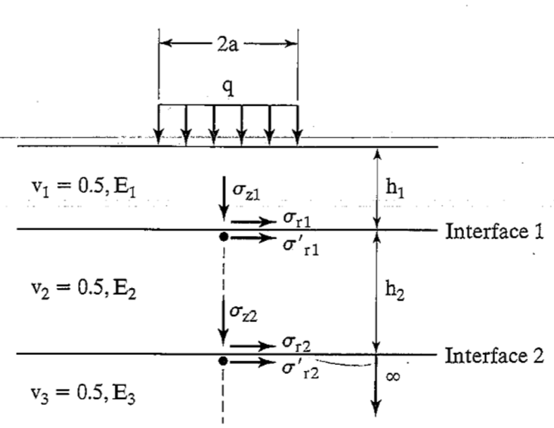
Source: Jones, 1962
Figure 2.2 Stresses at Interface of a Three – Layer system
Jones’ tables the stress in a three layer system depends on the ratios k1, k2, A, and H, defined as
$K1=\frac{E1}{E2}$ & $K2 =\frac{E2}{E3}$………….….…… (2.18)
$A=\frac{a}{h2}$ & $H =\frac{h1}{h2}$…………….…………. (2.19)
Jones (1962) presented a series of tables for determining σ_{z1,} σ_{z1-} σ_{r1,} σ_{z1 and} σ_{z1-} σ_{r2.} His tables also include values of σ_{z1-} σ`_{r1}at top of layer 2 and σ_{z1-} σ`_{r1.} at the top of layer 2, σ_{z2 -} σ`_{r2} at top of layer 3 but these tabulation are actually not necessary because they can be easily determined from those at the bottom of layers 1 and 2 the continuity of horizontal displacement at the interface implies that the radial strains at the bottom of layer are equal to that at the top of the next layer, or, from equation
$σz1 - σ`r1=\frac{σz1- σr1}{k1}$…………………………………………….. (2.20)
$σz2 - σ`r2=\frac{σz2- σr2}{k2}$……………………………………………… (2.21)
The tables presented by jones consist of four values of k1 and K2 (0.2, 2, 20, and 200), so solutions for intermediate values of k1 and K2 can be obtained by interpolation. But the interpolation is impractical and requires a large amount of time and effort, only the more realistic cases (k1=2, 20, and 200) K2 = 2 and 20 are presented, to conserve space.
Table present the stress factors for three- layers systems. The sign convention is positive in compression and negative in tension. Four sets of stress factors,-zz1, zz2, zz1-rr1, and zz2-rr2-are shown. The product of the contact pressure and the stress factors gives the stresses
σ_{z1 =} q (zz1)……………………………………… (2.22)
σ_{z2 =} q (zz2)………………………………………………………….. (2.23)
σ_{z1-} σ_{r1 = =} q (zz1-RR1)……………………………. (2.24)
σ_{z2-} σ_{r2 = =} q (zz2-RR2)…………………………..... (2.25)

2.4.5 Huang Deflection Equation (1969c)

Flexible pavements are layered system with better materials on top and cannot represented by a homogeneous mass, so the use of Burmister layered theory is more appropriate (Burmister, 1943). First developed solutions for a two-layered system and then extended them to a three-layer system (Burmister, 1945). With the advent of computers, the theory can be applied to a multilayer system with any number of layers (Huang, 1967, 1968a).
Basic assumptions
- Each layer is homogeneous, isotropic, and elastic with an elastic modules E and Poisson ratio ν.
- The material is weightless and infinite in a real extent.
- Each layer has a finite thickness h, except that the lowest layer is infinite in thickness.
- A uniform pressure q is applied on the surface over a circular area of radius a.
- Continuity condition are satisfied at the layer interfaces, as indicated by the same vertical stress, shear stress, vertical displacement and radial displacement. For friction less interface, the continuity of shear stress and radial displacement is replaced by zero shear stress at each side of the interface.
The exact case of a two-layer system is the full- depth construction in which a thick layer of HMA is placed directly on the subgrade. If a pavement is composed of three layers (e.g., an asphalt surface course, a granular base course, and a sub grade, it is necessary to combine the base course and subgrade in to a single layer for computing the stress and strain in the asphalt layer or to combine the asphalt surface course and base course for computing the stress and strain in the subgrade.
The vertical interface deflection has also been used as a design criterion fig can be used to determine the vertical interface deflection in to a two layer system (Huang, 1969c). The deflection is expressed in terms of the deflection factor F by
$w =\frac{q*a}{E*F}…$………………………………….…… (2.26)

2.5 Advanced Numerical Method Used For Analysis
EVERSTRESS AND ABAQUS are finite-element analysis tools which provide continuous (up to point solution). The complete domain has to be discretized. Also have the ability to handle complicated geometry and boundaries. For this study analysis for a pavement structure consisting of asphalt layers, a granular base layer and a sub base layer, is modelled as a 3D ﬁnite element using the ﬁnite element computer package ABAQUS/STANDARD. When defining boundary conditions Since brick elements are considered in the ﬁnite element modelling, rotation is not allowed for at all nodes. Therefore, only three degrees of freedom have to be considered in deﬁning the boundary conditions. The vertical displacements of the nodes on the bottom plane of the model are ﬁxed. Plane of symmetry between the two wheels, thus the orthogonal displacements to the plane are prevented. For the vertical plane passing through midway of one wheel, thus the orthogonal displacements to the plane are prevented (Muhammad, Bodhinayake, 2003).
The general structure of finite element technique based program involves the following modules; Module to enter data (Preprocessing), Module to perform analysis (Processing), Module to interpret and display the result (Post Processing).
The preprocessing step must accomplish the following functions; Description of geometry (node coordinates, element connectivity, etc.), material properties (Poisson’s ratio, density, elastic modulus etc.), Mesh generation, Load definition and boundary condition
The post-processor describes the results of variables computed at the various nodes of the structure and involves the following; Nodal displacement values, Elemental stress values Reactions at constrained nodes, Graphical display of displacements, Graphical display of stress contours (Cam, 2014).

2.5.1 EVERSTRESS
EVERSTRESSFE version 1.0 is a 3D finite-element analysis tool for simulating the response of flexible pavement systems subjected to wheel loads.

2.5.2 ABAQUS/CAE Modules
The ABAQUS Software is a product of Dassault Systèmes Simulia Corp, 2013. Modules when using this software are Part module are the building blocks of an ABAQUS /CAE model. Use the Part module to create each part i.e. deformable any arbitrarily shaped axisymmetric, two-dimensional or three-dimensional. Assembly module to assemble instances of the parts. Sketch module to create, modify, and manage sketches. Use the property module to perform the following tasks: deﬁne materials, deﬁne sections, assign sections, orientations, normal, and tangents to parts. Assembly module to create instances of your parts and to position the instances relative to each other in a global coordinate system. Create analysis steps will specify output requests, specify adaptive meshing, and specify analysis controls. Use the load module to deﬁne and manage the following prescribed conditions: loads, boundary conditions, and predeﬁned ﬁelds and load cases. Mesh module contains tools that allow you to generate meshes on parts and assemblies created within ABAQUS /CAE. Job module used to create and manage analysis jobs and to view a basic plot of the analysis results. Allows to create a job, to submit it for analysis, and to monitor its progress.

2.5.3 KENLAYER
KENLAYER is a part of computer program KENPAVE, developed by Dr. Yang H. Huang at University of Kentucky which is used for the solution of an elastic multi-layered system under a circular loaded area. Its calculation principle is based on the Burmister's multi-layered elastic theory similar to other programs based on the analytical method. Stress, strain and deformations due to individual wheel assembles (such as dual or dual tandem) are super imposed for their combined effects. Its capability of analyzing pavement structure either by linear-elastic, nonlinear-elastic and viscoelastic models or combined of all the above taken together. Damage analysis can also be performed by KENLAYER, to evaluate the pavement design life. In damage analysis, damage caused by fatigue cracking and permanent deformation are evaluated using Software.

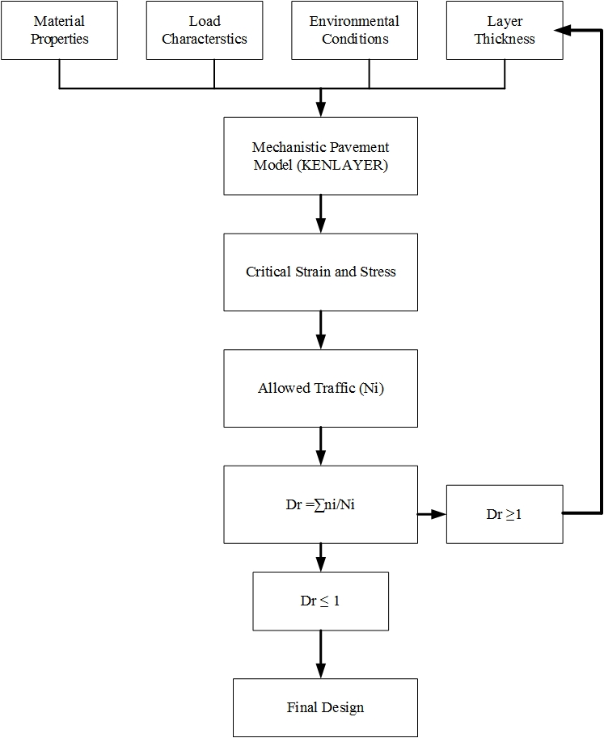
Figure 2.3 Flow Chart to Explain Advanced Numerical Method (KENLAYER) Design Approach for Flexible Pavement
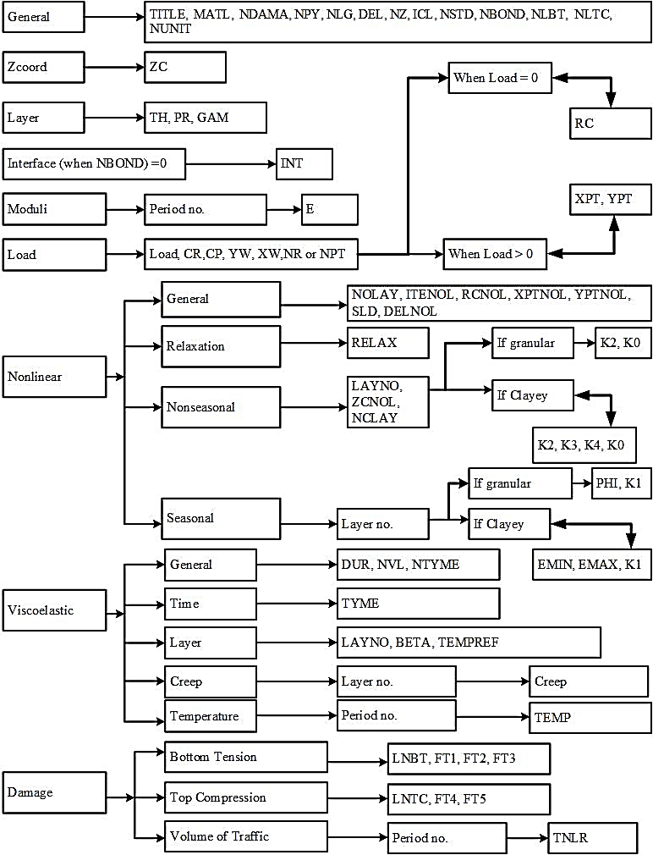
Figure 2.4 KENLAYER Program Structure for Various Input Parameter
KENLAYER Analysis Method
There are three method of analysis based on the nature of material namely linear, nonlinear and viscoelastic. Besides these there is damage analysis which can be incorporated any of the three methods for the prediction of pavement design life.
Viscoelastic analysis: in viscoelastic analysis material possesses both the Elastic property of a solid and viscous behavior of a liquid. Hot Mix Asphalt (HMA) is analyzed viscoelastic material. Viscoelastic materials are further characterized in to two methods:
1. Mechanical Model; and
2. Creep-Compliance.
In KENLAYER, Creep-Compliance method is used due to its simplicity. For Viscoelastic layers, elastic solutions under static loads are obtained at a specified number of time durations, usually 11, at reference temperatures and then fitted with a Dirichlet Series so that the compliances at any other temperature can be obtained by the time-temperatures upper position principle [Huang, 2004].The elastic solutions obtained at these durations are fitted with a Dirichlet series to be used for analyzing moving loads. A direct method for analyzing viscoelastic layer systems under static loads is to assume the viscoelastic layer to be elastic with a modulus varying with the loading time and the elastic modulus is the reciprocal of the creep compliances at that loading time. In present study, the reference temperature for the creep compliance used as the input in LAYERINP is assumed 26°C. The generalized model for creep compliance at reference temperature 25°C is developed from Huang (Huang, 1993) and expressed as
$D (t)=\frac{1}{E} (1-e^{-0.833t})…$.......................... (2.27)
The creep compliance under a reference temperature T_{o} are known, those under any given temperature T can be obtained by using a time-temperature shift factor a_{T}, defined (Pagen, 1965) as
a_{T} = t_{T} / t_{To} ........................................…… (2.28)
In which t_{T} is the time to obtain a creep compliance temperature T and t_{To} is the time to obtain a creep compliance at reference temperature T_{o}. Various laboratory tests on asphalt mixes have shown that a plot of log a_{T} versus temperature results in straight line as shown in figure 2.5 the slope of straight line ᵦ varies from 0.061 to 0.170, with an average 0.113 (FHWA,1978).
$β=log⁡\left(\frac{\frac{t_{T}}{t_{T_{0}}}}{T-To}\right)$.................................................... (2.29)
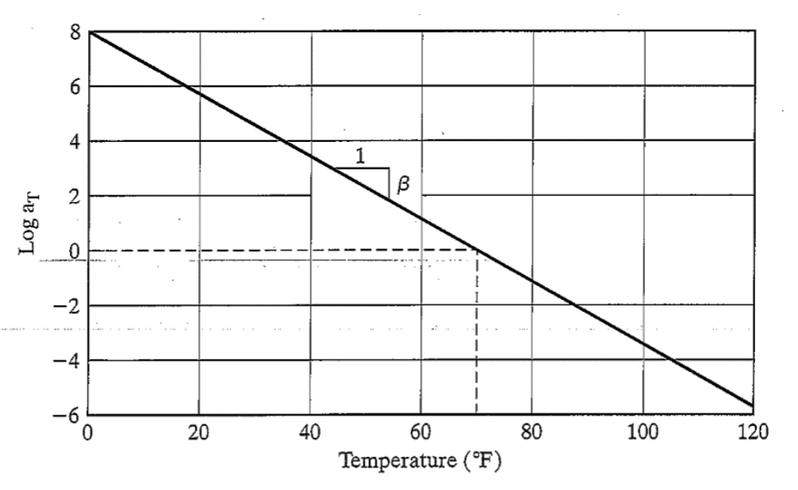
Figure 2.5 Shift Factor versus Temperature

Damage Analysis by KENLAYER: The damage caused by fatigue cracking and Permanent deformation in each period overall load groups is summed up to evaluate the design life. The damage analysis is based on the horizontal tensile strain at the bottom of a specified asphalt layer and the vertical compressive strain on the surface of a specified layer, usually subgrade. The damage ratios for fatigue cracking and permanent deformation are evaluated. Dr is damage ratio which is the ratio between the predicted and allowable number of repetitions, is computed by Huang, 2004.
Dr = ∑^{p}_{i=1} ∑^{m}_{j=1} n_{ij}/N_{ij} ..................................... (2.30)
In which Dr is the damage ratio at the end of a year, n, is the predicted number of load repetitions for load y in period i, N is the allowable number of load repetitions based on Equations given inTable3.16 for Nf and Nr, p is the number of periods in each year, and m is the number of load groups. The design life, which is equal to 1/Dr, is evaluated both for fatigue cracking and for permanent deformation, and the one with a shorter life controls the design and shortest design life is found out to be for maximum damage ratio as given below (Huang, 2004).
$Design Life \{years)=\frac{1}{maximum damage ratio Design Life \{years)}$... (2.31)
To complete the analysis of KENPAVE the following steps are followed:
1. Pavement compositions (thickness of layers) are selected for subgrade strength class S5 and T2 from ERA catalogue is selected for analysis.
2. Required data (material properties and parameters like unit weights of each layer, elastic moduli, Poisson’s ratio, load information, nonlinear parameters, viscoelastic parameters (creep), locations of pavement responses, fatigue and rutting models and load repetitions) for each designed pavement is entered in LAYERINP for the analysis purpose.
3. With all these above information the data file is saved with a name like "probleml.DAT" using "Save as button" at the working directory.
4. Now getting out from LAYERINP by using exit button and click the button KENLAYER. With this the program starts processing the input file.
5. After the process completion there is message on the screen of completion and two new file are generated, in the same working directory, one having *.LAY format and other is a text file.
6. The Text file is the output for the provided input data.
7. Further "LGRAPH" icon can be used to view the plan and cross section of the pavement along with important input and output information.

CHAPTER 3: GEOGRAPHICAL LOCATION, MATERIALS AND METHODS

3.1 Geographical Location
The study area Kibremengist – Shakiso road is in southeaster Ethiopiait is located in the Gujizone of the Oromia region at an average altitude of 1758 meter above sea level and 470km far from Addis Ababa. This road is connecting this two small rural towns. The length of this road is 19 km and constructed Double Surface Treatment (DBST).
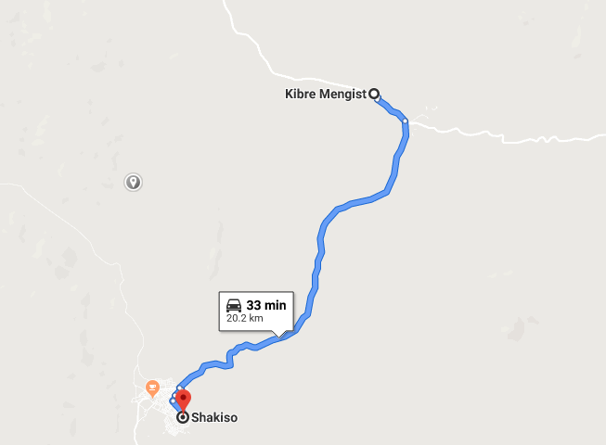 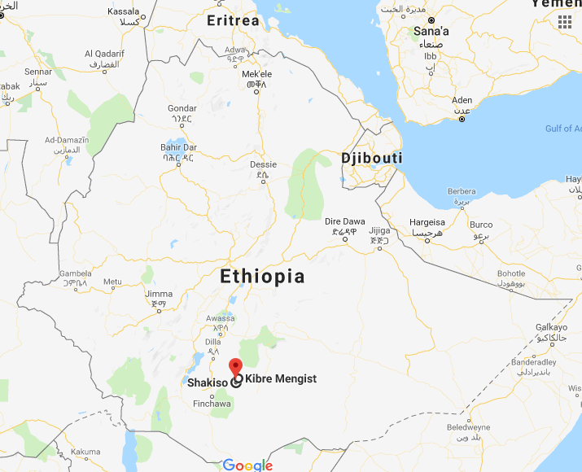 Figure 3.1 Location of Kibre Mengist to Shakiso Road

3.2 Material Secondary Data
This study is carried out to analysis a low traffic flexible pavement using secondary data’s such as; laboratory test results, ERA manual, standards, specification, models and constants etc.
Unit Weight, CBR, Modulus of Elasticity, Poisson’s ratio, None Linear Constants, Coefficients for Fatigue Cracking and Rutting Distress Models, Ø ( angle of internal friction), Traffic loading data and pavement layer data
The main material properties used for the analysis work in this study are unit weight, CBR, modulus of elasticity, Poisson’s ratio, none linear constants, Ø and pavement layer data. Unit weight of pavement layers (secondary data of laboratory test result in case study project taken 3 samples) as shown in table 3.1. CBR of each layers (secondary laboratory data test results done by case study project taken 3 samples) as shown in table 3.2. Modules of elasticity (MPa) of each layers calculated from equation 2.2 and table 3.2 as shown in table 3.3 in addition Poisson’s ratio, None Linear Constants, Ø and pavement layer data needed for analysis are described in tables 3.4, 3.5, 3.6, 3.7, 3.8, 3.9, 3.10, 3.11, 3.12
Unit Weight:
Table 3.1 Unit Weight of Pavement Layers
G-7 Material | G-15 Material | Sub base Material | base Material | DBST Material
14.5 | 17.6 | 20.8 | 21.5 | 24.1
14.6 | 19.8 | 21.4 | 22.75 | 24.1
15.3 | 21.9 | 22 | 24 | 24.1
Source: secondary laboratory data test results done by case study project
CBR (California Bearing Ratio)
Table 3.2 CBR of Pavement Layers
G-7 Material | G-15 Material | Sub base Material | Base Material
12 | 18 | 40 | 80
13 | 21 | 52 | 116
14 | 24 | 65 | 135
Source: secondary laboratory data test results done by case study project
Modules of Elasticity:
Table 3.3 Pavement Layers Modules of Elasticity
G-7 Material | G-15 Material | Sub base Material | base Material | DBST Material
78 | 95 | 115 | 200 | 3000
81 | 102 | 162 | 241 | 3000
84 | 109 | 181 | 260 | 3000
Source: Computed data using both Laboratory result of CBR table 3.3 and equation 2.2
Poisson’s Ratio
Table 3.4 Poisson’s ratio
Layer Type | Poisson’s ratio
Surface layer and untreated base course | 0.35
Granular Sub base and subgrade layers | 0.3
Source: Huang, 2004
None Linear Constants for K0, K1 and K2
Table 3.5 None Linear Constants K1 and K2 for Granular Materials
Material Type | K₁(psi) |  |  | K₂
 | No. of data points | Mean | Standard deviation | Mean | Standard Deviation
Silt Sand | 8 | 1620 | 78 | 0.62 | 0.13
Sand-Gravel | 37 | 4480 | 4300 | 0.53 | 0.17
Sand-aggregate blend | 78 | 4350 | 2630 | 0.59 | 0.13
Crushed stone | 115 | 7210 | 7490 | 0.45 | 0.23
Source: Huang, 2004
Table 3.6 Range of K₁ and K₂ for Untreated Granular Materials
Reference | Material | K₁(psi) | K₂
Hicks (1970) | Partially crushed gravel, crushed rock | 1600-5000 | 0.57-0.73
Hicks and Finn(1970) | Untreated base at san Diego test road | 2100-5400 | 0.61
Allen (1973) | Gravel, crushed stone | 1800-8000 | 0.32-0.7
Kalchff and Hicks (1973) | crushed stone | 4000-9000 | 0.46-0.64
Boyce et al.(1976) | Well graded crushed lime stone | 8000 | 0.67
Monismith and witczak(1980) | In service base and sub base material | 2900-7750 | 0.46-0.65
Source: Huang, 2004
Table 3.7 Value of K₀ for Granular Materials
Soil | Coefficient of Earth Pressure at Rest (K₀)
Dense soil | 0.4-0.45
Loose Sand | 0.45-0.5
Mechanically compacted sand | 0.8-1.5
Normally consolidated clay | 0.5-0.6
Over consolidated clay | 1-4
Source: Huang, 2004
Ø (Angle of Internal Friction)
According to (Huang, 2004) for granular layer (nonlinear) it is suggested that a Ø value of 40 be used for a weak subgrade with a modulus less than10, 000 psi (69MPa) and that a larger Ø, say, up to 60, be used for a stiff subgrade. Therefore from case study project use secondary data of CBR for computing modules of elasticity using equation 2.2 as shown in table 3.3. Hence Subgrade have minimum modules of elasticity 78MPa which is greater than 69MPa using table 3.3 for strong subgrade Ø of 50 used for analysis.
Table 3.8 Seasonal Input Parameter for Granular Materials
Type of subgrade | Ø
Weak subgrade with modules smaller than 6.9MPa | 40
Strong subgrade | 50
Source: Huang, 2004
Table 3.9 Nonlinear Constants and Ø Data’s for Analysis Used as Input
Nonlinear layer | Ø | K₀ | K₁(kPa) | K₂
Granular Base | 50 | 0.5 | 53400 | 0.64
Granular Sub-Base | 50 | 0.5 | 40000 | 0.46
Traffic loading data
Axle Configuration: Standard Legal Single Axle with Dual wheel, having dual tires, center to center spacing of 34.3cm, is considered for the study.
Load: Load of Single axle with dual tire is taken as 80kN
Tire pressure: For most of the commercial highway vehicles, the tire pressure ranges from 0.56 to 1.2MPa. In the present study the tire pressure is taken as 0.69MPa (Haung, 2004).
Radius of Contact Area: The contact area is important to be determined so that the axle load can be assumed to be uniformly distributed under each tire. In this study, only wheels on one side (the outer wheel path) are considered and each tire is assumed to have circular contact area (Huang, 2004). The contact radius(r) is calculated as:
$r (cm) =100(\frac{Load on single wheel \left(kN\right)}{3.14*Tire pressure \left(kPa\right)})^{0.5}$……….(3.1)
Therefore, r (cm) = 9.608
Pavement composition
Pavement structure of case study project have five layers. The analysis is done using ERA catalogue thickness layers which is determined On the basis of subgrade strength class (CBR) and traffic class (ESA) analysis as shown in tables 3.10 subgrade strength class (S5) and traffic class (T2). ASHTO flexible pavement thickness design. Using tables, equations and monographs existed in the manual and mentioned at this thesis in the appendix section.
Table 3.10 Thickness of Pavement Layers
Layer type | Case study project Layer thickness(mm) | AASHTO Design Method using design structural number SN (mm) | ERA Catalogue (mm)
DBST(double bitumen surface treatment) | 30 | 30 | 30
Base course  (CBR>80) | 150 | 150 | 150
Sub base ,Natural gravel or modified or crushed (CBR>45) | 150 | 195 | 150
Upper selected layer (CBR>15%) | 150 |  | 150
Lower Selected layer (CBR>7) | 150
Compacted subgrade
Total | 630 | 375 | 480
Analysis pavement response and design life of flexible pavement and compare result of classical and advance numerical method using classical method equation, model and table and advanced numerical method EVERSTRESS, ABAQUS and KENLAYER programs by using input data of ERA manual pavement catalogue pavement layer thickness in table 3.10 and creep data of table 3.11
Table 3.11 Computed Creep-Compliances Used for Analysis
Time | Creep-compliance
0.001 | 2.776*10⁻¹⁰
0.003 | 8.32*10-10
0.01 | 2.765*10⁻⁰⁹
0.03 | 8.227*10⁻⁰⁹
0.1 | 2.664*10⁻⁰⁸
0.3 | 7.371*10⁻⁰⁸
1 | 1.449*10⁻⁰⁷
3 | 3.059*10⁻⁰⁷
10 | 3.332*10⁻⁰⁷
30 | 3.332*10⁻⁰⁷
100 | 3.332*10⁻⁰⁷

Analysis with advanced numerical method the effect of increase in temperature, tire pressure and traffic on pavement response and pavement design life. To study the effect of temperature on pavement design life all other data regarding traffic loading data, material properties are same as used for objective1. Surface layer is analyzed for three pavement temperatures i.e.26°C, 27°C, and 28°C. For the evaluation of pavement structure design life the damage analysis is performed. The data used for the analysis is listed in following Table3.13.
Table 3.12 Effect of Temperature on pavement responses and design life
Elastic modules of bituminous layer | Pavement composition thickness | Pavement temperature for bituminous material
3000MPa | Surface layer =3cm  Base course =15cm  Sub base =15cm | 26
3000MPa | Surface layer =3cm  Base course =15cm  Sub base =15cm | 27
3000MPa | Surface layer =3cm  Base course =15cm  Sub base =15cm | 28

Flexible pavements are designed for specific axle load and tire pressure. But the commercial vehicle operators violate this limit by running their vehicles on high tire pressures to carry extra lug gage (over laden) so that they can minimize the transportation cost per unit. The increased tire pressure is one of the important factors for the early deterioration of pavements. This necessitates this part of the study. To the study of effect of increased tire pressure on pavement responses and pavement design life tire pressure given in Table 3.14 are considered for the analysis. The related radius of contact are as are calculated by using Equation 3.1.
The layer thickness and material properties for the analysis each year is considered as one single period having and 26°C AMPT. The data used in pavement design and analysis including tire pressure and contact radius as shown in Table3.14
Table 3.13Tire pressure and Related Contact Radius for Analysis
ESAL (KN ) | Tire Pressure (kPa) | Contact Radius (cm )
80 | 690 | 9.608
80 | 700 | 9.539
80 | 800 | 8.92 3
80 | 900 | 8.452
Table 3.14 Pavement Response and Design Life Analysis with in Traffic Class
Traffic Class
T2 | 425,000
T2 | 500,000
T2 | 600,000
T2 | 700,000

Economic analysis for Comparison of classical and advanced numerical method in flexible pavement design KENLAYER has the flexibility of varying thickness of individual pavement layer as an input. Using this advantage of KENLAYER an economic and stable pavement composition can be obtained with in permissible limits of minimum thickness can decided. Within permissible limits of minimum thickness of each layer and minimum material cost the thicknesses of layers can be reduced to get economic pavement composition at target design life. The thicknesses of each layer for the above designs are adjusted till a stable and economic pavement composition is obtained for the target design life of 10years with minimum material and laying cost. Table 3.16 shows the material and laying cost for material used in pavement to calculate the approximate material cost for the pavements.

Table 3.15 Material and Laying Cost for Pavement Materials
Type of Layer Material | Rates in Birr per cubic meter
DBST(double bitumen surface treatment) | 5,652
Base course  (CBR>80) | 699.2
Sub base ,Natural gravel or modified or crushed (CBR>45) | 199.94
Upper selected layer (CBR>15%) | 181.85
Lower Selected layer (CBR>7) | 173.19
Compacted subgrade
Source: Case Study Project

3.3 Methodology

3.3.1 Advanced Numerical Method
KENLAYER
General information of layerinp in putting the data for analysis
Ken layer from main menu layerinp we have different input category the first one is file we have two options old or new selected new. TITLE any title or comment can be typed and MATL (types of material): 1 when all layers are linear elastic, 2 when some layers are nonlinear elastic and the remaining, if any, are linear elastic, 3 when some layers are viscoelastic and the remaining, if any, are linear elastic, 4 when some layers are nonlinear elastic, some are viscoelastic, and the remaining, if any, are linear elastic. For our case study we select 4 for combined analysis. NDAMA (damage analysis): 0 without damage analysis, 1 damage analysis with summary printout, and 2 damage analysis with more detailed printout. We need damage analysis with more detail print out as shown kenlayer out puts in the appendix of this paper so we select 2 NPY (number of periods per year): input 1, NLG (number of load groups): Axle loads i.e. 1, DEL (tolerance for numerical integration): A default of 0.001 implies an accuracy of 0.1%. NL (number of layers, maximum 19): NL is 3 which used for analysis, NZ (number of vertical coordinates at which responses are to be computed): When NDAMA = 1, NZ can be left 0 because it will be determined by the program based on the number of locations at which damage analysis are to be made. ICL (Maximum number of integration cycles, 80 suggested): so we used 80 NSTD (number of stresses, strains and displacement): 1 for vertical displacements only, 5 for vertical displacements and four stresses, and 9 for vertical displacement, four stresses and four strains. When damage analysis is performed, NSTD must be assigned 9 so we input 9.NBOND (types of interface between two layers): 1 when all interfaces are bonded, as is usually the case, and 2 when some interfaces are unbounded or frictionless so input 1 for the analysis. NLBT (number of layers with damage analysis based on the tensile strain at the bottom of asphalt layer) we have only 1 layer for this analysis so input 1.NLTC (number of layers with damage analysis based on the vertical compressive strain at the top of subgrade or other unbounded layers).NUNIT (system of units): 1 for SI units and 0 for English units hear input 1. Upon completion, click OK to return to the Main Menu of LAYERINP.
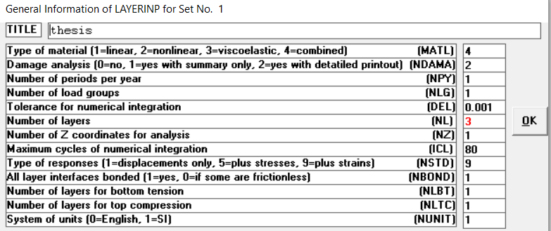
Figure 3.2 in putting General Information of kenlayer
Layer data
This form appears when the 'Layer' menu on the Main Menu of LAYERINP is clicked.TH (thickness of each layer): layer 1is 3cm layer 2 is 15cm and the last layer is infinite in thickness and need not be inputted.PR (Poisson's ratio of each layer): values are 0.35 for HMA and crushed basalt rock 0.3 for granular materials. GAM (unit weight of each layer): values are 24 kN/m^3) for HMA, 23 kN/m^3 for crushed basalt rock, and 21 kN/m^3 for granular materials. After completing this form, click OK to return to the Main Menu of LAYERINP.This form appears when the period button on the Layer Modulus of Each Period is clicked. The number of layers on this form is equal to NL, as specified in the 'General' menu. E (elastic modulus of each layer): Use as the assumed modulus for the first iteration when the layer is nonlinear.3000,000 for layer 1 ,200,000 for layer 2 and 150,000 for layer 3 in kPa After typing the data click the OK button to return.
Load information
This form appears when the 'Load' menu on the Main Menu of LAYERINP is clicked. The number of lines, or load groups, is equal to NLG, as specified in the 'General' menu. LOAD (type of loading): Assign 0 for single axle with single tire, 1 for single axle with dual tires, 2 for tandem axles, and 3 for tridem axles.so input 1 for analysis. CR (contact radius of circular loaded areas) is 9.608cm. CP (contact pressure on circular loaded areas) is 690kPa. YW (center to center spacing between two dual wheels along the y axis): is 34.3cm. XW (center to center spacing between two axles along the x axis): Assign 0. After completing this form and all the necessary auxiliary forms, click OK to return to the Main Menu of LAYERINP.

Figure 3.3 in putting load information
Nonlinear layer menu
This form appears when the 'General' menu on the Nonlinear Layers Menu is clicked. There are seven entries on this form. The location of stress point, which is the point in each nonlinear layer for computing the modulus. NOLAY (number of nonlinear layer) is 2. Recommended to always use the defaults of 15 for ITENOL (max. number of iteration) and 0.01 for DELNOL (tolerance for nonlinear analysis). It is assumed that the moduli will converge to a tolerance of 1% prior to 10 iterations. If the results converge but the execution stops at 15 iterations, a larger ITENOL may be needed to insure that the desired accuracy is obtained. For a single loaded area, if only the maximum stresses, strains, and deflections are required, the point for computing the layer modulus should be located under the center of the area with RCNOL (radial coordinate for nonlinear analysis) and SLD (slop of load distribution) For multiple wheel loads, a point between the center of two duals with XPTNOL(x coordinate for nonlinear analysis in cm) = 0, YPT = YW/2, and SLD = 0 is suggested. XPTNOL and YPTNOL are used only for two duals. If only the maximum stresses, strains, or deflections are required, the stress point should be located between the center of two duals with XPTNOL = 0 and YPTNOL = YW/2, and SLD = 0. Note that YW is the center to center spacing between the two duals. After completion, click OK to return to the Nonlinear Layers Menu.
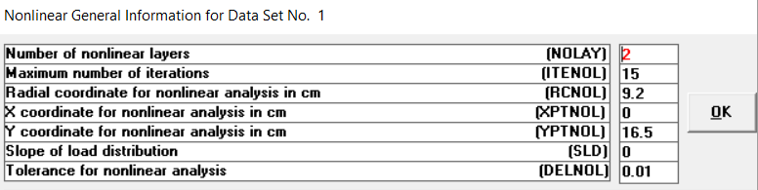
Figure 3.4 in putting nonlinear general information
Non seasonal information
This main form appears when the 'Non seasonal' menu on the Nonlinear Layers Menu is clicked. The number of lines, or sequence, is equal to NOLAY, as specified in the Nonlinear General Information. LAYNO (layer number of the nonlinear layer at which elastic modulus is stress dependent) so it is 2 and 3. ZCNOL (z coordinate of points for computing elastic modulus of nonlinear layer): Although any point in a nonlinear layer can be used for computing elastic modulus, it is suggested that the z coordinate at the mid depth of each layer be used. NCLAY (type of nonlinear layer): assign 0 for granular materials. After completing this form and all the necessary auxiliary forms, click OK to return to the Nonlinear Layers Menu.
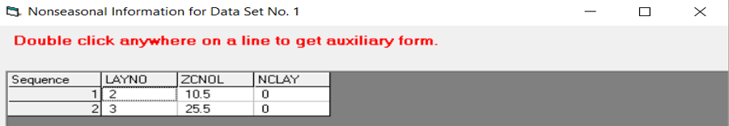
Figure 3.5 in putting Nonseasonal Information
This auxiliary form appears automatically when NCLAY other than 1 is typed on the main form for layer number 2. Nonlinear exponent for granular material is 0.46 and coefficient of earth pressure at rest is 0.5 after completion, click OK to return to the main form.
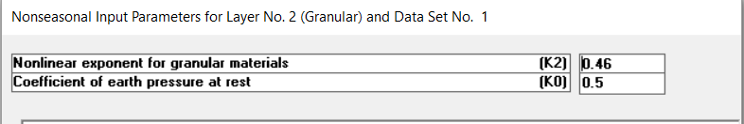
Figure 3.6 in putting Nonseasonal Information for layer 2
This auxiliary form appears automatically when NCLAY other than 1 is typed on the main form for layer number 3. Nonlinear exponent for granular material is 0.64 and coefficient of earth pressure at reast is 0.5. After completion, click OK to return to the main form.
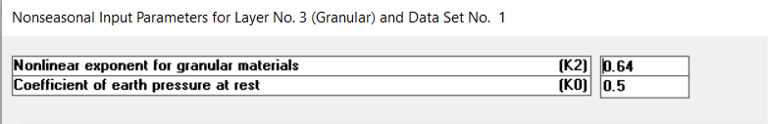
Figure 3.7 in putting Nonseasonal Information for layer 3
Seasonal input parameter for layer number 2
This form appears when the layer is granular and the layer button on the Seasonal Input Parameters of Layer 2 is clicked. Ø (angle of internal friction of granular materials): 50 is used and K1 (nonlinear coefficient of granular layer) is 53,400 used. After typing the data in the first cell, move to the next cell by pressing the Enter key. Upon completion, click the OK button to return to the Seasonal Input Parameters of Each Layer.
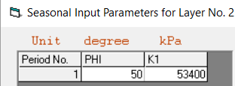
Figure 3.8 in putting seasonal Information for layer 2
This form appears when the layer is granular and the layer button on the Seasonal Input Parameters of Layer 3 is clicked. Ø (angle of internal friction of granular materials) is used and K1 (nonlinear coefficient of granular layer) is 40,000 used. After typing the data in the first cell, move to the next cell by pressing the Enter key. Upon completion, click the OK button to return to the Seasonal Input Parameters of Each Layer.
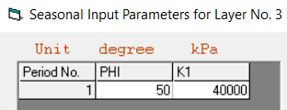
Figure 3.9 in Putting Seasonal Information for layer 3
Viscoelastic layer
This form appears when the 'General' menu of the Viscoelastic Layers Menu is clicked. For stationary Loads, DUR should be changed to 0 and NTYME may be any value. Note that NTYME for moving loads is the number of times at which creep compliances are provided. After completion, click OK to return to the Viscoelastic Layers Menu.
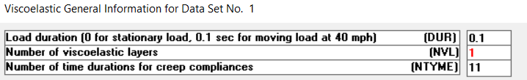
Figure 3.10 in Putting Viscoelastic General Information
This form appears when the 'Duration' menu on the Viscoelastic Layers Menu is clicked. The number of time sequences on this form is equal to NTYME, as specified in the Viscoelastic General Information. TYME (times at which creep compliances are to be specified). For moving load, the 11 default times from 0.001 to 100 sec should be used, if possible, so the creep compliances can be computed more accurately from one temperature to the other over a wide range, when needed. Upon completion, click the OK button to return to the Viscoelastic Layers Menu.
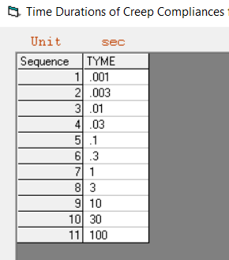
Figure 3.11 in Putting Duration of Creep Compliances
This form appears when the 'Layer' menu on the Viscoelastic Layers Menu is clicked. The number of viscoelastic layers on this form is equal to NVL, as specified in the Viscoelastic General Information. LAYNO (layer number in the layer system which is viscoelastic) is 1. BETA (temperature shift coefficient): This factor is obtained from the slope of the time-temperature shift factor versus temperature on a semi log plot and it is 0.20943. TEMPREF (reference temperature of each viscoelastic layer at which creep compliances are measured it is 26. After completing this form, click OK to return to the Viscoelastic Layers Menu.
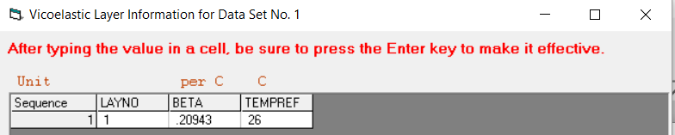
Figure 3.12 in Putting Viscoelastic Layer Information
This form appears when the layer button on the Creep Compliances of Each Layer is clicked. The number of creep compliances on this form is equal to NTYME, as specified in the Viscoelastic General Information. Note that TYME is the time at which the creep compliance is needed, as specified in the 'Duration' menu. CREEP (creep compliances of the viscoelastic layer at the reference temperature) i.e. 2.776*10^{-10,} 8.32*10^{-10,} 2.765*10^{-09,} 8.227*10⁻⁰⁹, 2.664*10⁻⁰⁸, 7.371*10⁻⁰⁸, 1.449*10⁻⁰⁷, 3.059*10⁻⁰⁷, 3.332*10⁻⁰⁷, 3.332*10⁻⁰⁷.Upon completion, click the OK button to return to the Creep Compliances of Each layer.
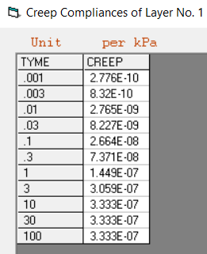
Figure 3.13 in Putting Computed Creep Compliances Data
Damage analysis
This form appears when the 'Bottom Tension' menu on the Damage Analysis is clicked. LNBT (layer number for damage analysis of bottom tension) is layer 1. FT1, FT2, FT3 (fatigue coefficients, as indicated by f1, f2 and f3): Values suggested by the Asphalt Institute in SI unit are 0.414, 3.291, and 0.854.After completing this form, click OK to return to the Damage Analysis.
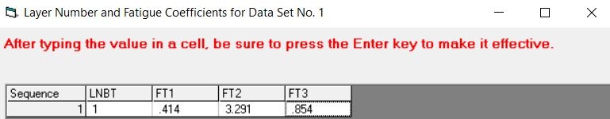
Figure 3.14 in Putting Layer Number and Fatigue Coefficients
This form appears when the 'Top Compression' menu on the Damage Analysis is clicked. The number of sequences or layers for damage analysis on this form is equal to NLTC, as specified in the 'General' menu. LNTC (layer number for damage analysis of top compression) is 3. FT4, FT5 (permanent deformation coefficients, as indicated by f4 and f5 in Eq. 3.7): Values suggested by the Asphalt Institute are 1.365x10^-9 and 4.477. After completing this form, click OK to return to the Damage Analysis.
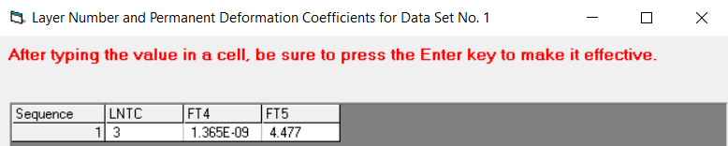
Figure 3.15 in Putting Layer Number and Permanent Deformation Coefficients
This form appears when the period button on the Load Repetitions of each period is clicked. The number of load groups on this form is equal to NLG, as specified in the 'General' menu. TNLR (total number of load repetitions for each load group during each period) is 425,000.Upon completion, click the OK button to return to the Load Repetitions of Each Period.
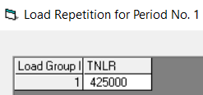
Figure 3.16 in Putting Load Repetition
After imputing all the necessary data the output will display in graphic and detail output parameter as shown in appendix part and results are mentioned in the result section.

ABAQUS
Part module
The Part module to create each part i.e. deformable and three-dimensional.to separate each layer and contact area of tire and pavement surface there is partition face sketch option.
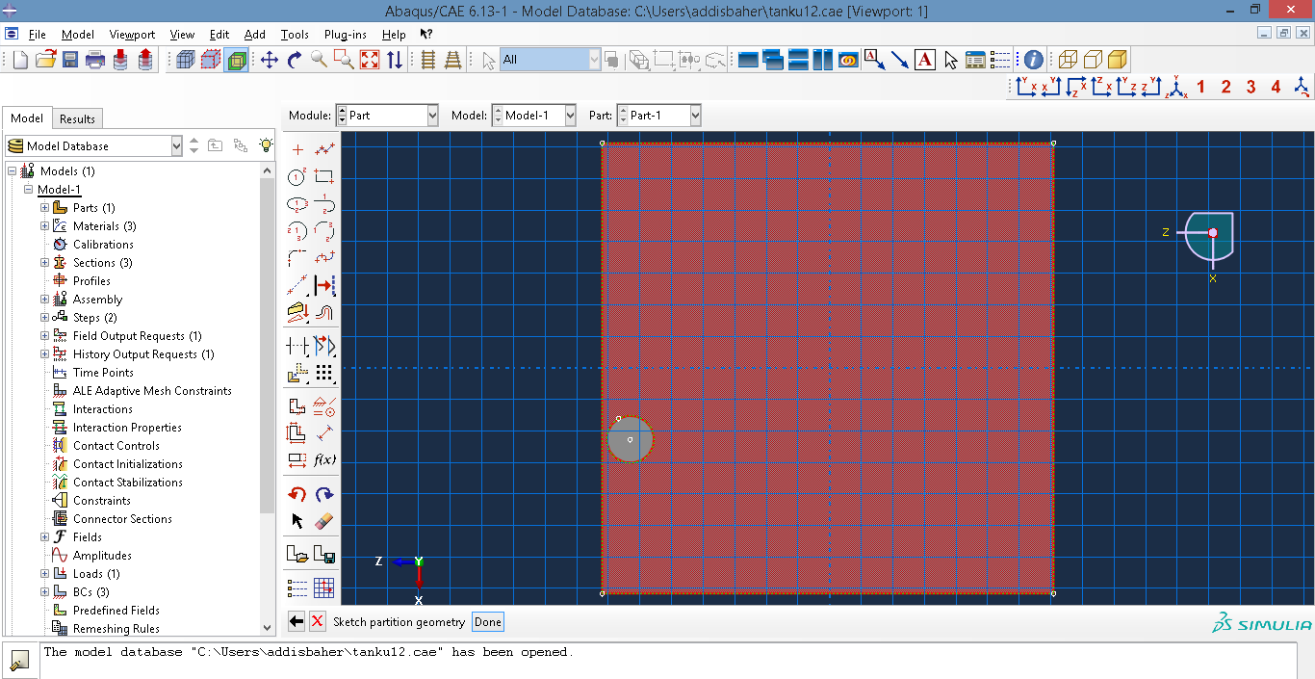 Figure 3.17 Crating Part in Abaqus
Property module
In this part mechanical material behaviors are imputed, crated sections for each layer and sections are assigned.
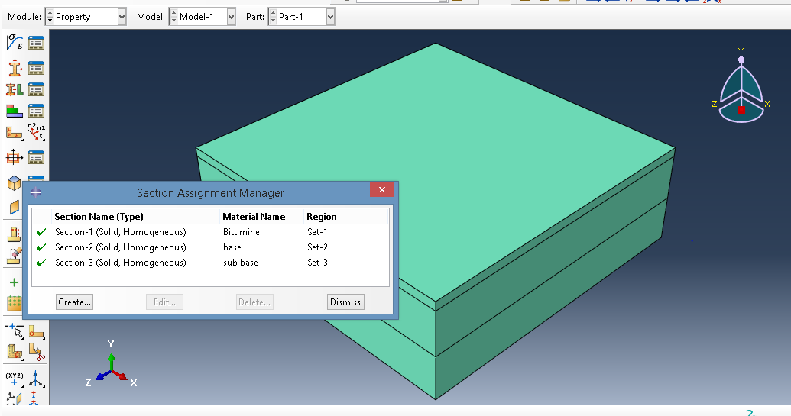 Figure 3.18 Section Assignment in Abaqus
Assembly module
Create instances of parts and to position the instances relative to each other in a global coordinate system.
Step module
Create analysis steps will specify output requests and specify analysis controls. For our case study we need only stress, strain and deformation.
Load module
Deﬁne and manage the following prescribed conditions: loads, boundary conditions, and predeﬁned ﬁelds and load cases. Applied 690kPa load and boundary conditions are rotation is not allowed for at all nodes. Therefore, only three degrees of freedom have to be considered in deﬁning the boundary conditions. The vertical displacements of the nodes on the bottom plane of the model are ﬁxed. Plane of symmetry between the two wheels, thus the orthogonal displacements to the plane are prevented. For the vertical plane passing through midway of one wheel, thus the orthogonal displacements to the plane are prevented.
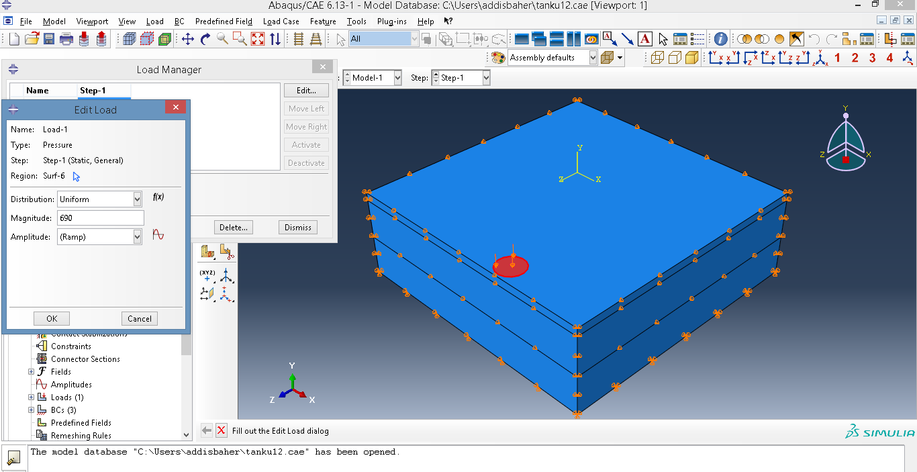 Figure 3.19 Defining Load and Boundary Condition
Mesh module
Contains tools that allow to generate meshes on parts and assemblies created within ABAQUS /CAE. Very fine mesh is used to increase its accuracy. Controlled mesh also done for surface layer and contact area between pavement surface and tire pressure.
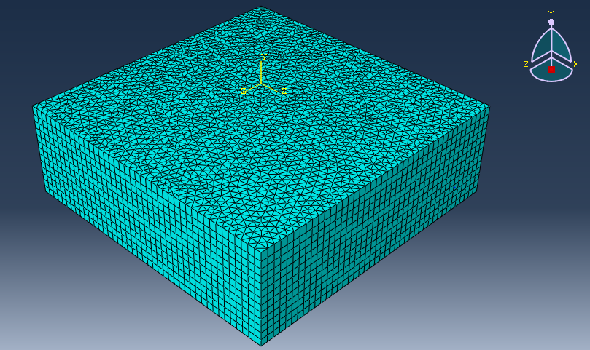 Figure 3.20 Mesh generating
Job module
It used to create and manage analysis jobs and to view a basic plot of the analysis results. Allows to create a job, to submit it for analysis, and to monitor its progress.
EVERSTRESS
Geometry and layer properties
When using everstress first we have got the geometry and layer properties in this section there are four tasks. The first is plot the finite plan dimension length(x) is1m and length(y) 1m then the second task is specifying the number of layers three then mention the thickness 30mm, 150mm and 150mm for layer 1, 2 and 3 respectively and modules of elasticity in MPa 3000,200,150 for layer 1,2and 3 respectively. The fourth and final task for geometry and layer properties is boundary and we have two options model infinite domain and model finite domain select model infinite domain and for y-boundary of layer 1away from wheel hear also have two options the fires is free and the second is infinite select free.
Load
In these portion load parameters like wheel type dual and single axle type are selected. From tire contact of circular, rectangular, user defined and load custom options select circular. Tire pressure of 690kPa and c/c spacing 343mm and by default the program set contact radius of 96mm.
Mesh
From plane view meshing parameters of two options of locally refined and simply grid select locally refined and adjust length of x and y number of elements so, length ,x is 400mm length ,y is 540mm, element along length ,x is 24 and element along y is 18 are used. for coarse region the only thing is element along length, x i.e. 7 and element along, y is also 7 and there is vertical mesh parameter the first is element divisions for layers1 is 9 for layer 2 is 19 and for layer 3 is 20 used and interface condition we have two options fully bonded and partially bonded select fully bonded. When we finished this automatically number of nodes of 133,271 and number of finite elements are 31,200 displayed.
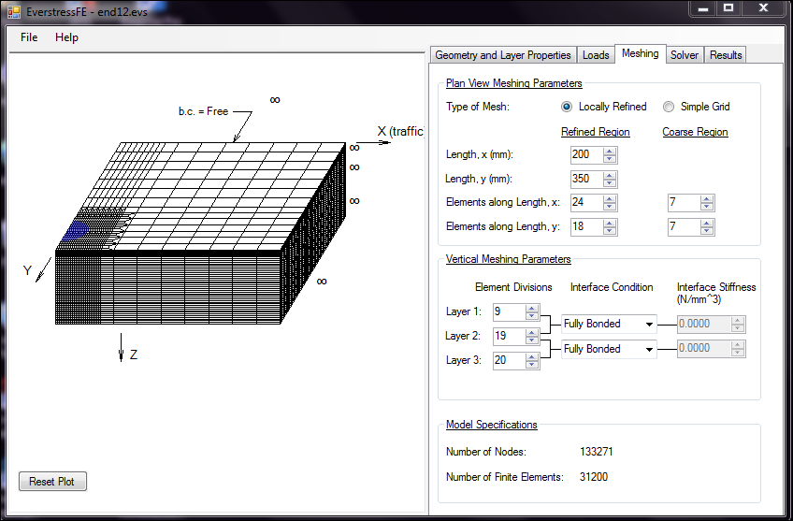
Figure 3.21 Mesh generating
Solver
In this we have two options work with a batch list and solve current model select solve current model.
Result
In this part we have results with plots and the parameters are normal strain, shear strain and displacement for all results we can originating at every x and y to find standard plot through depth , we have also contour plot through plane and deformed mesh plot from this result.

3.3.2 Classical method of analysis
For this study propose selected models and equations briefly described in previous section chapter 2 of this study. Which is used for compare result obtained with advanced numerical method under similar input parameters. Jones table, Huang (1969c), Hekeom and Klomp (1962) model, Thompse and Elliott (1985) (regression equation) and Asphalt institute equations are used to compute all the necessary parameters used to compare such as stress, strain (tensile and compressive), deformation , allowable load repetitions , damage ratio , design life all this parameters are computed at critical locations and results are described in result section.

CHAPTER 4: RESULTS AND DISCUSSIONS

4.1 Introduction
The complete details regarding data collection and methodology used for this analytical study are provided in previous two chapter of this thesis i.e. data collected from the relevant studies, standards, manuals and case study project secondary laboratory data. In this section analyzed by using classical and advanced numerical method at critical location of pavement responses. This analysis of result and discussion work is carried out to find comparative relation between pavement responses, economic analysis and factors affecting pavement analysis such as increase in temperature, increase in traffic, tire pressure etc. the following sections present output data obtained from Classical and advanced numerical analysis for the provided inputs data to complete the objectives with detailed discussion.

4.2 Result

4.2.1 Comparison of Classical and Advanced Numerical Method by Pavement Response and Design Period of Flexible Pavement (Objective 1)
In this section flexible pavements designed for low traffic road for given input data are analyzed by comparing all linear elastic classical, linear elastic advanced numerical and combined (nonlinear and viscoelastic) advanced numerical method.
When all the necessary data for analysis is used the pavement responses i.e. outputs namely vertical stresses, deflections, compressive and tensile strains are obtained. In addition allowable load repetition, damage analysis and design life results are obtained. Input of pavement composition is taken from ERA manual catalogue for analysis at critical locations at the bottom of bituminous layer (layer 1) and on the top of sub base (layer3) for both classical and advanced numerical method and results are shown in tables below.

Table 4.1 Vertical Stress at Critical Point
Method of Analysis | Structural model type | Tools for analysis | Vertical stress
Method of Analysis | Structural model type | Tools for analysis | At bottom of bituminous  layer(surface layer) | At top of  sub base(bottom layer)
Classical | linear | Jone’s table | 524 | 181
Advanced numerical method | linear | Everstress | 629 | 231
Advanced numerical method | linear | Abaqus | 1850 | 154
Advanced numerical method | linear | kenlayer | 574 | 172
Advanced numerical method | Combined (nonlinear and viscoelastic) | kenlayer | 180 | 89
(Stresses are in "kPa")
Table 4.2 Deflection at Critical Point
Method of analysis | Structural model type | Tools for analysis | Deflection
Method of analysis | Structural model type | Tools for analysis | at bottom of bituminous  layer(surface layer) | At top of  subgrade (bottom layer)
Classical | Linear | Huang(1969c) | 0.046 | 0.031
Advanced numerical method | Linear | Everstress | 0.050 | 0.026
Advanced numerical method | Linear | Abaqus | 0.020 | 0.015
Advanced numerical method | Linear | kenlayer | 0.060 | 0.040
Advanced numerical method | Combined (nonlinear and viscoelastic) | kenlayer | 0.009 | 0.006
(Deflection are in "cm")

Table 4.3 Tensile and Compressive Strain at Critical Point
Method of analysis | Structural model type | Analysis tools | Tensile horizontal strain at bottom of bituminous  layer(surface layer)  (micro strain i.e. *10⁻⁶) | Compressive vertical strain at top of  subgrade (bottom layer)(micro strain i.e. *10⁻⁶)
Classical | Linear | Heukeom and klomp (1962) model | 3,604 | 630
Classical | Linear | Jone’s table | 634 | 1,543
Classical | Linear | Thompse and Elliott(1985)(regression equation) | 229 | 68
Advanced numerical | Linear | Kenlayer | 419 | 1,156
Advanced numerical | Linear | Everstress | 429 | 1,029
Advanced numerical | Linear | Abaqus | 424 | 1,114
Advanced numerical | Combined (nonlinear and viscoelastic) | Kenlayer | 41 | 115
Table 4.4 Allowable Load Repetition at Critical Point
Method of analysis | Structural model type | Analysis tools | Allowable load repetition for fatigue (Nf) failure) | Allowable load repetition for rutting (Nr) failure)
Classical | Linear | Heukeom and klomp (1962) model | 430,476 | 418,794
Classical | Linear | Jone’s table | 40,725 | 5,282
Classical | Linear | Thompse and Elliott(1985)(regression equation) | 1,164,505 | 6,208,550,946
Advanced numerical | Linear | Kenlayer | 159,800 | 19,270
Advanced numerical | Linear | Everstress | 146,597 | 32,457
Advanced numerical | Linear | Abaqus | 153,066 | 22,711
Advanced numerical | Combined (nonlinear and viscoelastic) | Kenlayer | 7,043,000 | 586,500,000

The predicted numbers of load repetitions (design traffic) are divided by the allowable load repetitions to calculate the damage ratio (Equation 2.30) in pavement structure. The maximum damage ratio signifies the type of failure in pavement i.e. fatigue or rutting. If the damage ratio is less than 1 then design is acceptable otherwise the design is rechecked for thickness and material properties again. The damage ratios obtained for bituminous (at the bottom of layer 1) and sub base (at the top of layer3) layers are given in Table 4.5. Damage ratio at critical point due to linear and combined Structural model type using classical and advanced numerical methods
Table 4.5 Damage Ratio at Critical Point
Method of analysis | Structural model type | Analysis tools | Damage ratio at the bottom of layer 1 | Damage ratio at the top of layer3
Classical | Linear | Heukeom and klomp (1962) model | 0.987 | 1.015
Classical | Linear | Jone’s table | 10.44 | 80.46
Classical | Linear | Thompse and Elliott(1985)(regression equation) | 0.365 | 0.0000685
Advanced numerical | Linear | Kenlayer | 2.659 | 22.050
Advanced numerical | Linear | Everstress | 2.899 | 13.094
Advanced numerical | Linear | Abaqus | 2.777 | 18.7134
Advanced numerical | Combined i.e. (nonlinear and viscoelastic) | Kenlayer | 0.0603 | 0.000723

The design life of a pavement is governed by the maximum damage ratio and can be obtained as the reciprocal of the maximum damage ratio (Equation 2.31). The design life for linear classical, linear advanced numerical and combined advanced numerical analysis results are given in table 4.6 Design life due to linear and combined Structural model type using classical and advanced numerical methods.
Table 4.6 Design Life in Year
Method of analysis | Structural model type | Analysis tools | Design Life
Classical | linear | Heukeom and klomp (1962) model | 0.99
Classical | linear | Jone’s table | 0.01
Classical | linear | Thompse and Elliott(1985)(regression equation) | 2.74
Advanced numerical | linear | Kenpave | 0.05
Advanced numerical | linear | Everstress | 0.08
Advanced numerical | linear | Abaqus | 0.05
Advanced numerical | Combined i.e. (nonlinear and viscoelastic) | Kenlayer | 16.57

Figure 4.1 Design Period Comparison of Classical and Advanced Numerical Methods

4.2.2 Sensitivity Analysis with Advanced Numerical Method (Objective 2)
Analysis with advanced numerical method the effect of increase in temperature, tire pressure and traffic on pavement response and pavement design life.
4.2.2.1. The Effect of Increase in Temperature
Pavement designed for combined (nonlinear and viscoelastic) is analyzed using KENLAYER; at 26°C, 27°C and 28°C Pavement temperatures to evaluate the effect of temperature, as per methodology and input data table 3.13 then analysis is carried out only by advanced numerical analysis and results of output are shown in tables 4.7 and 4.8
Table 4.7 Effect of Temperature on Stresses and Strain
Pavement Temperature(ºc)
 | 26 | 27 | 28
Vertical Stress at bottom of bituminous  layer(surface layer) | 41 | 59 | 72
Vertical stress at top of  Sub base (bottom layer) | 115 | 140 | 147
Tensile horizontal strain at bottom of bituminous  layer(surface layer)(ɛt) | 180 | 283 | 361
Compressive vertical strain at top of  Sub base (bottom layer)(ɛc) | 89 | 133 | 152

Figure 4.2 Effect of temperature on strain
Table 4.8 Effect of Temperature on Deformation, Allowable Load Repetition and Design Life
Temperature(ºc)
 | 26 | 27 | 28
Deformation at bottom of bituminous  layer(surface layer) | 0.009 | 0.010 | 0.010
Deformation at top of  Sub base(bottom layer) | 0.006 | 0.006 | 0.006
Allowable load repetition for fatigue (Nf) failure | 7,043,000 | 6,112,000 | 4,192,000
Allowable load repetition for rutting (Nr) failure | 586,500,000 | 242,100,000 | 199,500,000
Damage ratio at the bottom of layer 1 | 0.0603 | 0.0695 | 0.1014
Damage ratio at the top of layer3 | 0.000725 | 0.001755 | 0.00213
Design life | 16.57 | 14.38 | 9.86

4.2.2.2. Effect of Increase in Tire Pressure
In order to study the effect of tire pressure on the flexible pavement performance, a pavement is designed by using design parameters as given in table 3.14 of chapter 3 the inputs are entered in to LAYERINP for analysis. All the analysis is done by using tire pressure of 0.69MPa for low traffic road (Huang, 2004).Keeping all other parameters constant tire pressure is increased to 0.7MPa, 0.8MPa and 0.9MPa in the subsequent analysis. The effect of these tire pressures are observed in the form of stresses, strains ,deformations ,allowable number of repetitions(for fatigue cracking and rutting failure) and design life of pavement. Results are given in Tables 4.9, 4.10 and 4.11
Table 4.9 Effect of Tire pressure on Vertical Stress and Deformation
Tire Pressure (kPa)
 | 690 | 700 | 800 | 900
Vertical Stress at bottom of bituminous  layer(surface layer) | 180 | 180 | 188 | 197
Vertical stress at top of  Sub base(bottom layer) | 89 | 89 | 90 | 92
Deformation at bottom of bituminous  layer(surface layer) | 0.00850 | 0.00851 | 0.00860 | 0.00872
Deformation at top of  Sub base (bottom layer) | 0.00563 | 0.00563 | 0.00563 | 0.00566
Table 4.10 Effect of Tire Pressure on Strains
Tire Pressure (kPa)
 | 690 | 700 | 800 | 900
Contact Radius  (cm ) | 9.608 | 9.539 | 8.923 | 8.452
Tensile horizontal strain at bottom of bituminous  layer(surface layer)(ɛt) | 41 | 41 | 45 | 48
Compressive vertical strain at top of sub base (bottom layer)(ɛc) | 115 | 115 | 117 | 118
Table 4.11 Effect of increase in Tire Pressure on Allowable Load Repetition, Damage ratio and Design Life
Tire Pressure (kPa)
 | 690 | 700 | 800 | 900
Allowable load repetition for fatigue (Nf) failure) | 7,043,000 | 6,866,000 | 5,475,000 | 4,472,000
Allowable load repetition for rutting (Nr) failure) | 586,500,000 | 582,900,000 | 552,400,000 | 519,800,000
Damage ratio | 0.060 | 0.062 | 0.078 | 0.095
Design life | 16.57 | 16.16 | 12.88 | 10.52

4.2.2.3. Effect of Increase in Design Traffic
In order to study the effect of traffic on the flexible pavement performance, a pavement is designed by using design parameters as given in Table 3.15 of chapter 3 the inputs are entered in to LAYERINP for analysis. Keeping all other parameters constant traffic is increased to 500,000, 600,000 and 700,000 in the subsequent analysis which is based on ERA manual traffic class T2. The effect of these traffic are observed in the form of damage ratio and design life of pavement. Results are given in tables 4.12.

Table 4.12 Effect of Increase in Design Traffic on Damage Ratio and Design Life
Design Traffic (ESA)
 | 425,000 | 500,000 | 600,000 | 700,000
Damage ratio | 0.060 | 0.071 | 0.085 | 0.099
Design life | 16.57 | 14.09 | 11.74 | 10.06

Figure 4.3 Effect of Increase in Design Traffic in Design Period

4.2.3 Economic Analysis Comparison of Flexible Pavement Design (Objective 3)
Economical solution for pavement compositions designed for target design life of ten year. Comparison of pavement layer thickness required under satisfy the design period of ten year between four pavement thickness predictions i.e. case study project it is actually on site implemented, advanced numerical method pavement thickness which is obtained by considering combined model of analysis through iteration, ERA manual catalogue for subgrade Strength Classes S5 and Traffic Classes T2 and finally ASHTO flexible pavement thickness design using tables, equations and monographs existed in the manual and mentioned at this thesis in the appendix section. As a design selection criteria pavement composition with minimum material cost and maximum design life with permissible limits of minimum thickness of each layer will selected.

Table 4.13 Pavement Layer Thickness Composition for Classical and Advanced Numerical Method
Layer thickness(mm) | case study project used Layer thickness(mm) | Advanced numerical method layer thickness (mm) | ERA manual catalogue(mm) | AASHTO Layer thickness(mm)
DBST(double bitumen surface treatment) | 30 | 30 | 30 | 30
Base course  (CBR>80) | 150 | 60 | 150 | 150
Sub base ,Natural gravel or modified or crushed (CBR>45) | 150 | 150 | 150 | 195
Upper selected layer (CBR>15%) | 150
Lower Selected layer (CBR>7) | 150
Compacted subgrade
Total | 630 | 240 | 330 | 375

Figure 4.4 Layer Thickness Comparison for Classical and Advanced Numerical Method

Economic comparison between classical and advanced numerical method of analysis is presented in table 4.14. Especially under similar design period result of case study actually implemented and mentioned in the table 4.14 as classical and result obtained through combined advanced numerical method is discussed in percentile in discussion part.

Table 4.14 Economic Comparison between Classical and Advanced Numerical Method of Analysis
Layer type | Unit price |  | Classical obtained Layer thickness(mm) | advanced numerical method obtained Layer thickness(mm) | Amount per unit quantity (in birr) for classical analysis | Amount per unit quantity (in birr) for Advanced numerical method
Layer type | Amount | Unit
DBST(double bitumen surface treatment) | 5,652 | m³ | 30 | 30 | 5,652 | 5,652
Base course  (CBR>80) | 699.2 | m³ | 150 | 60 | 699.2 | 280
Sub base ,Natural gravel or modified or crushed (CBR>45) | 199.94 | m³ | 150 | 150 | 199.94 | 199.94
Upper selected layer (CBR>15%) | 181.85 | m³ | 150 |  | 181.85
Lower Selected layer (CBR>7) | 173.19 | m³ | 150 |  | 173.19
Compacted subgrade
Total |  |  | 630 | 240 | 6,906.18 | 6,131.94

4.3 Discussion
The study shows anew frame work for flexible Pavement designs with advanced numerical approach. Through computational mechanics to solve specific problems by simulation through numerical methods implemented on digital computers physical causes are load, material properties and climatically condition (temperature).The outputs include the stresses, strains and deflections in the flexible pavement. Hear discussion of result presented on the base of objectives of study.
First objective of the thesis is analysis pavement response and design life to compare classical and advanced numerical method. The findings of the study regarding on first objective discussed as follows:
1. The vertical stress and deflection at the top of the sub base layer i.e. at critical point classical and linear advanced numerical method analysis over estimate when we compare with combined advanced method of analysis result (from table 4.1). The result of vertical stress and deflection for classical method is approaches to linear of advanced numerical method of results but the linear structural model type of analysis is far from realty since granular materials having nonlinear behavior and bituminous materials have viscoelastic behavior.
2. Since damage ratio is the ratio of predicted (design traffic) and allowable load repetition Thompse and Elliott(1985)(regression equation) and combined advanced numerical method have maximum damage ratio at the bottom of bituminous layer and other have at the top of sub base layer this maximum damage ratio indicates that the type of failure in pavement when maximum damage ratio at the bottom of bituminous layer the type of failure will be fatigue and maximum damage ratio at the top of sub base layer rutting or permanent deformation.
3. Pavements maybe failed due to a lot of reasons such as workmanship, quality of material, work procedure, design etc. according to this study design period for classical and linear advanced numerical analysis result as shown in table 4.6 under estimate the design period of pavement whereas combined advanced numerical method analysis result show as pavement will serve above ten year without defect and additional maintenance cost.
4. Advanced numerical method analysis results shows that the pavement responses and pavement design life affected with the change Structural model type used in the pavement structure analysis.
5. Critical pavement response are the right locations according to this study i.e. the maximum tensile strains occur at the bottom of first layer and maximum compressive strain occurs at the top of layer3(final pavement layer).
6. Even if for both classical and advanced numerical method of analysis maximum deflection /displacement occur at the bottom of bituminous layer (layer1), Combined advanced numerical analysis deflection value is less than classical and linear advanced numerical analysis at both locations of critical pavement response as shown in table 4.2 result. This shows that excess prediction to deflection leads to uneconomical use of resources for pavement layers.
7. The case study project use five pavement layers for ten year design period and combined advanced numerical method using three layers but exceed the design period. It is 16.57 years this show as if the road failed before design period, it will not the problem of design. The causes will be a reduced amount of Quality control, not using correct material and methodology and unavailability of proper workmanship etc.
The findings of objective 2 which is concerned on analysis with advanced numerical method the effect of temperature on pavement response and pavement design life are discussed as follows:

1. The pavement responses i.e. stresses, strain and deflection also damage ratio increase with increase in pavement temperature at the bottom of bituminous layer from reference temperature 26°C to 28°C except temperature have no effect on displacement/deformation at the top of sub base layer result from table 4.7 and table 4.8 explain this. The reason for this is bituminous having viscoelastic behavior and more sensitive to temperature when we compare with other pavement layers.
2. When the pavement temperature increase allowable load repetition will decreases this lead as decrease in design life as table 4.8 shows.
3. Even if the pavement composition for surface layer used in our case study project is 80/100, it is sensitive for pavement temperature changes in design life analysis.
The discussion of findings in the objective 2 analysis with advanced numerical method the effect of tire pressure on pavement response and pavement design life are discussed as follows:
1. Deformation due to increase in tire pressure intense at the bottom of bituminous layer (surface layer) when compared with deformation at top of sub base (bottom layer) result mentioned in table 4.9 indicate this condition.
2. Increase in tire pressure from 690kPa to 900kPa decrease a design life by 36.5% and damage ratio increase with increase in tire pressure as table 4.11 shown.
3. Allowable load repetition decrease with increase in tire pressure whereas value of strain increase as table 4.9 and 4.10 shown.
The discussion of findings in the objective 2 analysis with advanced numerical method the effect of traffic on pavement response and pavement design life are as follows:

1. Damage ratio increases with increase in traffic i.e.425, 000 to 700,000 ESA as shown in table 4.12 and design life of pavement decreases with the increase in traffic. This shows that influence of traffic on pavement is not limited to the magnitude of the wheel load but also on the frequency of load applications. The pavement deformation due to single load application is very small, the cumulative effect of number of load repetition is significant. According to ERA catalogue pavement thickness classification this design traffic (i.e. 425, 000 to 700,000 ESA) classified under one traffic class but as the result shown in table 4.12 this will lead as incorrect prediction of pavement thickness.
The third and final objective of this thesis is economic comparison of classical and advanced numerical method for flexible pavement design. The findings of objective 3 are discussed below:
1. Pavement composition under similar ten year design period ERA pavement thickness catalogue a thickness of bituminous layer 30mm, base course 150mm and sub base 150mm. case study project using additional two subgrade layers have CBR of 15% and 7% based on classical analysis and judgment i.e. bituminous layer 30mm, base course 150mm and sub base 150mm, upper subgrade 150mm, lower subgrade 150mm. Combined advanced numerical method of analysis have a thickness of bituminous layer 30mm, base course 60mm and sub base 150mm.AASHTO pavement thickness have bituminous layer 30mm, base course 150mm, sub base 195mm all this are calculated and analysis pavement thickness outputs. From this result combined advanced numerical method have a total pavement composition thickness of 240, ERA pavement thickness catalogue 330mm, AASHTO pavement thickness 375mm, case study project 630mm.
2. Combined advanced numerical method decrease 11.2 % of total pavement layer cost when we compare with classical and linear advanced numerical method.

CHAPTER 5: CONCLUSIONS AND RECOMMENDATION

5.1 Conclusions
The conclusions from results of analysis are listed below as:
- When we compare strain at critical points there values are deviated from combined advanced numerical analysis obtained result hence, there is an over estimation of tensile strain value of linear assumption classical analysis because surface layer have viscoelastic property and base and sub base have non-linear property for the case study project.
- According to ERA manual traffic classification from 300,000 to 700,000 cumulative total number of equivalent standard axle over the life of the road classified under low traffic class but the result of traffic sensitivity analysis using advanced numerical method with in one traffic class shows that decrease in design period.
- In case study project the design assumes linear model of analysis for simplicity purpose due to this analysis result of classical method under estimate design life of road when we compared with advanced numerical result.
- Damage ratio result signifies the type of failure in pavement i.e. fatigue or permanent deformation (rutting) from advanced numerical analysis result maximum damage ratio exists at the bottom of bituminous layer therefore the type of failure expected is fatigue therefor the case study road can serve after failure by maintaining surface layer.
- Result of deformation at critical locations show that increase in traffic, temperature and tire pressure have increased at the bottom of surface layer than other critical location for thin bitumen surface layer of low traffic road.
- As a design selection criteria pavement layer thickness with minimum material cost and permissible limit of minimum thickness will be selected so, according to the analysis combined advanced numerical method selected due to reduction in 60% of base course material and 100% of both lower and upper subgrade material when compared with result of case study project.
- When we compare economical implementation of analysis methods combined advanced numerical method decrease 11.2% of total pavement layer material cost when we compare with classical method analysis of case study project.
- Advanced numerical based software tools provides reasonable response and the result obtained are consistent when compared with classical method.

5.2 Recommendation
Generally advanced numerical method of analysis is the best computational tool with accuracy result and provide economic analysis output when we compare with classical method of analysis for low traffic road.

REFRENCES
AASHTO (1993). Guide for Design of Pavement Structure
Alessio, M. (2012). Flexible pavement design using mechanistic empirical methods the California approach. University of bolgne.
Amare, L., Imad, L.A., and Mostafa, E. (2006). Difference between in situ flexible pavements measured and calculated stress and strain. Journal of transportation engineering, 32(7) pp 574-579.
Asphalt institute (1982). Research and development of the asphalt institute’s thickness design manual (MS-1), 9th ed., research report 82-2, asphalt institute.
Burmister, D.M. (1945). The general theory of stress and displacement in layer soil system .journal of applied physics, vol.16, pp.84-94,126-127,296-302.
Came, K. (2014). Analysis of flexible pavement in cooperating nonlinear resilient behavior of unbounded granular layer.
ERA (2013). Pavement design manual volume I flexible pavement. Ethiopia.
FHWA (1978). predictive design procedures, VESYS user’s manual, report No.FHWA-RD-77-154; Federal Highway Administration.
Harish, K. (2013). Analysis of flexible pavement using kenlayer. National institute of technology kurukshetra, India
Heukelom, W. and Klomp, A. (1962). Dynamic testing as a means of controlling pavements during and after construction. Proceedings, (1st) international conference on the structural design of asphalt pavement, pp-667-685.
Huang, Y. (2004). Pavement Analysis and Design. 2nd ed., Prentice Hall
Huang, Y. (1967). Stress and Displacements in Viscoelastic Layered System under Circular Loaded Area. Proceedings, 2nd International Conference on the Structural Design of Asphalt Pavement, PP, 225-244.
Huang, Y. (1968a). Stress and Displacement in nonlinear Soil Media. Journal of the soil mechanics and foundation Division, ASCE, Vol.94, No.SM1, PP, 1-19.
Huang, Y. (1969c). Computation of Equivalent Single-Wheel Loads Using Layered Theory. Highway Research Recorded 291, PP.144-155, Highway research board.
Jones, A. (1962). Table of Strass in Three Layer Elastic Systems. Bulletin 342, pp.176-214 Highway Research Board.
Loulizi, A. , Al-Qadi, I. & Elseifi, M. (2006). Difference between in situ flexible pavements measured and calculated stresses and strains. Journal of transportation engineering, 132(7), 574-579.
Minkwan, K. (2007). 3D FEM analysis of flexible pavements considering nonlinear pavement foundations behavior. University of Illinois, urbana.
Monismith, C., Lysmer (1988). Modern pavement design technology including dynamic loading condition. Vehicle /pavement interaction where the truck meets the road sp-165, pp.33-52, society of automotive engineering, Inc.
Muhammed, N. and Bodhinayake, B. (2003). Non-linear FEM analysis of flexible pavement. University of Wollongong, Australia.
Nino, v., Ivana, B. and Sanja, D. (2017). analysis of the influence of material characteristics on pavement design.
Pagen, C. (1965). Rheological response of bituminous concrete. Highway Research record 67, pp.1-26, high way research board.
Porter, O. (1950). Development of the original method of highway design: symposium on development of CBR flexible pavement design method for air field. Transactions, ASCE pp.461-467.
Refiullah, k. Muhammed, I. and Afed, U. (2012). Software development (PAK PAVE) For Flexible Pavement Design. International journal of multi-disciplinary science and engineering, 3(11).
Shiferaw, G. Emer, T. and Tarekegn, K. (2017). Analysis of stress-strain and deflection of flexible pavement using FEM case study on Bako-Nekemet rod. Journal of civil, construction and environmental engineering 2(4) pp100-111
Sigurdur, E. (2014). Mechanical Pavement Design Method Road to Better Understanding of Pavement Performance.
Srikanth, M. (2015). Study on analysis of flexible pavement using FEM software tool. international journal of engineering research and technology.vol.4, Mysore, India
Thompson, M. and Elliot, R. (1985). ILLI PAVE-based response algorithm for design of conventional flexible pavement. Transport research record 1121, pp14-22; transportation research board.
Tom, V. and Krishna, R. (2007). Factors affecting pavement design.
Yoder, E. and Witczak, M. (1975) Principles of pavement design. Wiley, New York.
https://www.resurch research gate.net

APPENDIX

Annex I. AASHTO flexible pavement thickness design
Once the design structural number (SN) for an initial pavement structure is determined, it is necessary to identify a set of pavement layer thicknesses which, when combined, will provide the load-carrying capacity corresponding to the design SN. The following equation provides the base for converting SN in to actual thickness of surfacing, base and sub base
Where, a1, a2, a3= Layer coefficients of the wearing course, base and sub-base course respectively D1, D2, D3= Thickness of wearing, base, and sub-base course. m2, m3= Drainage coefficients for base and sub-base course.
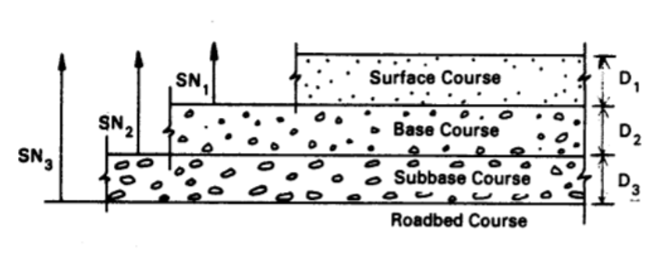
Source: AASHTO, 1993
Figure 1 Thickness of Each Course
Table 1 Minimum Thickness for Asphalt and Base Course Layer
Traffic, ESAL's | Asphalt Concrete | Aggregate Base
Less than 50,000 | 1.0 (or surface treatment) | 4
50,001-150,000 | 2.0 | 4
150,001-500,000 | 2.5 | 4
500,001-2,000,000 | 3.0 | 6
2,000,001- 7,000,000 | 3.5 | 6
Greater than 7,000,000 | 4.0 | 6

Table 2 AASHTO Pavement Thickness Computing Data
Input data for AASHTO pavement thickness calculation
R(Reliability) | 75%
S₀(over all standard deviation) | 0.45
P_{t} (terminal serviceability) | 2
P₀ (original or initial serviceability) | 4.2
ΔPSI (total change in serviceability) | 2.2
a1 | 0.43
a2 | 0.134
a3 | 0.12
m2 | 1.325
m3 | 1.325
SN (design structural number) | 2.8
Source: AASHTO, 1993
ΔPSI = P₀ ₋ P_{t} …….................................................................................equation 1
SN= a₁D + a₂D₂m₂ + a₃D₃m₃………………………………………….equation 2

Annex II Jones’ tables of stress in a three-layer system and Huang Deflection Equation (1969c)
Table 3 Stress Factor for Three Layer System
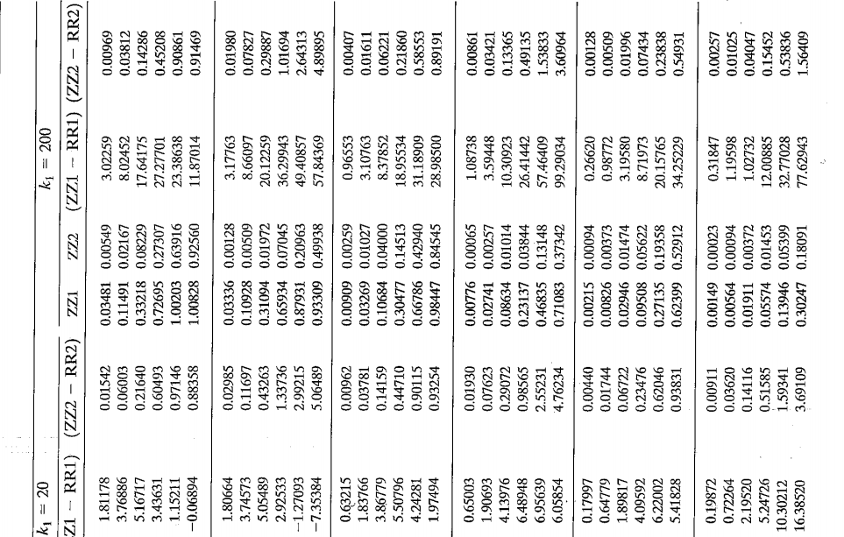
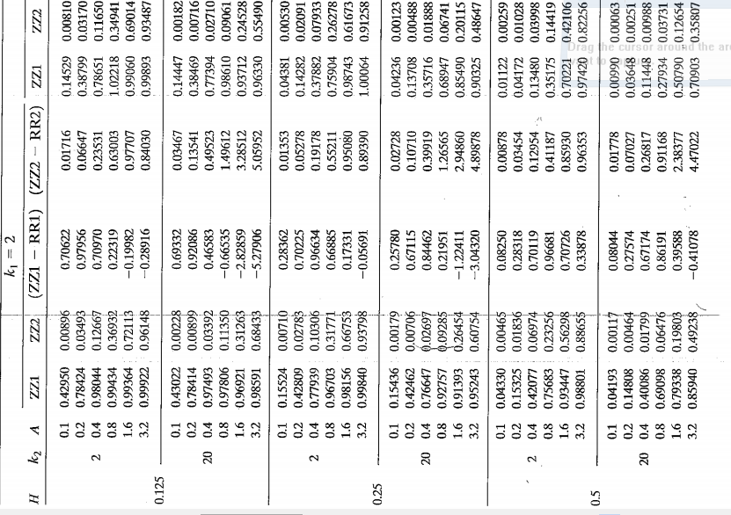

Table 4 Stress Factor for Three Layer System 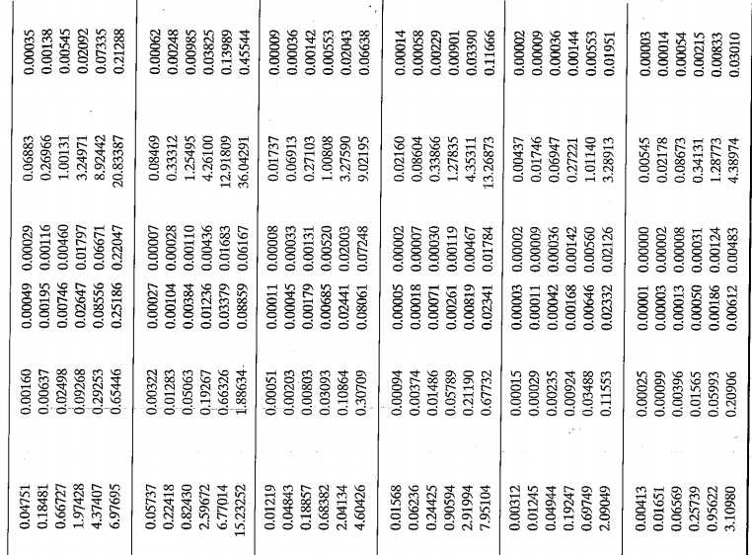
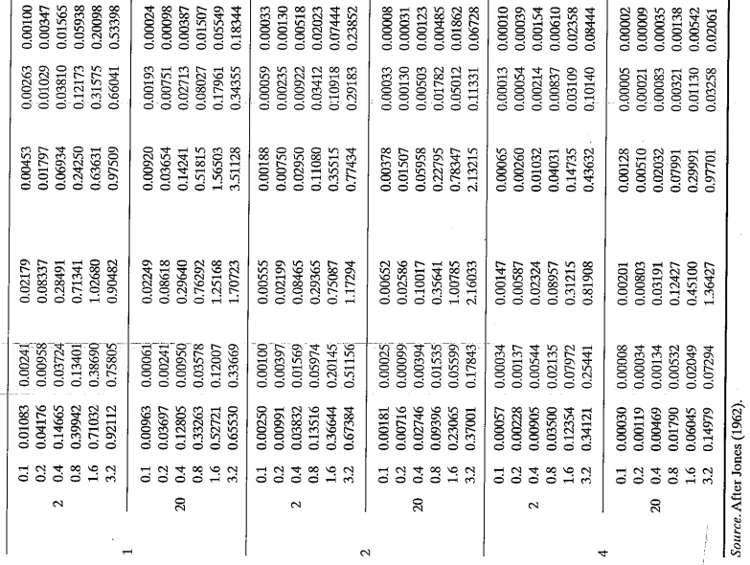

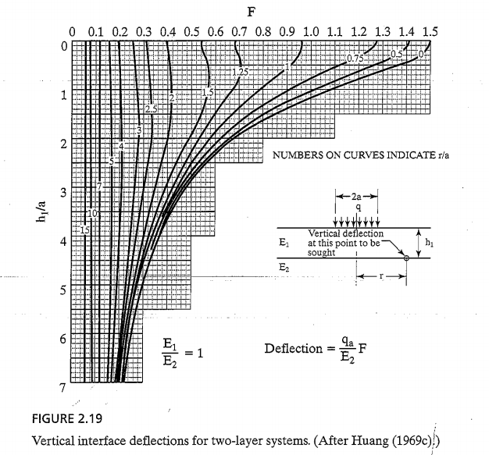
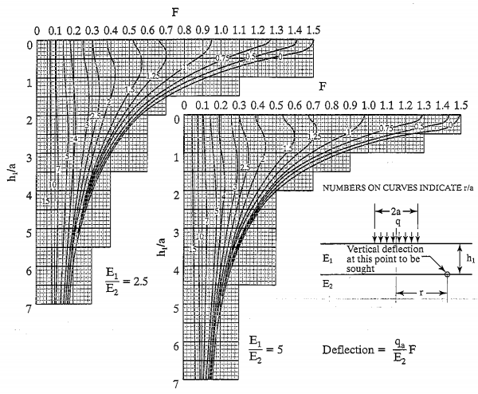
Figure 2 Vertical Interface Deflection for Interface between Two-Layers (Source: Huang, 1969)

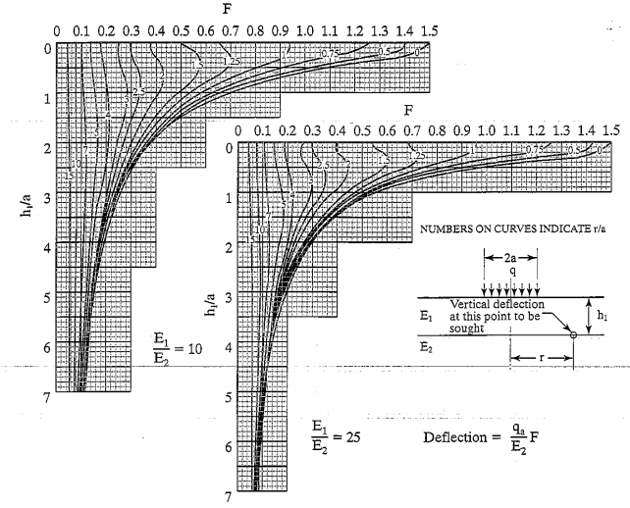

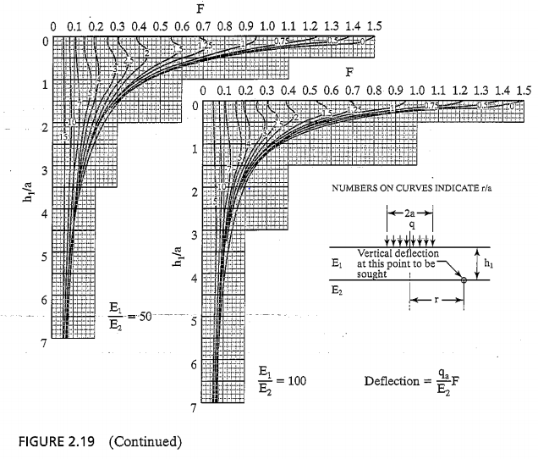 Figure 3 Vertical Interface Deflection for Interface between Two-Layers (Source: Huang, 1969)

Annex III Sample Output Everstress, Abaqus and Ken layer
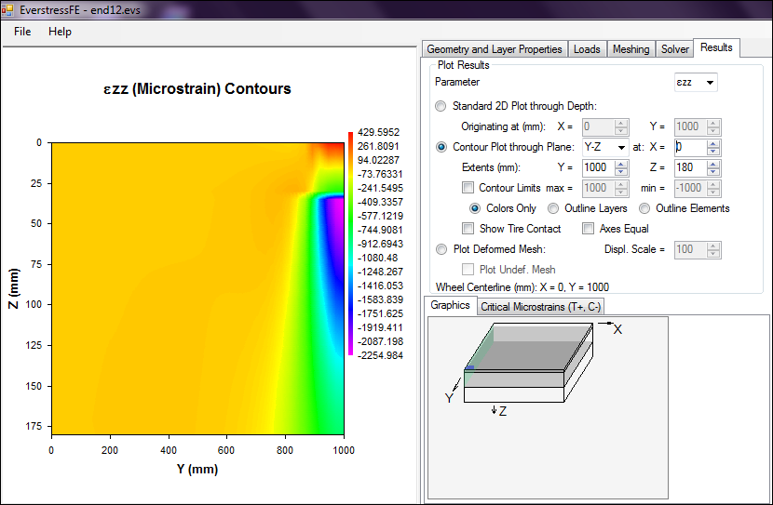
Figure 4 Compressive Strain (Sample EVERSTRESS Output)

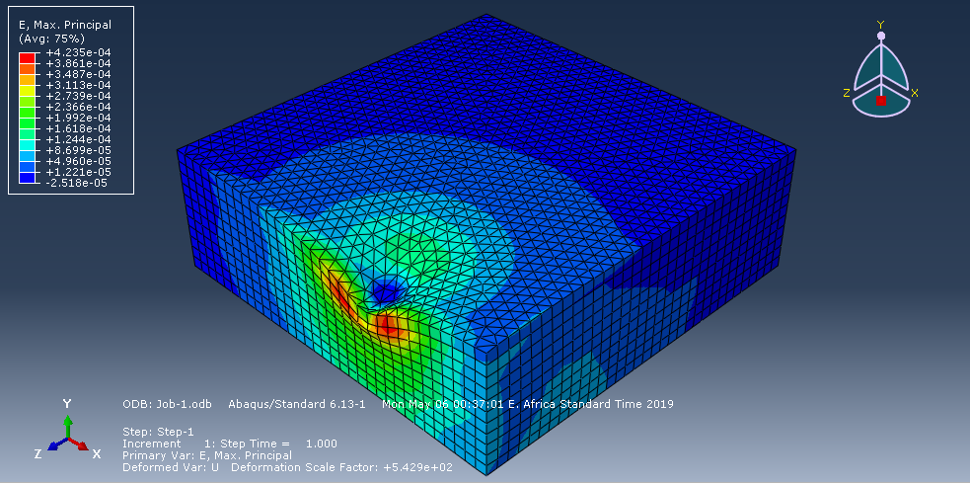
Figure 5 Tensile Strain (Sample ABAQUS output)
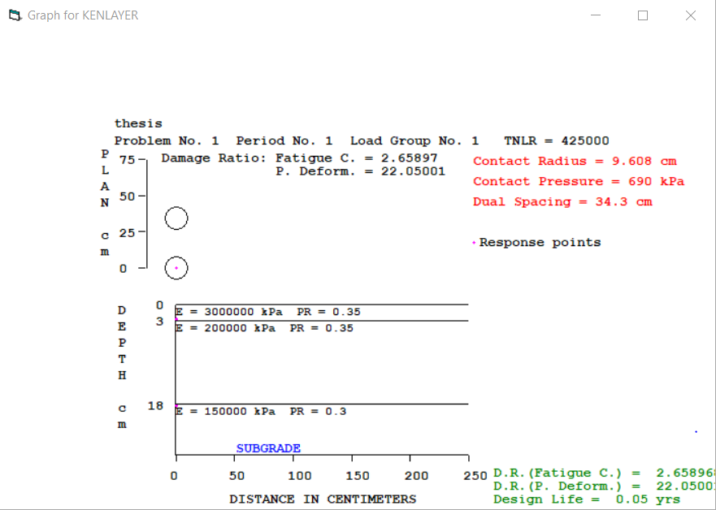
Figure 6 Linear Structural Model Type of Analysis Graphical Output (KENPAVE)

Combined (Non-Linear and Viscoelastic) Structural Model Type of Analysis Output
INPUT FILE NAME -E: \Combined Analysis
NUMBER OF PROBLEMS TO BE SOLVED = 1
TITLE –thesis
MATL = 4 FOR VISCOELASTIC AND NONLINEAR ELASTIC LAYERED SYSTEMS
NDAMA=2, SO DAMAGE ANALYSIS WITH DETAILED PRINTOUT WILL BE PERFORMED
NUMBER OF PERIODS PER YEAR (NPY) = 1
NUMBER OF LOAD GROUPS (NLG) = 1
TOLERANCE FOR INTEGRATION (DEL) -- = 0.001
NUMBER OF LAYERS (NL) ------------- = 3
NUMBER OF Z COORDINATES (NZ) ------ = 1
LIMIT OF INTEGRATION CYCLES (ICL) - = 80
COMPUTING CODE (NSTD) ------------- = 9
SYSTEM OF UNITS (NUNIT) ------------= 1
Length and displacement in cm, stress and modulus in kPa
unit weight in kN/m^3, and temperature in C
THICKNESSES OF LAYERS (TH) ARE: 3 15
POISSON'S RATIOS OF LAYERS (PR) ARE: 0.35 0.35 0.3
ALL INTERFACES ARE FULLY BONDED
FOR PERIOD NO. 1 LAYER NO. AND MODULUS ARE: 1 3.000E+06 2 2.000E+05
3 1.500E+05
LOAD GROUP NO. 1 HAS 2 CONTACT AREAS
CONTACT RADIUS (CR) --------------- = 9.608
CONTACT PRESSURE (CP) ------------- = 690
NO. OF POINTS AT WHICH RESULTS ARE DESIRED (NPT) -- = 1
WHEEL SPACING ALONG X-AXIS (XW) ------------------- = 120
WHEEL SPACING ALONG Y-AXIS (YW) ------------------- = 34.3
RESPONSE PT. NO. AND (XPT, YPT) ARE: 1 0.000 0.000
NUMBER OF NONLINEAR LAYERS (NOLAY) -------------------------- = 2
MAXIMUM NUMBER OF ITERATIONS FOR NONLINEAR ANALYSIS (ITENOL) = 15
LAYER NUMBER (LAYNO) AND SOIL TYPE (NCLAY) ARE: 2 0 3 0
Z COORDINATES (ZCNOL) FOR COMPUTING ELASTIC MODULUS ARE: 10.5 25.5
R COORDINATE (RCNOL) FOR COMPUTING ELASTIC MODULUS ---------- = 9.2
X COORDINATE (XPTNOL) FOR COMPUTING ELASTIC MODULUS --------- = 0
Y COORDINATE (YPTNOL) FOR COMPUTING ELASTIC MODULUS --------- = 16.5
SLOPE OF LOAD DISTRIBUTION (SLD) ---------------------------- = 0
TOLERANCE (DELNOL) FOR NONLINEAR ANALYSIS ------------------- = 0.01
RELAXATION FACTORS (RELAX) FOR NONLINEAR ANALYSIS OF EACH PERIOD ARE: 0.5
UNIT WEIGHT OF LAYERS (GAM) ARE: 24 23 21
LAYER NO. = 2 NCLAY = 0 K2 = 0.46 K0 = 0.5
LAYER NO. = 3 NCLAY = 0 K2 = 0.64 K0 = 0.5

LAYER NUMBER AND GEOSTATIC STRESS (GEOS) ARE:
2 2.44500 3 5.74500
FOR PERIOD 1 LAYER NO. = 2 NCLAY = 0 PHI = 50 K1 = 53400
FOR PERIOD 1 LAYER NO. = 3 NCLAY = 0 PHI = 50 K1 = 40000
FOR LOAD GROUP 1 LAYER NO. AND X COORDINATE FOR COMPUTING MODULUS ARE:
2 0 3 0
FOR LOAD GROUP 1 LAYER NO. AND Y COORDINATE FOR COMPUTING MODULUS ARE:
2 16.5 3 16.5
DURATION OF MOVING LOAD (DUR) = 0.1
NUMBER OF VISCOELASTIC LAYER (NVL) = 1
LAYER NUMBERS WHICH ARE VISCOELASTIC (LNV) = 1
CREEP TIMES (TYME) ARE: 0.001 0.003 0.01 0.03 0.1 0.3 1 3 10 30 100
FOR LAYER 1 TIME TEMPERATURE SHIFT FACTOR (BETA) = 0.20943
REFERENCE TEMPERATURE (TEMREF) = 26
CREEP COMPLIANCES (CREEP) AT REFERENCE TEMP. (TEMREF) OF 26 ARE:
2.776E-10 8.320E-10 2.765E-09 8.227E-09 2.664E-08 7.371E-08 1.449E-07
3.059E-07 3.333E-07 3.333E-07 3.333E-07
LAYER NO. 1 DIRICHLET SERIES AT REFERENCE TEMPERATURE (TEMREF) OF 26 ARE:
3.419E-08 -8.369E-08 8.321E-08 -3.159E-07 -9.305E-08 4.999E-08 3.279E-07
COMPUTED COMPLIANCES (CREEP) AT REFERENCE TEMP. (TEMREF) OF 26 ARE:
1.657E-09 2.849E-10 8.646E-11 1.109E-08 2.742E-08 5.724E-08 1.759E-07
2.885E-07 3.295E-07 3.417E-07 3.297E-07
FOR PERIOD NO. 1 LAYER NO. AND TEMPERATURE ARE: 1 26

CREEP COMPLIANCES (CREEP) OF LAYER 1 AT TEMPERATURE (TEMP) OF 26 ARE:
1.657E-09 2.849E-10 8.646E-11 1.109E-08 2.742E-08 5.724E-08 1.759E-07
2.885E-07 3.295E-07 3.417E-07 3.297E-07
NUMBER OF LAYERS FOR BOTTOM TENSION (NLBT) ---- = 1
NUMBER OF LAYERS FOR TOP COMPRESSION (NLTC) --- = 1
LAYER NO. FOR BOTTOM TENSION (LNBT) ARE: 1
LAYER NO. FOR TOP COMPRESSION (LNTC) ARE: 3
LOAD REPETITIONS (TNLR) IN PERIOD 1 FOR EACH LOAD GROUP ARE: 425000
DAMAGE COEF.'S (FT) FOR BOTTOM TENSION OF LAYER 1 ARE: 0.414 3.291 0.854
DAMAGE COEFICIENTS (FT) FOR TOP COMPRESSION OF LAYER 3 ARE: 1.365E-09 4.477
DAMAGE ANALYSIS OF PERIOD NO. 1 LOAD GROUP NO. 1
AT ITERATION 1 LAYER NO. AND MODULUS ARE: 2 2.000E+05 3 1.500E+05
AT ITERATION 2 LAYER NO. AND MODULUS ARE: 2 3.314E+05 3 3.731E+05
AT ITERATION 3 LAYER NO. AND MODULUS ARE: 2 4.289E+05 3 5.275E+05
AT ITERATION 4 LAYER NO. AND MODULUS ARE: 2 4.866E+05 3 6.196E+05
AT ITERATION 5 LAYER NO. AND MODULUS ARE: 2 5.192E+05 3 6.723E+05
AT ITERATION 6 LAYER NO. AND MODULUS ARE: 2 5.373E+05 3 7.020E+05
AT ITERATION 7 LAYER NO. AND MODULUS ARE: 2 5.473E+05 3 7.186E+05
AT ITERATION 8 LAYER NO. AND MODULUS ARE: 2 5.528E+05 3 7.278E+05
AT ITERATION 9 LAYER NO. AND MODULUS ARE: 2 5.558E+05 3 7.330E+05
LAYER NUMBER AND THREE NORMAL STRESSES INCLUDING GEOSTATIC STRESSES
2 98.055 20.521 46.210 3 73.135 1.755 12.290
LAYER NUMBER AND ADJUSTED THREE NORMAL STRESSES INCLUDING GEOSTATIC
STRESSES FOR COMPUTING ELASTIC MODULUS ARE:
2 98.055 20.521 46.210 3 73.135 9.688 12.290
POINT VERTICAL VERTICAL VERTICAL MAJOR MINOR INTERMEDIATE
DISPL. PRINCIPAL PRINCIPAL PRINCIPAL
NO. COORDINATE (HORIZONTAL STRESS STRESS STRESS STRESS
P. STRAIN) (STRAIN) (STRAIN) (STRAIN) (STRAIN)
1 3.00000 0.00850 179.575 179.579 -21691.540 -18761.990
(STRAIN) -4.107E-05 4.166E-05 4.166E-05 -4.107E-05 -1.402E-04
1 18.00010 0.00563 88.475 89.858 2.380 9.721
(STRAIN) -3.751E-05 1.152E-04 1.176E-04 -3.751E-05 -7.240E-05
AT BOTTOM OF LAYER 1 TENSILE STRAIN = -4.107E-05
ALLOWABLE LOAD REPETITIONS = 7.043E+06 DAMAGE RATIO = 6.034E-02
AT TOP OF LAYER 3 COMPRESSIVE STRAIN = 1.152E-04
ALLOWABLE LOAD REPETITIONS = 5.865E+08 DAMAGE RATIO = 7.247E-04
******************************
* SUMMARY OF DAMAGE ANALYSIS *
******************************
AT BOTTOM OF LAYER 1 SUM OF DAMAGE RATIO = 6.034E-02
AT TOP OF LAYER 3 SUM OF DAMAGE RATIO = 7.247E-04
MAXIMUM DAMAGE RATO = 6.034E-02 DESIGN LIFE IN YEARS = 16.57

