

PERFORMANCE EVALUATION OF GEMESHA AND UFUTE SURFACE IRRIGATION SCHEMES
IN KACHABIRA WOREDA SNNPRS - ETHIOPIA

M.Sc. THESIS

MUHAMMEDZIYAD GELETO ANOTA

June, 2018
Hawassa, Ethiopia

HAWASSA UNIVERSITY
SCHOOL OF BIOSYSTEM AND ENVIRONMENTAL ENGINEERING
INSTITUTE OF TECHNOLOGY

PERFORMANCE EVALUATION OF GEMESHA AND UFUTE SURFACE IRRIGATION SCHEMES
IN KACHABIRA WOREDA SNNPRS – ETHIOPIA

A Thesis Submitted to the school of Biosystems and Environmental Engineering
Institute of Technology
Hawassa University
In Partial Fulfillment of the Requirements for the Degree of Master of Science in Water Resource Engineering and Management

BY:-MUHAMMEDZIYAD GELETO ANOTA

Major Advisor: Kannan N. (PhD)

Co-Advisor:Mihret .D (PhD)

Hawassa, Ethiopia

Approval sheet-I

This is to Certify that the thesis entitled “Performance Evaluation of Gemesha and Ufute Surface Irrigation Schemes In Kachabira Woreda SNNPRS-Ethiopia”Submitted in partial fulfillment of the requirements for the degree of Master of Science inBio-systems and Environmental Engineering with Specialization in Water resource Engineering and Management,is a record of original research carried out by Muhammedziyad Geleto under my supervision,and no part of the thesis has been submitted for any other degree. The assistance and help received during the course of this investigation have been duly acknowledged. Therefore, I recommend that it be accepted as fulfilling the thesis requirement.

- Major Advisor
Kannan N. (PhD) Signature __________Date ____________
- Co-Advisor
Mihret D. (PhD) Signature ___________Date ____________

Approval sheet-II

Department of Graduate Committee
HAWASSA UNIVERSITY
We, the undersigned, members of the Board Examiners of the Final MSc Open Defense by Muhammedziyad Geleto have read and evaluated his thesis entitled “Performance Evaluation of Selected Surface Irrigation Schemes In Kachabira Woreda SNNPRS-Ethiopia” and Examined the candidate. This is therefore to certify that the thesis has been accepted in partial fulfillment of the requirements for the degree of Master of Science in Bio-systems and Environmental Engineering with Specialization in Water resource Engineering and Management,

1. Chairman
Signature __________Date ____________
2. Major Advisor
Kannan N. (PhD) Signature __________Date ____________
2. Co-Advisor
Mihret Dananto (PhD)Signature ___________Date ____________
3. Internal Examiner
Signature ____________Date ____________
4. External Examiner
Signature ____________Date ____________
Final approval and acceptance of the thesis is contingent upon the submission of the final copy of the thesis to the CGS through the DGC of the candidate's department.

Dedication

“This work is dedicated to my family, friends and who loved me.Special dedication goes to my lovely mother Hansa Geleto, My wife Rukiya Aliyi and Sofia Geleto.

Statement of the Author

First, I declare that this thesis is my work and that all sources of materials used for this thesis have been duly acknowledged. This thesis has been submitted in partial fulfillment of therequirements for MSc degree at Hawassa University and is deposited at the University Library tobe made available to borrowers under rules of the library. I solemnly declare that this thesis is notsubmitted to any other institution anywhere for the award of any academic Degree, Diploma, orCertificate.
Brief quotations from this thesis are allowable without special permission provided that accurateacknowledgement of the source is made. Requests for permission for extended quotation from reproduction of this manuscript in whole or in part may be granted by the head of the majordepartment or the Dean of the School of Graduate Studies when in his or her judgment the proposeduse of the material is in the interests of scholarship. In all other instances, however, permissionmust be obtained from the author.

Name: Muhammedziyad Geleto

Signature: _______________

Place: Hawassa University, Ethiopia

Date of Submission: June, 2018
.

Biographical Sketch

The author was born in May 1990 in West Arsi Zone, Shashamene Town Kuyera sub-city, Oromia Region, Ethiopia. He attended his elementary class at Hagugata and Ilala junior School (Kuyera), Senior Secondary School at Kuyera Town and Preparatory at Shashamene Preparatory School at Shashamene Town.

After completion of his high school education in 2007, he joinedHawassa University, Institute of Technology and graduated with a BSc degree in Agricultural Engineering and Mechanization in 2011. After completing his first degree, he was employed by the Oromia Water Works Construction Enterprise as Junior Construction Engineer and served for one year, and then after He joined Upper Awash Agro-Industry as Site Engineer for supervision of road construction and Buildingfinally he joined South Design Constructionand Supervision Enterprise asSenior Irrigation Engineer in 2013. He joined the School of Graduate Studies of Hawassa University in September 2013 to pursue his post graduate Studies in Water Resource Engineering and Management.

Acknowledgements

First of all I would like to thank the Almighty God for giving me the aptitude, endurance, determination and guidance throughout the ups and downs of life.

I express my sincere thanks to my thesis Supervisors Dr.Kannan N. and Dr.Mihret D. for their constant encouragements and valuable academic guidance throughout the research process. Their unlimited and sweet advice that smoothen my educational journey

I extend my deepest gratitude to the staffs of Kachabira Irrigation Offices and Kachabira Woreda Agricultural Offices.

I would like to thank to my parents all the efforts and trust that always had on me .Specially my lovely mother Hansa Geleto; she kept me motivated with her positive energy and prayers. The understanding, support and encouragement received from my wife Rukiya Aliyi, my sons, Muharuk and Ehan was a driving force throughout my study time.

I once again thank my Sister Sofia Geleto who lives in Australia for her encouragement and generous support from beginning to the end in pursuing my research work. Her financial support during this period was valuable.

.

Abbreviations

ADLI Agricultural Development Led Industrialization
Ai Area Covered by Irrigated crop
AIDUIA Annual irrigation water delivery per unit irrigated cropped area
ARIS Annual relative irrigation supplies
ARWS Annual relative water supply
AWC Available water capacity
AR Advance Ratio
Bd Bulk Density
CBIWM Community based Irrigation Water Management
Co-SAERAR Commission for Sustainable Agriculture and Environmental Rehabilitation ofAmhara Region
CROPWAT 8 Crop Water Requirement Estimation Model Window 8
CWR Crop Water Requirement
DAs Developmental Agents
Dsr Water Stored in the Root Zone
DPR Deep Percolation Ratio
DP Depth of Water Percolated Beyond Root Zone
DU Distribution uniformity
Ea Application Efficiency
Ec Conveyance Efficiency
Ed Irrigation Uniformity
Ef Efficiency of Field Canal
Em Conveyance Efficiency of Main Canal
Ep Overall Scheme Efficiency
Er Storage Efficiency
Es Efficiency of Secondary Canal
ETa Actual Crop Evapotranspiration Rate
Et Efficiency of Tertiary Canal
ET Evapotranspiration
ETc Crop Evapotranspiration
ETo Reference Evapotranspiration
ETp Potential Evapotranspiration
FAO Food and Agriculture Organization of United Nation
FC Field Capacity
GDP Gross Domestic Product
GPS Global positioning system
ha Hectare
hr Hour
H1, H2 and H3 Fields Selected from Head Water Users
IFAD International Fund for Agricultural Development
IWMIInternational Water Management Institute
IR Irrigation Requirement
IWR Irrigation Water Requirement
Kc Crop Coefficient
LSI Large Scale Irrigation
M.C Moisture content
MoAFS Ministry of Agriculture and Food Security
MoWR Ministry of Water Resource
MAD Moisture Allowable Deficit
MSI Medium Scale Irrigation
M1, M2 and M3 Fields Selected from Middle Water Users
NGOs Non-Governmental Organizations
OPUCA Output per unit command area
OPUIA Output per unit irrigated cropped area
OPUIS Output per unit irrigation water supply
OPUWC Output per unit water consumed
Pb Price of Base Crop at Local Market
Pi Price of Irrigated Crop at Local Market
Pworld Price of Base Crop at World Market
PWP Permanent Wilting Point
Q Water Discharge in Canal
RIS Relative Irrigation Supply
RR Runoff Ratio
RWS Relative Water Supply
RWH Rain Water Harvesting
Rz Depth of root zone of crop
SGVP Sum of Gross Value Product
SNNPR South Nation Nationality and People’s Region
Sp.G Apparent specific gravity
SSA Sub-Saharan Africa
SSI Small Scale Irrigation
T1, T2 and T3 Fields Selected from Tail End Water Users
TAW Total Available Water
TWS Total Water Supply
UK United Kingdom
U.S United States
US$ United States Dollar
Wd Weight of Dry Soil
Wf Depth of Water applied to the Field
Wn Water Desired to be Stored at the Root Zone
WP Wilting point
WUA Water User’s Association
Wθ Gravimetric Moisture Content
Ws Depth of Water Diverted from the Source
Ww Weight of Wet Soil
Yi Yield of Irrigated Crop
Zr Root Zone

ContentsPage
Approval sheet-I iii
Approval sheet-II iv
Dedication v
Statement of the Author vi
Biographical Sketch vii
Acknowledgements viii
Acronyms and Abbreviations ix
List of Tables in the Appendices xvi
List of Figures xvii
List of Figures in the Appendices xviii
ABSTRACT xix
1. INTRODUCTION 1
1.1. Background 1
1.2 Statement of the Problem 3
1.3 Research Objectives 4
1.3.1 General Objective 4
1.3.2 Specific Objectives 4
1.4 Structure of the Thesis 5
2. LITERATURE REVIEW 6
2.1 Definition of Irrigation 6
2.2 Overview of Irrigation Development in Ethiopia 6
2.3 Current Status of Small-Scale Irrigation Schemes in Ethiopia 7
2.4 Irrigation Water Control and Management in Ethiopia 8
2.4.1 Irrigation management 8
2.4.2 Water users association 9
2.4.3 Community based water management 10
2.5 Performance Evaluation of Irrigation Practices 10
2.5.1 Importance of performance evaluation 10
2.5.2 Purpose of irrigation performance evaluation 11
2.5.3 Irrigation Performance Indicators 12
2.5.4 Internal performance indicators 14
2.6 External performance indicators 17
3. RESEARCH METHODOLOGY 19
3.1 General Description of the Study Area 19
3.2 Description of the Schemes 20
3.2.1 Gemesha Irrigation Project 20
3.2.2 Ufute Irrigation Project 22
3.3 Methodologies used 24
3.3.1 Data collection methodologies 24
3.3.2 The Materials Used 24
3.3.3 Primary data collection 24
3.3.4 Determination of the amount of water applied to the fields 25
3.4 Secondary data collection 26
3.7.1 Crop Production data collection 26
3.7.2 Laboratory analyses 26
3.7.3 Infiltration characterization 27
3.7.4 Gravimetric sampling for moisture content determination 27
3.5 Data analysis techniques 28
3.5.1 Crop water requirements and irrigation scheduling 28
3.5.2 Performance Evaluation Methodology 28
3.5.3 Internal performance Indicators 29
3.5.4 Farmer’s field evaluation in each scheme 31
3.5.5 External performance indicators 31
3.5.6 Agricultural output indicators 32
3.8.8 Water use performance indicators 34
3.8.9 Physical performance indicators 35
3.8.10 Economic performance indicators 36
4. RESULTS AND DISCUSSION 37
4.1. Soil Physical Properties 39
4.1.1 Bulk density 39
4.1.2 Field Capacity (FC) 39
4.1.3 Permanent wilting point (PWP) 40
4.1.4 Available water holding capacity 40
4.1.5 Soil Infiltration Rate 43
4.1.6 Irrigation Water Requirements of Major Crops in the Study Area 43
4.2 Internal Process Indicators 46
4.2.1 Conveyance efficiency 46
4.2.2 Application efficiency 47
4.2.3 Deep percolation ratio 48
4.2.4 Storage efficiency 48
4.2.5 Irrigation uniformity 49
4.2.6 Overall Scheme Efficiency 50
4.3 External Performance Indicators 51
4.3.1 Irrigated agriculture performance indicators 51
4.3.2 Water use performance indicators 54
4.3.3 Physical performance indicators 55
4.3.4 Economic performance indicators 56
5. CONCLUSION AND RECOMMENDATION 58
5.1 CONCLUSION 58
5.2 RECOMMENDATIONS 59
REFERENCE 60
APPENDICES 68
Appendix I. Table 68
Appendix II. Figures 81

List of Tables
Table 3.1 Apparent specific gravity of different soil Error! Bookmark not defined.
Table 4.1. Selected soil physical characteristics of Gemesha irrigation schemes 41
Table 4.2. Selected soil physical characteristics of Ufute irrigation schemes 42
Table 4.3 the crop water requirement and irrigation requirement of maize crop 43
Table 4.4 Results of CWR and IR of Gemesha irrigation schemes 44
Table 4.5 Results of CWR and IR of Ufute irrigation schemes 44
Table 4.6 Average irrigation efficiencies at Gemesha and Ufute irrigation projects 50
Table 4.7 Crop type and yield for Gemesha irrigation schemes 51
Table 4.8 Crop type and yield for Ufute irrigation schemes 51
Table 4.9 Agricultural indicator for Gemesha irrigation and Ufute irrigation schemes. 52
Table 4.10 Water supply indicators for Gemesha and Ufute irrigation schemes 54
Table 4.11 Irrigable lands, initial irrigated land and current irrigated land 55

List of Tables in the Appendices
Appendix Table Page
Appendix Table 1. Average 20 years (1995-2015) climatic data at Durame Metrological Station and Eto 68
Appendix Table 2. Soil Infiltration rate data by double ring infiltrometer in Gemesha irrigation scheme 69
Appendix Table 3. Soil Infiltration rate data by double ring infiltrometer in Ufute irrigation scheme 70
Appendix Table 4. Soil moisture contents one day before and after irrigation of Gemesha irrigation scheme 71
Appendix Table 5. Soil moisture contents one day before and after irrigation of Ufute irrigation scheme 72
Appendix Table 6.CROPWAT 8 output for Maize water requirement 73
Appendix Table 7.CROPWAT 7 output for Potato water requirement 73
Appendix Table 8.CROPWAT 8 output for Banana Water requirement 74
Appendix Table 9.CROPWAT 8 output for Tomato Water requirement 75
Appendix Table 10.CROPWAT 8 output for Cabbage Water requirement 75
Appendix Table 11. Canal discharges at different points and conveyance efficiency of Gemesha scheme 76
Appendix Table 12. Canal discharges at different points and conveyance efficiency of Ufute scheme 77
Appendix Table 13. Measured water depths applied to field, field application efficiency, and Deep percolation ratio and storage efficiency of Ufute irrigation scheme 78
Appendix Table 14. Measured water depths applied to field, field application efficiency, and Deep percolation ratio and storage efficiency of Gemesha irrigation scheme 78
Appendix Table 15. Advance time, recession time and irrigation uniformity of Gemesha irrigation scheme 79
Appendix Table 16. Advance time, recession time and irrigation uniformity of Ufute irrigation scheme 79
Appendix Table 17. Crop production, productivity, production costs and prices of crop at Gemesha irrigation scheme (2016 production season) 79
Appendix Table 18. Crop production, productivity, production costs and prices of crop at Ufute irrigation scheme (2016 production season) 80
Appendix Table 19. Investment, Operation and Maintenance costs of Gemesha irrigation project 80
Appendix Table 20. Investment, operation and maintenance costs of Ufute irrigation project 80

List of Figures
Figure 1.1: Structure of the Thesis 5
Fig.3.1 Location Map of Study area. 19
Figure 3.2. Seasonal distribution of rainfall at Durame Meteorological station 20
Figure 3.3 Gemesha irrigation scheme head work 21
Figure 3.4 Primary canal of Gemesha Irrigation Scheme 22
Figure 3.5 Ufute irrigation scheme head work 23
Figure 3.6 Lined Canal (Left) and Earthen Main canal (Right) of Ufute project 23
Figure 3.8 Focus group Discussion on the site Error! Bookmark not defined.
Figure 3.9 Double ring inflator-meter 27
Figure 4.1 Siltation problems of the secondary canal at Gemesha 38
Figure 4.2 Average Conveyance Efficiency of Gemesha and Ufute 47
Figure 4.3 Average Application Efficiency of Gemesha and Ufute 48
Figure 4.4 Average Irrigation Uniformity of Gemesha and Ufute 50

List of Figures in the Appendices
Appendix Figure 1. Taking undisturbed soil sample to measure some soil parameter 81
Appendix Figure 2. Physical soil characteristic description on site using Mounsul soil chart 81
Appendix Figure 3. Main canal of Ufute irrigation scheme 82
Appendix Figure 4. Poorly managed Main canal at Gemesha irrigation scheme 82
Appendix Figure 5. Unauthorized diversion from the secondary canal at Ufute Irrigation Scheme 83
Appendix Figure 6. Nursery site for Ufute irrigation scheme 83
Appendix Figure 7. Plantation of White onion during site visit at Gemesha irrigation scheme 84
Appendix Figure 8. Non-Functional secondary canal at Gemesha due to shortage of water 84
Appendix Figure 9. Poorly managed division-Box for Gemesha Irrigation scheme 85
Appendix Figure 10. Maize crop fields 85
Appendix Figure 11. Furrow lay out for Gemesha and Ufute irrigation schemes 86

ABSTRACT

This study was conducted to evaluate the comparative performances of two community-managed smallscale irrigation schemes at Kachabira Wereda SNNPRS-Ethiopia namely Gemesha with command area of 48 ha and Ufute with 40ha command areausinginternal and external performance indicators. Collecting primary and secondary data of each irrigation schemes has been carried out. Primary data collection included canal water flow measurement at diversion point, Soil moisture contents determination before and after irrigation, measurement of depth of water applied to the fields. The secondary data includes crop types, total yields, area irrigated per crop per season, incomes generated by the irrigation associations, investment costs and cost of production. In order to evaluate the irrigation water use efficiency of farmers at field level, nine farmer fields were selected from each irrigation schemes in relation to their location (from the head, middle and tail end water users).

From the analyses of the internal performance indicators, the conveyance efficiencies were61.15 and 65.63% ,application efficiencies were 58.75 and 71.7% Deep percolation ratios were 41.25 and 28.3%, Storage efficiencies were 98.65% and 98.4% and Irrigation uniformity were found to be 98.32 and 97.79% for Gemesha and Ufuterespectively. The results for physical sustainability indicator for irrigation ratio were 0.32 and 0.4 for Gemesha and Ufute irrigation respectively. Theoutputs per unit irrigation (OPUIA) were found as46, 868.75 and 46,145(Br/ha), Outputs per unit command area (OPUCA) were7,499 and 9,229(Br/ha), Output per unit irrigation water supply (OPUIS) were found as 4.39 and 3.80(Br/m³) and Output per unit water consumed (OPUWC) were found as 10.64(Br/m³) and 9.88(Br/m³)for Gemesha and Ufute irrigation schemesrespectively. From the analyses of the comparative performance indicators, the result of the ratios of RWS and RIS were 2.52 and 3.97 for Gemesha while 3.90 and 4.13 for Ufute irrigation projects, respectively. The result of Relative Irrigation Supply (RIS) for both irrigation schemes was higher than one this shows that there were over supply of water in both irrigation schemes for Gemesha and Ufute irrigation scheme respectively. In general, based on the assessment carried out, Ufute irrigation scheme performed better than Gemesha irrigation scheme. But there is still a room for improvement of the performance of both irrigation schemes.

Keywords: External Indicators, Internal Indicators, Gemesha, Ufute, Kachabira, SNNPRS

1. INTRODUCTION

Background

Irrigation is of major importance in many countries in terms of agricultural production and food supply. To meet the demand of the ever-increasing population in Ethiopia (presently ~ 100 million), in the country water development for agriculture is a priority, but poorly designed and planned irrigation undermines efforts to improve livelihoods and exposes people and environment to risks. Recent estimates indicate that the total irrigable area in Ethiopia is 197,225 ha around 3 % of the irrigation potential (MOWR). Moreover, much of the increase in irrigated area had come as a result of expansion of small-scale irrigation. Yet, the existing irrigation development in Ethiopia, as compared to the resource the country has, is negligible. Despite their promise as engines of agricultural growth, irrigation projects have typically performed far below their potential (Small and Svendsen, 1990; 1992).According to International Fund for Agricultural Development (IFAD, 2014) and (Hess, 2010) only 20% of the world’s total croplands are irrigated. However, these lands contribute to some 40% of the global agricultural harvest. The figure indicates that irrigated agriculture on average is roughly more than two and half times as productive as rain fed agriculture. Agriculture depending on rainfall has failed to produce enough food, and with increasing rainfall variability, productivity of rain fed agriculture is expected to diminish.

To meet increasing demand for food by 2050 the global agricultural production would need to increase by 60% of the production in 2005 (FAO, 2012). As such without significant investments in irrigation, agricultural production is unlikely to cope with ever increasing demand for food. It was identified that globally 60% of the diverted fresh water for agriculture does not contribute directly to food production. This amount of water is discharged because of poor water control, inefficient irrigation systems with leaky conveyance and distribution, poor on-farm water management practices, etc. (WAF, 2009). It depicts that only about 40% of global fresh water abstracted for irrigation is being effectively used for consumptive use in agriculture (WAF, 2009). Part of the amount of the discharged water of these systems is lost to saline groundwater or to poor quality drainage water. However, in some cases, discharged irrigation water can be recovered in the downstream reaches.

Agriculture is regarded as the backbone of Ethiopian economy and a key driver of its long-term growth and food security. Agriculture directly supports 85 percent of the population constitutes 43 percent of Gross domestic product (GDP), and 80 percent of export value (Seleshi et al., 2010). Improving this sector ensures food security, improves livelihoods and alleviates poverty of the rural community in the country. However, this sector has always remained dominated by small-scale resource-poor farmers whose production and productivity are very low (Seleshi et al., 2010). The production systems are traditional and subsistence in nature. It has been always cited that the causes of the inefficiency of agriculture in the country is aggravated by high rate of population growth and unfavorable natural and socio- economic condition (Seleshi et al., 2010).

Despite its importance for the national economy, agriculture is largely based on subsistence farming. The productivity of the agricultural sector is very low and lags behind the population growth rate resulting in food insecurity. To address this problem, the Ethiopian Government designed an Agricultural Development Led Industrialization (ADLI) Policy which aims at using agriculture as the base for the country's overall development (MoWR, 2001). This strategy aims at enhancing the productivity of small scale farmers and improving food security both in the rural and urban areas. One of the strategies within this Policy is stimulating and/or supporting the development of small scale irrigation.

Ethiopia has an estimated irrigation potential of 3.7 million hectares (ha) of land (Awulachew et al., 2007). During 2006, the total estimated area of irrigated agriculture in the country was625,819 ha, which, in total, constitutes about 17% of the potential (MoWR, 2006). Despite its enormous potential to boost the country’s economy irrigated agriculture is facing a number of problems. One of the major concerns is the generally poor efficiency with which water resources have been used for irrigation. A relatively safe estimate is that 40 percent or more of the water diverted for irrigation is wasted at the farm level through either deep percolation or surface runoff (FAO, 1989).

This research deals with two community managed small-scale irrigation schemes namely Gemesha and Ufute Specifically located in Kachabira Woreda, Kembata zone in SNNPRS(Ethiopia).The key stakeholders of these schemes are smallholder farmers. The schemes are community managed, because farmers are responsible for management of irrigation water and maintenance of their infrastructure through their water users association (WUA).

Statement of the Problem

Almost all the irrigation schemes initiated in the past in Ethiopia have been functioning below anticipated targets (Habtamu, 1990). In spite of the considerable investment in irrigation development of both government and NGOs constructed and community managed irrigation schemes, the overall performance has remained far below expectations (Sharma, 1998). Hundreds of reservoirs have been constructed but are not yet effectively used for irrigation (FAO, 1995).Co-SAERAR (1999) stated that irrigation development in the country did not perform poorly because of lack of technology or technical deficiencies, but rather because of faulty assumptions and practices related to the operation and maintenance and overall management of the system.

Given the complex set of constraints facing smallholder producers, providing access to irrigation water by itself is not enough; smallholders also require a broad range of support services (access to inputs, credit, output markets), knowledge of farming and secure land tenure (Kamara and McCornick, 2002). According to Tafa (2002) analysis of existing situation indicates that if irrigation is to play a crucial role as engine for further expansion of agricultural production, the management and organization of irrigation systems, including their institutional implications, must be substantially improved.

The question – how is irrigated agriculture performing with limited resources? – has not been satisfactorily answered in our study area. We have not been able to compare irrigated land, water use, financial investments and crop production to learn how irrigation systems are performing relative to each other and what the appropriate targets for achievement are. Moreover, the results of individual improvement efforts have often not been satisfactorily measured and documented.

The study has the potential benefit of improving irrigation efficiency and reducing stress on water resources and losses of water and nutrients to groundwater and surface water resources. Furthermore, findings from the study would serve as a guide in the implementation of future surface irrigation systems for irrigating larger areas with a given volume of water. This study would also contribute to knowledge in the field of irrigation practice in Ethiopia at large.

Research Objectives

General Objective
The general objective of this study is to assess and evaluate local water management practices of Gemesha and Ufute small scale irrigation schemes with the view to improve irrigation water management and irrigation performance.

Specific Objectives

The specific Objectives of the study are:
- To compare Gemesha and Ufute irrigated schemes using comparative performance indicators;
- To evaluate the performance of Gemesha and Ufute irrigation schemes using internalprocess indicators
- To evaluate the performance of Gemesha and Ufute irrigation schemes usingexternal process indicators

Structure of the Thesis
This dissertation consists of five chapters following the Introduction chapter namely: Literature Review, Research Methodology, Analysis and Discussion of Results, and Conclusions and Recommendations.
Explains the background to the research field as well as the statement of the problem and the objectives of the study. It discusses significance of the study and gives brief explanation of the methodology to be used to arrive at the objectives of the study.
Chapter One:
Introduction

Defines irrigation performance and indicator concepts; it reviews literature on nature of irrigation, irrigation performance assessment framework and performance indicators for irrigation sector. It develops a generic set of performance indicators
Chapter Two:
Literature
Review

Discusses in detail the various methods used in conducting the study. It explains the procedures and instruments for collecting data, and analyzing the collected data.
Chapter Three:
Research
Methodology

Chapter Four:
Analysis and Discussion of
Results
Describes the response rate, gives data summary and analysis methods are described in detail. It presents results and discusses various research findings.

Chapter Five:
Conclusions and
Recommendations
Gives various conclusions obtained from the results, findings and discussions of the previous chapters. Based on the results and conclusions, the chapter will present recommendations.

Figure 1.1: Structure of the Thesis

LITERATURE REVIEW

Definition of Irrigation

Irrigation is the science of artificial application of water to the land, in accordance with the crop requirements throughout the crop period for full nourishment of the crops. It is the Engineering of controlling and harnessing the various natural sources of water, by construction of dams & reservoirs, canals & head works and finally distributing the water to agricultural fields. Water is normally supplied to the plants by nature through the rains. However, the total rainfall in a particular area may be either insufficient, or ill-timed. In order to get the maximum yield it is essential to supply the optimum quantity of water and to maintain correct timing of water. This is possible only through systematic irrigation system by collecting water during the periods of excess rainfall and releasing it to the crops as when it is needed. Generally the following are some of the factors that necessitate irrigation: Inadequate rainfall, uneven distribution of rainfall, increasing the yield of the crops, growing a number of crops, insuring against drought and growing perennial crops (Malvern, 2001).

Overview of Irrigation Development in Ethiopia

It is believed that Ethiopia has a total volume of 123 billion cubic meters of surface water and about 2.6 billion cubic meters of groundwater. The distribution is not, however, uniform. The western half of the country receives sustainable amounts of precipitation and has many perennial rivers and streams while the precipitation is marginal in the eastern half of the country.
The Ethiopian plateau is the source of the Abay, Awash, Tekeze, Mereb, Baro- Akobo and Omo rivers that flow to the west and southwest. The Baro-Akobo basin is potentially the largest possible irrigable area (about483 thousand hectares) though only a negligible portion of it has been developed probably because of the large investment cost required and its distance from the central market, which makes it less favorable for commercial agriculture. Awash River is the only river extensively used for commercial plantations of industrial and horticultural. Out of the total irrigated area of about 161,125 ha, over 43% is found in the Awash River basin. The remaining potential of the Awash River for irrigated agriculture is in the order of 136,220 ha (McCornick et al, 2003).

Irrigation is practiced in Ethiopia since ancient times producing subsistence food crops.
However, modern irrigation systems were started in the 1960s with the objective of producing industrial crops in Awash Valley. Private concessionaires who operated farms for growing commercial crops such as cotton, sugarcane and horticultural crops started the first formal irrigation schemes in the late 1950s in the upper and lower Awash Valley. In the 1960s, irrigated agriculture was expanded in all parts of the Awash Valley and in the Lower Rift Valley (Seleshi et al., 2007).
Modern small-scale irrigation (SSI) development and management started in the 1970s initiated by the Ministry of Agriculture (MoA) in response to major droughts, which caused wide spread crop failures and food insecurity (Teshome, 2006).
From 1974 to 1991, no large scale private capital investment was committed as a result of the prohibition of private land ownership or rental of land on commercial scale by the land reform proclamation of 1975 as per the then socialist policy adopted by the Government. During this period public capital expenditure were concentrated on the development of state farms and producer cooperatives which contributed for less than 10 percent of the total production during that period (Fekadu et al., 2000).

Current Status of Small-Scale Irrigation Schemes in Ethiopia

According to Seleshi et al. (2010) the current estimates of irrigation schemes of the country cover about 640,000 ha. However, there is some uncertainty about the exact number and location of some schemes, particularly small-scale irrigation and rainwater harvesting (RWH). These irrigation schemes vary widely in size and structure, from micro irrigation (RWH), to river diversion, pumping, and small or large dams, etc. These schemes can be subdivided into:

- Small scale-irrigation (SSI), which are often community-based and traditional methods, covering less than 200 hectares.
- Medium-scale irrigation (MSI), which is community based or publicly sponsored, Covering 200 to 3,000 hectares.
- Large-scale irrigation (LSI) covering more than 3,000 hectares, which is typically commercially or publicly sponsored.

- Development of SSI schemes is the responsibility of the MoARD and regions, while
MSI and LSI are the responsibility of the MoWR. Seleshi et al. (2010) pointed out thatit is relatively easy to identify and map LSI and MSI, the information related to SSI isnot readily available and data about many RWHs are extremely difficult to capture dueto poor information management and availability of data.

The current development has been focusing on the development of small scale irrigation. To address the problem of food security, and to meet the demands of food and fiber requirement, the country has prepared a five year growth and transformation plan to develop additional 1.16 M ha of land, which is an increase of around 280 percent of the currently irrigated land.SSI and RWH will account for about two-thirds of this expansion, as they require lower capital and technical investments, labor is available, they are able to reach fragmented communities and households, and they are possible on small plain areas (Seleshi et al., 2010).

Irrigation Water Control and Management in Ethiopia

Almost all the irrigation schemes initiated in the past in Ethiopia have been functioning below anticipated targets (Habtamu, 1990). In spite of the considerable investment in irrigation development of both government and NGOs constructed and community managed irrigation schemes, the overall performance has remained far below expectations (Sharma, 1998).Hundreds of reservoirs have been constructed but are not yet effectively used for irrigation (FAO, 1995).

Co-SAERAR (1999) stated that irrigation development in the country did not perform poorly because of lack of technology or technical deficiencies, but rather because of faulty assumptions and practices related to the operation and maintenance and overall management of the system. Given the complex set of constraints facing smallholder producers, providing access to irrigationwater by itself is not enough; smallholders also require a broad range of support services (access to inputs, credit, output markets), knowledge of farming and secure land tenure (Kamara and McCornick, 2002). According to Tafa (2002) analysis of existing situation indicates that if irrigation is to play a crucial role as engine for further expansion of agricultural production, the management and organization of irrigation systems, including their institutional implications, must be substantially improved.

Irrigation management
Rahel, (2008), employed both qualitative and quantitative approach, to assess the contribution of irrigation on household food security and irrigation management and problems associated with it in the case of Atsbi in Tigray Region and Ada’ain Oromiya Region small-scale irrigation schemes. The findings of the study revealed that irrigation contribution on minimizing household’s socio-economic poverty significantly vary from one irrigation scheme to another. Its contribution also vary across irrigation systems depending on the physical structures of the scheme, amount of irrigation water, plot size, availability of agricultural inputs, management qualities and educational status of individual farmers to accept new ideas.

Zeleke, (2006) employed qualitative approach, to examine water rights and the process of negotiations among irrigators along Indris modern scheme in Toke Kutaye district, West Shoa zone of Ethiopia. The findings of the research depicted that Indris scheme marked three different significant phases in its historical development. In these phases, exploration pertaining to water rights and processes of negotiations were found to be at their immature ground. Multiple water right rules emanating both from the customary and formal water acts have co-existed to direct the actions of users. Zeleke et al, (2012) employed on irrigation performance in communitymanaged schemes: assessment using comparative indicators and utility analysis. Mihret and Ermias (2014) conduct on Irrigation Water Management in Small Scale Irrigation Schemes: the Case of the Ethiopian Rift Valley Lake Basin.

Water users association
A Water Users Association (WUA) is a non-profit organization that is initiated, and managed by the group of water users along one or more hydrological sub-systems (distributary canals which are the higher level than a watercourse) regardless of the type of farms involved. By water users we mean the ordinary cultivators of land, individual members of lease-holding farms, owners of private farms, owners of home garden plots, etc. These are the potential members of the WUA, who pool financial, material, technical and human resources for the operation and maintenance of the irrigation and drainage system within their jurisdiction for the benefit of all the members. The membership in the WUA is based on contracts and/ or agreements between the members and the WUA. Likewise, the supply of water and payment of fees to the water service provider is also based on contracts and/ or agreements between the WUA and the irrigation service provider, where rights and obligations of both parties to the contract, time of delivery and agreed-on volumes are specified (Gebremedhin et al, 2003).
The farmers, by joining a WUA can have some, or all of the following benefits (Gebremedhin et al, 2003).
- Equitable water distribution among farmers regardless of their location, type of farm, or size of the farm
- More reliable water supply
- Water supply becomes more responsive to crop needs
- Quick dispute resolution at the local level
- Well-maintained canals (decreasing the time of irrigation due to less fluctuation of discharges, reduced losses, etc).
- Less water theft/ stealing

Community based water management
Community-based Irrigation Water Management (CBIWM) focuses on the collective management of irrigation water to improve human well-being and poverty reduction. It aims to devolve authority of irrigation water management to the local (community) level, thereby empowering communities to manage their own resources without permanently damaging, depleting or degrading them. CBIWM, therefore, requires strong investments in capacity development and the development of local institutions and governance structures. More recently, CBIWM has come under strong criticism for its failures to deliver real benefits to communities and for the high incidence of collapse of CBIWM initiatives (Fabricius, 2004).

Performance Evaluation of Irrigation Practices

Importance of performance evaluation
Much of the work to date in irrigation performance assessment has been focused on both external and internal processes of irrigation systems. These process indicators relate performance to management targets such as timing, duration, and flow rate of water, area irrigated and cropping patterns. Kloezen and Graces (1998) stated that effective irrigation management requires reliable performance assessment. Good farm irrigation management assures correct frequency of irrigations, correct application depth, uniform irrigation, minimum runoff, and minimum deep percolation except for that required for salt management, minimum erosion, and optimal return on irrigation investment.
Performance evaluation is basically to ensure all activities proceed smoothly as planned towards achieving those objectives and that system managers are alerted easily to potential threats to crop and production system performances and react in time to avoid or overcome the situation when it occurs. Specially, some of the major roles of performance assessment and evaluation are to ensure that the cropping intensity targets met, for accurate supply demand matching, water savings and to alert potential crisis event.
Evaluation of farm irrigation systems specially plays a fundamental role in improving surface irrigation, a system which is usually considered inefficient in terms of water use. Evaluation of the system provide information used to advise irrigators on how to improve their system design and/or operation, as well as information on improving design, and developing real time irrigation management decisions. According to FAO (1989) the principal objective of evaluating surface irrigation systems is to identify management practices and system configurations that can be feasibly and effectively implemented to improve the irrigation efficiency. An evaluation may show that higher efficiencies are possible by reducing the duration of the inflow to an interval required to apply the depth that would refill the root zone soil moisture deficit. The evaluation may also show opportunities for improving performance through changes in the field size and topography.
Evaluations are useful in a number of analyses and operations, particularly those that are essential to improve management and control. Evaluation data can be collected periodically from the system to refine management practices and identify the changes in the field that occur over the irrigation season or from year to year. The surface irrigation system is a complex and dynamic hydrologic system and, thus, the evaluation processes are important to optimize the use of water resources in this system (Walker, 1989).

Purpose of irrigation performance evaluation

The performance of an irrigation system is represented by its measured levels of achievement in terms of one or several parameters that are chosen as indicators of the system’s goals (Style and Marino, 2002). The cause of the poor irrigation performance has been blamed on technical, financial, managerial, social, and/or institutional causes. As Prasad and Jayakumar (2003) indicated performance assessment practices are very much essential because of their central role in effective management. Dawit et al. (1997) defined performance as a measure of “how close an irrigation event (scenario) is to the reference irrigation”. Performance assessment in irrigation and drainage can be defined as the systematic observation, documentation and interpretation of activities related to irrigated agriculture with the objective of continuous improvement.
Performance assessment is an activity that supports the planning and implementation process. The ultimate purpose of performance assessment is to achieve an efficient and effective use of resources by providing relevant feedback to the project management at all levels (Molden et al., 2004).
Schultz and De Wrachien (2002) described that the aim of performance assessment is to select a small number of powerful, easily observable indicators that allow reliable conclusions to be drawn. The performance assessment should be a regular, short-duration process for investigating suspected critical shortfalls in performance. According to Bos (2000) the wider objectives of performance assessment is to upgrade management capabilities in both public and private sector irrigation and drainage projects with a view to improving the efficiency with which available resources are used. As such, the assessment should become part of the routine management procedures of the irrigation institution.

Small and Svendsen (1992) identified four different interrelated purposes of performance assessment: operational, accountability, intervention and sustainability. Operational performance assessment relates to the day-to-day, season-to-season monitoring and evaluation of system or scheme performance. Accountability performance assessment is carried out to assess the performance of those responsible for managing a system or scheme. Intervention assessment iscarried out to study the performance of the scheme or system and, generally, to look for ways to enhance that performance. Performance assessment associated with sustainability looks at the longer-term resource use and scheme or system impacts.
Yashima (1997) described that the responsibilities of irrigation managers in irrigation performance assessment encompass (1) evaluating the existing situation of irrigation performance in their systems, (2) identifying constraints to proper performance if the performance is not satisfactory, and (3) implementing management interventions to improve the performance. At all levels, performance must be assessed using a combination of targets and associated set of standards that describe the acceptable range of values around that target (Bos et al., 1994).

Irrigation Performance Indicators

Performance indicators measure the value of a particular item such as yield or canal discharge and have to include a measure of quality as well as of quantity, and be accompanied by appropriate standards or permissible tolerances (Rust and Snellen, 1993). In connection with main system performance, the authors concluded that the services provided by the system and the appropriate performance standards are greatly influenced by the design of that system. The improvement of irrigation practice requires knowledge of crop water requirement and yield responses to water, the constraints that are specific to each irrigation method and irrigation equipment, the limitation to water supply system, and the financial and economic implication of irrigation practice.
Improvement of irrigation method requires the considerations of the factors influencing the hydraulic process, the water infiltration and uniformity of water application to the entire field (Hlavek, 1992). The consideration of the different factors renders irrigation management a complex decision-making and field practice process (Periera and Luis, 1999).
Performance evaluation exercises are meaningful if related with certain management objectives that are defined for certain given situation. Some key indices or terms are developed that are used to describe the achievement of these objectives, followed by the identification of variables that are controllable and measurable and can be regulated to achieve the established indicators.
The indices are used to evaluate the farm irrigation system that could be categorized into delivery subsystem (the system extending from head-works to field canals), and water use subsystem (part of the system extending from field canals to water application system). The indices should be subjected to management control so that they can be manipulated to improve system performance (Walker and Skogerobe, 1987).
Efforts have been made over the years to develop appropriate evaluation models that could usethe irrigation parameters and variables to evaluate irrigation performance. Among these, the volume balance model is the basis for most design and field evaluation procedures. This has been proven with field and laboratory data. It allows quick and reliable definition of infiltration rates over the length of the field and it is easily extended to indications of uniformity and efficiency parameters (Walker and Skogerobe, 1987).
In response to the insufficient performance of existing irrigation system, focus was made on the performance evaluation of the schemes. This led to the establishment of performance criteria such as productivity, adequacy, equity, etc. However, in conducting performance of irrigation, more than one viewpoint exists. In addition, few of these criteria reflect the view of the farmers (Gowing et al., 1996). It is therefore essential that evaluation of the performance of surface irrigation systems be continued with a view to improve the performance of the systems and also to incorporate the view of the stake holders, i.e., the farmers in particular.
Different indices have been developed that are used for evaluating the performances of individual irrigation systems and for comparing the performances of different irrigation systems as well as farms. The type and number of indices (indicators) used for a particular situation depend on the level of details required for quantification, and on the number of disciplines selected for assessment. These may include, Agricultural, water use, economics, environment, management, physical etc. which are regarded as external indicators (Bos, 1997).
The common efficiency terms used for on-farm irrigation system evaluation (internal process indicators) include application efficiency, uniformity, storage efficiency and adequacy, and recently complementary terms such as runoff ratio, deep percolation ratio, are being applied (Jureims et al., 2001). The principal terms and their uses are described as follows.

Internal performance indicators

These indicators examine the technical or field performance of a project by measuring how close an irrigation event is to an ideal one. An ideal or reference irrigation is one that can apply the right amount of water over the entire region of interest (i.e. depth of root zone) uniformly and without losses. Analysis of the field data allows quantitative definition of the irrigation system performance. The performance of irrigation practice is determined by the efficiency with which the water is conveyed through the canal, how irrigation is applied to the field, how adequate the amount is and how the application is uniformly applied to the field (Feyen and Dawit, 1999)

Conveyance efficiency (Ec)

Significant volume of water is lost by the networks of the conveyance canals due to seepage and evaporation depending on the nature of the soil and agro-climatic zone in which the canals are located. Conveyance efficiency is defined as the ratio of the amount of water that reaches the field to the total amount of water diverted into the irrigation system.
The concept can also be viewed as the evaluation of the water balance of the main, lateral and sub-lateral canals and related structures of the irrigation system (Rust and Snellen, 1993). It is one of the several closely related and commonly used output measures of performance that focus on the physical efficiency of water conveyance by the irrigation system (Bos, 1997). Losses of irrigation water in the conveyance system can be a major component of the overall water losses particularly for farms located at significant distances from water sources where the main canals are long and unlined. The amount lost depends on quality of operation, and maintenance, and thenature of the soil that affects the seepage rate.

Application efficiency (Ea)

Depending on the type of the source, water is diverted, or pumped to a canal or pipe for conveyance to the farm for distribution and finally for application to the crops in the field. When water is diverted into any water application system such as furrows, part of the water infiltrates into the soil for consumptive use by the crop, while the rest is lost as deep percolation and as runoff. The efficiency terms determine these components and compare them with the volume of water actually applied to the field is regarded as application efficiency. The term is an indication of the effectiveness of the system in reducing losses during an irrigation event (Walter, and Berisavijevic, 1991).
The Application Efficiency is a term initially formulated by Israelson (1950) and measures the ratio between the volumes (depth) of water stored in the root zone for use by the plant to the volume (depth) of water applied to the field. As reported by Walter and Berisavijevic (1991) the term has been expressed in different ways over the years to include different parameters by different authorities. Field irrigation efficiencies are influenced by factors such as soil type, field application methods, depth of application and climate. Very high values are achieved in arid climates and where water shortages prevail. However in the area where the water applied exceeds water required, indicating an over irrigation, emphases should be given to reduce the amount of irrigation water (Walters and Berisavijevic, 1991).
The level of irrigation efficiencies under which irrigation projects operate vary according to the efficiency of design of the system and its quality of operation. The availability of water for irrigation also influences the level of efficiency; as under water shortage conditions farmersattempt to reduce water losses. Modern farms under good management can achieve better management as evidenced from 70 and 93% application and distribution efficiencies respectively obtained for the modern Amibara Project, recorded for 250 m furrows using stream flows varying from 2.13 to 3.5 l s⁻¹on Vertisols and alluvial soils (Kandiah, 1981).
The irrigation efficiencies vary in accordance with the type of surface irrigation. Walters and
Berisavijevic (1991) found that sprinkler irrigation had the highest Ea (70%) while basin irrigation of rice had the lowest (30%). Wild flooding was also low (45%). For non-rice crops, such as dry food crops, the authors reported that the figures were not significantly different from each other (basins 54, furrows 55 and borders 58%).

Deep percolation ratio (DPR)

A component of the irrigation applied to a field percolates into the soil below the root zone. Part of the water is intentionally added to the irrigation water to maintain the salt balance of the soil through leaching additional salt brought by the irrigation water itself or through capillary process from saline groundwater (Smedema and Rycroft, 1983). Higher DPR values are indications of over irrigation. The volume of percolated water in excess of the leaching requirement is considered as lost water and is used to define the efficiency of irrigation. DPR expresses the ratio between the percolated water beyond the root zone to the volume of water applied to the field (Feyen and Dawit, 1999)

Storage efficiency (Er)

Small irrigations may lead to high application efficiencies, yet the irrigationpractice may be poor. The concept of water storage efficiency is useful in evaluating this problem. Jurriens et al (2001) express adequacy of irrigation turn in terms of storage efficiency and the purpose of an irrigation turn is to meet at least the required water depth over the entire length of the field.
Conceptually, the adequacy of irrigation depends on how much water is stored within the crop root zone, losses percolating below the root zone, losses occurring as surface runoff or tail water the uniformity of the applied water, and the remaining deficit or under-irrigation within the soil profile following irrigation.

The water storage efficiency refers how completely the water needed prior to irrigation has been stored in the root zone during irrigation. The water requirement efficiency,, r E , which is also commonly referred to as the storage efficiency is defined as (Mishra and Ahmed, 1990; FAO, 1989):

$$Er=\frac{Volume of water added to the root zone storage}{Potential soil moisture storage volume}$$

The requirement efficiency is an indicator of how well the irrigation meets itsobjective of refilling the root zone. The value of Eris important when either the irrigations tend to leave major portions of the field under-irrigated or where under-irrigation is purposely practiced to use precipitation as it occurs and storage efficiency become important when water supplies are limited (FAO, 1989).

Distribution uniformity (Du)

To fully express the efficiency of an irrigation system, the uniformity of the water applied need to be evaluated. Irrigation water needs to be applied uniformly in a field in order to achieve uniform crop growth. In practice, however, perfect uniformity of application is not possible. The common measure of uniformity of irrigation is coefficient of uniformity which is expressed as the deviation of infiltrated depth of water from mean depth of infiltrated water in the field.
Distribution uniformity is closely related with the advance ratio (AR), the ratio between the advance time and the time of irrigation. Large advance ratio and low distribution uniformity indicate too long a furrow or too small initial stream. It also indicates too small management allowed deficiency (MAD), or too large furrow spacing (Jensen, 1983). Infiltration, which is the movement of water into the soil, is an important factor affecting surface irrigation in that it determines the time the soil should be in contact with water (the intake opportunity time or the contact time). It also determines the rate at which water has to be applied to the fields, thereby controlling the advance rate of the overland flow and avoiding excessive deep percolation or excessive runoff. The infiltration or intake rate is defined as the rate at which water enters into the soil, usually expressed in mm hr-1 (Savva and Frenken, 2002).

Overall scheme efficiency

Irrigation efficiencies are evaluated at scheme or farm level for the purpose of identifying the losses that occur in the irrigation system starting at the water abstraction point, through the conveyance system down to water application in the field, to determine the overall irrigation efficiency. As reported by the MoAFS (2002) for small irrigation schemes in Tanzania typical values proposed were 28 and 34% for poorly operated, and for well operated canals, respectively. In addition to design and other technical factors, the farm efficiency is much regulated by the operation of the main supply system to meet the actual field supply requirements and the skill of the system operators (FAO, 1977).

External performance indicators

External performance indicators evaluate irrigation systems based on relative comparison of absolute values, rather than being referenced to standards or target. Many indicators used for external performance evaluation can be calculated from secondary data rather than primary data.
These set of indicators are designed to show gross relationship and trends and are useful in indicating where more detailed study should take place, where a project has done extremely well, or where dramatic changes take place. According to Bos et al. (1994) external performance indicators are grouped as follow:

Irrigated agriculture performance indicators

They are used for the evaluation of the project performance in terms of the production it results in. It expresses output of irrigated area in terms of gross or net value of production measured at local or world prices. This addresses the direct impact of operational inputs in terms of such aspects as area actually irrigated and crop production, over which an irrigation manager may have some but not full responsibility.

Water use performance indicators

This deals with the primary task of irrigation managers in the capture, allocation and conveyance of water from source to field by management of irrigation facilities. Indicators address several aspects of this task: efficiency of conveying water from one location to another, the extent to which agencies maintain irrigation infrastructure to keep the system running efficiently, and the service aspects of water delivery which include such concepts as predictability and equity.

Physical performance indicators

Physical indicators are related with the changing or losing irrigated land in the command area by different reasons. Among those reason water scarcity and input availability are the main reason why lands in command area are not fully under irrigation in a particular season. From physical performance irrigation ratio and water delivery ratio are the two main indicators.

Economic performance indicators

This indicator considers the production and the total cost of infrastructure for each scheme. It deals with the total revenues from the scheme, total cost spent for running the project and initial investment costs. Economic indicators deal with how much investment cost is spent on the project in comparison with total production and how much fee collected from water users for yearly maintenance and operation expenditure and whether the system is self-sufficient or not(Vermillion, 2000).

RESEARCH METHODOLOGY

General Description of the Study Area

Kacha Birra Woreda is one of the Seven Woredas and one City Administration of Kembata-Tembaro Zone Administration of Southern Nations, Nationalities and Peoples Region (SNNPR) State. The neighboring boundaries of the Woreda are on the South- Bolososore Woreda of Wolaita Zone, North- Angacha Woreda and Duna Woreda (Hadiya Zone), on the East-Kedida Gamela Woreda and Mirab Badewacho-Woreda (Hadiya Zone) and West-Hadero-Tunto Zuriya Woreda. The capital of Kacha Birra Woreda is Shinshicho town, which is 17 Kilometer far from the Zonal Capital Durame and 160 Kilometer far south from regional Capital Hawassa on the main high way of Durame-Mazoriya-Halaba-Hawassa Asphalt Road. Of course the remaining 7-10 Kilometer of the Asphalt road from Mazoriya to Durame is under construction and suitable to transportation. The Woreda comprises 21 Kebele Administrations (all of them are Rural Kebeles).
In order to illustrate the potential use of irrigation performance indicators inevaluating efficiency of irrigation systems, two schemesGemesha and Ufute small scale irrigationwere considered. The criteria for consideration of the two irrigation projects were based on the availability of secondary data and organizational set up of the irrigation projects.
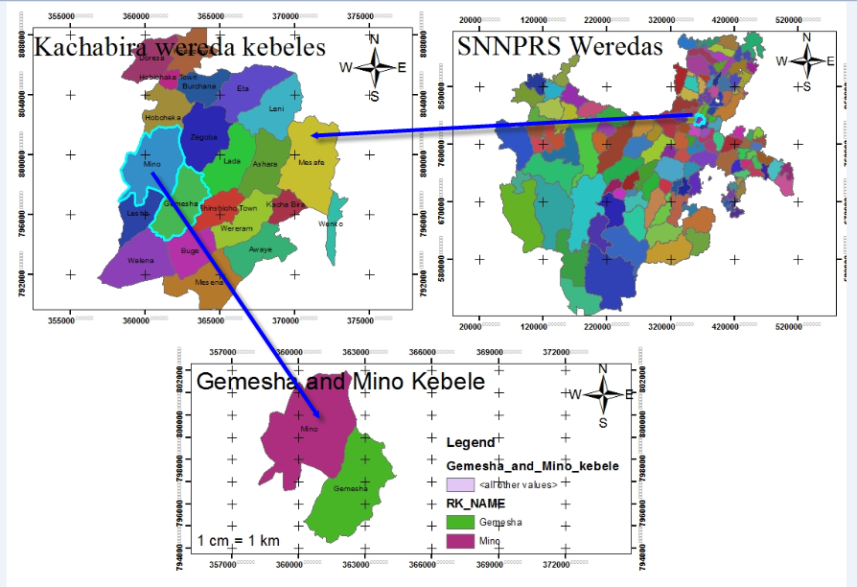

Fig.3.1 Location Map of Study area.

Climate and hydrology
The mean annual rainfall of the project area (as measured at Durame meteorological station for the period of 1984-2013 (30years) is 1115.8mm. This is the closest meteorological station to the projects area, which is located at nearer areal distance from the projects area. The monthly rainfall distribution as measured at Durame station is a sort of bimodal where the main rainy season extends over the period of mid-April to mid-September with its peak in August. The area also experiences small peak (“Belg” rain) during the period of April and May. The main rainy season contributes about 14 % of the annual total rainfall. The seasonal distribution of rainfall and the intra month variability is shown in Figure below.

Figure 3.2. Seasonal distribution of rainfall at Durame Meteorological station

Description of the Schemes

Gemesha Irrigation Project

Establishment: Before to the Construction of the Gemesha irrigation project, the life of the farmers in the area were relied on the production of rain fed crops and livestock. Considering the seriousness of the problem and to eradicate it from the area, the Gemesha irrigation scheme was established by a Non-governmental organization called World Vision Ethiopia in 1992E.C. Gemesha Small Scale Irrigation Project is found in the Woreda Rural Kebeles specifically in Gamasha Kebele Administration in which the command area located at 25 km far from Durame Town (the Zonal Capital) with gravel road and about 38 km from Alaba to Shoen Asphalt Road. The Project area is situated on geographical grid of 7⁰15`N Latitude and 37⁰45`E Longitude. Initially the area was designed to cover gross command area of 75 ha. Up on the development of the project, each farmer was cultivating his own land separately. This has created disputes among farmers. To settle the dispute, it was founded to set up the organization. This organization was established with the given name the Gemeshawater users association in May 15, 1992 E.C.

Water sources and abstraction: The source of water for the irrigation project is Senbeta River. The Senbeta River is diverted to the canal by constructing a diversion wall at a location where there is small natural protruding land in the river. The diverted water is then blocked by a weir near the main gate to raise the head of the water in the canal.
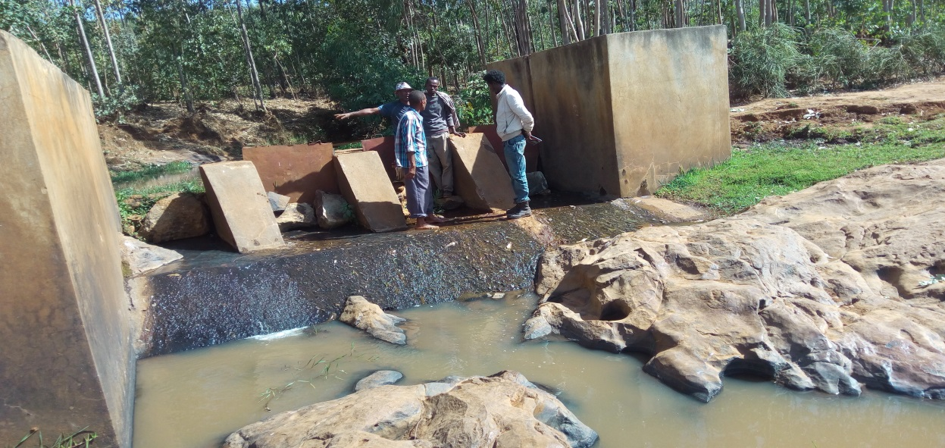

Figure 3.3 Gemesha irrigation scheme head work

Water distribution system: the irrigation water from the river is diverted to 2500meter length concrete made primary canal thatruns longitudinally and with the help of several division box along the canal distributes the water to Field canals laterally. Individual farmers, according to their need, construct the field canals to divert water into their fields. Farmers are diverting the water through their preferred direction as long as it is suitable to provide available head to irrigate their field.

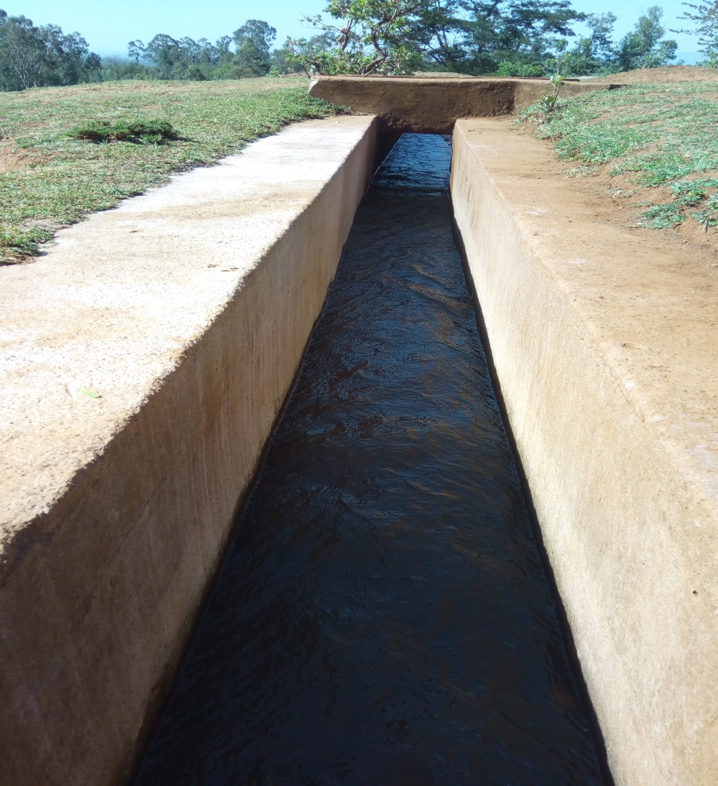

Figure 3.4 Primary canal of Gemesha Irrigation Scheme

Ufute Irrigation Project

Establishment: Ufute irrigation scheme was established by SNNPRS Water Resource Development Bureau in 2004E.C.The Project is found in the Woreda Rural Kebeles specifically in Mino Kebele Administration in which the Head work is located 3 km South West of the Gemesha irrigation scheme. Initially the project was designed to cover gross command area of 70 ha.

Water sources and abstraction: The source of water for the irrigation project is Ufute River. The Ufute River is diverted to the canal by constructing a diversion wall at a location where there is small natural protruding land in the river. The diverted water is then blocked by a weir near the main gate to raise the head of the water in the canal.

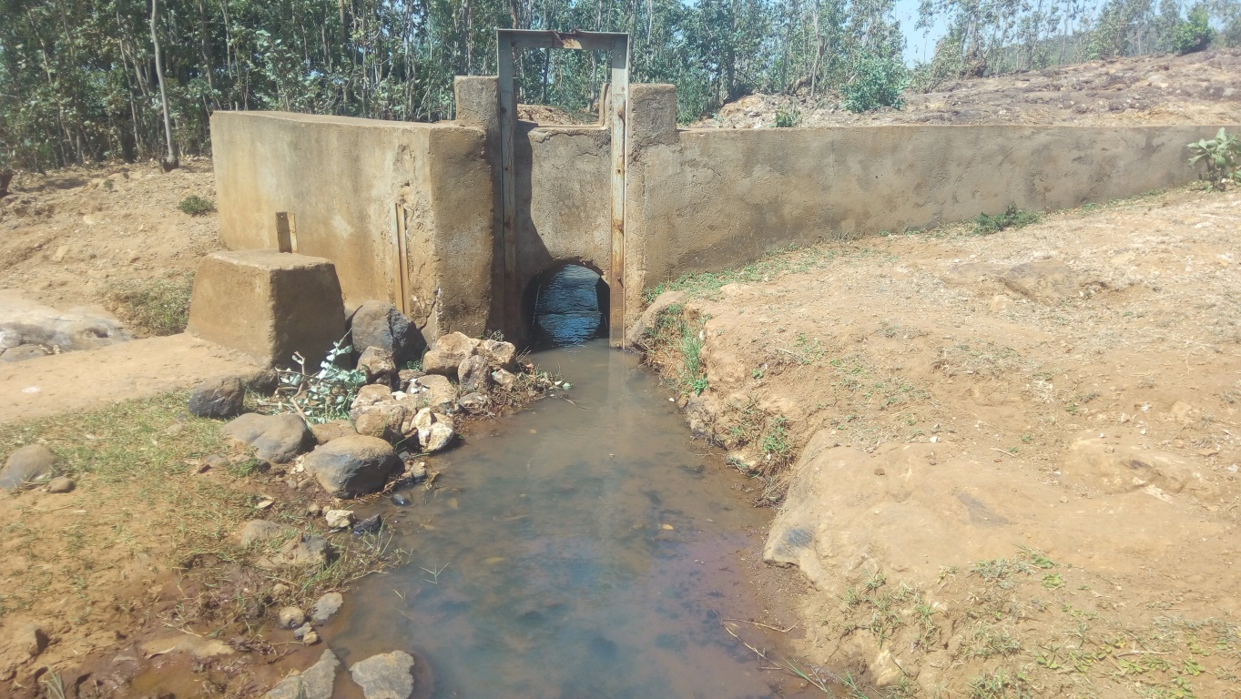

Figure 3.5 Ufute irrigation scheme head work

Water distribution system: the irrigation water from the river is diverted by 1037 meter length concrete madeand 730m earthen canal carries that runs longitudinally and with the help of several tertiary canals and turnouts along the canal distributes the water to field canal laterally. Individual farmers, according to their need, construct the field canals to divert water into their fields. Farmers are diverting the water through their preferred direction as long as it is suitable to provide available head to irrigate their field.
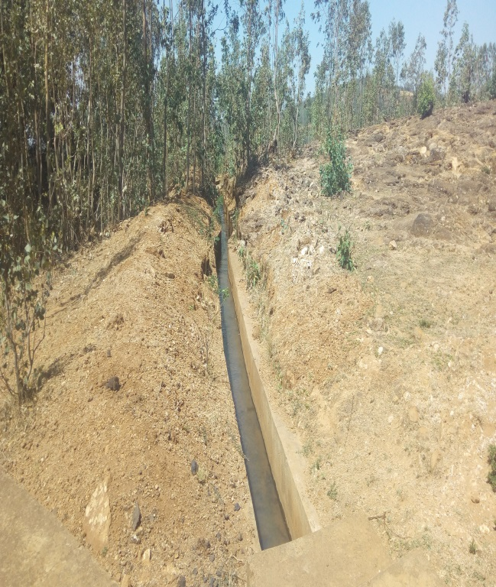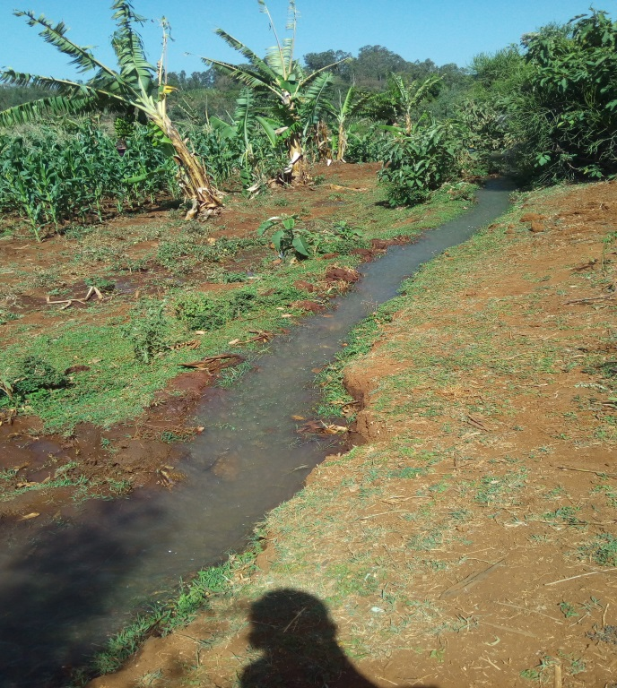
Figure 3.6 Lined Canal (Left) and Earthen Main canal (Right) of Ufute project

Methodologies used

Data collection methodologies

The data collection has been carried out in collaboration with the DA of Ufuteand GemeshaIrrigation Projects assigned by the Woreda Agricultural Office. It was started in September 2016. During the reconnaissance survey, agricultural offices, sponsor organizations, professional staff, DAs and some farmers were consulted about the general conditions of small-scale irrigations.
Based on the survey made and the information gathered; two irrigation projects were selected. The criteria for selection were availability of organizational set up, nearness to weather station, and the availability of secondary data. Data collected included primary sources at field level in the irrigation project. As much as possible, three farmers’ fields were selected from the head; middle and tail water users of each irrigation projects.

The Materials Used

The following materials and equipment were used for data collection and analysis of the data for this study: augur, soil sampling rings, graduated staff gauge, stopwatch, balance, GPS, Digital camera and others. CLIMWAT 2.0 for CROPWAT, CROPWAT VERSION 8.0 FOR WINDOWS software’s was used for determining ET and water demand of the crop, Arc GIS software’s was used.

Primary data collection

Primary data were collected by the use of formal and informal survey methods. A formal survey was carried out with the help of standard questionnaire designed to obtain information from selected sample households. Discussion were made with key farmers including committee members of local irrigation water user's, executive members of peasant associations, development agents and Kacha Bira district irrigation development desk representatives and experts from cooperative desk. The leading questions prepared to guide the discussion with the focus group emphasis on policy issues, external support for the schemes, institutional and managerial issues, major problems and future plans to further develop the irrigation systems.

Determination of the amount of water applied to the fields

3.3.4.1 Floating method

If a flow measuring device is not available it is possible to use a float to calculate the surface velocity of the stream. An orange, partially filled with water, or waterlogged stick will all float just below the surface and minimize the effects of air currents. It will need to mark off a known length of the reach of at least 20m. Introduce the float just upstream of the first marker so the float has time to reach the stream’s velocity. Measure the time it takes to pass between the two markers. Ideally, it should time three passages of the float and average the three times. In order to correct the effect of the streams bottom there is a correction factor, K = 0.85 based on the bed roughness it ranges from 0.8 to 0.9(Liggett, 2001).

This method applies estimation of running velocity of a floating object placed on a stream. A straight section of the channel about 20m long cross section is selected. Several trials have been made to get the average time of travel. To determine the velocity of water, the known distance is divided by the average time taken by the float.
$$VelocityoftheFloat=\frac{KnownDistance(m)}{TimerequiredtopassthisknownDistance (s)}…………3.1$$
$$Averagevelocityofflow=measuredvelocityoffloat*0.85$$
$$∴Q=Averagec/sarea*Averagevelocityofflow$$

3.3.5.2 Float Method Procedure

- Measure and mark two points at canal cross section from each other
- Two observers one at beginning and the other at the end of the points; one tosses the float into the channel above the marker and calls out when it crosses the upstream point. Toss the float repeatedly for five times to get average velocity.
- The downstream observer starts the timer when the upstream one call out and stops immediately when float passes the second Point and record the time elapsed.
- Averaging the values to get the mean surface velocity and then multiply it by a velocity adjustment coefficient of 0.85 to calculate the mean velocity of discharge.
- Using the cross-sectional area of the canal, multiply velocity times area to find Discharge (Q = A*V)

Secondary data collection

For each of the selected irrigation schemes, secondary data were collected from the Kachabira Agricultural and Rural Development Office and Water Resource Offices and irrigation offices at regional and zonal levels. Furthermore, NGOs of the agricultural sectors were visited periodically to gather further information like feasibility study documents, production costs, investment cost and other relevant information. The secondary data included total yields, farm gate prices of irrigated crops, area irrigated per crop per season, production cost per season, incomes generated by the irrigation associations and cropping pattern. Climatic data of the irrigation schemes were collected from the nearby metrological station. Durame metrological station Center was the source of the climatic data for both Gemesha and Ufute irrigation scheme.
Based on the questionnaire developed interview were made to get the perception of the farmers about the water distribution with in the project. Much effort has been spent through survey and observations of different documents at different places to check the reliability and consistency of these data.

3.7.1 Crop Production data collection

One of the criteria used to select the two irrigation projects was the availability of recorded data that are used to calculate some of the performance evaluation parameters. Even if the data recorded by the projects are not complete, consistent and not supported by skilled manpower, relatively these irrigation projects were at the better position than others. The financial data used to calculate some of the parameters in this study were copied from the documents that have been audited and checked by the responsible government offices.

3.7.2 Laboratory analyses

Bulk densities (BD), textures, Field Capacity (FC), Permanent Wilting Point (PWP) of the soils of the selected farmers’ fields at different depths were determined in the laboratory. To determine these soil parameters with their respective laboratorial procedures, recommendation manuals of Kamara andHaque (1991) and Sahlemedhin and Taye (2000) were followed. Then the values of the parameters determined were applied where they are appropriate for the analyses of the study.

3.7.3Infiltration characterization

To determine infiltration characteristics of the soil in the scheme, double ring infiltrometer of 30 cm and 60 cm inner and outer ring diameters respectively were used at the selected representative three fields (from head, middle, and tail ends of the schemes). Double ring infiltrometer was driven to the depth of 15 cm into the soil by hammer. A minimum head of 10 cm was maintained in both rings during measurement. Depths to water levels were measured at increasing time intervals from the datum established on the edge of each cylinder
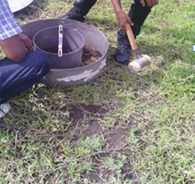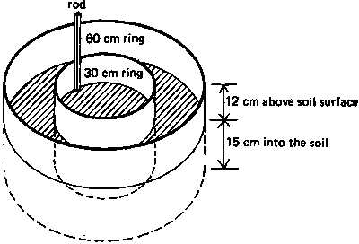

Figure 3.9 Double ring inflator-meter

3.7.4 Gravimetric sampling for moisture content determination

Gravimetric samplings were made by collecting more than 9 soil samples from each farmer’s fields with an interval of 40 cm of the soil depth up to 150 cm depth. It is presumed that this depth is deeper than the effective root zone of the irrigated vegetable crops. The maximum effective root zone of small vegetables, like onion, is 60 cm (Allen et al, 1998). The soil samples were placed in a container of known weight and then weighed. The samples were then placed in an oven heated to 105° C for 24 hours with the container cover removed. After drying, the soil and container were again weighed and the weight of water was determined. The dry weight fraction of each sample was calculated using the equation (FAO, 1989; Kamara and Haque, 1991)
$$Wθ=\frac{Ww-Wd}{Wd}*100*Bd…………………3.2$$

Where;
Wθ- is gravimetric soil moisture content (% volume bases),
Ww- is wet weight of the soil (g),
Wd- is dry weight of the soil (g) and
Bd-bulk density of soil (g cm⁻³)

Then the moisture contents of the soils collected from the selected fields’at different depths were determined.

Data analysis techniques

Generally primary data was gathered through field surveys, questionnaire, interviews and focus group discussions, practically participating in the operation and maintenance of the components of the irrigation system, attending farmers’ meeting when decisions were made regarding water sharing and other, are among the methods used to understand the local water management of the two community managedirrigation system.

Crop water requirements and irrigation scheduling

To estimate the crop water requirements (CWR), irrigation scheduling and irrigation water requirement (IWR) of the irrigated crops at field levels and the irrigation project as a whole the CROPWAT 8 was used (FAO, 1992).This program uses the FAO (1992) Penman-Monteith equation for calculating reference crop evapotranspiration. The determination of the CWR by this model depends on the determination of the reference evapotranspiration values using the available climatic data. The determination of IWR was carried out after estimation of effective rainfall by USDA soil conservation service method (Clarke, 1998). The irrigation requirements of each irrigation projects were calculated withCROPWAT 8 using the climatic data, cropping pattern, planting dates, and area of each crops.

Performance Evaluation Methodology

Performances of the projects were evaluated using both internal and external indicators.
The internal performance indicators computed were conveyance efficiency, application efficiency, runoff ratio, storage efficiency, deep percolation ratio, distribution uniformity and overall scheme efficiency. For computation of absolute performance efficiencies, irrigation fields with Maize were purposely selected (Appendix Figure 10). For this purpose, a total of nine farmers’ fields were selected from each irrigation scheme, i.e. three from the head (H1, H2 and H3); three from the middle (M1, M2 and M3) and three from the tail (T1, T2 and T3) end water users of each irrigation scheme. The standardized performance indicators established by IWMI were taken to measure external indicators. The external indicators included in this study were agriculture, water use, physical and economic performance.

Internal performance Indicators
The internal performance indicators for each scheme were computed based on field measured data. Accordingly, the conveyance efficiency of the scheme was computed by taking discharges measurement at different points. The measurements were taken at a point of diversion and at the initial and final points of main canals. It was computed as the follows (Ramulu, 1998):

$$Ec=\frac{Wf}{Ws}*100…………………3.3$$

The conveyance efficiency of the scheme was computed as:
$$Ec=Em*Es*Et*Ef…………………3.4$$

Where:
Ecis conveyance efficiency (%),
Emis conveyance efficiency of main canal (%),
Es is conveyance efficiency of secondary canal (%),
Etis conveyance efficiency of tertiary canal (%),
Efis conveyance efficiency of field canal (%),
Ws is depth of water diverted from the source (m³) and
Wf is depth of water applied to the field (m³).

The application efficiency was computed as the ratio of moisture added to the soil profile due to irrigation to the total water supplied to the farm or the ratio of moisture retained due to irrigation with total water added to the field. In this particular research soil samples were collected from different fields at different depths (0-40, 40-70, 70-110 and 70-150cm) and the amount of water stored in the root zone determined by gravimetric method. Application efficiency was computed as follows (Ramulu, 1998):
$$Ea=\frac{Zr}{D}*100…………………3.5$$
Where:
Ea is application efficiency (%),
Zr is average depth of water applied to the root zone as storage (mm), and
D is average depth of water applied to the field (mm).

The runoff ratio is normally considered for this particular study as zero as the farmers are using furrows whose tail ends are closed. However, the deep percolation ratio was computed as the ratio of the percolated water beyond the root zone to the volume of water applied to the field. It was computed using the following formula (Feyen and Dawit, 1999):

$$DPR=100-Ea-RR…………………3.6$$
Where:
DPR is deep percolation ratio (%),
Ea is application efficiency and RR is runoff ratio.

The water storage efficiency refers how completely the water needed prior toirrigation has been stored in the root zone during irrigation.
Based on the FC, PWP, BD of the soils of the selected irrigation fields and the root depth of the crop irrigated, the depth of irrigation water required by the crop was calculated at the 75% moisture depletion level (Allen et al, 1998).
After determining the storage and the required depths, the storage efficiency was calculated using equation below
$$Er=\frac{Volume of water added to the root zone }{Potential soil moisture }…3.7$$
Where:
Er is storage efficiency (%),

Distribution uniformity was determined by recording advance time and recession time at three equal points of the selected furrows. The depth of water infiltrated during the opportunity time was derived from measurement of the infiltration rate of the soil, which was determined using double ring infiltrometer. The irrigation distribution uniformity was computed using the following formula (Ramulu, 1998):
$$Ed=\left(1-\frac{\overline{y}}{d}\right)*100…………………3.8$$

$$\overline{y}=\sum_{i=1}^{n}{\left(\frac{\left(\left|y-d\right|\right)}{n}\right)}…………………3.9$$
Where:
Ed is distribution uniformity (%),
d is average depth of water infiltrated (mm)
$\overline{y}$is average absolute deviation depth of infiltrated water from the mean d (mm) and
y is depth of water infiltrated at a given point (mm).
Finally the overall scheme efficiency was calculated as the product of conveyance and application efficiency. It was computed using following formula (Ramulu, 1998):
$$Ep=Ec*Ea…………………3.10$$
Where:
Ep is overall scheme efficiency (%),
Ec is conveyance efficiency (%) and
Ea application efficiency (%).

Farmer’s field evaluation in each scheme

In order to evaluate the irrigation water use efficiency of farmers at field level and to compare each other in the same irrigation projects, three farmers were selectedfrom each irrigation Schemes. These fields were selected from the head, middle and tail end water users of the irrigation projects. The assumption behind the selection criterion of the farmer’s fields was that there was a tendency of the head end users to over-irrigate their crops while the tail end users were in short supply of irrigation water (Levin et al, 1998).

Infiltration of water into the furrow is the most important variable affecting the characteristics of flow in furrows. According to Michael (1997), in order to evaluate furrow irrigation performance gravimetric method of measuring soil moisture content, which was done by taking the moisture contents of the soil before and after irrigation, is more accurate but time consuming.
The parameters used to compare the efficiencies at field level were application efficiency, storage efficiency and distribution efficiency.

External performance indicators

The external or comparative performance of the scheme was evaluated using some selected comparative indicators, which are normally classified into four groups, namely agricultural, water use, physical and economic performance as standardized by IWMI (Molden et al., 1998).To compute the total production of each scheme in all the crop types grown in the respective sites, average yield per ha as well as an average price for each crop per kg was collected for each scheme.

The design feasibility study documents of the irrigation projects were collected from the World Vision NGO forGemesha and SNNPRS Water and Irrigation Bureau for Ufuteirrigation project and were used as a source of information on the investment costs of the irrigation projects. The results obtained on all the indicators were then used to compare the two schemes. For the comparison of irrigated agriculture performance indicators, four indicators related to the output of different units were used. They were used for the evaluation of the project performance in terms of the production it results in.

Agricultural output indicators

Agricultural output indicators can be subdivided into land productivity and water productivity indicators.Four relevant water productivity were considered under this group of indicators for this study. The outputs of agricultural production in this paper were based on local prices.

Output per unit cropped area (OPUA)

The output per unit irrigated cropped area (output per unit harvested area) quantifies the total value of agricultural production per unit of area harvested during the period of analysis. The annual harvested area depends on the intensity of cropping (irrigation intensity). This indicator is not affected by the intensity of cropping (irrigation). However, it can also indirectly indicate the degree of irrigation water availability. In addition to water availability, soil type and fertility, land suitability, crop variety and agricultural inputs do have significant impact on output and hence on land productivity. It was given by (Molden and Gates, 1990):

$$OPUIA=\frac{VAP}{Ha}\left({birr}/{ha}\right)…………………3.11$$
Where:
OPUIA= Output per unit irrigated cropped (harvested) area (birr/ha)
VAP=Production(birr) is the output of the irrigated area in terms of gross or net value of production measured at local or world prices annually and
Ha= harvested area is the total area under the crop (ha).

3.8.7.2 Output per unit command area (OPUCA)

The output per unit command area is the value of agricultural production per unit of nominal area which can be irrigated. Smaller values of this indicator can also imply, although not necessarily, less intensive irrigation and vice versa. It is particularly important where land is a constraining resource for production. It is given as (Molden and Gates, 1990):

$$OPUCA=\frac{VAP}{Na}\left({birr}/{ha}\right)…………………3.12$$
Where:
OPUCA= Output per unit command area(birr/ha)
Na= Nominal (ha) is Command area or design area to be irrigated, and irrigated area is the sum of the areas under irrigation during the time period of analysis and
VAP=Value of annual Production (birr) is the output of the irrigated area.

Output per unit irrigation water supply (OPUIS)

The output per unit irrigation water supply tells on how well the total annual diverted irrigation water from a source is productive. Irrigation water supply includes conveyance (seepage) losses in canals, and hence it is generally measured at the intake from the source or at diversion. In areas where water is scarce, water management aims to increase the output per drop of irrigation water: It is given as (Molden and Gates, 1990):

$$OPUIS=\frac{VAP}{DAIS}\left({birr}/{m^{3}}\right)…………………3.13$$
Where: OPUIS= Output per unit irrigation water supply (birr/m3)
VAP=Production(birr) is the output of the irrigated area in terms of gross or net value of production measured at local or world prices annually and
DAIS=Diverted irrigation supply (m³) is the volume of surface irrigation water diverted to the command area.

Output per unit water consumed (OPUWC)

The output per unit water consumed informs on the output per unit annual volume of water consumed by actual evapotranspiration (ET). Its value is highly dependent on climate. Moreover, less consumptive use coefficient due to water losses does not affect its value; as only the water consumptively used by the crops is considered. It is given as(Molden and Gates, 1990).

$$OPUWC=\frac{VAP}{VET}\left({birr}/{m^{3}}\right)…………………3.14$$
Where:
OPUWC= Output per unit water consumed(birr/m³)
VAP= Production(birr) is the output of the irrigated area in terms of gross or net value of production measured at local or world prices annually and
VET= Volume of water consumed (m³) by ET is the actual evapotranspiration of crops

Water use performance indicators

The water supply indicators are based on irrigation and water supply/delivery measurements being related to water demands or irrigated area. The two indicators that were considered under this group are:

3.8.8.1 Relative water supply (RWS)

The relative water supply is the ratio of total annual water supplied to the annual crop water demand. It signifies whether the water supply is in short or in excess of demand(Molden and Gates, 1990):
$$RWS=\frac{AWS}{ACWD}\left({m^{3}}/{m^{3}}\right)…………………3.15$$
Where:
RWS= Relative water supply(m³/m³)
AWS=annual water supply (m³) is Surface diversions plus net groundwater plus effective rainfall and
ACWD=Crop demand (m³) is potential crop ET, or the ET under well-watered conditions.

3.8.8.2 Relative irrigation supplies (RIS)

The relative irrigation supply is the ratio of annual irrigation supply to annual irrigation demand. Irrigation water is a scarce resource in many irrigation schemes and may be a major constraint for production. This indicator is useful to assess the degree of irrigation water stress/abundance in relation to irrigation demand. It was given by(Molden and Gates, 1990).
$$RIS=\frac{AIS}{AID}\left({m^{3}}/{m^{3}}\right)…………………3.16$$
Where:
RIS= Relative irrigation supplies (m³/m³)
AIS=annual Irrigation supply (m³) is only the surface diversions and net groundwater draft for irrigation and
AID= annual Irrigation demand (m³) is the crop ET less effective rainfall.

Physical performance indicators

Two indicators are of relevance under the group of physical sustainability indicators.

3.8.9.1 Irrigation ratio

Irrigation ratio is the ratio of currently irrigated area to irrigable command (nominal) area. It tells the degree of utilization of the available command area for irrigated agriculture at a particular time. Shortage of irrigation water, lack of irrigation infrastructure, lack of interest on irrigation due to less return, reduced productivity due to problems such as salinization/waterlogging, etc., could result in underutilization of land. On the other hand, cropping intensity, a ratio of annual cropped area to nominal area is indicative of annual land utilization.Burton et al. (2000) state that cropping intensities from 100 to 200% are considered good; whereas an inferior figure is low. Irrigation ratio is expressed asBurton et al. (2000):-
$$IrrigationRatio=\frac{IA}{CA}\left({ha}/{ha}\right)…………………3.17$$
Where:
CA=Command area (ha) is the nominal or design area to be irrigated, and
IA=irrigatedarea (ha) is the sum of the areas under irrigation during the time period of analysis.

3.8.9.2 Sustainability of irrigated area

Sustainability of irrigated area is the ratio of currently irrigated area to initially irrigated area when designed (Bos, 1997). It is a useful indicator for assessing the sustainability of irrigated agriculture. Lower values of this indicator would mean abandonment of lands which were initially irrigated; and hence, indicate contraction of irrigated area over time. On the other hand, values higher than unity indicate expansion of irrigated area and would imply more sustainable irrigation (Bos, 1997)
$$SustainabilityofIrrigatedarea=\frac{CIA}{IIA}\left({ha}/{ha}\right)…………………3.18$$
Where:
CIA=currently irrigated area (ha) is the area under the irrigation during the analysis of this study and
IIA= initially irrigated area (IIA) is an area under irrigation at the beginning of the project.

Economic performance indicators

This indicator considers the production and the total cost of infrastructure for each scheme. It deals with the total revenues from the scheme, total cost spent for running the project and initial investment costs. Economic indicators deal with how much investment cost is spent on the project in comparison with total production and how much fee collected from water users for yearly maintenance and operation expenditure and whether the system is self-sufficient or not (Vermillion, 2000).

4. RESULTS AND DISCUSSION

GemeshaIrrigation Project

The discharge in the canal is controlled by manually operated gate. The discharge of the main canal varies from time to time, along with the parent source, Senbeta River. The dischargelies in the range of 150 and 420 liters per second with an average discharge of 210 liters per second. The maximum discharge capacity of the main canal of the Gemesha irrigation project is 150 liter per second.

Water distribution system:In Gemesha irrigation scheme, the water user association called Gamasha Irrigation association is exist. A representative farmer assigned by the association throughout the year manipulates the gate at diversion weir. Once it is opened, it stays till the rain season comes with regular two over-night interruptions for canal cleanings. The representative from committee makes water allocation between for farmers and it is basically governed by the discharge of the Senbeta River. The distribution can be allocated day and night rotation or for specific period (days interval) within a week. The irrigation interval in the initial period of the crops commonly grown in the area is about 9-11 days; which increases 15to 17 days at the end of the growing season As far as the schedule of irrigation water allocation farmers have the right to apply the water as much as theywant. That means there is no any restriction how much water a farmer can divert for their fields regardless of the size of their farm, especially for head end users. From field observation and results of the questionnaire, due to unwise use of water by the head end users and siltation problems of the main canal the tail end user faced water shortages frequently.

Command area:According to the design document land suitable for irrigation in the area is estimated to be over 300ha.Taking into consideration the beneficiary capacity, labor availability and input requirement, a gravity system that can irrigate a gross area of 300 ha was constructed.Unfortunately currently the total actively irrigable area covered by the main canal is only 48 ha.
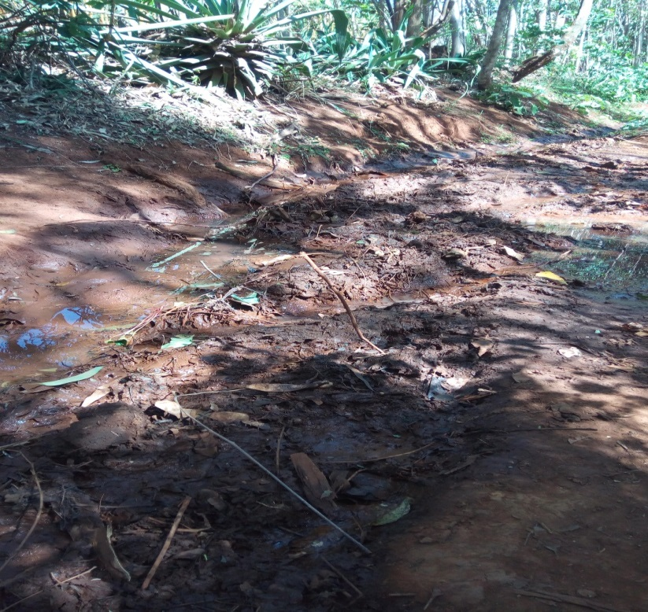

Figure 4.1 Siltation problems of the secondary canal at Gemesha

Ufute Irrigation Project

The discharge in the canal is controlled by manually operated gate. The discharge of the main canal varies from time to time, along with the parent source, Senbeta River. The discharge lies in the range of 98 and 215 liters per secondwith an average discharge of 125 liters per second. The maximum discharge capacity of the main canal of the Ufute irrigation Scheme is 98 liter per second.
Command area: According to the design document land suitable for Ufute irrigation is estimated to be over 200ha.Taking into consideration the beneficiary capacity, labor availability and input requirement, a gravity system that can irrigate a gross area of 200 ha was constructed. Unfortunately currently the total actively irrigable area covered by the main canal is only 40 ha.

4.1. Soil Physical Properties

FAO –ISRIC-IUSS (WRB, 2006) classification system was used for the description and classification of the soil. Thus, the soil morphological, physical and chemical properties obtained from field and laboratory analysis has been utilized for soil classification of the command area. Accordingly, the Reference Soil Group (RSG) identified in the command area is Luvisols for Gemesha and Nitisols for Ufute at irrigation schemes, indicating that soils of both schemes are not similar in texture (Table 1). The main factors considered as diagnostic criteria within the command areas are presence of cracking clays, effective depth, soil structural development, matrix color,percentage of base saturation (PBS), evidence of profile development such as soil diagnostic horizons development, etc.

Bulk density
Bulk density is the density for a volume of soil as it exists naturally, includes any air space and organic materials in the soil volume. The main purpose of the bulk density measurement is to indicate the problems of root penetration and soil aeration in different soil horizons.
The bulk density of soil of the area showed a variation with depth (Table 4.1).Laboratory result for Bulk density varied between from 1.12 to 1.35 g/cm3 for Gemesha and 1.13 to 1.42 g/cm3 for Ufute. Generally in normal soils bulk density ranges from 1-1.65g/ cm3. In very compact soils, sometimes, it goes up to 2.0g/cm. The value of bulk density seems does not cause hindrance on soil aeration and root penetration due to soil compaction.

Field Capacity (FC)
Field capacity is the amount of water a well-drained soil holds after free water has drained because of gravity. For coarse textured soil, drainage occurs soon after irrigation because of relatively large pores and low soil particle surface tension. In fine textured soil, drainage takes much longer because of smaller pores and their horizontal shape. Major soil properties that affect field capacity are texture, structure, bulk density, and strata within the profile
According to the laboratory test results, the field capacity of the representative soils of the project ranges between 310 to 450 mm/m or 31.0 to 45.0% for Gemesha and between 339.3 to 356.7mm/m for Ufute respectively.

Permanent wilting point (PWP)

It is the amount of water left in the soil when the plant is unable to extract any more, or Removal of soil moisture by crop roots reaches a stage when the soil particles exert a greater tension on the soil moisture than the crop roots can exert to extract the remaining moisture.When this condition is reached the soil is said to be at permanent wilting point.The corresponding soil moisture tension is about 15 atmospheres. Accordingly the laboratory results of PWP for the soils of the project command area ranges from149 to 312 mm/m for Gemesha and 140.3 to 179.7mm/m for Ufute respectively.

Available water holding capacity
The difference in moisture content of the soil between field capacity and permanent wilting is termed as available water holding capacity. It can be used as a factor in land suitability classification and in irrigation planning. It is commonly used for determination of the depth and frequency of irrigation required.
The total available water holding capacity of soils selected from both schemes ranged from 141-201 mm m-1 except two samples 130 -132 mm m-1 from Ufute and Gemesha scheme respectively. In general soil of both schemes are medium as per available water holding rating of McIntyre (1974). The result depict that the relevant soil physical properties measured are not different to a great deal from each other with depth and across the different sampling points indicate that the soils of the study area is homogeneous

Table 4.1.Selected soil physical characteristics of Gemesha irrigation schemes

Gemesha Scheme
Field  code | Soil  depth  (cm) | Particle size  Distribution (%) |  |  | Textural  class | FC  (mm/m) | PWP  (mm/m) | TAW  (mm m-1) | Bd  (g cm-3)
Field  code | Soil  depth  (cm) | Sand | Silt | Clay
H | 0-40 | 41.01 | 33.71 | 25.28 | clay loam | 350 | 203 | 147 | 1.29
H | 40-70 | 37.54 | 34.46 | 28.0 | Clay loam | 310 | 149 | 161 | 1.34
H | 70-110 | 29.94 | 28.46 | 41.6 | Clay | 440 | 276 | 164 | 1.22
H | 110-150 | 34.13 | 31.8 | 34.07 | Clayloam | 420 | 272 | 148 | 1.24
M | 0-40 | 26.36 | 35.17 | 38.47 | clay loam | 330 | 183 | 147 | 1.32
M | 40-70 | 11.41 | 64.28 | 21.31 | Silt loam | 360 | 219 | 141 | 1.28
M | 70-110 | 10.41 | 61.24 | 28.35 | Silt clay loam | 420 | 252 | 168 | 1.24
M | 110-150 | 4.73 | 44.15 | 51.12 | Silt clay | 450 | 312 | 138 | 1.22
T | 0-40 | 37.93 | 35.18 | 26.9 | Loam | 349 | 200 | 149 | 1.32
T | 40-70 | 39.25 | 37.71 | 23.04 | Loam | 444 | 287 | 157 | 1.23
T | 70-110 | 32.47 | 37.99 | 29.54 | Clay loam | 405 | 273 | 132 | 1.31
T | 110-150 | 15.57 | 18.26 | 66.17 | clay | 411 | 265 | 146 | 1.36
H is field selected from head water users, M is fields selected from middle water users and, T is fields selected fromtail water users, FC is moisture content of soil at field capacity, PWP is moisture content of soil at field permanent wilting point, TAW is total available water and Bd is soil Bulk density,

Table 4.2. Selected soil physical characteristics of Ufute irrigation schemes

Ufute Scheme
Field  code | Soil  depth  (cm) | Particle size  Distribution (%) |  |  | Textural  class | FC  (mm/m) | PWP  (mm/m) | TAW  (mm m-1) | Bd  (g cm-3)
Field  code | Soil  depth  (cm) | Sand | Silt | Clay
H | 0-40 | 23.74 | 22.98 | 53.27 | Silt Clay Loam | 356.7 | 159.8 | 196.9 | 1.25
H | 40-70 | 23.6 | 16.3 | 60.1 | Clay | 339.6 | 177.1 | 162.5 | 1.35
H | 70-110 | 19 | 16 | 65 | Clay | 339.3 | 198 | 141.3 | 1.42
H | 110-150 | 35.21 | 22.63 | 42.17 | Clay | 342.6 | 160.5 | 182.1 | 1.42
M | 0-40 | 20.01 | 24.11 | 55.88 | Clay | 350.6 | 179.7 | 170.9 | 1.28
M | 40-70 | 17.01 | 29.41 | 53.57 | Clay | 308.5 | 130.2 | 178.3 | 1.27
M | 70-110 | 16.53 | 16.01 | 67.46 | Clay | 324.3 | 150.6 | 173.7 | 1.3
M | 110-150 | 28.86 | 30.64 | 40.49 | Clay | 326 | 143.5 | 182.5 | 1.41
T | 0-40 | 18.40 | 53.65 | 27.94 | Silt clay Loam | 350.00 | 220.00 | 130.00 | 1.29
T | 40-70 | 13.43 | 58.46 | 28.11 | Silt clay Loam | 399.00 | 198.00 | 201.00 | 1.23
T | 70-110 | 19.04 | 68.41 | 12.54 | Silt Loam | 385.00 | 210.00 | 175.00 | 1.31
T | 110-150 | 20.21 | 71.92 | 7.87 | Silt Loam | 385.00 | 210.00 | 175.00 | 1.36

H is field selected from head water users, M is fields selected from middle water users and, T is fields selected fromtail water users, FC is moisture content of soil at field capacity, PWP is moisture content of soil at field permanent wilting point, TAW is total available water and Bd is soil Bulk density.

Soil Infiltration Rate

The infiltration rate was measured at (head, middle and tail end) to determine the infiltration characteristics of the soil using double ring infiltrometer and mean data calculated from the study field is presented in Appendix Table 2 and 3.The basic infiltration rate of soil at Gemesha irrigation scheme was 18mm/hr and the same parameter for Ufute was 12mm/hr.
According to Kay (1986), the basic infiltration rate of a soil in the range of 1-10 mm/hr, is classified as a soil with low infiltration rate which is the typical characteristics of clay textured soil. A value ofthe infiltration for both Gemesha and Ufute scheme is classified as soils with low infiltration rate. This might be due to increase of organic matter, nutrient availability and poor management practice of the land. However, the textural class and average infiltration rate are agreed on the textural class of the scheme.

Irrigation Water Requirements of Major Crops in the Study Area

The crop water requirement and irrigation requirement of each crop was calculated and listed below in Table.

Table 4.3the crop water requirement and irrigation requirement of maize crop
Month | Decade | Stage | Kc | ETc | ETc | Eff rain | Irr. Req.
 |  |  | coeff | mm/day | mm/dec | mm/dec | mm/dec
Oct | 3 | Init | 0.3 | 1.19 | 6 | 5.5 | 0
Nov | 1 | Init | 0.3 | 1.2 | 12 | 12 | 0
Nov | 2 | Deve | 0.34 | 1.36 | 13.6 | 10.6 | 3
Nov | 3 | Deve | 0.57 | 2.25 | 22.5 | 7.6 | 14.9
Dec | 1 | Deve | 0.83 | 3.22 | 32.2 | 2.6 | 29.6
Dec | 2 | Deve | 1.09 | 4.15 | 41.5 | 0 | 41.5
Dec | 3 | Mid | 1.2 | 4.59 | 50.5 | 2.6 | 47.9
Jan | 1 | Mid | 1.2 | 4.58 | 45.8 | 6.7 | 39.1
Jan | 2 | Mid | 1.2 | 4.57 | 45.7 | 9.2 | 36.5
Jan | 3 | Late | 1.2 | 4.69 | 51.6 | 14.6 | 37
Feb | 1 | Late | 0.99 | 4.01 | 40.1 | 21.6 | 18.5
Feb | 2 | Late | 0.71 | 2.95 | 29.5 | 27.3 | 2.2
Feb | 3 | Late | 0.45 | 1.91 | 15.3 | 27.4 | 0
 |  |  |  |  | 406.2 | 147.6 | 270.3

For all major crops (Maize, Tomato and Potato) that are grown in both irrigation schemes under respective area crop water requirement are calculated in similar ways and are shown below.

Table 4.4 Results of CWR and IR of Gemesha irrigation schemes

Results of CWR and IR of Gemesha irrigation project
Crop | Area(ha) | Crop water requirement | Effective rain fall | Irrigation requirement | CWR (mm/season) | IR (mm/season)
Crop | Area(ha) | mm/season | mm/season | mm/season
Maize | 30 | 406.2 | 147.6 | 270.3 | 253.88 | 168.94
Banana | 1 | 981 | 708.8 | 435.3 | 20.44 | 9.07
Onion | 5 | 368 | 264.3 | 102.4 | 38.33 | 10.67
Potato | 4 | 464.3 | 159.3 | 303 | 38.69 | 25.25
Tomato | 8 | 535 | 199.6 | 333.2 | 89.17 | 55.53
Total | 48 |  |  |  | 440.50 | 269.46

For Ufute irrigation scheme the crop water requirement and irrigation requirement was calculated and shown below

Table 4.5 Results of CWR and IR of Ufute irrigation schemes
Results of CWR and IR of Ufute irrigation project
Crop | Area(ha) | Crop water requirement | Effective rain fall | Irrigation requirement | CWR (mm/season) | IR (mm/season)
Crop | Area(ha) | (mm/season) | (mm/season) | (mm/season)
Maize | 23 | 406.2 | 147.6 | 270.3 | 233.57 | 155.42
Banana | 1 | 981 | 708.8 | 435.3 | 24.53 | 10.88
Cabbage | 7 | 505.9 | 477 | 48.3 | 88.53 | 8.45
Tomato | 9 | 535 | 199.6 | 333.2 | 120.38 | 74.97
Total | 40 |  |  |  | 467.00 | 249.73

The seasonal crop and irrigation water requirements of the major crops grown in the study area during the study period as estimated by the CROPWAT 8 model, for the 2016 cropping season of both irrigation projects was calculated and the result for both schemes was as follow. The results indicated that for each of the three crops, the seasonal crop and irrigation water requirements were not equal since there was rainfall during the study period. Accordingly, the seasonal crop and irrigation water requirement of Maize, which was planted at the third decade of October and harvested during the third decade ofFebruary, was estimated as406.2and270.3 mm respectively(Appendix Table 6).Similarly, seasonal crop and irrigation water requirement of Tomato, planted at the third decade of October and harvested during the Second decade of March was estimated to be535 and 333.2 mmrespectively (Appendix Table 9).Additionally, the seasonal crop and irrigation water requirement of Cabbage, planted at the third decade of April and harvested during First decade of October, was found to be 506and 48.3mm respectively (Appendix Table 10).The estimated crop and irrigation water requirements indicated that Banana crophad relatively higher crop and irrigation water requirement(Appendix Table 8) compared to Maize and Tomato whereas Maize had lower water requirement than both Tomato and Cabbage crops presumably owing to its short crop cycle (125 days).

Furthermore, most of the crops had the highest crop and irrigation water requirement during their mid-season stage, followed by the late season stage. This being so, the water requirement of Maize during the initial, developmental, mid-season and late-season stages accounted for 5.9, 27.0, 33.8and 33.3% , respectively, of the seasonal water requirement of the crop. Similarly, the figures for the same growth stages of Tomato were 13.1, 23.3, 32.5 and 31.1%, respectively, of the seasonal water requirement. For Cabbage, the initial, development, mid-season and late-season stages water requirements accounted for 21.6, 33.3, 25.2 and 19.9% of the seasonal water requirement of the crop. These figures indicate that most of crops harvested for their fresh products require high amount of water even during their late-season stage.

The net crop water requirement (CWR) and the net irrigation requirement (IR) were computed for each irrigated crops for the 2016 cropping season The crop coefficients provided with Cropwat Computer program were used (input: planting dates and growth length in days) to calculate thecrop water requirement at each growth stage. The total crop water demand for the 2016 cropping season was calculated by equation given below and the result for both schemes was as follow.

$$\frac{mm}{Season}=CWRMaize*\left({AreaMaize}/{Areatotal}\right)+CWRTomato*\left({AreaTomato}/{Areatotal}\right)+etc$$

For Gemesha irrigation scheme the result is 440.50mm/season. To change the depth to volume of CWRmultiply it by the total irrigated area, i.e. 48 * 10⁴ * 440.50 *10⁻³ m³ = 211,442.0 m³ /season. The total irrigation requirement is calculated in thesameway and the result is 269.46mm/season i.e. 48 * 10⁴ * 269.46*10⁻³ m3 / season=129,339m³ /season and for Ufute irrigation scheme the result is 467.0mm/season. To change the depth to volume of CWRmultiply it by the total irrigated area, i.e. 40 * 10⁴ * 467.0 *10⁻³ m³ =186,799m³ /season. The total irrigation requirement is calculated in thesame way and the result is 249.73mm/season i.e. 40 * 10⁴ * 249.73*10⁻³ m3 / season=99,891m³ /season.

Internal Process Indicators

Conveyance efficiency

The results of the conveyance efficiency evaluation revealed that this indicator varied within a farm at different points, between farms within a scheme and between schemes. The average conveyance efficiency values which indicate the amount of water lost during transportation of water from the diversion point or source to the field canal of Gemesha, and Ufute irrigation schemes were found to be 61.15 and 65.63%, respectively. The details of conveyance efficiencies for selected fields in both the irrigation schemes are shown in Appendix Table 11 and 12 and the average conveyance efficiencies presented in Table 4.6.

The conveyance efficiency of the Ufute irrigation scheme is better than the Gemesha (Figure 4.2).This is probably associated with length of main canals and technical and managerial facilities ofWater control. In Gemesha irrigation about 2500 m length of the main canal is lined which cause high water loss due to evaporation, Head loss , high Silt accumulation along the canal, leakage in some parts of the canal, ‘poaching’ by people and to livestock watering and over-topping of water in main canals was common. In the case of Ufute irrigation scheme the main canal is 1037m lined; all the division boxes works properly and the main canal andsecondary canals size is enough to convey the water and no over topping of water on field canals.

However, the values of conveyance efficiency for both schemes are below the recommended value i.e.70% unlined poorly managed main canals (MoAFS, 2002).

Figure 4.2 Average Conveyance Efficiency of Gemesha and Ufute

Application efficiency

Water application efficiency provides a general indication of how well an irrigation system application efficiency of selected fields at the Gemesha irrigation scheme was found to vary from 43.39% to 75.22% with an average of 58.75% but the same parameter for selected fields at the Ufute irrigation scheme vary from 55.98 to 87.50% with an average application efficiency of 68.8%.
The details of application efficiencies for the selected fields in both schemes are shown in
Appendix Tables 13 and 14 and average application efficiency is presented in Table 4.6.

The finding indicates that the application efficiency of Ufute scheme was slightly better than Gemeshairrigation scheme. This may be associated with the institutional set up of Ufute irrigation scheme which is stronger than that of Gemesha and non-beneficial use such as leaching is high in Gemesha scheme. Generally the application efficiency of both schemes are typical results for furrow irrigation (Savva and Frenken, 2002), which is recommended as 50-70% for properly designed furrow irrigation. Kandiah (1981) also reported an application efficiency of 70% for furrow irrigation.

Figure 4.3Average Application Efficiency of Gemesha and Ufute

Deep percolation ratio

Since the irrigation schemes considered in this study is blocked end furrows, the main source of water loss was deep percolation. Higher deep percolation ratio values are indications of over irrigation. As depicted in Table 4.6 average deep percolation ratios at Gemesha irrigation scheme was found to be 41.25% and that of Ufute irrigation scheme was 31.2%. From the result obtained a higher deep percolation ratio was observed in lower application efficiency. During the study period it was observed that some irrigators in Gemesha scheme were trying to drain out excess water from their fields by digging traditional drainage ditches. Hence, it was an implication of over irrigation which is resulted in water logging problem. In both schemes, there is high deep percolation ratio which indicates over irrigation.

Storage efficiency

Storage efficiency refers to how completely the water needed prior to irrigation has been stored in the root zone during irrigation water application. The water storage efficiencies (Er) were computed by monitoring soil moisture before and after irrigations.

The result of storage efficiency of selected fields from Gemesha irrigation scheme was found to vary from 95.95to 99.74% with an average storage efficiency of 98.65% and that of selected fields from Ufute irrigation scheme varied from94.93to 99.89% with an average storage efficiency of 98.4%. The details of storage efficiency for selected fields and the average storage efficiency in both schemes are shown in Appendix Tables 13 and 14 and the details of all samples collected from each farm at different depth was presented in Appendix Tables 4 and 5.
As shown in Table 4.6 the storage efficiency at Gemesha irrigation scheme was slightly greater than Ufute, but in general the storage efficiency of both schemes were very poor as compared to 63% storage efficiency usually found in typical furrow irrigation systems (Raghuwanshi and Wallender, 1998). This normally shows over irrigation of the field and this might be associated with the intention of the farmers on high return from high irrigation depth.

Irrigation uniformity

Irrigation uniformity is used to express the variation in depths of application or supplied volumes. Irrigation uniformity of the scheme was evaluated by monitoring the depth of water infiltrated into the root zone depth using soil moisture content.

When irrigation water is applied uniformly in a field it helps to get uniform crop stand and uniform crop growth on the field. In this particular study the irrigation uniformity for Gemesha varies from 96.78to 99.84% with an average value of 98.32% and on the fields in Ufute scheme it varied from 93.08 to 99.69% with an average of 97.79%. The details of irrigation uniformity are presented in Appendix Tables 15 and 16.

The irrigation uniformities of both schemes were very good, which may be due to the short furrow length commonly 12 meter, closed furrow ends and large stream flow used. The irrigation uniformity figures observed in both schemes of present study are much higher than the advanced furrow irrigation systems, which is 70% reported by Raghuwanshi and Wallender (1998) and the modern Amibara Project irrigation uniformity of 93% as reported by Kandiah (1981).

Figure 4.4Average Irrigation Uniformity of Gemesha and Ufute

Overall Scheme Efficiency

The overall efficiency of the scheme is the ratio of water made available to the crop to the amount released at the headwork. In other words, it is the product of conveyance efficiency and application efficiency. In the present study the overall efficiencies of the irrigation schemes atGemesha and Ufutewere found to be 35.9and 41.94%, respectively. The details of overall scheme efficiency of both schemes were derived from the data shown in Appendix Tables 13, 14, 15and 16 while the average overall irrigation scheme efficiencies of both schemes are shown in Table 4.6.
The result indicated that the Gemeshairrigation scheme was relatively poor. The overall efficiency of the Ufute irrigation scheme was within the range of values (40-50%) commonly observed in other similar African irrigation schemes (Savva and Frenken, 2002).

Table 4.6 Average irrigation efficiencies at Gemesha and Ufute irrigation projects
Internal Indicator | Project Efficiencies (%)
Internal Indicator | Gemesha | Ufute
Conveyance Efficiency | 61.15 | 65.63
ApplicationEfficiency | 58.75 | 63.9
Deep percolation Ratio | 41.25 | 31.2
StorageEfficiency | 98.65 | 98.4
Irrigation uniformity | 98.32 | 97.79
Overall scheme Efficiency | 35.9 | 41.94

External Performance Indicators

Irrigated agriculture performance indicators
The data and calculated result under respective area was shown in Table below for both irrigation schemes

Table 4.7 Crop type and yield for Gemesha irrigation schemes
GEMESHA
Crop type | Area | Yield | Yield | Price | Revenue
Crop type | (ha) | (Qt/ha) | (Qt) | (Birr/Qt) | (Birr)
Maize(local) | 30 | 38 | 1140 | 600 | 684,000.00
Banana | 1 | 91 | 91 | 700 | 63,700.00
Onion | 5 | 110 | 550 | 800 | 440,000.00
Potato | 4 | 78 | 312 | 750 | 234,000.00
Tomato | 8 | 115 | 920 | 900 | 828,000.00
Total | 48 |  |  |  | 2,249,700.00

Table 4.8Crop type and yield for Ufute irrigation schemes
UFUTE
Crop type | Area | Yield | Yield | Price | Revenue
Crop type | (ha) | (Qt/ha) | (Qt) | (Birr/Qt) | (Birr)
Maize | 23 | 42 | 966 | 600 | 579,600.00
Banana | 1 | 86 | 86 | 700 | 60,200.00
Cabbage | 7 | 60 | 420 | 750 | 315,000.00
Tomato | 9 | 110 | 990 | 900 | 891,000.00
Total | 40 |  |  |  | 1,845,800.00

The production per unit of harvested land in both irrigation schemes is different for the same crops. The production of Tomatoper hectare of land for Gemesha irrigation scheme were higher than that of Ufute irrigation scheme and the production of Maize for Ufute irrigation scheme were higher than that of Gemesha irrigation scheme and this variation is due to production constraints such as farmers have lack of knowledge in using inputs such as fertilizers, seeds, chemicals, water availability, soil type and fertility, land suitability and using natural manure. Weed infestation and crop diseases are one of theproduction constraints that decrease crop yield, but the price per quintal are the same, because the production in both schemes were sold in the same market(Shinshicho and Durame town).

From Table 4.7 and 4.8 the total revenue for Gemesha irrigation scheme was 2,249,700birr and 1,845,800birr for Ufute irrigation scheme. The total revenue for Gemesha irrigation scheme was higher than the total revenue of Ufute irrigation scheme. This indicates that the production level and area of irrigated land forGemesha irrigation scheme was good and the production level for Ufute irrigation scheme was law. The production difference was due to farming practice, soil fertility, crop adaptability and others. This was improved by sharing farming practice, using fertilizer and planting crops adaptable to the farmer field in order to increase the productivity of Ufute irrigation scheme.
For evaluation of agricultural indicators the main crops grown in both irrigation schemes and the total value of annual production were listed in Table 4.7 and 4.8 including areal allocation of each crop for agricultural year of 2016 and were summarized in Table 4.9below.

Table 4.9Agricultural indicator for Gemesha irrigation and Ufute irrigation schemes.
Parameter | Gemesha | Ufute
Irrigation supply, m³ | 513,000.00 | 486,000.00
Crop water demand, m³ | 211,442.00 | 186,799.00
Nominal area, ha | 300 | 200
Harvested area, ha | 48 | 40
Value of annual production, birr | 2,249,700.00 | 1,845,800.00
OPUIA in(Birr/ha) | 46,868.75 | 46,145.00
OPUCA in(Birr/ha) | 7,499.00 | 9,229.00
OPUIS in(Birr/m3) | 4.39 | 3.80
OPUWC in (Birr/m3) | 10.64 | 9.88

4.3.1.1Output per unit cropped area (OPUA)

The output per unit cropped area shows the response of each cropped area on generating gross return. This parameter gives a clue about the management practice in every scheme. According to the data collected from each irrigation schemes the outputs per unit cropped area were 46,868.75 birr/hafor Gemesha irrigation scheme and 46,145birr/ha for Ufute irrigation scheme. Based on this information as a datum it is possible to say that the response or income per cropped area in Gemesha was higher than as compared to Ufute irrigation scheme. That means the return from Ufute irrigation scheme is smaller than Gemesha irrigation scheme. This is due to water availability, land suitability and crop variety and agricultural inputs do have significant impact on land productivity. It is given as (Malano et al., 2004; Molden et al., 1998). If the soil is fertile and water is available then the output per unite irrigated cropped area are high.

4.3.1.2 Output per unit command area (OPUCA)

This parameter indicates the average returns of each design command area and it is different from scheme to scheme. It is an indication of whether all the command areas are generating returns or not. The outputs per unit command area of Gemesha and Ufute irrigation scheme were 7,499.07 and 9,229 Birr ha-1, respectively. The output per unit command of Ufute irrigation scheme was higher than Gemesha irrigation scheme. The irrigated area of Gemesha was 48 ha and that of Ufute was 40ha respectively. This indicator also works with water availability, soil type and soil fertility, land suitability and crop variety. Where water is a limiting factor to production, output per unit water may be more important (Molden et al, 1998).

4.3.1.3Output per unit irrigation water supply (OPUIS)

As it obtained from the calculation in Gemesha scheme it is about 4.39 birr/m³of irrigation water supply and for Ufute scheme it was 3.80 birr/m³ ofwater supplied. This result shows that the output per unit irrigation water supply for Ufute irrigation scheme was higher than that of Gemesha irrigation scheme.

4.3.1.4Output per unit water consumed (OPUWC)

The output per unit water consumed is used to describe the return on water actually consumed bythe crop. This indicator gives due attention to the water consumed by each scheme and tells us how water is efficiently utilized by the scheme from economic point of view. The result of this output was10.64birr/m³for Gemesha irrigation scheme and 9.88birr/m³ for Ufute irrigation scheme. Its value is highly dependent on climate. Moreover, less consumptive use coefficient due to water losses does not affect its value; as only the water consumptively used by the crops is considered (Molden et al., 1998).The value for Gemesha irrigation scheme was higher as compared to the Ufute irrigation scheme. This is mainly gives due attention to the water consumed by each scheme and tells us how water is efficiently utilized by the scheme from economic point of view.

Water use performance indicators

Water supply indicators for Gemesha and Ufute Scheme were given in Table 4.10 below and the calculated value of water delivery performance indicators, that means relative Water supply (RWS) and relative irrigationsupply (RIS) were given in Table 4.11 below. These indicators evaluates water supply of the irrigation system. If their values of the indicator were equal to one then the system was optimal but if the indicators were less or greater than one then the water supply of the irrigation system was under or oversupply of the water respectively. The values are shown below

Table 4.10 Water supply indicators for Gemesha and Ufute irrigation schemes
Parameter | Gemesha | Ufute
Area developed(ha) | 48 | 40
Crop water demand( m³) | 211,442.00 | 186,799.00
Total water supply, m³ | 532,776.00 | 502,480.00
Irrigation supply, m³ | 513,000.00 | 486,000.00
Irrigation demand, m³ | 129,339.00 | 99,891.00
RWS (m³/m³) | 2.52 | 2.69
RIS (m³/m³) | 3.97 | 4.87

4.3.2.1 Relative water supply (RWS)

The relative water supply depicts whether there is enough irrigation water supplied or not. Both the relative water supply and relative irrigation supply relate supply to demand, and give some indication as the condition of water abundance or scarcity, and how tightly supply and demand is matched. The relative water supply value below one normally indicates that the water applied is less than the crop demands and values above one indicate extra water is added to the root zone beyond plant demands. The relative water supply of Gemesha irrigation scheme was found to be 2.52 and that of the Ufute scheme was 2.69.

The result in Table 4.10, which is greater than one indicates that excess water was used beyond plant demands in both schemes but the case of Ufute scheme, is relatively higher than that of the Gemesha scheme. In order to maximize water use efficiency of the scheme, it is required that the amount of water supplied be reduced in both schemes.

4.3.2.2 Relative irrigation supplies (RIS)

The result for Relative irrigation supply was shown in Table 4.10 above. In this Table it can be observed that RIS value of Gemesha was less than RIS value of Ufute irrigation scheme. It is better to have RIS close to 1 than ahigher or lower value (Molden et al, 1998). These indicates that if their values would be equal to one then irrigation water supply was evaluated as optimal and if their values are less or greater than one it wouldmean under or over supply of waterrespectively. Itcan also be observed that the RIS values for each scheme are higher than 1.0 depicting on the distribution of the supply over the field which is 3.97and4.87for Gemesha and Ufute schemes respectively and this value indicates that for both irrigation schemes there was over supply of water at both irrigation schemes. The main reason for over supply was the fact that at each scheme, the volume of water diverted is totally decided by the water users themselves. This indicates that water were diverted without due consideration of demand and due to that over supply were occurred in both irrigation schemes and also there is no water fee in both schemes due to that farmer supplies water in to their field as they want and due to that over irrigation supply was happen.

Physicalperformance indicators

The two physical indicators were used are irrigation ratio and sustainability of irrigation. Data related to area of the land at each scheme was shown on Table 4.11 below.
In the community managed small-scale irrigation schemes sustainability has been a critical issue. Without sustainability of irrigation scheme it is difficult to find sustainability indicators. So, sustainability in small-scale irrigation schemes in Ethiopia is a key issue for food security and rural livelihood enhancement. Issues constraining sustainability in these schemes are in general a collective result of non-sustainable irrigation area, defective irrigation scheduling, size of landholding, decreasing land productivity, etc.

Table 4.11 Irrigable lands, initial irrigated land and current irrigated land
Scheme | Irrigable | Initial irrigated | Current irrigated | Irrigation ratio | Sustainability of irrigated area
Scheme | Land | Land | Land | ( ha/ha) | ( ha/ha)
Scheme | ( ha) | ( ha) | (ha)
Gemesha | 300 | 75 | 48 | 0.16 | 0.64
Ufute | 200 | 75 | 40 | 0.2 | 0.53

4.3.3.1 Sustainability of irrigated area
The values for sustainability of irrigate area for the two schemes are shown in Table 4.11 above. In the result the value for sustainability of irrigation area for Gemesha irrigation scheme was 0.64 which is 64% of area was currently under irrigation and the value was less than one that means in comparison with initially irrigated area currently irrigated area was reduced by 36%. For Ufute irrigation the result for sustainability irrigated area was 0.53which indicates that 53% of area was currently under irrigation compared to initially irrigated area it means currently irrigated area of Ufute irrigation scheme was reduced by 47%. In this two irrigation schemes the sustainability of irrigated area was reducing and this were happening due to flooding, natural drainage, and water shortage and soil fertility degradation. In both irrigation schemes flooding were happen and damages the farmer’s field by loading stones on the field and affects the soil fertility. The flood erodes the fertile soil of the field and also it causes valleys that are not important for irrigation. This leads to reduction of irrigation area.

4.3.3.2 Irrigation ratio
The result for this indicator for both irrigation schemes were0.16and 0.20 for Gemesha and Ufuteirrigation scheme respectively. This result shows that 16% and 20% of irrigable land has been currently under irrigation for Gemesha and Ufute Scheme respectively. In this result the irrigation ratio of Ufute irrigation was higher than that of Gemesha irrigation. For this two irrigation schemes the result shows that it is underutilization this is due to shortage of irrigation water, lack of irrigation infrastructure, reduced productivity due to problems such as salinity/waterlogging, etc., could result in underutilization of land, soil fertility degradation, flooding and other factors that reduces currently irrigation area and leads to less return and reduce productivity.

Economic performance indicators

4.3.4.1 Gross return on investment
This indicator considers the production and the total cost of infrastructure for each scheme. The gross return on investment of Gemeshais better than Ufute irrigation scheme i.e.12.46 and 5.64 for Gemesha and Ufute irrigation schemes, respectively. The details of the gross return on investment for both schemes are shown in Appendix Tables 19and 20.
This is mainly associated with the higher infrastructure cost incurred at the Ufute than Gemesha which were 46,334.78 and 20,972.87US$, respectively for command areas of 40 and 48 ha.
However, the area irrigated during the study period 2016 was 32 and 40% of their design potential for Gemesha and Ufute schemes, respectively. The costs of the infrastructure considered here were the total expenditure for constructing all infrastructures found in the schemes.

4.3.4.2 Financial self-sufficiency

Financial self-sufficiency indicates the ratio of revenue from the irrigation to the expenditure for operation and maintenance. It shows the compensation ratio of management and maintenance costs for irrigation system based on the income obtained from the irrigation. This in other words implies the sustainability of the schemes, and perception of the farmers towards the irrigation scheme. The government covers the operation and maintenance of the schemes and it is considered as subsidy. Above and beyond, there is no fee for water it is for free. Therefore it is not possible to compare these schemes based on this indicator

CONCLUSION AND RECOMMENDATION

CONCLUSION

The conveyance efficiency of both schemes at all hydraulic levels showed some low values,even in the lined part of the main canal at Gemesha scheme due to lack of regular maintenance. But there is a room for improvement if the scheme gets regular maintenance. The application efficiency of both schemes has, however, showed good when we compare with application efficiency of 50-70% for furrow irrigation observed in other African countries.

From the analyses irrigation water efficiencies as a whole, farmers were doinggood job in terms of water distribution uniformity. This does not mean that they were using the water efficiently; there is room for improvement.

There was a marked deficiency in irrigation water management plot level at both irrigation projects. Low efficiencies were achieved because applications far exceed farmers’ management know-how. This was due to the fact that the system permitted farmers to apply large volumes of water to their plots combined with poor knowledge about the crop water requirements of the farmers.

The outputs per cropped area at Gemesha and Ufute Scheme were slightly similar showing that irrigation practice in both schemes was relatively similar. The outputs per unit command area was also relatively high at Ufute and low at Gemesha. Moreover, the relative water and irrigation supply for both schemes shows that there was a high ratio, which implies that the amount of water applied during irrigation events was much higher than what was required by crops. The gross return on investment of Ufute was better than Gemesha irrigation project and financial self-sufficiency of Gemesha was also better than Ufute irrigation schemes.

In general, based on the assessment carried out, it can be concluded that the Ufute irrigation scheme performed better than the Gemesha scheme. According to the results obtained, water management practice of both schemes was generally poor. As there is no shortage of water, the schemes have room to expand and to provide irrigation opportunities to the surrounding community relying on rain fed agriculture.

RECOMMENDATIONS
.
The output from cultivable area of Gemesha irrigation scheme was low. So it should improve its production by experience sharing from Ufute irrigation scheme. Therefore farmers and development agents of these systems should share experience by visiting their sites one another.
The return from the water supplied in each scheme is varying and it was low in Gemesha irrigation scheme. Therefore, to maximize the return from each drop of water a great effort should be carried out particularly in Gemesha irrigation scheme. This may be improved by implementing reasonable irrigation water fee than giving them for free.
From the study of the farmers’ fields the distribution efficiencies were good while application efficiencies were poor. So, in order to improve the efficiency of the schemes furrow layouts irrigation scheduling has to be made and recommended for the farmers.

The study covered the minimum set of indicators that can be used to evaluate the health of a system (IWMI). The small number of samples cannot permit a deep analysis of the indicators but the study showed the usefulness of the indicators. The method can be a useful tool in performance measurement and in the detection of possible improvements needed.

This paper can be considered as a starting point to evaluate the performance of small-scale irrigation systems in Ethiopia and tried to demonstrate the application of the method developed by IWMI on the two selected irrigation projects. And as this paper is the result of two irrigation projects, further evaluation has to be carried out in some other places so as to adopt and correlate these indicators with irrigation efficiencies.

REFERENCE

Ahmed. H., 2005, Water management: Its role in food self-sufficiency. The New Nation Bangladesh’sIndependent News Source. Dhaka, Bangladesh.
Allen R.G., Pereira L. S., Raes D. and Smith M.1998.Crop Evapotranspiration:-Guidelines for Computing Crop Water Requirements. Irrigation and Drainage Paper, 56. FAO, Rome.
Awulachew S., Yilma A., Loulseged M., W. Loiskandl, Ayana M., Tena A., 2007. WaterResources and Irrigation Development in Ethiopia. Colombo, Sri Lanka: International Water Management Institute. IWMI Working Paper 123
Bos, G., 1997. Performance indicators for irrigation and drainage, Irrigation and Drainage Systems 11: 119 - 120.
Bos, M., D. Murray-Rust, D. Merrey, H. Johnson and W. Snellen, 1994.Methodologies forassessing performance of irrigation and drainage management. Irrigation and Drainage Systems 7: 231-261.
Bos, R., 2000.ICID Guidelines on Performance Assessment. Working Group on Performance Indicators and Benchmarking. Report on a Workshop 3 and 4 August2000. FAO. Rome, Italy
Clarke D. 1998. Cropwat for Windows: User Guide. Version 4.2. University of Southampton, UK.
Co-SAERAR(Commission for sustainable Agriculture and Environmental Rehabilitation ofAmhara Region), 1999. Report on Existing Operation and Maintenance Modalities of Handedover Irrigation Projects. Bahir Dar.
Dawit Z., Zhi Wang, S. Rimal, J. Feyen, and R. Mohan, 1997.Analysis of Surface Irrigation Performance Terms and Indices. Agricultural Water Management 34: 25 – 46.
Depeweg, H., 1999. Off-Farm Conveyance and Distribution Systems.Land and WaterEngineering.CIGR Handbook of Agricultural Engineering.VolumeI.America Society of Agricultural Engineers (ASAE). U.S.A
Ertsen, M., 2005.The control of Water: extension of the conference call. www.ILRI.nl.Accessed in May 2010.
Fabricius, C., (2004).Fundamentals of community-based natural resource management. In Rights, Resources and Rural Development: Community-based Natural Resource Management in Southern Africa. Fabricius, C., Koch, E., Magome, H. and Turner, S. (eds). Earthscan, London, pp. 3– 43.
FAO (Food and Agriculture Organization), 1977.Guidelines for Predicting Crop Water Requirements: Irrigation and Drainage Paper No.24.
FAO (Food and Agriculture Organization), 1989.Guidelines for Designing and Evaluating Surface Irrigation Systems. Irrigation and drainage paper No.45. FAO, Rome.
FAO (Food and Agriculture Organization).1992Cropwat: A Computer Program forIrrigation Planning and Management: Irrigation and Drainage Paper. No. 45. FAO, Rome.
FAO, Rome. FAO(Food and Agriculture Organization), 1995. Irrigation in Africa in Figures. Water Reports 7, FAO, Rome

FAO (Food and Agriculture Organization) (2012).World Agriculture towards 2030/2050: The 2012 revision.Food and Agriculture Organization of the United Nations. Agricultural Development Economics Division Rome, Italy:
Fekadu Moges, Teshome Afrasa and Mekuria Tafesse, 2000.Existing Constraints andSuggested Strategies for Enhancing Investment in Irrigated Agriculture on Investment inIirrigated Agriculture, Agricultural Workshop, Addis Ababa.
Feyen, J., and Dawit Z., 1999. Assessment of the performance of border and furrow Irrigation Systems and the Relationship between Performance Indicators and System Variables,Agricultural Water Management. 40: 353 – 362
Gebremedhin, B., Pender,J. andTesfaye, G., (2003).Nature and Determinants of Collective ActionforWoodlotManagementinNorthernEthiopia.Socio-economicandPolicy Research.WorkingPaper40,ILRI(InternationalLivestockResearchInstitute)Addis Ababa, Ethiopia
Gowing, J., A. Ternuno and O. EL-Awod, 1996.A rational method for assessing irrigation performance at farm level with the aid of Fuzzy Set Theory. Irrigation and Drainagesystems.10: 319 – 330.
Habtamu G., 1990.Problems and Constraints in the Study, construction and management of small scale irrigation projects, Paper No.S2-6.Presented at the National Irrigation Policy and Strategy Workshop, Addis Ababa.
Irmak, S., L. O. Odhiambo, W. L. Kranz and D. E. Eisenhauer. 2011. Irrigationefficiency and uniformity, and crop water use efficiency. Agriculture and Natural Resources,University of Nebraska, Lincoln and U.S. Department of Agriculture. Lincoln, NE.
Israelsen, O. W., W. D. Criddle, D. K. Fuhriman and V. E. Hansen. 1944.Water application Efficiencies in Irrigation Bulletin No. 311.
IWMI (International Water Management Institute), (2005).Planning groundwater use for sustainable rural development: International Water Management Institute. Colombo, Sri Lanka
Habtamu G., 1990. Problems and Constraints in the Study, construction and management ofSmall scale irrigation projects, Paper No. S2-6.Presented at the National Irrigation Policy andStrategy Workshop, Addis Ababa.
Hess, T. (2010).Water use: Water pressure. In http://www.ecpa.eu/page/wateruseBrussels,
Hillel, D. (2004). Introduction to Environmental soil Physics. Elsevier Academic Press. Amsterdam Boston Heidelberg London New York Oxford Paris.
Hlavek, R., 1992. Selection criteria for irrigation systems, ICID. International Printers: New
Delhi.
IFAD (International Fund for Agricultural Development) (2014). Special country program phase II. Interim evaluation report number 1643-ET, Ethiopia IFAD.
IWMI (International Water Management Institute),Colombo, SriLanka, and ILRI (International Livestock Research Institute), Nairobi,Kenya. 267 pp.
Jureims, M., Dawit Z., J. Boonasta and J. Feyen, 2001. SURDEV:Surface Irrigation Software.ILRI Publication 59. Wageningen, The Netherlands.
Jensen, M., 1983.Design and Operation of Farm Irrigation Systems. An ASAE, Monograph.
Kamara C. S. and Haque I. 1991.Soil Physics Manual.Working Document No.B12.Soil science& Plant Nutrition Section: International Livestock Center for Africa. Addis Abeba, Ethiopia.
Kamara, A. and P. McCornick, 2002.Synthesis of research issues and capacity building in water and land resources management in Ethiopia. Paper presented at Workshop on Integrated water and land management research and capacity building priorities for Ethiopia. 2-4 December 2002.Addis Ababa, Ethiopia.www.ILRI.nl. Accessed in May 2010.
Kandiah K., 1981. Evaluation of furrow irrigation system for cotton, Melka Werer ResearchStation, IAR, Ethiopia.

Kloezen, W. and R. Graces, 1998.Assessing Irrigation Performance with Comparative Indicators: The Case of the Alto Rio Lerma Irrigation District, Mexico. Research Report 22.International Water Management Institute. Colombo, Sir Lanka.
Kraatz, D. and I. Mahajan, 1975.Small hydraulic structures. FAO Irrigation and Drainage Paper26/2. Rome, Italy.
Lowdermilk, M., 1981. Social and Organizational Aspect of Irrigation system Lecture fordiagnostic Analysis workshop, water management synthesis project, Colorado State University fort Collins, Colorado.
Liggett.(2001).Stream Hydrology - Discharge Measurements & Profile.Stroud Water Research Center.
McCay , B. J. and Acheson, J. M., (1987). The Question of the Commons: The Culture and Ecology of Communal Resources, Tucson, AZ, University of Arizona Press
Mehta, N., 1994. Irrigation Water Management for Bhadra Reservoir project. Water Report 2 Karnataka, India.
Merdun, H. and H. DeIrmenci, 2004.Topology of Performance Indicators of All IrrigationSchemes in Turkey. Pakistan Journal of Biological Sciences 7: 163-173.
McCornick P.G., Kamara A.B. and Girma Tadesse. 2003.Integrated water and land management research and capacity building priorities for Ethiopia. Proceedings of a MoWR/EARO/IWMI/ILRI international workshop held at ILRI, Addis Ababa, Ethiopia, 2–4 December 2002.
Mihret, D. and Ermias, A., (2014):Irrigation Water Management in Small Scale Irrigation Schemes: the Case of the Ethiopian Rift Valley Lake Basin. Arba Minch University, Department of Water Resources and Irrigation Engineering ArbaMinch,Ethiopia.
Mishra, R.D., M. Ahmed. 1990.Manual on Irrigation Agronomy. Oxford and
IBHPublishing Co. PVT. LTd. New Delhi, Bombay, Calcutta.
MoAFS (Ministry of Agriculture and Food Security, Irrigation Section), 2002.
Assessment of Irrigation Efficiency in Traditional Small holder schemes din Pangani andRufiji Basins,Tanzania.
Molden, D., R. Sakthivadivel, C. Perry, C. Fraiture and W. Klozen, 1998. Indicators forcomparing performance of irrigated agricultural systems. IWMI. Colombo, Sri Lanka.
Molden, D., M. Burton and M. Bos, 2004.Guidelines for irrigation and drainage performanceassessment.ICID-PAG.FAO. Rome, Italy

OWR, 1989 Master Plan for the Development of Surface Water Resource In The Awash Basin.
MoWR (Ministry of Water Resource), 2001. Data collected from different river basindevelopment master plan studies. Planning and Projects Department, Ministry of WaterResources. Addis Ababa, Ethiopia.
MoWR (Ministry of Water Resource), (2004).National water development report for Ethiopia.Addis Ababa, Ethiopia: Ministry of Water Resources No 4418/1, Ashburton Community Water Trust. Lincoln Environmental, a division of Lincoln Ventures Ltd.No 570. New Zealand.
MoWR (Ministry of Water Resource), 2006. Five Year Irrigation Development Programmme(2005/06–2009/10). Addis Ababa, Ethiopia: MoWR. p57.
Pereira, L., 1999. Higher performance through combined improvements in irrigation methods and scheduling: a discussion, Agricultural Water Management, 40: 140 – 150.
Pereira, L. and T. Trout, 1999.Irrigation Methods, Land and water engineering, CIGR handbook of agricultural engineering.ASAE.
Playan, E. and Mateos M., 2004.Modernization and optimization of irrigation systems to increase water productivity.4th International Crop Science Congress.Author gateway. http://www.regional.org.au/au/cs/. Accessed in June 2010
Prasad, J. and K. Jayakumar, 2003. Performance Evaluation of Existing Irrigation Systems under Different Hydro meteorological Conditions. Conference Proceeding part of World Water &Environmental Resources Congress 2003 and Related Symposia. Civil Engineering Database.America Society of Civil Engineering. U.S.A
Raghuwanshi, S. and W. Wal1ender, 1998.Optimal furrow irrigation scheduling under heterogeneous conditions, Agricultural Systems, 56: 39 – 35.
Rahel, D., (2008), Institutional Analysis of Water Management on Communal Irrigation Systems: The case of Atsbi Wemberta District in Tigray Region and Ada’a District in Oromiya Region, Ethiopia. MS. c. Thesis.For the Degree of Master of Science in Economics, faculty of business and economics Addis Ababa University. Addis Abeba ,Ethiopia
Ramulu, S., 1998. Management of Water Resources in Agriculture: New Age International
Publishers, New Delhi.
Rust, H. and W. Snellen, 1993. Irrigation system performance assessment and diagnosis, IIMI,ILRI, the Netherlands.
Sahlemedhin Sertsu and Taye Bekele. 2000. Procedures for Soil and Plant Analysis. National Soil Research Center.Ethiopian AgriculturalResearch Organization.Technical Report No. 74. Addis AbebaEthiopia.
Salman, M., M. Burton, E. Dakar, 1999.Improved irrigation water management, or drainage water reuse: a case study from the Euphrates basin, Syria. WCA infoNET. Water Conservation and Use in Agriculture. Lausanne, Switzerland.
Savva, A. and K.Frenken, 2002. Planning, Development Monitoring and Evaluation of Irrigated Agriculture with Farmer Participation.FAO, Harare.
Schultz, B. and D. DeWrachien, 2002. Irrigation and Drainage Systems Research and
Development in the 21st Century. Irrigation and Drainage 51: 311-327. Published online in Wiley Inter-Science (www.interscience.wiley.com). DOI:10.1002/ird67. Accessed in May 2010.
Seleshi Bekele Awulachew, Aster Denekew Yilma, Mekonnen Loulseged, W. Loiskandl,Mekonnen Ayana and Tena Alamirew, 2007. Water Resources and Irrigation Development in Ethiopia. Colombo, Sri Lanka: International Water Management Institute. 78p. (Working Paper 123).
Seleshi Bekele Awulachew, Teklu Erkossa and Regassa E. Namara, 2010.Irrigation potential in Ethiopia.Constraints and opportunities for enhancing the system. International WaterManagement Institute.
Seleshi Bekele Awulachew, Teklu Erkossa and Regassa E. Namara, 2010.Irrigation potential in Ethiopia.Constraints and opportunities for enhancing the system. International Water Management Institute. Rainwater harvesting (RWH)
Sharma, K., 1998. Institutional and technical options in the development and management of small scale irrigation systems in Nepal.Proceedings of the third session of the Multilateral Cooperation Workshops for Sustainable Agriculture, Forestry and Fisheries Development.WaterReports 17. FAO, Rome.
Small, L.E. and Svendsen, M. (1990),A Framework for Assessing IrrigationPerformance, Irrigation and Drainage Systems, The Netherlands, .Kluwer AcademicPublishers.
Small, L. and M. Svendsen, 1992.A framework for assessing irrigation performance. IFPRI Working Papers on Irrigation Performance No.1, International Food Policy Research Institute,Washington, D.C
Smedema, K. and W. Rycroft, 1983. Land Drainage Planning and Design of AgriculturalDrainage systems, BT. Batsford Ltd, London
Style, S. and M. Marino, 2002.Water Delivery Service as a Determinant of Irrigation Project Performance. Paper presented at the July 21-28, 2002 18th ICID Congress. ITRC paper noP0207
.http://www.itrc.org/papers/WaterDeliveryService/WaterDeliveryService.pdf Accessed in May 2010.
Tafa Tulu, 2002.Small scale irrigation development in the wetlands of Southern West Ethiopia.Paper presented at Workshop on Integrated water and land management research and capacity building priorities for Ethiopia. Addis Ababa, Ethiopia. www.ILRI.nl. Accessed in May 2010.
Teshome Atnafie, 2006.Irrigation Policies, Strategies and Institutional Support Conditions in Ethiopia. Proceedings of Symposium on Best Practices and Technologies for AgriculturalWater Management in Ethiopia, March 7-9, 2006, Addis Ababa Ethiopia
U.S. (United State) Bureau of Reclamation and Water Management:
Lower Colorado Region Managing Water intheWest.Yuma Area Office.http://www.ussl.usda.gov/lcrsan/index.htm Accessed in May 2010.
Vermillion, D., 2000. Guide to monitoring and evaluation of irrigation management transfer. http://www.impim.org/library.html. Accessed in April 2010.
Vidhya, R., M. Karmegam and K. Venugopal 2002. Conference paper on GIS based diagnostic analysis of irrigation system performance assessment of Bhadra command area at disaggregated level. GIS Development.net. http://www.gisdevelopmen002pf.htm. Accessed in April 2010.
WAF (World Agriculture Forum), (2009), Global agriculture towards 2050,High Level Expert Forum, Office of the Director, Agricultural Development Economics Division Economic and Social Development Department Viale delle Terme di Caracalla, 00153 Rome, Italy
Walker, R., V. Skogeroboe, 1987. Surface Irrigation, Theory and Practice, Prentice Hall, NewJersey.
Walker, R., 1989.Guidlines for Designing and Evaluating Surface Irrigation Systems. FAO
Irrigation and Drainage Paper 45. FAO, Rome.
Walters, R. and N. Berisavijevic, 1991, Evaluation of irrigation efficiencies (ICID), International Printers: New Delhi
Wil, N. and K. Vander, 1994.OMIS: A Model Package for Irrigation System Management.Water Reports 2. FAO, Rome.
World Bank. 2005.World Bank Development Indicator.
http://www.worldbank.org/data/databytopic/ GNIPC.pdf. Accessed in May 2010
Yashima, S., 1997. Data Systematization for Assessing Irrigation performance: a case study of the Muda Irrigation Project on Water Utilization Performance. Rural and EnvironmentalEngineering 32: 42 – 61
Zeleke, T., (2006), Water Rights and Practices of Negotiations among Irrigators, M. Sc. Thesis, Hydraulic Engineering-Land and Water Development. UNESCO-IHE institute for water education, Netherland
Zeleke, A., Bart, S., and Laszlo,H., (2012).Comparative irrigation performance assessment in community-managed schemes in Ethiopia. Arba Minch University, Arba Minch, Ethiopia

APPENDICES

Appendix I. Table

Appendix Table 1. Average 20 years (1995-2015) climatic data at Durame Metrological Station and Eto

CROPWAT 8 output

Month | Min Temp | Max Temp | Humidity | Wind | Sun | Rad | ETo
 | °C | °C | % | km/day | hours | MJ/m²/day | mm/day
January | 10.8 | 27.6 | 57 | 78 | 8.1 | 19.8 | 3.8
February | 12.1 | 28.1 | 54 | 78 | 8.2 | 21.1 | 4.17
March | 12.3 | 27.7 | 59 | 78 | 8.5 | 22.6 | 4.43
April | 12.9 | 27 | 63 | 78 | 8.1 | 21.9 | 4.31
May | 12 | 26.9 | 74 | 78 | 7.6 | 20.6 | 4
June | 12.3 | 25.3 | 75 | 95 | 6.5 | 18.5 | 3.62
July | 12.8 | 23.5 | 78 | 52 | 5.3 | 16.9 | 3.18
August | 12.6 | 23.8 | 77 | 35 | 5.4 | 17.5 | 3.23
September | 12.5 | 25.1 | 77 | 69 | 5.2 | 17.4 | 3.37
October | 10.5 | 26.6 | 71 | 69 | 8.2 | 21.2 | 3.96
November | 9.2 | 27.1 | 58 | 86 | 8.8 | 21 | 4.01
December | 7.9 | 27.8 | 53 | 86 | 8.3 | 19.7 | 3.82
Average | 11.5 | 26.4 | 66 | 73 | 7.3 | 19.8 | 3.83

Appendix Table 2. Soil Infiltration rate data by double ring infiltrometer in Gemesha irrigation scheme
Test date: 5 October 2016

Time |  | Intake |  |  | Infiltration
Cumulative time (minute) | Elapsed time (minute) | Depth of filling(cm) | Change of depth(cm) | Cumulative Reading(cm) | Infiltration Rate mm/min | Infiltration Rate mm/hr
0 | 0 | 10
1 | 1 | 9.1 | 0.9 | 0.9 | 9 | 540
2 | 1 | 8.7 | 0.4 | 1.3 | 4 | 240
3 | 1 | 8.2 | 0.5 | 1.8 | 5 | 300
5 | 2 | 7.8 | 0.4 | 2.2 | 2 | 120
7 | 2 | 7.5 | 0.3 | 2.5 | 1.5 | 90
9 | 2 | 7.1 | 0.4 | 2.9 | 2 | 120
12 | 3 | 6.9 | 0.2 | 3.1 | 0.67 | 40
15 | 3 | 6.6 | 0.3 | 3.4 | 1 | 60
25 | 10 | 6.3 | 0.3 | 3.7 | 0.3 | 18
35 | 10 | 6 | 0.3 | 4 | 0.3 | 18
55 | 20 | 5.6 | 0.4 | 4.4 | 0.2 | 12
75 | 20 | 5.2 | 0.4 | 4.8 | 0.2 | 12
105 | 30 | 4.3 | 0.9 | 5.7 | 0.30 | 18.0
135 | 30 | 3.4 | 0.9 | 6.6 | 0.30 | 18.0
165 | 30 | 2.5 | 0.9 | 7.5 | 0.30 | 18.0
195 | 30 | 1.6 | 0.9 | 8.4 | 0.30 | 18.0
225 | 30 | 0.7 | 0.9 | 9.3 | 0.30 | 18.0

Appendix Table 3. Soil Infiltration rate data by double ring infiltrometer in Ufute irrigation scheme

Test date: 6October 2016

Time |  | Intake |  |  | Infiltration
Cumulative time (minute) | Elapsed time (minute) | Depth of filling(cm) | Change of depth(cm) | Cumulative Reading(cm) | Infiltration Rate mm/min | Infiltration Rate mm/hr
0 | 0 | 12
1 | 1 | 11.2 | 0.8 | 0.8 | 8 | 480
2 | 1 | 10.7 | 0.5 | 1.3 | 5 | 300
3 | 1 | 10.1 | 0.6 | 1.9 | 6 | 360
5 | 2 | 9.4 | 0.7 | 2.6 | 3.5 | 210
7 | 2 | 9.1 | 0.3 | 2.9 | 1.5 | 90
9 | 2 | 8.6 | 0.5 | 3.4 | 2.5 | 150
12 | 3 | 8.1 | 0.5 | 3.9 | 1.7 | 100
15 | 3 | 7.5 | 0.6 | 4.5 | 2 | 120
25 | 10 | 6.9 | 0.6 | 5.1 | 0.6 | 36
35 | 10 | 6.1 | 0.8 | 5.9 | 0.8 | 48
55 | 20 | 5.8 | 0.3 | 6.2 | 0.15 | 9
75 | 20 | 5.5 | 0.3 | 6.5 | 0.15 | 9
105 | 30 | 4.9 | 0.6 | 7.1 | 0.2 | 12.0
135 | 30 | 4.3 | 0.6 | 7.7 | 0.2 | 12.0
165 | 30 | 3.7 | 0.6 | 8.3 | 0.2 | 12.0
195 | 30 | 3.1 | 0.6 | 8.9 | 0.2 | 12.0
225 | 30 | 2.5 | 0.6 | 9.5 | 0.2 | 12.0

Appendix Table 4. Soil moisture contents one day before and after irrigation of Gemesha irrigation scheme
Field code | Soil depth (cm) | Bd (g cm-3) | Moisture before irrigation(%) | Moisture After irrigation(%) | Moisture stored in depth (%) | Moisture stored in depth (mm)
H1 | 0-40 | 1.29 | 37.14 | 42.85 | 5.71 | 29.46
H1 | 40-70 | 1.34 | 36.45 | 40.15 | 3.7 | 19.83
H1 | 70-130 | 1.35 | 39.41 | 41.66 | 2.25 | 12.15
H2 | 0-40 | 1.27 | 28.14 | 32.85 | 4.71 | 23.93
H2 | 40-70 | 1.27 | 26.45 | 30.15 | 3.7 | 18.80
H2 | 70-130 | 1.29 | 25.11 | 27.66 | 2.55 | 13.16
H3 | 0-40 | 1.2 | 44.14 | 49.85 | 5.71 | 27.64
H3 | 40-70 | 1.23 | 35.45 | 39.21 | 3.76 | 18.50
H3 | 70-130 | 1.26 | 25.11 | 27.66 | 2.55 | 12.85
M1 | 0-40 | 1.24 | 33.45 | 39.66 | 6.21 | 30.80
M1 | 40-70 | 1.28 | 26.65 | 31.41 | 4.76 | 24.37
M1 | 70-130 | 1.34 | 24.9 | 27.96 | 3.06 | 16.40
M2 | 0-40 | 1.23 | 33.45 | 39.66 | 6.21 | 30.55
M2 | 40-70 | 1.25 | 27.65 | 33.41 | 5.76 | 28.80
M2 | 70-130 | 1.26 | 24.9 | 27.96 | 3.06 | 15.42
M3 | 0-40 | 1.25 | 33.92 | 39.66 | 5.74 | 28.70
M3 | 40-70 | 1.26 | 23.65 | 28.41 | 4.76 | 23.99
M3 | 70-130 | 1.28 | 24.9 | 27.96 | 3.06 | 15.67
T1 | 0-40 | 1.13 | 34.26 | 39.85 | 5.59 | 25.27
T1 | 40-70 | 1.23 | 27.25 | 32.11 | 4.86 | 23.91
T1 | 70-130 | 1.31 | 26.66 | 29.25 | 2.59 | 13.57
T2 | 0-40 | 1.19 | 35.78 | 39.88 | 4.1 | 19.516
T2 | 40-70 | 1.21 | 25.91 | 29.11 | 3.2 | 15.488
T2 | 70-130 | 1.23 | 26.72 | 28.63 | 1.91 | 9.3972
T3 | 0-40 | 1.12 | 33.79 | 39.45 | 5.66 | 25.3568
T3 | 40-70 | 1.14 | 26.46 | 30.13 | 3.67 | 16.7352
T3 | 70-130 | 1.23 | 25.53 | 27.87 | 2.34 | 11.5128

Appendix Table 5. Soil moisture contents one day before and after irrigation of Ufute irrigation scheme
Field code | Soil depth (cm) | Bd (g cm-3) | Moisture before irrigation (%) | Moisture After irrigation (%) | Moisture stored in depth (%) | Moisture stored in depth (mm)
H1 | 0-40 | 1.25 | 29.11 | 32.77 | 3.66 | 18.30
H1 | 40-70 | 1.35 | 27.59 | 29.47 | 1.88 | 10.15
H1 | 70-110 | 1.42 | 26.82 | 27.8 | 0.98 | 5.57
H2 | 0-40 | 1.17 | 27.25 | 30.77 | 3.52 | 16.47
H2 | 40-70 | 1.27 | 23.78 | 26.24 | 2.46 | 12.50
H2 | 70-130 | 1.32 | 22.98 | 24.58 | 1.6 | 8.45
H3 | 0-40 | 1.19 | 30.47 | 35.74 | 5.27 | 25.09
H3 | 40-70 | 1.2 | 27.46 | 31.53 | 4.07 | 19.54
H3 | 70-130 | 1.26 | 25.88 | 28.28 | 2.4 | 12.10
M1 | 0-40 | 1.27 | 24.65 | 28.69 | 4.04 | 20.52
M1 | 40-70 | 1.28 | 23.88 | 26.99 | 3.11 | 15.92
M1 | 70-110 | 1.3 | 20.38 | 22.56 | 2.18 | 11.34
M2 | 0-40 | 1.13 | 27.75 | 31.44 | 3.69 | 16.68
M2 | 40-70 | 1.25 | 24.96 | 27.33 | 2.37 | 11.85
M2 | 70-130 | 1.26 | 22.51 | 24.67 | 2.16 | 10.89
M3 | 0-40 | 1.22 | 30.15 | 35.63 | 5.48 | 26.74
M3 | 40-70 | 1.25 | 28.24 | 31.65 | 3.41 | 17.05
M3 | 70-130 | 1.28 | 26.45 | 29.11 | 2.66 | 13.62
T1 | 0-40 | 1.23 | 29.46 | 33.69 | 4.23 | 20.81
T1 | 40-70 | 1.29 | 27.25 | 29.49 | 2.24 | 11.56
T1 | 70-110 | 1.31 | 25.25 | 27.13 | 1.88 | 9.85
T2 | 0-40 | 1.21 | 31.08 | 34.77 | 3.69 | 17.86
T2 | 40-70 | 1.24 | 29.73 | 33.41 | 3.68 | 18.25
T2 | 70-130 | 1.27 | 27.79 | 30.22 | 2.43 | 12.34
T3 | 0-40 | 1.22 | 32.18 | 36.18 | 4 | 19.52
T3 | 40-70 | 1.24 | 29.36 | 32.61 | 3.25 | 16.12
T3 | 70-130 | 1.33 | 26.41 | 29.38 | 2.97 | 15.80

H1, H2 and H3 are code of fields selected from head water users, M1, M2 and M3 are code of fields selected from middle water users, and T1, T2 and T3 are code of fields selected from tail end water users and Bd is bulk density

Appendix Table 6.CROPWAT 8 output for Maize water requirement
Month | Decade | Stage | Kc | ETc | ETc | Eff rain | Irr. Req.
 |  |  | coeff | mm/day | mm/dec | mm/dec | mm/dec
Oct | 3 | Init | 0.3 | 1.19 | 6 | 5.5 | 0
Nov | 1 | Init | 0.3 | 1.2 | 12 | 12 | 0
Nov | 2 | Deve | 0.34 | 1.36 | 13.6 | 10.6 | 3
Nov | 3 | Deve | 0.57 | 2.25 | 22.5 | 7.6 | 14.9
Dec | 1 | Deve | 0.83 | 3.22 | 32.2 | 2.6 | 29.6
Dec | 2 | Deve | 1.09 | 4.15 | 41.5 | 0 | 41.5
Dec | 3 | Mid | 1.2 | 4.59 | 50.5 | 2.6 | 47.9
Jan | 1 | Mid | 1.2 | 4.58 | 45.8 | 6.7 | 39.1
Jan | 2 | Mid | 1.2 | 4.57 | 45.7 | 9.2 | 36.5
Jan | 3 | Late | 1.2 | 4.69 | 51.6 | 14.6 | 37
Feb | 1 | Late | 0.99 | 4.01 | 40.1 | 21.6 | 18.5
Feb | 2 | Late | 0.71 | 2.95 | 29.5 | 27.3 | 2.2
Feb | 3 | Late | 0.45 | 1.91 | 15.3 | 27.4 | 0
 |  |  |  |  | 406.2 | 147.6 | 270.3
Kc is crop coefficient, ETc is crop evapotranspiration and IR is irrigation requirement

Appendix Table 7.CROPWAT 7 output for Potato water requirement
Month | Decade | Stage | Kc | ETc | ETc | Eff rain | Irr. Req.
 |  |  | coeff | mm/day | mm/dec | mm/dec | mm/dec
Oct | 3 | Init | 0.5 | 1.99 | 11.9 | 6.6 | 5.8
Nov | 1 | Init | 0.5 | 2 | 20 | 12 | 8
Nov | 2 | Deve | 0.5 | 2.01 | 20.1 | 10.6 | 9.5
Nov | 3 | Deve | 0.64 | 2.53 | 25.3 | 7.6 | 17.7
Dec | 1 | Deve | 0.86 | 3.33 | 33.3 | 2.6 | 30.8
Dec | 2 | Mid | 1.07 | 4.1 | 41 | 0 | 41
Dec | 3 | Mid | 1.15 | 4.39 | 48.3 | 2.6 | 45.8
Jan | 1 | Mid | 1.15 | 4.38 | 43.8 | 6.7 | 37.2
Jan | 2 | Mid | 1.15 | 4.37 | 43.7 | 9.2 | 34.6
Jan | 3 | Mid | 1.15 | 4.52 | 49.7 | 14.6 | 35.1
Feb | 1 | Late | 1.1 | 4.46 | 44.6 | 21.6 | 23.1
Feb | 2 | Late | 0.97 | 4.04 | 40.4 | 27.3 | 13.1
Feb | 3 | Late | 0.84 | 3.6 | 28.8 | 27.4 | 1.4
Mar | 1 | Late | 0.76 | 3.31 | 13.2 | 10.6 | 0
 |  |  |  |  | 464.3 | 159.3 | 303
Kc is crop coefficient, ETc is crop evapotranspiration and IR is irrigation requirement

Appendix Table 8.CROPWAT 8 output for Banana Water requirement
Month | Decade | Stage | Kc | ETc | ETc | Eff rain | Irr. Req.
 |  |  | coeff | mm/day | mm/dec | mm/dec | mm/dec
Apr | 2 | Init | 0.5 | 2.15 | 10.8 | 17.2 | 0
Apr | 3 | Init | 0.5 | 2.1 | 21 | 32.8 | 0
May | 1 | Init | 0.5 | 2.05 | 20.5 | 31.4 | 0
May | 2 | Init | 0.5 | 2 | 20 | 30.5 | 0
May | 3 | Init | 0.5 | 1.94 | 21.3 | 26.7 | 0
Jun | 1 | Init | 0.5 | 1.87 | 18.7 | 20.2 | 0
Jun | 2 | Init | 0.5 | 1.81 | 18.1 | 15.5 | 2.6
Jun | 3 | Init | 0.5 | 1.74 | 17.4 | 21.8 | 0
Jul | 1 | Init | 0.5 | 1.66 | 16.6 | 30.9 | 0
Jul | 2 | Deve | 0.51 | 1.61 | 16.1 | 36.8 | 0
Jul | 3 | Deve | 0.54 | 1.74 | 19.1 | 35.8 | 0
Aug | 1 | Deve | 0.58 | 1.87 | 18.7 | 34.4 | 0
Aug | 2 | Deve | 0.62 | 2 | 20 | 34.3 | 0
Aug | 3 | Deve | 0.66 | 2.15 | 23.7 | 33.1 | 0
Sep | 1 | Deve | 0.69 | 2.31 | 23.1 | 32.9 | 0
Sep | 2 | Deve | 0.73 | 2.46 | 24.6 | 32.4 | 0
Sep | 3 | Deve | 0.77 | 2.74 | 27.4 | 26.5 | 0.8
Oct | 1 | Deve | 0.8 | 3.02 | 30.2 | 19 | 11.2
Oct | 2 | Deve | 0.84 | 3.32 | 33.2 | 13.2 | 20
Oct | 3 | Deve | 0.88 | 3.49 | 38.4 | 12.2 | 26.2
Nov | 1 | Deve | 0.91 | 3.65 | 36.5 | 12 | 24.5
Nov | 2 | Deve | 0.95 | 3.81 | 38.1 | 10.6 | 27.5
Nov | 3 | Deve | 0.99 | 3.89 | 38.9 | 7.6 | 31.3
Dec | 1 | Deve | 1.02 | 3.97 | 39.7 | 2.6 | 37.2
Dec | 2 | Deve | 1.06 | 4.05 | 40.5 | 0 | 40.5
Dec | 3 | Mid | 1.09 | 4.16 | 45.8 | 2.6 | 43.3
Jan | 1 | Mid | 1.1 | 4.17 | 41.7 | 6.7 | 35.1
Jan | 2 | Mid | 1.1 | 4.17 | 41.7 | 9.2 | 32.5
Jan | 3 | Mid | 1.1 | 4.3 | 47.3 | 14.6 | 32.8
Feb | 1 | Late | 1.1 | 4.44 | 44.4 | 21.6 | 22.8
Feb | 2 | Late | 1.07 | 4.48 | 44.8 | 27.3 | 17.5
Feb | 3 | Late | 1.04 | 4.43 | 35.4 | 27.4 | 8
Mar | 1 | Late | 1.01 | 4.37 | 43.7 | 26.5 | 17.2
Mar | 2 | Late | 0.99 | 4.36 | 4.4 | 2.7 | 4.4
 |  |  |  |  | 981.9 | 708.8 | 435.3
Kc is crop coefficient, ETc is crop evapotranspiration and IR is irrigation requirement

Appendix Table 9.CROPWAT 8 output for Tomato Water requirement
Month | Decade | Stage | Kc | ETc | ETc | Eff rain | Irr. Req.
 |  |  | coeff | mm/day | mm/dec | mm/dec | mm/dec
Oct | 3 | Init | 0.6 | 2.39 | 14.3 | 6.6 | 8.2
Nov | 1 | Init | 0.6 | 2.4 | 24 | 12 | 12
Nov | 2 | Init | 0.6 | 2.41 | 24.1 | 10.6 | 13.4
Nov | 3 | Deve | 0.63 | 2.48 | 24.8 | 7.6 | 17.2
Dec | 1 | Deve | 0.76 | 2.94 | 29.4 | 2.6 | 26.8
Dec | 2 | Deve | 0.89 | 3.41 | 34.1 | 0 | 34.1
Dec | 3 | Deve | 1.04 | 3.95 | 43.5 | 2.6 | 40.9
Jan | 1 | Mid | 1.14 | 4.34 | 43.4 | 6.7 | 36.8
Jan | 2 | Mid | 1.15 | 4.35 | 43.5 | 9.2 | 34.3
Jan | 3 | Mid | 1.15 | 4.49 | 49.4 | 14.6 | 34.8
Feb | 1 | Mid | 1.15 | 4.64 | 46.4 | 21.6 | 24.8
Feb | 2 | Late | 1.14 | 4.75 | 47.5 | 27.3 | 20.2
Feb | 3 | Late | 1.06 | 4.5 | 36 | 27.4 | 8.6
Mar | 1 | Late | 0.95 | 4.13 | 41.3 | 26.5 | 14.7
Mar | 2 | Late | 0.84 | 3.71 | 33.4 | 24.4 | 6.3
 |  |  |  |  | 535 | 199.6 | 333.2
Kc is crop coefficient, ETc is crop evapotranspiration and IR is irrigation requirement

Appendix Table 10.CROPWAT 8 output for Cabbage Water requirement
Month | Decade | Stage | Kc | ETc | ETc | Eff rain | Irr. Req.
 |  |  | coeff | mm/day | mm/dec | mm/dec | mm/dec
Apr | 3 | Init | 0.7 | 2.94 | 23.5 | 26.2 | 0
May | 1 | Init | 0.7 | 2.87 | 28.7 | 31.4 | 0
May | 2 | Init | 0.7 | 2.8 | 28 | 30.5 | 0
May | 3 | Init | 0.7 | 2.71 | 29.8 | 26.7 | 3.1
Jun | 1 | Deve | 0.72 | 2.71 | 27.1 | 20.2 | 6.9
Jun | 2 | Deve | 0.78 | 2.81 | 28.1 | 15.5 | 12.6
Jun | 3 | Deve | 0.83 | 2.87 | 28.7 | 21.8 | 6.9
Jul | 1 | Deve | 0.88 | 2.92 | 29.2 | 30.9 | 0
Jul | 2 | Deve | 0.93 | 2.96 | 29.6 | 36.8 | 0
Jul | 3 | Deve | 0.99 | 3.15 | 34.7 | 35.8 | 0
Aug | 1 | Mid | 1.01 | 3.25 | 32.5 | 34.4 | 0
Aug | 2 | Mid | 1.01 | 3.27 | 32.7 | 34.3 | 0
Aug | 3 | Mid | 1.01 | 3.32 | 36.5 | 33.1 | 3.4
Sep | 1 | Mid | 1.01 | 3.37 | 33.7 | 32.9 | 0.8
Sep | 2 | Late | 1.01 | 3.41 | 34.1 | 32.4 | 1.7
Sep | 3 | Late | 0.98 | 3.48 | 34.8 | 26.5 | 8.3
Oct | 1 | Late | 0.94 | 3.53 | 14.1 | 7.6 | 4.6
 |  |  |  |  | 505.8 | 477 | 48.3

Kc is crop coefficient, ETc is crop evapotranspiration and IR is irrigation requirement

Appendix Table 11. Canal discharges at different points and conveyance efficiency of Gemesha scheme
Field Code | Q(m3/s) Main Canal |  | Q(m3/s) 2ndCanal |  | Q(m3/s) field Canal | Ec(%)
Field Code | Initial | Final | Initial | Final | Initial | Ec(%)
H1 | 0.13 | 0.0821 | 0.0821 | 0.0754 | 0.0754 | 58.00
EC | 0.631538462 |  | 0.918392205 |  |  | 58.00
H2 | 0.13 | 0.0854 | 0.0741 | 0.0654 | 0.0644 | 57.98
EC | 0.656923077 |  | 0.882591093 |  |  | 57.98
H3 | 0.13 | 0.0933 | 0.0934 | 0.067 | 0.067 | 51.48
EC | 0.717692308 |  | 0.717344754 |  |  | 51.48
M1 | 0.11 | 0.0908 | 0.0908 | 0.066 | 0.066 | 60.00
EC | 0.825454545 |  | 0.726872247 |  |  | 60.00
M2 | 0.11 | 0.0916 | 0.0912 | 0.056 | 0.056 | 51.13
EC | 0.832727273 |  | 0.614035088 |  |  | 51.13
M3 | 0.11 | 0.0912 | 0.0912 | 0.065 | 0.065 | 59.09
EC | 0.829090909 |  | 0.712719298 |  |  | 59.09
T1 | 0.1 | 0.0756 | 0.0756 | 0.0752 | 0.0752 | 75.20
EC | 0.756 |  | 0.994708995 |  |  | 75.20
T2 | 0.1 | 0.0699 | 0.0697 | 0.0692 | 0.0692 | 69.40
EC | 0.699 |  | 0.992826399 |  |  | 69.40
T3 | 0.0655 | 0.0599 | 0.0422 | 0.0314 | 0.0314 | 68.05
EC | 0.914503817 |  | 0.744075829 |  |  | 68.05
Mean |  |  |  |  |  | 61.15
H1, H2 and H3 are code of fields selected from head water users, M1, M2 and M3 are code of fields selected from
middle scheme water users, and T1, T2 and T3 are code of fields selected from tail end water users, Q is discharge of water, 20 secondary canal, 30 tertiary canal and Ec is conveyance efficiency

Appendix Table 12. Canal discharges at different points and conveyance efficiency of Ufute scheme
Field Code | Q(m3/s) Main Canal |  | Q(m3/s) 2ndCanal |  | Q(m3/s) field Canal | Ec(%)
Field Code | Initial | Final | Initial | Final | Initial | Ec(%)
H1 | 0.089 | 0.064 | 0.064 | 0.059 | 0.059 | 66.29
EC | 0.719101124 |  | 0.921875 |  |  | 66.29
H2 | 0.088 | 0.04 | 0.04 | 0.0335 | 0.0335 | 38.07
EC | 0.454545455 |  | 0.8375 |  |  | 38.07
H3 | 0.088 | 0.0566 | 0.0566 | 0.0421 | 0.0421 | 47.84
EC | 0.643181818 |  | 0.743816254 |  |  | 47.84
M1 | 0.065 | 0.0511 | 0.0511 | 0.048 | 0.048 | 73.85
EC | 0.786153846 |  | 0.939334638 |  |  | 73.85
M2 | 0.065 | 0.05 | 0.05 | 0.048 | 0.048 | 73.85
EC | 0.769230769 |  | 0.96 |  |  | 73.85
M3 | 0.065 | 0.048 | 0.048 | 0.044 | 0.044 | 67.69
EC | 0.738461538 |  | 0.916666667 |  |  | 67.69
T1 | 0.041 | 0.039 | 0.039 | 0.0314 | 0.0314 | 76.59
EC | 0.951219512 |  | 0.805128205 |  |  | 76.59
T2 | 0.041 | 0.035 | 0.035 | 0.03 | 0.03 | 73.17
EC | 0.853658537 |  | 0.857142857 |  |  | 73.17
T3 | 0.04 | 0.0355 | 0.0322 | 0.0266 | 0.0266 | 73.32
EC | 0.8875 |  | 0.826086957 |  |  | 73.32
Mean |  |  |  |  |  | 65.63

H1, H2 and H3 are code of fields selected from head water users, M1, M2 and M3 are code of fields selected from
Middle scheme water users, and T1, T2 and T3 are code of fields selected from tail end water users, Q is discharge of water, 20 secondary canal, 30 tertiary canal and Ec is conveyance efficiency

Appendix Table 13. Measured water depths applied to field, field application efficiency, and Deep percolation ratio and storage efficiency of Ufute irrigation scheme
Field Code | Water head(cm) | Canal Width(cm) | Elapsed Time(Sec) | Velocity(m/s) | Q(M3/S) | Area(m2) | Total Volume(m3) | Depth applied(mm) | Water stored at Zr(mm) | Wn(mm) | Ea(%) | Er(%) | DPR
H1 | 19 | 13 | 7320 | 0.805 | 0.020 | 3000 | 145.55 | 48.52 | 23.73 | 25 | 48.92 | 94.93 | 51.08
H2 | 18 | 13 | 7200 | 0.722 | 0.017 | 3000 | 121.64 | 40.55 | 27.59 | 28 | 68.05 | 98.54 | 31.95
H3 | 17 | 13 | 8100 | 0.855 | 0.019 | 3000 | 153.05 | 51.02 | 42.73 | 43 | 83.76 | 99.38 | 16.24
M1 | 20 | 10 | 8400 | 0.85 | 0.017 | 2500 | 142.80 | 57.12 | 33.96 | 34 | 59.46 | 99.89 | 40.54
M2 | 19 | 10 | 9120 | 0.79 | 0.015 | 2500 | 136.89 | 54.76 | 29.92 | 30 | 54.64 | 99.74 | 45.36
M3 | 19 | 10 | 8400 | 1.09 | 0.021 | 2500 | 173.96 | 69.59 | 42.04 | 43 | 60.42 | 97.77 | 39.58
T1 | 21 | 11 | 8100 | 0.689 | 0.016 | 2500 | 128.92 | 51.57 | 30.39 | 31 | 58.94 | 98.05 | 41.06
T2 | 20 | 11 | 8280 | 0.778 | 0.017 | 2500 | 141.72 | 56.69 | 35.67 | 36 | 62.93 | 99.09 | 37.07
T3 | 20 | 11 | 9720 | 0.975 | 0.021 | 2500 | 208.49 | 83.40 | 37.20 | 38 | 44.61 | 97.90 | 55.39
Mean |  |  |  |  |  |  |  |  |  |  | 60.2 | 98.4 | 39.8
H1, H2 and H3 are code of fields selected from head water users, M1, M2 and M3 are code of fields selected from middle scheme water users, and T1, T2 and T3 are code of fields selected from tail end water users, Wn is water desired in root zone for Maize at 50% depletion fraction, Ea is application efficiency, DPR is deep percolation ratio and Eris storage efficiency.

Appendix Table 14. Measured water depths applied to field, field application efficiency, and Deep percolation ratio and storage efficiency of Gemesha irrigation scheme
Field Code | Canal Width(cm) | Elapsed Time(sec) | Velocity(m/s) | Q(M3/S) | Area(m2) | Total Volume(m3) | Depth applied(mm) | Water stored at Zr(mm) | Wn(mm) | Ea(%) | Er(%) | DPR
H1 | 11 | 8100 | 0.769 | 0.010 | 1500 | 82.25 | 54.83 | 42.44 | 43.00 | 68.90 | 98.70 | 22.59
H2 | 11 | 7920 | 0.820 | 0.010 | 1500 | 78.55 | 52.37 | 39.89 | 40.00 | 60.78 | 99.74 | 23.82
H3 | 11 | 9000 | 0.726 | 0.009 | 1500 | 79.10 | 52.73 | 43.75 | 45.60 | 75.22 | 95.95 | 17.03
M1 | 13 | 8400 | 0.926 | 0.012 | 1200 | 101.11 | 84.26 | 51.07 | 52.00 | 44.19 | 98.21 | 39.39
M2 | 13 | 9600 | 0.679 | 0.011 | 1200 | 101.66 | 84.71 | 54.71 | 55.00 | 64.58 | 99.47 | 35.42
M3 | 13 | 8700 | 0.833 | 0.010 | 1200 | 84.83 | 70.6875 | 49.36 | 49.60 | 43.39 | 99.51 | 30.17
T1 | 10 | 9240 | 0.809 | 0.011 | 1500 | 104.66 | 69.78 | 47.47 | 48.00 | 59.86 | 98.89 | 31.97
T2 | 10 | 7140 | 0.785 | 0.010 | 1500 | 72.86 | 48.58 | 33.52 | 34.00 | 44.34 | 98.60 | 30.99
T3 | 10 | 10320 | 0.654 | 0.009 | 1500 | 87.74 | 58.49 | 42.48 | 43.00 | 67.43 | 98.79 | 27.38
Mean |  |  |  |  |  |  |  |  |  | 58.75 | 98.65 | 28.75

H1, H2 and H3 are code of fields selected from head water users, M1, M2 and M3 are code of fields selected from middle scheme water users, and T1, T2 and T3 are code of fields selected from tail end water users, Wn is water desired in root zone for Maize at 50% depletion fraction, Ea is application efficiency, PR is deep percolation ratio and Eris storage efficiency.

Appendix Table 15. Advance time, recession time and irrigation uniformity of Gemesha irrigation scheme
Field Code | Time taken for Advance(Minute) |  |  | Time taken for recession(Minute) |  |  | Time taken for Opportunity(Minute) |  |  | Depth Infiltrated(mm) |  |  | Average Depth(mm) | Uniformity (%)
 | 5 | 10 | 20 | 5 | 10 | 20 | 5 | 10 | 20 | 5 | 10 | 20
H1 | 3.02 | 4.5 | 5.4 | 12 | 11 | 11 | 10.9 | 10.88 | 11 | 6.54 | 6.528 | 6.6 | 6.56 | 99.84
H2 | 3.15 | 3.95 | 6.1 | 12.6 | 12 | 12.6 | 10.8 | 10.98 | 11.2 | 6.48 | 6.588 | 6.72 | 6.60 | 98.83
H3 | 3.23 | 4.01 | 5.96 | 10.6 | 11.2 | 11.2 | 10.6 | 10.75 | 11 | 6.36 | 6.45 | 6.6 | 6.47 | 98.87
M1 | 3.1 | 4.98 | 6.2 | 11.2 | 12 | 12 | 10.56 | 11.1 | 11.3 | 6.336 | 6.66 | 6.78 | 6.59 | 97.41
M2 | 3.32 | 4.54 | 5.97 | 10.87 | 11 | 11 | 10.23 | 10.79 | 11.23 | 6.138 | 6.474 | 6.738 | 6.45 | 96.78
M3 | 3.2 | 4.97 | 5.87 | 11 | 10.7 | 11.3 | 11 | 10.68 | 12 | 6.6 | 6.408 | 7.2 | 6.74 | 98.65
T1 | 3.1 | 4.66 | 5.53 | 12 | 12.3 | 12.5 | 11.3 | 11.42 | 12.1 | 6.78 | 6.852 | 7.26 | 6.96 | 98.24
T2 | 3.1 | 5.12 | 5.84 | 11.5 | 11.5 | 12.4 | 11.44 | 11.88 | 12.3 | 6.864 | 7.128 | 7.38 | 7.12 | 97.57
T3 | 3.78 | 4.75 | 5.64 | 13.1 | 12.98 | 13.4 | 12.64 | 12.52 | 13.5 | 7.584 | 7.512 | 8.1 | 7.73 | 98.72
Mean |  |  |  |  |  |  |  |  |  |  |  |  |  | 98.32
H1, H2 and H3 are code of fields selected from head water users, M1, M2 and M3 are code of fields selected from middle water users, and T1, T2 and T3 are code of fields selected from tail end water users,

Appendix Table 16. Advance time, recession time and irrigation uniformity of Ufute irrigation scheme

Field Code | Time taken for Advance(Minute) |  |  | Time taken for recession(Minute) |  |  | Time taken for Opportunity(Minute) |  |  | Depth Infiltrated(mm) |  |  | Average Depth(mm) | Uniformity (%)
 | 5 | 10 | 20 | 5 | 10 | 20 | 5 | 10 | 20 | 5 | 10 | 20
H1 | 3.52 | 5.5 | 6.4 | 13.5 | 12.6 | 13 | 10.63 | 11.36 | 10.87 | 5.1 | 5.5 | 5.2176 | 5.26 | 98.03
H2 | 3.65 | 4.95 | 6.65 | 11 | 11 | 11 | 11.5 | 12.3 | 11.88 | 5.5 | 5.9 | 5.70 | 5.71 | 97.80
H3 | 3.73 | 5.01 | 5.96 | 11.8 | 12 | 11.8 | 11.95 | 12.34 | 12.41 | 5.7 | 5.9 | 5.9568 | 5.87 | 98.46
M1 | 4.23 | 5.75 | 6.74 | 12.3 | 11.66 | 12.3 | 11 | 12.62 | 13.2 | 5.3 | 6.1 | 6.34 | 5.89 | 93.08
M2 | 3.67 | 4.55 | 5.97 | 12.6 | 12 | 12 | 11.5 | 12.3 | 11.5 | 5.5 | 5.9 | 5.52 | 5.65 | 98.49
M3 | 3.55 | 4.97 | 5.87 | 10 | 10.7 | 10.7 | 12.3 | 12.77 | 12 | 5.9 | 6.1 | 5.76 | 5.93 | 99.69
T1 | 3.75 | 4.7 | 6.25 | 13.6 | 12.8 | 13.6 | 11.6 | 12 | 12.5 | 5.6 | 5.8 | 6.00 | 5.78 | 97.60
T2 | 3.33 | 5.46 | 6.13 | 12 | 12 | 12.4 | 10.65 | 11 | 11.5 | 5.1 | 5.3 | 5.52 | 5.30 | 97.59
T3 | 4.52 | 5.55 | 6.53 | 11.6 | 13 | 11.5 | 11.67 | 12.12 | 11.56 | 5.6 | 5.8 | 5.55 | 5.66 | 99.36
Mean |  |  |  |  |  |  |  |  |  |  |  |  |  | 97.79
H1, H2 and H3 are code of fields selected from head water users, M1, M2 and M3 are code of fields selected from middle water users, and T1, T2 and T3 are code of fields selected from tail end water users,

Appendix Table 17. Crop production, productivity, production costs and prices of crop at Gemesha irrigation scheme (2016 production season)

GEMESHA
Crop type | Area | Yield | Yield | Price | Revenue
Crop type | (ha) | (Qt/ha) | (Qt) | (Birr/Qt) | (Birr)
Maize(local) | 30 | 38 | 1140 | 600 | 684,000.00
Banana | 1 | 91 | 91 | 700 | 63,700.00
Onion | 5 | 110 | 550 | 800 | 440,000.00
Potato | 4 | 78 | 312 | 750 | 234,000.00
Tomato | 8 | 115 | 920 | 900 | 828,000.00
Total | 48 |  |  |  | 2,249,700.00

SGVP is Sum of Gross Value Product in US$

Appendix Table 18. Crop production, productivity, production costs and prices of crop at Ufute irrigation scheme (2016 production season)

UFUTE
Crop type | Area | Yield | Yield | Price | Revenue
Crop type | (ha) | (Qt/ha) | (Qt) | (Birr/Qt) | (Birr)
Maize | 23 | 42 | 966 | 600 | 579,600.00
Banana | 1 | 86 | 86 | 700 | 60,200.00
Cabbage | 7 | 60 | 420 | 750 | 315,000.00
Tomato | 9 | 110 | 990 | 900 | 891,000.00
Total | 40 |  |  |  | 1,845,800.00

SGVP is Sum of Gross Value Product in US

Appendix Table 19. Investment, Operation and Maintenance costs of Gemesha irrigation project
Type of costs | Amount of money (US$)
Initial investment cost | 20,972.87
Operation & maintenance cost in 2016 | 21000
Total | 41,972.8725
Gross Return on Investment | 12.46

Appendix Table 20. Investment, operation and maintenance costs of Ufute irrigation project
Type of costs | Amount of money (US$)
Initial investment cost | 46,334.78
Operation & maintenance cost in 2016 | 30000
Total | 76,334.78
Gross Return on Investment | 5.64

Appendix II. Figures

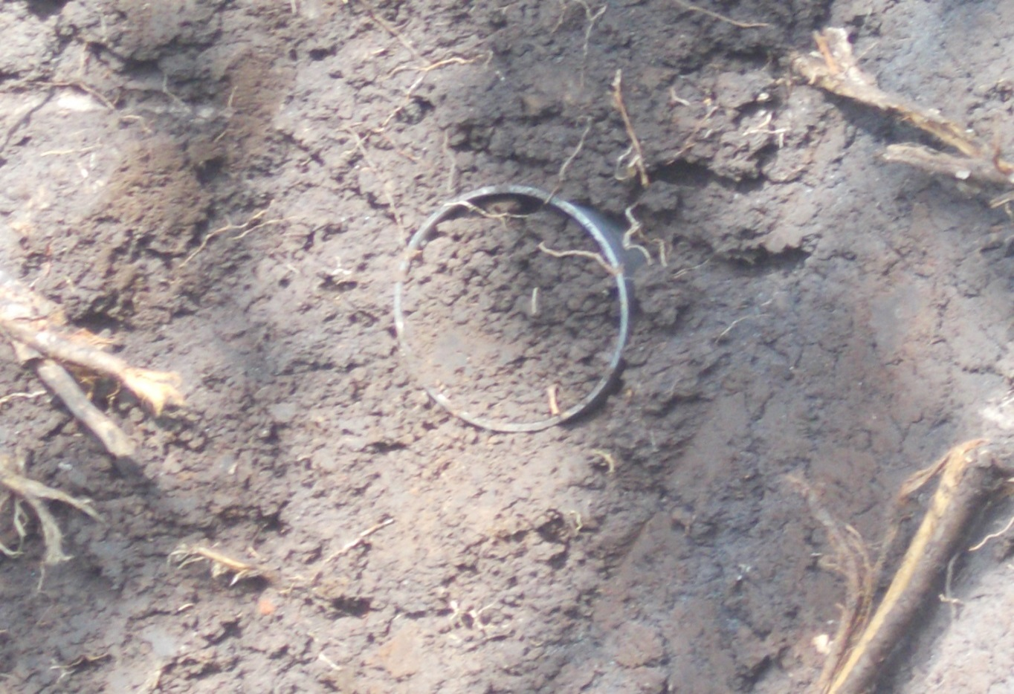
Appendix Figure 1.Taking undisturbed soil sample to measure some soil parameter

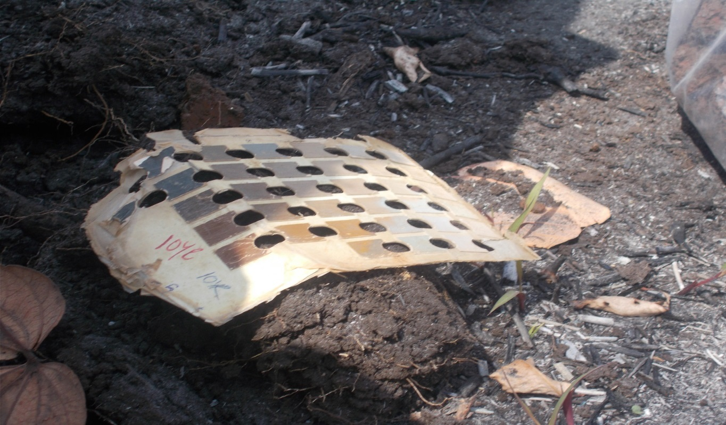
Appendix Figure 2.Physical soil characteristic description on site using Mounsul soil chart
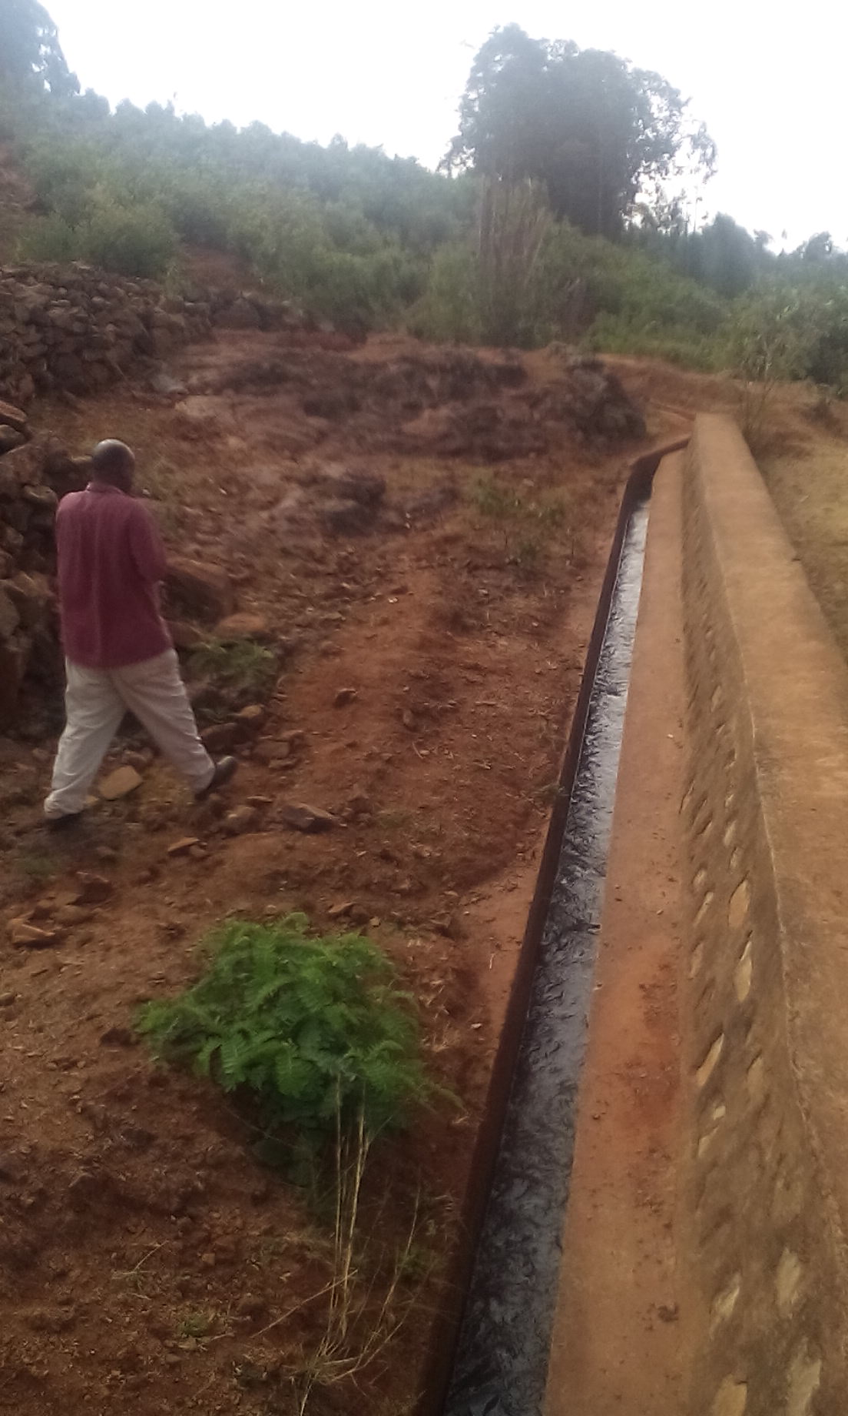
Appendix Figure 3.Main canal of Ufute irrigation scheme

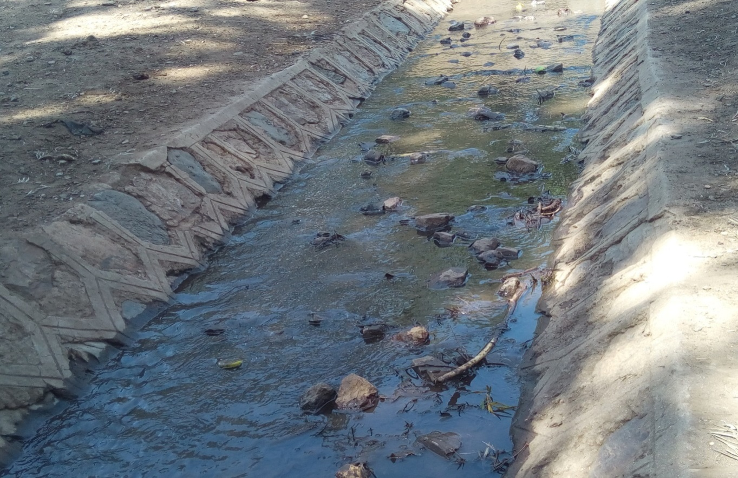
Appendix Figure 4.Poorly managed Main canal at Gemesha irrigation scheme

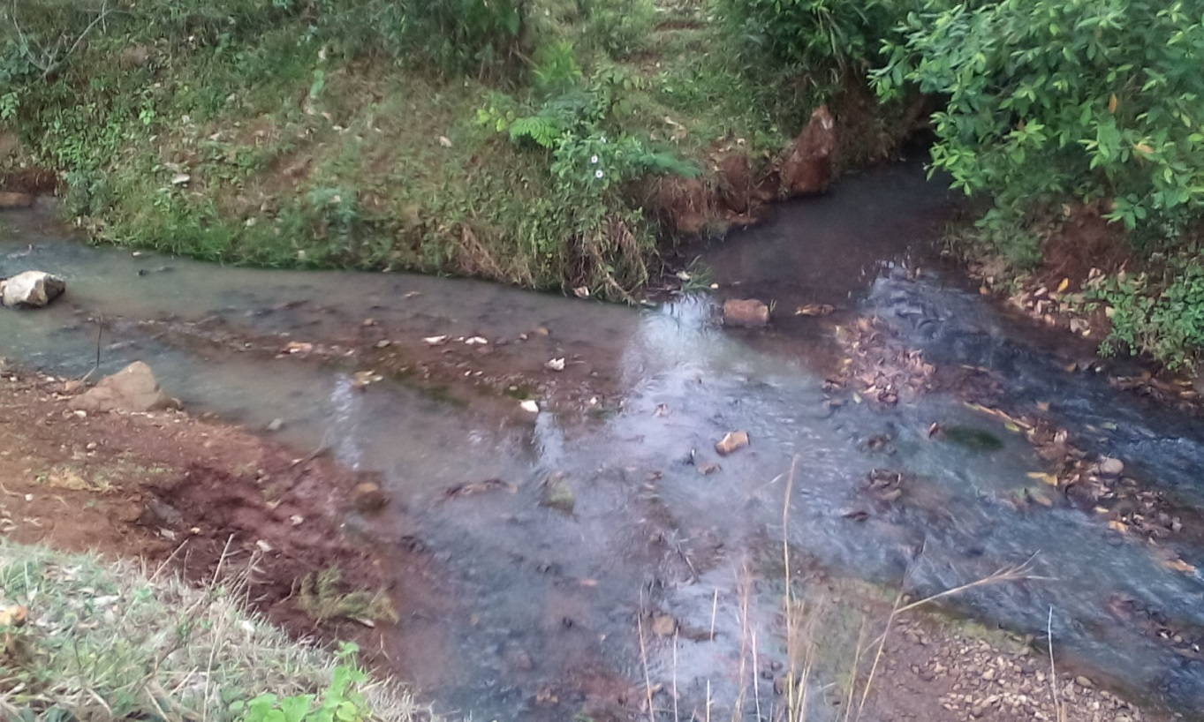
Appendix Figure 5.Unauthorized diversion from the secondary canal at Ufute Irrigation Scheme

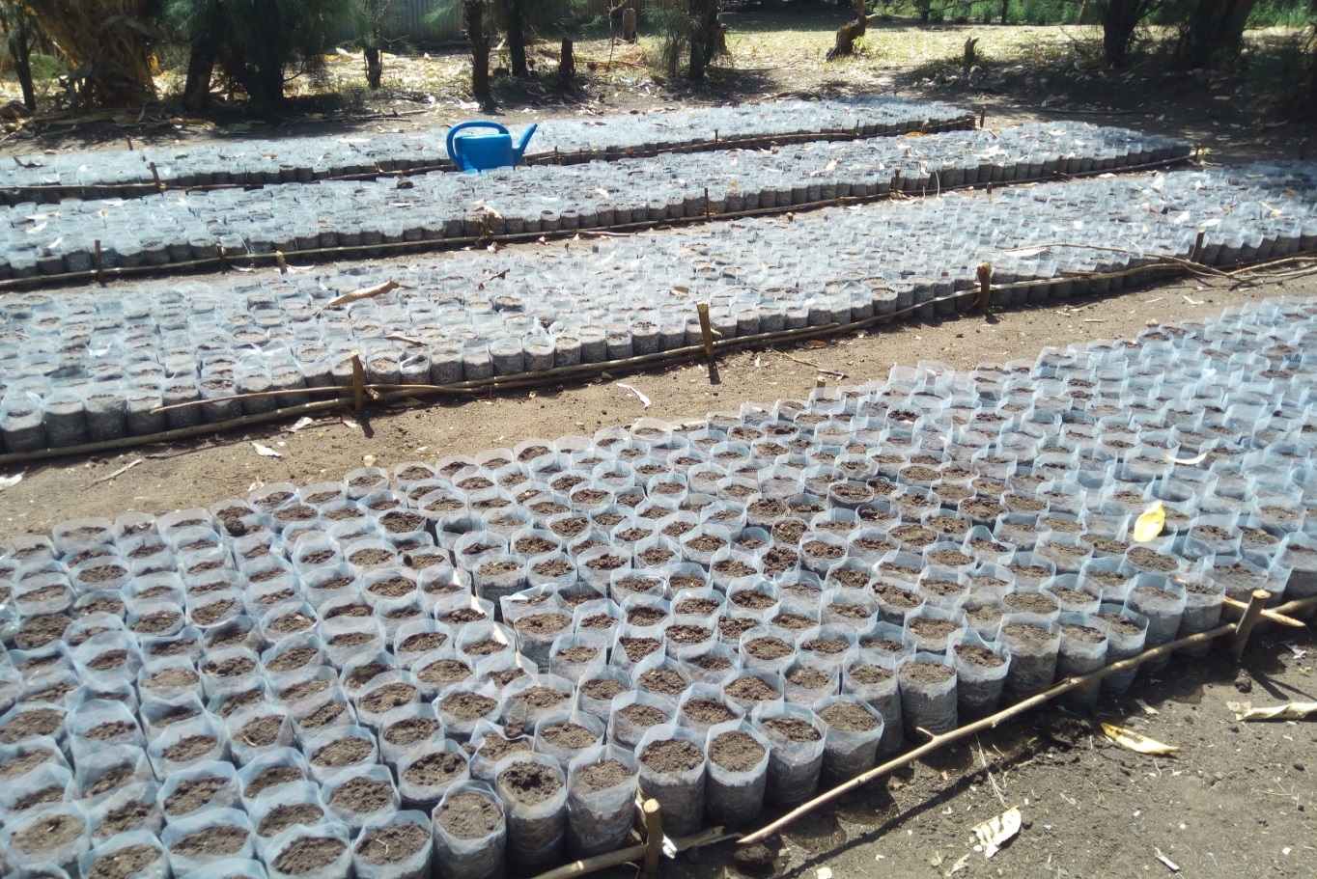
Appendix Figure 6.Nursery site for Ufute irrigation scheme

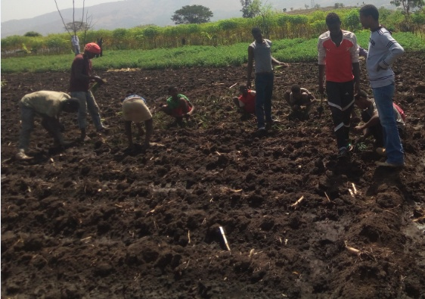
Appendix Figure 7.Plantation of White onion during site visit at Gemesha irrigation scheme

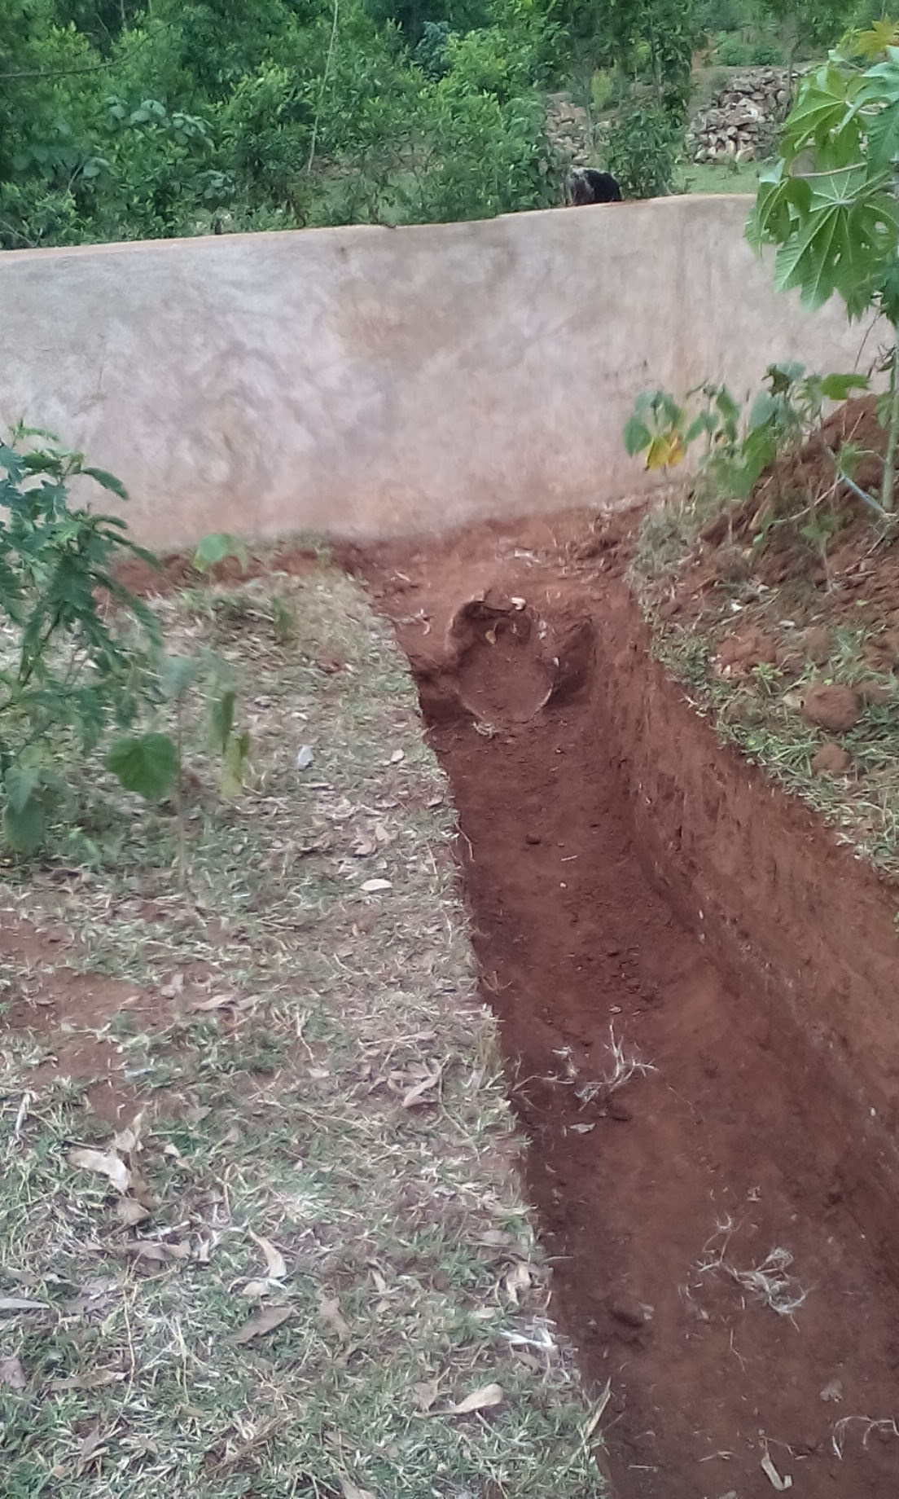
Appendix Figure 8.Non-Functional secondary canal at Gemesha due to shortage of water

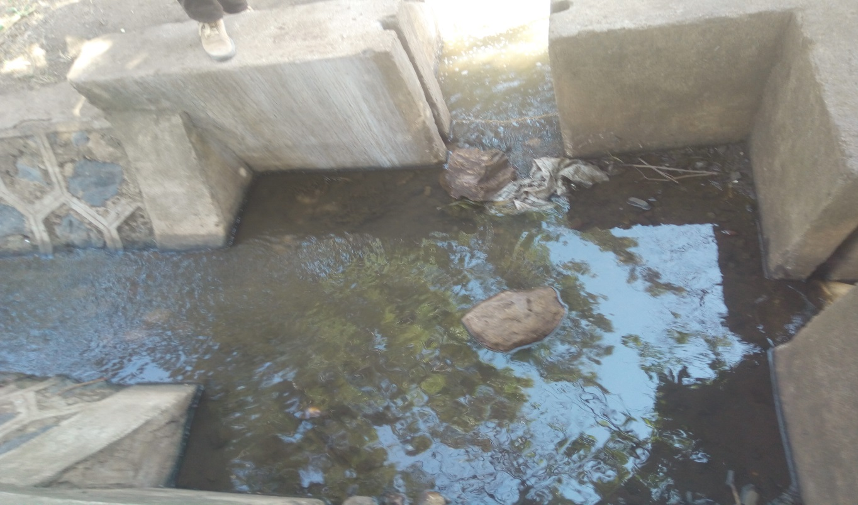
Appendix Figure 9.Poorly managed division-Box for Gemesha Irrigation scheme

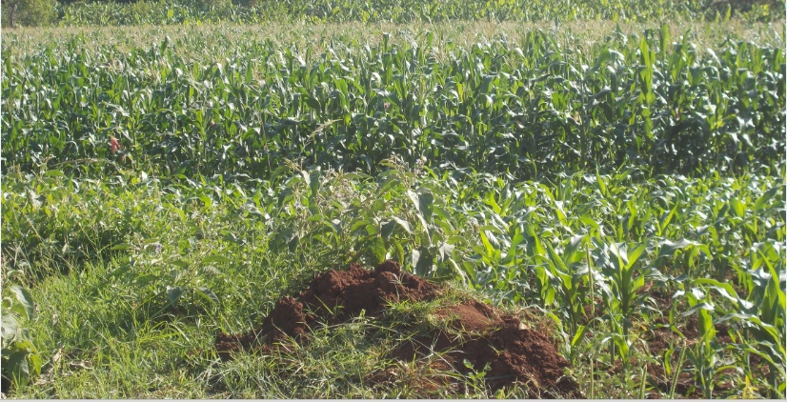
Appendix Figure 10.Maize crop fields

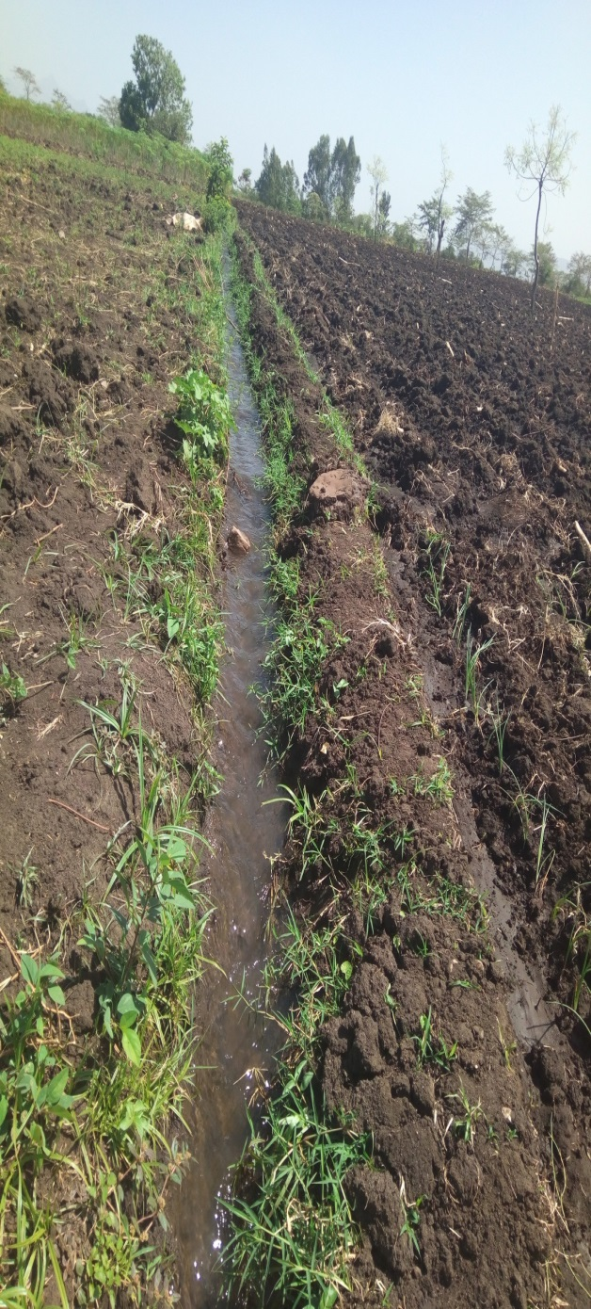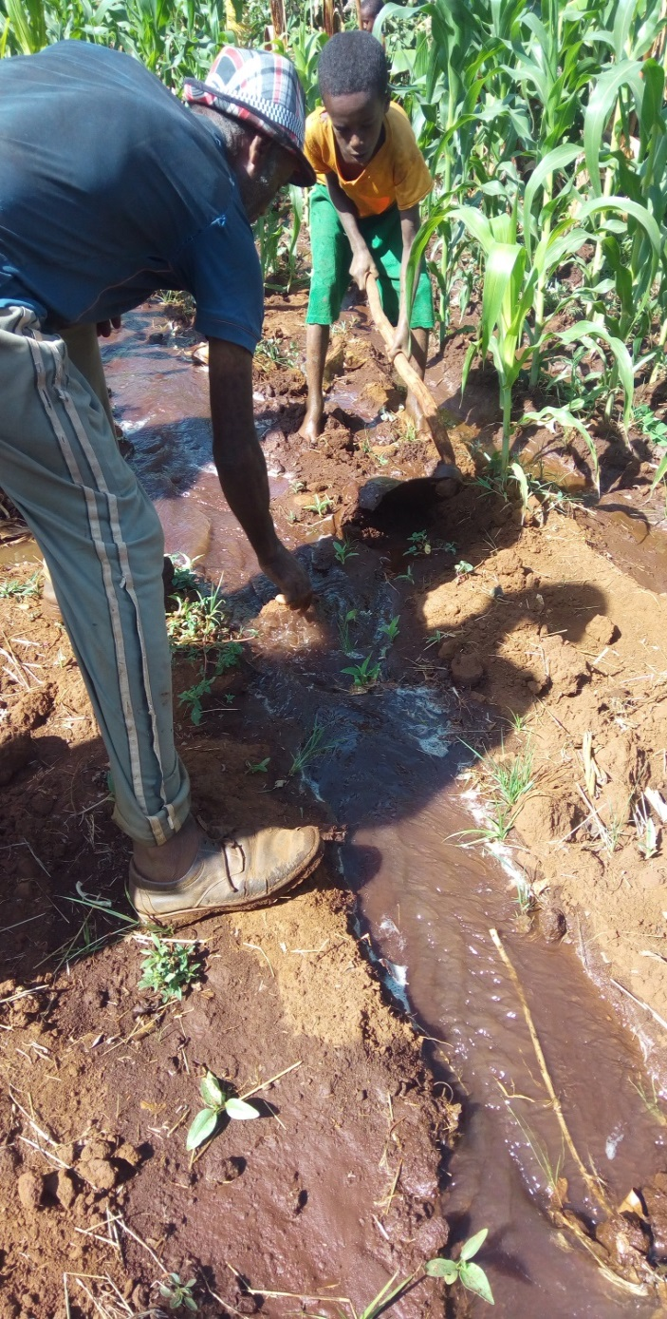
Appendix Figure 11.Furrow lay out for Gemesha and Ufute irrigation schemes

